Life Professed (23)
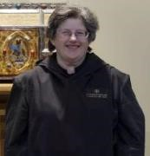 | Abbess Martha Lamoy, OSB +  400 E. Maple St.  Independence, KS 67301  Cell : (913) 709-3195  srmarthaosb@yahoo.com | 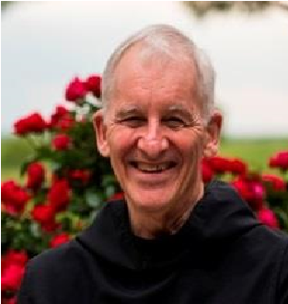 | Br. Steven Olderr, OSB  1165 Wenonah Ave.  Oak Park, IL 60304  Tel : (708) 383-8176 olderr@ameritech.net
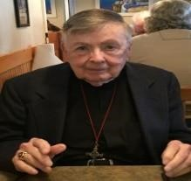 | Br. Matthias Smith, OSB  3610 Highlands Road, #2  Franklin, NC 28734  Home : (828) 524-6299 hno.matias@aol.com | 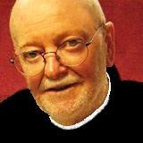 | Br Thomas Anthony Goddard, OSB  Heritage Commons  38 Boston Rd. Unit 216  Middletown, CT 06457  Tel : (860) 894-6047 tagoddard15@comcast.net
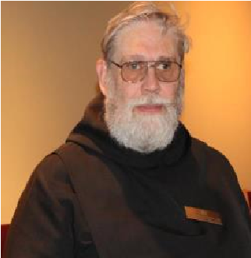 | Br. David Gerns, OSB  1197 North Ave., Apt 310  Burlington, VT 05408  Cell : (617) 834-7326  cwdxer12@gmail.com | 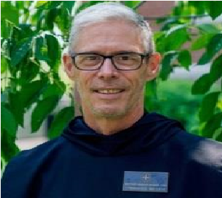 | Br. Anskar Nonken, OSB +  3828 Milflores Dr  Ruskin, FL 33573  Cell : (727) 260-1784  Scott.nonken@gmail.com
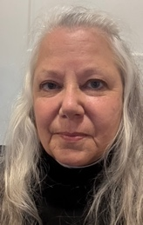 | Sr. Anna Grace Madden, OSB  2502 S. Market St.,  Apt. 317  Brenham, TX 77883  Cell : (318) 934-3836  srannagrace@gmail.com | 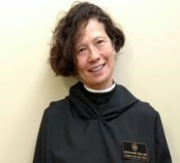 | Sr. Catherine Ann Ballinger, OSB +  The Rectory St. John’s Episcopal Church  10 Church St  Essex, NY 12936  Text : (202) 704-1409  Voice/landline: (518) 963-4657  laboheme3023@icloud.com
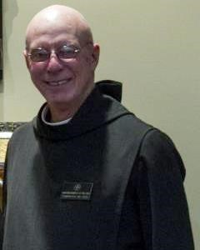 | Br. Robert Cotton, OSB  13 Pond Place Lane  Concord, NH 03301  Home : (603) 228-3645  Cell/Best : (603) 892-1410 rcotton722@gmail.com | 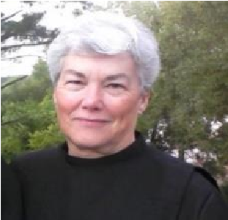 | Sr. Toni Sylvester, OSB  1125 Wonder Drive Chapin, SC 29036 Cell : (803) 261-1825 tonisyl.smc@gmail.com
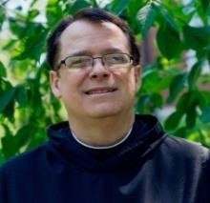 | Br. Dunstan Townsend, OSB  P. O. Box 928  Stockton, CA 95201  Cell : (209) 481.4100  br.dunstan@csl-osb.org | 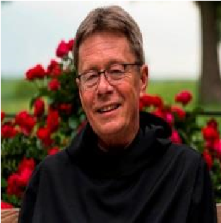 | Br. Raymond Escott, OSB +  Prior  7401 Davis Grey Dr.  Ashville, NC 28803  Cell : (828) 399-1378  revdnray@gmail.com

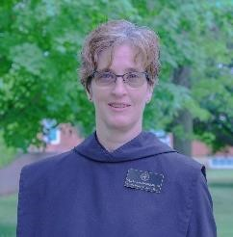 | Sr. Jana Lynn Whitworth, OSB +  3145 45th St.  Washougal, WA 98671  Cell : (360) 241-0939  Jrimom@gmail.com | 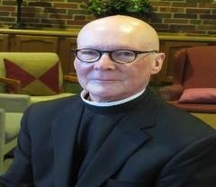 | Br. Stephen Francis Arnold, OSB  4111 Ingersoll Ave. #304,  Des Moines, IA 50312  Tel : (860) 377-0019  stephenosb248@gmail.com
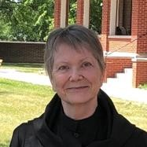 | Sr. Julian Smith-Boyer, OSB  Dean of Professed Life  502 Lynnhurst Ave. East  Apt 206  St Paul, MN 55104  Cell : (612) 210-3078  boyerhelen66@gmail.com |  | Sr. Ànah Elizabeth Marshall, OSB  Elizabeth Marshall  230 Sunrise Avenue, Suite B-349  Palm Beach, FL 33480  Tel : (561) 373-7174  anah.elizabeth.osb@gmail.com
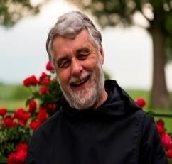 | Br. Gregory Tatchell, OSB  2222 Prince Edward St. #203  Vancouver, BC Canada V5T 4M6  Cell : (604) 612-9984  Home : (604) 709-9692  gregtatchell@hotmail.com | 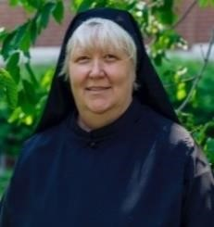 | Sr. Genevieve Lynn Robinson, OSB  Dean of Continuing Education  1301 South Arrowhead Dr.  Westminster, SC 29693  Tel : (770) 490-0063  srgenevievelynnosb@gmail.com
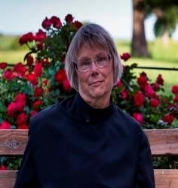 | Sr. Margaret Mary Bergeron, OSB  2515 S.9th Street; #1212  Minneapolis, MN 55406  Cell : (612) 203-6233  bermouse86@gmail.com | 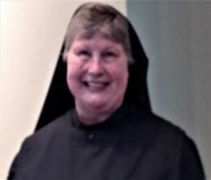 | Sr. Katharine Fleck, OSB  2505 Austin Lane #278  Mt Vernon, WA 98273  Tel: (360) 632-0209  oakharborknits@gmail.com
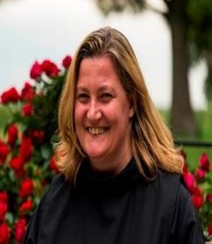 | Sr. Clara Ulson Freirias, OSB  R. Gregorio P. Almeida, 1097—V. Madalena  Sao Paulo – SP 05450-001  Brazil  Tel : 011 + 55 (11) 97546-2876  afreirias@gmail.com | 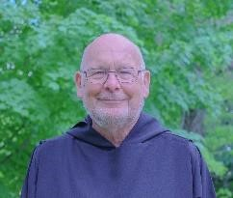 | Br. John David Wynne, OSB  5710 Atlantic Ave.  Virginia Beach, VA 23451  Cell : (757) 802-6812  brjd.osb@gmail.com  Life Profession: July 24, 2025
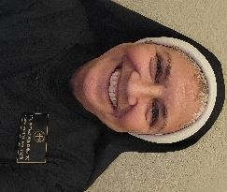 | Sr. Mary Magdalene Clarke, OSB  Business Manager  12100 Archeleta Blvd Unit 232  Austin, TX 78739  7870 US Highway 290 W  Apt 9308  Austin, TX 78736  Tel : (512) 226-3916  sr.mary.magdalene@csl-osb.org

Annually Professed (Year) (7)
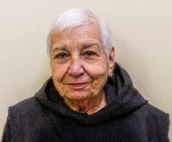 | Sr. Marie Patricia Hughes, OSB (3)  CSL Council Member  79 Fennell St. #21  Skaneateles, NY. 13152  Tel : (315) 702-3757  mphughes3139@gmail.com | 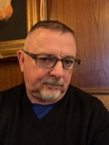 | Br. Jérôme Bertrand, OSB (1)  5719 Rawles Ave.  Indianapolis, IN 46219  Cell : (317) 446-0190  brjerome.osb@icloud.com
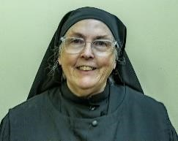 | Sr. Madeleine Sophie Smith, OSB + (2)  107 Allison Rd, Apt A  Oreland, PA 19075  Tel : (215) 435-9423  sistermadeleinesophie@gmail.com | 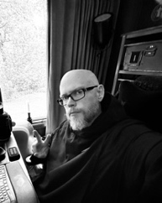 | Br. Ronan Patrick, OSB (1)  370 Preakness Way  Forsyth, GA 31029  Tel : (630) 229-1126  br.ronan@csl-osb.org
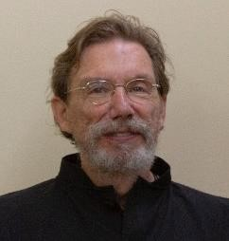 | Br. William Marion Page, OSB (2)  CSL Council Member  2326 West Kiowa St.  Colorado Springs, CO 80904  Tel : (719) 339-0165  wmpage2326kitty@gmail.com | 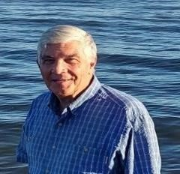 | Br. Jean Baptiste Blizzard, OSB + (1)  Treasurer  420 rue Robichaud  Cacouna, Québec,  Canada G0L 1G0  Tel: (514) 929-4230  pilgrimbill13@gmail.com
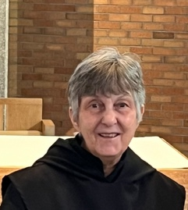 | Sr. Clare Koronka, OSB (1)  4813 Lido Lane  Houston, TX 77092  Tel : (832) 216-9199  sisterclareosb5@gmail.com

Novices (Year) (4)
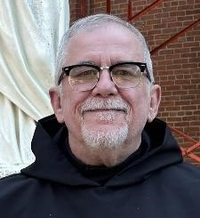 | Br. Joseph Elias Varsanyi, n/OSB (2)  2001 Hamilton St.  Apt. 1027  Philadelphia, PA 19130  Tel : (215) 850-6635  joevasl@aol.com | 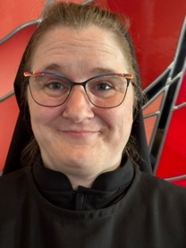 | Sr. Seraphina MacKay, n/OSB (1)  1701 Welch St. Unit 20  Fort Collins, CO 80525  Tel : (603) 496-6458  sr.seraphina@csl-osb.org
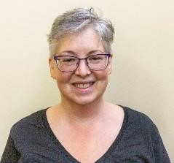 | Sr. Gianna Altadonna, n/OSB (2)  CSL Council Member  781 Spring St. #521  Macon, GA 31201  Tel: (770) 608-5482  lo.alta86@gmail.com | 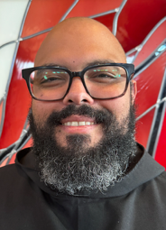 | Br. Dominic Ndife. n/OSB (1)  554 Farley Dr.  Indianapolis, IN 46214  Tel : (812) 223-4324  christopher.ndife@gmail.com

Postulants (2)
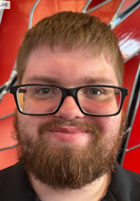 | Joseph Hain, p/OSB  9627 Convent Ave.  Philadelphia, PA 19114  Tel : (267) 312-9904  mailto:JosephH1197@gmail.com | 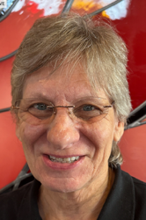 | Nan DeStafney, p/OSB  657 N. Pace Blvd  Pensacola, FL 32505  Tel : (850) 512-6693  NanDestafney@yahoo.com

Oblates (13)
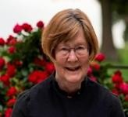 | Sr. Brigid Gerns, Obl/OSB  1197 North Ave., Apt 310  Burlington, VT 05408  Cell : (603) 819-9659  ann2brigid@gmail.com | 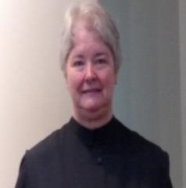 | Sr. Hildegard Longmire, Obl/OSB  1818 Hidaway Lane  Durham, NC 27712  Tel : (919) 308-1211  bwlongmire@mindspring.com
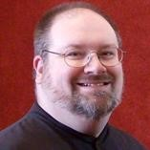 | Br. Daniel Moore, Obl/OSB  330 North Washington St.  Kahoka, MO 63445  Cell : (319) 470-6581  danielmoore@minister.com | 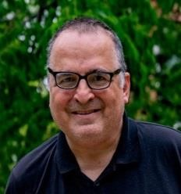 | Br. Jeffrey Thaddeus Kasica, Obl/OSB  164 Chestnut St  Hudson Ma 01749  Tel : (617) 834-2283  lovebunky77@gmail.com
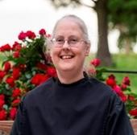 | Sr. Denise Moore, Obl/OSB  330 North Washington St.  Kahoka, MO 63445  Cell : (319) 470-2708  sisdenise@yahoo.com | 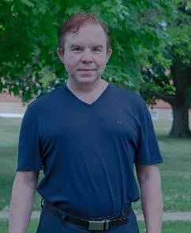 | Br. Jude Thaddeus Orth, Obl/OSB  8438 South 115th Place  Seattle, WA 98178  Tel : (206) 931-3058  brjudethaddeus@gmail.com
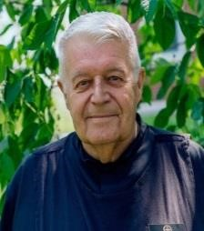 | Br. Michael Anicetus McCabe, Obl/OSB  2517 E. Jensen  Mesa, AZ 85213  Tel : (402) 926-1342  jmmcccabe@cox.net | 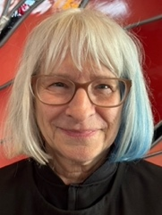 | Sr. Cynthia Anne Page, Obl/OSB  2326 West Kiowa St.  Colorado Springs, CO 80904  Tel : (719) 339-8428  cindypage2326@gmail.com
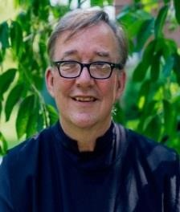 | Br. James Rafael Davies, Obl/OSB  Dean of Oblate Life  1923 3rd Ave. South  Minneapolis, MN 55404  Tel : (612) 360-4031  aumjames@aol.com | 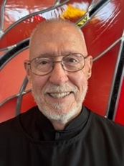 | Br. Richard Joachim Knight, Obl/OSB  2071 28th Ave. N.  St. Petersburg, FL 33713-4144  Tel : (727) 625.0550  reknight.CSL@gmail.com
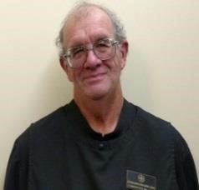 | Br. Florian Campbell, Obl/OSB  CSL Council Member  507 West Race St.  Mount Pleasant, IA 52641  Tel : (319) 217-3365  unclejoe314159@gmail.com | 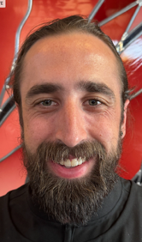 | Br. Andrew Grimsby, Obl/OSB  1061 NE 9th Ave, #1418  Portland, OR 97232  Tel : (458) 257-3155  nsgrimsby@gmail.com

Novice Oblates (Year) (3)
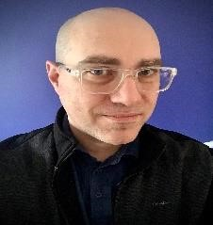 | Jason Lentz, nObl/OSB (2)  107 Sprunt St.  Chapel Hill, NC 27517  Tel : (919) 923-8303  jason.lentz.pm@gmail.com | 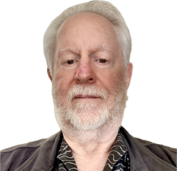 | John Mangels, nObl/OSB+ (1)  19680 Sun Valley Rd.  Colfax, CA 95713  Tel : (916) 202-4853  jmangels3@gmail.com
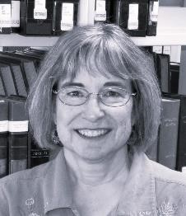 | Andromeda Jazmon Sibley, nObl/OSB (2)  210 Summit Ave.  Willow Grove, PA 19090  Tel : (267) 482-0734  cloudscome@gmail.com |  | Sr. Dawna Clare Sutton, Obl/OSB  1701 S. Thornburg St. #6  Santa Maria, CA 93458  Phone : (805) 268-4819  dawnasutton@hotmail.com

Spiritual Support (4)
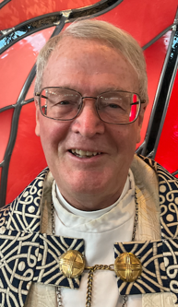 | The Rt. Rev. Alan Scarfe, Bishop Visitor Emeritus  719 52nd St.  Des Moines, IA 50312  Cell : (515) 314-1874  ascarfe009@gmail.com | 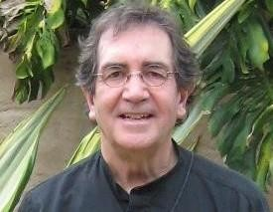 | The Rev. Sidney Breese, Chaplain  2534 Francis St.  St. Joseph, MO 64501  Tel : (816) 262-4958  ssbreese@aol.com
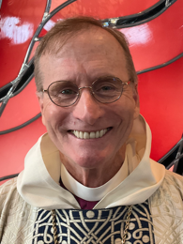 | The Rt. Rev. Dorsey McConnell, Bishop Visitor Elect  191 Dyke Rd.  Sugar Hill, NH 03586  Tel : (617) 817-7774  ironcitybishop@gmail.com | 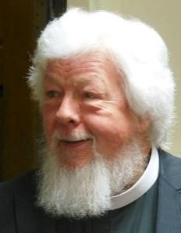 | The Rev. Wayne Kamm  1451 Salem Road  Salem, IA 52649  rockermarchersalem@gmail.com

- Post Office Address:
Companions of Saint Luke
P.O. Box 36
Independence, KS 67301

Directory Update Reminder

If you are listed in the current directory and notice that any of your information has changed, please make the necessary updates on this/these last page.s:

Simply write:

• Your name
• Only the information that has changed (e.g., phone number, email, title)

This helps us keep the directory accurate and up to date.

Thank you for your cooperation!

Name : | Change.s to be recorded for the next version of the directory :

Name : | Change.s to be recorded for the next version of the directory :

