July 21-25 Convocation
St. Gregory’s Abbey—St. Benedict Center
Schuyler, Nebraska
Part 4 of 4
Almost all the photographs were taken by Colleen Patrick.

People are identified left to right.
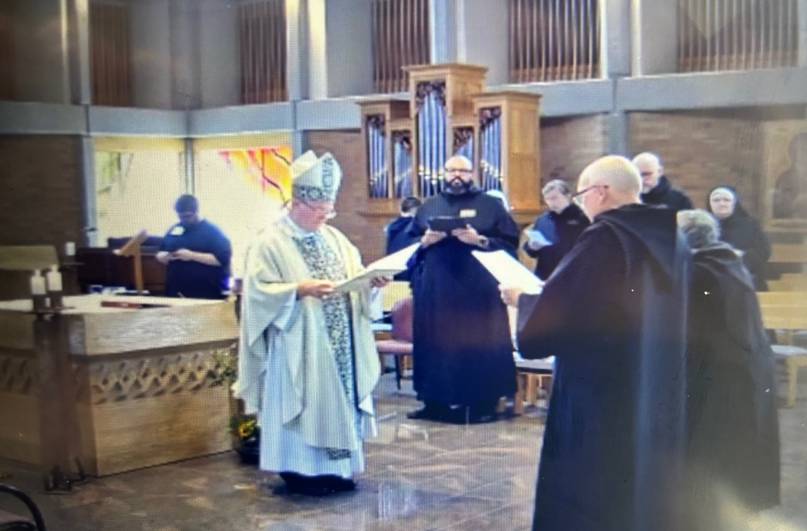
Joseph Hain; Bp. Alan Scarfe; Br. Dunstan Townsend; Br. Dominic Ndife; Br. William Marion Page; Br. John David Wynne; Br. Ronan Patrick; Abbess Martha Lamoy; Sr. Genevieve Lynn Robinson

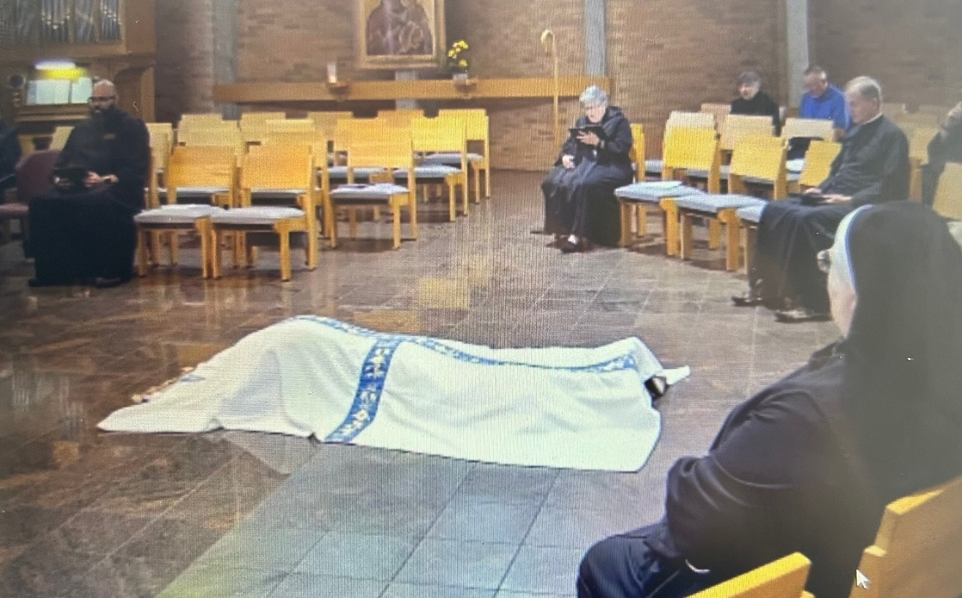
Br. Dominic Ndife; Br. John David Wynne under pall; Abbess Martha Lamoy; Sr. Clare Koronka; Larry Koronka; Bp. Dorsey McConnell; Sr. Genevieve Lynn Robinson

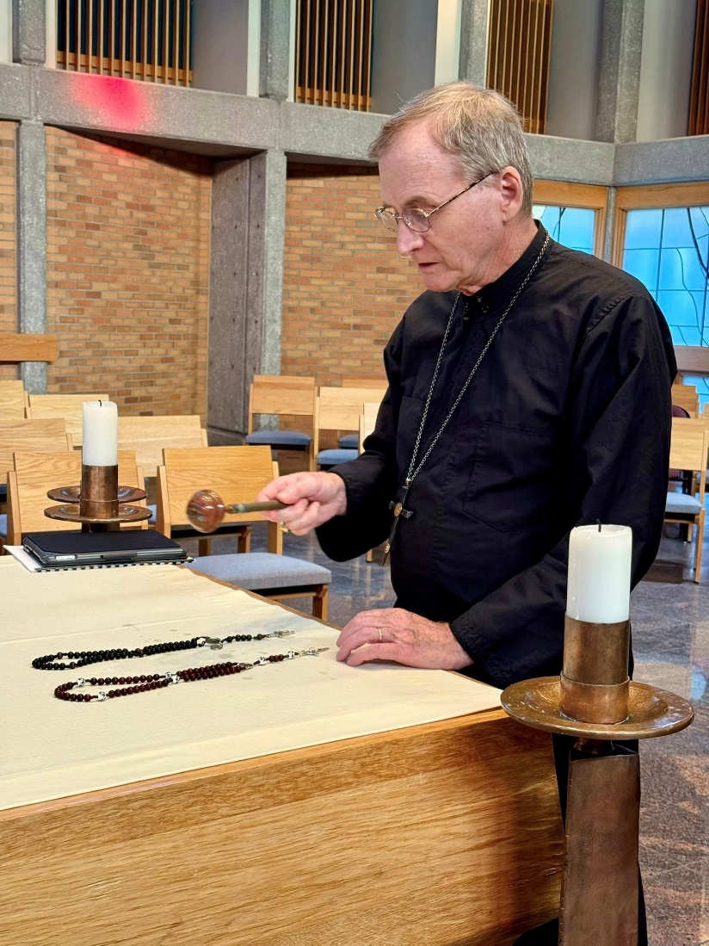
Bp. Dorsey McConnell
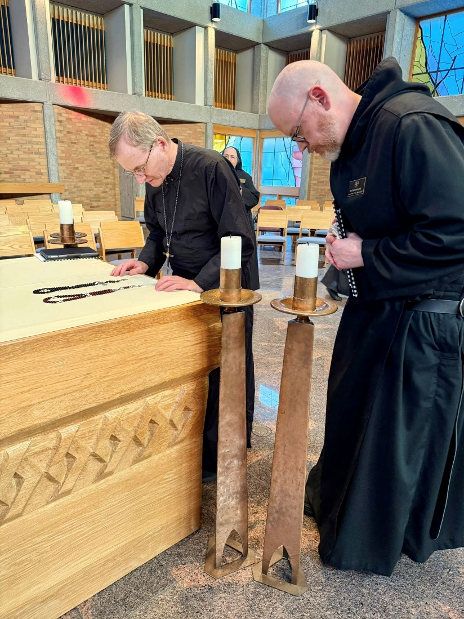
Bp. Dorsey McConnell; Sr. Madeleine Sophie Smith; Br. Ronan Patrick
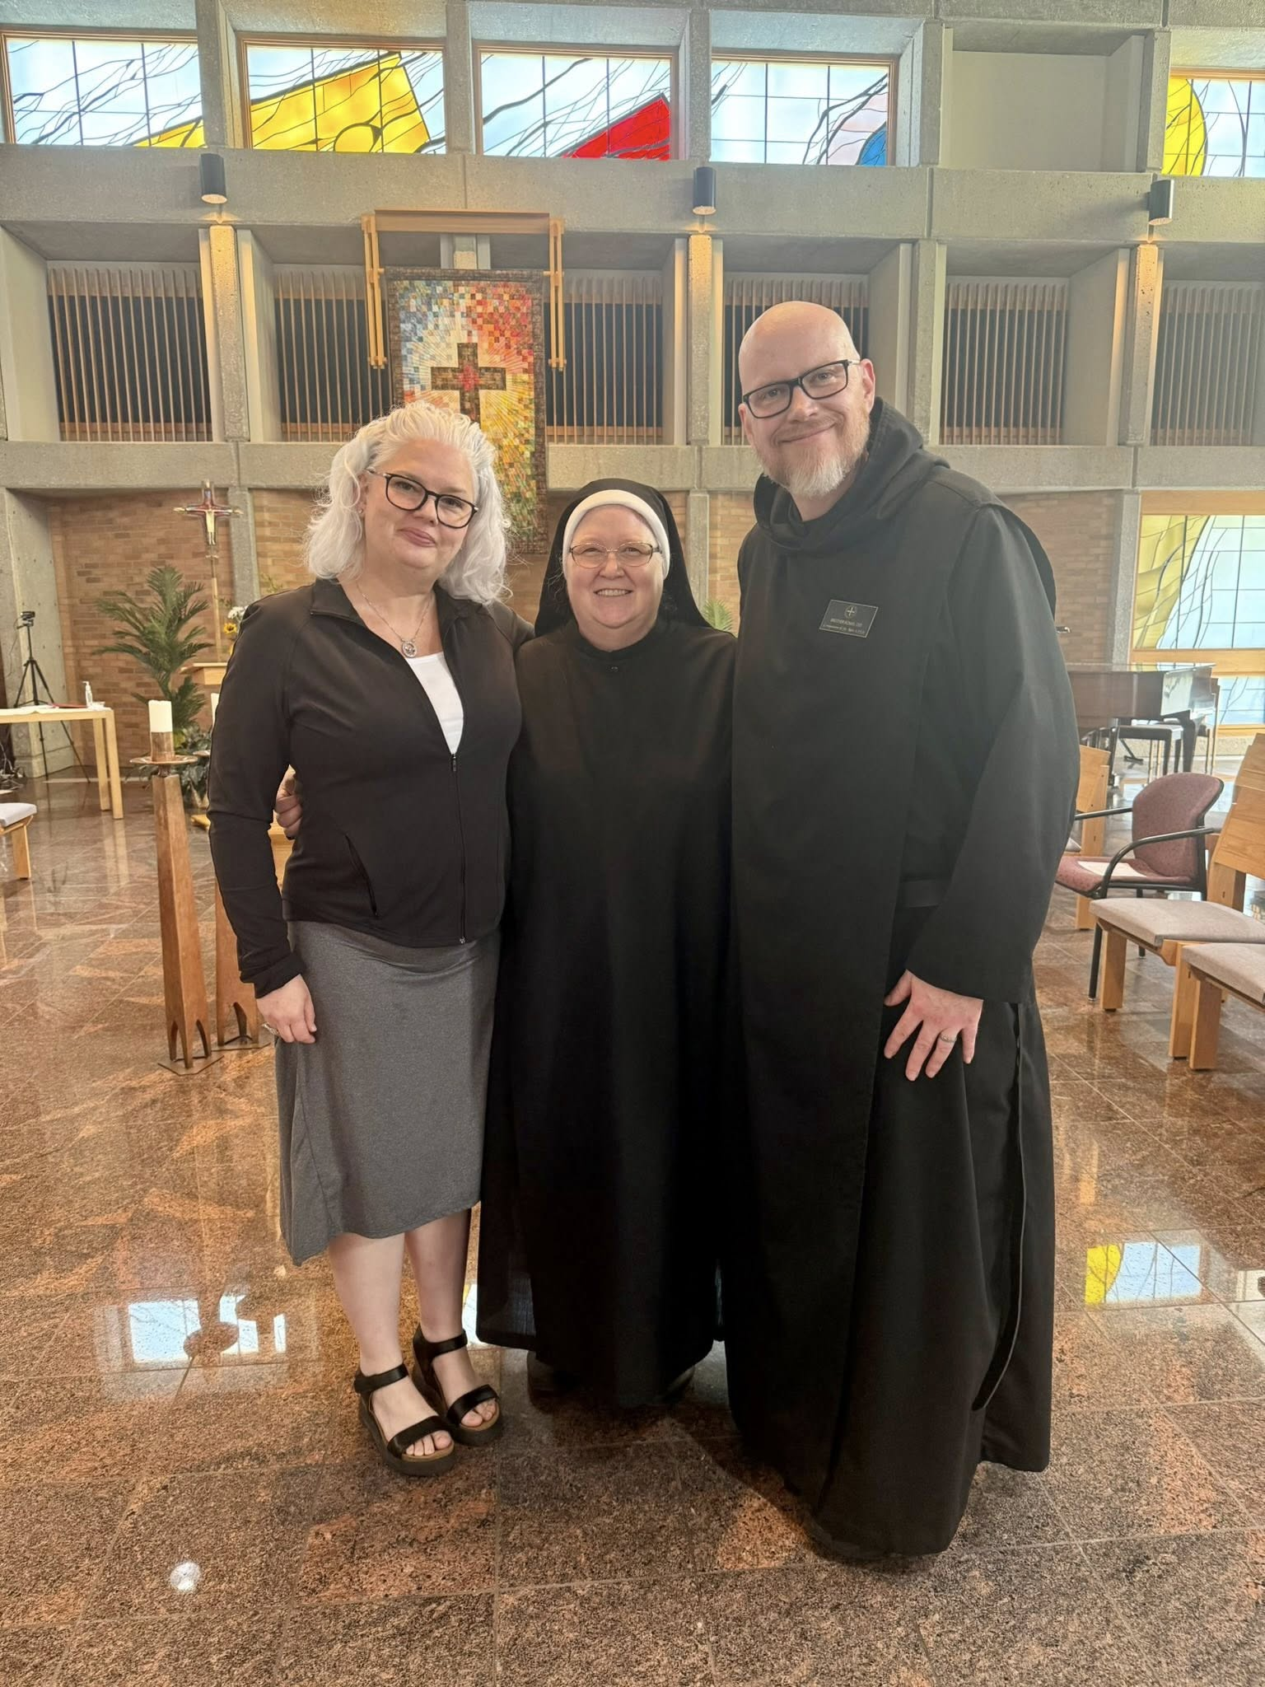
Colleen Patrick; Sr. Genevieve Lynn Robinson; Br. Ronan Patrick
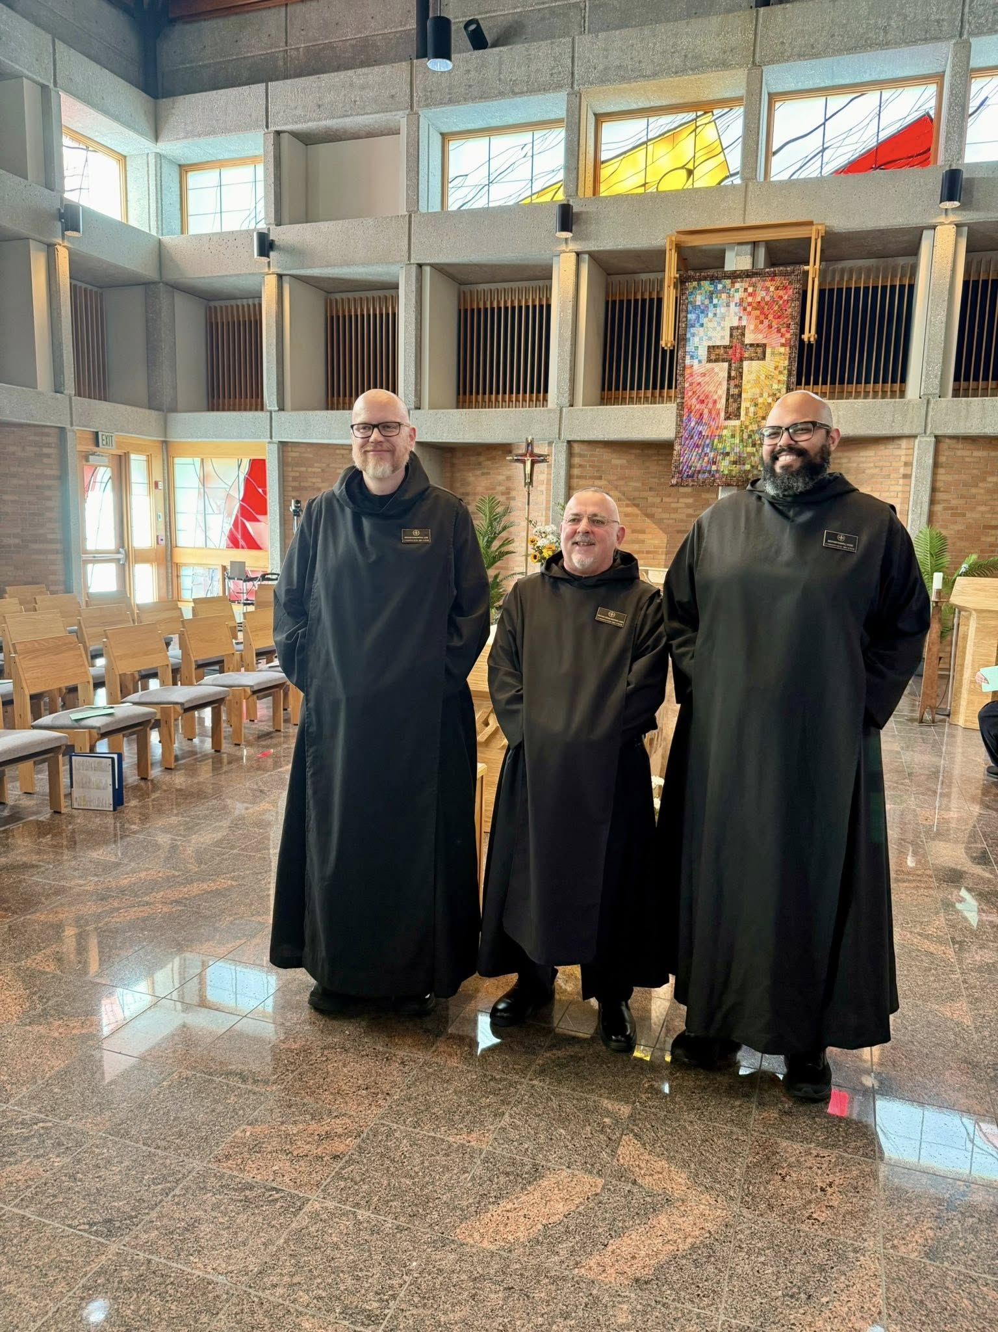
Br. Ronan Patrick; Br. Jérôme Bertrand; Br. Dominic Ndife
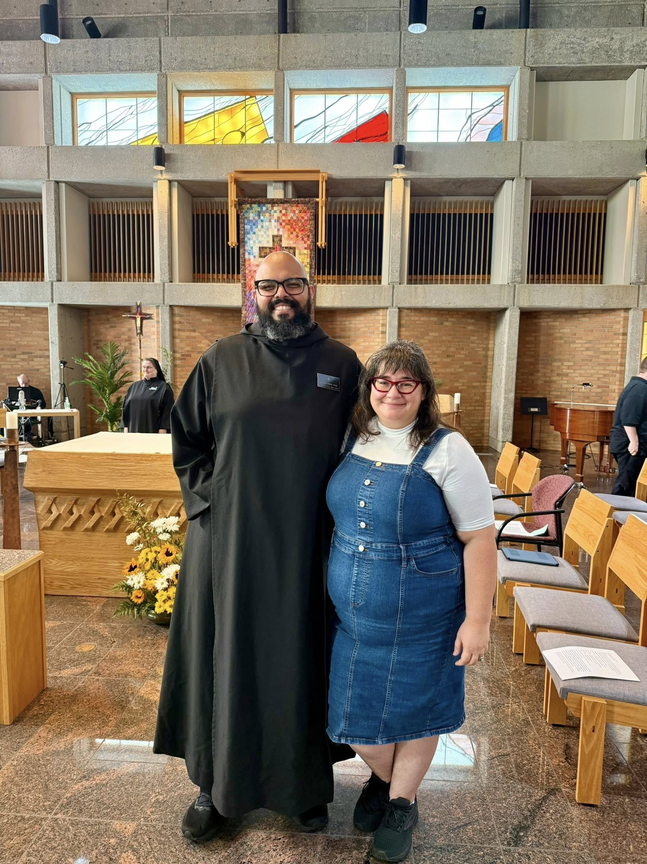
Br. Florian Campbell; Sr. Seraphina MacKay; Br. Dominic Ndife; Kayla Ndife; Joseph Hain

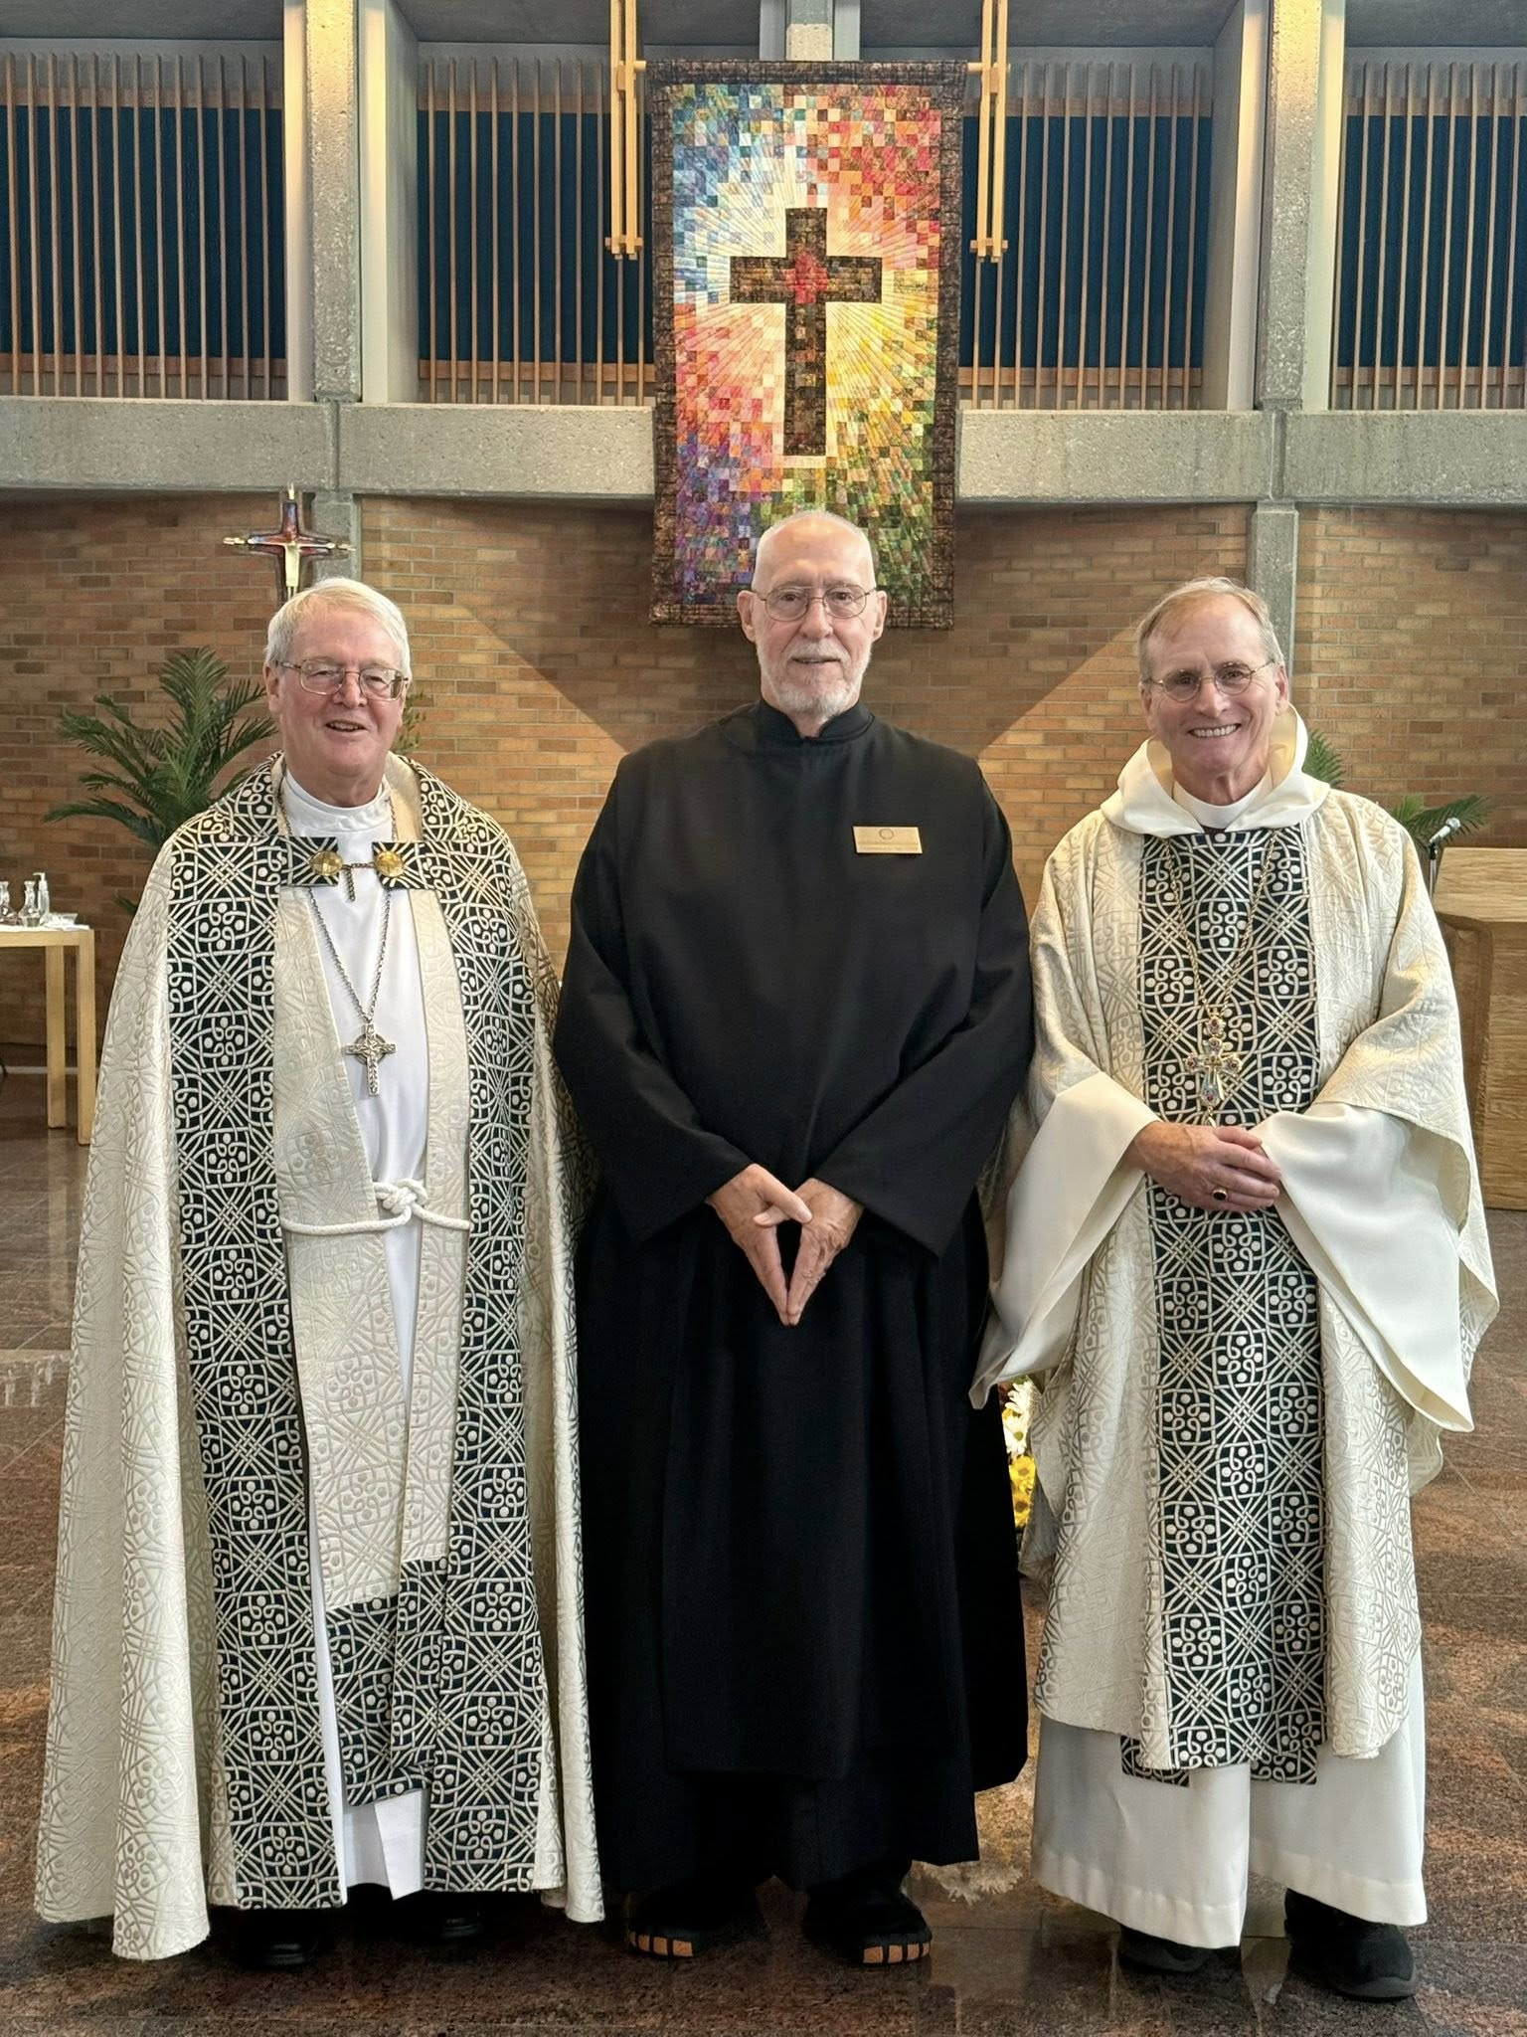
Bp. Alan Scarfe; Br. Richard Joachim Knight; Bp. Dorsey McConnell
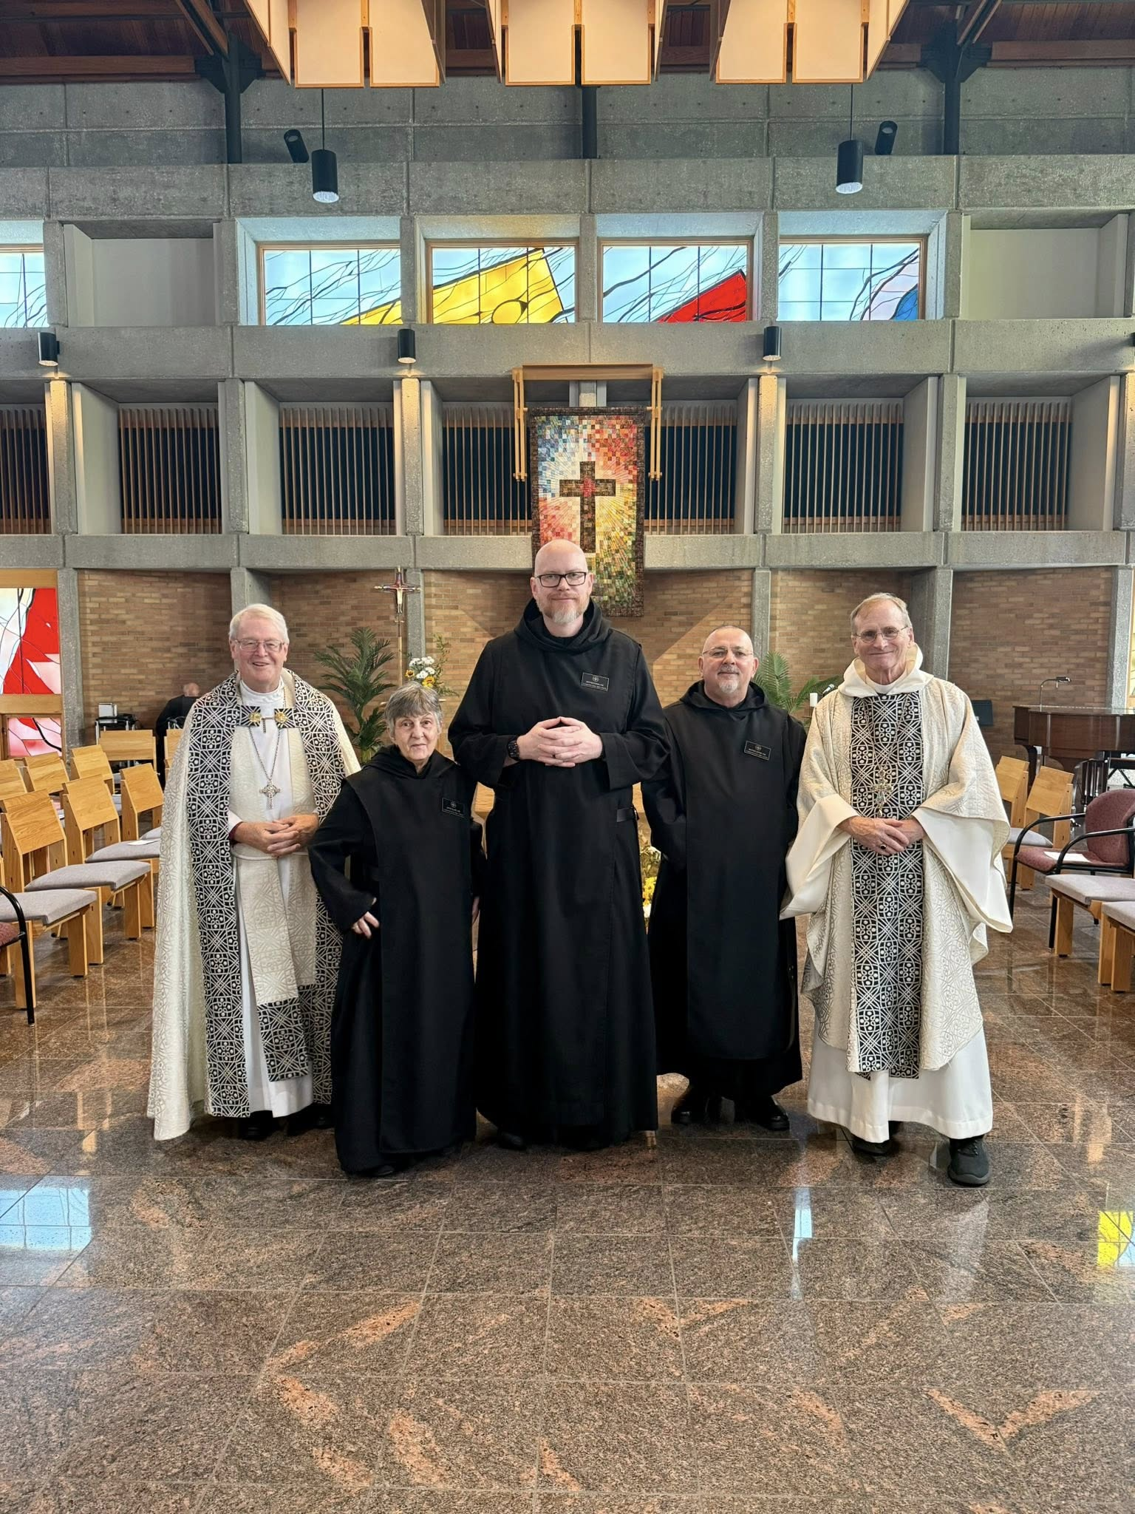
Br. Florian Campbell; Bp. Alan Scarfe; Sr. Clare Koronka; Br. Ronan Patrick; Br. Jérôme Bertrand; Bp. Dorsey McConnell

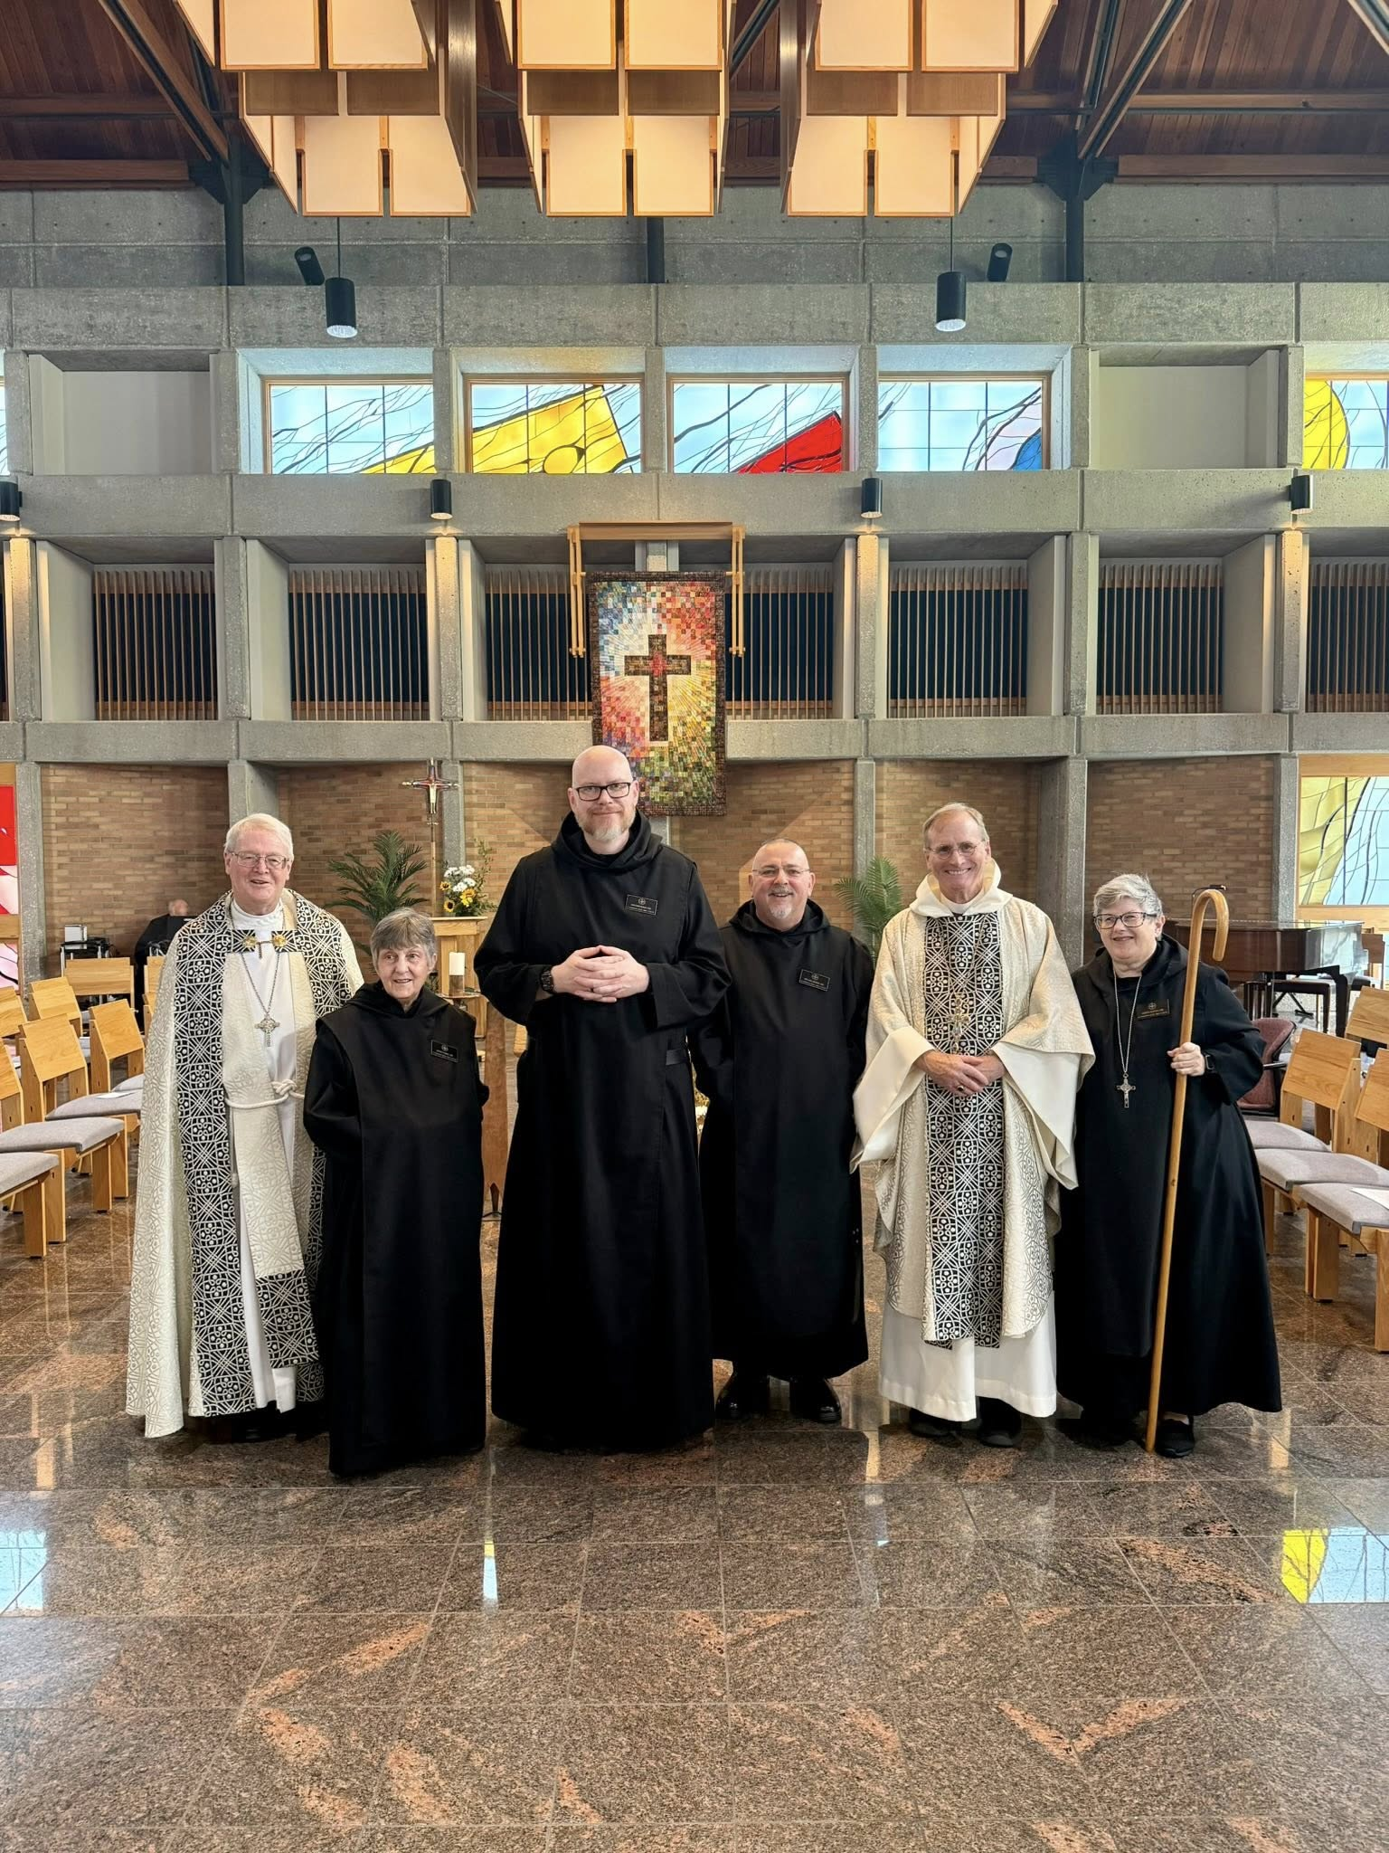
Br. Florian Campbell; Bp. Alan Scarfe; Sr. Clare Koronka; Br. Ronan Patrick; Br. Jérôme Bertrand; Bp. Dorsey McConnell; Abbess Martha Lamoy

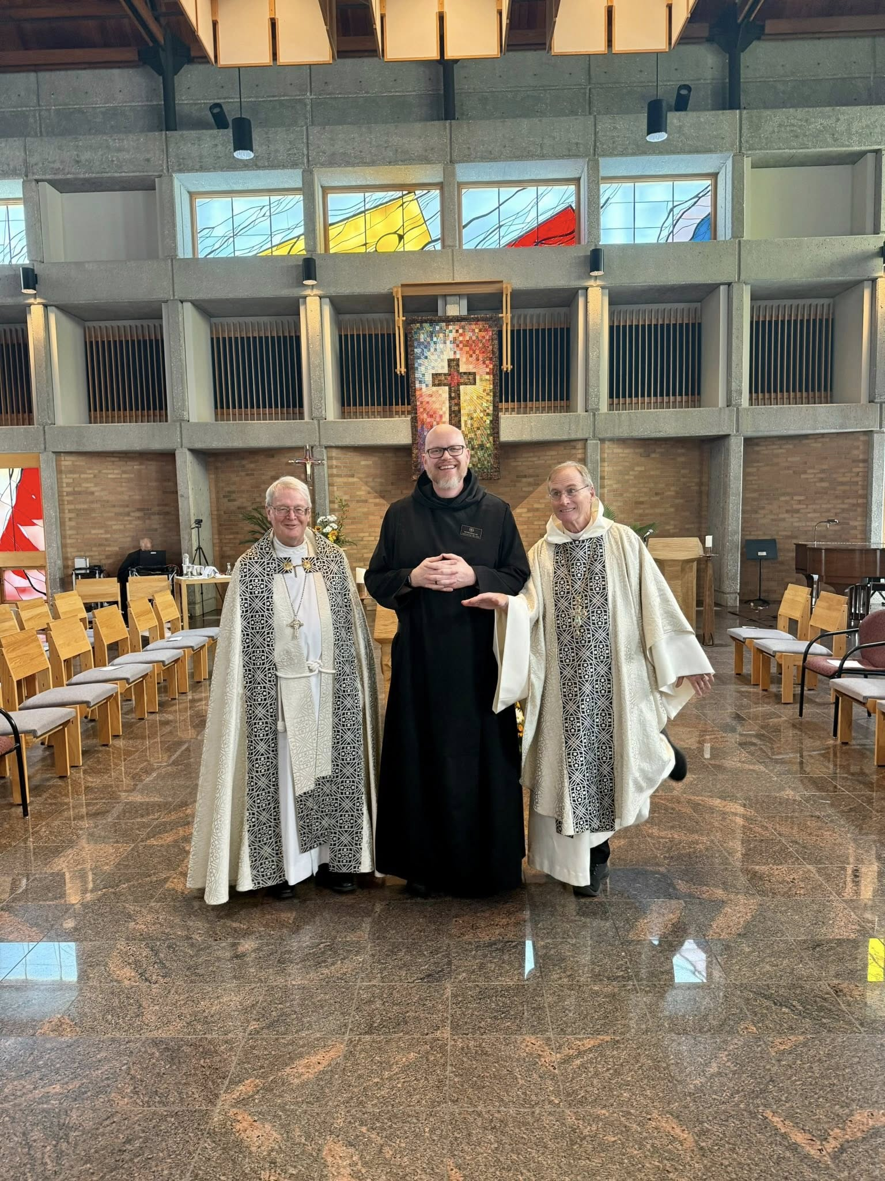
Br. Florian Campbell; Bp. Alan Scarfe; Br. Ronan Patrick; Bp. Dorsey McConnell

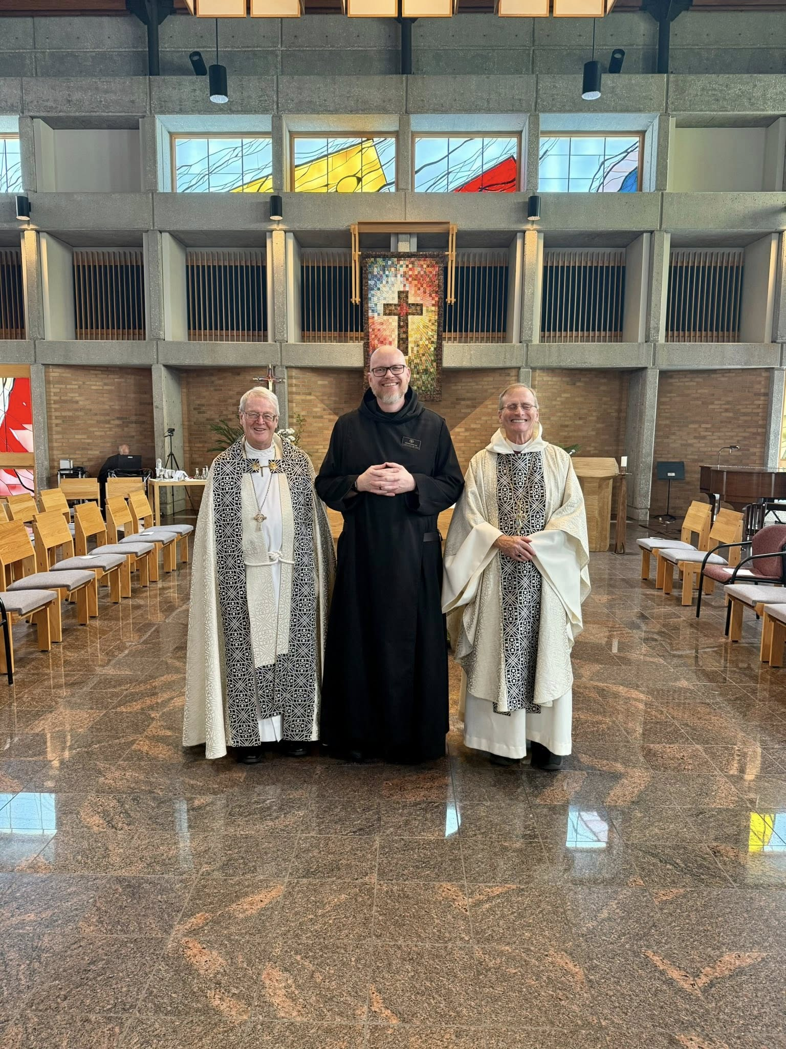
Br. Florian Campbell; Bp. Alan Scarfe; Br. Ronan Patrick; Bp. Dorsey McConnell
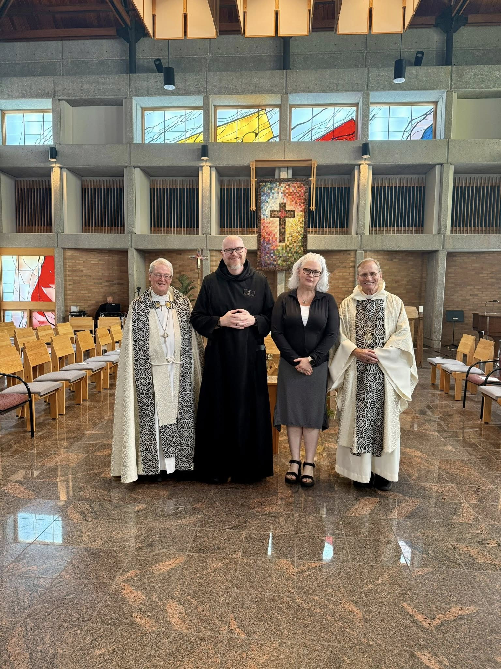
Br. Florian Campbell; Bp. Alan Scarfe; Br. Ronan Patrick; Colleen Patrick; Bp. Dorsey McConnell
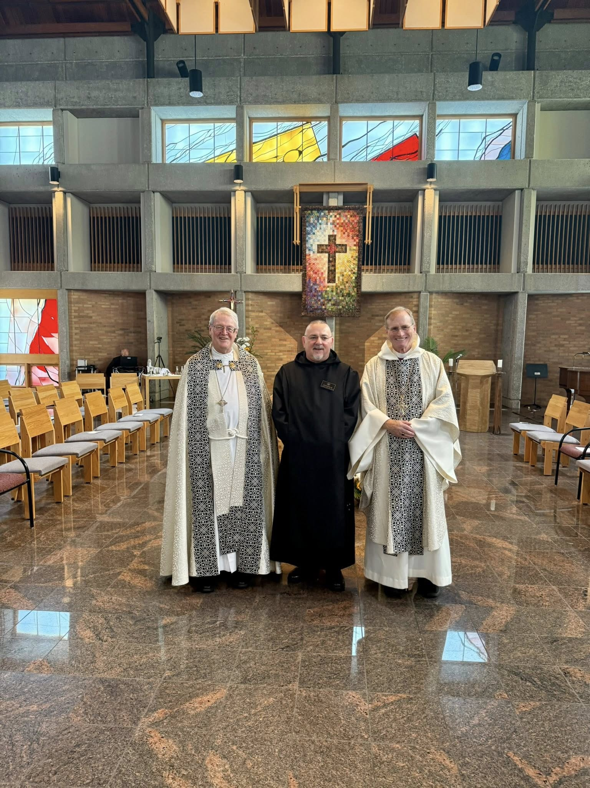
Br. Florian Campbell; Bp. Alan Scarfe; Br. Jérôme Bertrand; Bp. Dorsey McConnell
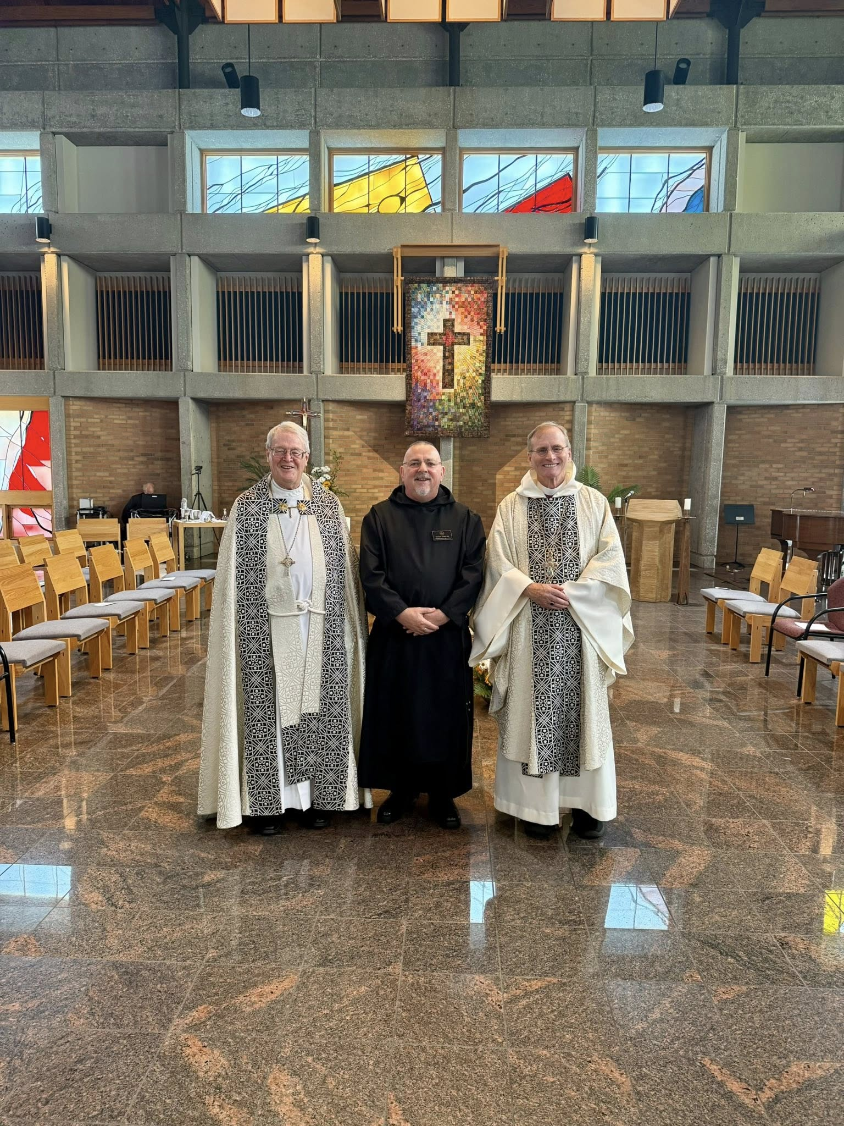
Br. Florian Campbell; Bp. Alan Scarfe; Br. Jérôme Bertrand; Bp. Dorsey McConnell

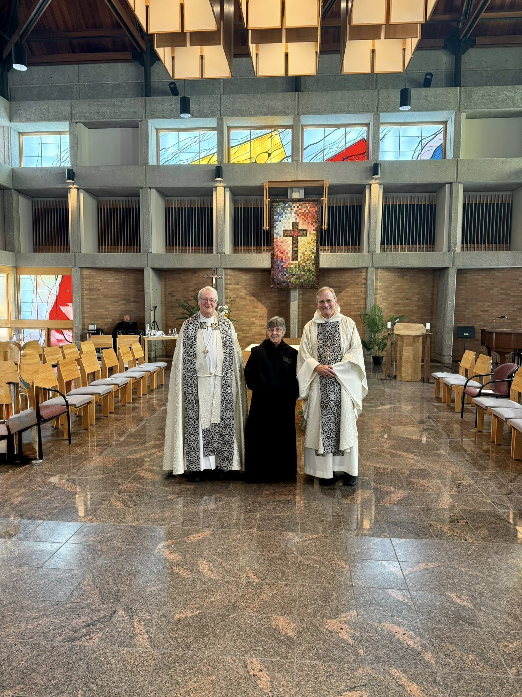
Br. Florian Campbell; Bp. Alan Scarfe; Sr. Clare Koronka; Bp. Dorsey McConnell
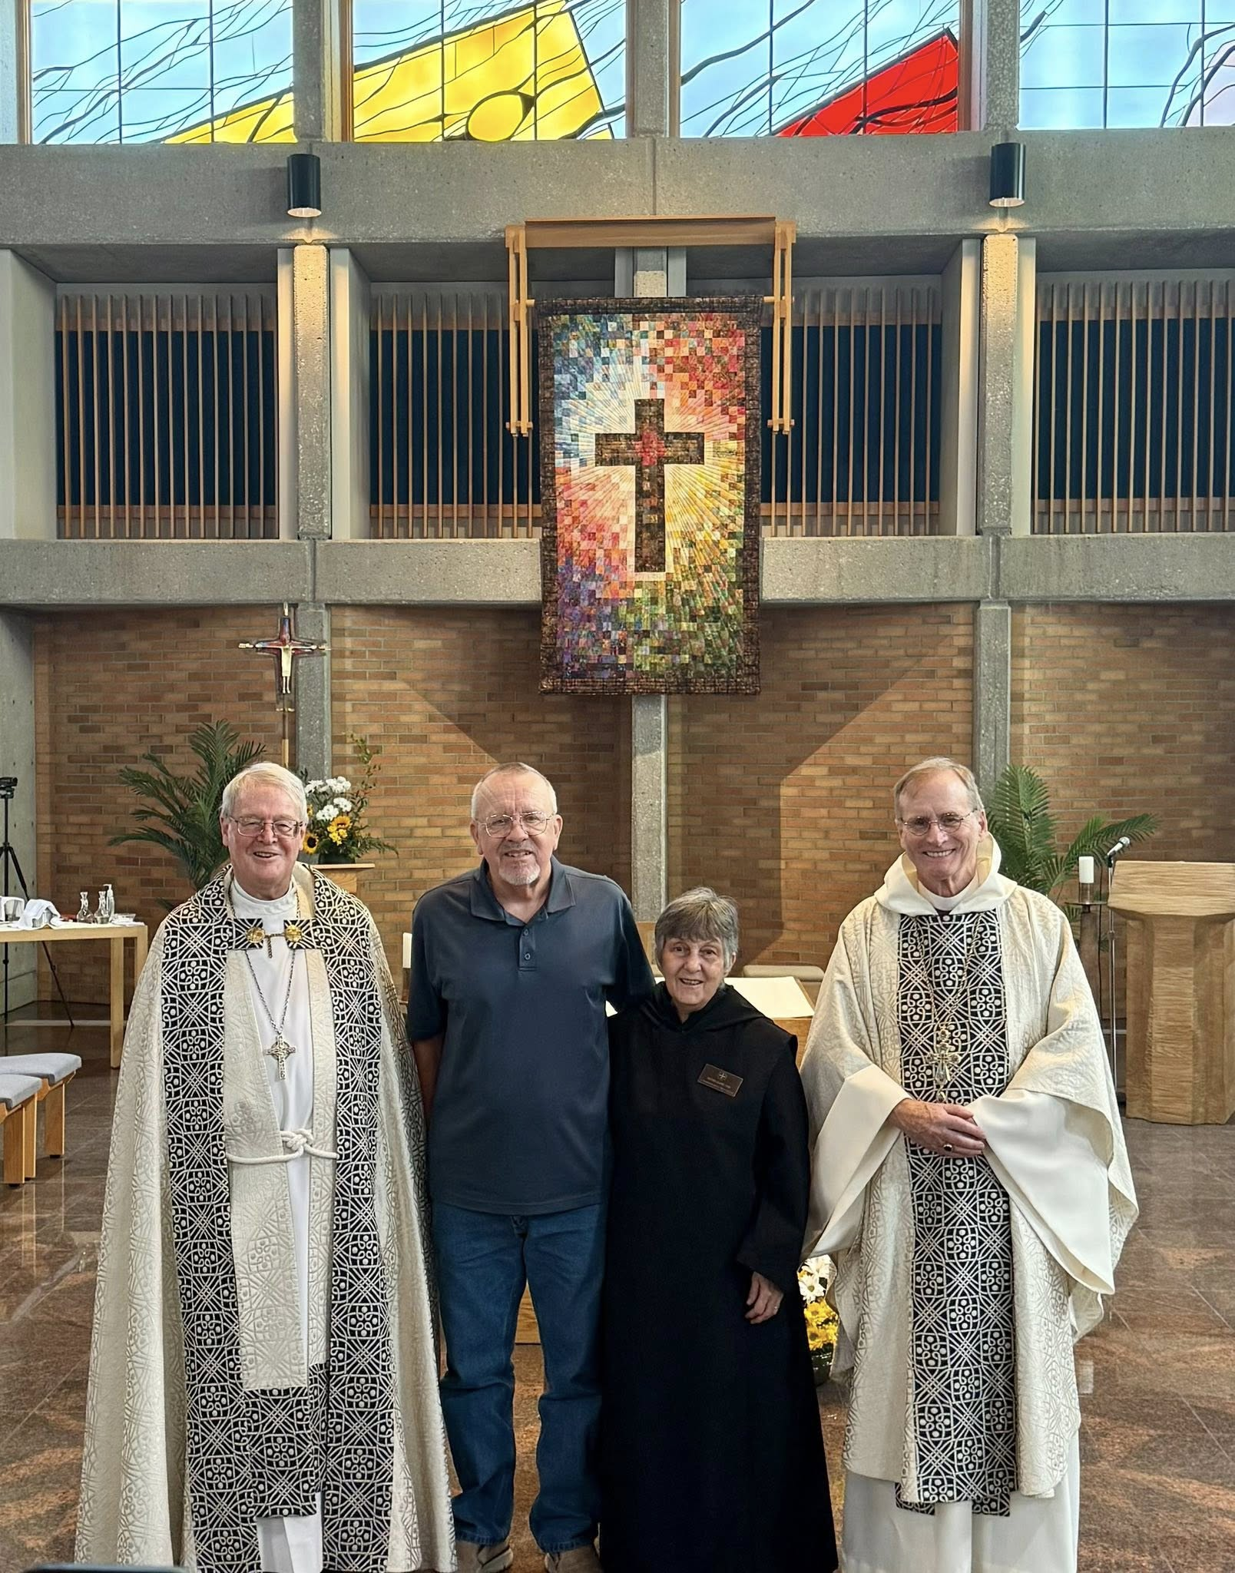
Bp. Alan Scarfe; Larry Koronka; Sr. Clare Koronka; Bp. Dorsey McConnell

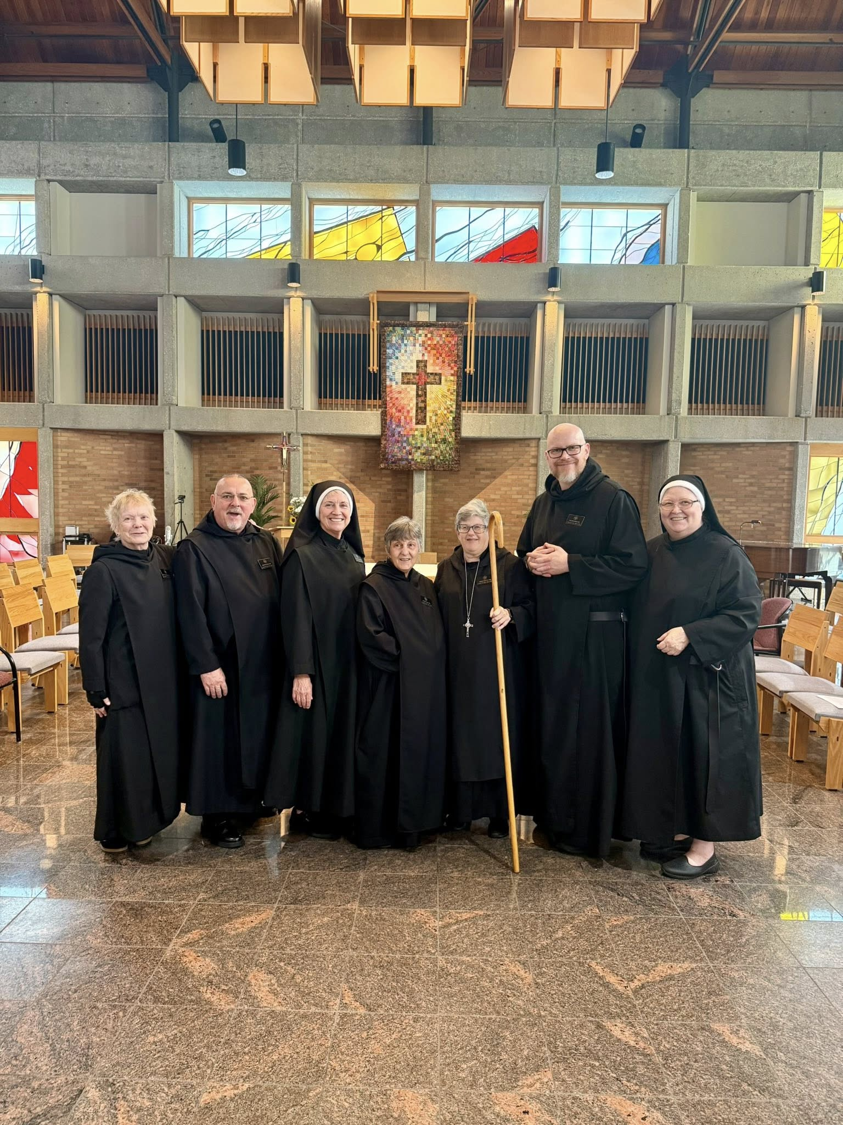
Sr. Julian Smith-Boyer; Br. Jérôme Bertrand; Sr. Mary Magdalene Clarke; Sr. Clare Koronka; Abbess Martha Lamoy; Br. Ronan Patrick; Sr. Genevieve Lynn Robinson
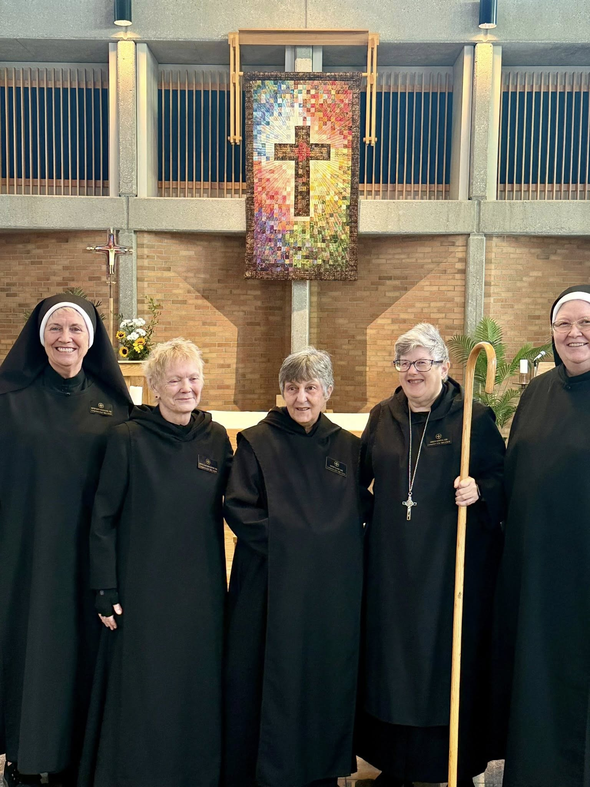
Sr. Mary Magdalene Clarke; Sr. Julian Smith-Boyer; Sr. Clare Koronka;
Abbess Martha Lamoy; Sr. Genevieve Lynn Robinson

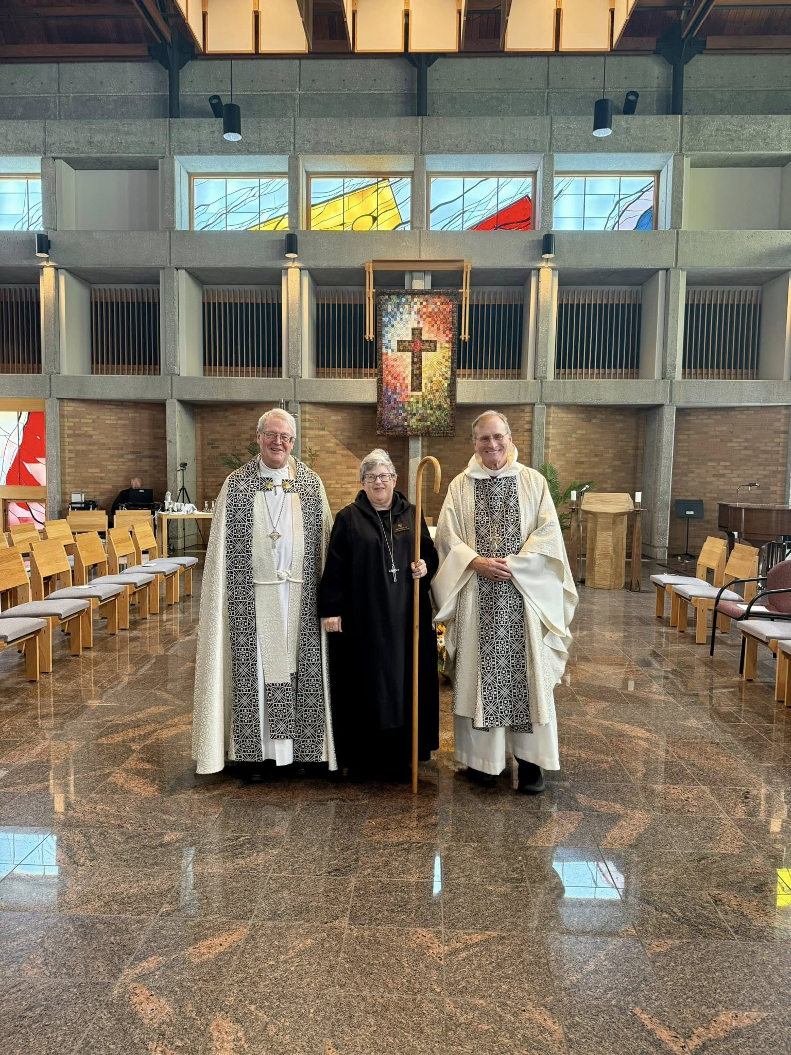
Br. Florian Campbell; Bp. Alan Scarfe; Abbess Martha Lamoy; Bp. Dorsey McConnell

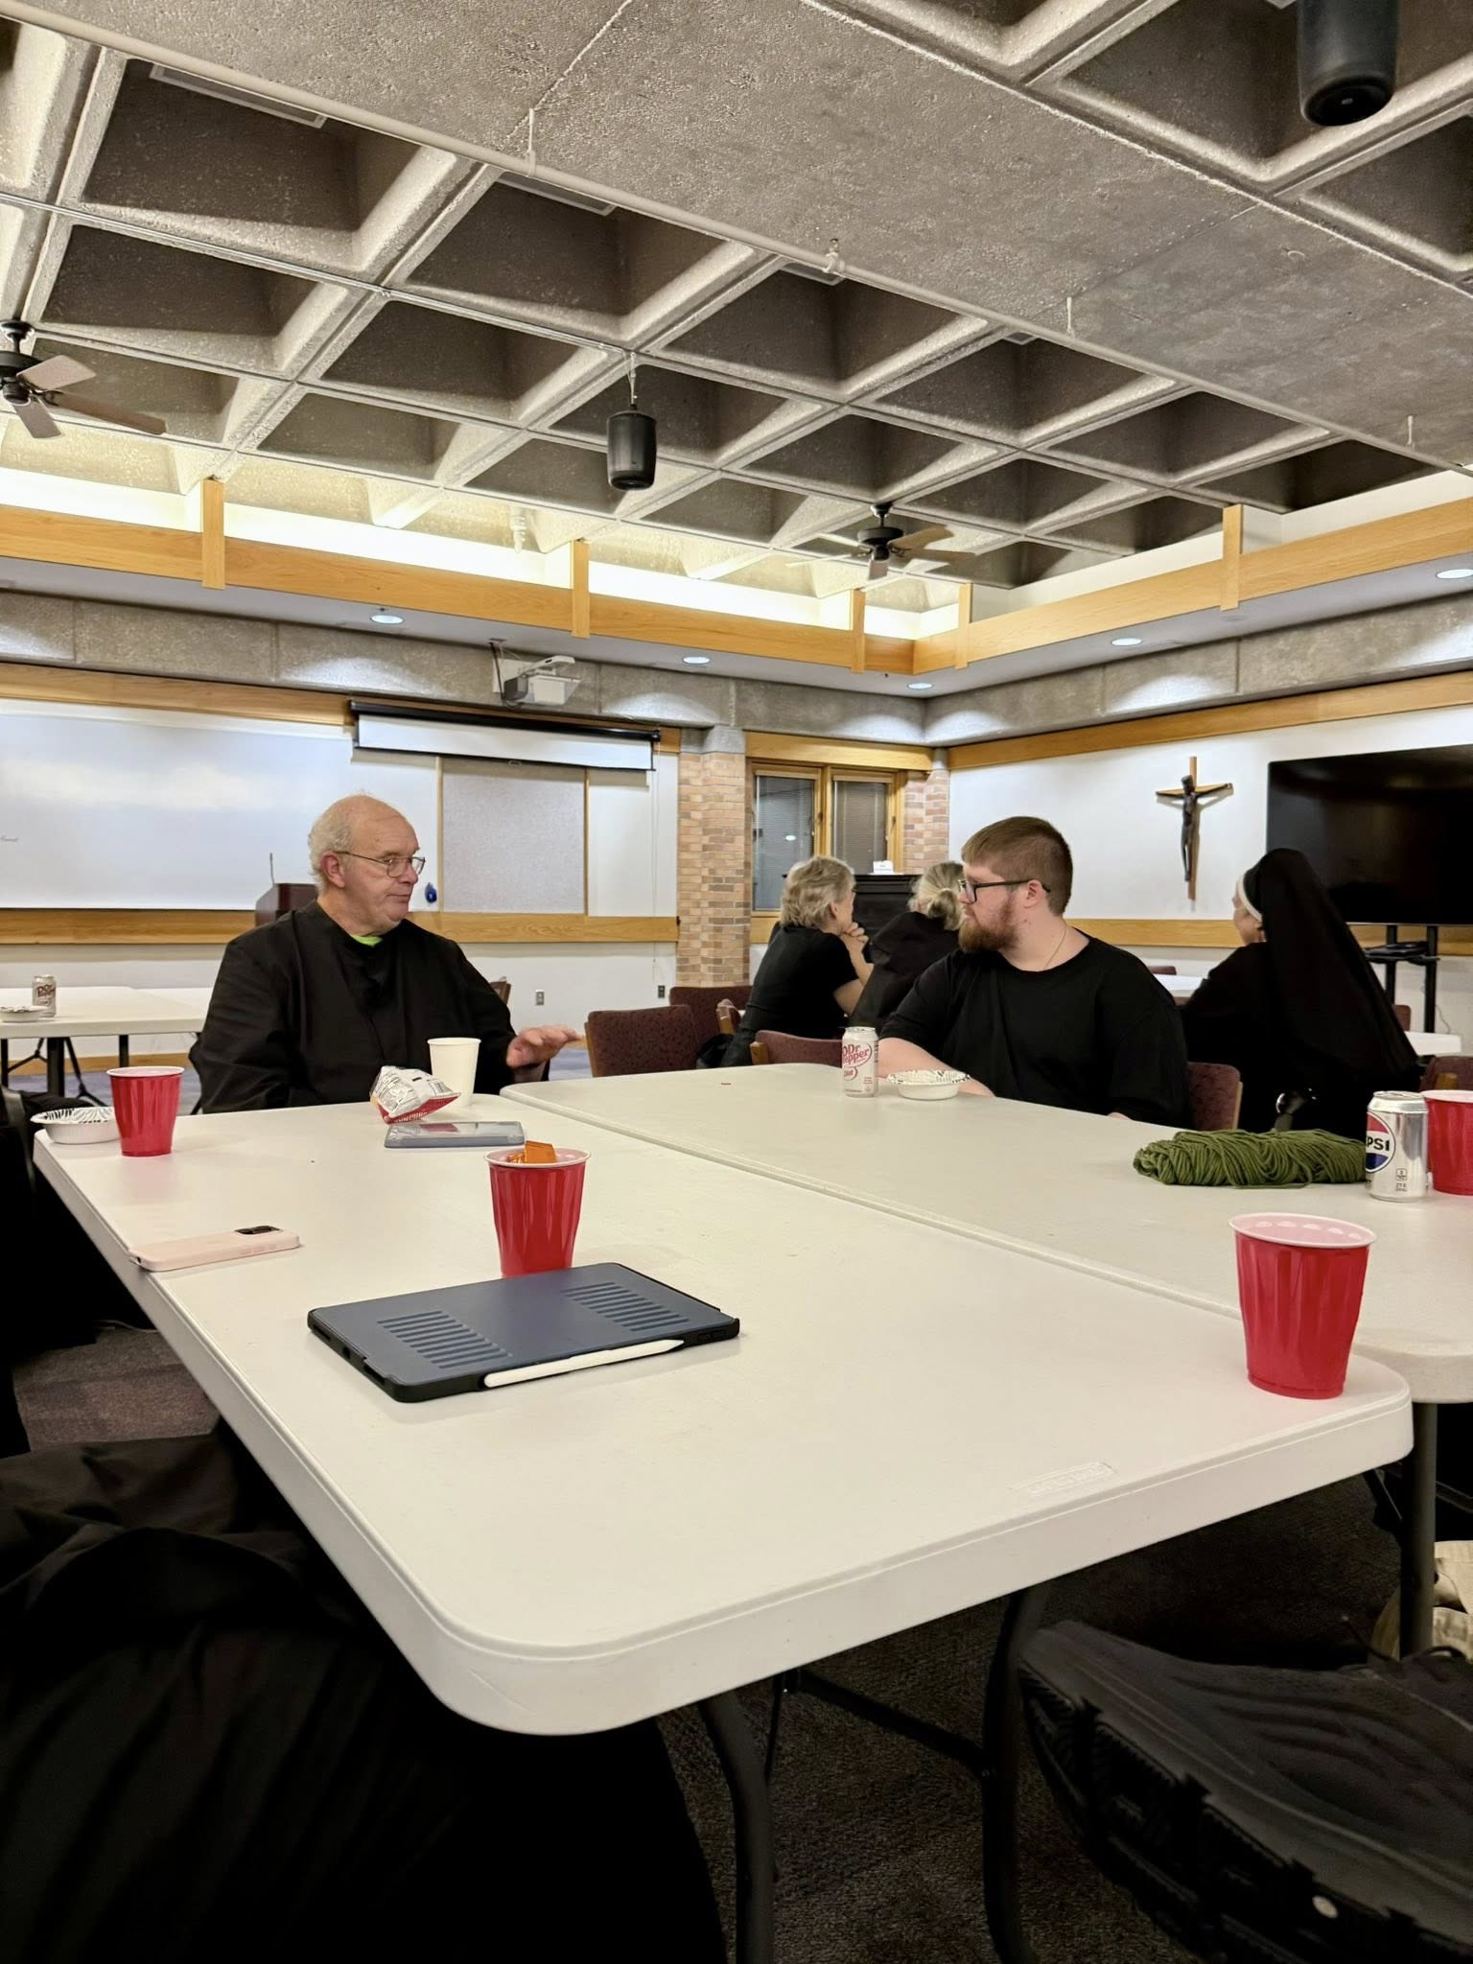
Br. Florian Campbell; Nan DeStafney; Sr. Gianna Altadonna Joseph Hain; Sr. Mary Magdalene Clarke
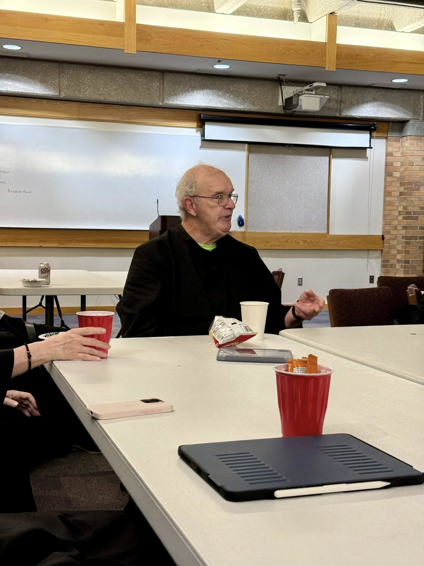
Br. Florian Campbell

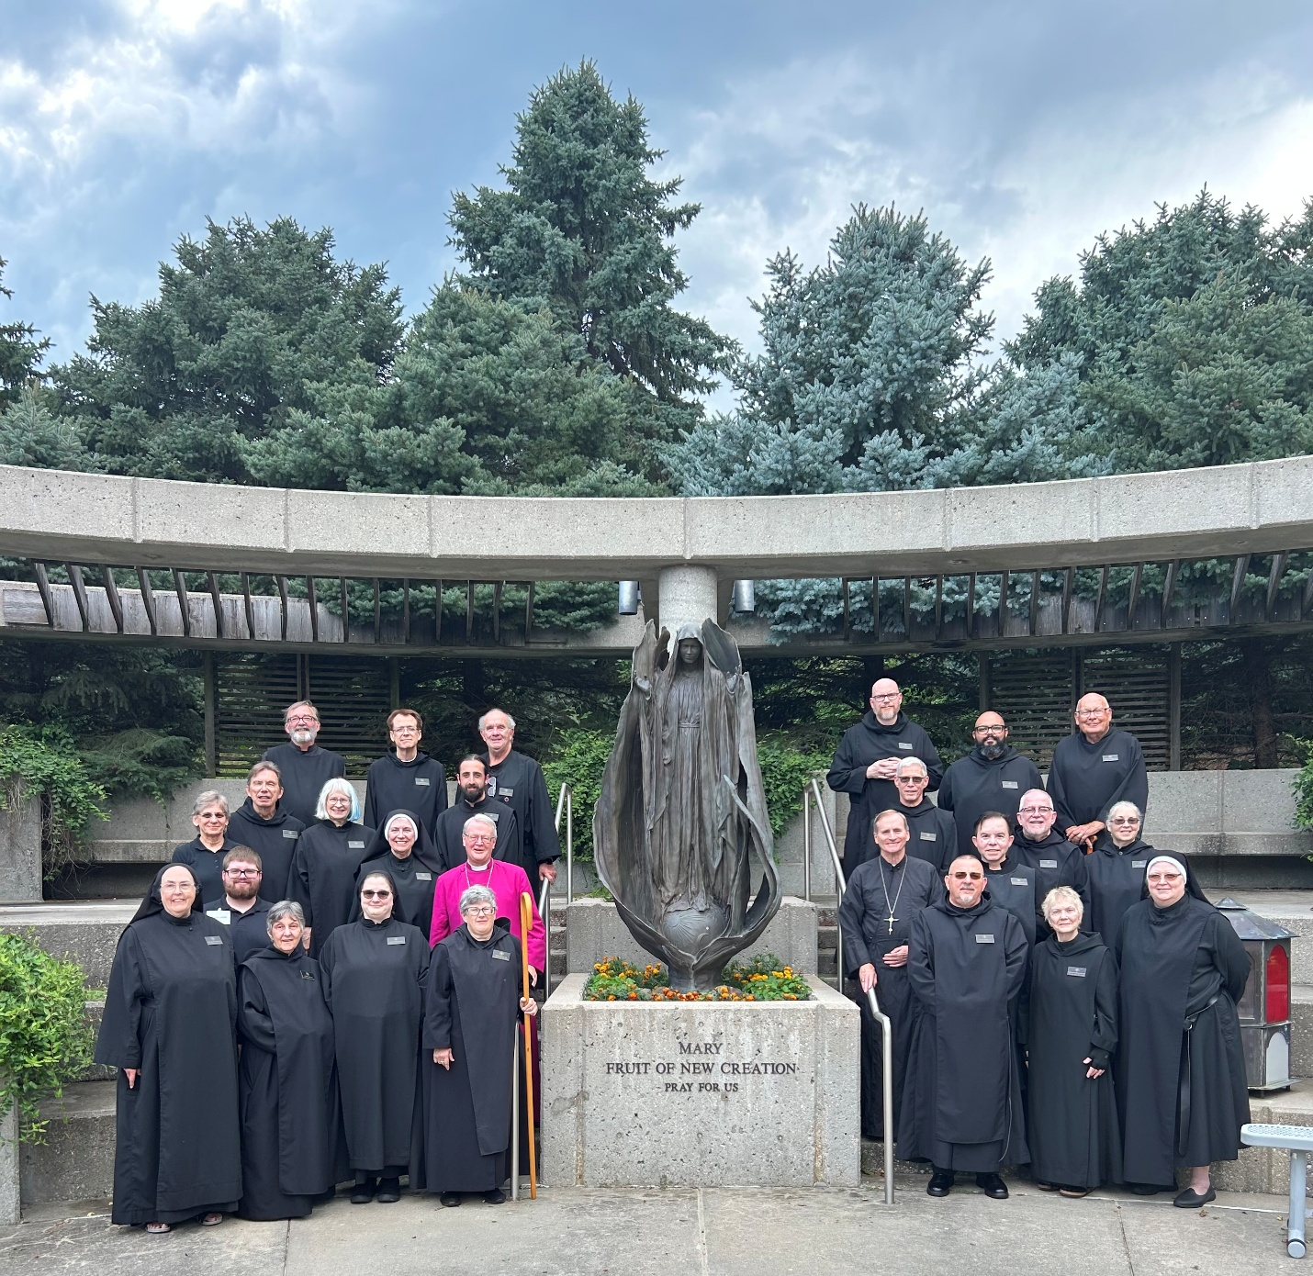
First Row: Sr. Madeleine Sophie Smith; Joseph Hain; Sr. Clare Koronka; Sr. Seraphina MacKay; Abbess Martha Lamoy; Br. Jérôme Bertrand; Sr. Julian Smith-Boyer; Sr. Genevieve Lynn Robinson
Second Row: Nan DeStafney; Br. William Marion Page; Sr. Cynthia Anne Page; Sr. Mary Magdalene Clarke; Bp. Alan Scarfe; Bp. Dorsey McConnell; Br. Anskar Nonken; Br. Jude Thaddeus Orth; Br. Joseph Elias Varsanyi; Sr. Gianna Altadonna
Third Row: Br. James Raphael Davies; Br. Dunstan Townsend; Br. Florian Campbell; Br. Ronan Patrick; Br. Dominic Ndife; Br. John David Wynne

