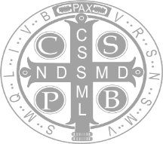

The Companion
September 2025

The Companion
September 2025

The Companion
September 2025

The Companion
September 2025

The Newsletter of The Companions of St. Luke — An Offering
Change, celebration, and community are key words that express the underlying focus
of the articles included in this edition of the newsletter. Information is provided about our bishop visitor elect, our new convocation sites, and our members who have moved from one formation stage to the next. Tips about participating in online Vespers emphasize the importance of harmony in communal prayer; and a farewell message from our Chaplain leaves us feeling blessed by his spiritual guidance and presence within our community.
Peace and Well-Being, The Companion Editorial Team: Br. John David, Br. Jérôme, Sr. Julian, and Abbess Martha

Contents
Page
Messages from Our Leaders, Abbess Martha and Bishop Elect McConnell 2
Convocations, 2025, in Nebraska and Maryland 4
Monastic Growth in our Community, New member receptions to life profession 6
Refresher for Online Vespers, Prayer guidance and notes 15
Godspeed. Farewell from Fr. Sid, CSL Chaplain 2015-2025 … 16
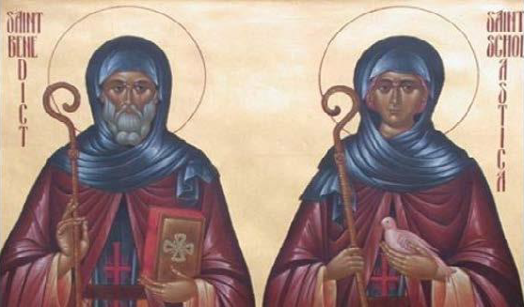

Messages from Our Leaders

CSL Changes by Abbess Martha, OSB+
Dear Sisters and Brothers,
The first three quarters of 2025 have been filled with changes for CSL. We have embarked on a new cycle for Fall convocations, one that will hopefully make it easier for some of our members to attend. Regrettably, any change is always a “Catch-22” situation, because no location works perfectly for all. Conception Abbey was reasonably centrally located; the move from there may make it easier for some but unfeasible for others. And yes, there were a few kinks this summer; know that the coordination team is working to ease some of those from the process.
In September at Chapter, we will elect a new Bishop Visitor. I am grateful for the guidance of Bishop Scarfe these last six+ years and look forward to the ministry of Bishop Dorsey. Pending your approval, the transition will take place on All Saints, November 1. Bishop Scarfe anticipates being with us for some of our Fall convocation, so we will have an opportunity to honor him.
It is also with a heavy heart that we say good-bye to Fr. Sid after ten years as our
Chaplain. He will be deeply missed. I intend to make plans to recognize and honor him soon at one of our special services.
In the midst of sadness at departures, CSL continues to grow. Two new Postulants were received at Convocation in July; one Novice Oblate and one returning Oblate were recognized at our special service in August; and we also celebrated multiple transitions as part of these gatherings. In addition, members have been very generous at identifying and volunteering their gifts and talents, which create opportunities to redesign, revamp, improve and update some of our platforms, resulting eventually in cost savings to the community.
Yet in the midst of change, let us remember that we are called to live in stability, to maintain the balance of Ora et Labora that Benedict speaks of so often. This includes

remembering to care for ourselves even as we often must multi-task caring for and ministering to others. Sometimes obedience is not to another person, but to ourselves– listening for God’s message of how to care for ourselves.
My prayer for all of us is that this period of change in CSL may also ignite a spark of renewal in your own lives.

Greetings from +Bishop McConnell
Dear Sisters and Brothers,
When Bishop Hirschfeld of New Hampshire asked me if I might be interested in exploring a call to become your next Bishop Visitor, I knew exactly nothing about The Companions of Saint Luke. I did know I was in need of a deeper life of prayer, hungry for a contemplative practice and discipline that had eluded me during my busy years, first as Bishop of Pittsburgh until 2021, then as Bishop in the Diocese of Aberdeen and Orkney until last fall. Specifically, I wanted to know what apostolic ministry might look like once I had given up jurisdiction. How might the core elements of episcopal witness—the testimony to the Resurrection, the ministry of reconciliation—be put in practice, now that I have parked my crozier in the corner of the den?
Then you came along! And from the first moments with you at Convocation in Schuyler, Nebraska, I have felt at home.
In a sense I have come full circle. Benedictine communities have appeared and reappeared at crucial times in my life. Over forty years ago, I spent both my pre- ordination retreats with the Order of the Holy Cross in West Park, New York; at crucial moments during my tenure in Pittsburgh, I found rest and renewal at monasteries in Pennsylvania and New Mexico. When my prayer life has worn thin, the wisdom and witness of great monks, from John Cassian to Thomas Merton, have encouraged and enlivened me.

I hope that, in the coming years, I may in some measure be able to offer you a similar encouragement. Certainly, you will be in prayers, as you already are, and I hope to join you on occasion by zoom for the evening office. Beyond that, should any pastoral matter arise that I need to be aware of, please do not hesitate to reach out to me, at ironcitybishop@gmail.com, or on my cell phone, (617) 817-7774.
I am deeply grateful to Bishop Scarfe for the time we spent together at Convocation, for his counsel and good humor as I take up the mantle, and to Abbess Martha for her warm welcome and her confidence that this is indeed a call from the Lord. May God bless us all as we walk this road together, and in a world desperate for good news, may we shine with the radiance of Christ’s glory.
Faithfully in the Lamb,
+Dorsey

Convocations, 2025

Our dispersed Benedictine community is blessed to be able to meet twice a year for in-person worship, prayer, and fellowship. These Convocations provide special opportunities to share the monastic pathway from formation to transformation with one another; and to enhance our online interactions throughout the year.

Our Summer 2025 Convocation.* Beginning in 2025, our community began meeting at a new midwestern location. From July 21-25, we met for the first time at the Benedictine Center, Schuyler, NE. (Our airport was Omaha, but other options are also under consideration for next year.) The Benedictine Center is a beautiful site surrounded by miles of farmland. The facility was very well maintained and well appointed. Our hosts seemed genuinely glad to have us; and our worship and prayer services, and dining and meetings, were all indoors and close by.
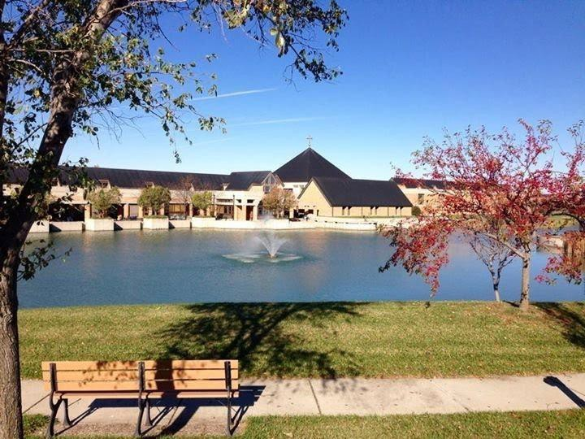

A dozen members whose monastic receptions or transitions were celebrated provided reflections for this newsletter. In addition to these, Br. Dunstan celebrated his 10th anniversary of making his solemn profession; and Br. Dominic was named and clothed as a new novice at Convocation. Thankfully, photos taken throughout the July Convocation by Collen Patrick were archived and shared with our membership by Br. Steven Olderr; and, audio-video recordings of the Rites of Passage during the convocation were also made available to us by Br. Florian via CSL’s group email.
*Editor’s Note: For those members unable to attend convocation, special services were made available to acknowledge their monastic transitions: Sr. Katherine made her live-streamed solemn vows at her Seattle, WA parish in May. On August 25, Abbess Martha officiated a special Vespers for Sr. Marie Patricia to renew her annual vows; and for Joseph Mangels to be received as a new CSL novice oblate.
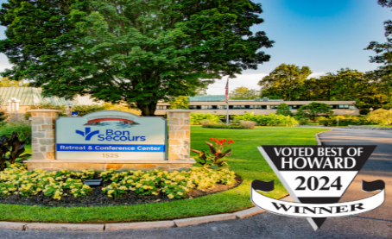
Plans for the October 2025 Convocation. Our Fall gathering this year moves East as we gather at the Bon Secours Retreat Center near Baltimore, MD, thanks to the extra efforts by Abbess Martha and Sr. Madeleine Sophie to make this new adventure an option for us. Like our summer convocation, we will meet for worship, prayer, and fellowship. What is different is that more time is available for contemplative prayer and for time to explore spiritual practices―since rites of passage generally occur in the summer, and not in the fall.
We are scheduled to gather in the early afternoon on October 20 and leave on October 25. For those flying, the destination is Baltimore/Washington International Thurgood Marshall Airport (BWI). Many easterners are taking a train, so plan on the Baltimore Penn Station. For BWI or Penn Station, the hotel has a shuttle (410-691-0500). Our bus will leave the hotel (Hilton Garden Inn-BWI) at 12:00 noon. On Friday, the bus will leave the convocation site at 10:00 a.m. If you need help to and from, contact Sr Madeleine Sophie (rsmith12jm@gmail.com).

Monastic Growth in Our Community

Life Profession

Reflection on Becoming Life Professed by Br. John David, OSB
In a strange sort of way I was very lucky. I began my journey as a member of another dispersed Order. Their formation was just two years, and they offered life profession, but “discernment” worked, and I was led to decline. Abbott David, with whom I had spoken before, graciously allowed me to transition to Novice Two. Fortunately for me, the Guardian of the other order was a Benedictine from CSL and most of the material from postulancy and the novitiate, year one, was very similar. I was assigned to Br. Robert, a former CSL Abbott, whose experience and theological scholarship enhanced my journey.
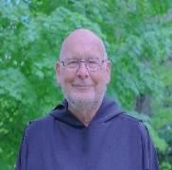
My annual vows project was a study in contemplative prayer. Although I had been a practitioner, I was not well read on the topic until the project. Br. Raymond became my guide and Br. Robert transitioned to my subject matter expert. The requirement of quarterly reports helped keep me on course. During that time, I assisted Sr. Julian by drafting updates of a couple chapters in our Manual. With her help, we picked up the newsletter from Sr. Toni. Unfortunately, I had to take two leaves-of-absence; one for a cycling crash recovery and another after my wife passed, although CSL helped immensely in that process. My project renewed more explicitly for me that Benedictines are a people of prayer. “For God alone, my soul waits in silence…” Ps 62.
The service of Life Profession itself was almost anti-climatic, but it was very nice to be so honored. It took me a while to understand the significance of the pall that covers you during part of the service. Now, I use the image of me under that pall as my opening screen image, to remind me every day that our old life is over, forgiven, and, always, we begin anew.

First Annual Profession

The Consecration of Sister Clare by Sr. Clare, OSB

This is what it says at the top of my chart. The word consecration means to formally dedicate someone or something to be set apart for a holy or divine purpose. On that day, of my own free will, I vowed my life to God and my community. I formally said, “God, I’m completely yours, my life is yours…use me, lead me, let me serve you for your purposes within the context of the Rule of St. Benedict and within the community you have brought me into.” I recognize and accept your call to me to be set apart to pray for your world and bring your love to those around me. Since that moment I have experienced a sense of grounding and purpose, an internal sense of knowing myself as I have been known, a sense of being settled and content because I am home. There is a joy in all things and at all times that radiates from my center, because at last there is harmony within – my “inside” and my “outside” finally match. And for me there is not only joy, but also peace in living in alignment with God’s purpose for me.
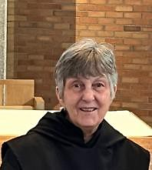

The Gentle Call: Vocation as Relationship by Br. Jérôme, OSB
As I pause to reflect on my first annual vows, this recent step in my journey, I am reminded of how meaningful it is to mark transitions with intention and gratitude. We need—I need—moments like these, not just as a checkpoint but more like the reminder of an unfolding, a quiet turning of the soul toward something deeper.

Throughout the process of my novice formation, probably under the influence of the Rule, what surprised me most was the gentleness of God’s presence—a quiet insistence that didn’t force but invited. I came in with questions, and instead of answers, I found companions, stories, and subtle shifts that helped me see vocation as a dynamic relationship more than a destination. My prayer life feels less like checking a box—to be honest, it did when I started my formation—and more like breathing. It has become a space I crave, not just visit.

In this next phase, I carry a deep hope to show up more authentically: for God, for others, and for myself. Joy has come through unexpected windows: laughter during shared meals, silence that spoke louder than words, and even tension that clarified what really matters. I’m grateful, humbled, and eager to keep walking.

The Blood of the Covenant by Br. Ronan, OSB
"The blood of the covenant is thicker than the water of the womb."
We’ve all heard the shortened version: “Blood is thicker than water.” It’s often taken to mean that family ties should be stronger than any other. In recent years, some have used the fuller-sounding phrase—“The blood of the covenant is thicker than the water of the womb”—to point to a deeper truth: that the bonds we choose in love and faith can be even stronger than those of blood relations.
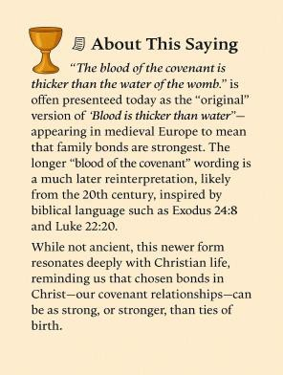
In The Companions of St. Luke, we are such a family. Our paths are each unique, yet they run alongside one another in a shared rhythm of prayer, lectio divina, and service. Those shared experiences forge something lasting—a covenant of love in Christ.
When I first came to CSL, I imagined I might live as something of a hermit, loosely connected to others. I could never have anticipated how quickly my brothers and sisters here would become my true family. For many of us, our biological families are complicated. In my own case, after losing a few key pillars, the structure fell away. I lost my stability. In CSL, I found a family built not on obligation or accident of birth, but on a common vow to seek God together. In that, I discovered stability rooted in God and lived out in community.
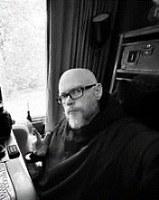
Convocation, for me, feels like the family reunions of my youth. In the early days, as a Postulant or a Novice Oblate, you arrive with few responsibilities just simply being present

and learning. Over time, the call deepens. You’re entrusted with leading prayer, proclaiming the Word, or serving at the altar. All along, there is the joy of seeing new faces among us—each one a sign that our covenant family is still growing.
Here, in this chosen family, we live out the truth of the fuller saying. The water of the womb may bind us by nature. But the blood of the covenant—the life of Christ flowing through our shared vocation—binds us by grace. Grace, as we know, is the stronger bond.

Benedictines in Time of Plague by Br. Jean-Baptiste, OSB
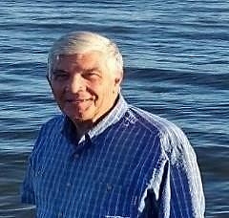
It was the worst of times, and yet, somehow, the best. Years ago, while writing my thesis on Irénée de Lyons and Theosis in Rivière du Loup, I was invited by Rev. Mother Louise Guay to pray the daily offices with les Sœurs Clarisses (the Poor Clares). Their cloistered life opened a door for me—into community, into stability, into a rhythm of worship that shaped my vocation.
Then came the pandemic. From 2020 to 2022, common worship faltered. Yet, through the grace of Zoom, Dean Robert Willis of Canterbury and his partner Fletcher Banner offered a new kind of liturgy—garden prayers, cats, bread, and the holiness of the ordinary. Their quiet faithfulness reminded me that imagination and attentiveness can sanctify even the trivial round.
Their references to Benedictine life led me to The Companions of St. Luke. Postulancy, the novitiate, and now annual vows have become a continuation of the path I first glimpsed with the Clares. Benedict’s wisdom—stability, obedience, daily conversion—frames my days. Morning prayer, the Angelus, vespers, and compline mark time and give breath.
Though retired, I remain a priest. I visit the sick, cook for shut-ins, support families. In our aggressively secular society, the habit is no longer familiar, but I wear it still. The local parish spans fifteen villages, served by one full-time priest and a few of us older ones.

Benedictine life has been with me for over fifty years—sometimes well, sometimes poorly—but always present.
Is this outreach? Is an annual vow just another step? I think so. The door opens, and Christ is there. I bring all of me to the Way.

Novitiate and Postulancy

Moving Up by Sr. Seraphina MacKay, n/OSB
Just a week before convocation, my rector asked me to speak to the congregation about monastic life and the Rule of St. Benedict. I was happy to do so, but also nervous. After the service, I had several people come up to me and ask me more about it. The week after I got back, I had someone tell me that I changed their life! I didn’t even think that I, someone who is a bit shy and nervous to speak in front of large crowds, could change anyone’s life. I also inspired another parishioner to apply to CSL!
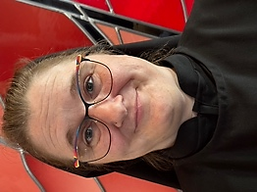
So, after a busy year of prayer and study, I have been received as a novice at convocation, going from Adriane p/OSB to Sister Seraphina n/OSB. To say that I’m very happy about this transition would be an understatement. With amazing support from my formation guide, Sister Anna Grace (and everyone else who helped me along), I have made this huge leap in my faith journey. This just goes to show that with prayer, support, and dedication that great things can happen.

Rooted in Prayer: A Benedictine Journey Toward God by Joseph Hain, p/OSB
My name is Joseph Hain, and I am a recent postulant in The Companions of St. Luke, OSB. I live in Philadelphia, Pennsylvania, in the Diocese of Pennsylvania. I was drawn to CSL through its Benedictine charism. Ever since I became an Episcopalian, I have modeled my prayer life and personal charism of prayer and doing the work of God on the Benedictine model. My spiritual background has roots in my Catholic upbringing and gradual journey


to the Episcopal Church over time. I have always felt a call to serve God in some way. As a child, I felt drawn to the priesthood, but I did not give the contemplative life much thought until I matured more in my faith. I am currently discerning a call to the priesthood and a contemplative life. I am active in my parish as a lay reader and lay eucharistic minister. Outside of church, I am active in the Freemasons and a men’s prayer group. I enjoy reading and spending time with friends and family. In joining this community, I hope to learn more about how to do the Work of God as prescribed in the Rule of St. Benedict. Through this learning, I hope to gain further insight into how to be a better Christian.

Anchored in Dawn: A Journey into Benedictine Vocation by Nan DeStafney, p/OSB

Peace to you, dear Companions.
I live in Pensacola, Florida, where I am in the midst of a joyful but challenging life transition. After retiring from US Navy Nursing, I started a new career as the CEO of Blues Angel Music and now, after 18 years there, I am preparing to hand over the reins so that I may fully embrace my Benedictine vocation.
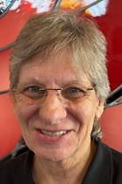
My peace is found in the hours before dawn. I especially enjoy quiet early morning Matins and Lectio Divina—when the day is new and uncluttered. These hours are my anchor for the day ahead and my practice is teaching me to notice God’s voice more readily and to respond with less hesitation.
I was drawn to The Companions of Saint Luke because here I found what I longed for: a monastic community that is dispersed yet deeply connected, rooted in the rule of Saint Benedict while fully engaged in the world. At our recent convocation in Schuyler, NE, I was received as a postulant and welcomed with such warmth that it felt like coming home.
What I would most like you to know, my brothers and sisters, is this: I have prayed for many years for a life wholly given to God, and the CSL has opened that path. I do not yet know where this journey will lead―only that it will lead ever deeper into Christ, and that I am grateful to be walking it with you.

Full Oblation

The Name I Was Always Meant to Bear by Sr. Cynthia Anne, Obl/OSB
It was a source of mild anxiety going into Convocation and my Full Oblation, not knowing what my "new" name would be; I sent three nominations to the Abbess and asked her to choose for me – I would have been happy with any one of the religious names I came up with, and honestly could not decide for myself. I trusted our seasoned and wise Abbess Martha to make the choice for me. So, when she said, "...and your new name is Sister Cynthia Anne" it took me quite by surprise! As I turned to read my Oblation promises to the group I was overcome with emotion. (Thank you, Brother Jérôme, for the gallant delivery of an ample Kleenex!) Cynthia Anne has indeed been my name from birth, bestowed on me by my wonderful parents; I have loved my given name but was always and forever called "Cindy". Now, at the twilight of my life, I get to take on the birth name I have adored for its beauty and meaning―"Cynthia" having to do with the Moon and "bringer of light"; Anne for St. Anne, the mother of Mary and―the best!―grandmother of Jesus. It feels full circle, this taking on a "new" name that I've had all my life. The Abbess chose well, and I am grateful to her. (NOTE: In a happy coincidence, another new Full Oblate was given the name of Jesus's grandfather – Br. Richard "Joachim" (pronounced "yo-AH-kim").
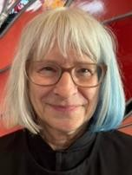

Reflection on My Journey to Becoming an Oblate by Br. Richard Joachim, Obl/OSB
At convocation, surrounded by the quiet strength of monastic rhythm and community, I felt the moment settle deeply within me—not merely a ceremony, but a sacred threshold. Two years ago, I began my journey as a novice oblate, guided by curiosity and reverence. The Rule of St. Benedict became both mirror and map, inviting me into a life of humility, stability, and conversion. The path was not without struggle—dry seasons, doubts, and the slow shedding of self-reliance—but in those very tensions, I learned to remain, to listen, and to trust the slow work of God.
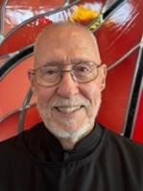

Making my oblate promises was a solemn and joyful “yes” to a way of being: rooted in prayer, community, and service. I joined a lineage of souls who have walked this path for centuries, each bringing their own longing and love. Now, the monastery lives within me. The Rule is no longer just a guide—it is a companion.
In preparation, I chose the name Br. Richard Joachim. Richard honors my given name and affirms the continuity of my story. Joachim, father of Mary, evokes quiet faithfulness and generational blessing. Together, the name holds memory and mission—a vow to live with prayerful presence, hospitality, and generative love. It is not for recognition, but a quiet commitment to the Benedictine values that continue to shape me: humility, obedience, and peace.

The Rule in My Pocket: Living the Benedictine Way by Br. Andrew, Obl/OSB
When I began discerning my vocation, I initially felt called to the priesthood and saw monastic life as a steppingstone toward seminary. But as I immersed myself in monastic formation and became more involved in parish and diocesan life, I noticed a shift—the call to priesthood faded, and my desire to live as a monastic deepened. This transformation is reflected in my spiritual practices. What once felt like a struggle—keeping up with the Daily Office, Lectio Divina, and studying the Rule of St. Benedict—has now become a source of joy. I even carry a small copy of the Rule with me, turning to it instead of my phone during idle moments.
Ordering my habit brought unexpected anxiety. I feared being judged—by religious people as a fraud, and by others as eccentric. But then, on a bus ride, I saw two Buddhist monks in bright saffron robes, completely unbothered by the indifference of those around them. That moment gave me courage. If they could wear their robes with confidence, surely, I could wear my habit. I reminded myself of Portland’s World Naked Bike Ride—if thousands can ride unclothed through the city, I can walk to church in my habit. I did, and no one batted an eye.


Now, as an oblate, I look forward to deepening my monastic vocation. Whether I remain an oblate or become a life-professed member, only God knows. The Benedictine path is one of continual listening, praying, and discerning—and my journey is just beginning.

Novice Oblation

Liturgical Roots, Feminist Wings: A Journey Beyond the Cloister by Sr. Dawna Clare, nObl/OSB
My spiritual formation has deepened through the shared reading of books with Brother James Raphael. As I engage with these texts, my prayer life becomes richer, and I experience a more intimate connection with God—at least, that has been my personal journey.
I lived as a vowed Benedictine for ten years, earnestly striving to embody the religious life to which I felt called. Eventually, I left the Catholic Benedictine community, having grown beyond certain doctrines and dictates of the Church. Becoming an Episcopalian broadened both my theological education and my understanding of church life. I especially appreciated the Episcopal Church’s commitment to ordaining women. As a committed feminist, I later sought ordination within an independent Catholic Church—and was ordained.

Now retired, I no longer carry out formal ministry, except on rare occasions when I offer the Eucharist to a small gathering. Beyond that, I do not fulfill any ordained functions. Still, I deeply value praying with the online community, especially through the Divine Office, which was central to my life as a Roman Catholic Benedictine. Trained as a liturgist, I participated in chanting the Office for five hours daily—it was foundational to our spiritual rhythm.
I am also deeply committed to inclusive language, inspired by communities like the Sisters of St. Helen and their inclusive translations. I believe it is essential to use inclusive language when speaking to—and about—God. I contributed significantly to the Benedictine Sisters’ translation of the Psalms, and some of my work is still in use today. It was a meaningful collaboration, and I remain proud of the inclusive language they now sing.

Refresher on Our Online Vespers

Participating in Online Services by Abbess Martha+
Have you ever wondered how some of the practices for our online services came to be? Well, they are a combination of things: desire to replicate as much as possible the experience in the Oratory at convocation, limitations with the zoom platform and, sometimes, simple trial and error. In no real order, here are a list of some of the “best practices” that we (CSL) have found work for us.
- If you prefer not to be asked to participate in a particular service, please notify the officiant via direct chat. If you’re unsure who the officiant is, a brief message to all is perfectly fine.
- Once we go into silence at 15 minutes before the Office, please remain muted unless you have been asked to read.
- Please do not read the scripture verses before the psalms. They are for personal reflection only.
- The officiant will ask two people to lead a psalm. The first person prays the opening antiphon, first verse of the psalm, and alternate verses thereafter. The second person prays the second verse and alternates with the first person. At the end, the first person prays the Gloria Patri and closing antiphon.
- Please read all psalms, prayers and canticles as they are written. Trying to change certain words to gender-inclusive language is distracting to some and runs the risk of inaccurate translations.
- The officiant will usually ask two people to lead the prayers, suffrages, commemorations if any, and collects. As a general rule, the first person named will lead and the second respond, alternating the collects starting with person one. However, it is also okay for person one to invite their partner to begin any section.
I get it, sometimes our minds are elsewhere, and we forget to mute or unmute, or we accidentally cut off our partner in a shared prayer. But if we all remember these basics, the experience will be more sacred for all of us.

Notes about Pausing in Prayer by Br. John David, OSB
Benedictines have been pausing at the asterisk in our Psalms for centuries, often as they were chanting. A pause in the reading enables a balance between the active life of reading, and the contemplative life wherein God’s speaks to us, in silence. The pause provides a brief stillness, allowing us to contemplate more meaningfully what the Psalmist is saying to us.
By pausing we will often discern the parallelism that was common in Hebrew poetry and discern a rhythm in the Psalmist’s prayer. We pause to allow a breath. We are reminded that we are but human, “a breath that goes out and does not return.” How long do you pause? About a breath. The Hebrew ruach is often translated breath. Think of creation itself.
It is important for all, especially for those in Formation (pls note Formation Guides), to practice the pause as we pray the Psalms. If you prefer to count during your pause, that’s okay, but make it about the time of a breath.
As Benedictines, although we do not “evangelize or recruit”, by pausing, we identify ourselves as set apart and often others are led to inquire.

Godspeed

Farewell by Fr. Sid, CSL Chaplain (as shared with Abbess Martha)
I write this with a heavy heart. I have been chaplain to CSL since 2015. It has been a meaningful and exciting ministry. But I now have been diagnosed with MDS (Mylodisplastic syndrome). Because of treatments and constant blood monitoring, I am unable to travel long distances. I had hoped to spend part of your week together at The Benedictine Center in Nebraska. But a dangerously low white cell and platelet count, meant that I could not be with you.
Our time at Conception Abbey has ended and you now face convocations at various places around the country. This will offer new opportunities for your gatherings which are

an important part of life together. This will be difficult at times, but in the end will provide needed diversity to your life together.
I have appreciated my time with you. There have been some difficulties as you face into the life of a dispersed order, but there have also been many joys and growth as you have gained new members. It has been a joy to preside at Eucharist, preach, hear confessions, listen to your concerns, counsel, and celebrate with you in many ways.
You have grown in the Benedictine experience: Community, Conversatio, Hospitality, Humility, Reverence, Stability, Obedience, and Conversion of life. I have admired your ability to follow the Rule while engaged in sometime stressful employment and ministries to and within your local faith and secular communities. I have also been thankful to be with you as you discerned your calling to CSL’s peculiar form of monastic life and your tenacity to work together in this community.
We are living in interesting times. As People of faith we will be challenged in unknown ways. I close with the words of Joan Chittister: “In the face of profit and comfort, exploitation and narcissism, superiority and domination, let us beseech God for the wisdom to take action. Like the ancients let us beg God, now and always, forever and everywhere, to stir up holy warfare in our souls so that we refuse to be either executioners or victims in a world rife with oppressors and oppressed. Let us resolve to follow this fiery-eyed Benedict of Nursia, whose one life illuminated the Western world. Let us, in other words, live Benedictine spirituality and so illuminate our own darkening but beautiful world.” (Trinity Wall Street, NYC, 2003)
God Bless you in the days and years to come, The Rev. Sidney Breese, Chaplain

A Heart of Rain and Flame* by Br. Jérôme
Create in me a heart of rain,
soft as the hush before the dawn,
where sorrow drips like golden grain
and every wound gently drawn.
Renew in me the quiet thread
that holds the stars when night is long,
a spirit not by thunder led,
but by the whisper of a song.
Do not cast me to the wild wind,
where voices fade and shadows press—
but let Your breath, so pure, so thinned,
remain my light and my wholeness.
* Inspired by Psalm 51:10–11, this contemplative poem pleads for inner renewal and divine presence, weaving imagery of gentleness, sorrow, and sacred breath into a prayer for spiritual wholeness.

