July 21-25 Convocation
St. Gregory’s Abbey
Schuyler, Nebraska
Part 3 of 4

People are identified left to right.
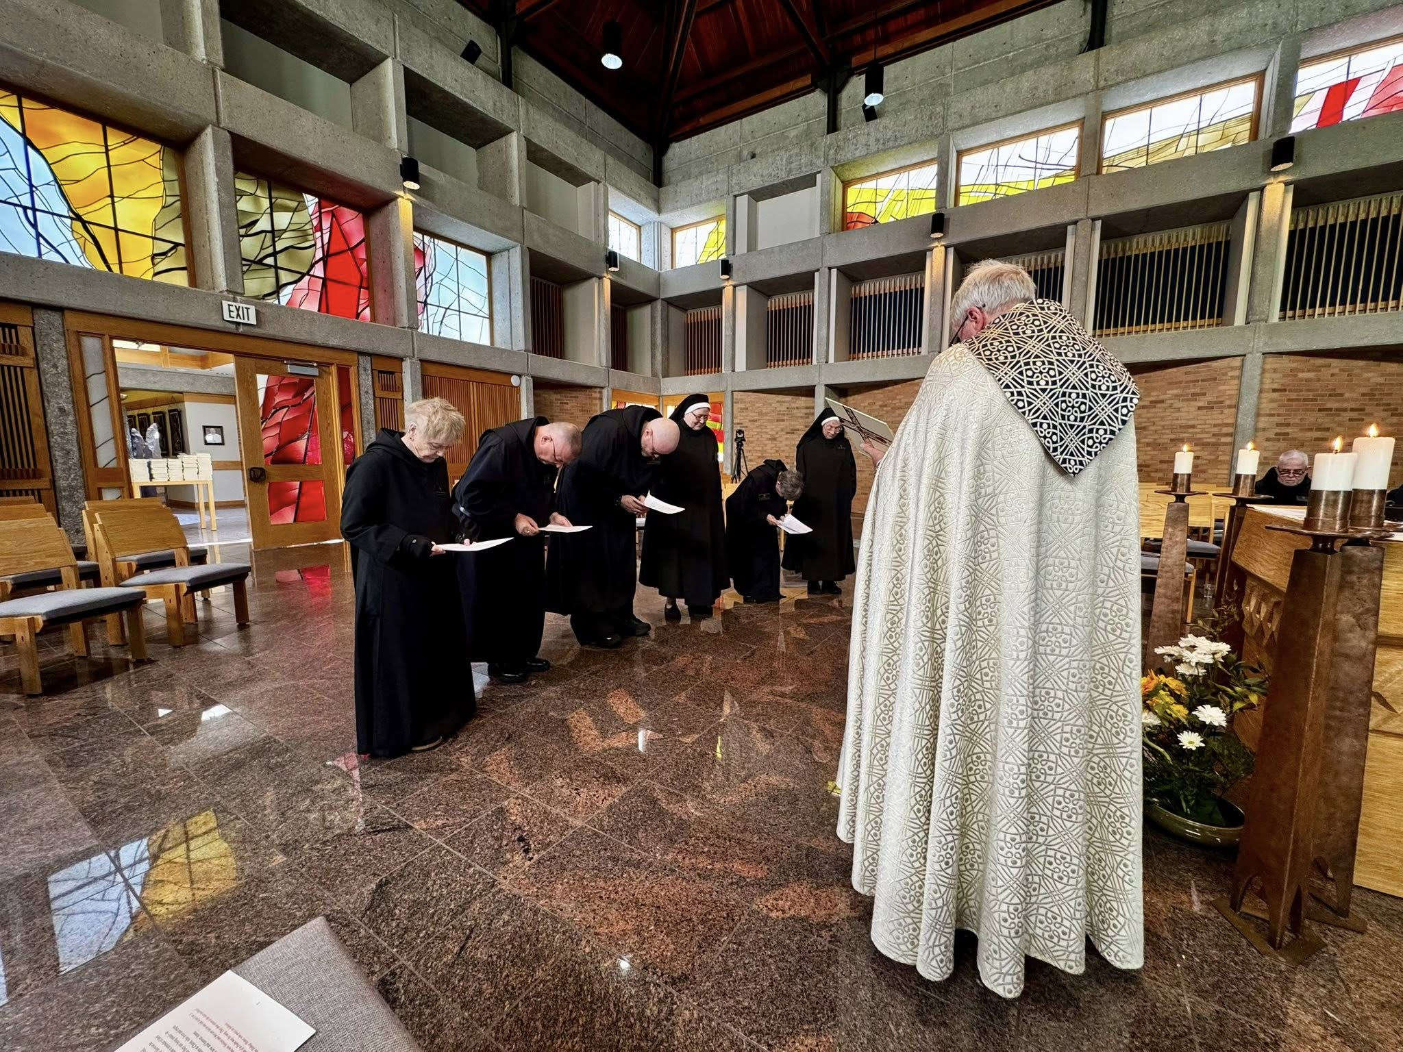
Sr. Julian Smith-Boyer; Br. Jérôme Bertrand; Br. Ronan Patrick; Sr. Genevieve Lynn Robinson; Sr. Clare Koronka; Sr. Mary Magdalene Clarke; Bp. Alan Scarfe; Br. Joseph Elias Varsanyi
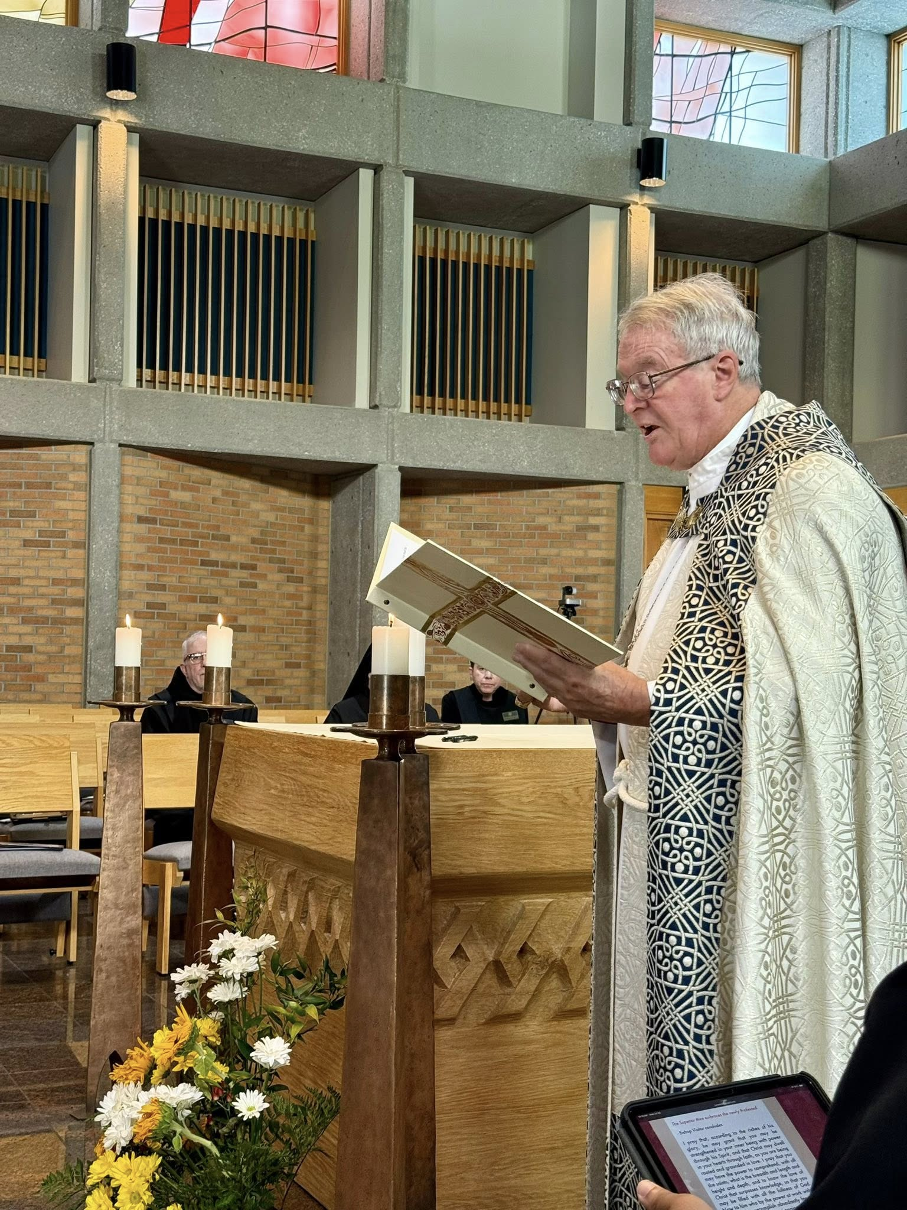
Br. Joseph Elias Varsanyi; Br. Jude Thaddeus Orth; Bp. Alan Scarfe
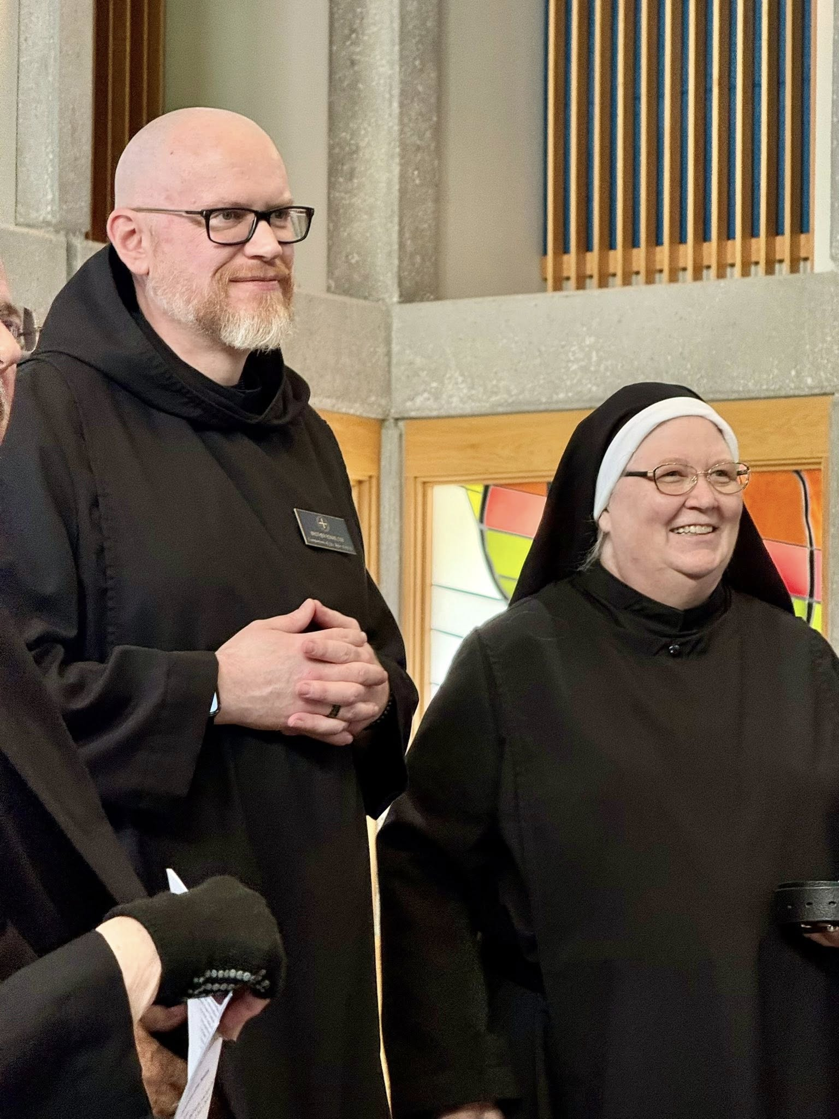
Br. Ronan Patrick; Sr. Genevieve Lynn Robinson

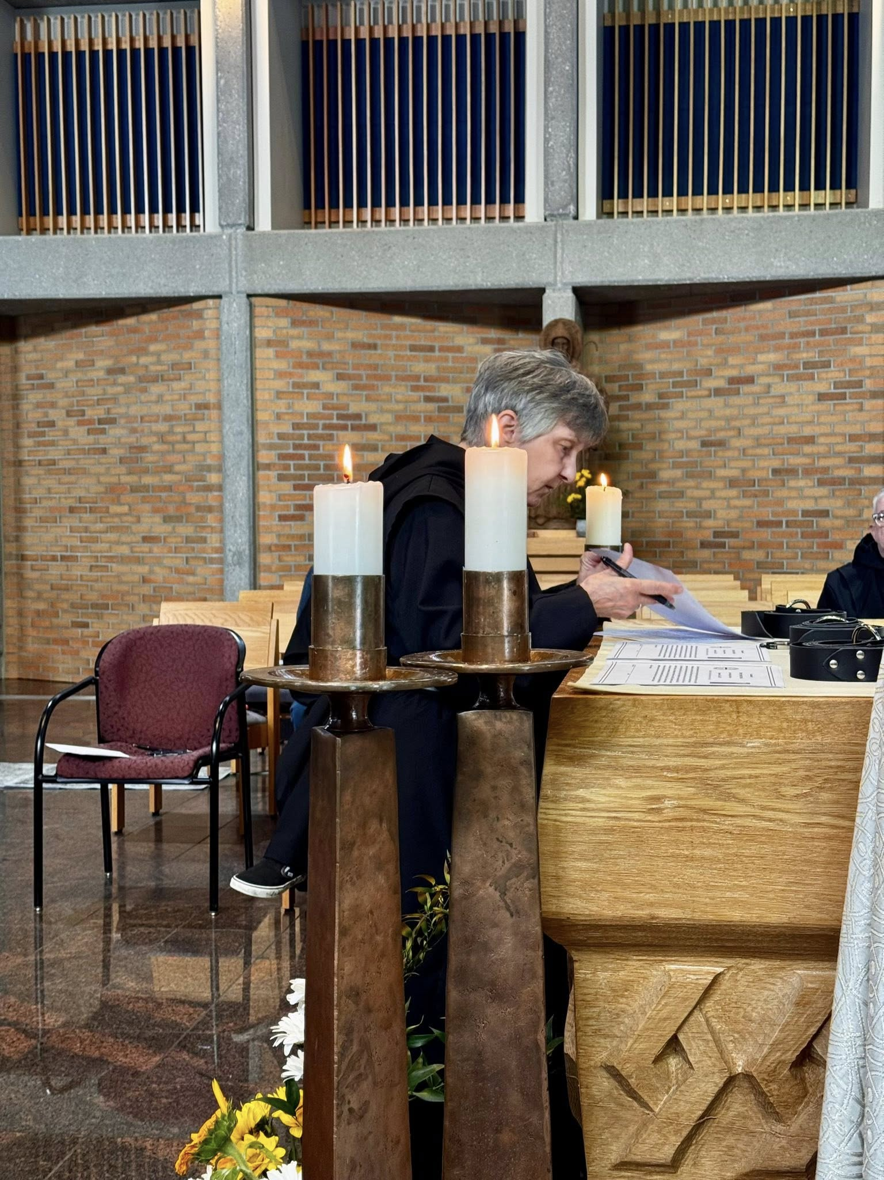
Sr. Clare Koronka; Br. Joseph Elias Varsanyi

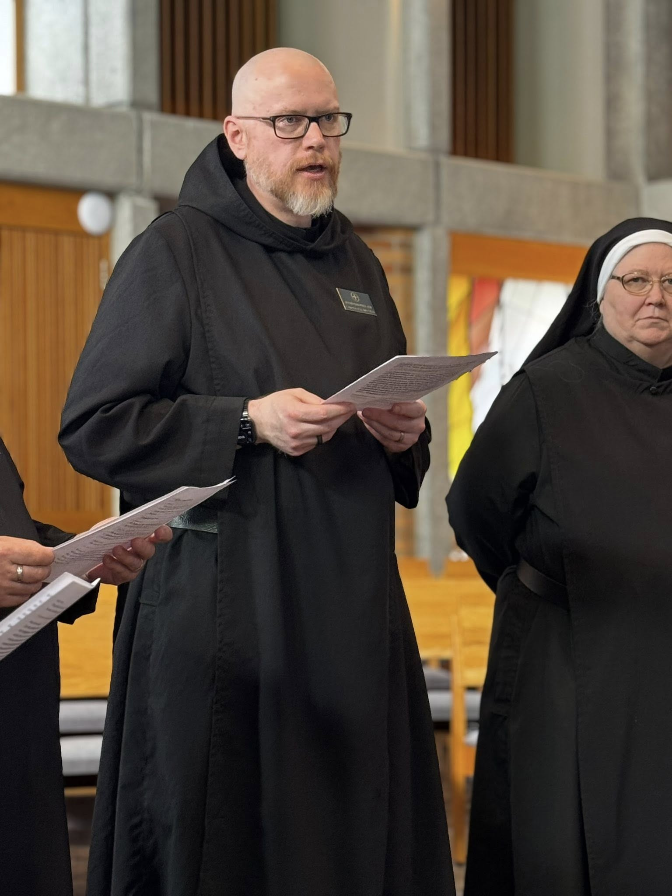
Br. Ronan Patrick; Sr. Genevieve Lynn Robinson
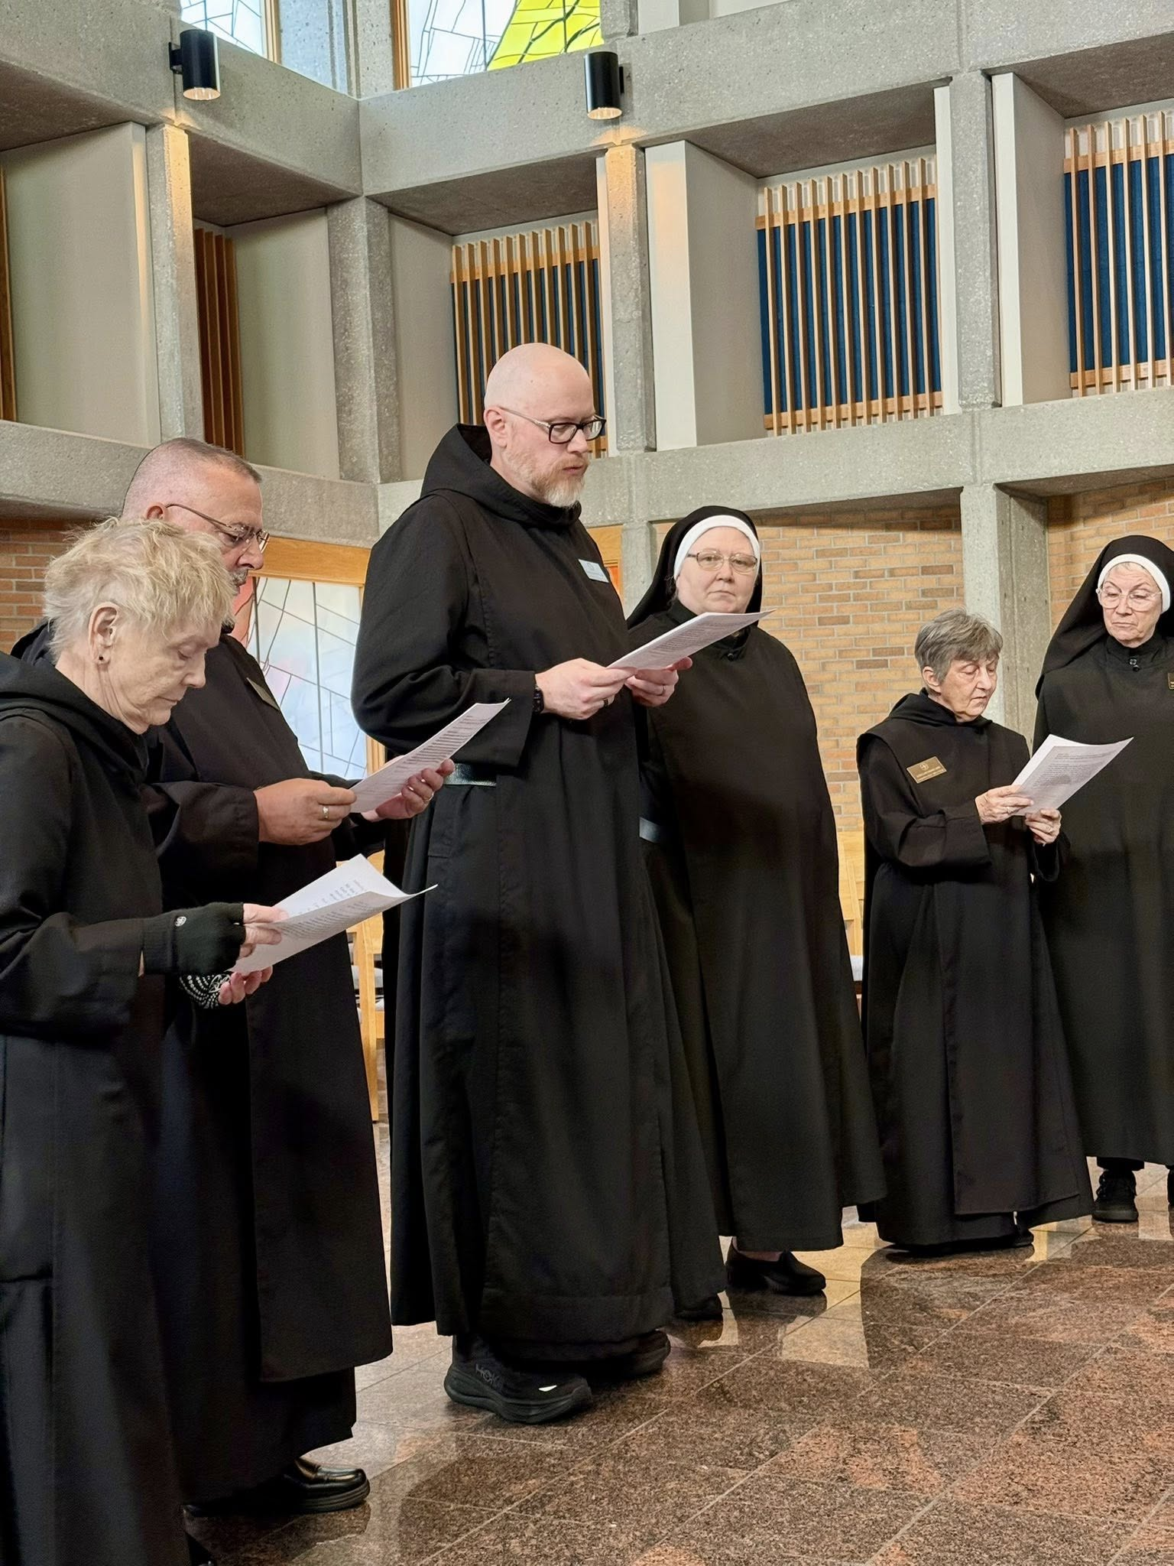
Sr. Julian Smith-Boyer; Br. Jérôme Bertrand; Br. Ronan Patrick; Sr Genevieve Lynn Robinson;
Sr. Clare Koronka; Sr. Mary Magdalene Clarke

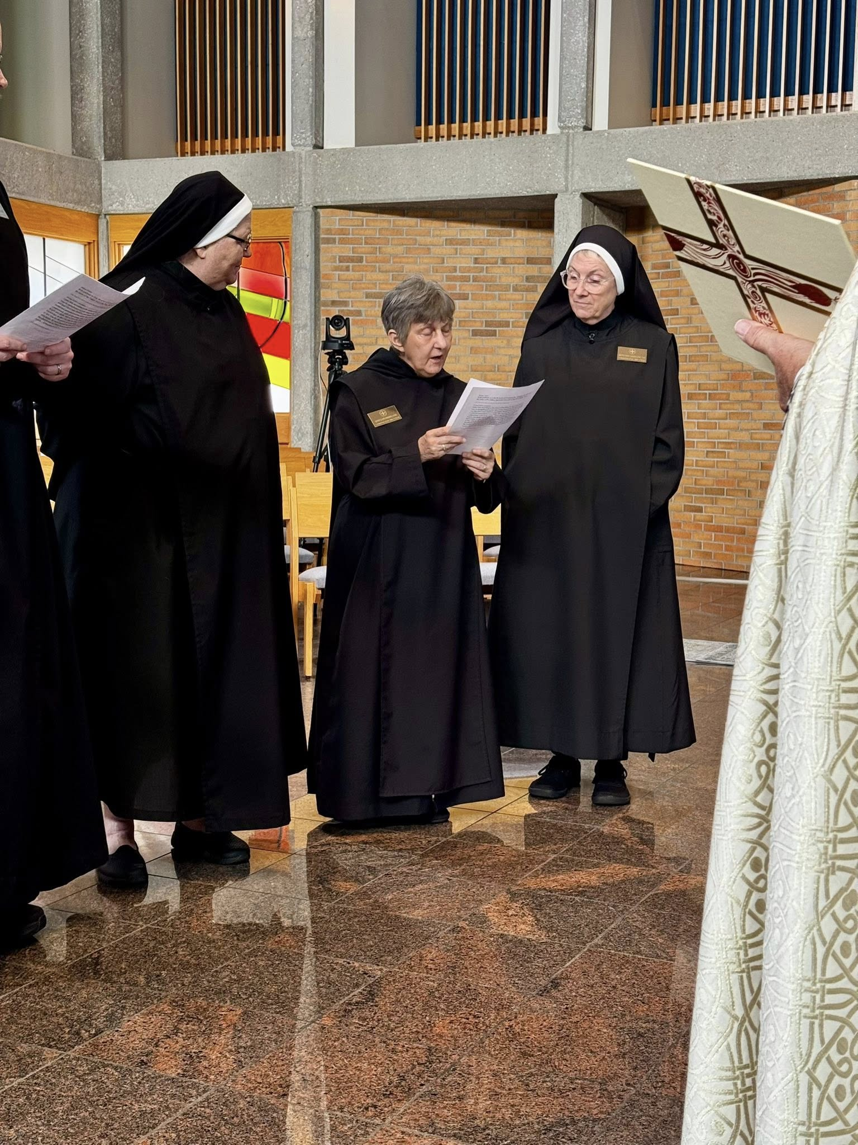
Sr. Genevieve Lynn Robinson; Sr. Clare Koronka; Sr. Mary Magdalene Clarke; Bp. Alan Scarfe
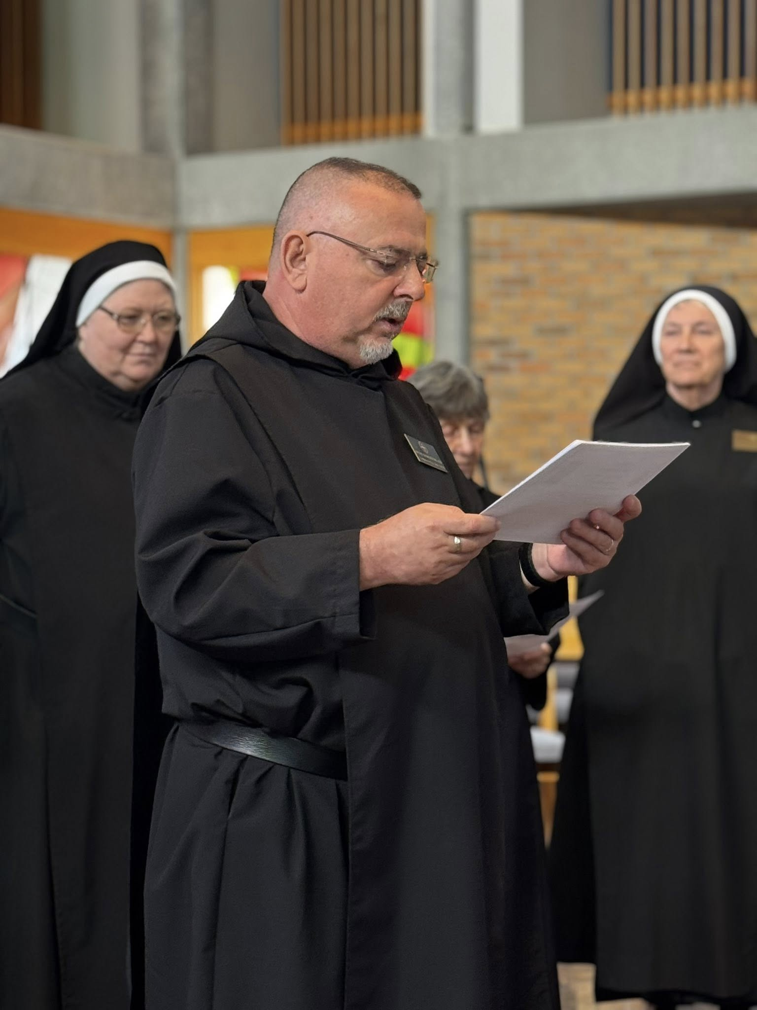
Sr. Genevieve Lynn Robinson; Br. Jérôme Bertrand; Sr. Clare Koronka; Sr. Mary Magdalene Clarke
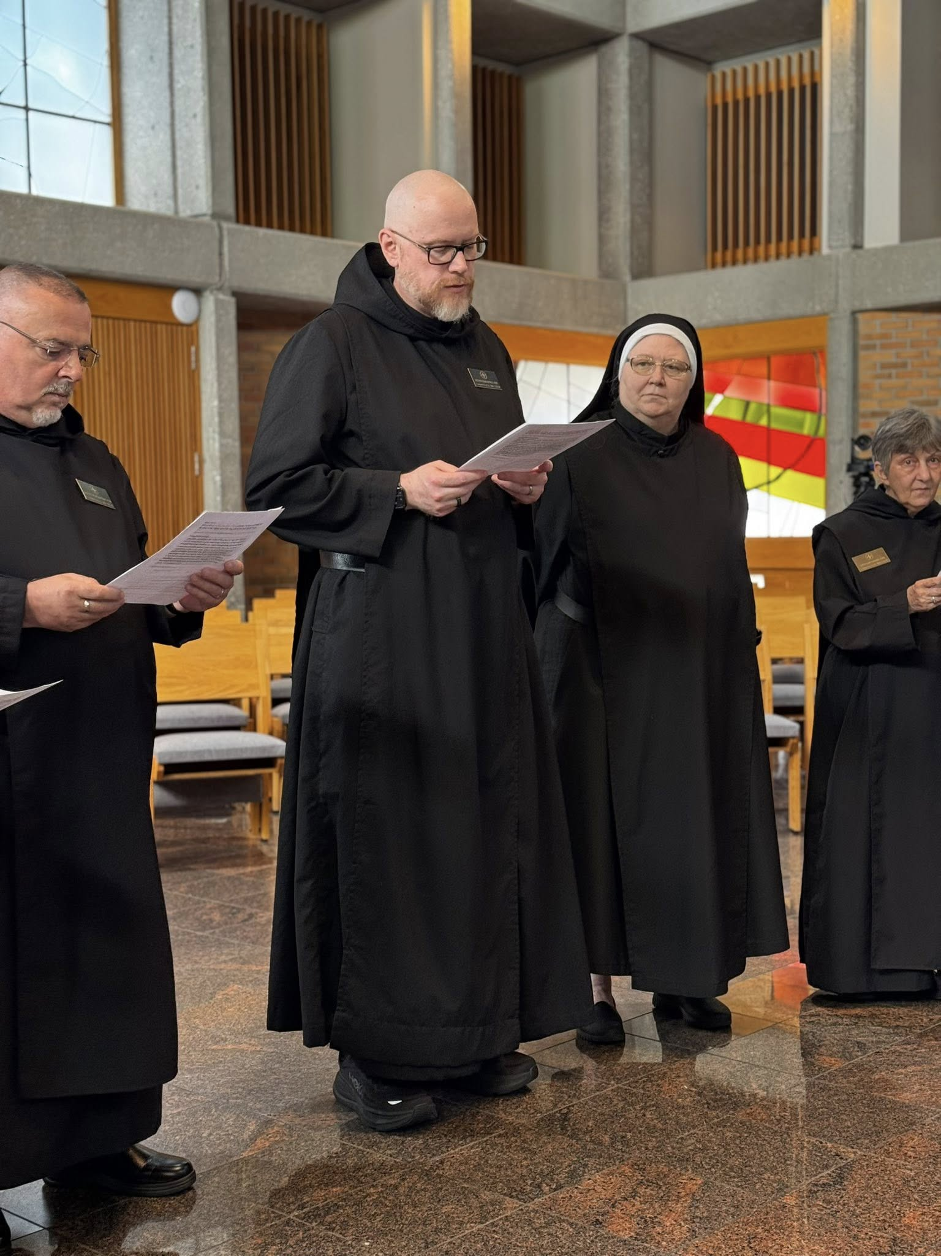
Br. Jérôme Bertrand; Br. Ronan Patrick; Sr. Genevieve Lynn Robinson; Sr. Clare Koronka
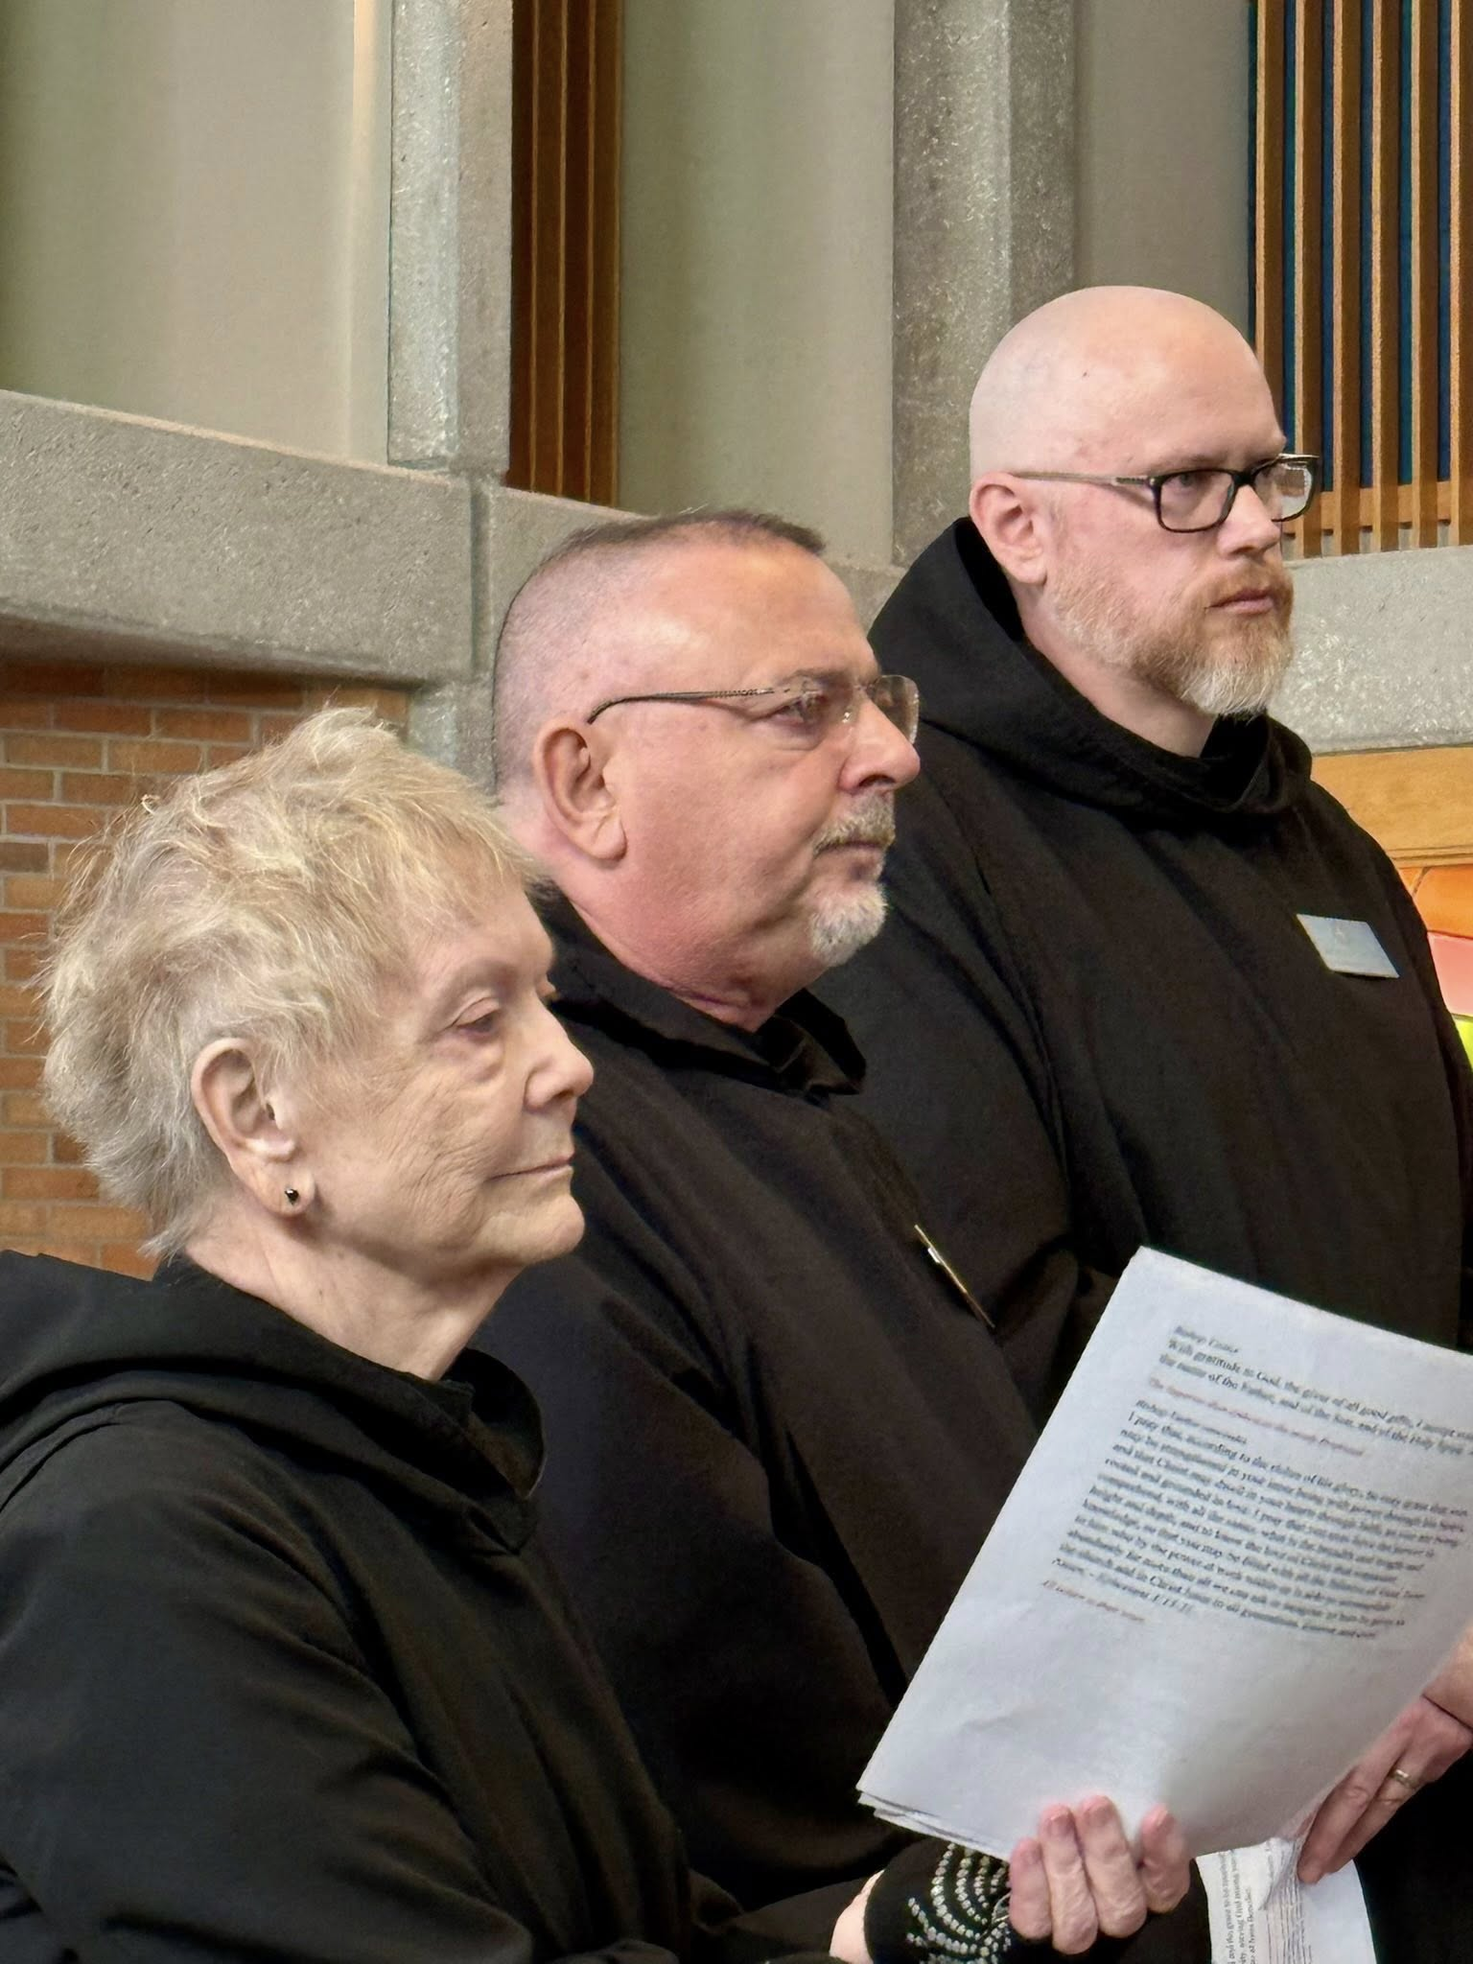
Sr. Julian Smith-Boyer; Br. Jérôme Bertrand; Br. Ronan Patrick
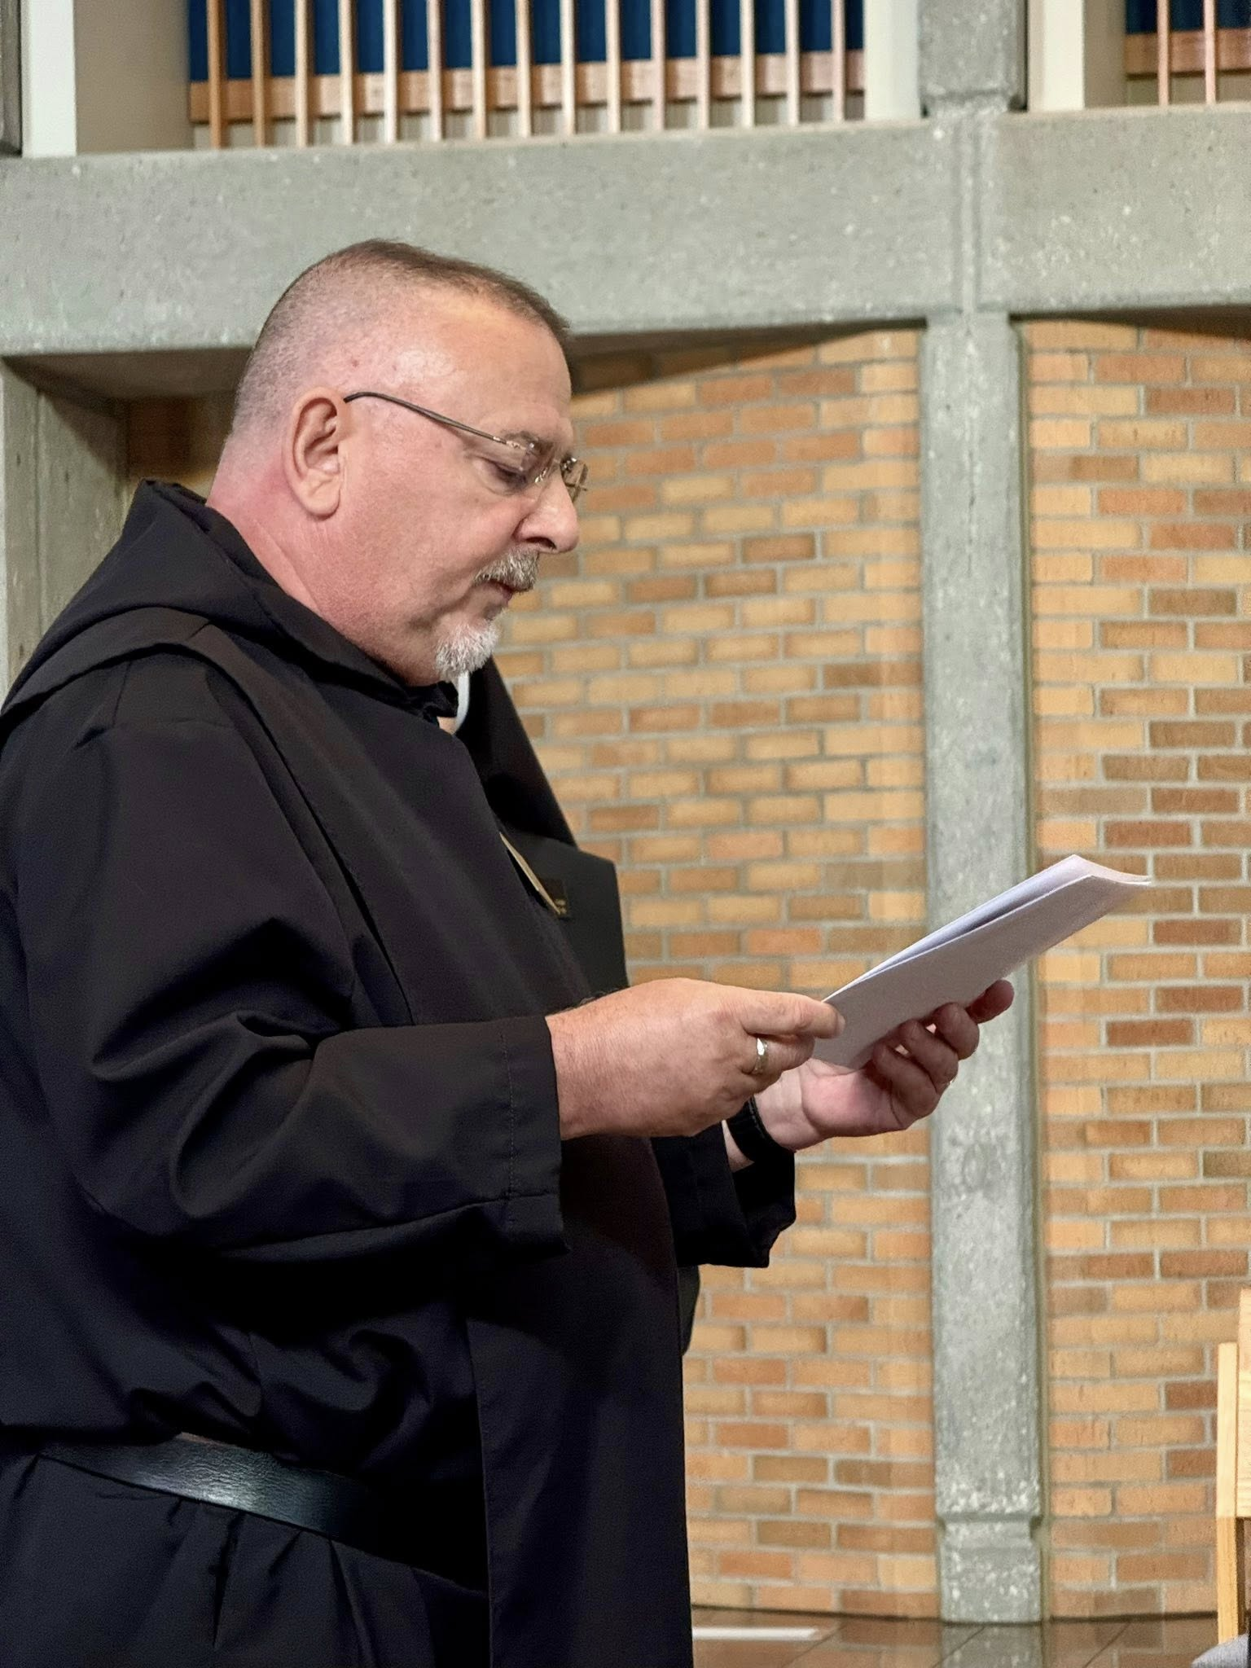
Br. Jérôme Bertrand

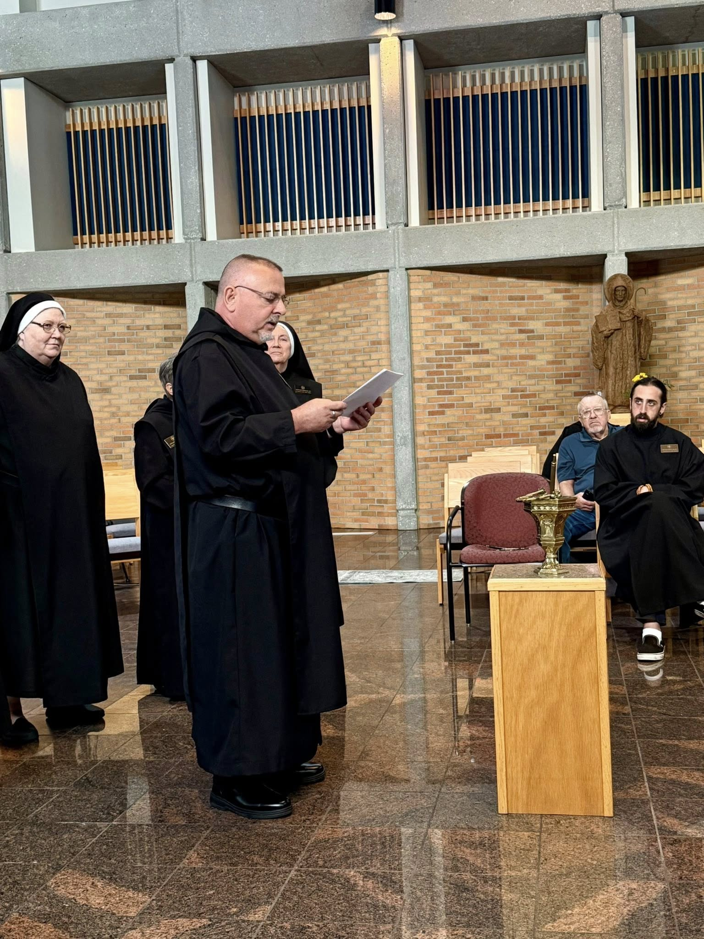
Sr. Genevieve Lynn Robinson; Sr. Clare Koronka; Br. Jérôme Bertrand; Sr. Mary Magdalene Clarke; Larry Koronka; Br. Andrew Grimsby

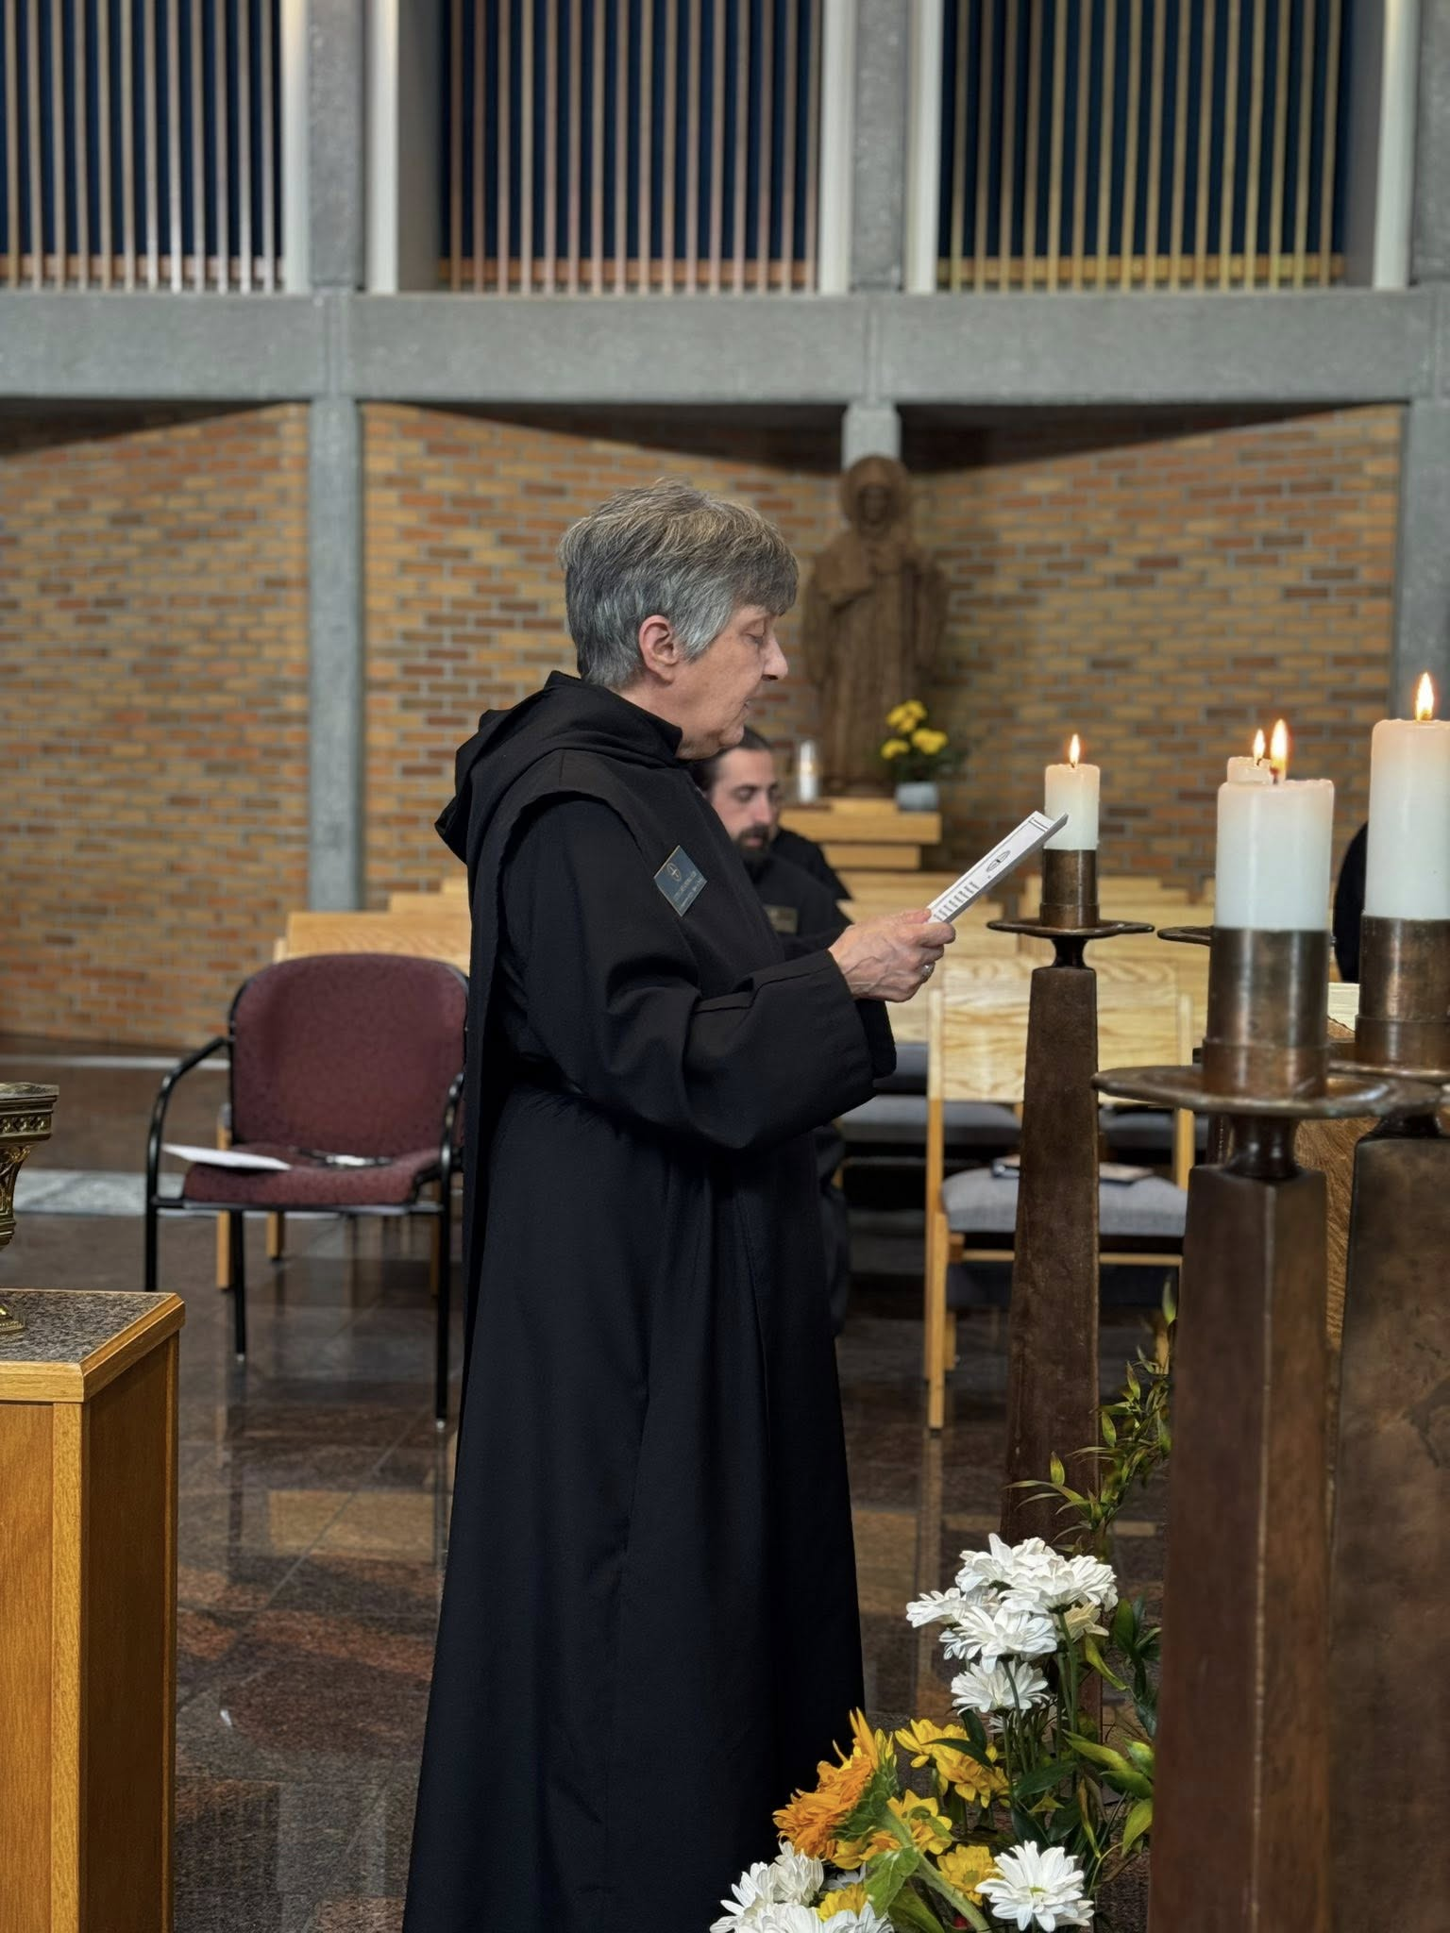
Sr. Clare Koronka; Br. Andrew Grimsby
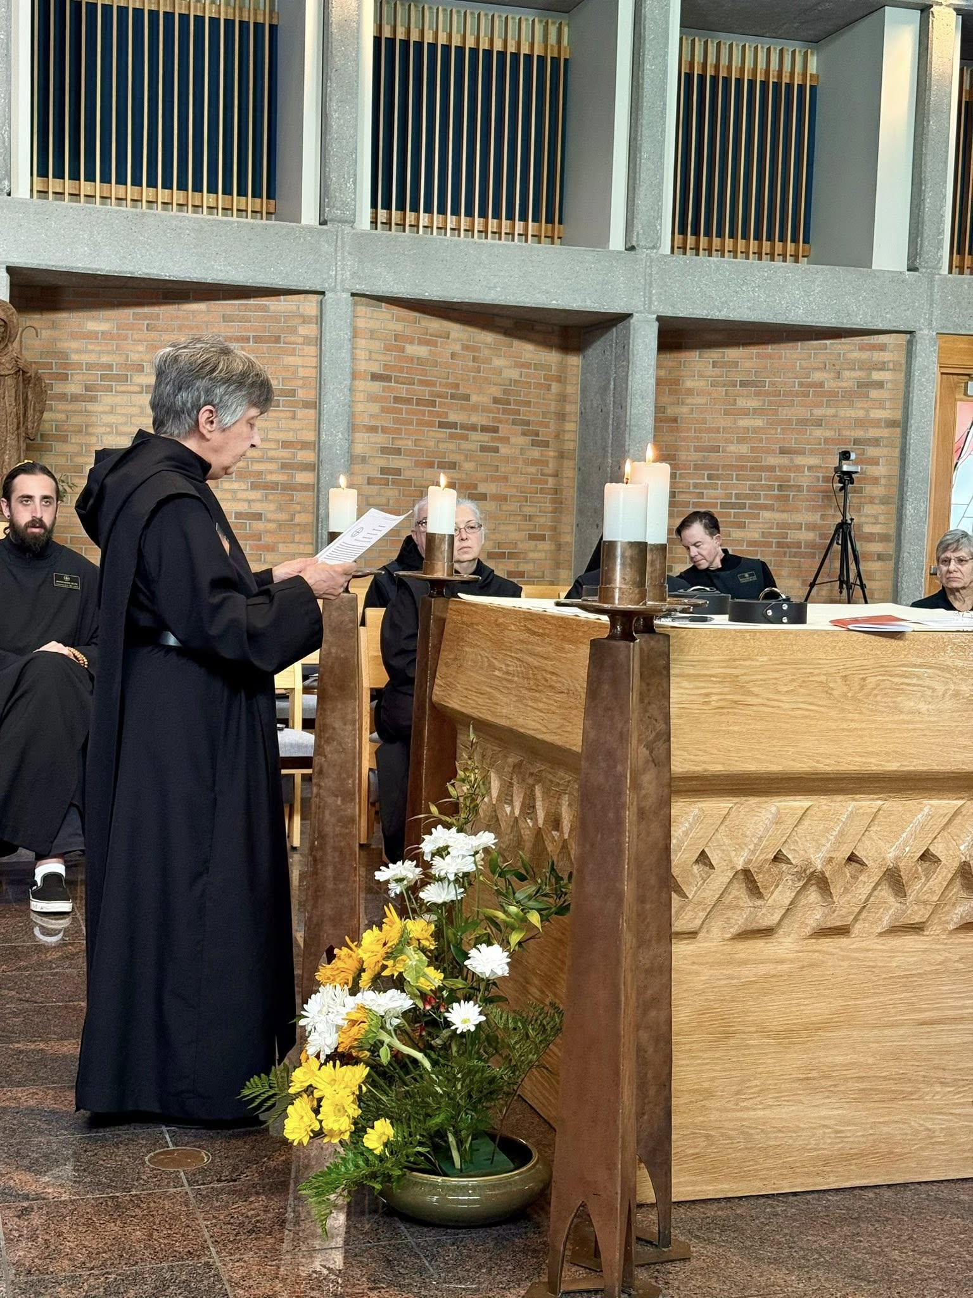
Br. Andrew Grimsby; Sr. Clare Koronka; Br. Joseph Elias Varsanyi; Sr. Gianna Altadonna; Br. Jude Thaddeus Orth; Nan DeStafney

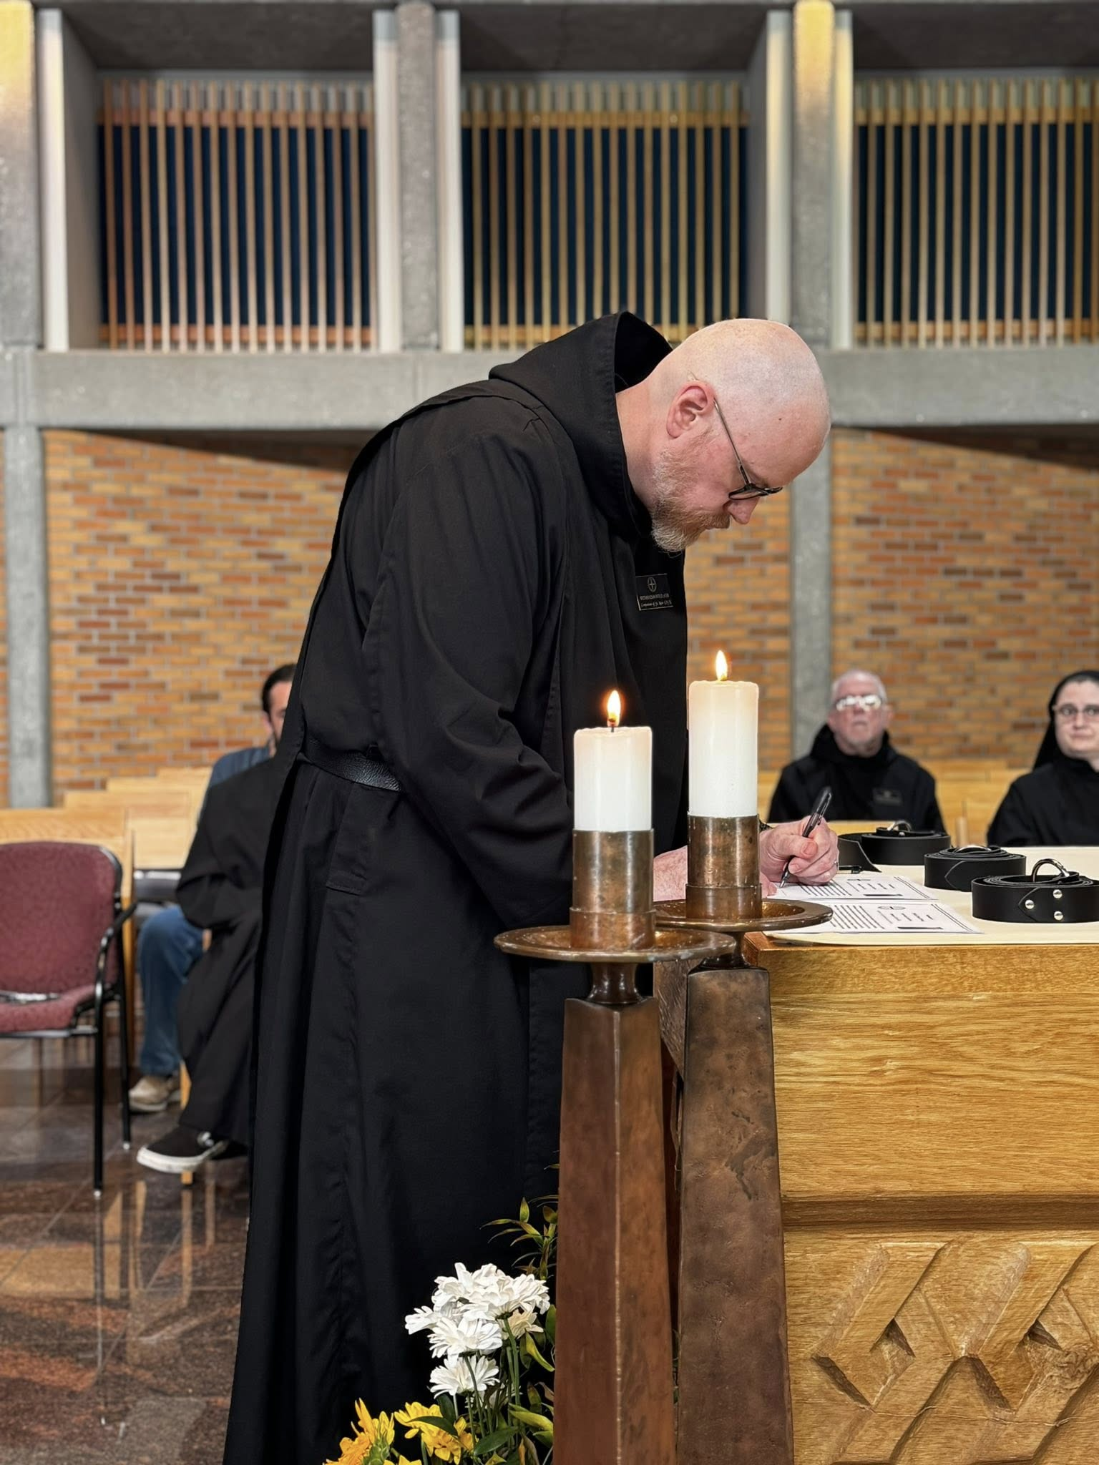
Br. Andrew Grimsby; Br. Ronan Patrick; Br. Joseph Elias Varsanyi; Sr. Seraphina MacKay
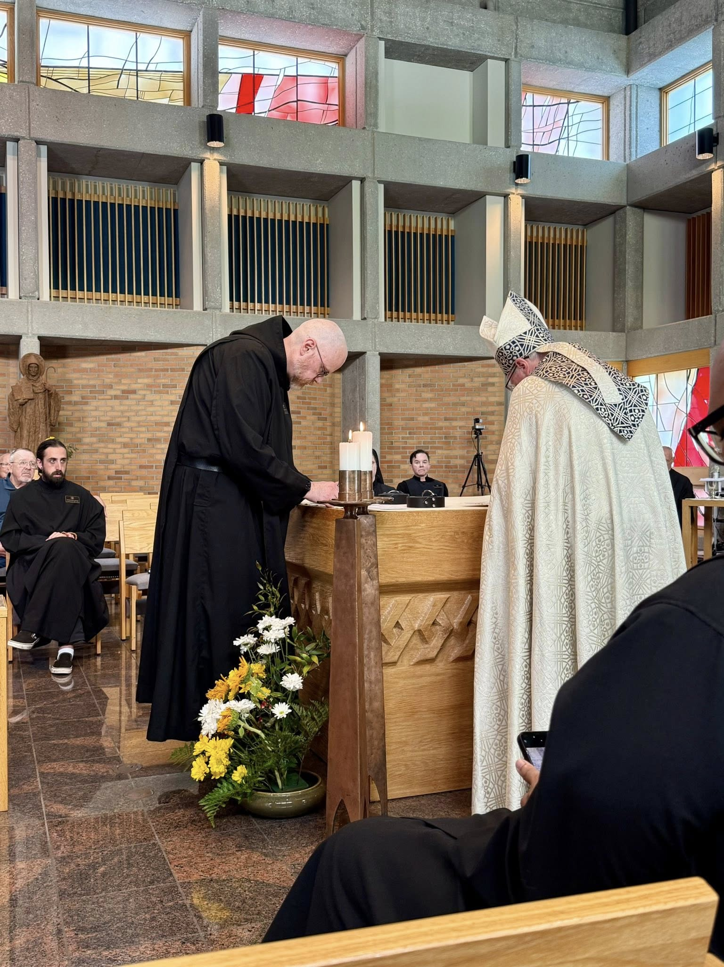
Br. John David Wynne; Larry Koronka; Br. Andrew Grimsby; Br. Ronan Patrick; Br. Jude Thaddeus Orth; Bp. Alan Scarfe

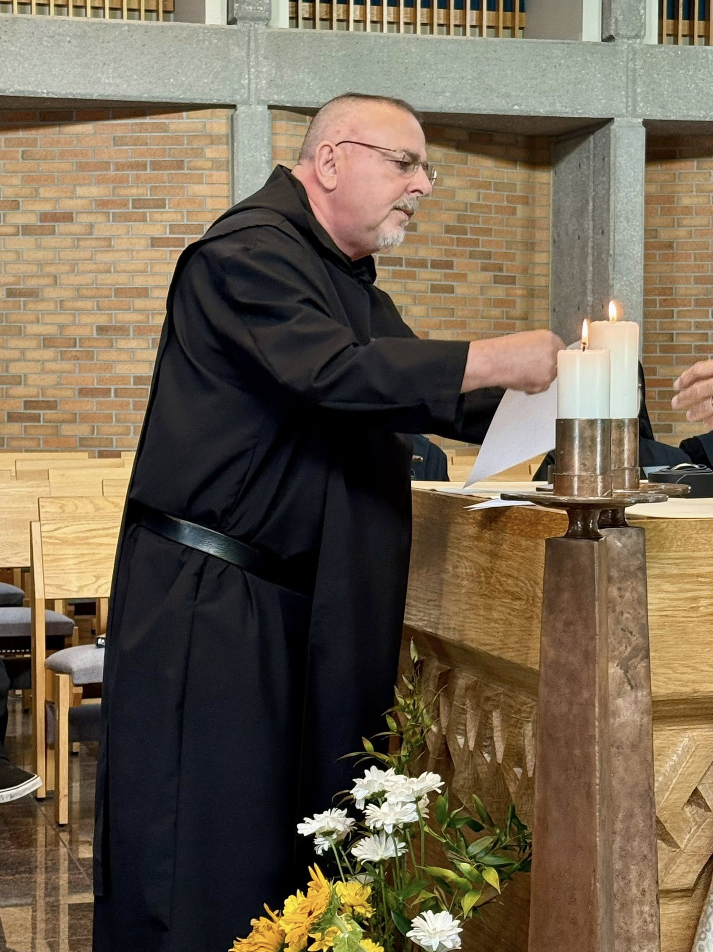
Br. Jérôme Bertrand

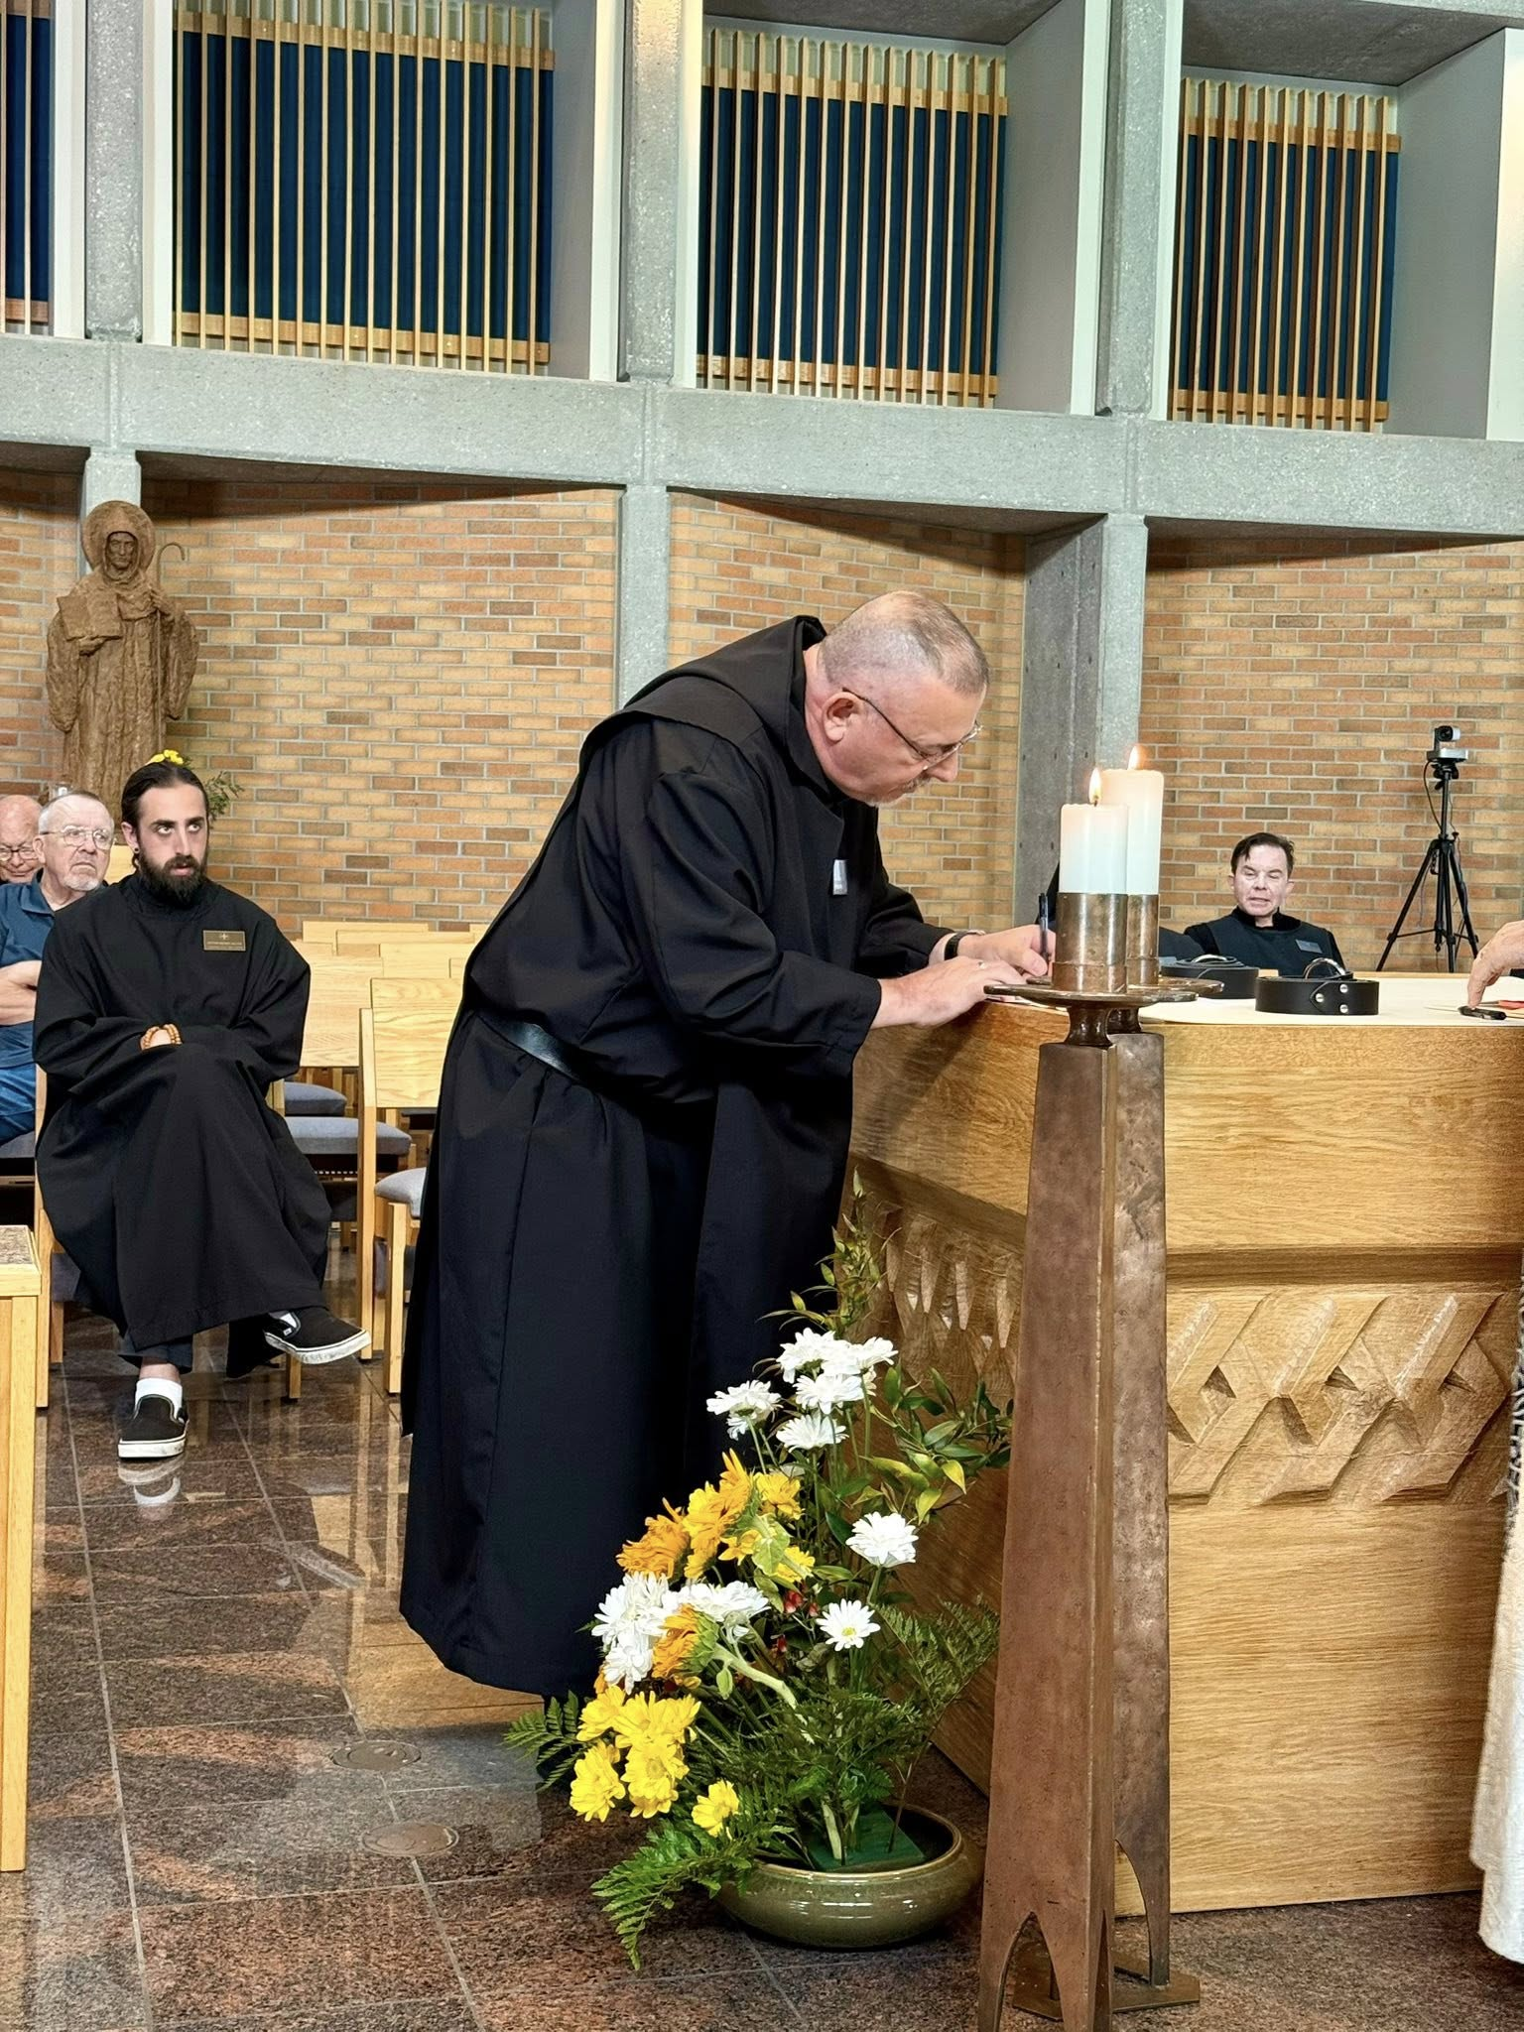
Br. John David Wynne; Larry Koronka; Br. Andrew Grimsby; Br. Jérôme Bertrand; Br. Jude Thaddeus Orth

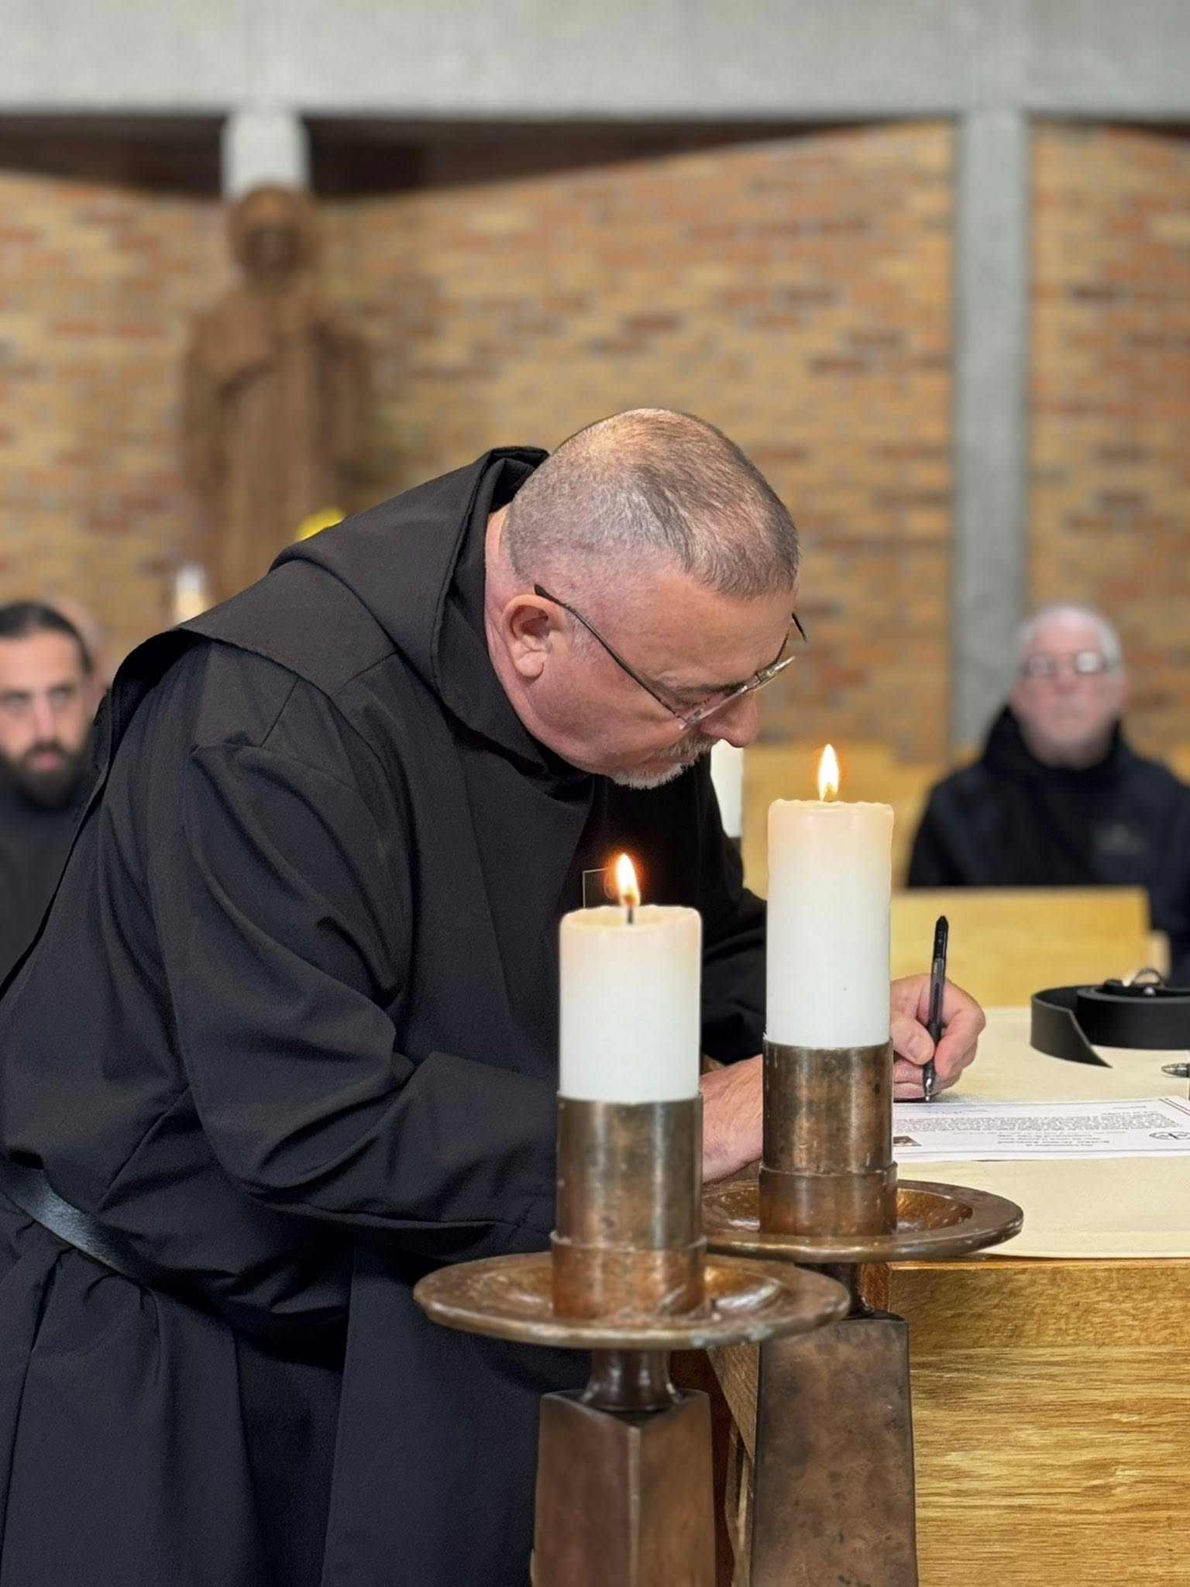
Br. Andrew Grimsby; Br. Jérôme Bertrand; Br. Joseph Elias Varsanyi

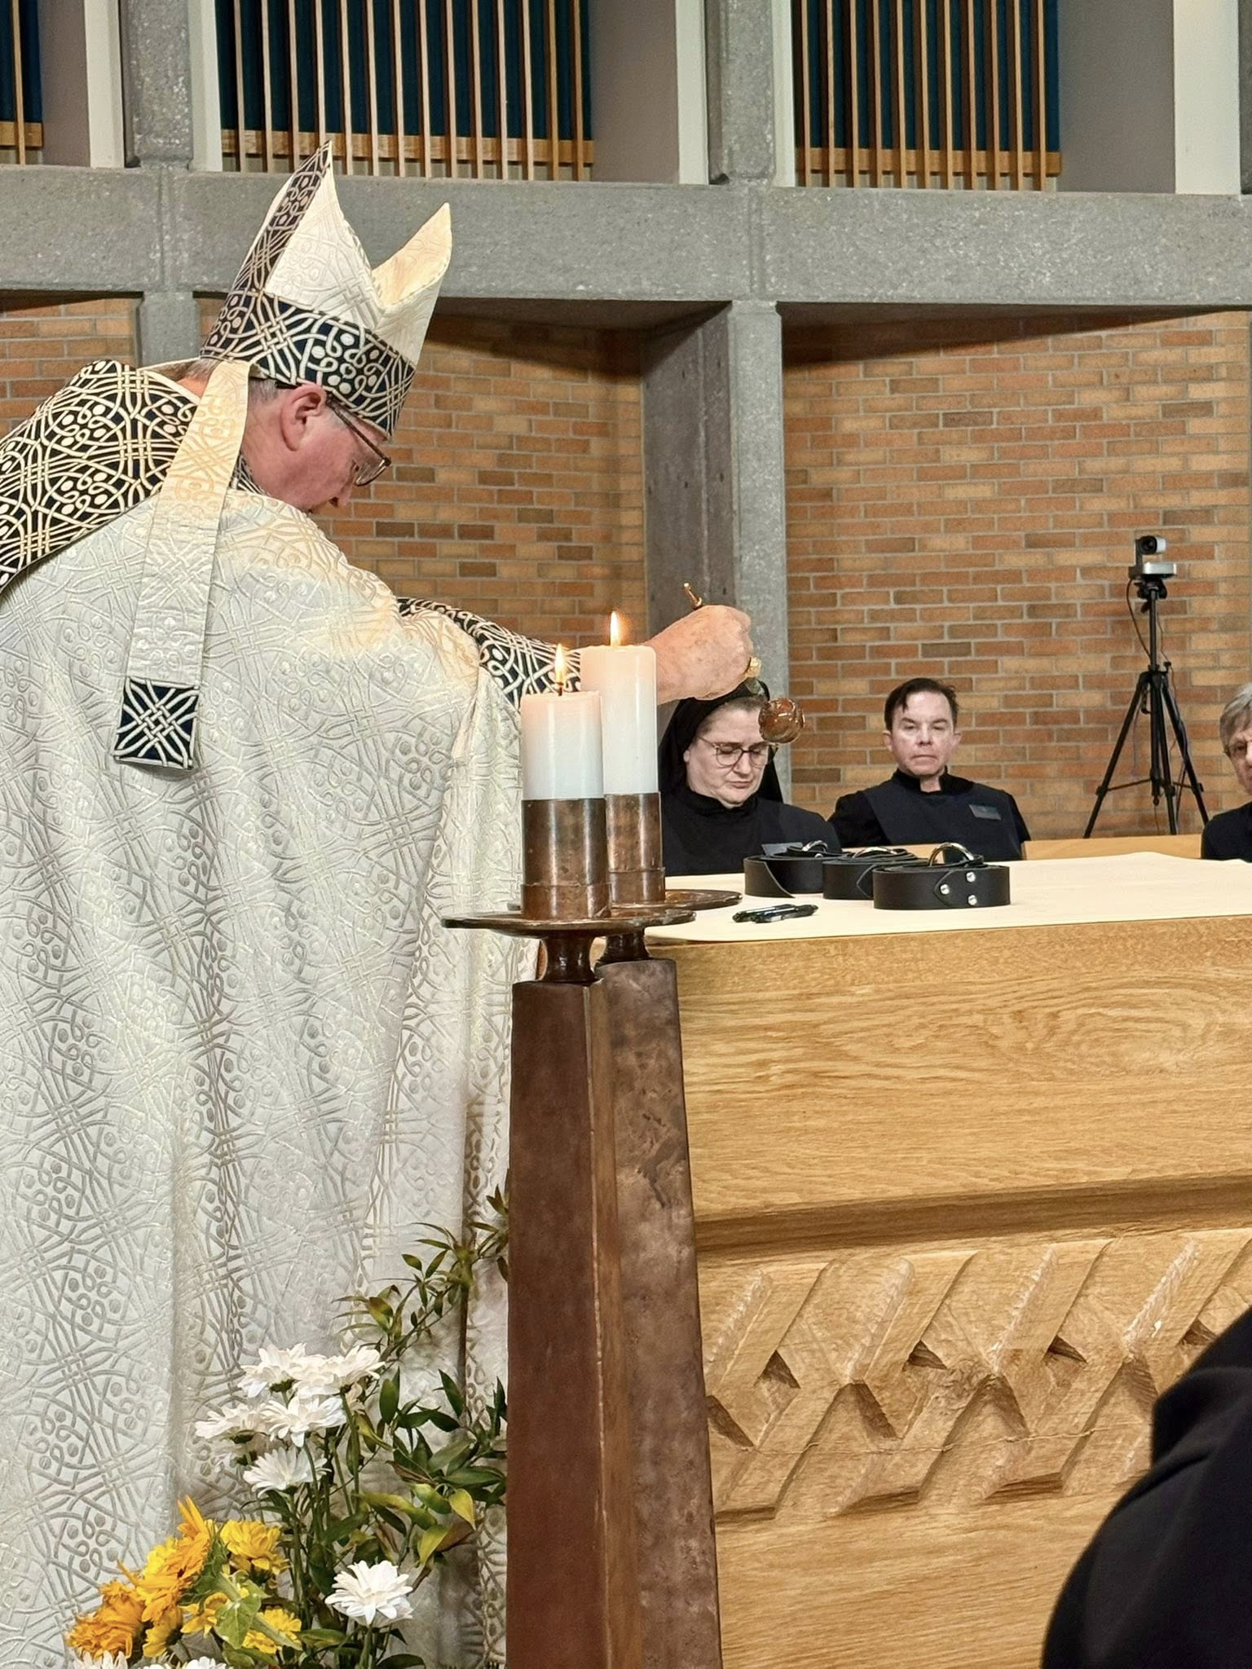
Bp. Alan Scarfe; Sr. Seraphina MacKay; Br. Jude Thaddeus Orth; Nan DeStafney
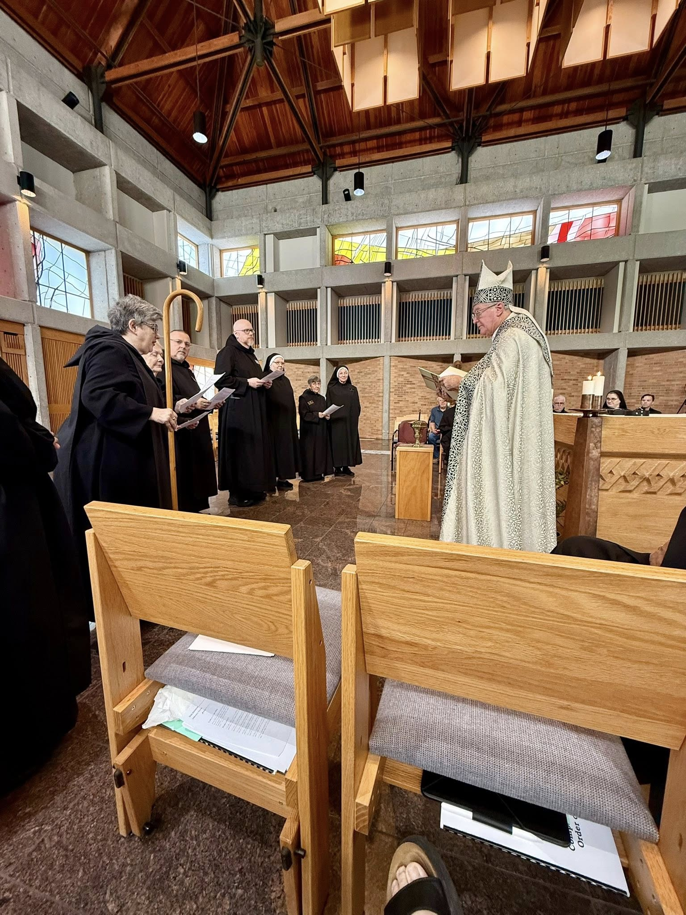
Abbess Martha Lamoy; Sr. Julian Smith-Boyer; Br. Jérôme Bertrand; Br. Ronan Patrick; Sr. Clare Koronka; Sr. Mary Magdalene Clarke; Larry Koronka; Bp. Alan Scarfe; Br. Joseph Elias Varsanyi; Sr. Seraphina MacKay; Br. Jude Thaddeus Orth

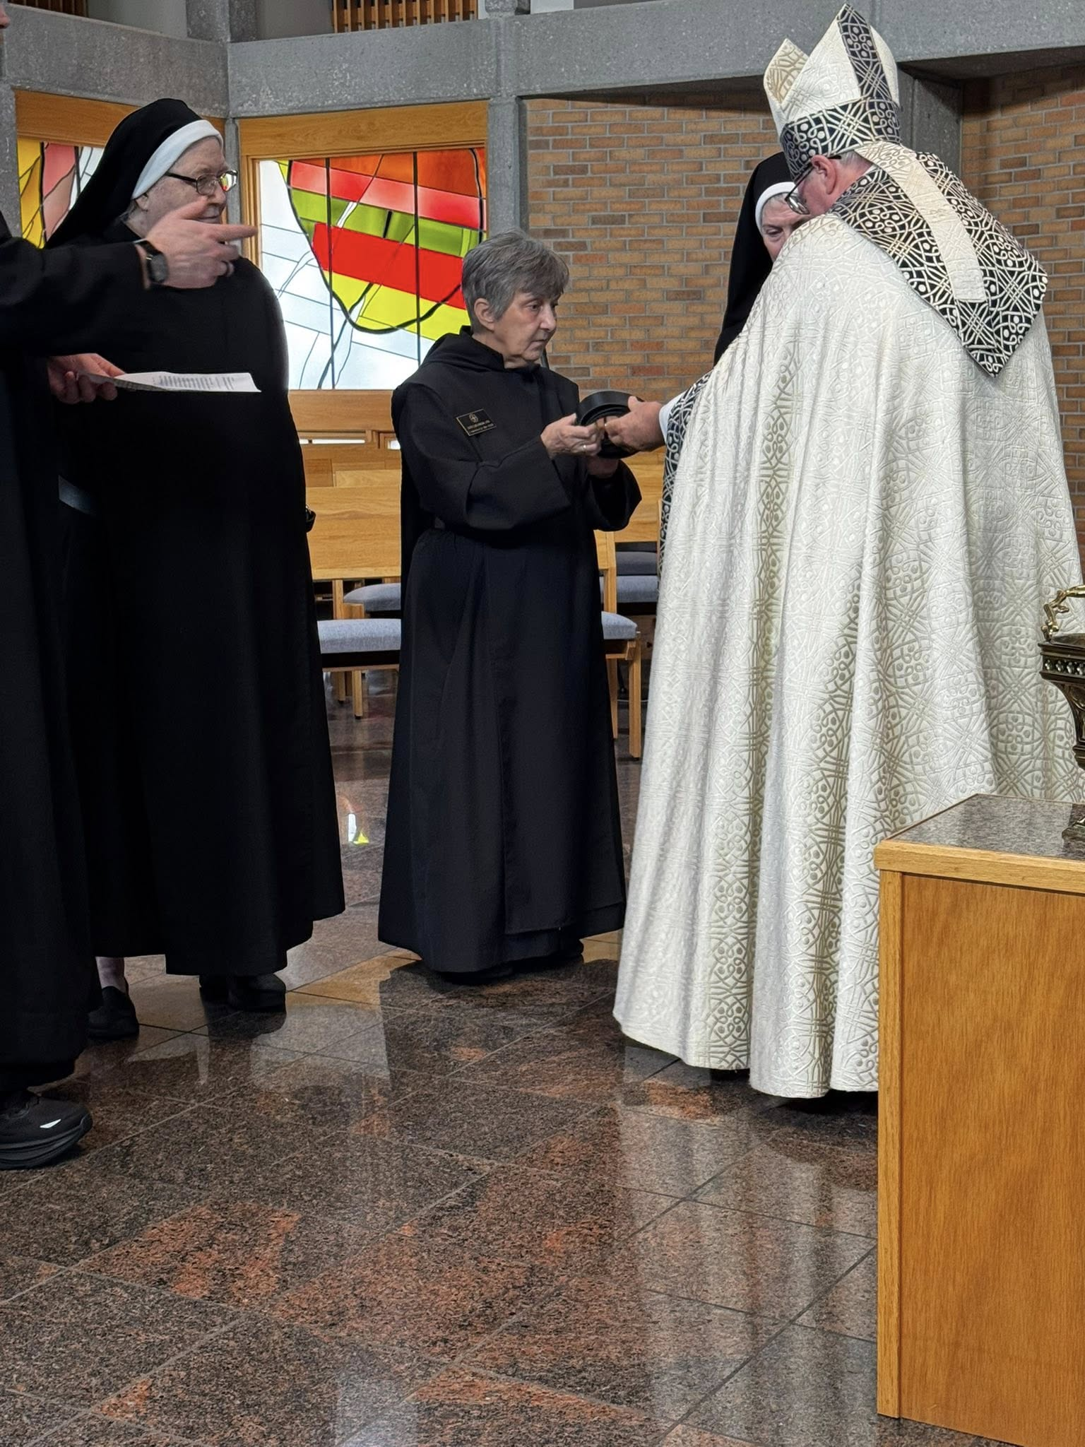
Sr. Genevieve Lynn Robinson; Sr. Clare Koronka; Sr. Mary Magdalene Clarke; Bp. Alan Scarfe
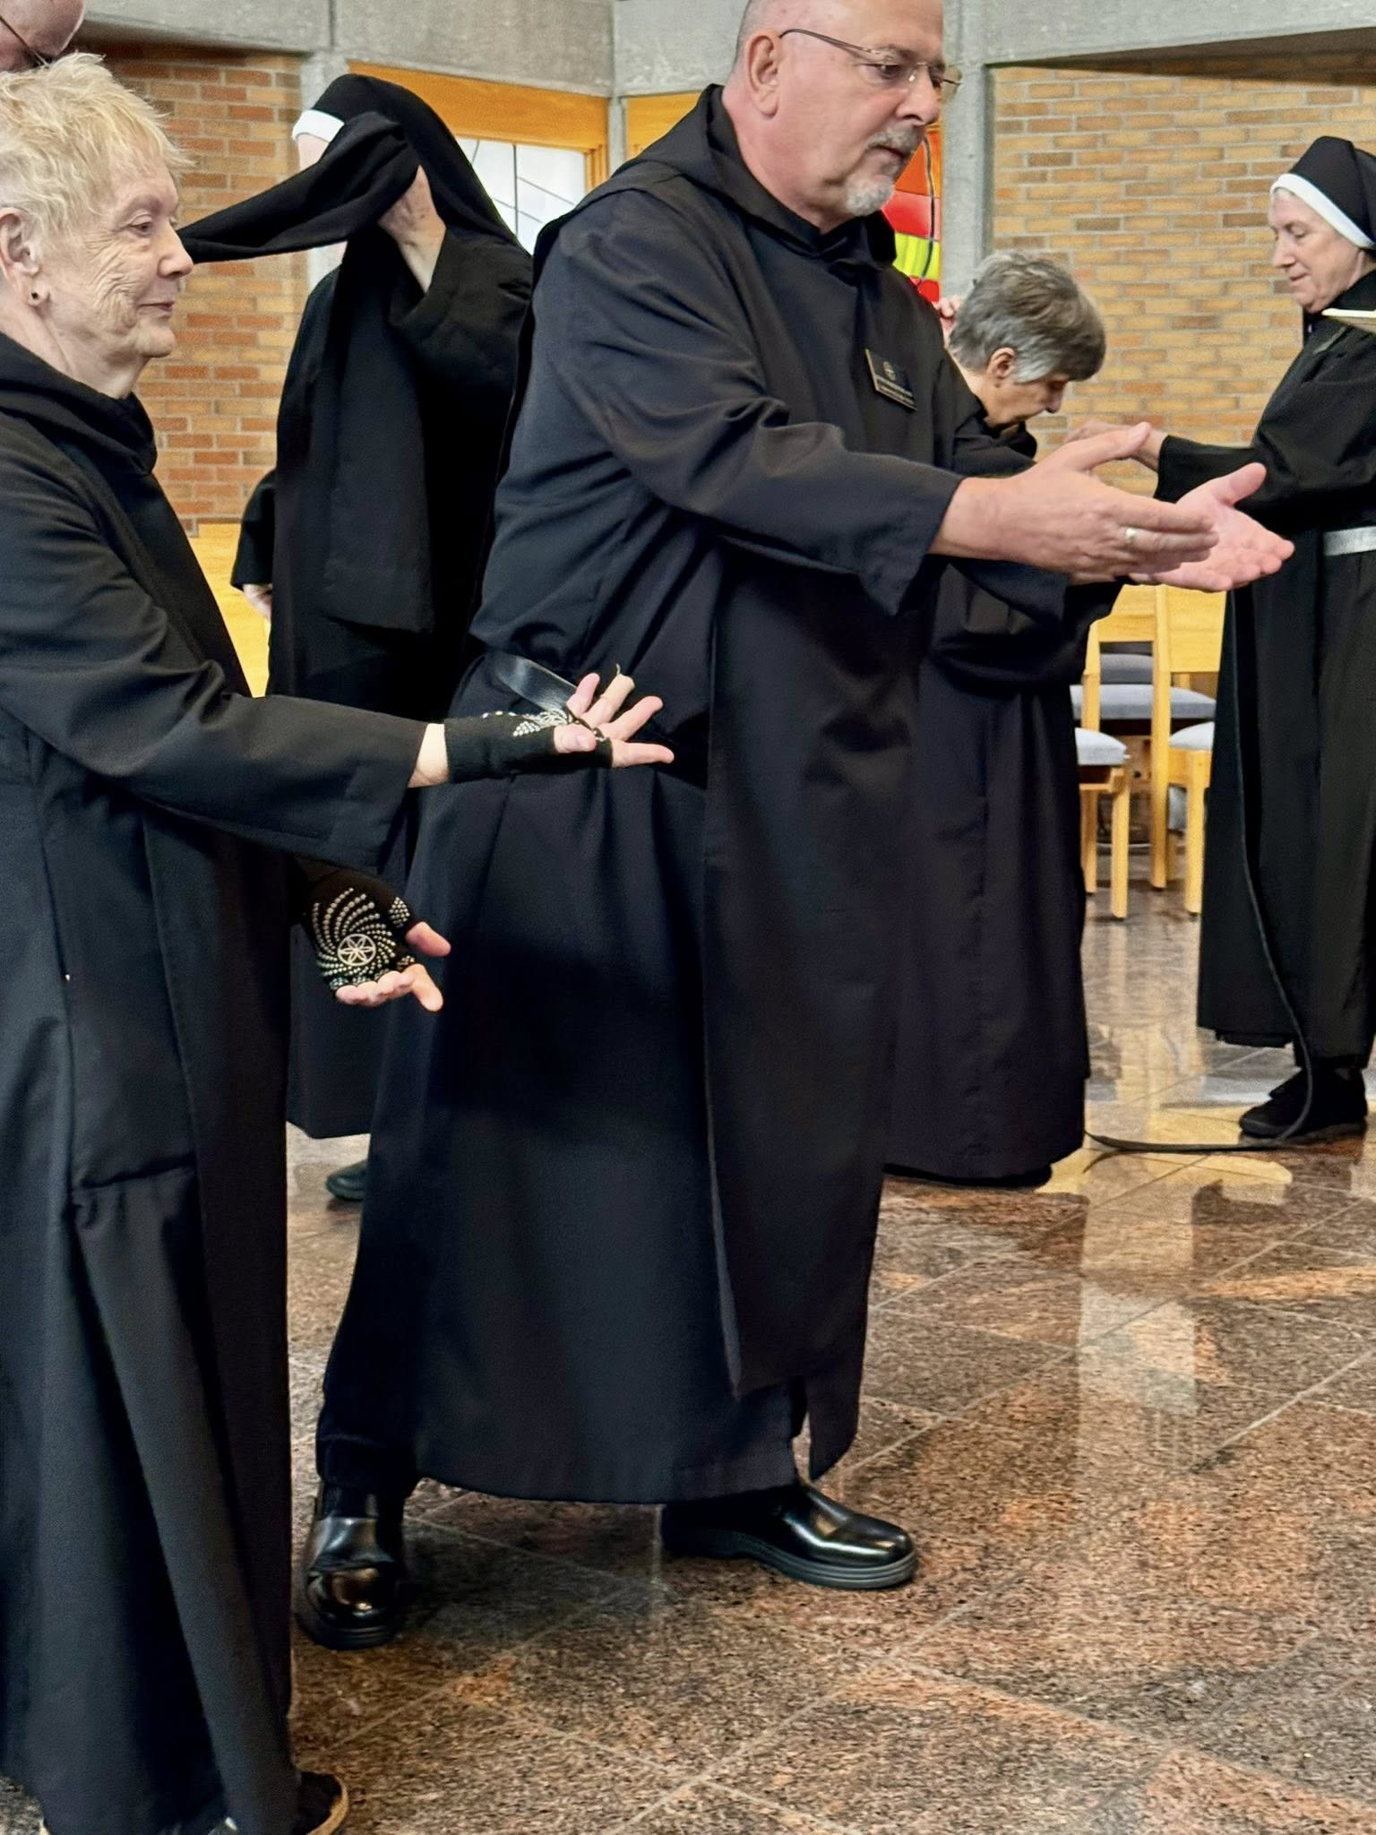
Sr. Julian Smith-Boyer; Br. Jérôme Bertrand; Sr. Clare Koronka; Sr. Mary Magdalene Clarke

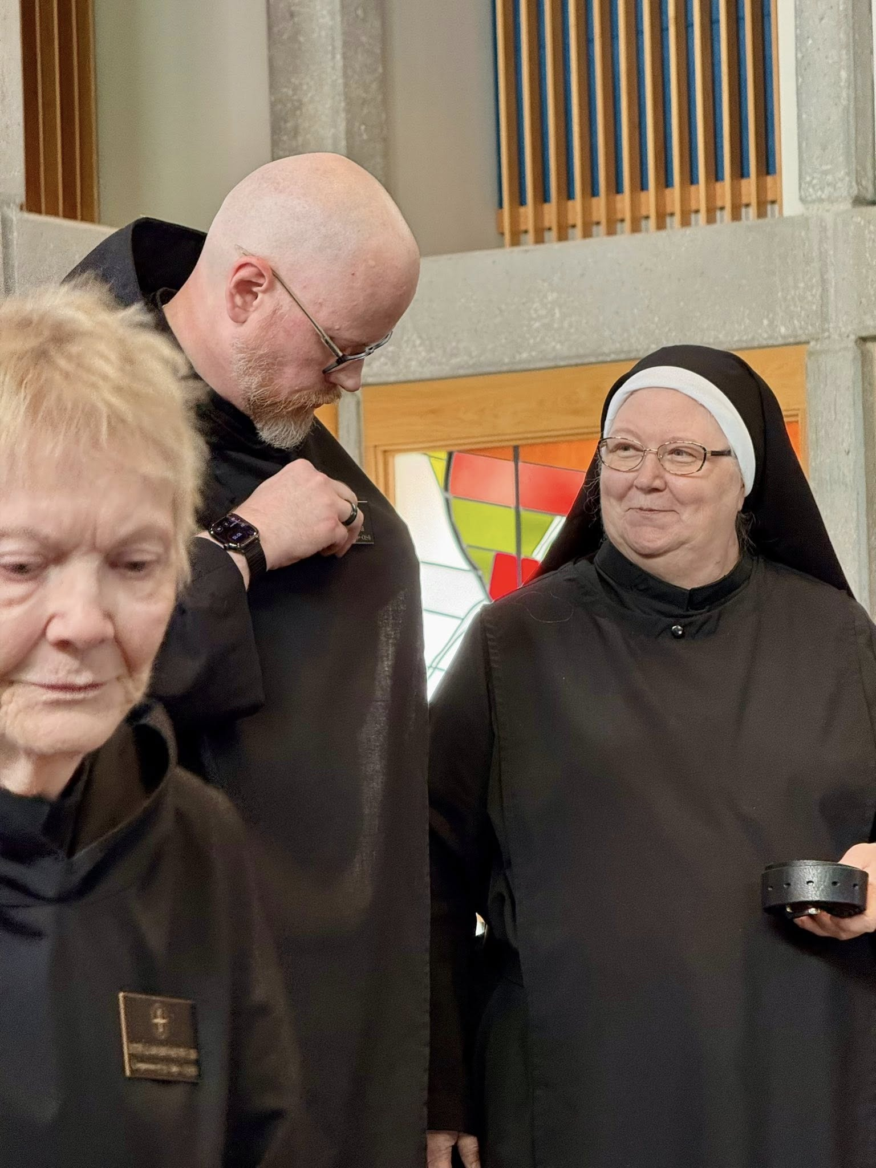
Sr. Julian Smith-Boyer; Br. Ronan Patrick; Sr. Genevieve Lynn Robinson

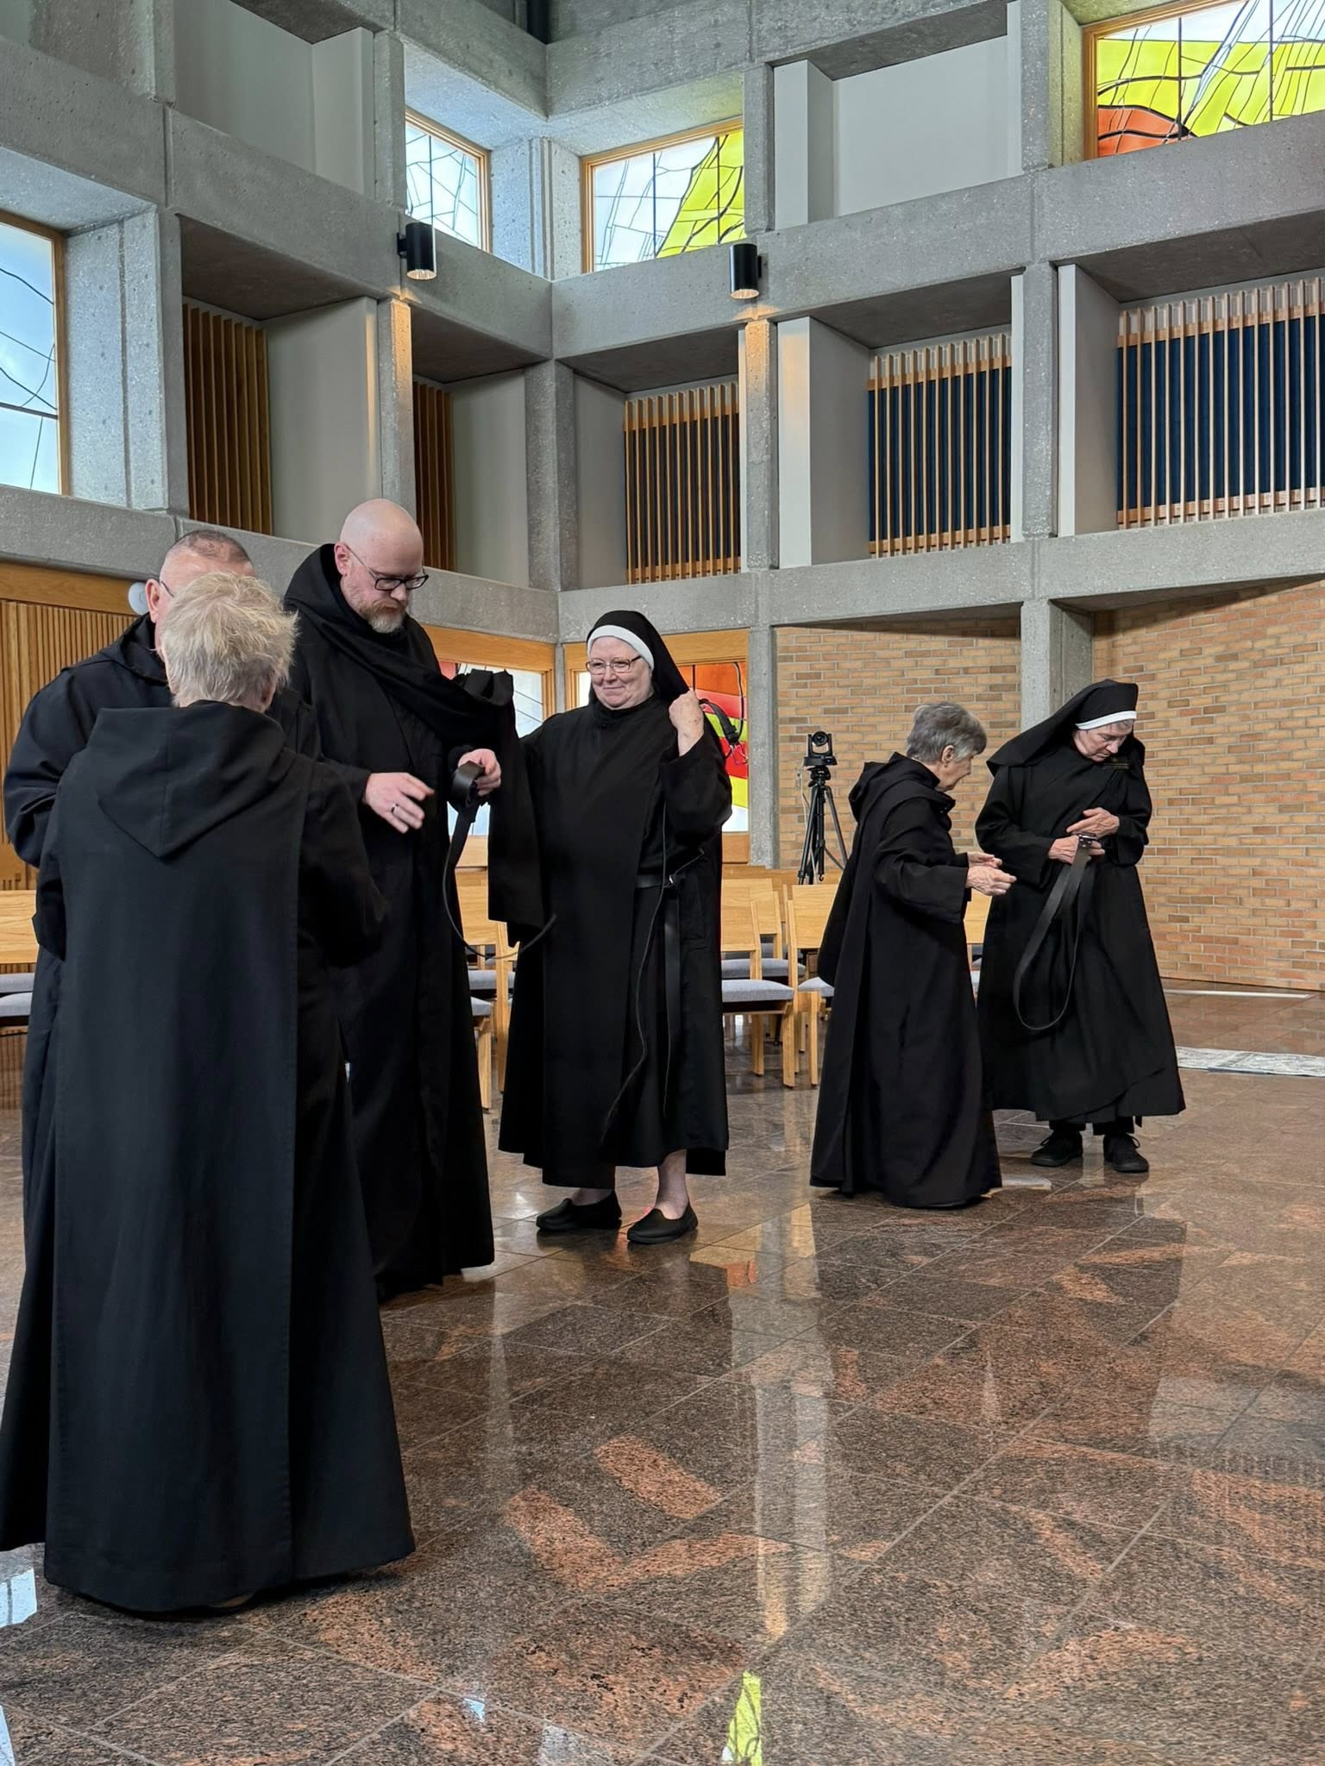
Sr. Julian Smith-Boyer; Br. Jérôme Bertrand; Br. Ronan Patrick; Sr. Genevieve Lynn Robinson;
Sr. Clare Koronka; Sr. Mary Magdalene Clarke

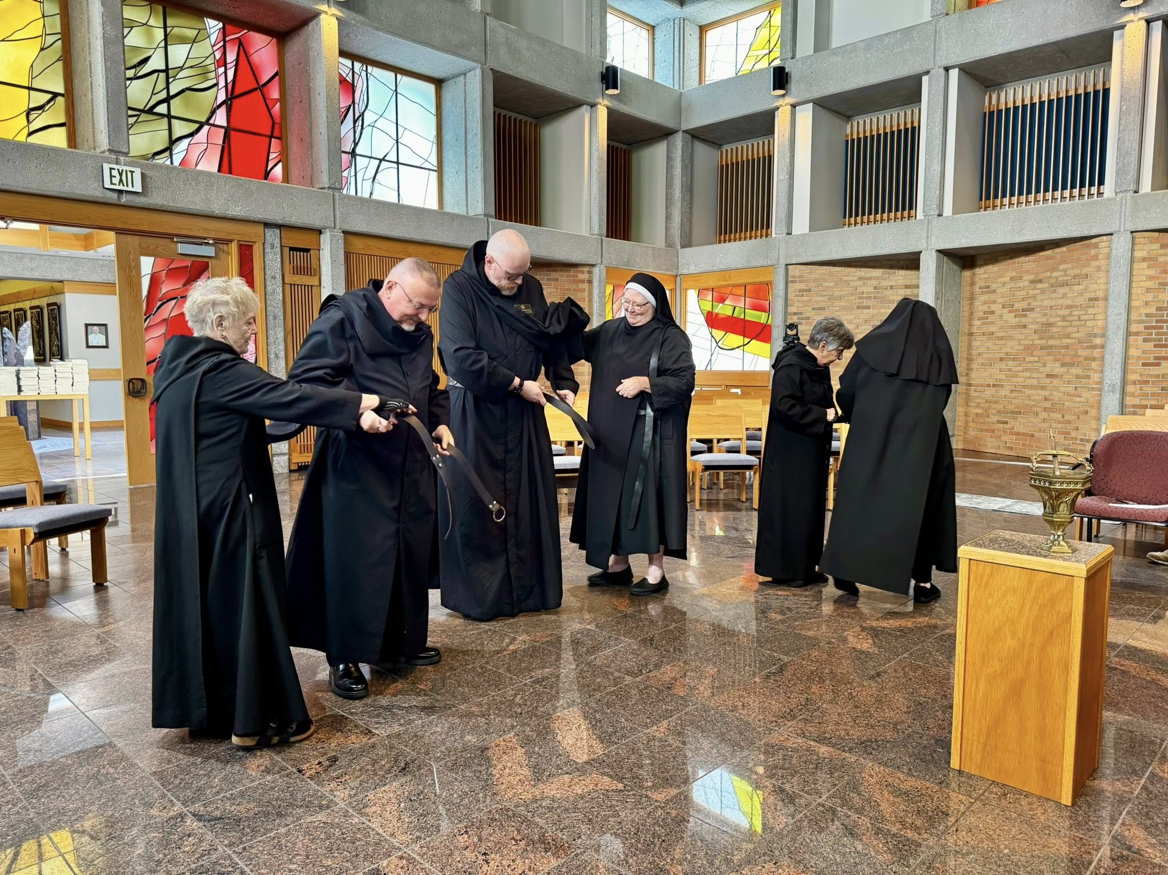
Sr. Julian Smith-Boyer; Br. Jérôme Bertrand; Br. Ronan Patrick; Sr. Genevieve Lynn Robinson; Sr. Clare Koronka; Sr. Mary Magdalene Clarke
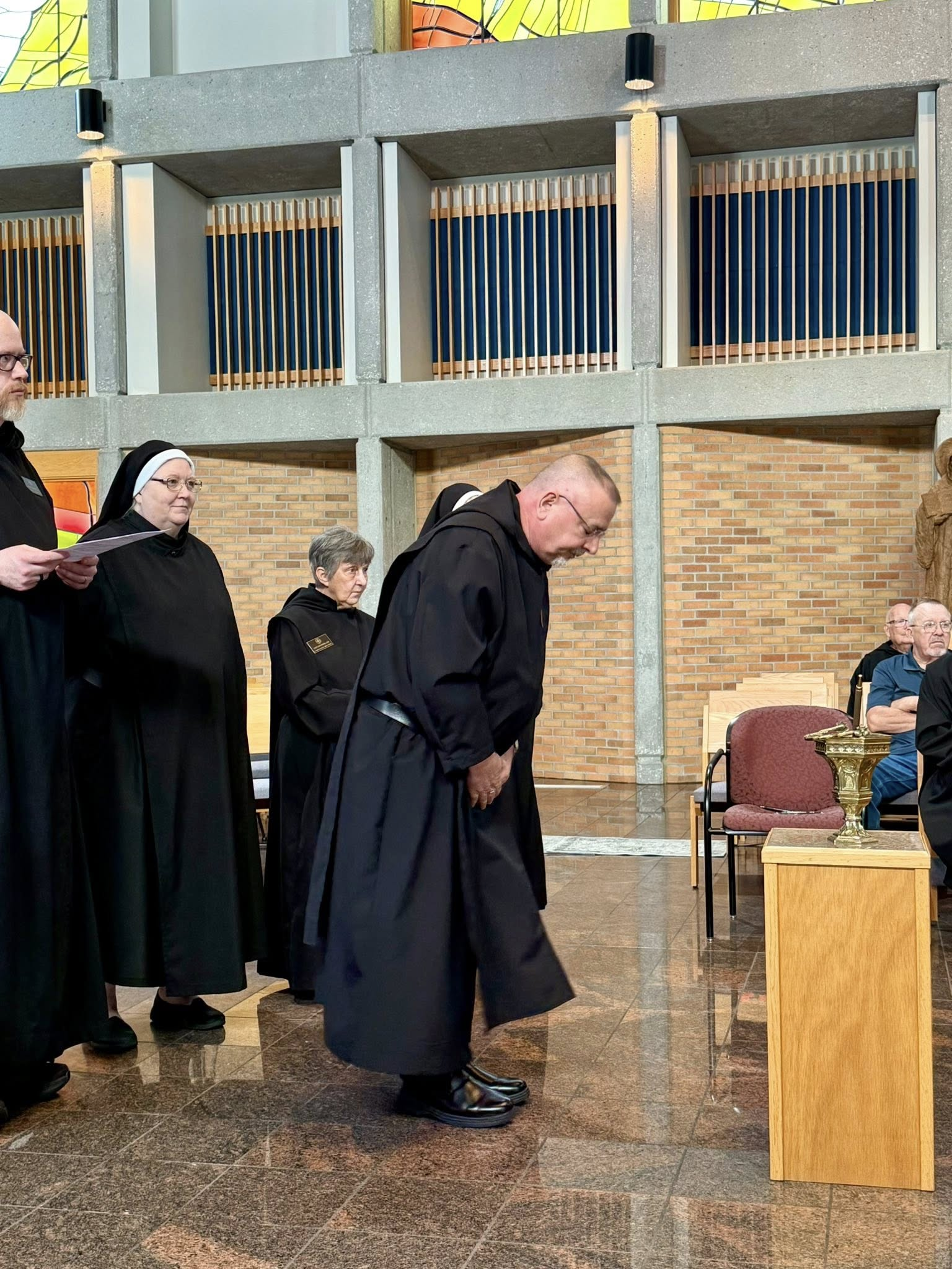
Br. Ronan Patrick; Sr. Genevieve Lynn Robinson; Sr. Clare Koronka; Br. Jérôme Bertrand; Br. John David Wynne; Larry Koronka

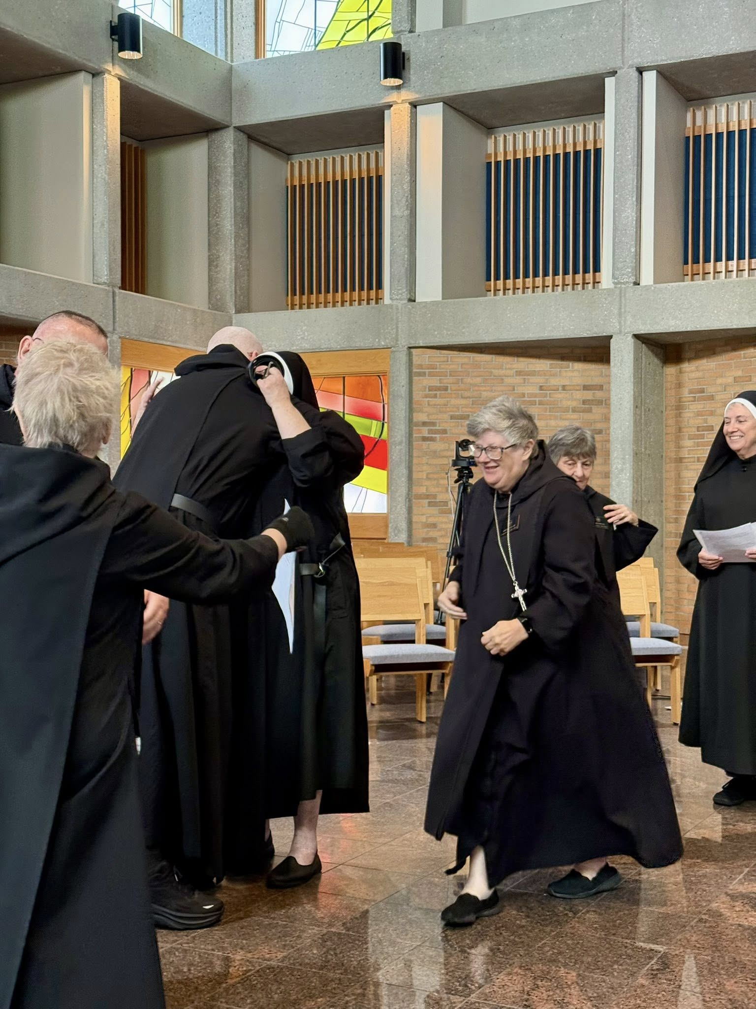
Sr. Julian Smith-Boyer; Br. Jérôme Bertrand; Br. Ronan Patrick; Sr. Genevieve Lynn Robinson; Abbess Martha Lamoy; Sr. Clare Koronka; Sr. Mary Magdalene Clarke

