July 21-25 Convocation
St. Gregory’s Abbey
Schuyler, Nebraska
Part 2 of 4
People are identified left to right.

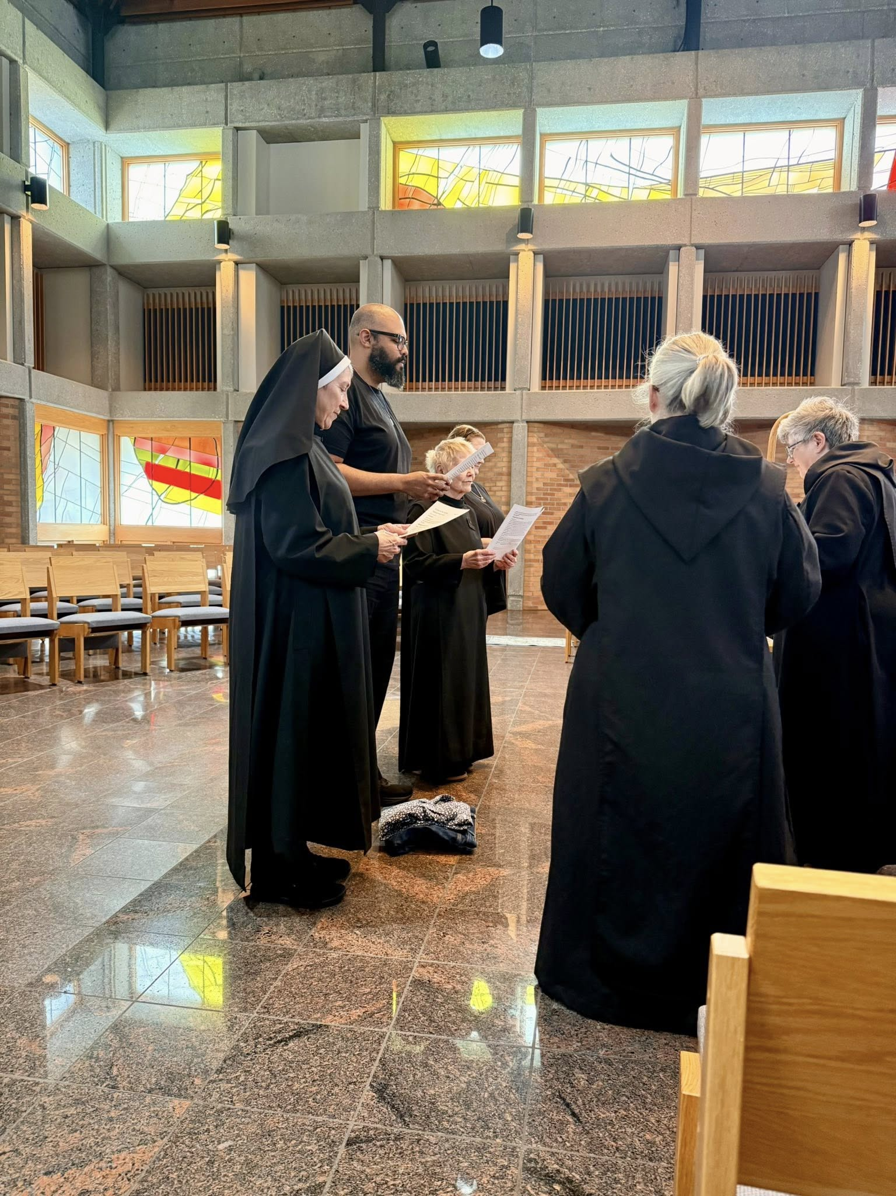
Sr. Mary Magdalene Clarke; Br. Dominic Ndife; Sr. Julian Smith-Boyer; Sr. Seraphina MacKay; Sr. Gianna Altadonna; Abbess Martha Lamoy

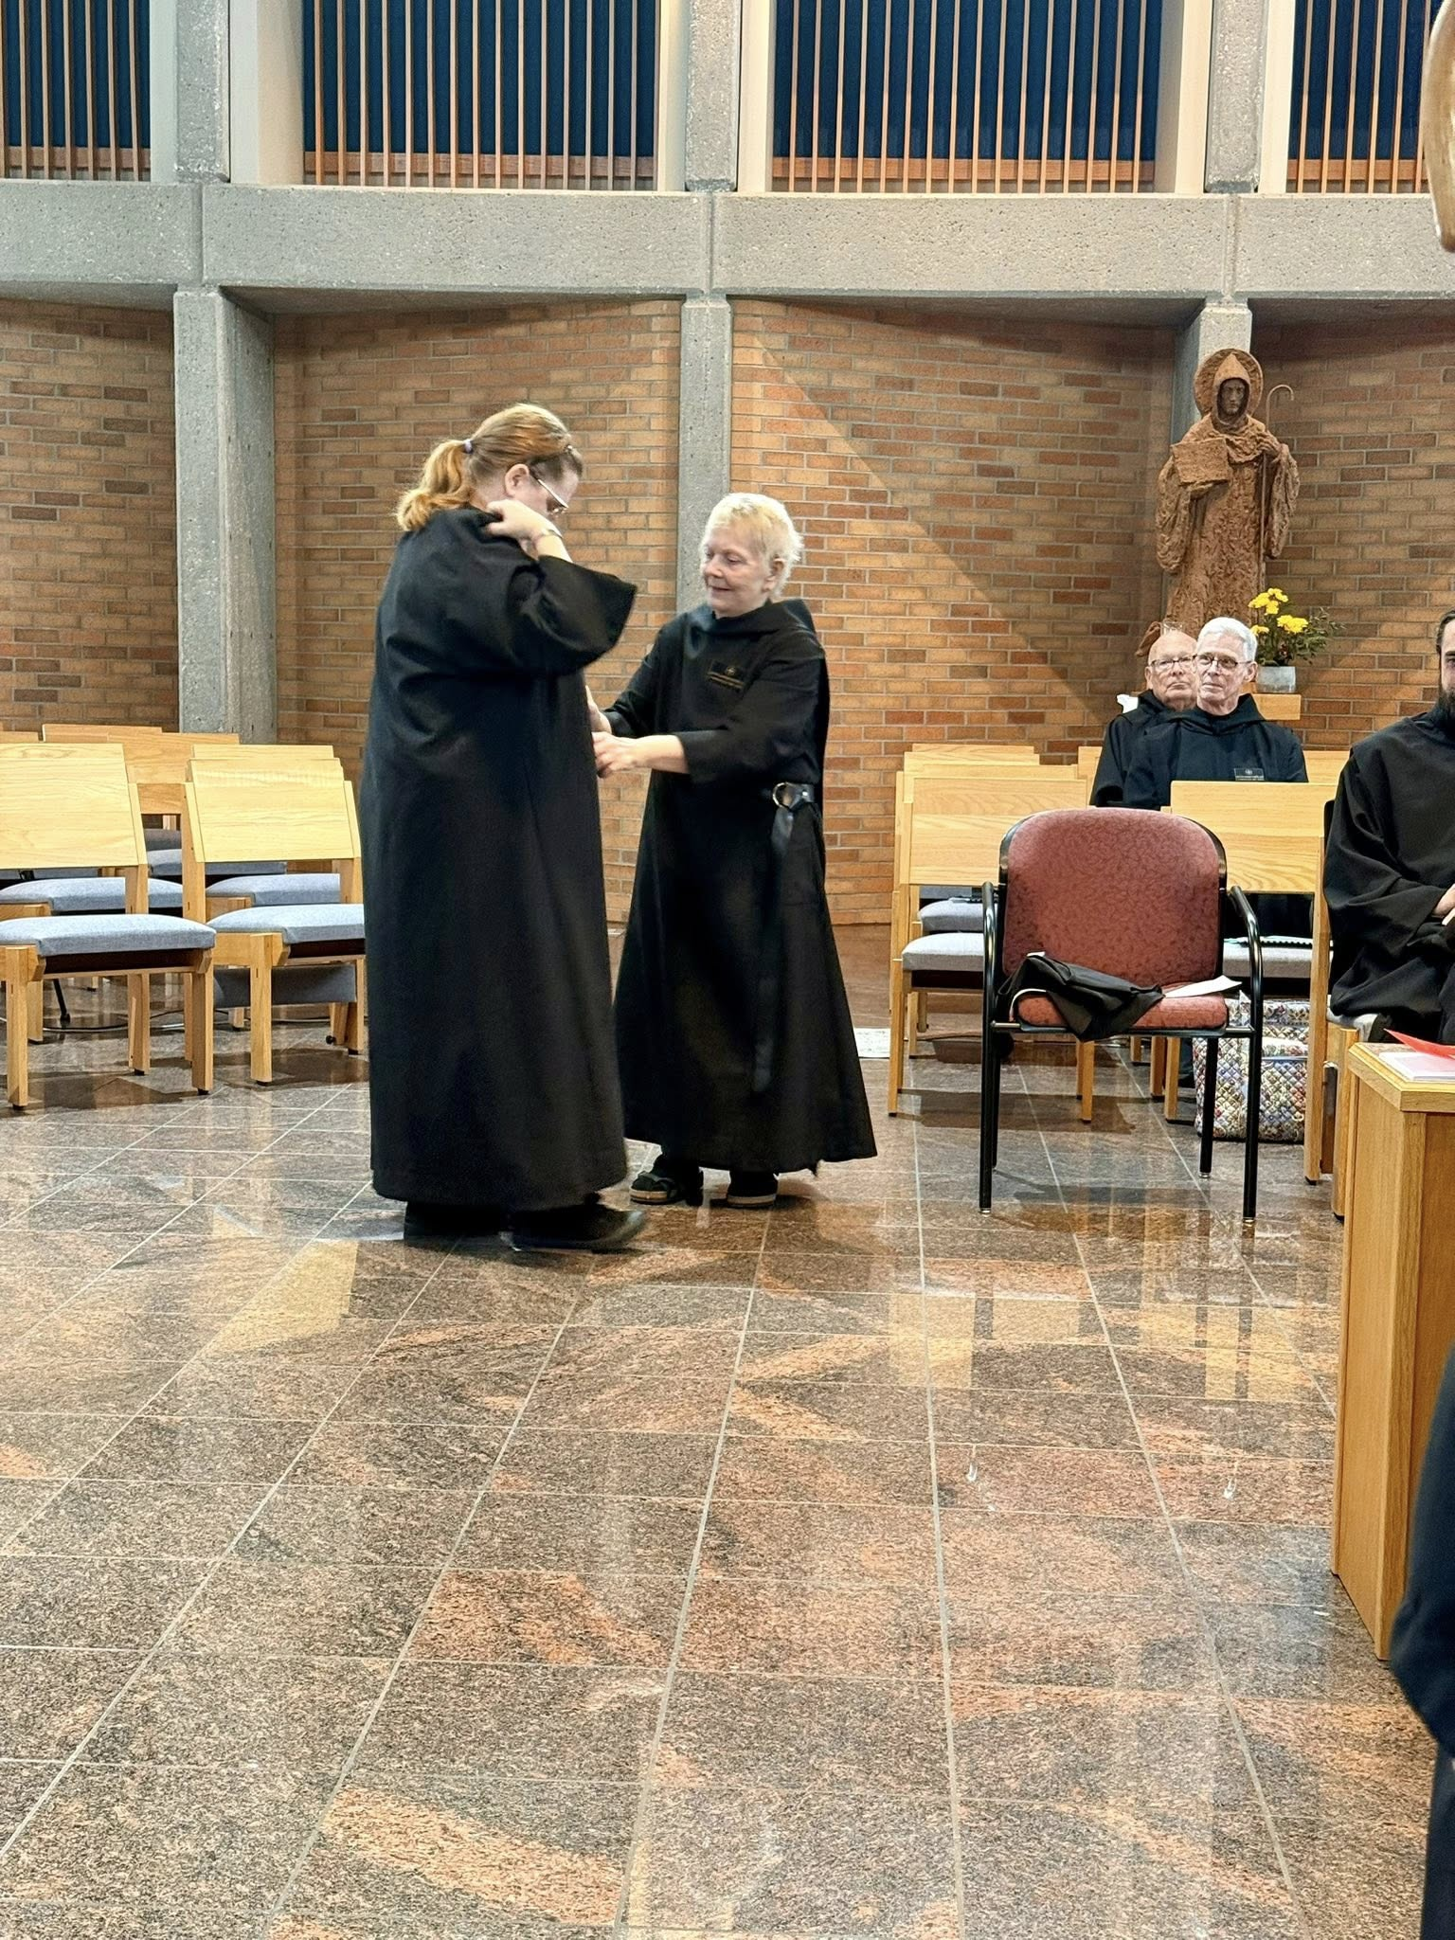
Sr. Seraphina MacKay; Sr. Julian Smith-Boyer; Br. Joseph Elias Varsanyi; Br. Anskar Nonken; Br. Andrew Grimsby

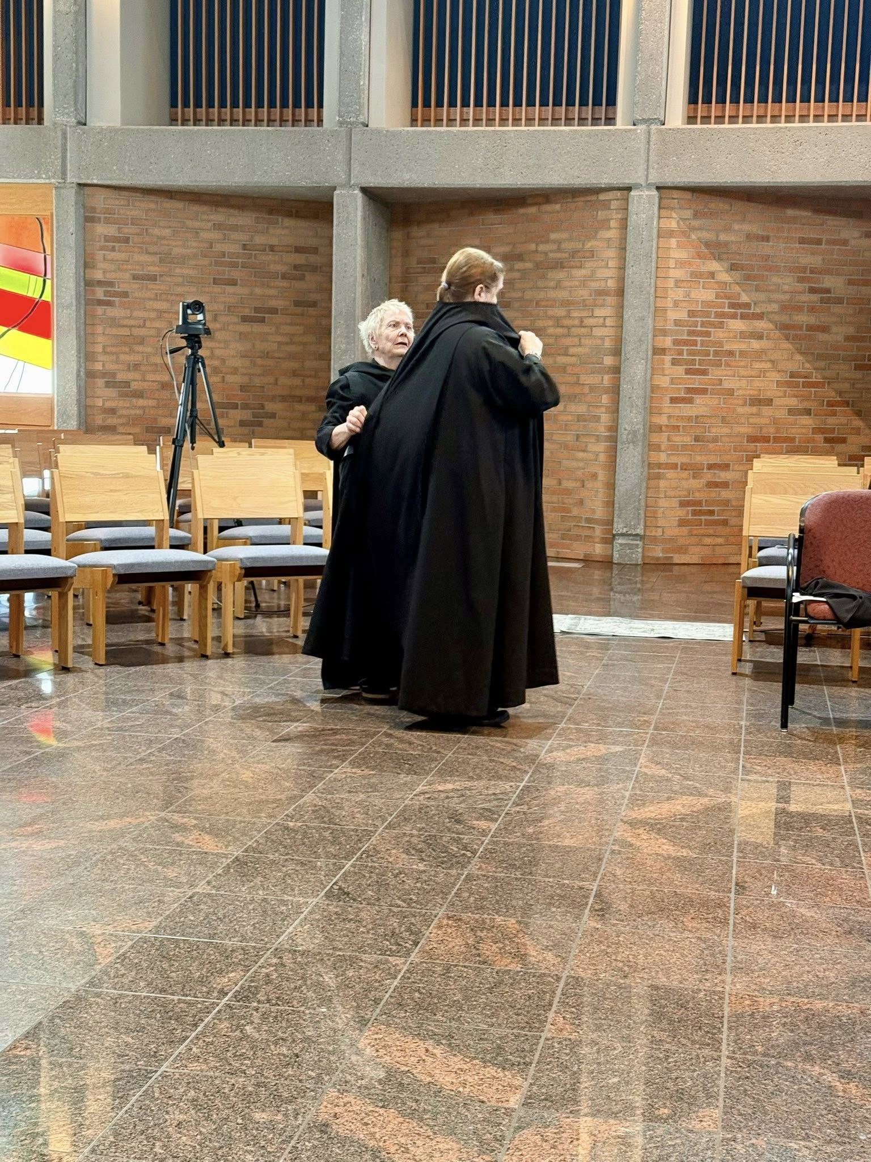
Sr. Julian Smith-Boyer; Sr. Seraphina MacKay
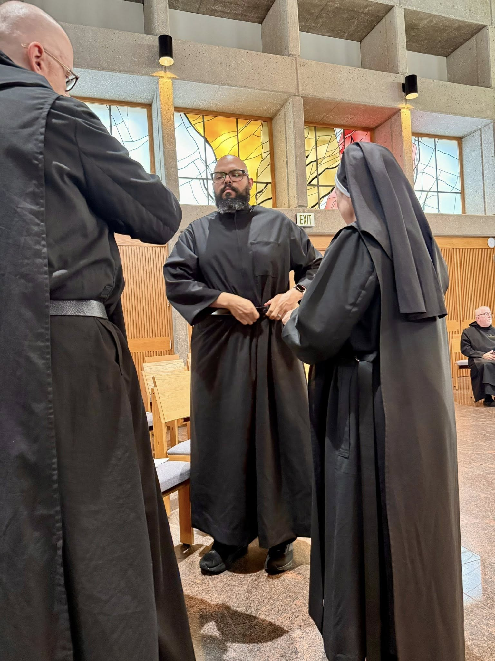
Br. Ronan Patrick; Br. Dominic Ndife; Sr. Mary Magdalene Clarke; Br. Joseph Elias Varsanyi

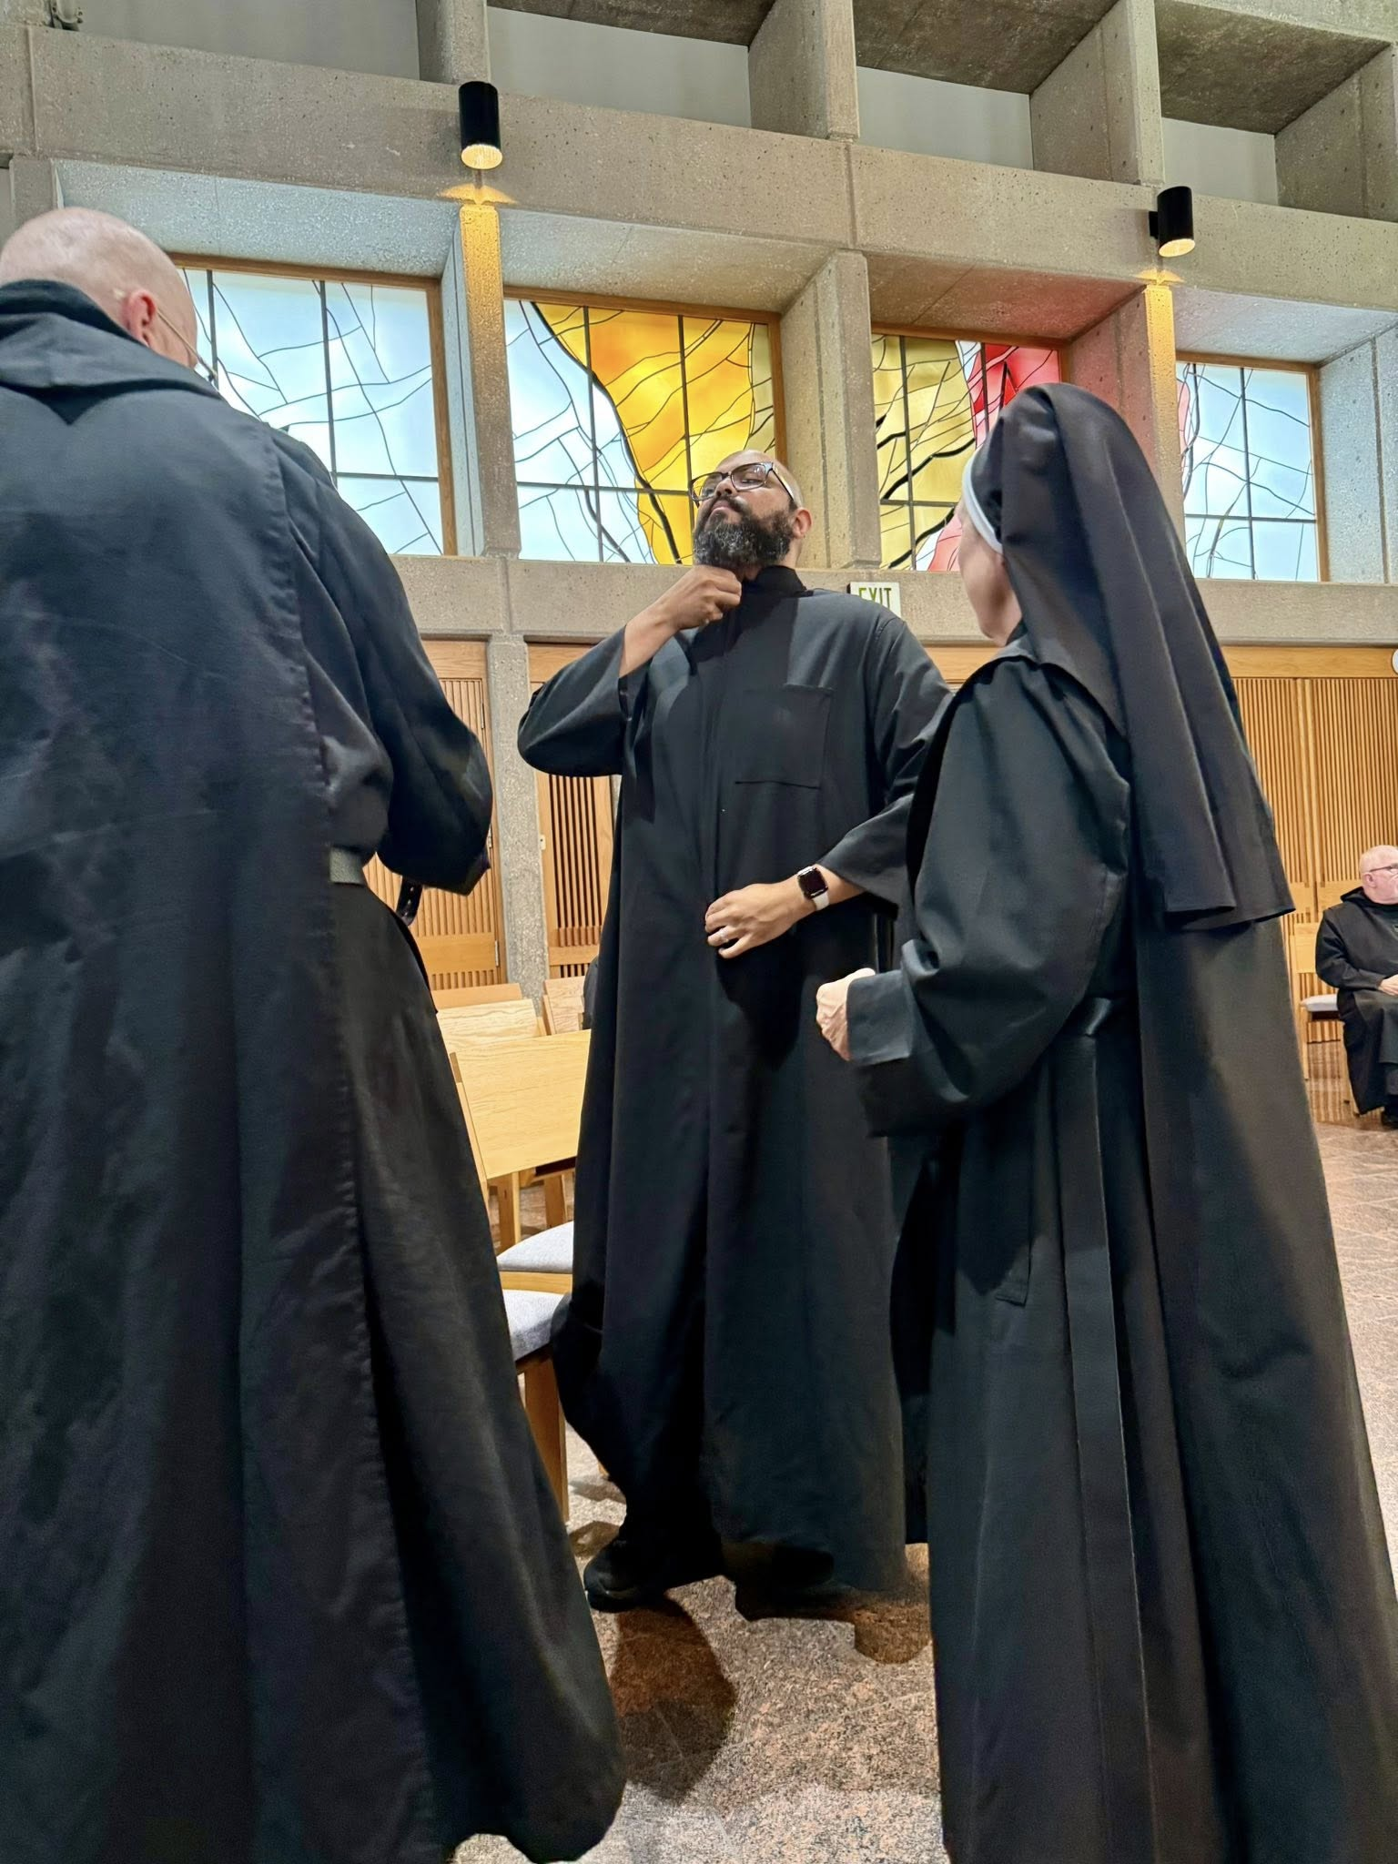
Br. Ronan Patrick; Br. Dominic Ndife; Sr. Mary Magdalene Clarke; Br. Joseph Elias Varsanyi

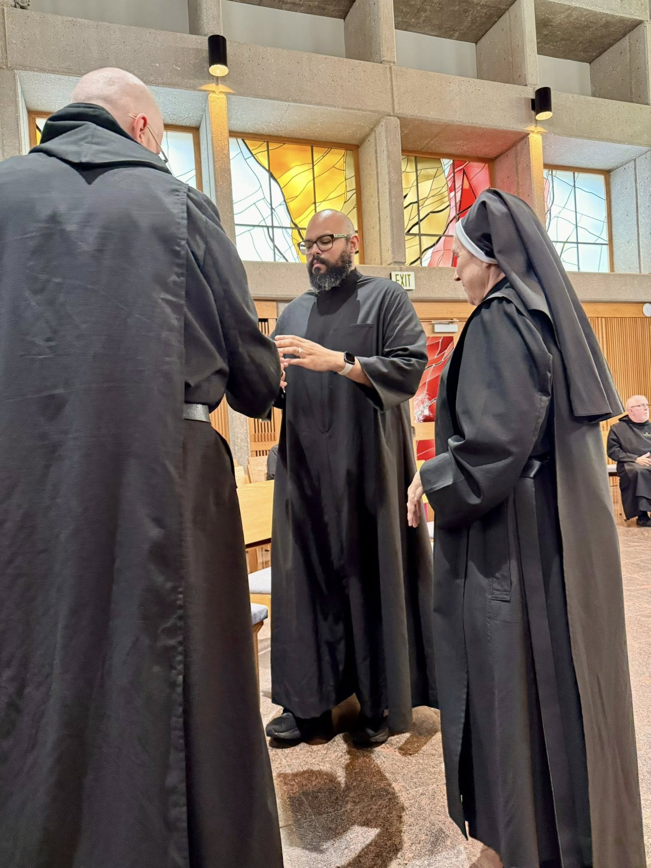
Br. Ronan Patrick; Br. Dominic Ndife; Sr. Mary Magdalene Clarke; Br. Joseph Elias Varsanyi
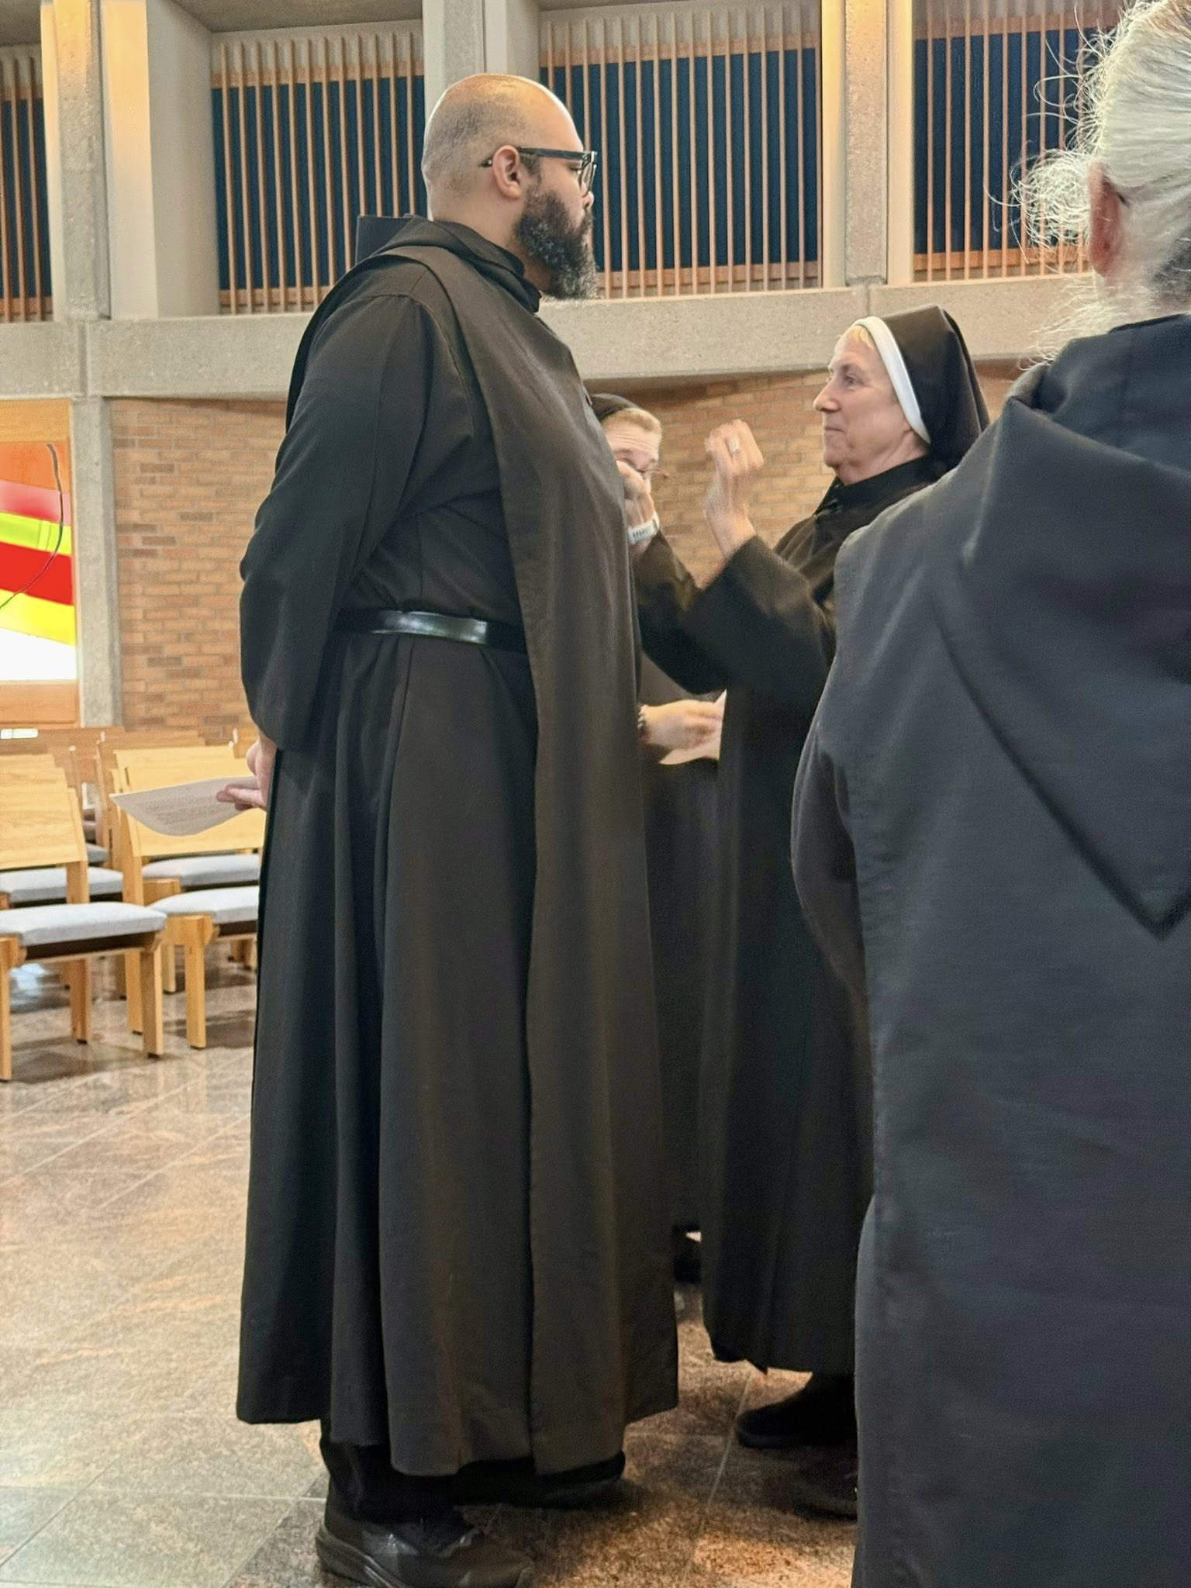
Br. Dominic Ndife; Sr. Seraphina MacKay; Sr. Mary Magdalene Clarke ; Sr. Gianna Altadonna

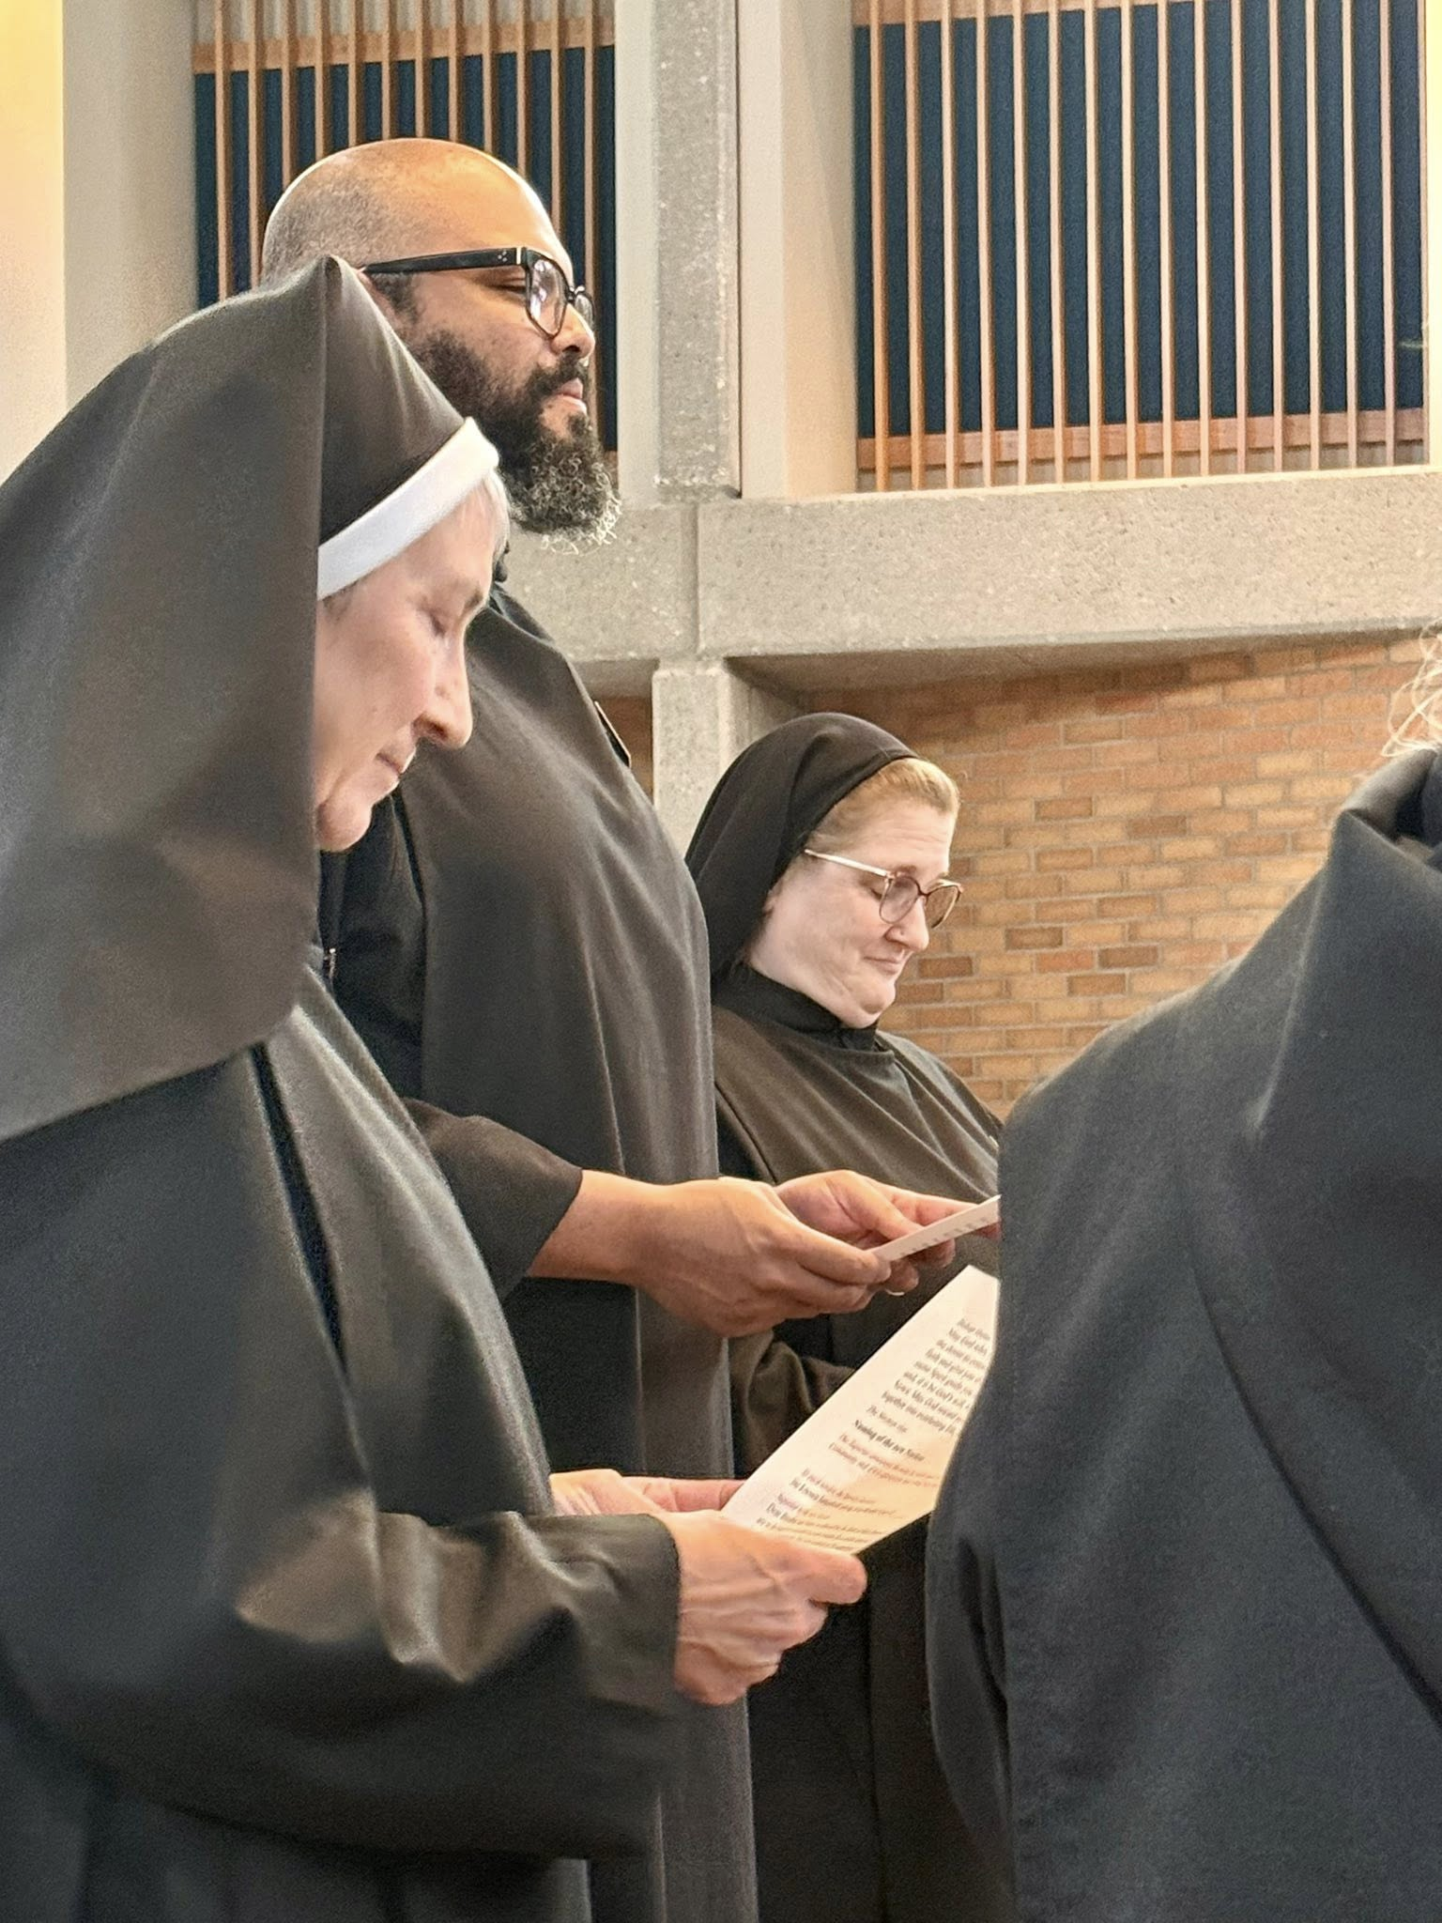
Sr. Mary Magdalene Clarke; Br. Dominic Ndife; Sr. Seraphina MacKay; Sr. Gianna Altadonna

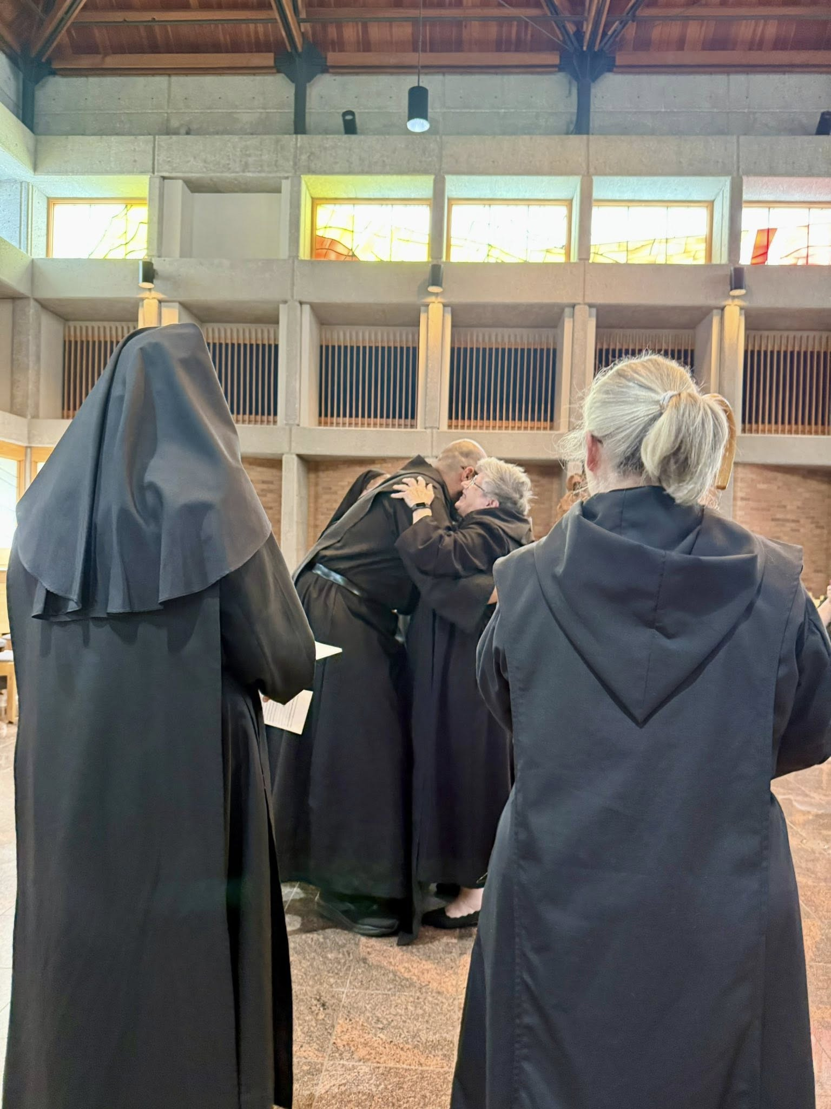
Sr. Mary Magdalene Clarke; Br. Dominic Ndife; Abbess Martha Lamoy; Sr. Gianna Altadonna
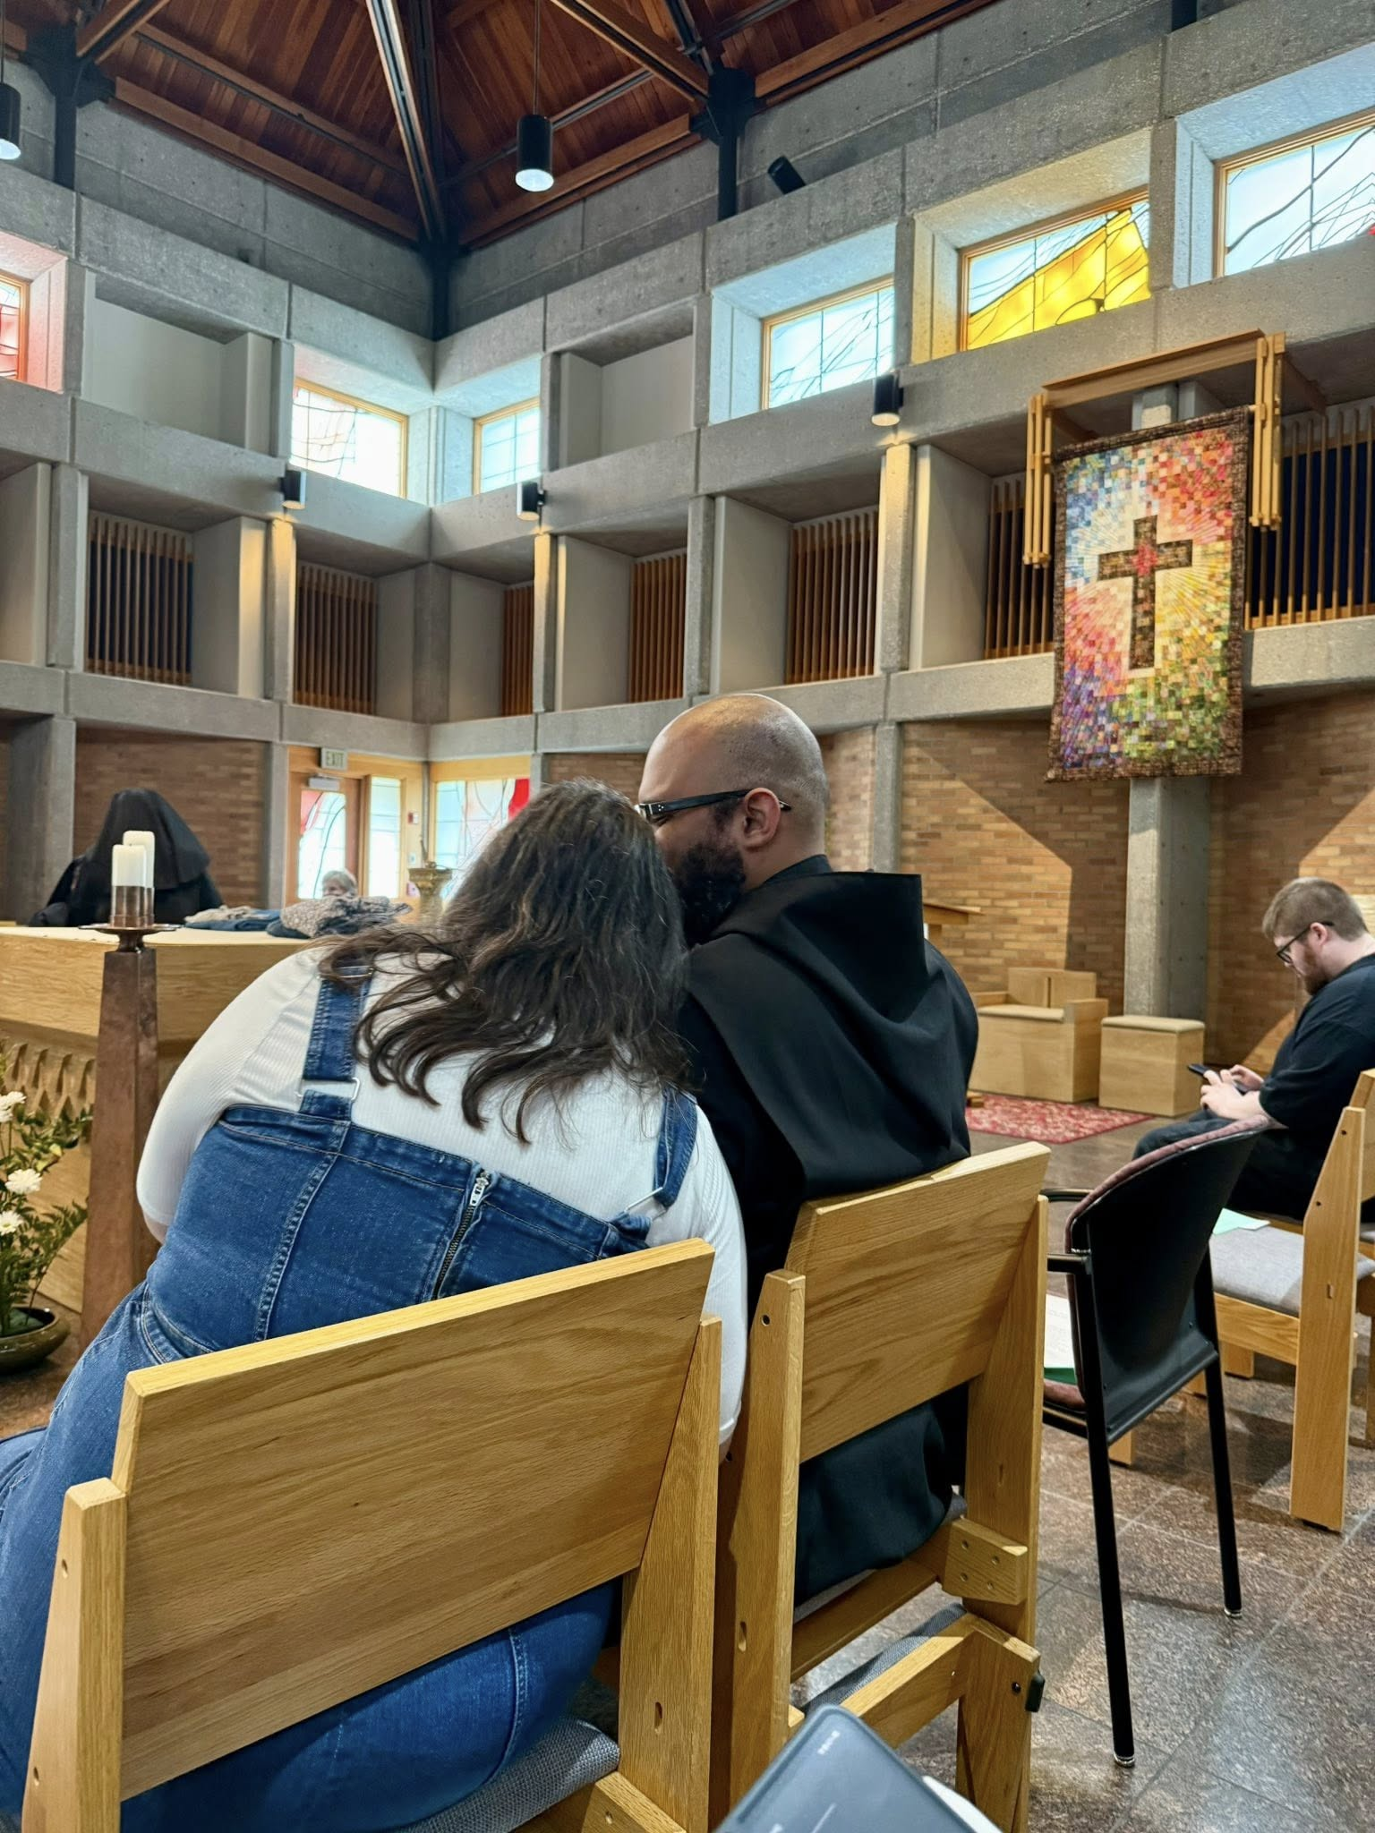
Kayla Ndife; Br. Dominic Ndife; Joseph Hain

