July 21-25 Convocation
St. Gregory’s Abbey
Schuyler, Nebraska
Part 1 of 4

People are identified left to right.

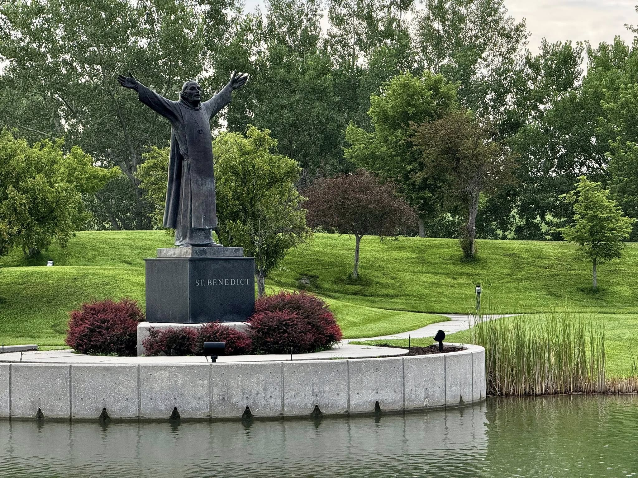
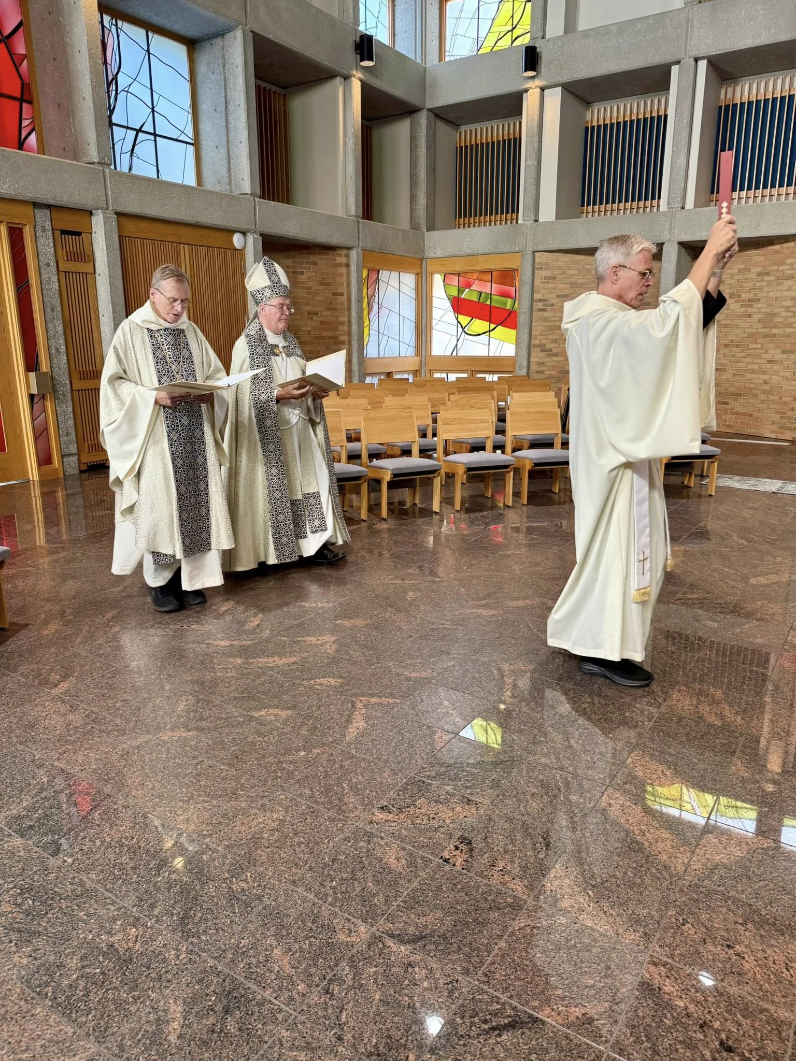
Bp. Dorsey McConnell; Bp. Alan Scarfe; Br. Anskar Nonken

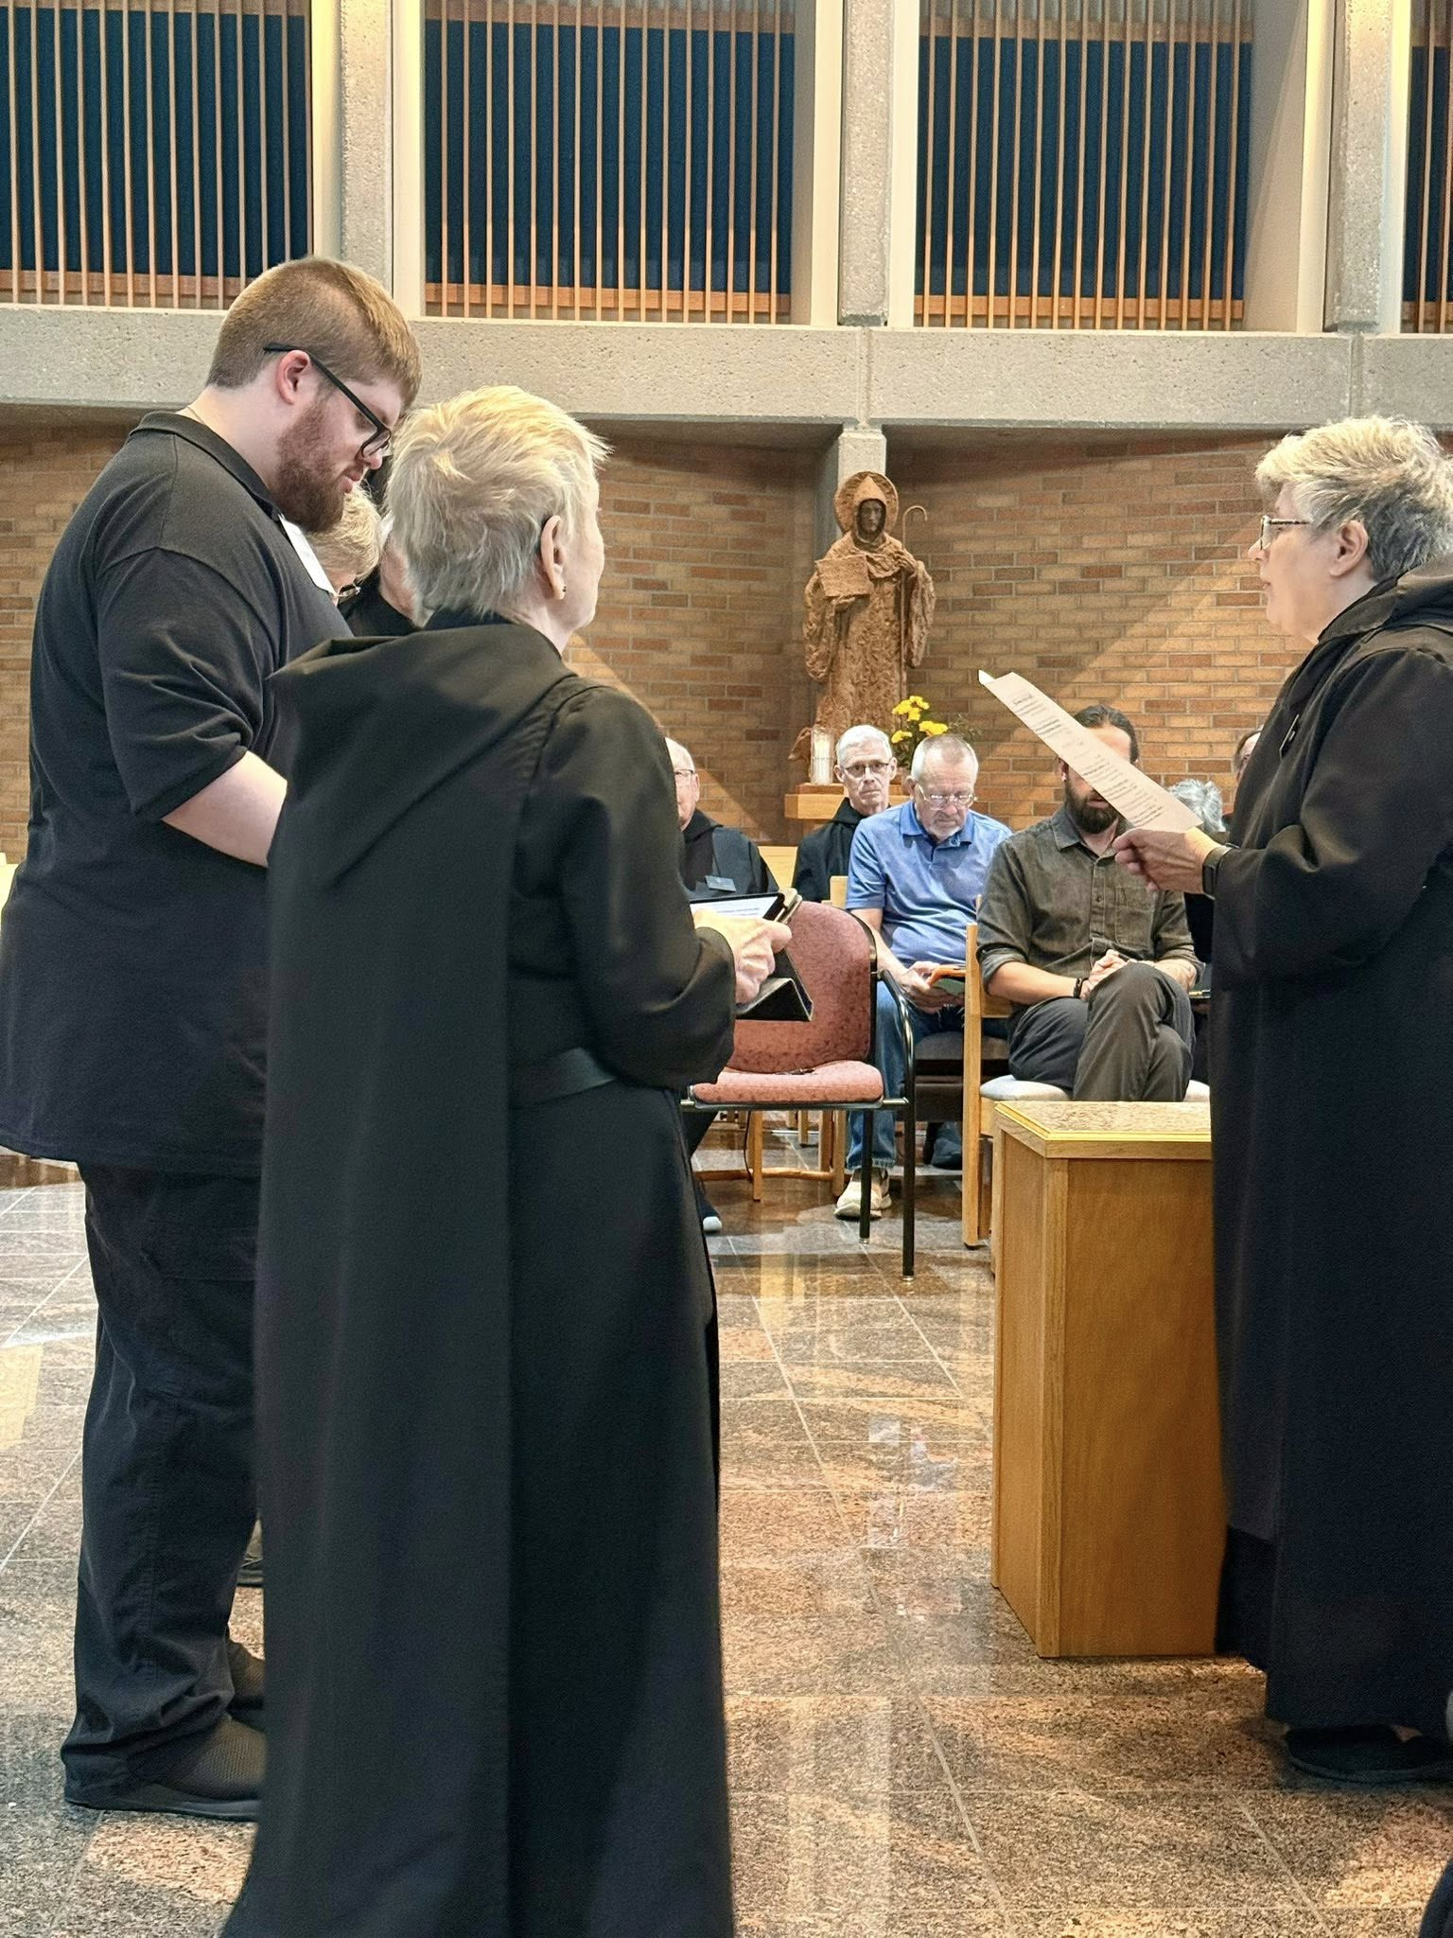
Joseph Hain; Nan DeStafney; Sr. Julian Smith-Boyer; Br. John David Wynne; Br. Anskar Nonken; Larry Koronka; Br. Andrew Grimsby; Abbess Martha Lamoy
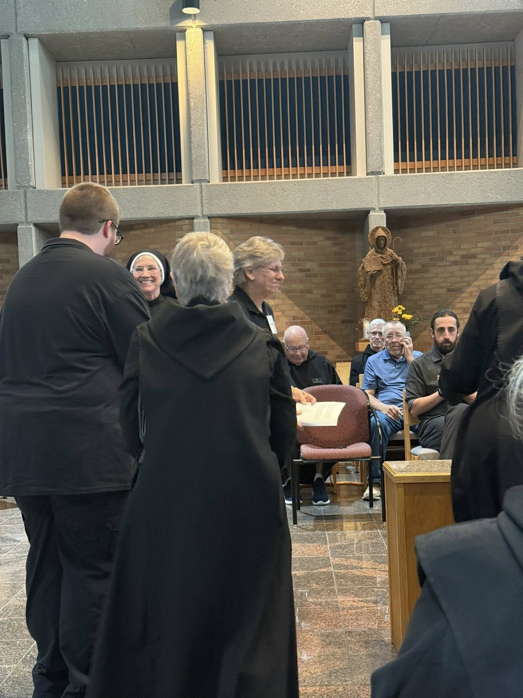
Joseph Hain; Sr. Mary Magdalen Clarke; Sr. Julian Smith-Boyer; Nan DeStafney; Br. John David Wynne; Br. Anskar Nonken; Larry Koronka; Br. Andrew Grimsby

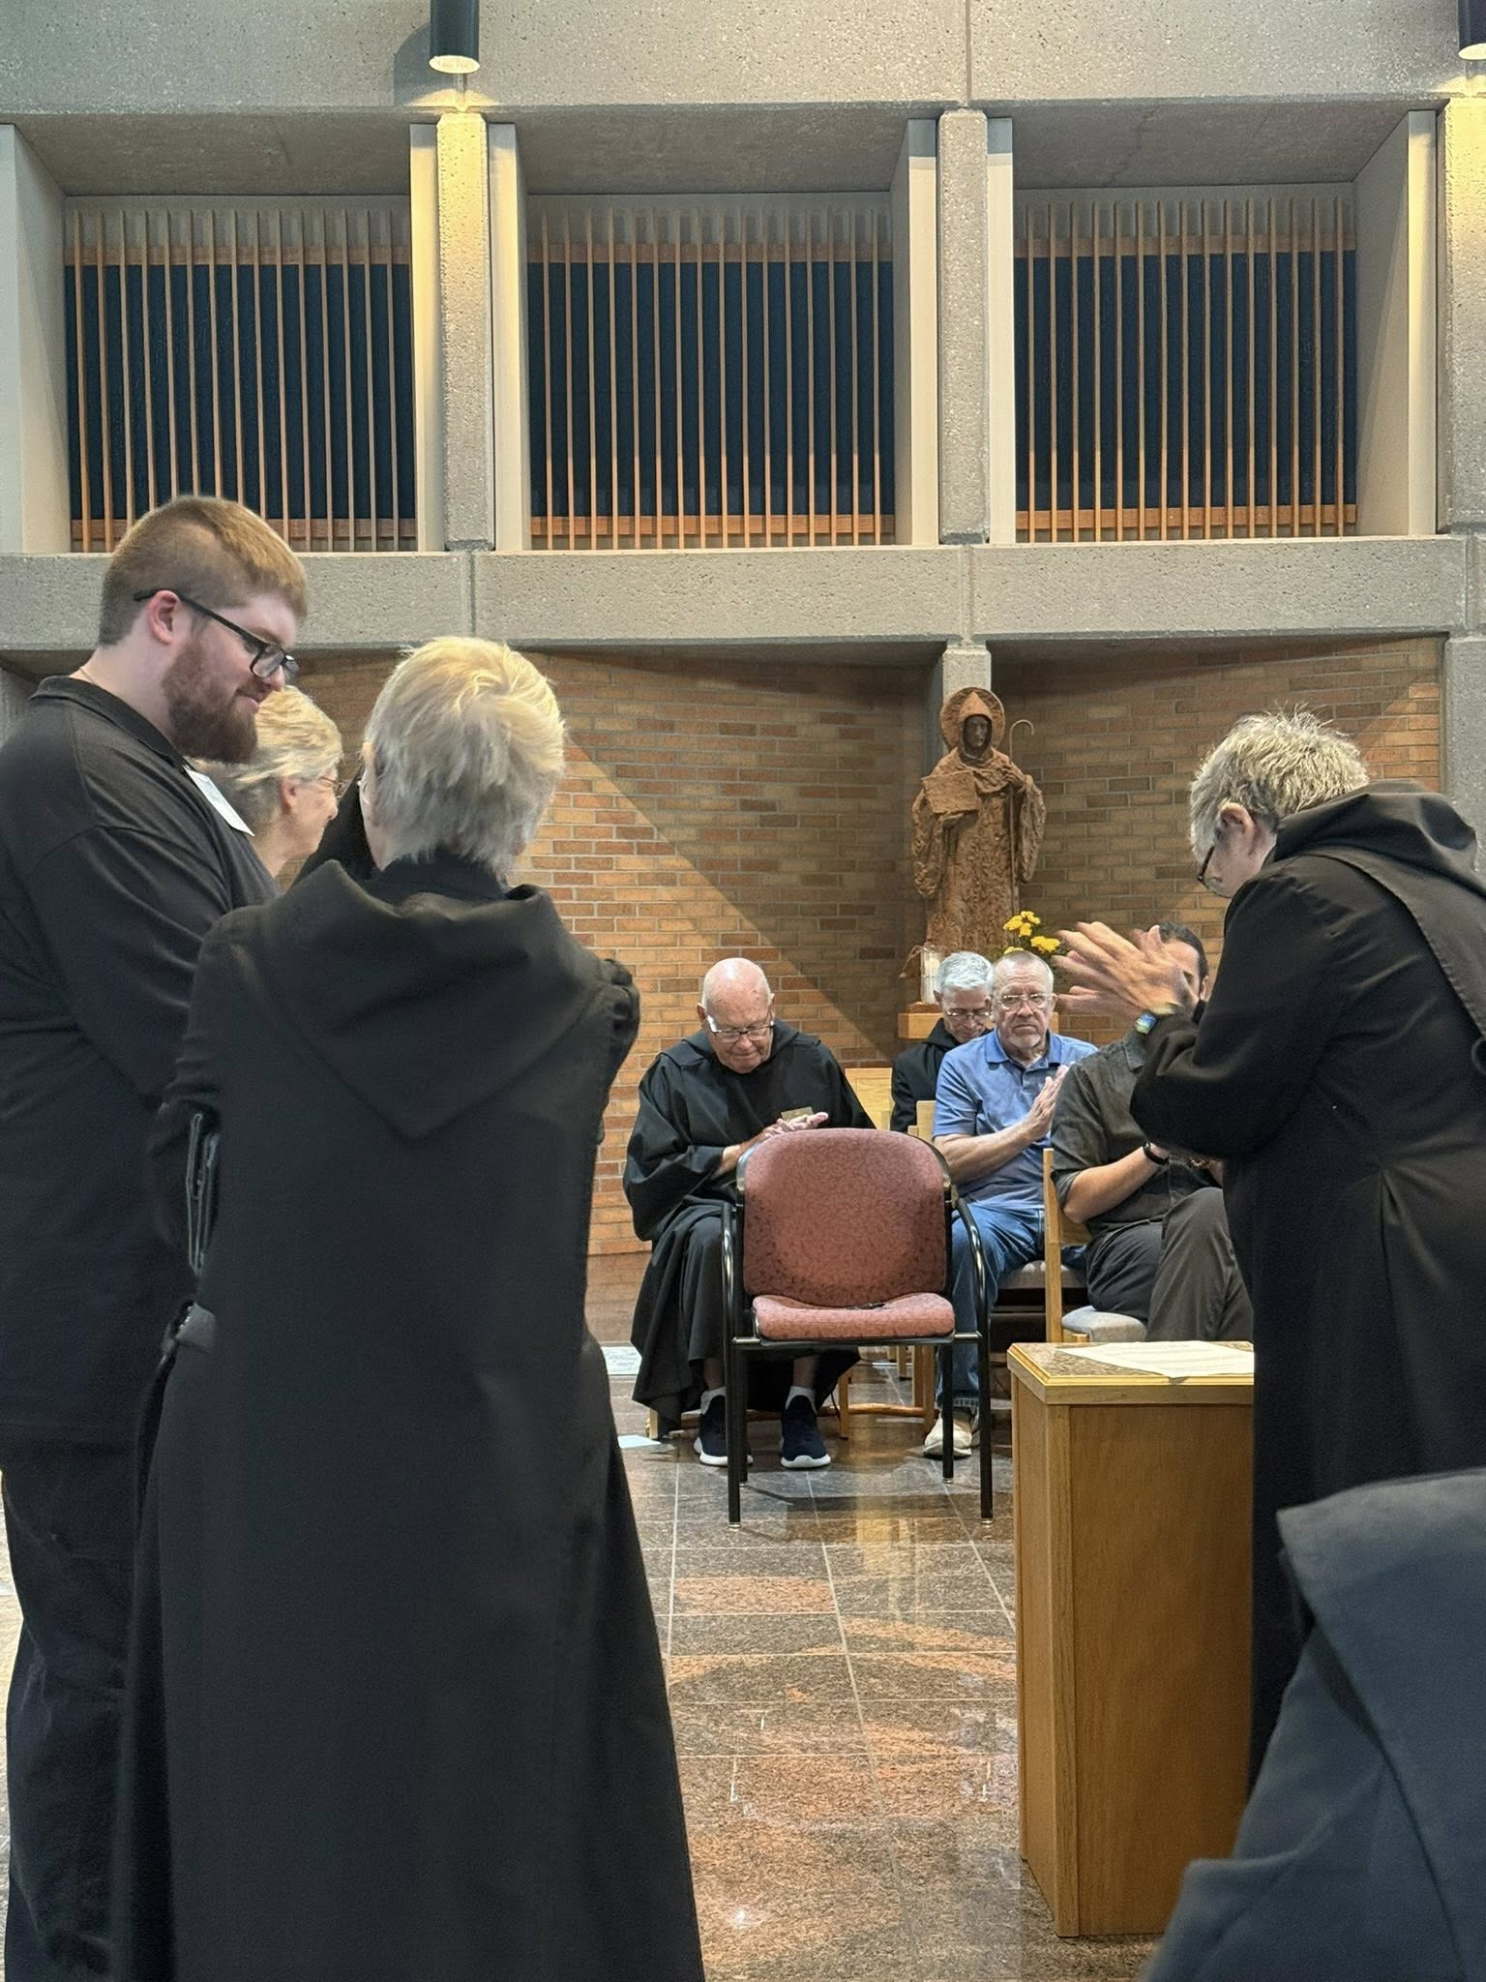
Joseph Hain; Nan DeStafney; Sr. Julian Smith-Boyer; Br. John David Wynne; Br. Anskar Nonken; Larry Koronka; Br. Andrew Grimsby; Abbess Martha Lamoy

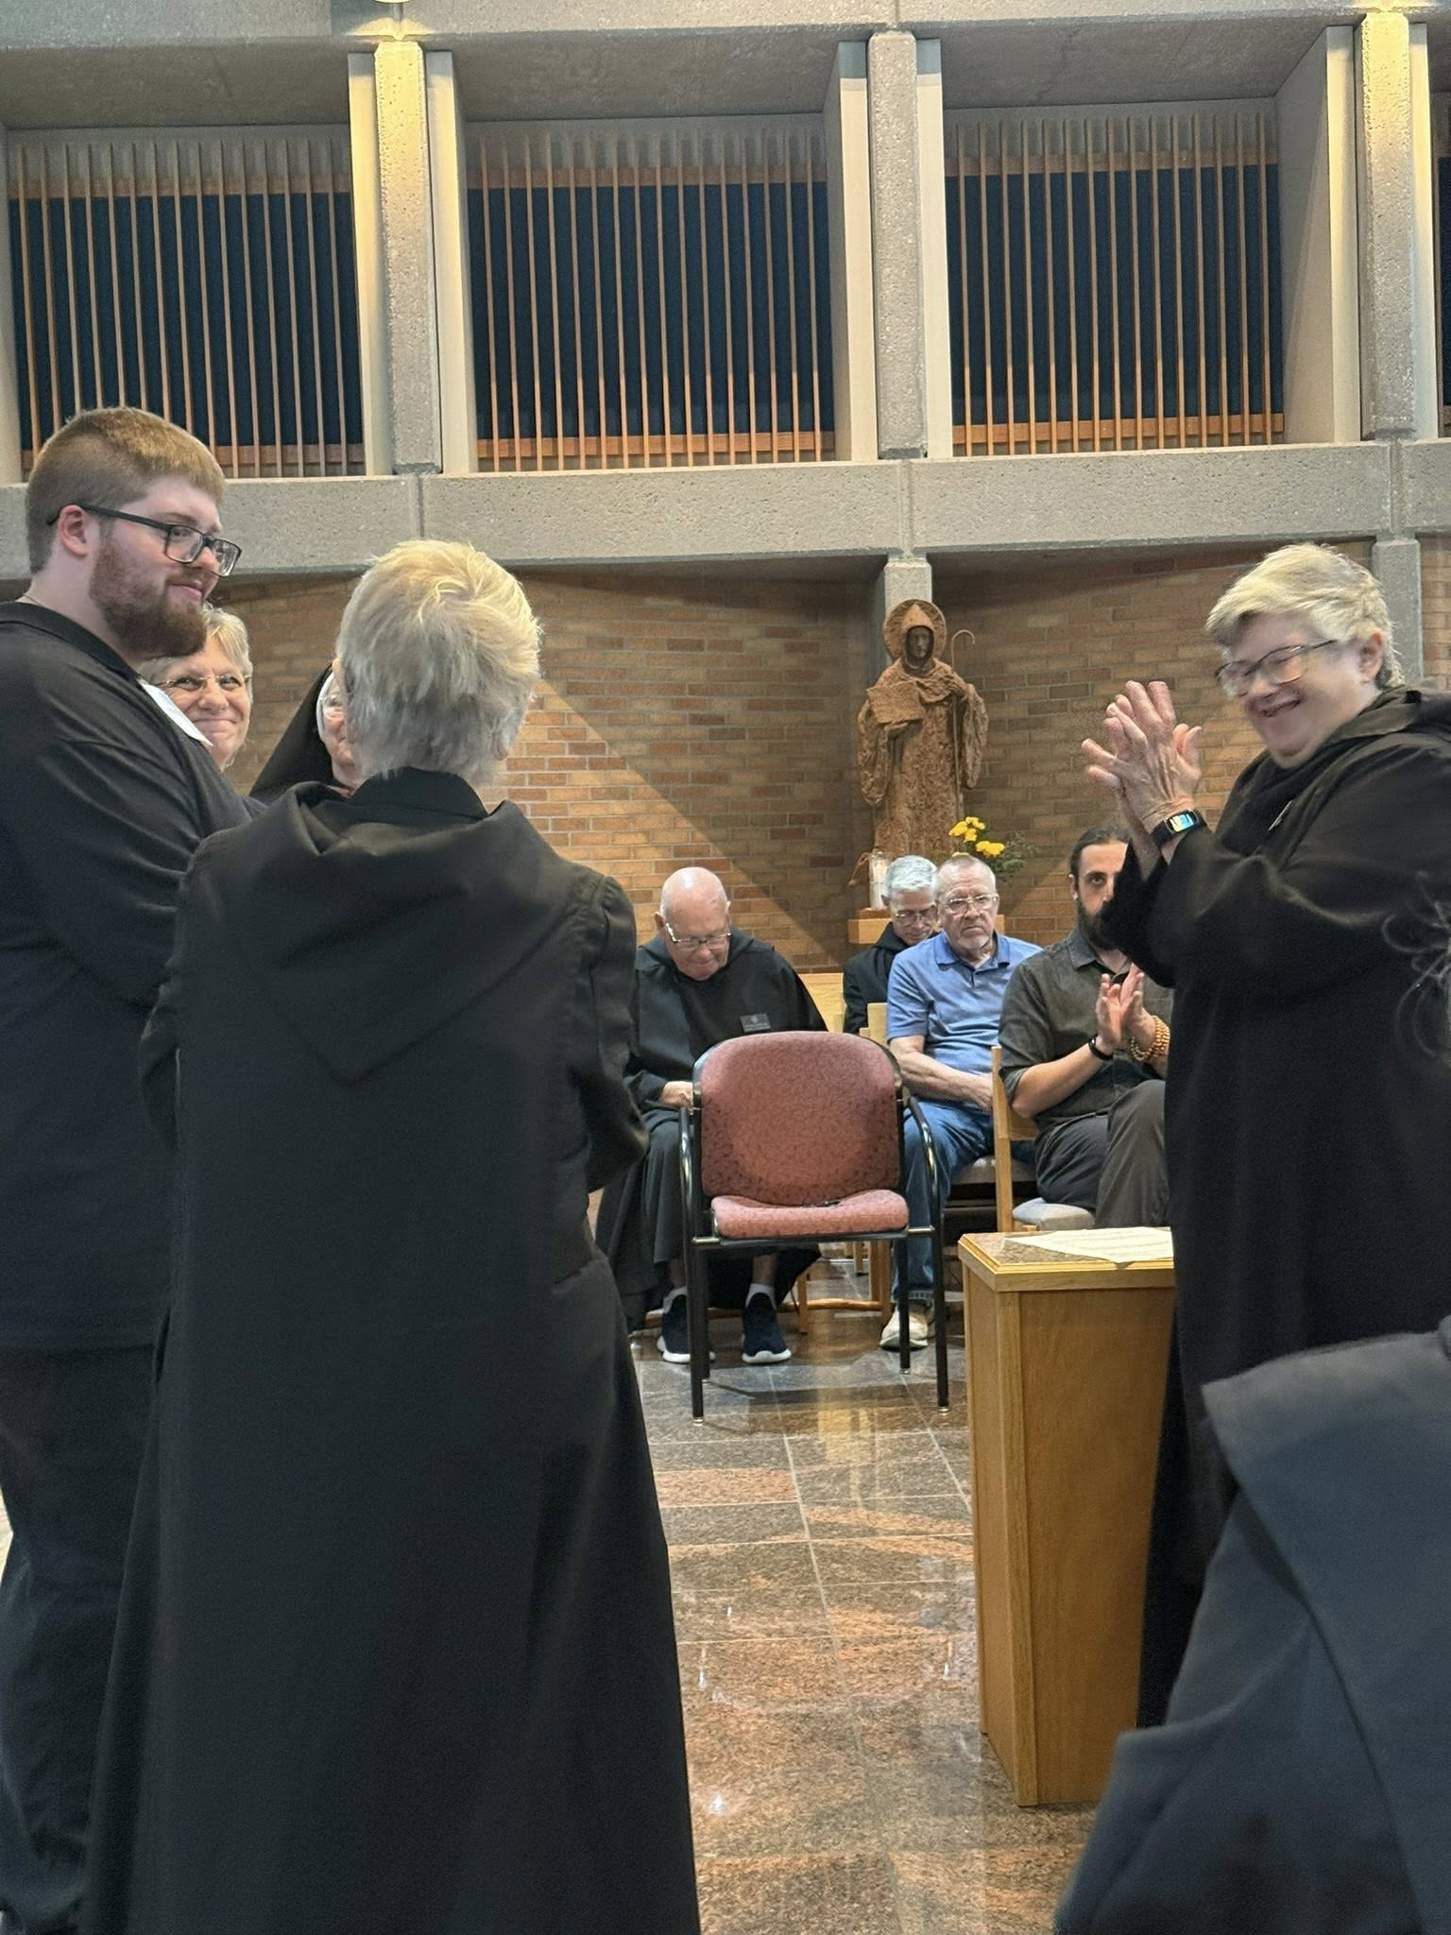
Joseph Hain; Nan DeStafney; Sr. Mary Magdalene Clarke; Sr. Julian Smith-Boyer; Br. John David Wynne; Br. Anskar Nonken; Larry Koronka; Br. Andrew Grimsby; Abbess Martha Lamoy
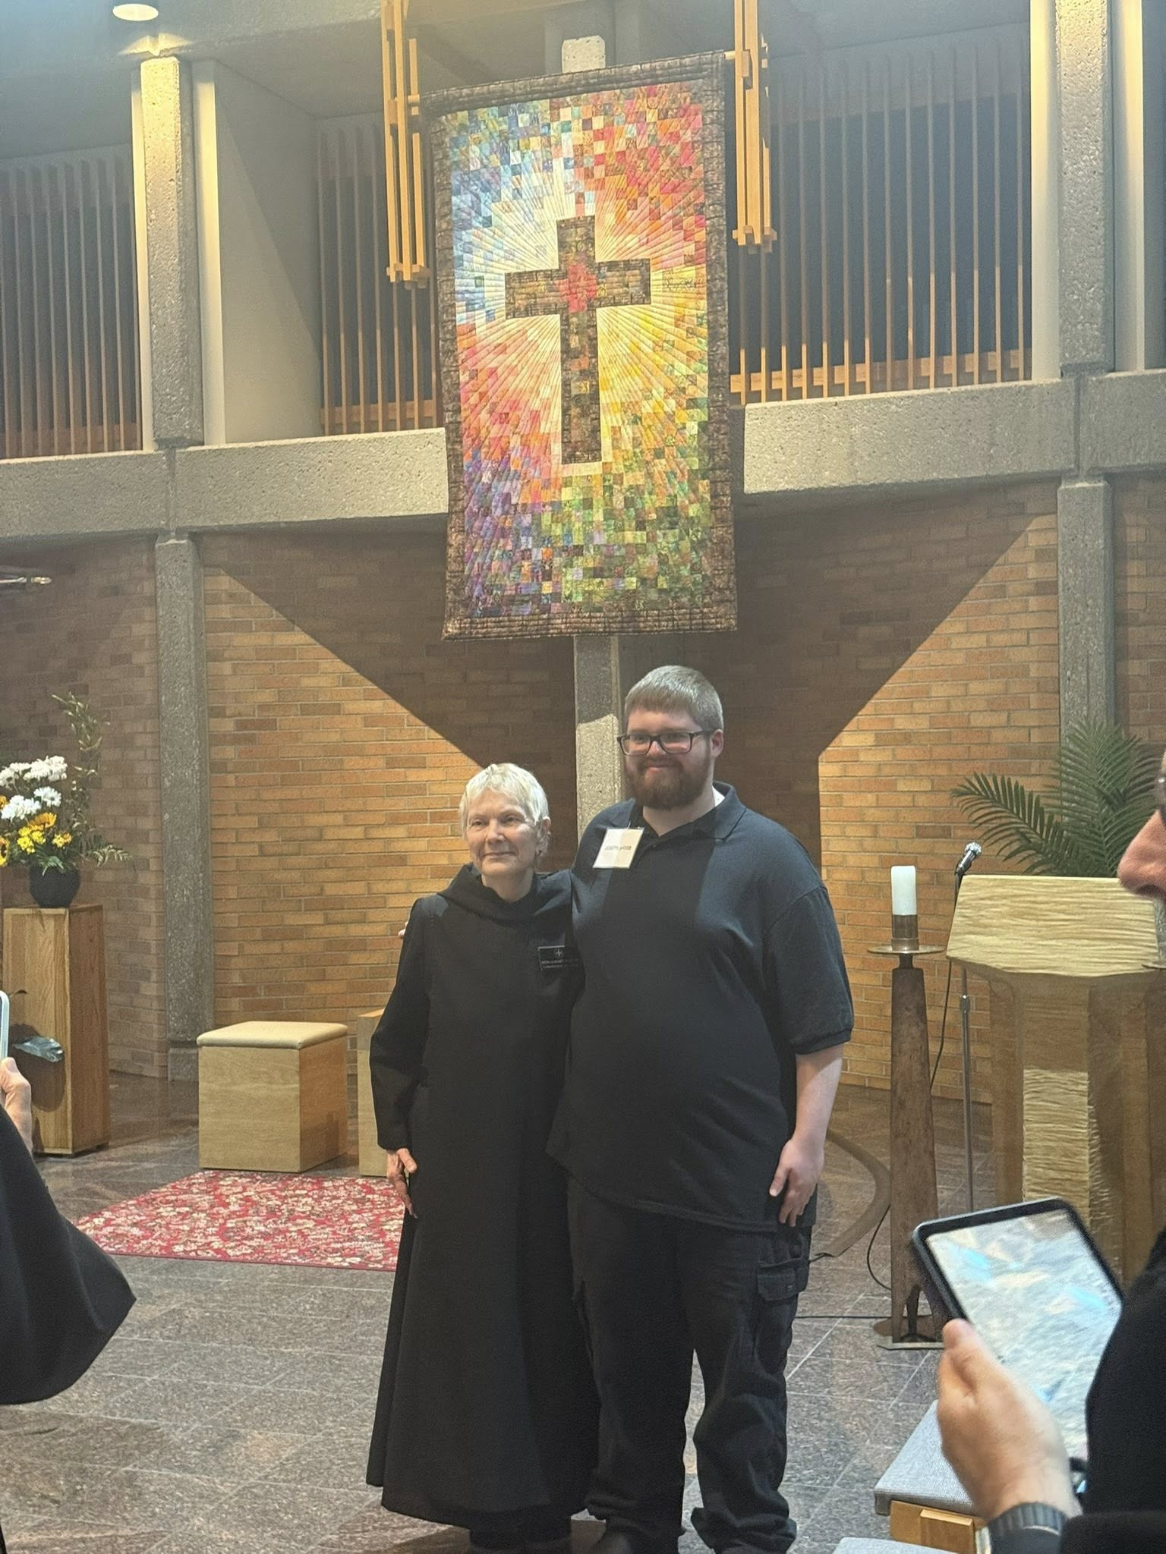
Sr. Julian Smith-Boyer; Joseph Hain
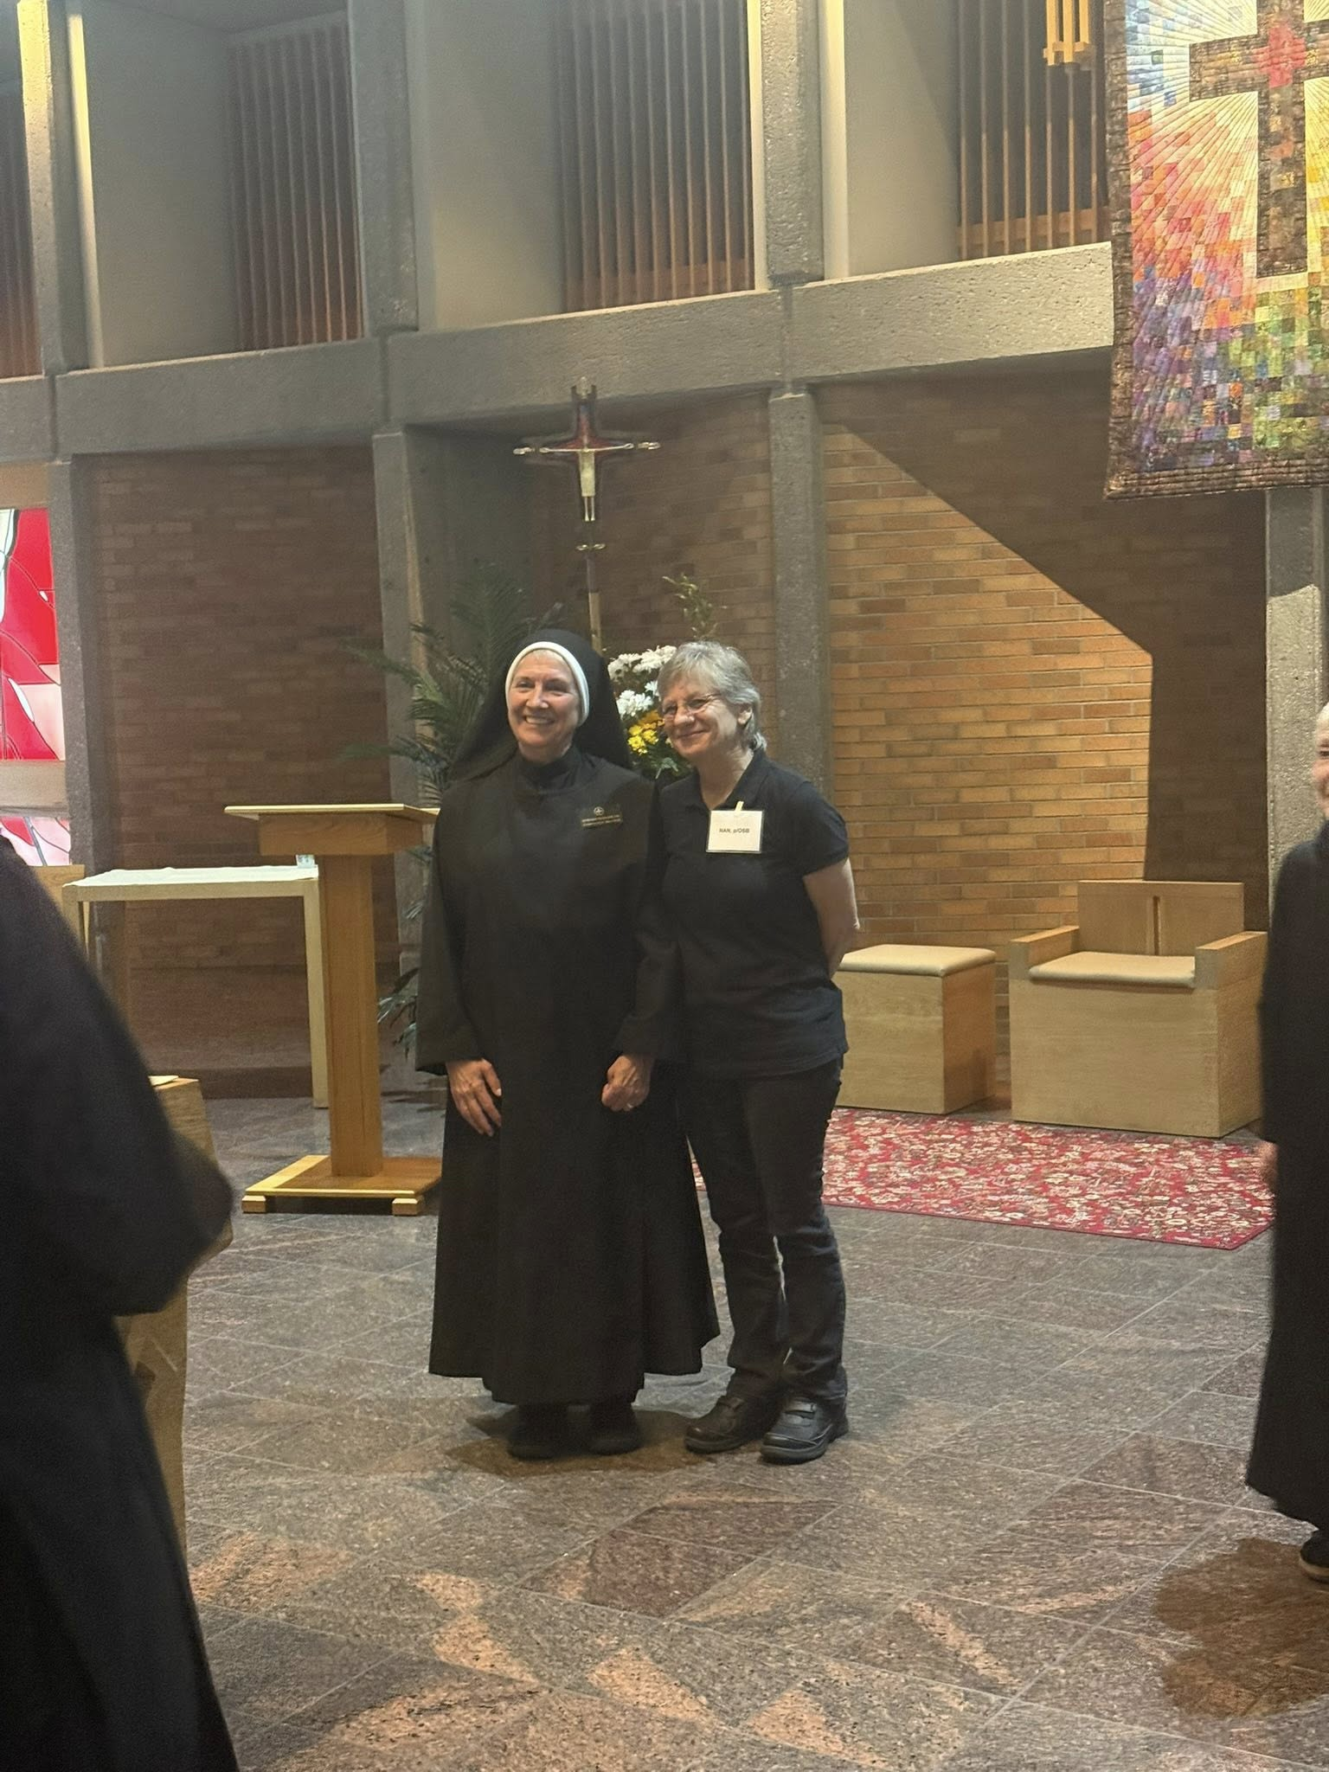
Sr. Mary Magdalene Clarke; Nan DeStafney; Sr. Julian Smith-Boyer
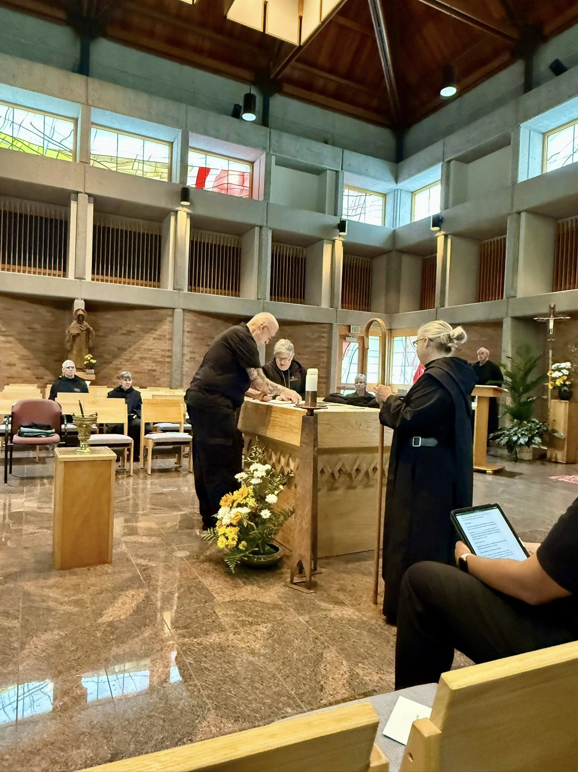
Br. Anskar Nonken; Sr. Clare Koronka; Br. Richard Joachim Knight; Abbess Martha Lamoy; Nan DeStafney; Sr. Gianna Altadonna; Br. Florian Campbell

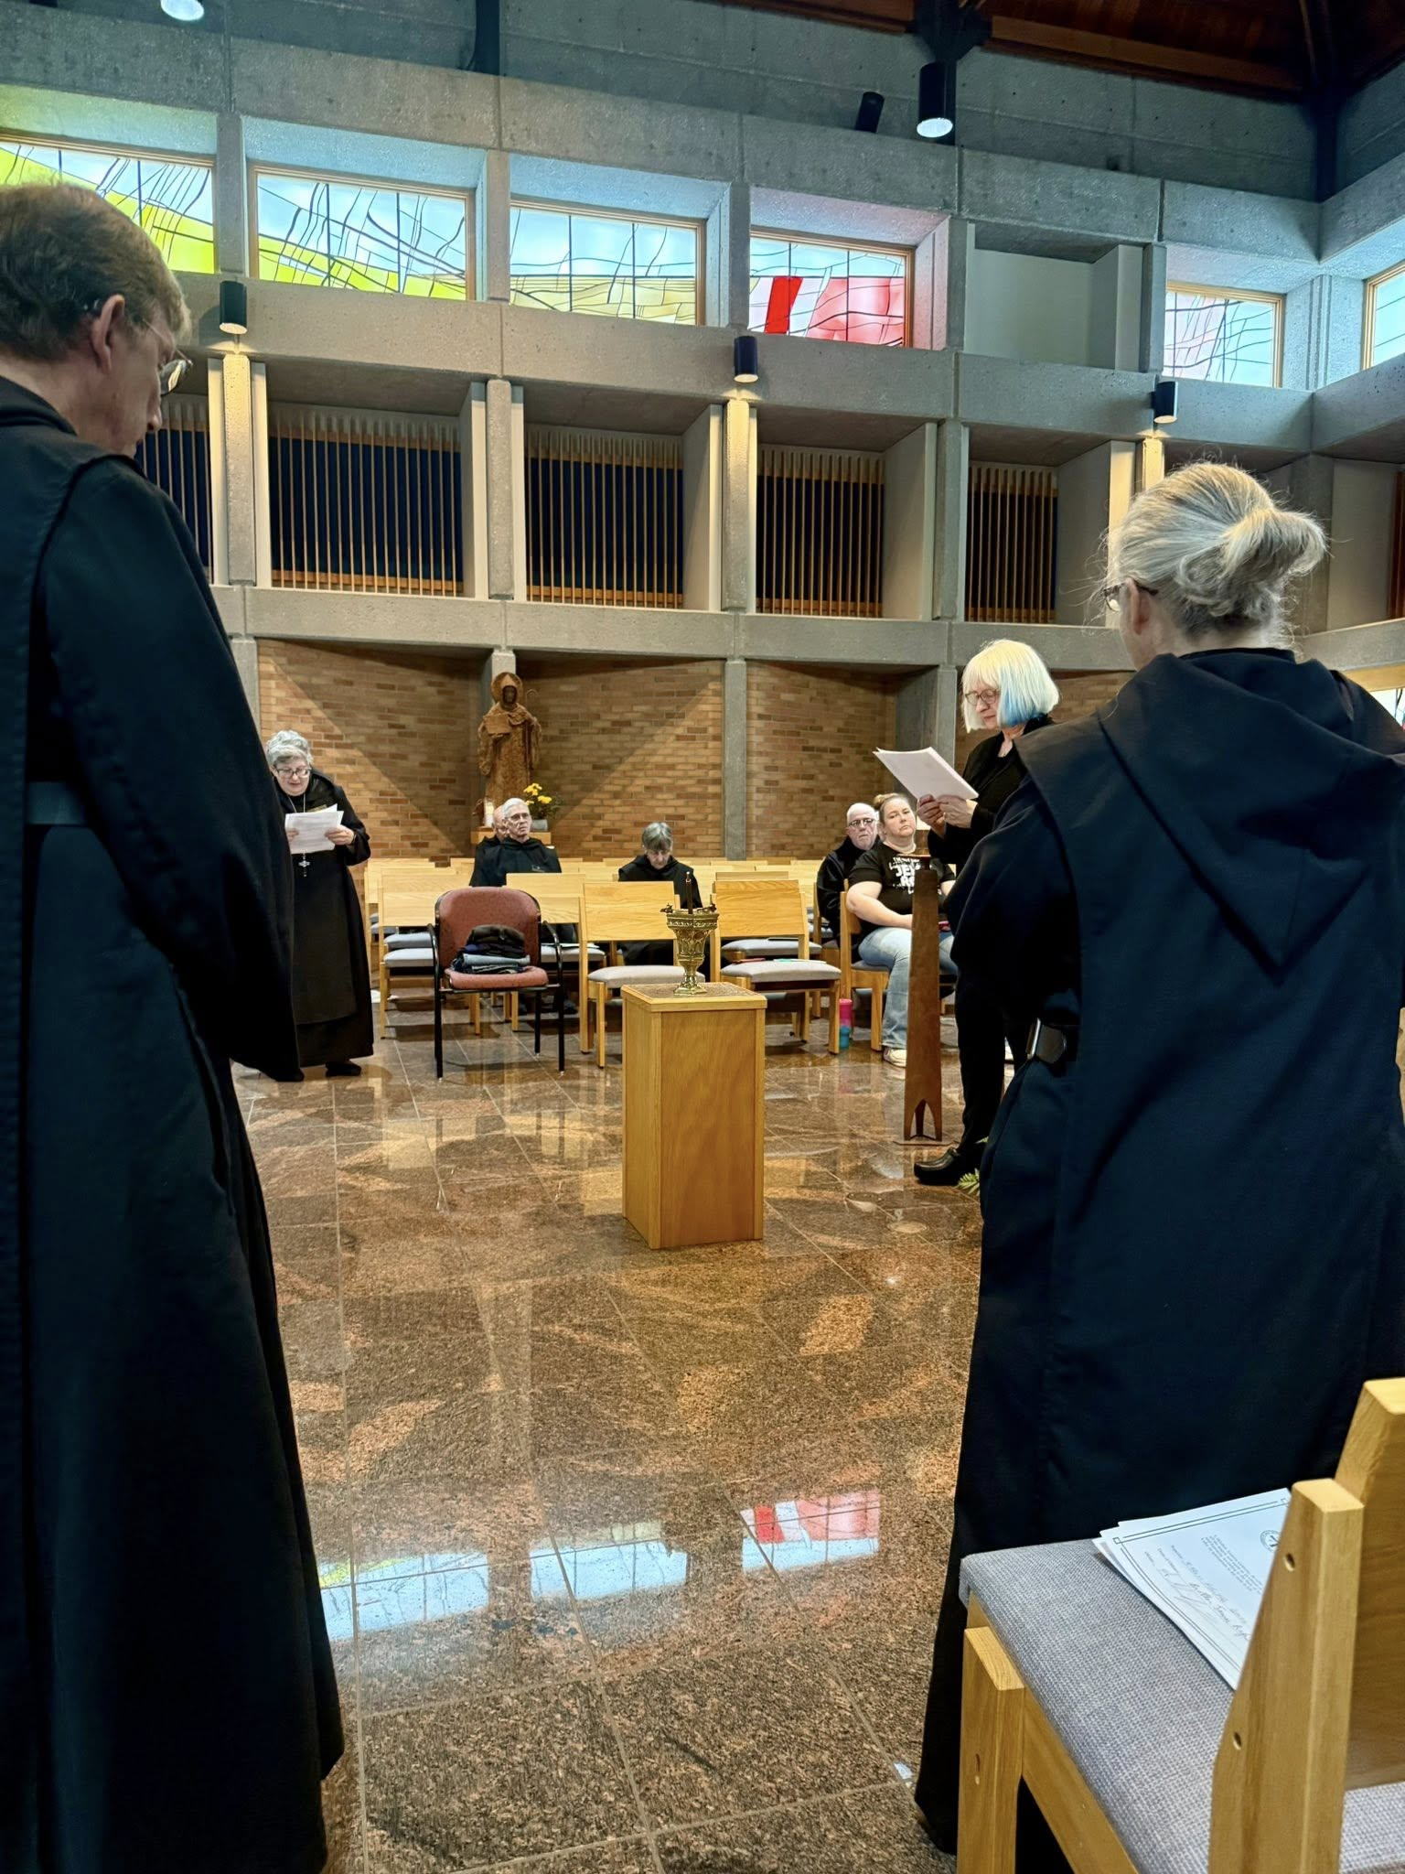
Br. William Marion Page; Abbess Martha Lamoy; Br. John David Wynne; Br. Anskar Nonken; Sr. Clare Koronka; Br. Joseph Elias Varsanyi; Jennifer Ivey; Sr. Cynthia Anne Page; Sr. Gianna Altadonna

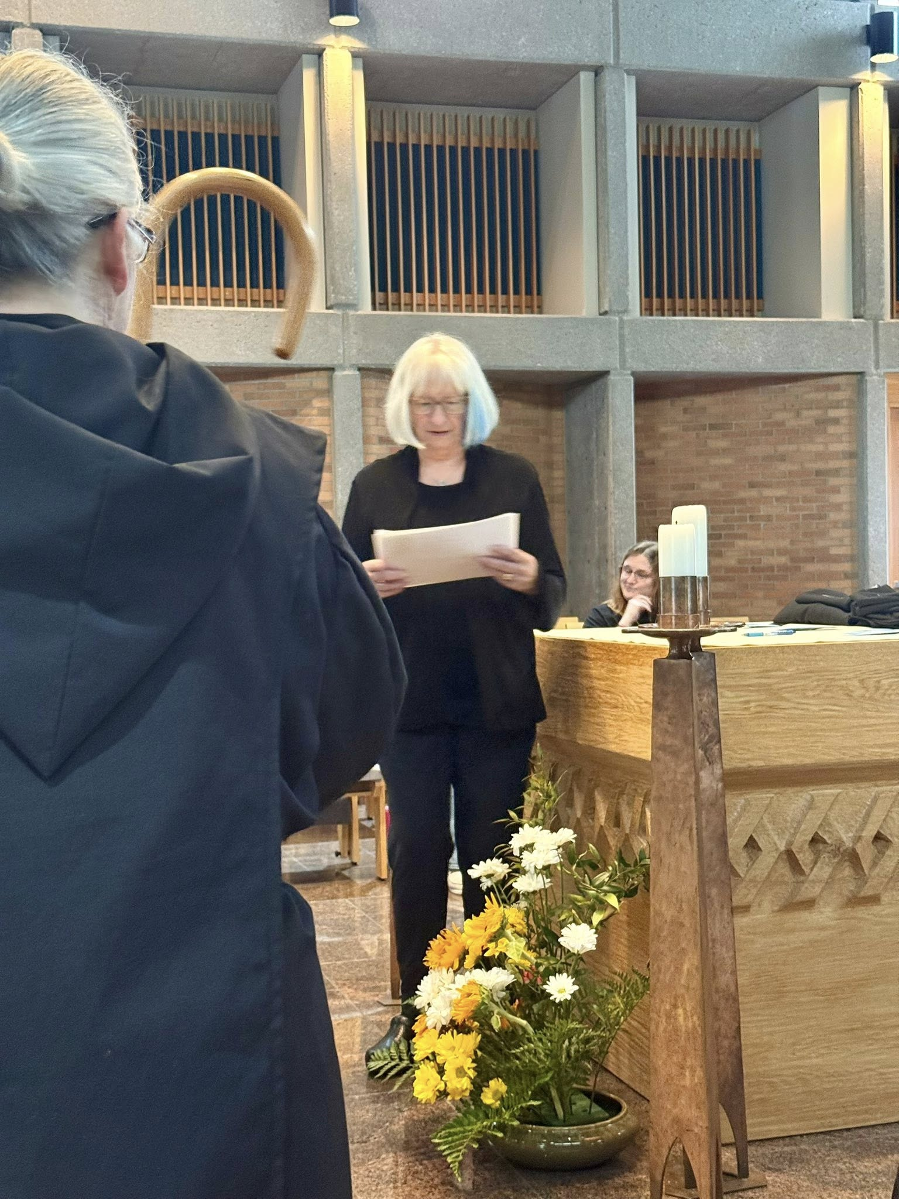
Sr. Gianna Altadonna; Sr. Cynthia Anne Page; Sr. Seraphina MacKay

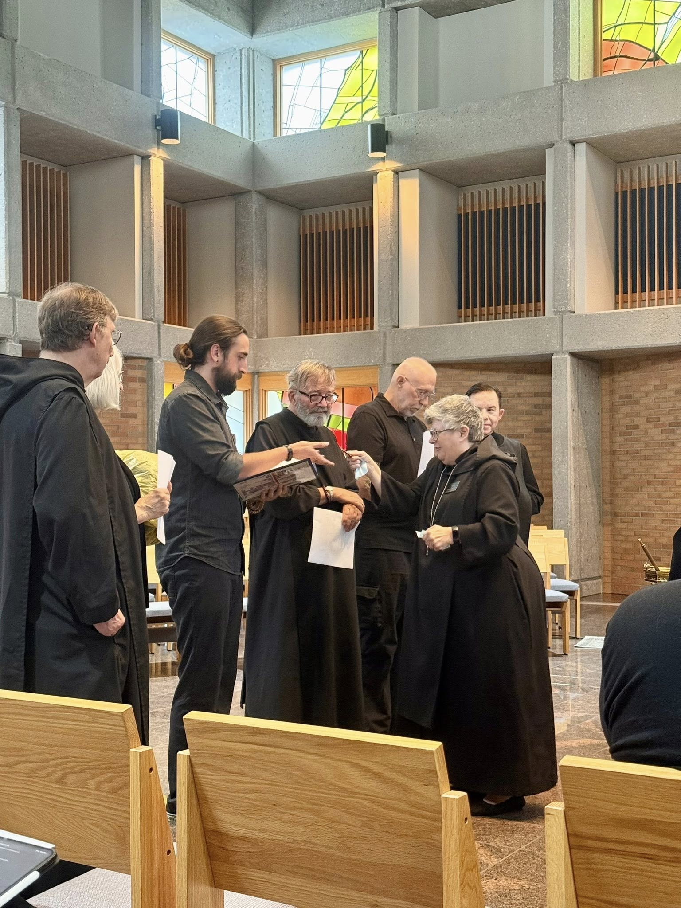
Br. William Marion Page; Sr. Cynthia Anne Page; Br. Andrew Grimsby; Br. James Raphael Davies; Br. Richard Joachim Knight; Abbess Martha Lamoy; Br. Jude Thaddeus Orth
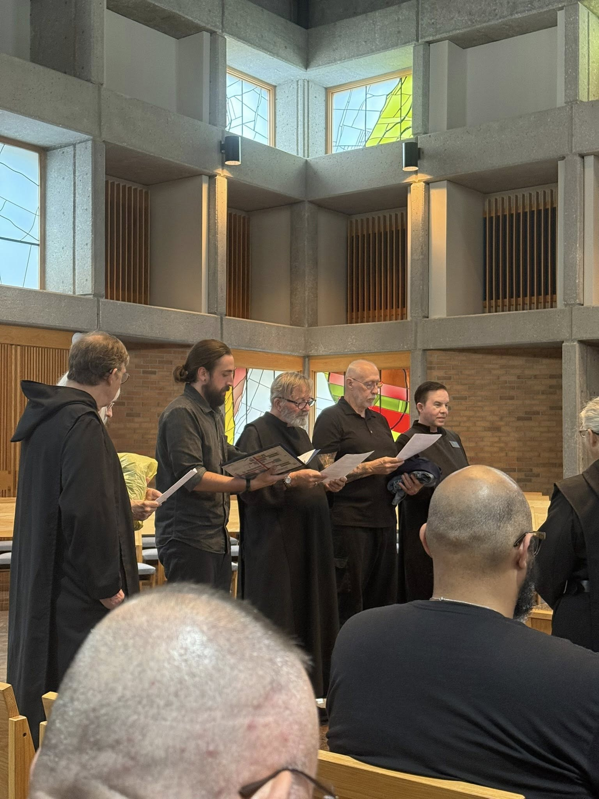
Br. William Marion Page; Sr. Cynthia Anne Page; Br. Jérôme Bertrand; Br. Andrew Grimsby; Br. James Raphael Davies; Br. Richard Joachim Knight; Br. Jude Thaddeus Orth; Br. Dominic Ndife; St. Gianna Altadonna
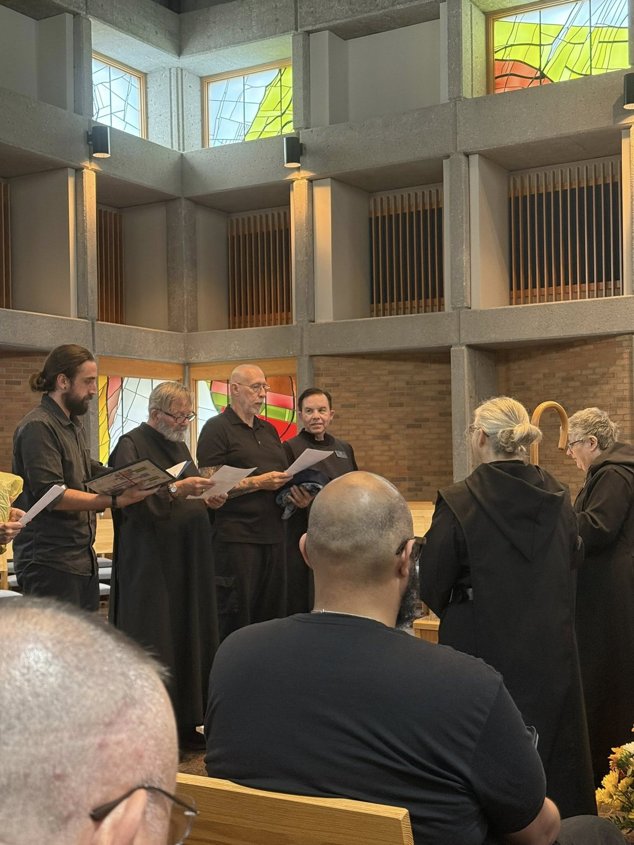
Br. Jérôme Bertrand; Br. Andrew Grimsby; Br. James Raphael Davies; Br. Richard Joachim Knight: Br. Jude Thaddeus Orth; Br. Dominic Ndife; Sr. Gianna Altadonna; Abbess Martha Lamoy
Br. William Marion Page; Sr. Cynthia Anne Page; Br. Jérôme Bertrand; Br. Andrew Grimsby; Br. James Raphael Davies; Br. Richard Joachim Knight; Br. Jude Thaddeus Orth; Br. Dominic Ndife; St. Gianna Altadonna

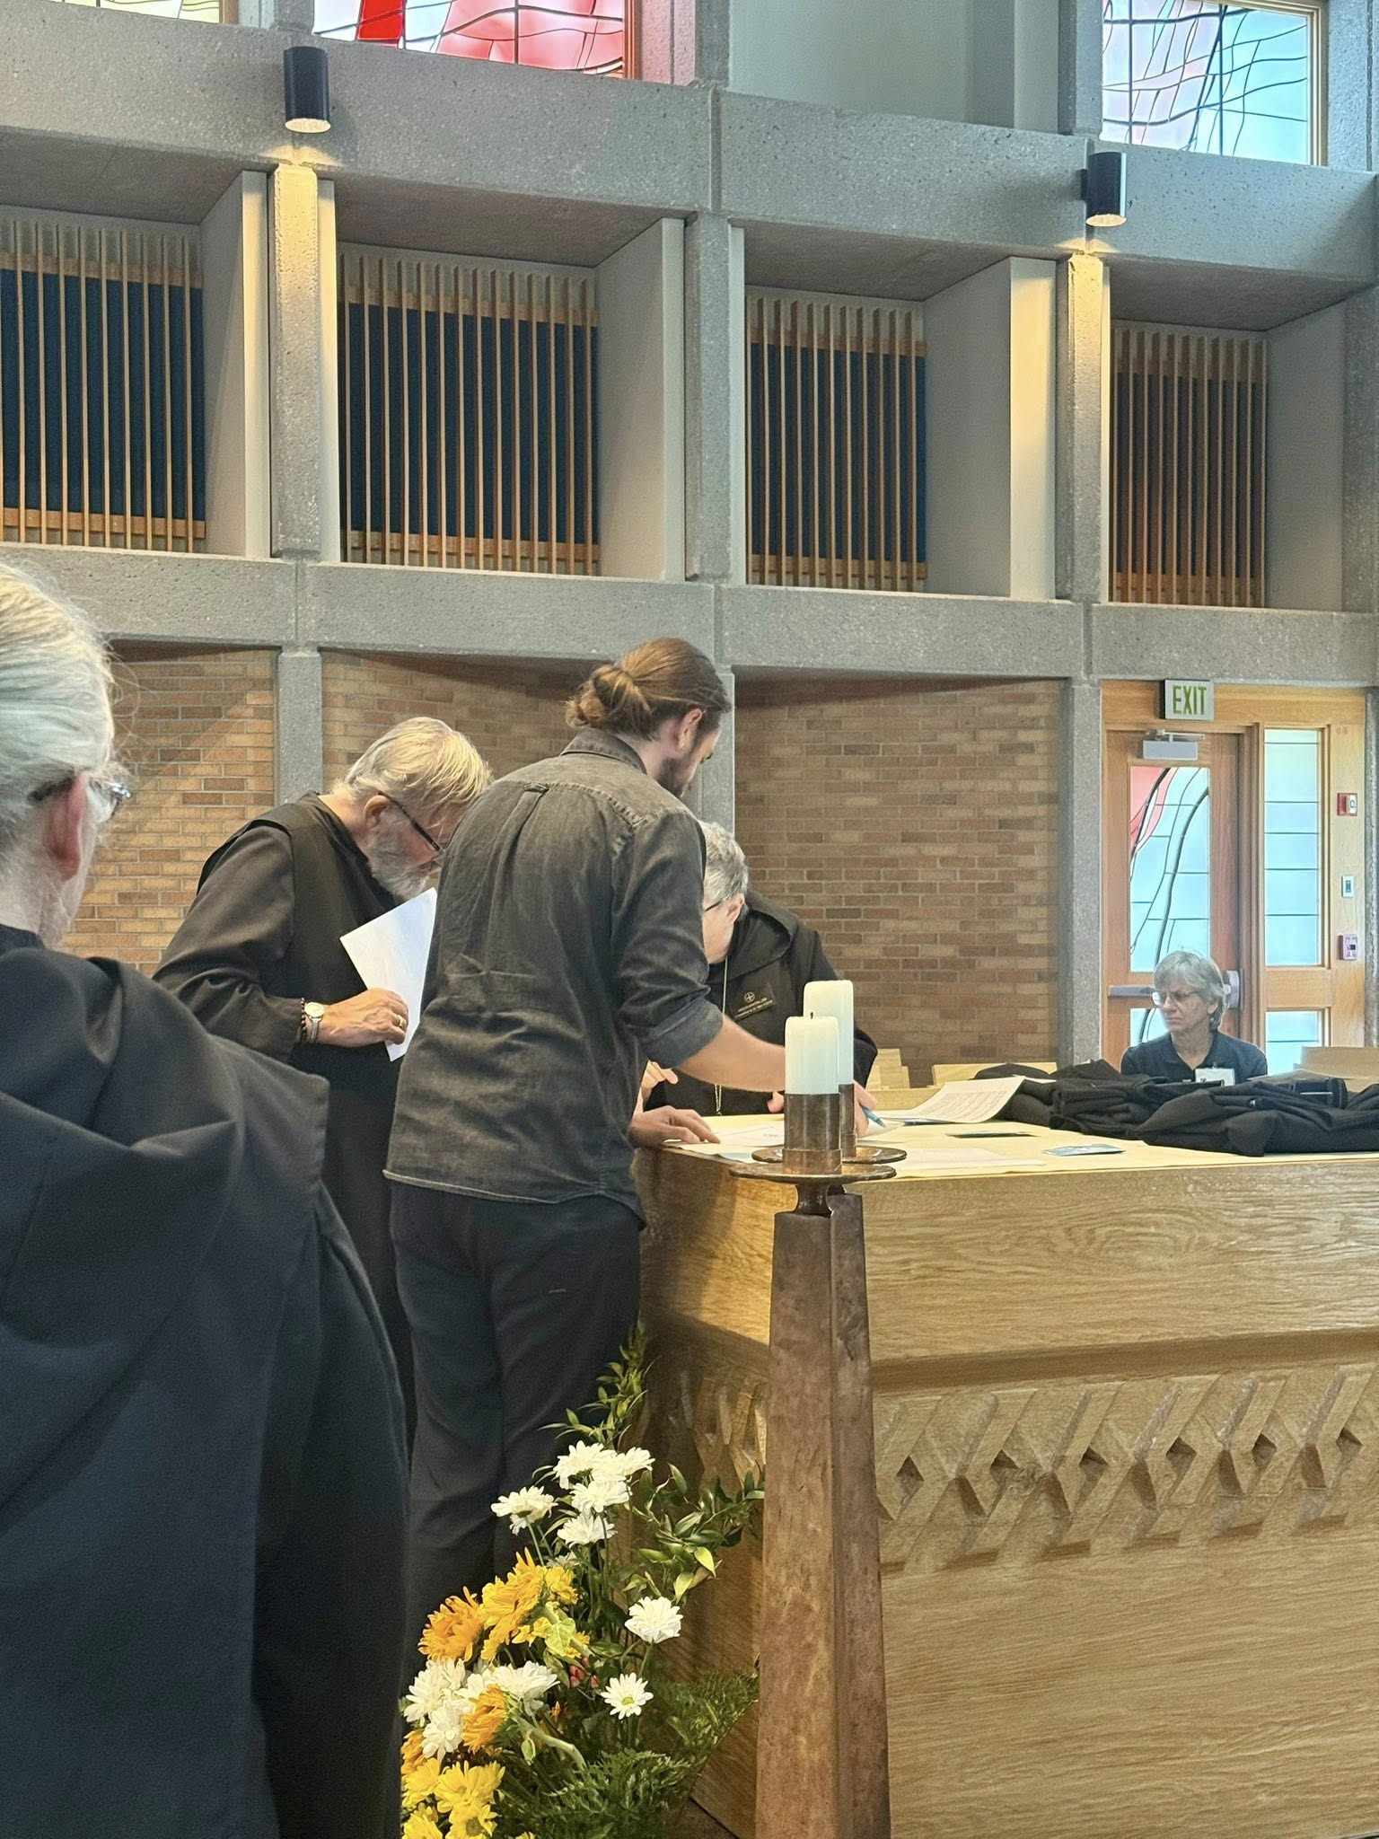
Sr. Gianna Altadonna; Br. James Raphael Davies; Br. Andrew Grimsby; Abbess Martha Lamoy; Nan DeStafney
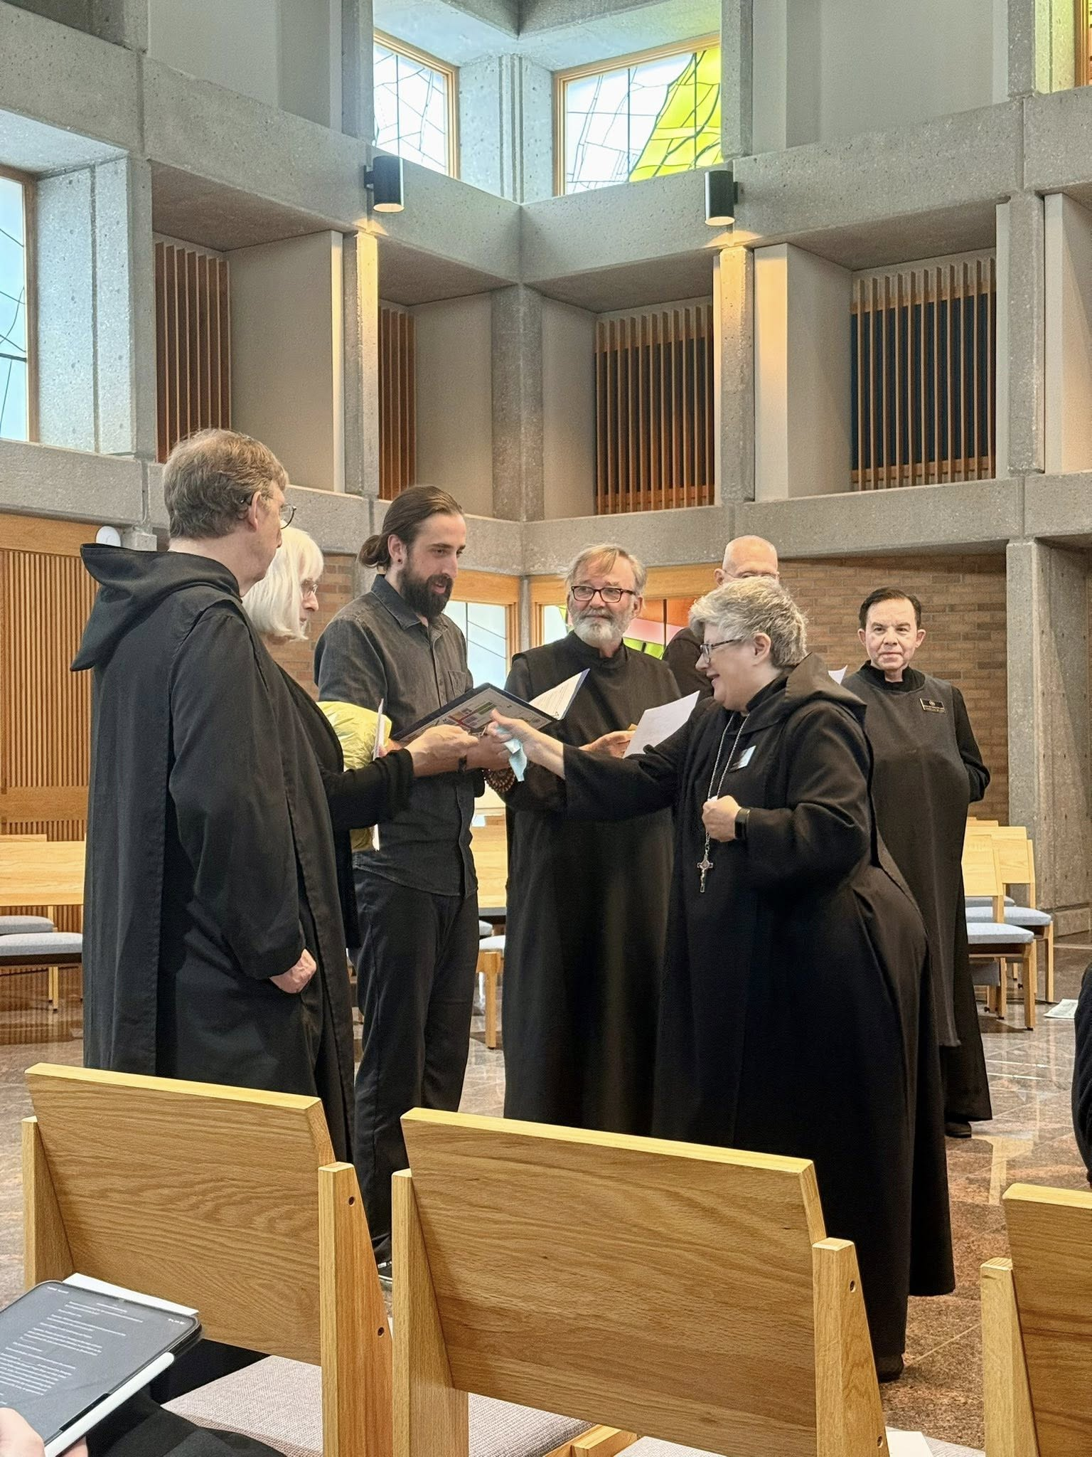
Br. William Marion Page; Sr. Cynthia Anne Page; Br. Andrew Grimsby; Br. James Raphael Davies; Abbess Martha Lamoy; Br. Richard Joachim Knight; Br. Jude Thaddeus Orth
Br. William Marion Page; Sr. Cynthia Anne Page; Br. Andrew Grimsby; Br. James Raphael Davies; Br. Richard Joachim Knight; Abbess Martha Lamoy; Br. Jude Thaddeus Orth

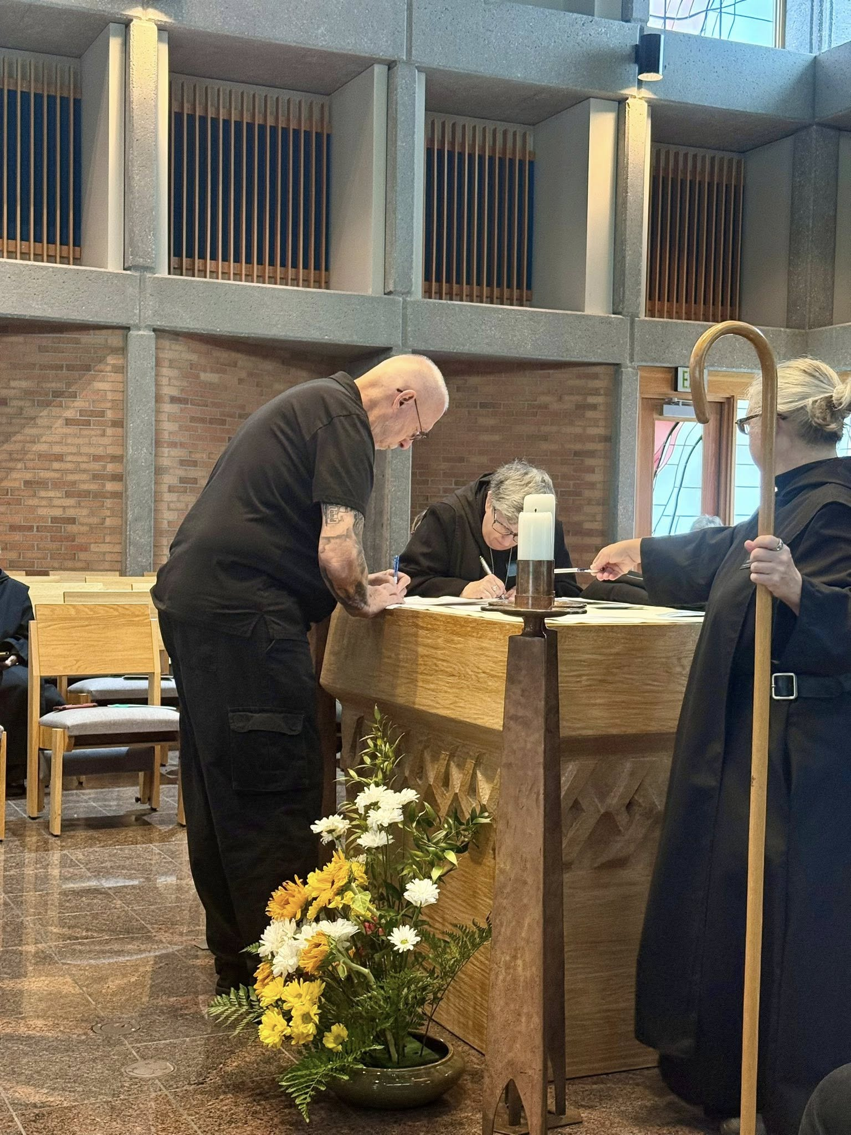
Br. Richard Joachim Knight; Abbess Martha Lamoy; Sr. Gianna Altadonna
Br. Anskar Nonken; Sr. Clare Koronka; Br. Richard Joachim Knight; Abbess Martha Lamoy; Nan DeStafney; Sr. Gianna Altadonna; Br. Florian Campbell

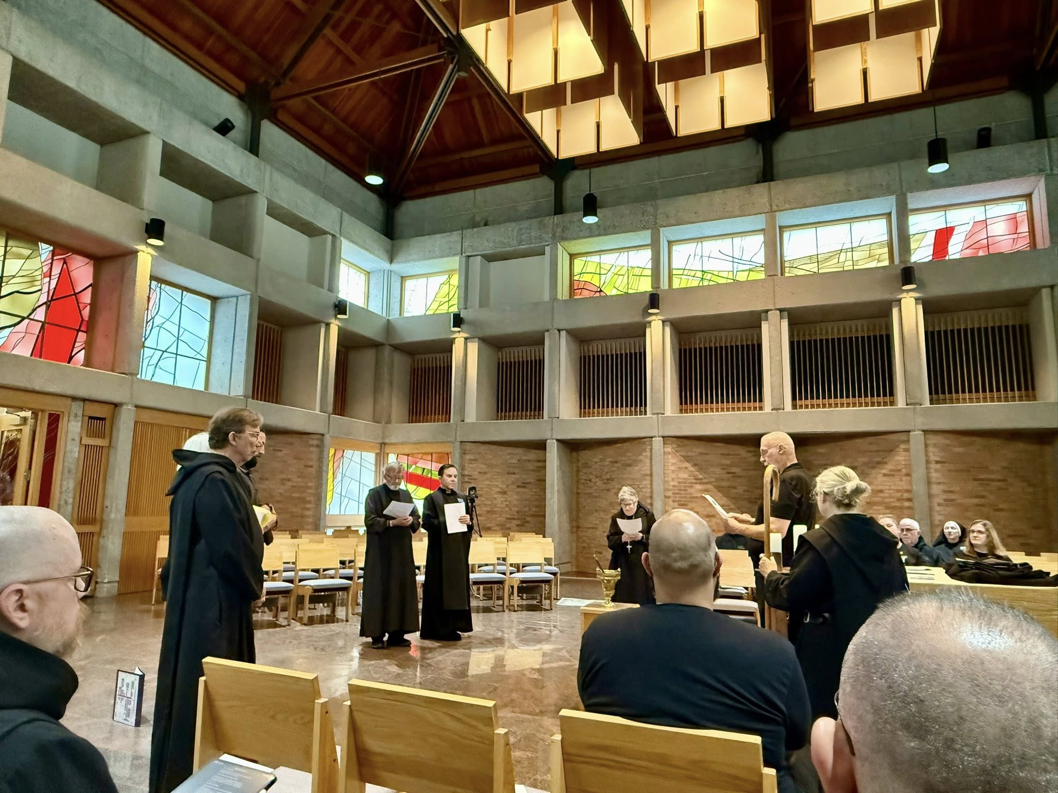
Br. Ronan Patrick; Br. William Marion Page; Sr. Cynthia Anne Page; Br. Andrew Grimsby; Br. James Raphael Davies; Br. Jude Thaddeus Orth; Abbess Martha Lamoy; Br. Dominic Ndife; Br. Richard Joachim Knight; Sr. Gianna Altadonna; Br. Joseph Elias Varsanyi; Sr. Mary Magdalene Clarke; Sr. Seraphina MacKay; Br. Jérôme Bertrand
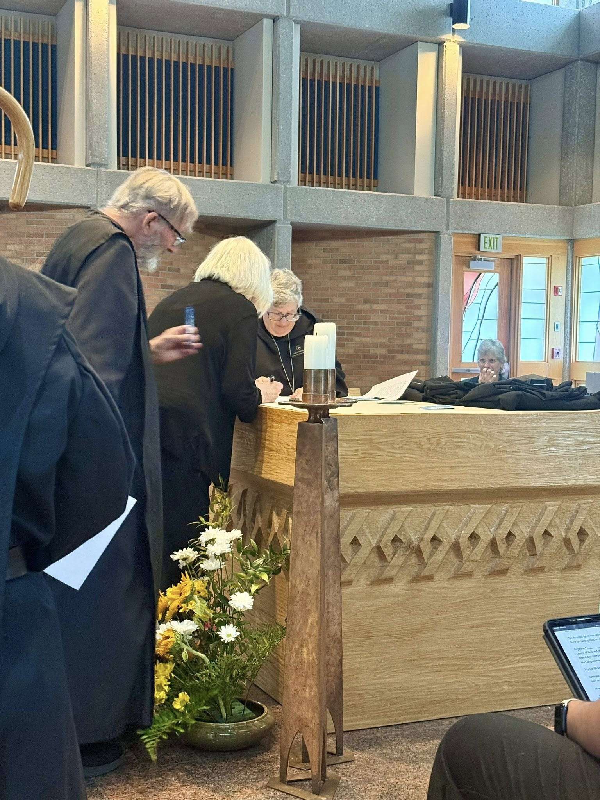
Sr. Gianna Altadonna; Br. James Raphael Davies; Sr. Cynthia Anne Page; Abbess Martha Lamoy; Nan DeStafney

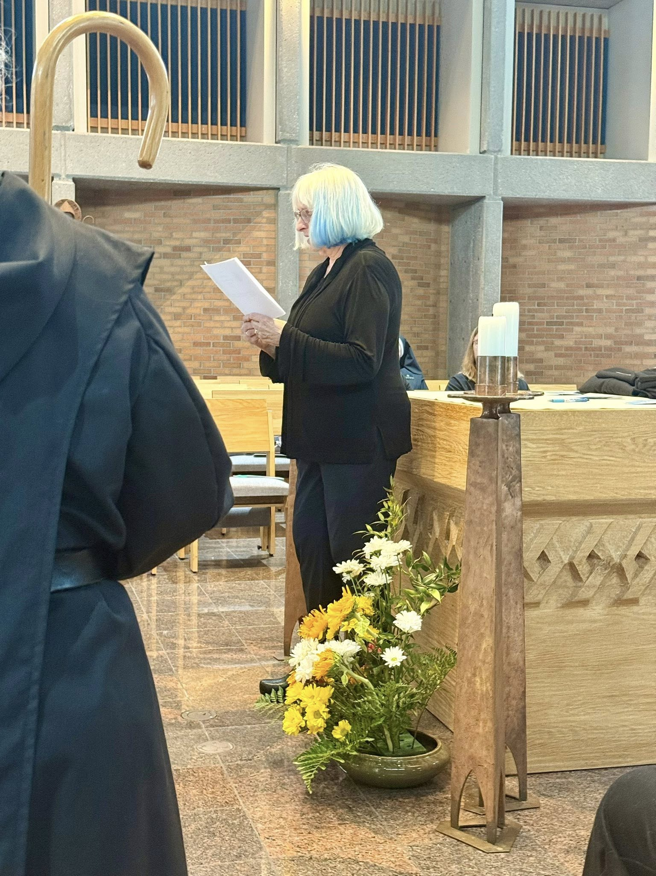
Sr. Gianna Altadonna; Sr. Cynthia Anne Page

Br. William Marion Page; Abbess Martha Lamoy; Br. John David Wynne; Br. Anskar Nonken; Sr. Clare Koronka; Br. Joseph Elias Varsanyi; ?; Sr. Cynthia Anne Page; Sr. Gianna Altadonna
Sr. Gianna Altadonna; Sr. Cynthia Anne Page; Sr. Seraphina MacKay

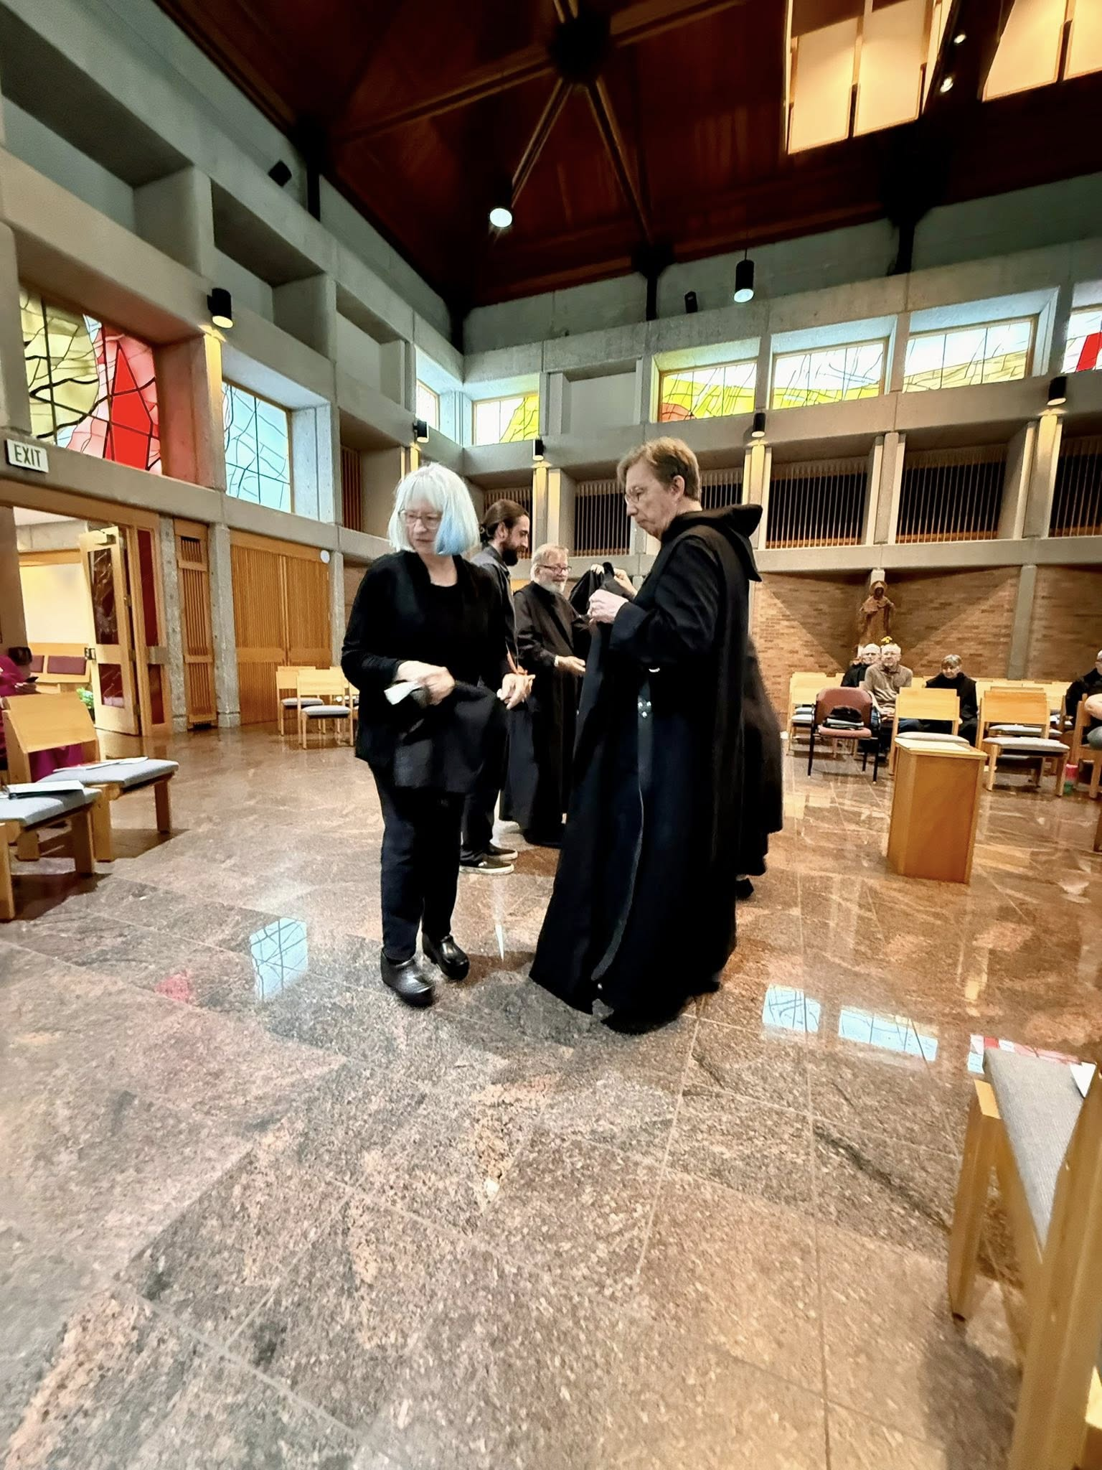
Sr. Cynthia Anne Page; Br. Andrew Grimsby; Br. James Raphael Davies; Br. William Marion Page; Br. Anskar Nonken; Sr. Clare Koronka
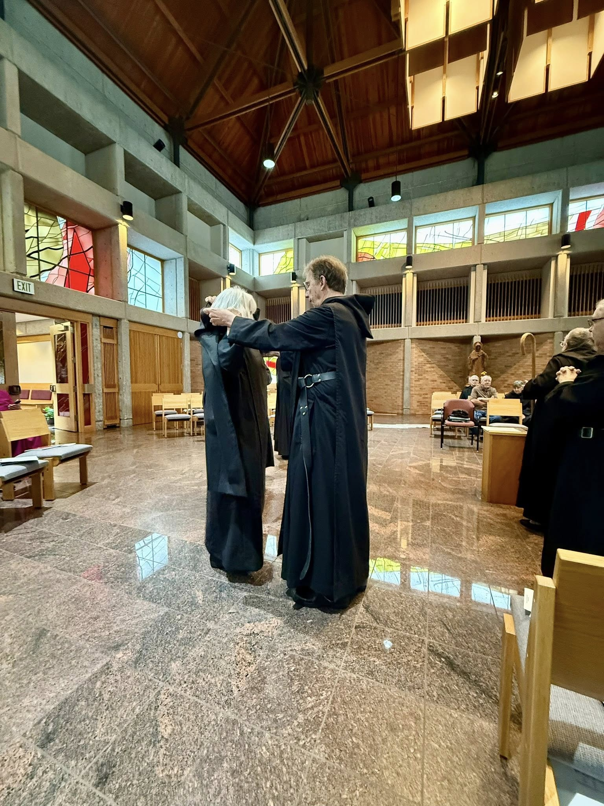
Sr. Cynthia Anne Page; Br. William Marion Page; Br. Anskar Nonken; Abbess Martha Lamoy; Sr. Clare Koronka; Sr. Gianna Altadonna

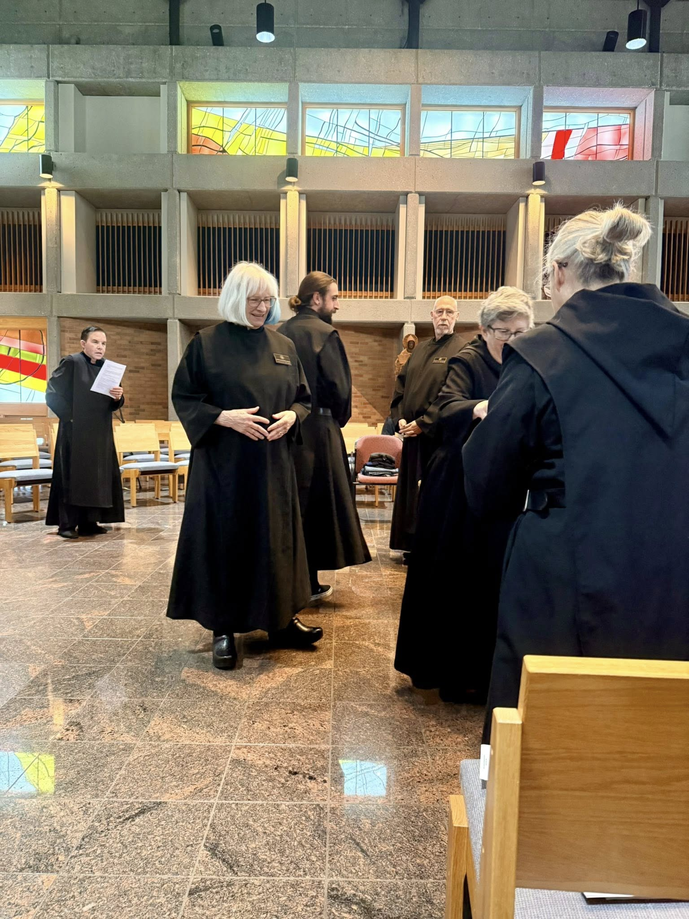
Br. Jude Thaddeus Orth; Sr. Cynthia Anne Page; Br. Andrew Grimsby; Br. Richard Joachim Knight; Abbess Martha Lamoy; Sr. Gianna Altadonna

