**Spring Convocation Portraits, 2024**

**Photos by Sr. Denise Moore**

NB: The Crockagator has been following Sr. Denise and Br. Daniel around and has a way of popping up unexpectedly. Apparently it secreted itself in Sr. Denise’s luggage as she packed for the Convocation. In true Benedictine fashion, however, it was welcomed by the community despite having not made a reservation….

*~Edited by Br. Steven Olderr 1 August 2024. Please send any corrections or additional information to* [*olderr@ameritech.net*](mailto:olderr@ameritech.net)

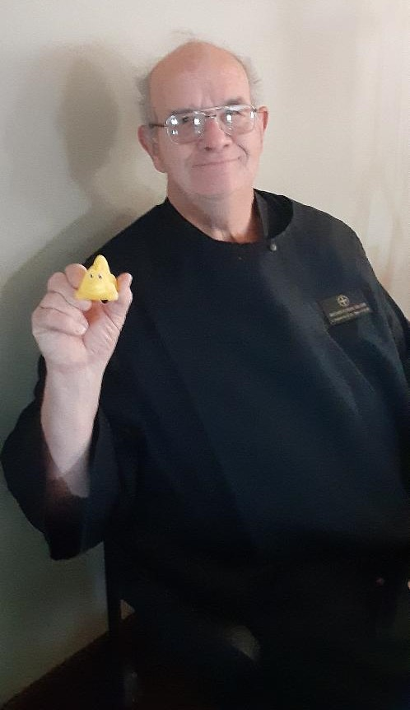

Br. Florian Campbell & Crockagator

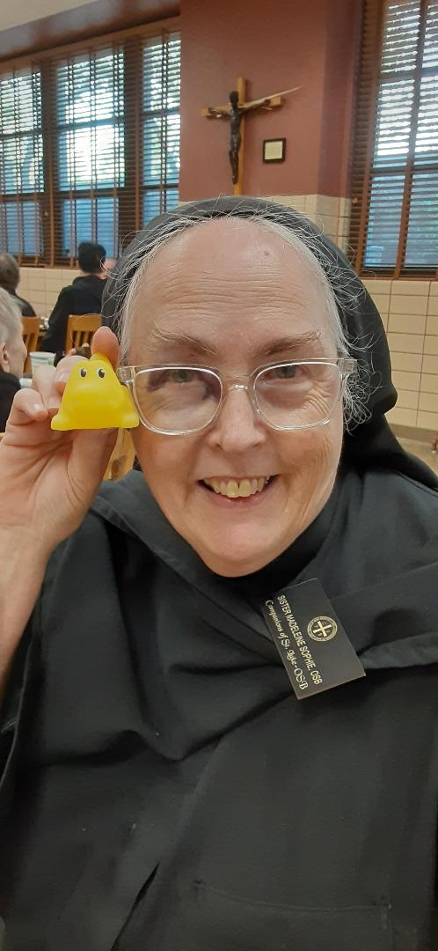

Sr. Madeleine Sophie Smith & Crockagator

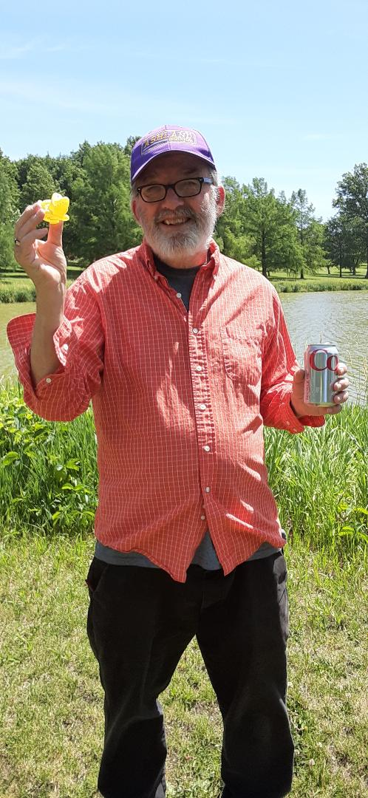

Br. James Rafael Davies & Crockagator

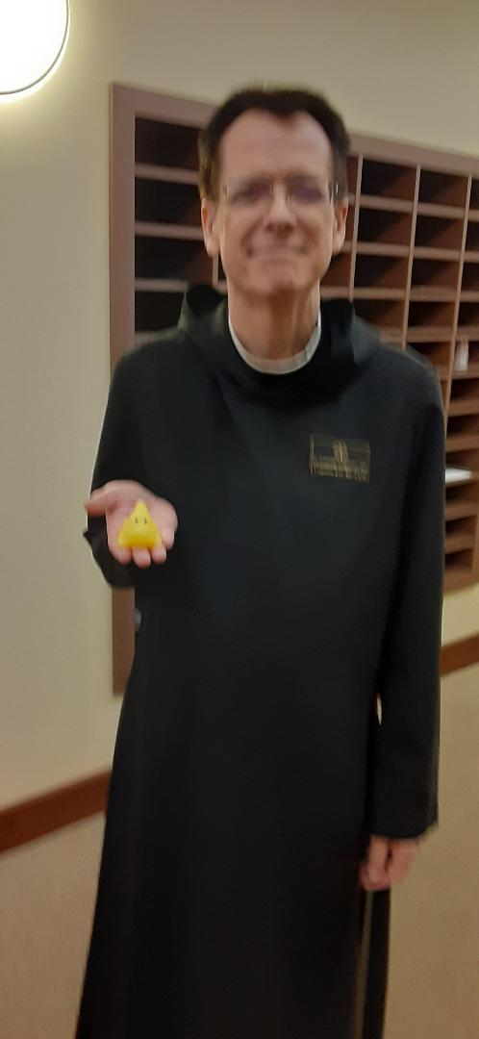

Br. Dunstan Townsend & Crockagator

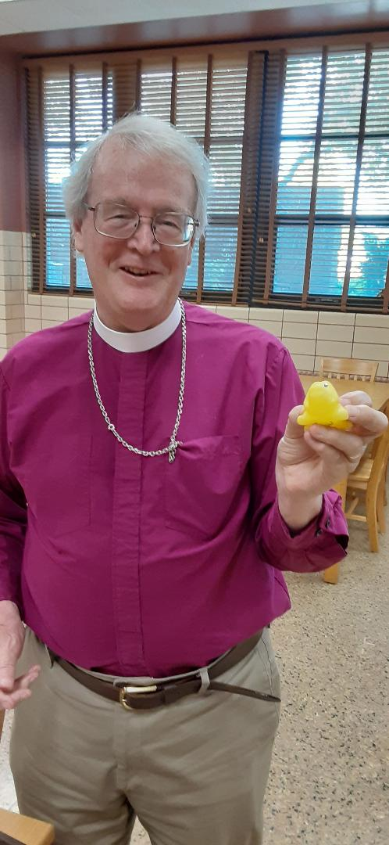

Bp. Alan Scarfe & Crockagator