Companions of St. Luke
Fall Convocation at Conception Abbey
October 25-30, 2010
Part 4 of 4
Photographed by Sr. Brigid Gerns

People are identified from left to right.

Edited by Br. Steven Olderr 26 October 2023. Please send any comments, corrections, or additions to olderr@ameritech.net

NOTE: In May of 2011, Abbot David Vincent Cotton announced that members could use their birth names instead of religious names if they chose. The following names were changed—some immediately, some later.

Br. Aidan Maguire > Br. Kenneth
Br. Chad Anselm Gerns > Br. David
Br. David Vincent Cotton > Br. Robert
Br. Gregory Kingsley > Br. Joshua
Br. Joseph > Br. Steven Joseph, and later still, just Br. Steven
Br. Luke Doucette > Br. Lee
Br. Willard Moore > Br. Daniel Moore
Sr. Bernadette Barrett > Sr. Helena
Sr. Cecelia Lamoy > Sr. Martha
Sr. Margaret Moore > Sr. Denise

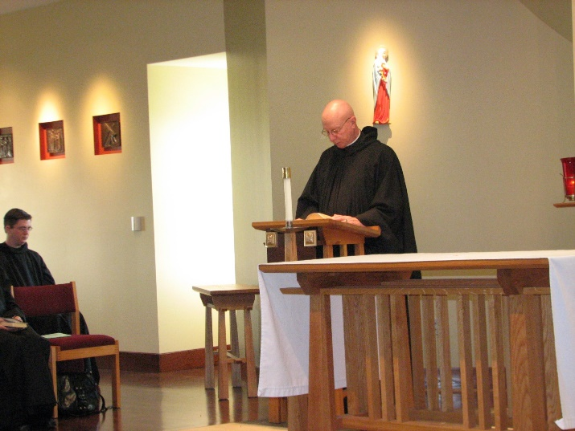
Br. Aidan Maguire; Abbot David Vincent Cotton

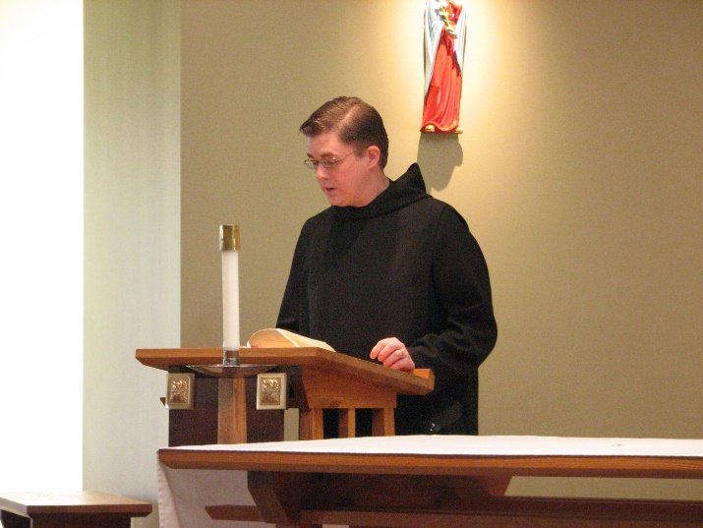
Br. Aidan Maguire

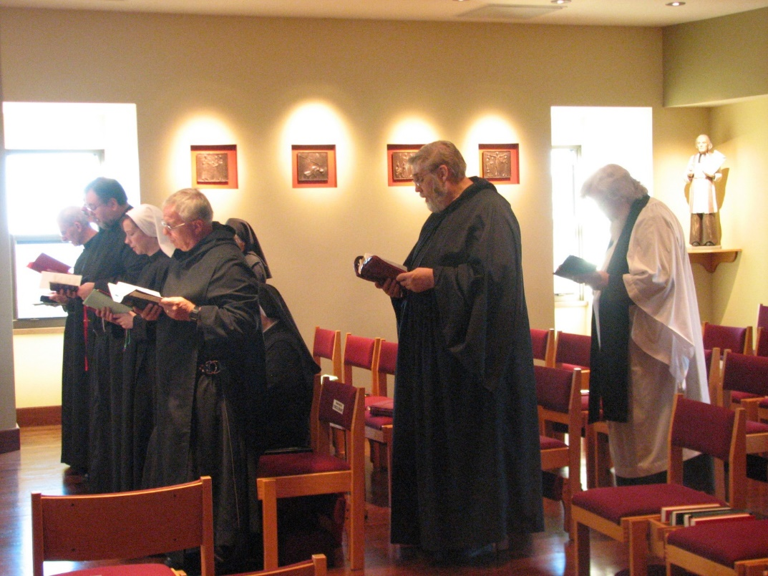
Br. Joseph Olderr; Br. Samuel Saterstrom; Sr. Veronica Taylor; Br. Bede Leach; Sr. Mary Francis Deulen; Sr. Bernadette Barrett; Br. Chad Anselm Gerns; Fr. Wayne Kamm

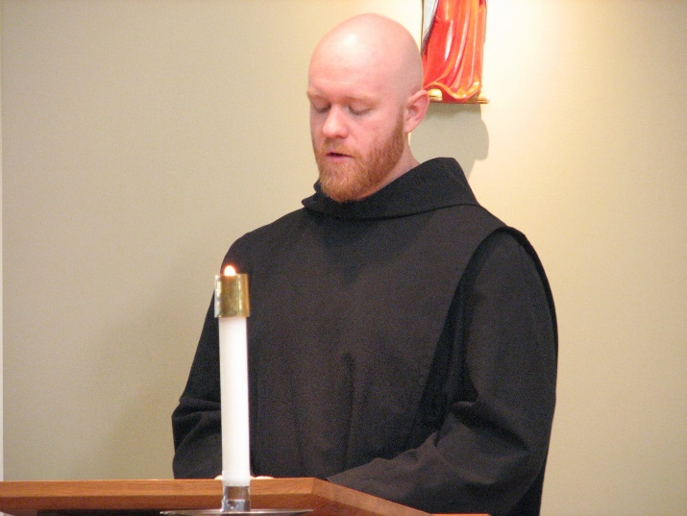
Br. Gregory Kingsley

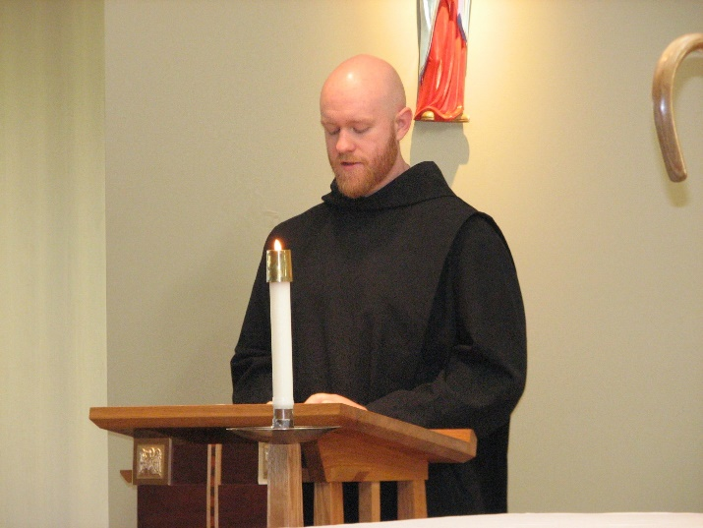
Br. Gregory Kingsley

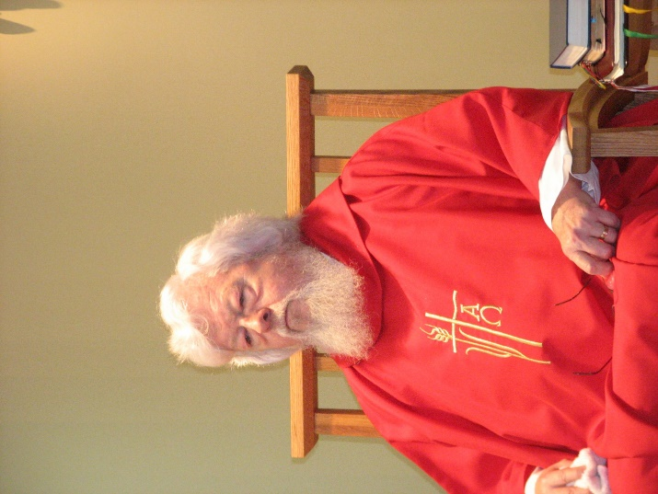
Fr. Wayne Kamm

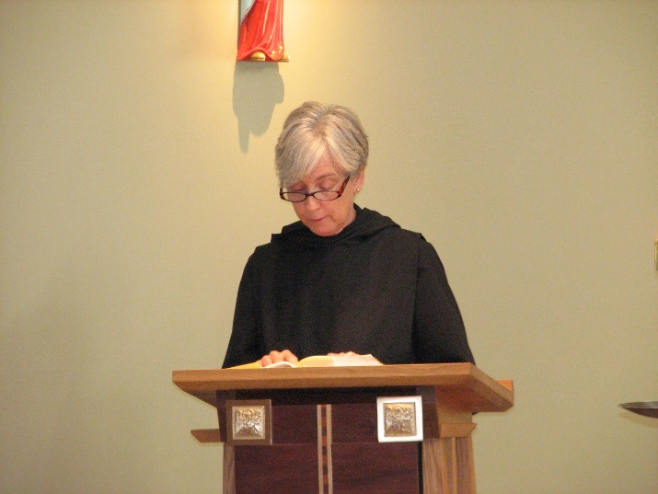
Sr. Julian Saterstrom

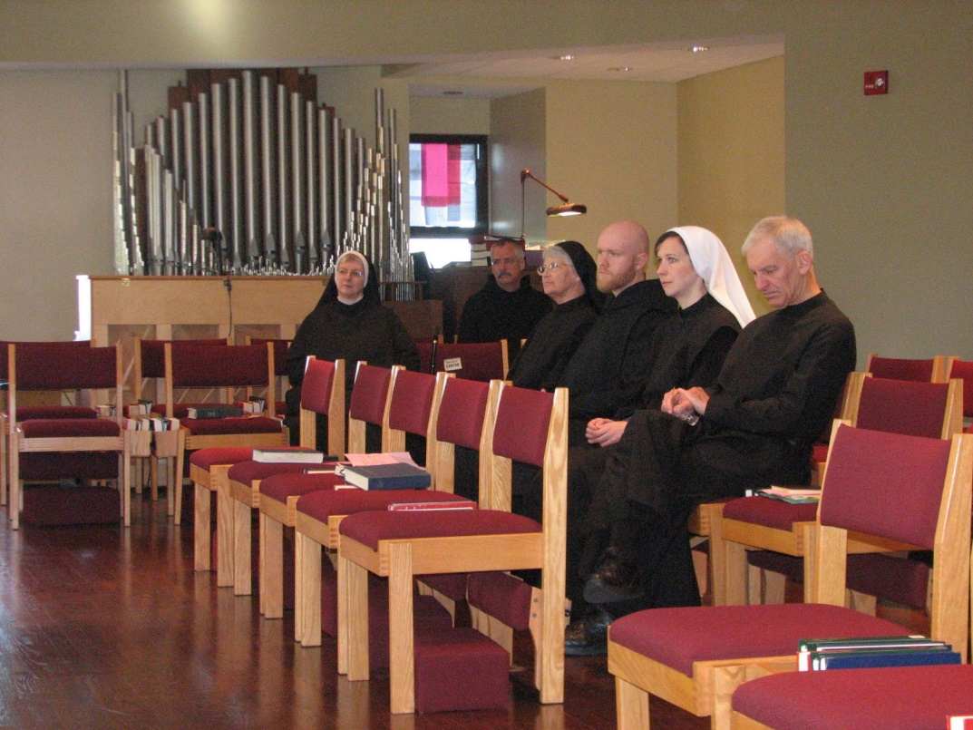
Sr. Bernadette Barrett; Br. Dunstan Townsend; Sr. Mary Fracis Deulen; Br. Gregory Kingsley; Sr. Veronica Taylor; Br. Joseph Olderr

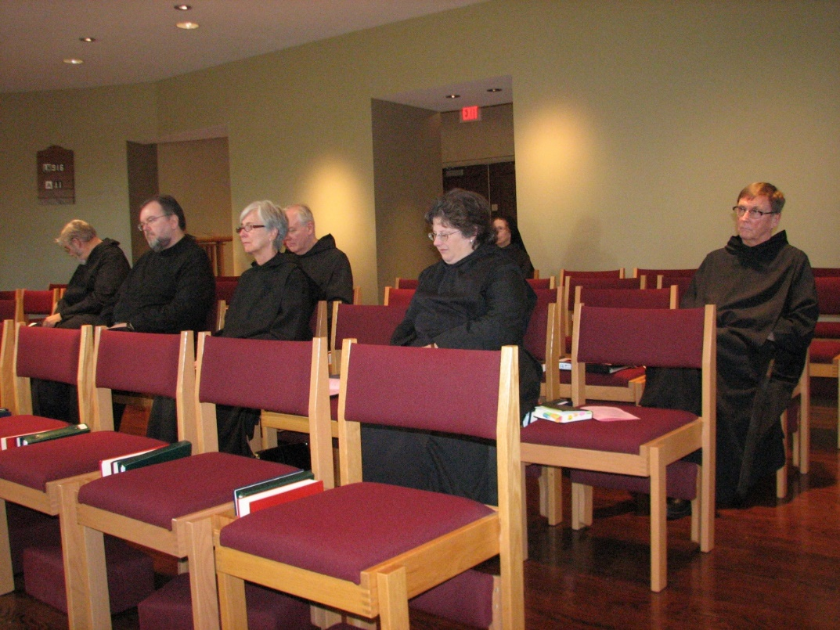
Br. Chad Anselm Gerns; Br. Samuel Saterstrom; Sr. Julian Saterstrom; Br. Luke Doucette; Sr. Cecelia Lamoy; Sr. Monica Ruth Mullen; Br. Camillus Converse

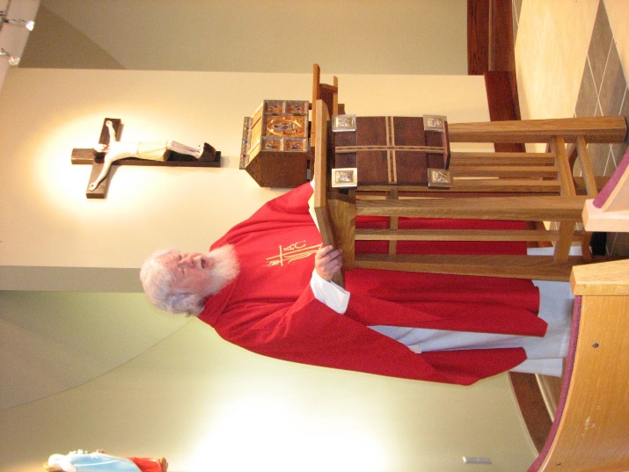
Fr. Wayne Kamm

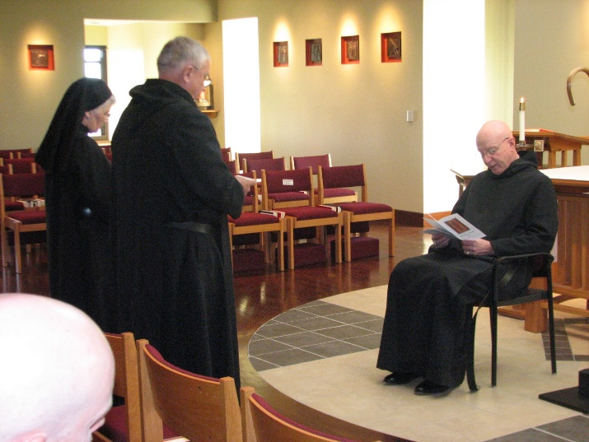
Sr. Mary Francis Deulen; Br. Bede Leach; Abbot David Vincent Cotton

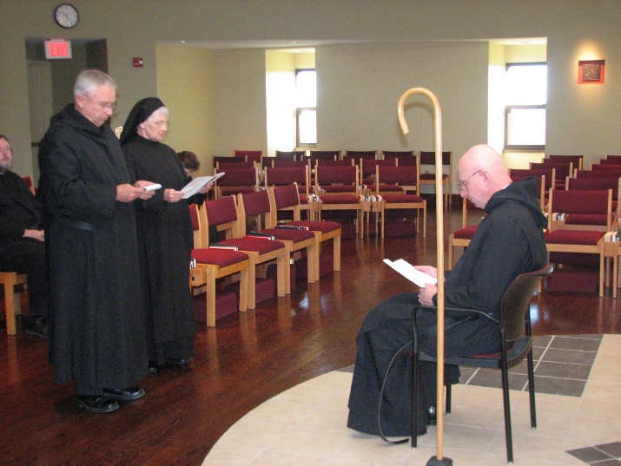
Br. Samuel Saterstrom; Br. Bede Leach; Sr. Mary Francis Deulen; Sr. Cecelia Lamoy; Abbot David Vincent Cotton

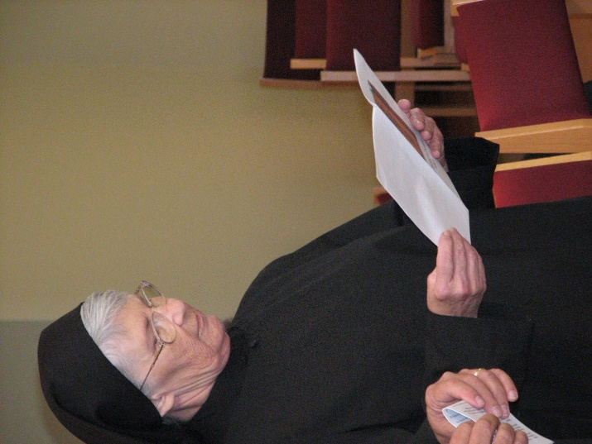
Sr. Mary Francis Deulen

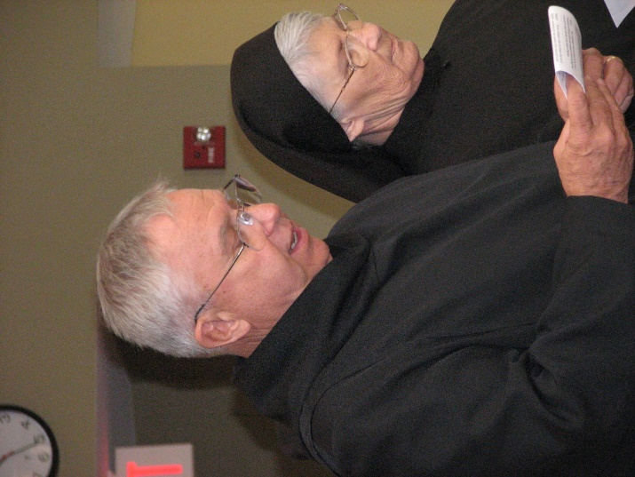
Br. Bede Leach; Sr. Mary Francis Deulen

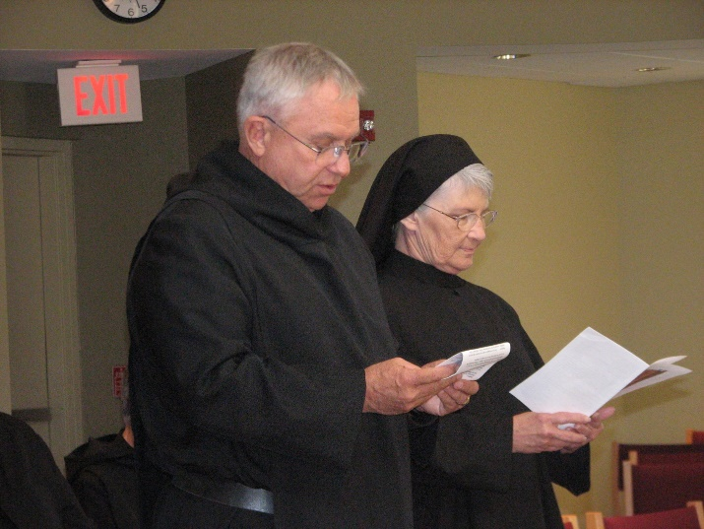
Br. Bede Leach; Sr. Mary Francis Deulen

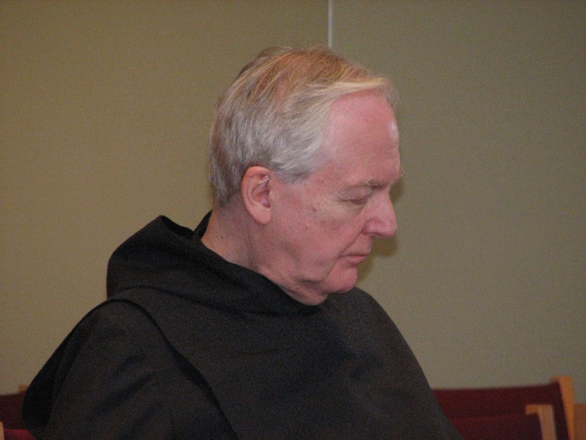
Br. Luke Doucette

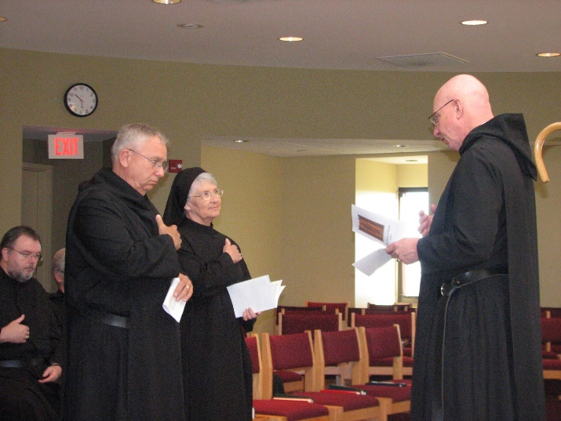
Br. Samuel Saterstrom; Sr. Julian Saterstrom; Br. Bede Leach; Sr. Mary Francis Deulen; Abbot David Vincent Cotton

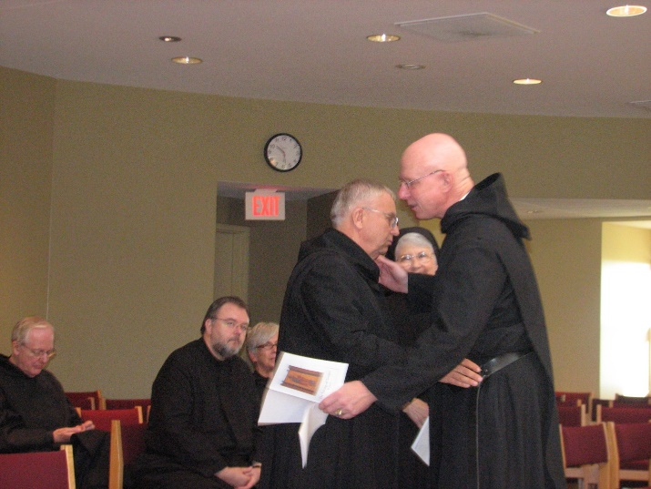
Br. Luke Doucette; Br. Samuel Saterstrom; Sr. Julian Saterstrom; Br. Bede Leach; Sr. Mary Francis Deulen; Br. Bede Leach; Abbot David Vincent Cotton

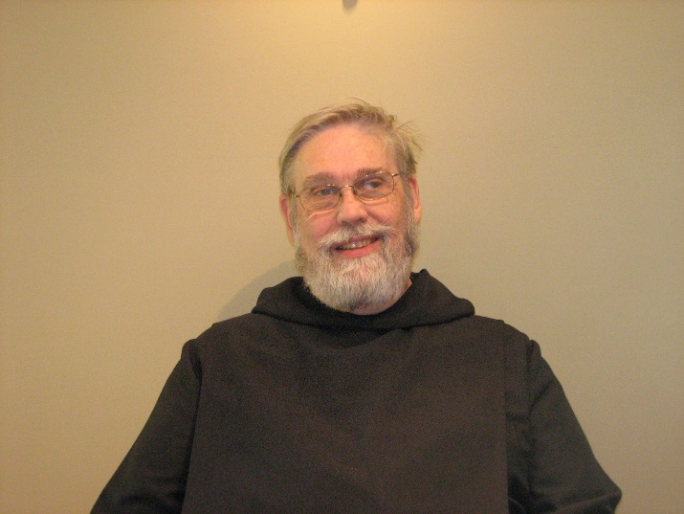
Br. Chad Anselm Gerns

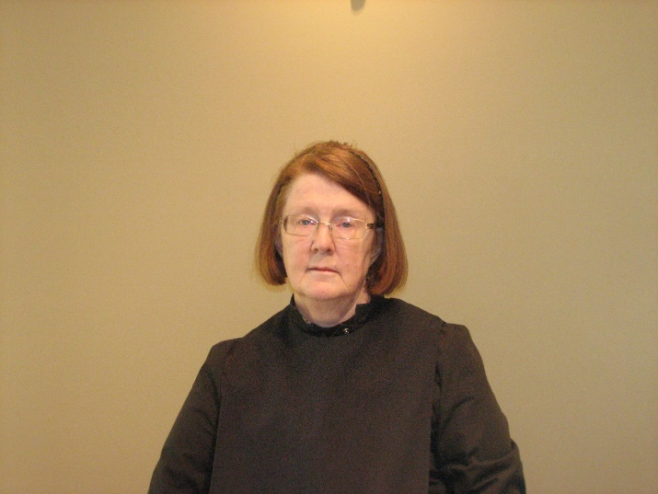
Sr. Brigid Gerns

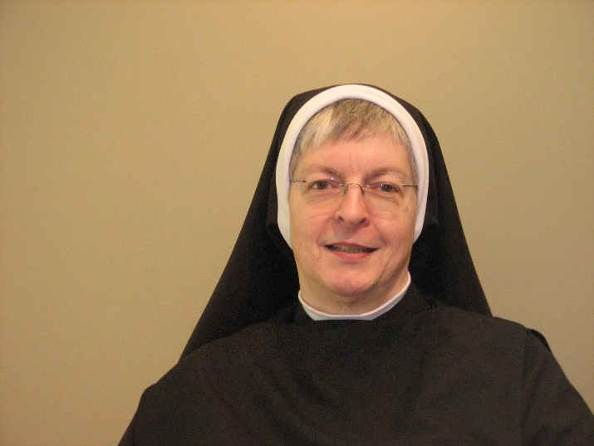
Sr. Bernadette Barrett

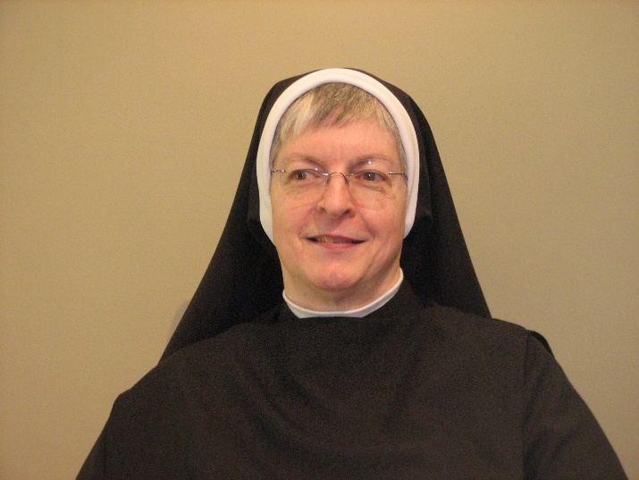
Sr. Bernadette Barrett

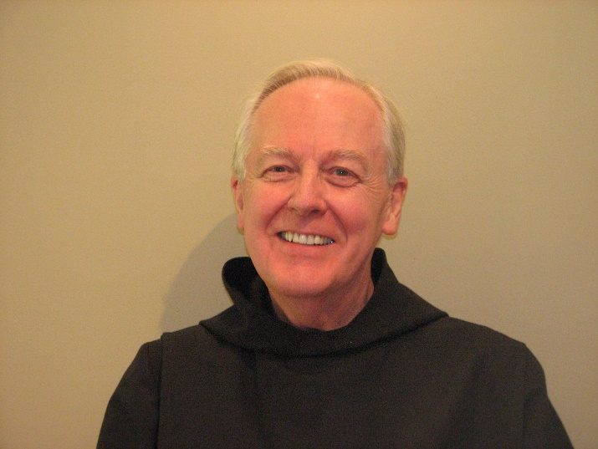
Br. Luke Doucette

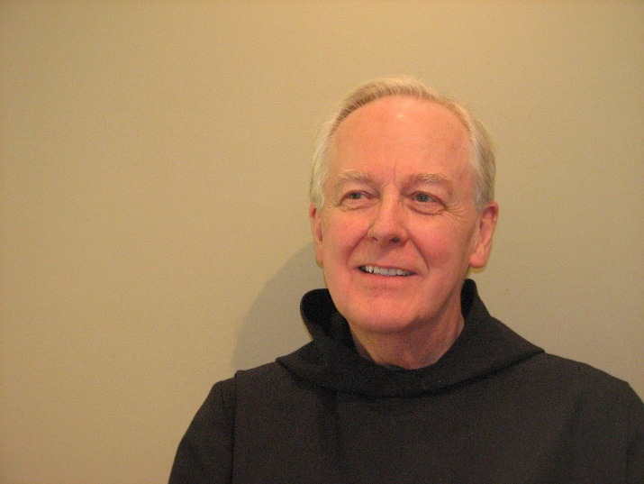
Br. Luke Doucette

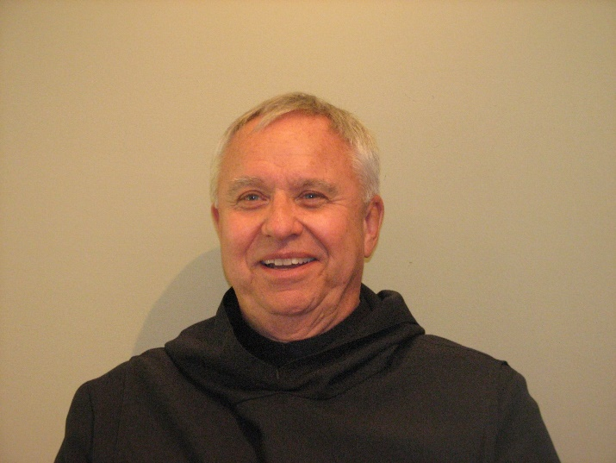
Br. Bede Leach

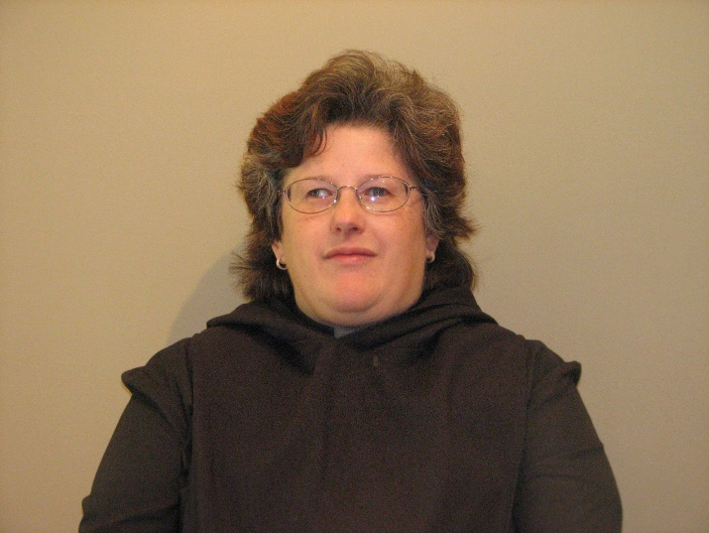
Sr. Cecelia Lamoy

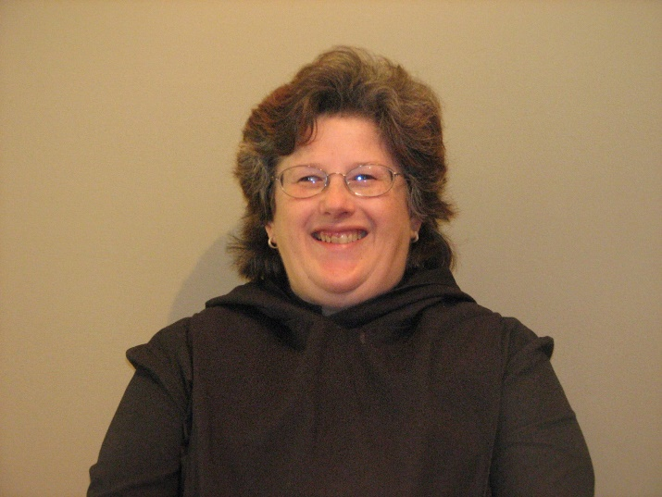
Sr. Cecelia Lamoy

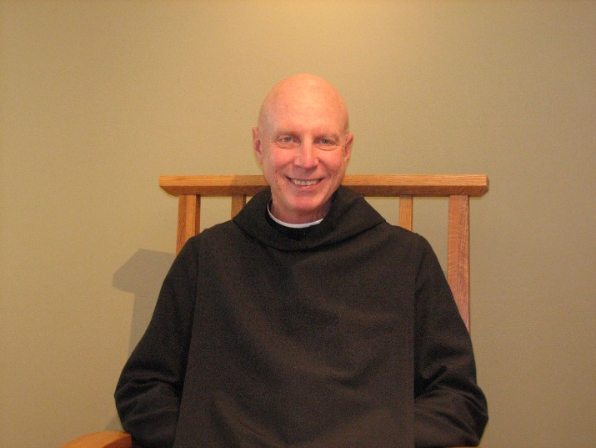
Abbot David Vincent Cotton

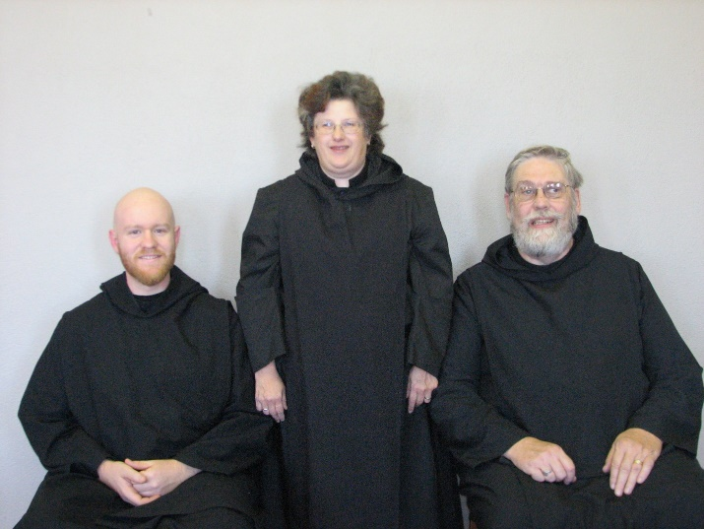
Br. Gregory Kingsley; Sr. Cecelia Lamoy; Br. Chad Anselm Gerns

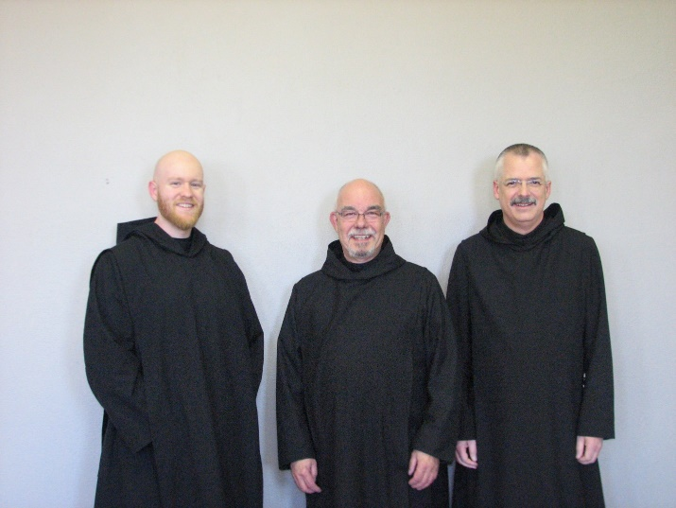
Br. Gregory Kingsley; Br. Basil Edwards; Br. Dunstan Townsend

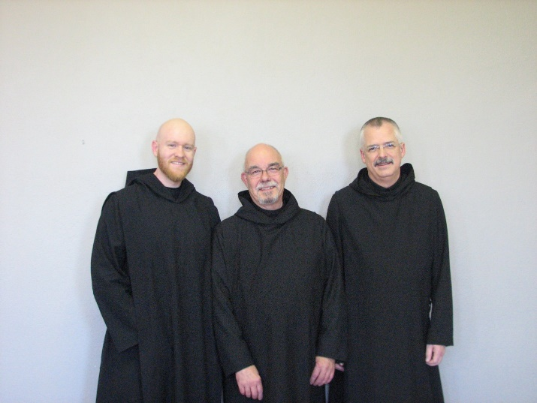
Br. Gregory Kingsley; Br. Basil Edwards; Br. Dunstan Townsend

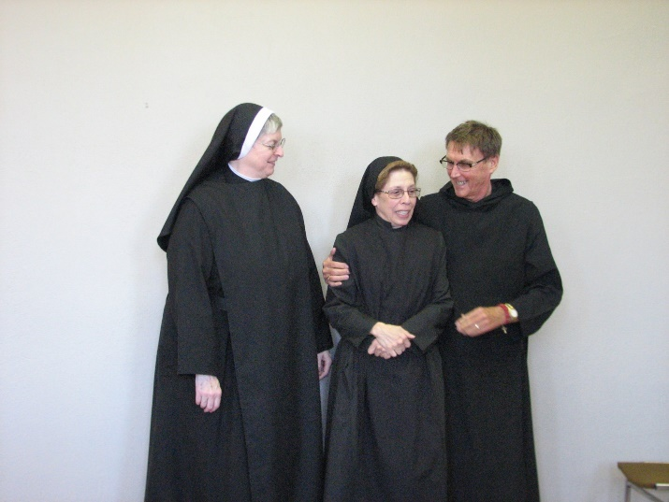
Sr. Bernadette Barrett; Sr. Monica Ruth Mullen; Br. Camillus Converse

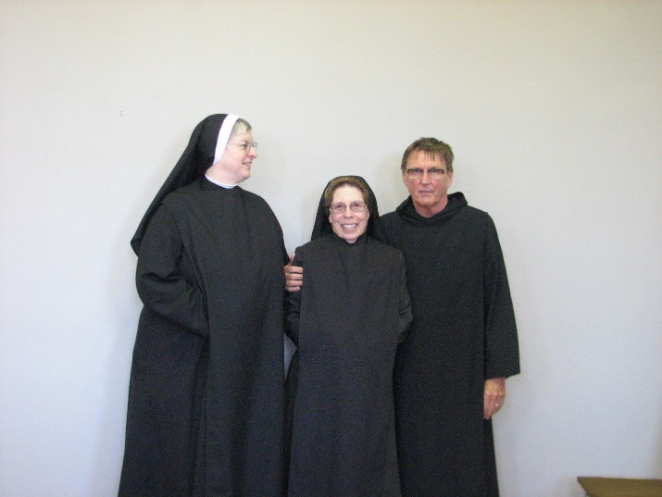
Sr. Bernadette Barrett; Sr. Monica Ruth Mullen; Br. Camillus Converse

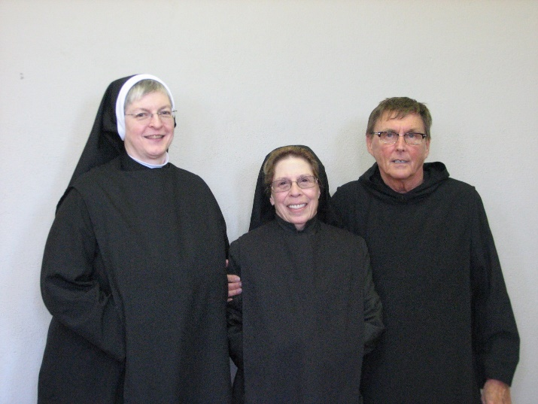
Sr. Bernadette Barrett; Sr. Monica Ruth Mullen; Br. Camillus Converse

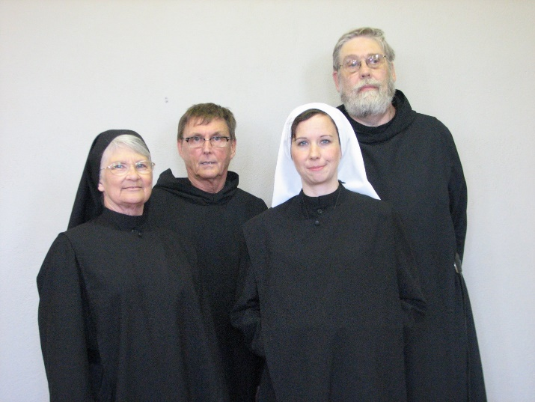
Mary Francis Deulen; Br. Camillus Converse; Sr. Veronica Taylor; Br. Chad Anselm Gerns

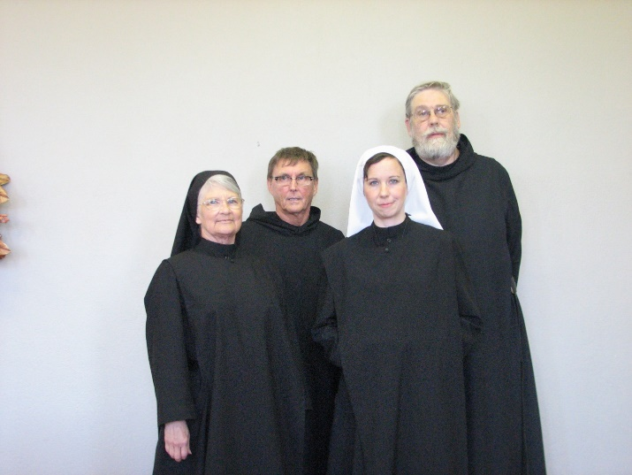
Mary Francis Deulen; Br. Camillus Converse; Sr. Veronica Taylor; Br. Chad Anselm Gerns

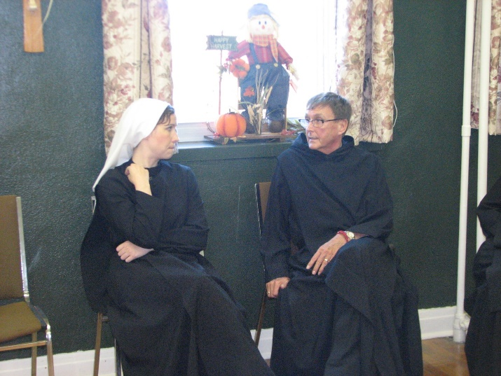
Sr. Veronica Taylor; Br. Camillus Converse

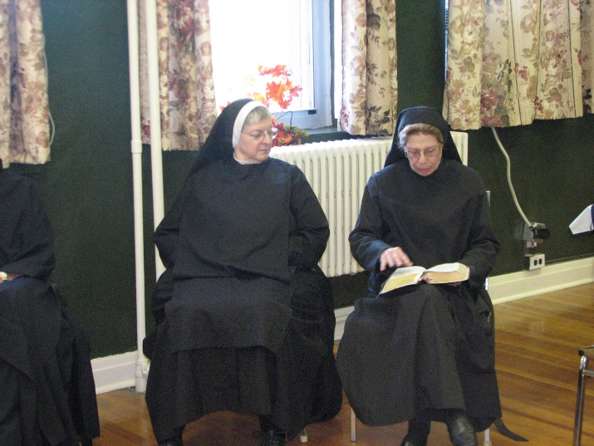
Sr. Bernadette Barrett; Sr. Monica Ruth Mullen

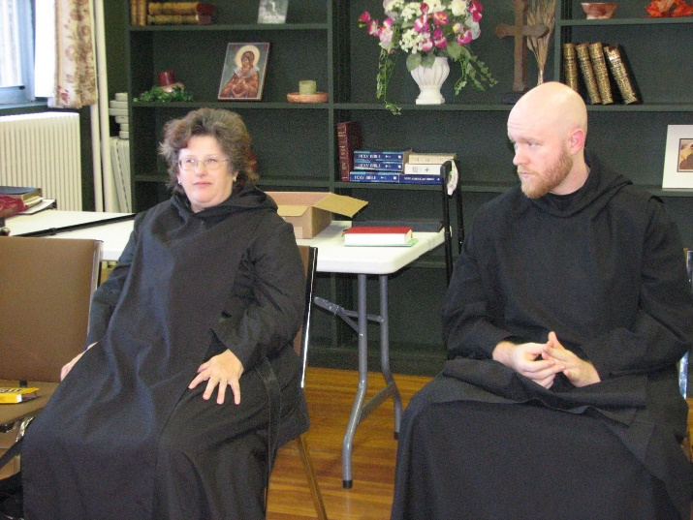
Sr. Cecelia Lamoy; Br. Gregory Kingsley

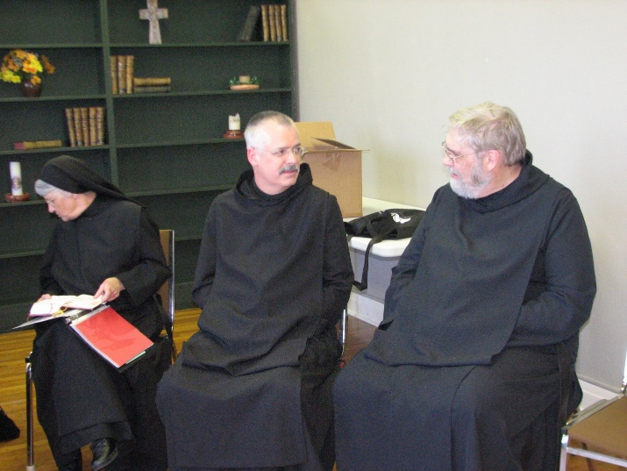
Sr. Mary Francis Deulen; Br. Dunstan Townsend; Br. Chad Anselm Gerns

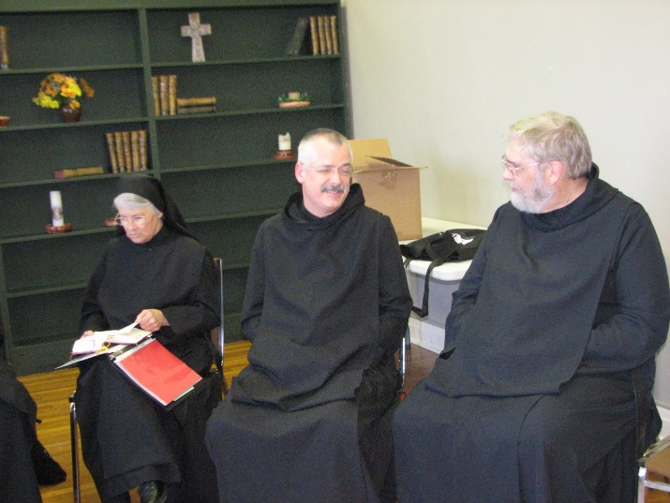
Sr. Mary Francis Deulen; Br. Dunstan Townsend; Br. Chad Anselm Gerns
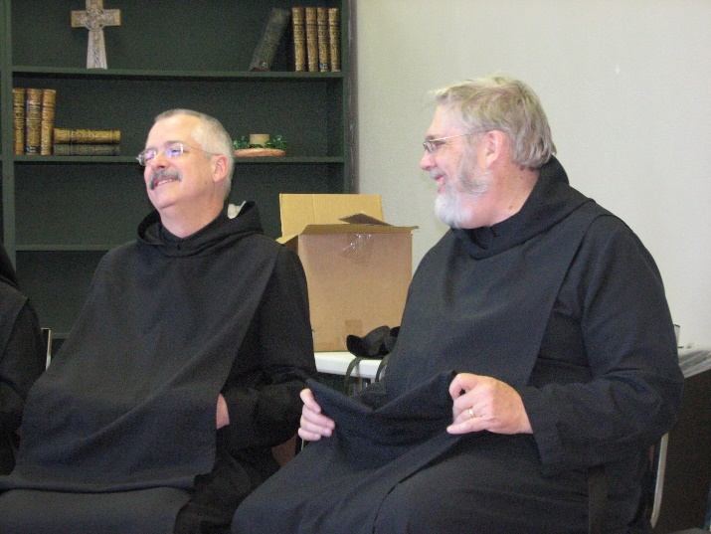
Br. Dunstan Townsend; Br. Chad Anselm Gerns

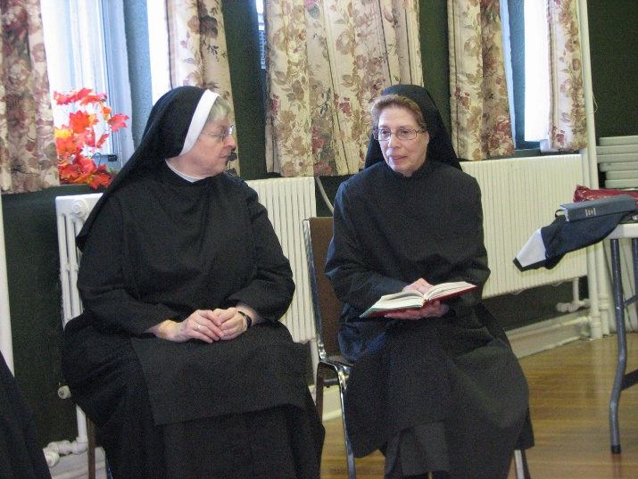
Sr. Bernadette Barrett; Sr. Monica Ruth Mullen

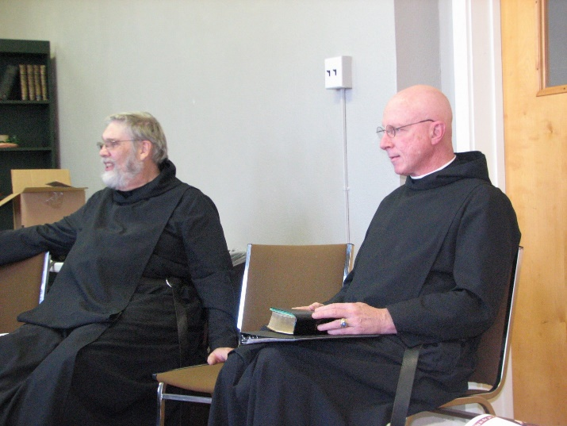
Br. Chad Anselm Gerns; Abbot David Vincent Cotton

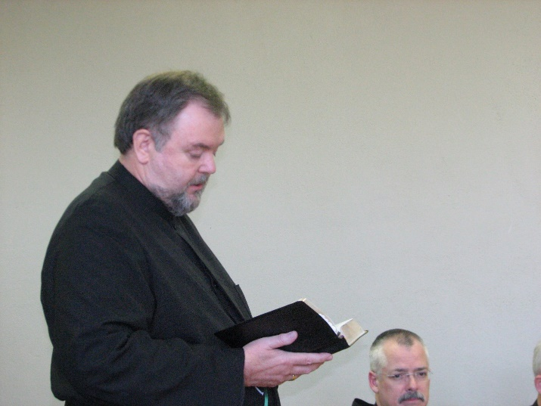
Br. Samuel Saterstrom; Br. Dunstan Townsend

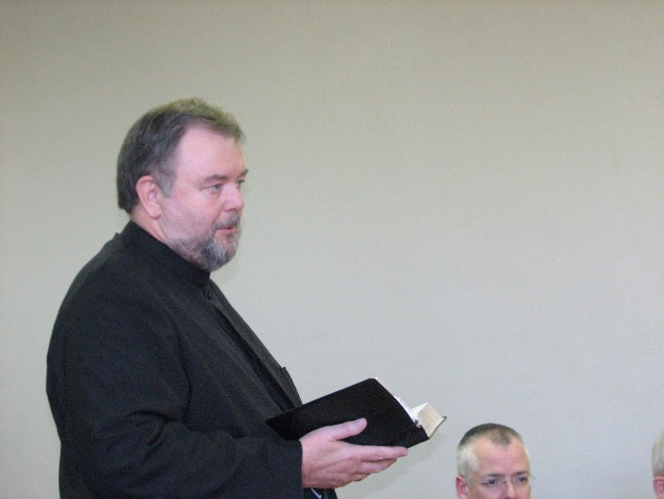
Br. Samuel Saterstrom; Br. Dunstan Townsend

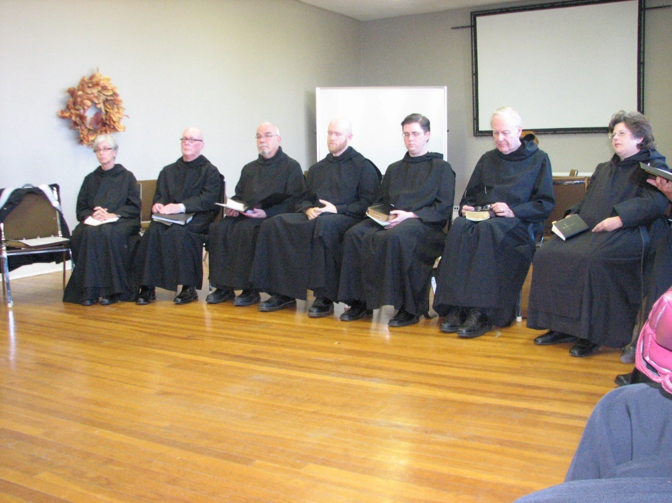
Sr. Julian Saterstrom; Br. Stephen Francis Arnold; Br. Basil Edwards; Br. Gregory Kingsley; Br. Aidan Maguire; Br. Luke Doucette; Sr. Cecelia Lamoy

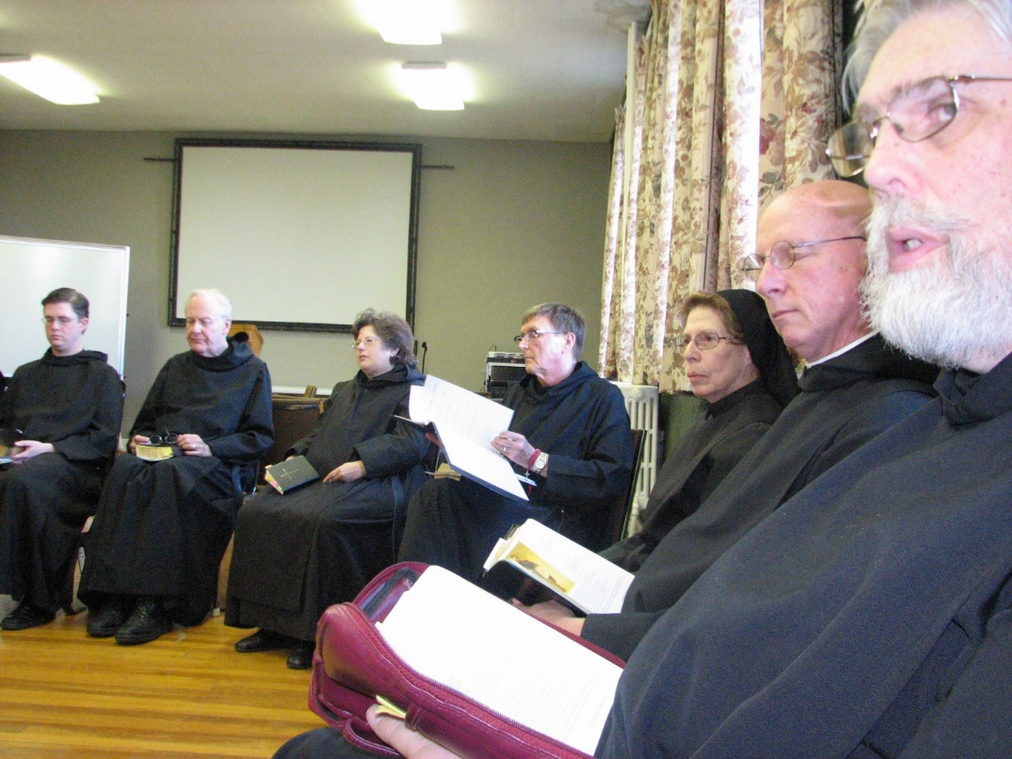
Br. Aidan Maguire; Br. Luke Doucette; Sr. Cecelia Lamoy; Br. Camillus Converse; Sr. Monica Ruth Mullen; Abbot David Vincent Cotton; Br. Chad Anselm Gerns

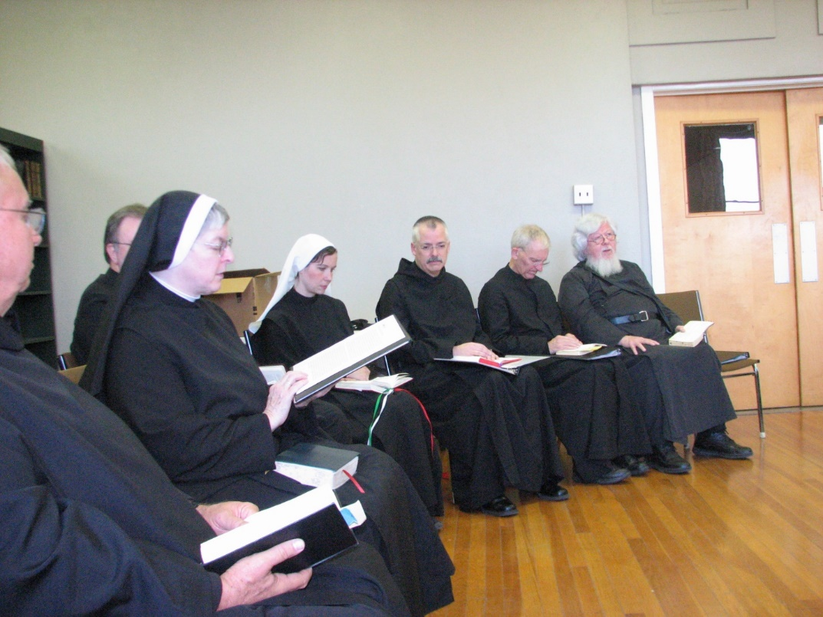
Br. Bede Leach; Br. Samuel Saterstrom; Sr. Bernadette Barrett; Sr. Veronica Taylor; Br. Dunstan Townsend; Br. Joseph Olderr; Fr. Wayne Kamm


Sr. Cecelia Lamoy; Br. Samuel Saterstrom; Sr. Julian Saterstrom; Br. Basil Edwards; Br. Stephen Francis Arnold

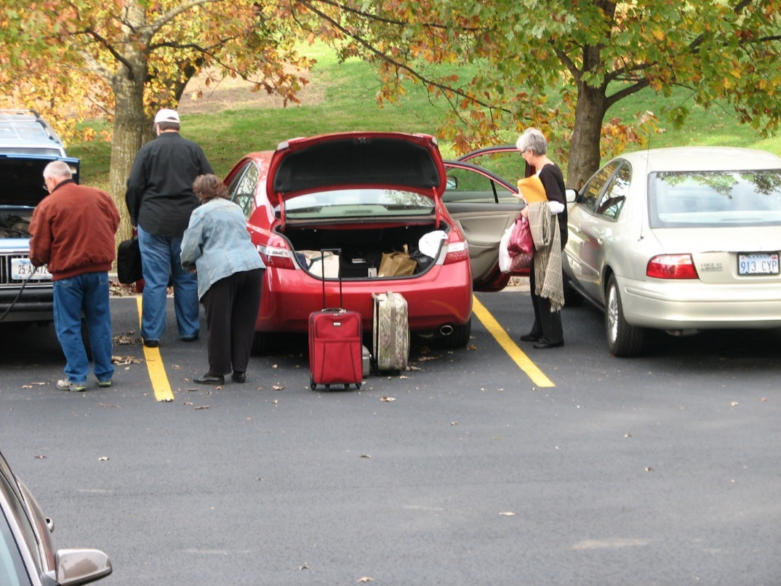
Br. Bede Leach; Br. Samuel Saterstrom; Sr. Cecelia Lamoy; Sr. Julian Saterstrom

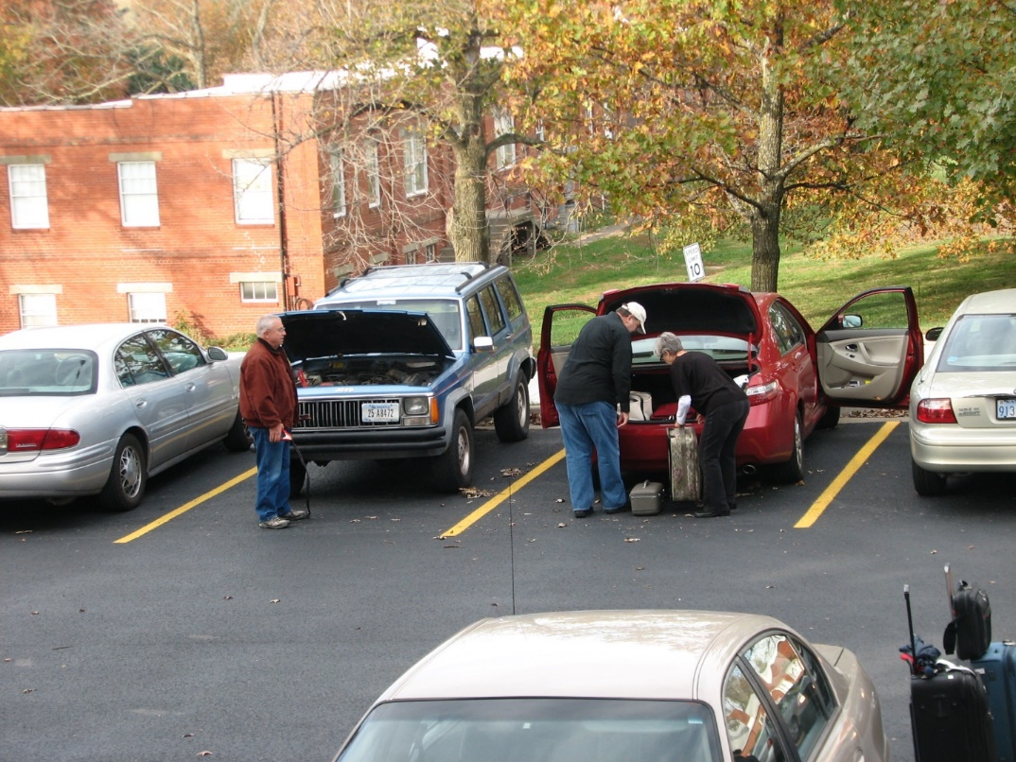
Br. Bede Leach; Br. Samuel Saterstrom; Sr. Julian Saterstrom


Br. Bede Leach; Br. Samuel Saterstrom; Sr. Julian Saterstrom; Br. Stephen Francis Arnold; Br. Basil Edwards; driver

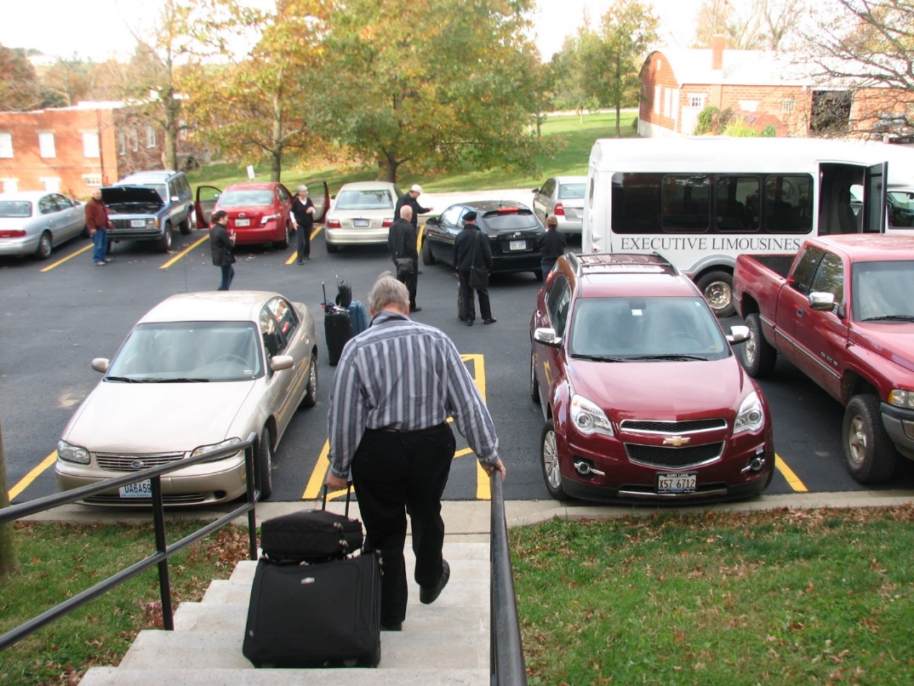
Br. Bede Leach; Sr. Veronica Taylor; Sr. Julian Saterstrom; Br. Basil Edwards; Br. Stephen Francis Arnold; Br. Samuel Saterstrom; Br. Chad Anselm Gerns; Sr. Monica Ruth Mullen

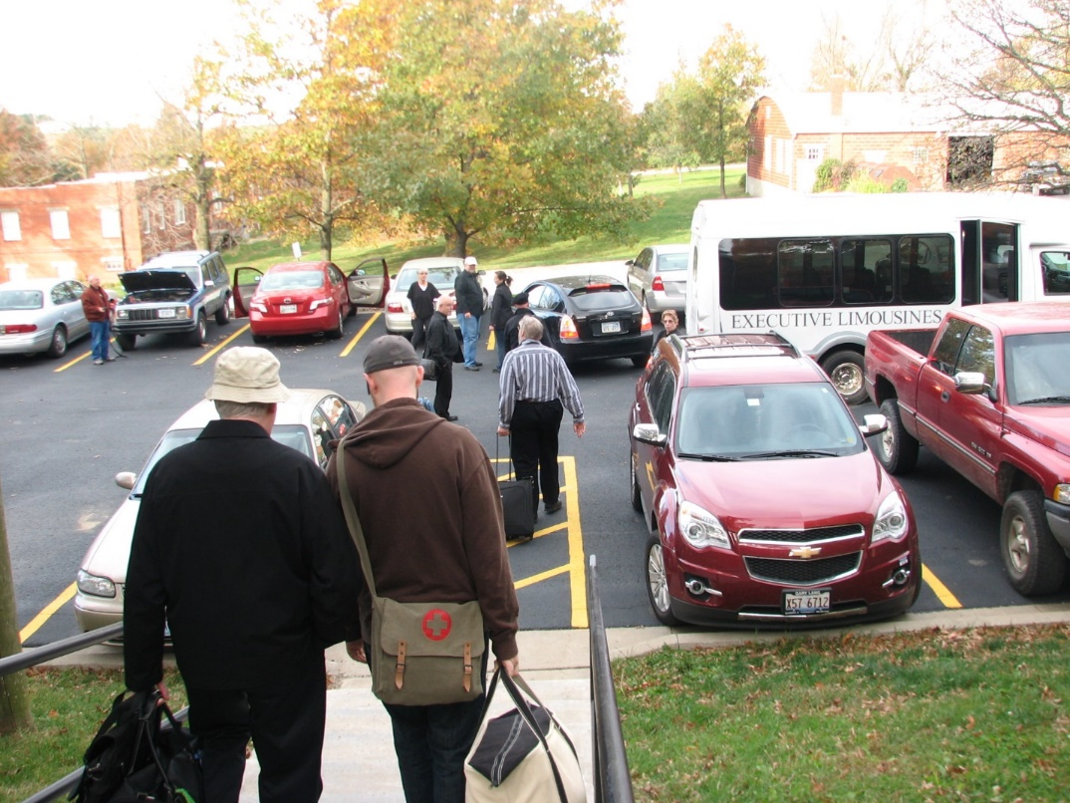
Br. Bede Leach; Br. Luke Doucette; Br. Gregory Kingsley; Sr. Julian Saterstrom; Br. Basil Edwards; Br. Samuel Saterstrom; Sr. Veronica Taylor; Br. Chad Anselm Gerns; Sr. Monica Ruth Mullen

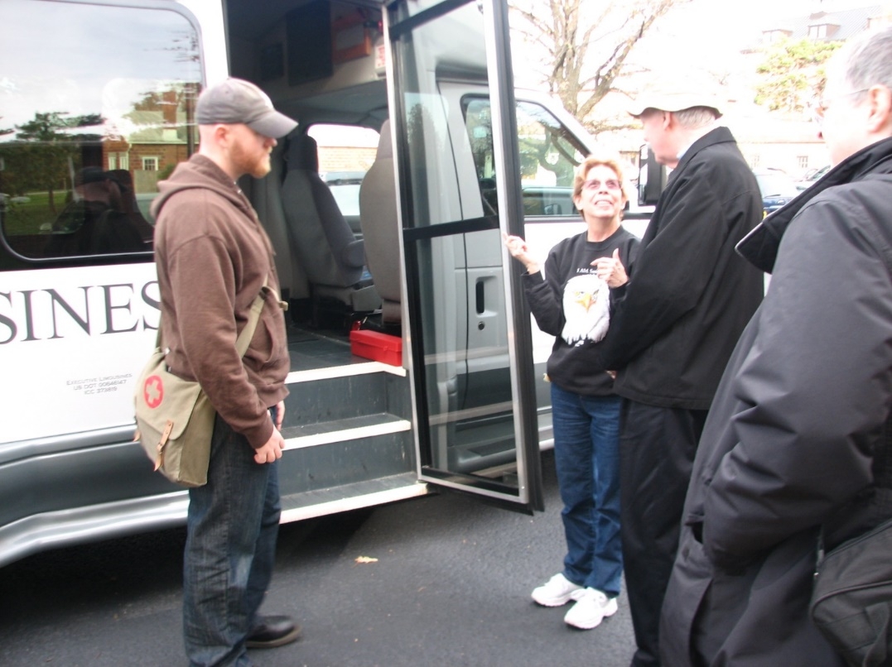
Br. Gregory Kingsley; Sr. Monica Ruth Mullen; Br. Luke Doucette; Sr. Bernadette Barrett

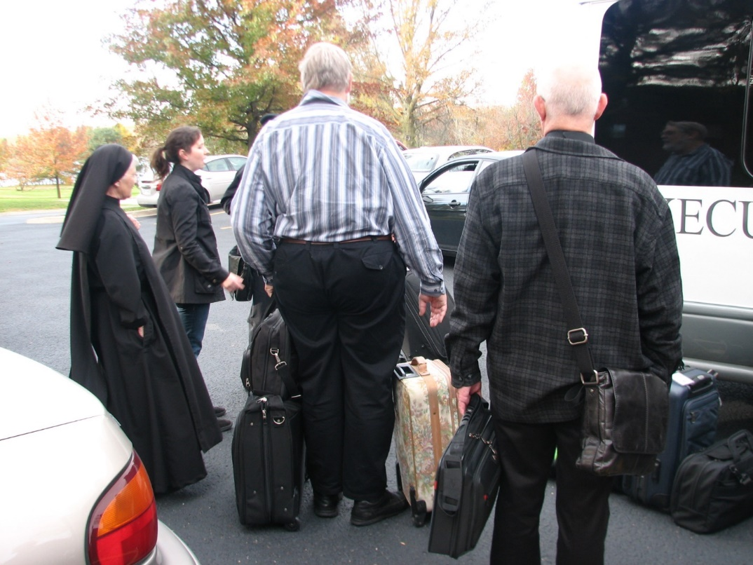
Sr. Mary Francis Deulen; Sr. Veronica Taylor; Br. Chad Anselm Gerns; Br. Basil Edwards

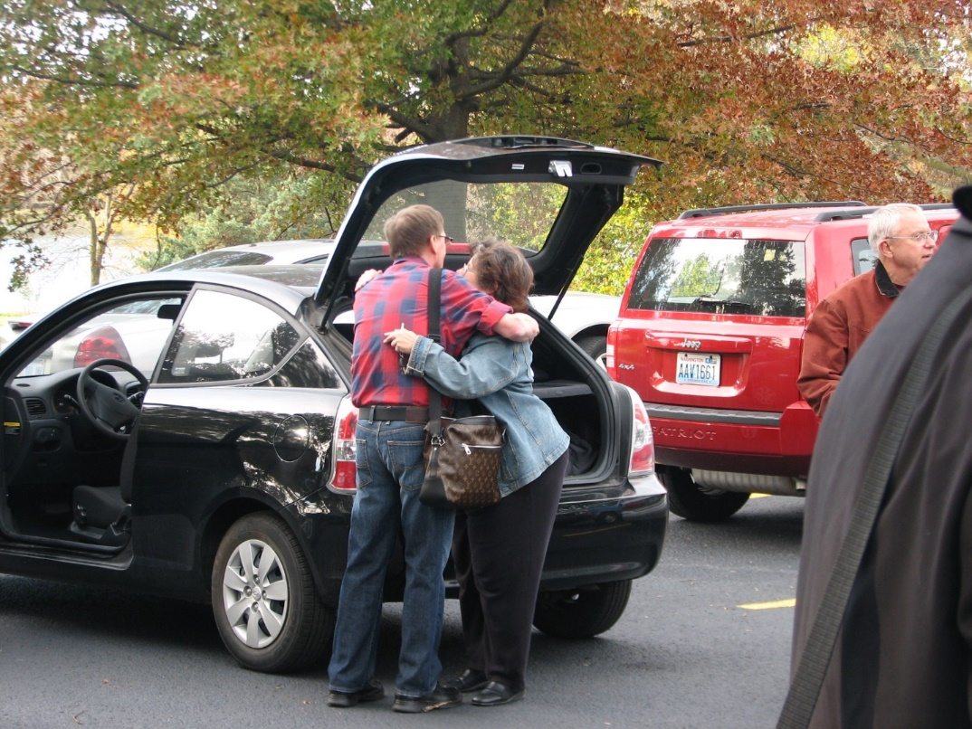
Br. Camillus Converse; Sr. Cecelia Lamoy; Br. Bede Leach
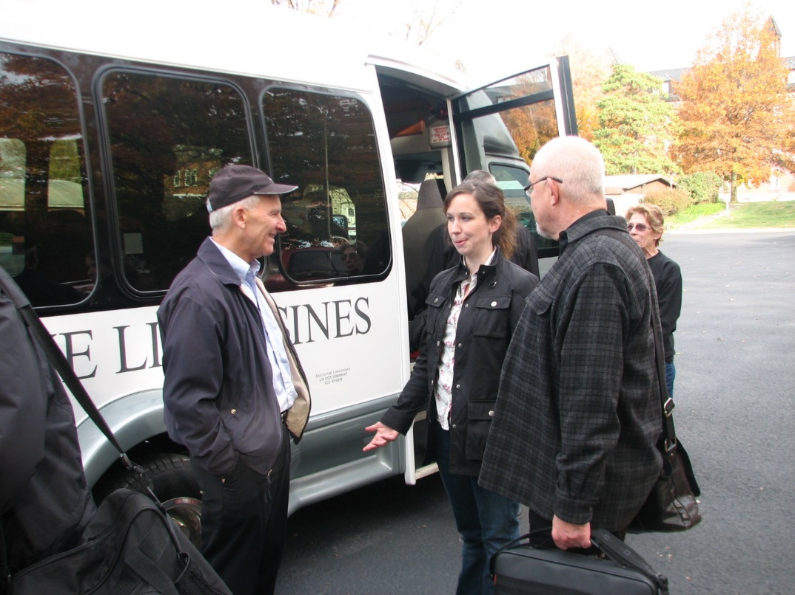
Br. Joseph Olderr; Sr. Veronica Taylor; Br. Basil Edwards; Sr. Monica Ruth Mullen

