Companions of St. Luke
Fall Convocation at Conception Abbey
October 25-30, 2010;
Part 2 of 4
Photographed by Sr. Brigid Gerns

People are identified from left to right.

Edited by Br. Steven Olderr 24 October 2023. Please send any comments, corrections, or additions to olderr@ameritech.net

NOTE: In May of 2011, Abbot David Vincent Cotton announced that members could use their birth names instead of religious names if they chose. The following names were changed—some immediately, some later.

Br. Aidan Maguire > Br. Kenneth
Br. Chad Anselm Gerns > Br. David
Br. David Vincent Cotton > Br. Robert
Br. Gregory Kingsley > Br. Joshua
Br. Joseph > Br. Steven Joseph, and later still, just Br. Steven
Br. Luke Doucette > Br. Lee
Br. Willard Moore > Br. Daniel Moore
Sr. Bernadette Barrett > Sr. Helena
Sr. Cecelia Lamoy > Sr. Martha
Sr. Margaret Moore > Sr. Denise

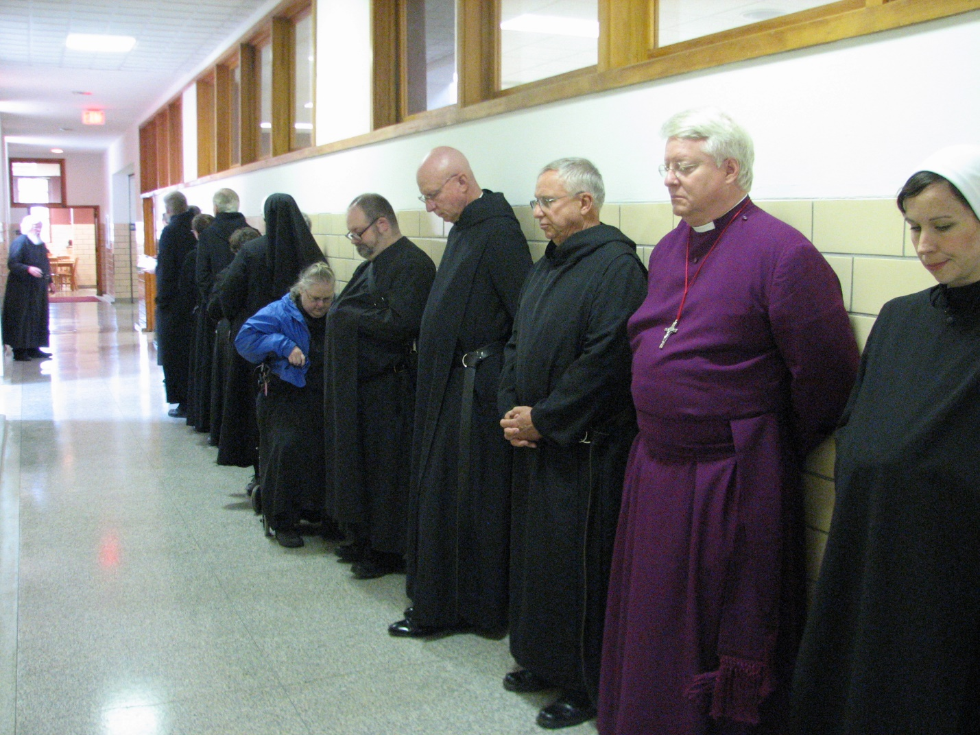
Fr. Wayne Kamm; Br. Chad Anselm Gerns; Br. Camillus Converse; Br. Luke Doucette; Sr. Cecelia Lamoy; Kamm; Sr. Bernadette Barrett; Sr. Margaret Moore; Br. Willard Moore; Abbot David Vincent Cotton; Br. Bede Leach; Bp. Dean Wolfe; Sr. Veronica Taylor; Sr. Mary Francis Deulen

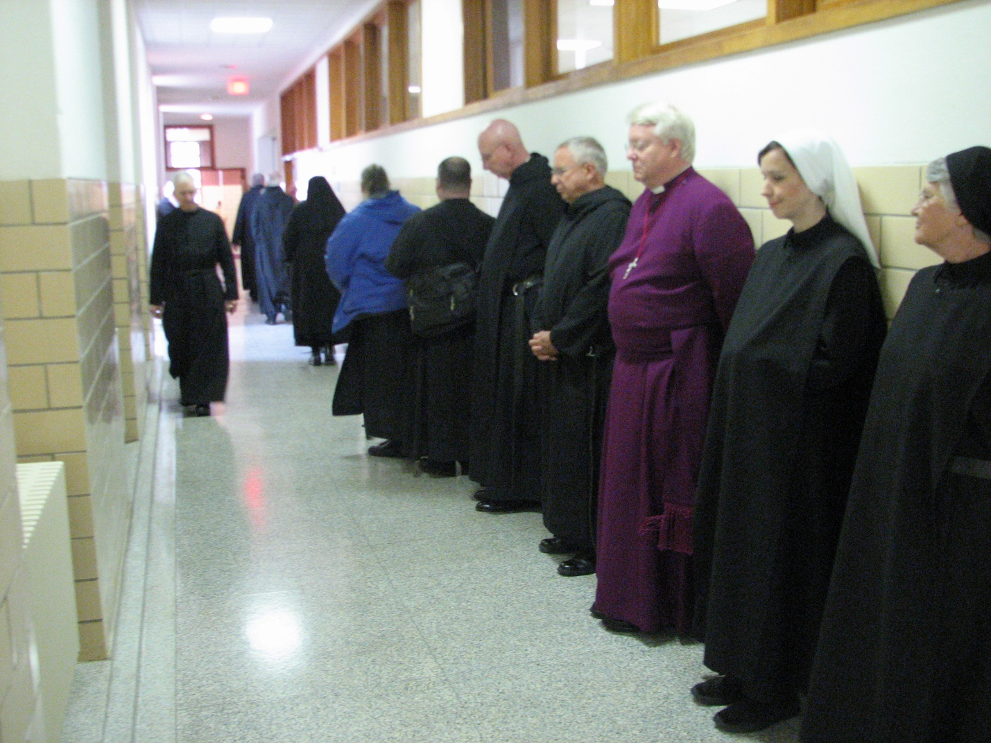
Fr. Wayne Kamm; Br. Joseph Olderr; Br. Chad Anselm Gerns; Br. Camillus Converse; Br. Luke Doucette; Sr. Bernadette Barrett; Sr. Margaret Moore; Br. Willard Moore; Abbot David Vincent Cotton; Br. Bede Leach; Bp. Dean Wolfe; Sr. Veronica Taylor; Sr. Mary Francis Deulen

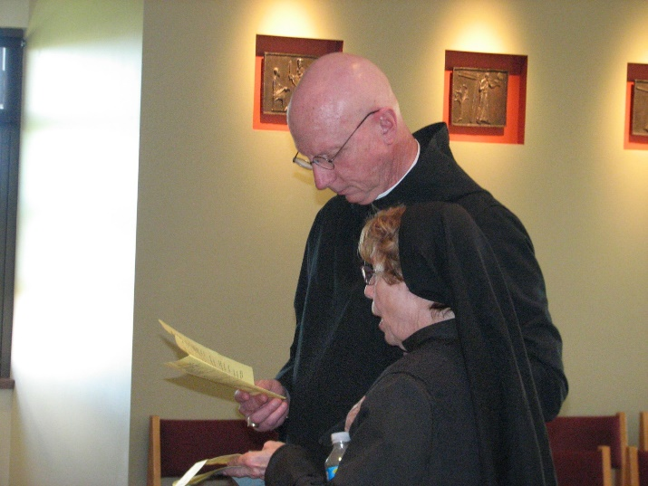
Abbot David Vincent Cotton; Sr. Monica Ruth Mullen
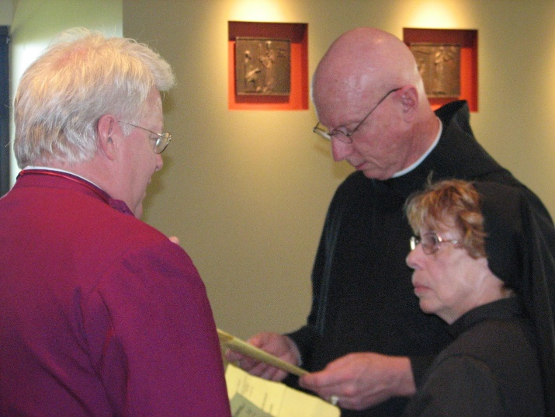
Bp. Dean Wolfe; Abbot David Vincent Cotton; Sr. Monica Ruth Mullen

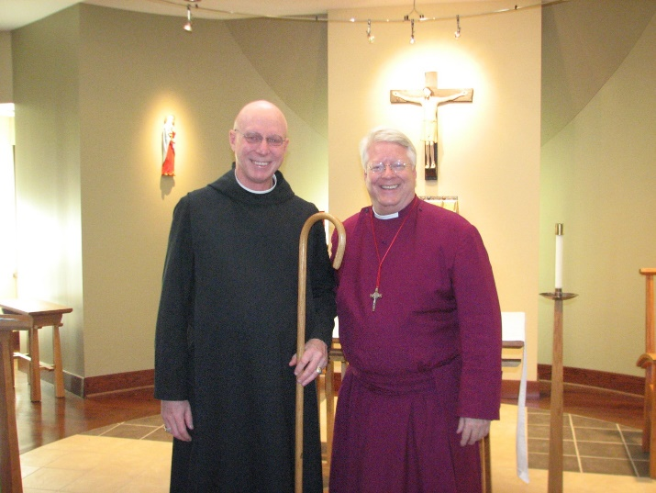
Abbot David Vincent Cotton; Bp. Dean Wolfe

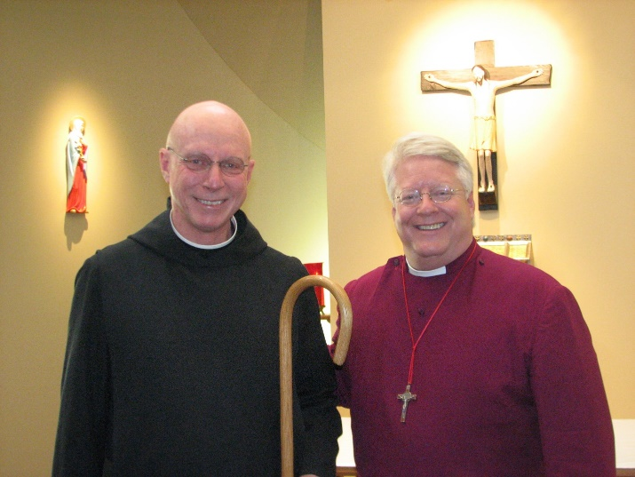
Abbot David Vincent Cotton; Bp. Dean Wolfe
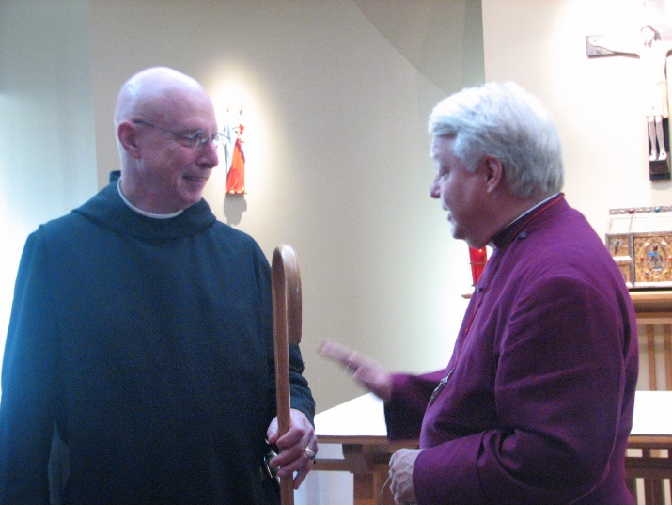
Abbot David Vincent Cotton; Bp. Dean Wolfe

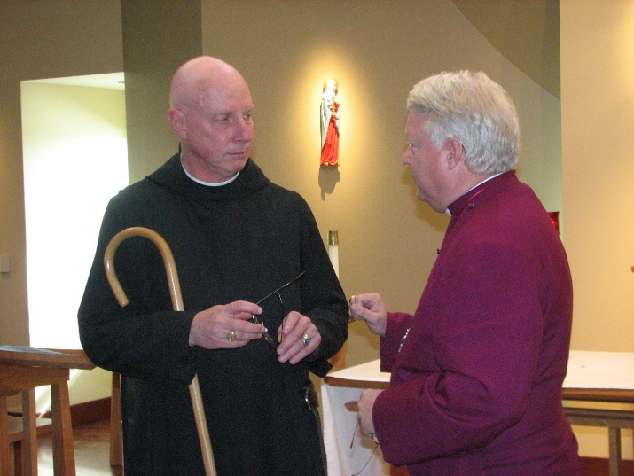
Abbot David Vincent Cotton; Bp. Dean Wolfe

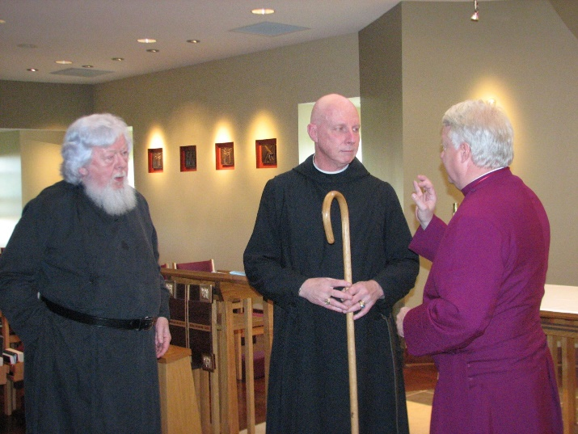
Fr. Wayne Kamm; Abbot David Vincent Cotton; Bp. Dean Wolfe
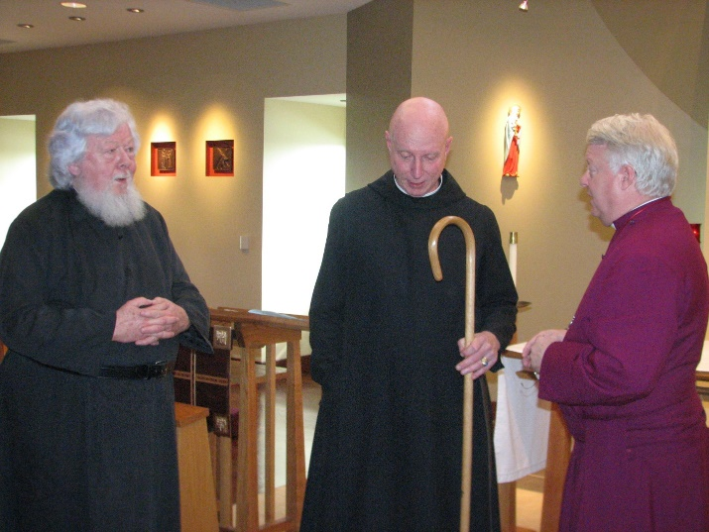
Fr. Wayne Kamm; Abbot David Vincent Cotton; Bp. Dean Wolfe

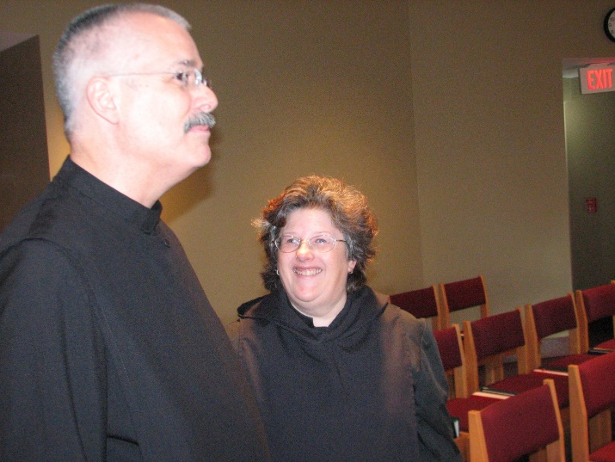
Br. Dunstan Townsend; Sr. Cecelia Lamoy

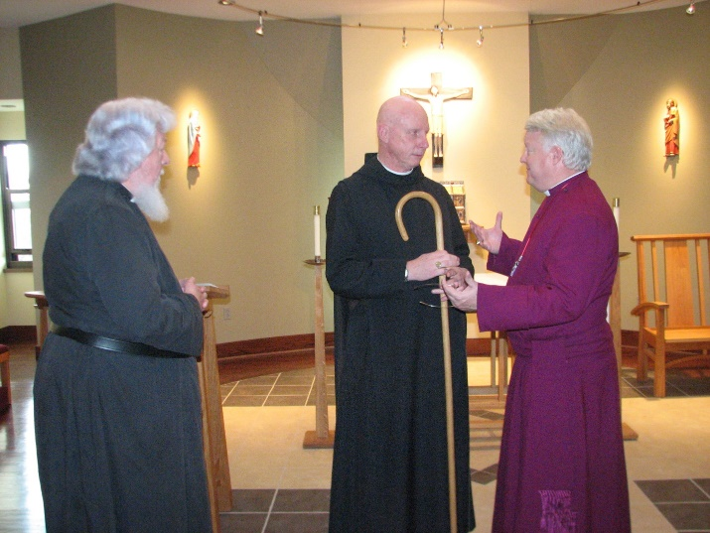
Fr. Wayne Kamm; Abbot David Vincent Cotton; Bp. Dean Wolfe
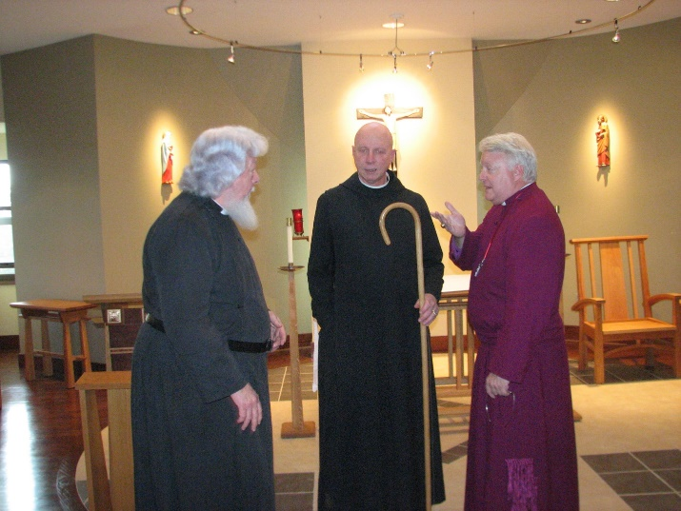
Fr. Wayne Kamm; Abbot David Vincent Cotton; Bp. Dean Wolfe

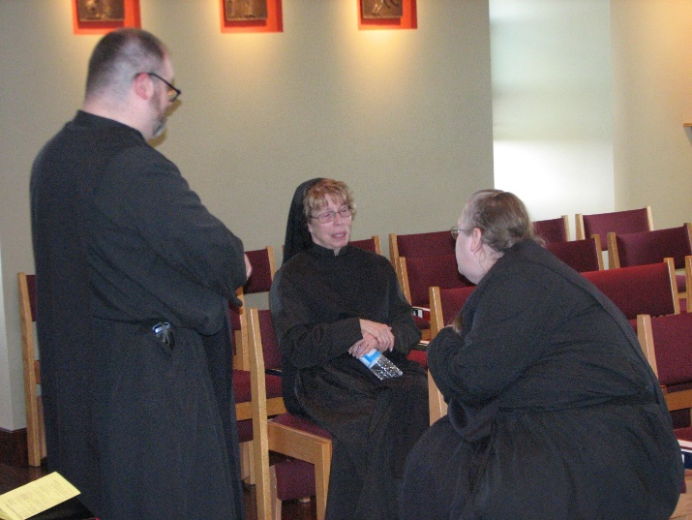
Br. Willard Moore; Sr. Monica Ruth Mullen; Sr. Margaret Moore

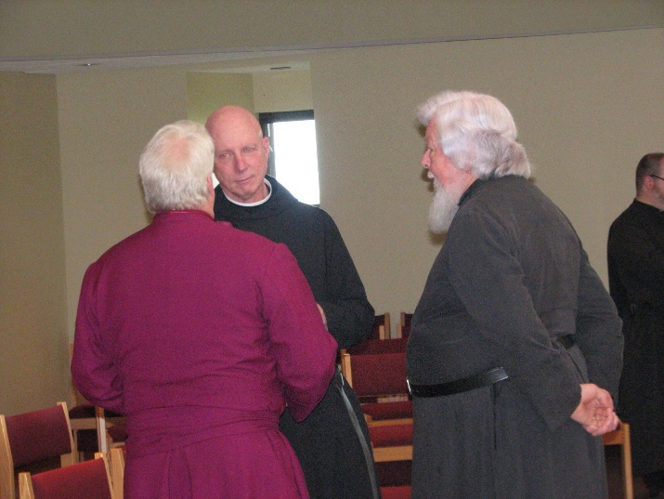
Bp. Dean Wolfe; Abbot David Vincent Cotton; Fr. Wayne Kamm; Br. Willard Moore
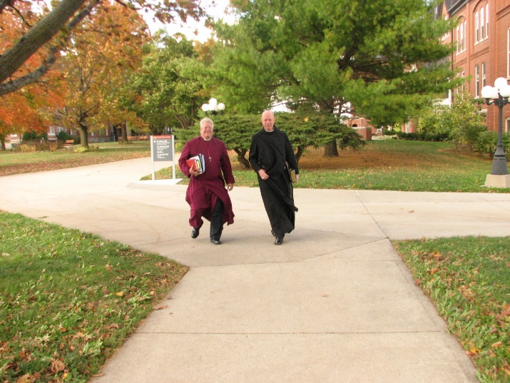
Bp. Dean Wolfe; Abbot David Vincent Cotton

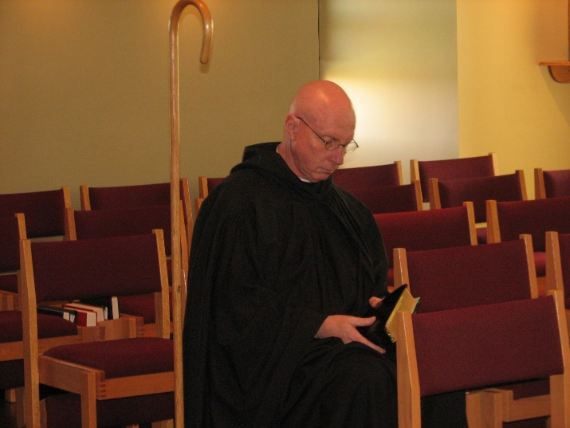
Abbot David Vincent Cotton

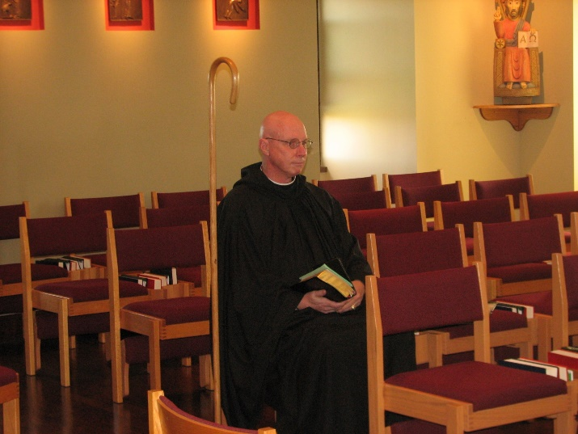
Abbot David Vincent Cotton

Br. Dunstan Townsend

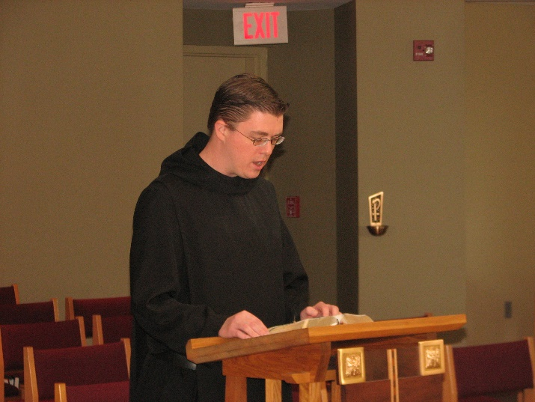
Br. Aidan Maguire

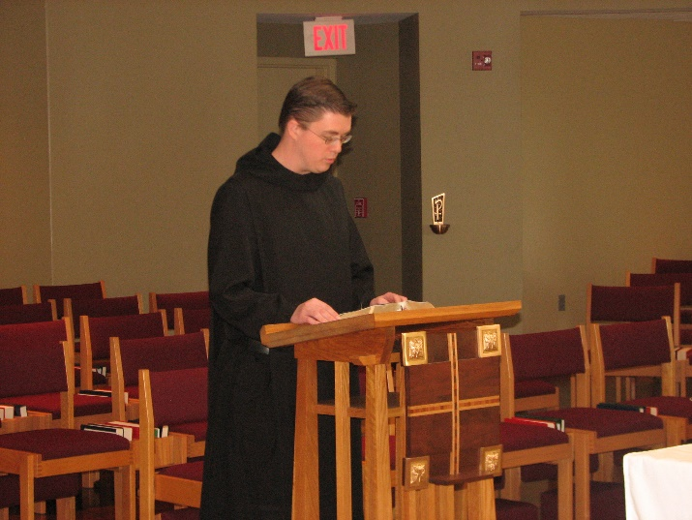
Br. Aidan Maguire
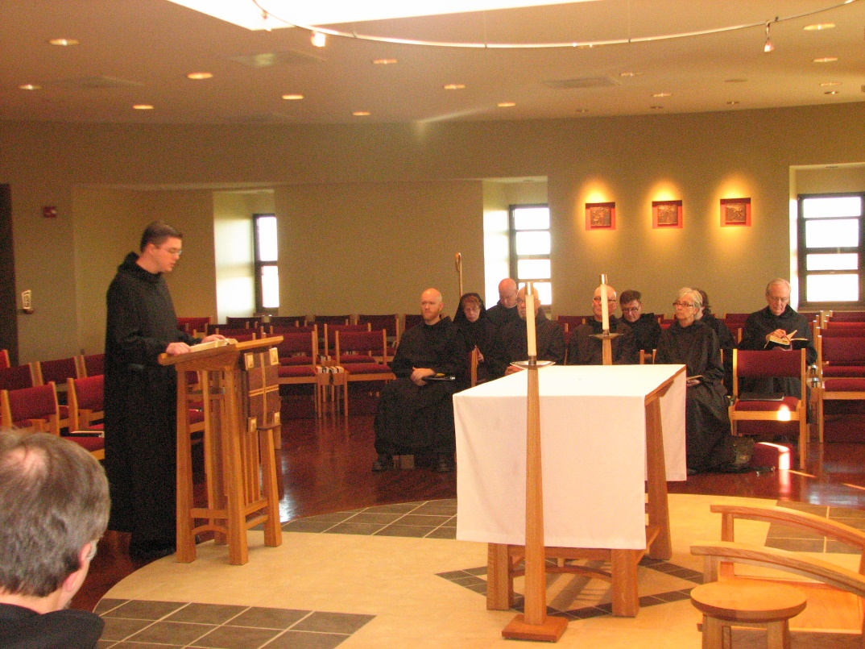
Br. Aidan Maguire; Br. Gregory Kingsley; Sr. Monica Ruth Mullen; Abbot David Vincent Cotton; Br. Basil Edwards; Br. Stephen Francis Arnold; Br. Camillus Converse; Sr. Julian Saterstrom; Sr. Cecelia Lamoy; Br. Luke Doucette

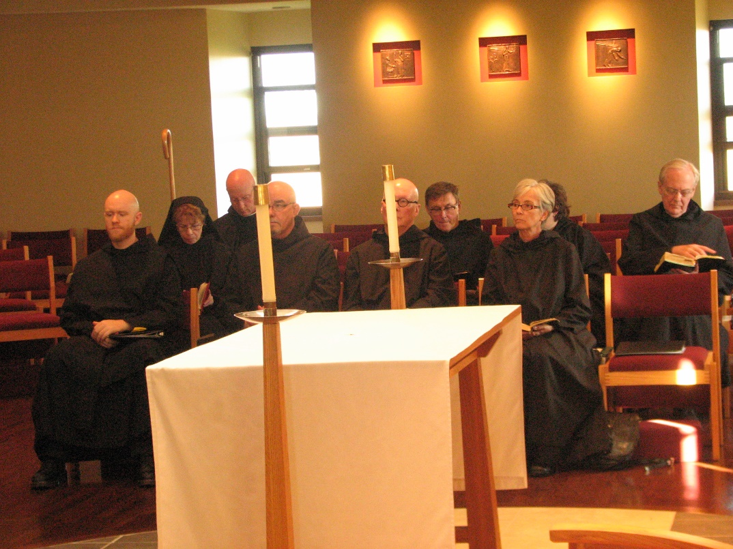
Br. Gregory Kingsley; Sr. Monica Ruth Mullen; Abbot David Vincent Cotton; Br. Basil Edwards; Br. Stephen Francis Arnold; Br. Camillus Converse; Sr. Julian Saterstrom; Sr. Cecelia Lamoy; Br. Luke Doucette
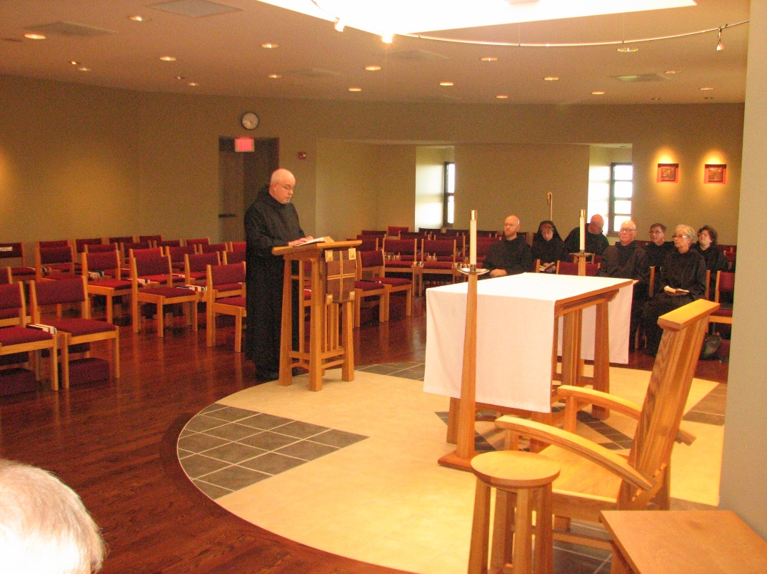
Br. Basil Edwards; Br. Gregory Kingsley; Sr. Monica Ruth Mullen; Abbot David Vincent Cotton; Br. Stephen Francis Arnold; Br. Camillus Converse; Sr. Julian Saterstrom; Sr. Cecelia Lamoy; Br. Luke Doucette

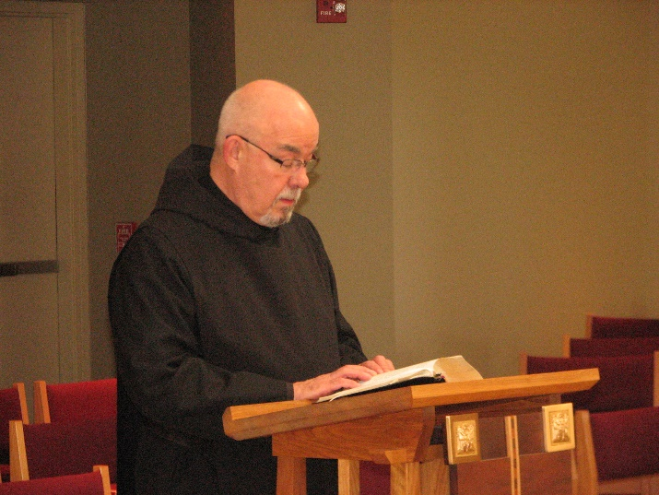
Br. Basil Edwards
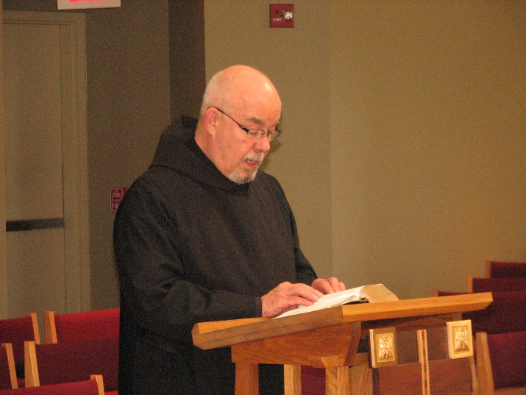
Br. Basil Edwards

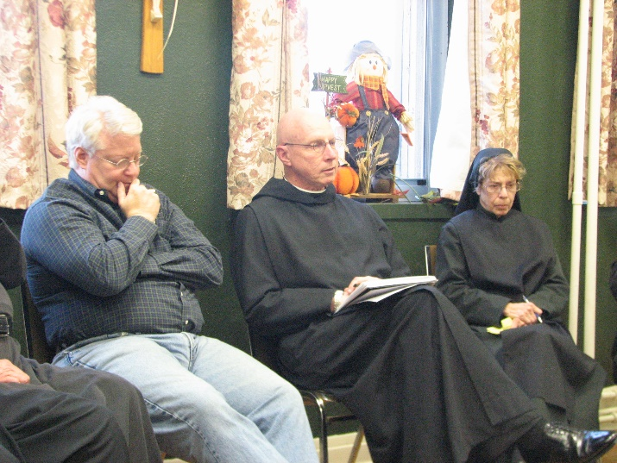
Bp. Dean Wolfe; Abbot David Vincent Cotton; Sr. Monica Ruth Mullen

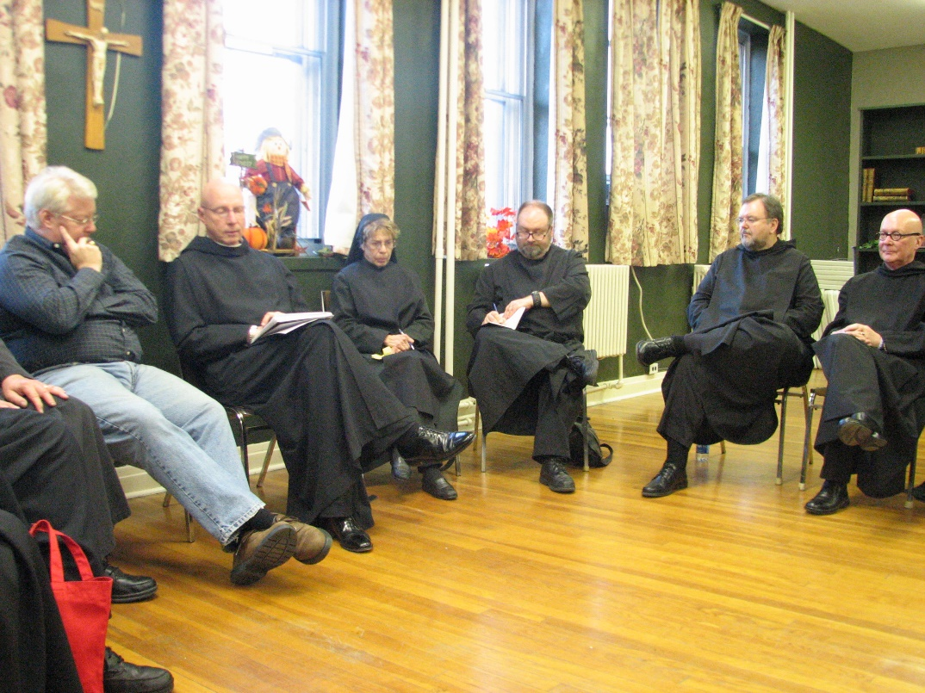
Bp. Dean Wolfe; Abbot David Vincent Cotton; Sr. Monica Ruth Mullen; Br. Willard Moore; Br. Samuel Saterstrom; Br. Stephen Francis Arnold

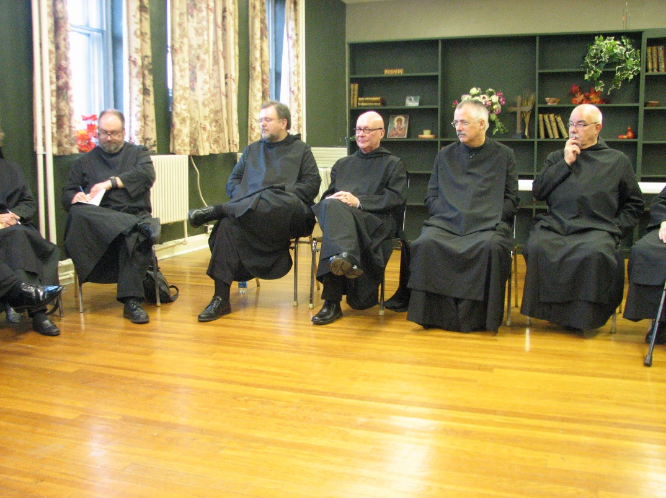
Br. Willard Moore; Br. Samuel Saterstrom; Br. Stephen Francis Arnold; Br. Dunstan Townsend; Br. Basil Edwards
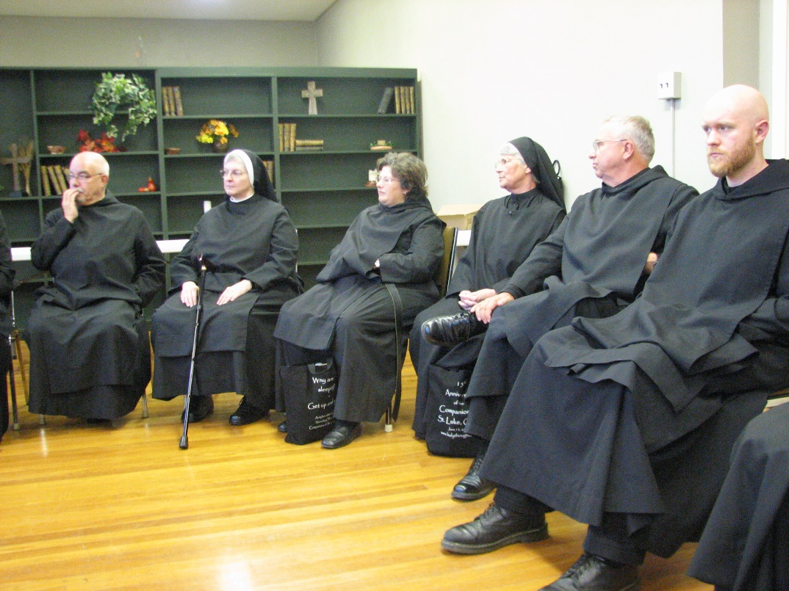
Br. Basil Edwards; Sr. Bernadette Barrett; Sr. Cecelia Lamoy; Sr. Mary Francis Deulen; Br. Bede Leach; Br. Gregory Kingsley

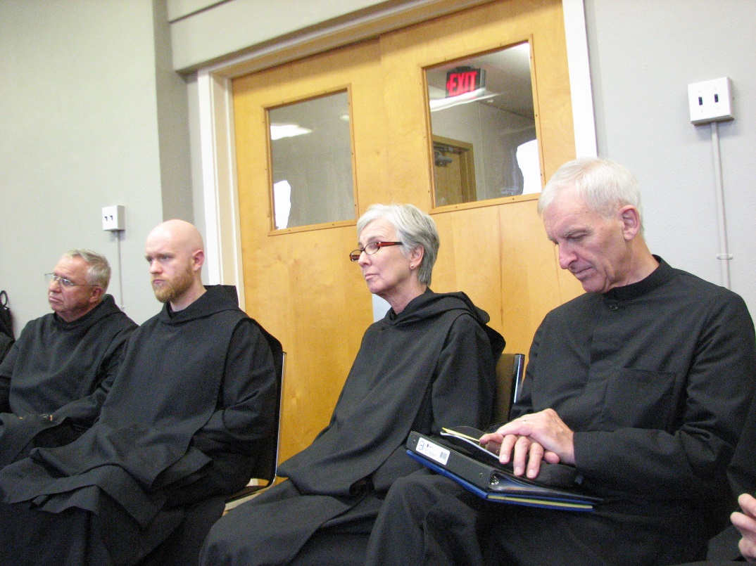
Br. Bede Leach; Br. Gregory Kingsley; Sr. Julian Saterstrom; Br. Joseph Olderr

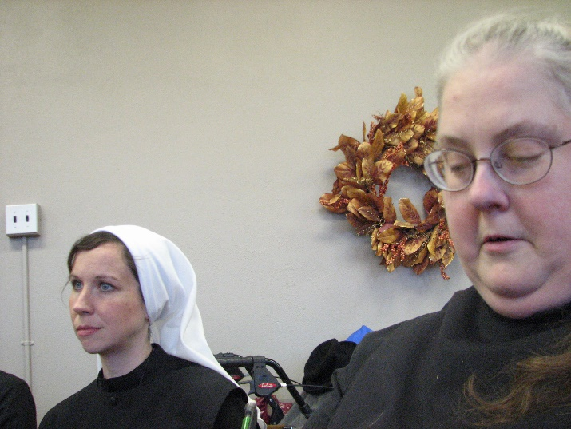
Sr. Veronica Taylor; Sr. Margaret Moore

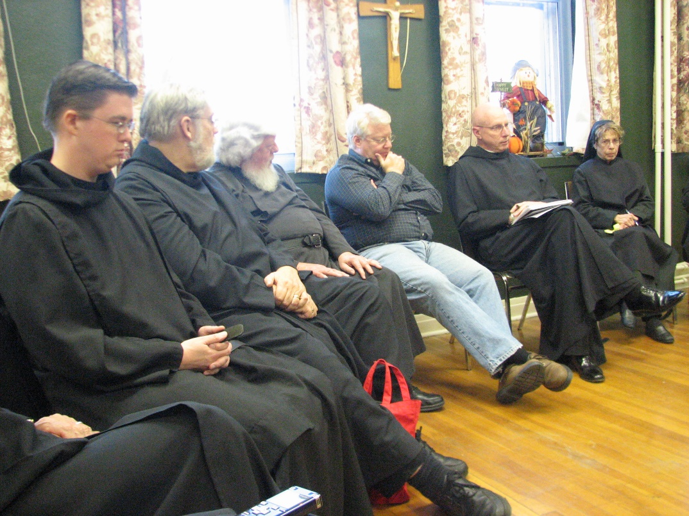
Br. Aidan Maguire; Br. Chad Anselm Gerns; Fr. Wayne Kamm; Bp. Dean Wolfe; Abbot David Vincent Cotton; Sr. Monica Ruth Mullen

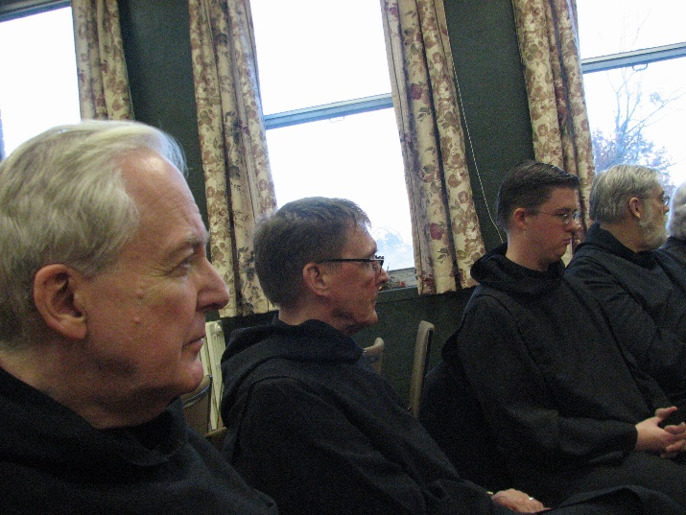
Br. Luke Doucette; Br. Camillus Converse; Br. Aidan Maguire; Br. Chad Anselm Gerns

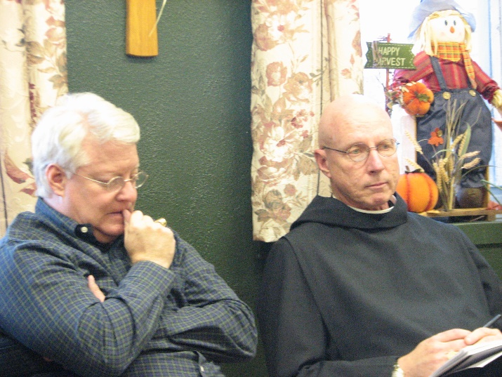
Bp. Dean Wolfe; Abbot David Vincent Cotton

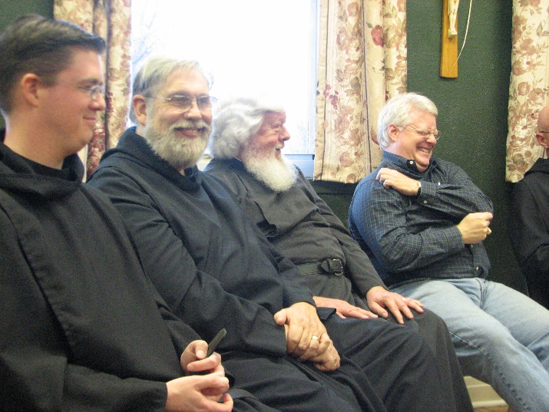
Br. Aidan Maguire; Br. Chad Anselm Gerns; Fr. Wayne Kamm; Bp. Dean Wolfe; Abbot David Vincent Cotton
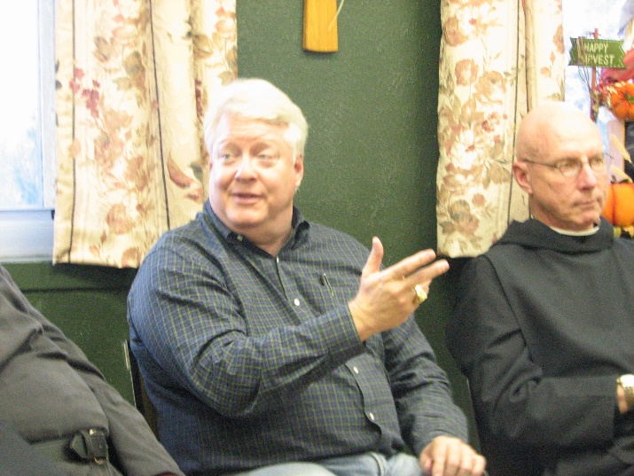
Bp. Dean Wolfe; Abbot David Vincent Cotton

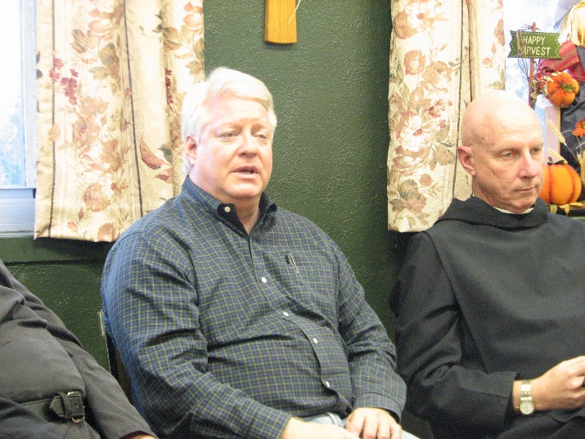
Bp. Dean Wolfe; Abbot David Vincent Cotton

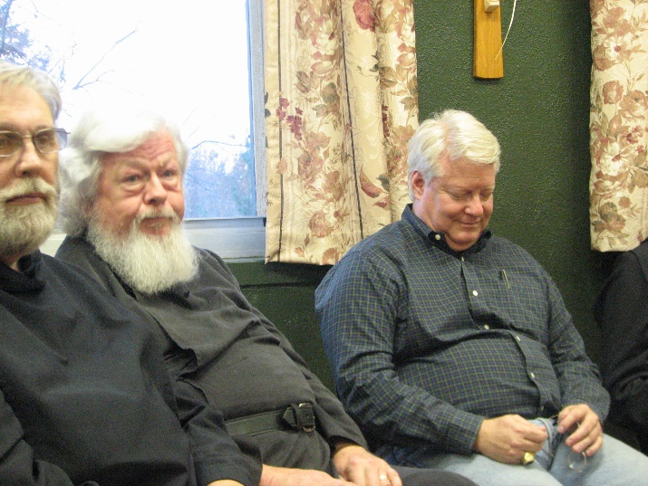
Br. Chad Anselm Gerns; Fr. Wayne Kamm; Bp. Dean Wolfe
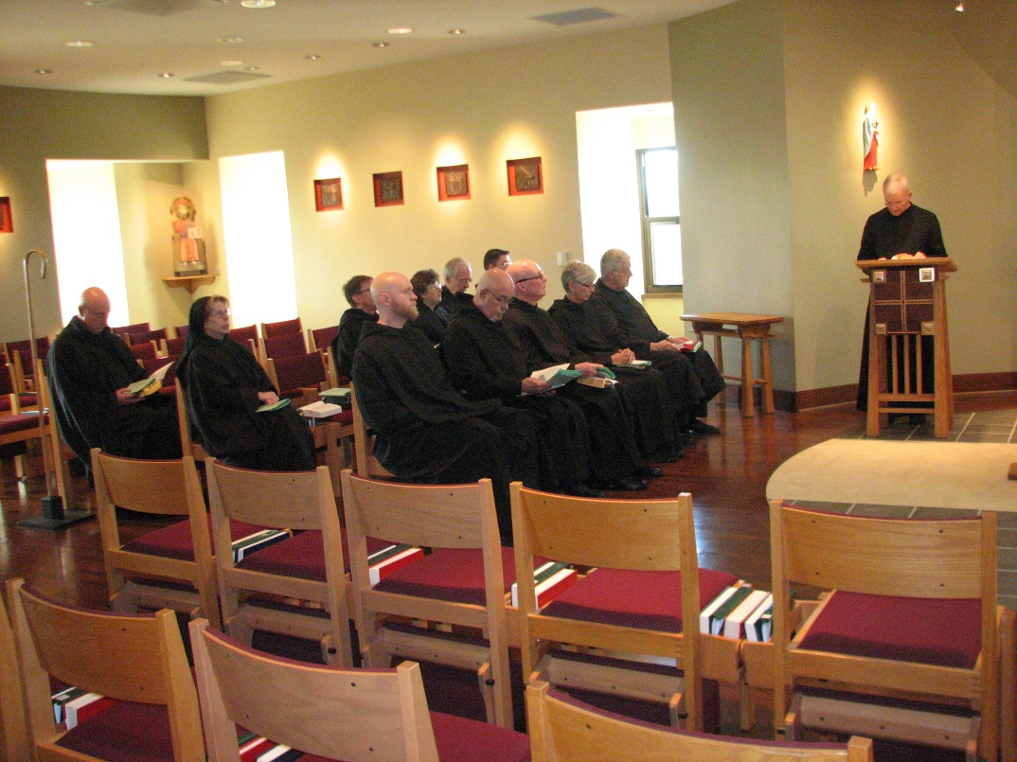
Abbot David Vincent Cotton; Sr. Monica Ruth Mullen; Br. Camillus Converse; Br. Gregory Kingsley; Sr. Cecelia Lamoy; Br. Luke Doucette; Br. Basil Edwards; Br. Aidan Maguire; Br. Stephen Francis Arnold; Sr. Julian Saterstrom; Br. Michael Anicetus McCabe; Br. Joseph Olderr

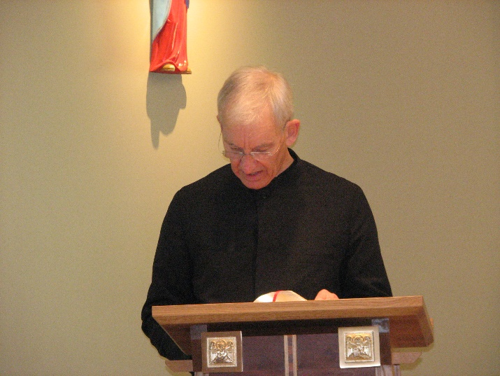
Br. Joseph Olderr
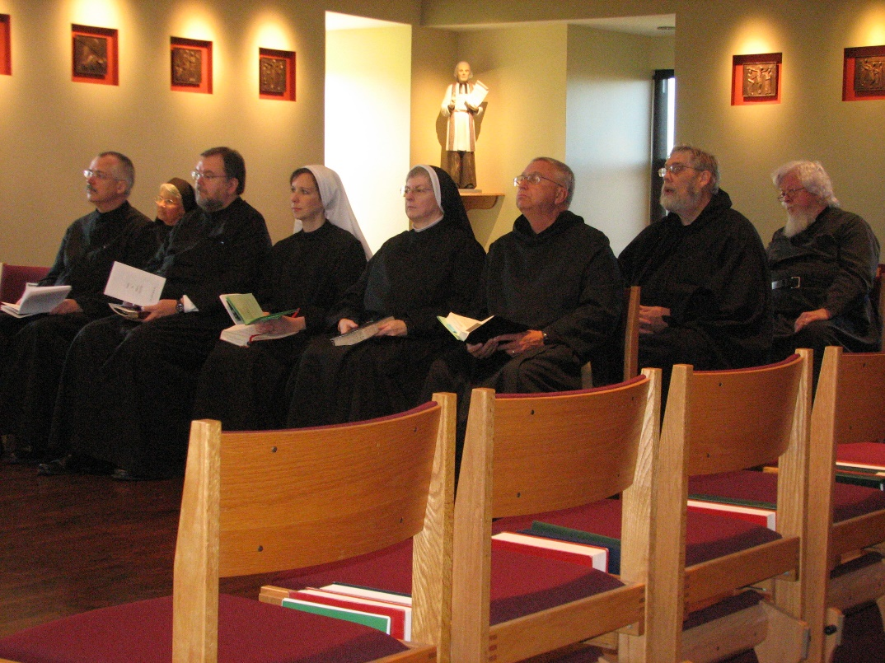
Br. Dunstan Townsend; Sr. Mary Francis Deulen; Br. Samuel Saterstrom; Sr. Veronica Taylor; Sr. Bernadette Barrett; Br. Bede Leach; Br. Chad Anselm Gerns; Fr. Wayne Kamm

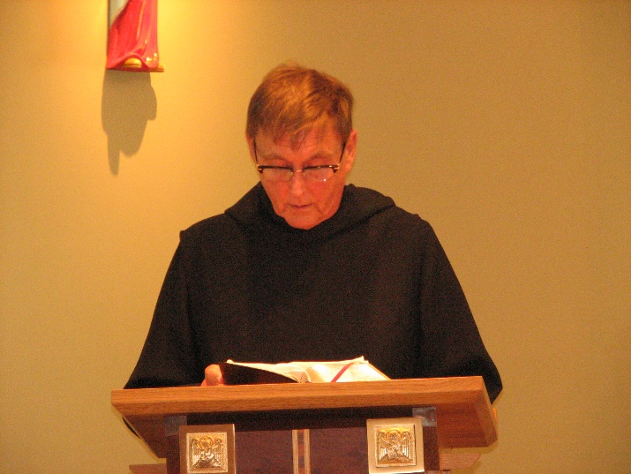
Br. Camillus Converse

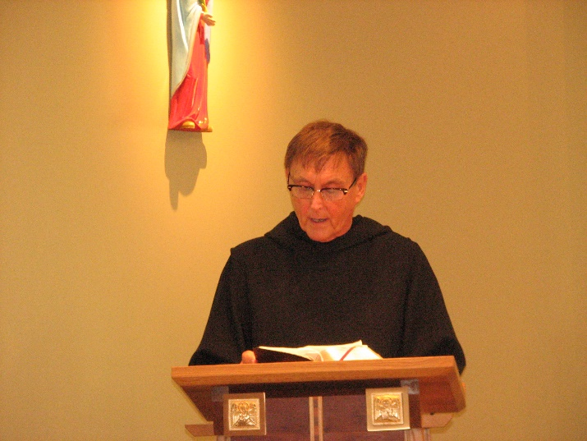
Br. Camillus Converse

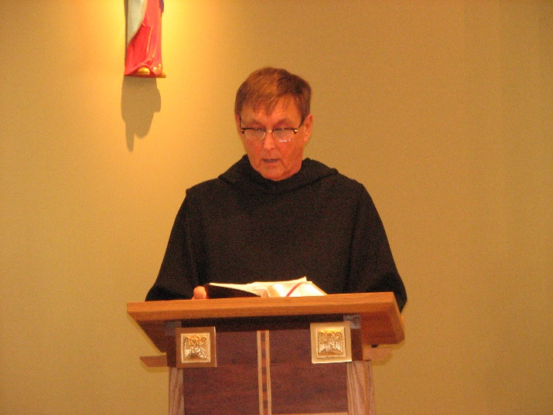
Br. Camillus Converse

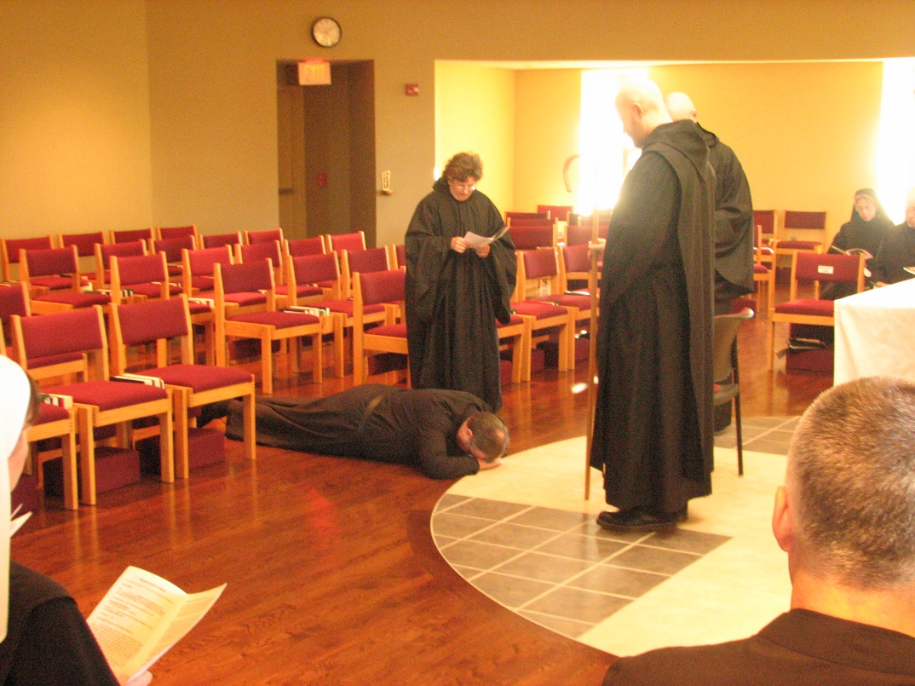
Sr. Veronica Taylor; Br. Samuel Saterstrom; Sr. Cecelia Lamoy; Br. Gregory Kingsley; Abbot David Vincent Cotton; Br. Dunstan Townsend; Sr. Monica Ruth Mullen; Br. Basil Edwards

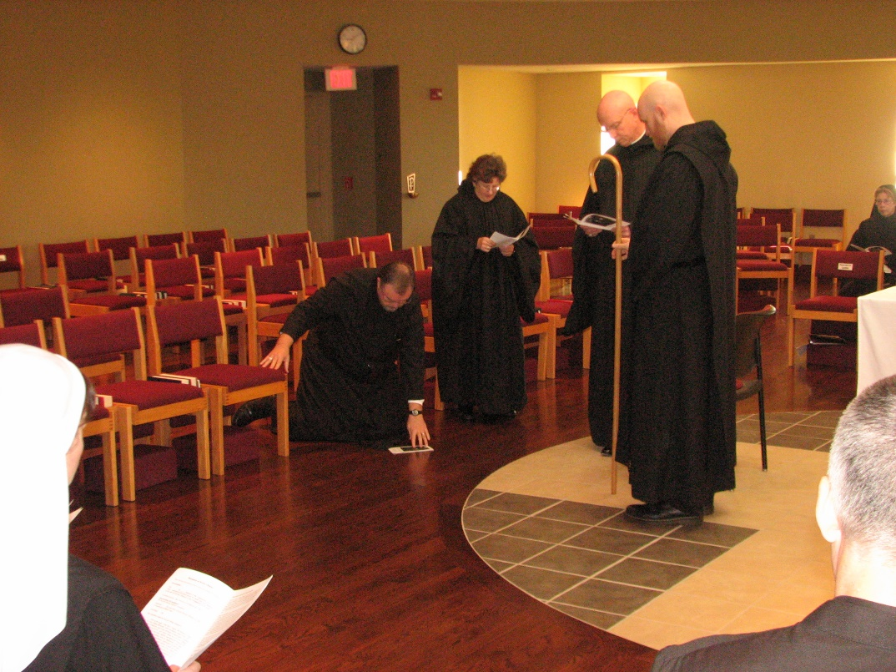
Sr. Veronica Taylor; Br. Samuel Saterstrom; Sr. Cecelia Lamoy; Abbot David Vincent Cotton; Br. Gregory Kingsley; Br. Dunstan Townsend; Sr. Monica Ruth Mullen
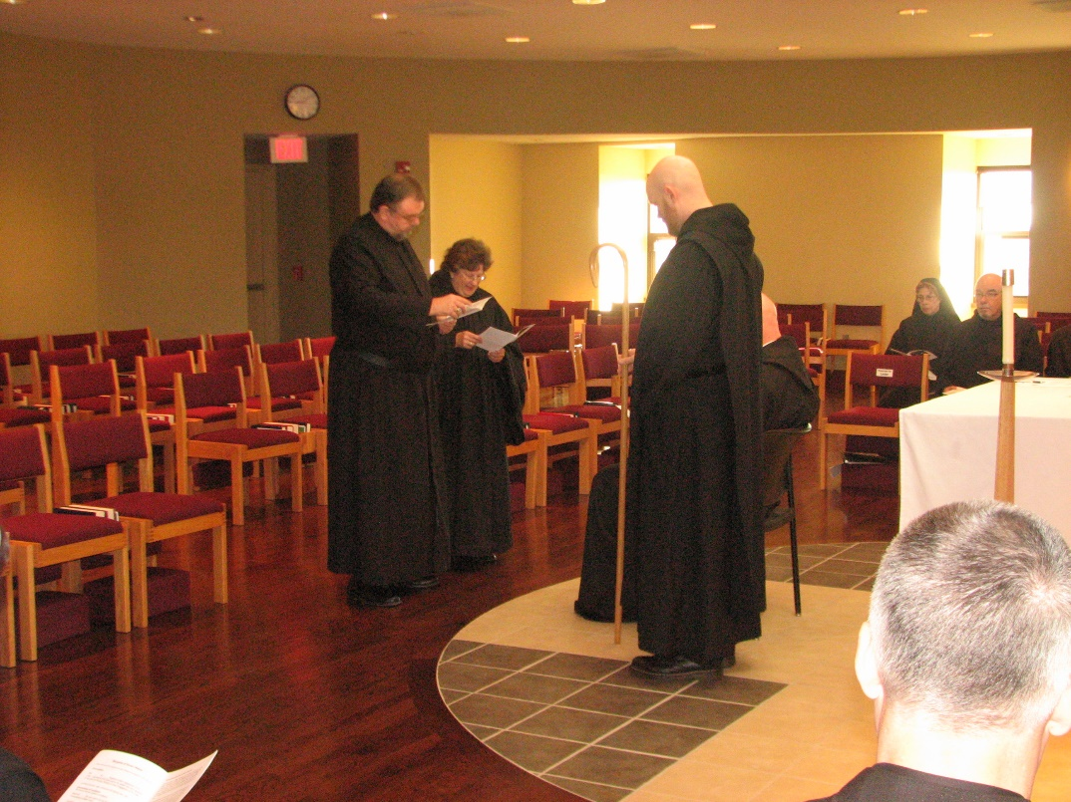
Br. Samuel Saterstrom; Sr. Cecelia Lamoy; Br. Gregory Kingsley; Abbot David Vincent Cotton; Br. Dunstan Townsend; Sr. Monica Ruth Mullen; Br. Basil Edwards

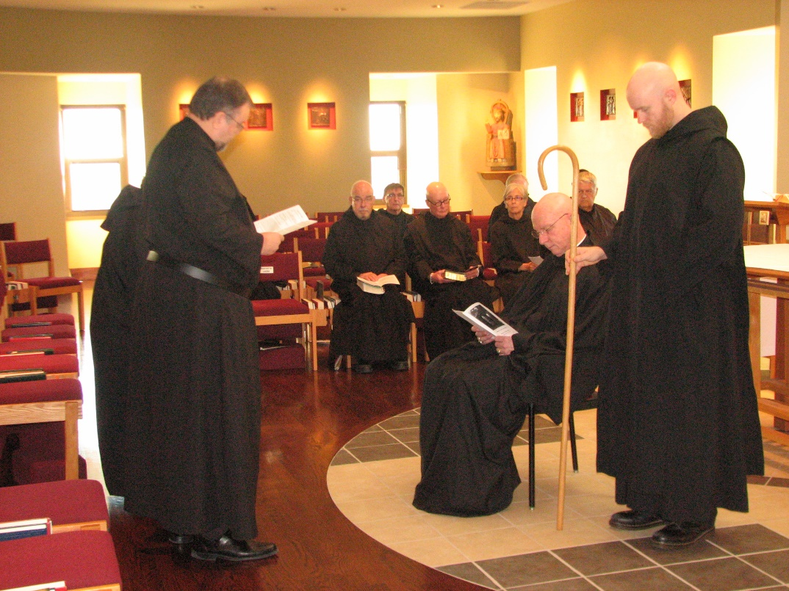
Sr. Cecelia Lamoy; Br. Samuel Saterstrom; Br. Basil Edwards; Br. Camillus Converse; Br. Stephen Francis Arnold; Sr. Julian Saterstrom; Abbot David Vincent Cotton; Br. Michael Anicetus McCabe; Br. Gregory Kingsley
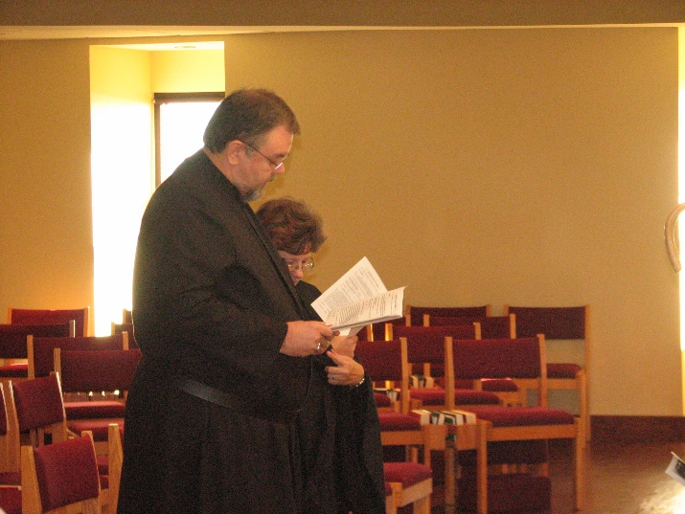
Br. Samuel Saterstrom; Sr. Cecelia Lamoy

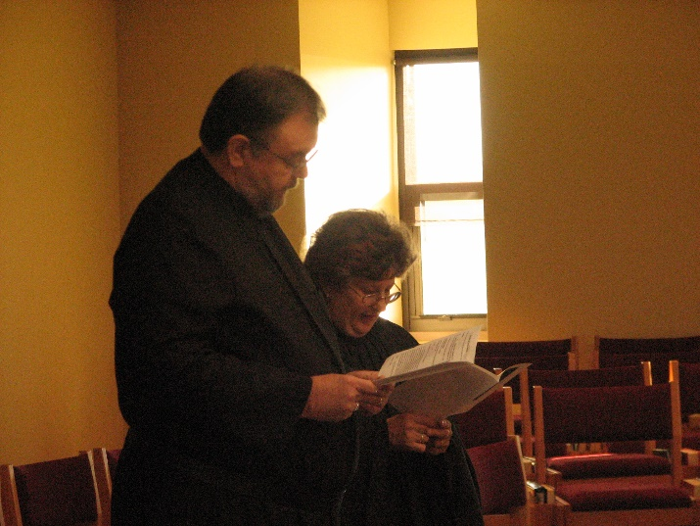
Br. Samuel Saterstrom; Sr. Cecelia Lamoy

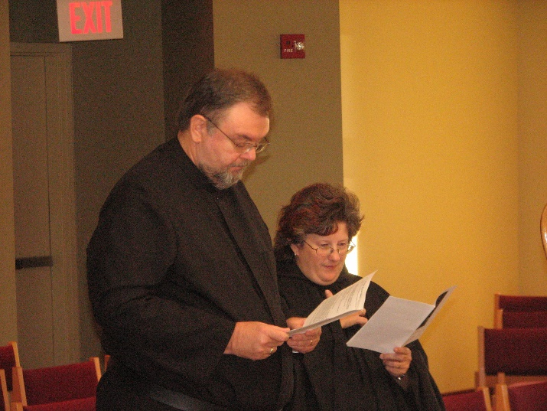
Br. Samuel Saterstrom; Sr. Cecelia Lamoy

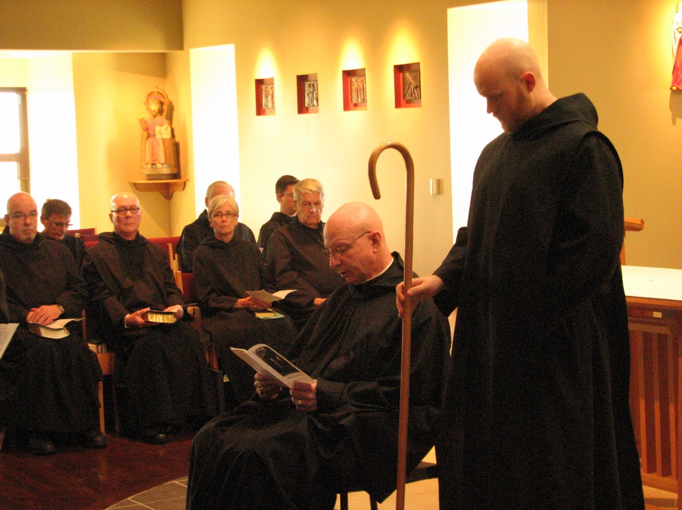
Br. Basil Edwards; Br. Camillus Converse; Br. Stephen Francis Arnold; Br, Luke Doucette; Sr. Julian Saterstrom; Br. Aidan Maguire; Br. Michael Anicetus McCabe; Abbot David Vincent Cotton; Br. Gregory Kingsley

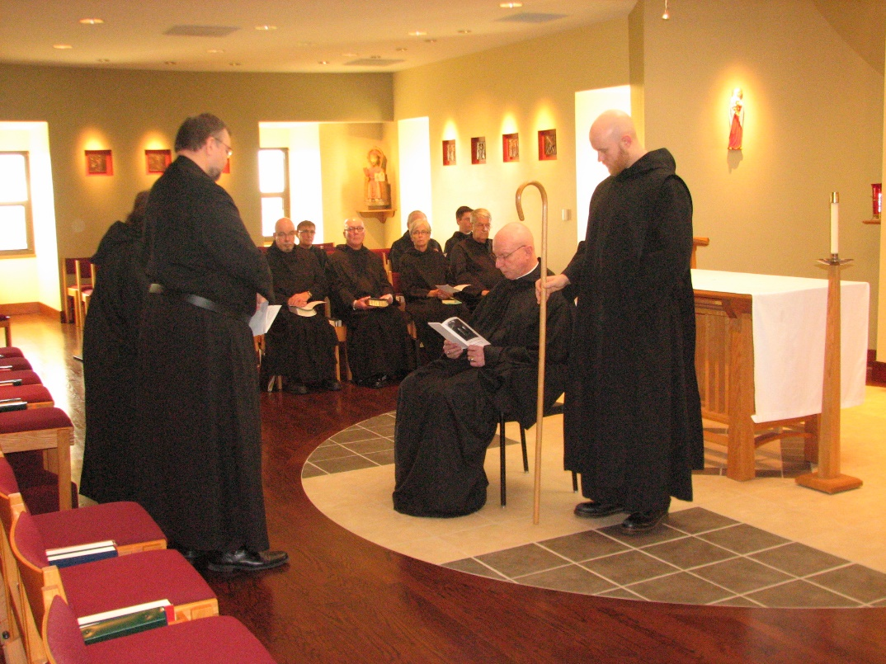
Sr. Cecelia Lamoy; Br. Samuel Saterstrom; Br. Basil Edwards; Br. Camillus Converse; Br. Stephen Francis Arnold; Br, Luke Doucette; Sr. Julian Saterstrom; Br. Aidan Maguire; Br. Michael Anicetus McCabe; Abbot David Vincent Cotton; Br. Gregory Kingsley
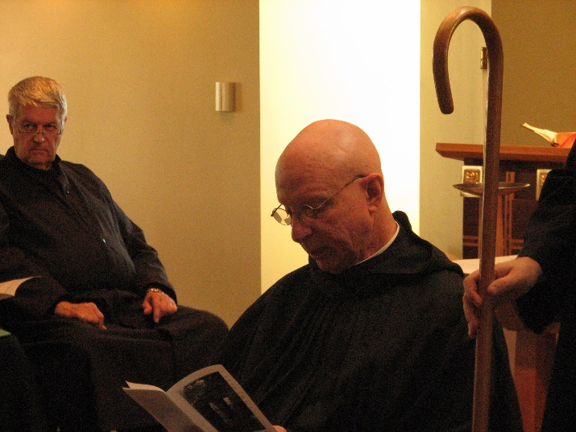
Br. Micahel Anicetus McCabe; Abbot David Vincent Cotton

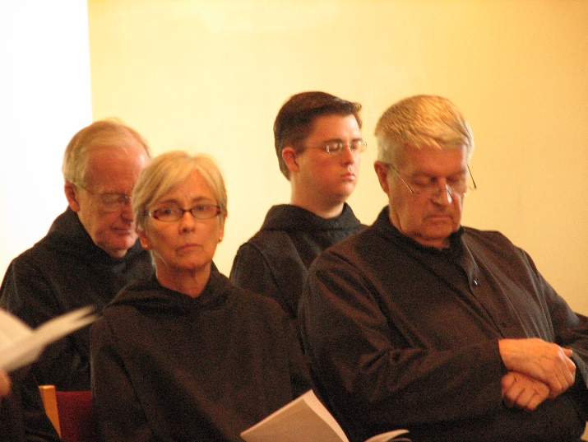
Br. Luke Doucette; Sr. Julian Saterstrom; Br. Aidan Maguire; Br. Michael Anicetus McCabe

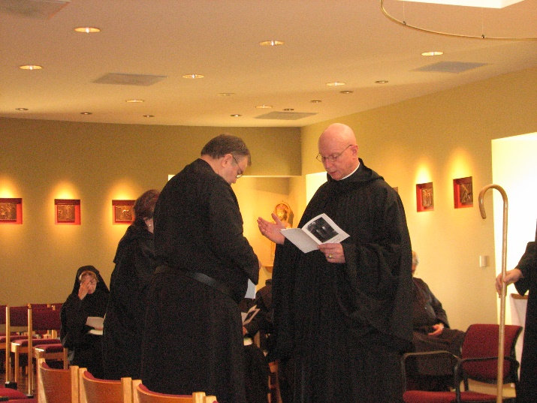
Sr. Monica Ruth Mullen; Sr. Cecelia Lamoy; Br. Samuel Saterstrom; Abbot David Vincent Cotton; Br. Michael Anicetus McCabe; Br. Gregory Kingsley
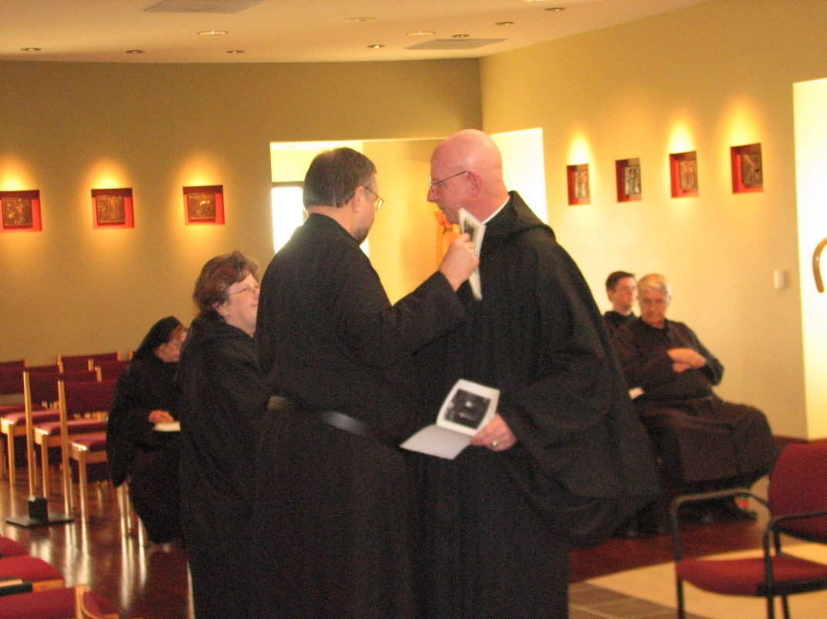
Sr. Monica Ruth Mullen; Sr. Cecelia Lamoy; Br. Samuel Saterstrom; Abbot David Vincent Cotton; Br. Aidan Maguire; Br. Michael Anicetus McCabe

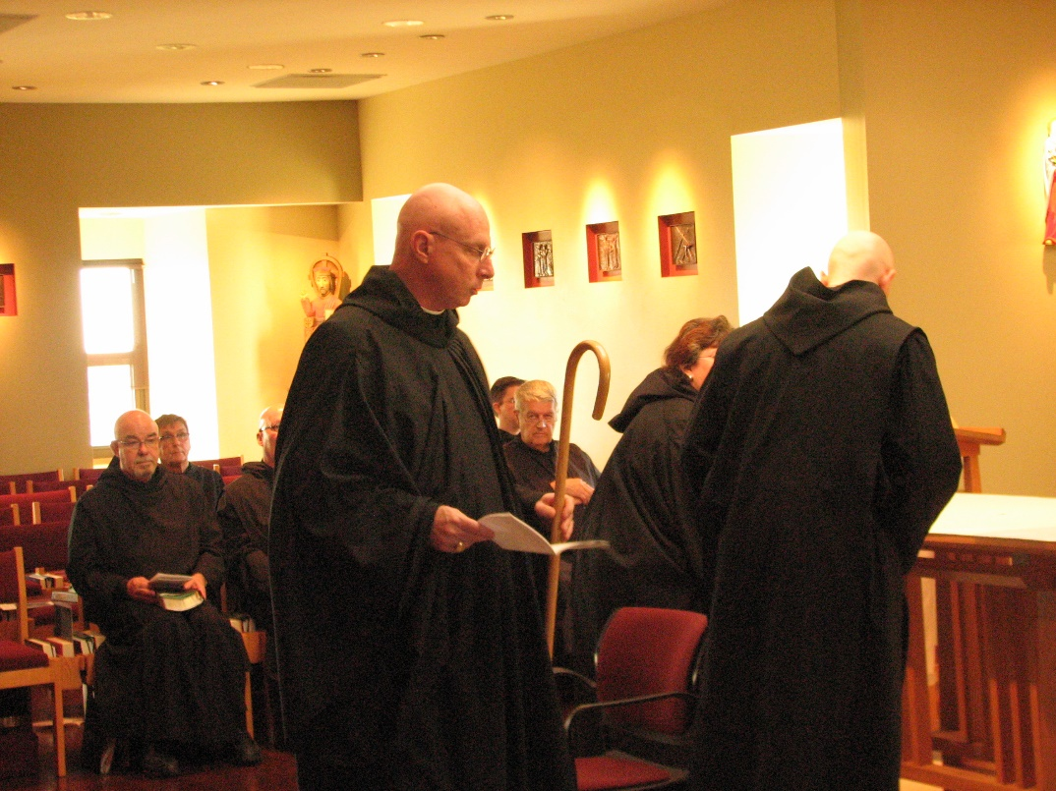
Br. Basil Edwards; br. Camillus Converse; Br. Stephen Francis Arnold; Abbot David Vincent Cotton; Br. Aidan Maguire; Br. Michael Anicetus McCabe; Sr. Cecelia Lamoy; Br. Gregory Kingsley
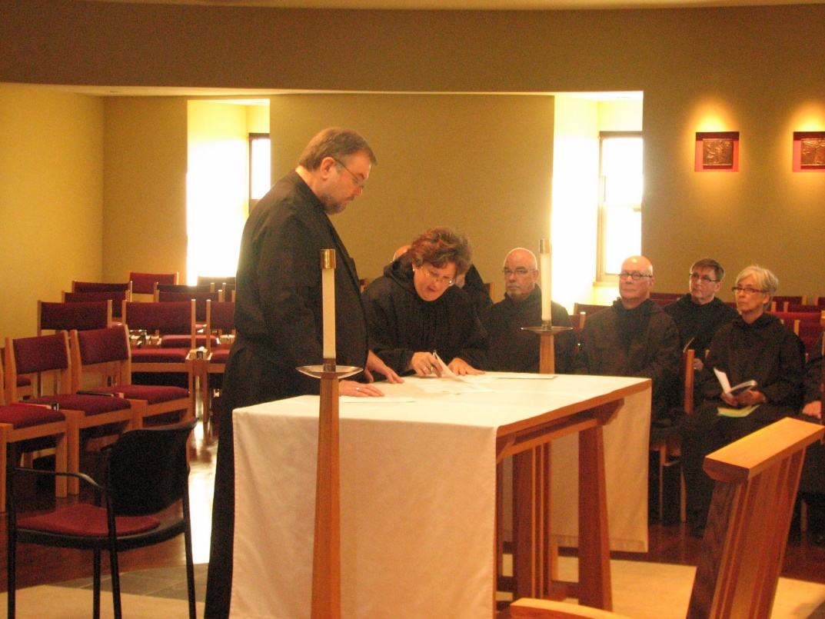
Br. Samuel Saterstrom; Sr. Cecelia Lamoy; Br. Basil Edwards; Br. Stephen Francis Arnold; Br. Camillus Converse; Sr. Julian Saterstrom

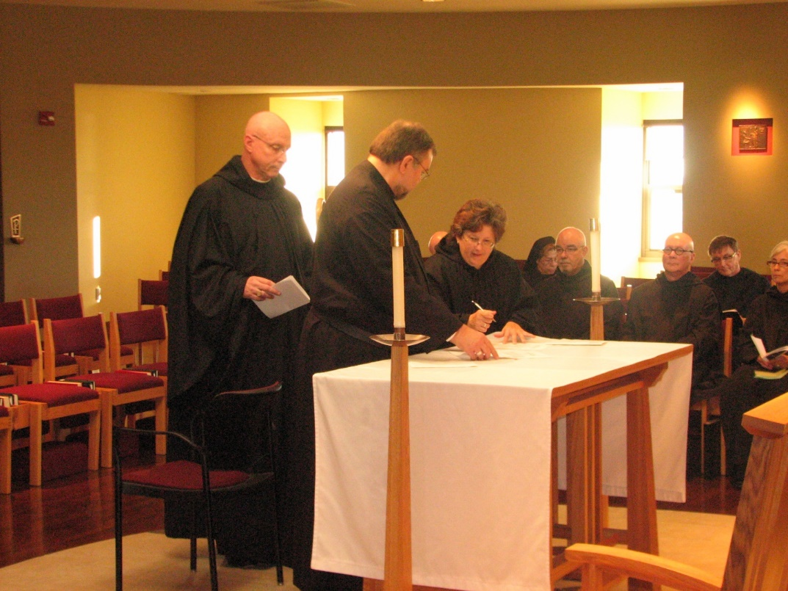
Abbot David Vincent Cotton; Br. Samuel Saterstrom; Sr. Cecelia Lamoy; Sr. Monica Ruth Mullen; Br. Basil Edwards; Br. Stephen Francis Arnold; Br. Camillus Converse; Sr. Julian Saterstrom

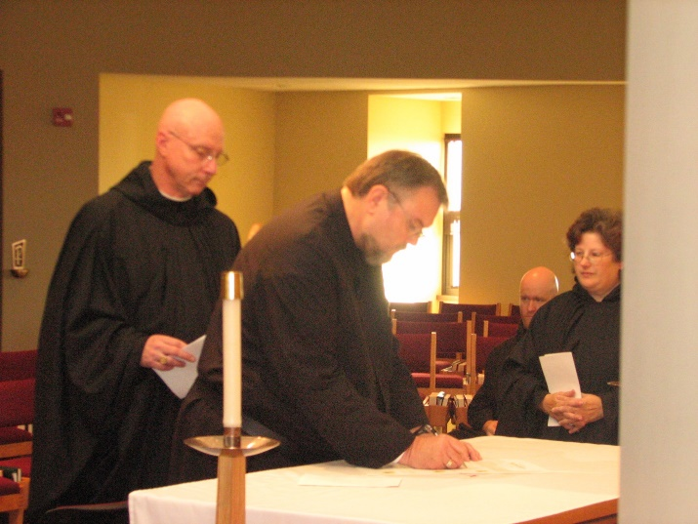
Abbot David Vincent Cotton; Br. Samuel Saterstrom; Br. Greagory Kingsley; Sr. Cecelia Lamoy

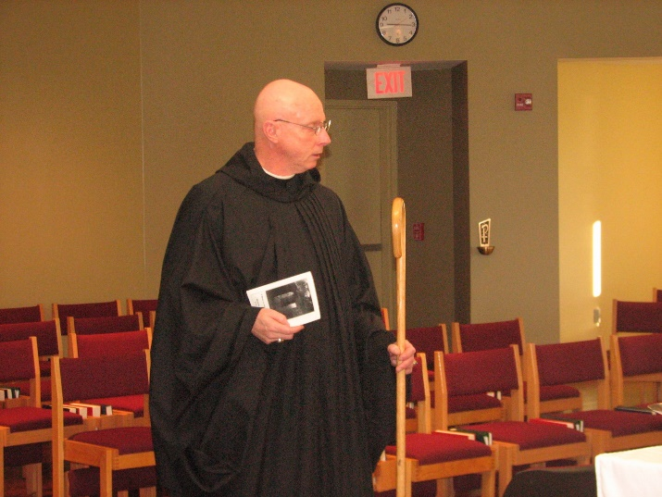
Abbot David Vincent Cotton

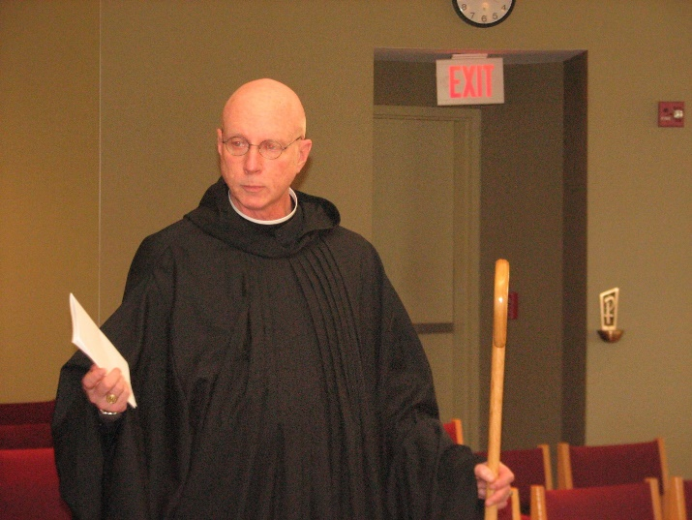
Abbot David Vincent Cotton
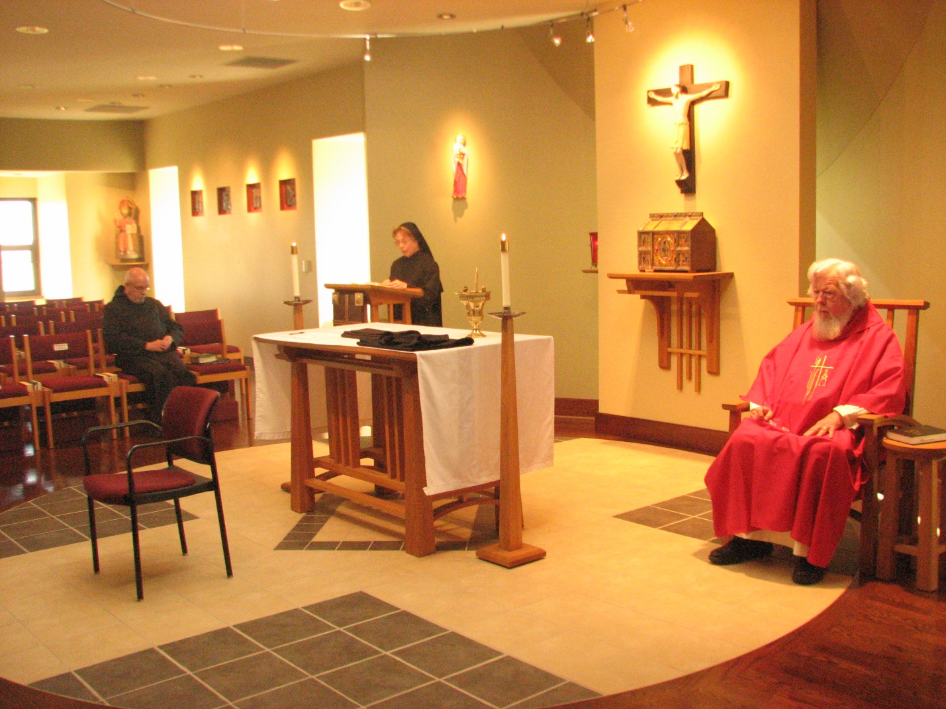
Br. Basil Edwards; Sr. Monica Ruth Mullen; Fr. Wayne Kamm

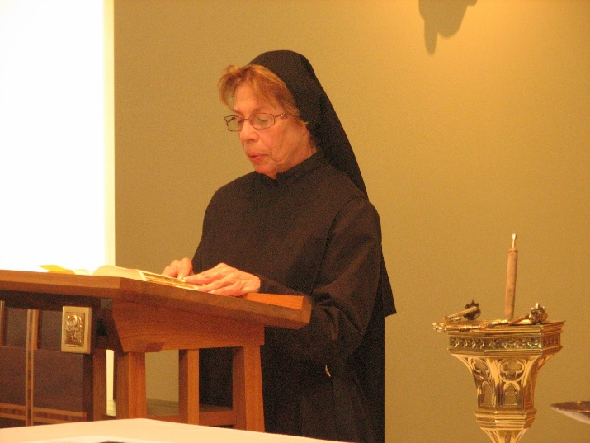
Sr. Monica Ruth Mullen
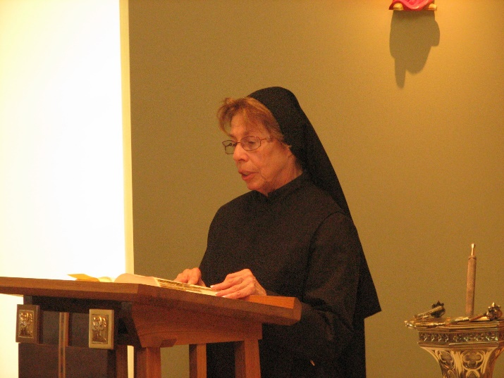
Sr. Monica Ruth Mullen

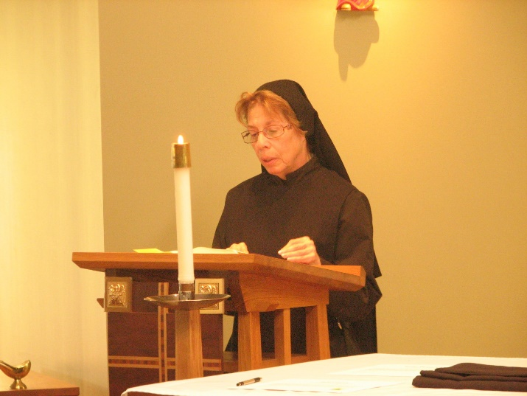
Sr. Monica Ruth Mullen

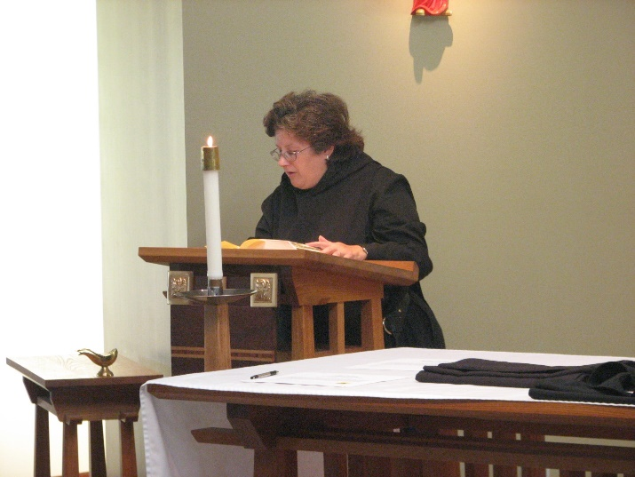
Sr. Cecelia Lamoy
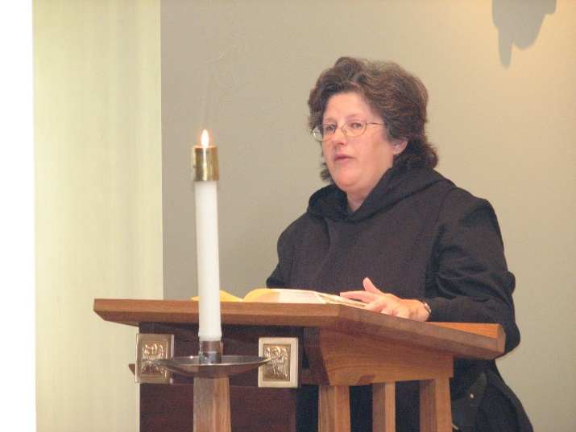
Sr. Cecelia Lamoy

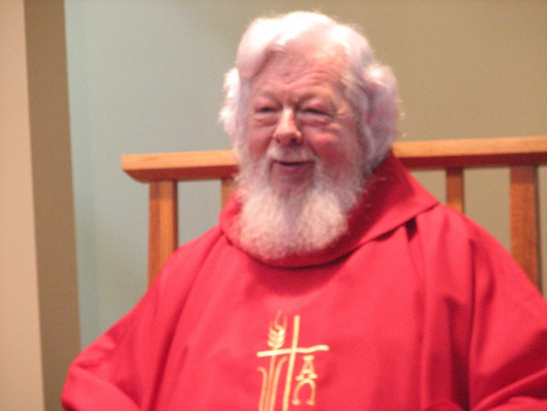
Fr. Wayne Kamm

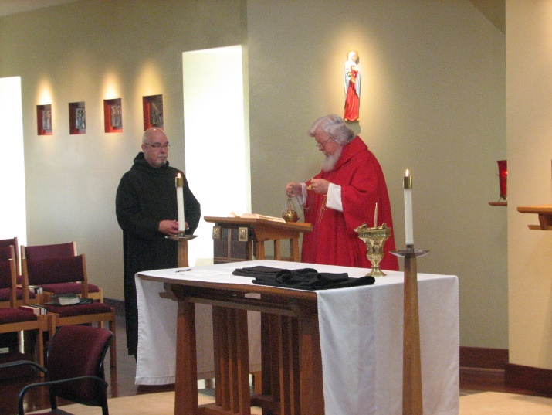
Br. Basil Edwards; Fr. Wayne Kamm
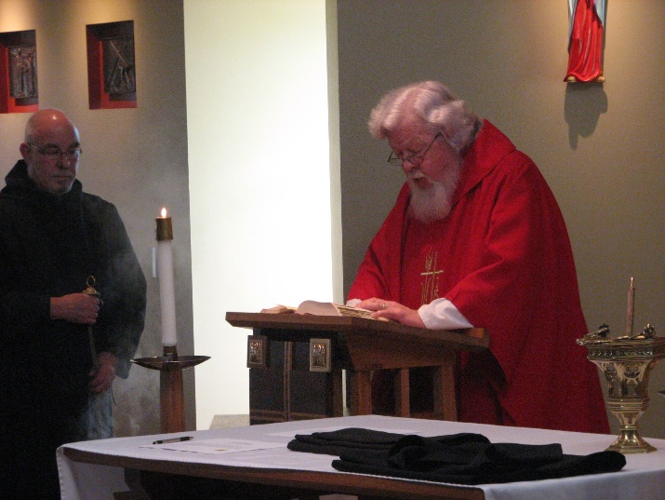
Br. Basil Edwards; Fr. Wayne Kamm

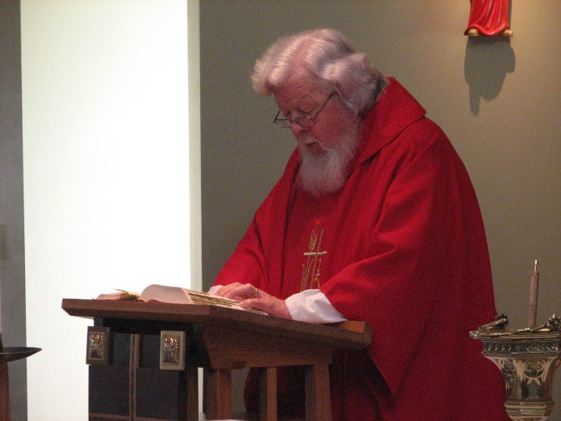
Fr. Wayne Kamm

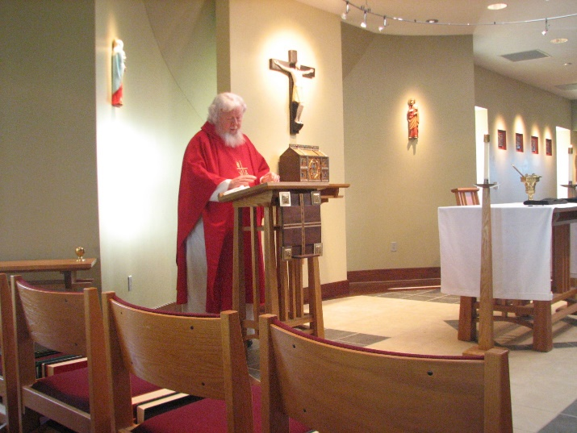
Fr. Wayne Kamm
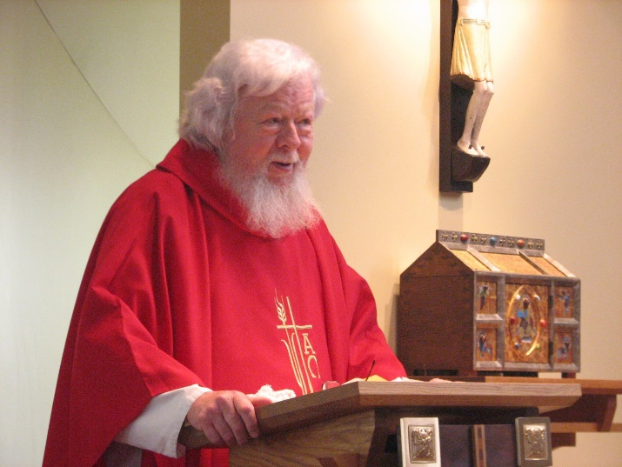
Fr. Wayne Kamm

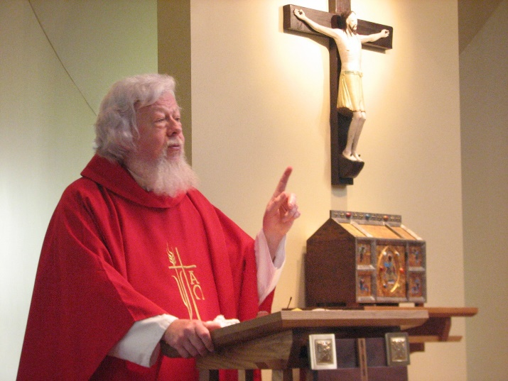
Fr. Wayne Kamm

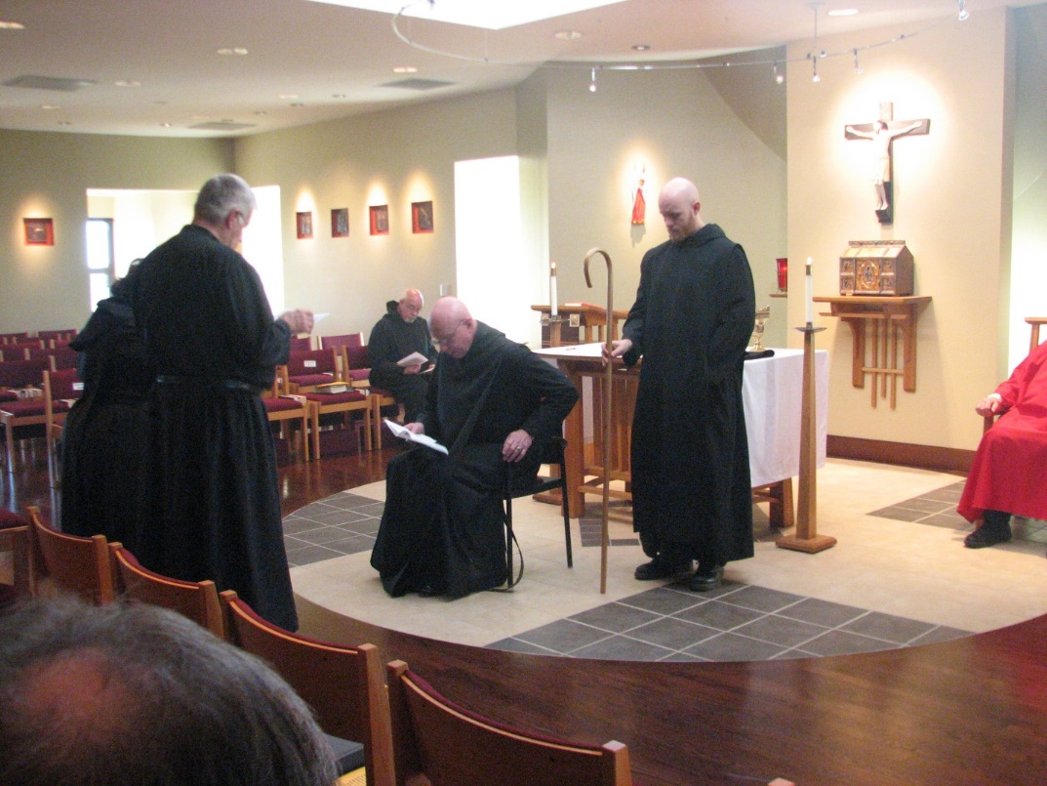
Sr. Cecelia Lamoy; Br. Michael Anicetus McCabe; ; Br. Basil Edwards; Br. Michael Anicetus McCabe; Abbot David Vincent Cotton; Br. Gregory Kingsley; Fr. Wayne Kamm

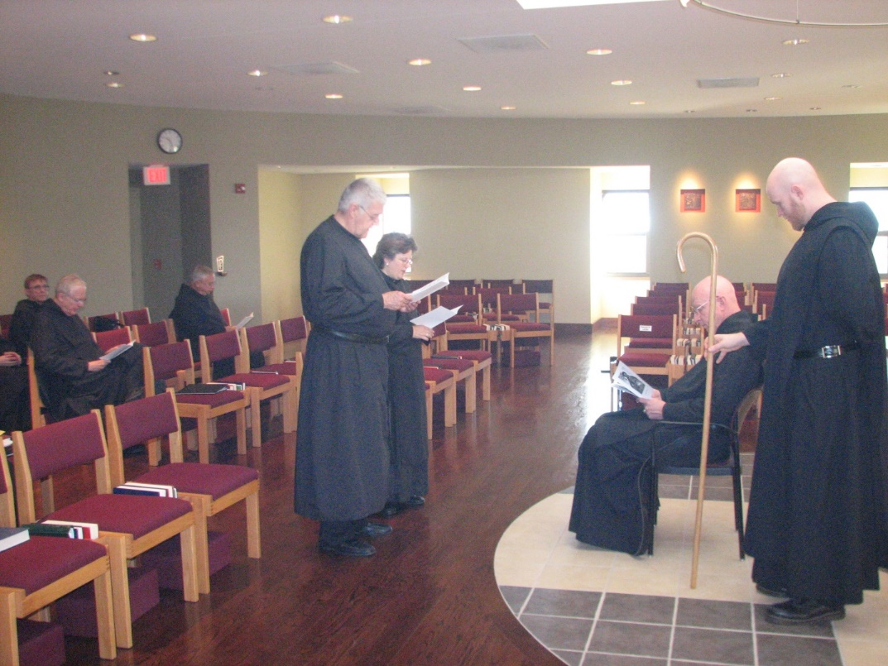
Br. Camillus Converse; Br. Luke Doucette; Br. Bede Leach; Br. Michael Anicetus McCabe; Sr. Cecelia Lamoy; Abbot David Vincent Cotton; Br. Greagory Kingsley

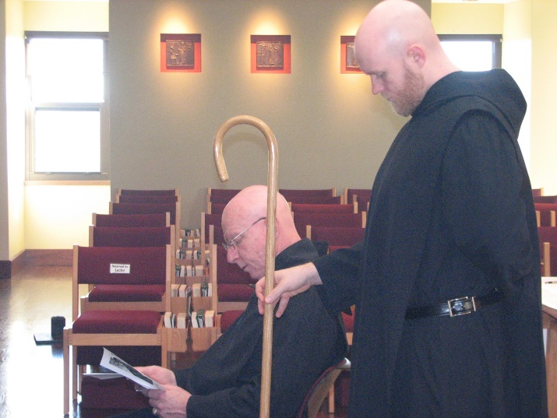
Abbot David Vincent Cotton; Br. Gregory Kingsley

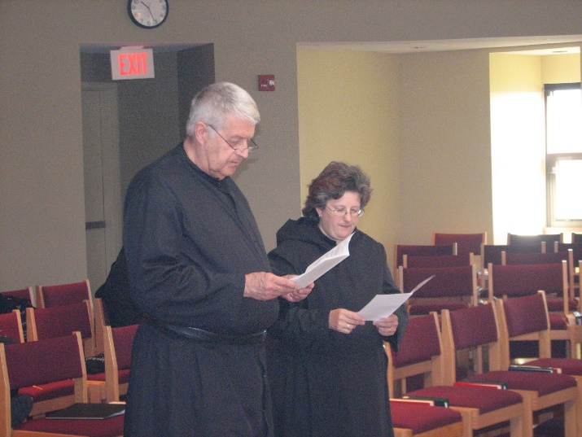
Br. Michael Anicetus McCabe; Sr. Cecelia Lamoy

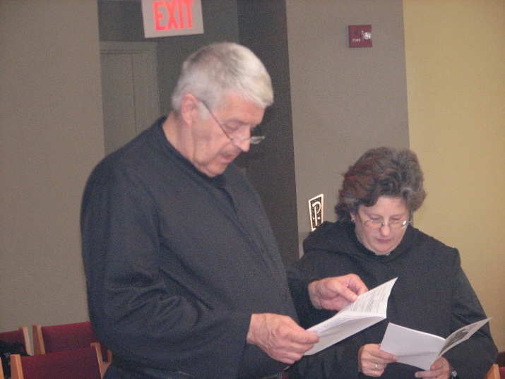
Br. Michael Anicetus McCabe; Sr. Cecelia Lamoy

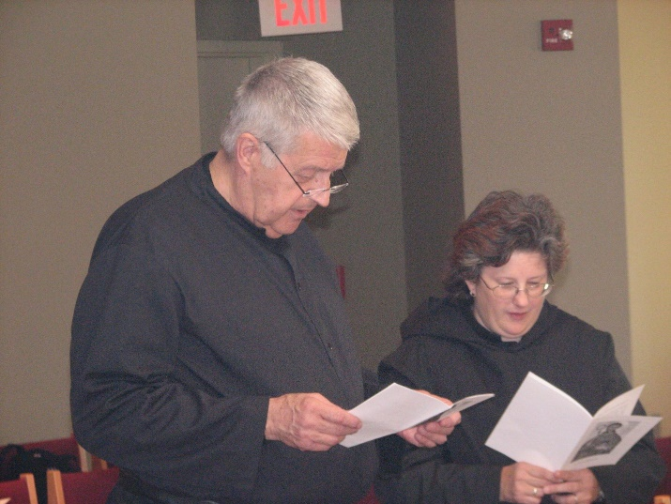
Br. Michael Anicetus McCabe; Sr. Cecelia Lamoy

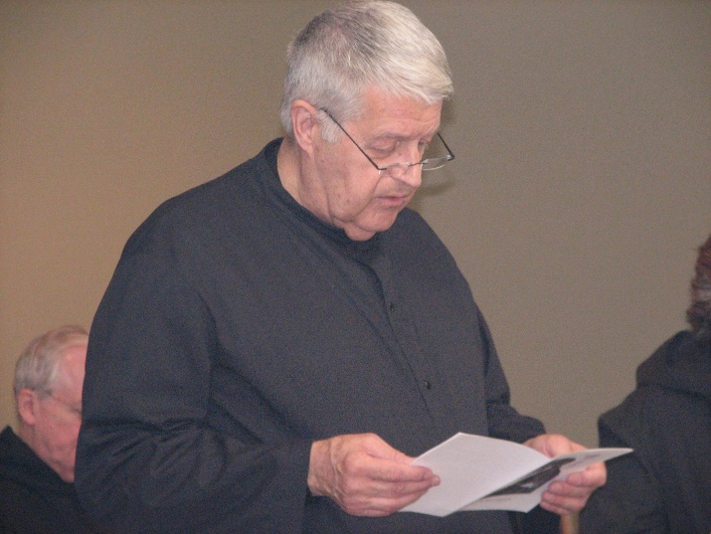
Br. Luke Doucette; Br. Michael Anicetus McCabe; Sr. Cecelia Lamoy

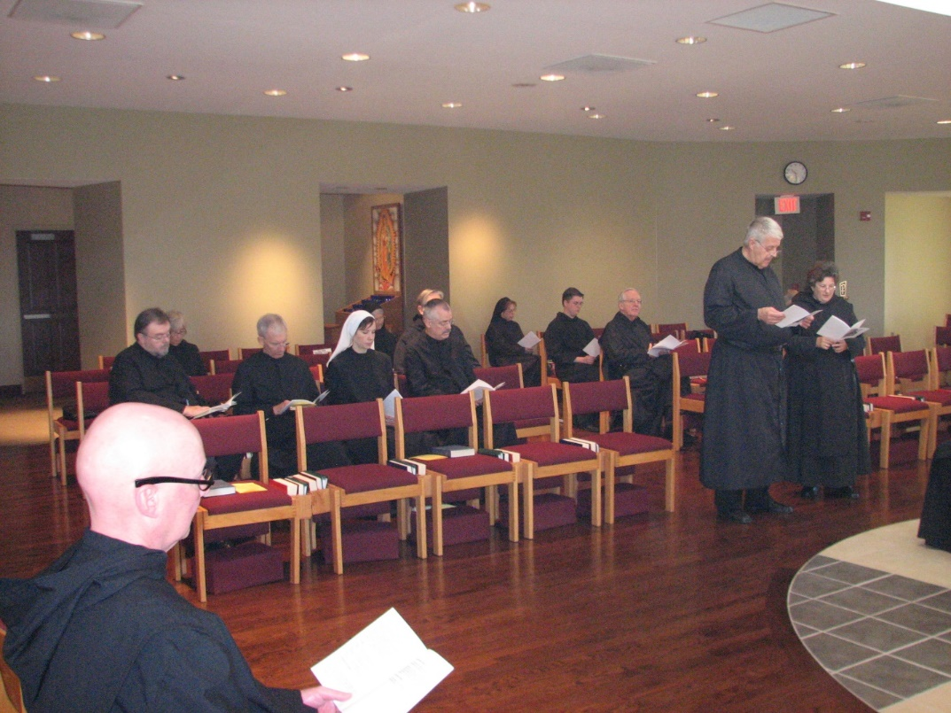
Br. Stephen Francis Arnold; Br. Samuel Saterstrom; Sr. Julian Saterstrom; Br. Joseph Olderr; Sr. Veronica Taylor; Sr. Mary Francis Deulen; Br, Chad Anselm Gerns; Br. Dunstan Townsend; Sr. Monica Ruth Mullen; Br. Aidan Maguire; Br. Luke Doucette; Br. Michael Anicetus McCabe; Sr. Cecelia Lamoy

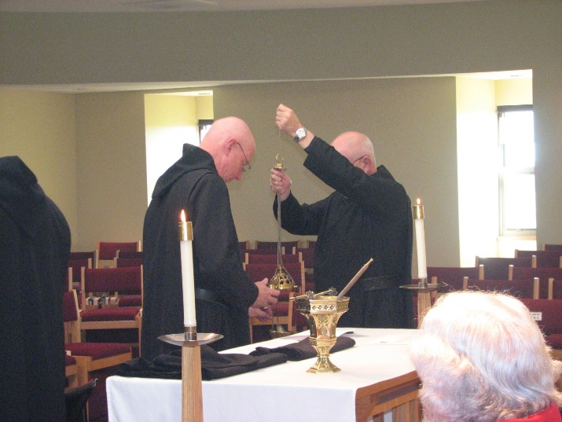
Abbot David Vincent Cotton; Br. Basil Edwards; Fr. Wayne Kamm

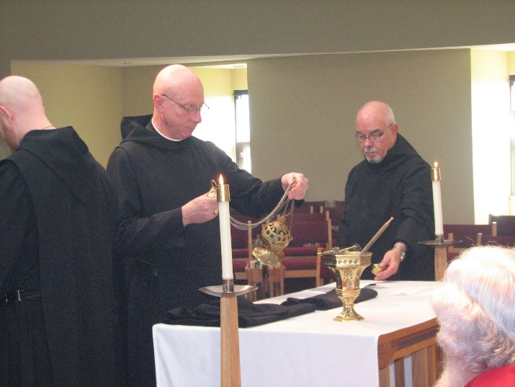
Br. Gregory Kingsley; Abbot David Vincent Cotton; Br. Basil Edwards; Fr. Wayne Kamm

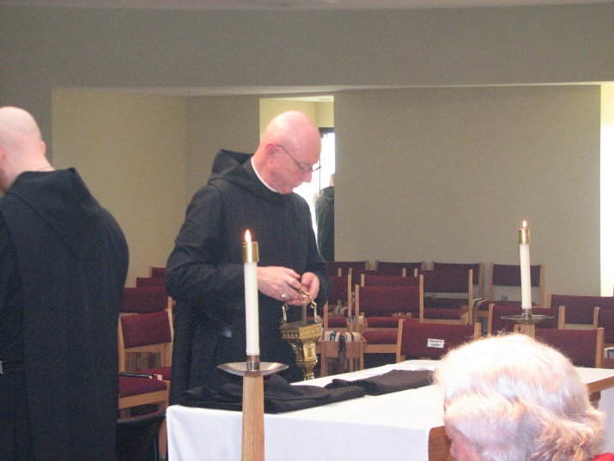
Br. Gregory Kingsley; Abbot David Vincent Cotton; Fr. Wayne Kamm

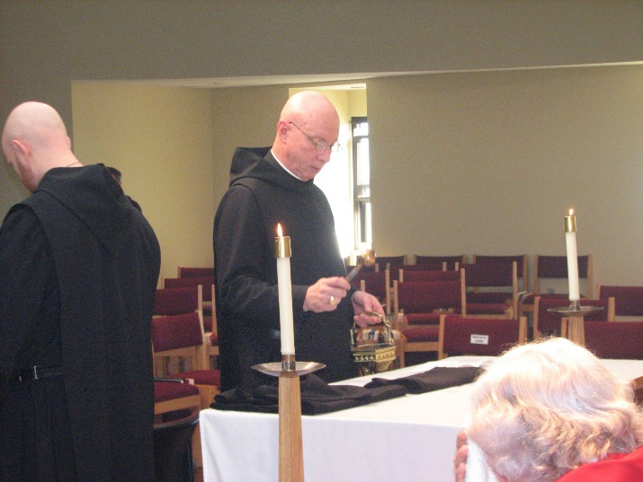
Br. Gregory Kingsley; Abbot David Vincent Cotton; Fr. Wayne Kamm

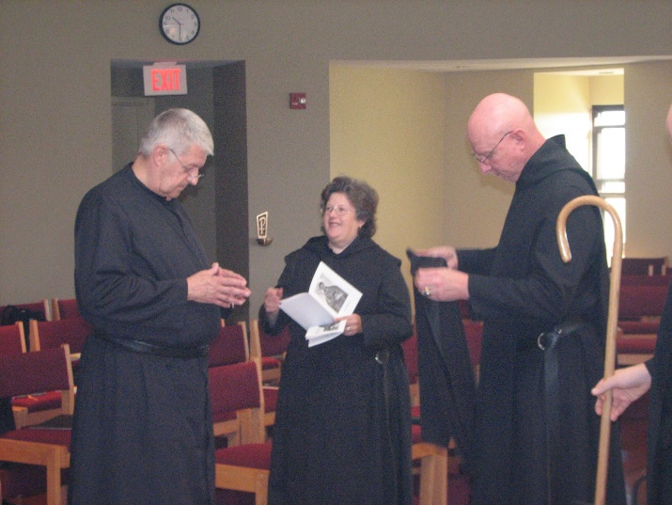
Br. Michael Anicetus McCabe; Sr. Cecelia Lamoy; Abbot David Vincent Cotton

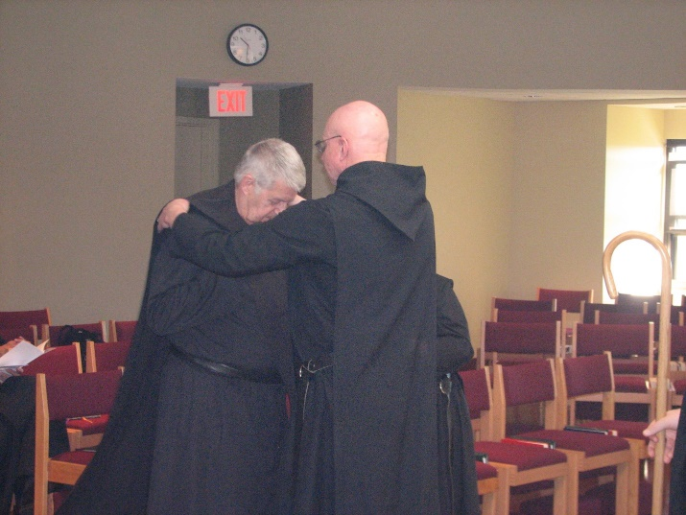
Br. Michael Anicetus McCabe; Abbot David Vincent Cotton; Sr. Cecelia Lamoy

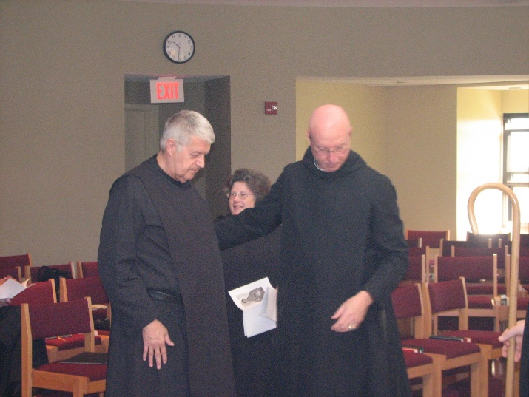
Br. Michael Anicetus McCabe; Sr. Cecelia Lamoy; Abbot David Vincent Cotton

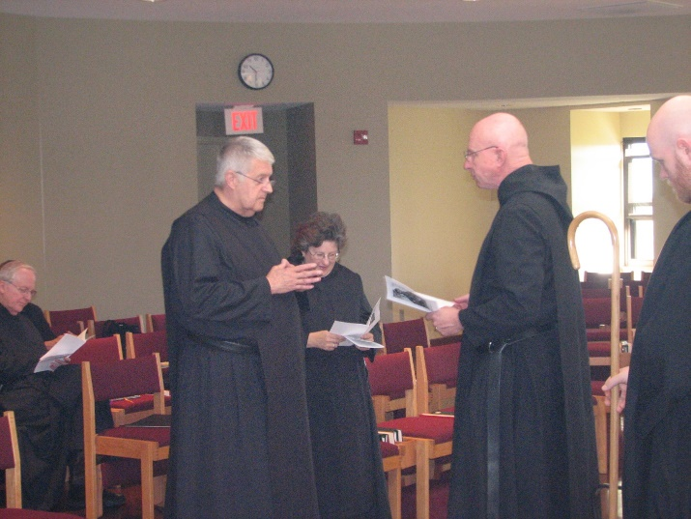
Br. Luke Doucette; Br. Michael Anicetus McCabe; Sr. Cecelia Lamoy; Abbot David Vincent Cotton; Br. Gregory Kingsley

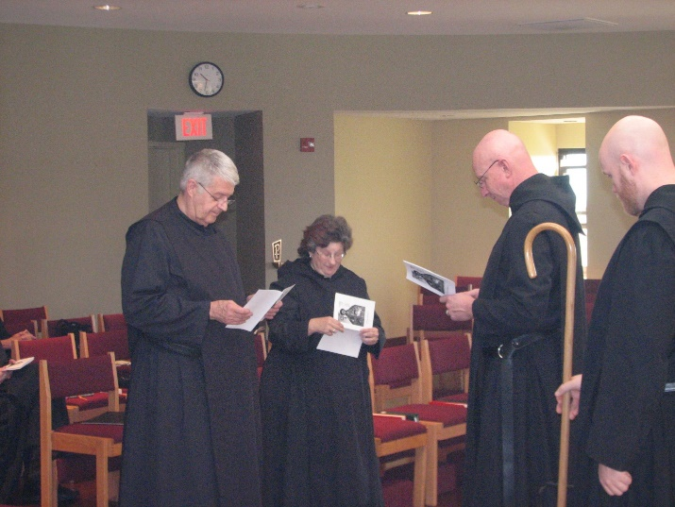
Br. Michael Anicetus McCabe; Sr. Cecelia Lamoy; Abbot David Vincent Cotton; Br. Gregory Kingsley

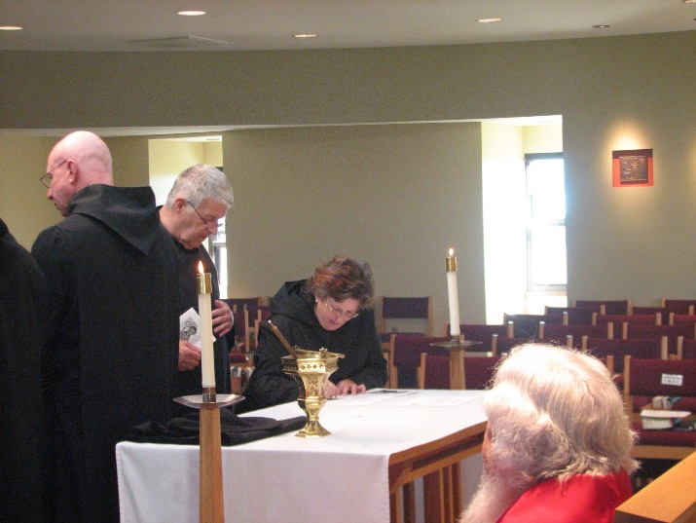
Abbot David Vincent Cotton; Br. Michael Anicetus McCabe; Sr. Cecelia Lamoy; Fr. Wayne Kamm

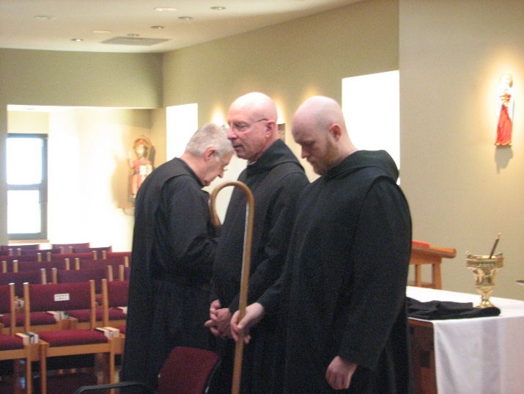
Br. Michael Anicetus McCabe; Abbot David Vincent Cotton; Br. Gregory Kingsley

