Companions of St. Luke
Fall Convocation at Conception Abbey
October 25-30, 2010
Part 1 of 4
Photographed by Sr. Brigid Gerns

People are identified from left to right.

Edited by Br. Steven Olderr, 24 October 2023. Please send any comments, corrections, or additions to olderr@ameritech.net

NOTE: In May of 2011, Abbot David Vincent Cotton announced that members could use their birth names instead of religious names if they chose. The following names were changed—some immediately, some later.

Br. Aidan Maguire > Br. Kenneth
Br. Chad Anselm Gerns > Br. David
Br. David Vincent Cotton > Br. Robert
Br. Gregory Kingsley > Br. Joshua
Br. Joseph > Br. Steven Joseph, and later still, just Br. Steven
Br. Luke Doucette > Br. Lee
Br. Willard Moore > Br. Daniel Moore
Sr. Bernadette Barrett > Sr. Helena
Sr. Cecelia Lamoy > Sr. Martha
Sr. Margaret Moore > Sr. Denise

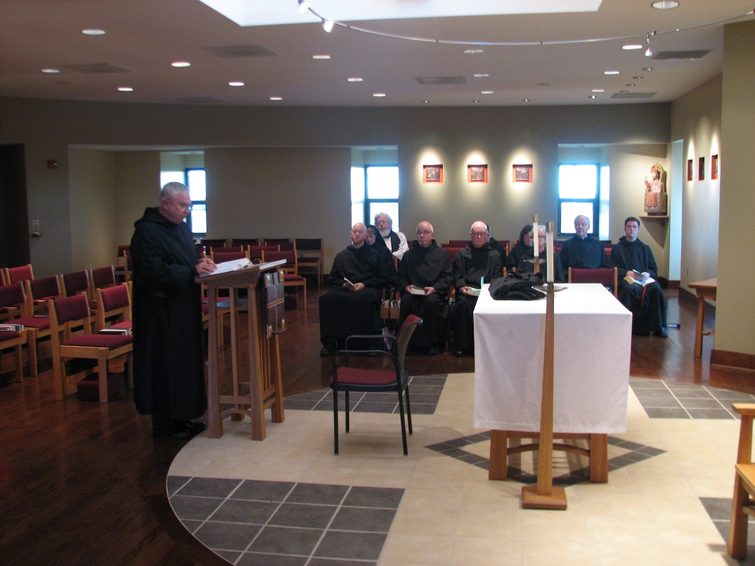
Br. Bede Leach; Br. Gregory Kingsley; Sr. Monica Ruth Mullen; Fr. Wayne Kamm; Br. Basil Edwards

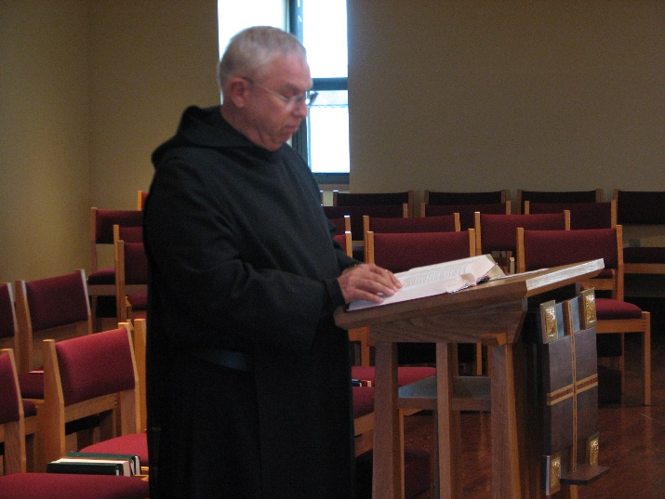
Br. Bede Leach

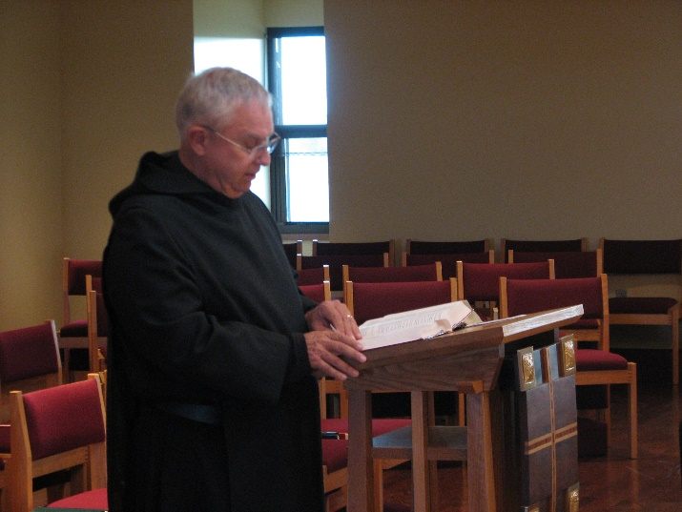
Br. Bede Leach

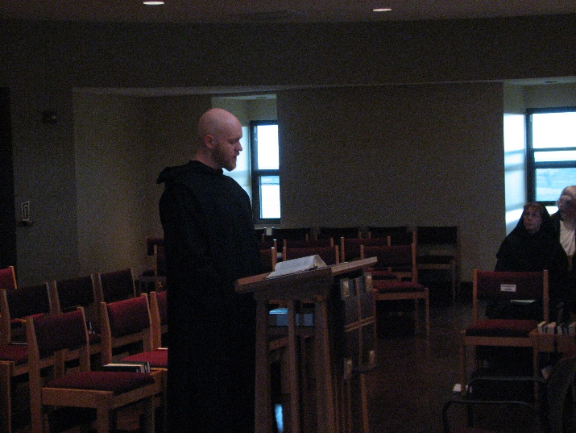
Br. Gregory Kingsley; Sr. Monica Ruth Mullen; Fr. Wayne Kamm

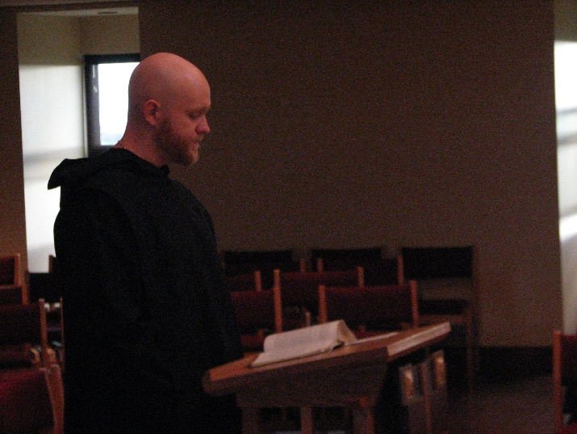
Br. Gregory Kingsley

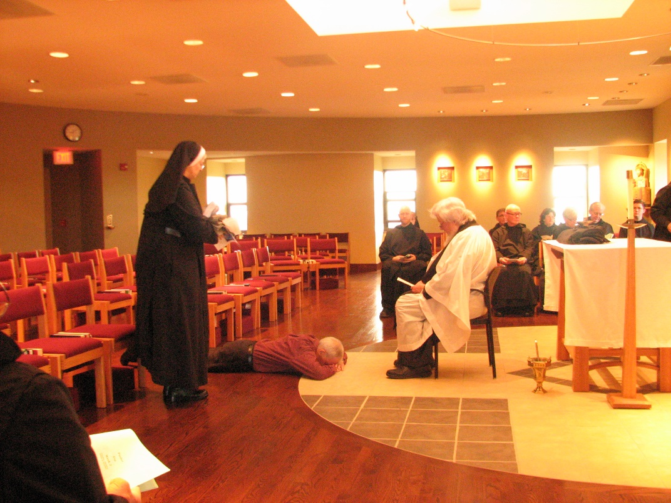
Sr. Bernadette Barrett; Steven Olderr; Br. Gregory Kingsley; Fr. Wayne Kamm; Br. Camillus Converse; Br. Stephen Francis Arnold; Sr. Cecelia Lamoy; Sr. Julian Saterstrom; Br. Luke Doucette; Br. Aidan Maguire

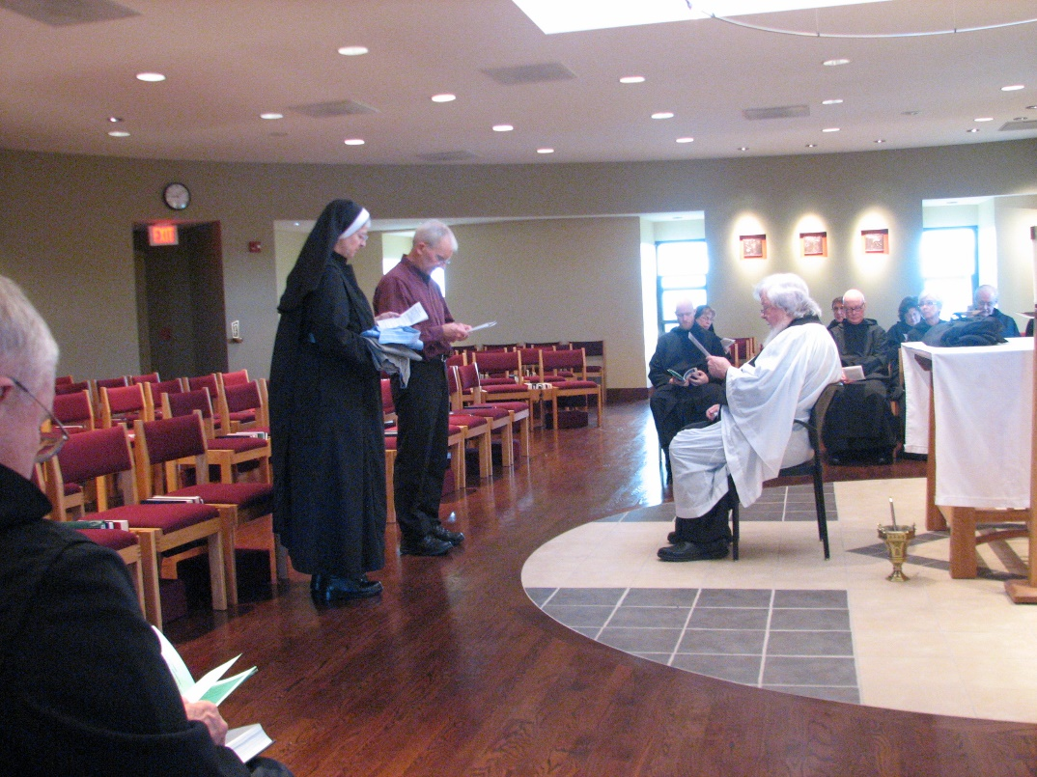
Br. Bede Leach; Sr. Bernadette Barrett; Steven Olderr; Br. Gregory Kingsley; Sr. Monica Ruth Mullen; Fr. Wayne Kamm; Br. Camillus Converse; Br. Stephen Francis Arnold; Sr. Cecelia Lamoy; Sr. Julian Saterstrom; Br. Luke Doucette

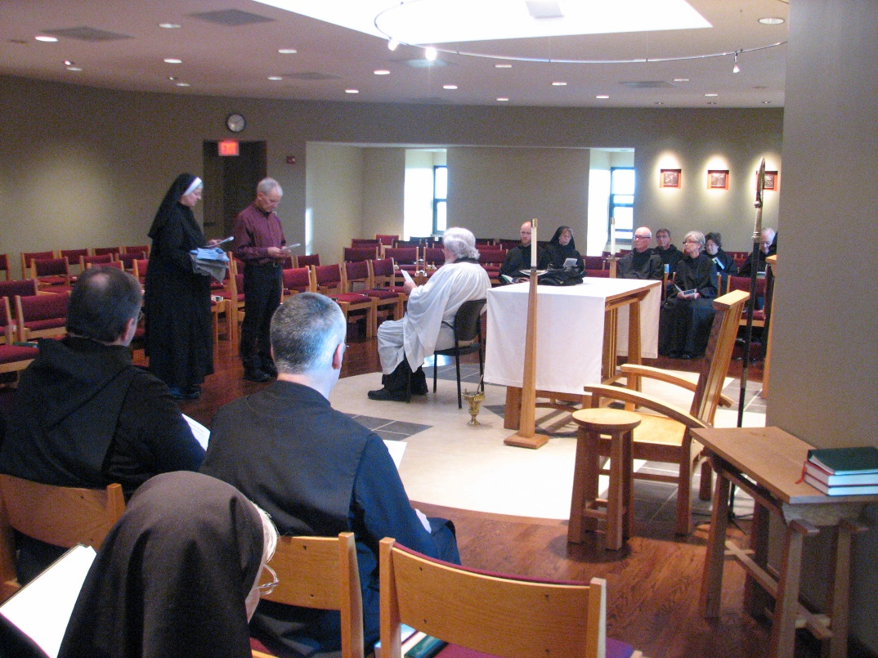
Br. Samuel Saterstrom; Sr. Bernadette Barrett; Sr. Mary Francis Deulen; Steven Olderr; Br. Dunstan Townsend; Fr. Wayne Kamm; Br. Gregory Kingsley; Sr. Monica Ruth Mullen; Br. Stephen Francis Arnold; Br. Camillus Converse; Sr. Julian Saterstrom; Sr. Cecelia Lamoy; Br. Luke Doucette

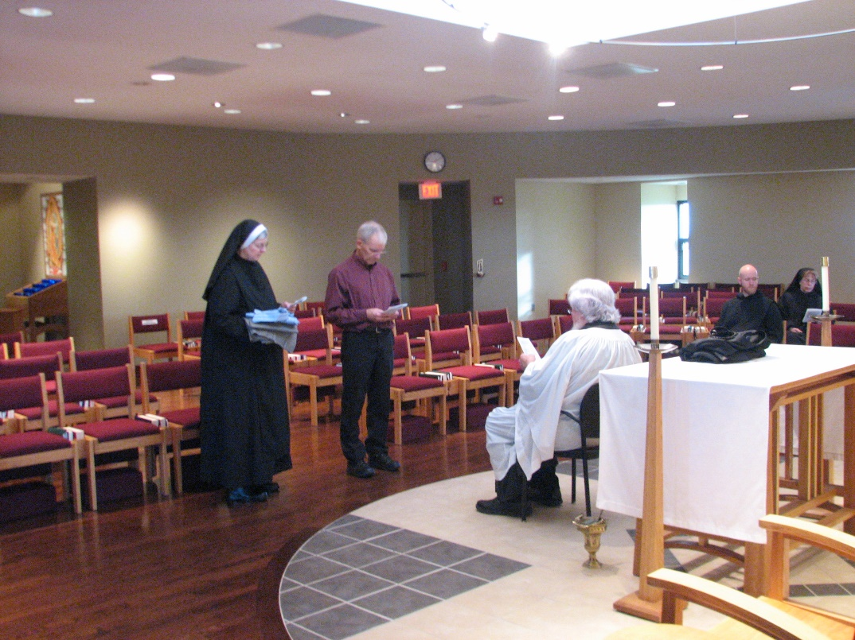
Sr. Bernadette Barrett; Steven Olderr; Fr. Wayne Kamm Br. Gregory Kingsley; Sr. Monica Ruth Mullen

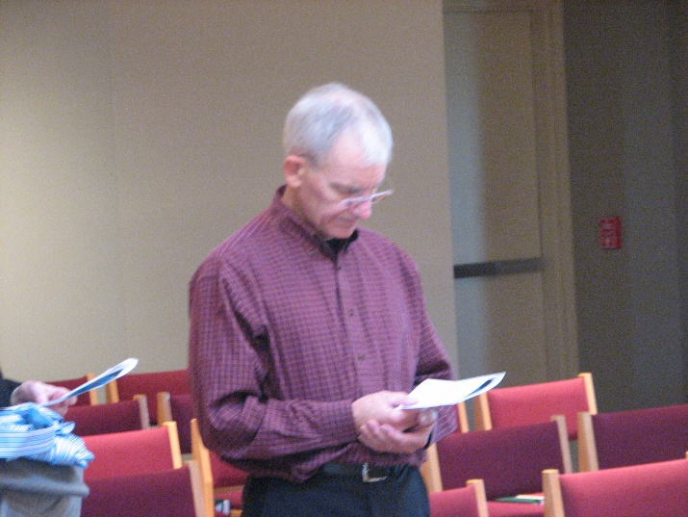
Steven Olderr

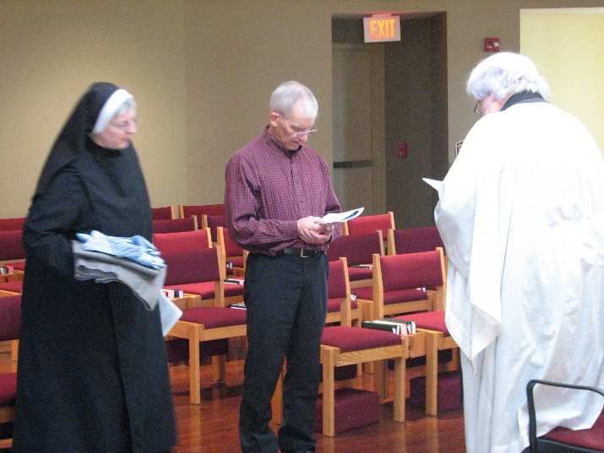
Sr. Bernadette Barrett; Steven Olderr; Fr. Wayne Kamm

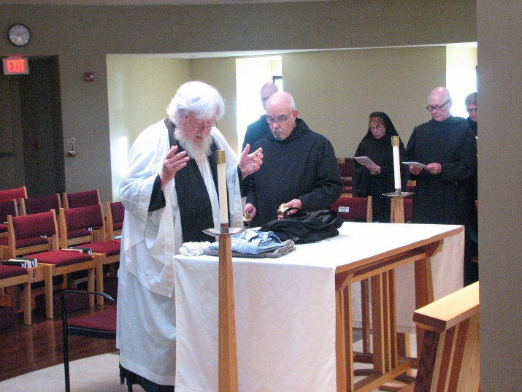
Fr. Wayne Kamm; Br. Gregory Kingsley; Br. Basil Edwards; Sr. Monica Ruth Mullen; Br. Stephen Francis Arnold; Br. Camillus Converse

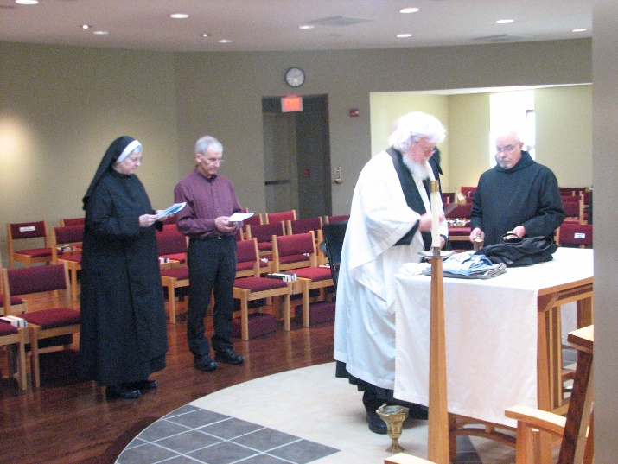
Sr. Bernadette Barrett; Steven Olderr; Fr. Wayne Kamm; Br. Basil Edwards

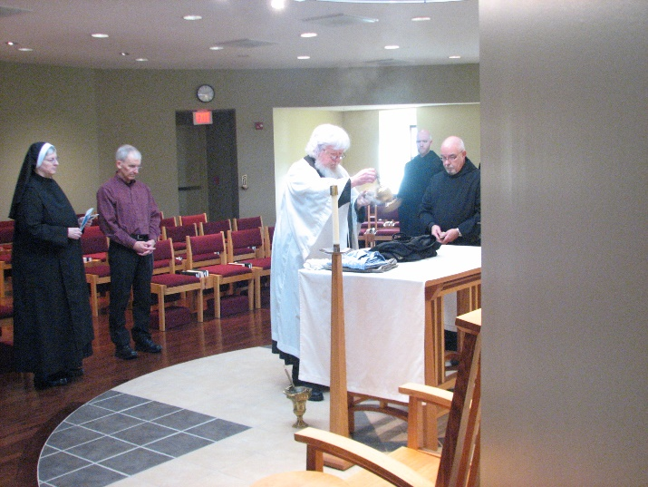
Sr. Bernadette Barrett; Steven Olderr; Fr. Wayne Kamm; Br. Gregory Kingsley; Br. Basil Edwards

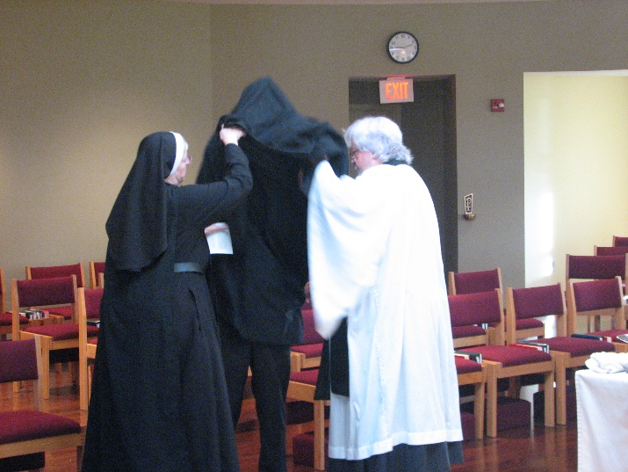
Sr. Bernadette Barrett; Br. Joseph Olderr; Fr. Wayne Kamm

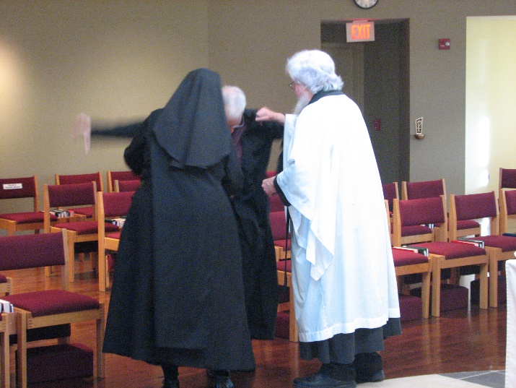
Sr. Bernadette Barrett; Br. Joseph Olderr; Fr. Wayne Kamm

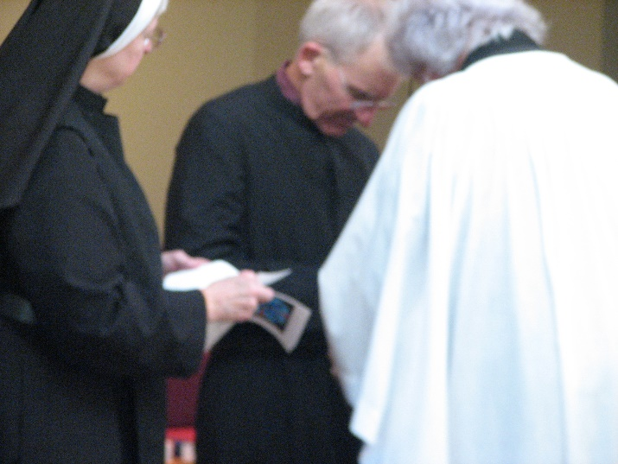
Sr. Bernadette Barrett; Br. Joseph Olderr; Fr. Wayne Kamm

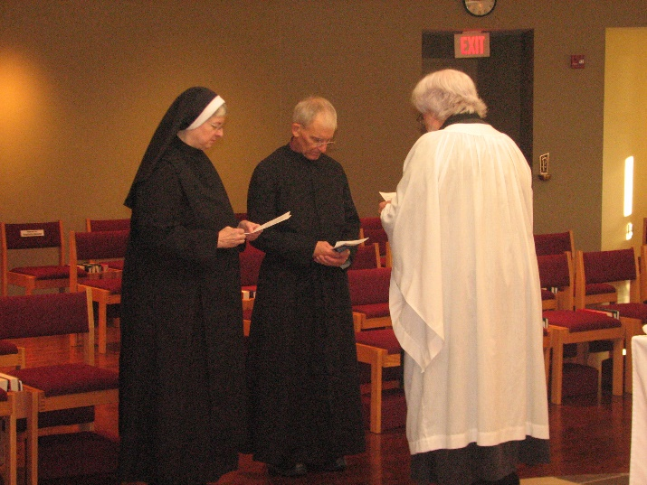
Sr. Bernadette Barrett; Br. Joseph Olderr; Fr. Wayne Kamm

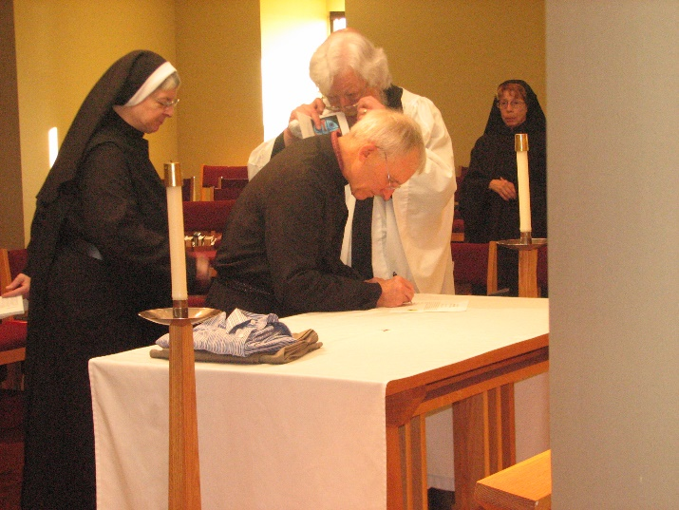
Sr. Bernadette Barrett; Fr. Wayne Kamm; Br. Joseph Olderr; Sr. Monica Ruth Mullen

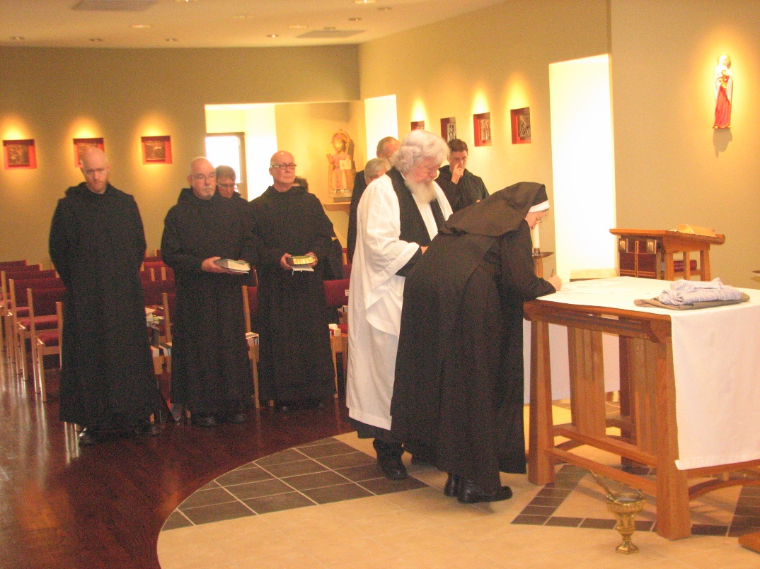
Br. Gregory Kingsley; Br. Basil Edwards; Br. Camillus Converse; Br. Stephen Francis Arnold; Sr. Cecilia Lamoy; Sr. Julian Saterstrom; Br. Luke Doucette; Fr. Wayne Kamm; Br. Aidan Maguire; Sr. Bernadette Barrett

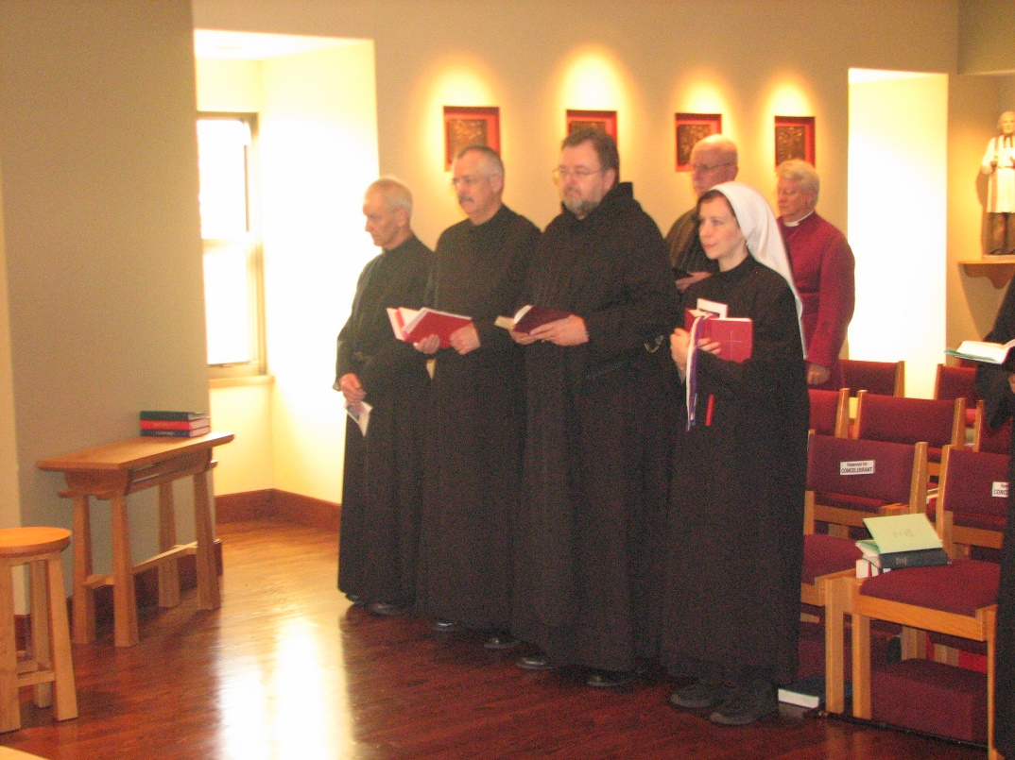
Br. Joseph Olderr; Br. Dunstan Townsend; Br. Samuel Saterstrom; Br. David Vincent Cotton; Sr. Veronica Taylor; Bp. Dean Wolfe

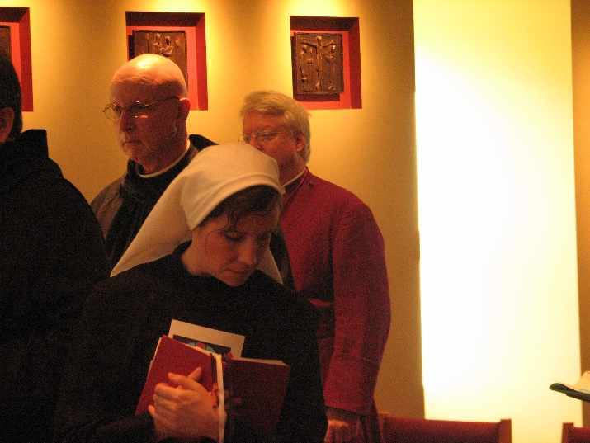
Br. David Vincent Cotton; Sr. Veronica Taylor; Bp. Dean Wolfe

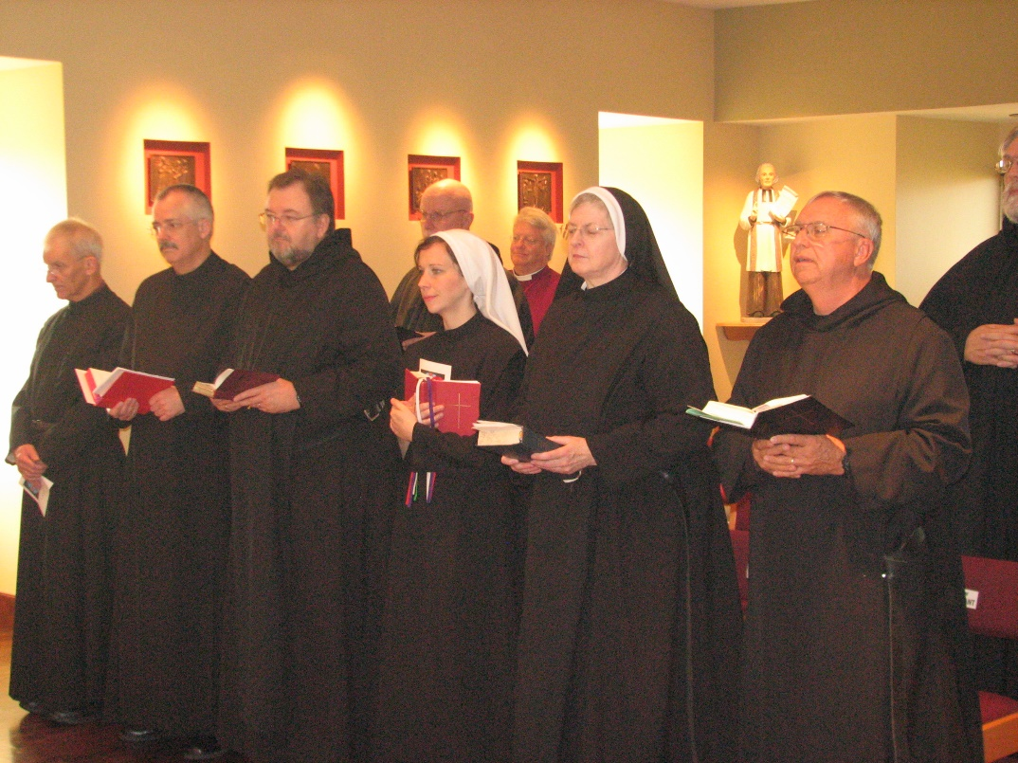
Br. Joseph Olderr; Br. Dunstan Townsend; Br. Samuel Saterstrom; Br. David Vincent Cotton; Sr. Veronica Taylor; Bp. Dean Wolfe; Sr. Bernadette Barrett; Br. Bede Leach; Br. Chad Anselm Gerns

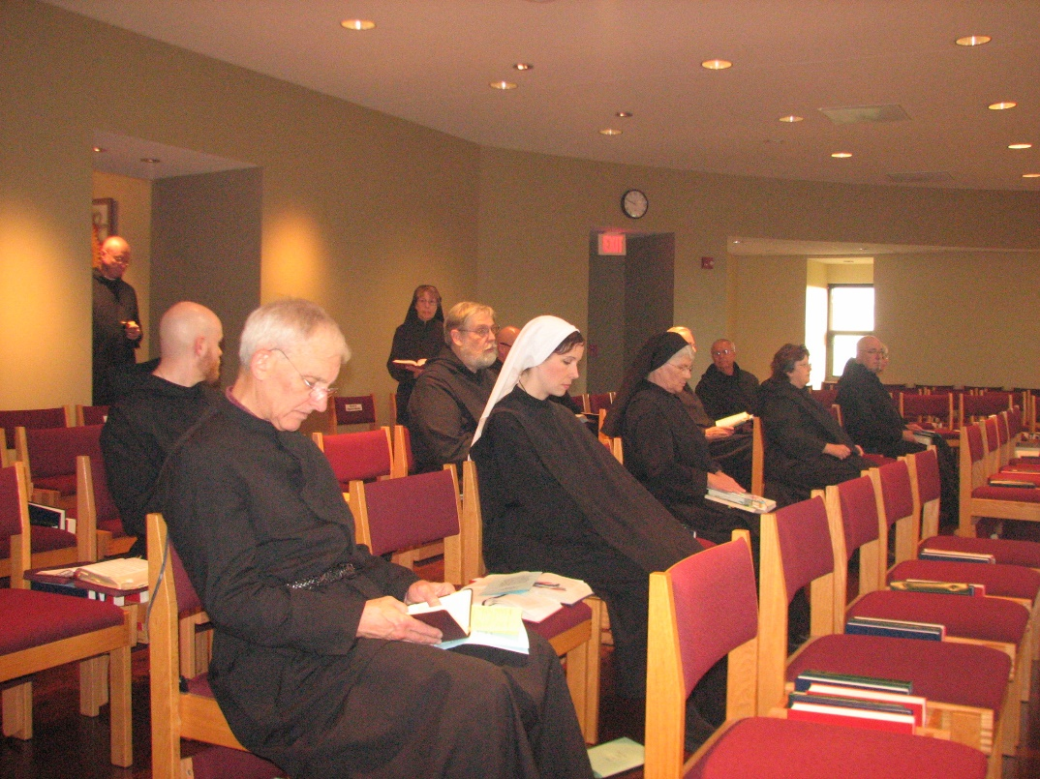
Br. David Vincent Cotton; Br. Gregory Kingsley; Br. Joseph Olderr; Sr. Monica Ruth Mullen; Br. Chad Anselm Gerns; Br. Stephen Francis Arnold; Sr. Veronica Taylor; Sr. Mary Francis Deulen; Br. Luke Doucette; Br. Bede Leach; Sr. Cecelia Lamoy; Br. Basil Edwards

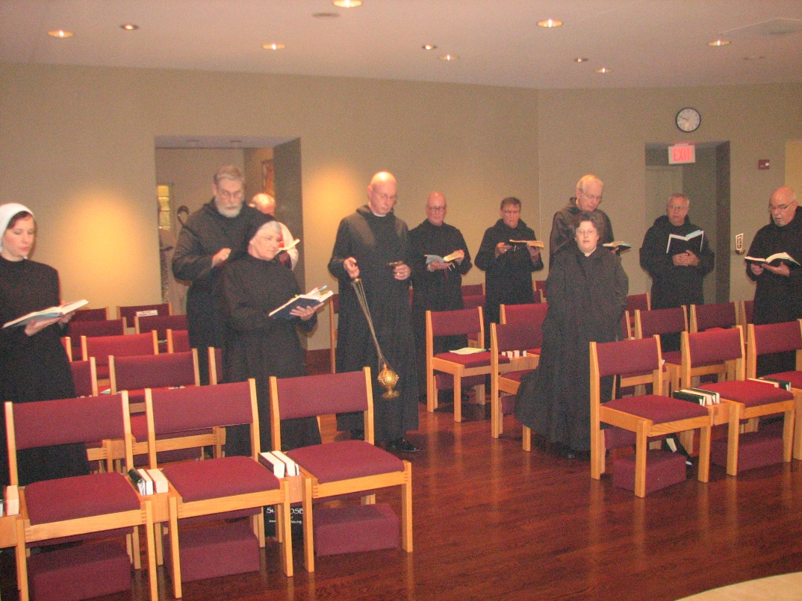
Sr. Veronica Taylor; Br. Chad Anselm Gerns; Sr. Mary Francis Deulen; Fr. Wayne Kamm; Br. David Vincent Cotton; Br. Stephen Francis Arnold; Br. Camillus Converse; Sr. Cecelia Lamoy; Br. Luke Doucette; Br. Bede Leach; Br. Basil Edwards

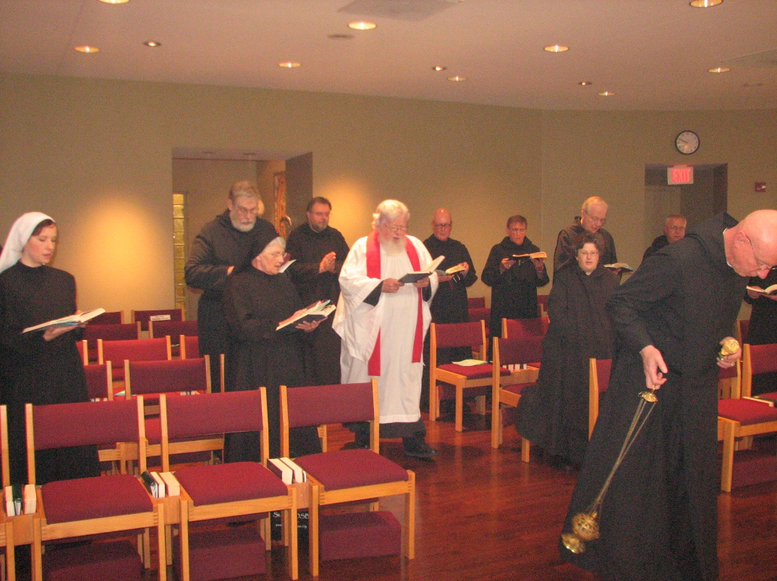
Sr. Veronica Taylor; Br. Chad Anselm Gerns; Sr. Mary Francis Deulen; Br. Samuel Saterstrom; Fr. Wayne Kamm; Br. Stephen Francis Arnold; Br. Camillus Converse; Sr Cecelia Lamoy; Br. Luke Doucette; Br. Bede Leach; Br. David Vincent Cotton

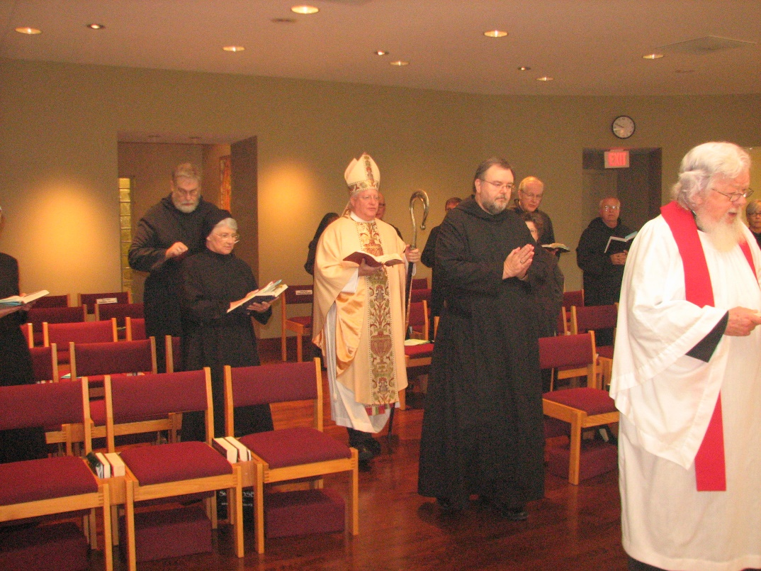
Br. Chad Anselm Gerns; Sr. Mary Francis Deulen; Sr. Monica Ruth Mullen; Bp. Dean Wolfe; Br. Stephen Francis Arnold; Br. Camillus Converse; Br. Samuel Saterstrom; Br. Luke Doucette; Sr. Cecelia Lamoy; Br. Bede Leach; Fr. Wayne Kamm

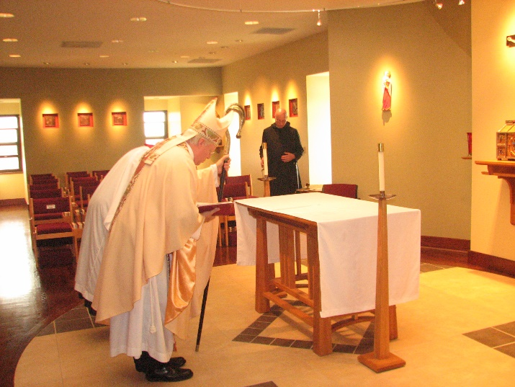
Bp. Dean Wolfe; Br. David Vincent Cotton

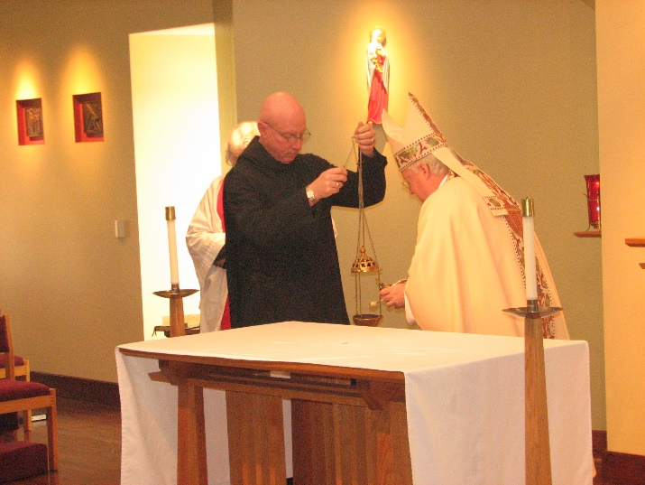
Fr. Wayne Kamm; Br. David Vincent Cotton; Bp. Dean Wolfe

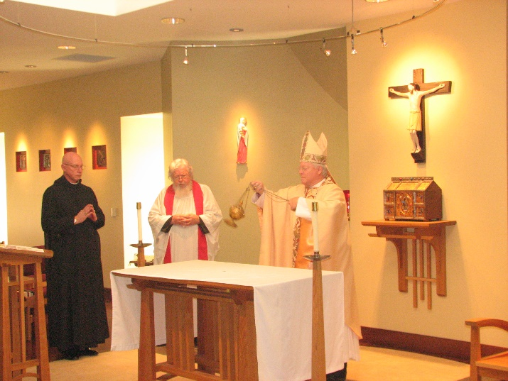
Br. David Vincent Cotton; Fr. Wayne Kamm; Bp. Dean Wolfe

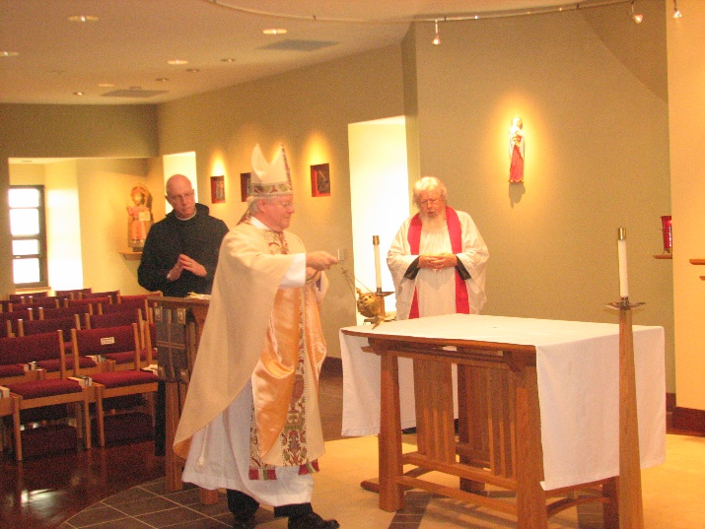
Br. David Vincent Cotton; Bp. Dean Wolfe; Fr. Wayne Kamm

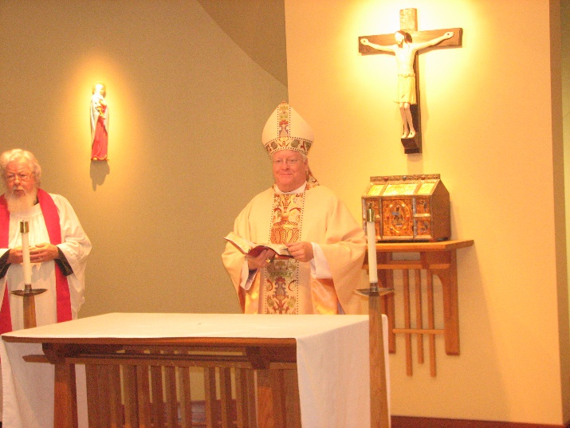
Fr. Wayne Kamm; Bp. Dean Wolfe

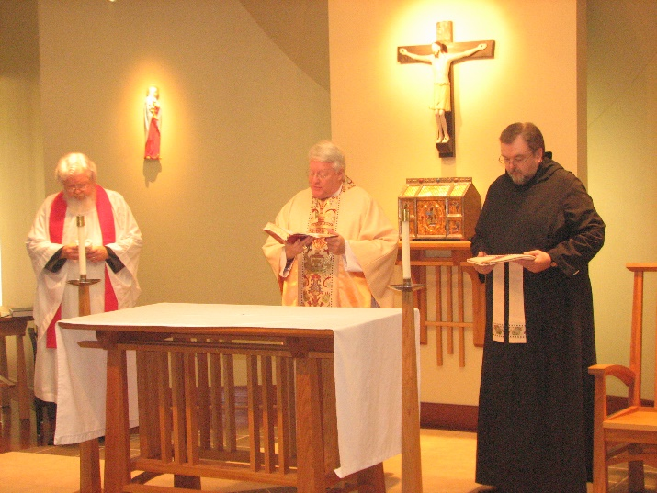
Fr. Wayne Kamm; Bp. Dean Wolfe; Br. Samuel Saterstrom

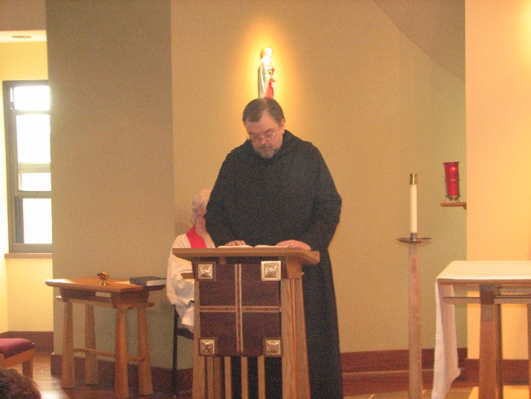
Fr. Wayne Kamm; Br. Samuel Saterstrom

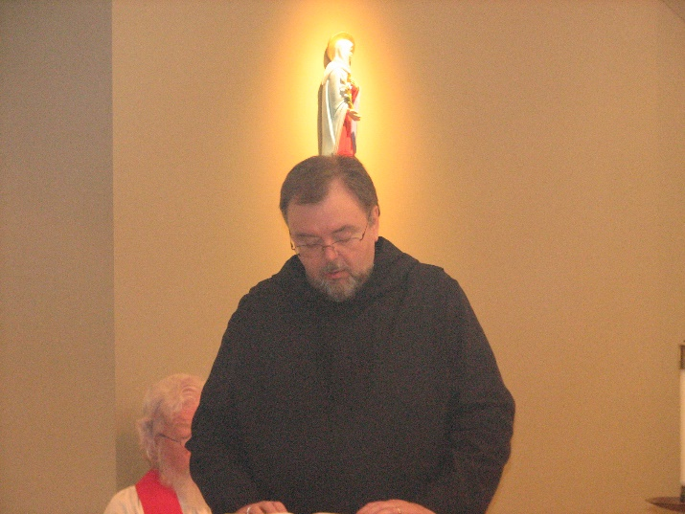
Fr. Wayne Kamm; Br. Samuel Saterstrom

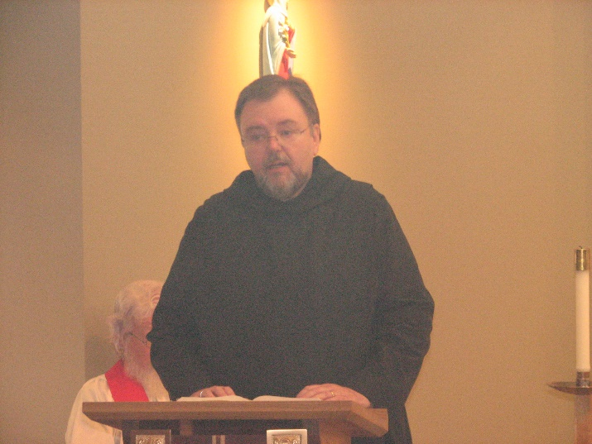
Fr. Wayne Kamm; Br. Samuel Saterstrom

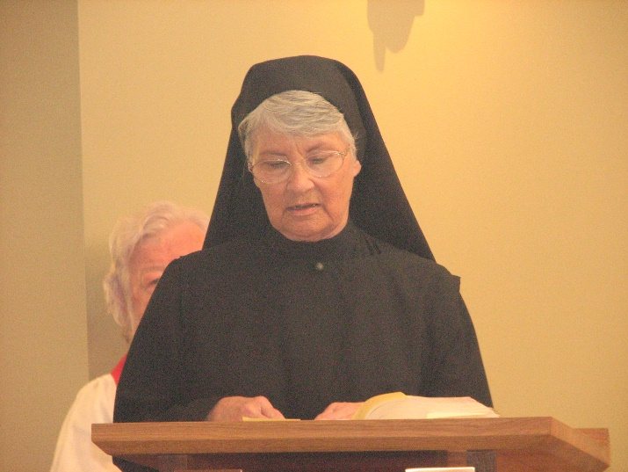
Fr. Wayne Kamm; Sr. Mary Francis Deulen

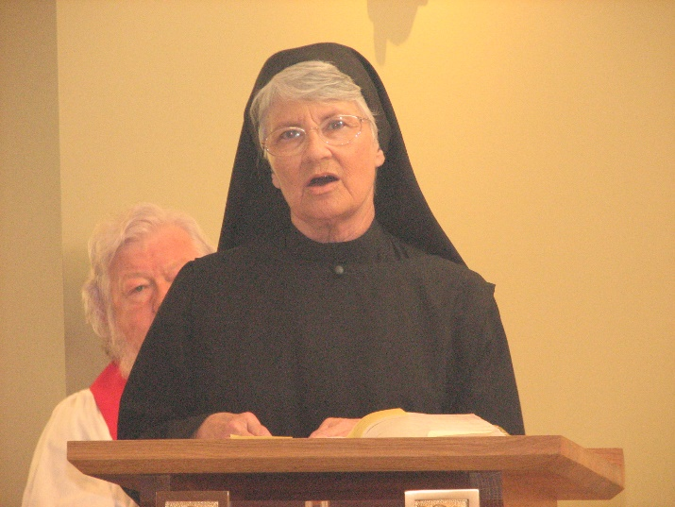
Fr. Wayne Kamm; Sr. Mary Francis Deulen

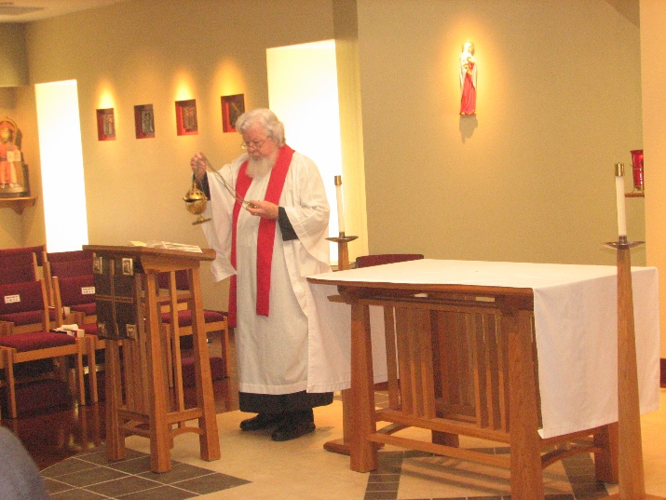
Fr. Wayne Kamm

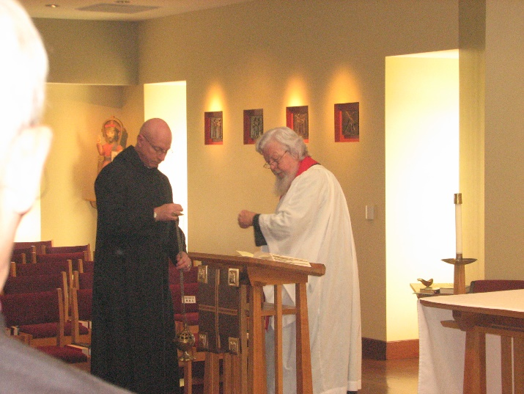
Br. David Vincent Cotton; Fr. Wayne Kamm

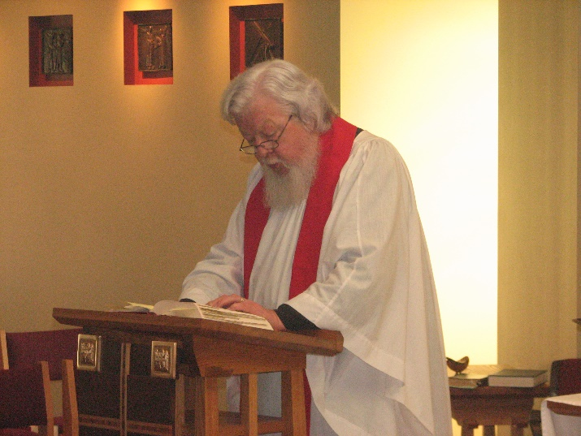
Fr. Wayne Kamm

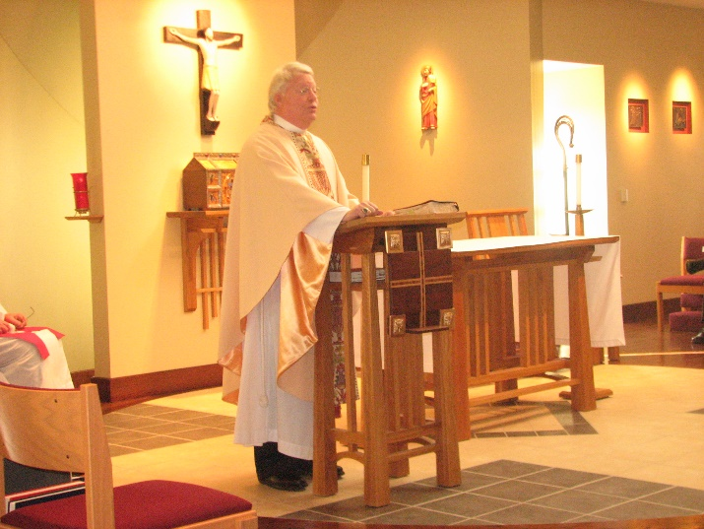
Bp. Dean Wolfe

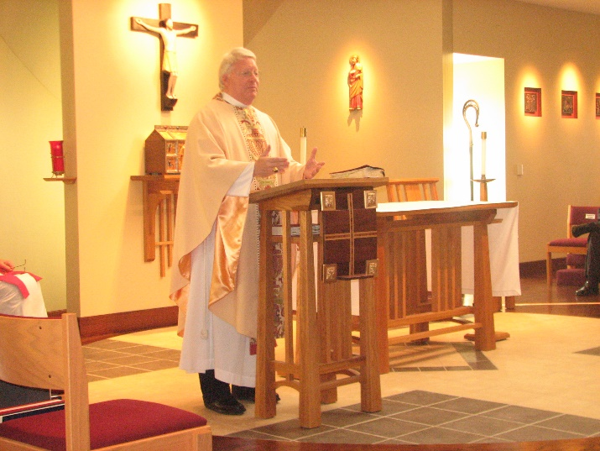
Bp. Dean Wolfe

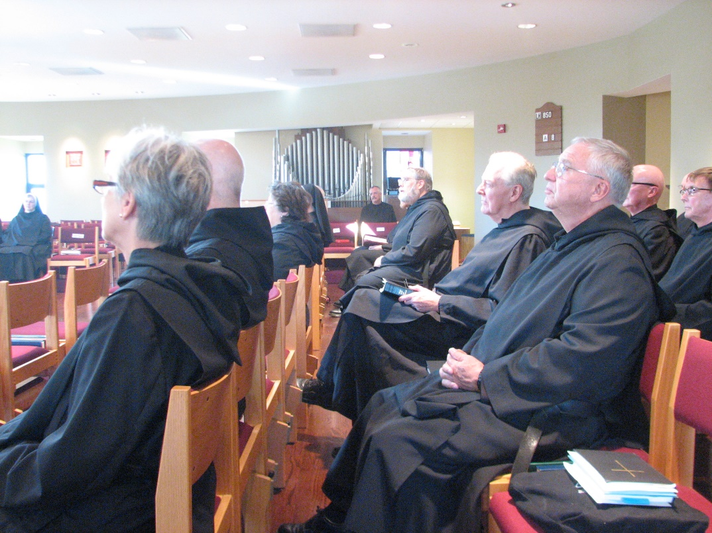
Sr. Bernadette Barrett; Sr. Julian Saterstrom; Br. Basil Edwards; Sr. Cecelia Lamoy; Sr. Mary Francis Deulen; Br. Dunstan Townsend; Br. Chad Anselm Gerns; Br. Luke Doucette; Br. Bede Leach; Br. Stephen Francis Arnold; Br. Camillus Converse

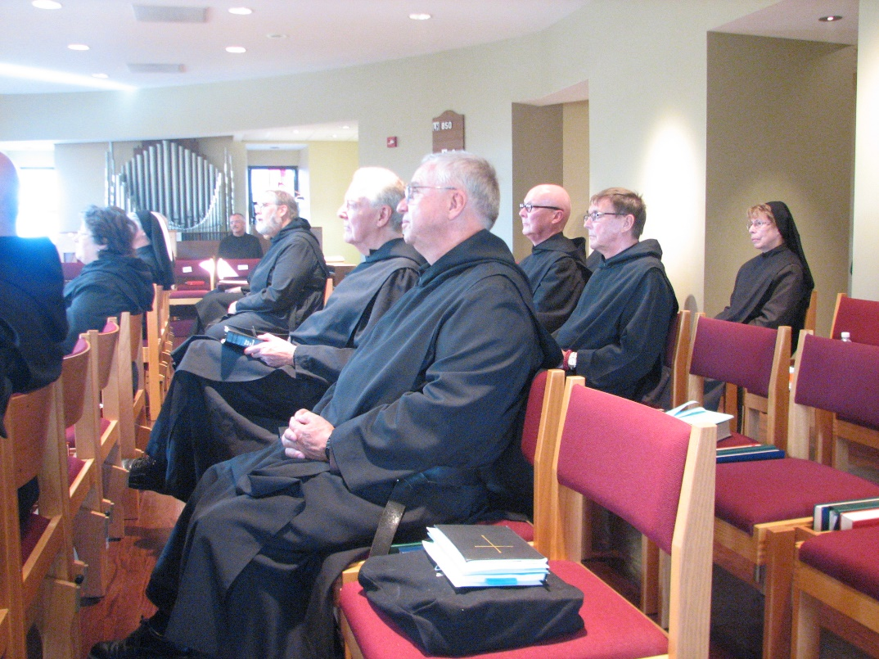
Br. Basil Edwards; Sr. Cecelia Lamoy; Sr. Mary Francis Deulen; Br. Dunstan Townsend; Br. Chad Anselm Gerns; Br. Luke Doucette; Br. Bede Leach; Br. Stephen Francis Arnold; Br. Camillus Converse; Sr. Monica Ruth Mullen

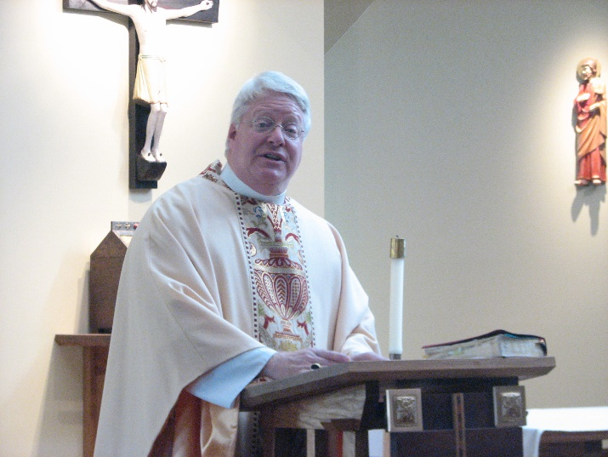
Bp. Dean Wolfe

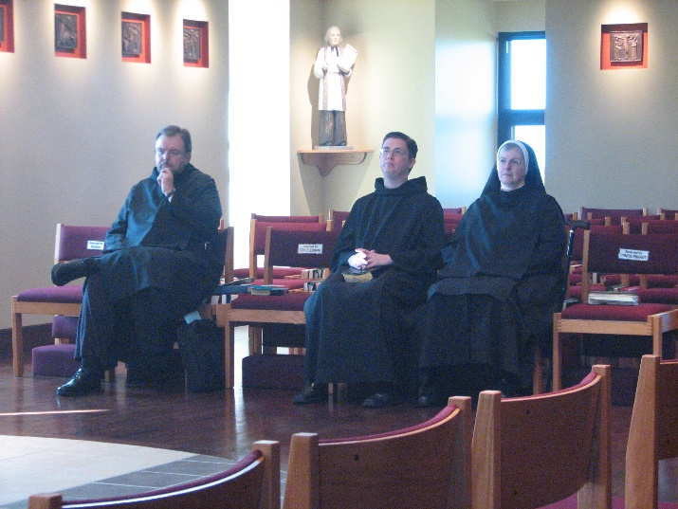
Br. Samuel Saterstrom; Br. Aidan Maguire; Sr. Bernadette Barrett

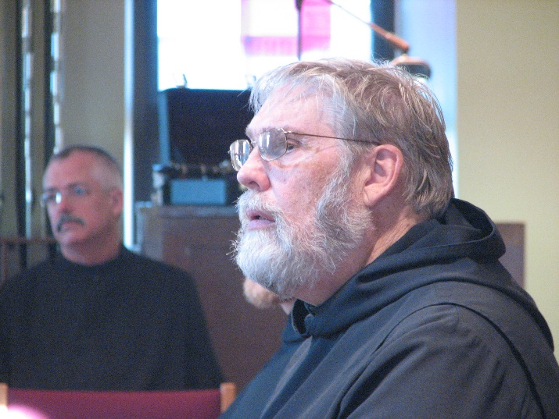
Br. Dunstan Townsend; Br. Chad Anselm Gerns

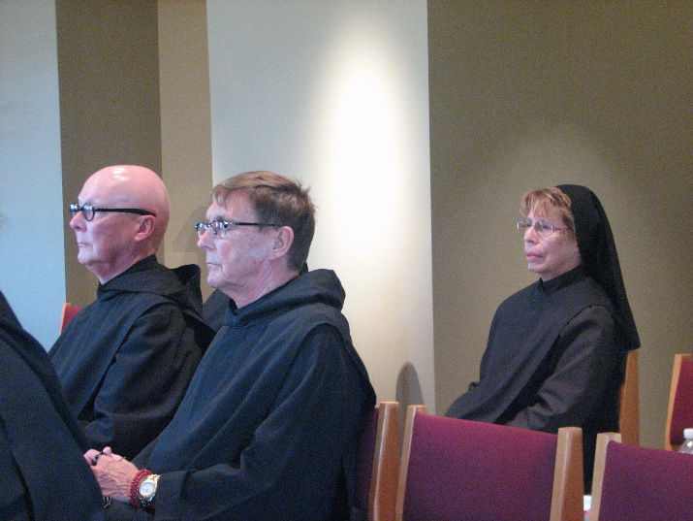
Br. Stephen Francis Arnold; Br. Camillus Converse; Sr. Monica Ruth Mullen

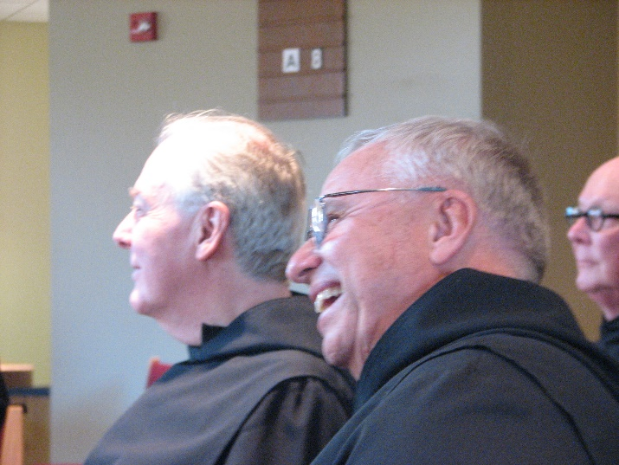
Br. Luke Doucette; Br. Bede Leach; Br. Stephen Francis Arnold

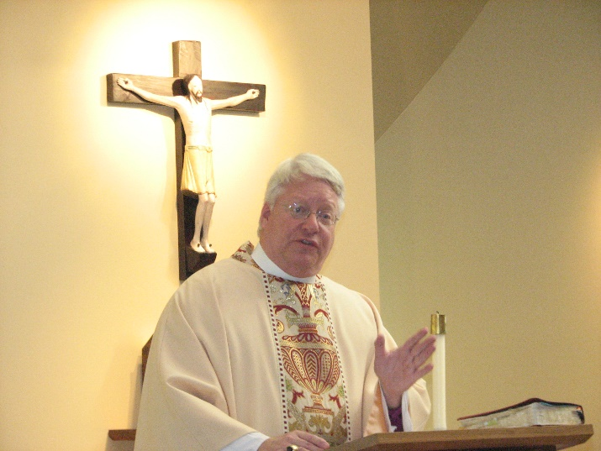
Bp. Dean Wolfe

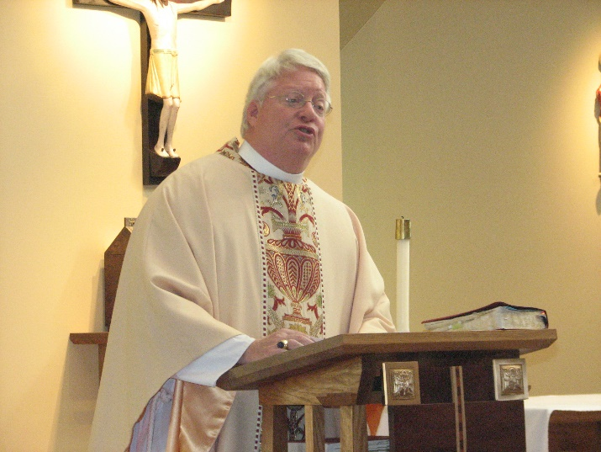
Bp. Dean Wolfe

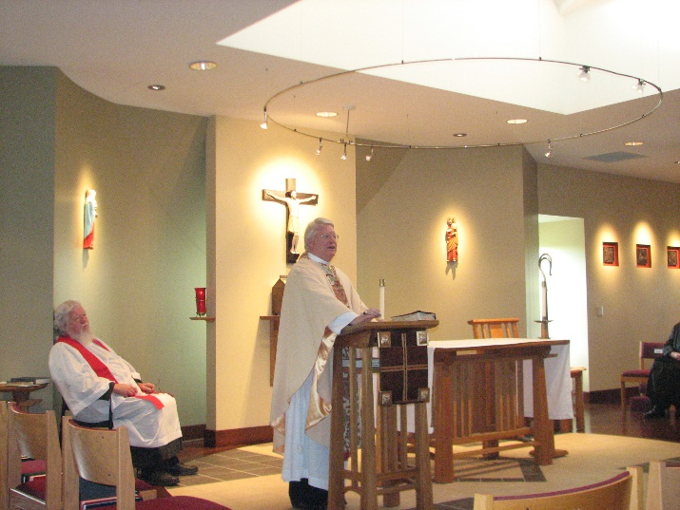
Fr. Wayne Kamm; Bp. Dean Wolfe

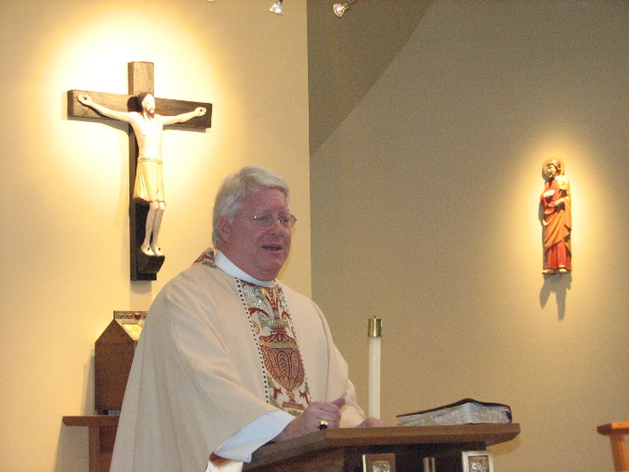
Bp. Dean Wolfe

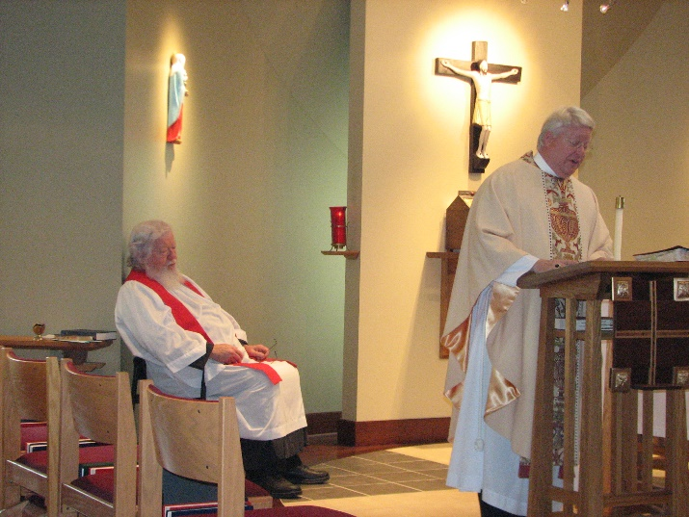
Fr. Wayne Kamm; Bp. Dean Wolfe

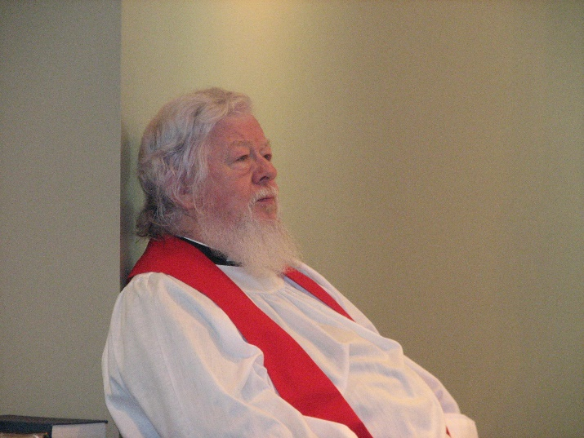
Fr. Wayne Kamm

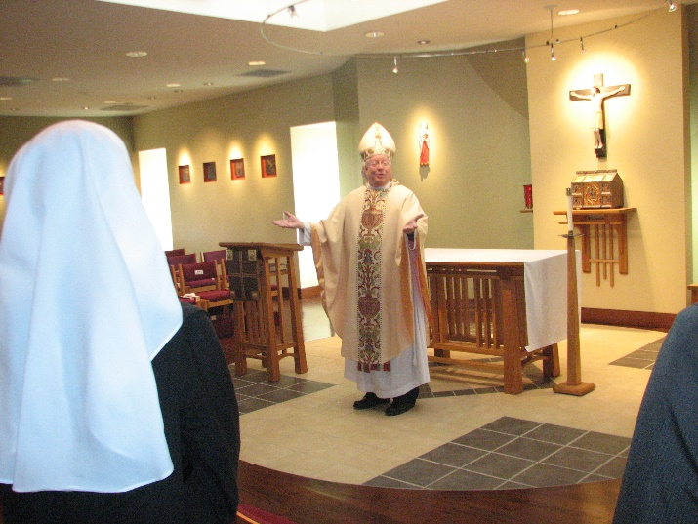
Sr. Veronica Taylor; Bp. Dean Wolfe

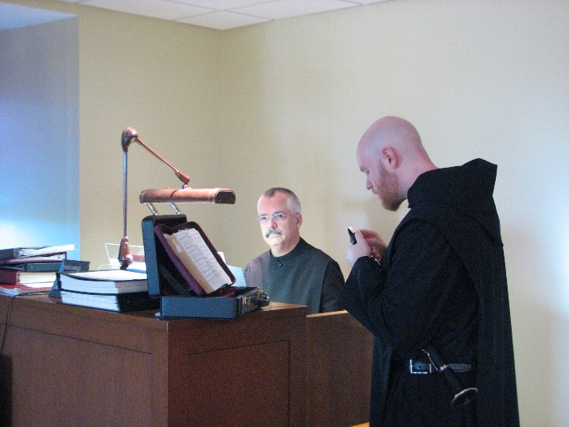
Br. Dunstan Townsend; Br. Gregory Kingsley

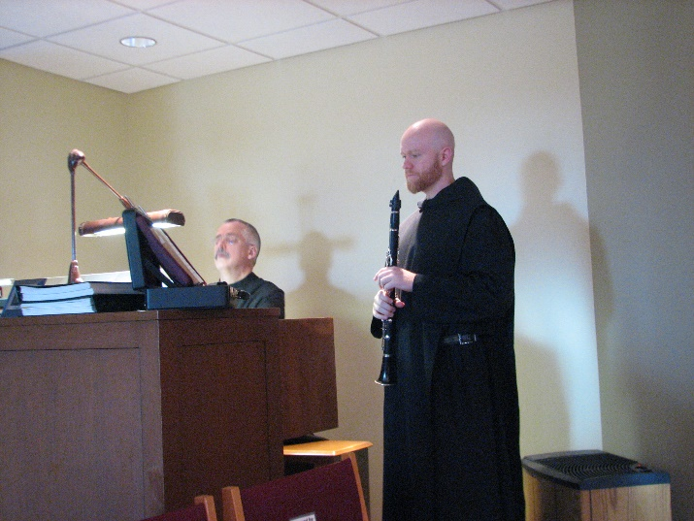
Br. Dunstan Townsend; Br. Gregory Kingsley

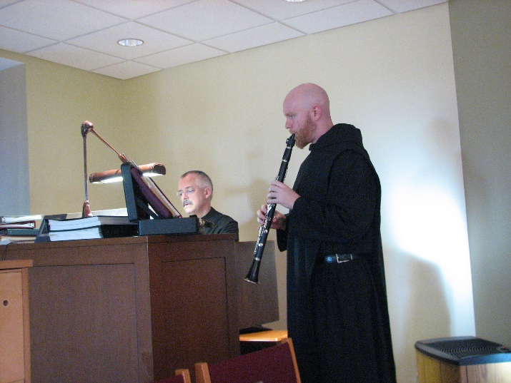
Br. Dunstan Townsend; Br. Gregory Kingsley

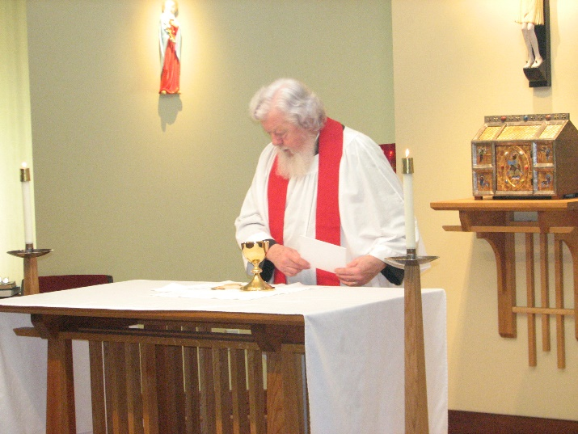
Fr. Wayne Kamm

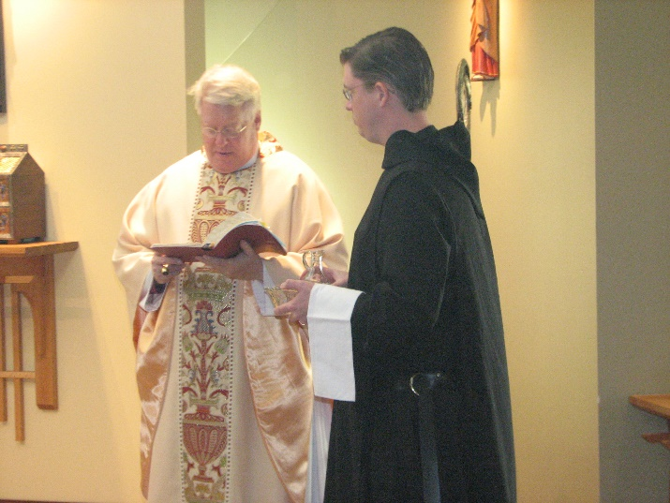
Bp. Dean Wolfe; Br. Aidan Maguire

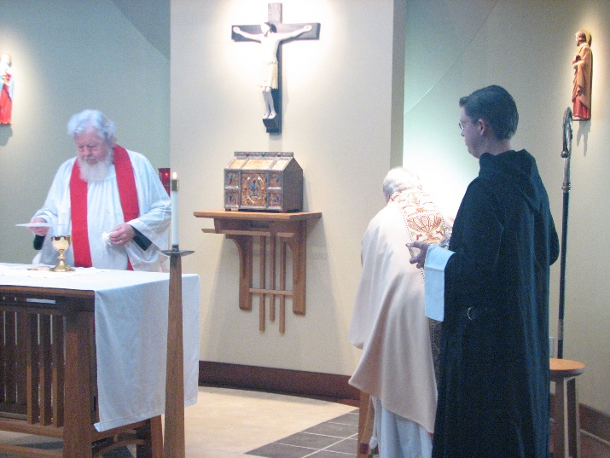
Fr. Wayne Kamm; Bp. Dean Wolfe; Br. Aidan Maguire

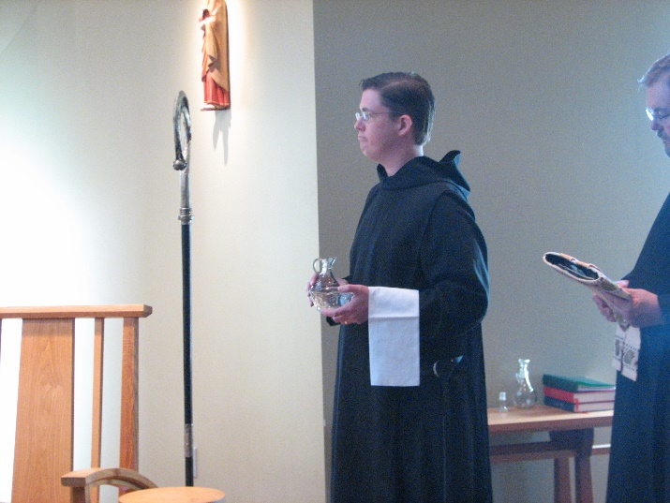
Br. Aidan Maguire; Br. Samuel Saterstrom

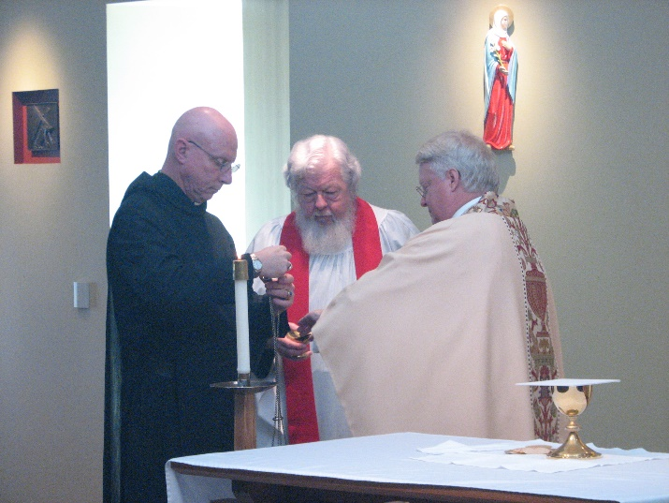
Br. David Vincent Cotton; Fr. Wayne Kamm; Bp. Dean Wolfe

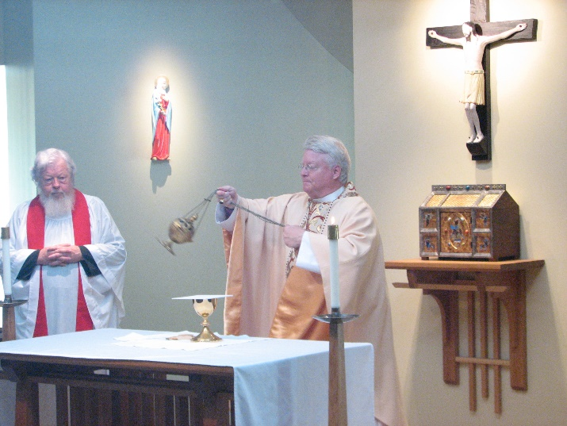
Fr. Wayne Kamm; Bp. Dean Wolfe

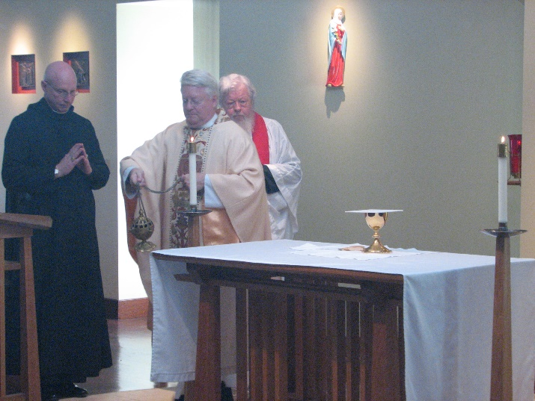
Br. David Vincent Cotton; Bp. Dean Wolfe; Fr. Wayne Kamm

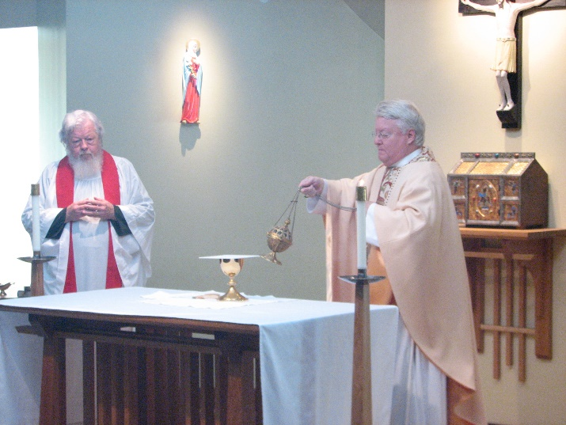
Fr. Wayne Kamm; Bp. Dean Wolfe

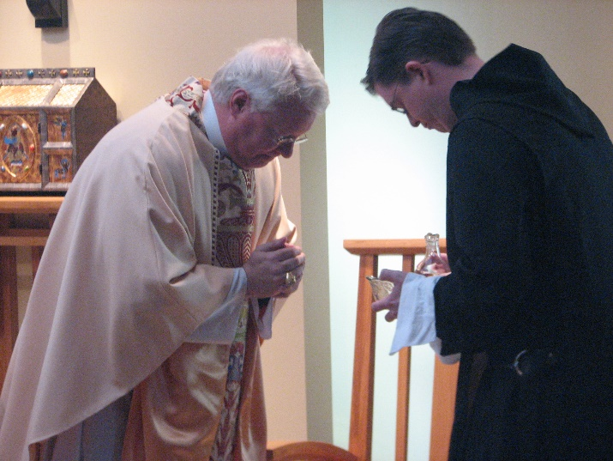
Bp. Dean Wolfe; Br. Aidan Maguire

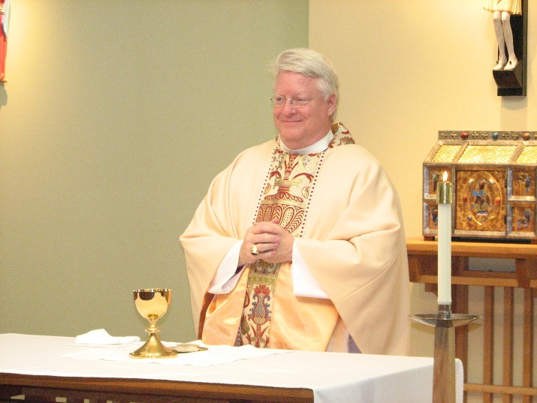
Bp. Dean Wolfe

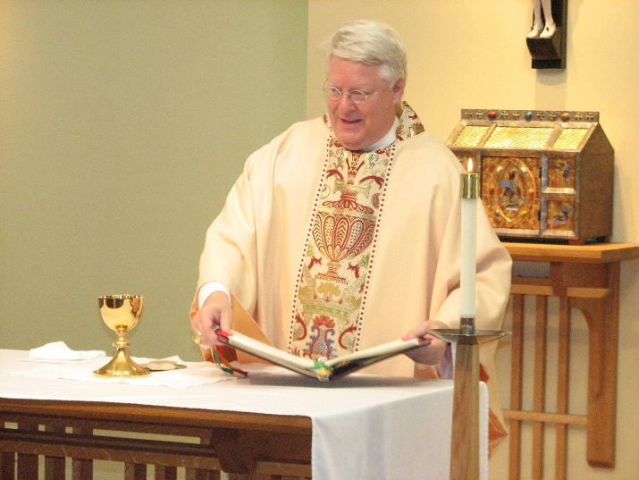
Bp. Dean Wolfe

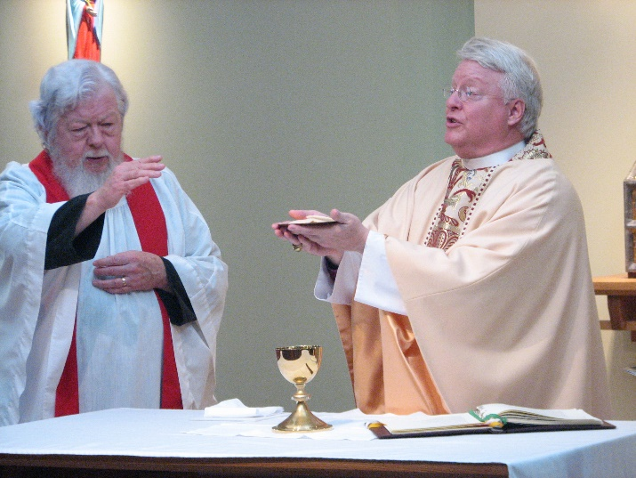
Fr. Wayne Kamm; Bp. Dean Wolfe

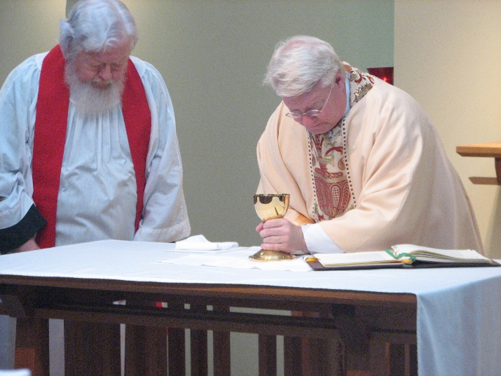
Fr. Wayne Kamm; Bp. Dean Wolfe

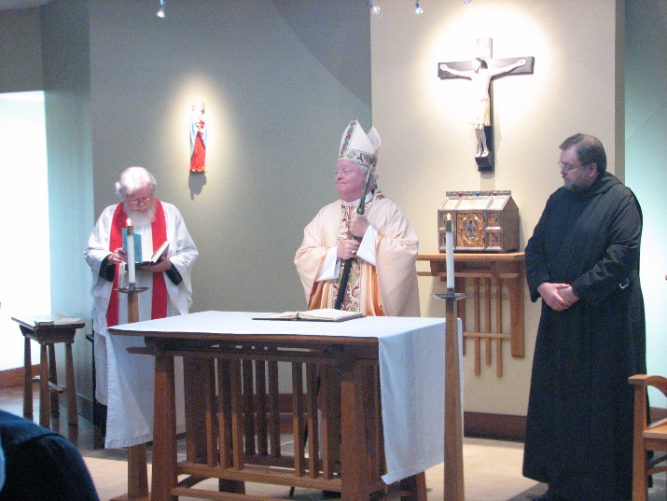
Fr. Wayne Kamm; Bp. Dean Wolfe; Br. Samuel Saterstrom

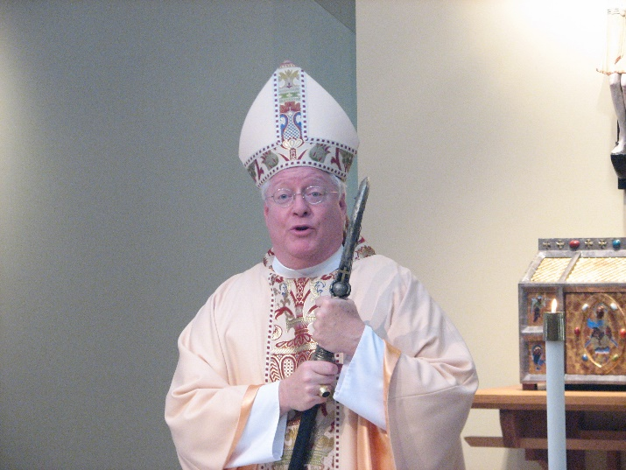
Bp. Dean Wolfe

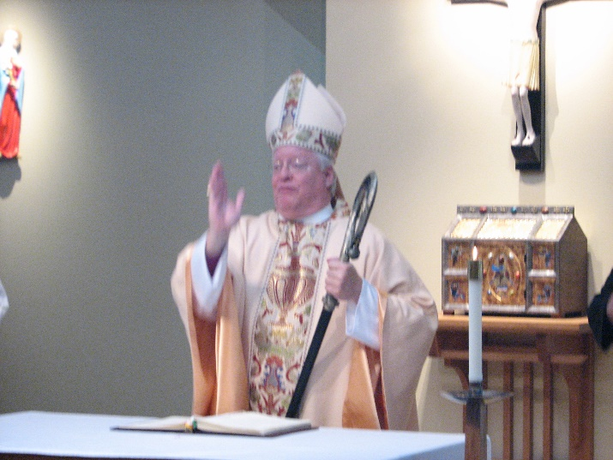
Bp. Dean Wolfe

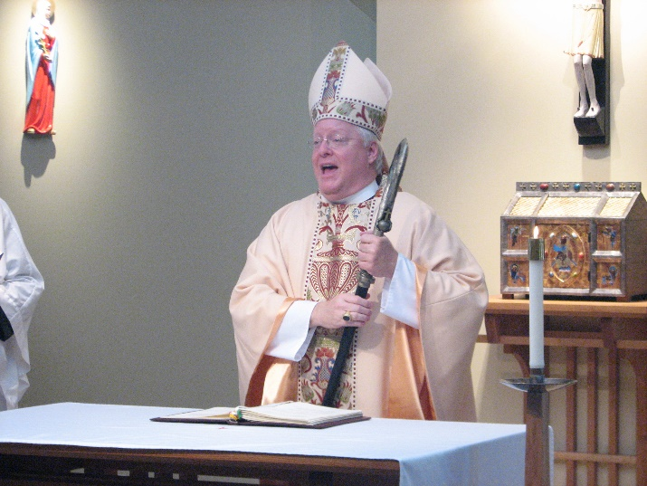
Bp. Dean Wolfe

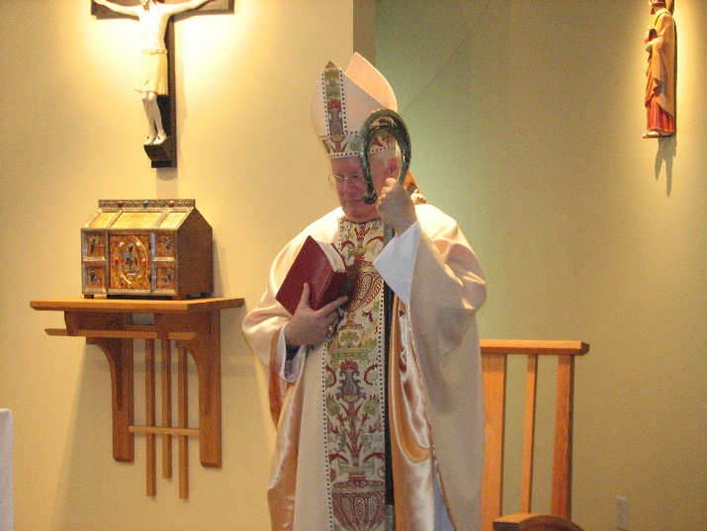
Bp. Dean Wolfe

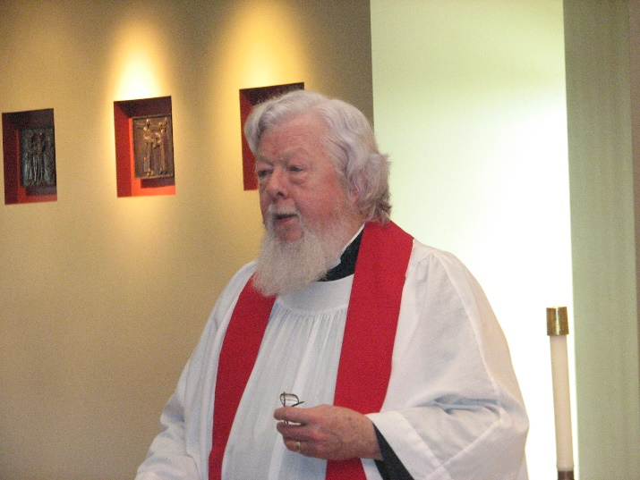
Fr. Wayne Kamm

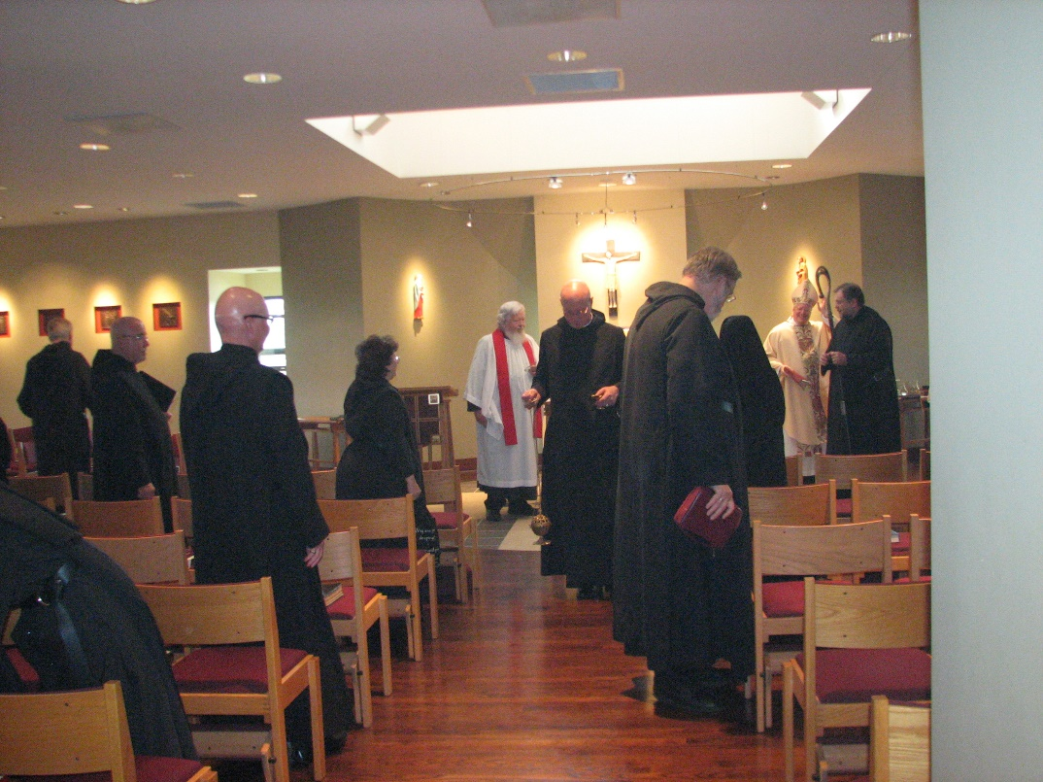
Br. Luke Doucette; Br. Basil Edwards; Br. Stephen Francis Arnold; Sr. Cecelia Lamoy; Fr. Wayne Kamm; Br. David Vincent Cotton; Br. Chad Anselm Gerns; Sr. Mary Francis Deulen; Bp. Dean Wolfe; Br. Samuel Saterstrom

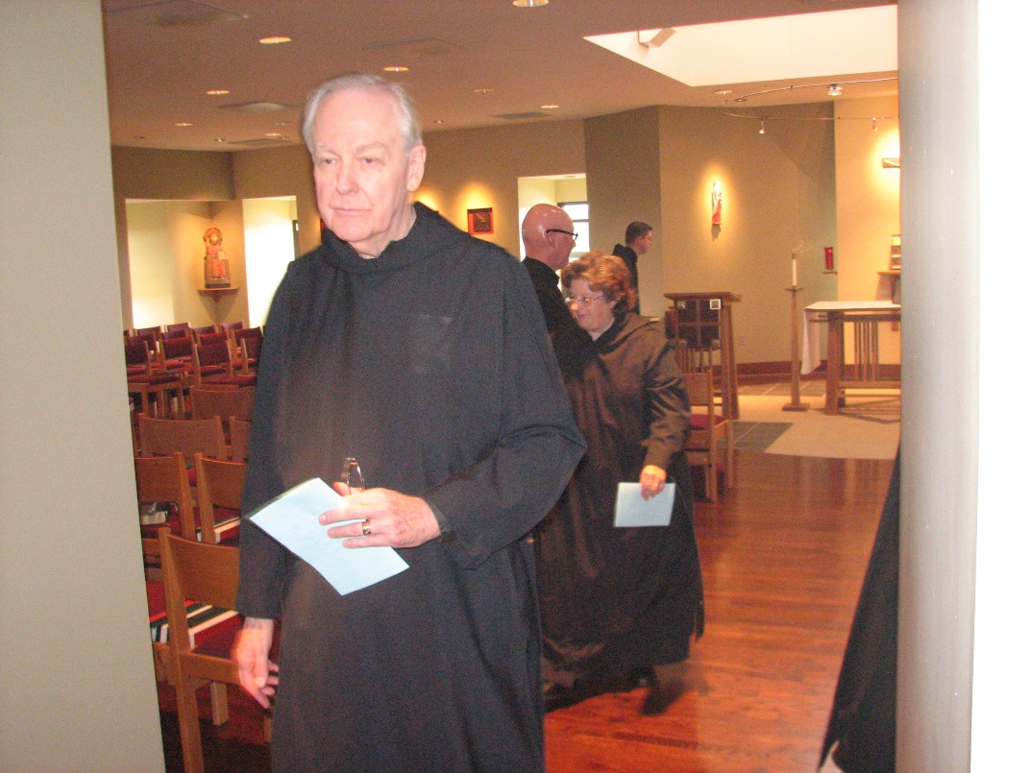
Br. Luke Doucette; Br. Stephen Francis Arnold; Sr. Cecelia Lamoy; Br. Aidan Maguire

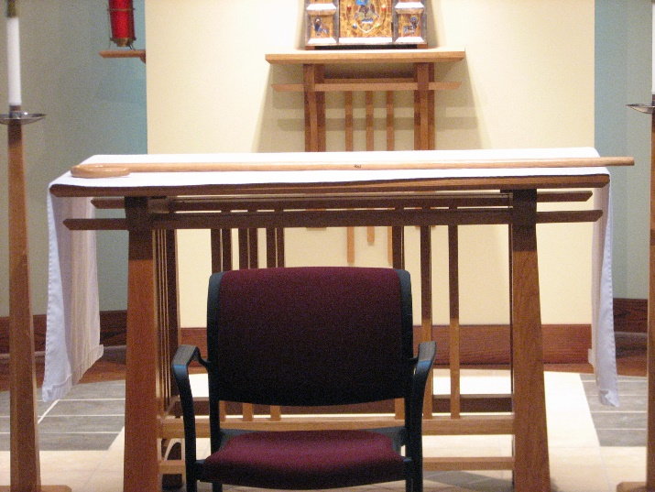
Newly purchased abbot’s staff

