Companions of St. Luke
Fall Convocation at Conception Abbey
October 25-30, 2010
Part 2 of 4
Photographed by Sr. Brigid Gerns

People are identified from left to right.

Edited by Br. Steven Olderr 25 March 2023. Please send any comments, corrections, or additions to olderr@ameritech.net

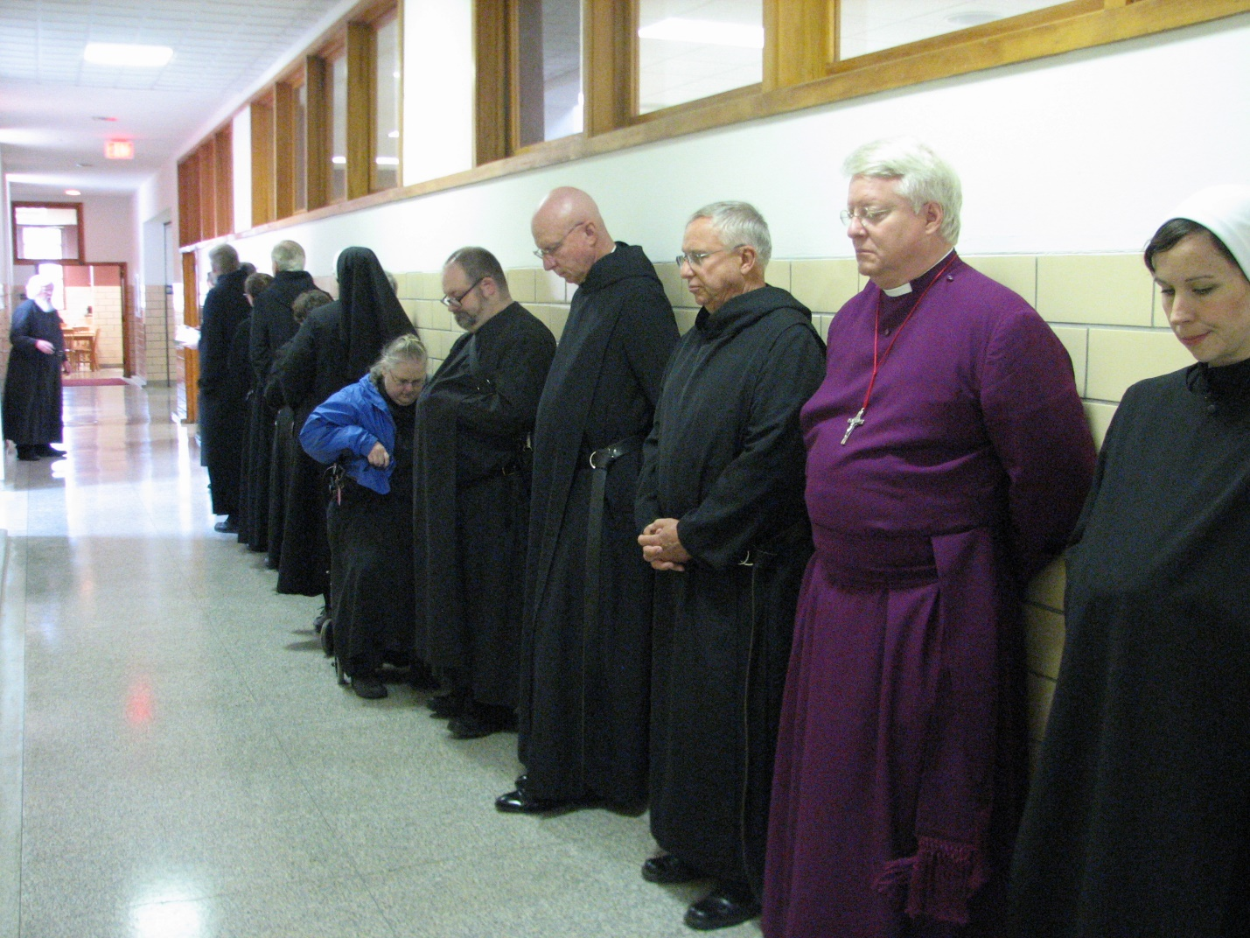Fr. Wayne Kamm; Br. Chad Anselm Gerns; Br. Camillus Converse; Br. Luke Doucette; Sr. Cecelia Lamoy; Kamm; Sr. Bernadette Barrett; Sr. Margaret Moore; Br. Willard Moore; Abbot David Vincent Cotton; Br. Bede Leach; Bp. Dean Wolfe; Sr. Veronica Taylor; Sr. Mary Francis Deulen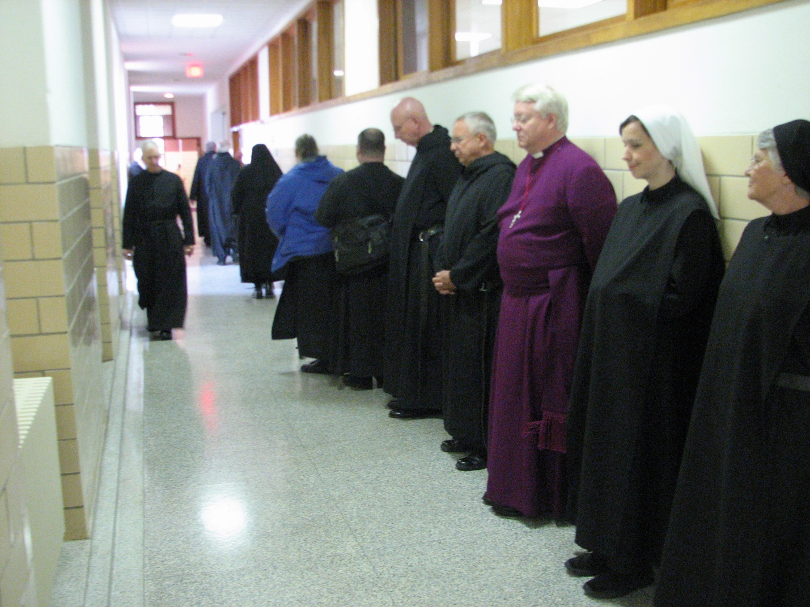
Fr. Wayne Kamm; Br. Joseph Olderr; Br. Chad Anselm Gerns; Br. Camillus Converse; Br. Luke Doucette; Sr. Bernadette Barrett; Sr. Margaret Moore; Br. Willard Moore; Abbot David Vincent Cotton; Br. Bede Leach; Bp. Dean Wolfe; Sr. Veronica Taylor; Sr. Mary Francis Deulen

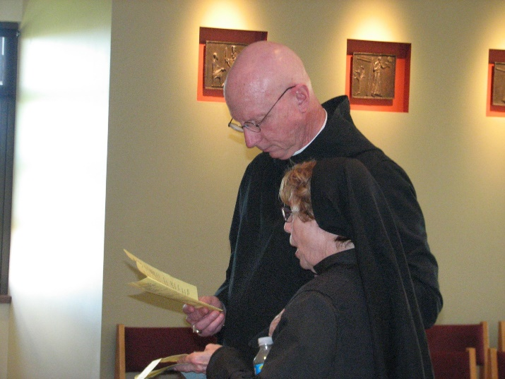
Abbot David Vincent Cotton
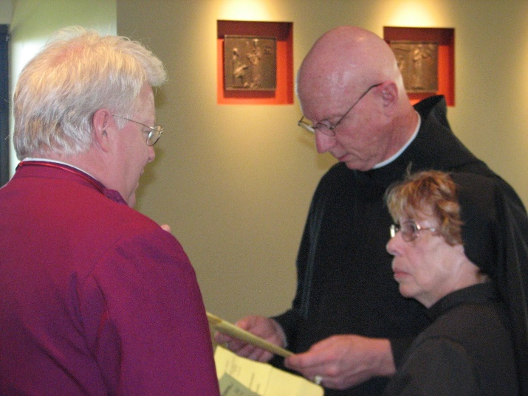
Bp. Dean Wolfe; Abbot David Vincent Cotton

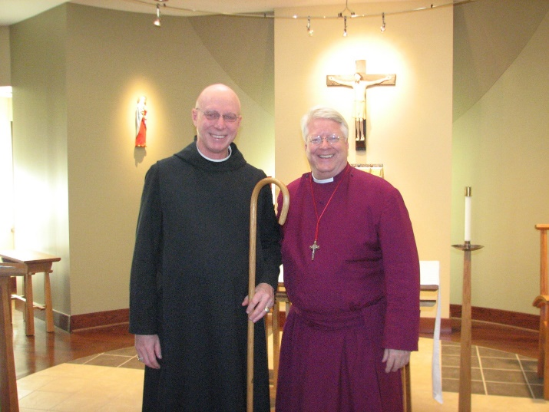
Abbot David Vincent Cotton; Bp. Dean Wolfe

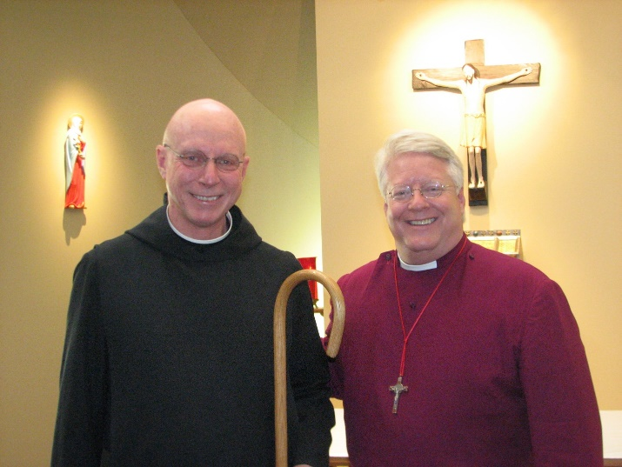
Abbot David Vincent Cotton; Bp. Dean Wolfe
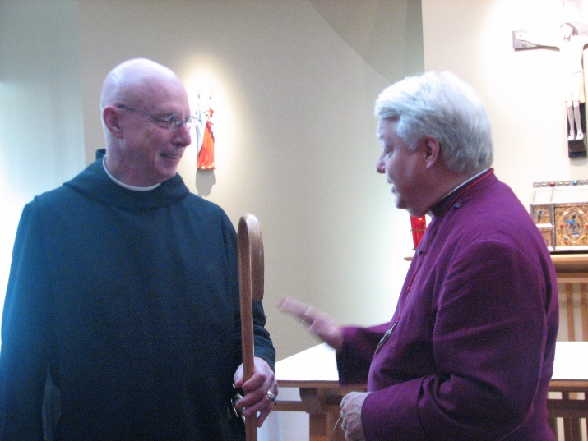
Abbot David Vincent Cotton; Bp. Dean Wolfe

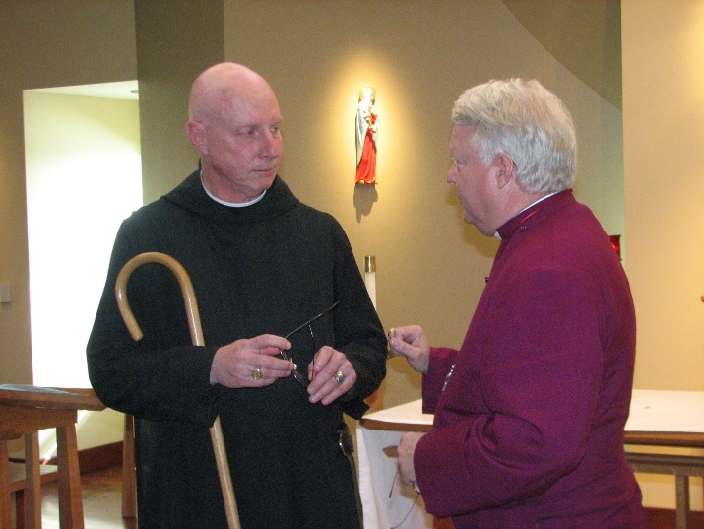
Abbot David Vincent Cotton; Bp. Dean Wolfe

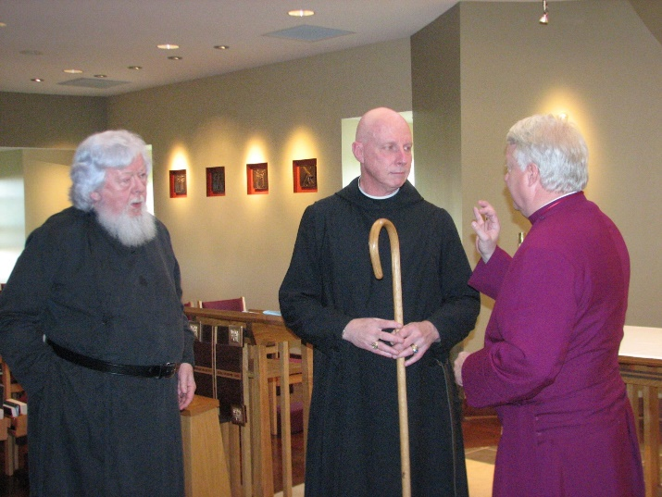
Fr. Wayne Kamm; Abbot David Vincent Cotton; Bp. Dean Wolfe
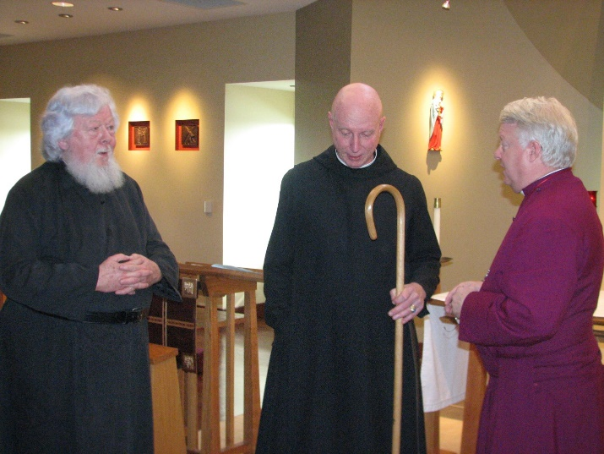
Fr. Wayne Kamm; Abbot David Vincent Cotton; Bp. Dean Wolfe

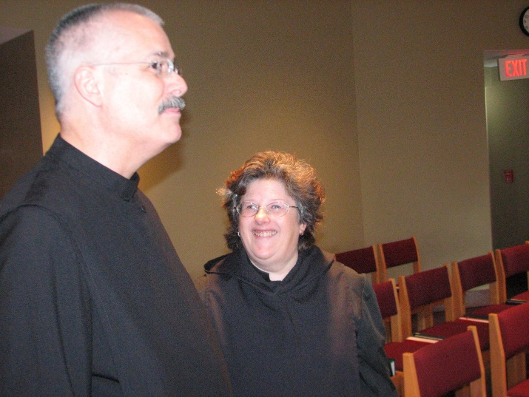
Br. Dunstan Townsend; Sr. Cecelia Lamoy

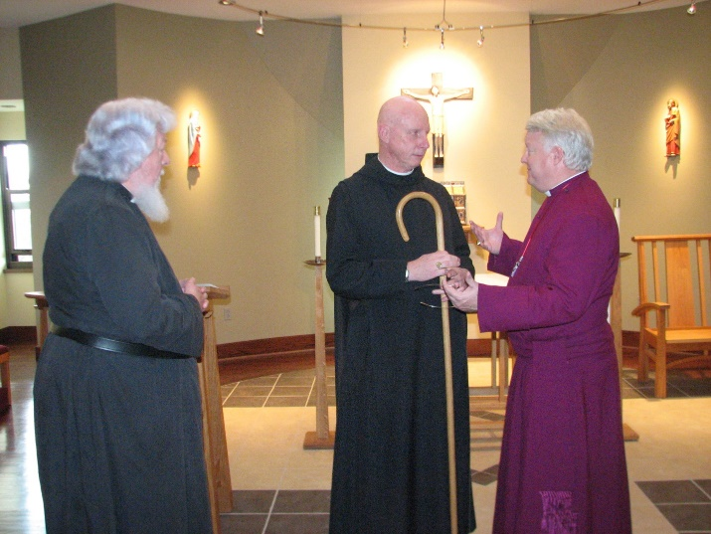
Fr. Wayne Kamm; Abbot David Vincent Cotton; Bp. Dean Wolfe
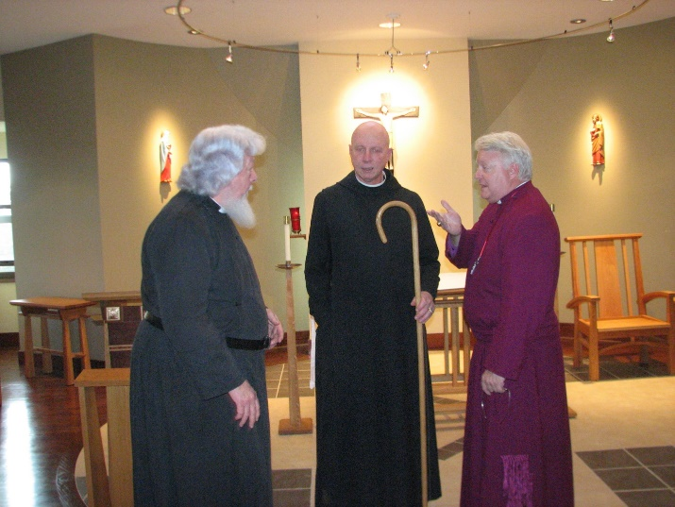
Fr. Wayne Kamm; Abbot David Vincent Cotton; Bp. Dean Wolfe

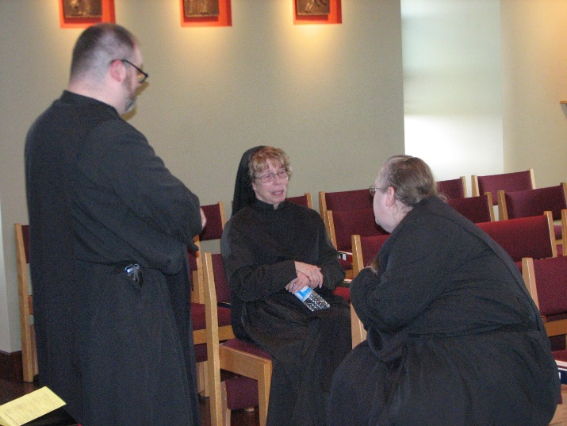
Br. Willard Moore; Sr. Monica Ruth Mullen; Sr. Margaret Moore

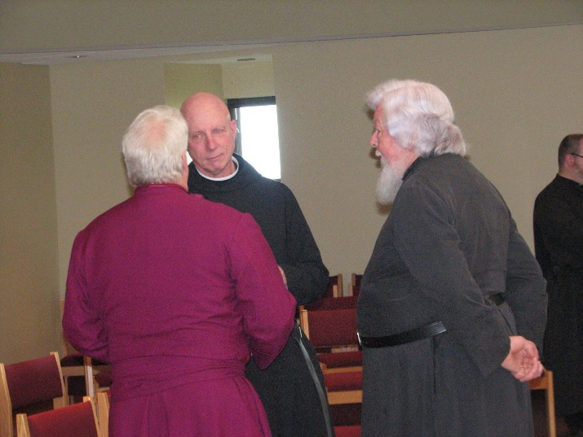
Bp. Dean Wolfe; Abbot David Vincent Cotton; Fr. Wayne Kamm; Br. Willard Moore
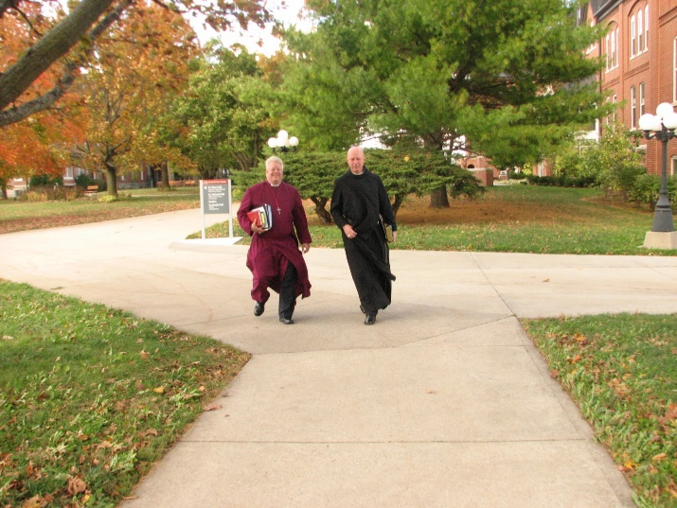
Bp. Dean Wolfe; Abbot David Vincent Cotton

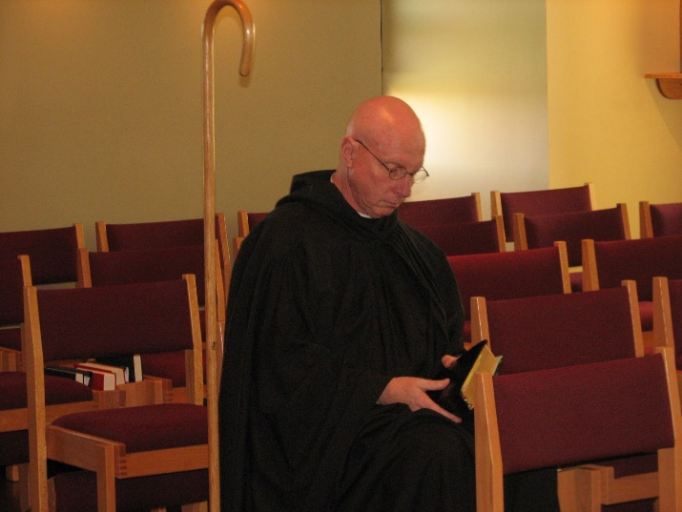
Abbot David Vincent Cotton

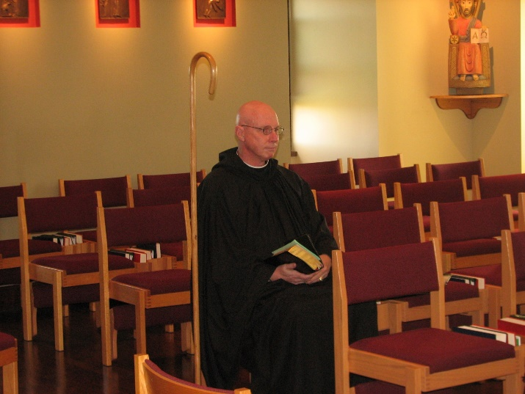
Abbot David Vincent Cotton

Br. Dunstan Townsend

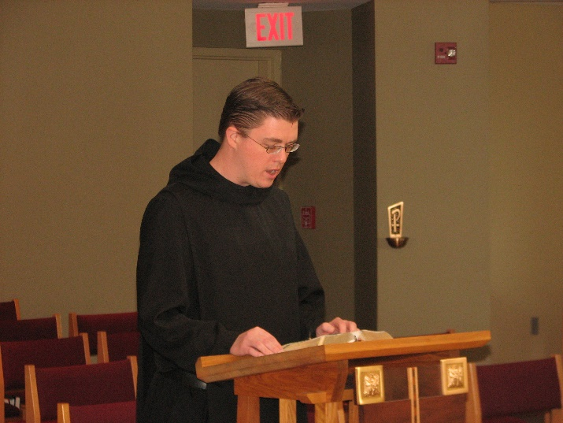
Br. Aidan Maguire

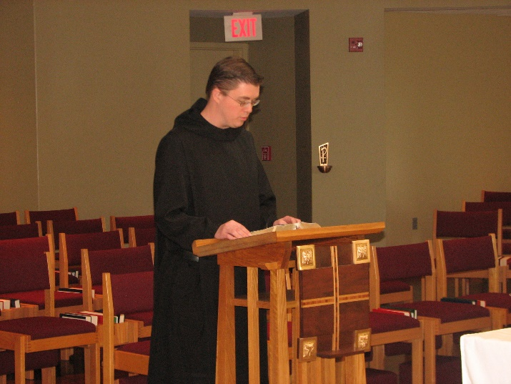
Br. Aidan Maguire
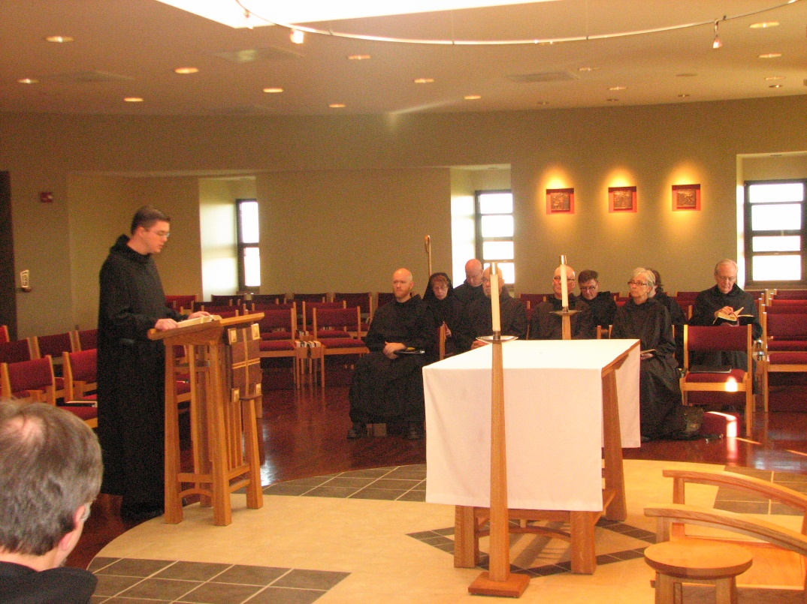
Br. Aidan Maguire; Br. Gregory Kingsley; Sr. Monica Ruth Mullen; Abbot David Vincent Cotton; Br. Basil Edwards; Br. Stephen Francis Arnold; Br. Camillus Converse; Sr. Julian Saterstrom; Sr. Cecelia Lamoy; Br. Luke Doucette

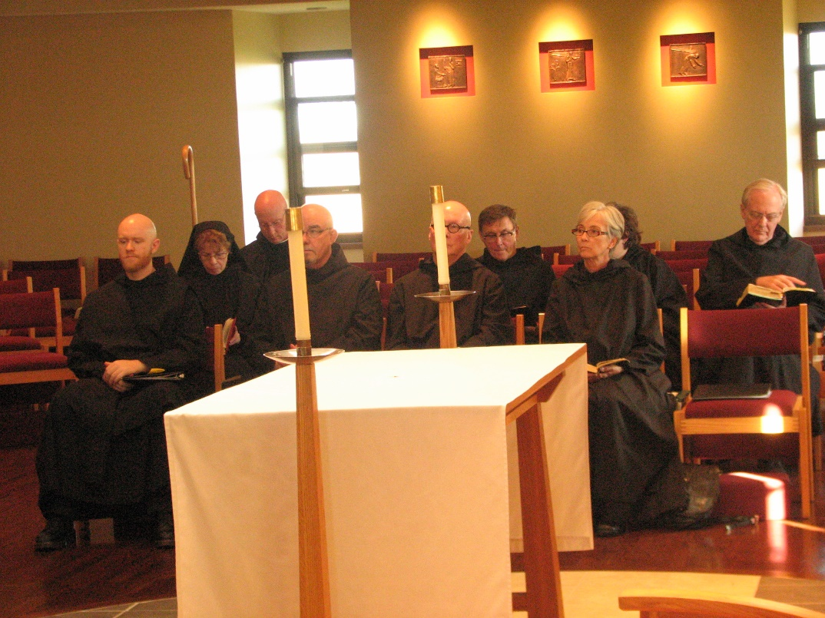
Br. Gregory Kingsley; Sr. Monica Ruth Mullen; Abbot David Vincent Cotton; Br. Basil Edwards; Br. Stephen Francis Arnold; Br. Camillus Converse; Sr. Julian Saterstrom; Sr. Cecelia Lamoy; Br. Luke Doucette
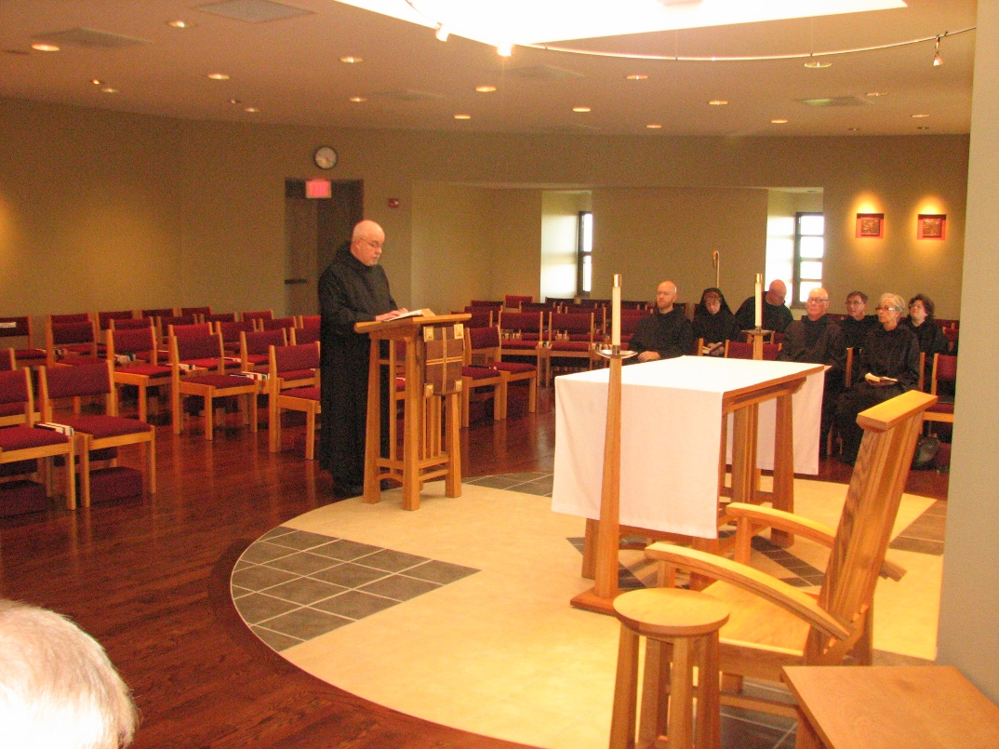
Br. Basil Edwards; Br. Gregory Kingsley; Sr. Monica Ruth Mullen; Abbot David Vincent Cotton; Br. Stephen Francis Arnold; Br. Camillus Converse; Sr. Julian Saterstrom; Sr. Cecelia Lamoy; Br. Luke Doucette

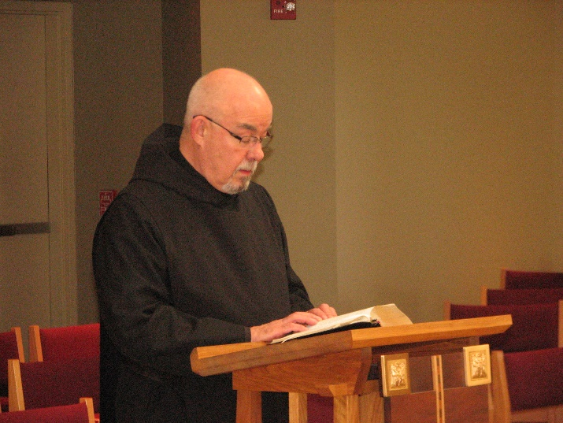
Br. Basil Edwards
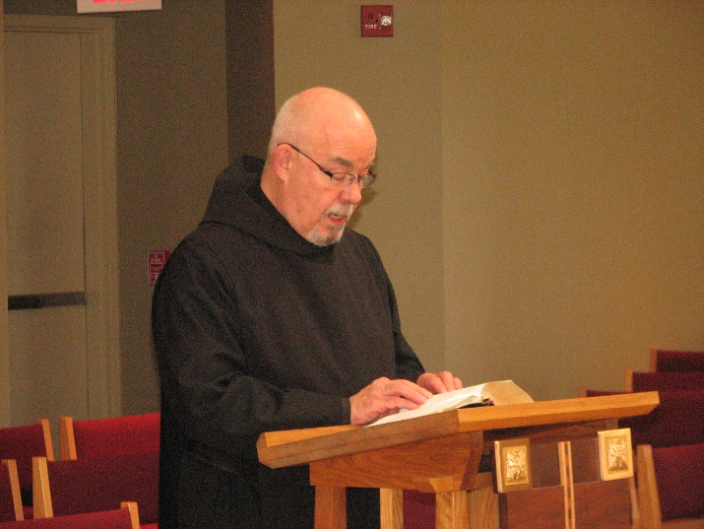
Br. Basil Edwards

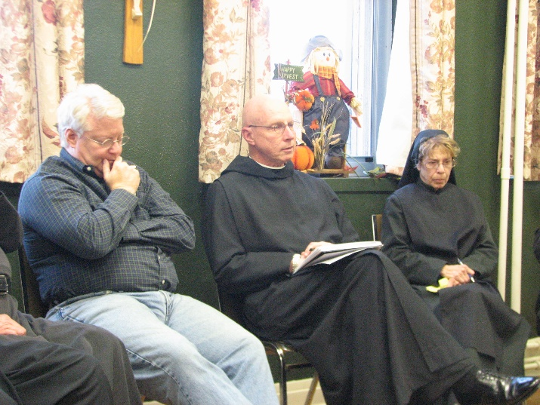
Bp. Dean Wolfe; Abbot David Vincent Cotton; Sr. Monica Ruth Mullen

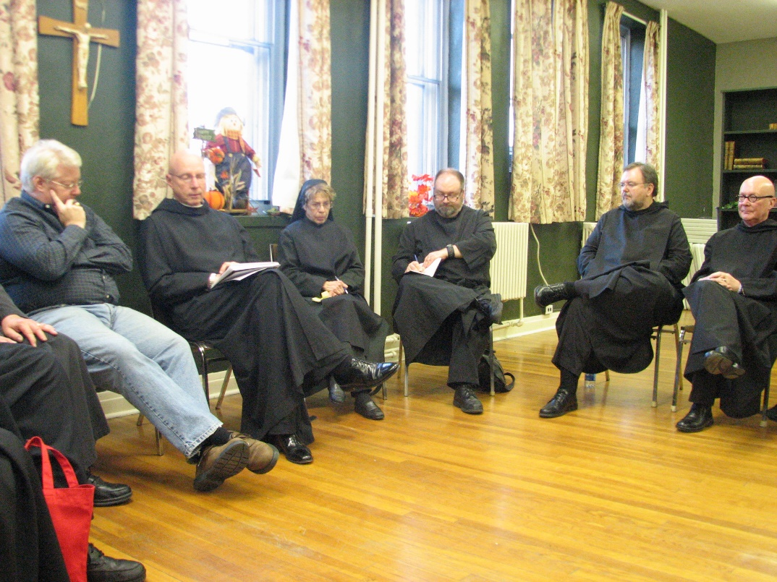
Bp. Dean Wolfe; Abbot David Vincent Cotton; Sr. Monica Ruth Mullen; Br. Willard Moore; Br. Samuel Saterstrom; Br. Stephen Francis Arnold

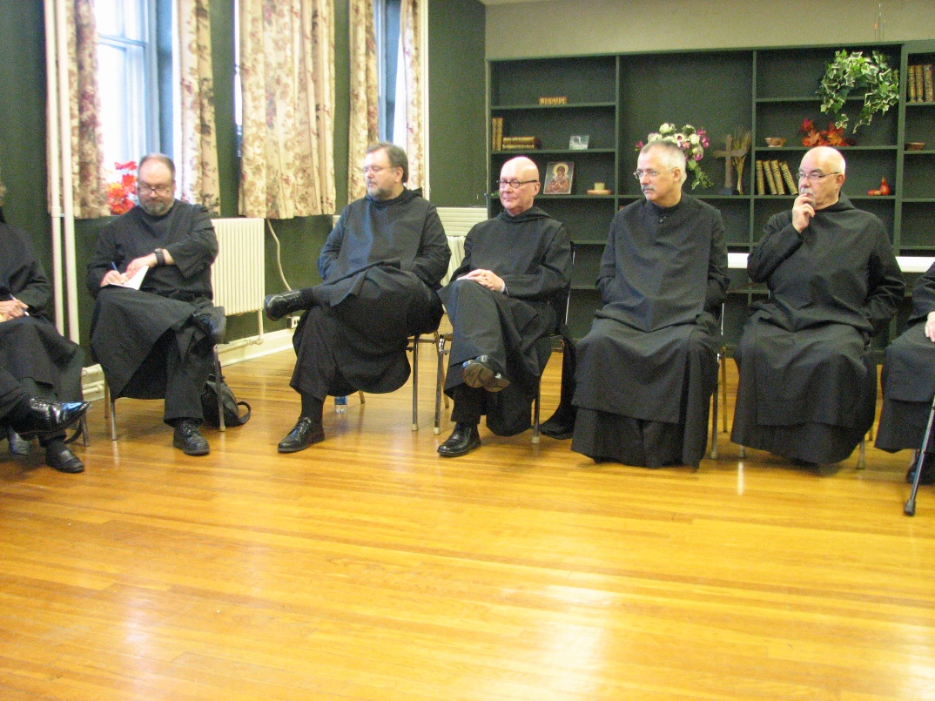
Br. Willard Moore; Br. Samuel Saterstrom; Br. Stephen Francis Arnold; Br. Dunstan Townsend; Br. Basil Edwards
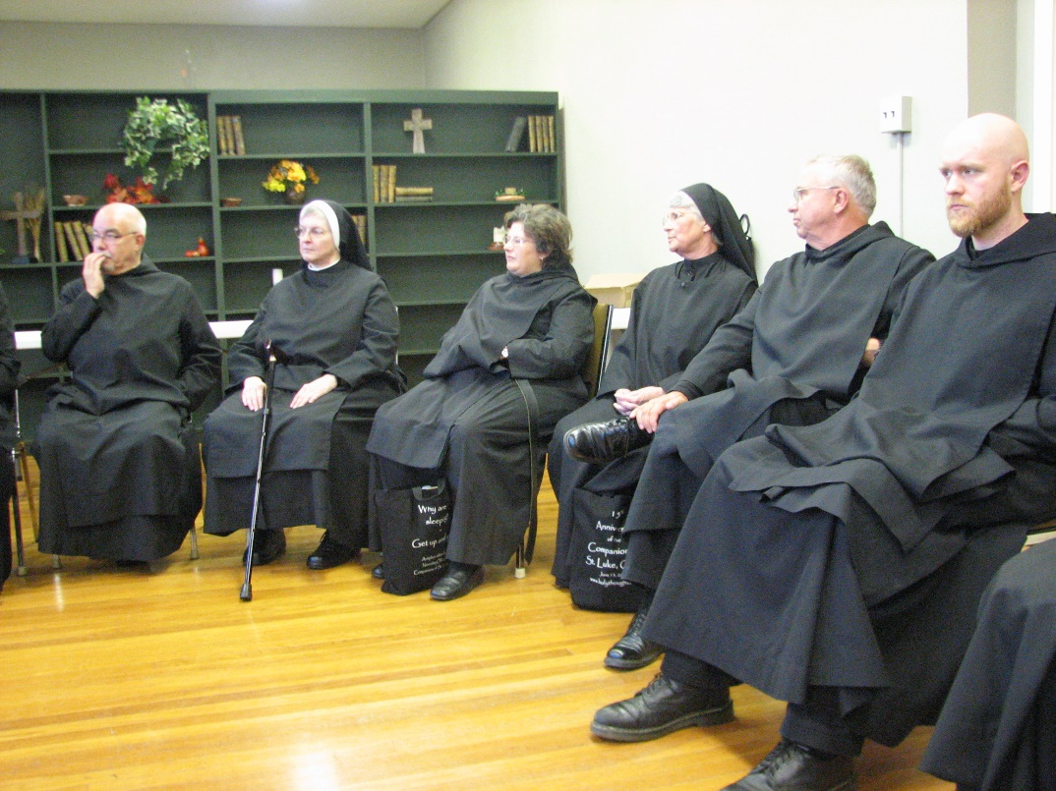
Br. Basil Edwards; Sr. Bernadette Barrett; Sr. Cecelia Lamoy; Sr. Mary Francis Deulen; Br. Bede Leach; Br. Gregory Kingsley

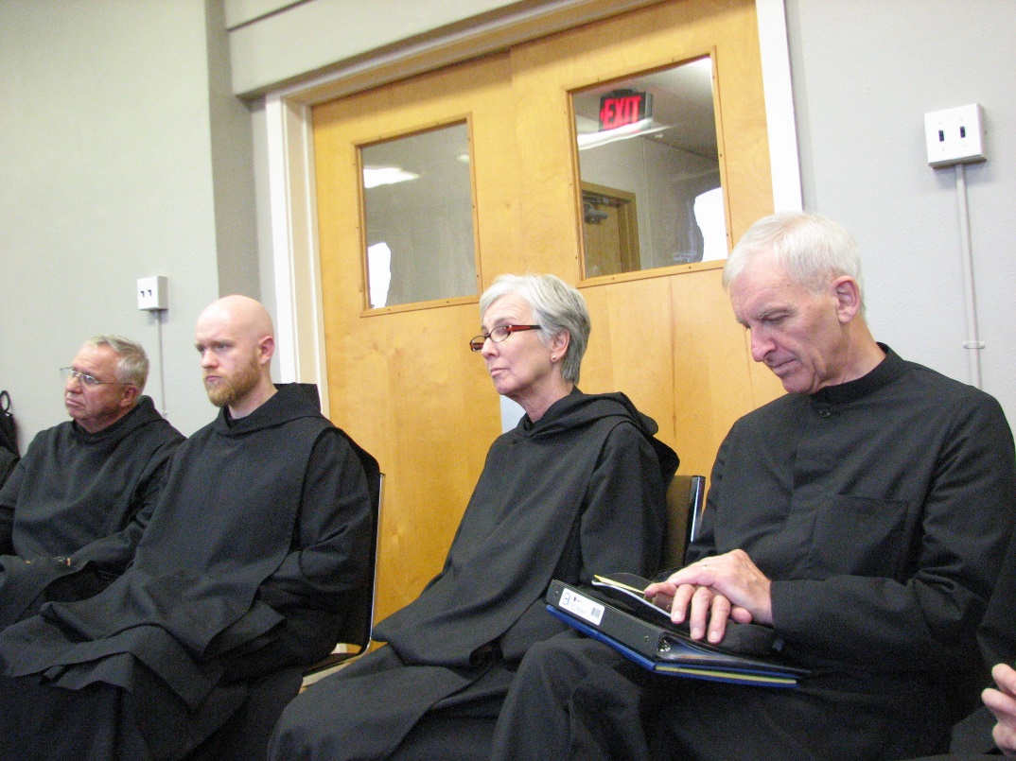
Br. Bede Leach; Br. Gregory Kingsley; Sr. Julian Saterstrom; Br. Joseph Olderr

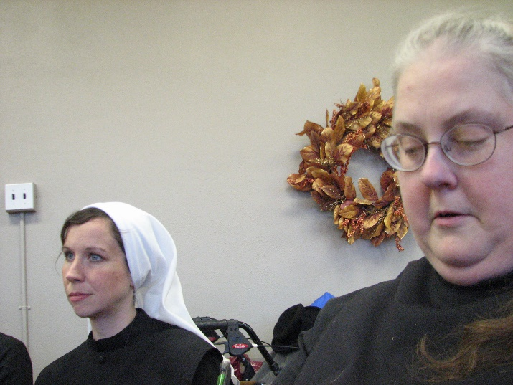
Sr. Veronica Taylor; Sr. Margaret Moore

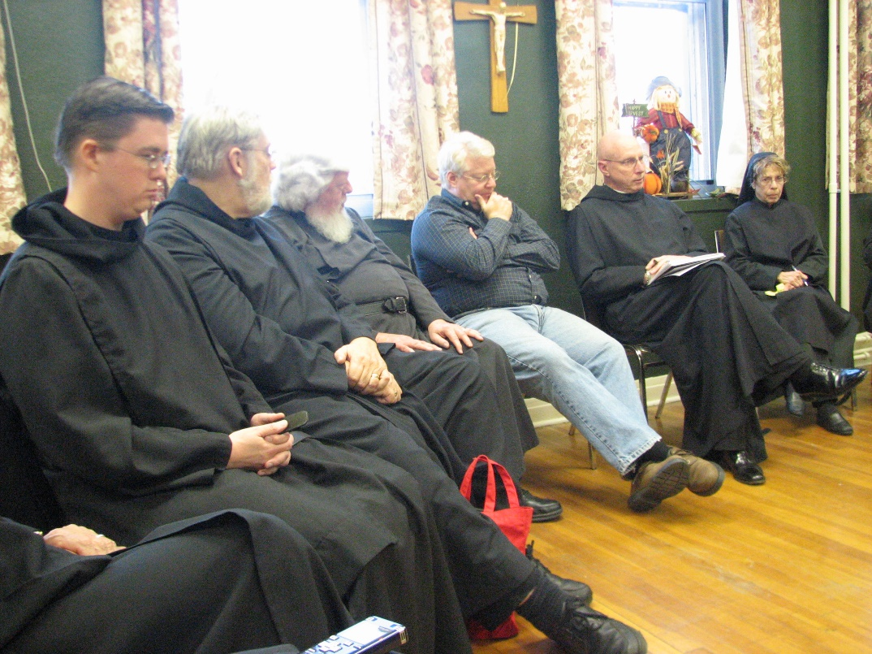
Br. Aidan Maguire; Br. Chad Anselm Gerns; Fr. Wayne Kamm; Bp. Dean Wolfe; Abbot David Vincent Cotton; Sr. Monica Ruth Mullen

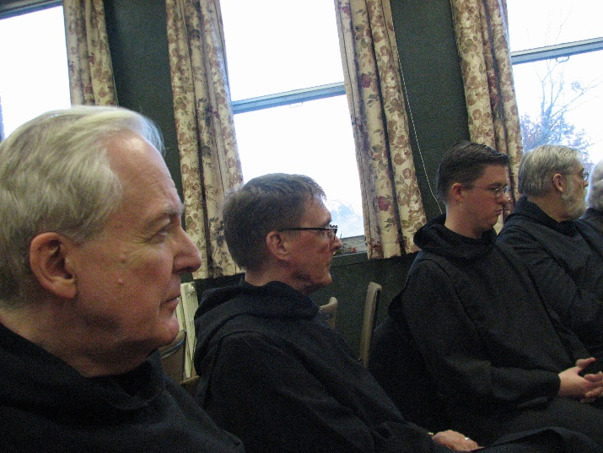
Br. Luke Doucette; Br. Camillus Converse; Br. Aidan Maguire; Br. Chad Anselm Gerns

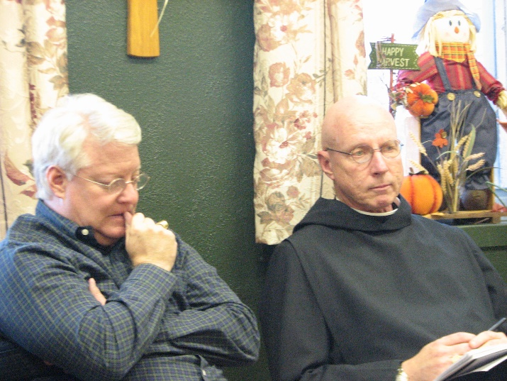
Bp. Dean Wolfe; Abbot David Vincent Cotton

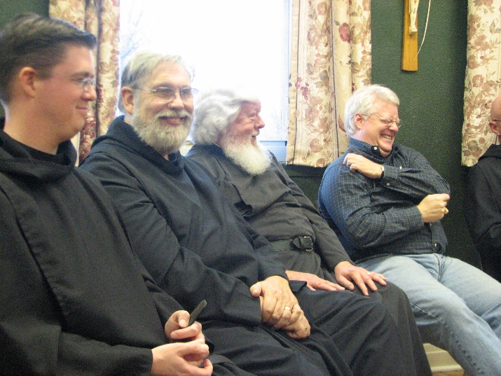
Br. Aidan Maguire; Br. Chad Anselm Gerns; Fr. Wayne Kamm; Bp. Dean Wolfe; Abbot David Vincent Cotton
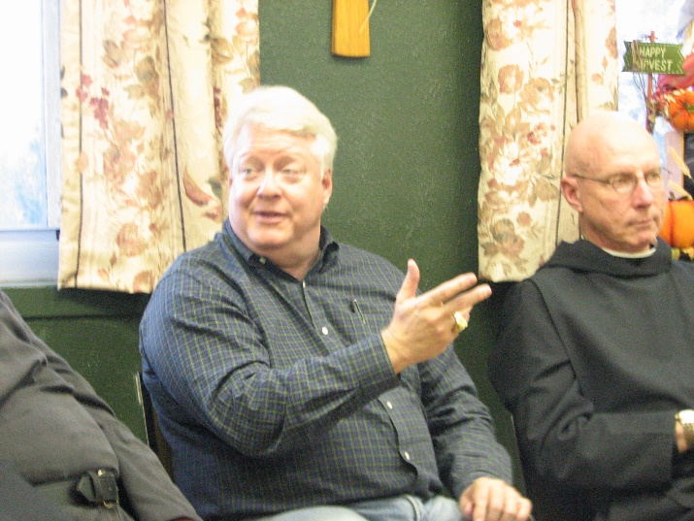
Bp. Dean Wolfe; Abbot David Vincent Cotton

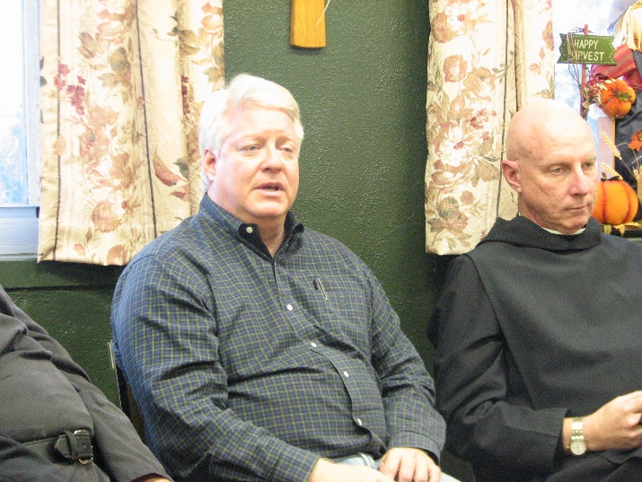
Bp. Dean Wolfe; Abbot David Vincent Cotton

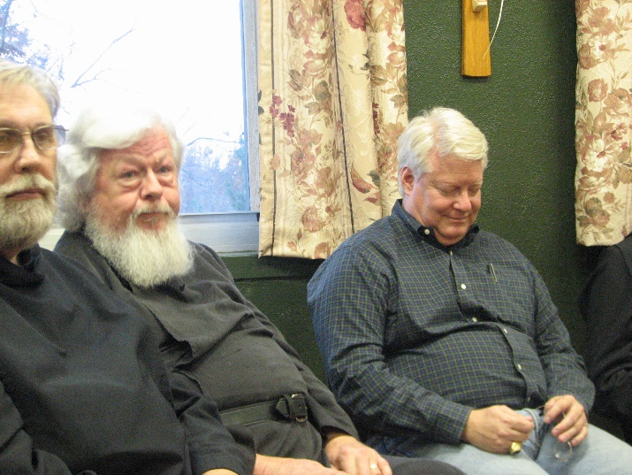
Br. Chad Anselm Gerns; Fr. Wayne Kamm; Bp. Dean Wolfe
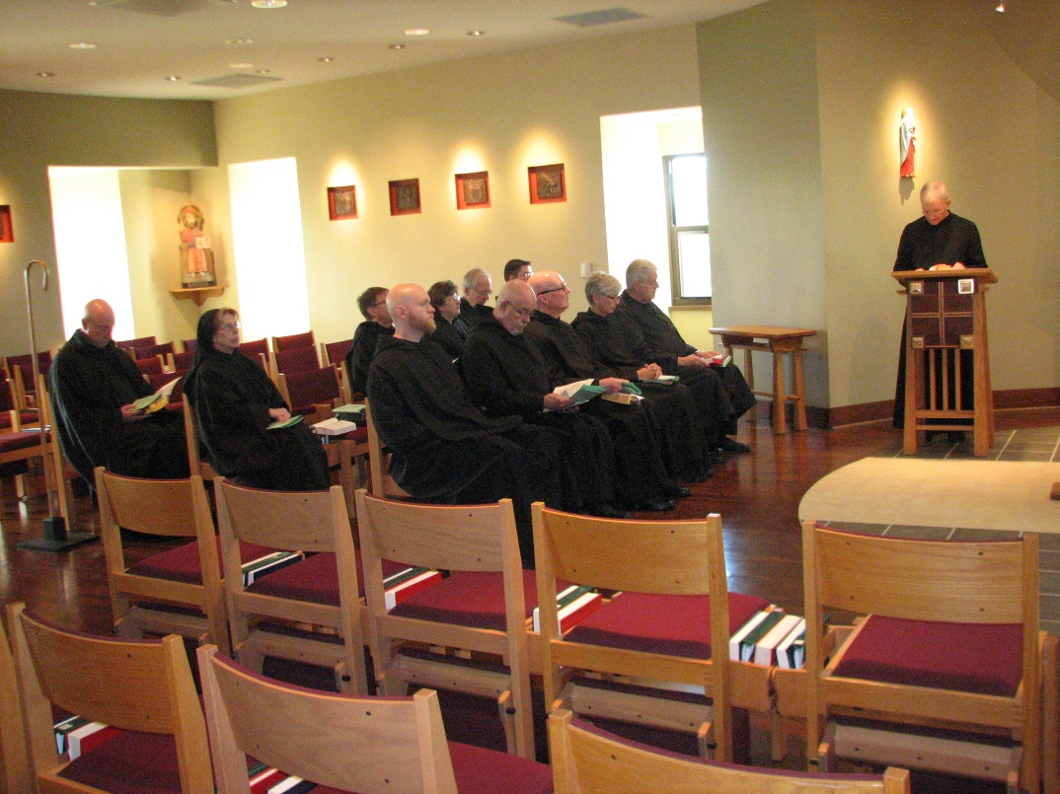
Abbot David Vincent Cotton; Sr. Monica Ruth Mullen; Br. Camillus Converse; Br. Gregory Kingsley; Sr. Cecelia Lamoy; Br. Luke Doucette; Br. Basil Edwards; Br. Aidan Maguire; Br. Stephen Francis Arnold; Sr. Julian Saterstrom; Br. Michael Anicetus McCabe; Br. Joseph Olderr

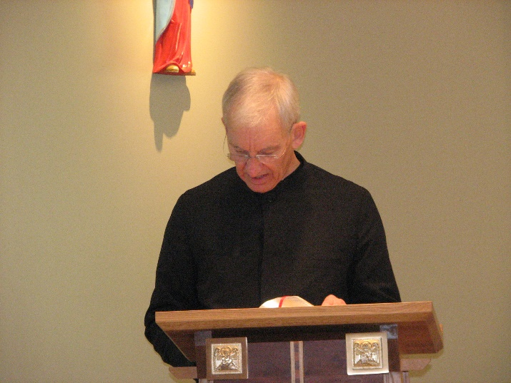
Br. Joseph Olderr
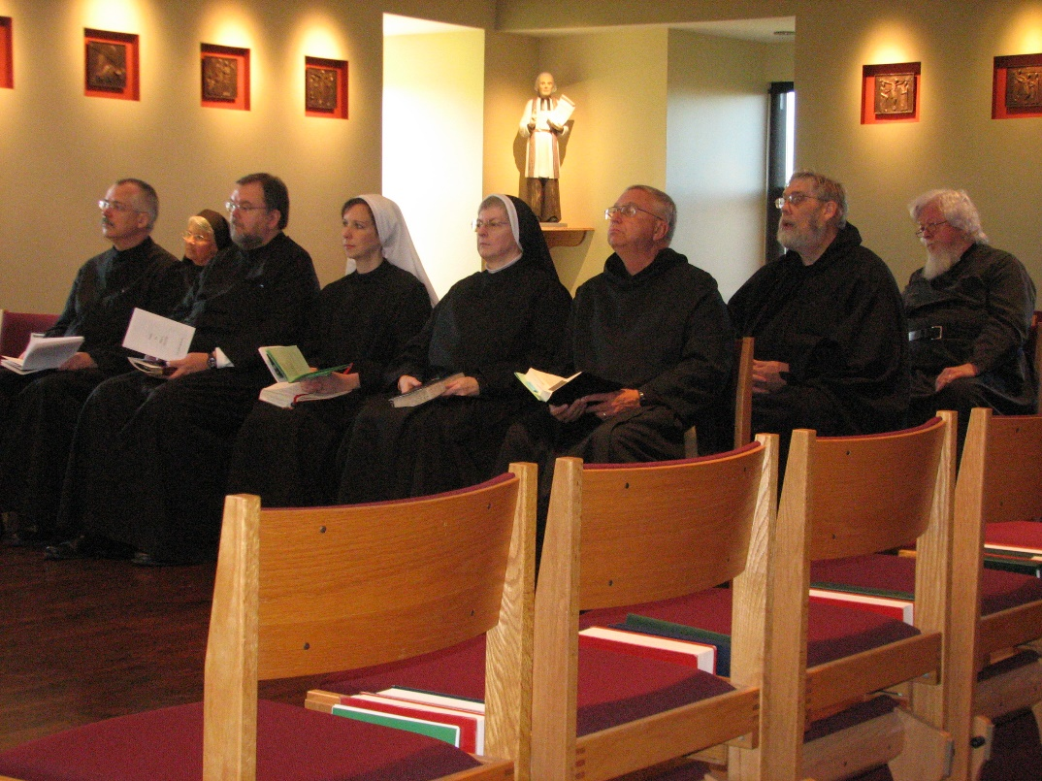
Br. Dunstan Townsend; Sr. Mary Francis Deulen; Br. Samuel Saterstrom; Sr. Veronica Taylor; Sr. Bernadette Barrett; Br. Bede Leach; Br. Chad Anselm Gerns; Fr. Wayne Kamm

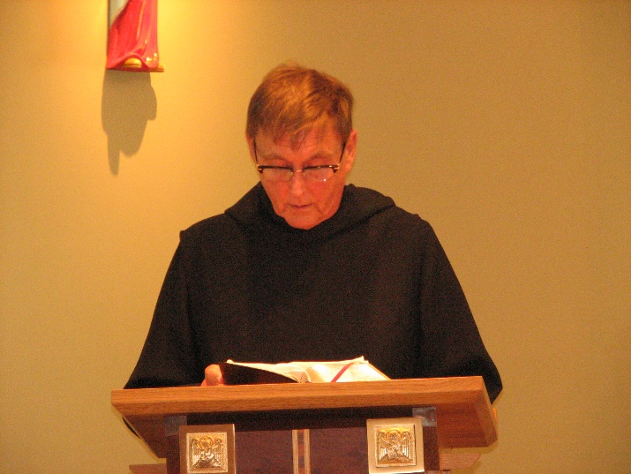
Br. Camillus Converse

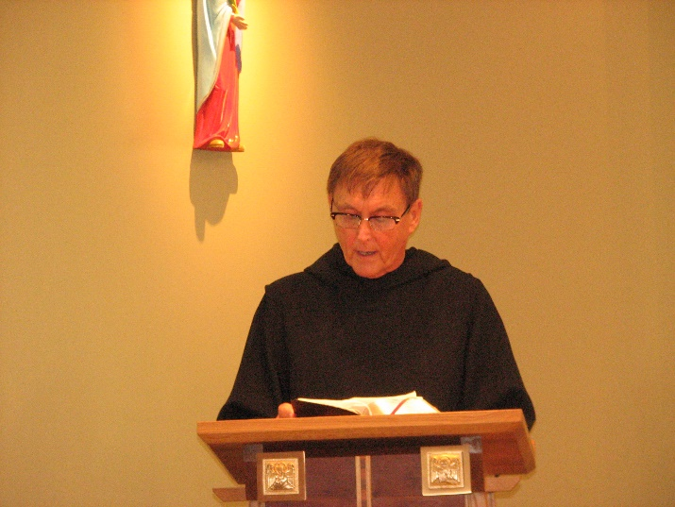
Br. Camillus Converse

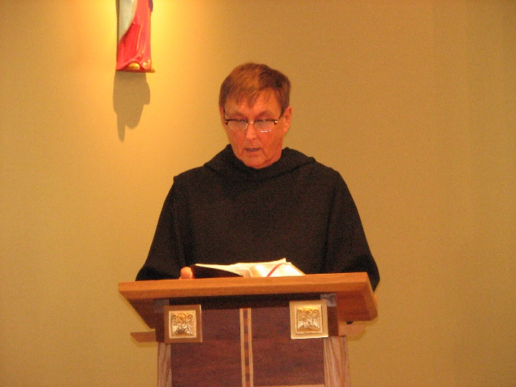
Br. Camillus Converse

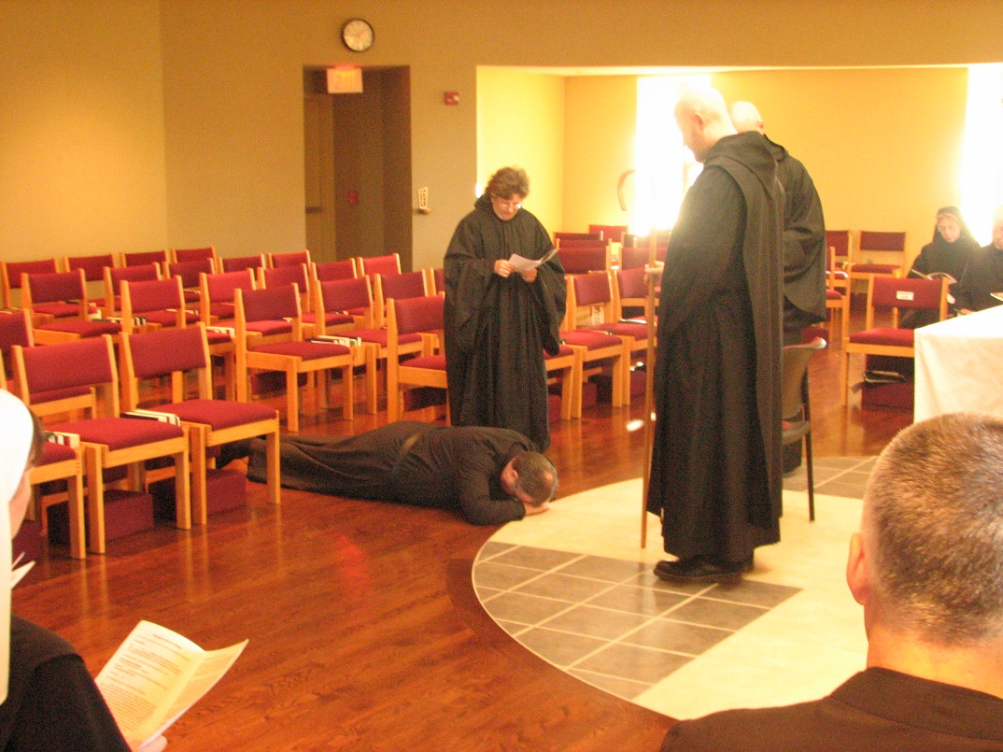
Sr. Veronica Taylor; Br. Samuel Saterstrom; Sr. Cecelia Lamoy; Br. Gregory Kingsley; Abbot David Vincent Cotton; Br. Dunstan Townsend; Sr. Monica Ruth Mullen; Br. Basil Edwards

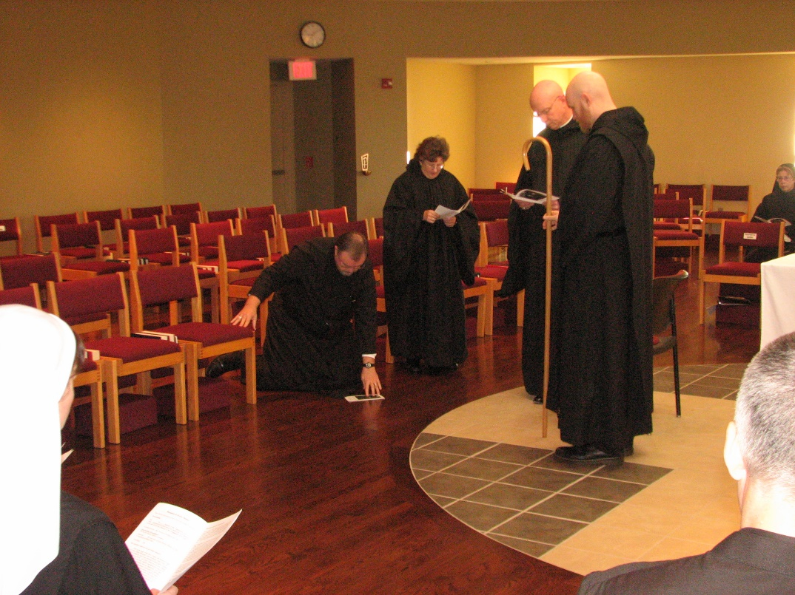
Sr. Veronica Taylor; Br. Samuel Saterstrom; Sr. Cecelia Lamoy; Abbot David Vincent Cotton; Br. Gregory Kingsley; Br. Dunstan Townsend; Sr. Monica Ruth Mullen
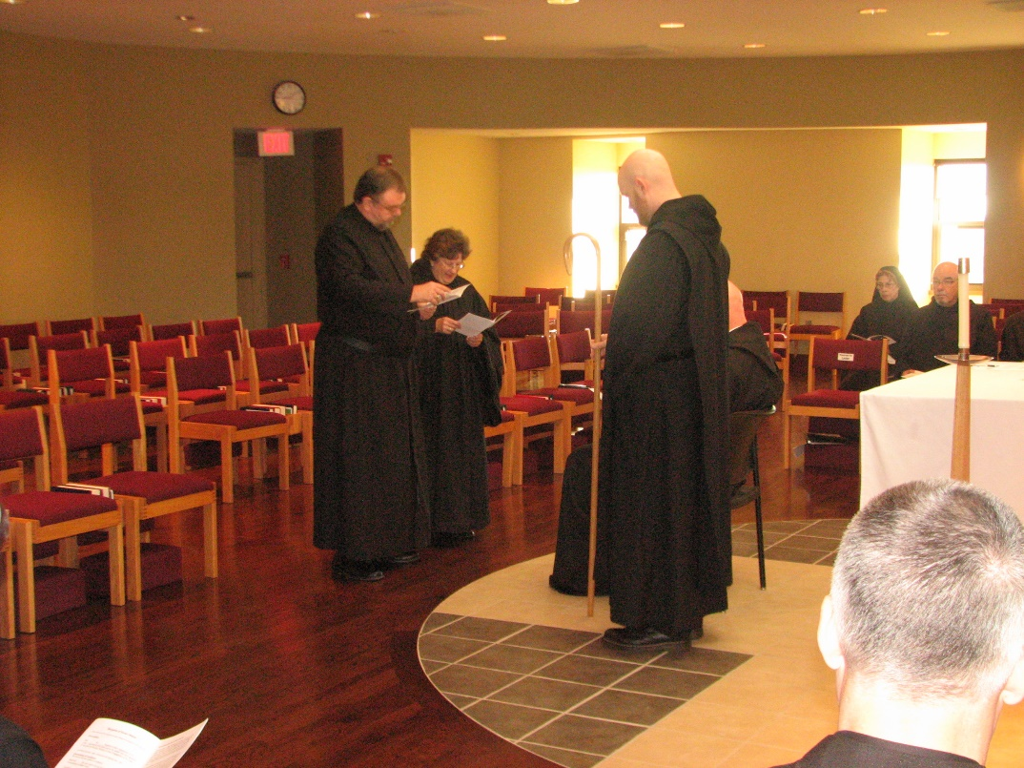
Br. Samuel Saterstrom; Sr. Cecelia Lamoy; Br. Gregory Kingsley; Abbot David Vincent Cotton; Br. Dunstan Townsend; Sr. Monica Ruth Mullen; Br. Basil Edwards

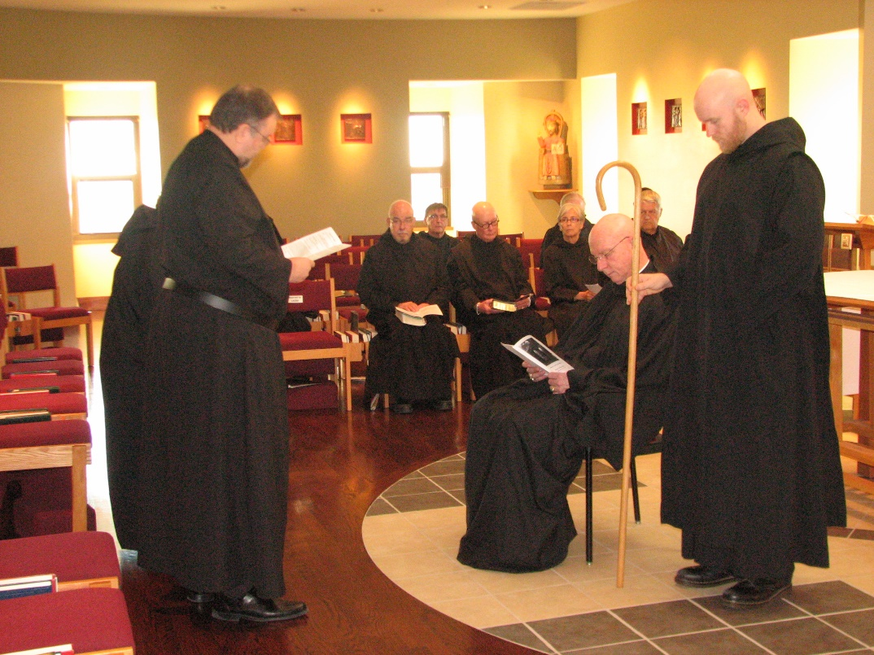
Sr. Cecelia Lamoy; Br. Samuel Saterstrom; Br. Basil Edwards; Br. Camillus Converse; Br. Stephen Francis Arnold; Sr. Julian Saterstrom; Abbot David Vincent Cotton; Br. Michael Anicetus McCabe; Br. Gregory Kingsley
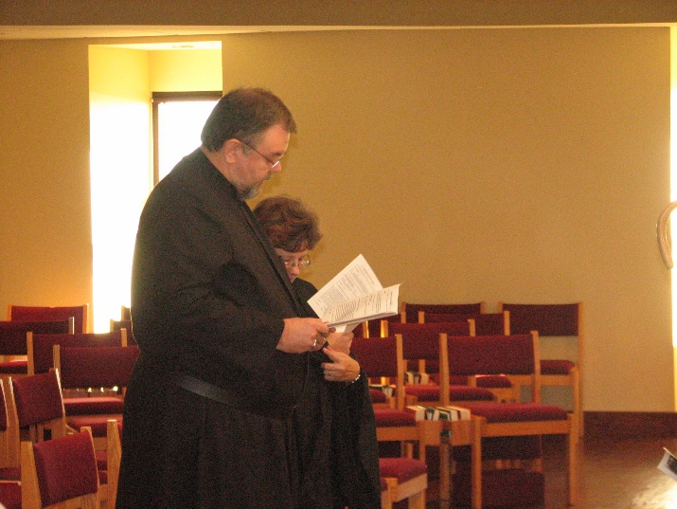
Br. Samuel Saterstrom; Sr. Cecelia Lamoy

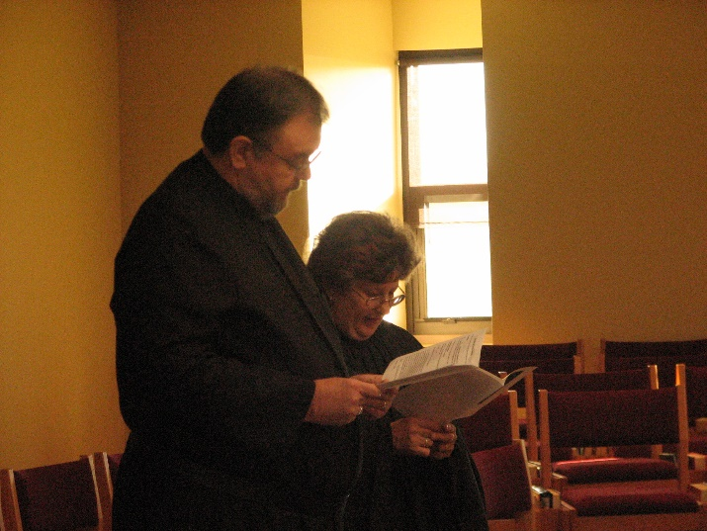
Br. Samuel Saterstrom; Sr. Cecelia Lamoy

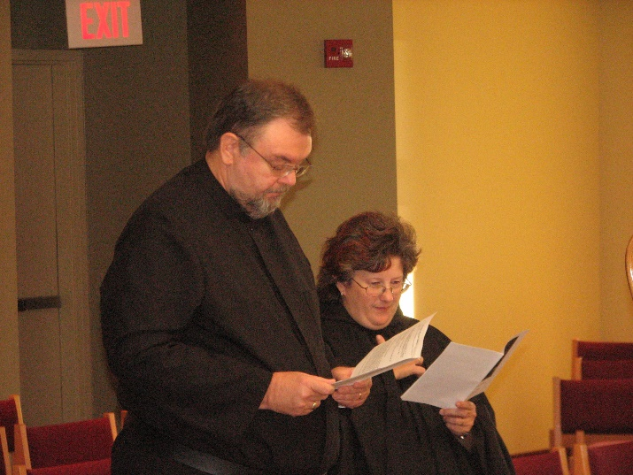
Br. Samuel Saterstrom; Sr. Cecelia Lamoy

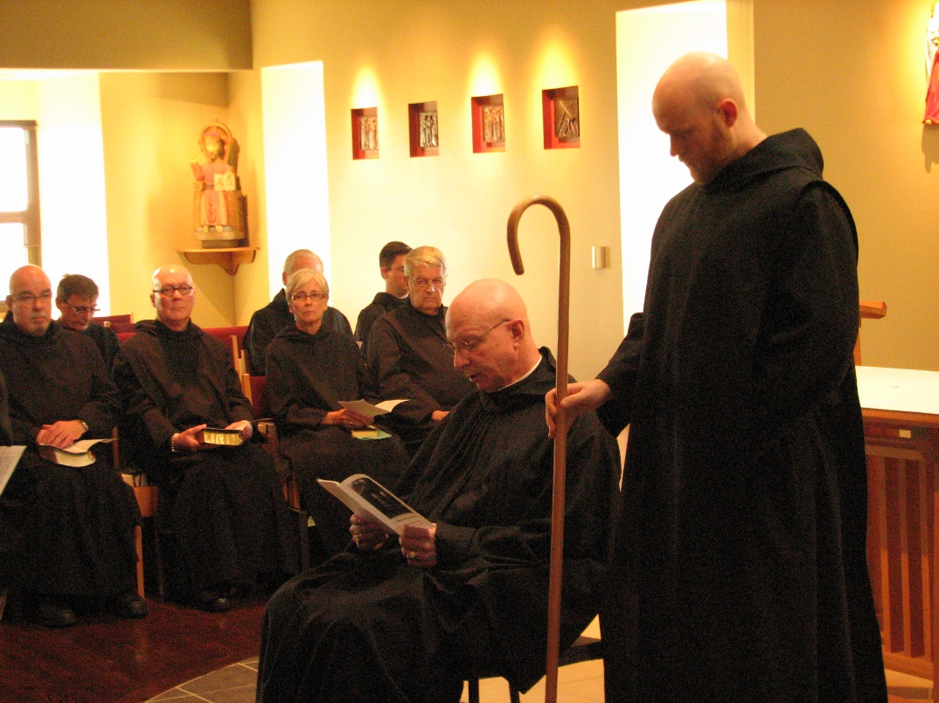
Br. Basil Edwards; Br. Camillus Converse; Br. Stephen Francis Arnold; Br, Luke Doucette; Sr. Julian Saterstrom; Br. Aidan Maguire; Br. Michael Anicetus McCabe; Abbot David Vincent Cotton; Br. Gregory Kingsley

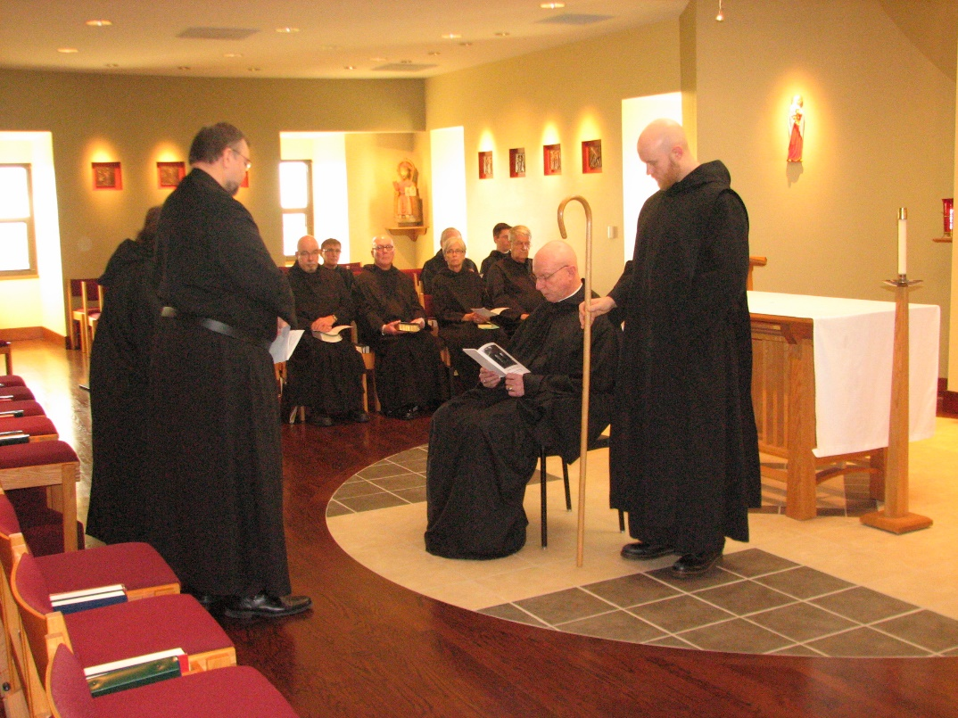
Sr. Cecelia Lamoy; Br. Samuel Saterstrom; Br. Basil Edwards; Br. Camillus Converse; Br. Stephen Francis Arnold; Br, Luke Doucette; Sr. Julian Saterstrom; Br. Aidan Maguire; Br. Michael Anicetus McCabe; Abbot David Vincent Cotton; Br. Gregory Kingsley
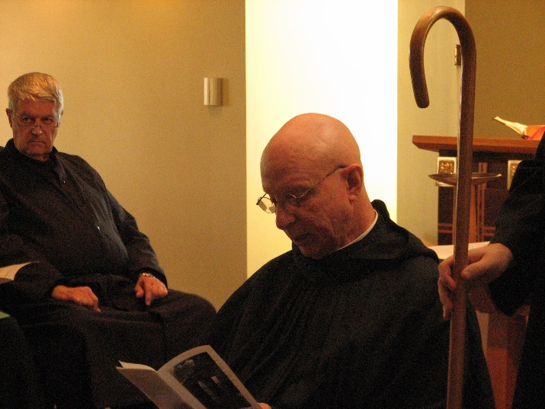
Br. Micahel Anicetus McCabe; Abbot David Vincent Cotton

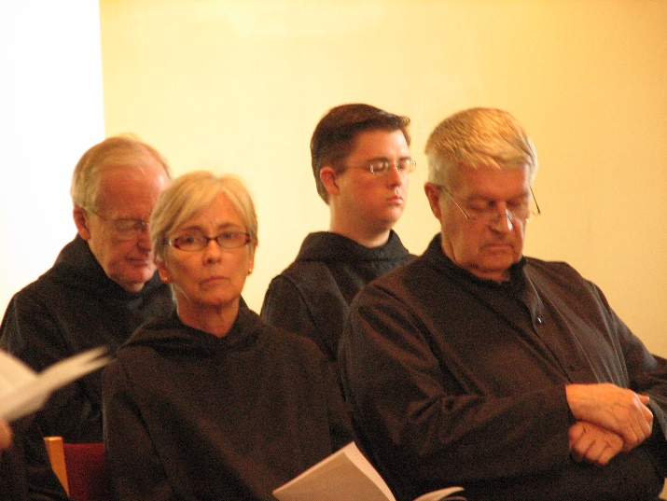
Br. Luke Doucette; Sr. Julian Saterstrom; Br. Aidan Maguire; Br. Michael Anicetus McCabe

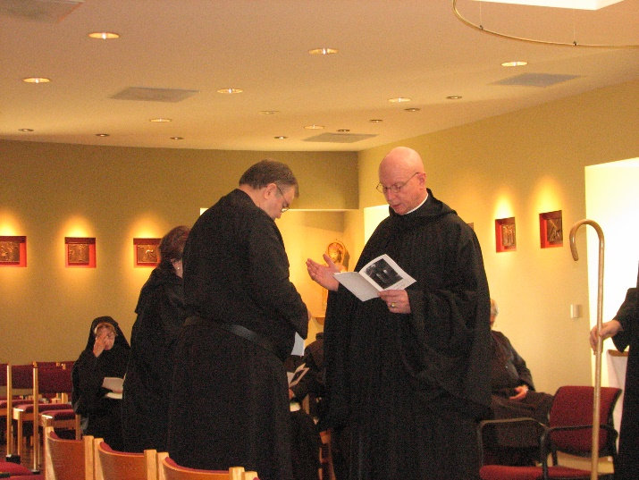
Sr. Monica Ruth Mullen; Sr. Cecelia Lamoy; Br. Samuel Saterstrom; Abbot David Vincent Cotton; Br. Michael Anicetus McCabe; Br. Gregory Kingsley
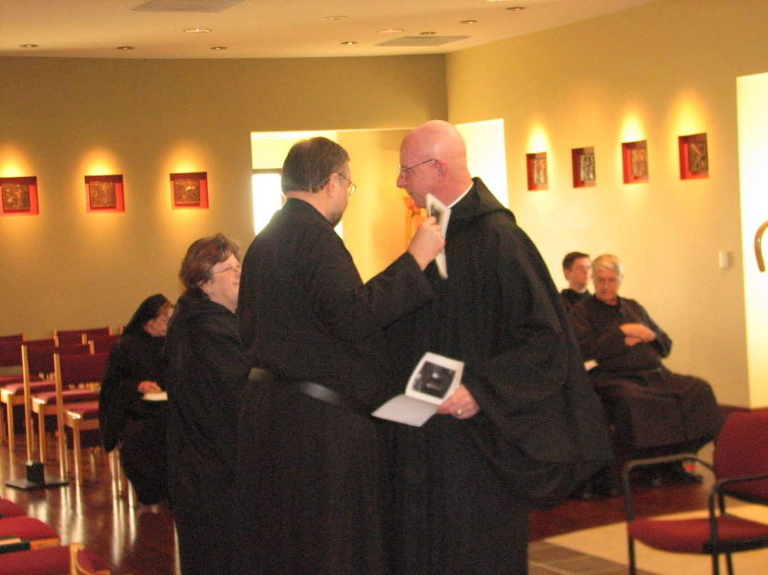
Sr. Monica Ruth Mullen; Sr. Cecelia Lamoy; Br. Samuel Saterstrom; Abbot David Vincent Cotton; Br. Aidan Maguire; Br. Michael Anicetus McCabe

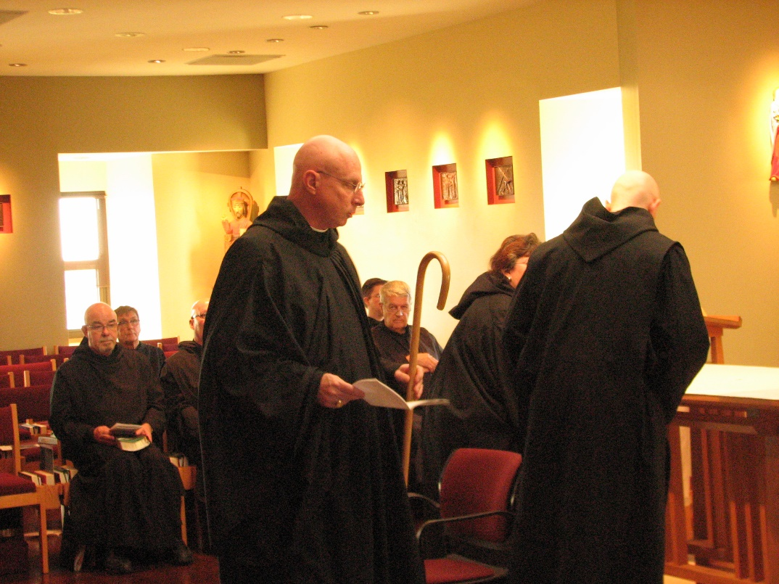
Br. Basil Edwards; br. Camillus Converse; Br. Stephen Francis Arnold; Abbot David Vincent Cotton; Br. Aidan Maguire; Br. Michael Anicetus McCabe; Sr. Cecelia Lamoy; Br. Gregory Kingsley
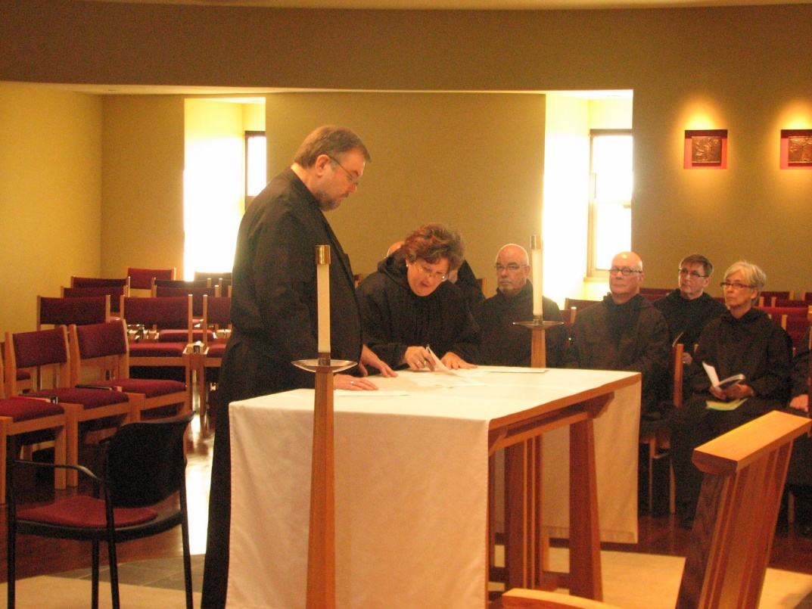
Br. Samuel Saterstrom; Sr. Cecelia Lamoy; Br. Basil Edwards; Br. Stephen Francis Arnold; Br. Camillus Converse; Sr. Julian Saterstrom

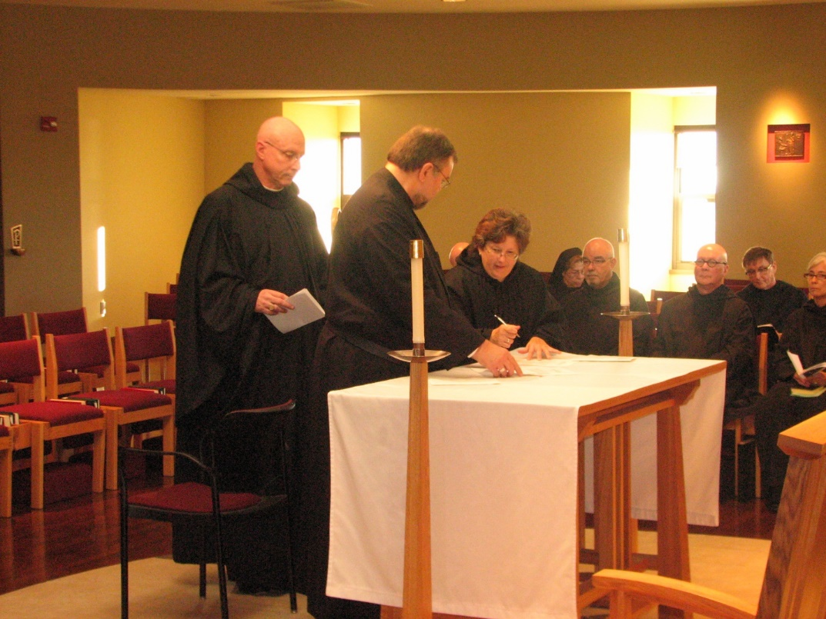
Abbot David Vincent Cotton; Br. Samuel Saterstrom; Sr. Cecelia Lamoy; Sr. Monica Ruth Mullen; Br. Basil Edwards; Br. Stephen Francis Arnold; Br. Camillus Converse; Sr. Julian Saterstrom

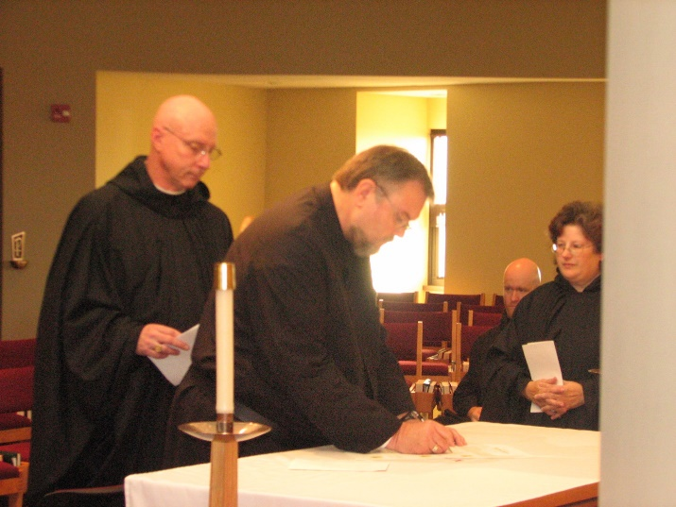
Abbot David Vincent Cotton; Br. Samuel Saterstrom; Br. Greagory Kingsley; Sr. Cecelia Lamoy

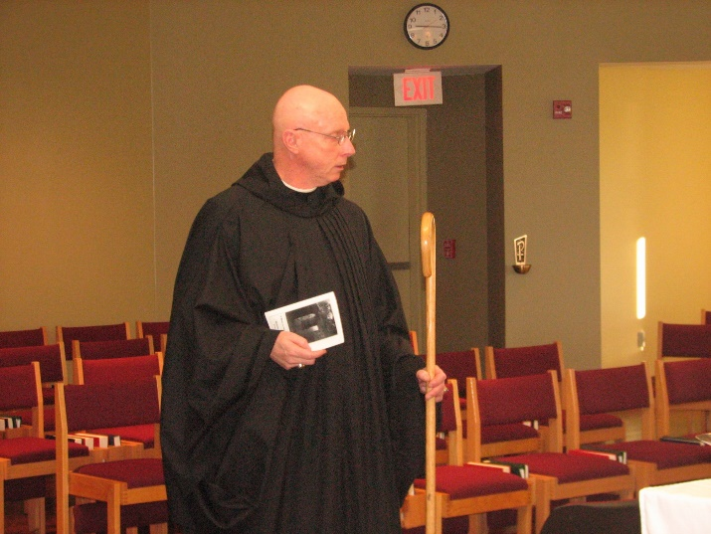
Abbot David Vincent Cotton

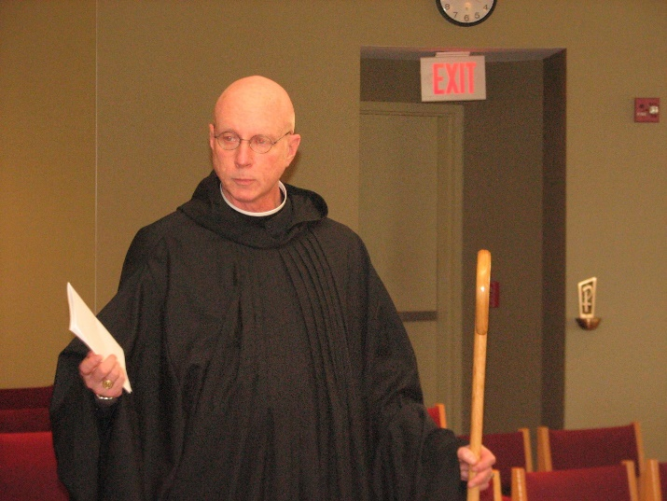
Abbot David Vincent Cotton
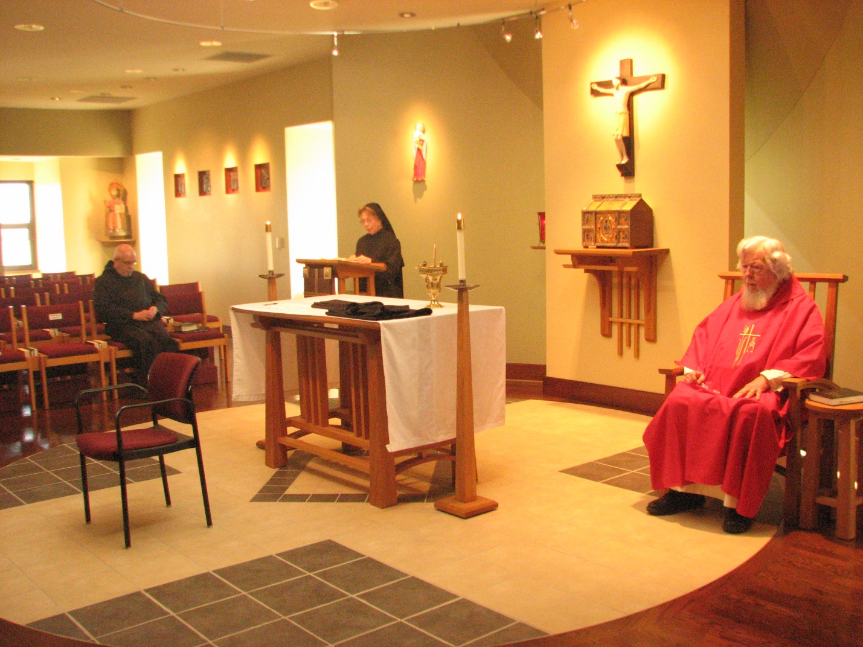
Br. Basil Edwards; Sr. Monica Ruth Mullen; Fr. Wayne Kamm

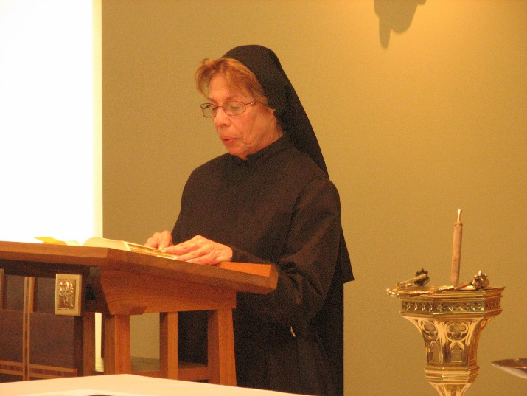
Sr. Monica Ruth Mullen
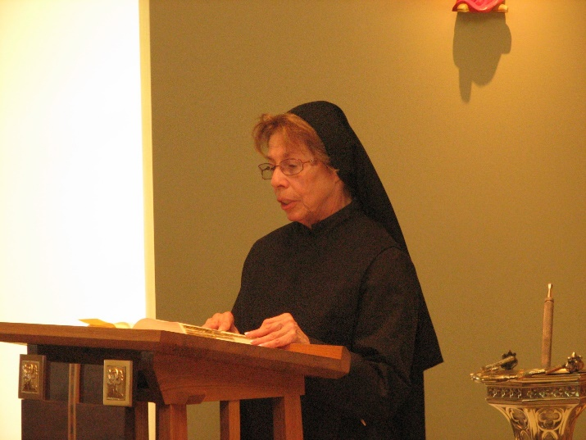
Sr. Monica Ruth Mullen

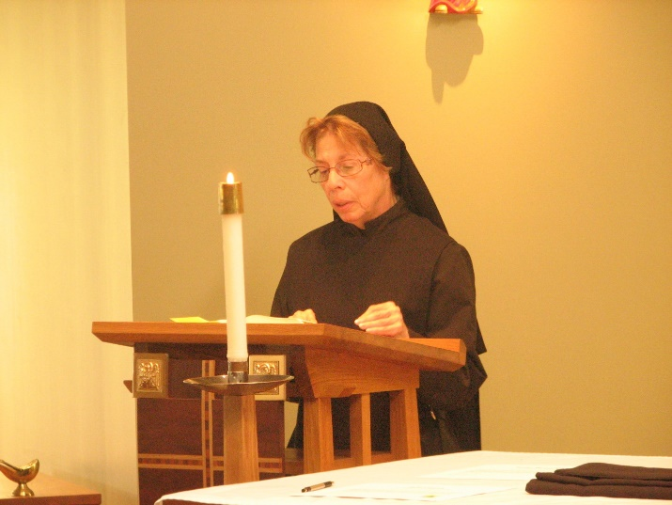
Sr. Monica Ruth Mullen

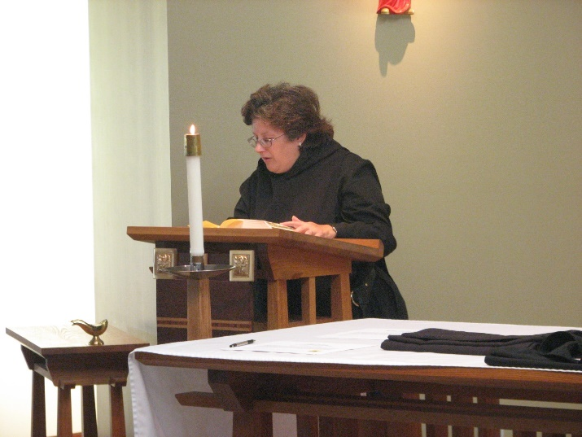
Sr. Cecelia Lamoy
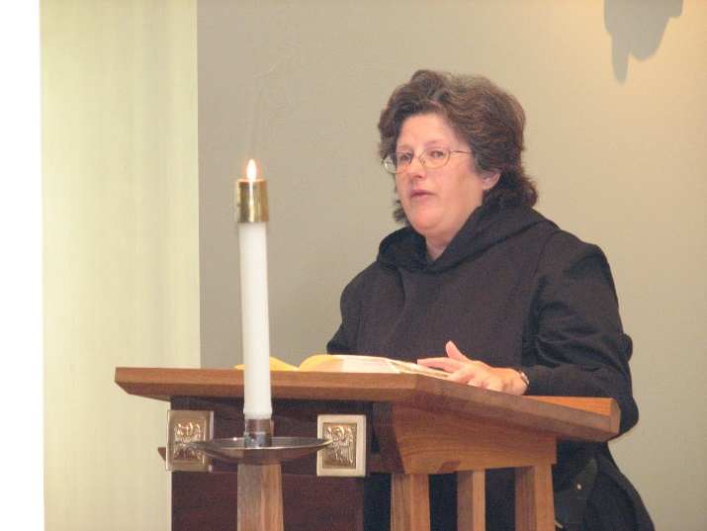
Sr. Cecelia Lamoy

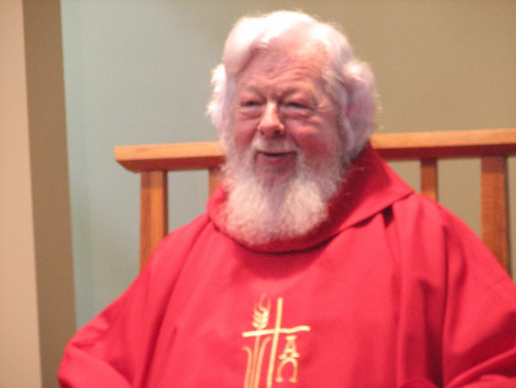
Fr. Wayne Kamm

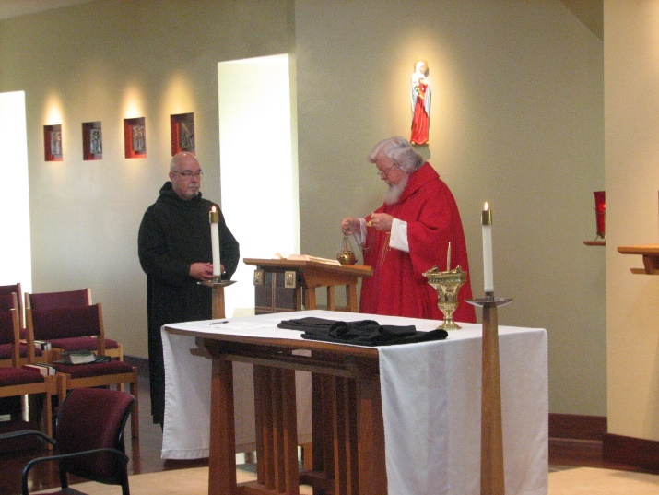
Br. Basil Edwards; Fr. Wayne Kamm
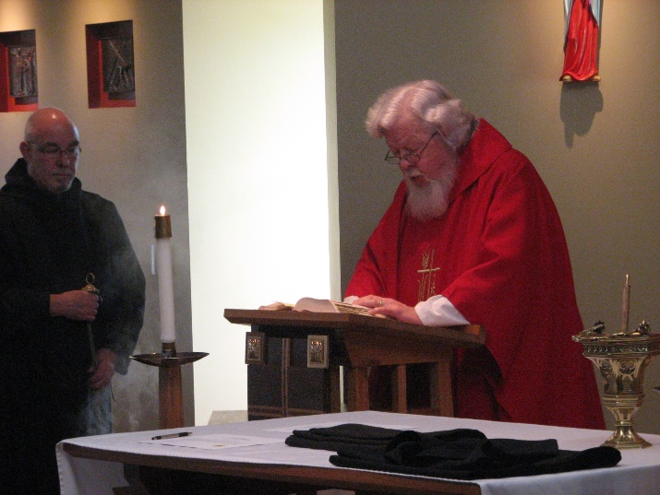
Br. Basil Edwards; Fr. Wayne Kamm

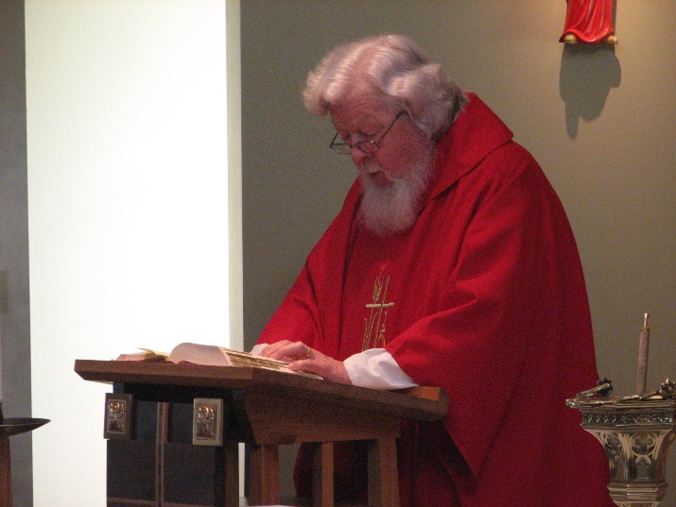
Fr. Wayne Kamm

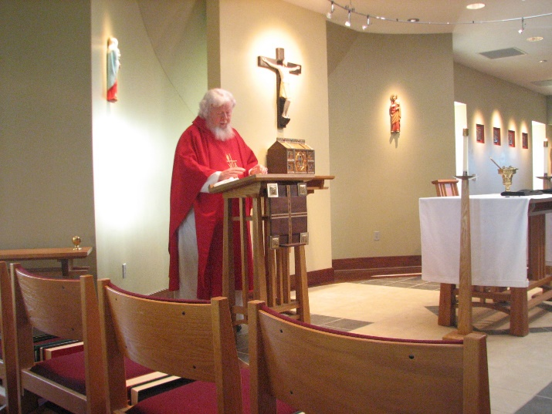
Fr. Wayne Kamm
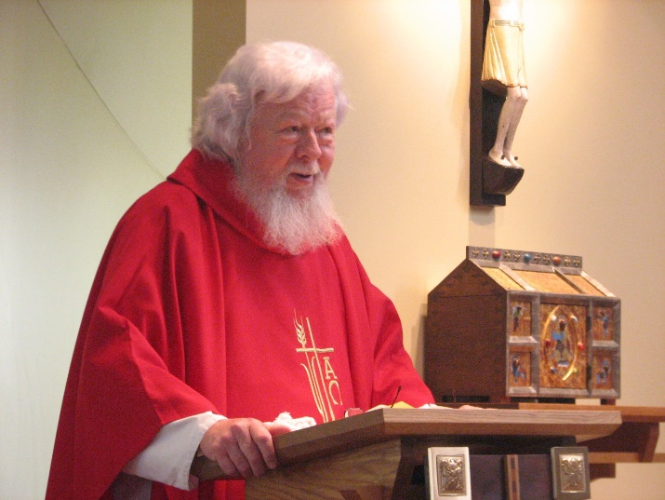
Fr. Wayne Kamm

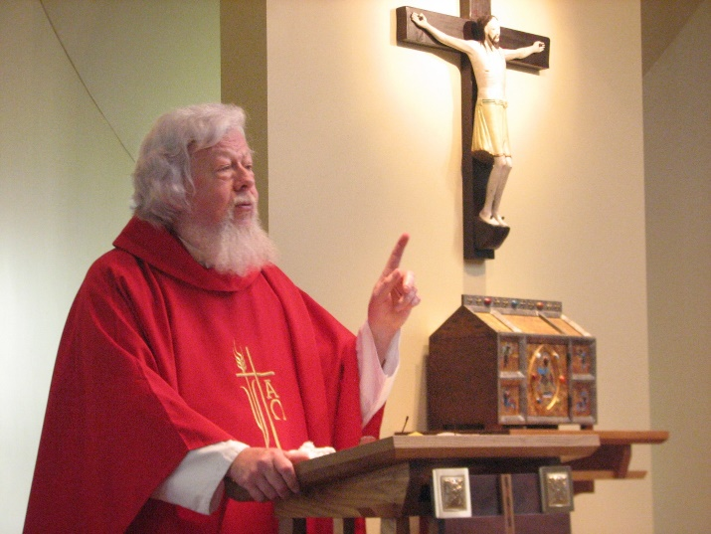
Fr. Wayne Kamm

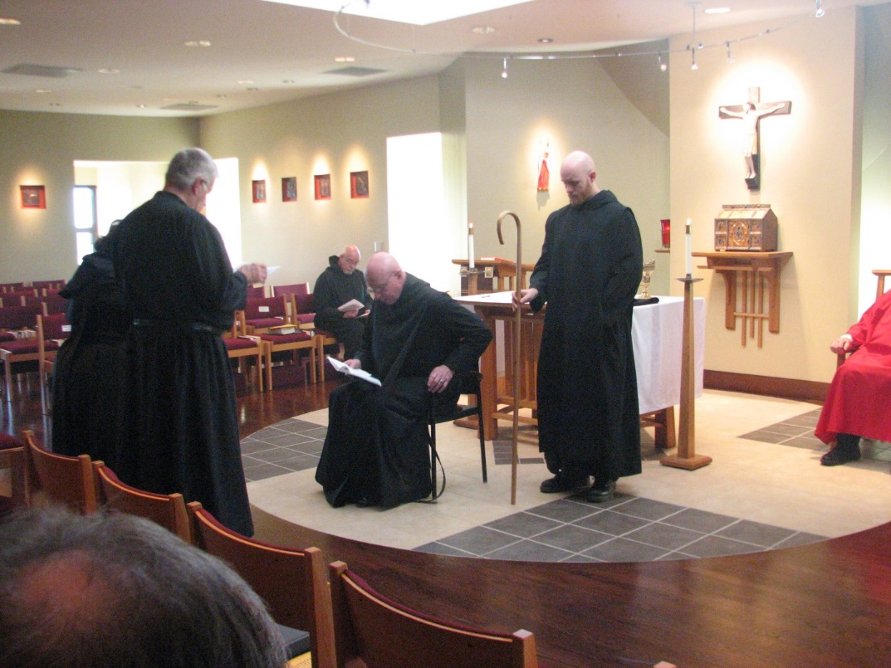
Sr. Cecelia Lamoy; Br. Michael Anicetus McCabe; ; Br. Basil Edwards; Br. Michael Anicetus McCabe; Abbot David Vincent Cotton; Br. Gregory Kingsley; Fr. Wayne Kamm

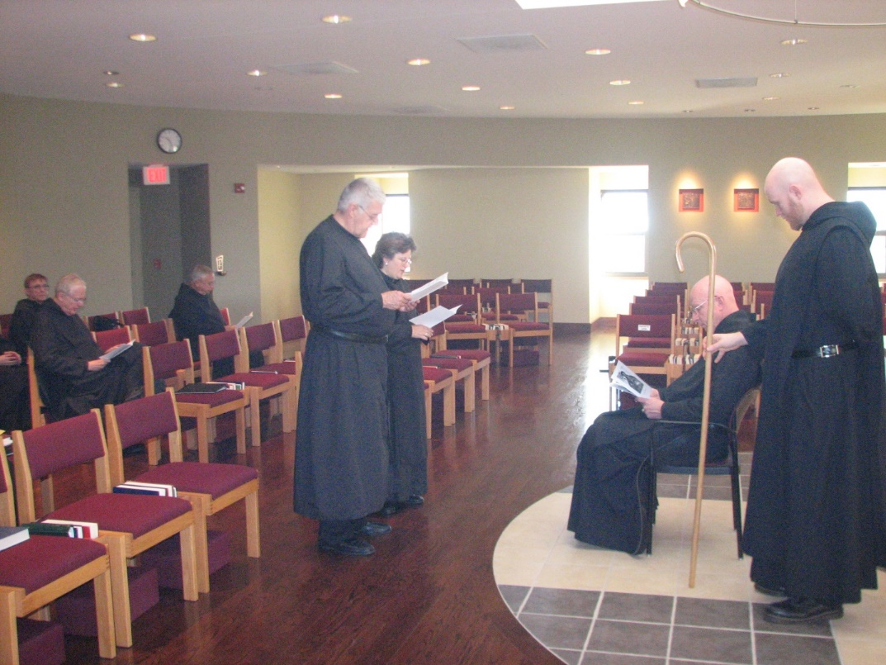
Br. Camillus Converse; Br. Luke Doucette; Br. Bede Leach; Br. Michael Anicetus McCabe; Sr. Cecelia Lamoy; Abbot David Vincent Cotton; Br. Greagory Kingsley

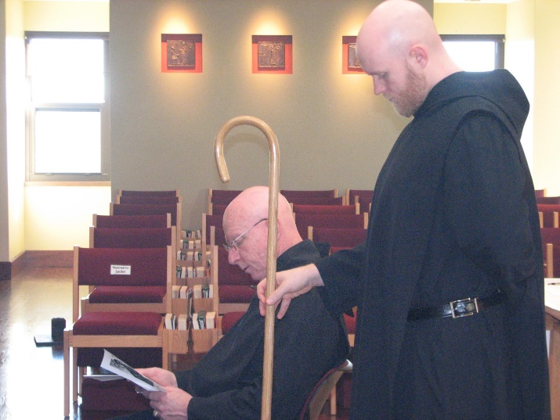
Abbot David Vincent Cotton; Br. Gregory Kingsley

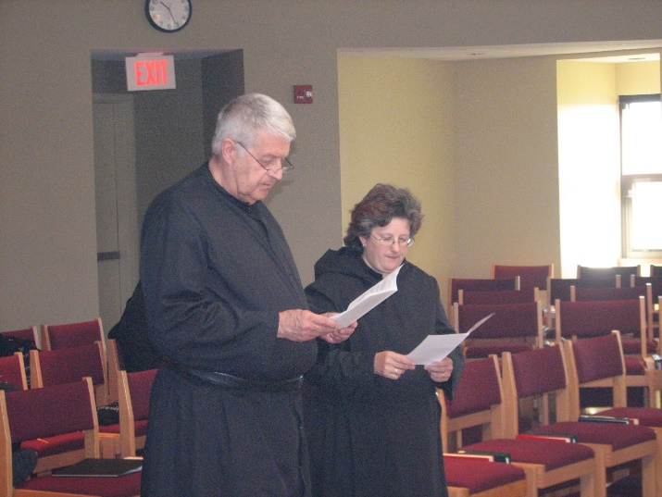
Br. Michael Anicetus McCabe; Sr. Cecelia Lamoy

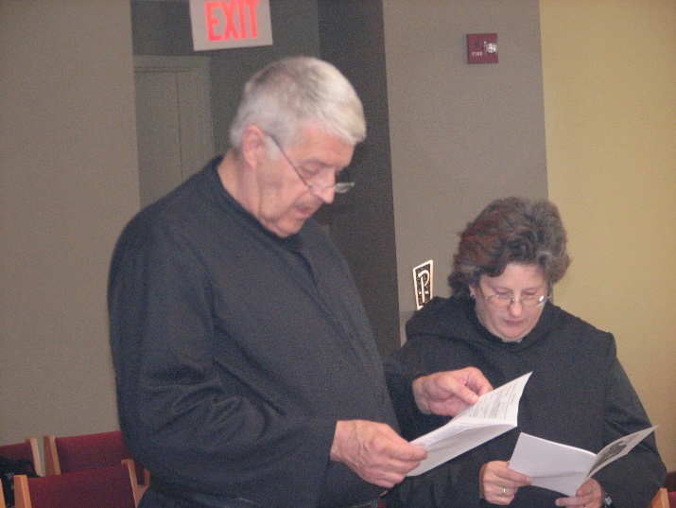
Br. Michael Anicetus McCabe; Sr. Cecelia Lamoy

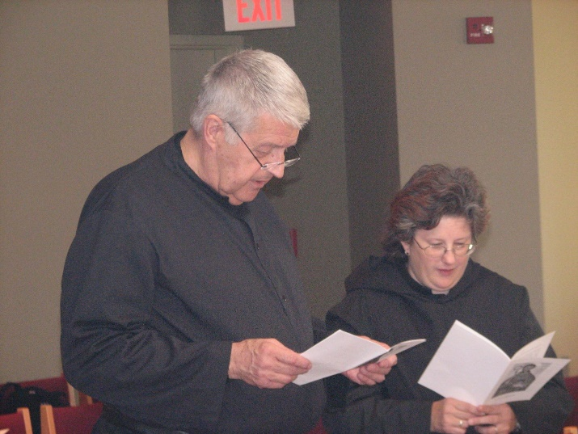
Br. Michael Anicetus McCabe; Sr. Cecelia Lamoy

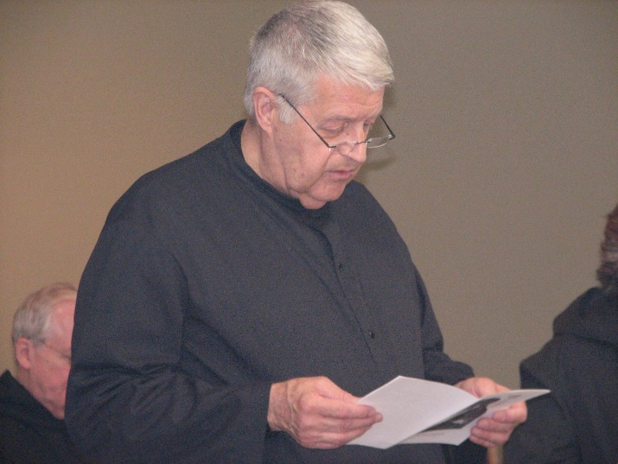
Br. Luke Doucette; Br. Michael Anicetus McCabe; Sr. Cecelia Lamoy

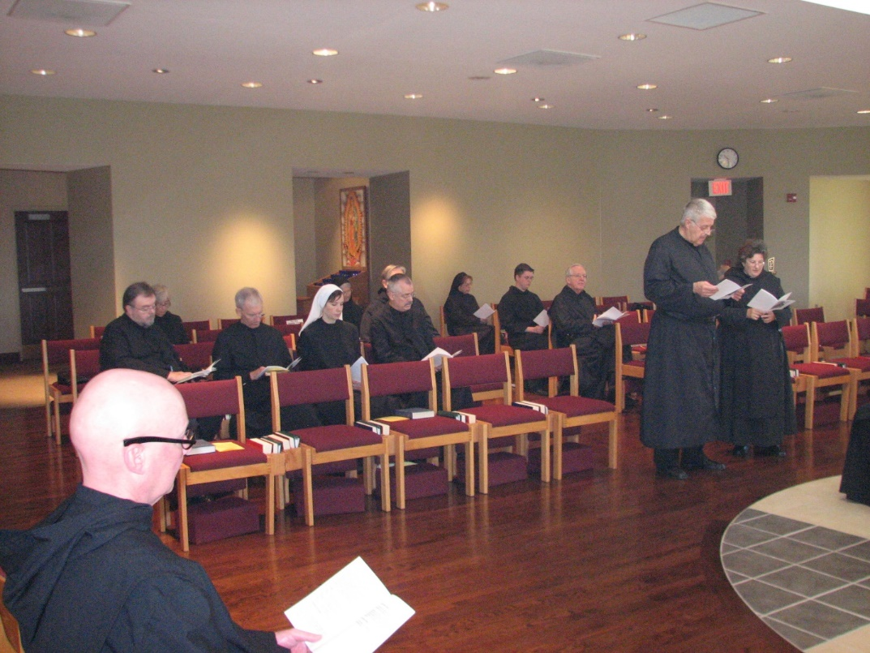
Br. Stephen Francis Arnold; Br. Samuel Saterstrom; Sr. Julian Saterstrom; Br. Joseph Olderr; Sr. Veronica Taylor; Sr. Mary Francis Deulen; Br, Chad Anselm Gerns; Br. Dunstan Townsend; Sr. Monica Ruth Mullen; Br. Aidan Maguire; Br. Luke Doucette; Br. Michael Anicetus McCabe; Sr. Cecelia Lamoy

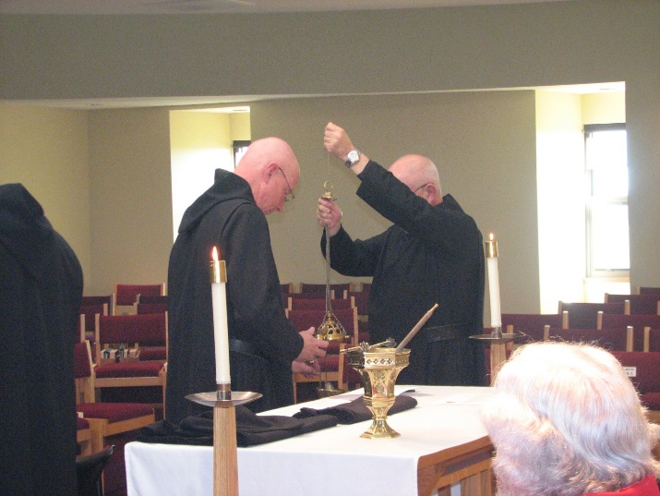
Abbot David Vincent Cotton; Br. Basil Edwards; Fr. Wayne Kamm

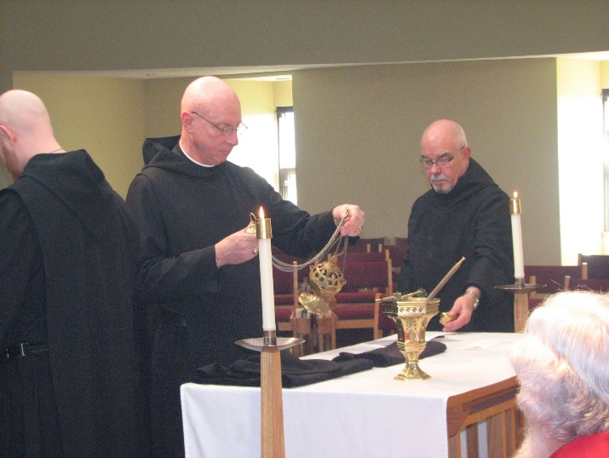
Br. Gregory Kingsley; Abbot David Vincent Cotton; Br. Basil Edwards; Fr. Wayne Kamm

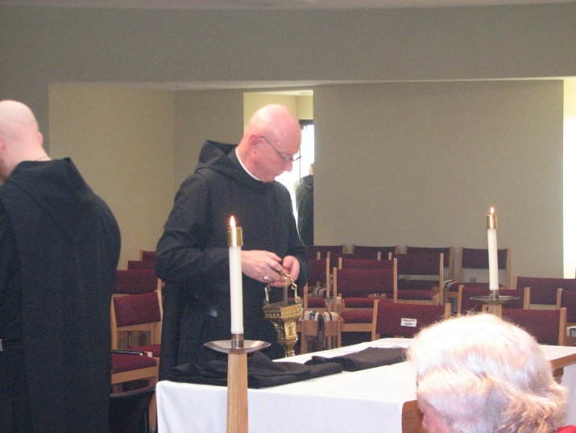
Br. Gregory Kingsley; Abbot David Vincent Cotton; Fr. Wayne Kamm

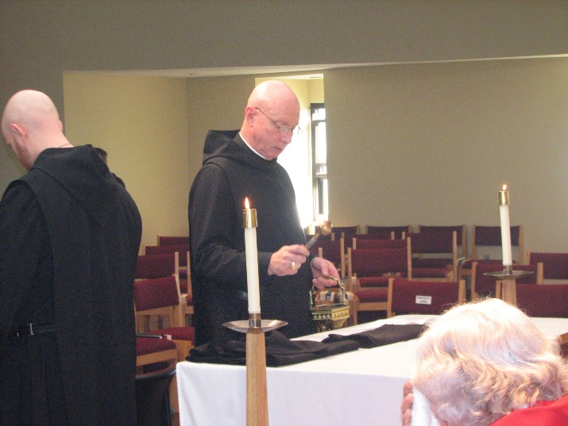
Br. Gregory Kingsley; Abbot David Vincent Cotton; Fr. Wayne Kamm

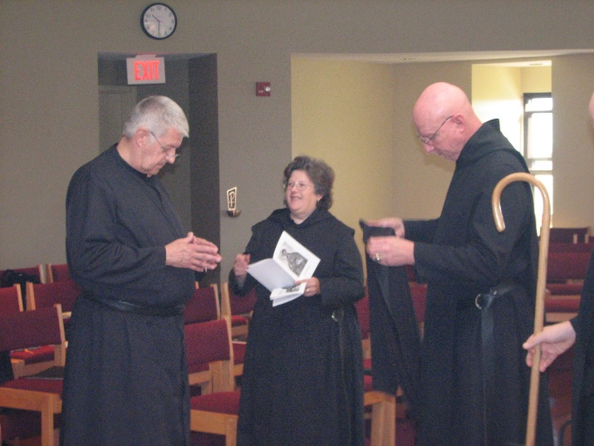
Br. Michael Anicetus McCabe; Sr. Cecelia Lamoy; Abbot David Vincent Cotton

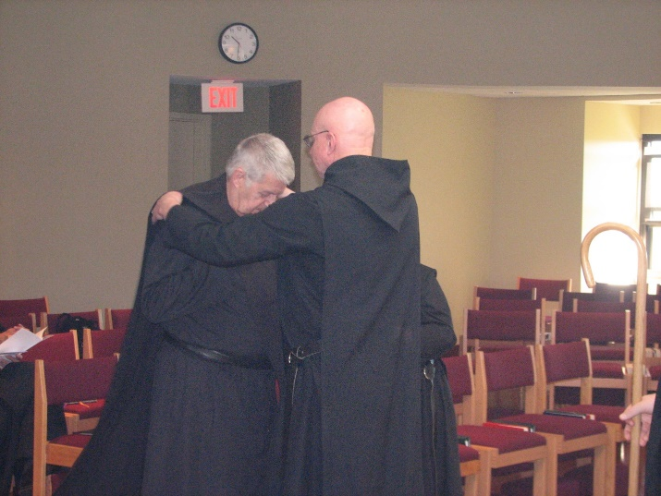
Br. Michael Anicetus McCabe; Abbot David Vincent Cotton; Sr. Cecelia Lamoy

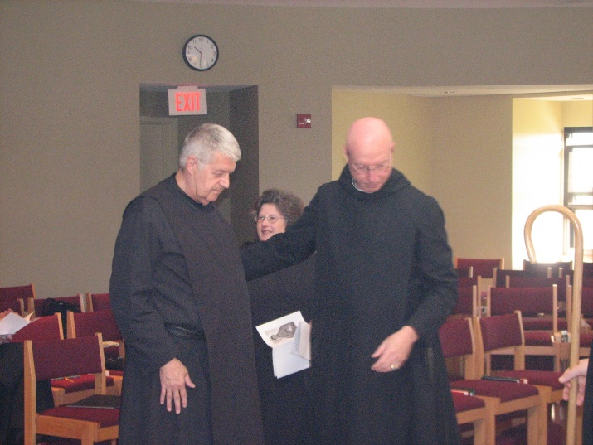
Br. Michael Anicetus McCabe; Sr. Cecelia Lamoy; Abbot David Vincent Cotton

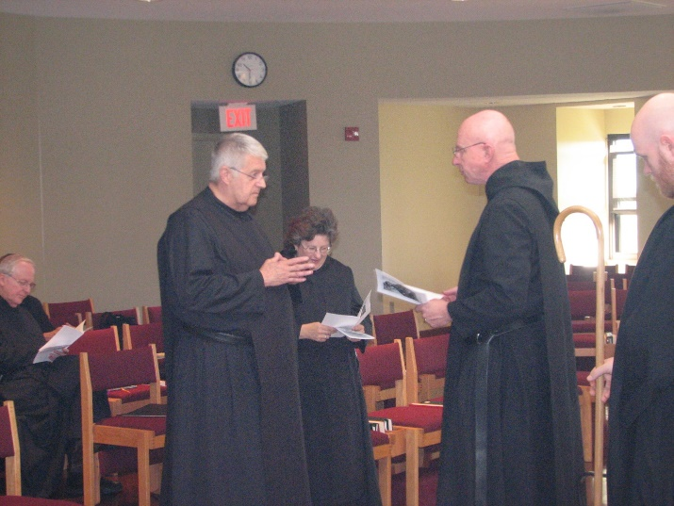
Br. Luke Doucette; Br. Michael Anicetus McCabe; Sr. Cecelia Lamoy; Abbot David Vincent Cotton; Br. Gregory Kingsley

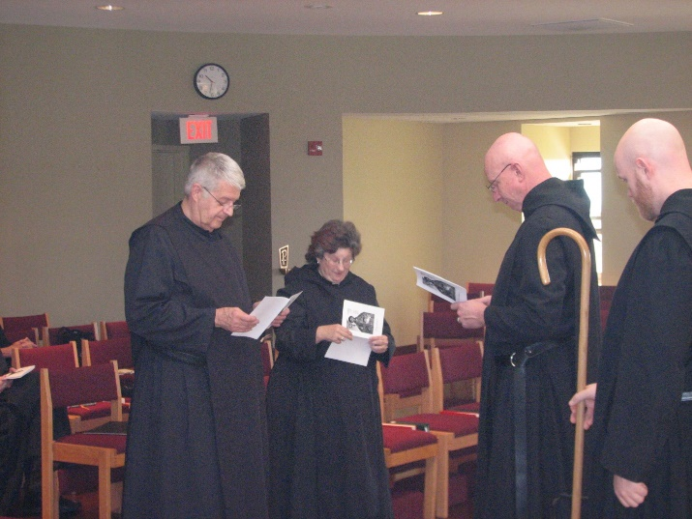
Br. Michael Anicetus McCabe; Sr. Cecelia Lamoy; Abbot David Vincent Cotton; Br. Gregory Kingsley

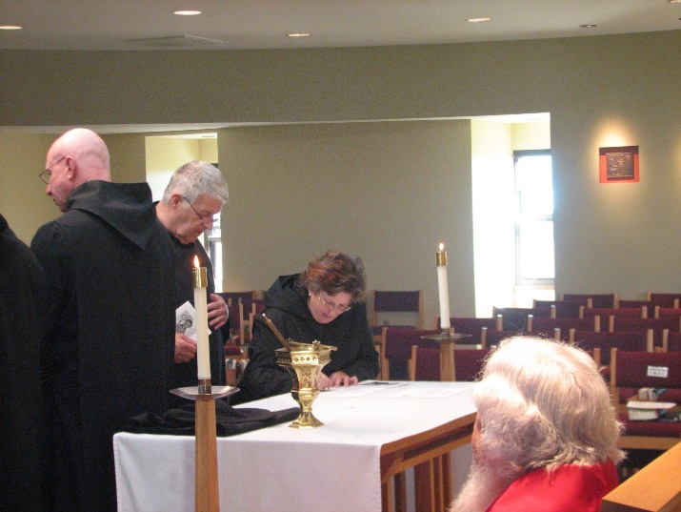
Abbot David Vincent Cotton; Br. Michael Anicetus McCabe; Sr. Cecelia Lamoy; Fr. Wayne Kamm

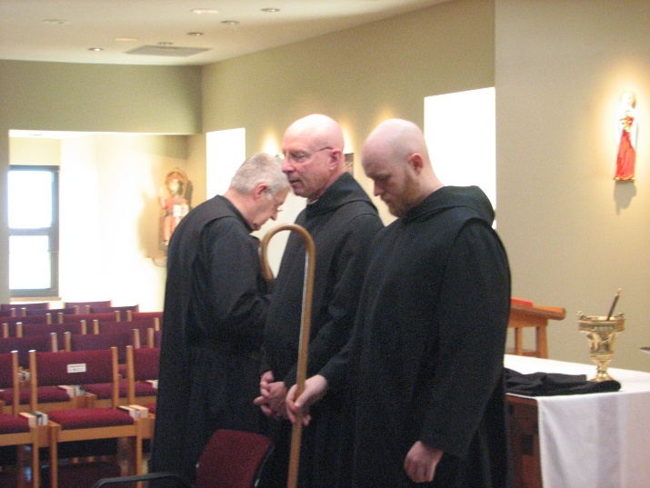
Br. Michael Anicetus McCabe; Abbot David Vincent Cotton; Br. Gregory Kingsley

