**Companions of St. Luke**

**Spring Convocation**

**June 2021**

**Part 1 of 3**

People are identified left to right.

Edited by Br. Steven Olderr 1 Mar 2023. Please send any corrections or additional information to [olderr@ameritech.net](mailto:olderr@ameritech.net)

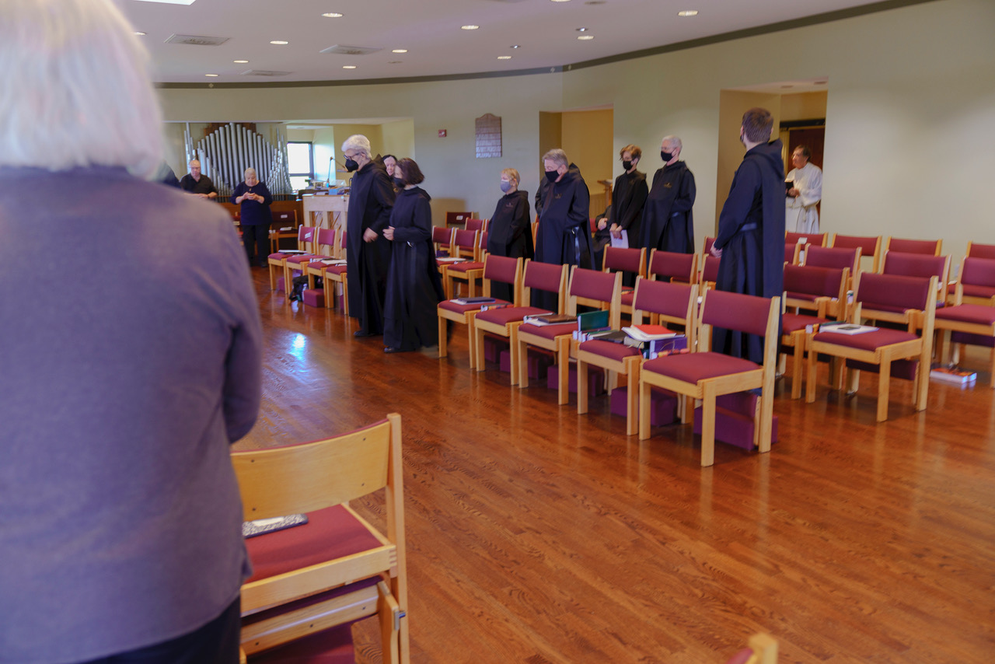

?; Kevin Orth; Marie Patricia Huges; Br. Chrysostom Olsen; Sr. Genevieve Lynn Robinson; Sr. Catherine Ann Ballinger; Sr. Julian Smith-Boyer; Br. Raymond Escott; Sr. Joanna Whitworth; Br. Anskar Nonken; ?; Fr. Sidney Breese

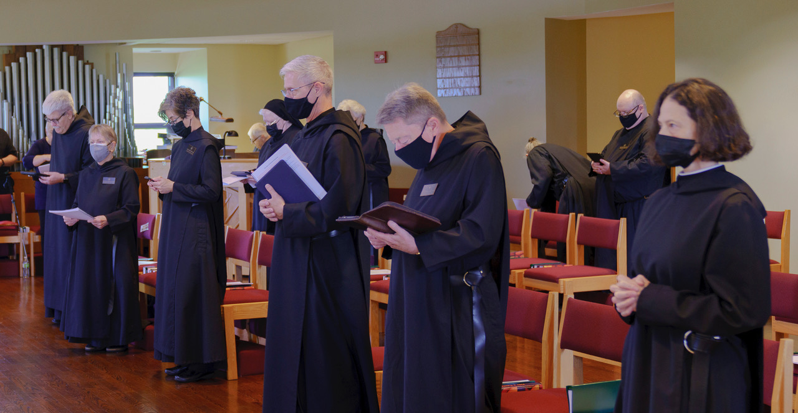

Marie Paricia Hughes; Br. Chrysostom Olsen; Sr. Julian Smith-Boyer; Sr. Joanna Whitworth; ?; Sr. Genevieve Lynn Robinson; Br. Anskar Nonken; Sr. Toni Sylvester; Br. Raymond Escott; Sr. Denise Moore; Br. Daniel Moore; Sr. Catherine Ann Ballinger

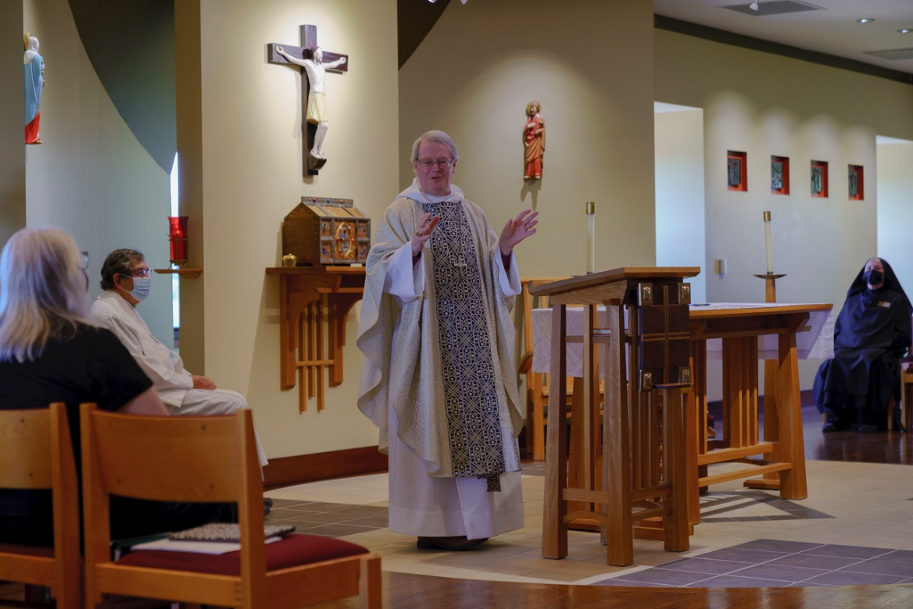

Robin Smith; Fr. Sidney Breese; Bp. Alan Scarfe; Sr. Mary Magdalene Clarke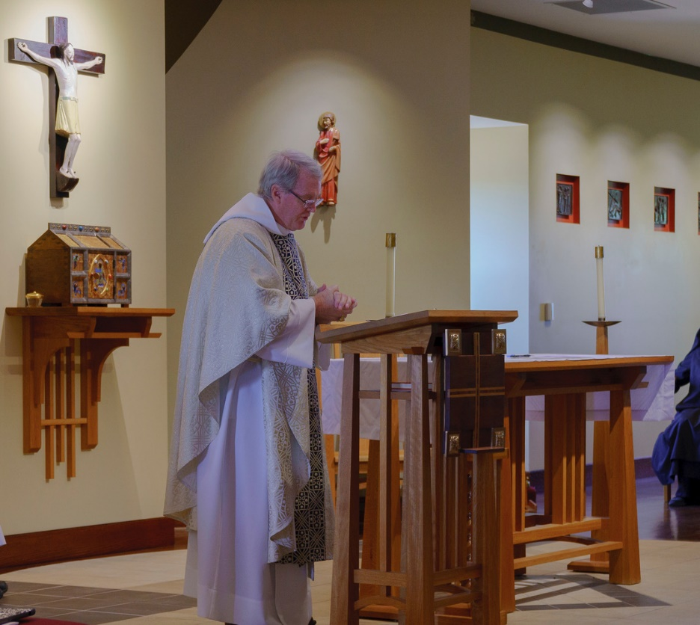

Bp. Alan Scarfe

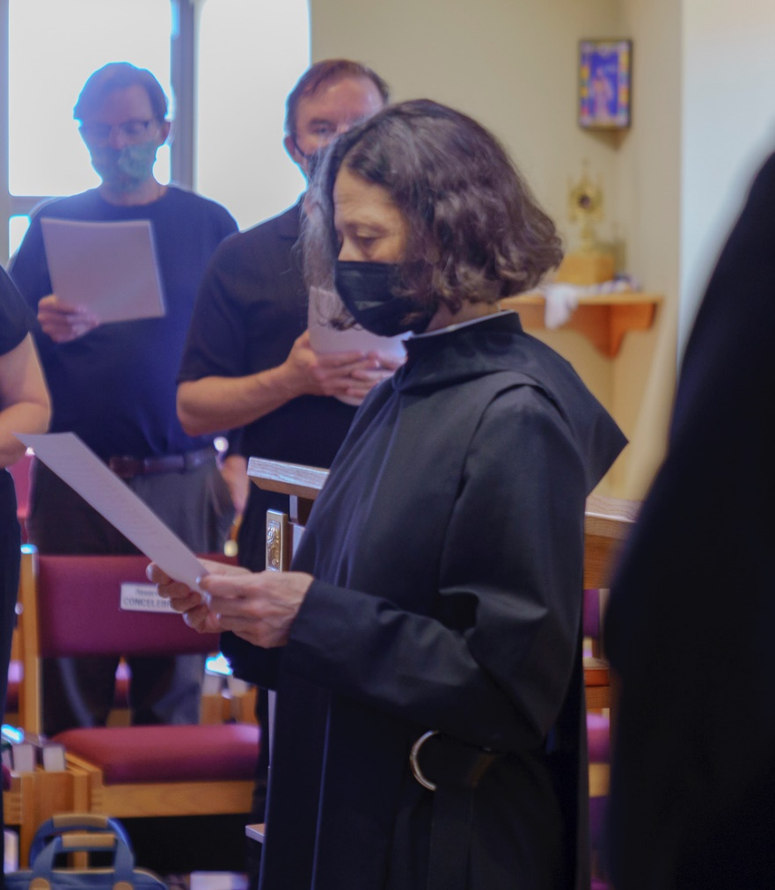

William Page; Kevin Orth; Sr. Catherine Ann Ballinger

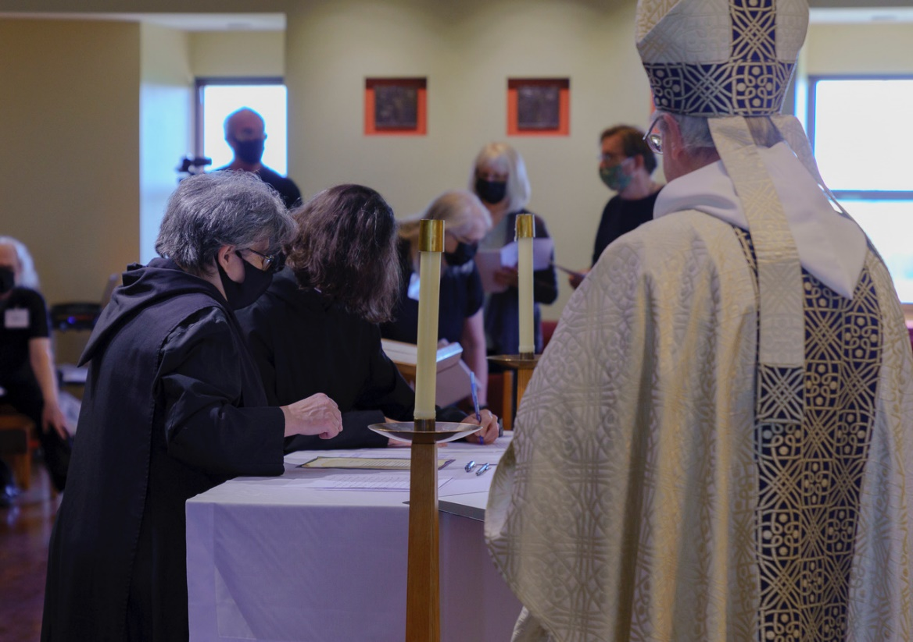

Kevin Orth; Sr. Martha Lamoy; Br. Florian Campbell; Sr. Catherine Ann Ballinger; Robin Smith; ?; Bp. Alan Scarfe

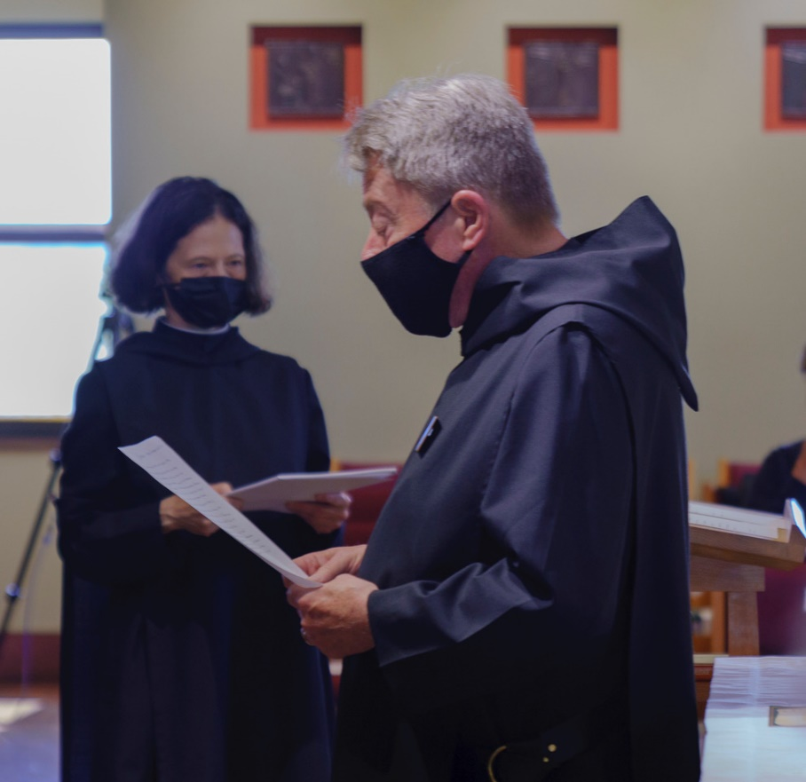

Sr. Catherine Ann Ballinger; Br. Raymond Escott

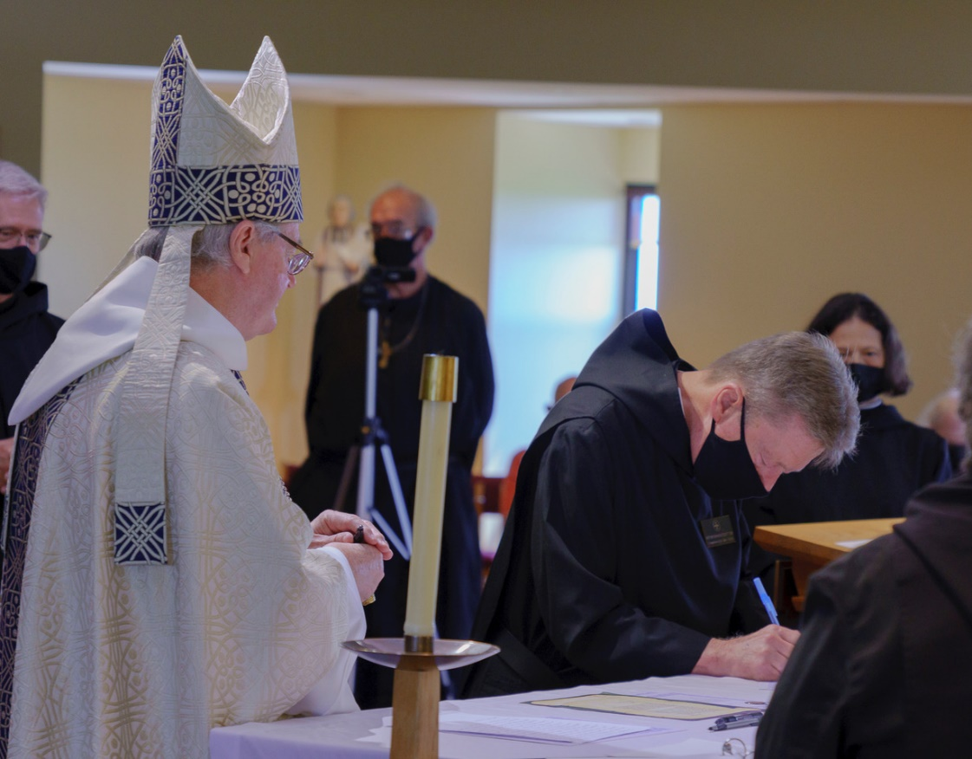

Br. Anskar Nonken; Bp. Alan Scarfe; Br. Florian Campbell; Br. Raymond Escott; Sr. Catherine Ann Ballinger; Sr. Martha Lamoy

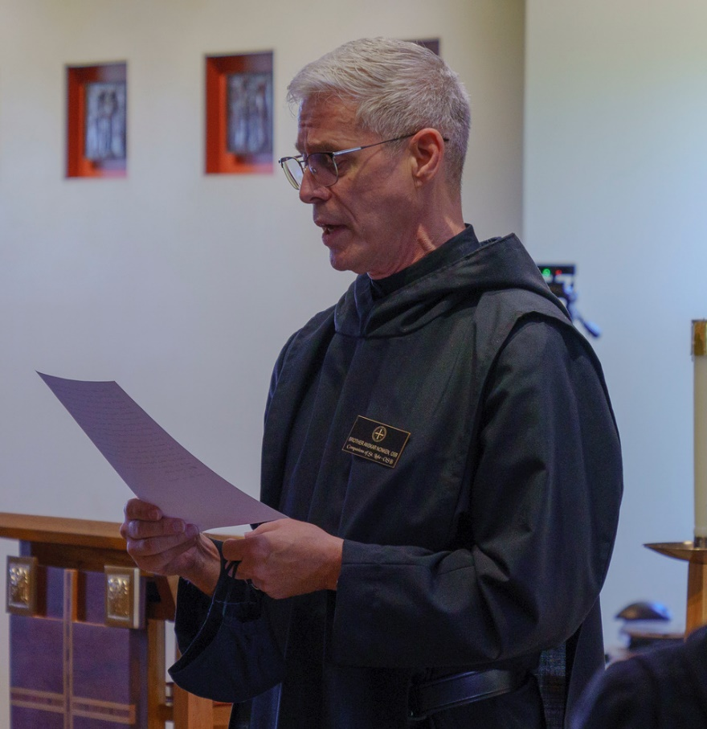

Br. Anskar Nonken

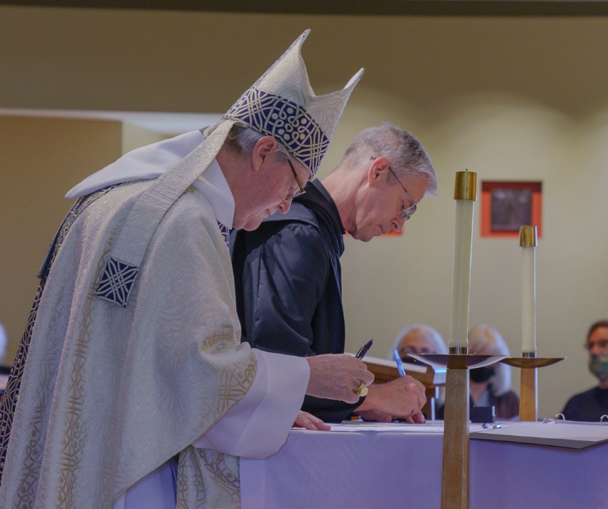

Bp. Alan Scarfe; Br. Anskar Nonken; Robin Smith; ?; William Page

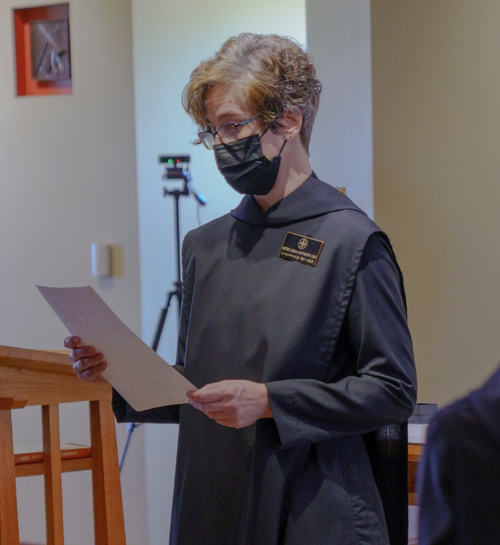

Sr. Joanna Whitworth

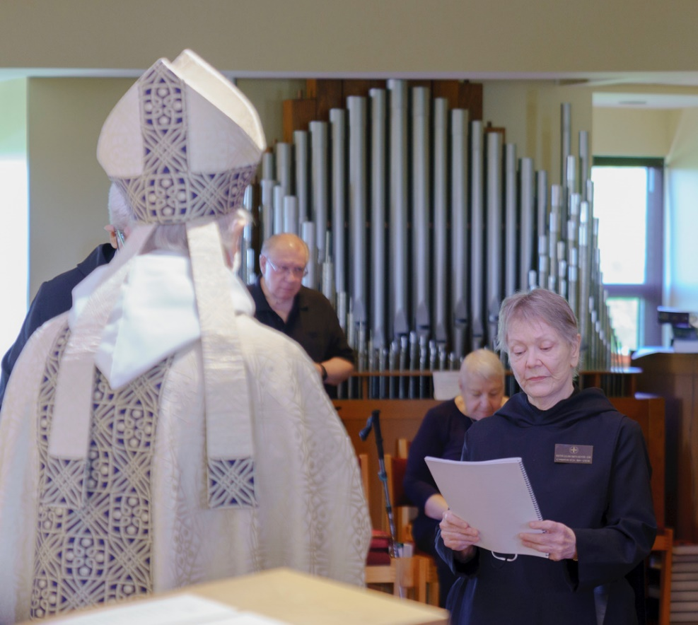

Br. Chrysostom Olsen; Bp. Alan Scarfe; ?; Marie Patricia Hughes; Sr. Julian Smith-Boyer

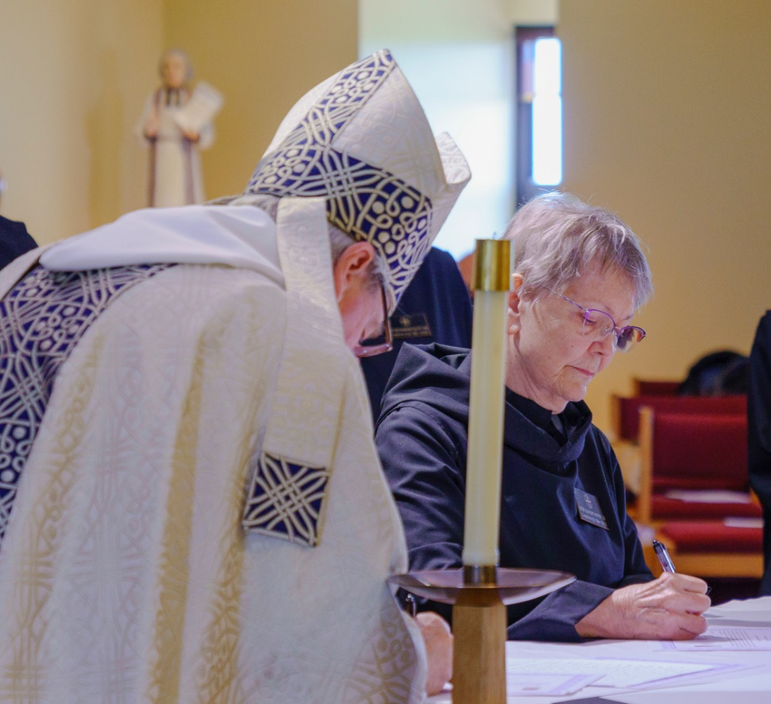

Bp. Alan Scarfe; Sr. Julian Smith-Boyer

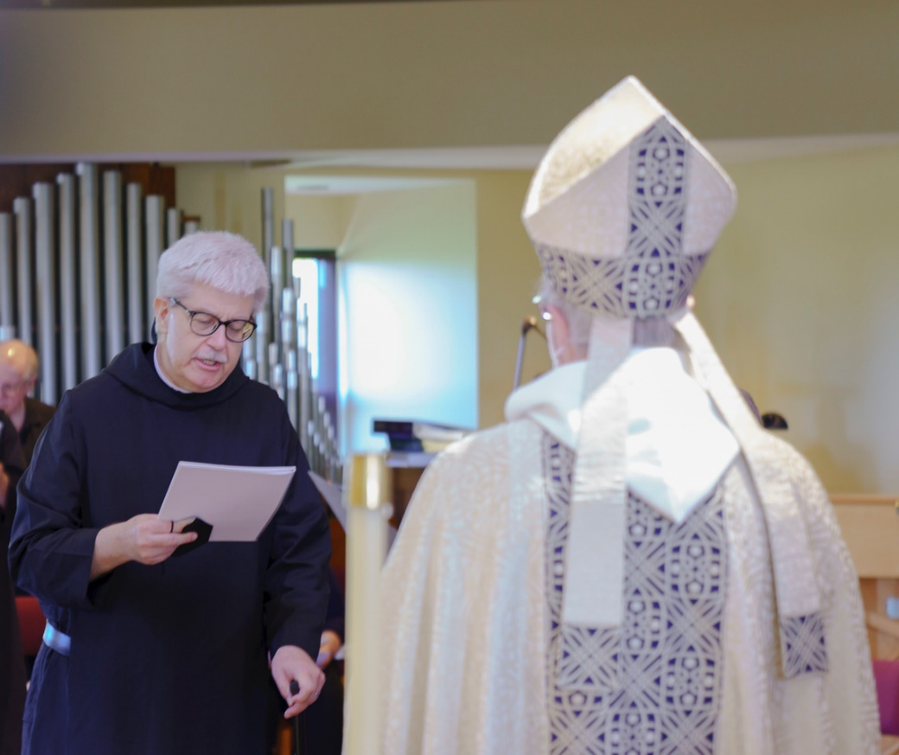

?; Br. Chrysostom Olsen; Bp. Alan Scarfe

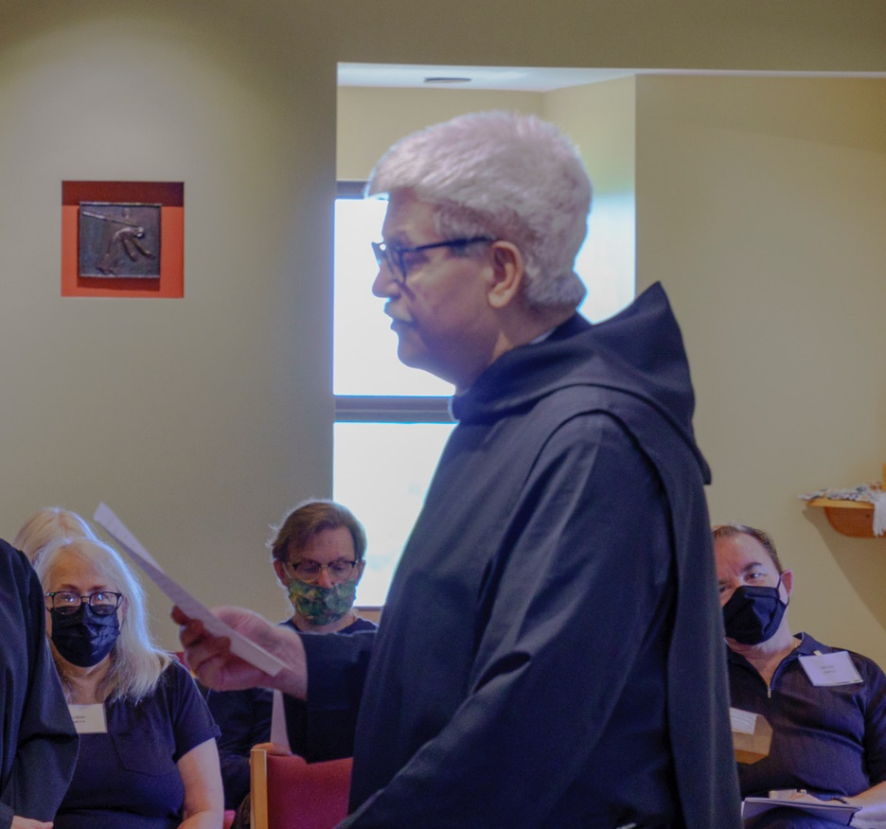

Robin Smith; William Page; Br. Chrysostom Olsen; Kevin Orth

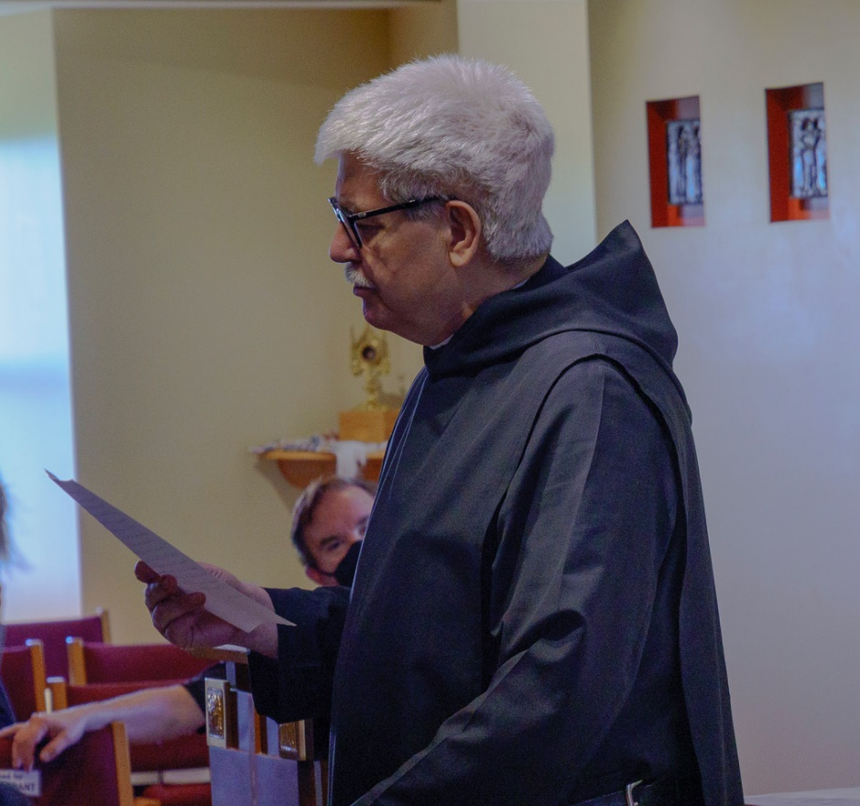

Kevin Orth; Br. Chrysostom Olsen

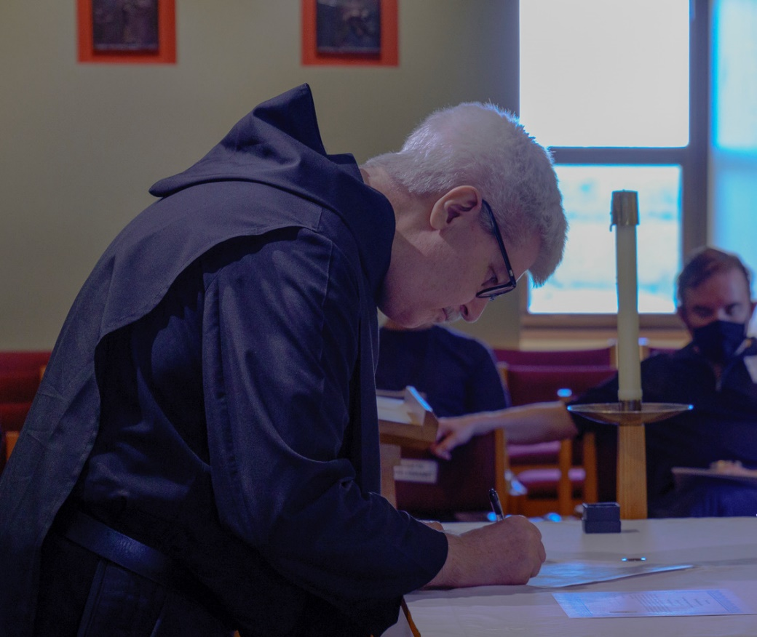

Br. Chrysostom Olsen; Kevin Orth

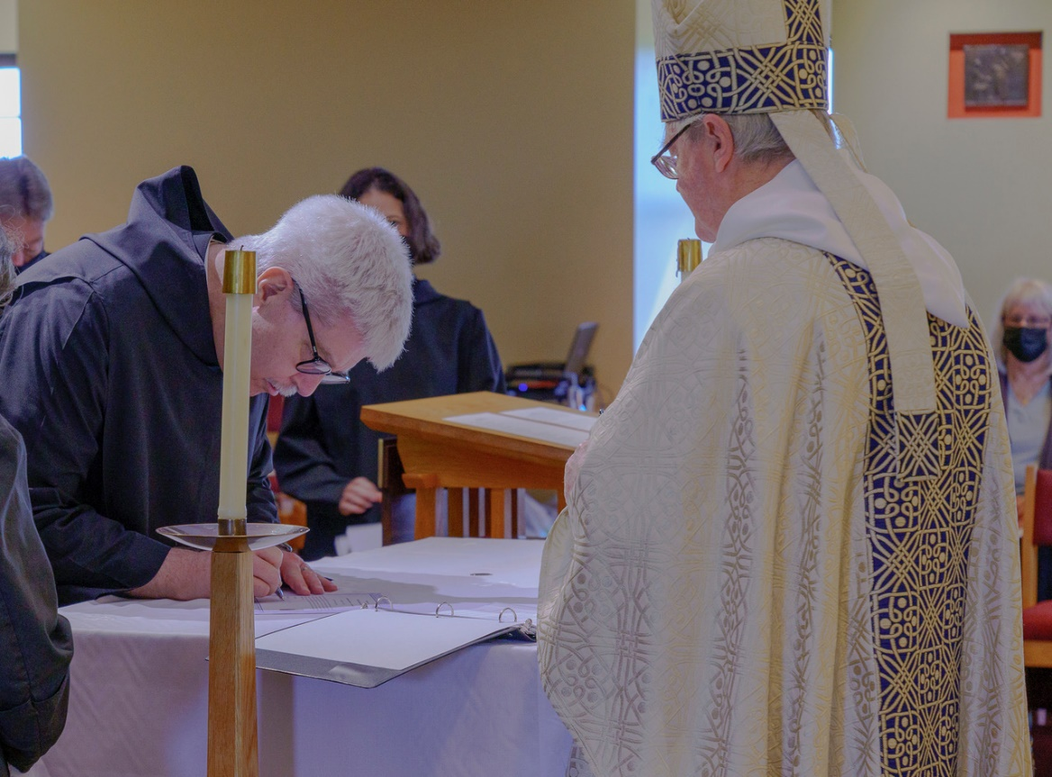

Br. Raymond Escott; Br. Chrysostom Olsen; Sr. Catherine Ann Ballinger; Bp. Allen Scarfe; ?

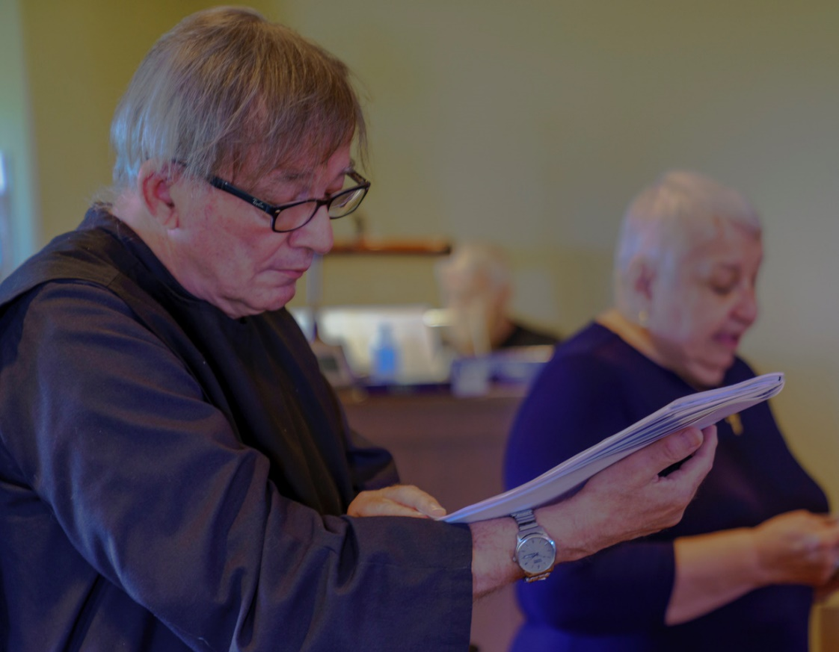

Br. James Rafael Davies; Br Michael Anicetus McCabe; Marie Patricia Hughes

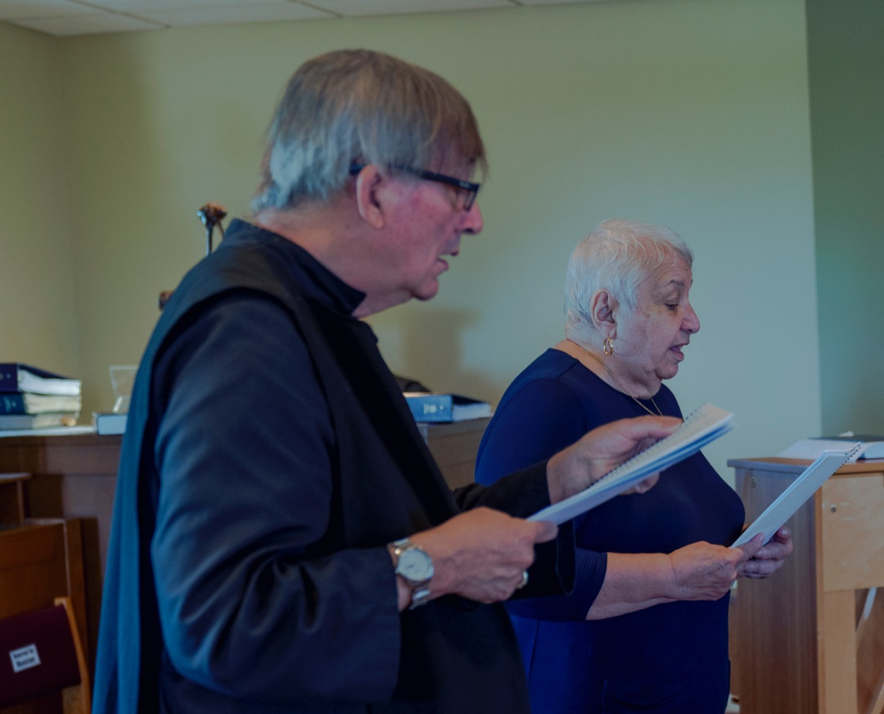

Br. James Rafael Davies; Marie Patricia Hughes

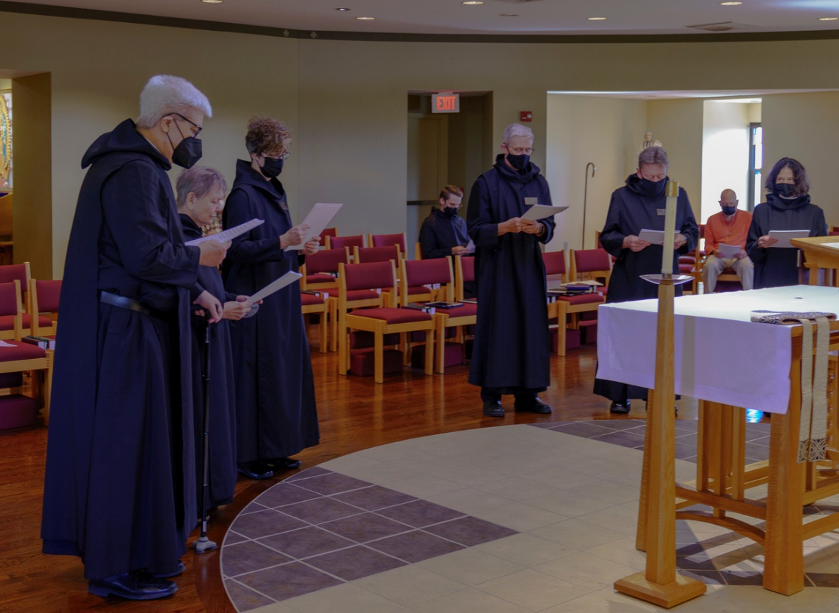

Br. Chrysostom Olsen; Sr. Julian Smith-Boyer; Sr. Joanna Whitworth; Br. Peter Francis Kyle; Br. Anskar Nonken; Br. Raymond Escott; ?; Sr. Catherine Ann Ballinger

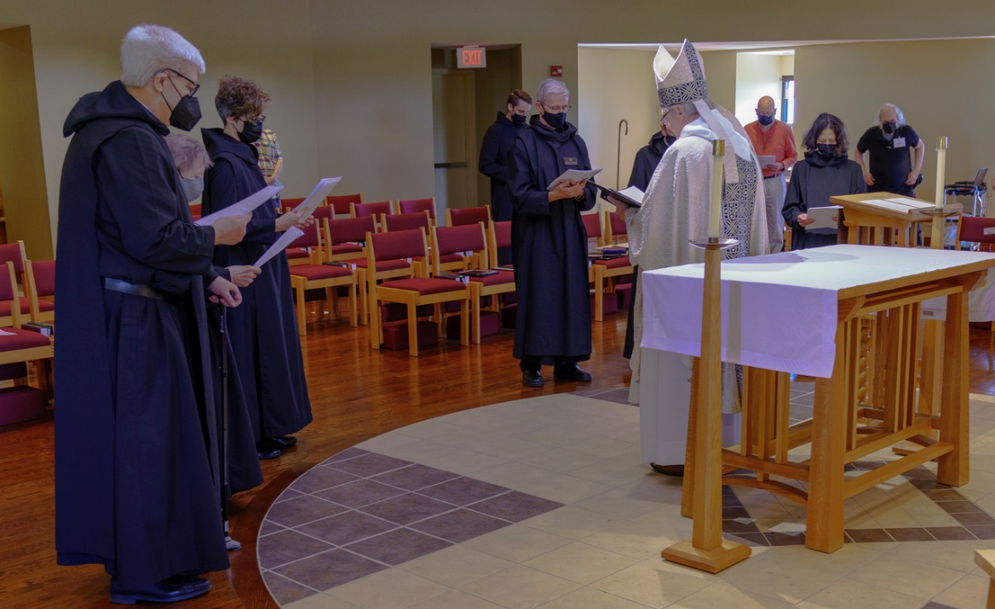

Br. Chrysostom Olsen; Sr. Julian Smith-Boyer; Sr. Joanna Whitworth; Br. Peter Francis Kyle; Br. Anskar Nonken; Br. Raymond Escott; Bp. Alan Scarfe; ?; Sr. Catherine Ann Ballinger; Keith McKenna

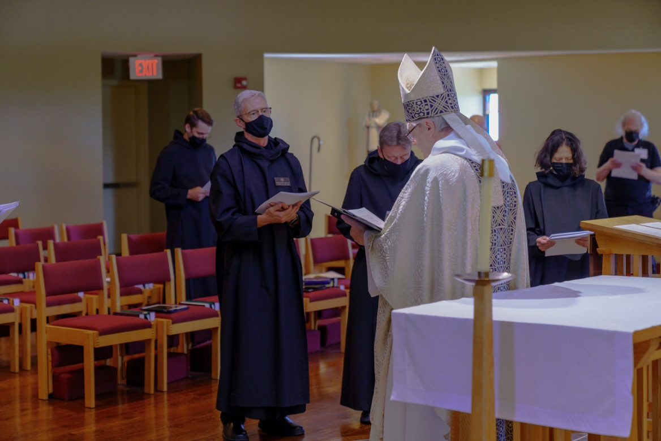

Br. Peter Francis Kyle; Br. Anskar Nonken; Br. Raymond Escott; Bp. Alan Scarfe; Sr. Catherine Ann Ballinger; Keith McKenna

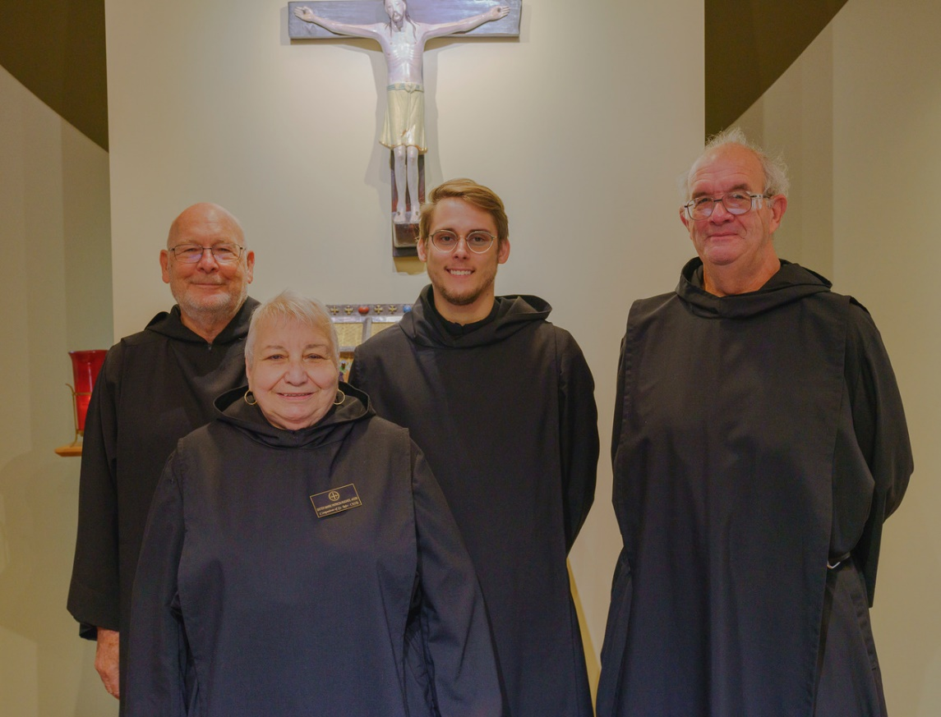

Br. John David Wynne; Sr. Marie Patricia Hughes; Br. Peter Francis Kyle; Br. Florian Campbell

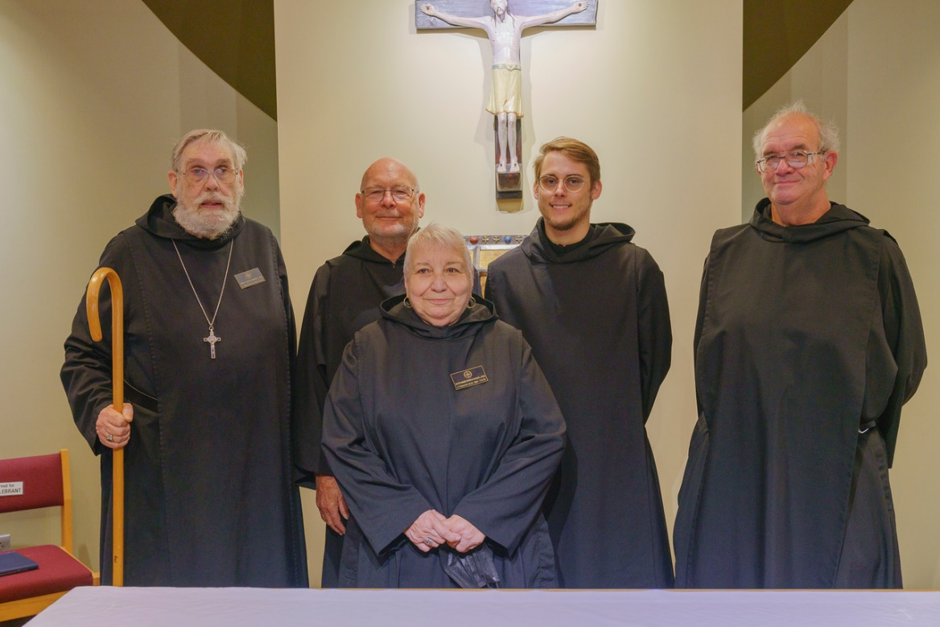

Abbot David Gerns; Br. John David Wynne; Sr. Marie Patricia Hughes; Br. Peter Francis Kyle; Br. Florian Campbell

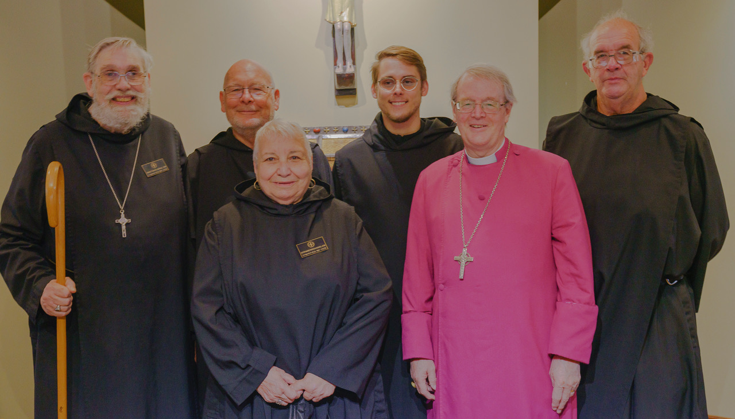

Abbot David Gerns; Br. John David Wynne; Sr. Marie Patricia Hughes; Br. Peter Francis Kyle; Bp. Allen Scarfe; Br. Florian Campbell

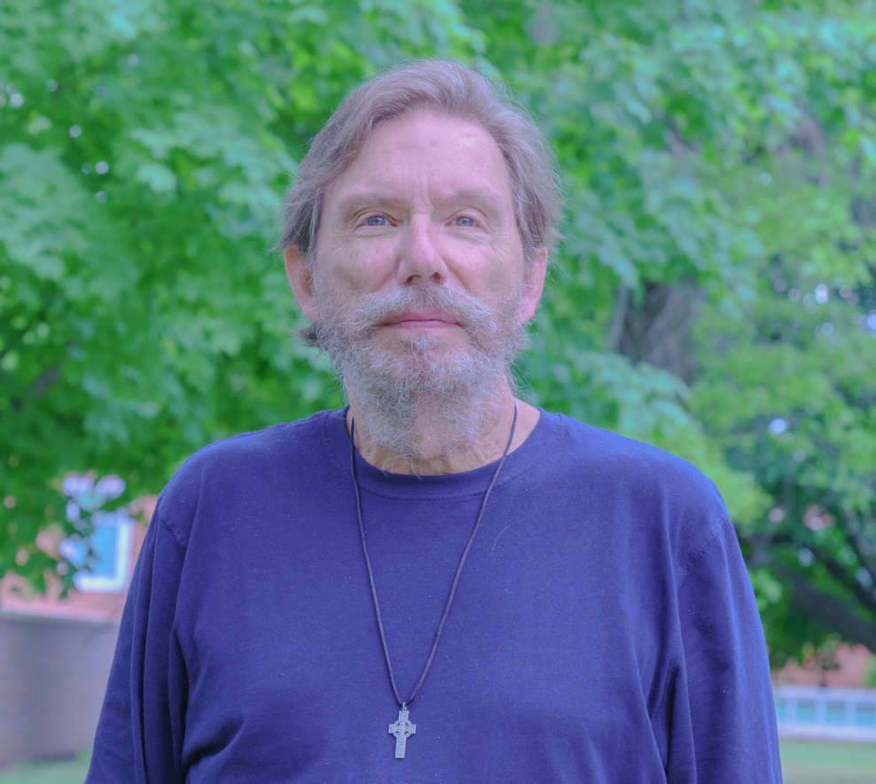

William Page