Life Professed (21)

 | 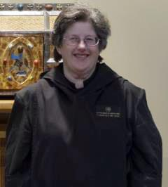 | Abbess Martha Lamoy, OSB +  2217 East Cedar  Olathe, KS 66062  913.709.3195 (cell)  srmarthaosb@yahoo.com
 | 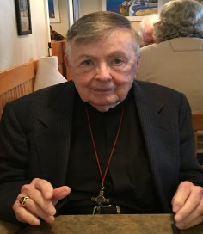 | Br. Matthias Smith, OSB  3610 Highlands Road, #2  Franklin, NC 28734  828.524.6299 (home)  hno.matias@aol.com
 | 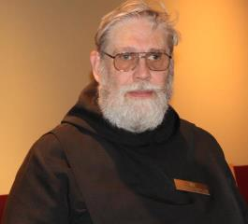 | Br. David Gerns, OSB  Interim Treasurer  3 Rolling Hill Avenue  Plaistow, NH 03865  617.834.7326 (cell)  br.davidosb@comcast.net
 | 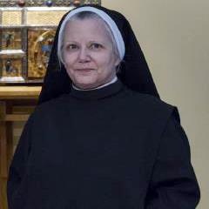 | Sr. Anna Grace Madden, OSB  204 Deville Place  Shreveport, LA 71115  318.934.3836 (home/cell)  srannagrace@gmail.com
 | 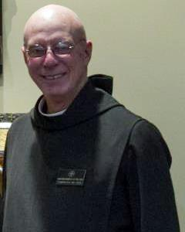 | Br. Robert Cotton, OSB  13 Pond Place Lane  Concord, NH 03301  603.228.3645 (home)  603.892.1410 (cell – best)  rcotton722@gmail.com
 | 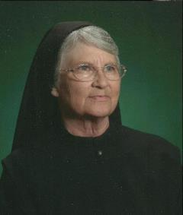 | Sr. Mary Francis Deulen, OSB  1933 Portland Avenue  Abilene, TX 79605  325.268.7214 (cell)  chrpubs@gmail.com
 | 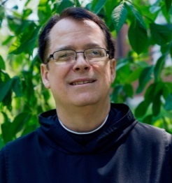 |  |  | Br. Dunstan Townsend, OSB  P. O. Box 928  Stockton, CA 95201  209.481.4100 (cell)  Br.dunstan@comcast.net
 | 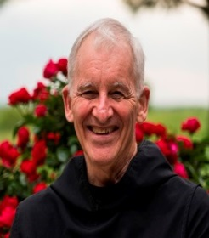 |  |  | Br. Steven Olderr, OSB  1165 S. Wenonah  Oak Park, IL 60304  708.383.8176  olderr@ameritech.net
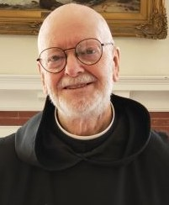 |  |  | Br Thomas Anthony Goddard, OSB  59 Hidden Lake Road  Higganum, CT 06441  860.345.4290  Tagoddard115@comcast.net
 | 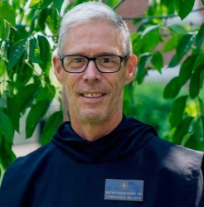 |  |  | Br. Anskar Nonken, OSB +  CSL Council  3828 Milflores Dr  Ruskin, FL33573  727-260-1784 (cell)  Scott.nonken@gmail.com
 | 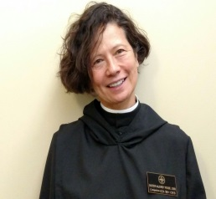 |  |  | Sr. Catherine Ann Ballinger, OSB +  La Boheme  3023 Cambridge Place, NW  Washington, DC 20007  202-471-4380 (H)  laboheme3023@icloud.com
 | 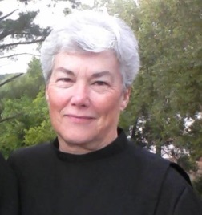 |  |  | Sr. Toni Sylvester, OSB  1125 Wonder Drive  Chapin, SC 29036  tonisyl.smc@gmail.com  803.261.1825 (cell/home)  tonisyl.smc@gmail.com
 | 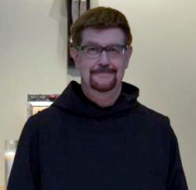 |  |  | Br. Chrysostom Olsen, OSB  CSL council  PO Box 217  Waldport, OR 97394  425-420-7250  brchrysostom@icloud.com
 | 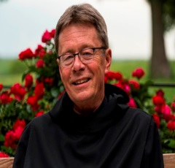 |  |  | Br. Raymond Escott, OSB +  Prior  912 Turtle Creek Drive  Ashville, NC 28803  828-399-1378 cell  mailto:revdnray@gmail.com
 | 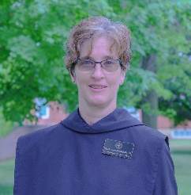 |  |  | Sr. Jana Lynn Whitworth, OSB +  2109 NW 30th Circle.  Camas, WA 98607  (C) 360-241-0939  Jrimom@gmail.com
 | 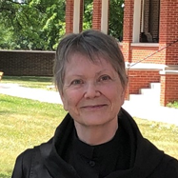 |  |  | Sr. Julian Smith-Boyer, OSB  Dean of Professed Life  502 Lynnhurst Avenue East, Apt 206  St Paul, MN 55104  612-210-3078 (Cell)  boyerhelen66@gmail.com
 | 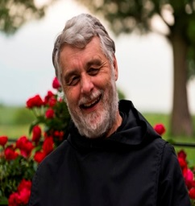 |  |  | Br. Gregory Tatchell, OSB  #203 - 2222 Prince Edward St.  Vancouver, BC, Canada V5T 4M6  gregtatchell@hotmail.com  Cell 604.612-9984  Home 604.709-9692
 | 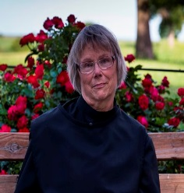 |  |  | Sr. Margaret Mary Bergeron, OSB  2515 S.9th Street; No. 1212  Minneapolis, MN 55406  612-203-6233 (cell)  bermouse86@gmail.com
 | 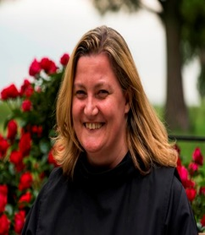 |  |  | Sr. Clara Ulson Freirias OSB  R. Gregorio P. Almeida, 1097 -  V. Madalena - S. Paulo – SP  Zip code 05450-001Brazil  afreirias@gmail.com  011+ 55 (11) 97546-2876
 | 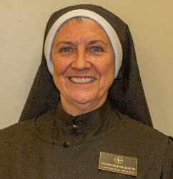 |  |  | Sr. Mary Magdalene, OSB  4701 Monterey Oaks Blvd. #923  Austin, TX 78746  512.226.3916  srmm7759@gmail.com
 | 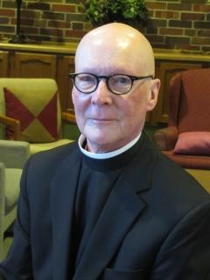 |  |  | Br. Stephan Francis Arnold, OSB  4111 Ingersoll Ave. #304,  Des Moines IA 50312.  stephenosb248@gmail.com  860-377-0019

Annually Professed (5)
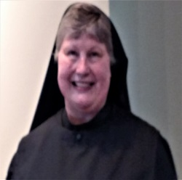 | Sr. Katherine Fleck, OSB  2619 N La Venture Rd. #312  Mt Vernon, WA 98273  360.632.0209  oakharborknits@gmail.com  year three of discernment program
  7 | Sr. Ànah Elizabeth Marshall, OSB  340 Royal Poinciana Way,  Suite 317-349  Palm Beach, FL 33480  anah.elizabeth.osb@gmail  Home: 561- 373-7174  year three of discernment program
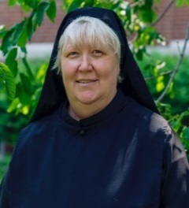 | Sr. Genevieve Lynn Robinson, OSB  Dean of Continuing Education  1937 Paynes Point  Winder, GA 30680  sulyrobinson@gmail.com  Home: 770-490-0063  year three of discernment program
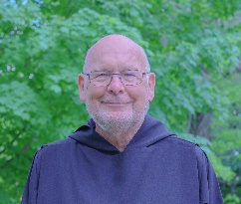 | Br. John David Wynne, OSB  208A 64th St..  Virginia Beach, VA 23451  757-802-6812  brjohndavidosb@gmail.com  year two of discernment program
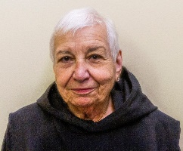 | Sr. Marie Patricia Hughes, OSB  79 Fennell St. #21  Skaneateles, NY 13152  315-702-3757  mphughes3139@gmail.com  year one of discernment program
Novices (7)
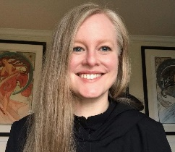 | Sr. Petra Puckett, n/OSB  6348 SE 85th Ave  Portland, Or 97266  205-246-3194  hollyrebecca@protonmail.com  Year 1 of Novitiate
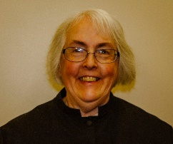 | Sr. Madeleine Sophie n/OSB  CSL Council  107 Allison Rd, Apt. A  Oreland, PA 19075  215.435.9423  rsmith12jm@gmail.com  Year 2 of Novitiate

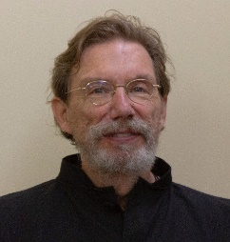 |  | Br. William Marion Page n/OSB  2326 West Kiowa St.  Colorado Springs, CO. 80904  719-339-0165  wmpage2326kitty@gmail.com  Year 2of Novitiate
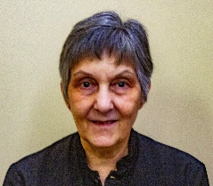 | Sr. Clare Koronka, n/OSB  4813 Lido Lane  Houston, TX 77092  832-216-9199  cynthiakoronka@gmail.com  Year 1of Novitiate
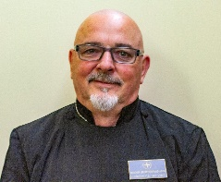 | Br. Jerome Bertrand, n/OSB  5719 Rawles Ave  Indianapolis, IN 46219  didierbertrand8@gmail.com  Year 1of Novitiate
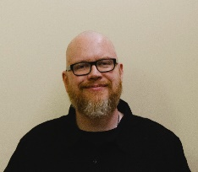 | Br. Ronan Patrick, n/OSB  6320 Old Orchard Road  Indianapolis, IN 46226  630-229-1126  rpatrick@gmail.com  Year 1of Novitiate
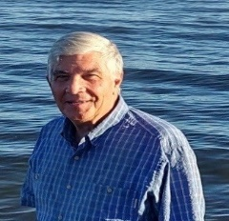 | Br. Jean Baptiste Blizzard, n/OSB +  175Rangdila la Montagne  St. Paul a Abotsford  Quebec, CA JOE1AO  514-929-4230  pilgrimbill13@gmail.com  Year 1of Novitiate
Postulants (2)
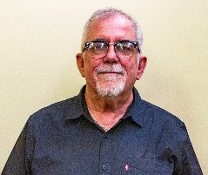 | Joseph Versanyi +  2001 Hamilton St.  Apt. 1027  Philadelphia, PA 19130  joevasl@aol.com
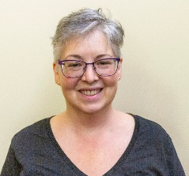 | Lorien Altadonna  1467 Stonewater Dr  Cullman, AL 35055  770-608-5482  lo.alta86@gmail.com

Oblates (9)
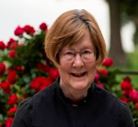 | Sr. Brigid Gerns, Obl./OSB  3 Rolling Hill Avenue  Plaistow, NH 03865  603.819.9659 (cell)  ann2brigid@gmail.com
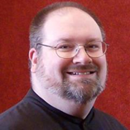 | Br. Daniel Moore, Obl./OSB  CSL Council  330 North Washington St  Kahoka, MO 63445  319-470-6581 (cell-best)  danielmoore@minister.com
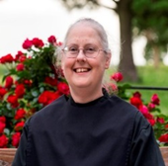 | Sr. Denise Moore, Obl./OSB  330 North Washington St  Kahoka, MO 63445  319.470.2708 (cell)  sisdenise@yahoo.com
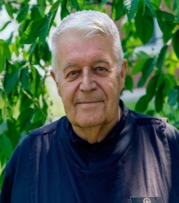 | Br. Michael Anicetus Mc Cabe, Obl./OSB  2517 E Jensen  Mesa, Az. 85213  402-926-1342.  jmmccabe@cox.net
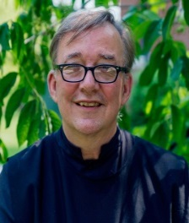 | Br. James Rafael Davies, Obl./OSB  Dean of Oblate Life  1923 3rd Ave. So.  Minneapolis, MN 55404  612.360.4031  aumjames@aol.com
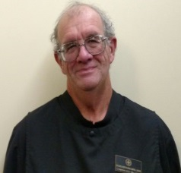 | Br. Florian Campbell, Obl./OSB  507 West Race St.  Mount Pleasant Iowa 52641  319-217-3365  unclejoe314159@gmail.com  Year 2of Novitiate
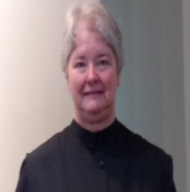 | Sr. Hildegard Longmire, Obl./OSB  1818 Hidaway Lane  Durham, NC 27712  919.308.1211  bwlongmire@mindspring.com

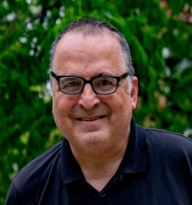 | Br. Jeffrey Thaddeus Kasica, Obl./OSB  43 Roosevelt St., apt. # 17  Braintree, MA 02184  774.360.4219  jeffreykasica@gmail.com
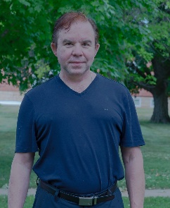 | Br. Jude Thaddeus Orth, Obl./OSB  8438 South 115th Place  Seattle, WA 98178  206-931-3058  kevinorth@icloud.com
Novice-Oblates (5)
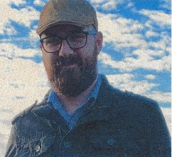 | Adam Wilson  7342 Hodges Ferry Rd.  Knoxville, TN 37920  423-715-7055  wilsonad@pm.me
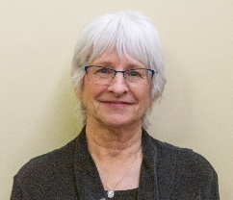 | Cindy Page  2326 West Kiowa St.  Colorado Springs, CO 80904  719-339-8428  cindypage2326@gmail.com
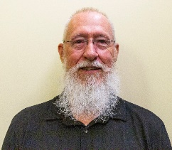 | Rick Knight  2071 28th Ave. N  St. Petersburg, FL 33713-4144  727-692-4463  reknight.CSL@gmail.com
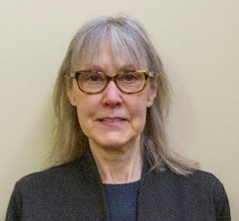 | Cynthia Reece  P.O. Box 1144  Fairfield, IA 52556  641-919-2109  cindyreece@lisco.com
Nikolaus Grimsby
15912 Water Gap Rd
Williams, OR 97544
458-257-3155
nsgrimsby@gmail.com

Companion Associates
Sr Dawna Clare Sutton, SFCC, ca/OSB
1701 S. Thornburg St. #6
Santa Maria, CA 93458
805.868.5007 (home)
dawnasutton@hotmail.com
Spiriual Support
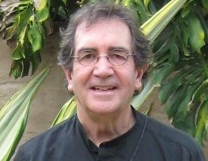 | The Rev. Sidney Breese, Chaplin  2534 Francis St  St. Joseph, MO 64501  816-262-4958  ssbreese@aol.com
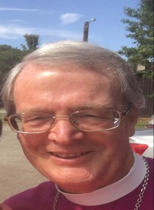 | The Right Reverend Alan Scarfe Bishop Visitor  719 52nd St,  Des Moines IA 50312.  515-314-1874 (cell)  ascarfe009@gmail.com
Others
 | The Rev. Wayne Kamm  319.258.9503 (home)  319.931.1330 (cell)  1451 Salem Road  Salem, IA 52649  rockermacher@yahoo.com

