Companions of St. Luke
Spring Convocation at Conception Abbey
June 1, 2013
Photographed by Sr. Brigid Gerns

People are identified from left to right.

Edited by Br. Steven Olderr, 3 April 2023. Please send any comments, corrections, or additions to olderr@ameritech.net





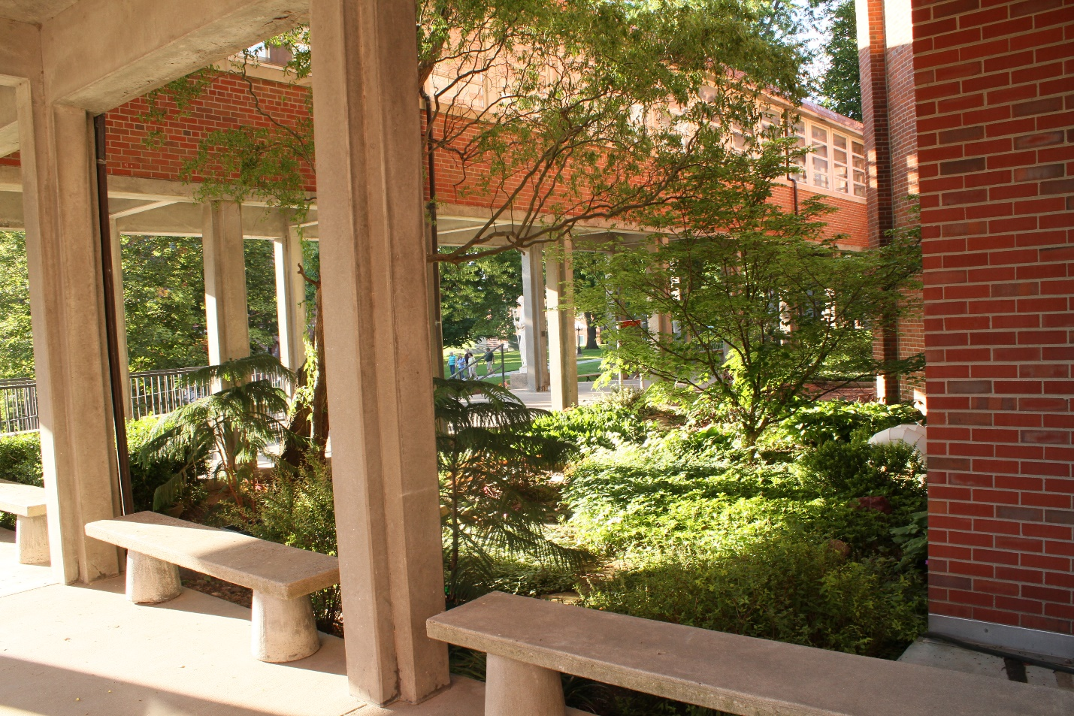



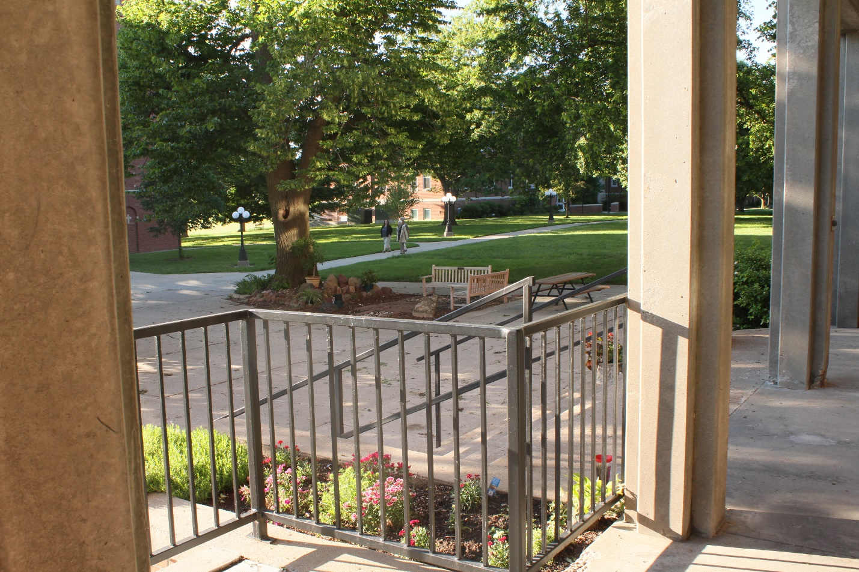

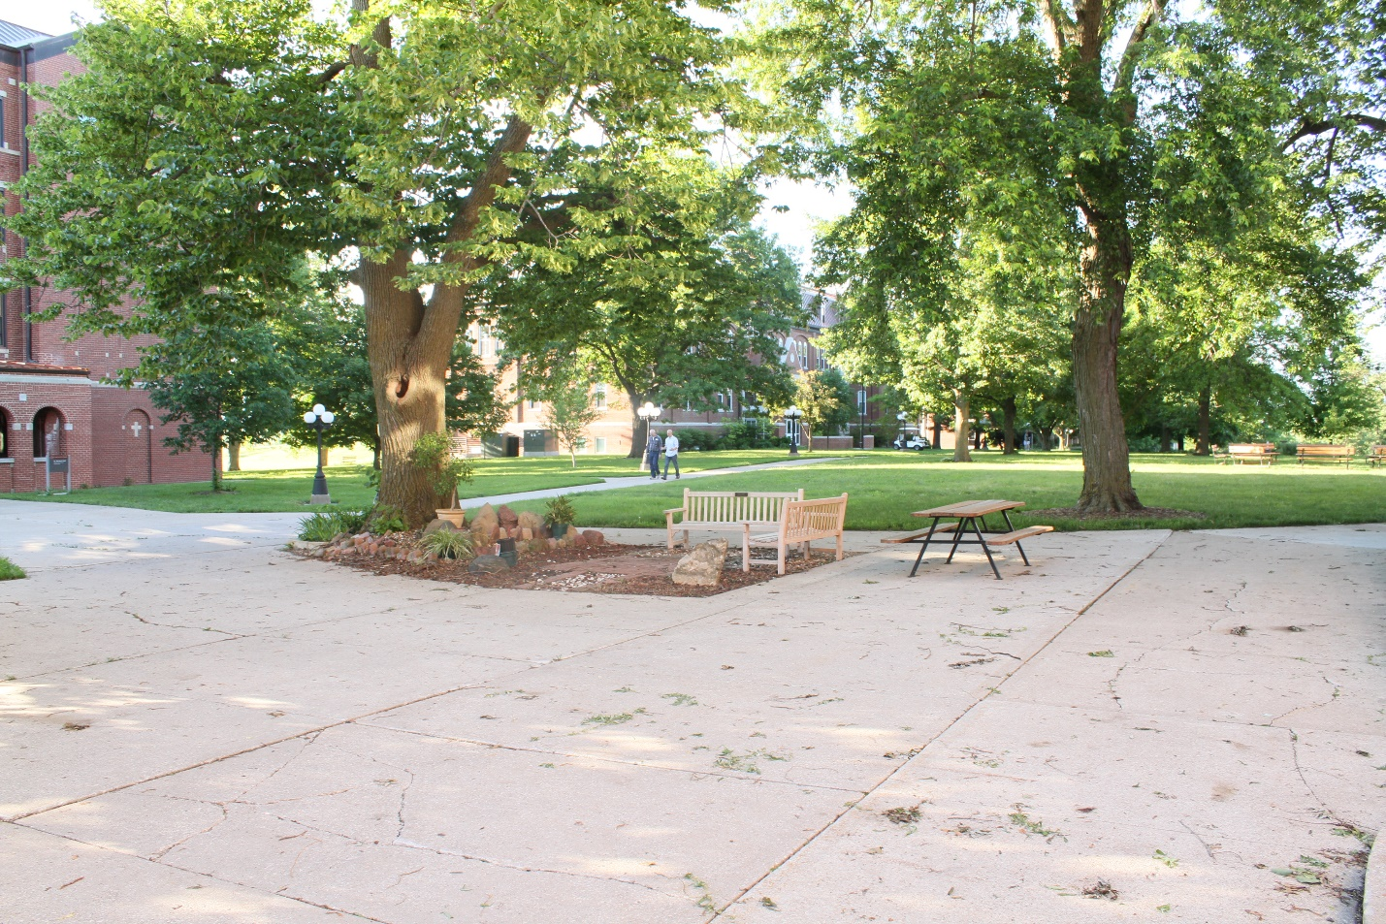

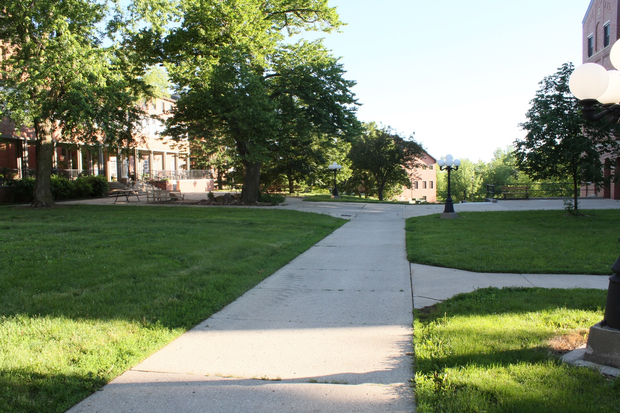

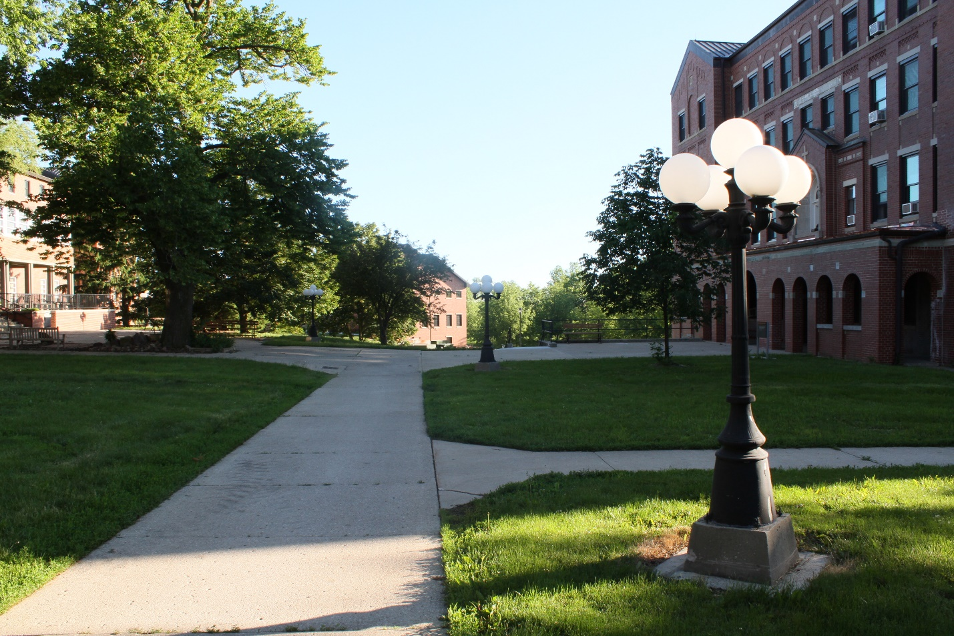



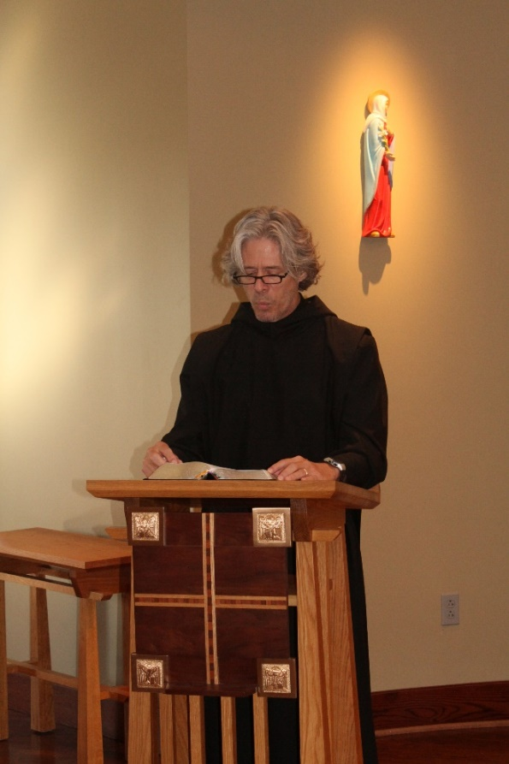
Br. Anskar Nonken

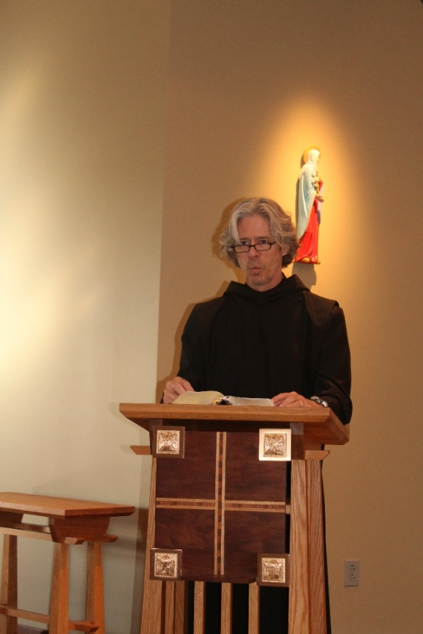
Br. Anskar Nonken

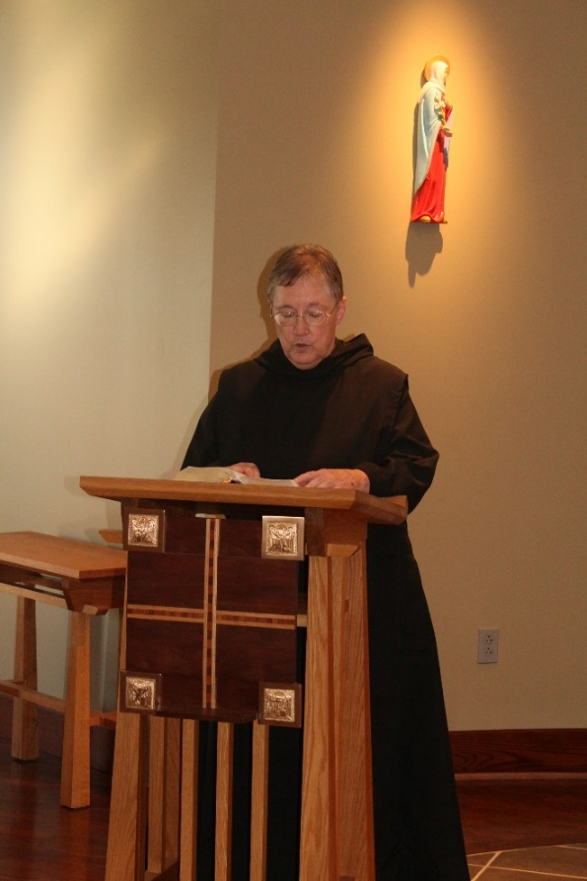
Sr. Kate Maxwell

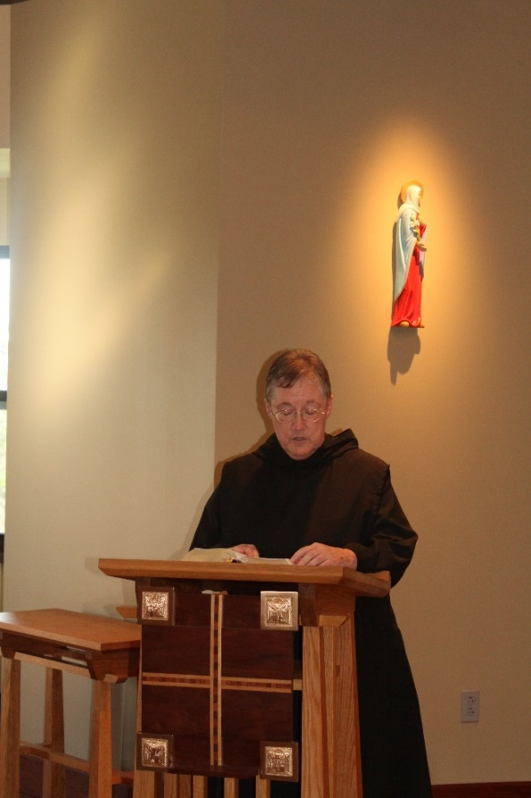
Sr. Kate Maxwell

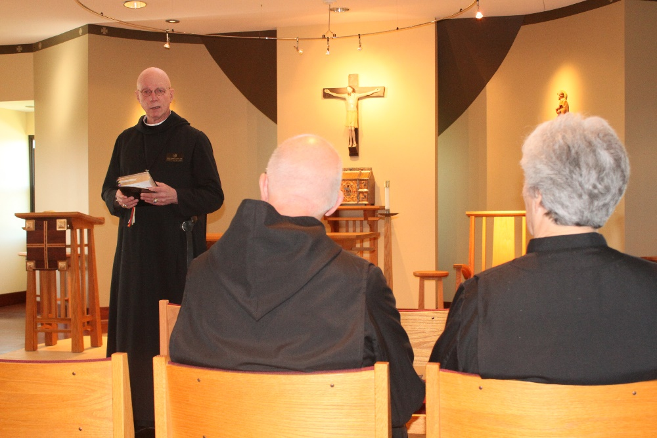
Abbot Robert Cotton; Br. Peter DeFranco; Sr. Toni Sylvester

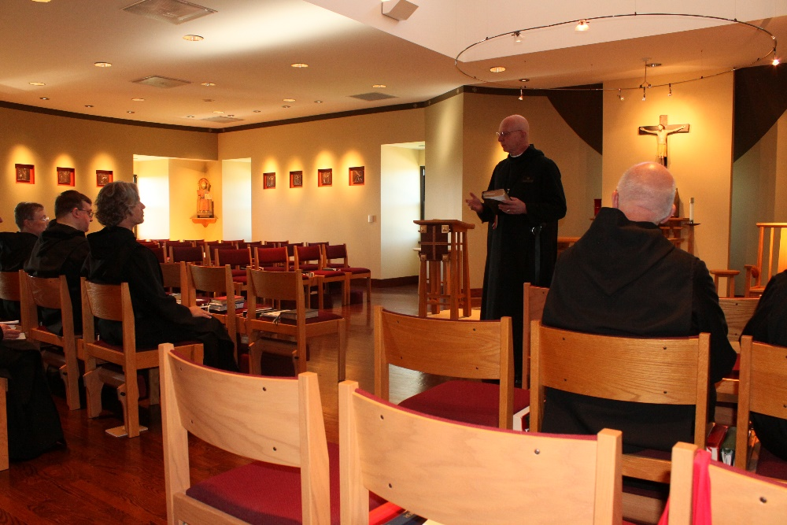
Sr. Kate Maxwell; Br. Victor Bullock; Br. Anskar Bullock; Abbot Robert Cotton; Br. Peter DeFranco

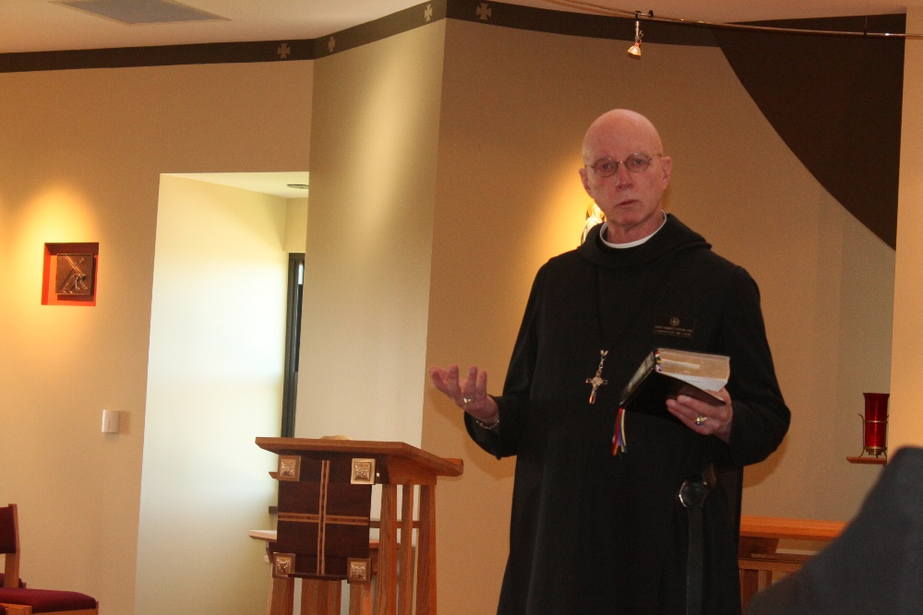
Abbot Robert Cotton

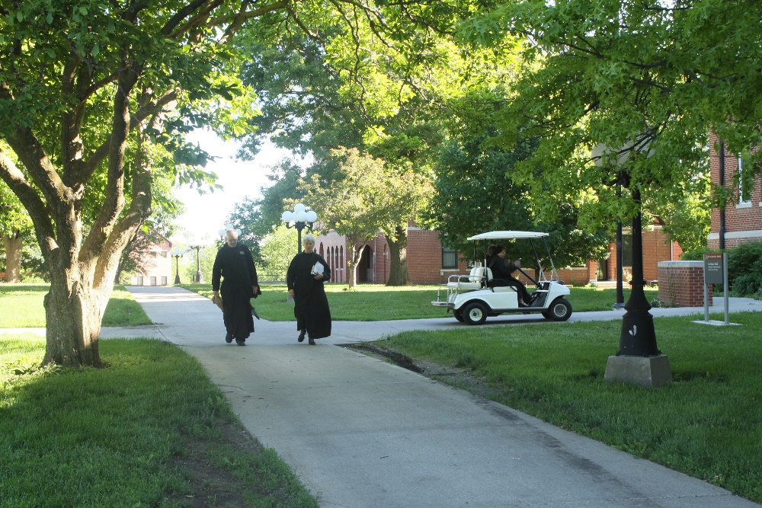
Br. Dunstan Townsend; Sr. Toni Sylvester

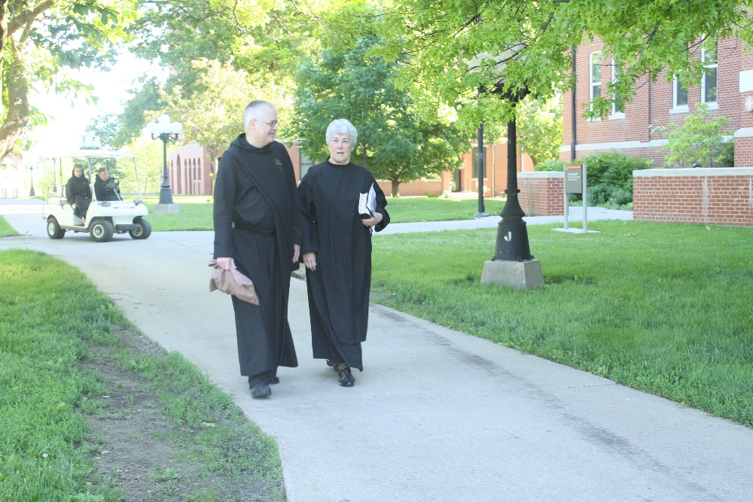
Sr. Monica Ruth Mullen; Sr. Kate Maxwell; Br. Dunstan Townsend; Sr. Toni Sylvester

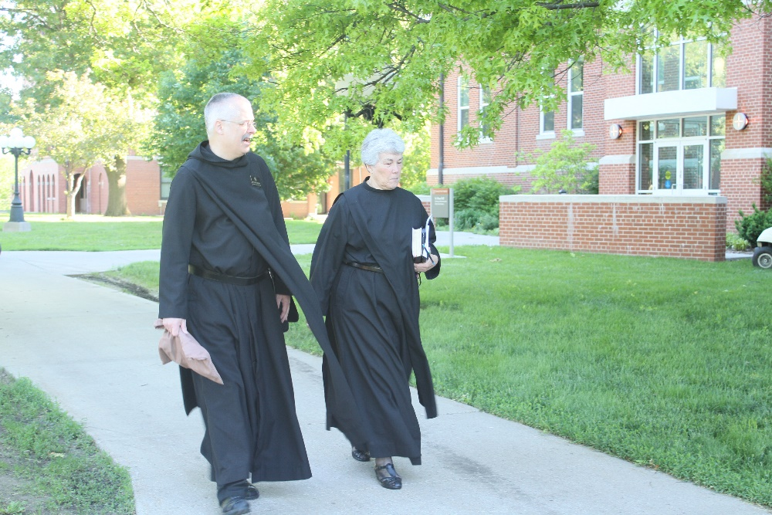
Br. Dunstan Townsend; Sr. Toni Sylvester

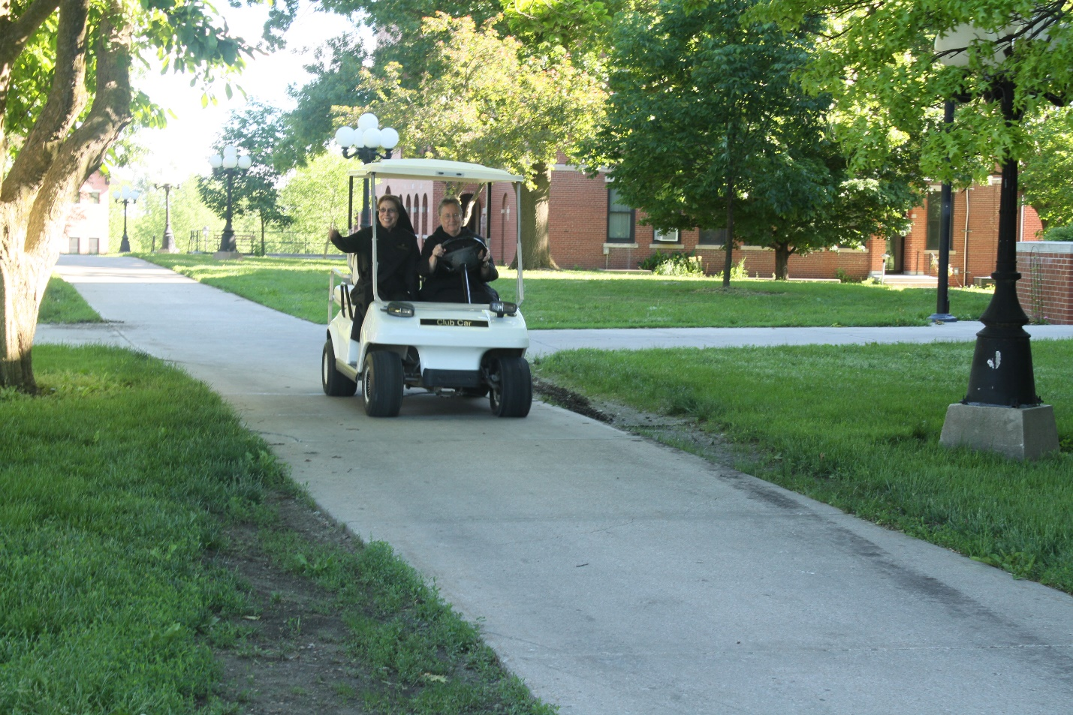
Sr. Monica Ruth Mullen; Sr. Kate Maxwell
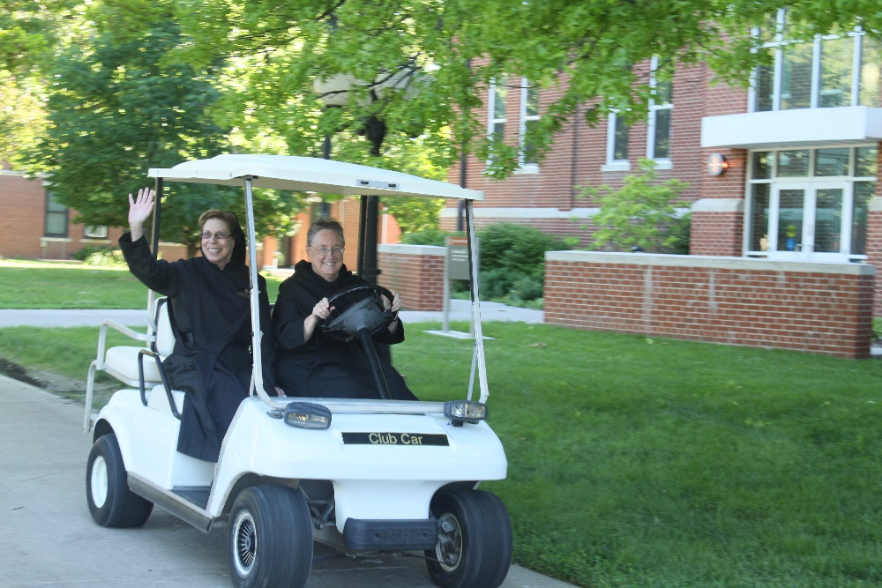
Sr. Monica Ruth Mullen; Sr. Kate Maxwell

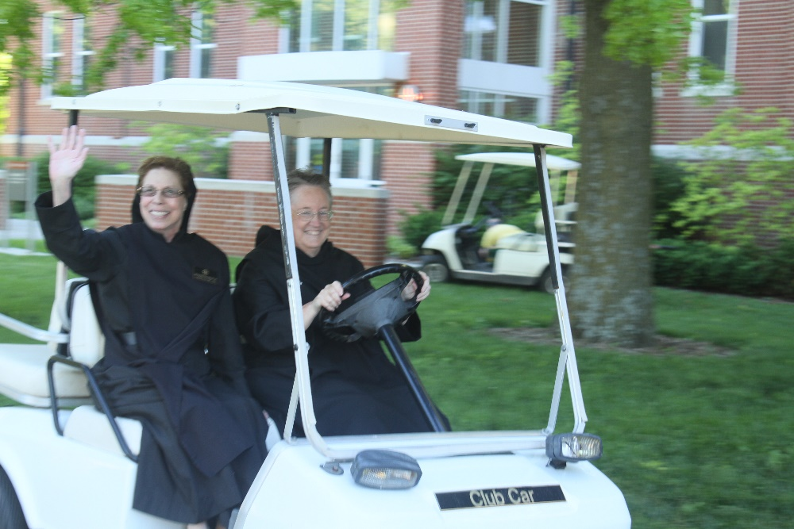
Sr. Monica Ruth Mullen; Sr. Kate Maxwell

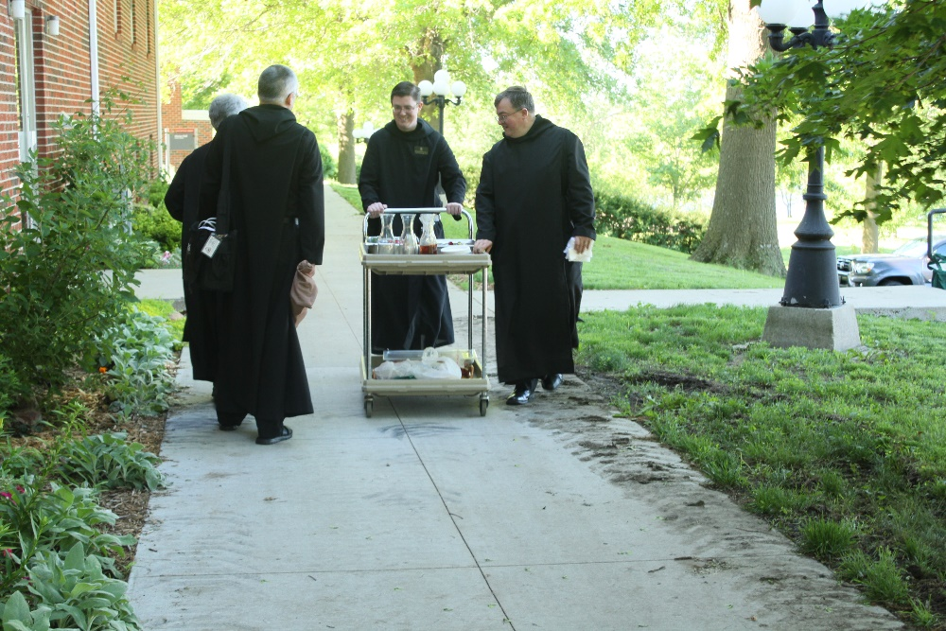
Sr. Toni Sylvester; Br. Dunstan Townsend; Br. Kenneth Maguire; Br. Victor Bullock

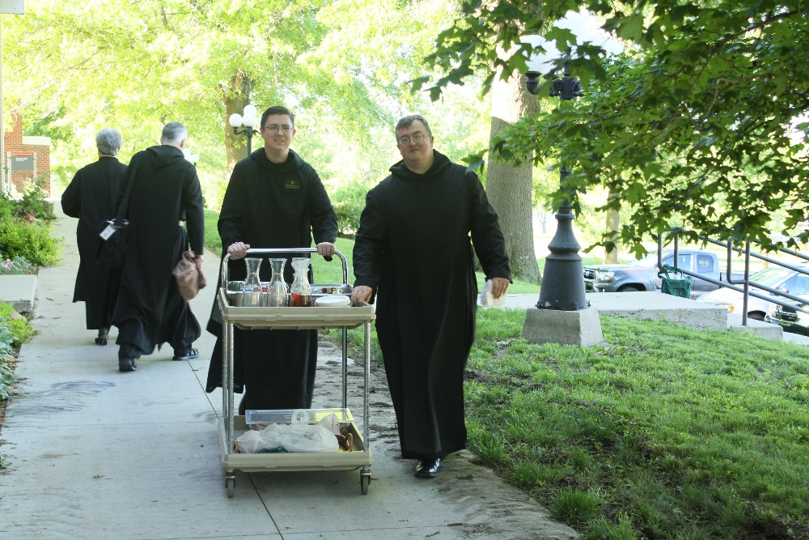
Sr. Toni Sylvester; Br. Dunstan Townsend; Br. Kenneth Maguire; Br. Victor Bullock

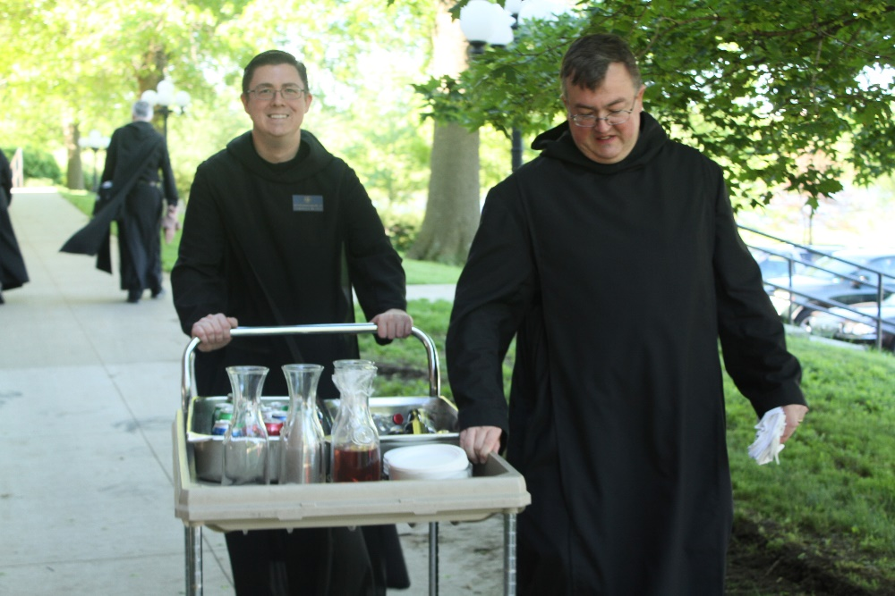
Br. Dunstan Townsend; Br. Kenneth Maguire; Br. Victor Bullock

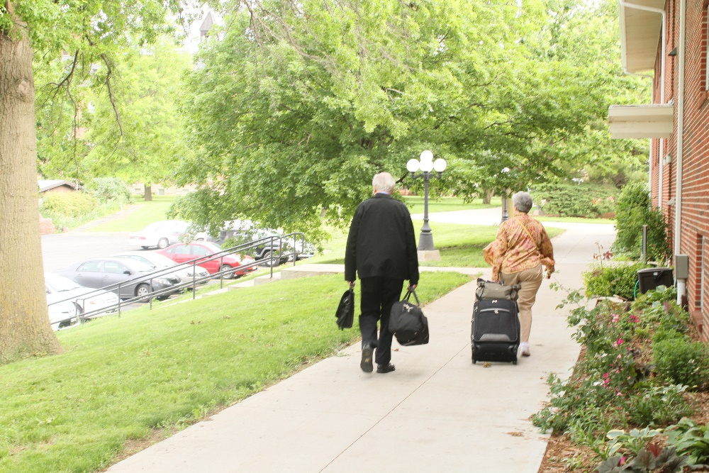
Br. Lee Doucette; Sr. Toni Sylvester

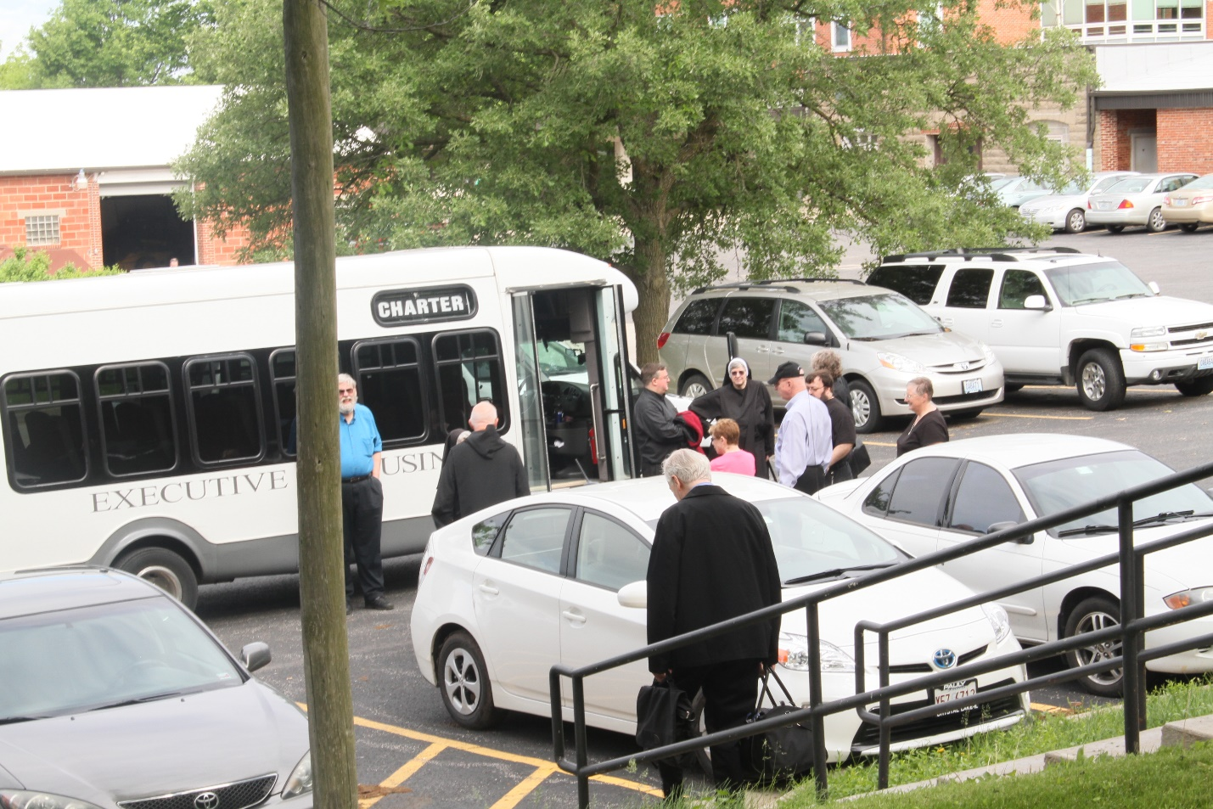
Br. David Gerns; Sr. Mary Francis Deulen; Br. Peter DeFranco; Br. Victor Bullock; Br, Lee Doucette; Sr. Monica Ruth Mullen; Sr. Helena Barrett; Abbot Robert Cotton; Br. Anselm King-Lowe; Br. Anskar Nonken; Sr. Kate Maxwell

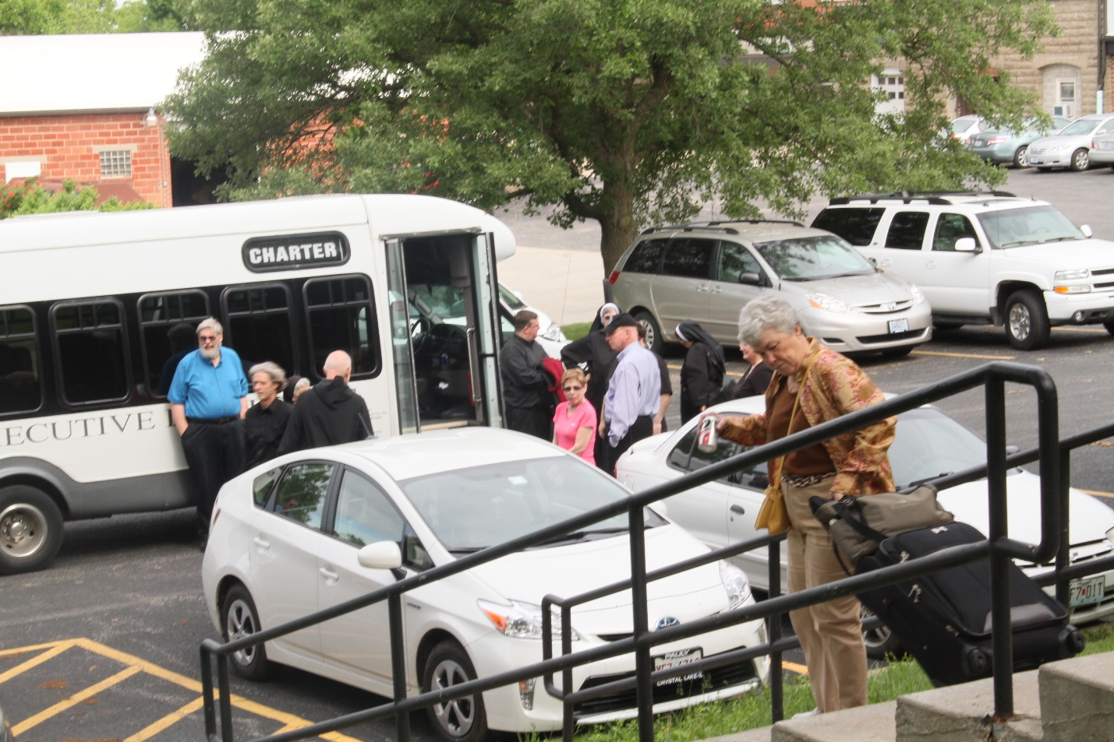
Br. David Gerns; Br. Anskar Nonken; Sr. Mary Francis Deulen; Br. Peter DeFranco; Br. Victor Bullock; Sr. Monica Ruth Mullen; Sr. Helena Barrett; Abbot Robert Cotton; Br. Anselm King-Lowe; Sr. Alison Joy Whybrow; Sr. Kate Maxwell; Sr. Toni Sylvester

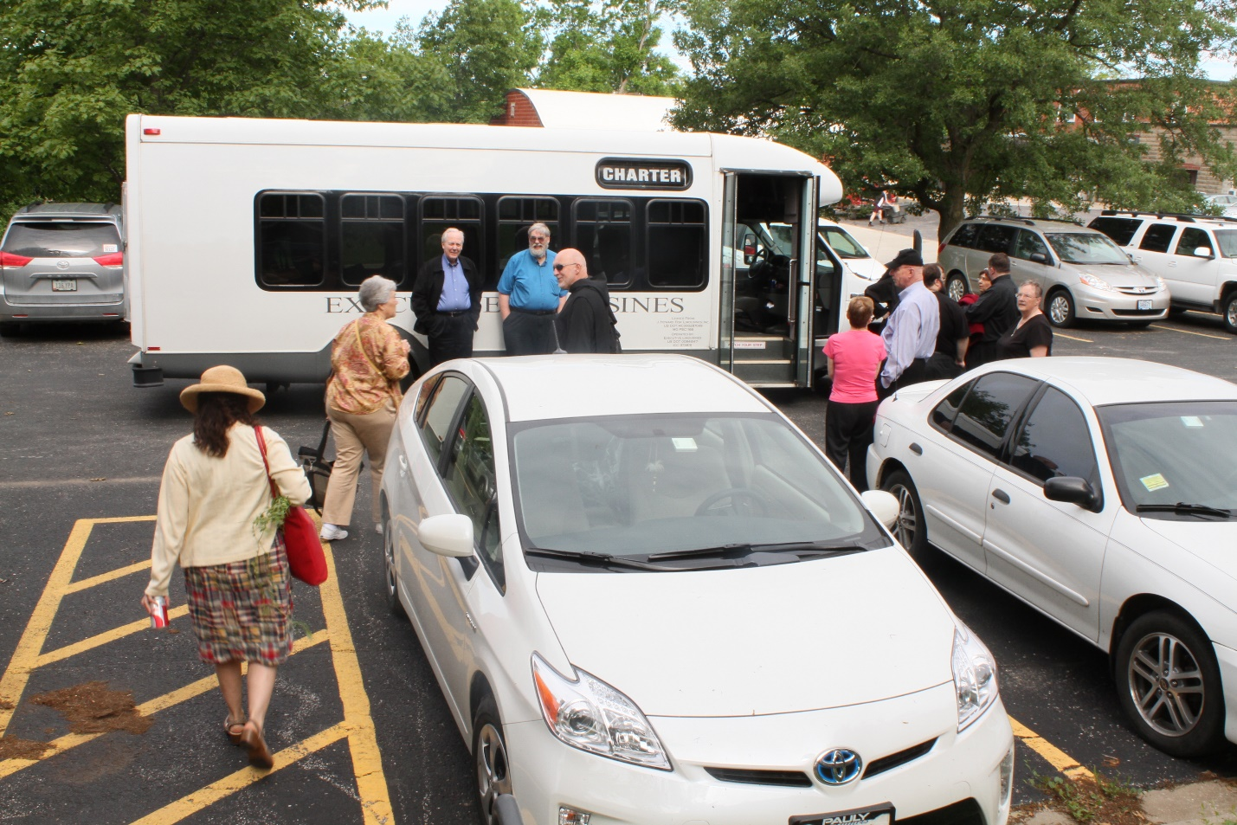
Catherine Ballinger; Sr. Toni Sylvester; Br. Lee Doucette; Br. David Gerns; Br. Peter DeFranco; Sr. Monica Ruth Mullen; Sr. Helena Barrett; Abbot Robert Cotton; Br. Anselm King-Lowe; Sr. Alison Joy Whybrow; Br. Victor Bullock; Sr. Kate Maxwell

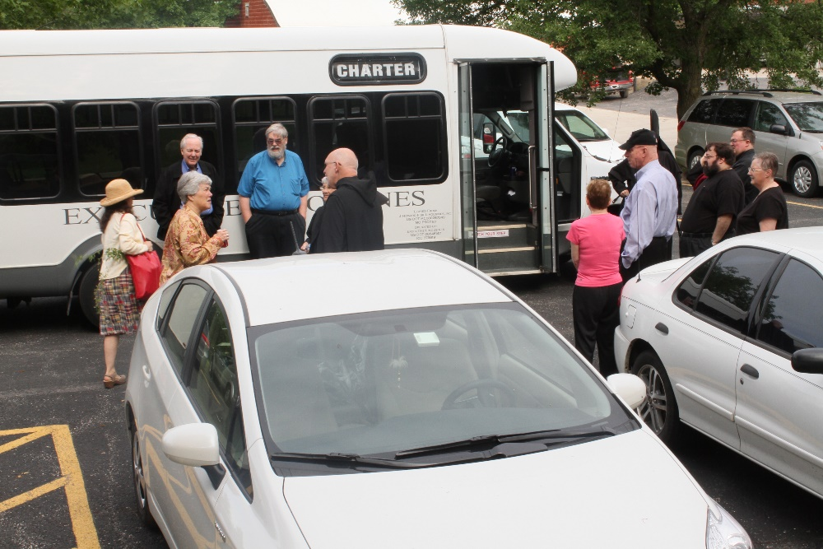
Catherine Ballinger; Sr. Toni Sylvester; Br. Lee Doucette; Br. David Gerns; Sr. Mary Francis Deulen; Br. Peter DeFranco; Sr. Monica Ruth Mullen; Abbot Robert Cotton; Sr. Helena Barrett; Br. Anselm King-Lowe; Br. Victor Bullock; Sr. Kate Maxwell

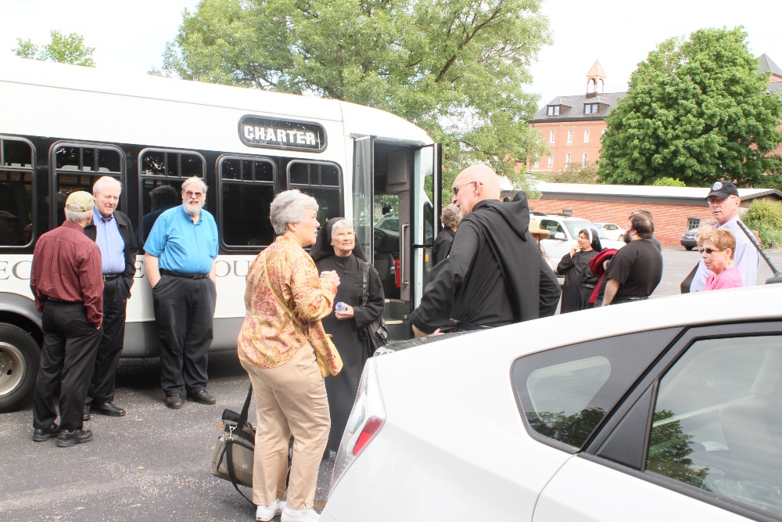
Br. Steven Joseph Olderr; Br. Lee Doucette; Br. David Gerns; Sr. Toni Sylvester; Sr. Mary Francis Deulen; Br. Anskar Nonken; Br. Peter DeFranco; Sr. Alison Whybrow; Br. Anselm King-Lowe; Sr. Kate Maxwell; Sr. Monica Ruth Mullen; Abbot Robert Cotton

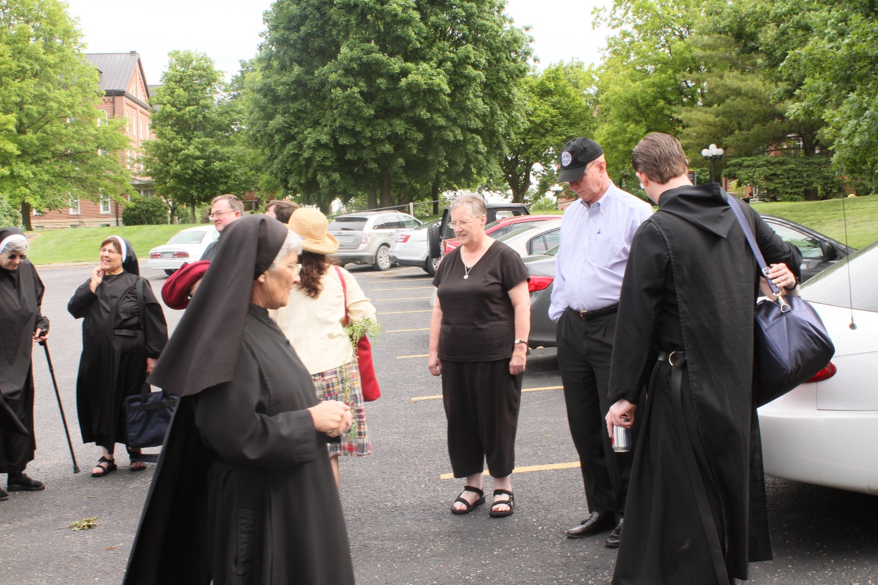
Sr. Helena Barrett; Sr. Alison Joy Whybrow; Br. Victor Bullock; Sr. Mary Francis Deulen; Catherine Ballinger; Sr. Kate Maxwell; Abbot Robert Cotton; Br. Kenneth Maguire
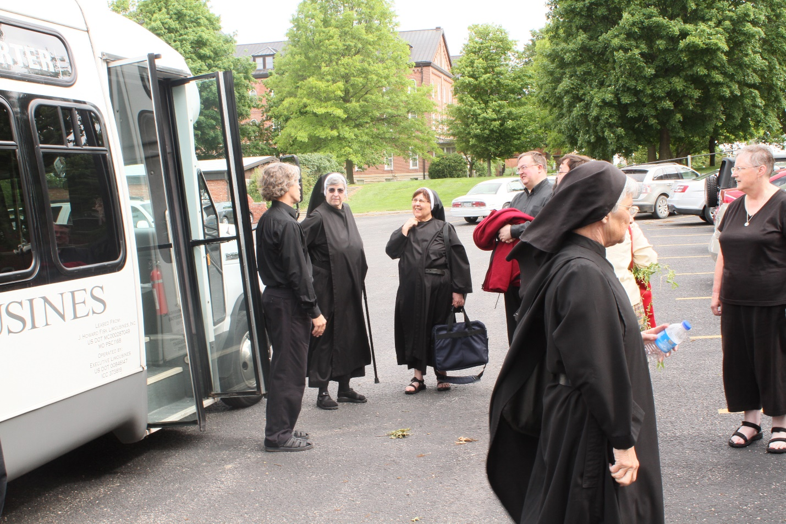
Br. Anskar Nonken; Sr. Helena Barrett; Sr. Alison Joy Whybrow; Br. Victor Bullock; Sr. Mary Francis Deulen Sr. Kate Maxwell

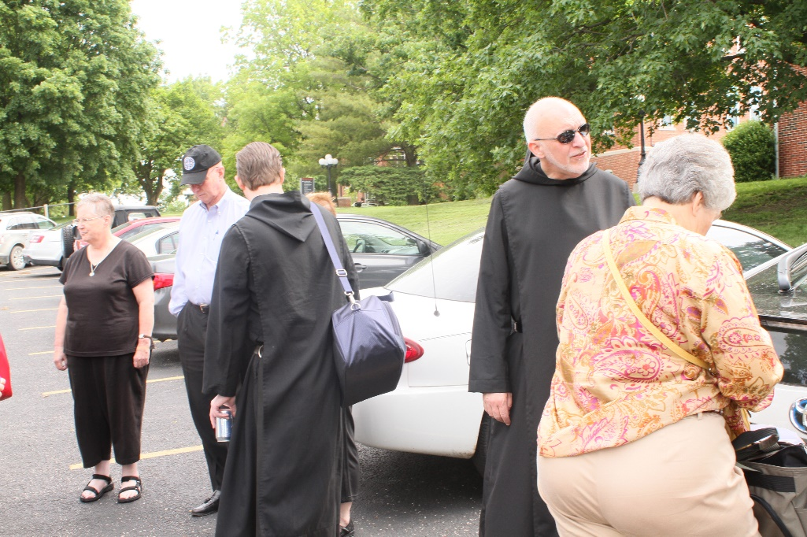
Sr. Kate Maxwell; Abbot Robert Cotton; Br. Kenneth Maguire; Br. Peter DeFranco; Sr. Toni Sylvester
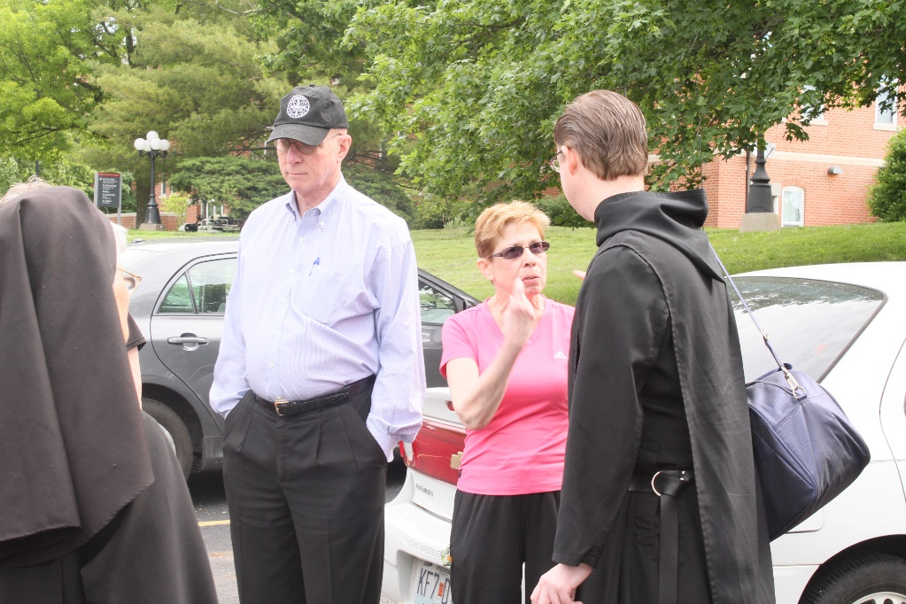
Sr. Mary Francis Deulen; Abbot Robert Cotton; Sr. Monica Ruth Mullen; Br. Kenneth Maguire

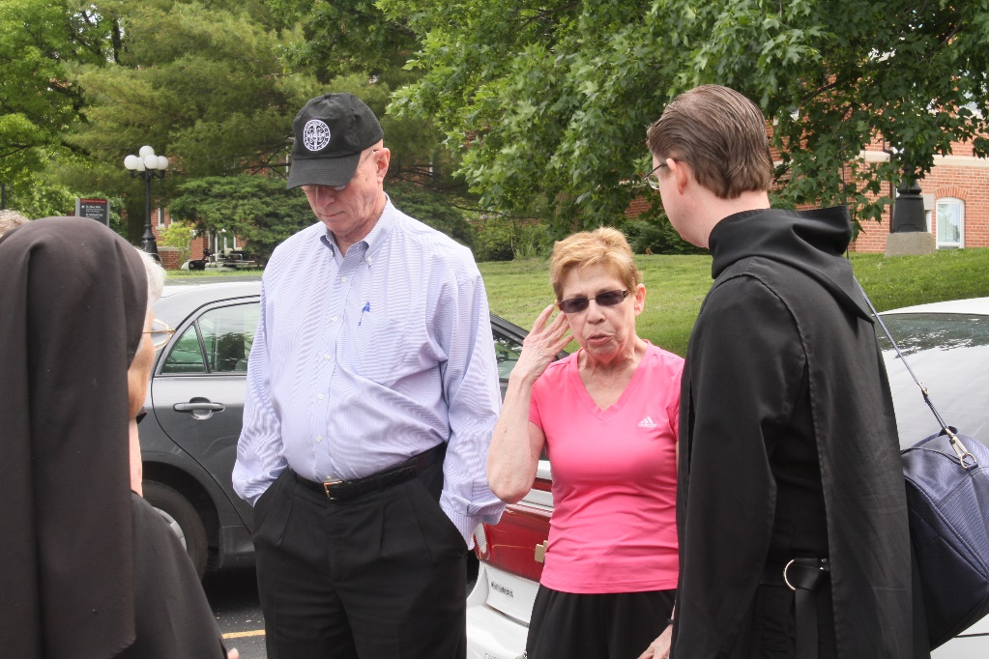
Sr. Mary Francis Deulen; Abbot Robert Cotton; Sr. Monica Ruth Mullen; Br. Kenneth Maguire

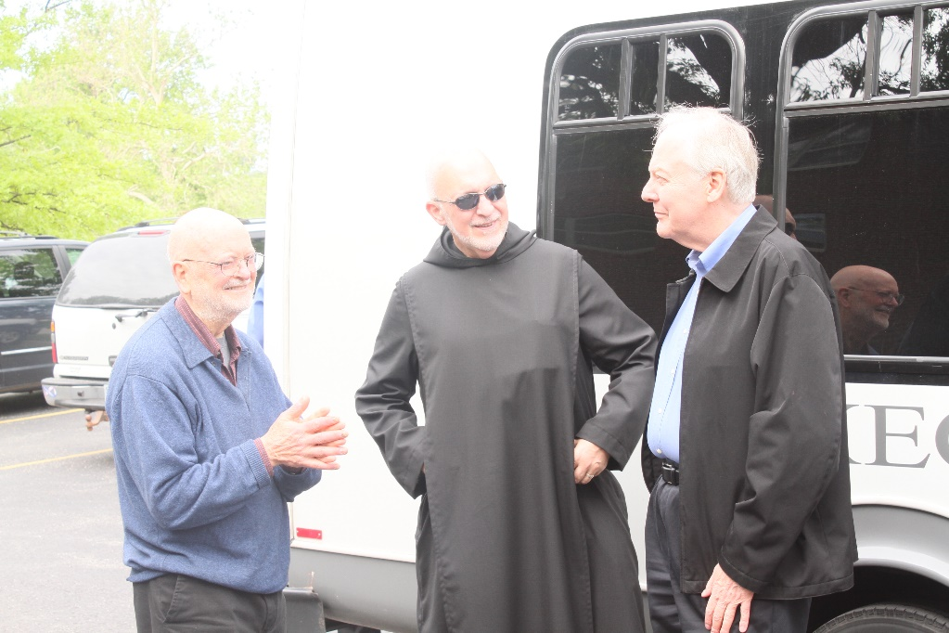
Br. Thomas Anthony Goddard; Br. Peter DeFranco; Br. Lee Doucette

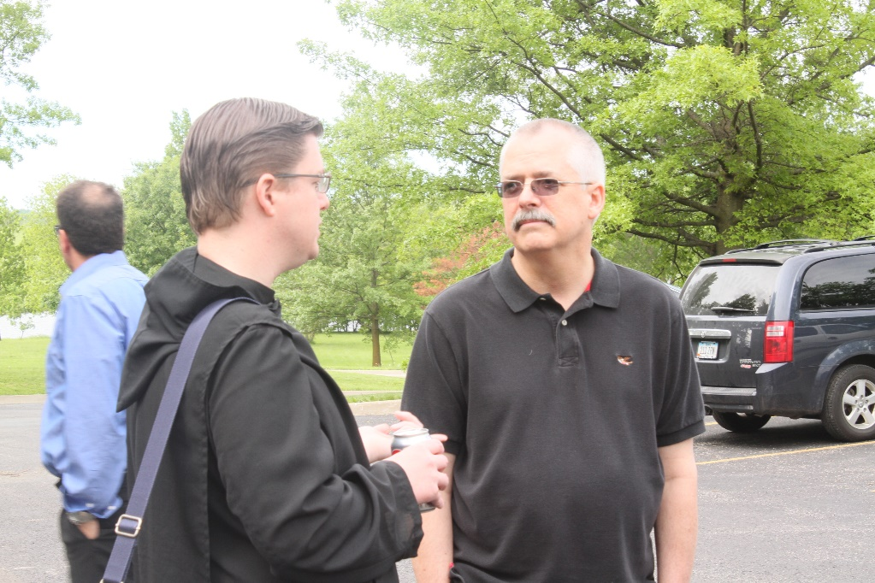
Bus driver; Br. Kenneth Maguire; Br. Dunstan Townsend

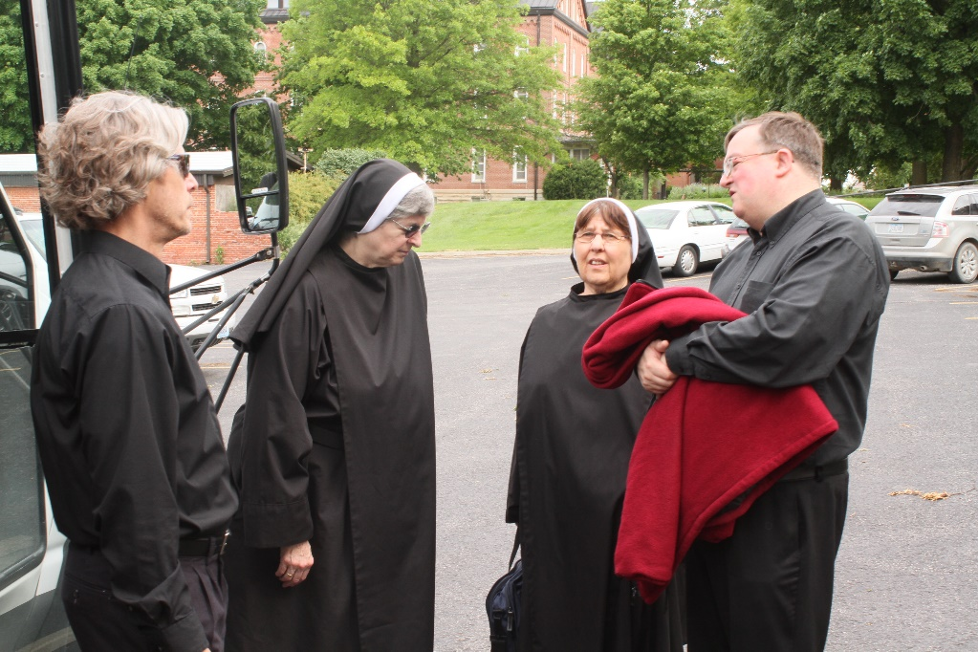
Br. Anskar Nonken; Sr. Helena Barrett; Sr. Alison Whybrow; Br. Victor Bullock

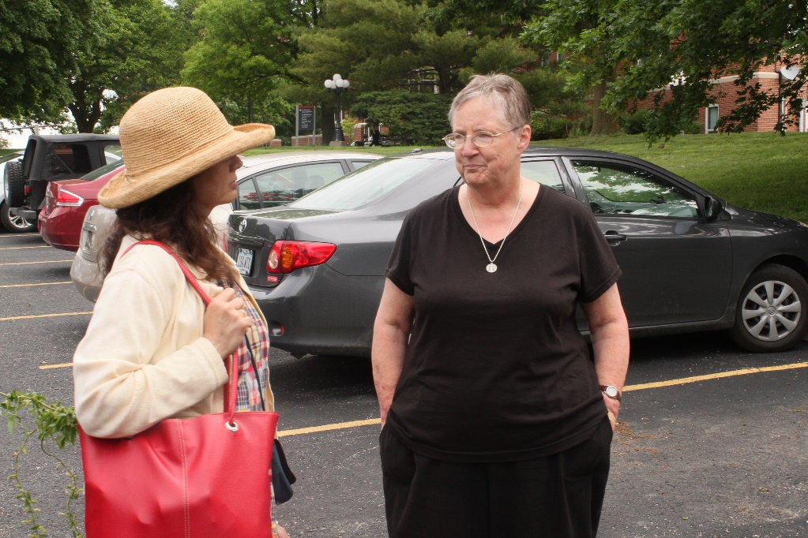
Catherine Ballinger; Sr. Kate Maxwell

