Companions of St. Luke
Spring Convocation at Conception Abbey
May 31, 2013
Photographed by Sr. Brigid Gerns

People are identified from left to right.

Edited by Br. Steven Olderr, 3 April 2023. Please send any comments, corrections, or additions to olderr@ameritech.net

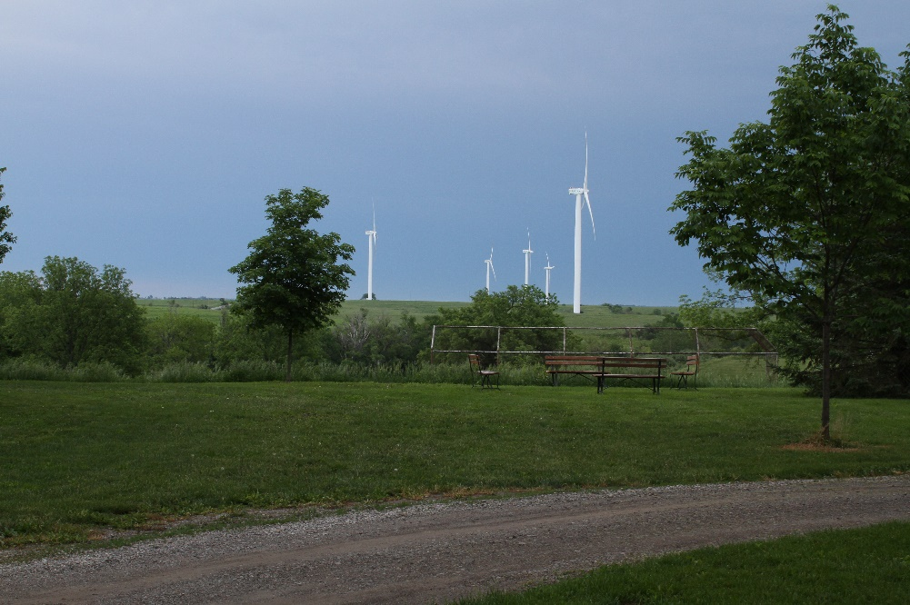





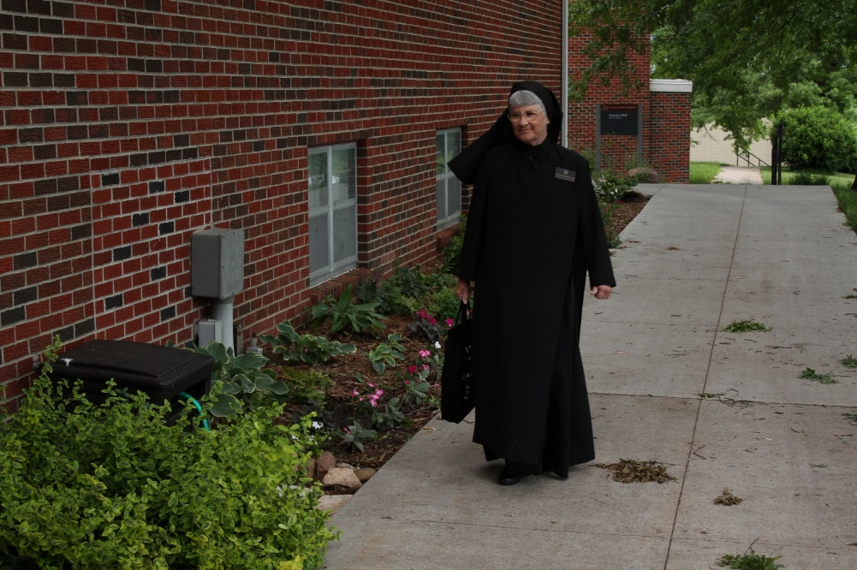
Sr. Mary Francis Deulen
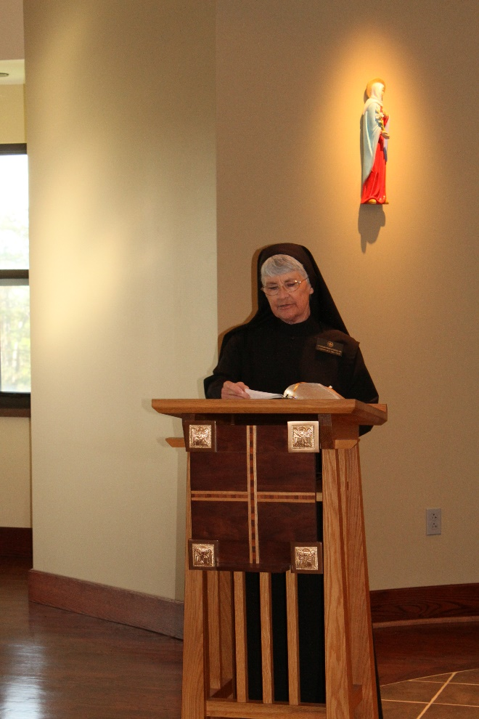
Sr. Mary Francis Deulen

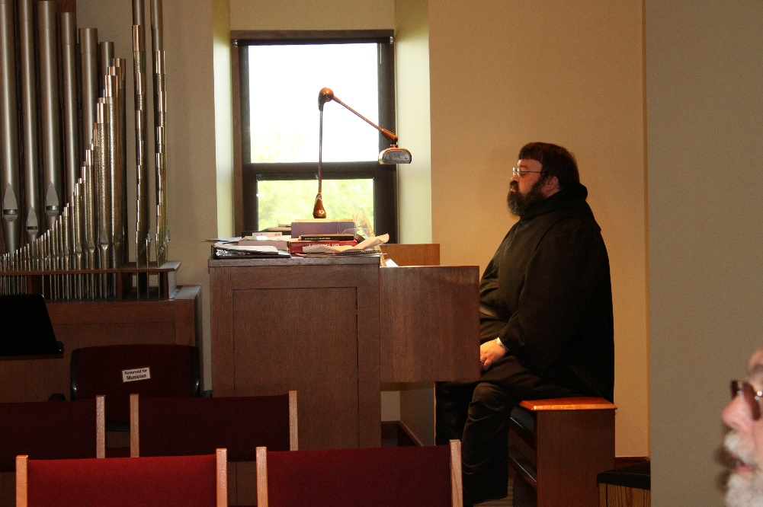
Br. Anselm King-Lowe; Br. David Gerns

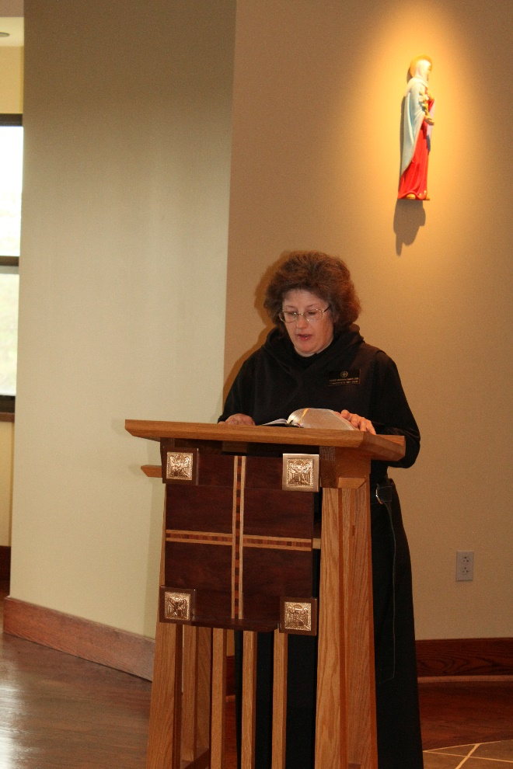
Sr. Martha Lamoy

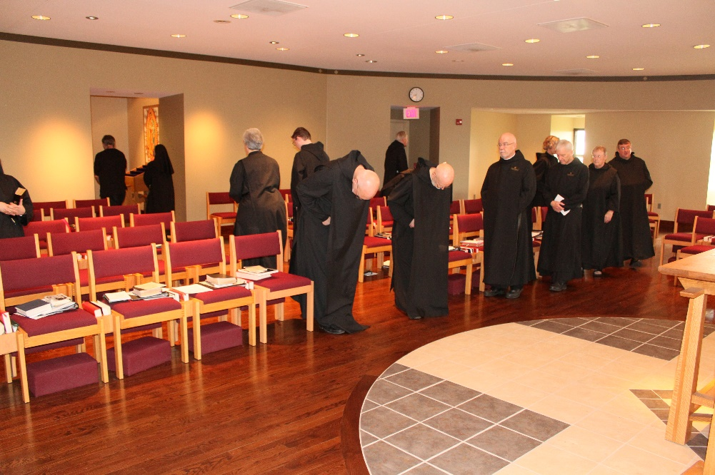
James Davies; Sr. Mary Francis Deulen; Sr. Toni Sylvester; Br. Kenneth Maguire; Br. Pete DeFranco; Br. Lee Doucette; Br. Thomas Anthony Goddard; Br. Basil Edwards; Br. Anskar Nonken; Br. Steven Joseph Olderr; Sr. Kate Maxwell; Br. Victor Bullock
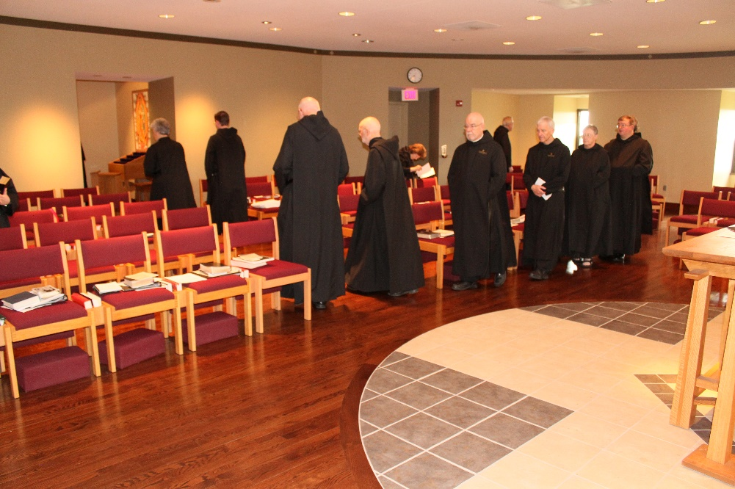
Sr. Toni Sylvester; Br. Kenneth Maguire; Br. Pete DeFranco; Br. Thomas Anthony Goddard; Sr. Martha Lamoy; Br. Basil Edwards; Br. Lee Doucette; Br. Steven Joseph Olderr; Sr. Kate Maxwell; Br. Victor Bullock

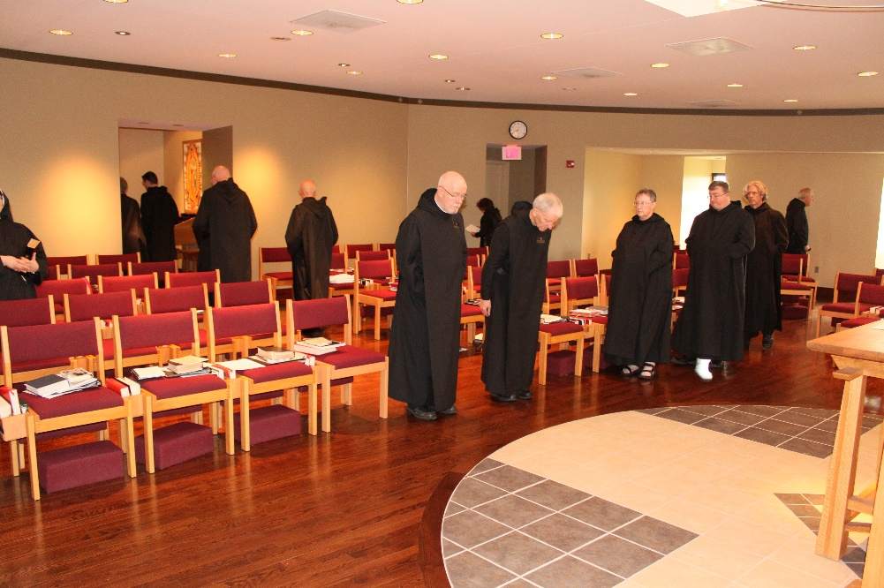
Sr. Alison Joy Whybrow; Br. Kenneth Maguire; Br. Pete DeFranco; Br. Thomas Anthony Goddard; Br. Basil Edwards; Sr. Martha Lamoy; Br. Steven Joseph Olderr; Sr. Kate Maxwell; Br. Victor Bullock; Br. Anskar Nonken; Br. Lee Doucette
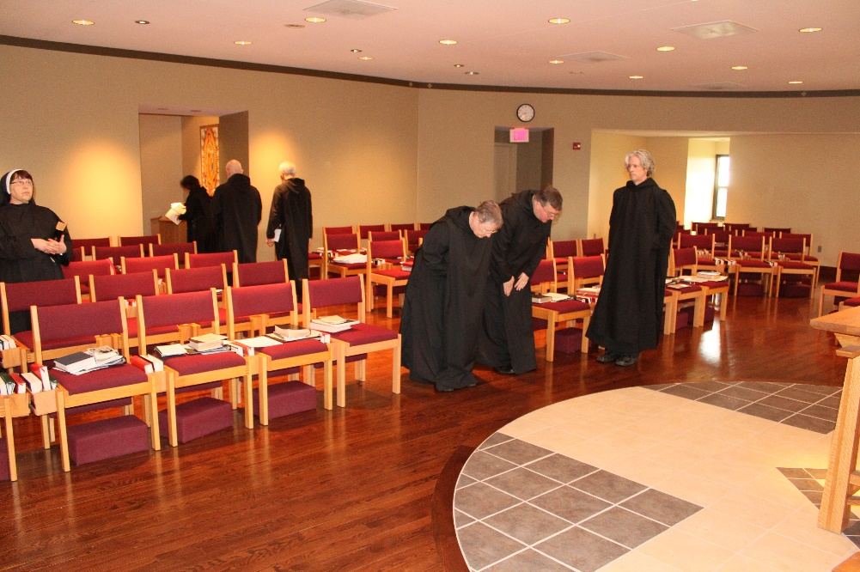
Sr. Alison Joy Whybrow; Sr. Martha Lamoy; Br. Basil Edwards; Br. Steven Joseph Olderr; Sr. Kate Maxwell; Br. Victor Bullock; Br. Anskar Nonken

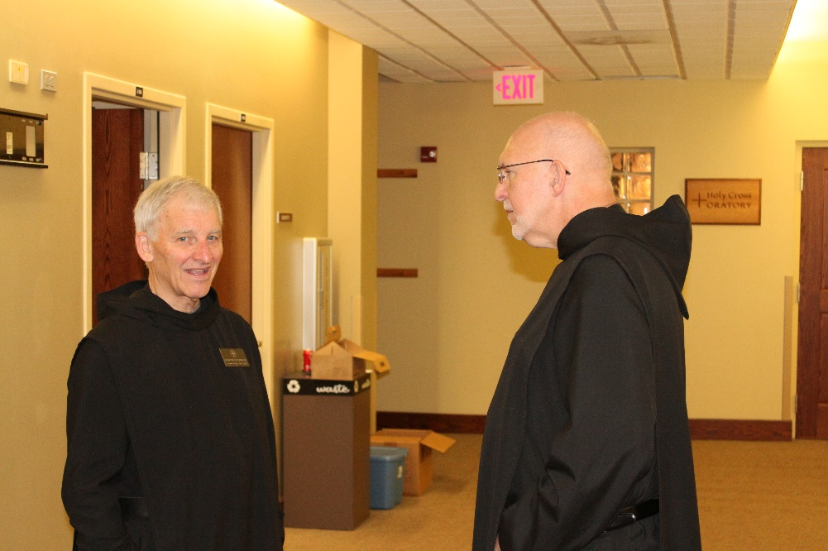
Br. Steven Joseph Olderr; Br. Peter DeFranco
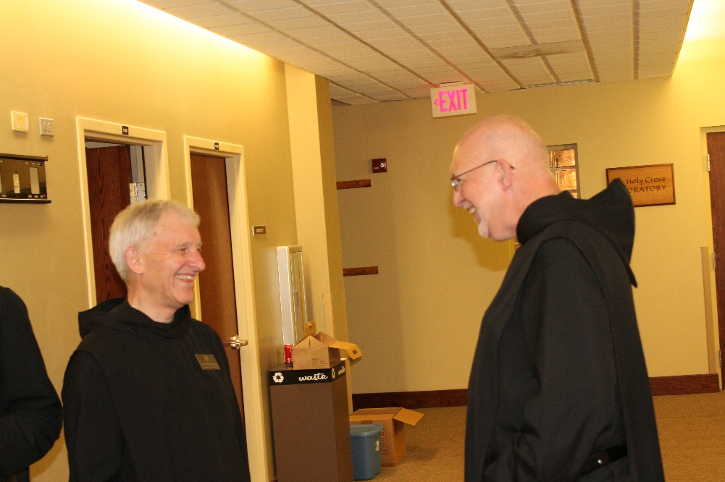
Br. Steven Joseph Olderr; Br. Peter DeFranco

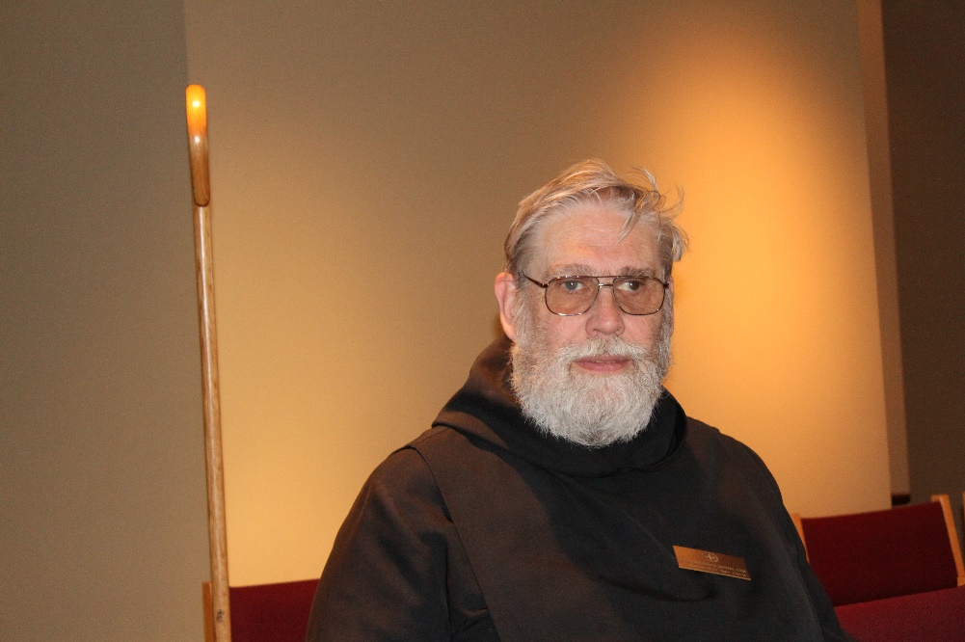
Br. David Gerns
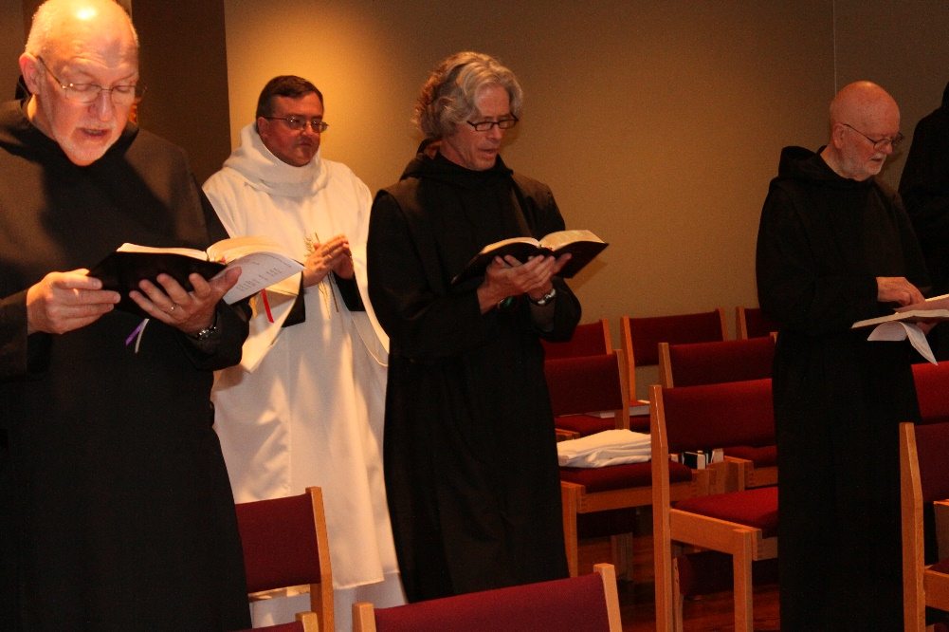
Br. Peter DeFranco; Br. Victor Bullock; Br. Anskar Nonken; Br. Thomas Anthony Goddard

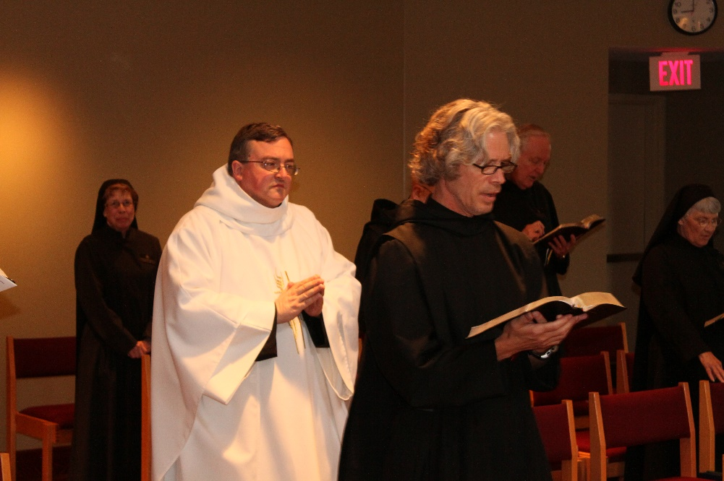
Sr. Monica Ruth Mullen; Br. Victor Bullock; Br. Anskar Nonken; Br. Lee Doucette; Sr. Mary Francis Deulen

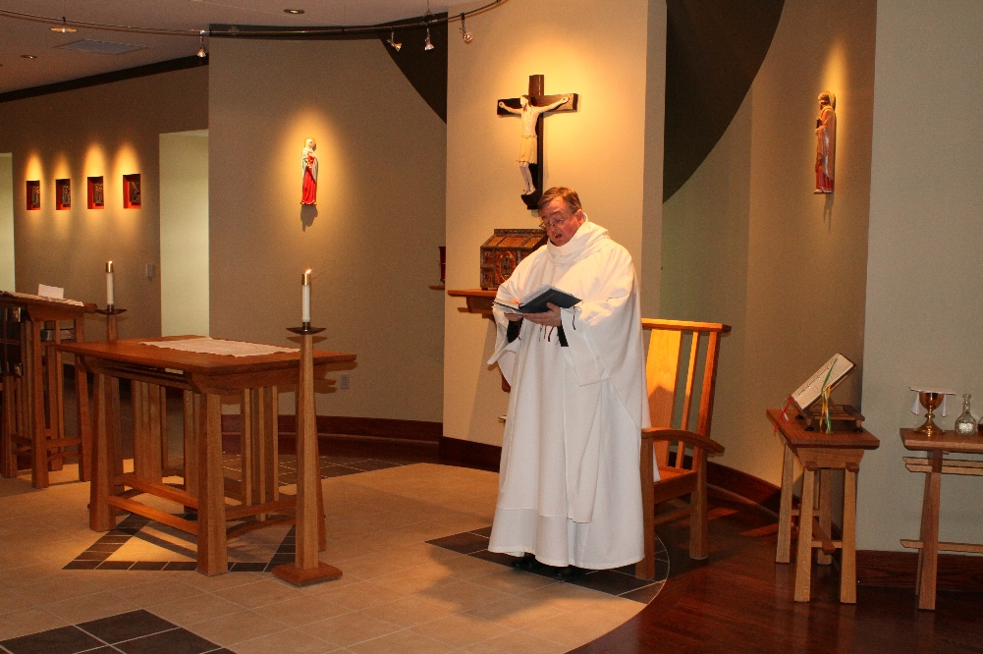
Br. Victor Bullock

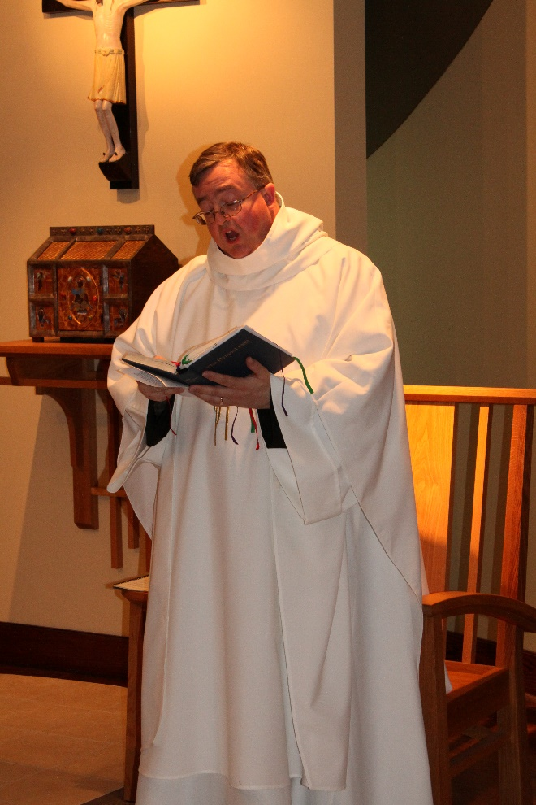
Br. Victor Bullock

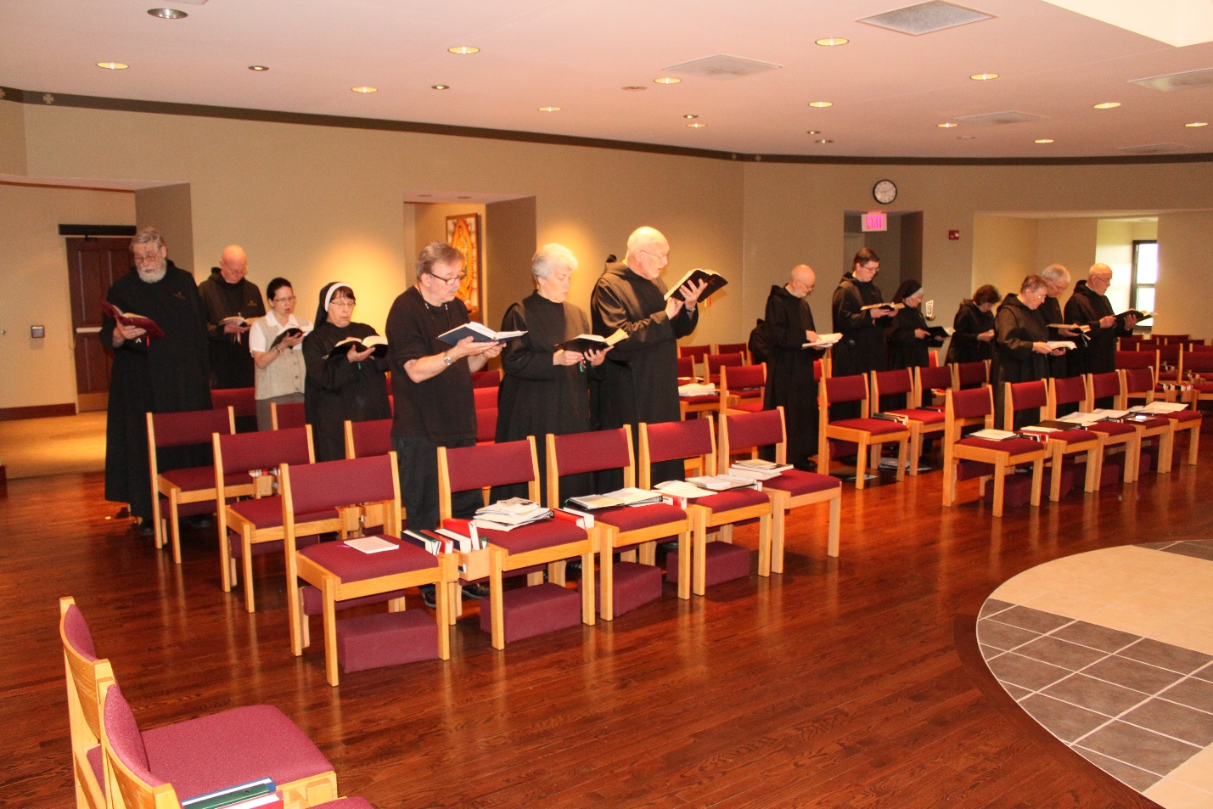
Br. David Gerns; Abbot Robert Cotton; Catherine Ballinger; Sr. Alison Joy Whybrow; James Davies; Sr. Toni Sylvester; Br. Peter DeFranco; Br. Kenneth Maguire; Sr. Mary Francis Deulen; Sr. Martha Maguire; Sr. Kate Maxwell; Br. Steven Joseph Olderr; Br. Basil Edwards

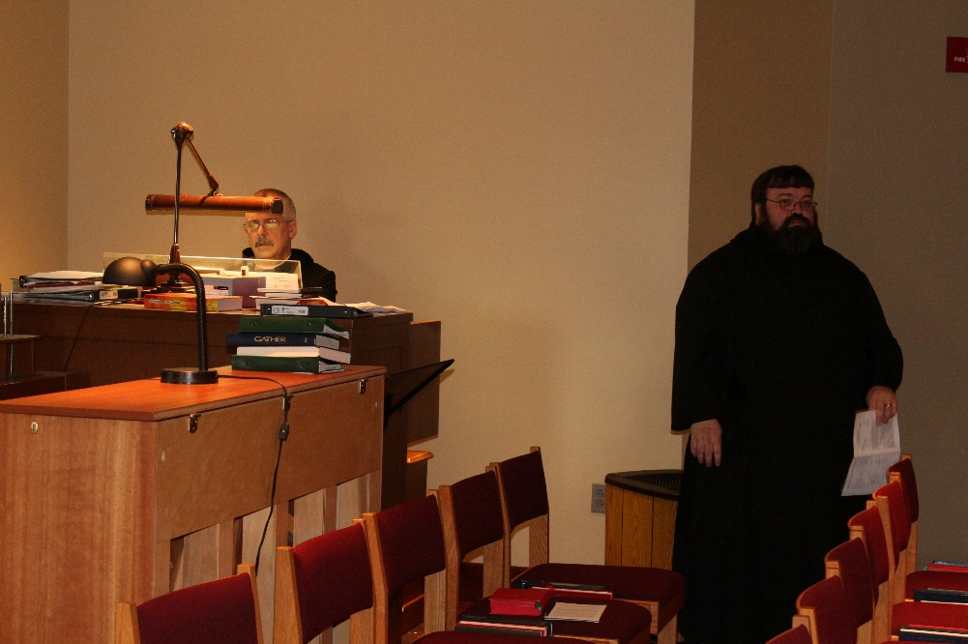
Br. Anselm King-Lowe
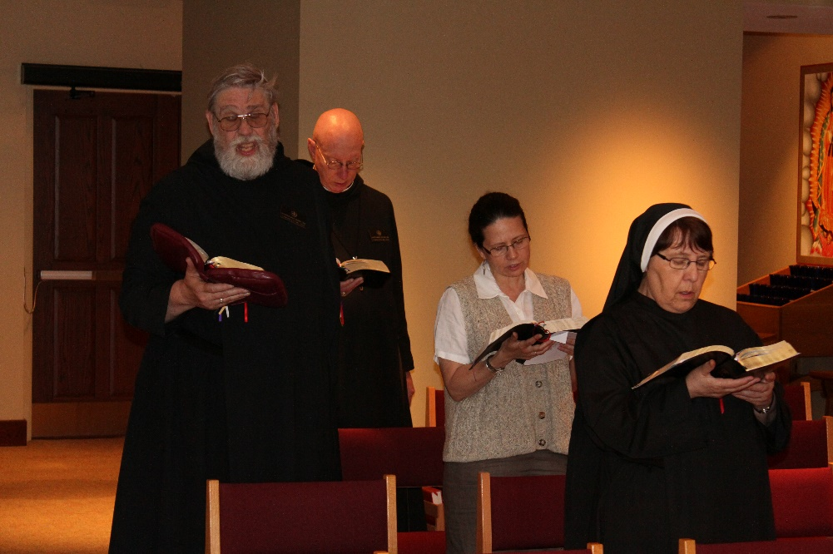
Br. David Gerns; Abbot Robert Cotton; Catherine Ballinger; Sr. Alison Joy Whybrow

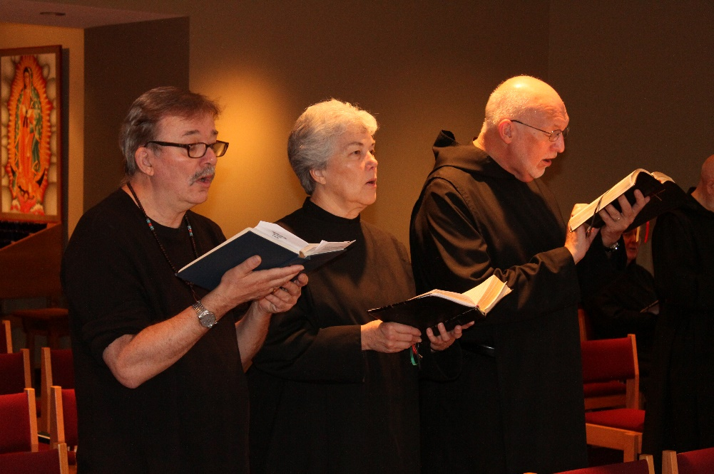
James Davies; Sr. Toni Sylvester; Br. Peter DeFranco
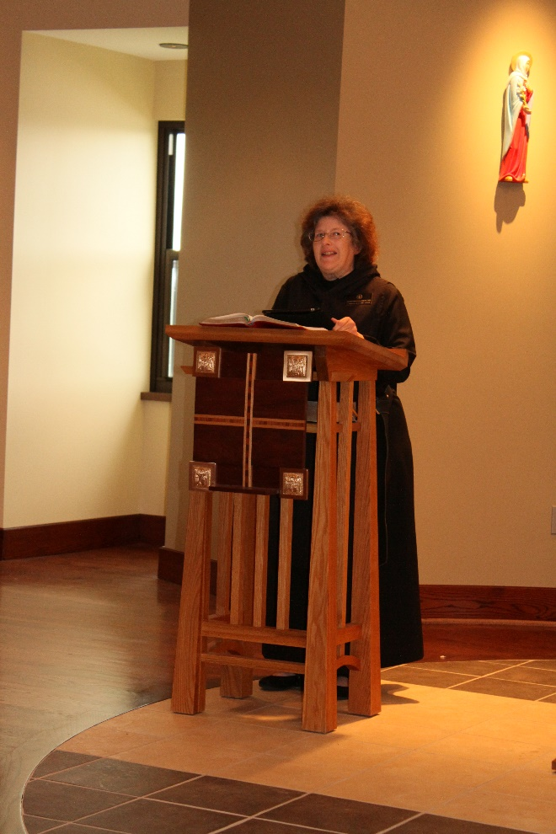
Sr. Martha Lamoy
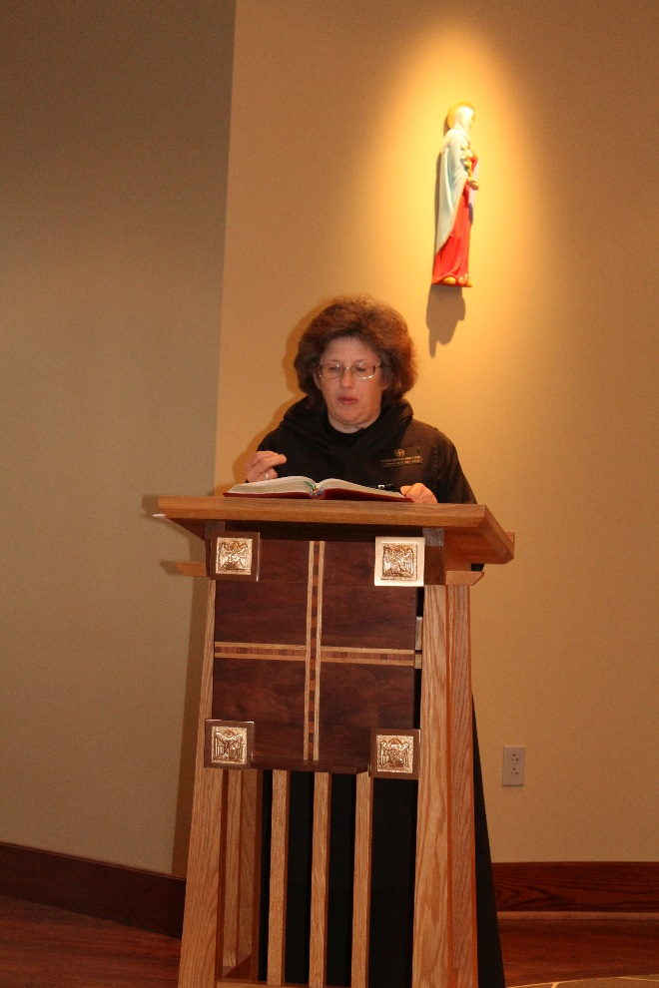
Sr. Martha Lamoy

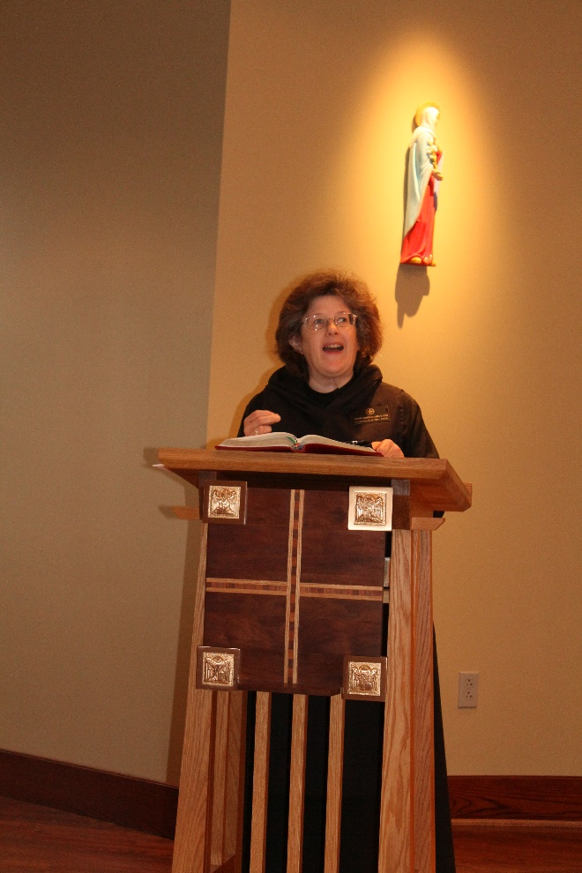
Sr. Martha Lamoy

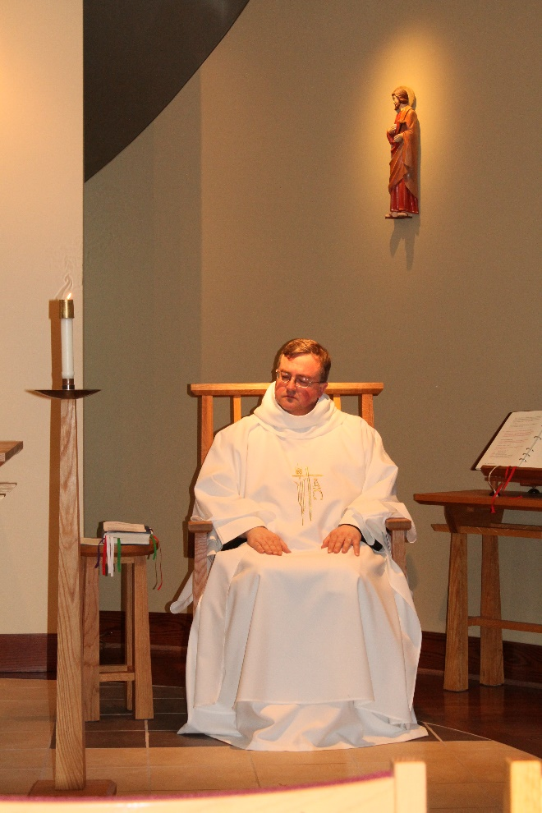
Br. Victor Bullock

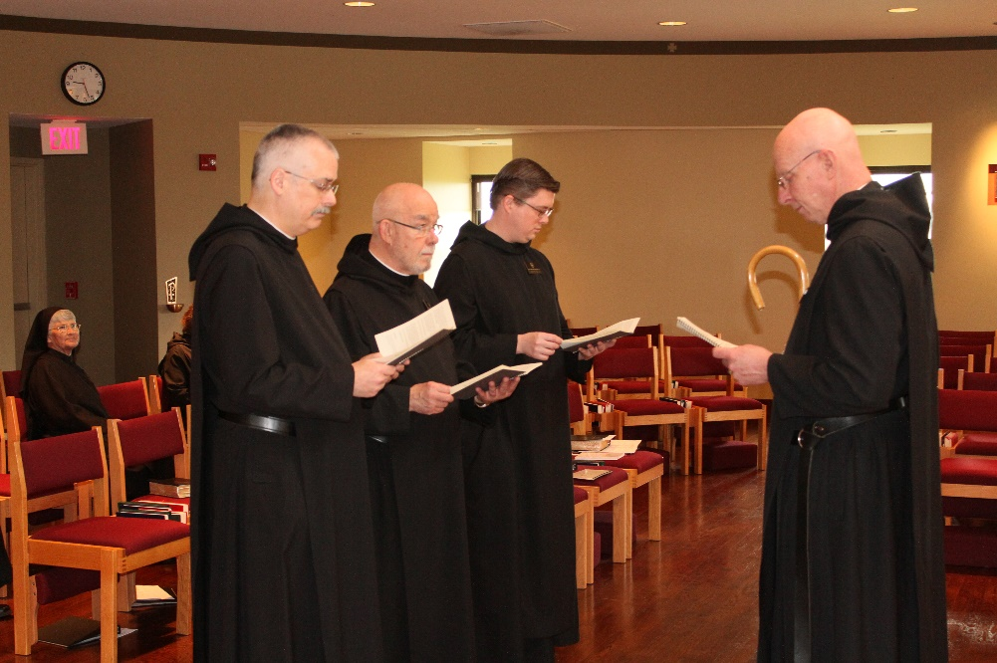
Sr. Mary Francis Deulen; Sr. Martha Lamoy; Br. Dunstan Townsend; Br. Basil Edwards; Br. Kenneth Maguire; Abbot Robert Cotton
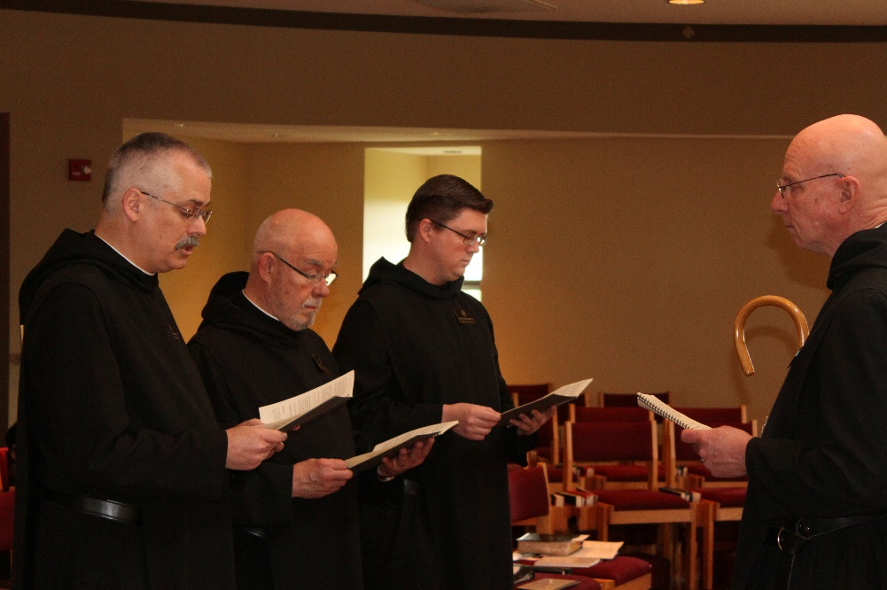
Br. Dunstan Townsend; Br. Basil Edwards; Br. Kenneth Maguire; Abbot Robert Cotton

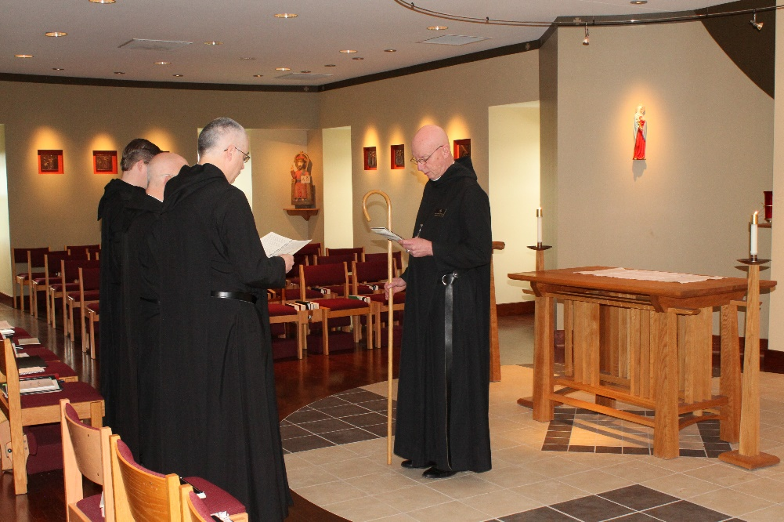
Br. Kenneth Maguire; Br. Basil Edwards; Br. Dunstan Townsend; Br. Robert Cotton
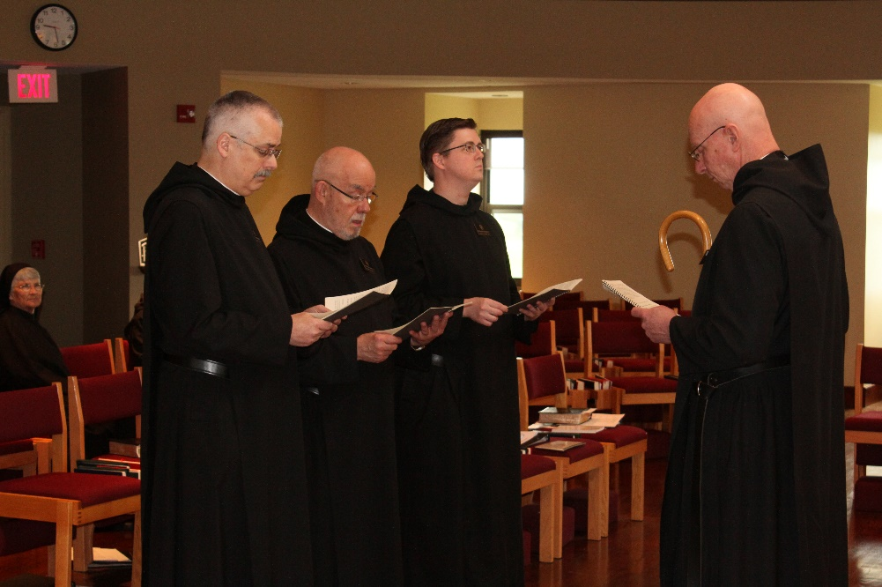
Sr. Mary Francis Deulen; Br. Dunstan Townsend; Br. Basil Edwards; Br. Kenneth Maguire; Abbot Robert Cotton

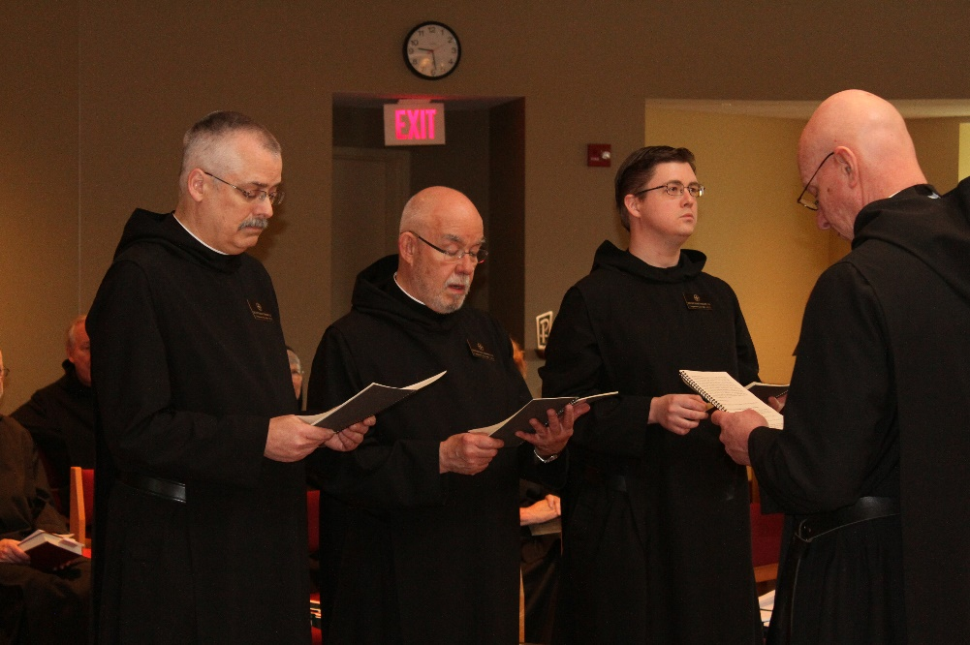
Br. Lee Doucette; Br. Dunstan Townsend; Sr. Mary Francis Deulen; Br. Basil Edwards; Br. Kenneth Maguire; Abbot Robert Cotton

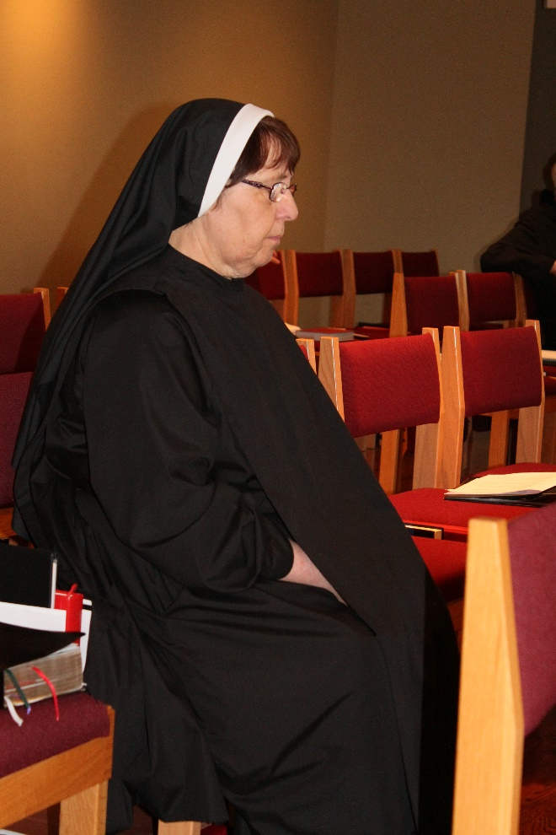
Sr. Alison Joy Whybrow
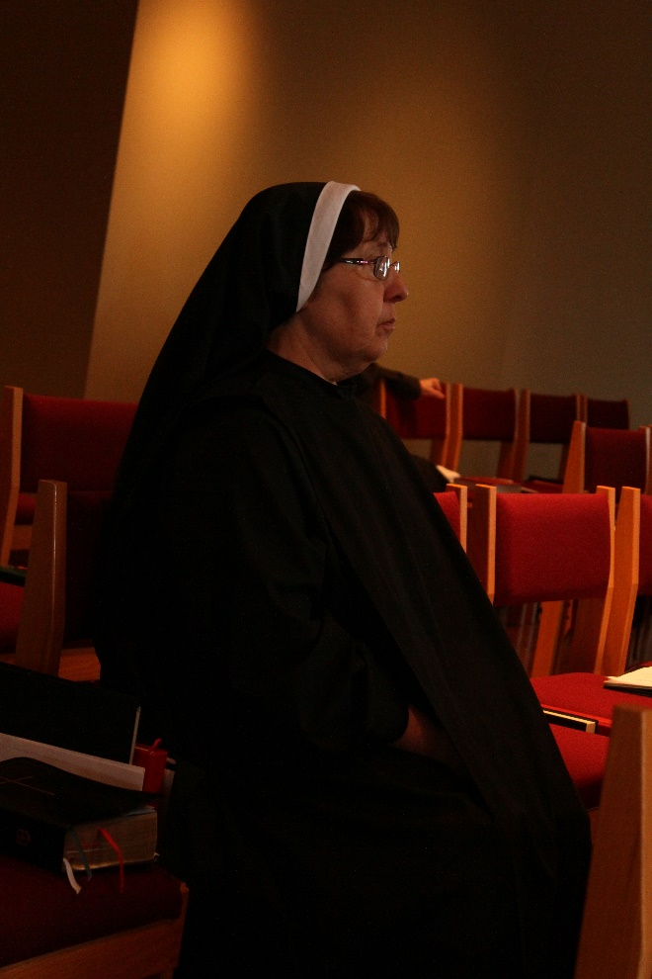
Sr. Alison Joy Whybrow

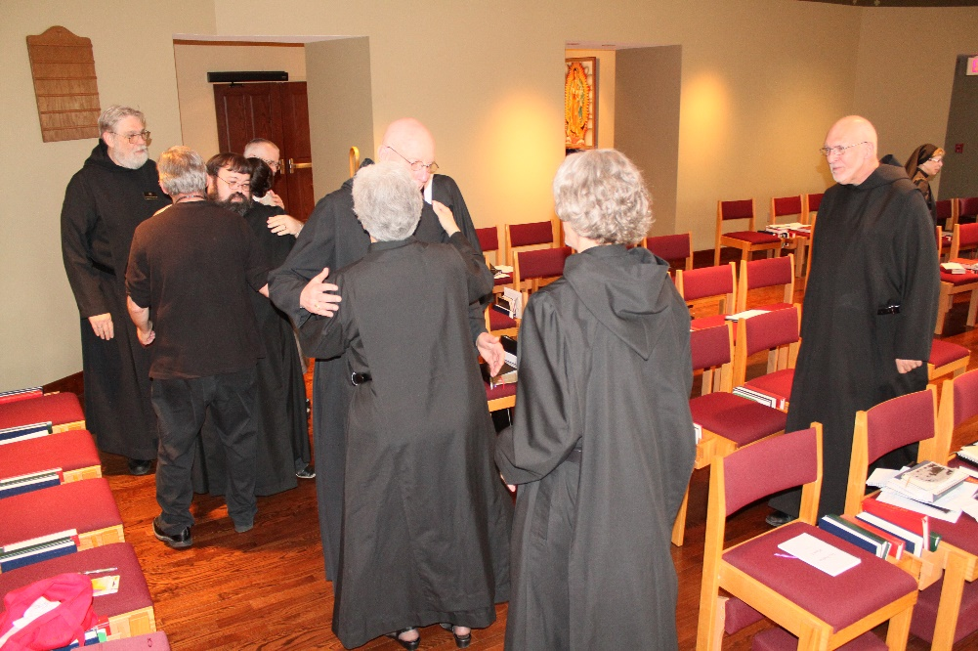
Br. David Gerns; James Davies; Br. Anselm King-Lowe; Sr. Toni Sylvester; Abbot Robert Cotton; Br. Anskar Nonken; Br. Peter DeFranco; Sr. Monica Ruth Mullen
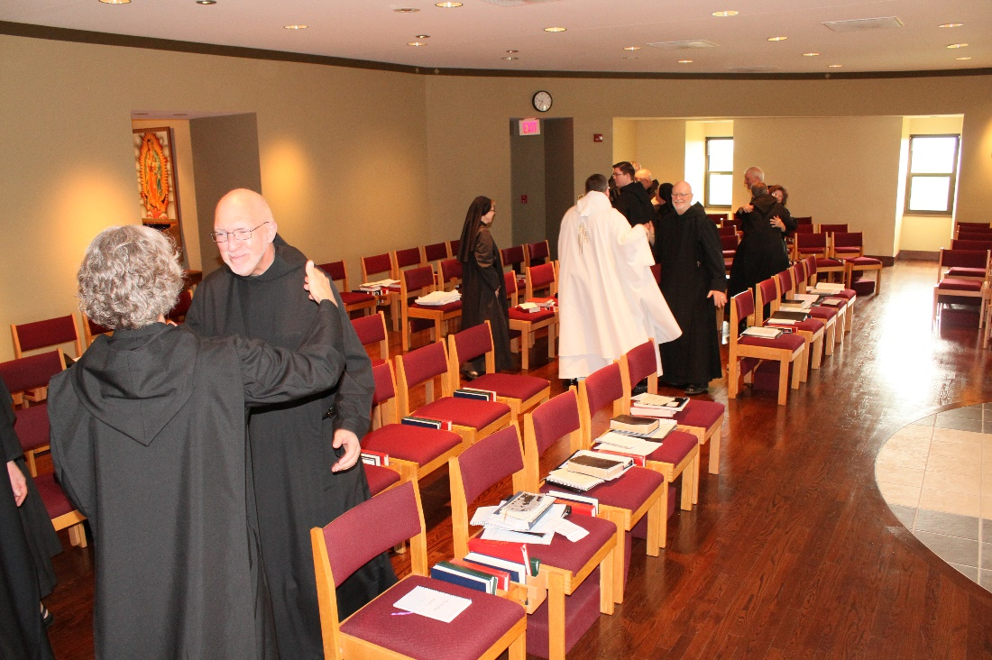
Br. Anskar Nonken; Br. Peter DeFranco; Sr. Monica Ruth Mullen; Br. Victor Bullock; Br. Kenneth Maguire; Br. Thomas Anthony Goddard; Br. Steven Joseph Olderr; Sr. Kate Maxwell; Sr. Martha Lamoy

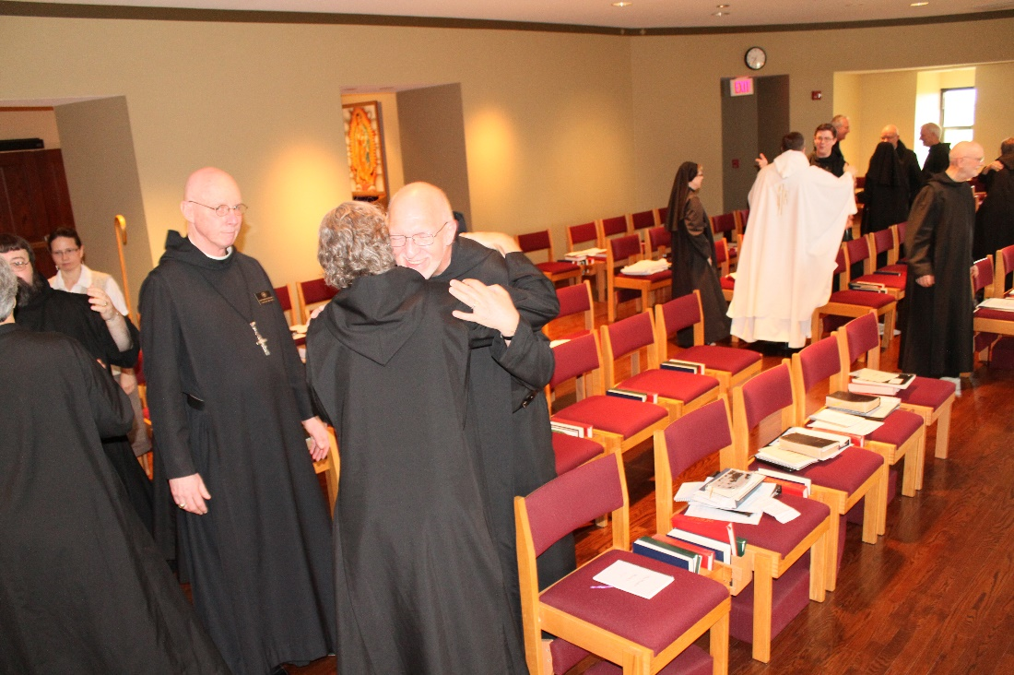
Sr. Toni Sylvester; Br. Anselm King-Lowe; Catherine Ballinger; Abbot Robert Cotton; Br. Anskar Nonken; Br. Peter DeFranco; Sr. Monica Ruth Mullen; Br. Victor Bullock; Br. Kenneth Maguire; Br. Steven Joseph Olderr; Br. Thomas Anthony Goddard
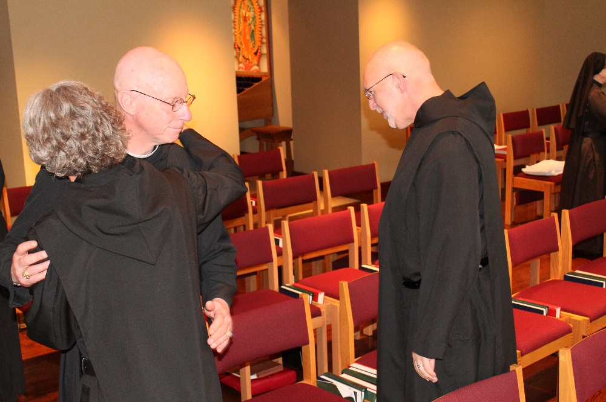
Br. Anskar Nonken; Abbot Robert Cotton; Br. Peter DeFranco; Sr. Monica Ruth Mullen

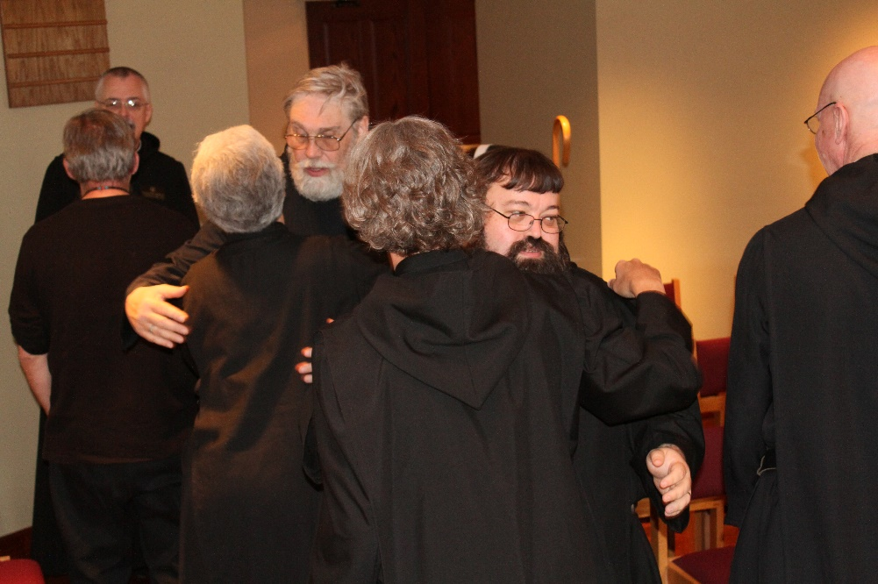
James Davies; Br. Dunstan Townsend; Br. Toni Sylvester; Br. David Gerns; Br. Anskar Nonken; Br. Anselm King-Lowe; Br. Peter DeFranco
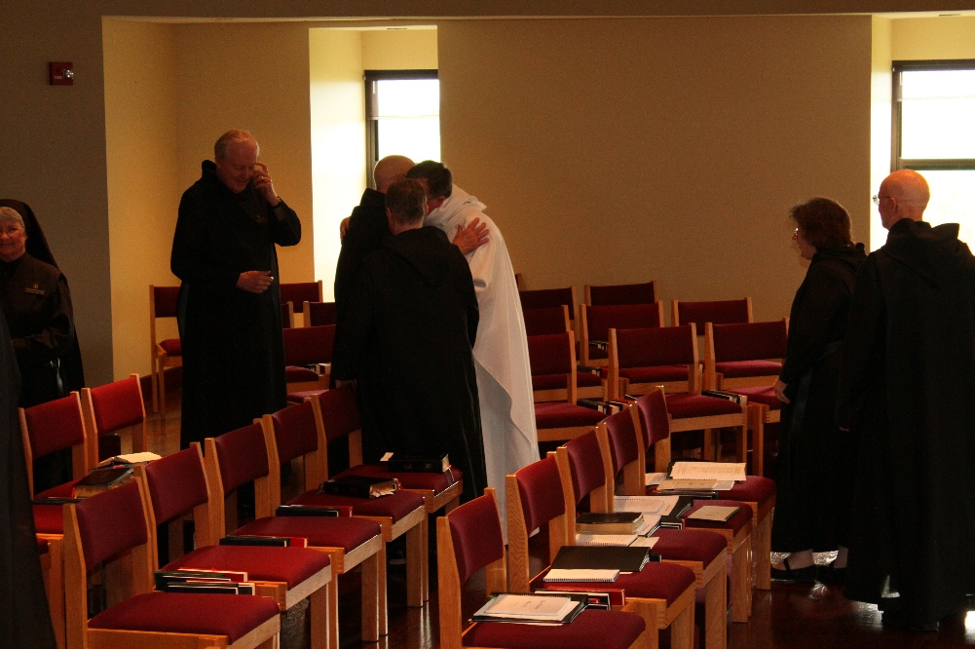
Sr. Mary Francis Deulen; Br. Lee Doucette; Br. Basil Edwards; Sr. Kate Maxwell; Br. Victor Bullock; Sr. Martha :Lamoy; Br. Stepehen Francis Arnold

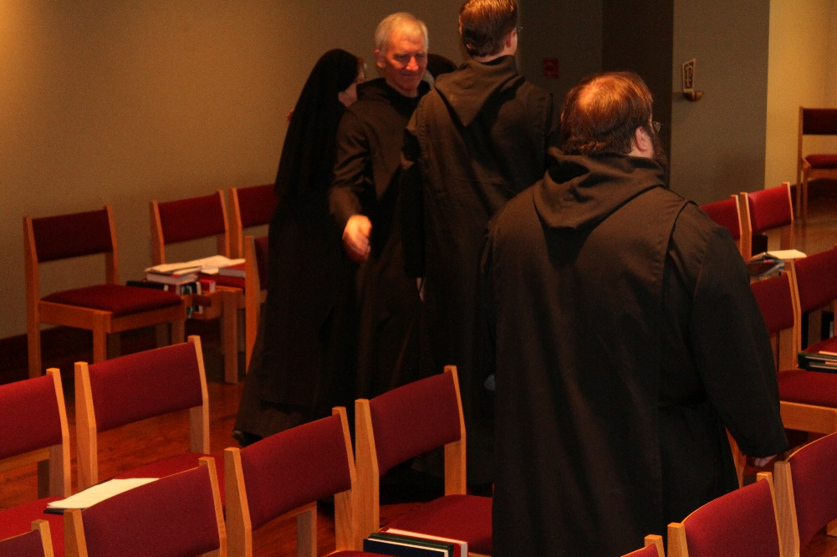
Sr. Monica Ruth Mullen; Br. Steven Joseph Olderr; Br. Kenneth Maguire; Br. Anselm King-Lowe
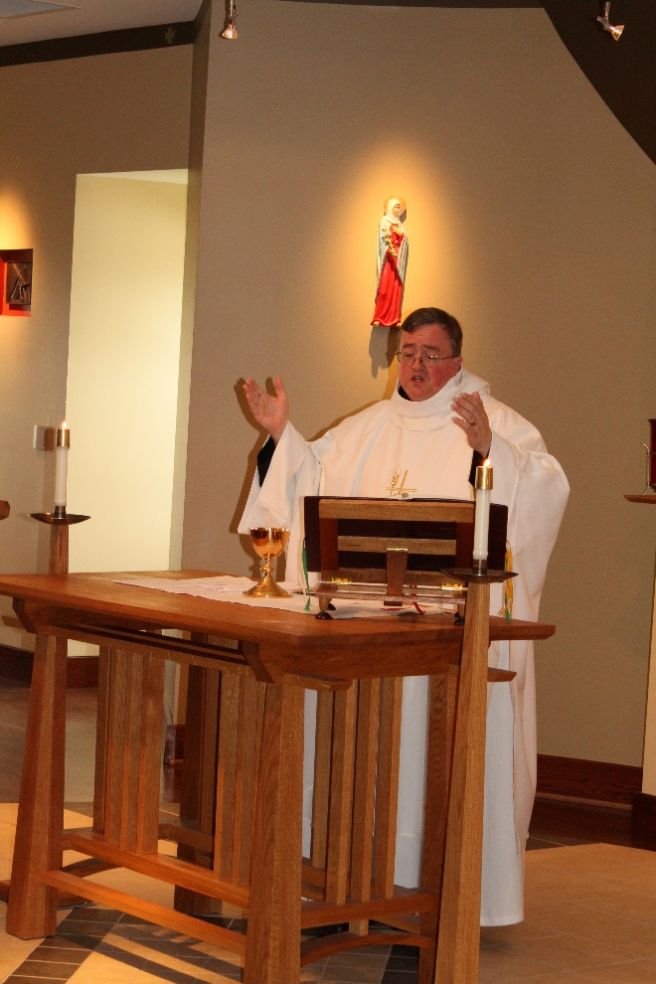
Br. Victor Bullock
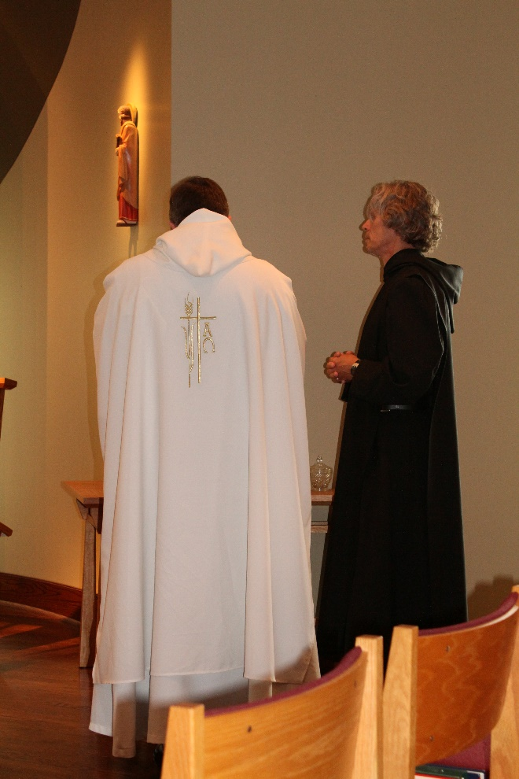
Br. Victor Bullock; Br. Anskar Nonken

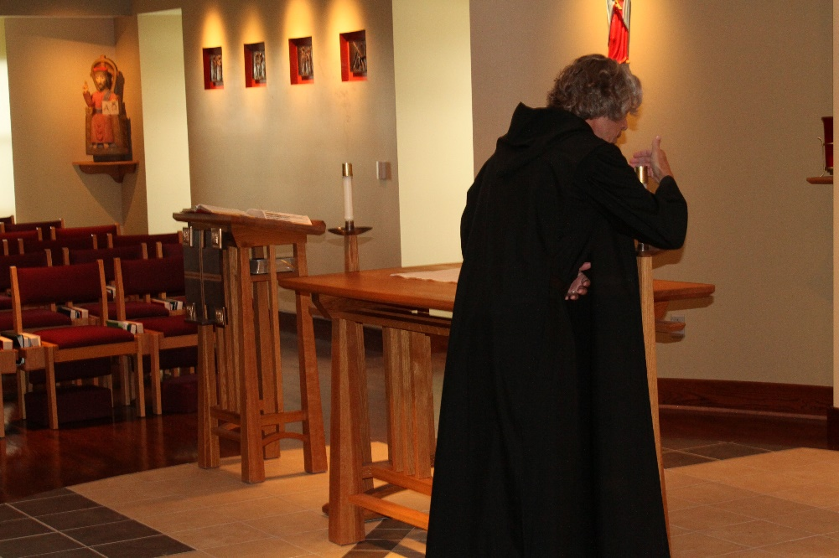

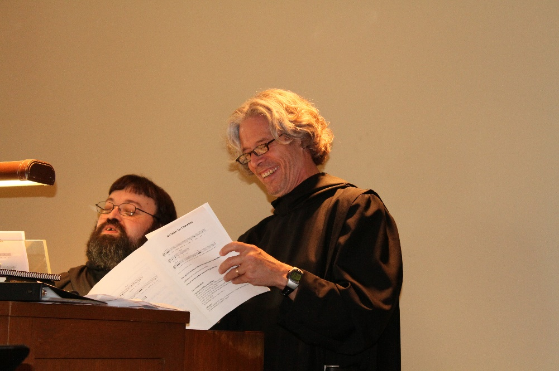
Br. Anselm King-Lowe; Br. Anskar Nonken

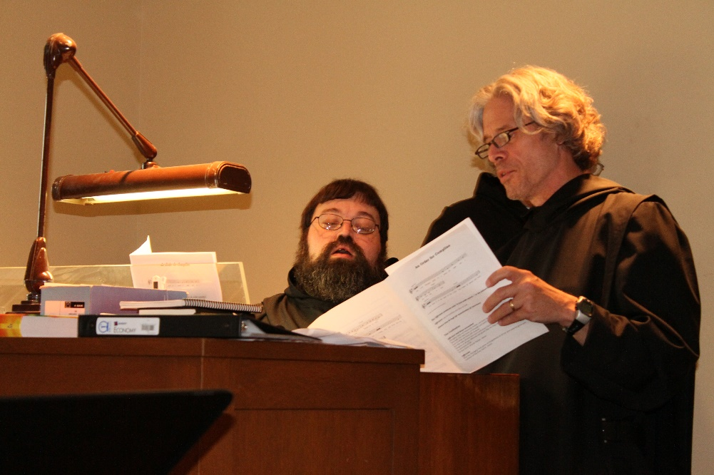
Br. Anselm King-Lowe; Br. Anskar Nonken

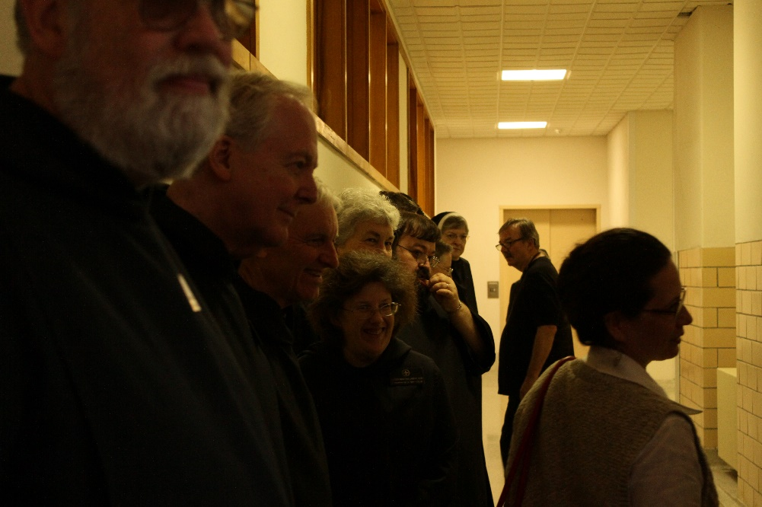
Br. David Gerns; Br. Lee Doucette; Br. Steven Joseph Olderr; Sr. Martha Lamoy; Sr. Toni Sylvester; Br. Anselm King-Lowe; Sr. Kate Maxwell; Sr. Helena Barrett; James Davies; Catherine Ballinger

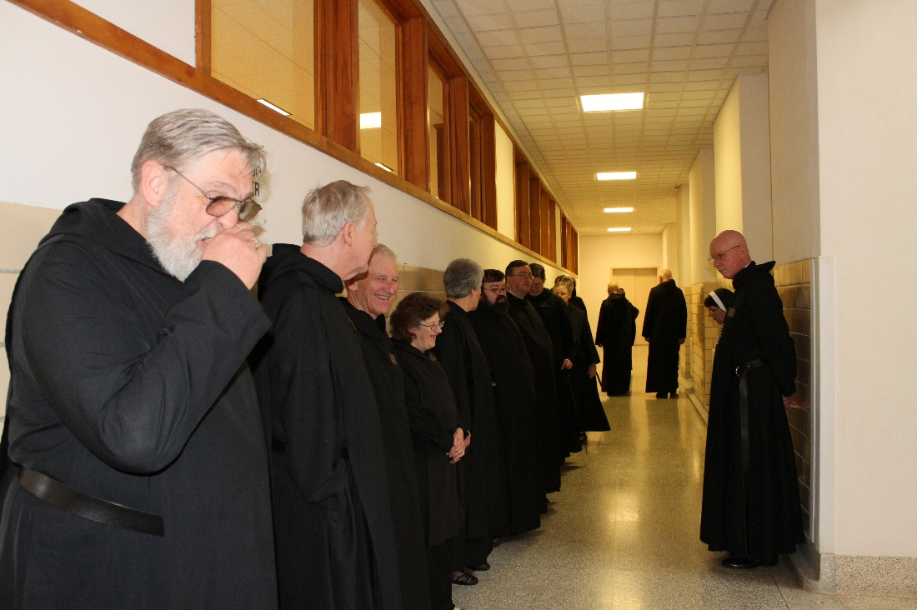
Br. David Gerns; Br. Lee Doucette; Br. Steven Joseph Olderr; Sr. Martha Lamoy; Sr. Toni Sylvester; Br. Anselm King-Lowe; Br. Victor Bullock; Br. Kenneth Maguire; Abbot Robert Cotton
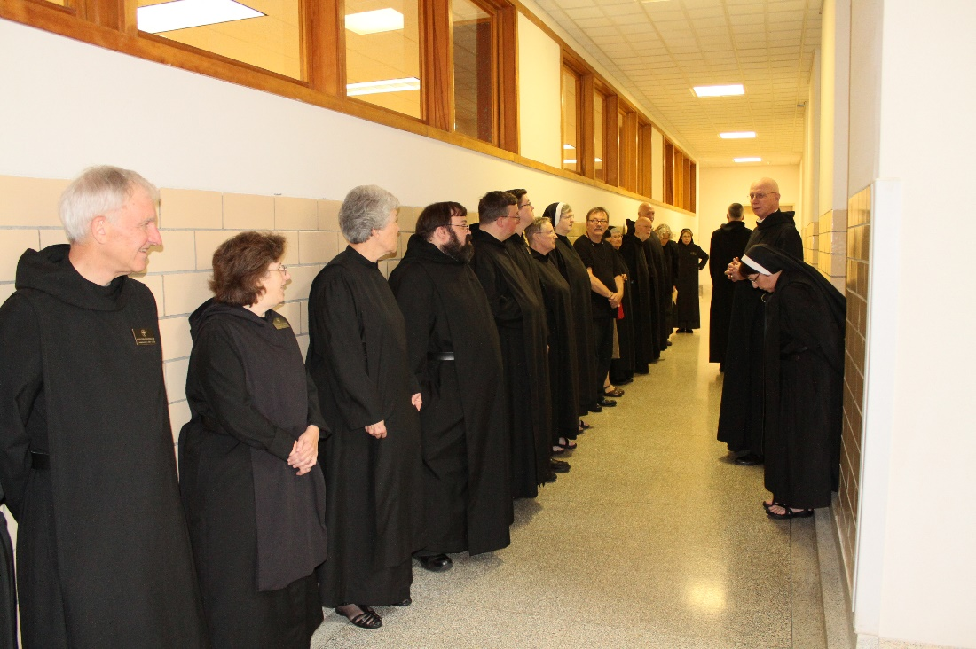
Br. Steven Joseph Olderr; Sr. Martha Lamoy; Sr. Toni Sylvester; Br. Anselm King-Lowe; Br. Victor Bullock; Br. Kenneth Maguire; Sr. Kate Maxwell; Sr. Helena Barrett; James Davies; ?; Br. Thomas Anthony Goddard; Br. Peter DeFranco; ?; Sr. Monica Ruth Mullen; Br. Dunstan Townsend; Sr. Alison Joy Whybrow; Abbot Robert Cotton

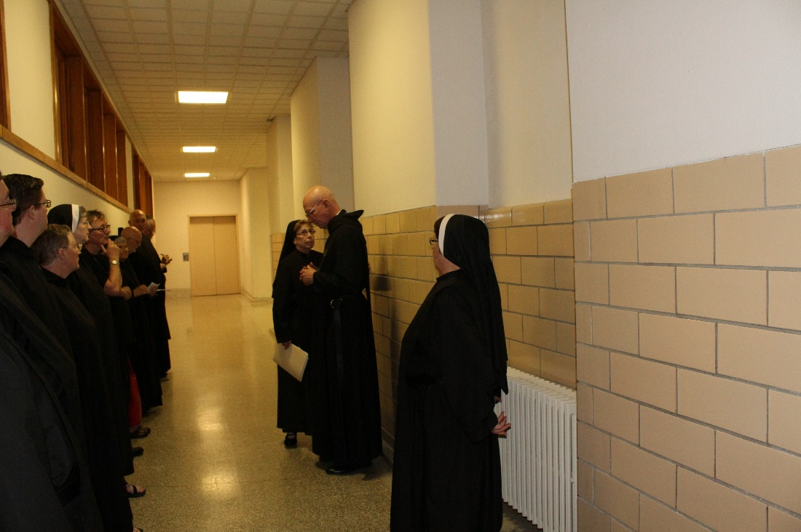
Br. Victor Bullock; Br. Kenneth Maguire; Sr. Kate Maxwell; Sr. Helena Barrett; James Davies; Sr. Mary Francis Deulen; Br. Thomas Anthony Goddard; Br. Peter DeFranco; ?; Sr. Monica Ruth Mullen; Abbot Robert Cotton; Sr. Alison Joy Whybrow

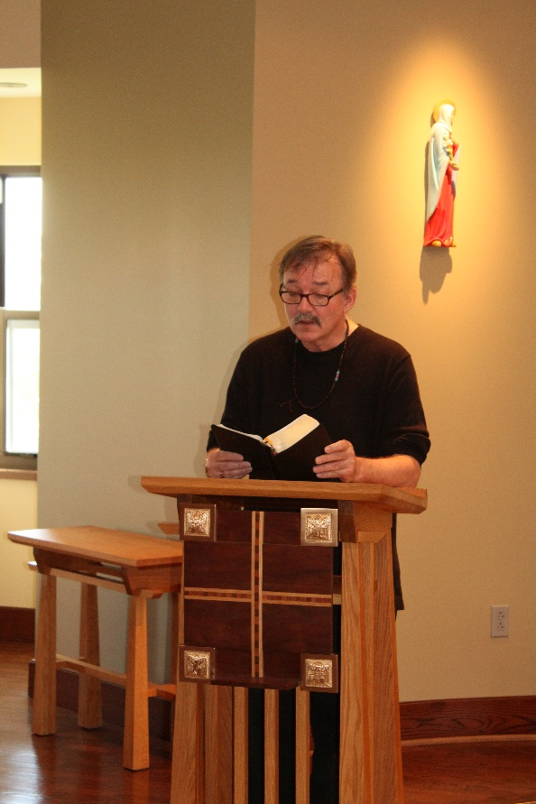
James Davies

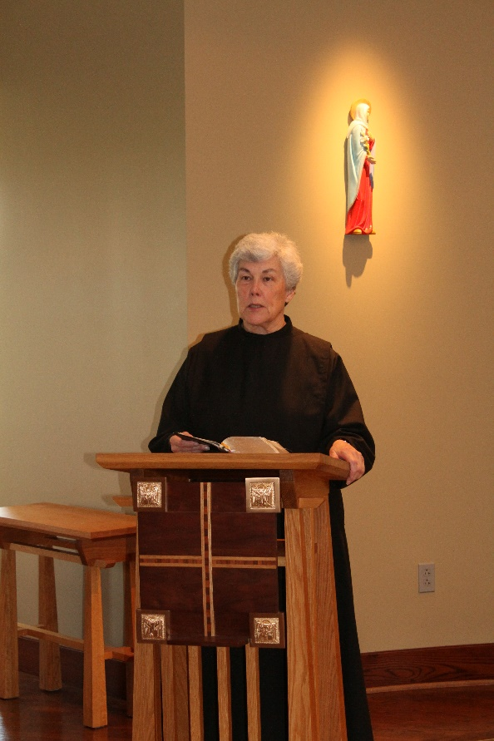
Sr. Toni Sylvester
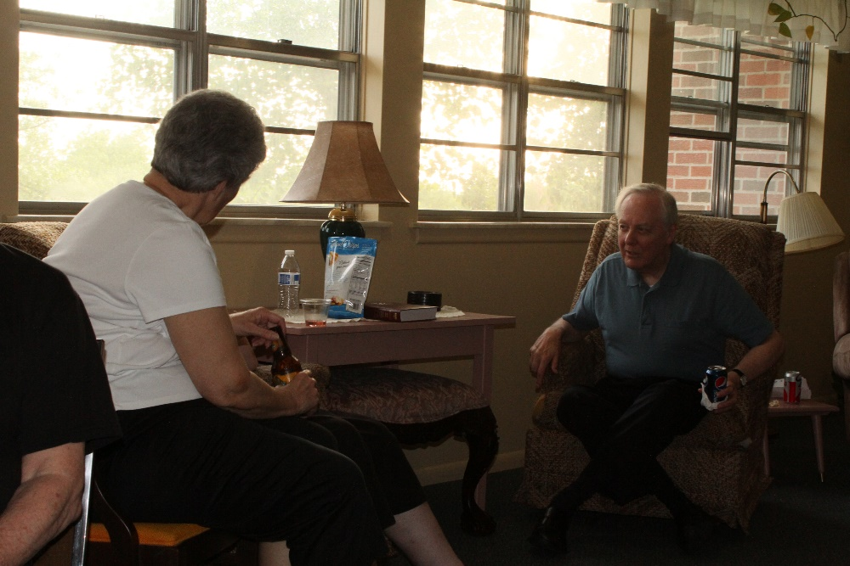
Sr. Toni Sylvester; Br. Lee Doucette

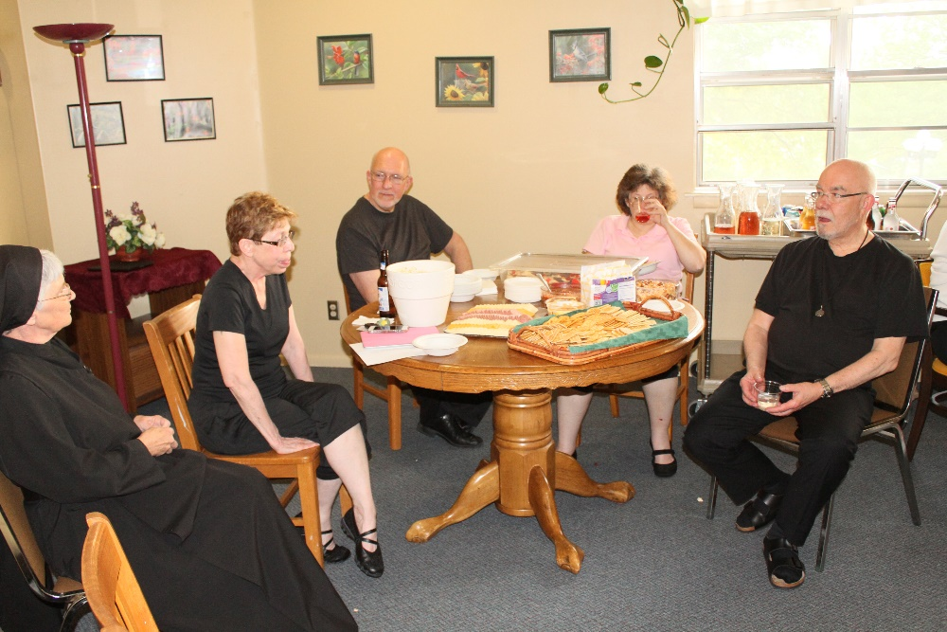
Sr. Mary Francis Deulen; Sr. Monica Ruth Mullen; Br. Peter DeFranco; Sr. Martha Lamoy; Br. Basil Edwards
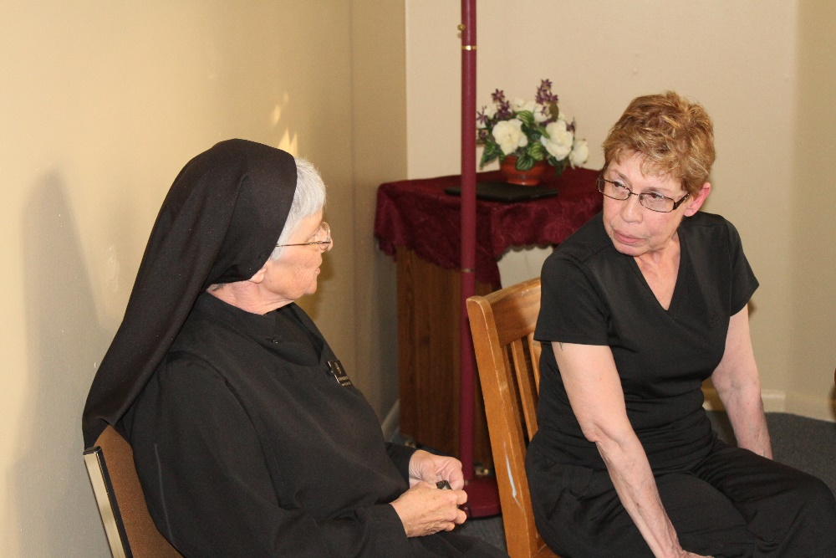
Sr. Mary Francis Deulen; Sr. Monica Ruth Mullen

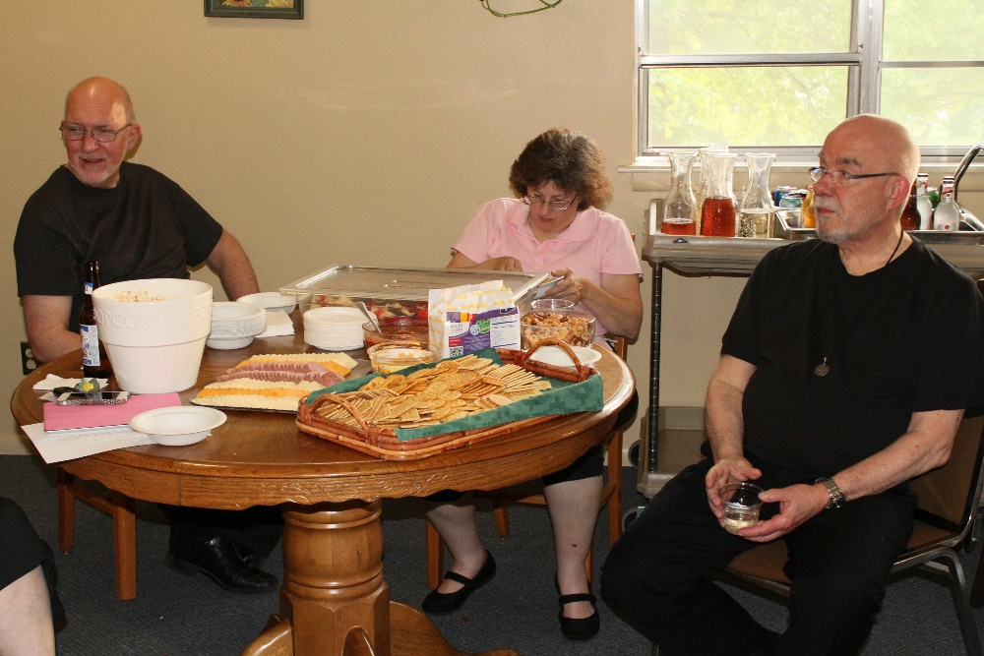
Br. Peter DeFranco; Sr. Martha Lamoy; Br. Basil Edwards
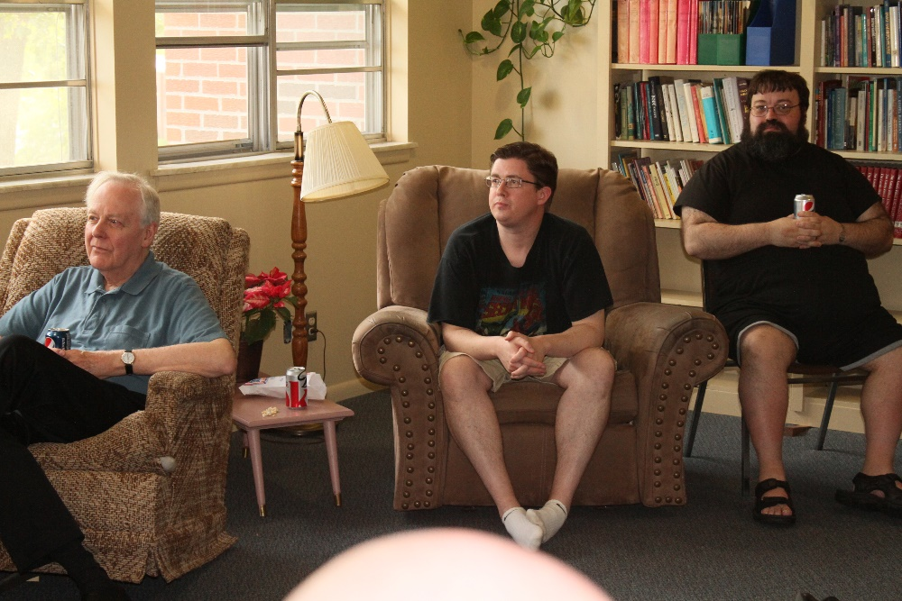
Br. Lee Doucette; Br. Kenneth Maguire; Br. Anselm King-Lowe

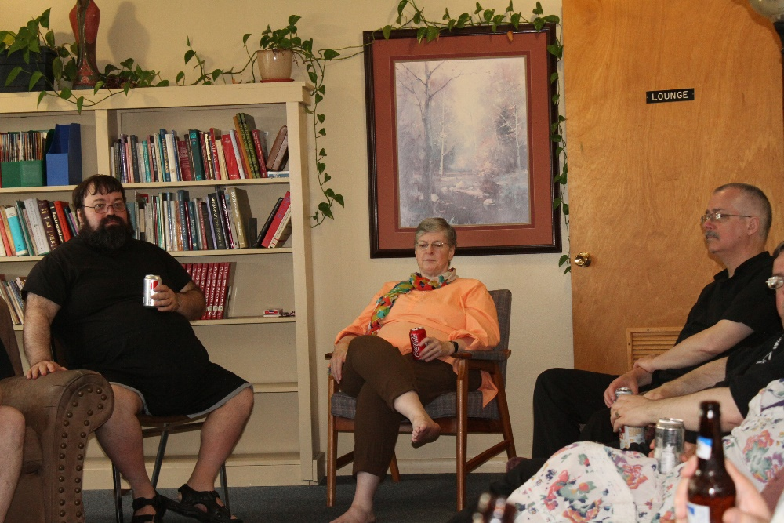
Br. Anselm King-Lowe; Sr. Helena Barrett; Br. Dunstan Townsend
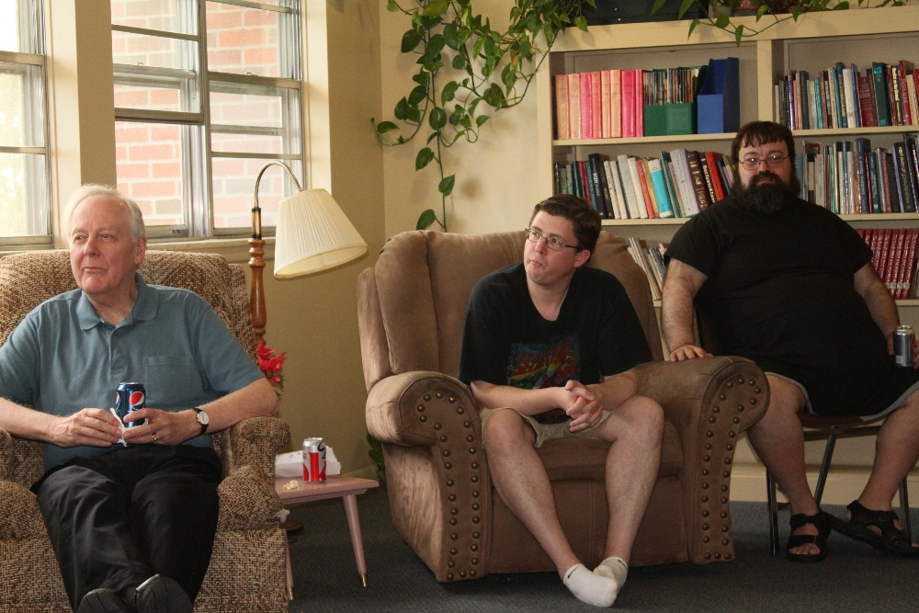
Br. Lee Doucette; Br. Kenneth Maguire; Br. Anselm King-Lowe

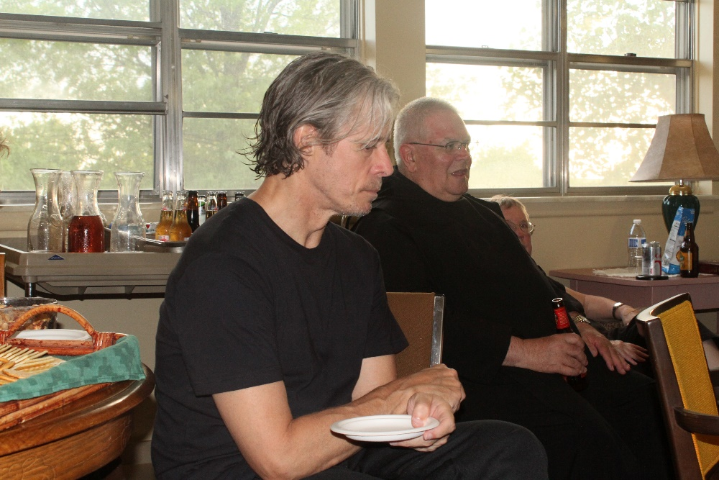
Br. Anskar Nonken; ?; Sr. Kate Maxwell
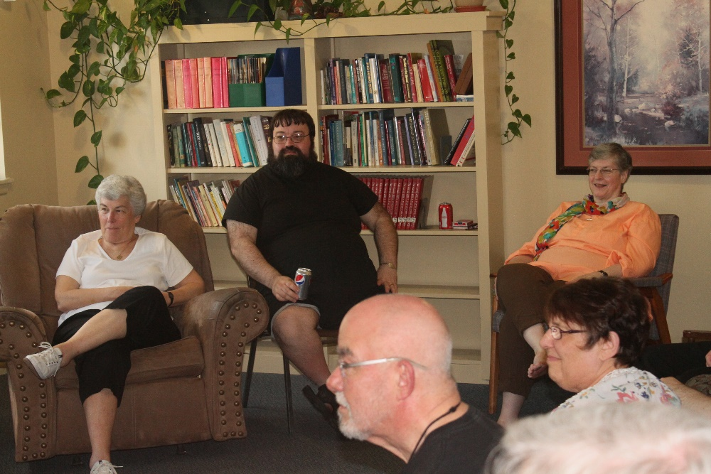
Sr. Toni Sylvester; Br. Anselm King-Lowe; Br. Basil Edwards; Sr. Alison Whybrow; Sr. Helena Barrett

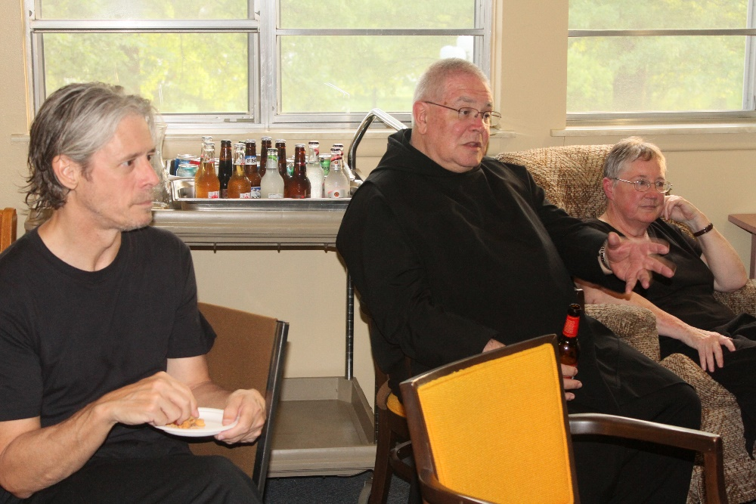
Br. Anskar Nonken; ?; Sr. Kate Maxwell

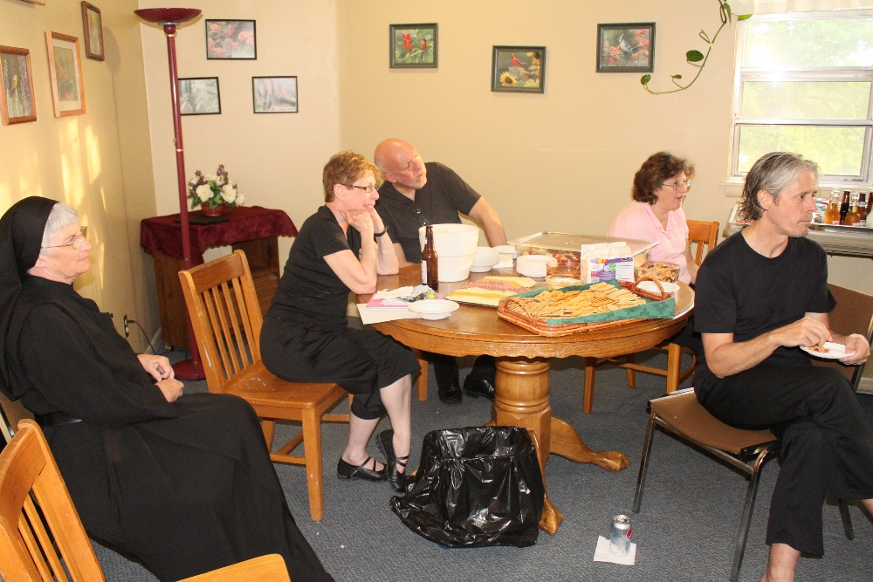
Sr. Mary Francis Deulen; Sr. Monica Ruth Mullen; Br. Peter DeFranco; Sr. Martha Lamoy; Br. Anskar Nonken

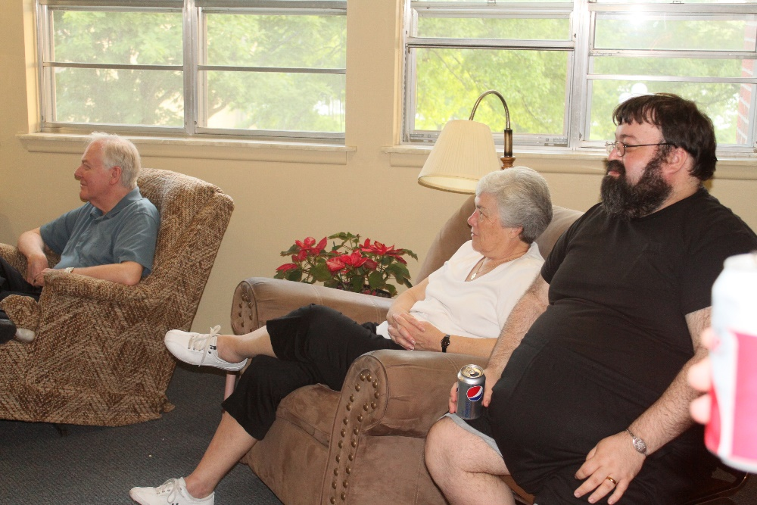
Br. Lee Doucette; Sr. Toni Sylvester; Br. Anselm King-Lowe
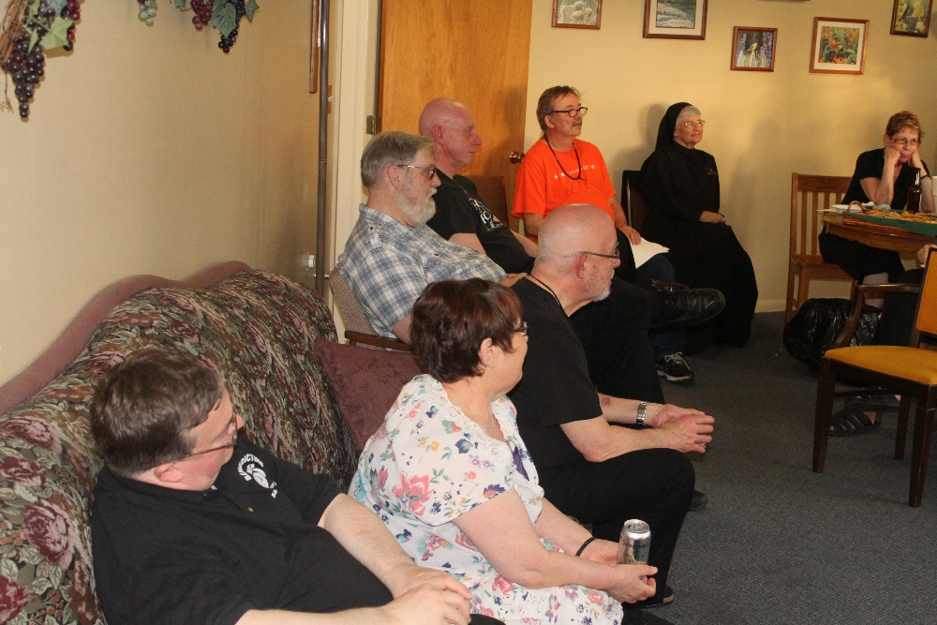
Br. Victor Bullock; Br. David Gerns; Abbot Robert Cotton; Sr. Alison Joy Whybrow; James Davies; Br. Basil Edwards; Sr. Mary Francis Deulen; Sr. Monica Ruth Mullen

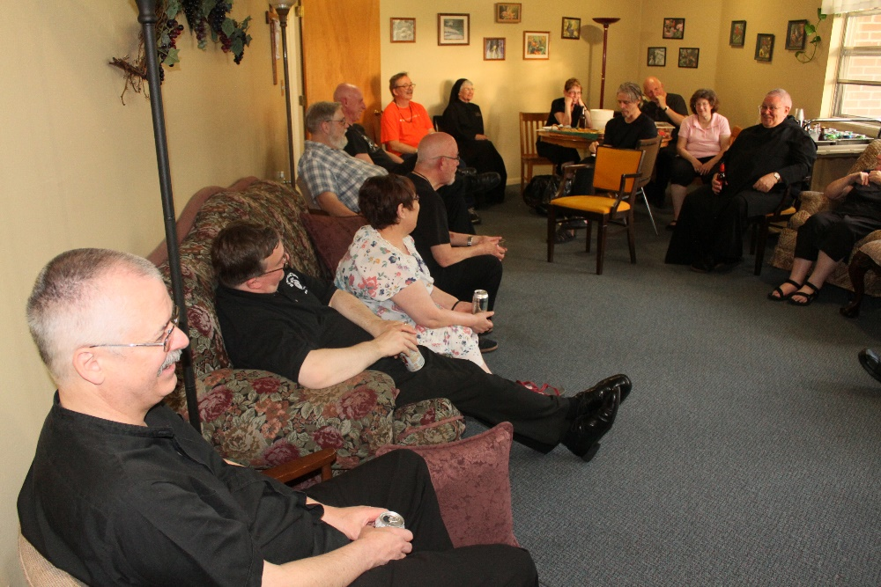
Br. Dunstan Townsend; Br. Victor Bullock; Br. David Gerns; Abbot Robert Cotton; Sr. Alison Joy Whybrow; James Davies; Br. Basil Edwards; Sr. Mary Francis Deulen; Sr. Monica Ruth Mullen; Br. Anskar Nonken; Br. Peter DeFranco; Sr. Martha Lamoy; ?; Sr. Kate Maxwell

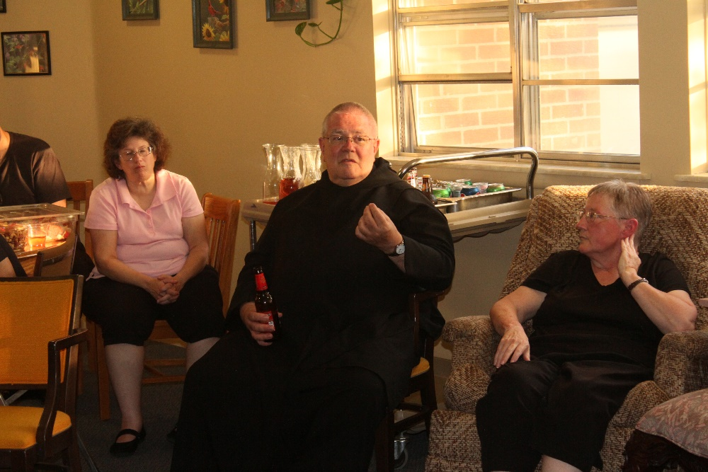
Sr. Martha Lamoy; ?; Sr. Kate Maxwell

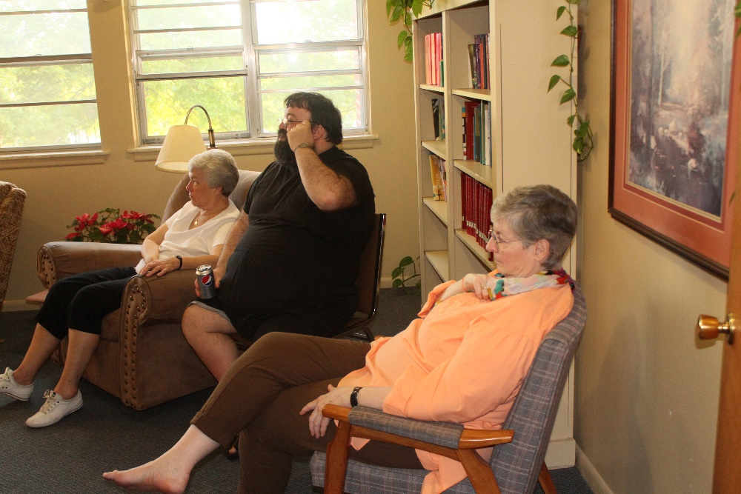
Sr. Toni Sylvester; Br. Anselm King-Lowe; Sr. Helena Barrett
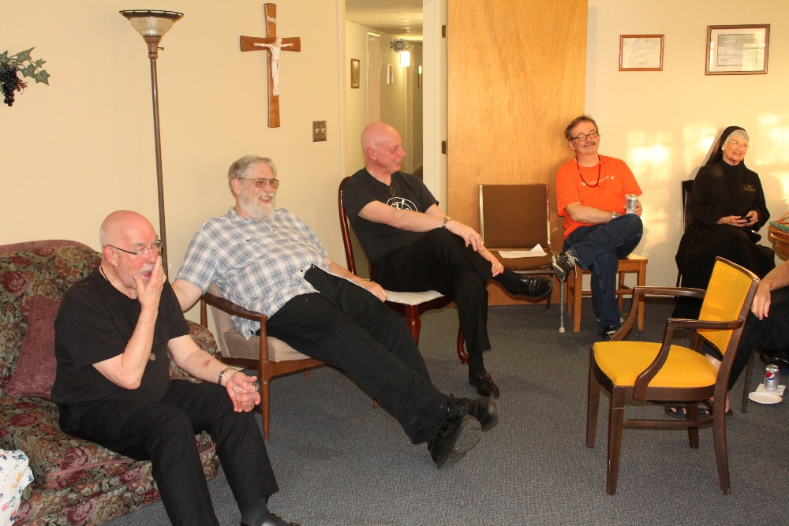
Br. Basil Edwards; Br. David Gerns; Abbot Robert Cotton; James Davies; Sr. Mary Francis Deulen

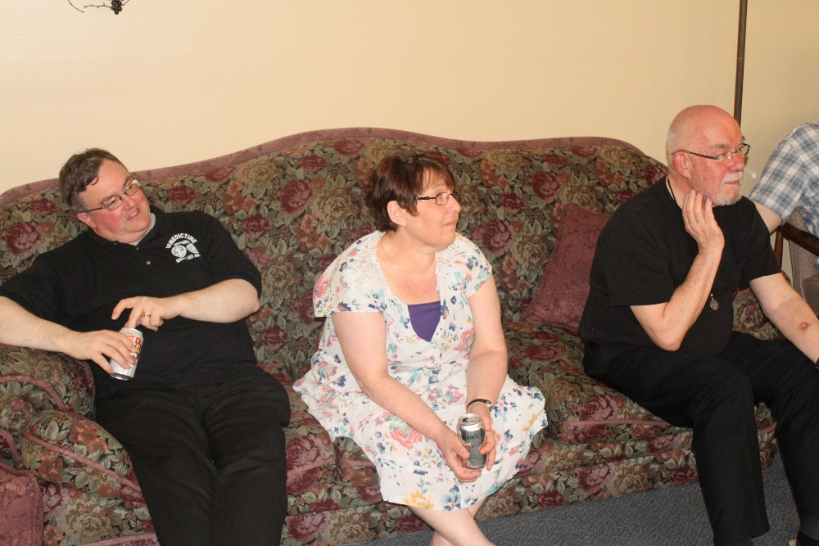
Br. Victor Bullock; Sr. Alison Joy Whybrow; Br. Basil Edwards

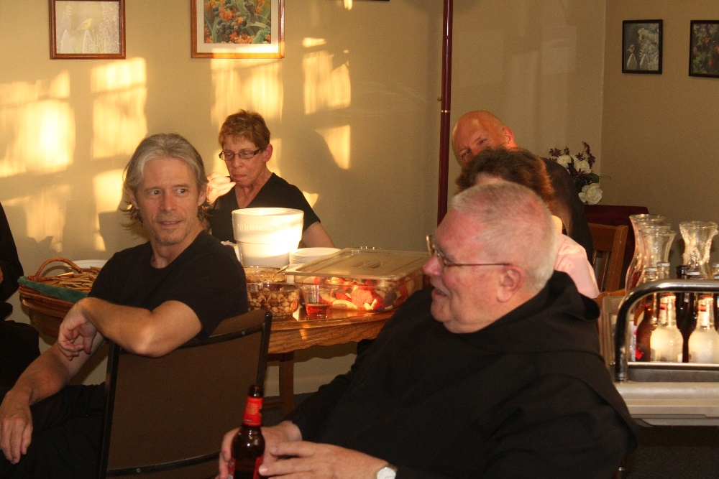

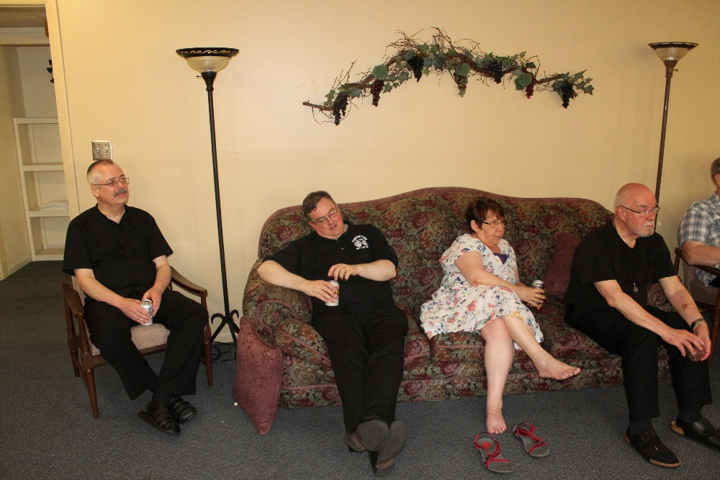
Br. Dunstan Townsend; Br. Victor Bullock; Sr. Alison Joy Whybrow; Br. Basil Edwards; Br. David Gerns
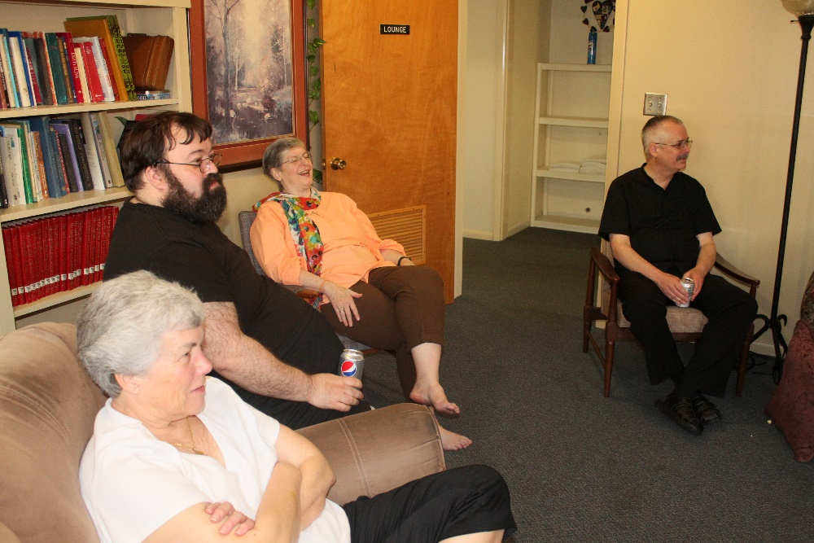
Sr. Toni Sylvester; Br. Anselm King-Lowe; Sr. Helena Barrett; Br. Dunstan Townsend

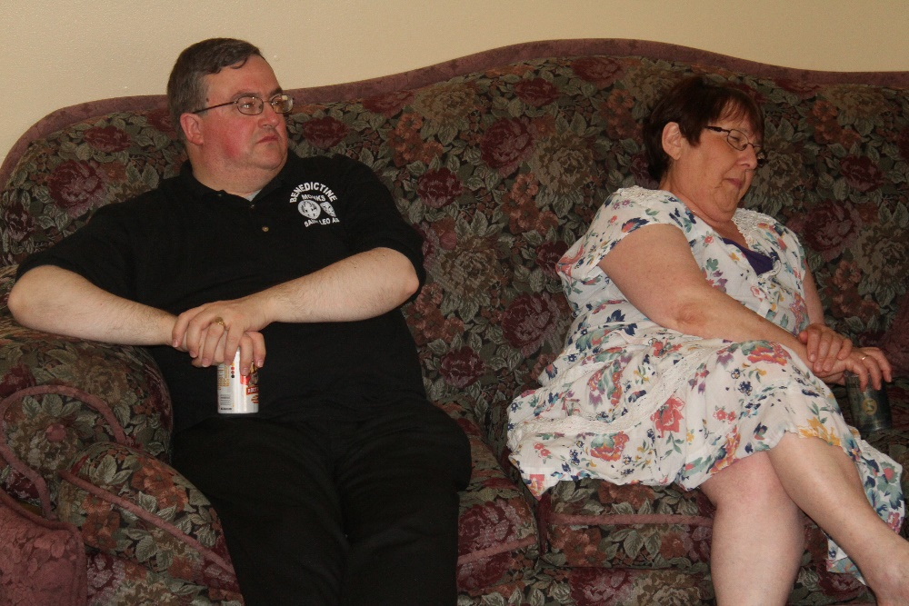
Br. Victor Bullock; Sr. Alison Joy Whybrow
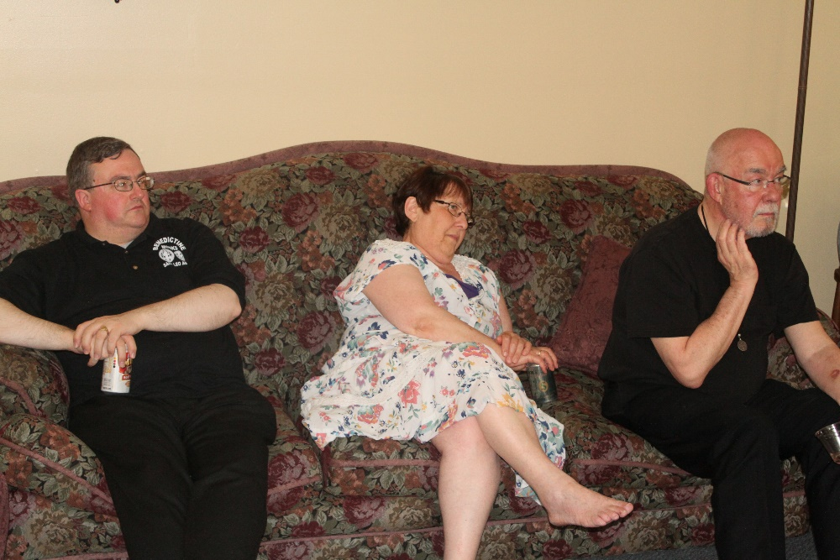
Br. Victor Bullock; Sr. Alison Joy Whybrow; Br. Basil Edwards

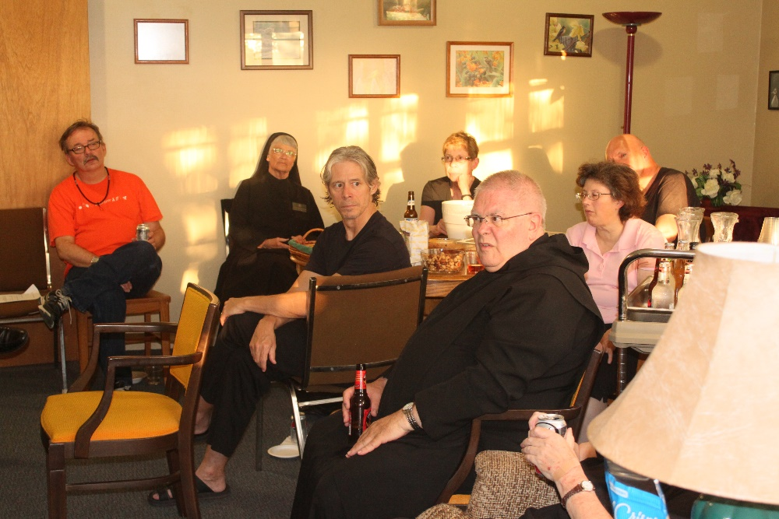
James Davies; Sr. Mary Francis Deulen; Br. Anskar Nonken; Sr. Monica Ruth Mullen; ?; Sr. Martha Lamoy; Br. Peter DeFranco
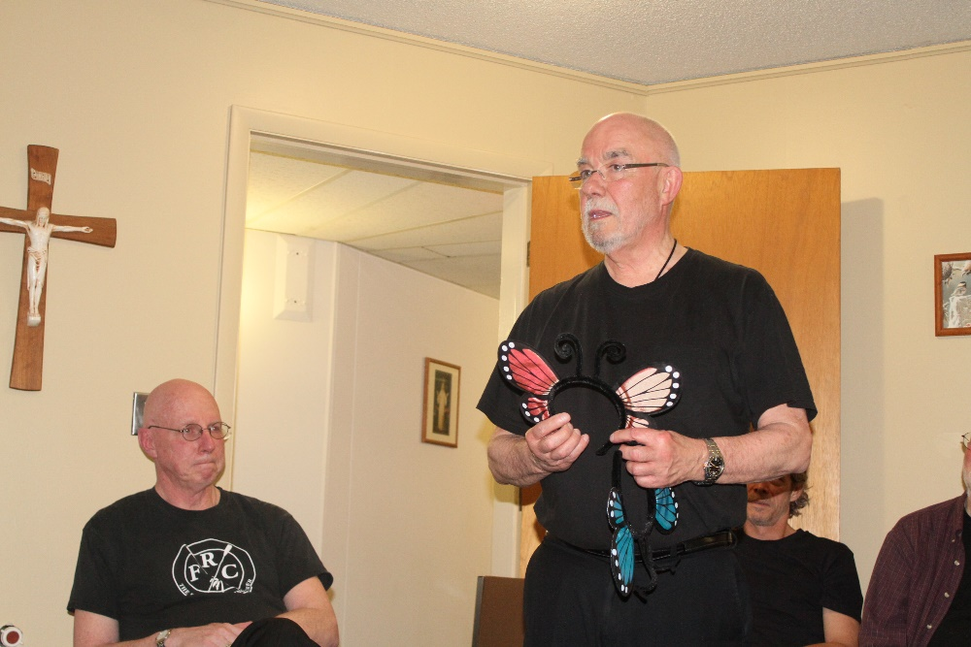
Abbot Robert Cotton; Br. Basil Edwards; Br. Anskar Nonken

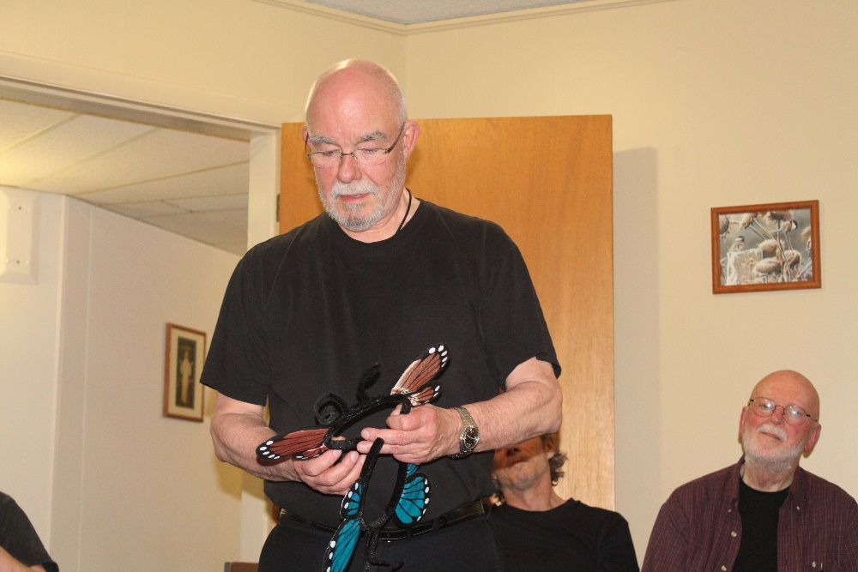
Br. Basil Edwards; Br. Anskar Nonken; Br. Thomas Anthony Goddard
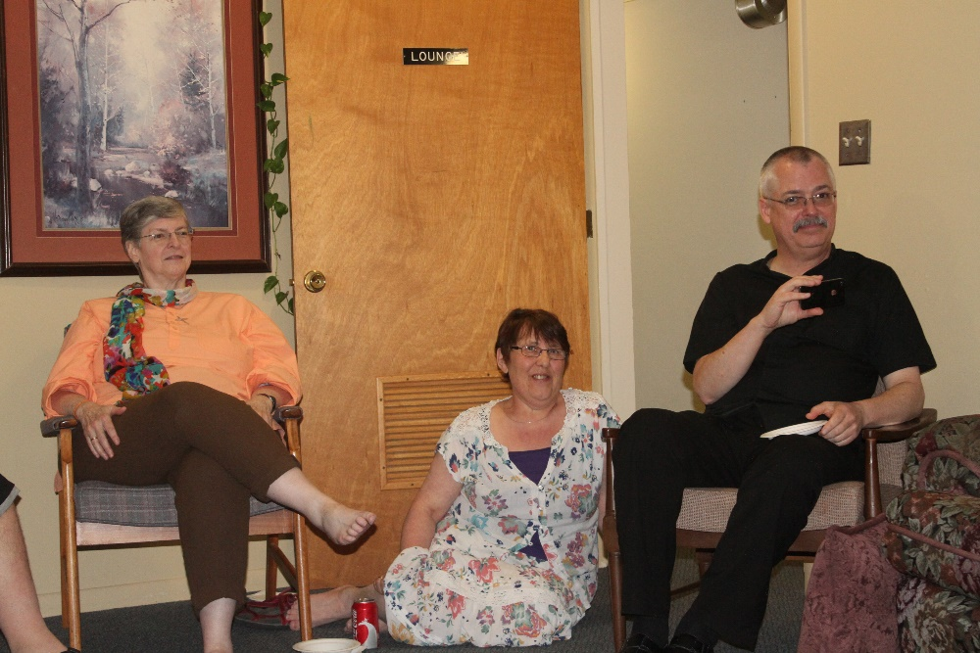
Sr. Helena Barrett; Sr. Alison Joy Whybrow; Br. Dunstan Townsend

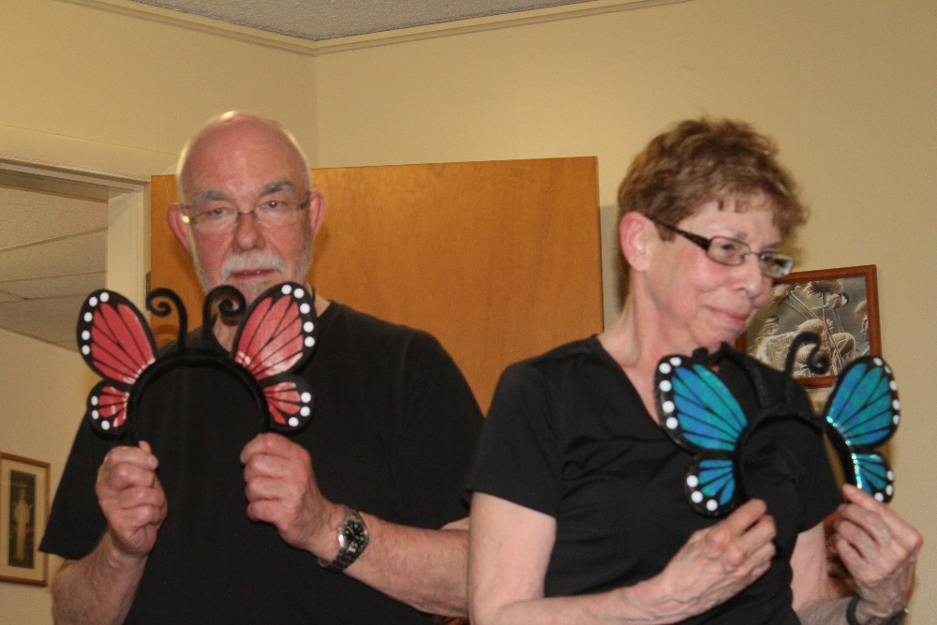
Br. Basil Edwards; Sr. Monica Ruth Mullen
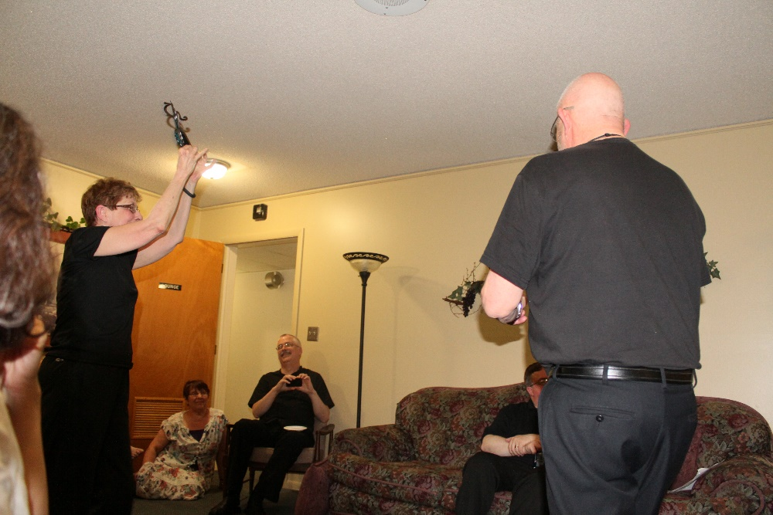
Sr. Monica Ruth Mullen; Sr. Alison Joy Whybrow; Br Dunstan Townsend; Br. Victor Bullock; Br. Basil Edwards

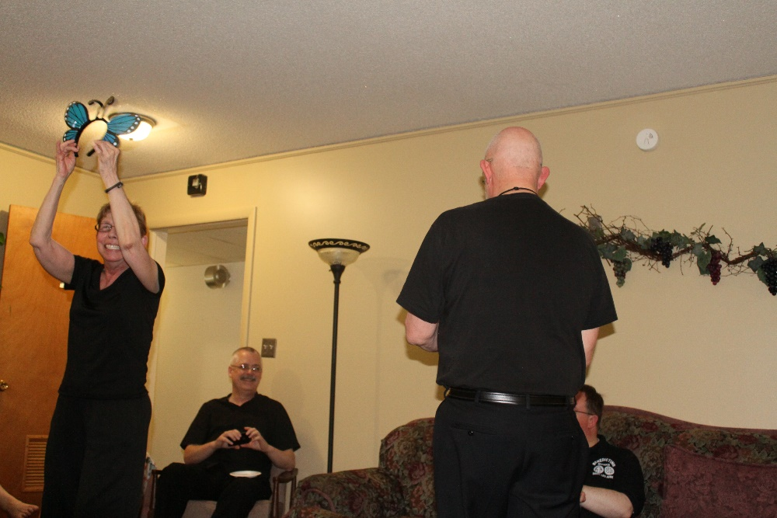
Sr. Monica Ruth Mullen; Br Dunstan Townsend; Br. Basil Edwards; Br. Victor Bullock


Sr. Toni Sylvester; Br. Anselm King-Lowe; Sr. Helena Barrett


Sr. Alison Joy Whybrow; Br. Dunstan Townsend
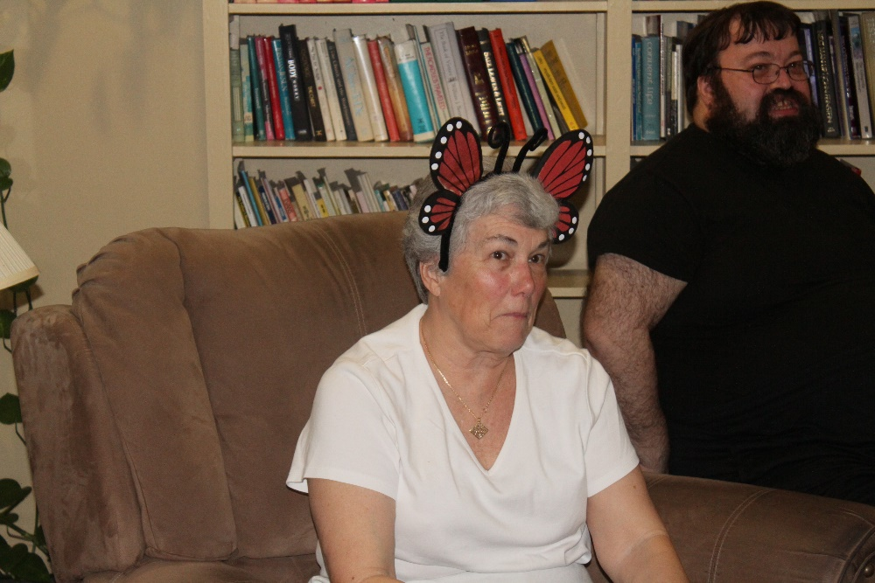
Sr. Toni Sylvester; Br. Anselm King-Lowe

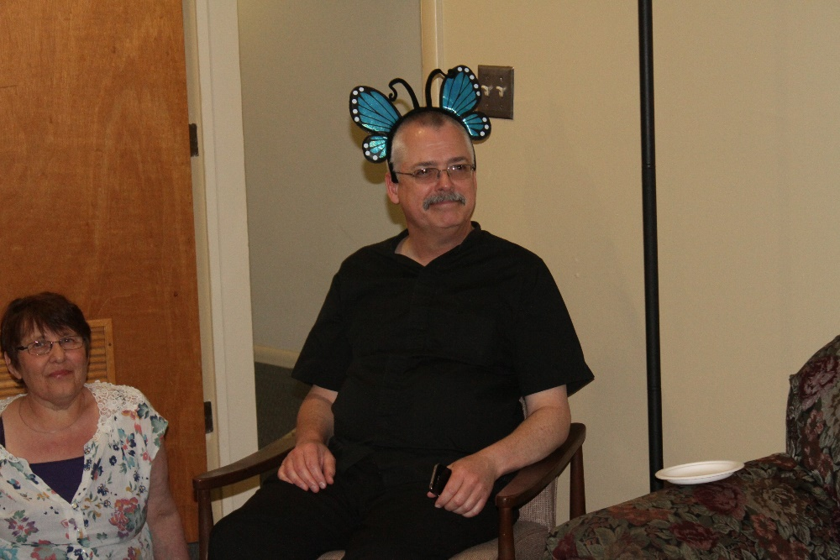
Sr. Alison Joy Whybrow; Br. Dunstan Townsend

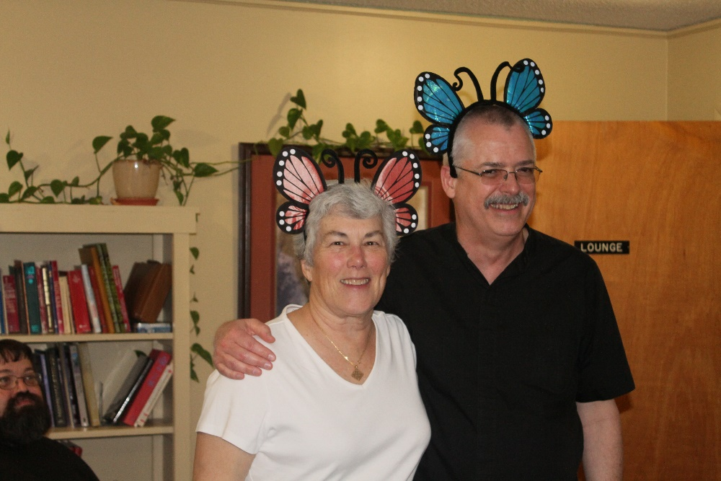
Sr. Toni Sylvester; Br. Dunstan Townsend

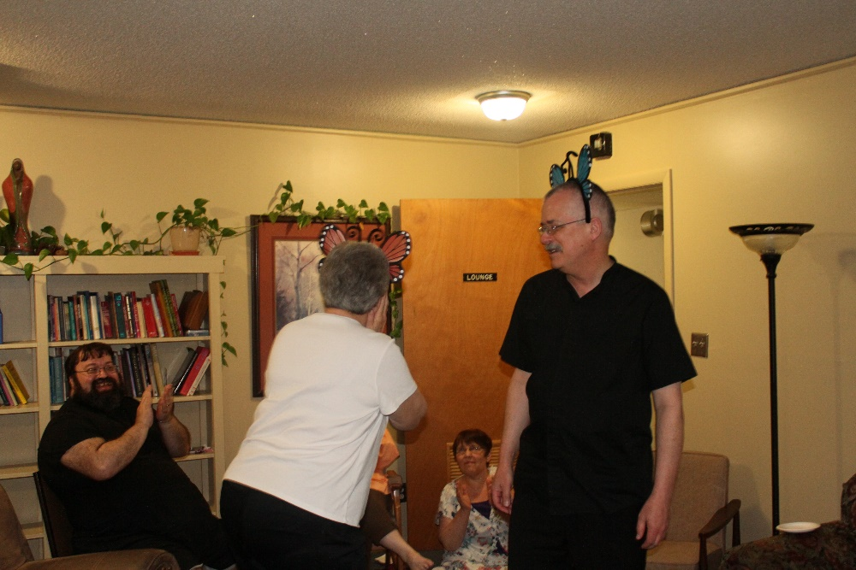
Br. Anselm King-Lowe; Sr. Toni Sylvester; Sr. Alison Joy Whybrow; Br. Dunstan Townsend

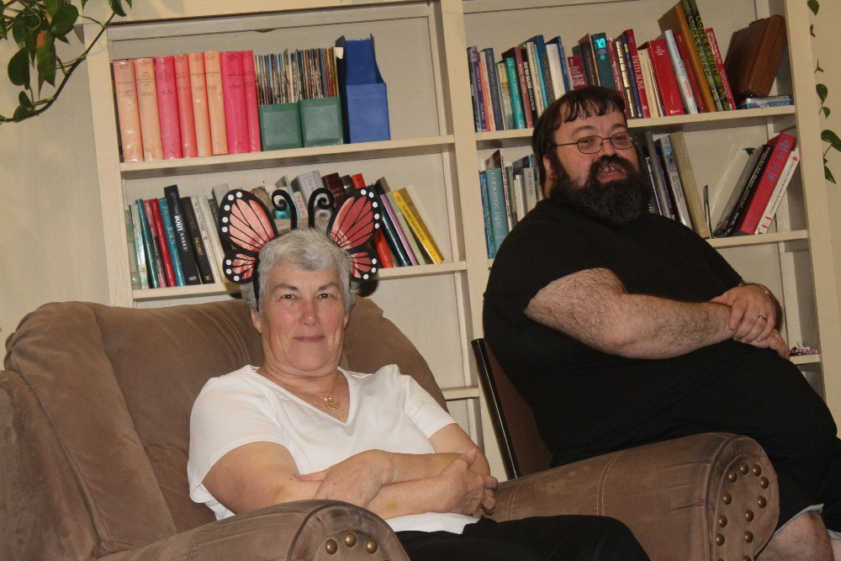
Sr. Toni Sylvester; Br. Anselm Ling-Lowe

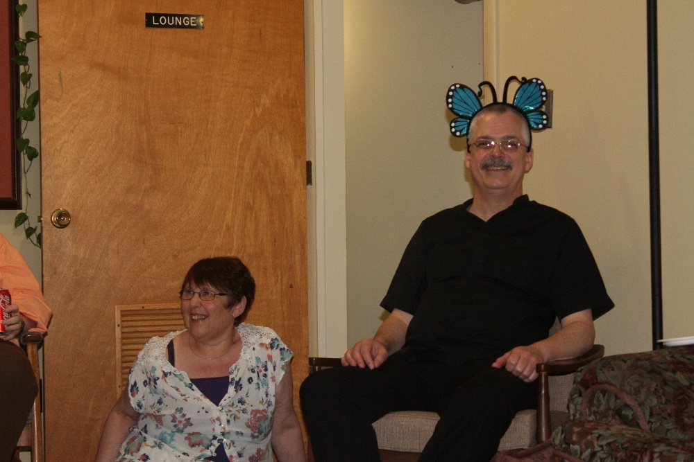
Sr. Alison Joy Whybrow; Br. Dunstan Townsend
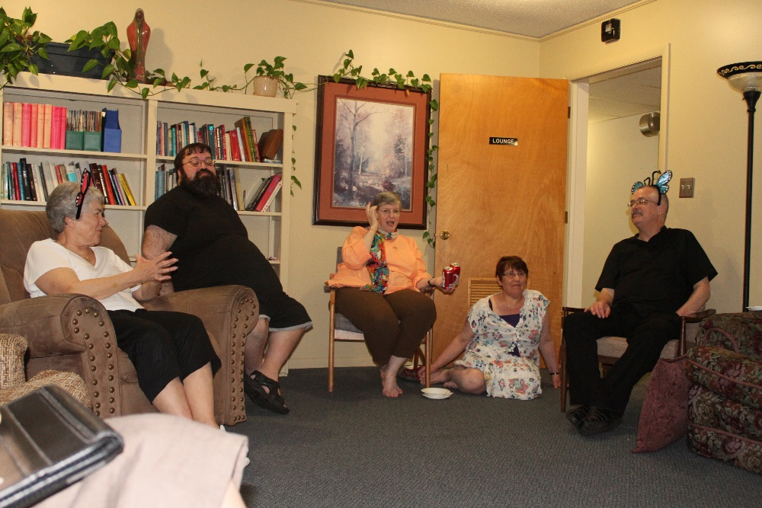
Sr. Toni Sylvester; Br. Anselm King-Lowe; Sr. Helena Barrett; Sr. Alison Joy Whybrow; Br. Dunstan Townsend

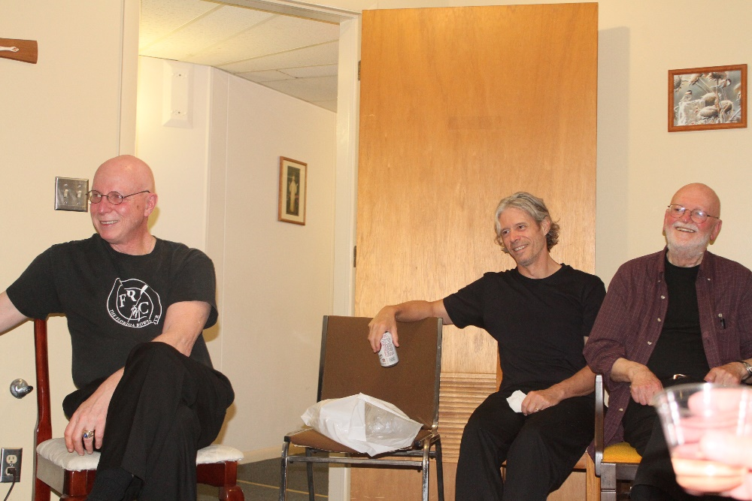
Abbot Robert Cotton; Br. Anskar Nonken; Br. Thomas Anthony Goddard

