Companions of St. Luke
Spring Convocation at Conception Abbey
May 30-31, 2012
Photographed by Sr. Brigid Gerns

People are identified from left to right.

Edited by Br. Steven Olderr 31 March 2023. Please send any comments, corrections, or additions to olderr@ameritech.net

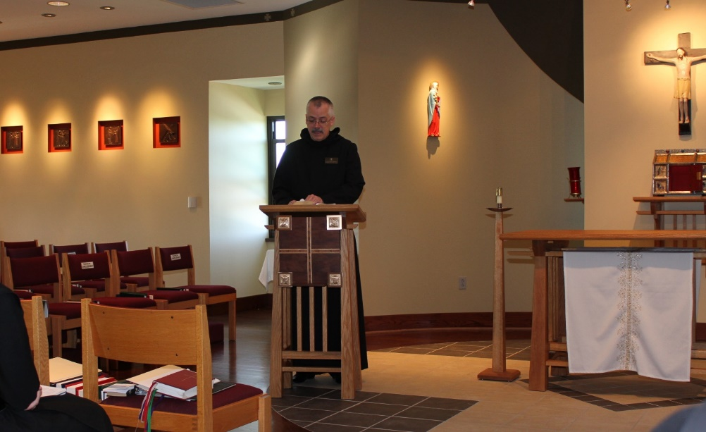
Br. Dunstan Townsend

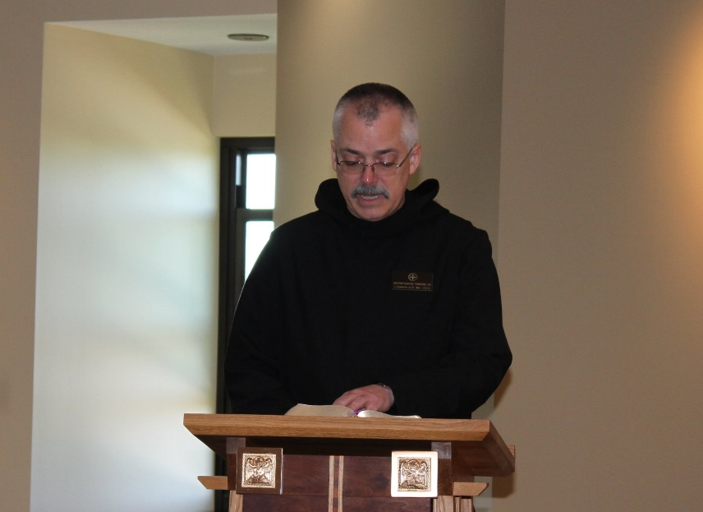
Br. Dunstan Townsend

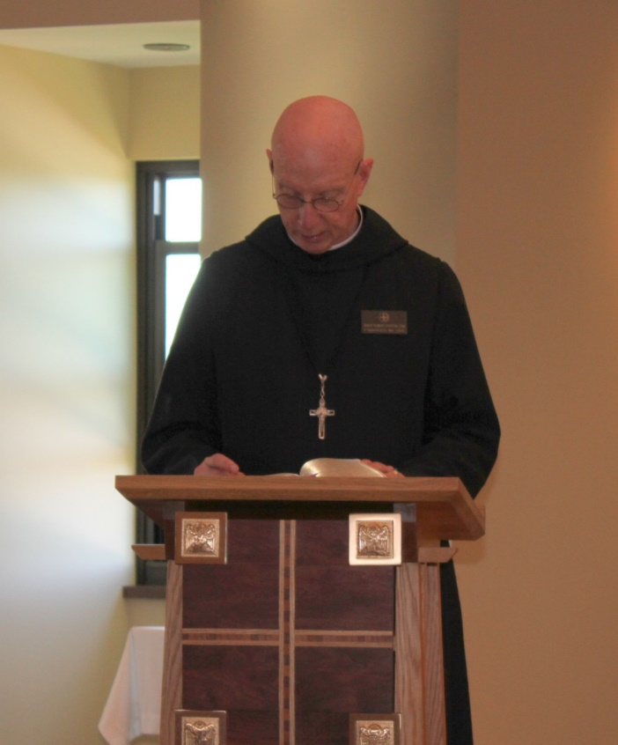
Abbot Robert Cotton
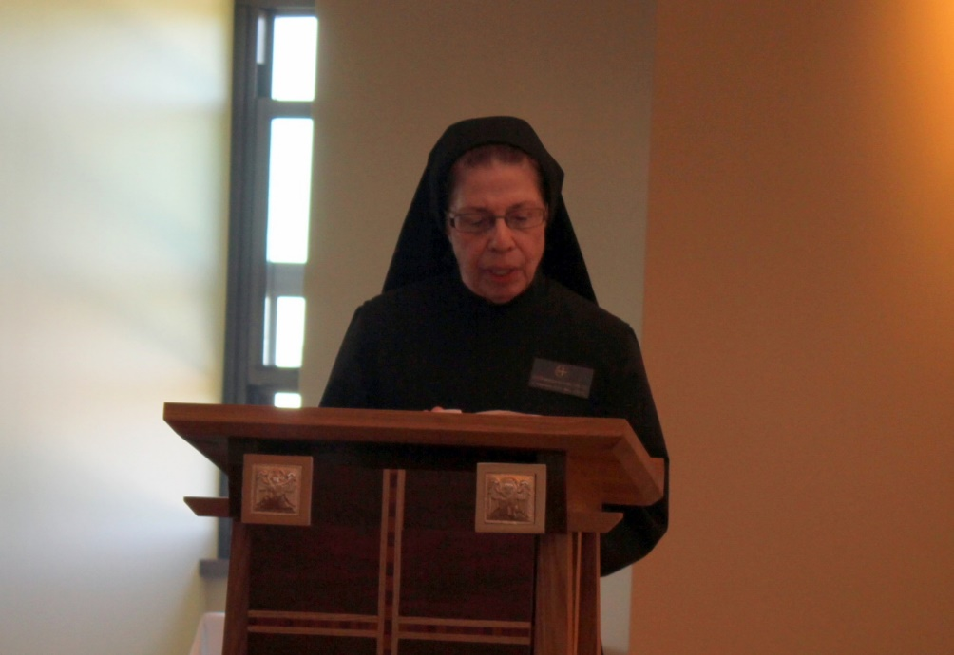
Sr. Monica Ruth Mullen

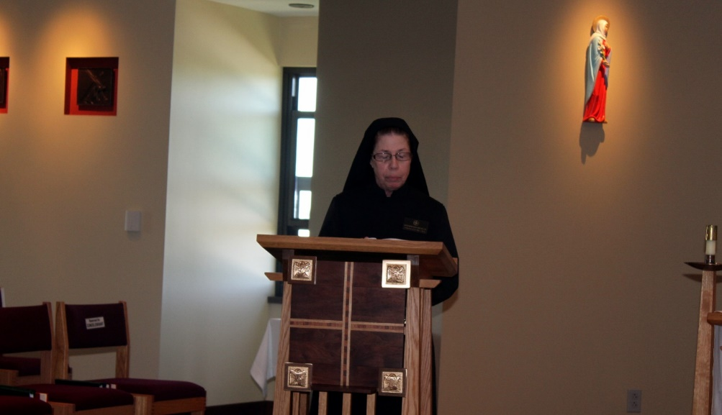
Sr. Monica Ruth Mullen
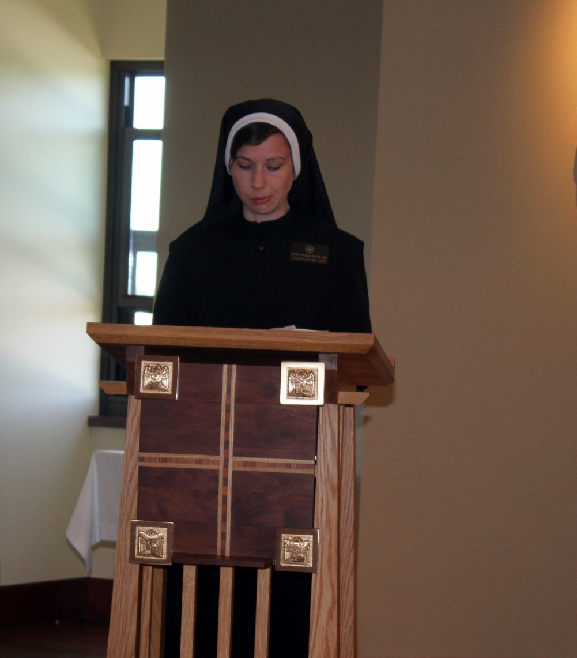
Sr. Veronica Taylor
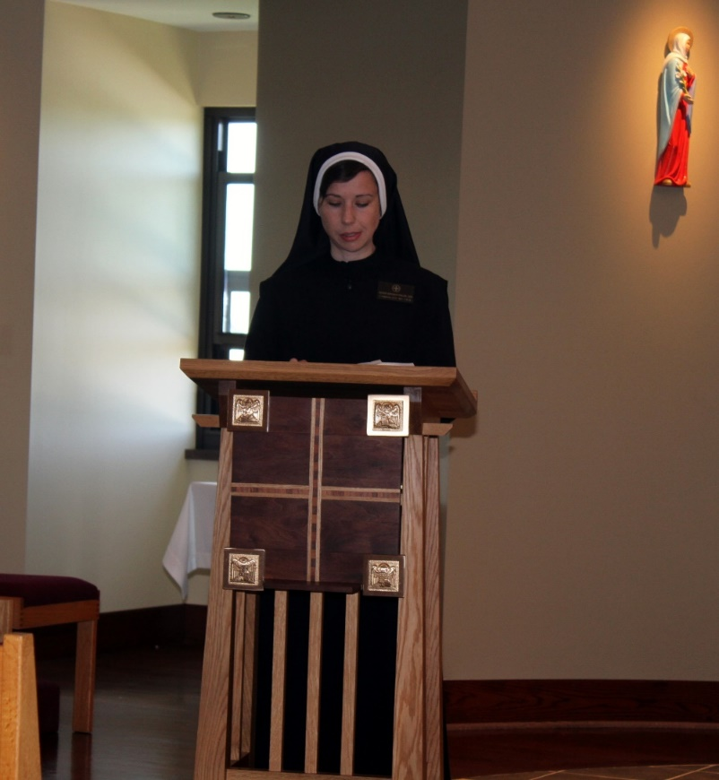
Sr. Veronica Taylor

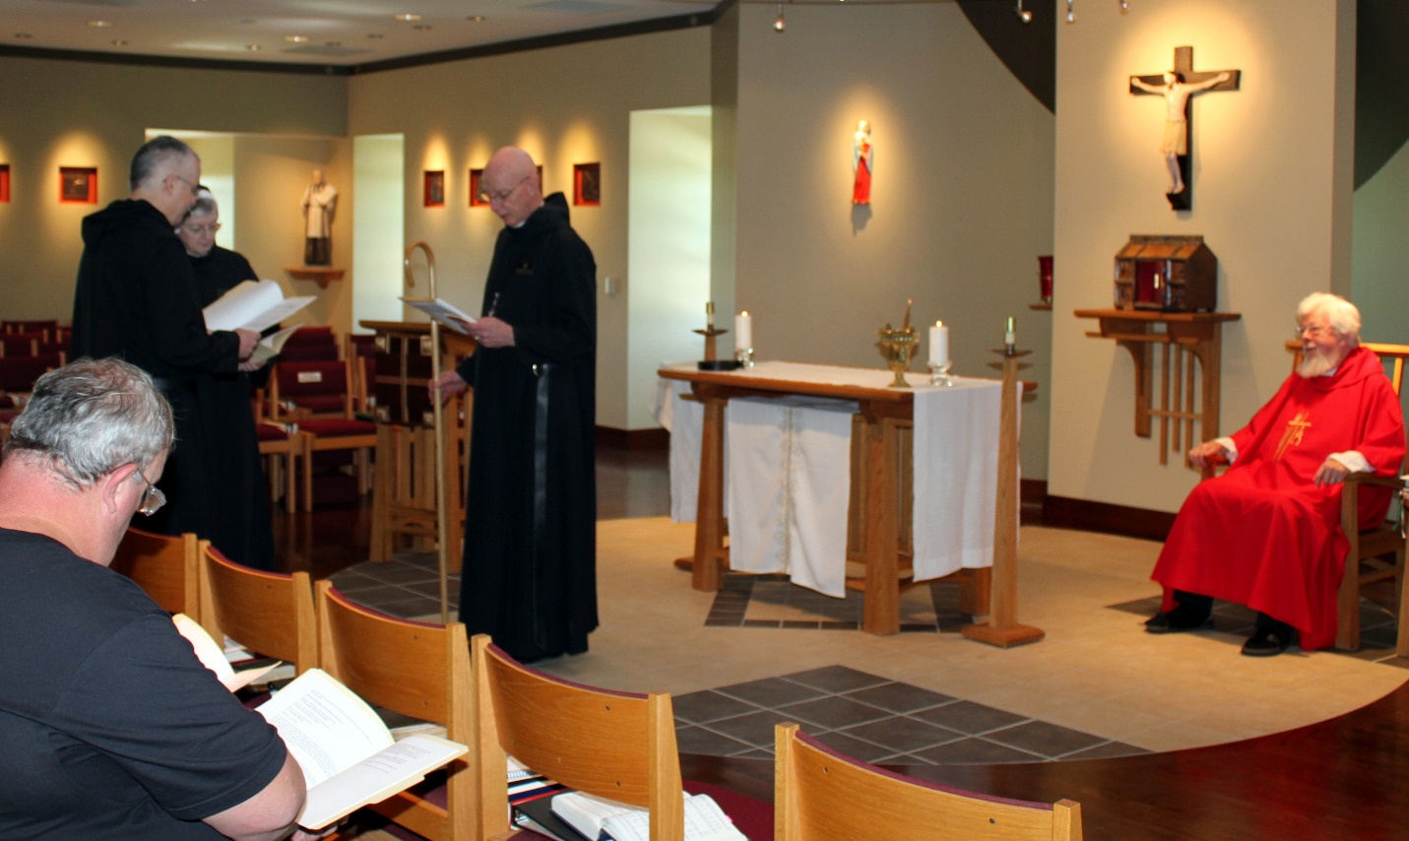
Joe Campbell; Br. Dunstan Townsend; Sr. Bernadette Barrett; Abbot Robert Cotton; Fr. Wayne Kamm

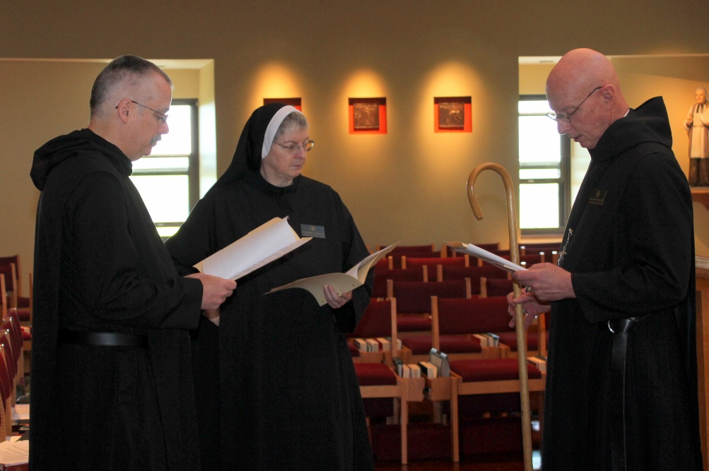
Br. Dunstan Townsend; Sr. Bernadette Barrett; Abbot Robert Cotton

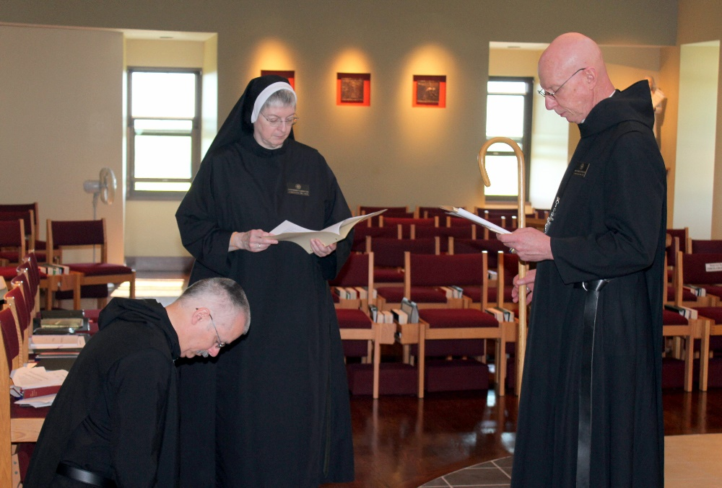
Br. Dunstan Townsend; Sr. Bernadette Barrett; Abbot Robert Cotton

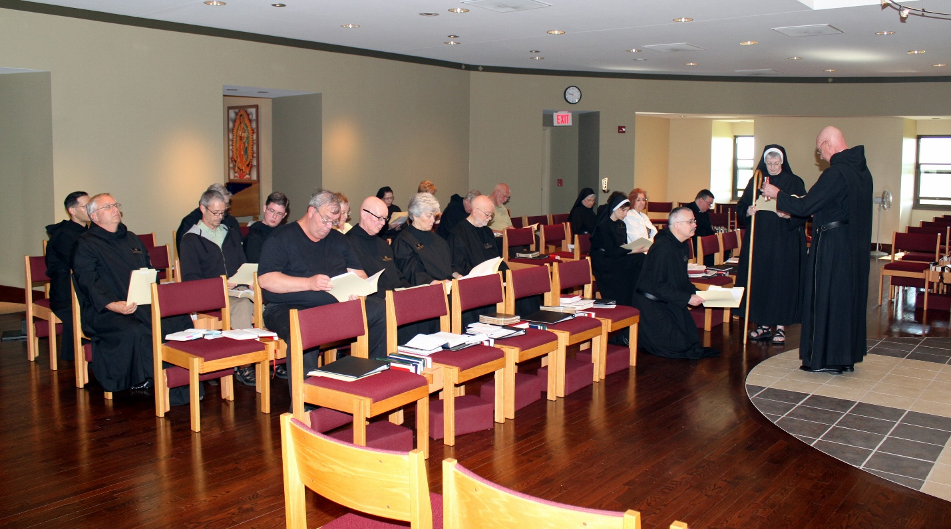
Br. Roman Shemayev; Br. Bede Leach; Scott Nonken; Br. David Gerns; Br. Kenneth Maguire; Joe Campbell; Kate Maxwell; Br. Stephen Francis Arnold; Sr. Monica Ruth Mullen; Sr. Toni Sylvester; Cam Leach; Br. Lee Doucette; Peter DeFranco; Sr. Mary Francis Deulen; Sr. Veronica Taylor; Br. Dunstan Townsend; Victor Bullock; Sr. Bernadette Barrett; Abbot Robert Cotton

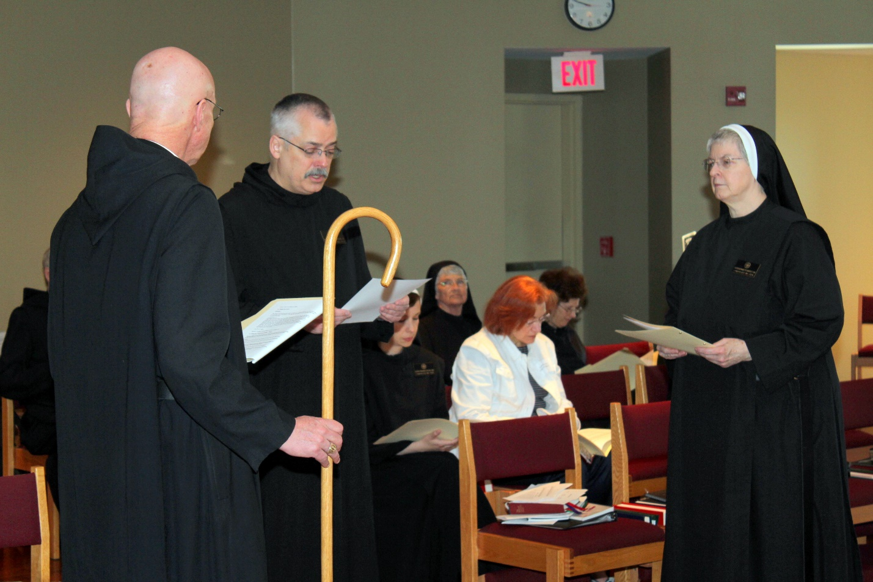
Abbot Robert Cotton; Br. Dunstan Townsend; Sr. Veronica Taylor; Sr. Mary Francis Deulen; ?; Sr. Martha Lamoy; Sr. Bernadette Barrett

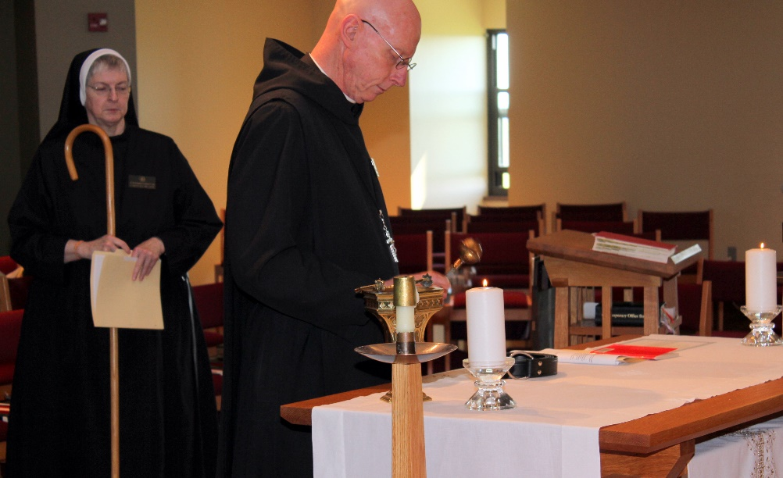
Sr. Bernadette Barrett; Abbot Robert Cotton

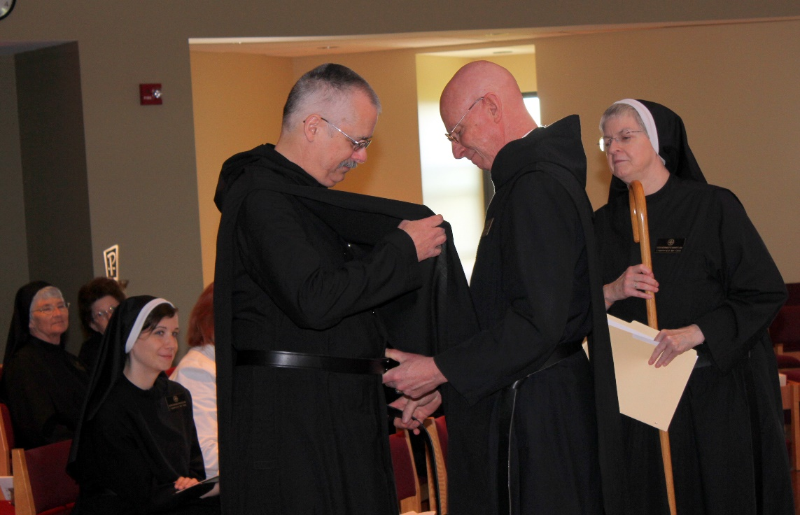
Sr. Mary Francis Deulen; Sr. Martha Lamoy; Sr. Veronica Taylor; Br. Dunstan Townsend; Abbot Robert Cotton; Sr. Bernadette Barrett

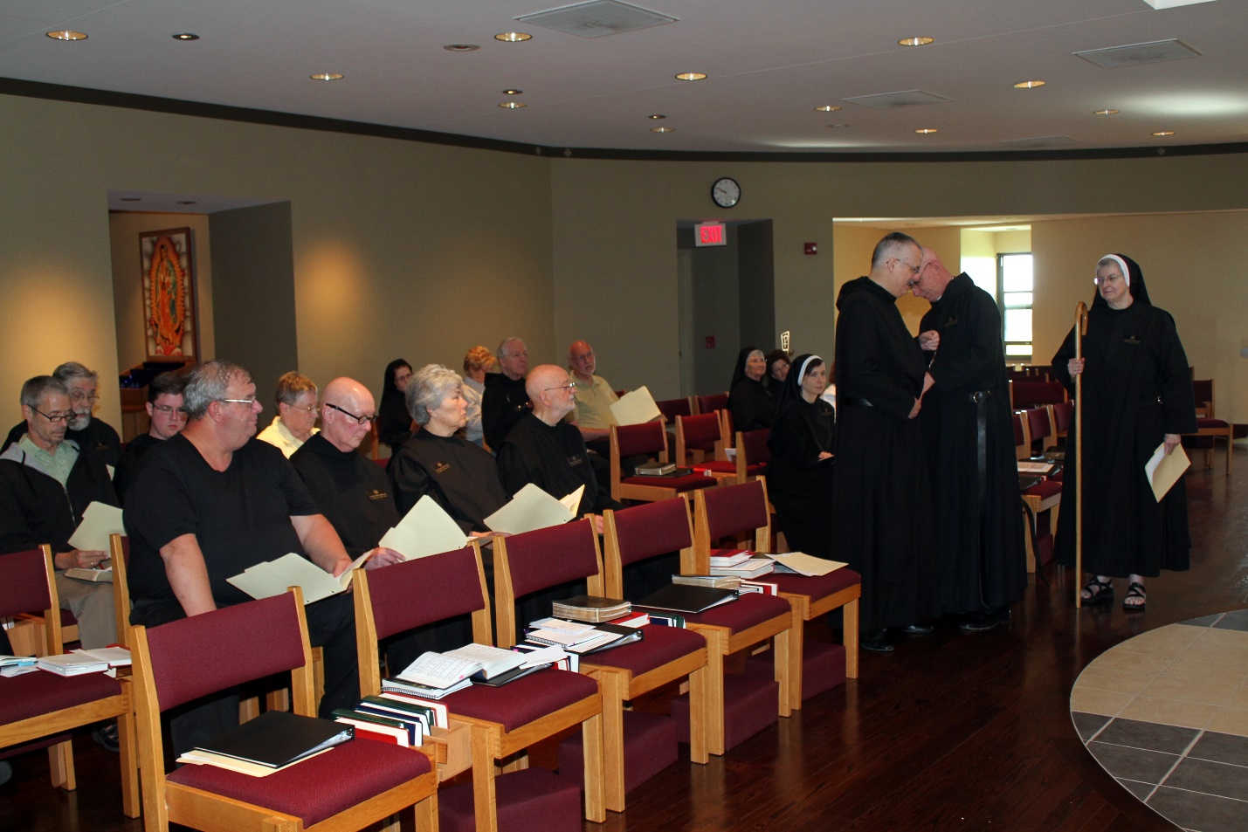
Scott Nonken; Br. David Gerns; Br. Kenneth Maguire; Joe Campbell; Kate Maxwell; Br. Stephen Francis Arnold; Sr. Monica Ruth Mullen; Cam Leach; Br. Lee Doucette; Br. Thomas Anthony Goddard; Br. Peter DeFranco; Sr. Mary Francis Deulen; Sr. Martha Lamoy; Sr. Veronica Taylor; Br. Dunstan Townsend; Abbot Robert Cotton; Sr. Bernadette Barrett

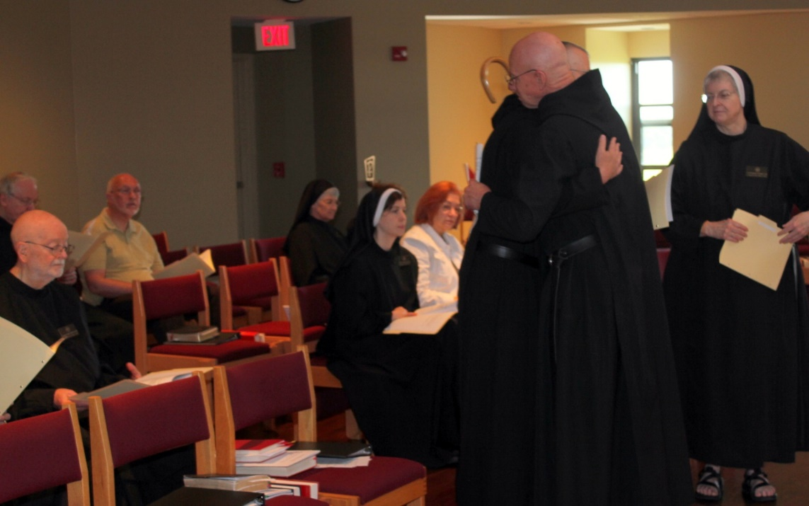
Br. Lee Doucette; Br. Thomas Anthony Goddard; Peter DeFranco; Sr. Mary Francis Deulen; Sr. Veronica Taylor; Br. Dunstan Townsend; Abbot Robert Cotton; Sr. Bernadette Barrett

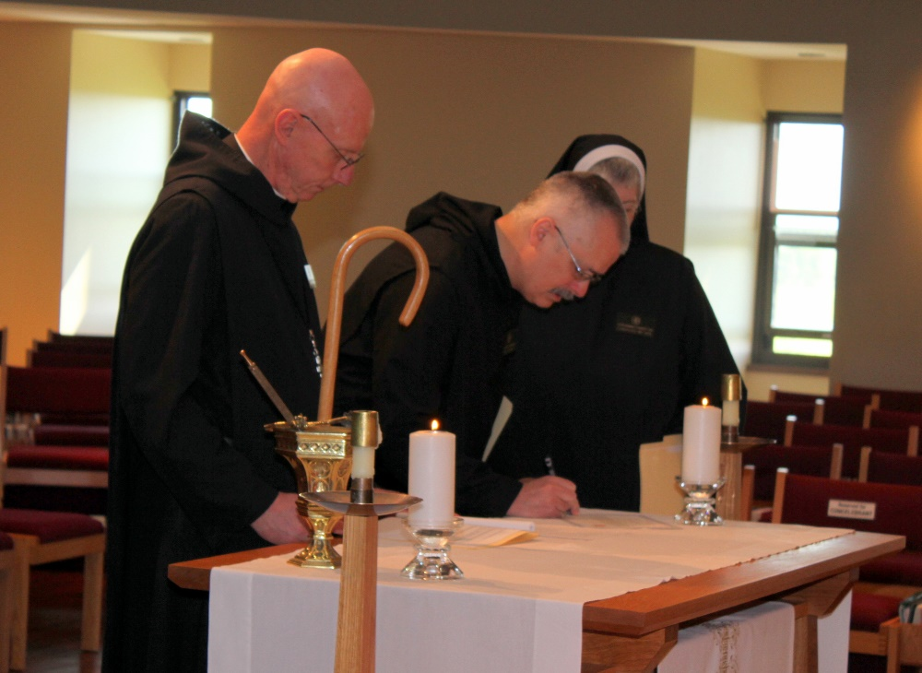
Abbot Robert Cotton; Br. Dunstan Townsend; Sr. Bernadette Barrett

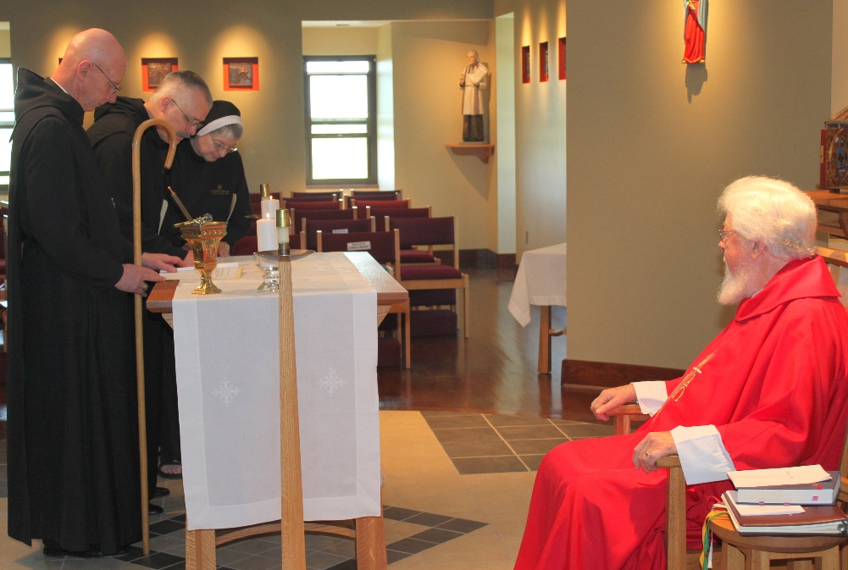
Abbot Robert Cotton; Br. Dunstan Townsend; Sr. Bernadette Barrett; Fr. Wayne Kamm

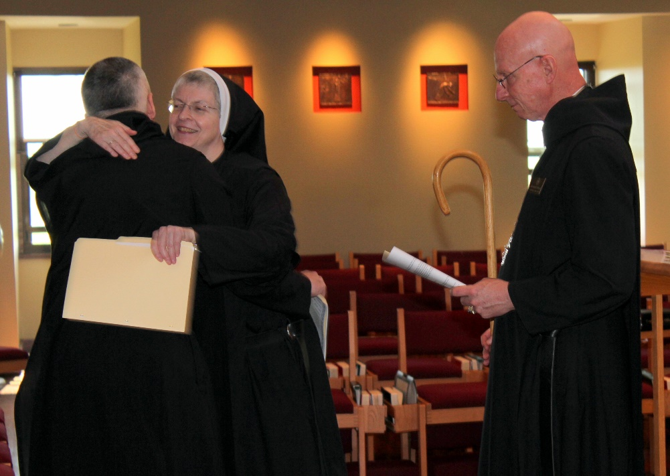
Br. Dunstan Townsend; Sr. Bernadette Barrett; Abbot Robert Cotton

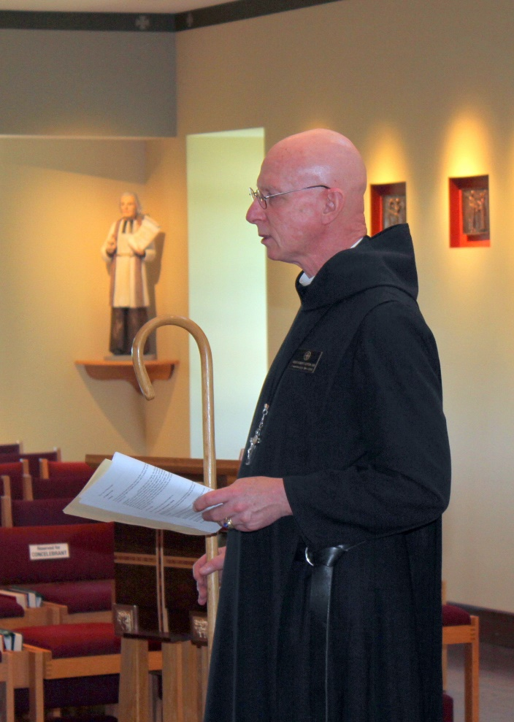
Abbot Robert Cotton

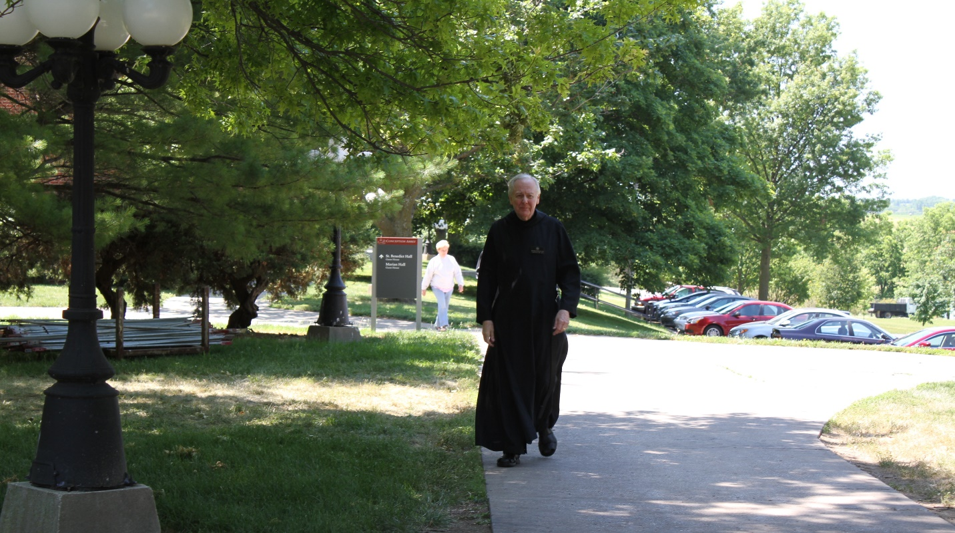
Br. Lee Doucette

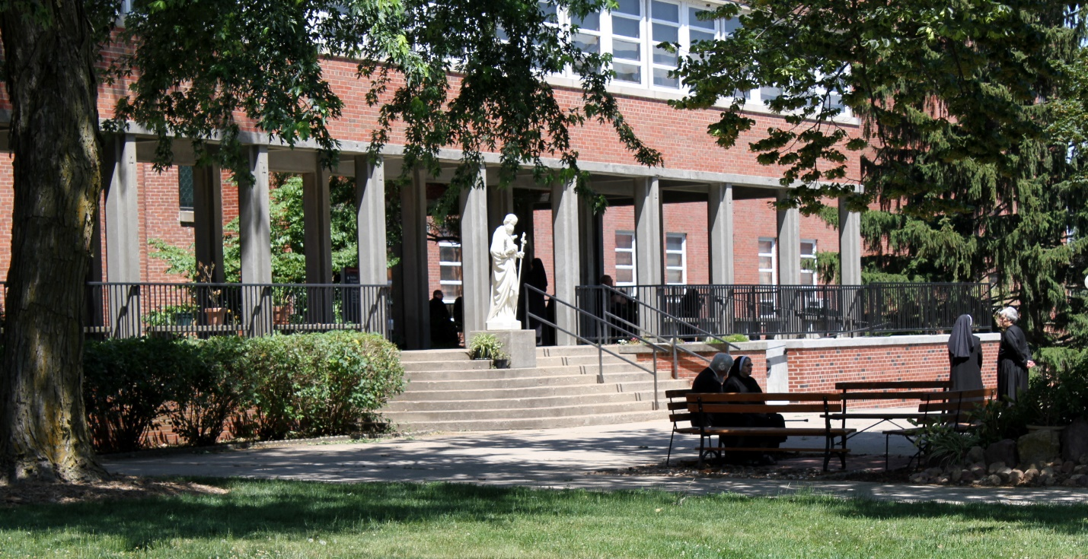
Fr. Wayne Kamm; Sr. Bernadette Barrett; Sr. Veronica Taylor; Sr. Toni Sylvester

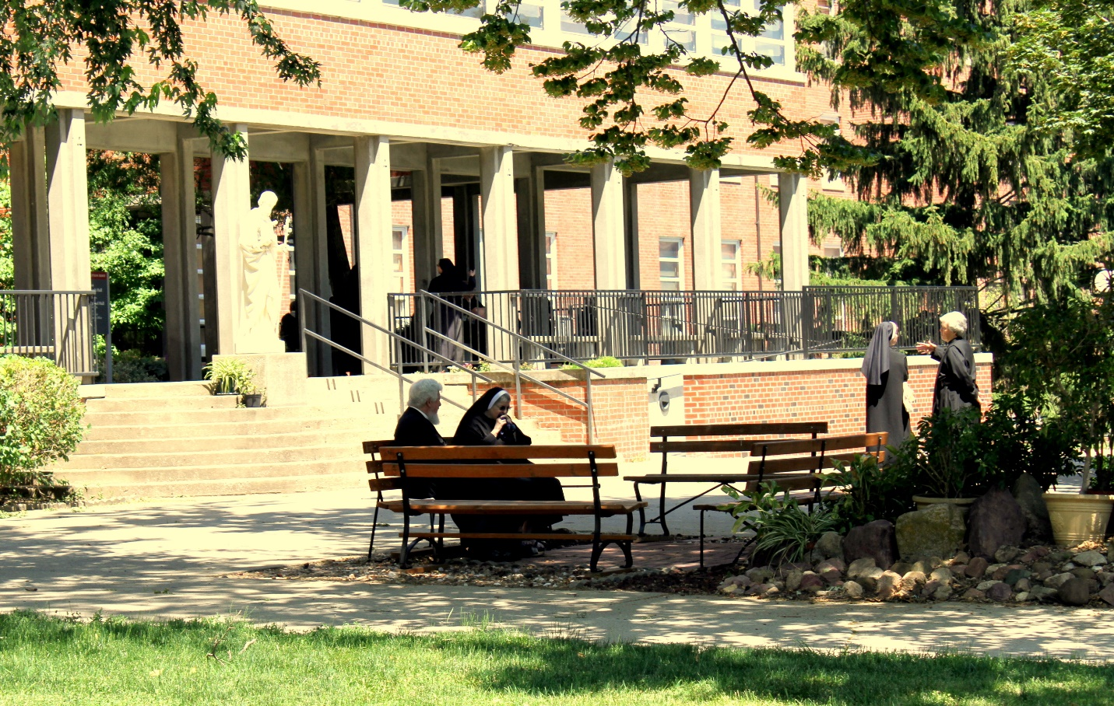
Fr. Wayne Kamm; Sr. Bernadette Barrett; Sr. Veronica Taylor; Sr. Toni Sylvester

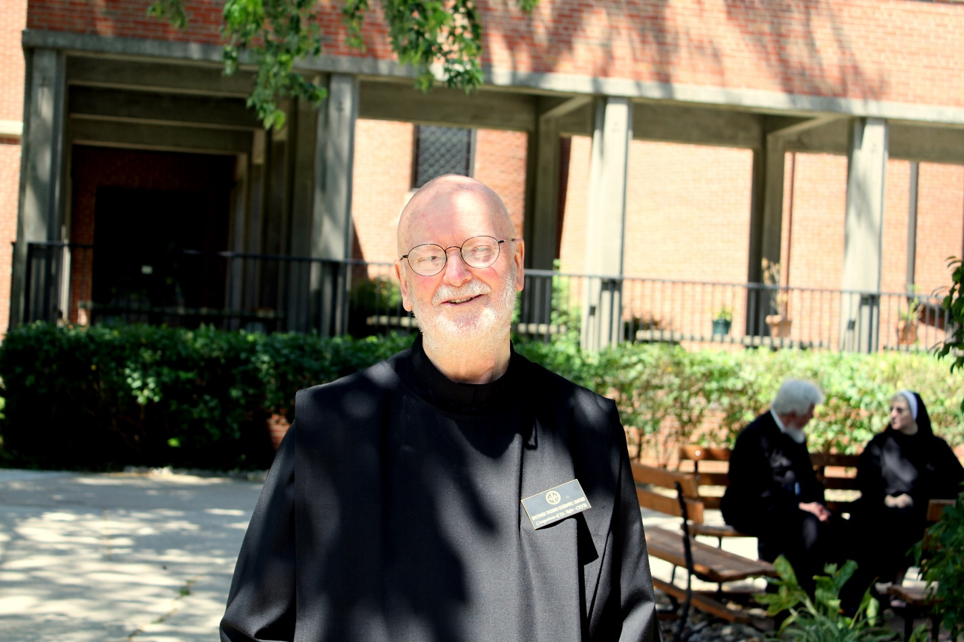
Br. Thomas Anthony Goddard; Fr. Wayne Kamm; Sr. Bernadette Barrett

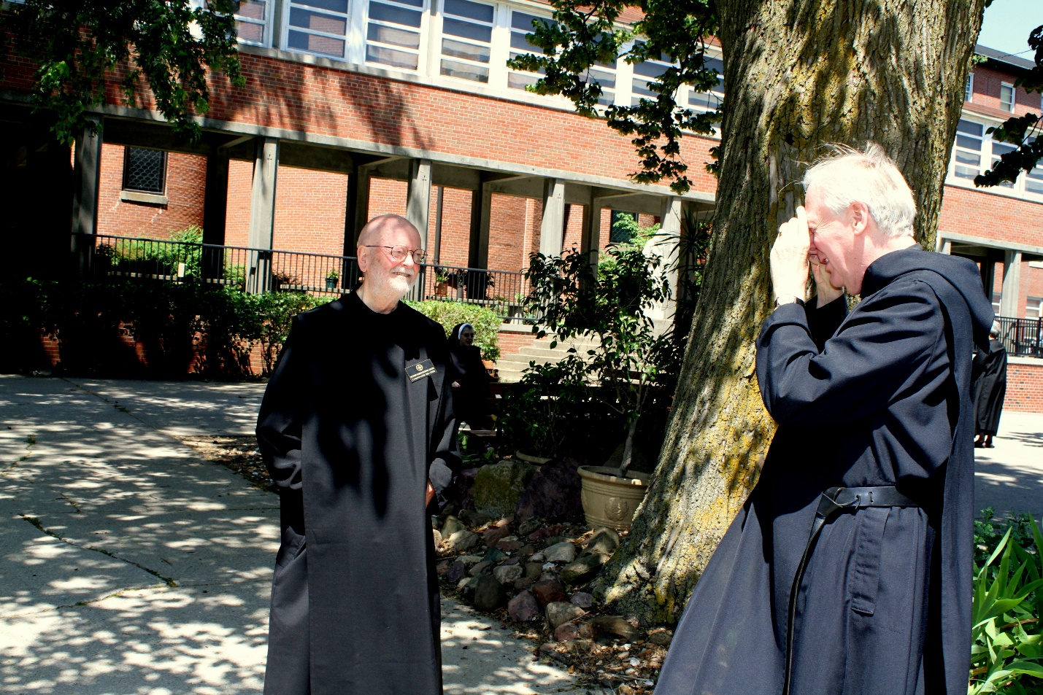
Br. Thomas Anthony Goddard; Br. Lee Doucette

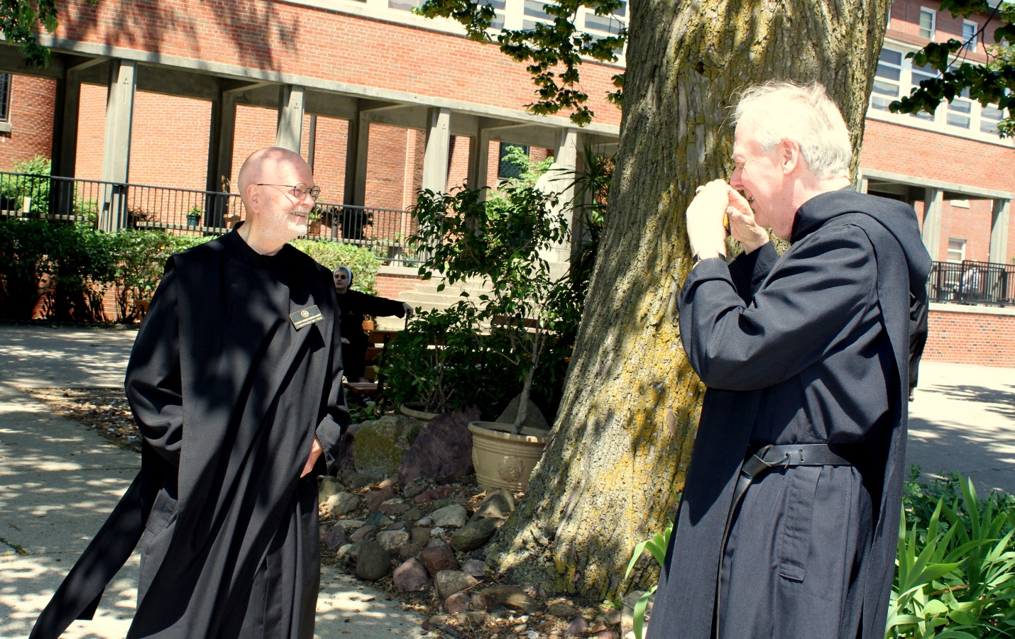
Br. Thomas Anthony Goddard; Br. Lee Doucette

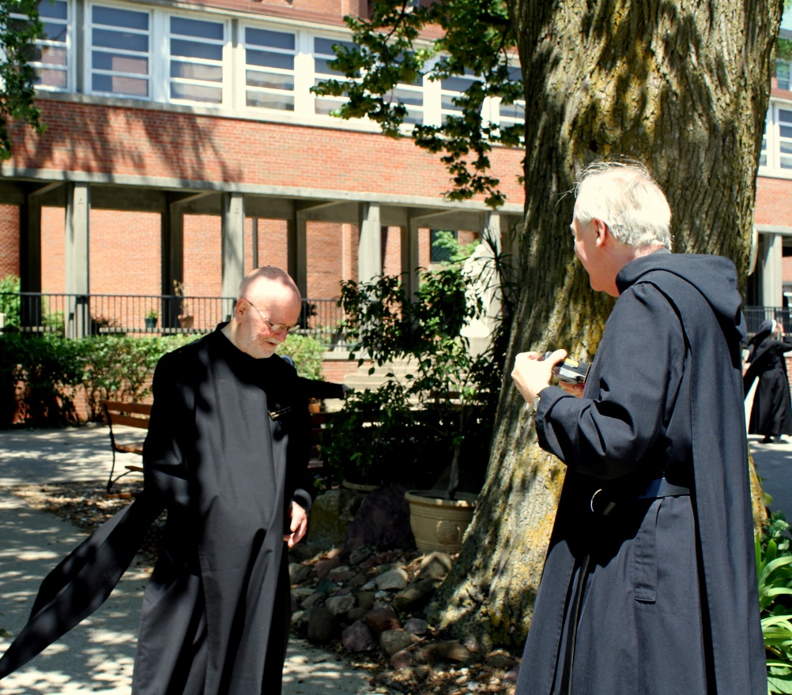
Br. Thomas Anthony Goddard; Br. Lee Doucette; Sr. Veronica Taylor

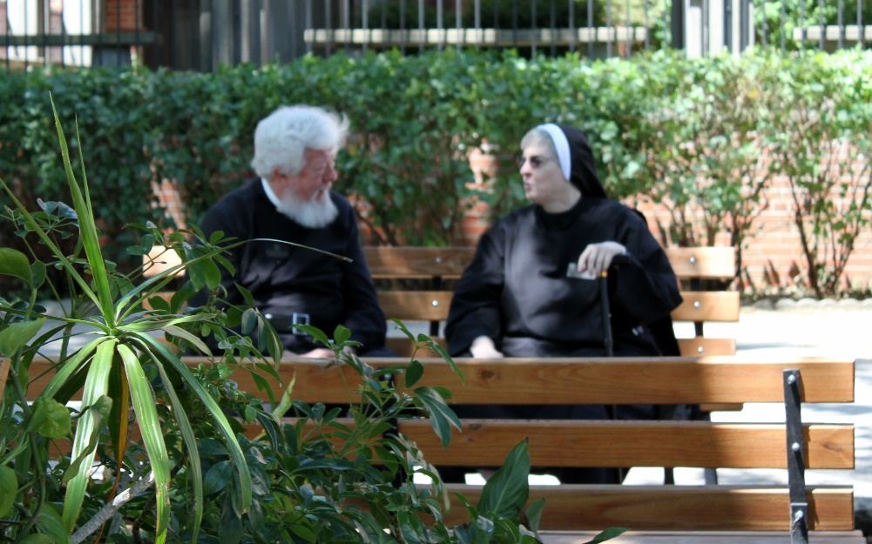
Fr. Wayne Kamm; Sr. Bernadette Barrett

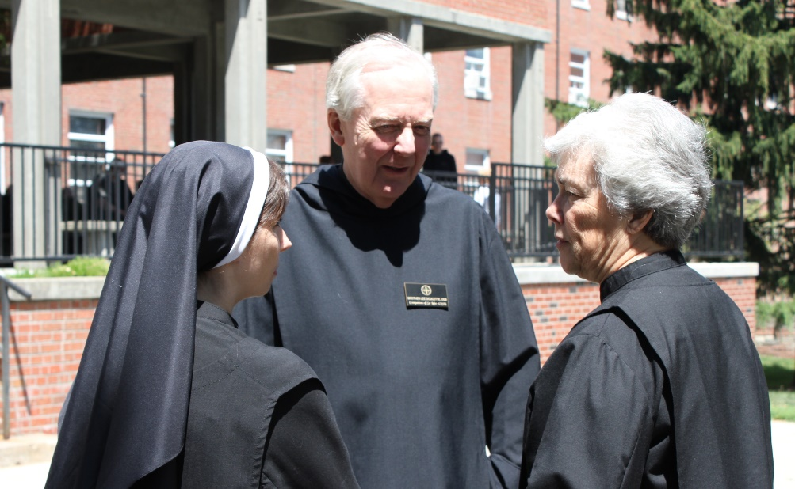
Sr. Veronica Taylor; Br. Lee Doucette; Sr. Toni Sylvester

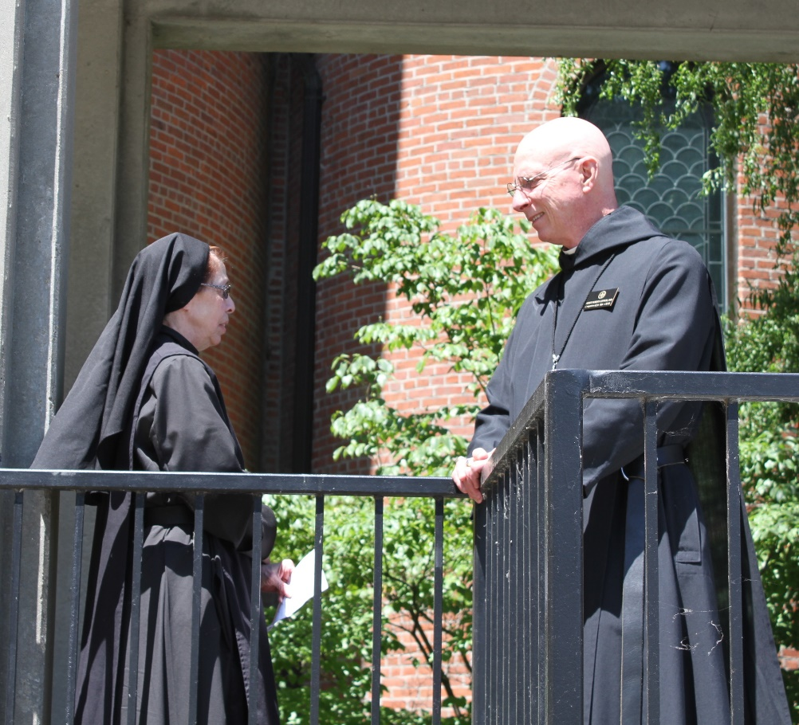
Sr. Monica Ruth Mullen; Abbot Robert Cotton

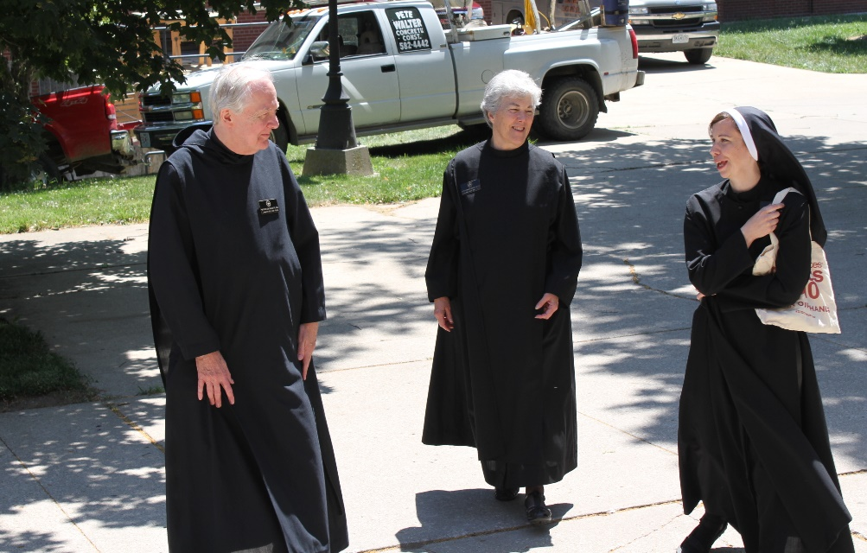
Br. Lee Doucette; Sr. Toni Sylvester; Sr. Veronica Taylor

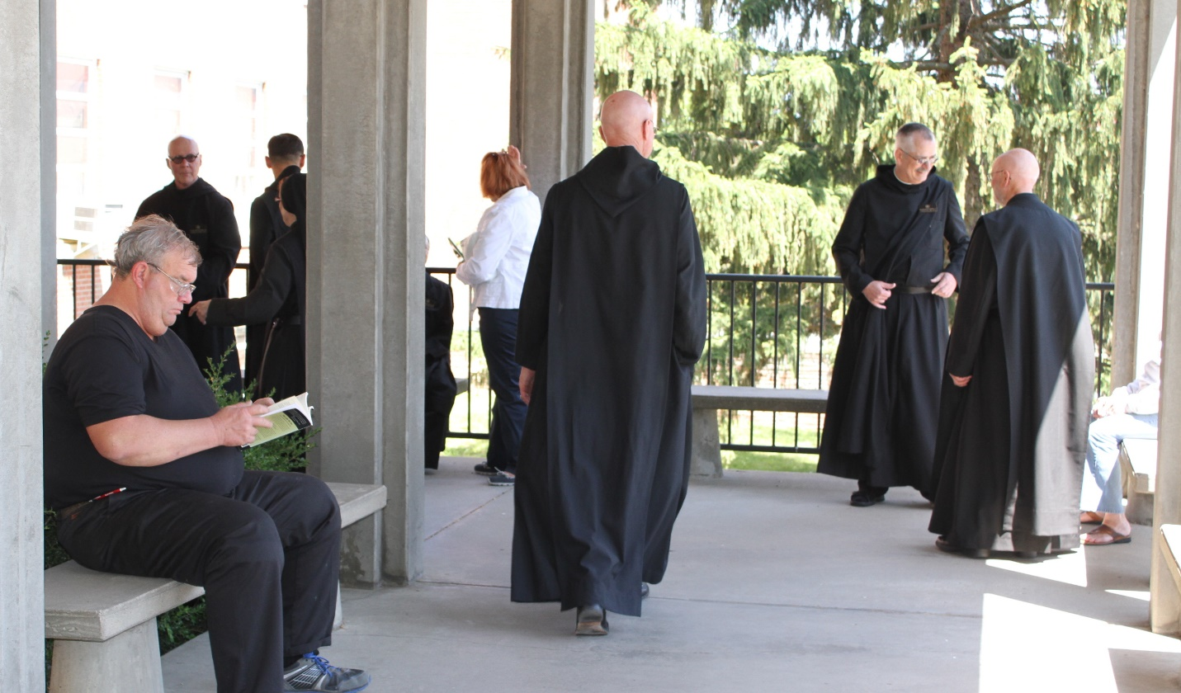
Joe Campbell; Br. Stephen Francis Arnold; Br. Roman Shemayev; Sr. Monica Ruth Mullen; ?; Abbot Robert Cotton; Br. Dunstan Townsend; Br. Thomas Anthony Goddard

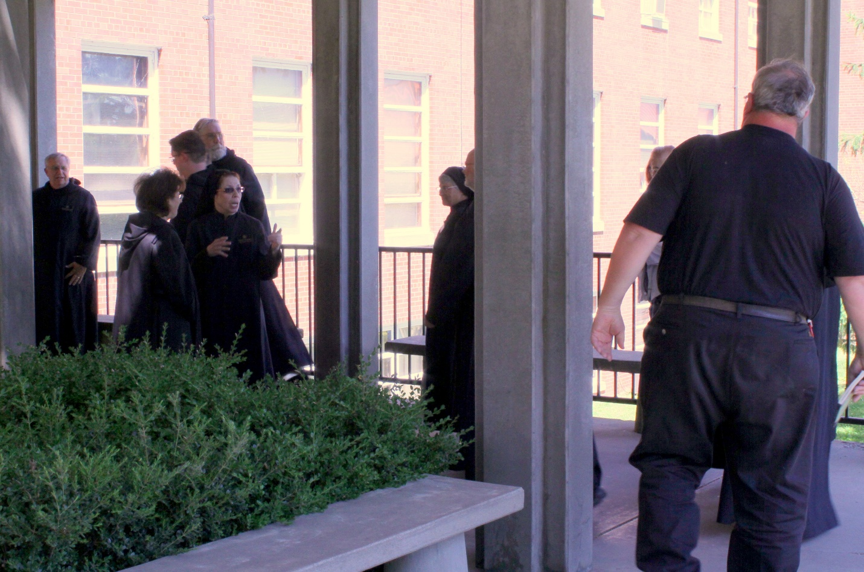
Br. Bede Leach; Sr. Martha Lamoy; Br. Kenneth Maguire; Br. David Gerns; Sr. Monica Ruth Mullen; Sr. Mary Francis Deulen; Br. Thomas Anthony Goddard; ?; Joe Campbell
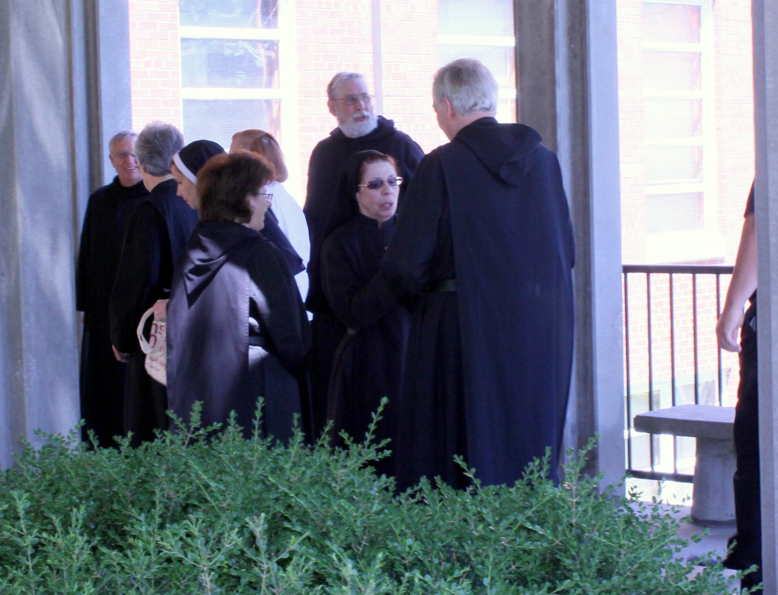
Br. Bede Leach; Sr. Toni Sylvester; Sr. Veronica Taylor; Sr. Martha Lamoy; Br. David Gerns; Sr. Monica Ruth Mullen; Br. Lee Doucette
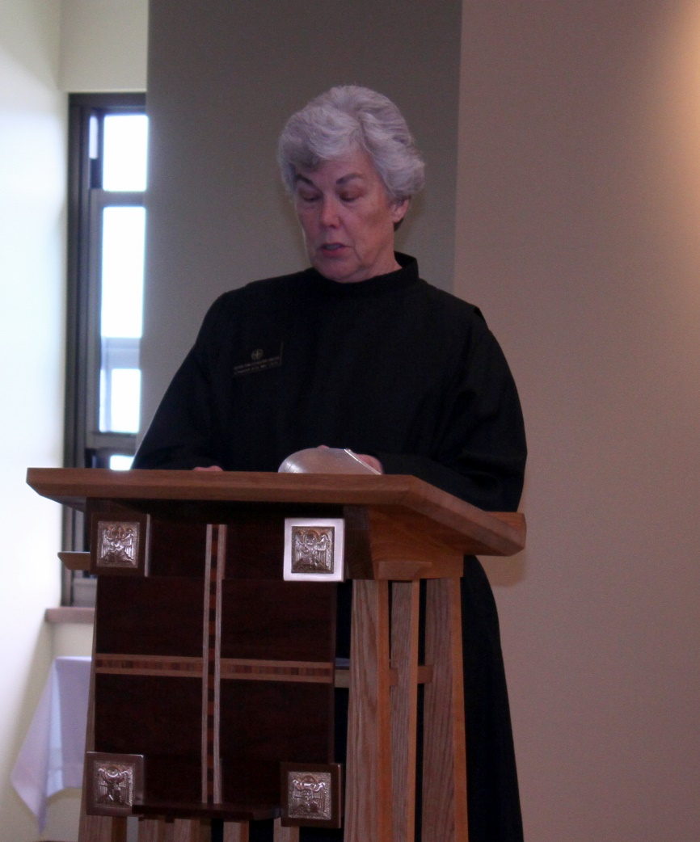
Sr. Toni Sylvester

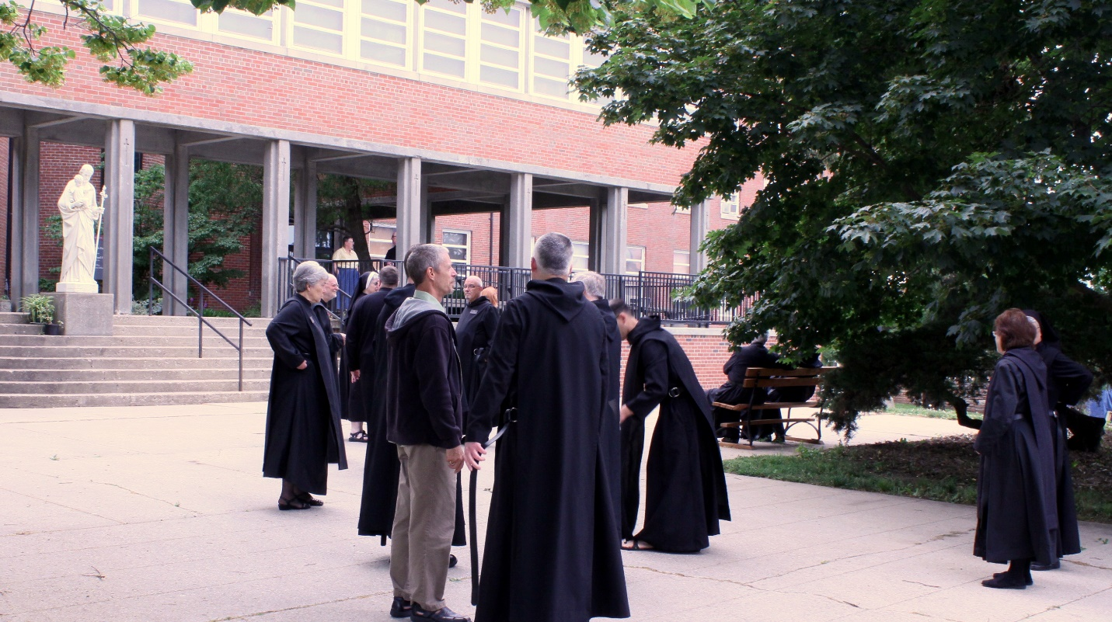
Sr. Toni Sylvester; Br. Thomas Anthony Goddard; Kate Maxwell; Sr. Bernadette Barrett; Victor Bullock; Br. Stephen Francis Arnold; Scott Nonken; Br. Basil Edwards; Br. Dunstan Townsend; Br. Kenneth Maguire; Sr. Martha Lamoy

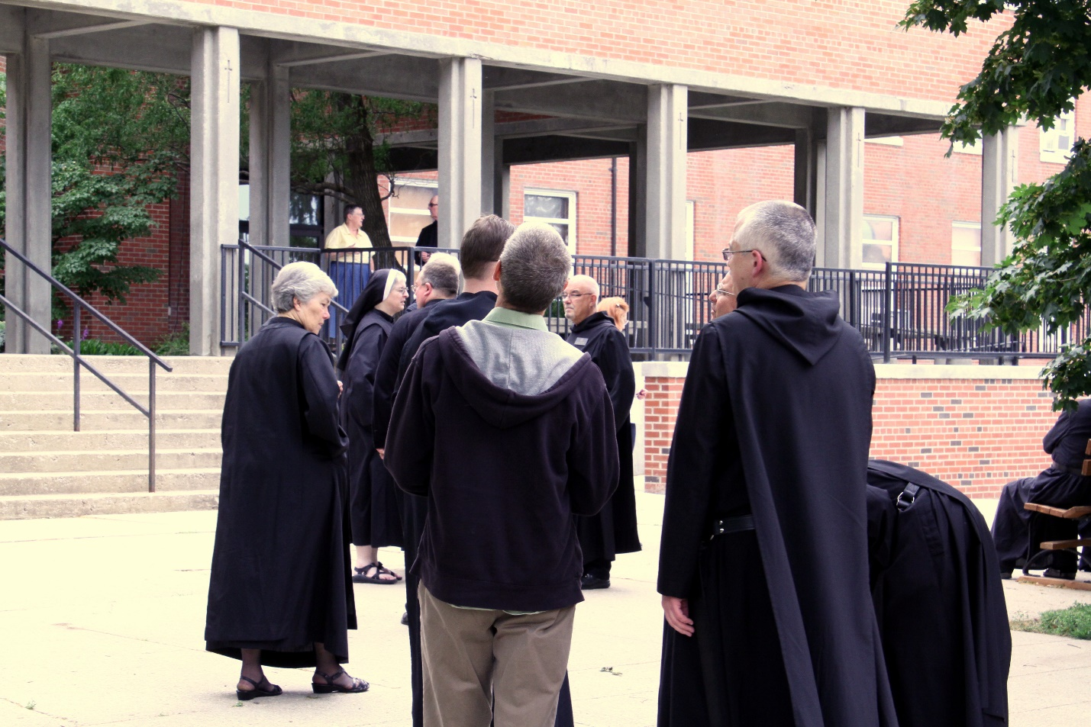
Sr. Toni Sylvester; Kate Maxwell; Sr. Bernadette Barrett; Victor Bullock; Br. Stephen Francis Arnold; Scott Nonken; Br. Basil Edwards; Br. Bede Leach; Br. Dunstan Townsend

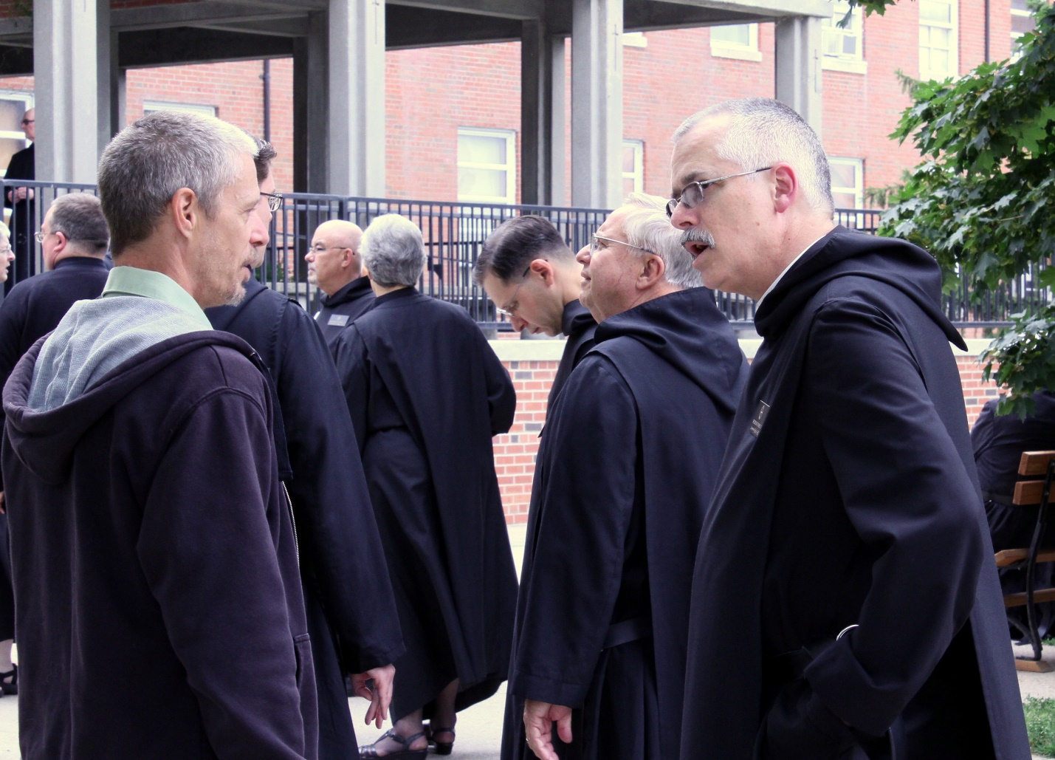
Sr. Bernadette Barrett; Br. Stephen Francis Arnold; Victor Bullock; Scott Nonken; Br. Kenneth Maguire; Br. Basil Edwards; Sr. Toni Sylvester; Br. Roman Shemayev; Br. Bede Leach; Br. Dunstan Townsend

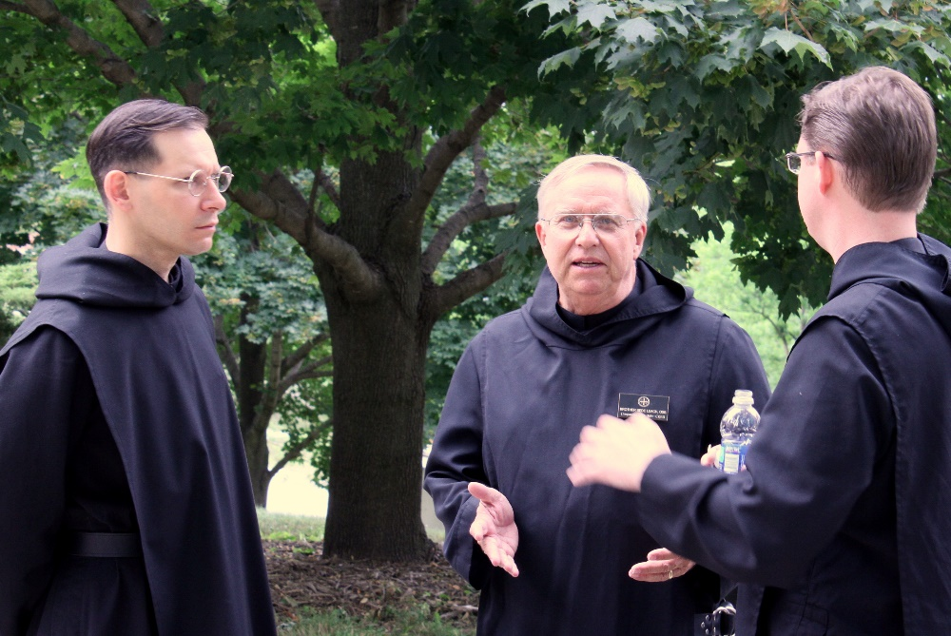
Br. Roman Shemayev; Br. Bede Leach; Br. Kenneth Maguire
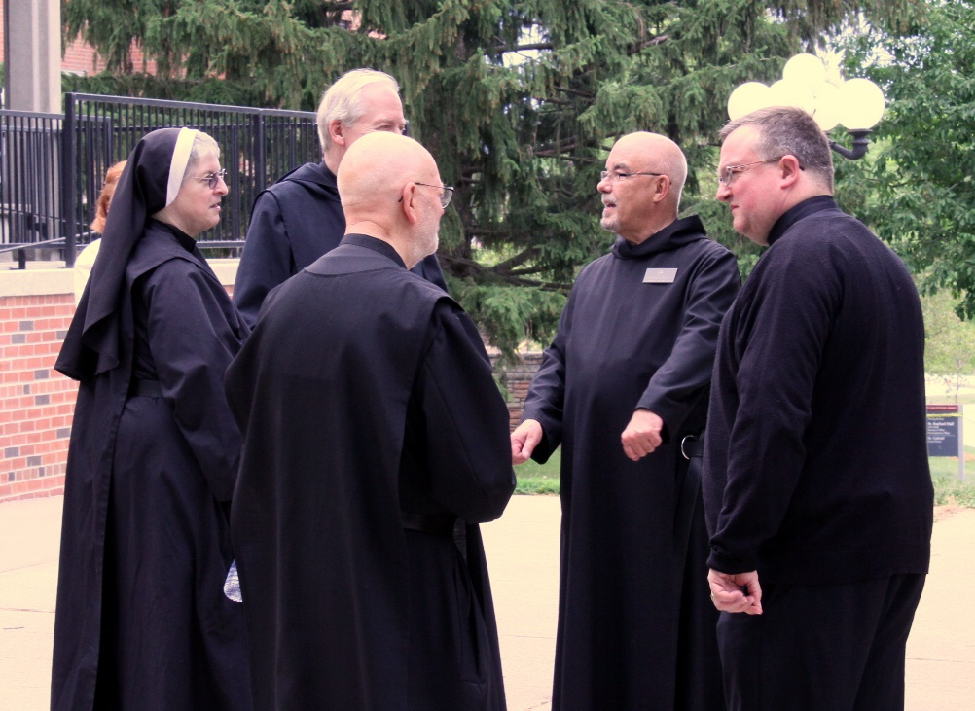
Sr. Bernadette Barrett; Br. Lee Doucette; Br. Thomas Anthony Goddard; Br. Basil Edwards; Victor Bullock

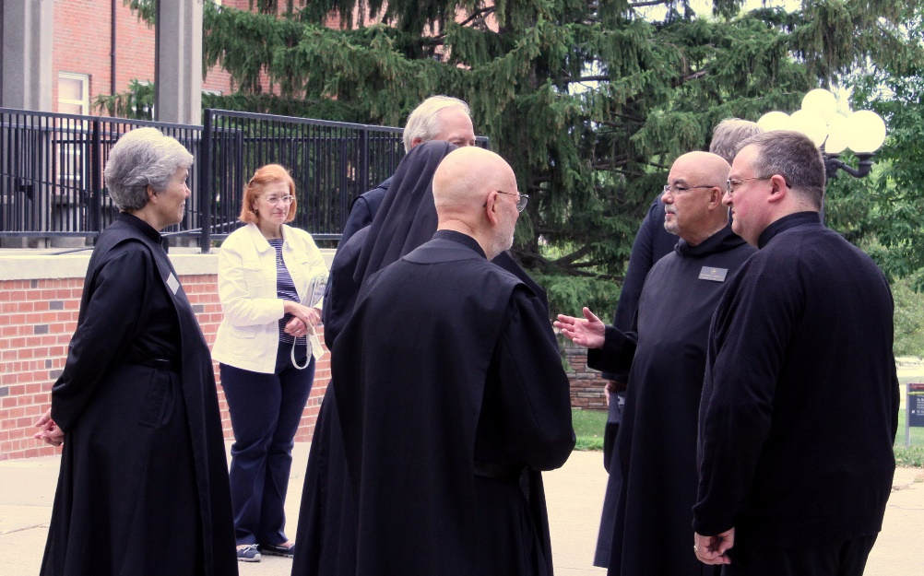
Sr. Toni Sylvester; ?; Br. Lee Doucette; Br. Thomas Anthony Goddard; Br. Basil Edwards; Victor Bullock
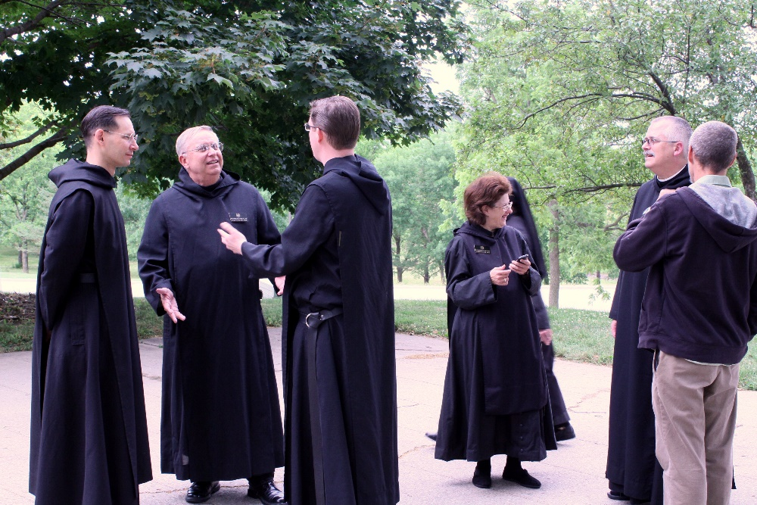
Br. Roman Shemayev; Br. Bede Leach; Br. Kenneth Maguire; Sr. Martha Lamoy; Br. Dunstan Townsend; Scott Nonken

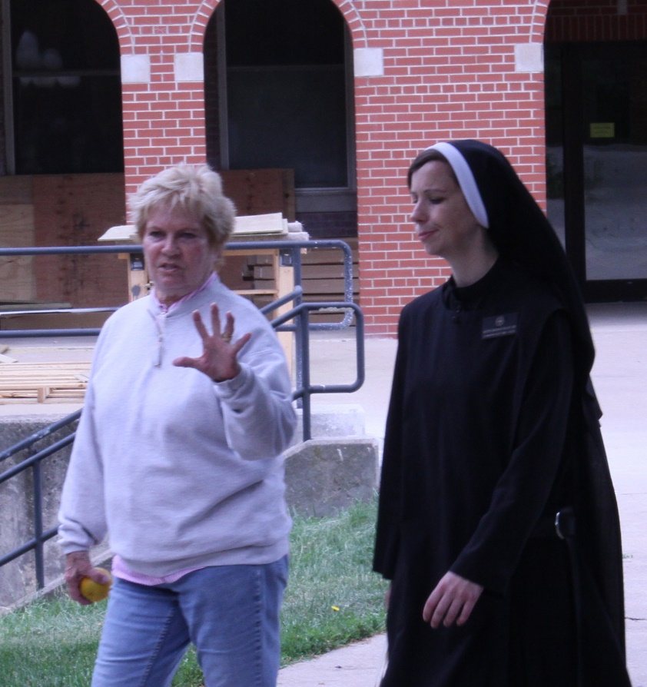
Cam Leach; Sr. Veronica Taylor

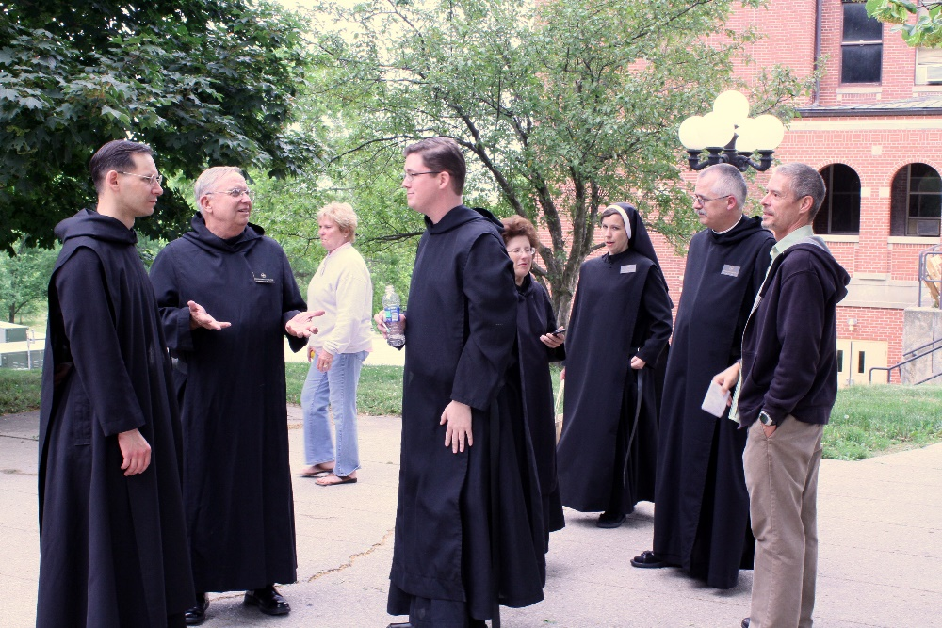
Br. Roman Shemayev; Br. Bede Leach; Cam Leach; Br. Kenneth Maguire; Sr. Martha Lamoy; Sr. Veronica Taylor; Br. Dunstan Townsend; Scott Nonken

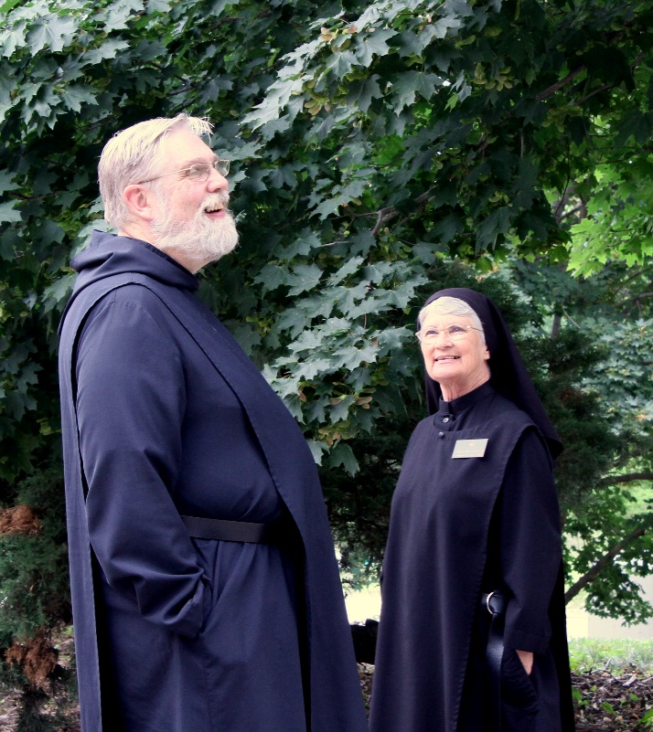
Br. David Gerns; Sr. Mary Francis Deulen
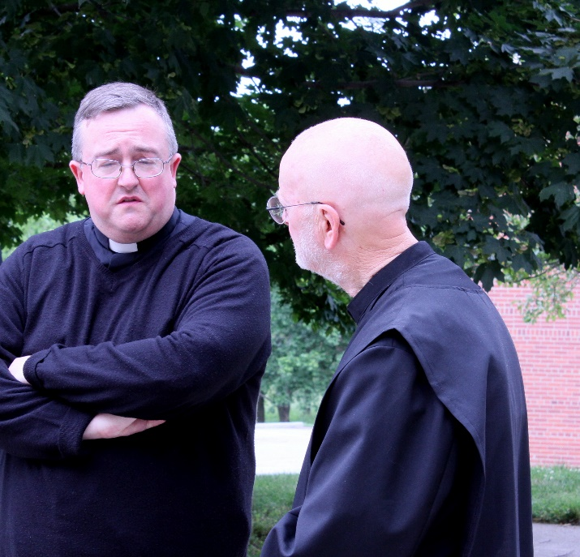
Victor Bullock; Br. Thomas Anthony Goddard

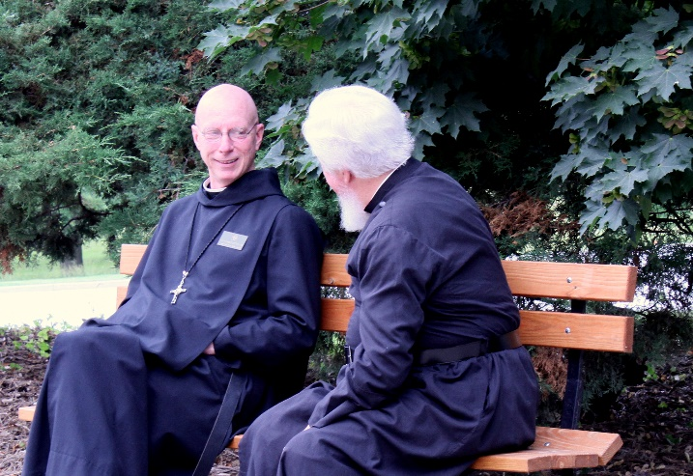
Abbot Robert Cotton; Fr. Wayne Kamm

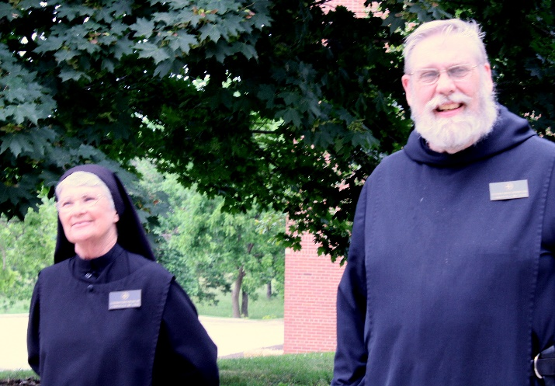
Sr. Mary Francis Deulen; Br. David Gerns
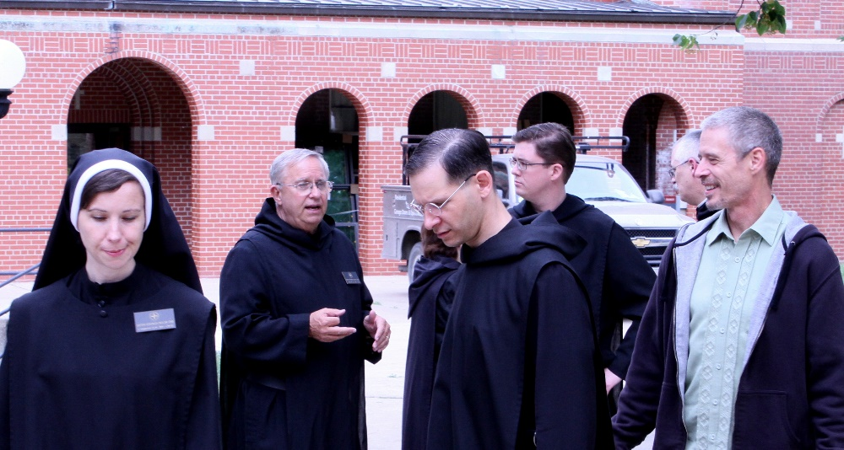
Sr. Veronica Taylor; Br. Bede Leach; Br. Roman Shemayev; Br. Kenneth Maguire; Br. Dunstan Townsend; Scott Nonken

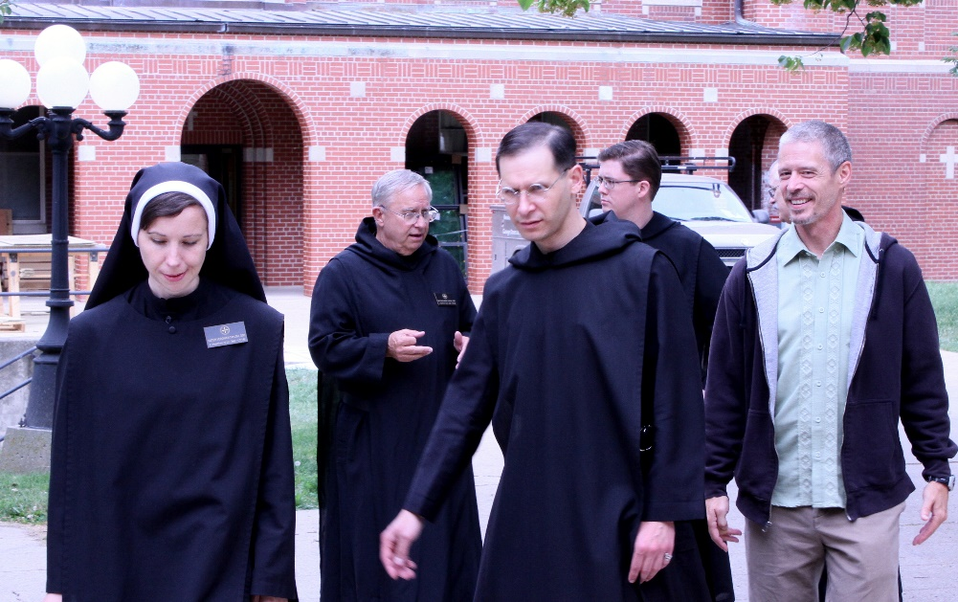
Sr. Veronica Taylor; Br. Bede Leach; Br. Roman Shemayev; Br. Kenneth Maguire; Br. Dunstan Townsend; Scott Nonken

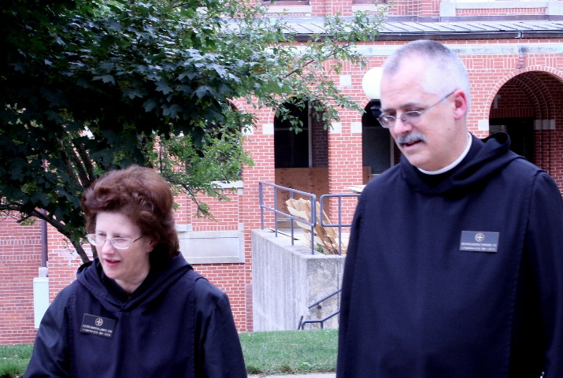
Sr. Martha Lamoy; Br. Dunstan Townsend

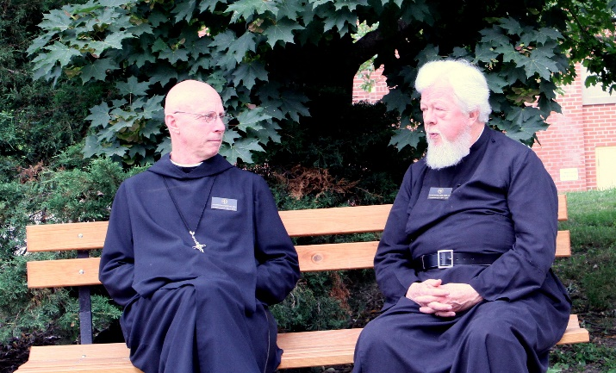
Abbot Robert Cotton; Fr. Wayne Kamm

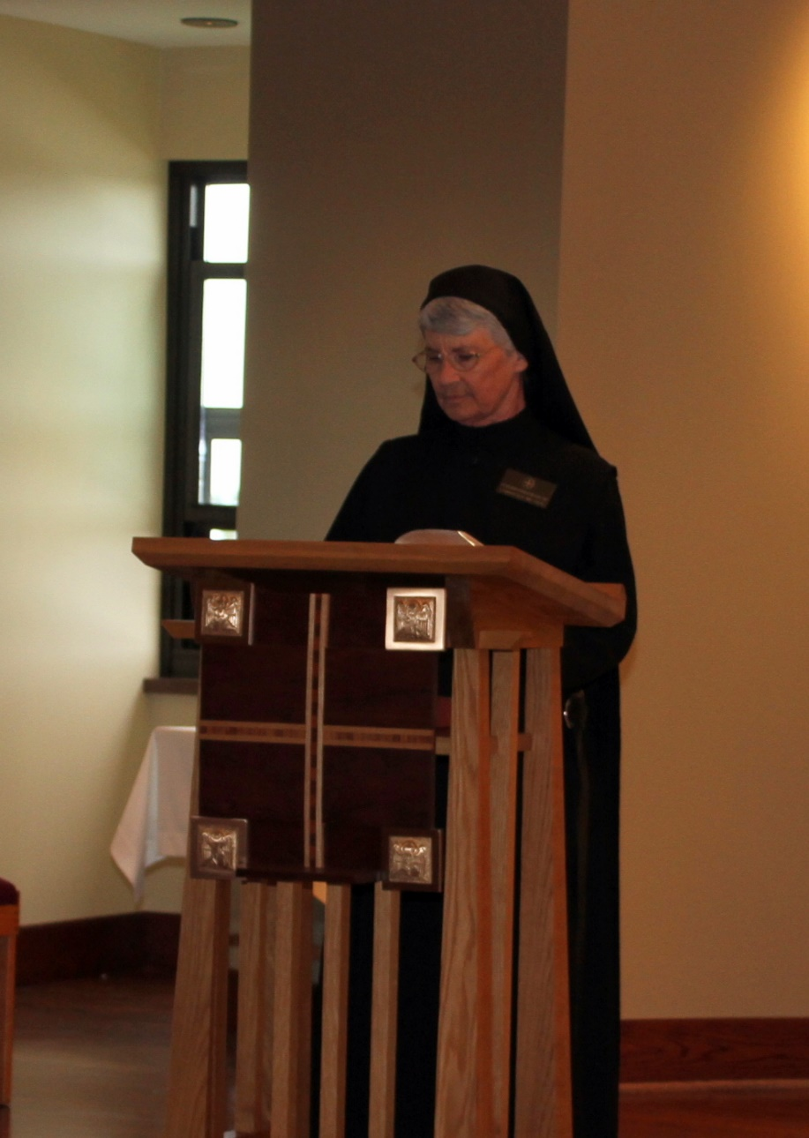
Sr. Mary Francis Deulen
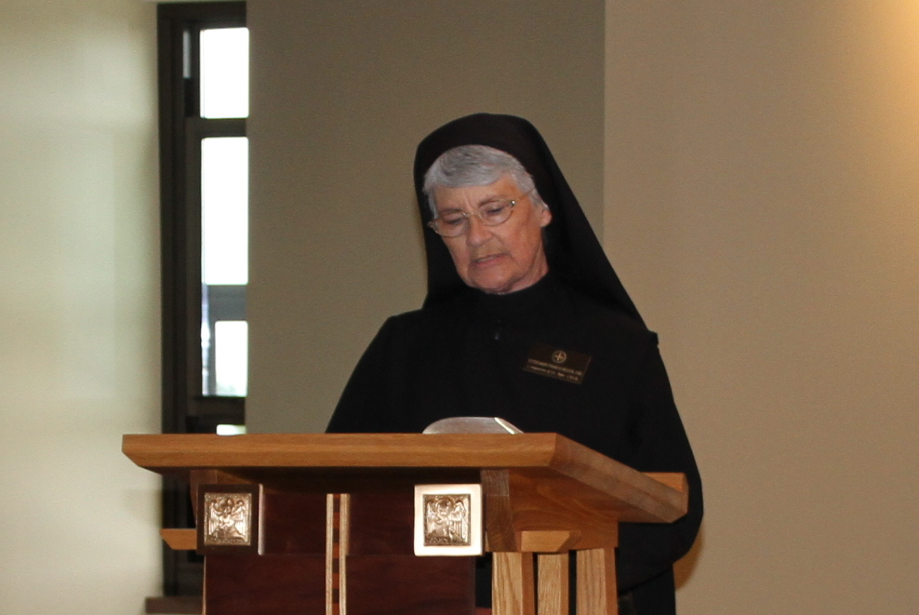
Sr. Mary Francis Deulen

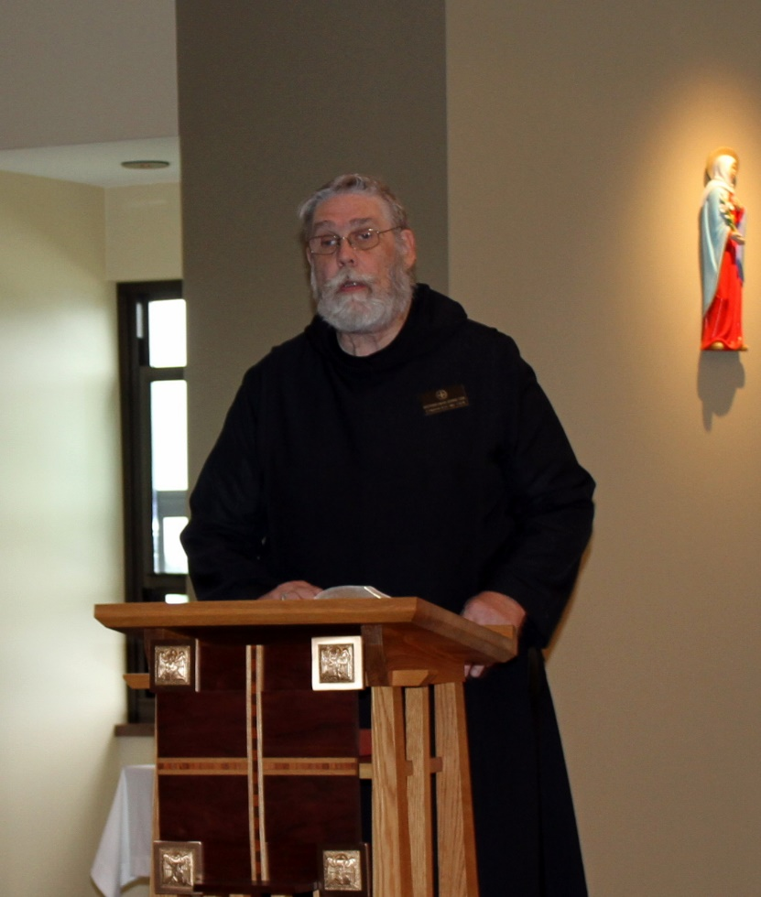
Br. David Gerns

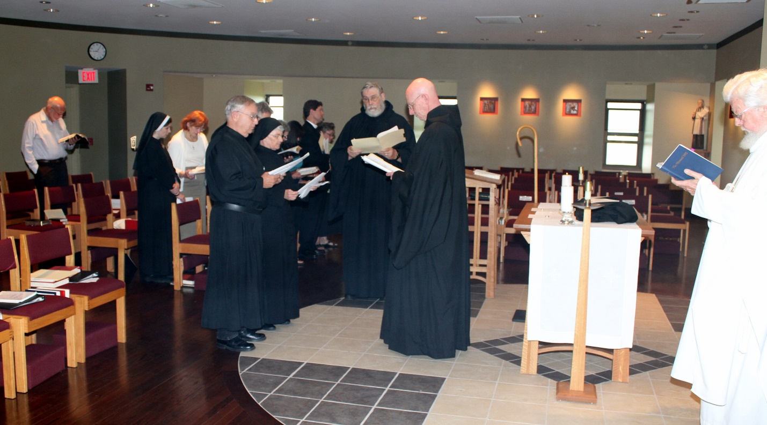
Peter DeFranco; Sr. Veronica Taylor; ?; Br. Bede Leach; Sr. Mary Francis Deulen; Fr. N. Luke Back; Lisa Angell; Br. David Gerns; Abbot Robert Cotton; Fr. Wayne Kamm

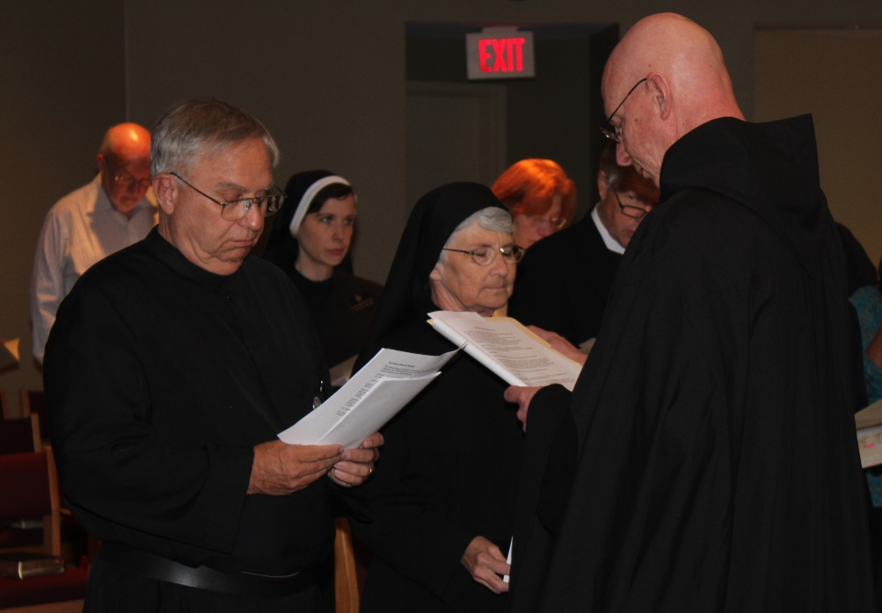
Peter DeFranco; Br. Bede Leach; Sr. Veronica Taylor; Sr. Mary Francis Deulen; ?; Dean George Back; Abbot Robert Cotton

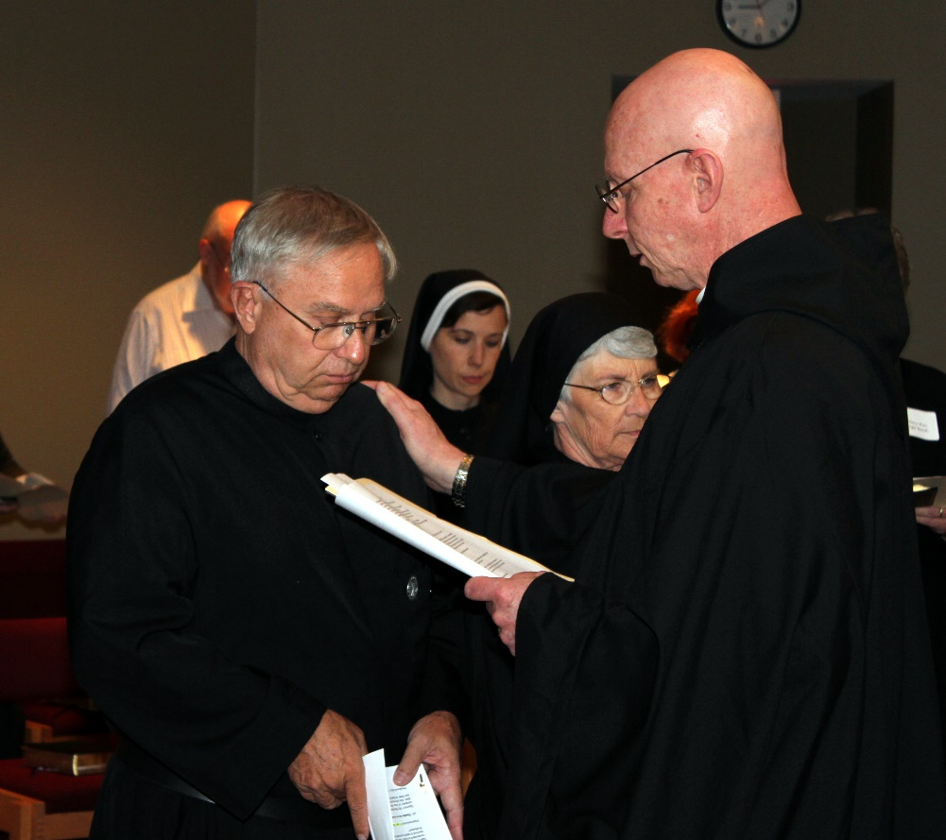
Peter DeFranco; Br. Bede Leach; Sr. Veronica Taylor; Sr. Mary Francis Deulen; Abbot Robert Cotton

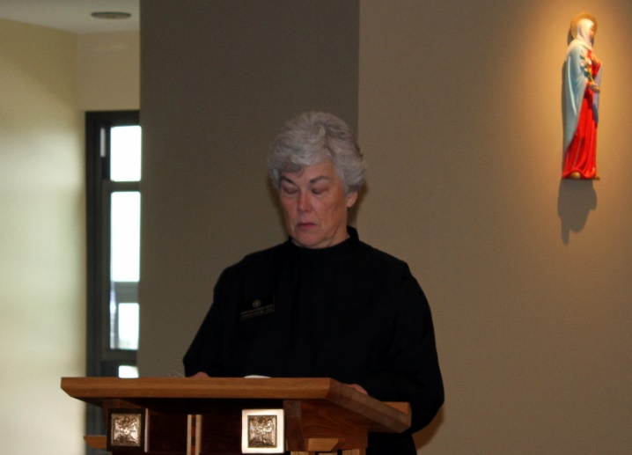
Sr. Toni Sylvester

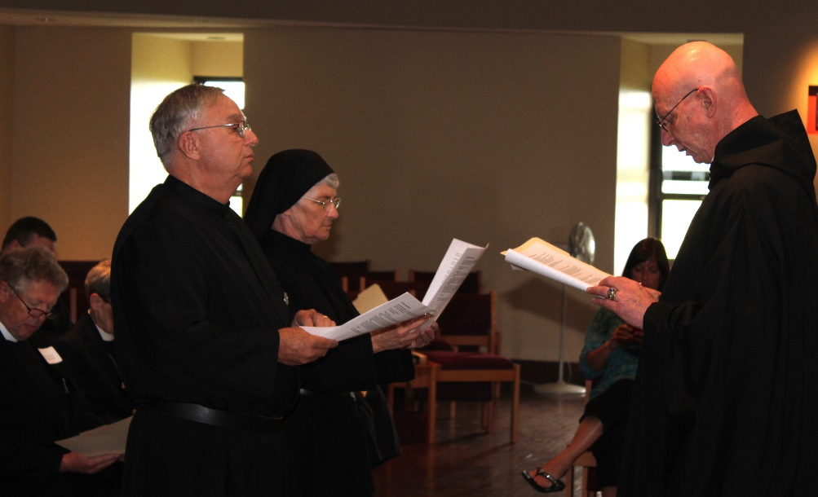
Dean George Back; Br. Bede Leach; Sr. Mary Francis Deulen; Melissa Milliorn; Abbot Robert Cotton

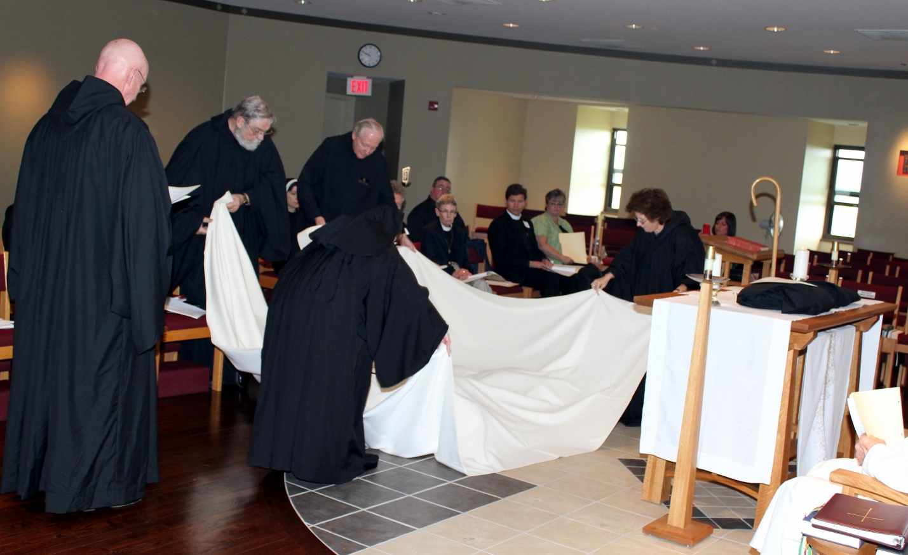
Abbot Robert Cotton; Br. David Gerns; Sr. Veronica Taylor; Br. Lee Doucette; Sr. Monica Ruth Mullen; Victor Bullock; Rev. Mary P. Thomas; Fr. N. Luke Back; Lisa Angell; Sr. Martha Lamoy; Melissa Milliorn;

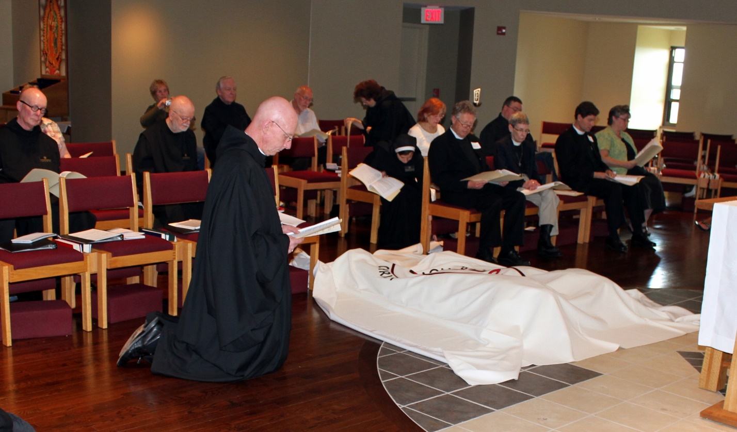
Br. Stephen Francis Arnold; Cam Leach; Br. Thomas Anthony Goddard; Br. Lee Doucette; Abbot Robert Cotton; Peter DeFranco; Sr. Martha Lamoy; Sr. Veronica Taylor; Dean George Back; Victor Bullock; Rev. Rosemary P. Thomas; Fr. George Back; Lisa Angell

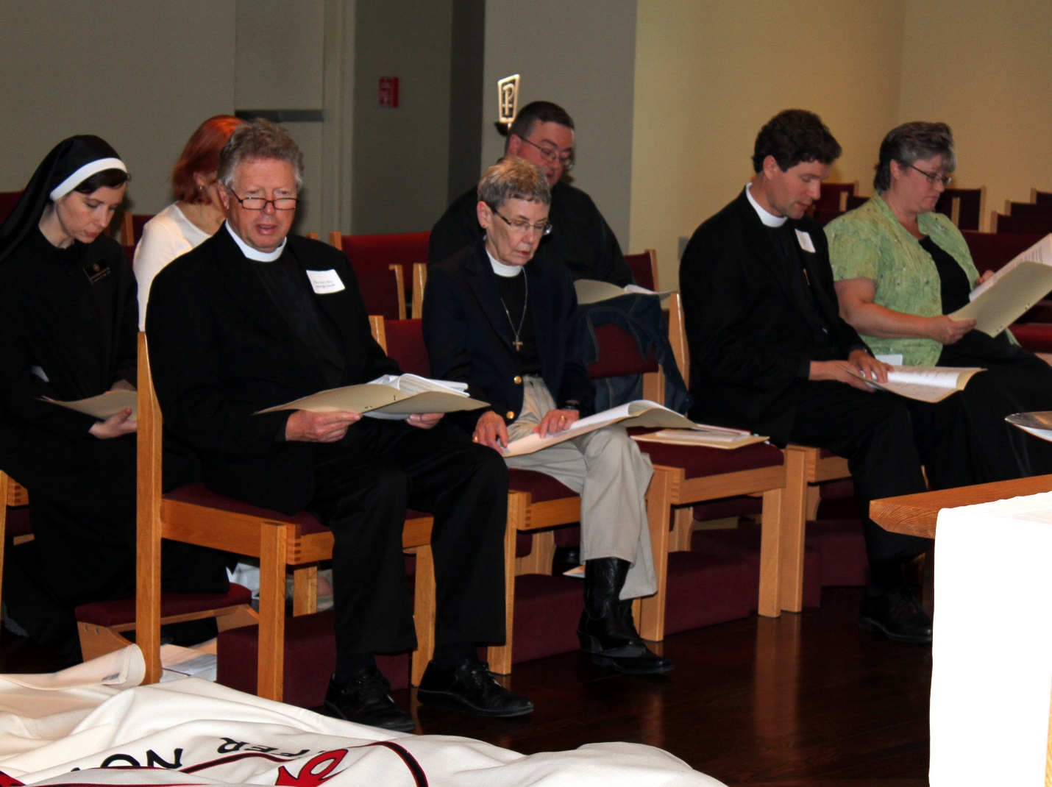
Sr. Veronica Taylor; ?; Dean George Back; Rev. Rosemary P. Thomas; Victor Bullock; Fr. N. Luke Back; Lisa Angell

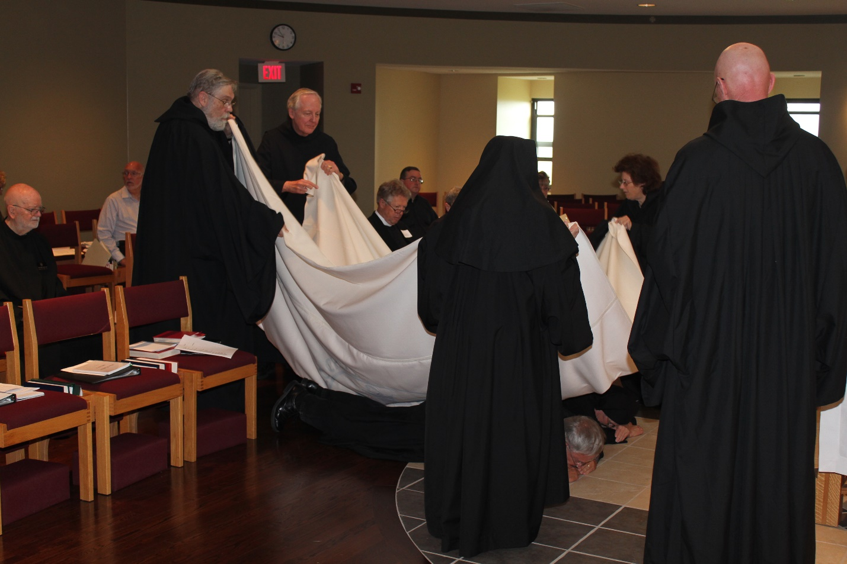
Br. Thomas Anthony Goddard; Peter DeFranco; Br. David Gerns; Br. Lee Doucette; Dean George Back; Victor Bullock; Sr. Monica Ruth Mullen; Br. Bede Leach; Sr. Mary Francis Deulen; Sr. Martha Lamoy; Abbot Robert Cotton

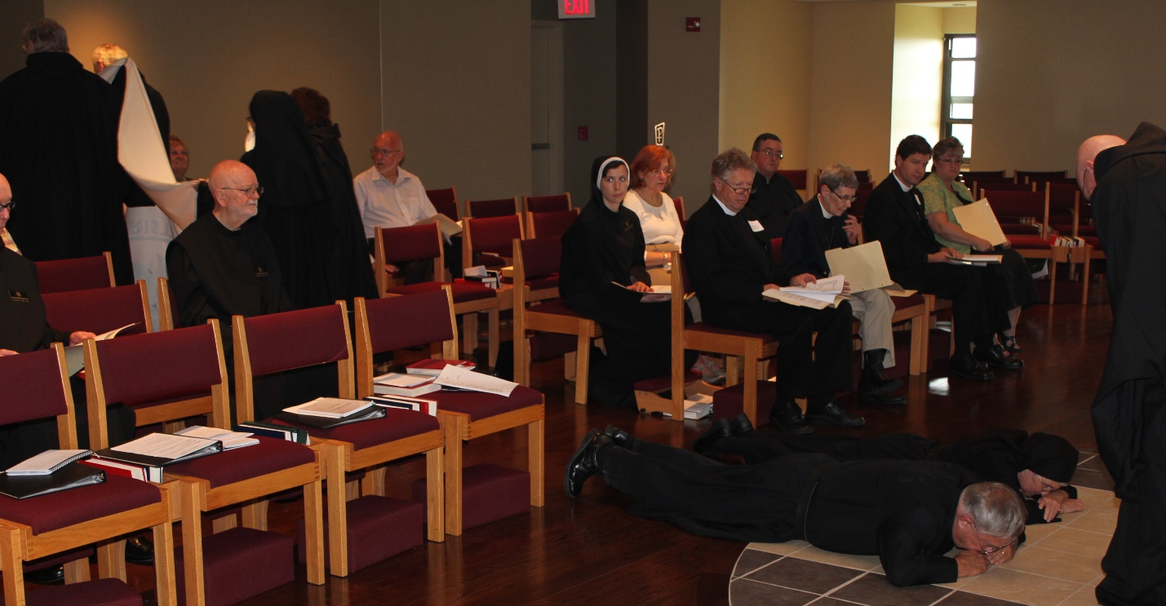
Br. Stephen Francis Arnold; Br. David Gerns; Cam Leach; Br. Thomas Anthony Goddard; Sr. Monica Ruth Mullen; Sr. Martha Lamoy; Peter DeFranco; Sr. Veronica Taylor; ?; Rev. Rosemary P. Thomas; Dea George Back; Victor Bullock; Rev. Rosemary P. Thomas; Fr. N. Luke Back; Lisa Angell; Br. Bede Leach; Sr. Mary Francis Deulen; Abbot Robert Cotton

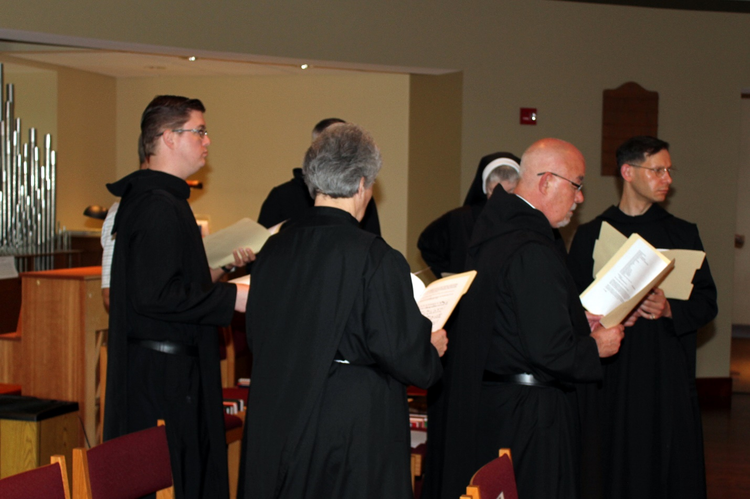
Br. Kenneth Maguire; Sr. Toni Sylvester; Sr. Bernadette Barrett; Br. Basil Edwards; Br. Roman Shemayev

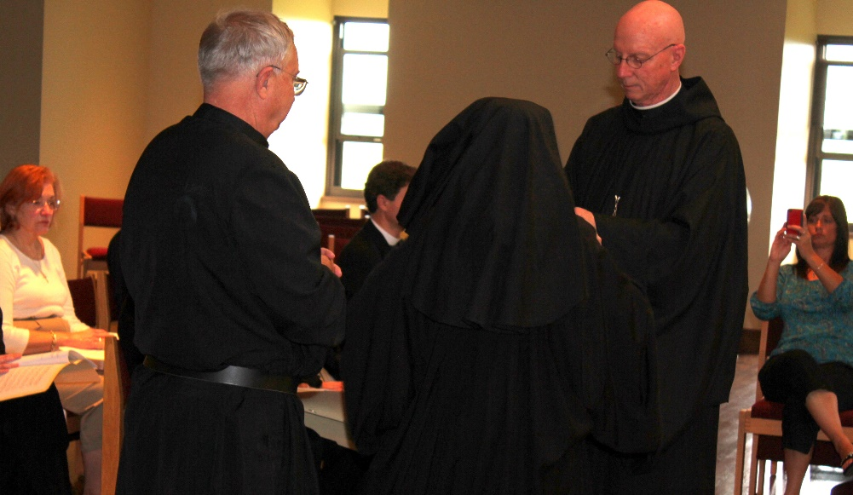
?; Br. Bede Leach; Fr. N. Luke Back; Sr. Monica Ruth Mullen; Abbot Robert Cotton; Melissa Milliorn

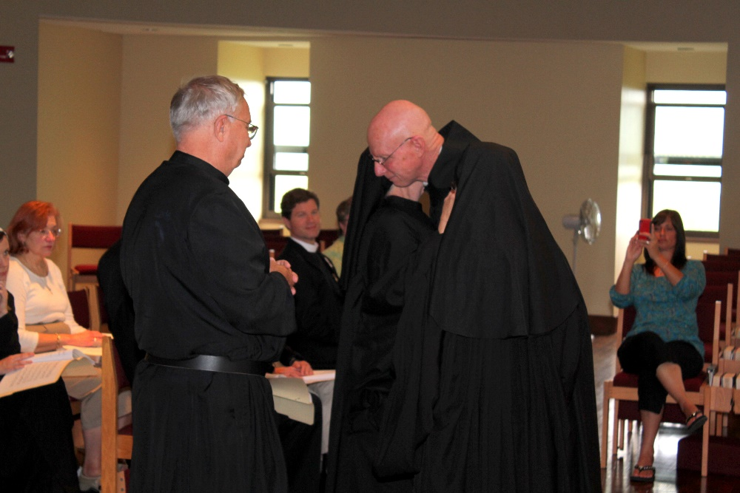
Sr. Veronica Taylor; ?; Br. Bede Leach; Fr. N. Luke Back; Sr. Mary Francis Deulen; Abbot Robert Cotton; Melissa Milliorn

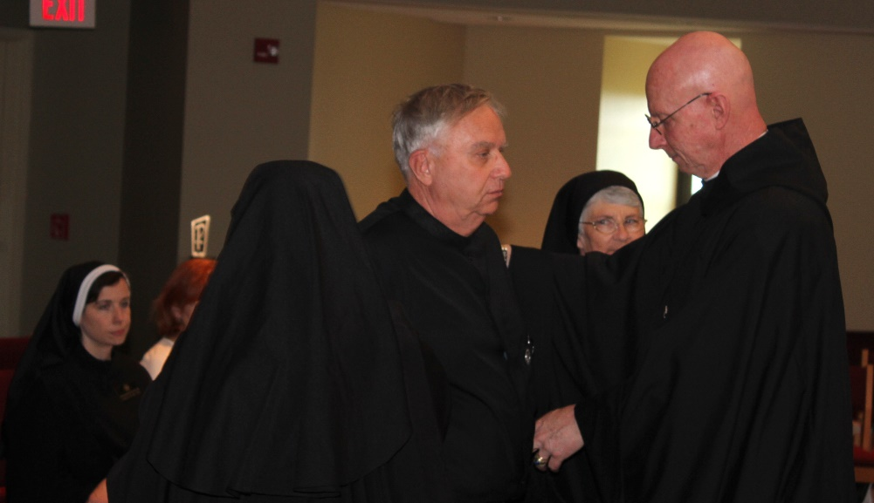
Sr. Veronica Taylor; ?; Sr. Monica Ruth Mullen; Br. Bede Leach; Sr. Mary Francis Deulen; Abbot Robert Cotton

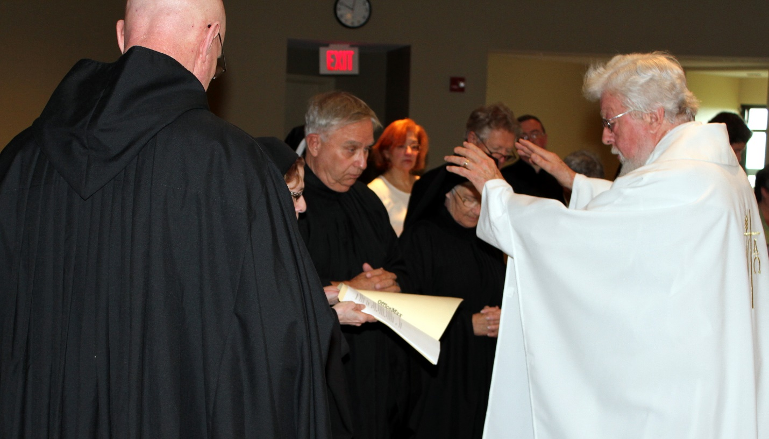
Abbot Robert Cotton; Sr. Monica Ruth Mullen; Br. Bede Leach; ?; Sr. Mary Francis Deulen; Dean George Back; Victor Bullock; Fr. Wayne Kamm

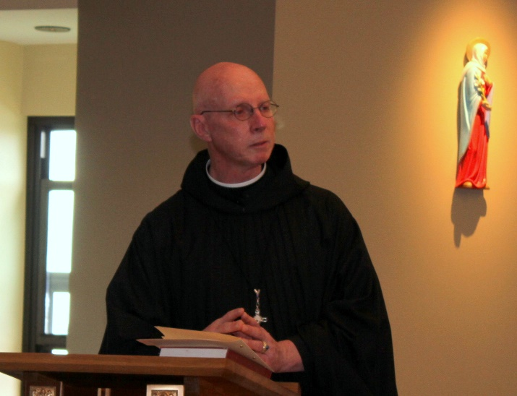
Abbot Robert Cotton

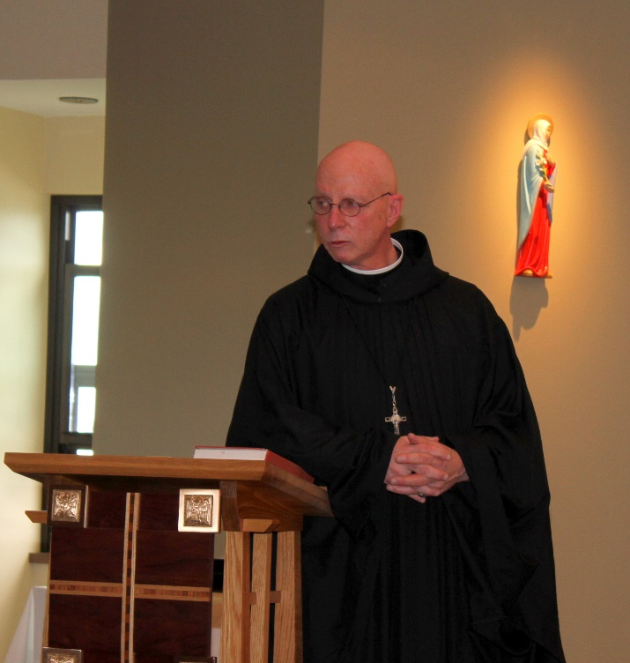
Abbot Robert Cotton

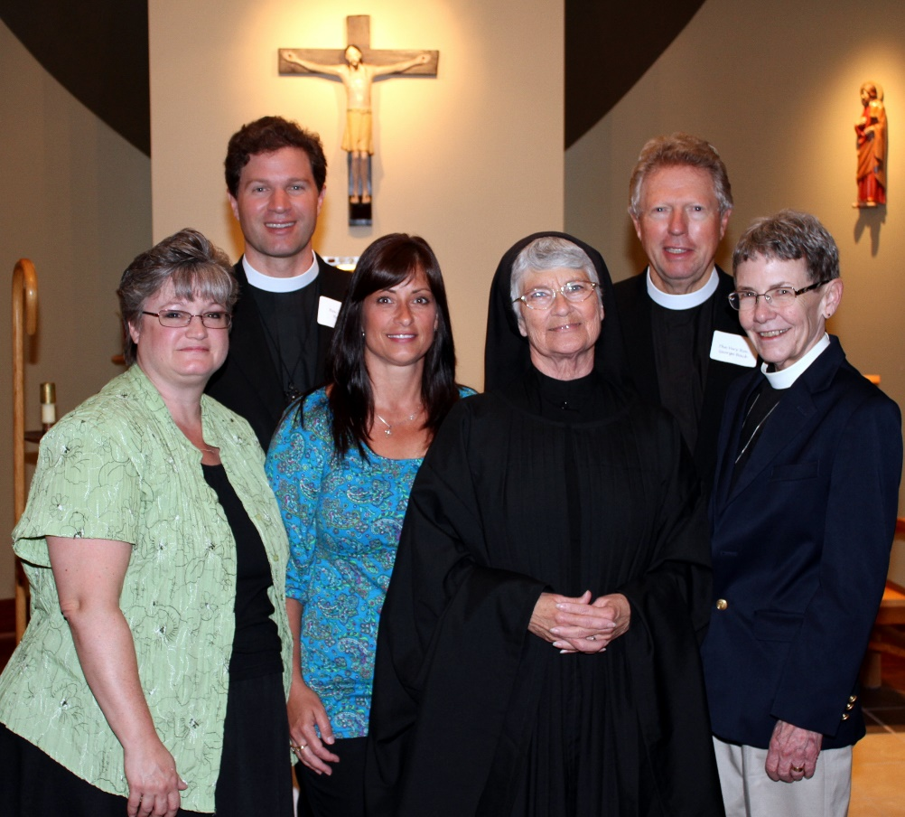
Lisa Angell; Fr. N. Luke Back; Melissa Milliorn; Sr. Mary Francis Deulen; Dean George Back; Rev. Rosemary P. Thomas

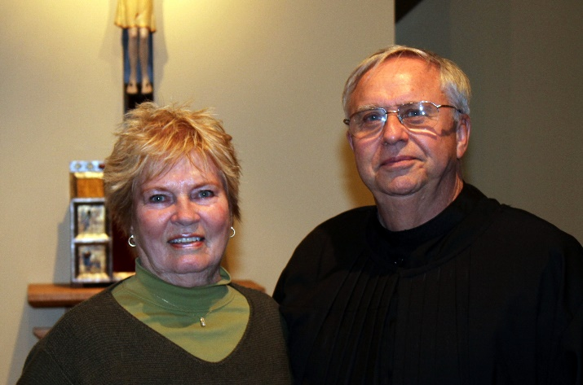
Cam Leach; Br. Bede Leach

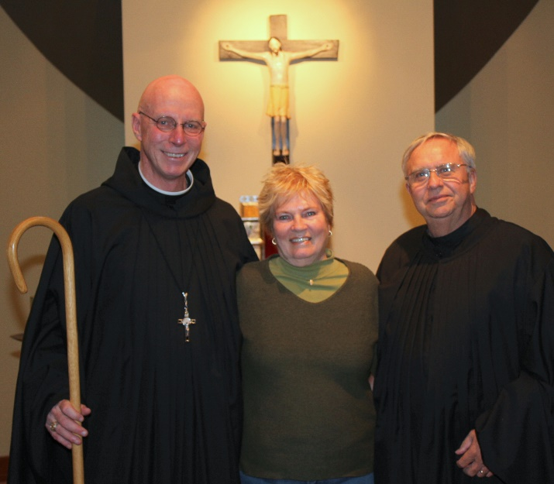
Abbot Robert Cotton; Cam Leach; Br. Bede Leach

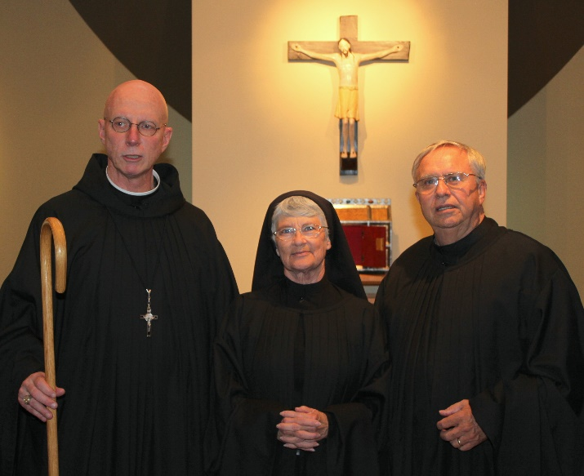
Abbot Robert Cotton; Sr. Mary Francis Deulen; Br. Bede Leach

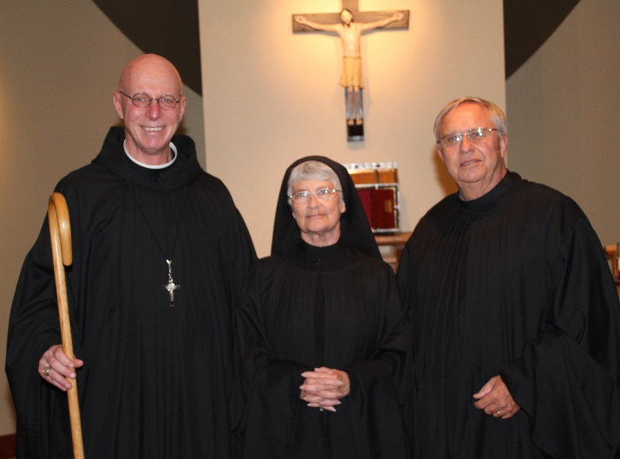
Abbot Robert Cotton; Sr. Mary Francis Deulen; Br. Bede Leach

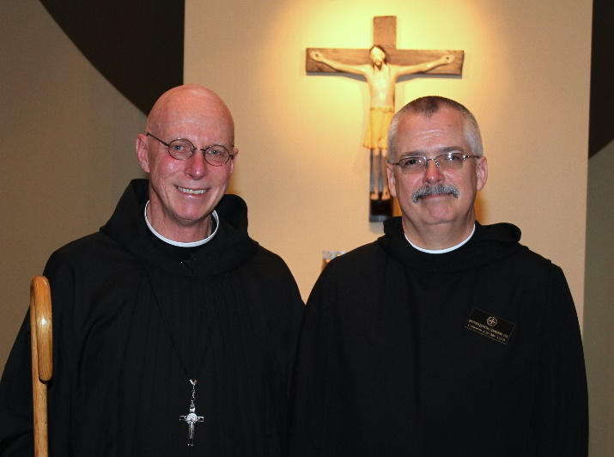
Abbot Robert Cotton; Br. Dunstan Townsend

