**Companions of St. Luke**

**Spring Convocation at Conception Abbey**

**May 28-29, 2012**

**Photographed by Sr. Brigid Gerns**

People are identified from left to right.

Edited by Br. Steven Olderr 29 March 2023. Please send any comments, corrections, or additions to [olderr@ameritech.net](mailto:olderr@ameritech.net)

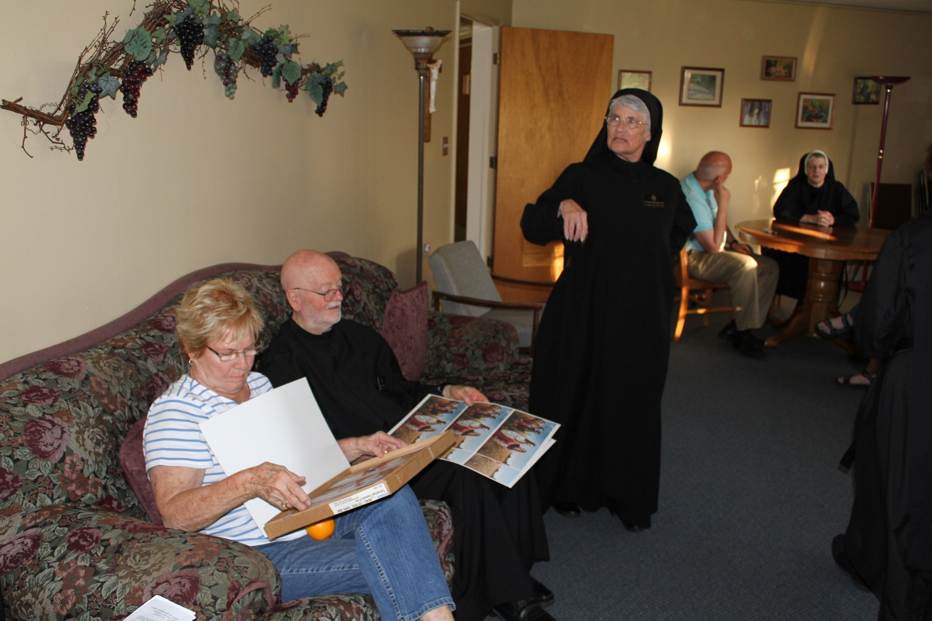

Jun 28: Cam Bede; Br. Thomas Anthony Goddard; Sr. Mary Francis Deulen; Peter DeFranco; Sr. Bernadette Barrett

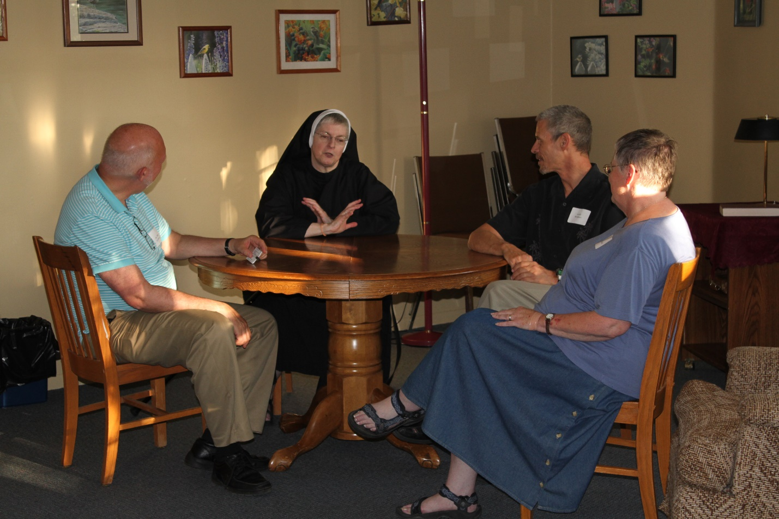

Jun 28: Peter DeFranco; Sr. Bernadette Barrett; Scott Nonken; Kate Maxwell

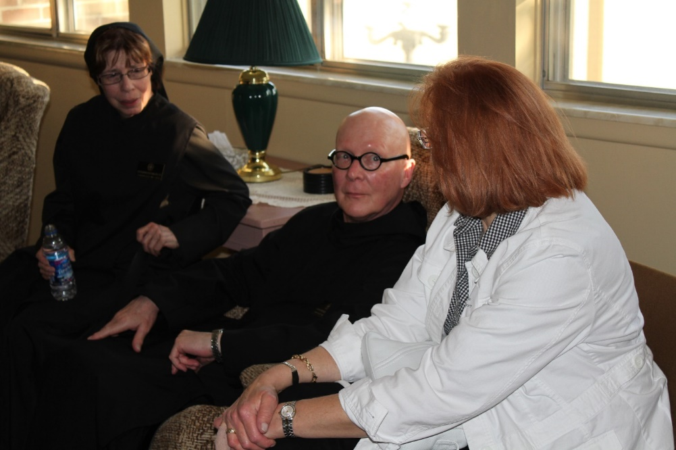

Jun 28: Sr. Monica Ruth Mullen; Br. Stephen Francis Arnold; ?

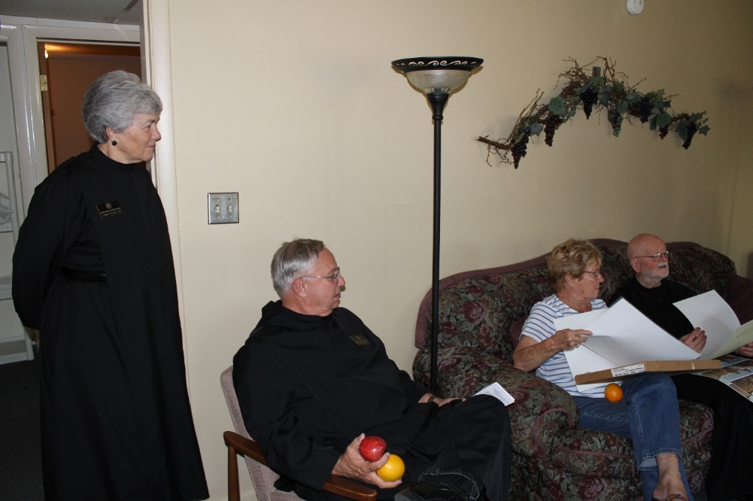

Jun 28: Sr. Toni Sylvester; Br. Bede Leach; Cam Leach; Br. Thomas Anthony Goddard

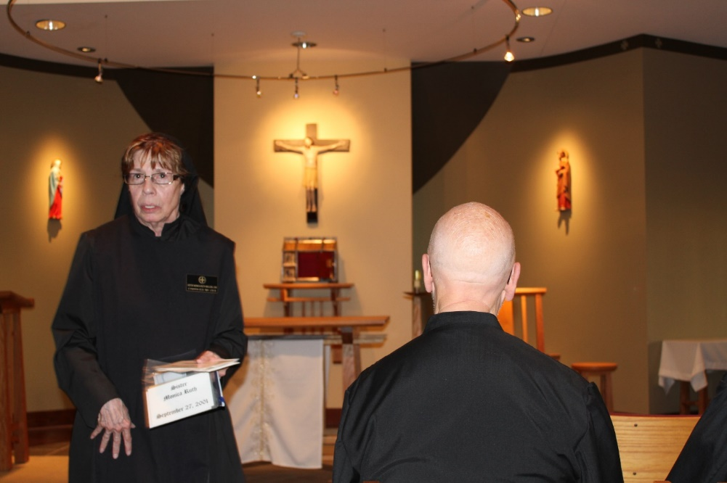

Jun 28: Sr. Monica Ruth Mullen; Br. Stephen Francis Arnold

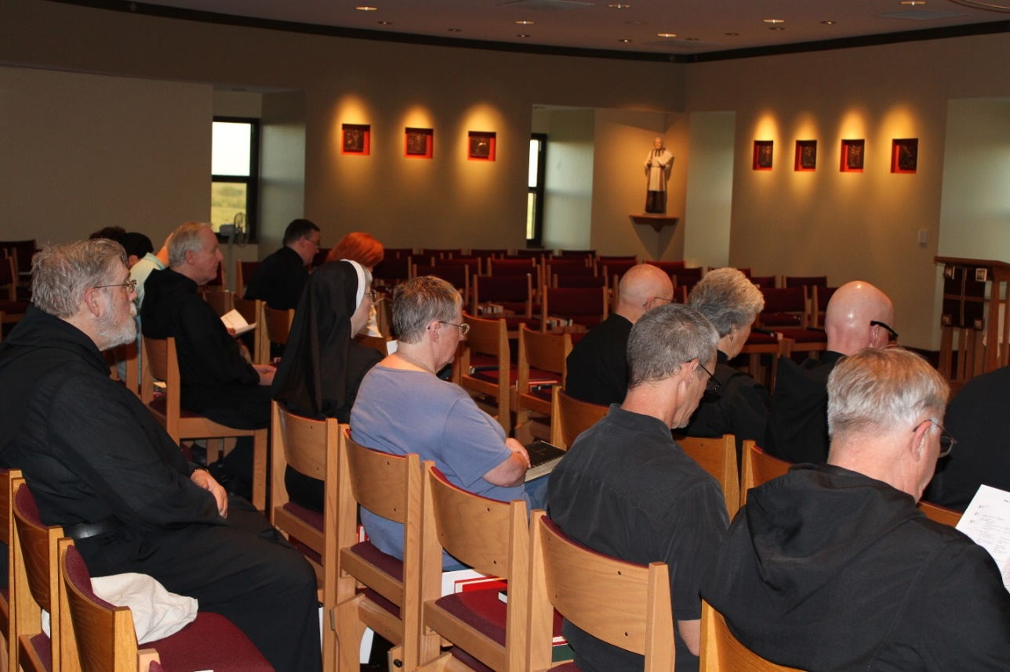

Jun 28: Br. David Gerns; Peter DeFranco; Br. Lee Doucette; Victor Bullock; Sr. Bernadette Barrett; ?; Kate Maxwell; Br. Thomas Anthony Goddard; Scott Nonken; Sr. Toni Sylvester; Br. Stephen Francis Arnold; Br. Bede Leach

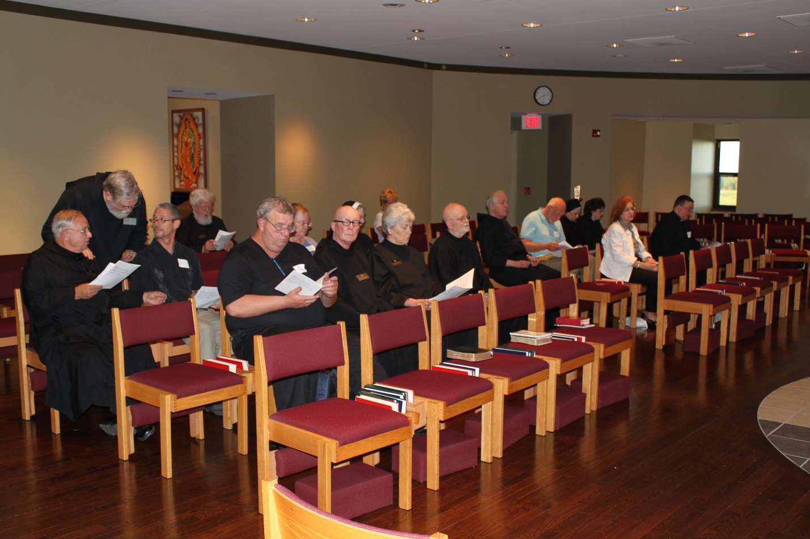

Jun 28: Br. Bede Leach; Br. David Gerns; Scott Nonken; Fr. Wayne Kamm; Joe Campbell; Kate Maxwell; Br. Stephen Francis Arnold; Sr. Bernadette Barrett; Cam Bede; Sr. Toni Sylvester; Br. Thomas Anthony Goddard; Br. Lee Doucette; Peter DeFranco; Sr. Mary Francis Deulen; Sr. Martha Lamoy; ?; Victor Bullock

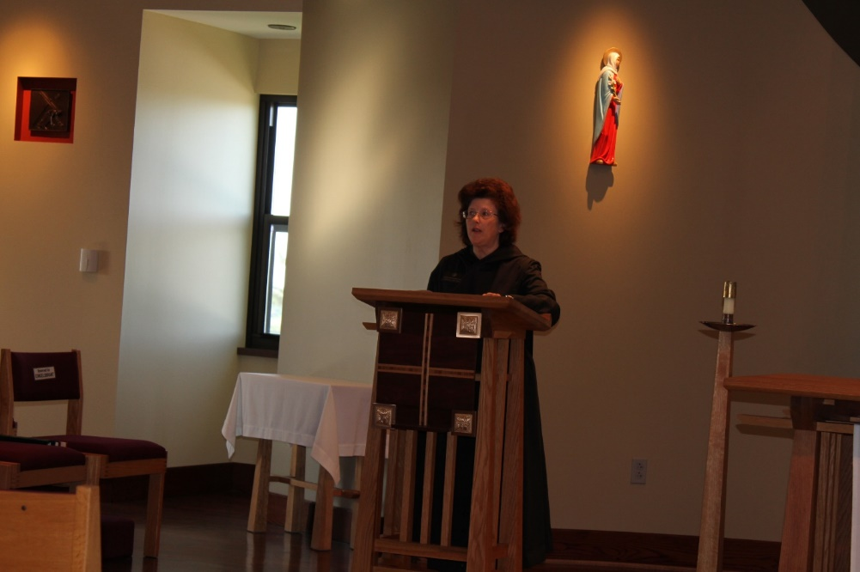

Jun 29: Sr. Martha Lamoy

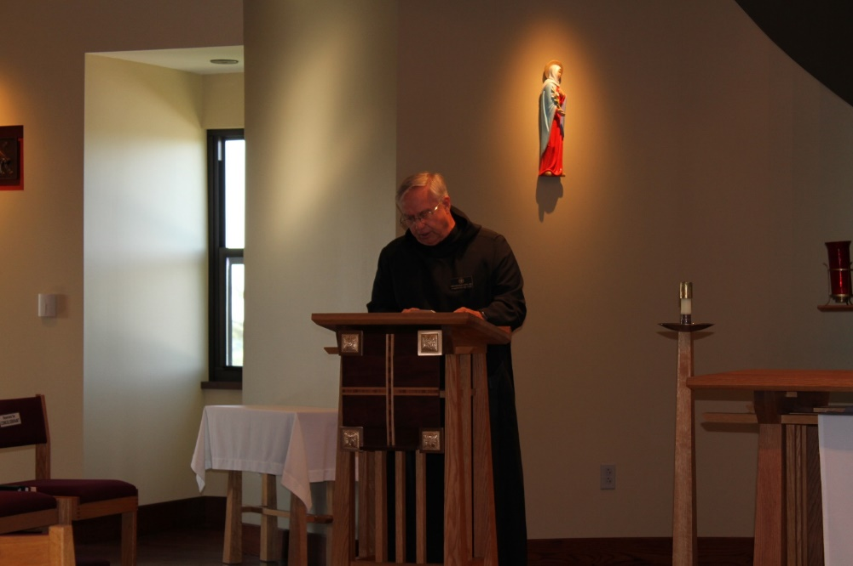

Jun 29: Br. Bede Leach



Jun 29: Sr. Martha Lamoy; Kate Maxwell; Sr. Mary Francis Deulen

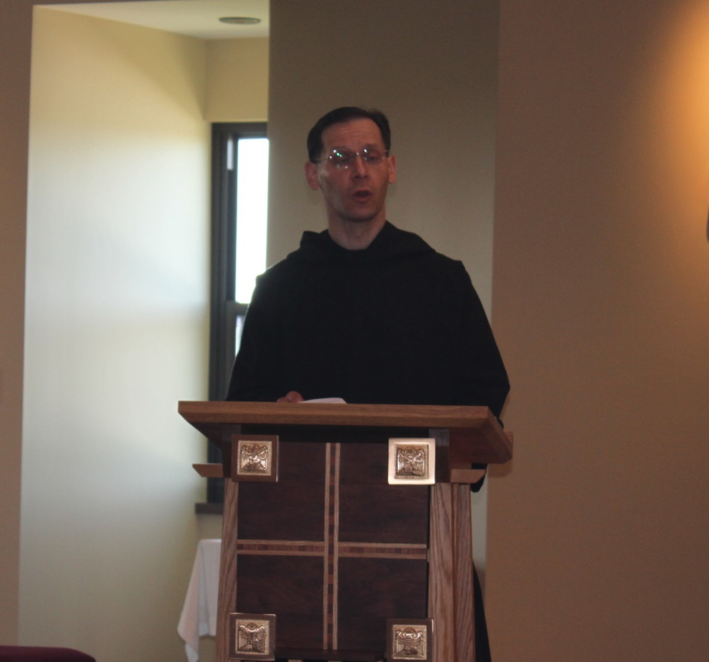

Jun 29: Br. Roman Shemayev

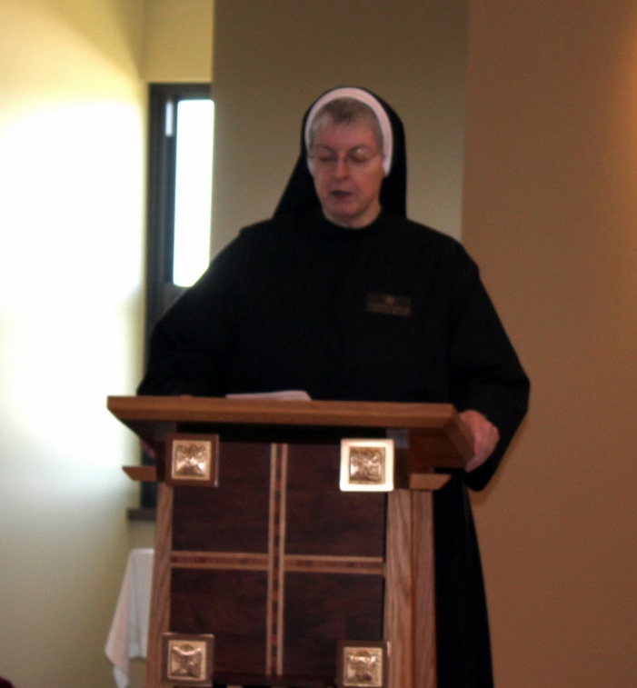

Jun 29: Sr. Bernadette Barrett

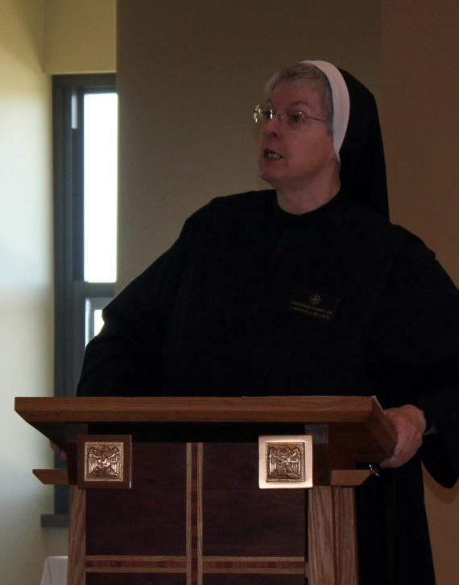

Jun 29: Sr. Bernadette Barrett

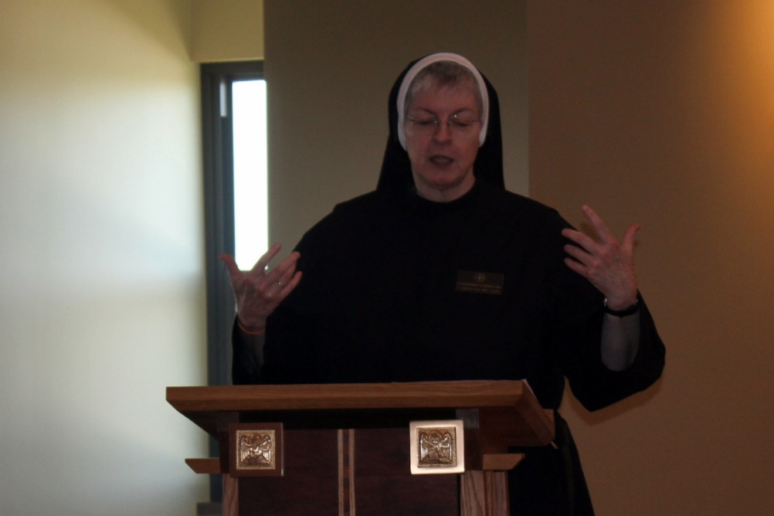

Jun 29: Sr. Bernadette Barrett

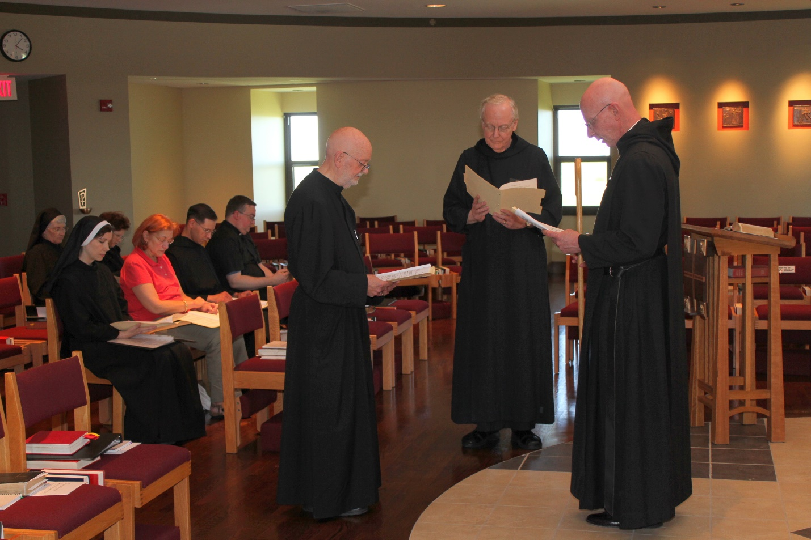

Jun 29: Sr. Mary Francis Deulen; Sr. Veronica Taylor; Sr. Martha Lamoy; ?; Br. Roman Shemayev; Victor Bullock; Br. Thomas Anthony Goddard; Br. Lee Doucette; Abbot Robert Cotton

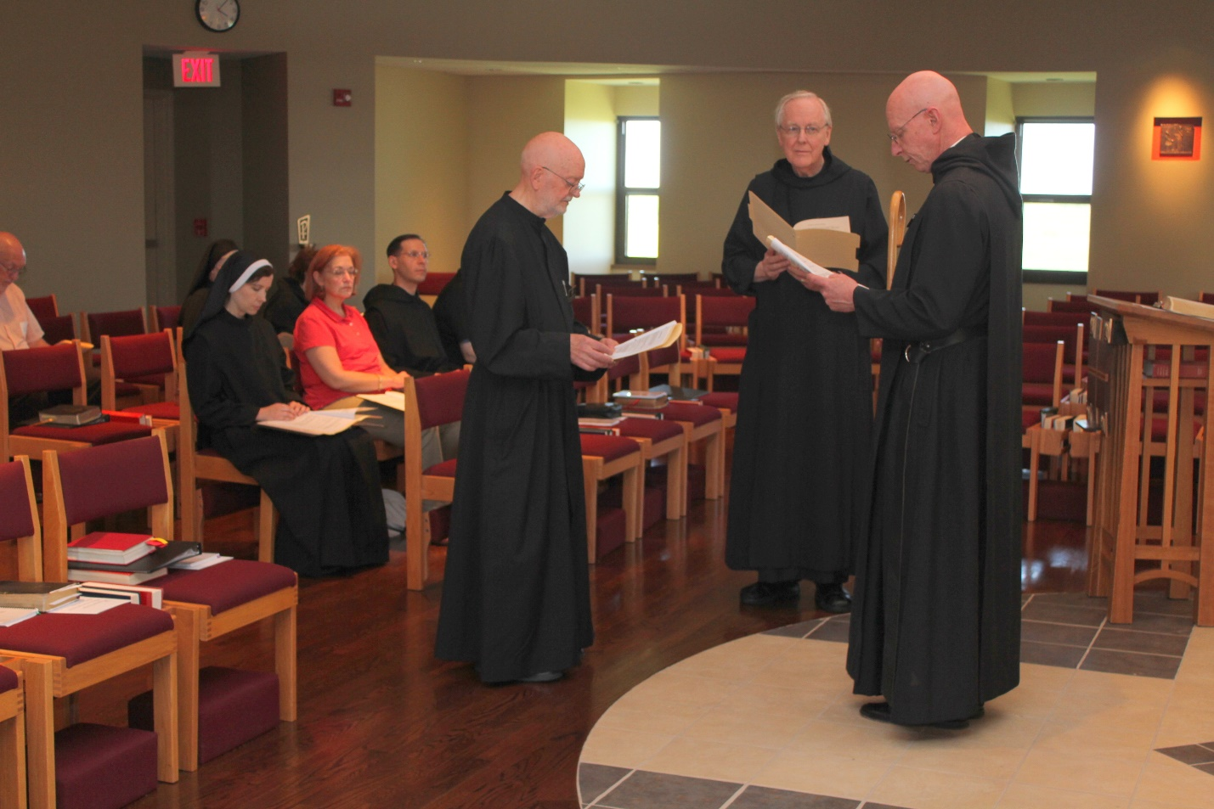

Jun 29: Peter DeFranco; Sr. Mary Francis Deulen; Sr. Veronica Taylor; Sr. Martha Lamoy; ?; Br. Roman Shemayev; Victor Bullock; Br. Thomas Anthony Goddard; Br. Lee Doucette; Abbot Robert Cotton

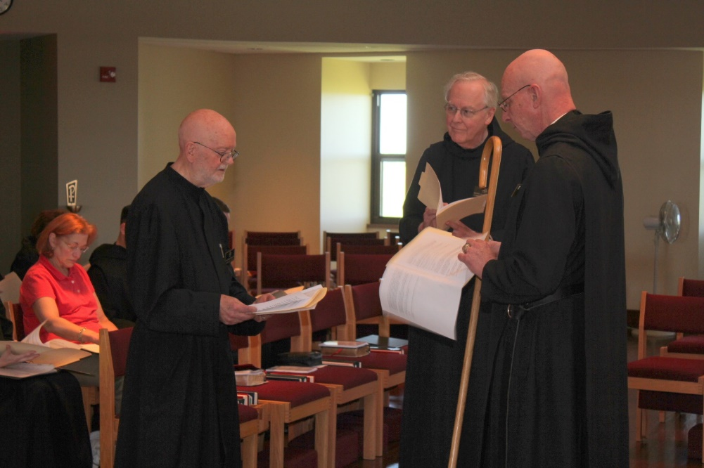

Jun 29: ?; Br. Roman Shemayev; Victor Bullock; Br. Thomas Anthony Goddard; Br. Lee Doucette; Abbot Robert Cotton

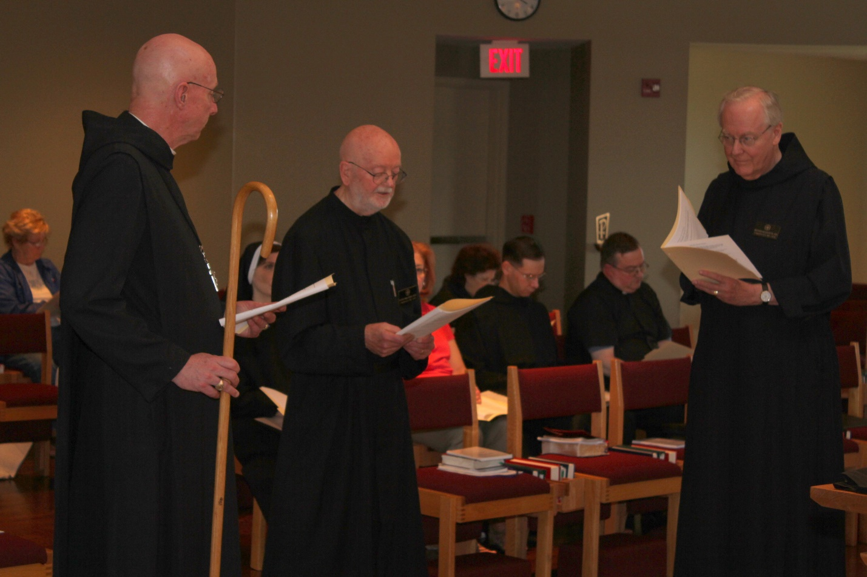

Jun 29: Cam Leach; Abbot Robert Cotton; Sr. Veronica Taylor; Br. Thomas Anthony Goddard; ? ; Sr. Martha Lamoy; Br. Roman Shemayev; Victor Bullock; Br. Lee Doucette

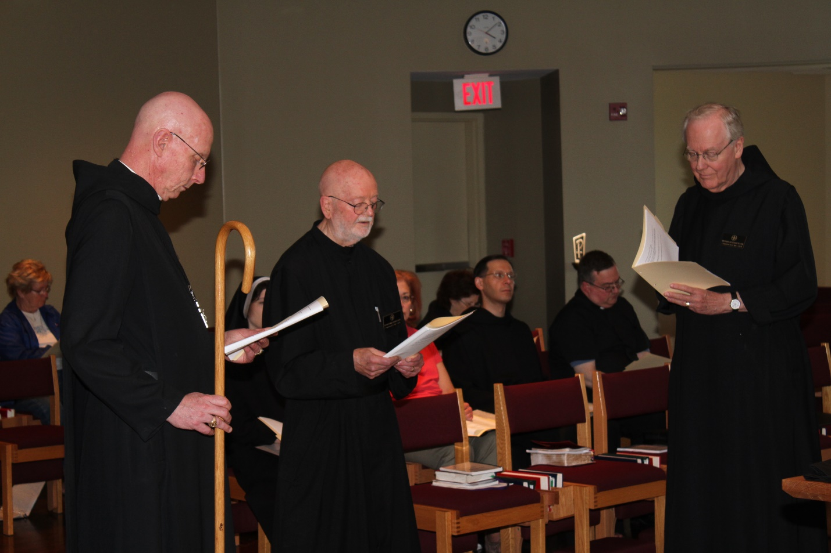

Jun 29: Cam Leach; Abbot Robert Cotton; Sr. Veronica Taylor; Br. Thomas Anthony Goddard; ? ; Sr. Martha Lamoy; Br. Roman Shemayev; Victor Bullock; Br. Lee Doucette

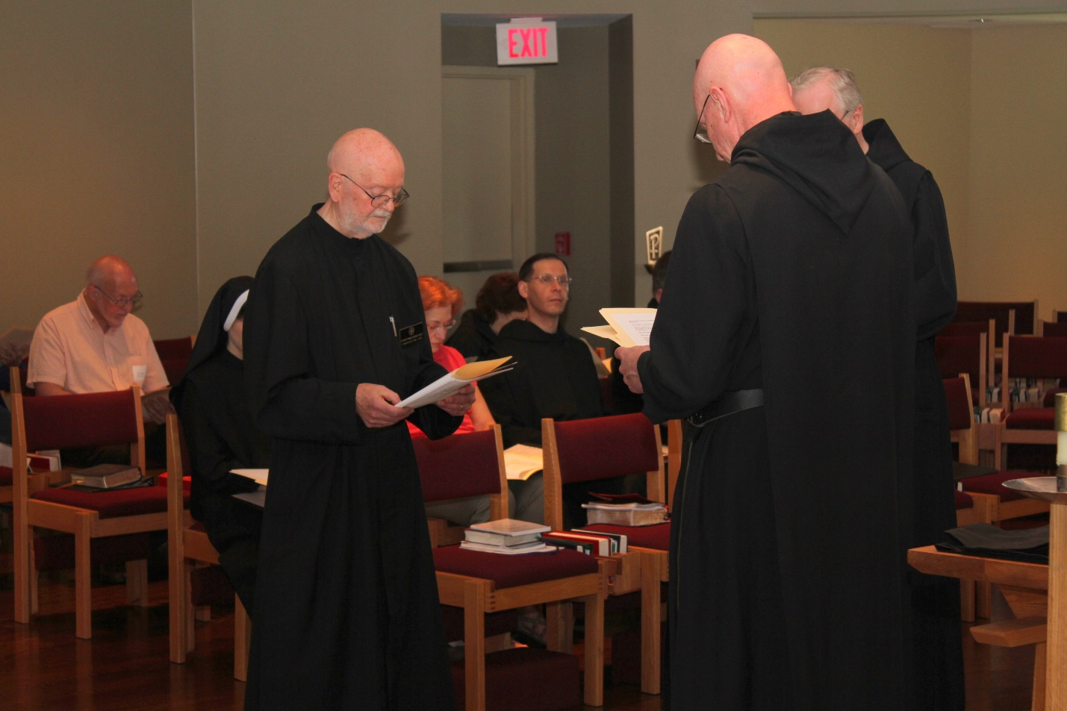

Jun 29: Peter DeFranco; Sr. Veronica Taylor; Br. Thomas Anthony Goddard; ?; Marth Lamoy; Br. Roman Shemayev; Abbot Robert Cotton; Br. Lee Doucette

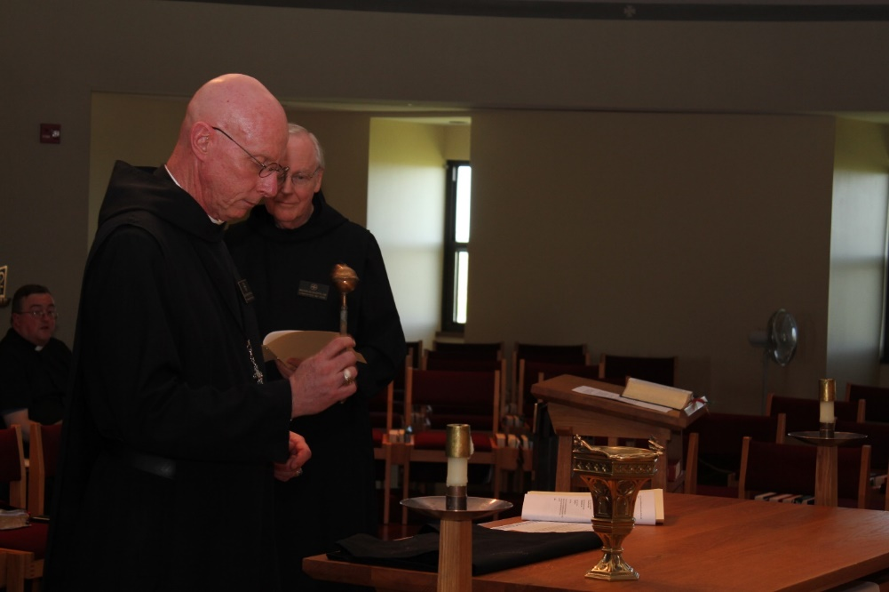

Jun 29: Victor Bullock; Abbot Robert Cotton; Br. Lee Doucette

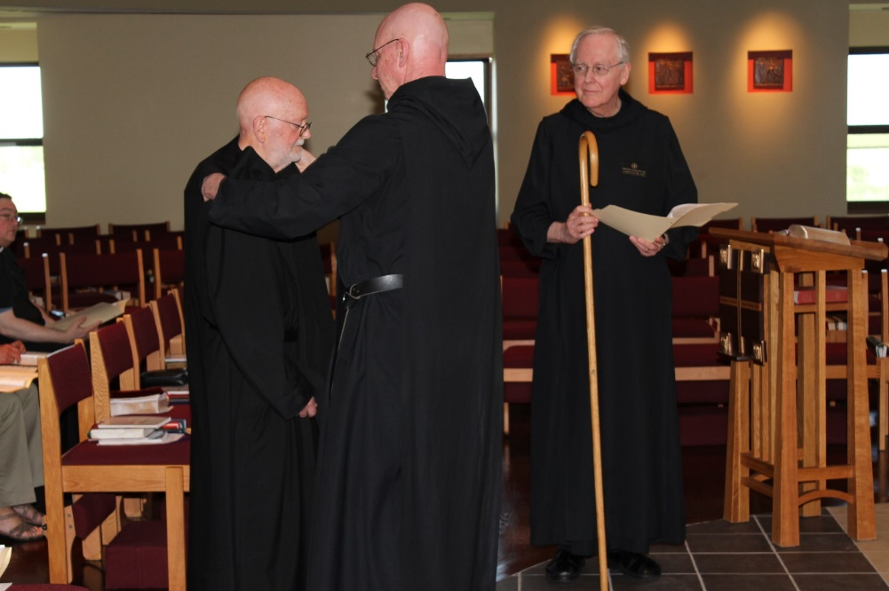

Jun 29: Victor Bullock; Br. Thomas Anthony Goddard; Abbot Robert Cotton; Br. Lee Doucette

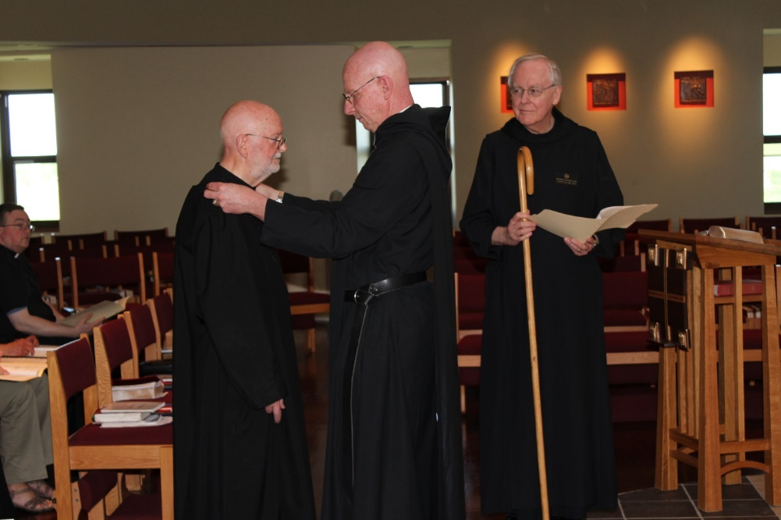

Jun 29: Victor Bullock; Br. Thomas Anthony Goddard; Abbot Robert Cotton; Br. Lee Doucette

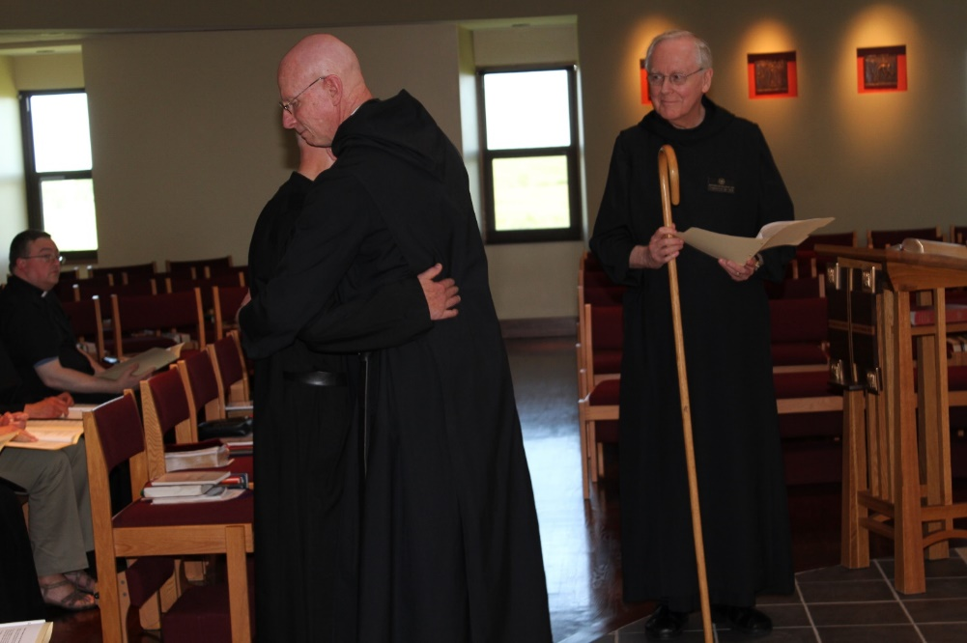

Jun 29: Victor Bullock; Br. Thomas Anthony Goddard; Abbot Robert Cotton; Br. Lee Doucette



Jun 29: Victor Bullock; Br. Thomas Anthony Goddard; Abbot Robert Cotton; Br. Lee Doucette

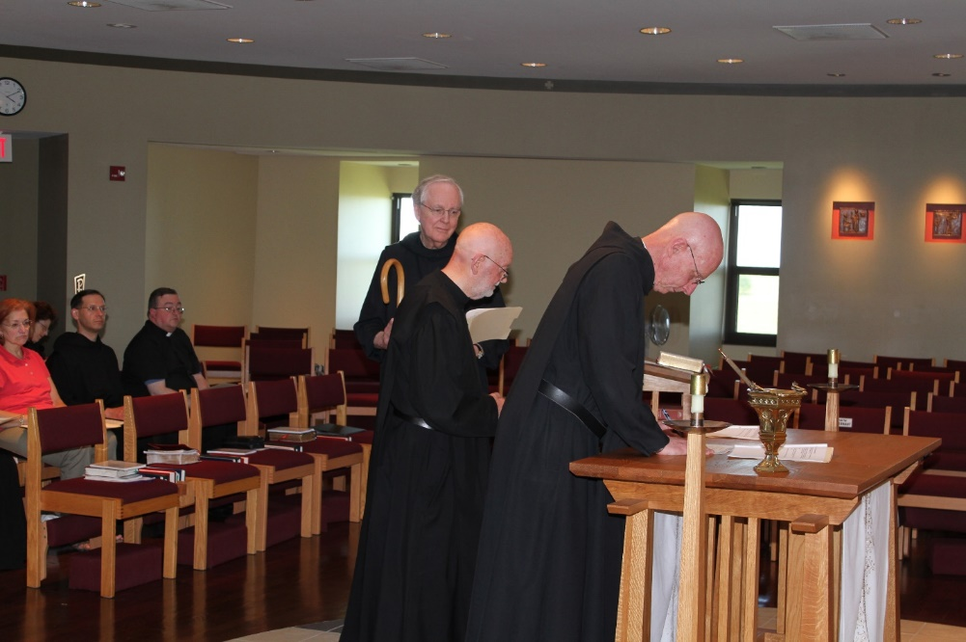

Jun 29: ?; Sr. Martha Lamoy; Br. Roman Shemayev; Victor Bullock; Br. Lee Doucette; Br. Thomas Anthony Goddard; Br. Robert Cotton

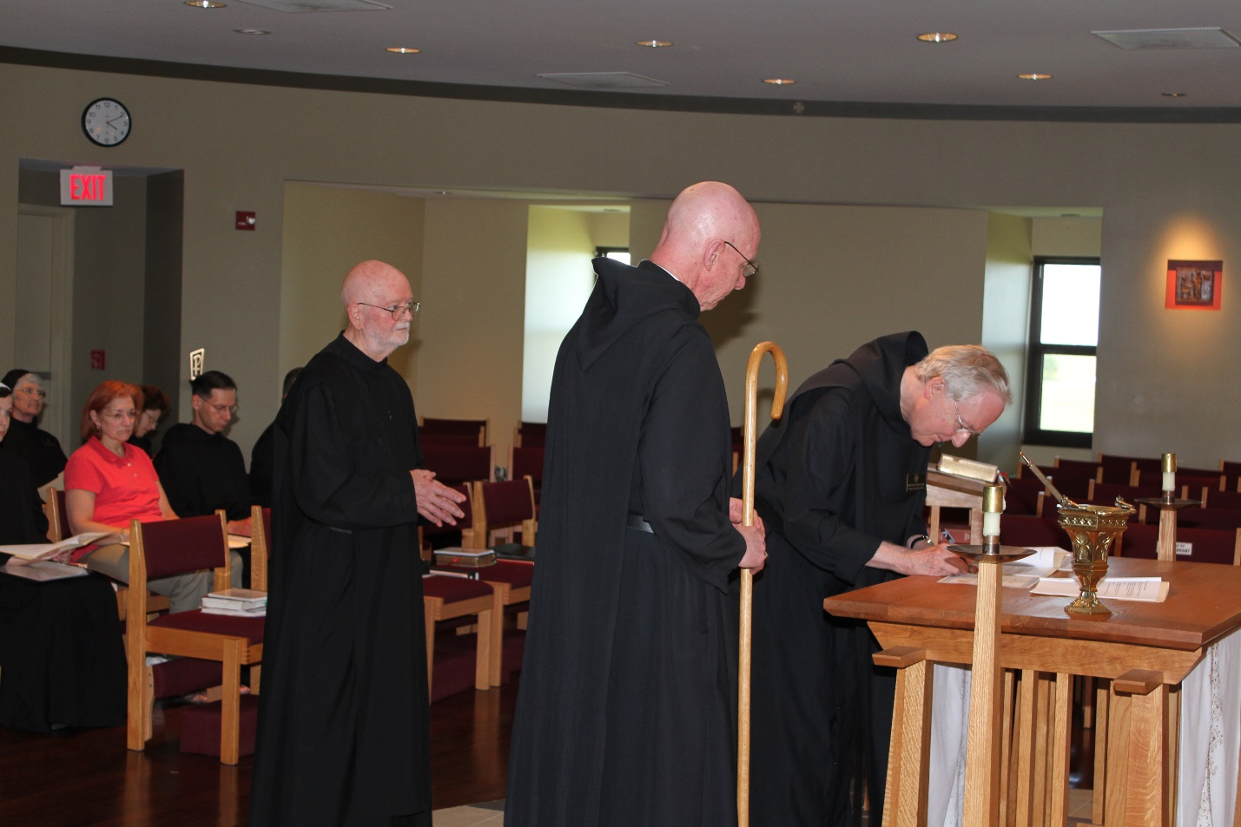

Jun 29: Sr. Veronica Taylor; Sr. Mary Francis Deulen; ?; Sr. Martha Lamoy; Br. Roman Shemayev; Br. Thomas Anthony Goddard; Abbot Robert Cotton; Br. Lee Doucette

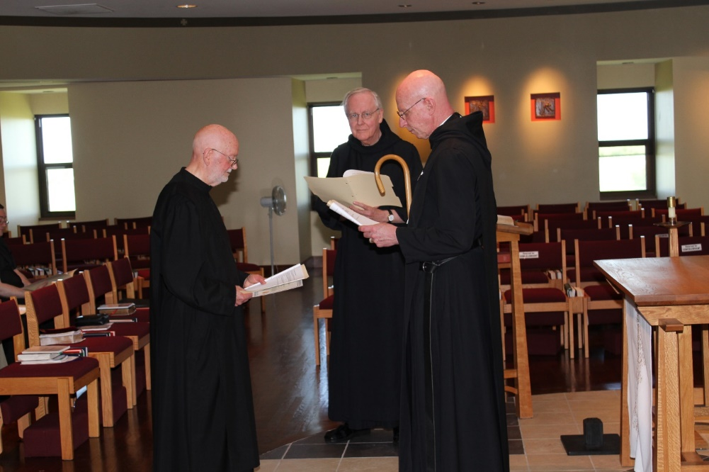

Jun 29: Victor Bullock; Br. Thomas Abthony Goddard; Br. Lee Doucette; Abbot Robert Cotton

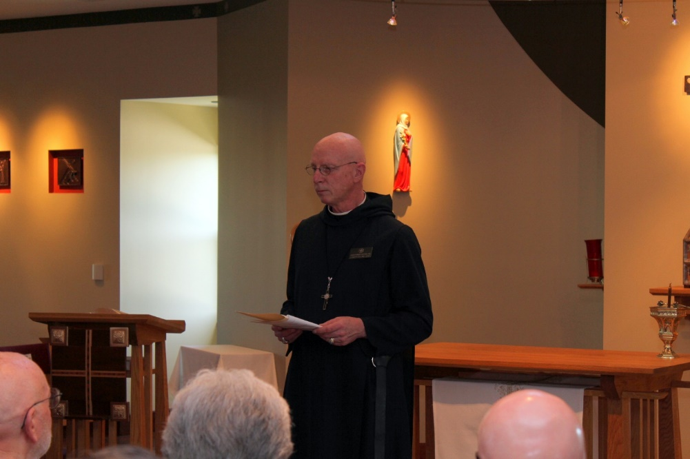

Jun 29: Br. Thomas Anthony Goddard; Sr. Toni Sylvester; Abbot Robert Cotton; Br. Stephen Francis Arnold

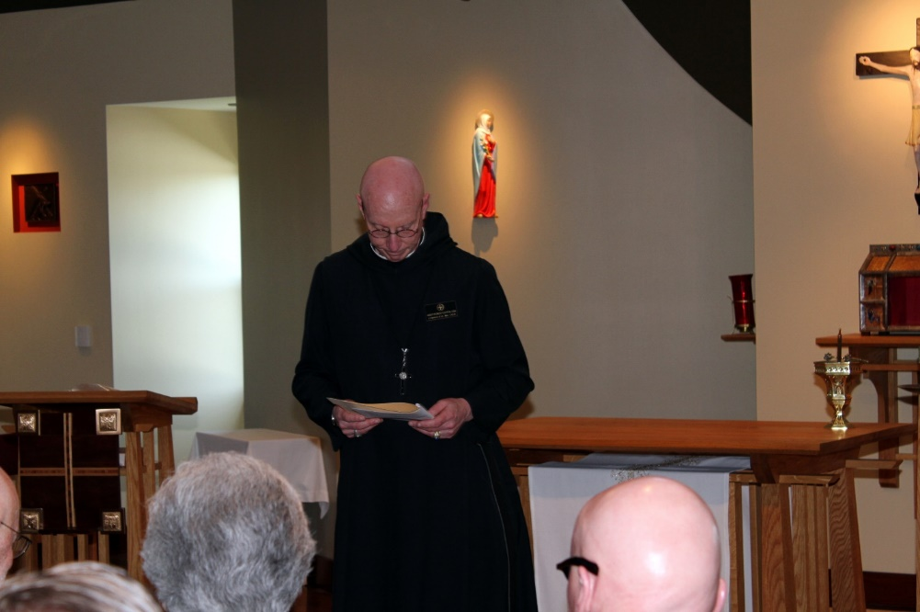

Jun 29: Br. Thomas Anthony Goddard; Sr. Toni Sylvester; Abbot Robert Cotton; Br. Stephen Francis Arnold

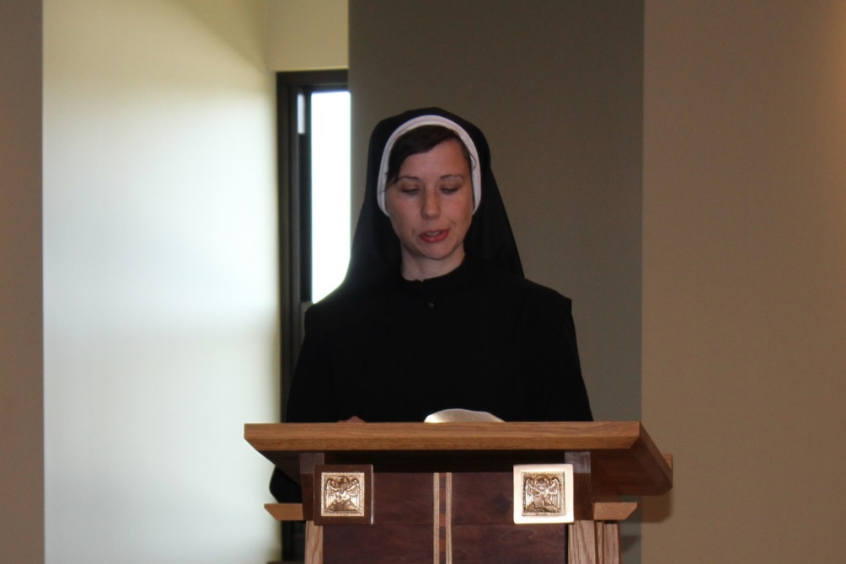

Jun 29: Sr. Veronica Taylor

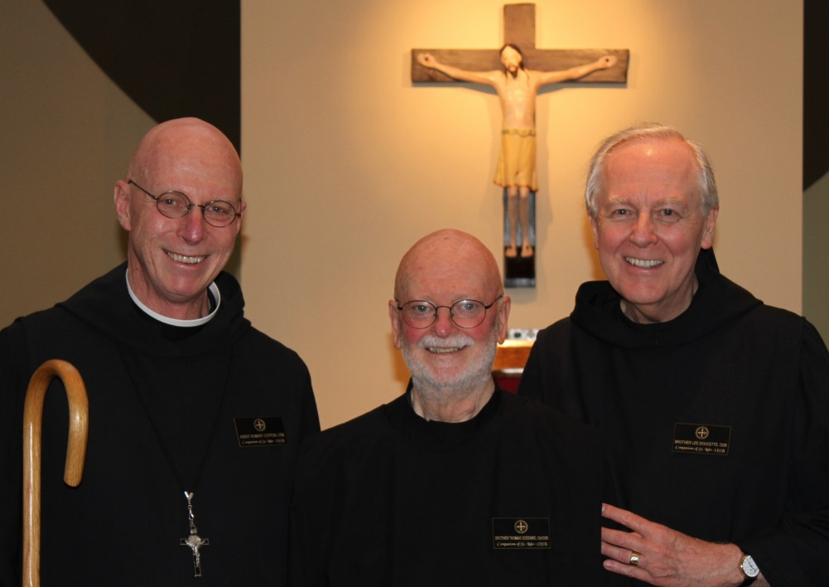

Jun 29: Abbot Robert Cotton; Br. Thomas Anthony Goddard; Br. Lee Doucette

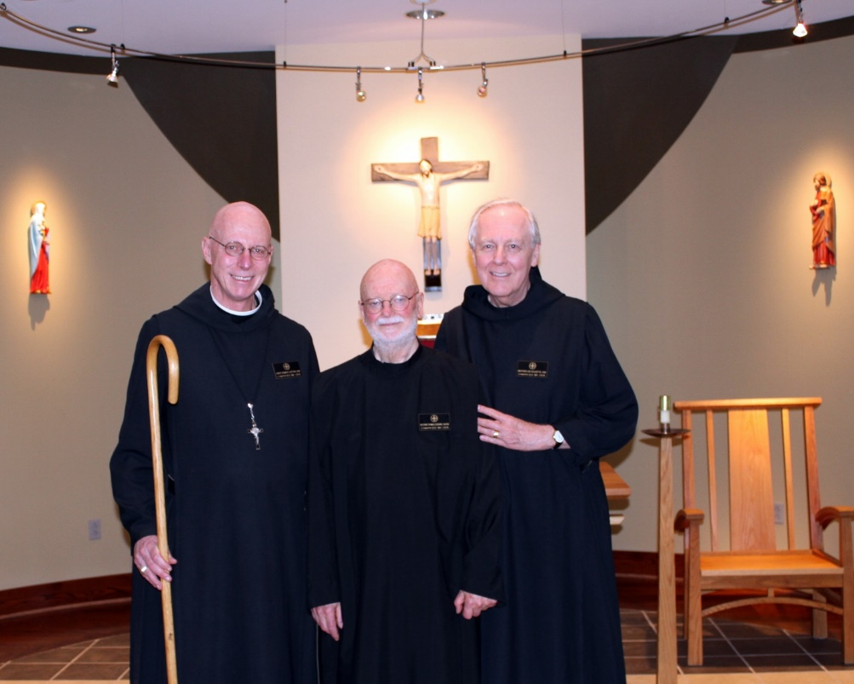

Jun 29: Abbot Robert Cotton; Br. Thomas Anthony Goddard; Br. Lee Doucette