Companions of St. Luke
Spring Convocation at Conception Abbey
May 25, 2011
Photographed by Sr. Brigid Gerns

People are identified from left to right.

Edited by Br. Steven Olderr, 27 March 2023. Please send any comments, corrections, or additions to olderr@ameritech.net

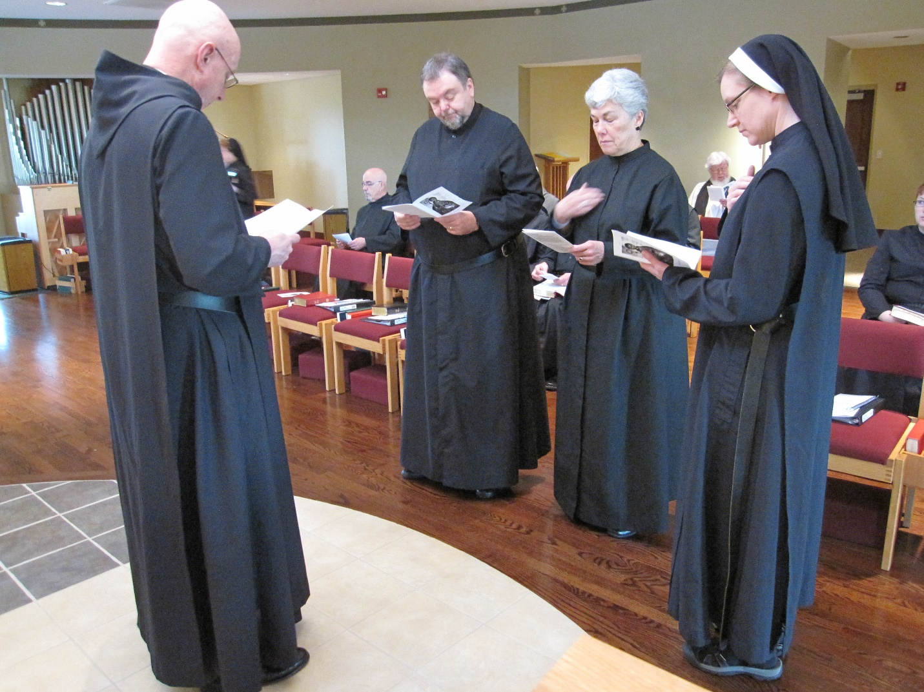
Abbot David Vincent Cotton; Sr. Monica Ruth Mullen; Br. Basil Edwards; Br. Samuel Saterstrom; Sr. Toni Sylvester; Fr. Wayne Kamm; Sr. Hannah Korver; Kellyanne Hale
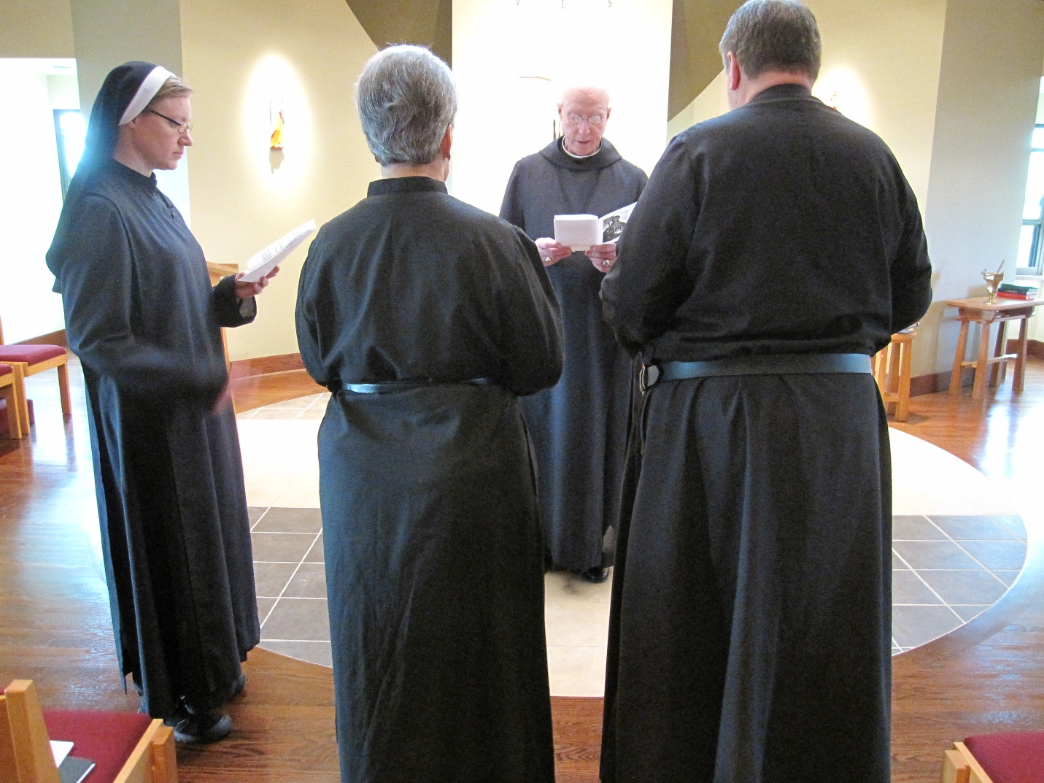
Sr. Hannah Korner; Sr. Toni Sylvester; Abbot David Vincent Cotton; Br. Samuel Saterstrom

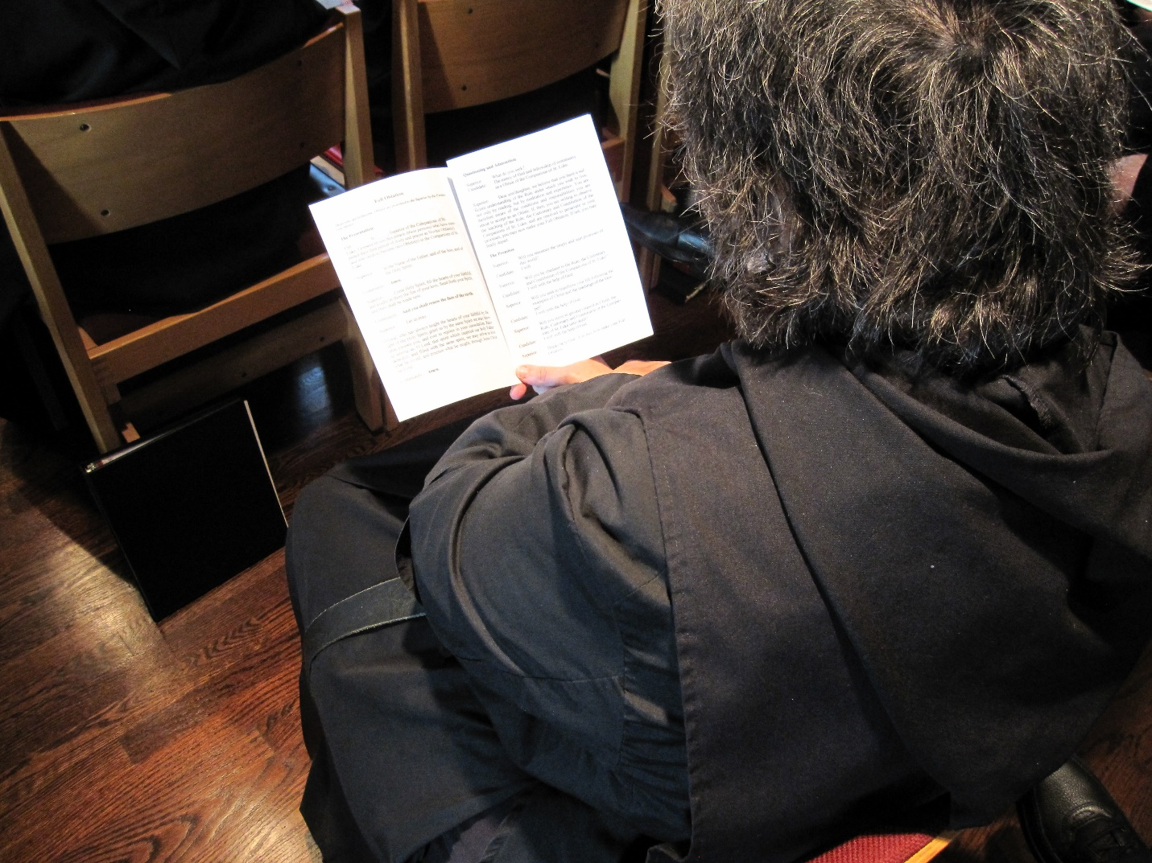
Sr. Cecelia Lamoy
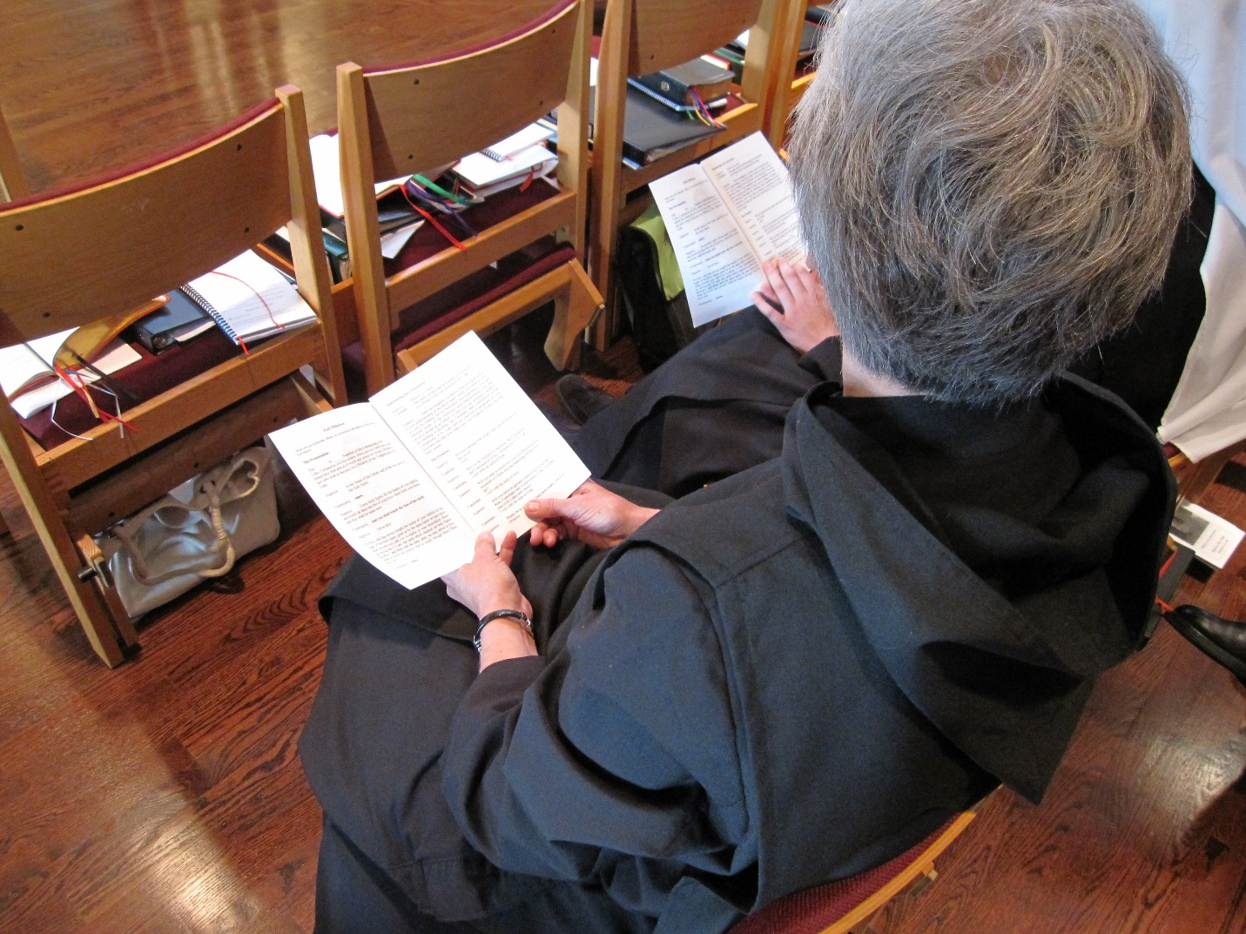
Sr. Julian Saterstrom

Abbot David Vincent Cotton; Br. Basil Edwards; Br. Samuel Saterstrom; Sr. Toni Sylvester; Fr. Wayne Kamm; Sr. Hanna Korver; Kellyanne Hale; Sr. Bernadette Barrett; Br. Chad Anselm Gerns

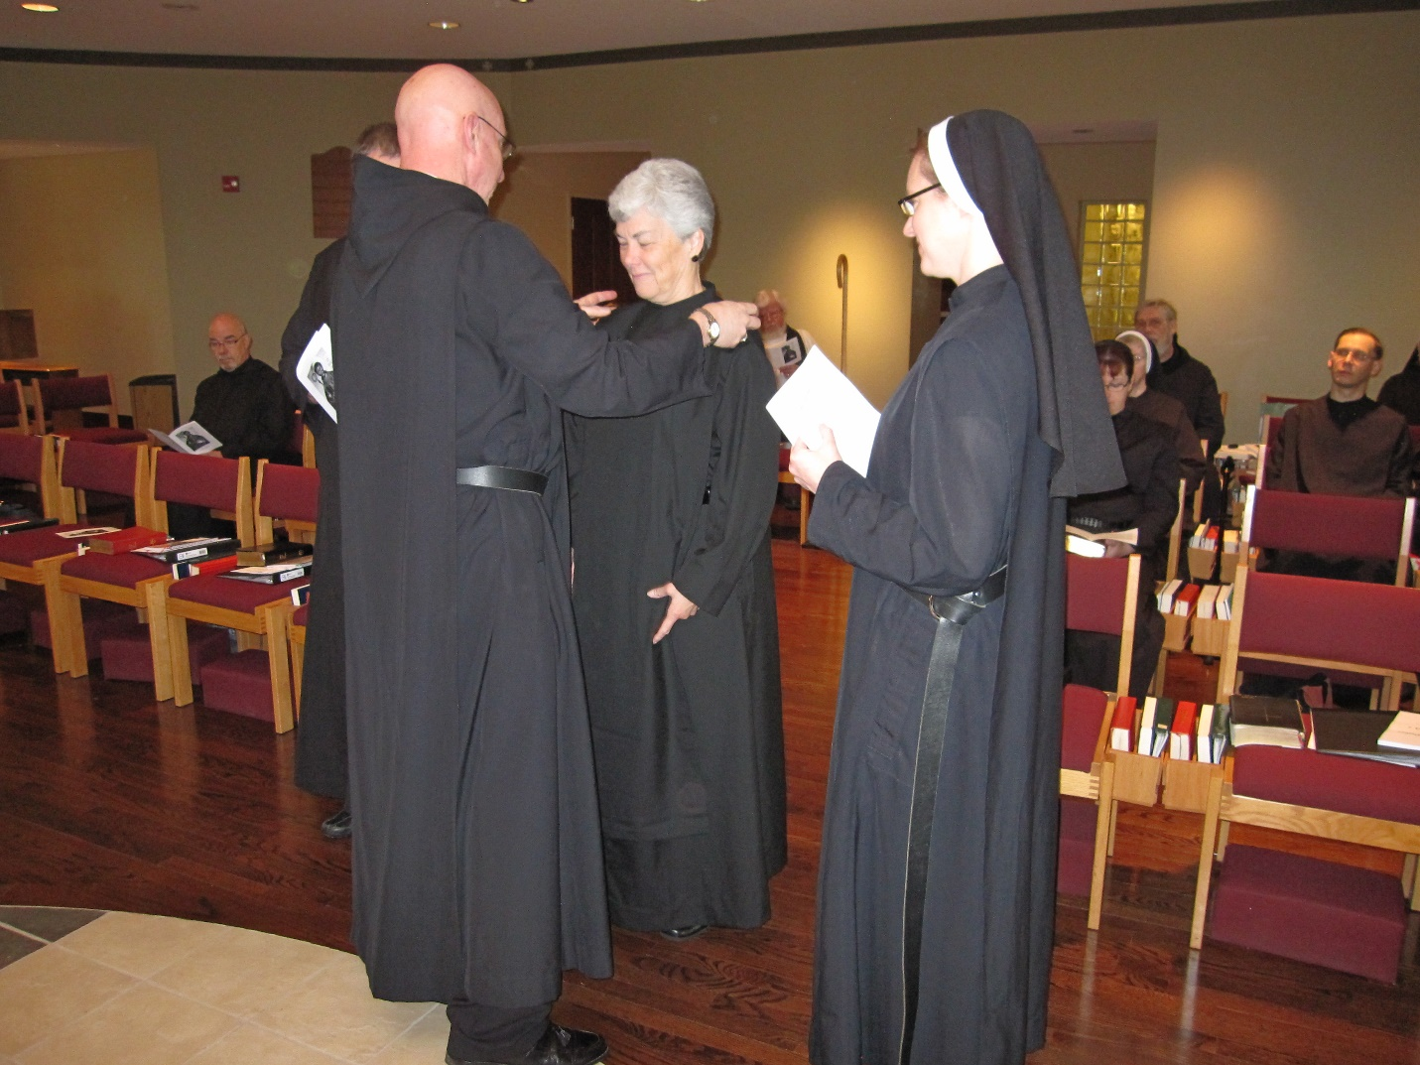
Br. Basil Edwards; Br. Samuel Saterstrom; Abbot David Vincent Cotton; Sr. Toni Sylvester; Sr. Hannah Korver; Kellyanne Hale; Sr. Bernadette Barrett; Br. Chad Anselm Gerns; Br. Roman Shemayev

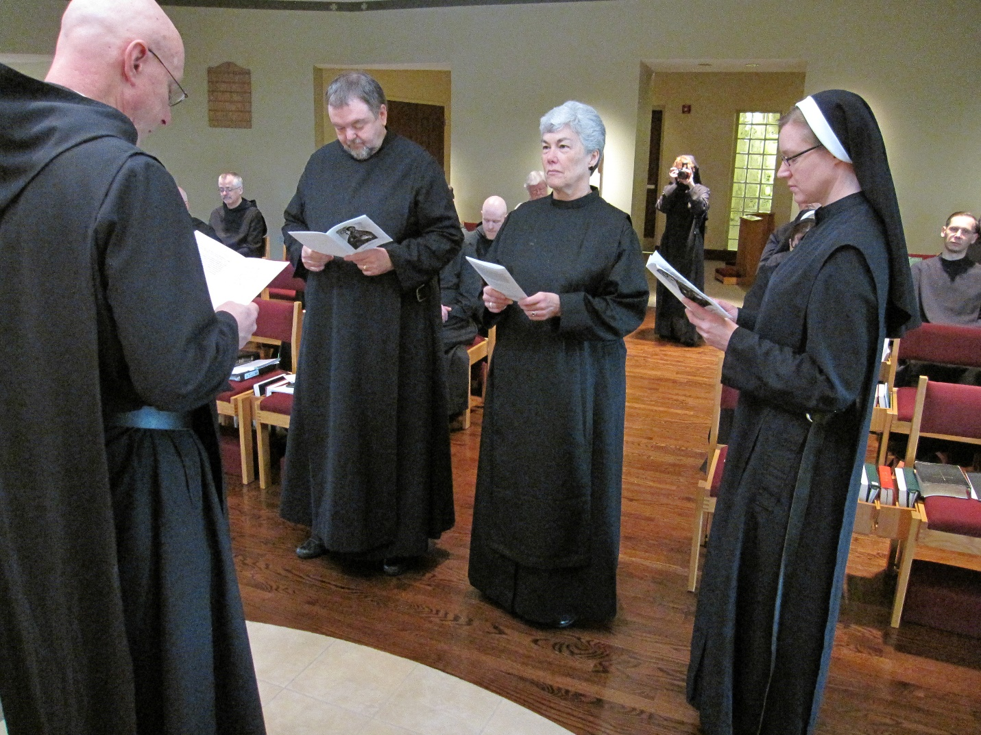
Abbot David Vincent Cotton; Br. Dunstan Townsend; Br. Samuel Saterstrom; Br. Gregory Kingsley; Fr. Wayne Kamm; Sr. Toni Sylvester; Sr. Monica Ruth Mullen; Sr. Hannah Korver; Br. Roman Shemayev

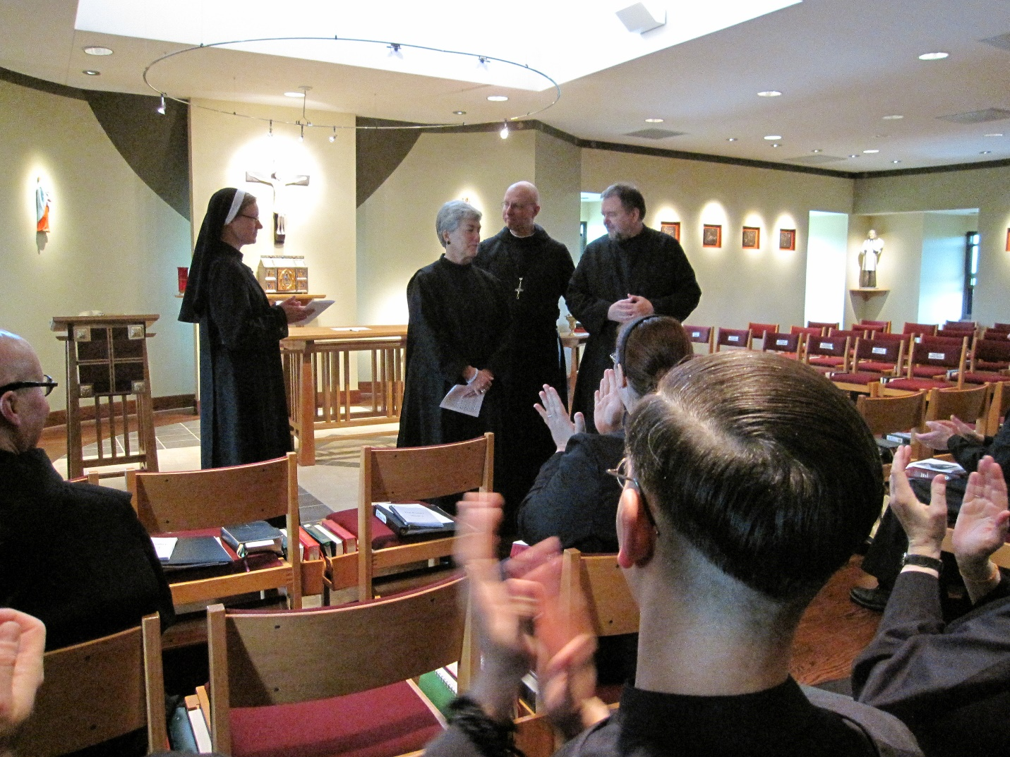
Br. Stephen Francis Arnold; Sr. Hannah Korver; Sr. Toni Sylvester; Abbot David Vincent Cotton; Br. Samuel Saterstrom; Kellyanne Hale; Br. Roman Shemayev

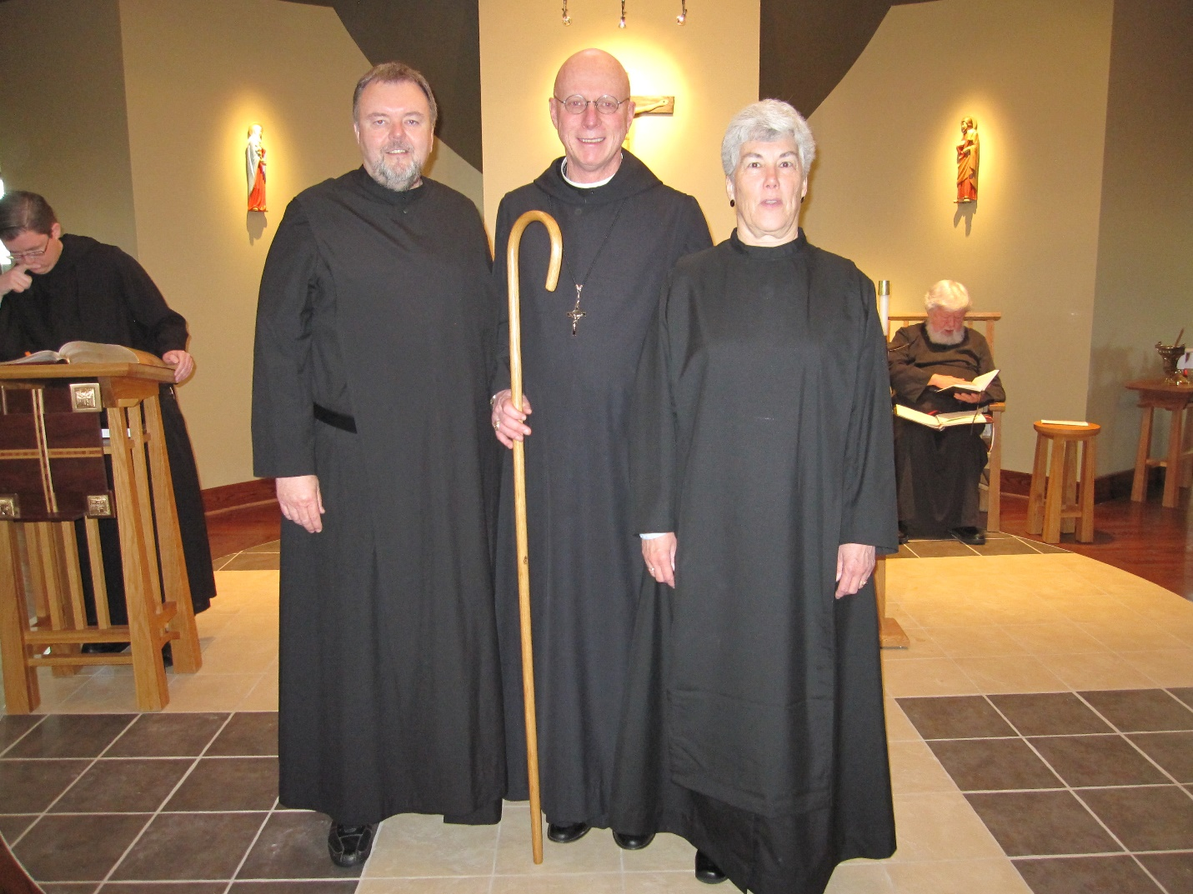
Br. Aidan Maguire; Br. Gregory Saterstrom; Abbot David Vincent Cotton; Sr. Toni Sylvester; Fr. Wayne Kamm

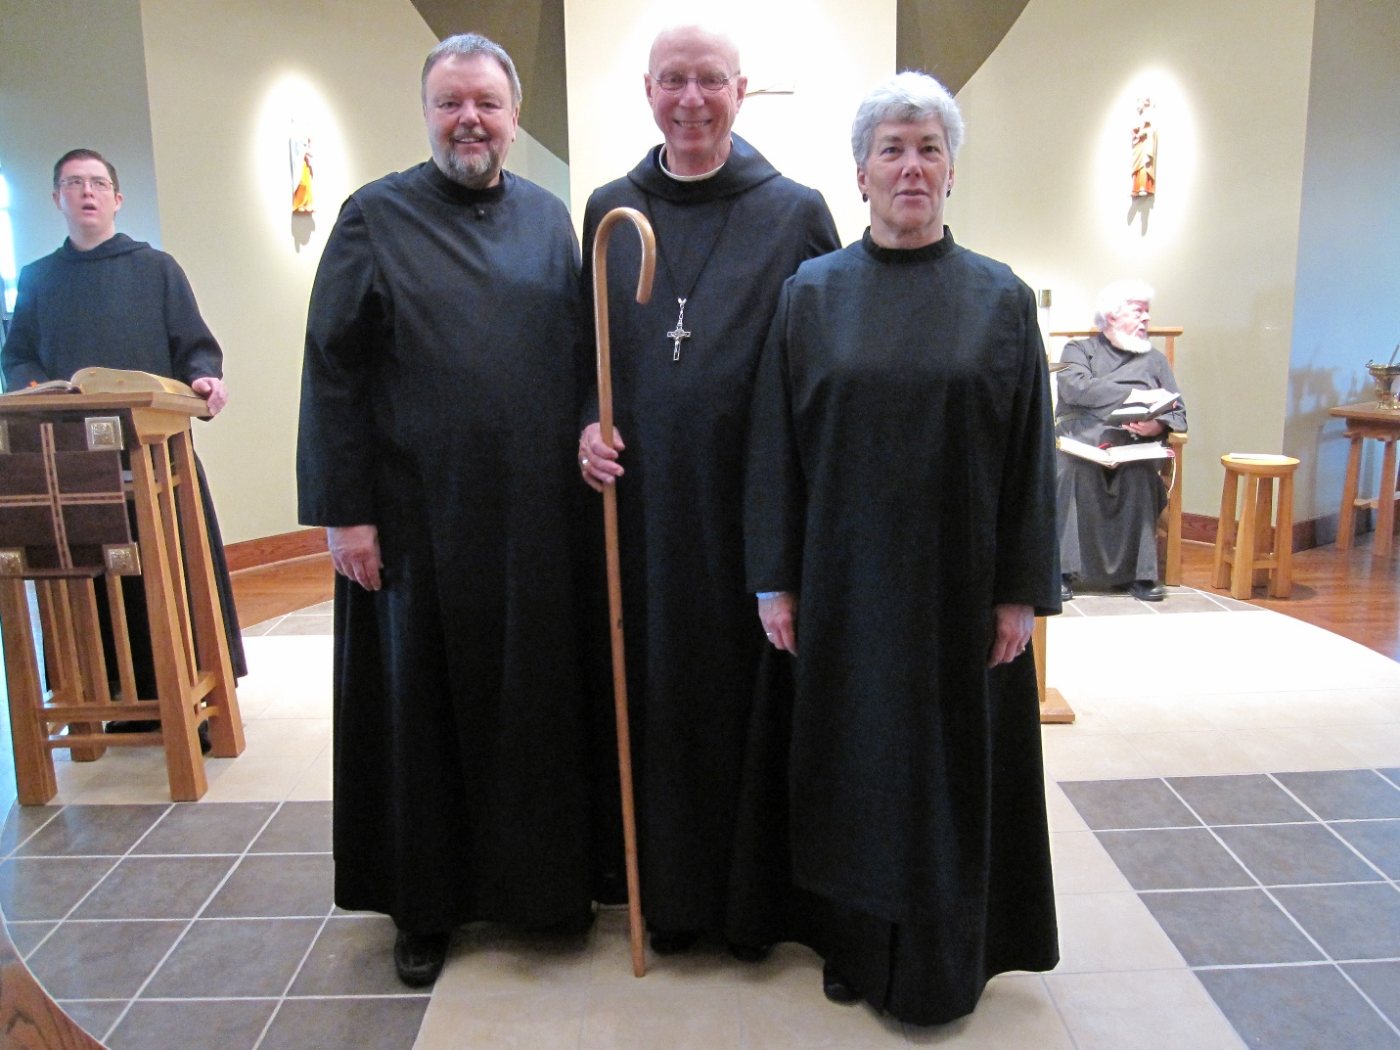
Br. Aidan Maguire; Br. Gregory Saterstrom; Abbot David Vincent Cotton; Sr. Toni Sylvester; Fr. Wayne Kamm

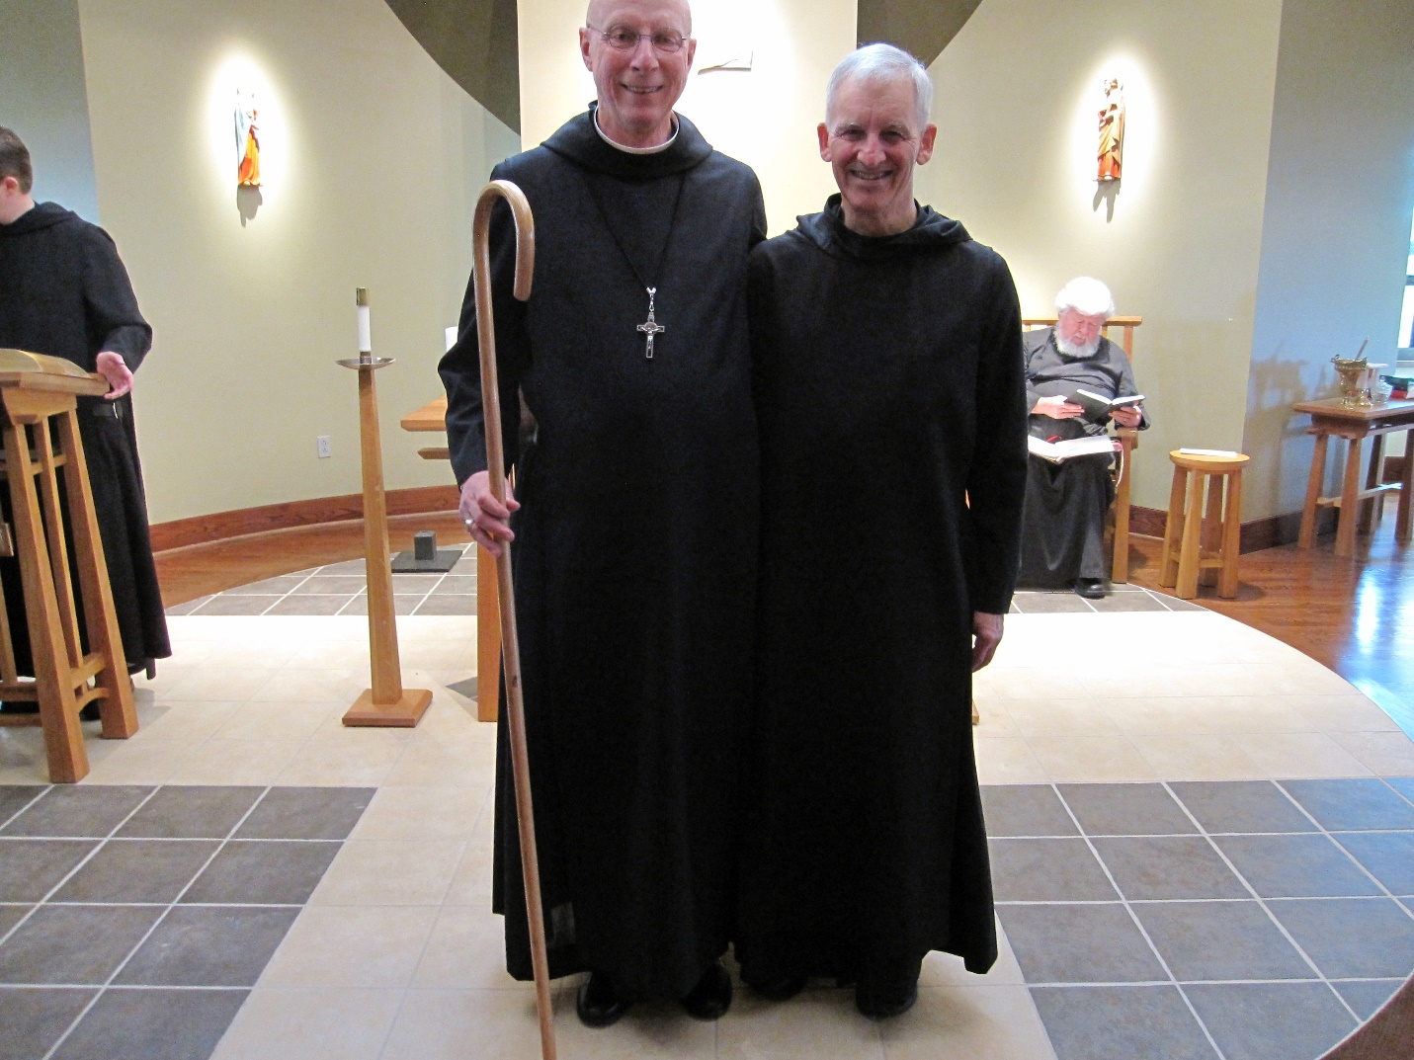
Br. Aidan Maguire; Abbot David Vincent Cotton; Br. Joseph Olderr; Fr. Wayne Kamm

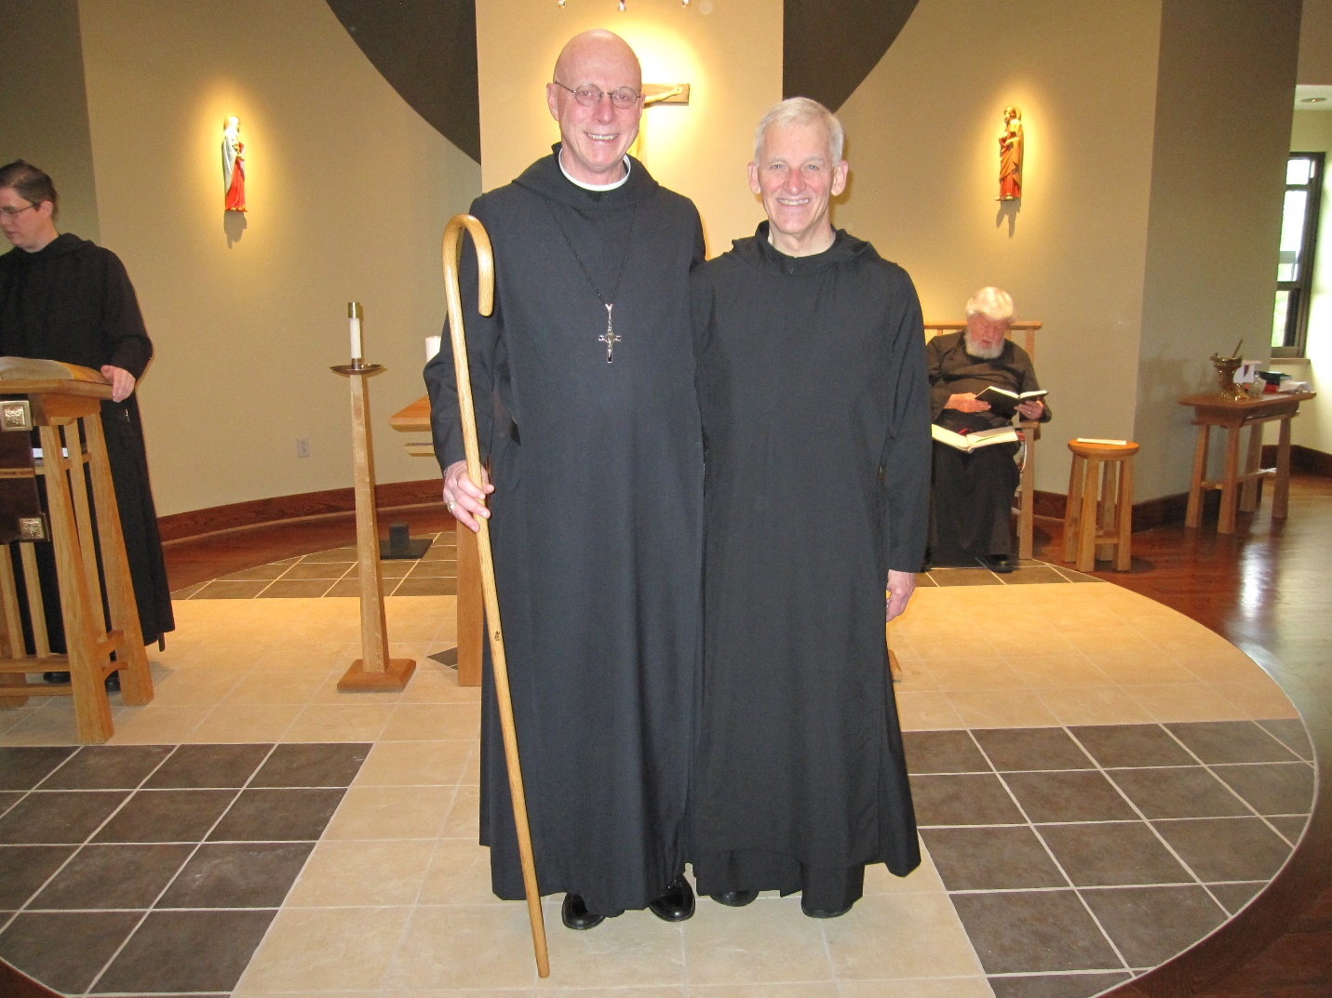
Br. Aidan Maguire; Abbot David Vincent Cotton; Br. Joseph Olderr; Fr. Wayne Kamm
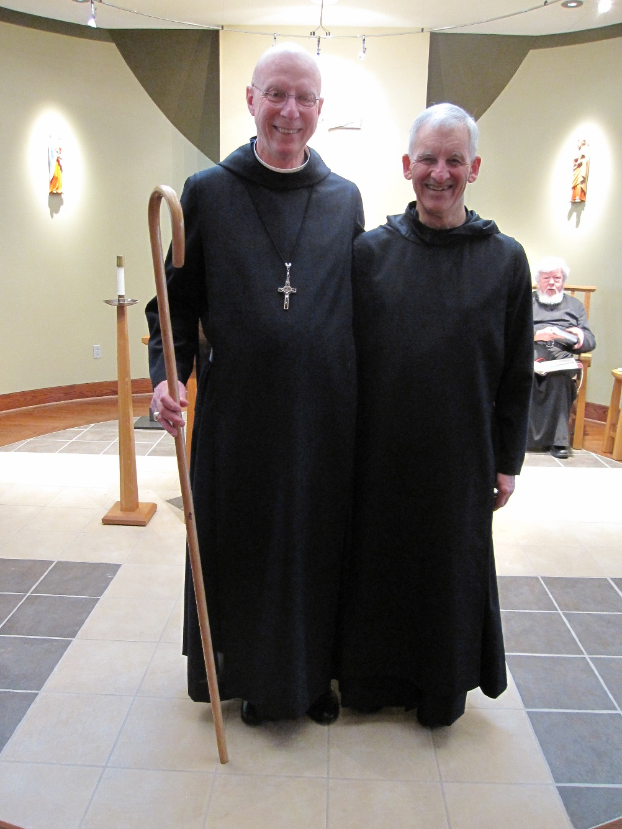
Abbot David Vincent Cotton; Br. Joseph Olderr; Fr. Wayne Kamm

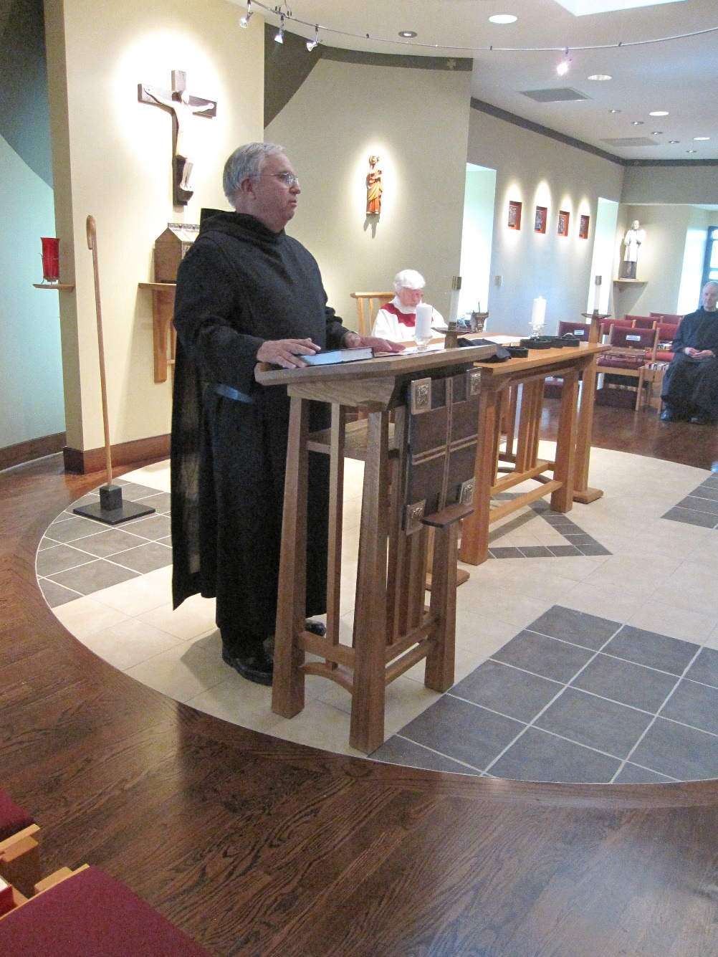
Br. Bede Leach; Fr. Wayne Kamm; Br. Joseph Olderr
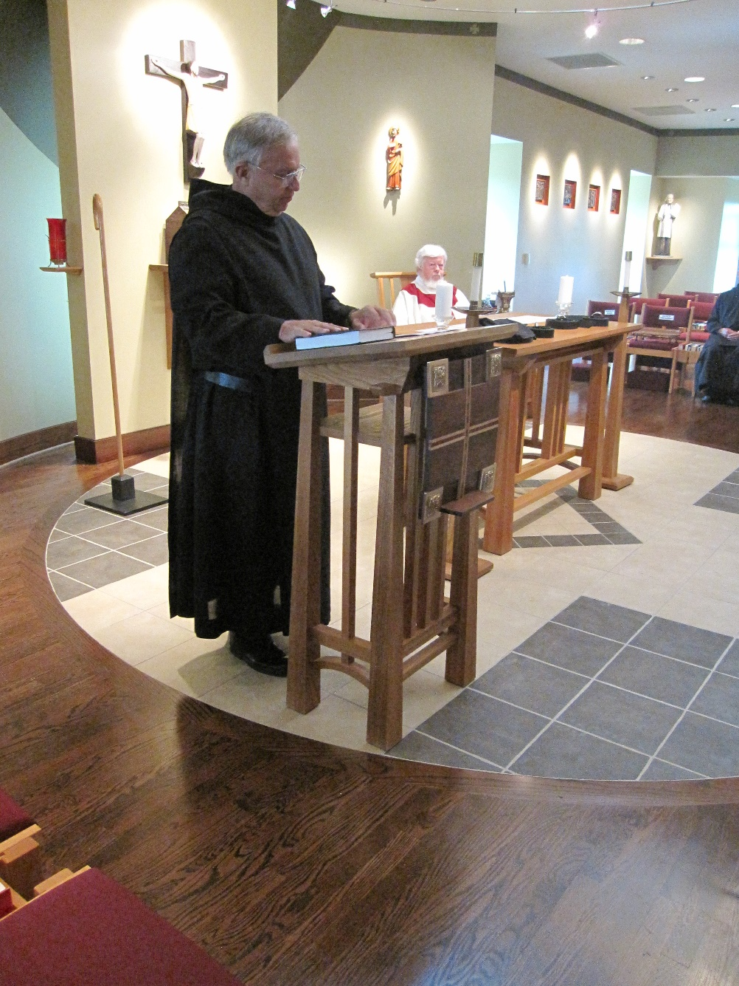
Br. Bede Leach; Fr. Wayne Kamm; Br. Joseph Olderr

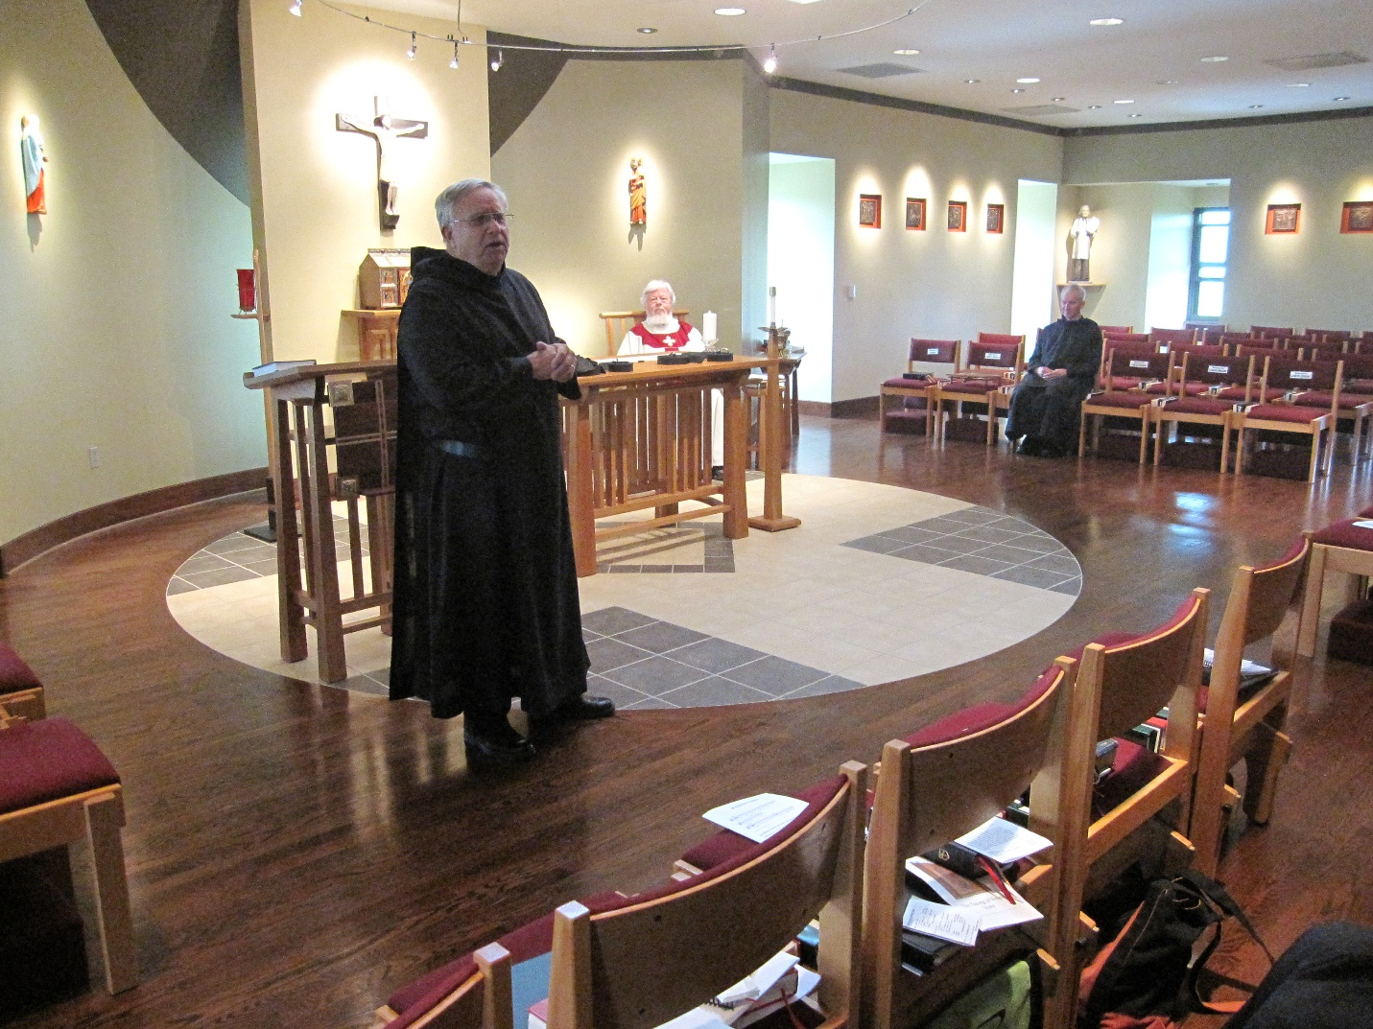
Br. Bede Leach; Fr. Wayne Kamm; Br. Joseph Olderr

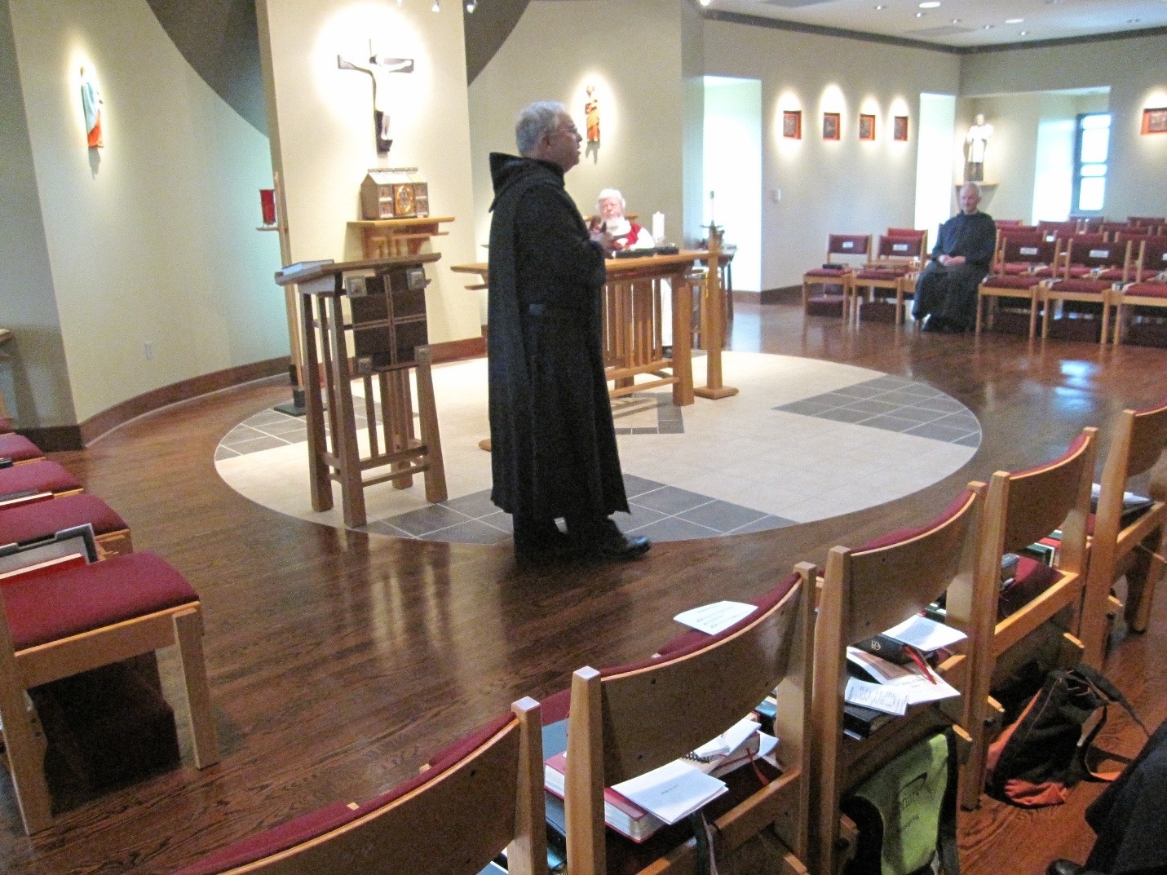
Br. Bede Leach; Fr. Wayne Kamm; Br. Joseph Olderr

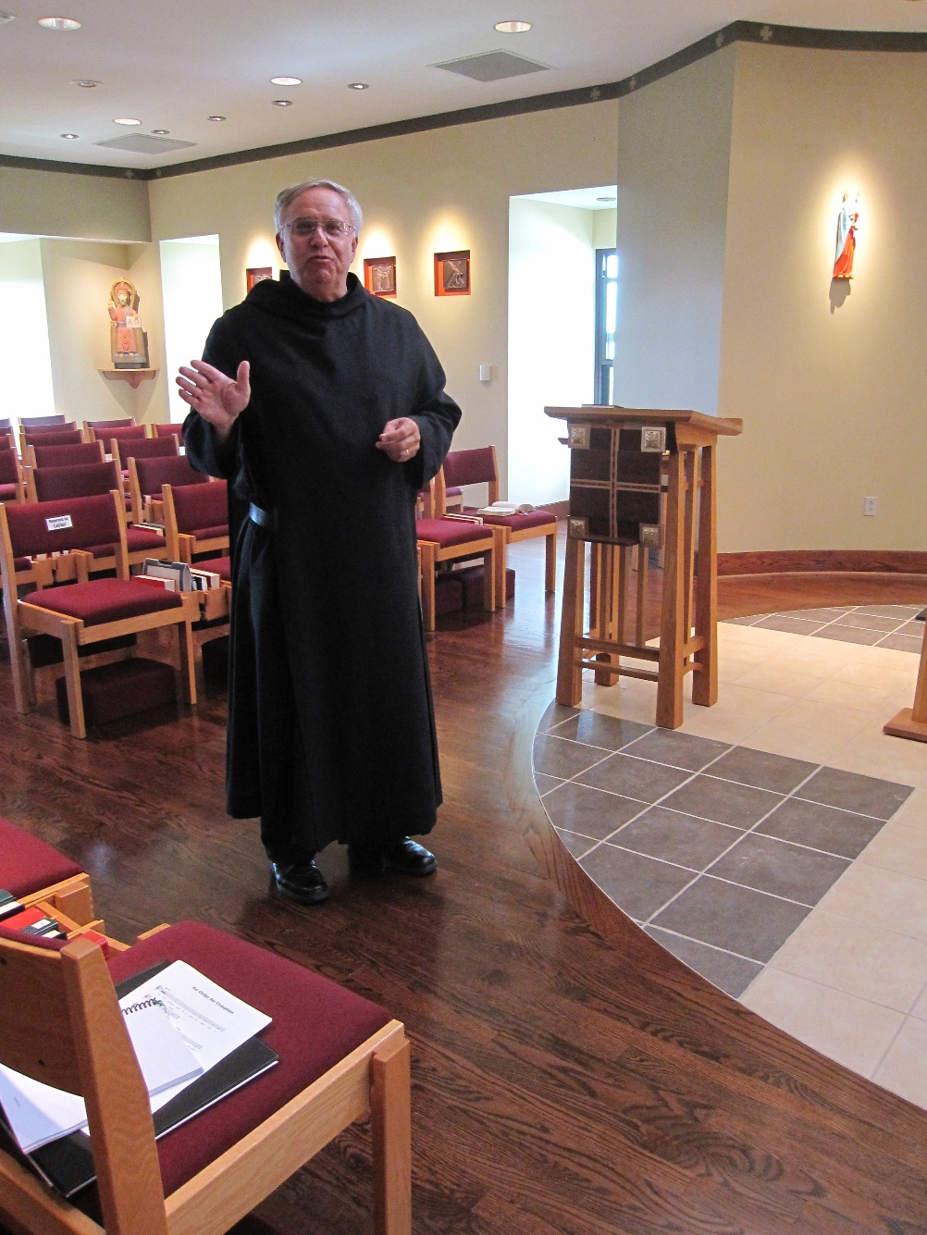

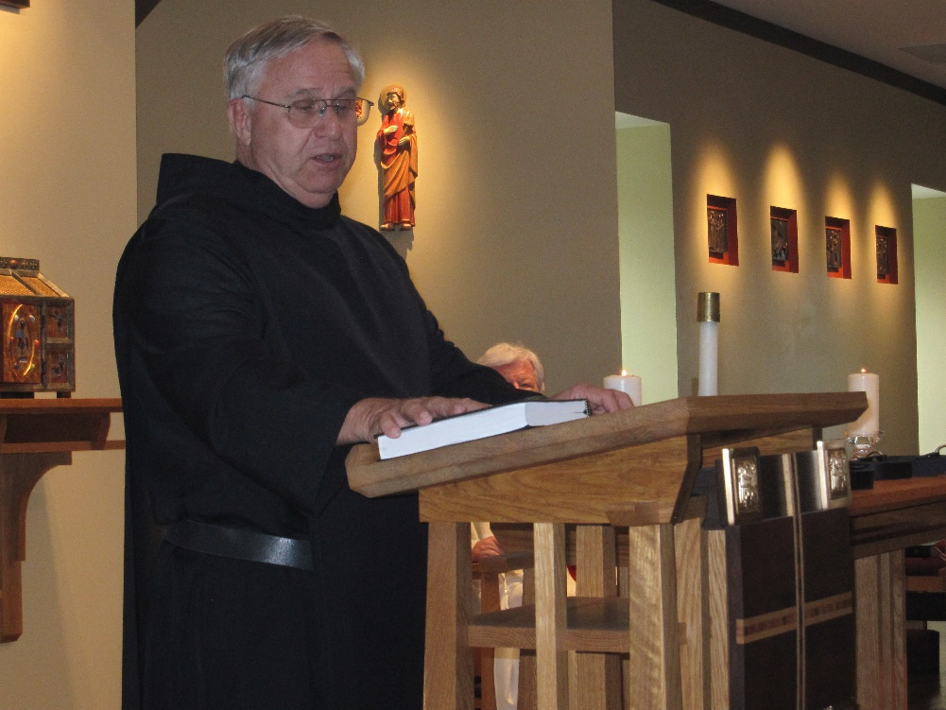
Br. Bede Leach; Fr. Wayne Kamm

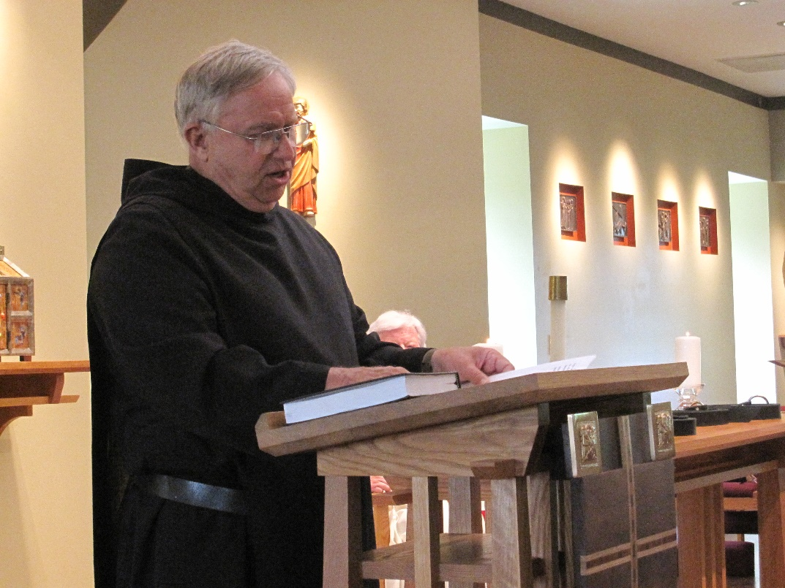
Br. Bede Leach; Fr. Wayne Kamm

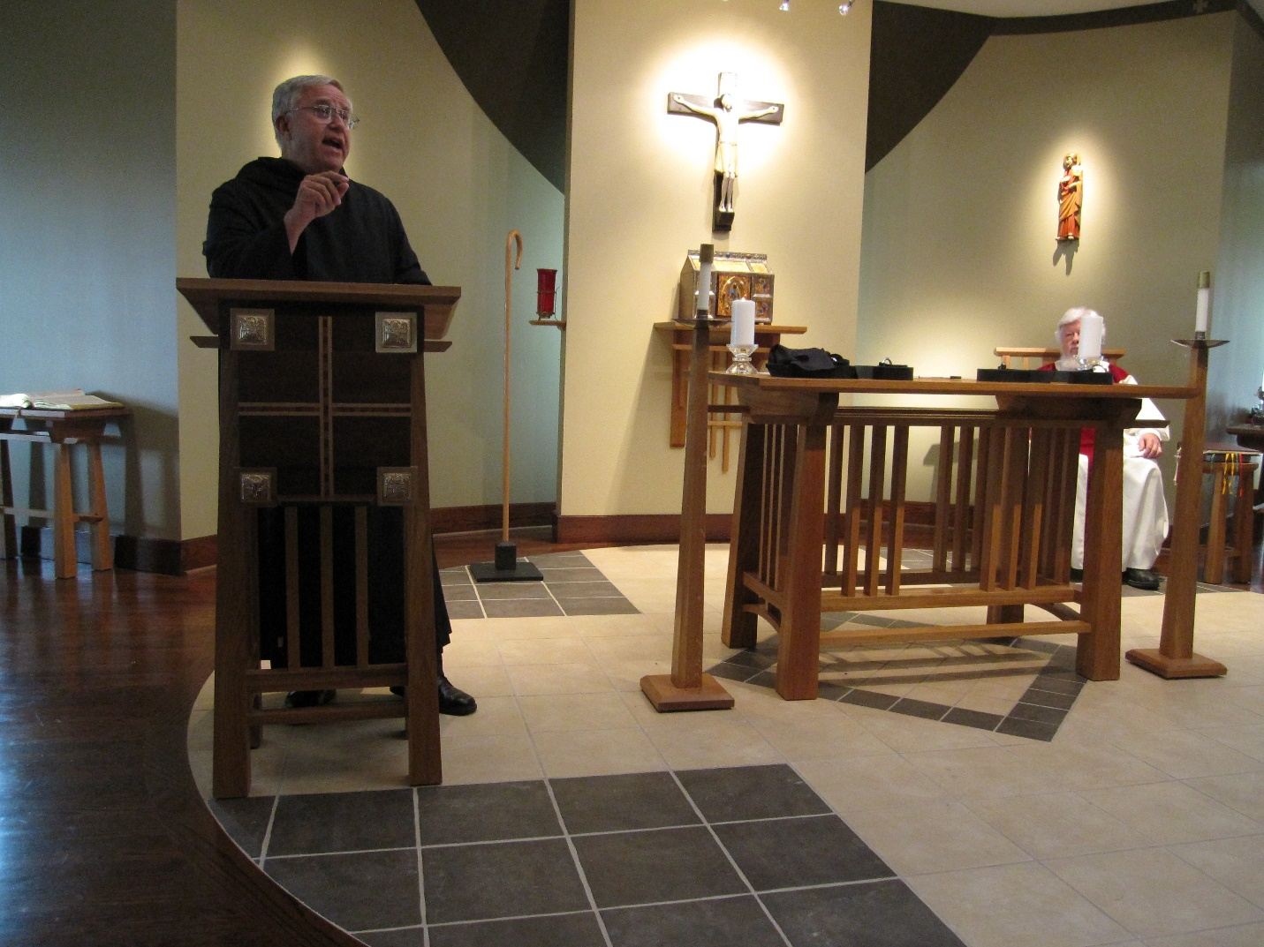
Br. Bede Leach; Fr. Wayne Kamm

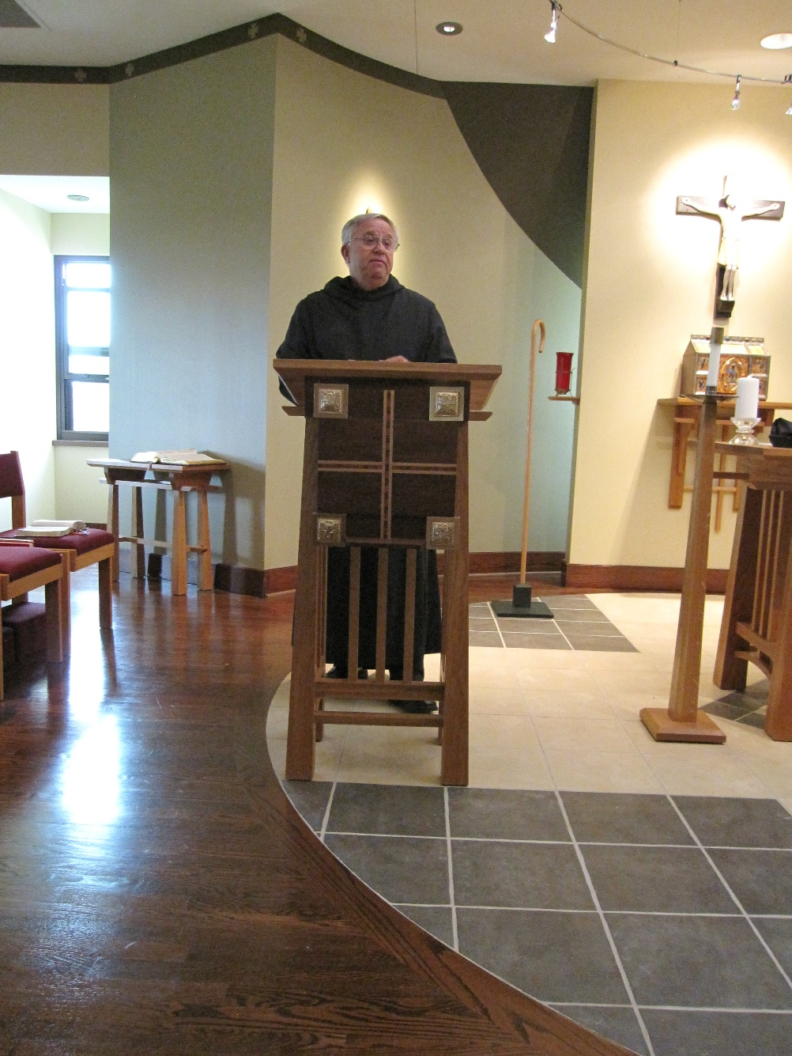
Br. Bede Leach

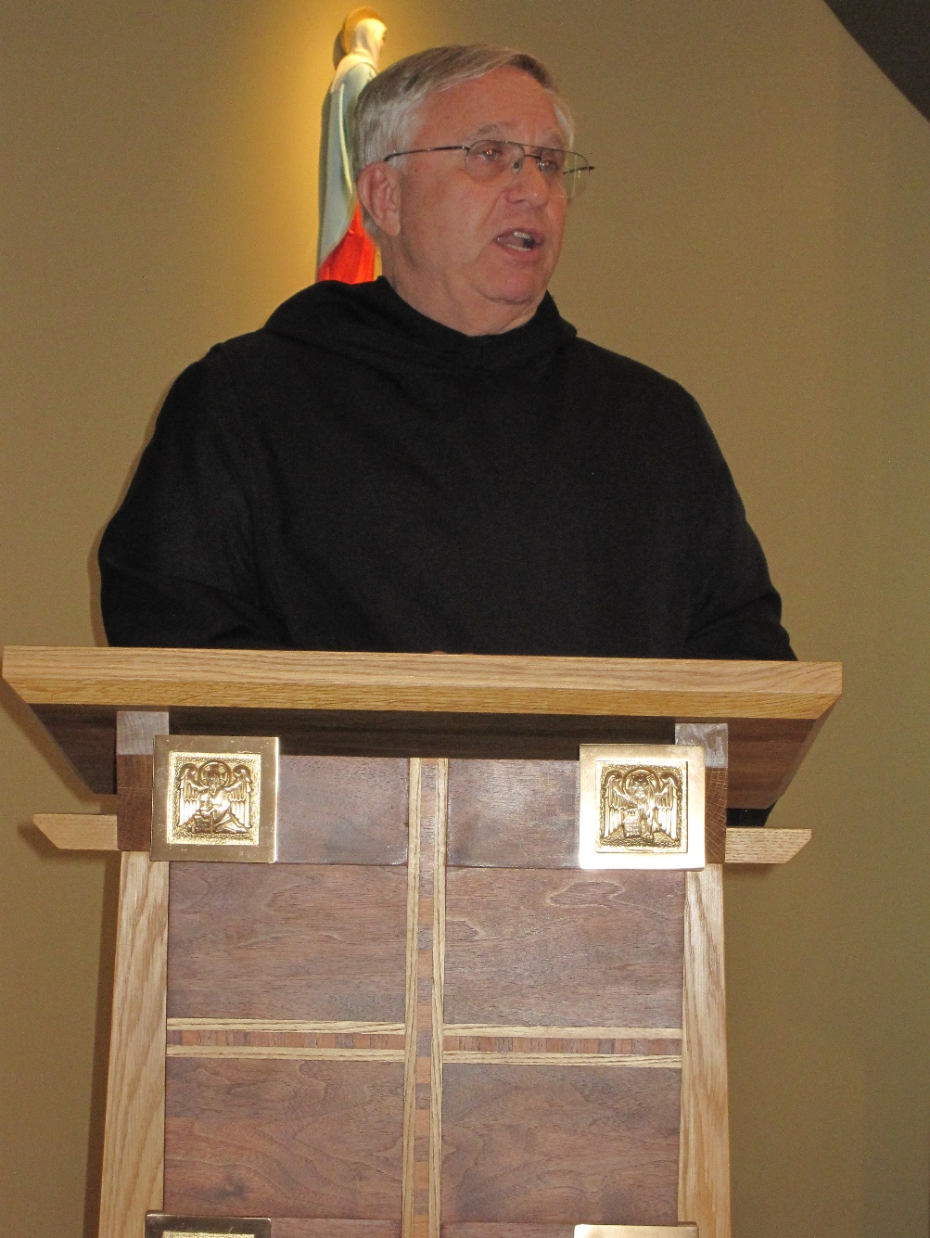
Br. Bede Leach

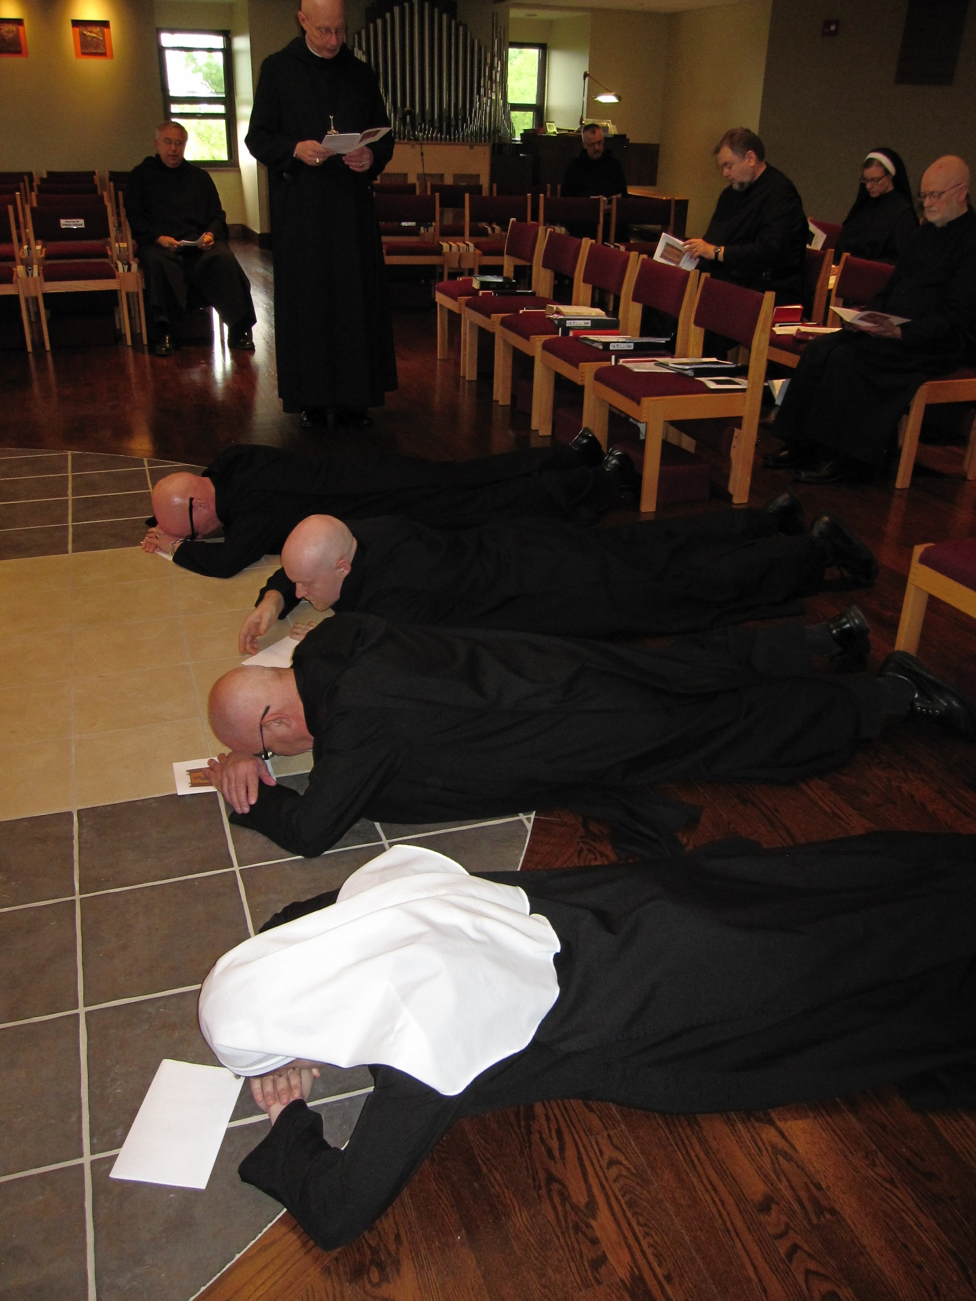
Br. Bede Leach; Br. Stephen Francis Arnold; Sr. Veronica Taylor; Br. Basil Edwards; Br. Gregory Kingsley; Abbot David Vincent Cotton; Br. Dunstan Townsend; Br. Samuel Saterstrom; Sr. Hannah Korver; Thomas Goddard

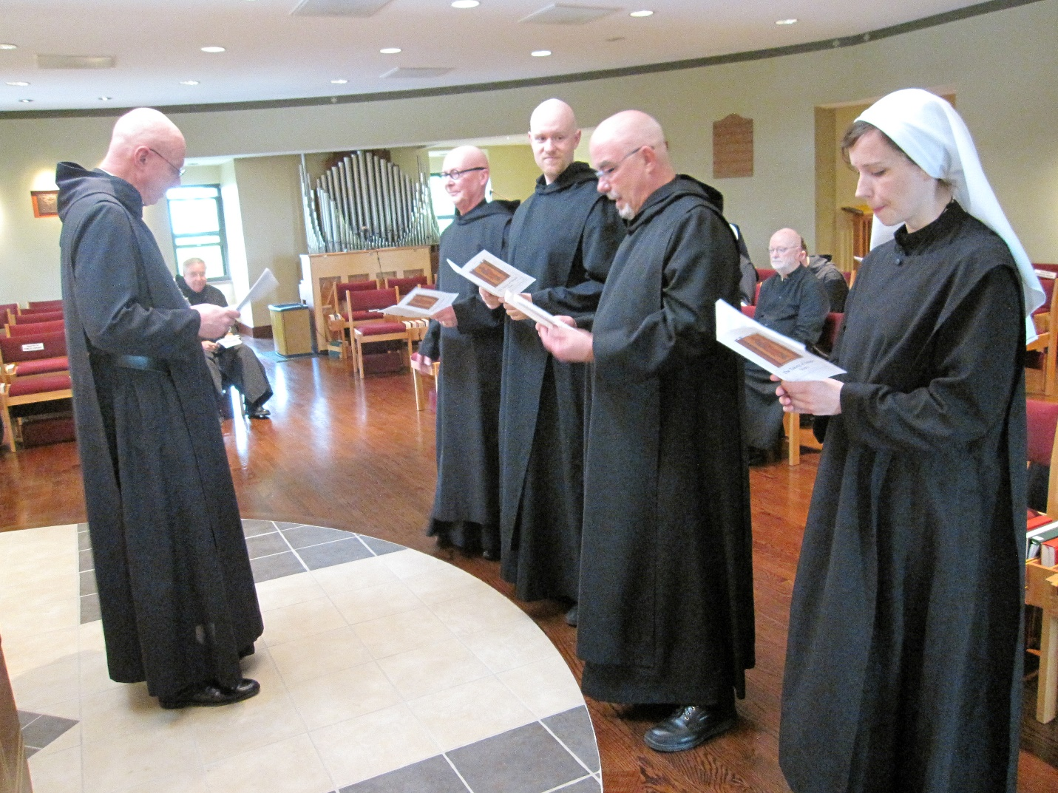
Abbot David Vincent Cotton; Br. Bede Leach; Br. Stephen Francis Arnold; Br. Gregory Kinsley; Br. Basil Edwards; Thomas Goddard; Sr. Veronica Taylor

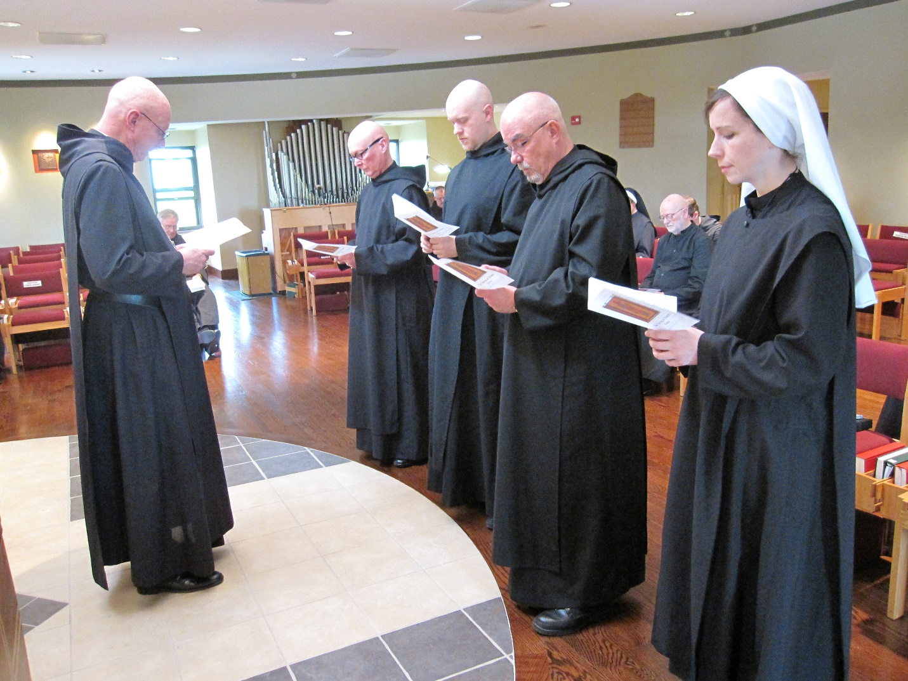
Abbot David Vincent Cotton; Br. Bede Leach; Br. Dunstan Townsend; Br. Stephen Francis Arnold; Br. Gregory Kinsley; Br. Basil Edwards; Sr. HaNNAH Korver; Thomas GoddardThomas Goddard; Sr. Veronica Taylor

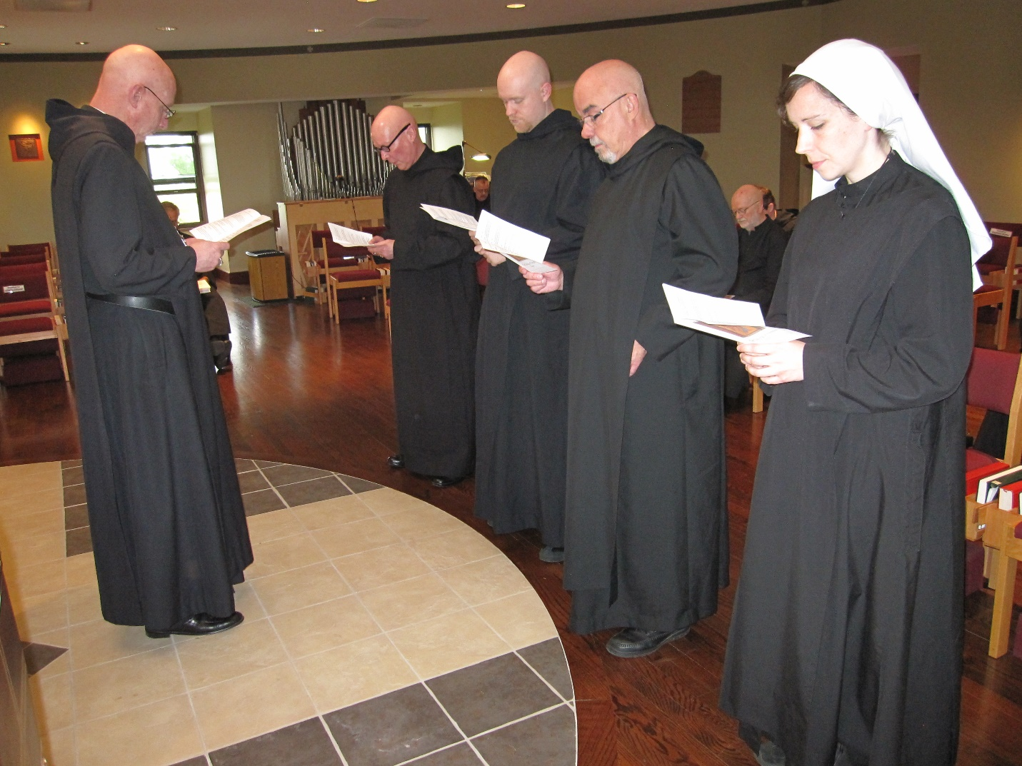
Abbot David Vincent Cotton; Br. Bede Leach; Br. Stephen Francis Arnold; Br. Gregory Kinsley; Br. Basil Edwards; Thomas Goddard; Sr. Veronica Taylor

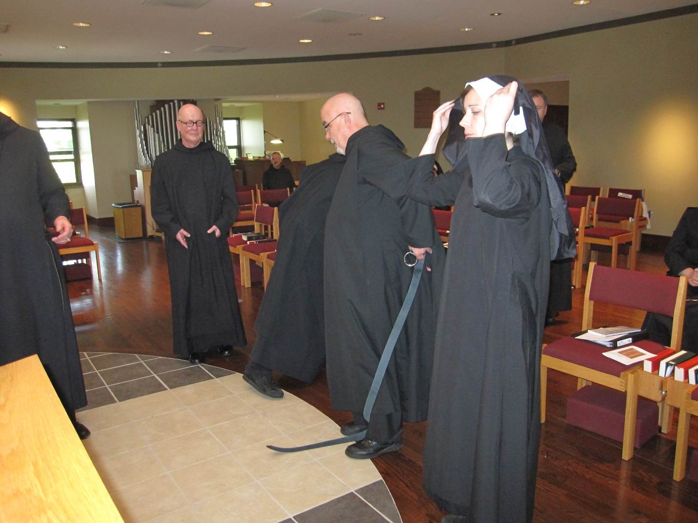
Abbot David Vincent Cotton; Br. Stephen Francis Arnold; Br. Dunstan Townsend; Br. Gregory Kinsley; Br. Basil Edwards; Sr. Veronica Taylor; Br. Samuel Saterstrom

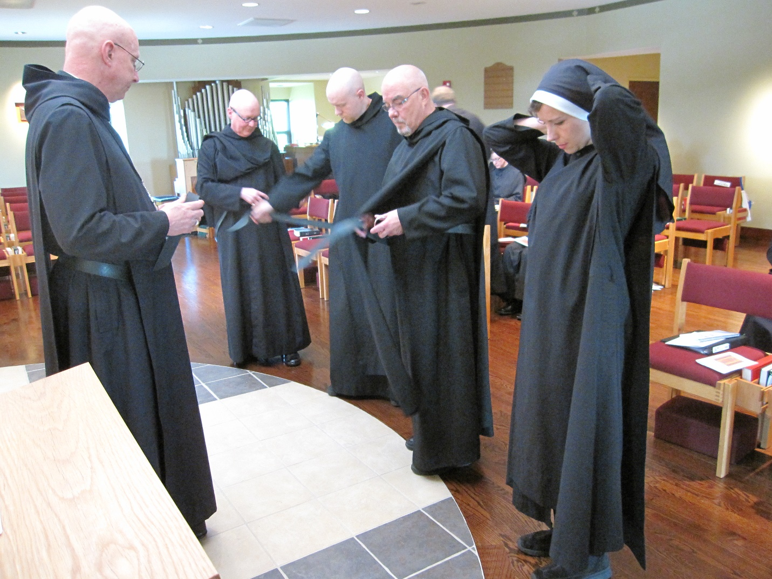
Abbot David Vincent Cotton; Br. Stephen Francis Arnold; Br. Gregory Kinsley; Br. Basil Edwards; Sr. Veronica Taylor;

