Companions of St. Luke
Spring Convocation at Conception Abbey
May 24, 2011
Photographed by Sr. Brigid Gerns

People are identified from left to right.

Edited by Br. Steven Olderr, 27 March 2023. Please send any comments, corrections, or additions to olderr@ameritech.net

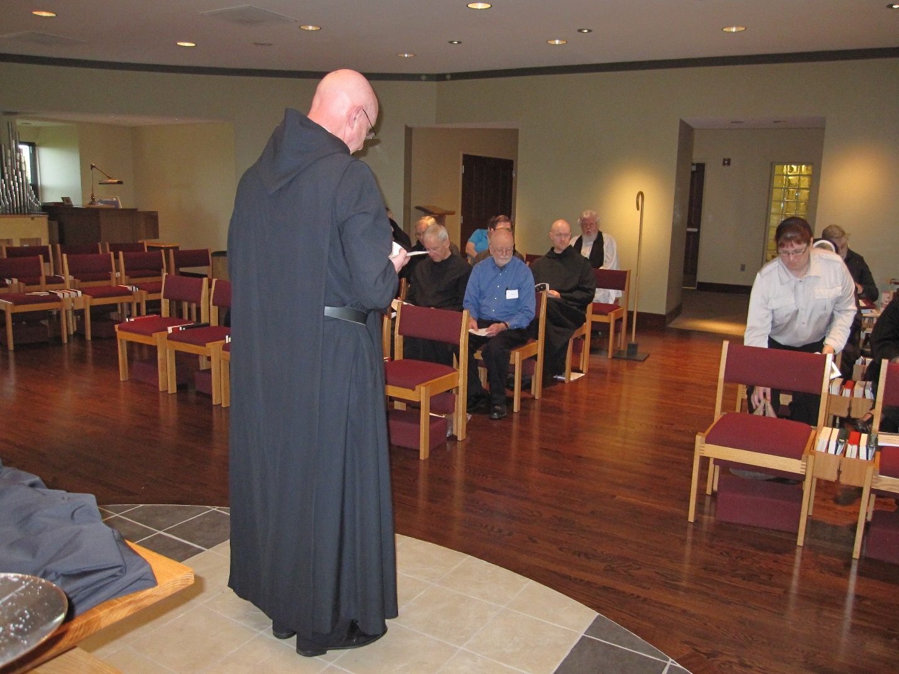
Abbot David Vincent Cotton; Br. Bede Leach; Br. Joseph Olderr; Br. Luke Doucette; Thomas Goddard; Br. Aidan Maguire; Br. Gregory Kingsley; Fr. Wayne Kamm; Kellyanne Hale; Sr. Bernadette Barrett; Br. Chad Anselm Gerns
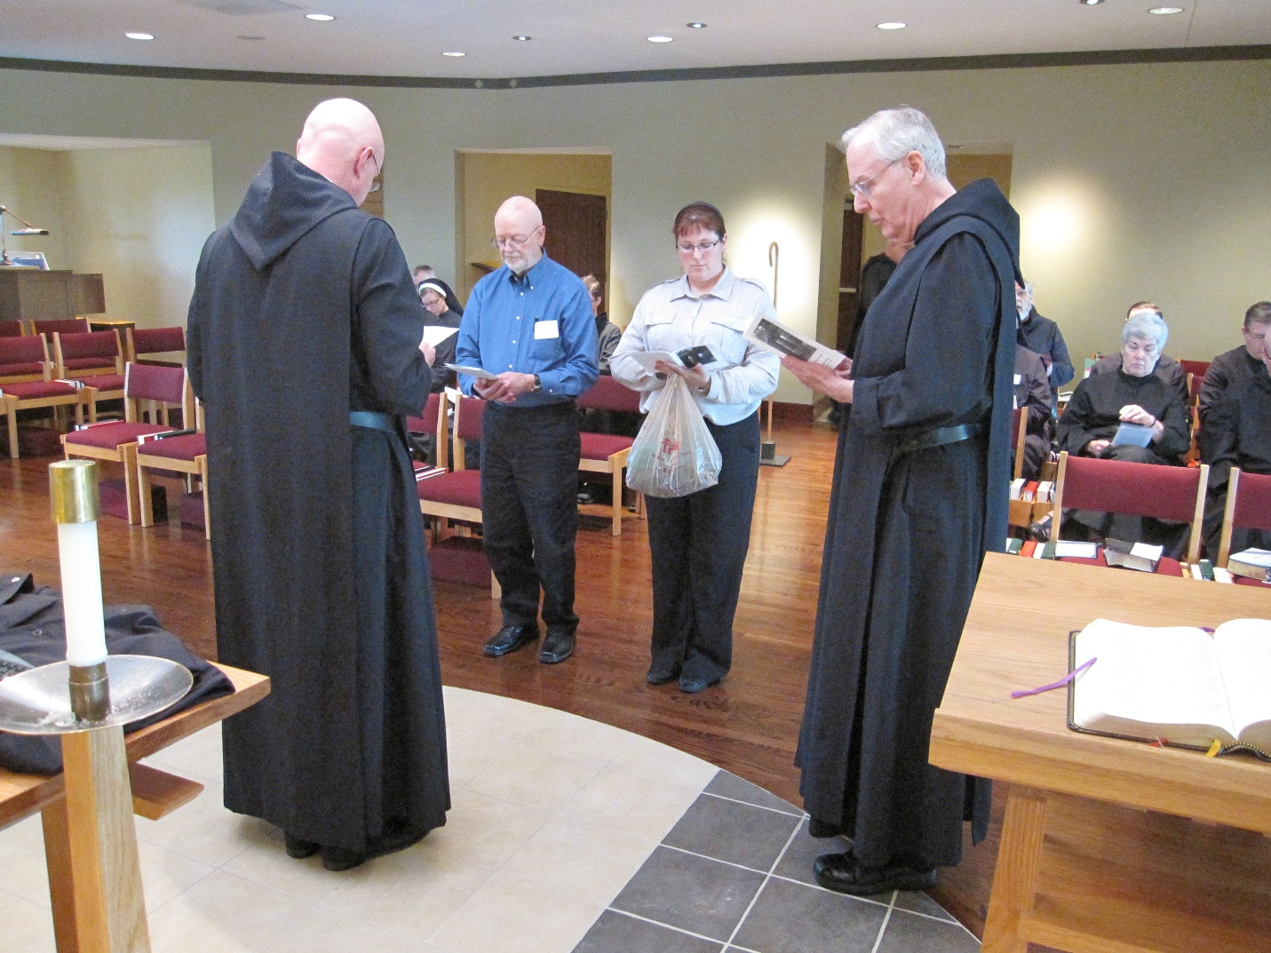
Abbot David Vincent Cotton; Br. Dunstan Townsend; Sr. Hannah Korver; Thomas Goddard; Br. Aidan Maguire; Kellyanne Hale; Br. Luke Doucette; Br. Basil Edwards; Br. Chad Anselm Gerns; Sr. Toni Sylvester; Br. Roman Shemayev; Br. John of Kanty Kennedy; Br. Stephen Francis Arnold

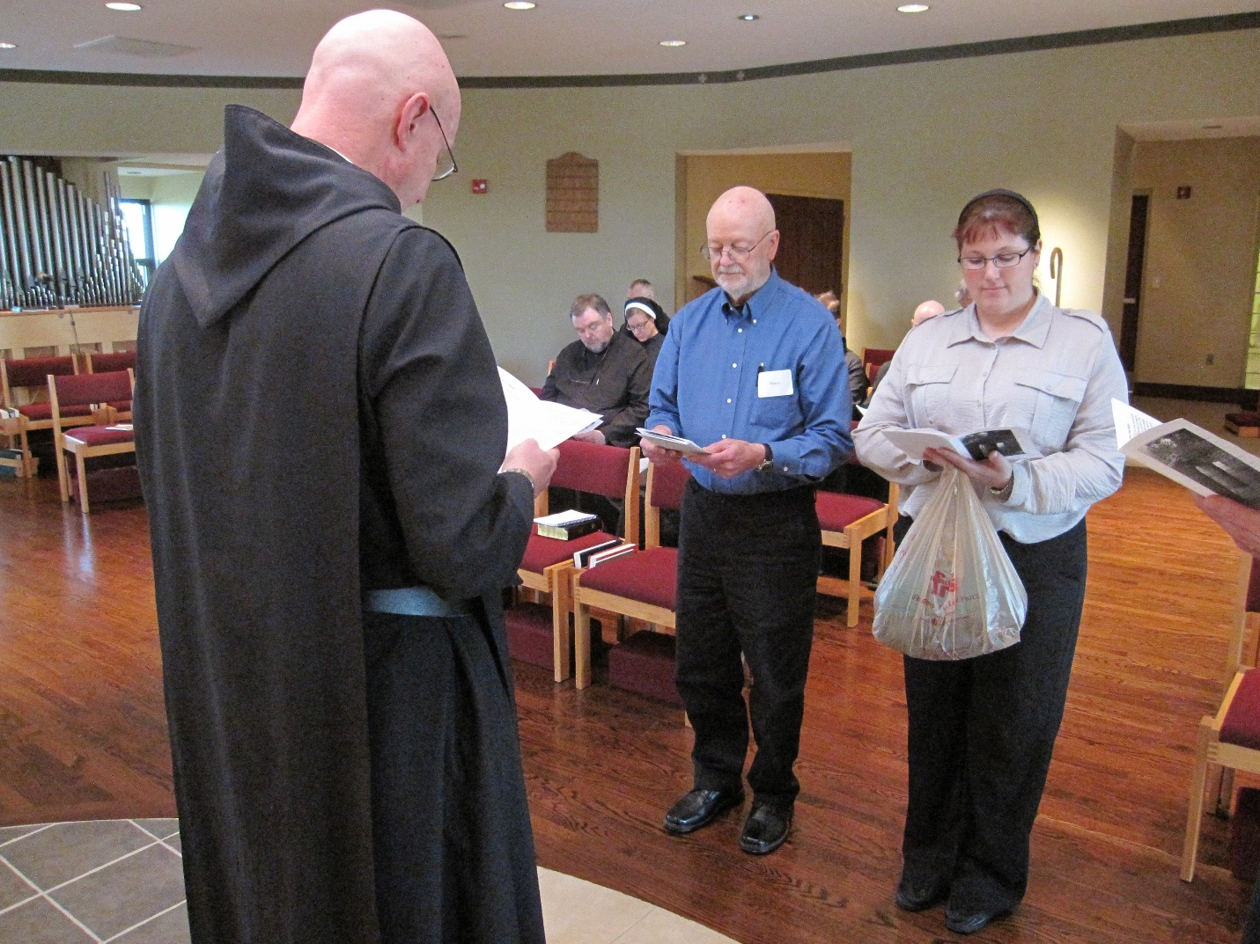
Abbot David Vincent Cotton; Br. Samuel Saterstrom; Sr. Hannah Korver; Br. Dunstan Townsend; Thomas Goddard; Br. Aidan Maguire; Br. Gregory Kingsley; Fr. Wayne Kamm; Kellyanne Hale

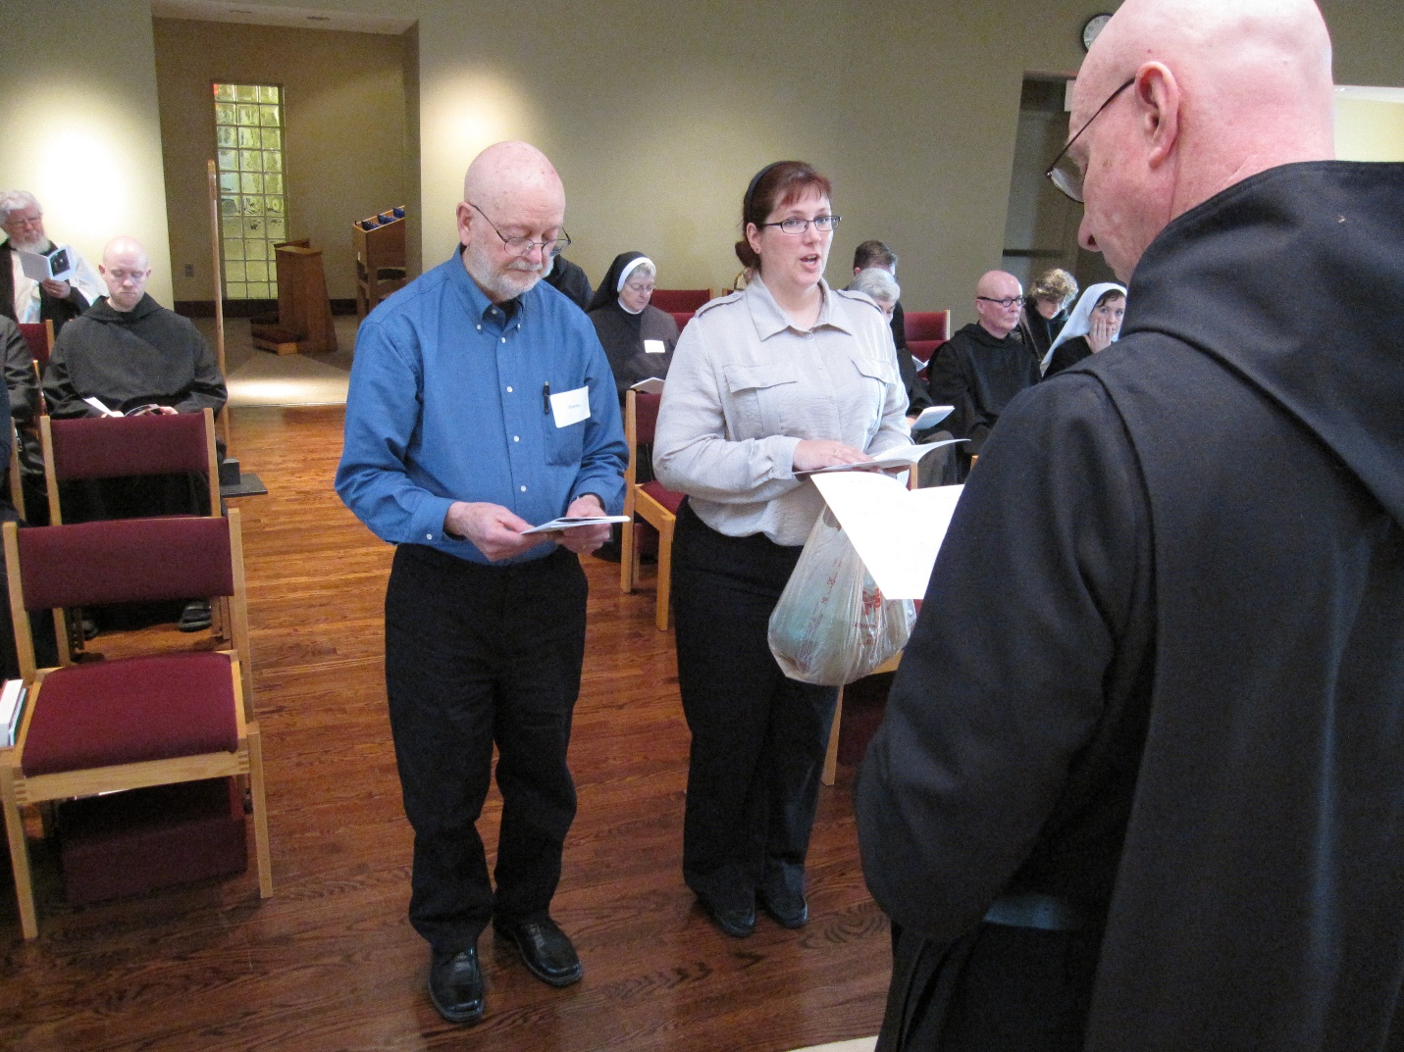
Fr. Wayne Kamm; Br. Gregory Kingsley; Thomas Goddard; Sr. Bernadette Barrett; Kellyanne Hale; Sr Toni Sylvester; Br. John of Kanty Kennedy; Br. Stephen Francis Arnold; Sr. Cecelia Lamoy; Sr. Veronic Taylor; Abbot David Vincent Cotton
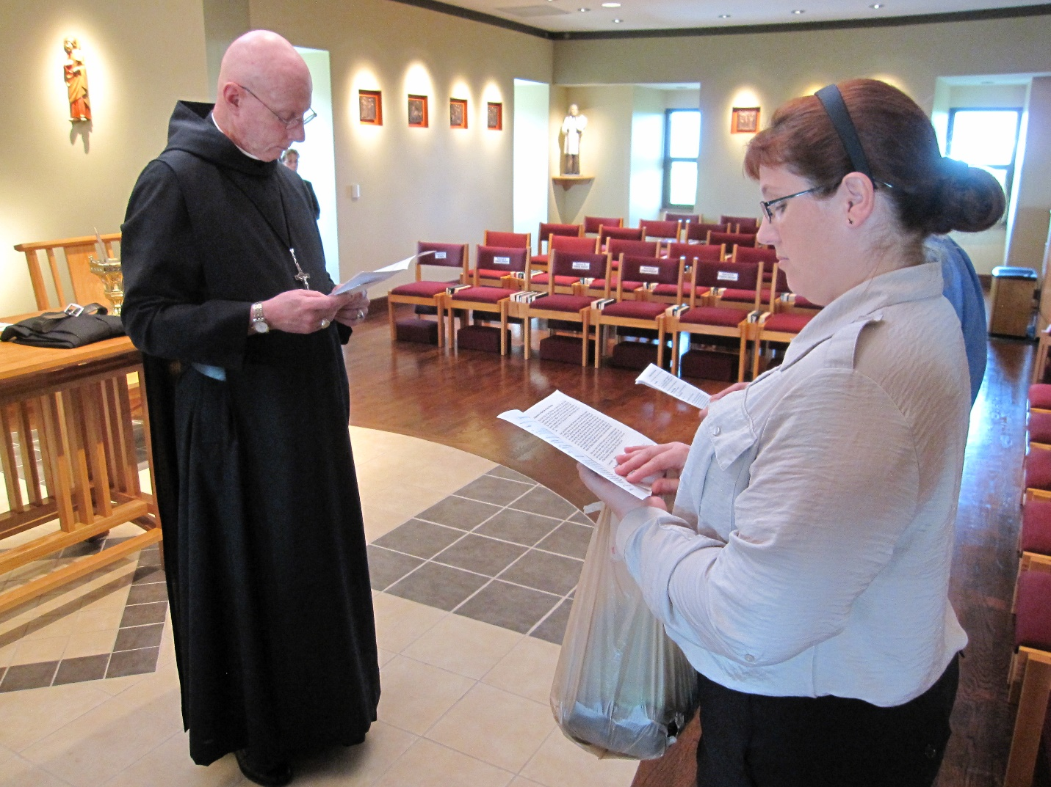
Abbot David Vincent Cotton; Sr. Monica Ruth Mullen; Kellyanne Hale; Thomas Goddard

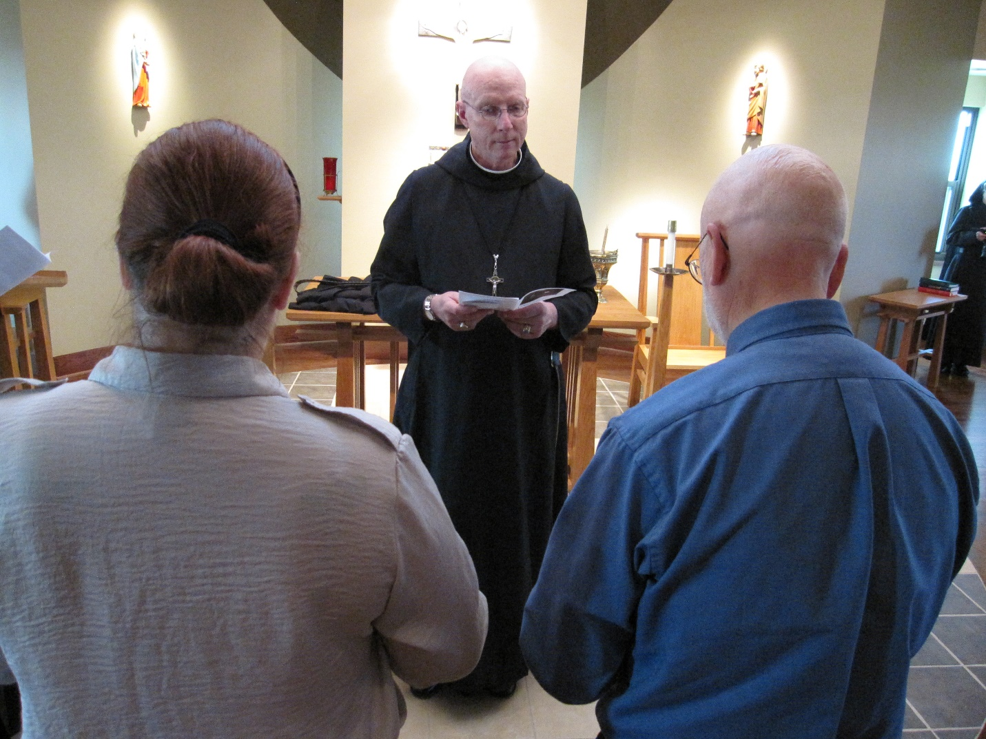
Kellyanne Hale; Abbot David Vincent Cotton; Thomas Goddard; Sr. Monica Ruth Mullen

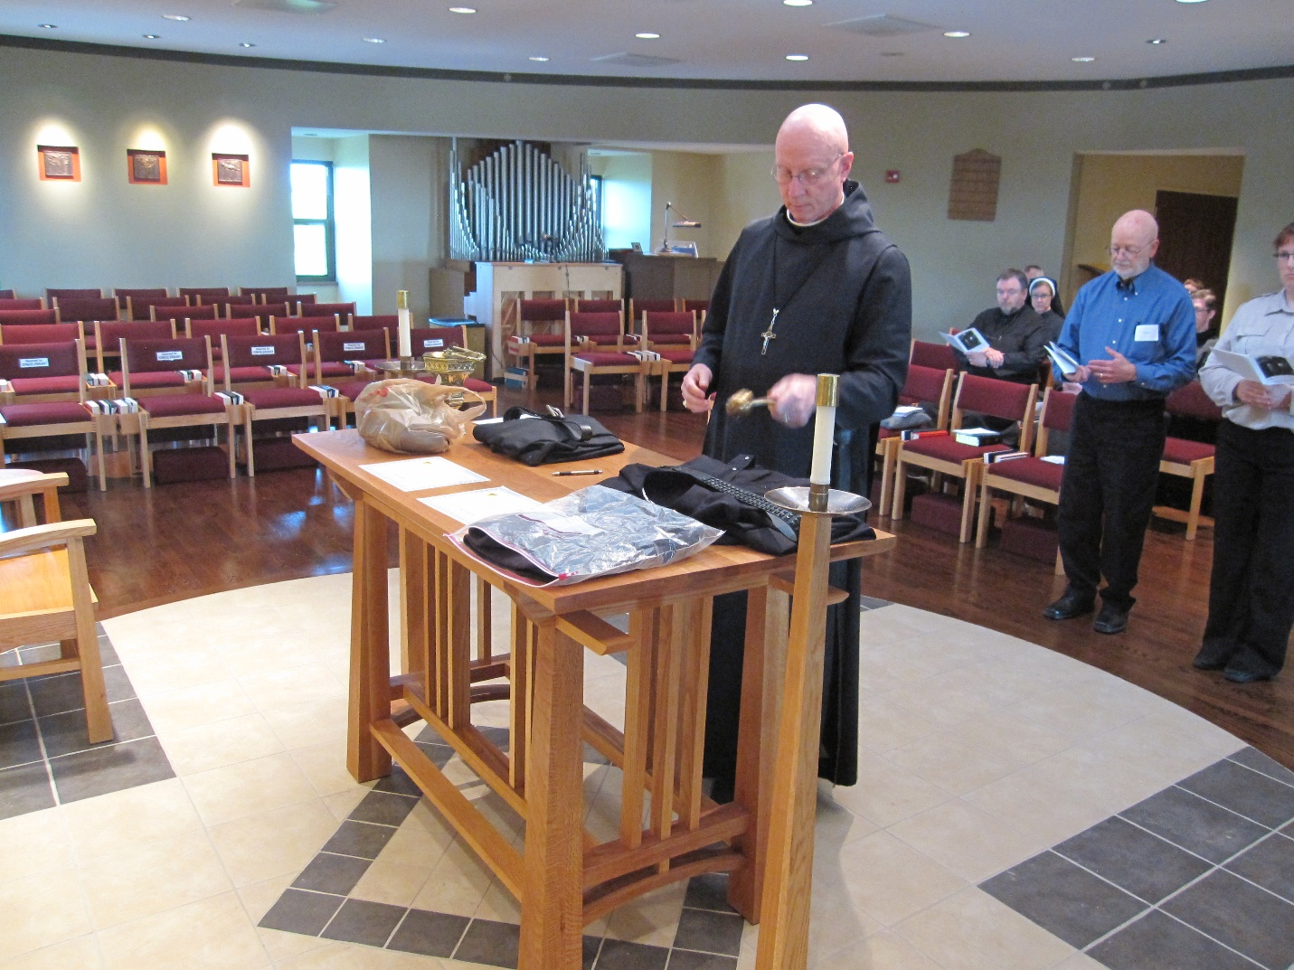
Abbot David Vincent Cotton; Br. Samuel Saterstrom; Br. Dunstan Townsend; Sr. Hannah Korver; Thomas Goddard; ?; Br. Aidan Maguire; Kellyanne Hale

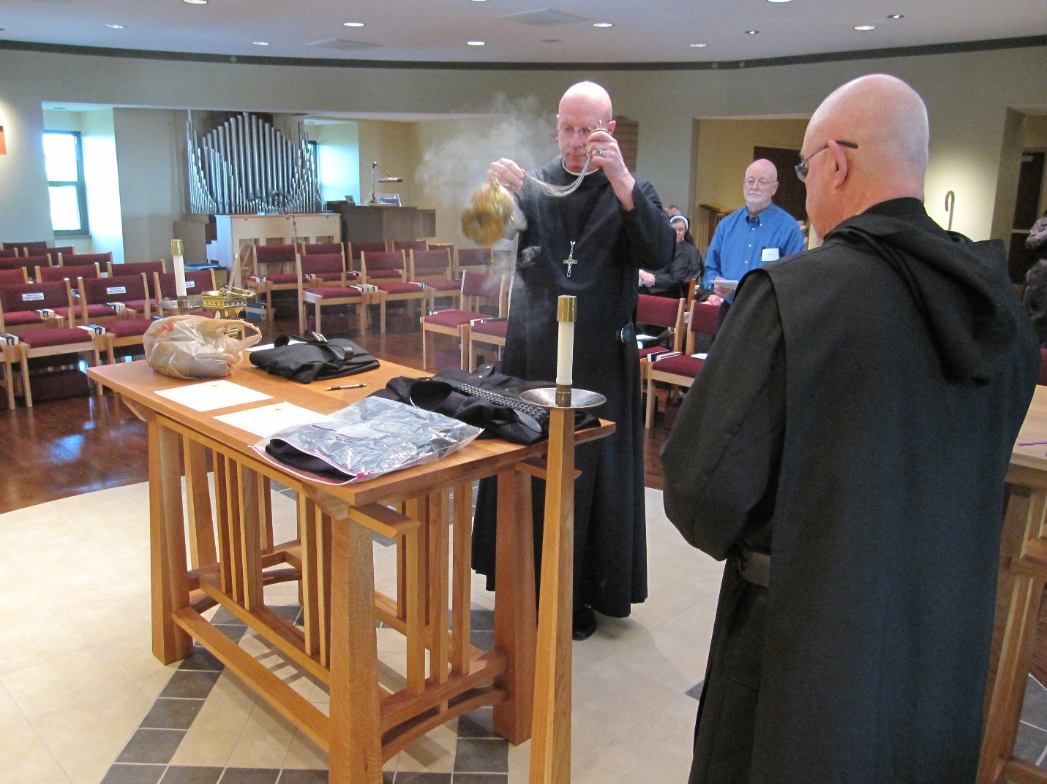
Abbot David Vincent Cotton; Br. Dunstan Townsend; Sr. Hannah Korver; Thomas Goddard; Br. Basil Edwards

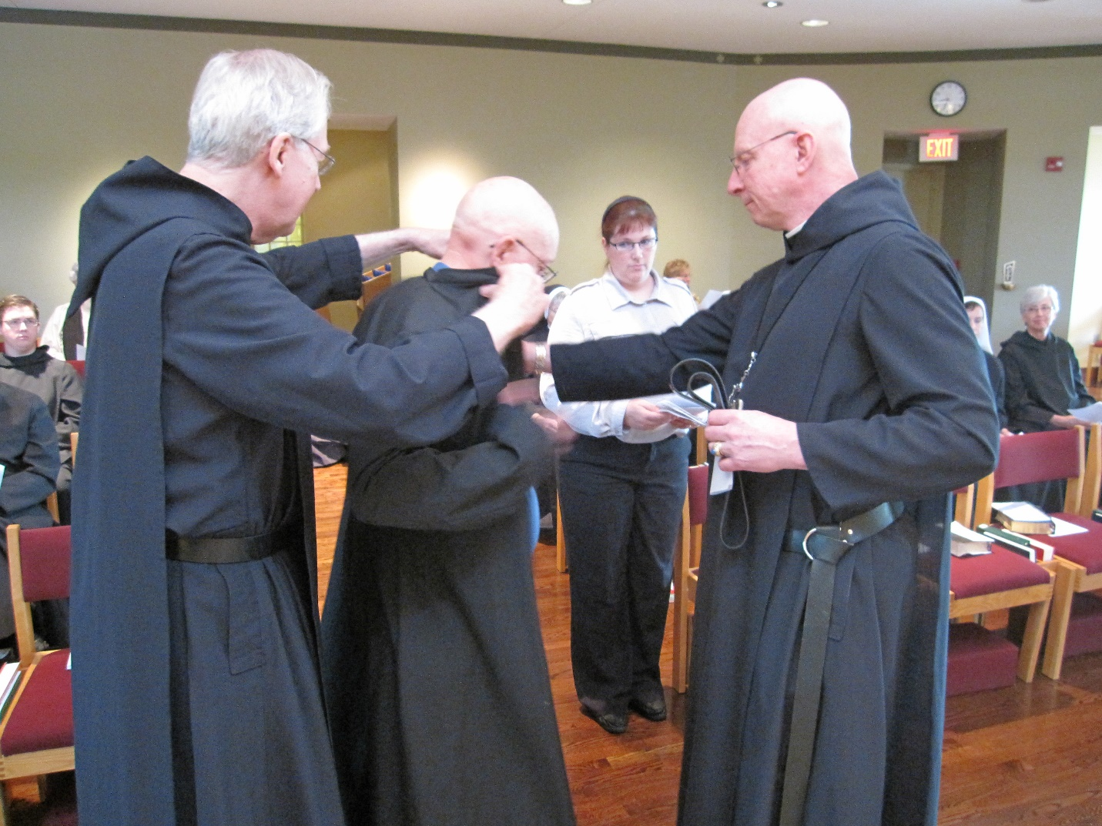
Br. Aidan Maguire; Br. Luke Doucette; Thomas Goddard; Sr. Bernadette Barrett; Kellyanne Hale; ?; Abbot David Vincent Cotton; Sr. Veronica Taylor; Sr. Julian Saterstrom

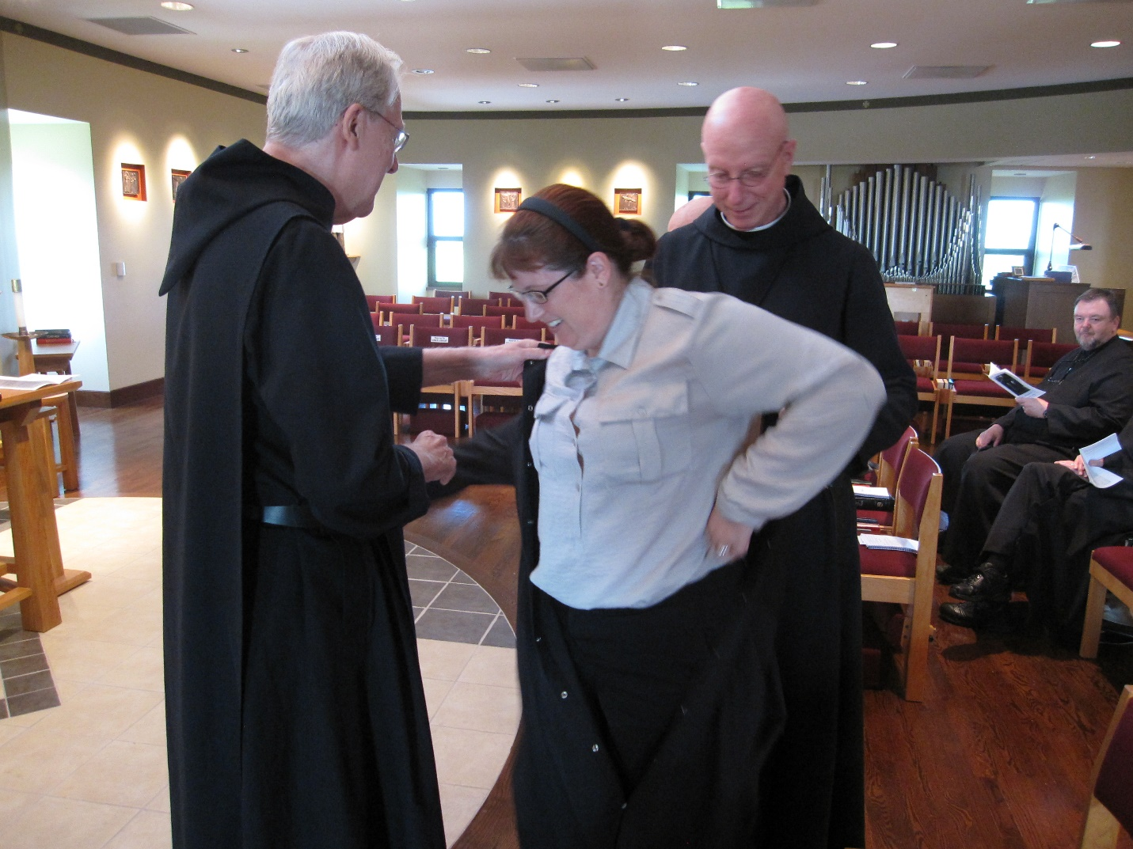
Br. Luke Doucette; Kellyanne Hale; Abbot David Vincent Cotton; Br. Samuel Saterstrom

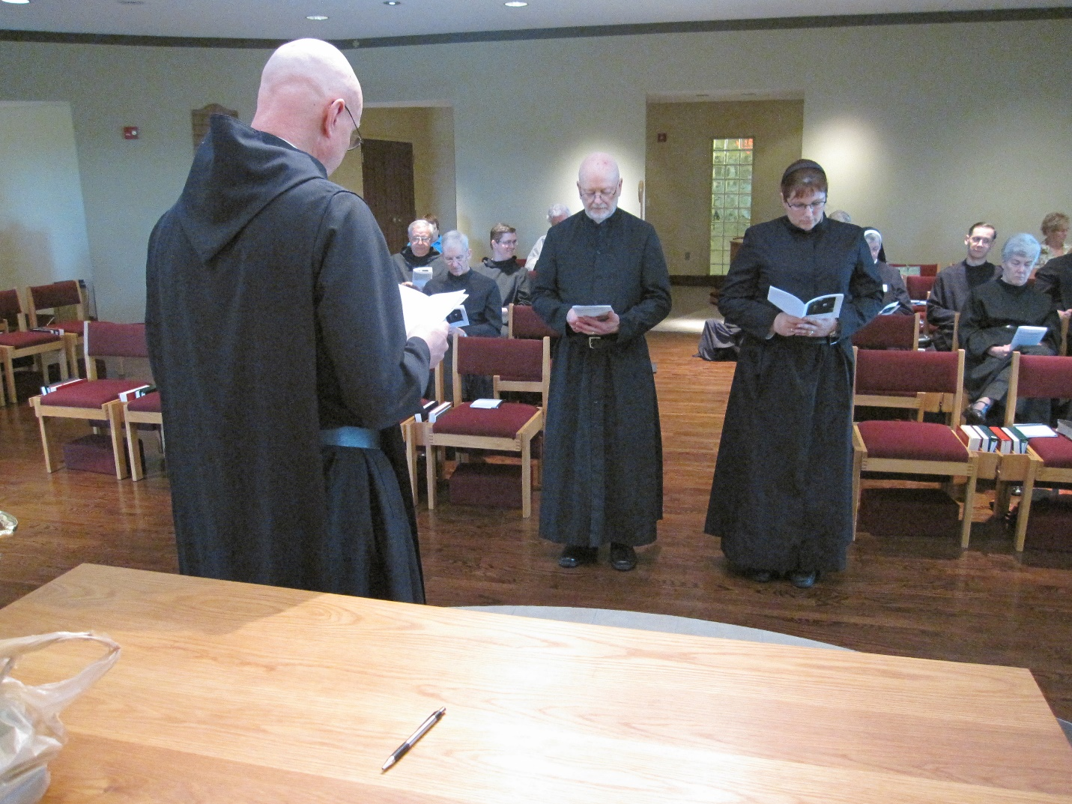
Abbot David Vincent Cotton; Br. Bede Leach; ?; Br. Joseph Olderr; Br. Aidan Maguire; Fr. Wayne Kamm; Thomas Goddard; Kellyanne Hale; Sr. Bernadette Barrett; Br. Roman Shemayev; Sr. Toni Sylvester; ?

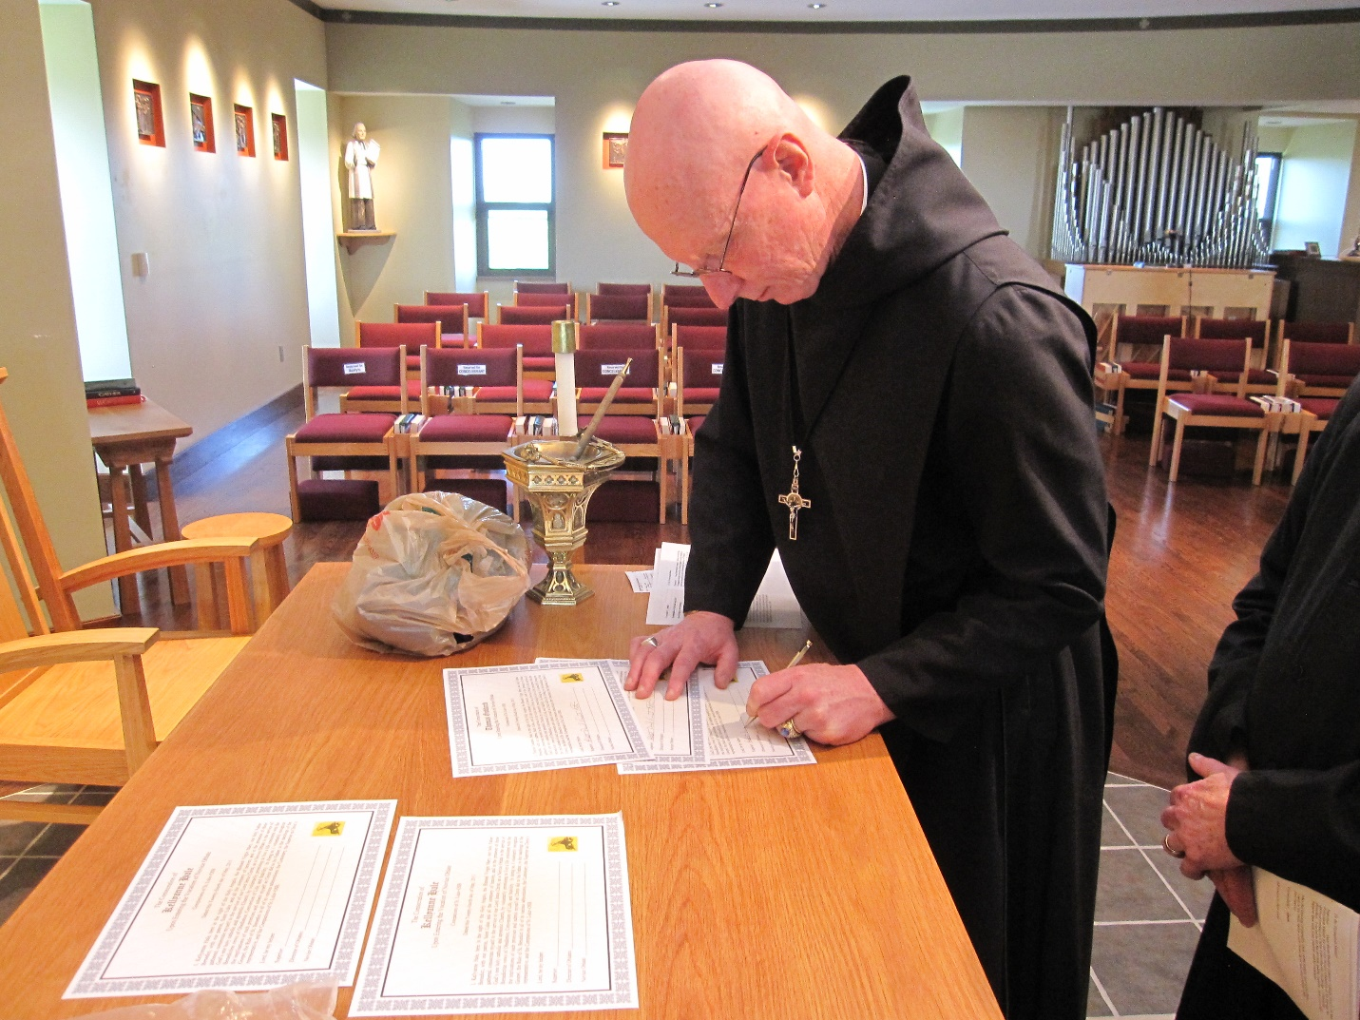
Abbot David Vincent Cotton

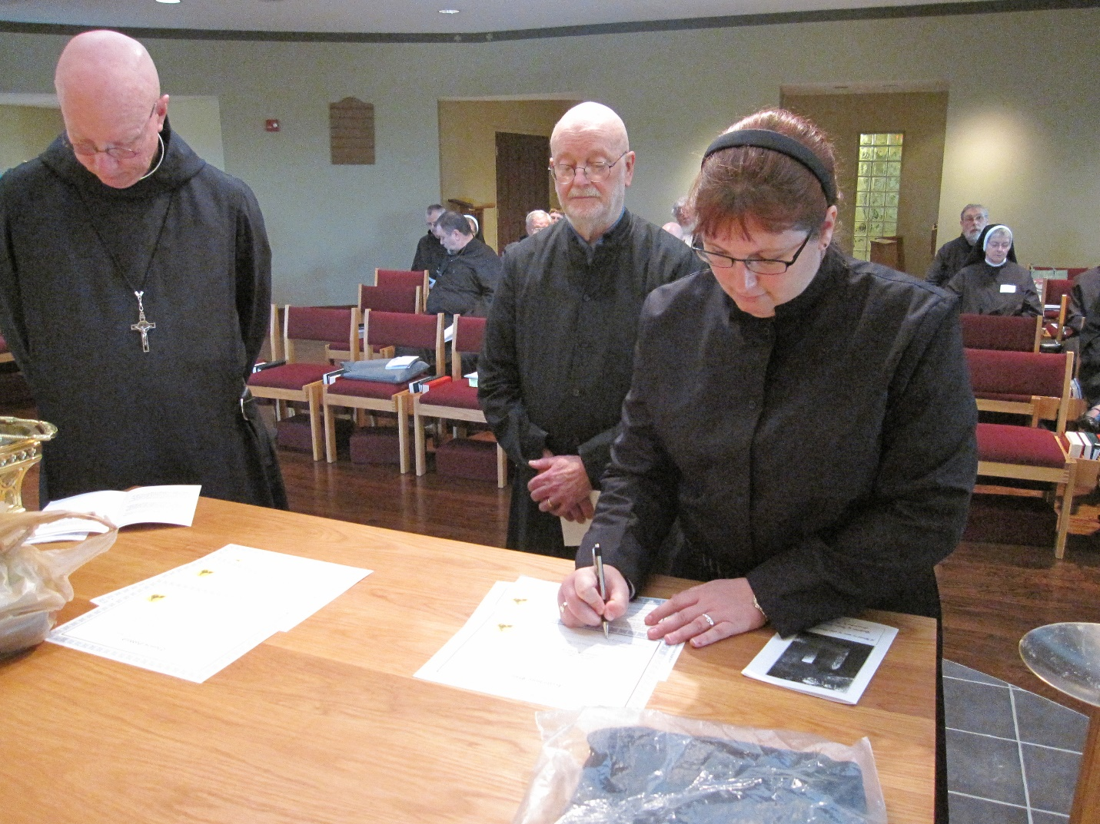
Abbot David Vincent Cotton; Br. Dunstan Townsend; Br. Samuel Saterstrom; ?; Br. Bede Leach; ?; Thomas Goddard; Br. Gregory Kingsley; Fr. Wayne Kamm; Kellyanne Hale; Br. Chad Anselm Gerns; Sr. Bernadette Barrett

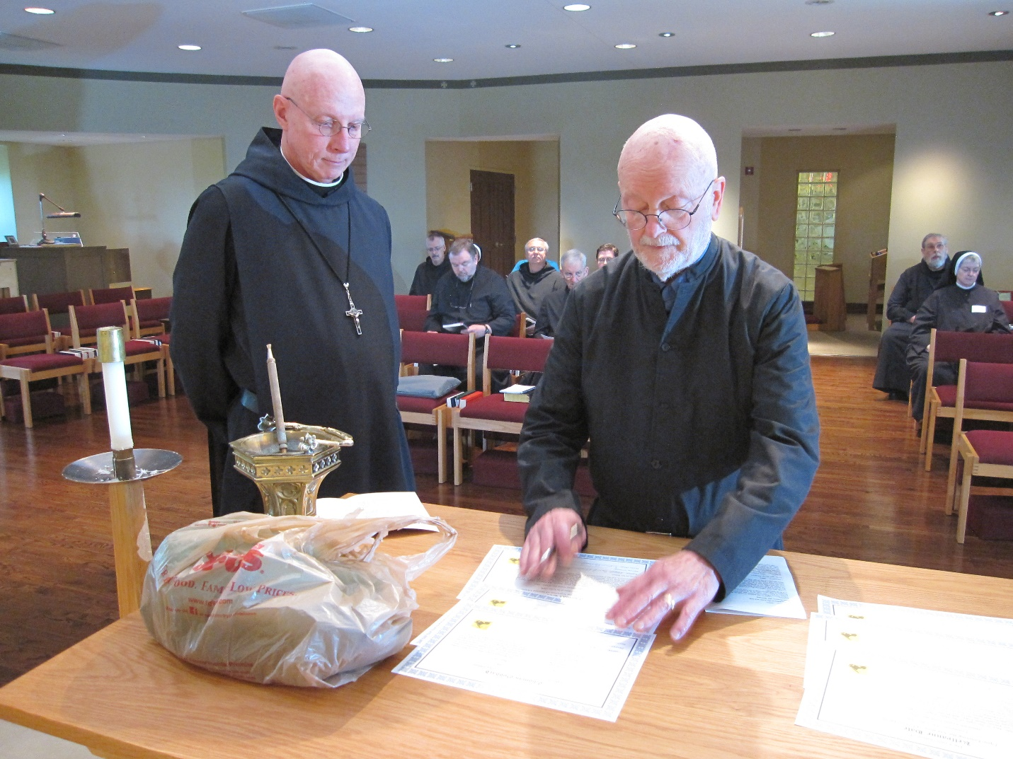
Abbot David Vincent Cotton; Br. Dunstan Townsend; Br. Samuel Saterstrom; Br. Bede Leach; Br. Joseph Olderr; Br. Aidan Maguire; Thomas Goddard; Br. Chad Anselm Gerns; Sr. Bernadette Barrett

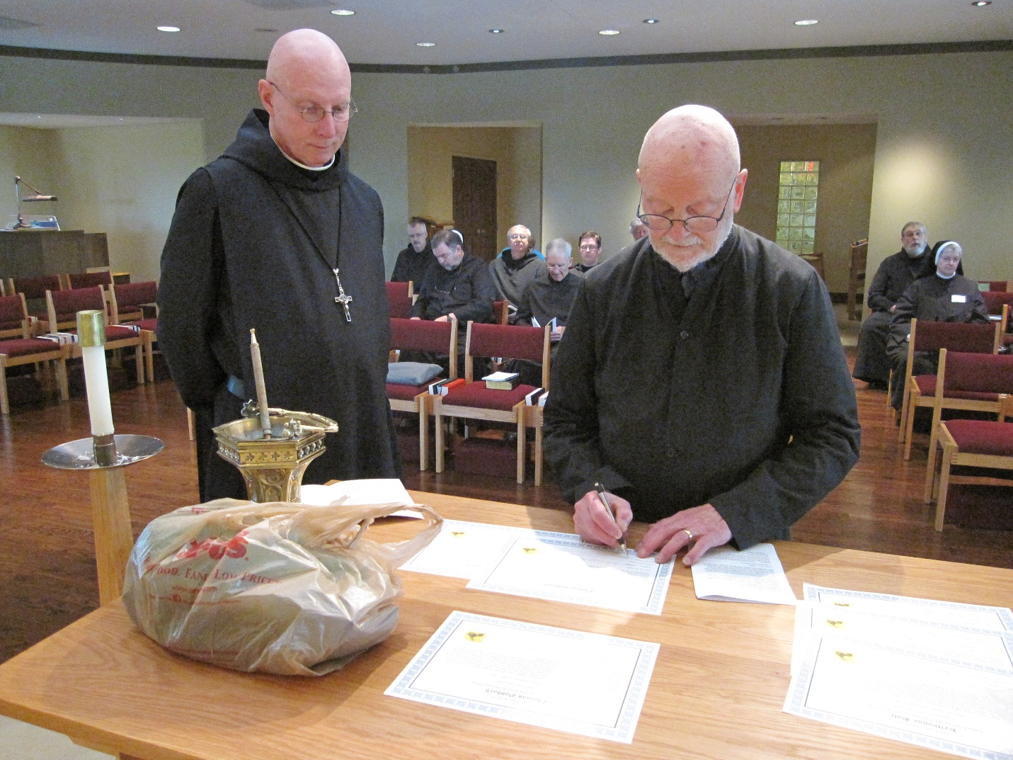
Abbot David Vincent Cotton; Br. Dunstan Townsend; Br. Samuel Saterstrom; Br. Bede Leach; Br. Joseph Olderr; Br. Aidan Maguire; Fr. Wayne Kamm; Thomas Goddard; Br. Chad Anselm Gerns; Sr. Bernadette Barrett

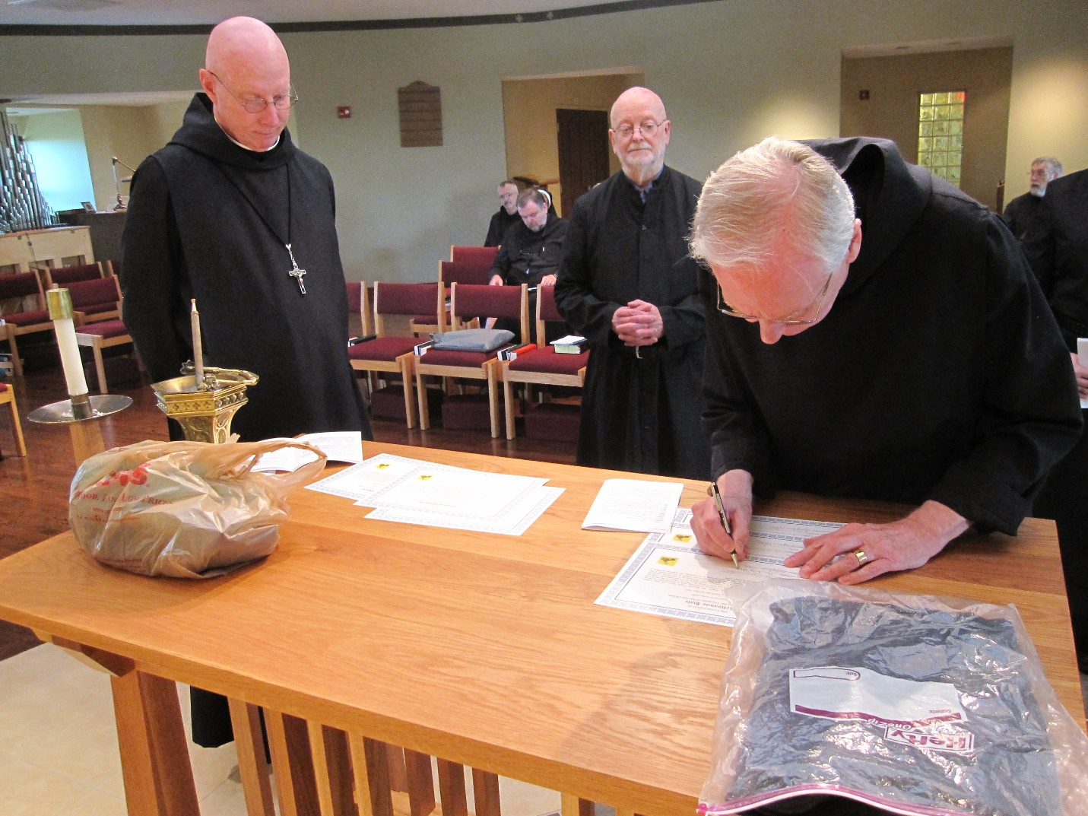
Abbot David Vincent Cotton; Br. Dunstan Townsend; Br. Samuel Saterstrom; Thomas Goddard; Br. Luke Doucette; Br. Chad Anselm Gerns

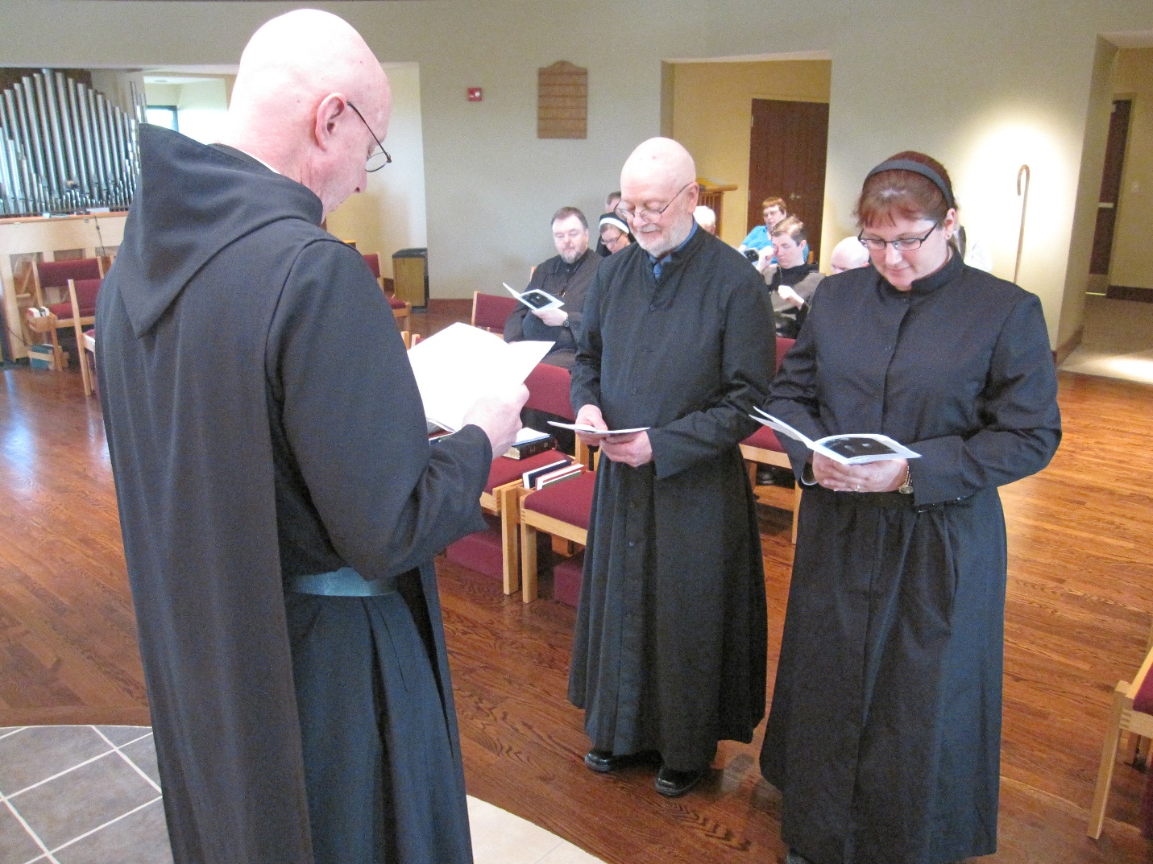
Abbot David Vincent Cotton; Br. Samuel Saterstrom; Sr. Hannah Korver; Thomas Goddard; ?; Br. Aidan Maguire; Br. Gregory Kingsley; Kellyanne Hale

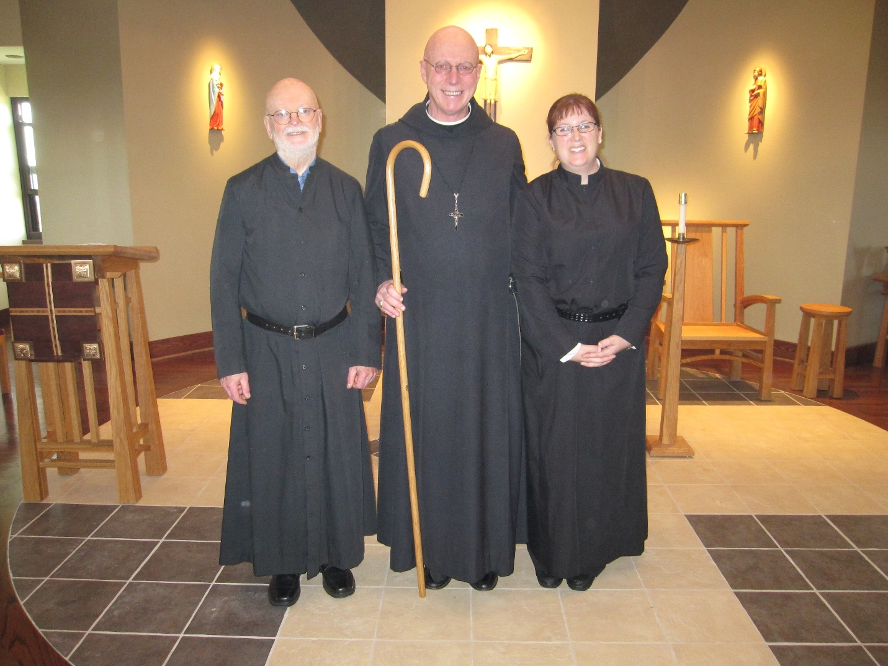
Thomas Goddard; Abbot David Vincent Cotton; Kellyanne Hale

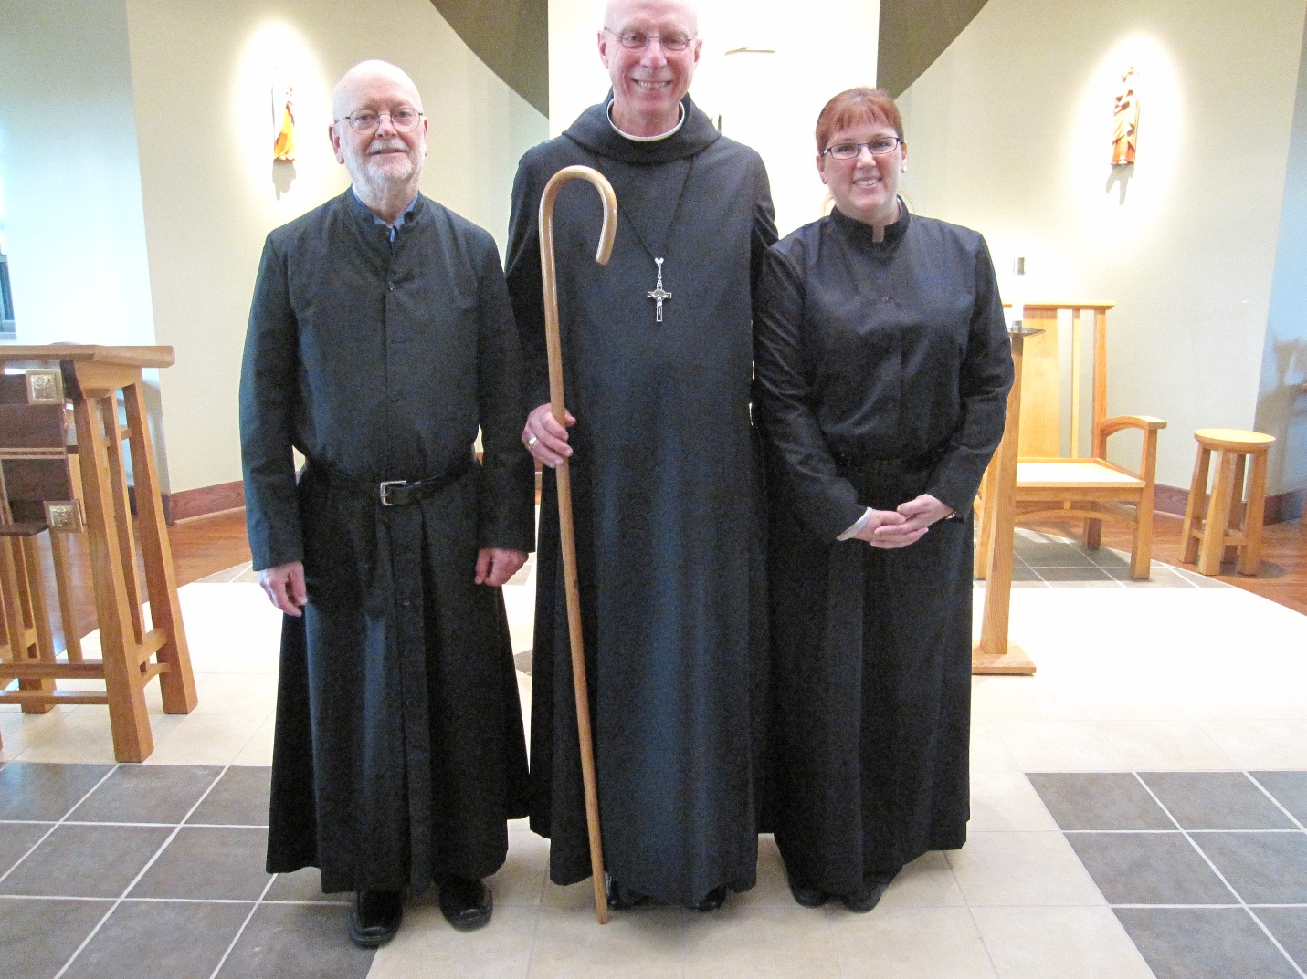
Thomas Goddard; Abbot David Vincent Cotton; Kellyanne Hale
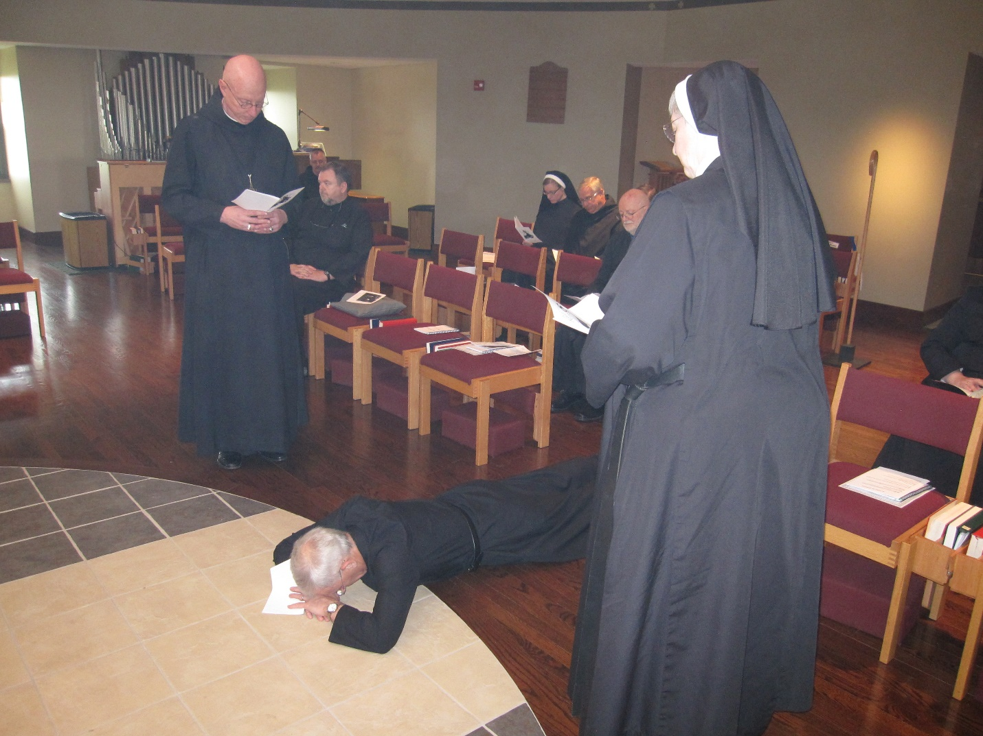
Abbot David Vincent Cotton; Br. Dunstan Townsend; Br. Samuel Saterstrom; Br. Joseph Olderr; Sr. Hannah Korver; Br. Bede Leach; Thomas Goddard; Sr. Bernadette Barrett

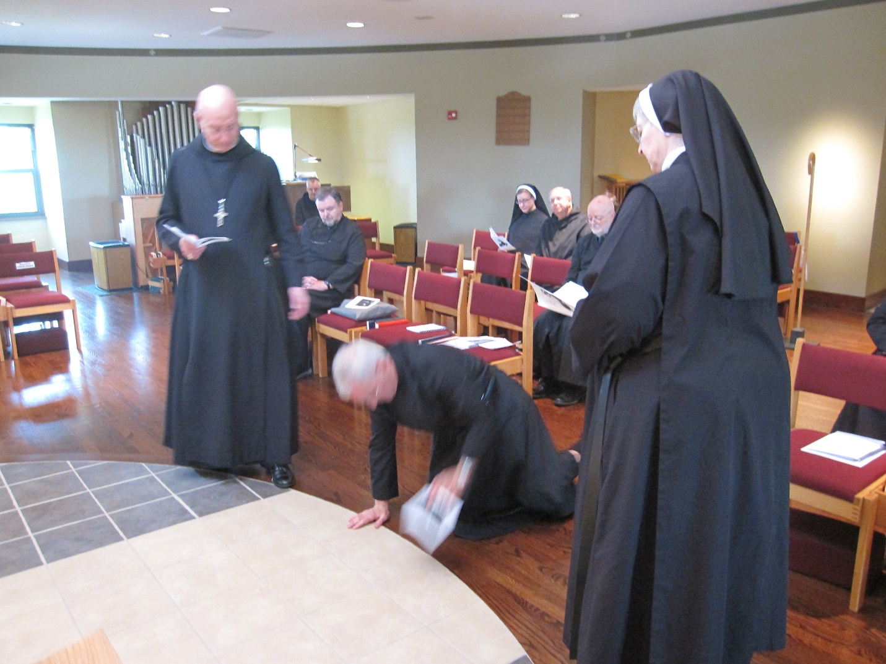
Abbot David Vincent Cotton; Br. Dunstan Townsend; Br. Samuel Saterstrom; Br. Joseph Olderr; Sr. Hannah Korver; Br. Bede Leach; Thomas Goddard; Sr. Bernadette Barrett

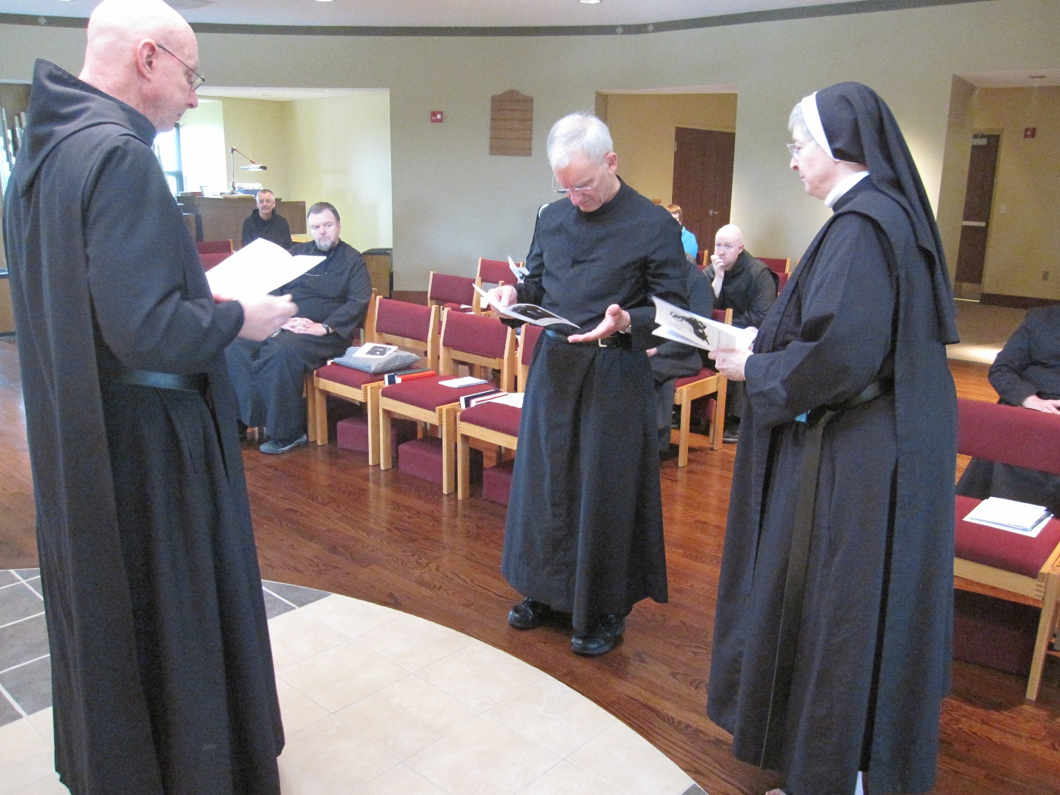
Abbot David Vincent Cotton; Br. Dunstan Townsend; Br. Samuel Saterstrom; Br. Joseph Olderr; ?; Br. Gregory Kingsley; Sr. Bernadette Barrett

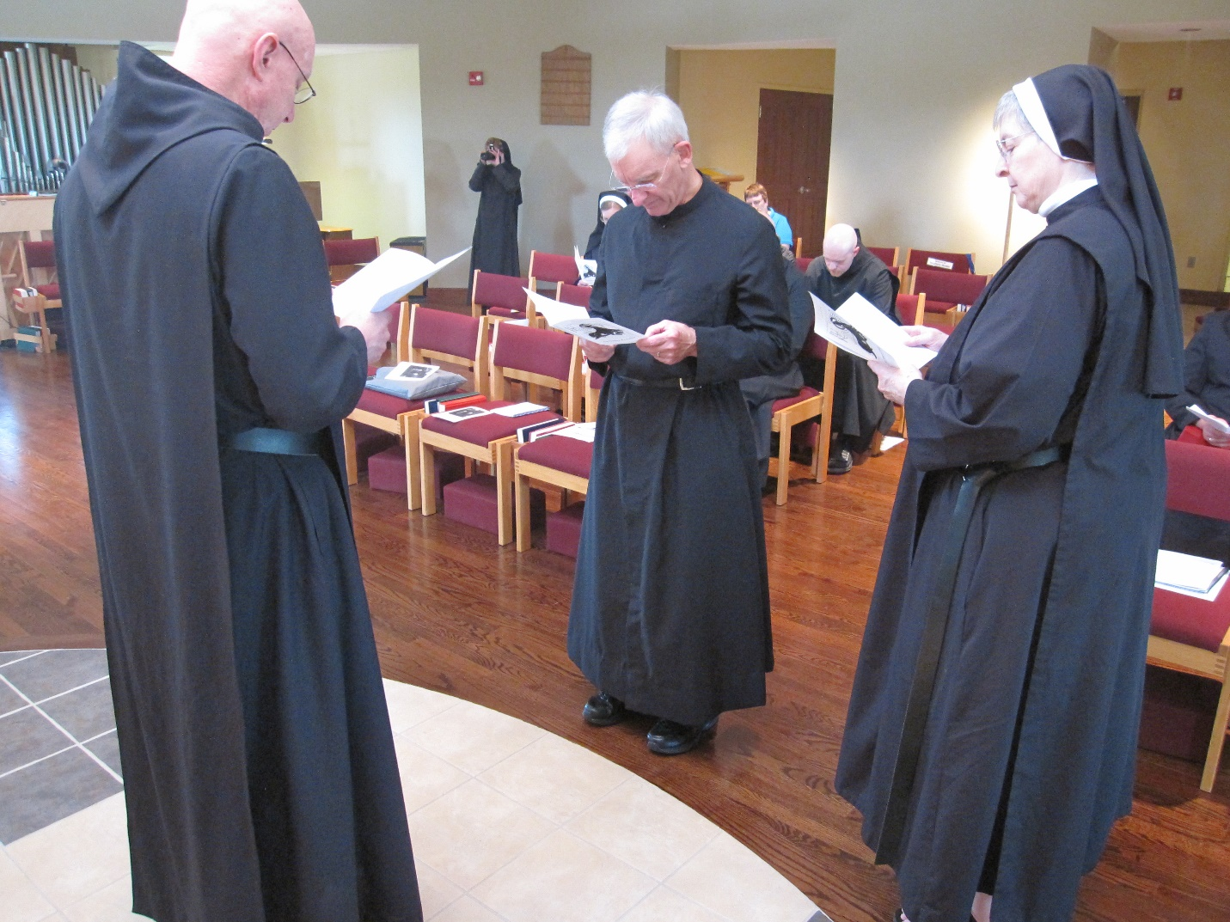
Abbot David Vincent Cotton; Sr. Monica Ruth Mullen; Sr. Hannah Korver; Br. Joseph Olderr; ?; Br. Gregory Kingsley; Sr. Bernadette Barrett

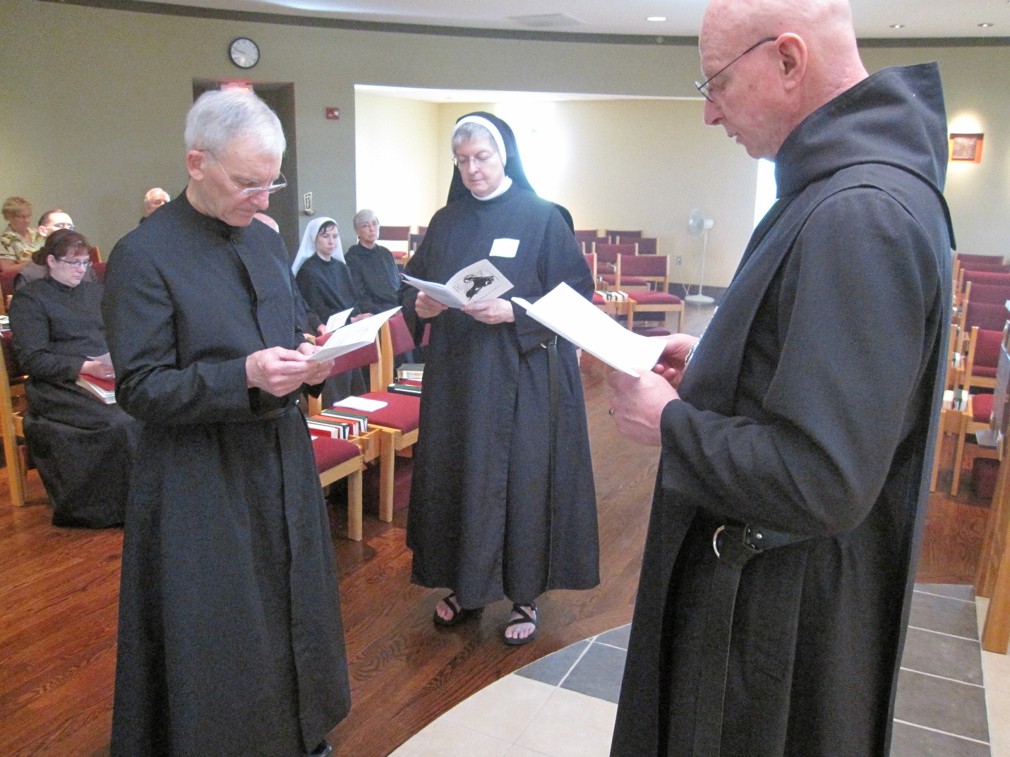
?; Kellyanne Hale; Br. Roman Shemayev; Br. Luke Doucette; Br. Joseph Olderr; Sr. Veronica Taylor; Sr. Julian Saterstrom; Sr. Bernadette Barrett; Abbot David Vincent Cotton

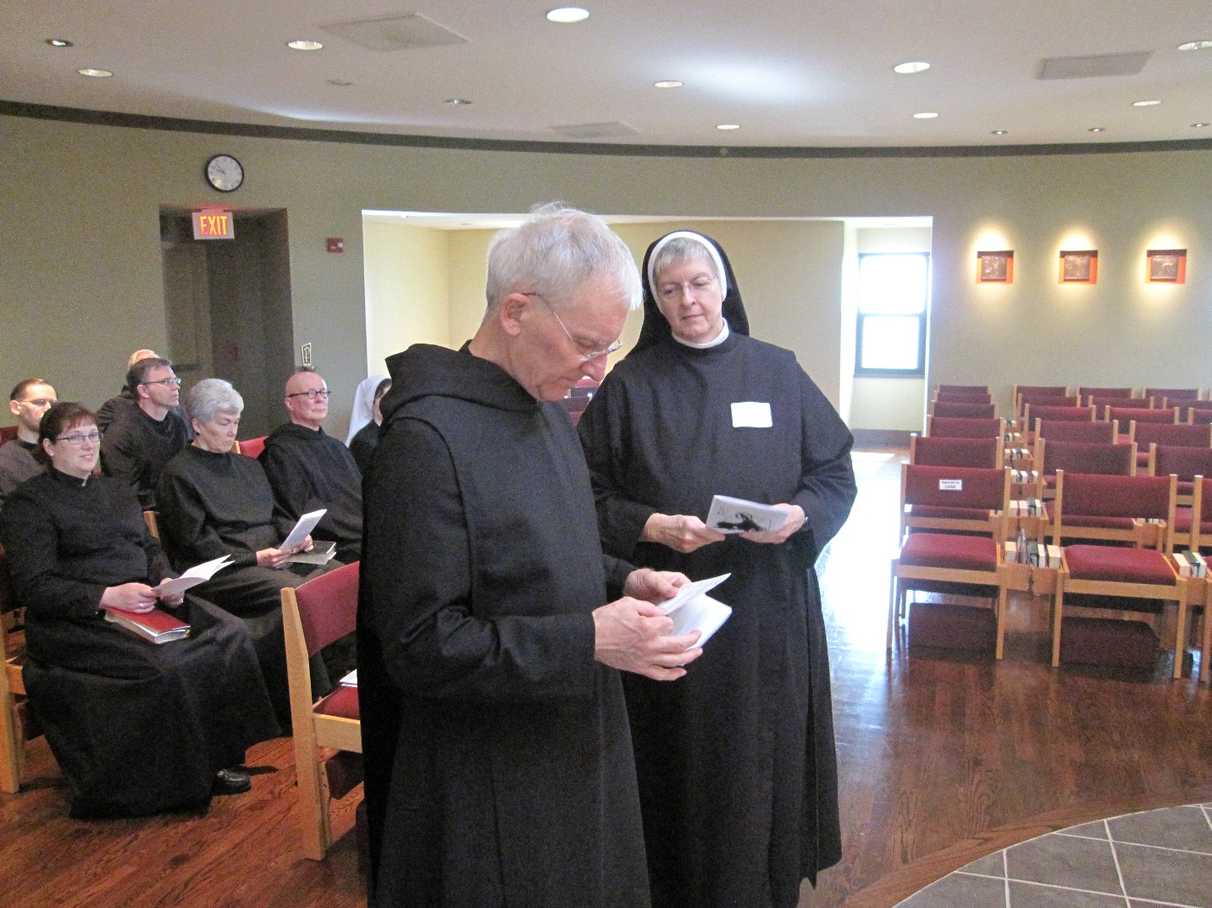
Br Roman Shemayev; Kellyanne Hale; Br. John of Kanty Kennedy; Br. Luke Doucette; Sr. Toni Sylvester; Br. Stephen Francis Arnold; Sr. Veronica Taylor; Br. Joseph Olderr; Sr. Bernadette Barrett;
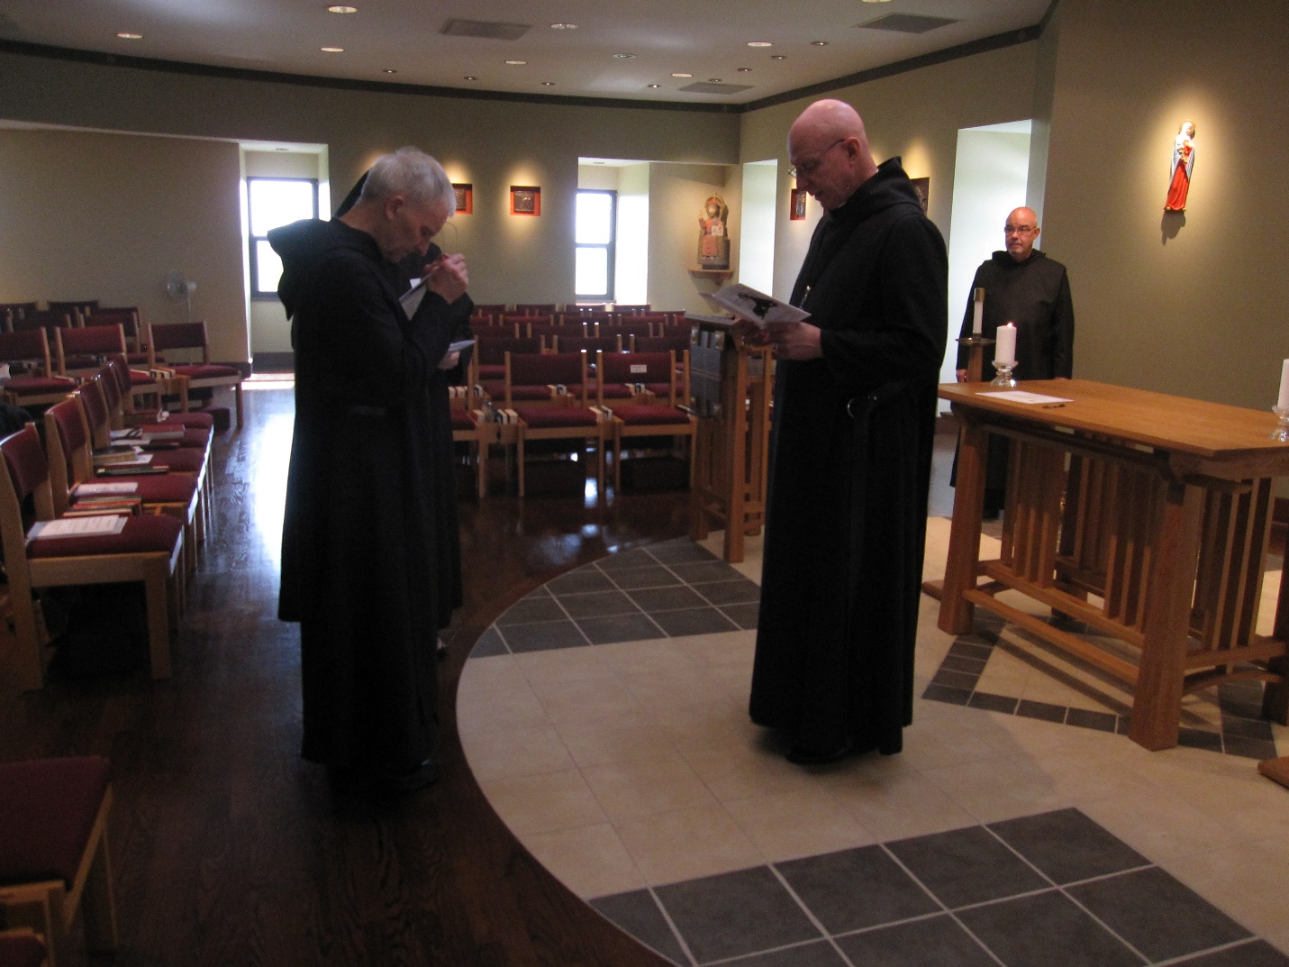
Br. Joseph Olderr; Sr. Bernadette Barrett; Abbot David Vincent Cotton; Br. Basil Edwards

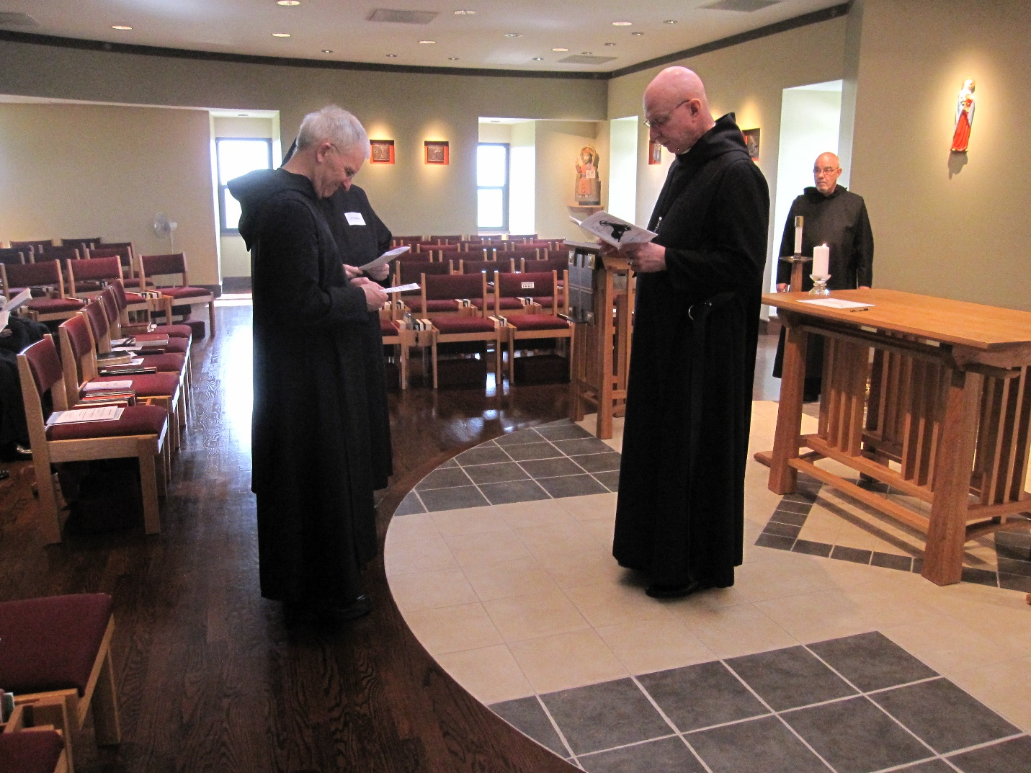
Br. Joseph Olderr; Sr. Bernadette Barrett; Abbot David Vincent Cotton; Br. Basil Edwards

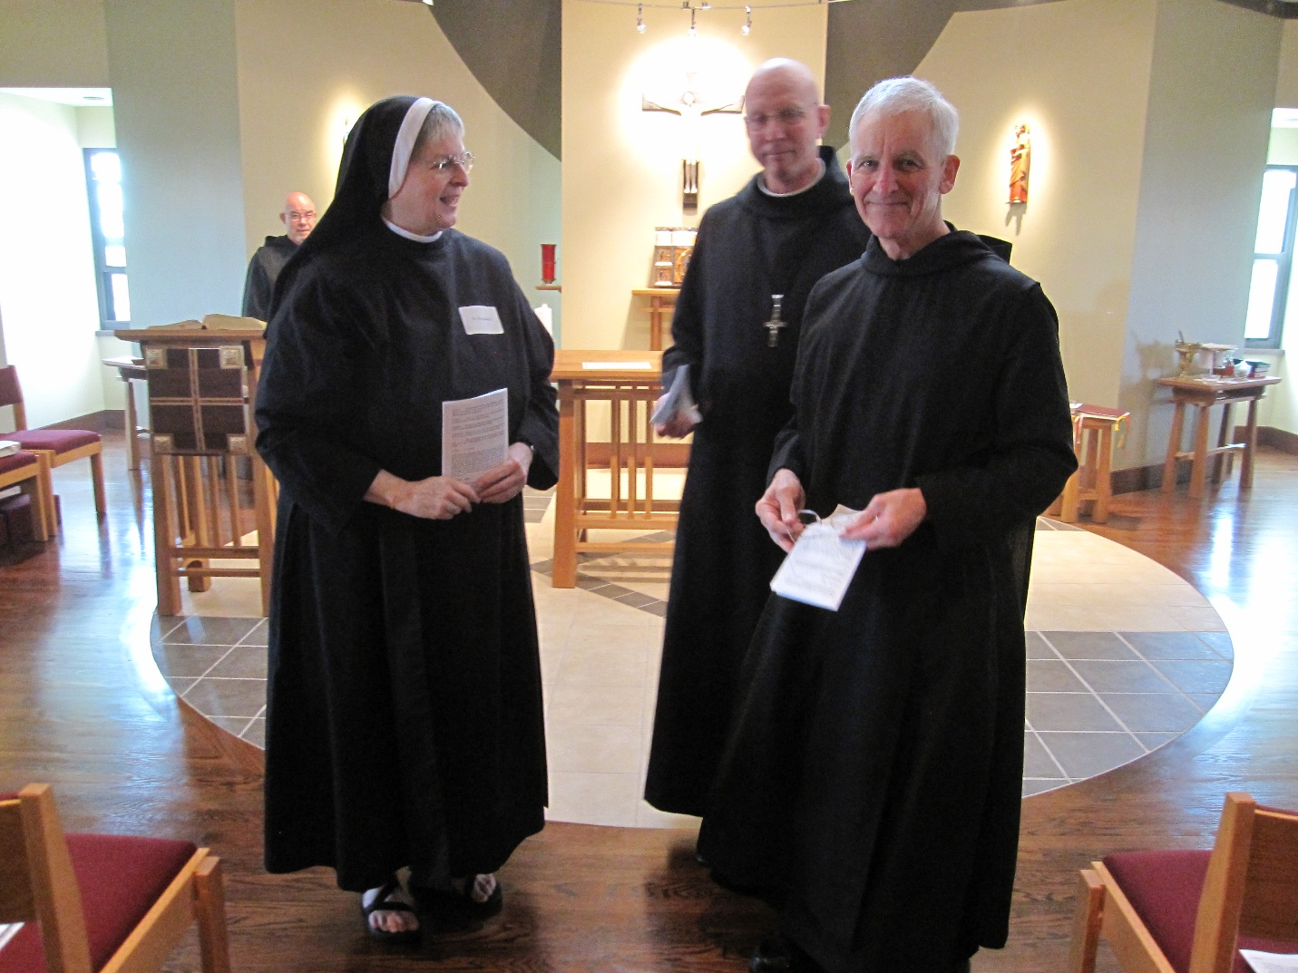
Br. Basil Edwards; Sr. Bernadette Barrett; Abbot David Vincent Cotton; Br. Joseph Olderr

