Companions of St. Luke
Fall Convocation at Conception Abbey
October 25-30, 2010
Part 3 of 4
Photographed by Sr. Brigid Gerns

People are identified from left to right.

Edited by Br. Steven Olderr 25 March 2023. Please send any comments, corrections, or additions to olderr@ameritech.net

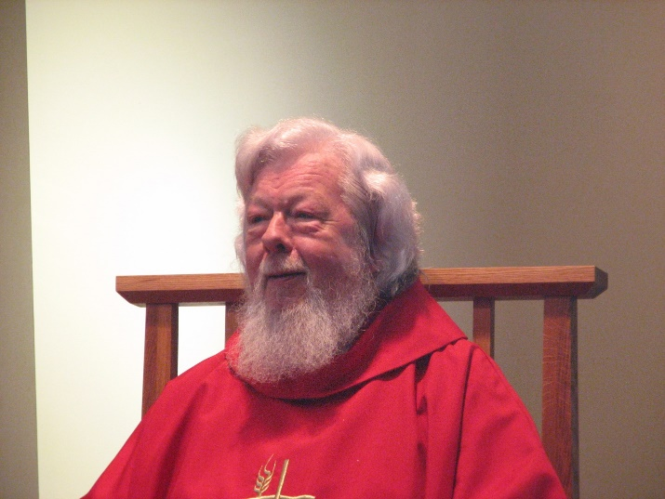
Fr. Wayne Kamm

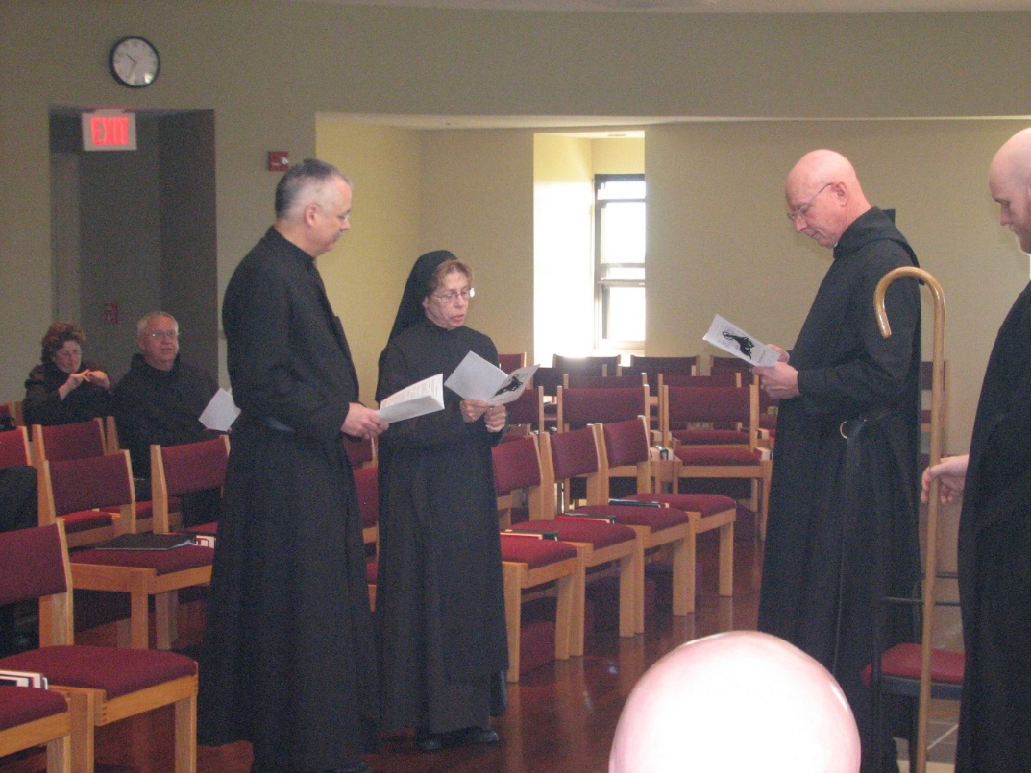
Sr. Cecelia Lamoy; Br. Bede Leach; Br. Dunstan Townsend; Sr. Monica Ruth Mullen; Br. Stephen Francis Arnold; Abbot David Vincent Cotton; Br. Gregory Kingsley

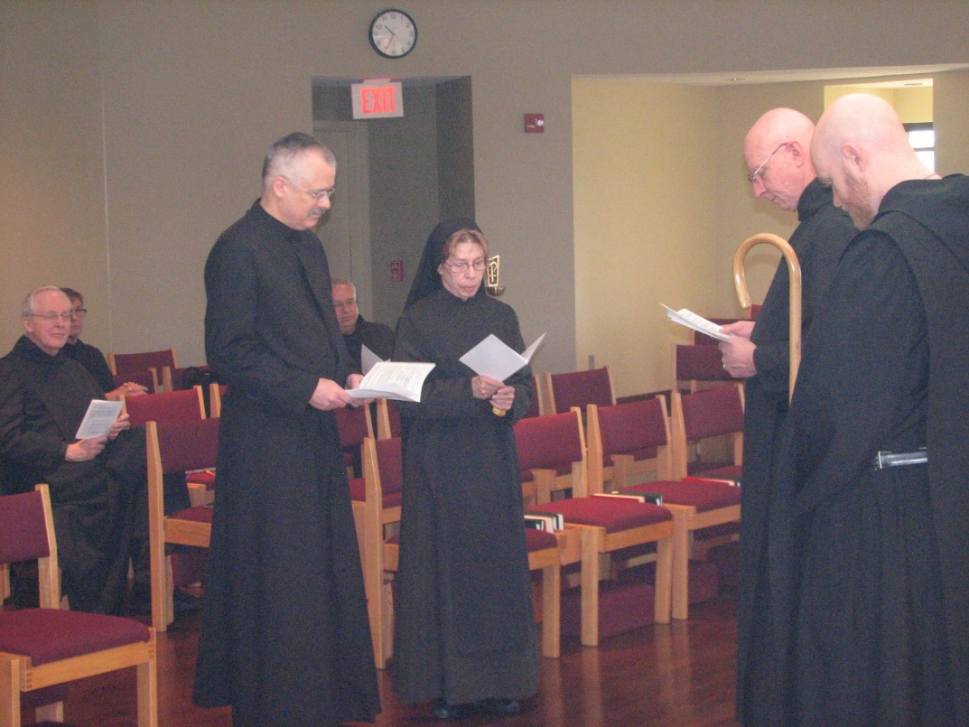
Br. Luke Doucette; Br. Camillus Converse; Br. Dunstan Townsend; Br. Bede Leach; Sr. Monica Ruth Mullen; Abbot David Vincent Cotton; Br. Gregory Kingsley

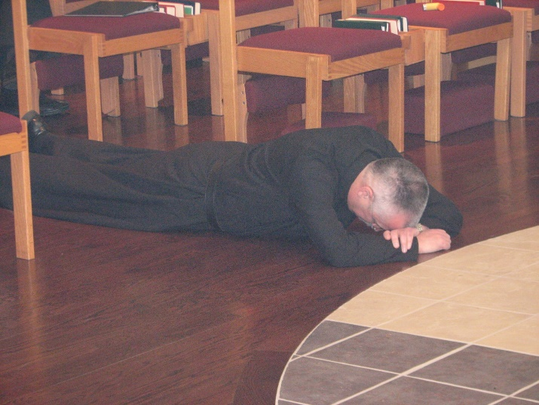
Br. Dunstan Townsend
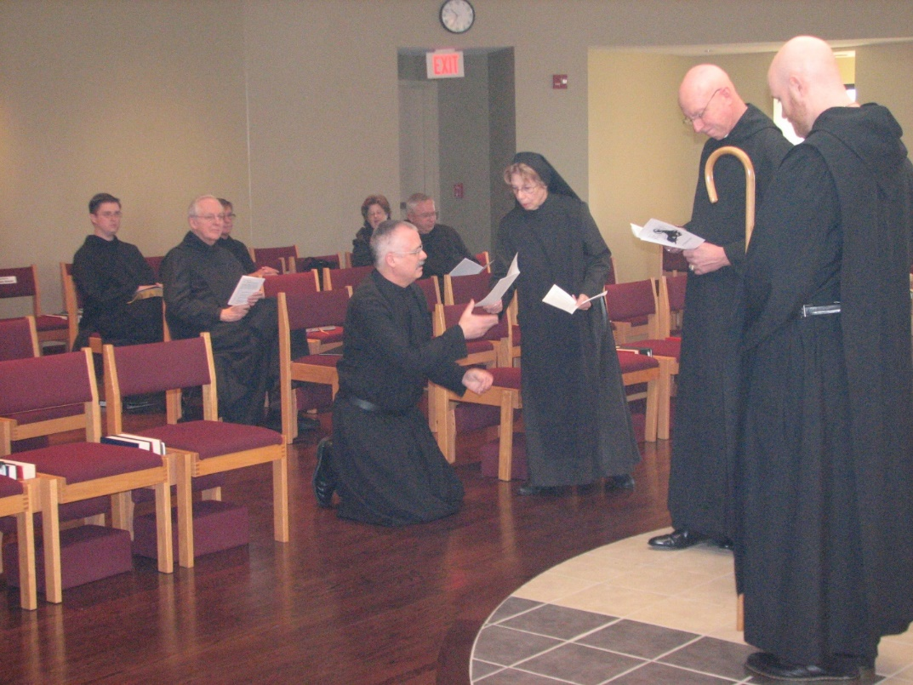
Br. Aidan Maguire; Br. Luke Doucette; Br. Camillus Converse; Sr. Cecelia Lamoy; Br. Dunstan Townsend; Br. Bede Leach; Br. Dunstan Townsend; Sr. Monica Ruth Mullen; Abbot David Vincent Cotton; Br. Gregory Kingsley

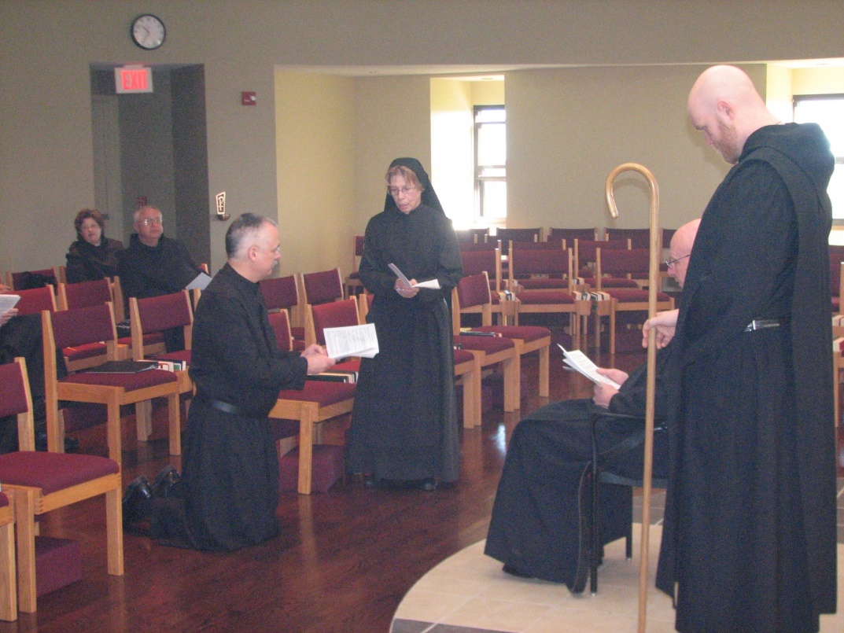
Sr. Cecelia Lamoy; Br. Bede Leach; Br. Dunstan Townsend; Sr. Monica Ruth Mullen; Abbot David Vincent Cotton; Br. Gregory Kingsley
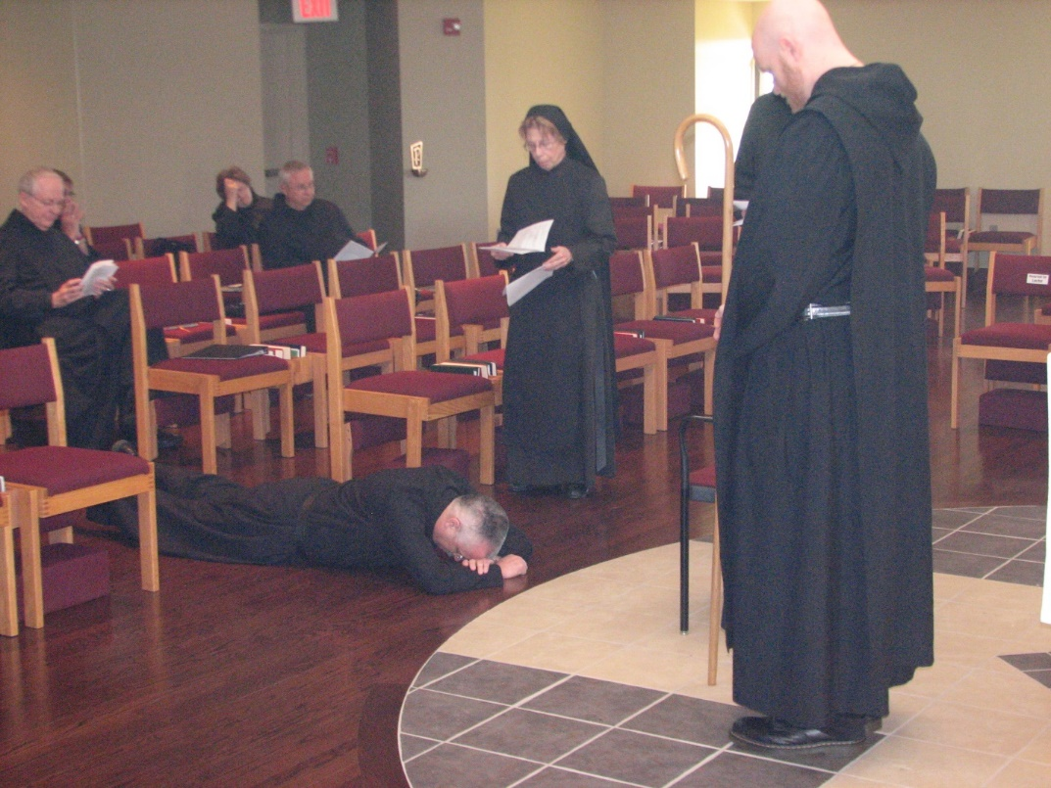
Br. Luke Doucette; Br. Camillus Converse; Sr. Cecelia Lamoy; Br. Bede Leach; Br. Dunstan Townsend; Abbot David Vincent Cotton; Br. Gregory Kingsley
Br. Dunstan Townsend

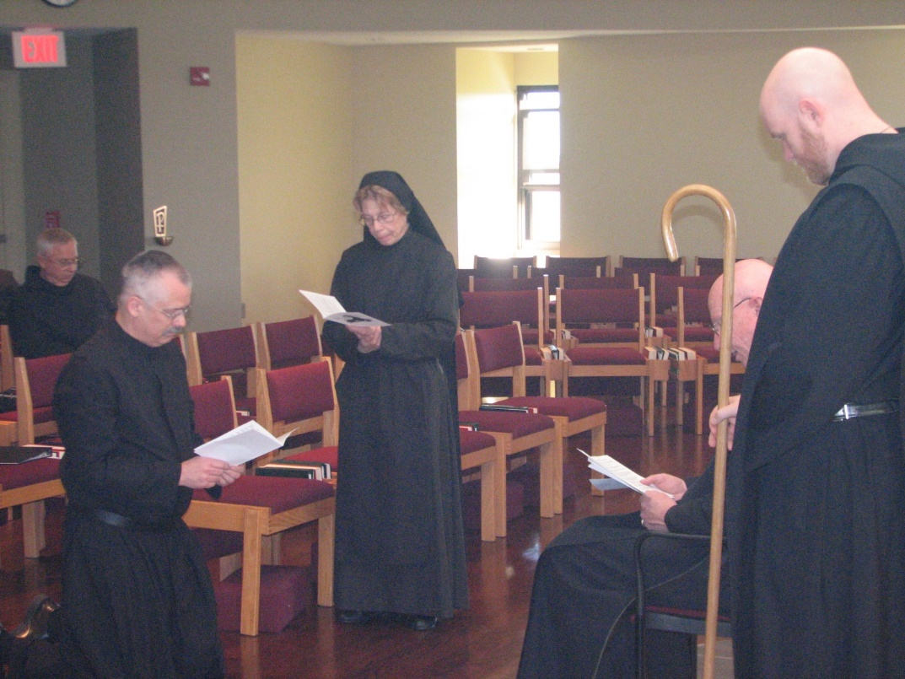
Br. Bede Leach; Br. Dunstan Townsend; Sr. Monica Ruth Mullen; Abbot David Vincent Cotton; Br. Gregory Kingsley
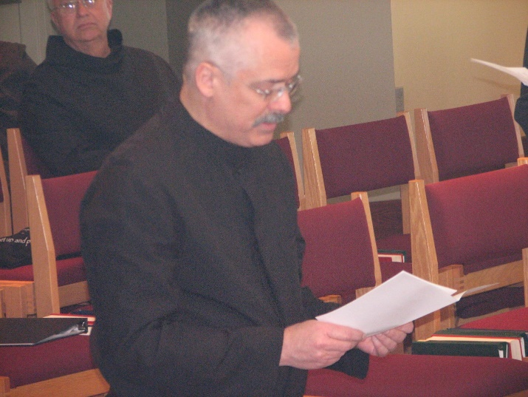
Br. Dunstan Townsend

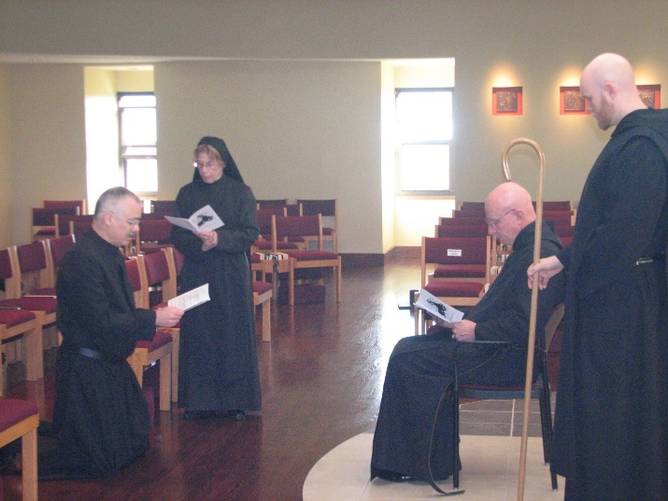
Br. Dunstan Townsend; Sr. Monica Ruth Mullen; Abbot David Vincent Cotton; Br. Gregory Kingsley

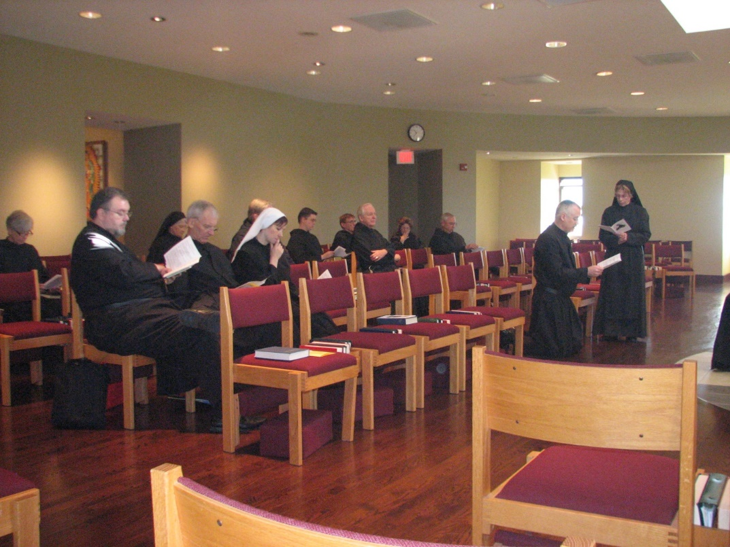
Sr. Julian Saterstrom; Br. Samuel Saterstrom; Sr. Mary Francis Deulen; Br. Joseph Olderr; Br. Chad Anselm Gerns; St. Veronica Taylor; Br. Aidan Maguire; Br. Camillus Converse; Br. Luke Doucette; Sr. Cecelia Lamoy; Br. Bede Leach; Br. Dunstan Townsend; Sr. Monica Ruth Mullen

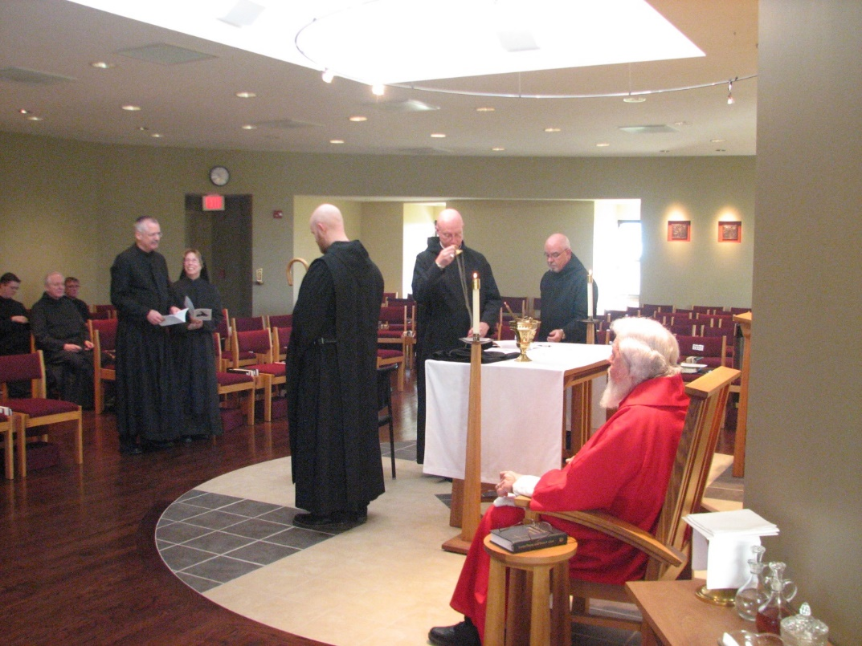
Br. Aidan Maguire; Br. Luke Doucette; Br. Camillus Converse; Br. Dunstan Townsend; Sr. Monica Ruth Mullen; Br. Gregory Kingsley; Abbot David Vincent Cotton; Br. Basil Edwards; Fr. Wayne Kamm

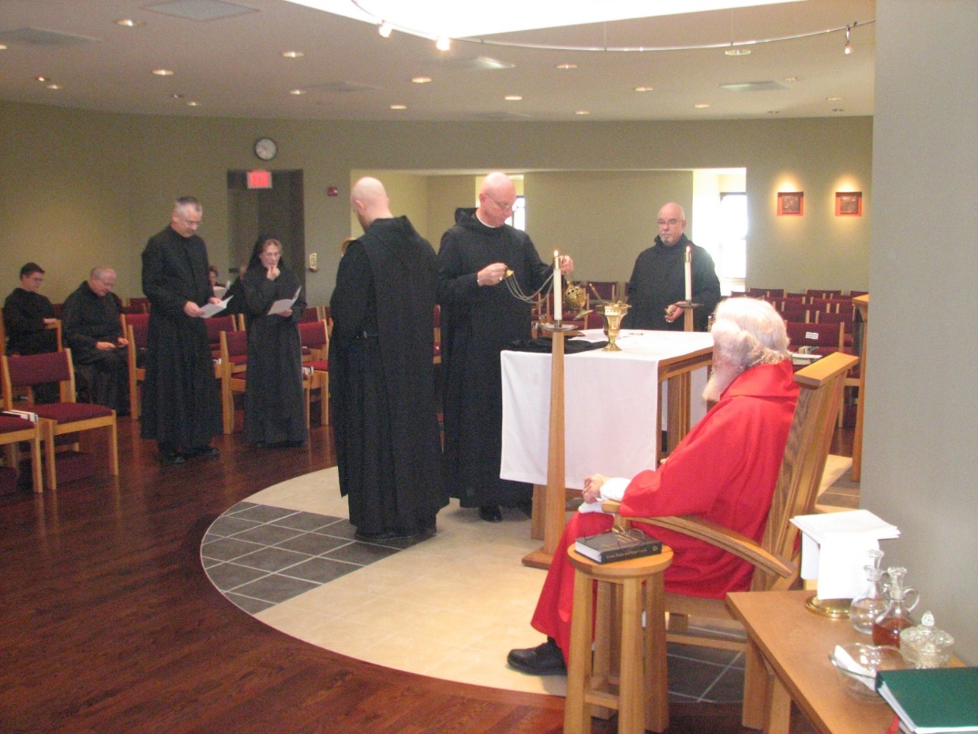
Br. Aidan Maguire; Br. Luke Doucette; Br. Dunstan Townsend; Sr. Monica Ruth Mullen; Br. Gregory Kingsley; Abbot David Vincent Cotton; Br. Basil Edwards; Fr. Wayne Kamm

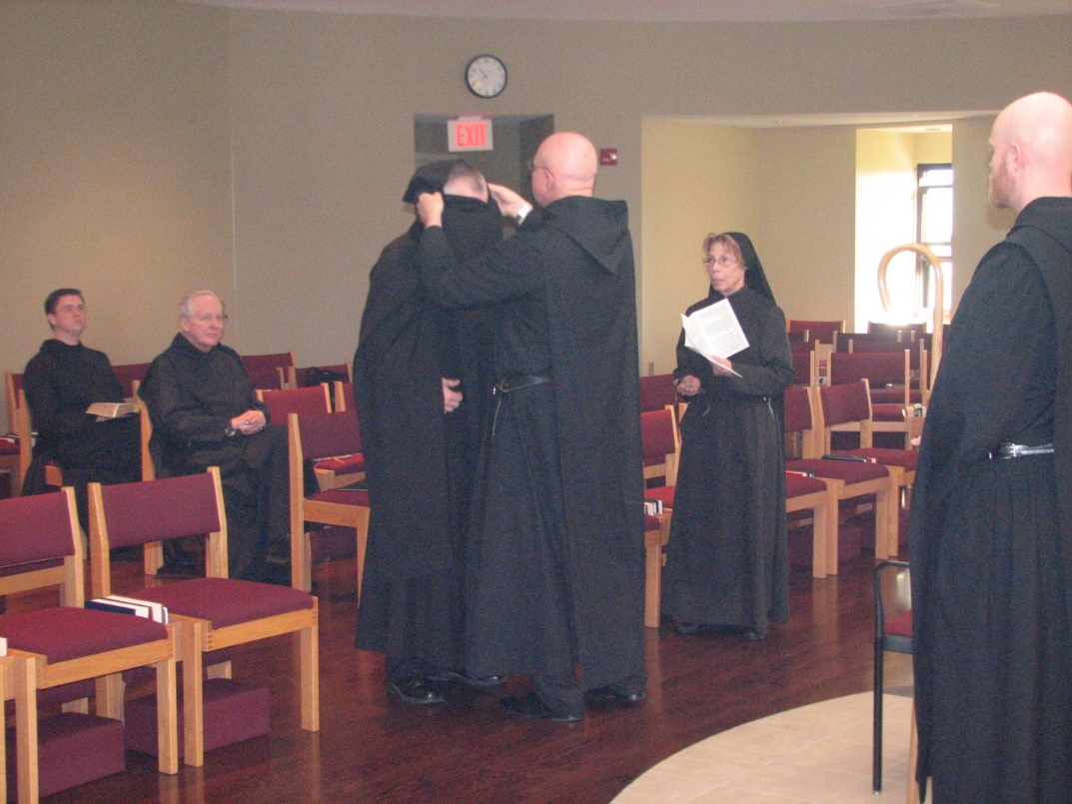
Br. Aidan Maguire; Br. Luke Doucette; Br. Dunstan Townsend; Abbot David Vincent Cotton; Sr. Monica Ruth Mullen; Br. Gregory Kingsley

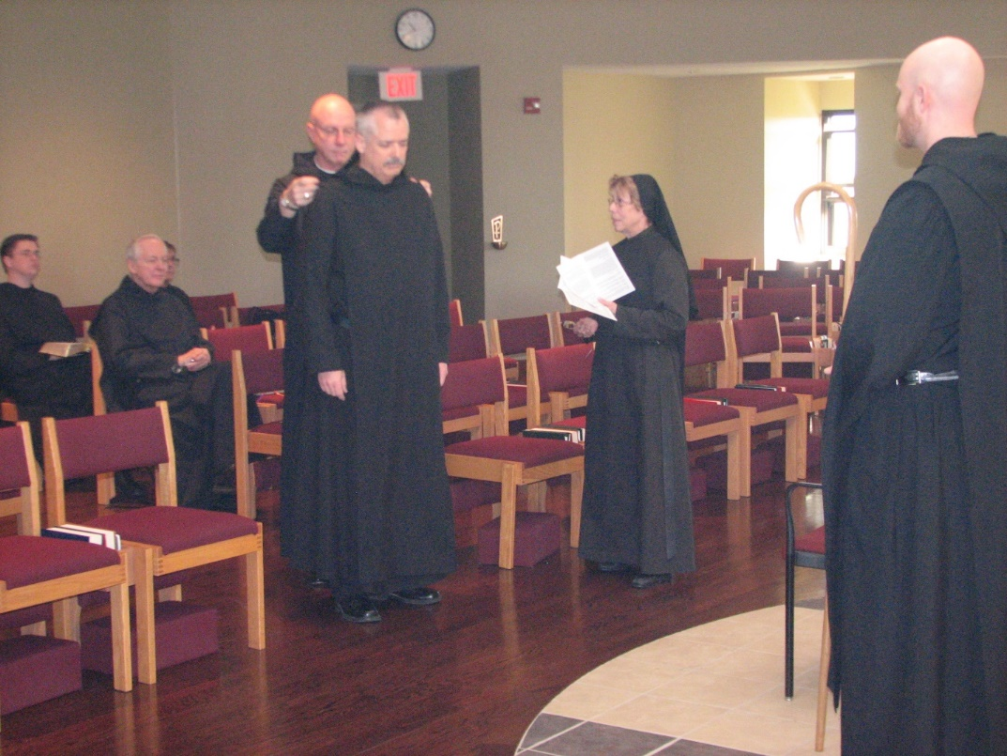
Br. Aidan Maguire; Br. Luke Doucette; Br. Camillus Converse; Abbot David Vincent Cotton; Br. Dunstan Townsend; Sr. Monica Ruth Mullen; Br. Gregory Kingsley

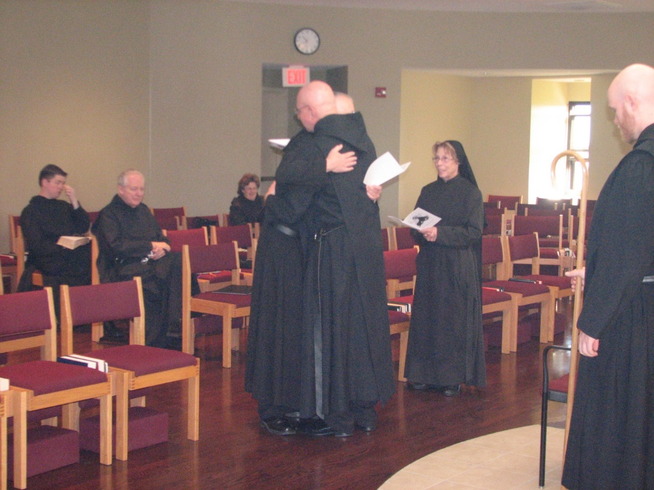
Br. Aidan Maguire; Br. Luke Doucette; Sr. Cecelia Lamoy; Abbot David Vincent Cotton; Br. Dunstan Townsend; Sr. Monica Ruth Mullen; Br. Gregory Kingsley

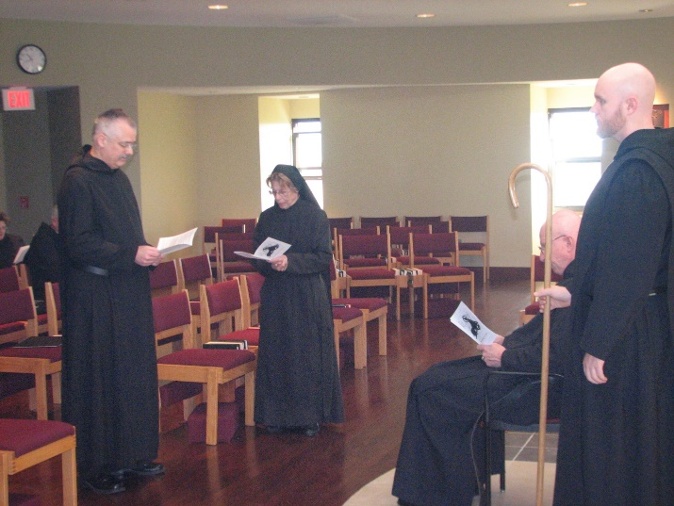
Br. Dunstan Townsend; Sr. Monica Ruth Mullen; Abbot David Vincent Cotton; Br. Gregory Kingsley

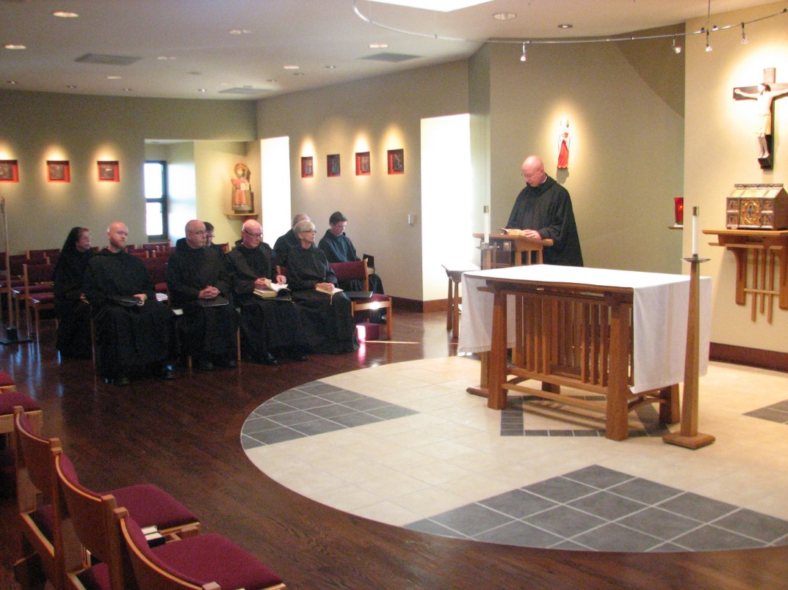
Sr. Monica Ruth Mullen; Br. Gregory Kingsley; Br. Basil Edwards; Br. Camillus Converse; Br. Luke Doucette; Sr. Julian Saterstrom; Abbot David Vincent Cotton

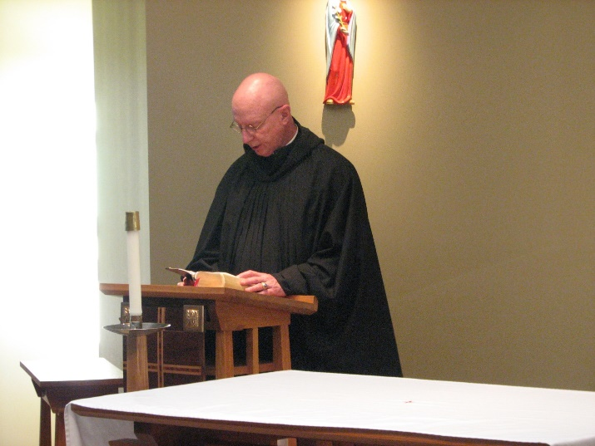
Abbot David Vincent Cotton

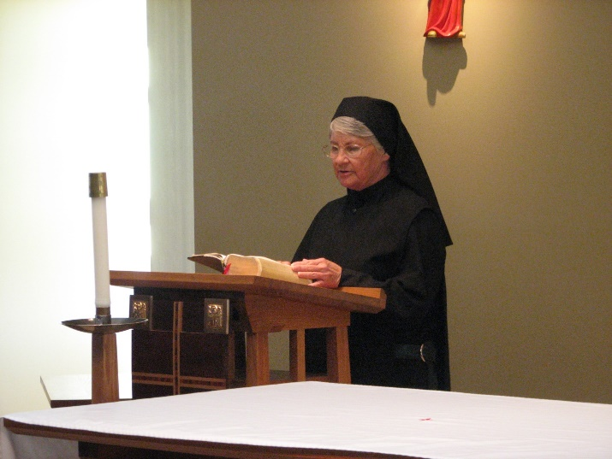
Sr. Mary Francis Deulen

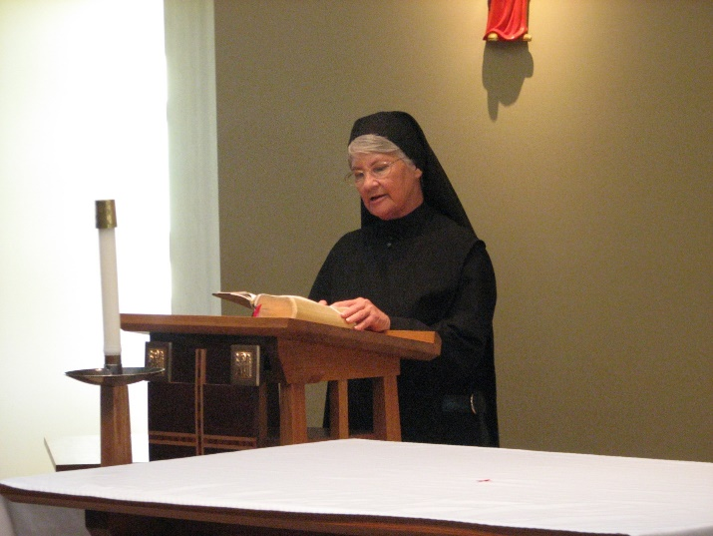
Sr. Mary Francis Deulen
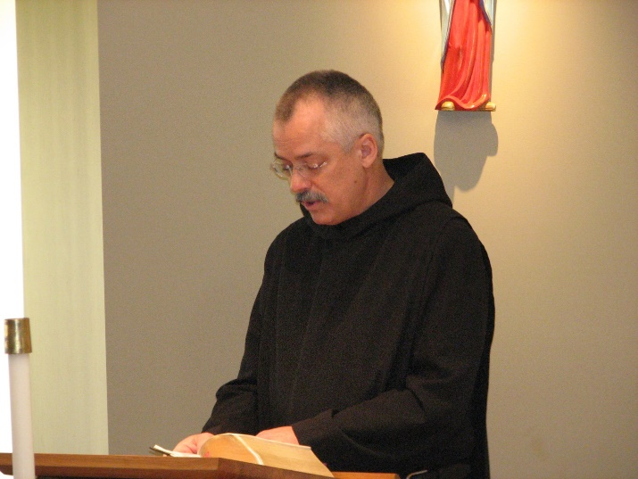
Br. Dunstan Townsend

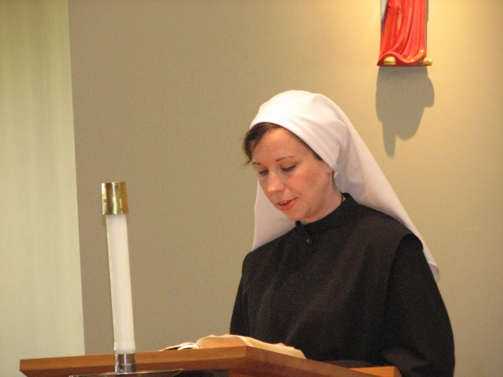
Sr. Veronica Taylor

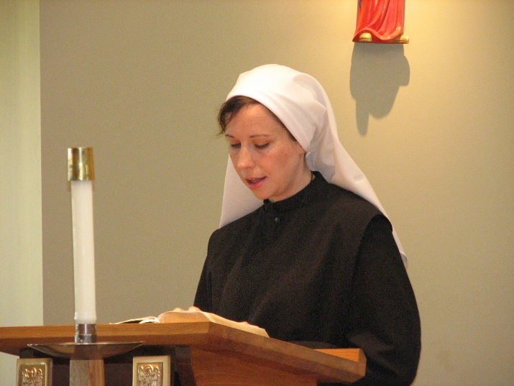
Sr. Veronica Taylor
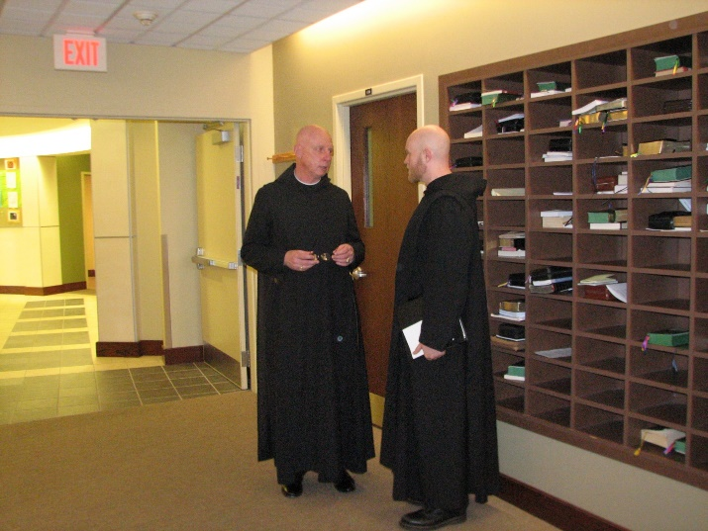
Abbot David Vincent Cotton; Br. Gregory Kingsley

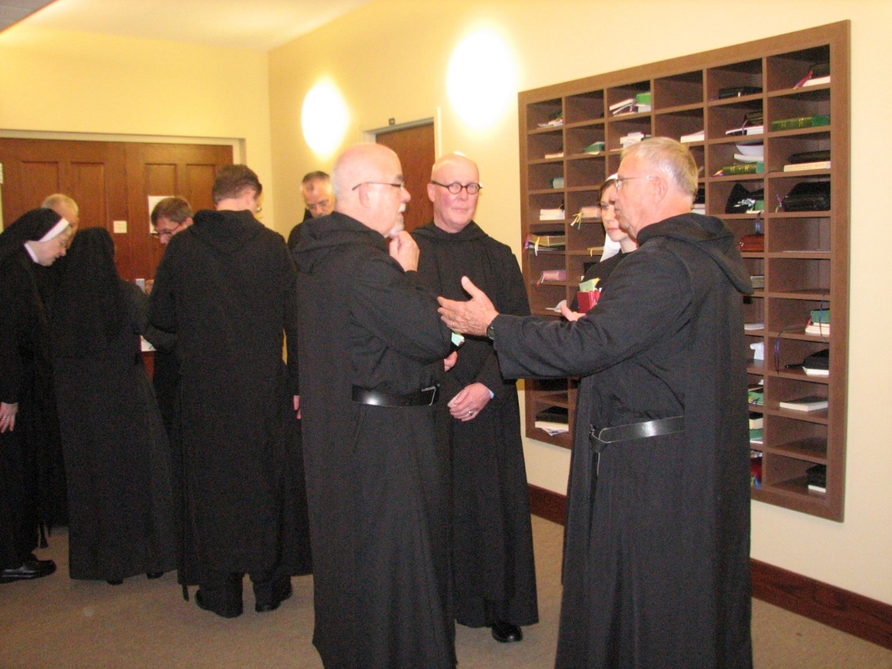
Sr. Bernadette Barrett; Br. Joseph Olderr; Sr. Mary Francis Deulen; Br. Camillus Converse; Br. Aidan Maguire; Br. Dunstan Townsend; Br. Basil Edwards; Br. Stephen Francis Arnold; Sr. Veronica Taylor; Br. Bede Leach
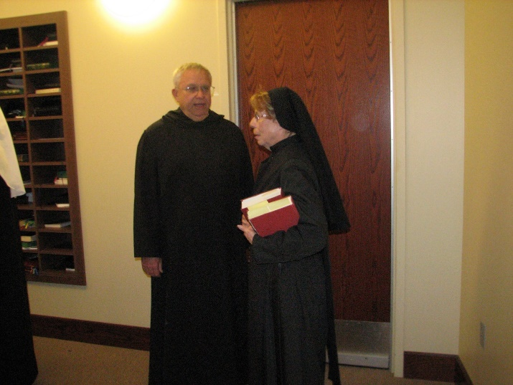

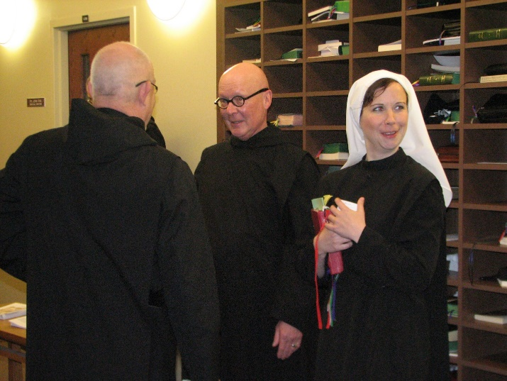
Br. Basil Edwards; Br. Stephen Francis Arnold; Sr. Veronica Taylor

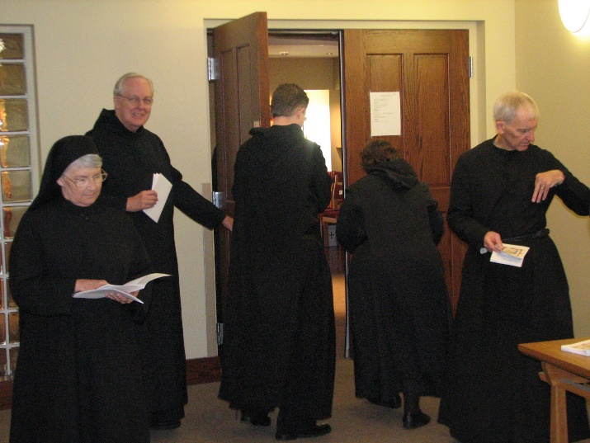
Sr. Mary Francis Deulen; Br. Luke Doucette; Br. Aidan Maguire; Sr. Cecelia Lamoy; Br. Joseph Olderr
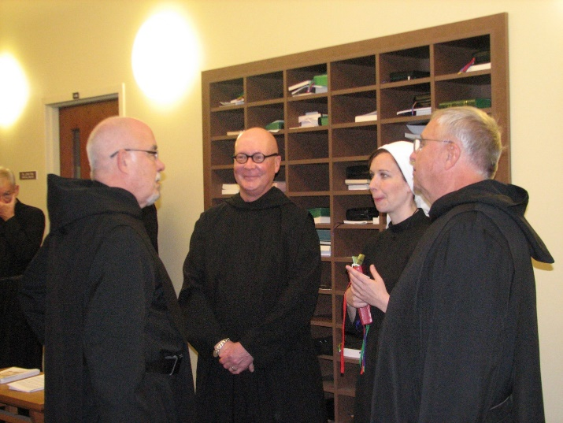
Br. Joseph Olderr; Br. Basil Edwards; Br. Stephen Francis Arnold; Sr. Veronica Taylor; Br. Bede Leach

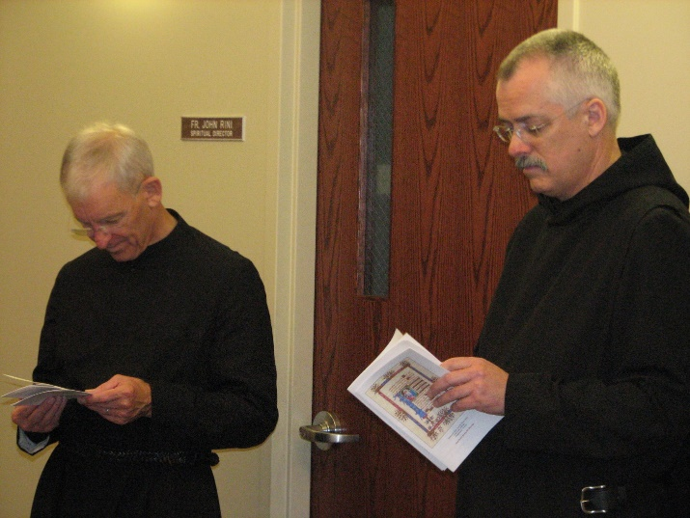
Sr. Monica Ruth Mullen; Br. Dunstan Townsend

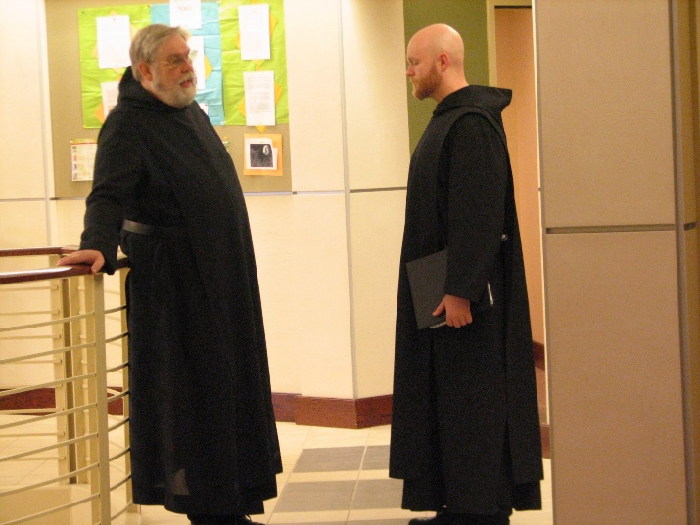
Br. Chad Anselm Gerns; Br. Gregory Kingsley
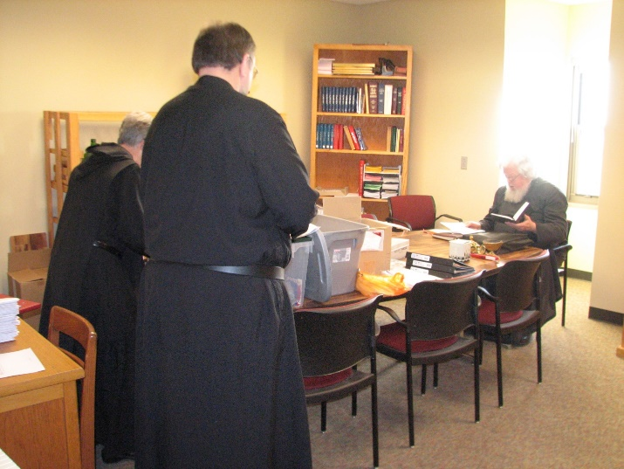
Sr. Julian Saterstrom; Br. Samuel Saterstrom; Fr. Wayne Kamm

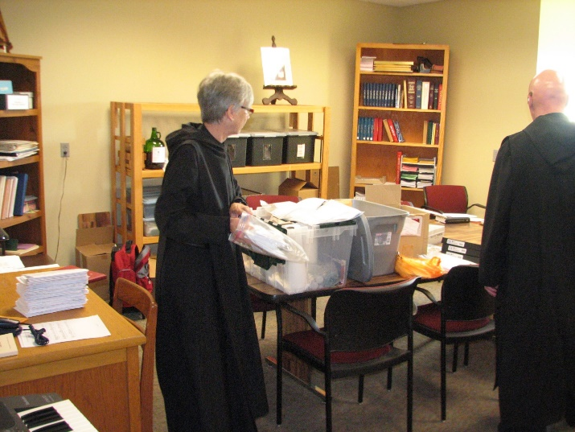
Sr. Julian Saterstrom; Br. Stephen Francis Arnold

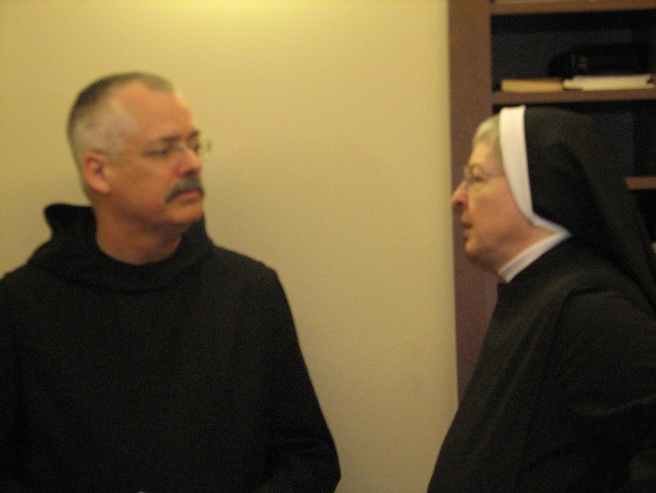
Br. Dunstan Townsend; Sr. Bernadette Barrett

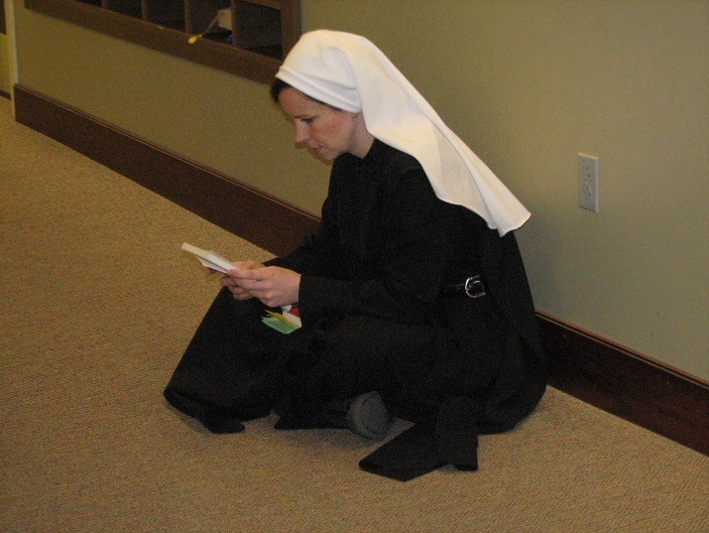
Sr. Veronica Taylor

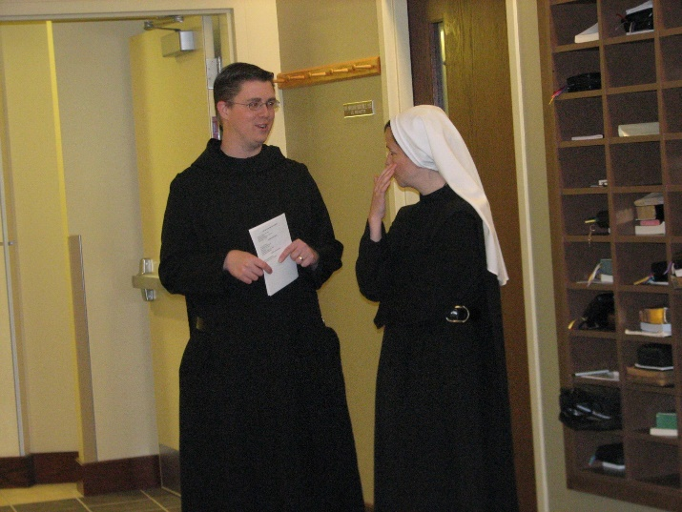
Br. Aidan Maguire; Sr. Veronica Taylor

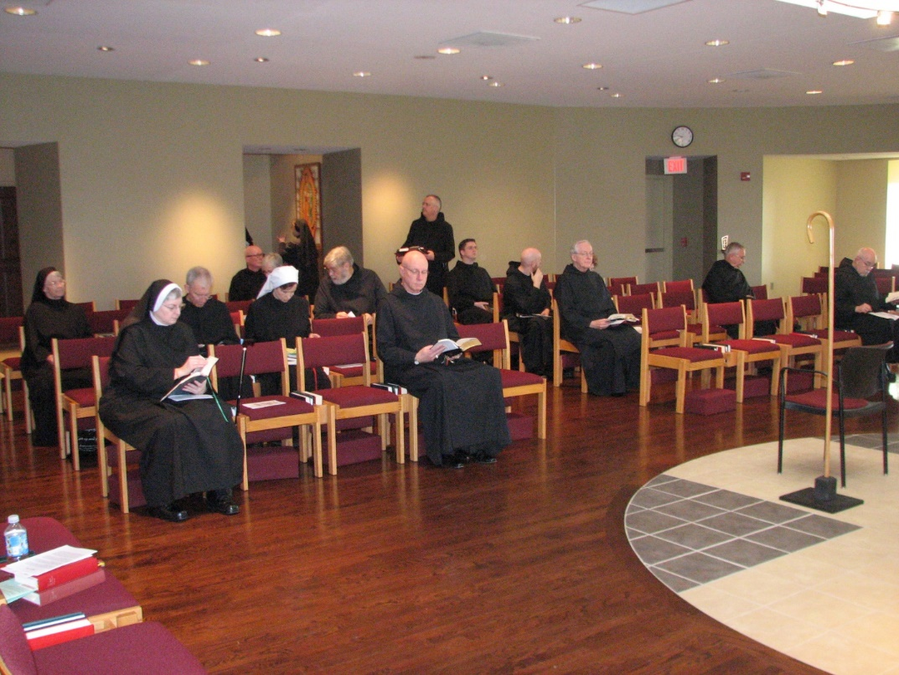
Sr. Mary Francis Deulen; Sr. Bernadette Barrett; Br. Joseph Olderr; Br. Stephen Francis Arnold; Sr. Julian Saterstrom; Sr. Veronica Taylor; Sr. Monica Ruth Mullen; Br. Chad Anselm Gerns; Abbot David Vincent Cotton; Br. Dunstan Townsend; Br. Aidan Maguire; Br. Gregory Kingsley; Br. Luke Doucette; Br. Bede Leach; Br. Basil Edwards

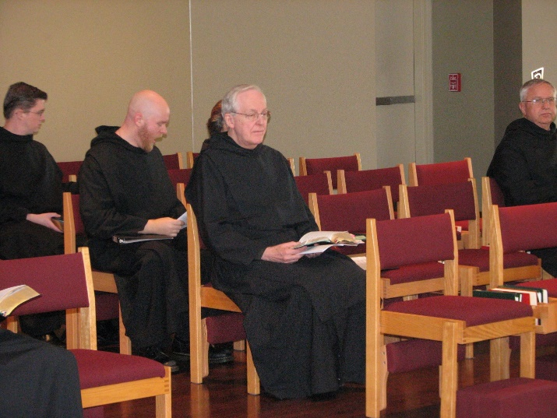
Br. Aidan Maguire; Br. Gregory Kingsley; Br. Luke Doucette; Br. Bede Leach

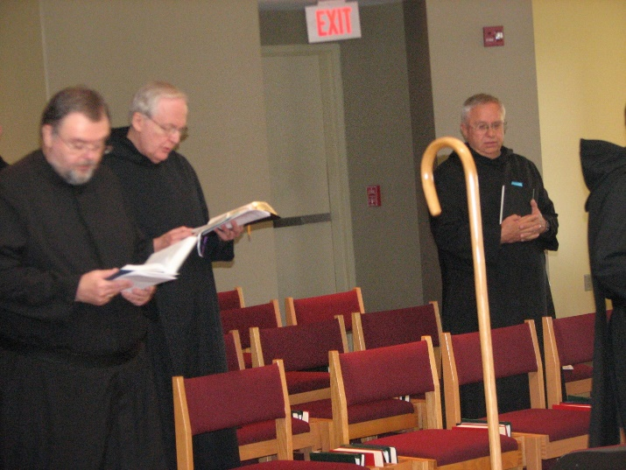
Br. Samuel Saterstrom; Br. Luke Doucette; Br. Bede Leach

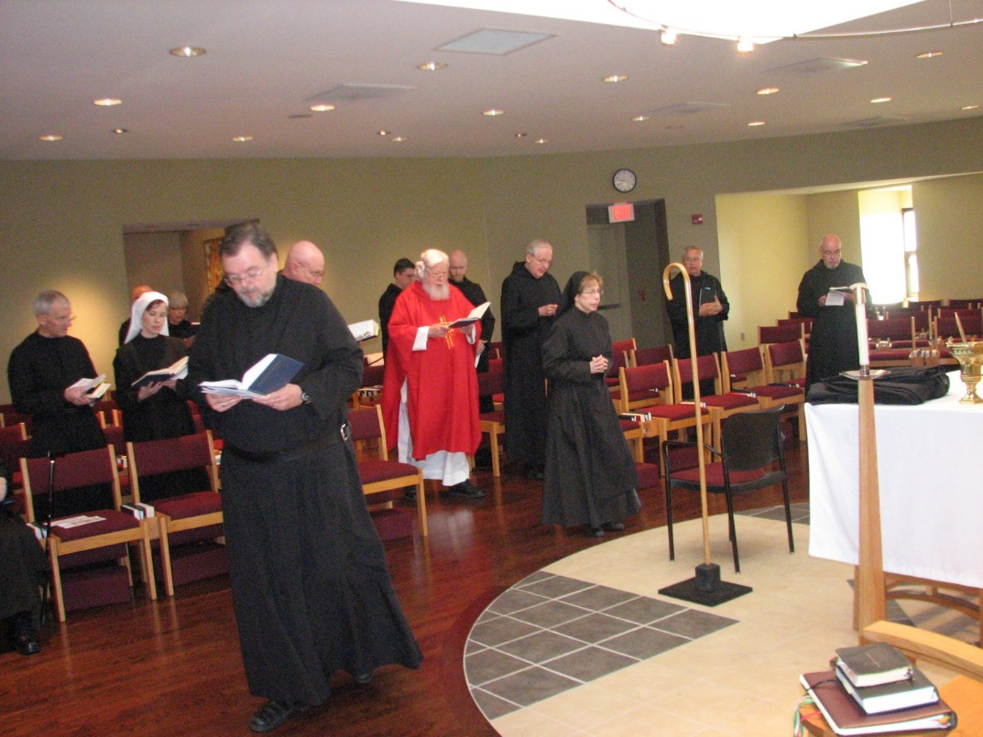
Br. Joseph Olderr; Sr. Veronica Taylor; Br. Stephen Francis Arnold; Sr. Julian Saterstrom; Br. Samuel Saterstrom; Abbot David Vincent Cotton; Br. Aidan Maguire; Fr. Wayne Kamm; Br. Gregory Kingsley; Br. Luke Doucette; Sr. Monica Ruth Mullen; Br. Bede Leach; Br. Basil Edwards

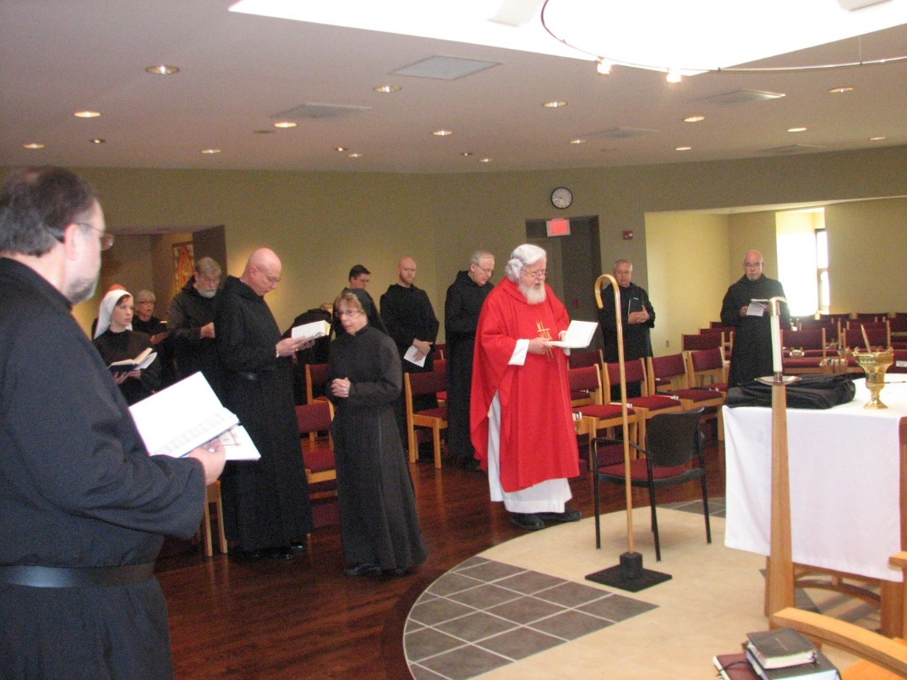
Br. Samuel Saterstrom; Sr. Veronica Taylor; Sr. Julian Saterstrom; Br. Chad Anselm Gerns; Abbot David Vincent Cotton; Sr. Monica Ruth Mullen; Br. Aidan Maguire; Br. Gregory Kingsley; Br. Luke Doucette; Fr. Wayne Kamm; Br. Bede Leach; Br. Basil Edwards

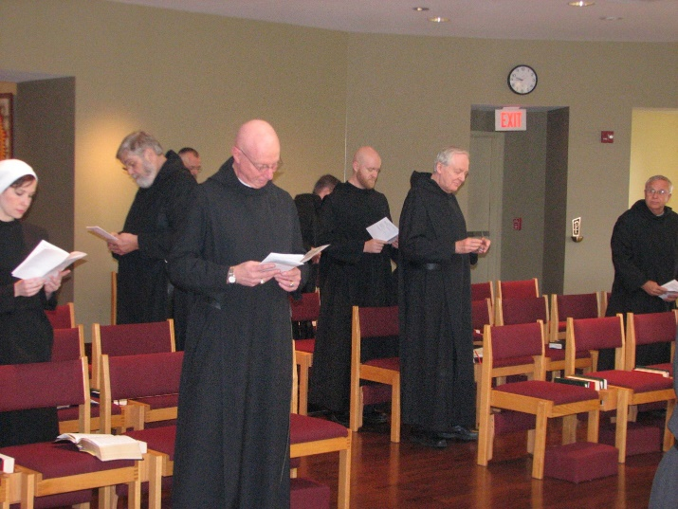
Sr. Veronica Taylor; Br. Chad Anselm Gerns; Br. Dunstan Townsend; Abbot David Vincent Cotton; Br. Gregory Kingsley; Br. Luke Doucette; Br. Bede Leach
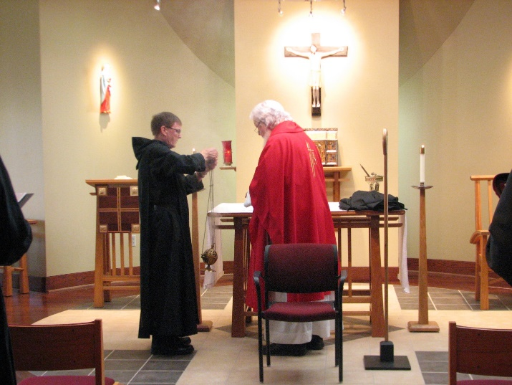
Br. Camillus Converse; Fr. Wayne Kamm

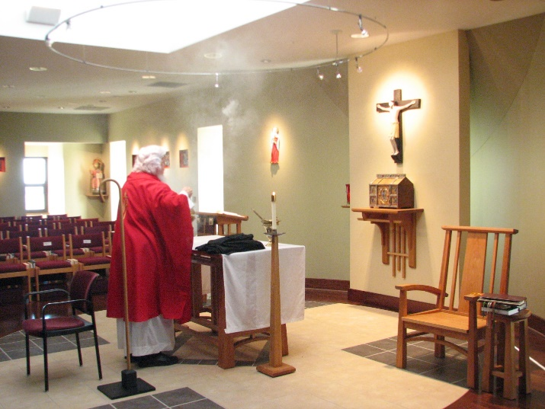
Fr. Wayne Kamm

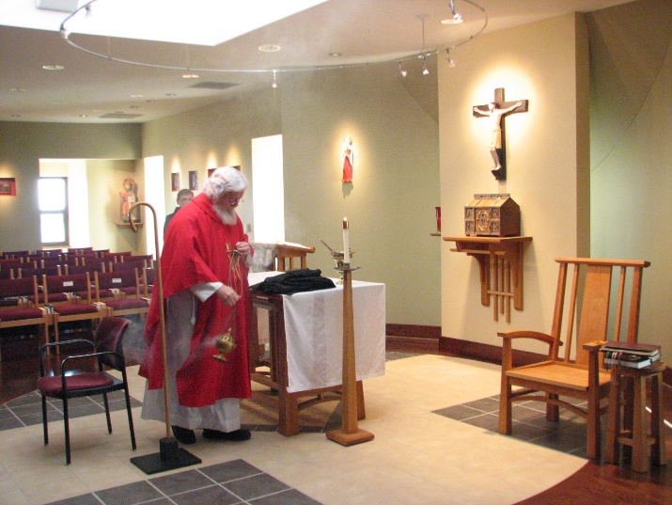
Fr. Wayne Kamm

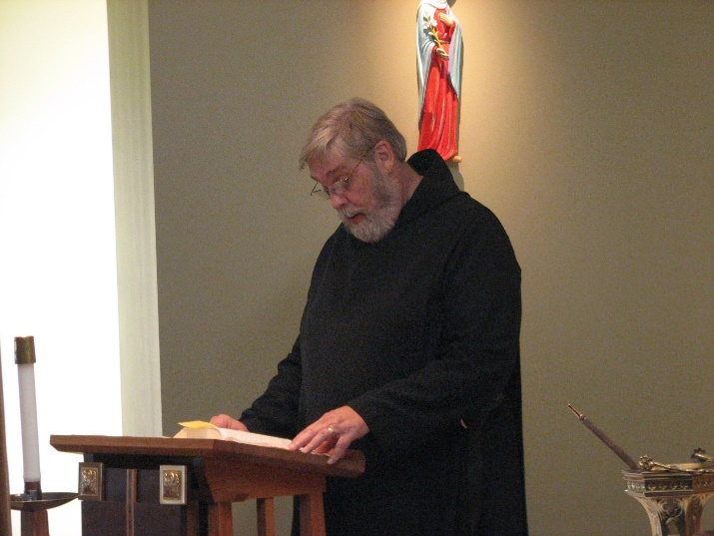
Br. Chad Anselm Gerns

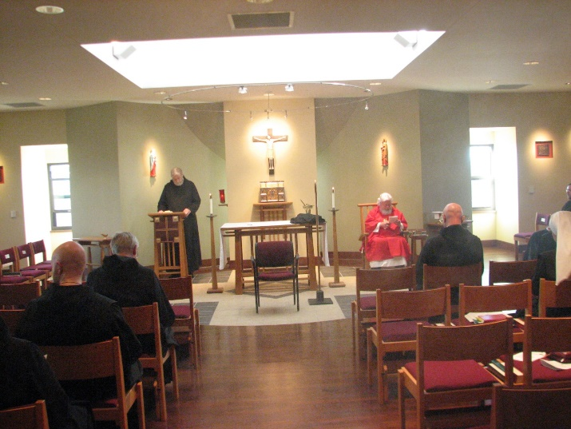
Br. Gregory Kingsley; Br. Luke Doucette; Br. Chad Anselm Gerns; Fr. Wayne Kamm; Abbot David Vincent Gerns; Sr. Veronica Taylor

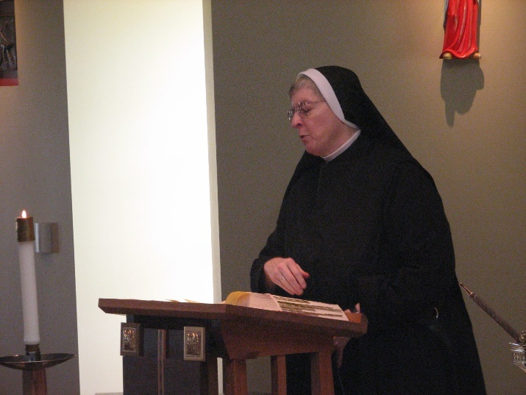
Sr. Bernadette Barrett
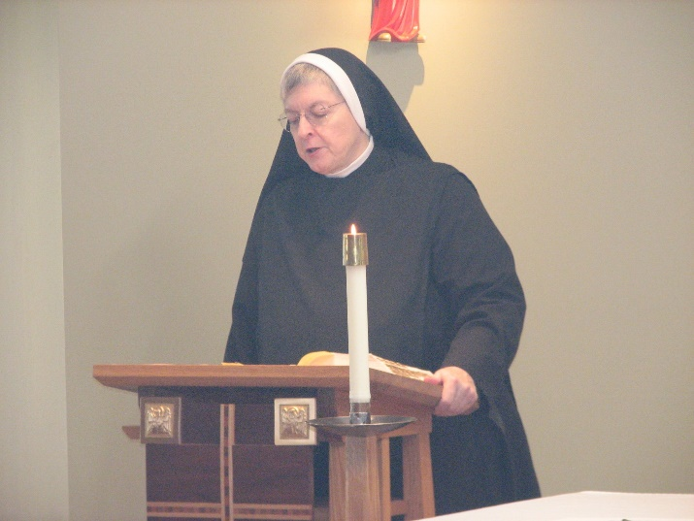
Sr. Bernadette Barrett

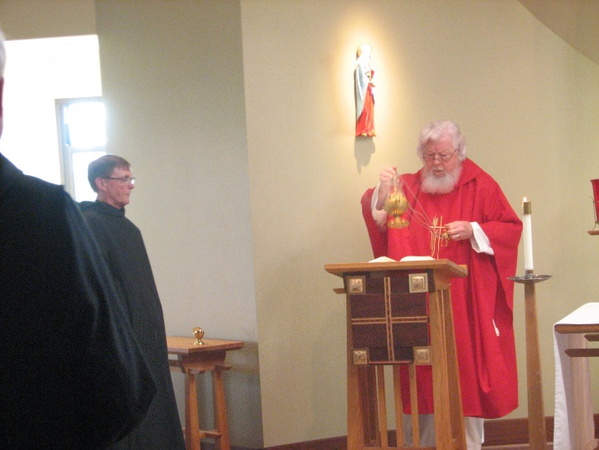
Br. Camillus Converse; Fr. Wayne Kamm

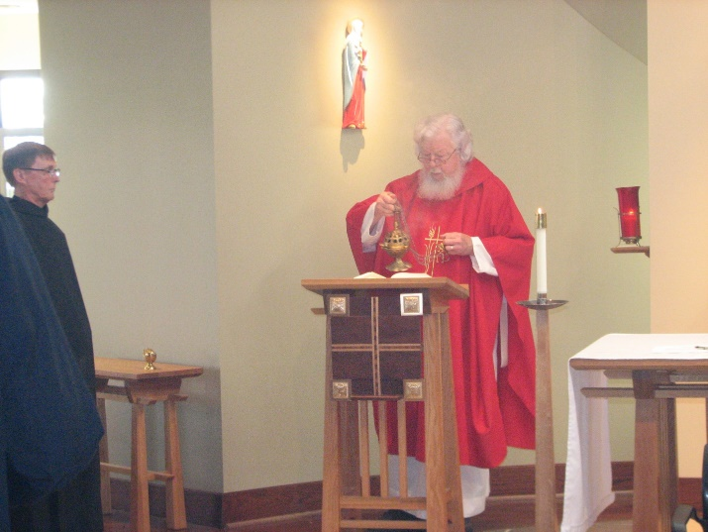
Br. Camillus Converse; Fr. Wayne Kamm

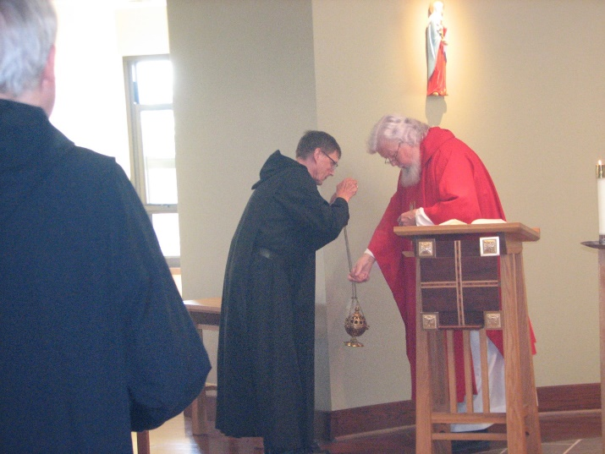
Br. Luke Doucette; Br. Camillus Converse; Fr. Wayne Kamm

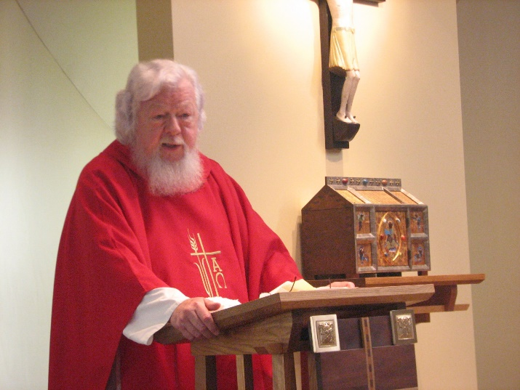
Fr. Wayne Kamm

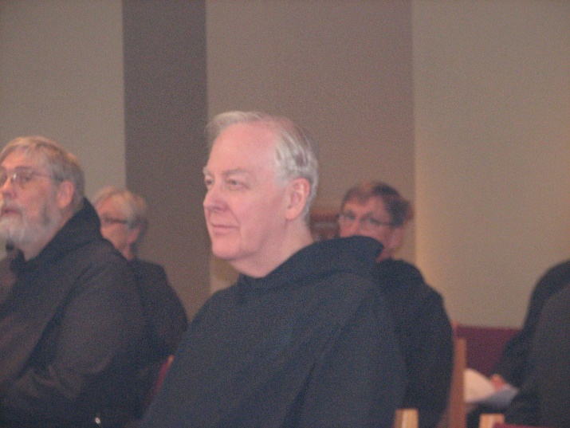
Br. Chad Anselm Gerns; Sr. Julian Saterstrom; Br. Luke Doucette; Br. Camillus Converse
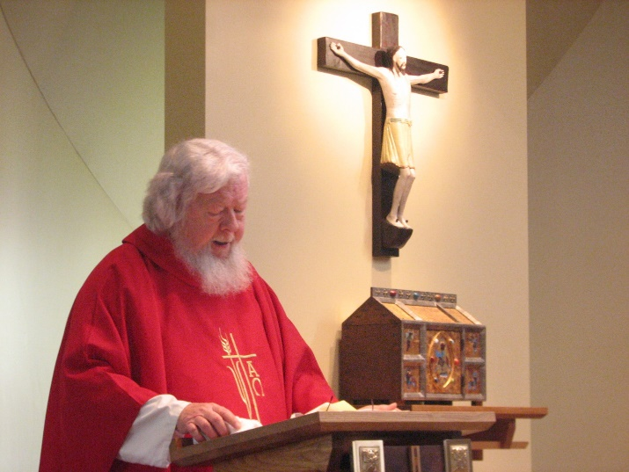
Fr. Wayne Kamm


Br. Luke Doucette


Br. Joseph Olderr; Sr. Veronica Taylor; Sr. Mary Francis Deulen
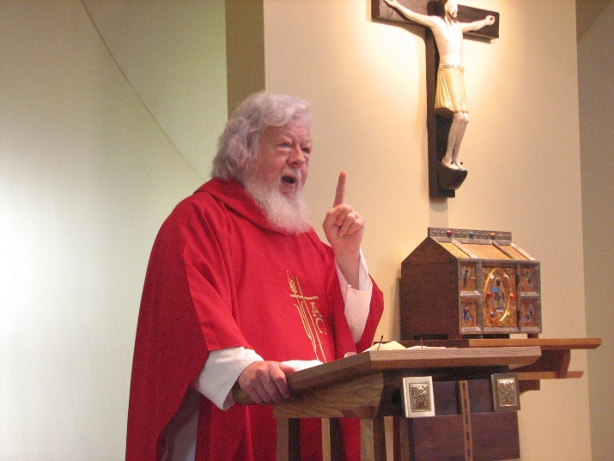
Fr. Wayne Kamm

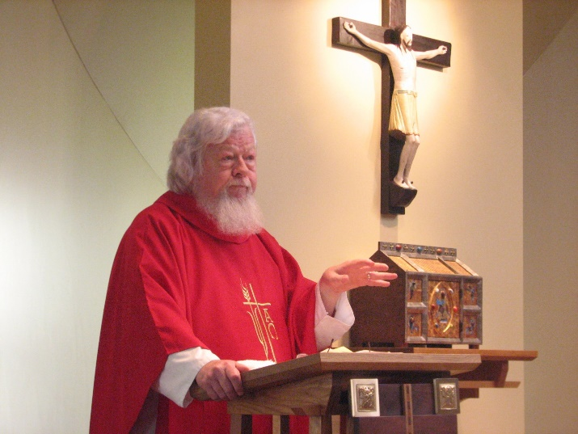
Fr. Wayne Kamm

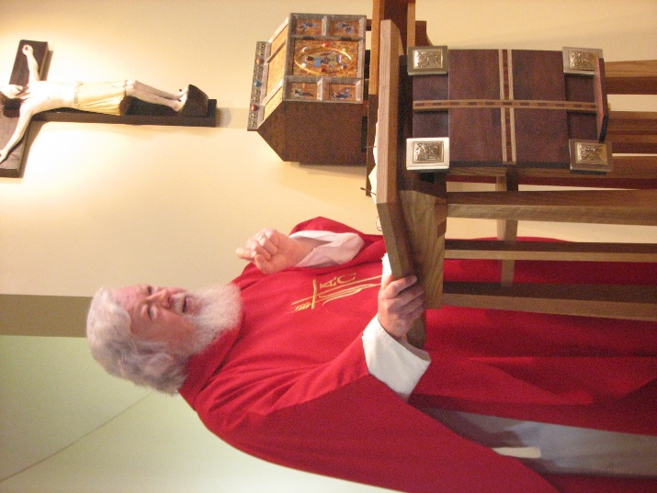
Fr. Wayne Kamm

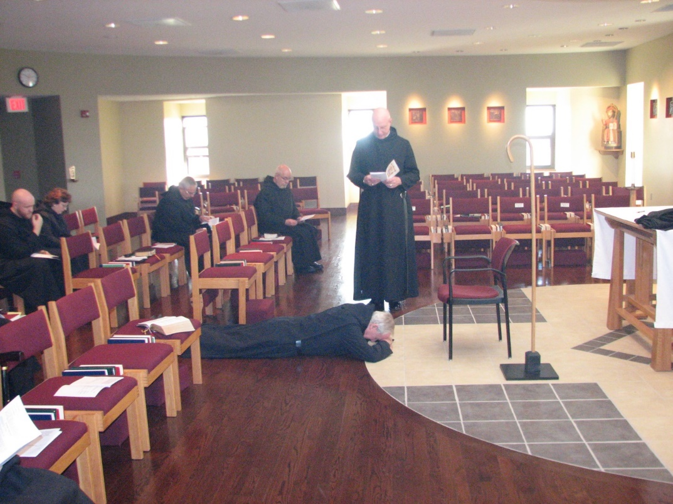
Br. Luke Doucette
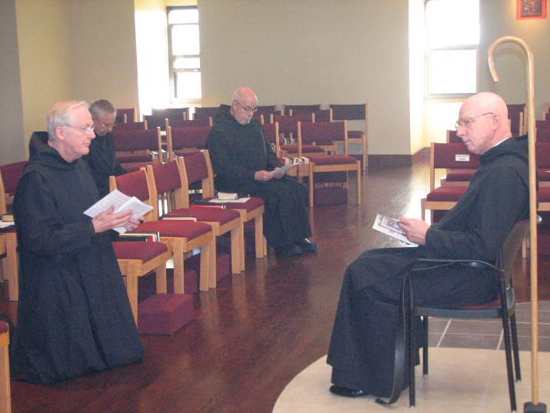
Br. Luke Doucette

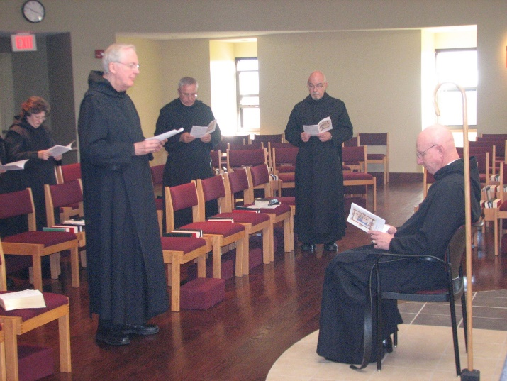
Br. Luke Doucette

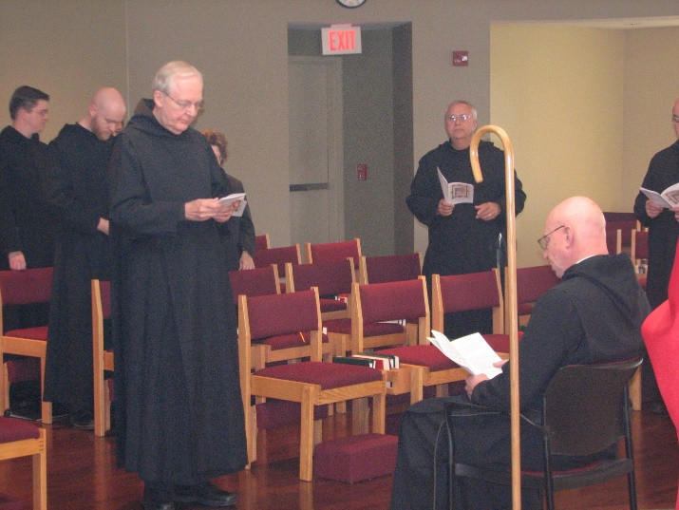
Br. Luke Doucette

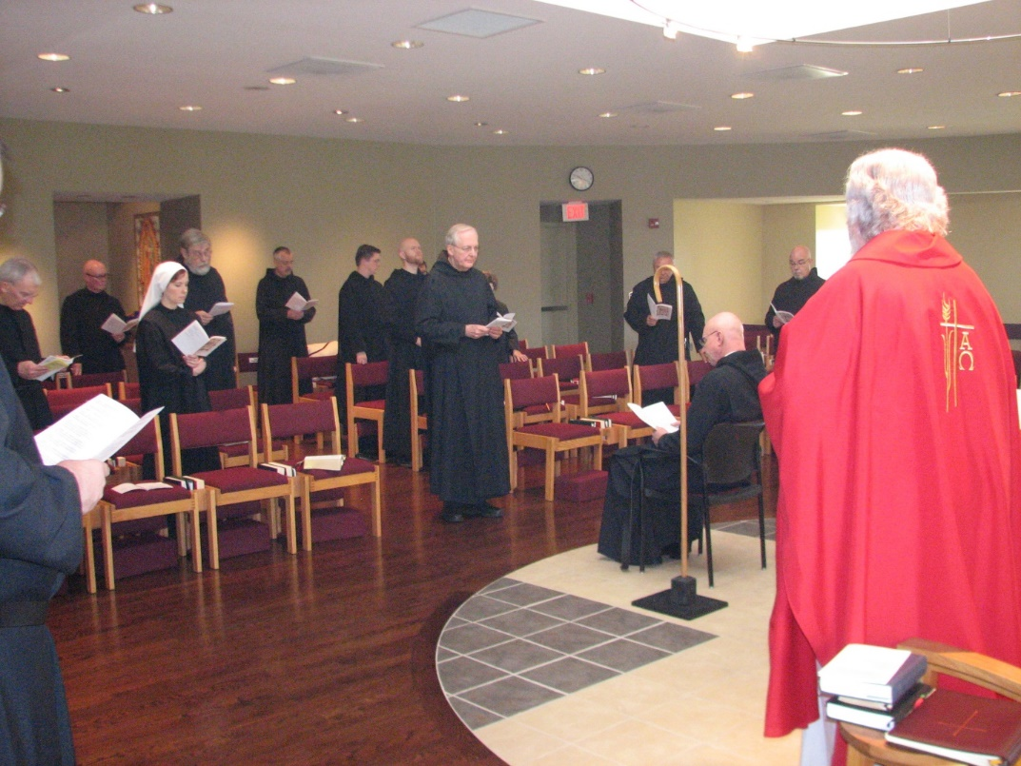
Br. Joseph Olderr; Br. Stephen Francis Arnold; Sr. Veronica Taylor; Br. Chad Anselm Gerns; Br. Dunstan Townsend; Br. Aidan Maguire; Br. Gregory Kingsley; Br. Luke Doucette; Br. Bede Leach; Abbot David Vincent Cotton; Br. Basil Edwards; Fr. Wayne Kamm

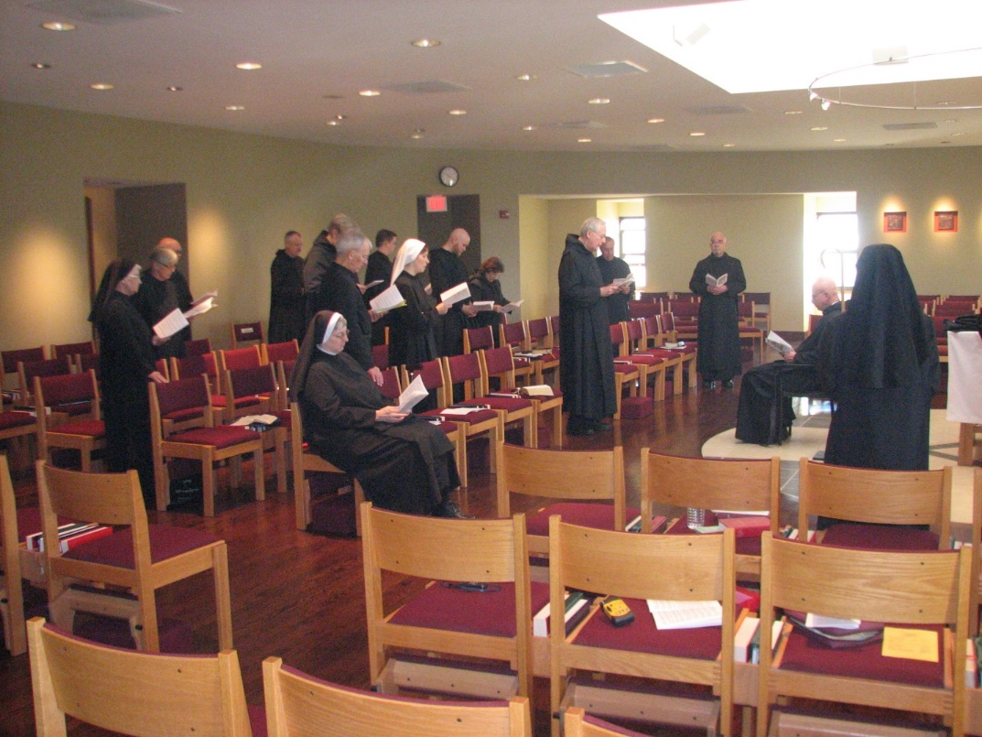
Sr. Mary Francis Deulen; Sr. Julian Saterstrom; Br. Stephen Francis Arnold; Br. Dunstan Townsend; Br. Chad Anselm Gerns; Sr. Bernadette Barrett; Br. Joseph Olderr; Br. Aidan Maguire; Sr. Veronica Taylor; Br. Gregory Kingsley; Sr. Cecelia Lamoy; Br. Luke Doucette; Br. Bede Leach; Br. Basil Edwards; Abbot David Vincent Cotton; Sr. Monica Ruth Mullen

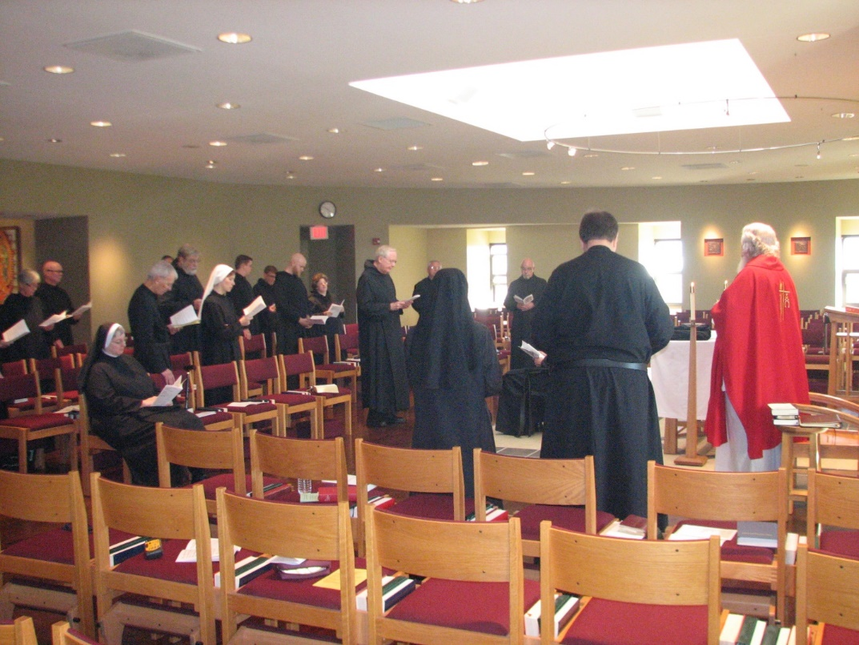
Sr. Julian Saterstrom; Br. Stephen Francis Arnold; Sr. Bernadette Barrett; Br. Joseph Olderr; Br. Chad Anselm Gerns; Sr. Veronica Taylor; Br Aidan Maguire; Br. Camillus Converse; Br. Gregory Kingsley; Sr. Cecelia Lamoy; Br. Luke Doucette; Br. Bede Leach; Sr. Monica Ruth Mullen; Br. Basil Edwards; Br. Samuel Saterstrom; Fr. Wayne Kamm

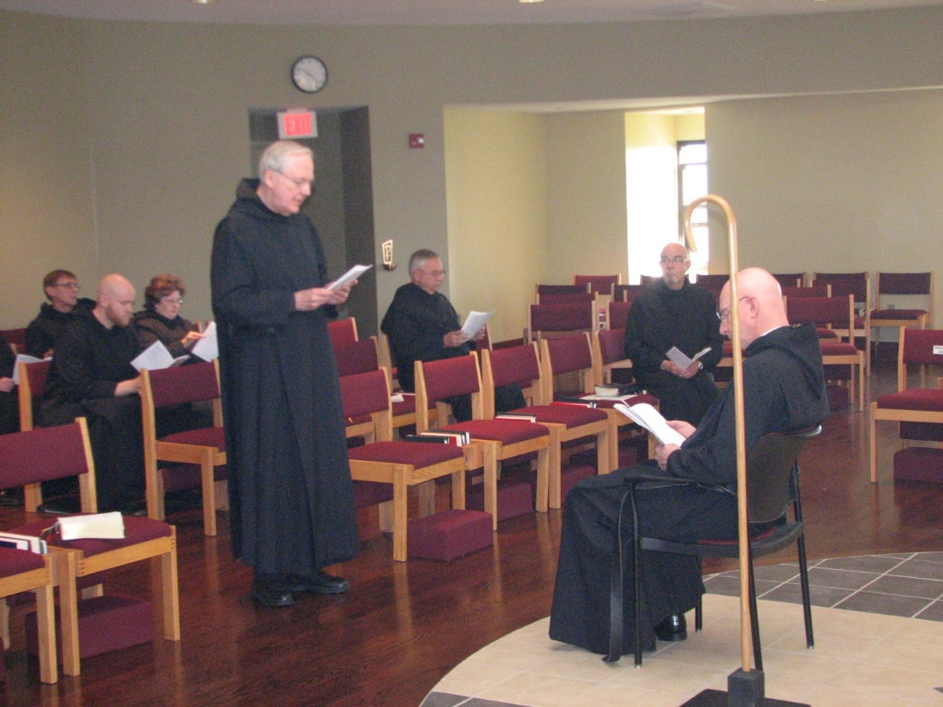
Br. Camillus Converse; Br. Gregory Kingsley; Sr. Cecelia Lamoy; Br. Luke Doucette; Br. Bede Leach; Br. Basil Edwards; Abbot David Vincent Cotton

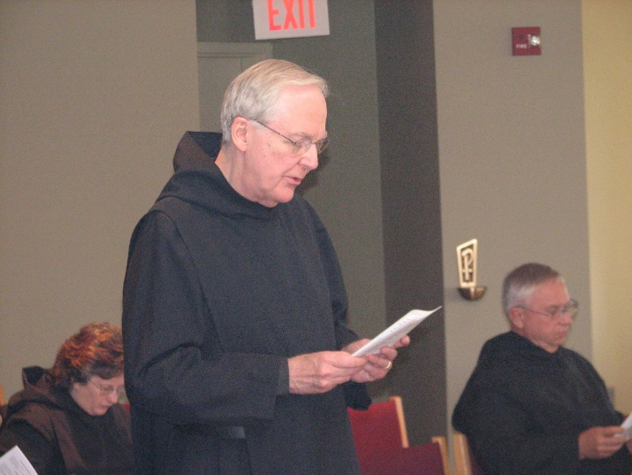
Sr. Cecelia Lamoy; Br. Luke Doucette; Br. Bede Leach
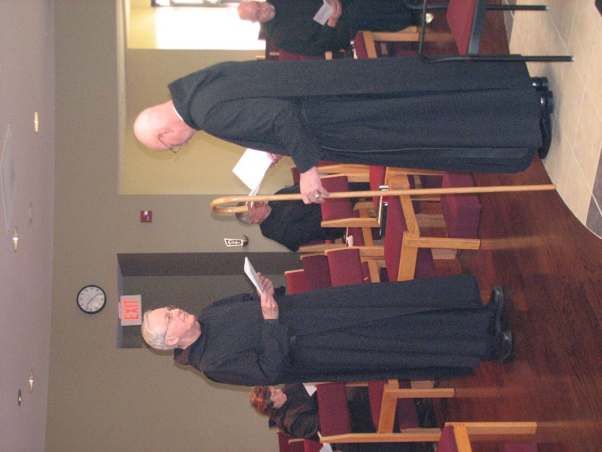
Sr. Cecelia Lamoy; Br. Luke Doucette; Br. Bede Leach; Abbot David Vincent Cotton; Br. Basil Edwards

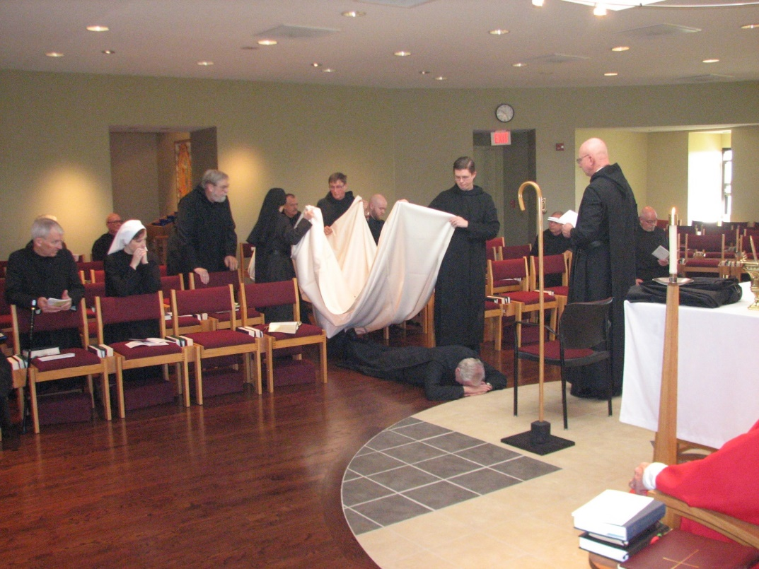
Br. Joseph Olderr; Br. Stephen Francis Arnold; Sr. Veronica Taylor; Br. Chad Anselm Gerns; Sr. Monica Ruth Mullen; Br. Dunstan Townsend; Br. Camillus Converse; Br. Gregory Kingsley; Br. Aidan Maguire; Br. Luke Doucette; Br. Bede Leach; Abbot David Vincent Cotton; Br. Basil Edwards; Fr. Wayne Kamm

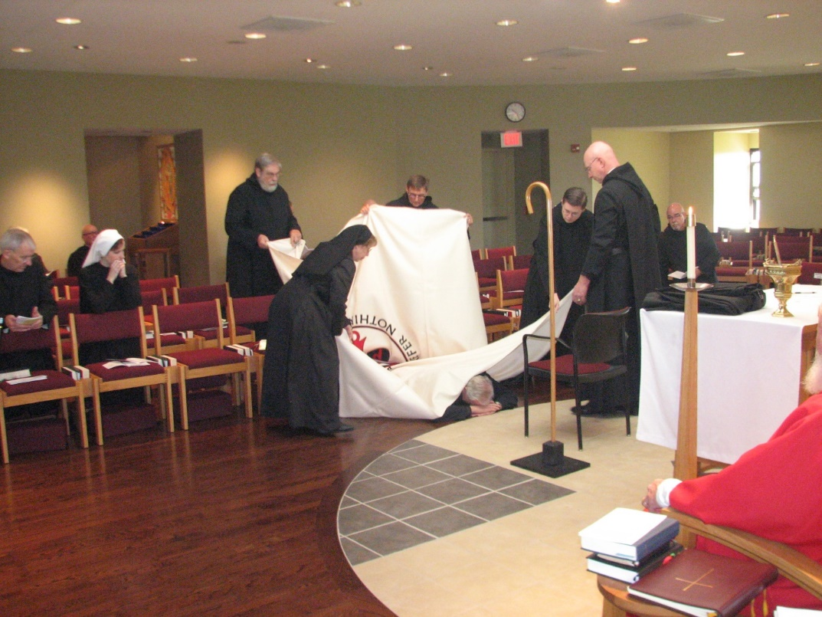
Br. Joseph Olderr; Br. Stephen Francis Arnold; Sr. Veronica Taylor; Br. Chad Anselm Gerns; Sr. Monica Ruth Mullen; Br. Camillus Converse; Br. Luke Doucette; Br. Aidan Maguire; Br. Bede Leach; Abbot David Vincent Cotton; Br. Basil Edwards; Fr. Wayne Kamm

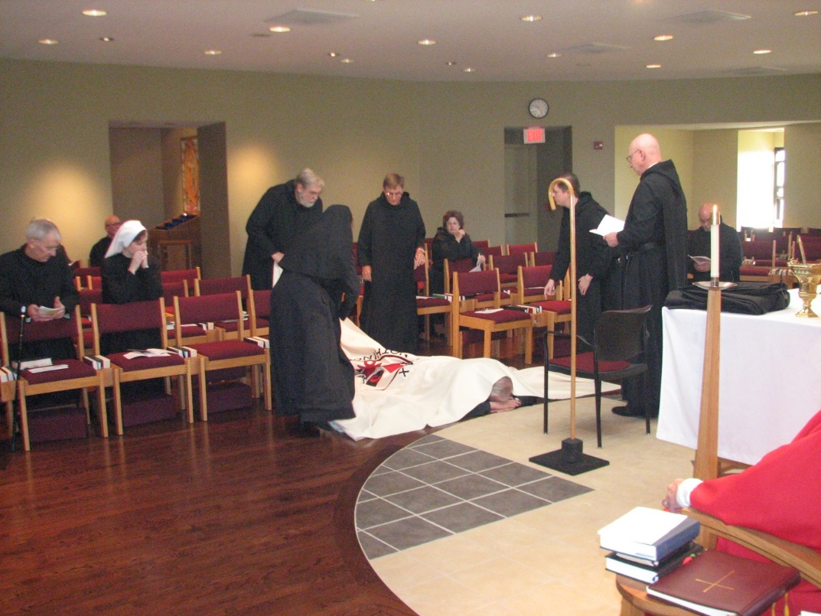
Br. Joseph Olderr; Br. Stephen Francis Arnold; Sr. Veronica Taylor; Br. Chad Anselm Gerns; Sr. Monica Ruth Mullen; Br. Camillus Converse; Sr. Cecelia Lamoy; Br. Luke Doucette; Br. Aidan Maguire; Abbot David Vincent Cotton; Br. Basil Edwards; Fr. Wayne Kamm

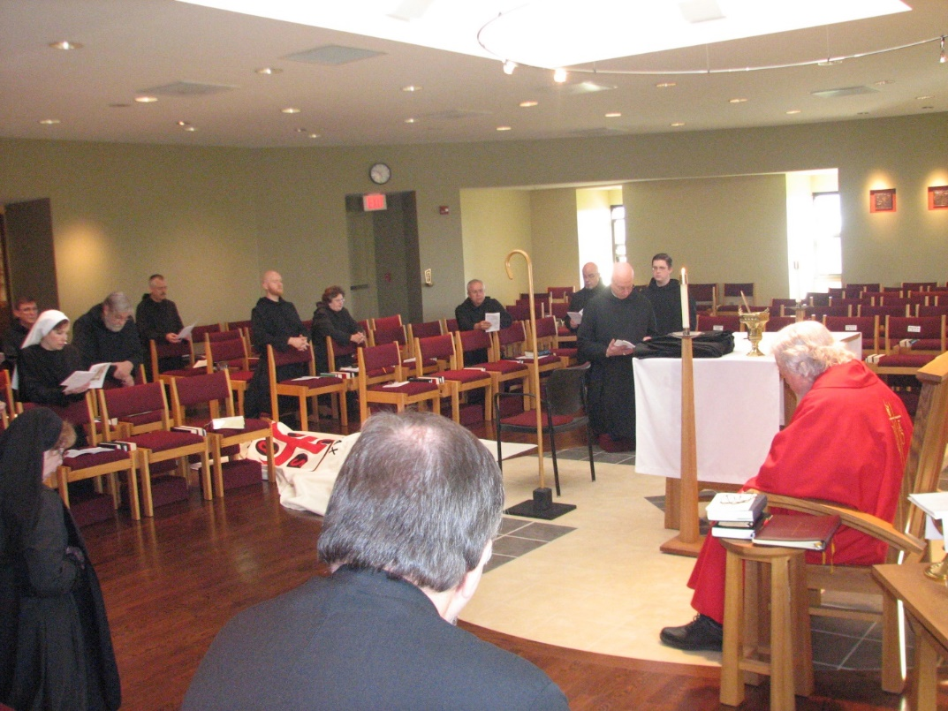
Sr. Monica Ruth Mullen; Br. Camillus Converse; Sr. Veronica Taylor; Br. Chad Anselm Gerns; Br. Dunstan Townsend; Br. Gregory Kingsley; Sr. Cecelia Lamoy; Br. Luke Doucette; Br. Samuel Saterstrom; Br. Bede Leach; Br. Basil Edwards; Abbot David Vincent Cotton; Br. Aidan Maguire; Fr. Wayne Kamm

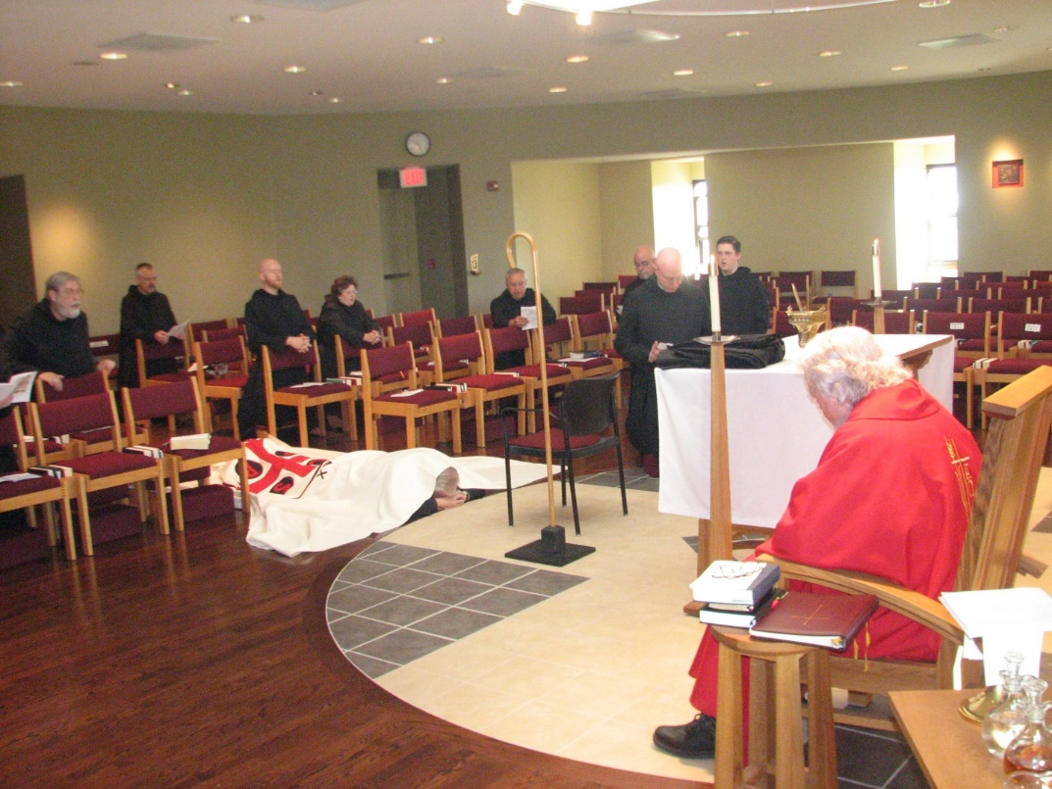
Br. Chad Anselm Gerns; Br. Dunstan Townsend; Br. Gregory Kingsley; Sr. Cecelia Lamoy; Br. Luke Doucette; Br. Bede Leach; Br. Basil Edwards; Abbot David Vincent Cotton; Br. Aidan Maguire; Fr. Wayne Kamm


Sr. Monica Ruth Mullen; Sr. Mary Francis Deulen; Sr. Bernadette Barrett; Br. Joseph Olderr

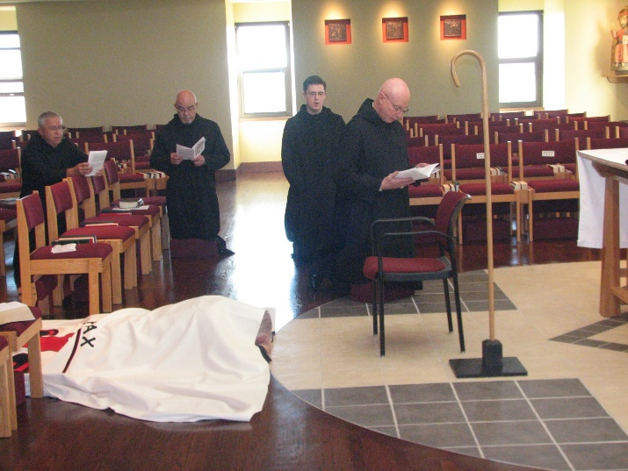
Br. Bede Leach; Br. Basil Edwards; Br. Luke Doucette; Br. Aidan Maguire; Abbot David Vincent Cotton
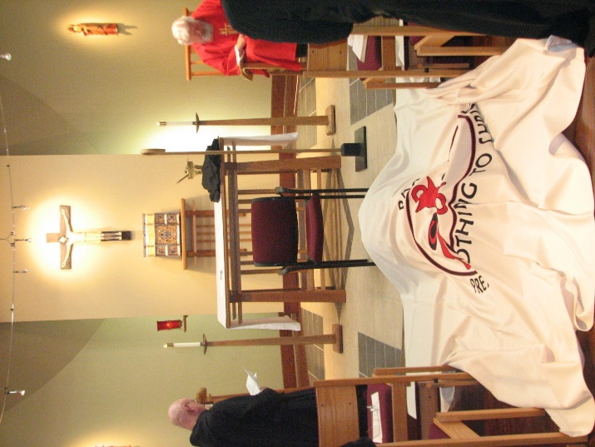
Abbot David Vincent Cotton; Br. Luke Doucette; Fr. Wayne Kamm

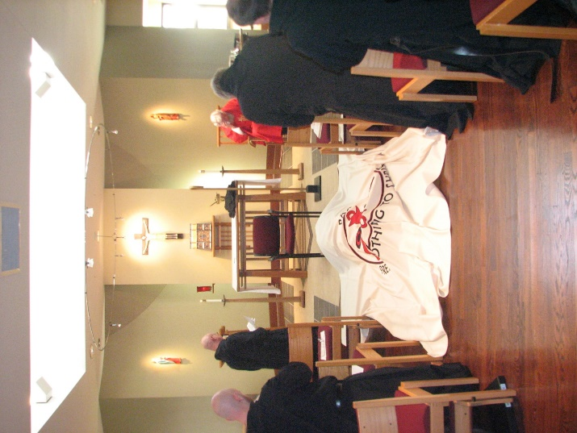
Br. Gregory Kingsley; Abbot David Vincent Cotton; Br. Luke Doucette; Fr. Wayne Kamm; Br. Chad Anselm Gerns; Br. Camillus Converse

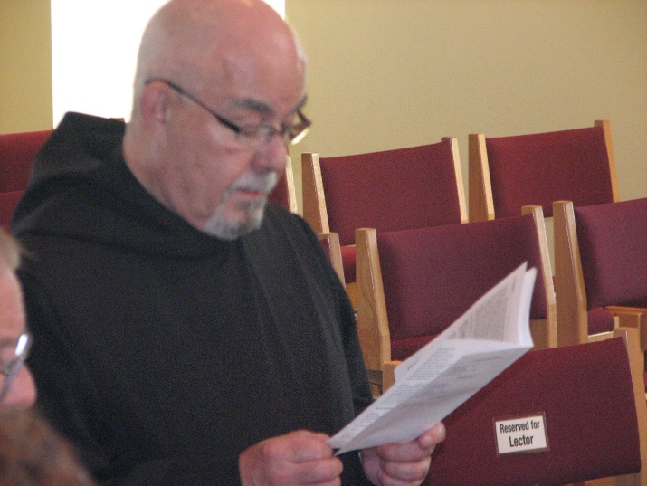
Br. Basil Edwards

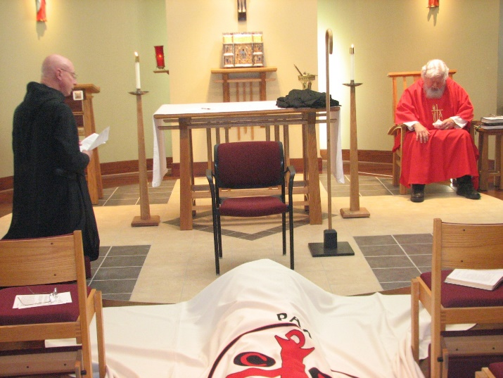
Abbot David Vincent Cotton; Br. Luke Doucette; Fr. Wayne Kamm

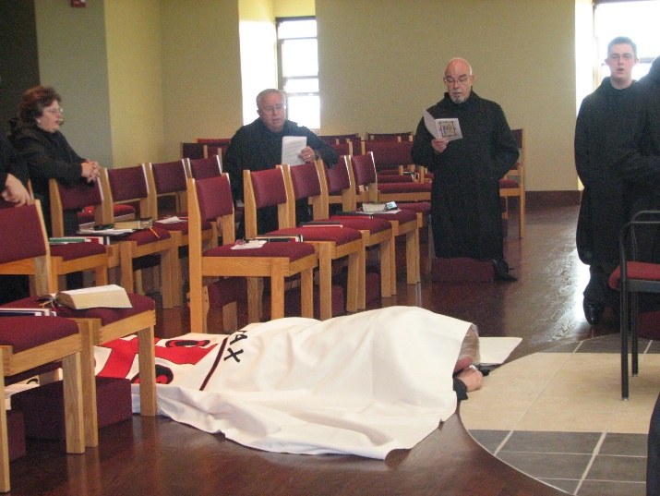
Br. Luke Doucette; Br. Basil Edwards
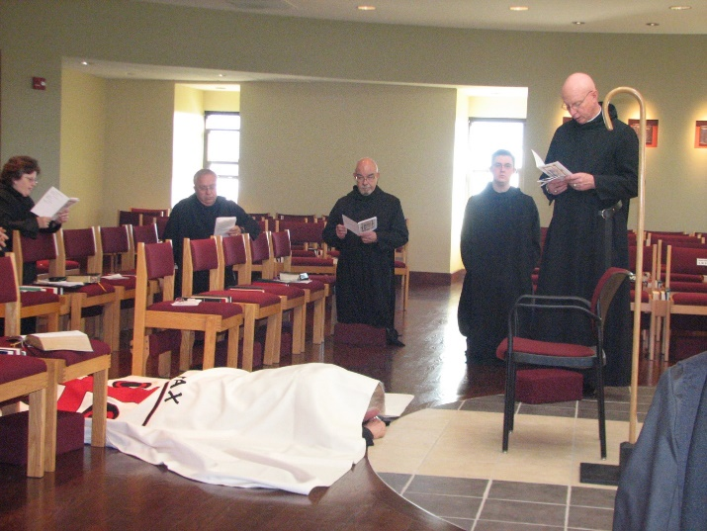
Sr. Cecelia Lamoy; Br. Bede Leach; Br. Luke Doucette; Br. Basil Edwards; Br. Aidan Maguire; Abbot David Vincent Cotton

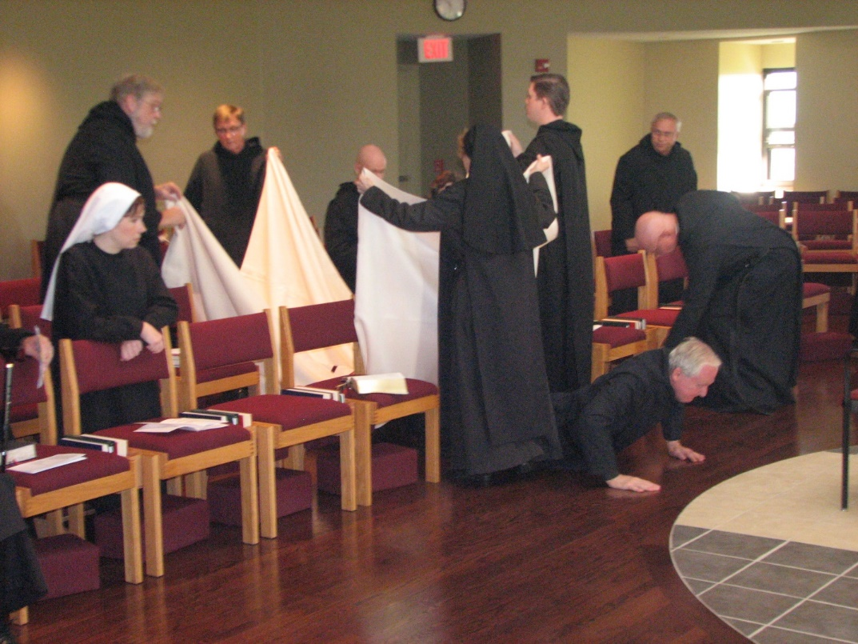
Sr. Veronica Taylor; Br. Chad Anselm Gerns; Br. Camillus Converse; Br. Gregory Kingsley; Sr. Monica Ruth Mullen; Br. Aidan Maguire; Br. Bede Leach; Abbot David Vincent Cotton; Br. Luke Doucette
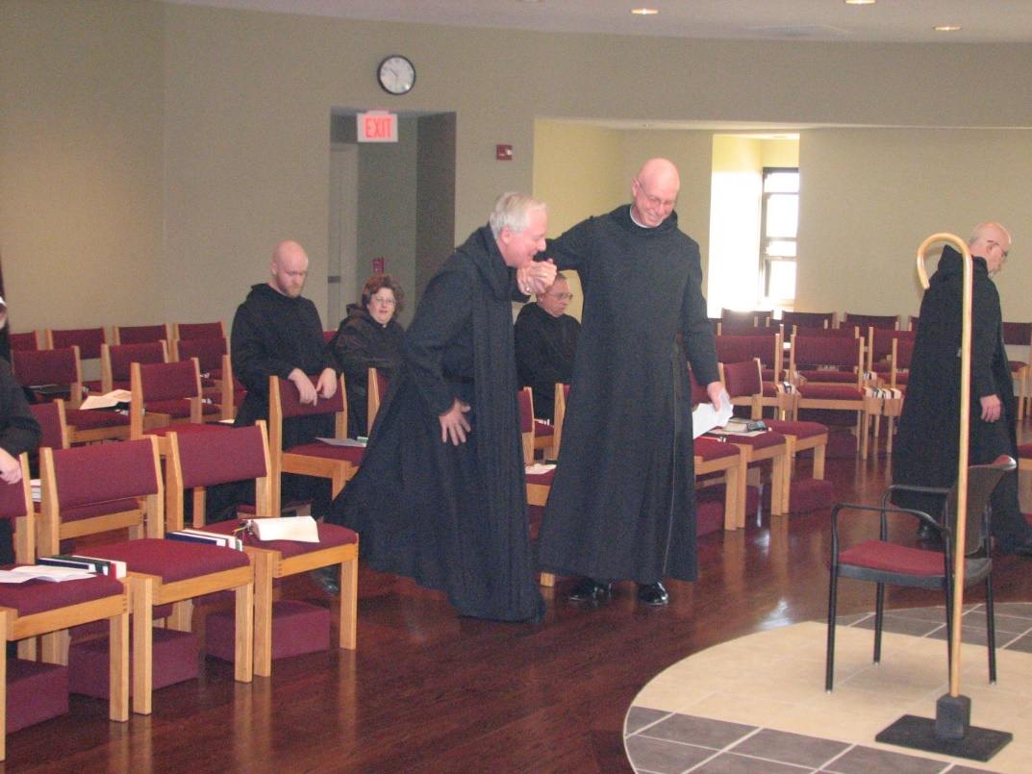
Br. Gregory Kingsley; Sr. Cecelia Lamoy; Br. Luke Doucette; Br. Bede Leach; Abbot David Vincent Cotton; Br. Basil Edwards

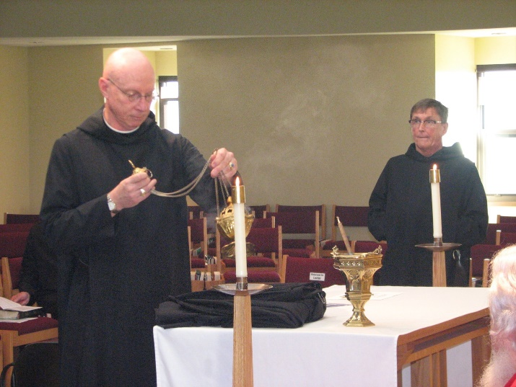
Abbot David Vincent Cotton; Br. Camillus Converse; Fr. Wayne Kamm

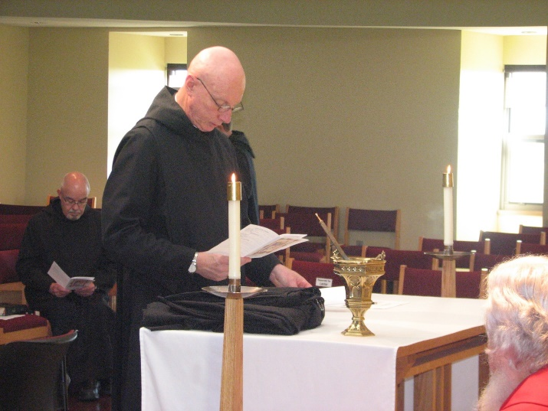
Br. Basil Edwards; Abbot David Vincent Cotton; Fr. Wayne Kamm

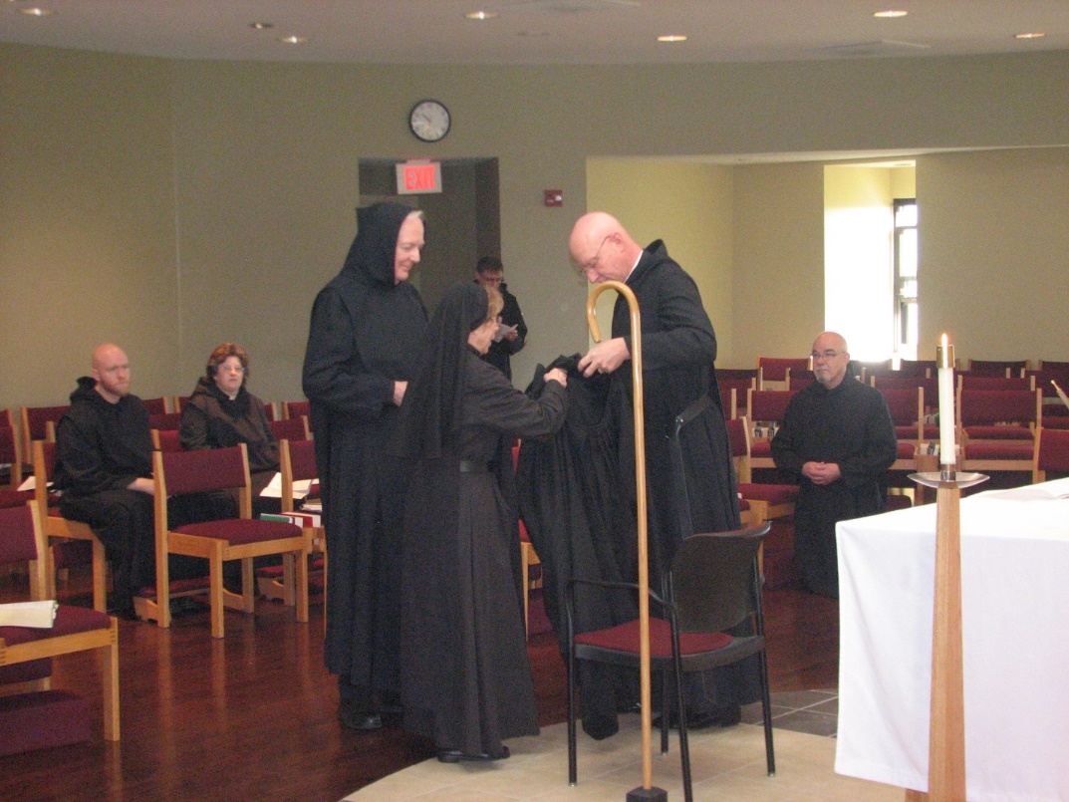
Br. Gregory Kingsley; Sr. Cecelia Lamoy; Br. Luke Doucette; Sr. Monica Ruth Mullen; Br. Camillus Converse; Abbot David Vincent Cotton; Br. Basil Edwards

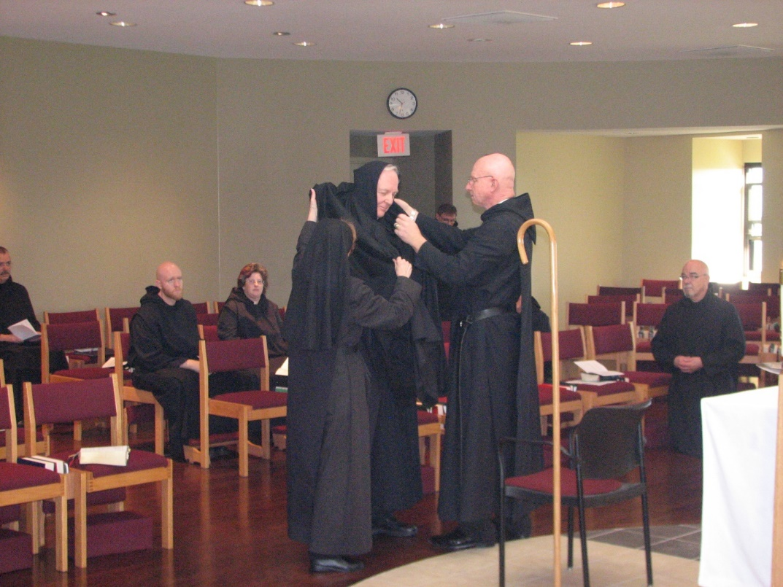
Br. Dunstan Townsend; Br. Gregory Kingsley; Sr. Cecelia Lamoy; Sr. Monica Ruth Mullen; Br. Luke Doucette; Br. Camillus Converse; Abbot David Vincent Cotton; Br. Basil Edwards

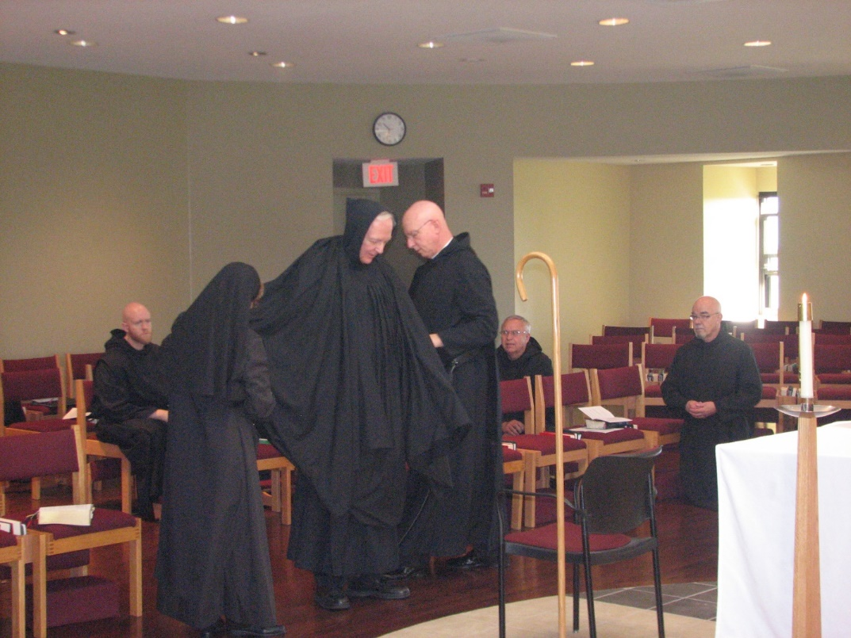
Br. Gregory Kingsley; Sr. Monica Ruth Mullen; Br. Luke Doucette; Abbot David Vincent Cotton; Br. Bede Leach; Br. Basil Edwards

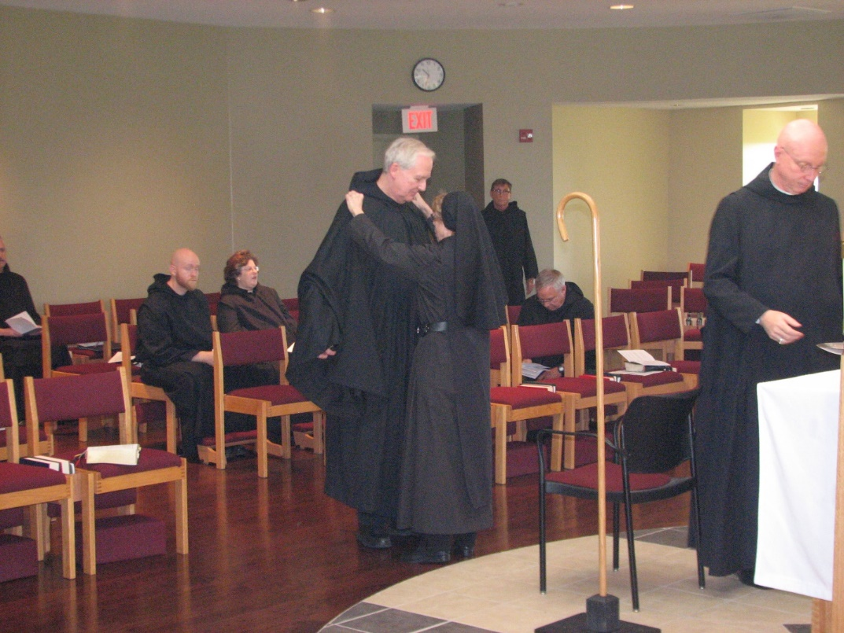
Br. Dunstan Townsend; Br. Gregory Kingsley; Sr. Cecelia Lamoy; Br. Luke Doucette; Sr. Monica Ruth Mullen; Br. Camillus Converse; Br. Bede Leach; Abbot David Vincent Cotton

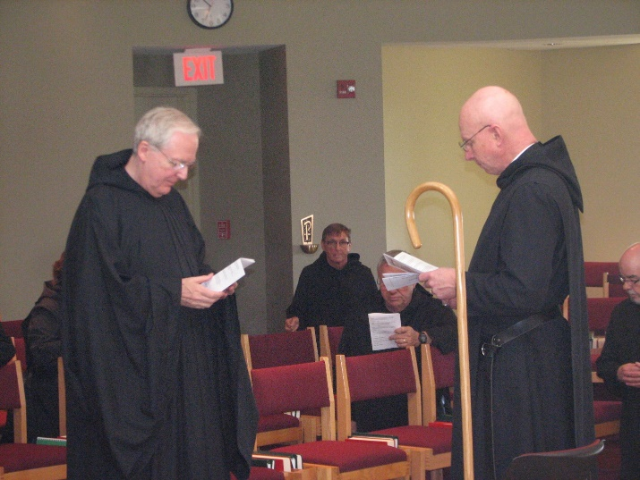
Sr. Ceclia Lamoy; Br. Luke Doucette; Br. Camillus Converse; Br. Bede Leach; Abbot David Vincent Cotton; Br. Basil Edwards

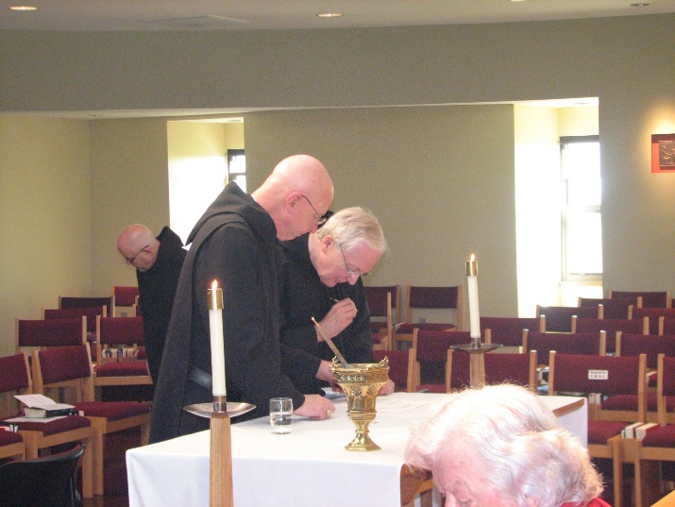
Br. Basil Edwards; Abbot David Vincent Cotton Br. Luke Doucette; Fr. Wayne Kamm

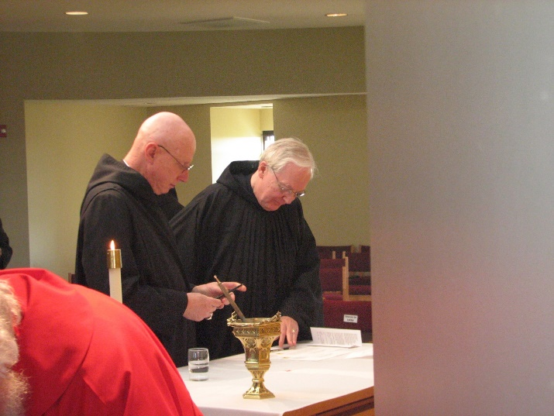
Fr. Wayne Kamm; Abbot David Vincent Cotton; Br. Luke Doucette

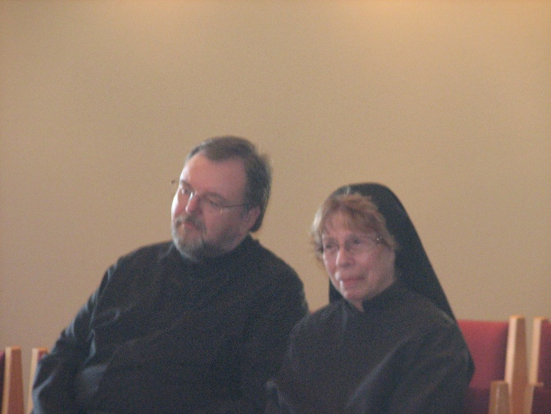
Br. Samuel Saterstrom; Sr. Monica Ruth Mullen
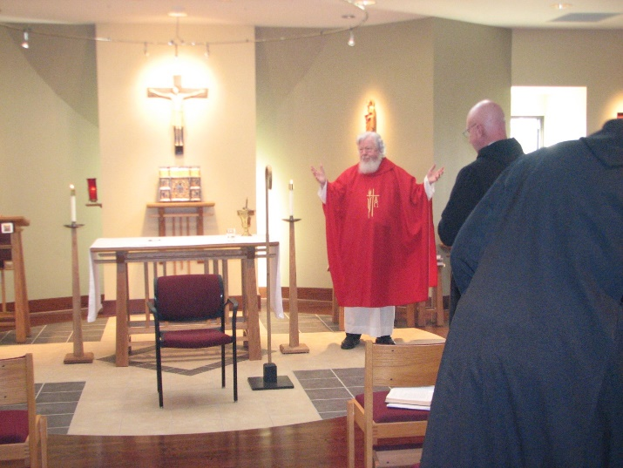
Fr. Wayne Kamm; Abbot David Vincent Cotton; Br. Chad Anselm Gerns

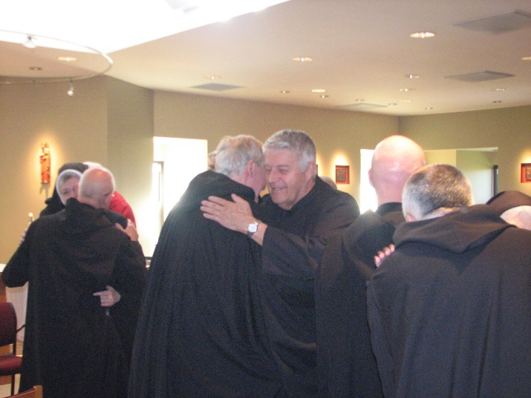
Sr. Bernadette Barrett; Br. Basil Edwards; Br. Luke Doucette; Br. Michael Anicetus McCabe; Br. Stephen Francis Arnold; Br. Dunstan Townsend; Sr. Mary Francis Deulen

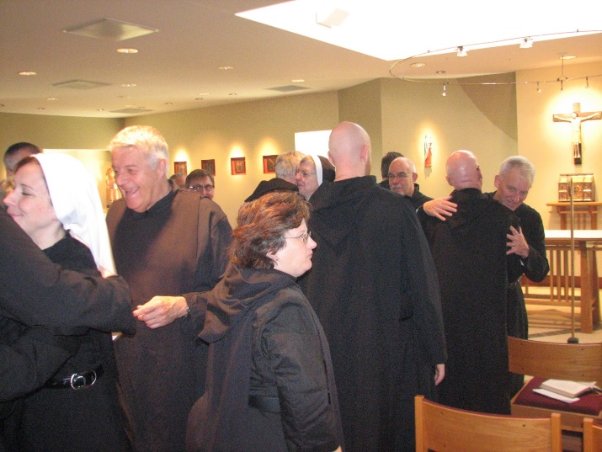
Sr. Veronica Taylor; Br. Michael Anicetus McCabe; Br. Camillus Converse; Sr. Cecelia Lamoy; Br. Luke Doucette; Sr. Bernadette Barrett; Br. Gregory Kingsley; Br. Basil Edwards; Br. Steven Francis Arnold; Br. Joseph Olderr
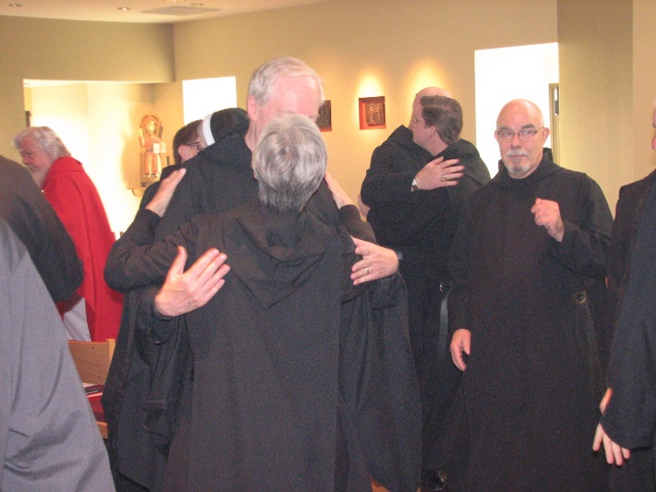
Fr. Wayne Kamm; Sr. Bernadette Barrett; Br. Luke Doucette; Sr. Julian Saterstrom; Abbot David Vincent Cotton; Br. Aidan Maguire; Br. Basil Edwards


Sr. Mary Francis Deulen; Br. Dunstan Townsend; Br. Joseph Olderr; Br. Luke Doucette; Br. Camillus Converse; Sr. Bernadette Barrett; Br. Samuel Saterstrom; Br. Basil Edwards

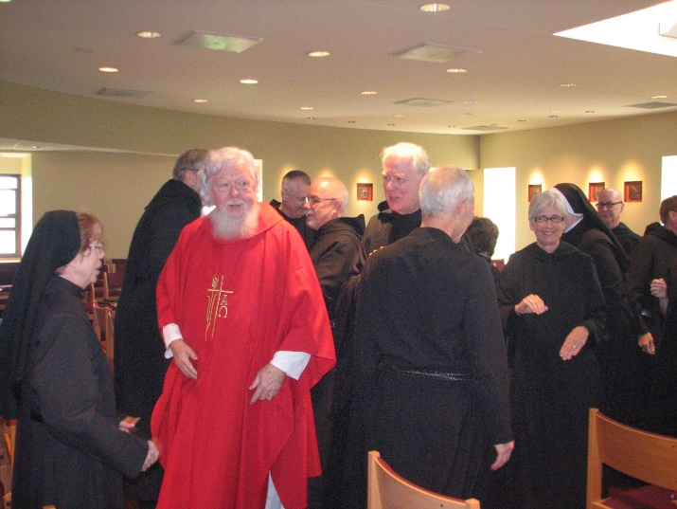
Sr. Monica Ruth Mullen; Br. Chad Anselm Gerns; Fr. Wayne Kamm; Br. Dunstan Townsend; Br. Basil Edwards; Br. Luke Doucette; Br. Joseph Olderr; Sr. Julian Saterstrom; Sr. Bernadette Barrett; Br. Stephen Francis Arnold; Br. Camillus Converse

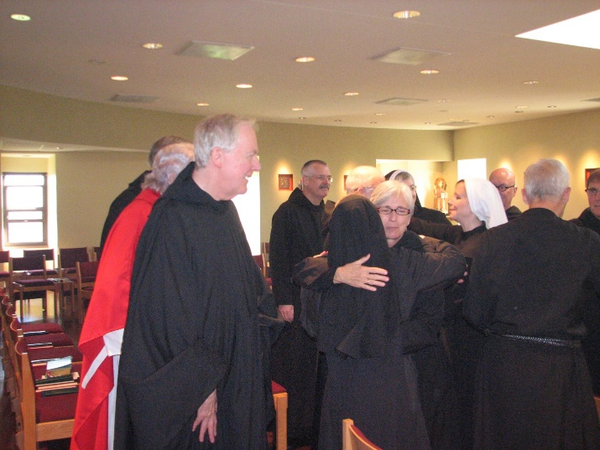
Fr. Wayne Kamm; Br. Luke Doucette; Br. Dunstan Townsend; Sr. Monica Ruth Mullen; Br. Basil Edwards; Sr. Julian Saterstrom; Sr. Bernadette Barrett; Sr. Veronica Taylor; Br. Stephen Francis Arnold; Br. Joseph Olderr; Br. Camillus Converse

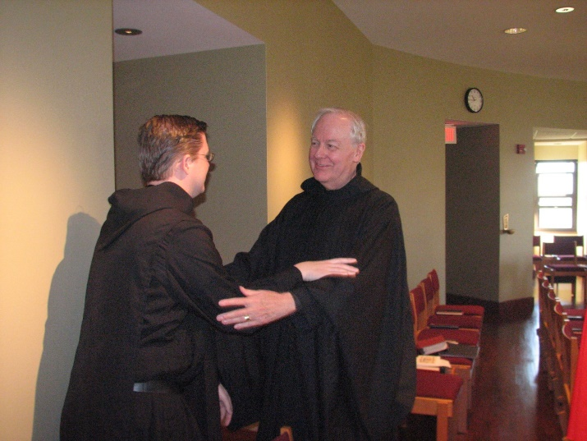
Br. Aidan Maguire; Br. Luke Doucette

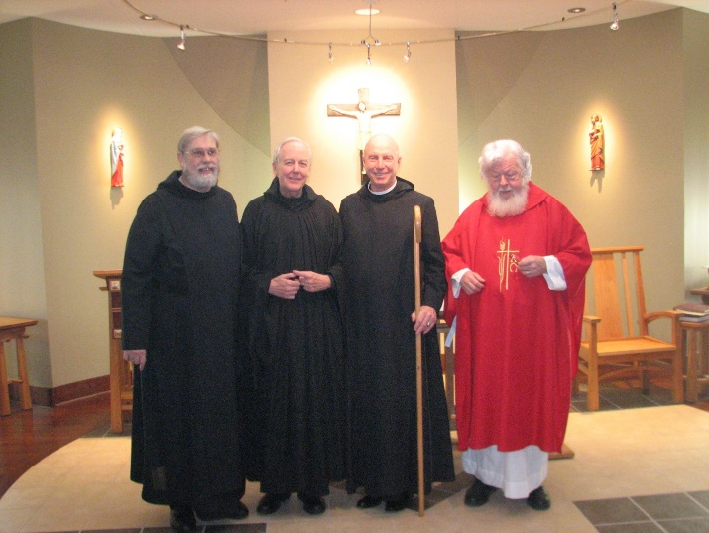
Br. Chad Anselm Gerns; Br. Luke Doucette; Abbot David Vincent Cotton; Fr. Wayne Kamm

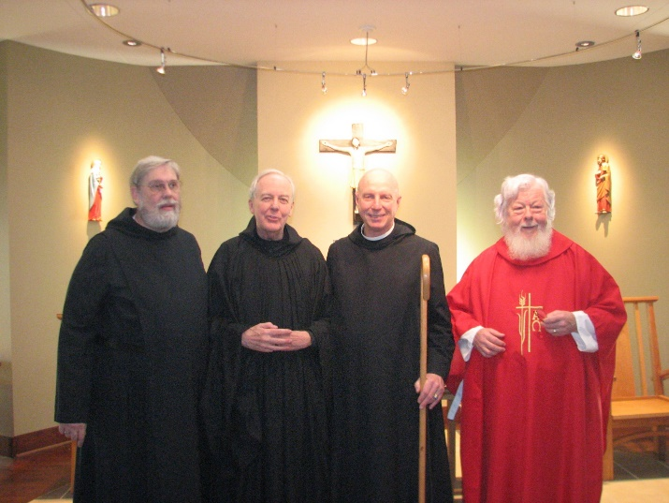
Br. Chad Anselm Gerns; Br. Luke Doucette; Abbot David Vincent Cotton; Fr. Wayne Kamm

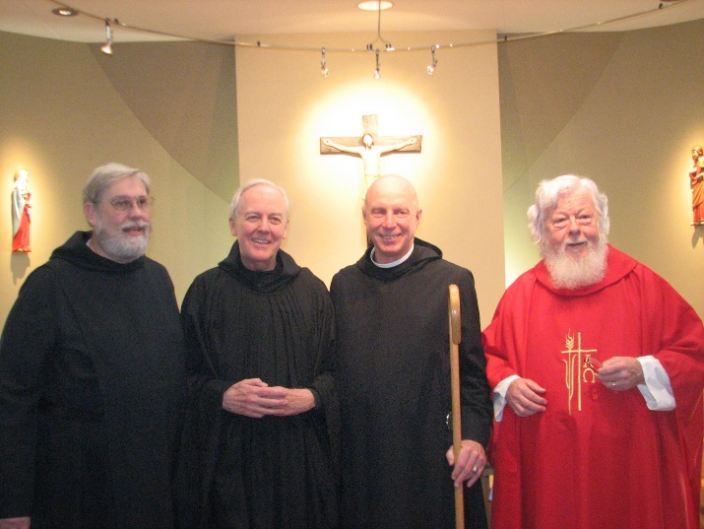
Br. Chad Anselm Gerns; Br. Luke Doucette; Abbot David Vincent Cotton; Fr. Wayne Kamm

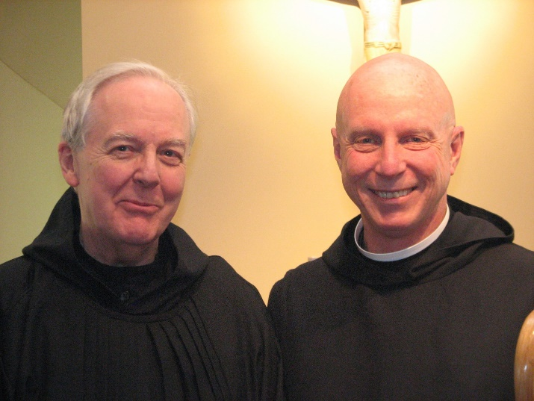
Br. Luke Doucette; Abbot David Vincent Cotton

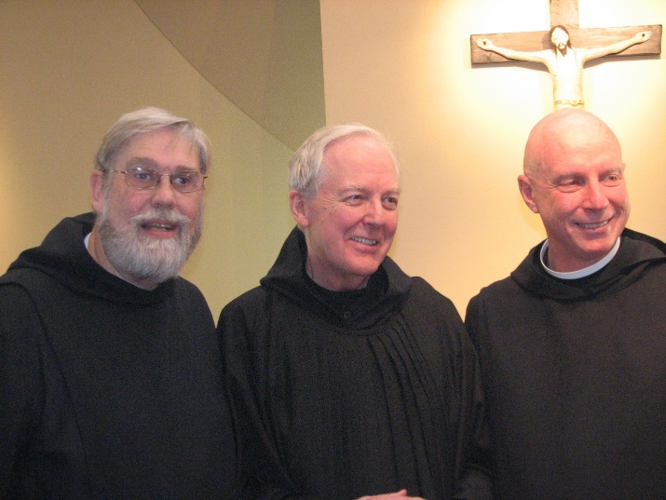
Br. Chad Anselm Gerns; Br. Luke Doucette; Abbot David Vincent Cotton

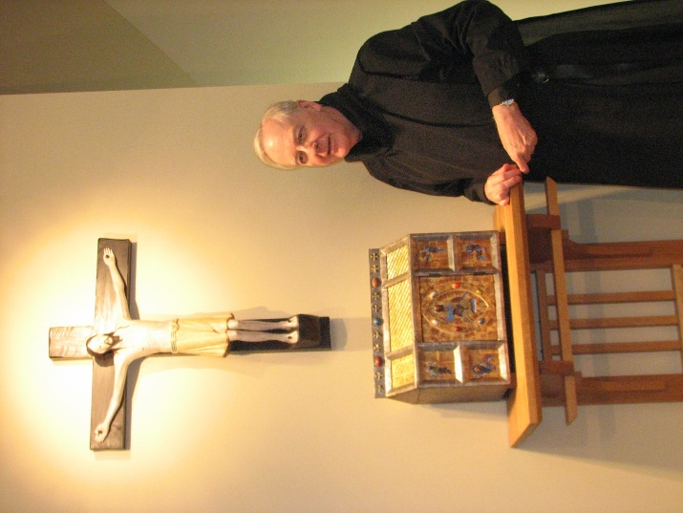
Br. Luke Doucette

