Companions of St. Luke
Fall Convocation at Conception Abbey
October 25-30, 2010
Part 1 of 4
Photographed by Sr. Brigid Gerns

People are identified from left to right.

Edited by Br. Steven Olderr 24 March 2023. Please send any comments, corrections, or additions to olderr@ameritech.net

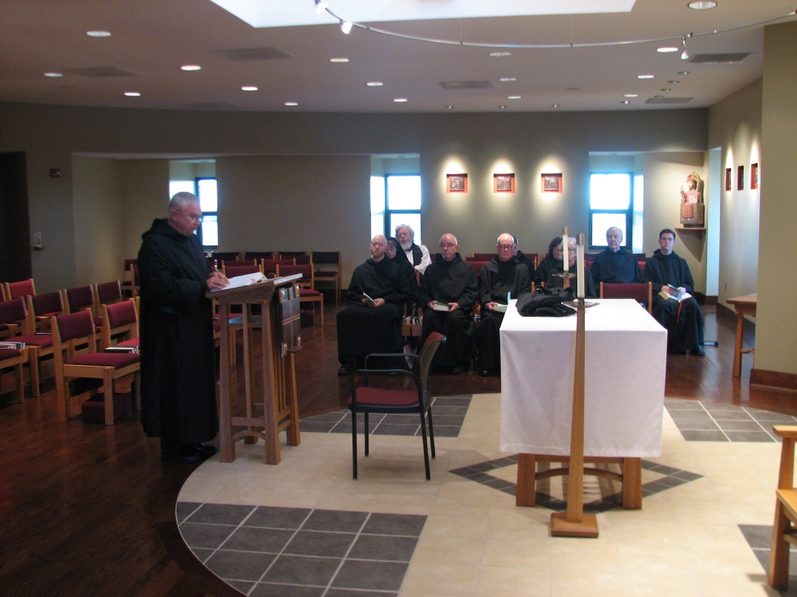
Br. Bede Leach; Br. Gregory Kingsley; Sr. Monica Ruth Mullen; Fr. Wayne Kamm; Br. Basil Edwards

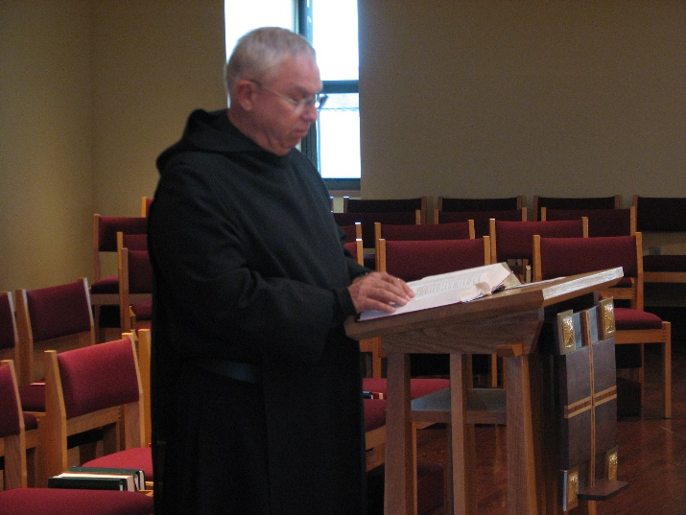
Br. Bede Leach

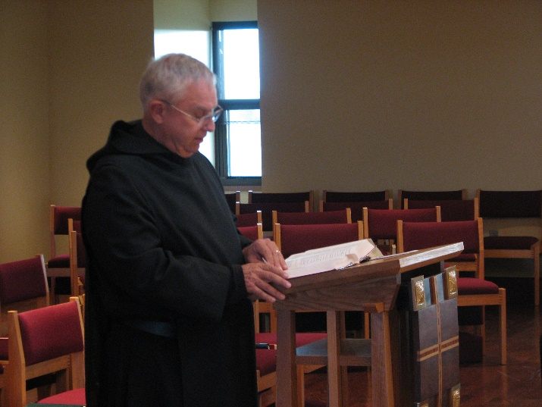
Br. Bede Leach

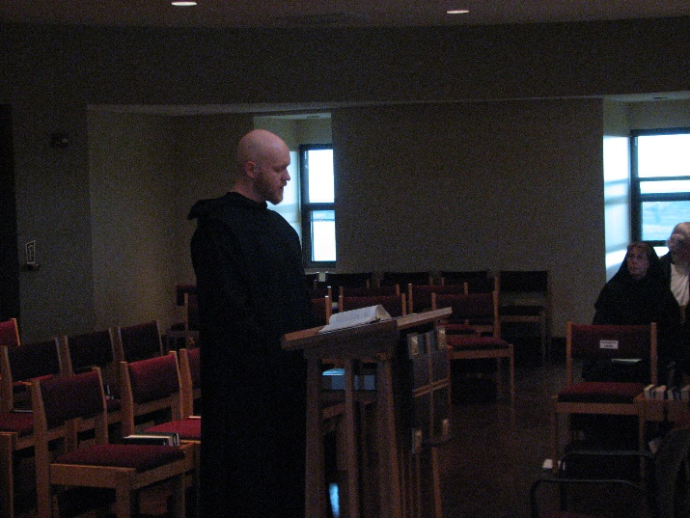
Br. Gregory Kingsley; Sr. Monica Ruth Mullen; Fr. Wayne Kamm

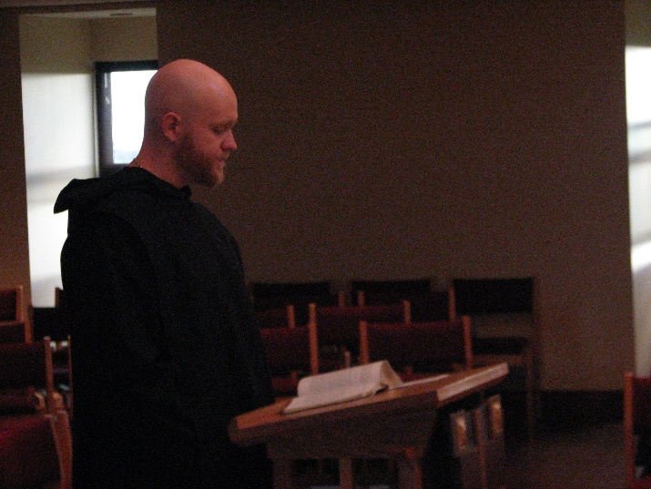
Br. Gregory Kingsley

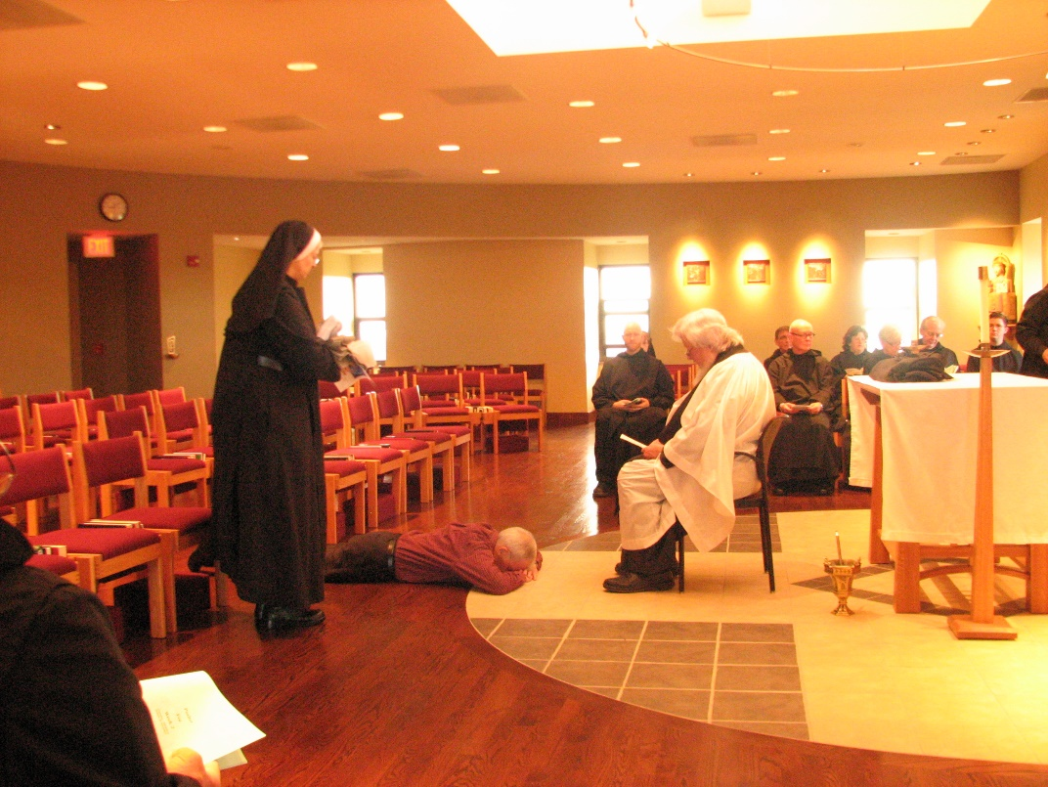
Sr. Bernadette Barrett; Steven Olderr; Br. Gregory Kingsley; Fr. Wayne Kamm; Br. Camillus Converse; Br. Stephen Francis Arnold; Sr. Cecelia Lamoy; Sr. Julian Saterstrom; Br. Luke Doucette; Br. Aidan Maguire

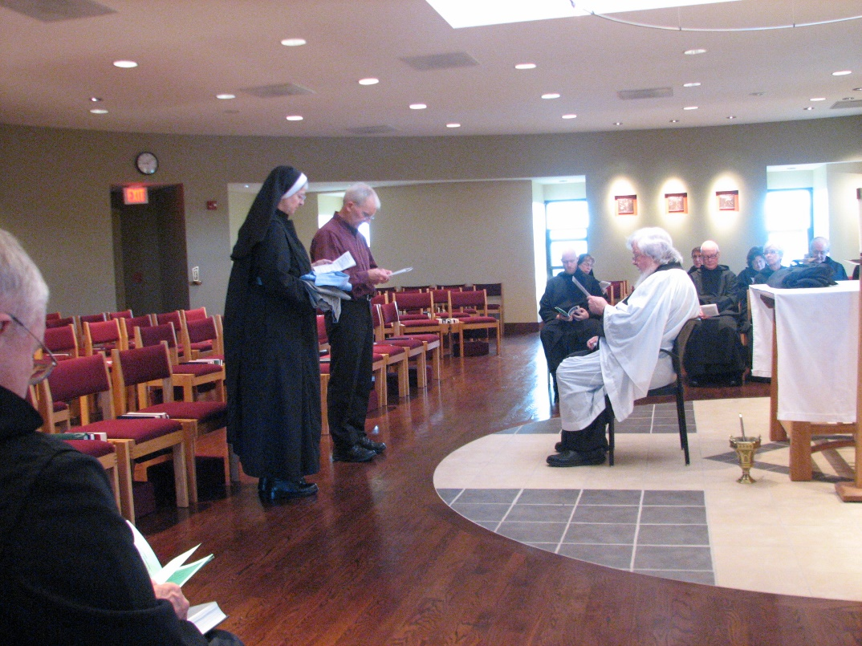
Br. Bede Leach; Sr. Bernadette Barrett; Steven Olderr; Br. Gregory Kingsley; Sr. Monica Ruth Mullen; Fr. Wayne Kamm; Br. Camillus Converse; Br. Stephen Francis Arnold; Sr. Cecelia Lamoy; Sr. Julian Saterstrom; Br. Luke Doucette

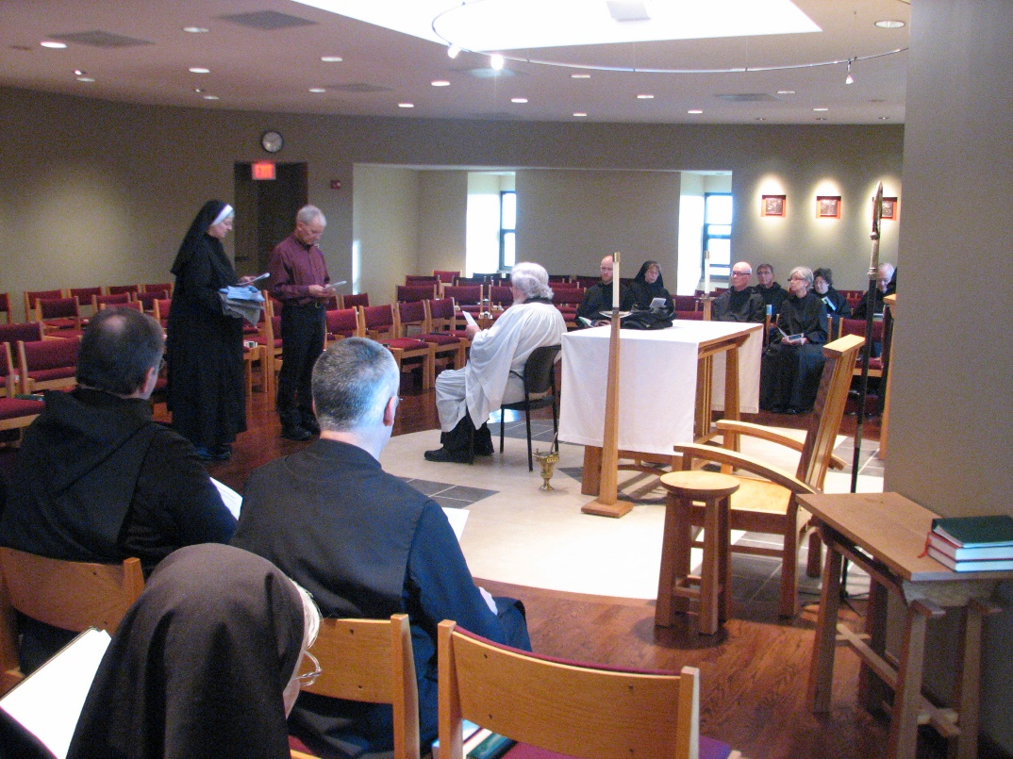
Br. Samuel Saterstrom; Sr. Bernadette Barrett; Sr. Mary Francis Deulen; Steven Olderr; Br. Dunstan Townsend; Fr. Wayne Kamm; Br. Gregory Kingsley; Sr. Monica Ruth Mullen; Br. Stephen Francis Arnold; Br. Camillus Converse; Sr. Julian Saterstrom; Sr. Cecelia Lamoy; Br. Luke Doucette

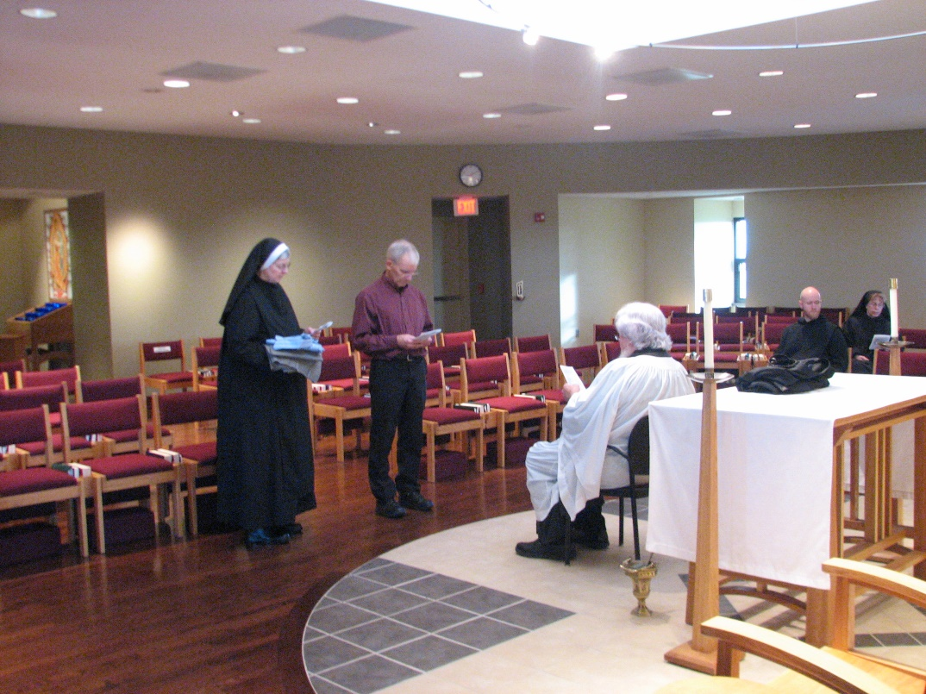
Sr. Bernadette Barrett; Steven Olderr; Fr. Wayne Kamm Br. Gregory Kingsley; Sr. Monica Ruth Mullen

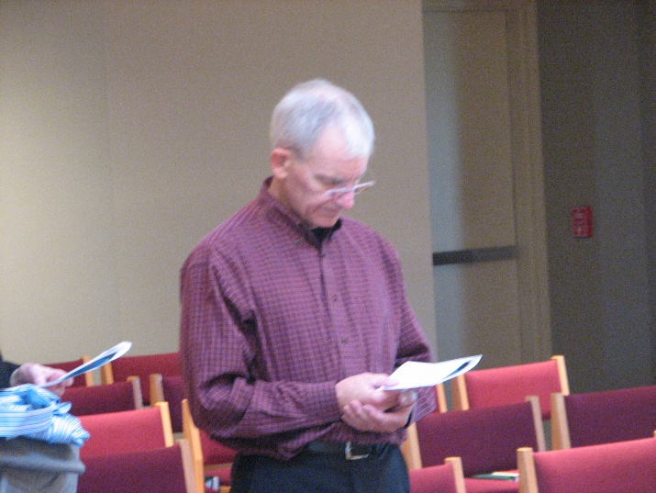
Steven Olderr
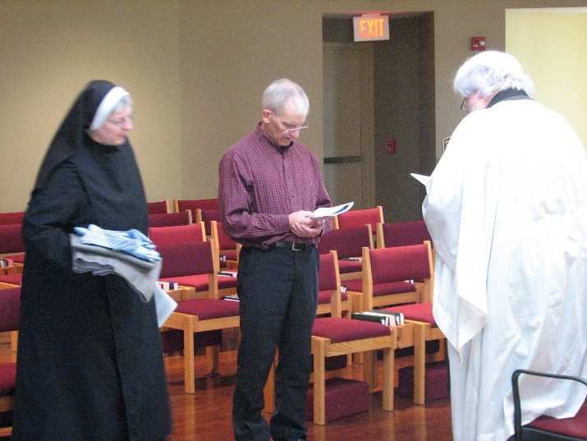
Sr. Bernadette Barrett; Steven Olderr; Fr. Wayne Kamm

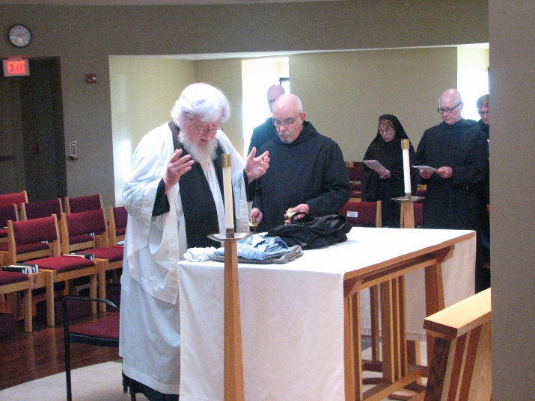
Fr. Wayne Kamm; Br. Gregory Kingsley; Br. Basil Edwards; Sr. Monica Ruth Mullen; Br. Stephen Francis Arnold; Br. Camillus Converse

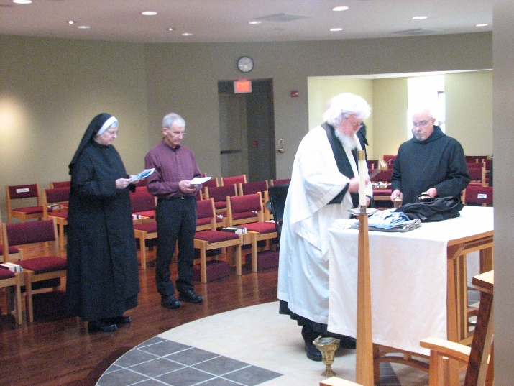
Sr. Bernadette Barrett; Steven Olderr; Fr. Wayne Kamm; Br. Basil Edwards

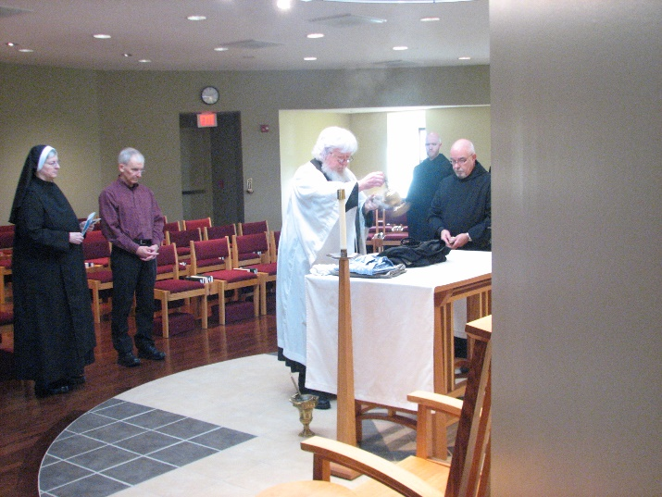
Sr. Bernadette Barrett; Steven Olderr; Fr. Wayne Kamm; Br. Gregory Kingsley; Br. Basil Edwards

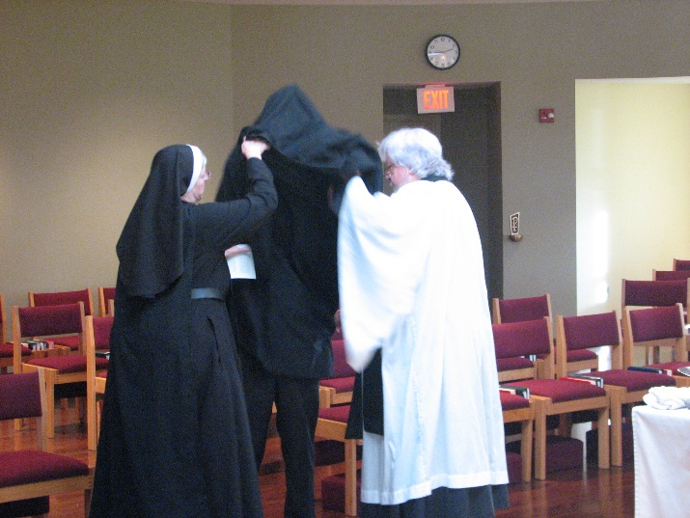
Sr. Bernadette Barrett; Br. Joseph Olderr; Fr. Wayne Kamm

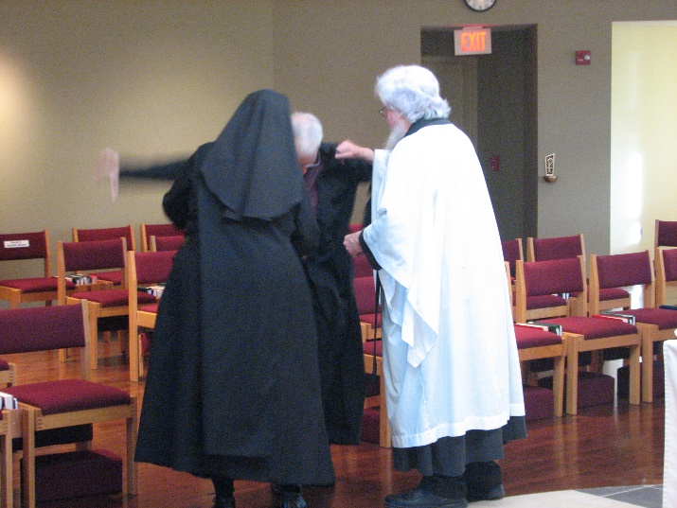
Sr. Bernadette Barrett; Br. Joseph Olderr; Fr. Wayne Kamm

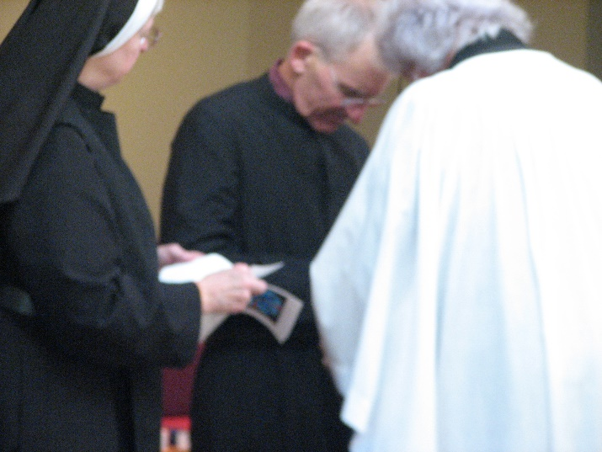
Sr. Bernadette Barrett; Br. Joseph Olderr; Fr. Wayne Kamm

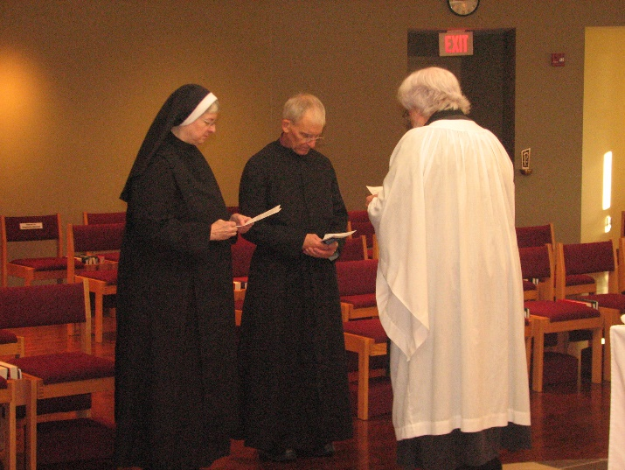
Sr. Bernadette Barrett; Br. Joseph Olderr; Fr. Wayne Kamm

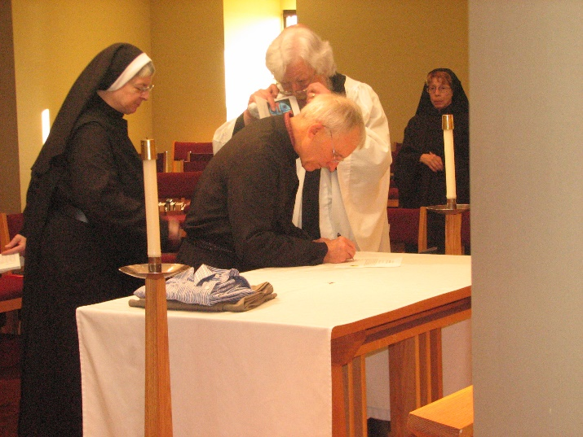
Sr. Bernadette Barrett; Fr. Wayne Kamm; Br. Joseph Olderr; Sr. Monica Ruth Mullen

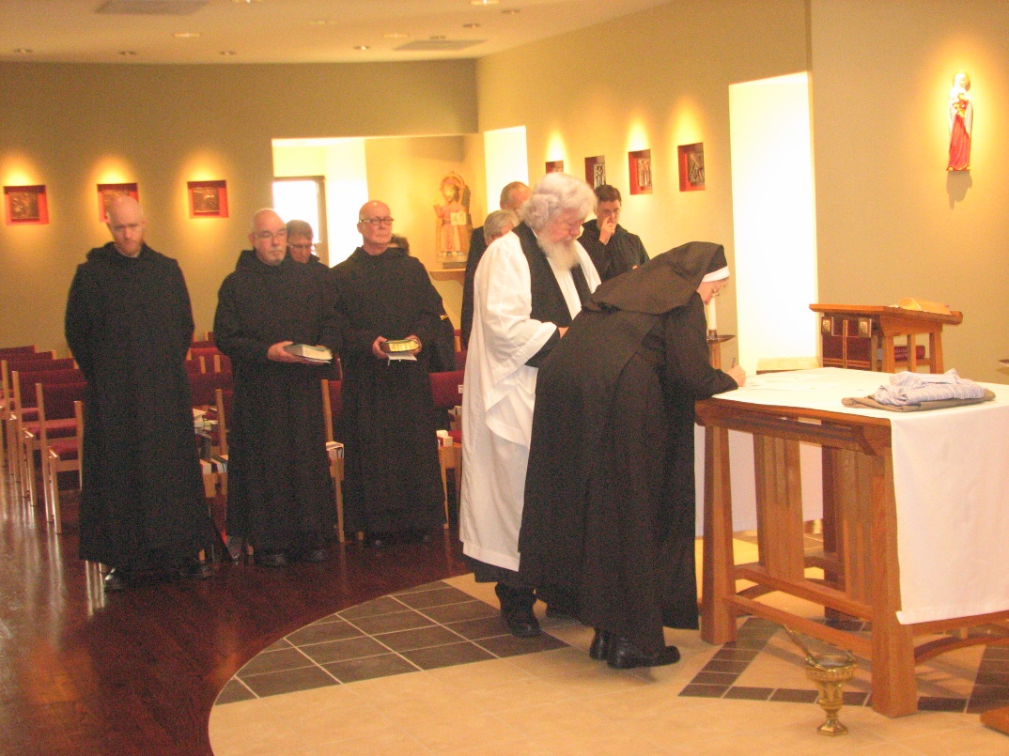
Br. Gregory Kingsley; Br. Basil Edwards; Br. Camillus Converse; Br. Stephen Francis Arnold; Sr. Julian Saterstrom; Sr. Cecilia Lamoy; Sr. Julian Saterstrom; Br. Luke Doucette; Fr. Wayne Kamm; Br. Aidan Maguire; Sr. Bernadette Barrett

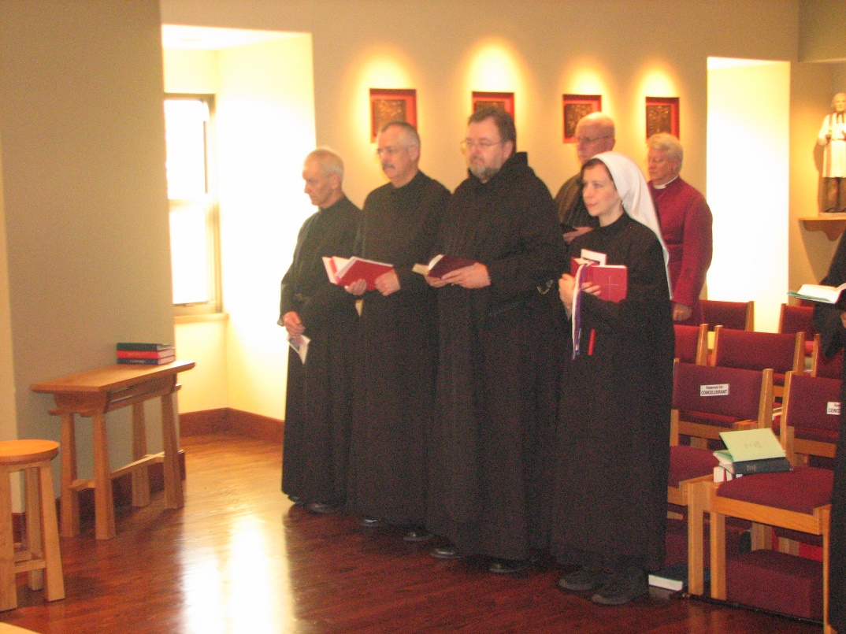
Br. Joseph Olderr; Br. Dunstan Townsend; Br. Samuel Saterstrom; Br. David Vincent Cotton; Sr. Veronica Taylor; Bp. Dean Wolfe

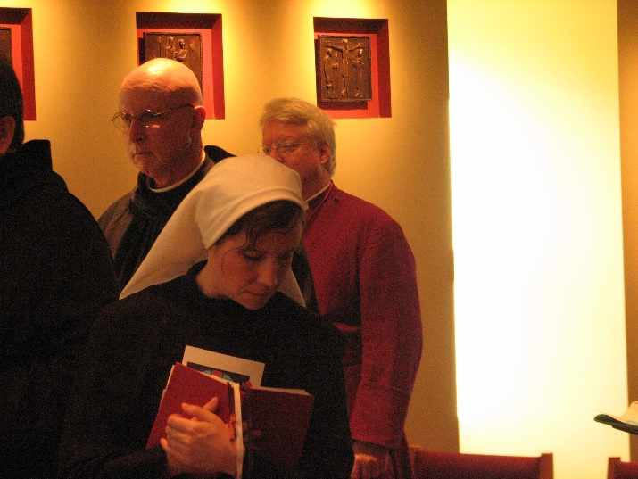
Br. David Vincent Cotton; Sr. Vernoica Taylor; Bp. Dean Wolfe
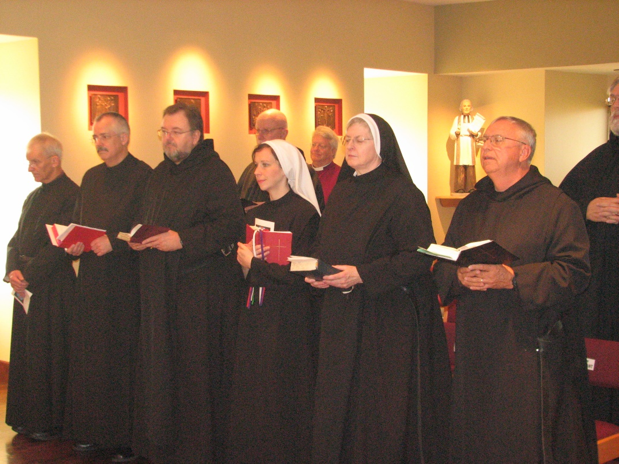
Br. Joseph Olderr; Br. Dunstan Townsend; Br. Samuel Saterstrom; Br. David Vincent Cotton; Sr. Veronica Taylor; Bp. Dean Wolfe; Sr. Bernadette Barrett; Br. Bede Leach; Br. Chad Anselm Gerns

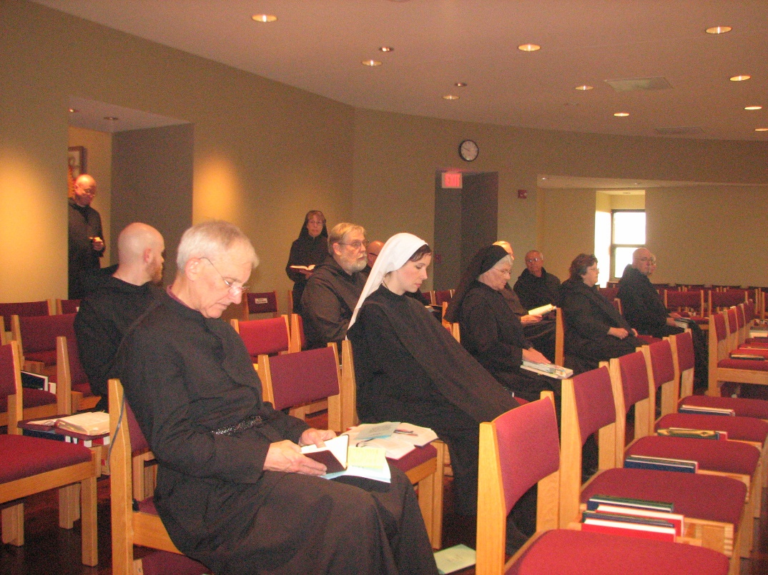
Br. David Vincent Cotton; Br. Gregory Kingsley; Br. Joseph Olderr; Sr. Monica Ruth Mullen; Br. Chad Anselm Gerns; Br. Stephen Francis Arnold; Sr. Veronica Taylor; Sr. Mary Francis Deulen; Br. Luke Doucette; Br. Bede Leach; Sr. Cecelia Lamoy; Br. Basil Edwards;
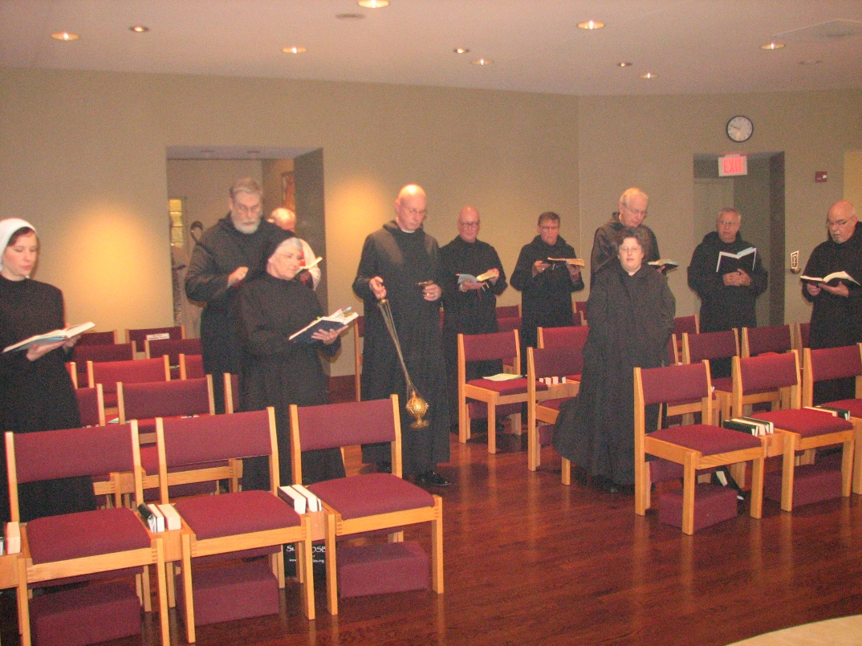
Sr. Veronica Taylor; Br. Chad Anselm Gerns; Sr. Mary Francis Deulen; Fr. Wayne Kamm; Br. David Vincent Cotton; Br. Stephen Francis Arnold; Br. Camillus Converse; Sr Cecelia Lamoy; Br. Luke Doucette; Br. Bede Leach; Br. Basil Edwards

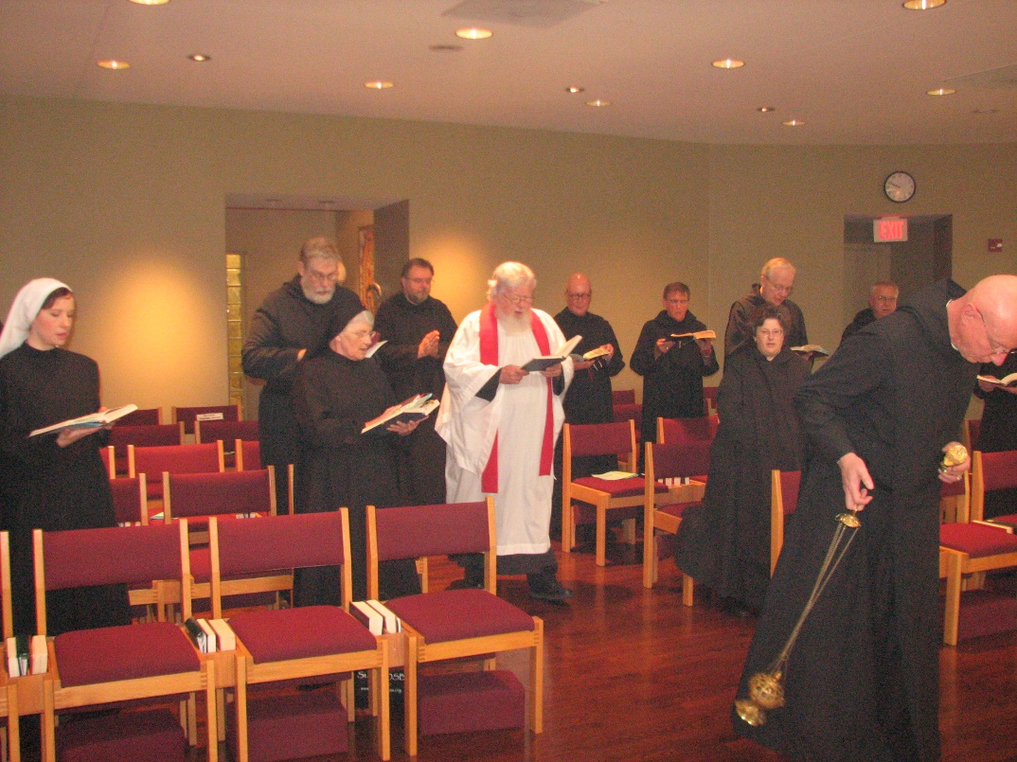
Sr. Veronica Taylor; Br. Chad Anselm Gerns; Sr. Mary Francis Deulen; Br. Samuel Saterstrom; Fr. Wayne Kamm; Br. Stephen Francis Arnold; Br. Camillus Converse; Sr Cecelia Lamoy; Br. Luke Doucette; Br. Bede Leach; Br. David Vincent Cotton;
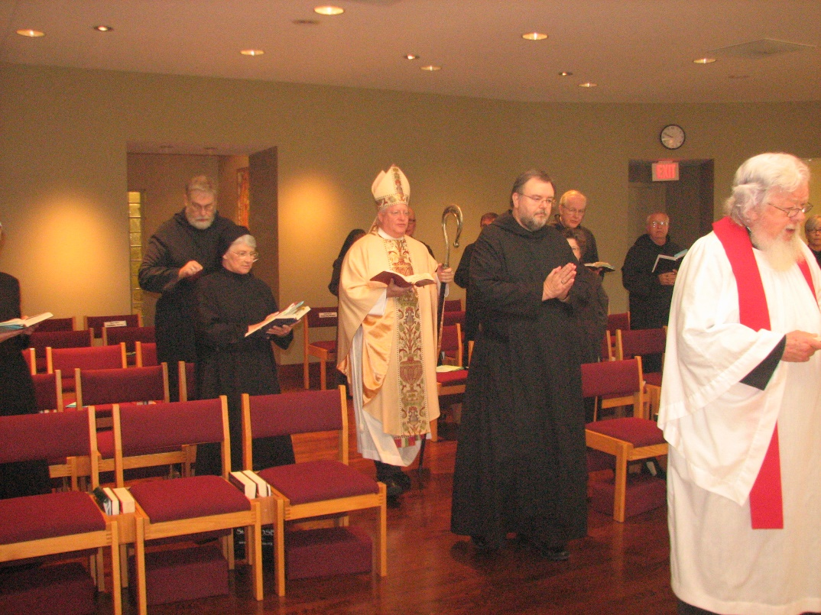
Br. Chad Anselm Gerns; Sr. Mary Francis Deulen; Sr. Monica Ruth Mullen; Bp. Dean Wolfe; Br. Stephen Francis Arnold; Br. Camillus Converse; Br. Samuel Saterstrom; Br. Luke Doucette; Sr. Cecelia Lamoy; Br. Bede Leach; Fr. Wayne Kamm

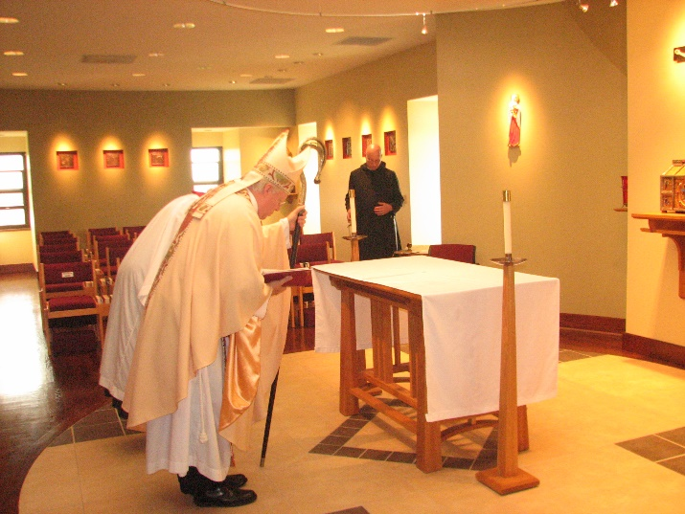
Bp. Dean Wolfe; Br. David Vincent Cotton
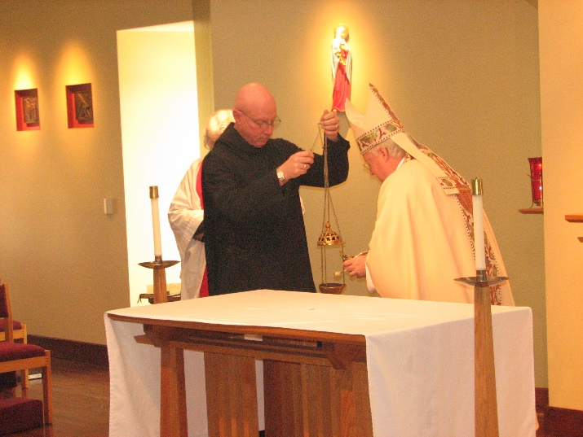
Fr. Wayne Kamm; Br. David Vincent Cotton; Bp. Dean Wolfe

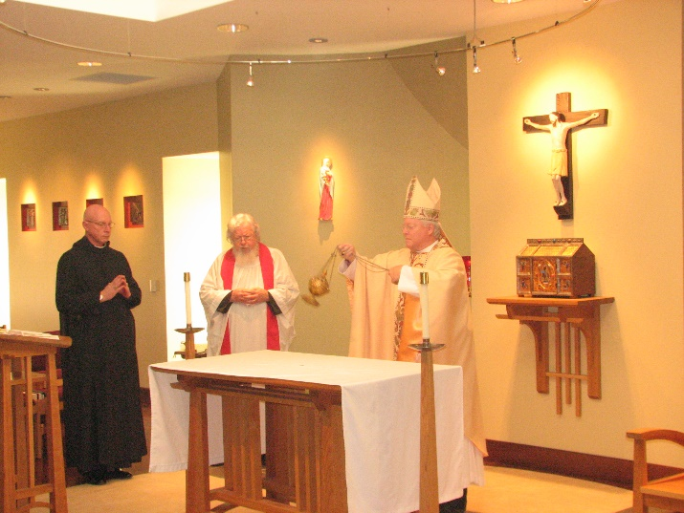
Br. David Vincent Cotton; Fr. Wayne Kamm; Bp. Dean Wolfe

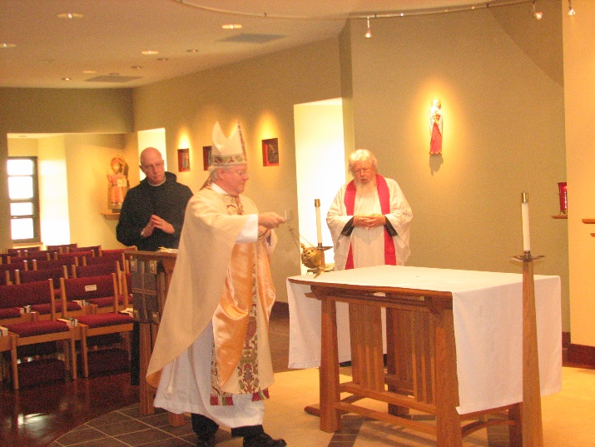
Br. David Vincent Cotton; Bp. Dean Wolfe; Fr. Wayne Kamm

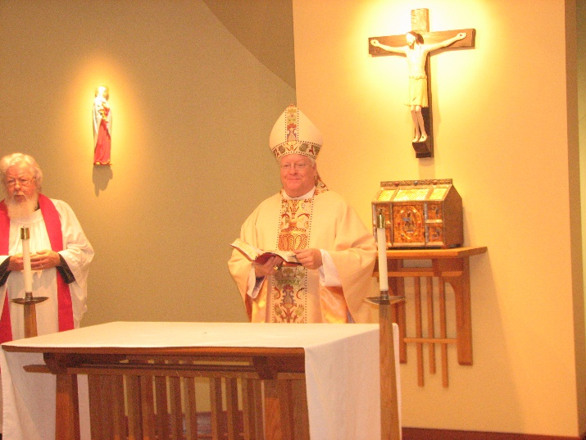
Fr. Wayne Kamm; Bp. Dean Wolfe

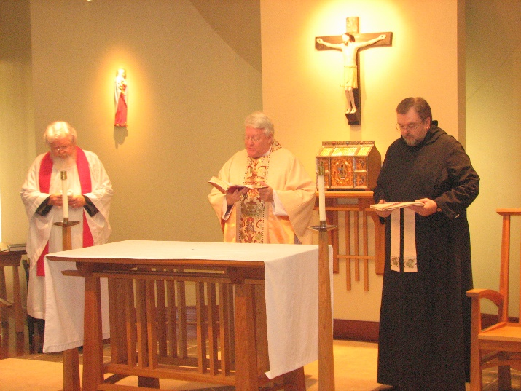
Fr. Wayne Kamm; Bp. Dean Wolfe; Br. Samuel Saterstrom

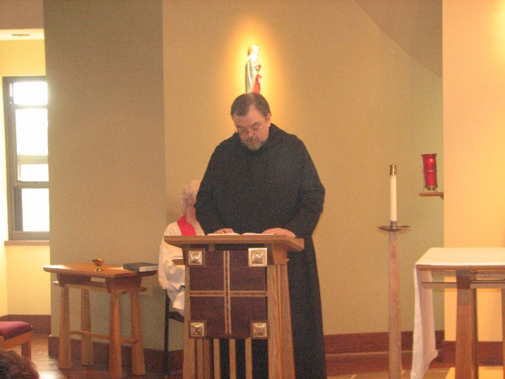
Fr. Wayne Kamm

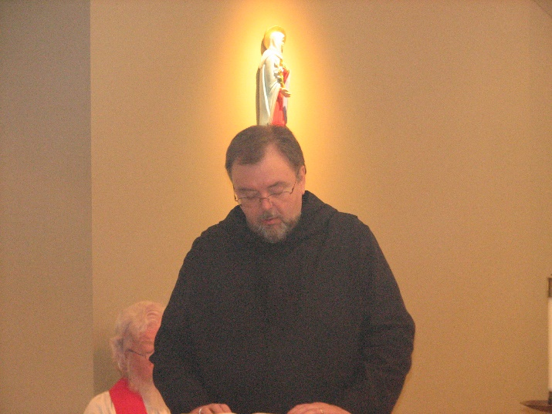
Fr. Wayne Kamm

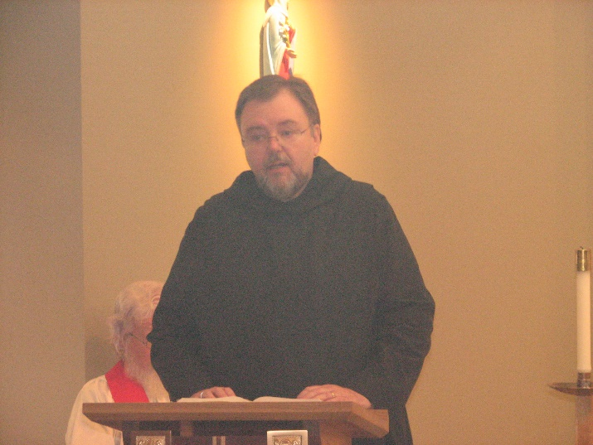
Fr. Wayne Kamm

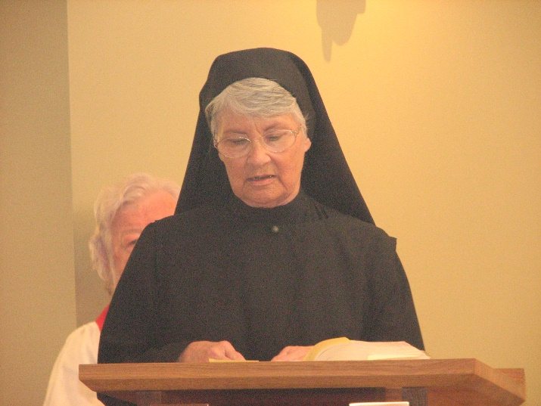
Fr. Wayne Kamm; Sr. Mary Francis Deulen

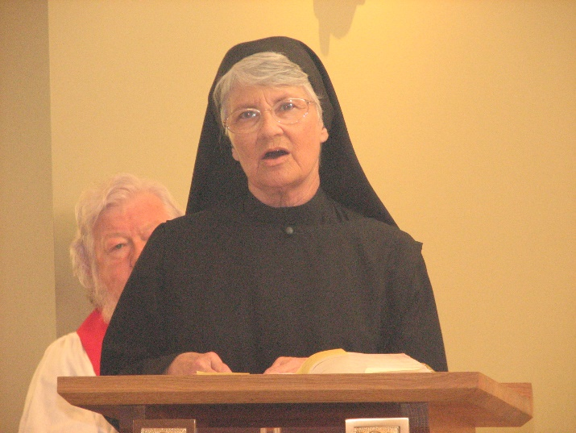
Fr. Wayne Kamm; Sr. Mary Francis Deulen

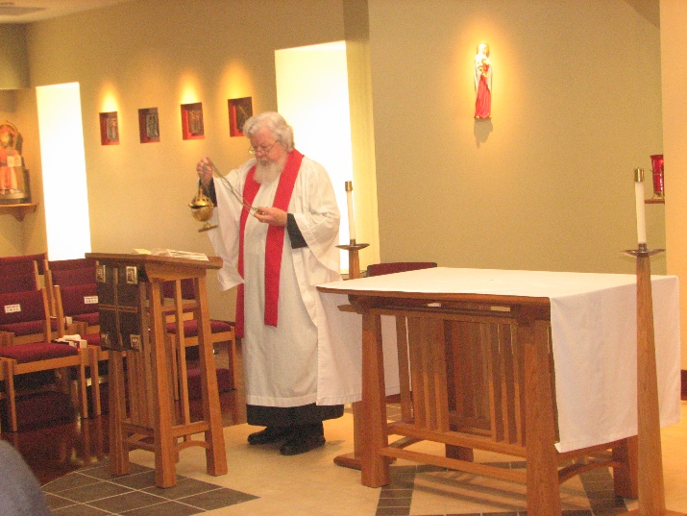
Fr. Wayne Kamm

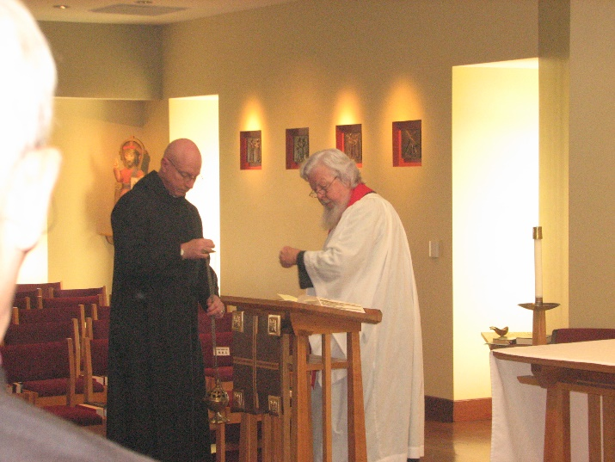
Br. David Vincent Cotton; Fr. Wayne Kamm

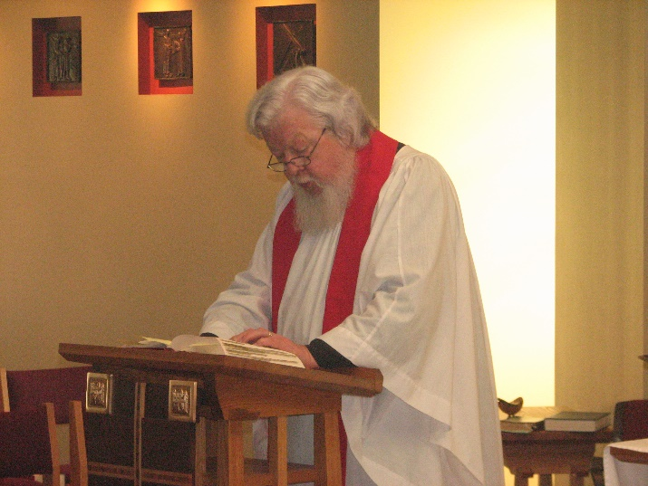
Fr. Wayne Kamm

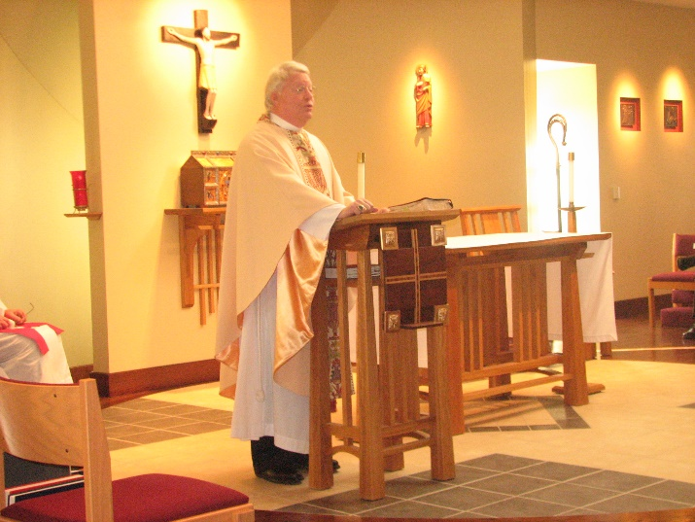
Bp. Dean Wolfe

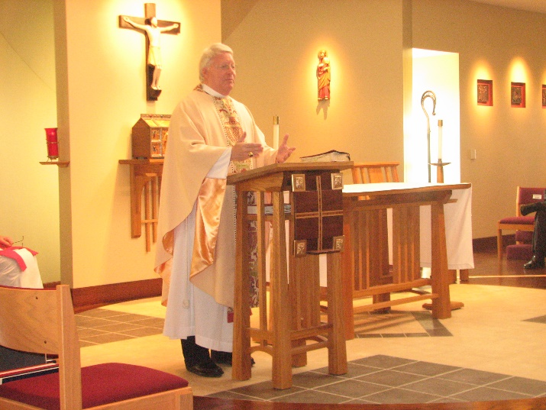
Bp. Dean Wolfe
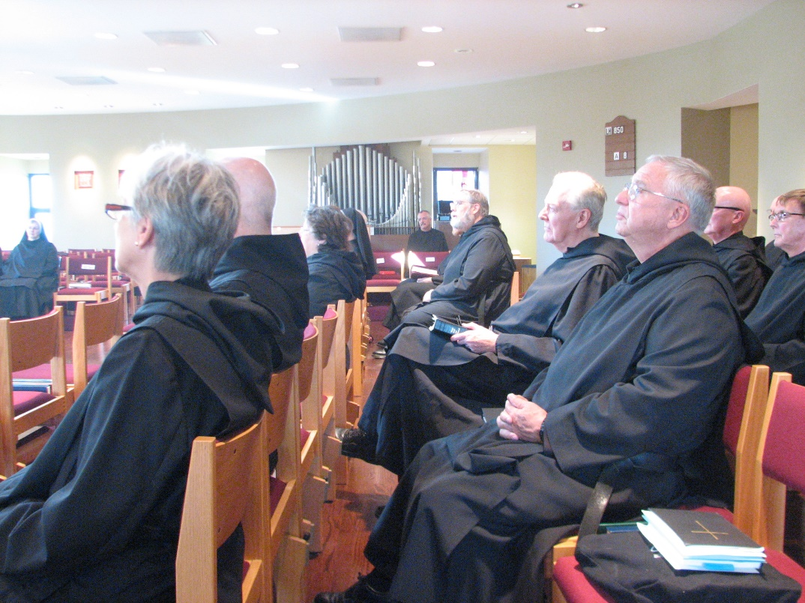
Sr. Bernadette Barrett; Sr. Julian Saterstrom; Br. Basil Edwards; Sr. Cecelia Lamoy; Sr. Mary Francis Deulen; Br. Dunstan Townsend; Br. Chad Anselm Gerns; Br. Luke Doucette; Br. Bede Leach; Br. Stephen Francis Arnold; Br. Camillus Converse

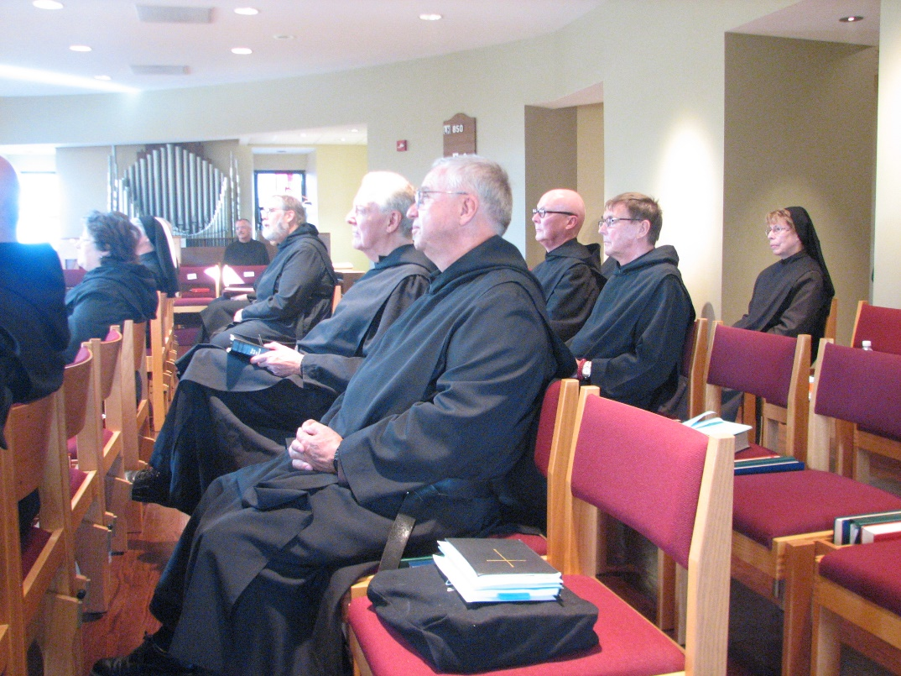
Br. Basil Edwards; Sr. Cecelia Lamoy; Sr. Mary Francis Deulen; Br. Dunstan Townsend; Br. Chad Anselm Gerns; Br. Luke Doucette; Br. Bede Leach; Br. Stephen Francis Arnold; Br. Camillus Converse; Sr. Monica Ruth Mullen
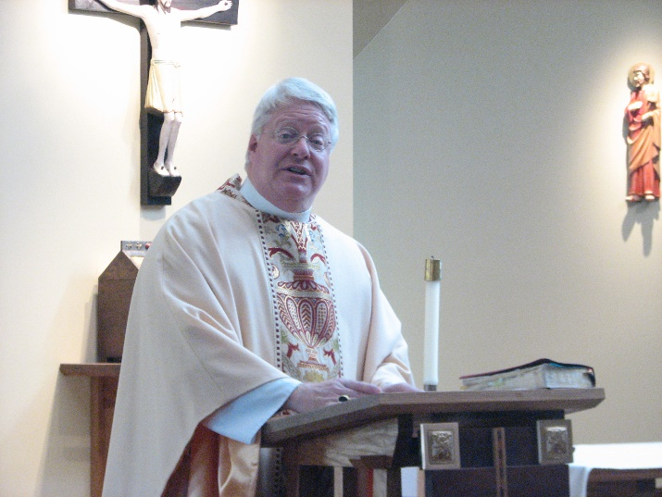
Bp. Dean Wolfe

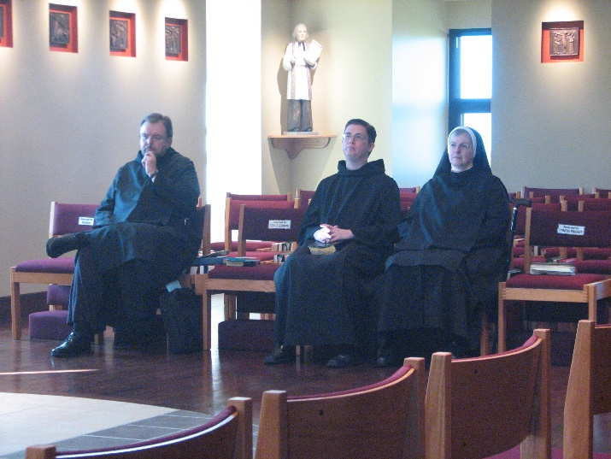
Br. Samuel Saterstrom; Br. Aidan Maguire; Sr. Bernadette Barrett

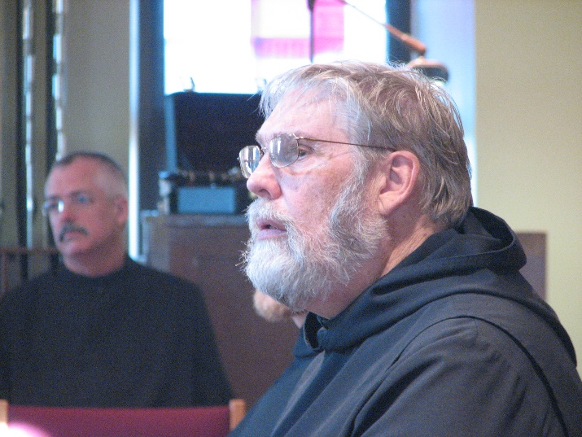
Br. Dunstan Townsend; Br. Chad Anselm Gerns
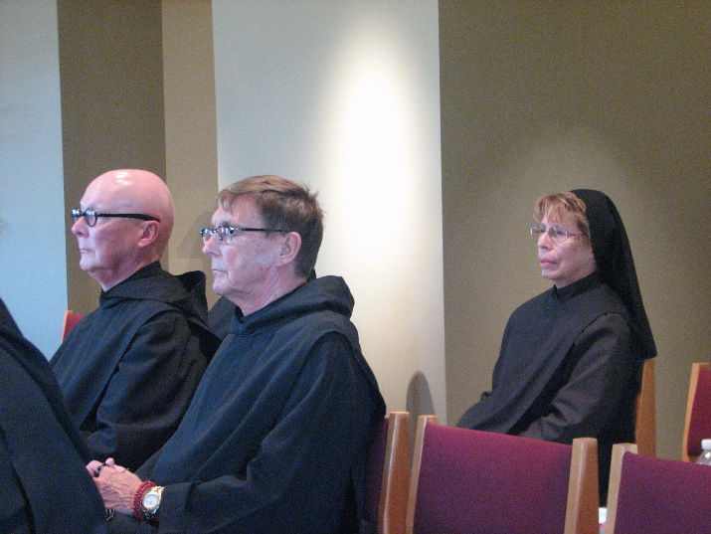
Br. Stephen Francis Arnold; Br. Camillus Converse; Sr. Monica Ruth Mullen
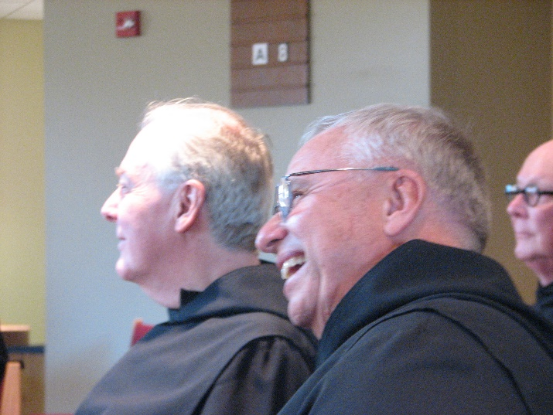
Br. Luke Doucette; Br. Bede Leach; Br. Stephen Francis Arnold

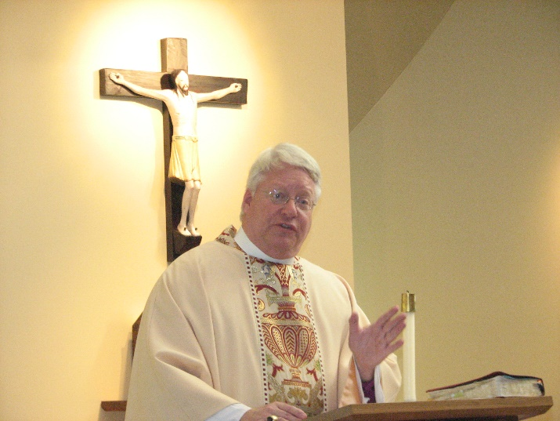
Bp. Dean Wolfe
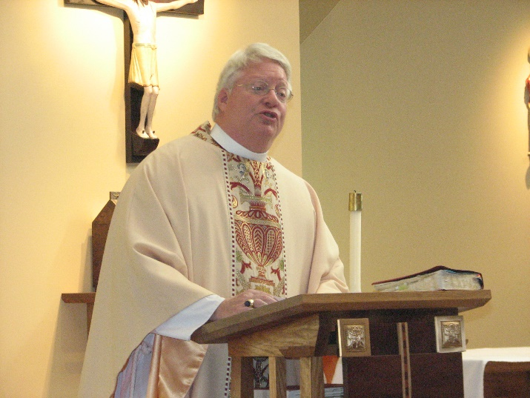
Bp. Dean Wolfe

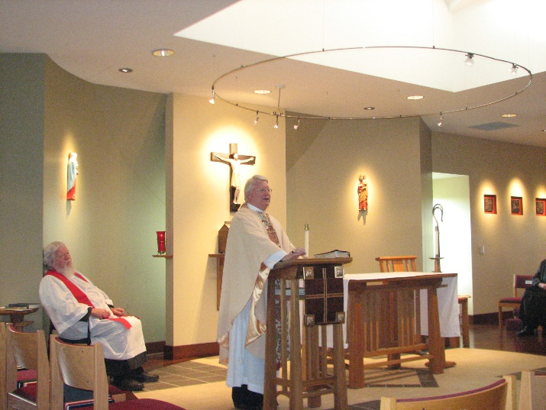
Fr. Wayne Kamm; Bp. Dean Wolfe

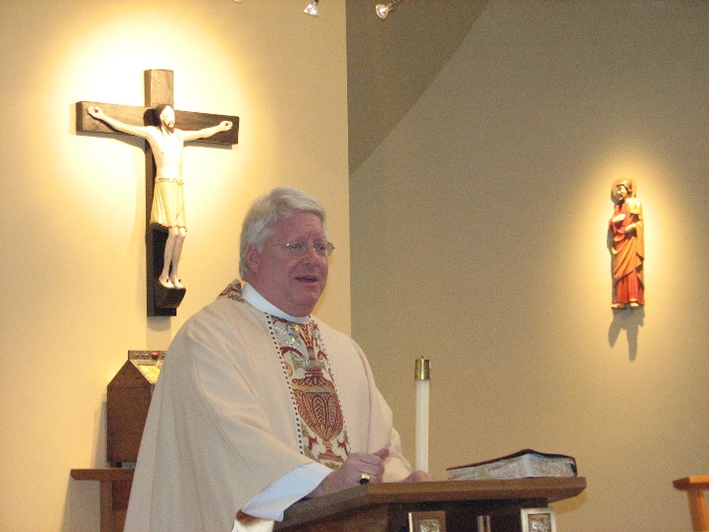
Bp. Dean Wolfe
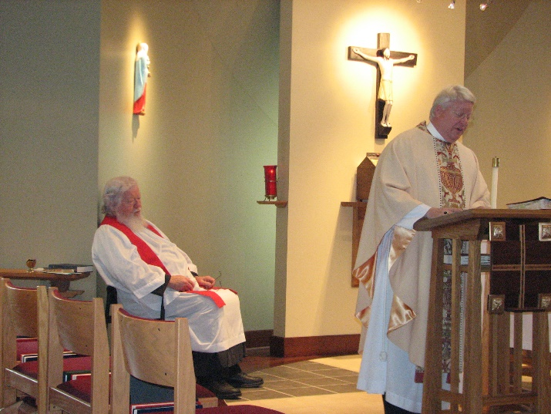
Fr. Wayne Kamm; Bp. Dean Wolfe

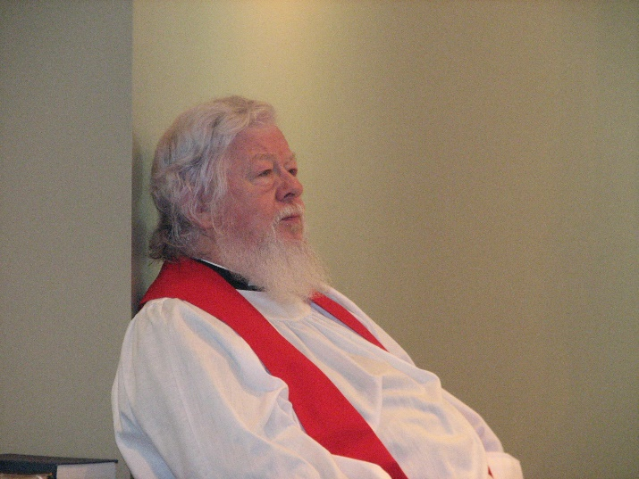
Fr. Wayne Kamm

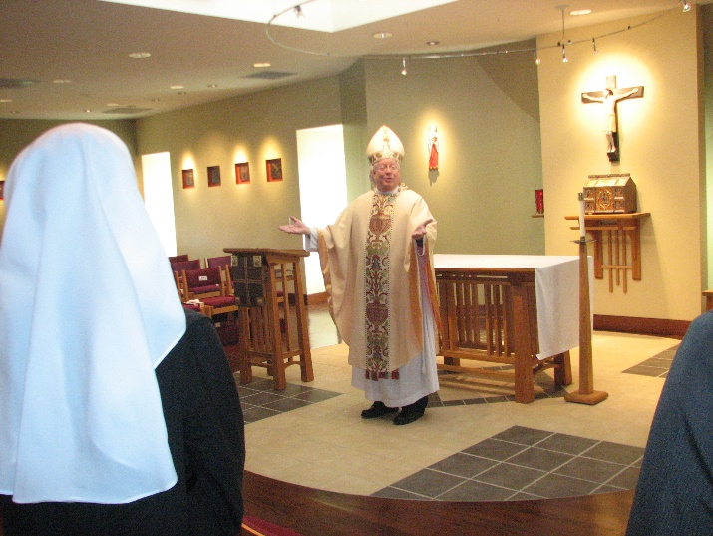
Sr. Veronica Taylor; Bp. Dean Wolfe

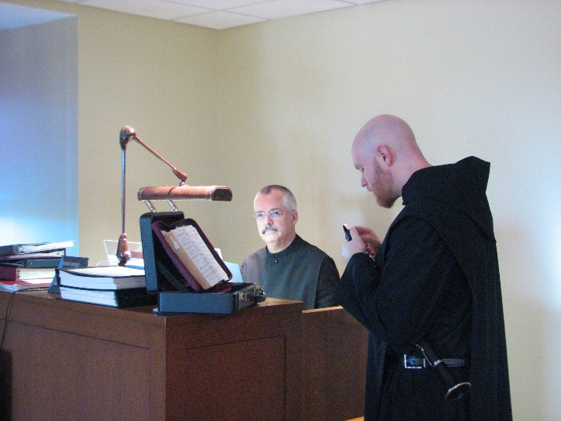
Br. Dunstan Townsend; Br. Gregory Kingsley

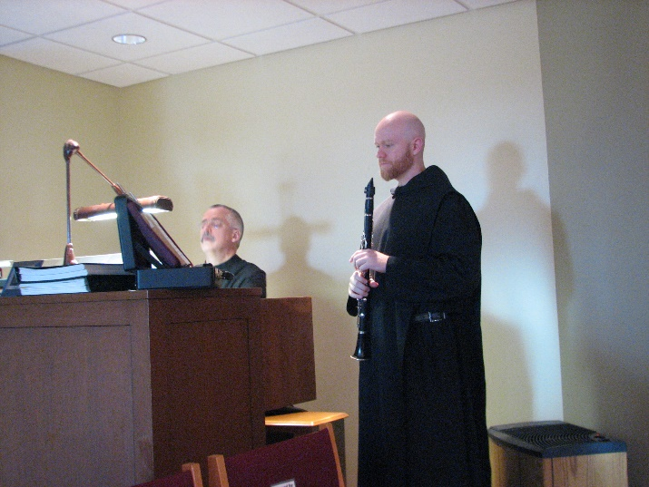
Br. Dunstan Townsend; Br. Gregory Kingsley

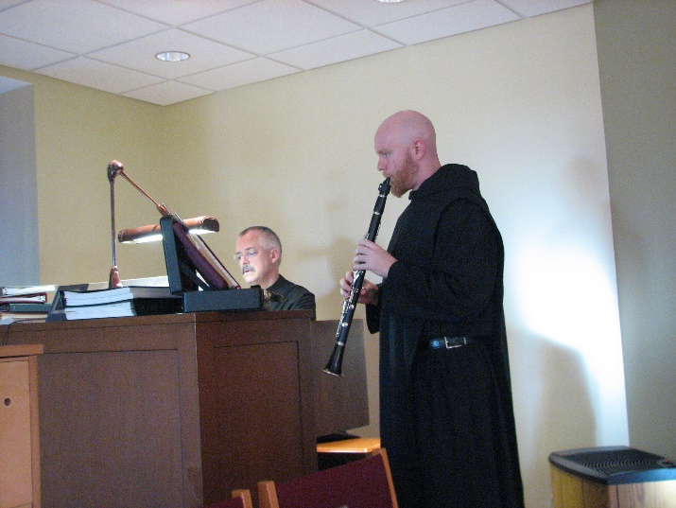
Br. Dunstan Townsend; Br. Gregory Kingsley

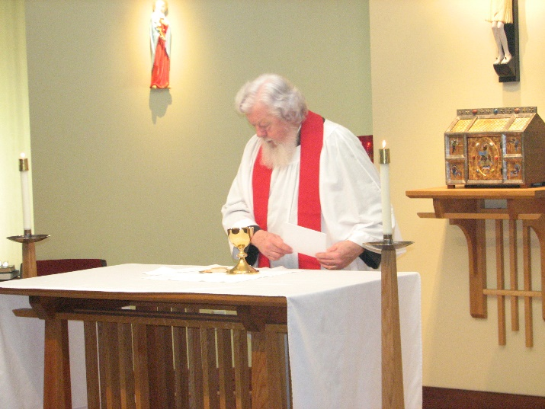
Fr. Wayne Kamm

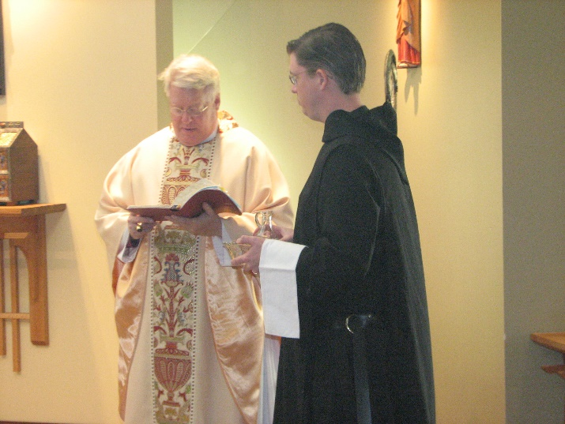
Bp. Dean Wolfe; Br. Aidan Maguire

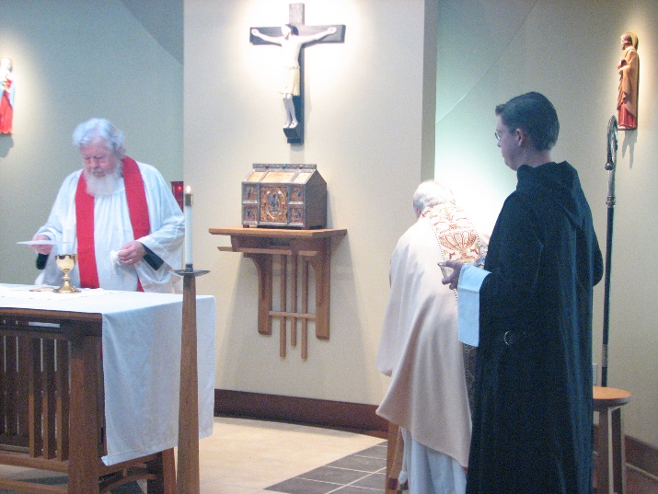
Fr. Wayne Kamm; Bp. Dean Wolfe; Br. Aidan Maguire

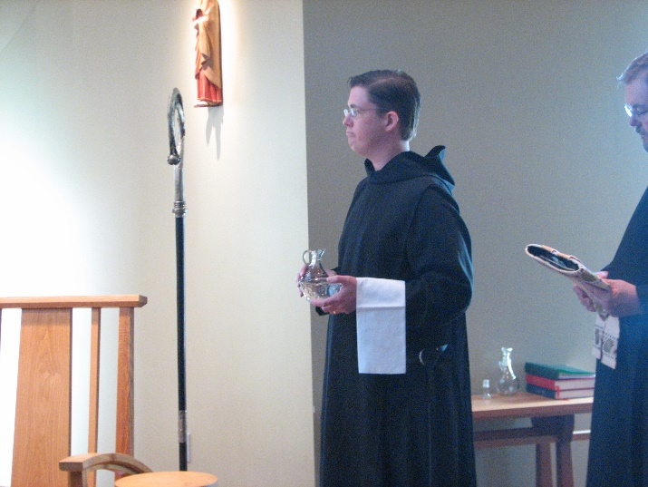
Br. Aidan Maguire; Br. Samuel Saterstrom

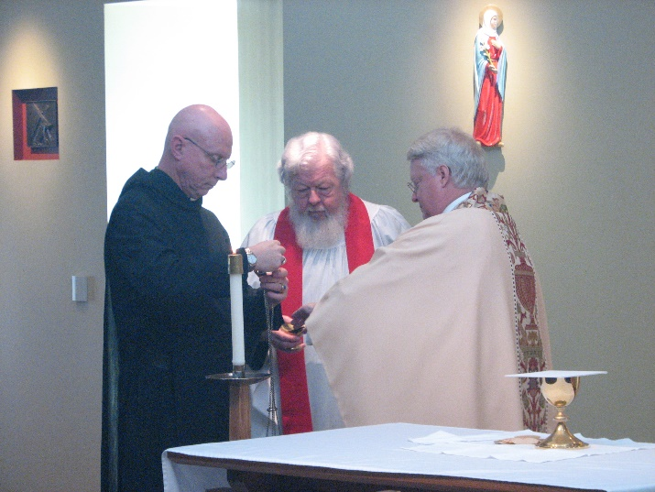
Br. David Vincent Cotton; Fr. Wayne Kamm; Bp. Dean Wolfe

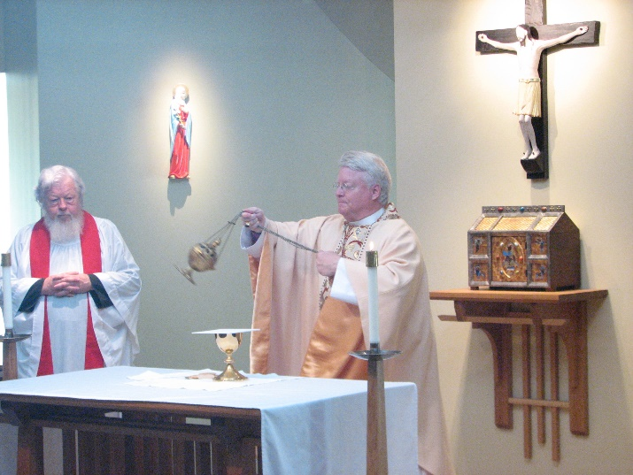
Fr. Wayne Kamm; Bp. Dean Wolfe

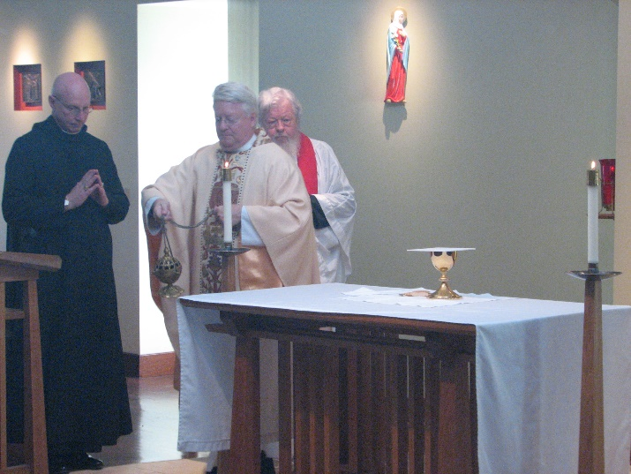
Br. David Vincent Cotton; Bp. Dean Wolfe; Fr. Wayne Kamm

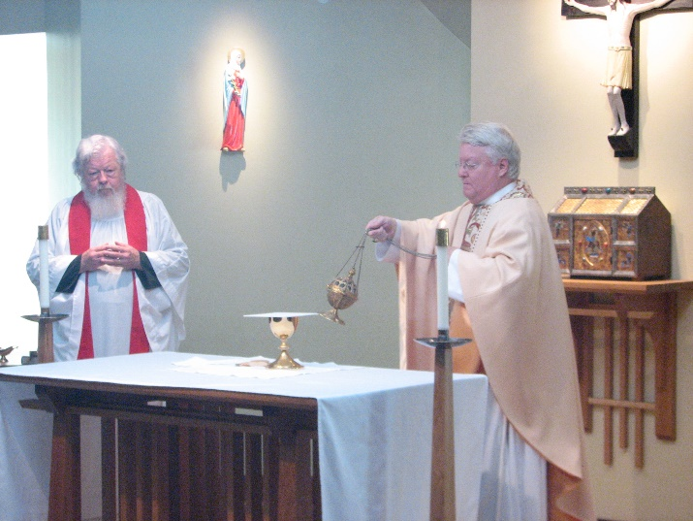
Fr. Wayne Kamm; Bp. Dean Wolfe

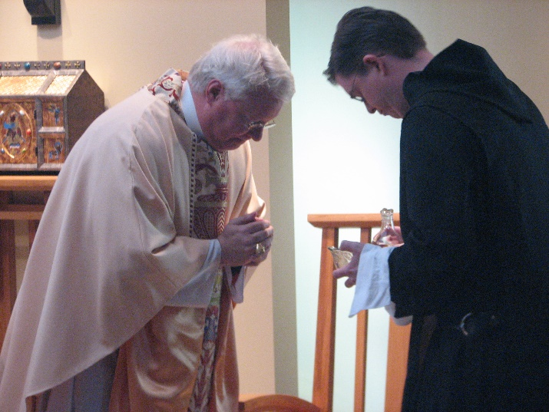
Bp. Dean Wolfe; Br. Aidan Maguire
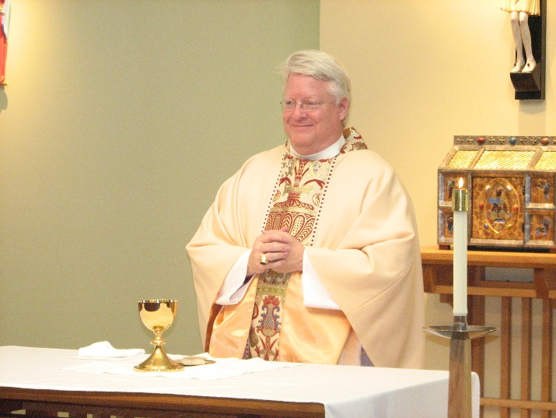
Bp. Dean Wolfe

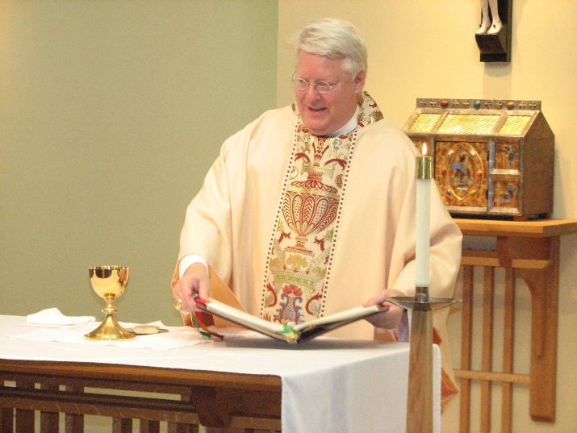
Bp. Dean Wolfe

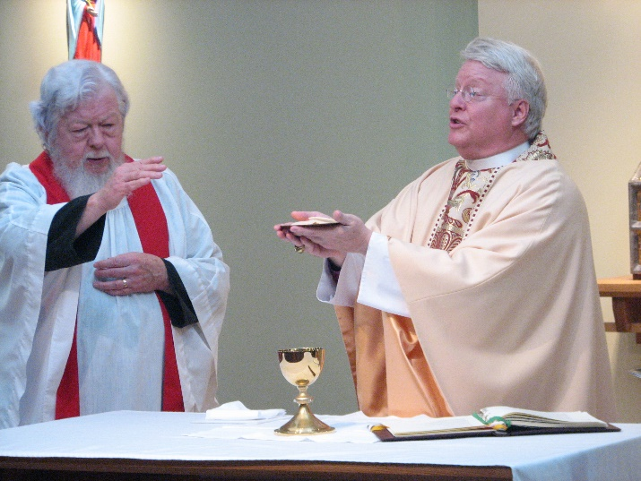
Fr. Wayne Kamm; Bp. Dean Wolfe

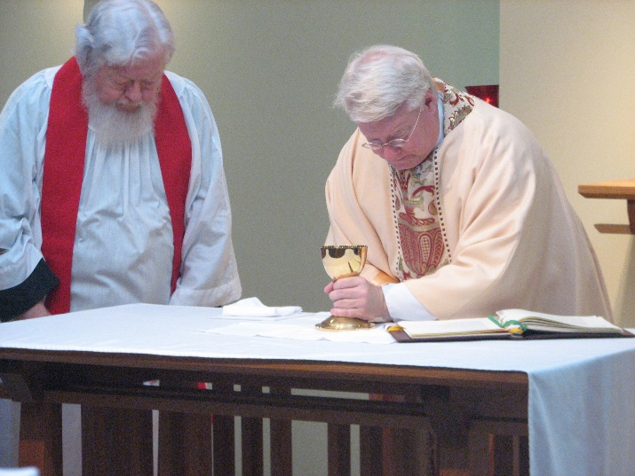
Fr. Wayne Kamm; Bp. Dean Wolfe

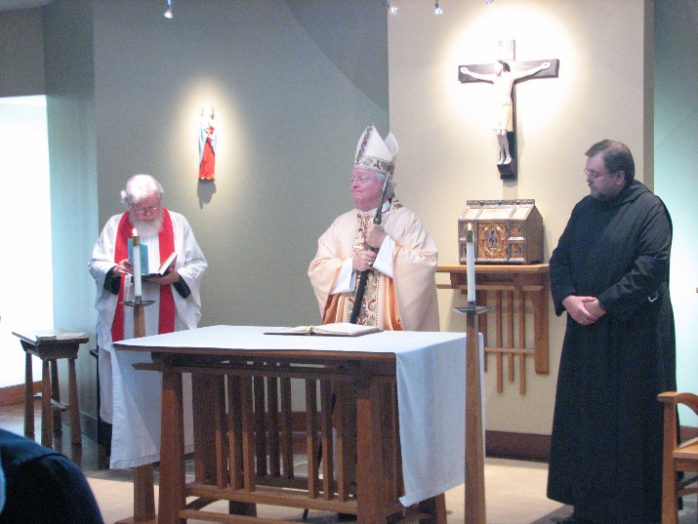
Fr. Wayne Kamm; Bp. Dean Wolfe; Br. Samuel Saterstrom

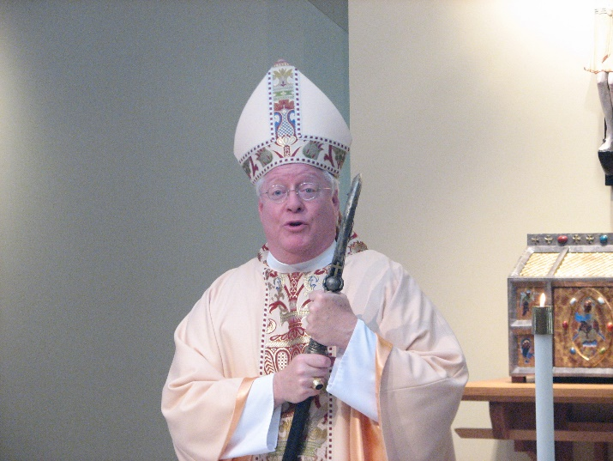
Bp. Dean Wolfe
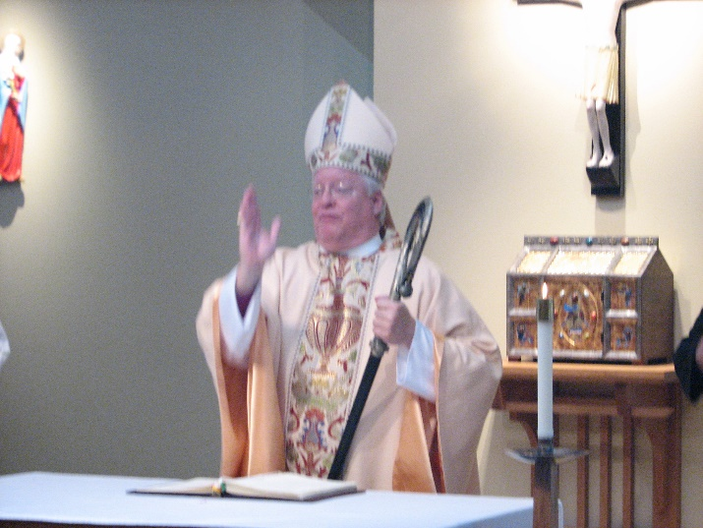
Bp. Dean Wolfe

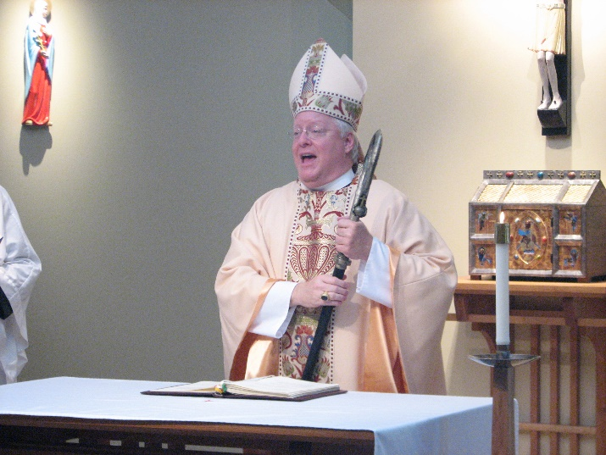
Bp. Dean Wolfe

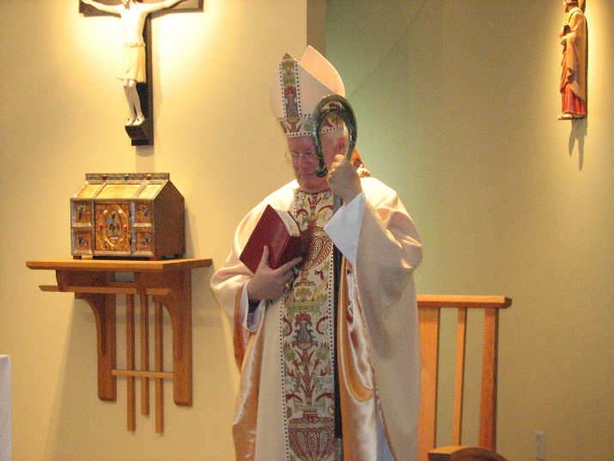
Bp. Dean Wolfe
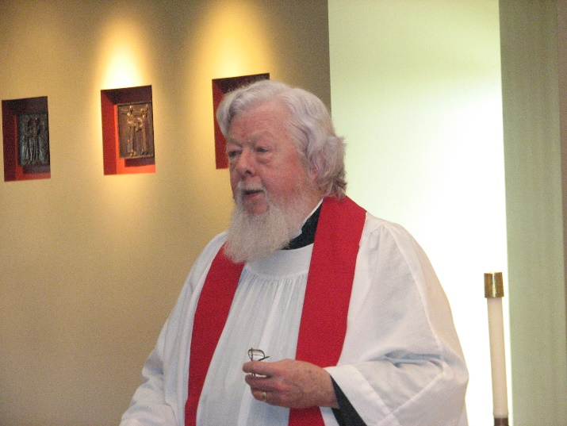
Fr. Wayne Kamm

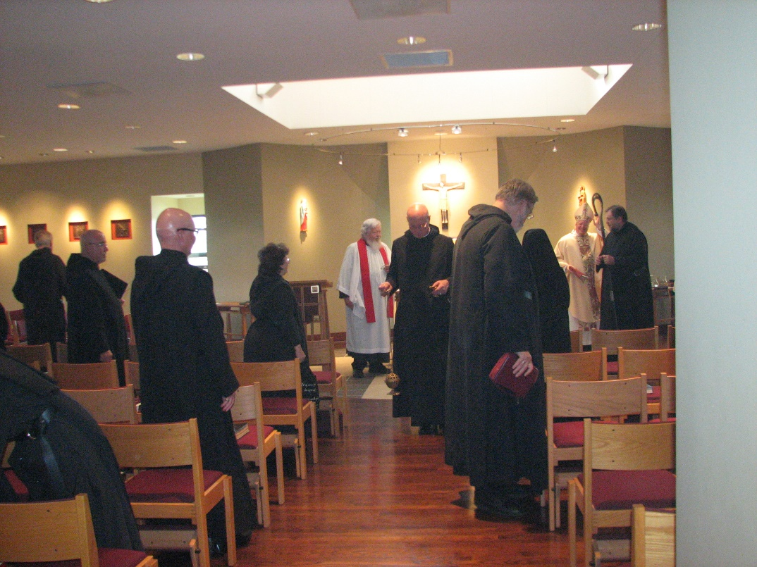
Br. Luke Doucette; Br. Basil Edwards; Br. Stephen Francis Arnold; Sr. Cecelia Lamoy; Fr. Wayne Kamm; Br. David Vincent Cotton; Br. Chad Anselm Gerns; Sr. Mary Francis Deulen; Bp. Dean Wolfe; Br. Samuel Saterstrom

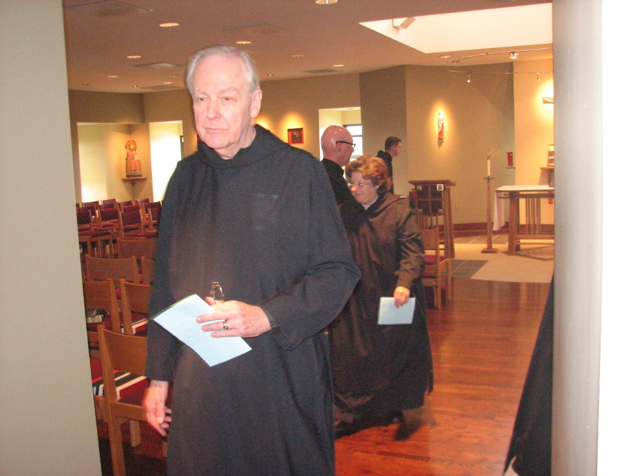
Br. Luke Doucette; Br. Stephen Francis Arnold; Sr. Cecelia Lamoy; Br. Aidan Maguire

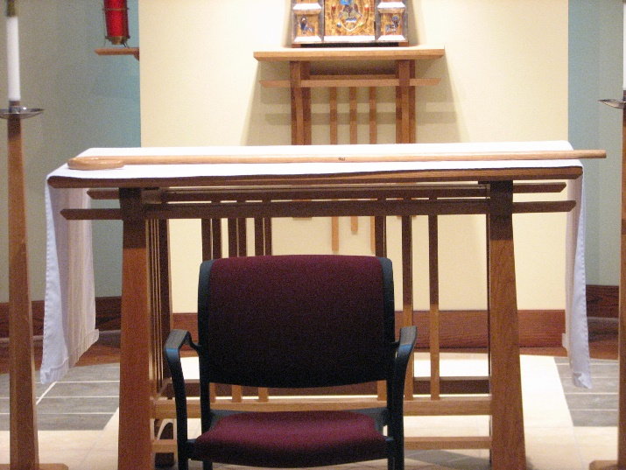
Newly purchased abbot’s staff

