**Companions of St. Luke**

**2013 Fall Convocation at Conception Abbey**

~Edited by Br. Steven Olderr, 3 March 2023. If you find any errors or omissions or have anything to add, please notify Br. Steven at [olderr@ameritech.net](mailto:olderr@ameritech.net)

People are identified from left to right.

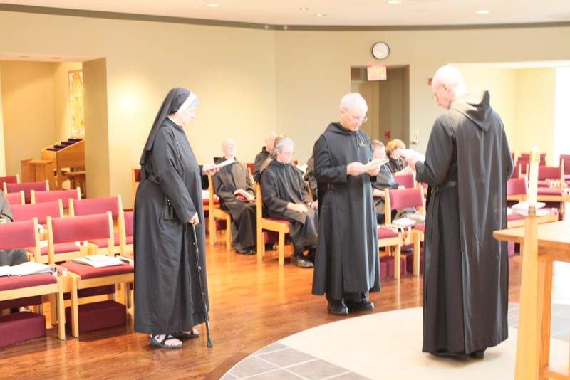

Sr. Helena Barrett; Br. Thomas Anthony Goddard; Br. Lee Doucette; Br. Anskar Nonken; Br. Steven Joseph Olderr; Sr. Kate Maxwell; Sr. Martha Lamoy

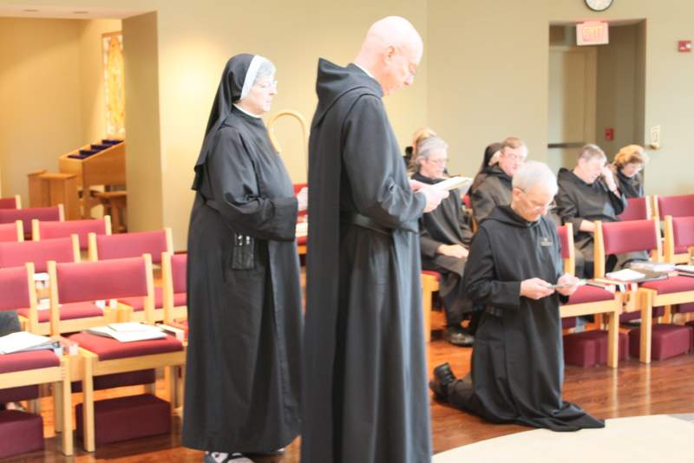

Sr. Helena Barrett; Br. Thomas Anthony Goddard; Br. Lee Doucette; Br. Anskar Nonken; Br. Victor Bullock; Br. Steven Joseph Olderr; Sr. Kate Maxwell; Sr. Martha Lamoy

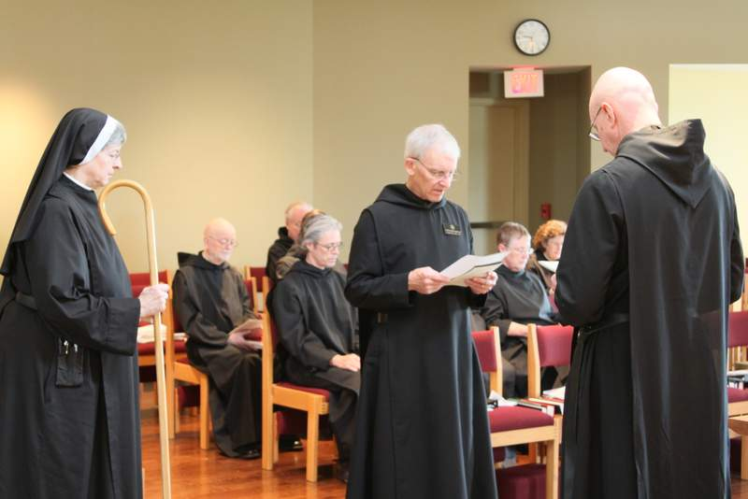

Sr. Helena Barrett; Br. Thomas Anthony Goddard; Br. Lee Doucette; Br. Anskar Nonken; Br. Steven Joseph Olderr; Sr. Kate Maxwell; Sr. Martha Lamoy

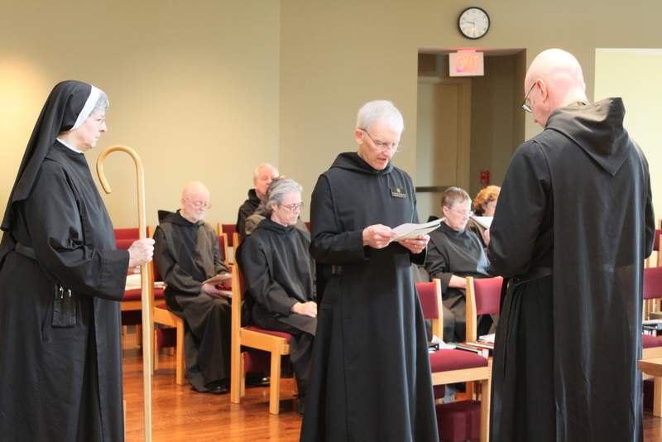

Sr. Helena Barrett; Br. Thomas Anthony Goddard; Br. Lee Doucette; Br. Anskar Nonken; Br. Steven Joseph Olderr; Sr. Kate Maxwell; Sr. Martha Lamoy

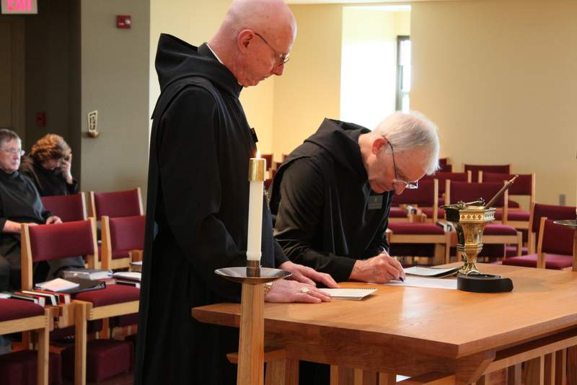

Sr. Kate Maxwell; Sr Martha Lamoy; Abbot Robert Cotton; Br. Steven Joseph Olderr