Companions of St. Luke
Construction & Dedication of Donnelson Abbey Guesthouses
June-August 2008

~Edited by Br. Steven Olderr, 6 July 2022 with the assistance of Br. Thomas Ferrell. If you find any errors or omissions or have anything to add, please notify Br. Steven at olderr@ameritech.net

People are identified from left to right.

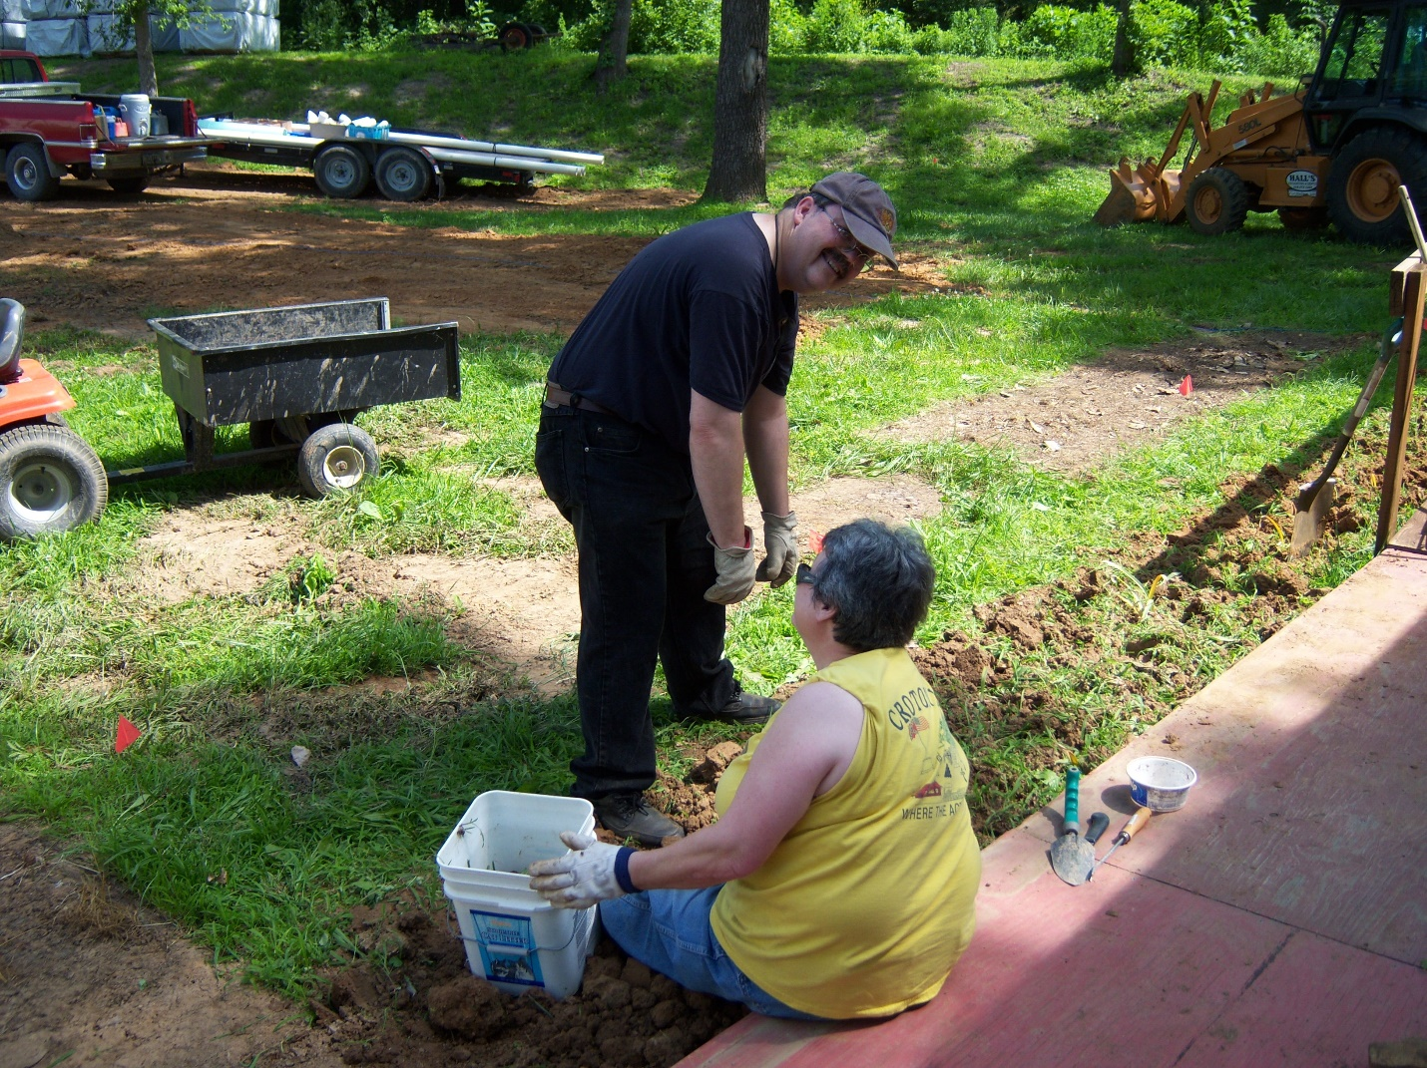
Br. Paul Howard and Sr. Vincent Marie Rittenhouse pulling weeds around St. Aelred

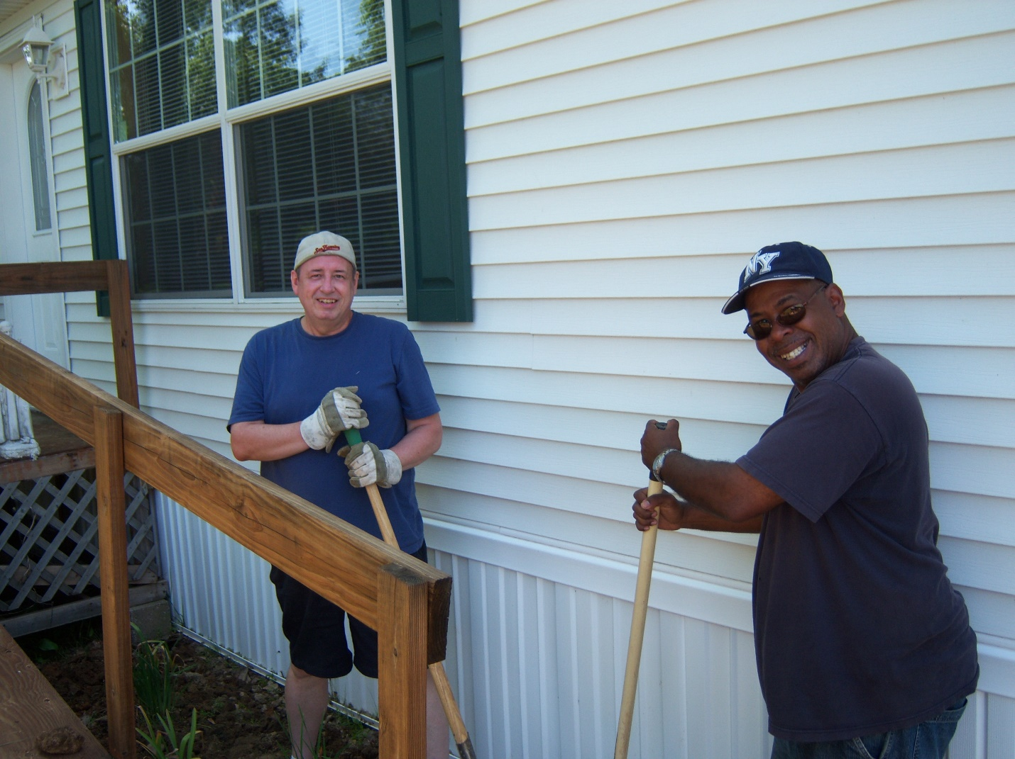
Br. Gabriel Hale and the construction company foreman

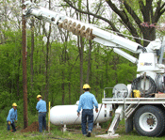
Installing electric pole

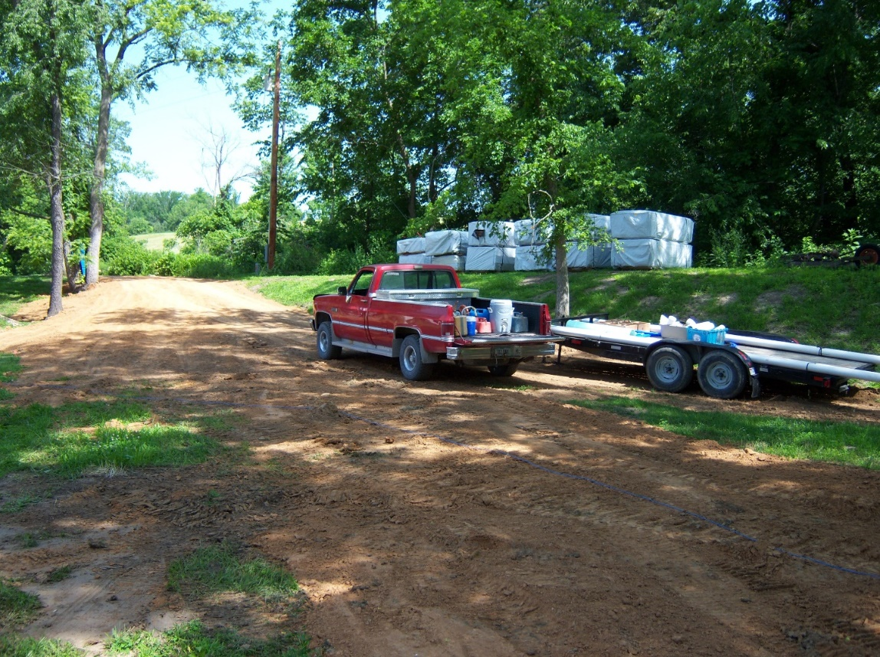
New fill for road leading to Hospitality Center. [The Hospitality Center was a trailer that also contained the library and a conference room. The trailer was removed after construction of the guest houses, one of which housed both the library and the conference room.]

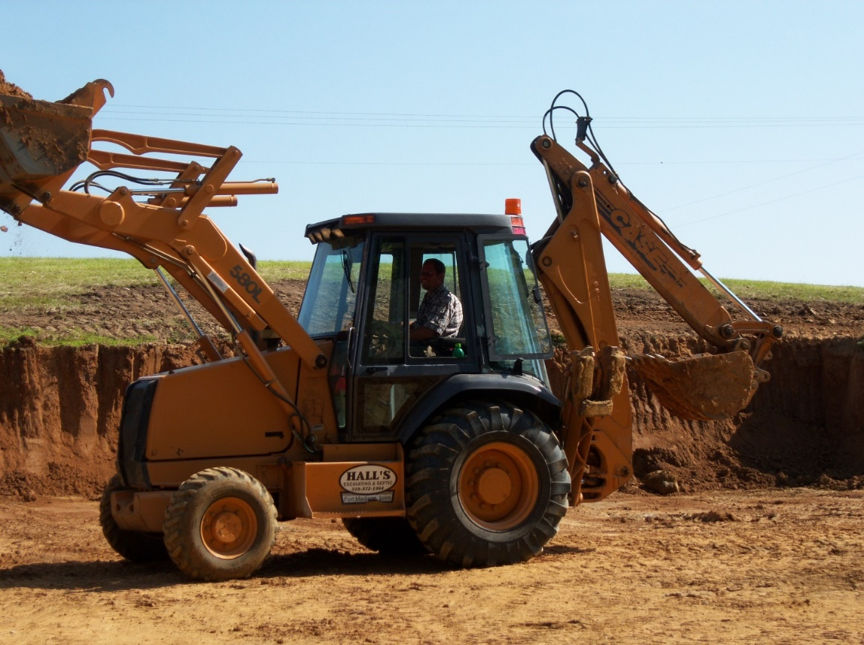
Dirt being removed from the north pasture to be used for fill—the driver is Shane Hall, a local man.

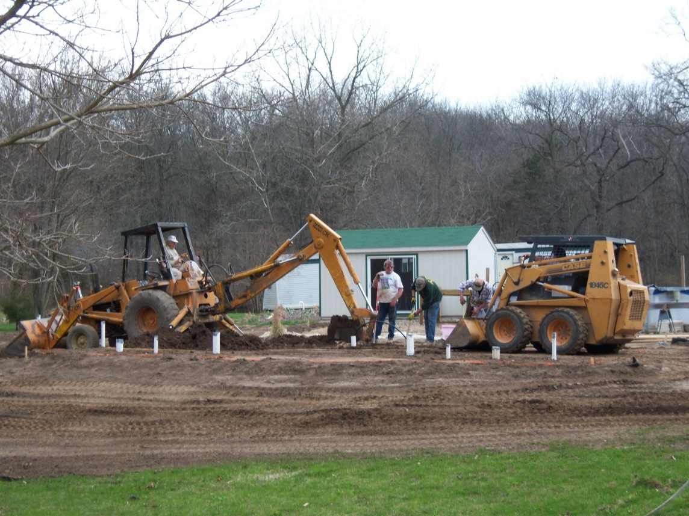

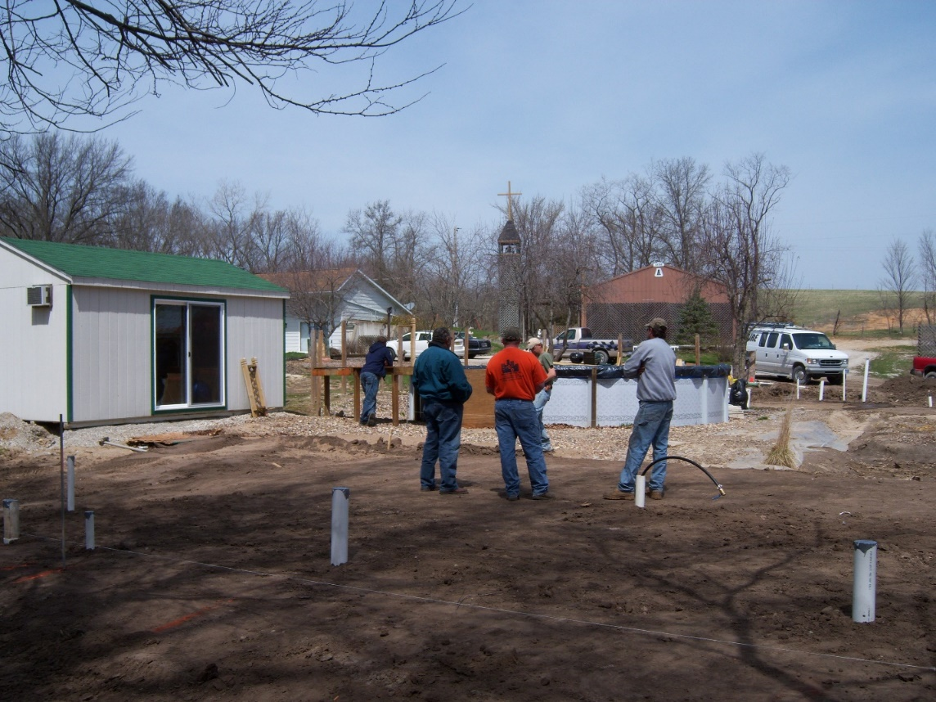
The man in the dark blue jacket standing next to the man in the red T-shirt is Lloyd Broussard, co-owner of the construction company.

Fitness center, abbey, above-ground swimming pool, and chapel in the background
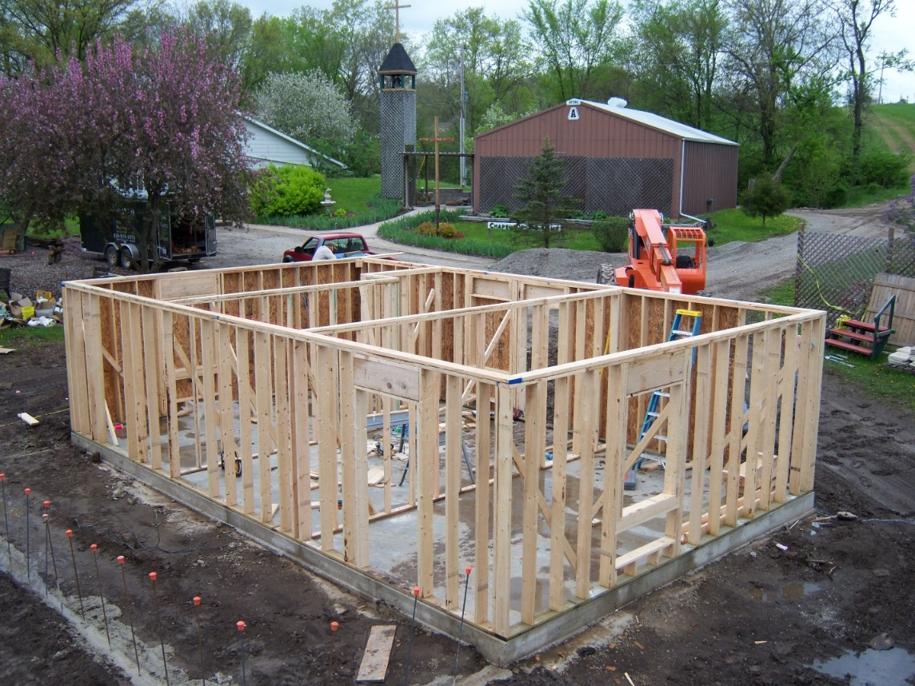
Guesthouse construction; abbey and chapel in background

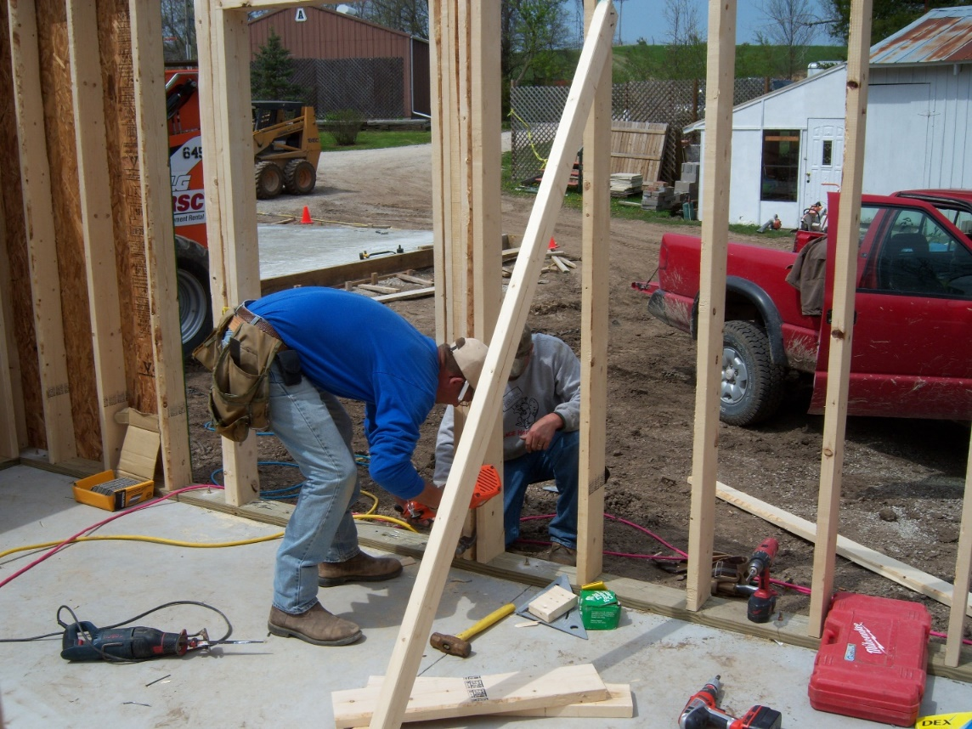
Guesthouse construction; chapel in background; white building on the right was the greenhouse
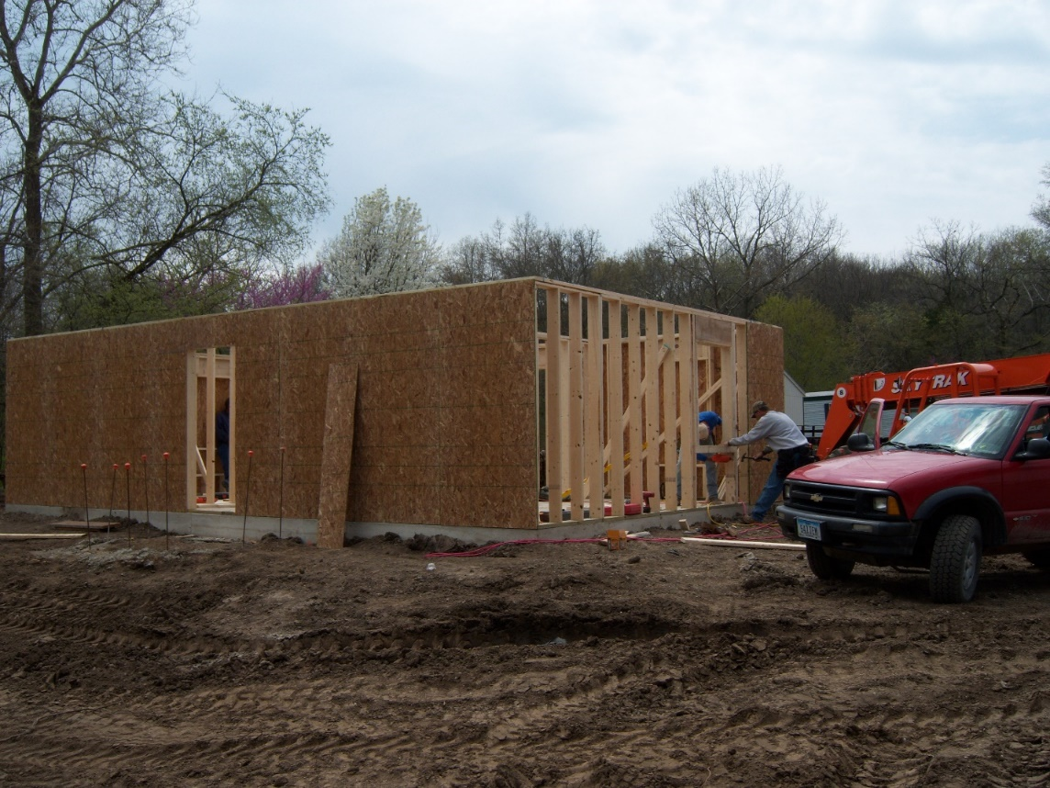

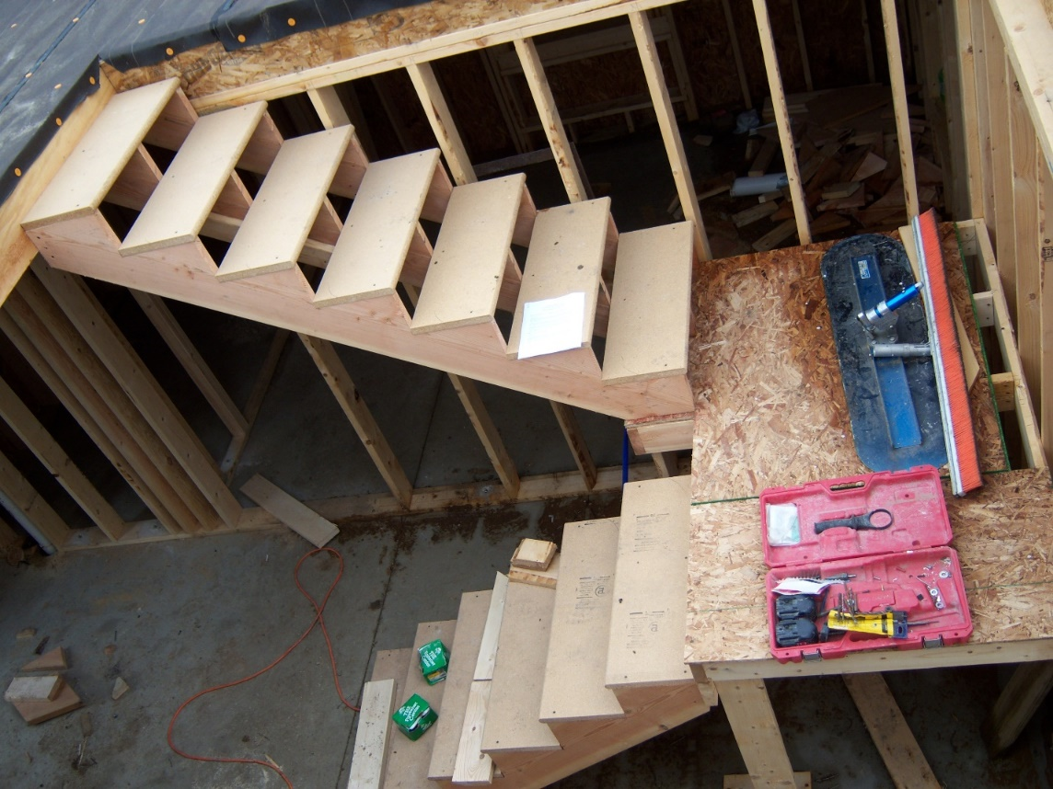

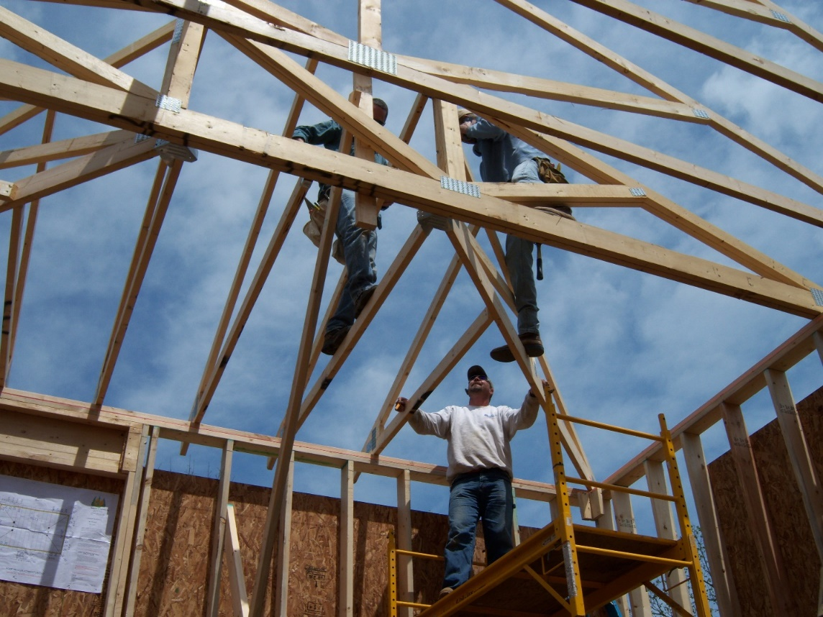

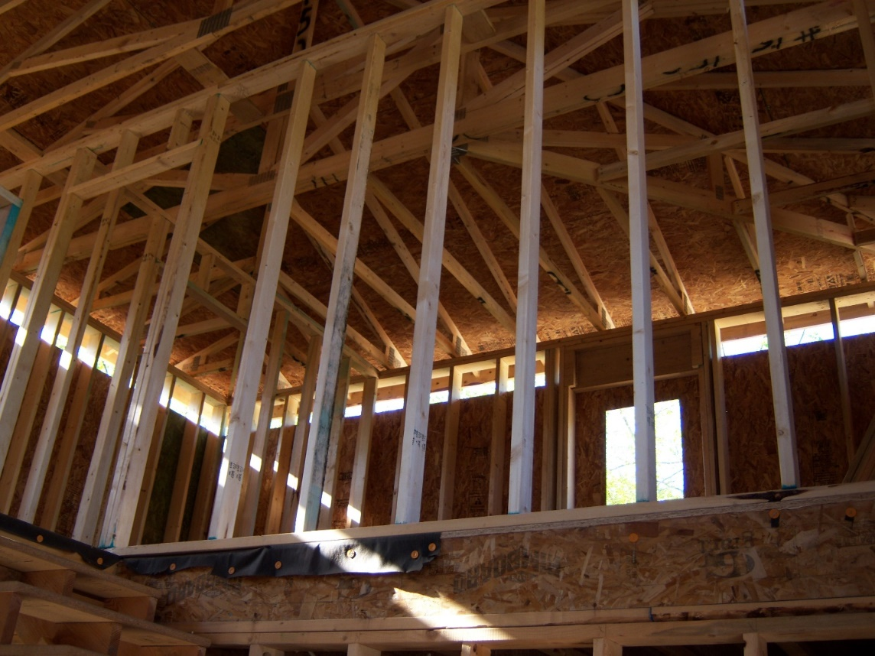
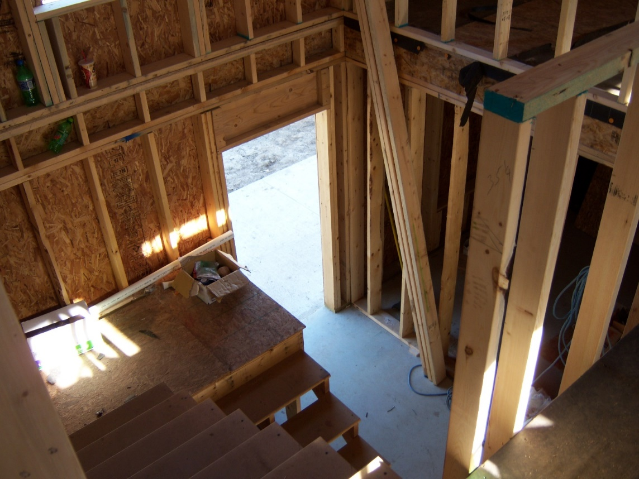

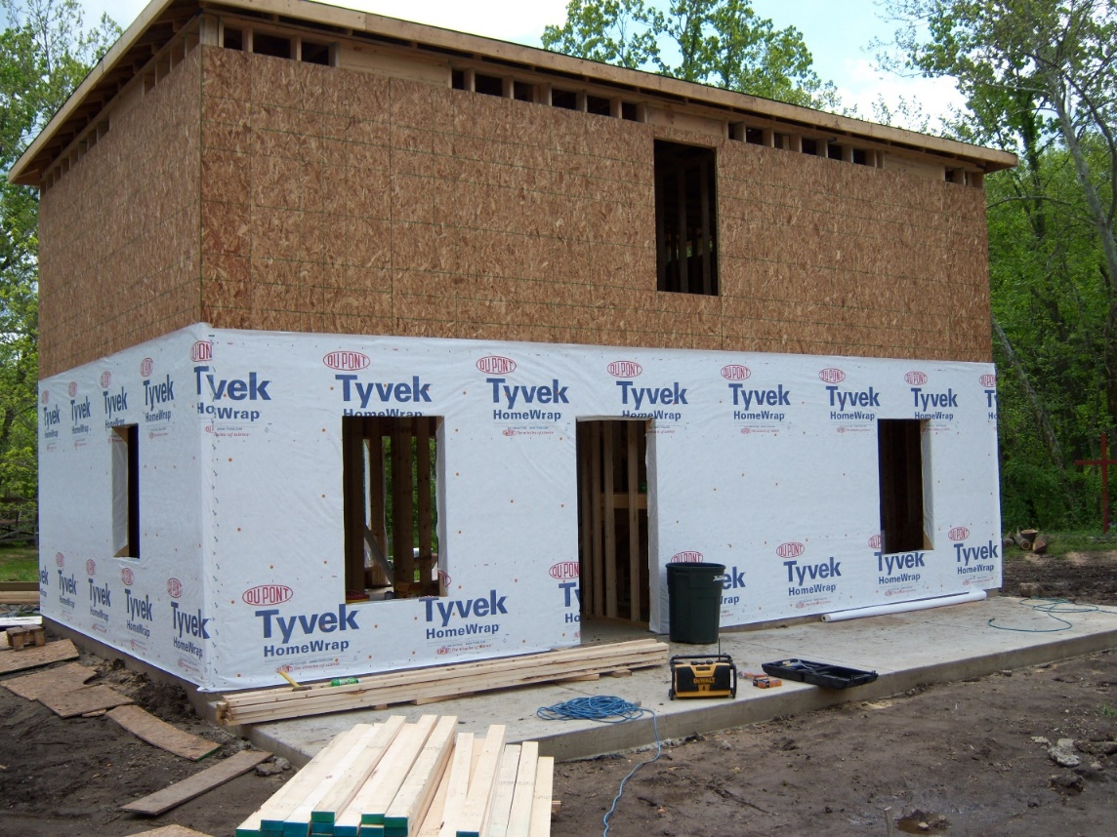

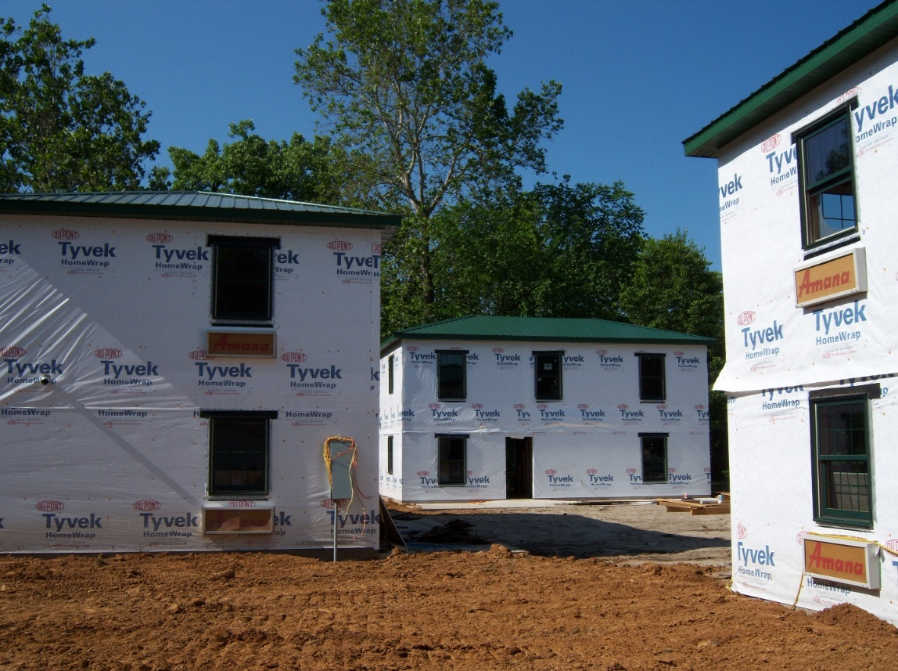

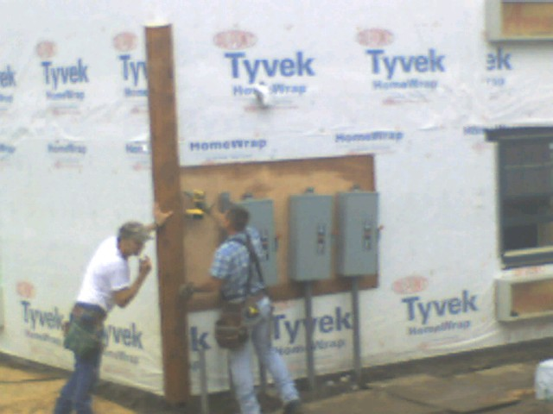

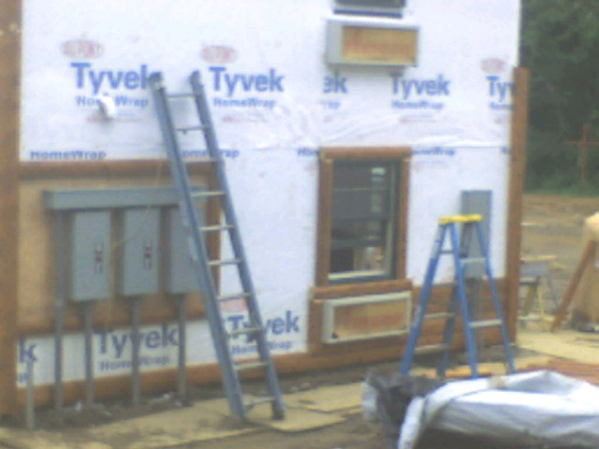

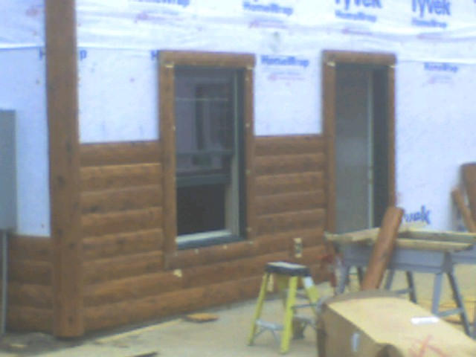

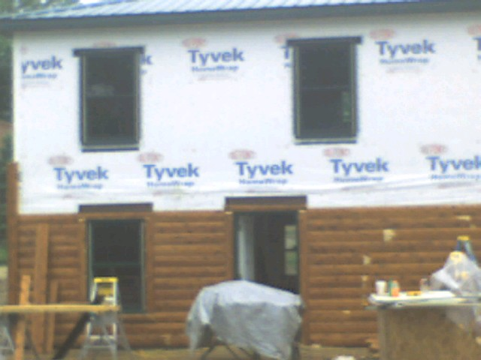

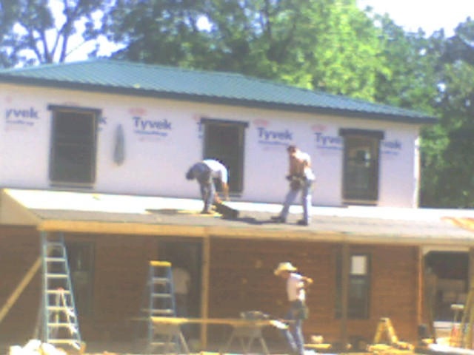

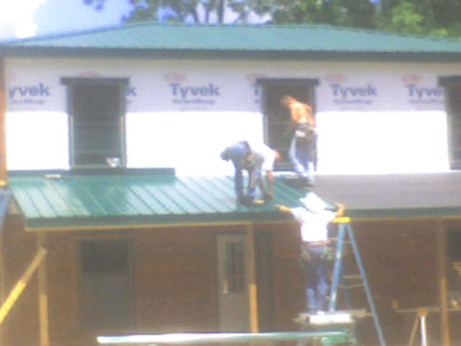

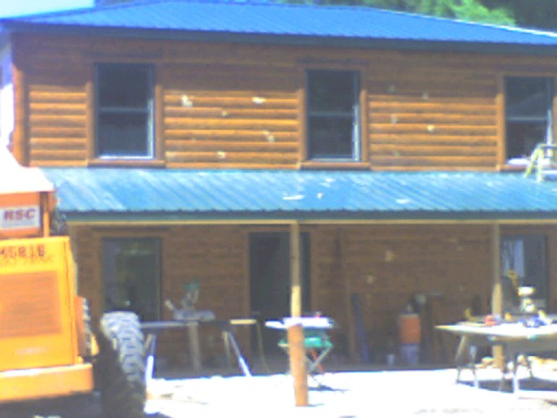

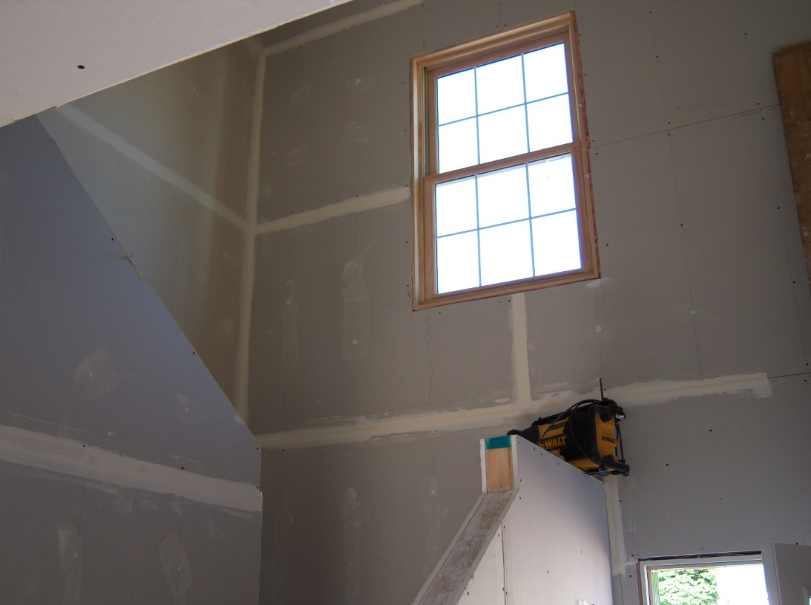
Drywall looking up a staircase

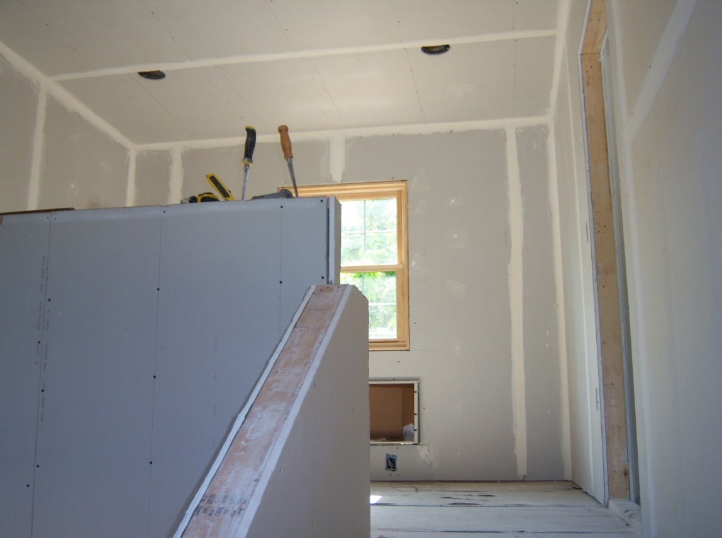
Second floor drywall

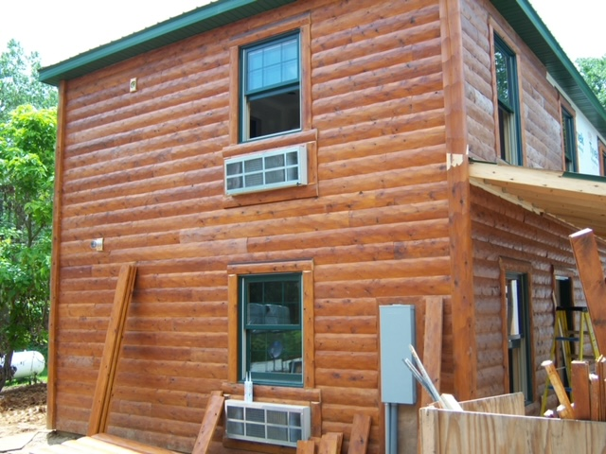

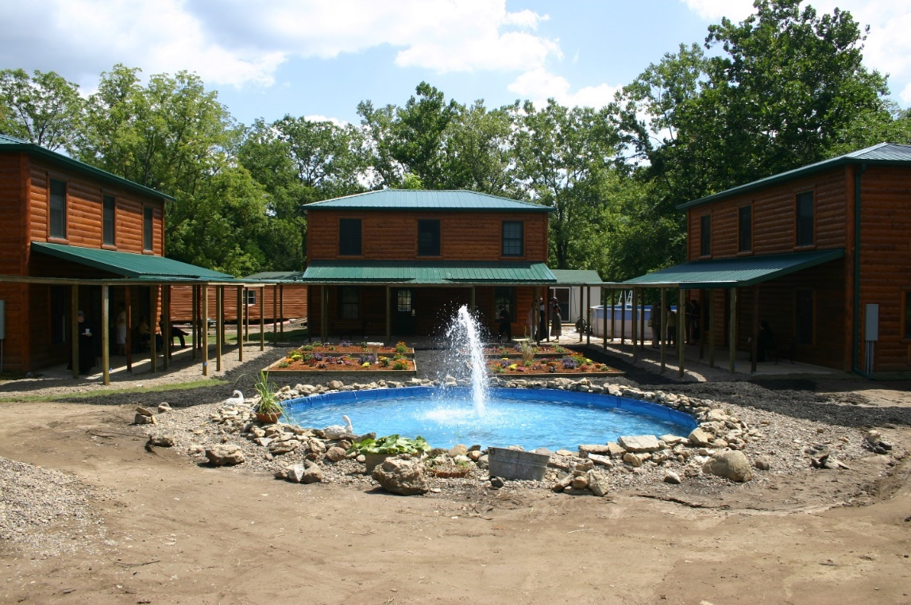
IMG 2462 Abbey guest houses; fitness center and the above-ground swimming pool in the background on the right

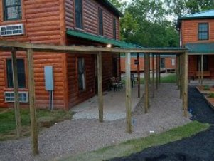

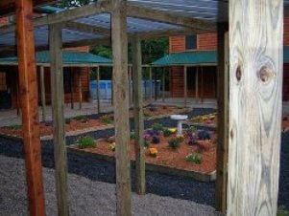
Gardens between guest houses

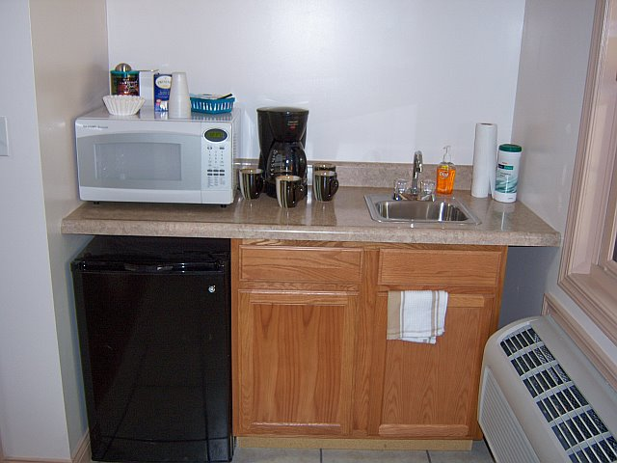
Convenience center in guesthouse

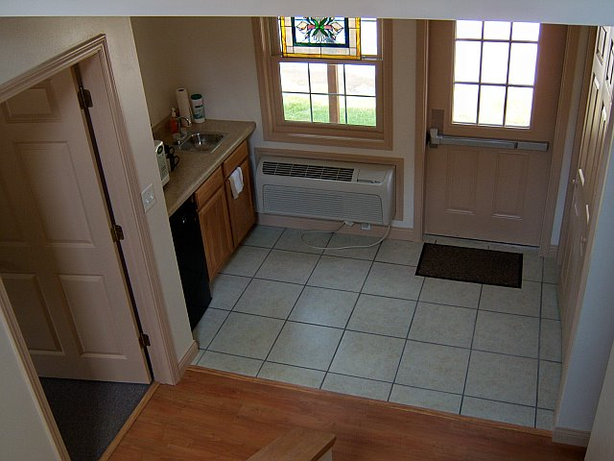
Back door and convenience center
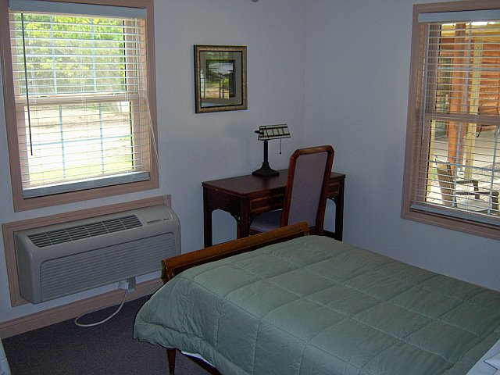
Bedroom

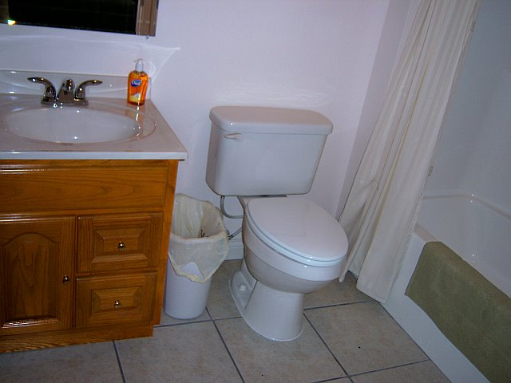
Bathroom


Laundry facilities located in each of the new guest houses

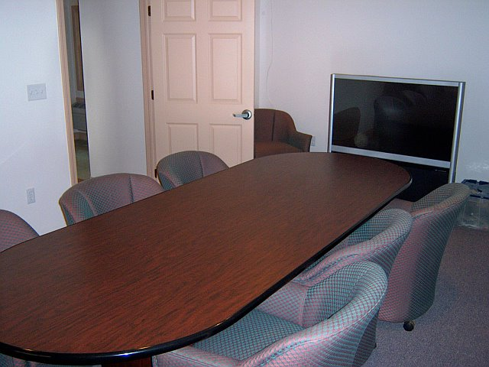
Conference room located in one of the guest houses

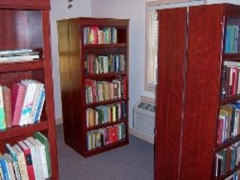
New library which was located in one of the guest houses

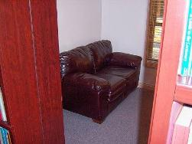
Couch in library

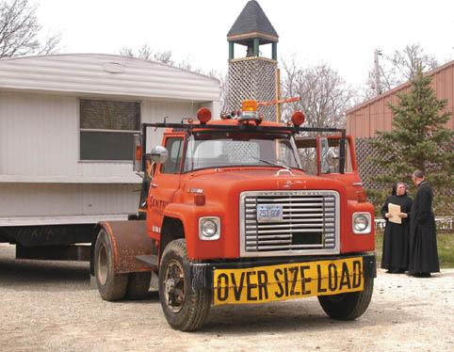
Sr. Sophia Holt and Abbot Michael John Austin watching the removal of the last of the trailers formerly used for guest houses and the Hospitality Center.

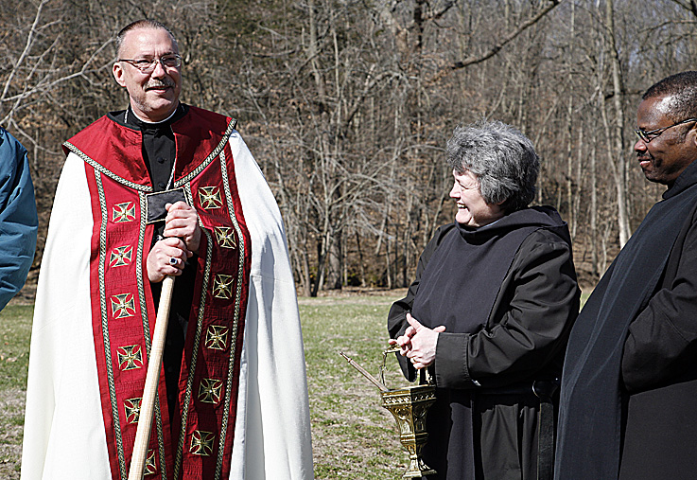
Image 001 Groundbreaking: Abbot Michael John Austin; Sr. Vincent Marie Rittenhouse; Br. Thomas Ferrell

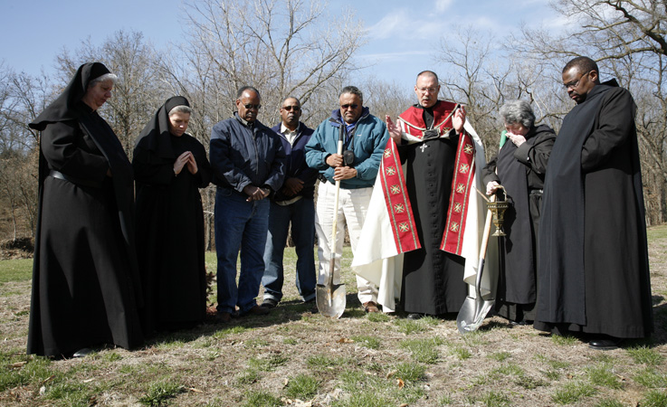
Image 003 Groundbreaking: Sr. Mary Catherine Christopher; Sr. Sophia Holt; Roger Banks; the construction company foreman; Lloyd Broussard; Abbot Michael John Austin; Sr.Vincent Marie Rittenhouse; Br. Thomas Ferrell

Mr. Banks and Mr. Broussard owned the company that built the guesthouses and donated money for the furnishing. Sr. Sophia Holt was an employee of their company as well as a member of the CSL.

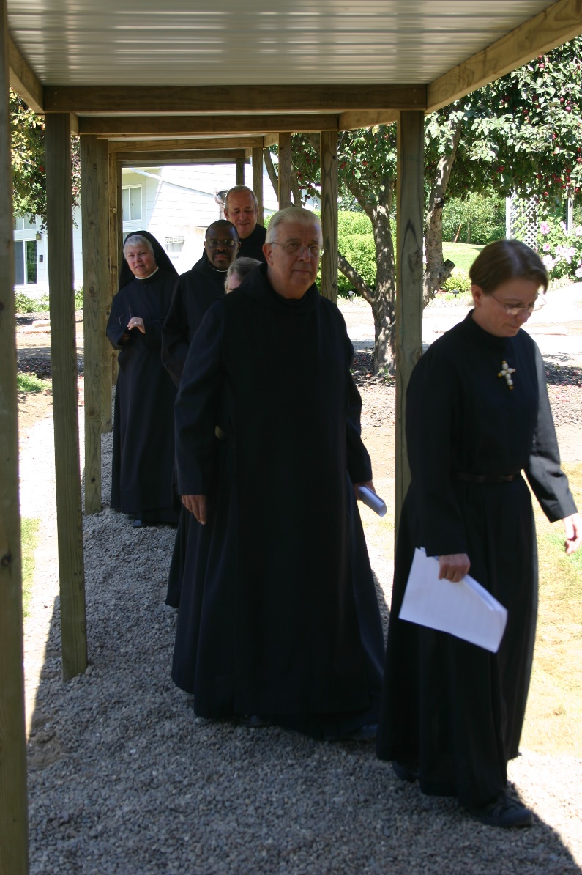
IMG 2412 Sr. Clare Benedicta Myers; Br. Thomas Ferrell; Br. Gabriel Hale; Sr. Vincent Marie Rittenhouse; Br. Timothy Titus Lunt; Sr. Michelle Moore
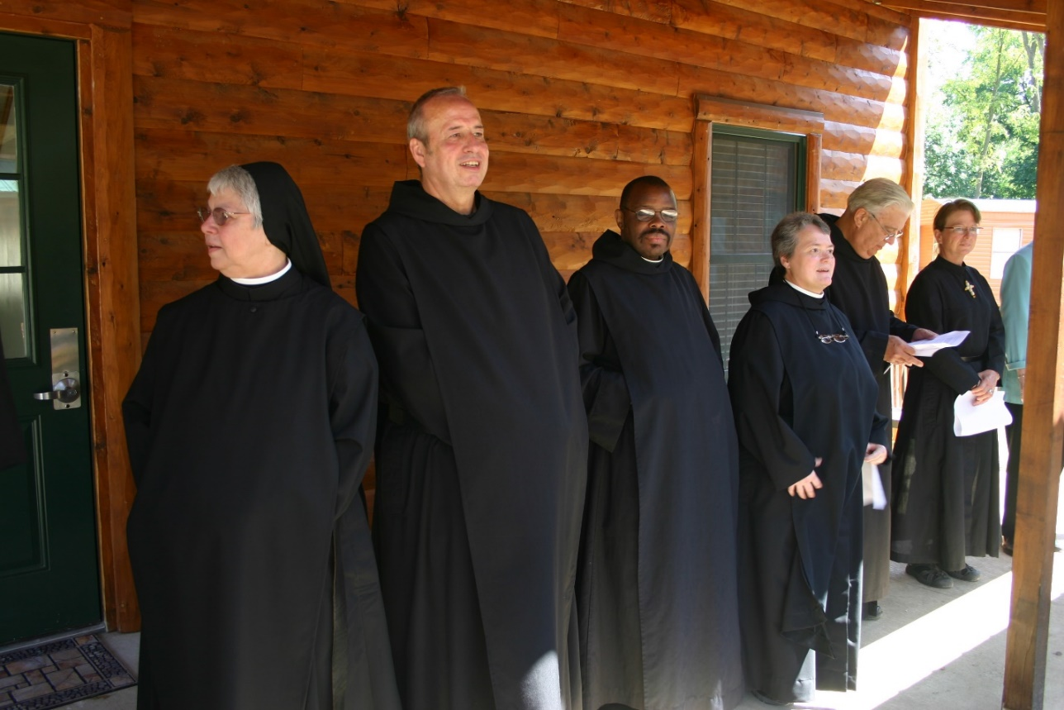
IMG 2416 Sr. Clare Benedicta Myers; Br. Thomas Ferrell; Br. Gabriel Hale; Sr. Vincent Marie Rittenhouse; Br. Timothy Titus Lunt; Sr. Michelle Moore

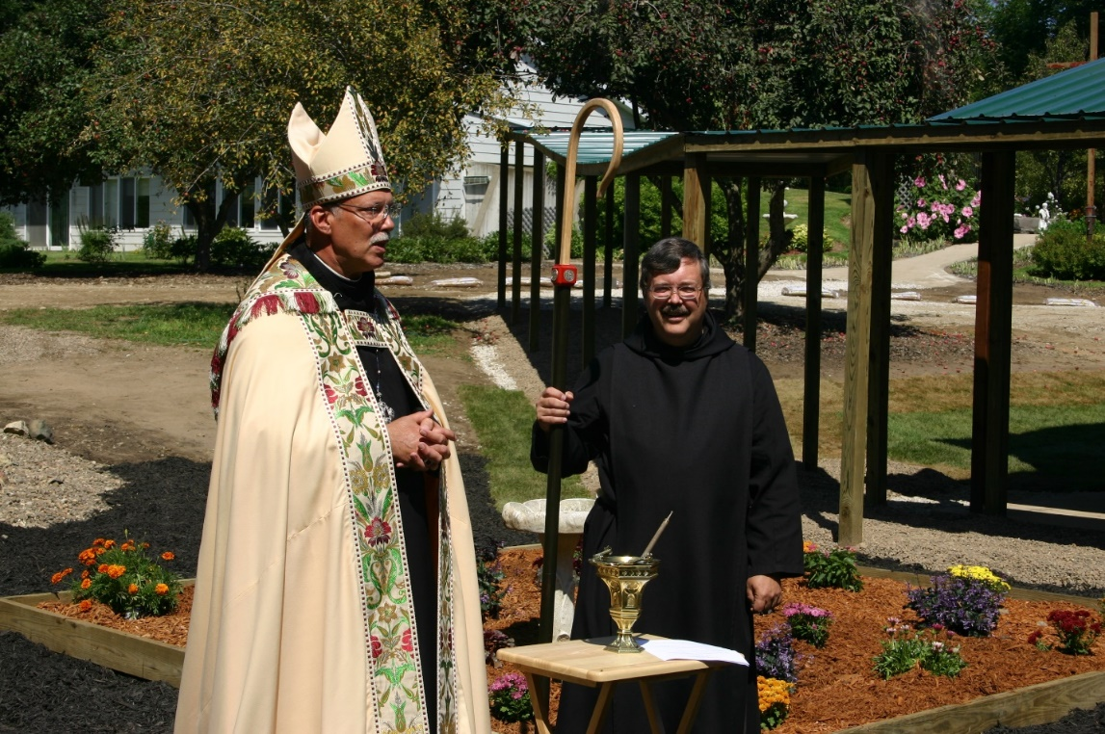
IMG 2420 Abbot Michael John Austin; Br. Paul Howard
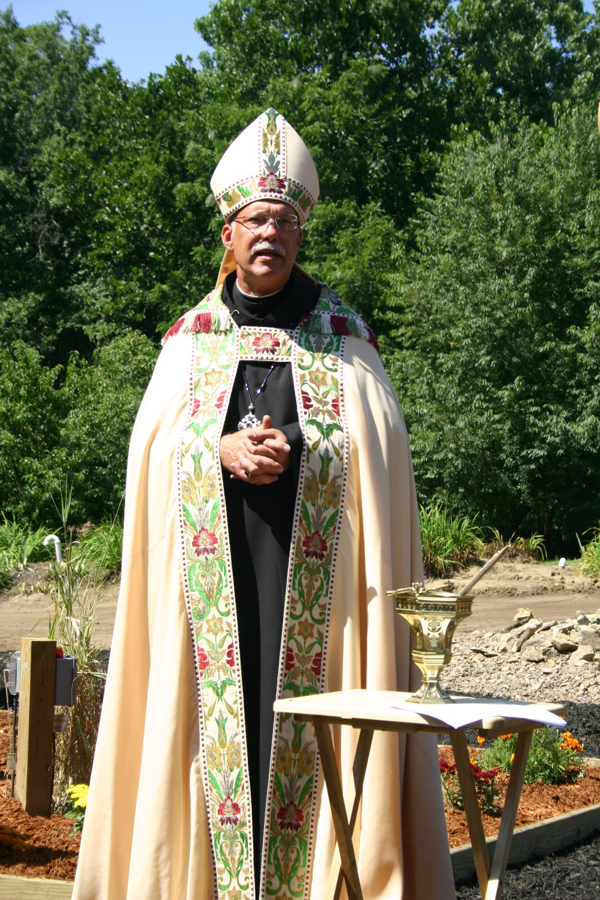
IMG 2428 Abbot Michael John Austin

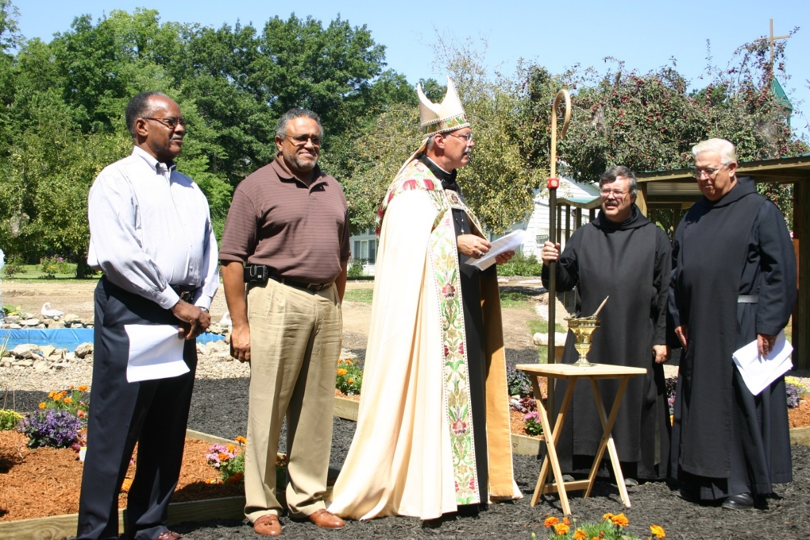
IMG 2440 Roger Banks; Lloyd Broussard; Abbot Michael John Austin; Br. Paul Howard; Br. Timothy Titus Lunt

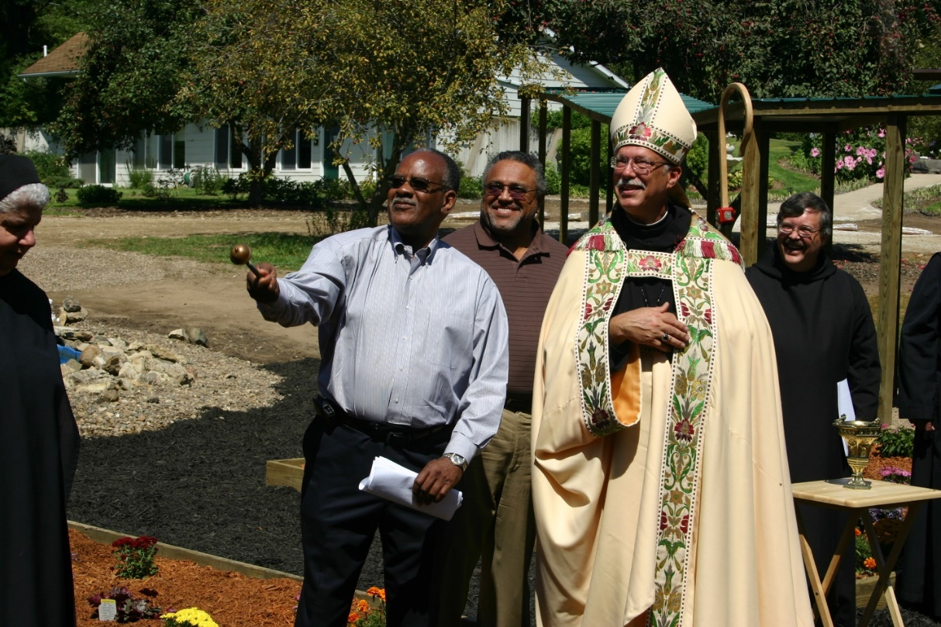
IMG 2450 Sr. Mary Catherine Christopher; Roger Banks; Lloyd Broussard; Abbot Michael John Austin; Br. Paul Howard; abbey in background

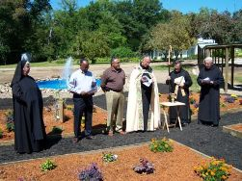
Sr. Mary Catherine Christopher; Roger Banks; Lloyd Broussard; Abbot Michael John Austin; Br. Paul Howard; Br. Timothy Titus Lunt

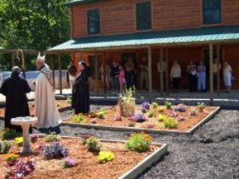
Gardens in between guest houses: Sr. Vincent Marie Rittenhouse; Abbot Michael John Austin; Sr. Mary Catherine Christopher; various guests

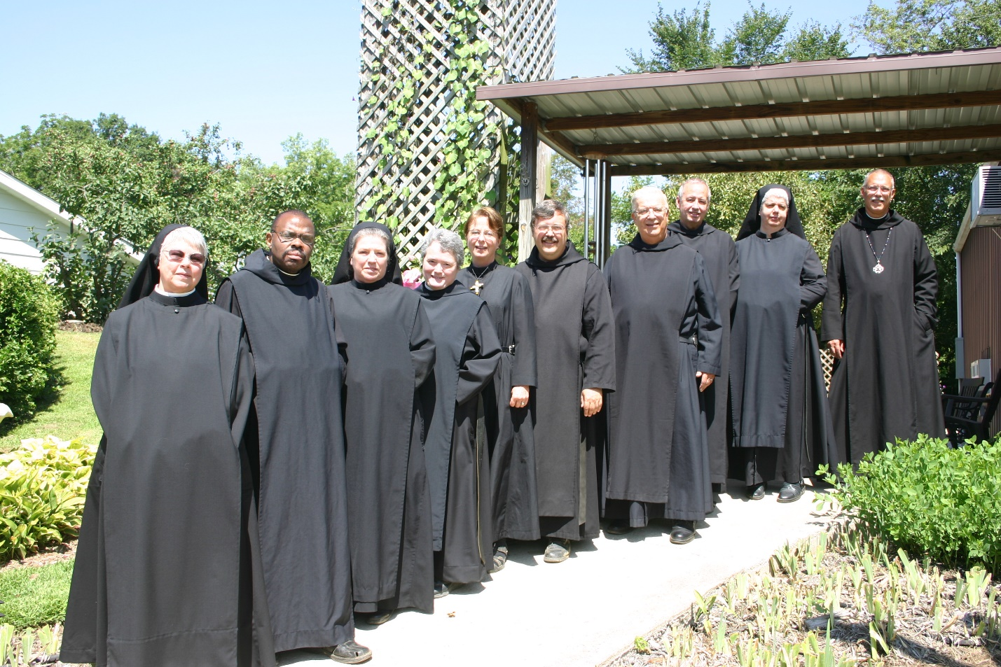
IMG 2459 Sr. Clare Benedicta Myers; Br. Thomas Ferrell; Sr. Sophia Holt; Sr. Vincent Marie Rittenhouse; Sr. Michelle Moore; Br. Paul Howard; Br. Timothy Titus Lunt; Br. Gabriel Hale; Sr. Mary Catherine Christopher; Abbot Michael John Austin

All are standing in front of the chapel; the abbey is to the left

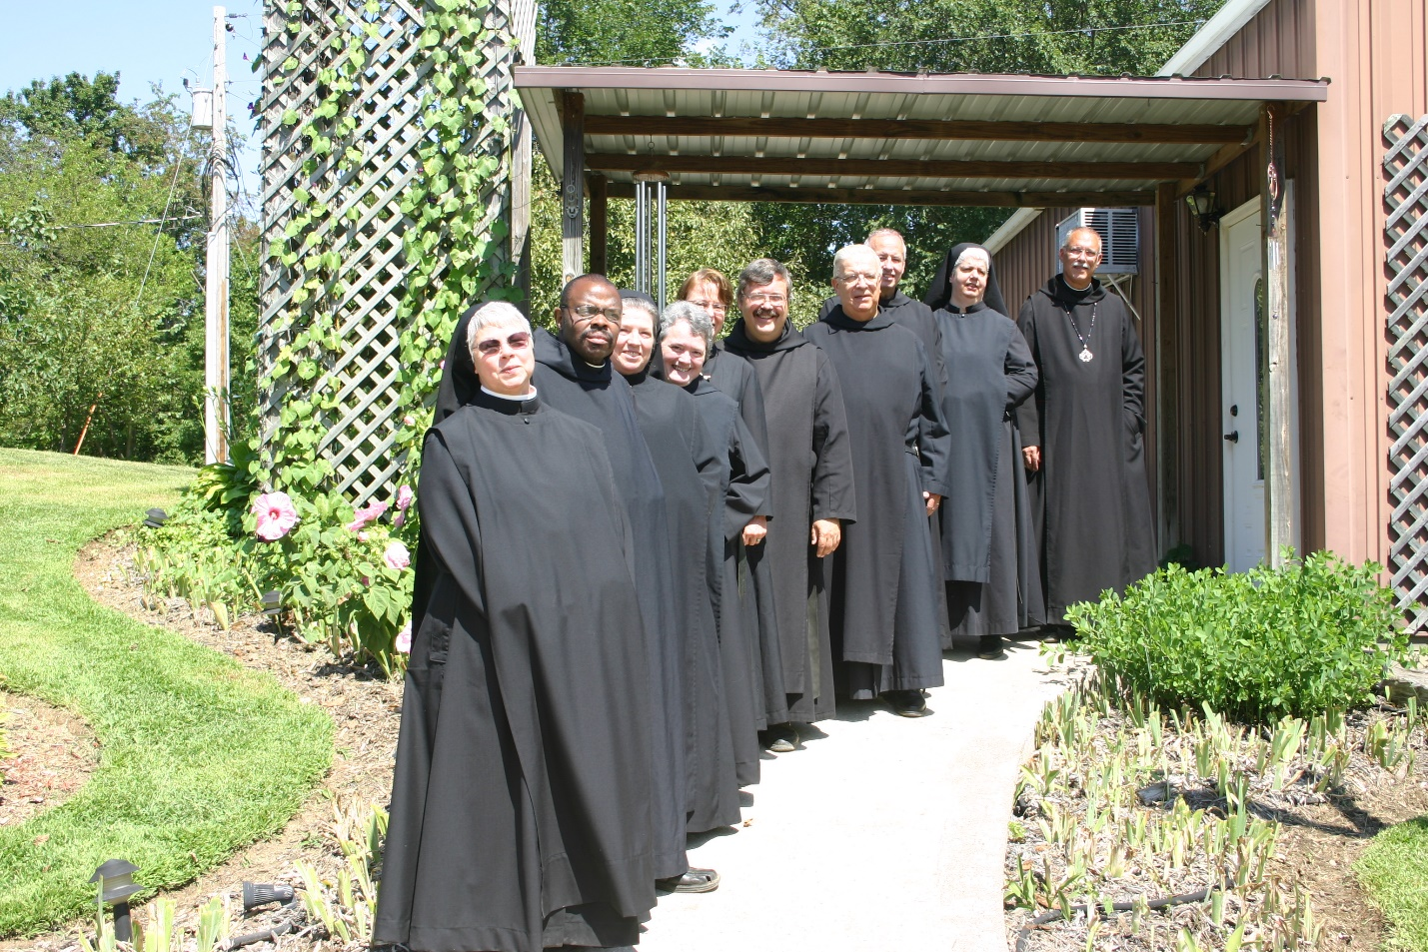
IMG 2461 Sr. Clare Benedicta Myers; Br. Thomas Ferrell; Sr. Sophia Holt; Sr. Vincent Marie Rittenhouse; Sr. Michelle Moore; Br. Paul Howard; Br. Timothy Titus Lunt; Br. Gabriel Hale; Sr. Mary Catherine Christopher; Abbot Michael John Austin

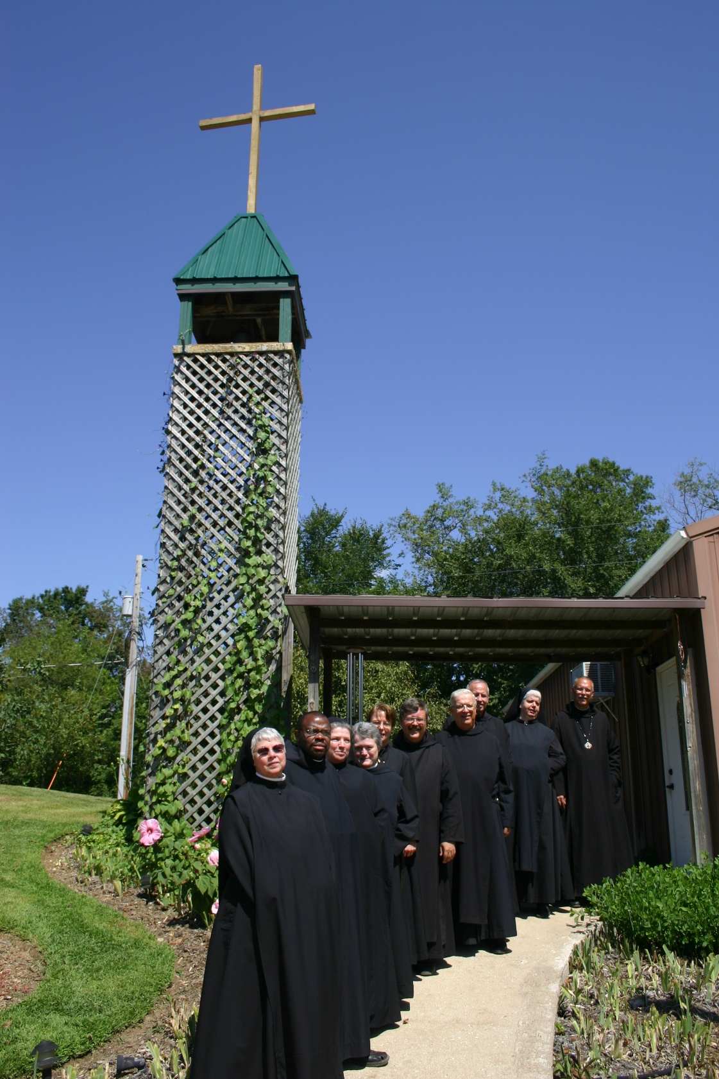
IMG 2461 Sr. Clare Benedicta Myers; Br. Thomas Ferrell; Sr. Sophia Holt; Sr. Vincent Marie Rittenhouse; Sr. Michelle Moore; Br. Paul Howard; Br. Timothy Titus Lunt; Br. Gabriel Hale; Sr. Mary Catherine Christopher; Abbot Michael John Austin

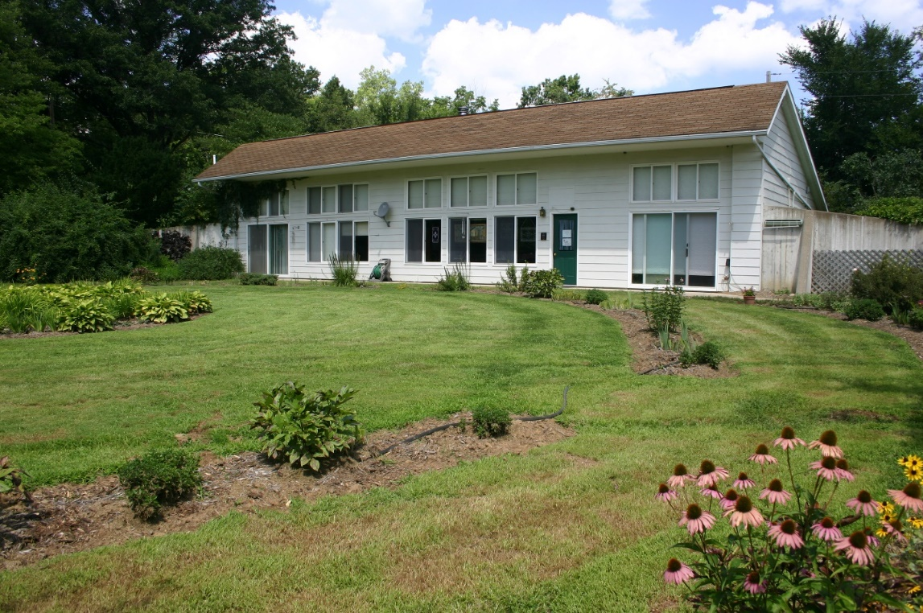
IMG 2467 Abbey

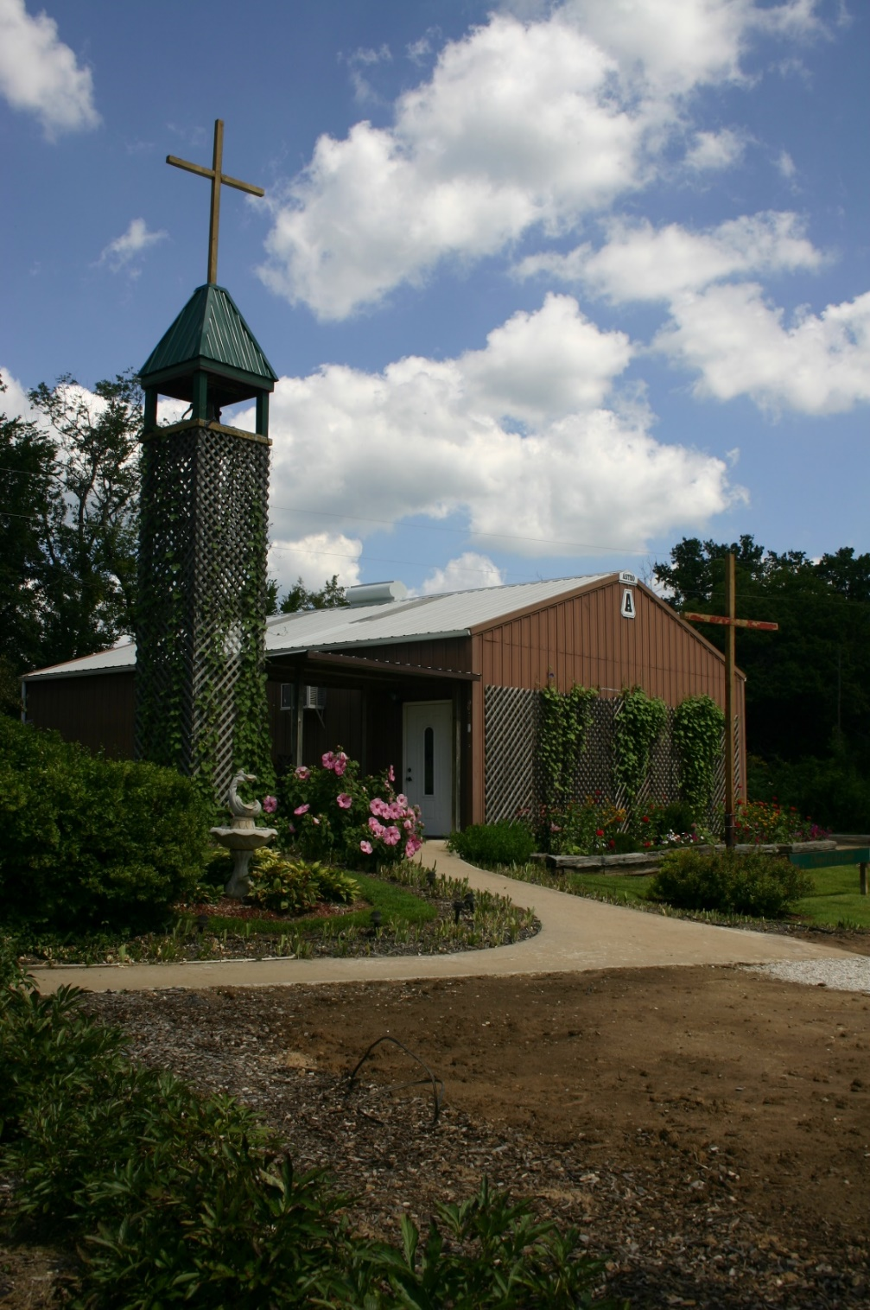
IMG 2468 Chapel

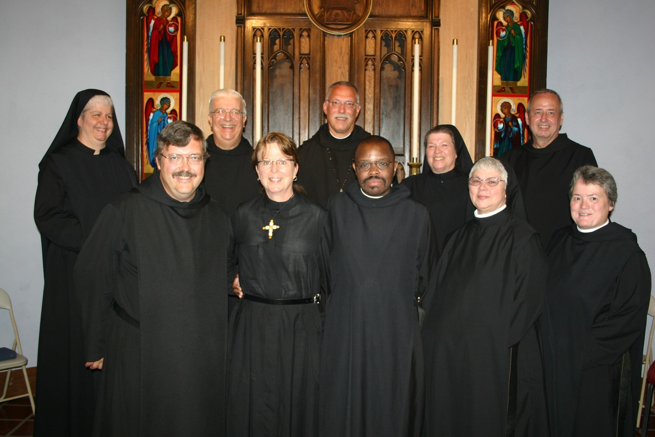

IMG 2458 Sr, Mary Catherine Christopher; Br. Paul Howard; Br. Timothy Titus Lunt; Sr. Michelle Moore; Abbot Michael John Austin; Br. Thomas Ferrell; Sr. Sophia Holt; Sr. Clare Benedicta Myers; Br. Gabriel Hale; Sr. Vincent Marie Rittenhouse

In the background is the chapel reredos with icons written by Br. Aelred Shemayev.

