2022 Spring Convocation
June 13-18
Companions of St. Luke

~Edited by Br. Steven Olderr, 2 March 2023 with the assistance of Sr. Mary Magdalene Clarke. People are identified from left to right. If you find any errors or omissions or have anything to add, please notify Br. Steven at olderr@ameritech.net

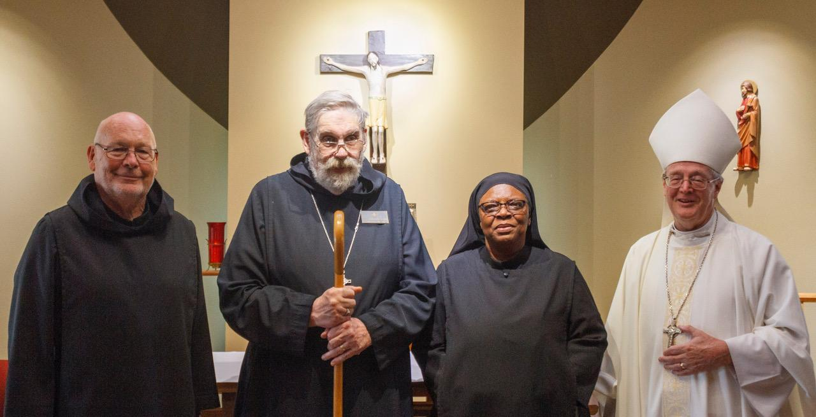
Br. John David Wynne; Abbot David Gerns; Sr. Cecelia Horton; Bp. Alan Scarfe

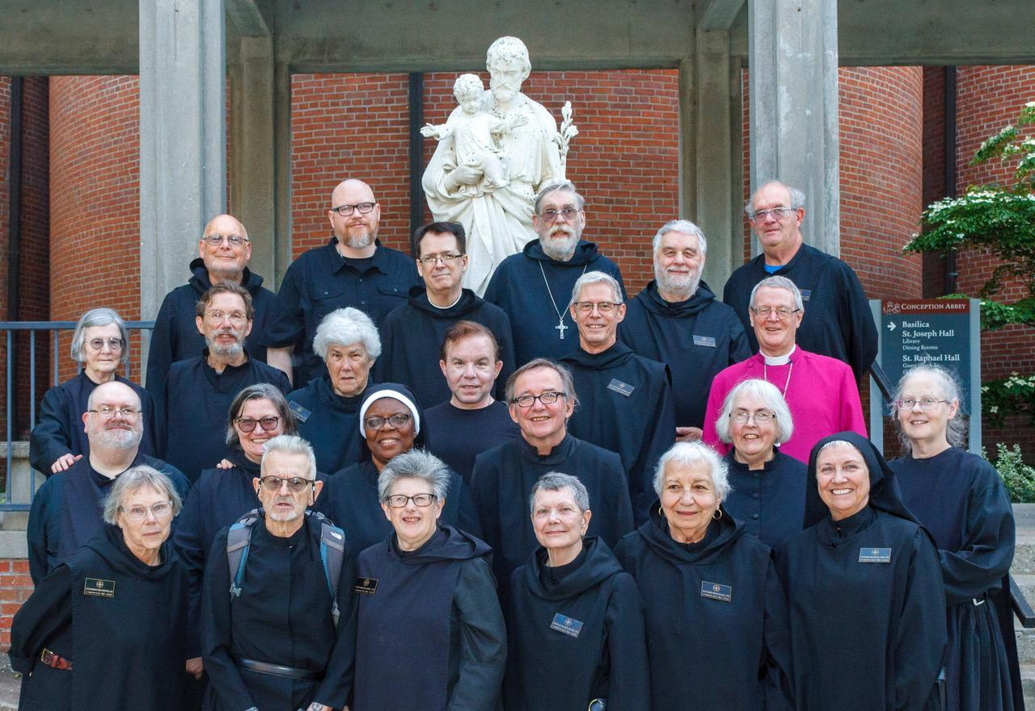

First Row: Sr. Margaret Mary Bergeron; Br. David-Mark Campbell; Sr. Martha Lamoy; Sr. Julian Smith-Boyer; Sr. Marie Patricia Hughes; Sr. Mary Magdalene Clarke
Second Row: Br. Daniel Moore; Sr. Clara Ulson Freirias; Sr. Cecelia Horton; Br. James Raphael Davies; Sr. Madeleine Sophie Smith; Sr. Denise Moore
Third Row: Sr. Brigid Gerns; Br. William Marion Page; Sr. Toni Sylvester; Kevin Orth; Br. Anskar Nonken; Bp. Alan Scarfe
Top Row: Br. John David Wynne; Rockford Patrick; Br. Dunstan Townsend; Abbot David Gerns; Br. Gregory Tatchell; Br. Florian Campbell

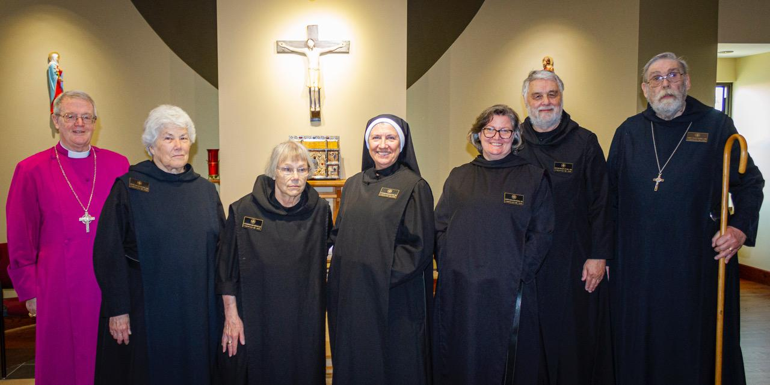
Bp. Alan Scarfe; Sr. Toni Sylvester; Sr. Margaret Mary Bergeron; St. Mary Magdalene Clarke. Sr. Clara Ulson Freirias; Br. Gregory Tatchell; Abbot David Gerns

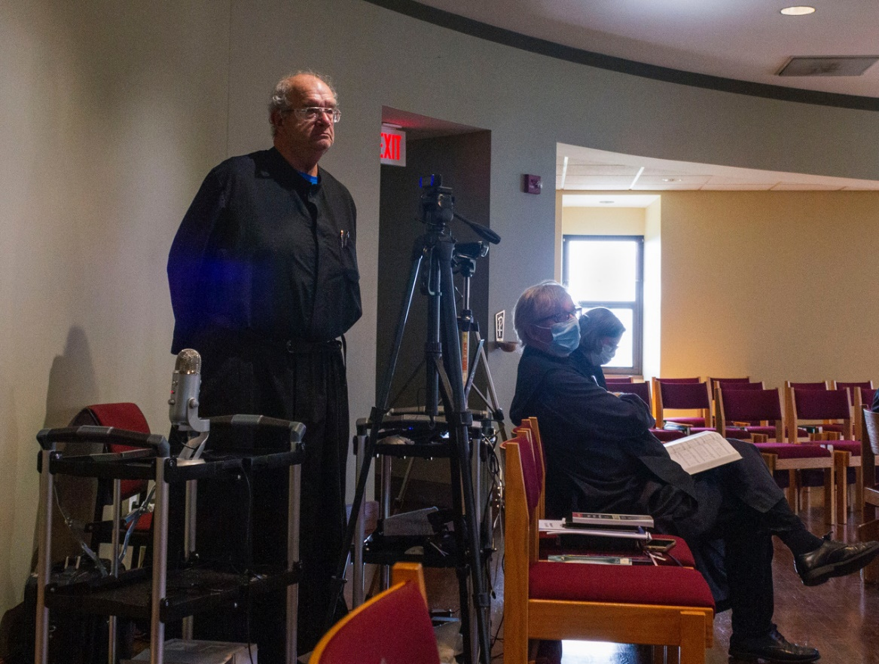
Br. Joseph Florian Campbell; Br. James Rafael Davies; Sr. Clara Ulson Freirias

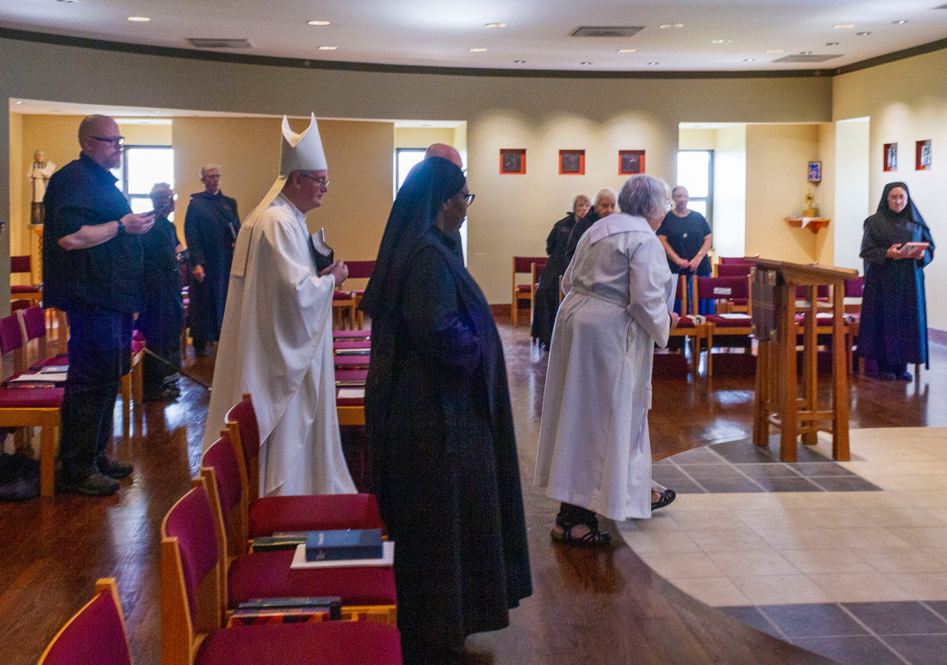
Rockford Patrick; Br. David-Mark Campbell; Br. Anskar Nonken; Bp. Alan Scarfe; Sr. Cecelia Horton; Br. John David Wynne; Sr. Margaret Mary Bergeron; Sr. Marie Patricia Hughes; Sr. Madeleine Sophie Smith; Sr. Kate Maxwell; Sr. Mary Magdalene Clarke

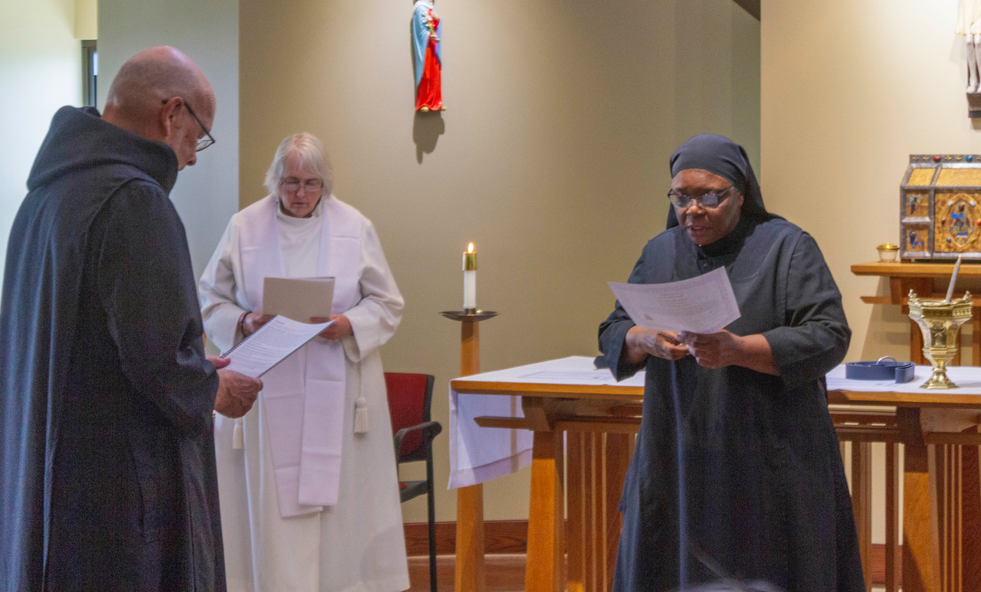
Br. John David Wynne; Sr. Madeleine Sophie Smith; Sr. Cecelia Horton

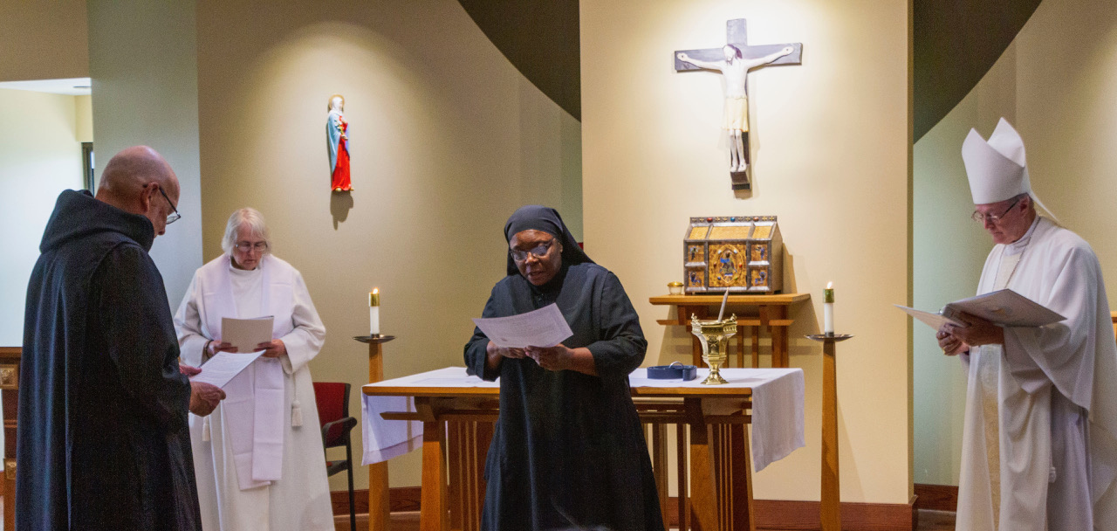
Br. John David Wynne; Sr. Madeleine Sophie Smith; Sr. Cecelia Horton; Bp. Alan Scarfe

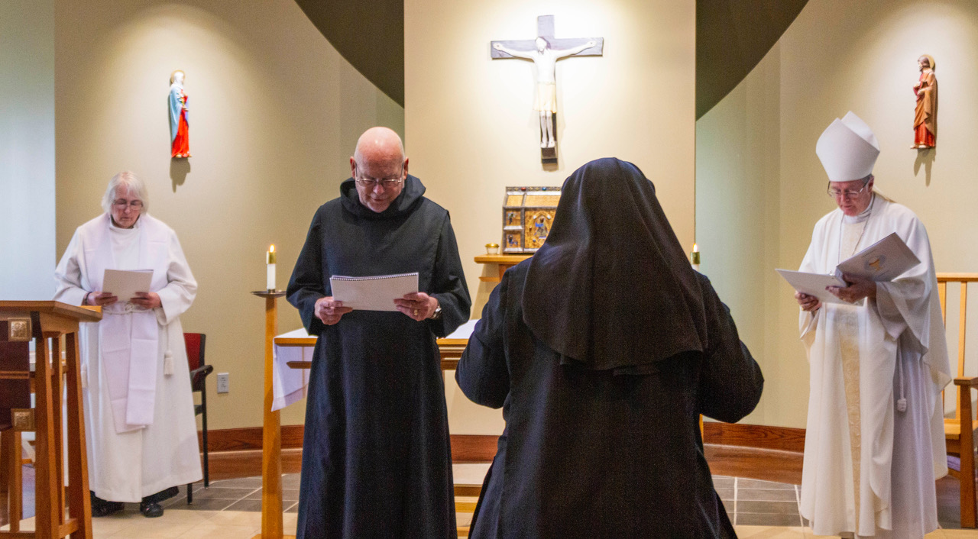
Sr. Madeleine Sophie Smith; Br. John David Wynne; Sr. Cecelia Horton; Bp. Alan Scarfe

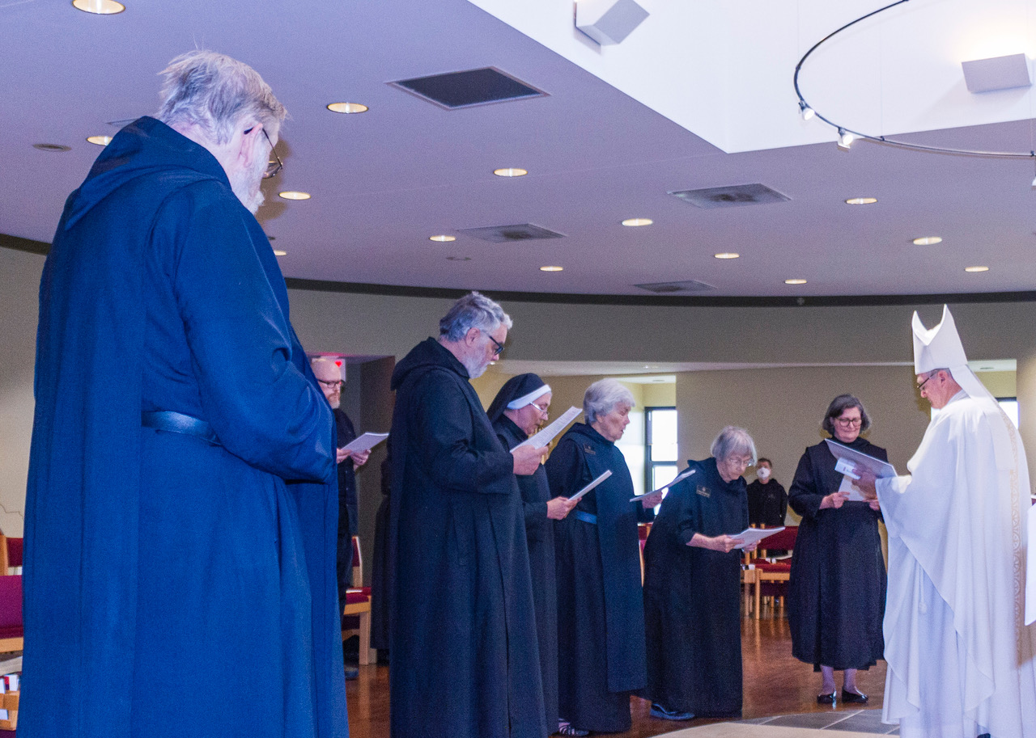
Abbot David Gerns; Rockford Patrick; Br. Gregory Tatchell; Sr. Mary Magdalene; Sr. Toni Sylvester; Sr. Margaret Mary Bergeron; Sr. Julian Smith Boyer; Sr. Clara Ulson Freirias; Bp. Alan Scarfe
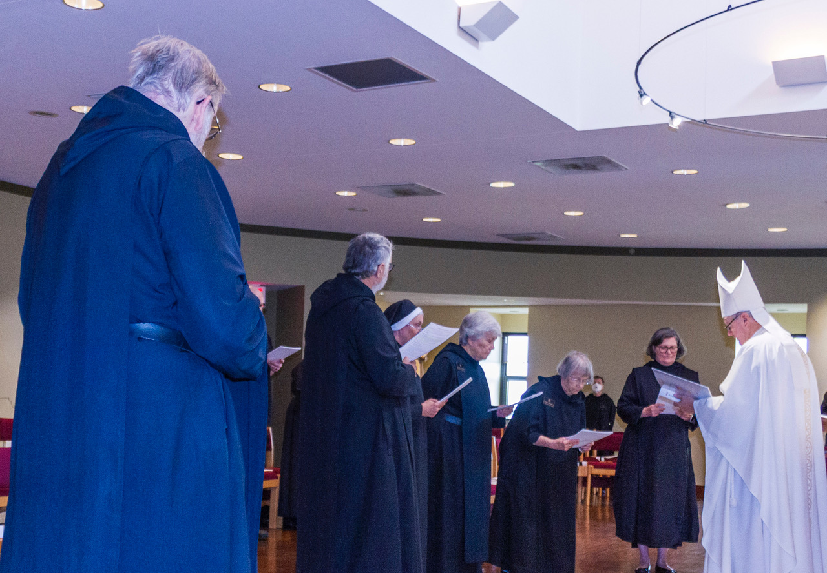
Abbot David Gerns; Br. Gregory Tatchell; Sr. Mary Magdalene Clarke; Sr. Toni Sylvester; Sr. Margaret Mary Bergeron; Sr. Julian Smith-Boyer; Sr. Clara Ulson Freirias; Bp. Alan Scarfe

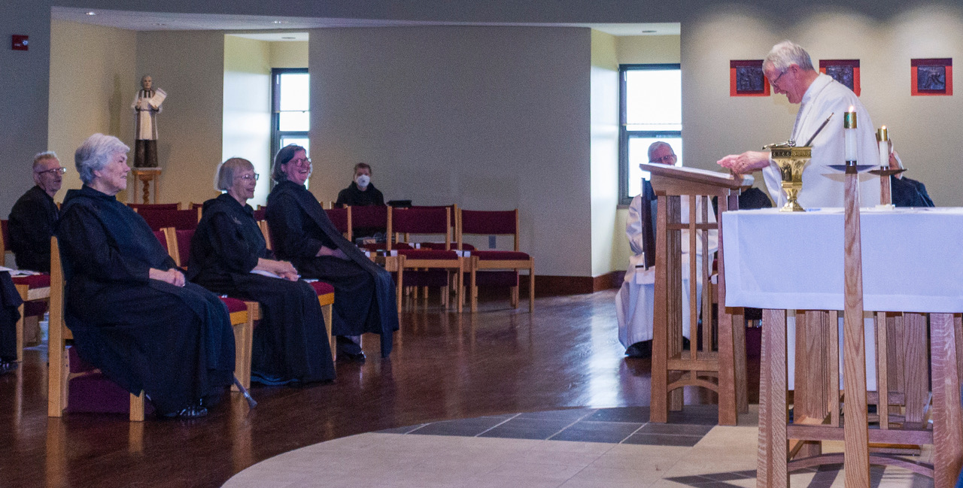
Br. David-Mark Campbell; Sr. Toni Sylvester; Sr. Margaret Mary Bergeron; Sr. Clara Ulson Freirias; Sr. Julian Sith-Boyer; Br. Anskar Nonken; Sr. Denise Moore; Bp. Alan Scarfe; Br Peter Francis Kyle; Br. Daniel Moore

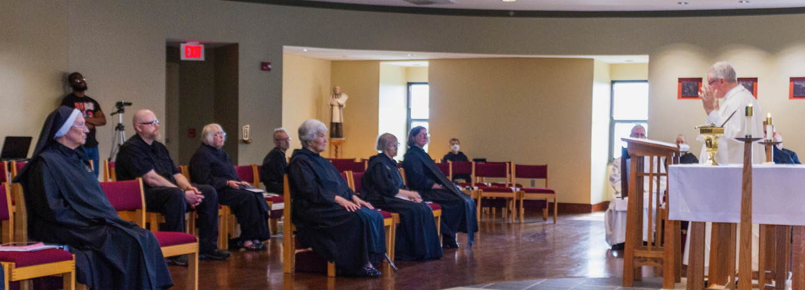
Sr. Mary Magdalene Clarke; Aaron Horton (Sr. Cecilia Horton’s son); Rockford Patrick; Sr. Madeleine Sophie Smith; Br. David-Mark Campbell; Sr. Toni Sylvester; Sr. Margaret Bergeron; Sr. Clara Ulson Freirias; Sr. Julian Smith-Boyer; Br. Anskar Nonken; Sr. Denise Moore; Bp. Alan Scarfe; Br Peter Francis Kyle; Br. Daniel Moore

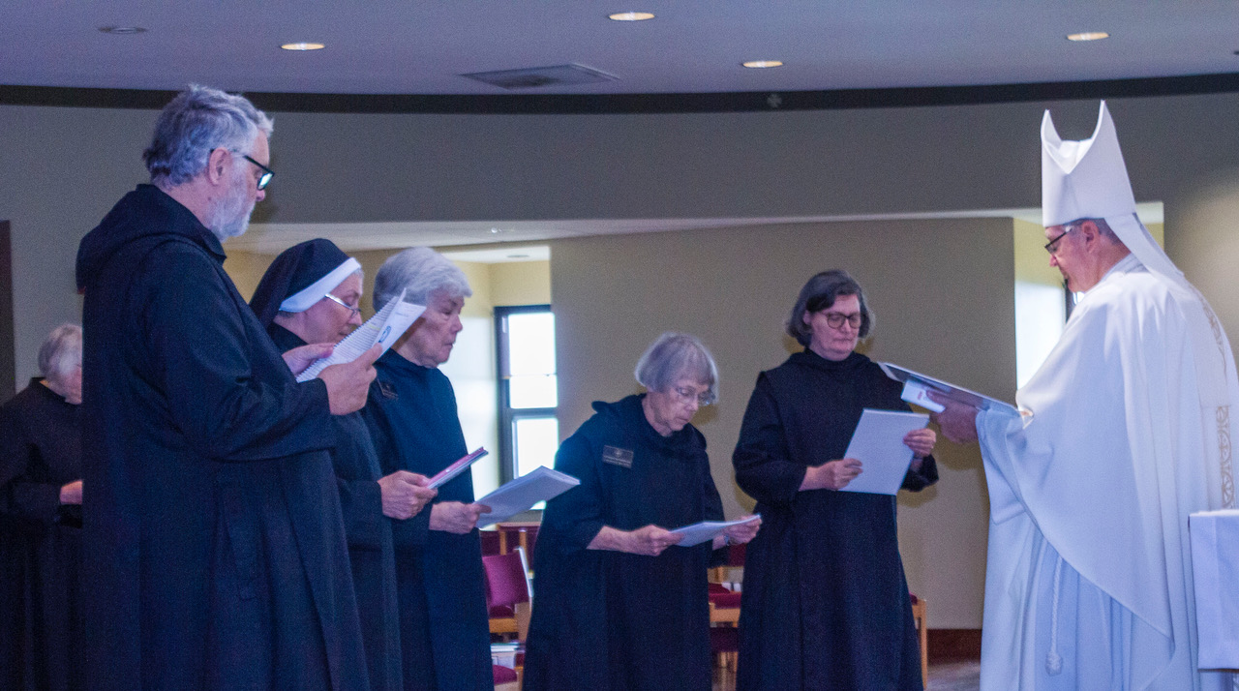
Sr. Madeleine Sophie Smith; Br. Gregory Tatchell; Sr. Mary Magdalene Clarke; Sr. Toni Sylvester; Sr. Margaret Mary Bergeron; Sr. Clara Ulson Freirias; Bp. Alan Scarfe

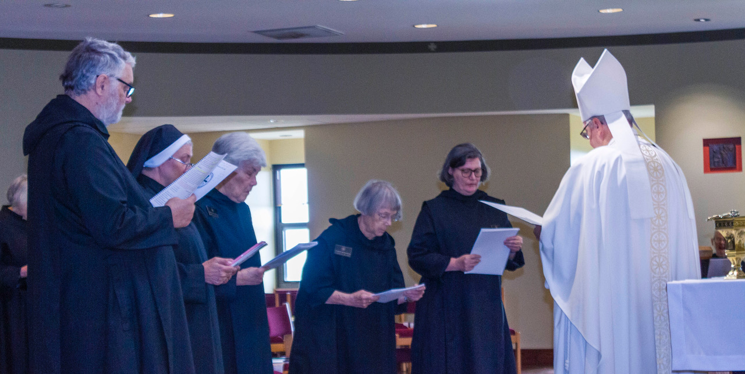
Sr. Madeleine Sophie Smith; Br. Gregory Tatchell; Sr. Mary Magdalene Clarke; Sr. Toni Sylvester; Sr. Margaret Mary Bergeron; Sr. Clara Ulson Freirias; Bp. Alan Scarfe; Sr. Denise Moore (behind the aspergillum)

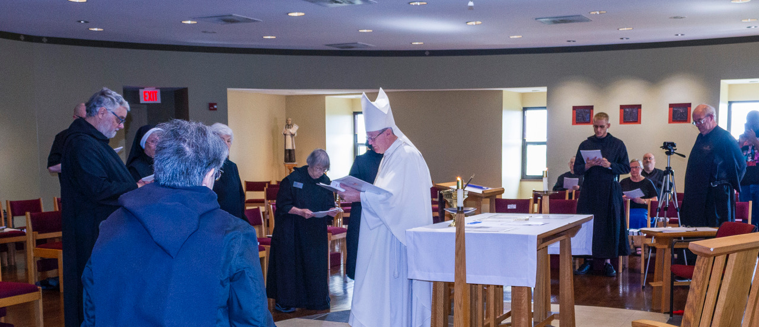
Rockford Patrick; Br. Gregory Tatchell; Sr. Mary Magdalene Clarke; Sr. Martha Lamoy; Sr. Toni Sylvester; Sr. Margaret Mary Bergeron; Sr. Clara Ulson Freirias; Bp. Alan Scarfe; Sr. Denise Moore; Br. Peter Francis Kyle; Sr. Kate Maxwell; Br. Daniel Moore; Br. Florian Campbell; Aaron Horton (Sr. Cecilia Horton’s son)

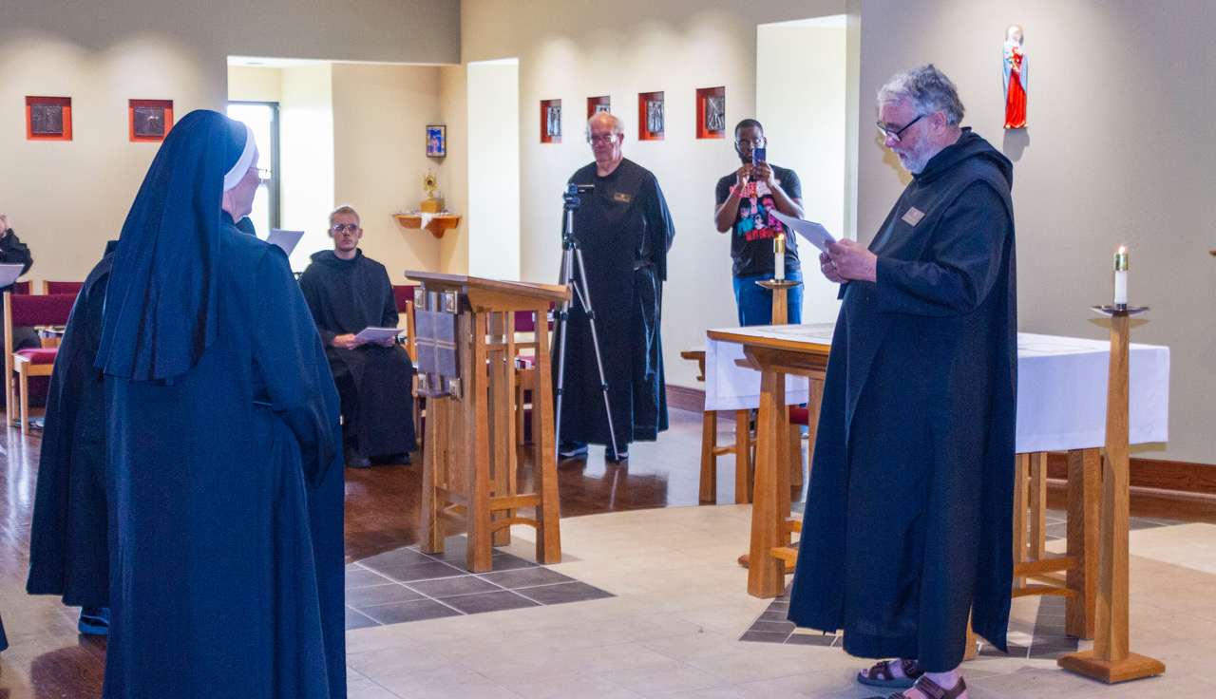
Sr. Mary Magdalene Clarke; Sr. Margaret Mary Bergeron; Br. Peter Francis Kyle; Br. Florian Campbell; Aaron Horton (Sr. Cecilia Horton’s son); Br. Gregory Tatchell

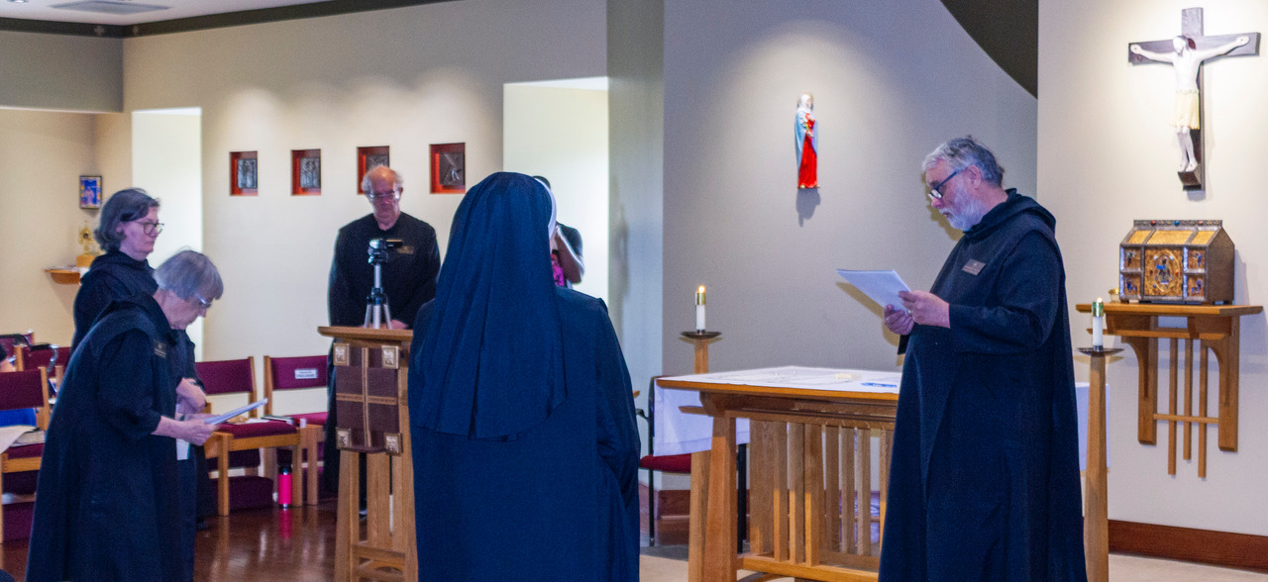
Sr. Clara Ulson Freirias; Sr. Margaret Mary Bergeron; Br. Florian Campbell, Sr. Mary Magdalene Clarke; Aaron Horton (Sr. Cecilia Horton’s son); Br. Gregory Tatchell

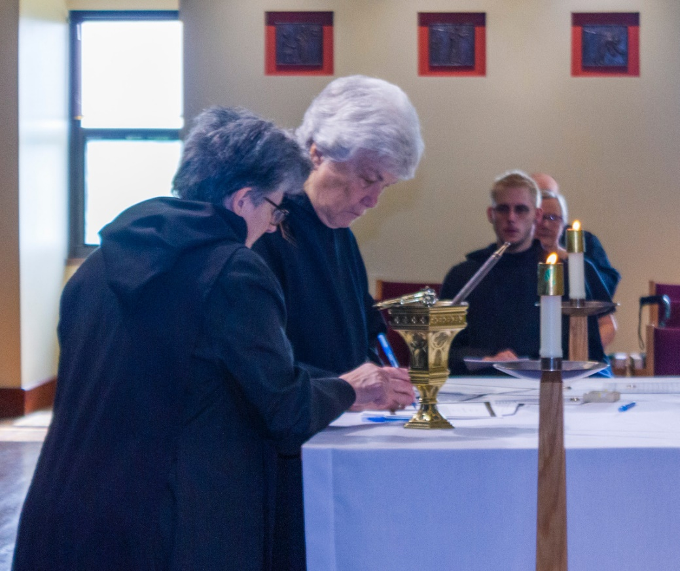
Sr Martha Lamoy; Sr. Toni Sylvester; Br. Pete Francis Kyle; Sr. Kate Maxwell; Br. Daniel Moore (behind Sr. Kate)

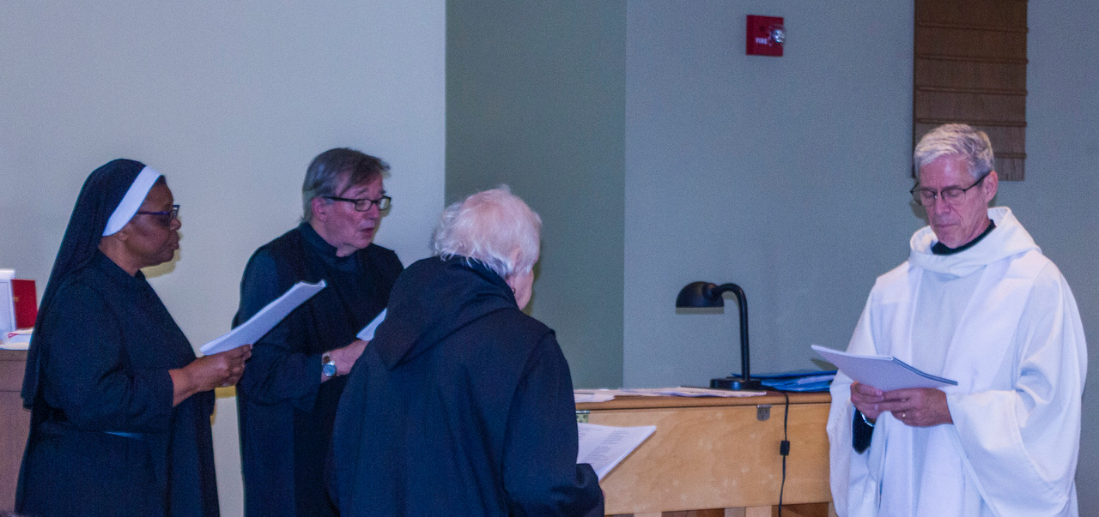
Sr. Cecilia Horton; Br. James Rafael Davies; Sr. Marie Patricia Hughes; Br. Anskar Nonken

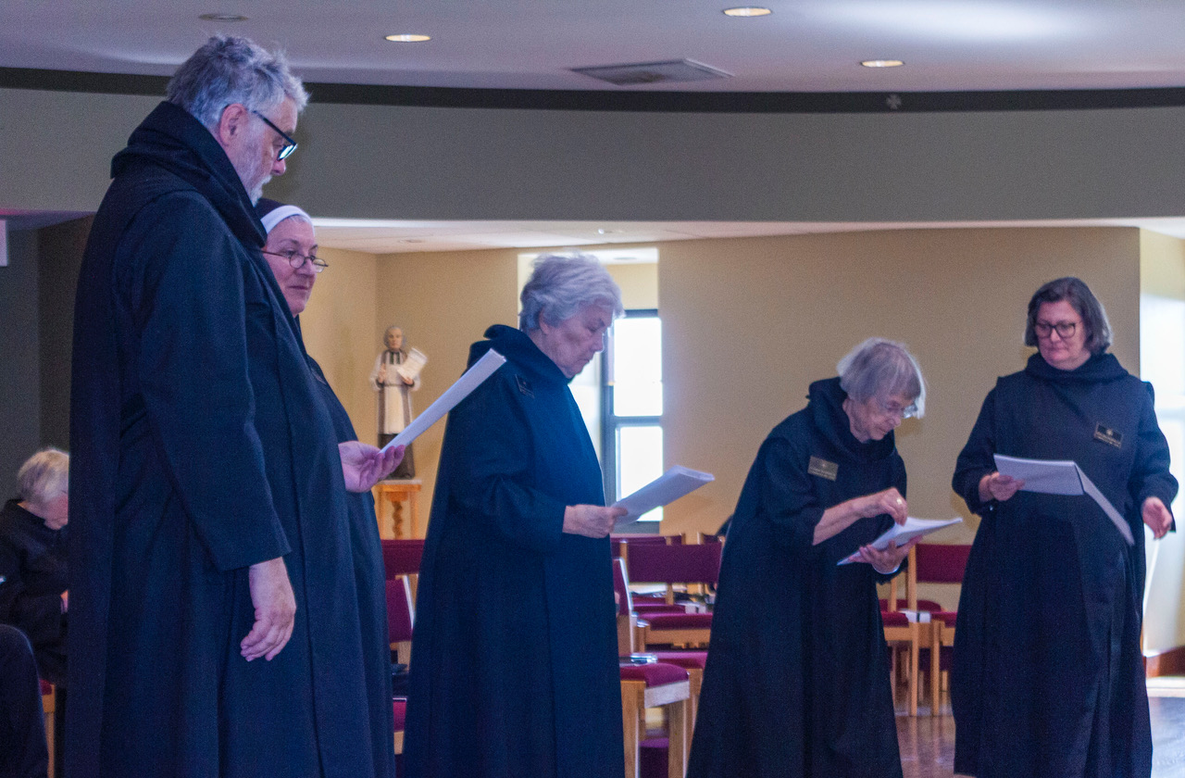
Sr. Madeleine Sophie Smith; Br. Gregory Tatchell; Sr. Mary Magdalene Clarke; Sr. Toni Sylvester; Sr. Margaret Mary Bergeron; Sr. Clara Ulson Freirias

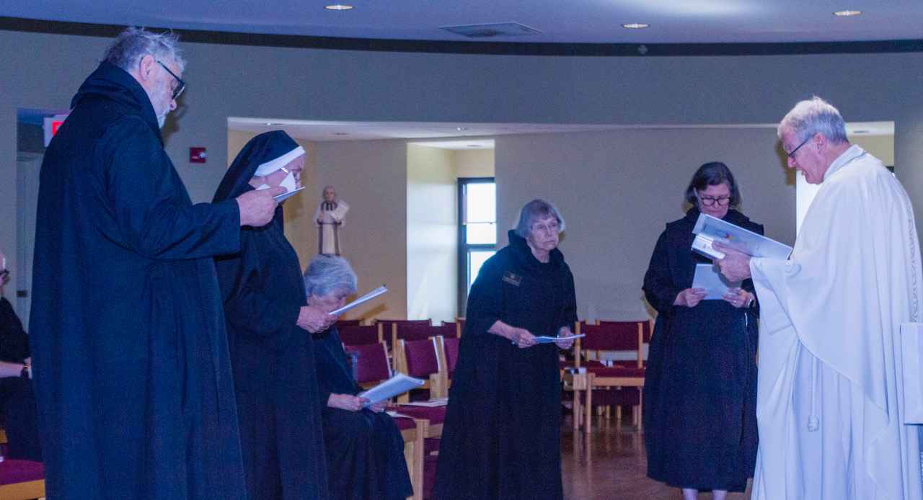
Rockford Patrick; Br. Gregory Tatchell; Sr. Mary Magdalene Clarke; Sr. Toni Sylvester; Sr. Margaret Mary Bergeron; Sr. Clara Ulson Freirias; Bp. Alan Scarfe

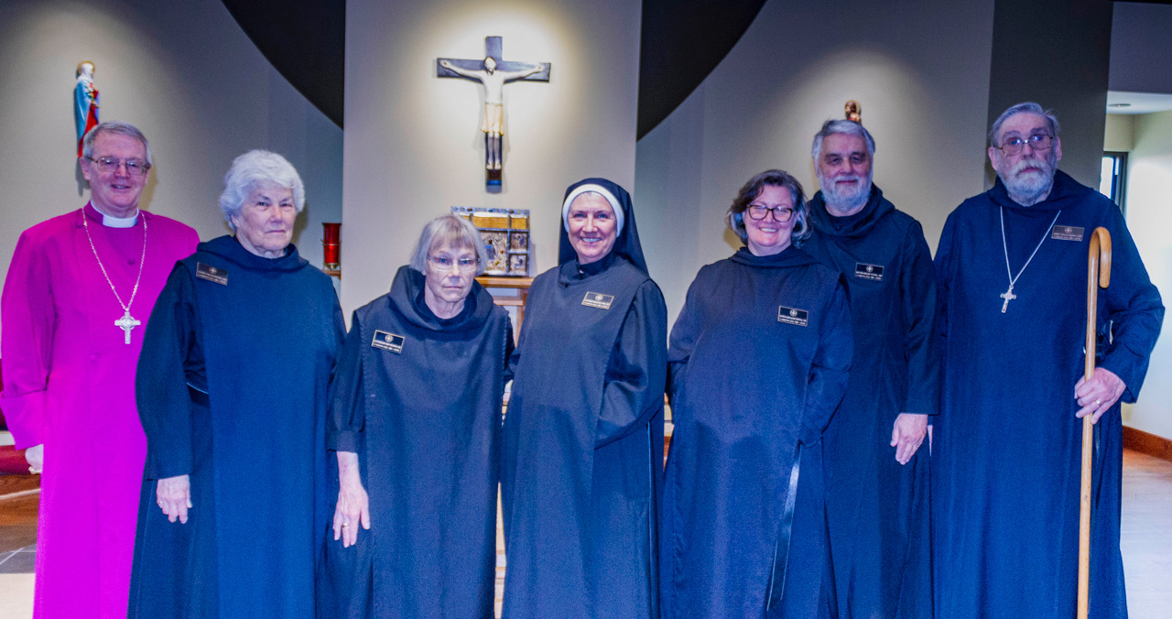
Bp. Alan Scarfe; Sr. Toni Sylvester; Sr. Margaret Mary Bergeron; Sr. Mary Magdalene Clarke; Sr. Clara Ulson Freirias; Br. Gregory Tatchell; Abbot David Gerns

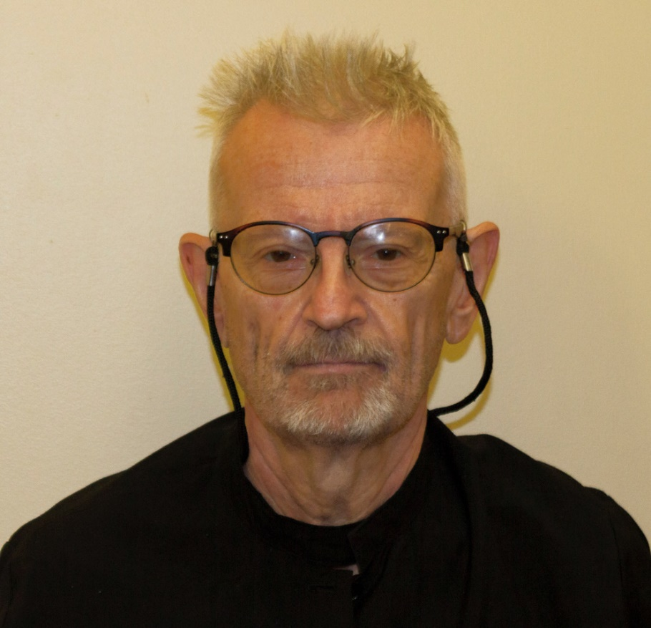
Br. David-Mark Campbell

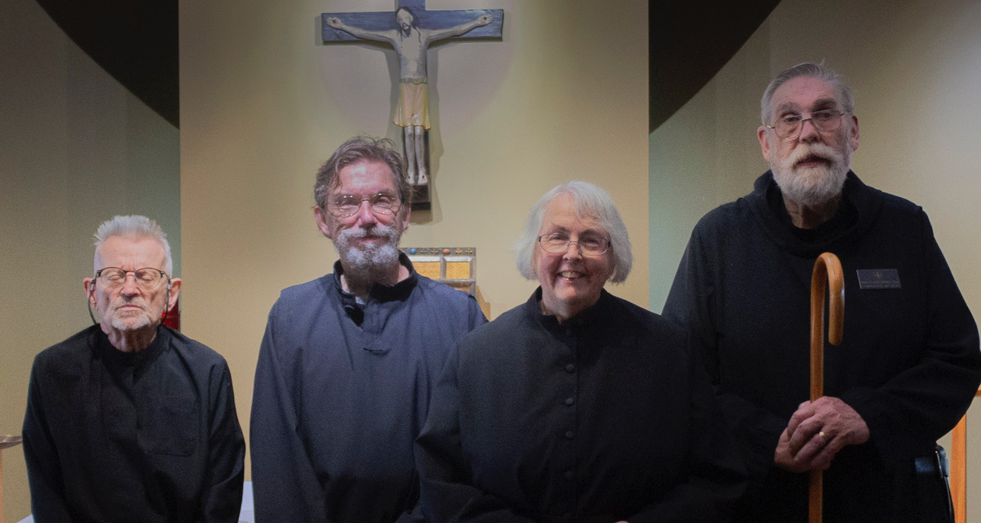
Br. David-Mark Campbell; Br. William Marion Page; Sr. Madeleine Sophie Smith; Abbot David Gerns

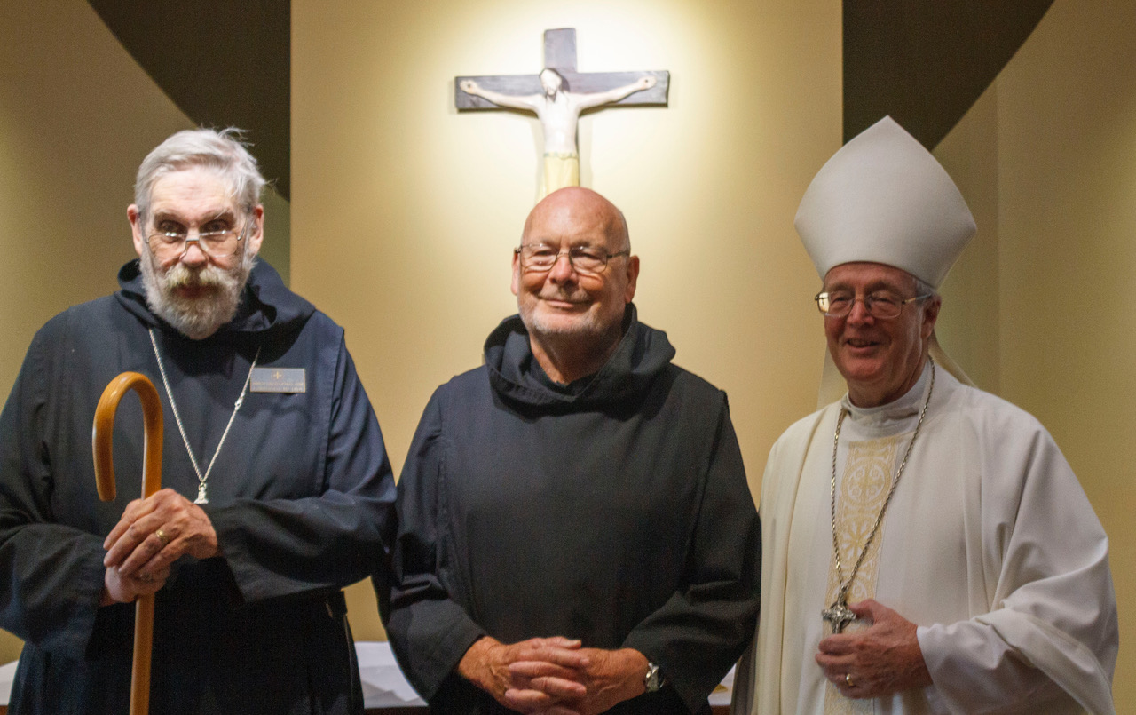
Abbot David Gerns; Br. John David Wynne; Bp. Alan Scarfe

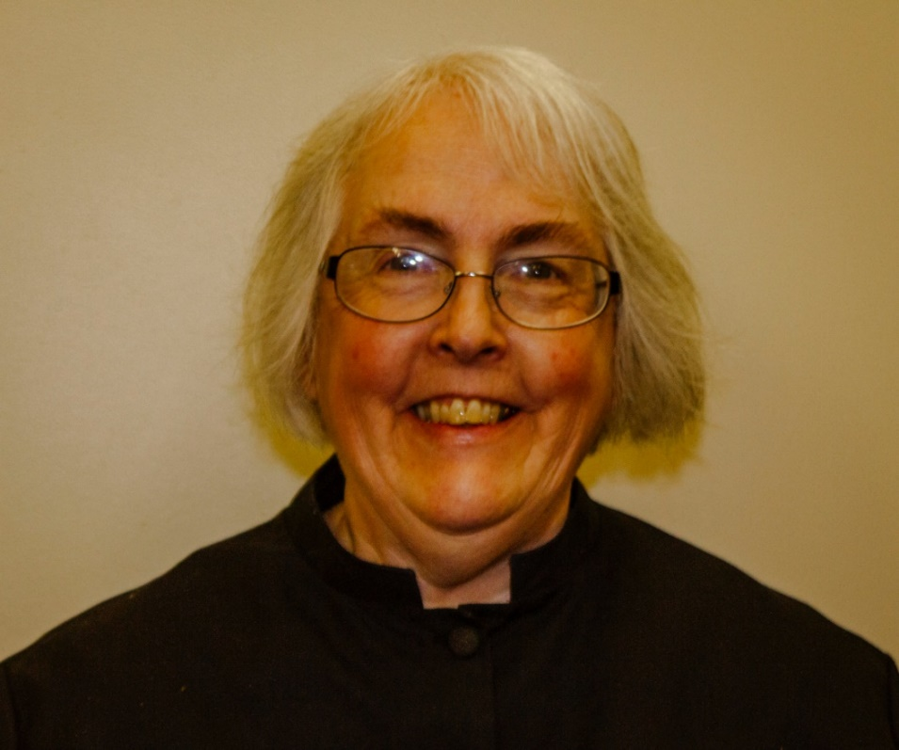
Sr. Madeleine Sophie Smith

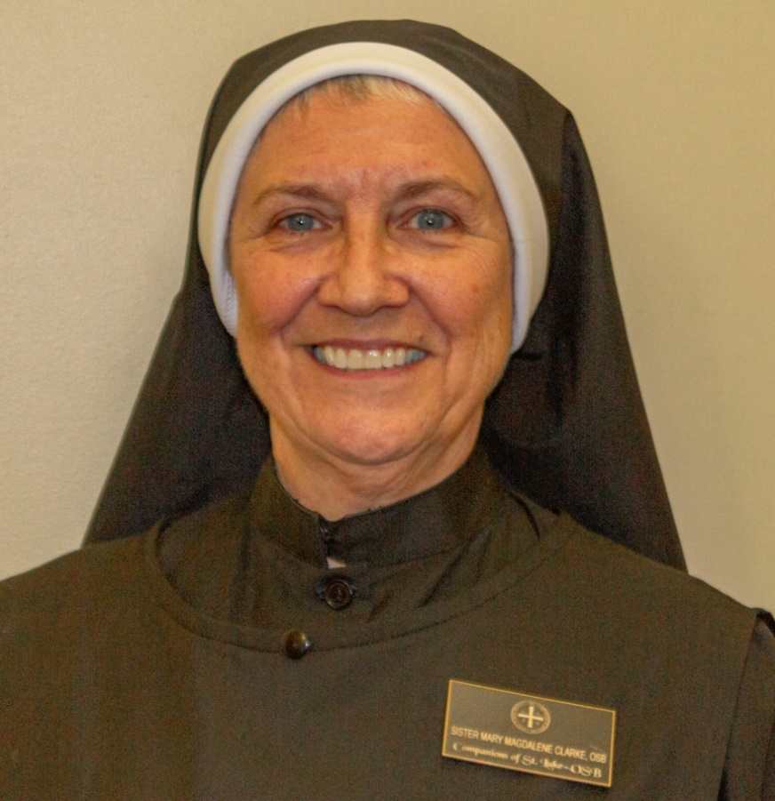
Sr. Mary Magdalene Clarke

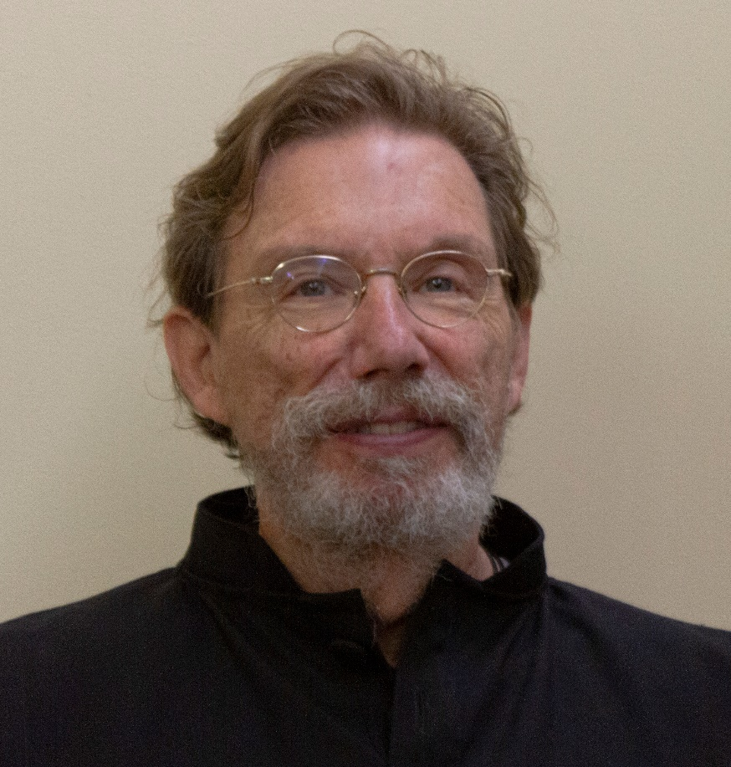
Br. William Marion Page

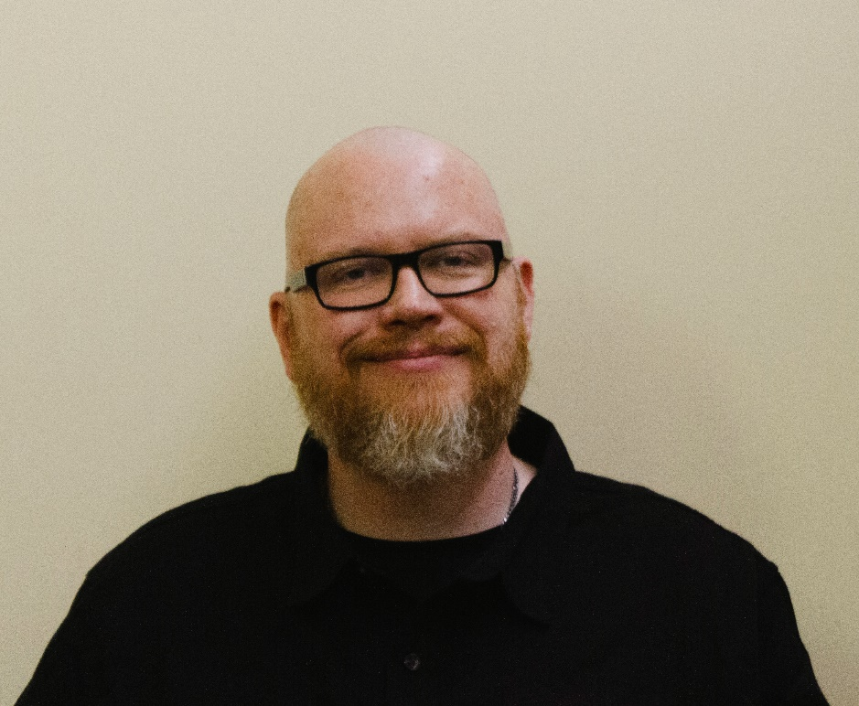
Rockford Patrick

