Spring Convocation
June 2021
Part 2 of 3

People are identified left to right.

~Edited by Br. Steven Olderr 1 March 2023. Please send any corrections or additional information to olderr@ameritech.net

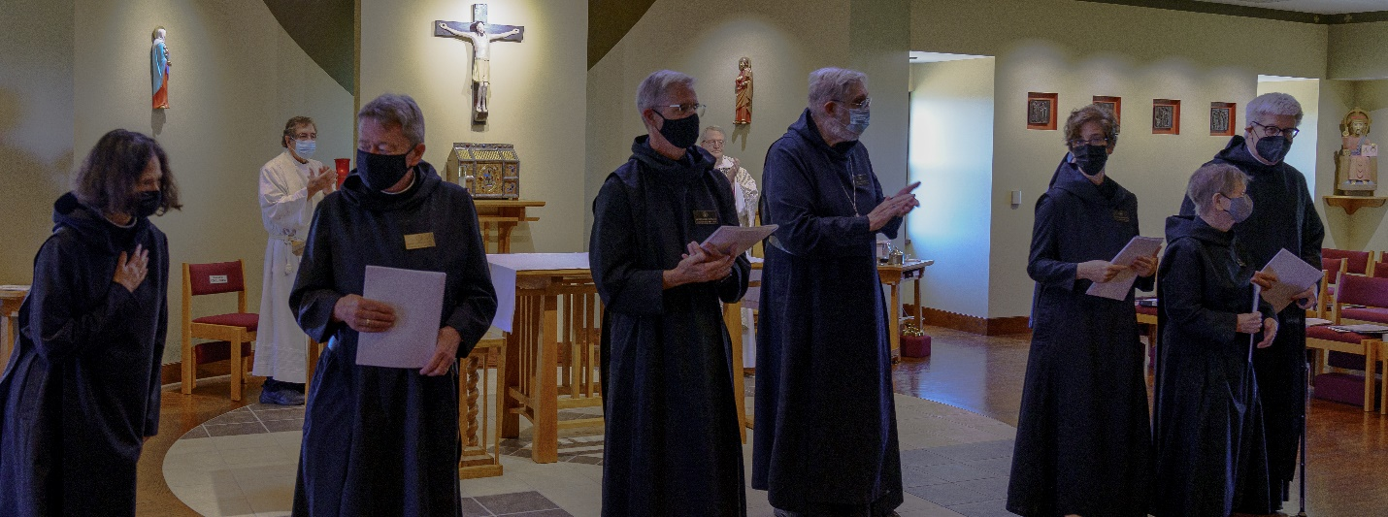
Sr. Catherine Ann Ballinger; Fr. Sidney Breese; Br. Raymond Escott; Br. Anskar Nonken; Bp. Alan Scarfe; Abbot David Gerns; Sr. Joanna Whitworth; Sr. Julian Smith-Boyer; Br. Chrysostom Olsen

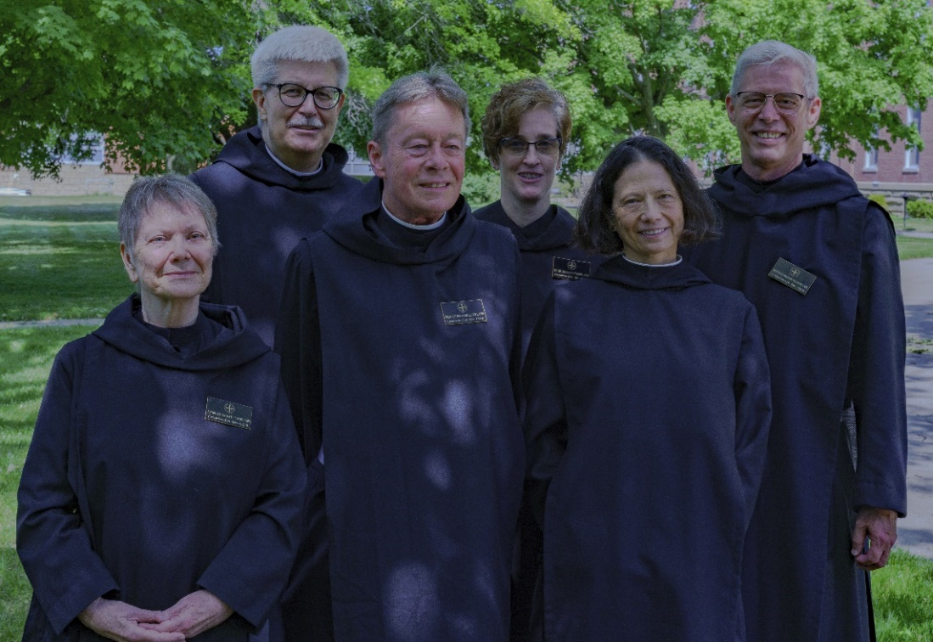
Sr. Julian Smith-Boyer; Br. Chrysostom Olsen; Br. Raymond Escott; Sr. Joanna Whitworth; Sr. Catherine Ann Ballinger; Br. Anskar Nonken

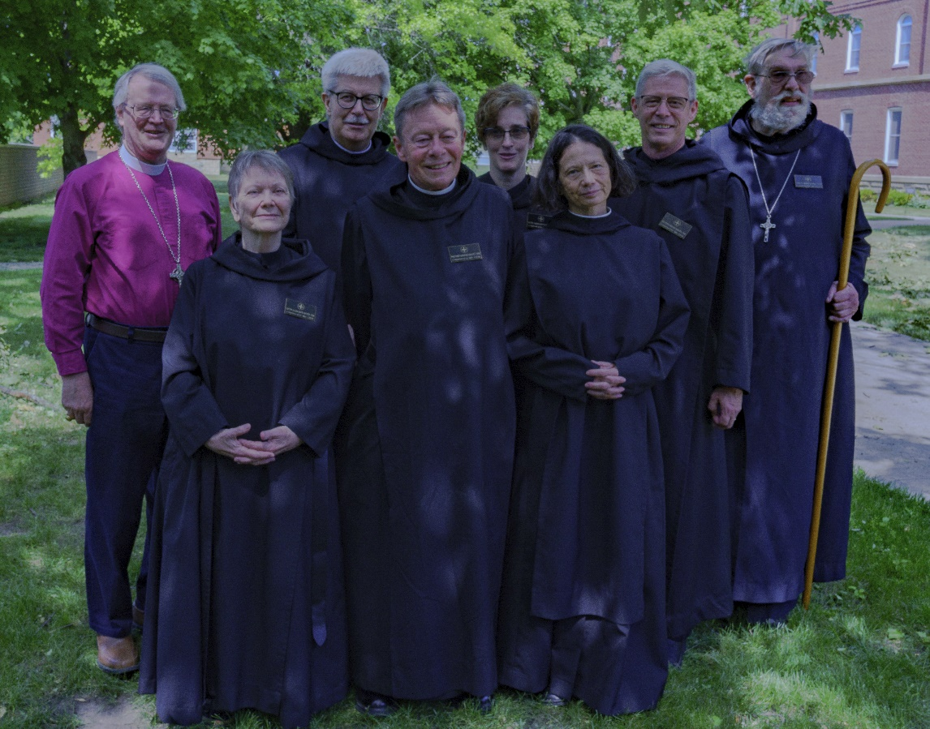
Bp. Alan Scarfe; Sr. Julian Smith-Boyer; Br. Chrysostom Olsen; Br. Raymond Escott; Sr. Joanna Whitworth; Sr. Catherine Ann Ballinger; Br. Anskar Nonken; Abbot David Gerns

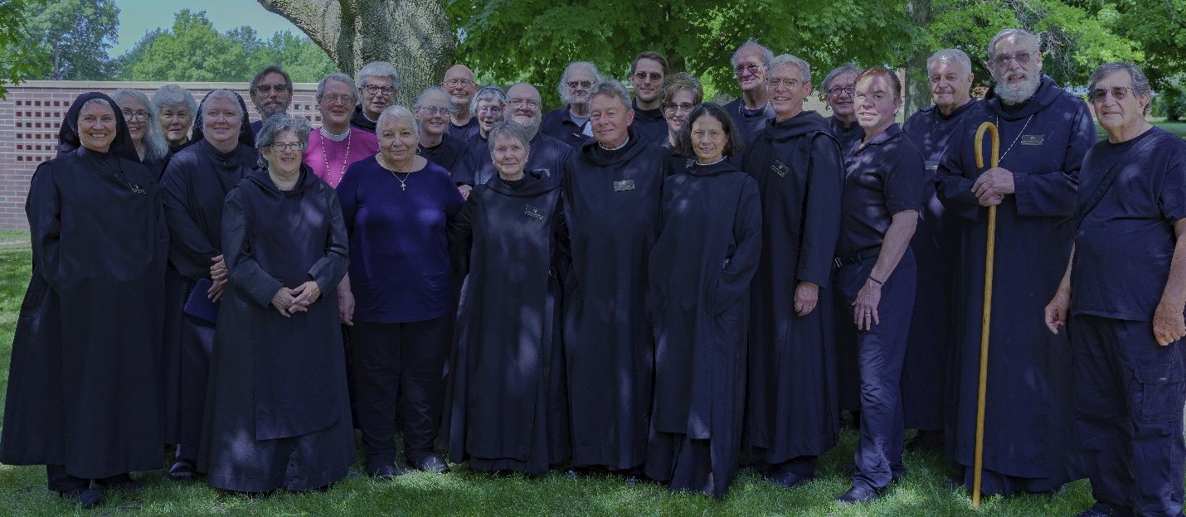
Sr. Mary Magdalene Clarke; Robin Smith; Sr. Toni Sylvester; Sr. Genevieve Lynn Robinson; William Page; Sr. Martha Lamoy; Bp. Alan Scarfe; Br. Chrysostom Olsen; Marie Patricia Hughes; ?; John David Wynne; Sr Brigid Gerns; Sr. Julian Smith-Boyer; Br. Thomas Anthony Goddard; Keith McKenna; Br. Raymond Escott; Br. Peter Francis Kyle; Sr. Joanna Whitworth; Sr. Catherine Ann Ballinger; Br. Joseph Florian Campbell; Br. Anskar Nonken; Br. James Rafael Davies; Kevin Orth; Br. Michael Anicetus McCabe; Abbot David Gerns; Fr. Sidney Breese
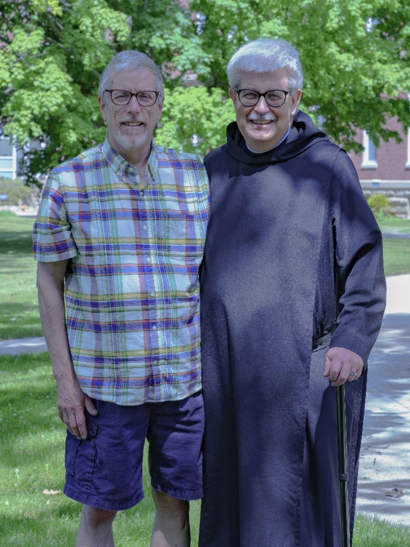
Rob Haverty; Br. Chrysostom Olsen

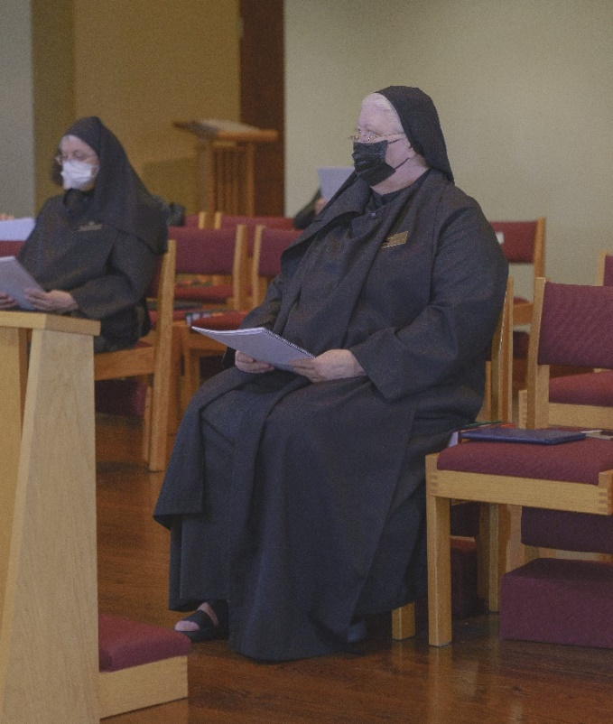
?; Sr. Genevieve Lynn Robinson

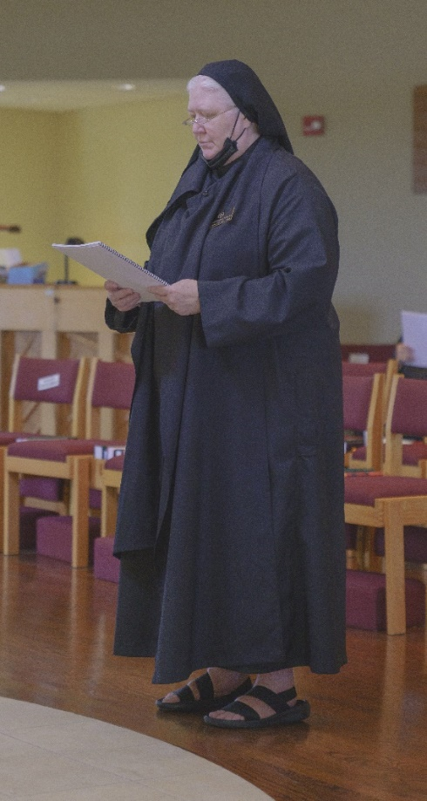
Sr. Genevieve Lynn Robinson

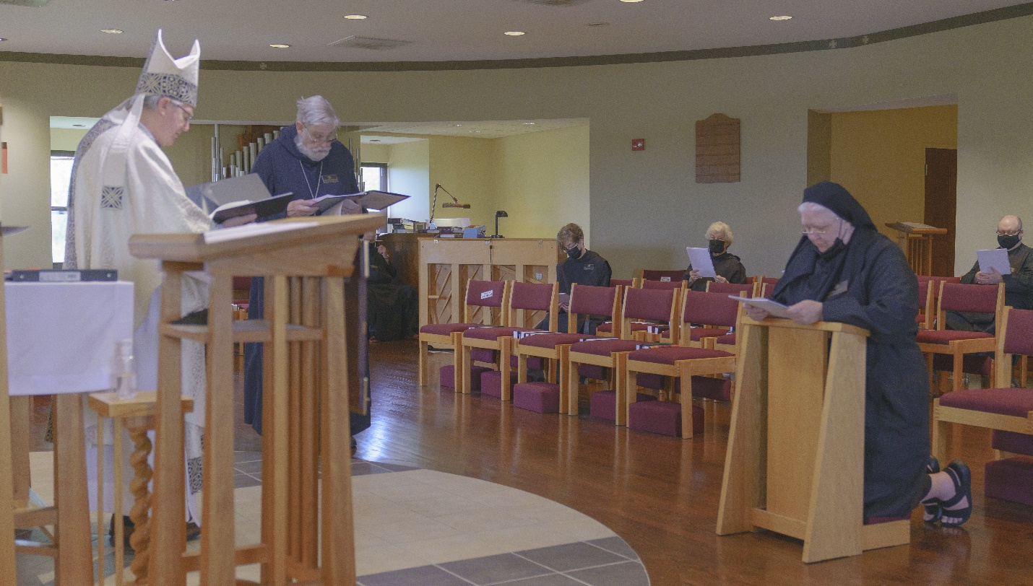
Bp. Alan Scarfe; Abbot David Gerns; Sr. Joanna Whitworth; Sr. Toni Sylvester; Sr. Genevieve Lynn Robinson; ?

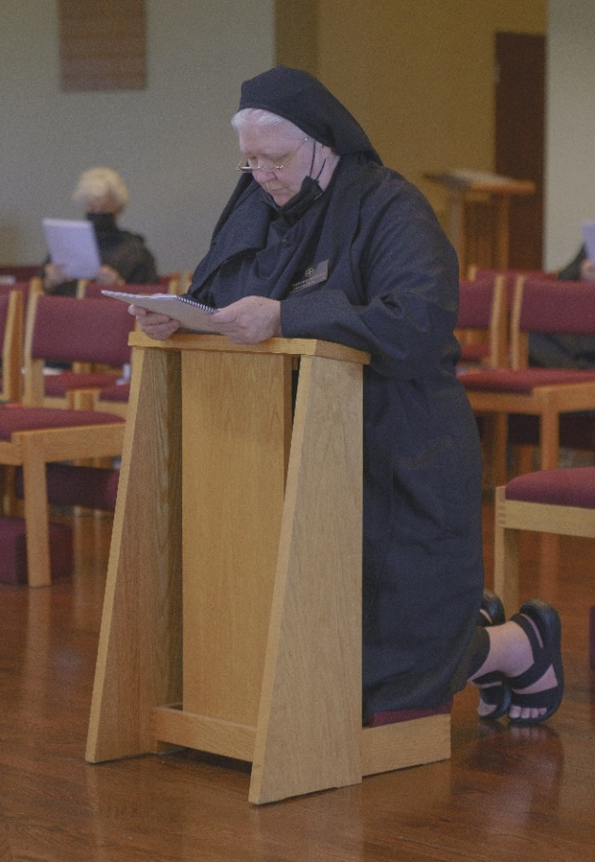
Sr. Toni Sylvester; Sr. Genevieve Lynn Robinson

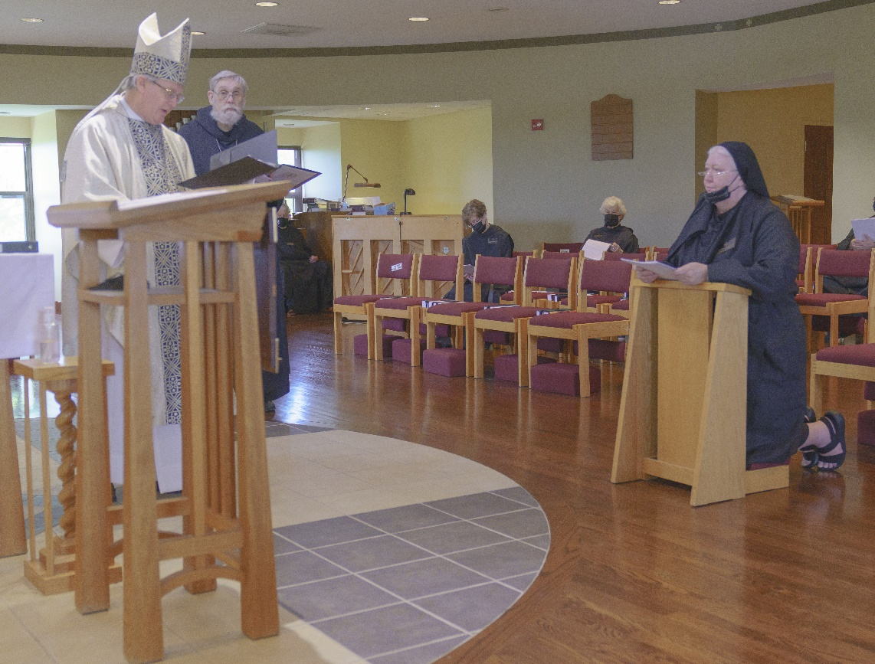
Abbot David Gerns; Bp. Alan Scarfe; Abbot David Gerns; ?; Sr. Joanna Whitworth; Sr. Toni Sylvester; Sr. Genevieve Lynn Robinson

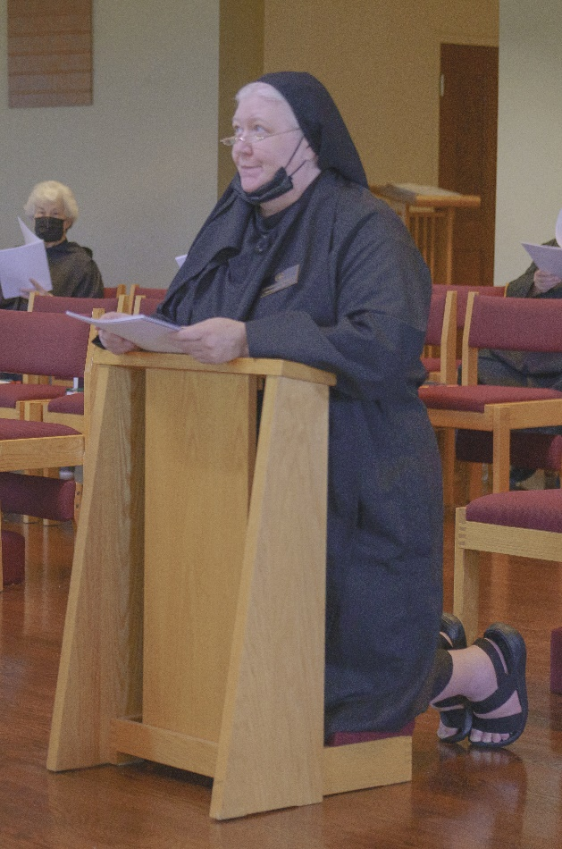
Sr. Toni Sylvester; Sr. Genevieve Lynn Robinson

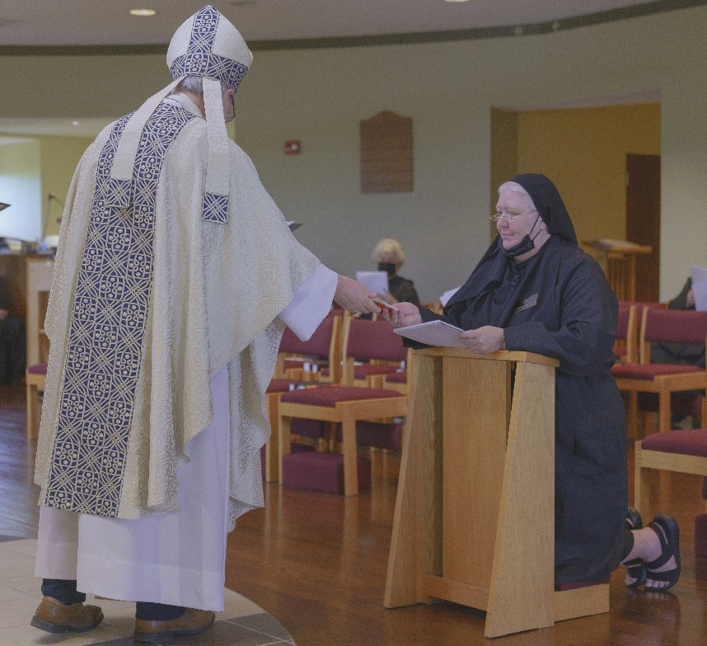
Bp. Alan Scarfe; Sr. Toni Sylvester; Sr. Genevieve Lynn Robinson
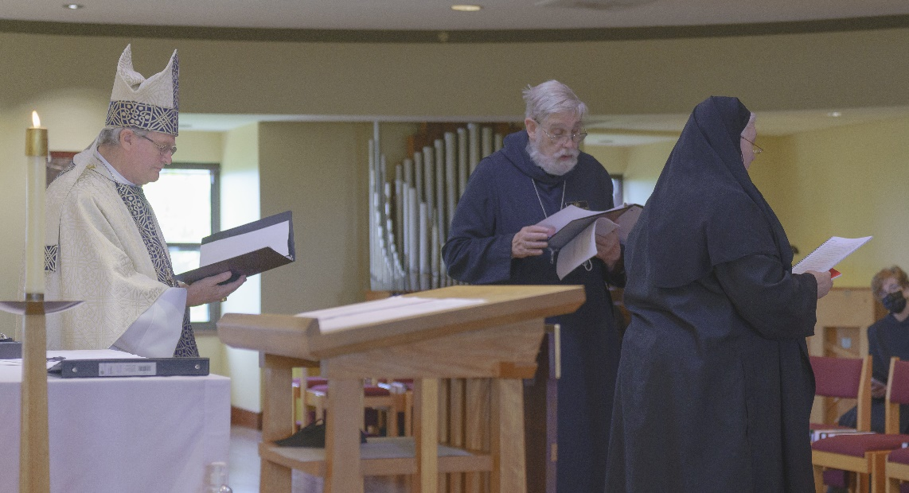
Bp. Alan Scarfe; Abbot David Gerns; Sr. Genevieve Lynn Robinson; Sr. Joanna Whitworth

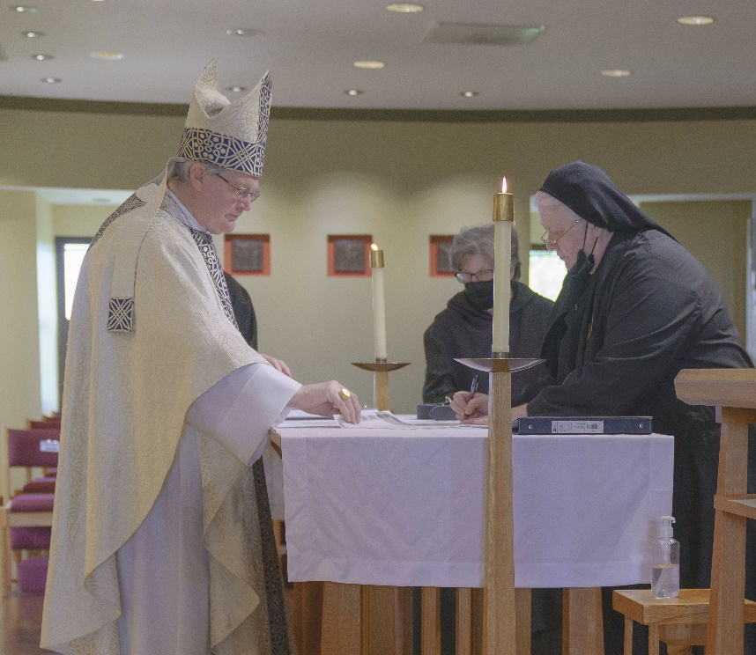
Bp. Alan Scarfe; Sr. Martha Lamoy; Sr. Genevieve Lynn Robinson

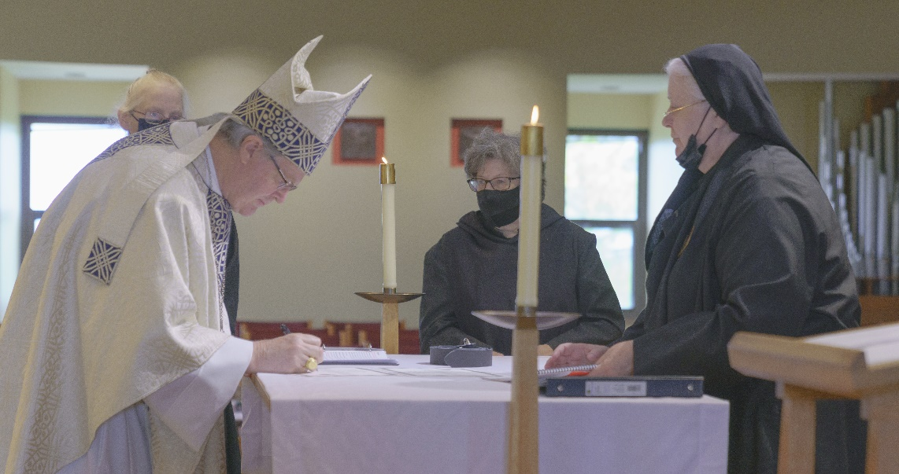
?; Bp. Alan Scarfe; Sr. Martha Lamoy; Sr. Genevieve Lynn Robinson

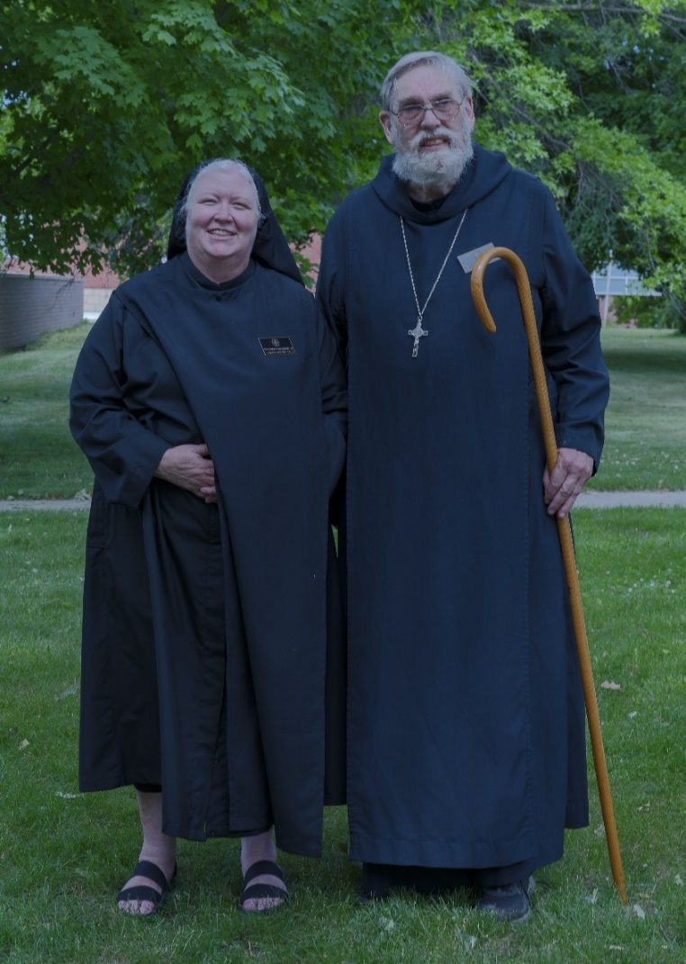
Sr. Genevieve Lynn Robinson; Abbot David Gerns

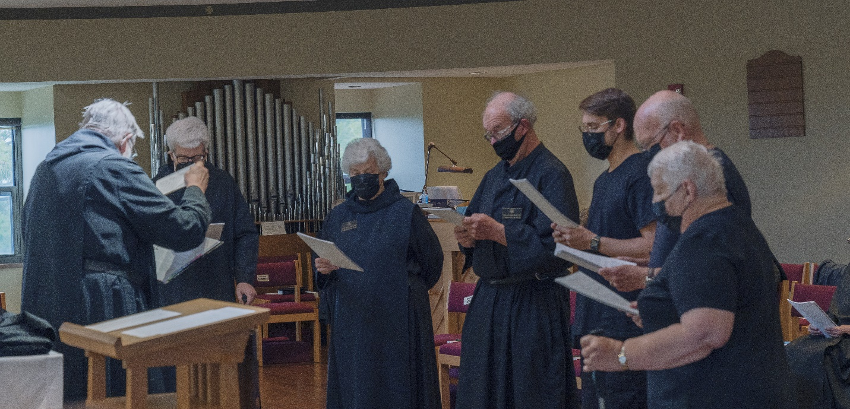
Abbot David Gerns; Br. Chrysostom Olsen; Sr. Toni Sylvester; Sr. Toni Sylvester; Br. Joseph Florian Campbell; Br. Peter Francis Kyle; Sr. Marie Patricia Hughes

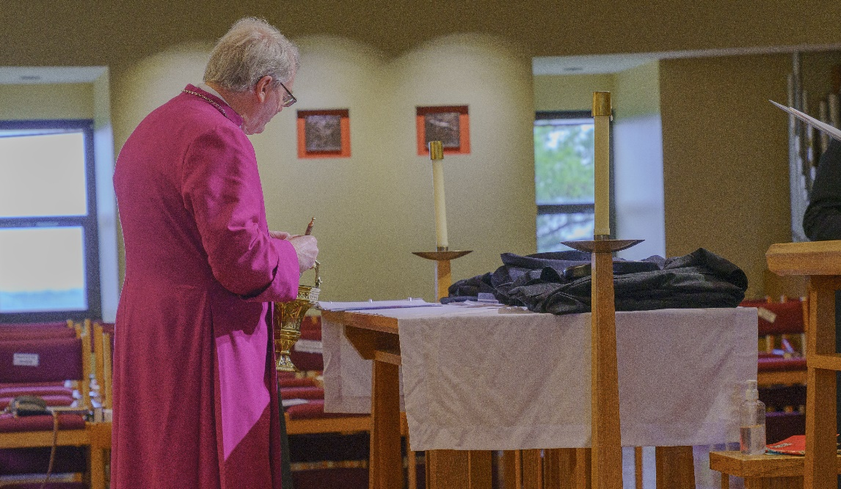
Bp. Alan Scarfe

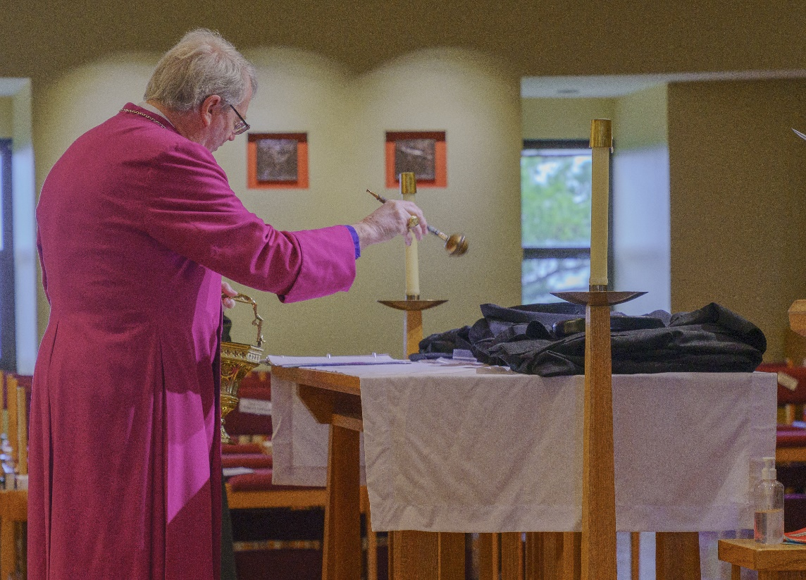
Bp. Alan Scarfe

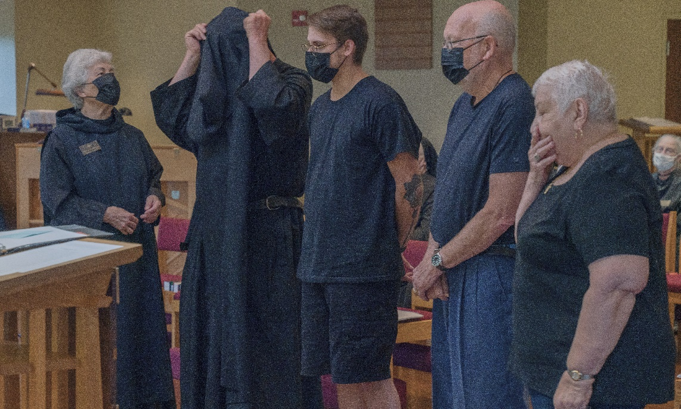
Sr. Toni Sylvester; Br. Joseph Florian Campbell; Br. Peter Francis Kyle; Br. John David Wynne; Sr. Marie Patricia Hughes; ?

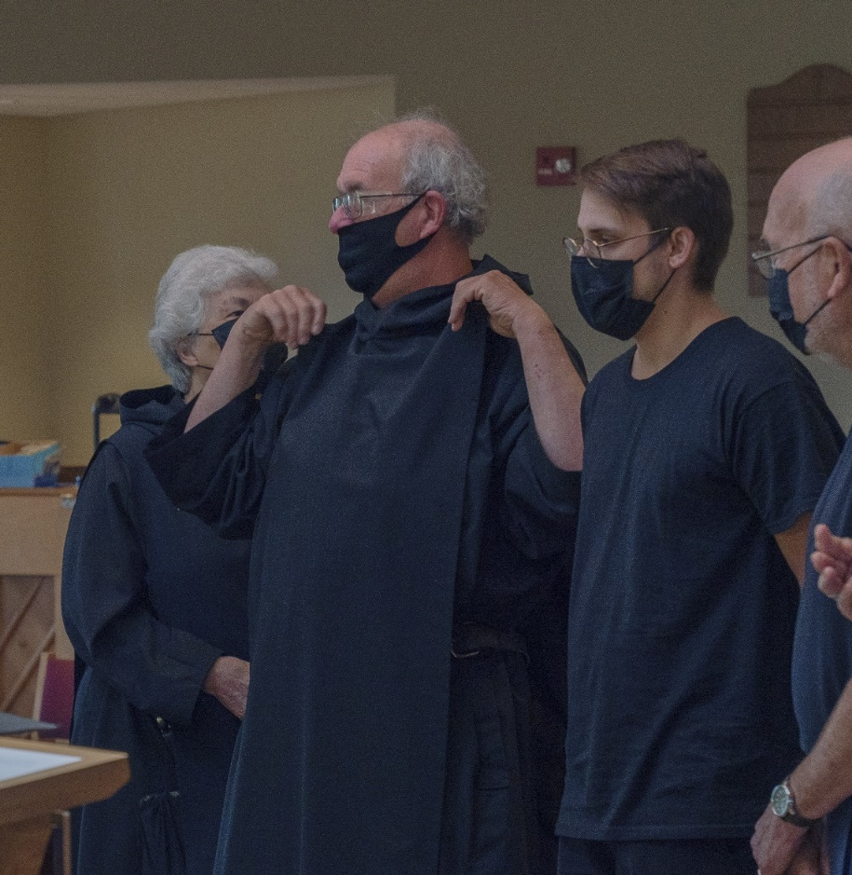
Sr. Toni Sylvester; Br. Joseph Florian Campbell; Br. Peter Francis Kyle; Br. John David Wynne
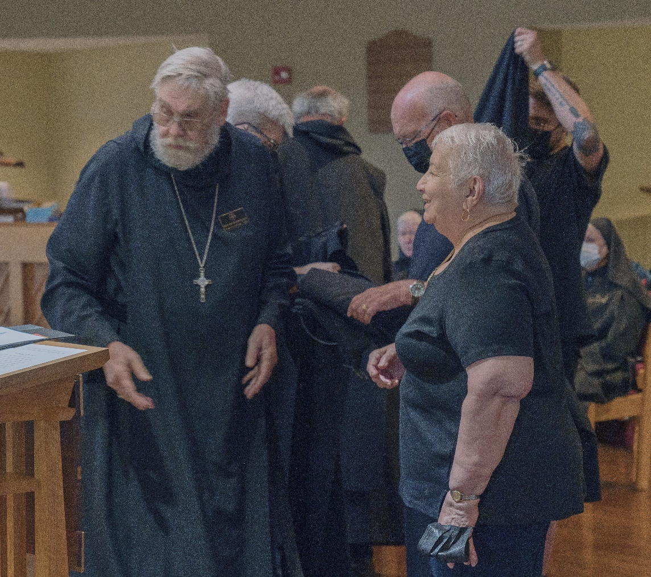
Abbot David Gerns; Br. Chrysostom Olsen; Br. Joseph Florian Campbell; ?; Br. John David Wynne; Br. Peter Francis Kyle; ?

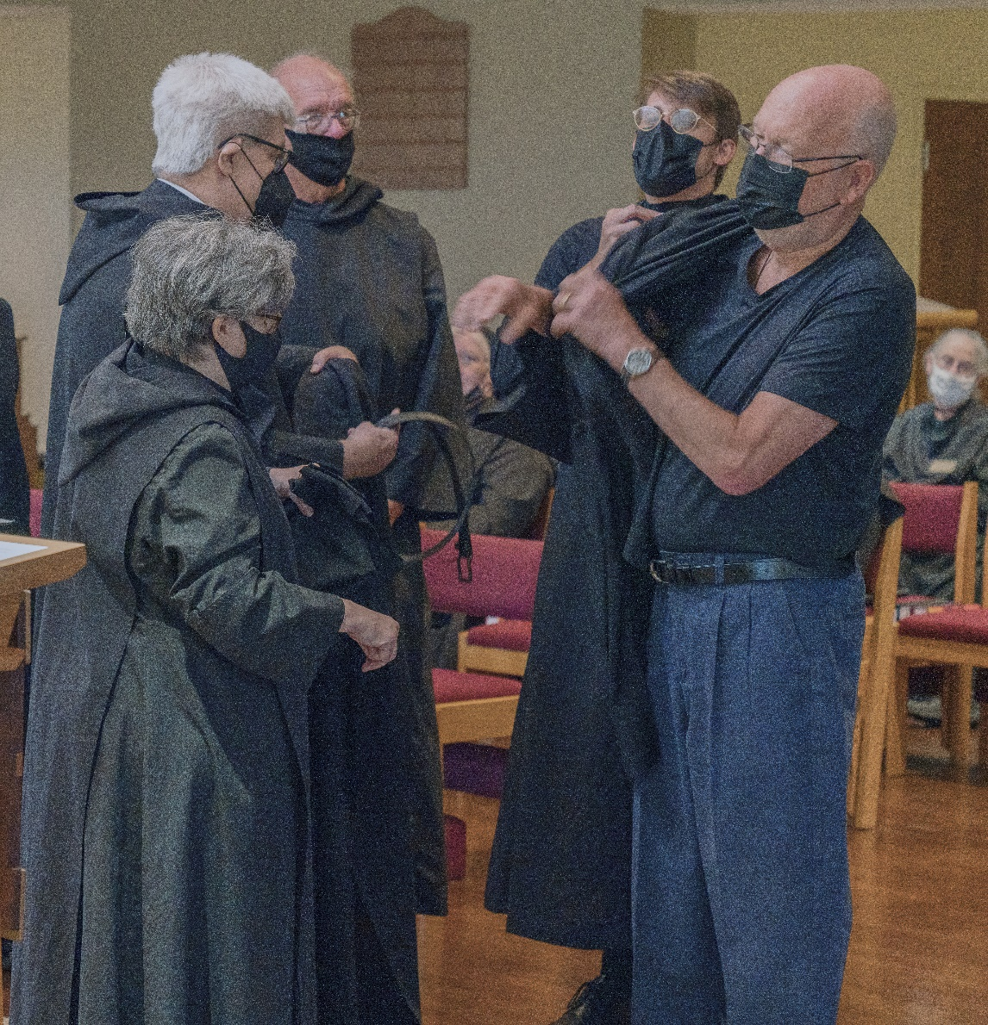
Sr. Martha Lamoy; Br. Chrysostom Olsen; Br. Joseph Florian Campbell; Br. Peter Francis Kyle; Br. John David Wynne; ?

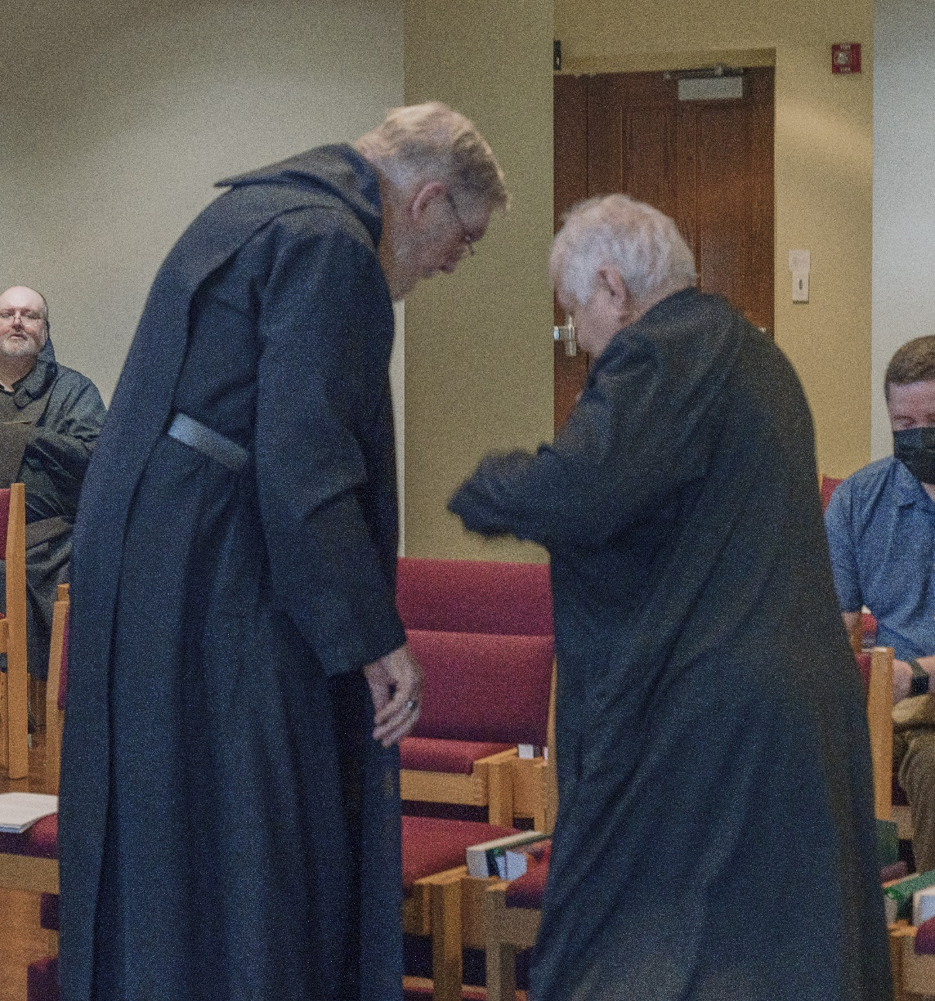
?; Abbot David Gerns; Sr. Marie Patricia Hughes; ?
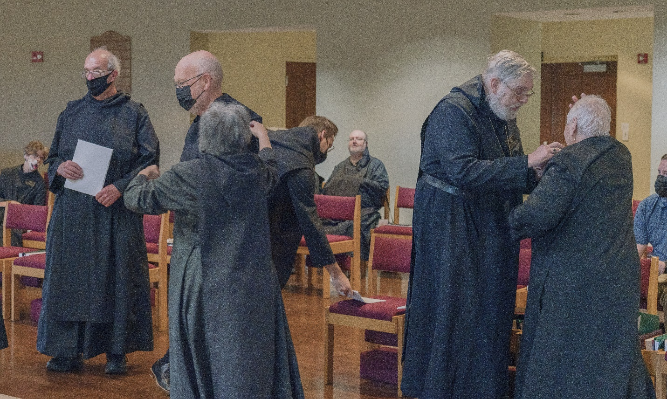
Sr. Joanna Whitworth; Br. Joseph Florian Campbell; Br. John David Wynne; Sr. Martha Lamoy; Br. Peter Francis Kyle; ?; Abbot David Gerns; Sr. Marie Patricia Hughes; ?

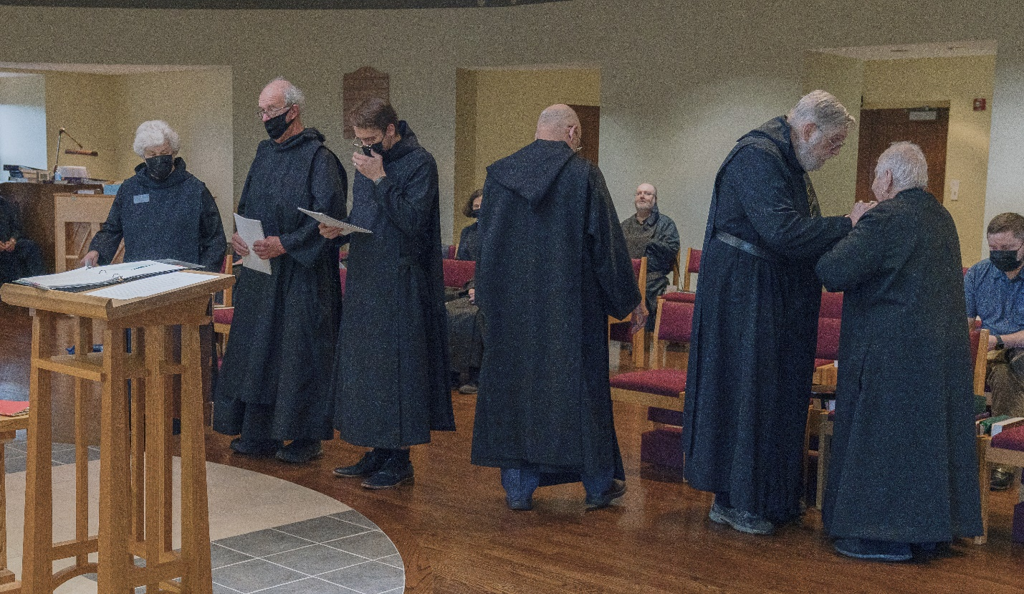
Sr Toni Sylvester; Br. Joseph Florian Campbell; Br. Peter Francis Kyle; Sr. Catherine Ann Ballinger; Br. John David Wynne; ?; Abbot David Gerns; Sr. Marie Patricia Hughes; ?
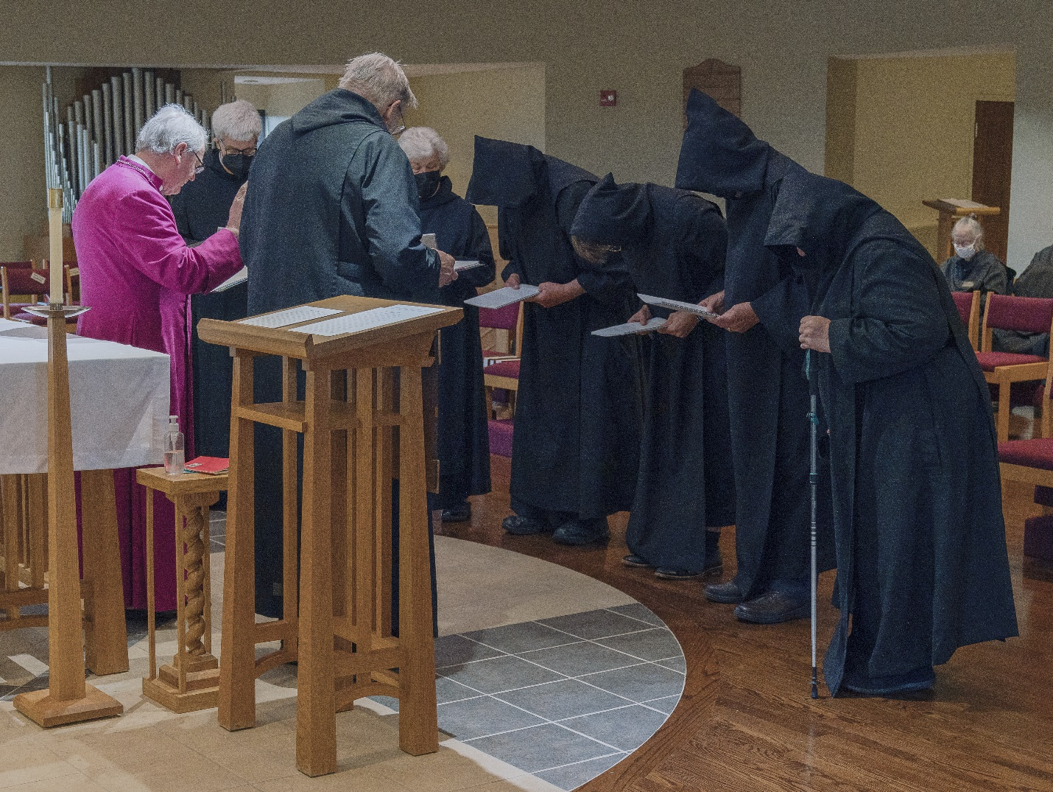
Bp. Alan Scarfe; Br. Chrysostom Olsen; Abbot David Gerns; Sr. Toni Sylvester; Br. Joseph Florian Campbell; Br. Peter Francis Kyle; Br. John David Wynne; Sr. Marie Patricia Hughes; ?

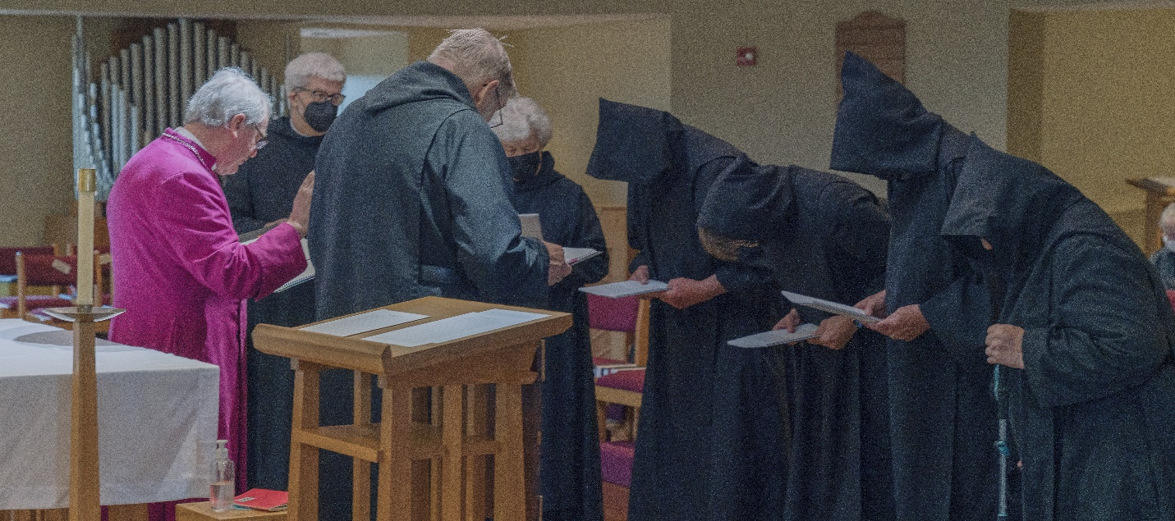
Bp. Alan Scarfe; Br. Chrysostom Olsen; Abbot David Gerns; Sr. Toni Sylvester; Br. Joseph Florian Campbell; Br. Peter Francis Kyle; Br. John David Wynne; Sr. Marie Patricia Hughes
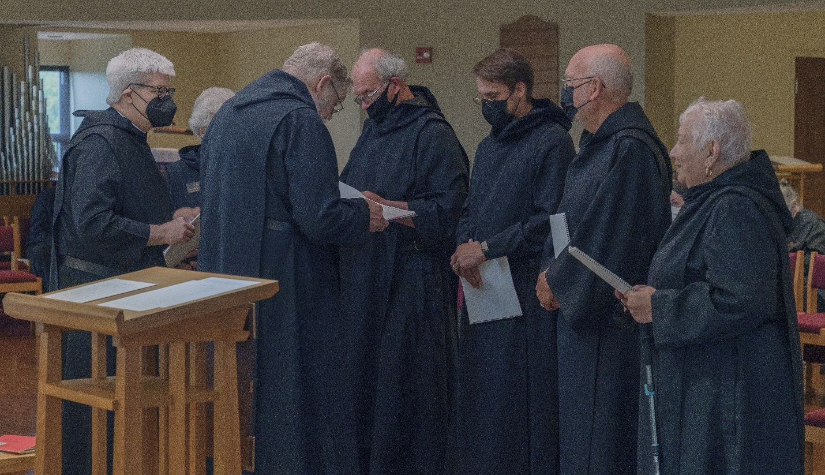
Br. Chrysostom Olsen; Sr. Toni Sylvester; Abbot David Gerns; Br. Joseph Florian Campbell; Br. Peter Francis Kyle; Br. John David Hughes; Sr. Marie Patricia Hughes

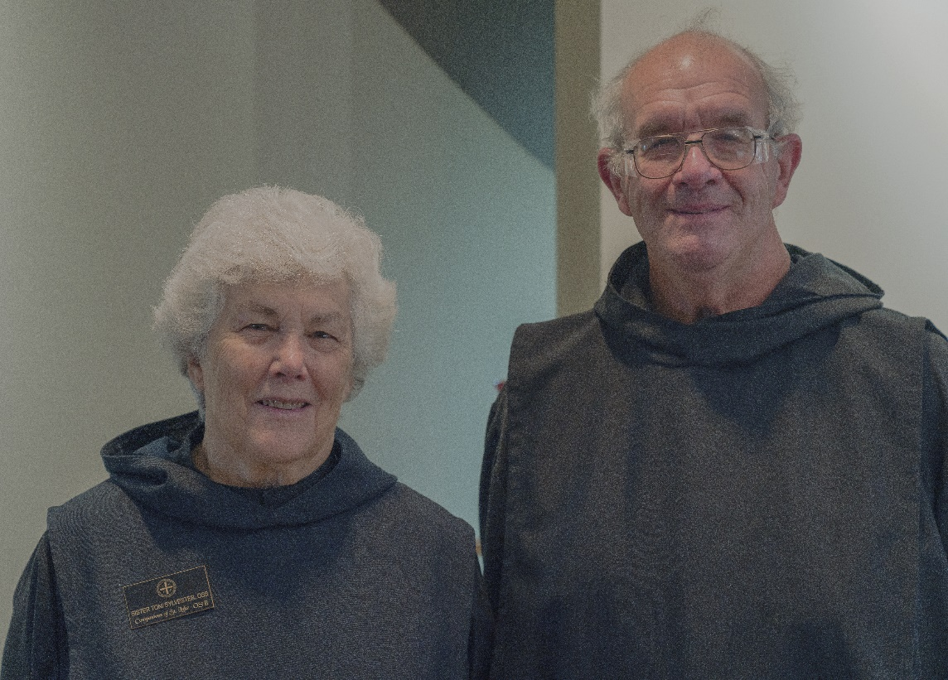
Sr. Toni Sylvester; Br. Joseph Florian Campbell
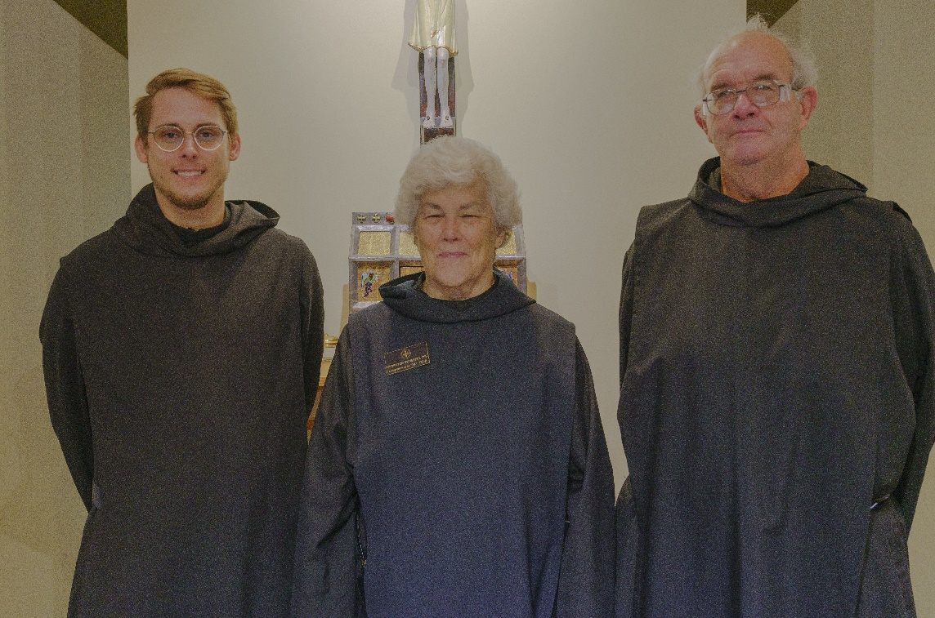
Br. Peter Francis Kyle; Sr. Toni Sylvester; Br. Joseph Florian Campbell

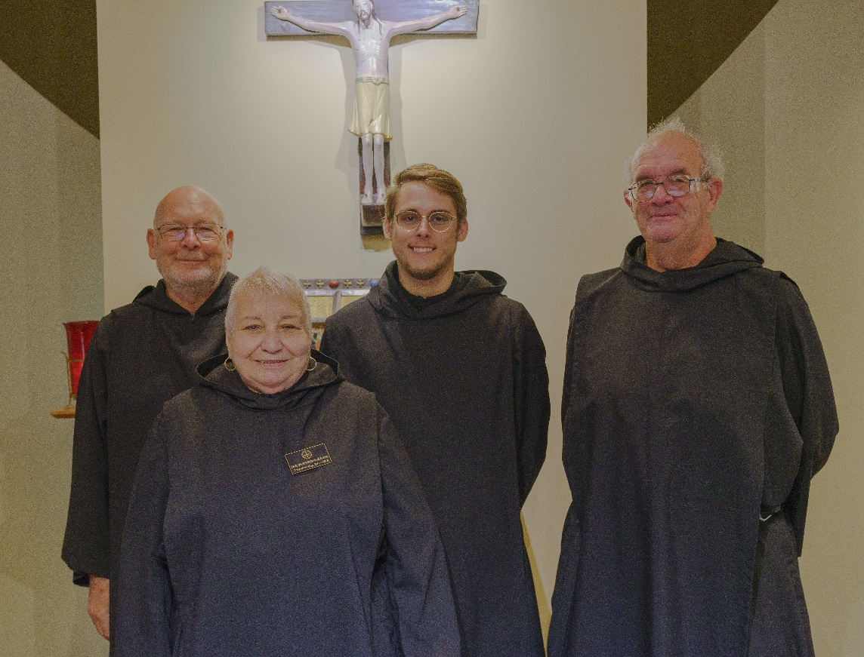
Br. John David Wynne; Sr. Marie Patricia Hughes; Br. Peter Francis Kyle; Br. Joseph Florian Campbell
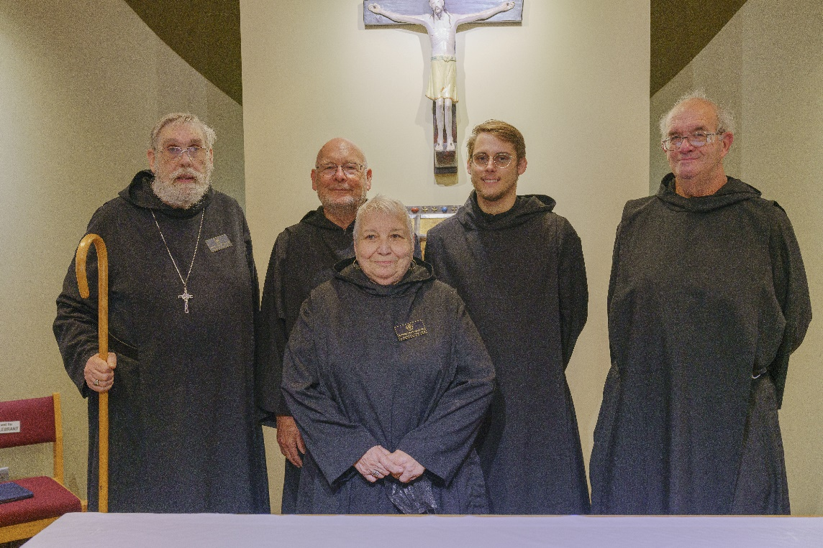
Abbot David Gerns; Br. John David Wynne; Sr. Marie Patricia Hughes; Br. Peter Francis Kyle; Br. Joseph Florian Campbell

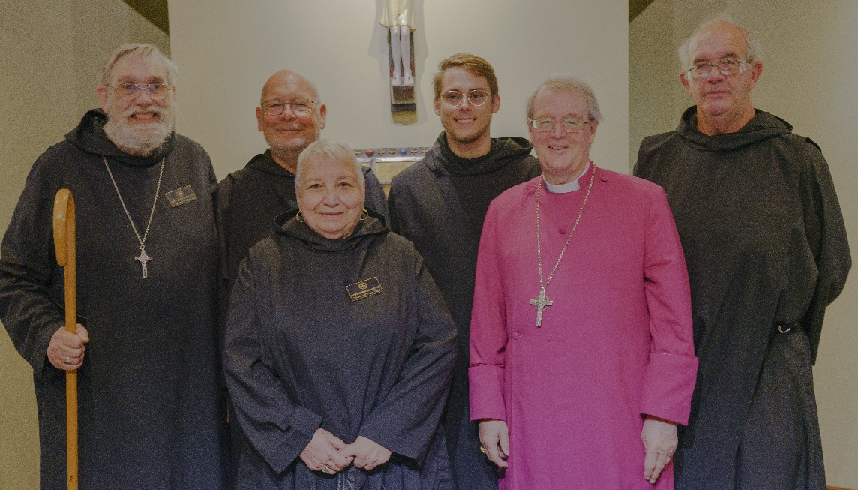
Abbot David Gerns; Br. John David Wynne; Sr. Marie Patricia Hughes; Br. Peter Francis Kyle; Bp. Alan Scarfe; Br. Joseph Florian Campbell

