**2009 Fall Convocation Portraits**

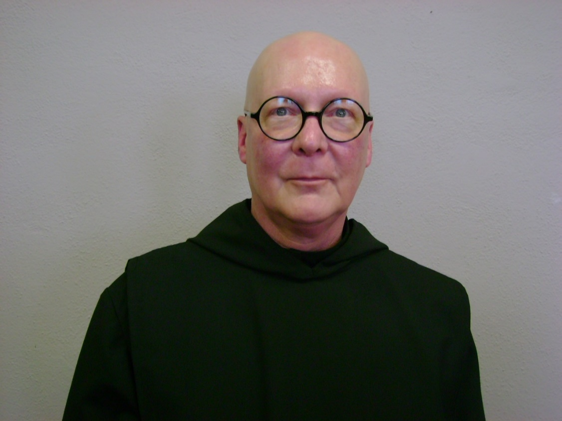

DSC04455.jpg Br. Stephen Francis Arnold

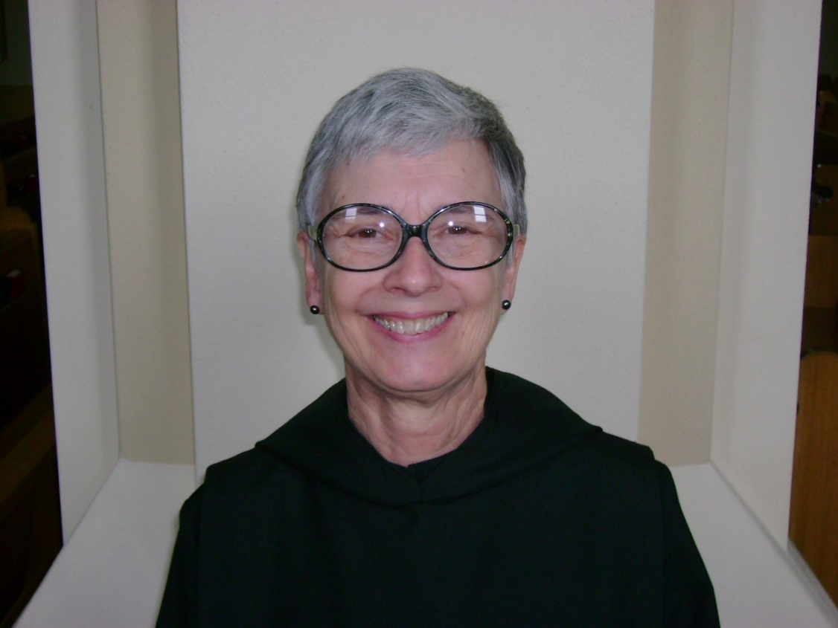

DSC04484.jpg Sr. Julian Saterstrom (Anna Saterstrom)

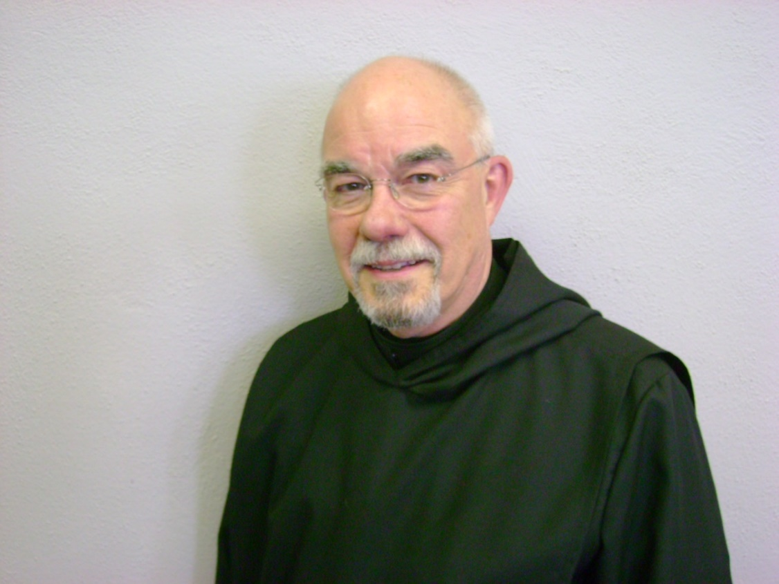

DSC04459.jpg Br. Basil Edwards (Tom Edwards)

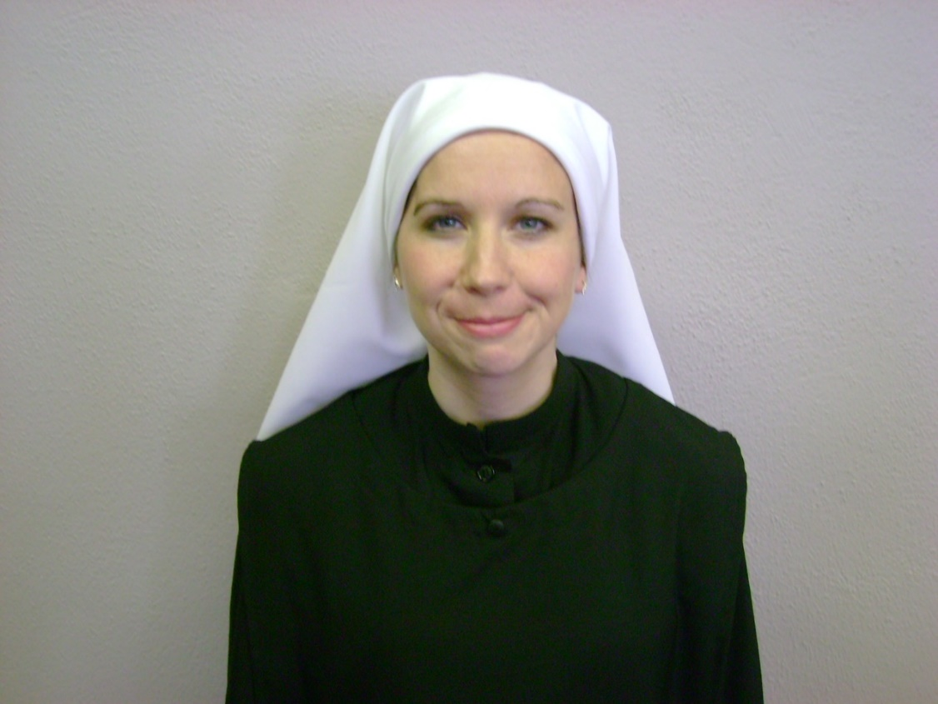

DSC04460 Sr. Veronica Taylor (Rebekah Taylor)

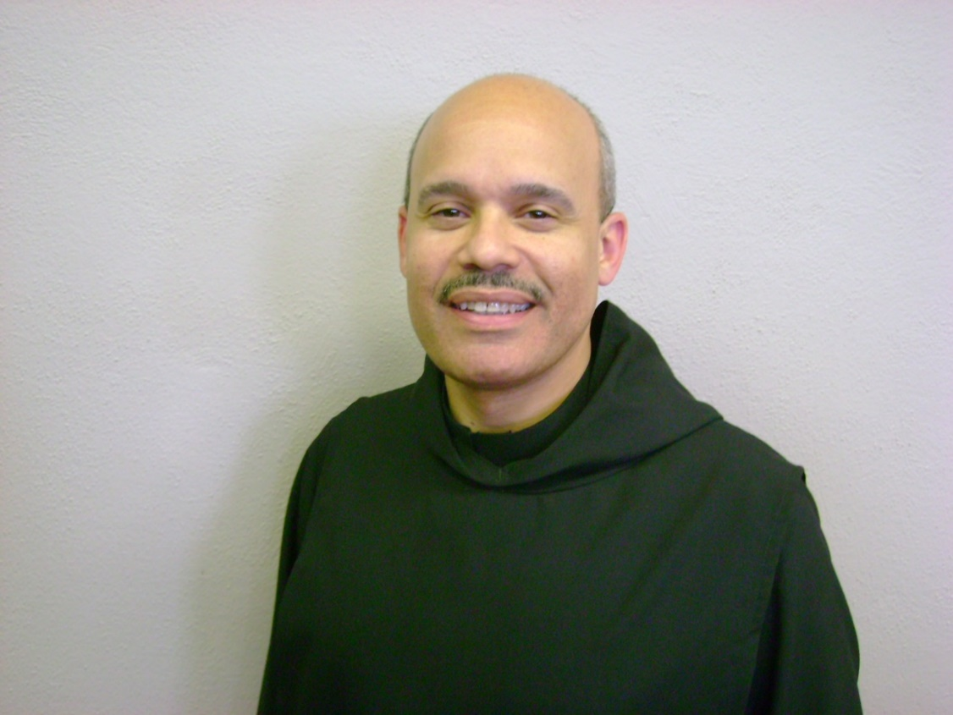

DSC04461 Br. Martin Xavier Harrell (Rick Harrell)

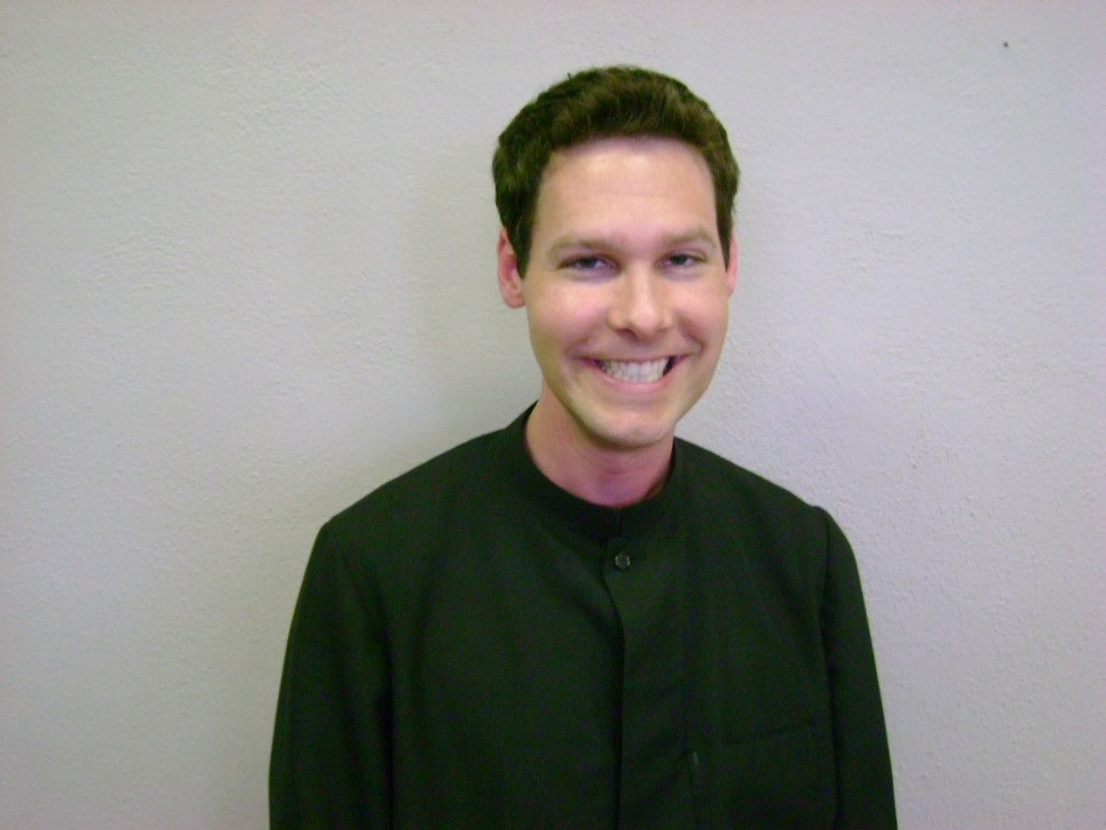

DSC04463,jpg Br. Adrian Mychel Shaw (Brian Shaw)

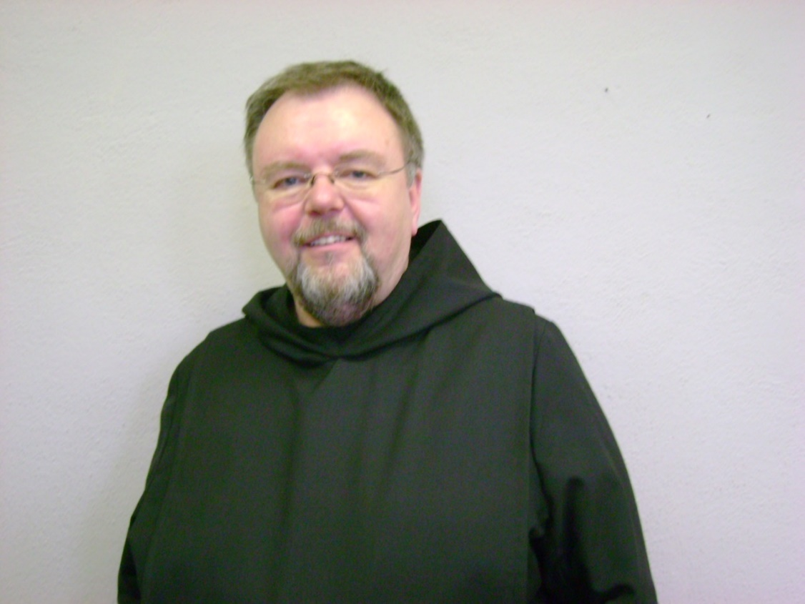

DSC004464 Br. Samuel Saterstrom (Roger Saterstrom)

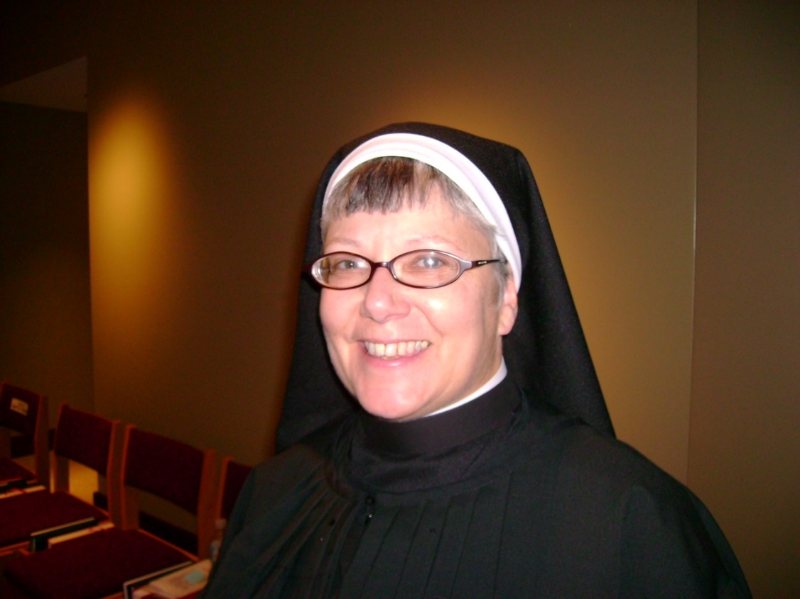

DSC04435 Sr. Anna Grace Madden

Names in parentheses are civilian names before religious names were given.

Br. Stephen Francis Arnold and Sr. Anna Grace Madden assisted with the identifications.

*~Br. Steven Olderr*

*12 Oct 2022*