**Fall Convocation Portraits**

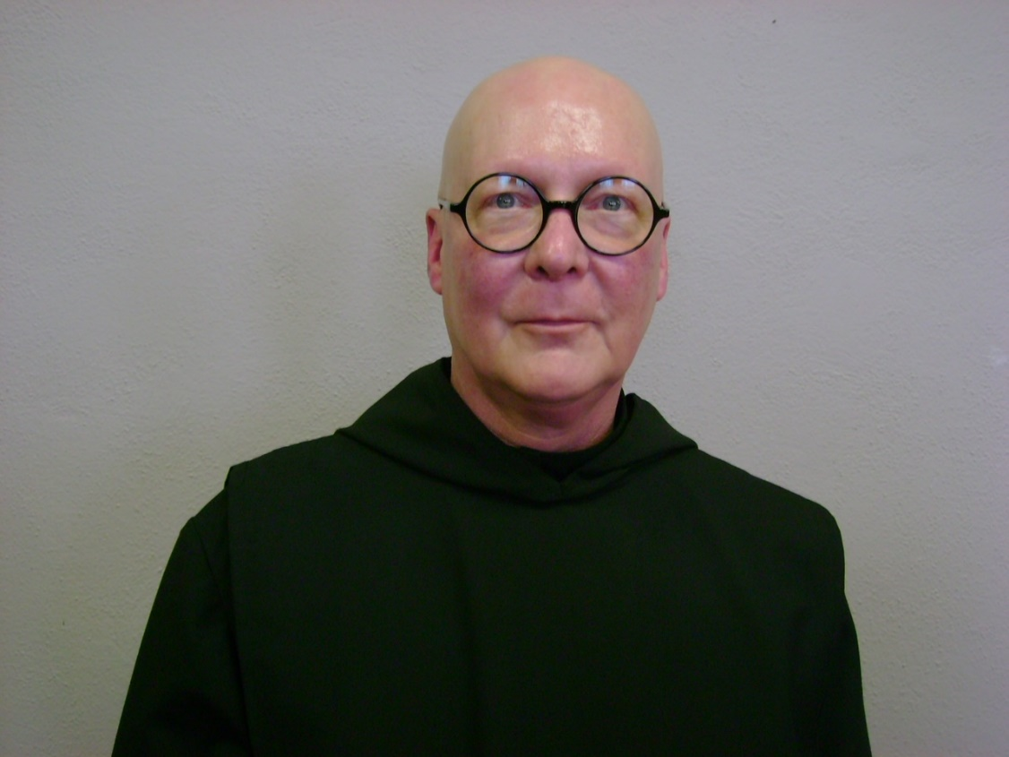

DSC04455.jpg Br. Stephen Francis Arnold

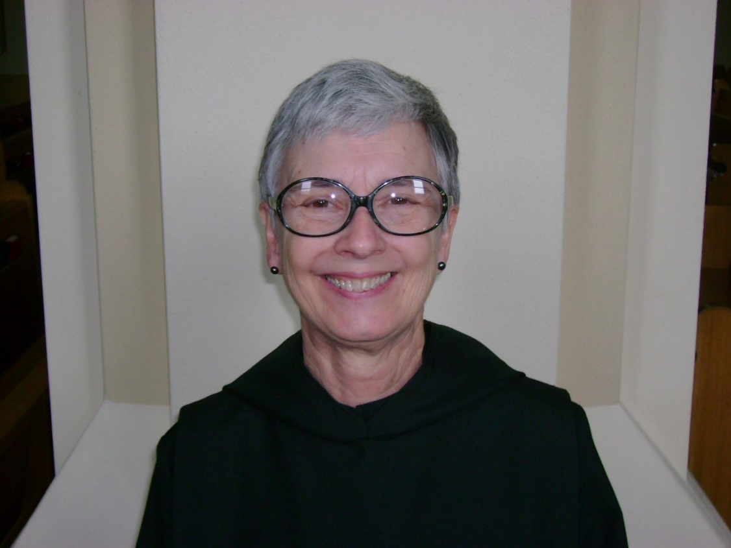

DSC04484.jpg Sr. Julian Saterstrom

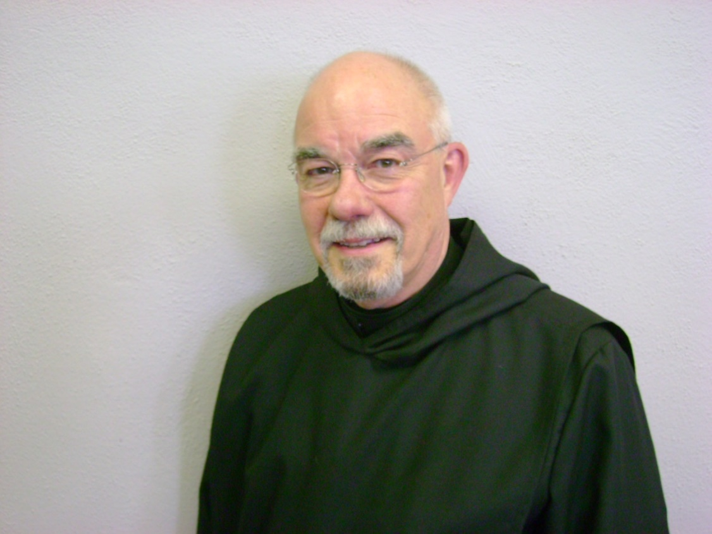

DSC04459.jpg Br. Basil Edwards

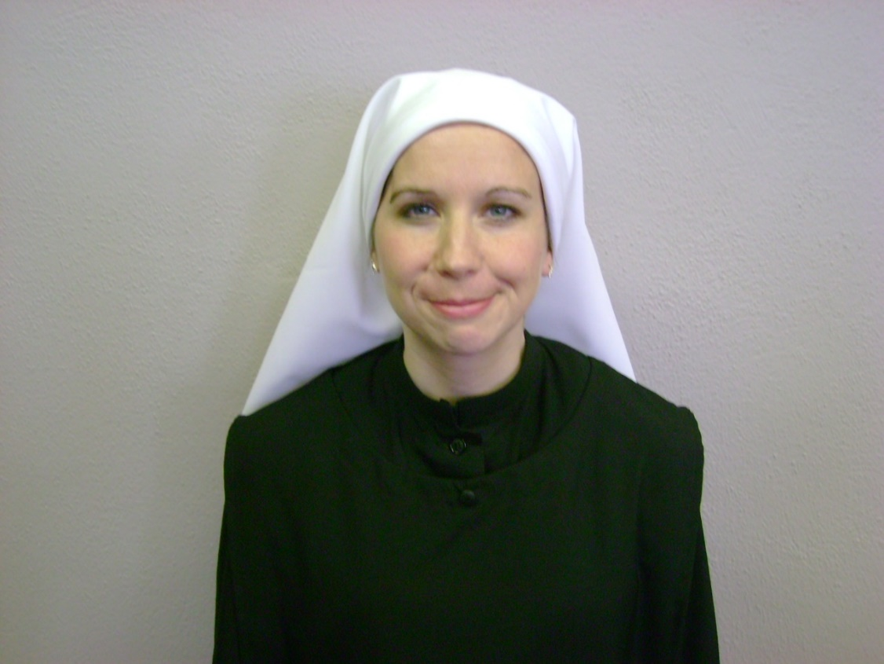

DSC04460 Sr. Veronica Taylor

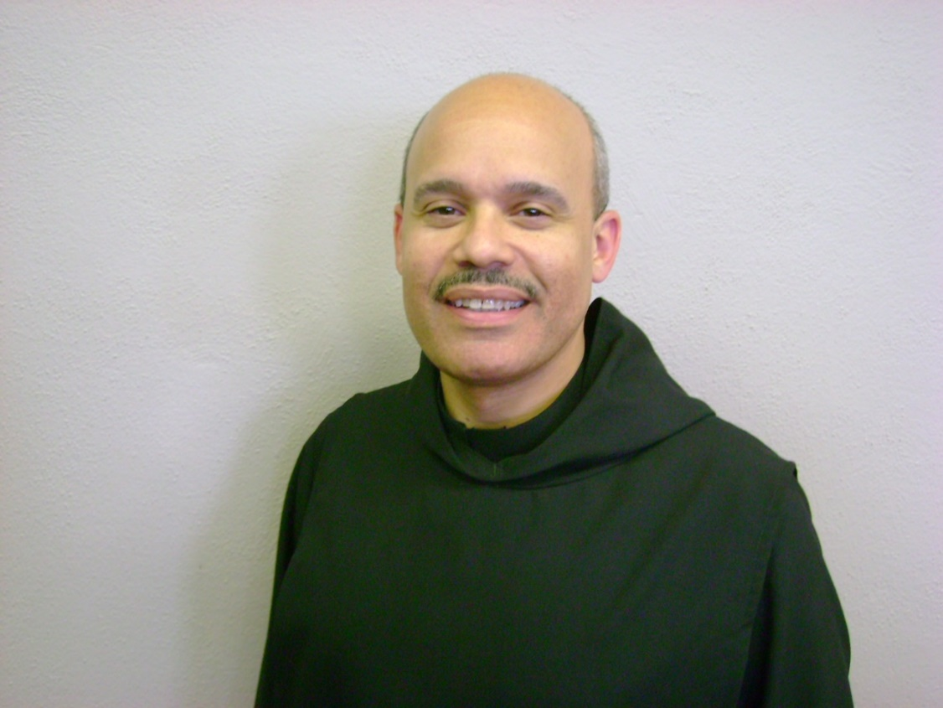

DSC04461.jpg?

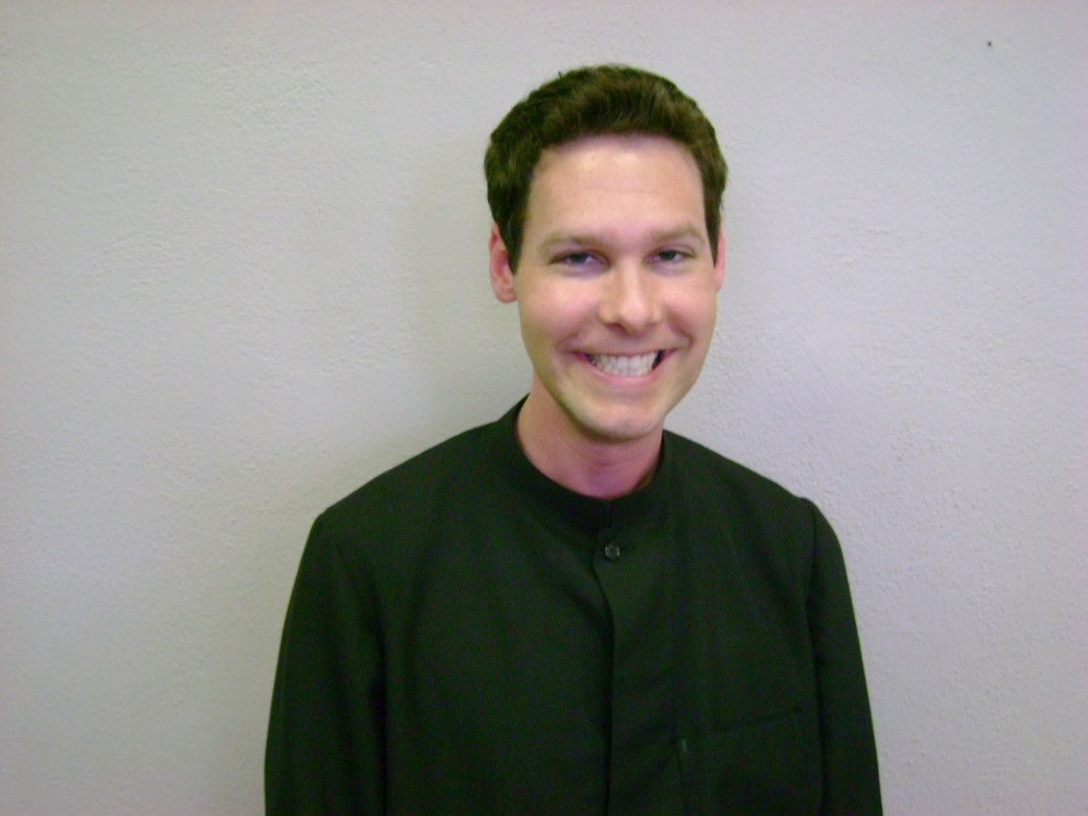

DSC04463,jpg ?

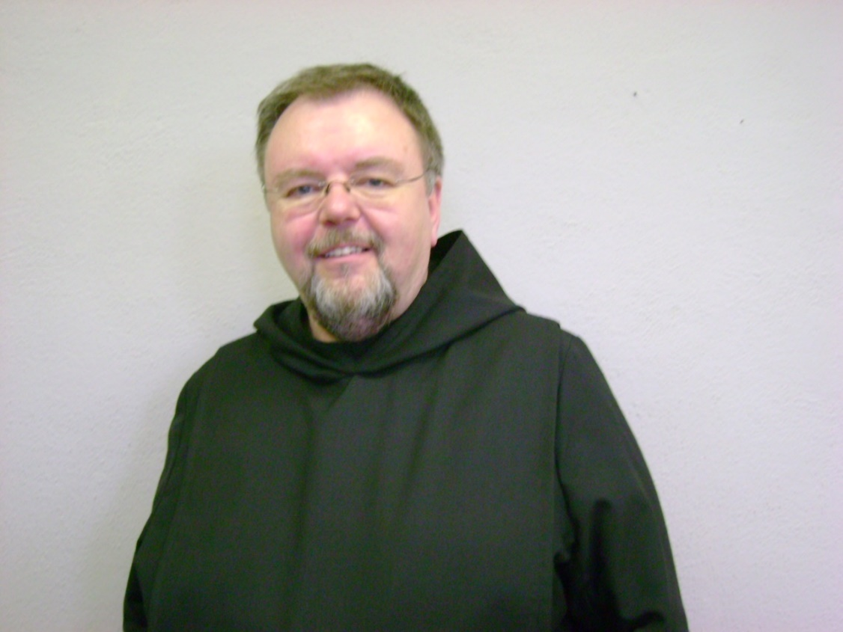

DSC004464 Br. Roger Saterstrom

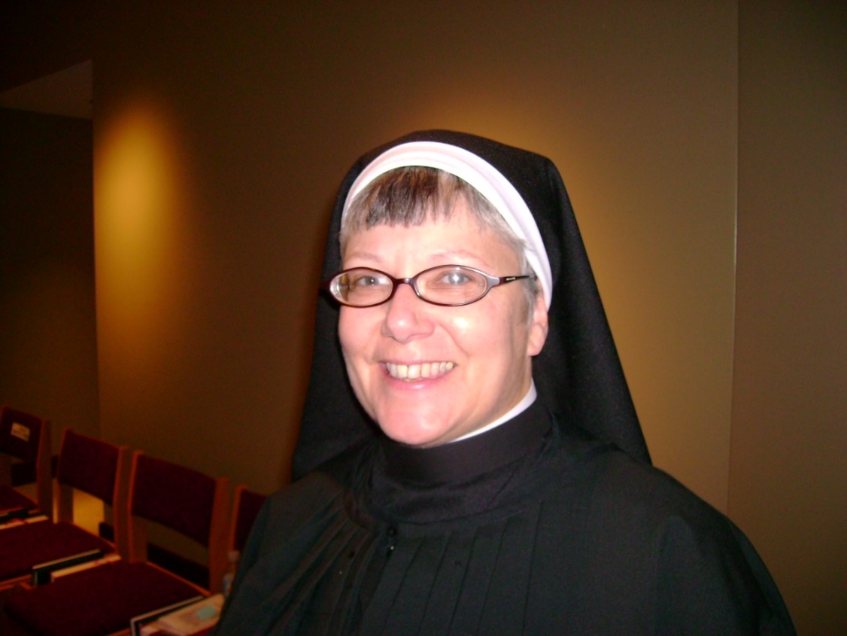

DSC04435 Sr. Anna Grace Madden