2022 Spring Convocation
Companions of St. Luke

~Edited by Br. Steven Olderr, 7 September 2022 with the assistance of Sr. Mary Magdalene Clarke. If you find any errors or omissions or have anything to add, please notify Br. Steven at olderr@ameritech.net

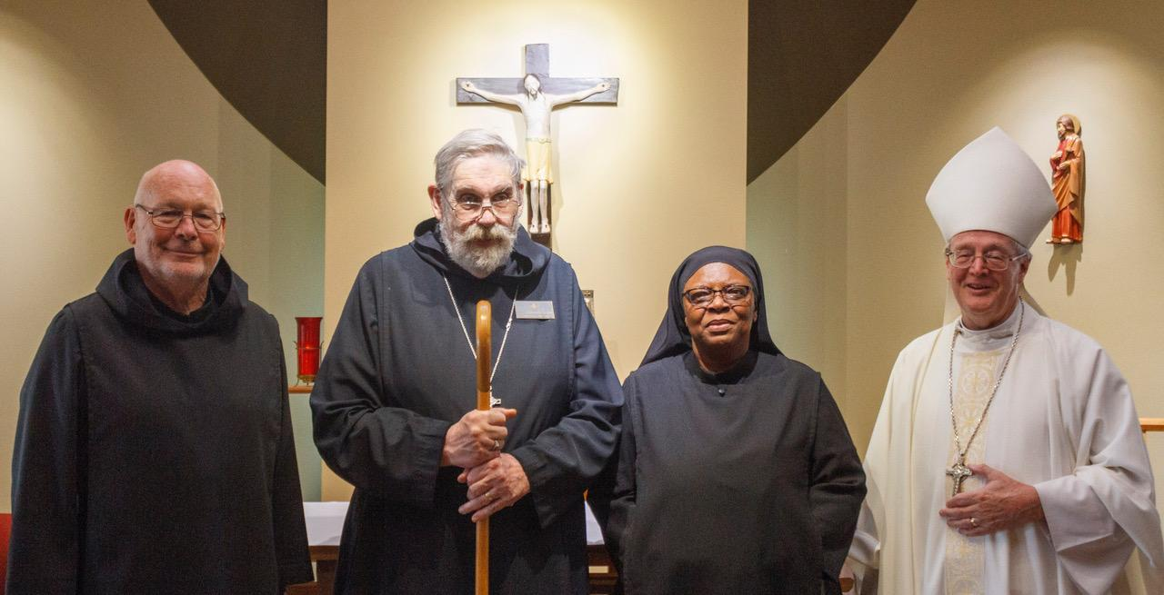
Br. John David Wynne; Abbot David Gerns; Sr. Cecelia Horton; Bp. Alan Scarfe

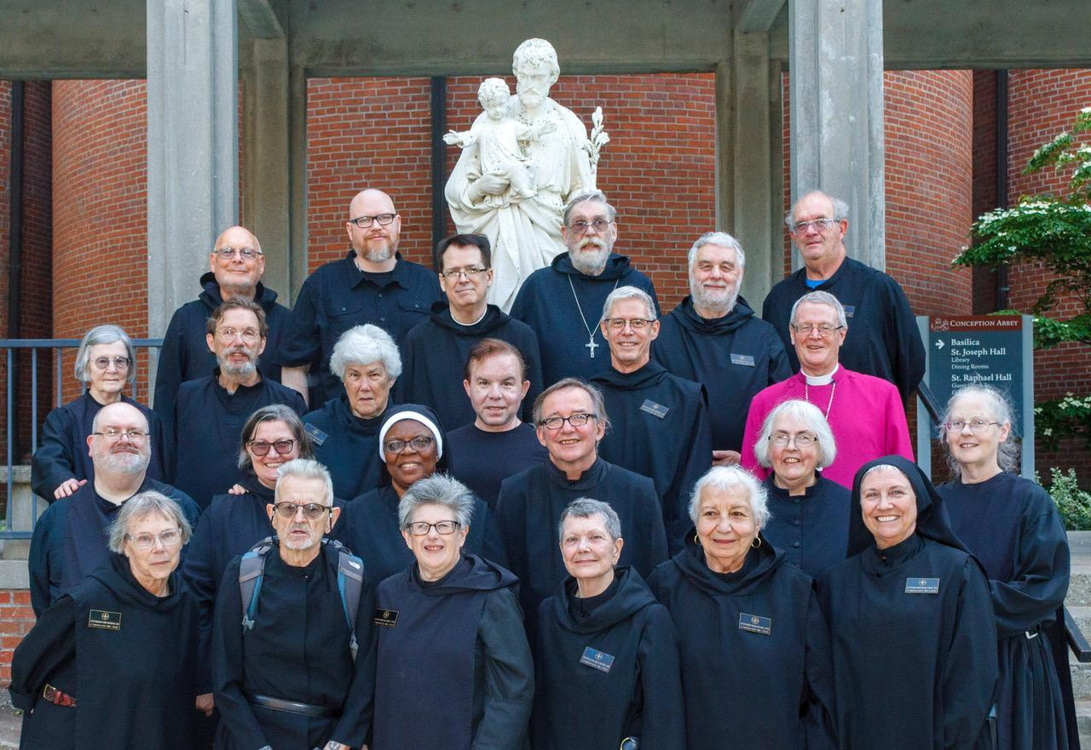

First Row: Sr. Margaret Mary Bergeron; Br. David-Mark Campbell; Sr. Martha Lamoy; Sr. Julian Smith-Boyer; Sr. Marie Patricia Hughes; Sr. Mary Magdalene Clarke
Second Row: Br. Daniel Moore; Sr. Clara Ulson Freiras; Sr. Cecelia Horton; Br. James Raphael Davies; Sr. Madeleine Sophie Smith; Sr. Denise Moore
Third Row: Sr. Brigid Gerns; Br. William Marion Page; Sr. Toni Sylvester; Kevin Orth; Br. Anskar Nonken; Bp. Alan Scarfe
Fourth Row: Br. John David Wynne; Rockford Patrick; Br. Dunstan Townsend; Abbot David Gerns; Br. Gregory Tatchell; Br. Florian Campbell

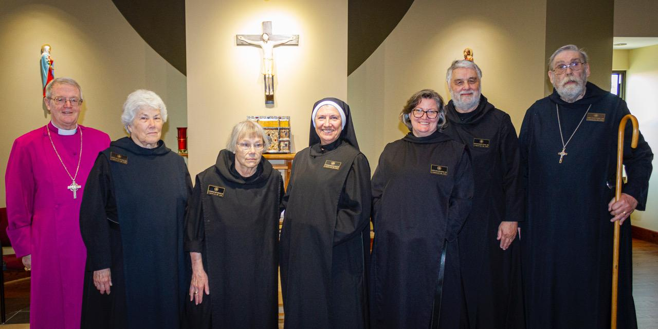

Bp. Alan Scarfe; Sr. Toni Sylvester; Sr. Margaret Mary Bergeron; St. Mary Magdalene Clarke. Sr. Clara Ulson Freiras; Br. Gregory Tatchell; Abbot David Gerns

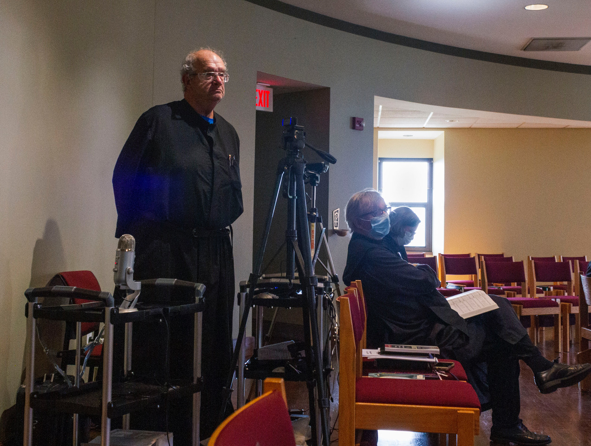
Br. Florian Campbell; Br. James Rafael Davies; Sr. Clara Ulson Freiras

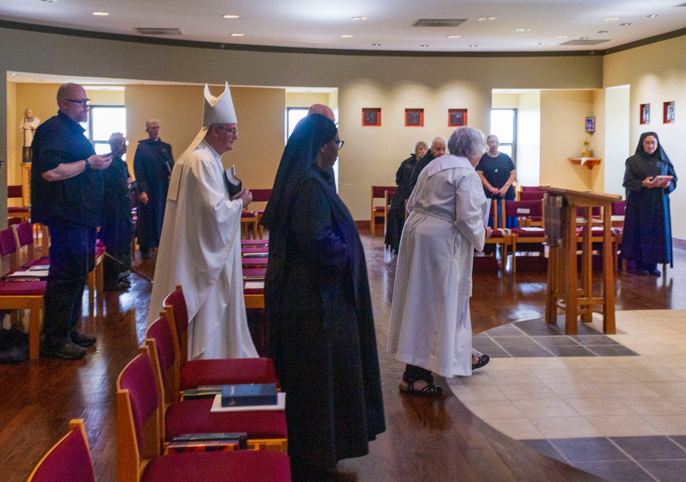
Rockford Patrick; Br. David-Mark Campbell; Br. Anskar Nonken; Bp. Alan Scarfe; Sr. Cecelia Horton; Br. John David Wynne; Sr. Margaret Mary Bergeron; Sr. Marie Patricia Hughes; Sr. Madeleine Sophie Smith; Sr. Kate Maxwell; Sr. Mary Magdalene Clarke

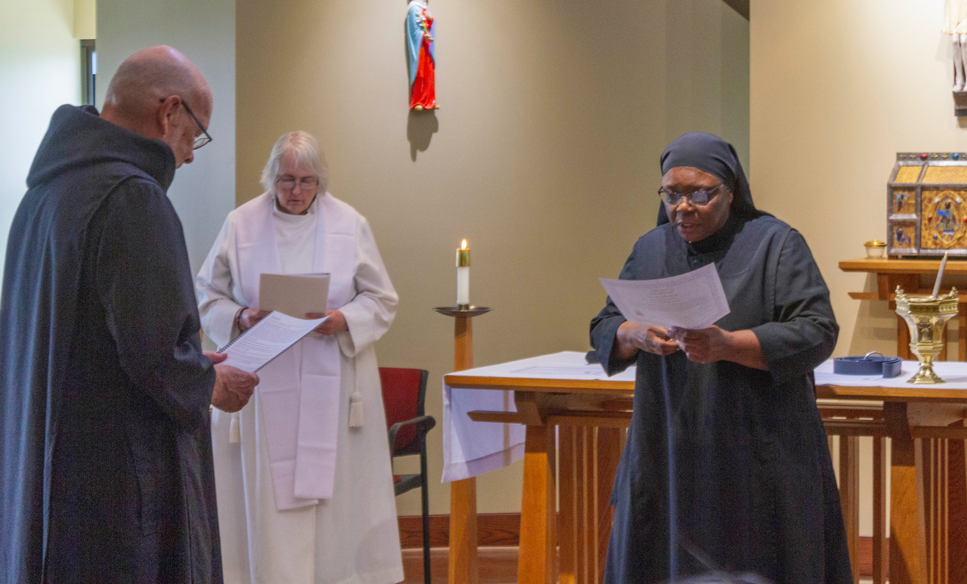
Br. John David Wynne; Sr. Madeleine Sophie Smith; Sr. Cecelia Horton

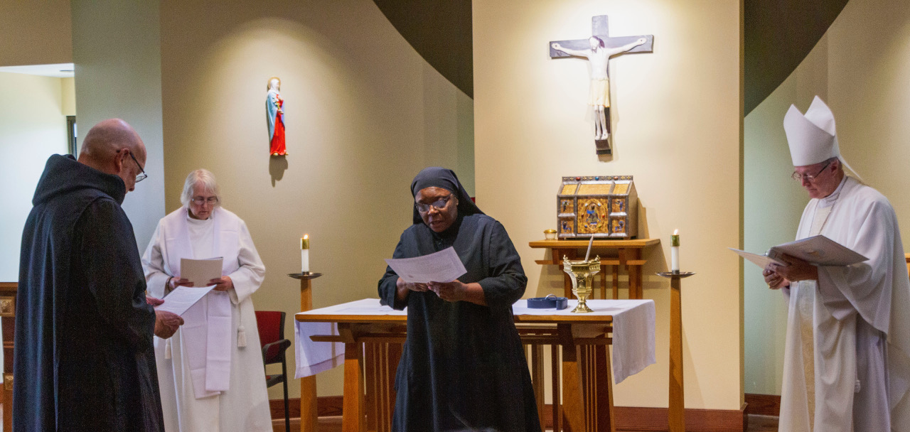
Br. John David Wynne; Sr. Madeleine Sophie Smith; Sr. Cecelia Horton; Bp. Alan Scarfe

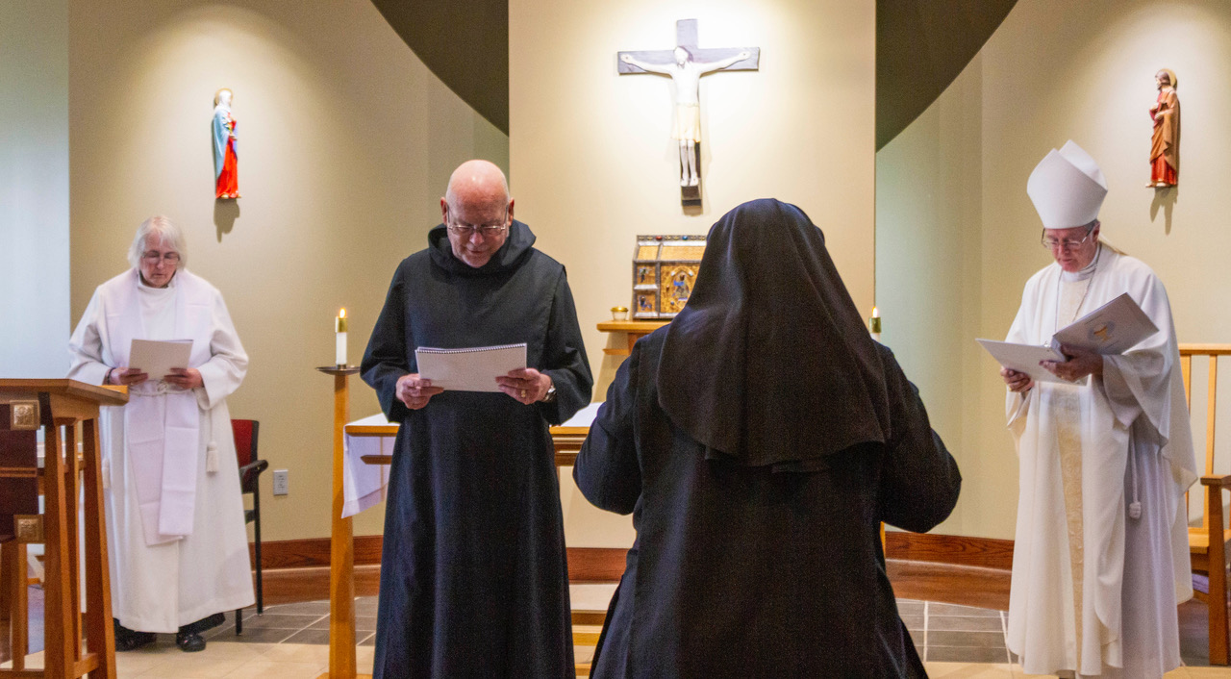
Sr. Madeleine Sophie Smith; Br. John David Wynne; Sr. Cecelia Horton; Bp. Alan Scarfe

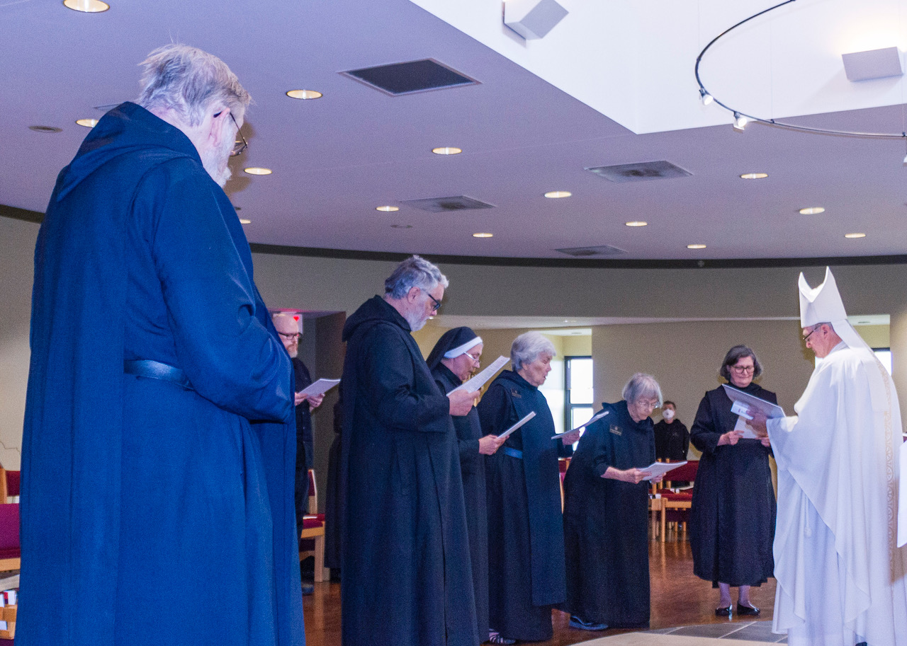
Abbot David Gerns; Rockford Patrick; Br. Gregory Tatchell; Sr. Mary Magdalene; Sr. Toni Sylvester; Sr. Margaret Mary Bergeron; Sr. Julian Smith Boyer; Sr. Clara Ulson Freiras; Bp. Alan Scarfe
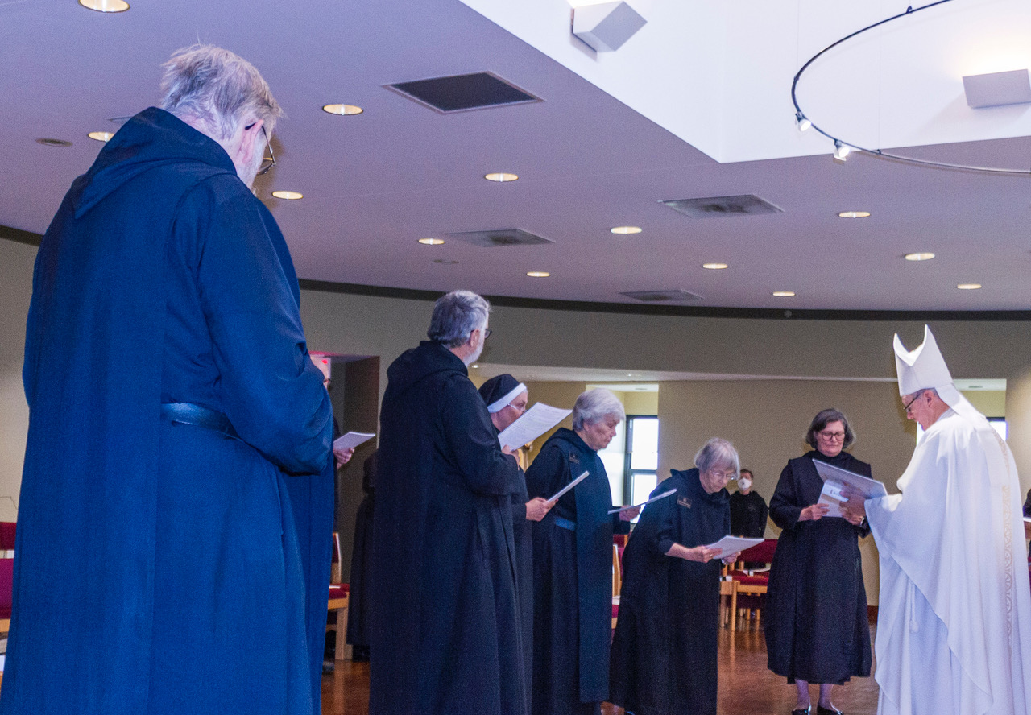
Abbot David Gerns; Rockford Patrick; Br. Gregory Tatchell; Sr. Mary Magdalene; Sr. Toni Sylvester; Sr. Margaret Mary Bergeron; Sr. Julian Smith-Boyer; Sr. Clara Ulson Freiras; Bp. Alan Scarfe

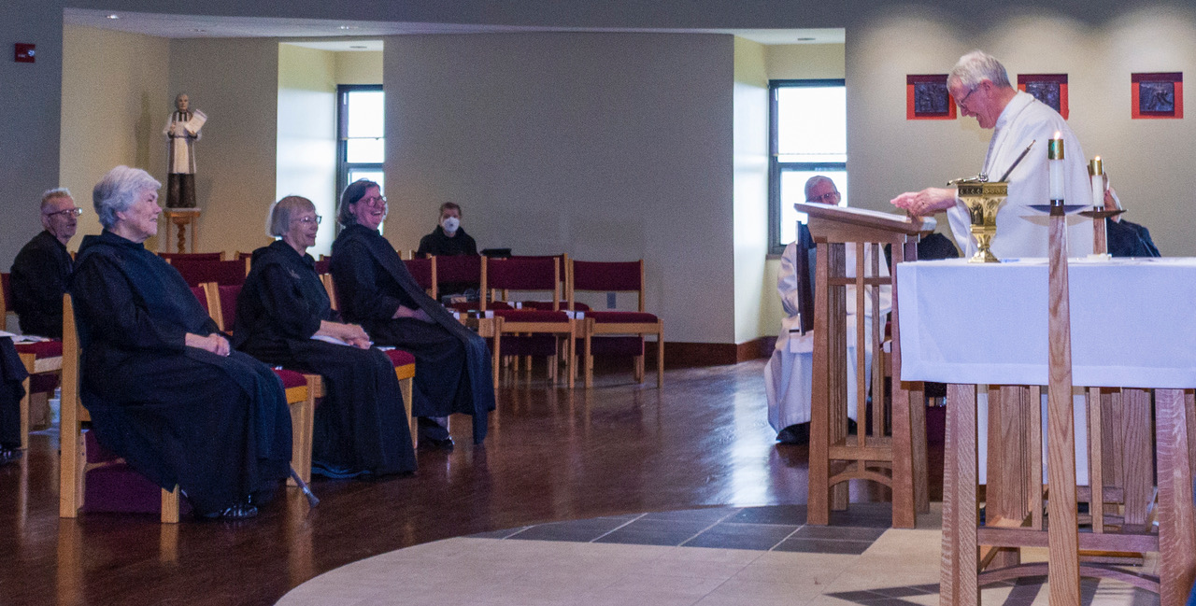
Br. David-Mark Campbell; Sr. Toni Sylvester; Sr. Margaret Mary Bergeron; Sr. Clara Ulson Freiras; Sr. Julian Sith-Boyer; Br. Anskar Nonken; Sr. Denise Moore; Bp. Alan Scarfe; Br Peter Francis Kyle; Br. Daniel Moore

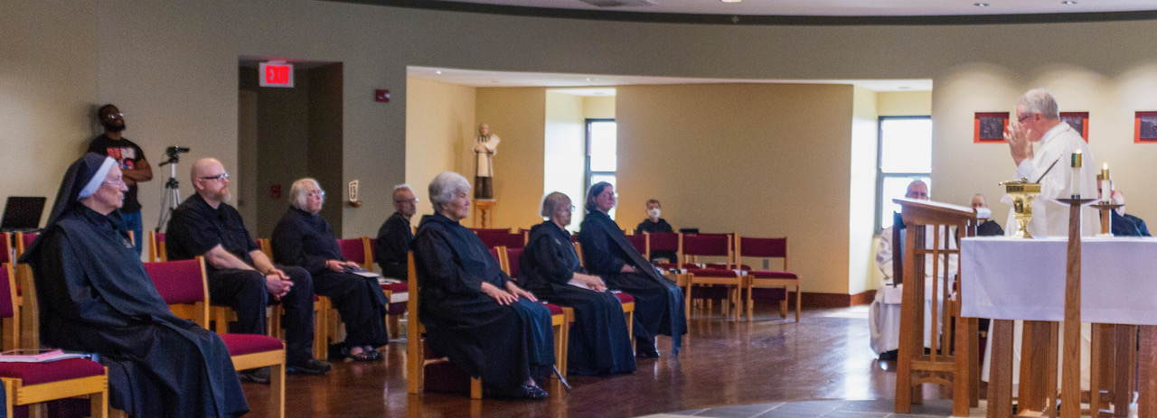
Sr. Mary Magdalene Clarke; Aaron Horton (Sr. Cecilia Horton’s son); Rockford Patrick; Sr. Madeleine Sophie Smith; Br. David-Mark Campbell; Sr. Toni Sylvester; Sr. Margaret Bergeron; Sr. Clara Ulson Freiras; Sr. Julian Smith-Boyer; Br. Anskar Nonken; Sr. Denise Moore; Bp. Alan Scarfe; Br Peter Francis Kyle; Br. Daniel Moore

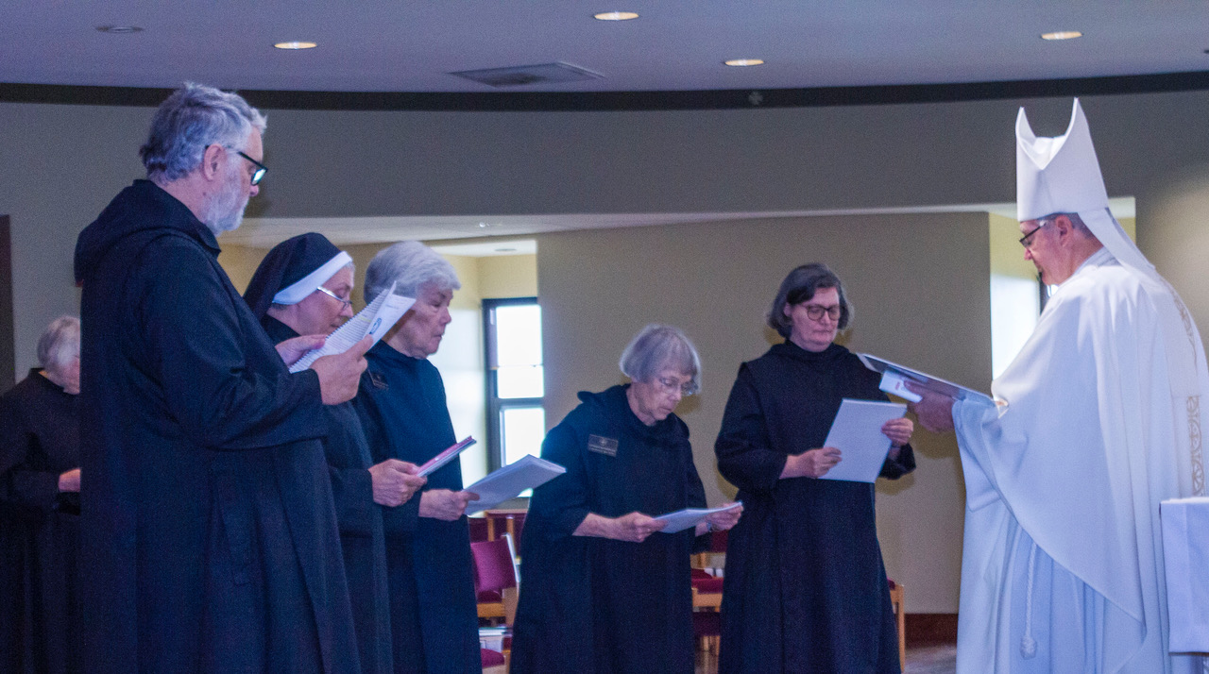
Sr. Madeleine Sophie Smith; Br. Gregory Tatchell; Sr. Mary Magdalene Clarke; Sr. Toni Sylvester; Sr. Margaret Mary Bergeron; Sr. Clara Ulson Freiras; Bp. Alan Scarfe

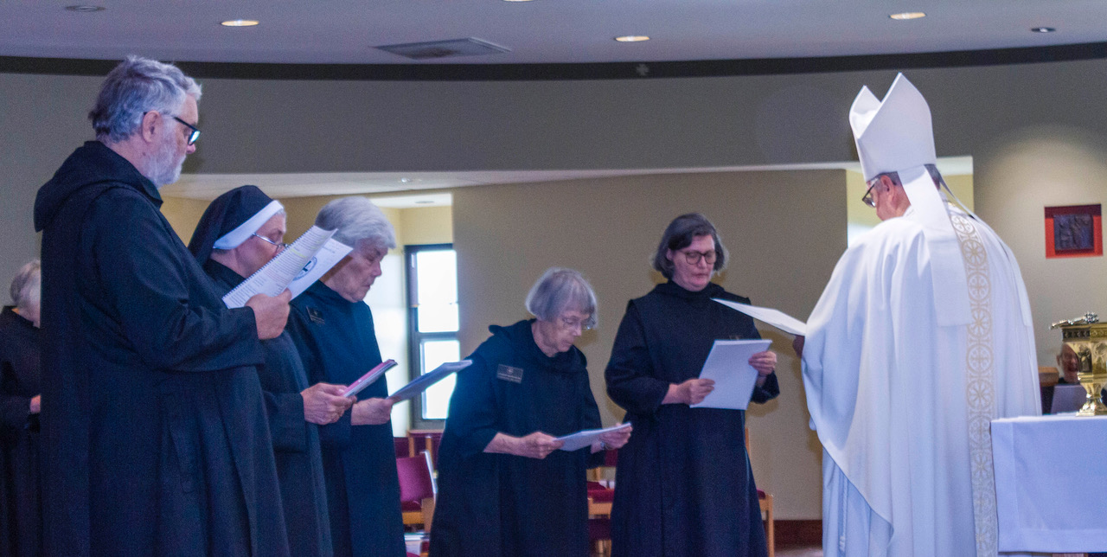
Sr. Madeleine Sophie Smith; Br. Gregory Tatchell; Sr. Mary Magdalene Clarke; Sr. Toni Sylvester; Sr. Margaret Mary Bergeron; Sr. Clara Ulson Freiras; Bp. Alan Scarfe; Sr. Denise Moore (behind the aspergillum)

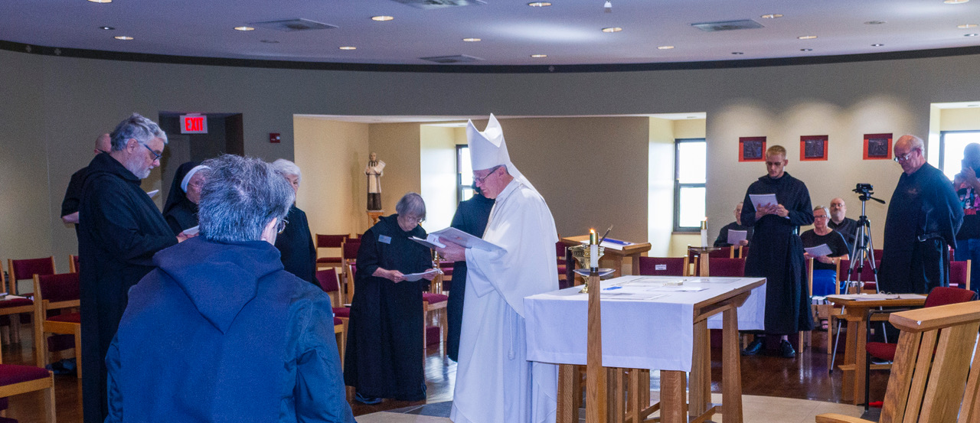
Rockford Patrick; Br. Gregory Tatchell; Sr. Mary Magdalene Clarke; Sr. Martha Lamoy; Sr. Toni Sylvester; Sr. Margaret Mary Bergeron; Sr. Clara Ulson Freiras; Bp. Alan Scarfe; Sr. Denise Moore; Br. Peter Francis Kyle; Sr. Kate Maxwell; Br. Daniel Moore; Br. Florian Campbell; Aaron Horton (Sr. Cecilia Horton’s son)

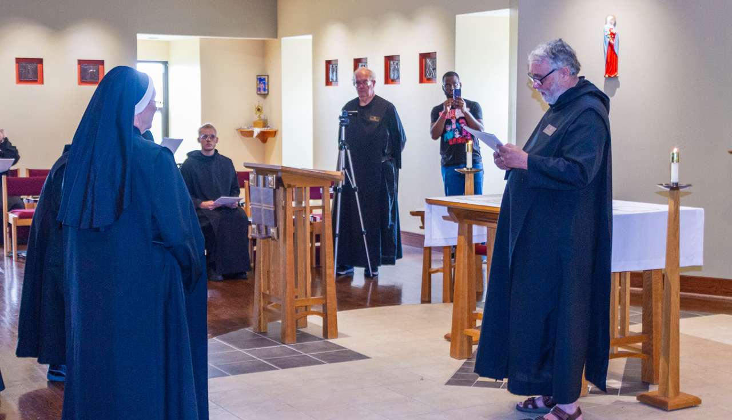
Sr. Mary Magdalene Clarke; Sr. Margaret Mary Bergeron; Br. Peter Francis Kyle; Br. Florian Campbell; Aaron Horton (Sr. Cecilia Horton’s son); Br. Gregory Tatchell

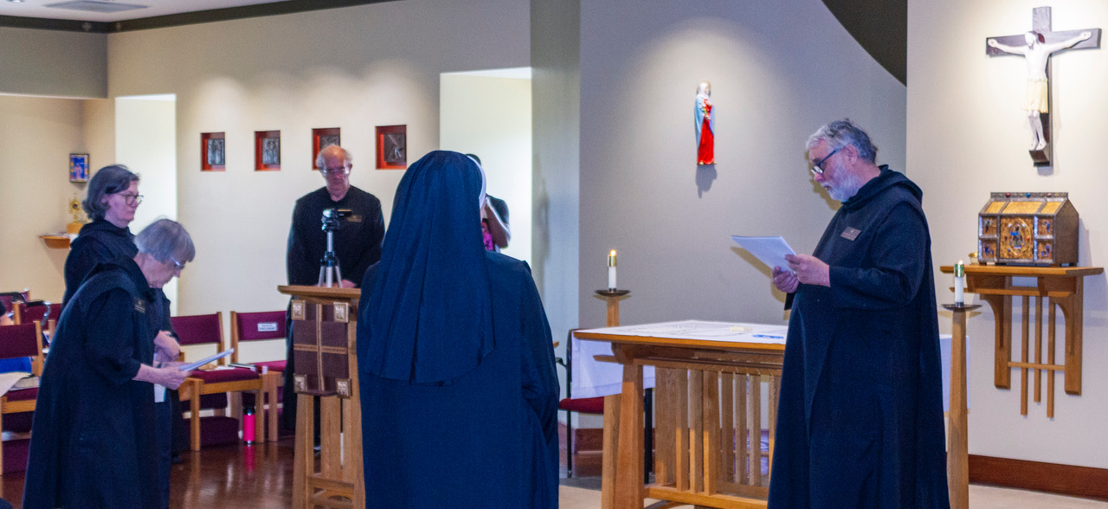
Sr. Clara Ulson Freiras; Sr. Margaret Mary Bergeron; Br. Florian Campbell, Sr. Mary Magdalene Clarke; Aaron Horton (Sr. Cecilia Horton’s son); Br. Gregory Tatchell

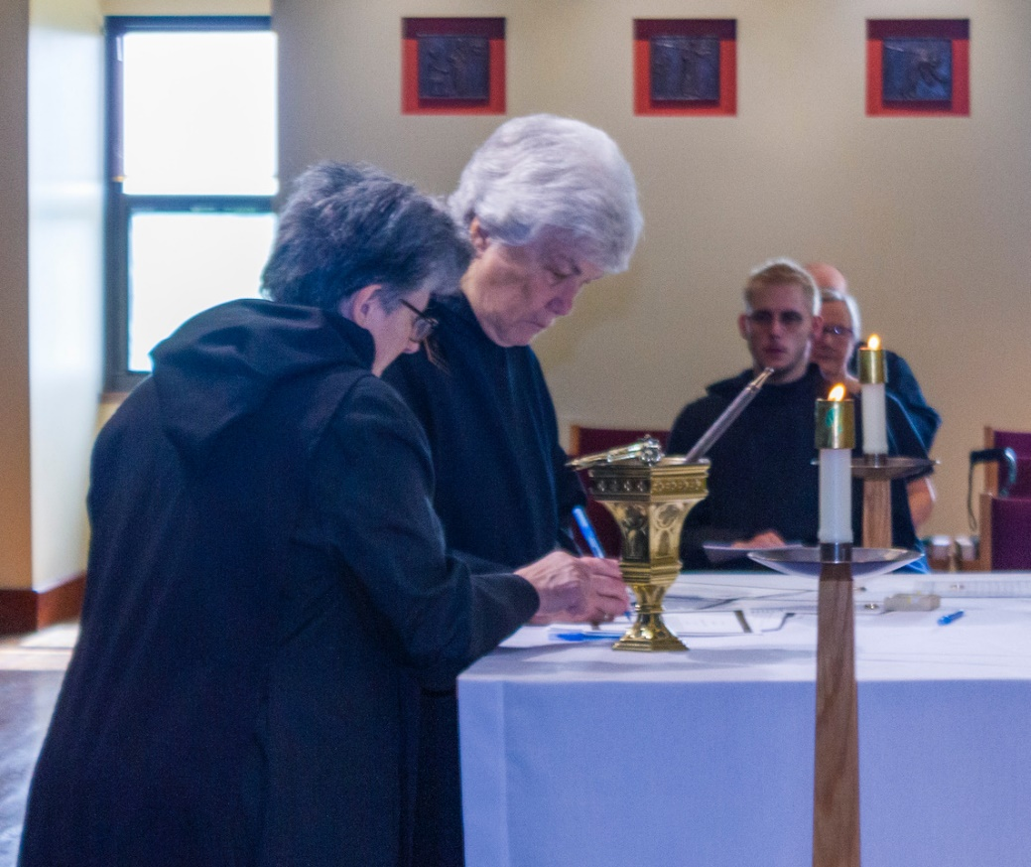
Sr Martha Lamoy; Sr. Toni Sylvester; Br. Pete Francis Kyle; Sr. Kate Maxwell; Br. Daniel Moore (behind Sr. Kate)

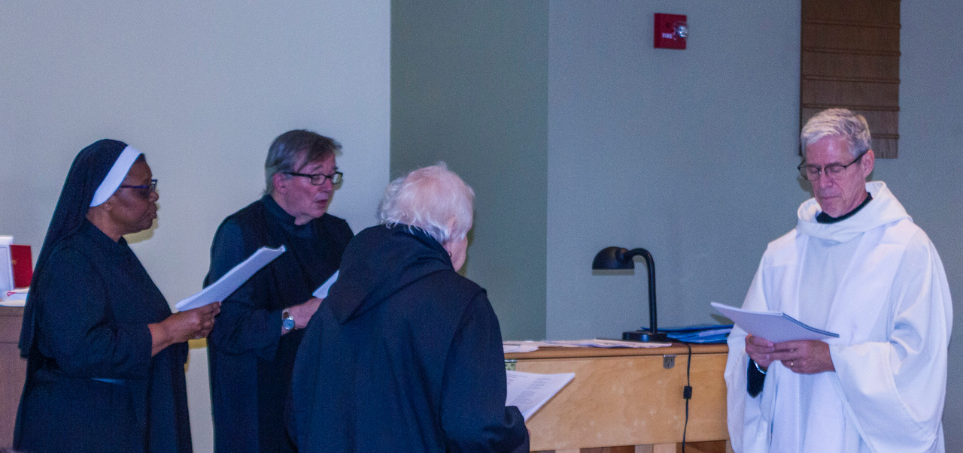
Sr. Cecilia Horton; Br. James Rafael Davies; Sr. Marie Patricia Hughes; Br. Anskar Nonken

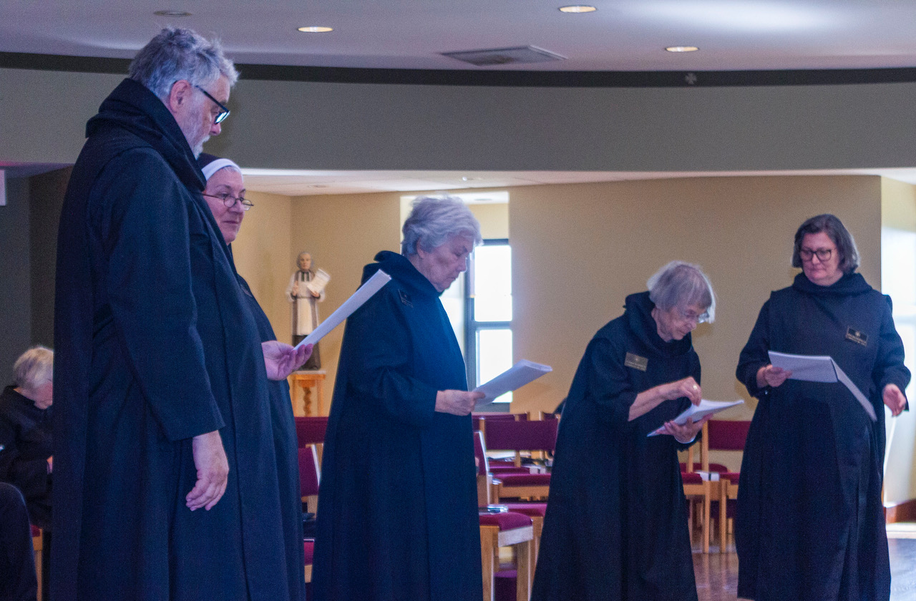
Sr. Madeleine Sophie Smith; Br. Gregory Tatchell; Sr. Mary Magdalene Clarke; Sr. Toni Sylvester; Sr. Margaret Mary Bergeron; Sr. Clara Ulson Freiras

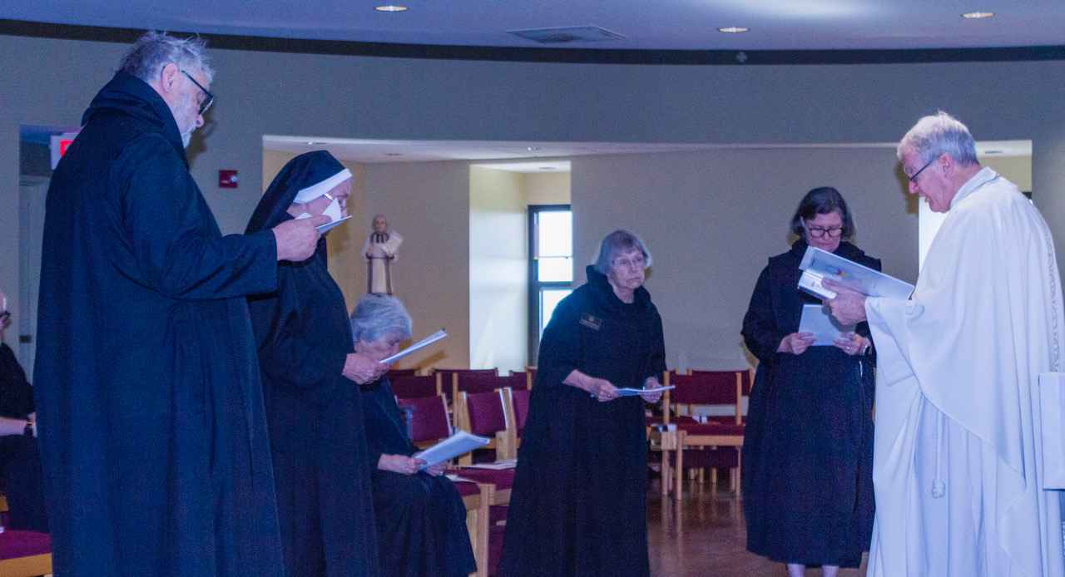
Rockford Patrick; Br. Gregory Tatchell; Sr. Mary Magdalene Clarke; Sr. Toni Sylvester; Sr. Margaret Mary Bergeron; Sr. Clara Ulson Freiras; Bp. Alan Scarfe

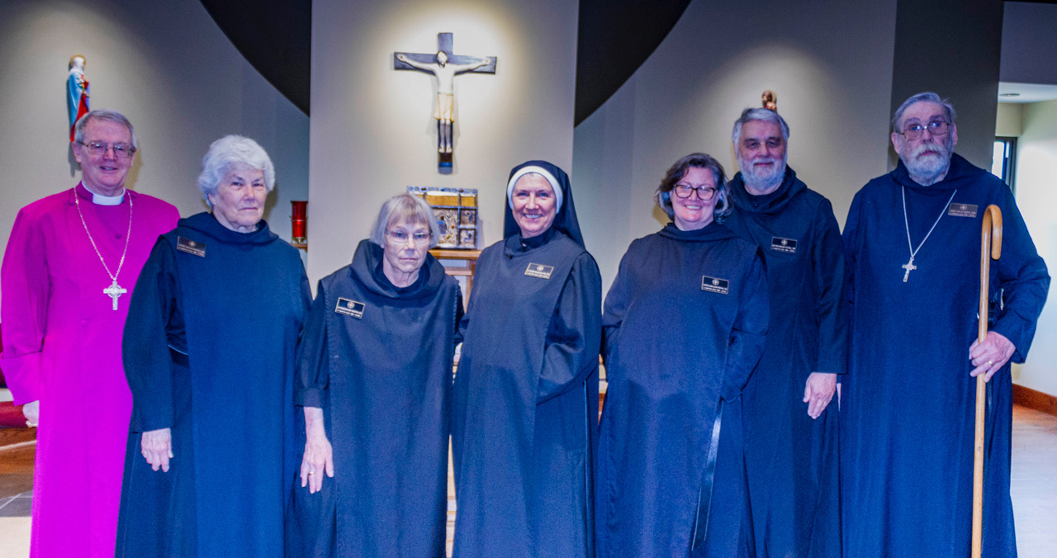
Bp. Alan Scarfe; Sr. Toni Sylvester; Sr. Margaret Mary Bergeron; Sr. Mary Magdalene Clarke; Sr. Clara Ulson Freiras; Br. Gregory Tatchell; Abbot David Gerns

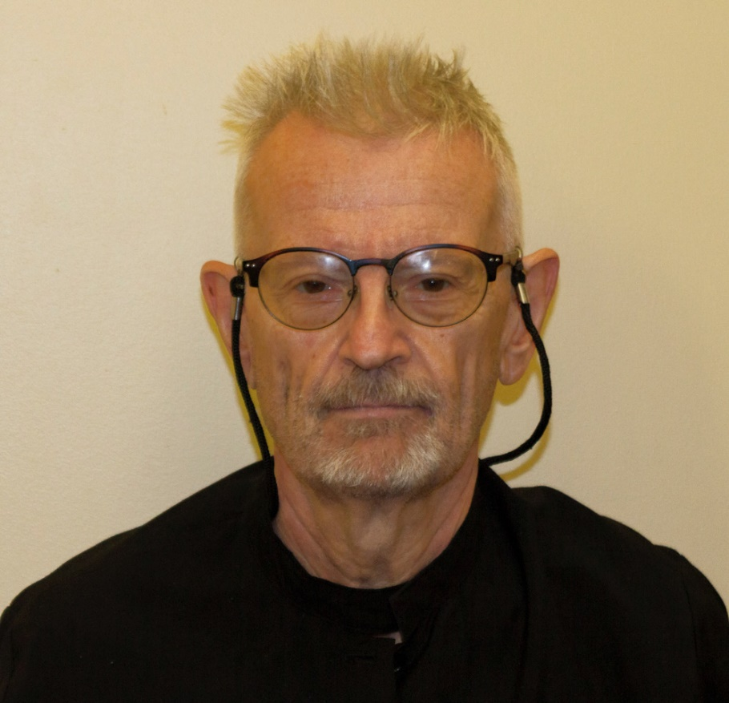
Br. David-Mark Campbell

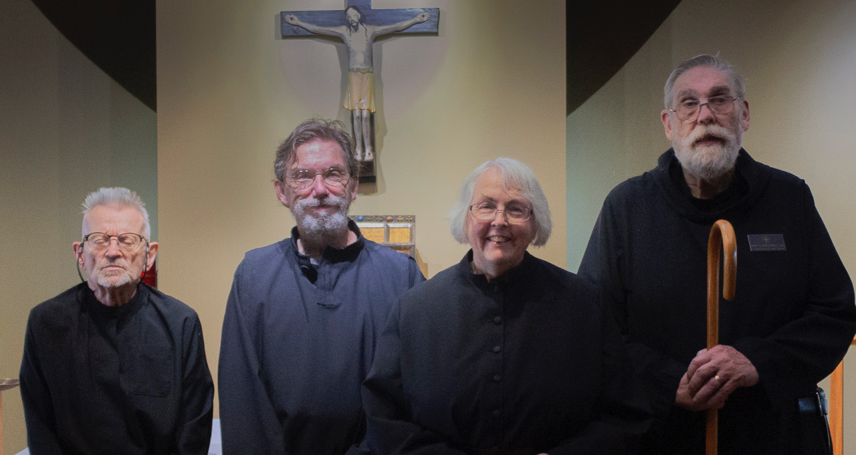
Br. David-Mark Campbell; Br. William Marion Page; Sr. Madeleine Sophie Smith; Abbot David Gerns

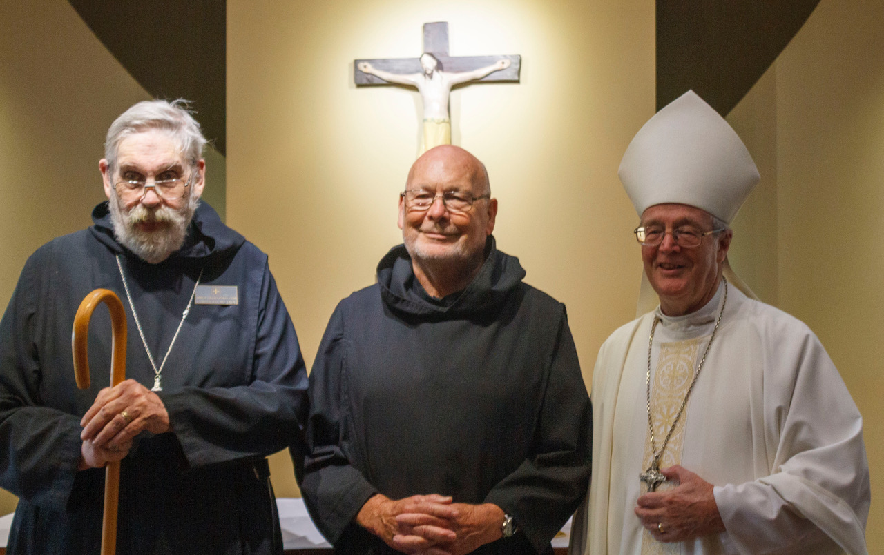
Abbot David Gerns; Br. John David Wynne; Bp. Alan Scarfe

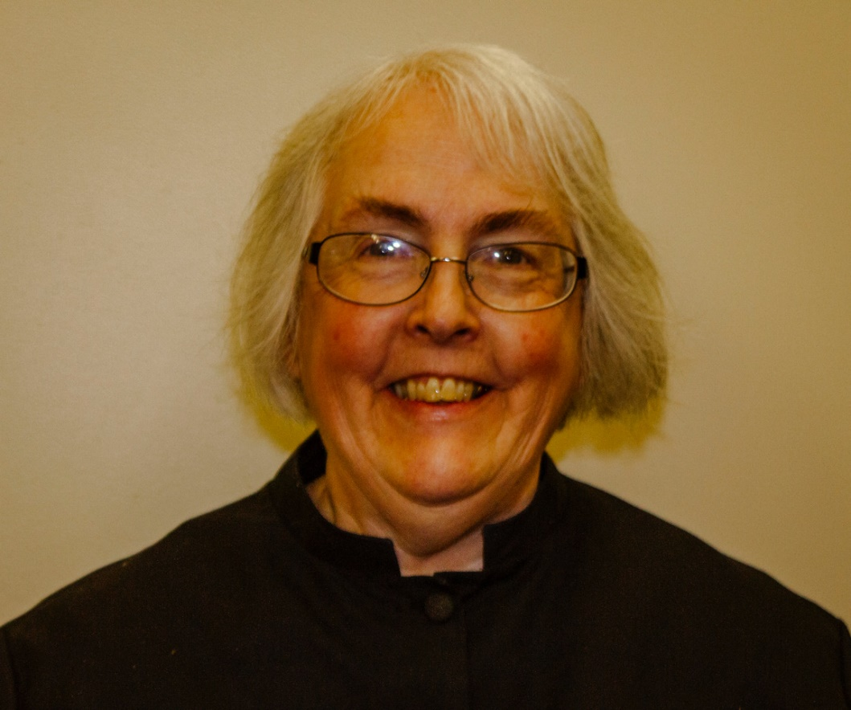
Sr. Madeleine Sophie Smith

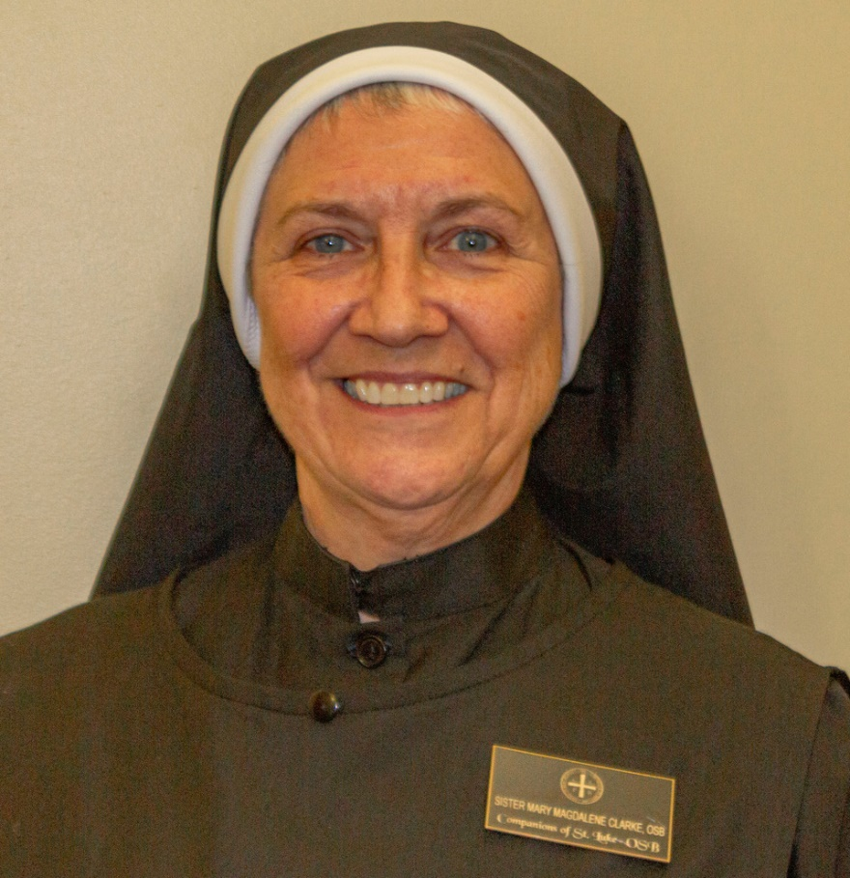
Sr. Mary Magdalene Clarke

