**Companions of St. Luke**

**Donnellson Abbey Guesthouses**

**August 2008**

~Edited by Br. Steven Olderr, 24 June 2022 with the assistance of Br. Thomas Ferrell. If you find any errors or omissions or have anything to add, please notify Br. Steven at [olderr@ameritech.net](mailto:olderr@ameritech.net)

People are identified from left to right.

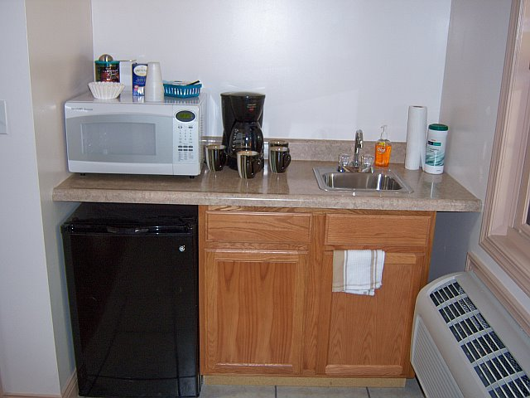

Convenience center

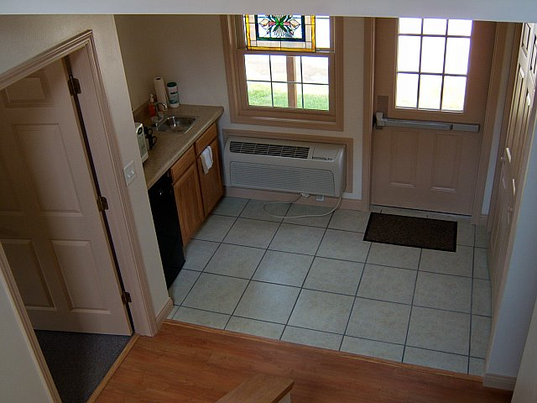

Back door and convenience center

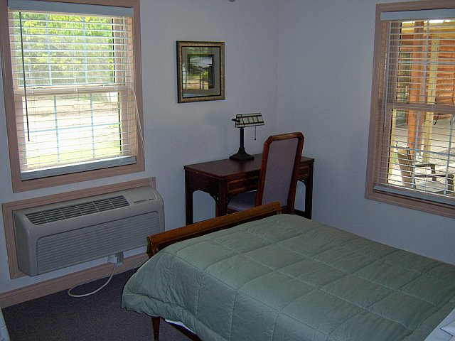

Bedroom

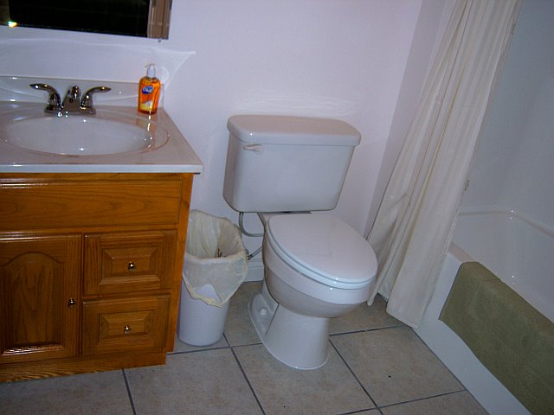

Bathroom

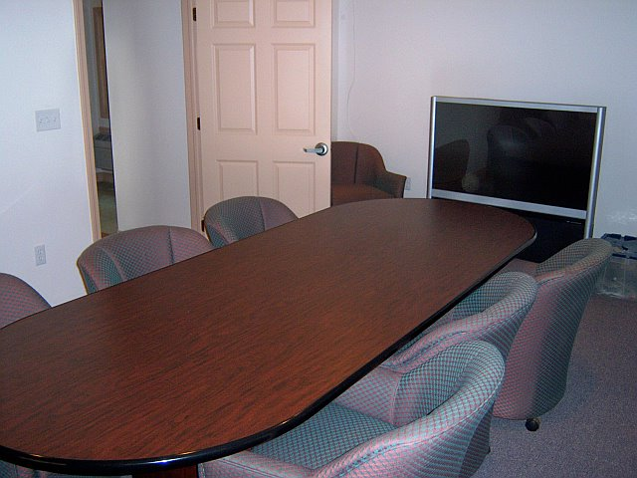

Conference room

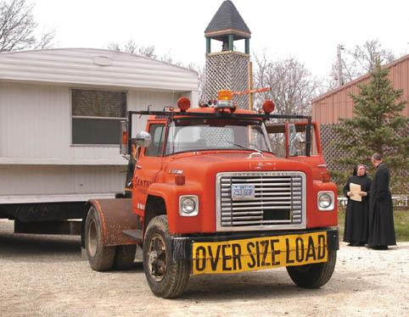

Sr. Sophia Holt; Abbot Michael John watching the removal of the last of the trailers formerly used for guest houses and the library.

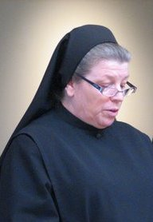

Sr. Sophia Holt