**Companions of St. Luke**

**Construction of Donnellson Abbey Guesthouses**

**18 June 2008**

~Edited by Br. Steven Olderr, 25 June 2022 with the assistance of Br. Thomas Ferrell. If you find any errors or omissions or have anything to add, please notify Br. Steven at [olderr@ameritech.net](mailto:olderr@ameritech.net)

People are identified from left to right.

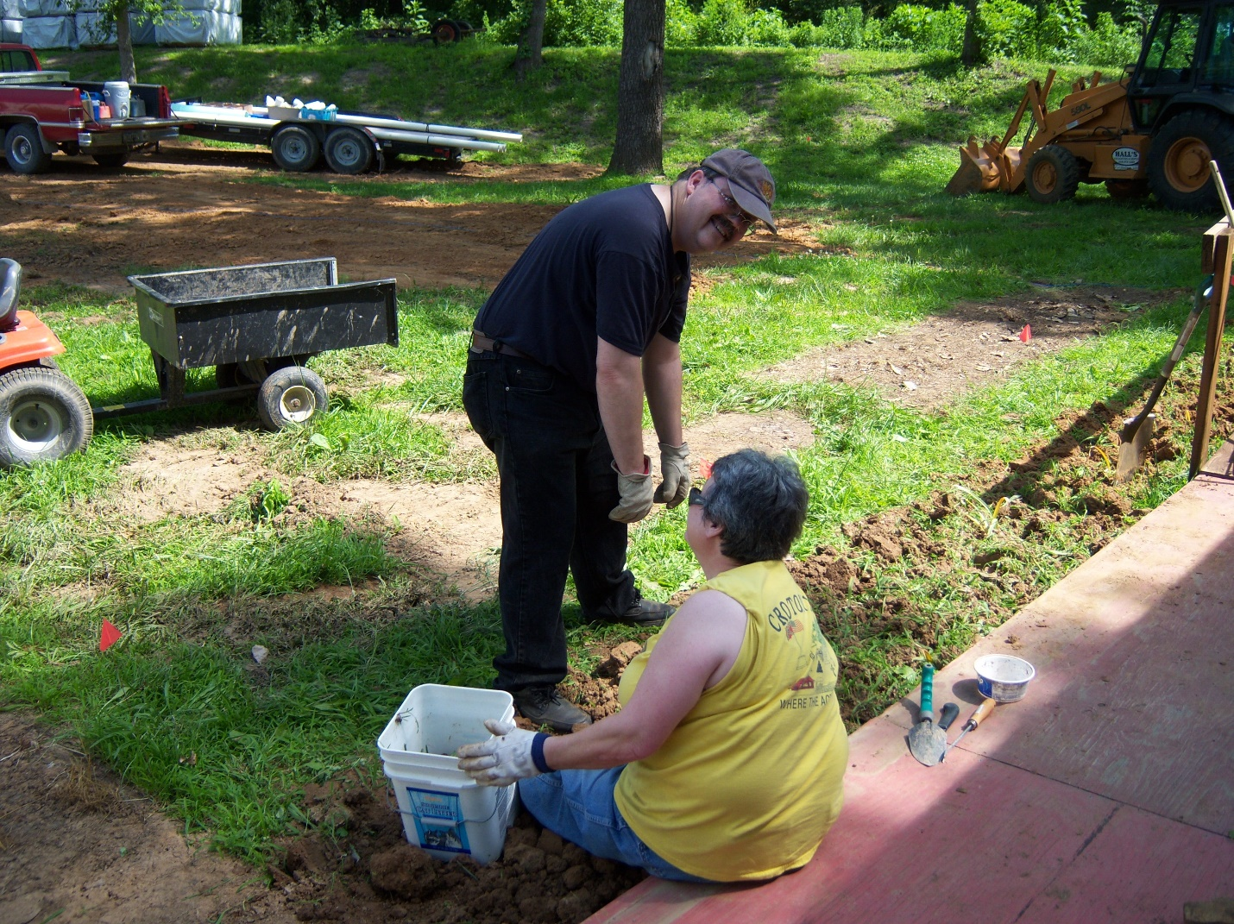

Br. Paul Howard and Sr. Vincent Marie Rittenhouse pulling weeds

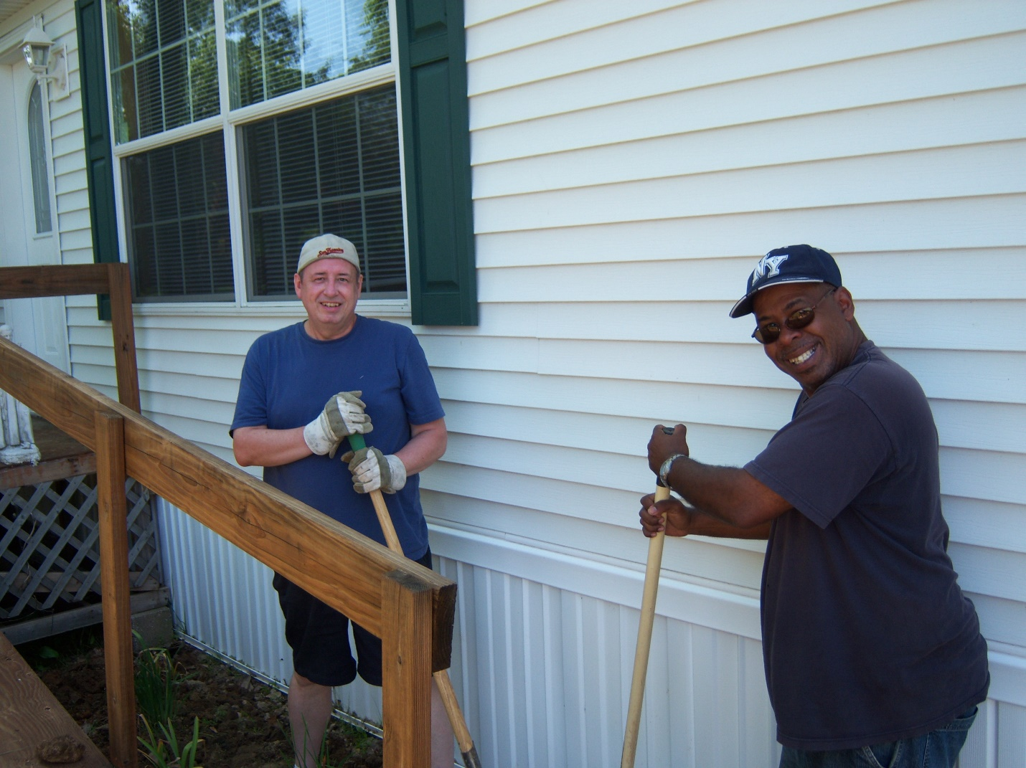

Br. Gabriel Hale and a construction worker from Houston, Texas.

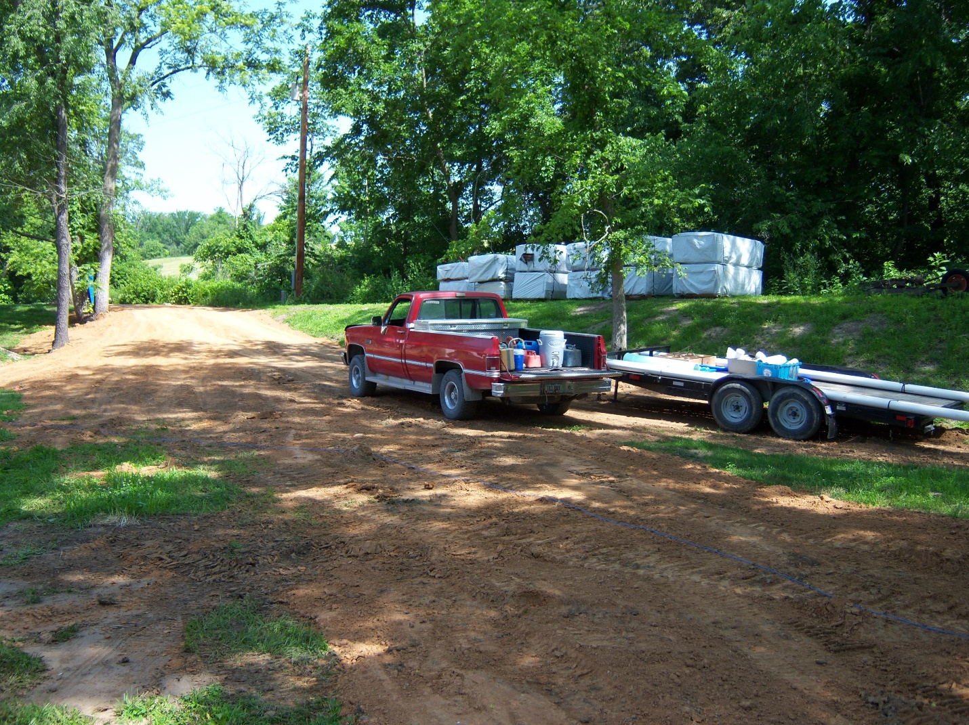

New fill for road leading to Hospitality Center. [The Hospitality Center was a trailer that also contained the library and a conference room.]

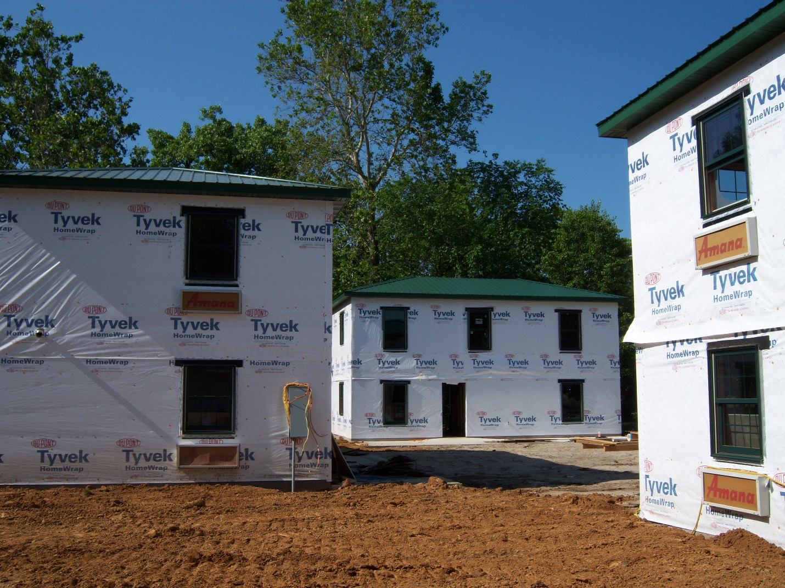

The three guesthouses under construction

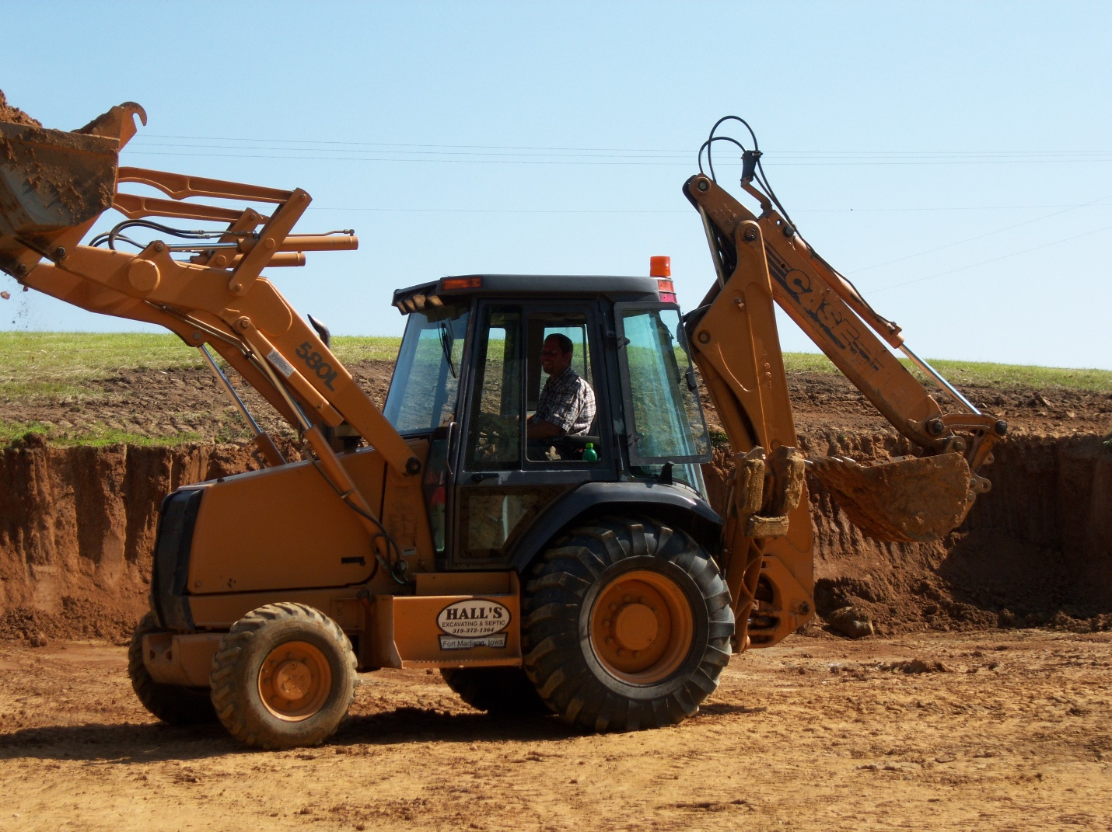

Dirt being removed from the north pasture to be used for fill—the driver is Shane Hall, a local man.

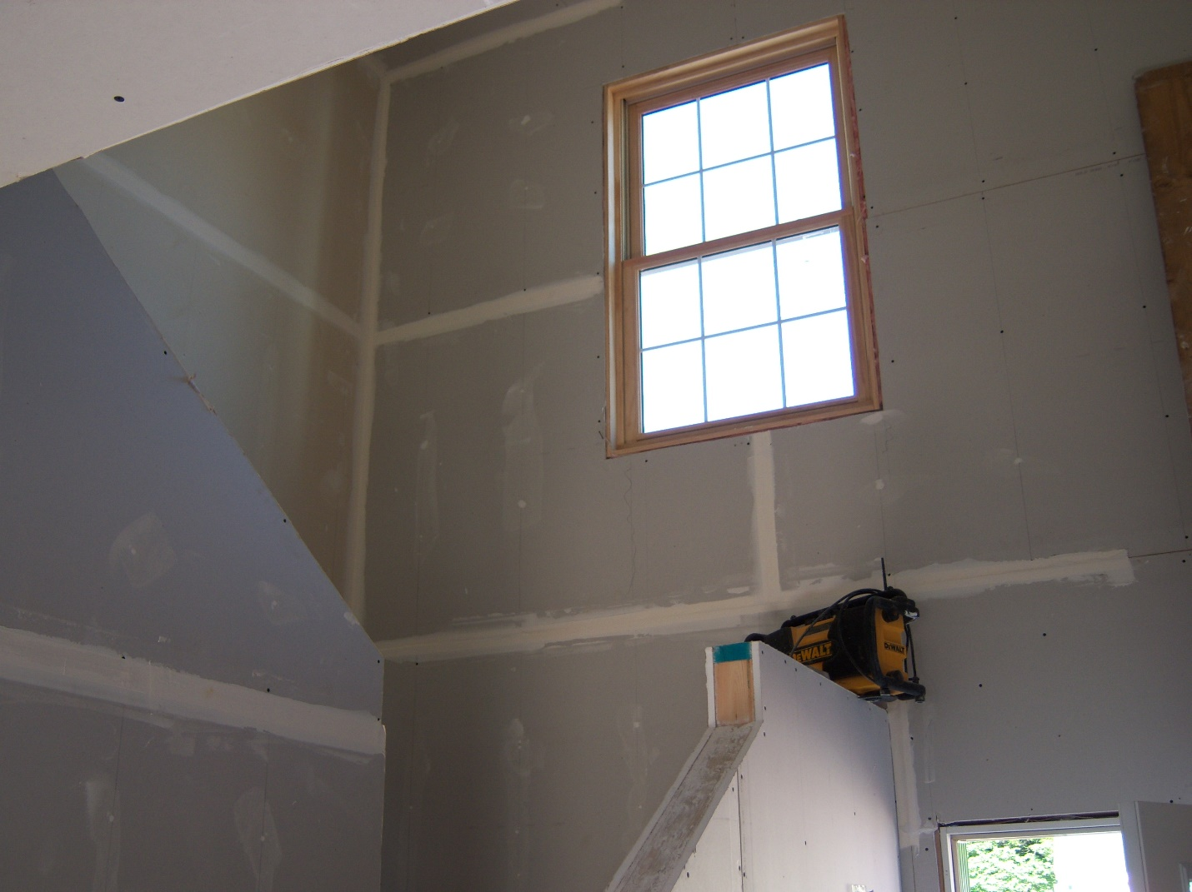

Drywall looking up a staircase

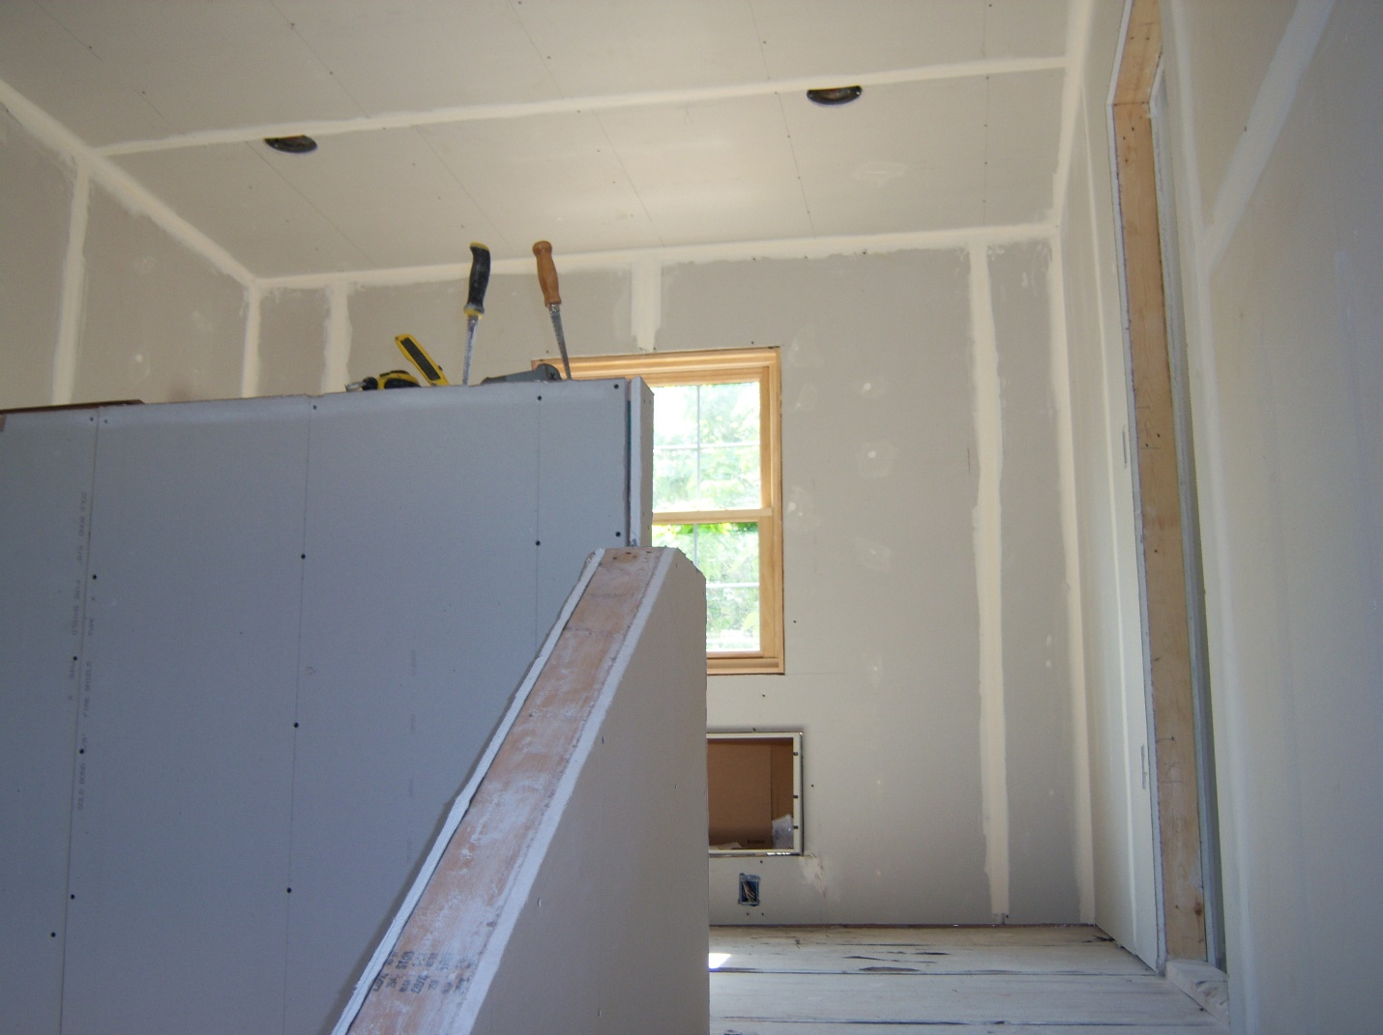

Second floor drywall