**2002 Spring Convocation**

**Companions of St. Luke**

~Edited by Br. Steven Olderr, 7 July 2022 with the assistance of Sr. Mary Magdalene Clarke. If you find any errors or omissions or have anything to add, please notify Br. Steven at [olderr@ameritech.net](mailto:olderr@ameritech.net)

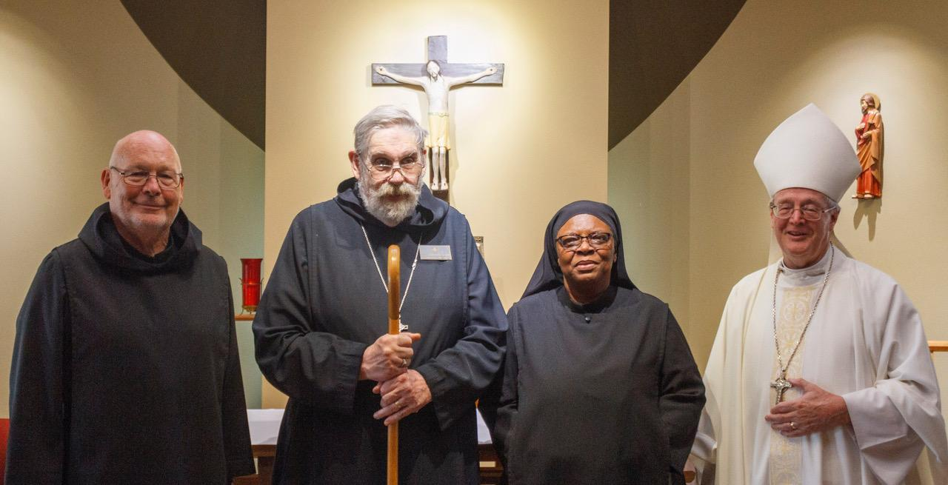

Br. John David Wynne; Abbot David Gerns; Sr. Cecelia Horton; Bp. Alan Scarfe

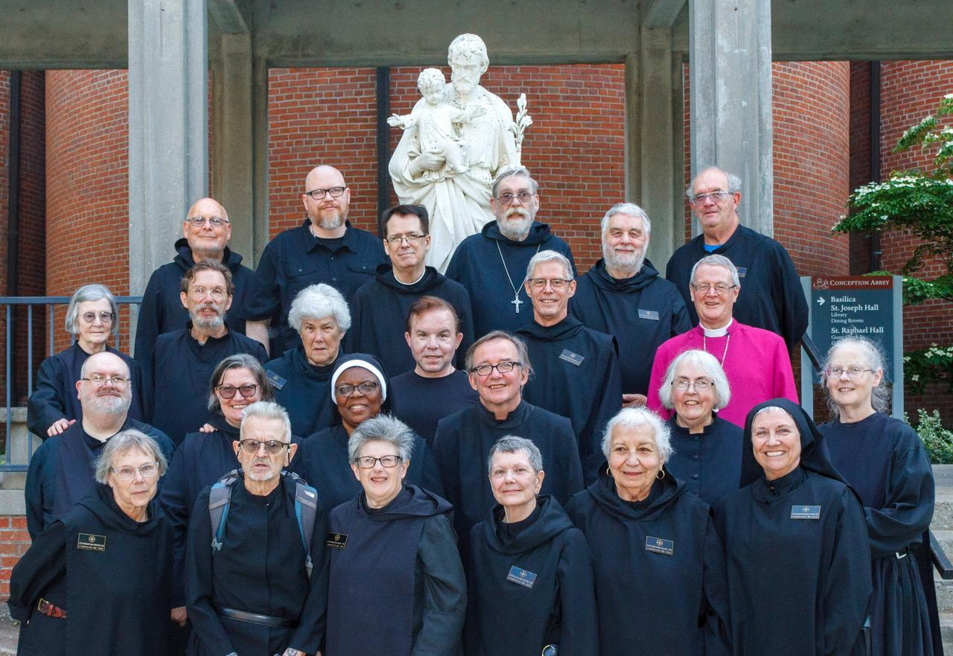

First Row: Sr. Margaret Mary Bergeron; David-Mark Campbell; Sr. Martha Lamoy; Sr. Julian Smith-Boyer; Sr. Marie Patricia Hughes; Sr. Mary Magdalene Clarke

Second Row: Br. Daniel Moore; Sr. Clara Ulson Freiras; Sr. Cecelia Horton; Br. James Raphael Davies; Sr. Madeline Sophie Smith; Sr. Denise Moore

Third Row: Sr.  Brigid Gerns; Br. William Marion Page; Sr. Toni Sylvester; Kevin Orth; Br. Anskar Nonken; Bp. Alan Scarfe

Fourth Row: Br. John David Wynne; Rockwell; Br. Dunstan Townsend; Abbot David Gerns; Br. Gregory Tatchell; Br. Florian Campbell

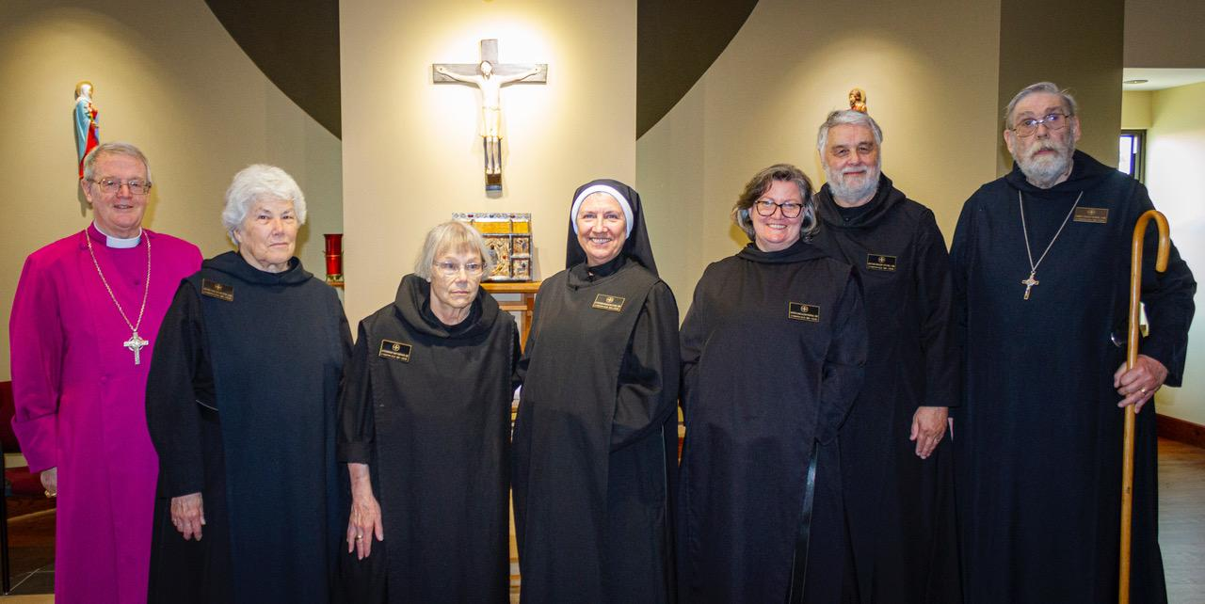

Bp. Alan Scarfe; Sr. Toni Sylvester; Sr. Margaret Mary Bergeron; St. Mary Magdalene Clarke. Sr. Clara Ulson Freiras; Br. Gregory Tatchell; Abbot David Gerns