Companions of St. Luke
2008 Spring Convocation at Conception Abbey
Photos by Br. Camillus Converse
Part 2 of 4

~Edited by Br. Steven Olderr, 28 June 2022 with the assistance of Br. Thomas Ferrell. If you find any errors or omissions or have anything to add, please notify Br. Steven at olderr@ameritech.net

People are identified from left to right.

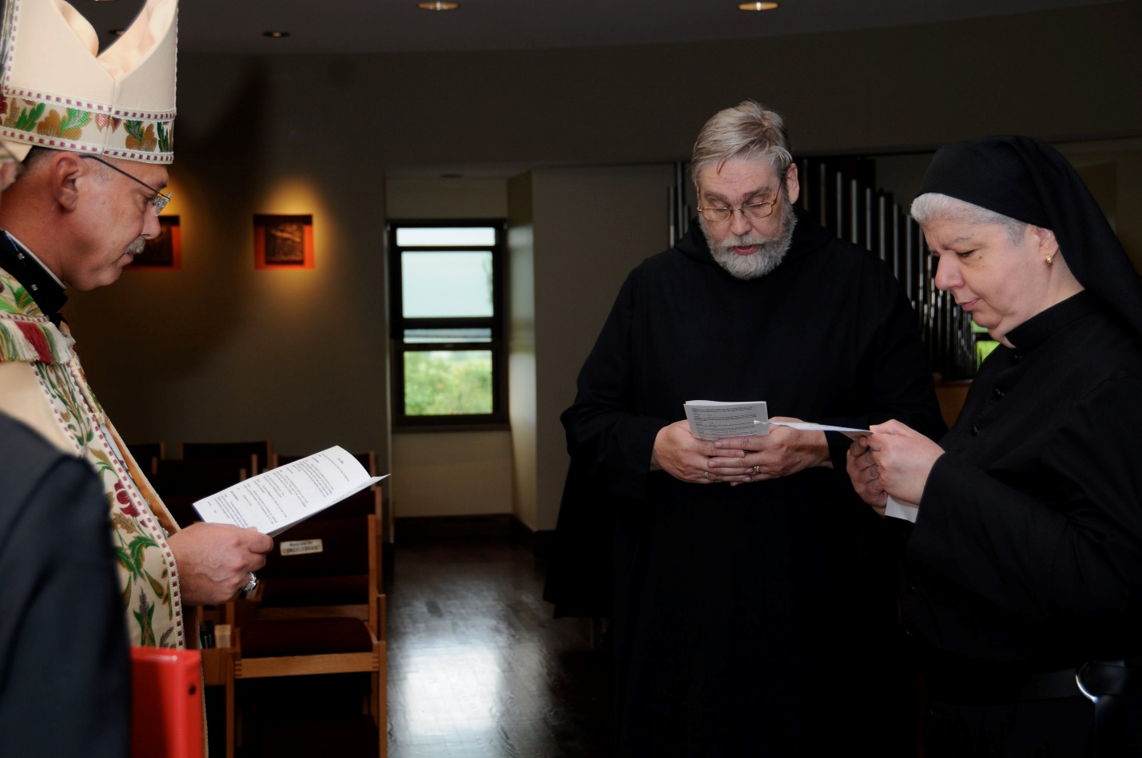
DSC 0177 Abbot Michael John Austin; Br. Chad Anselm Gerns; Sr. Mary Catherine Christopher
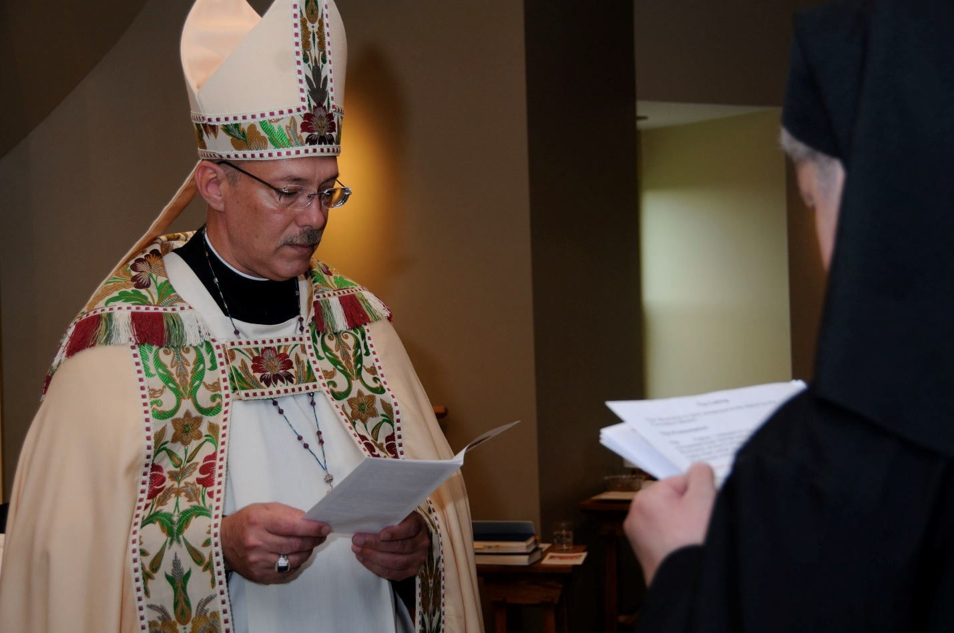
DSC 0178 Abbot Michael John Austin; Sr. Mary Catherine Christopher
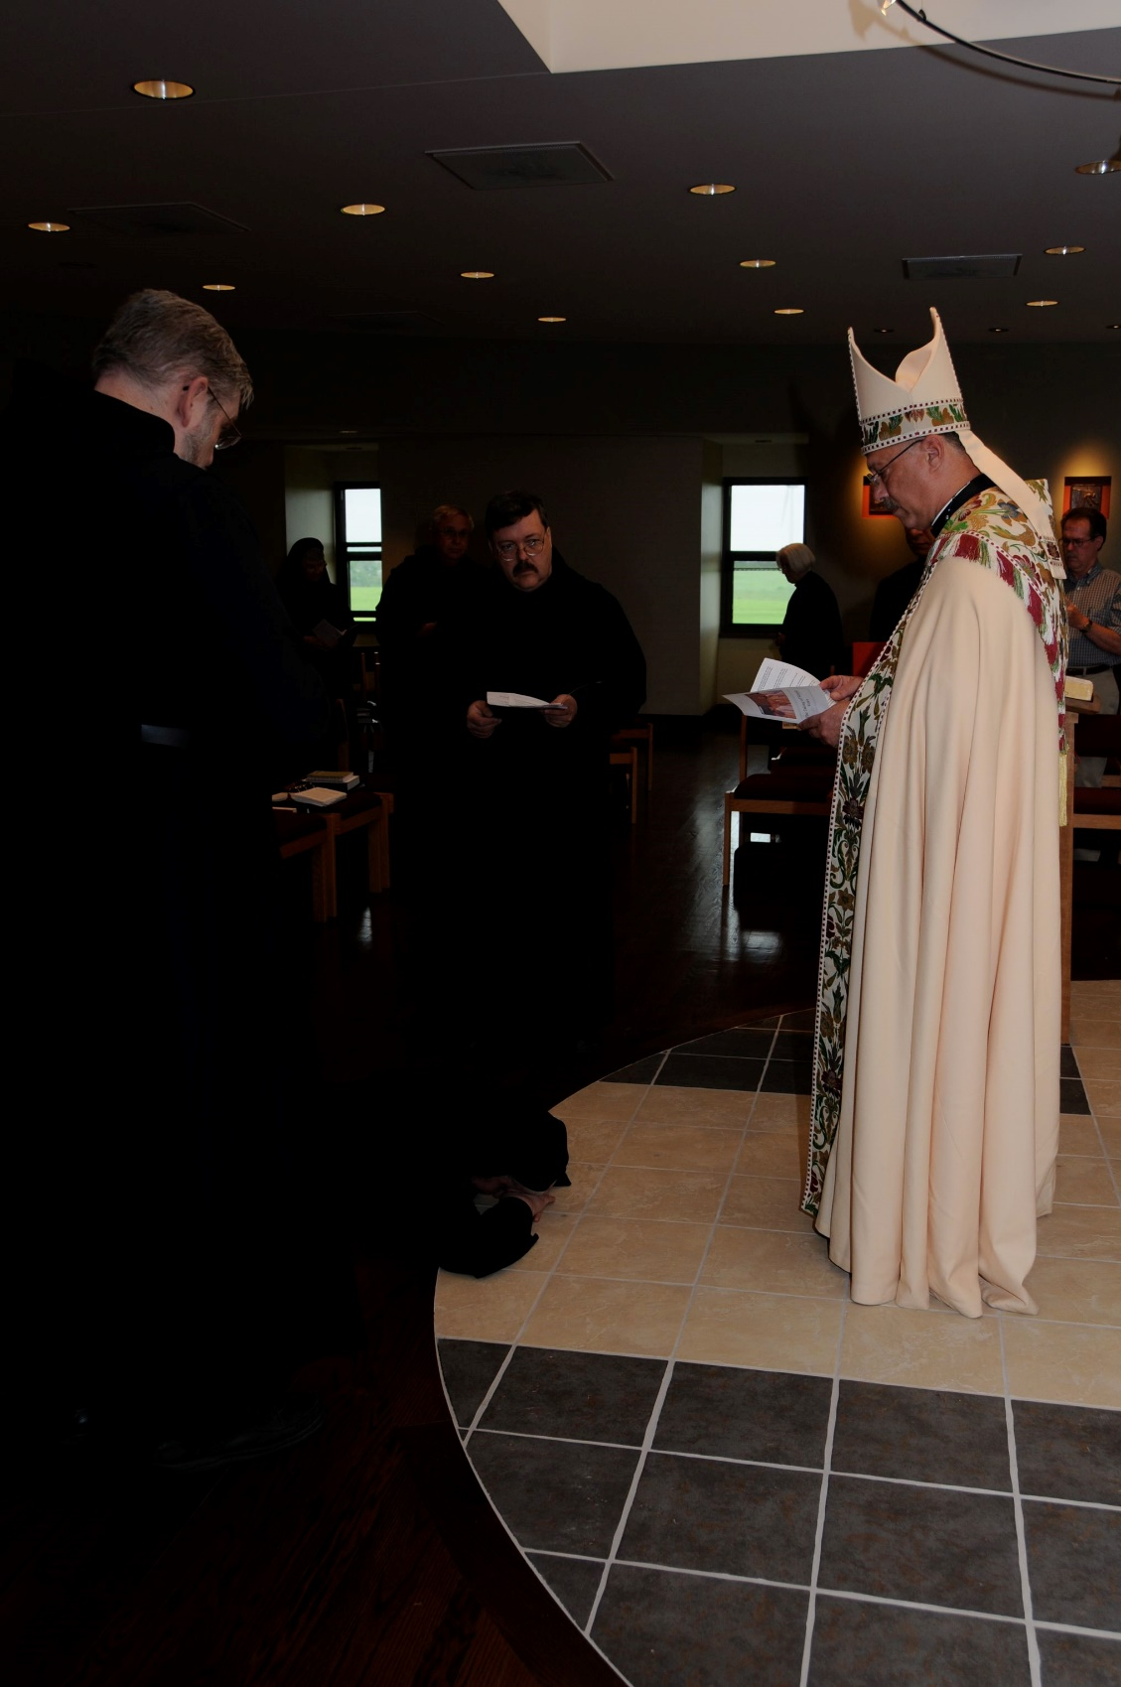
DSC 0179 Br. Chad Anselm Gerns; Sr. Mary Francis Deulen; Br. Bede Leach; Sr. Mary Catherine Christopher; Sr. Catherine Anne Stribley; Abbot Michael John Austin; guest
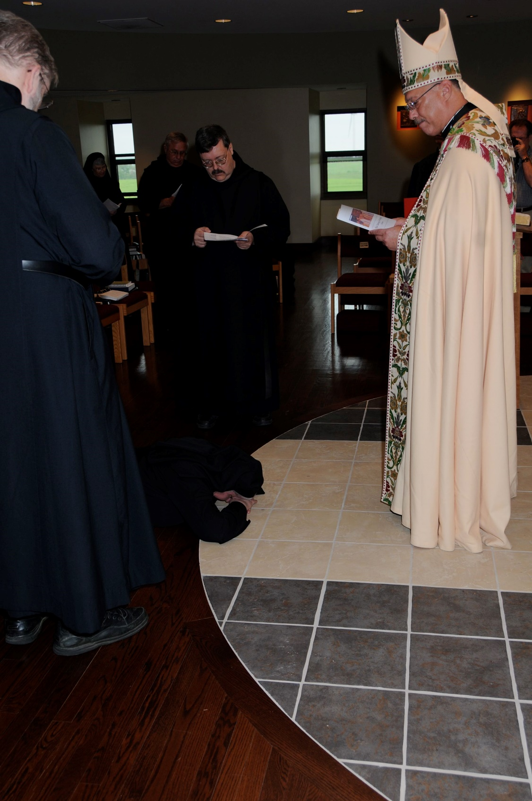
DSC 0180 Br. Chad Anselm Gerns; Sr. Mary Francis Deulen; Br. Bede Leach; Br. Paul Howard; Sr. Mary Catherine Christopher; Abbot Michael John Austin
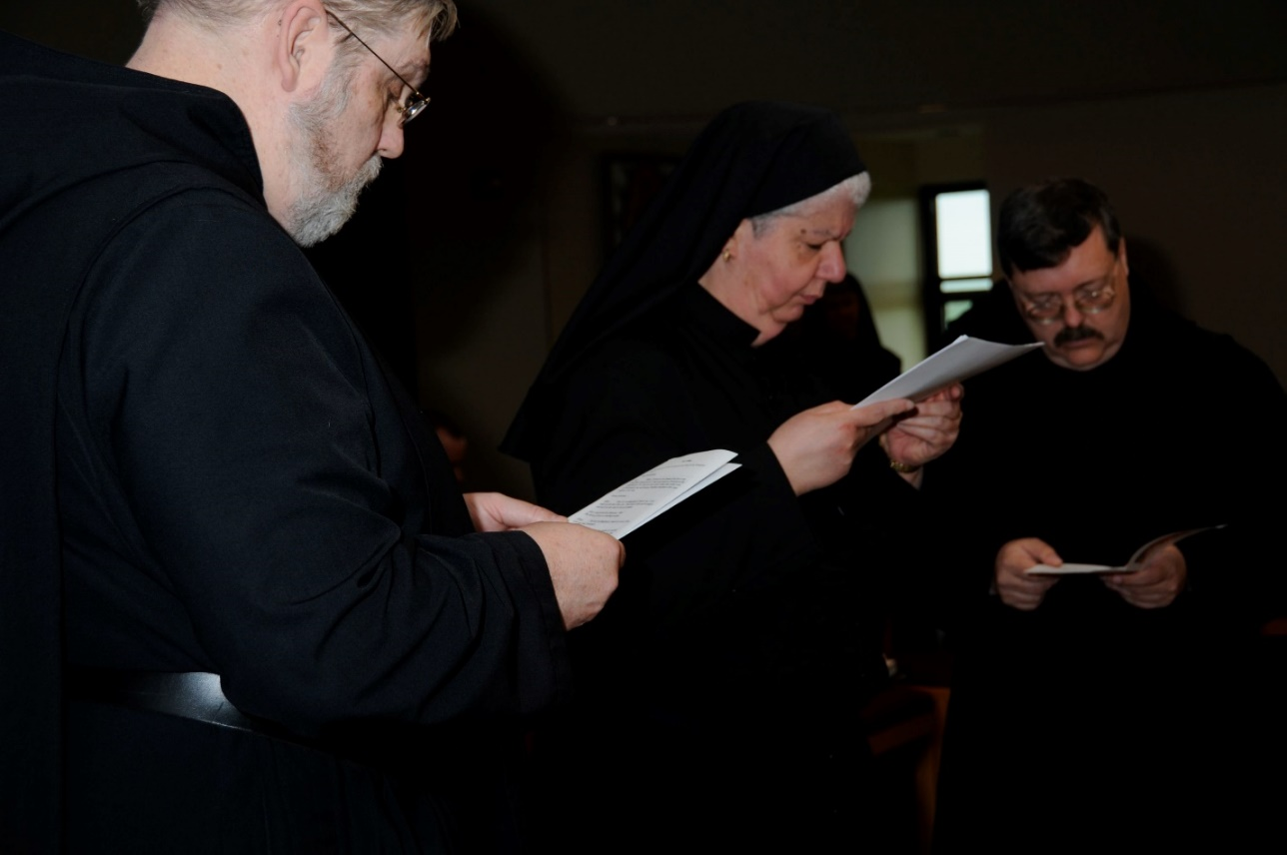
DSC 0181 Br. Chad Anselm Gerns; Sr. Mary Catherine Christopher; Br. Paul Howard

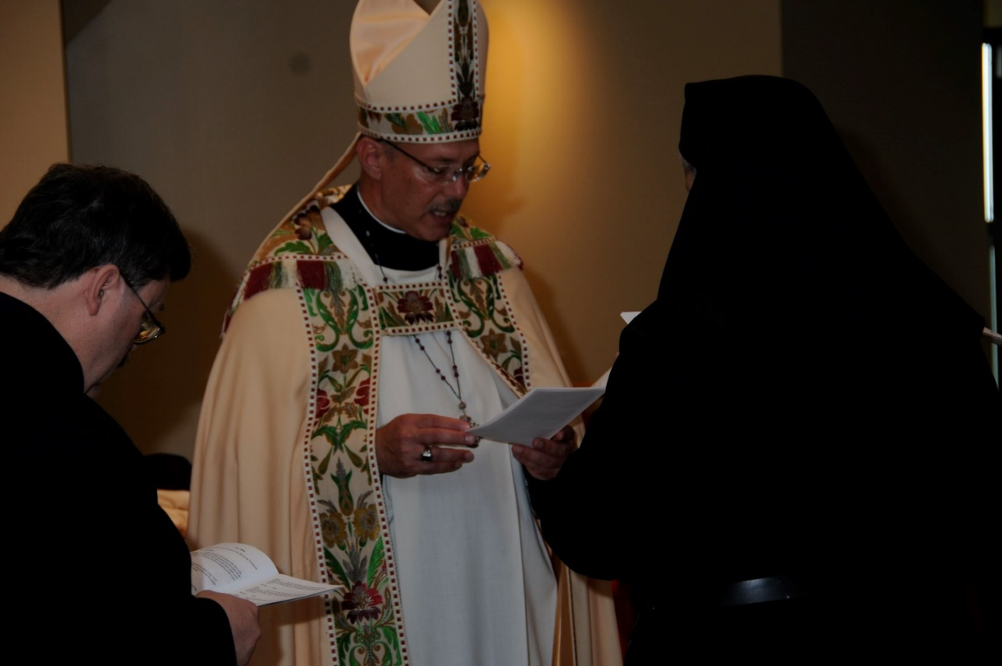
DSC 0182 Br. Paul Howard; Abbot Michael John Austin; Sr. Mary Catherine Christopher
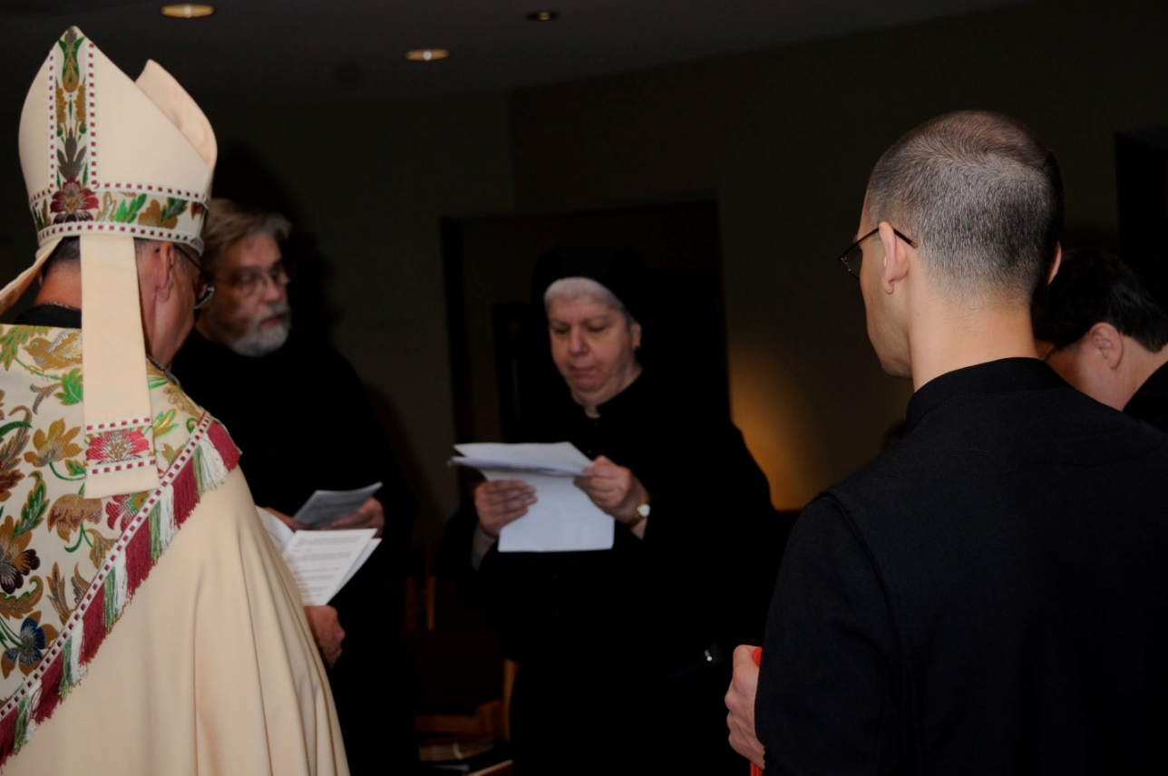
DSC 0183 Abbot Michael John Austin; Br. Chad Anselm Gerns; Sr. Mary Catherine Christopher; Br. Aelred Shemayev; Br. Paul Howard

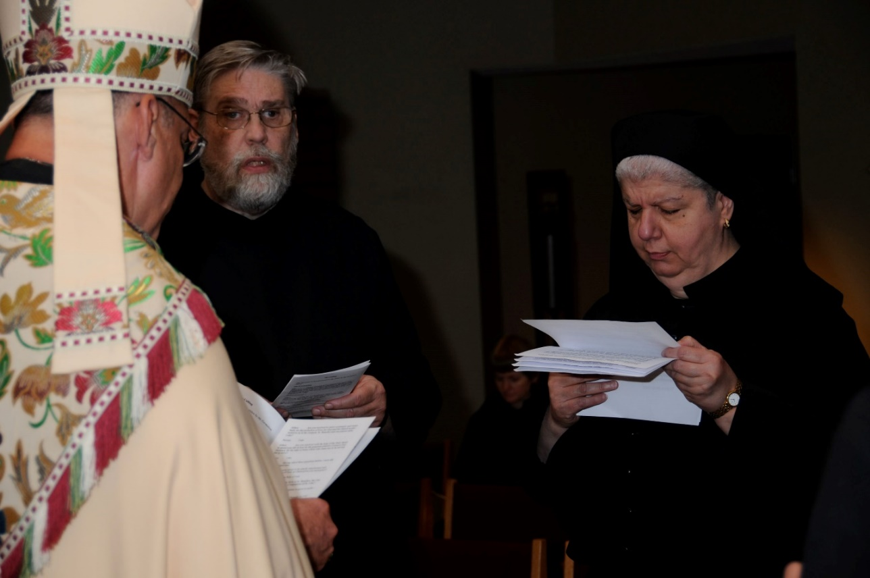
DSC 0184 Abbot Michael John Austin; Br. Chad Anselm Gerns; Sr. Mary Catherine Christopher
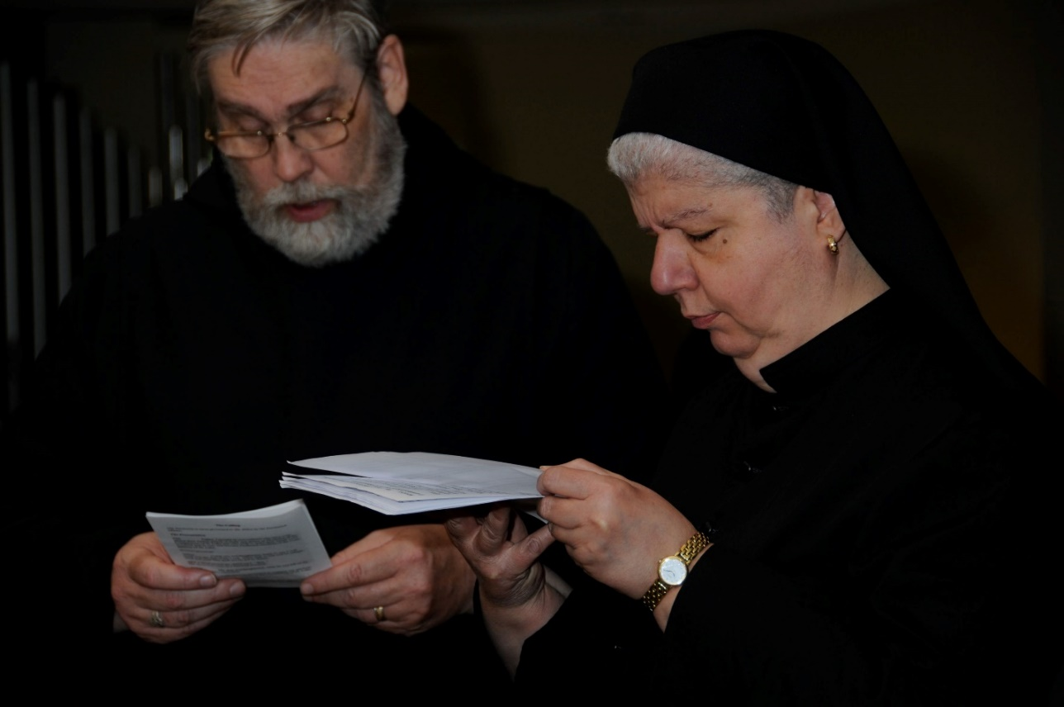
DSC 0185 Br. Chad Anselm Gerns; Sr. Mary Catherine Christopher

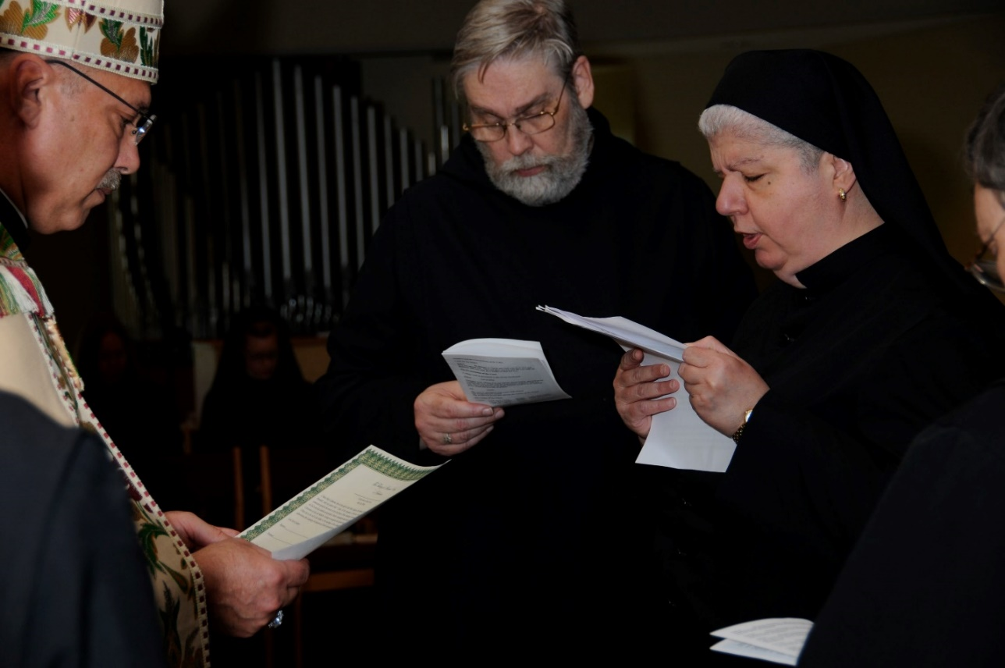
DSC 0186 Abbot Michael John Austin; Br. Chad Anselm Gerns; Sr. Mary Catherine Christopher; Br. Paul Howard
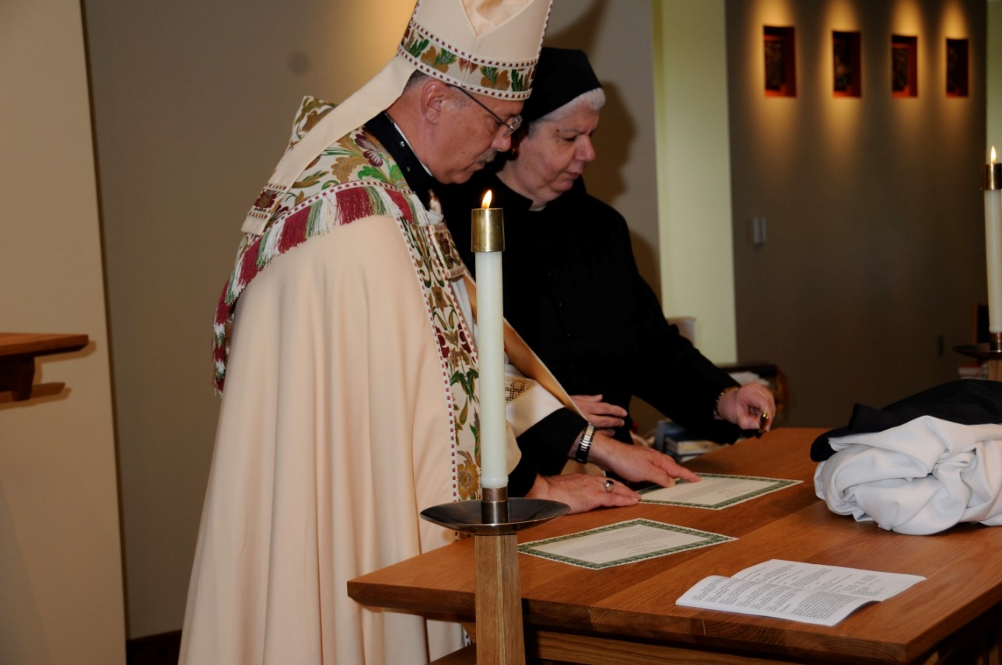
DSC 0188 Abbot Michael John Austin; Sr. Mary Catherine Christopher

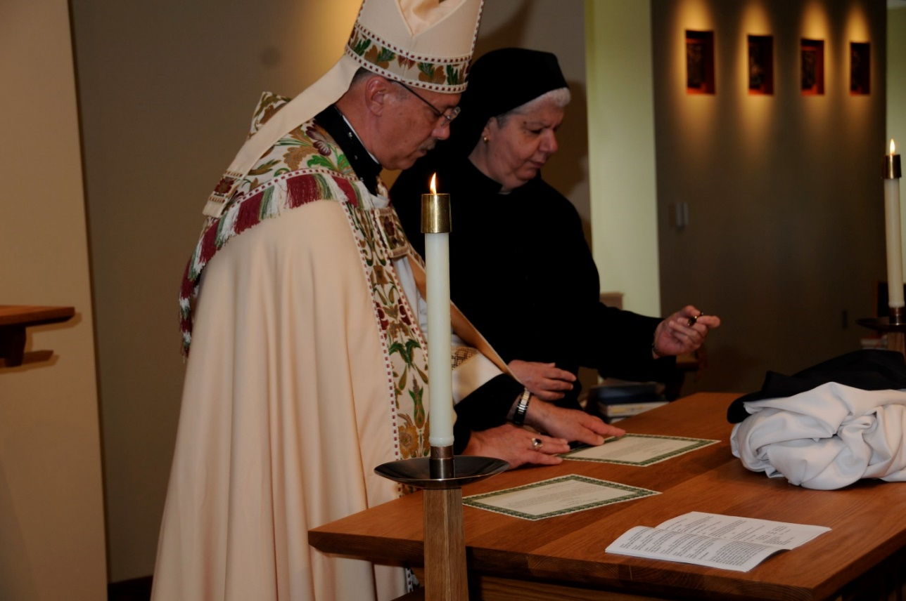
DSC 0189 Abbot Michael John Austin; Sr. Mary Catherine Christopher
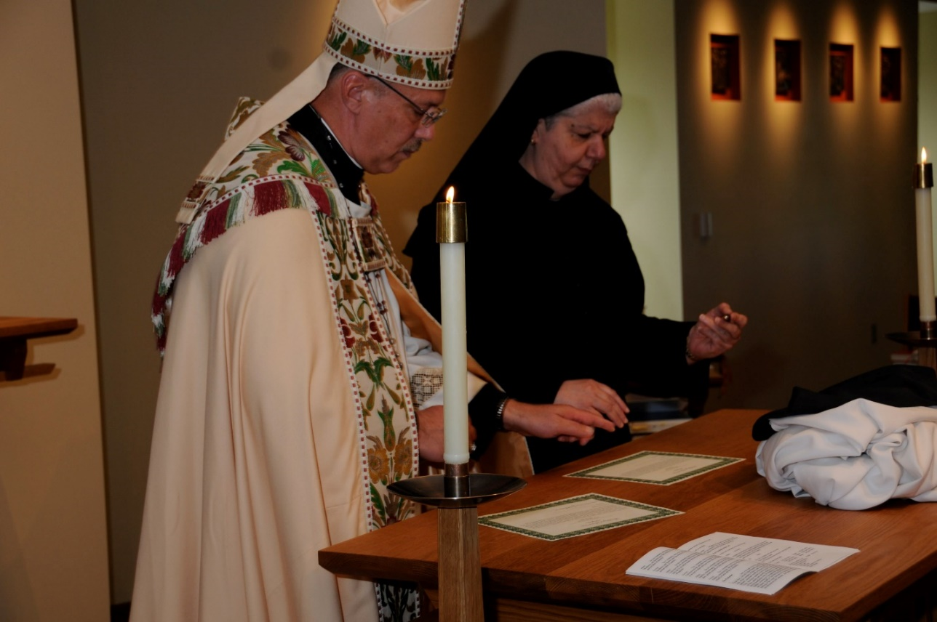
DSC 0190 Abbot Michael John Austin; Sr. Mary Catherine Christopher

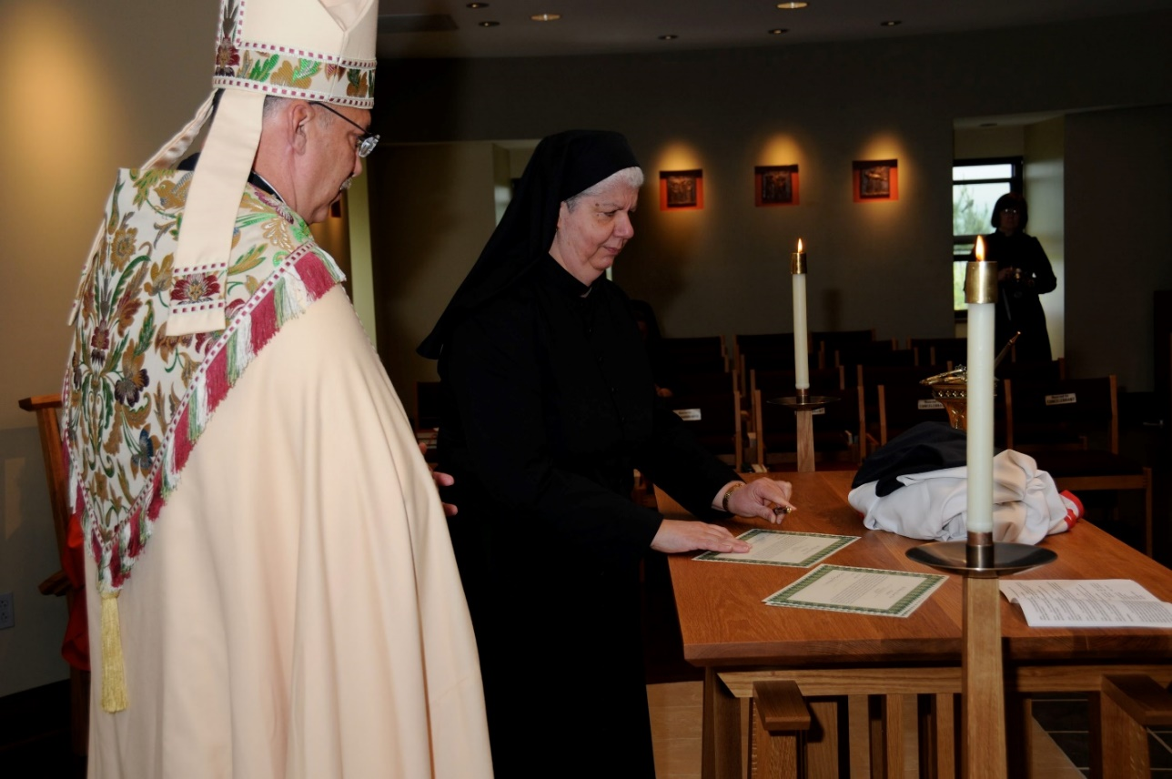
DSC 0191 Abbot Michael John Austin; Sr. Mary Catherine Christopher; Sr. Brigid Gerns
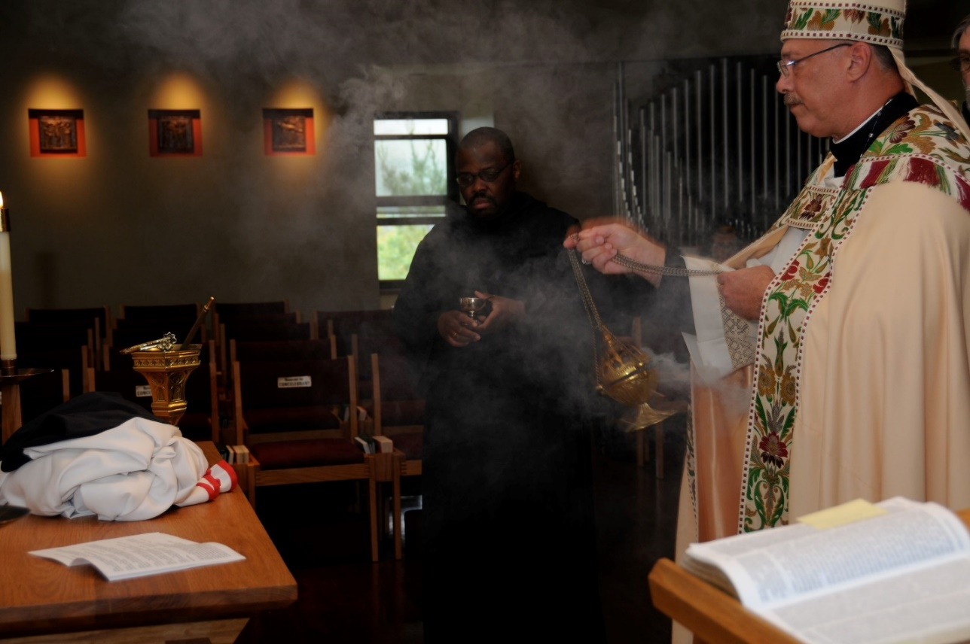
DSC 0195 Br. Thomas Ferrell; Abbot Michael John Austin

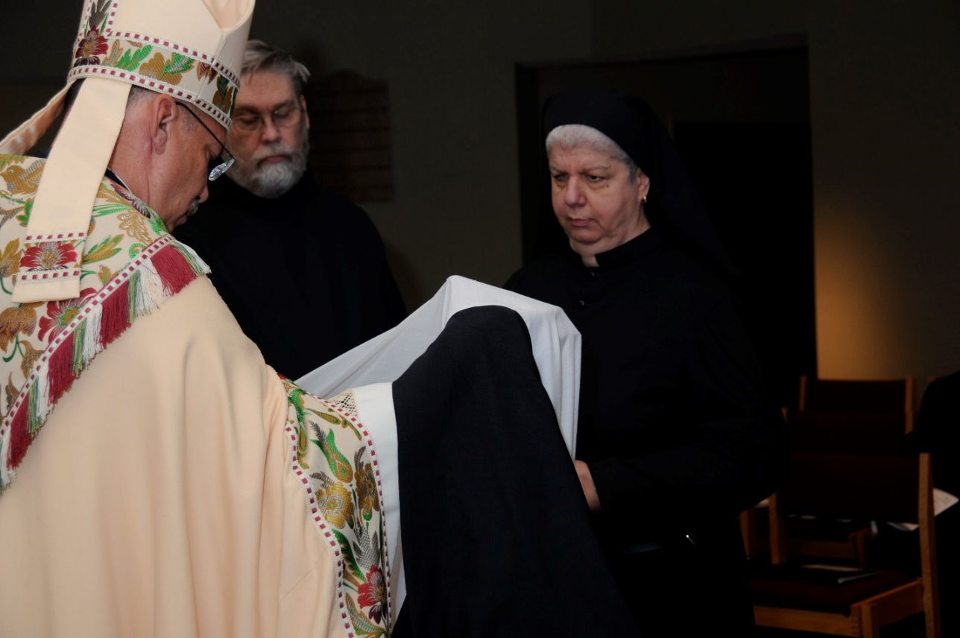
DSC 0197 Abbot Michael John Austin; Br. Chad Anselm Gerns; Sr. Mary Catherine Christopher
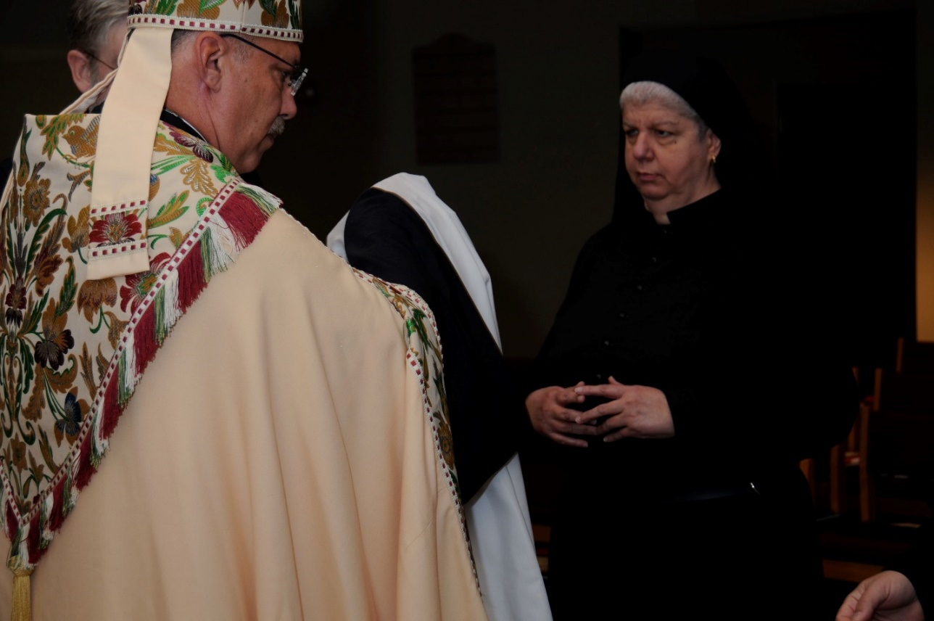
DSC 0198 Br. Chad Anselm Gerns; Abbot Michael John Austin; Sr. Mary Catherine Christopher

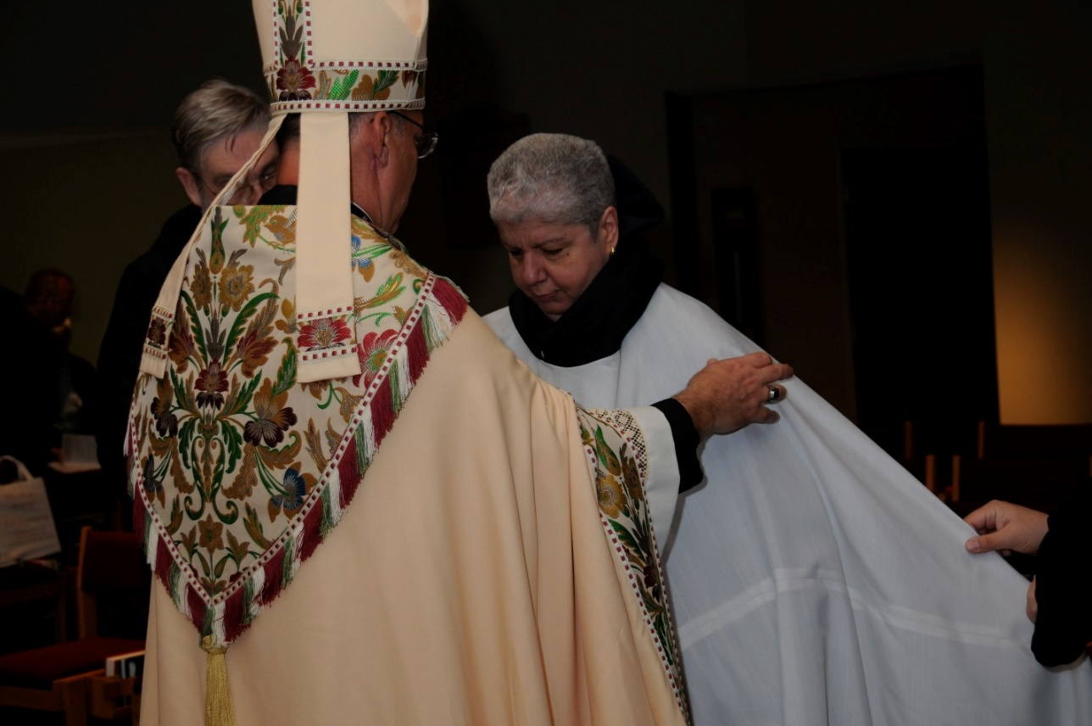
DSC 0199 Br. Chad Anselm Gerns; Abbot Michael John Austin; Sr. Mary Catherine Christopher
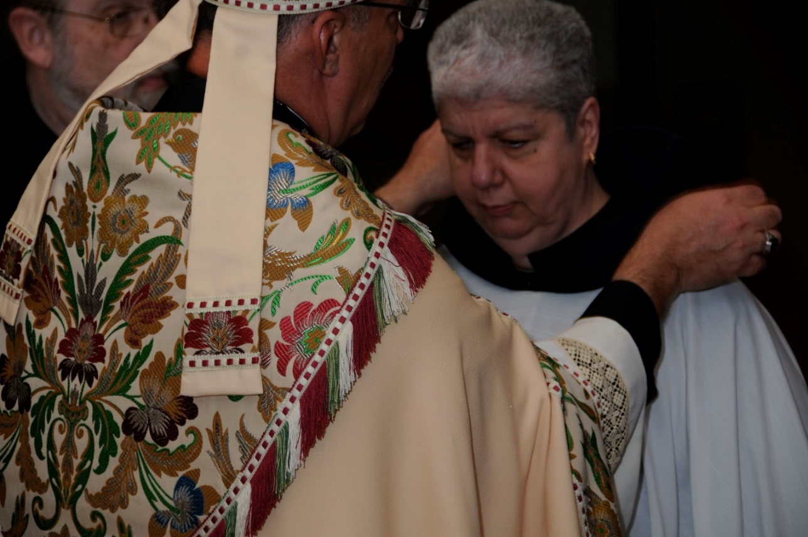
DSC 0200 Abbot Michael John Austin; Sr. Mary Catherine Christopher

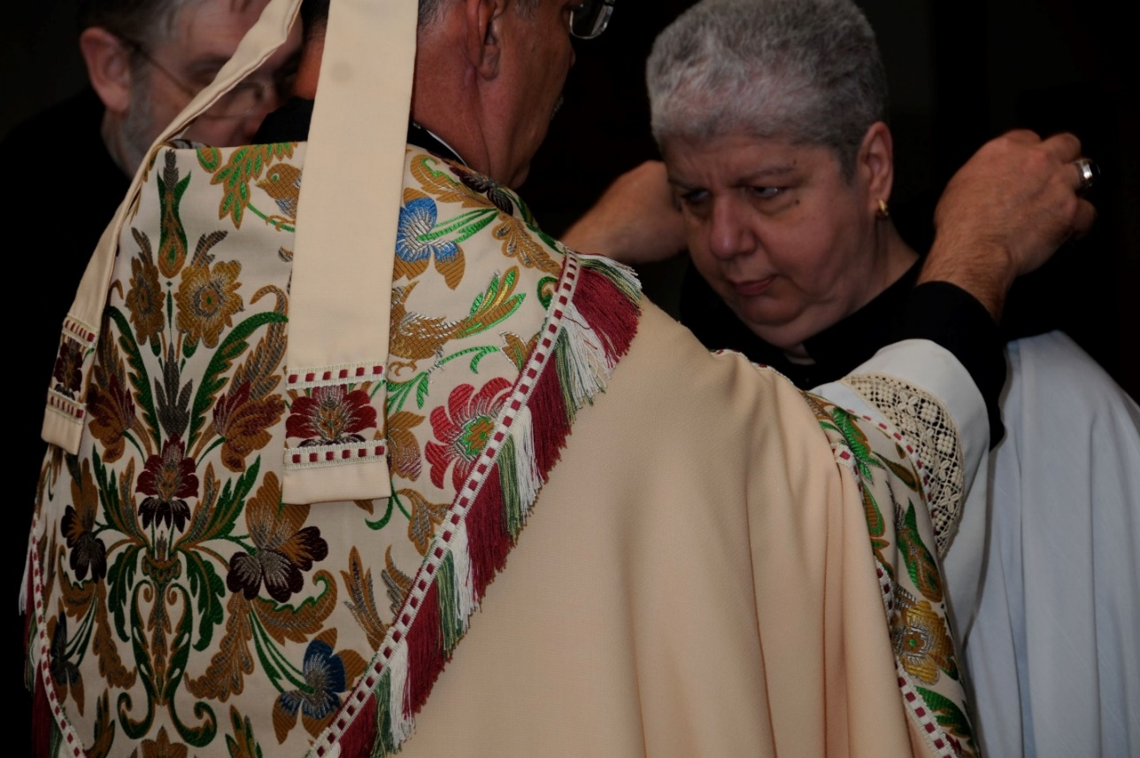
DSC 0201 Br. Chad Anselm Gerns; Abbot Michael John Austin; Sr. Mary Catherine Christopher
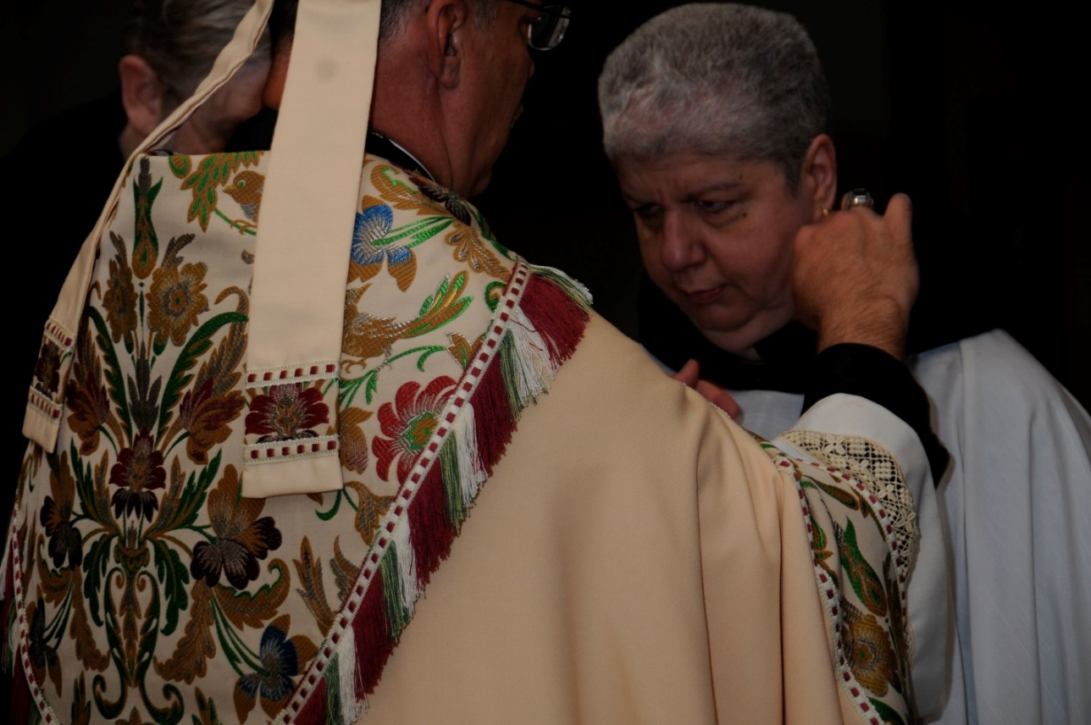
DSC 0202 Br. Chad Anselm Gerns; Abbot Michael John Austin; Sr. Mary Catherine Christopher

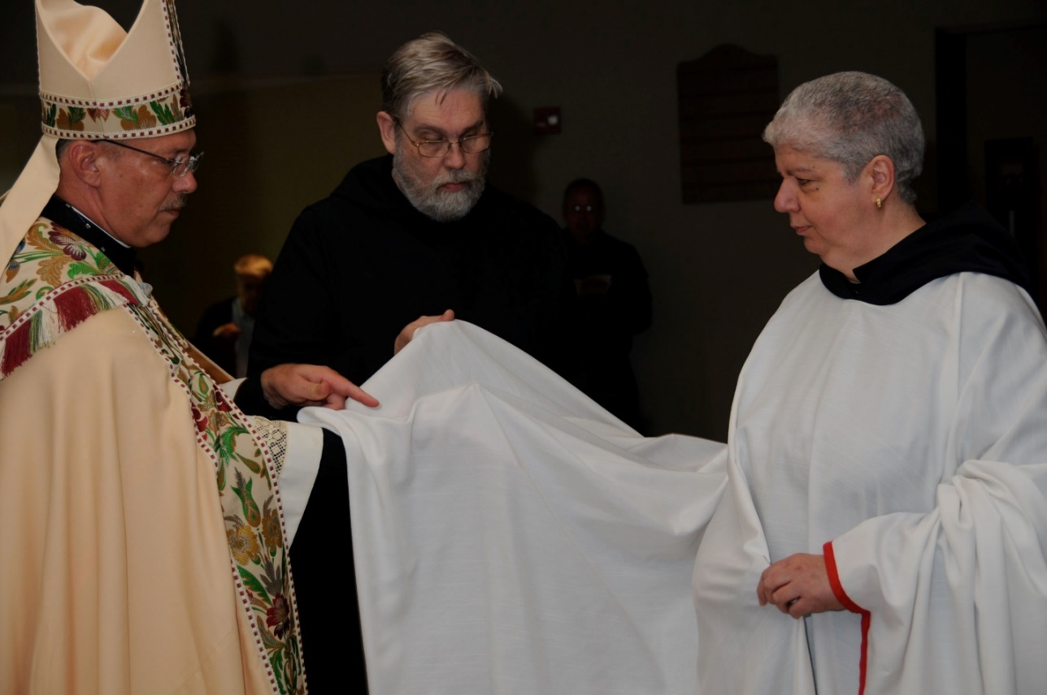
DSC 0203 Abbot Michael John Austin; Br. Chad Anselm Gerns; Sr. Mary Catherine Christopher
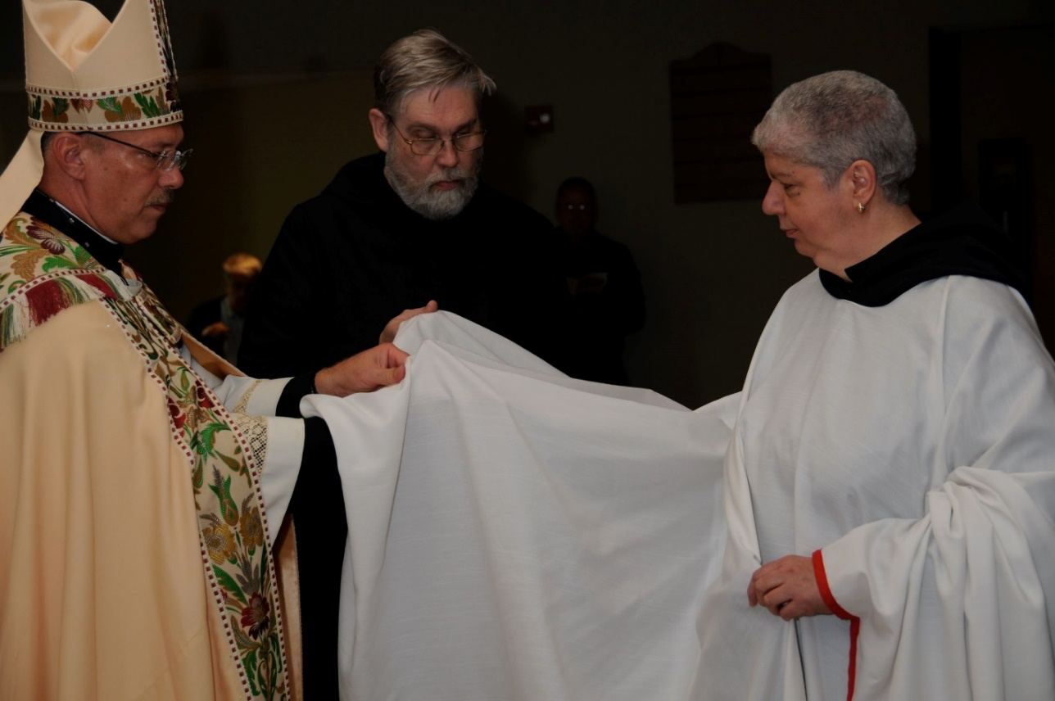
DSC 0204 Abbot Michael John Austin; Br. Chad Anselm Gerns; Sr. Mary Catherine Christopher

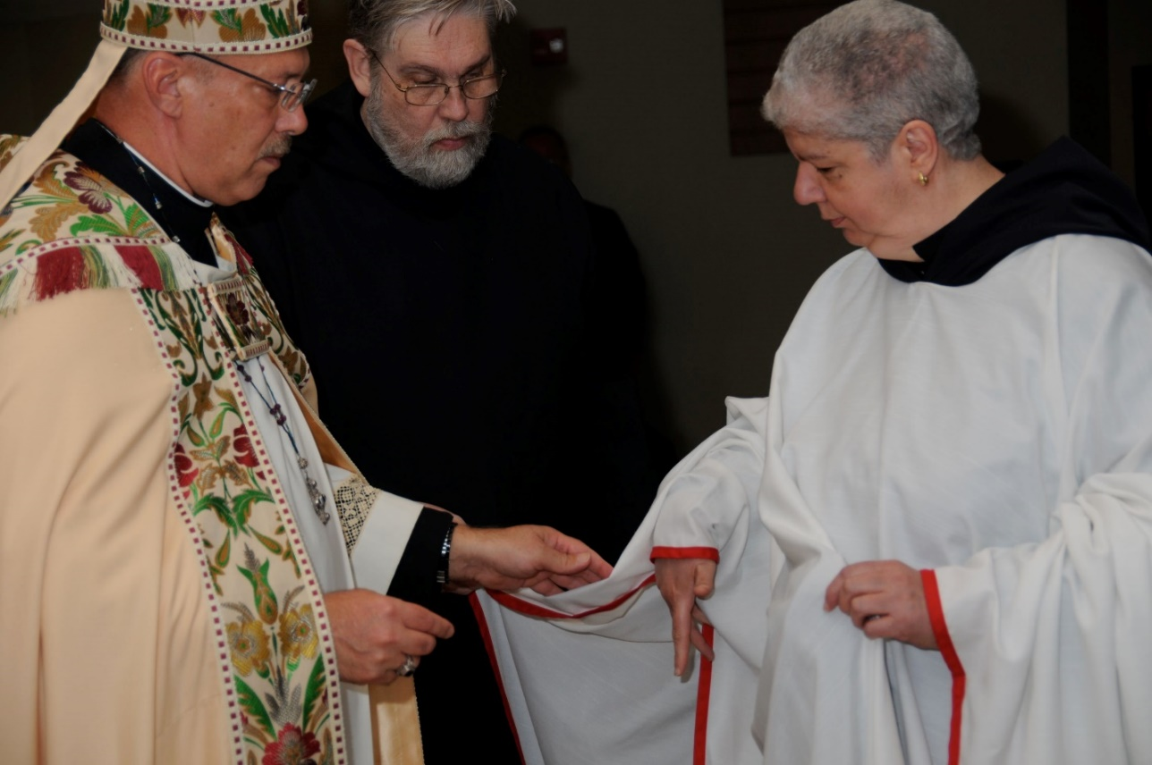
DSC 0205 Abbot Michael John Austin; Br. Chad Anselm Gerns; Sr. Mary Catherine Christopher
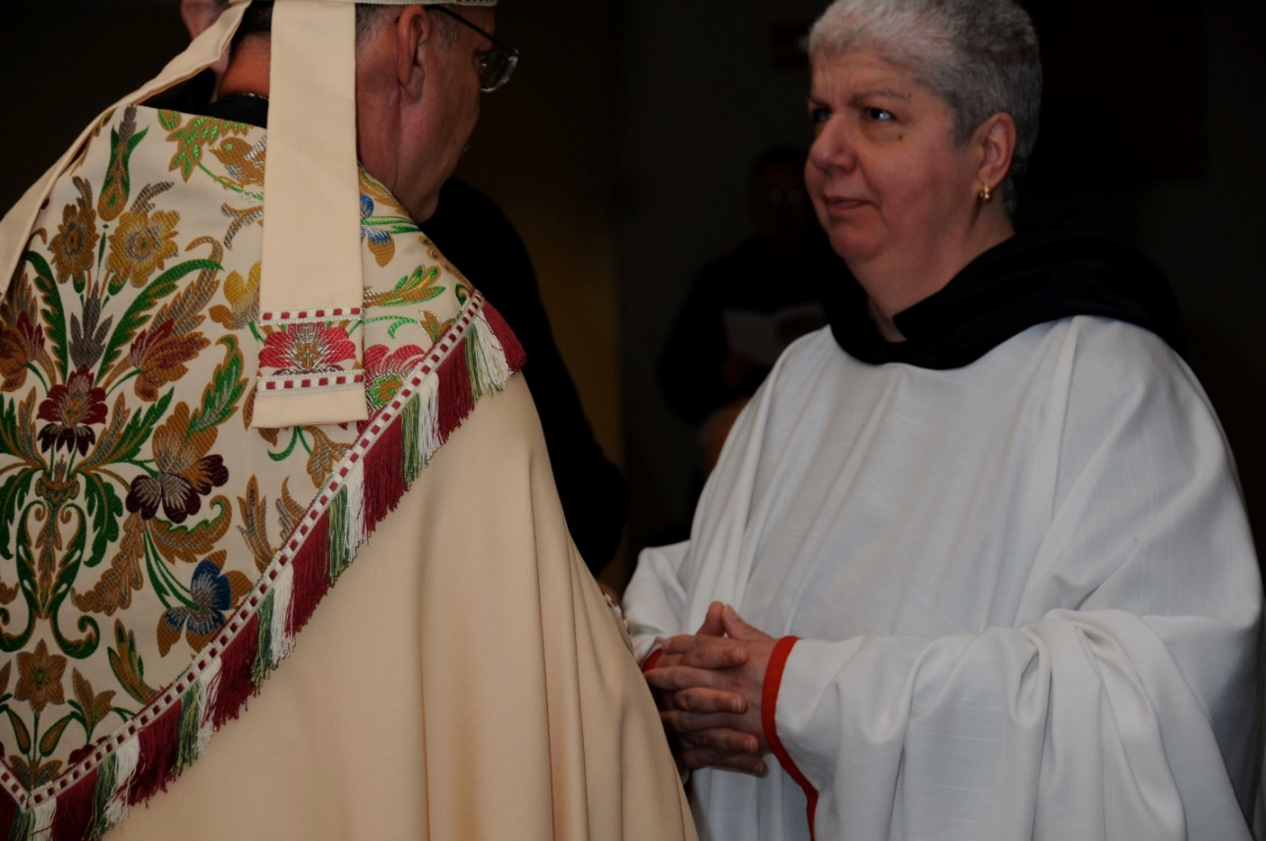
DSC 0206 Abbot Michael John Austin; Sr. Mary Catherine Christopher

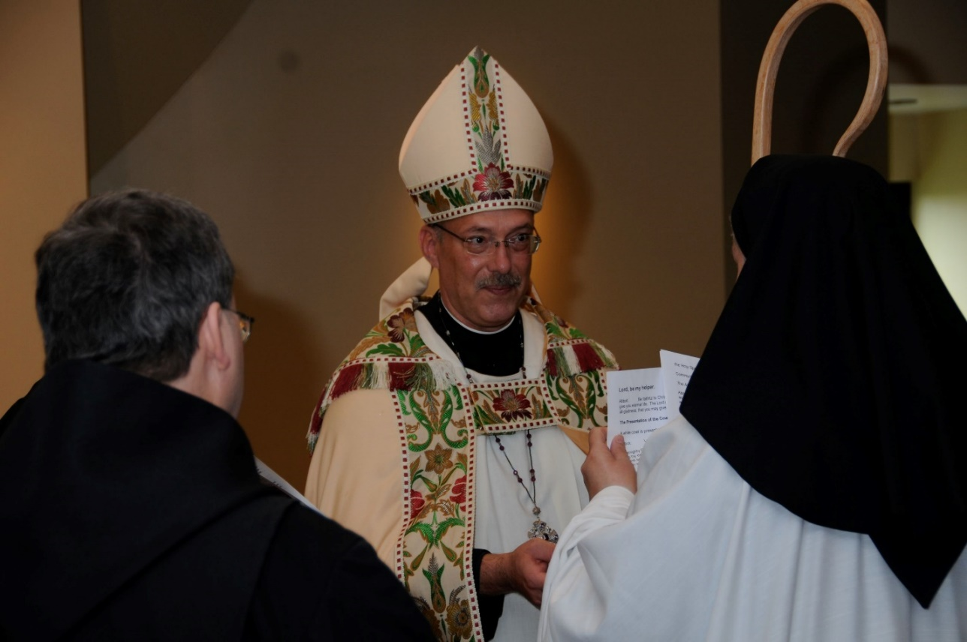
DSC 0207 Br. Paul Howard; Abbot Michael John Austin; Sr. Mary Catherine Christopher
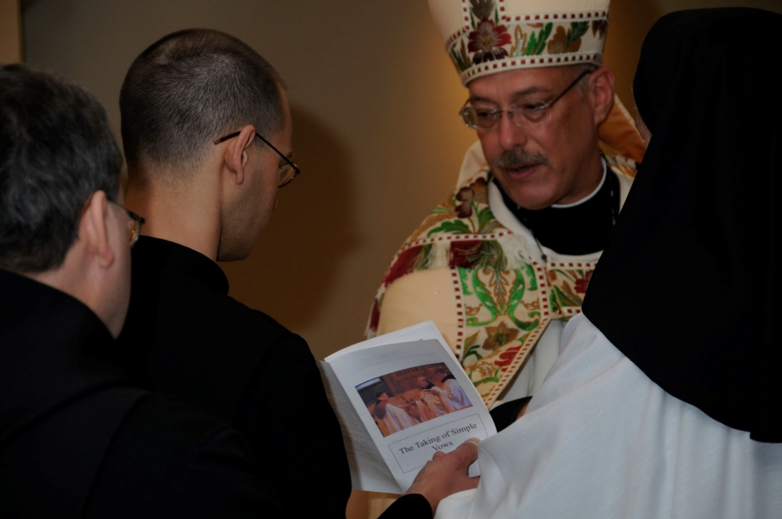
DSC 0208 Br. Paul Howard; Br. Aelred Shemayev; Abbot Michael John Austin; Sr. Mary Catherine Christopher

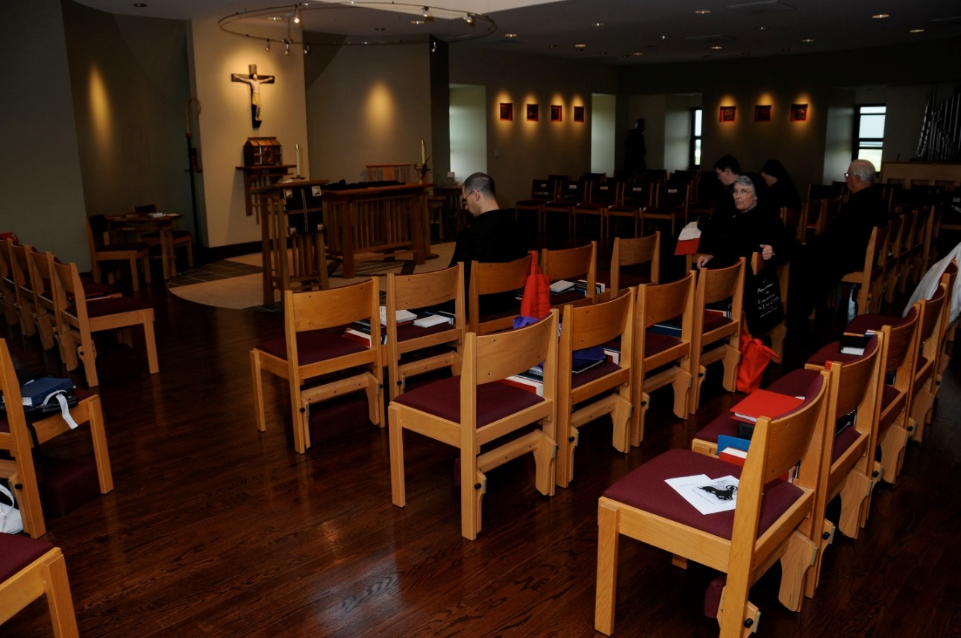
DSC 0209 Br. Aelred Shemayev; Br. Aidan Maguire; Sr. Mary Francis Deulen; Sr. Sophia Holt; Br. Bede Leach
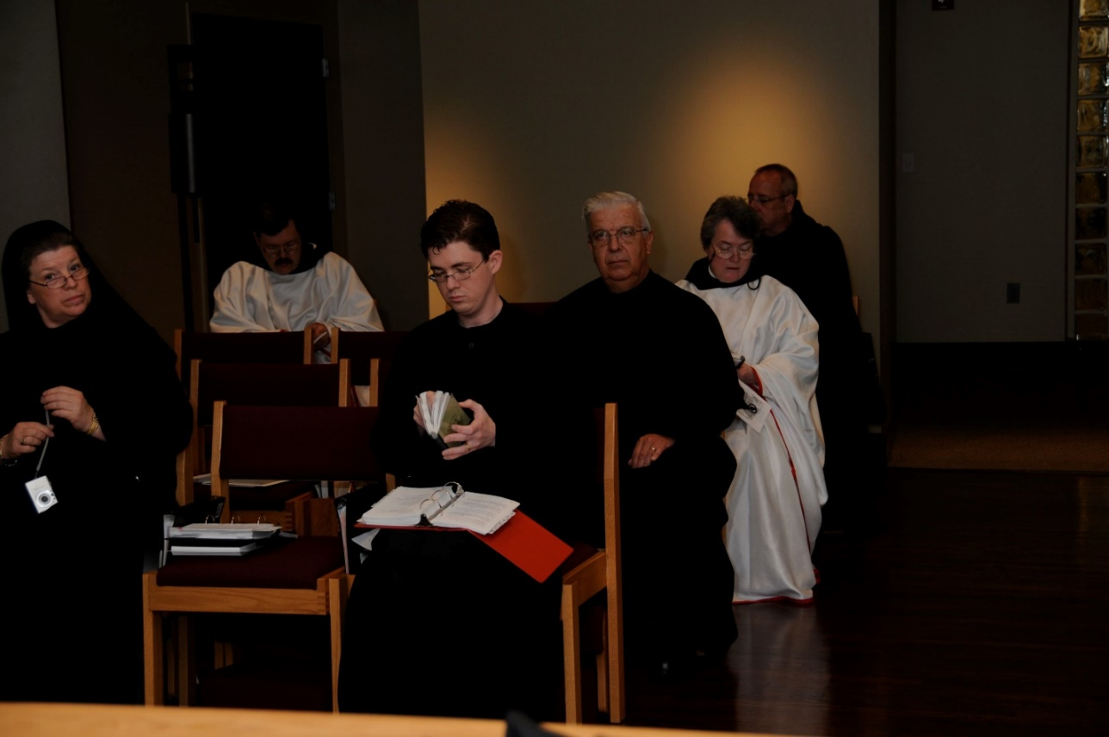
DSC 0210 Sr. Sophia Holt; Br. Paul Howard; Br. Aidan Maguire; Br. Timothy Titus Lunt; Sr. Vincent Marie Rittenhouse; Br. Gabriel Hale

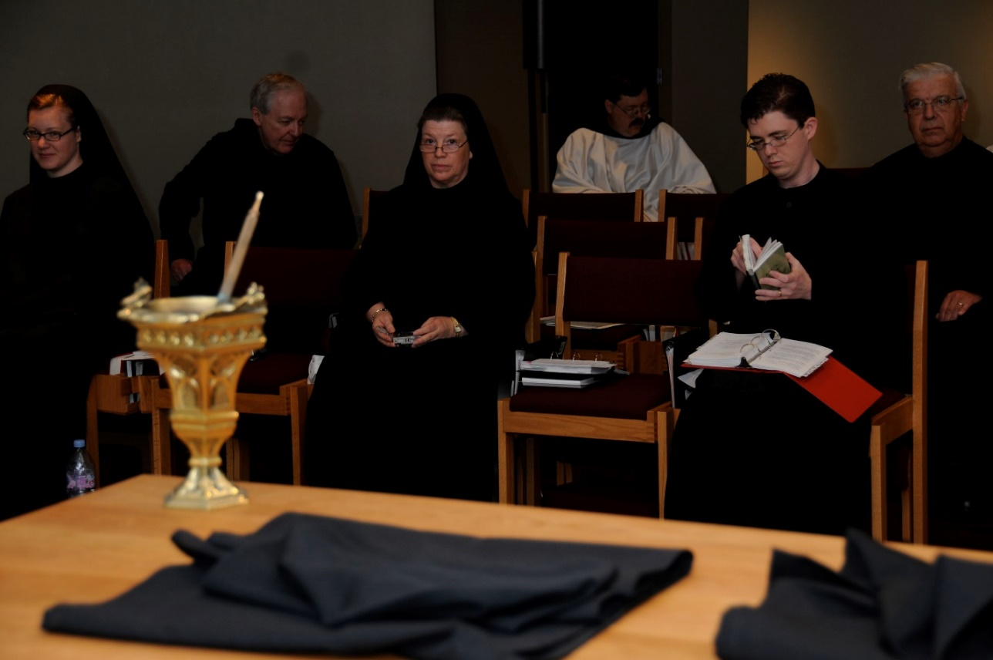
DSC 0212Sr. Hannah Sophia Korver; Br. Luke Doucette; Sr. Sophia Holt; Br. Paul Howard; Br. Aidan Maguire; Br. Timothy Titus Lunt
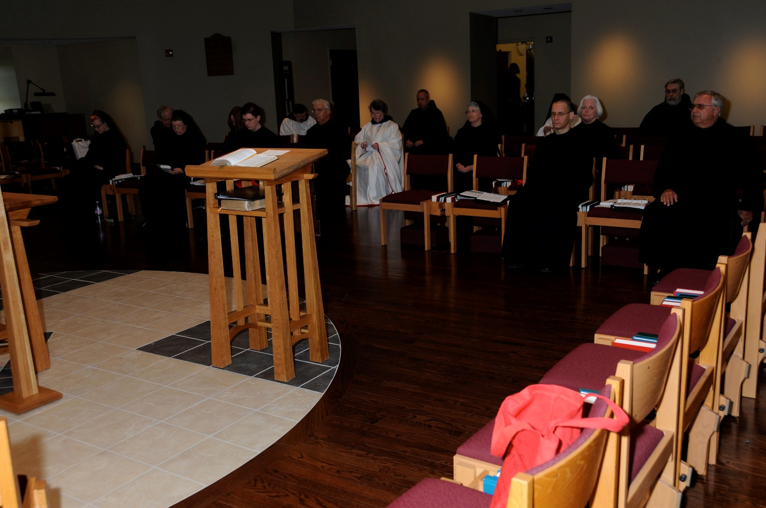
DSC 0219 Sr. Hannah Sophia Korver; Br. Luke Doucette; Sr. Sophia Holt; Sr. Teresa Beebe; Br. Aidan Maguire; Br. Paul Howard; Br. Timothy Titus Lunt; Sr. Vincent Marie Rittenhouse; Br. Gabriel Hale; Sr. Mary Francis Deulen; Br. Aelred Shemayev; Sr. Catherine Anne Stribley; Br. Chad Anselm Gerns; Br. Bede Leach

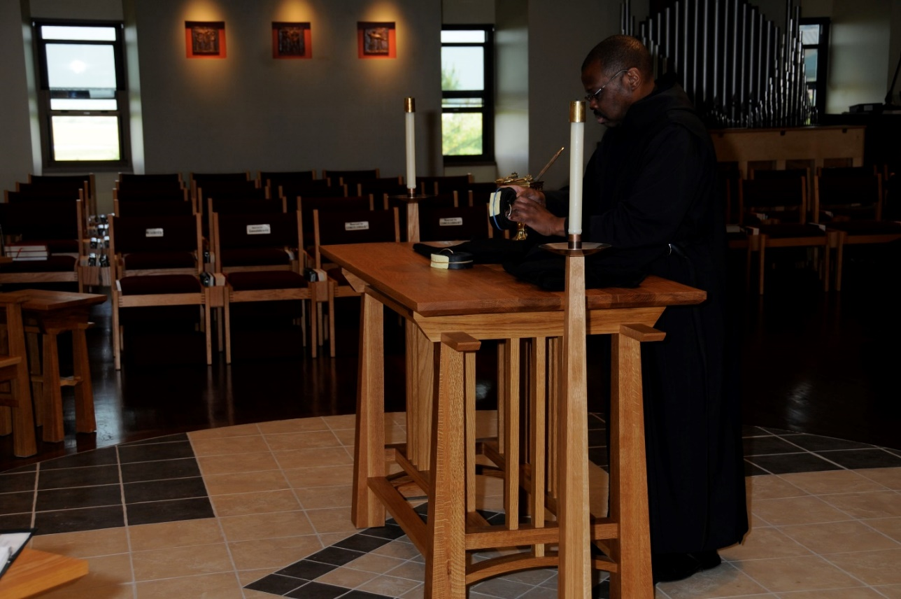
DSC 0220 Br. Thomas Ferrell

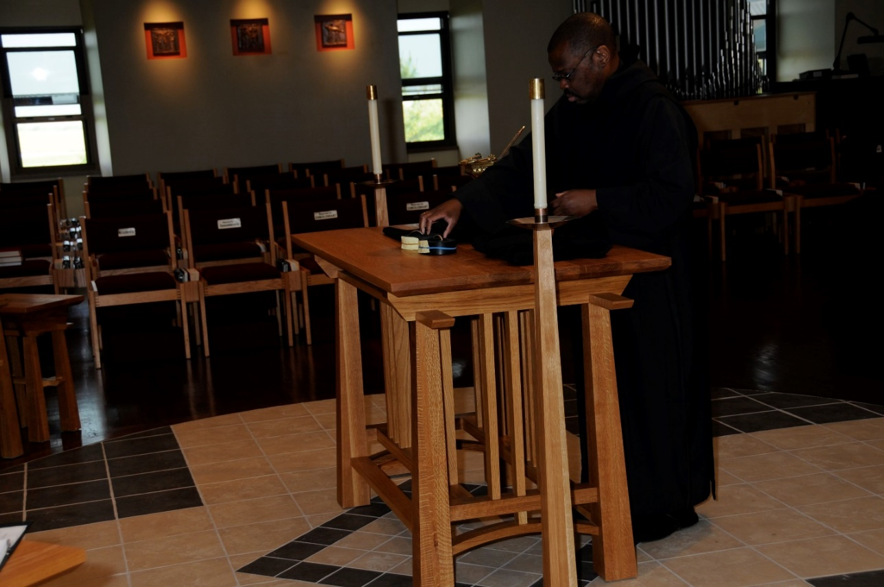
DSC 0221 Br. Thomas Ferrell
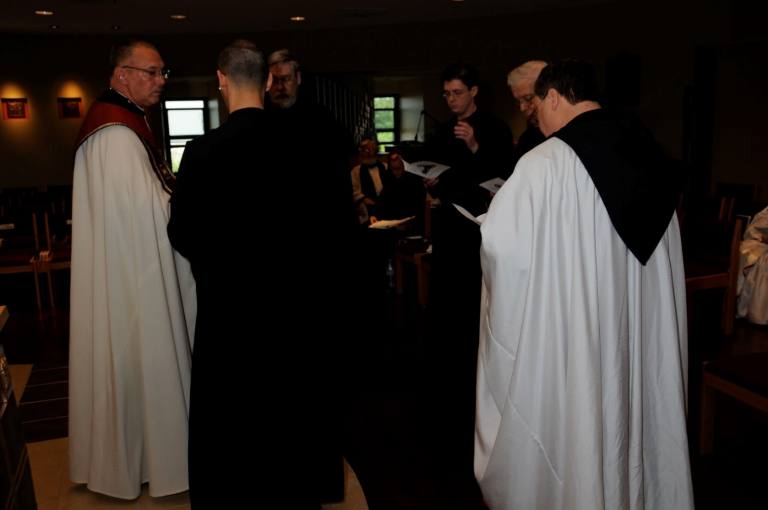
DSC 0222 Abbot Michael John Austin; Br. Aelred Shemayev; Fr. Wayne Kamm; Sr. Hannah Sophia Korver; Br. Aidan Maguire; Br. Timothy Titus Lunt; Br. Paul Howard

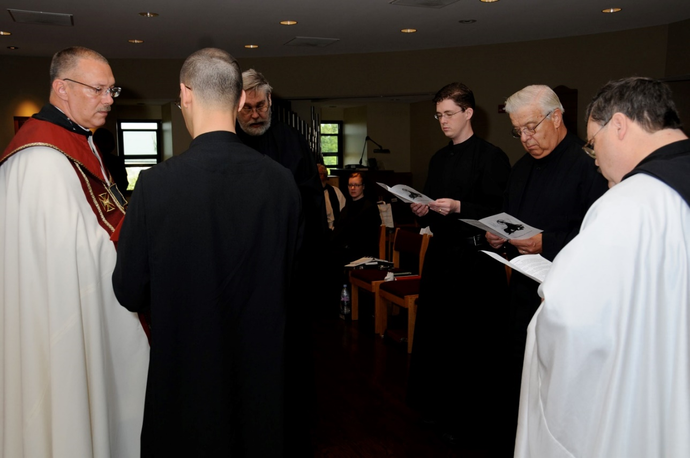
DSC 0223 Abbot Michael John Austin; Br. Aelred Shemayev; Br. Chad Anselm Gerns; Fr. Wayne Kamm; Sr. Hannah Sophia Korver; Br. Aidan Maguire; Br. Timothy Titus Lunt; Br. Paul Howard
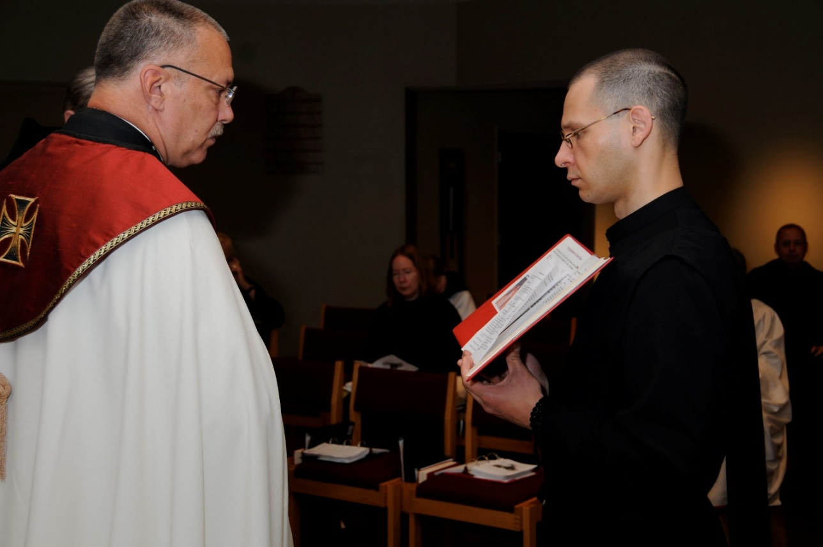
DSC 0224 Abbot Michael John Austin; Sr. Teresa Beebe; Br. Aelred Shemayev; Br. Gabriel Hale

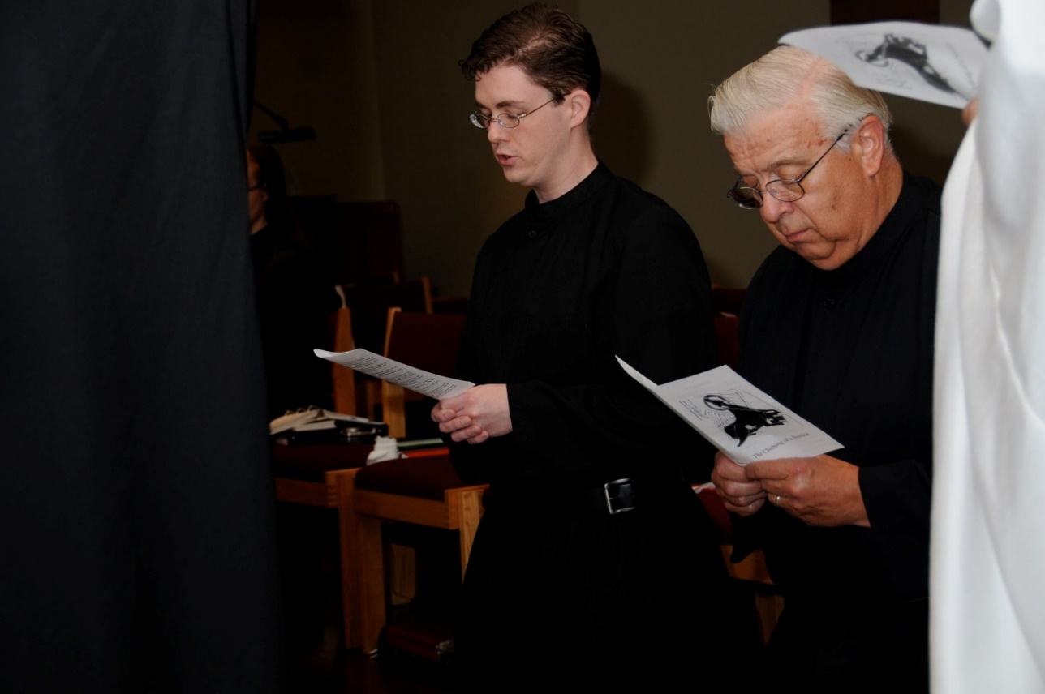
DSC 0225 Br. Aidan Maguire; Br. Timothy Titus Lunt
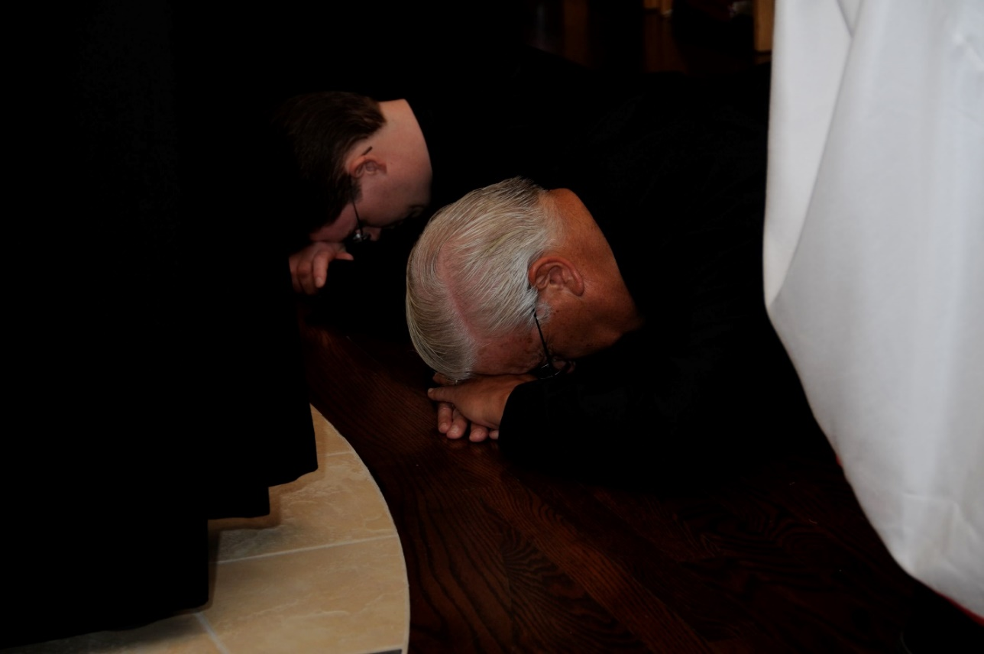
DSC 0226 Br. Aidan Maguire; Br. Timothy Titus Lunt

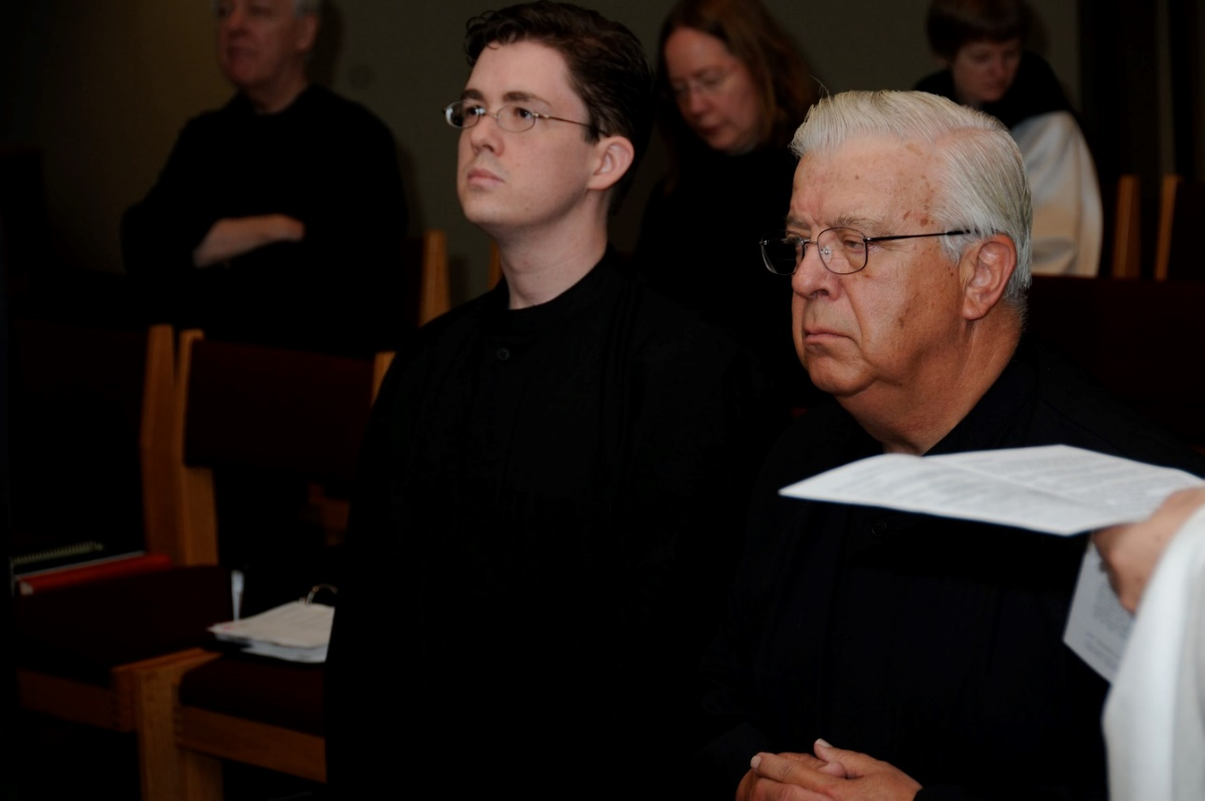
DSC 0228 Br. Luke Doucette; Br. Aidan Maguire; Sr. Teresa Beebe; Br. Timothy Titus Lunt; Sr. Catherine Unterseher
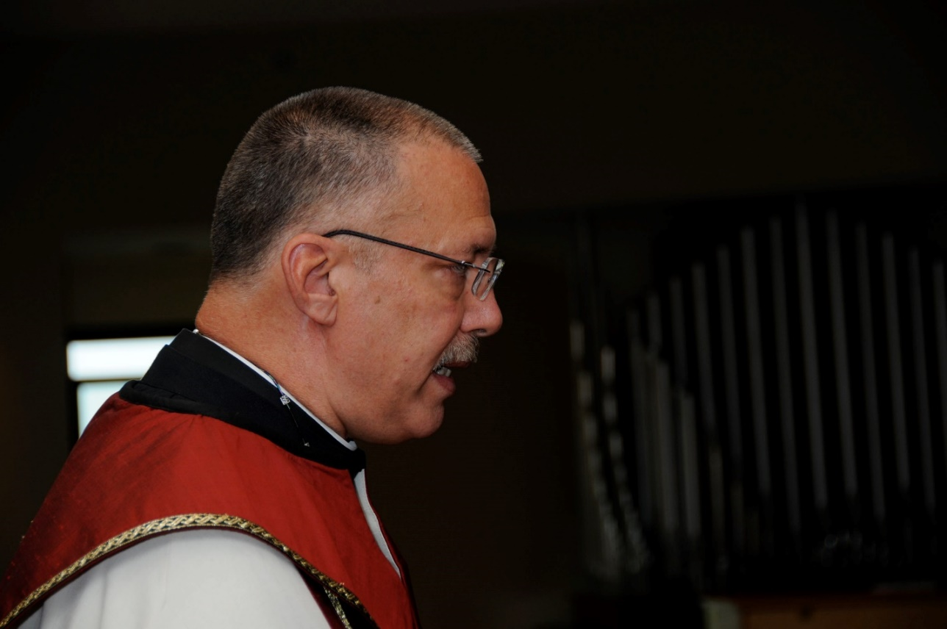
DSC 0229 Abbot Michael John Austin

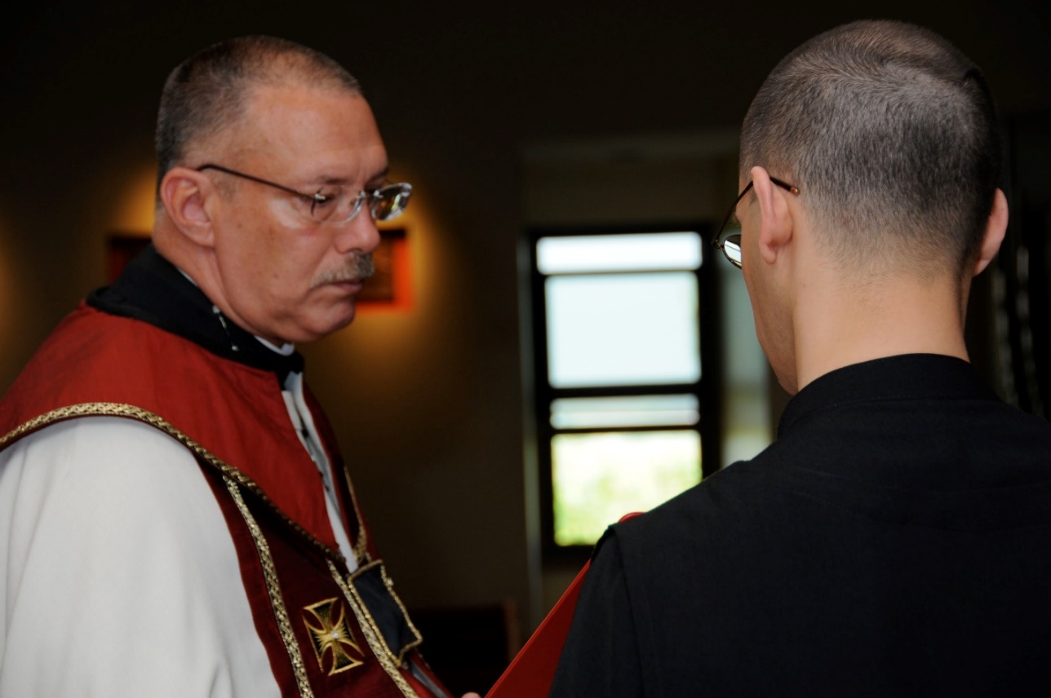
DSC 0230 Abbot Michael John Austin; Br. Aelred Shemayev
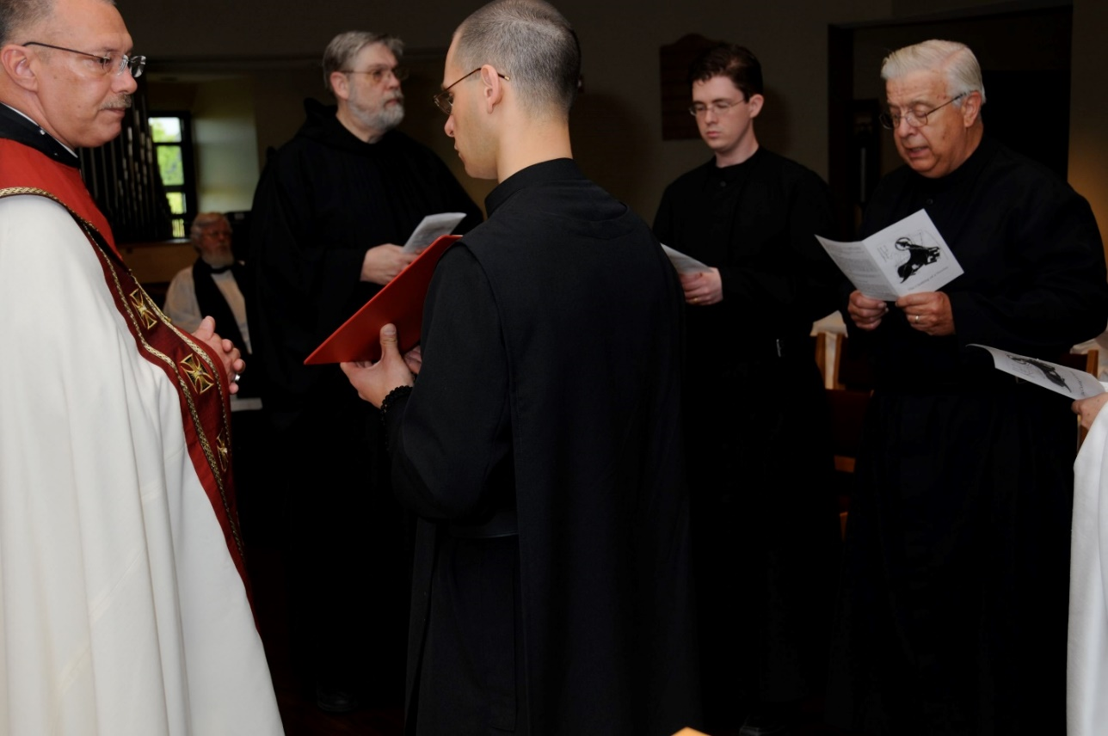
DSC 0231 Abbot Michael John Austin; Fr. Wayne Kamm; Br. Chad Anselm Gerns; Br. Aelred Shemayev; Br. Aidan Maguire; Br. Timothy Titus Lunt

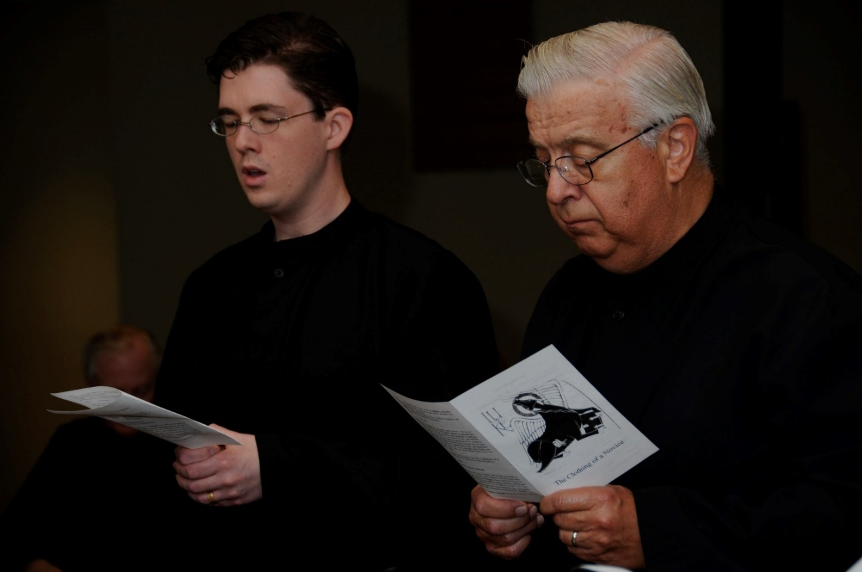
DSC 0232 Br. Aidan Maguire; Br. Timothy Titus Lunt
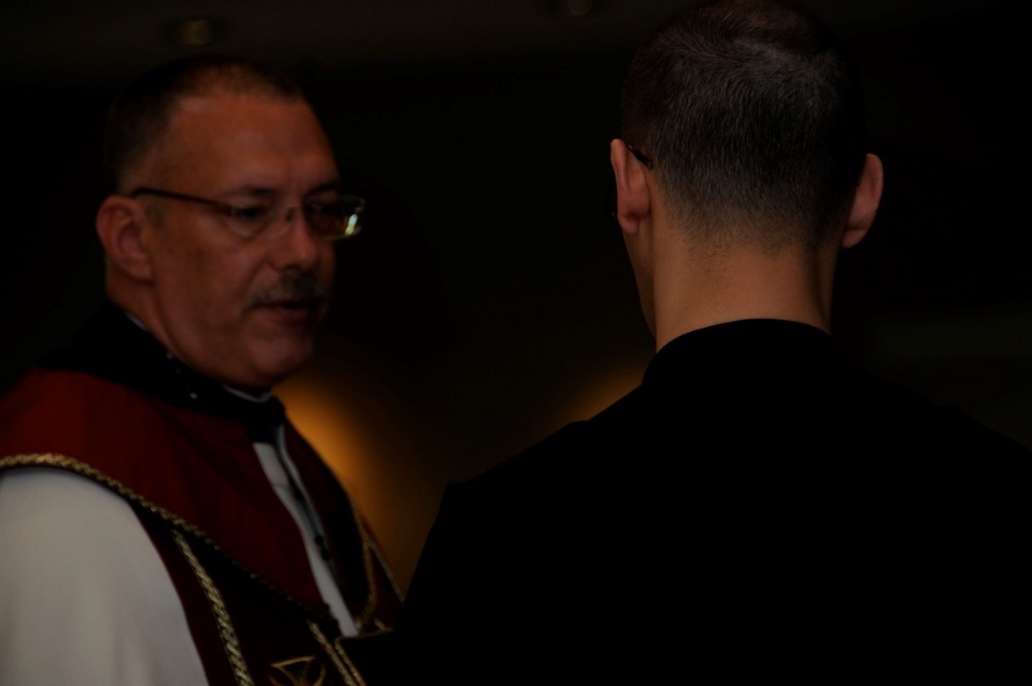
DSC 0233 Abbot Michael John Austin; Br. Aelred Shemayev

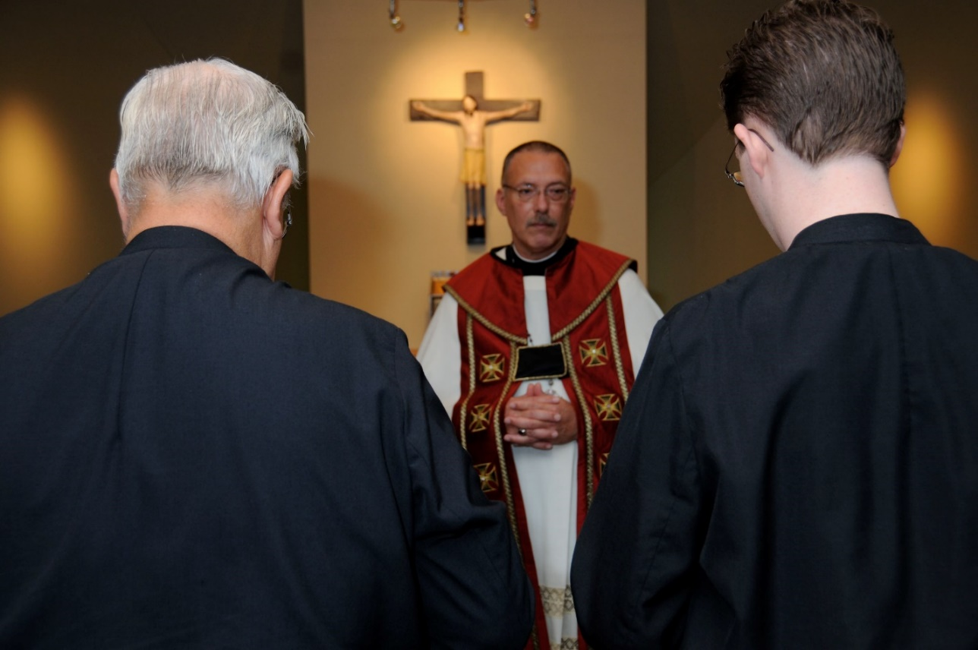
DSC 0235 Br. Timothy Titus Lunt; Abbot Michael John Austin; Br. Aidan Maguire
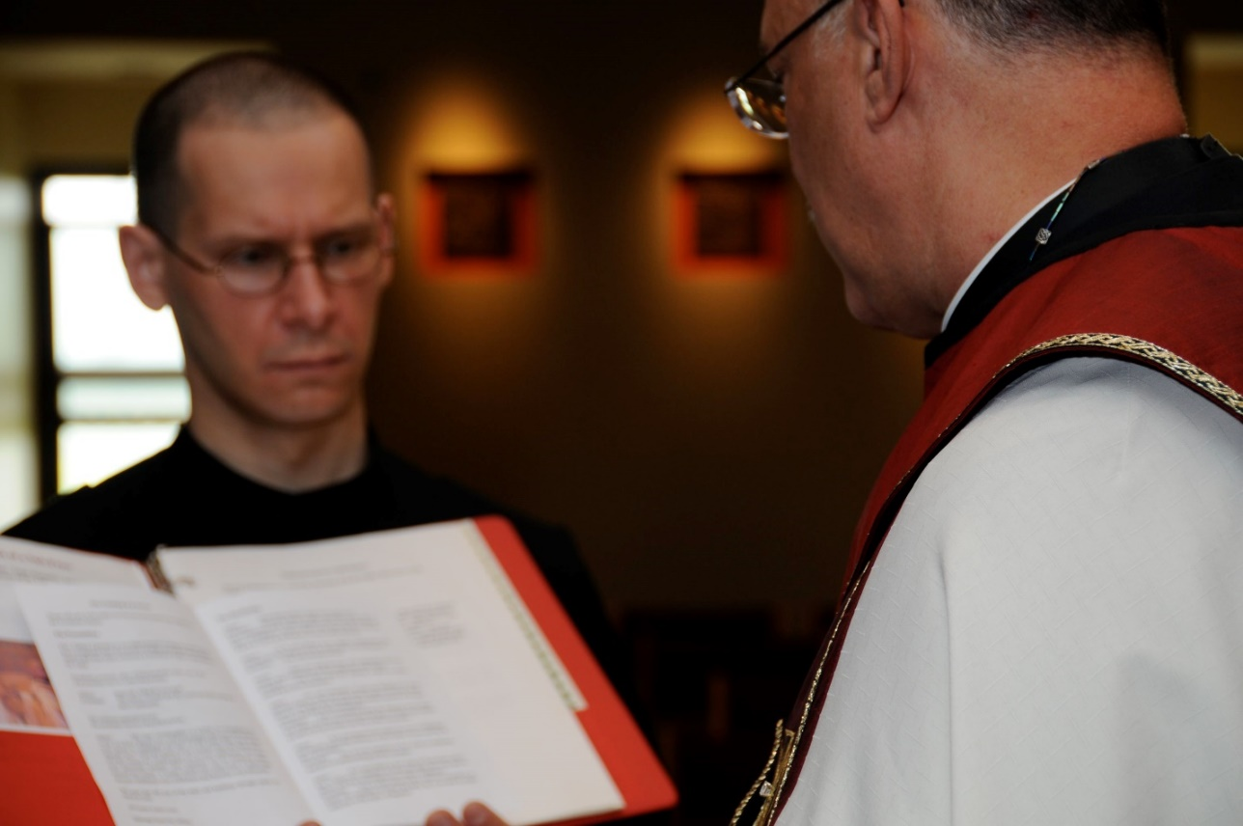
DSC 0236 Br. Aelred Shemayev; Abbot Michael John Austin

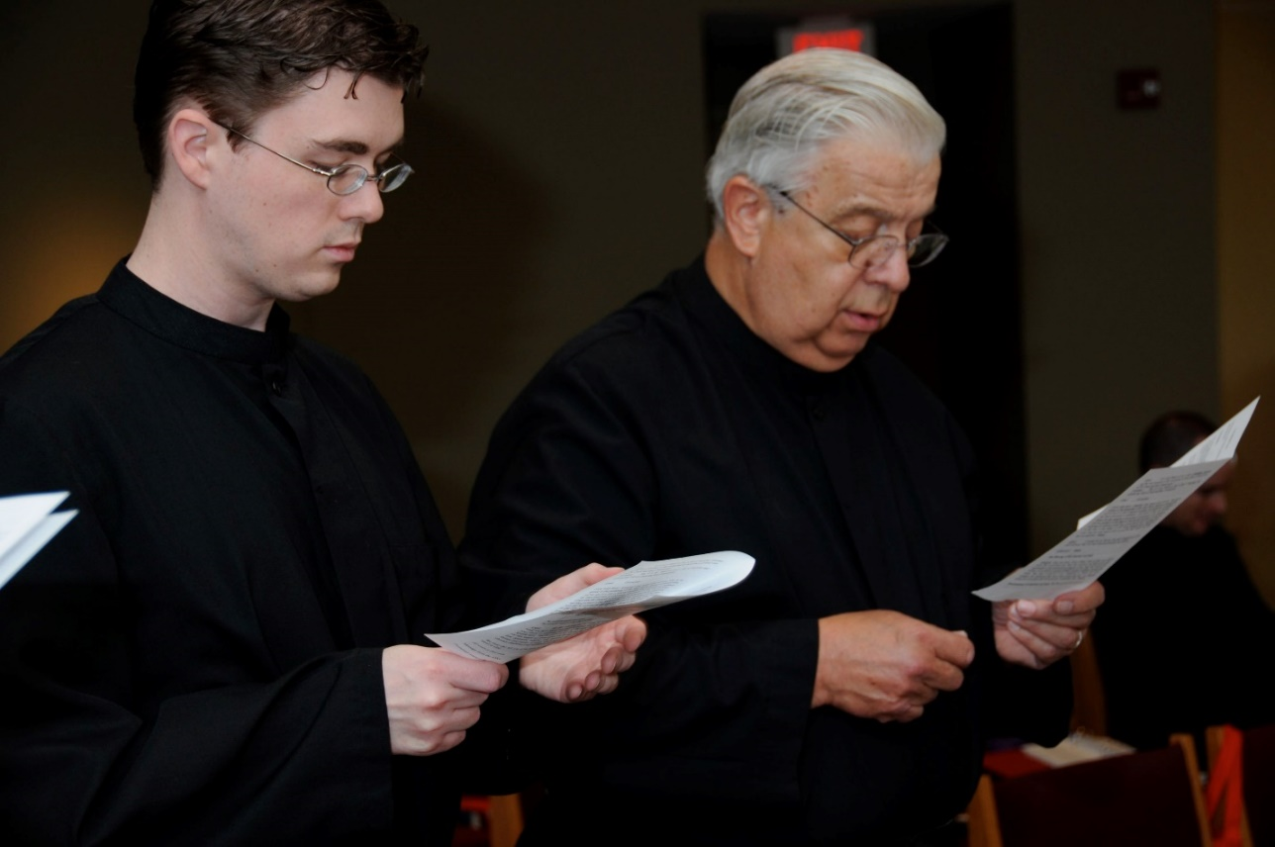
DSC 0237 Br. Aidan Maguire; Br. Timothy Titus Lunt; Br. John Matthias Cline
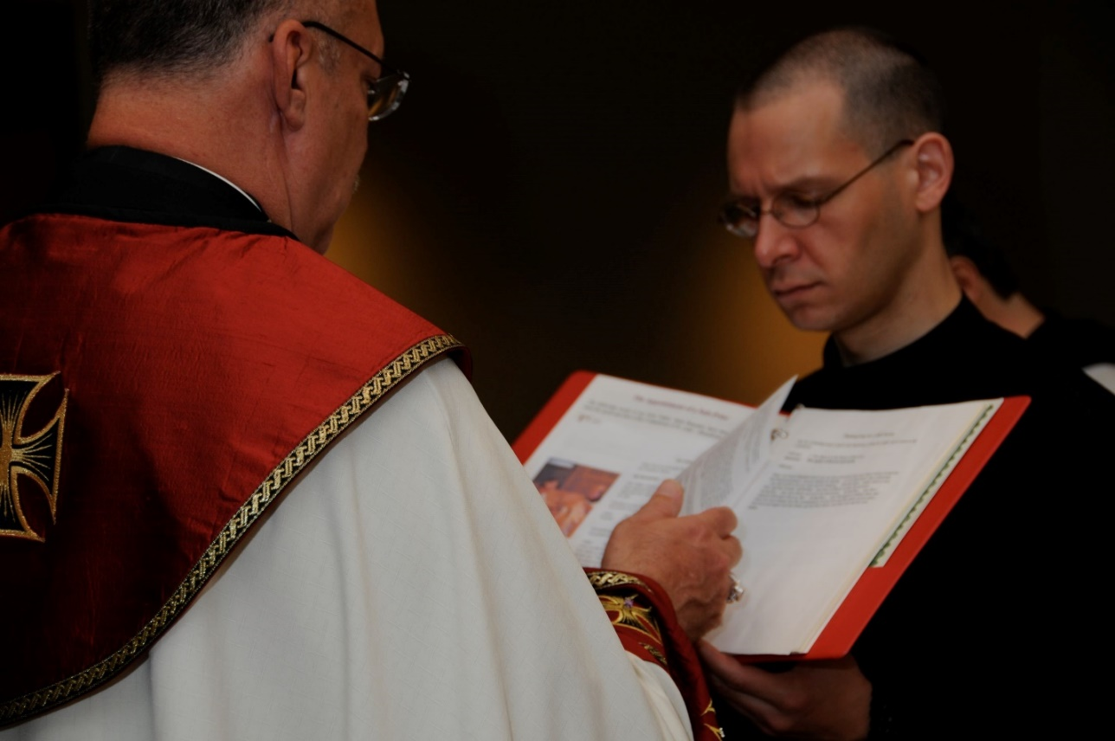
DSC 0238 Abbot Michael John Austin; Br. Aelred Shemayev

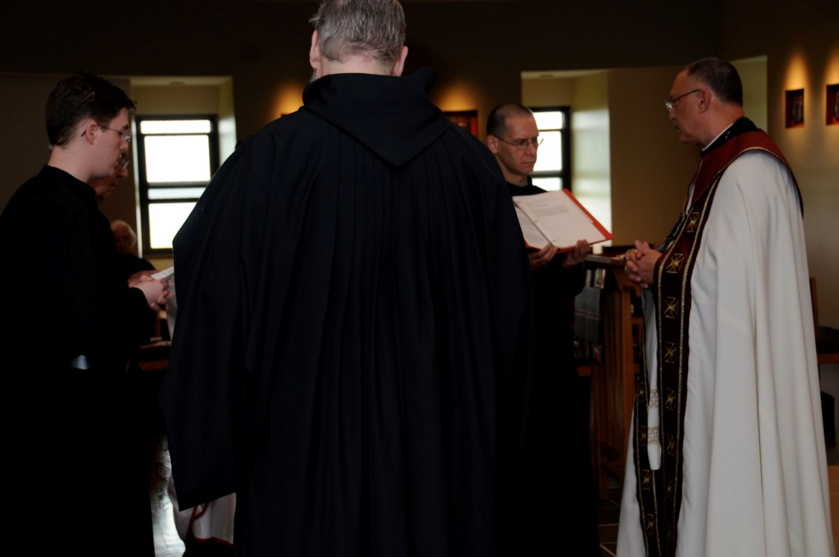
DSC 0239 Br. Aidan Maguire; Sr. Catherine Anne Stribley; Br. Chad Anselm Gerns; Br. Aelred Shemayev; Abbot Michael John Austin
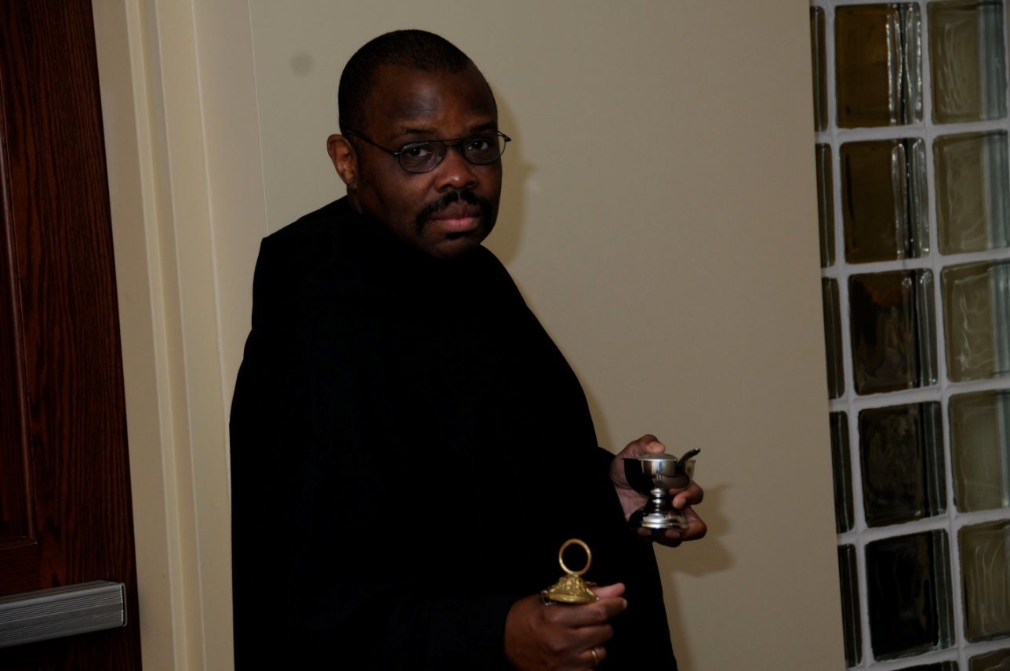
DSC 0240; Br. Thomas Ferrell

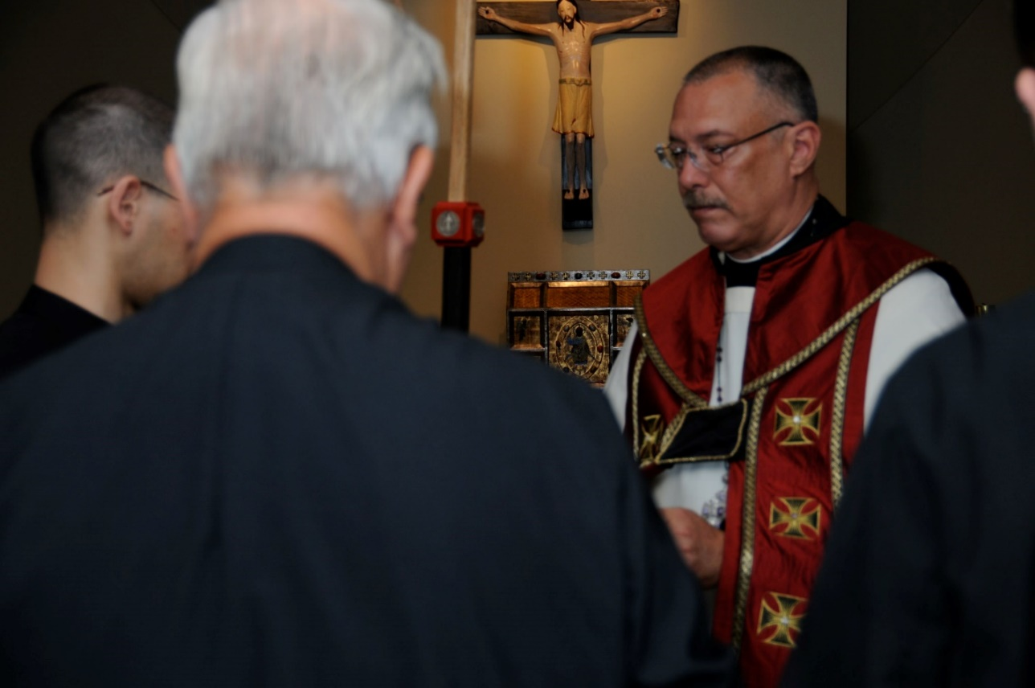
DSC 0243 Br. Aelred Shemayev; Br. Timothy Titus Lunt; Abbot Michael John Austin
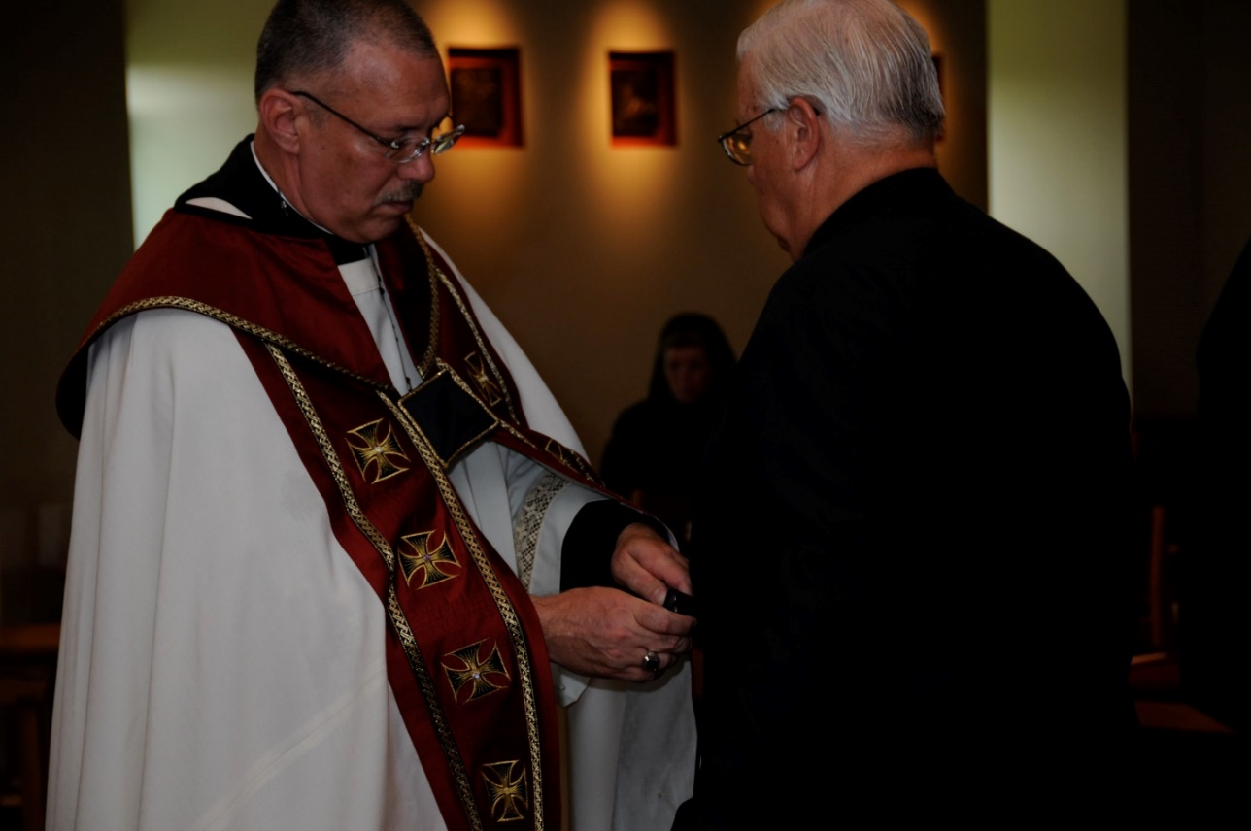
DSC 0246 Abbot Michael John Austin; Sr. Sophia Holt; Br. Timothy Titus Lunt

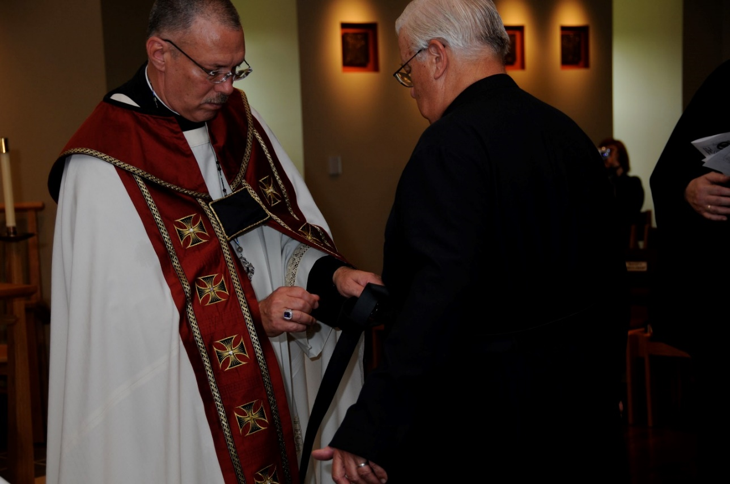
DSC 0247 Abbot Michael John Austin; Br. Timothy Titus Lunt
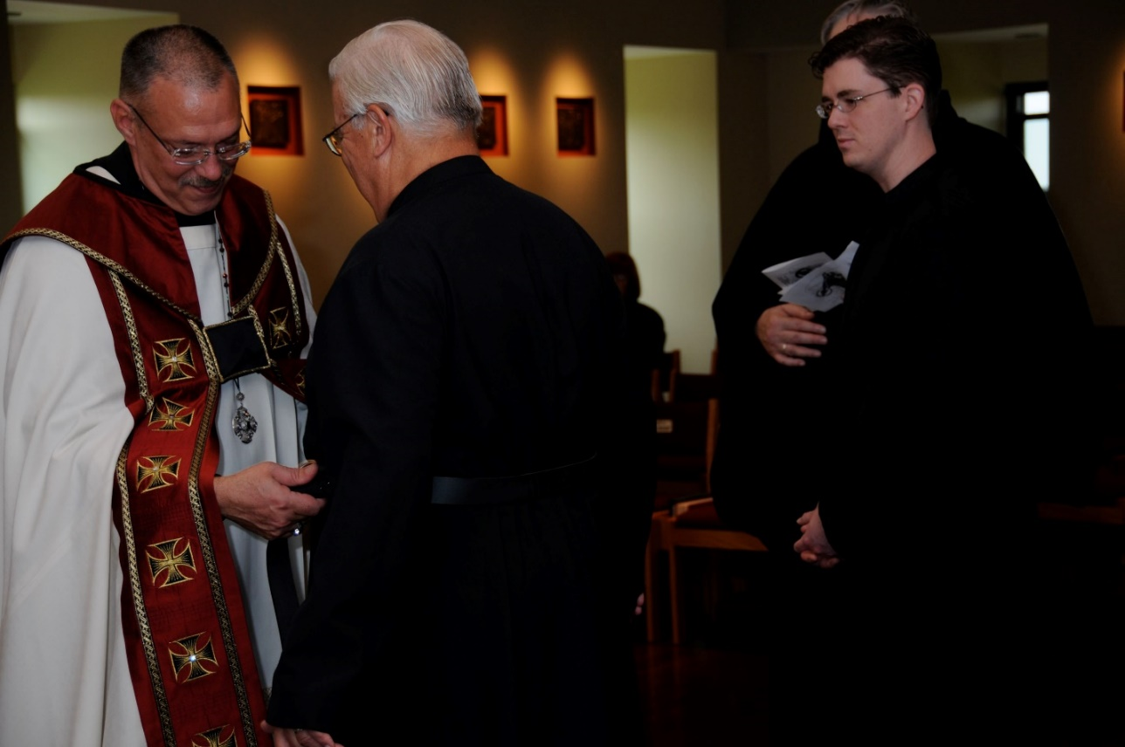
DSC 0248 Abbot Michael John Austin; Br. Timothy Titus Lunt; Br. Aidan Maguire; Br. Chad Anselm Gerns

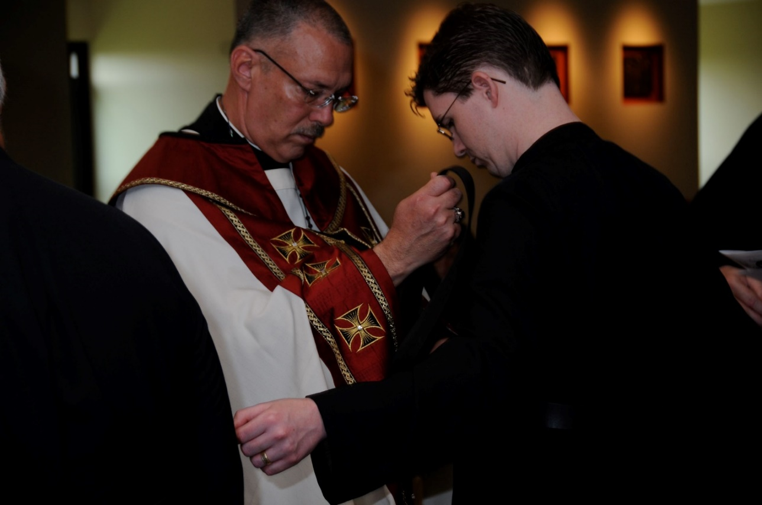
DSC 0249 Abbot Michael John Austin; Br. Aidan Maguire
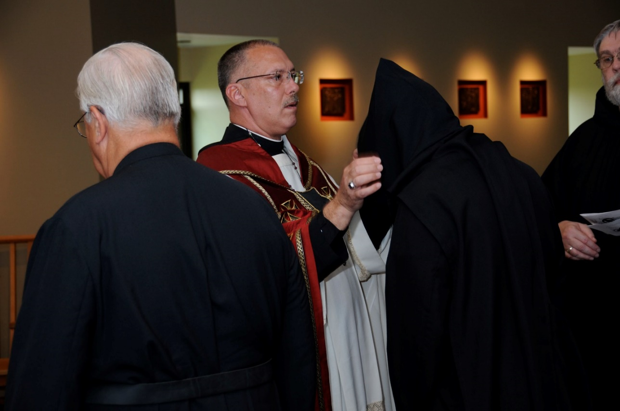
DSC 0250 Br. Timothy Titus Lunt;Abbot Michael John Austin; Br. Aidan Maguire; Br. Chad Anselm Gerns

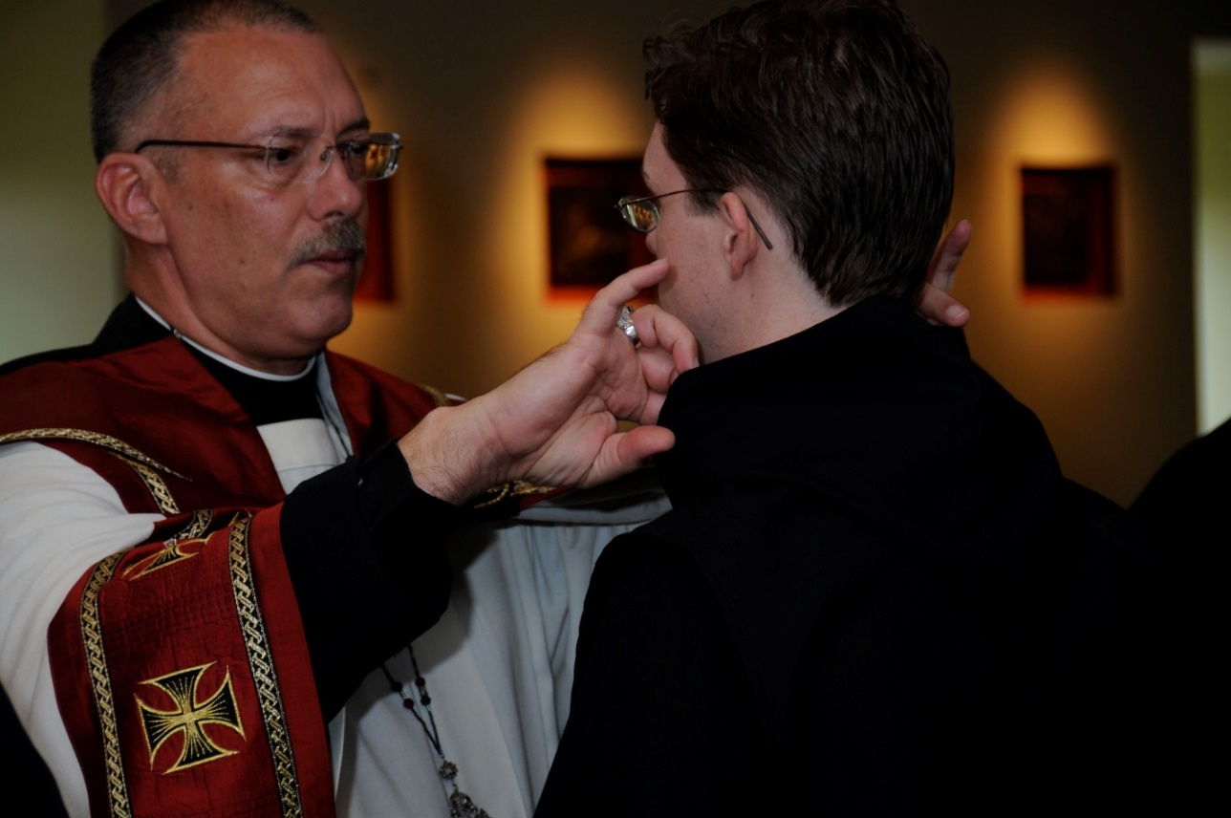
DSC 0251 Abbot Michael John Austin; Br. Aidan Maguire
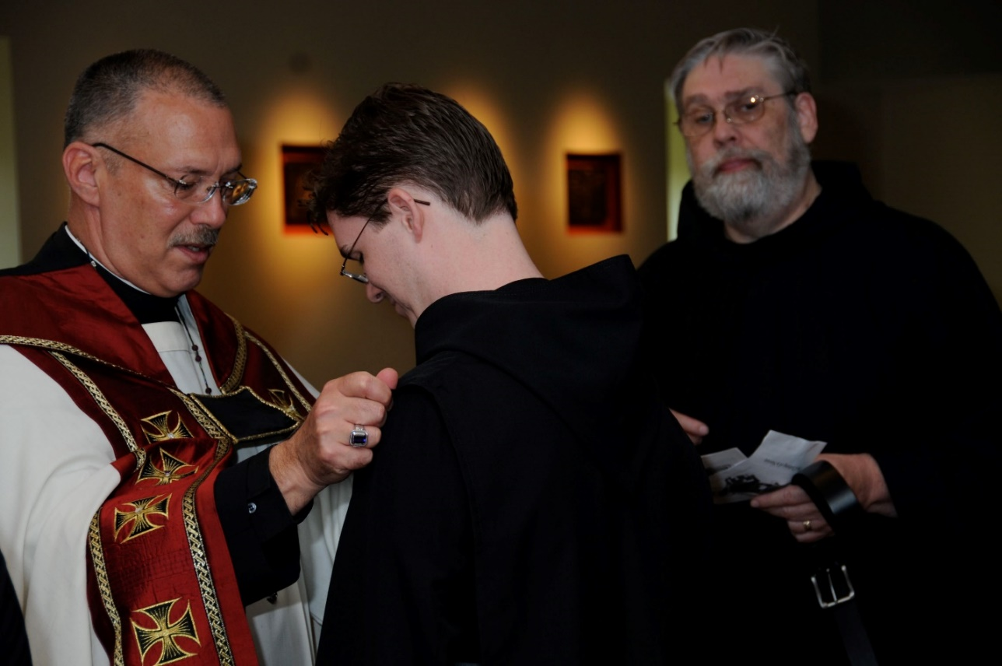
DSC 0252 Abbot Michael John Austin; Br. Aidan Maguire; Br. Chad Anselm Gerns

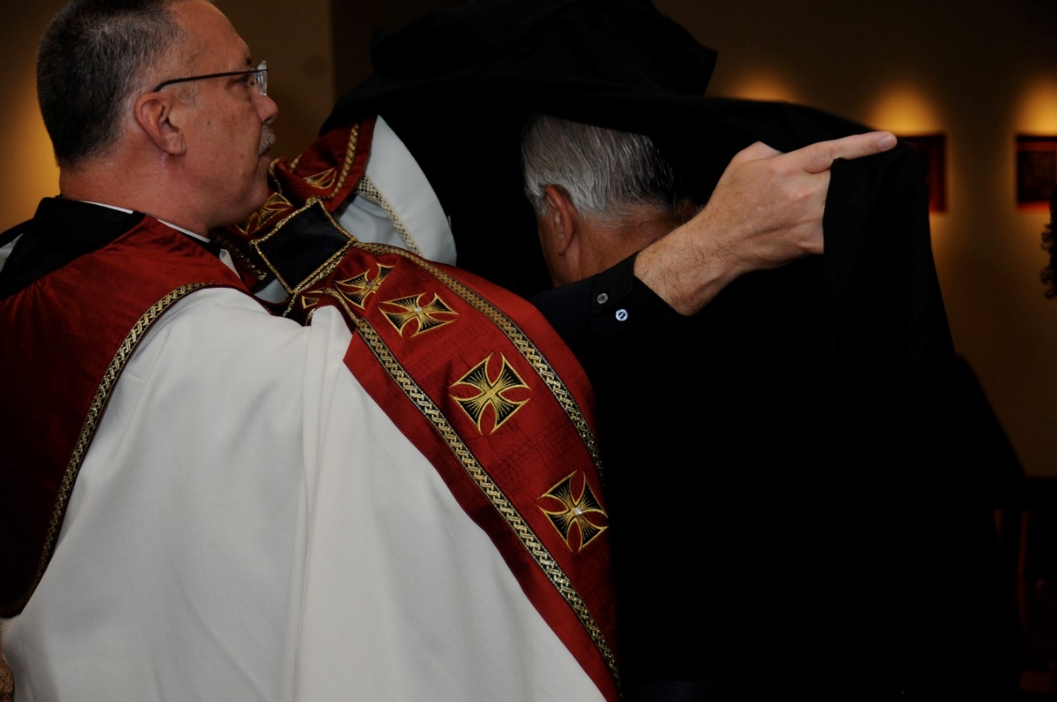
DSC 0253 Abbot Michael John Austin; Br. Timothy Titus Lunt
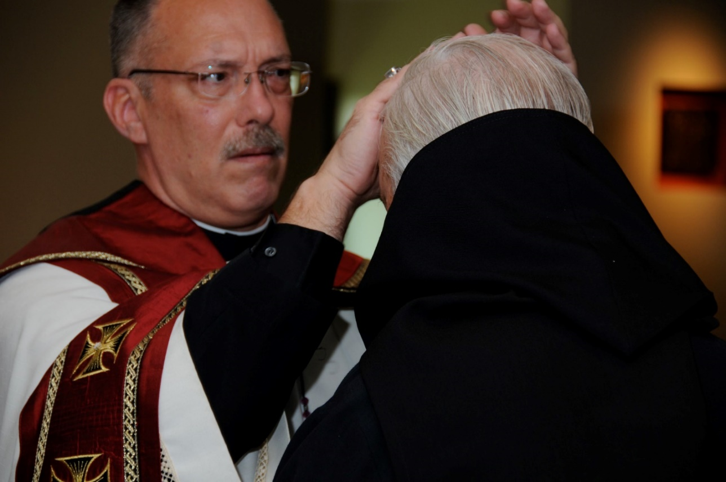
DSC 0254 Abbot Michael John Austin; Br. Timothy Titus Lunt

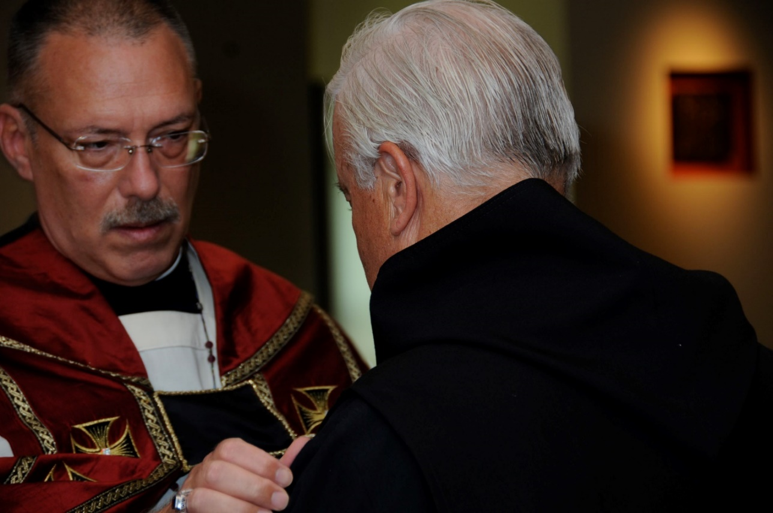
DSC 0255 Abbot Michael John Austin; Br. Timothy Titus Lunt
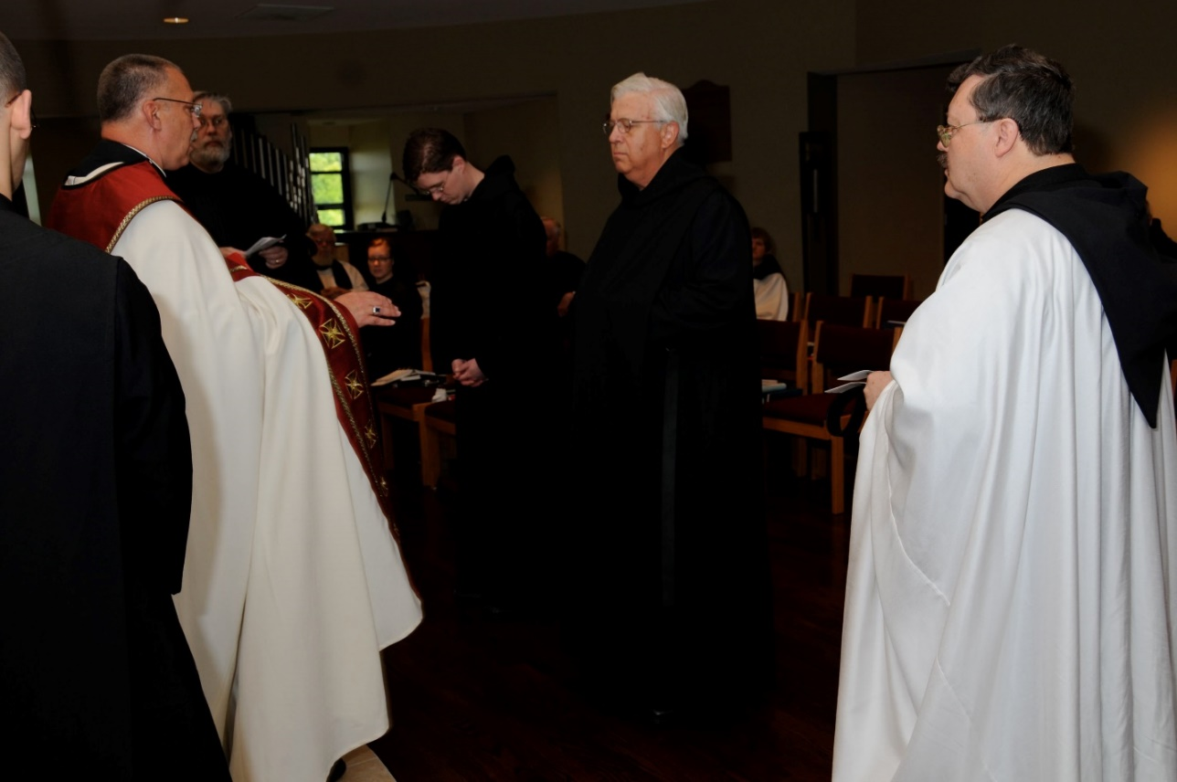
DSC 0256 Br. Aelred Shemayev; Abbot Michael John Austin; Br. Chad Anselm Gerns; Fr. Wayne Kamm; Sr. Hannah Sophia Korver; Br. Aidan Maguire; Br. Luke Doucette; Br. Timothy Titus Lunt; Sr. Catherine Unterseher; Br. Paul Howard

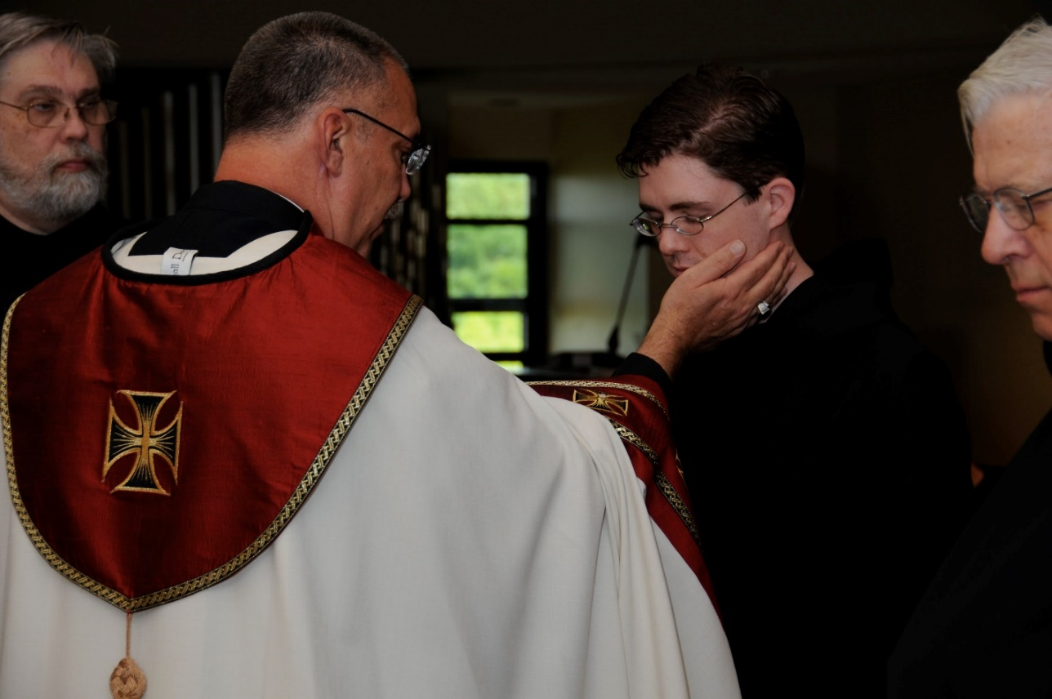
DSC 0258 Br. Chad Anselm Gerns; Abbot Michael John Austin; Br. Aidan Maguire; Br. Timothy Titus Lunt

