Companions of St. Luke
2007 Fall Convocation at Conception Abbey
Part 2 of 2

~Edited by Br. Steven Olderr, 20 June 2022 with the assistance of Br. Thomas Ferrell. If you find any errors or omissions or have anything to add, please notify Br. Steven at olderr@ameritech.net

People are identified from left to right.

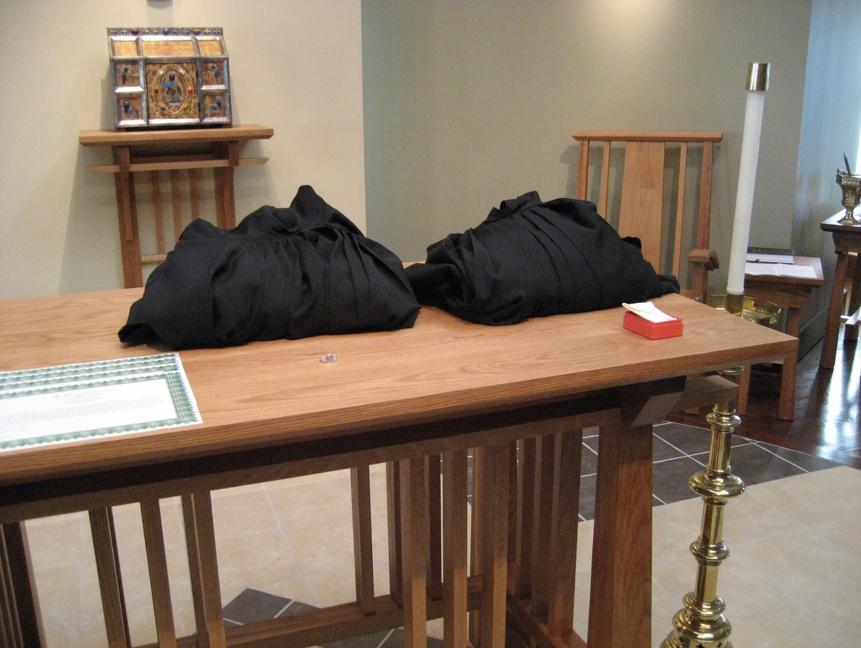
0300406244567619904256102706871.jpg

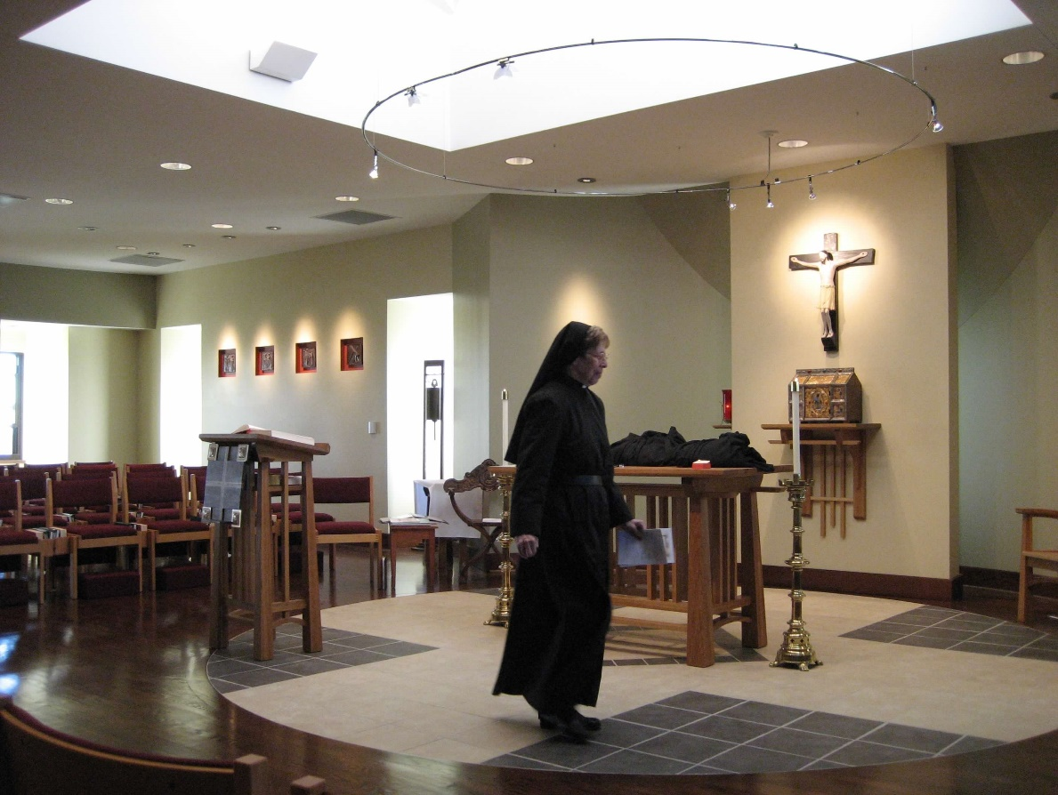
0300406244567619904256102707234.jpg Sr. Monica Ruth Mullen

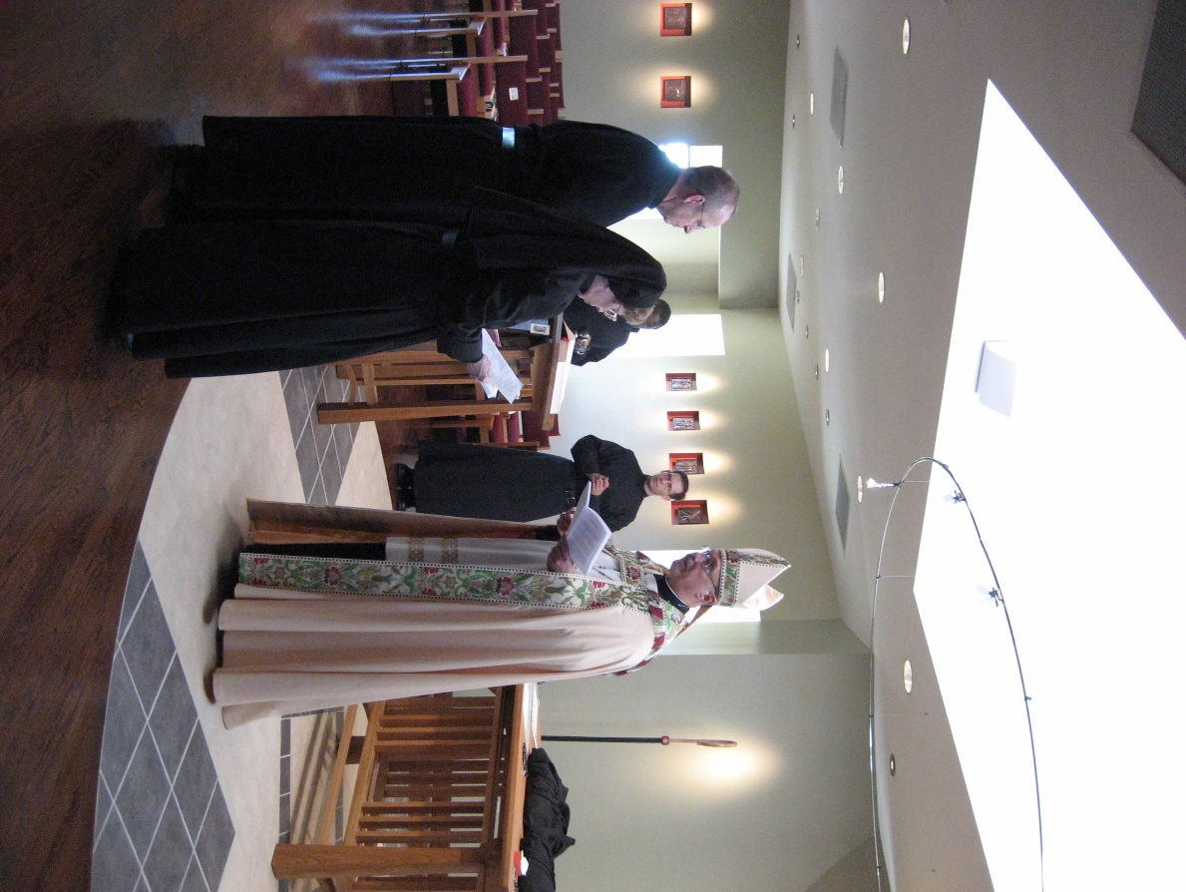
0300406244567619904256102707316.jpg Br. Gabriel Hale; Sr. Monica Ruth Mullen; Br. Thomas Ferrell; Br. Aelred Shemanov; Abbot Michael John Austin

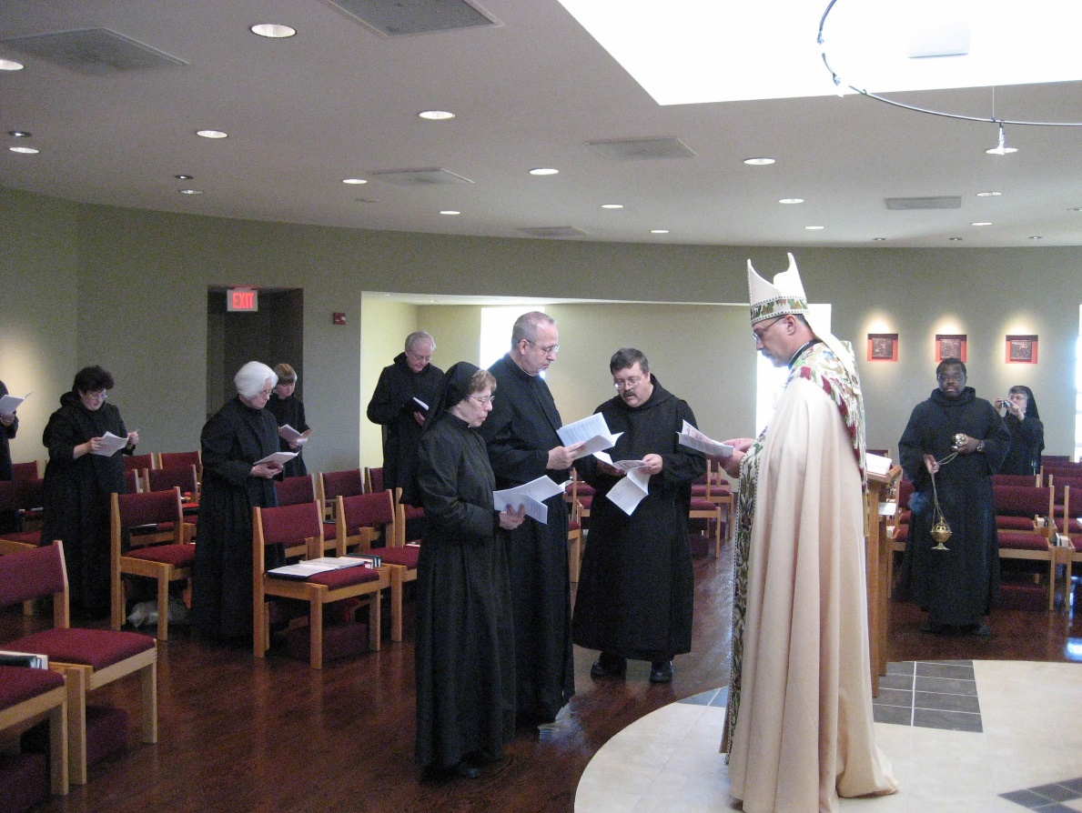
0300406244567619904256102707408.jpg Sr. Cecelia Lamoy; Sr. Elizabeth Anne Stribley; Sr. Catherine Unterseher; Br. Luke Doucette; Sr. Monica Ruth Mullen; Br. Gabriel Hale; Br. Paul Howard; Abbot Michael John Austin; Br. Thomas Ferrell; Sr. Anna Grace Mullen

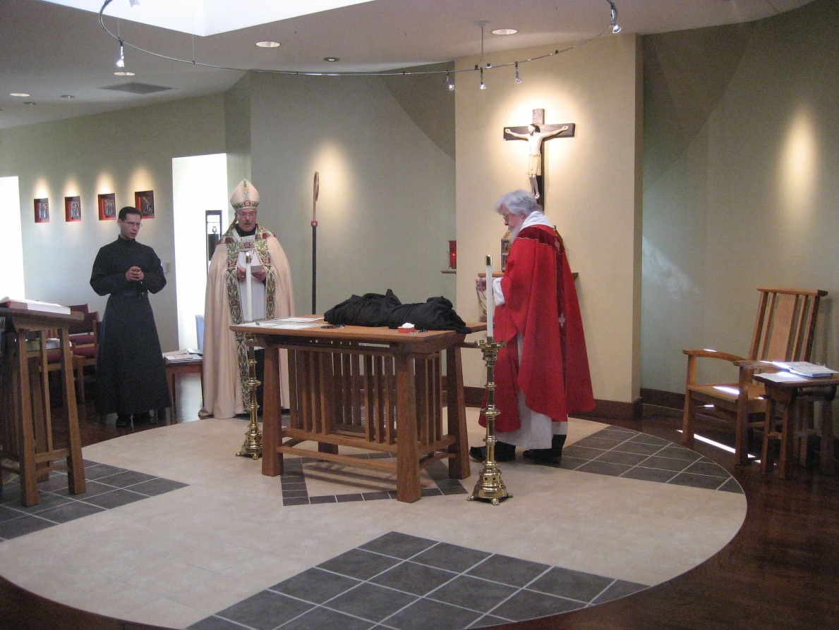
0300406244567619904256102708450.jpg Br. Aelred Shemanov; Abbot Michael John Austin; Fr. Wayne Kamm

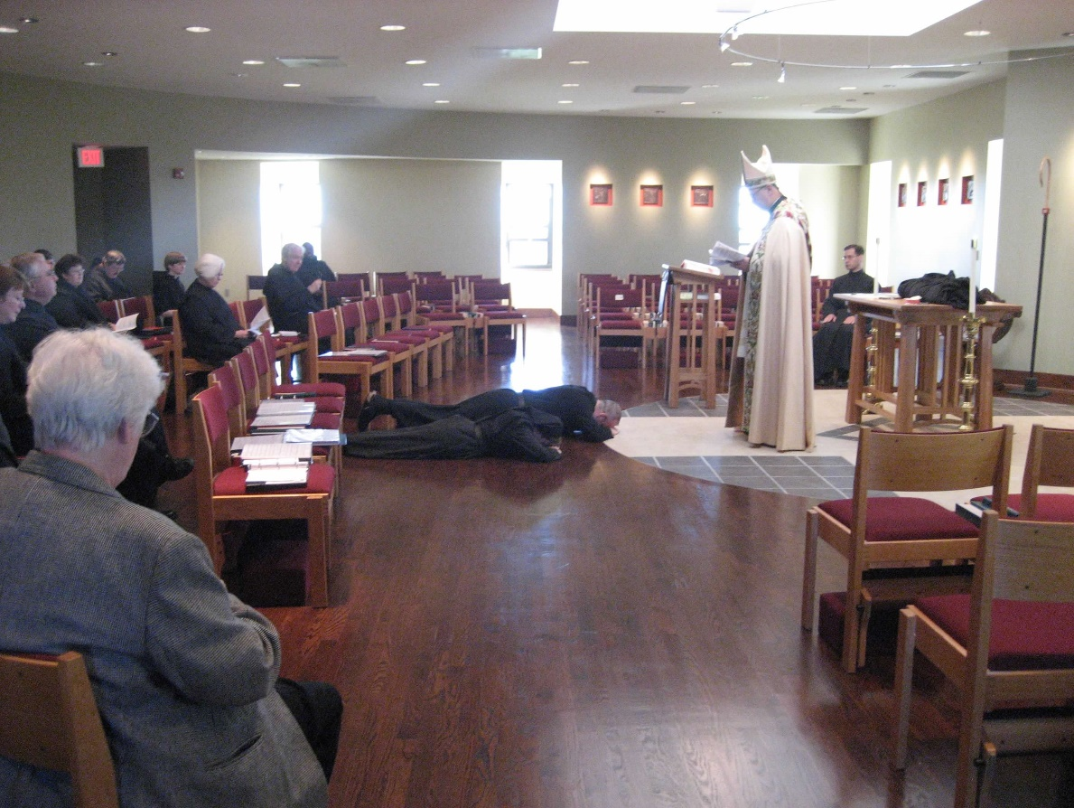
0300406244567619904256102708569.jpg Michelle Moore; Br. Bede Leach; Jackie Hale; Sr. Cecelia Lamoy; Br. Paul Howard; Sr. Catherine Unterseher; Br. Luke Doucette; Br. Thomas Ferrell; Sr. Monica Ruth Mullen; Br. Gabriel Hale; Abbot Michael John Austin; Br. Aelred Shemanov

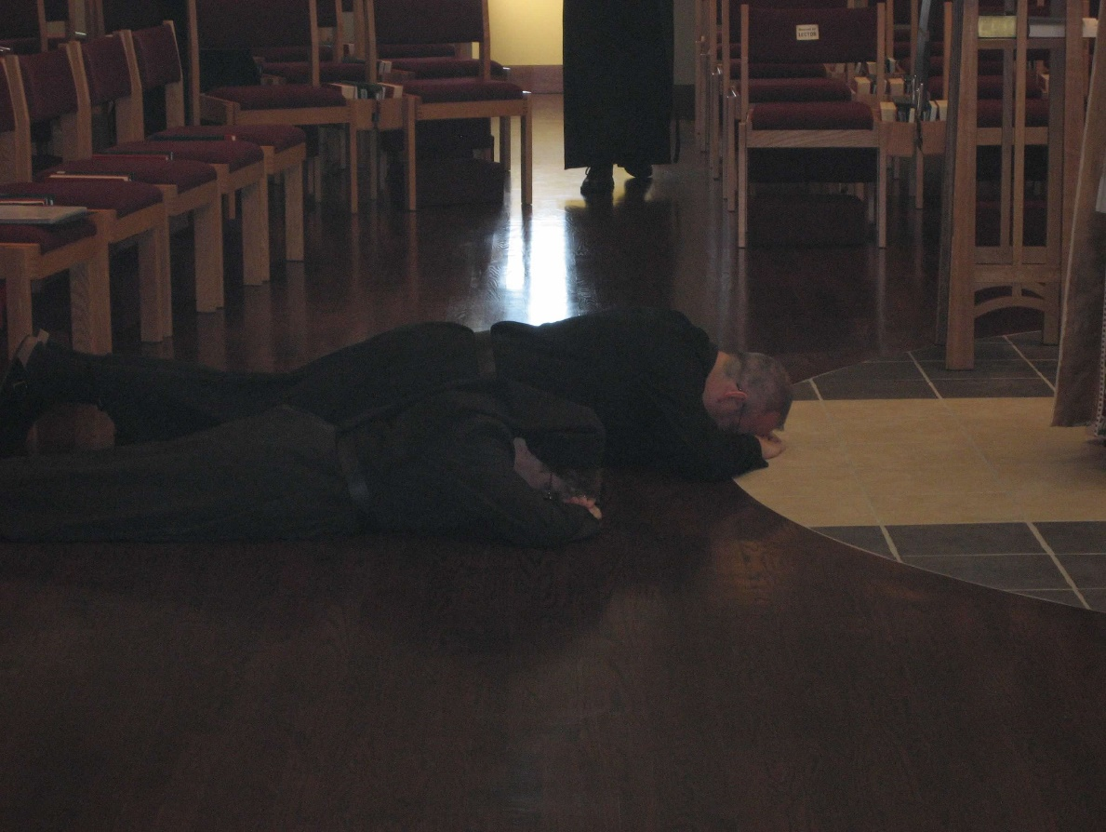
0300406244567619904256102708647.jpg Sr. Monica Ruth Mullen; Br. Gabriel Hale

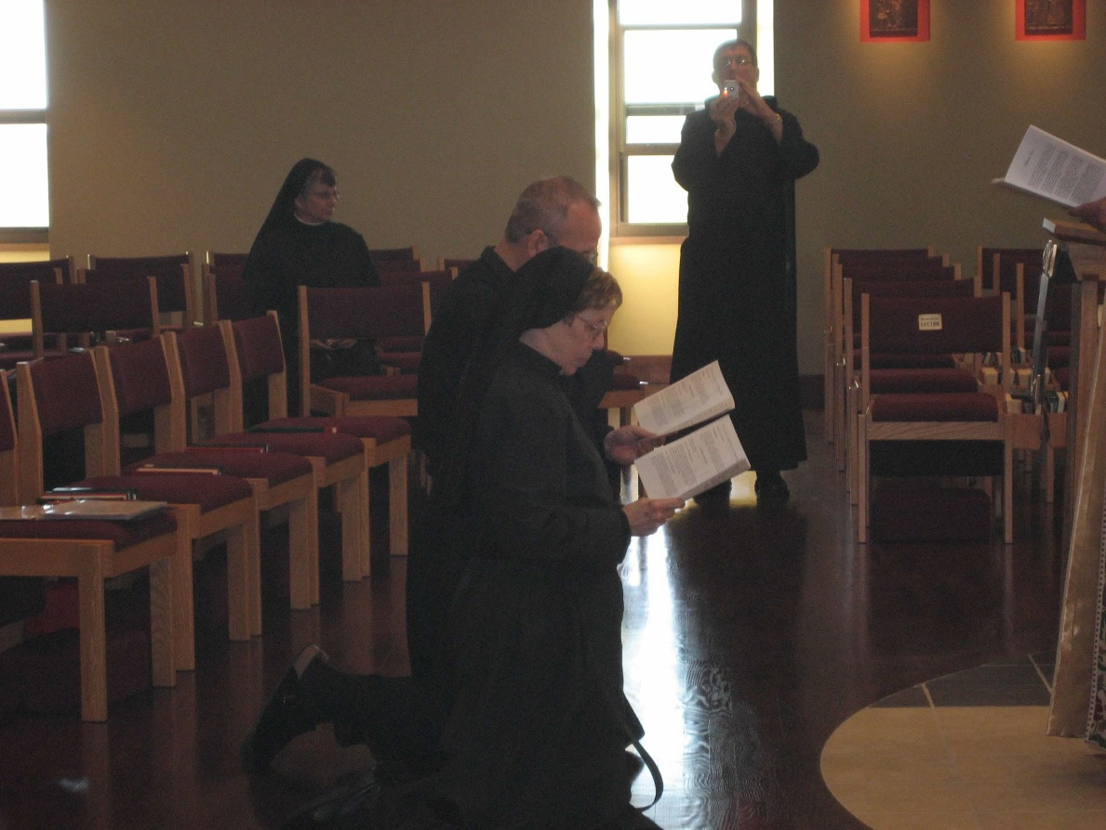
0300406244567619904256102708730.jpg Sr. Anna Grace Madden; Br. Gabriel Hale; Sr. Monica Ruth Mullen; Br. Camillus Converse

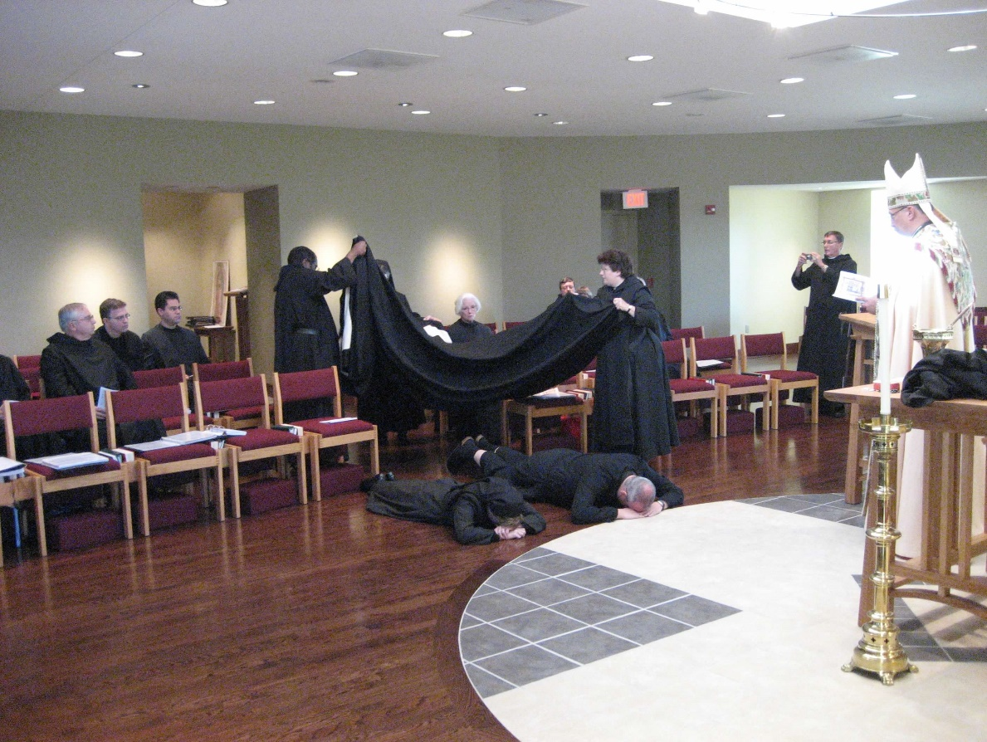
0300406244567619904256102708815.jpg Br. Bede Leach; Greg Kennedy; Br. Daniel Medina; Br. Thomas Ferrell; Sr. Elizabeth Anne Stribley; Br. Paul Howard; Br. Gabriel Hale; Sr. Cecelia Lamoy; Br. Camillus Converse; Abbot Michael John Austin

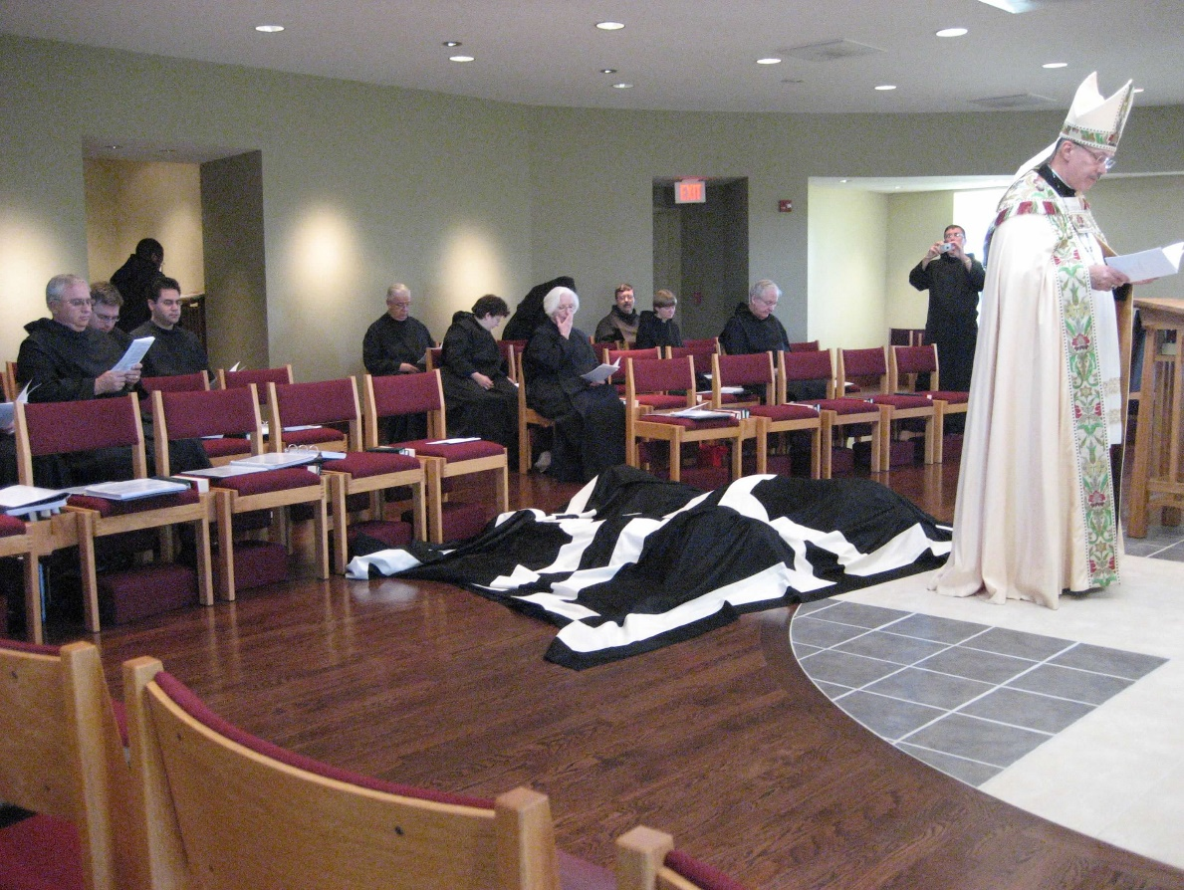
0300406244567619904256102708897.jpg Br. Bede Leach; Greg Kennedy; Br. Thomas Ferrell; Br. Daniel Medina; Br. Timothy Thomas Lunt; Sr. Cecelia Lamoy; Sr. Elizabeth Anne Stribley; Br. Paul Howard; Sr. Catherine Unterseher; Br. Luke Doucette; Br. Camillus Converse; Abbot Michael John Austin

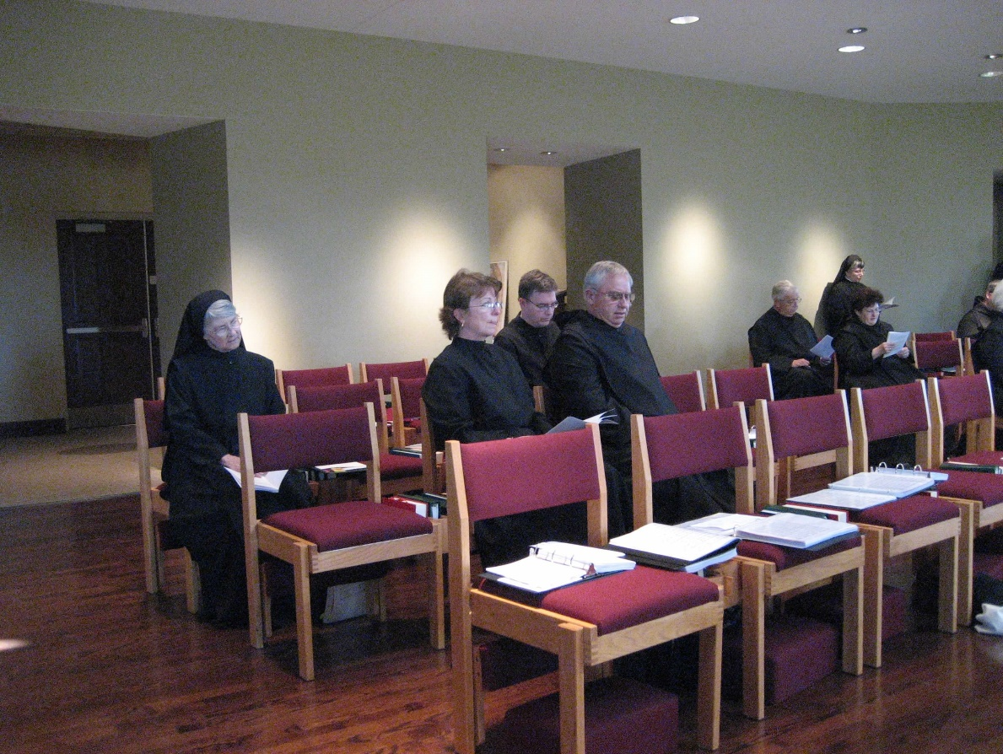
0300406244567619904256102709002.jpg Sr. Mary Francis Deulen; Michelle Moore; Greg Kennedy; Br. Bede Leach; Br. Timothy Titus Lunt; Sr. Anna Grace Madden; Sr. Cecelia Lamoy

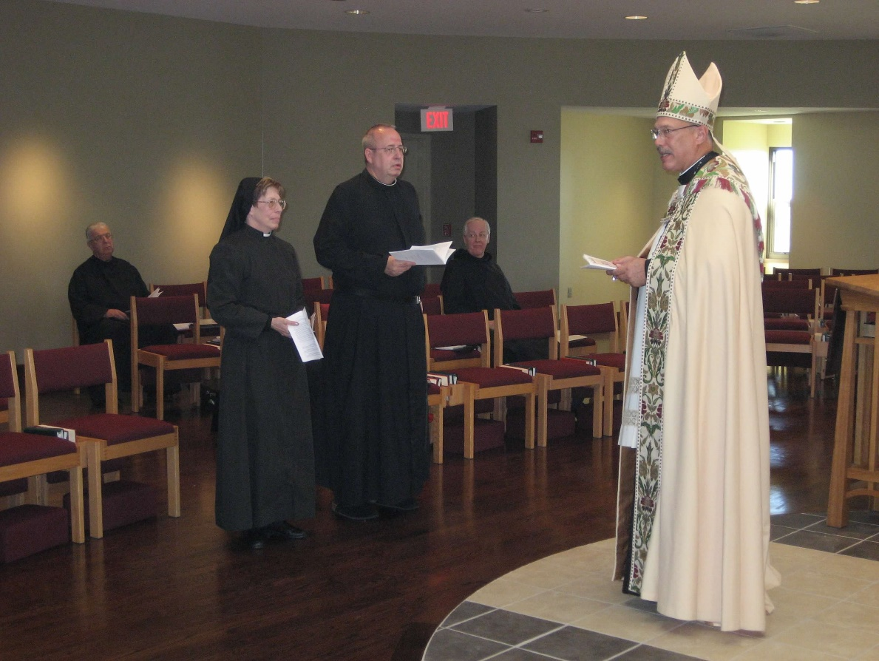
0300406244567619904256102709382.jpg Br. Timothy Titus Lunt; Sr. Monica Ruth Mullen; Br. Gabriel Hale; Br. Luke Doucette; Abbot Michael John Austin

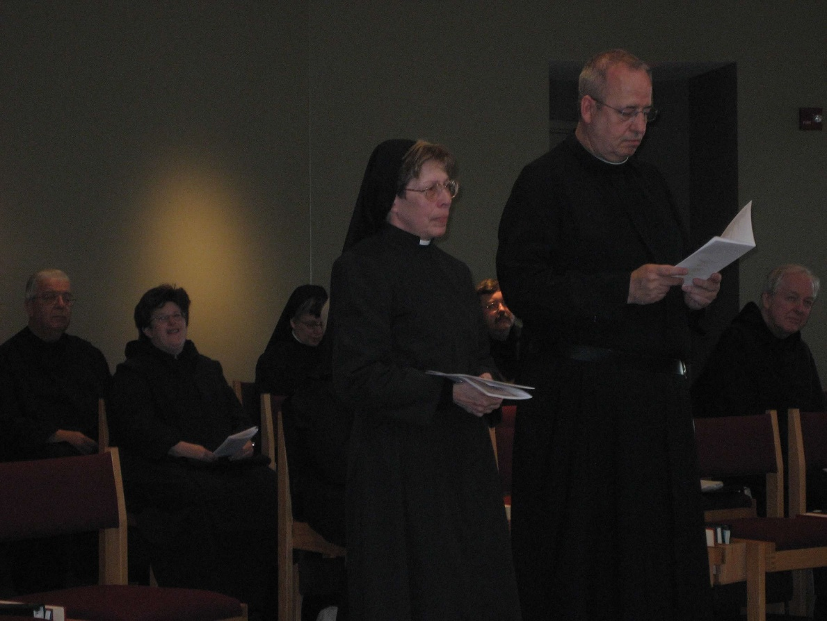
0300406244567619904256102709499.jpg Br. Timothy Titus Lunt; Sr. Cecelia Lamoy; Sr. Anna Grace Madden; Sr. Monica Ruth Mullen; Br. Paul Howard; Br. Gabriel Hale; Br. Luke Doucette

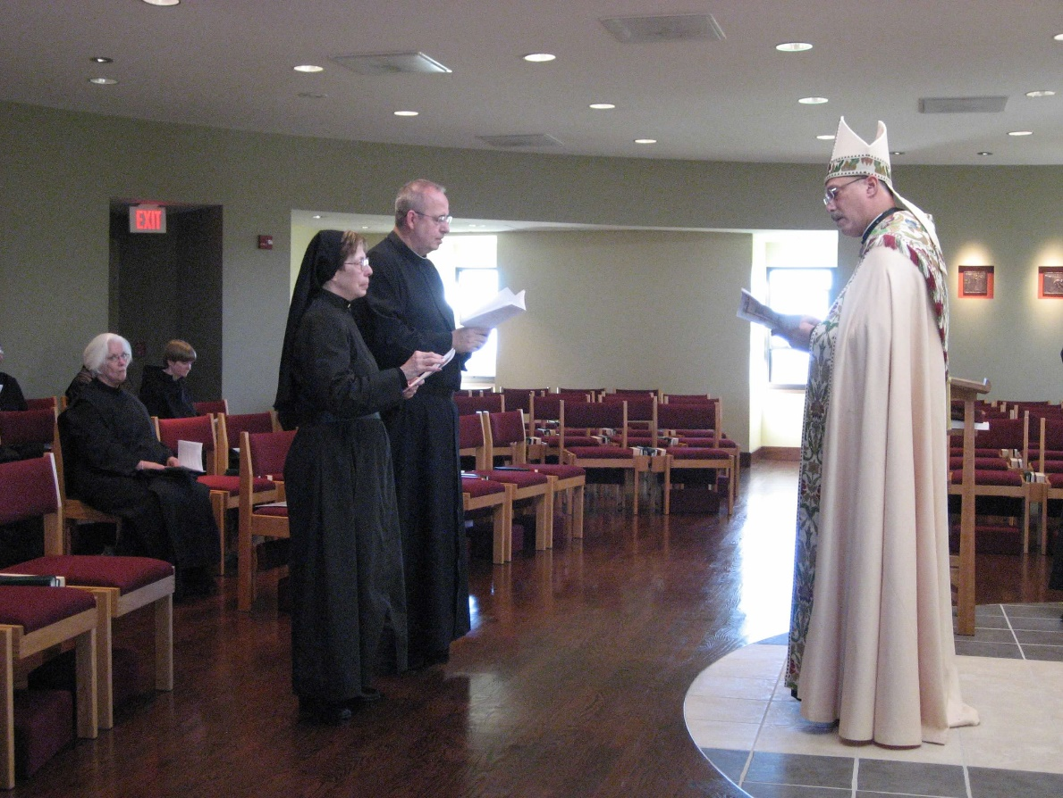
0300406244567619904256102709575.jpg Sr. Elizabeth Anne
Stribley; Sr. Catherine Unterseher; Sr. Monica Ruth Mullen; Br. Gabriel Hale; Abbot Michael John Austin

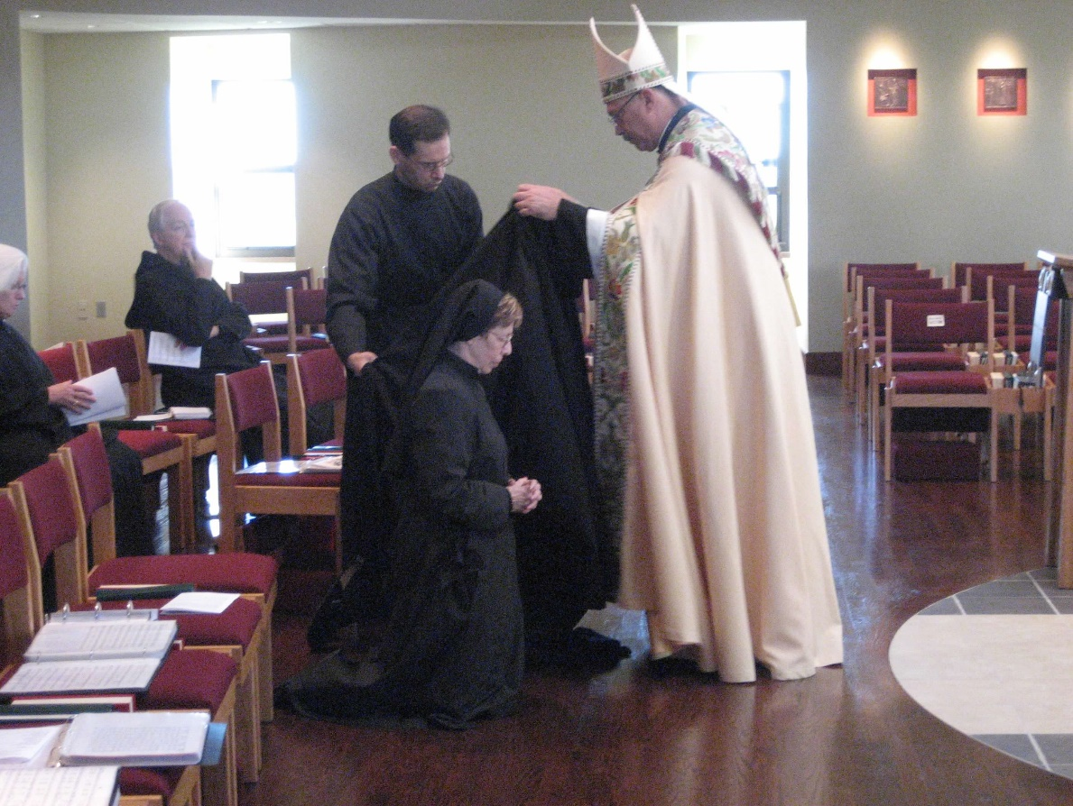
0300406244567619904256102709946.jpg Sr. Elizabeth Anne Stribley; Br. Luke Doucette; Br. Aelred Shemanov; Sr. Monica Ruth Mullen; Br. Gabriel Hale; Abbot Michael John Austin

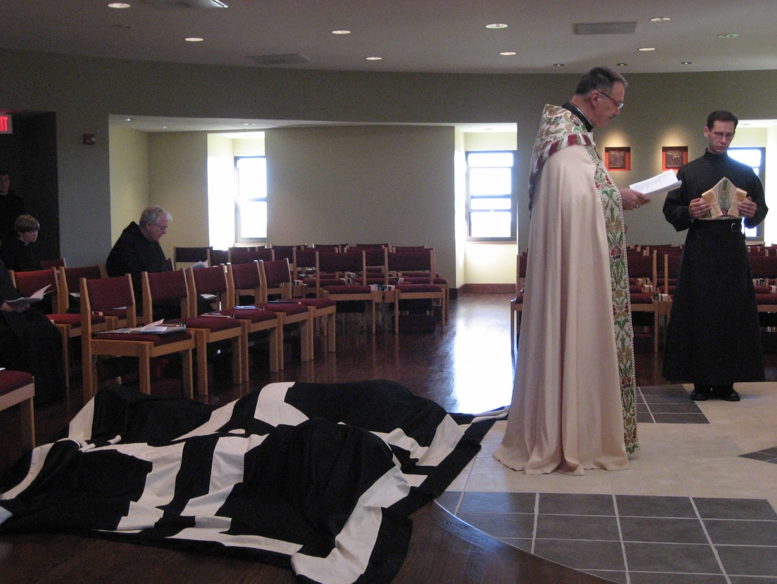
0300406244567619904256102709098.jpg Sr. Catherine Unterseher; Br. Luke Doucette; Abbot Michael John Austin; Br. Aelred Shemanov

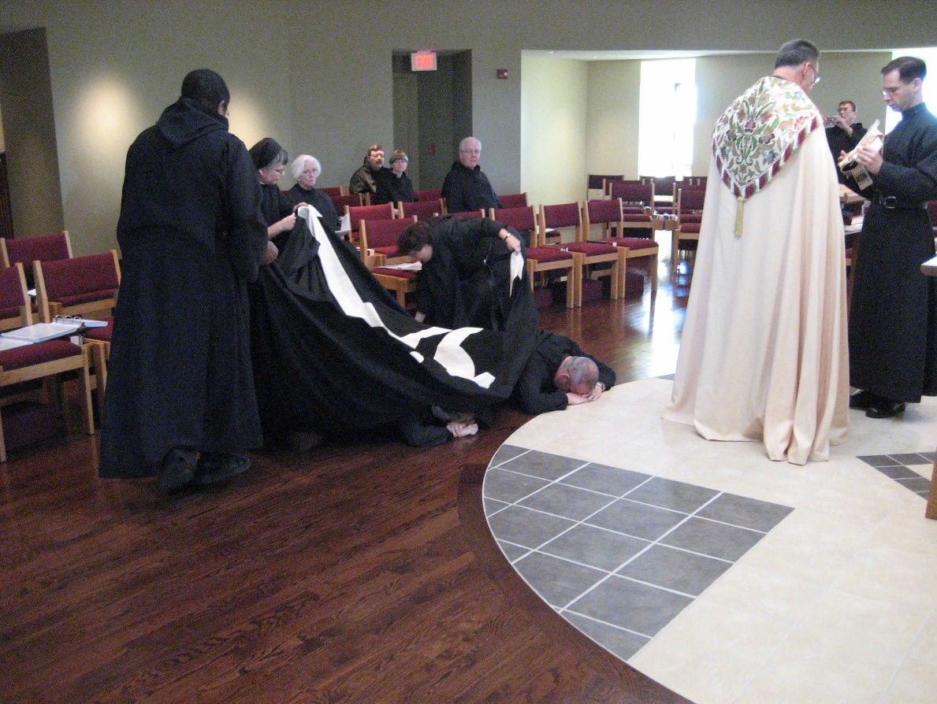
0300406244567619904256102709183.jpg Br. Thomas Ferrell; Sr. Anna Grace Madden; Sr. Elizabeth Anne Stribley; Br. Paul Howard; Sr. Catherine Unterseher; Sr. Cecilia Lamoy; Sr. Monica Ruth Mullen; Br. Luke Doucette; Br. Gabriel Hale; Abbot Michael John Austin; Br. Camillus Converse; Br. Aelred Shemanov

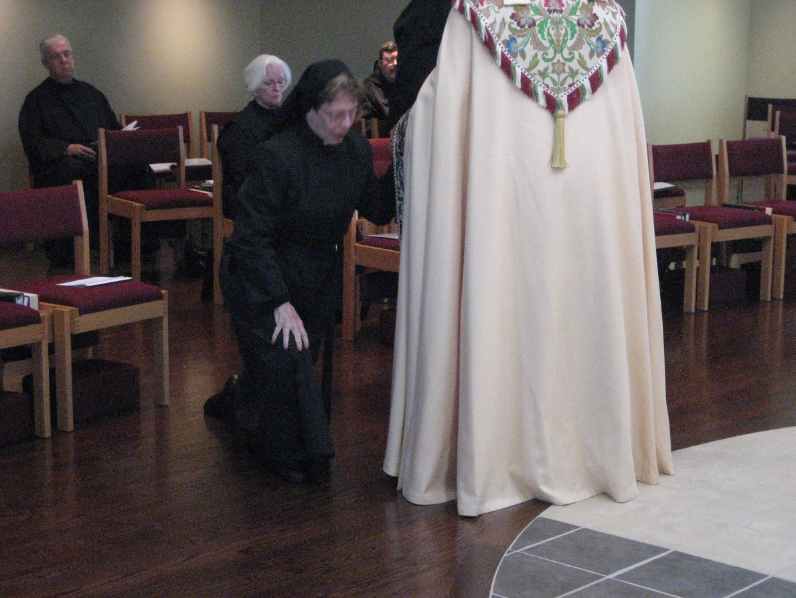
0300406244567619904256102709287.jpg Br. Timothy Titus Lunt; Sr. Elizabeth Anne Stribley; Sr. Monica Ruth Mullen; Br. Paul Howard; Abbot Michael John Austin

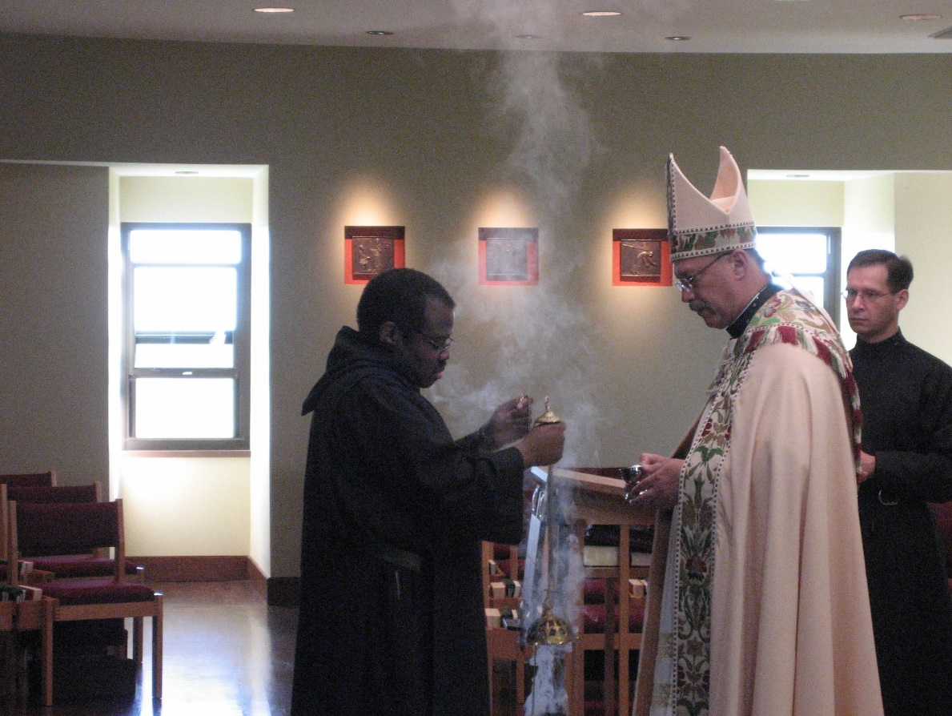
0300406244567619904256102709659.jpg Br. Thomas Ferrell; Abbot Michael John Austin; Br. Aelred Shemanov

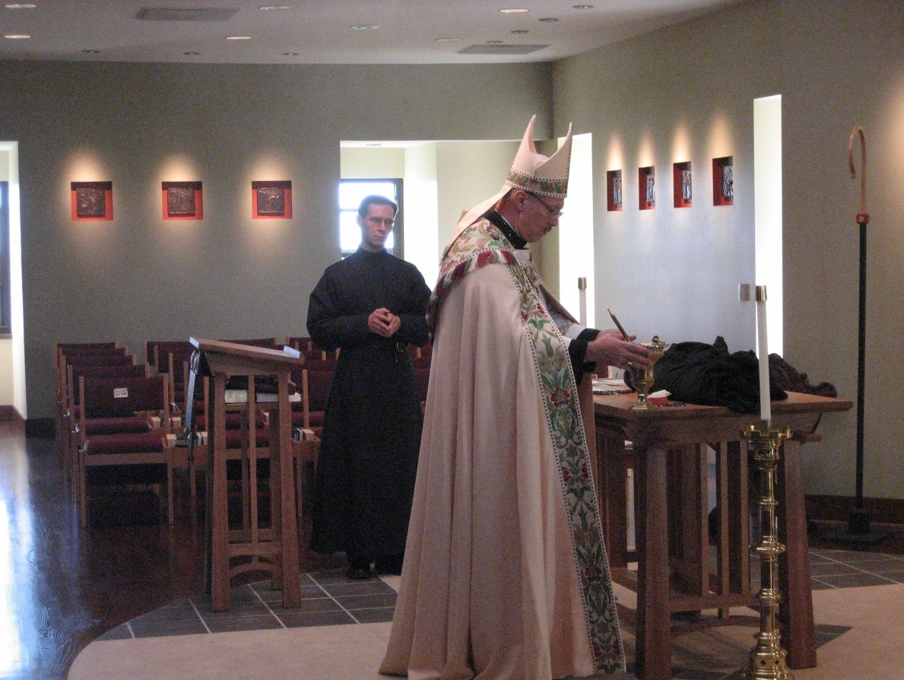
0300406244567619904256102709787.jpg Br. Aelred Shemanov; Abbot Michael John Austin

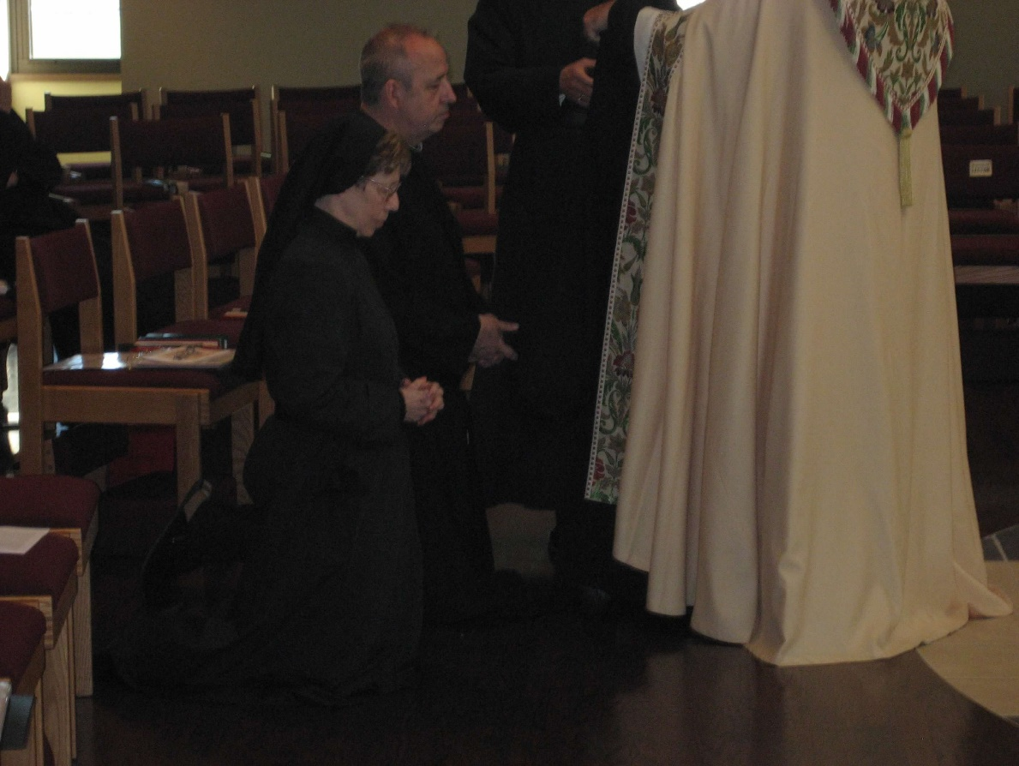
0300406244567619904256102709867.jpg Sr. Monica Ruth Mullen; Br. Gabriel Hale

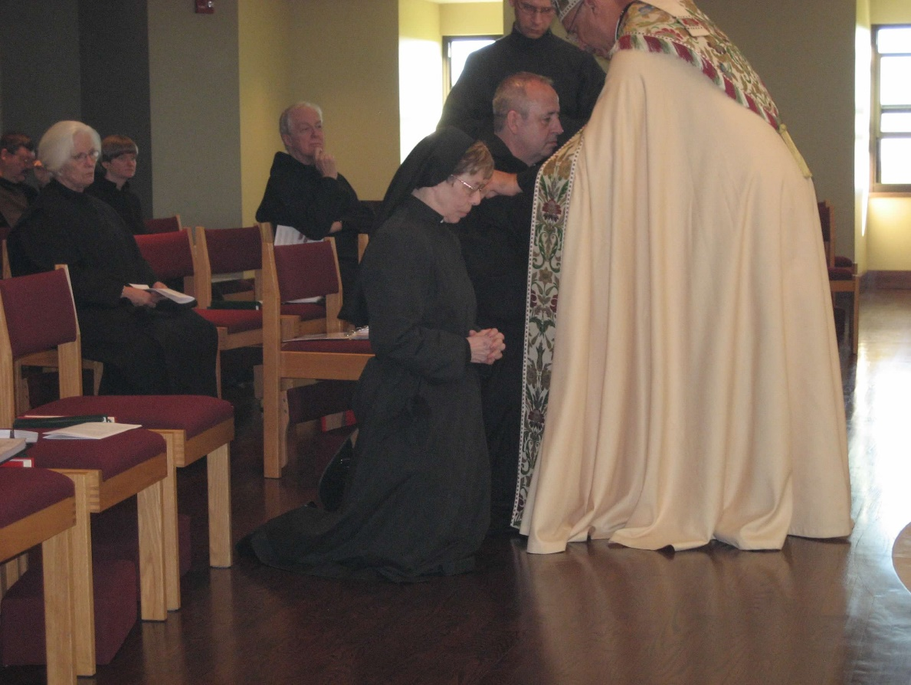
0300406244567619904256102710025.jpg Br. Paul Howard; Sr. Elizabeth Anne Stribley; Sr. Catherine Unterseher; Br. Luke Doucette; Sr. Monica Ruth Mullen; Br. Gabriel Hale; Br. Aelred Shemanov; Abbot Michael John Austin

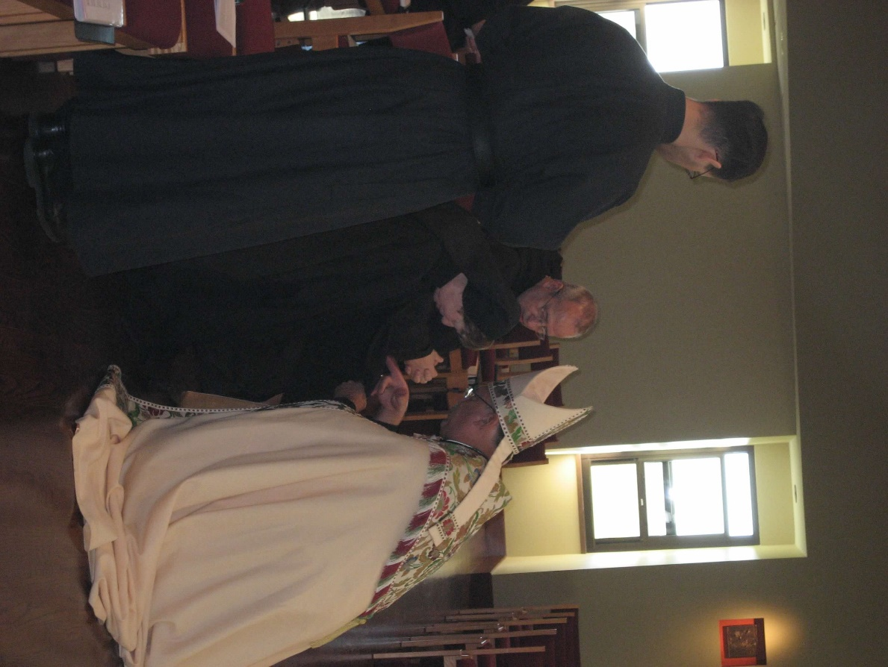
0300406244567619904256102710121.jpg Br. Aelred Shemanov; Sr. Monica Ruth Mullen; Br. Gabriel Hale; Abbot Michael John Austin

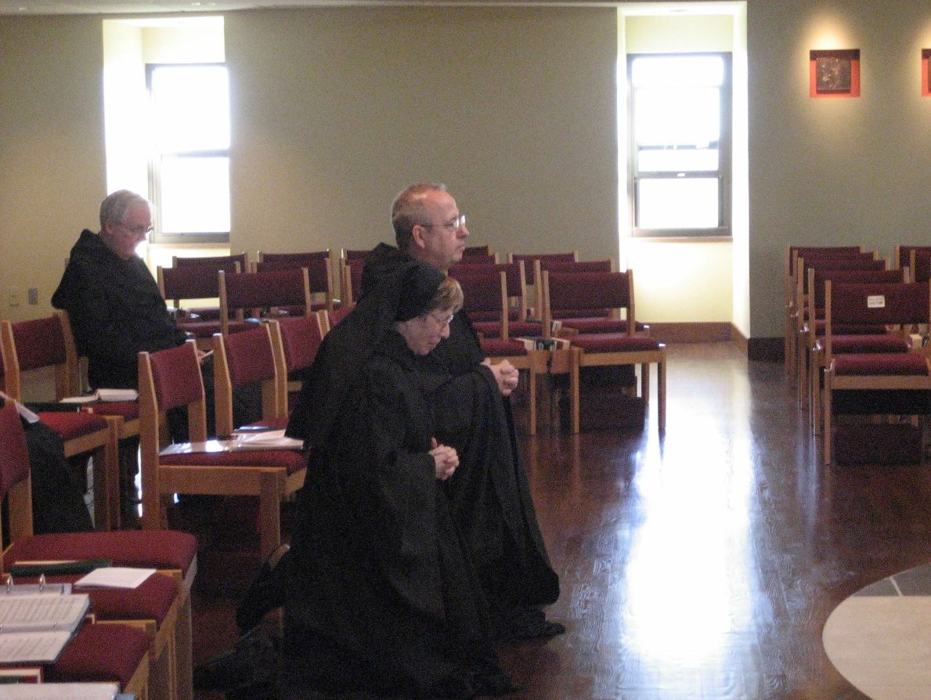
0300406244567619904256102710205.jpg Sr. Monica Ruth Mullen; Br. Gabriel Hale; Br. Luke Doucette

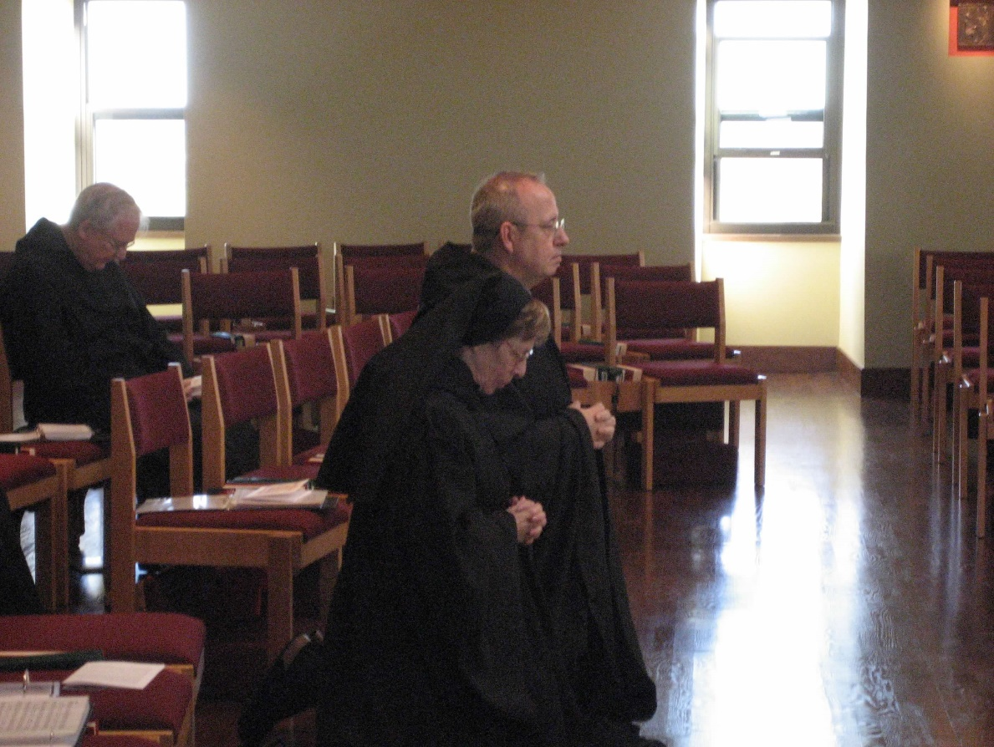
0300406244567619904256102710306.jpg Br. Luke Doucette; Sr. Monica Ruth Mullen; Br. Gabriel Hale

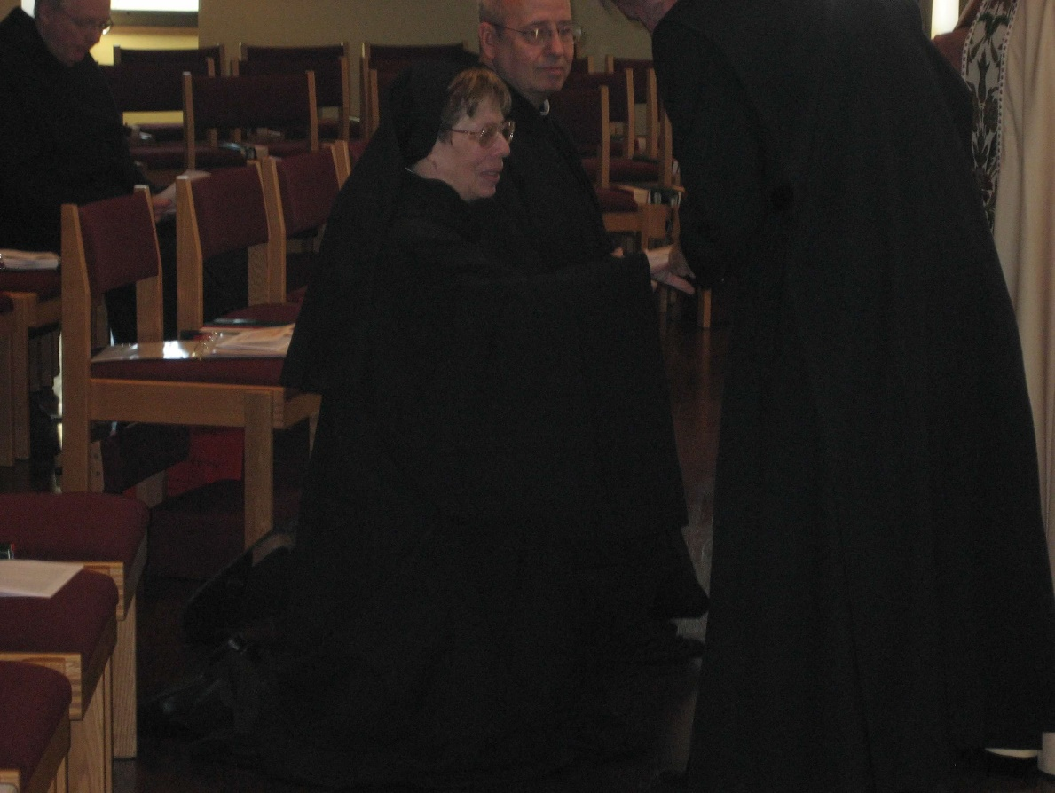
0300406244567619904256102710389.jpg Br. Luke Doucette; Sr. Monica Ruth Mullen; Br. Gabriel Hale

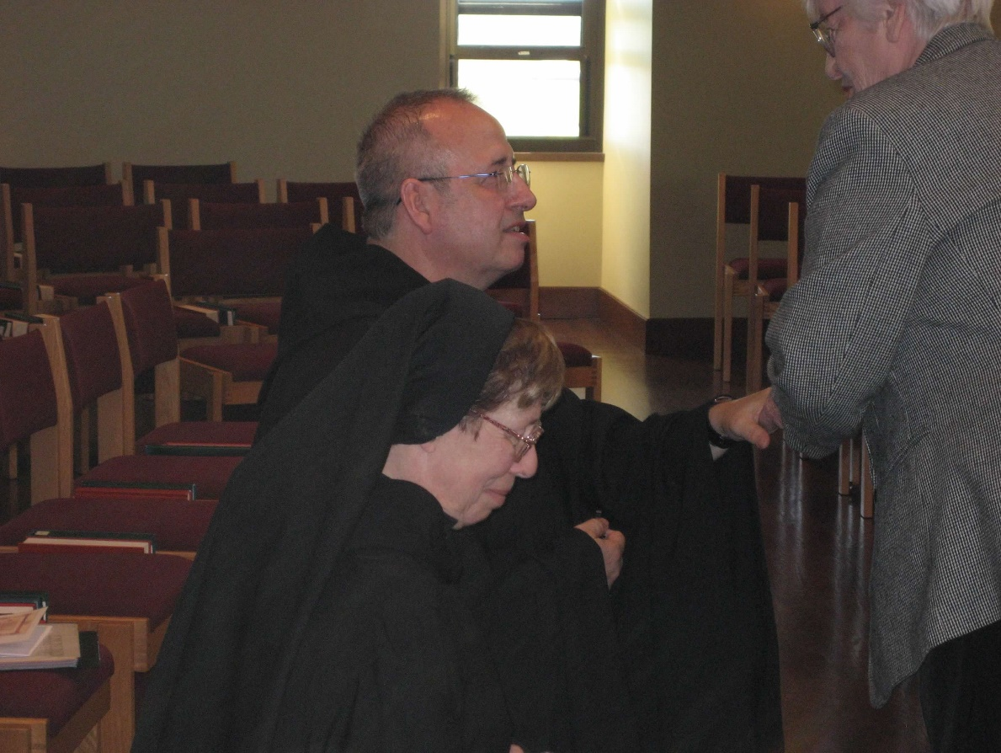
0300406244567619904256102710469.jpg Br. Gabriel Hale; Sr. Monica Ruth Mullen; Jackie Hale

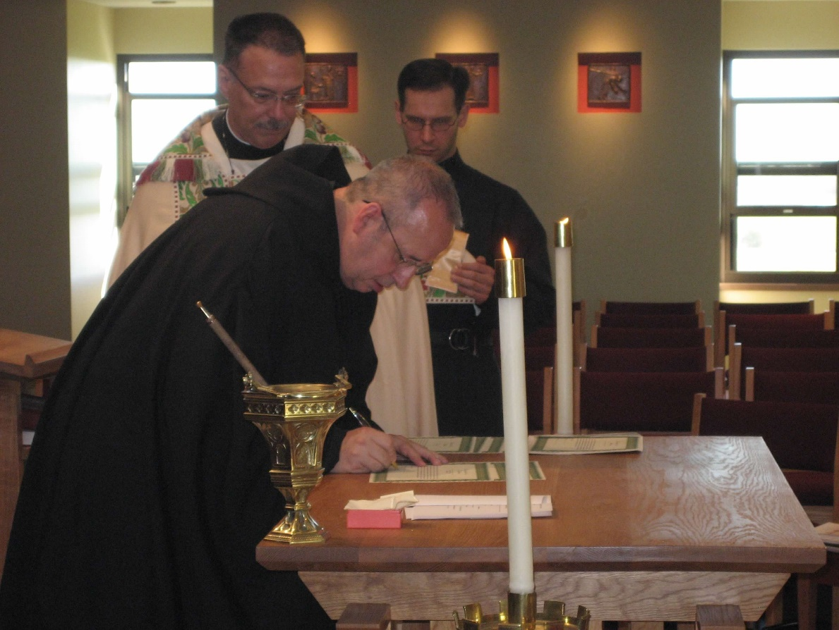
0300406244567619904256102710552.jpg Abbot Michael John Austin; Br. Gabriel Hale; Br. Aelred Shemanov

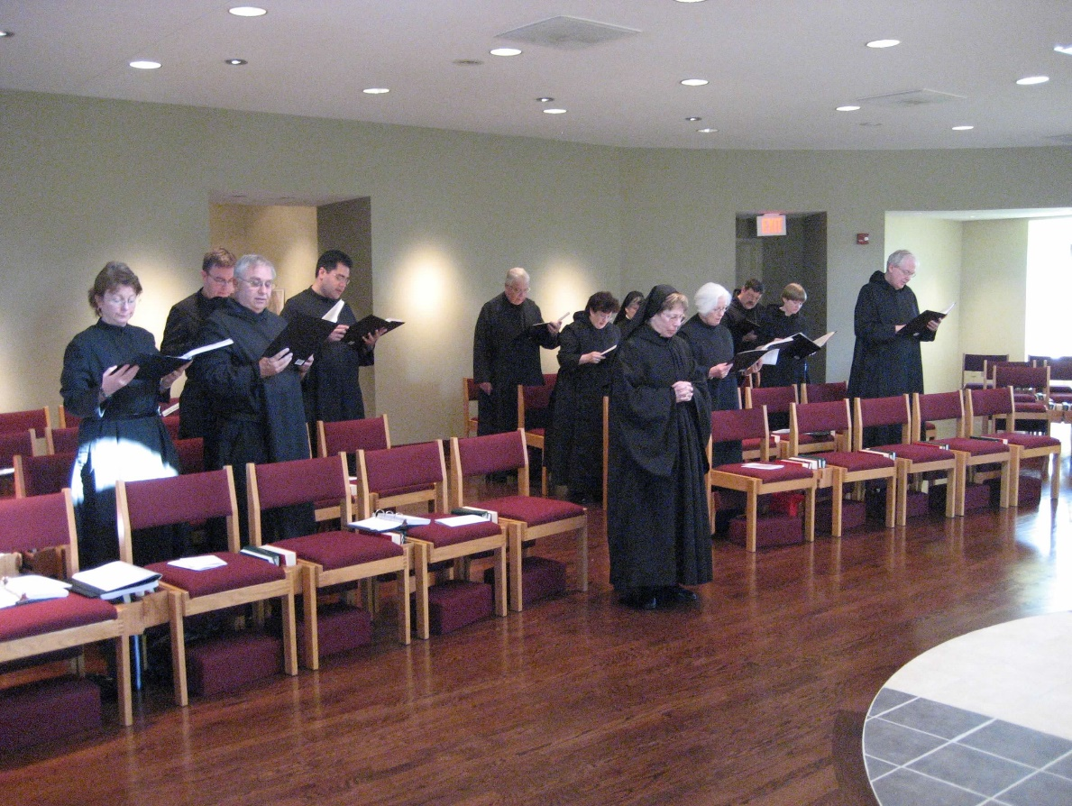
0300406244567619904256102710641.jpg Michelle Moore; Greg Kennedy; Br. Bede Leach; Br. Daniel Medina; Br. Timothy Titus Lunt; Br. Cecelia Lamoy; Sr. Anna Grace Madden; Sr. Monica Ruth Mullen; Sr. Elizabeth Anne Stribley; Br. Paul Howard; Sr. Catherine Unterseher; Br. Luke Doucette

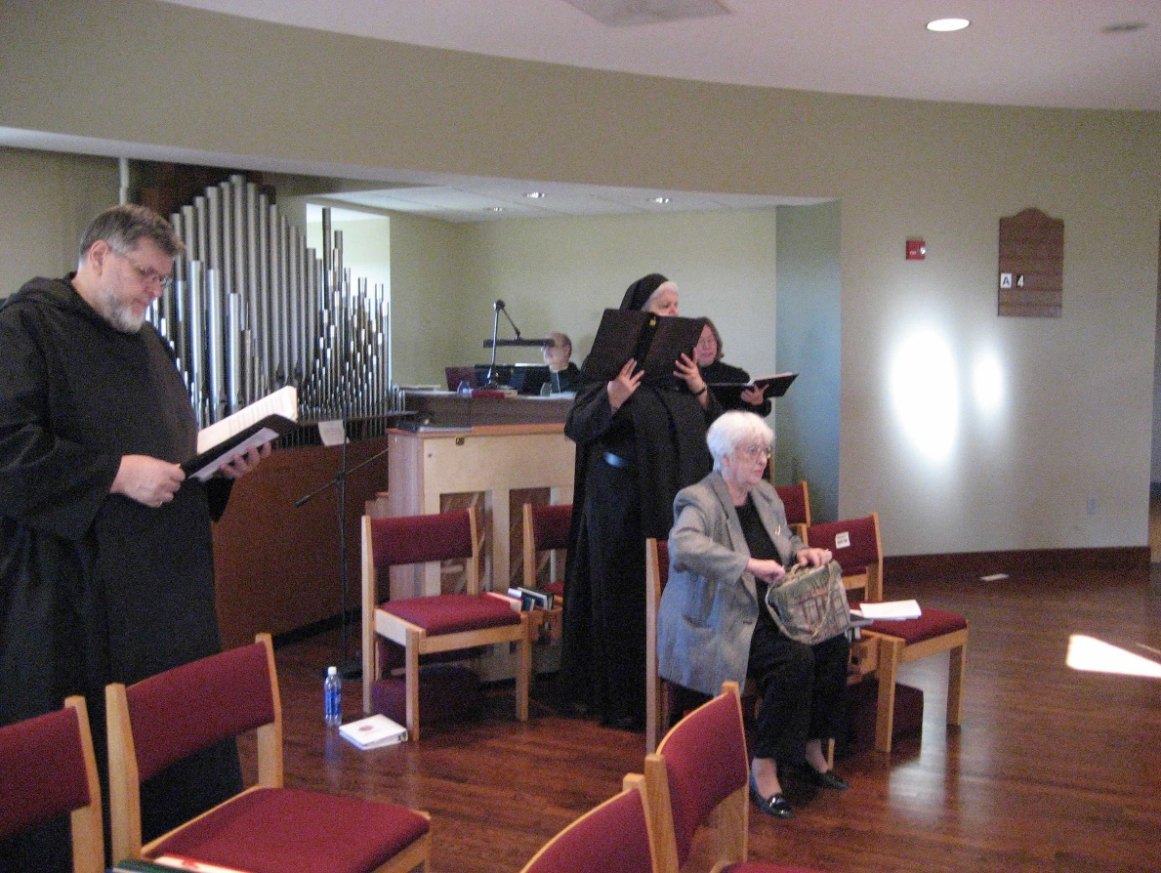
0300406244567619904256102710740.jpg Br. Nathan Gregory Miller; Br. Raymond Owens; Sr. Mary Catherine Christopher; Sr. Teresa Beebe; Jackie Hale

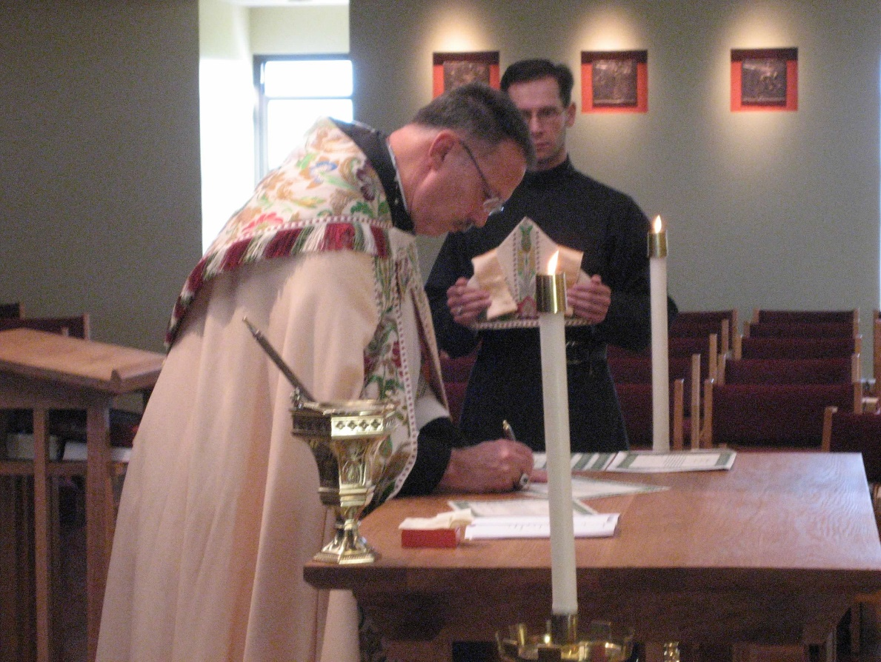
0300406244567619904256102710834.jpg Abbot Michael John Austin; Br. Aelred Shemanov

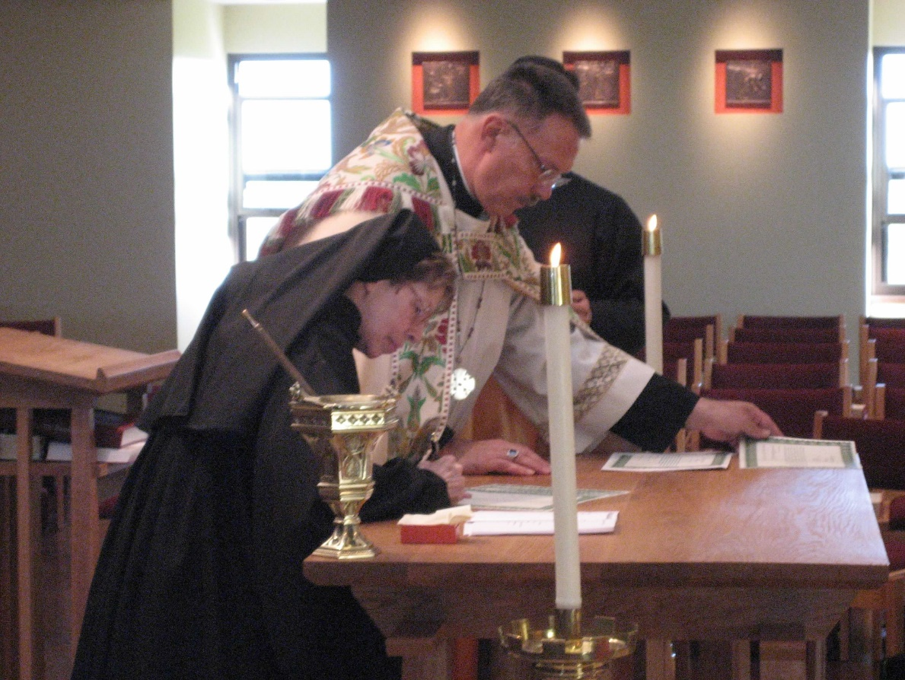
0300406244567619904256102710916.jpg Sr. Monica Ruth Mullen; Abbot Michael John Austin; Br. Aelred Shemanov

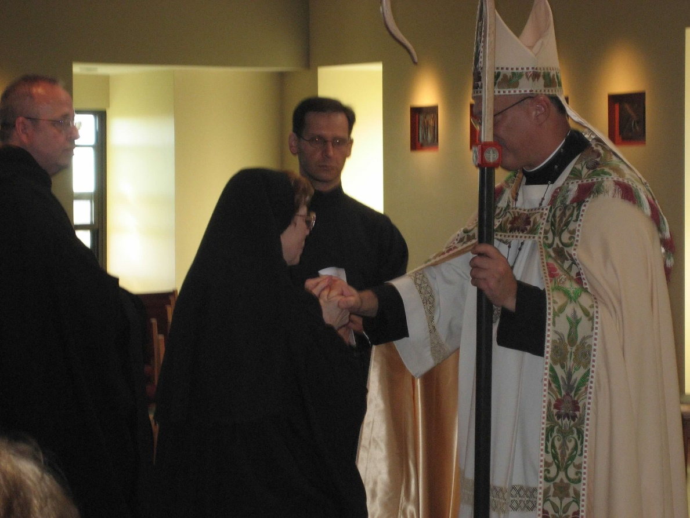
0300406244567619904256102710991.jpg Br. Gabriel Hale; Sr. Monica Ruth Mullen; Br. Aelred Shemanov; Abbot Michael John Austin

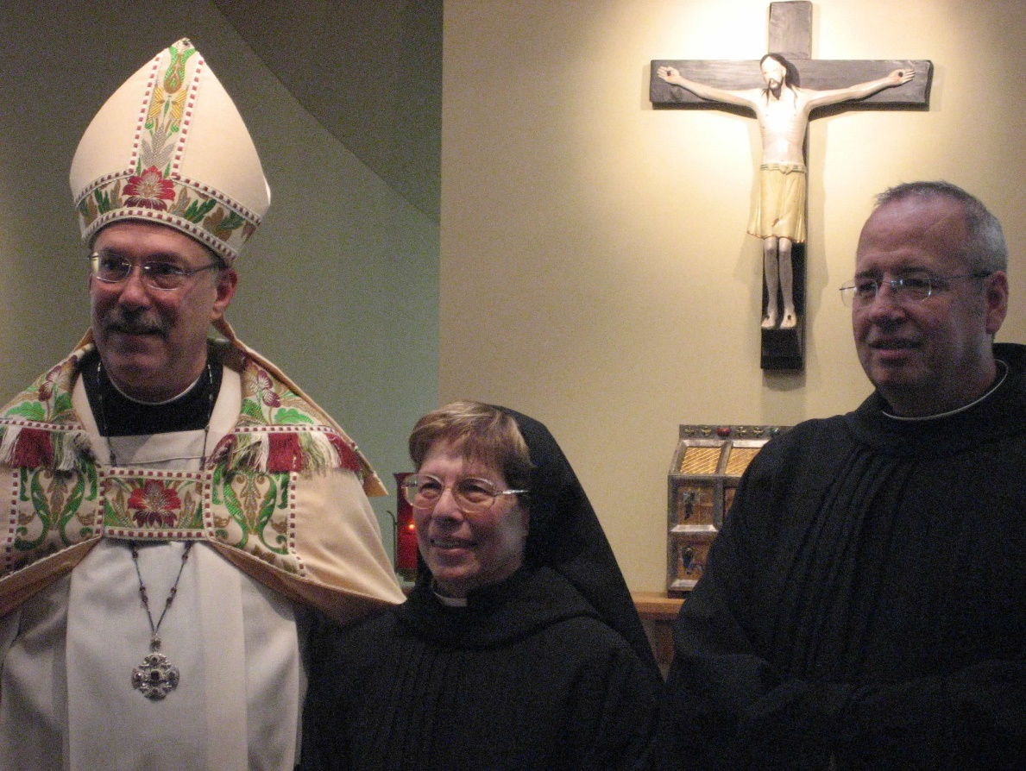
0300406244567619904256102711073.jpg Abbot Michael John Austin; Sr. Monica Ruth Mullen; Br. Gabriel Hale

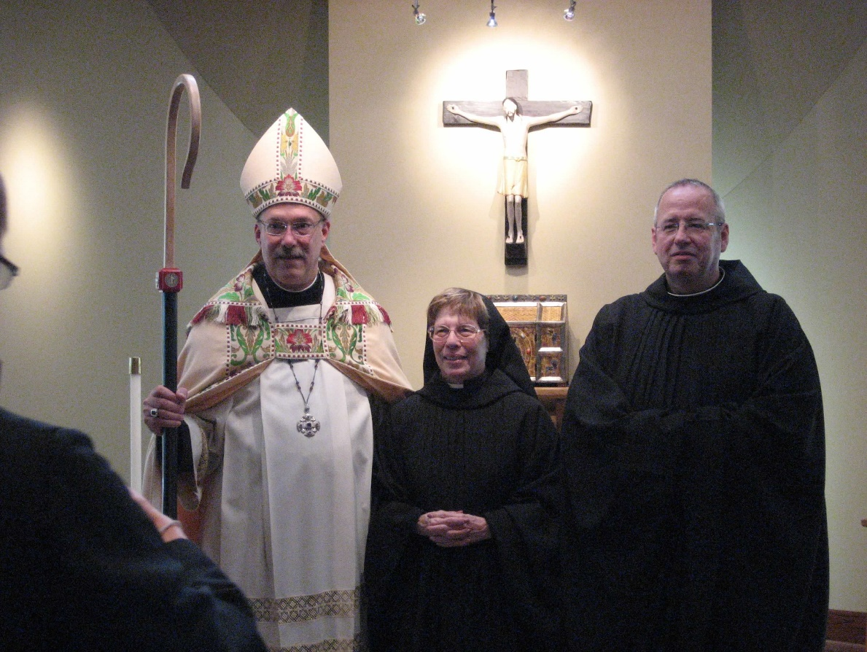
0300406244567619904256102711175.jpg Abbot Michael John Austin; Sr. Monica Ruth Mullen; Br. Gabriel Hale

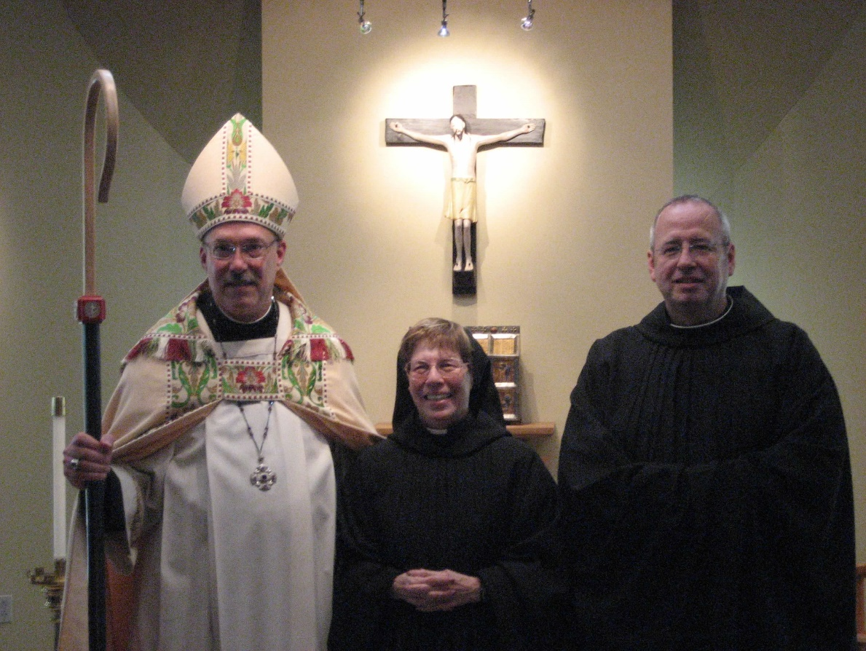
0300406244567619904256102711335.jpg Abbot Michael John Austin; Abbot Michael John Austin; Sr. Monica Ruth Mullen; Br. Gabriel Hale

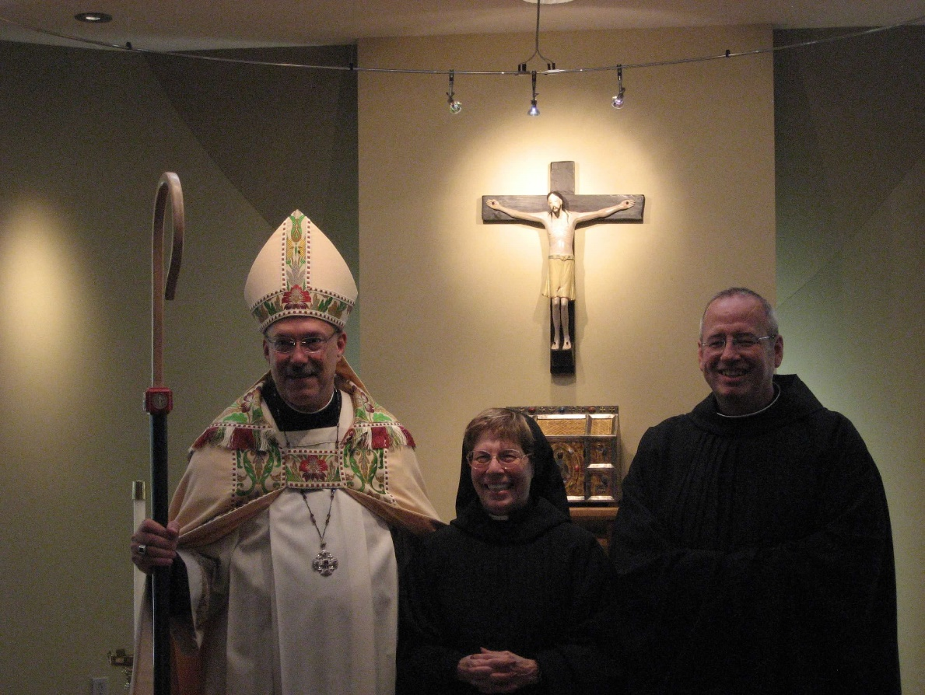
0300406244567619904256102711485.jpg Abbot Michael John Austin; Abbot Michael John Austin; Sr. Monica Ruth Mullen; Br. Gabriel Hale

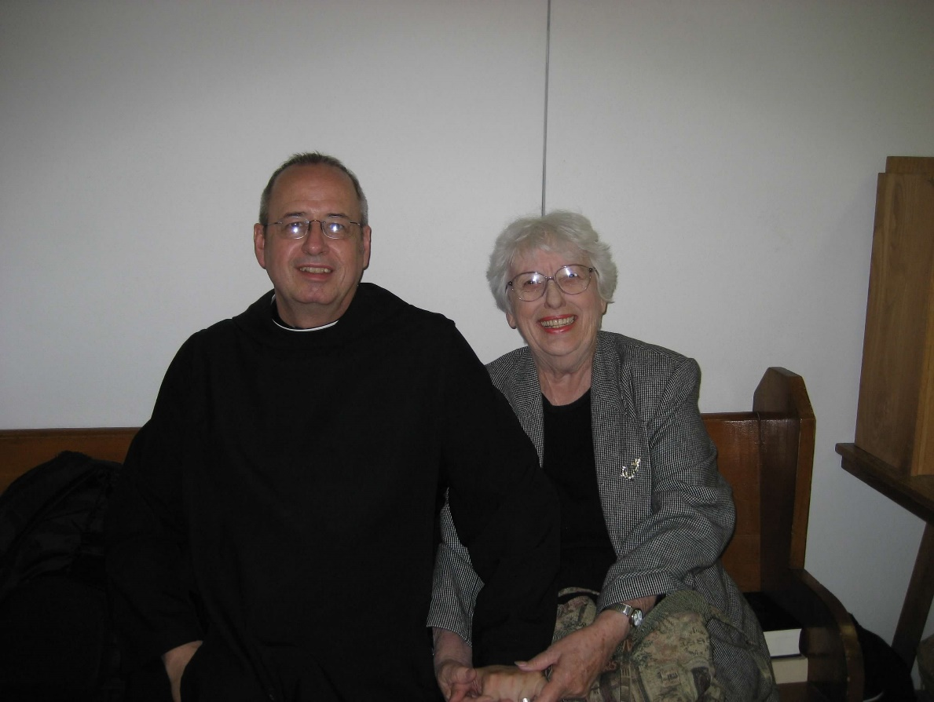
0300406244567619904256102711596.jpg Br. Gabriel Hale; Jackie Hale

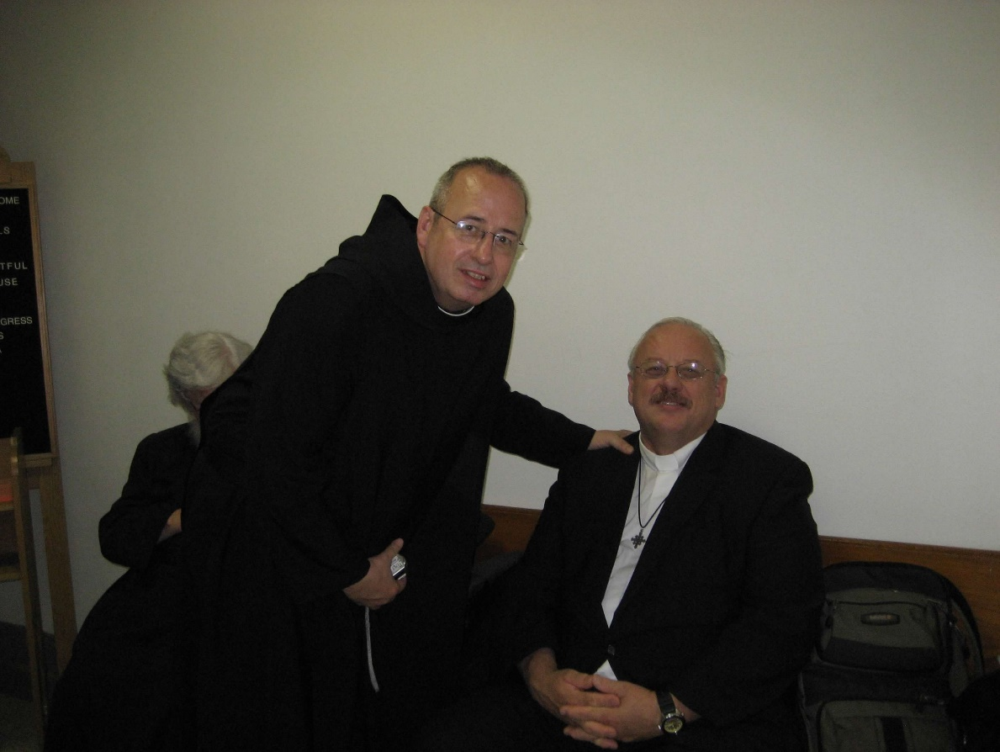
0300406244567619904256102711679.jpg Jackie Hale; Br. Gabriel Hale; Rev. Stephen Hale

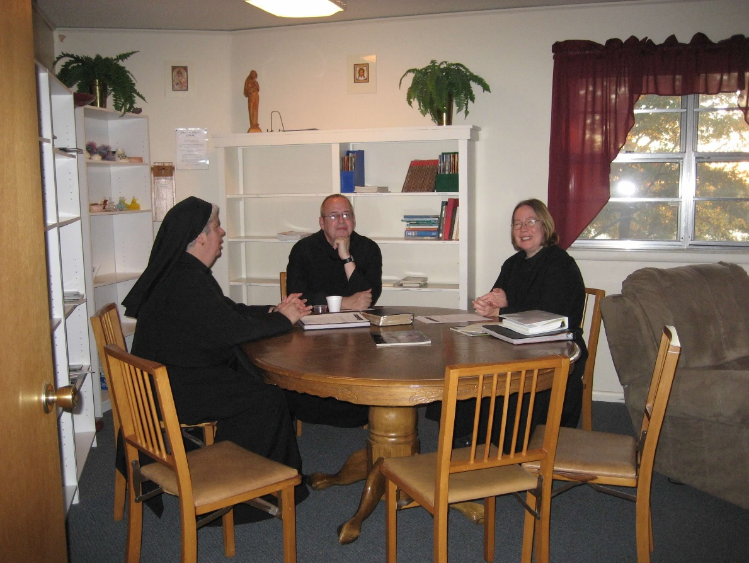
0300406244567619904256102711762.jpg Sr. Mary Catherine Christopher; Br. Gabriel Hale; Sr. Teresa Beebe

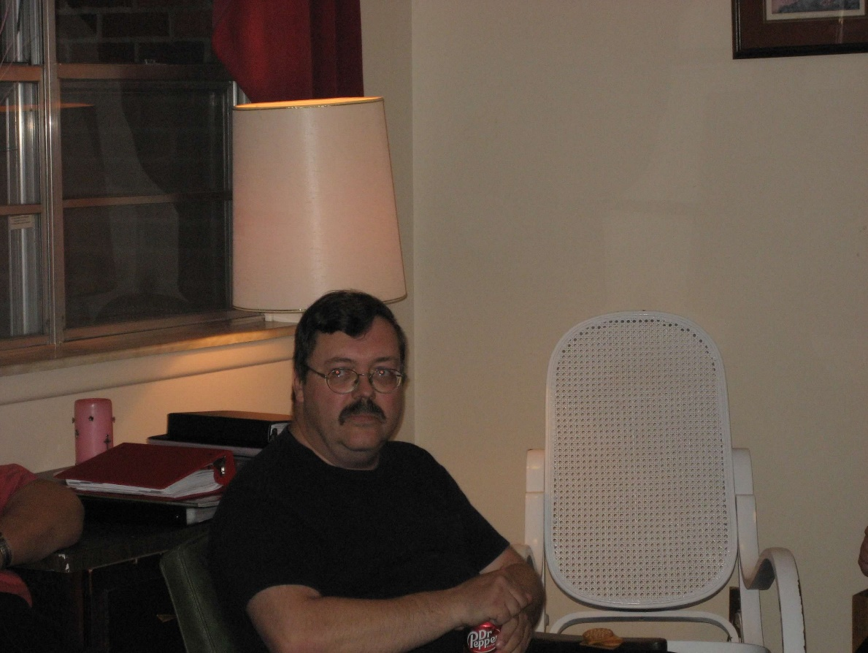
0300406244567619904256102711844.jpg Br. Paul Howard

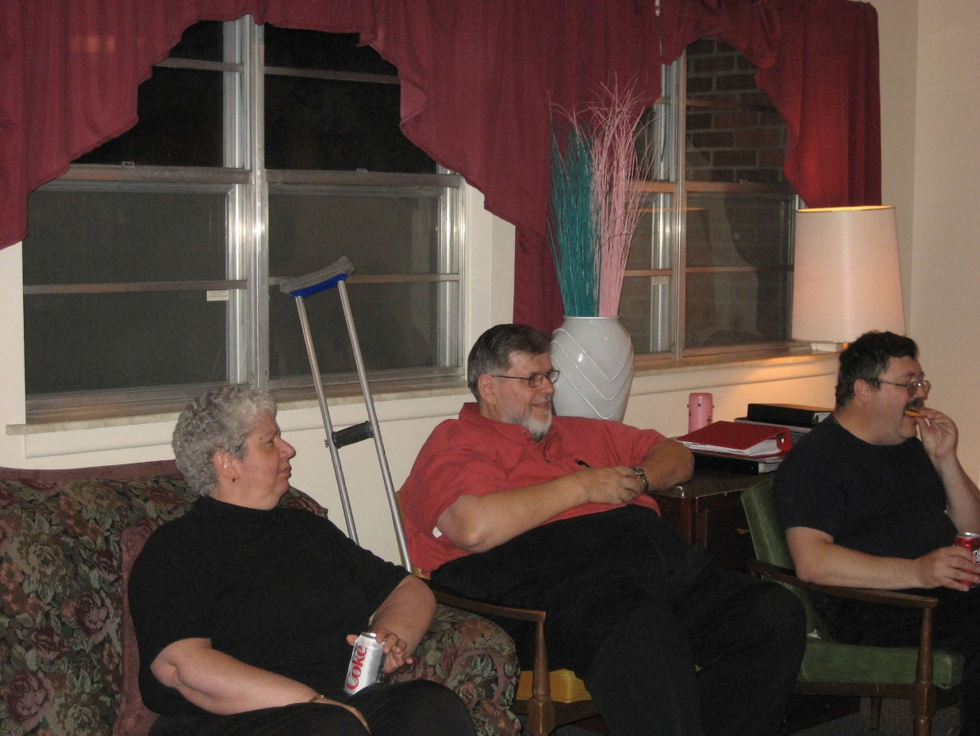
0300406244567619904256102711937.jpg Sr. Mary Catherine Christopher; Br. Nathan Gregory Miller; Br. Paul Howard

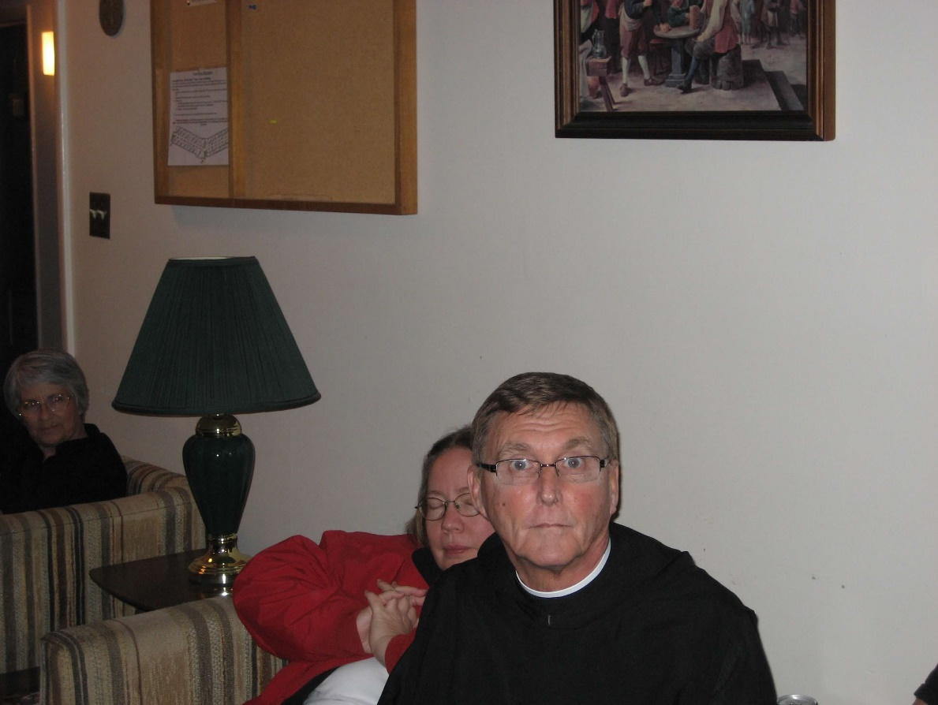
0300406244567619904256102712011.jpg Sr. Mary Francis Deulen; Sr. Teresa Beebe; Br. Camillus Converse

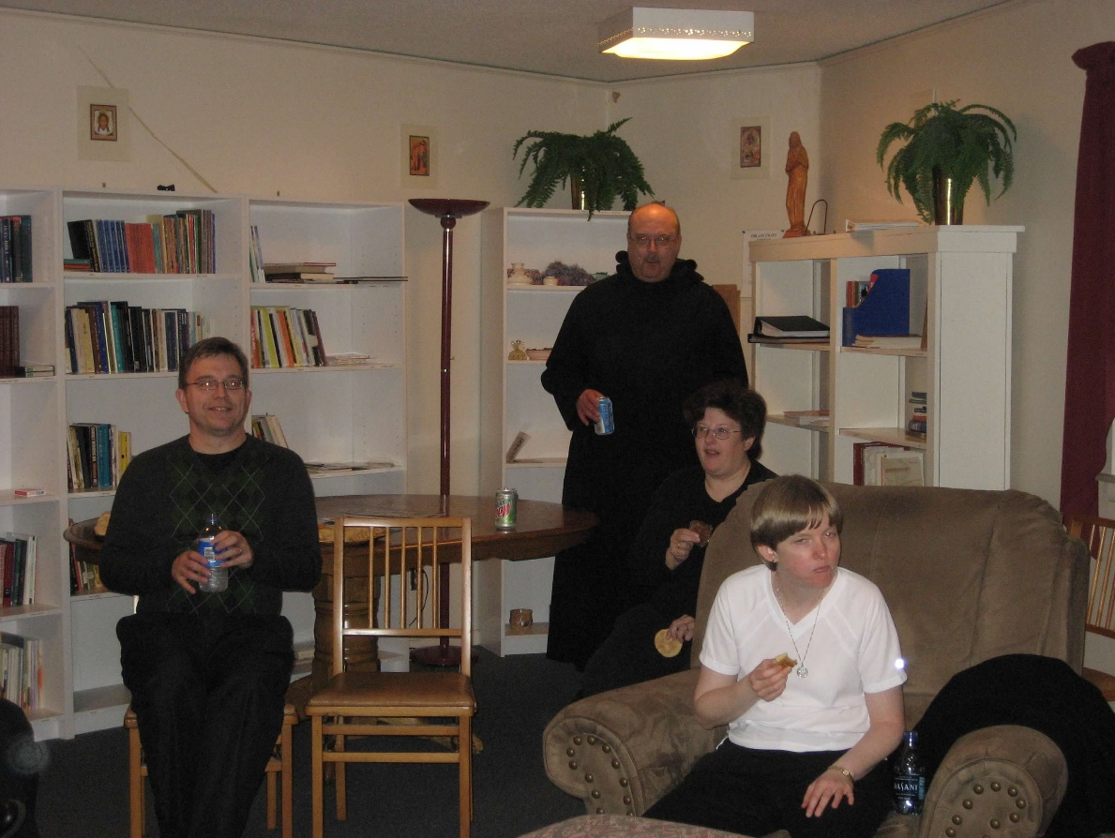
0300406244567619904256102712097.jpg Greg Kennedy; Br. Raymond Owens; Sr. Cecelia Lamoy; Sr. Catherine Unterseher

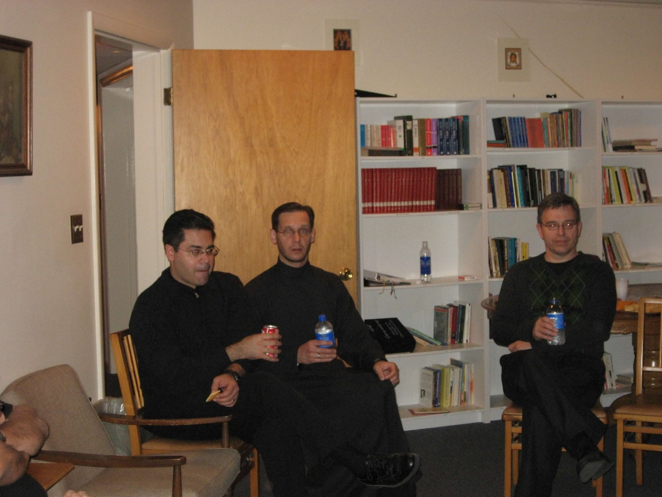
0300406244567619904256102712225.jpg Br. Daniel Medina; Br. Aelred Shemanov; Greg Kennedy

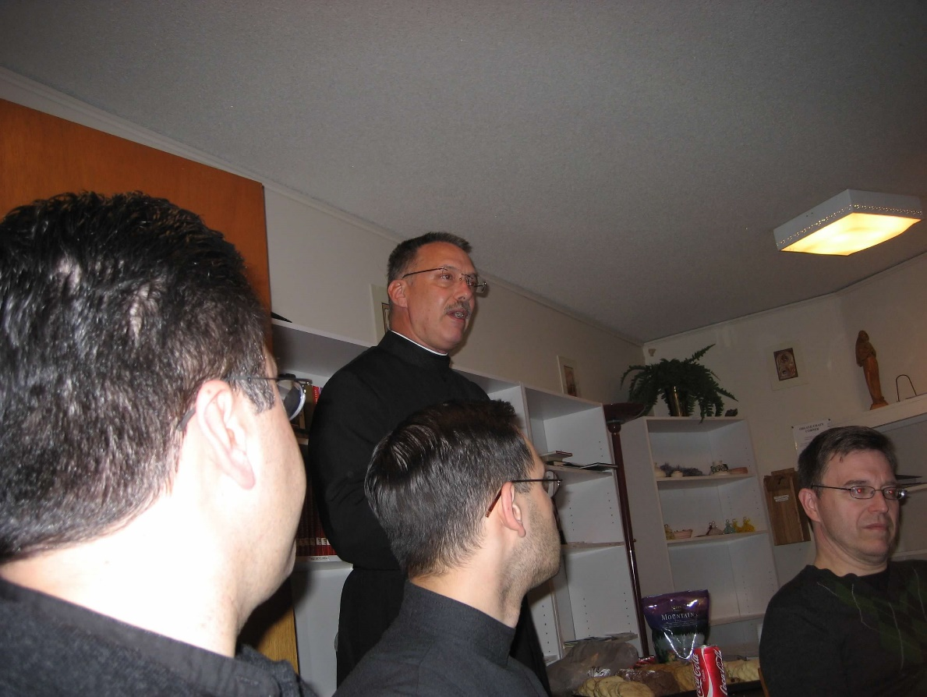
0300406244567619904256102712316.jpg Br. Daniel Medina; Abbot Michael John Austin; Br. Aelred Shemanov; Greg Kennedy

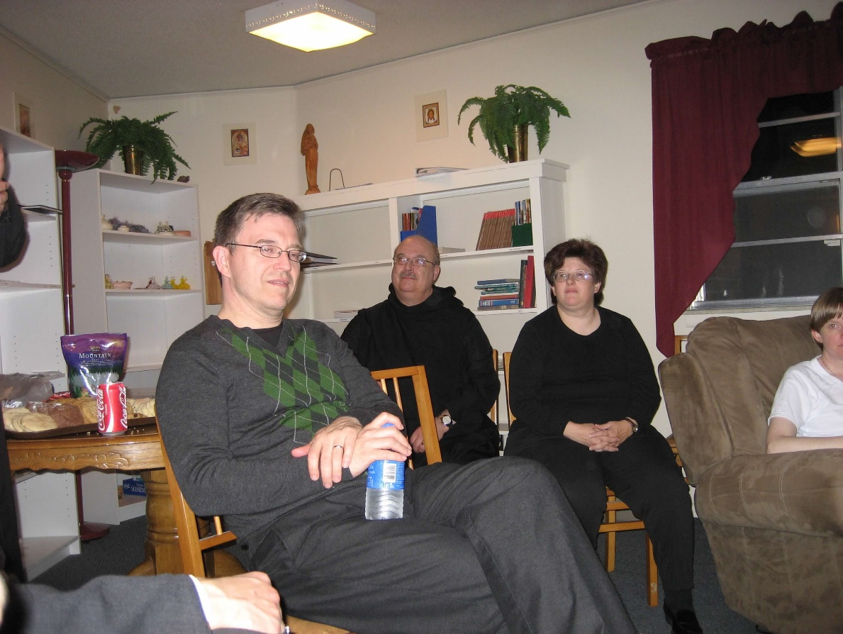
0300406244567619904256102712400.jpg Greg Kennedy; Br. Raymond Owens; Sr. Cecelia Lamoy; Sr. Catherine Unterseher

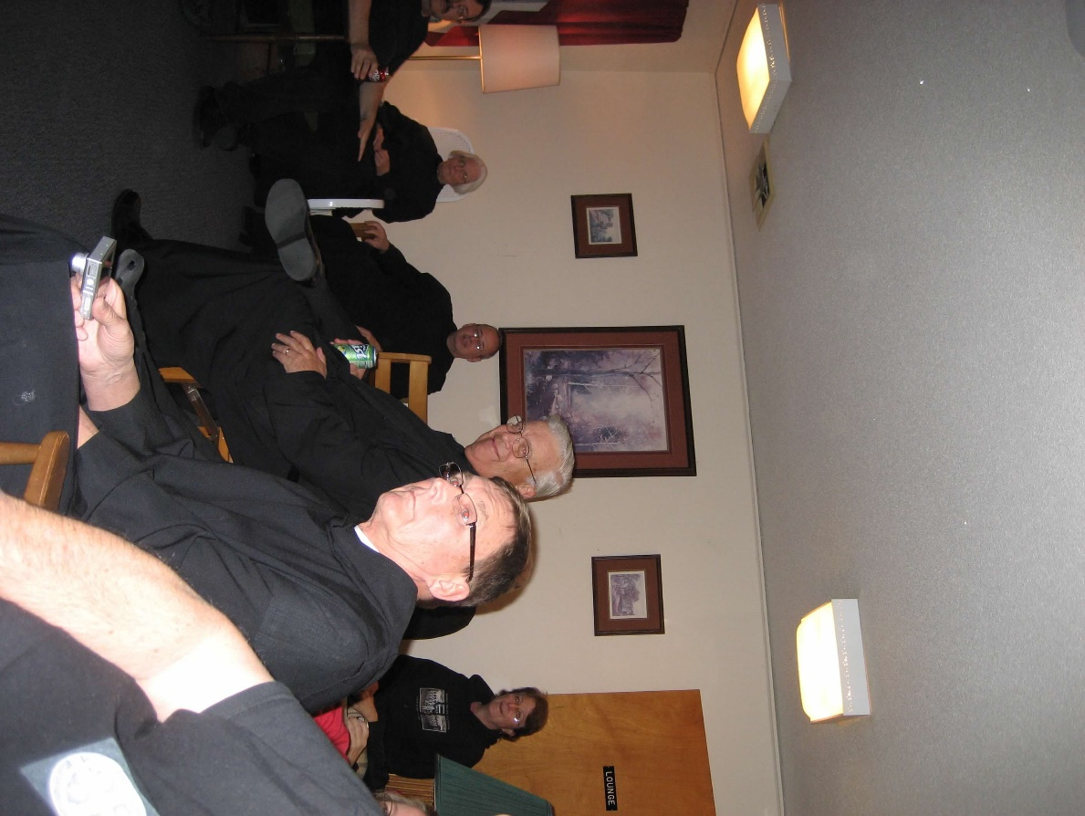
0300406244567619904256102712516.jpg Br. Paul Howard; Sr. Elizabeth Anne Stribley; Br. Gabriel Hale; Br. Timothy Titus Lunt; Br. Camillus Converse; Marilyn McKinney

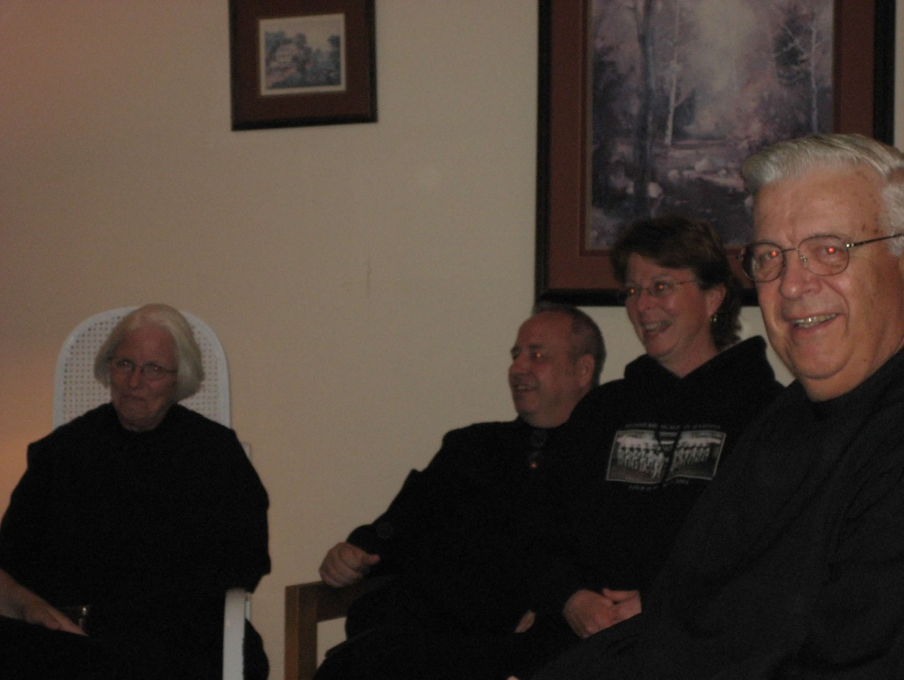
0300406244567619904256102712601.jpg Sr. Elizabeth Anne Stribley; Br. Gabriel Hale; Marilynn McKinney; Br. Timothy Titus Lunt

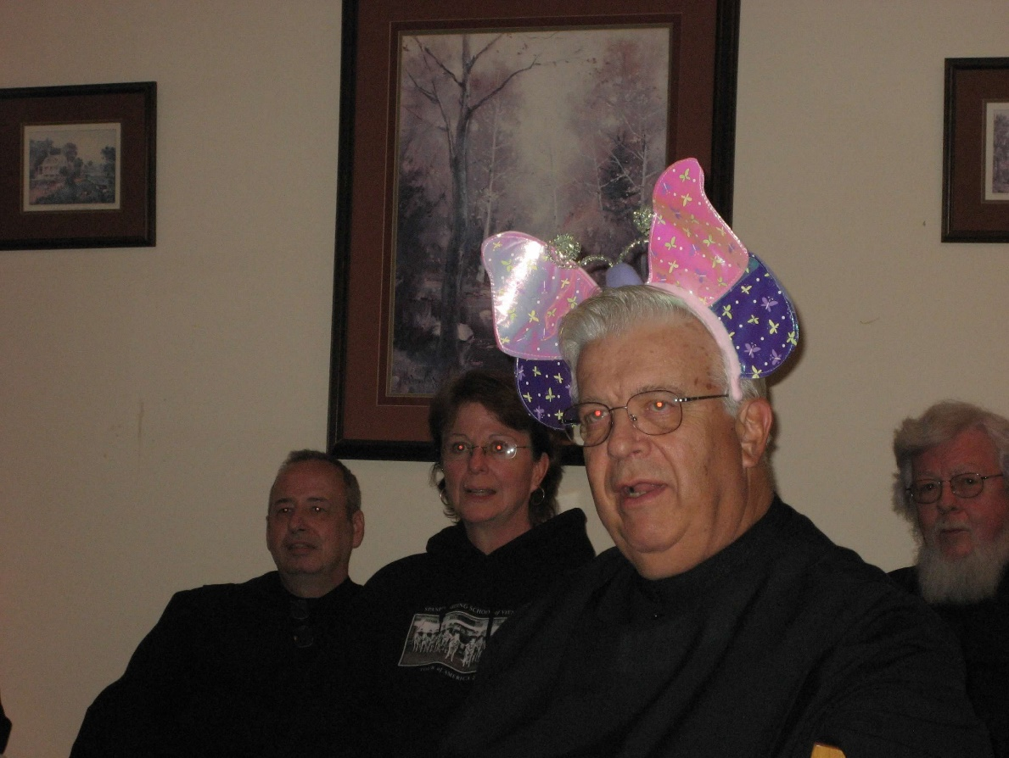
0300406244567619904256102712683.jpg Br. Gabriel Hale; Marilynn McKinney; Br. Timothy Titus Lunt; Fr. Wayne Kamm

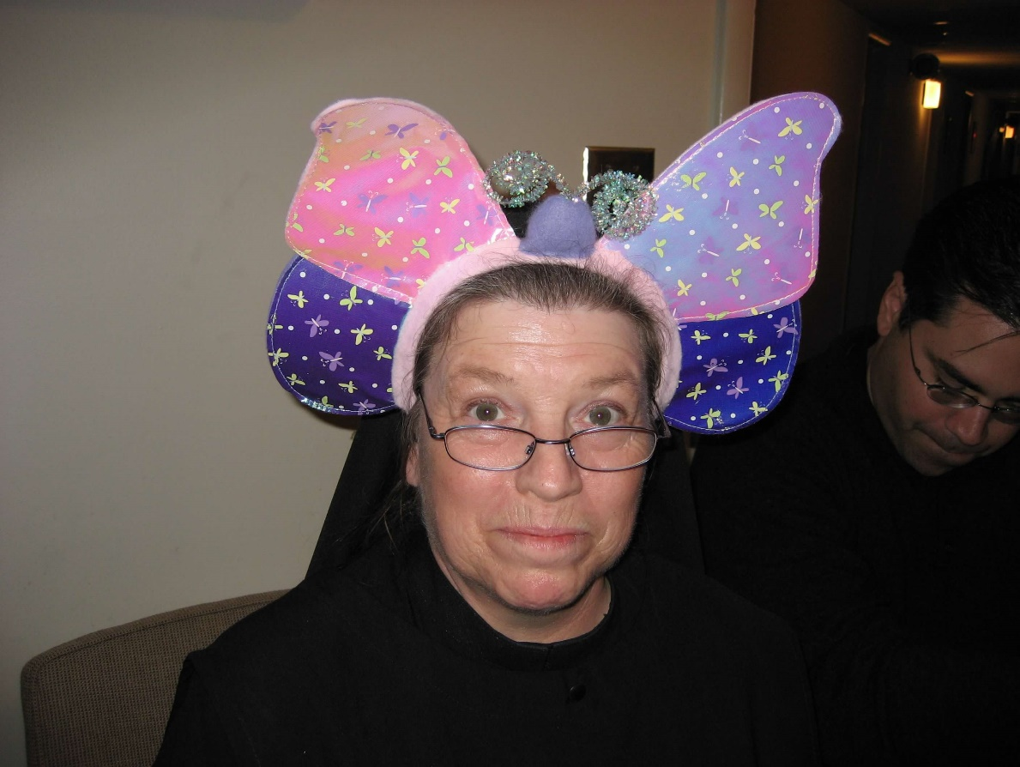
0300406244567619904256102712760.jpg Sr. Sophia Holt; Br. Daniel Medina

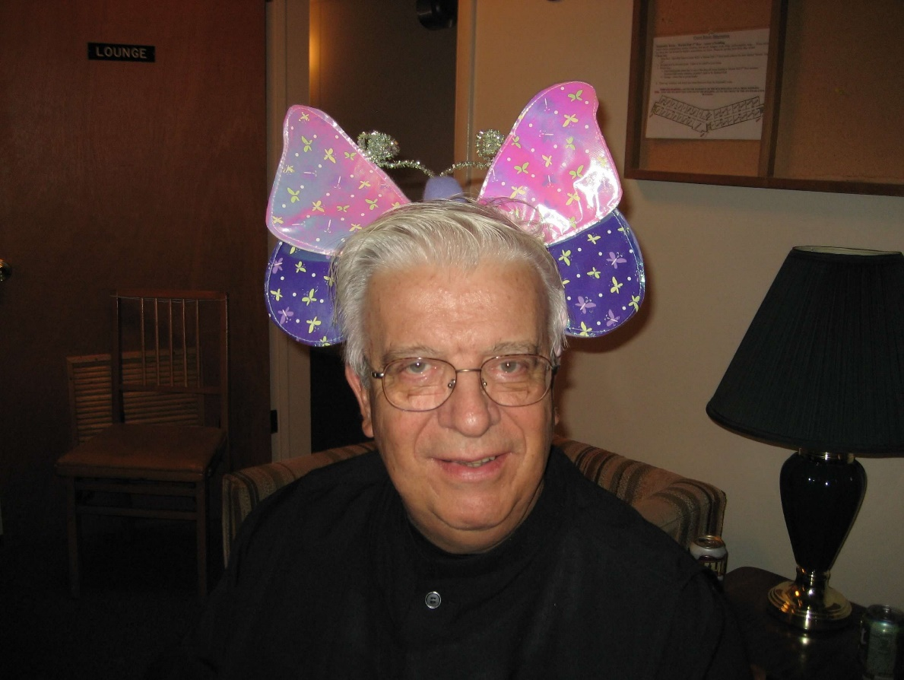
0300406244567619904256102712837.jpg Br. Timothy Titus Lunt

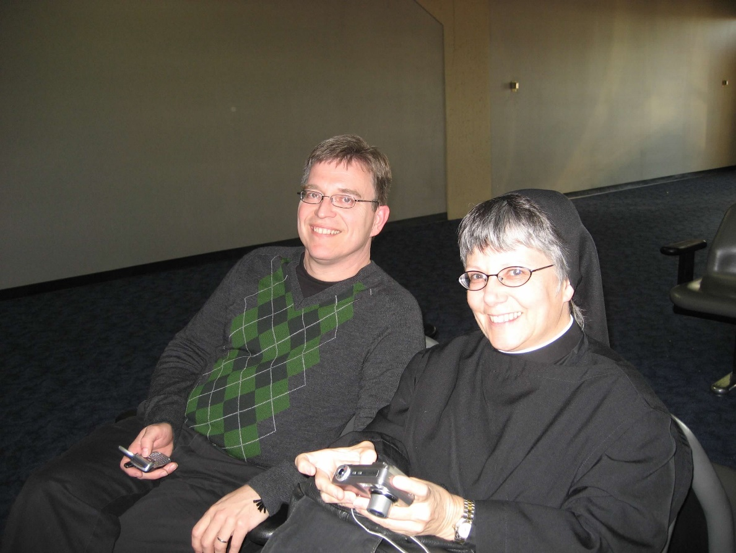
0300406244567619904256102712940.jpg Greg Kennedy; Sr. Anna Grace Madden

