Companions of St. Luke
2007 Fall Convocation at Conception Abbey
Part 1 of 2

~Edited by Br. Steven Olderr, 19 June 2022 with the assistance of Br. Thomas Ferrell. If you find any errors or omissions or have anything to add, please notify Br. Steven at olderr@ameritech.net

People are identified from left to right.

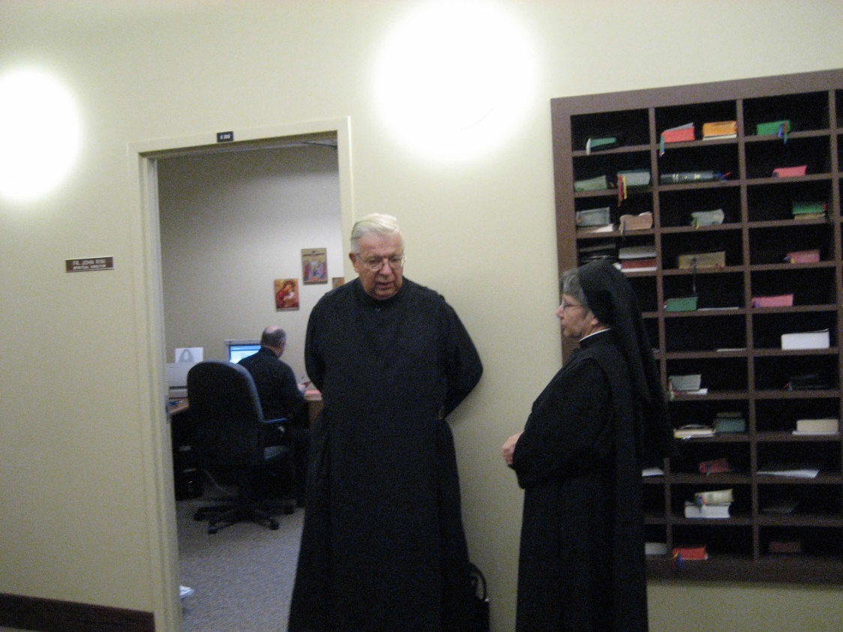
0300406244567619904256102701664.jpg Br. Timothy Titus Lunt; Sr. Anna Grace Madden

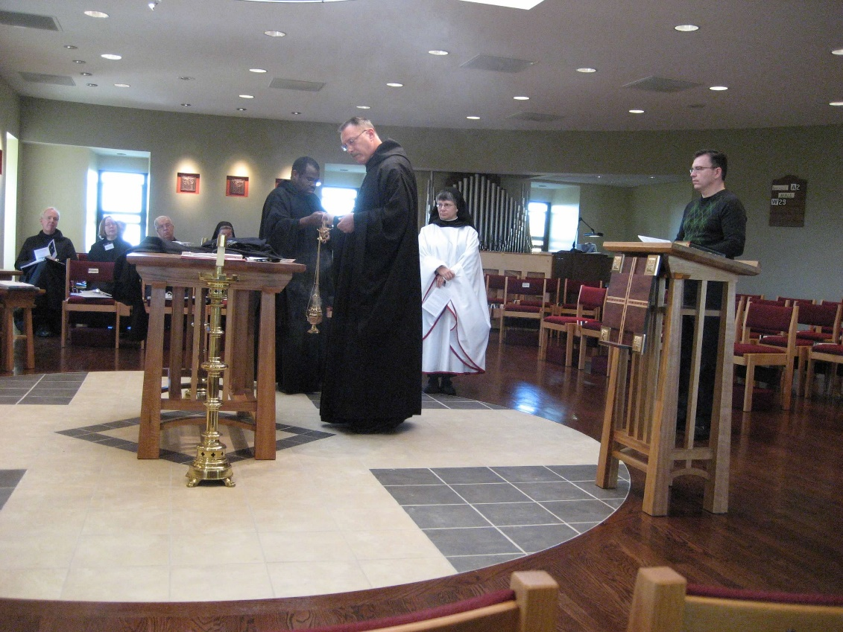
0300406244567619904256102701777.jpg Br. Luke Doucette; Sr. Teresa Beebe; Br. Timothy Titus Lunt; Sr. Sophia Holt; Br. Thomas Ferrell; Abbot Michael John Austin; Sr. Anna Grace Madden; Greg Kennedy

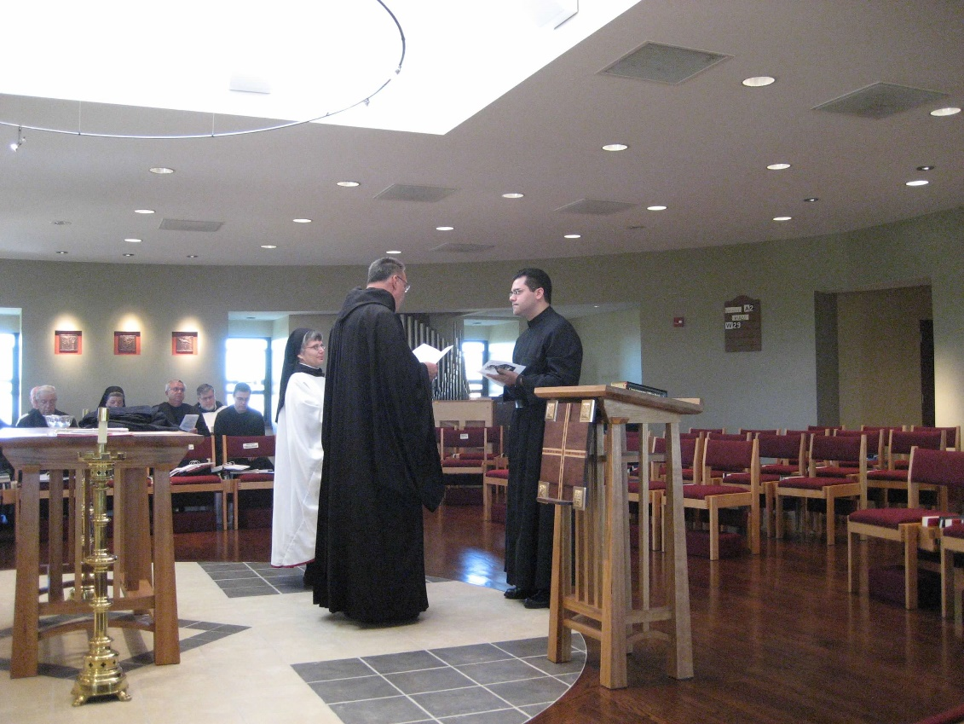
0300406244567619904256102701946.jpg Br. David Vincent Cotton; Br. Timothy Titus Lunt; Sr. Sophia Holt; Br. Bede Leach; Br. Nathan Gregory Miller; Br. Aelred Shemanov; Abbot Michael John Austin; Sr. Anna Grace Madden; Br. Daniel Medina

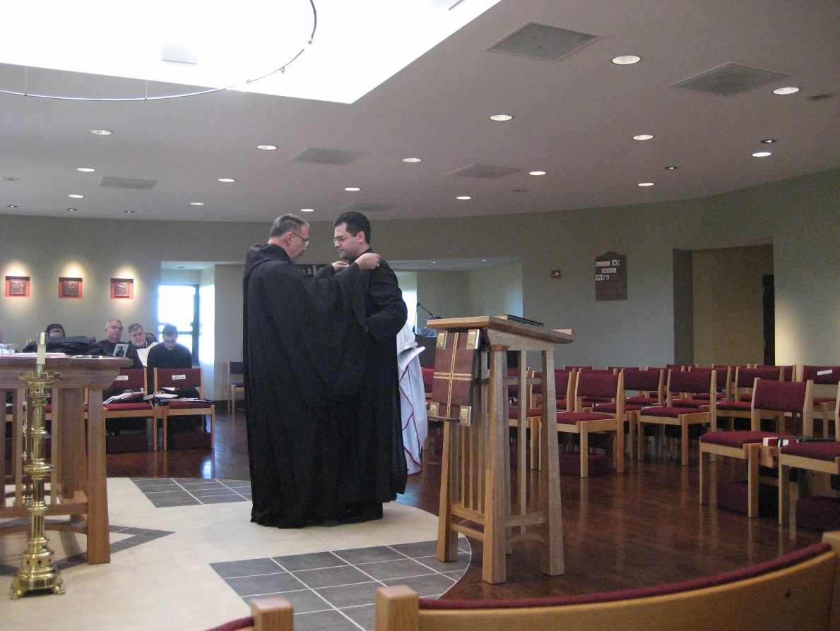
0300406244567619904256102702037.jpg Br. David Vincent Cotton; Br. Timothy Titus Lunt; Sr. Sophia Holt; Br. Bede Leach; Br. Nathan Gregory Miller; Br. Aelred Shemanov; Abbot Michael John Austin; Sr. Anna Grace Madden; Br. Daniel Medina

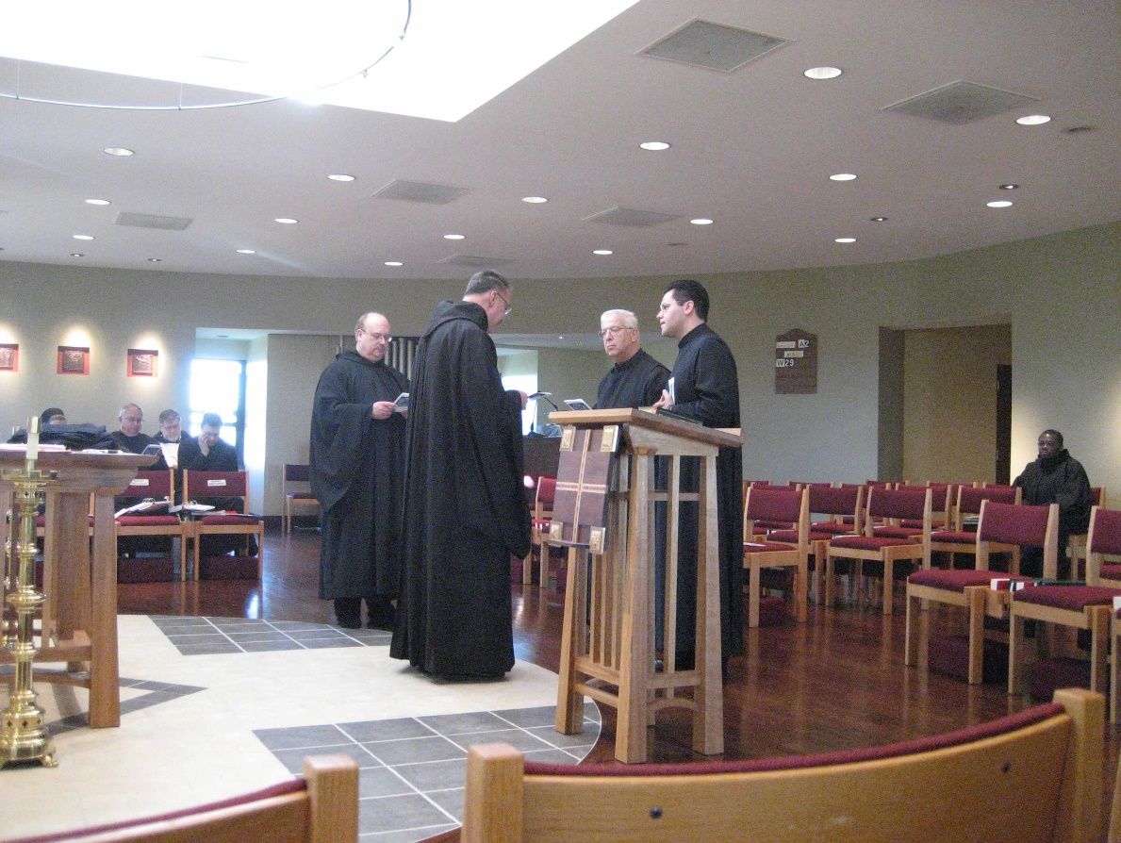
0300406244567619904256102702129.jpg Sr. Sophia Holt; Br. Bede Leach; Br. Nathan Gregory Miller; Br. Aelred Shemanov; Br. Raymond Owens; Abbot Michael John Austin; Br. Timothy Titus Lunt; Br. Daniel Medina; Br. Thomas Ferrell

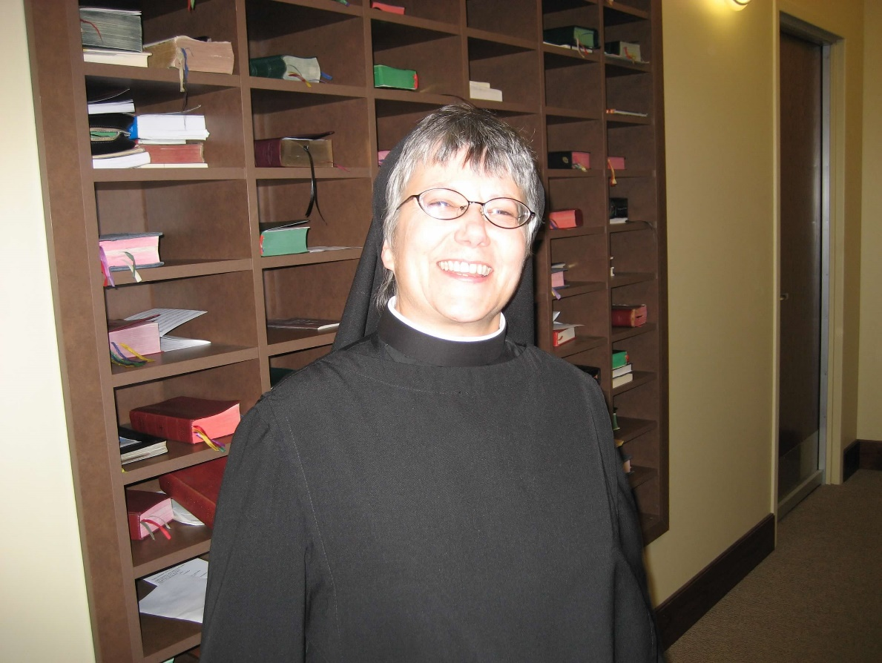
0300406244567619904256102702218.jpg Sr. Anna Grace Madden

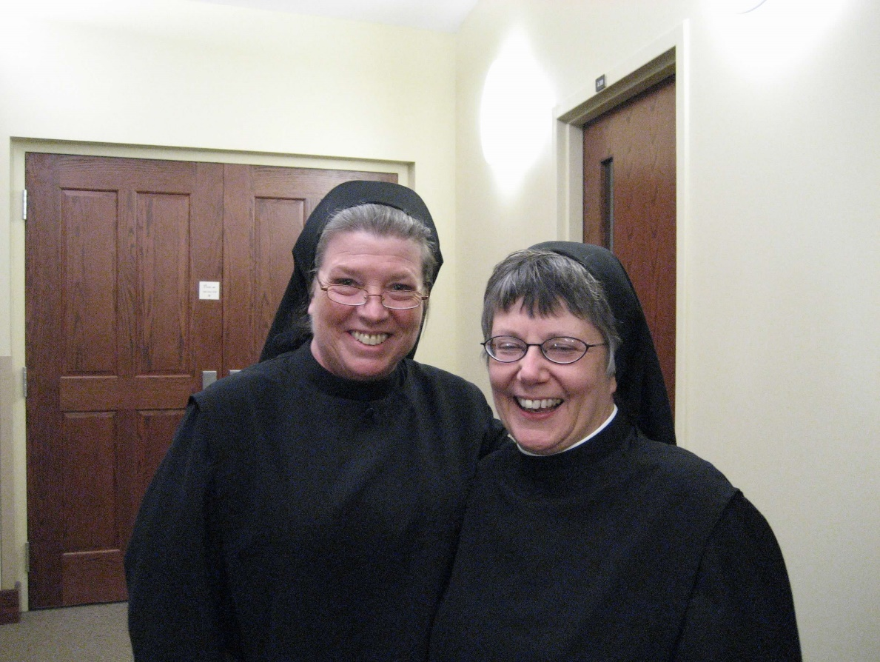
0300406244567619904256102702324.jpg Sr. Sophia Holt; Sr. Anna Grace Madden

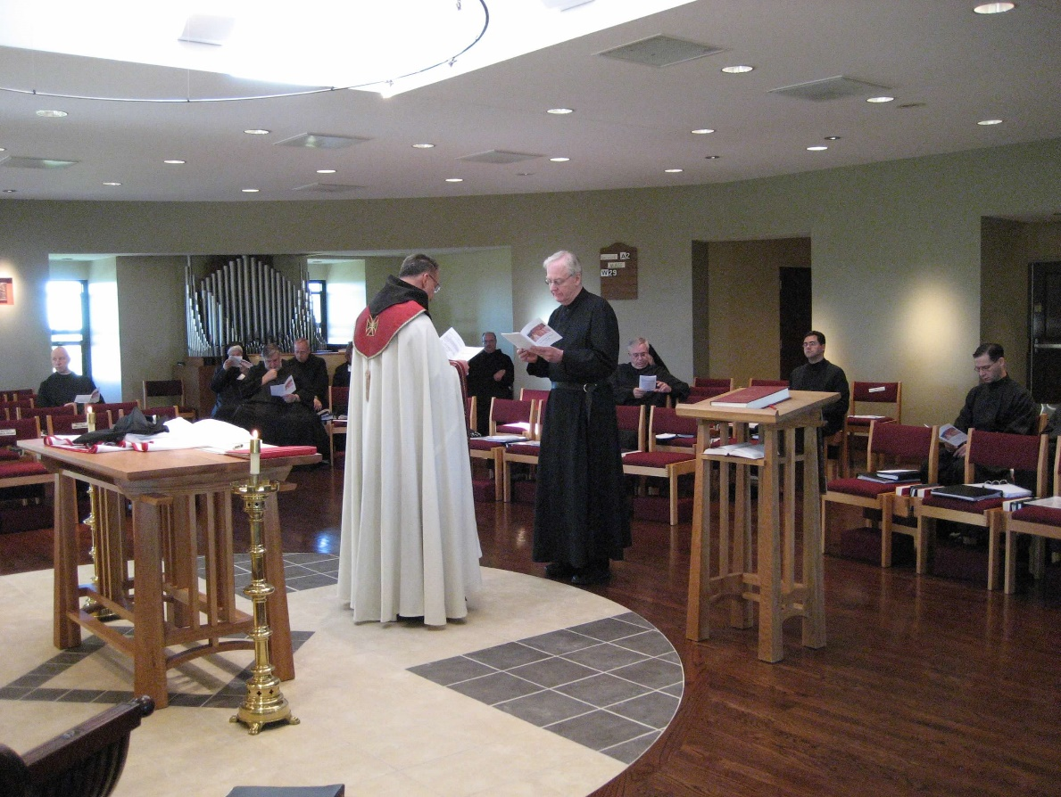
0300406244567619904256102702447.jpg Br. David Vincent Cotton; Sr. Mary Catherine Christopher; Br. Nathan Gregory Miller; Br. Gabriel Hale; Abbot Michael John Austin; Br. Raymond Owens; Br. Luke Doucette; Br. Bede Leach; Br. Daniel Medina; Br. Aelred Shemanov

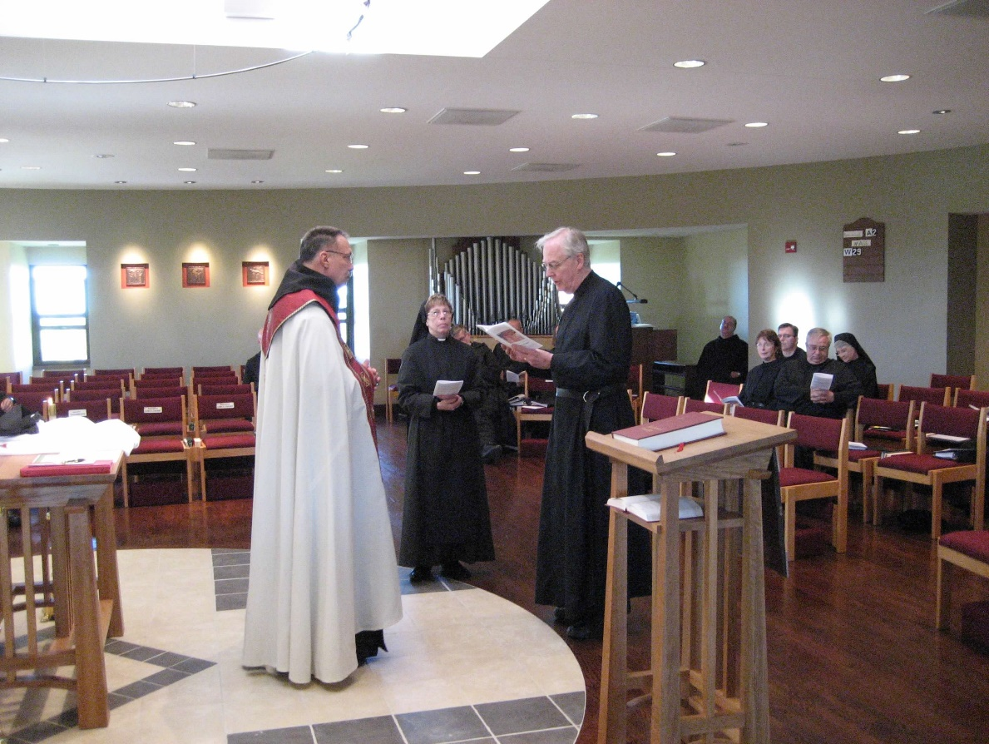
0300406244567619904256102702537.jpg Abbot Michael John Austin; Sr. Monica Ruth Mullen; Br. Luke Doucette; Br. Raymond Owens; Michelle Moore; Greg Kennedy; Br. Bede Leach; Sr. Mary Francis Deulen

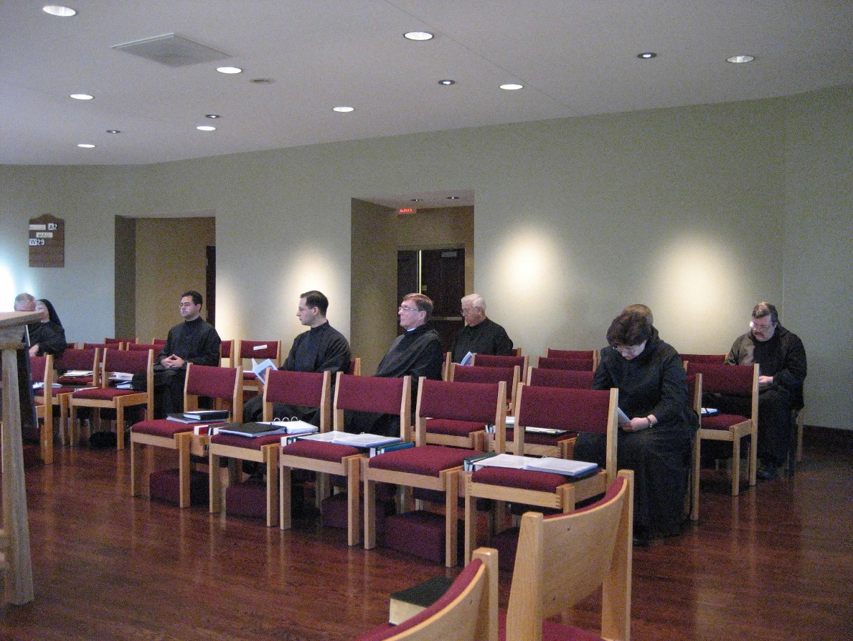
0300406244567619904256102702636.jpg Br. Bede Leach; Sr. Mary Francis Deulen; Br. Daniel Medina; Br. Aelred Shemanov; Br. Camillus Converse; Br. Timothy Titus Lunt; Sr. Cecelia Lamoy; Br. Paul Howard

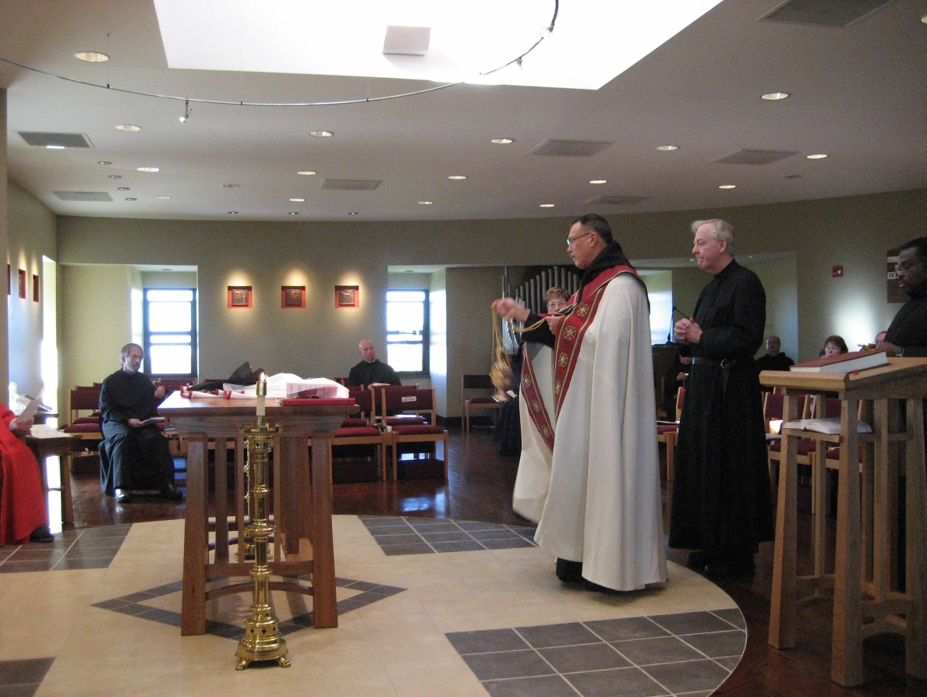
0300406244567619904256102702725.jpg Br. Lawrence Mullen; Br. David Vincent Cotton; Sr. Monica Ruth Mullen; Abbot Michael John Austin; Br. Luke Doucette; Br. Raymond Owens; Michelle Moore; Br. Thomas Ferrell

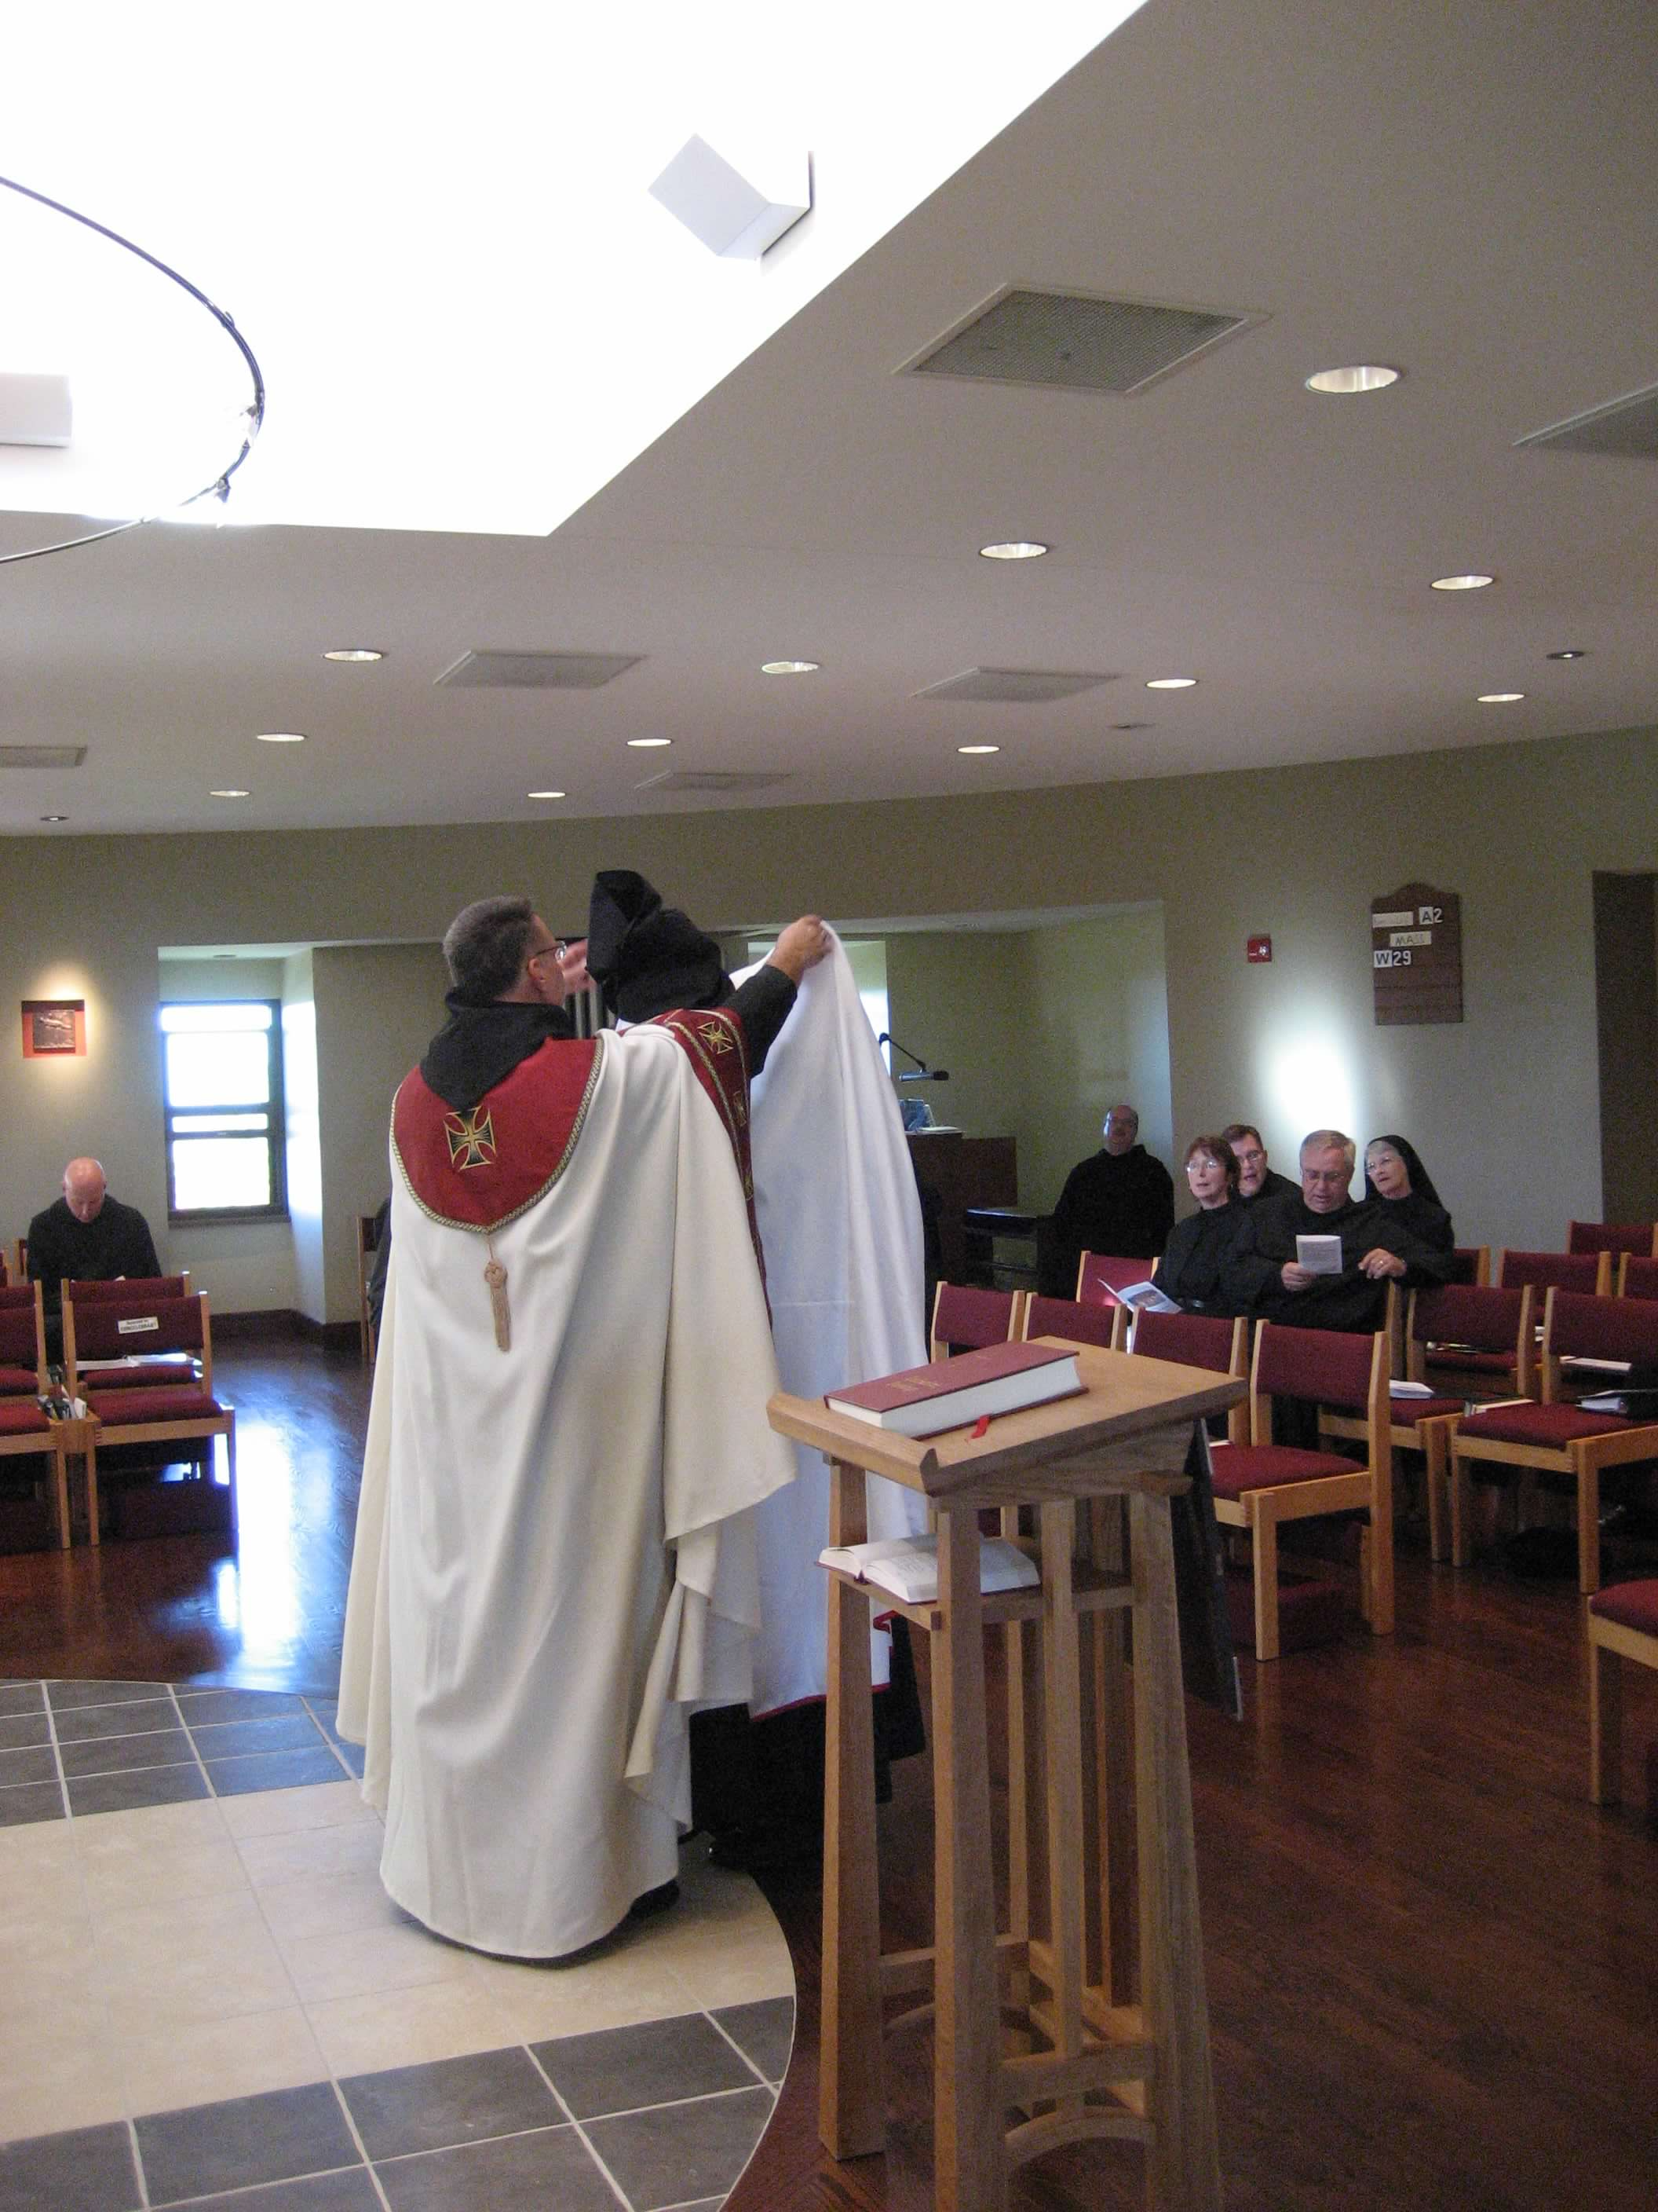
0300406244567619904256102702827.jpg Br. David Vincent Cotton; Abbot Michael John Austin; Br. Luke Doucette; Br. Raymond Owens; Michelle Moore; Greg Kennedy; Br. Bede Leach; Sr. Mary Francis Deulen

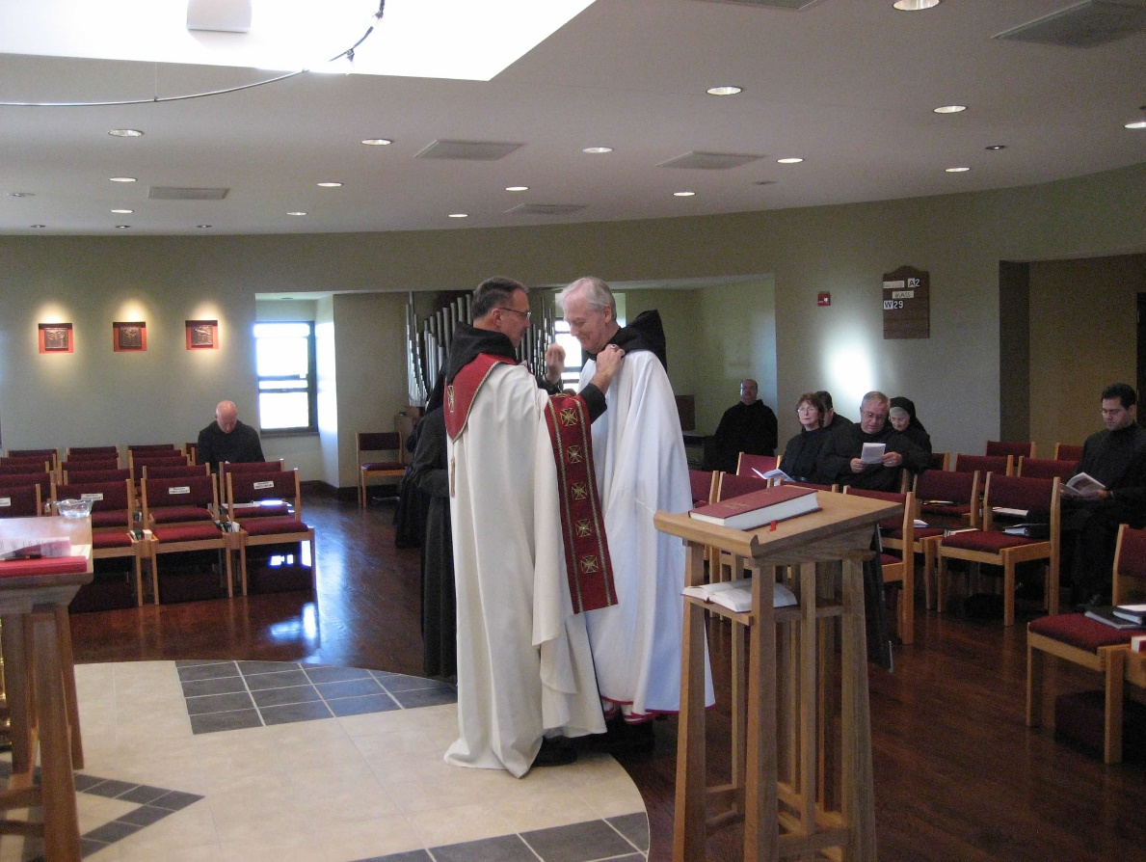
0300406244567619904256102702915.jpg Br. David Vincent Cotton; Abbot Michael John Austin; Br. Luke Doucette; Br. Raymond Owens; Michelle Moore; Greg Kennedy; Br. Bede Lech; Sr. Mary Francis Deulen; Br. Daniel Medina

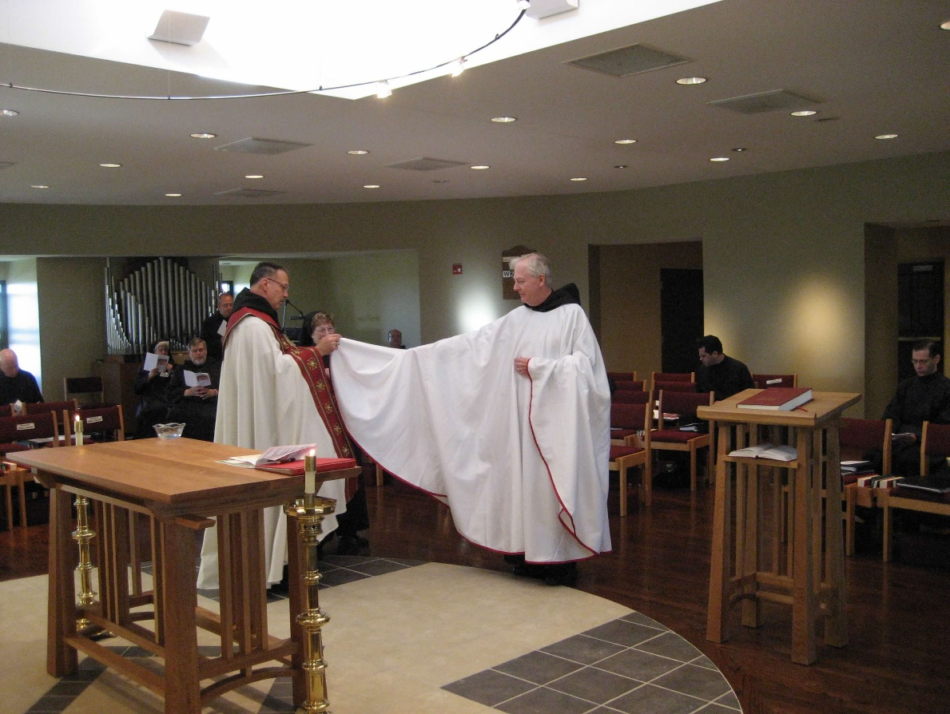
0300406244567619904256102703025.jpg Br. David Vincent Cotton; Sr. Mary Catherine Christopher; Br. Nathan Gregory Miller; Br. Gabriel Hale; Abbot Michael John Austin; Sr. Monica Ruth Mullen; Br. Raymond Owens; Br. Luke Doucette; Br. Daniel Medina; Br. Aelred Shemanov
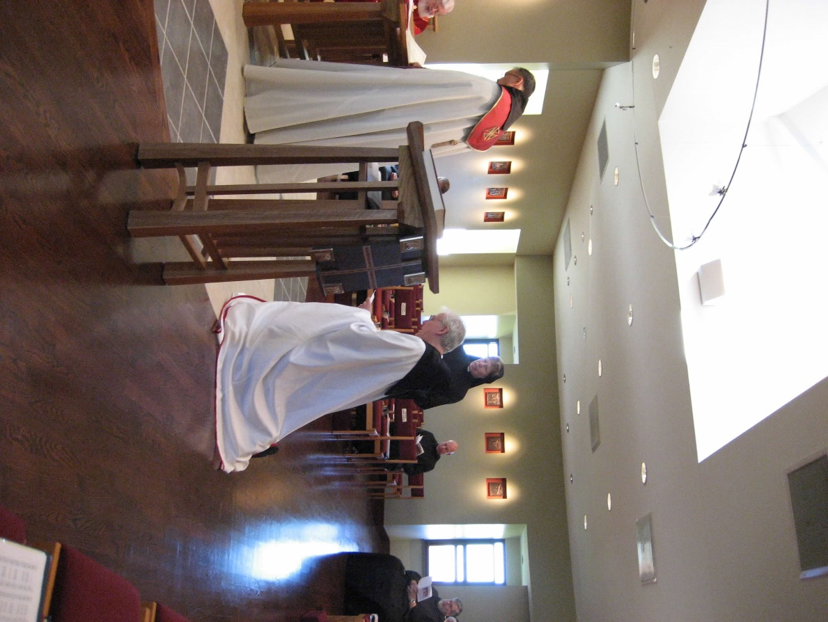
0300406244567619904256102703114.jpg Fr. Wayne Kamm; Abbot Michael John Austin; Sr. Monica Ruth Mullen; Br. David Vincent Cotton; Br. Nathan Gregory Miller

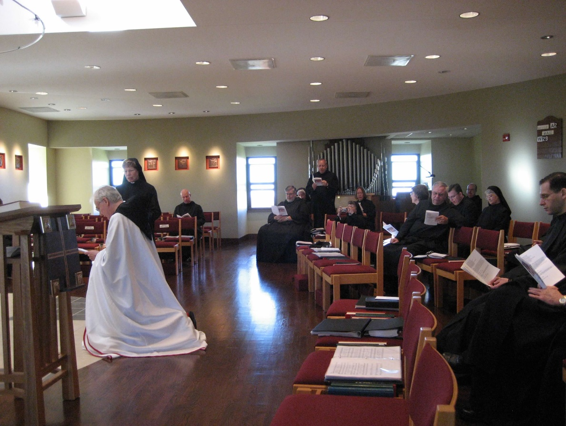
0300406244567619904256102703242.jpg Sr. Monica Ruth Mullen; Br. David Vincent Cotton; Br. Nathan Gregory Miller; Sr. Mary Catherine Christopher; Br. Gabriel Hale; Sr. Teresa Beebe; Michelle Moore; Br. Bede Leach; Greg Kennedy; Br. Raymond Owens; Sr. Mary Francis Deulen; Br. Aelred Shemanov

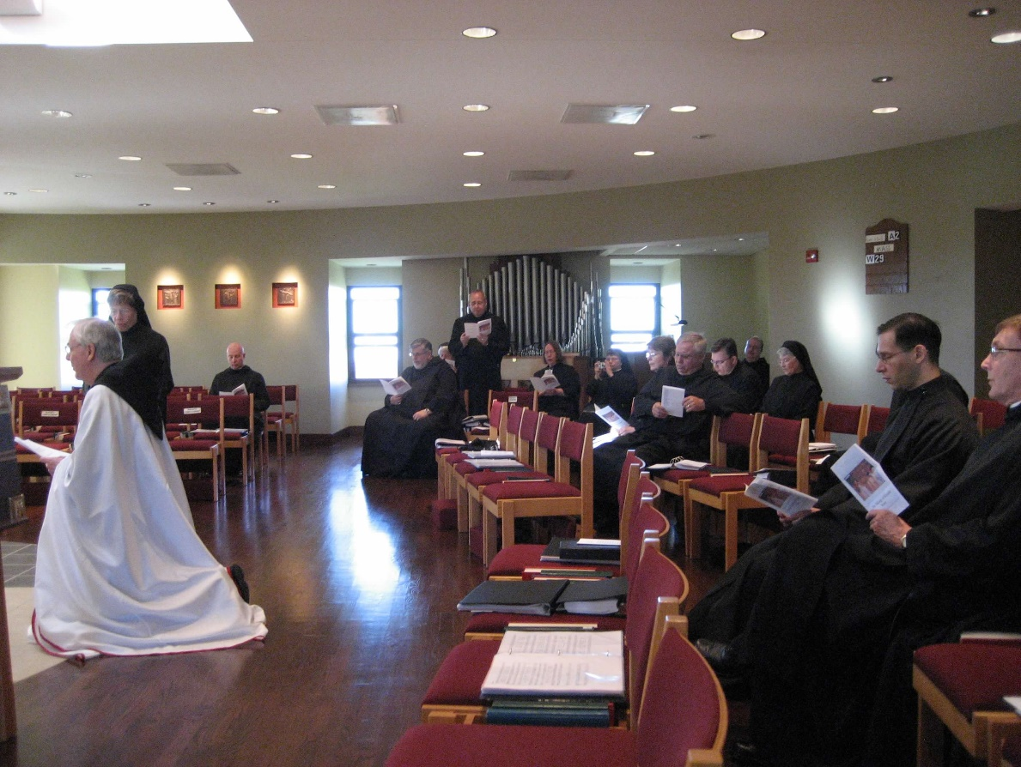
0300406244567619904256102703331.jpg Br. Luke Doucette; Sr. Monica Ruth Mullen; Br. David Vincent Cotton; Br. Nathan Gregory Miller; Sr. Mary Catherine Christopher; Br. Gabriel Hale; Sr. Teresa Beebe; Sr. Anna Grace Madden; Michelle Moore; Br. Bede Leach; Greg Kennedy; Br. Raymond Owens; Sr. Mary Francis Deulen; Br. Aelred Shemanov; Br. Camillus Converse

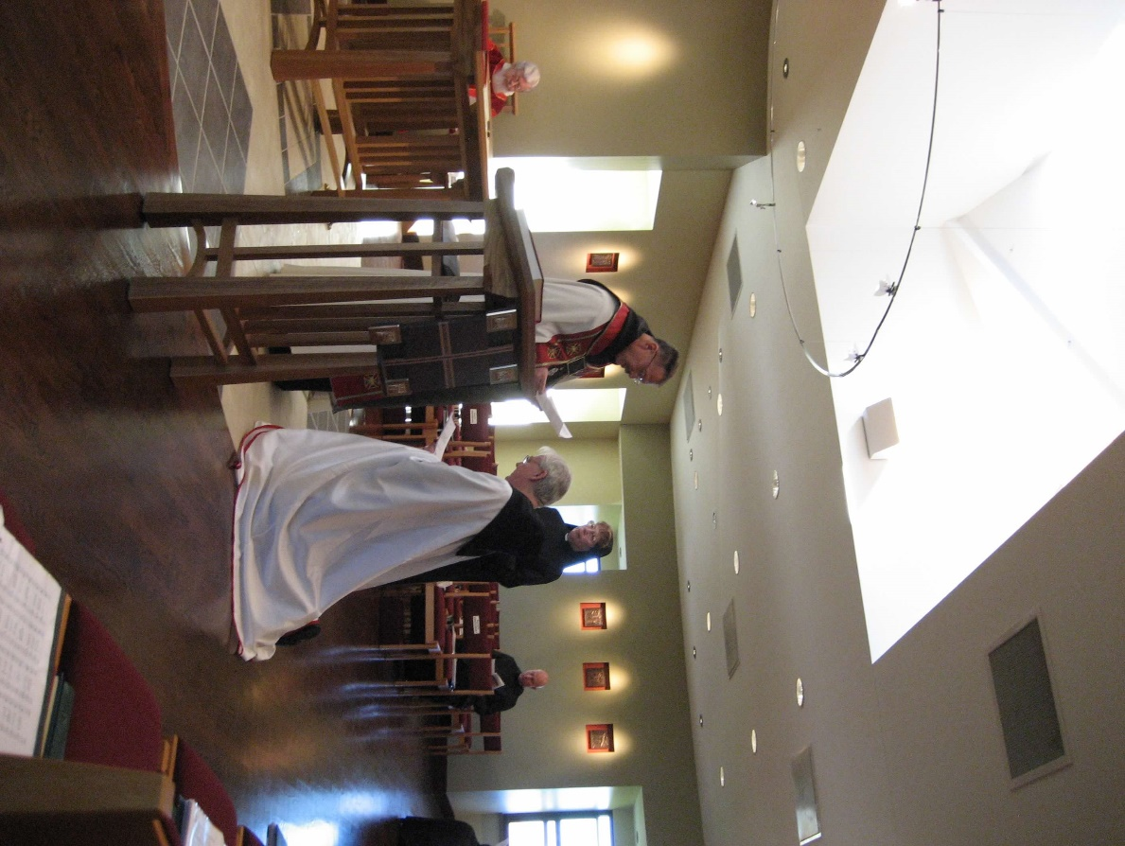
0300406244567619904256102703420.jpg Fr. Wayne Kamm; Abbot Michael John Austin; Br. Luke Doucette; Sr. Monica Ruth Mullen; Br. David Vincent Cotton

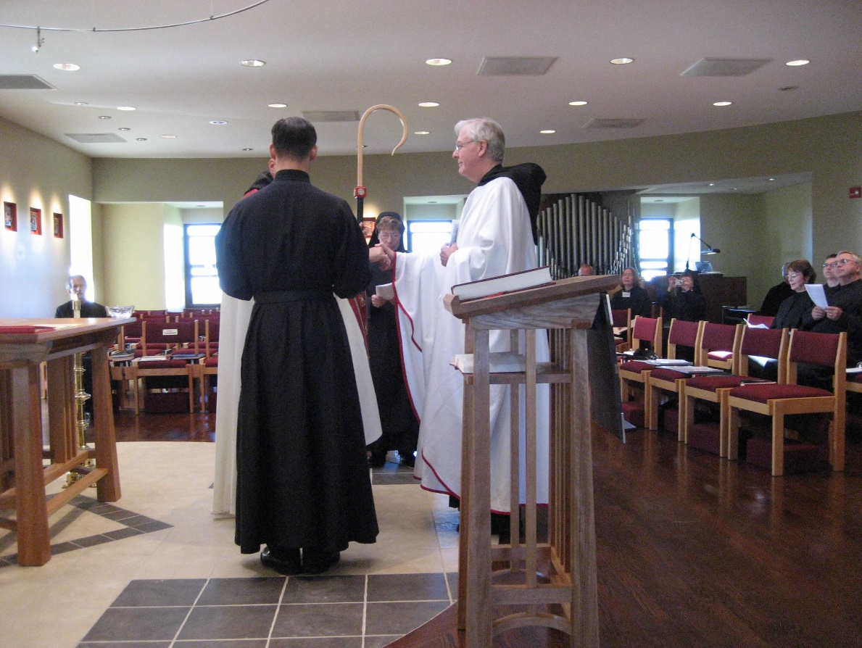
0300406244567619904256102703567.jpg Br. Lawrence Mullen; Abbot Michael John Austin; Br. Aelred Shemanov; Sr. Monica Ruth Mullen; Br. Luke Doucette; Br. Gabriel Hale; Sr. Teresa Beebe; Sr. Anna Grace Madden; Br. Raymond Owens; Michelle Moore; Greg Kennedy; Br. Bede Leach

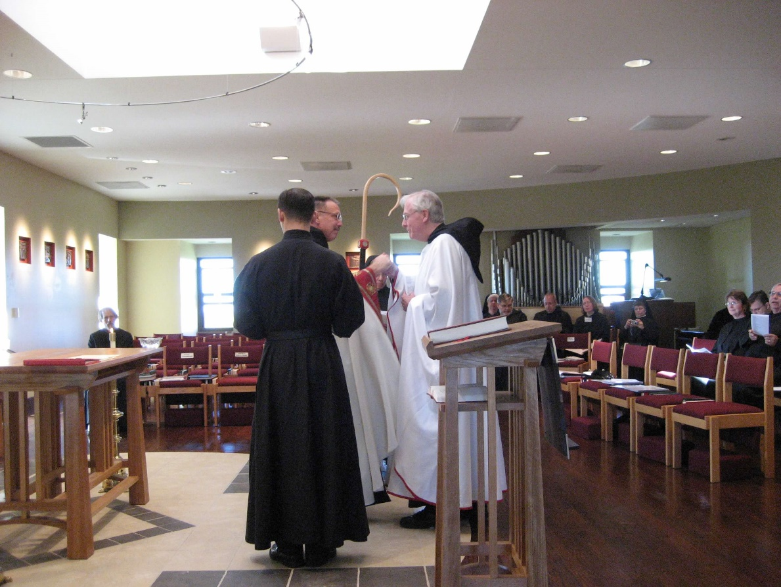
0300406244567619904256102703667.jpg Br. Lawrence Mullen; Br. Aelred Shemanov; Abbot Michael John Austin; Br. Luke Doucette; Sr. Mary Catherine Christopher; Br. Nathan Gregory Miller; Br. Gabriel Hale; Sr. Anna Grace Madden; Michelle Moore; Greg Kennedy; Br. Bede Leach

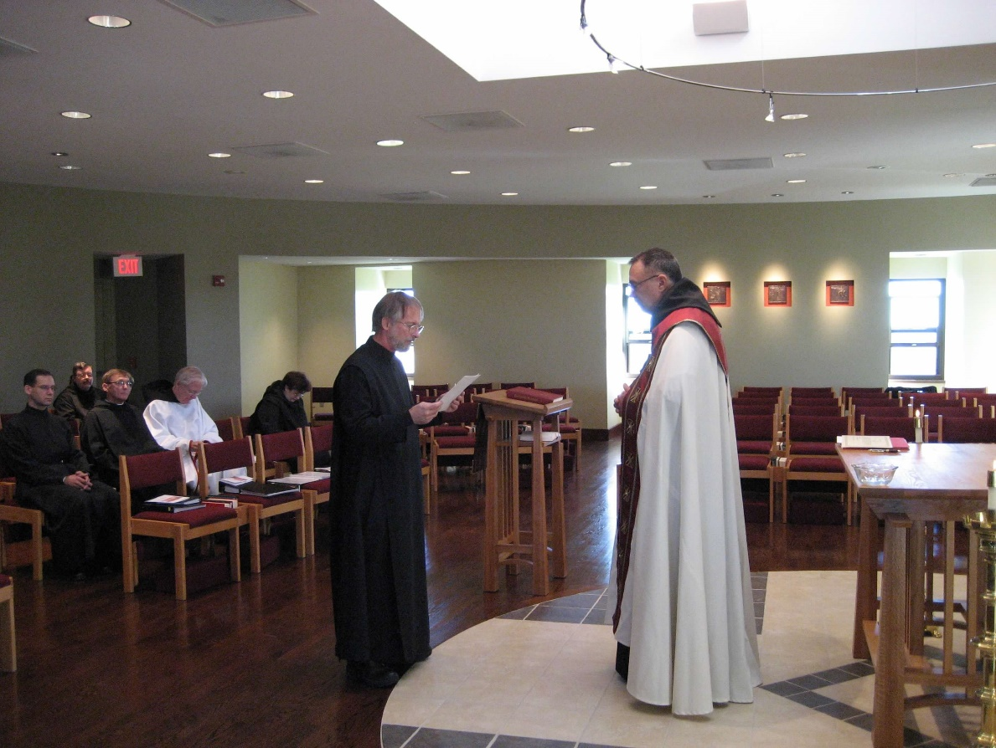
0300406244567619904256102703761.jpg Br. Aelred Shemanov; Br. Paul Howard; Br. Camillus Converse; Br. Luke Doucette; Sr. Cecelia Lamoy; Br. Lawrence Mullen; Abbot Michael John Austin

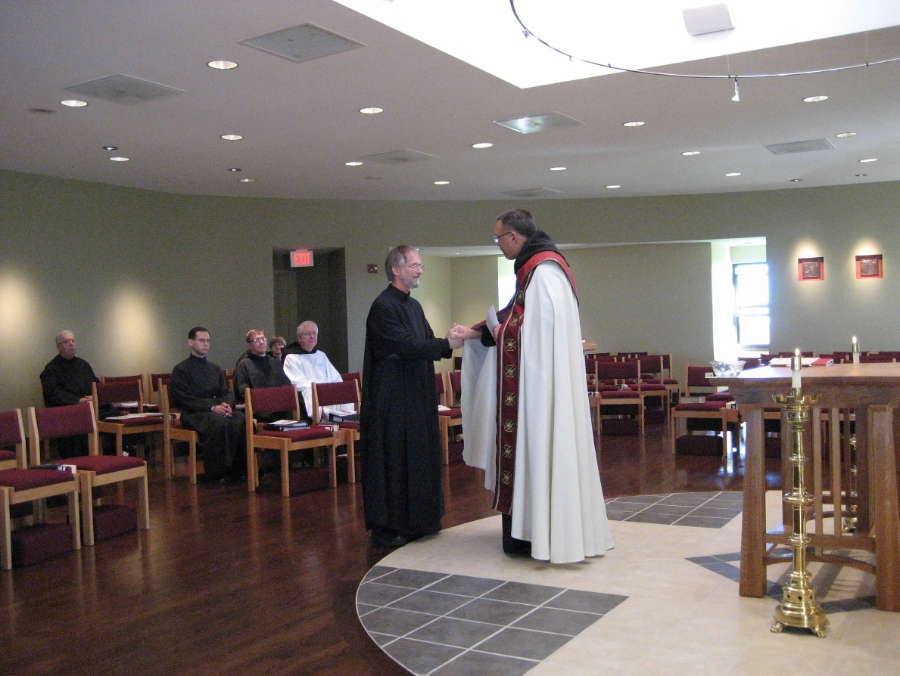
0300406244567619904256102703847.jpg Br. Timothy Titus Lunt; Br. Aelred Shemanov; Br. Camillus Converse; Sr. Catherine Unterseher; Br. Luke Doucette; Sr. Cecelia Lamoy; Br. Lawrence Mullen; Abbot Michael John Austin

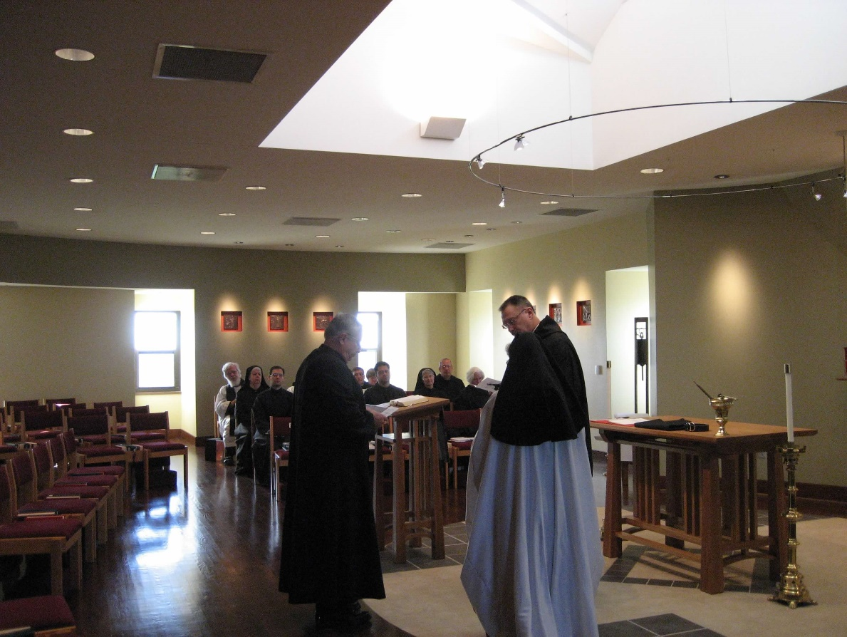
0300406244567619904256102703948.jpg Fr. Wayne Kamm; Sr. Mary Catherine Christopher; Br. Aelred Shemanov; Br. Timothy Titus Lunt; Br. Camillus Converse; Sr. Catherine Unterseher; Br. Daniel Medina; Sr. Mary Francis Deulen; Br. Gabriel Hale; Sr. Elizabeth Anne Stribley; Br. Paul Howard; Sr. Monica Ruth Mullen; Abbot Michael John Austin

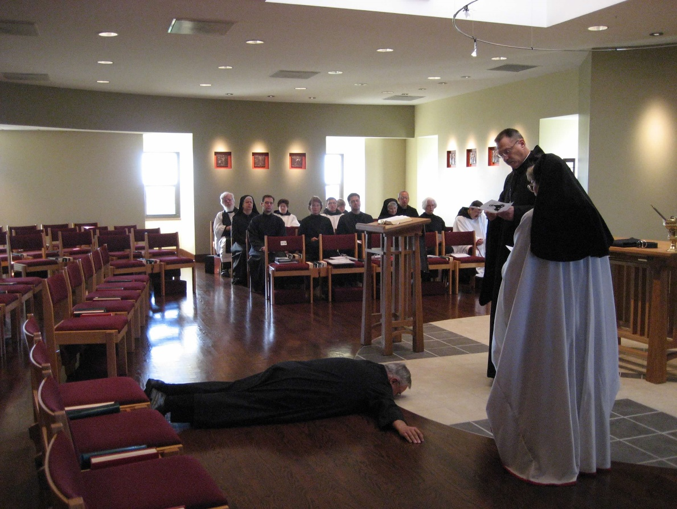
0300406244567619904256102704032.jpg Fr. Wayne Kamm; Sr. Mary Catherine Christopher; Br. Aelred Shemanov; Sr. Cecelia Lamoy; Michelle Moore; Br. Camillus Converse; Sr. Catherine Unterseher; Br. Daniel Medina; Sr. Mary Francis Deulen; Br. Gabriel Hale; Br. Timothy Titus Lunt; Sr. Elizabeth Anne Stribley; Br. Paul Hale; Abbot Michael John Austin; Sr. Monica Ruth Mullen
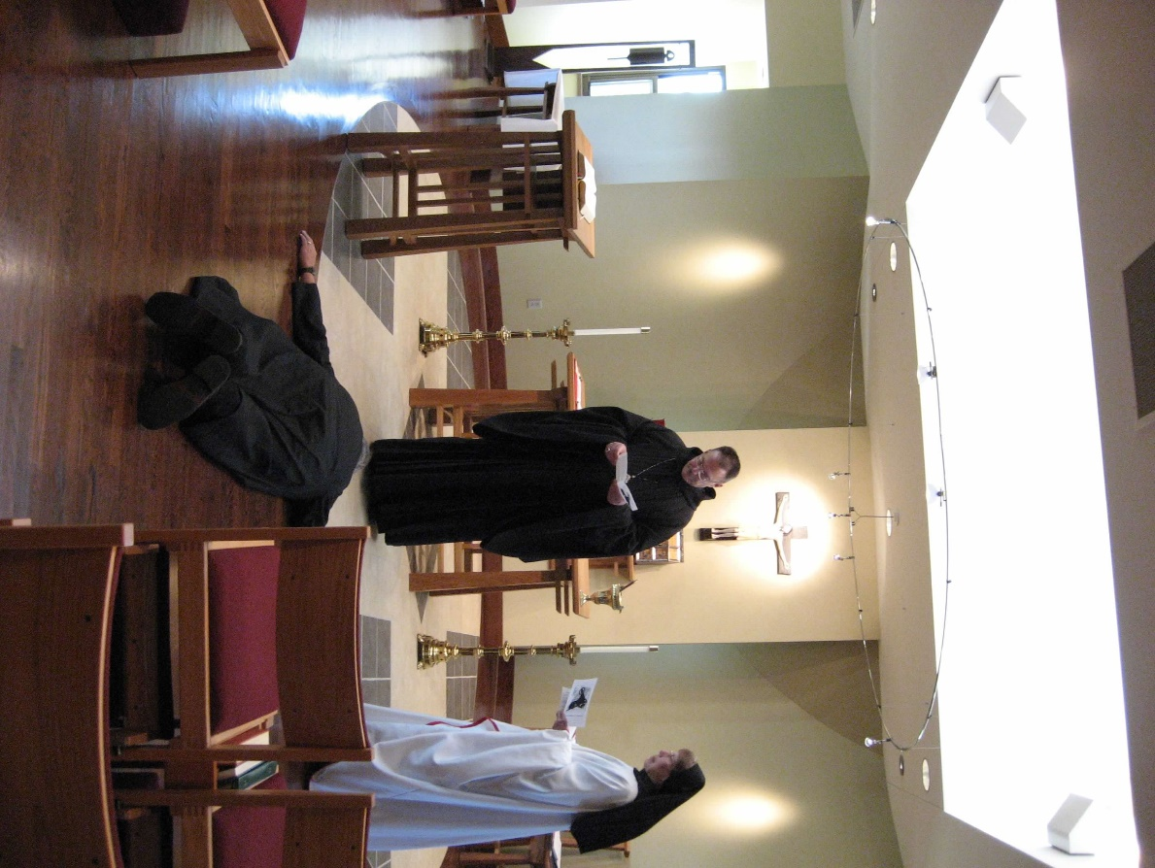
0300406244567619904256102704141.jpg Br. Timothy Titus Lunt; Abbot Michael John Austin; Sr. Monica Ruth Mullen

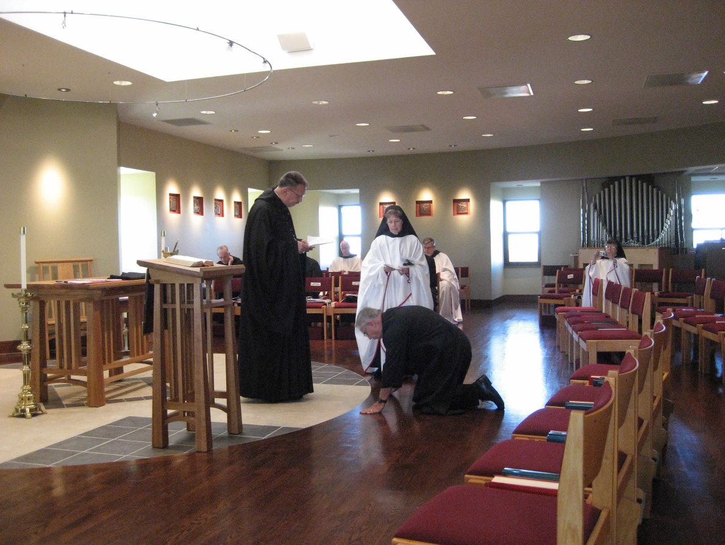
0300406244567619904256102705576.jpg Br. Luke Doucette; Abbot Michael John Austin; Br. David Vincent Cotton; Br. Timothy Titus Lunt; Sr. Monica Ruth Mullen; Br. Nathan Gregory Miller; Sr. Anna Grace Madden

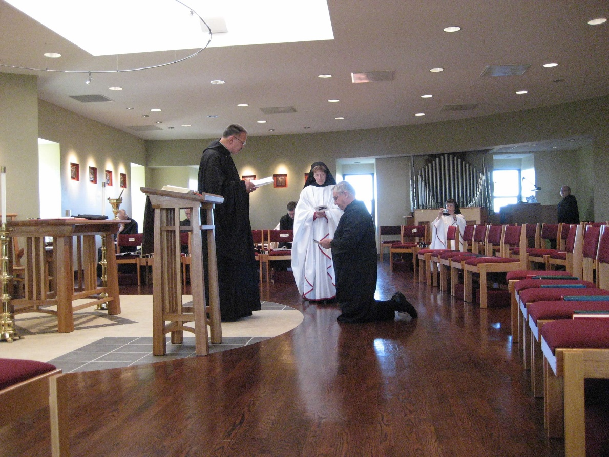
0300406244567619904256102705735.jpg Br. Luke Doucette; Br. Timothy Titus Lunt; Abbot Michael John Austin; Br. Aelred Shemanov; Sr. Monica Ruth Mullen; Br. Bede Leach; Sr. Anna Grace Madden; Br. Raymond Owens

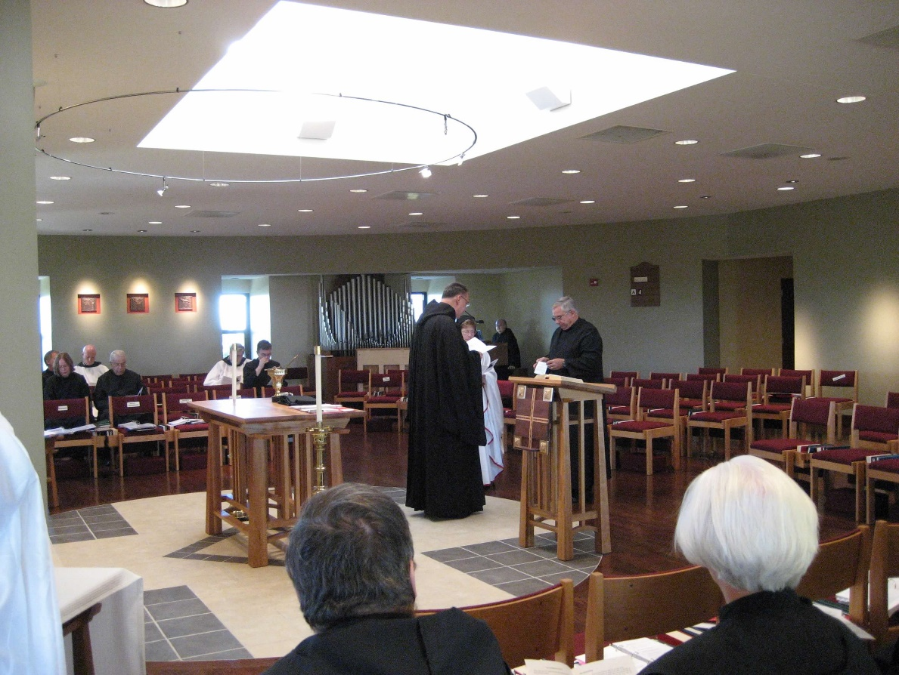
0300406244567619904256102705866.jpg Br. Lawrence Mullen; Sr. Teresa Beebe; Br. David Vincent Cotton; Br. Timothy Titus Lunt; Br. Nathan Gregory Miller; Greg Kennedy; Br. Paul Hale; Abbot Michael John Austin; Sr. Monica Ruth Mullen; Br. Raymond Owens; Br. Bede Leach; Sr. Elizabeth Anne Stribley

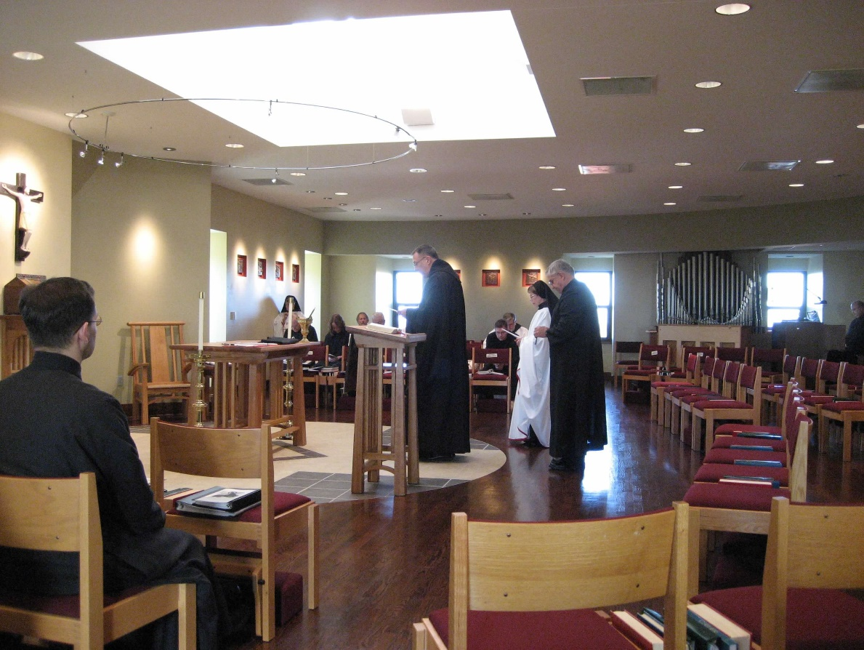
0300406244567619904256102705977.jpg Br. Aelred Shemanov; Sr. Anna Grace Madden; Br. Luke Doucette; Sr. Teresa Beebe; Br. Lawrence Mullen; Br. Timothy Titus Lunt; Abbot Michael John Austin; Greg Kennedy; Br. Nathan Gregory Miller; Sr. Monica Ruth Mullen; Br. Bede Leach; Br. Raymond Owens

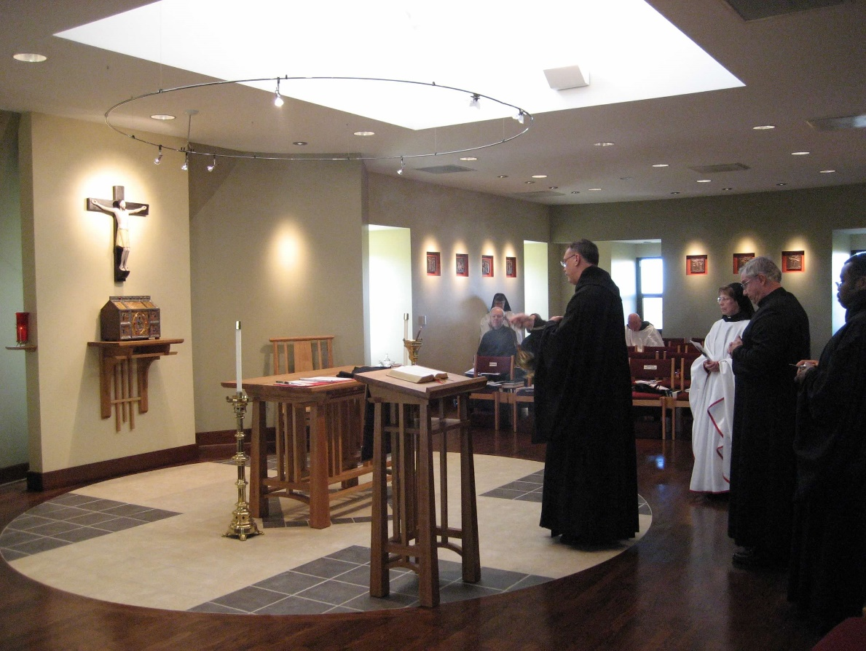
0300406244567619904256102706266.jpg Br. Luke Doucette; Sr. Anna Grace Madden; Abbot Michael John Austin; Br. David Vincent Cotton; Sr. Monica Ruth Mullen; Br. Bede Leach; Br. Thomas Ferrell

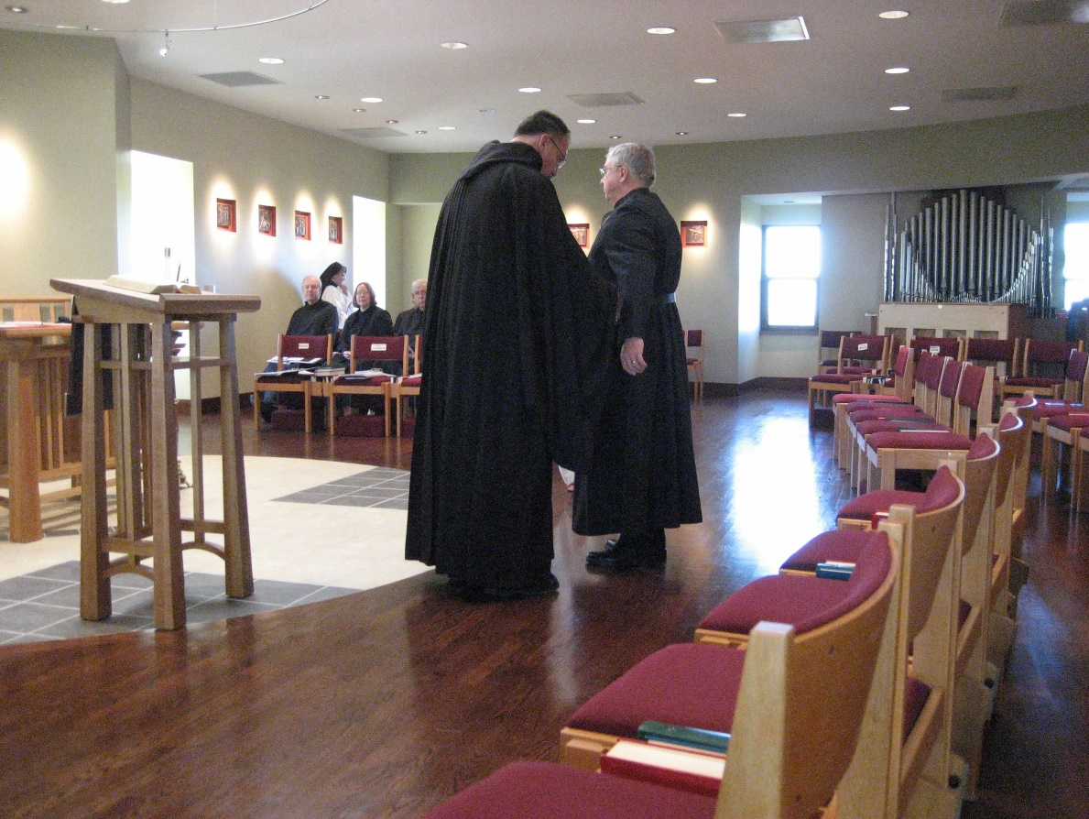
0300406244567619904256102706360.jpg Br. Luke Doucette; Sr. Anna Grace Madden; Sr. Teresa Beebe; Br. Timothy Titus Lunt; Abbot Michael John Austin; Br. Bede Leach

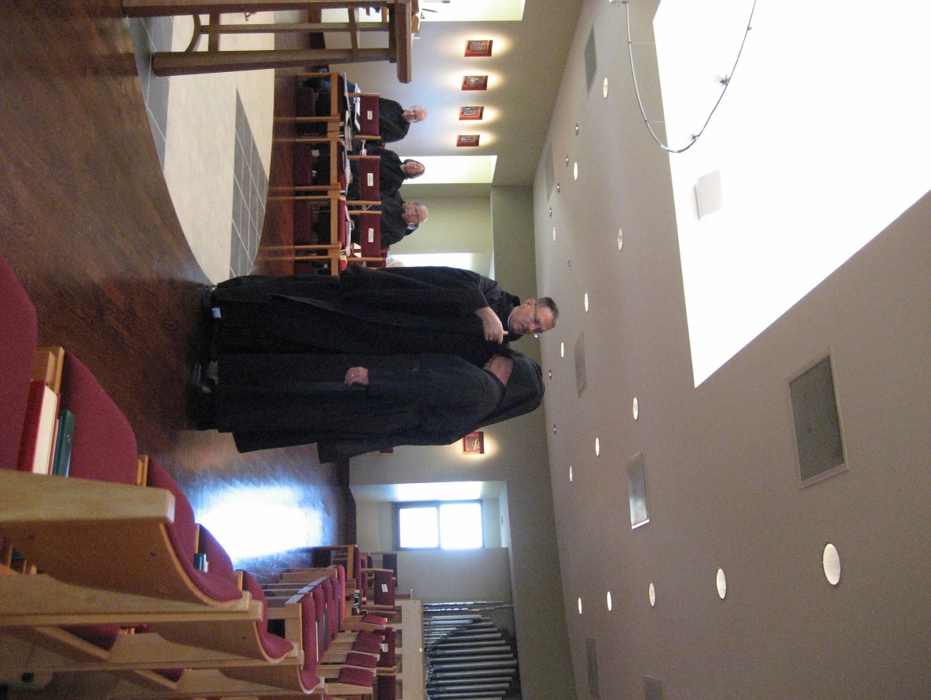
0300406244567619904256102706457.jpg Br. Luke Doucette; Sr. Teresa Beebe; Br. Lawrence Mullen; Br. Timothy Titus Lunt; Abbot Michael John Austin; Br. Bede Leach

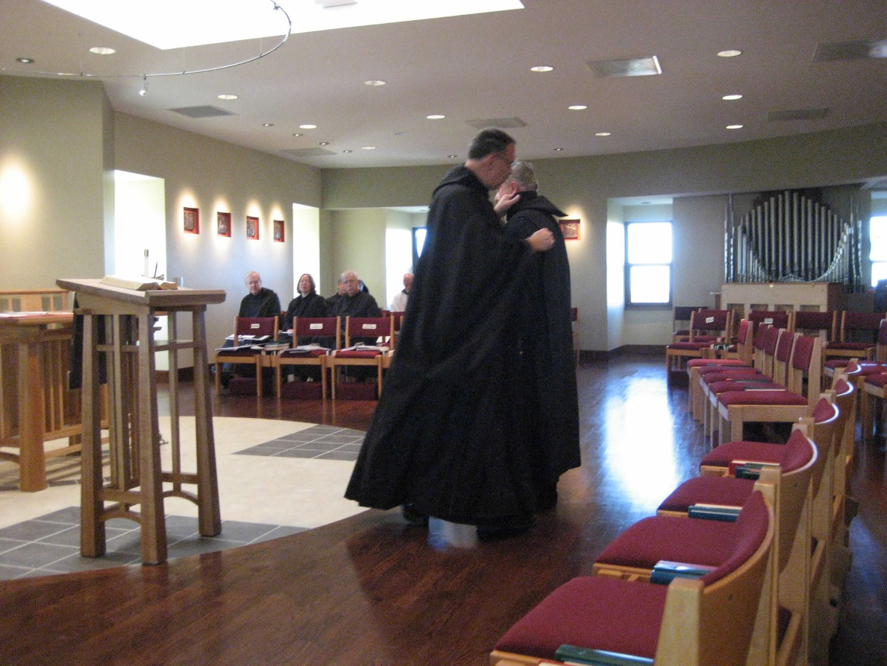
0300406244567619904256102706558.jpg Br. Luke Doucette; Sr. Teresa Beebe; Br. Lawrence Mullen; Br. Timothy Titus Lunt; Br. David Vincent Cotton; Abbot Michael John Austin; Br. Bede Leach

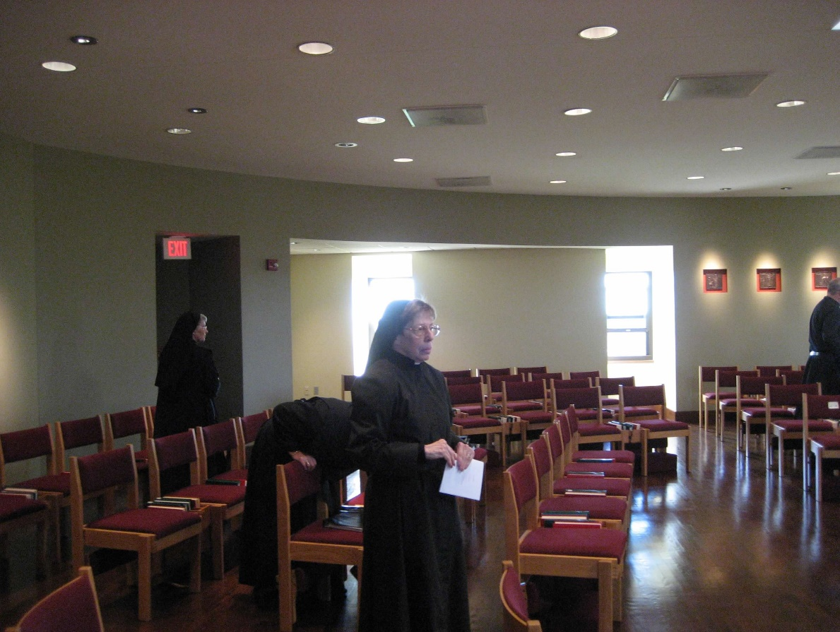
0300406244567619904256102706698.jpg Sr. Mary Francis Deulen; Sr. Monica Ruth Mullen


0300406244567619904256102706787.jpg

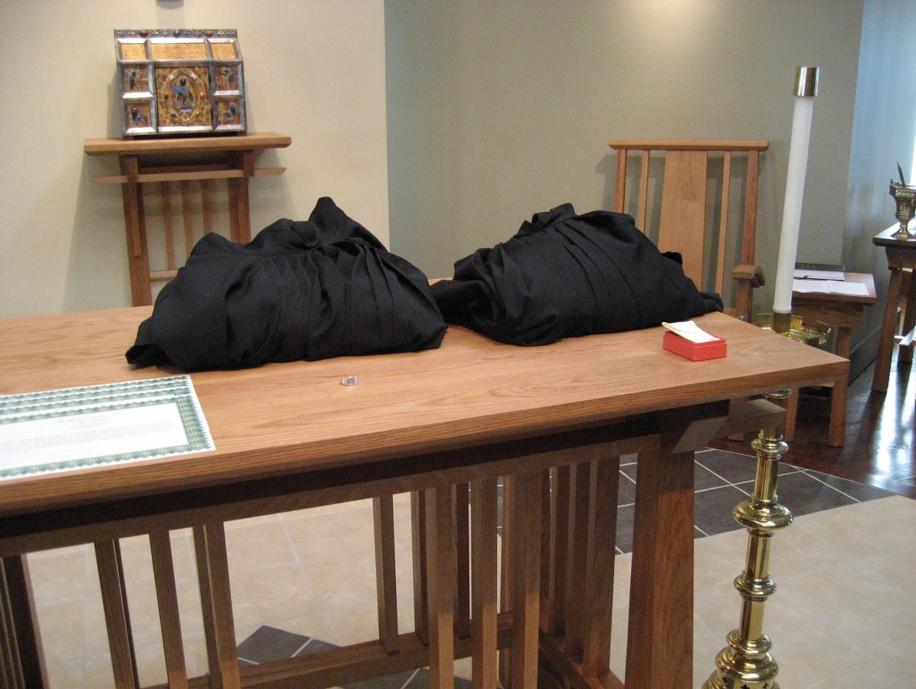
0300406244567619904256102706871.jpg

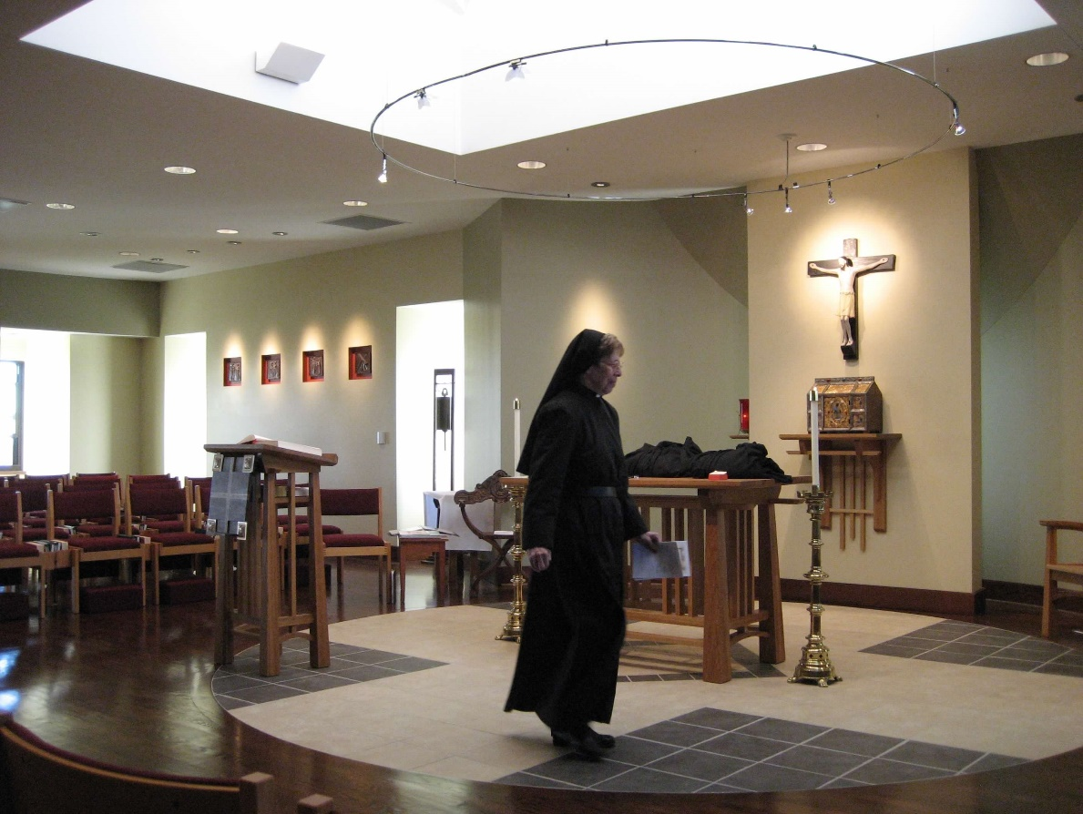
0300406244567619904256102707234.jpg Sr. Monica Ruth Mullen

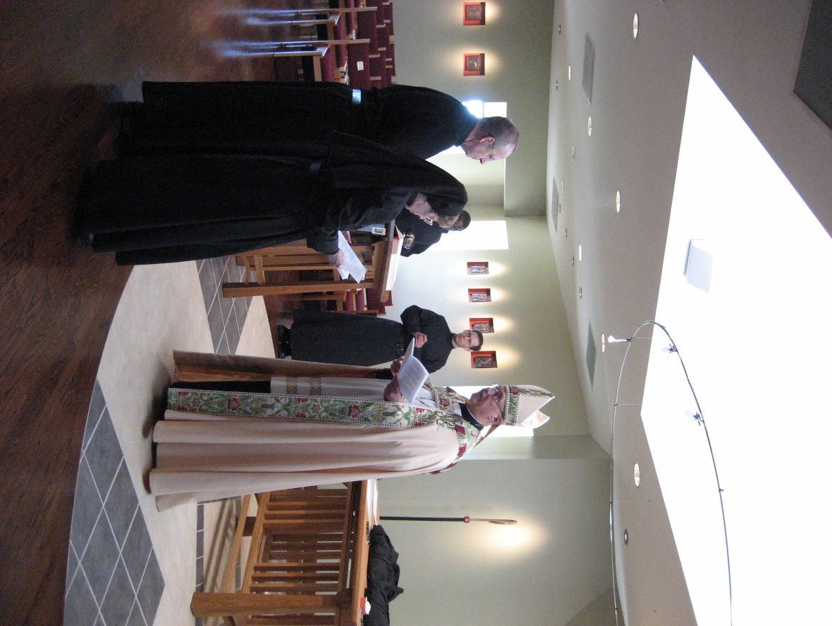
0300406244567619904256102707316.jpg Br. Gabriel Hale; Sr. Monica Ruth Mullen; Br. Thomas Ferrell; Br. Aelred Shemanov; Abbot Michael John Austin

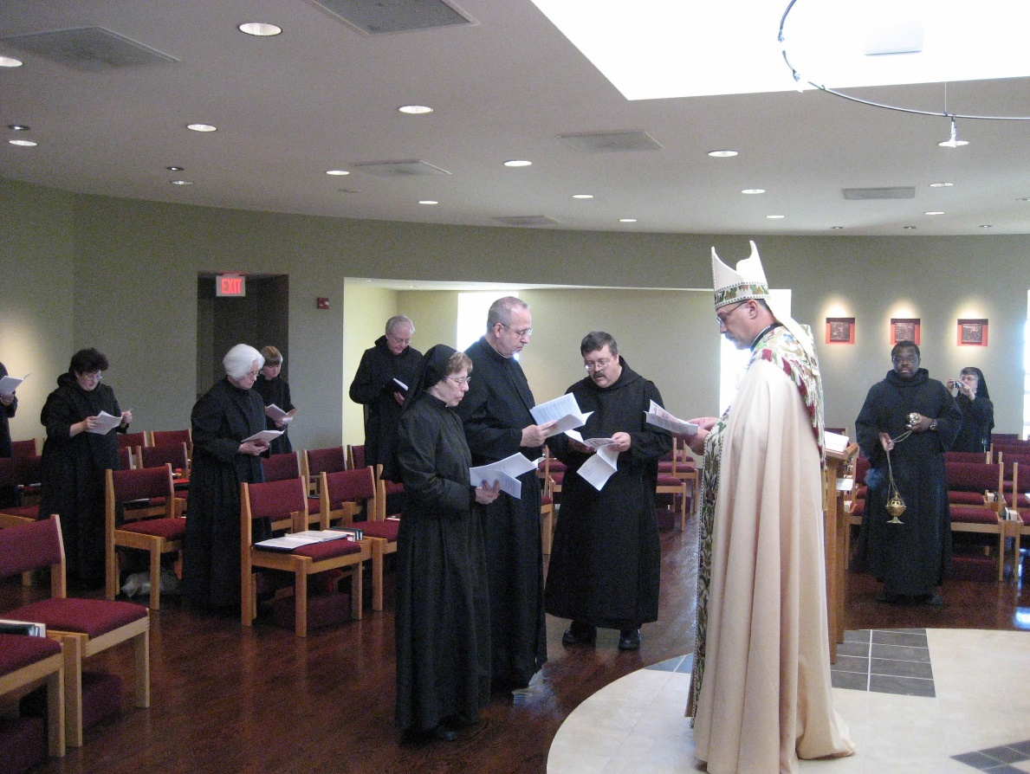
0300406244567619904256102707408.jpg Br. Cecelia; Sr Elizabeth Anne Stribley; Sr. Catherine Unterseher; Br. Luke Doucette; Sr. Monica Ruth Mullen; Br. Gabriel Hale; Br. Paul Howard; Abbot Michael John Austin; Br. Thomas Ferrell; Br. Thomas Ferrell; Sr. Anna Grace Madden

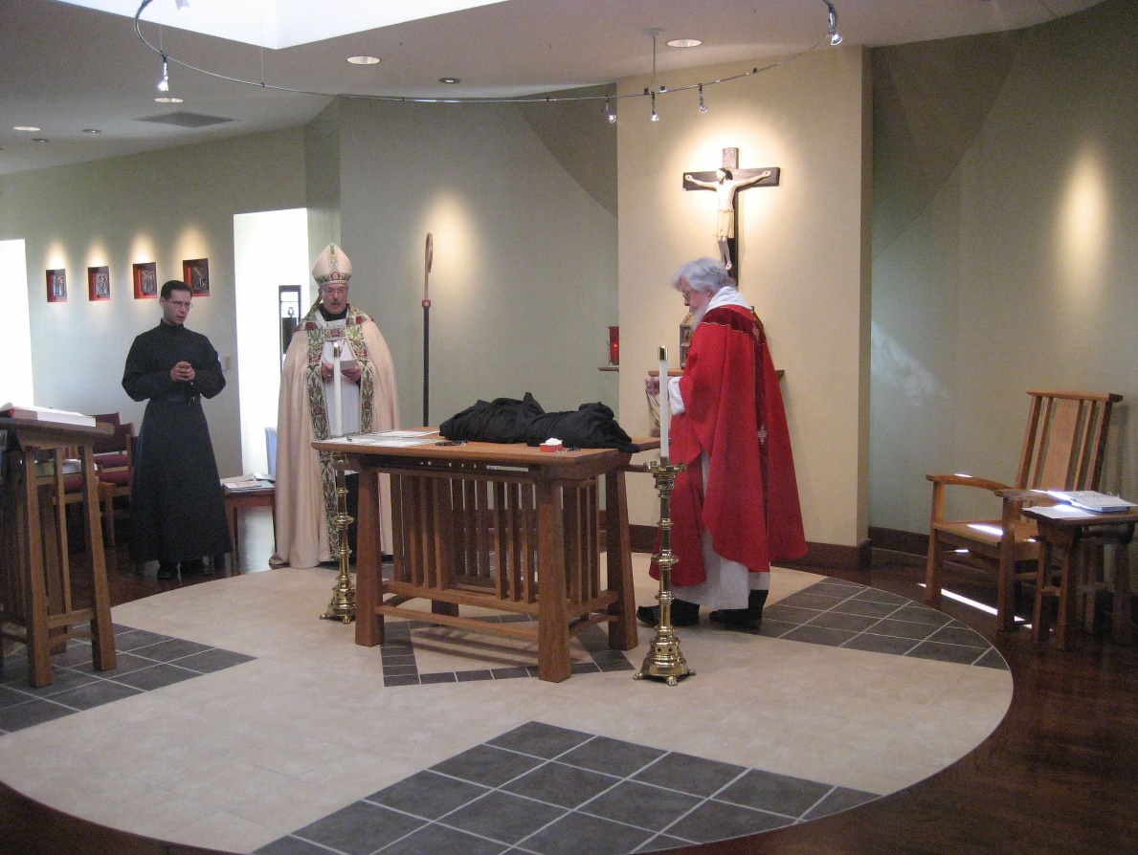
0300406244567619904256102708450.jpg Br. Aelred Shemanov; Abbot Michael John Austin; Fr. Wayne Kamm

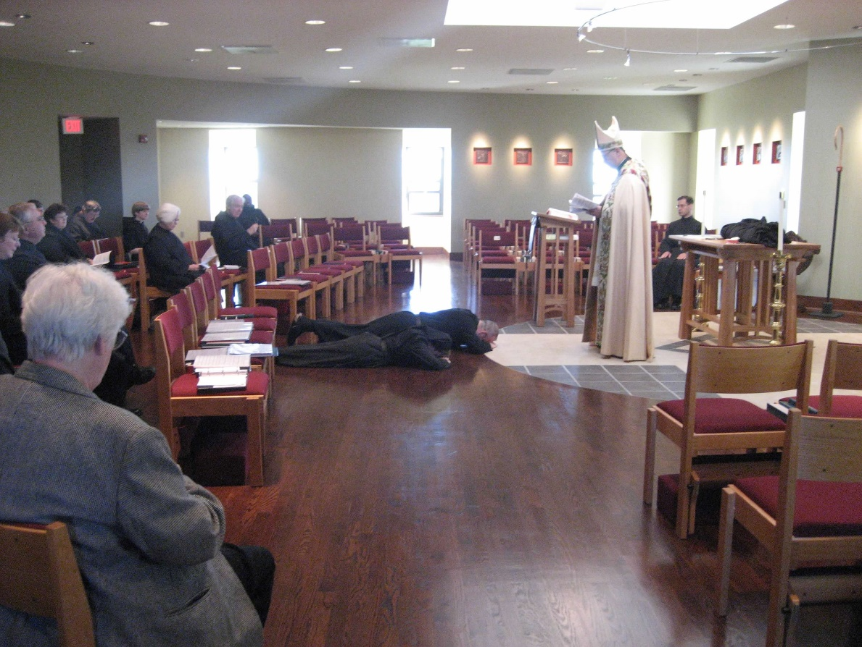
0300406244567619904256102708569.jpg Michelle Moore; Br. Bede Leach; Jackie Hale; Sr. Cecelia Lamoy; Br. Paul Howard; Sr. Catherine Unterseher; Sr. Elizabeth Anne Stribley; Br. Thomas Ferrell; Sr. Monica Ruth Mullen; Br. Gabriel Hale; Abbot Michael John Austin; Br. Aelred Shemanov

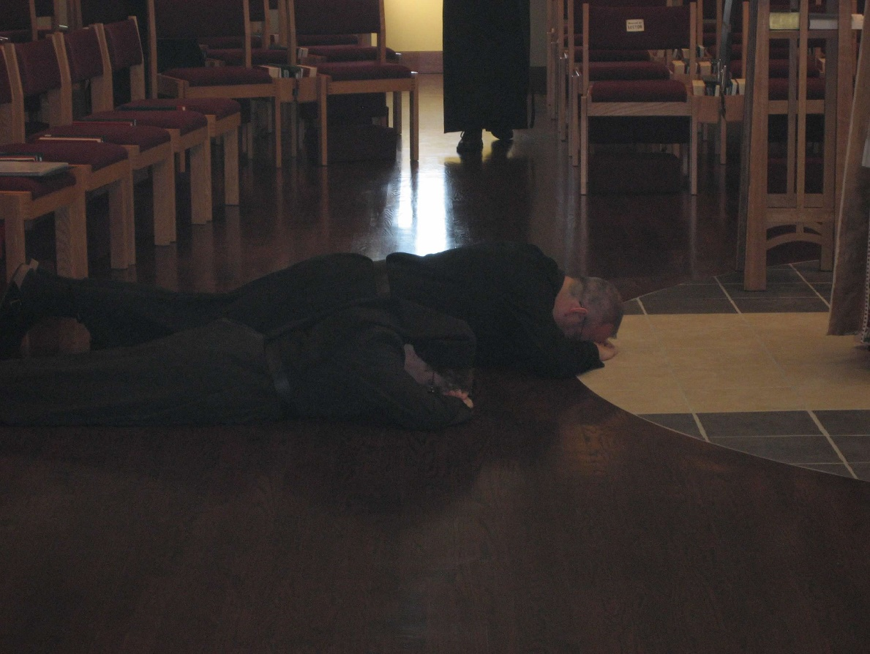
0300406244567619904256102708647.jpg Sr. Monica Ruth Mullen; Br. Gabriel Hale

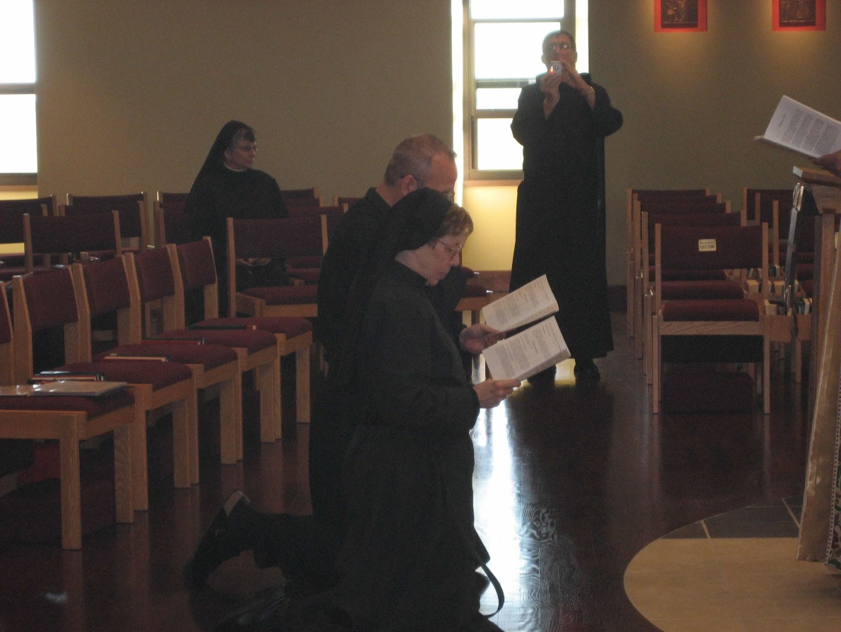
0300406244567619904256102708730.jpg Sr. Anna Grace Mullen; Br. Gabriel Hale; Sr. Monica Ruth Mullen; Br. Camillus Converse

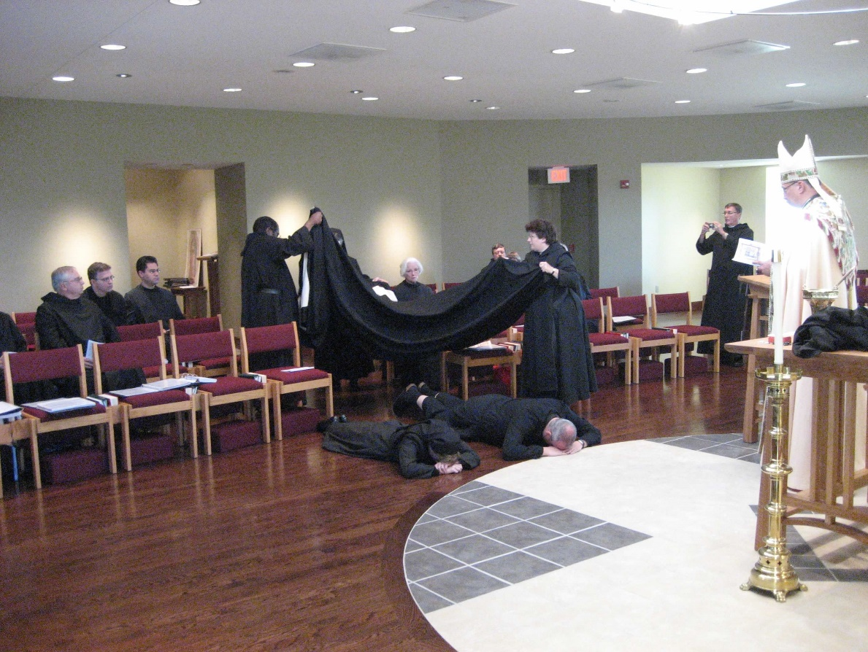
0300406244567619904256102708815.jpg Br. Bede Leach; Greg Kennedy; Br. Daniel Medina; Br. Thomas Ferrell; Sr. Elizabeth Anne Stribley; Sr. Monica Ruth Mullen; Br. Paul Howard; Sr. Cecelia Lamoy; Br. Gabriel Hale; Br. Camillus Converse; Abbot Michael John Austin;

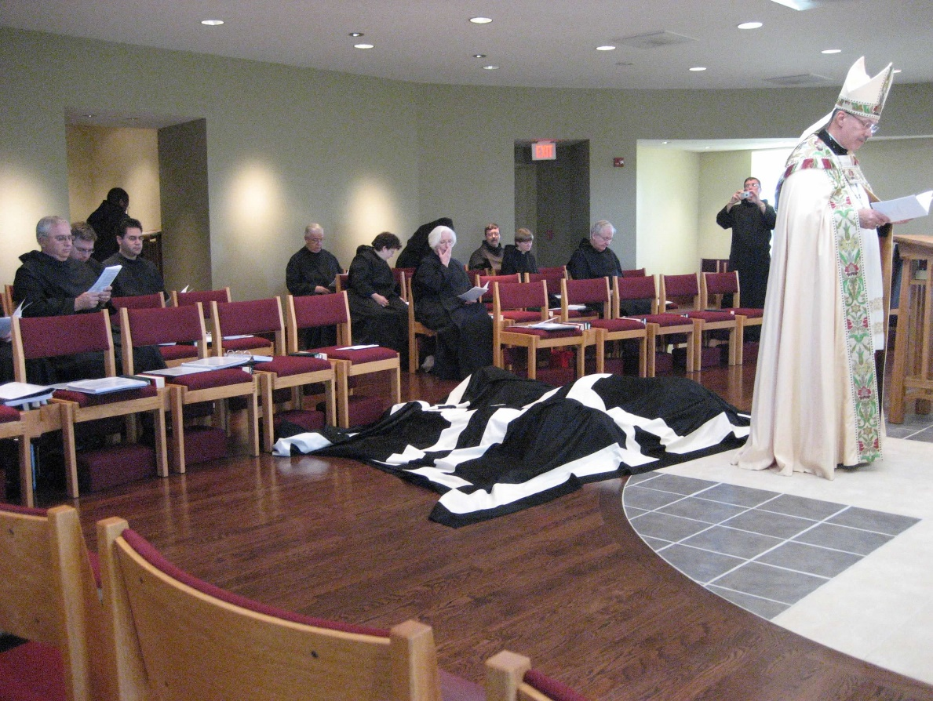
0300406244567619904256102708897.jpg Br. Bede Leach; Greg Kennedy; Br. Thomas Ferrell; Br. Daniel Medina; Br. Timothy Titus Lunt; Sr. Cecelia Lamoy; Sr. Elizabeth Anne Stribley; Br. Paul Howard; Sr. Catherine Unterseher; Br. Luke Doucette; Br. Camillus Converse; Abbot Michael John Austin

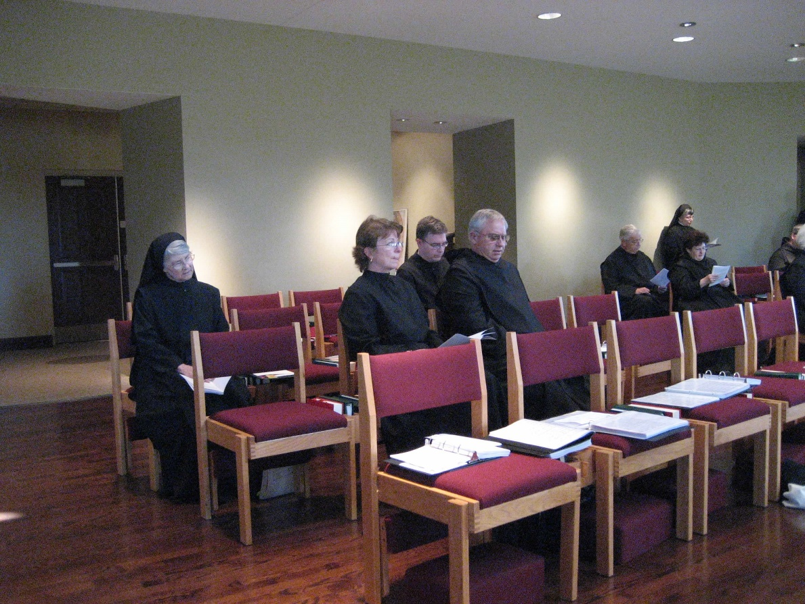
0300406244567619904256102709002.jpg Sr. Mary Francis Deulen; Michelle Moore; Greg Kennedy; Br. Bede Leach; Br. Timothy Titus Lunt; Sr. Anna Grace Madden; Sr. Cecelia Lamoy

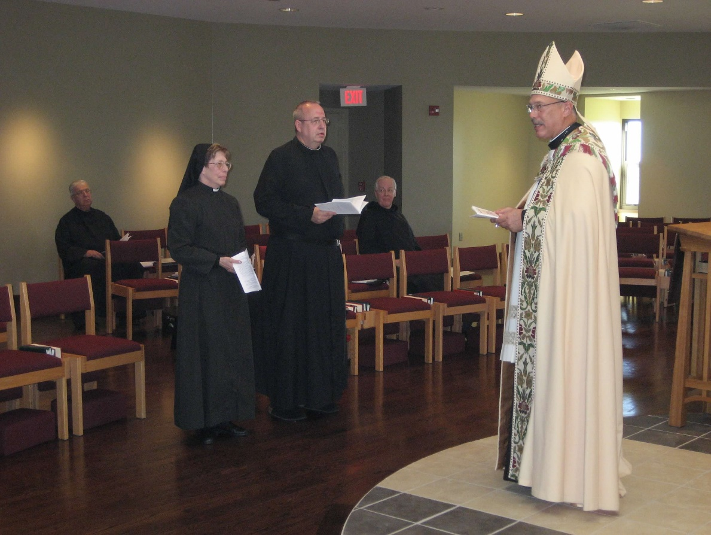
0300406244567619904256102709382.jpg Br. Timothy Titus Lunt; Sr. Monica Ruth Mullen; Br. Gabriel Hale; Br. Luke Doucette; Abbot Michael John Austin

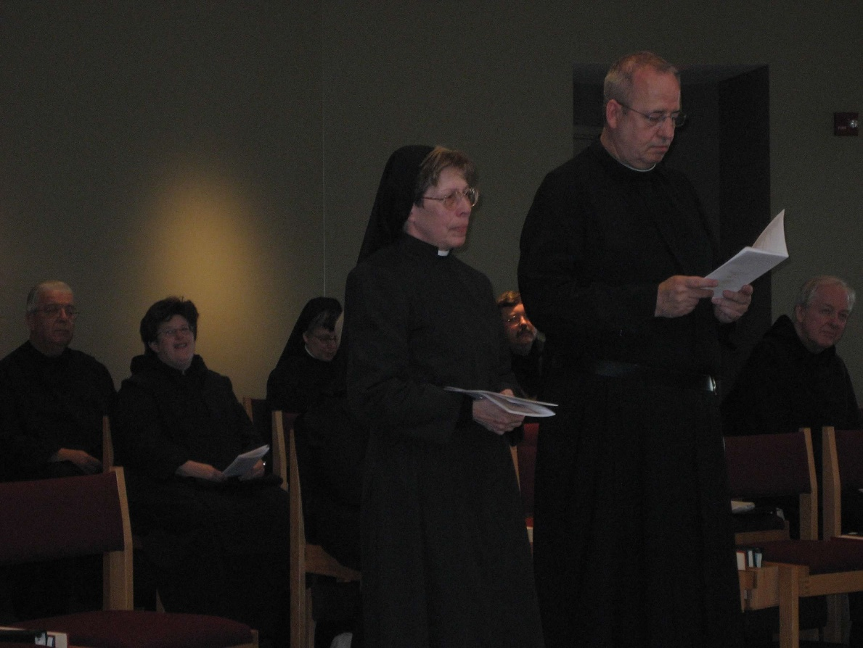
0300406244567619904256102709499.jpg Br. Timothy Titus Lunt; Sr. Cecelia Lamoy; Sr. Anna Grace Madden; Sr. Monica Ruth Mullen; Br. Paul Howard; Br. Gabriel Hale; Br. Luke Doucette

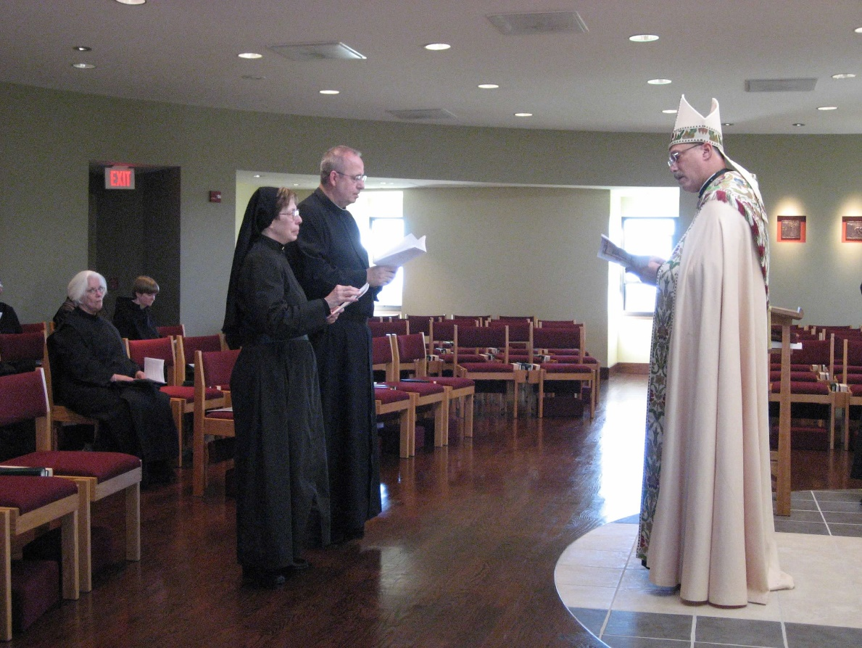
0300406244567619904256102709575.jpg Sr. Elizabeth Anne Stribley; Sr. Monica Ruth Mullen; Br. Gabriel Hale; Abbot Michael John Austin

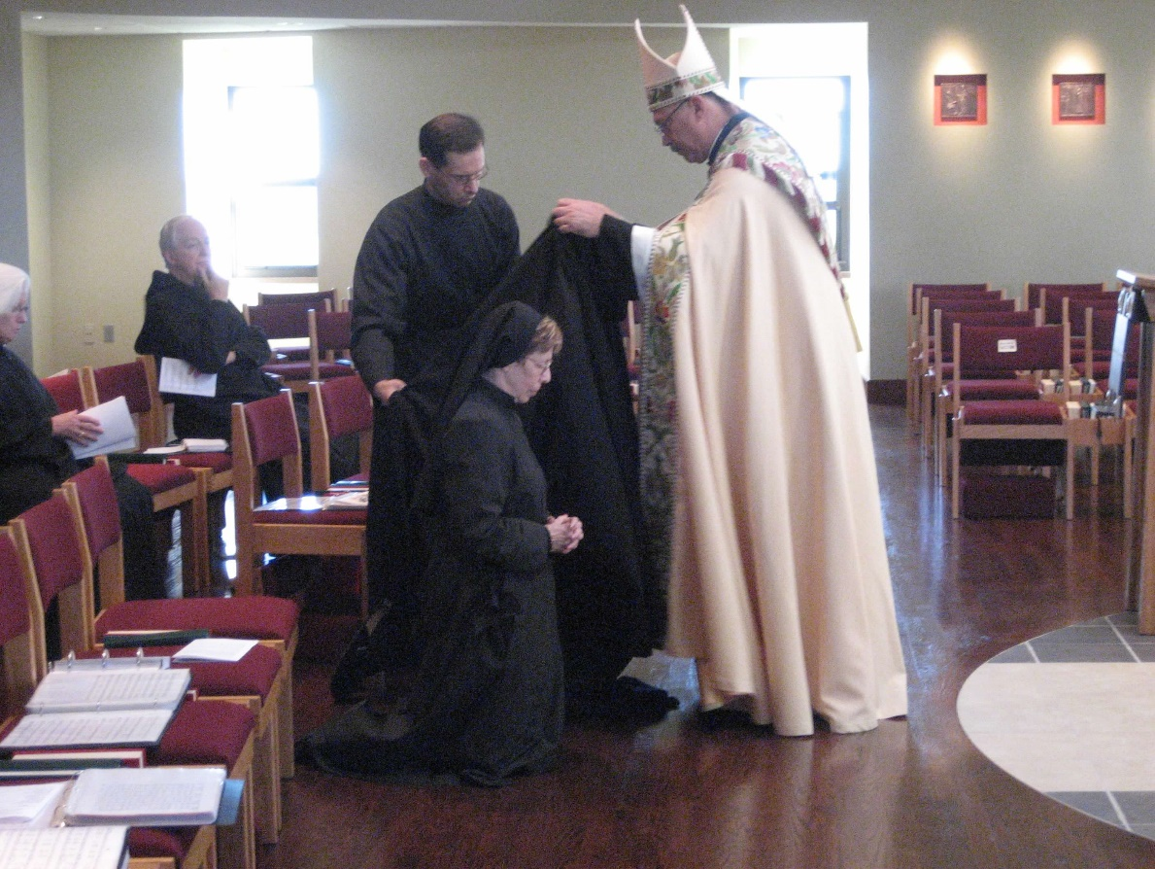
0300406244567619904256102709946.jpg Sr. Elizabeth Anne Stribley; Br. Luke Doucette; Br. Aelred Shemanov; Sr. Monica Ruth Mullen; Br. Gabriel Hale; Abbot Michael John Austin

