Companions of St. Luke
2008 Fall Convocation at Conception Abbey
Part 2 of 3

~Edited by Br. Steven Olderr, 17 June 2022 with the assistance of Br. Thomas Ferrell. If you find any errors or omissions or have anything to add, please notify Br. Steven at olderr@ameritech.net

People are identified from left to right.

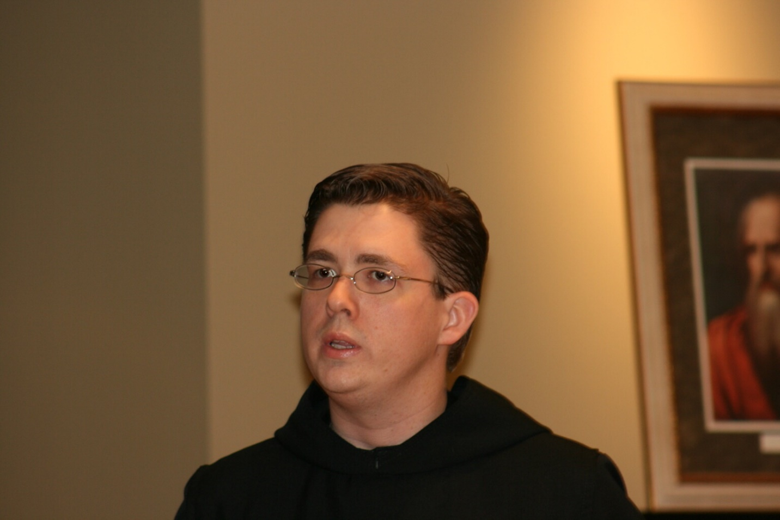
36290077 Br. Aidan Maguire
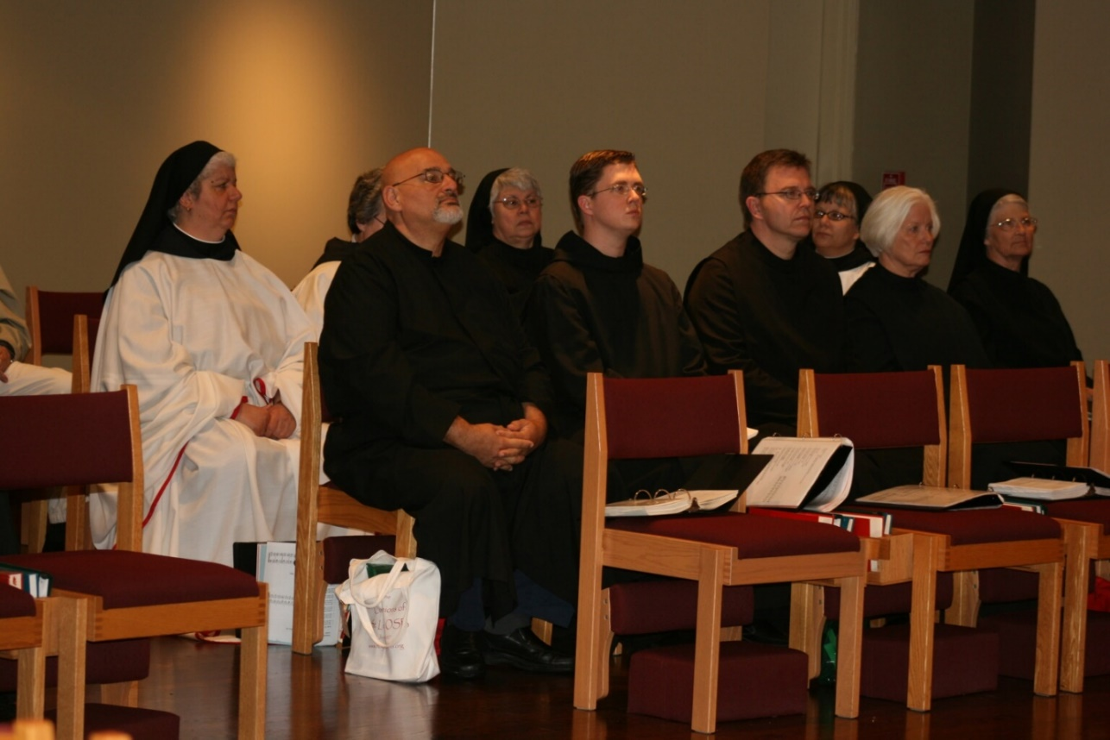
36290078 Sr. Mary Catherine Christopher; Sr. Vincent Marie Rittenhouse; Br. Simon DiNapoliSr. Clare Benedicta Myers; Br. Aidan Maguire; Br. John of Kanty Kennedy; Sr. Anna Grace Madden; Sr. Catherine Anne Stribley; Sr. Mary Francis Deulen

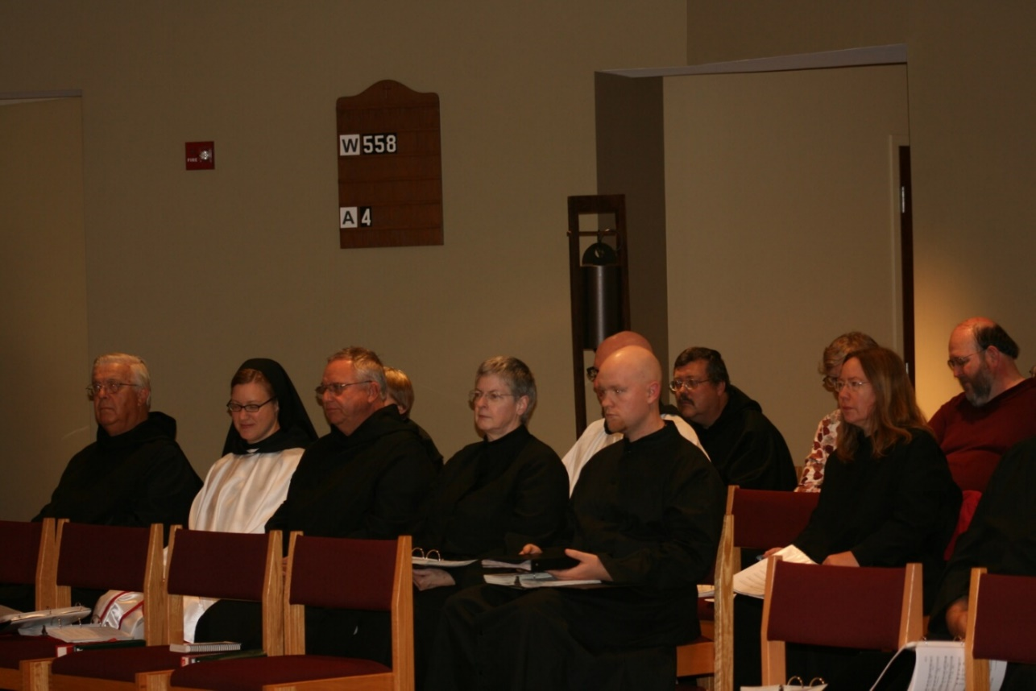
36290079 Br. Timothy Titus Lunt; Sr. Hannah Sophia Korver; Br. Bede Leach; Sr. Catherine Unterseher; Sr. Bernadette Barrett; Br. David Vincent Cotton; Br. Gregory Kingsley; Br. Paul Howard; ?; Sr. Teresa Beebe; ?

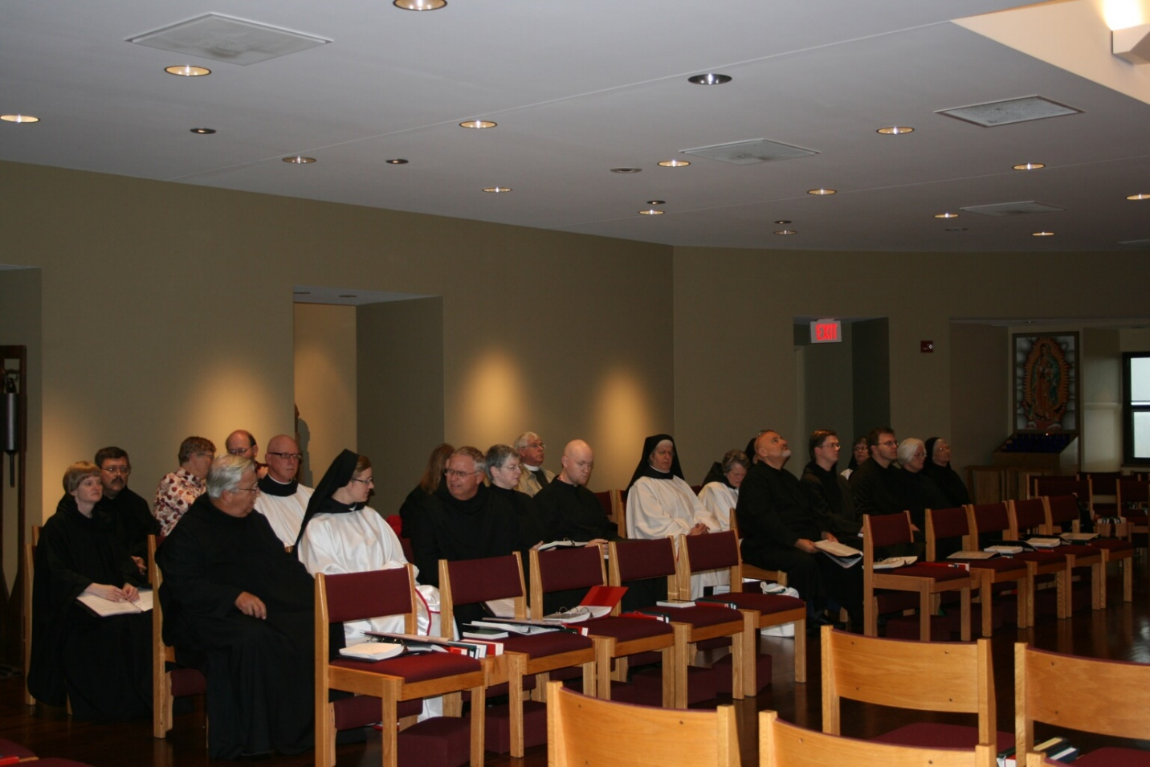
36290080 Sr.Catherine Unterseher; Br. Paul Howard; ?; Br. Timothy Titus Lunt; ?; Br. David Vincent Cotton; Sr. Hannah Sophia Korver; Sr. Teresa Beebe; Sr. Bernadette Barrett; ?; Br. Gregory Kingsley; Sr. Mary Catherine Christopher; Sr.Vincent Marie Rittenhouse; ?; Br. Aidan Maguire; Sr. Anna Grace Madden; Br. John of Kanty Kennedy; Sr. Catherine Anne Stribley; Sr. Mary Francis Deulen

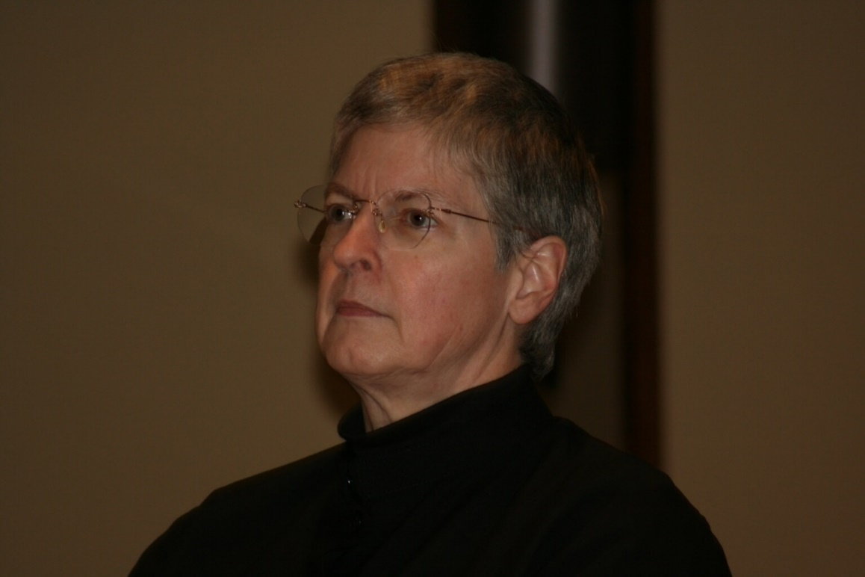
36290082 Sr. Bernadette Barrett

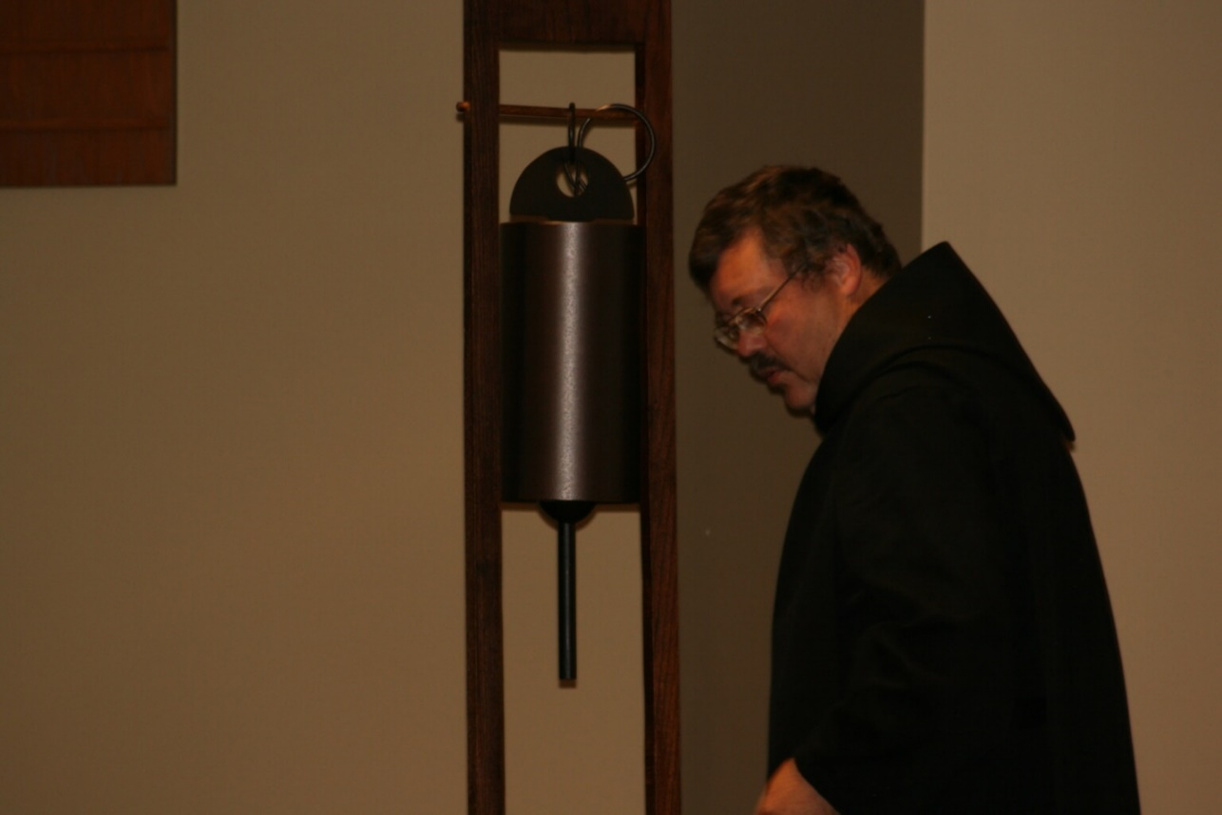
36290084 Br. Paul Howard


36290085 Sr. Elizabeth Anne Stribley

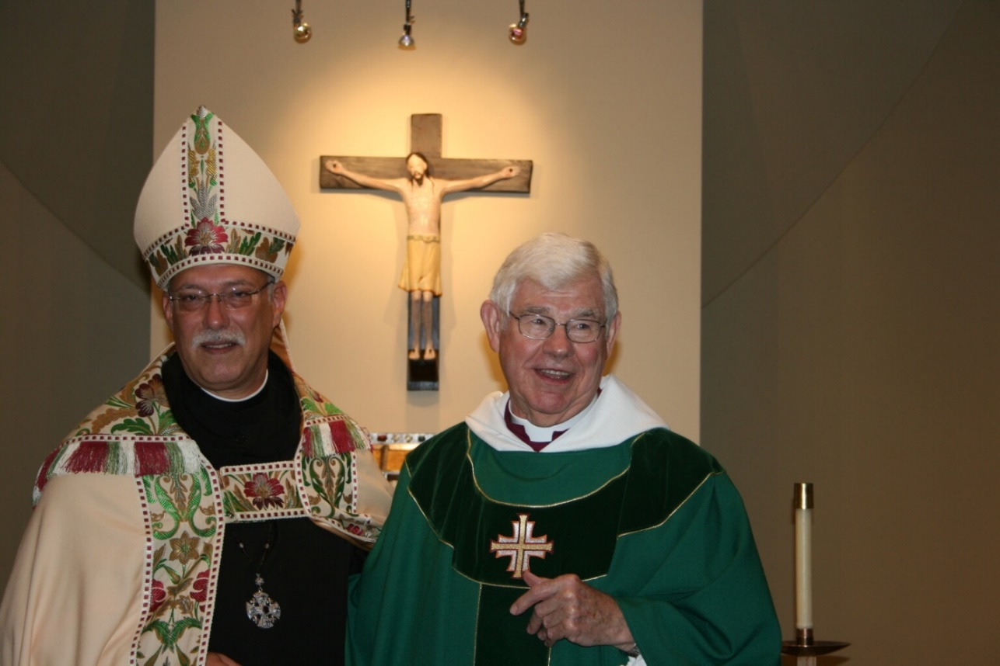
36290088 Abbot Michael John Austin; Rev. Canon Thomas Hulme

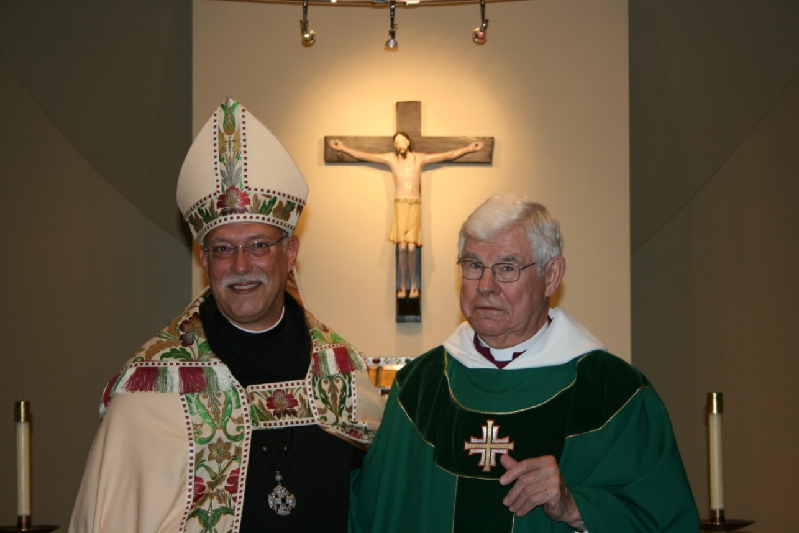
36290089 Abbot Michael John Austin; Rev. Canon Thomas Hulme

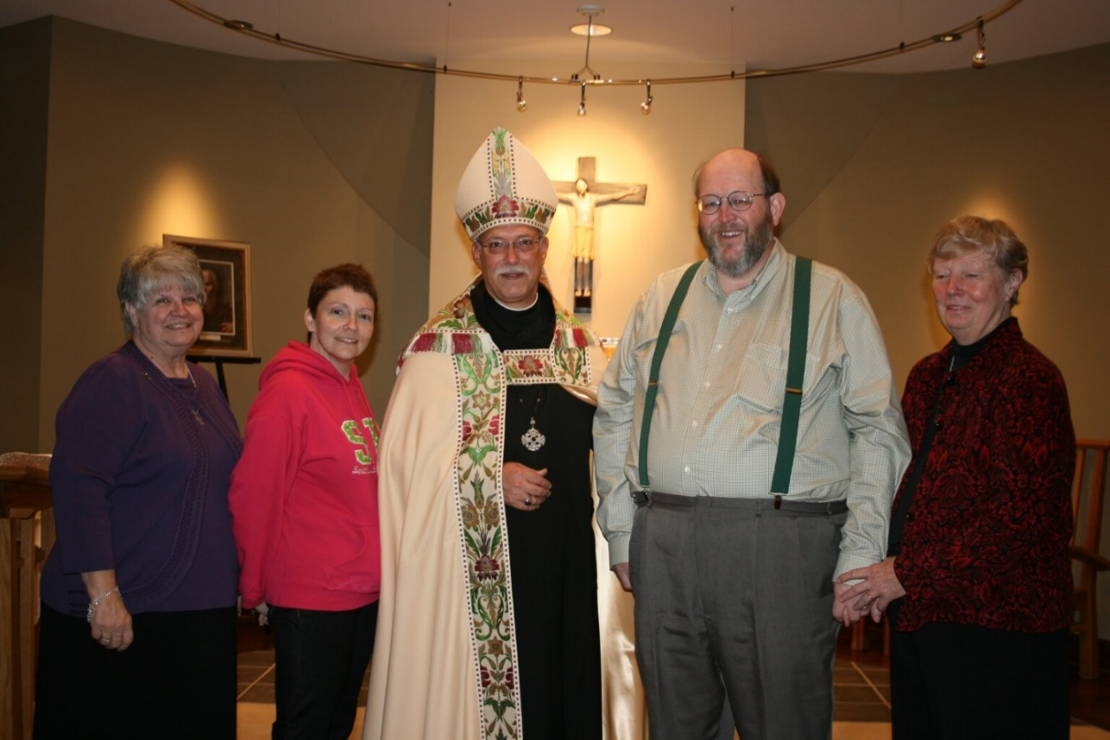
36290090 ?; Cindy Kennedy; Abbot Michael John Austin; ?; ?

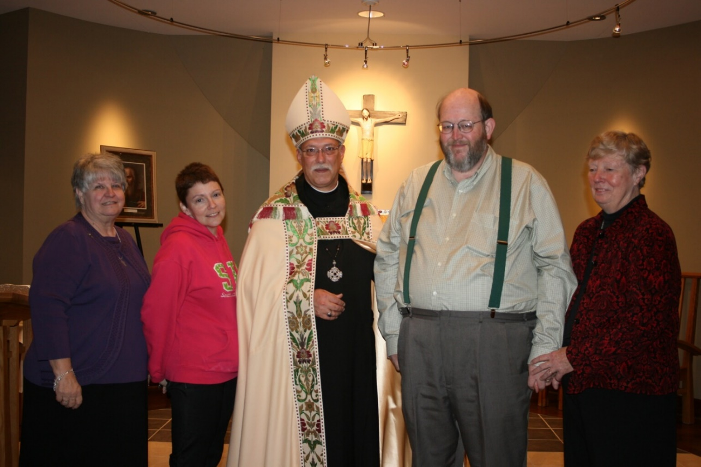
36290091 ?; Cindy Kennedy; Abbot Michael John Austin; ?; ?

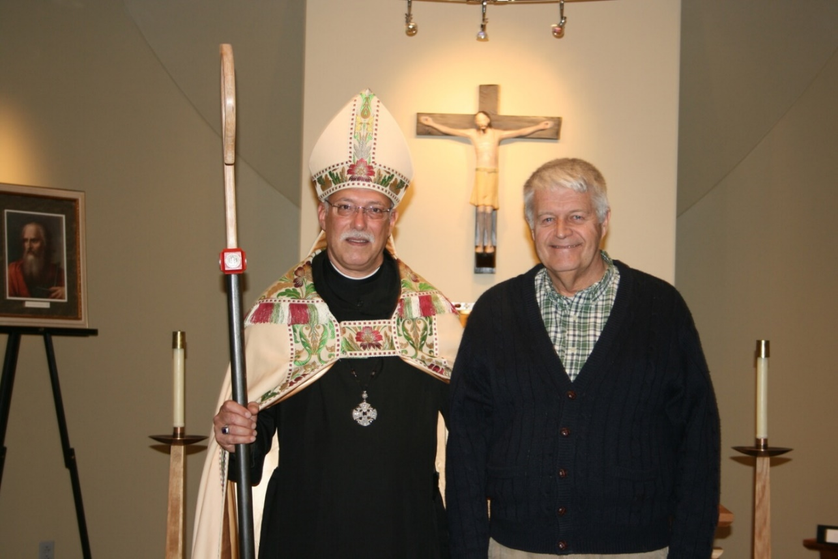
36290092 Abbot Michael John Austin; Michael McCabe

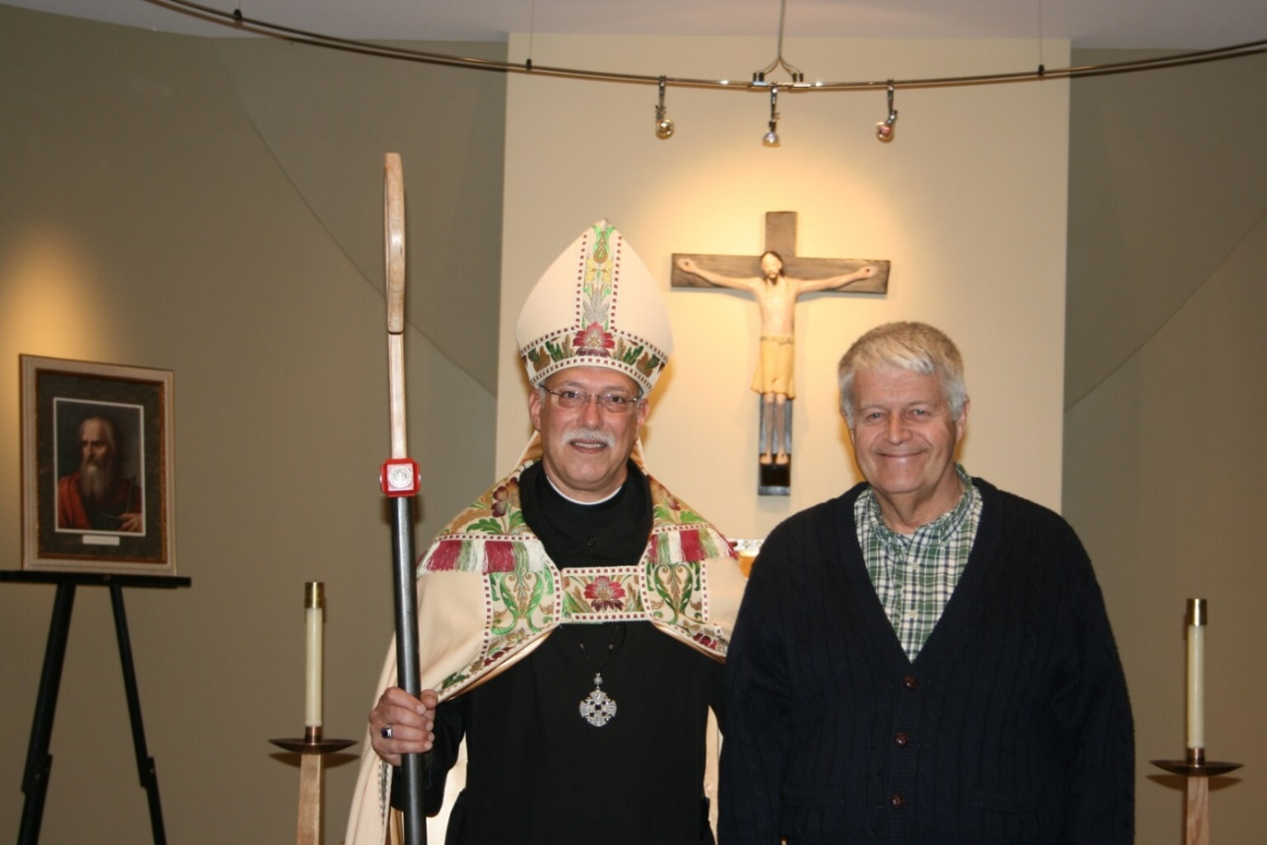
36290093 Abbot Michael John Austin; Michael McCabe

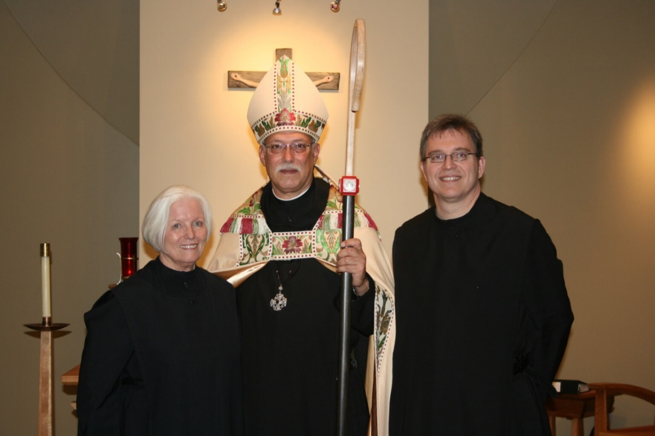
36290094 Sr. Elizabeth Anne Stribley; Abbot Michael John Austin; Br. John of Kanty Kennedy

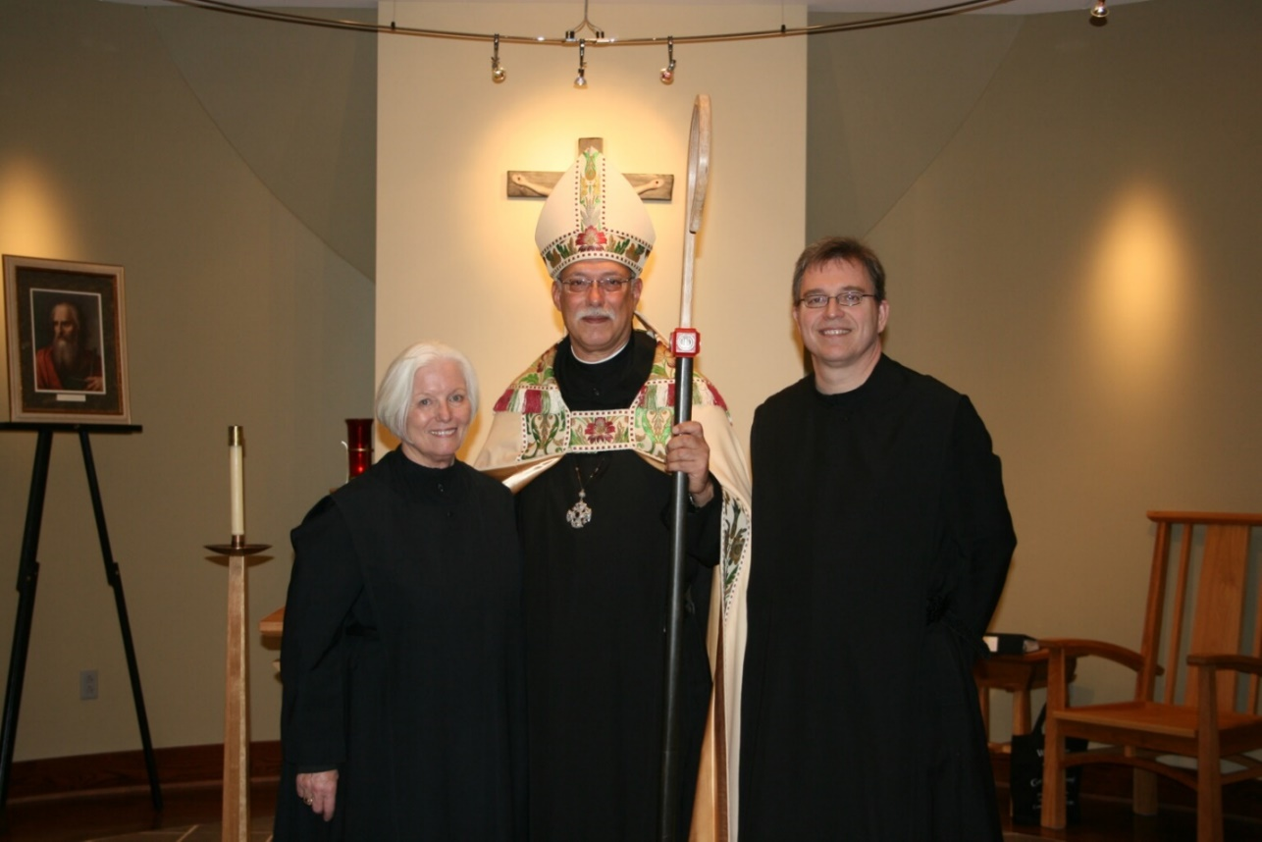
36290095 Sr. Elizabeth Anne Stribley; Abbot Michael John Austin; Br. John of Kanty Kennedy

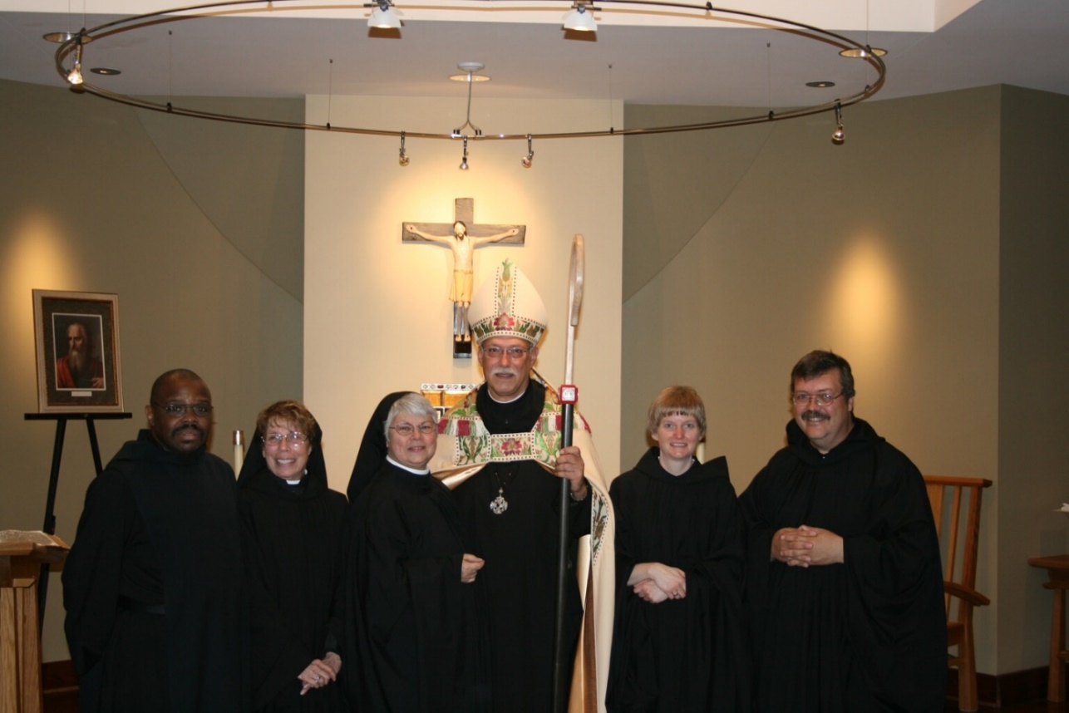
36290096 Br. Thomas Ferrell; Sr. Monica Ruth Mullen; Sr. Clare Benedicta Myers; Abbot Michael John Austin; Sr. Catherine Uterseher; Br. Paul Howard

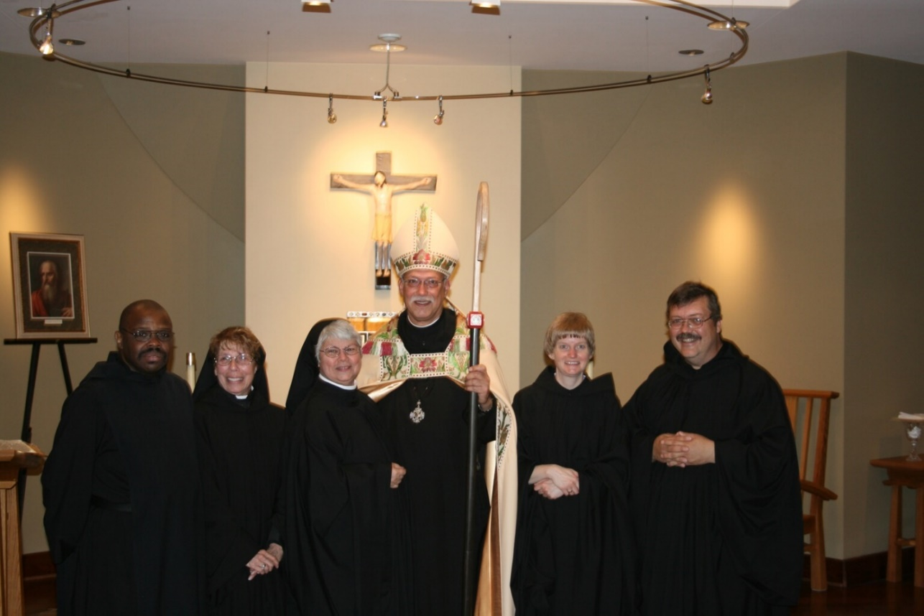
36290097 Br. Thomas Ferrell; Sr. Monica Ruth Mullen; Sr. Clare Benedicta Myers; Abbot Michael John Austin; Sr. Catherine Uterseher; Br. Paul Howard

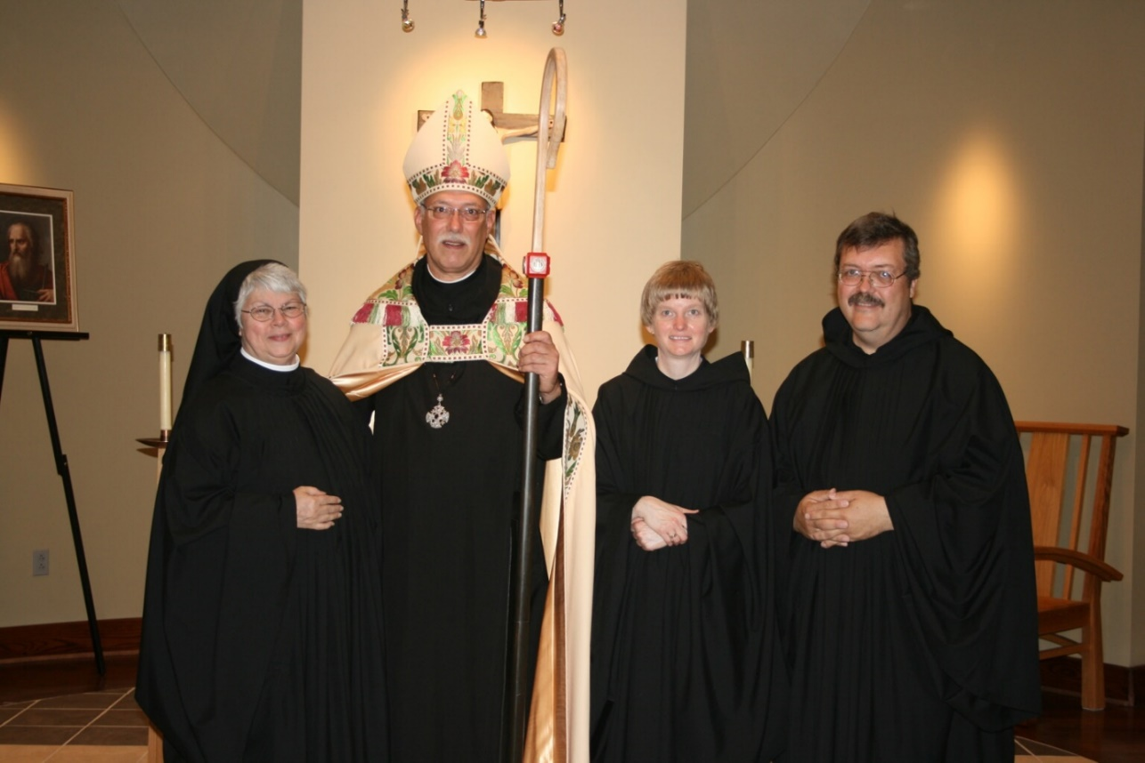
36290098 Sr. Clare Benedicta Myers; Abbot Michael John Austin; Sr. Catherine Uterseher; Br. Paul Howard

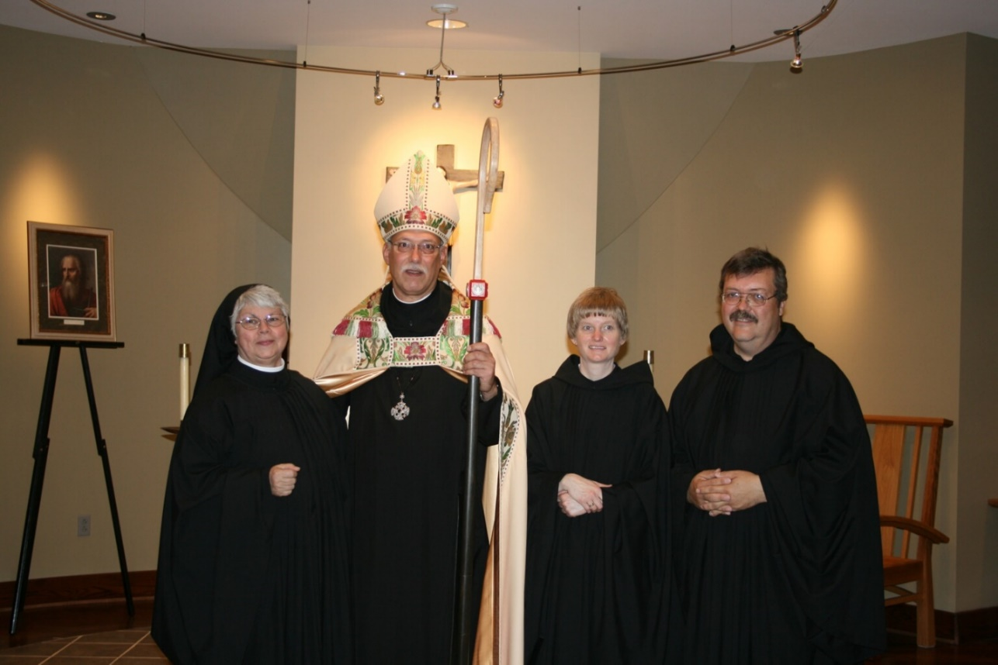
36290099 Sr. Clare Benedicta Myers; Abbot Michael John Austin; Sr. Catherine Uterseher; Br. Paul Howard

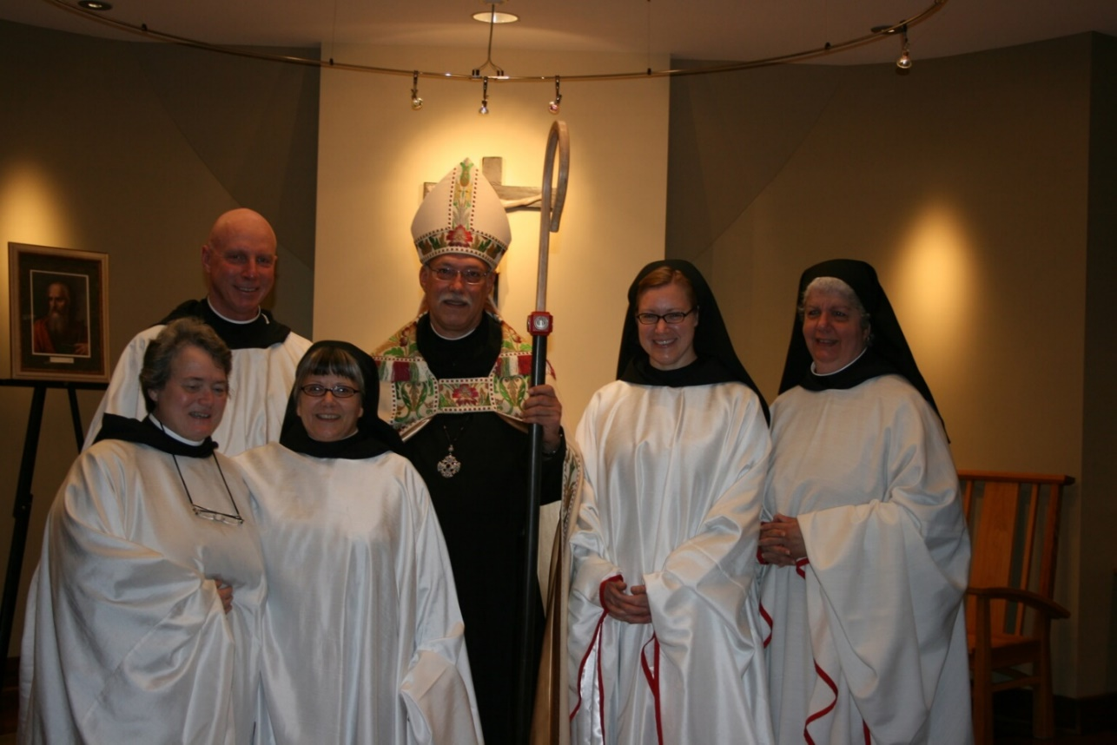
36290100 Sr. Vincent Marie Rittenhouse; Br. David Vincent Cotton; Sr. Anna Grace Madden; Abbot Michael John Vincent; Sr. Hannah Sophia Korver; Sr. Mary Catherine Christopher

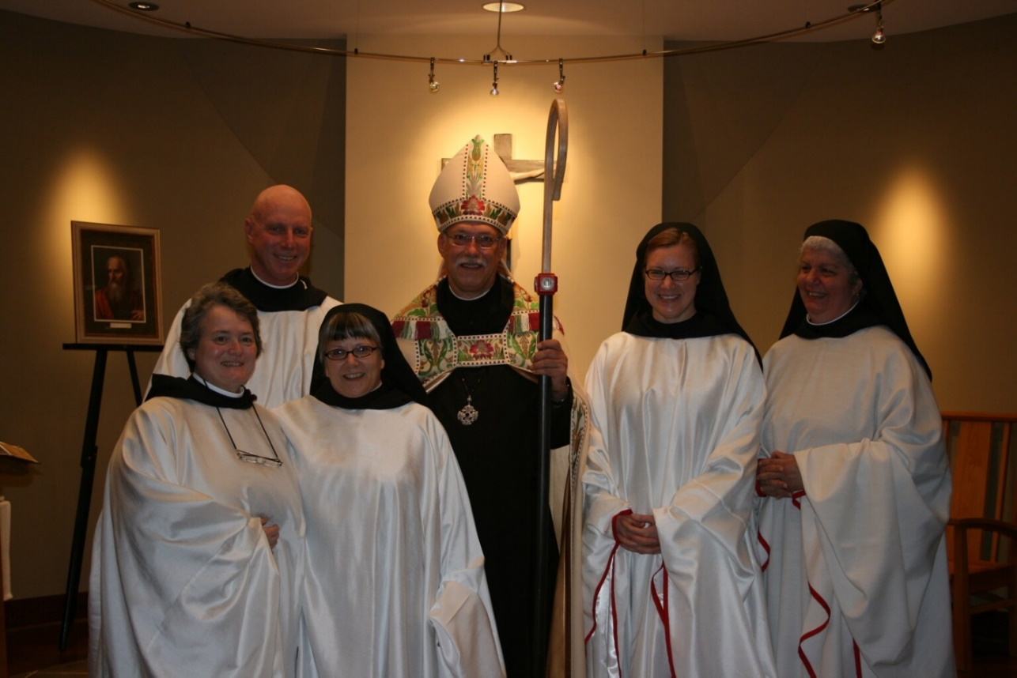
36290101 Sr. Vincent Marie Rittenhouse; Br. David Vincent Cotton; Sr. Anna Grace Madden; Abbot Michael John Vincent; Sr. Hannah Sophia Korver; Sr. Mary Catherine Christopher

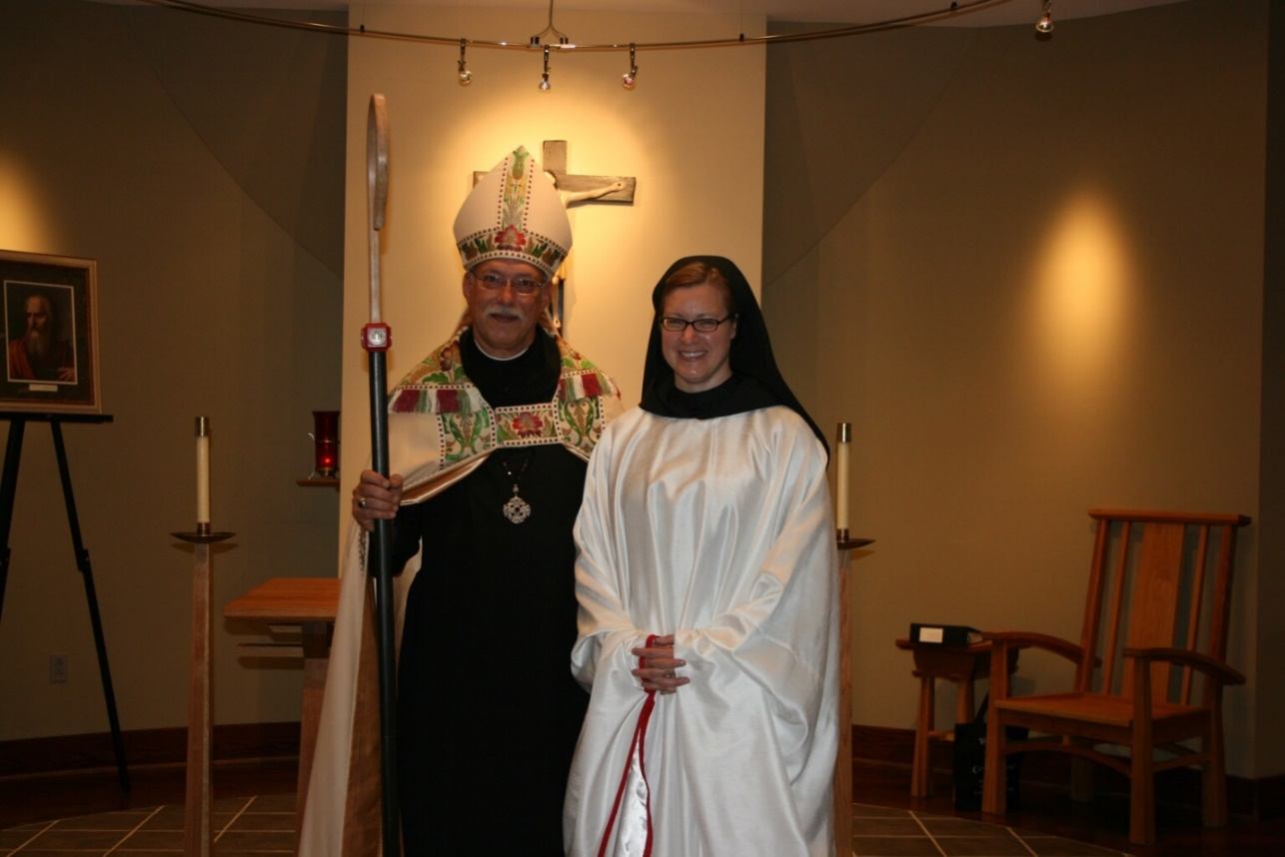
36290102 Abbot Michael John Vincent; Sr. Hannah Sophia Korver

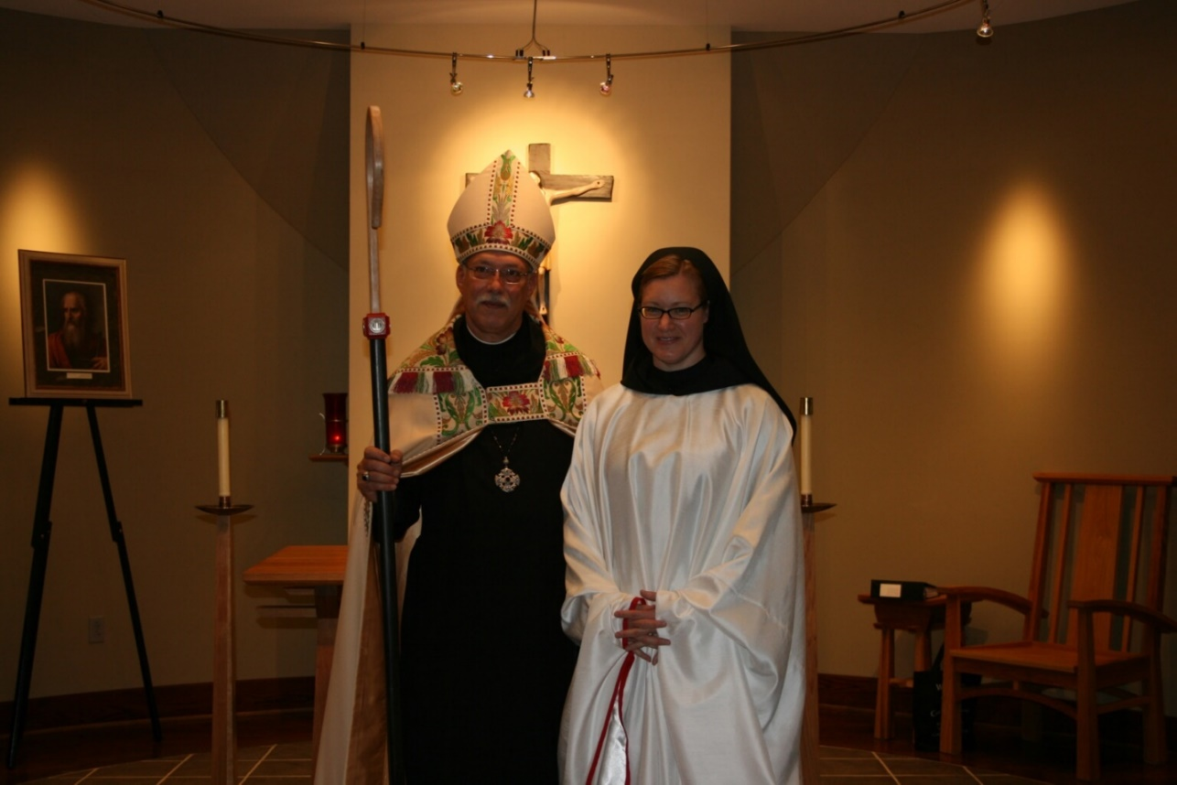
36290103 Abbot Michael John Vincent; Sr. Hannah Sophia Korver

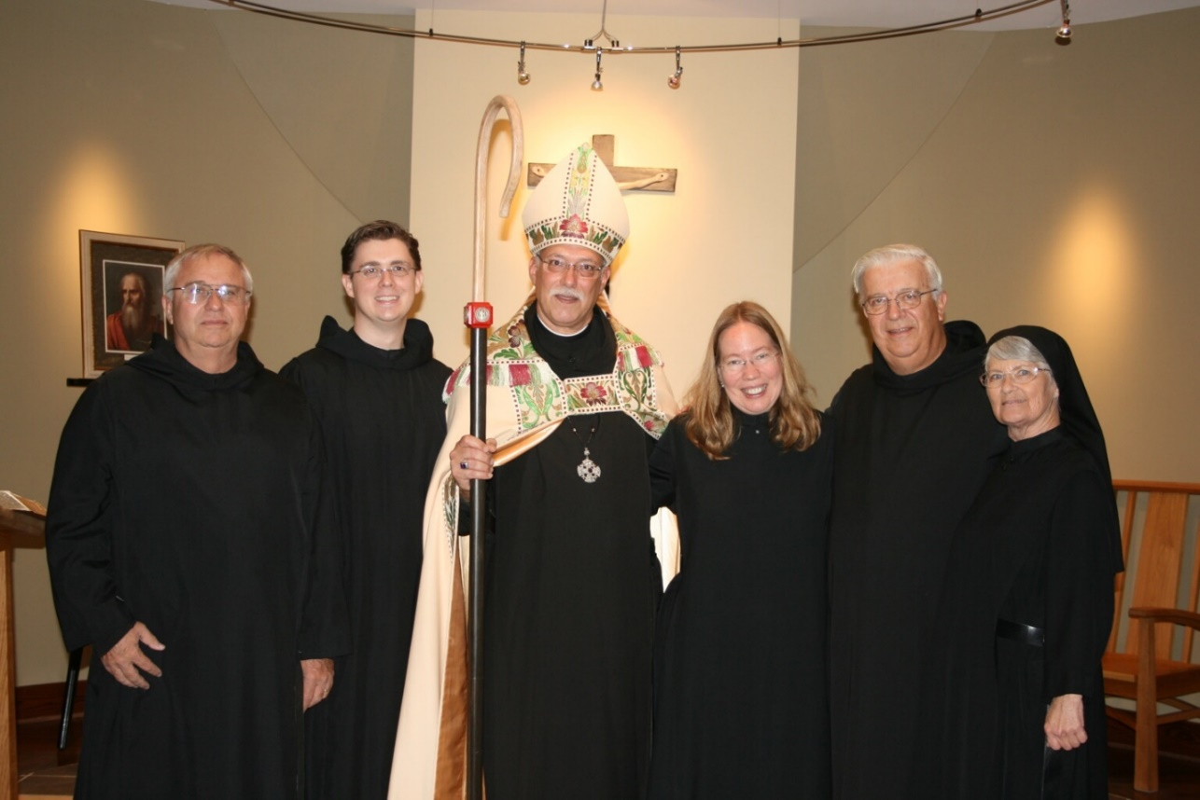
36290104 Br. Bede Leach; Br. Aidan Maguire; Abbot Michael John Austin; Sr. Teresa Beebe; Br. Timothy Titus Lunt; Sr. Mary Francis Deulen

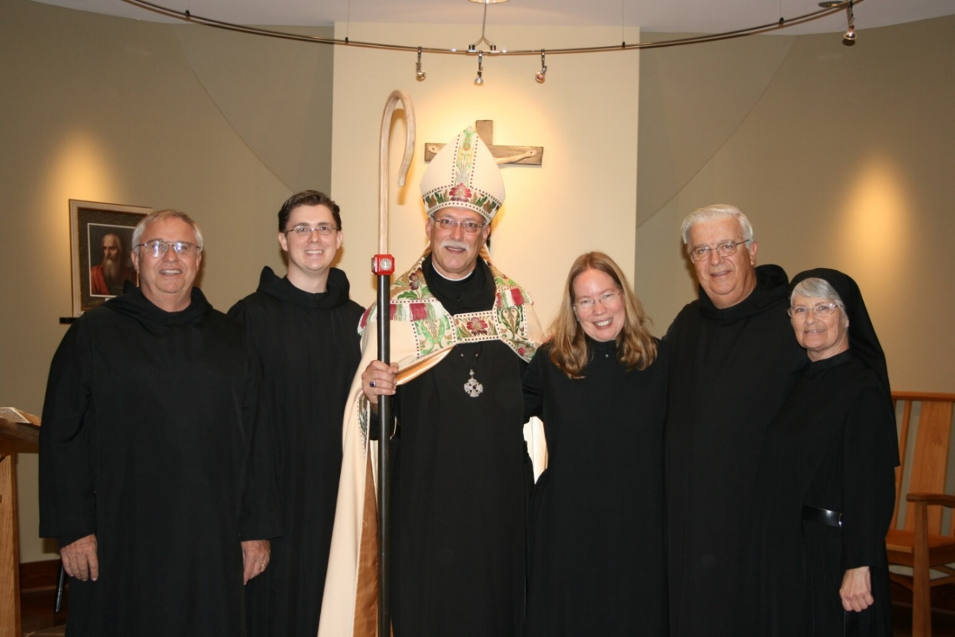
36290105 Br. Bede Leach; Br. Aidan Maguire; Abbot Michael John Austin; Sr. Teresa Beebe; Br. Timothy Titus Lunt; Sr. Mary Francis Deulen

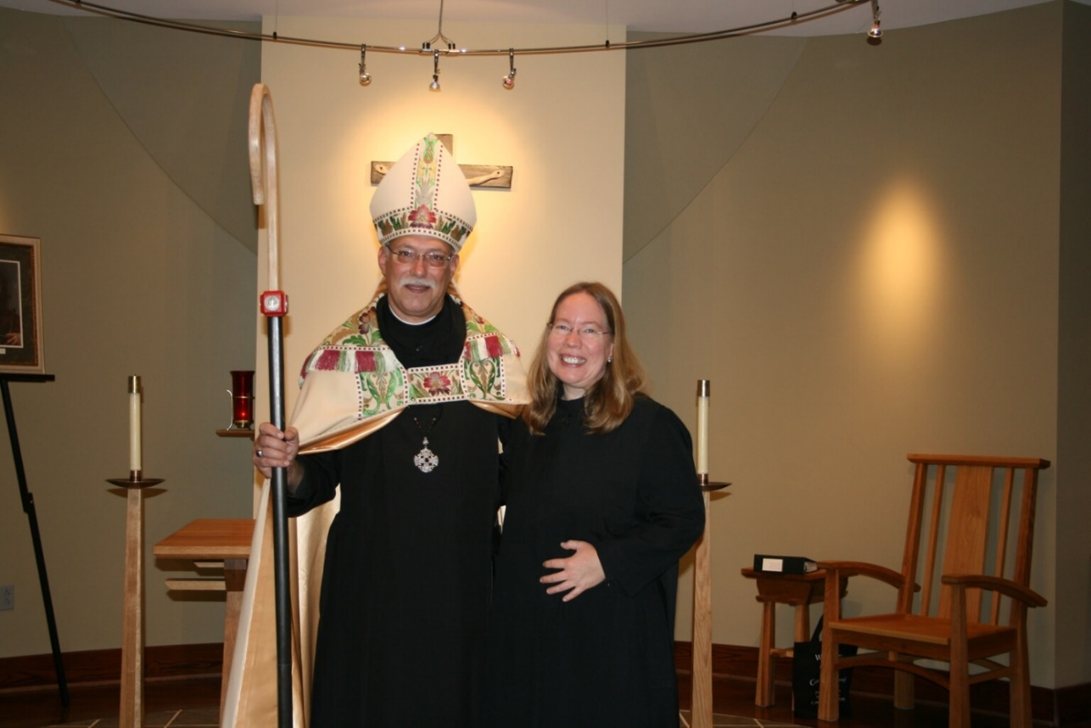
36290106 Abbot Michael John Austin; Sr. Teresa Beebe

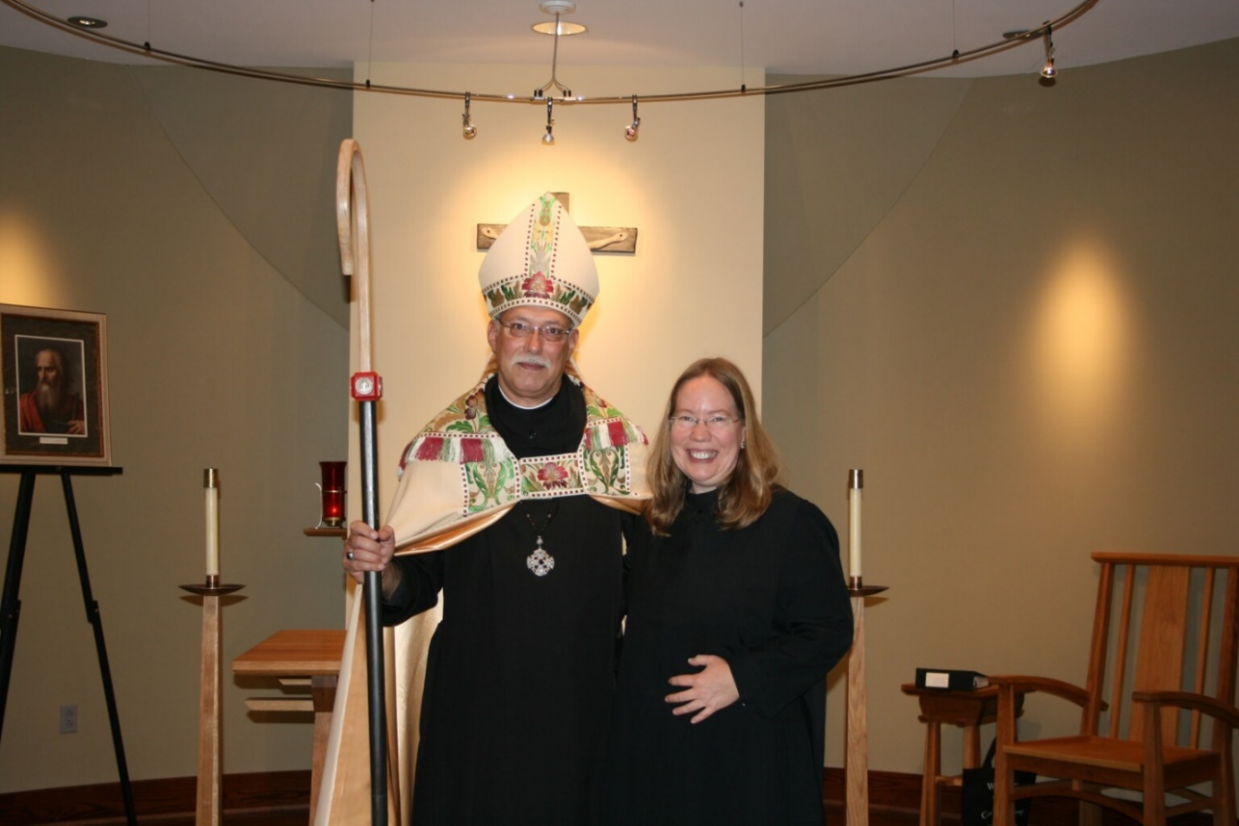
36290107 Abbot Michael John Austin; Sr. Teresa Beebe

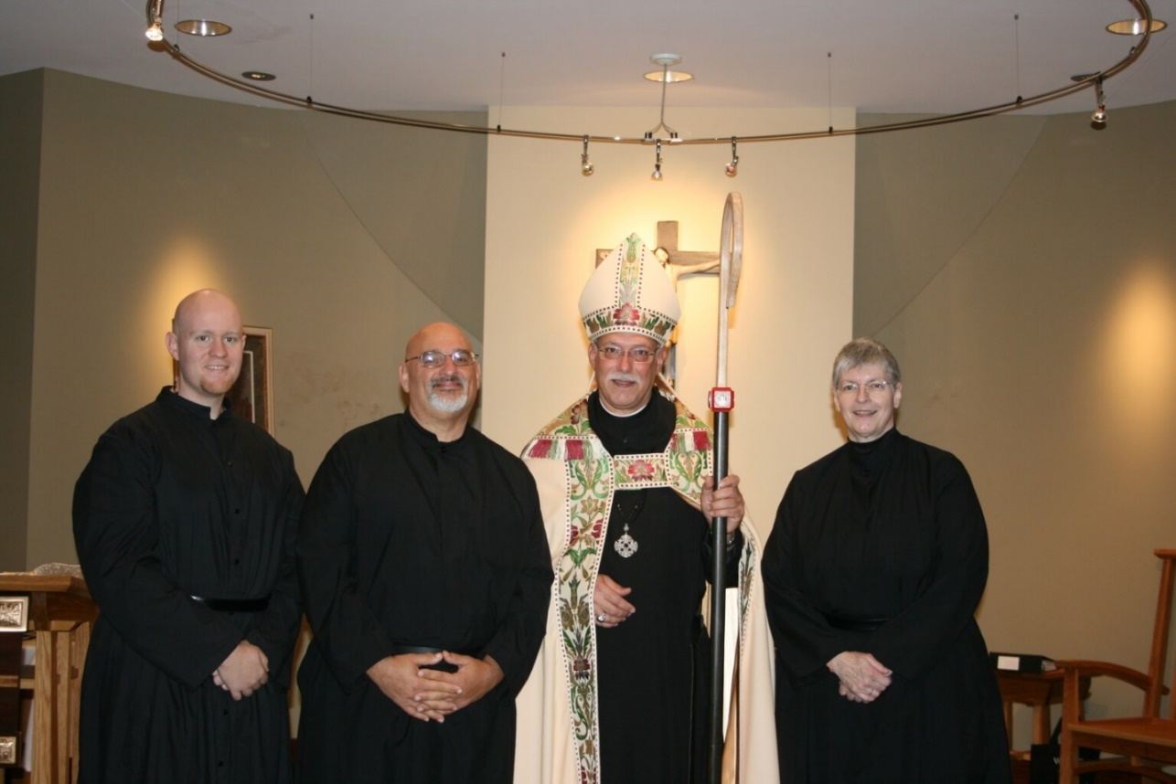
36290108 Br. Gregory Kingsley; Br. Simon DiNapoli; Abbot Michael John Austin; Sr. Bernadette Barrett

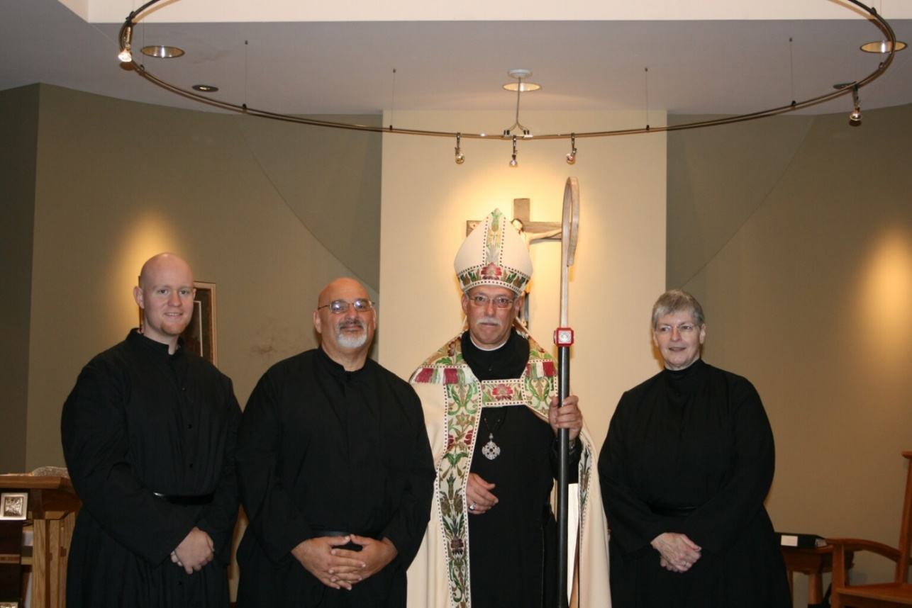
36290109 Br. Gregory Kingsley; Br. Simon DiNapoli; Abbot Michael John Austin; Sr. Bernadette Barrett

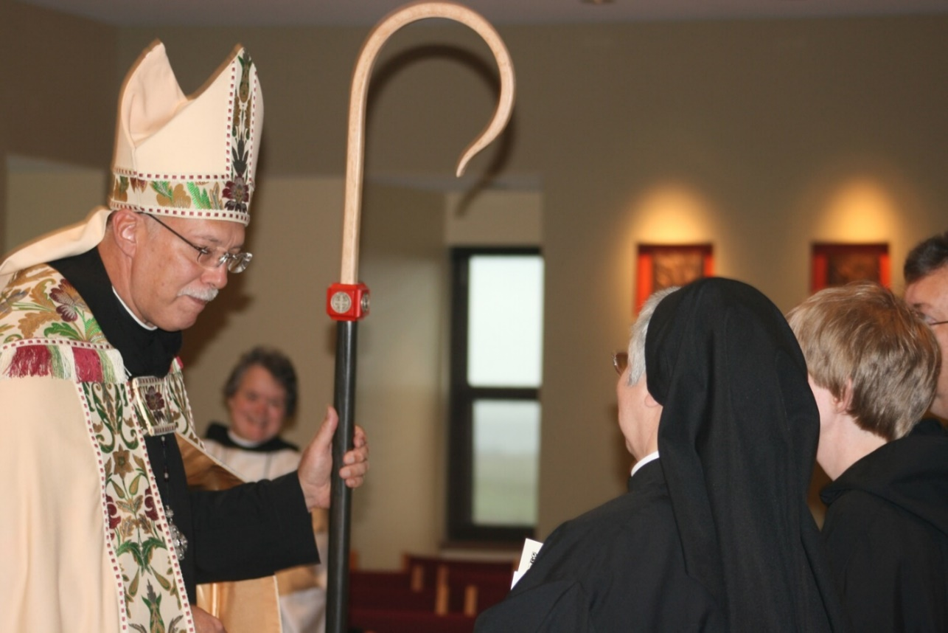
36290110 Abbot Michael John Austin;Sr. Vincent Mrie Rittenhouse; Sr. Clare Benedicta; Sr. Catherine Unterseher; Br. Paul Howard

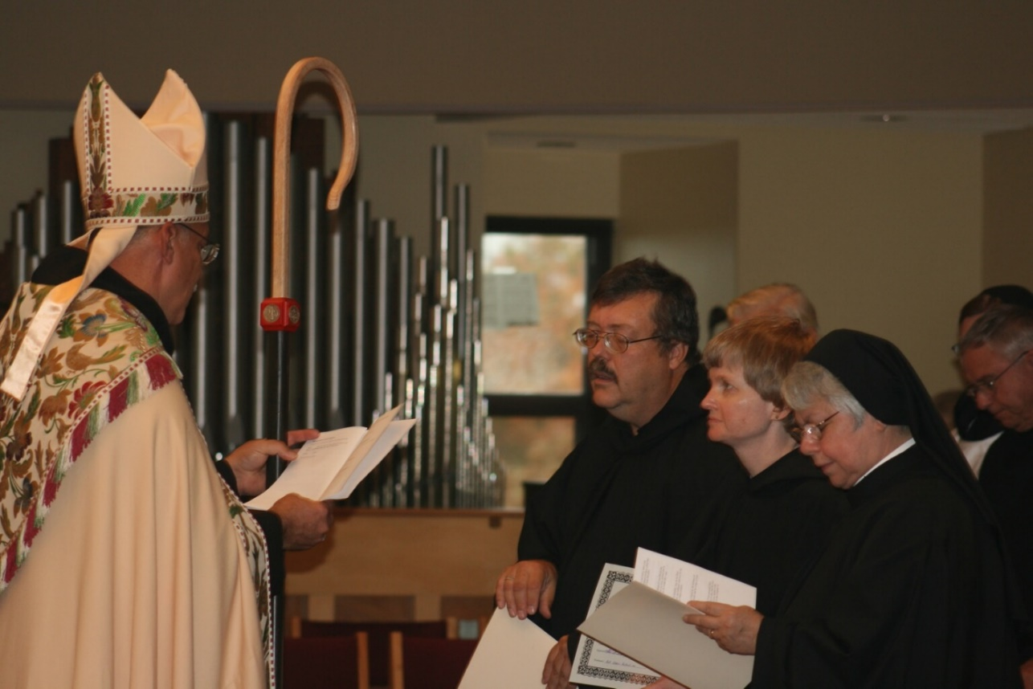
36290111 Abbot Michael John Austin; Br. Paul Howard; Br. Timothy Titus Lunt; Sr. Catherine Untersher; Sr. Clare Benedicta Myers; Br. Bede Leach; Sr. Hannah Sophia Korver

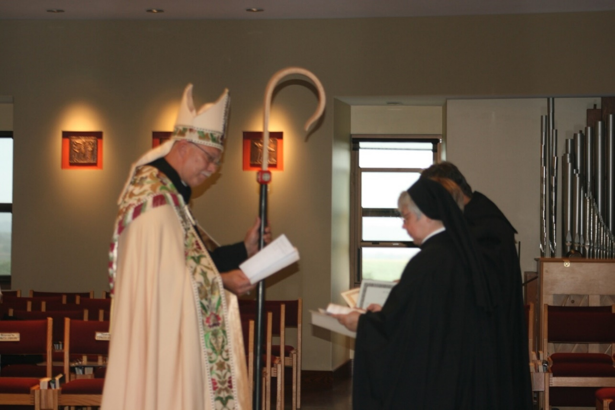
36290112 Abbot Michael John Austin; Sr. Clare Benedicta Myers; Br. Paul Howard

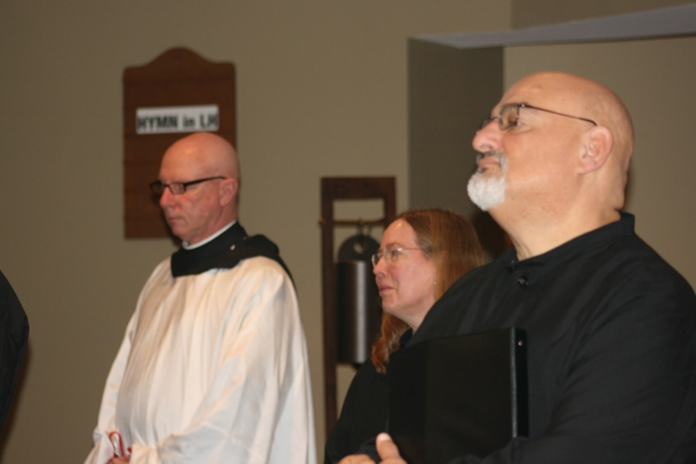
36290113 Br. David Vincent Cotton; Sr. Teresa Beebe; Br. Simon DiNapoli

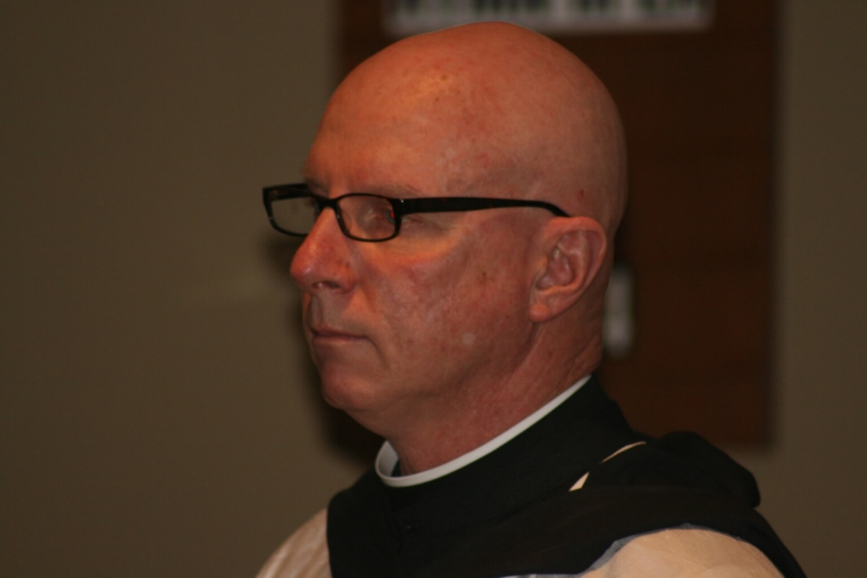
36290114 Br. David Vincent Cotton

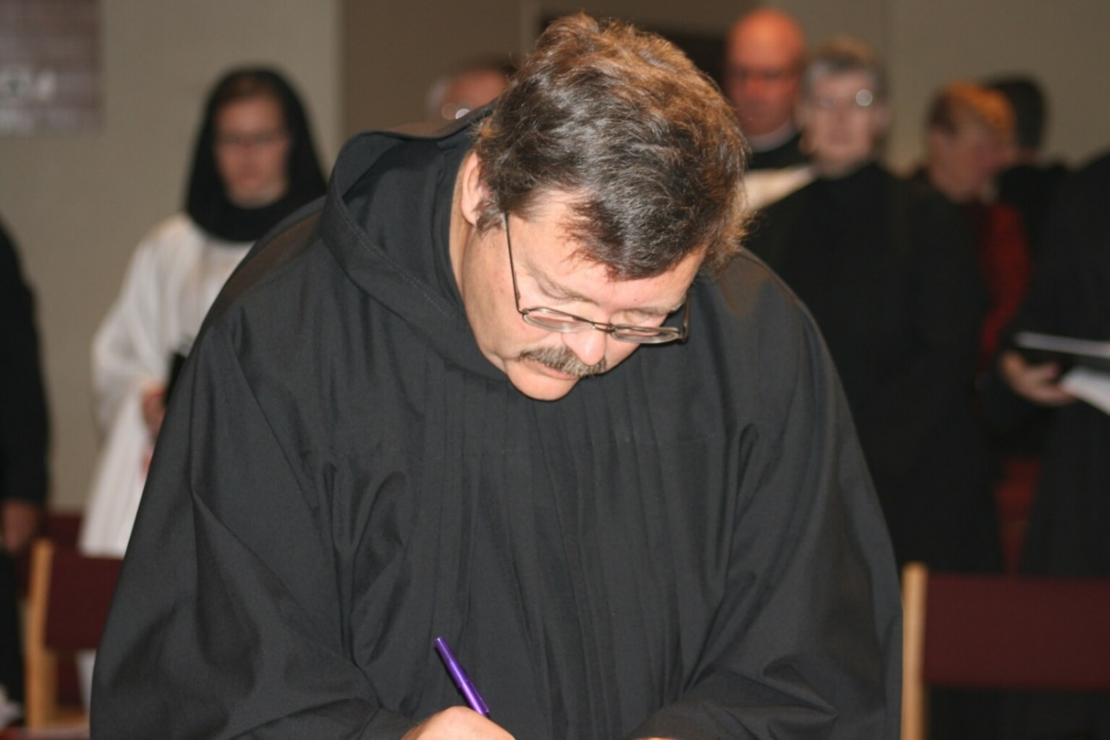
36290116 Sr. Hannah Sophia Korver; Br. Bede Leach; Br. Paul Howard; Br. David Vincent Cotton; Sr. Bernadette Barrett

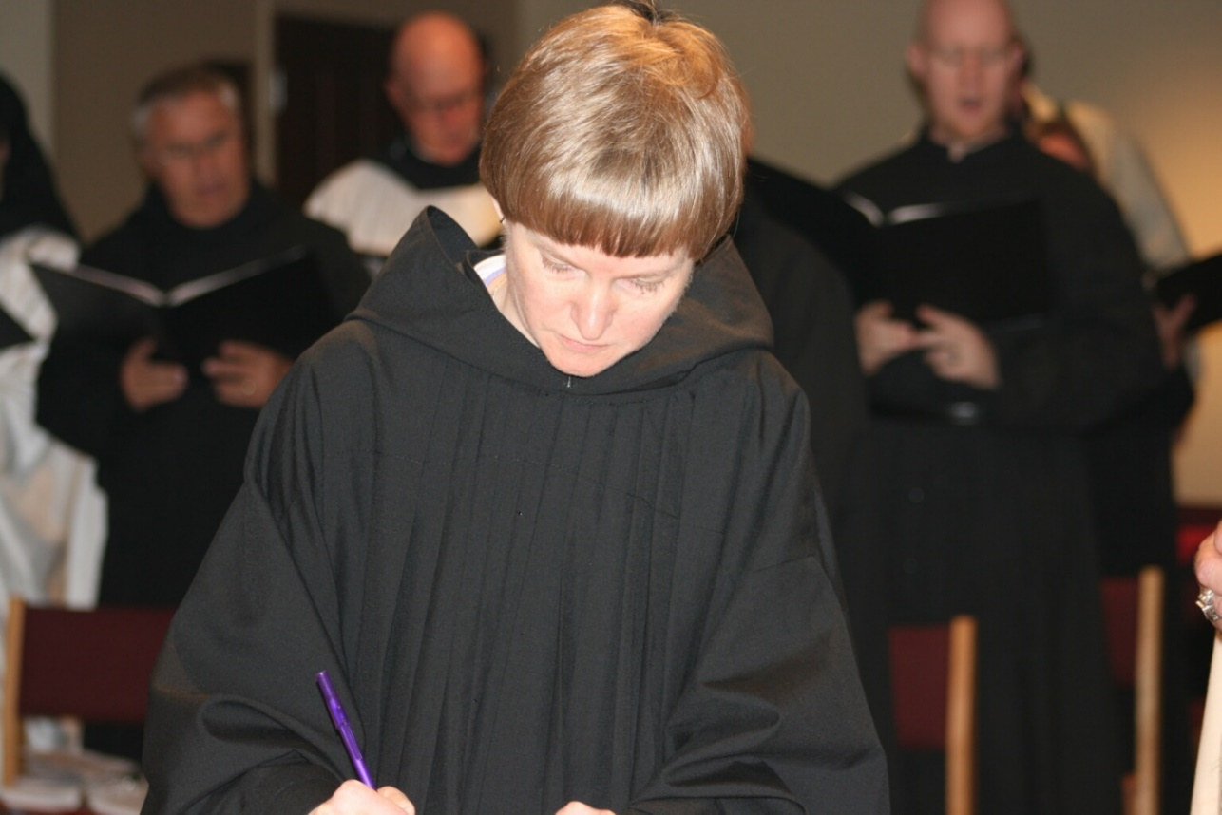
36290117 Br. Bede Leach; Br. David Vincent Cotton; Sr. Catherine Unterseher; Br. Gregory Kingsley

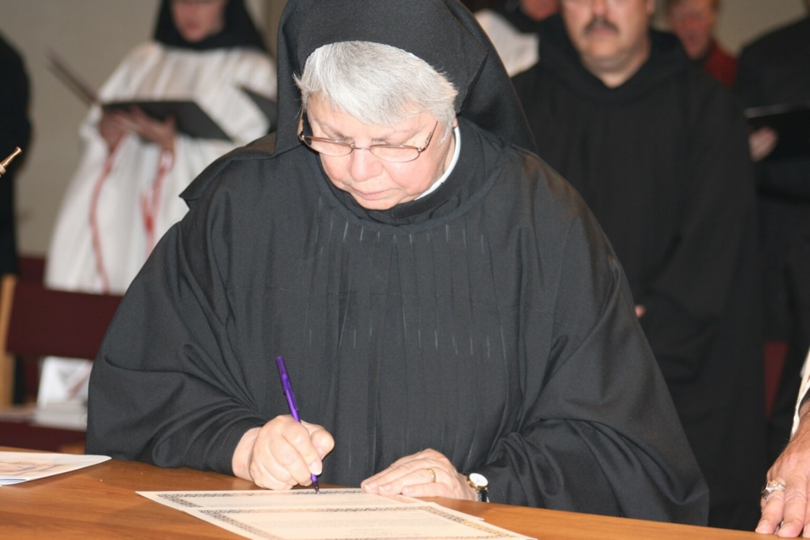
36290118 Sr. Hannah Sophia Korver; Sr. Clare Benedicta Myers; Br. Paul Howard

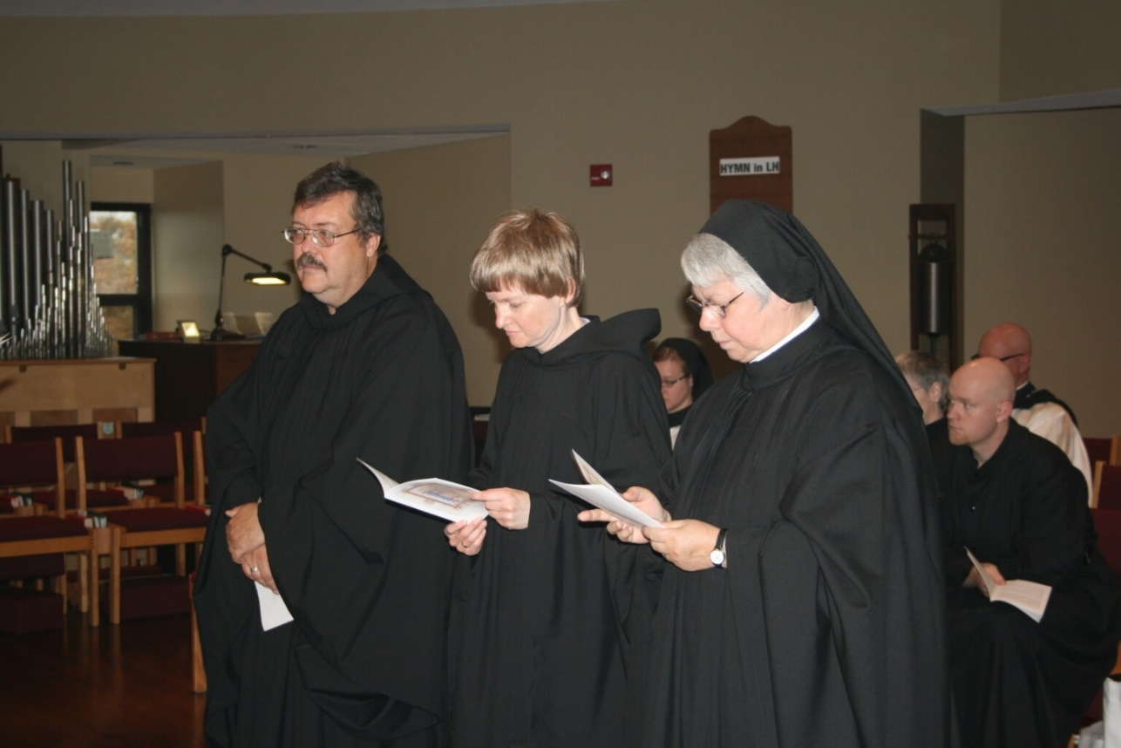
36290119 Br. Paul Howard; Sr. Catherine Unterseher; Sr. Hannah Sophia Korver; Sr. Clare Benedicta Myers; Sr. Bernadette Barrett; Br. Gregory Kngsley; Br. David Vincent Cotton

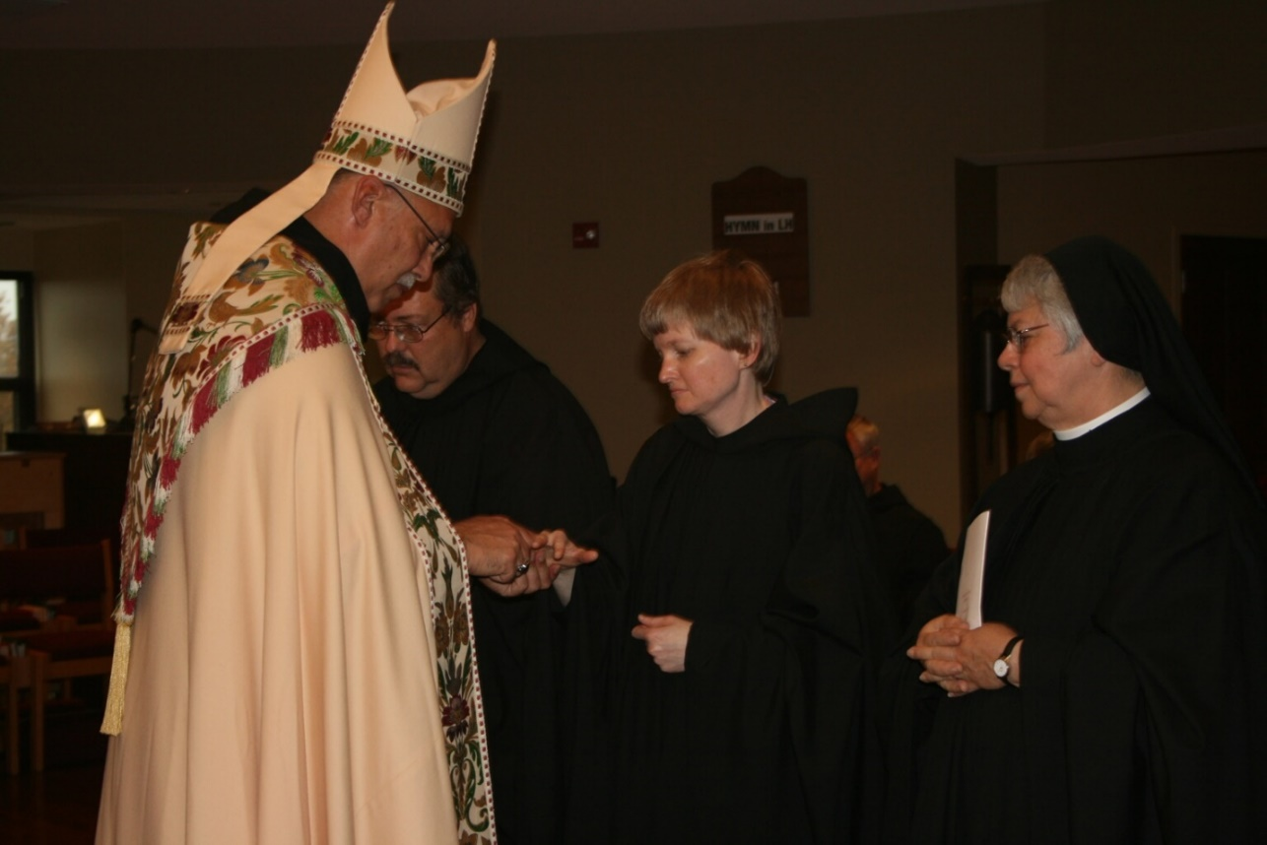
36290120 Br. Paul Howard; Sr. Catherine Unterseher; Sr. Clare Benedicta Myers

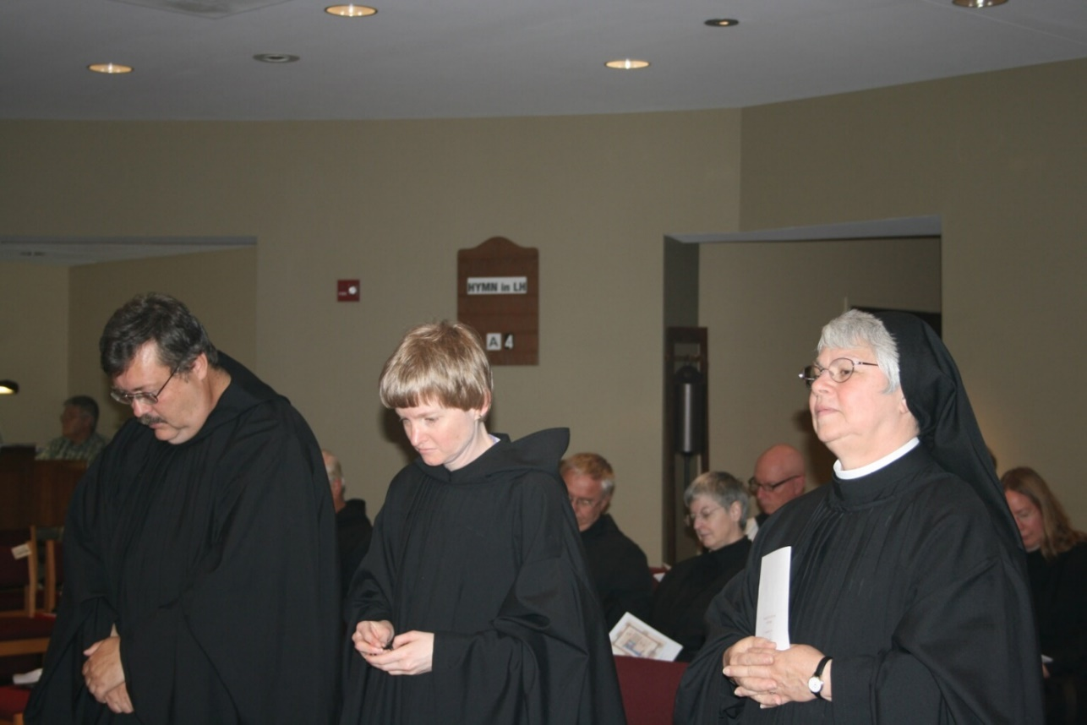
36290121 Michael McCabe; Br. Timothy Titus Lunt; Br. Paul Howard; Sr. Catherine Unterseher; Br. Bede Leach; Sr. Clare Benedicta Myers; Sr. Bernadette Barrett; Br. David Vincent Cotton; Sr. Teresa Beebe

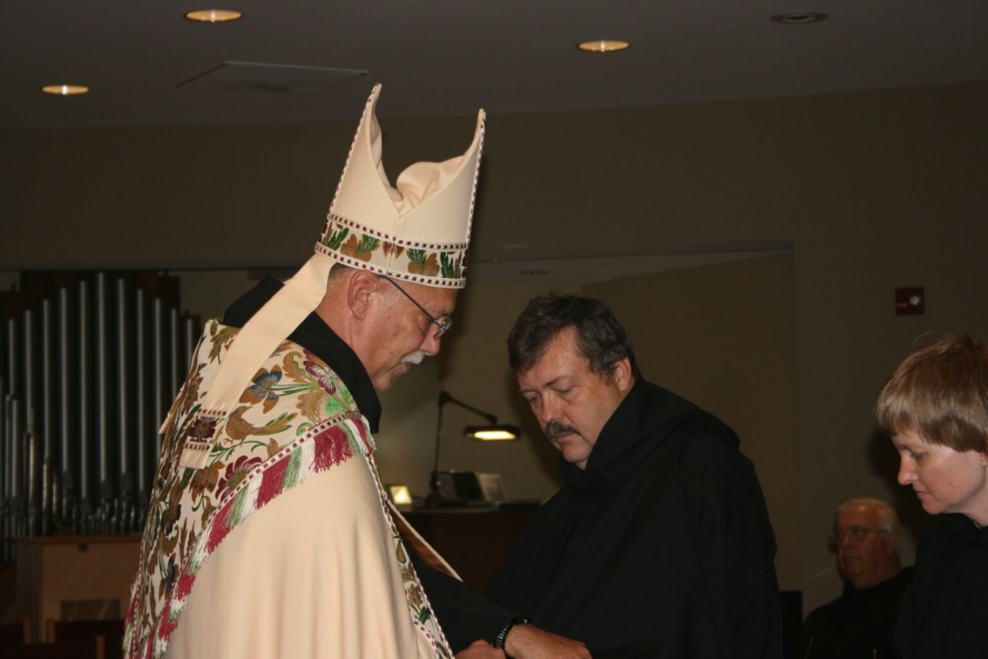
36290122 Abbot Michael John Austin; Br. Paul Howard; Br. Timothy Titus Lunt; Sr. Catherine Unterseher

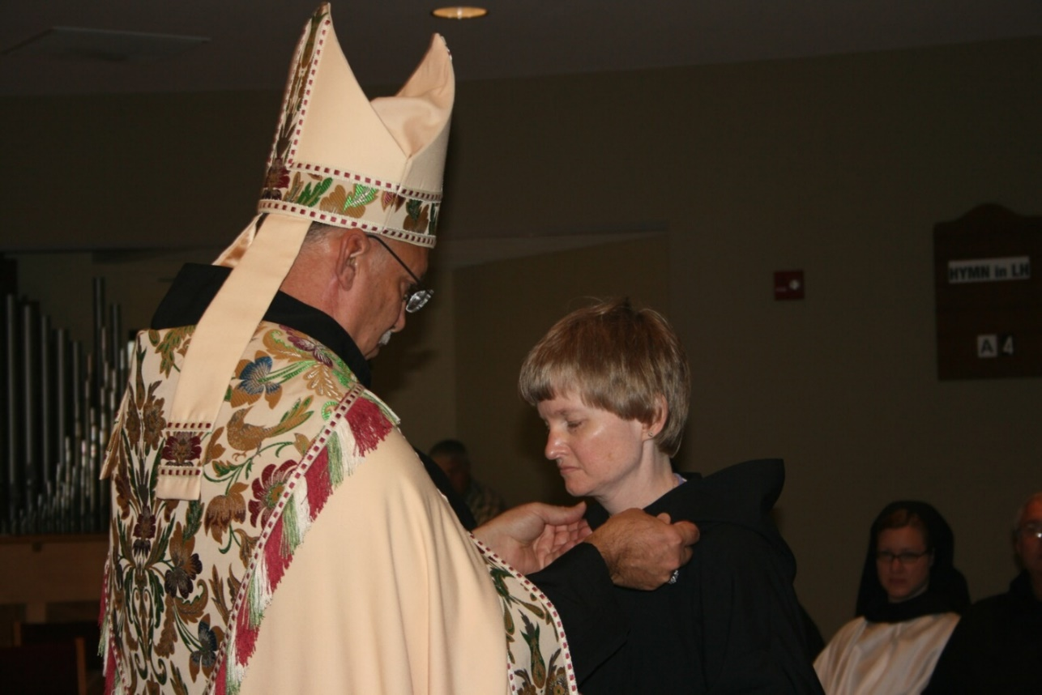
36290123 Abbot Michael John Austin; Sr. Catherine Unterseher; Sr. Hannah Sophia Korver

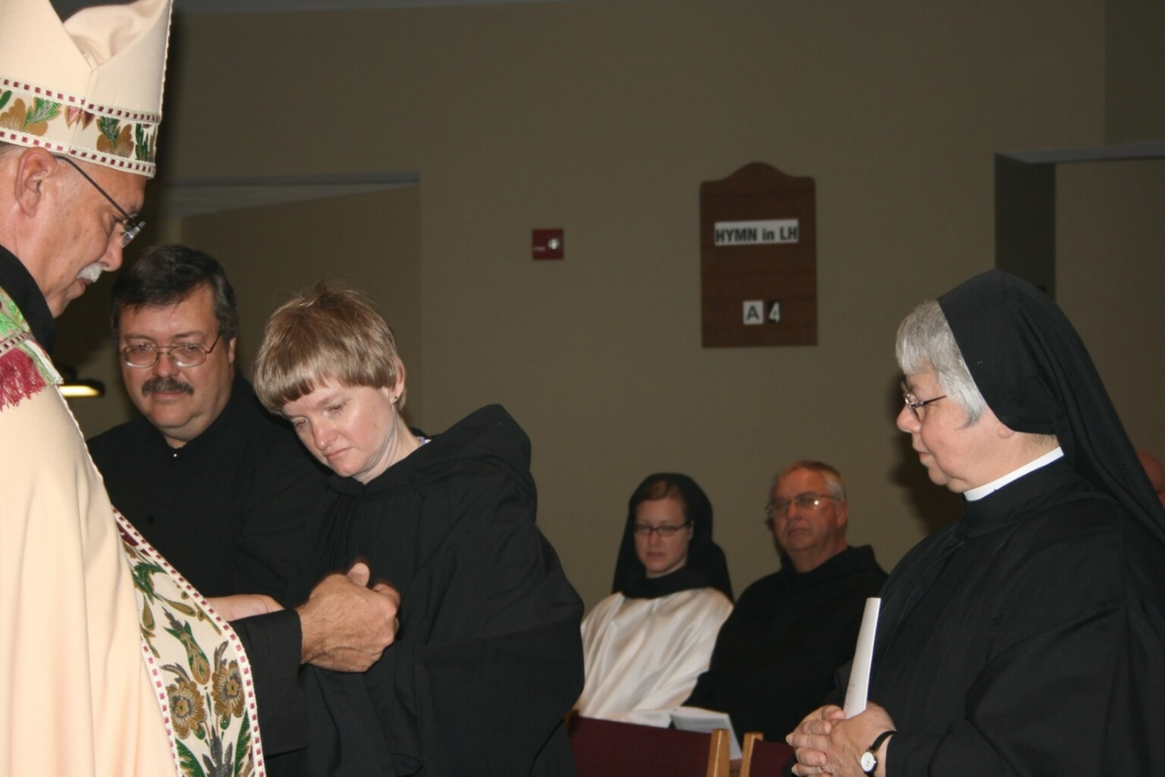
36290124 Abbot Michael John Austin; Br. Paul Howard; Sr. Catherine Unterseher; Sr. Hannah Sophia Korver; Br. Bede Leach; Sr. Clare Benedicta Myers

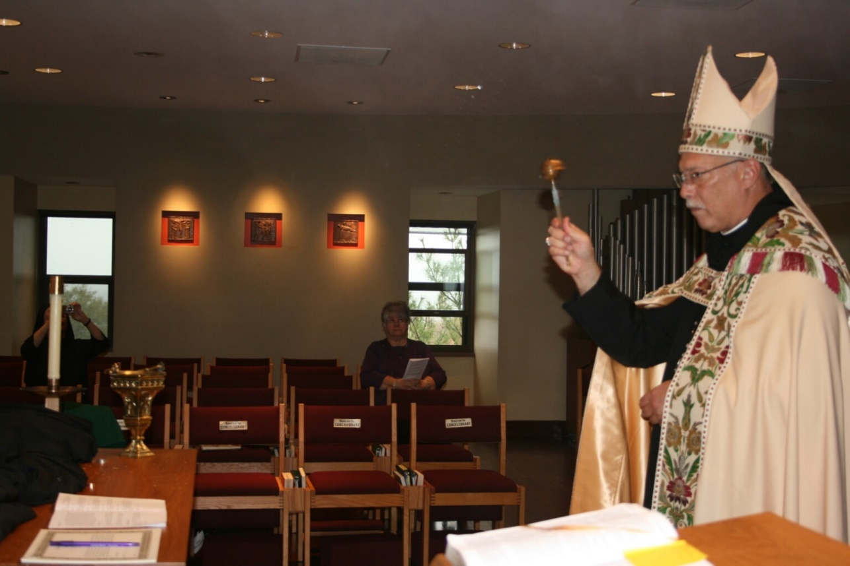
36290125 ?; Abbot Michael John Austin

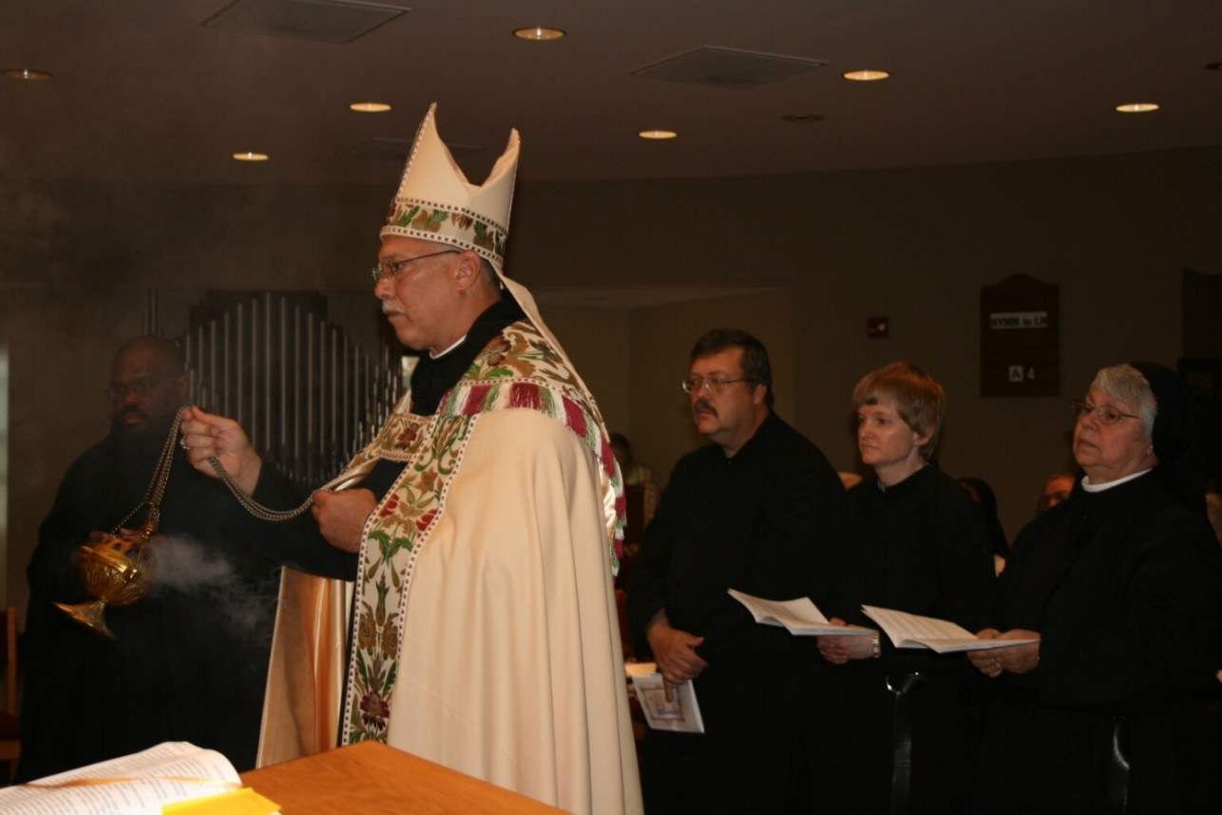
36290126 Br. Thomas Ferrell; Abbot Michael John Austin; Br. Paul Howard; Sr. Catherine Unterseher; Sr. Clare Benedicta Myers

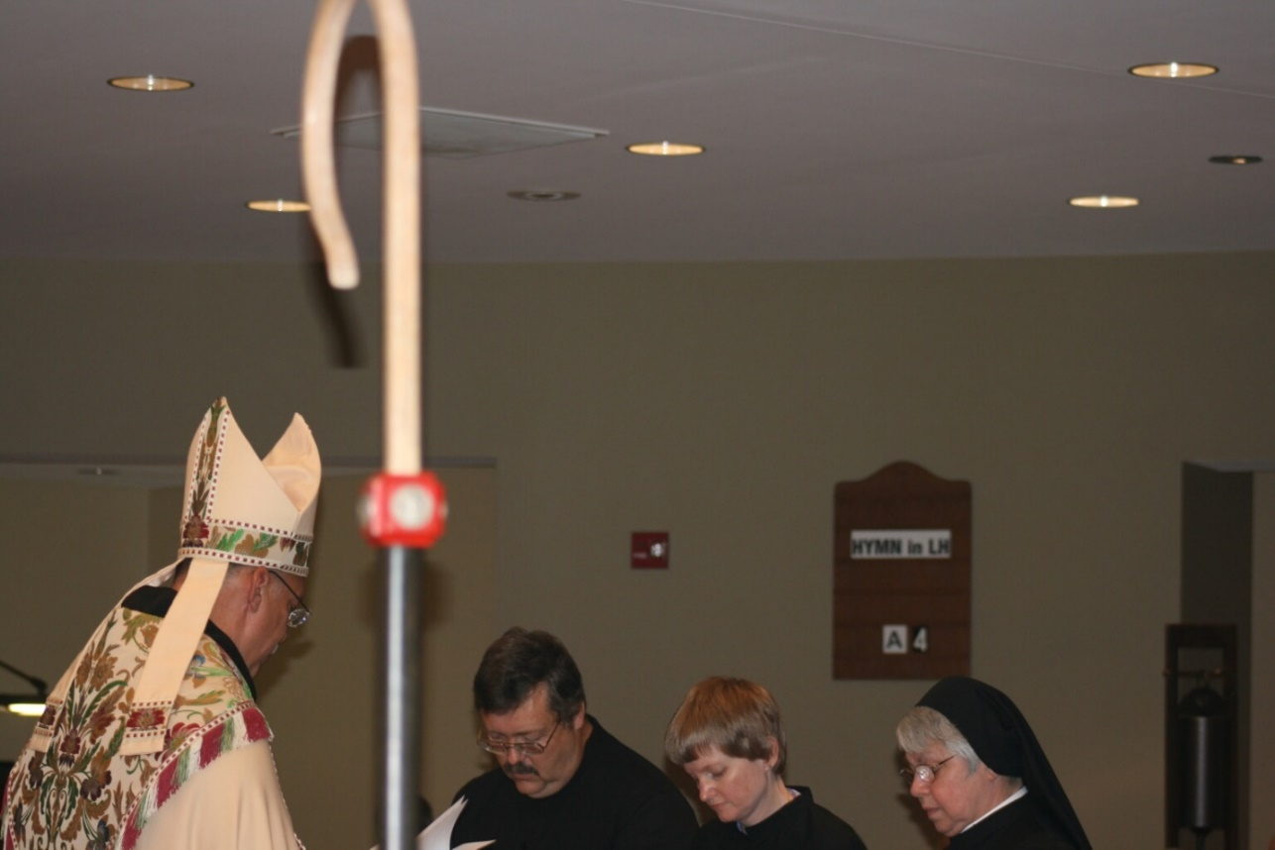
36290127 Abbot Michael John Austin; Br. Paul Howard; Sr. Catherine Unterseher; Sr. Clare Benedicta Myers

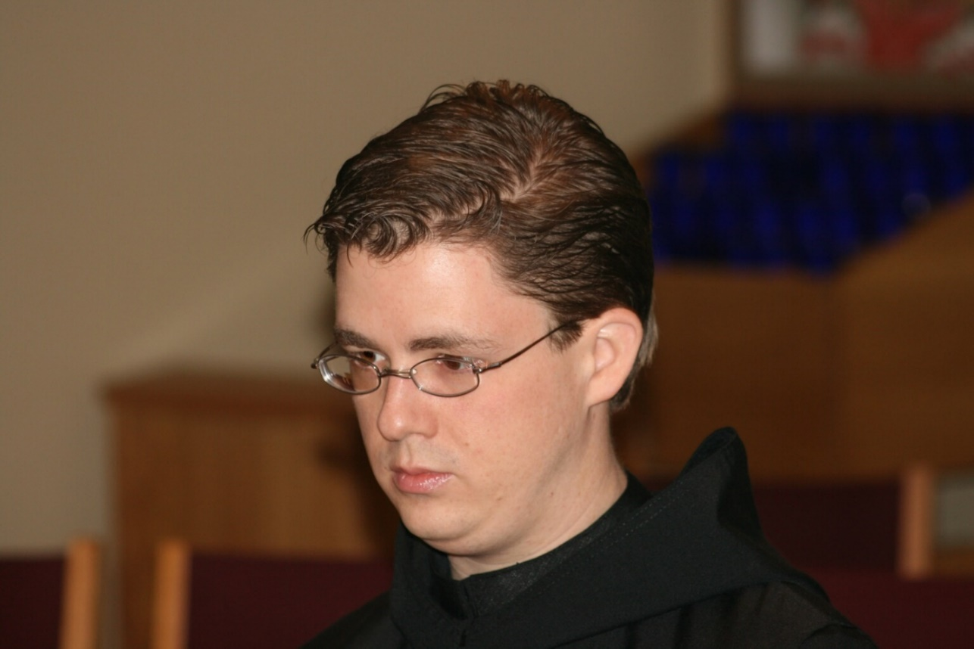
36290130 Br. Aidan Maguire

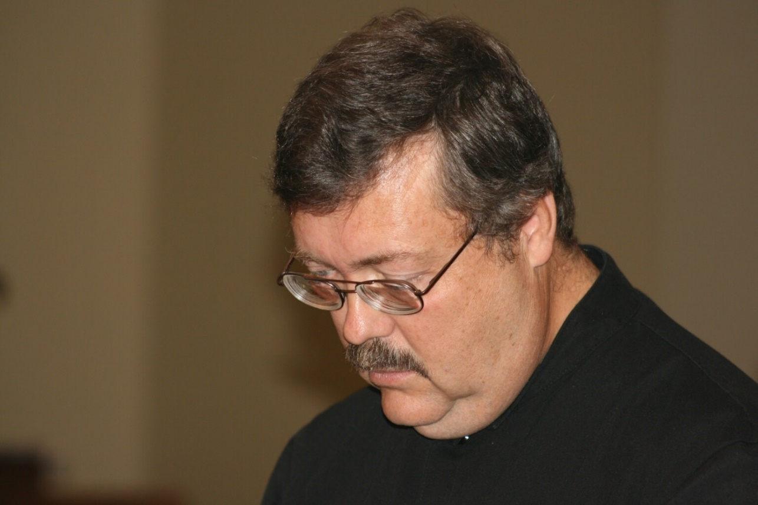
36290131 Br. Paul Howard

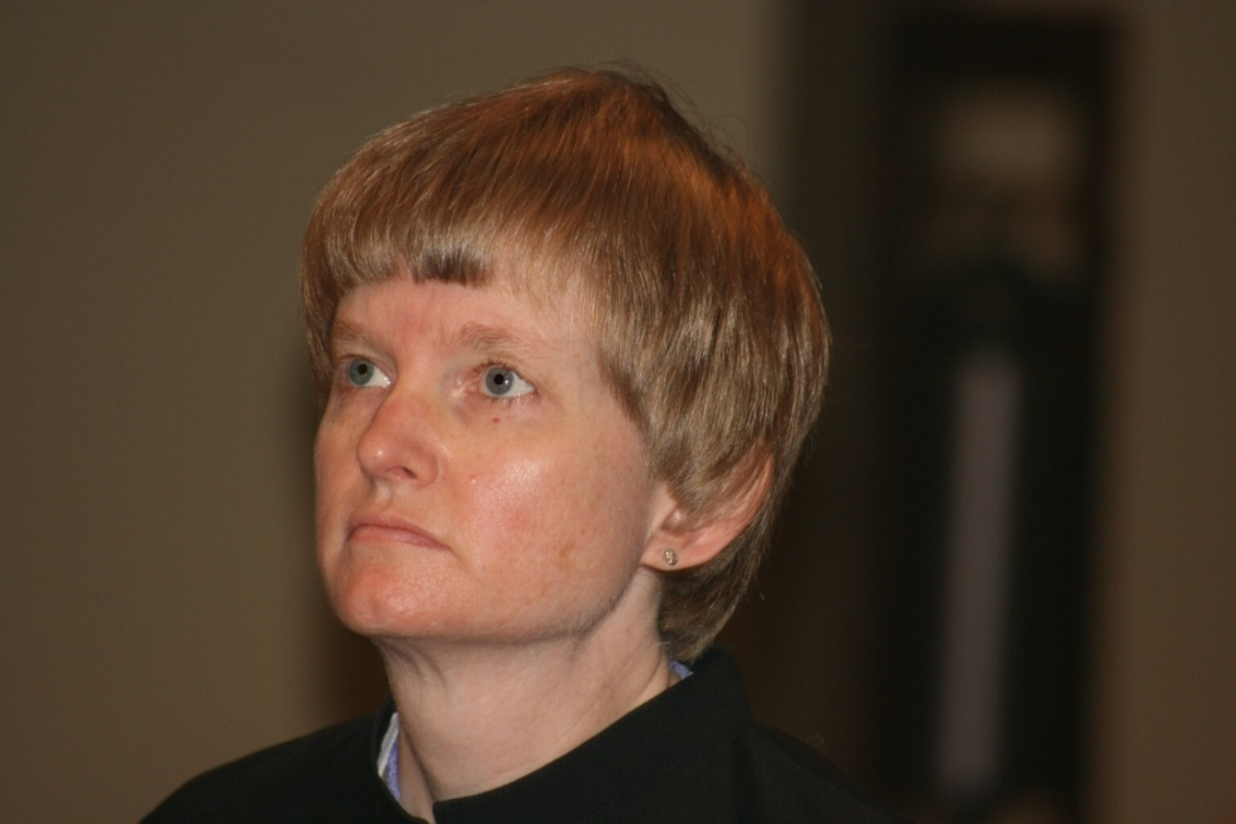
36290133 Sr. Catherine Unterseher

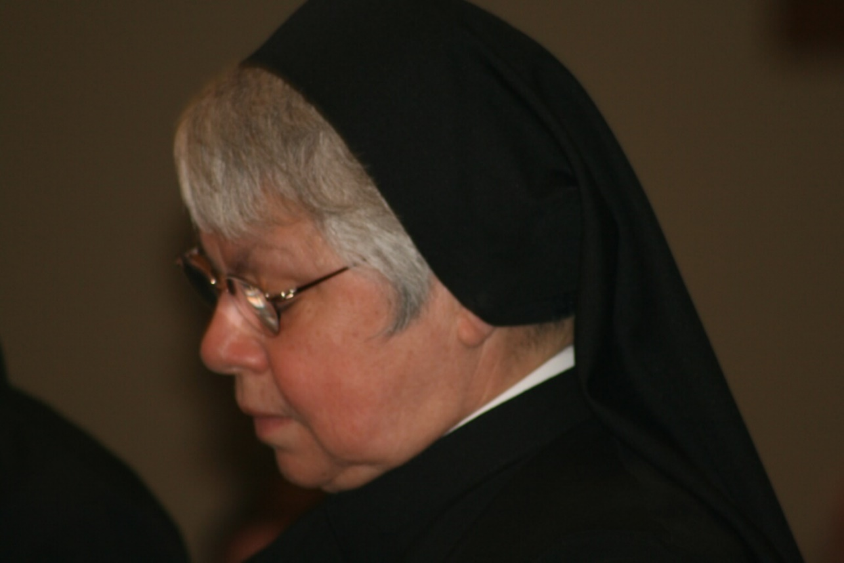
3629134 Sr. Clare Benedicta Myers

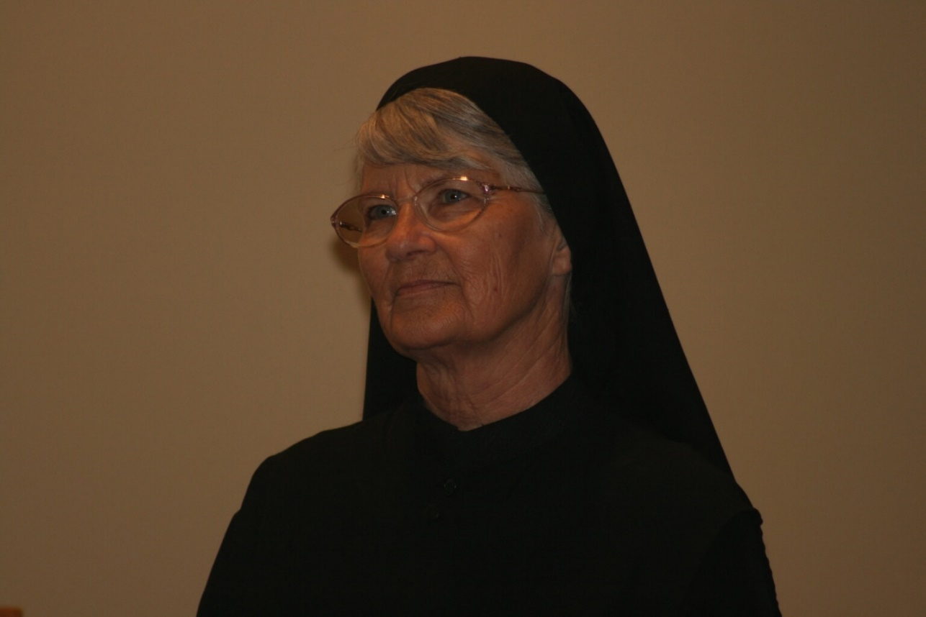
36290136 Sr. Mary Francis Deulen

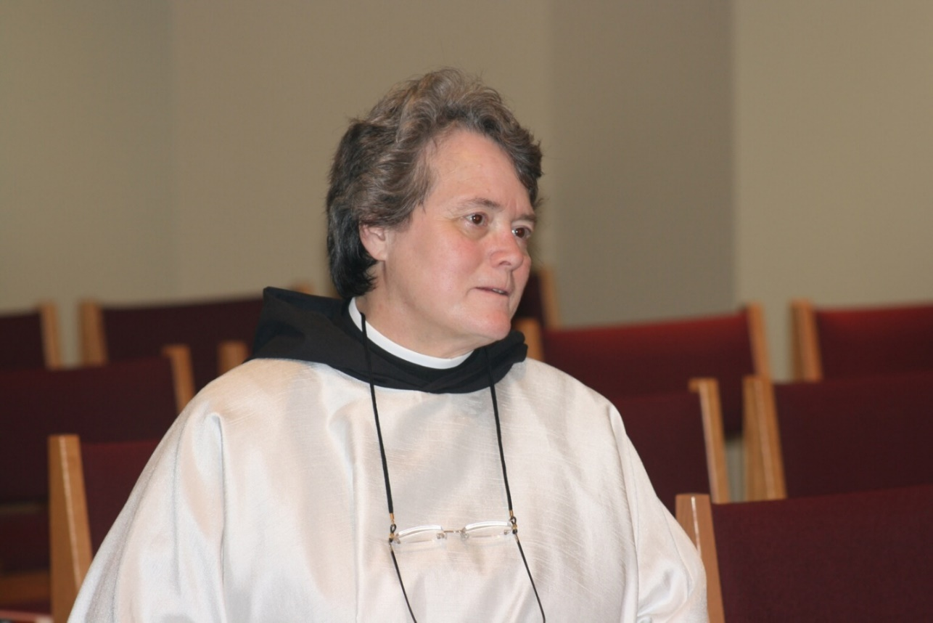
36290138 Sr. Vincent Marie Rittenhouse

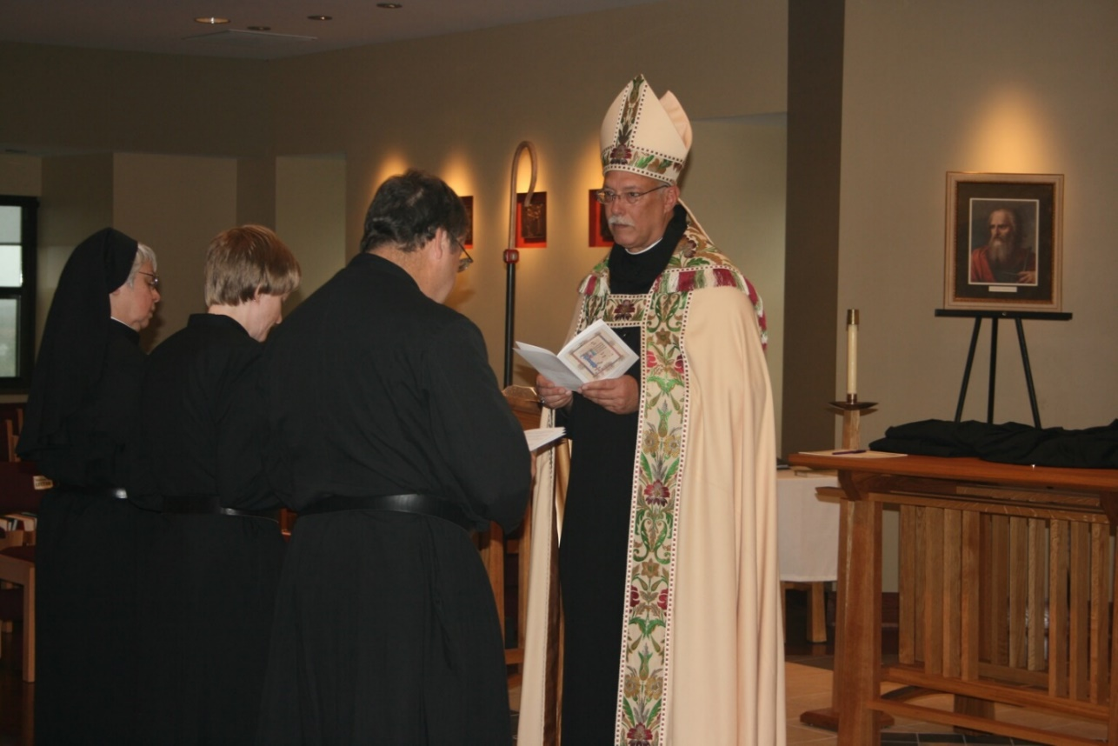
36290139 Sr. Clare Benedicta Myers; Sr. Catherine Unterseher; Br. Paul Howard; Abbot Michael John Austin

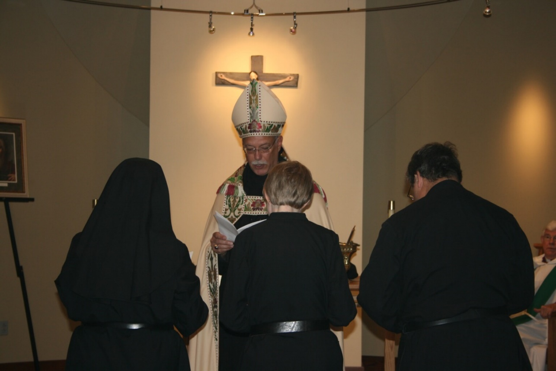
36290140 Sr. Clare Benedicta Myers; Abbot Michael John Austin; Sr. Catherine Unterseher; Br. Paul Howard; Rev. Canon Thomas Hulme

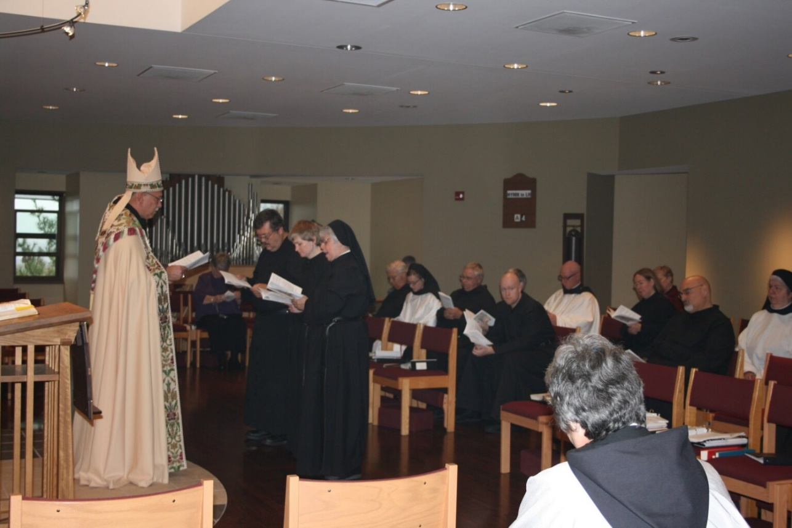
36290141 Abbot Michael John Austin; Br. Paul Howard; Sr. Catherine Unterseher; Sr. Clare Benedicta Myers; Br. Timothy Titus Lunt; Sr. Hannah Sophia Korver; Br. Bede Leach; Br. Gregory Kingsley; Sr. Vincent Marie Rittenhouse; Br. David Vincent Cotton; Sr. Teresa Beebe; Br. Simon DiNapoli; Sr. Mary Catherine Christopher

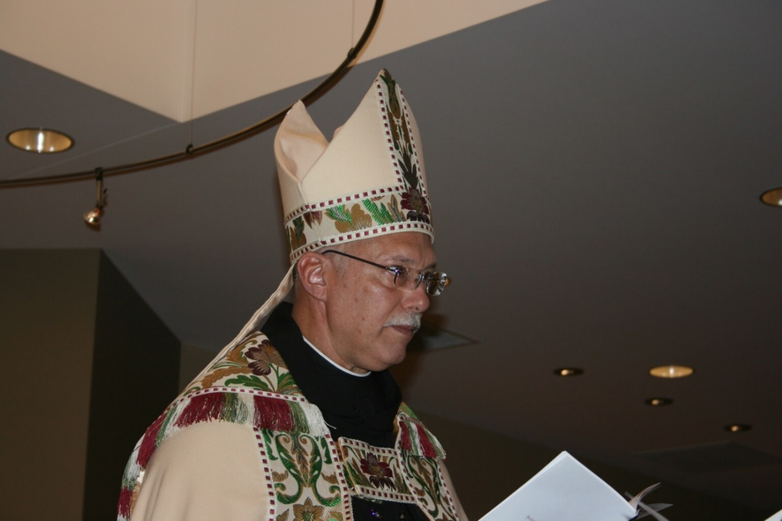
36290142 Abbot Michael John Austin

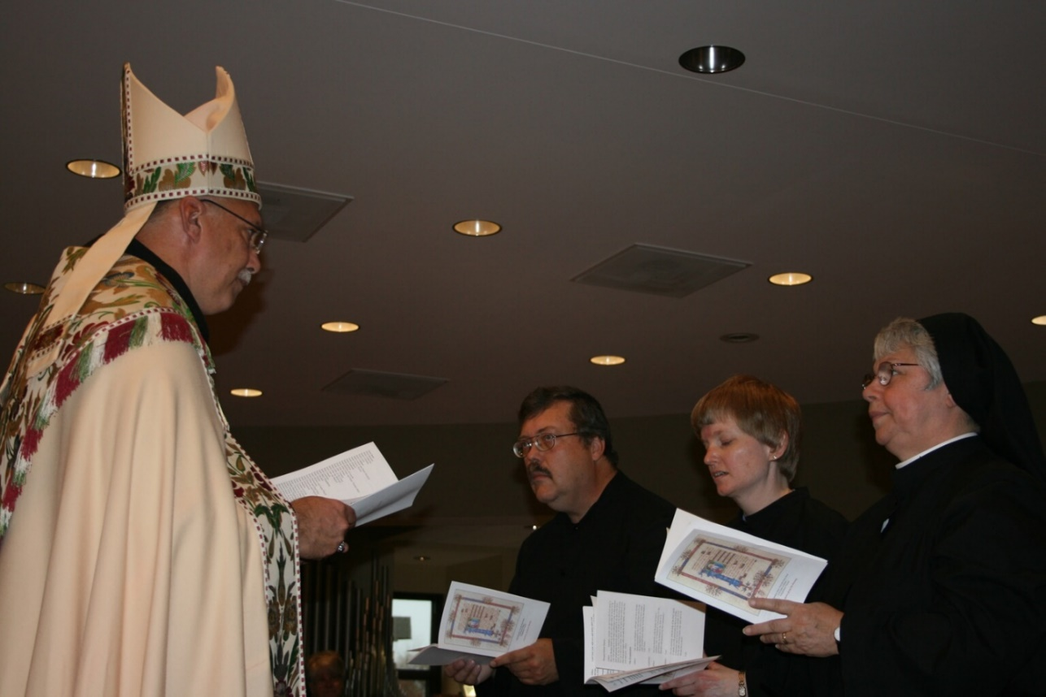
36290143 Abbot Michael John Austin; Br. Paul Howard; Sr. Catherine Unterseher; Sr. Clare Benedicta Myers

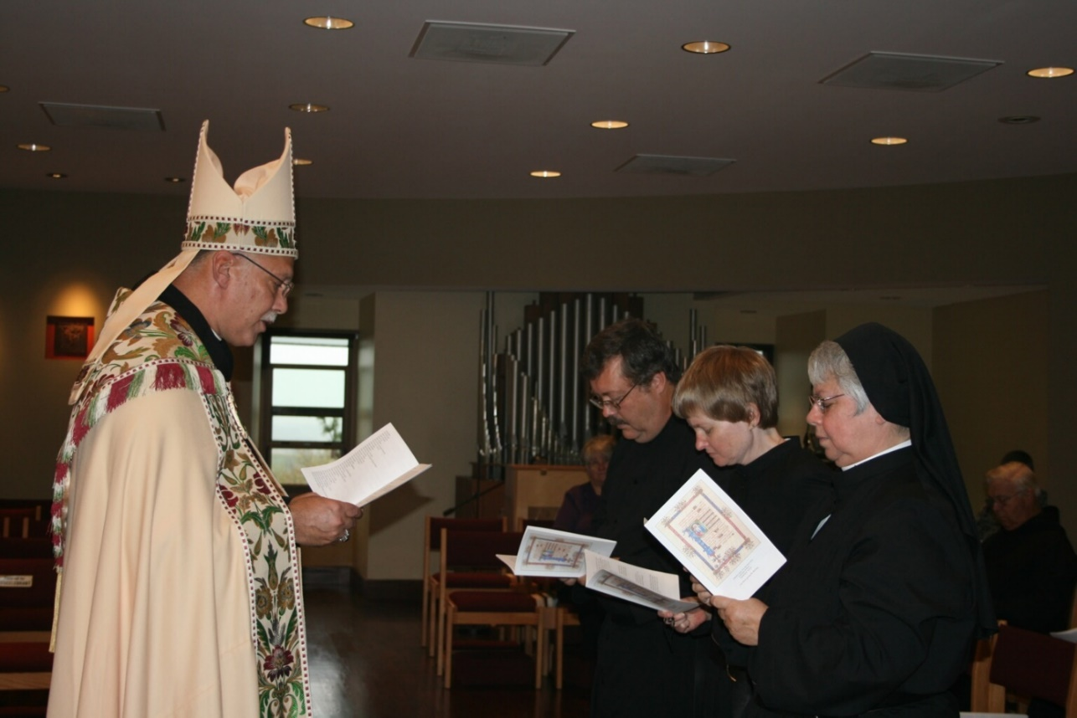
36290144 Abbot Michael John Austin; ?; Br. Paul Howard; Sr. Catherine Unterseher; Sr. Clare Benedicta Myers; Br. Timothy Titus Lunt

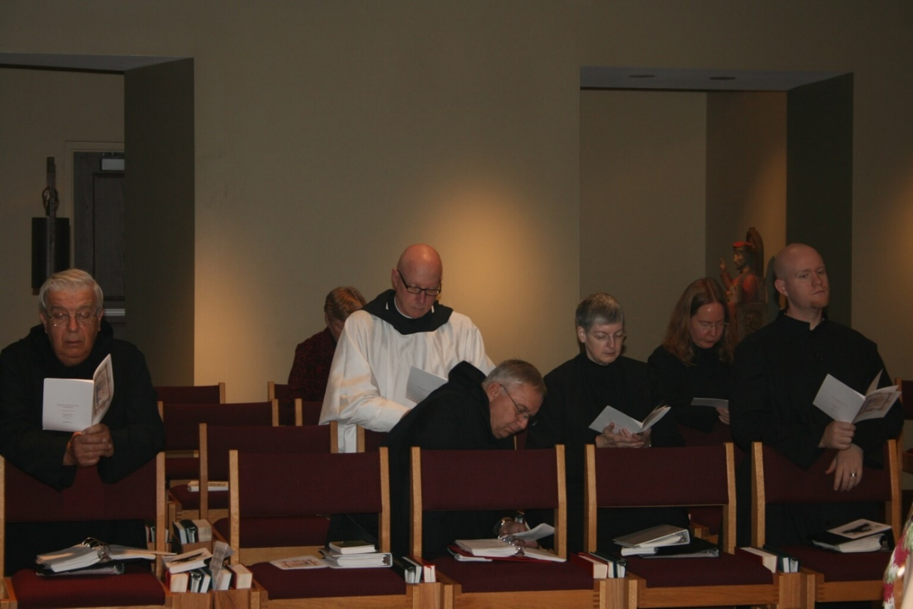
36290145 Br. Timothy Titus Lunt; ?; Br. David Vincent Cotton; Br. Bede Leach; Sr. Bernadette Barrett; Sr. Teresa Beebe; Br. Gregory Kingsley

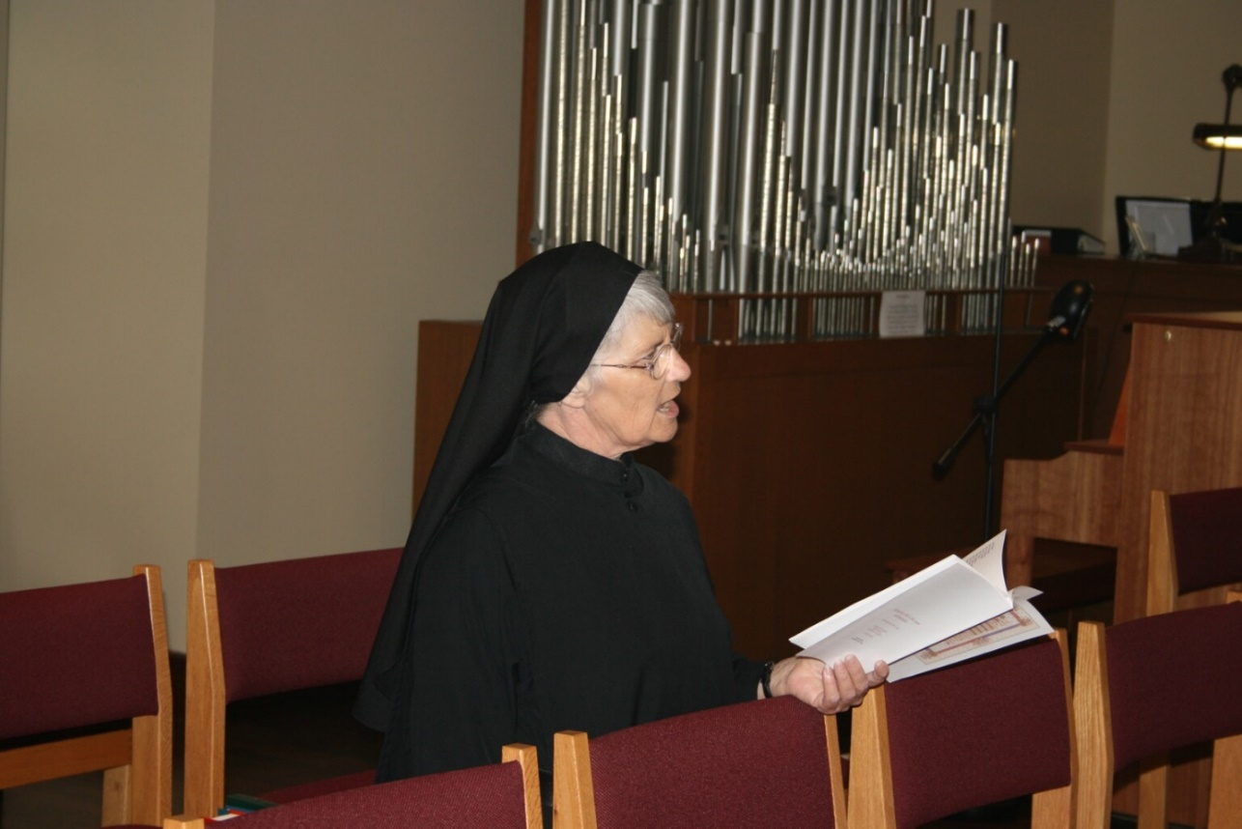
36290146 Sr. Mary Francis Deulen

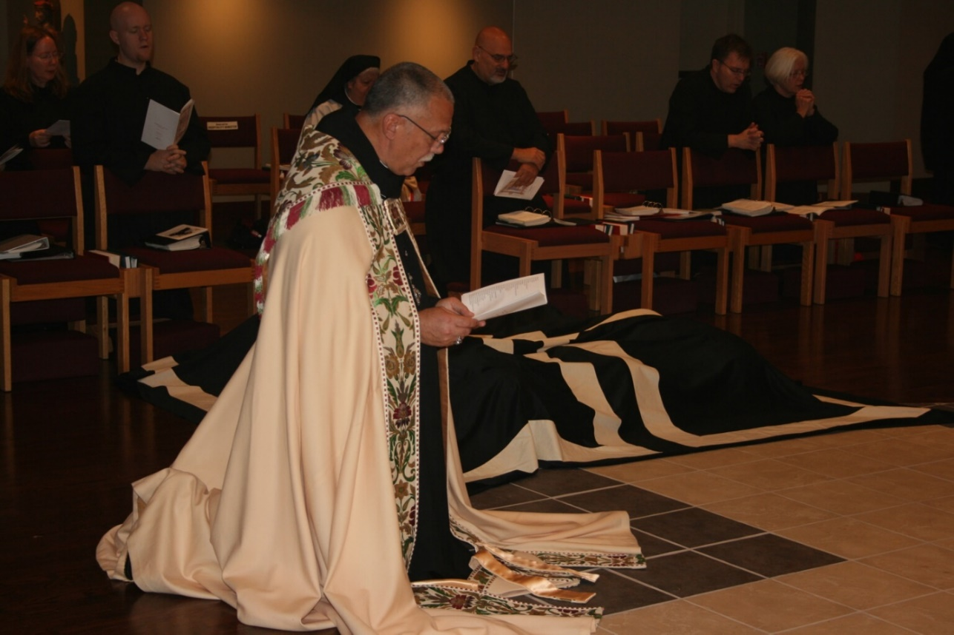
36290147 Sr. Teresa Beebe; Br. Gregory Kingsley; Sr. Mary Catherine Christopher; Abbot Michael John Austin; Br. Simon DiNapoli; Br. John of Kanty Kennedy; Sr. Elizabeth Anne Stribley

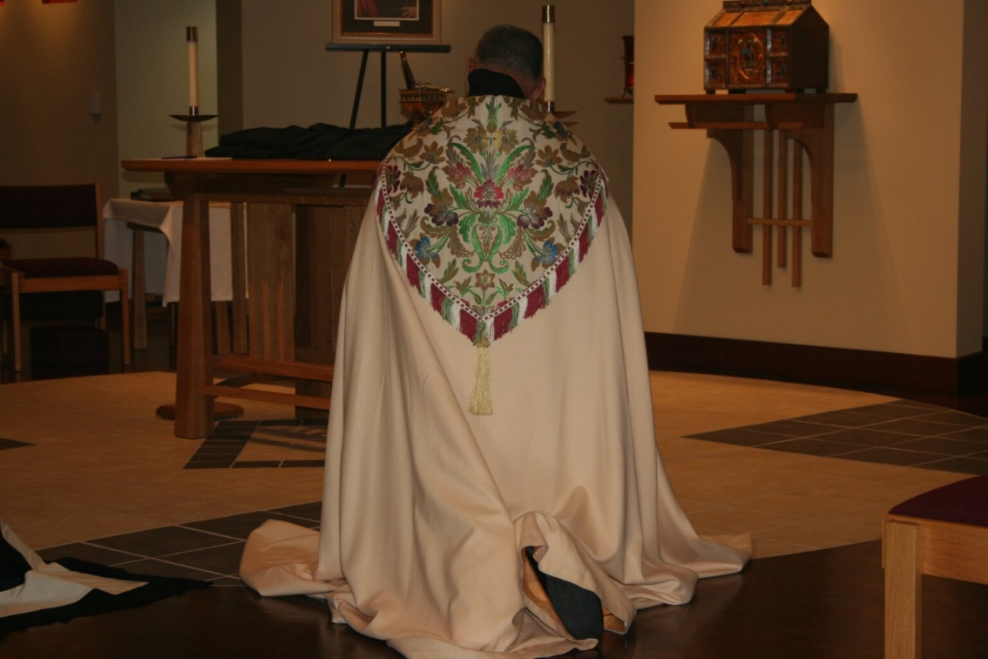
36290148 Abbot Michael John Austin

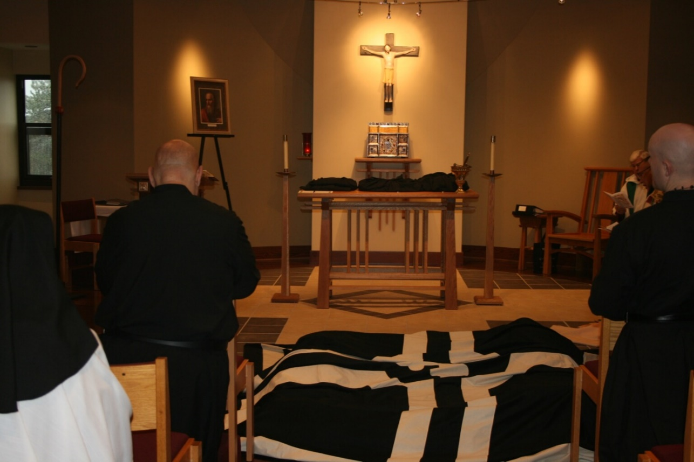
36290149 Br. Simon DiNapoli; Br. Gregory Kingsley

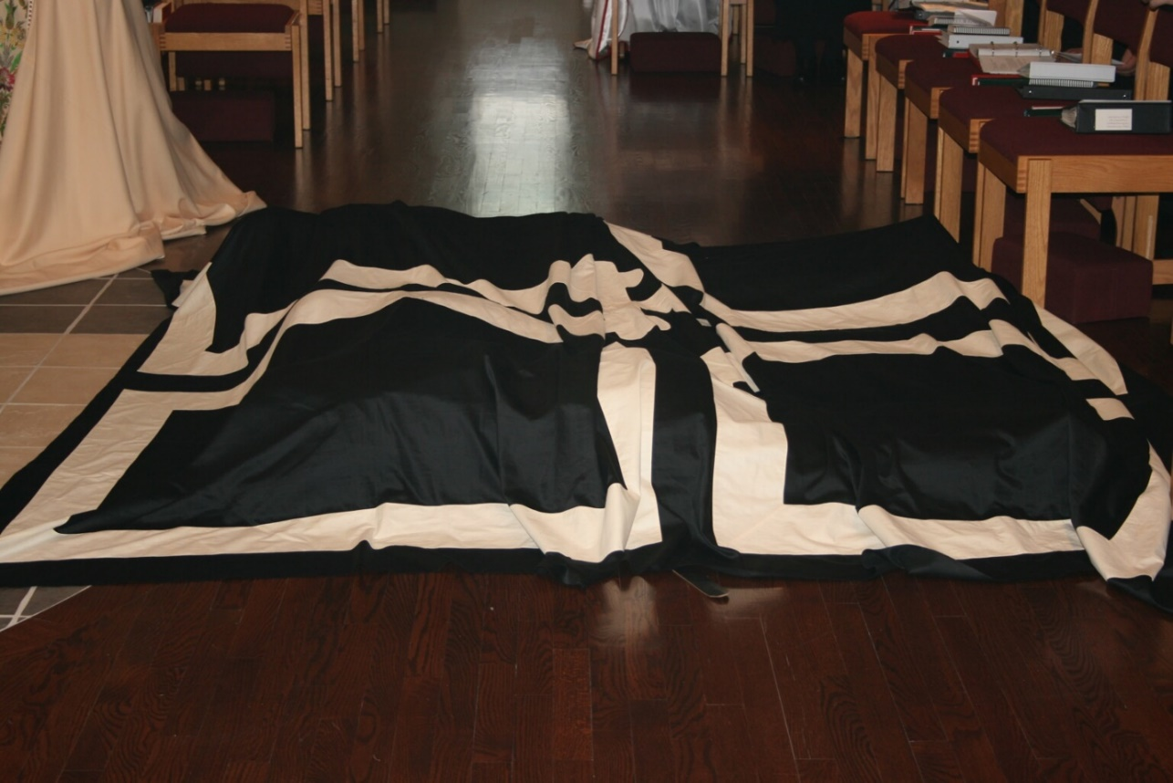
36290150

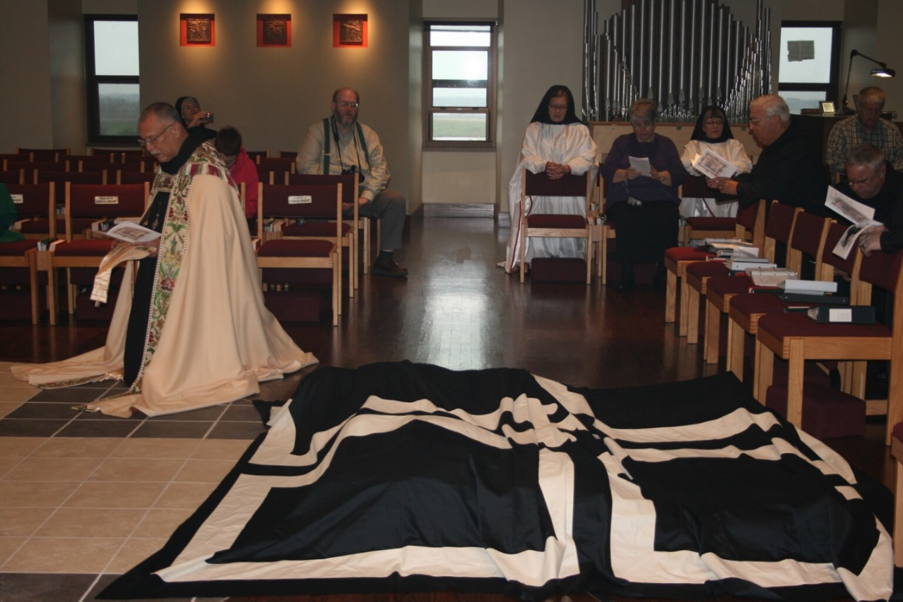
36290151 ?; ?; Abbot Michael John Austin; Sr. Hannah Sophia Korver; ?; Sr. Anna Grace Madden; Br. Timothy Titus Lunt; Br. Bede Leach; Michael McCabe

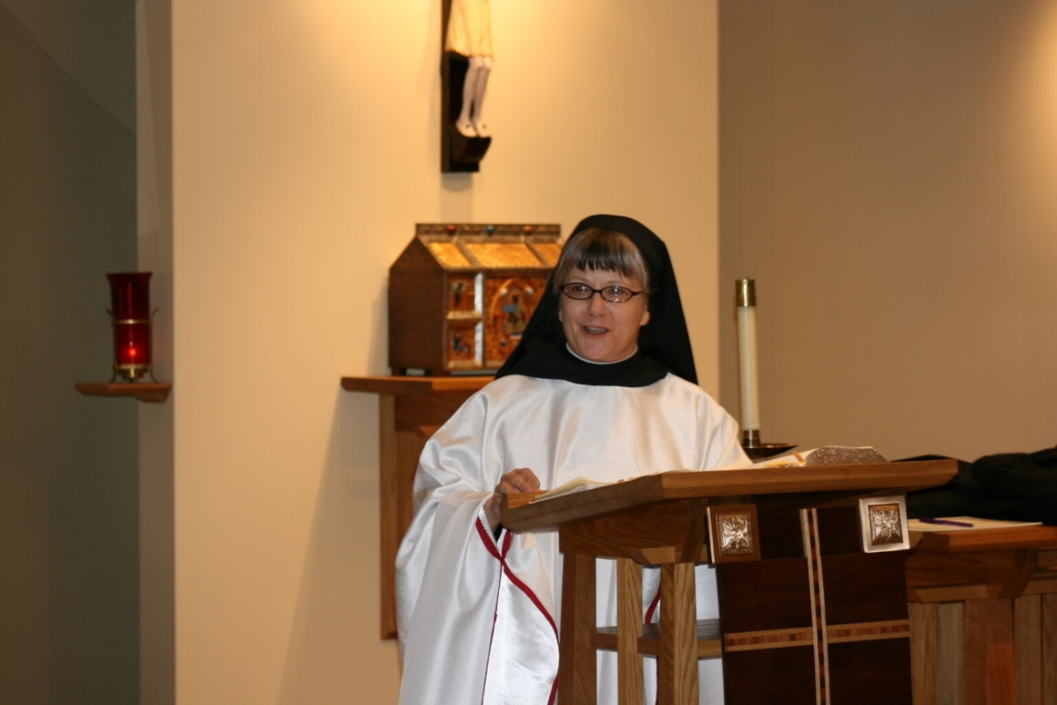
36290152 Sr. Anna Grace Madden

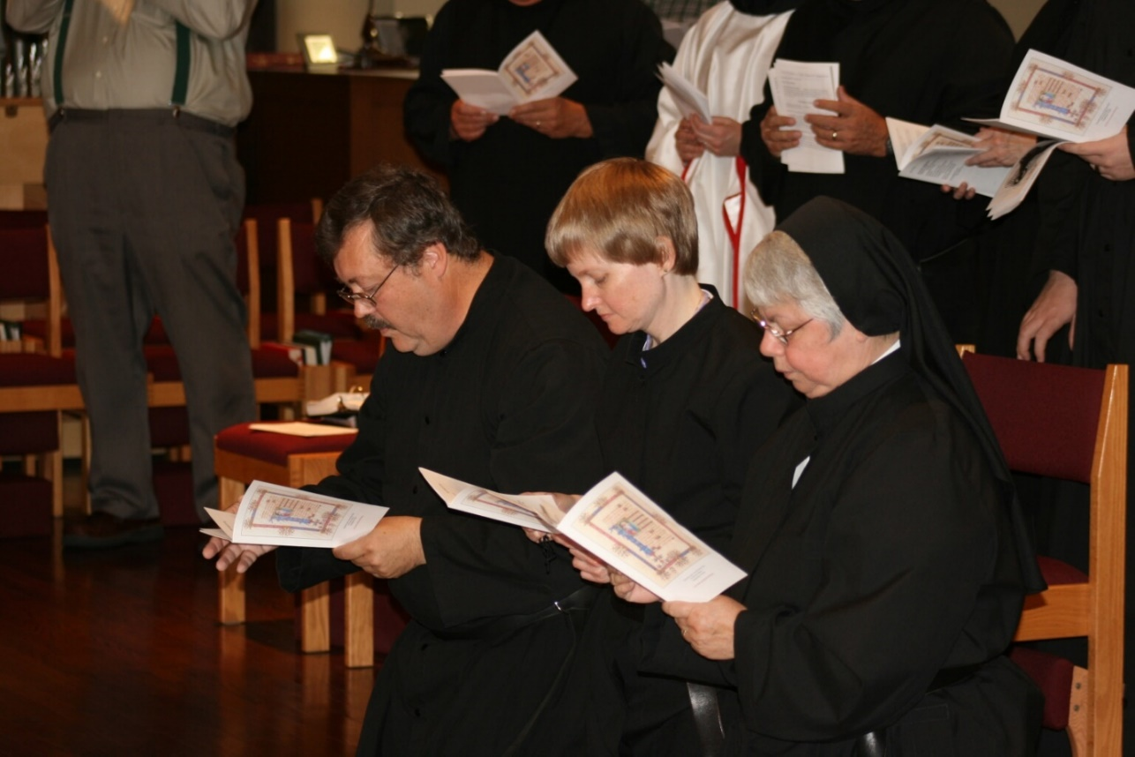
36290153 Br. Paul Howard; Sr. Catherine Unterseher; Sr. Clare Benedicta Myers

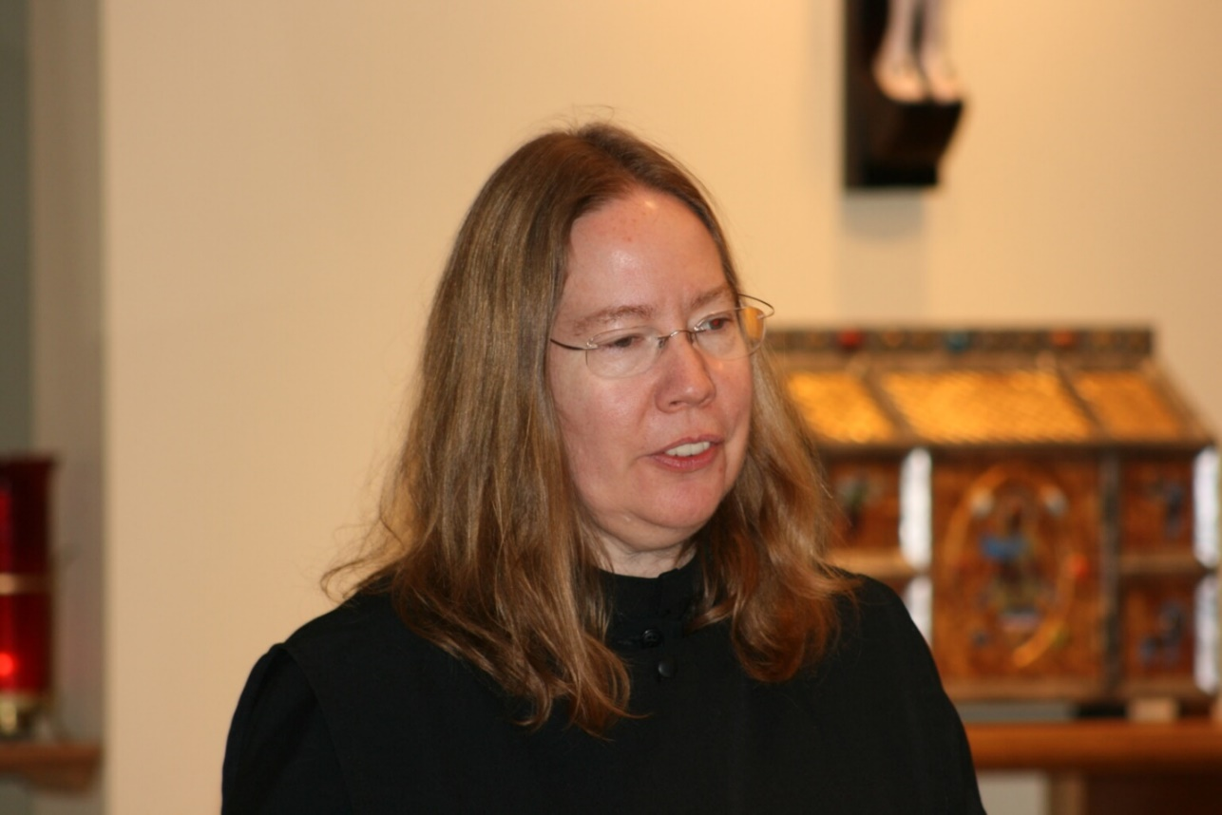
36290155 Sr. Teresa Beebe

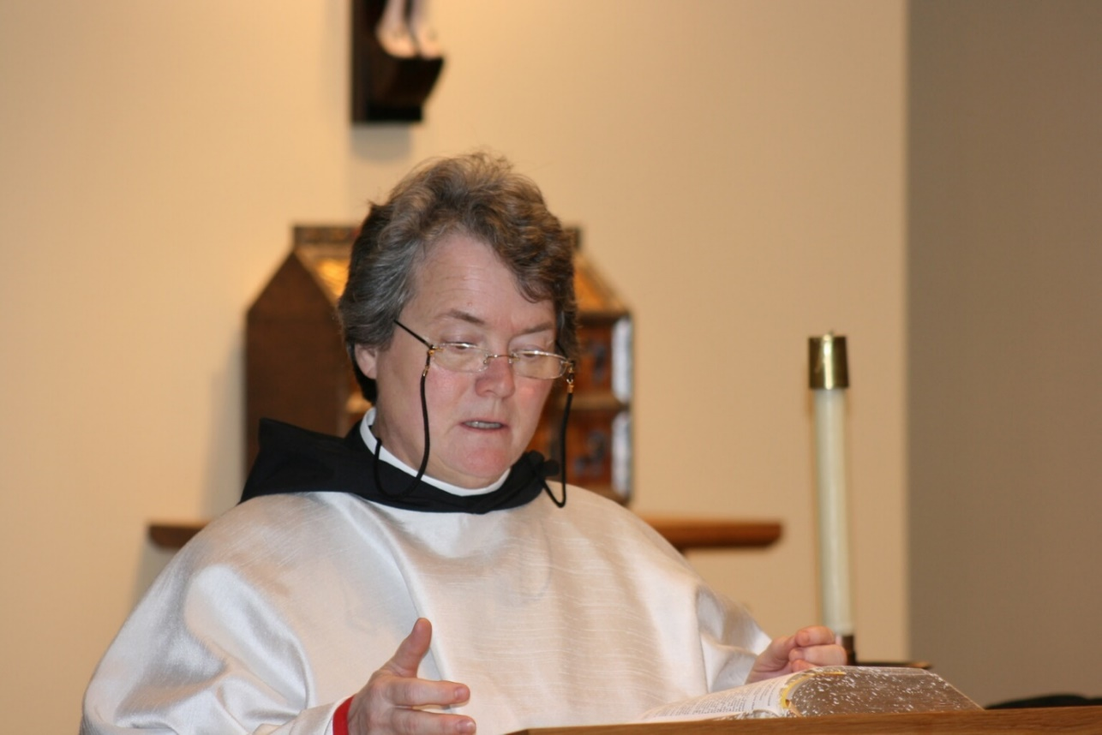
36290156 Sr. Vincent Marie Rittenhouse

