Companions of St. Luke
2008 Fall Convocation at Conception Abbey
Part 1 of 3

~Edited by Br. Steven Olderr, 17 June 2022 with the assistance of Br. Thomas Ferrell. If you find any errors or omissions or have anything to add, please notify Br. Steven at olderr@ameritech.net

People are identified from left to right.

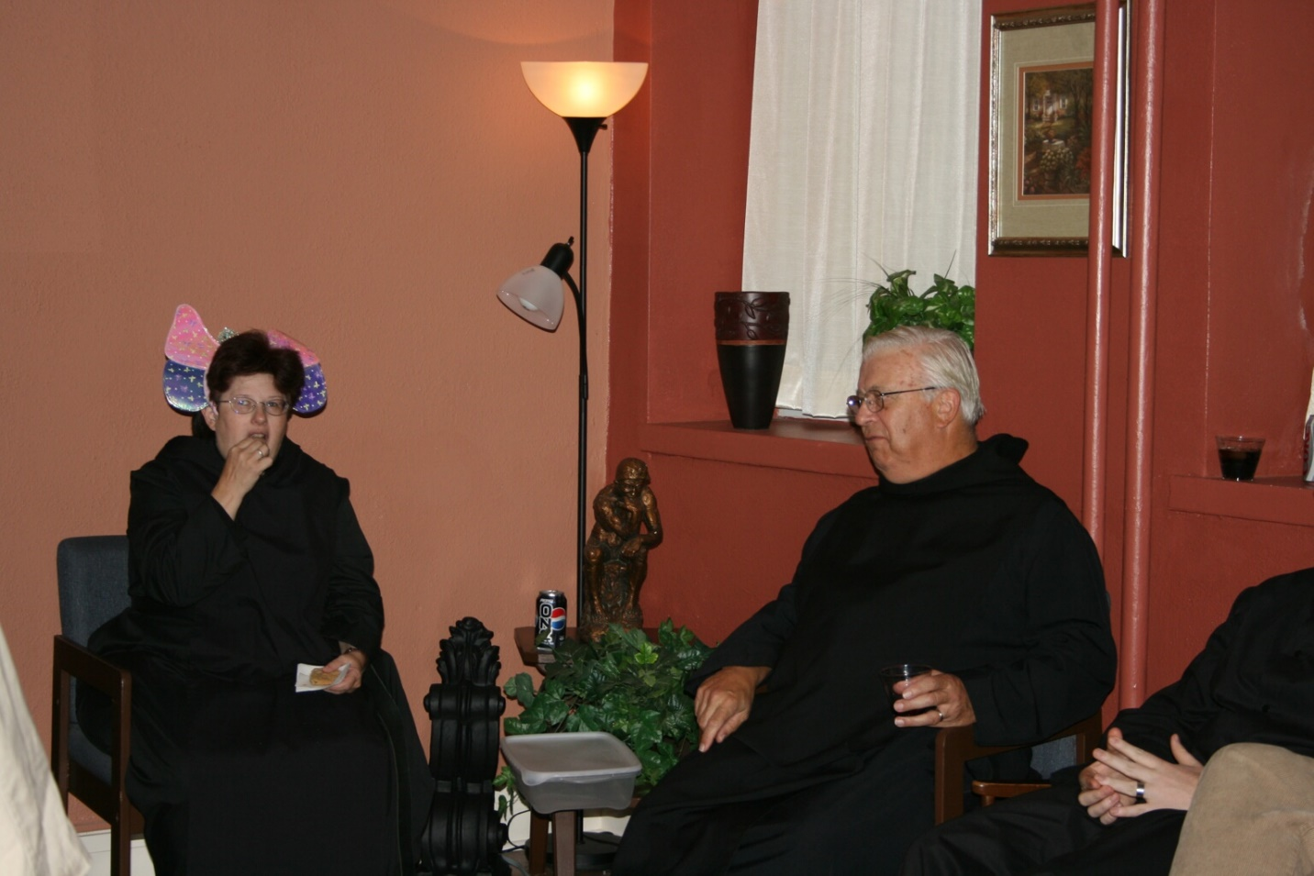
36290001 Sr, Cecelia Lamoy; Br. Timothy Titus Lunt

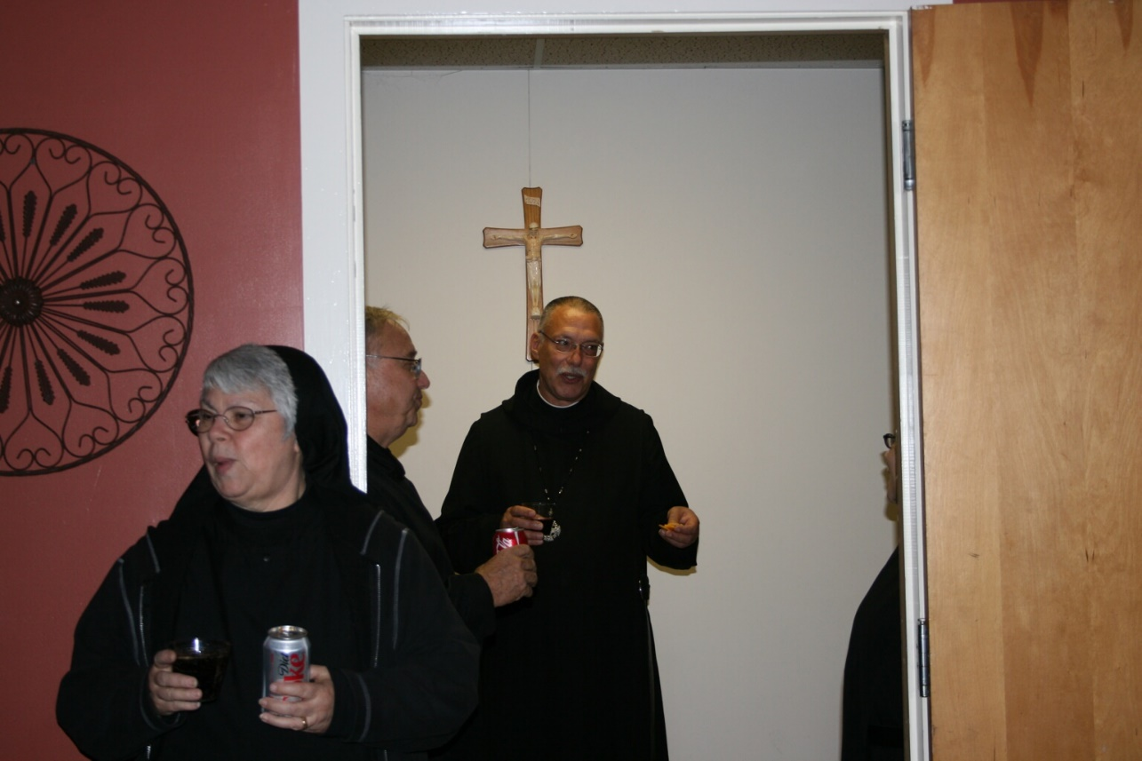
36290002 Sr. Clare Benedicta Myers; Br. Bede Leach; Abbot Michael John Austin

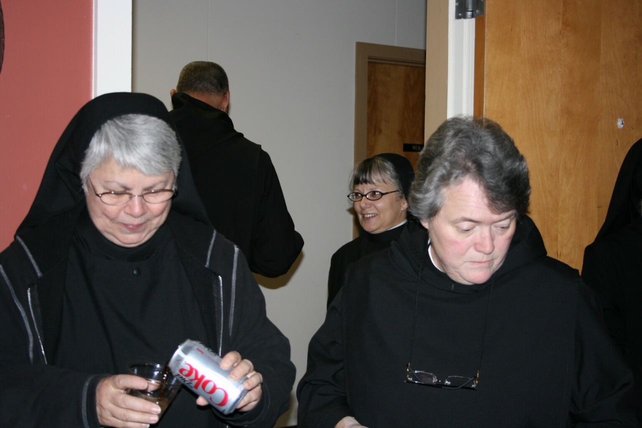
36290003 Sr. Clare Benedicta Myers; Abbot Michael John Austin; Sr. Anna Grace Madden; Sr. Vincent Marie Rittenhouse
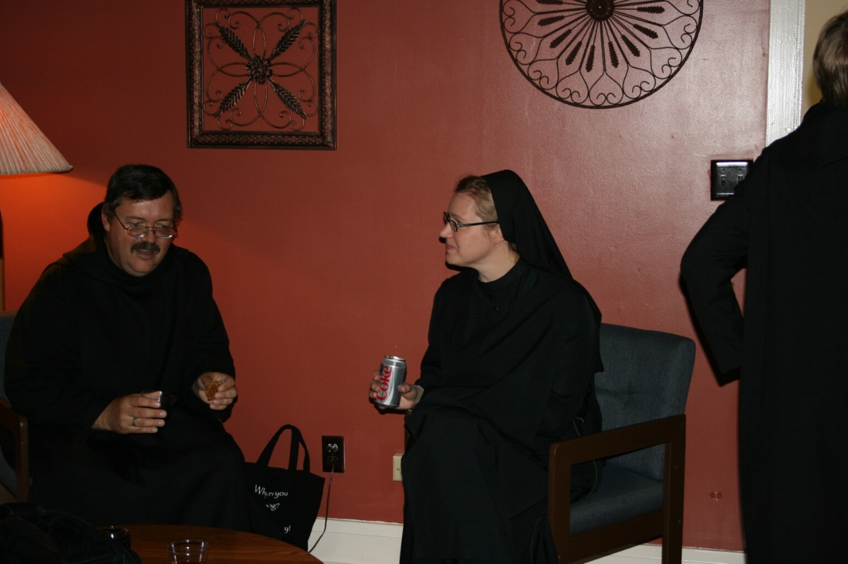
36290004 Br. Paul Howard; Sr. Hannah Sophia Korver

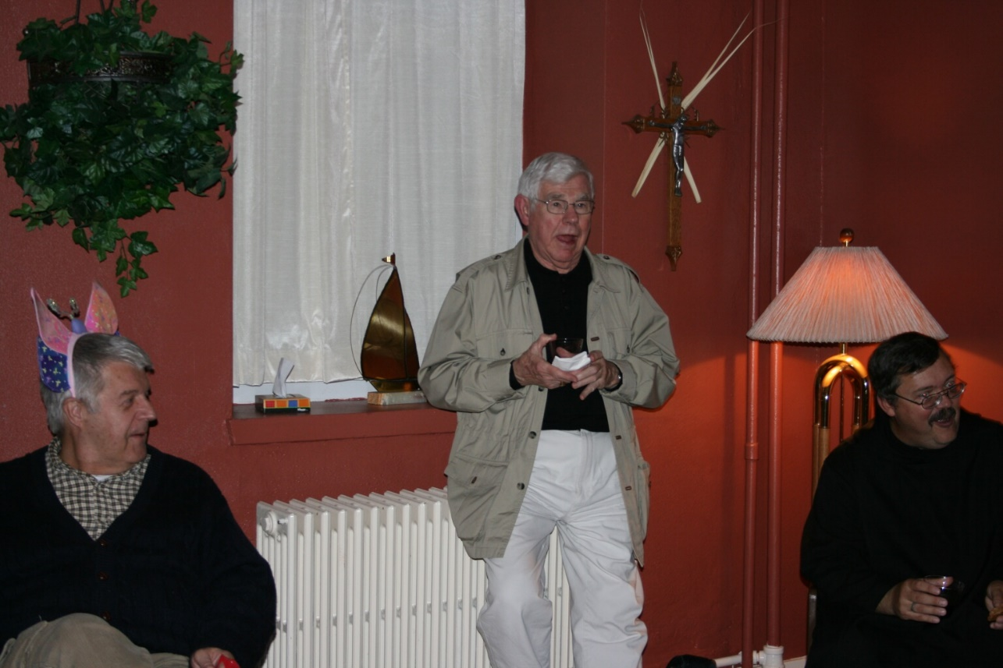
36290005 Br. Michael Anicetas McCabe; Rev. Canon Thomas Hulme; Br. Paul Howard

36290006 Cindy Kennedy

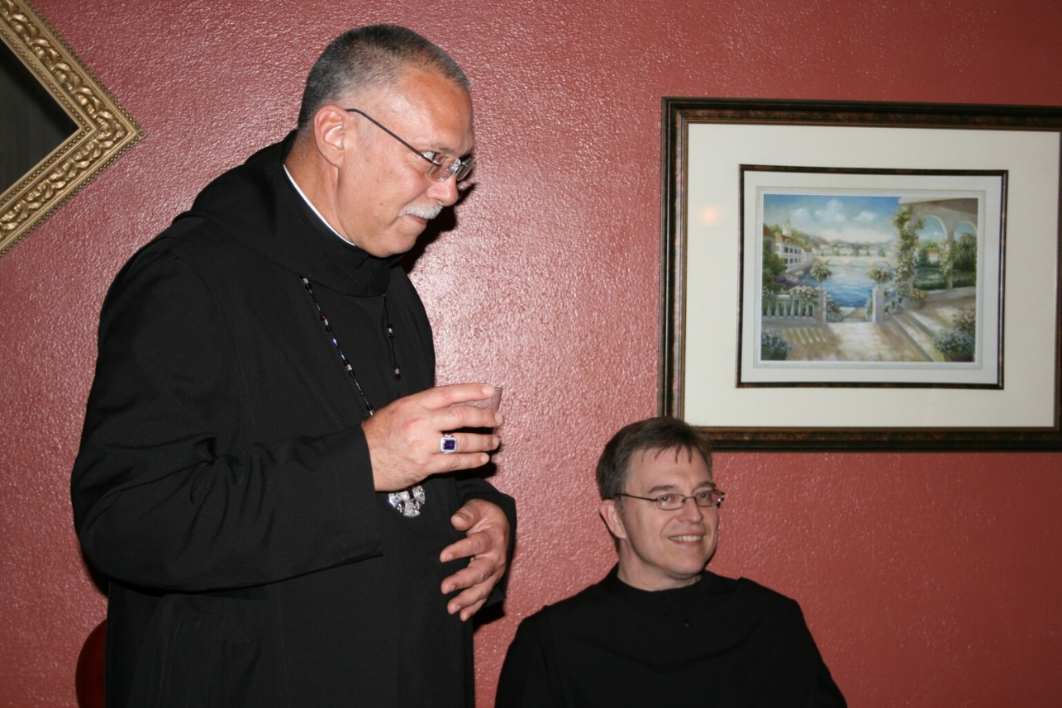
36290007 Abbot Michael John Austin; Br. John of Kanty Kennedy
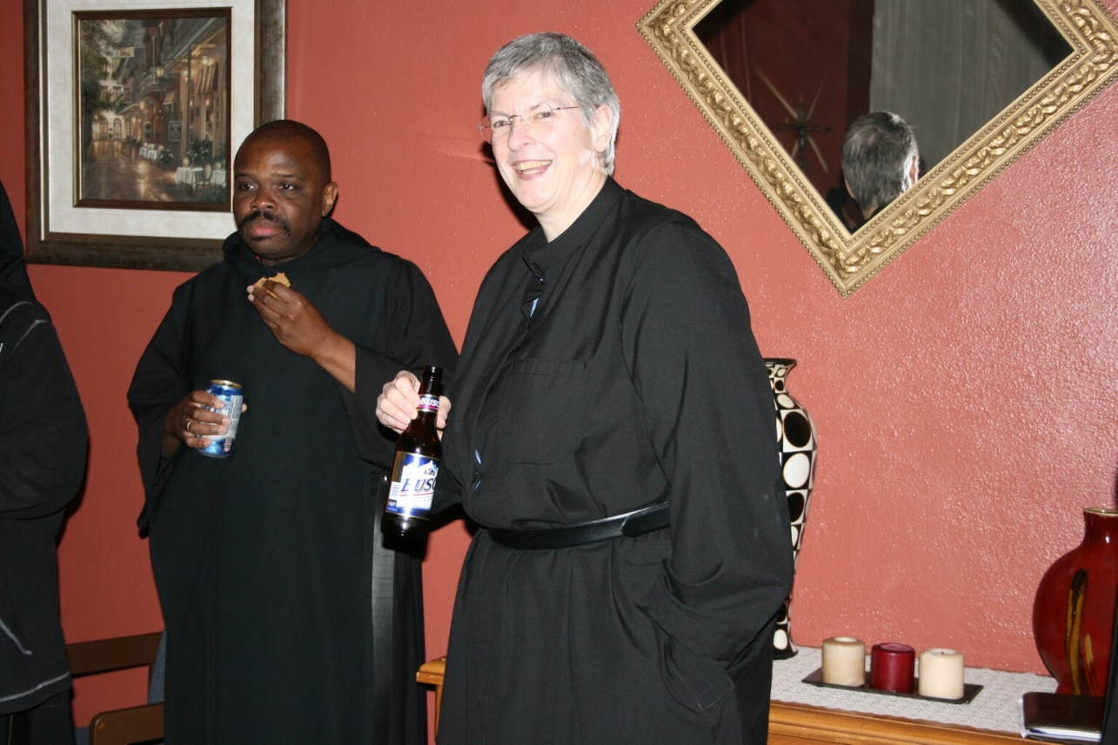
36290008 Br. Thomas Ferrell; Sr. Bernadette Barrett

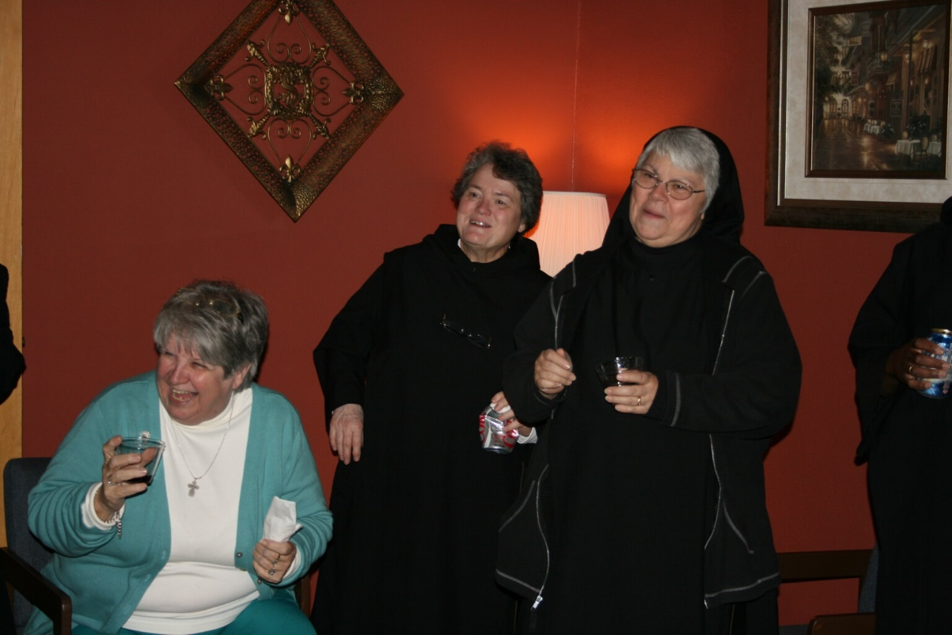
36290009 ?; Sr. Vincent Marie Rittenhouse; Sr. Clare Benedicta Myers
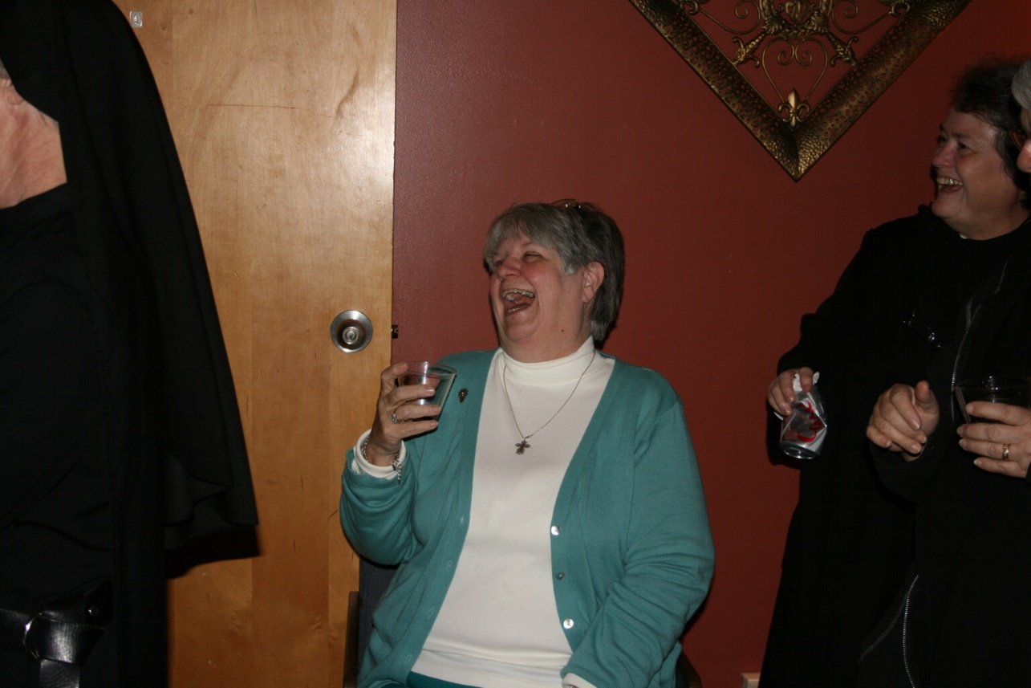
36290010 ?; Sr. Vincent Marie Rittenhouse

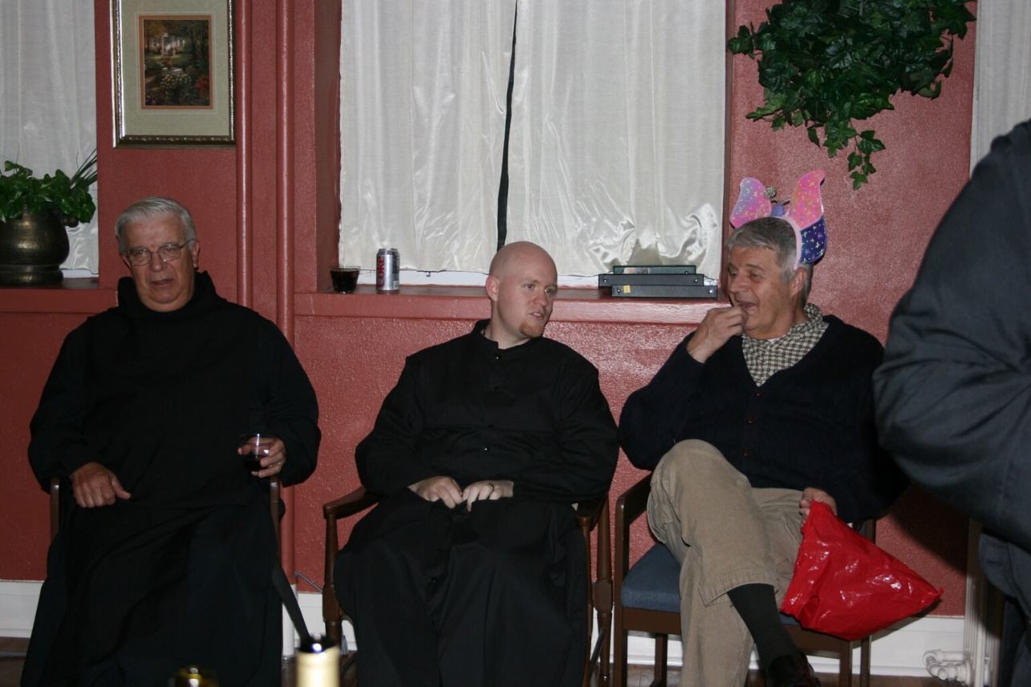
36290011 Br. Timothy Titus Lunt; Br. Gregory Kingsley; Br. Michael Anicetas McCabe
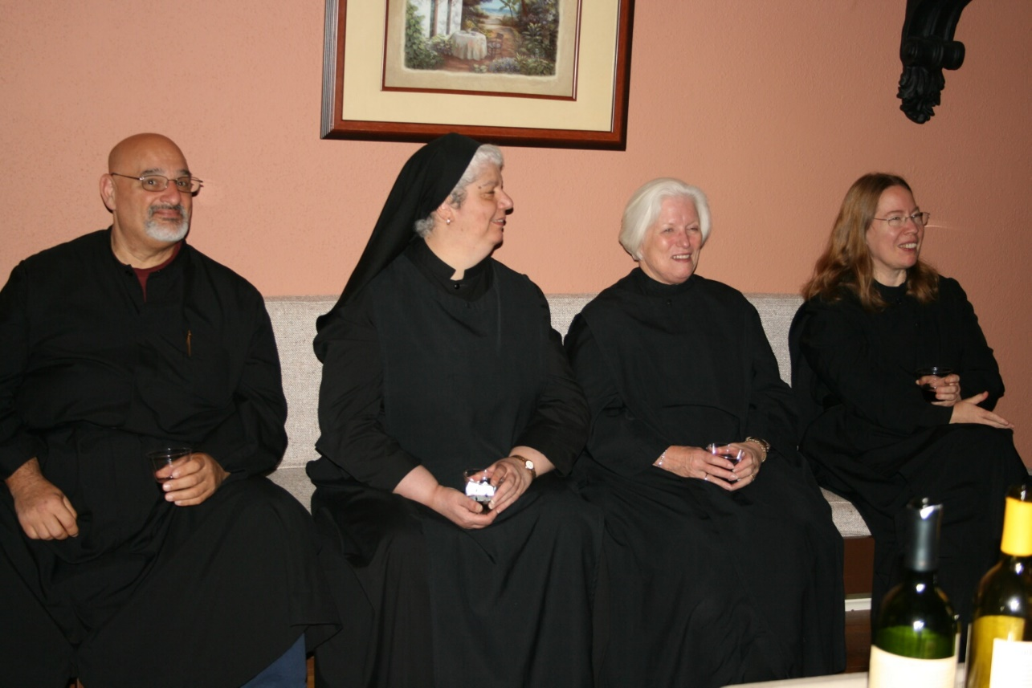
36290012 Br. Simon DiNapoli; Sr. Mary Catherine Christopher; Sr. Elizabeth Anne Stribley; Sr. Teresa Bebee

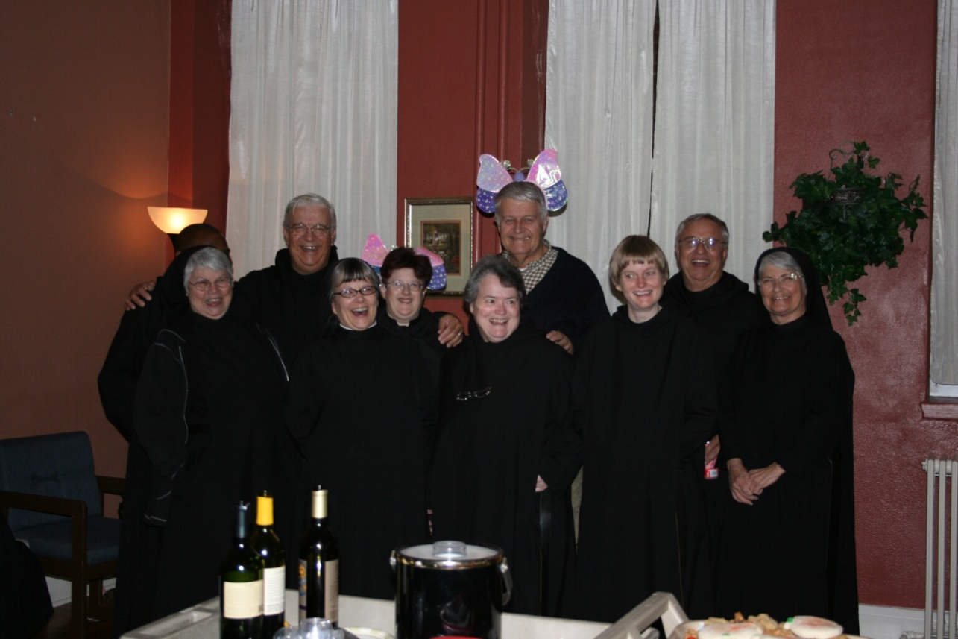
36290013 Br. Thomas Ferrell; Sr. Clare Benedicta Myers; Br. Timothy Titus Lunt; Sr. Anna Grace Madden; Sr. Cecelia Lamoy; Sr. Vincent Marie Rittenhouose; Br. Michael Anicetas McCabe; Sr. Catherine Unterseher; Br. Bede Leach; Sr. Mary Francis Deulen
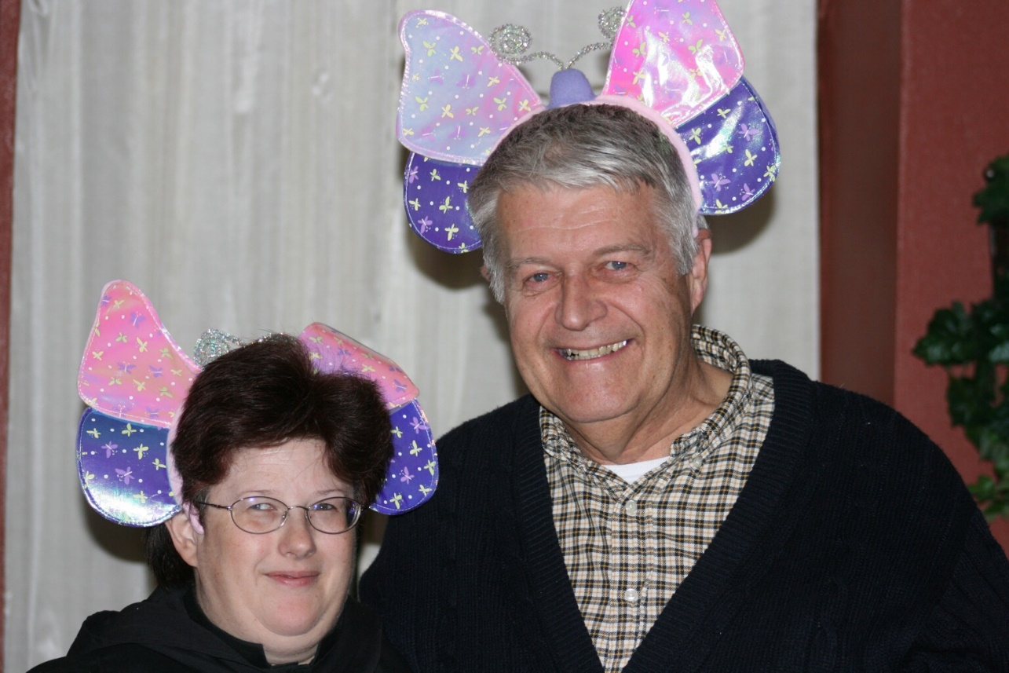
36290014 Sr. Cecelia Lamoy; Br. Michael Anicetas McCabe

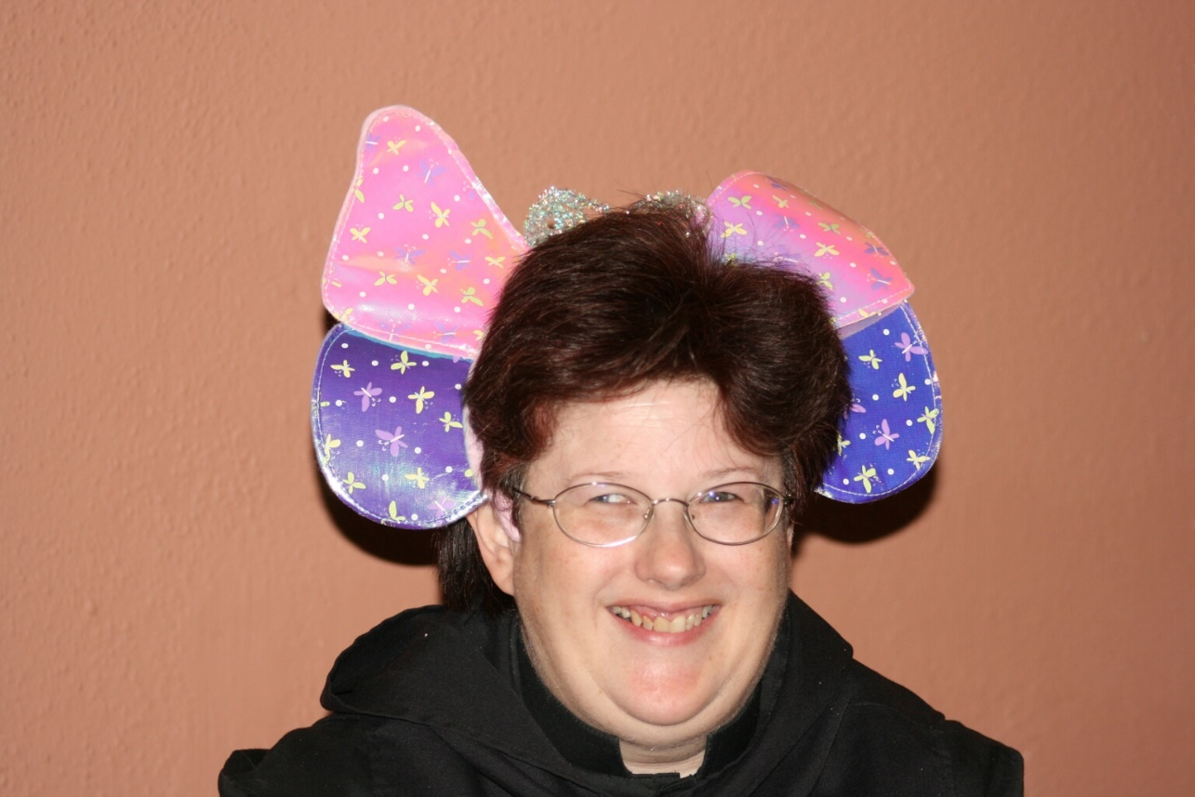
36290015 Sr. Cecelia Lamoy
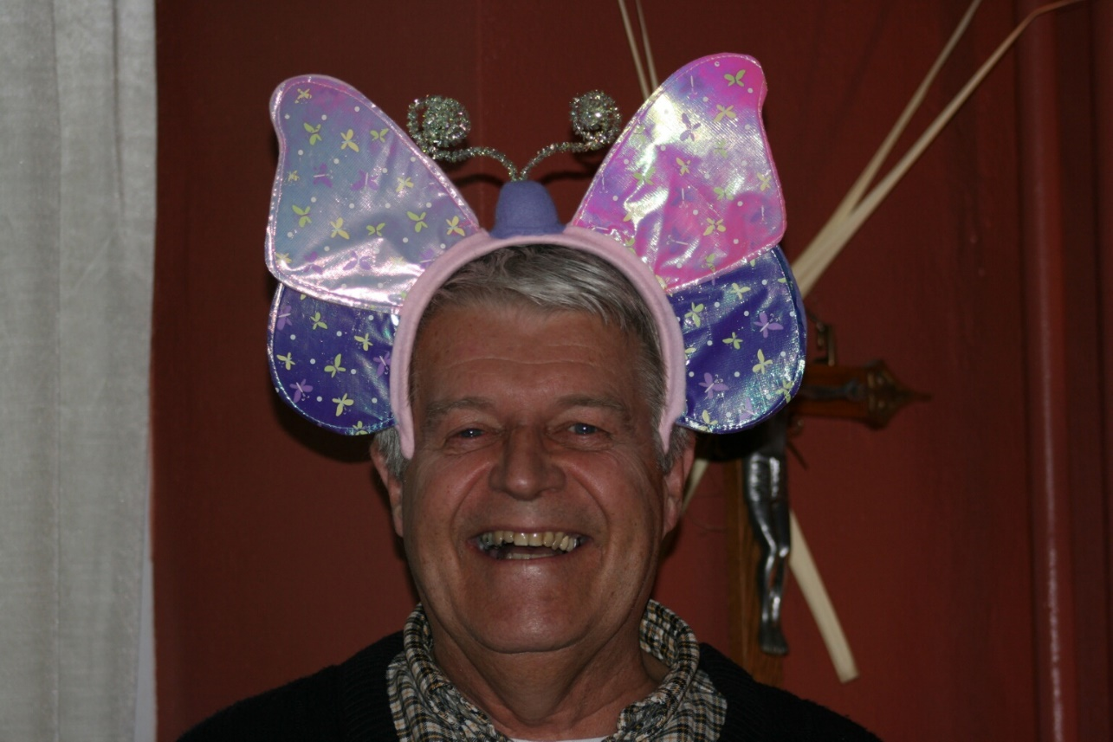
36290016 Br. Michael Anicetas McCabe

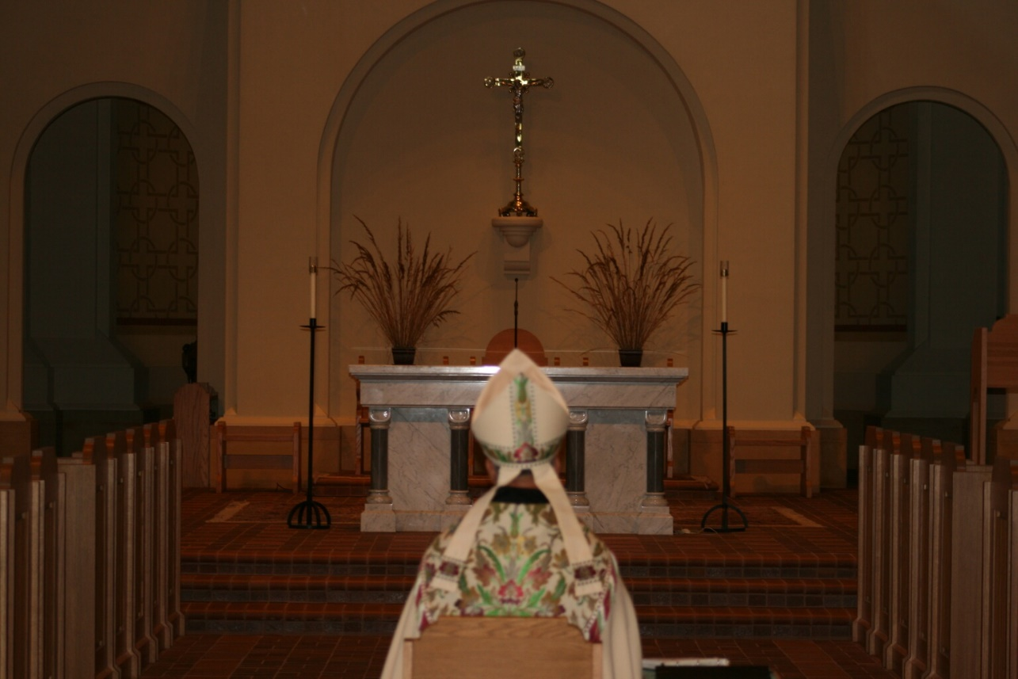
36290018 Abbot Michael John Austin
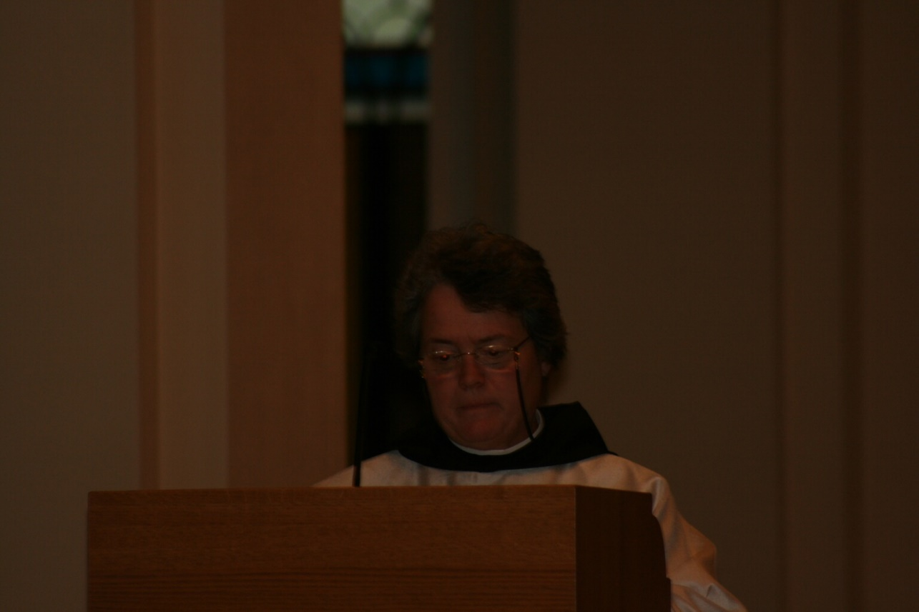
36290019 Sr. Vincent Marie Rittenhouse

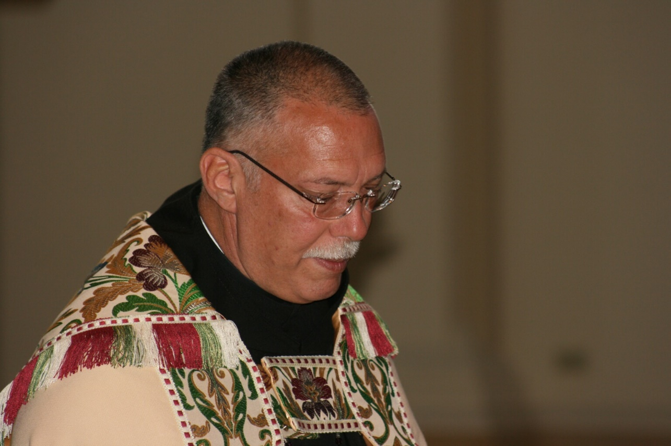
36290020 Abbot Michael John Austin
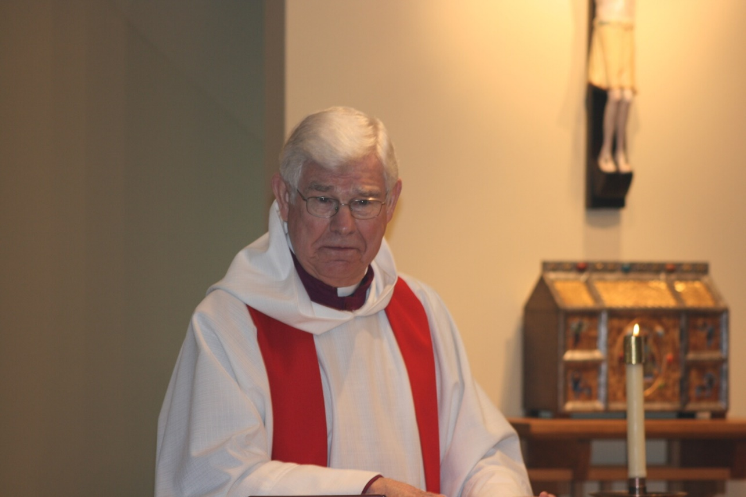
36290022 Rev. Canon Thomas Hulme

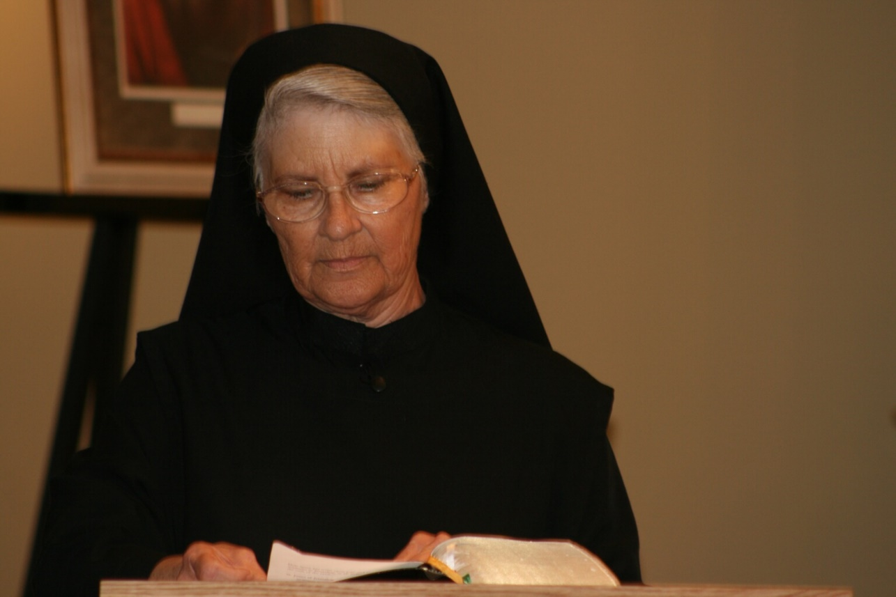
36290023 Sr. Mary Francis Deulen
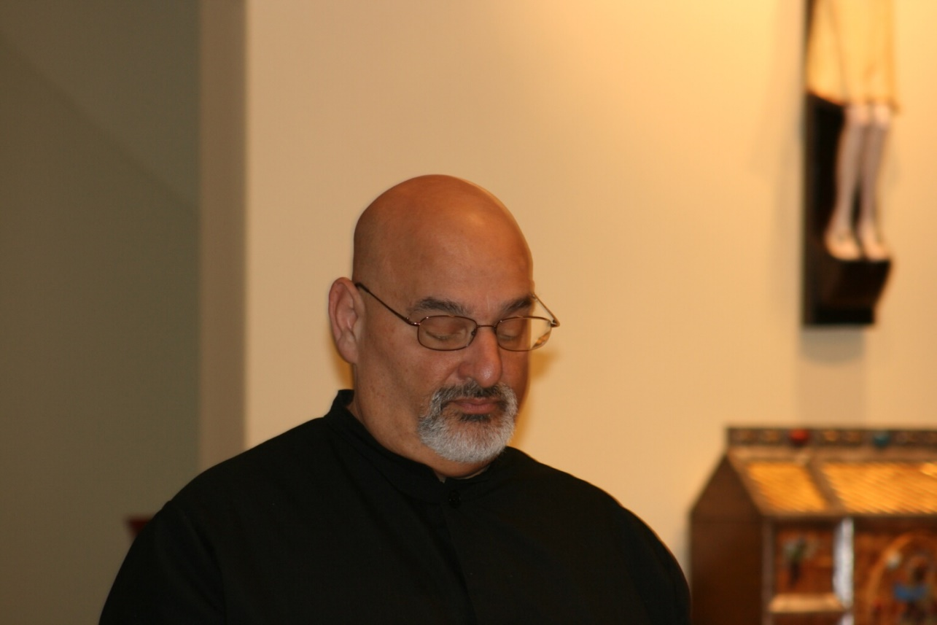
36290024 Br. Simon DiNapoli

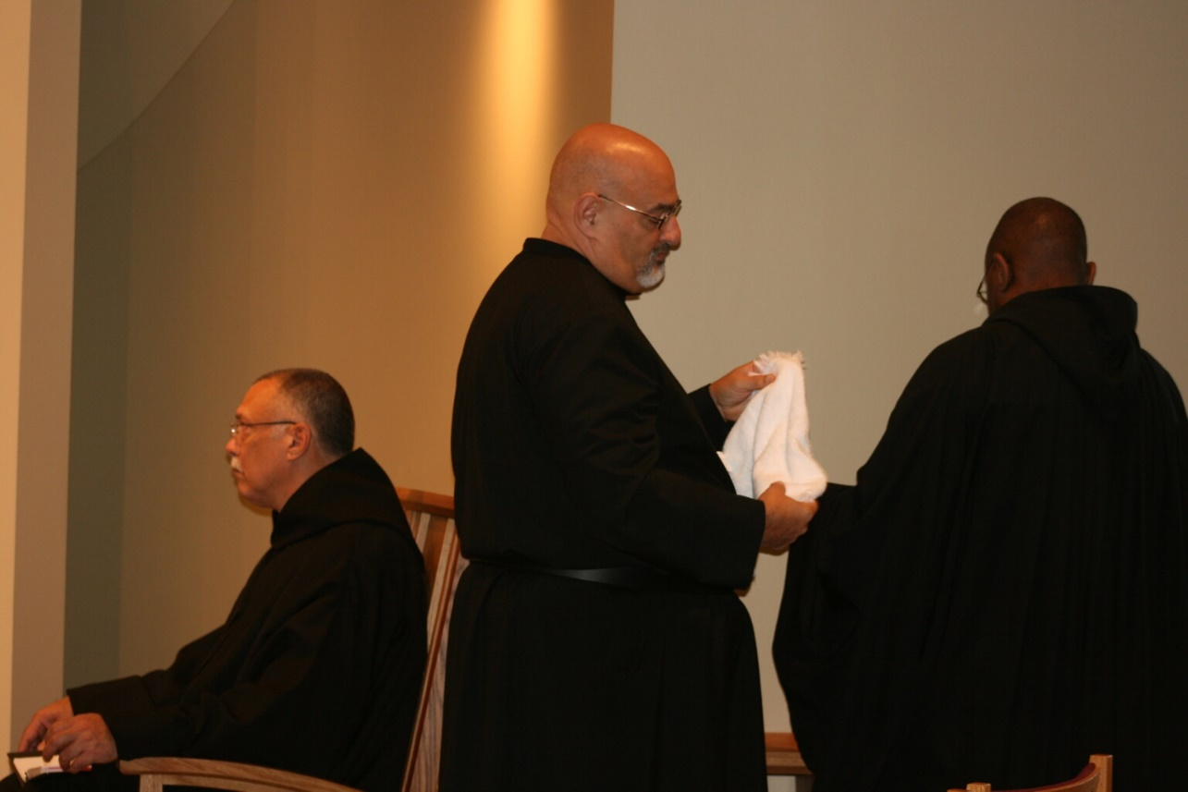
36290025 Abbot Michael John Austin; Br. Simon DiNapoli; Br. Thomas Ferrell
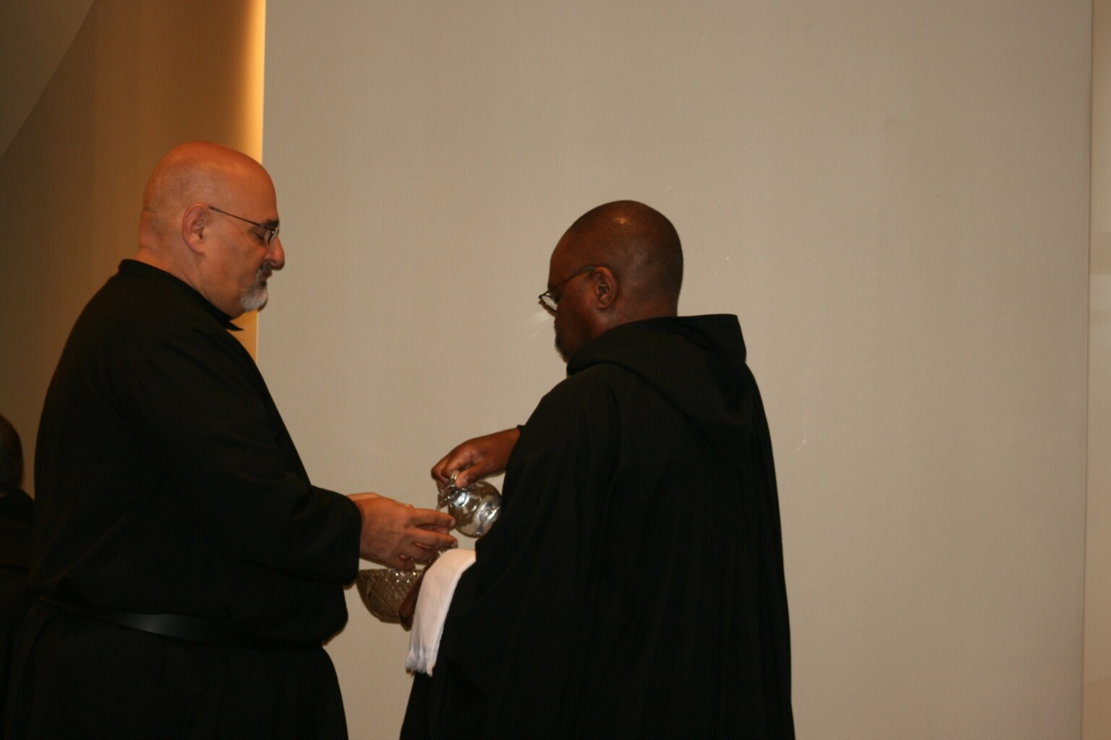
36290026 Br. Simon DiNaopli; Br. Thomas Ferrell

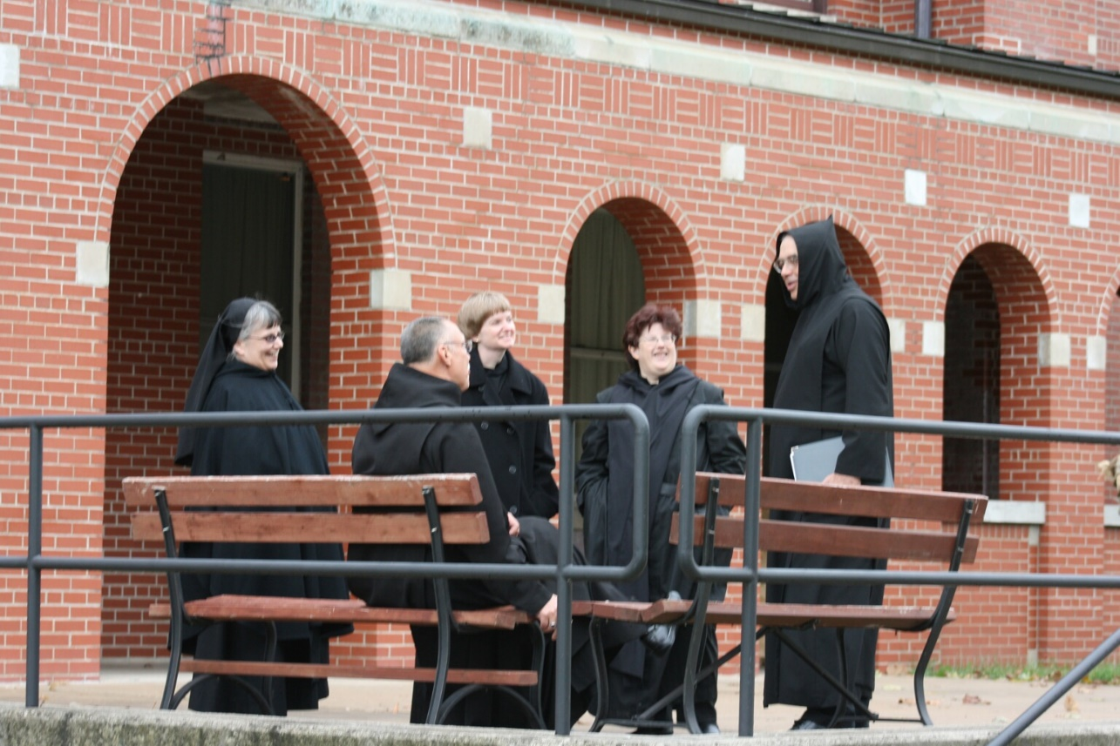
36290030 Sr. Anna Grace Madden; Abbot Michael John Austin; Sr. Catherine Unterseher; Sr. Cecelia Lamoy; Br. Gabriel Hale
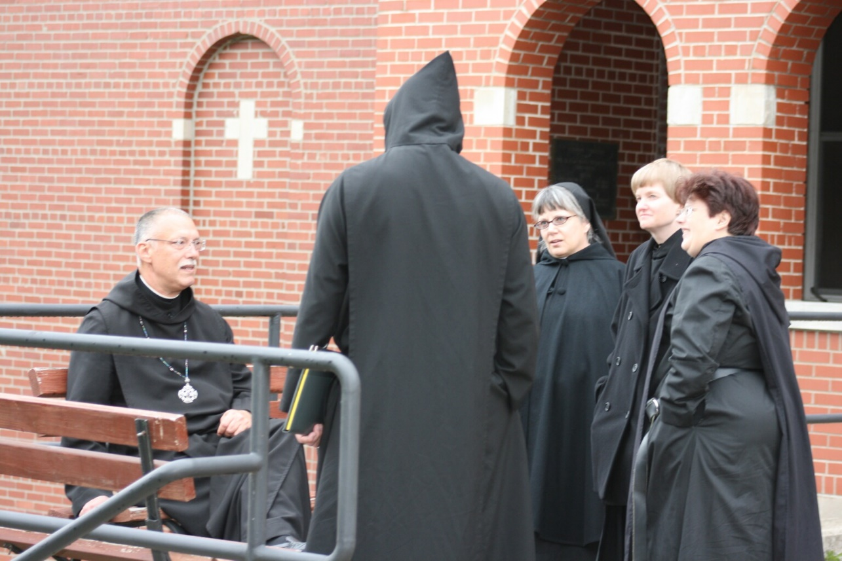
36290031 Abbot Michael John Austin; Br. Gabriel Hale; Sr. Anna Grace Madden; Sr. Catherine Unterseher; Sr. Cecelia Lamoy

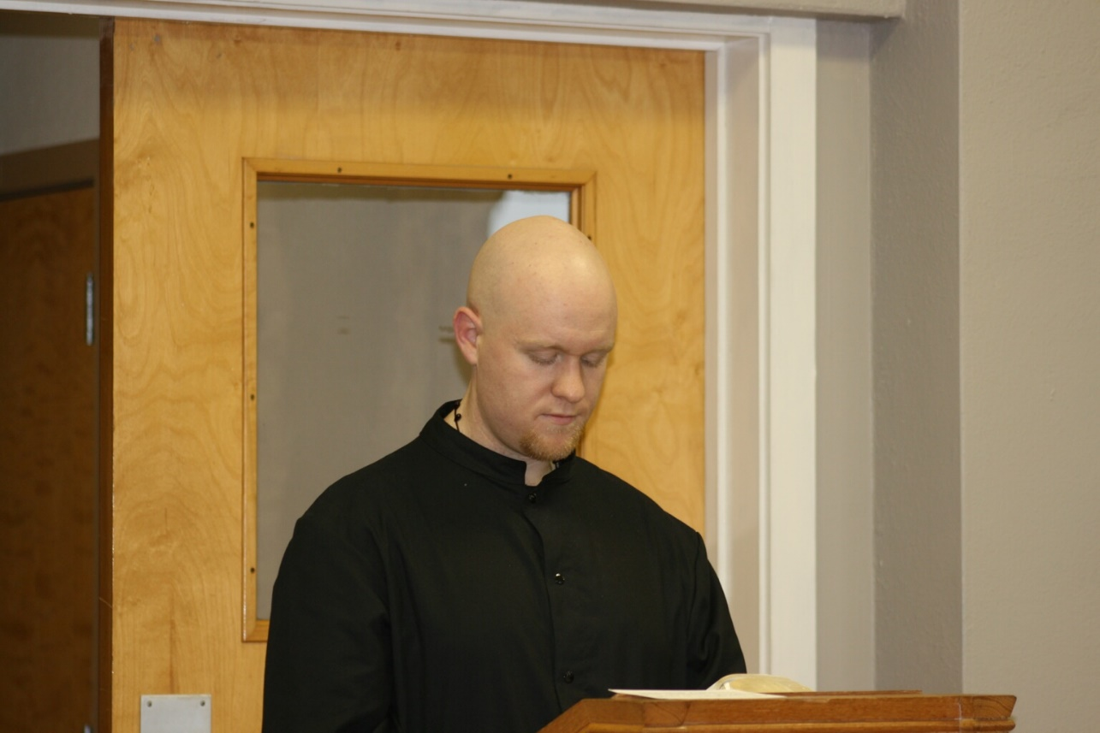
36290032 Br. Gregory Kingsley
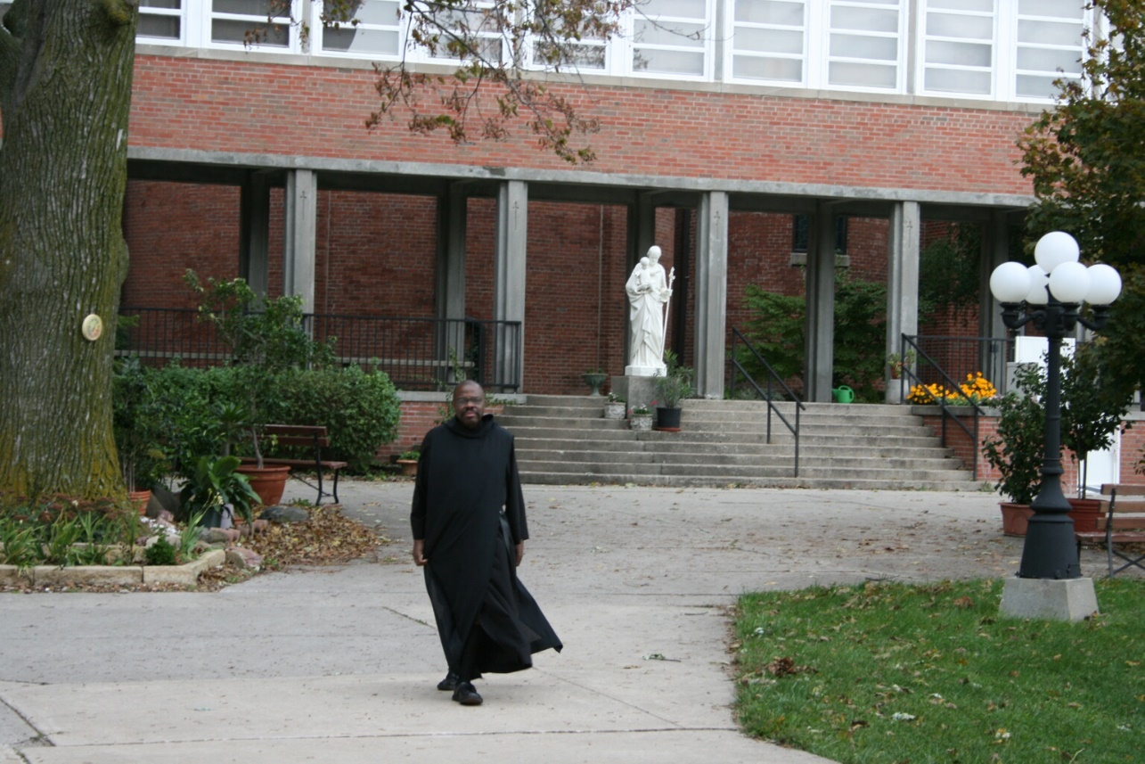
36290033 Br. Thomas Ferrell

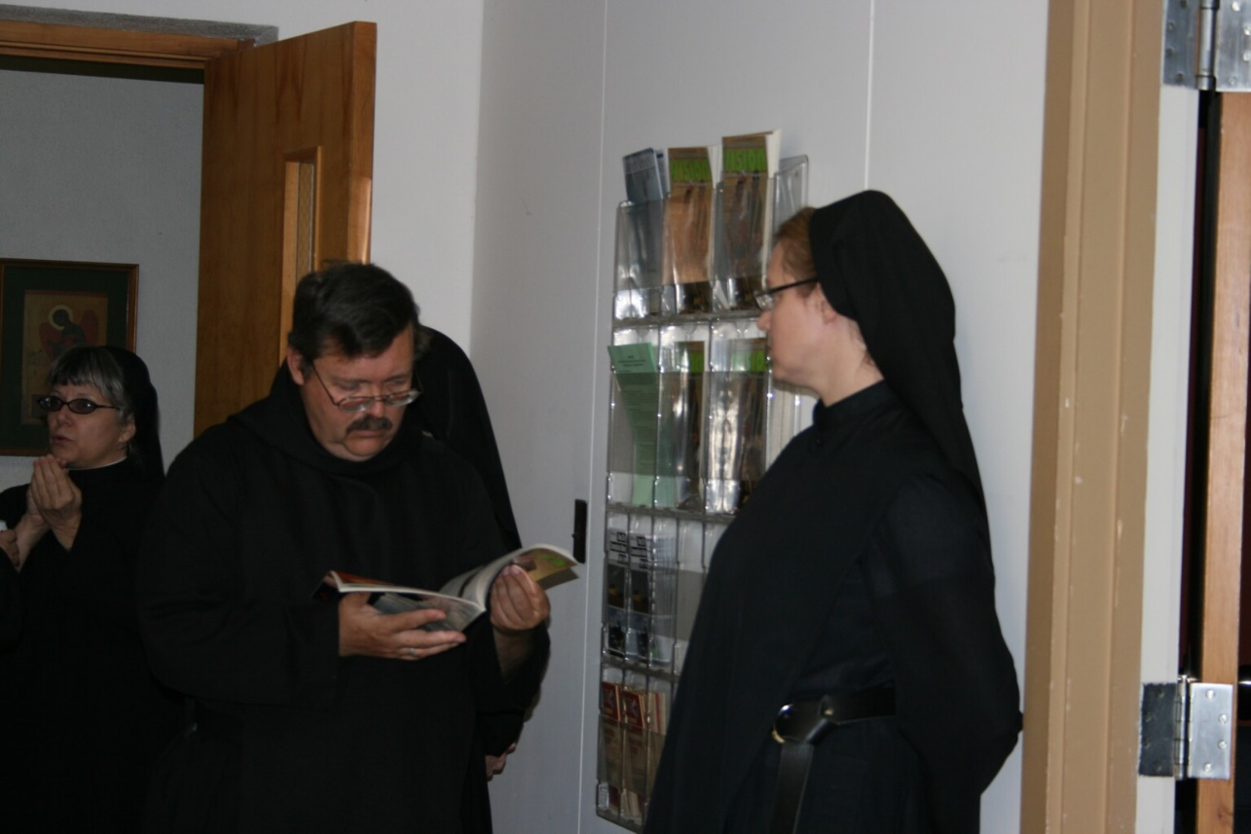
36290034 Sr. Anna Grace Myers; Br. Paul Howard; Sr. Hannah Sophia Korver
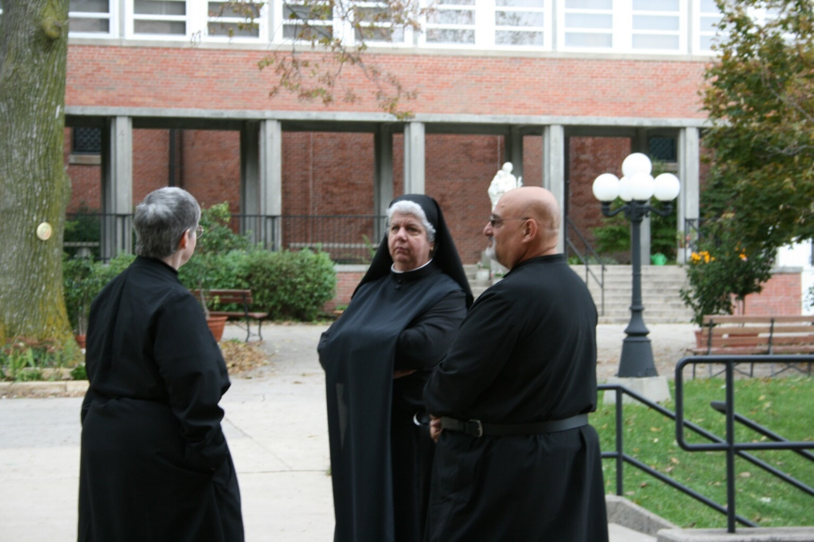
36290035 Sr. Bernadette Barrett; Sr. Mary Catherine Christoper; Br. Simon DiNapoli

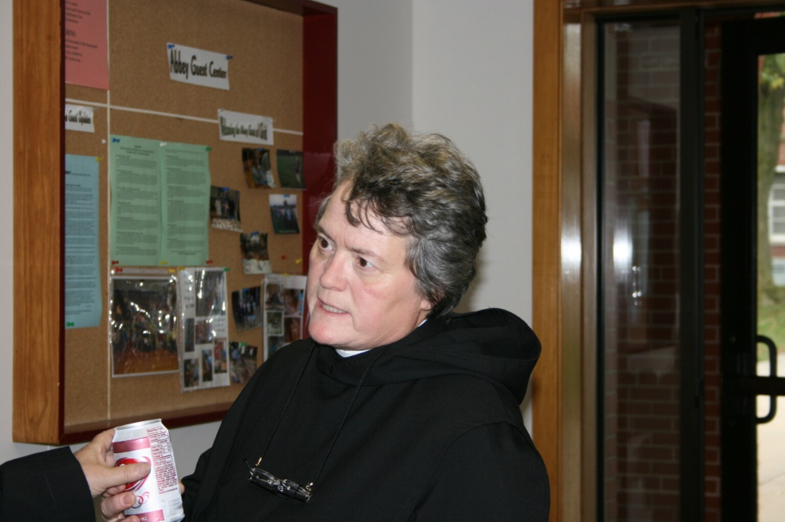
36290036 Sr. Vincent Marie Rittenhouse
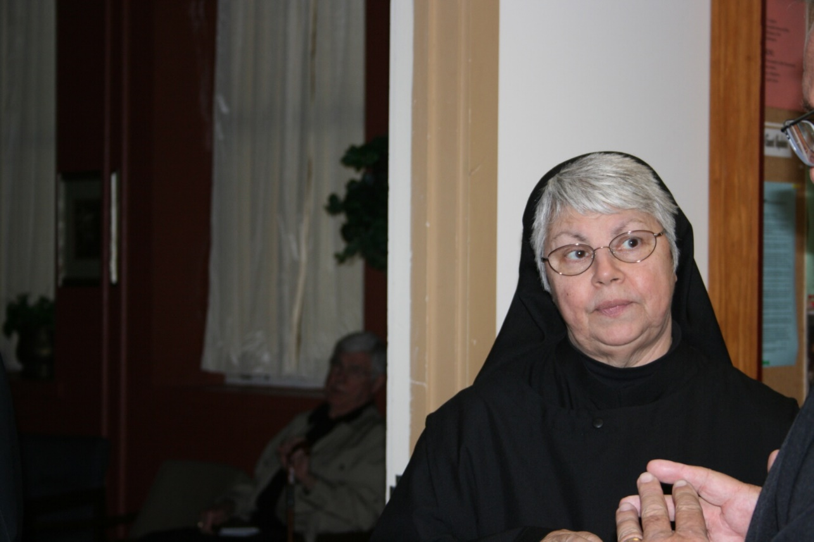
36290037 Sr. Clare Benedicta Myers

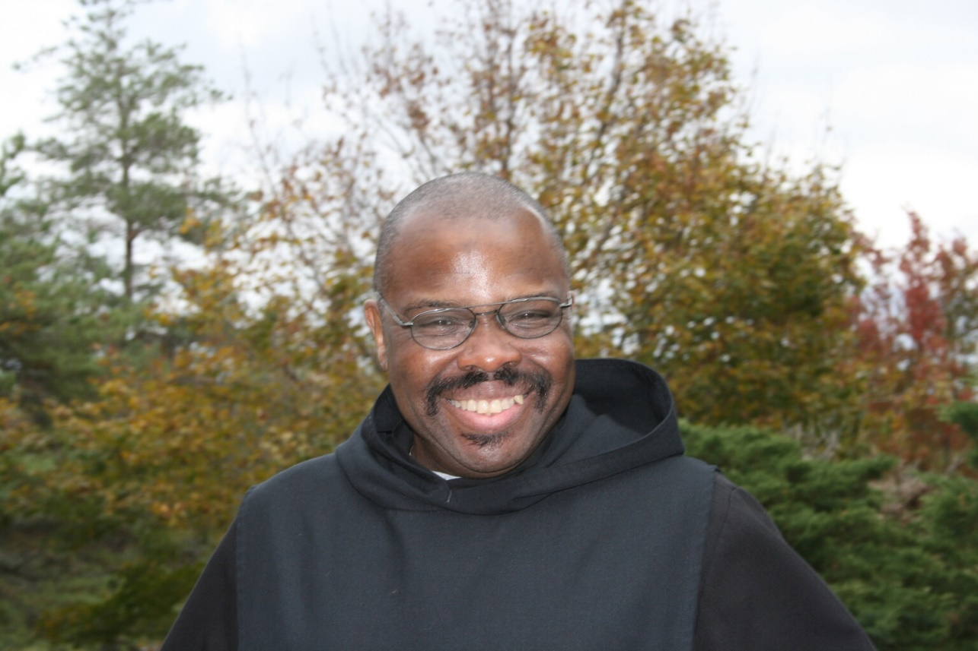
36290038 Br. Thomas Ferrell
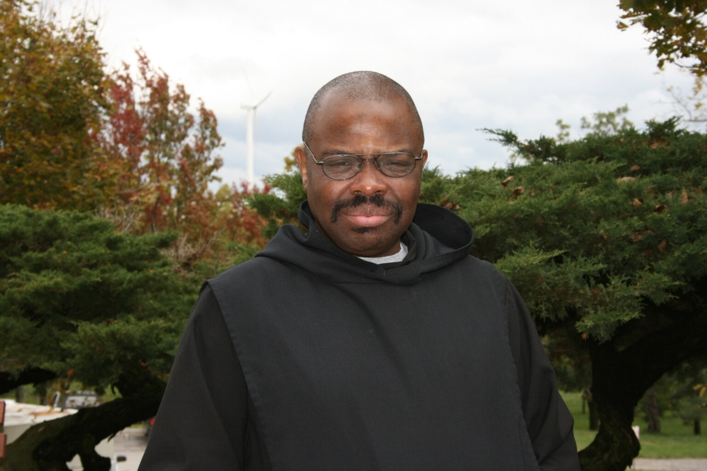
36290039 Br. Thomas Ferrell

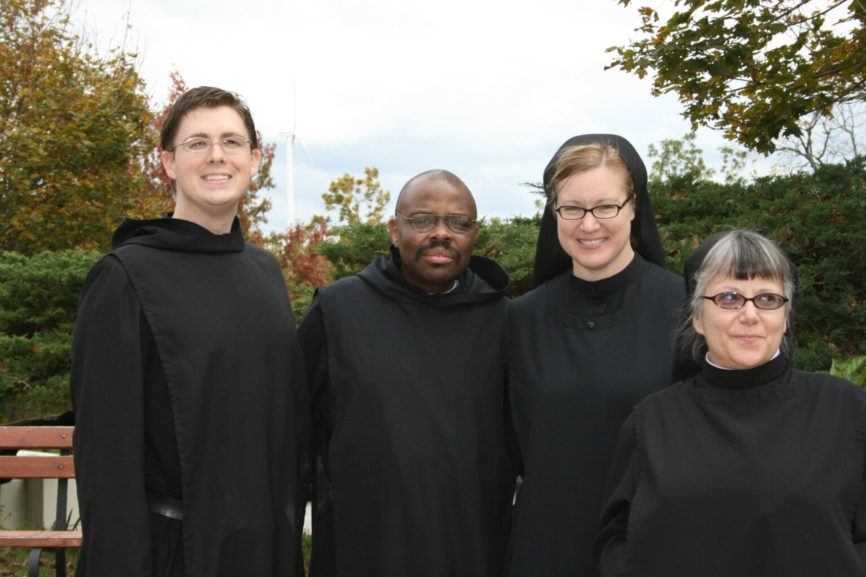
36290040 Br. Aidan Maguire; Br. Thomas Ferrell; Sr. Hannah Sophia Korver; Sr. Anna Grace Madden
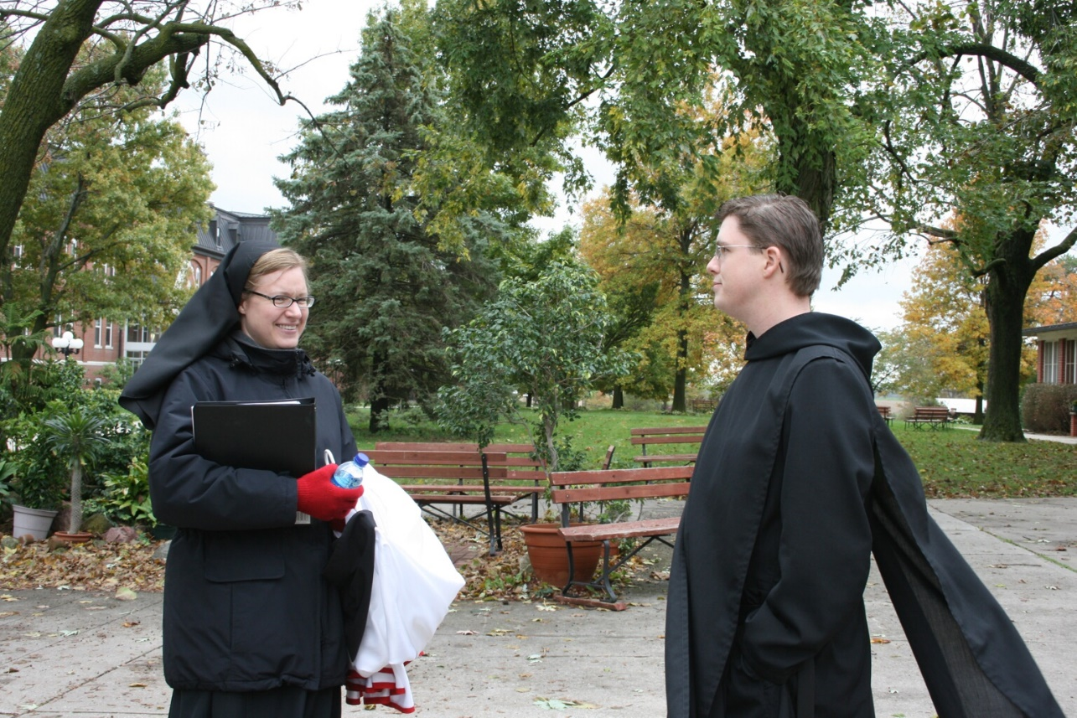
36290044 Sr. Hannah Sophia Korver; Br. Aidan Maguire

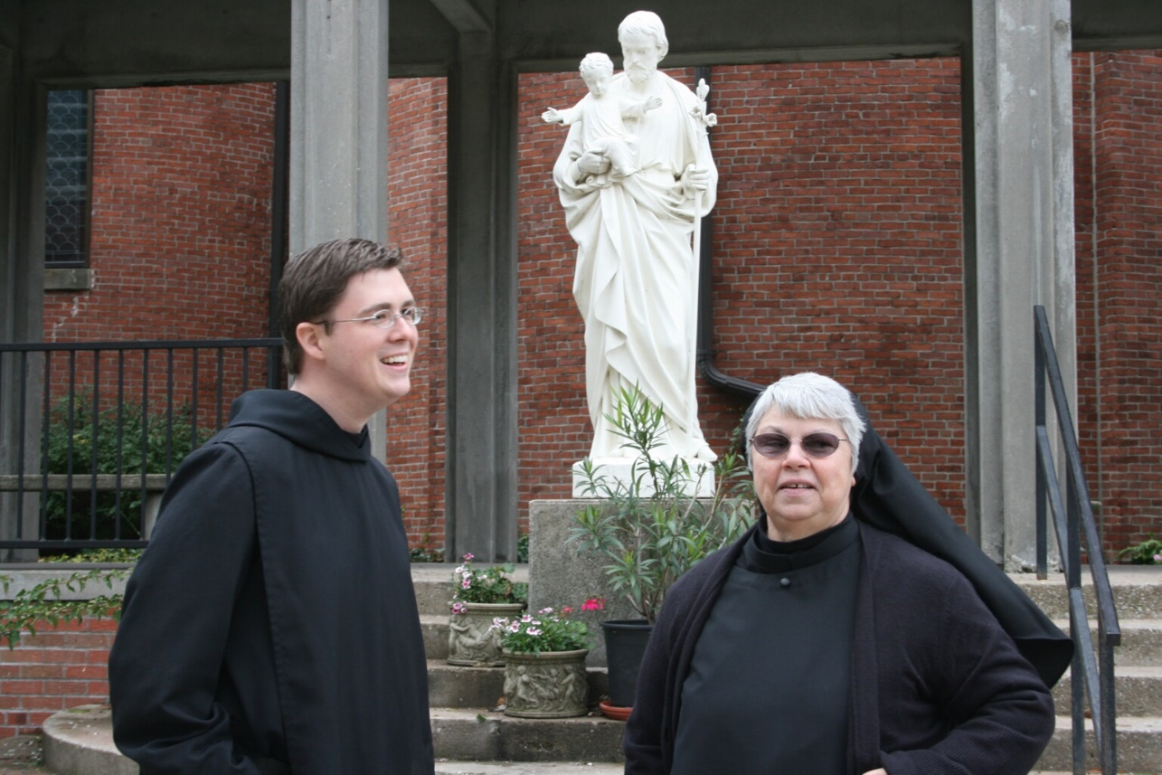
36290045 Br. Aidan Maguire; Sr. Clare Benedicta Myers
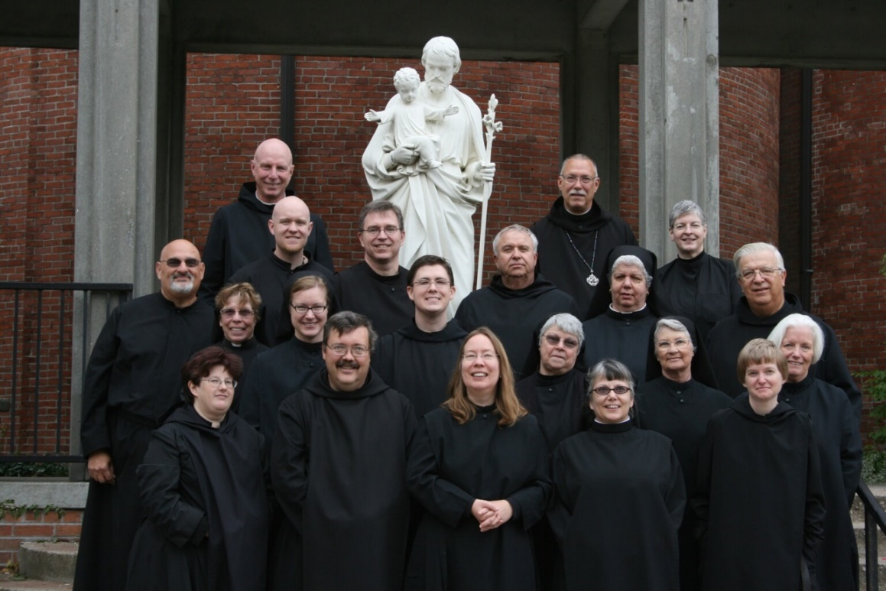
36290046 Br. Simon DiNapoli; Sr. Cecelia Lamoy; Sr. Monica Ruth Mullen; Br. David Vincent Cotton; Br. Gregory Kingley; Sr. Hannah Sophia Korver; Br. Paul Howard; Br. Aidan Maguire; Sr. Teresa Beebe; Br. Bede Leach; Br. John of Kanty Kennedy; Sr. Clare Benedicta Myers; Abbot Michael John Austin; Sr. Anna Grace Madden. Sr. Mary Catherine Christopher; Sr. Mary Francis Deulen; Sr. Bernadette Barrett; Sr. Catherine Unterseher; Br. Timothy Titus Lunt; Sr. Elizabeth Anne Stribley

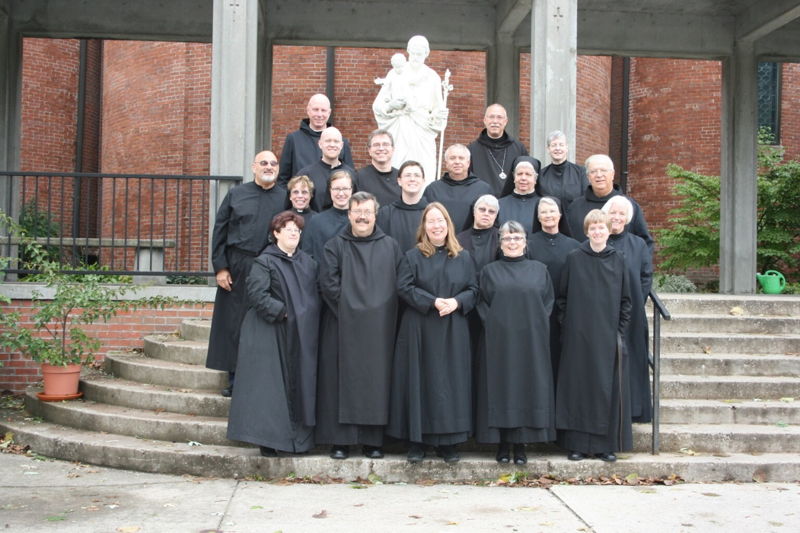
36290047 Br. Simon DiNaopli; Sr. Cecelia Lamoy; Sr. Monica Ruth Mullen; Br. David Vincent Cotton; Johsua Kingley; Sr. Hannah Sophia Korver; Br. Paul Howard; Br. Aidan Maguire; Sr. Teresa Beebe; Br. Bede Leach; Br. John of Kanty Kennedy; Sr. Clare Benedicta Myers; Abbot Michael John Austin; Sr. Anna Grace Madden. Sr. Mary Catherine Christopher; Sr. Mary Francis Deulen; Sr. Bernadette Barrett; Sr. Catherine Unterseher; Br. Timothy Titus Lunt; Sr. Elizabeth Anne Stribley

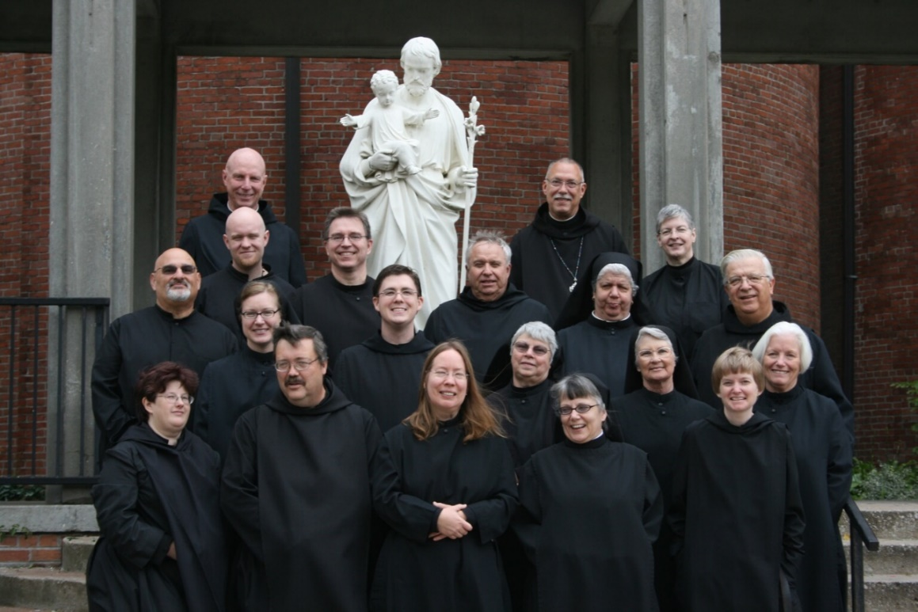
36290048 36290046 Br. Simon DiNapoi; Sr. Cecelia Lamoy; Sr. Monica Ruth Mullen; Br. David Vincent Cotton; Br. Gregory Kingley; Sr. Hannah Sophia Korver; Br. Paul Howard; Br. Aidan Maguire; Sr. Teresa Beebe; Br. Bede Leach; Br. John of Kanty Kennedy; Sr. Clare Benedicta Myers; Abbot Michael John Austin; Sr. Anna Grace Madden. Sr. Mary Catherine Christopher; Sr. Mary Francis Deulen; Sr. Bernadette Barrett; Sr. Catherine Unterseher; Br. Timothy Titus Lunt; Sr. Elizabeth Anne Stribley

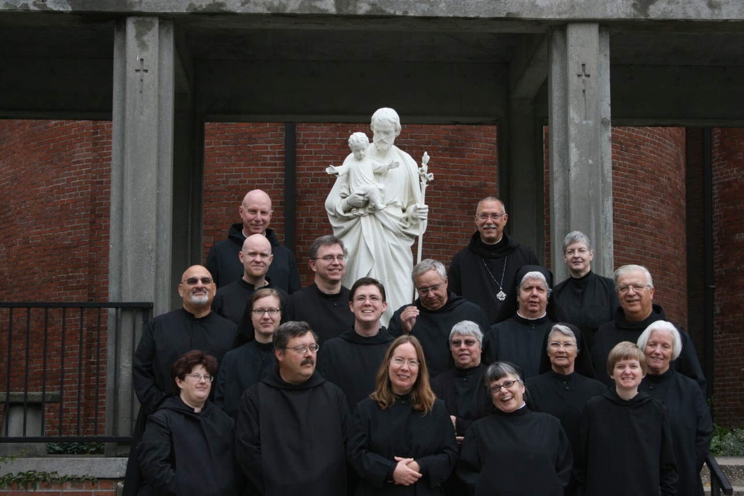
36290049 36290046 Br. Simon DiNapoli; Sr. Cecelia Lamoy; Sr. Monica Ruth Mullen; Br. David Vincent Cotton; Johsua Kingley; Sr. Hannah Sophia Korver; Br. Paul Howard; Br. Aidan Maguire; Sr. Teresa Beebe; Br. Bede Leach; Br. John of Kanty Kennedy; Sr. Clare Benedicta Myers; Abbot Michael John Austin; Sr. Anna Grace Madden. Sr. Mary Catherine Christopher; Sr. Mary Francis Deulen; Sr. Bernadette Barrett; Sr. Catherine Unterseher; Br. Timothy Titus Lunt; Sr. Elizabeth Anne Stribley
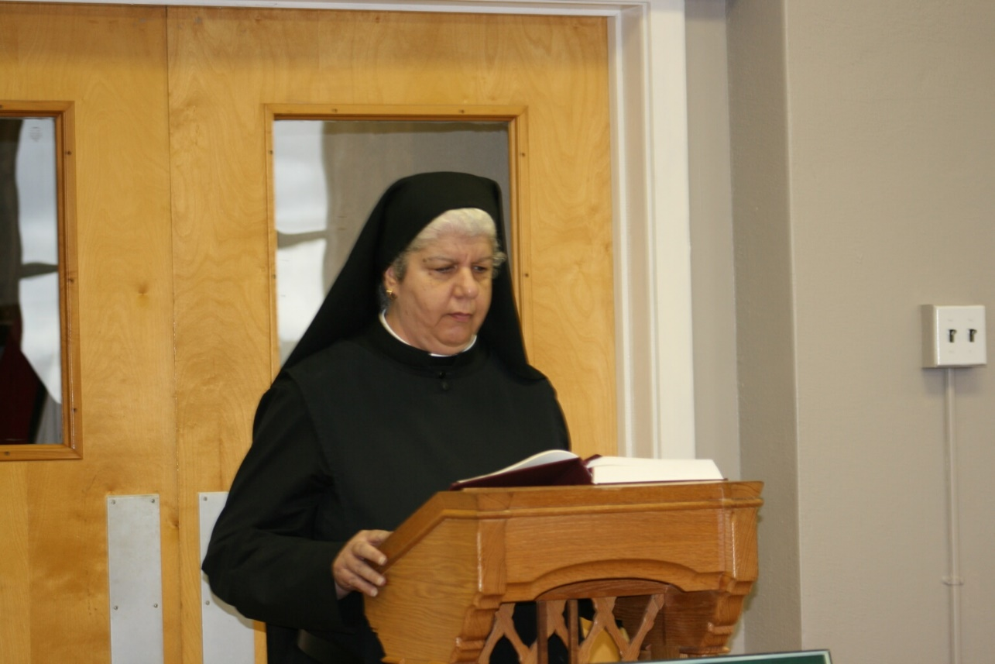
36290050 Sr. Mary Catherine Christopher

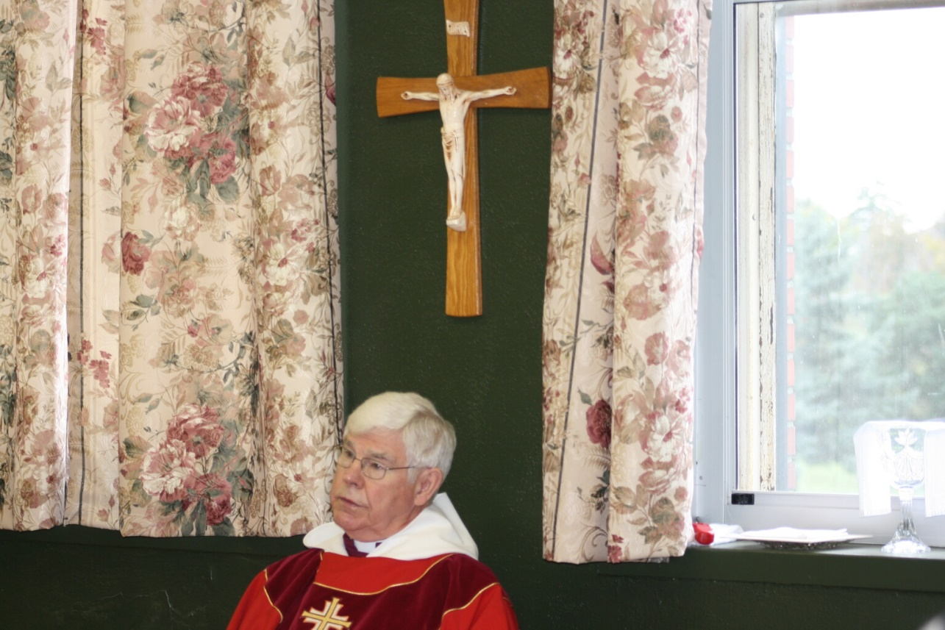
36290051 Rev. Canon Thomas Hulme
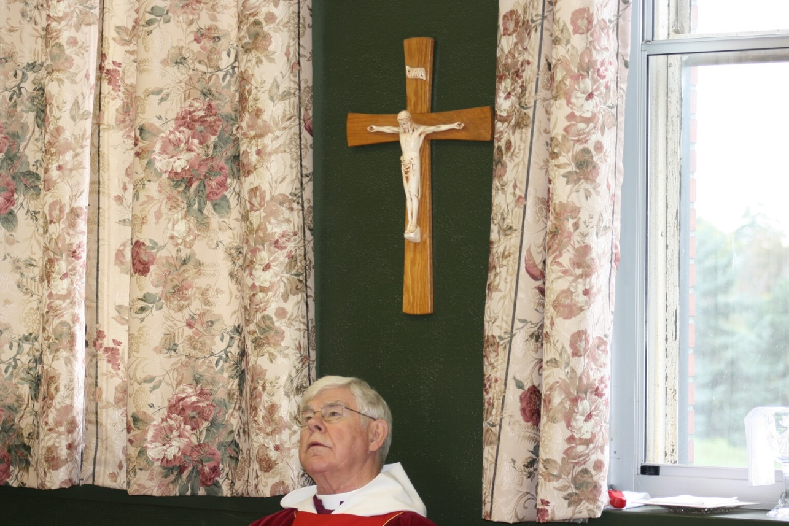
36290052 Rev. Canon Thomas Hulme

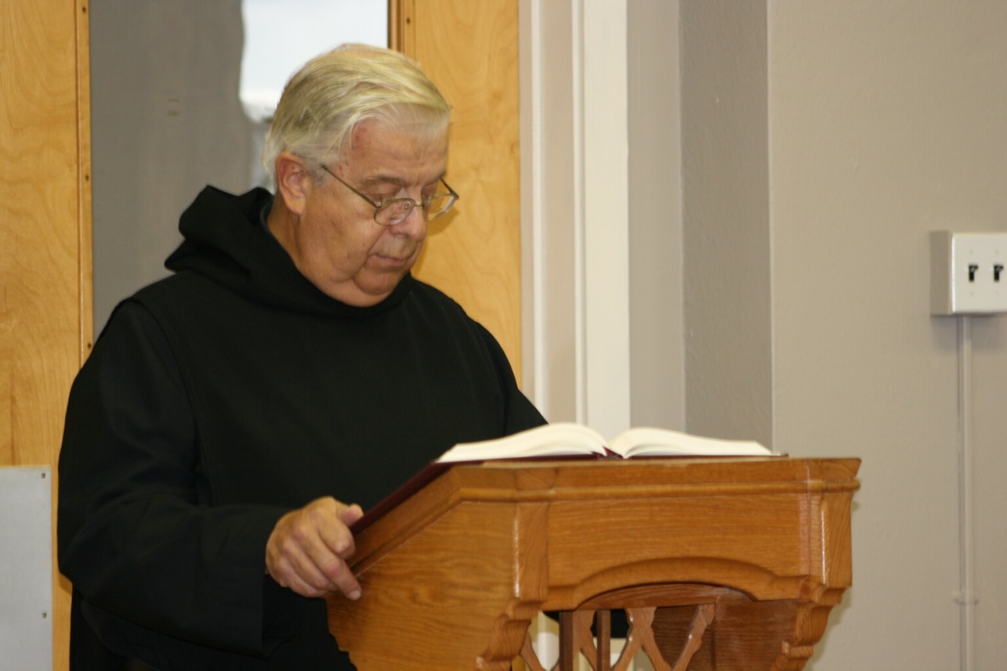
36290053 Br. Timothy Titus Lunt
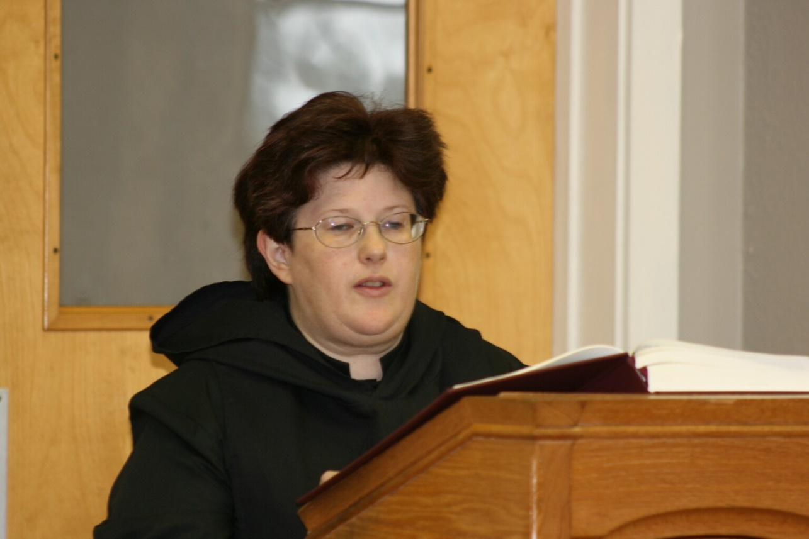
36290054 Sr. Cecelia Lamoy

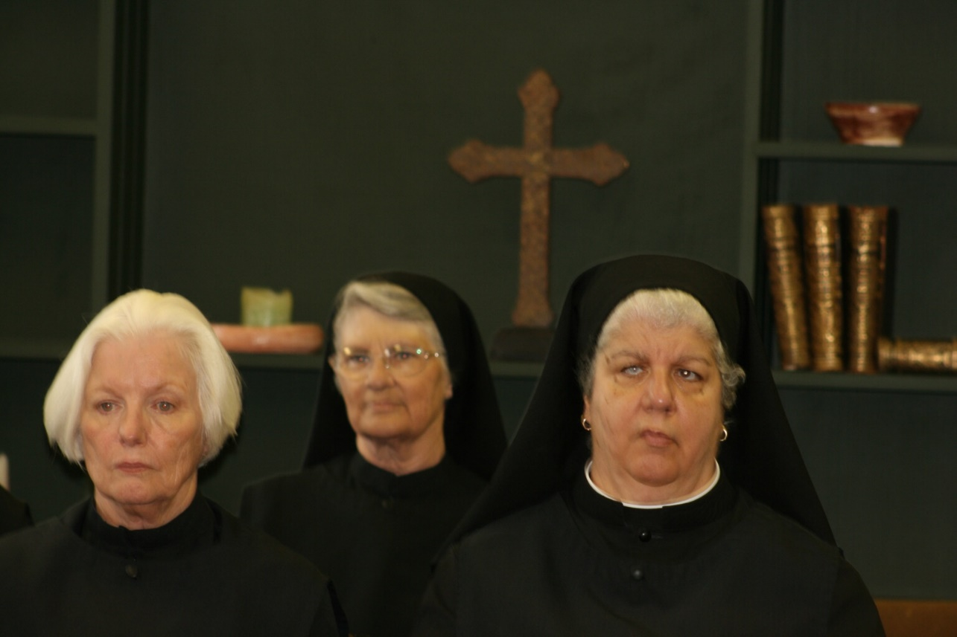
36290055 Sr. Elizabeth Anne Stribley; Sr. Mary Francis Deulen; Sr. Mary Catherine Christopher
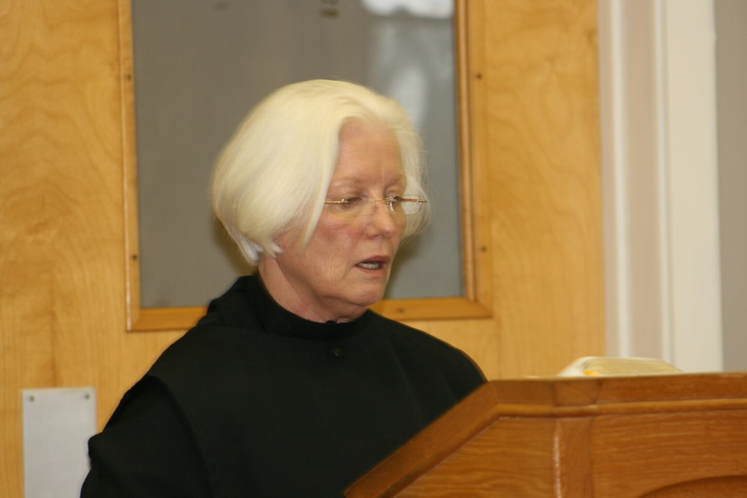
36290057 Sr. Elizabeth Anne Stribley

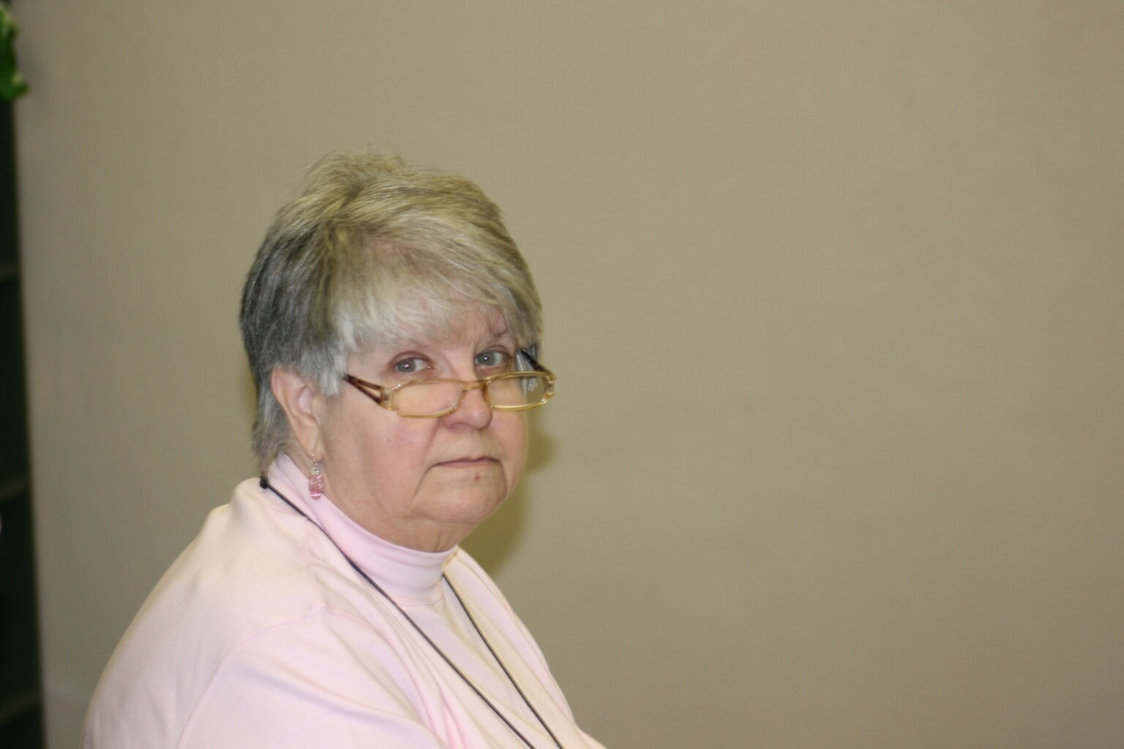
36290058 ?
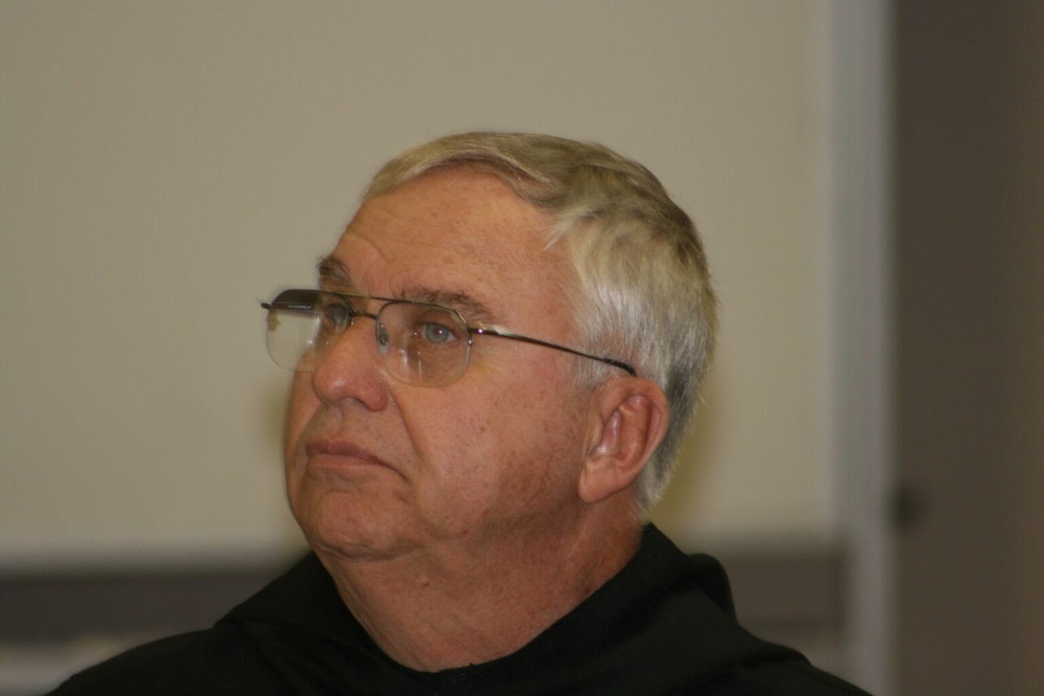
36290059 Br. Bede Leach

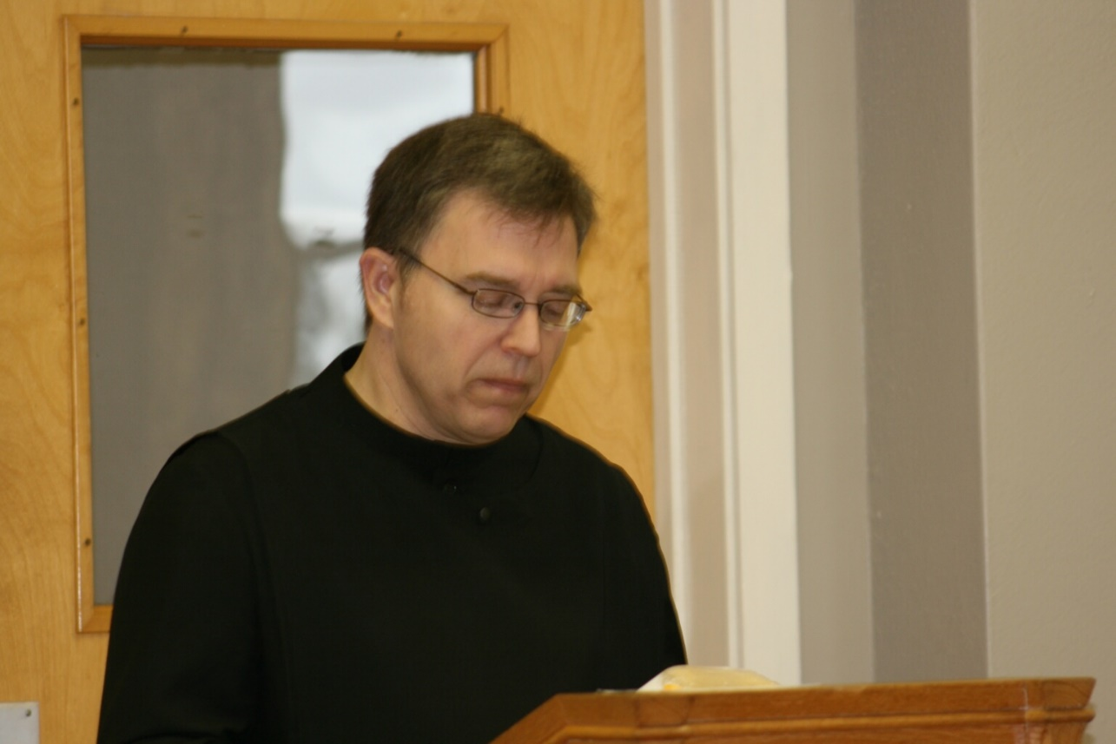
36290061 Br. John of Kanty Kennedy
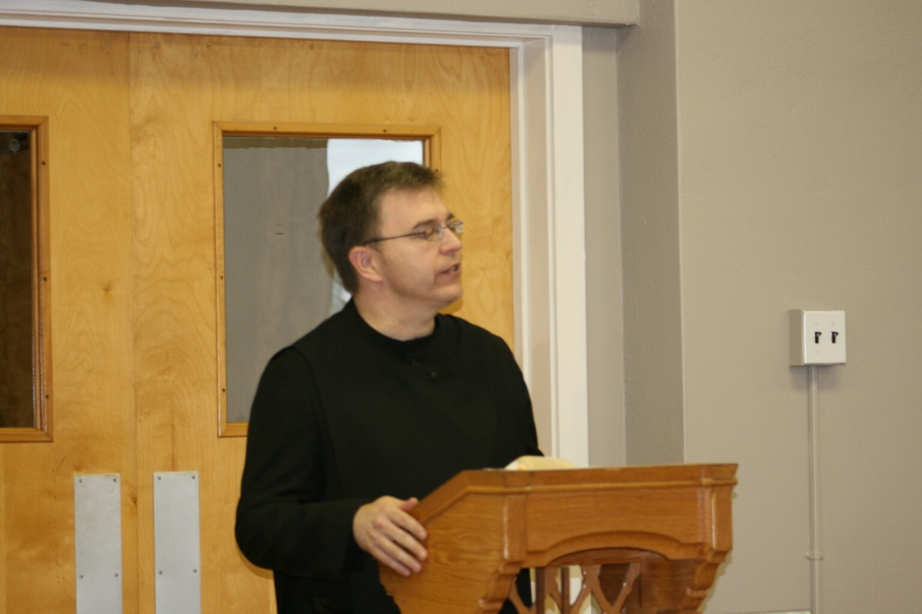
36290062 Br. John of Kanty Kennedy

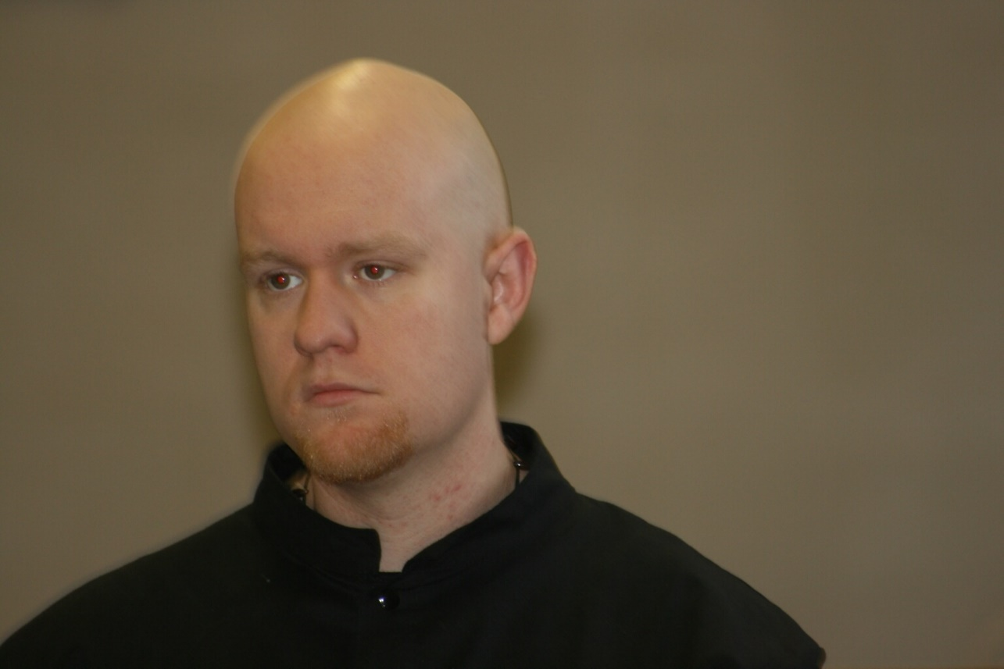
36290063 Br. Gregory Kingsley
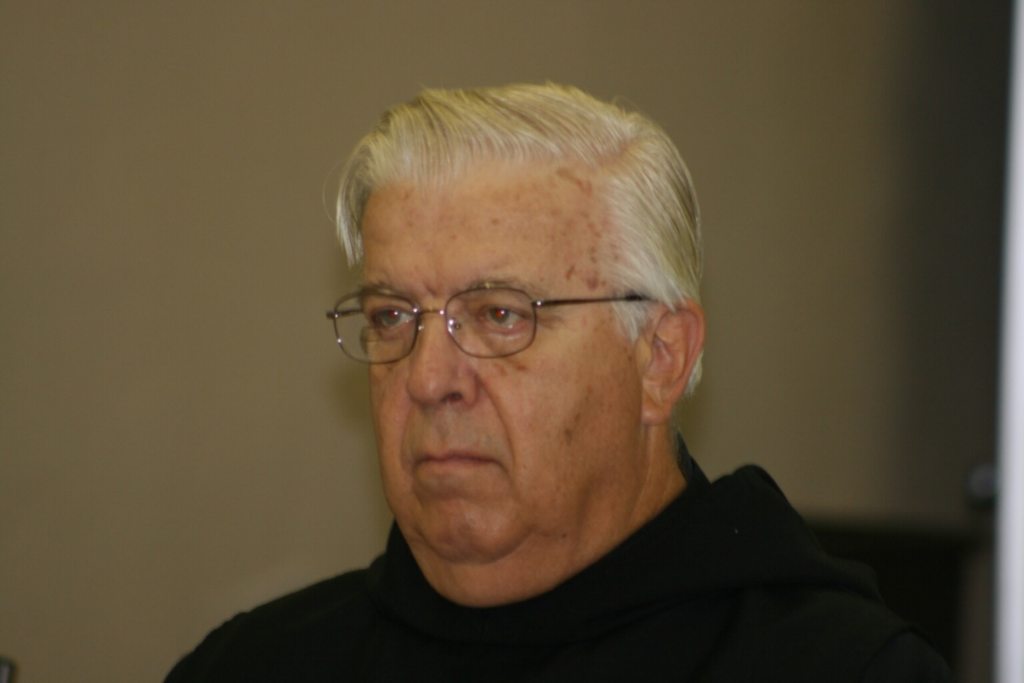
36290065 Br. Timothy Titus Lunt

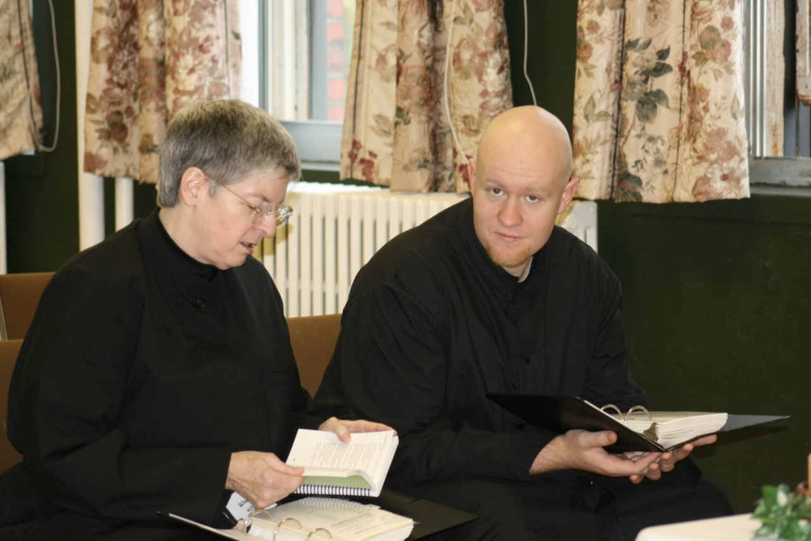
36290067 Sr. Bernadette Barrett; Br. Gregory Kingsley
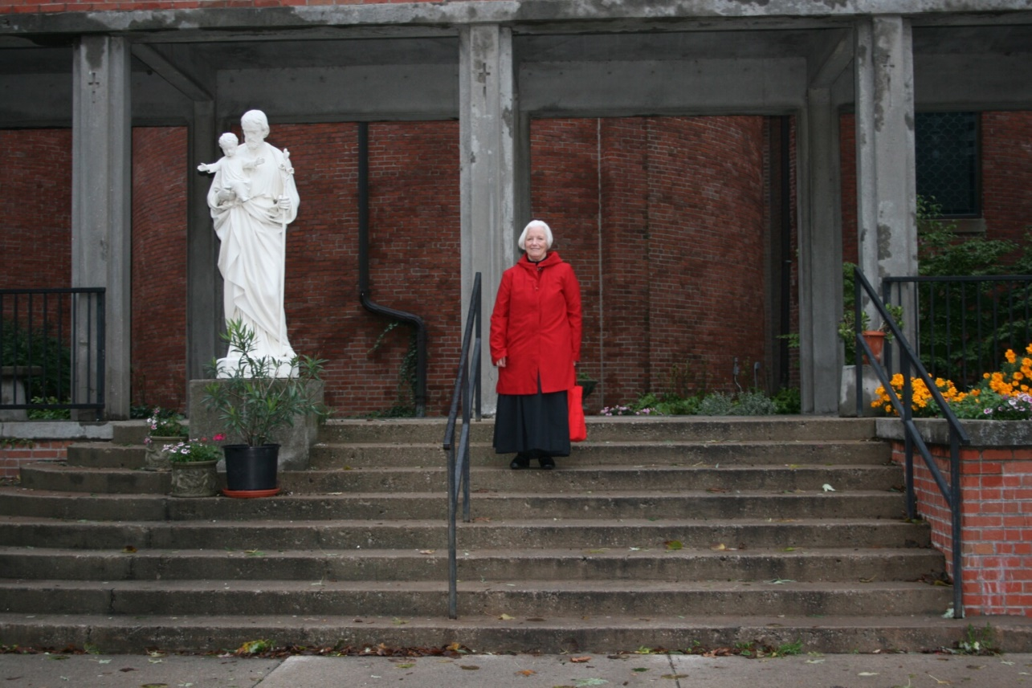
36290068 Sr. Elizabeth Anne Stribley

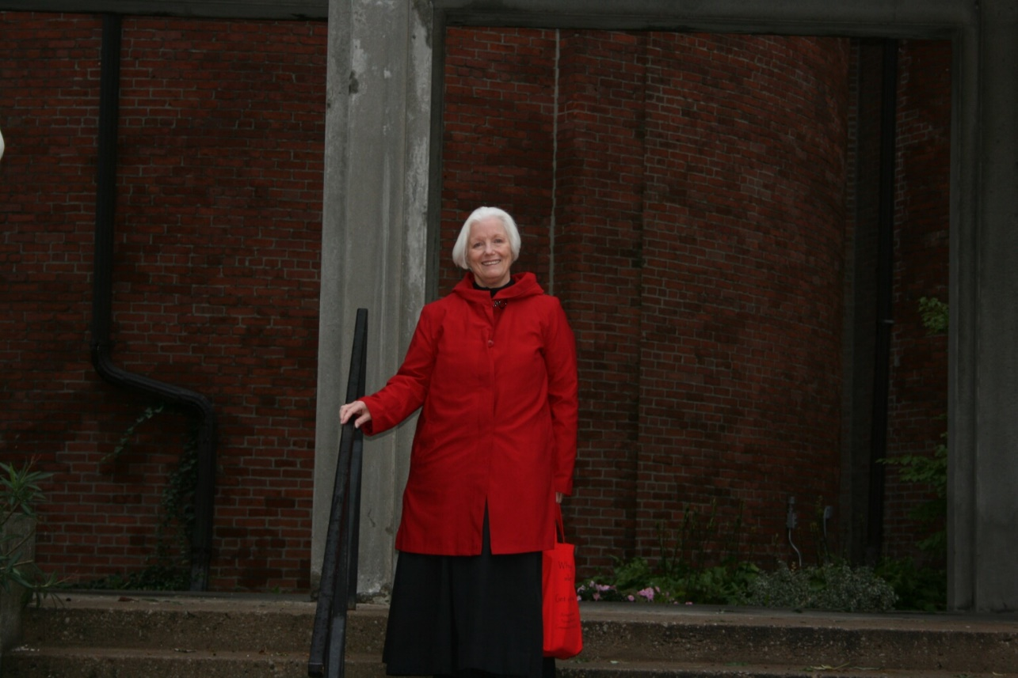
36290069 Sr. Elizabeth Anne Stribley
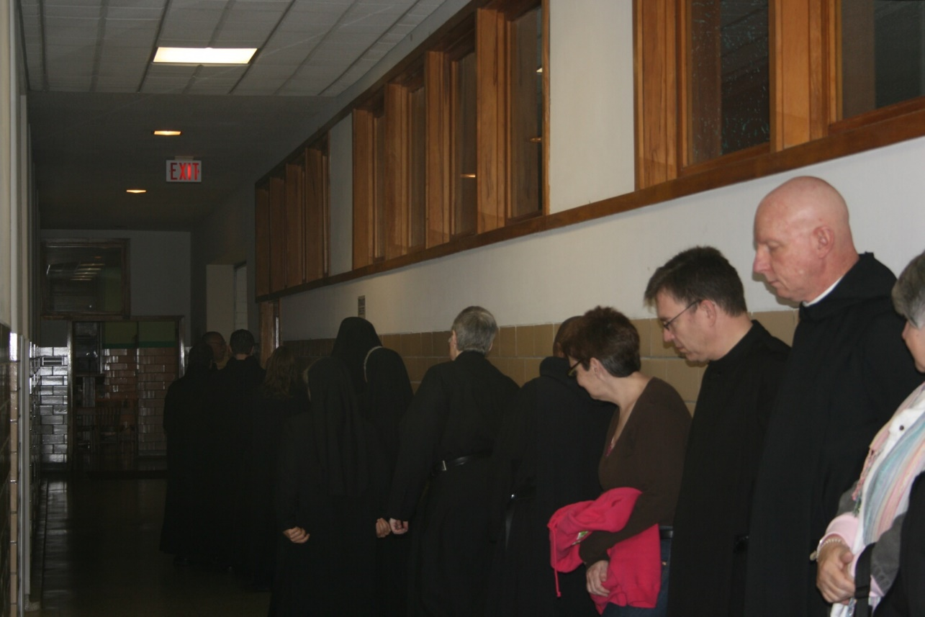
36290073 Sr. Bernadette Barrett; Br. Thomas Ferrell; Cindy Kennedy; Br. John of Kanty Kennedy; Br. David Vincent Cotton

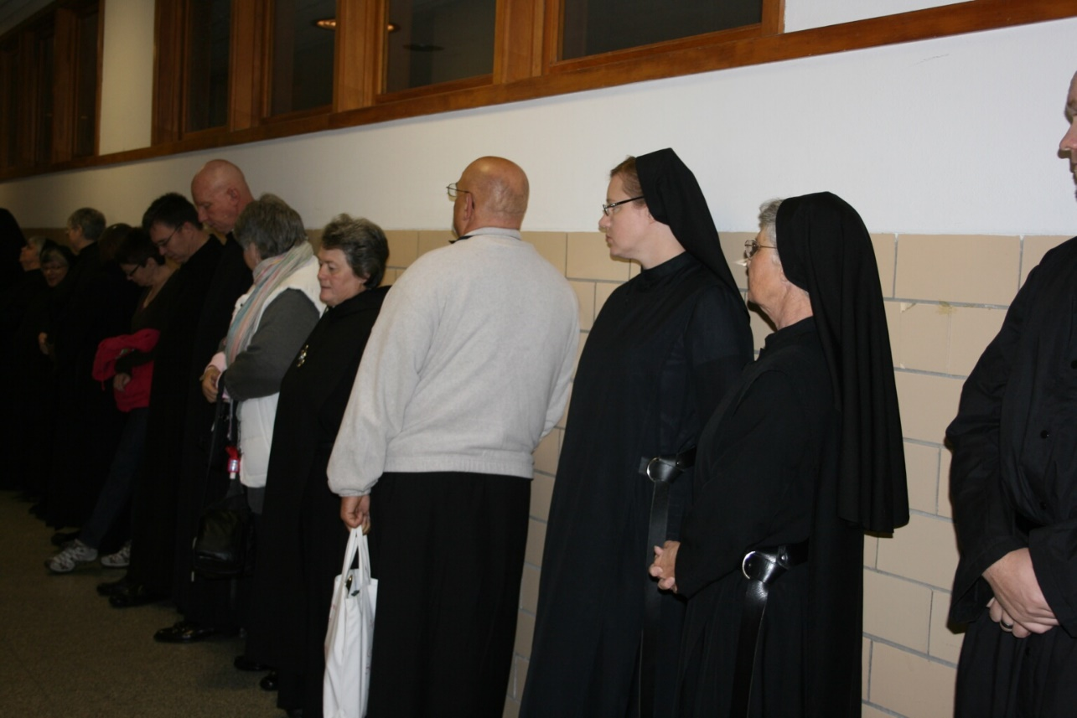
36290074 Cindy Kennedy; Br. John of Kanty Kennedy; Br. David Vincent Cotton; ?; Sr. Vincent Marie Rittenhouse; Br. Simon DiNapoli; Sr. Hannah Sophia Korver; Sr. Mary Francis Deulen

36290075 Cindy Kennedy; Br. John of Kanty Kennedy

