Companions of St. Luke
2006 Fall Convocation at Conception Abbey

~Edited by Br. Steven Olderr, 14 June 2022 with the assistance of Br. Thomas Ferrell. If you find any errors or omissions or have anything to add, please notify Br. Steven at olderr@ameritech.net

People are identified from left to right.
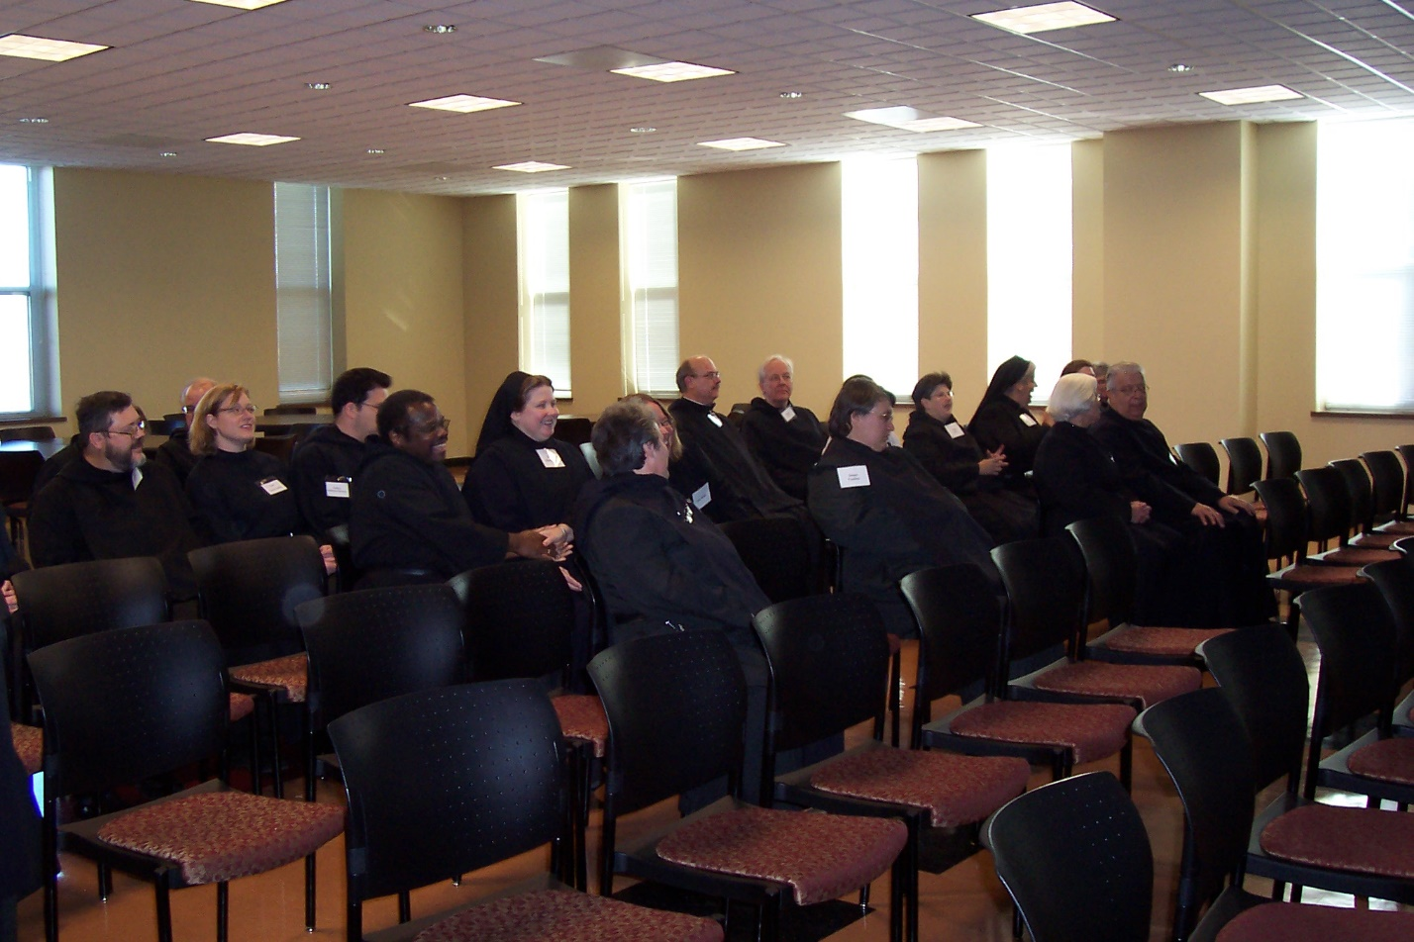100_0574 Br. Paul Howard; Br. Daniel Joseph Schroeder; Hannah Sophia Wolsleben; Br. Anthony Bernard Campos; Br. Thomas Ferrell; Hillary Grace Lundgren; Sr. Vincent Marie Rittenhouse; Sr. Teresa Bebee; Br. Raymond Owens; Br. Luke Doucette; Sr. Pauline Tysol; Sr. Cecelia Lamoy; Sr. Mary Catherine Christopher; Sr. Elizabeth Ann Stribley; Br. Timothy Titus Lunt
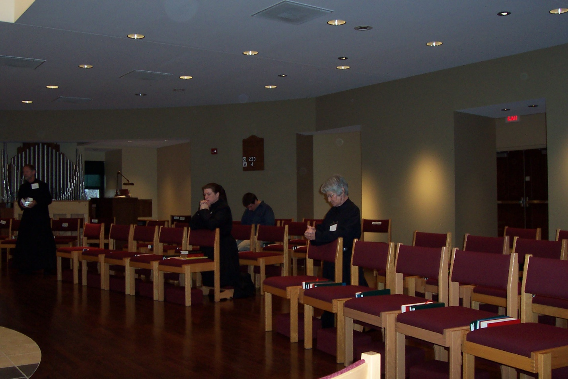
100_0577 Br. Lawrence Mullen; Sr. Sophia Holt; Br .Anthony Bernard Campos; Sr. Mary Francis Deulen
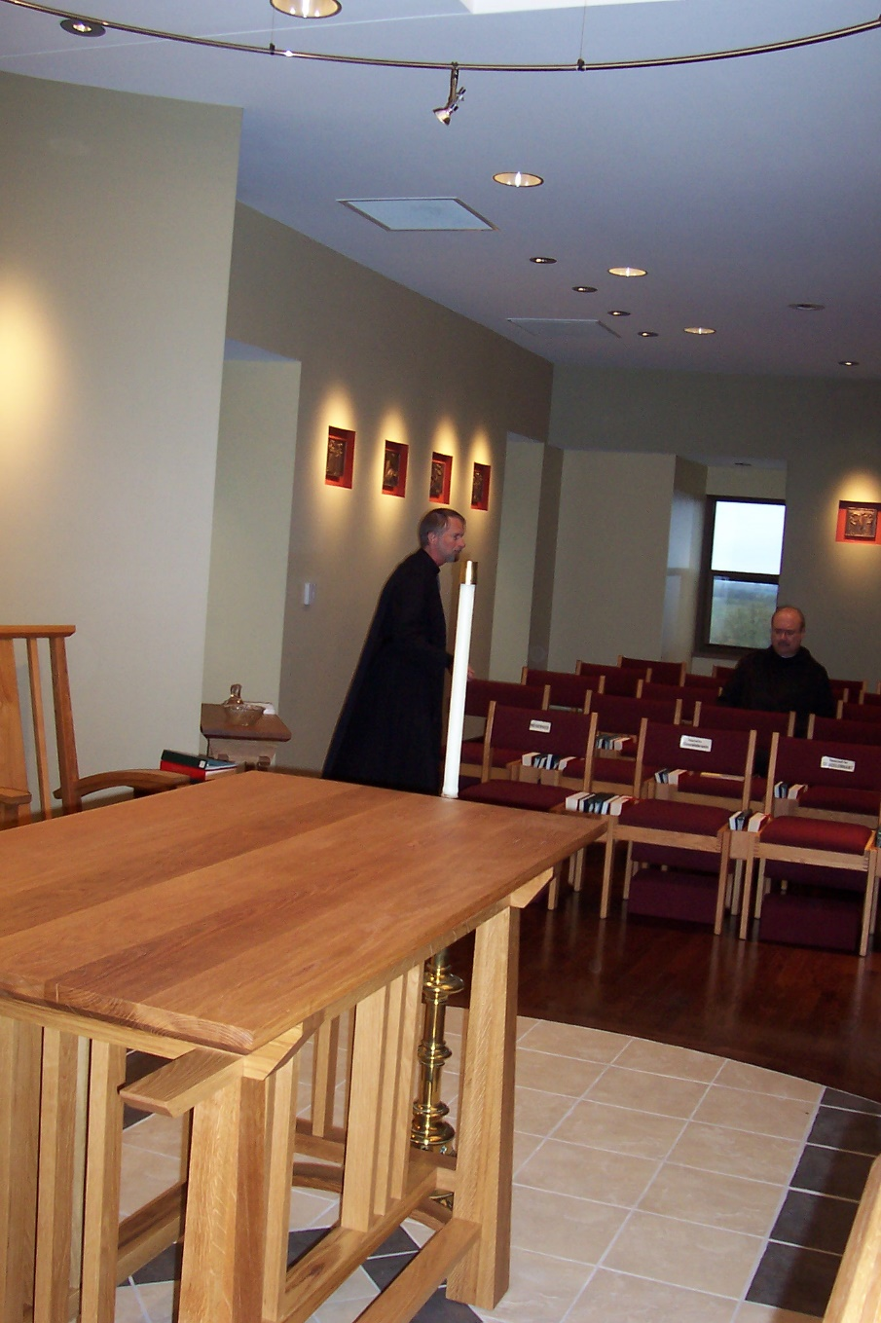
100_0578 Br. Lawrence Mullen; Br. Raymond Owens
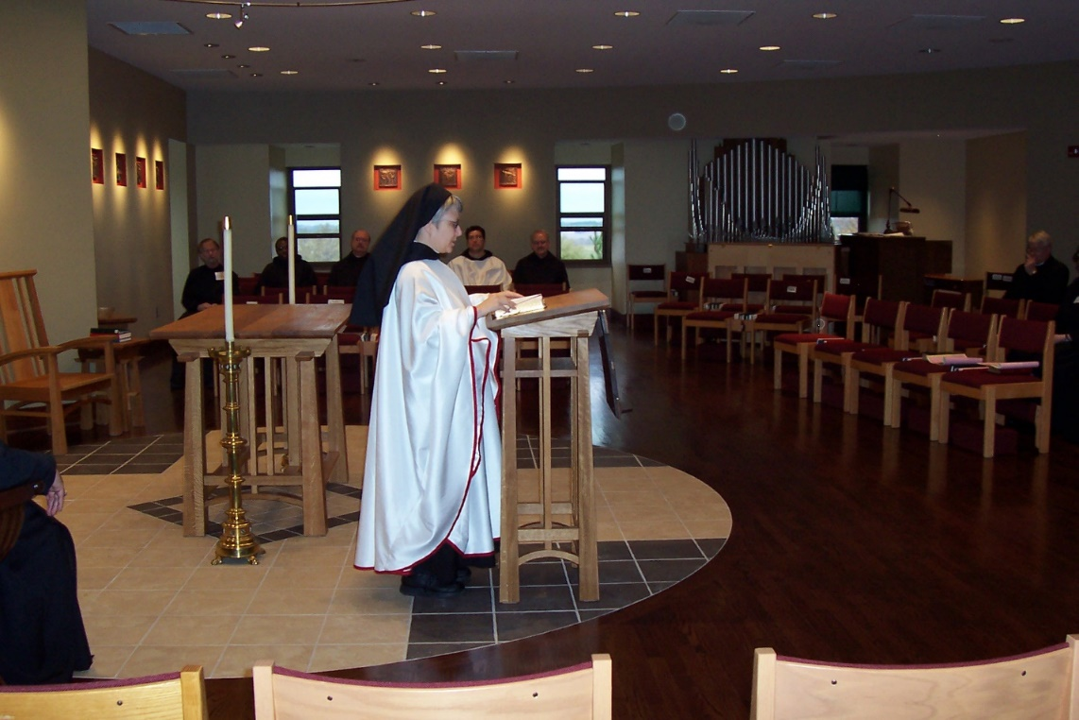
100_0579 Br. Lawrence Mullen; Br. Thomas Ferrell; Br. Raymond Owens; Sr. Anna Grace Madden; Br. Anthony Bernard Campos; Br. Daniel Joseph Schroeder; Br. Dean Wolfe

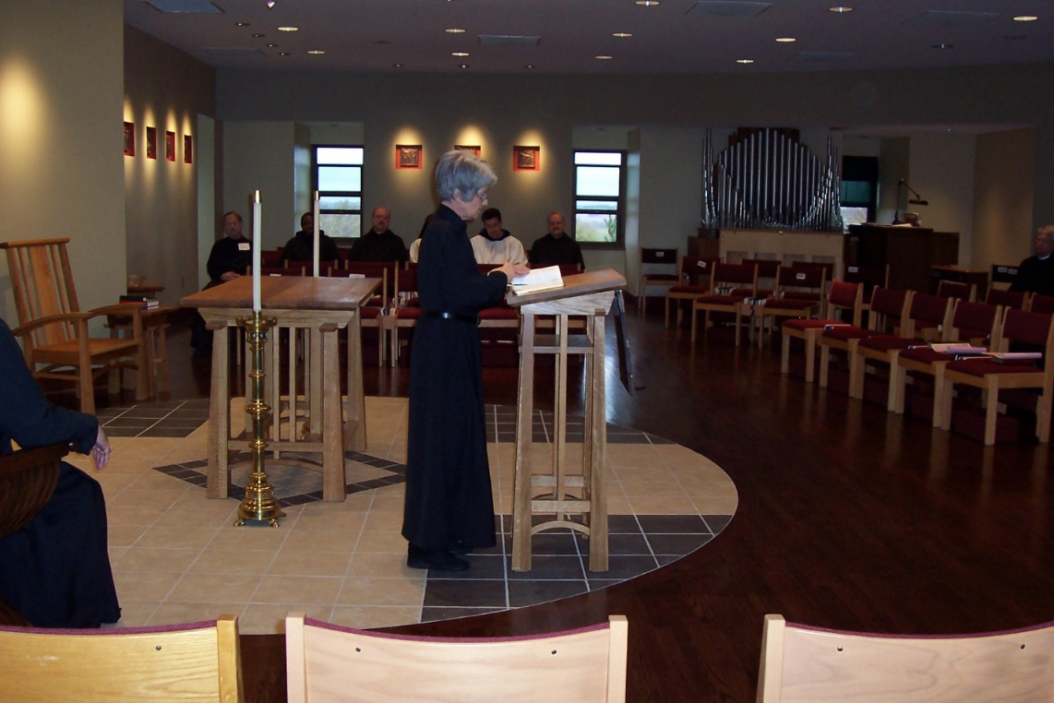
100_0580 Br. Lawrence Mullen; Br. Thomas Ferrell; Br. Raymond Owens; Sr. Mary Francis Deulen; Br. Anthony Bernard Campos; Br. Daniel Joseph Schroeder; Br. Dean Wolfe
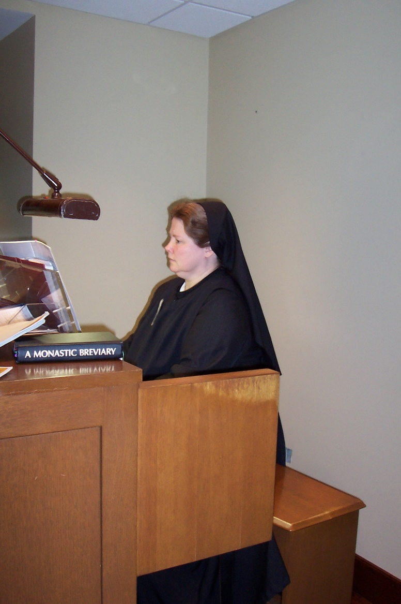
100_0581 Sr. Hillary Grace Lundgren

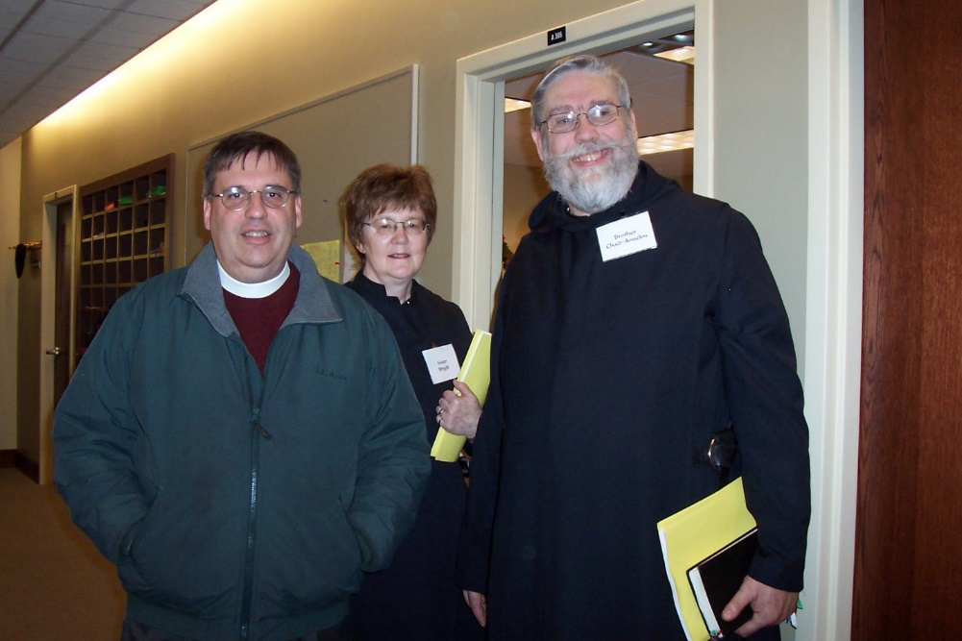
100_0582 Fr. Andrew Gerns (brother of Br. Chad Anselm Gerns); Sr. Brigid Gerns; Br. Chad Anselm Gerns

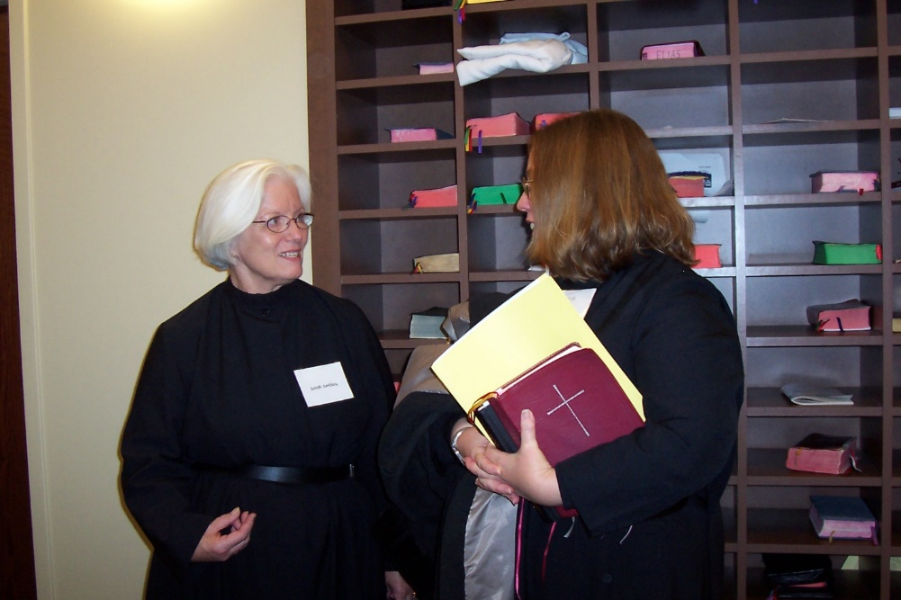
100_0583 Sr. Elizabeth Ann Stribley; Sr. Teresa Bebee

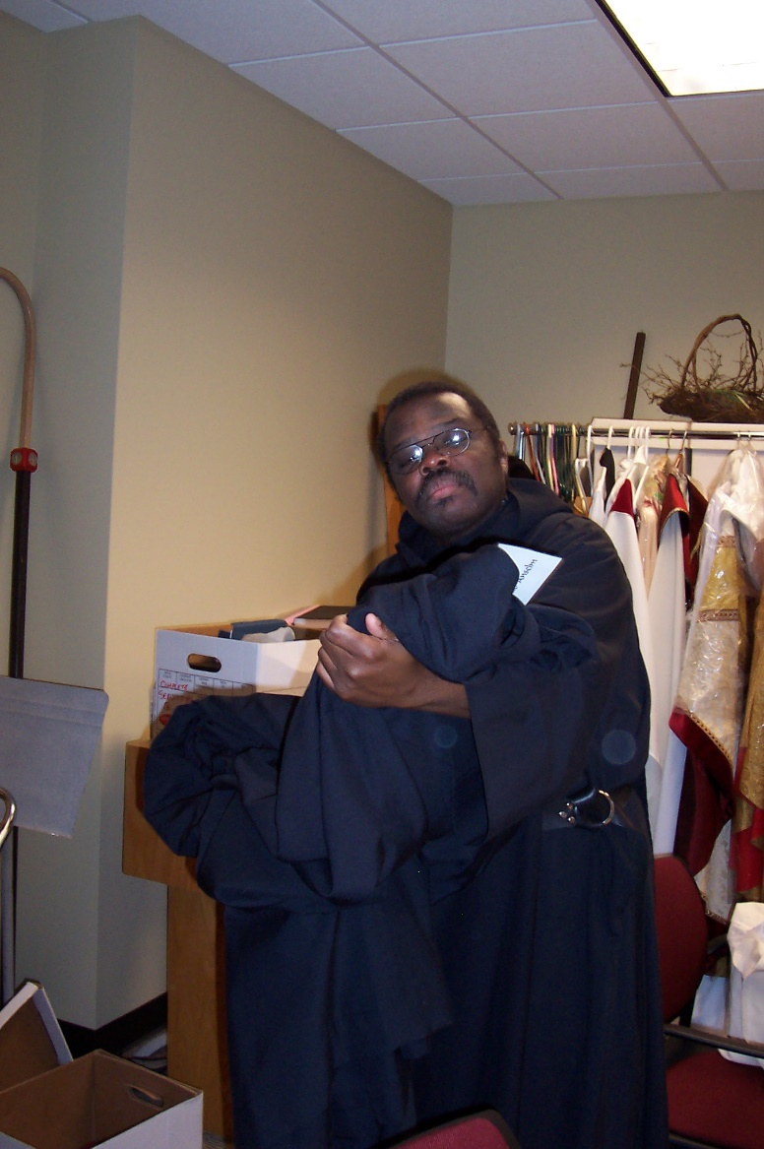
100_0584 Br. Thomas Ferrell
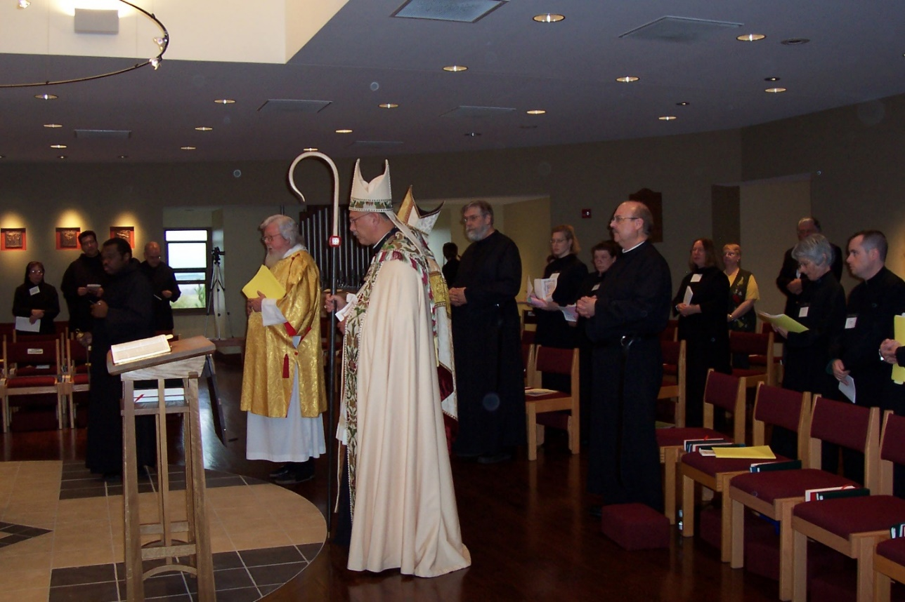
100_0585 Sr. Monica Ruth Mullen; Br. Anthony Bernard Campos; Br. Thomas Ferrell; Br. Daniel Schroeder; Fr. Wayne Kamm; Abbot Michael John Austin; Bp. Dean Wolfe; Br. Chad Anselm Gerns; Sr. Hannah Sophia Wolsleben; Sr. Sophia Holt; Br. Raymond Owens; Sr. Teresa Bebee; Lynn Owens (wife of Br. Raymond Gerns); Sr. Mary Francis Deulen; Br. John Matthias Cline
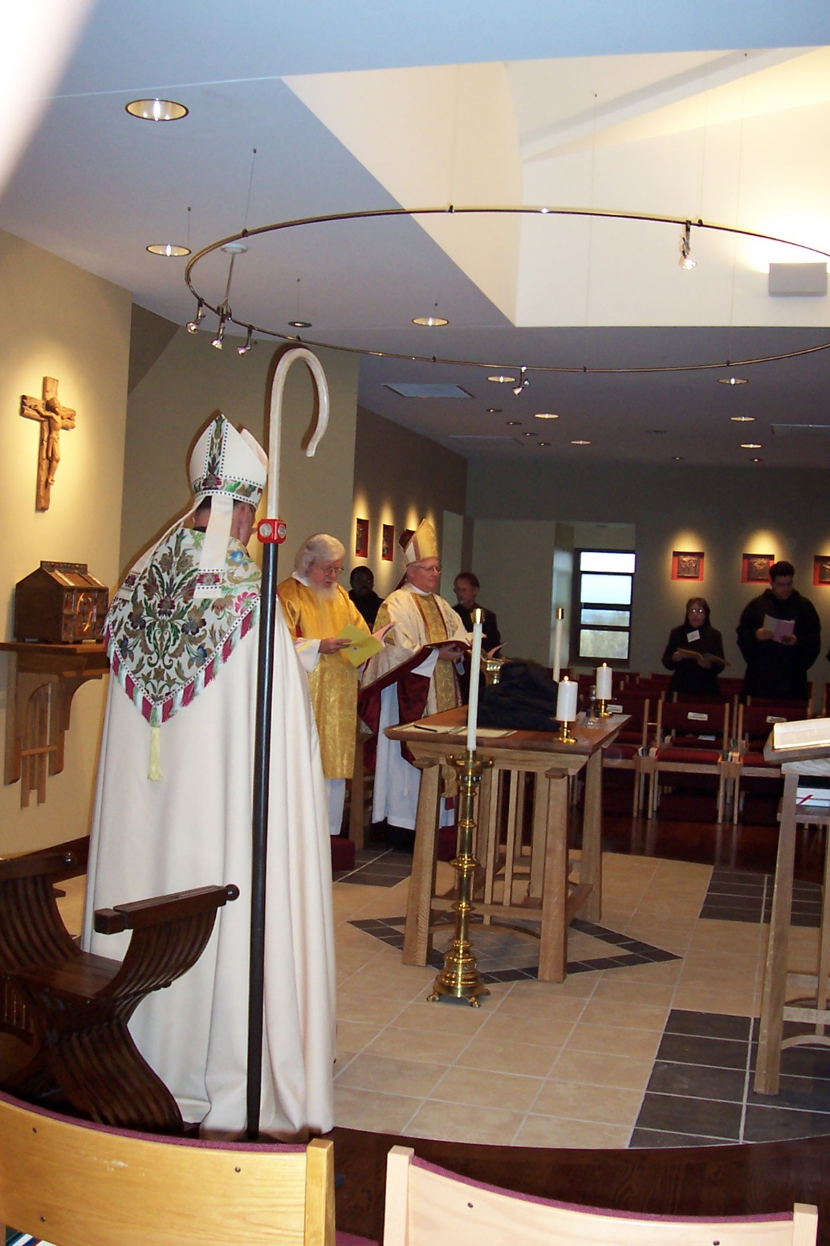
100_0586 Abbot Michael John Austin; Fr. Wayne Kamm; Br. Thomas Ferrell; Bp. Dean Wolfe; Br. Lawrence Mullen; Sr. Monica Ruth Mullen; Br. Anthony Bernard Campos
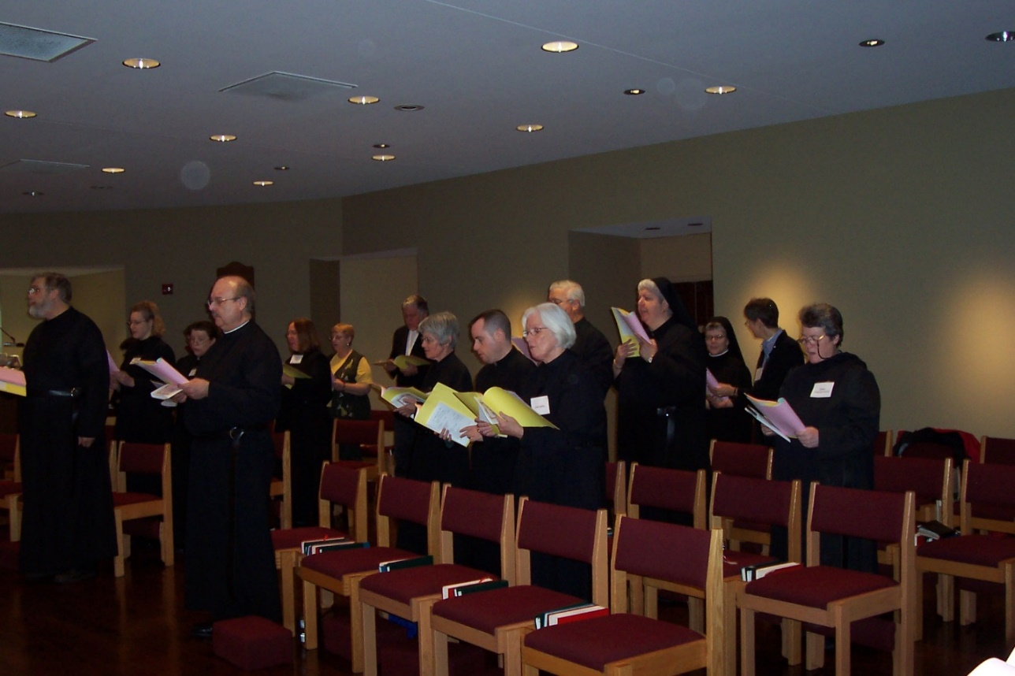
100_0587 Br. Chad Anselm Gerns; Sr, Hannah Sophia Wolsleben; Sr. Sophia Holt; Br. Raymond Owens; Sr. Teresa Bebee; Lynn Owens; Sr. Mary Francis Deulen; Br. John Matthias Cline; Br. John Matthias Cline; Sr. Elizabeth Ann Stribley; Sr. Timothy Titus Lunt; Sr. Mary Catherine Christopher; Sr. Anna Grace Madden; Deana Flak; Sr. Vincent Marie Rittenhouse

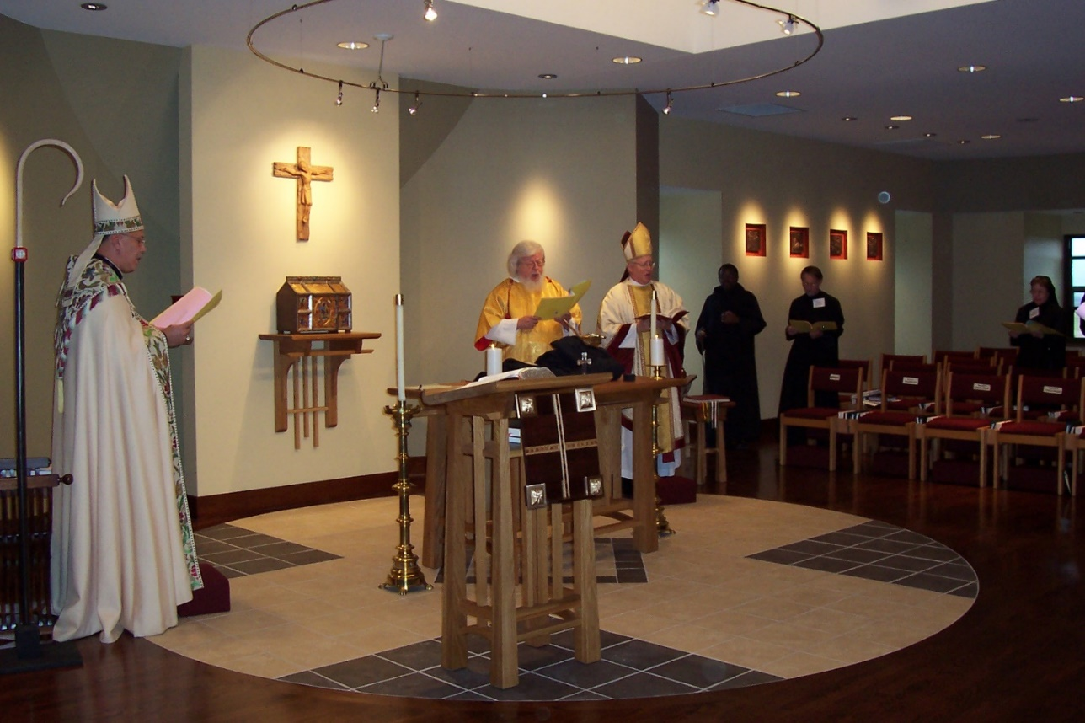
100_0588 Abbot Michael John Austin Fr. Wayne Kamm; Bp. Dean Wolfe; Br. Thomas Ferrell; Br. Lawrence Mullen; Sr. Monica Ruth Mullen
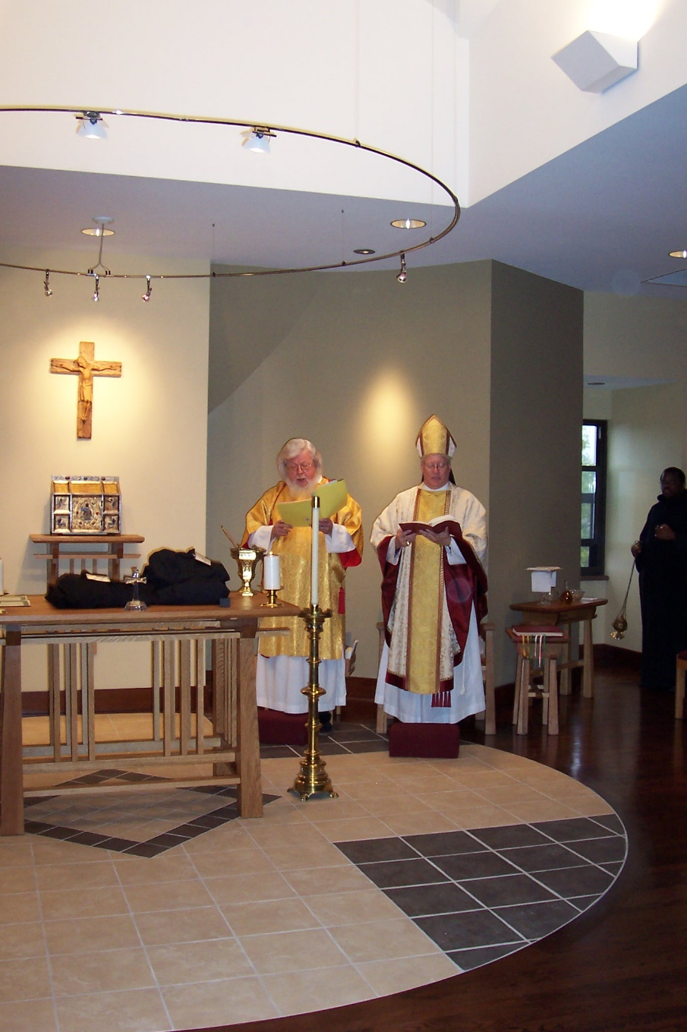
100_0589 Fr. Wayne Kamm; Bp. Dean Wolfe; Br. Thomas Ferrell
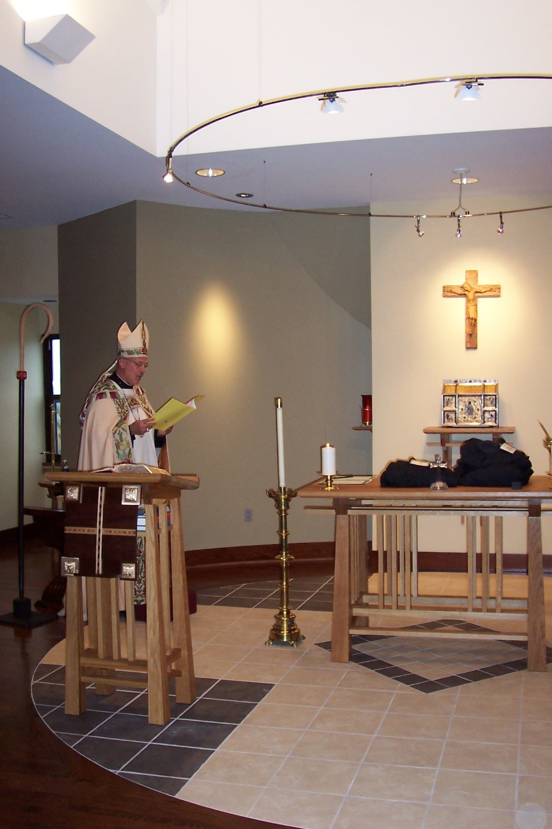
100_0590 Abbot Michael John Austin
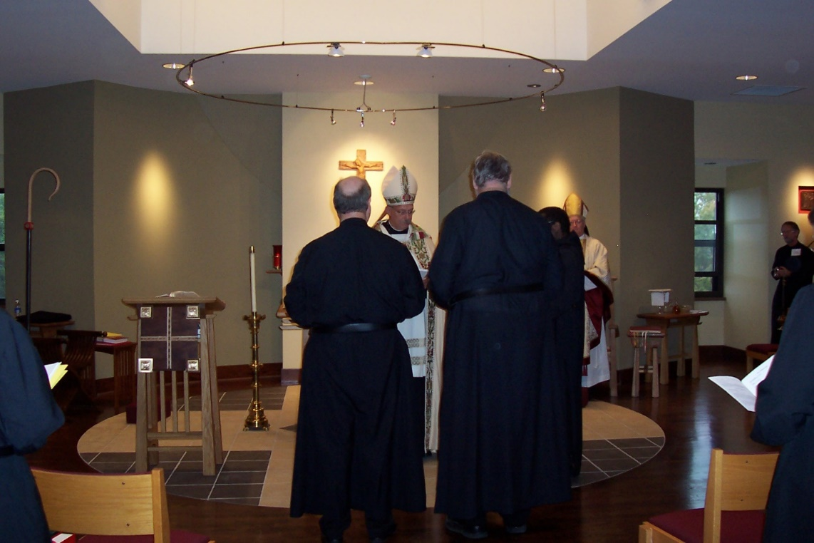
100_0591 Br. Raymond Owens; Abbot Michael John Austin; Br. Chad Anselm Gerns; Br. Thomas Ferrell; Bp. Dean Wolfe; Br. Lawrence Mullen

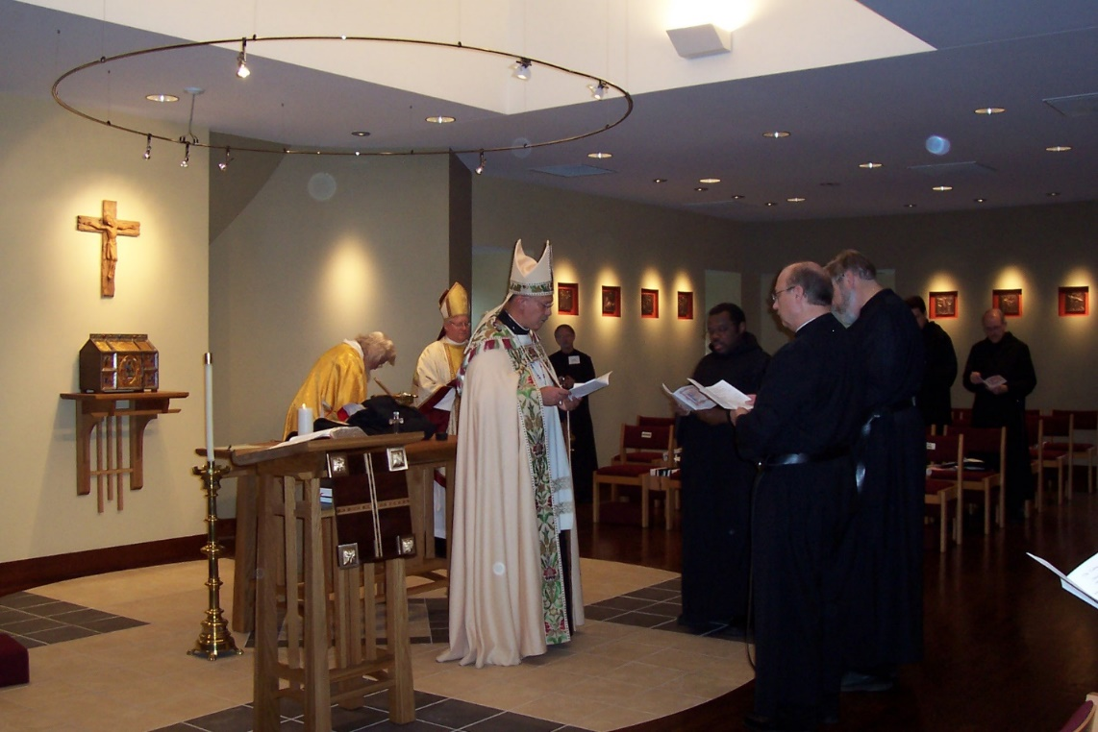
100_0592 Fr. Wayne Kamm; Bp. Dean Wolfe; Abbot Michael John Austin; Br. Lawrence Mullen; Br. Thomas Ferrell; Br. Raymond Owens; Br. Chad Anselm Gerns
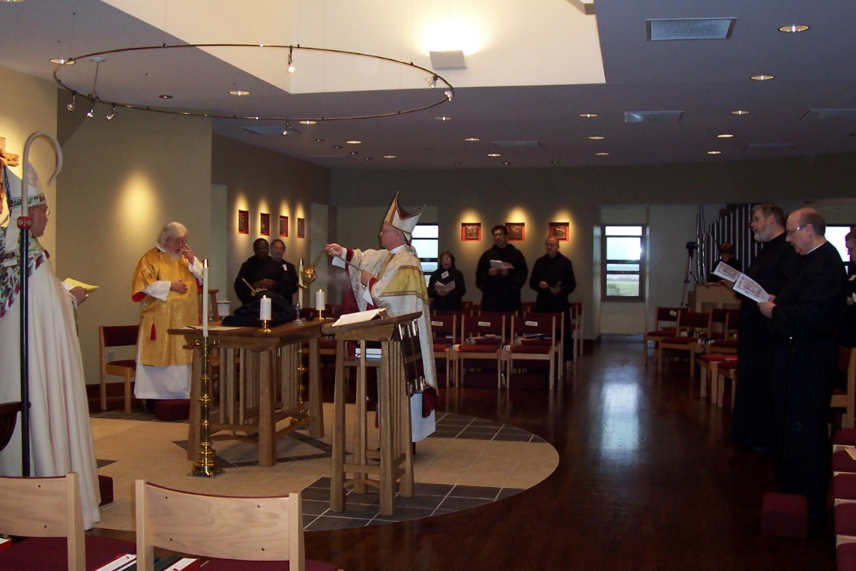
100_0593 Abbot Michael John Austin; Fr. Wayne Kamm; Br. Thomas Ferrell; Br. Lawrence Mullen; Bp. Dean Wolfe; Sr. Monica Ruth Mullen; Br. Anthony Bernard Campos; Br. Daniel Joseph Schroeder; Br. Chad Anselm Gerns; Br. Raymond Owens; Sr. Hannah Sophia Wolsleben
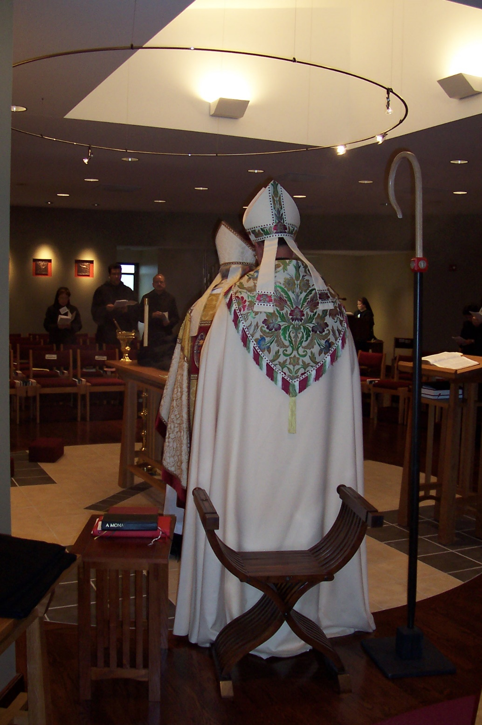
100_0594 Sr. Monica Ruth Mullen; Br. Anthony Bernard Campos; Bp. Dean Wolfe; Abbot Michael John Austin; Sr. Hillary Grace Lundgren
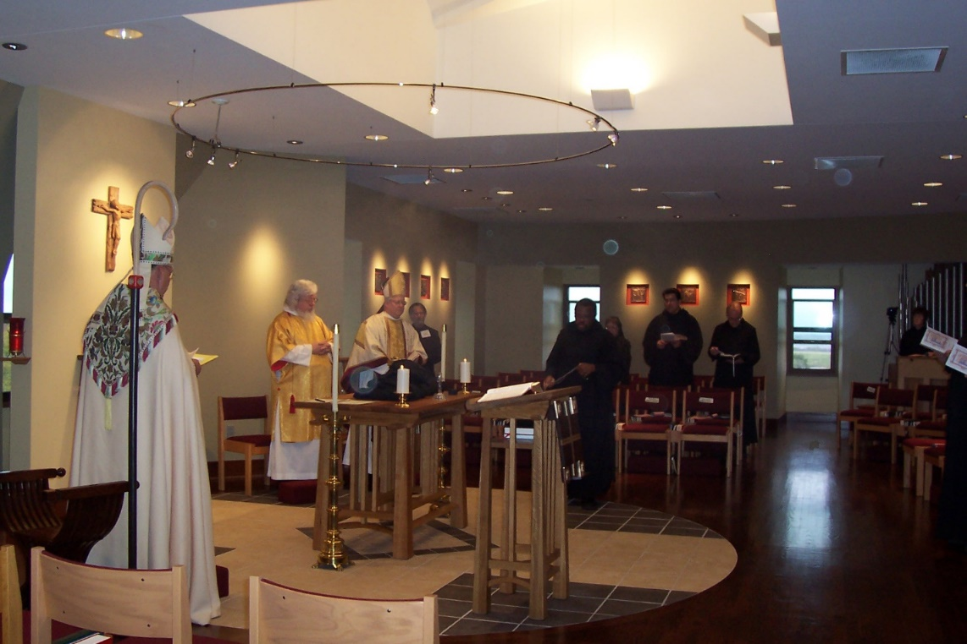
100_0595 Abbot Michael John Austin; Fr. Wayne Kamm; Bp. Dean Wolfe; Br. Lawrence Mullen; Br. Thomas Ferrell; Sr. Monica Ruth Mullen; Br. Anthony Bernard Campos; Br. Daniel Joseph Schroeder

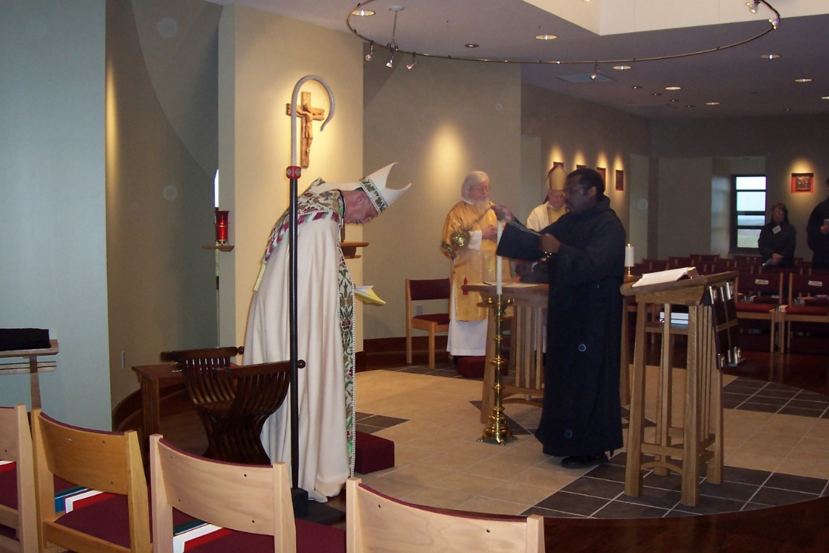
100_0596 Abbot Michael John Austin’ Fr. Wayne Kamm; Bp. Dean Wolfe; Br. Thomas Ferrell; Sr. Monica Ruth Mullen

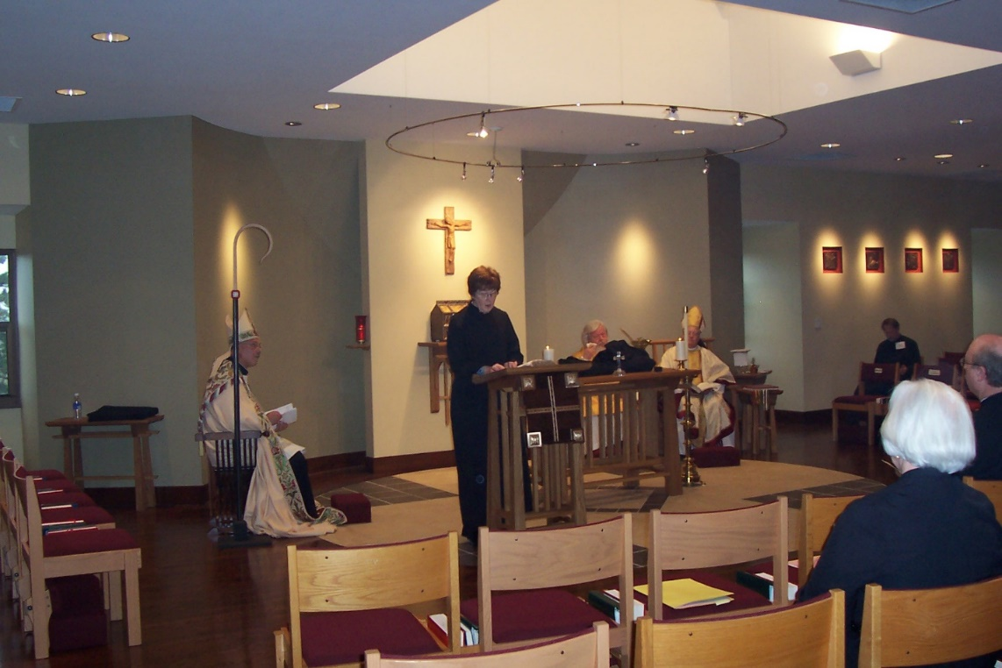
100_0596 Abbot Michael John Austin; Sr. Brigid Gerns; Fr. Wayne Kamm; Bp. Dean Wolfe; Br. Lawrence Mullen; Sr. Elizabeth Ann Stribley; Br. Raymond Owens
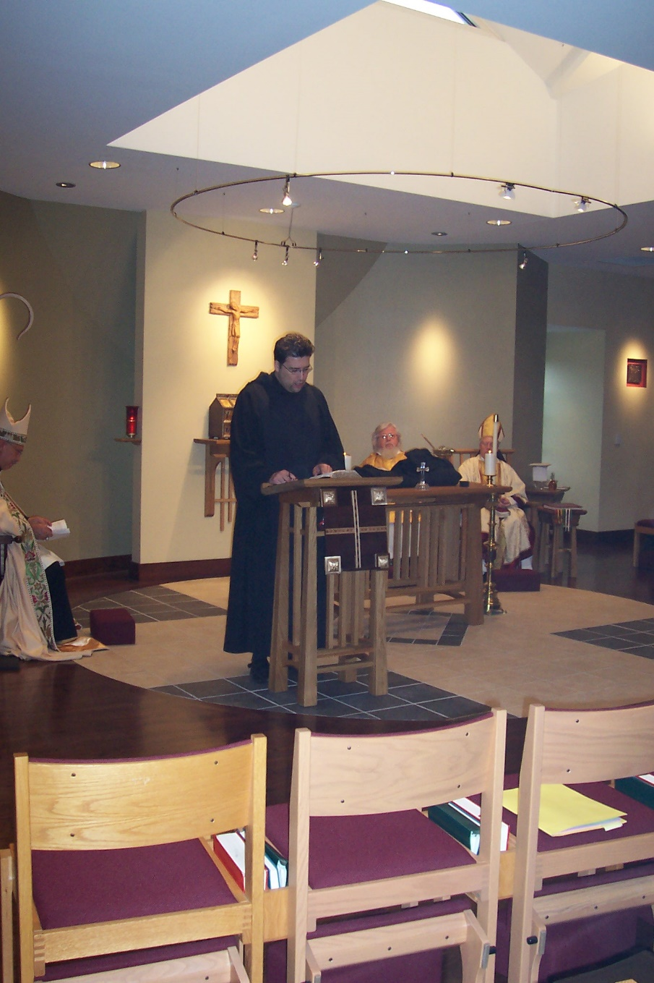
100_0598 Abbot Michael John Austin; Br. Anthony Bernard Campos; Fr. Wayne Kamm; Bp. Dean Wolfe
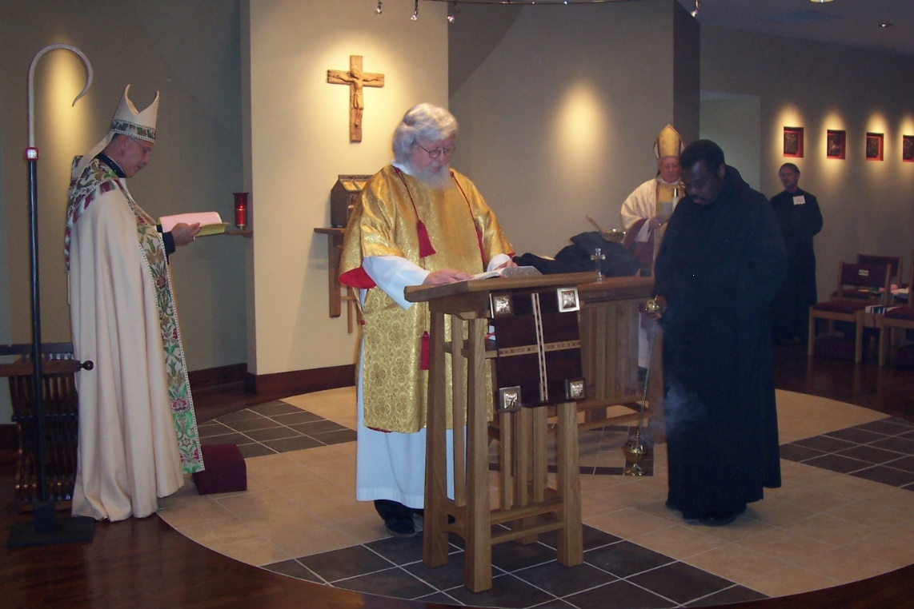
100_0599 Abbot Michael John Austin; Fr. Wayne Kamm; Bp. Dean Wolfe; Br. Thomas Ferrell; Br. Lawrence Mullen
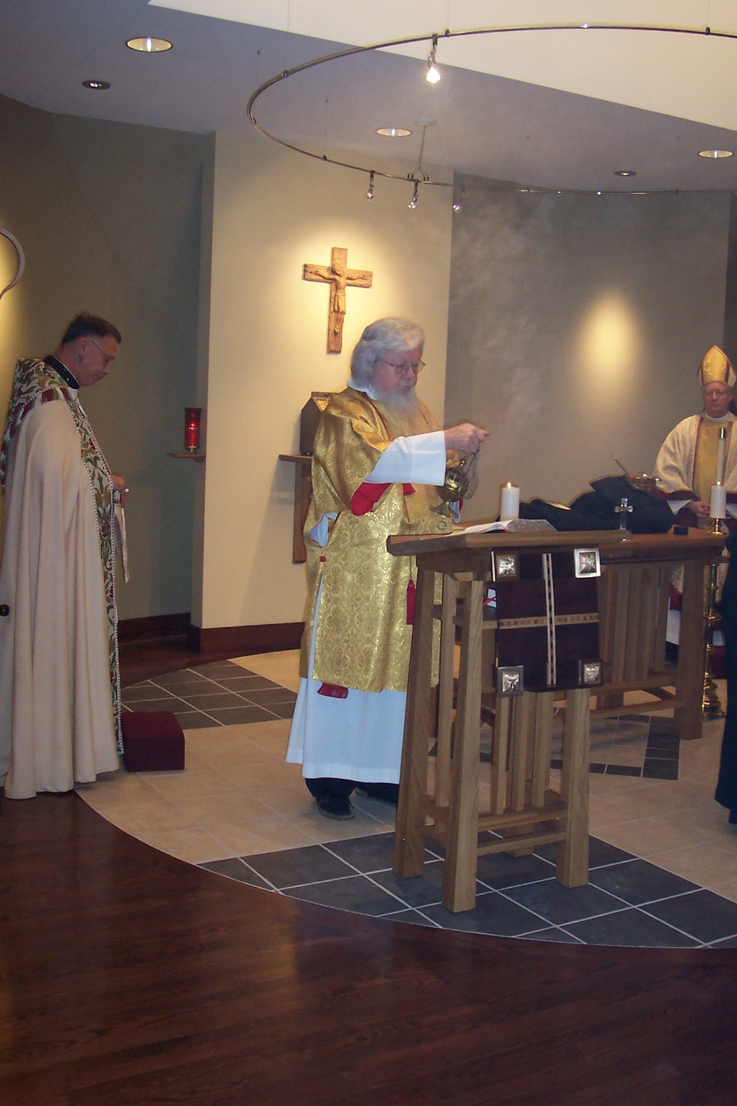
100_0600 Abbot Michael John Austin; Fr. Wayne Kamm; Bp. Dean Wolfe
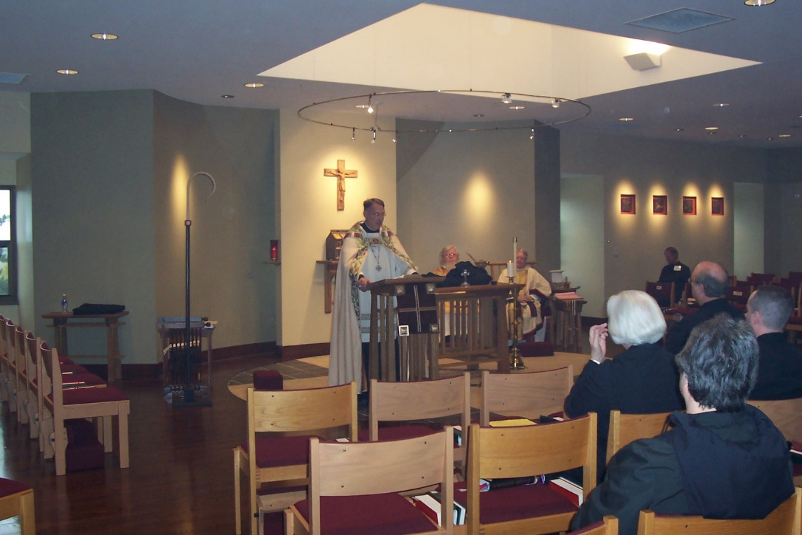
100_0601 Abbot Michael John Austin; Fr. Wayne Kamm; Bp. Dean Wolfe; Sr. Elizabeth Ann Stribley; Br. Lawrence Mullen; Sr. Vincent Marie Rittenhouse; Br. Raymond Owens; Br. John Matthias Cline

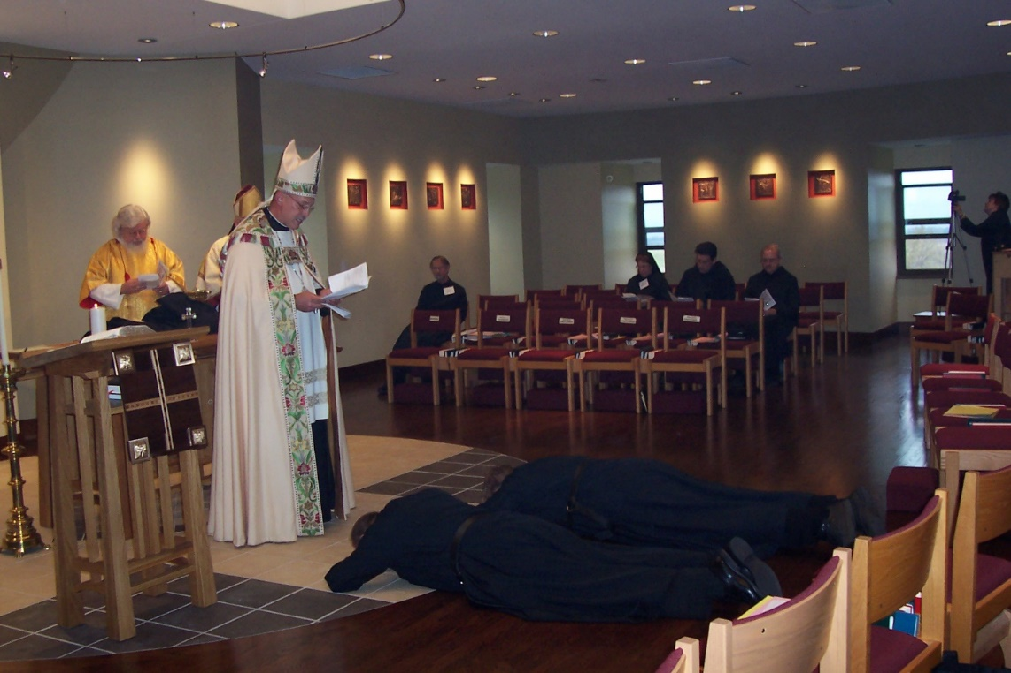
100_0602 Fr. Wayne Kamm; Bp. Dean Wolfe; Abbot Michael John Austin; Br. Raymond Owens; Br. Lawrence Mullen; Br. Raymond Owens; Br. Chad Anselm Gerns; Sr. Monica Ruth Mullen; Br. Anthony Bernard Campos; Br. Daniel Joseph Schroeder; Sr. Brigid Gerns
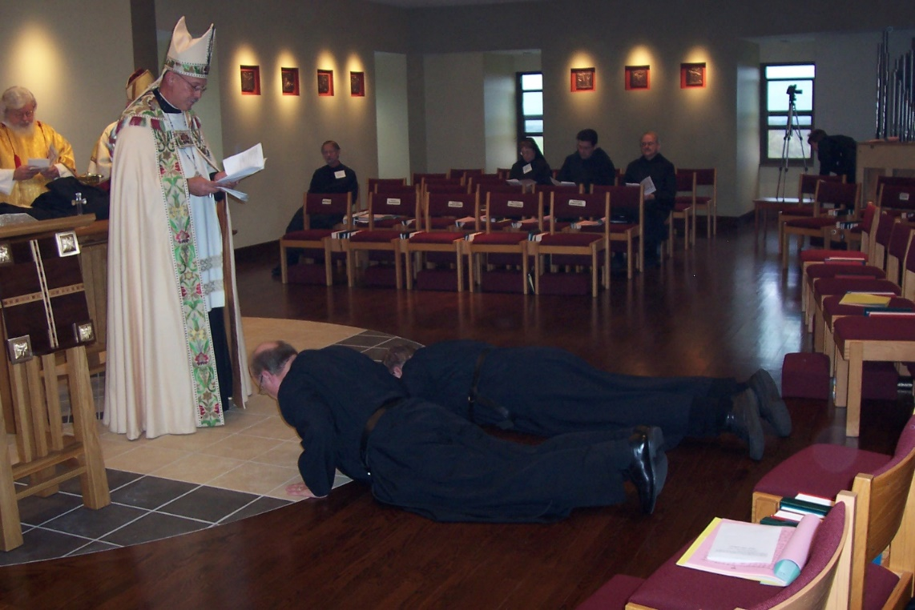
100_0603 Fr. Wayne Kamm; Abbot Michael John Austin; Br. Raymond Owens; Br. Lawrence Mullen; Br. Chad Anselm Gerns; Sr. Monica Ruth Mullen; Br. Anthony Bernard Campos; Dr. Daniel Joseph Schroeder; Sr. Brigid Gerns

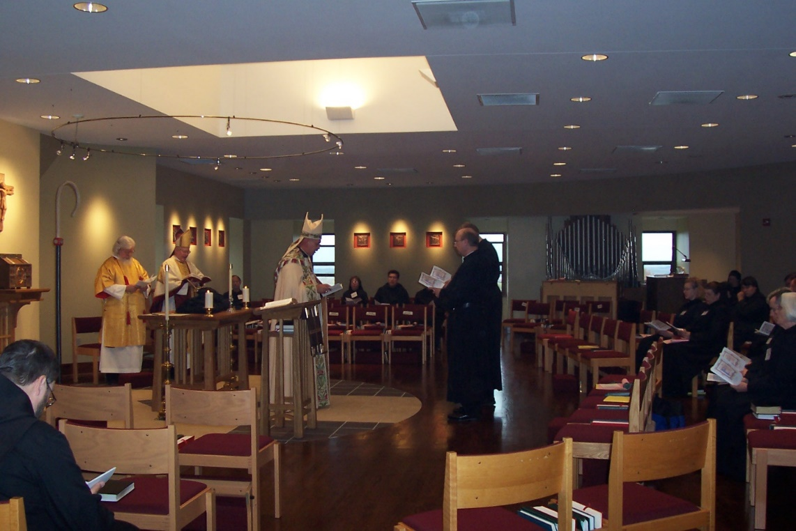
100_0604 Br. Paul Howard; Fr. Wayne Kamm; Bp. Dean Wolfe; Br. Lawrence Mullen; Abbot Michael John Austin; Sr. Monica Ruth Mullen; Br. Anthony Bernard Campos; Br. Raymond Owens; Br. Chad Anselm Gerns; Sr. Hannah Sophia Wolsleben; Sr. Sophia Holt; Sr. Hillary Grace Lundgren; Sr. Pauline Tysol; Br. John Matthias Cline; Sr. Elizabeth Ann Stribley
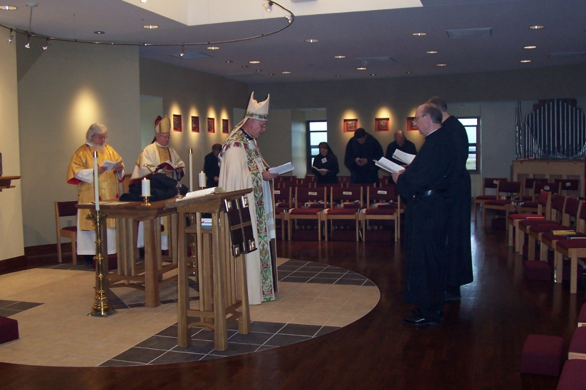
100_0605 Fr. Wayne Kamm; Bp. Dean Wolfe; Br. Lawrence Mullen; Abbot Michael John Austin Br. Raymond Owens; Br. Chad Anselm Gerns

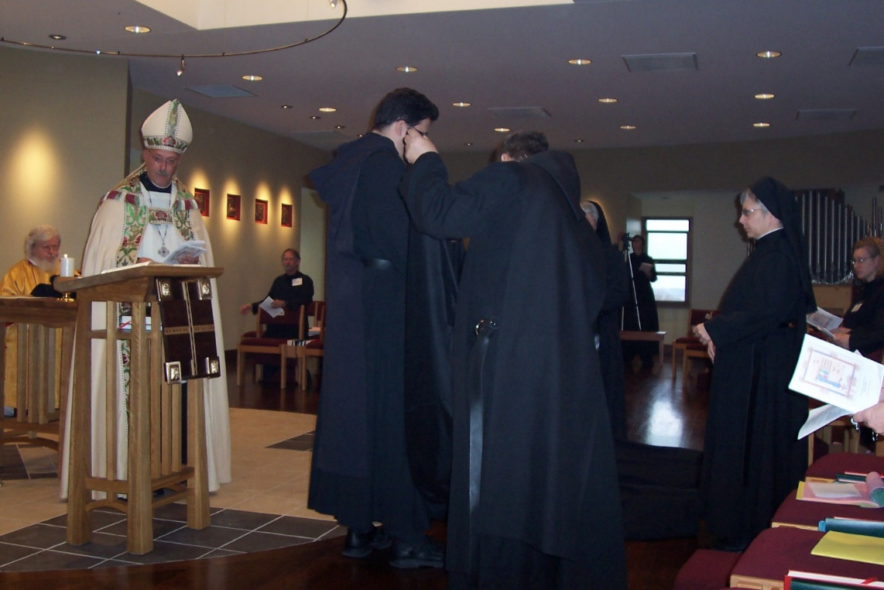
100_0606 Fr. Wayne Kamm; Abbot Michael John Austin; Br. Lawrence Mullen; Br. Anthony Bernard Campos; Br. Paul Howard; St. Clare Benedicta Myers; Sr. Anna Grace Madden; Sr. Hannah Sophia Wolsleben
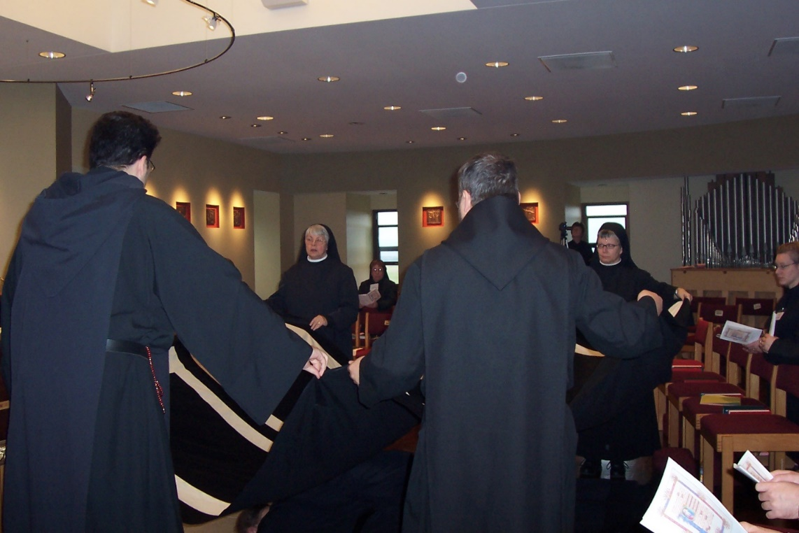
100_0607 Br. Anthony Bernard Campos; Sr. Clare Benedicta Myers; Sr. Monica Ruth Mullen; Br. Paul Howard; Sr. Brigid Gerns; Br. Paul Howard; Sr. Anna Grace Madden; Sr. Hannah Sophia Wolsleben

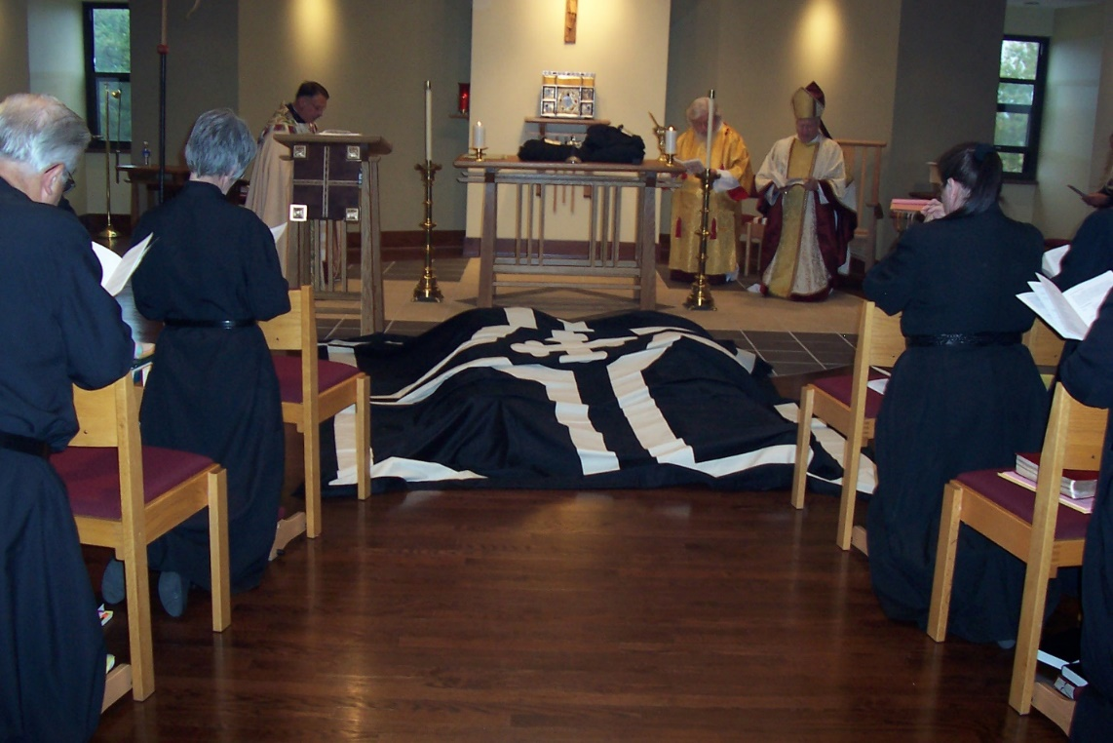
100_0608 Br. Timothy Titus Lunt; Sr. Mary Francis Deulen; Abbot Michael John Austin; Fr. Wayne Kamm; Bp. Dean Wolfe; Sr. Sophia Holt
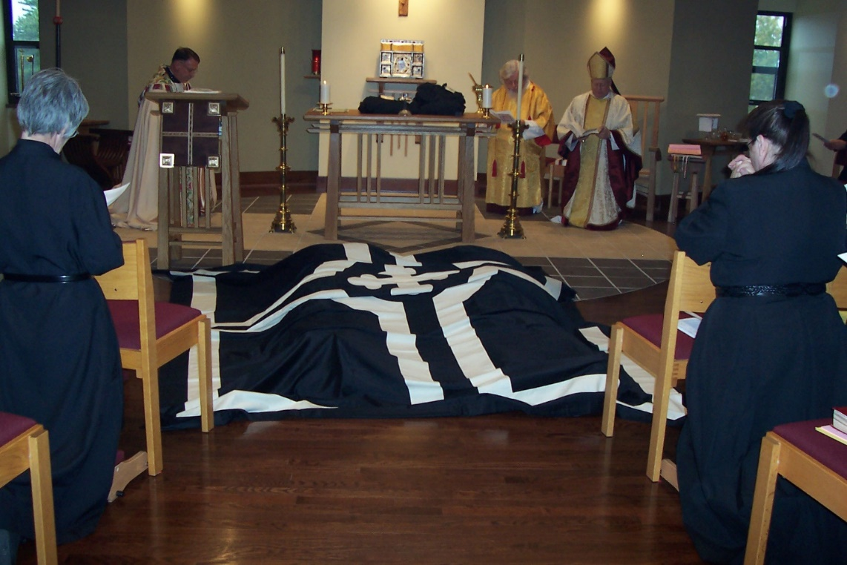
100_0609 Sr. Mary Francis Deulen; Abbot Michael John Austin; Fr. Wayne Kamm; Bp. Dean Wolfe; Sr. Sophia Holt

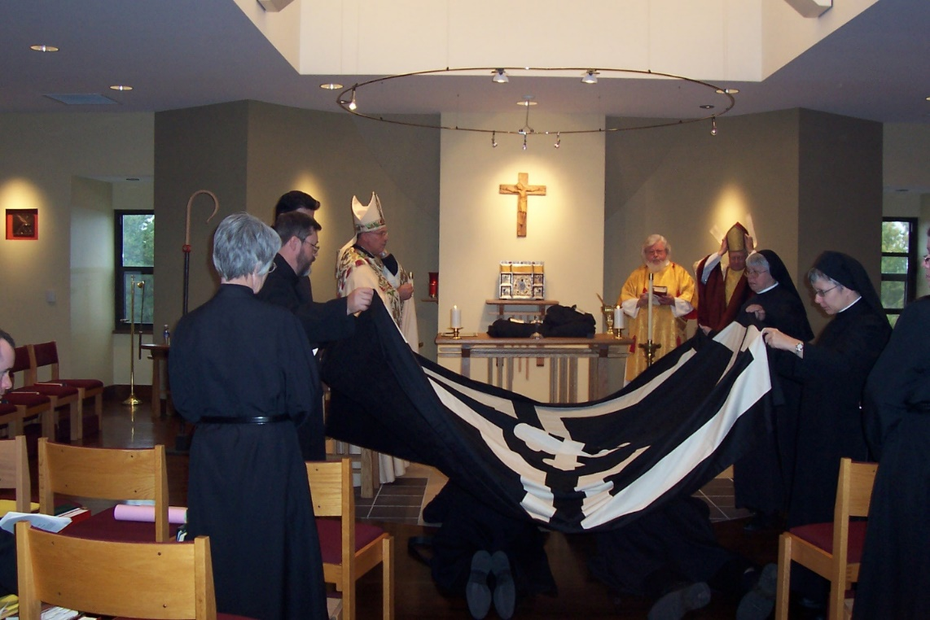
100_0610 Sr. Mary Francis Deulen; Br. Paul Howard; Br. Anthony Bernard Campos; Abbot Michael John Austin; Fr. Wayne Kamm; Bp. Dean Wolfe; Sr. Clare Benedicta Myers; Sr. Anna Grace Madden
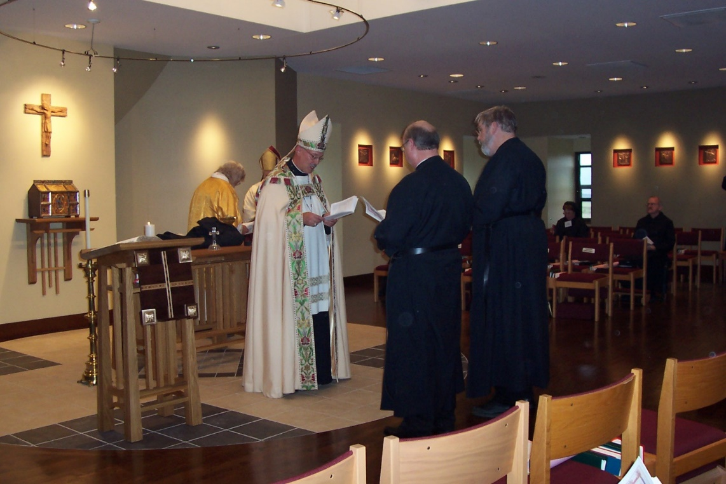
100_0611 Fr. Wayne Kamm; Bp. Dean Wolfe; Abbot Michael John Austin; Br. Raymond Owens; Br. Chad Anselm Gerns’ Sr. Monica Ruth Mullen; Br. Daniel Joseph Schroeder

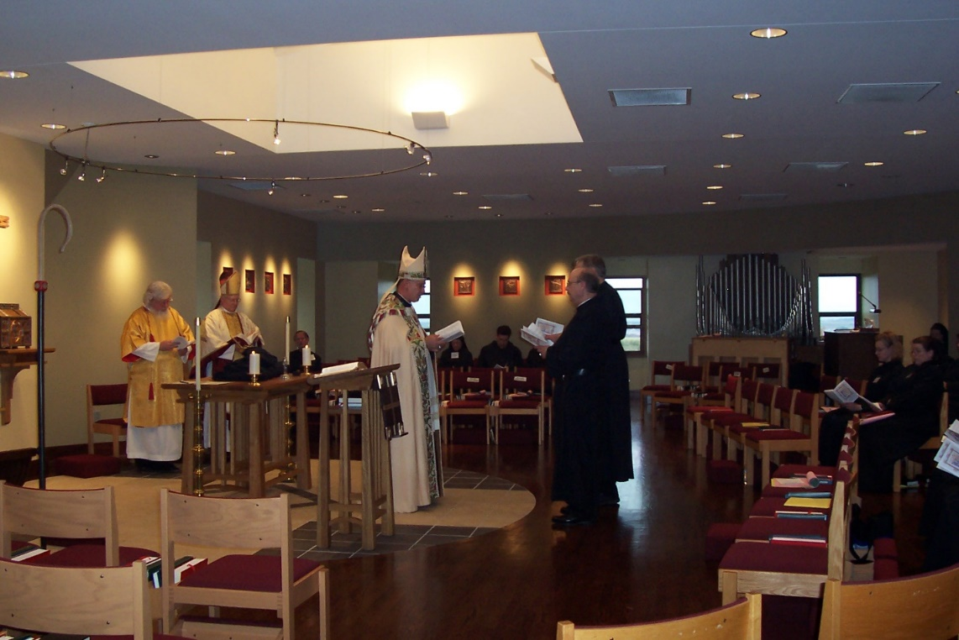
100_0612 Fr. Wayne Kamm; Bp. Dean Wolfe; Br. Lawrence Mullen; Abbot Michael John Austin Br. Raymond Owens; Br. Chad Anselm Gerns; Sr. Monia Ruth Mullen; Br. Anthony Bernard Campos; Sr. Hannah Sophia Wolsleben; Sr. Sophia Holt
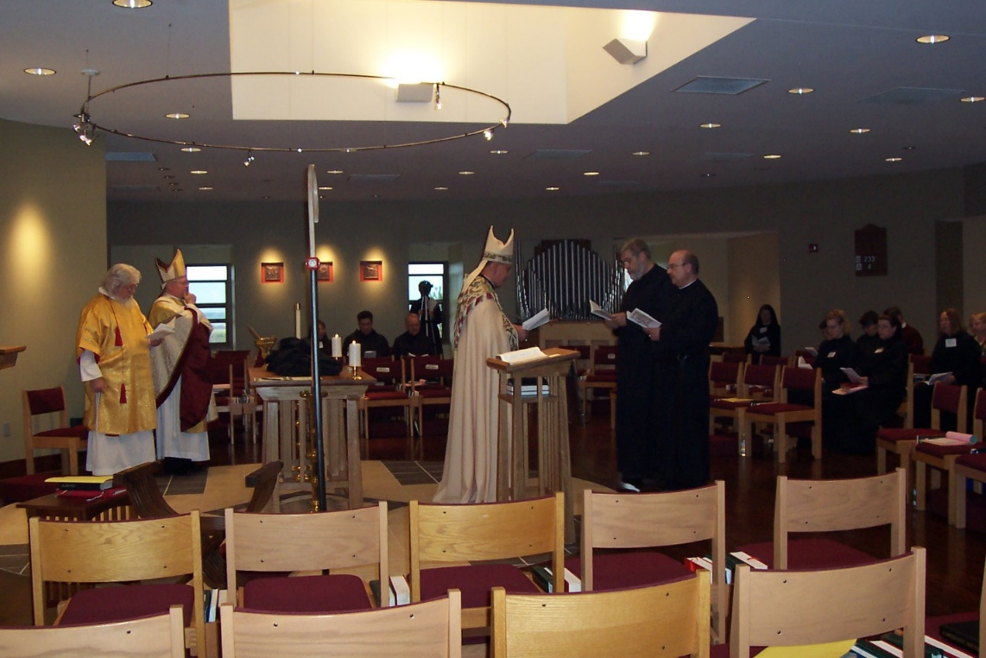
100_0613 Fr. Wayne Kamm; Bp. Dean Wolfe; Sr. Monica Ruth Mullen; Br. Anthony Bernard Campos; Br. Daniel Joseph Schroeder; Sr. Brigid Gerns; Abbot Michael John Austin; Br. Chad Anselm Gerns; Br. Raymond Owens; Sr. Johanna Kirkpatrick; Sr. Hillary Grace Lundgren; Sr. Hannah Sophia Wolsleben; Sr. Pauline Tysol; Sr. Sophia Holt; Sr. Teresa Bebee; Lynn Owens

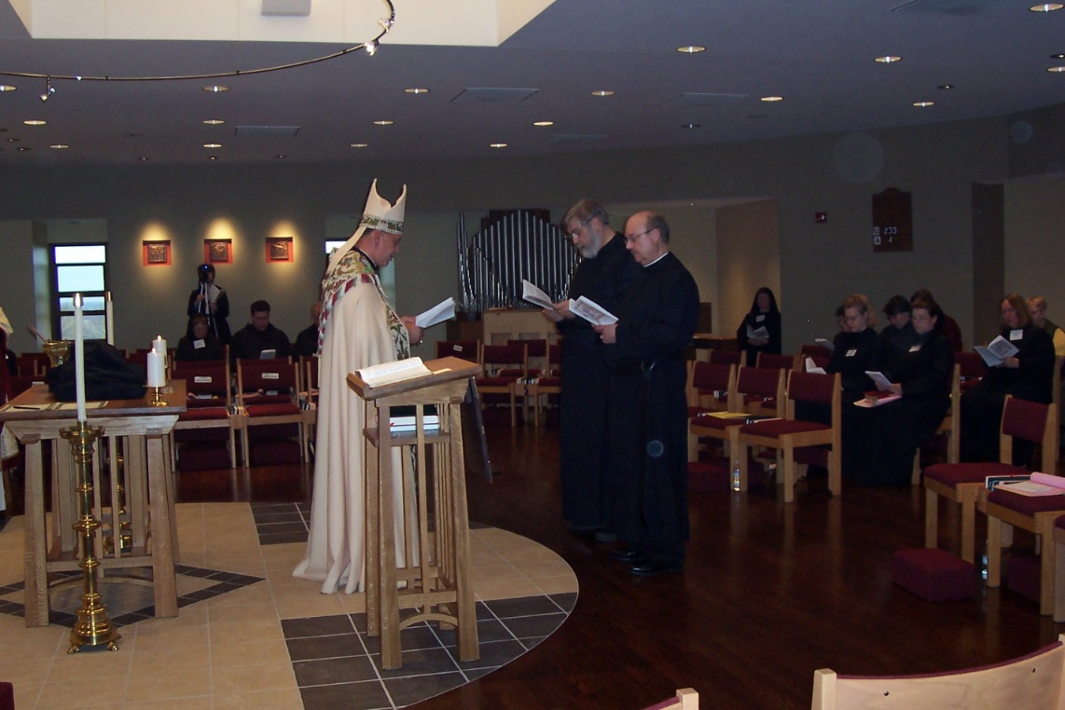
100_0614 Sr. Monica Ruth Mullen; Sr. Brigid Gerns; Br. Anthony Bernard Campos; Br. Daniel Schroeder; Abbot Michael John Austin; Br. Chad Anselm Gerns; Br. Raymond Owens; Sr. Hillary Grace Lundgren; Sr. Johanna Kirkpatrick; Sr. Hannah Sophia Wolsleben; Sr Pauline Tysol; Sr. Sophia Holt; Sr. Teresa Bebee; Lynn Owens
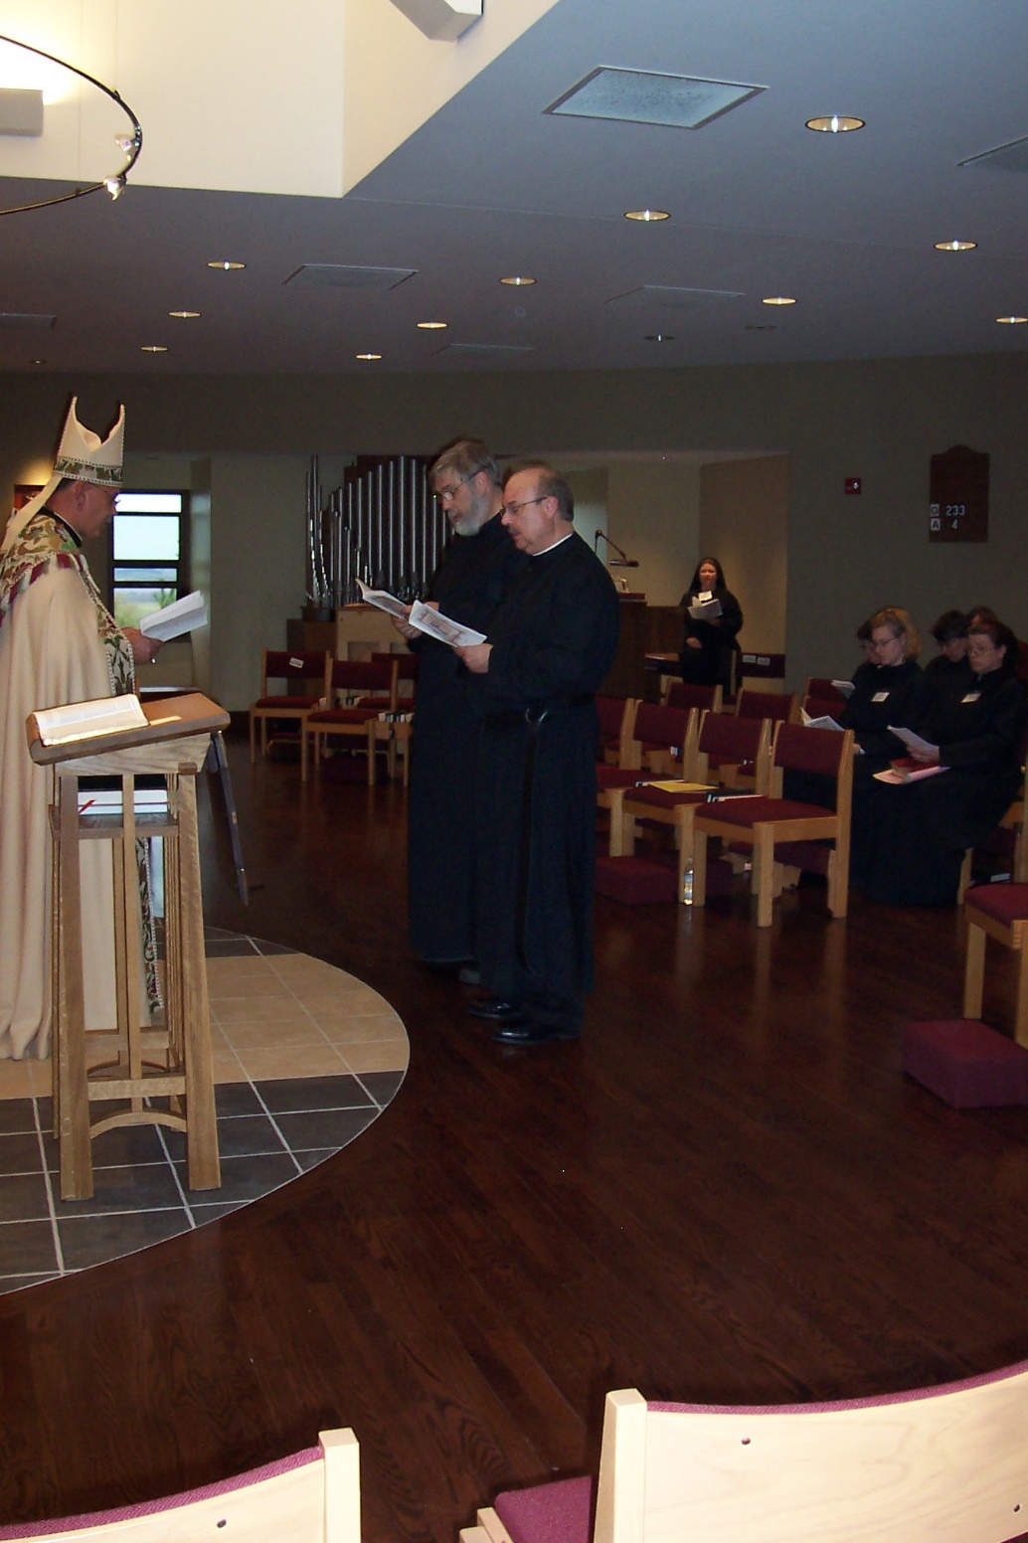
100_0615 Abbot Michael John Austin Br. Chad Anselm Gerns; Br. Raymond Owens; Sr. Hillary Grace Lundgren; Sr. Johanna Kirkpatrick; Sr. Hannah Sophia Wolsleben; Sr. Sophia Holt
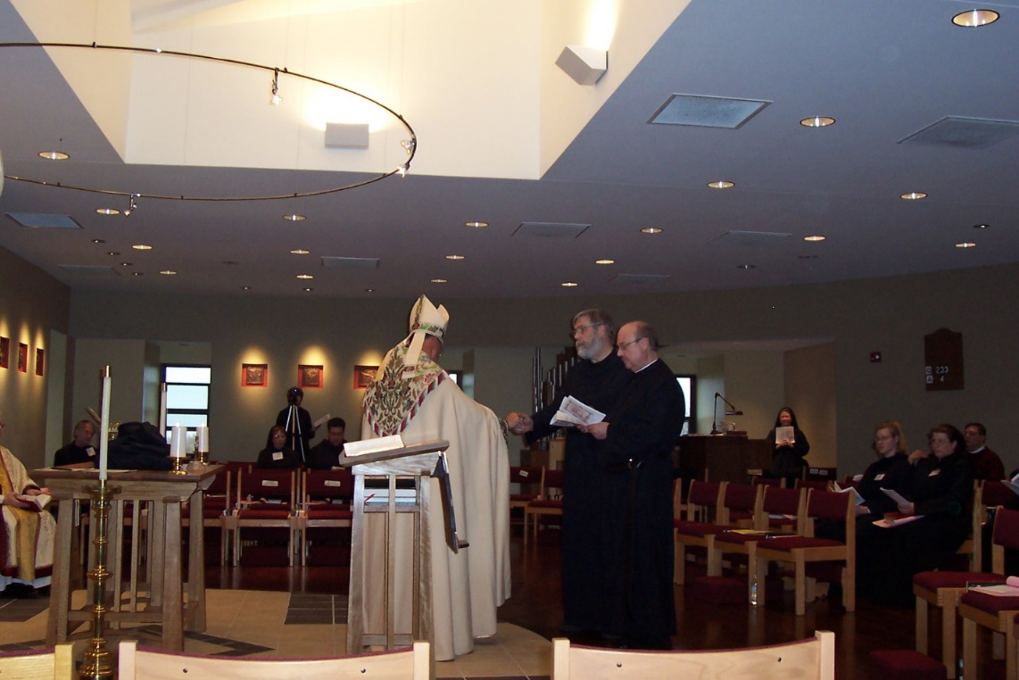
100_0616 Abbot Michael John Austin Br. Chad Anselm Gerns; Br. Raymond Owens; Sr. Hillary Grace Lundgren; Sr. Sophia Holt; Fr. Andrew Gerns

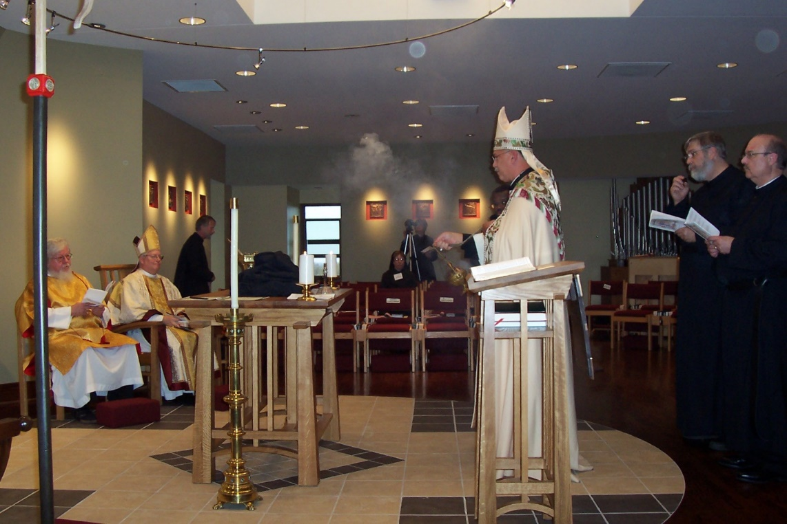
100_0617 Fr. Wayne Kamm; Bp. Dean Wolfe; Br. Lawrence Mullen; Sr. Monica Ruth Mullen; Sr. Brigid Gerns; Abbot Michael John Austin; Br. Chad Anselm Gerns; Br. Raymond Owens
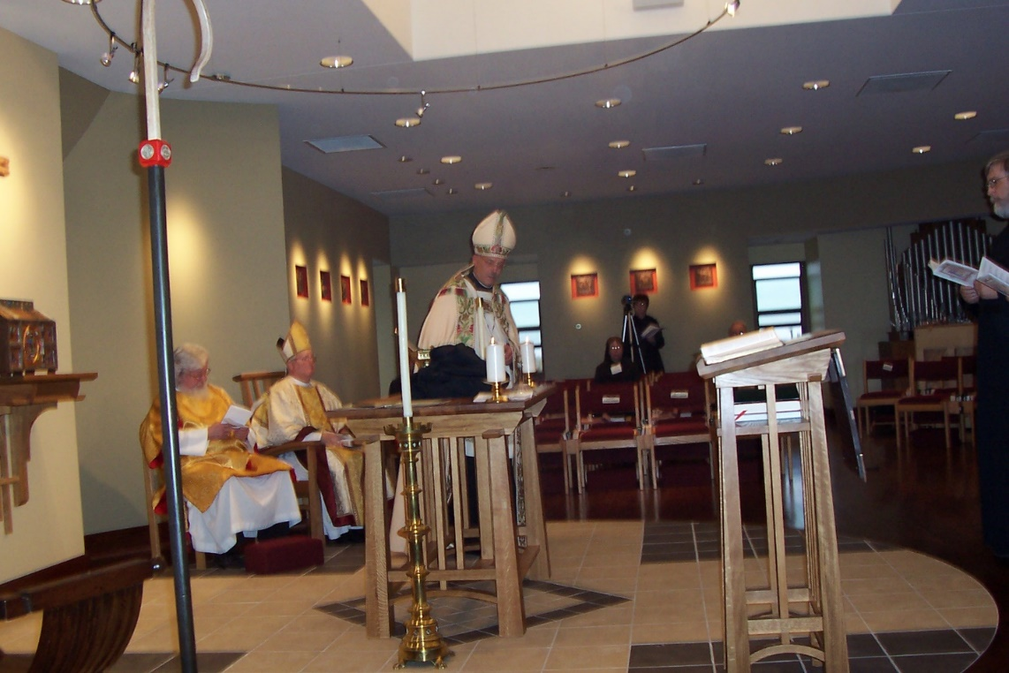
100_0618 Fr. Wayne Kamm; Bp. Dean Wolfe; Abbot Michael John Austin; Sr. Monica Ruth Mullen; Sr. Brigid Gerns; Br. Chad Anselm Gerns
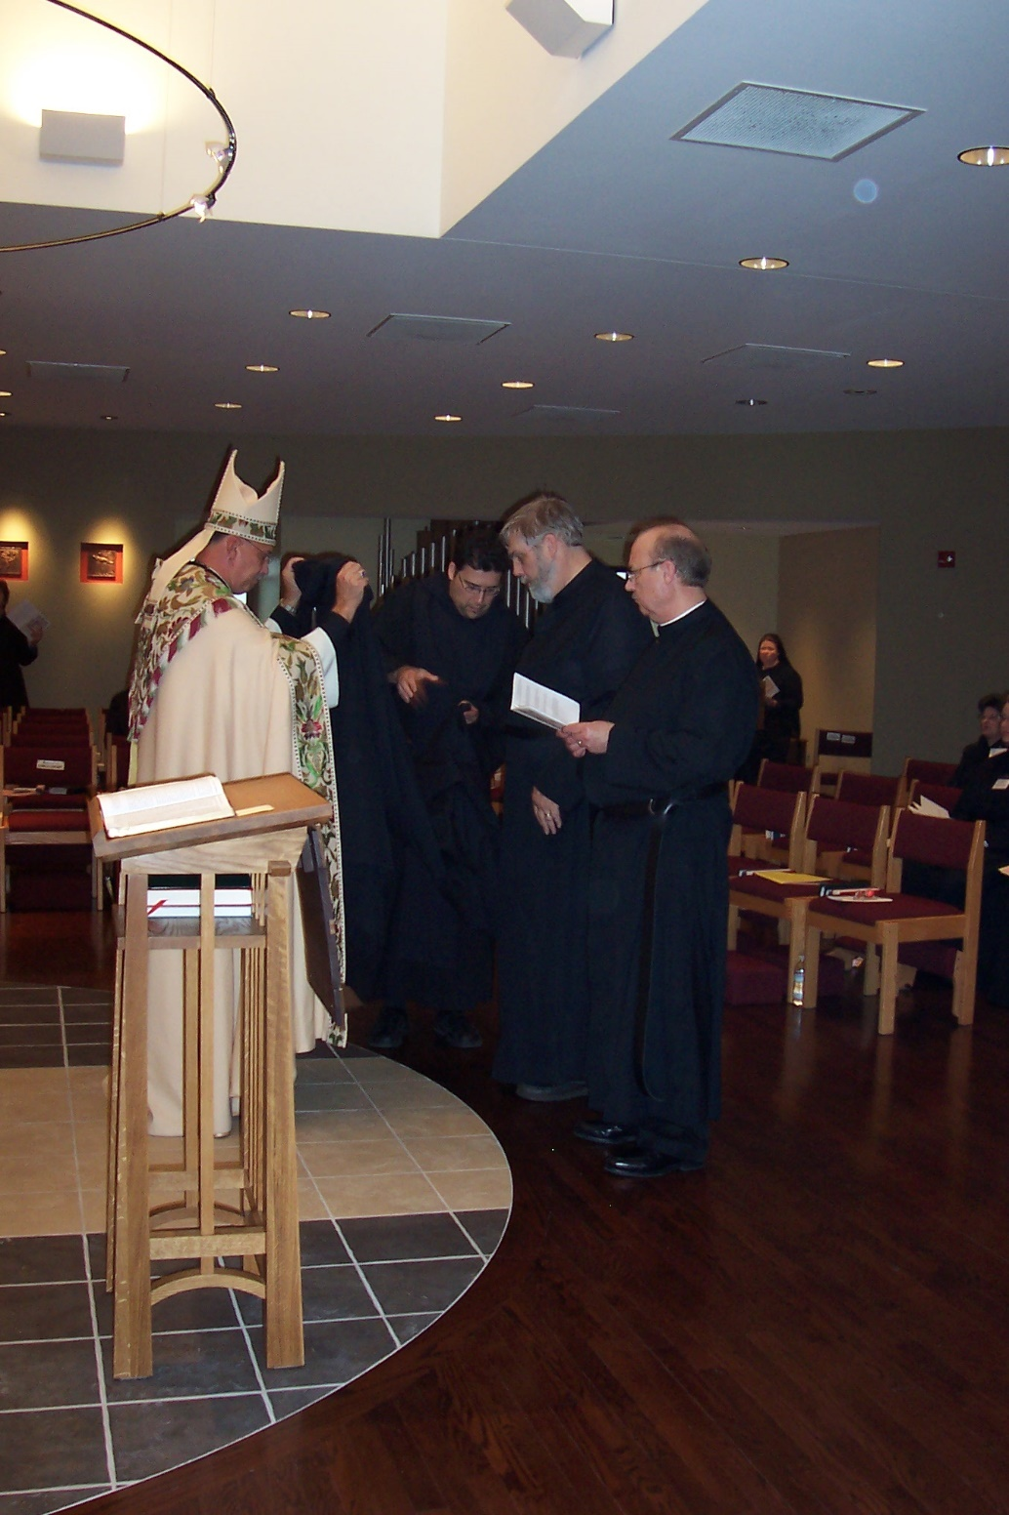
100_0619 Abbot Michael John Austin; Br. Anthony Bernard Campos; Br. Chad Anselm Gerns; Br. Raymond Owens; Sr. Hillary Grace Lundgren; Sr. Cecelia Lamoy; Sr. Theodora of Jesus Perecca
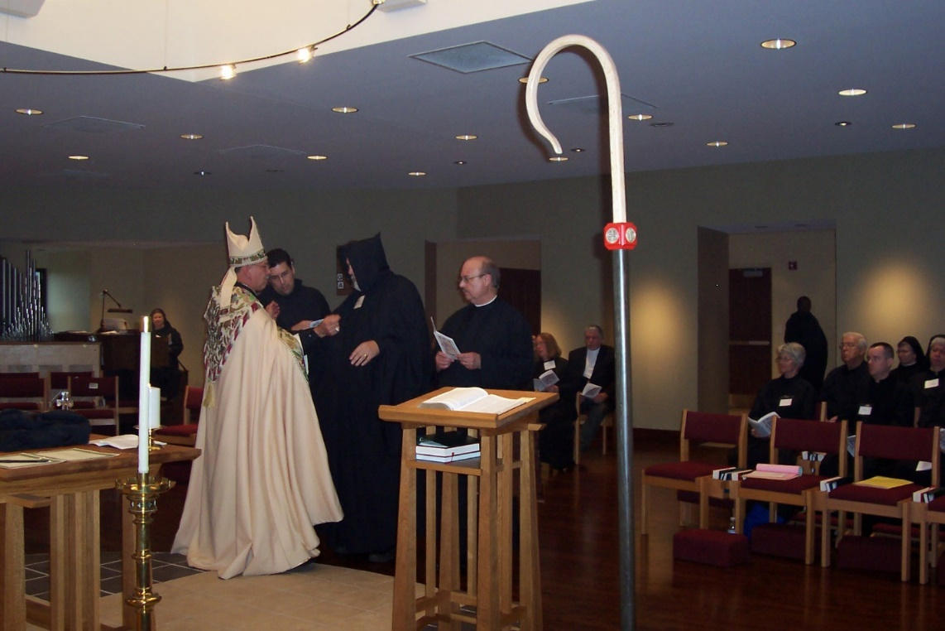
100_0620 Sr. Hillary Grace Lundgren; Abbot Michael John Austin; Br. Anthony Bernard Campos; Br. Chad Anselm Gerns; Br. Raymond Owens; Sr. Teresa Bebee; ?; Sr. Mary Francis Deulen; Br. Thomas Ferrell; Br. Timothy Titus Lunt; Br. John Matthias Cline; Sr. Anna Grace Madden; Sr. Mary Catherine Christopher
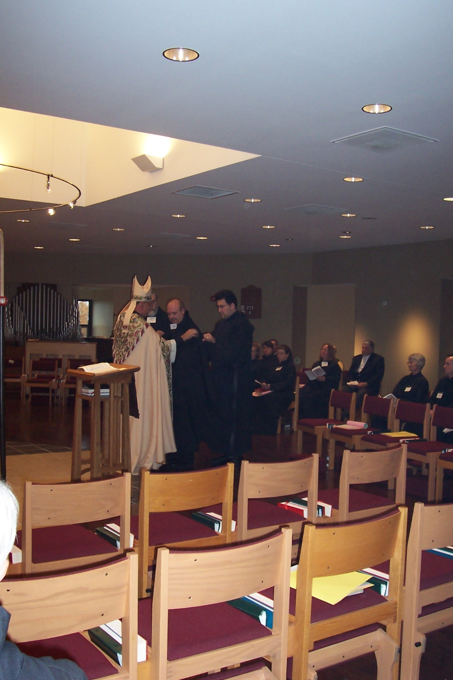
100_0621 Abbot Michael John Austin; Br. Chad Anselm Gerns; Br. Raymond Owens; Br. Anthony Bernard Campos; Sr. Hannah Sophia Wolsleben; Sr. Pauline Tysol; Fr. Andrew Gerns; Sr. Sophia Holt; Sr. Teresa Bebee; Sr. Mary Francis Deulen; Br. John Matthias Cline
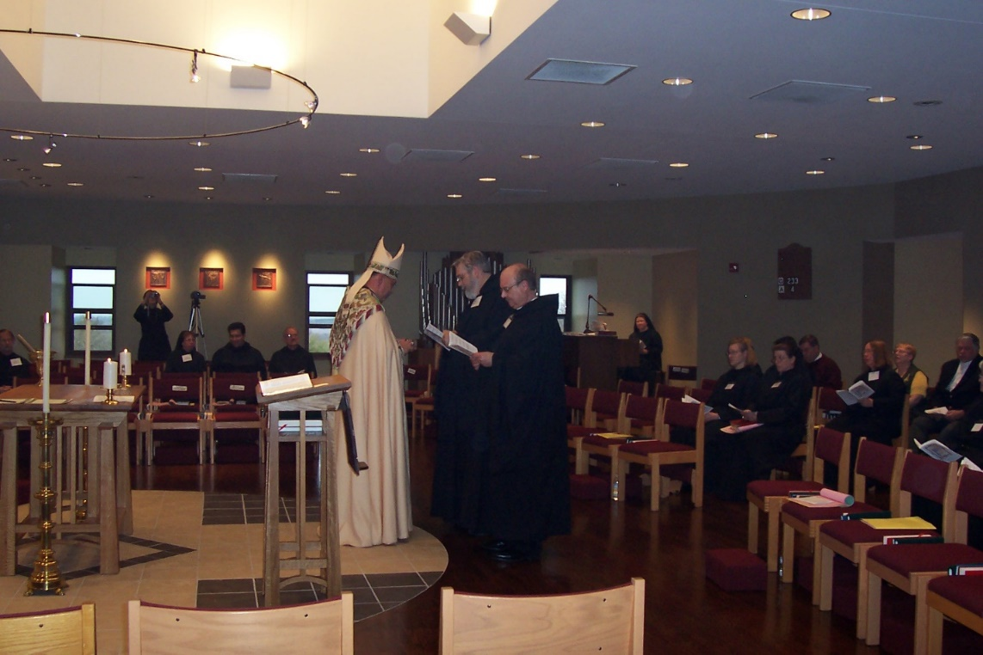
100_0622 Br. Lawrence Mullen; Sr. Brigid Gerns; Sr. Monica Ruth Mullen; Br. Anthony Bernard Campos; Br. Daniel Joseph Schroeder; Abbot Michael John Austin; Br. Chad Anselm Gerns; Br. Raymond Owens; Sr. Hillary Grace Lundgren; Sr. Hannah Sophia Wolsleben; Sr. Sophia Holt; Fr. Andrew Gerns; Sr. Teresa Bebee; Lynn Owens; ?

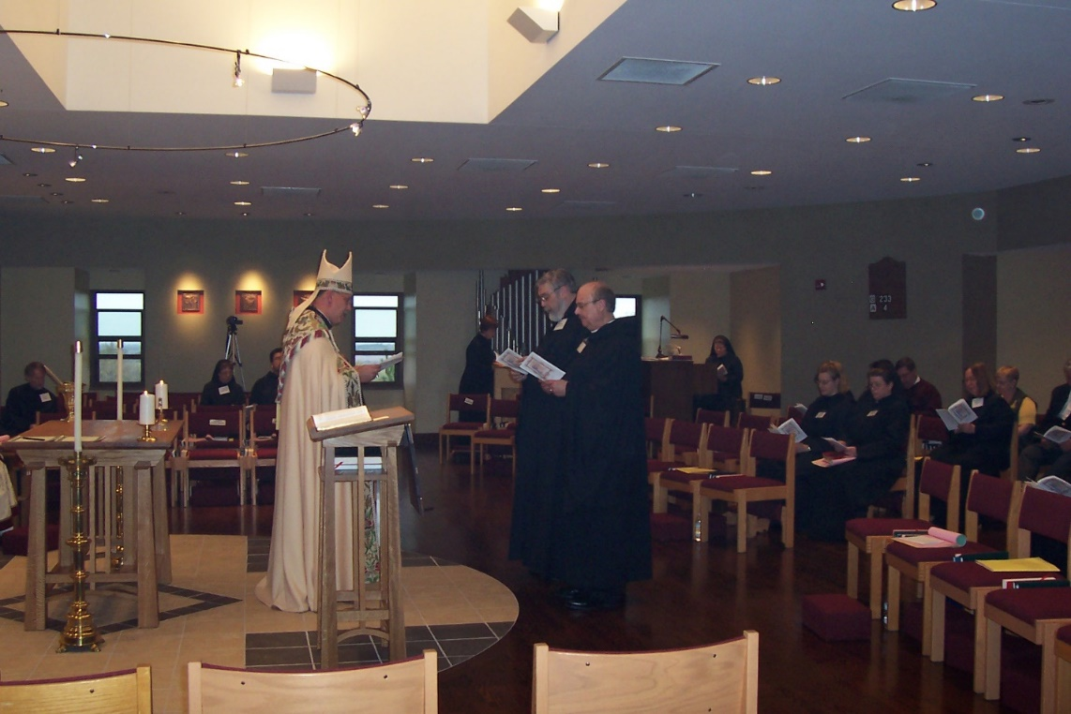
100_0623 Br. Lawrence Mullen; Sr. Monica Ruth Mullen; Br. Anthony Bernard Campos; Abbot Michael John Austin Br. Chad Anselm Gerns; Br. Raymond Owens; Sr. Hillary Grace Lundgren; Sr. Hillary Grace Lundgren; Sr. Hannah Sophia Wolsleben; Sr. Sophia Holkt; Fr. Andrew Gerns; Sr. Teresa Bebee; Lynn Owens

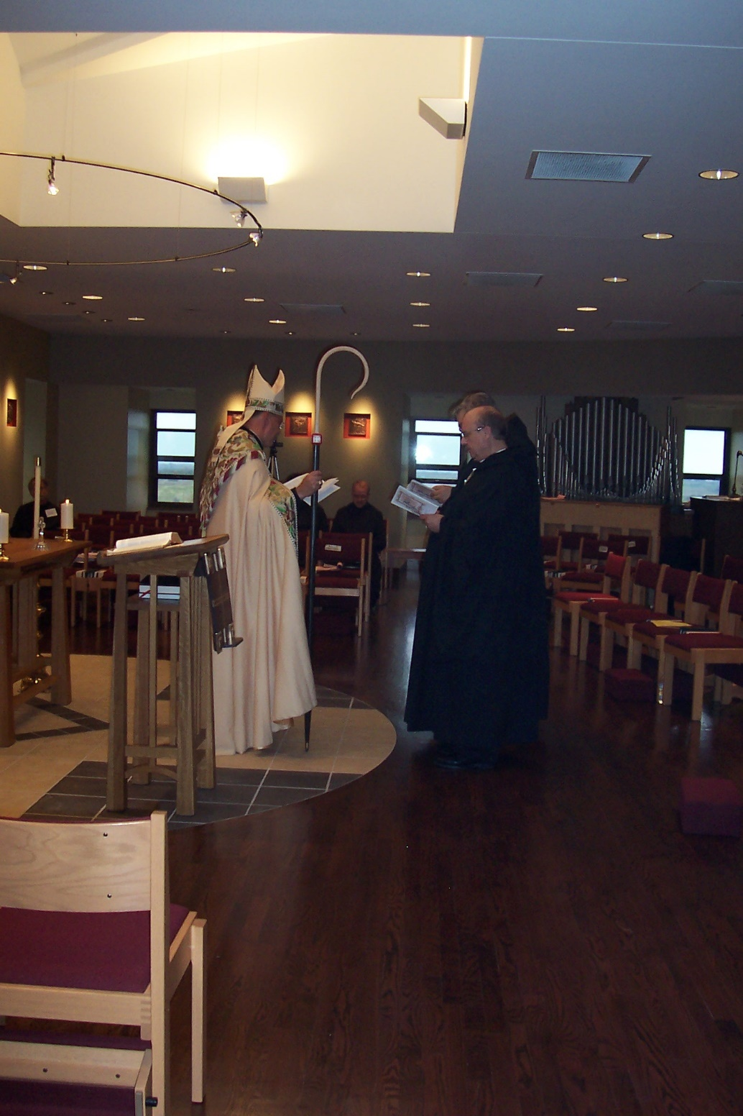
100_0624 Br. Lawrence Mullen; Abbot Michael John Austin; Br. Daniel Joseph Schroeder; Br. Chad Anselm Gerns; Br. Raymond Owens
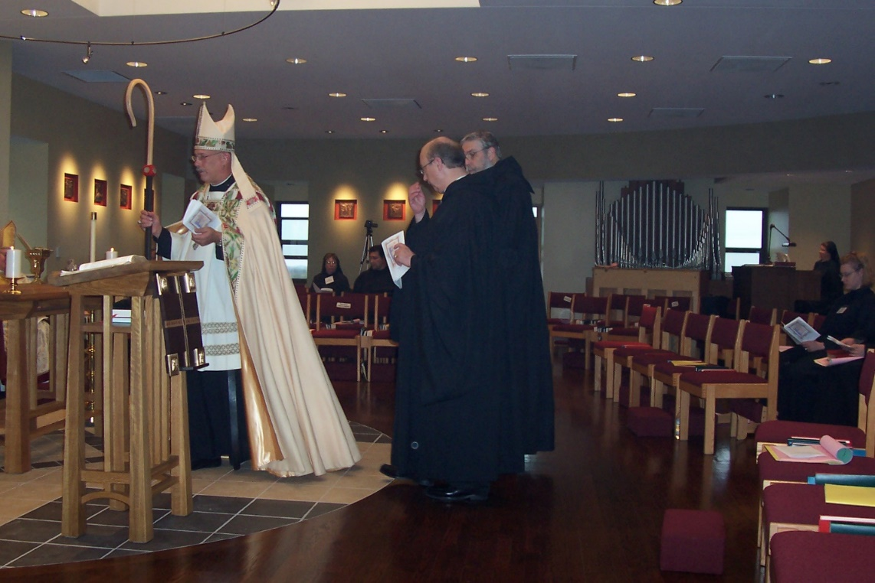
100_0625 Bp. Dean Wolfe; Abbot Michael John Austin; Sr. Monica Ruth Mullen; Br. Anthony Bernard Campos; Br. Raymond Owens; Br. Chad Anselm Gerns; Sr. Hillary Grace Lundgren; Sr. Hannah Sophia Wolsleben
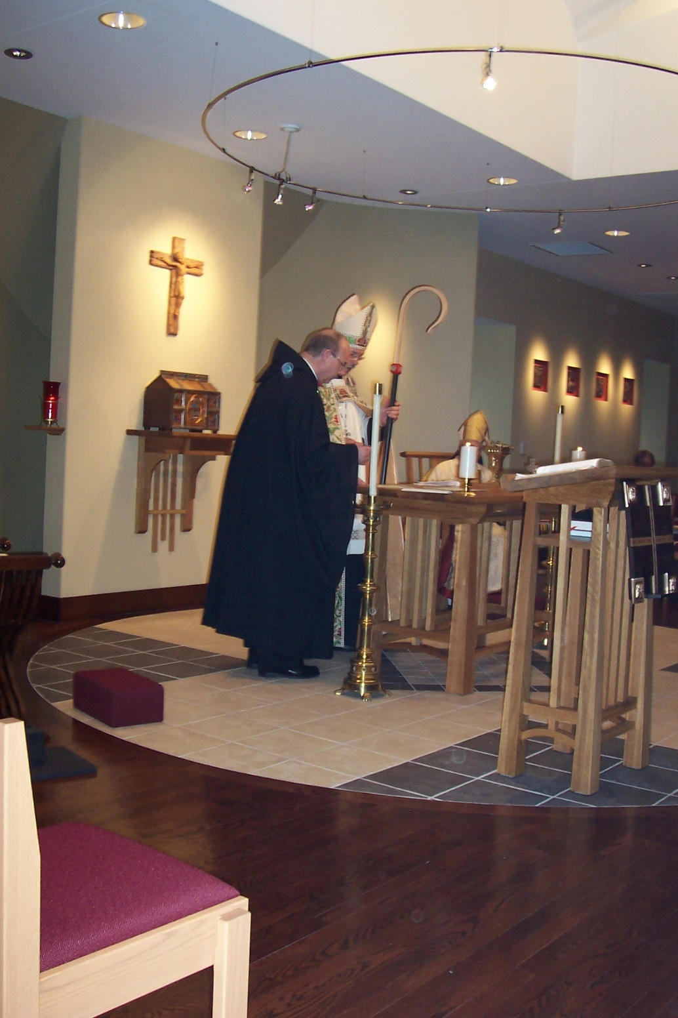
100_0626 Br. Raymond Owens; Abbot Michael John Austin; Bp. Dean Wolfe; Br. Lawrence Mullen
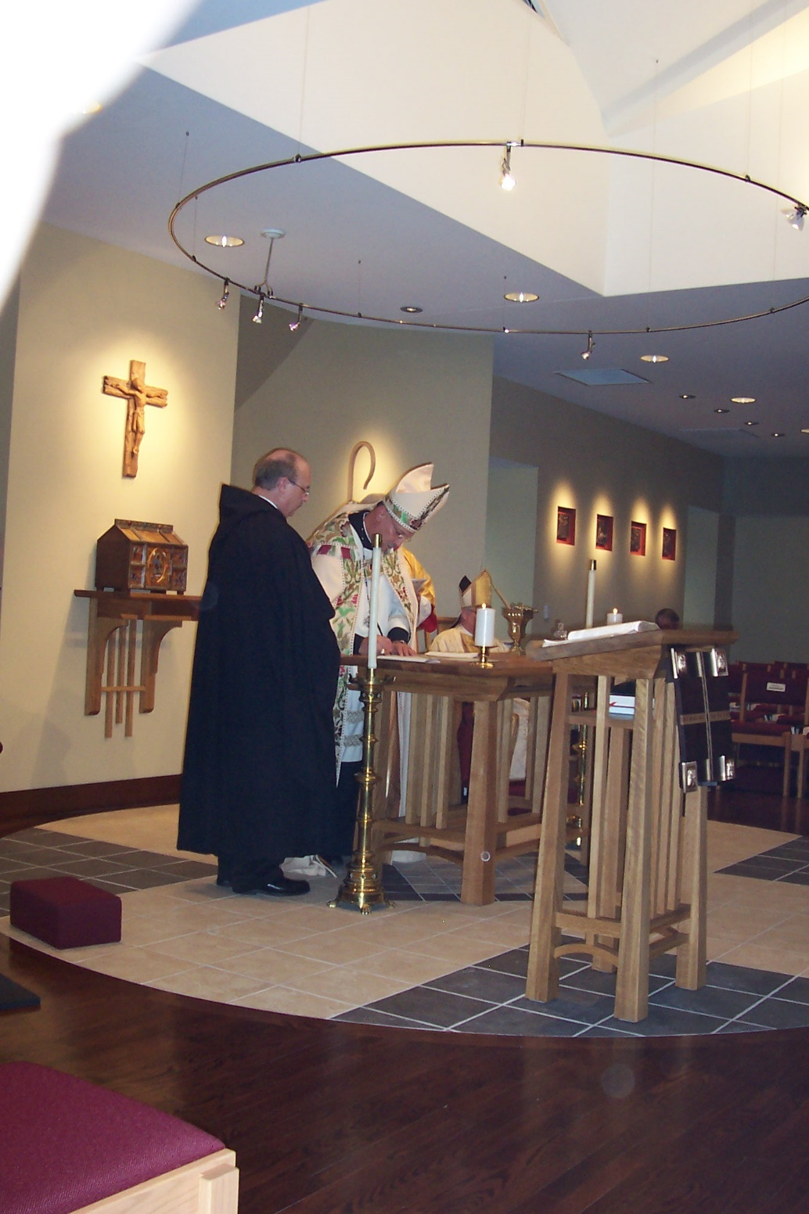
100_0627 Br. Raymond Owens; Abbot Michael John Austin; Bp. Dean Wolfe; Br. Lawrence Mullen
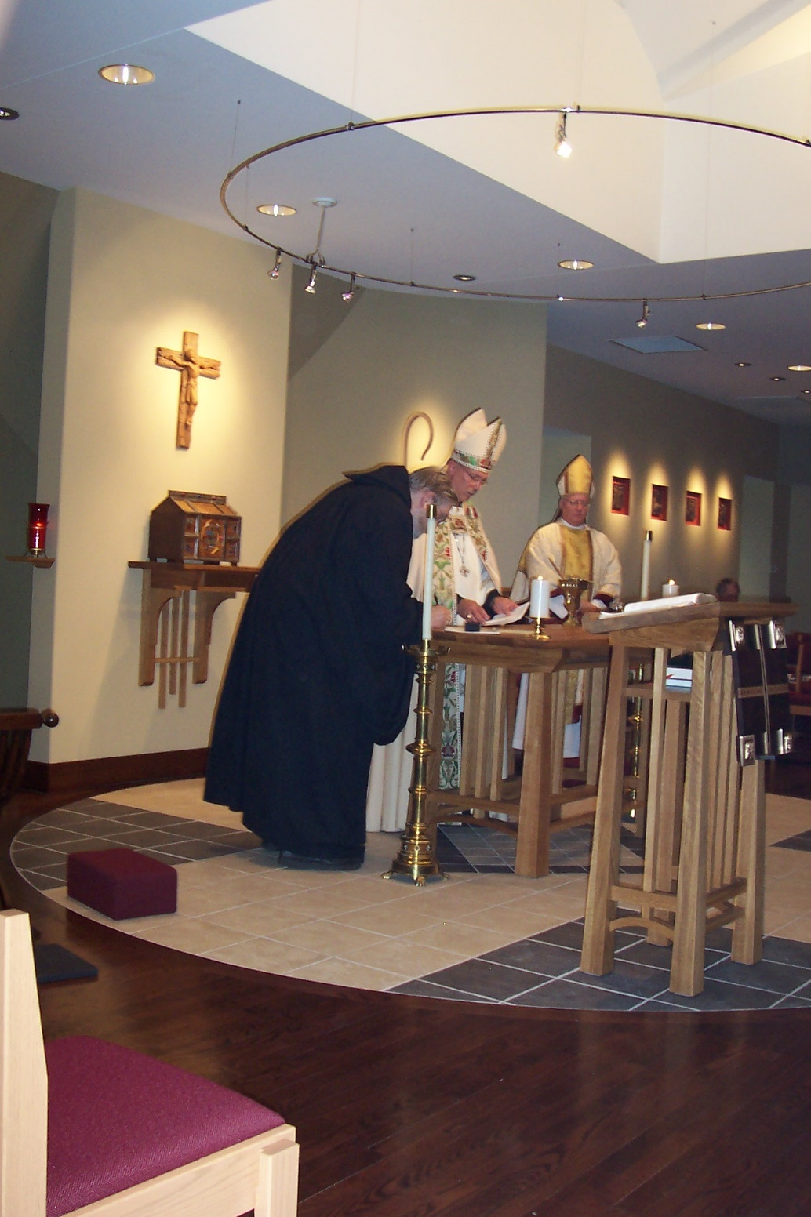
100_0628 Br. Chad Anselm Gerns; Abbot Michael John Austin; Bp. Dean Wolfe; Br. Lawrence Mullen
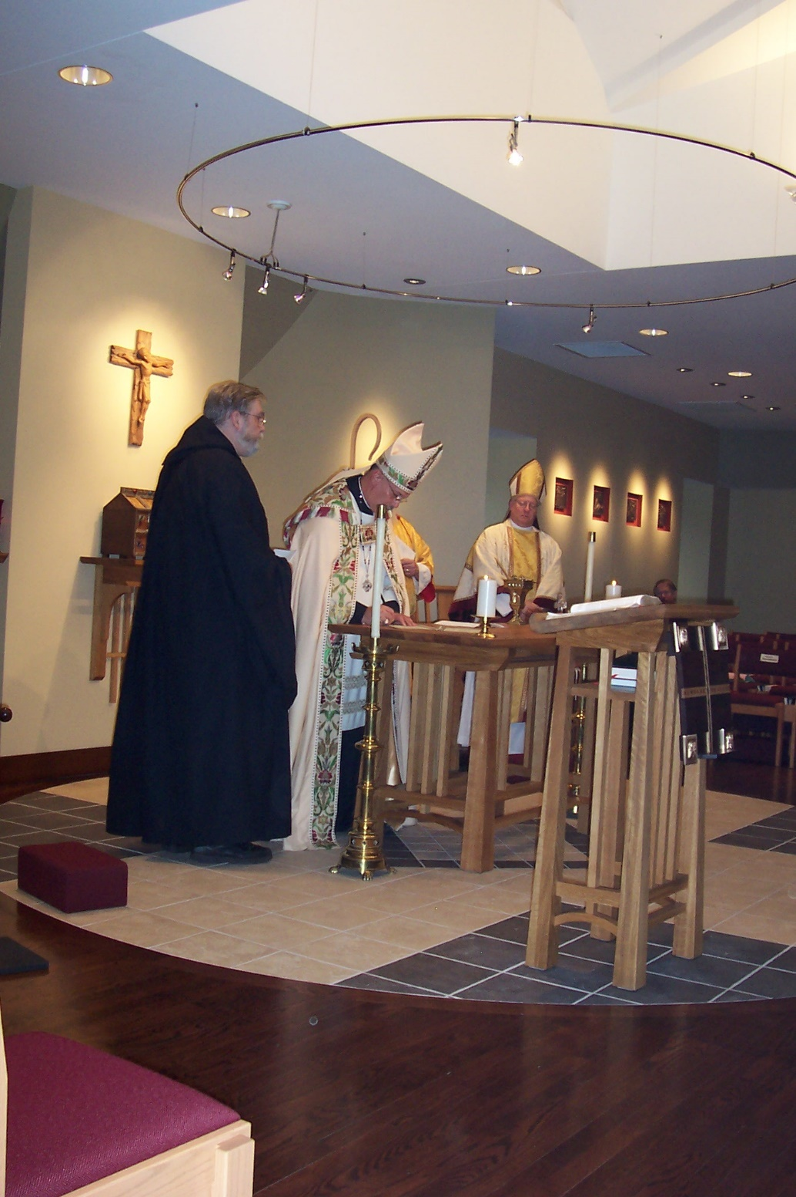
100_0629 Br. Chad Anselm Gerns; Abbot Michael John Austin; Bp. Dean Wolfe; Br. Lawrence Mullen
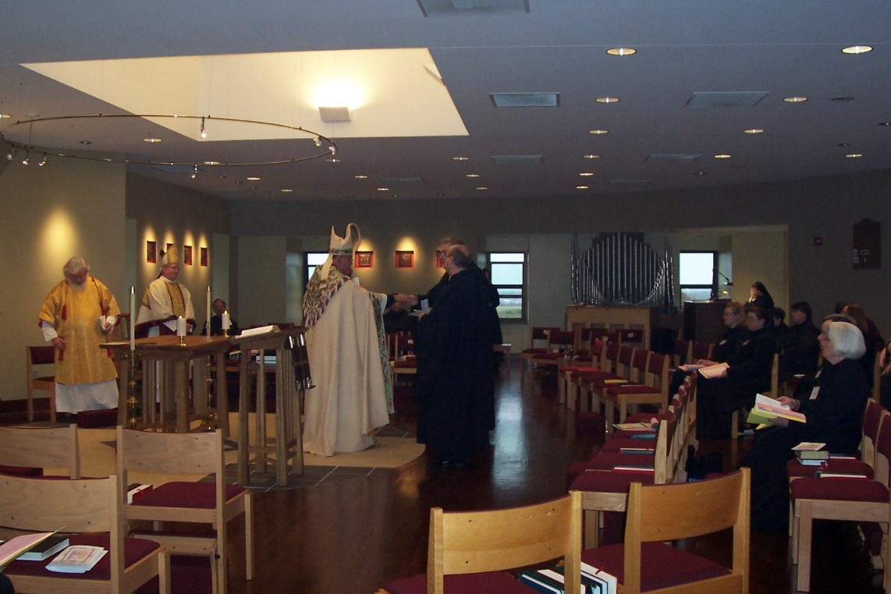
100_0630 Fr. Wayne Kamm; Bp. Dean Wolfe; Br. Lawrence Mullen; Abbot Michael John Austin; Br. Chad Anselm Gerns; Br. Raymond Owens; Sr. Hannah Sophia Wolsleben; Sr. Sophia Holt; Sr. Hillary Grace Lundgren; Sr Sophia Holt; Sr. Pauline Tysol; Br. John Matthias Cline; Sr. Elizabeth Ann Stribley

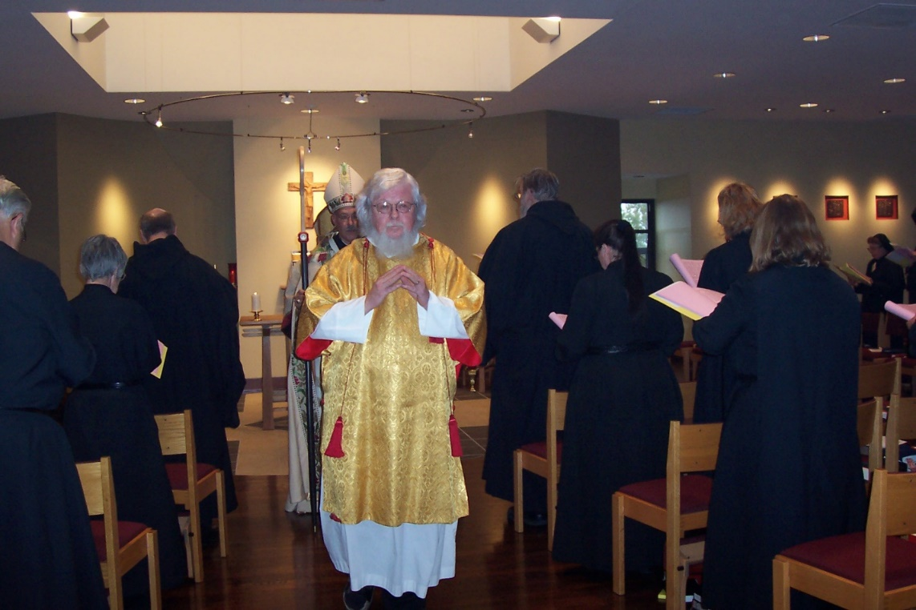
100_0631 Br. Timothy Titus Lunt; Sr. Mary Francis Deulen; Br. Raymond Owens; Abbot Michael John Austin; Fr. Wayne Kamm; Br. Chad Anselm Gerns; Sr. Sophia Holt; Sr. Hannah Sophia Wolsleben; Sr. Teresa Bebee; Sr. Monica Ruth Mullen
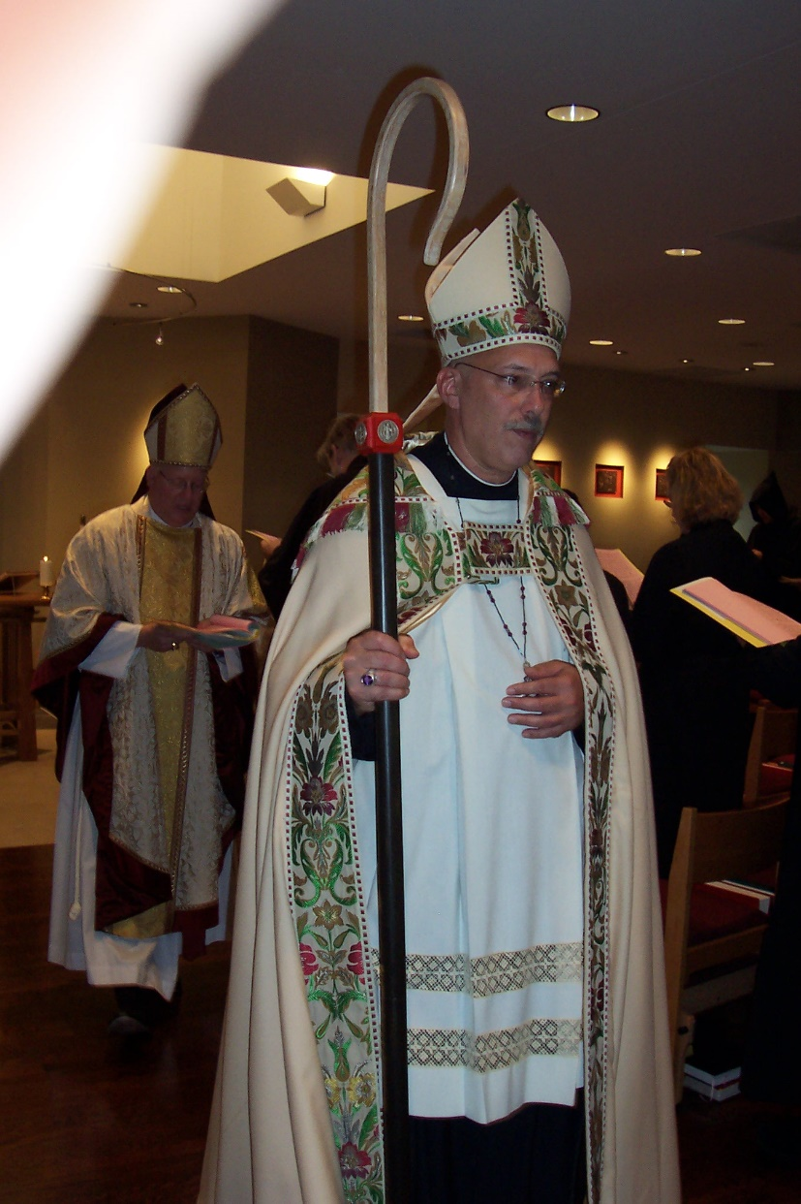
100_0632 Bp. Dean Wolfe; Br. Chad Anselm Gerns; Abbot Michael John Austin; Sr. Hannah Sophia Wolsleben
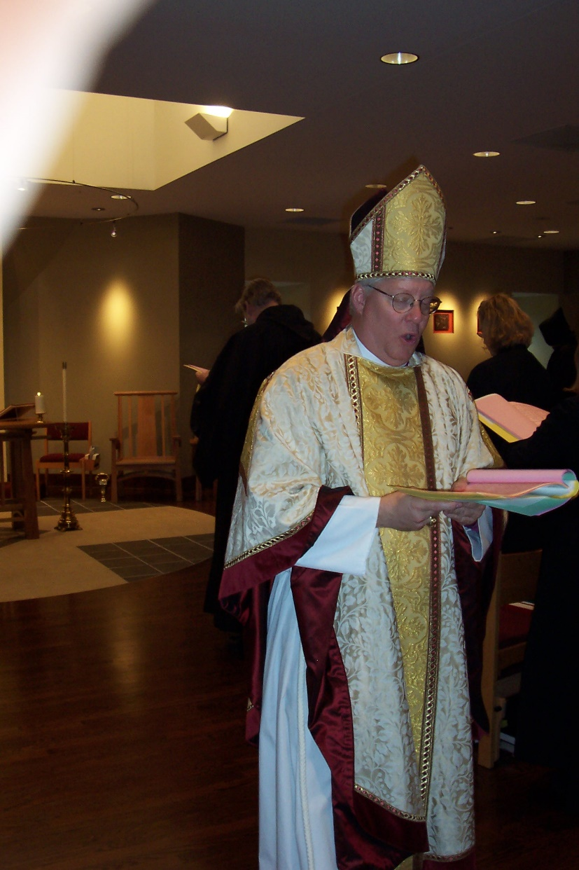
100_0633 Br. Chad Anselm Gerns; Bp. Dean Wolfe; Sr. Hannah Sophia Wolsleben
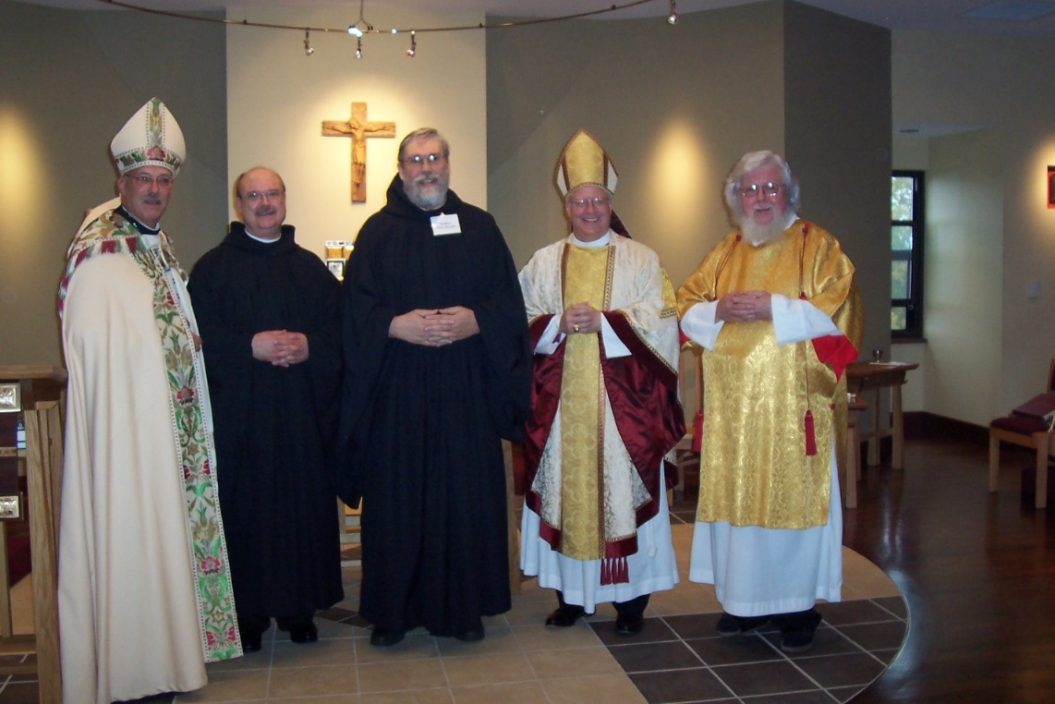
100_0634 Abbot Michael John Austin; Br. Raymond Owens; Br. Chad Anselm Gerns; Bp. Dean Wolfe; Fr. Wayne Kamm

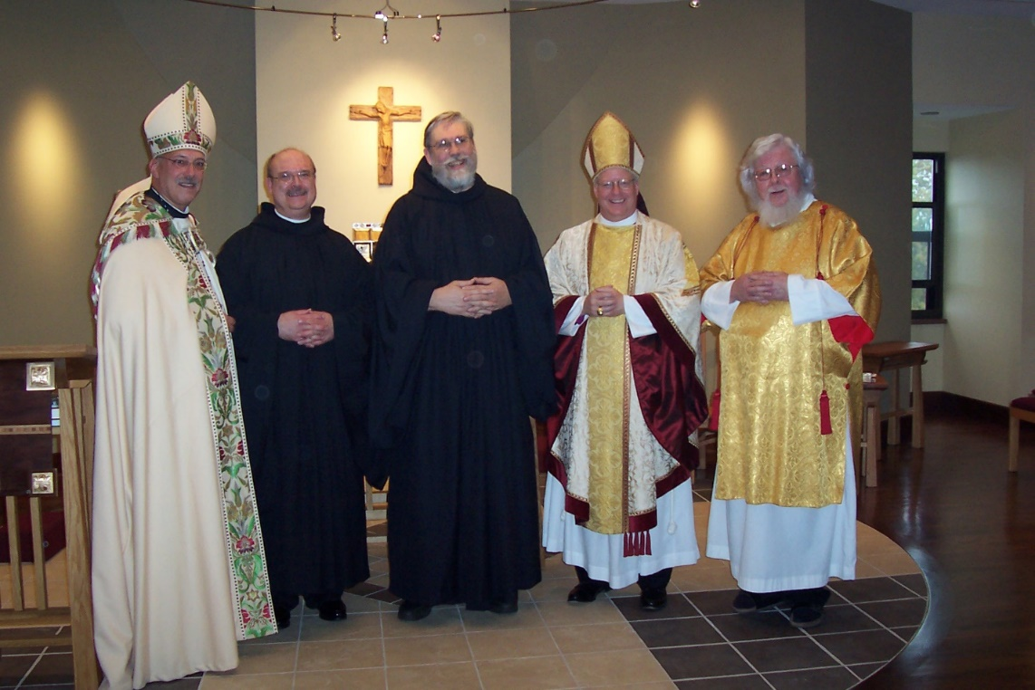
100_0636 Abbot Michael John Austin; Br. Raymond Owens; Br. Chad Anselm Gerns; Bp. Dean Wolfe; Fr. Wayne Kamm
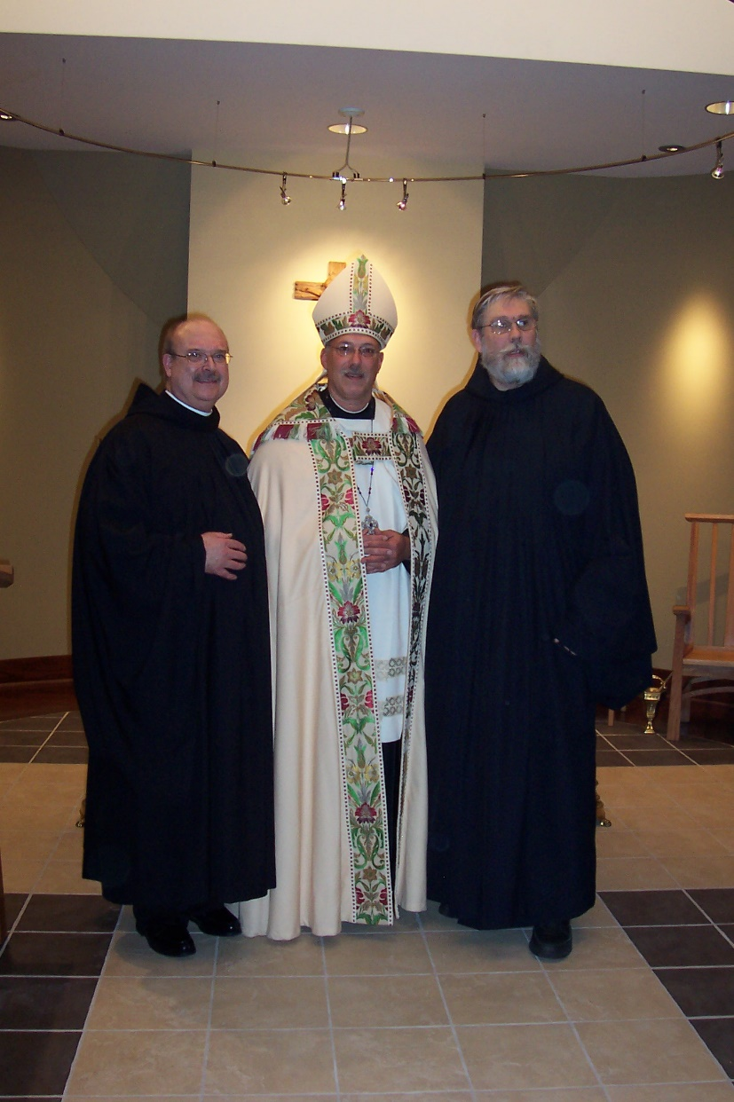
100_0637 Br. Raymond Owens; Abbot Michael John Austin; Br. Chad Anselm Gerns
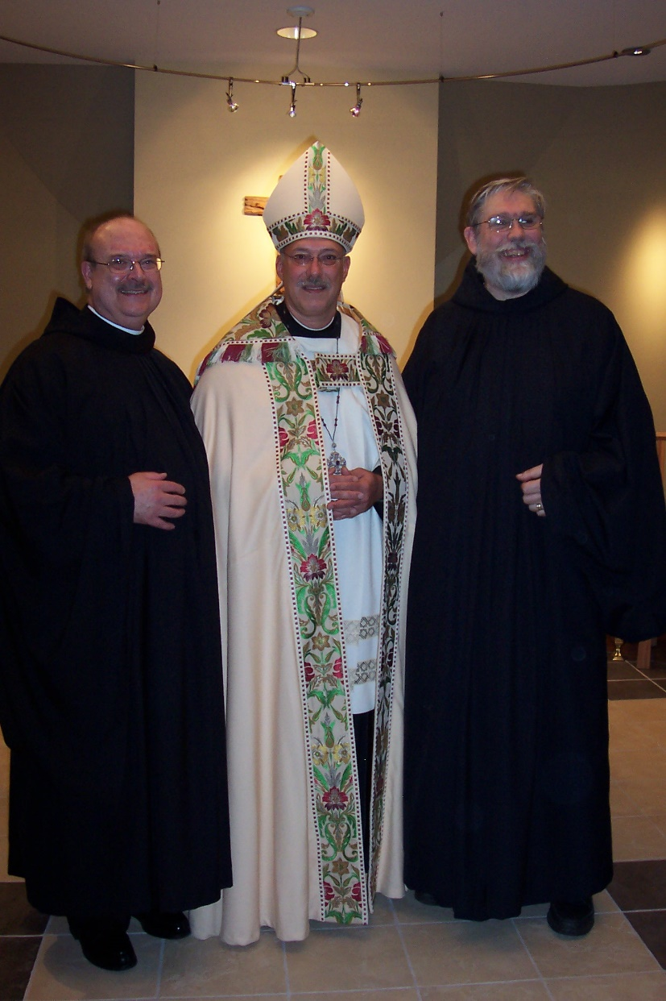
100_0638 Br. Raymond Owens; Abbot Michael John Austin; Br. Chad Anselm Gerns
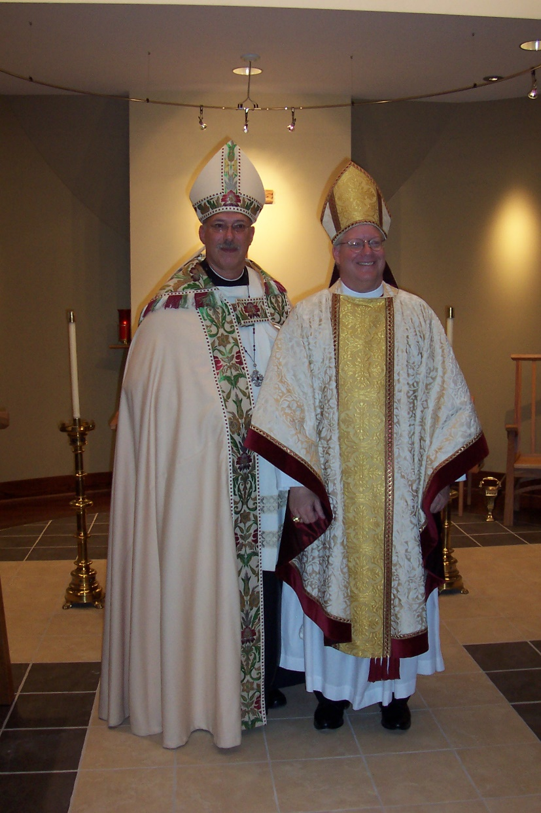
100_0639 Abbot Michael John Austin; Bp. Dean Wolfe
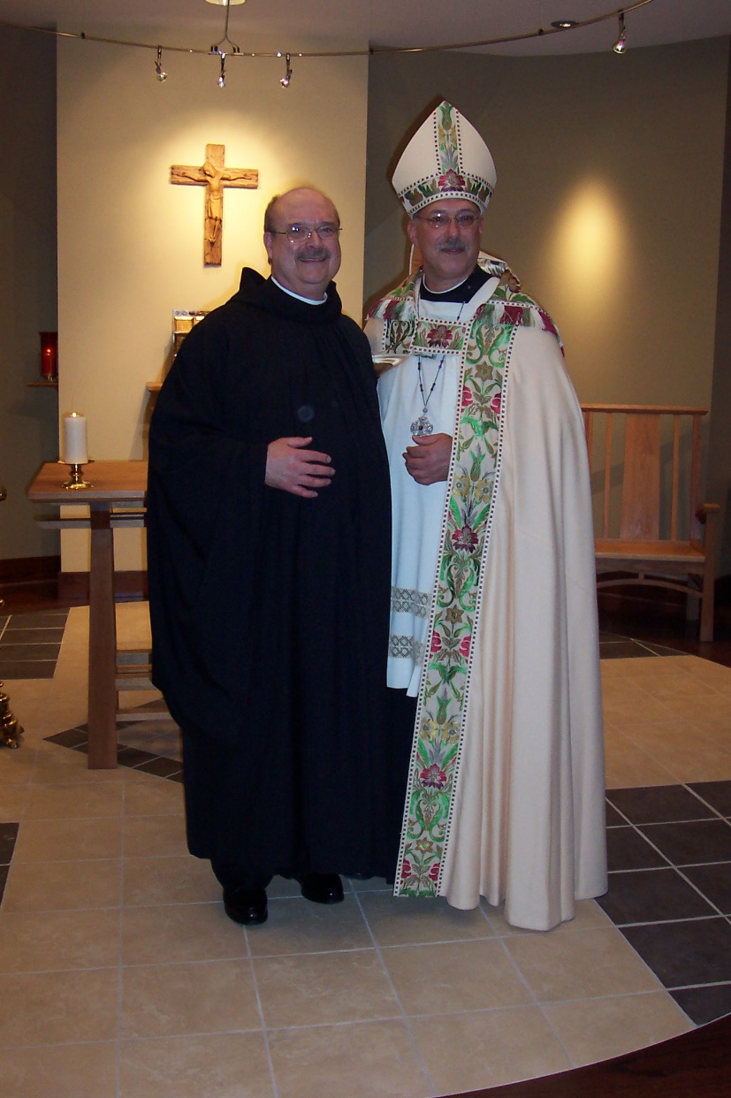
100_0640 Br. Raymond Owens; Abbot Michael John Austin
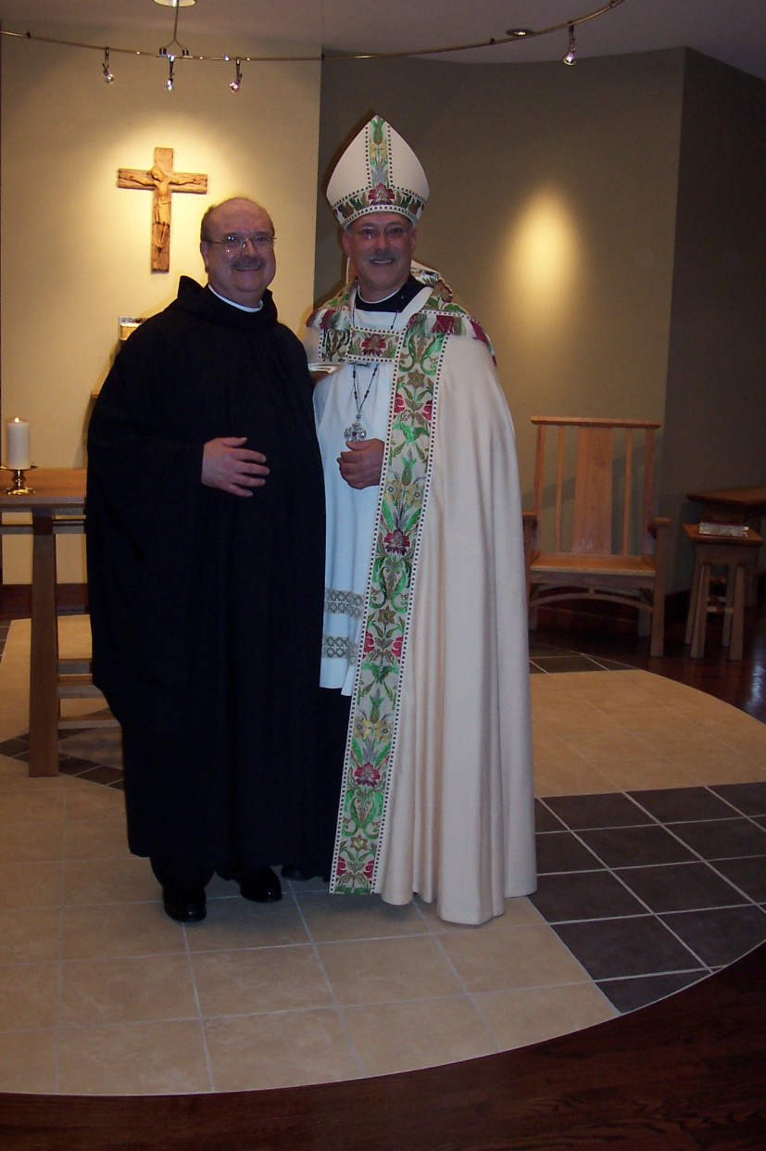
100_0641 Br. Raymond Owens; Abbot Michael John Austin
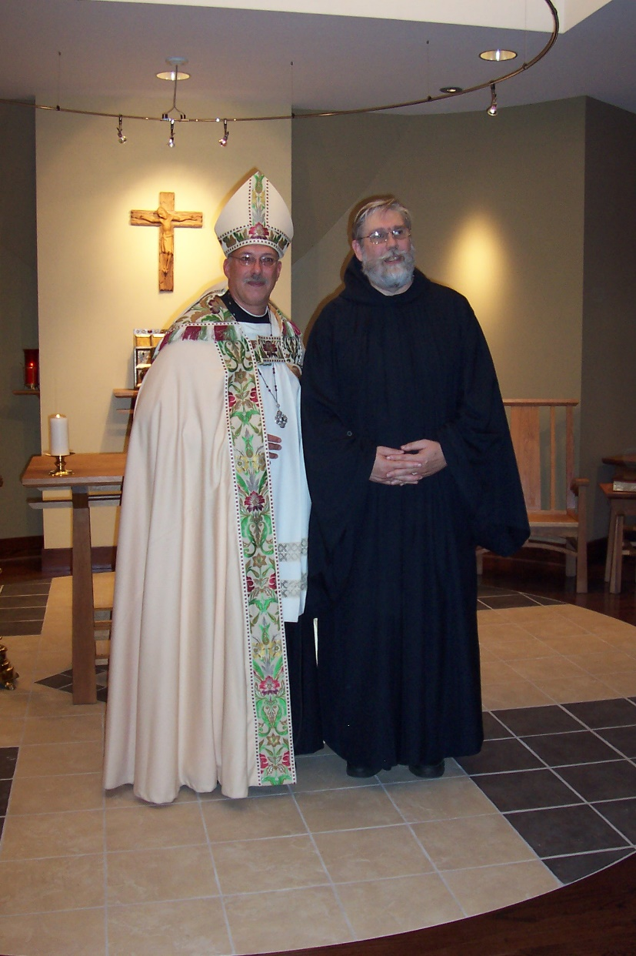
100_0642 Abbot Michael John Austin; Br. Chad Anselm Gerns
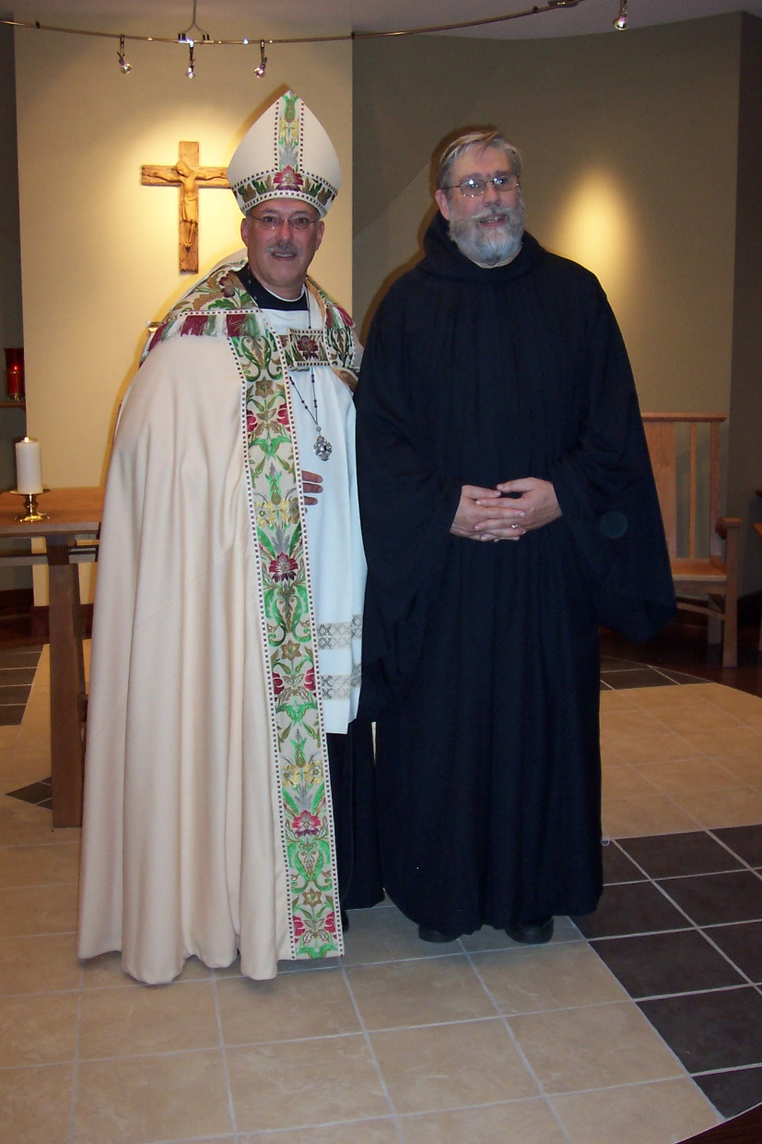
100_0643 Abbot Michael John Austin; Br. Chad Anselm Gerns
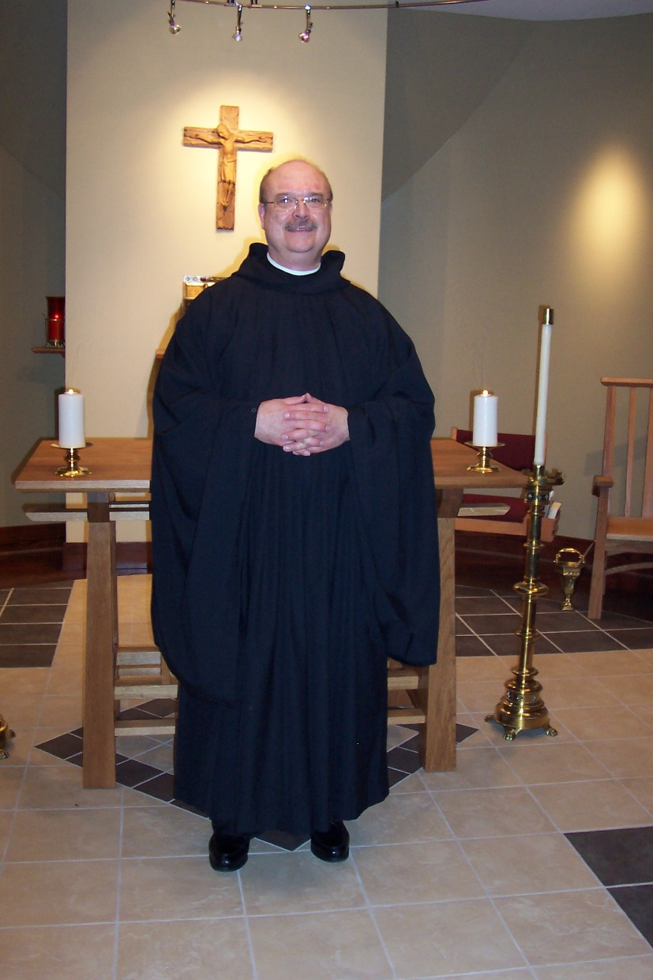
100_0644 Br. Raymond Owens
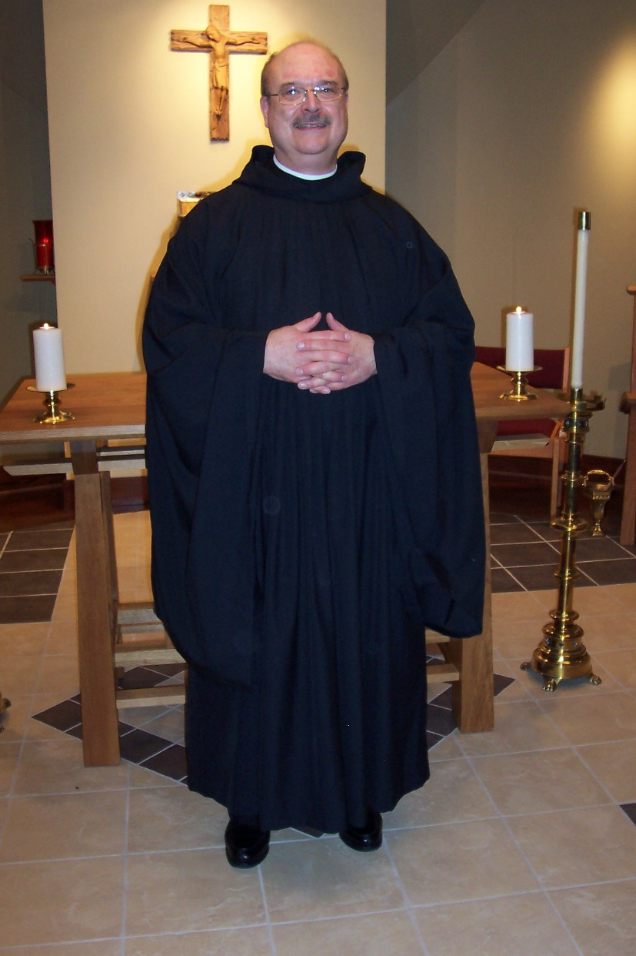
100_0645 Br. Raymond Owens
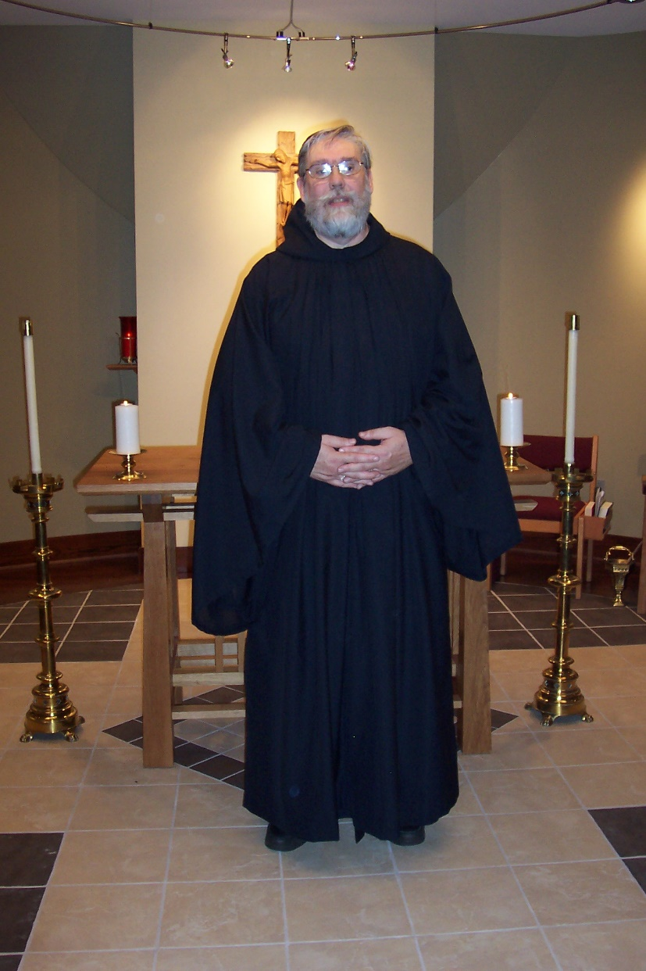
100_0646 Br. Chad Anselm Gerns
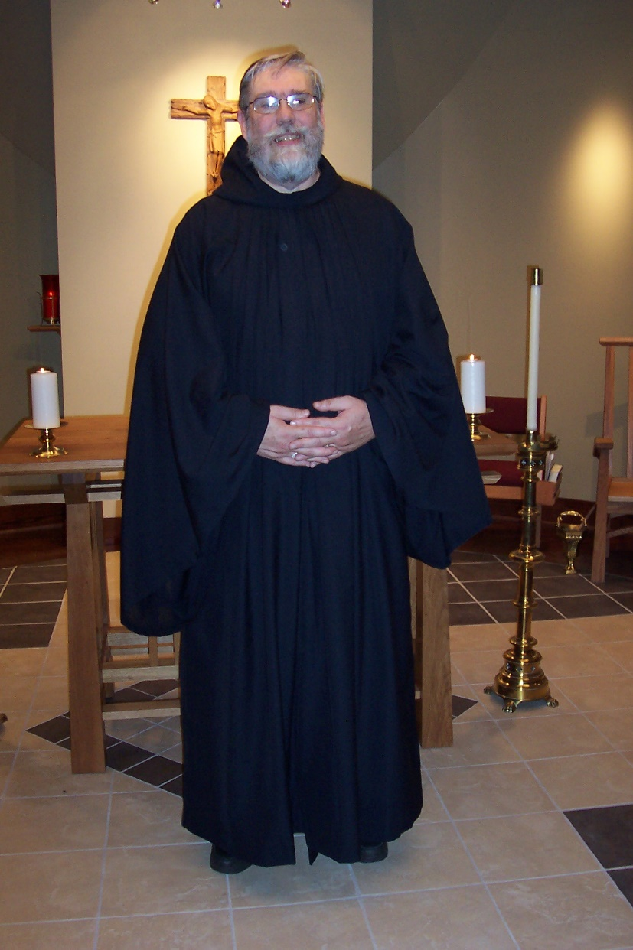
100_0647 Br. Chad Anselm Gerns
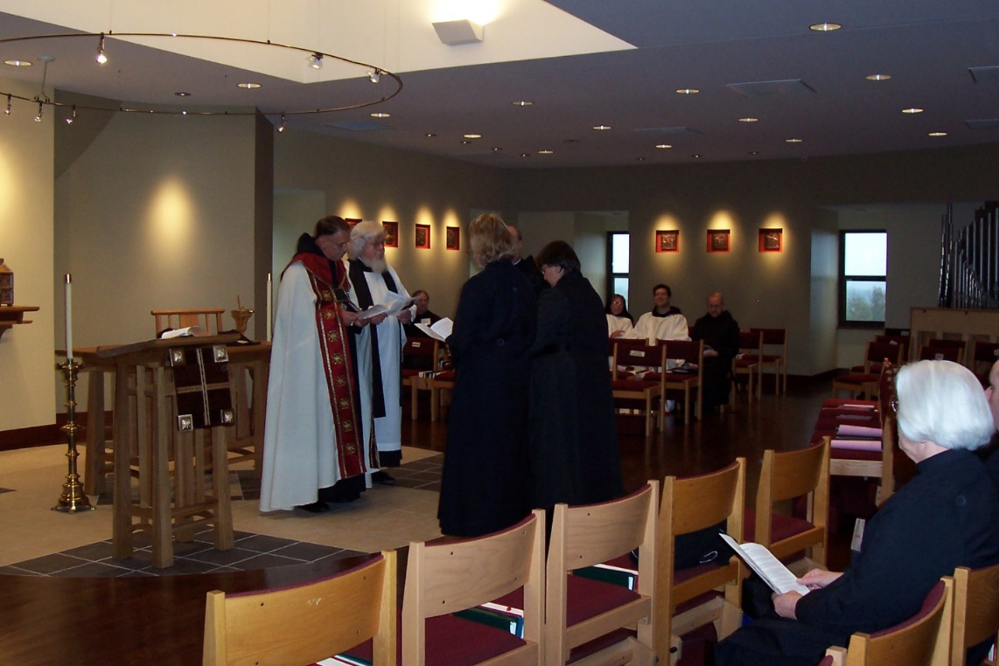
100_0648 Abbot Michael John Austin; Fr. Wayne Kamm; Br. Lawrence Mullen; Sr. Hannah Sophia Wolsleben; Br. Raymond Owens; Sr. Pauline Tysol; Sr. Monica Ruth Mullen; Br. Anthony Bernard Campos; Br. Daniel Joseph Schroeder; Sr. Elizabeth Ann Stribley

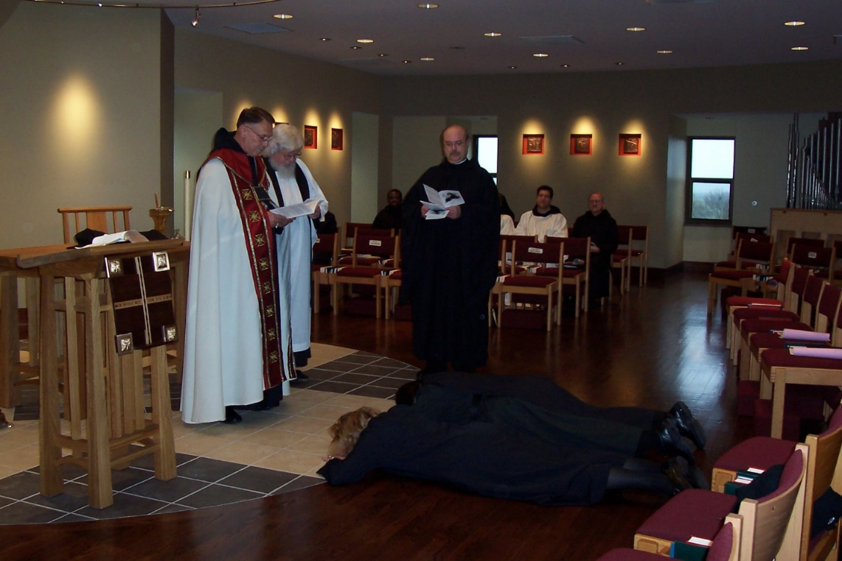
100_0649 Abbot Michael John Austin; Fr. Wayne Kamm; Br. Thomas Ferrell; Br. Raymond Owens; Br, Anthony Bernard Campos; Br. Daniel Joseph Schroeder; Sr. Hannah Sophia Wolsleben; Sr. Pauline Tysol
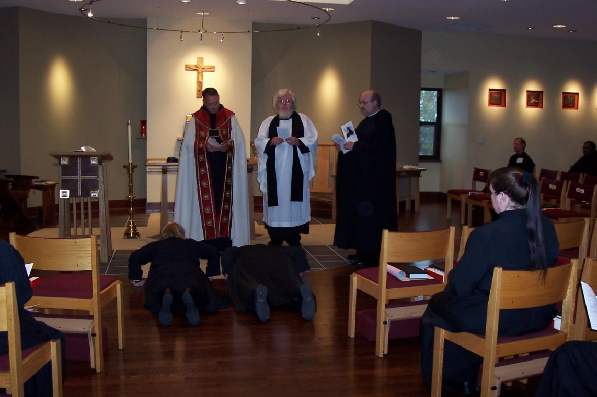
100_0650 Sr. Hannah Sophia Wolsleben; Abbot Michael John Austin; Sr. Pauline Tysol; Fr. Wayne Kamm; Br. Raymond Owens; Sr. Sophia Holt; Br. Lawrence Mullen; Br. Thomas Ferrell

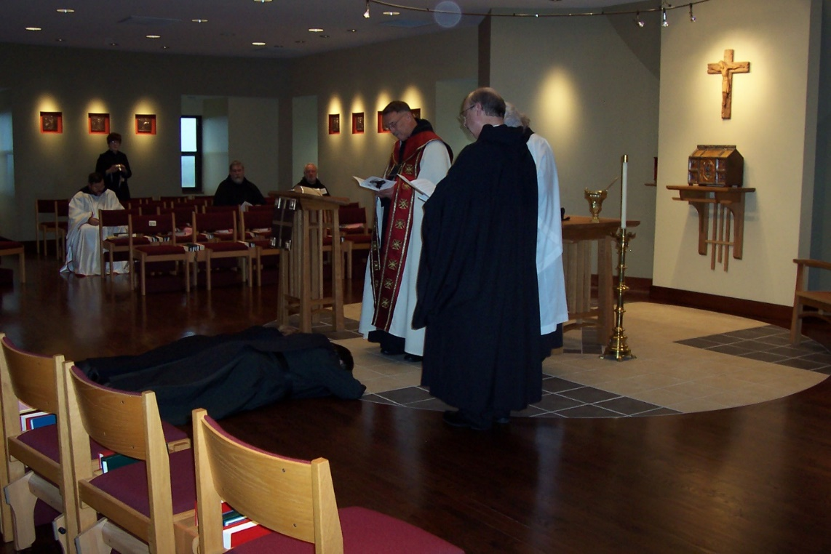
100_0651 Br. Paul Howard; Sr. Brigid Gerns; Br. Chad Anselm Gerns; Sr. Hannah Sophia Wolsleben; Br. Christopher John Baumann; Sr. Pauline Tysol; Abbot Michael John Austin; Br. Raymond Owens; Fr. Wayne Kamm
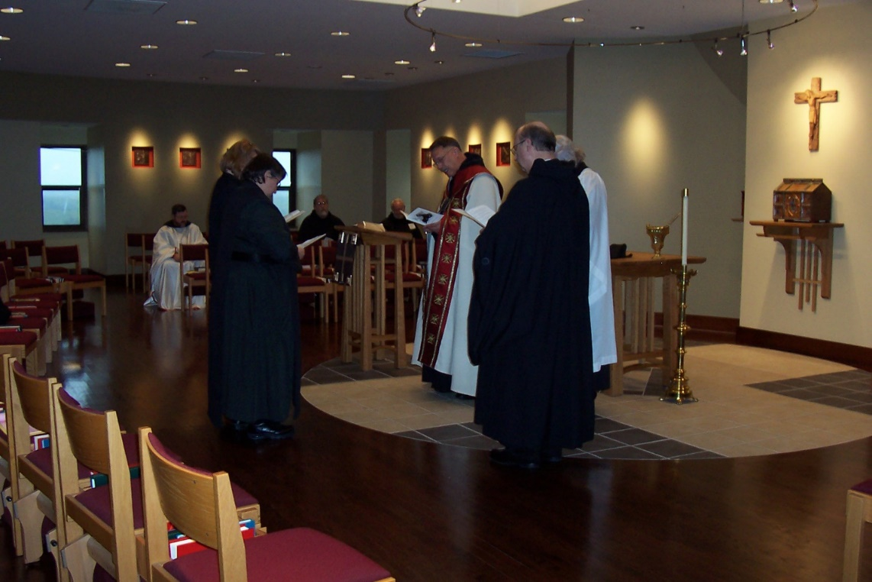
100_0652 Br. Paul Howard; Sr. Hannah Sophia Wolsleben; Sr. Pauline Tysol; Br. Chad Anselm Gerns; Br. Christopher John Baumann; Abbot Michael John Austin; Br. Raymond Owens; Fr. Wayne Kamm;

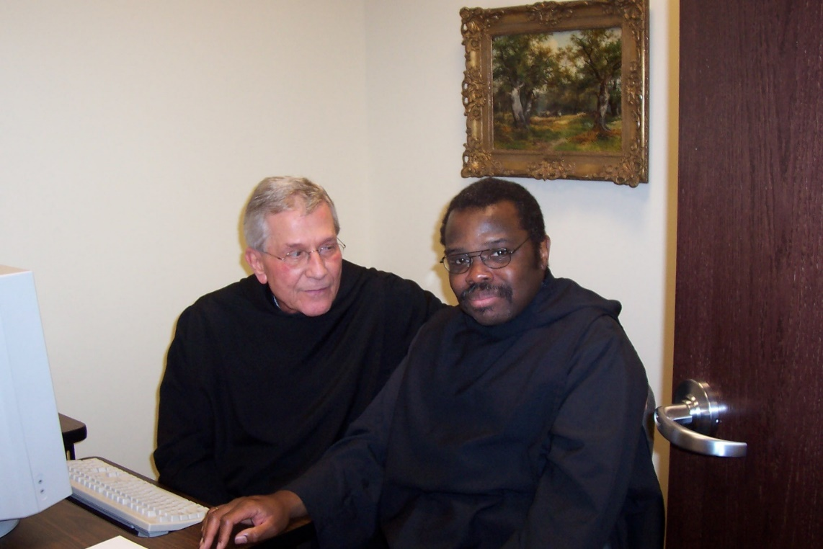
100_0654 Br. Mark Kosiba (archivist of Conception Abbey); Br. Thomas Ferrell
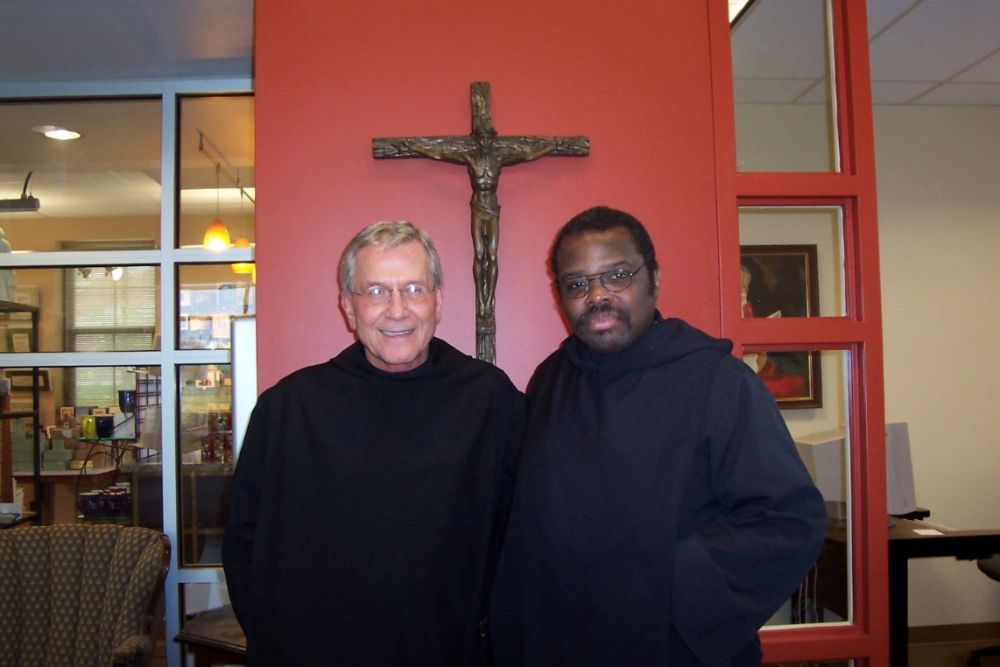
100_0655 Br. Mark Kosiba; Br. Thomas Ferrell

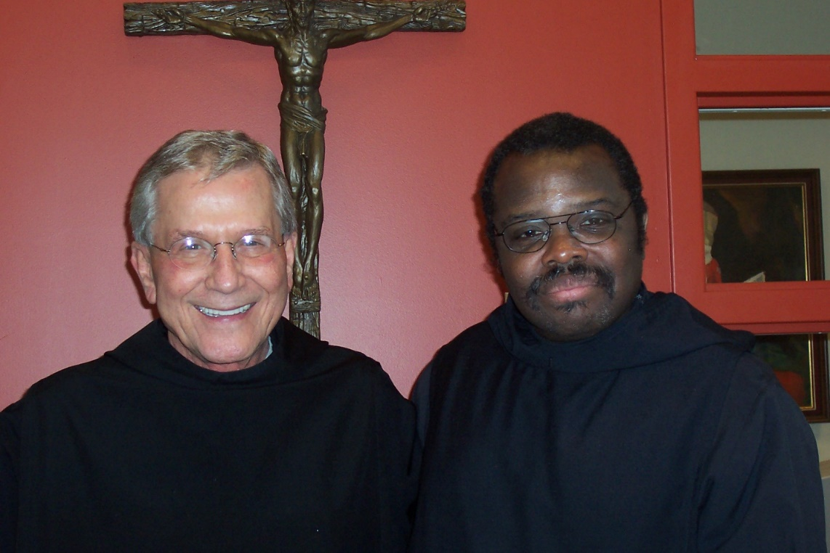
100_0656 Br. Mark Kosiba; Br. Thomas Ferrell

