Companions of St. Luke
2005 Fall Convocation at Conception Abbey
Part 1 of 2

~Edited by Br. Steven Olderr, 14 June 2022 with the assistance of Br. Thomas Ferrell. If you find any errors or omissions or have anything to add, please notify Br. Steven at olderr@ameritech.net

People are identified from left to right.

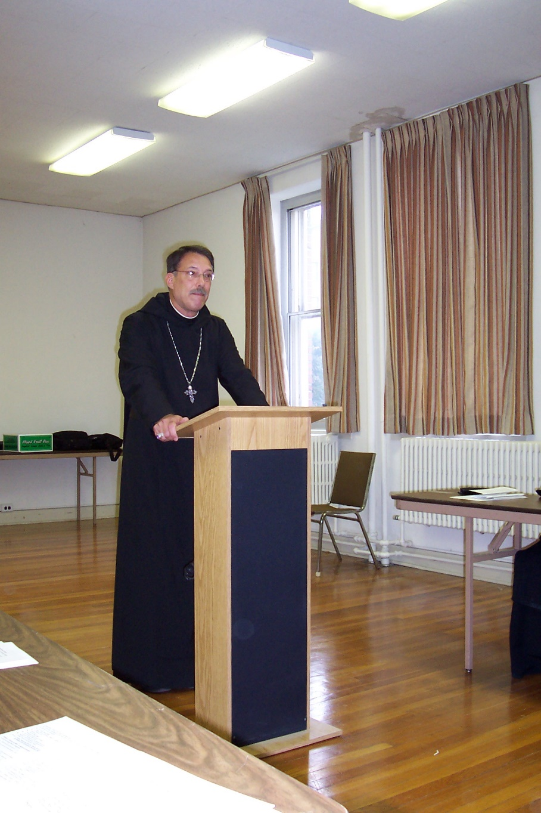

100 0386 Abbot Michael John Austin
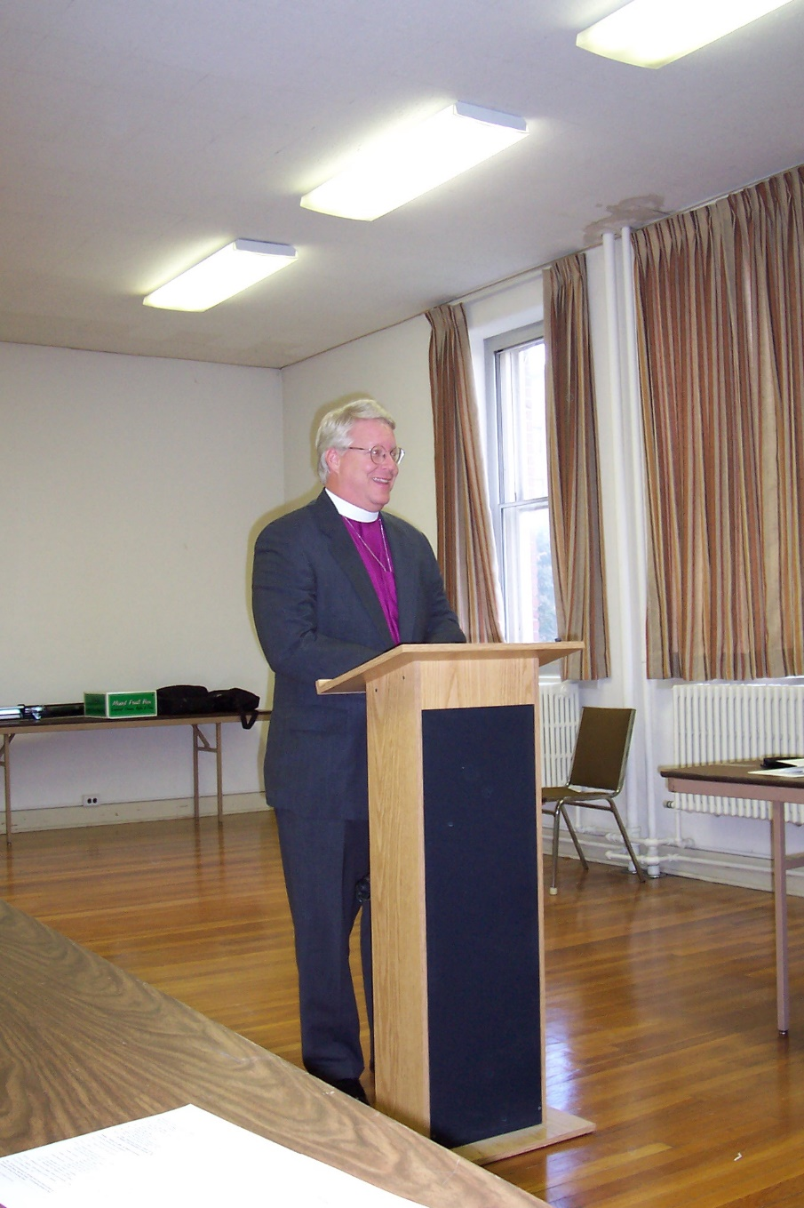
100 0387 Bp. Dean Wolfe
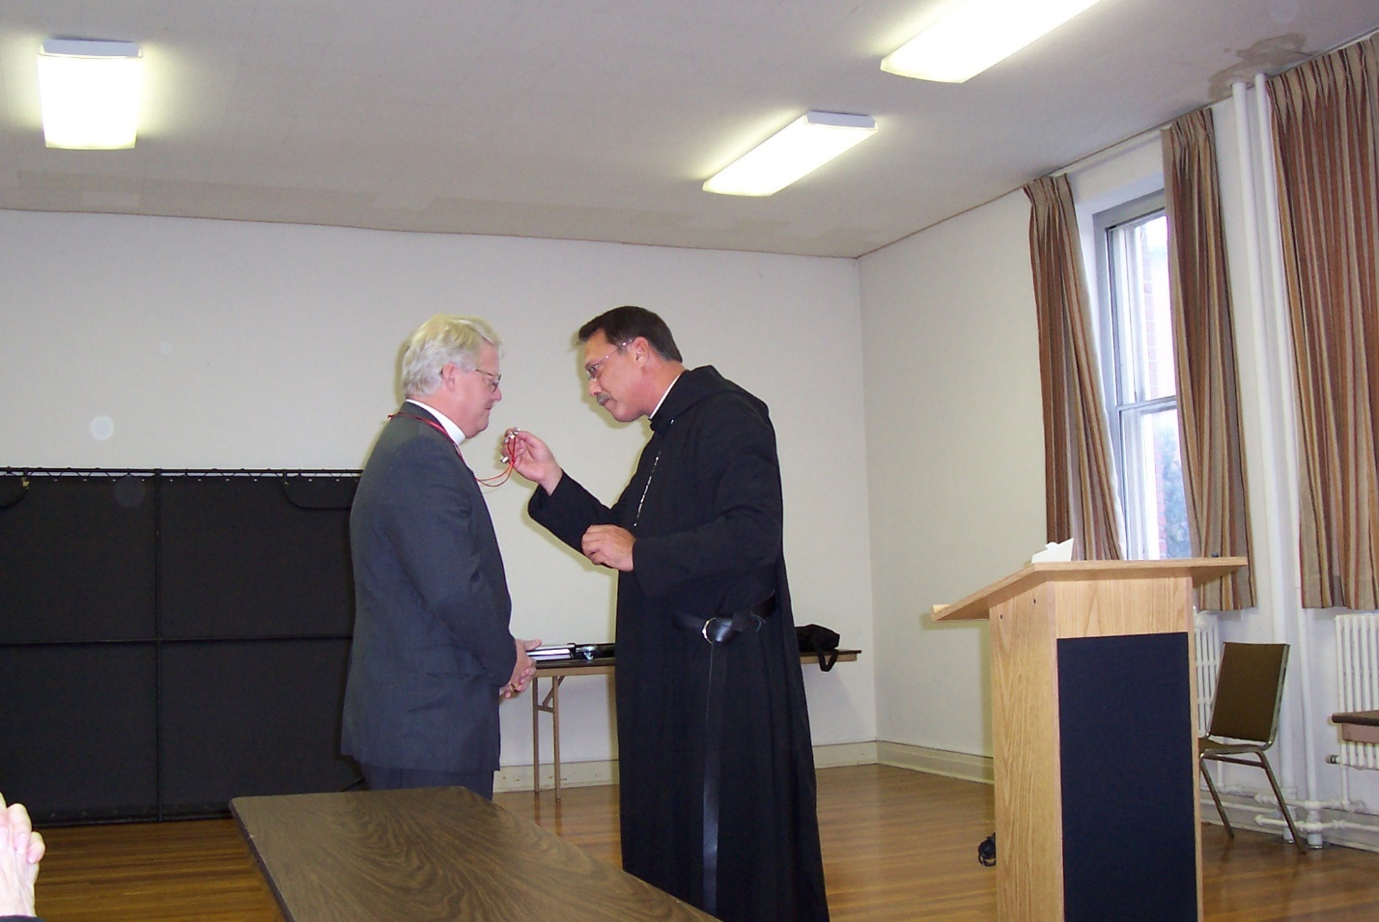
100 0388 Bp. Dean Wolfe; Abbot Michael John Austin
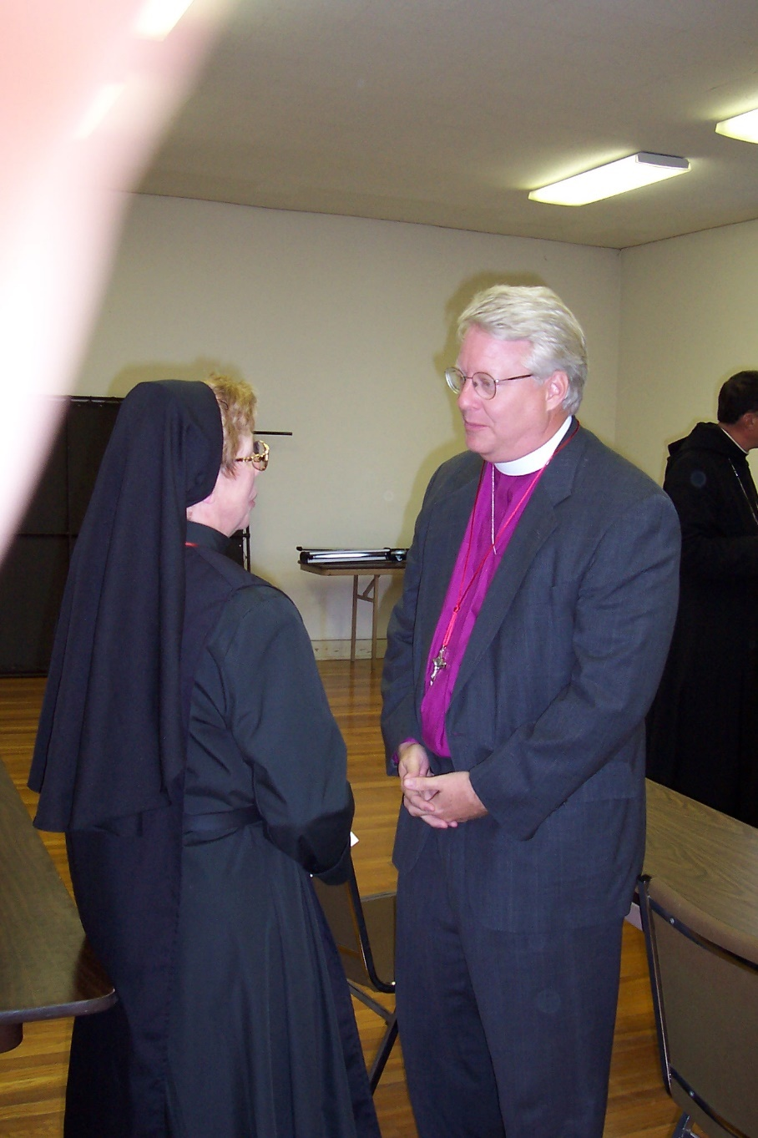
100 0389 Sr. Monica Ruth Mullen; Bp. Dean Wolfe
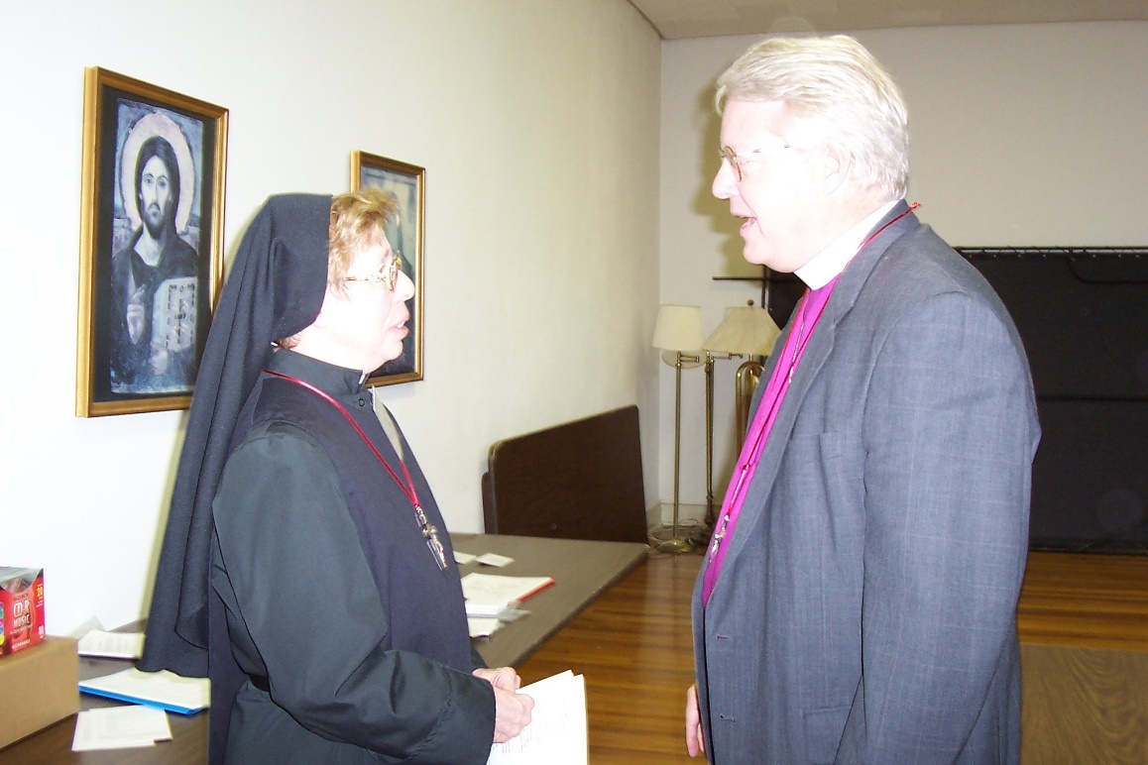
100 0390 Sr. Monica Ruth Mullen; Bp. Dean Wolfe

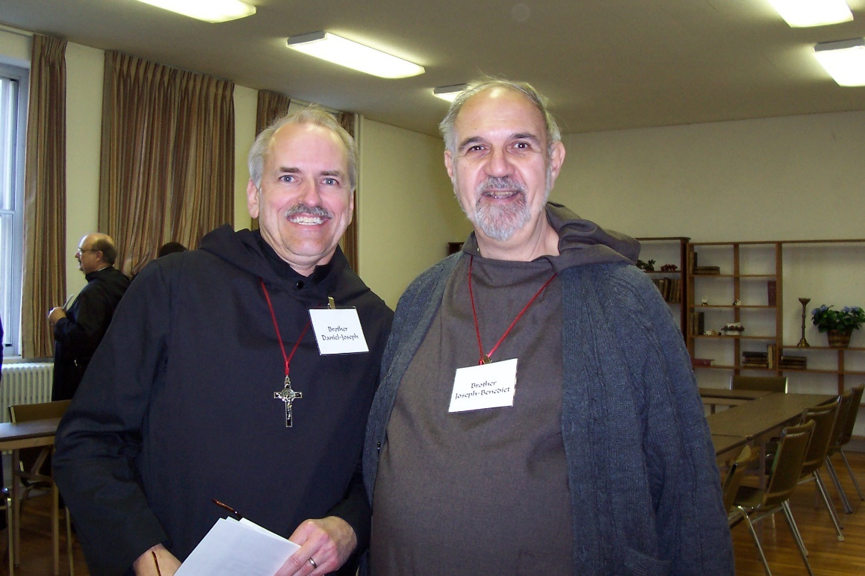
100 0391 Br. Raymond Owens; Br. Daniel Joseph Schroeder; Br. Joseph Benedict DiMauro
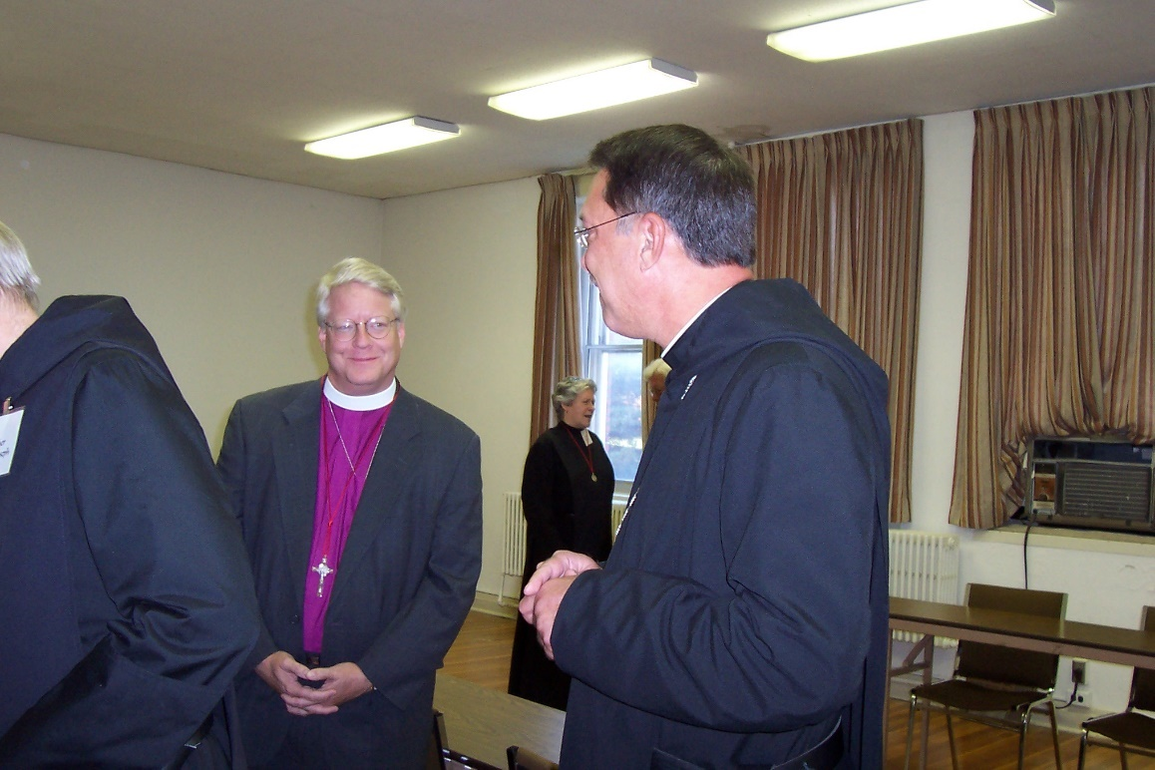
100 0392 Br. Luke Doucette; Bp. Dean Wolfe; Sr. Johanna Kirkpatrick; Abbot Michael John Austin

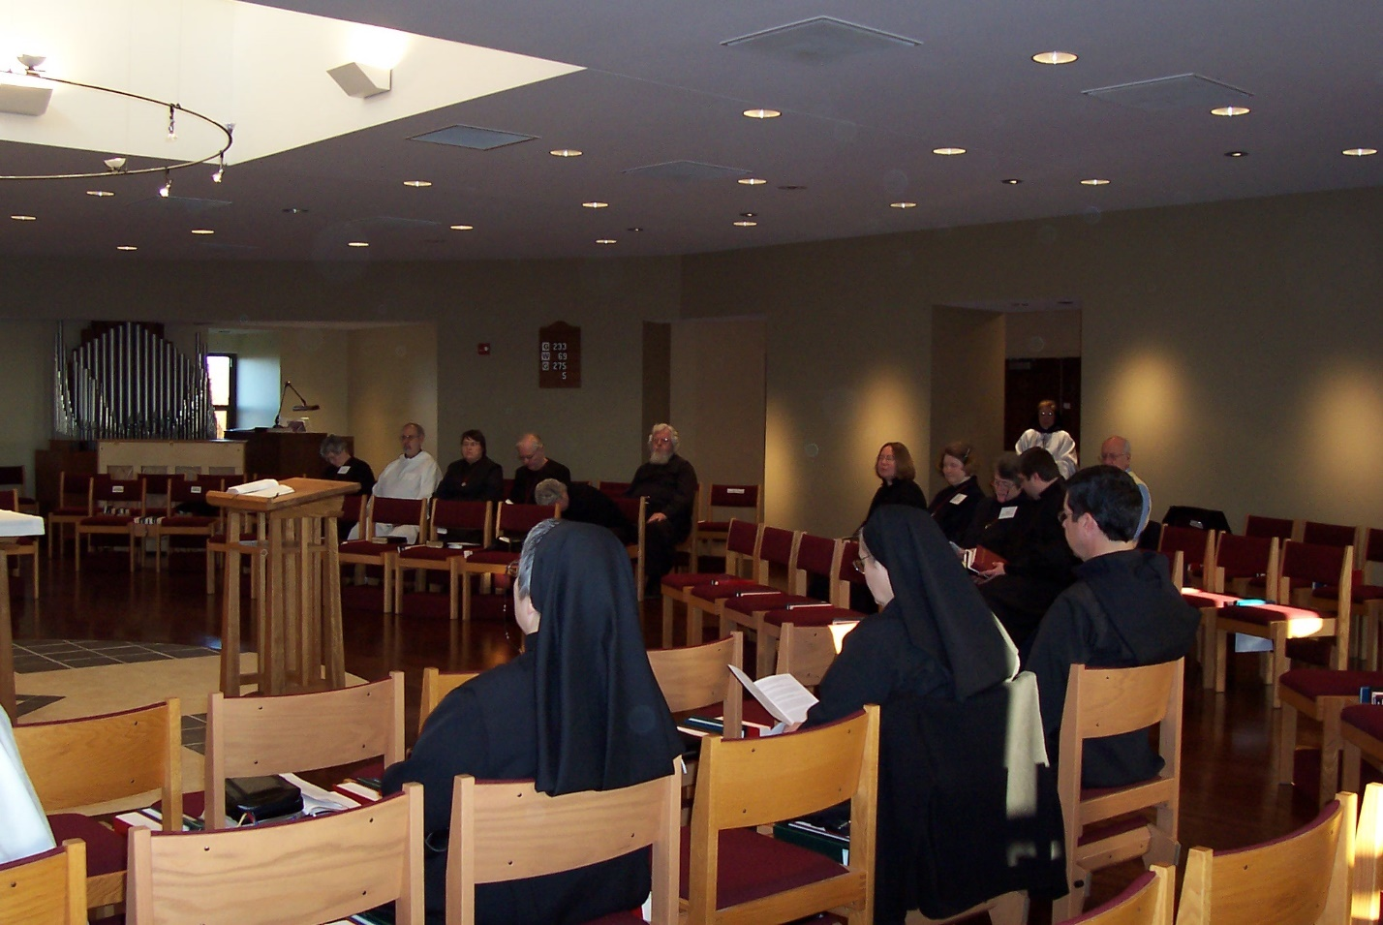
100 0393 Sr. Johanna Kirkpatrick; Br. Joseph Benedict DiMauro; Sr. Pauline Tysol; Br. Luke Doucette; Sr. Clare Benedicta Myers; Sr. Mary Catherine Christopher; Fr. Wayne Kamm; Sr. Theodora of Jesus Perecca; Sr. Teresa Bebee; Sr. Hillary Grace Lundgren; Sr. Vincent Marie Rittenhouse; Br. John Luke Scott; Br. ?; Br. Augustine Colvert; ?
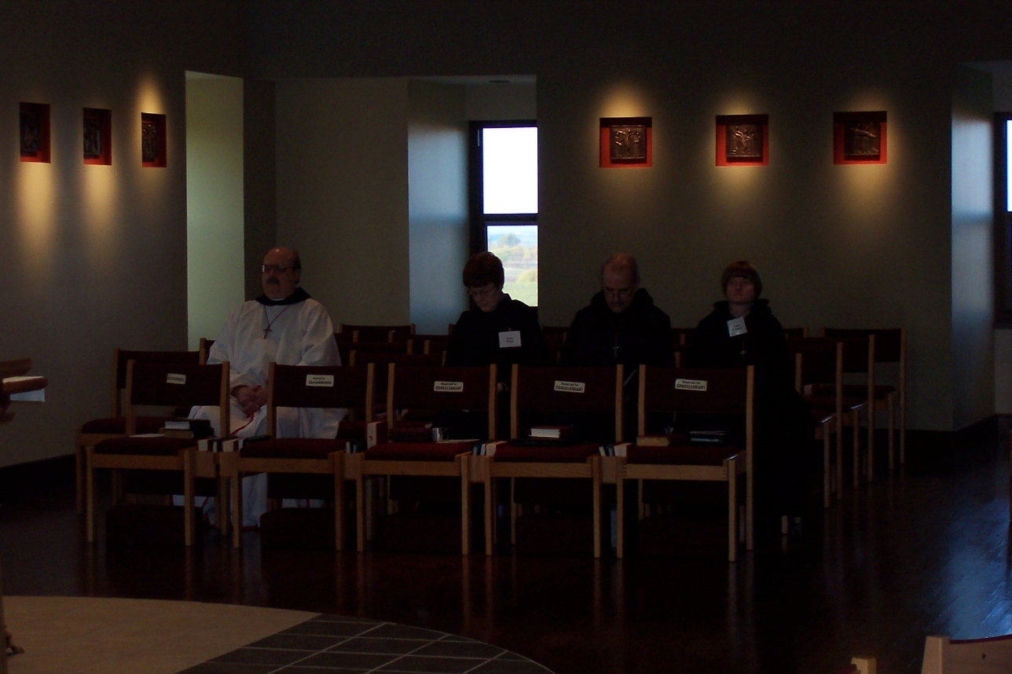
100 0394 Br. Raymond Owens; Sr. Brigid Gerns; Br. Daniel Joseph Schroeder; Sr. Catherine Unterseher

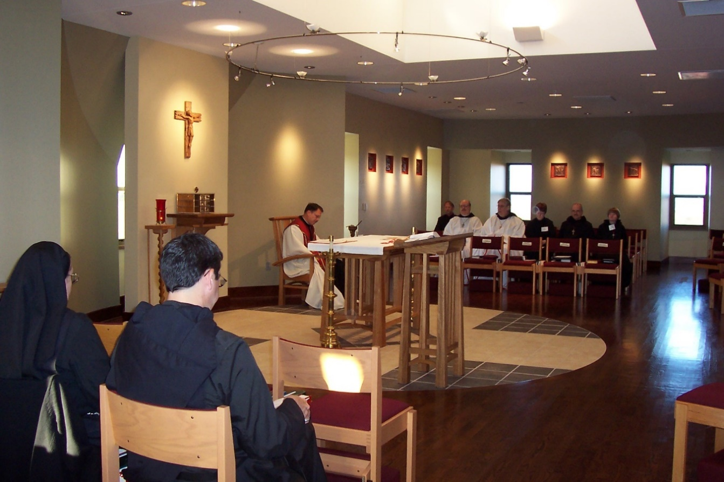
100 0395 Sr Theodora of Jesus Perecca; Br. Augustine Colvert; Abbot Michael John Austin; Br. Lawrence Mullen; Br. Raymond Owens; Br. Chad Anselm Gerns; Sr. Brigid Gerns; Br. Daniel Joseph Schroeder; Sr. Catherine Unterseher
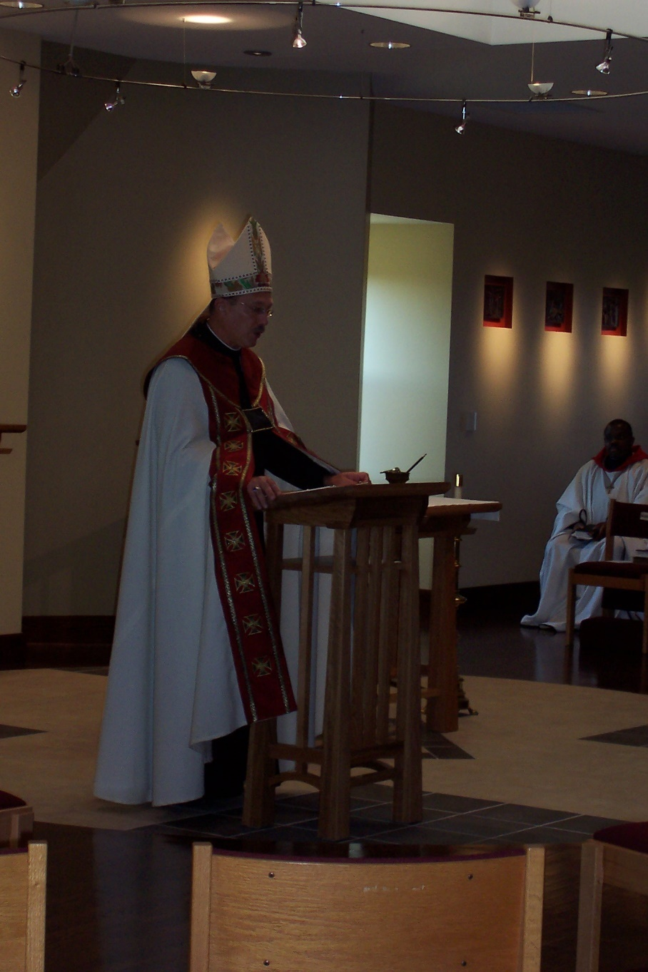
100 0396 Abbot Michael John Austin; Br. Thomas Ferrell
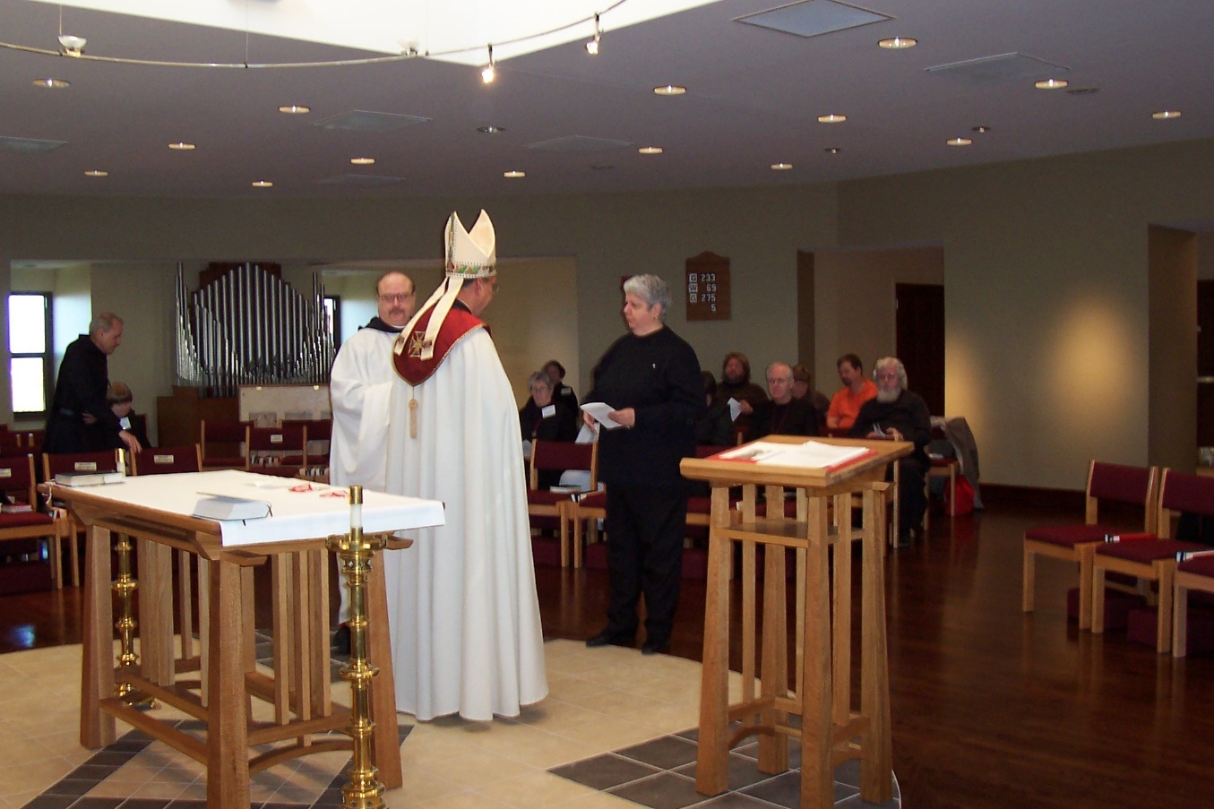
100 0397 Br. Daniel Joseph Schroeder; Sr. Catherine Unterseher; Br. Raymond Owens; Abbot Michael John Austin; Sr. Johanna Kirkpatrick; Sr. Hillary Grace Lundgren; Sr. Mary Catherine Christopher; ?; Br. Luke Doucette; Bobbi Jo Trobaugh; Jerry Trobaugh; Fr. Wayne Kamm

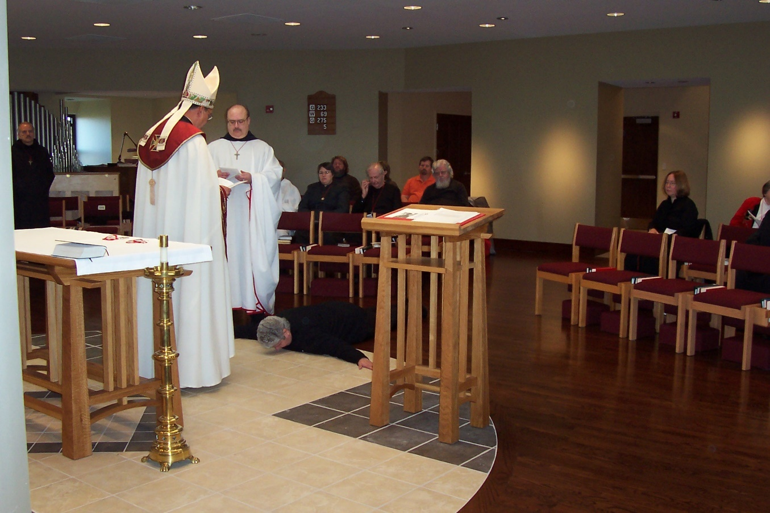
100 0398 Br. Daniel Joseph Schroeder; Abbot Michael John Austin; Br. Raymond Owens; Sr. Mary Catherine Christopher; Sr. Pauline Tysol; ?; Br. Luke Doucette; Jerry Trobaugh; Fr. Wayne Kamm

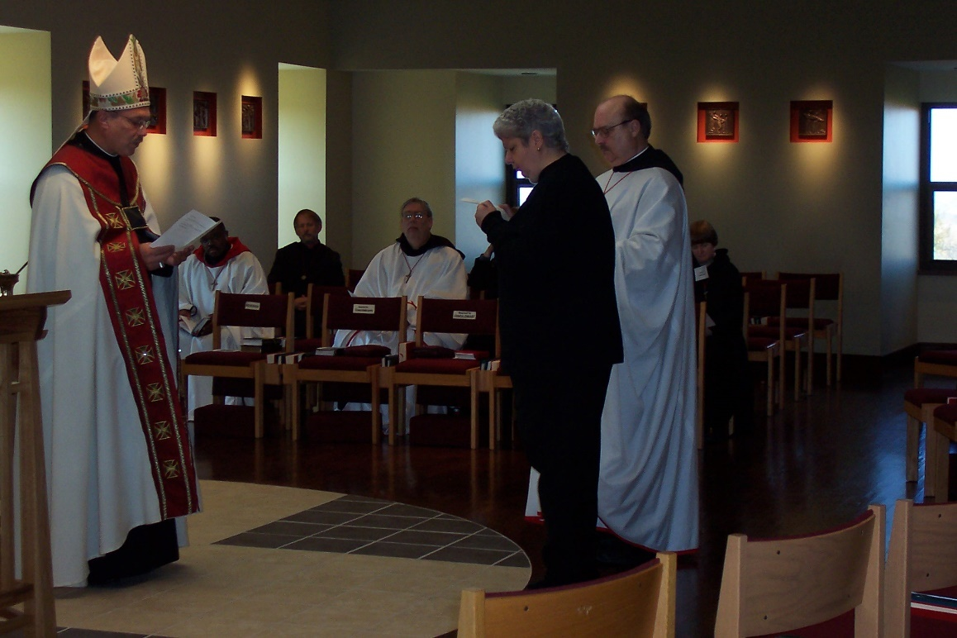
100 0399 Abbot Michael John Austin; Br. Thomas Ferrell; Br. Lawrence Mullen; Br. Chad Anselm Gerns; Sr. Mary Catherine Christopher; Br. Raymond Owens; Sr. Catherine Unterseher

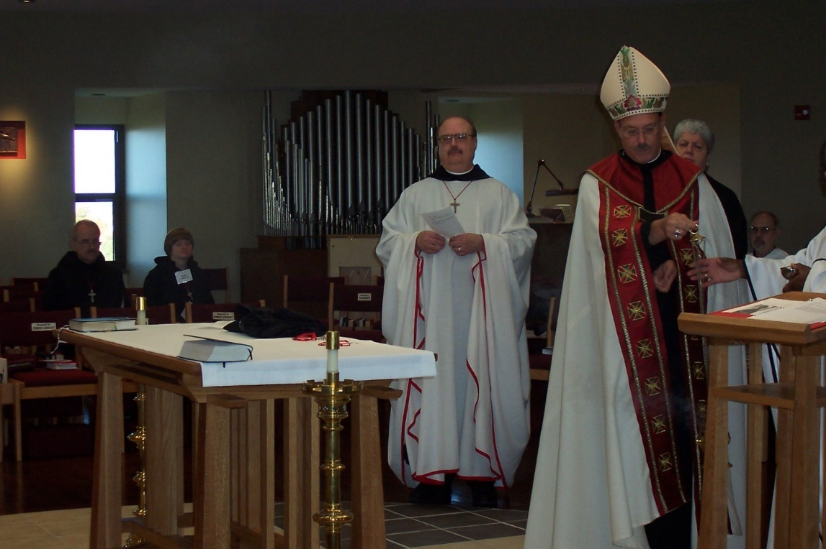
100 0400 Br. Daniel Joseph Schroeder; Sr. Catherine Unterseher; Br. Raymond Owens; Abbot Michael John Austin; Sr. Mary Catherine Christopher; Br. Joseph Benedict DiMauro

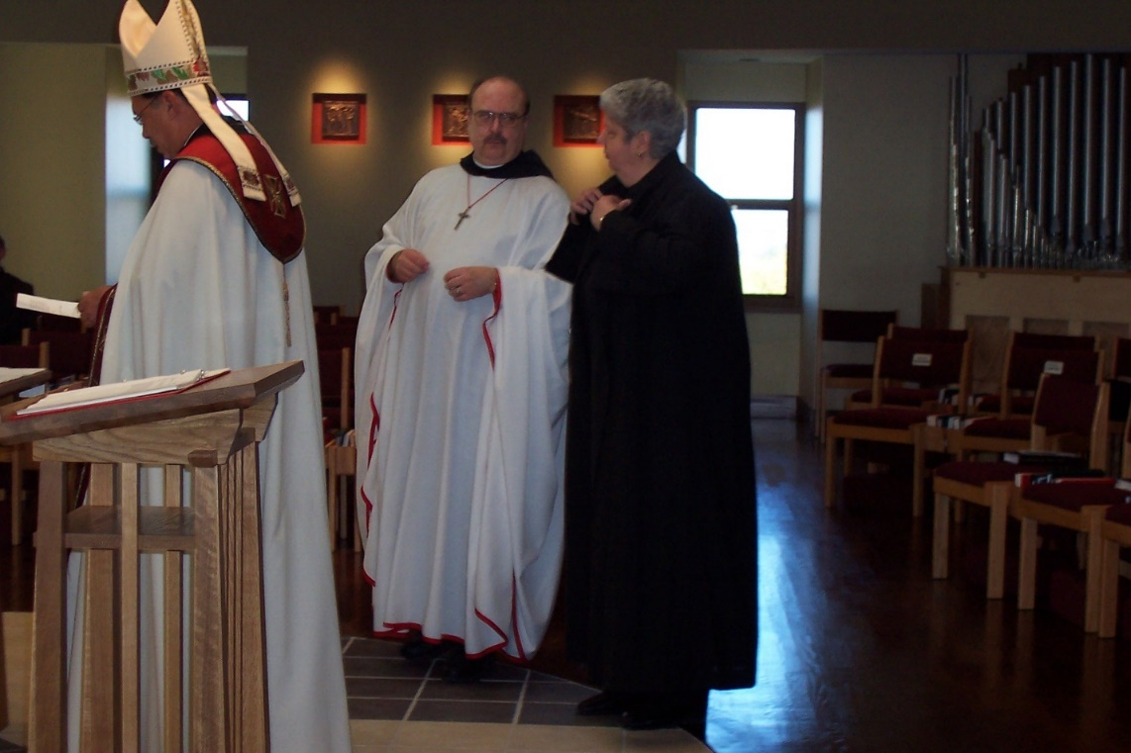
100 0401 Abbot Michael John Austin; Br. Raymond Owens; Sr. Mary Catherine Christopher
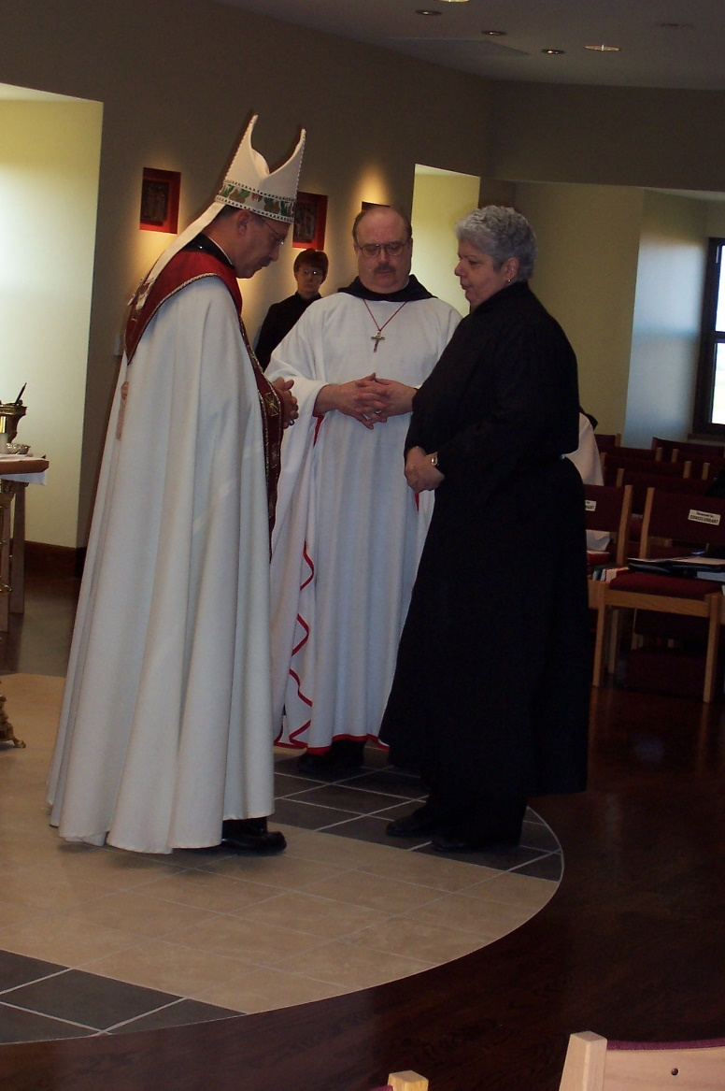
100 0402 Abbot Michael John Austin; Sr. Brigid Gerns; Br. Raymond Owens; Sr. Mary Catherine Christopher
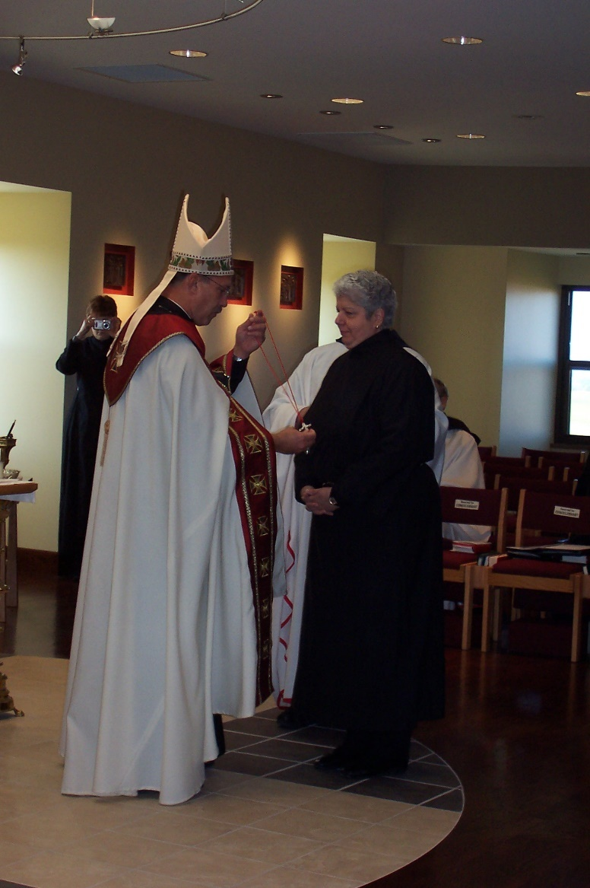
100 0403 Sr. Brigid Gerns; Abbot Michael John Austin; Sr. Mary Catherine Christopher
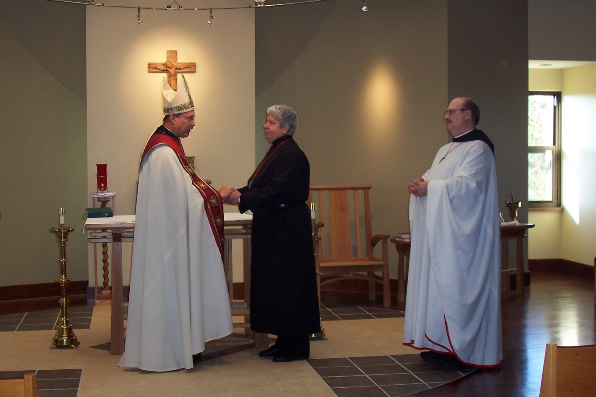
100 0404 Abbot Michael John Austin; Sr. Mary Catherine Christopher; Br. Raymond Owens

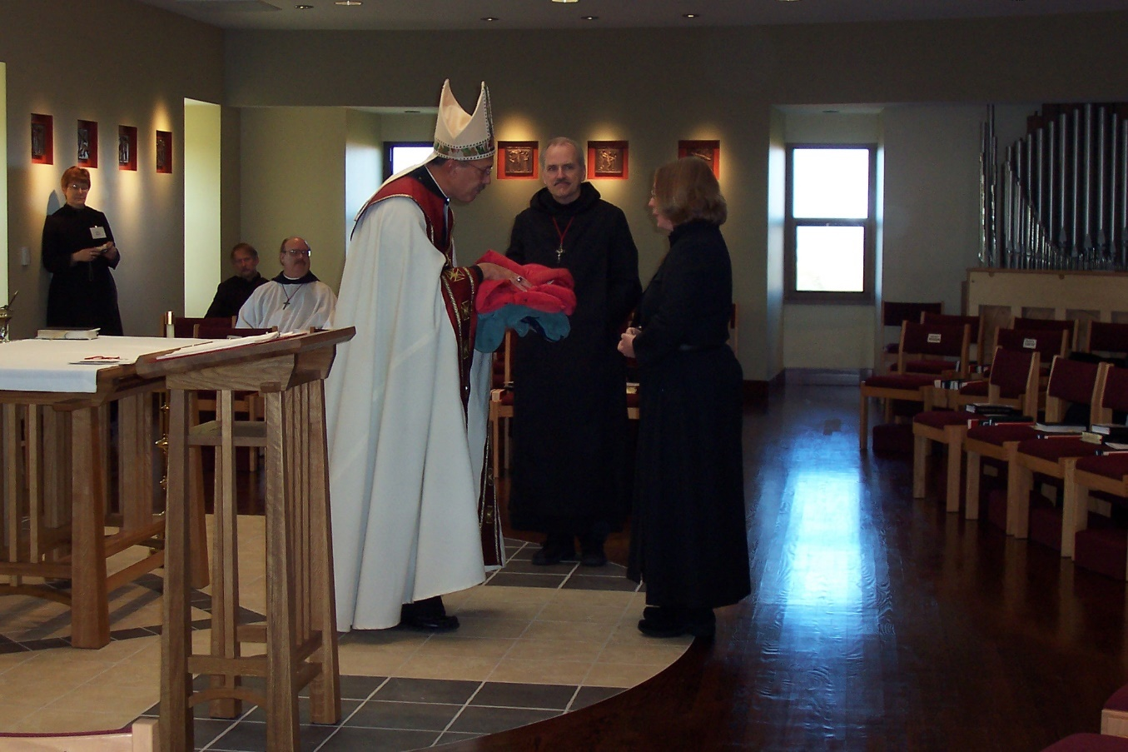
100 0405 Sr. Brigid Gerns; Br. Lawrence Mullen; Br. Raymond Owens; Abbot Michael John Austin; Br. Daniel Joseph Schroeder; Sr. Teresa Bebee
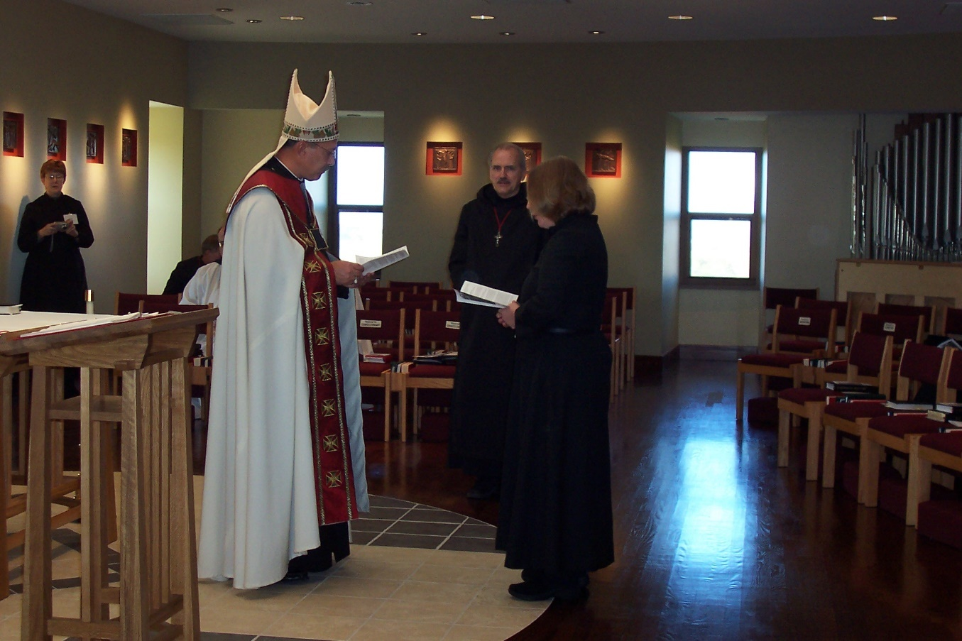
100 0406 Sr. Brigid Gerns; Br. Lawrence Mullen; Br. Raymond Owens; Abbot Michael John Austin; Br. Daniel Joseph Schroeder; Sr. Teresa Bebee

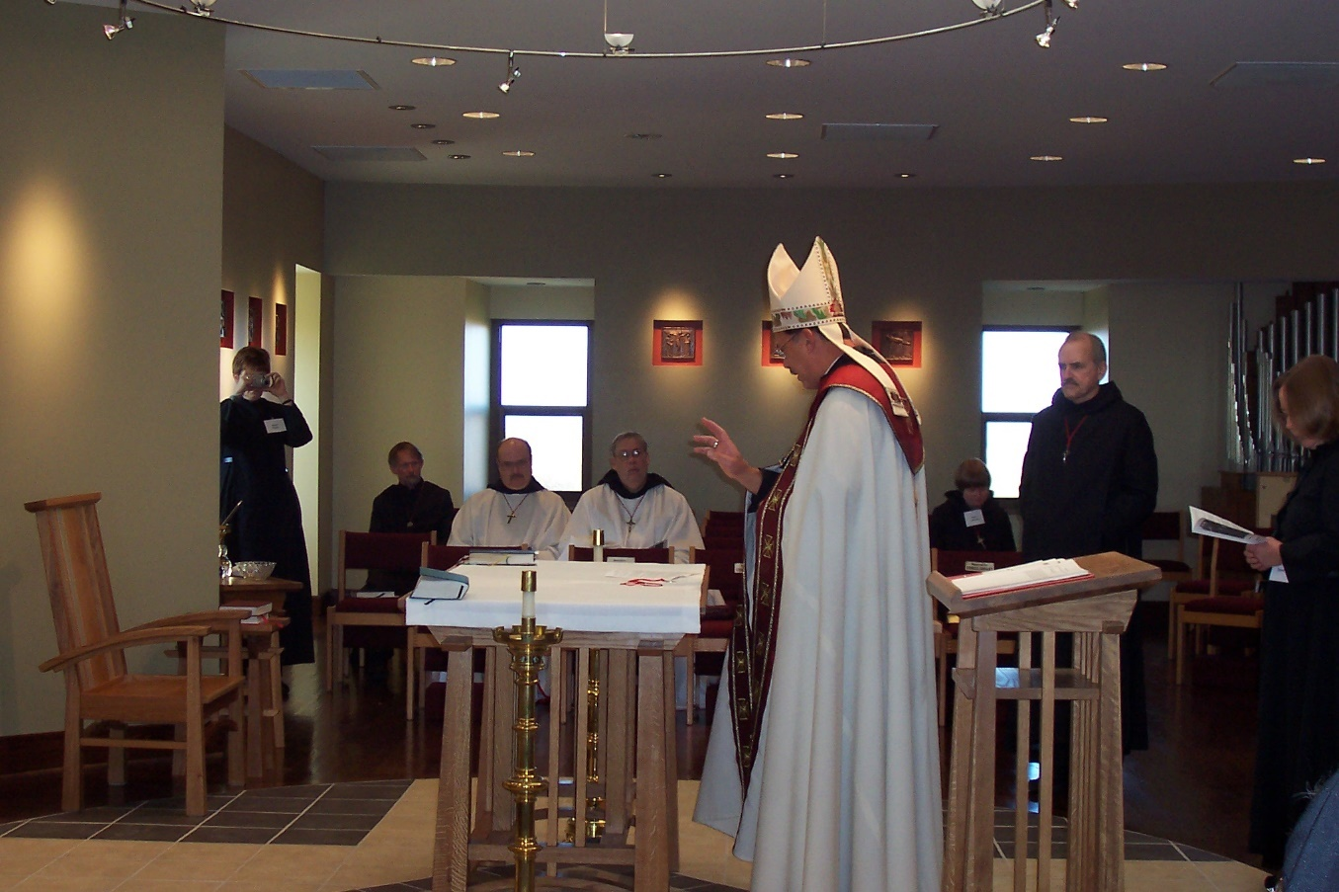
100 0407 Sr. Brigid Gerns; Br. Lawrence Mullen; Br. Raymond Owens; Br. Chad Anselm Gerns; Abbot Michael John Austin; Sr. Catherine Unterseher; Br. Daniel Joseph Schroeder; Sr. Teresa Bebee
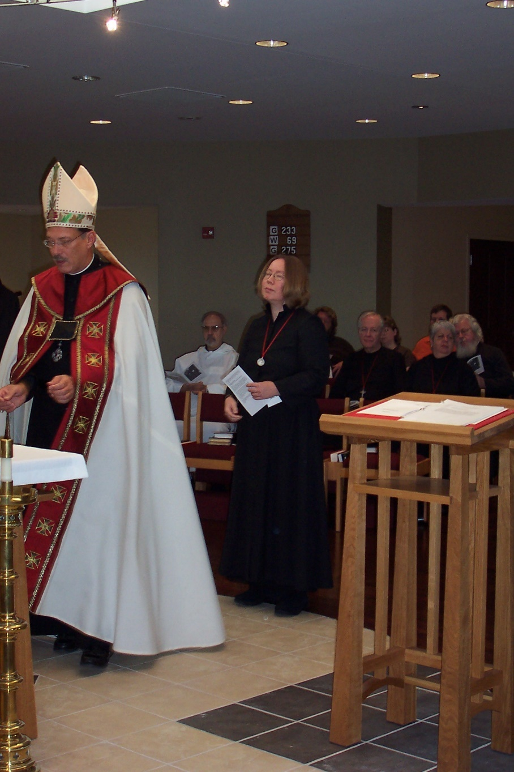
100 0408 Abbot Michael John Austin; Br. Joseph Benedict DiMauro; Sr. Teresa Bebee; ?; Br. Luke Doucette; Bobbi Jo Trobaugh; Jerry Trobaugh; Sr. Mary Catherine Christopher; Fr. Wayne Kamm
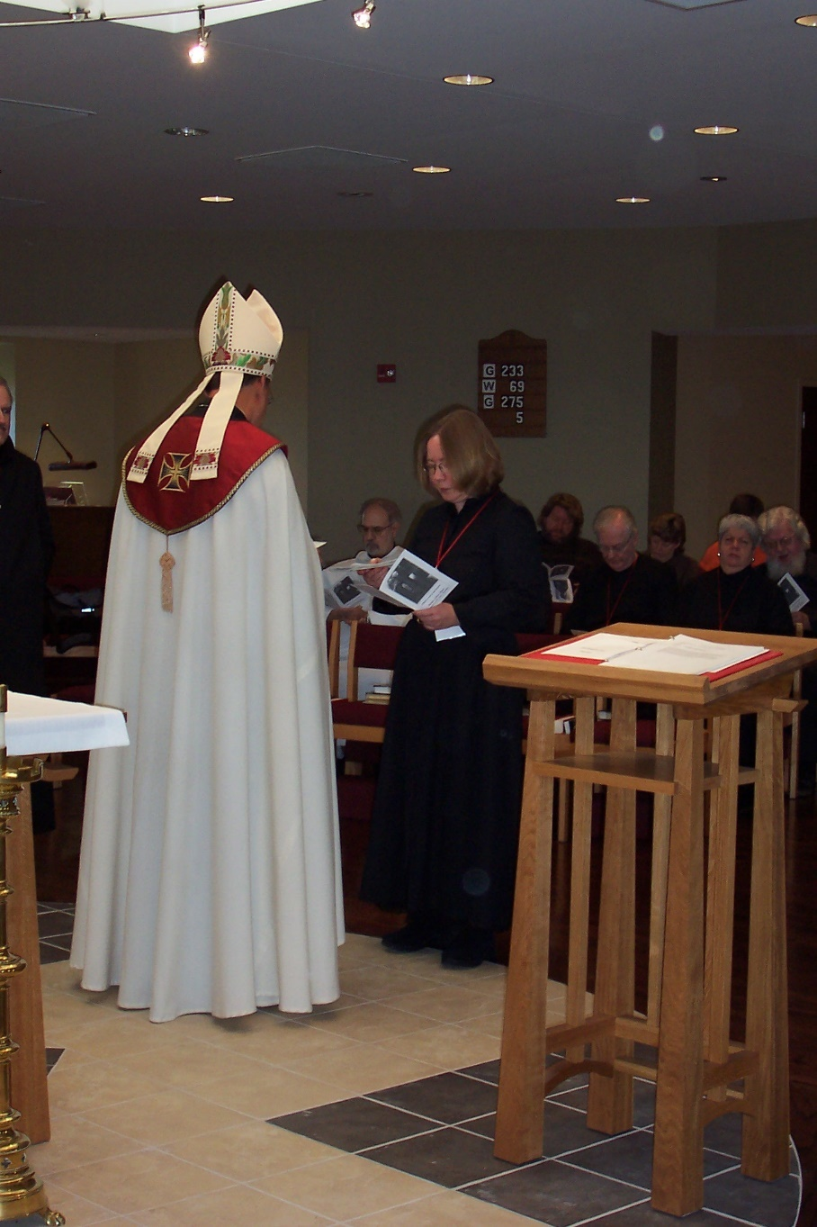
100 0409 Abbot Michael John Austin; Br. Joseph Benedict DiMauro; Sr. Teresa Bebee; ?; Br. Luke Doucette; Bobbi Jo Trobaugh; Sr. Mary Catherine Christopher; Jerry Trobaugh; Fr. Wayne Kamm
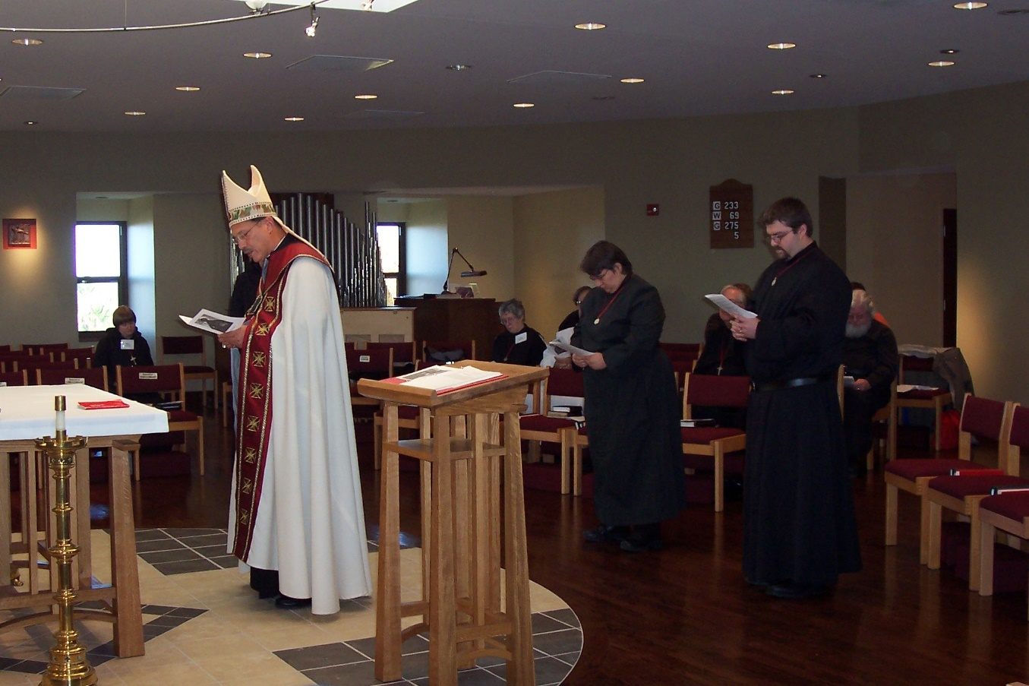
100 0410 Sr. Catherine Unterseher; Abbot Michael John Austin; Sr. Johanna Kirkpatrick; Sr. Pauline Tysol; Br. Luke Doucette; Br. John Luke Scott; Fr. Wayne Kamm

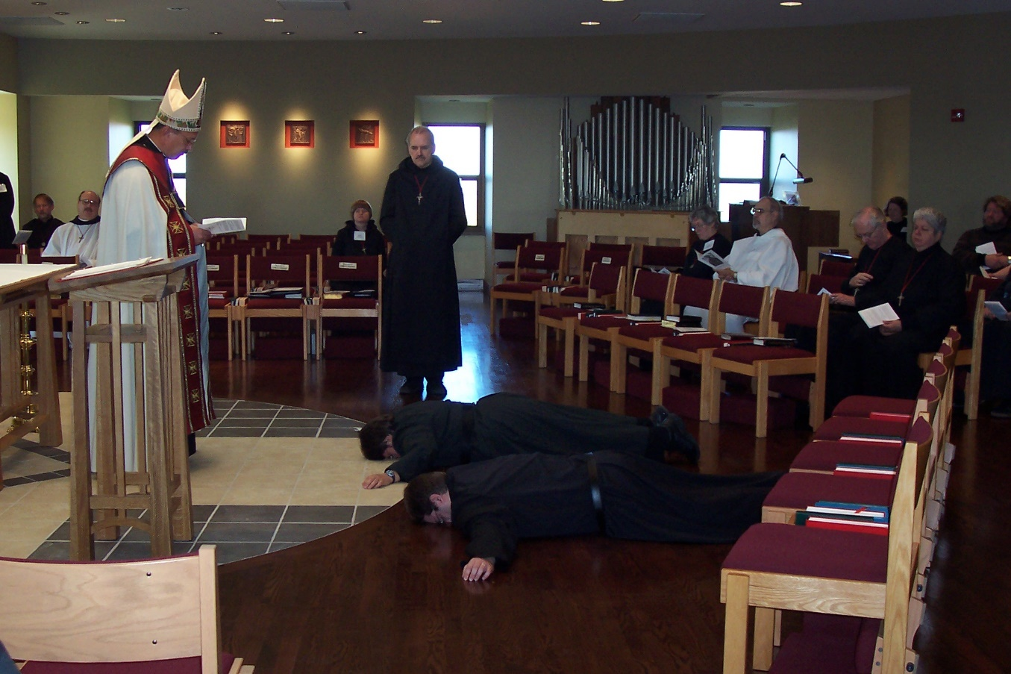
100 0411 Br. Lawrence Mullen; Br. Raymond Owens; Abbot Michael John Austin; Sr. Catherine Unterseher; Br. Daniel Joseph Schroeder; Sr. Pauline Tysol; Br. John Luke Scott; Sr. Johanna Kirkpatrick; Br. Joseph Benedict DiMauro; Br. Luke Doucette; Sr. Hilary Grace Lundgren; Sr. Mary Catherine Christopher; ?

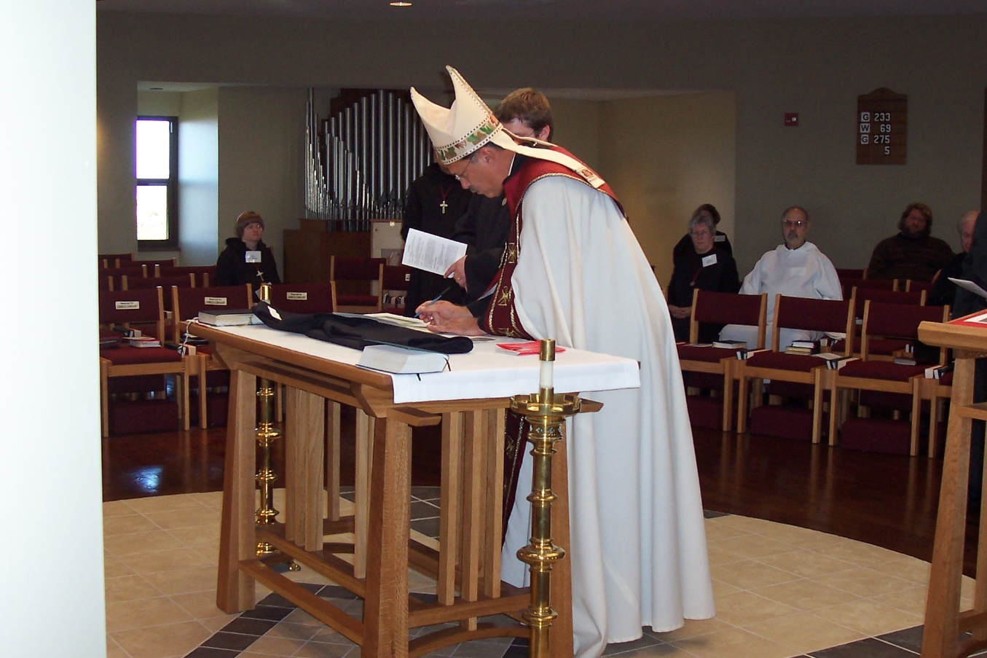
100 0412 Sr. Catherine Unterseher; Abbot Michael John Austin; Br. John Luke Scott; Sr. Hillary Grace Lundgren; Br. Joseph Benedict DiMauro; ?; Br. Luke Doucette

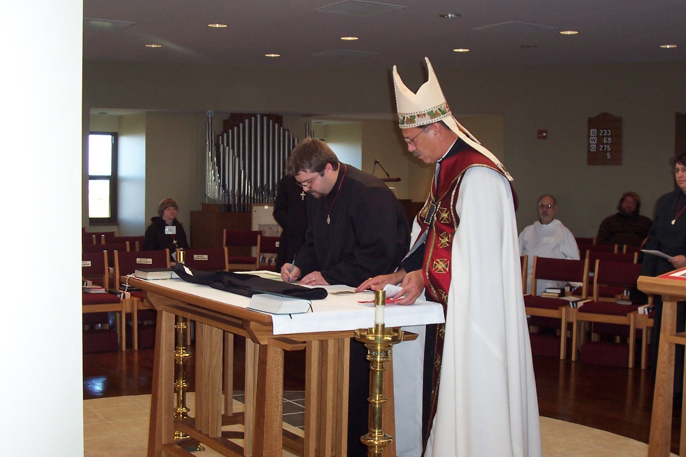
100 0413 Sr. Catherine Unterseher; Br. John Luke Scott; Abbot Michael John Austin; Br. Joseph Benedict; DiMauro; Sr. Pauline Tysol

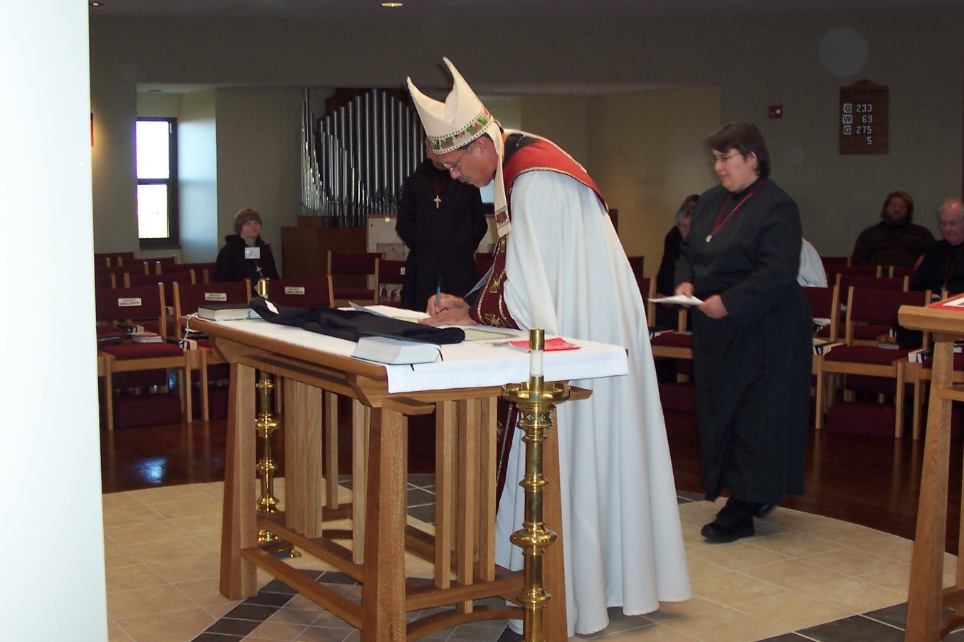
100 0414 Sr. Catherine Tysol; Br. Daniel Joseph Schroeder; Abbot Michael John Austin; Sr. Pauline Tysol; ?; Br. Luke Doucette

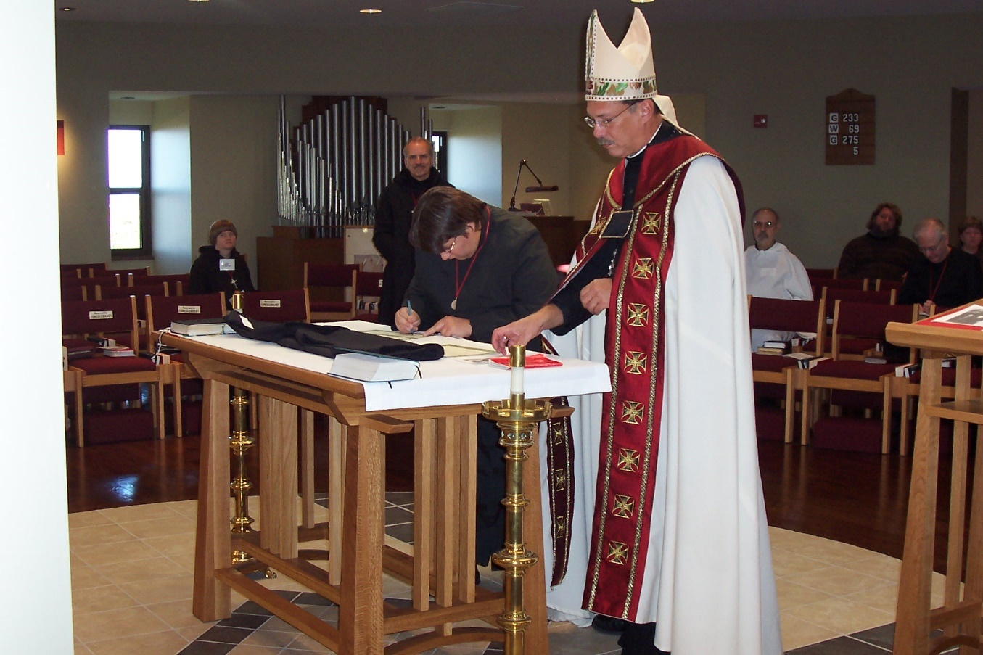
100 0415 Sr. Catherine Tysol; Br. Daniel Joseph Schroeder; Sr. Pauline Tysol; Abbot Michael John Austin; Br. Joseph Benedict DiMauro; Br. Luke Doucette; Bobbi Jo Trobaugh

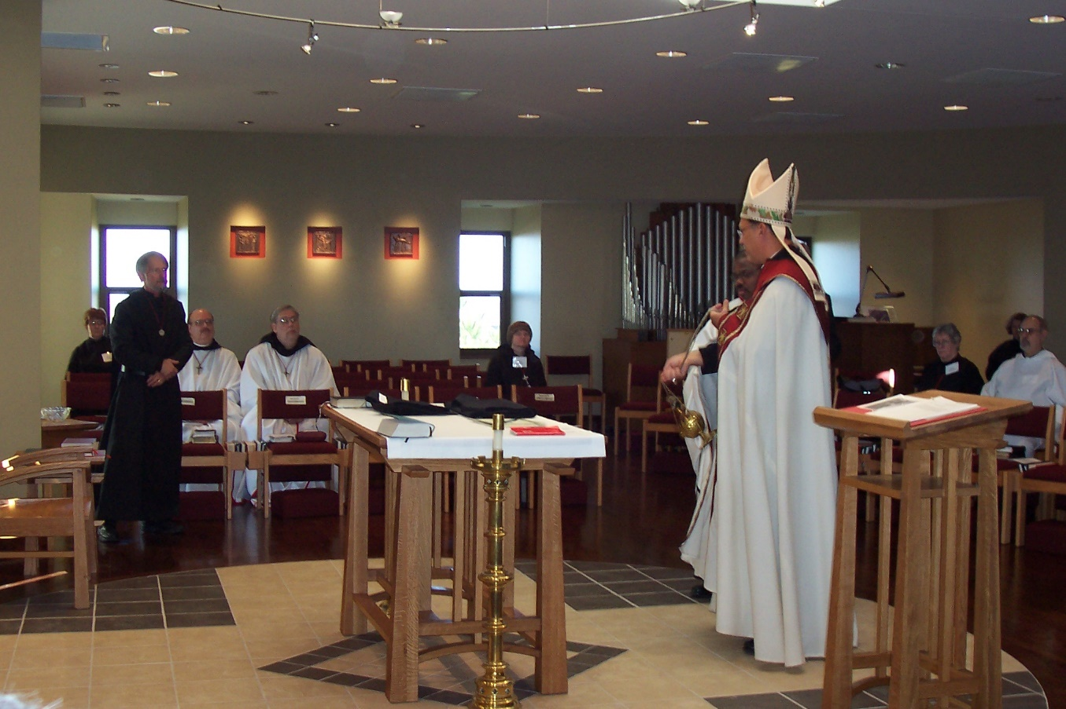
100 0416 Sr. Brigid Gerns; Br. Lawrence Mullen; Br. Raymond Owens; Br. Chad Anselm Gerns; Sr. Catherine Unterseher; Abbot Michael John Austin; Sr Johanna Kirkpatrick; Sr. Hillary Grace Lundgren; Br. Joseph Benedict DiMauro

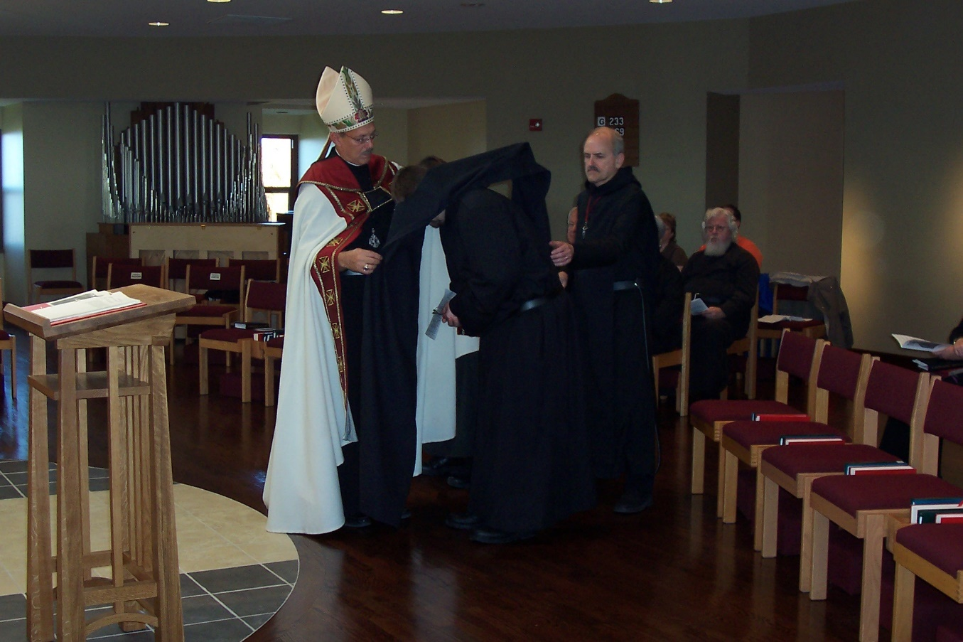
100 0417 Abbot Michael John Austin; Br. John Luke Scott; Br. Luke Doucette; Br. Daniel Joseph Schroeder; Bobbi Jo Trobaugh; Jerry Trobaugh; Fr. Wayne Kamm

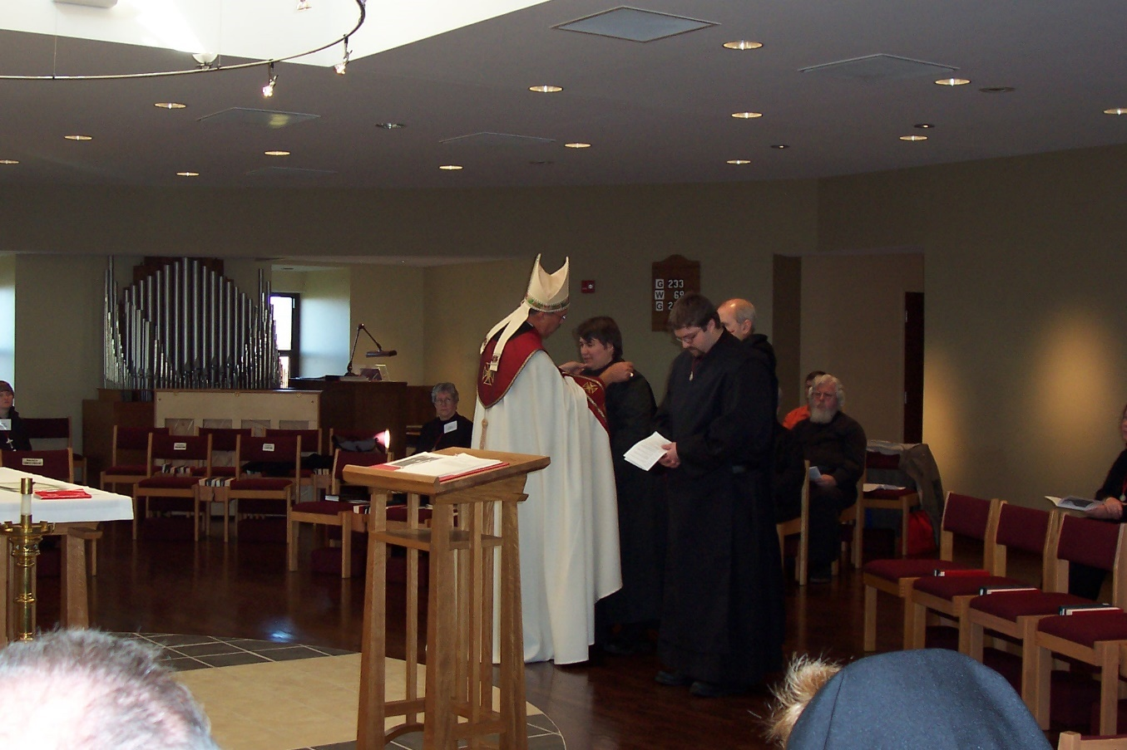
100 0418 Sr. Catherine Unterseher; Sr. Johanna Kirkpatrick; Abbot Michael John Austin; Sr. Pauline Tysol; Br. John Luke Scott; Br. Daniel Joseph Schroeder; Jerry Trobaugh; Fr. Wayne Kamm

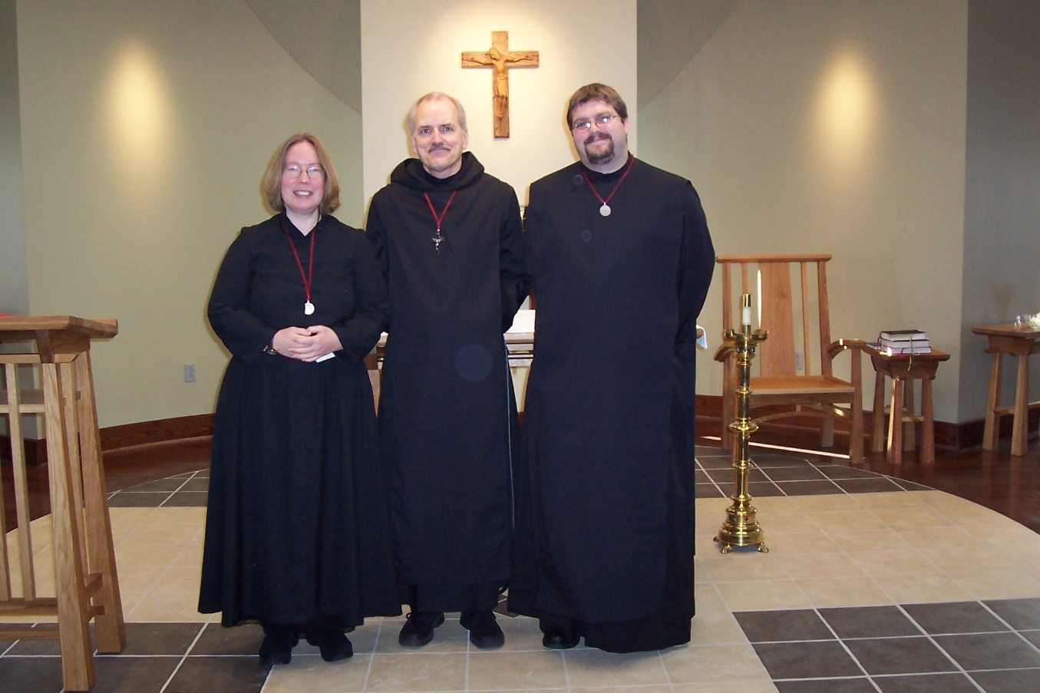
100 0419 Sr. Teresa Bebee; Br. Daniel Joseph Schroeder; Br. John Luke Scott

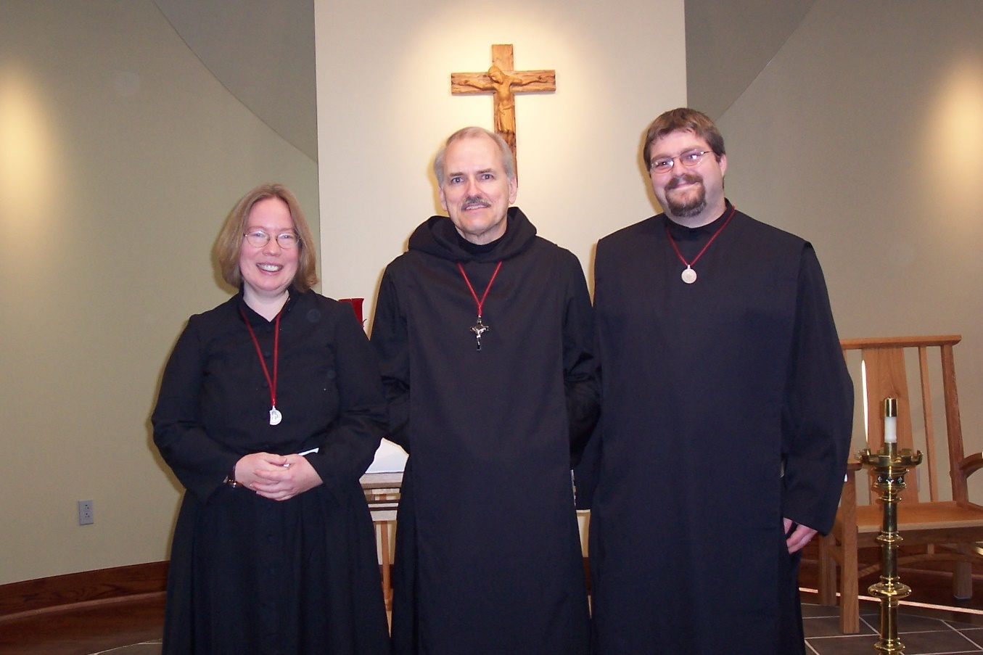
100 0420 Sr. Teresa Bebee; Br. Daniel Joseph Schroeder; Br. John Luke Scott
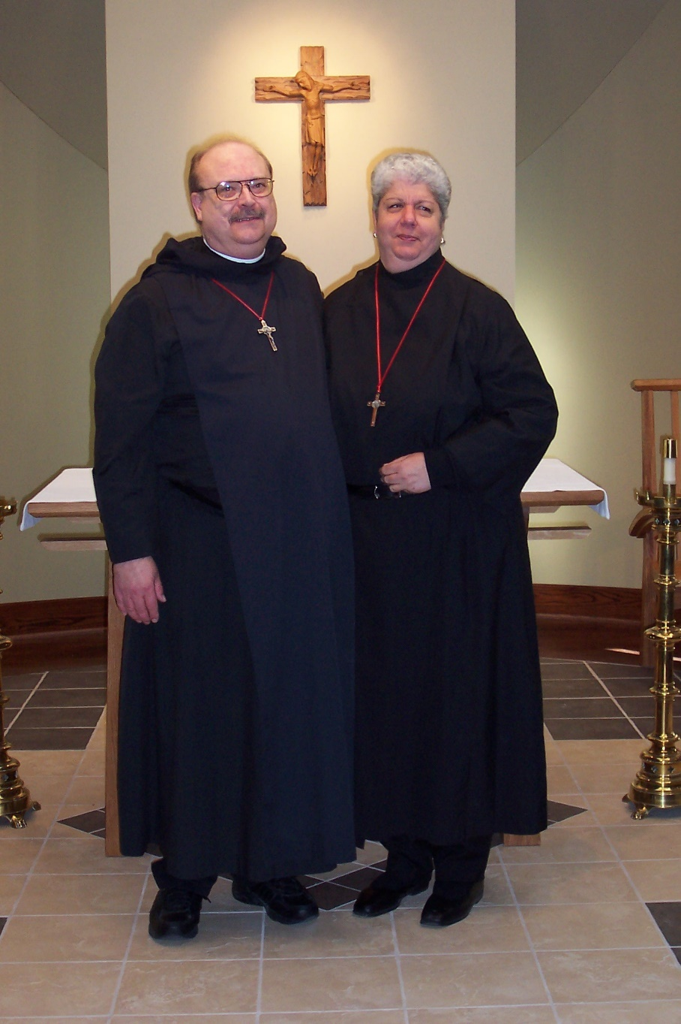
100 0421 Br. Raymond Owens; Sr. Mary Catherine Christopher
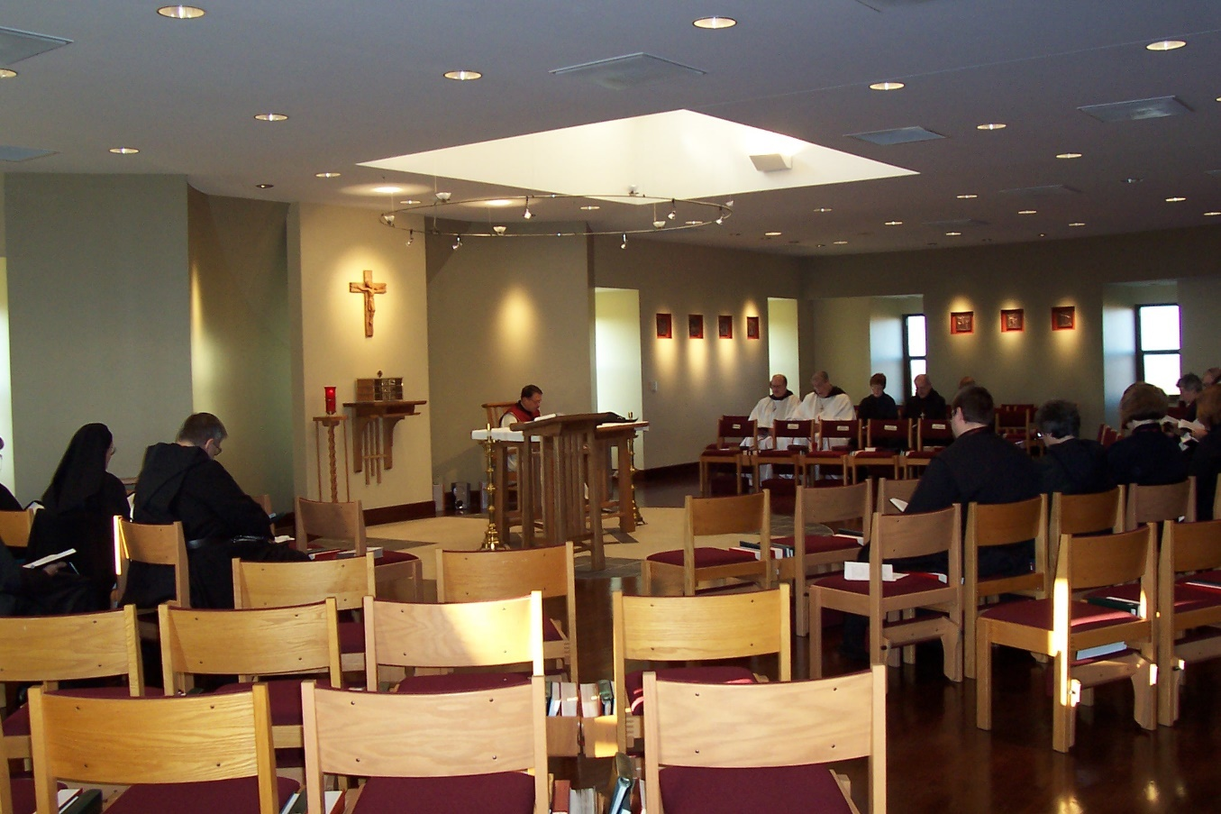
100 0424 Sr. Theodora of Jesus Perecca; Br. Nathan Gregory Miller; Abbot Michael John Austin; Br. Raymond Owens; Br. Chad Anselm Gerns; Sr. Brigid Gerns; Br. Daniel Joseph Schroeder; Br. John Luke Scott; Sr. Catherine Unterseher; Sr. Vincent Marie Rittenhouse; Sr. Hillary Grace Lundgren; Sr. Teresa Bebee; ?; ?
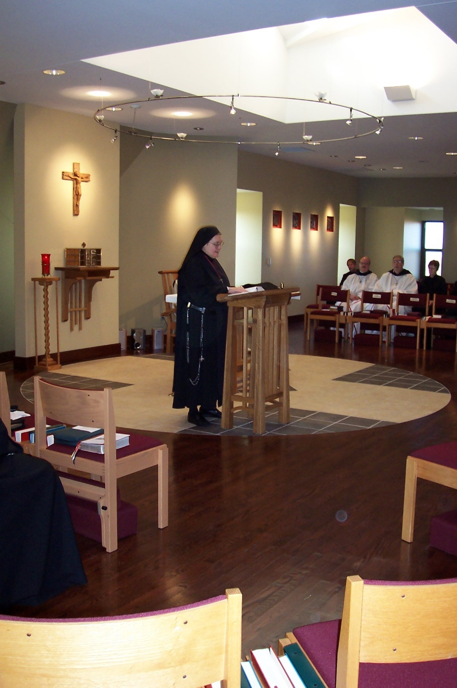
100 0425 Sr. Theodora of Joseph of Perecca; Br. Lawrence Mullen; Br. Raymond Owens; Sr. Brigid Gerns
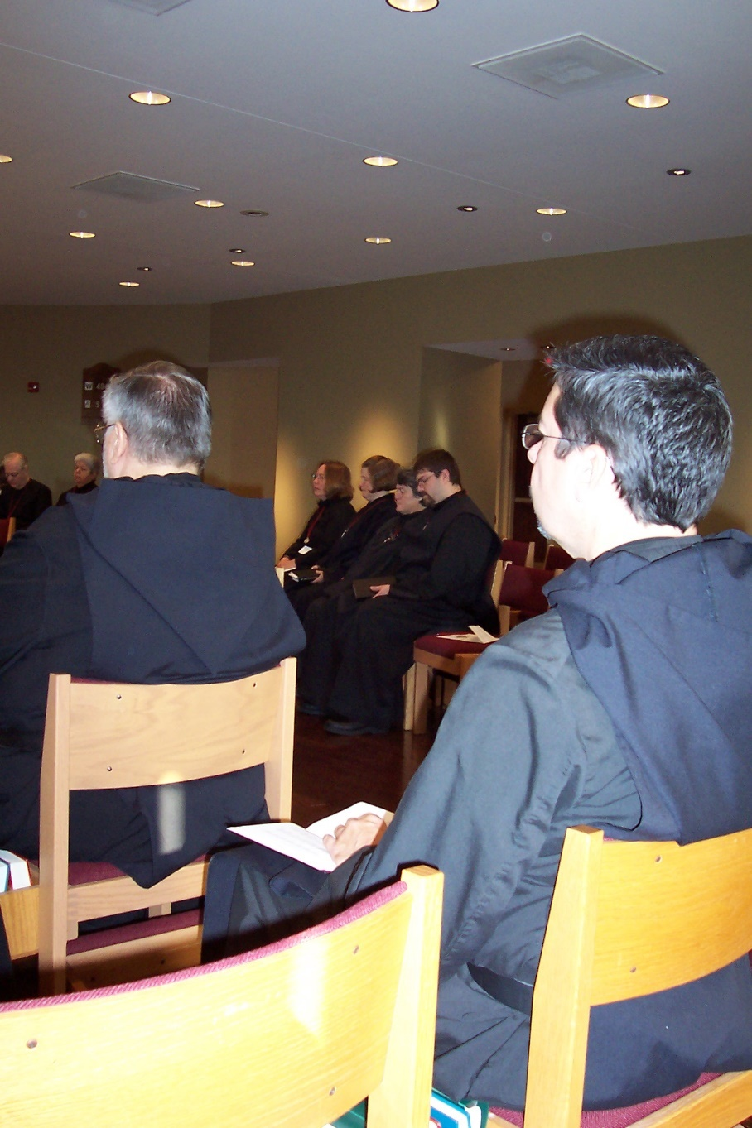
100 0426 Br. Luke Doucette; Sr. Mary Catherine Christopher; Br Nathan Gregory Miller; Sr. Teresa Bebee; Sr. Hillary Grace Lundgren; Sr. Vincent Marie Rittenhouse; Br. John Luke Scott; Br. Augustine Colvert
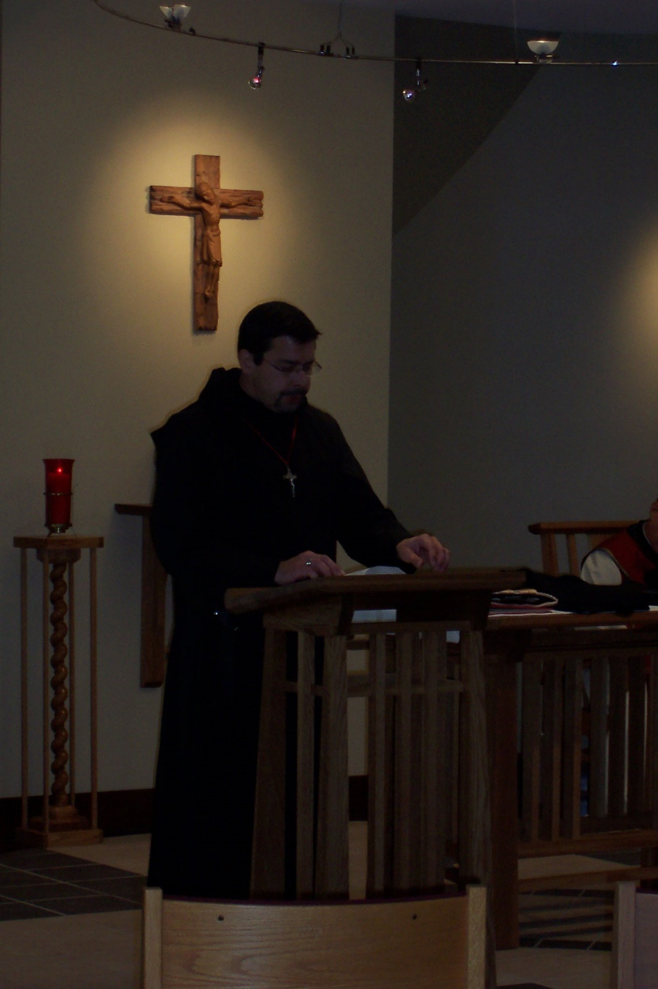
100 0427 Br. Augustine Colvert
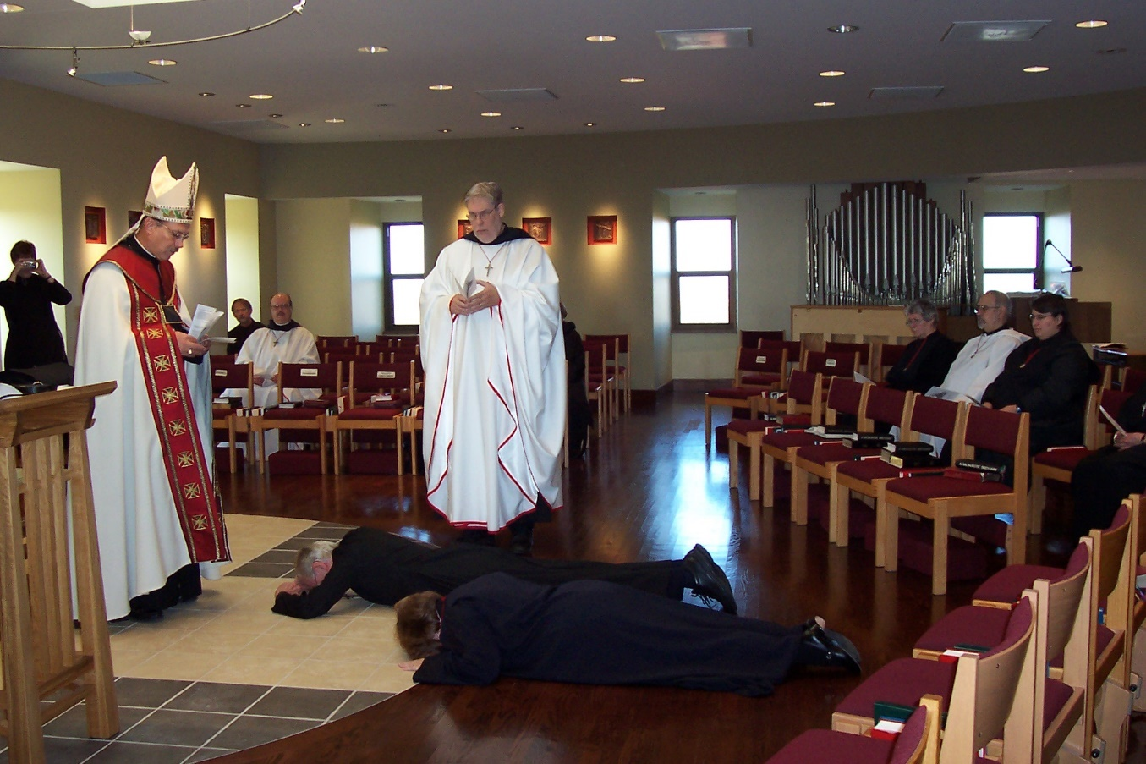
100 0428 Sr. Brigid Gerns; Abbot Michael John Austin; Br. Lawrence Mullen; Br. Luke Doucette; Sr. Hillary Grace Lundgren; Br. Chad Anselm Gerns; Sr. Johanna Kirkpatrick; Br. Joseph Benedict DiMauro; Sr. Pauline Tysol

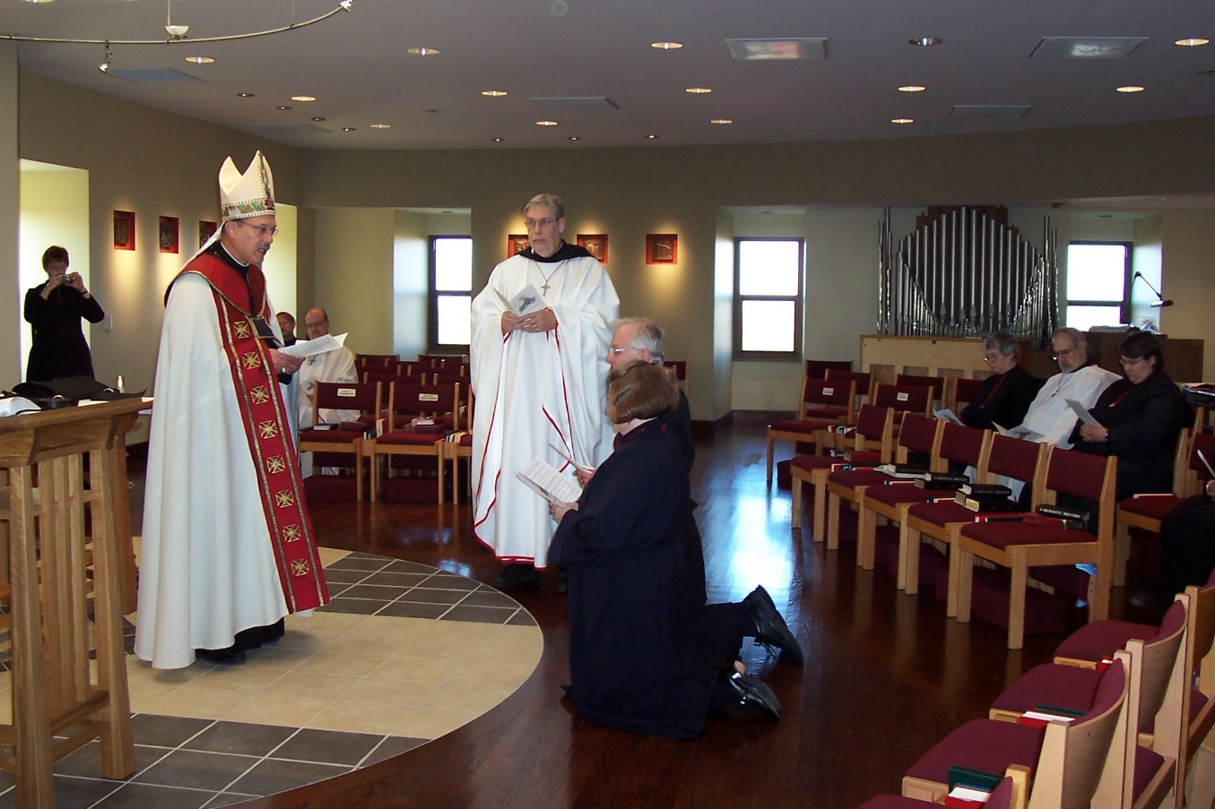
100 0429 Sr. Brigid Gerns; Abbot Michael John Austin; Br. Lawrence Mullen; Br. Luke Doucette; Sr. Hillary Grace Lundgren; Br. Chad Anselm Gerns; Sr. Johanna Kirkpatrick; Br. Joseph Benedict DiMauro; Sr. Pauline Tysol
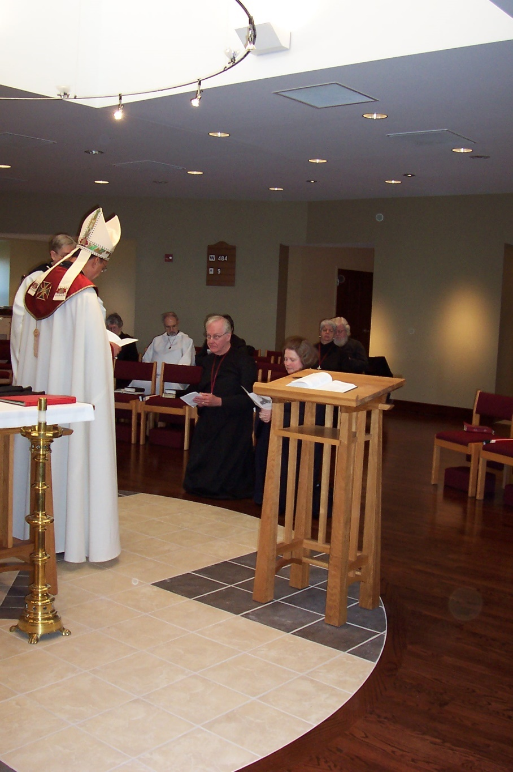
100 0430 Br. Chad Anselm Gerns; Abbot Michael John Austin; Sr. Johanna Kirkpatrick; Br. Joseph Benedict DiMauro; Br. Luke Doucette; Sr. Hillary Grace Lundgren; Sr. Mary Catherine Christopher; Fr. Wayne Kamm
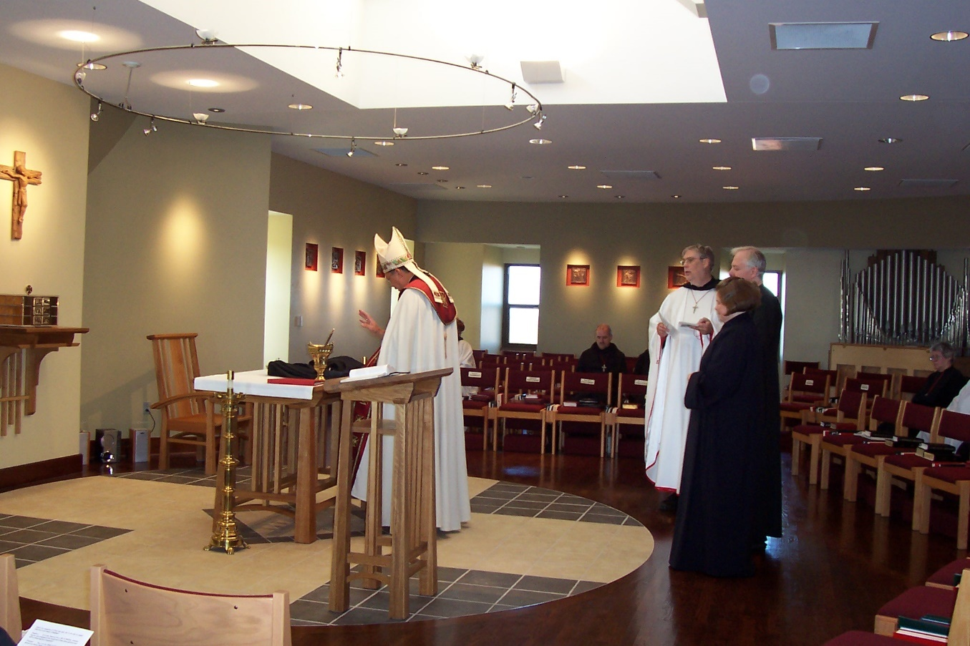
100 0431 Abbot Michael John Austin; Br. Daniel Joseph Schroeder; Br. Chad Anselm Gerns; Sr. Hillary Grace Lundgren; Br. Luke Doucette; Sr. Johanna Kirkpatrick

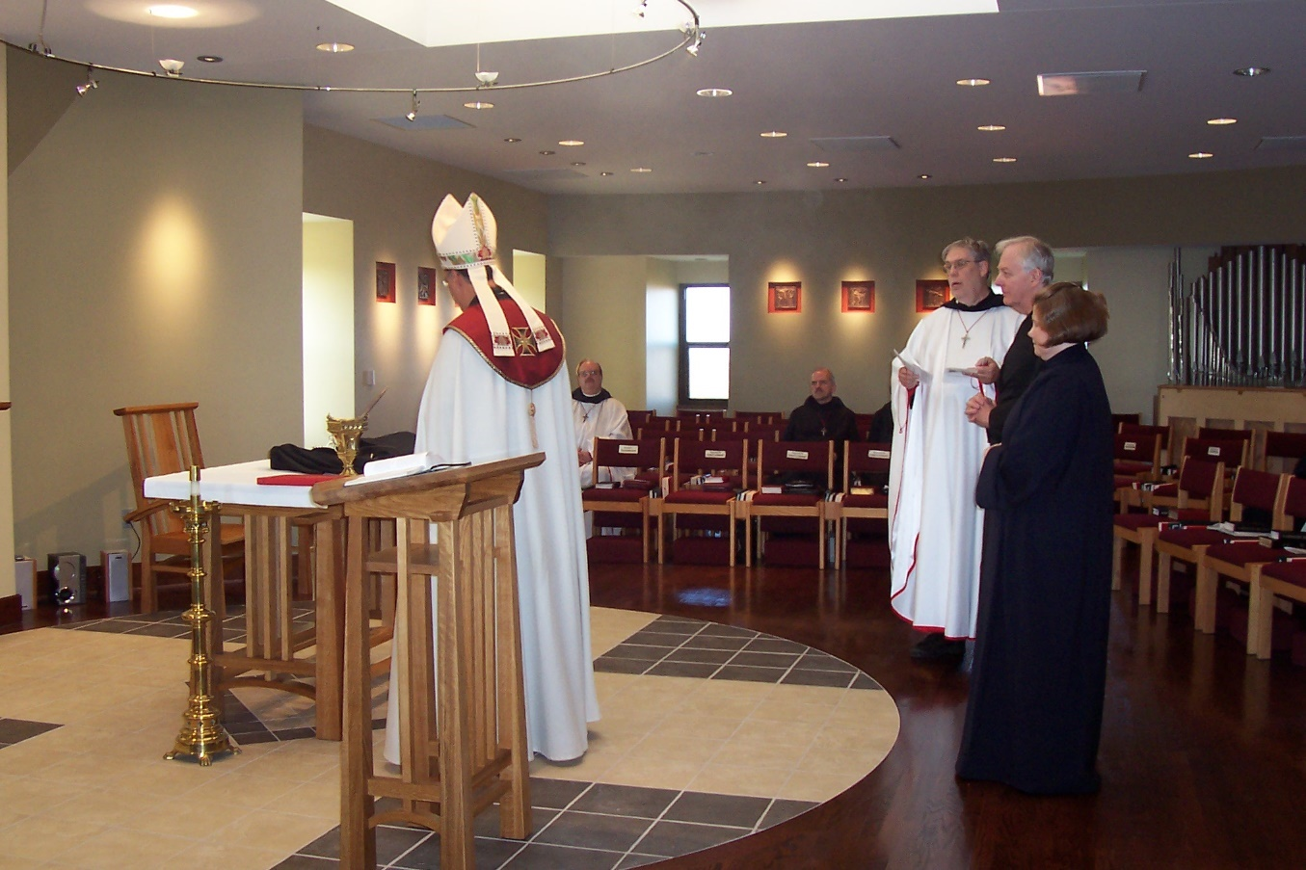
100 0432 Abbot Michael John Austin; Br. Raymond Owens; Br. Chad Anselm Gerns; Br. Luke Doucette; Sr. Hillary Grace Lundgren
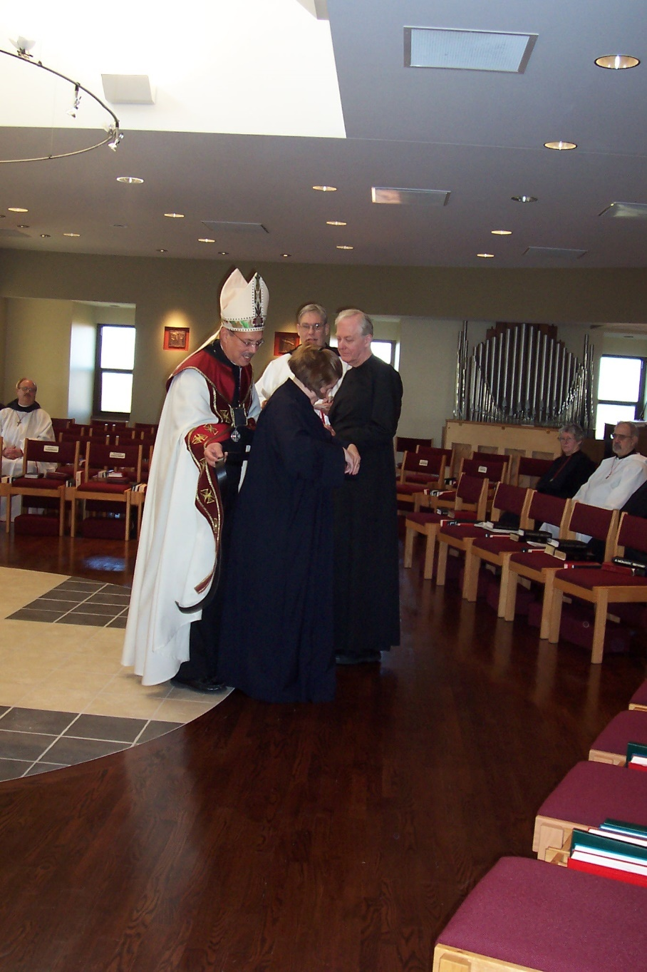
100 0433 Br. Raymond Owens; Abbot Michael John Austin; Sr. Hilary Grace Lundgren; Br. Chad Anselm Gerns; Br. Luke Doucette; Sr. Johanna Kirkpatrick; Br. Joseph Benedict DiMauro
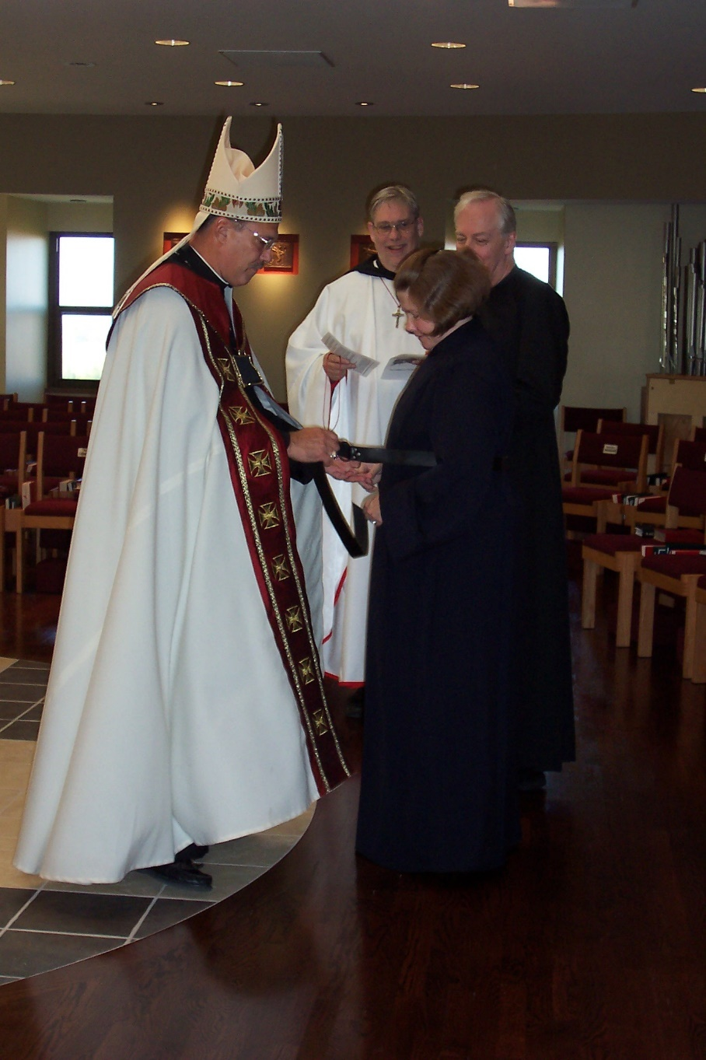
100 0434 Abbot Michael John Austin; Br. Chad Anselm Gerns; Sr. Hillary Grace Lundgren; Br. Luke Doucette
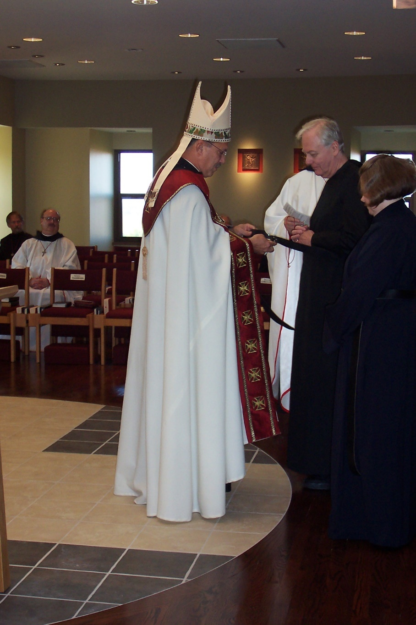
100 0435 Br. Lawrence Mullen; Br. Raymond Owens; Abbot Michael John Austin; Br. Luke Doucette; Sr. Hillary Grace Lundgren
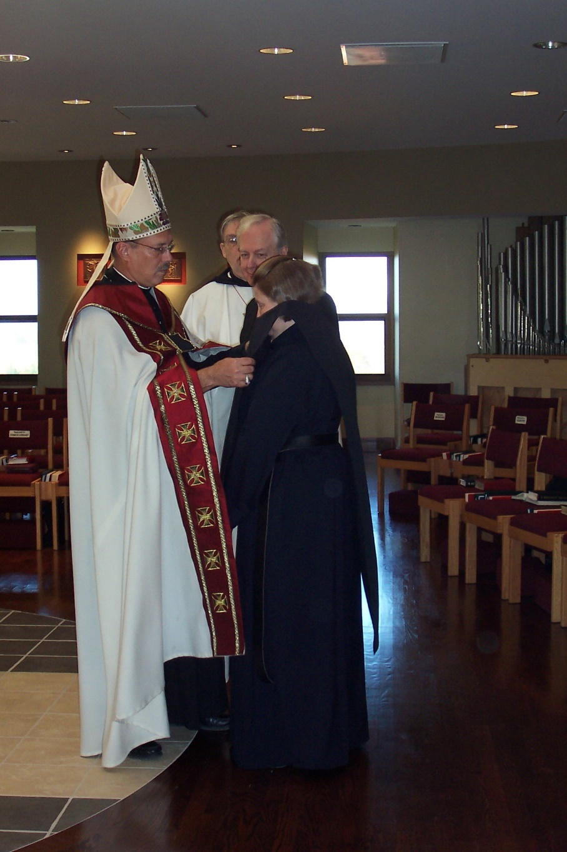
100 0436 Abbot Michael John Austin; Br. Chad Anselm Gerns; Br. Luke Doucette; Sr. Hillary Grace Lundgren
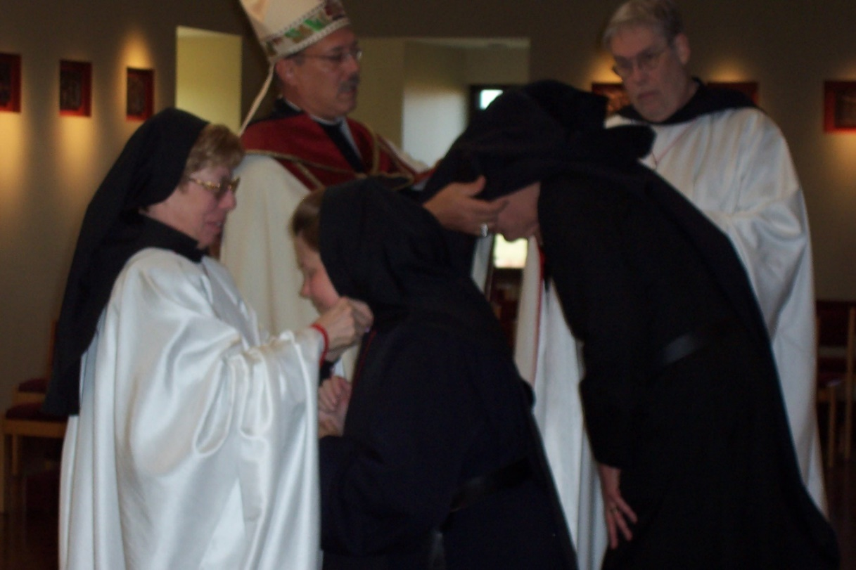
100 0437 Sr. Monica Ruth Mullen; Abbot Michael John Austin; Sr. Hillary Grace Lundgren; Br. Luke Doucette; Br. Chad Anselm Gerns

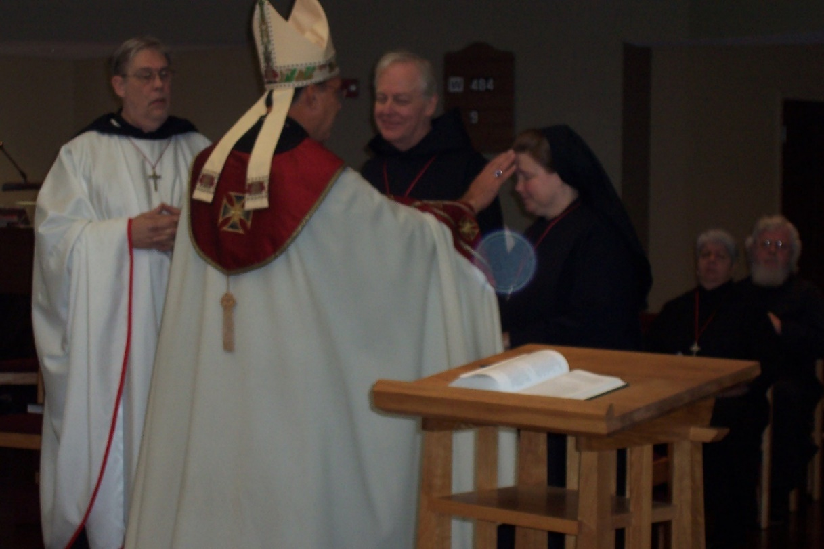
100 0438 Br. Chad Anselm Gerns; Abbot Michael John Austin; Br. Luke Doucette; Sr. Hillary Grace Lundgren

