Companions of St. Luke
Spring 2006 Convocation at Conception Abbey
Day 3, Part 4 of 4

~Edited by Br. Steven Olderr, 6 June 2022 with the assistance of Br. Thomas Ferrell. If you find any errors or omissions or have anything to add, please notify Br. Steven at olderr@ameritech.net

People are identified from left to right.

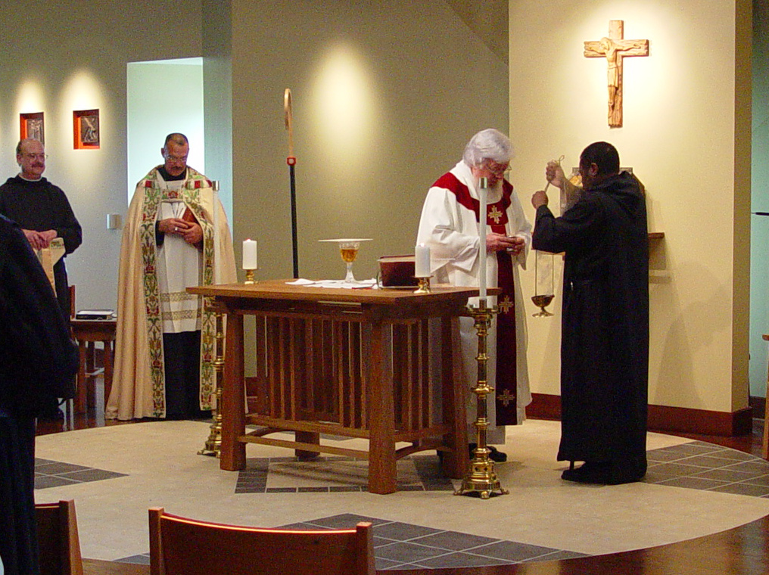
COSL Day 3 (S3) 006 Br. Raymond Owens; Abbot Michael John Austin; Fr. Wayne Kamm; Br. Thomas Ferrell
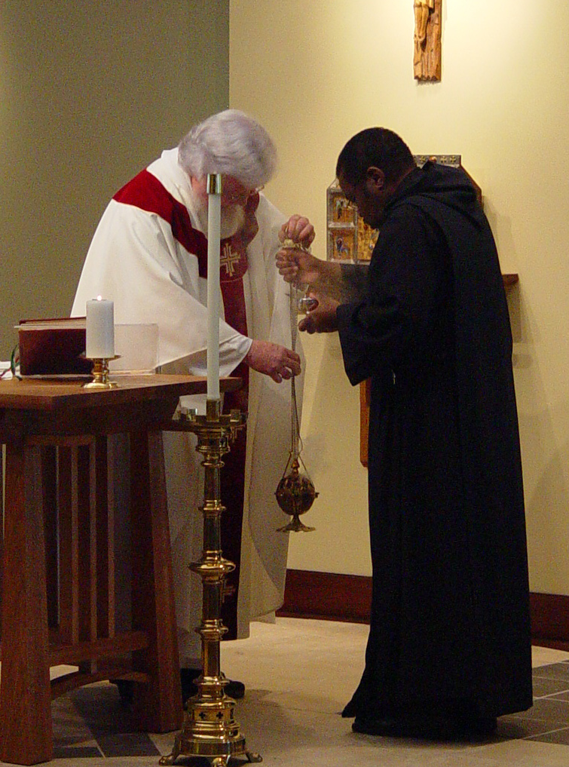
COSL Day 3 (S3) 007 Fr. Wayne Kamm; Br. Thomas Ferrell
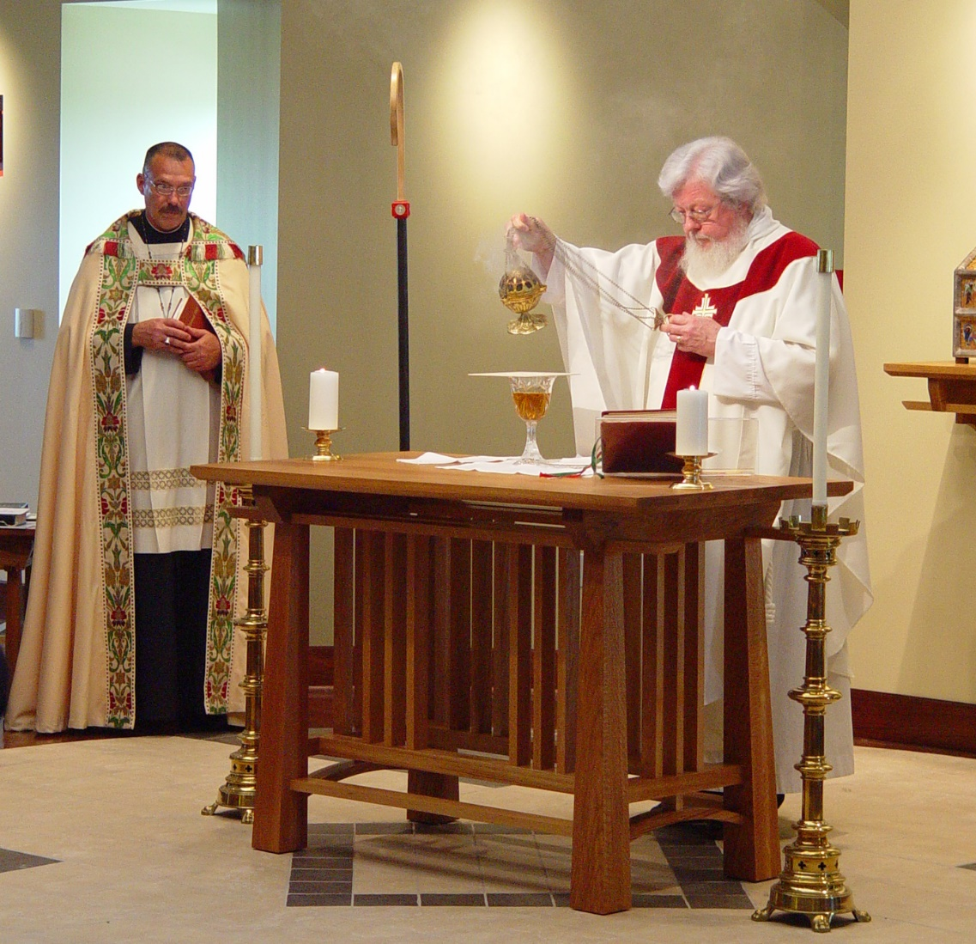
COSL Day 3 (S3) 008 Abbot Michael John Austin; Fr. Wayne Kamm
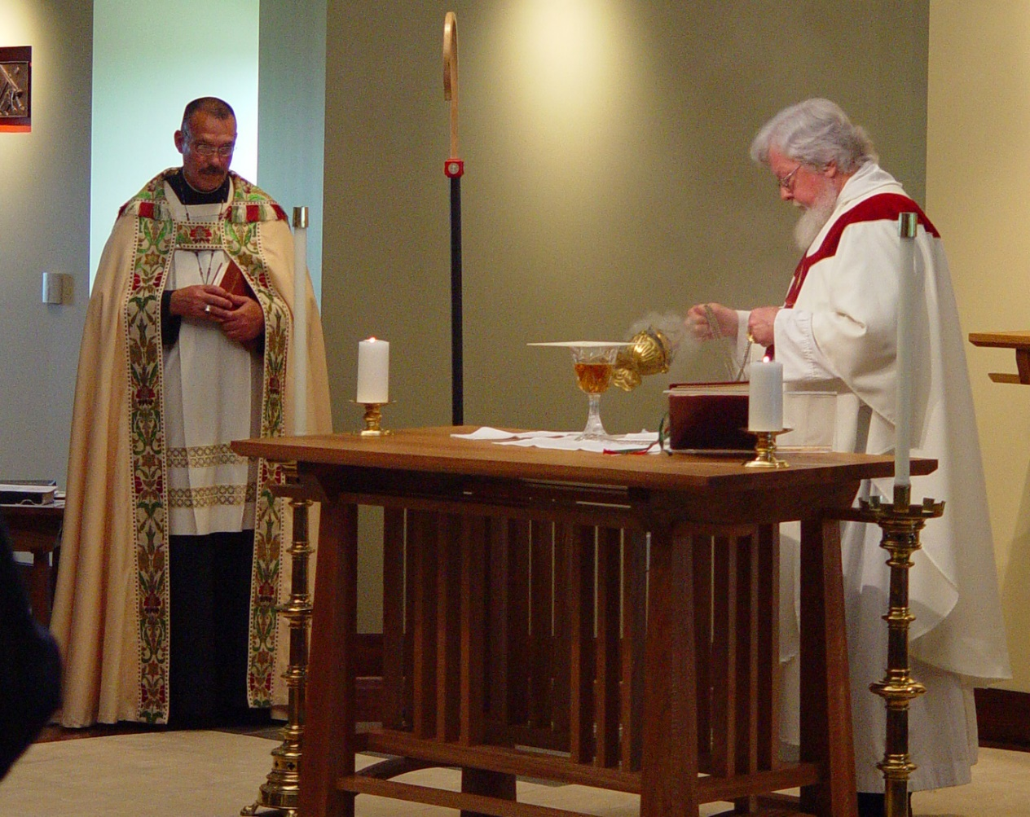
COSL Day 3 (S3) 009 Abbot Michael John Austin; Fr. Wayne Kamm
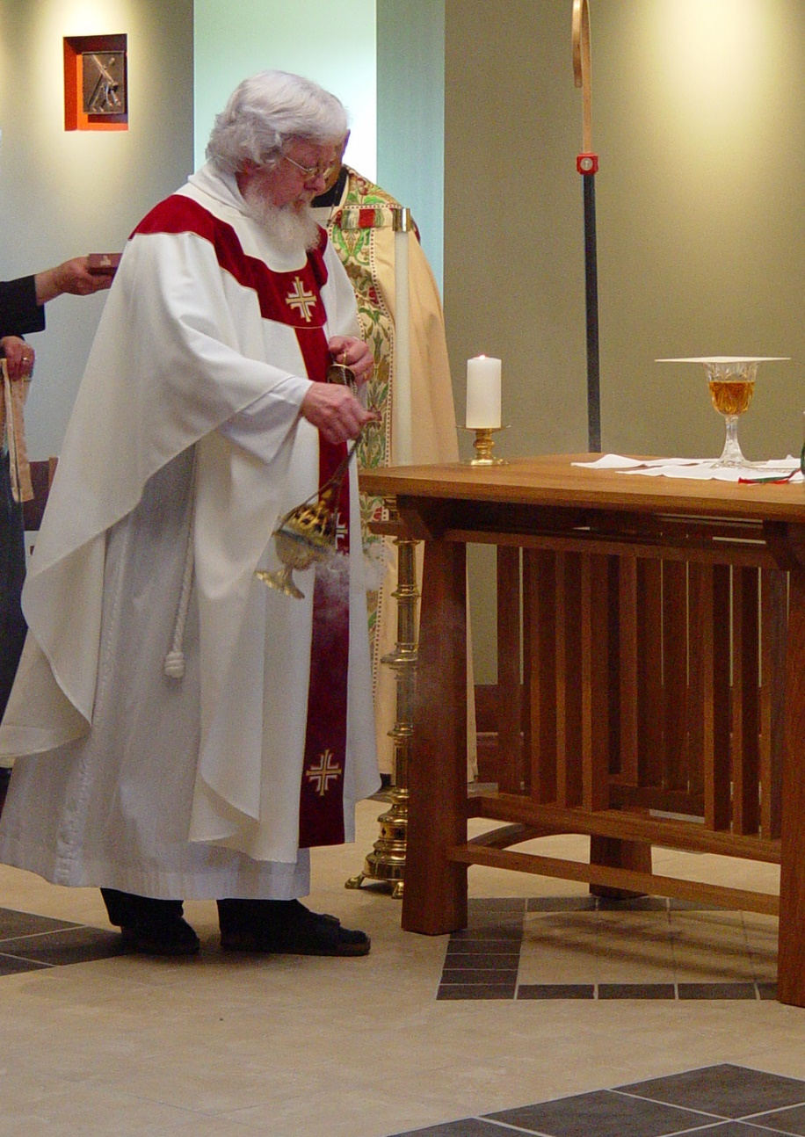
COSL Day 3 (S3) 010 Fr. Wayne Kamm; Abbot Michael John Austin
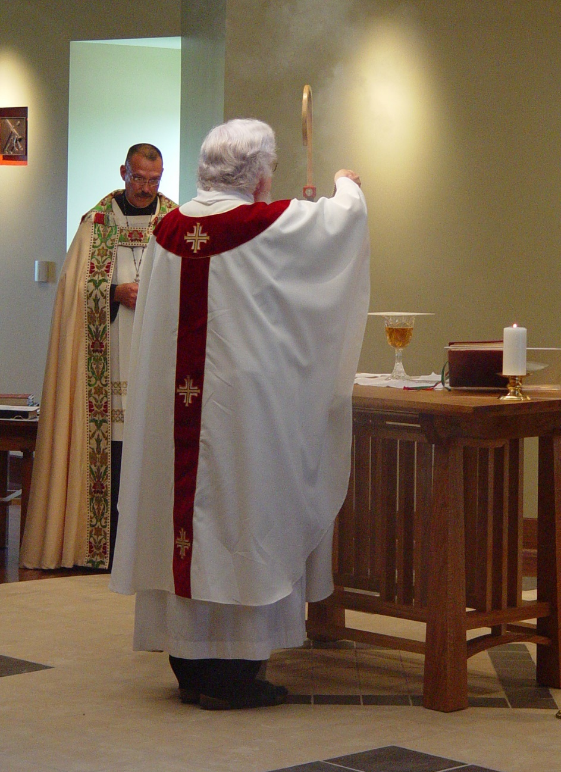
COSL Day 3 (S3) 011 Abbot Michael John Austin; Fr. Wayne Kamm
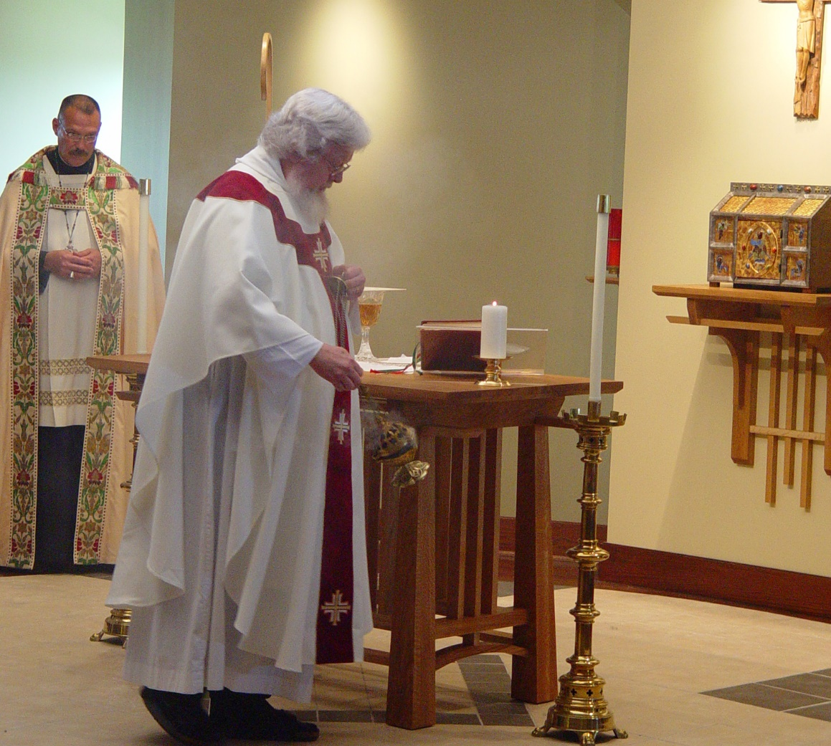
COSL Day 3 (S3) 012 Abbot Michael John Austin; Fr. Wayne Kamm
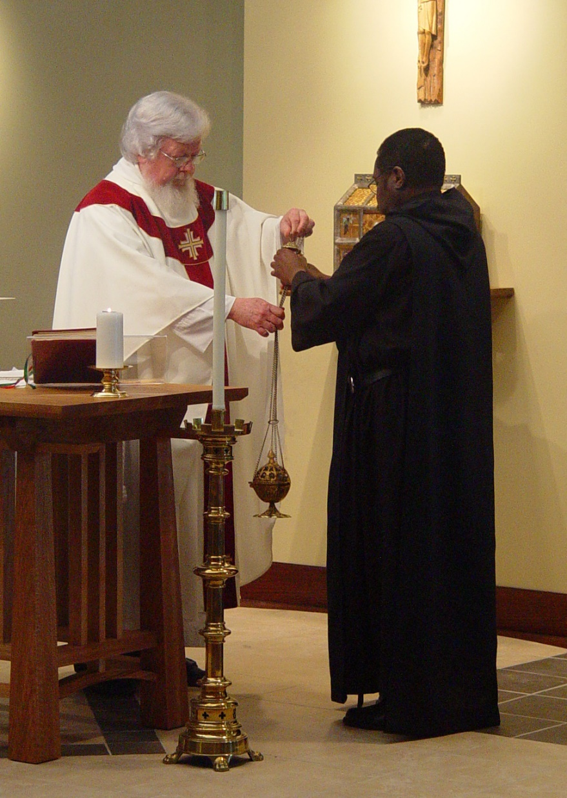
COSL Day 3 (S3) 013 Fr. Wayne Kamm; Br. Thomas Ferrell
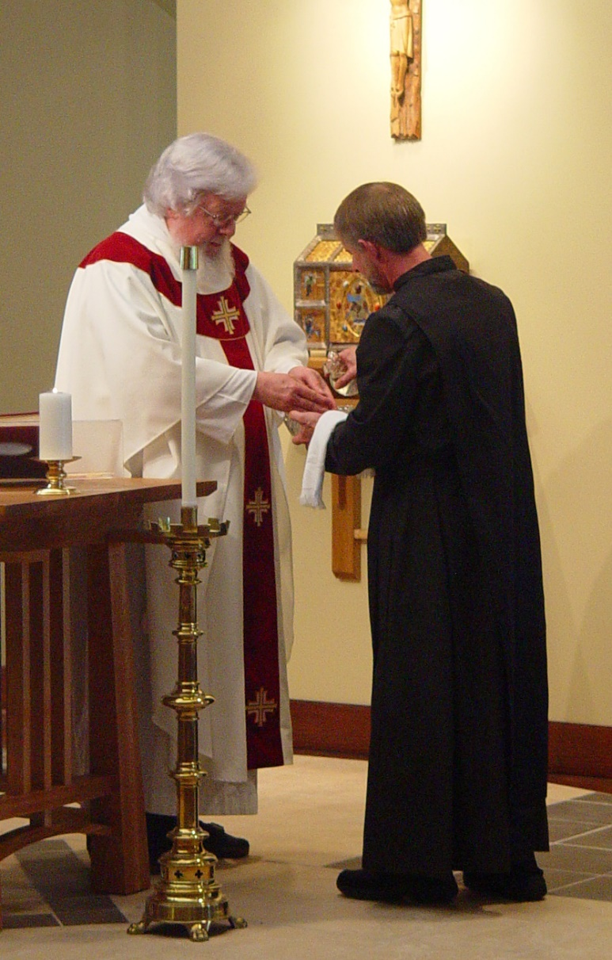
COSL Day 3 (S3) 014 Fr. Wayne Kamm; Br. Lawrence Mullen
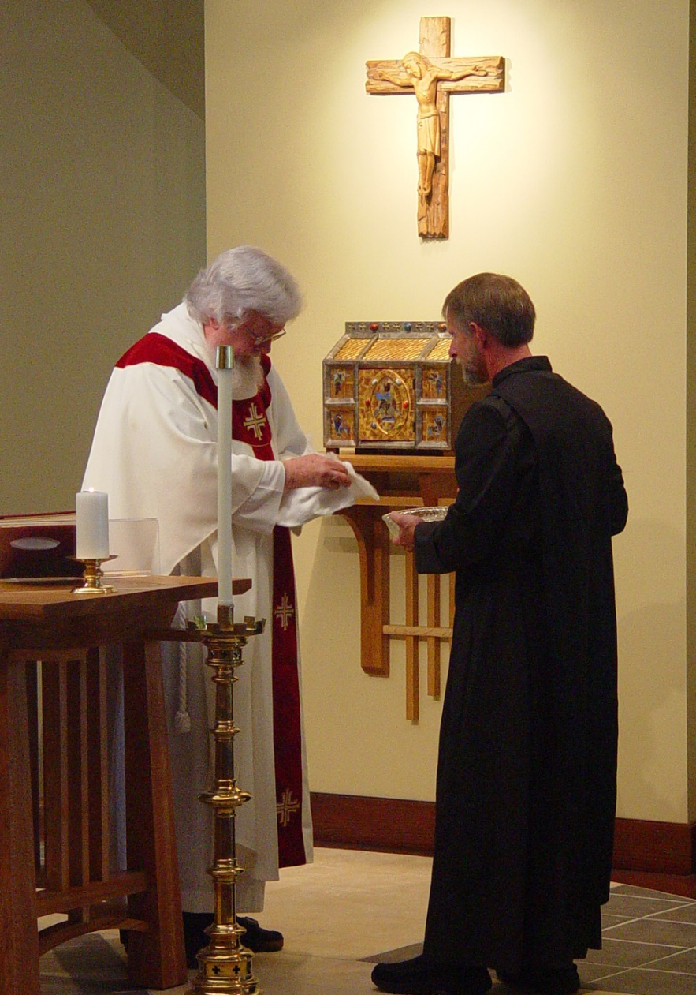
COSL Day 3 (S3) 015 Fr. Wayne Kamm; Br. Lawrence Mullen
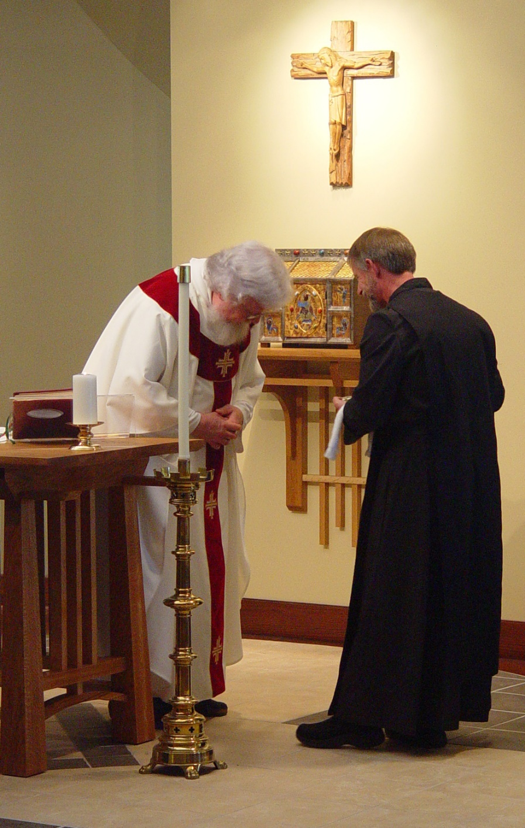
COSL Day 3 (S3) 016 Fr. Wayne Kamm; Br. Lawrence Mullen
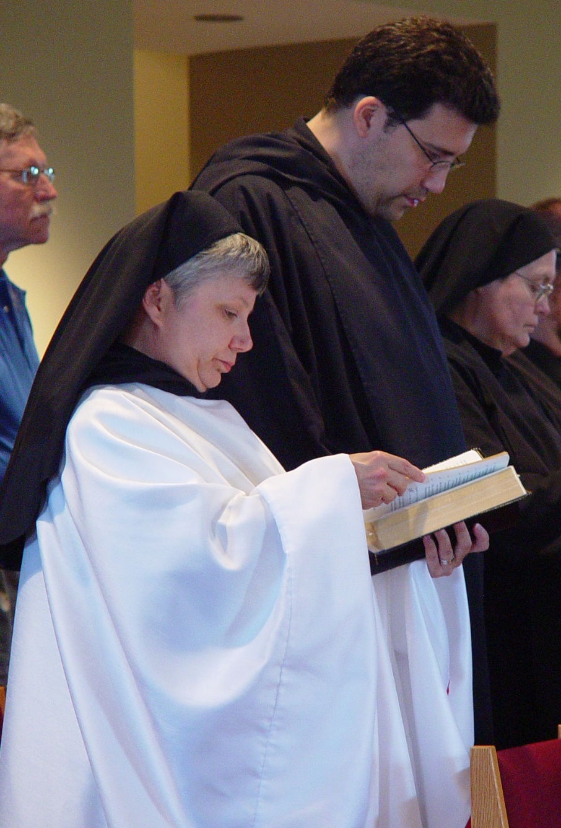
COSL Day 3 (S3) 017 Fr. Mel Schlacter; Sr. Anna Grace Madden; Br. Anthony Bernard Campos; Sr. Theodora of Jesus Perecca
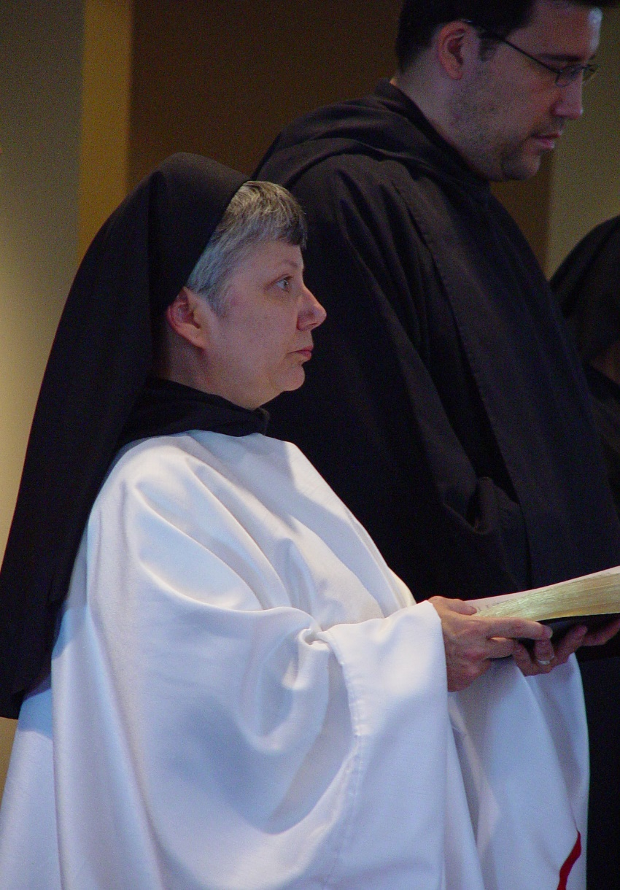
COSL Day 3 (S3) 018 Sr. Anna Grace Madden; Br. Anthony Bernard Campos
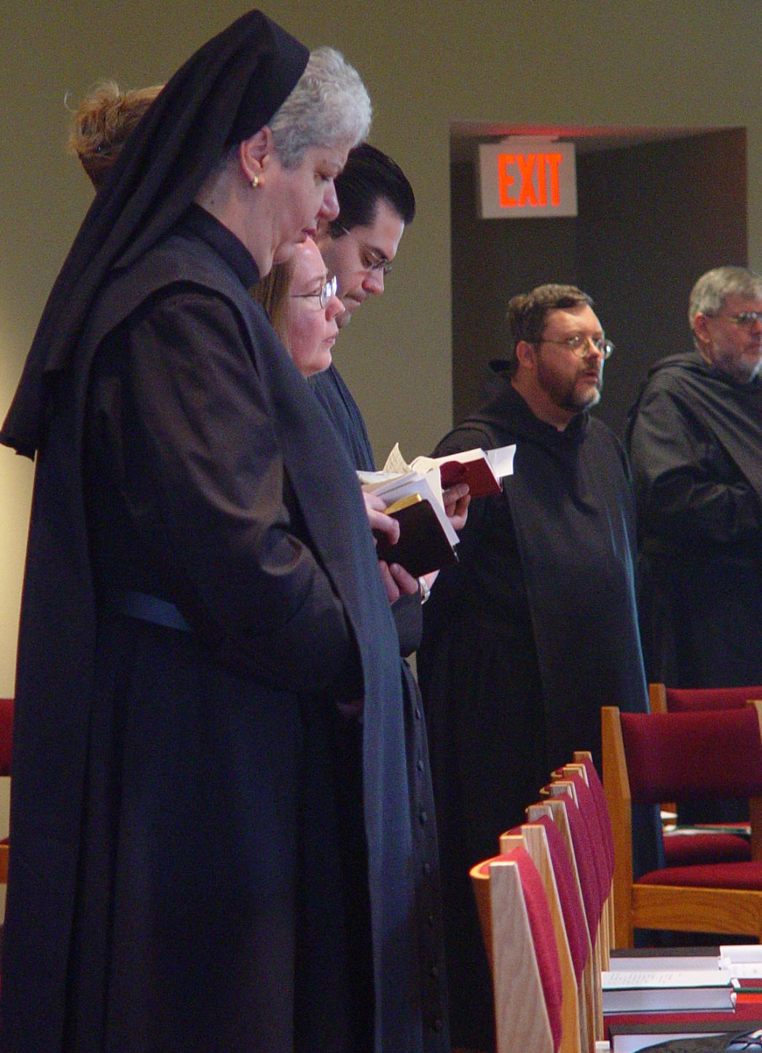
COSL Day 3 (S3) 019 Sr. Mary Catherine Christopher; Jane Beebe; Br. Daniel Medina; Br. Paul Howard; Br. Nathan Gregory Miller
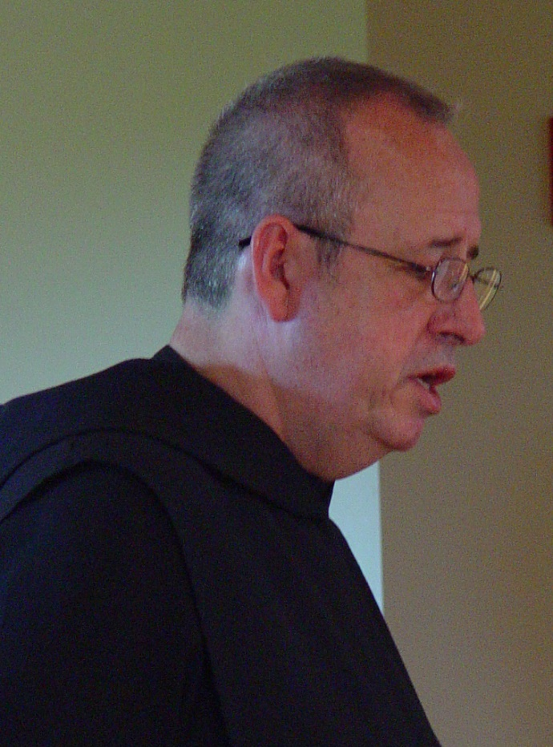
COSL Day 3 (S3) 020 Br. Gabriel Hale
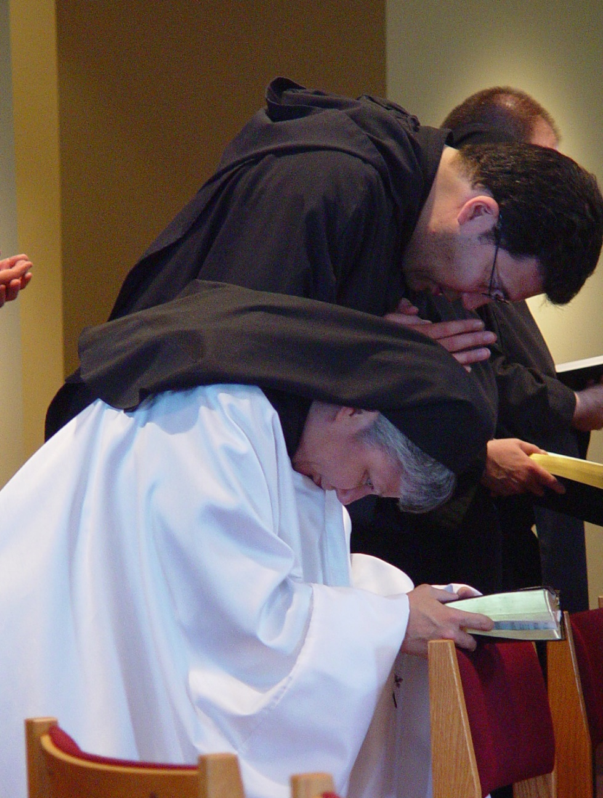
COSL Day 3 (S3) 021 Sr. Anna Grace Madden; Br. Anthony Bernard Campos; Br. Daniel Moore
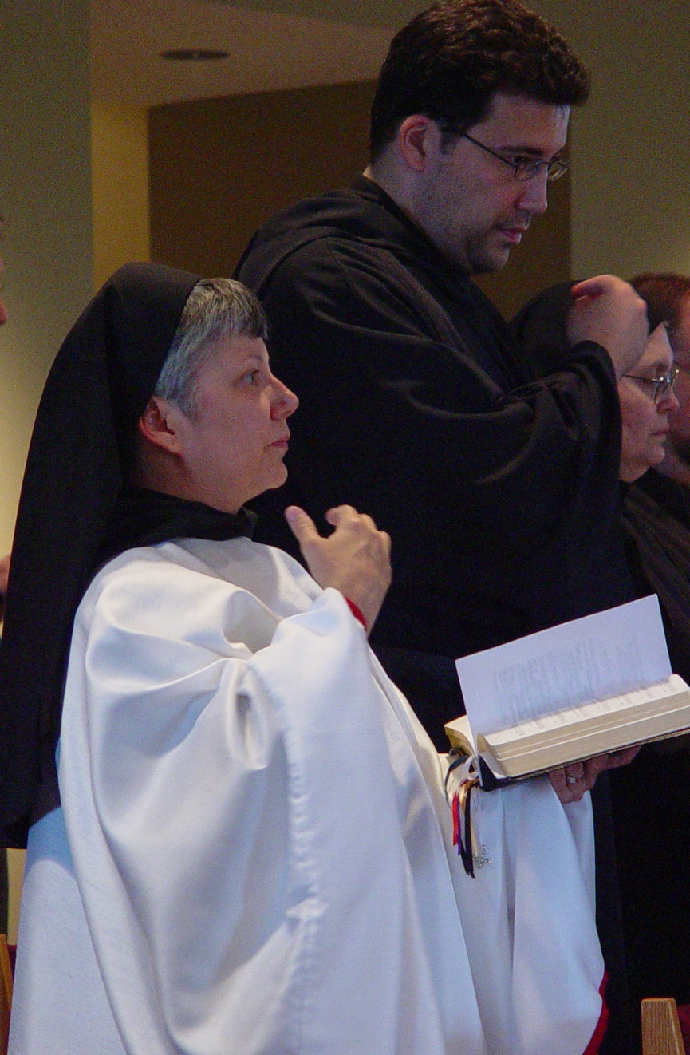
COSL Day 3 (S3) 022 Sr. Anna Grace Madden; Br. Anthony Bernard Campos; Sr. Theodora of Jesus Perecca; Br. Daniel Moore

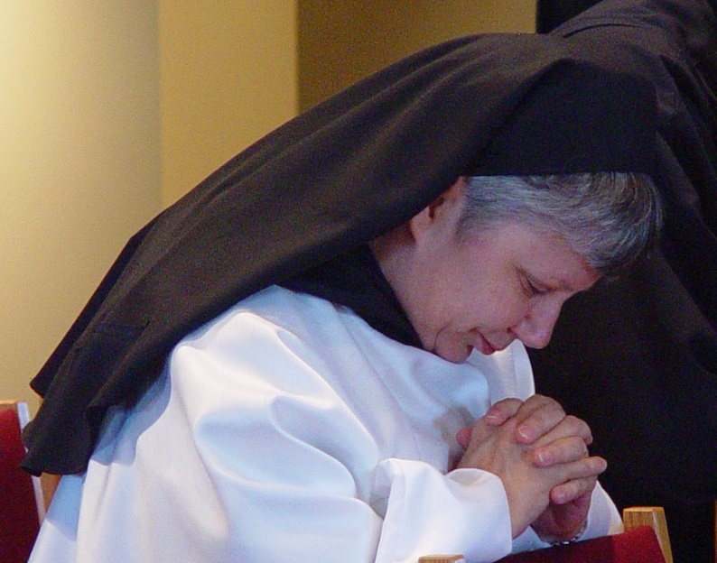
COSL Day 3 (S3) 023 Sr. Anna Grace Madden
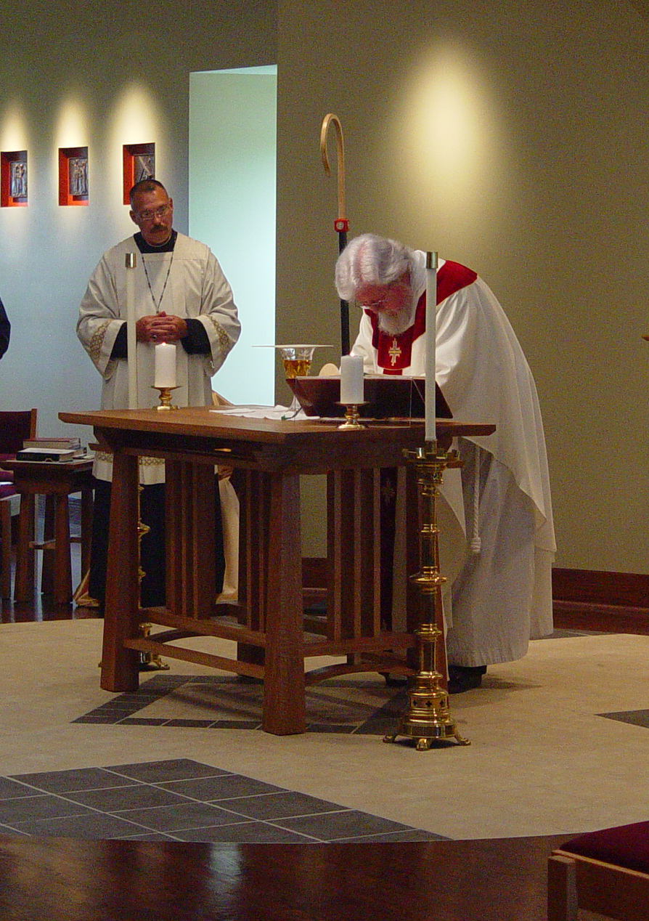
COSL Day 3 (S3) 024 Abbot Michael John Austin; Fr. Wayne Kamm
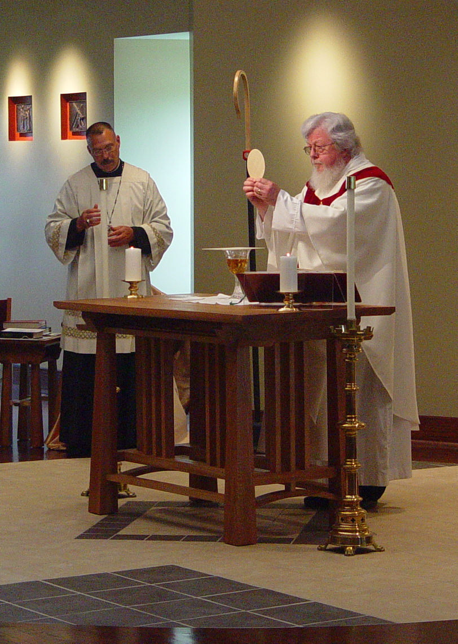
COSL Day 3 (S3) 025 Abbot Michael John Austin; Fr. Wayne Kamm
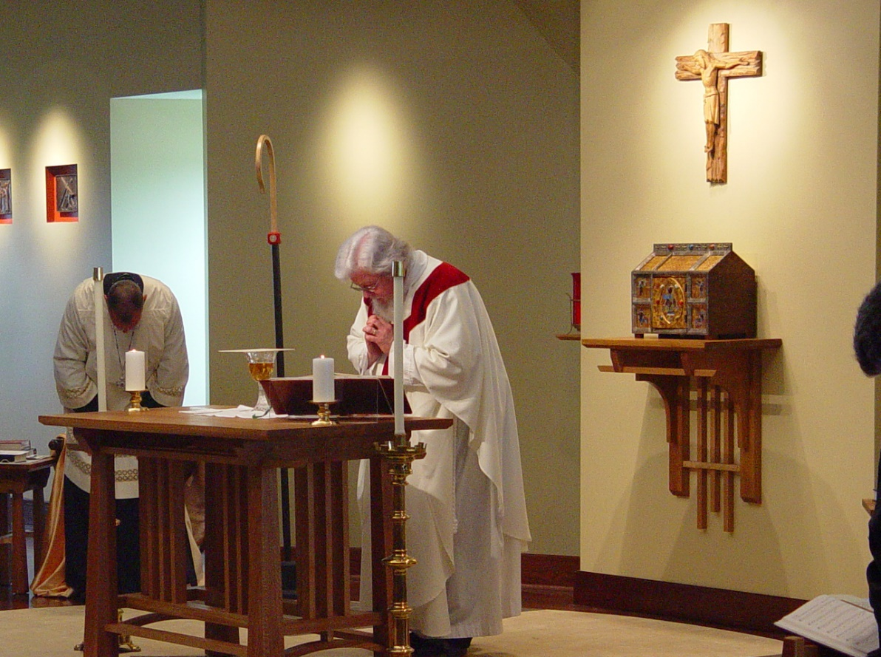
COSL Day 3 (S3) 026 Abbot Michael John Austin; Fr. Wayne Kamm
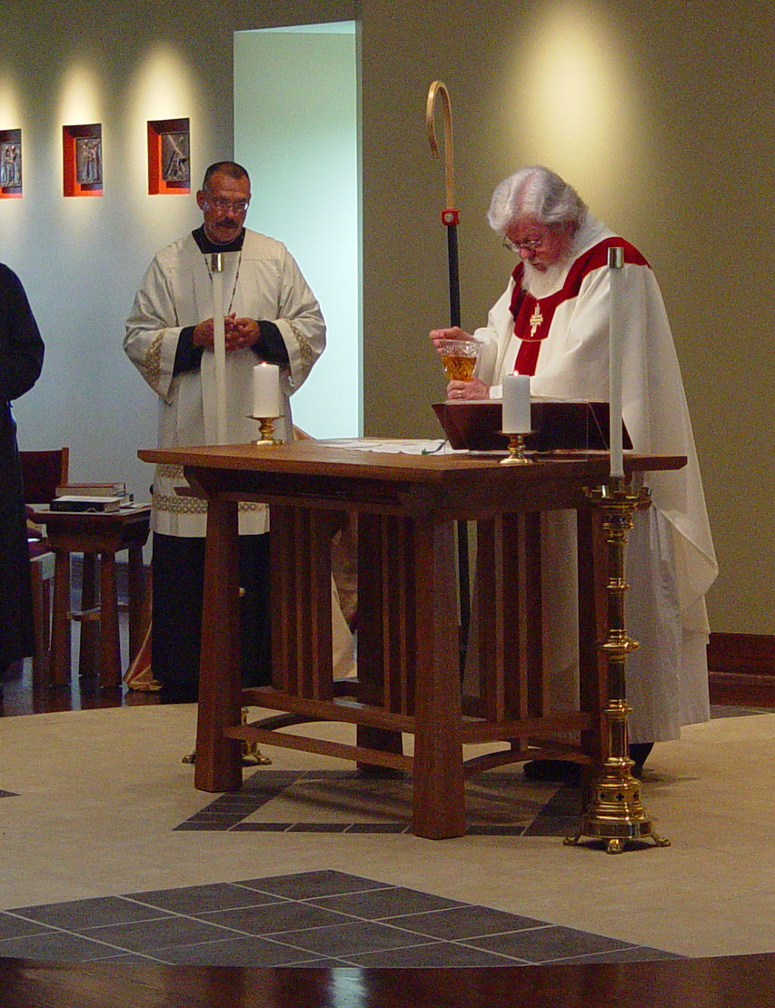
COSL Day 3 (S3) 027 Abbot Michael John Austin; Fr. Wayne Kamm

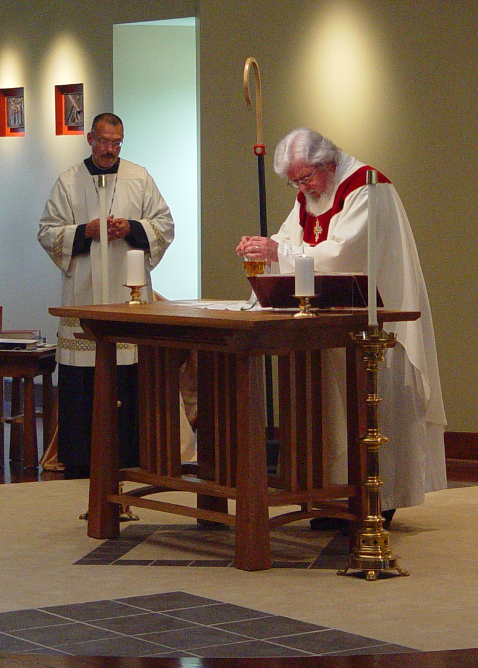
COSL Day 3 (S3) 028 Abbot Michael John Austin; Fr. Wayne Kamm
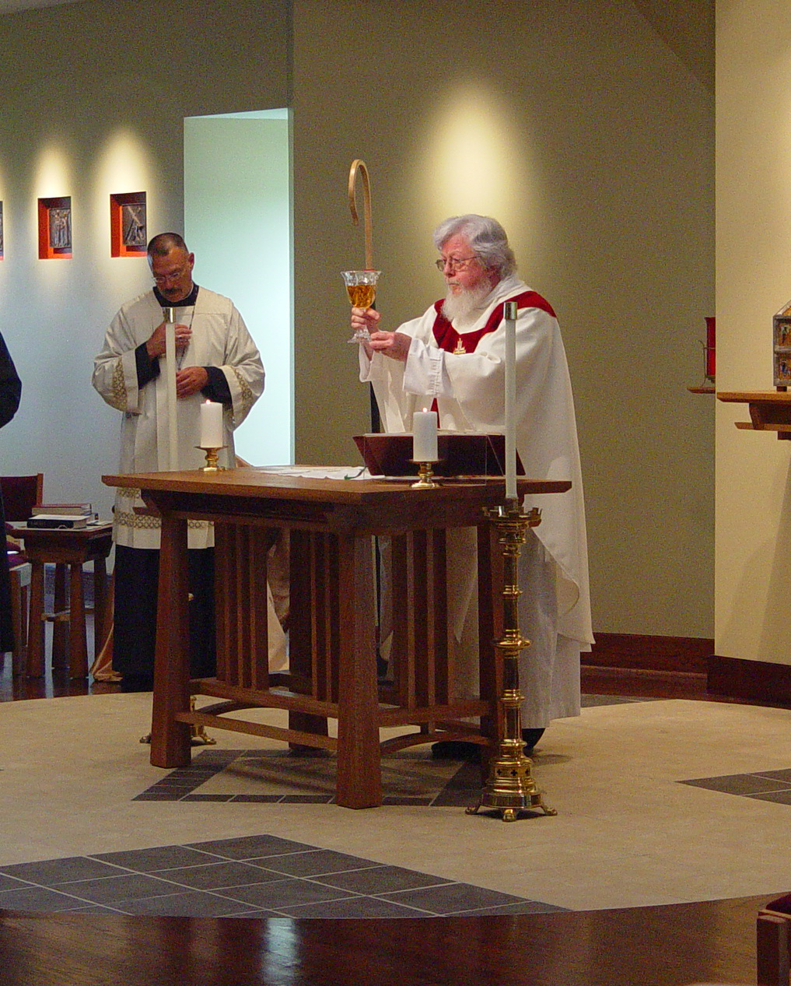
COSL Day 3 (S3) 029 Abbot Michael John Austin; Fr. Wayne Kamm
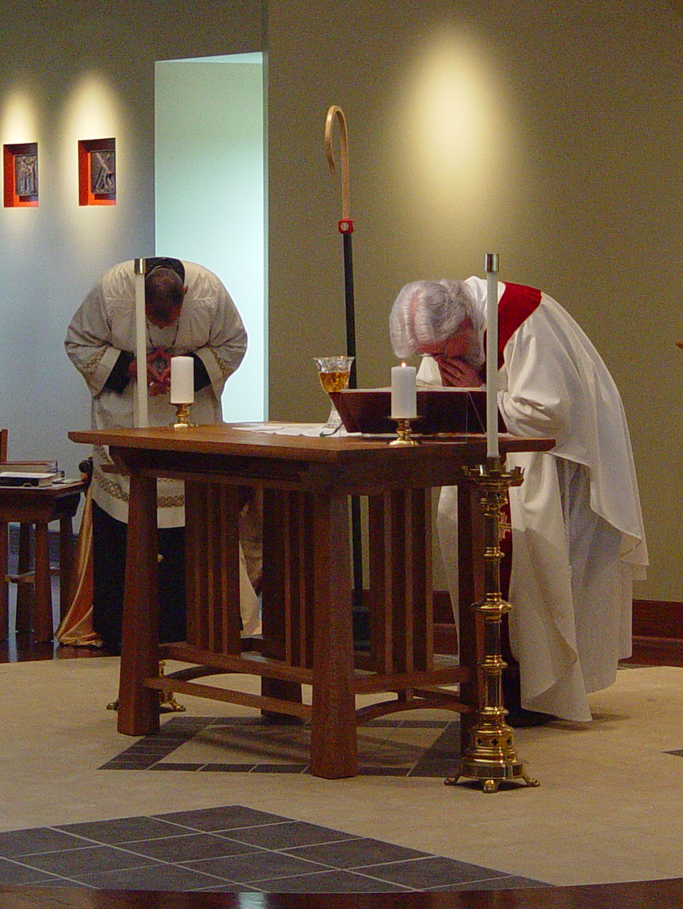
COSL Day 3 (S3) 030 Abbot Michael John Austin; Fr. Wayne Kamm
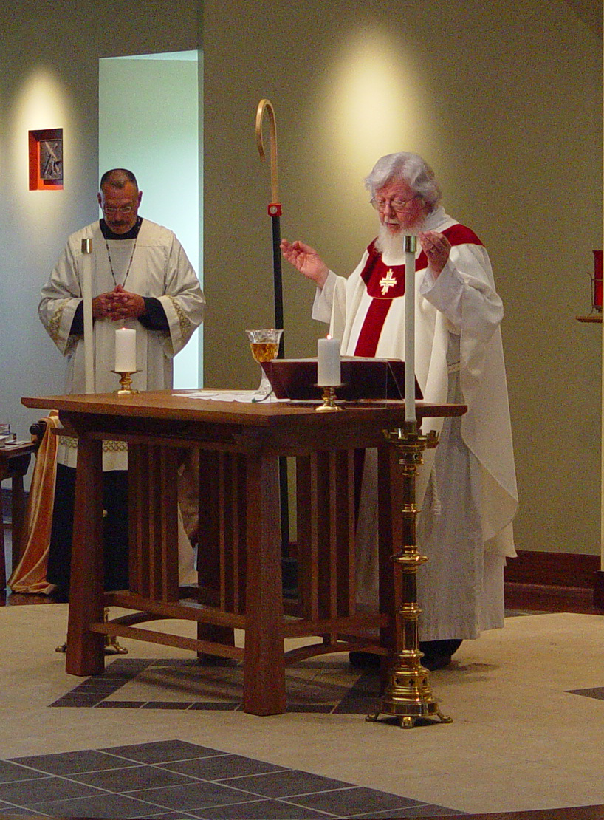
COSL Day 3 (S3) 031 Abbot Michael John Austin; Fr. Wayne Kamm
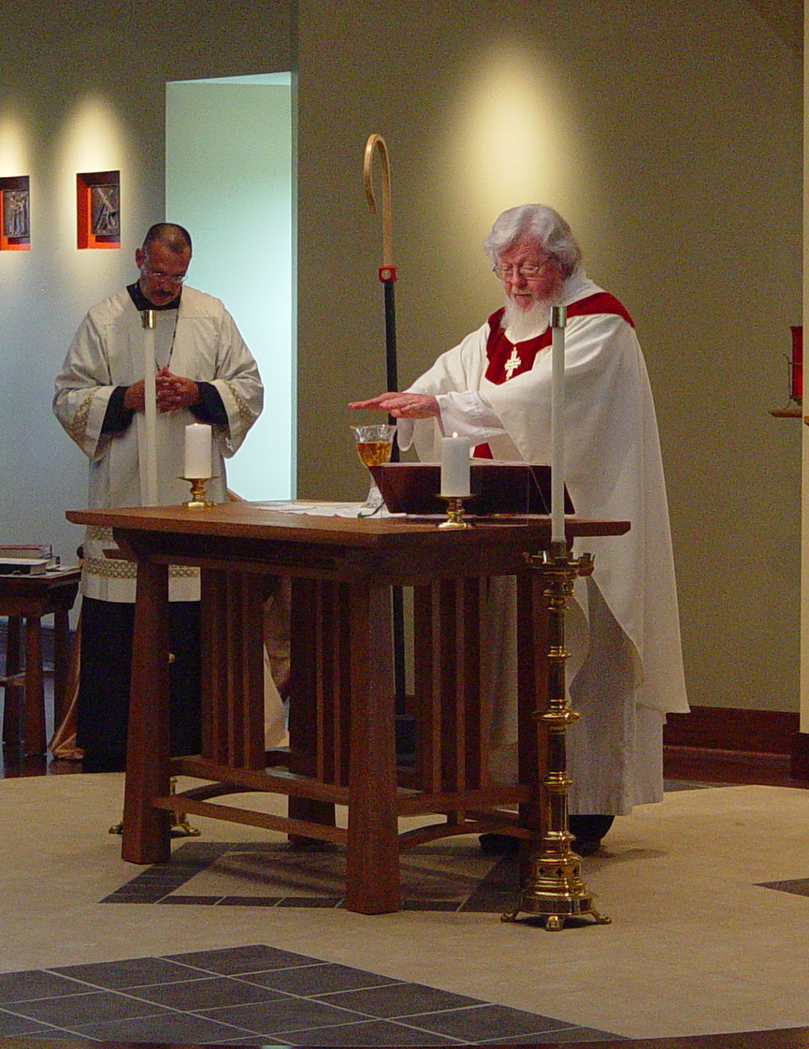
COSL Day 3 (S3) 032 Abbot Michael John Austin; Fr. Wayne Kamm

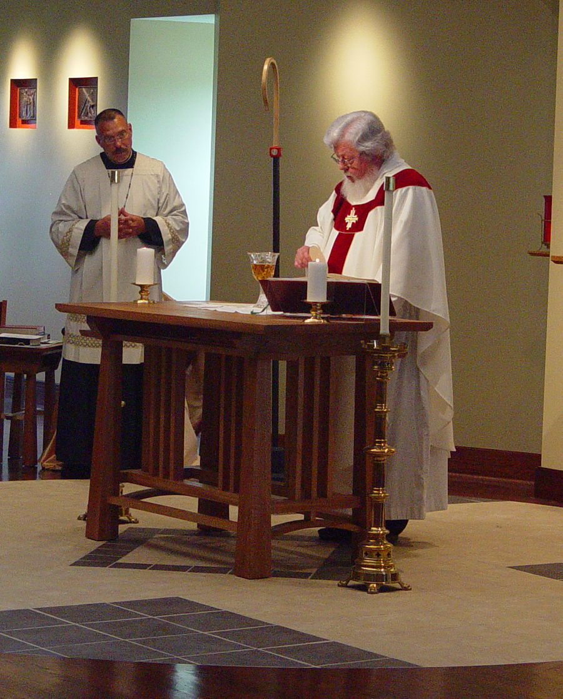
COSL Day 3 (S3) 033 Abbot Michael John Austin; Fr. Wayne Kamm
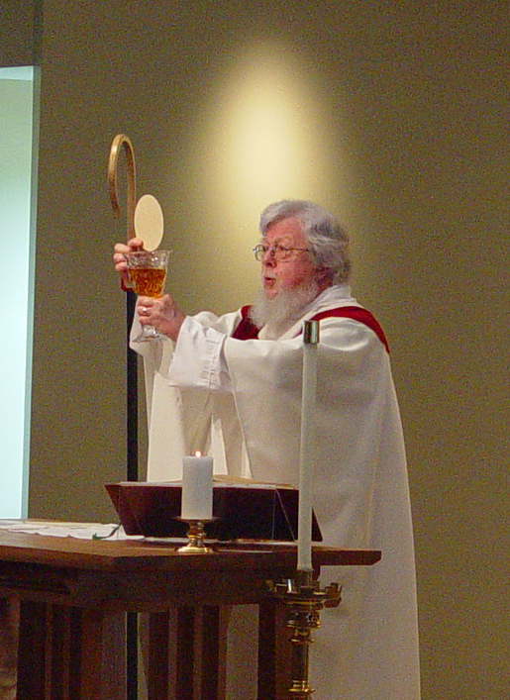
COSL Day 3 (S3) 034 Fr. Wayne Kamm
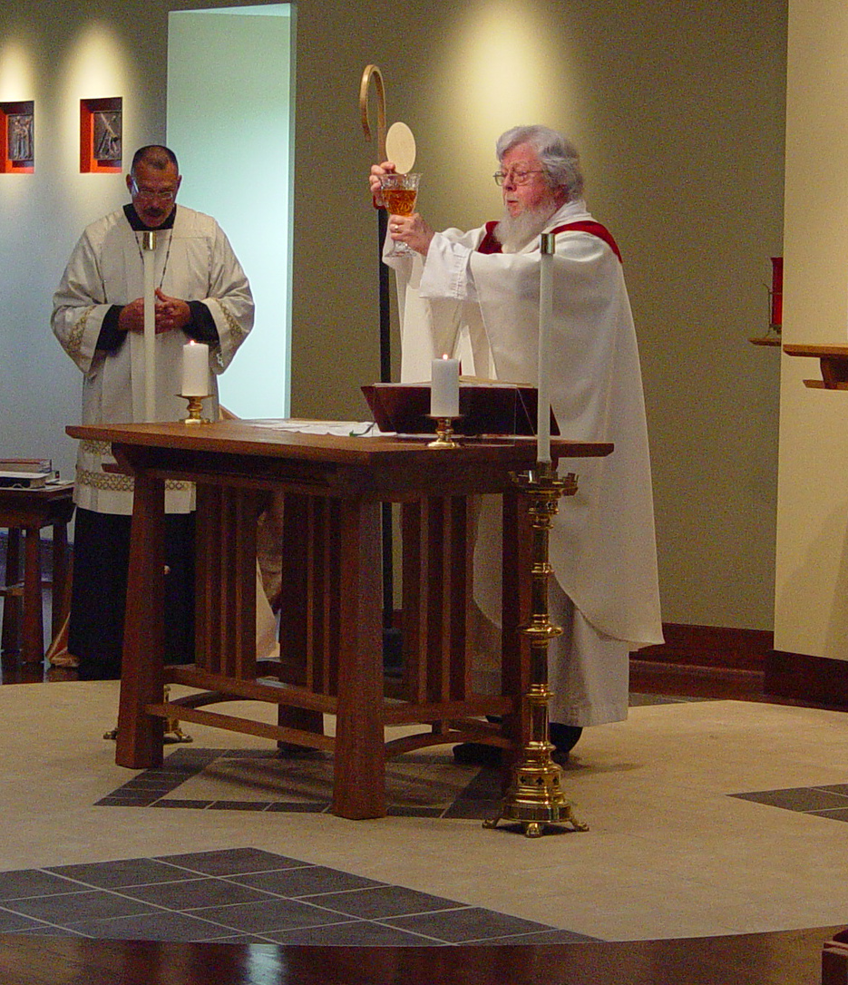
COSL Day 3 (S3) 035 Abbot Michael John Austin; Fr. Wayne Kamm

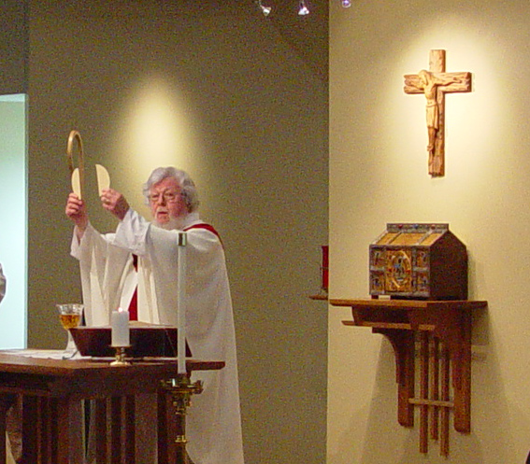
COSL Day 3 (S3) 036 Fr. Wayne Kamm

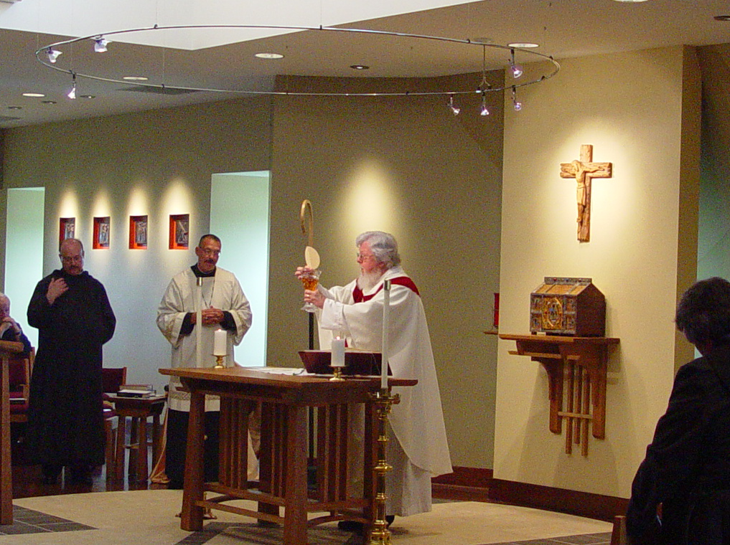
COSL Day 3 (S3) 037 Br. Raymond Owens; Abbot Michael John Austin; Fr. Wayne Kamm; Sr. Vincent Marie Rittenhouse
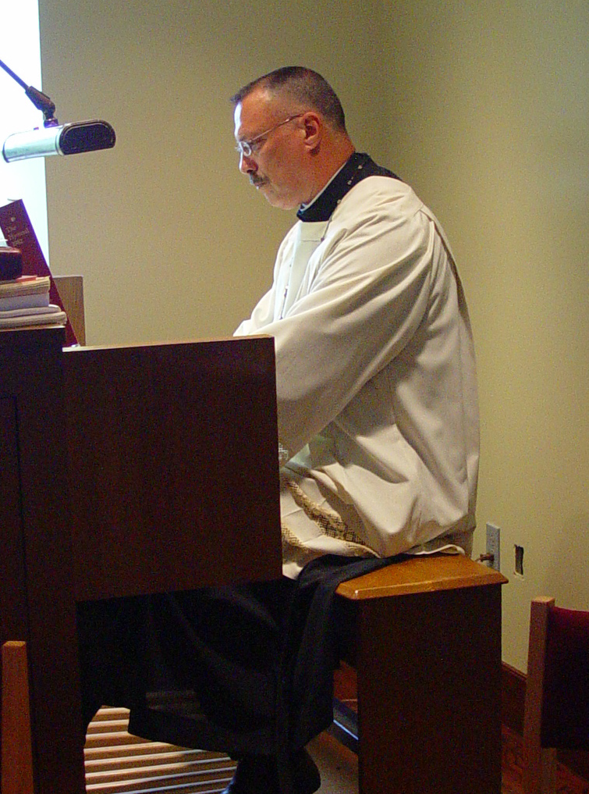
COSL Day 3 (S3) 038 Abbot Michael John Austin
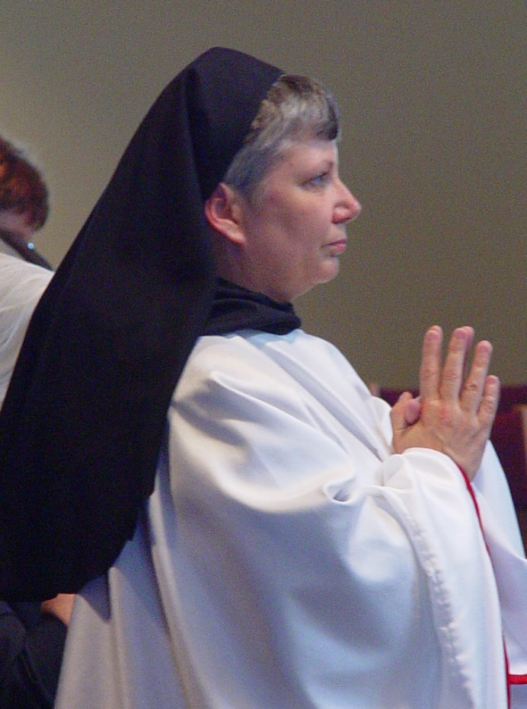
COSL Day 3 (S3) 039 Sr. Anna Grace Madden

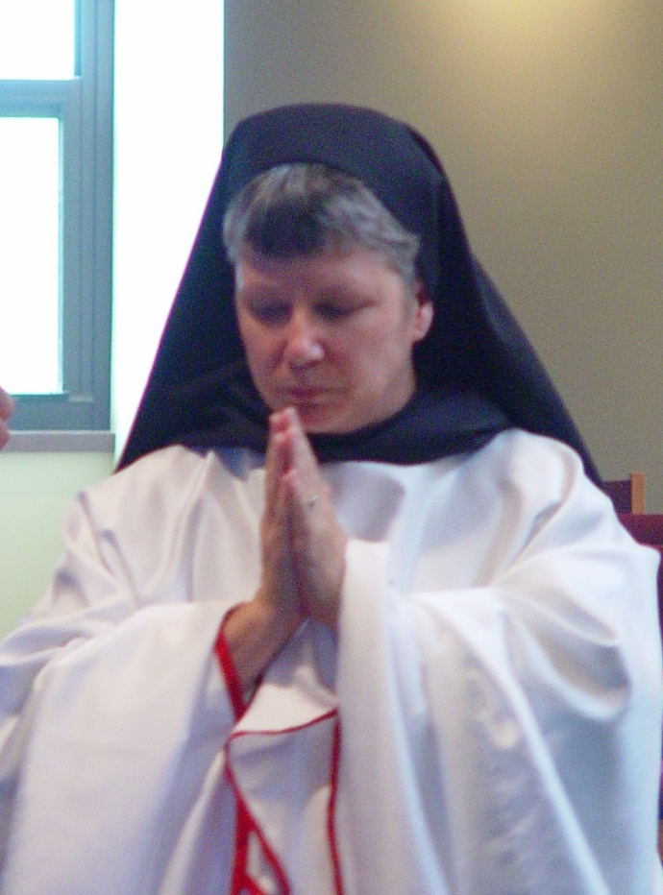
COSL Day 3 (S3) 040 Sr. Anna Grace Madden
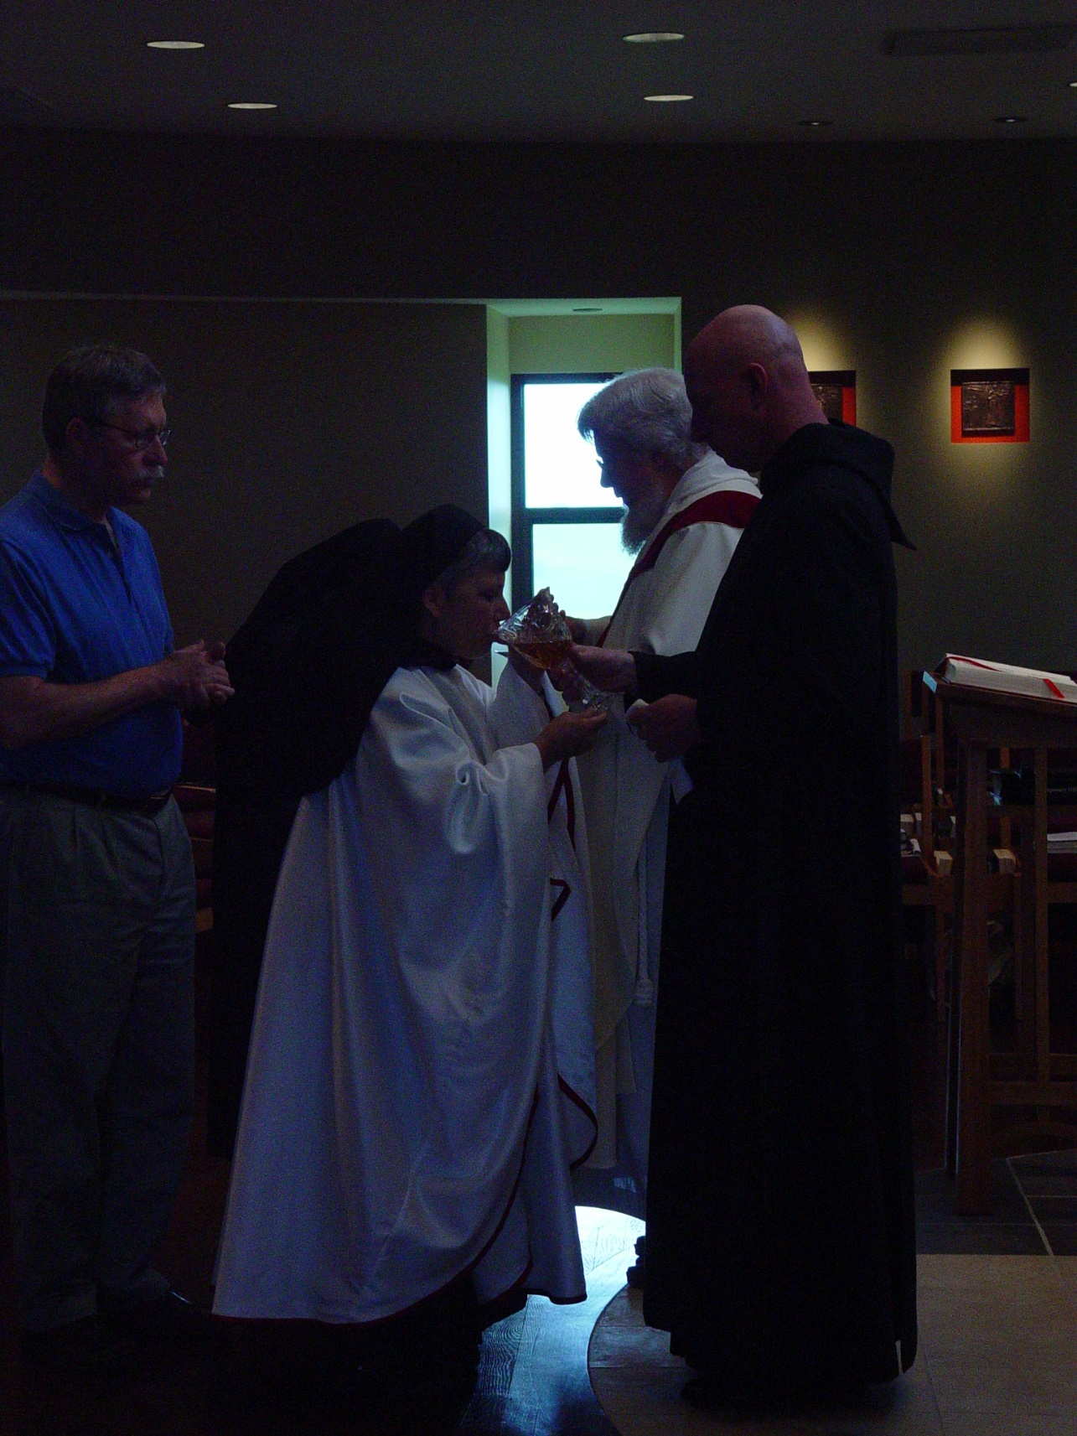
COSL Day 3 (S3) 041 Fr. Mel Schlacter; Sr. Anna Grace Madden; Fr. Wayne Kamm; Br. David Vincent Cotton

