Companions of St. Luke
Spring 2006 Convocation at Conception Abbey
Day 3, Part 3 of 4

~Edited by Br. Steven Olderr, 2 June 2022 with the assistance of Br. Thomas Ferrell. If you find any errors or omissions or have anything to add, please notify Br. Steven at olderr@ameritech.net

People are identified from left to right.

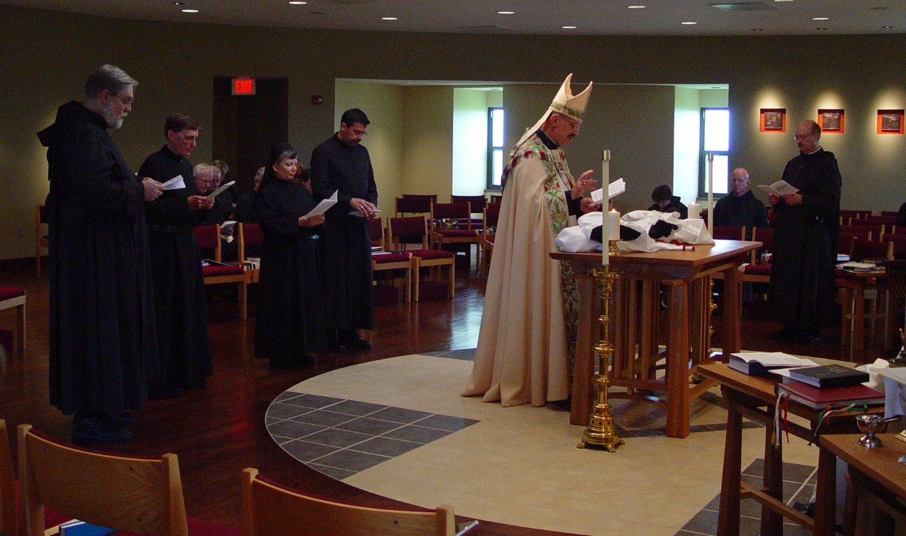
COSL Day 3 (S2) 063 Br. Chad Anselm Gerns; Br. Camillus Converse; Br. Luke Doucette; Br. Daniel Joseph Schroeder; Sr. Anna Grace Madden; Br. Augustine Colvert; Abbot Michael John Austin; Sr Cecelia Lamoy; Br. David Vincent Cotton; Br. Raymond Owens

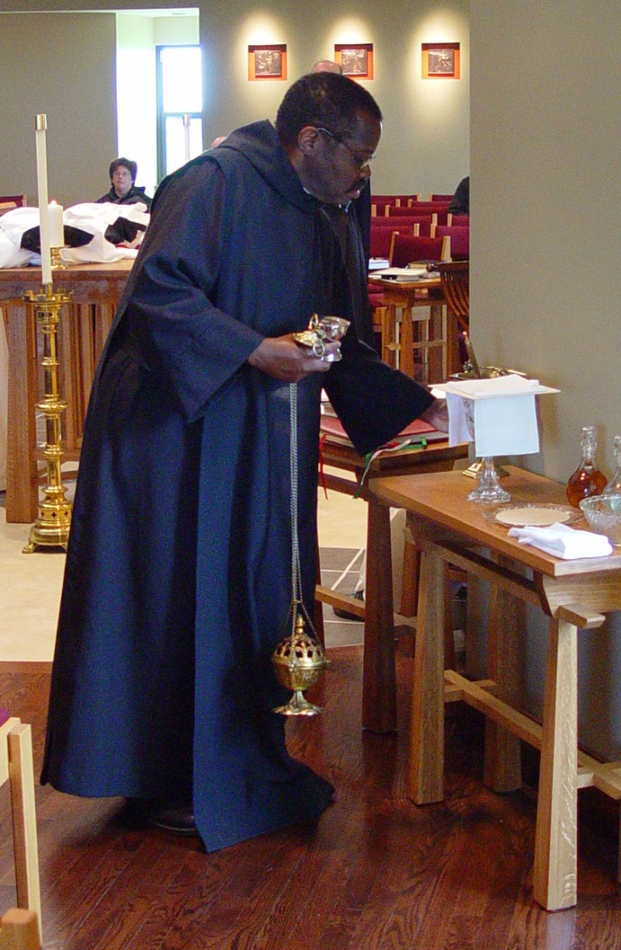
COSL Day 3 (S2) 064 Sr. Cecelia Lamoy; Br. Thomas Ferrell
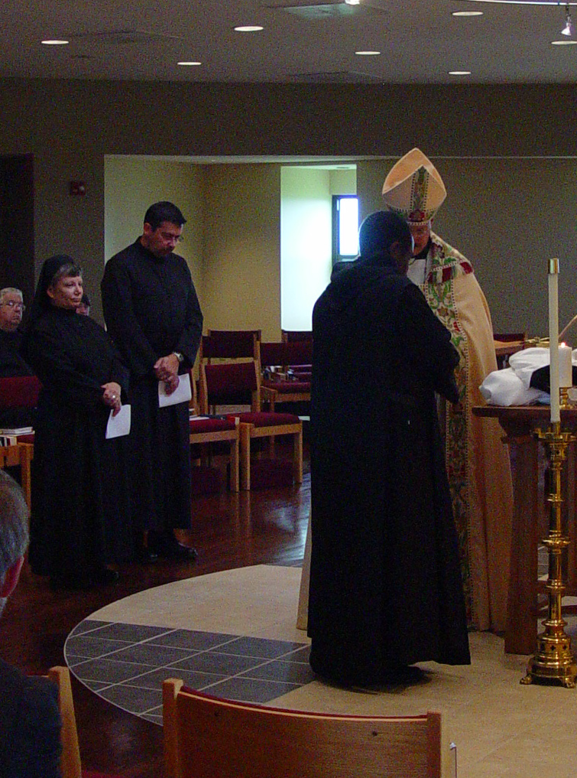
COSL Day 3 (S2) 065 Br. Timothy Titus Lunt; Sr. Anna Grace Madden; Br. Augustine Colvert; Br. Thomas Ferrell; Abbot Michael John Austin
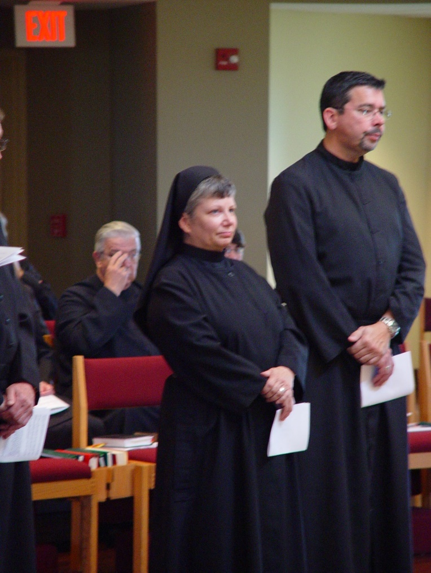
COSL Day 3 (S2) 066 Br. Timothy Titus Lunt; Sr. Anna Grace Madden; Br. Augustine Colvert

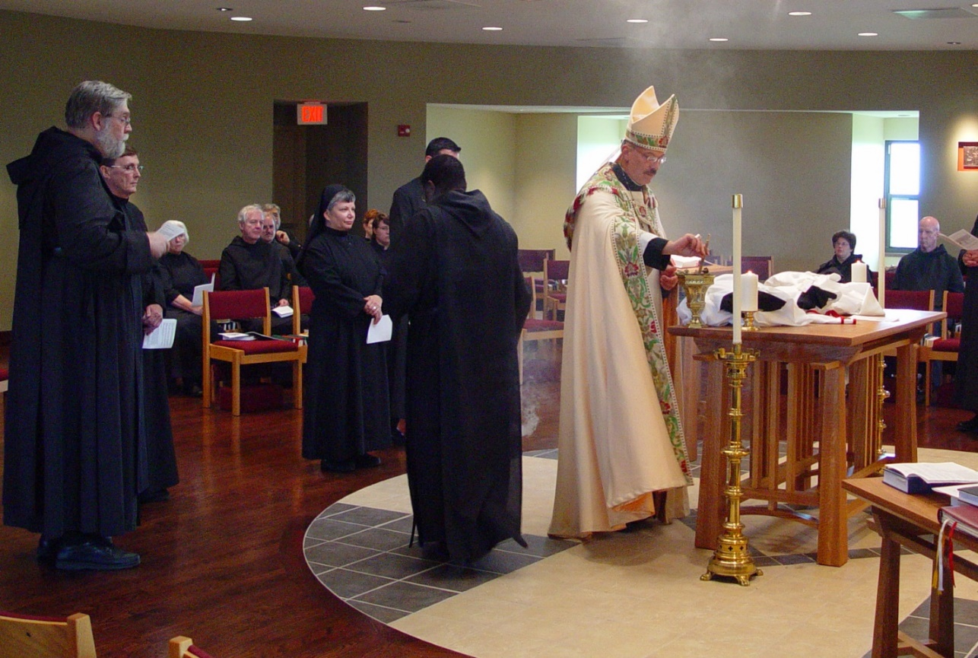
COSL Day 3 (S2) 067 Br. Chad Anselm Gerns; Br. Camillus Converse; Sr. Elizabeth Ann Stribley; Br. Luke Doucette; Br. Daniel Joseph Schroeder; Br. Nathan Gregory Miller; Sr. Anna Grace Madden; Sr. Brigid Gerns; Sr. Pauline Tysol; Sr. Brigid Gerns; Sr. Pauline Tysol; Br. Thomas Ferrell; Br. Augustine Colvert; Abbot Michael John Austin; Sr. Cecelia Lamoy; Br. David Vincent Cotton
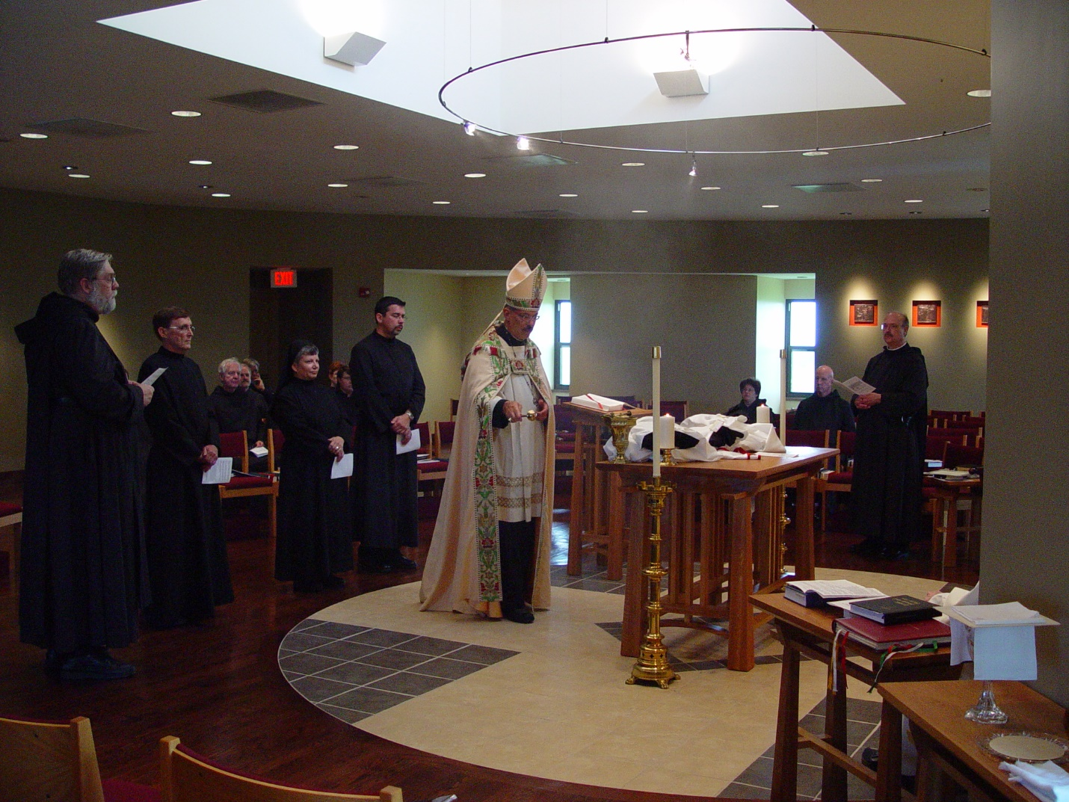
COSL Day 3 (S2) 068 Br. Chad Anselm Gerns; Br. Camillus Converse. Br. Luke Doucette; Daniel Joseph Schroeder; Br. Nathan Gregory Miller; Sr. Anna Grace Madden; Sr. Brigid Gerns; Sr. Pauline Tysol; Br. Augustine Colvert; Abbot Michael John Austin; Sr. Cecelia Lamoy; Br David Vincent Cotton; Br. Raymond Owens
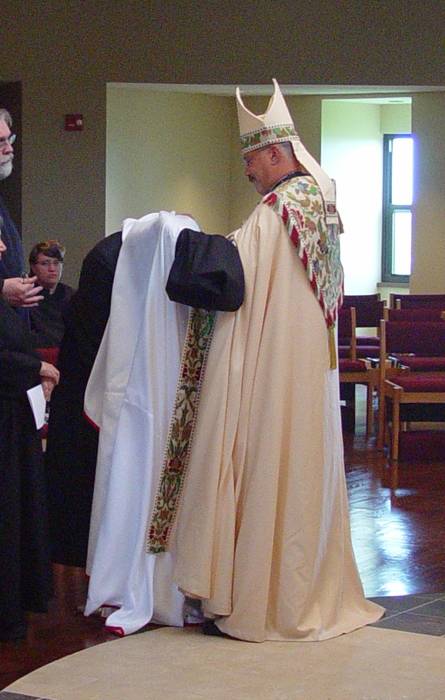
COSL Day 3 (S2) 069 Br. Chad Anselm Gerns; Sr. Pauline Tysol; Br. Augustine Colvert; Abbot Michael John Austin
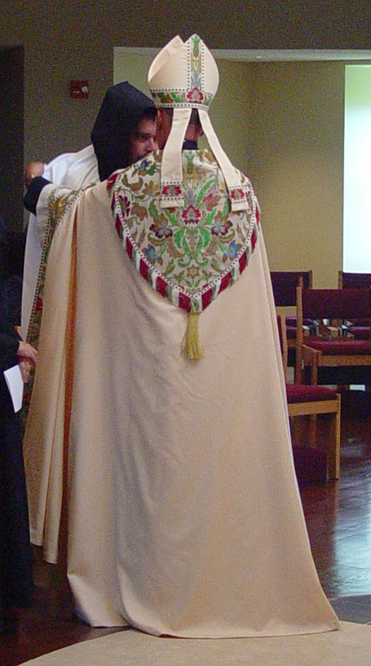
COSL Day 3 (S2) 070 Br. Augustine Colvert; Abbot Michael John Austin

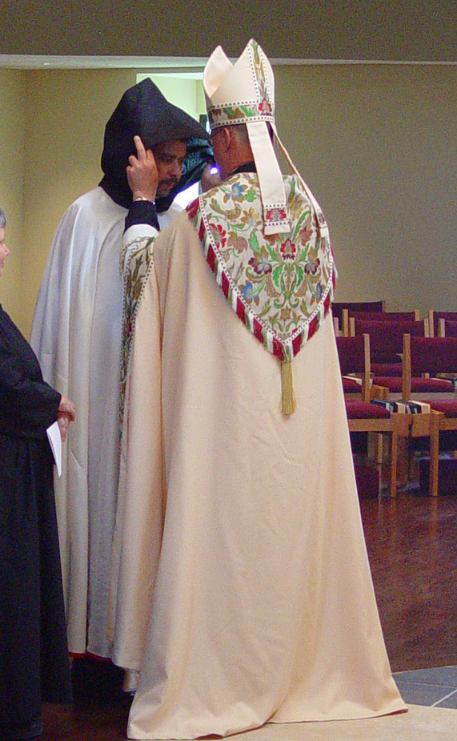
COSL Day 3 (S2) 071 Sr. Anna Grace Madden; Br. Augustine Colvert; Abbot Michael John Austin

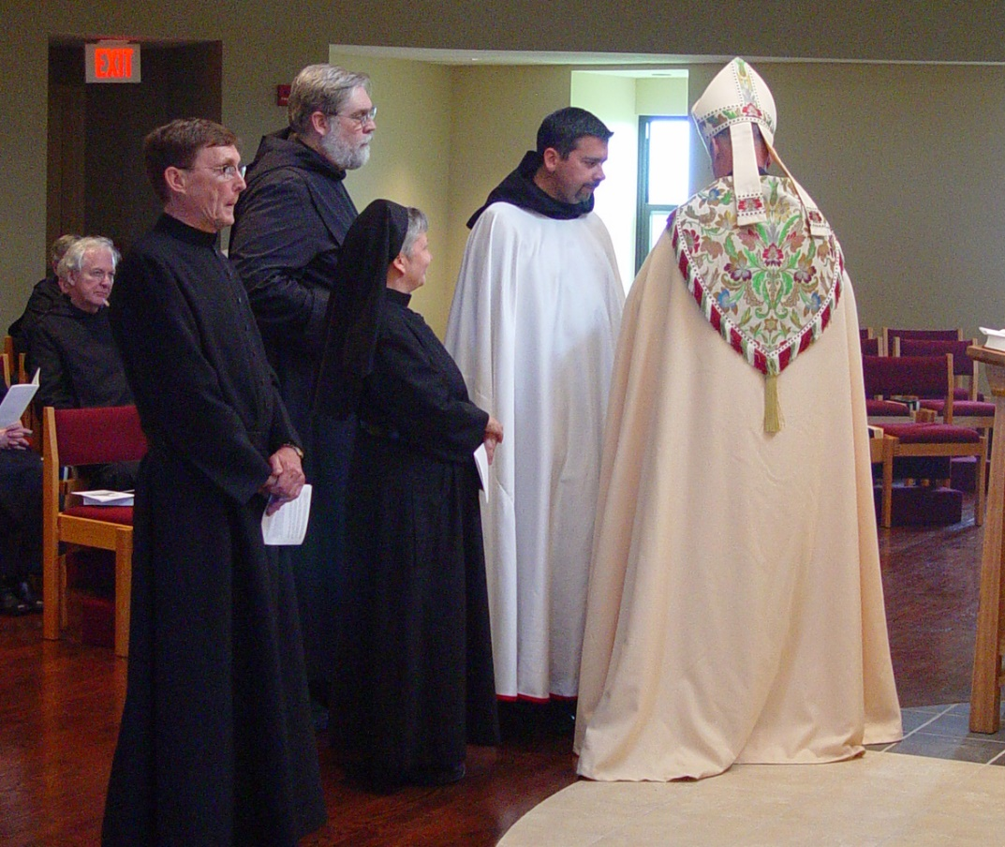
COSL Day 3 (S2) 072 Br. Luke Doucette; Br. Camillus Converse; Br. Chad Anselm Gerns; Sr. Anna Grace Madden; Br. Augustine Colvert; Abbot Michael John Austin
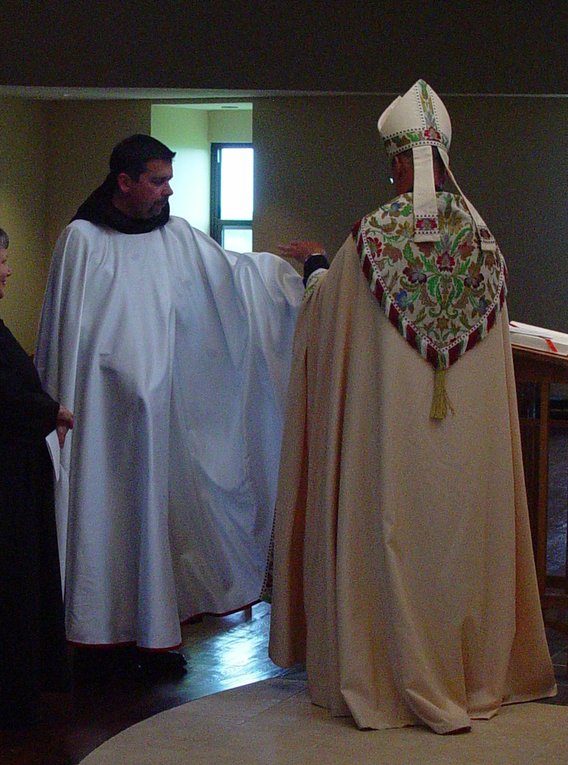
COSL Day 3 (S2) 073 Sr. Anna Grace Madden; Br. Augustine Colvert; Abbot Michael John Austin

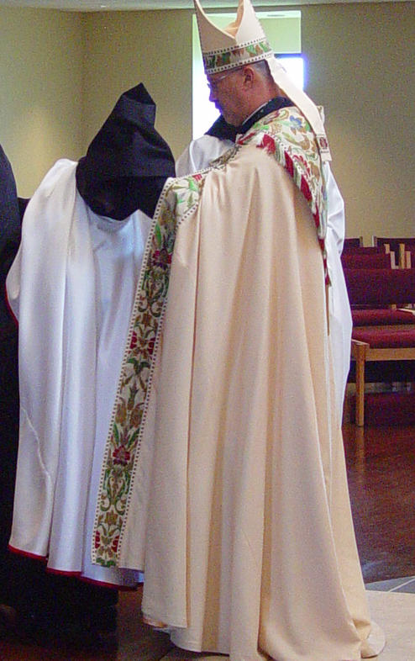
COSL Day 3 (S2) 074 Sr. Anna Grace Madden; Abbot Michael John Austin

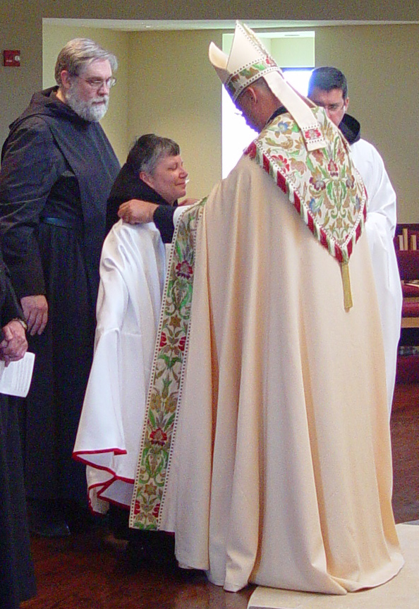
COSL Day 3 (S2) 075 Br. Chad Anselm Gerns; Sr. Anna Grace Madden; Abbot Michael John Austin; Br. Augustine Colvert
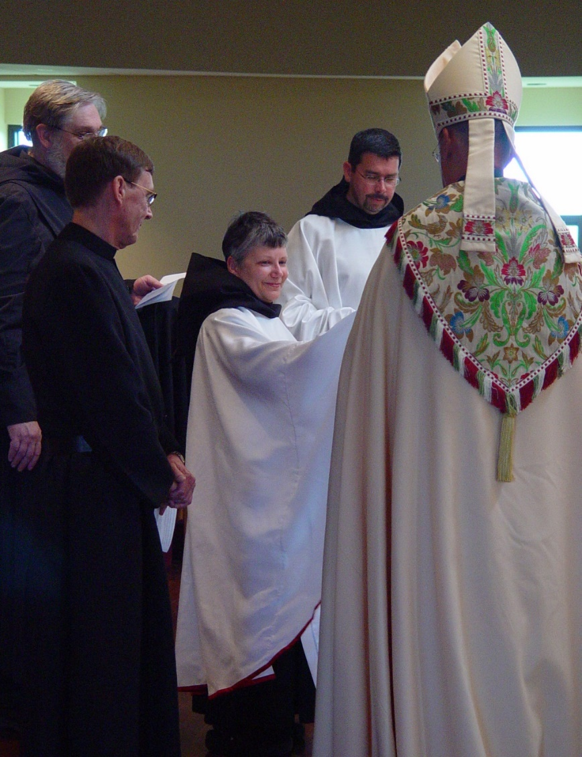
COSL Day 3 (S2) 076 Br. Chad Anselm Gerns; Br. Camillus Converse; Sr. Anna Grace Madden; ; Br. Augustine Colvert; Abbot Michael John Austin
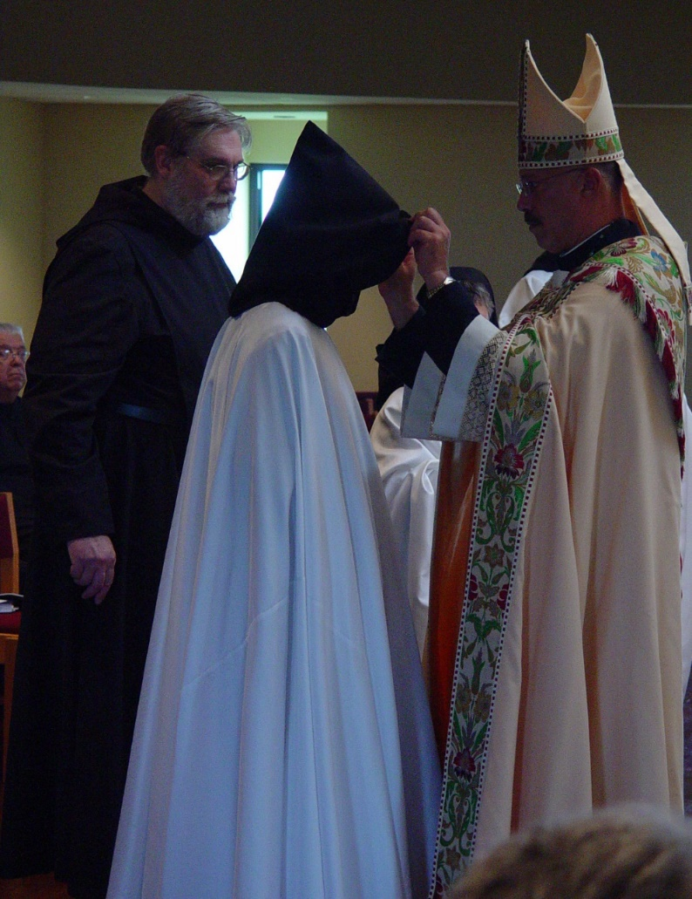
COSL Day 3 (S2) 077 Br. Timothy Titus Lunt; Br. Chad Anselm Gerns; Br. Camillus Converse; Sr, Anna Grace Madden; Abbot Michael John Austin
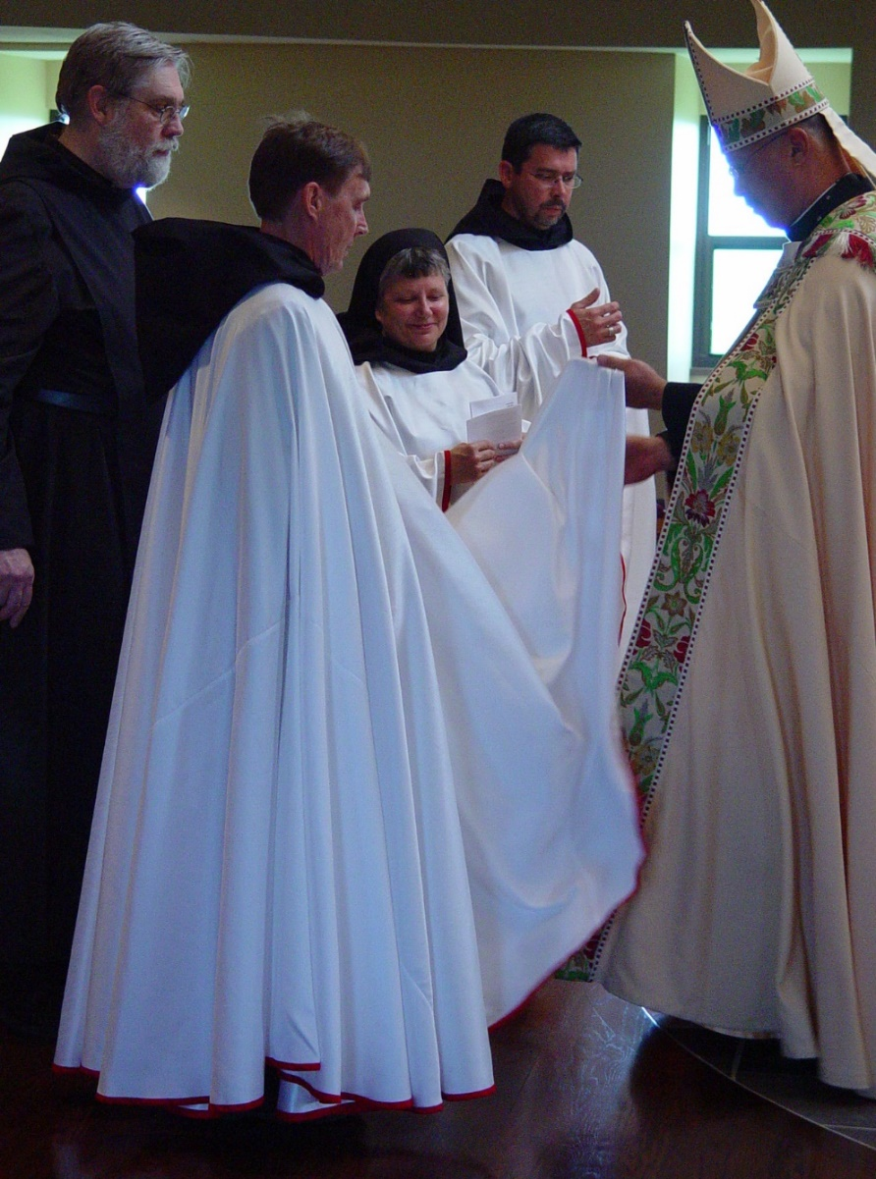
COSL Day 3 (S2) 078 Br. Chad Anselm Gerns; Br. Camillus Converse; Sr. Anna Grace Madden; Br. Augustine Colvert; Abbot Michael John Austin
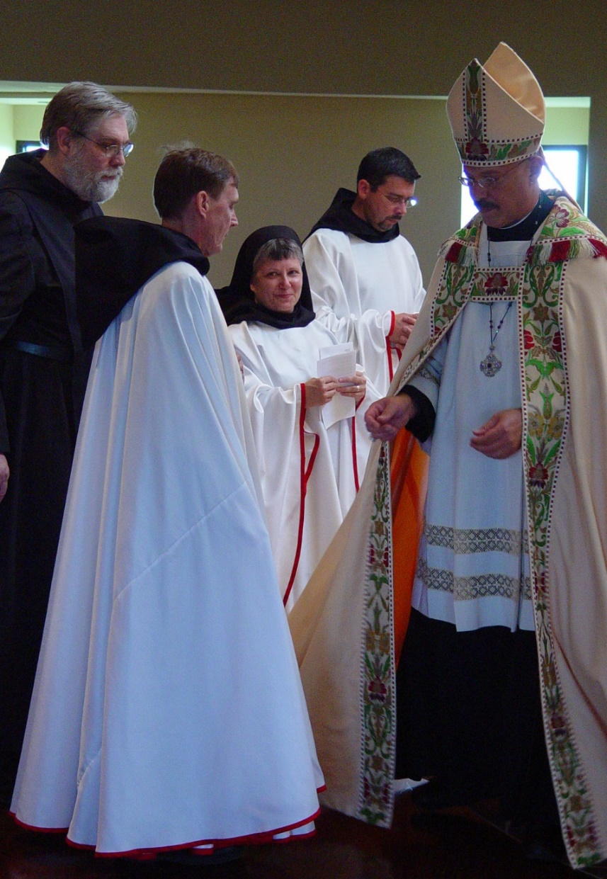
COSL Day 3 (S2) 079 Br. Chad Anselm Gerns; Br. Camillus Converse; Sr. Anna Grace Madden; Br. Augustine Colvert; Abbot Michael John Austin

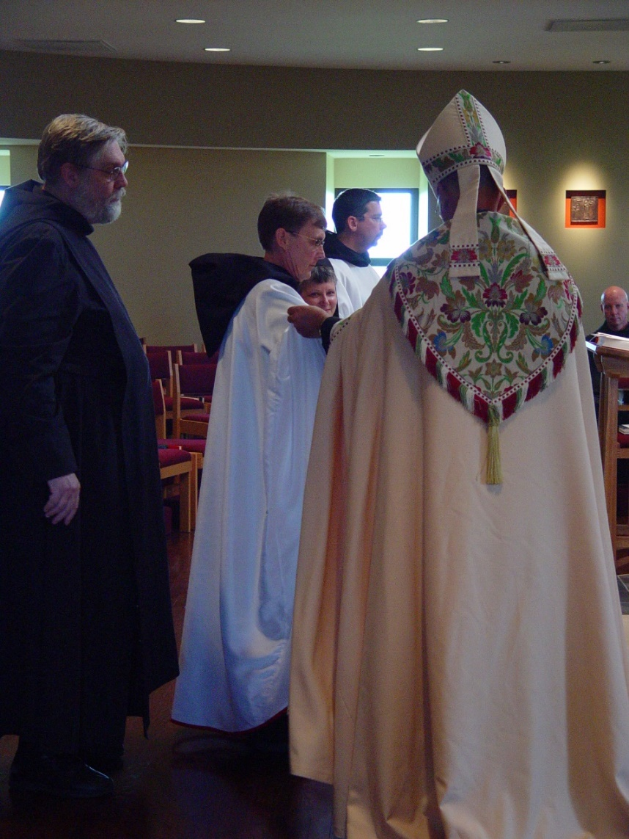
COSL Day 3 (S2) 080 Br. Chad Anselm Gerns; Br. Camillus Converse; Sr. Anna Grace Madden; Br. Augustine Colvert; Abbot Michael John Austin; Br. David Vincent Cotton

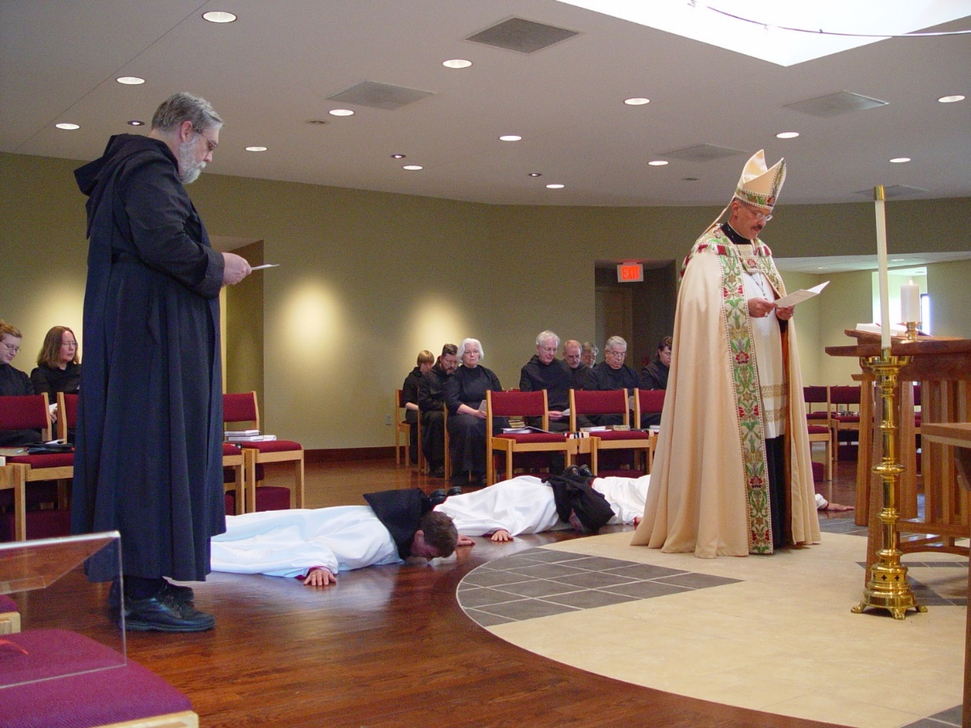
COSL Day 3 (S2) 081 Sr. Hannah Sophia Wolsleben; Sr. Teresa Bebee; Br. Chad Anselm Gerns; Br. Camillus Converse; Sr. Catherine Unterseher; Br. Paul Howard; Sr. Elizabeth Ann Stribley; Br Luke Doucette; Sr Anna Grace Madden; Br. Daniel Joseph Schroeder; Br. Nathan Gregory Miller; Br. Timothy Titus Lunt; Sr. Pauline Tysol; Abbot Michael John Austin; Br. Augustine Colvert

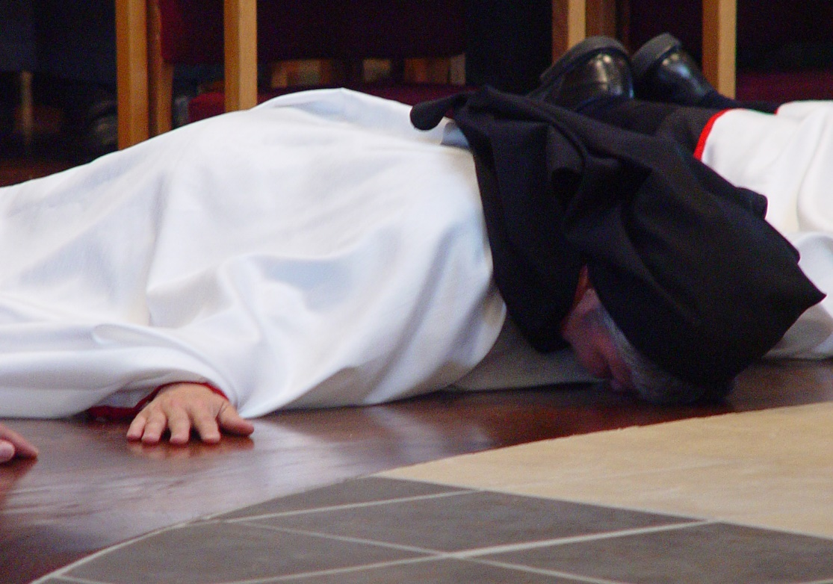
COSL Day 3 (S2) 082 Sr. Anna Grace Madden

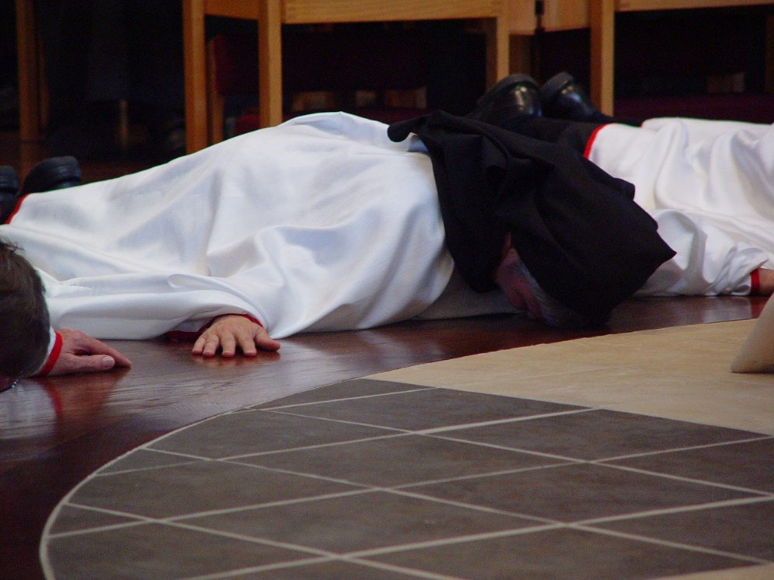
COSL Day 3 (S2) 083 Sr. Anna Grace Madden

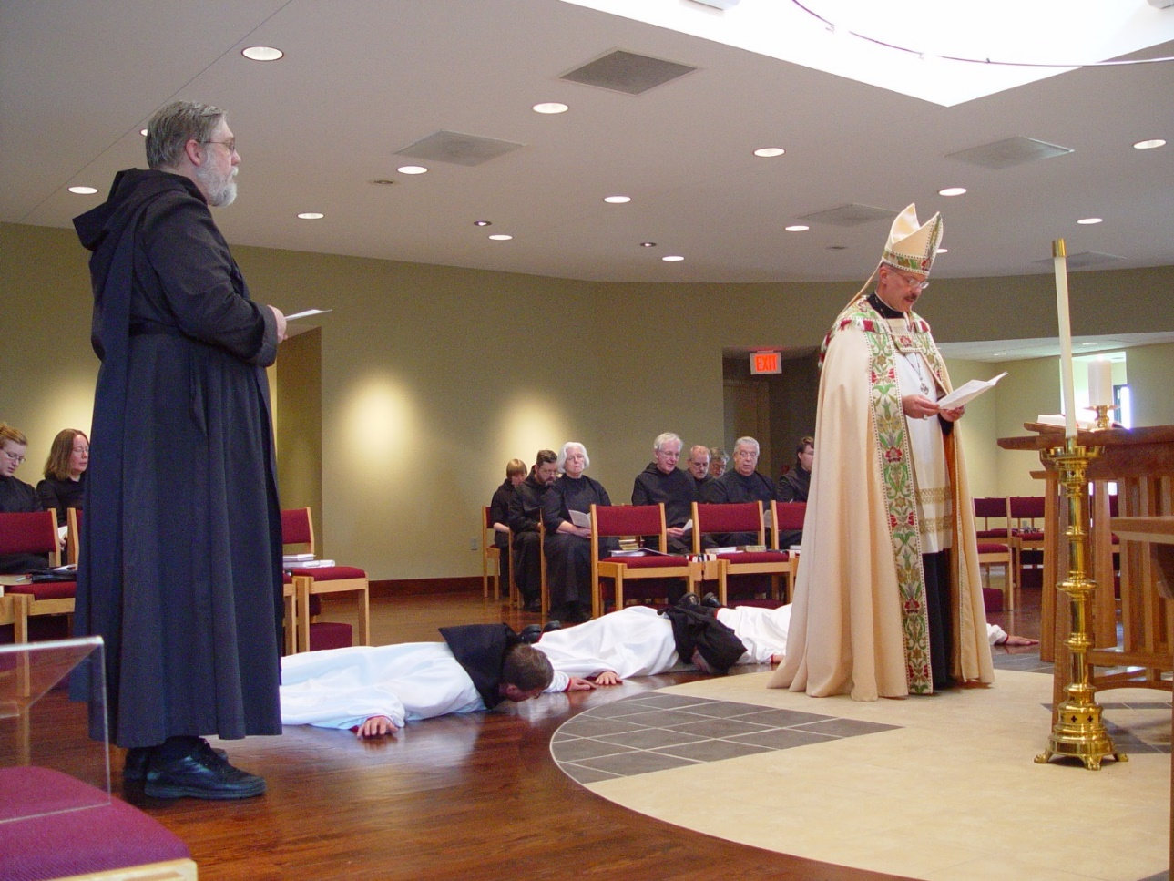
COSL Day 3 (S2) 084 Sr. Hannah Sophia Wolsleben; Sr. Teresa Bebee; Br. Chad Anselm Gerns; Br. Camillus Converse; Sr. Catherine Unterseher; Br. Paul Howard; Sr. Elizabeth Ann Stribley; Br Luke Doucette; Sr Anna Grace Madden; Br. Daniel Joseph Schroeder; Br. Nathan Gregory Miller; Br. Timothy Titus Lunt; Sr. Pauline Tysol; Abbot Michael John Austin; Br. Augustine Colvert

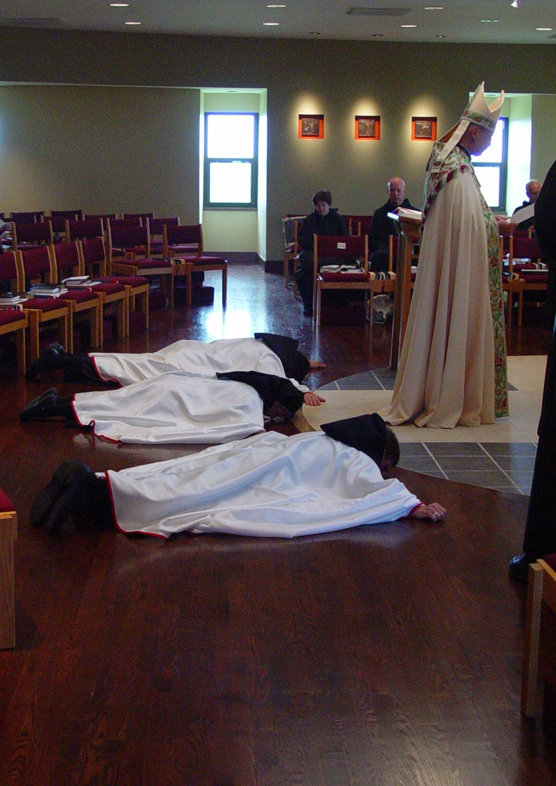
COSL Day 3 (S2) 085 Br. Camillus Converse; Sr. Anna Grace Madden; Br. Augustine Colvert; Sr. Cecelia Lamoy; Br. David Vincent Cotton; Abbot Michael John Austin

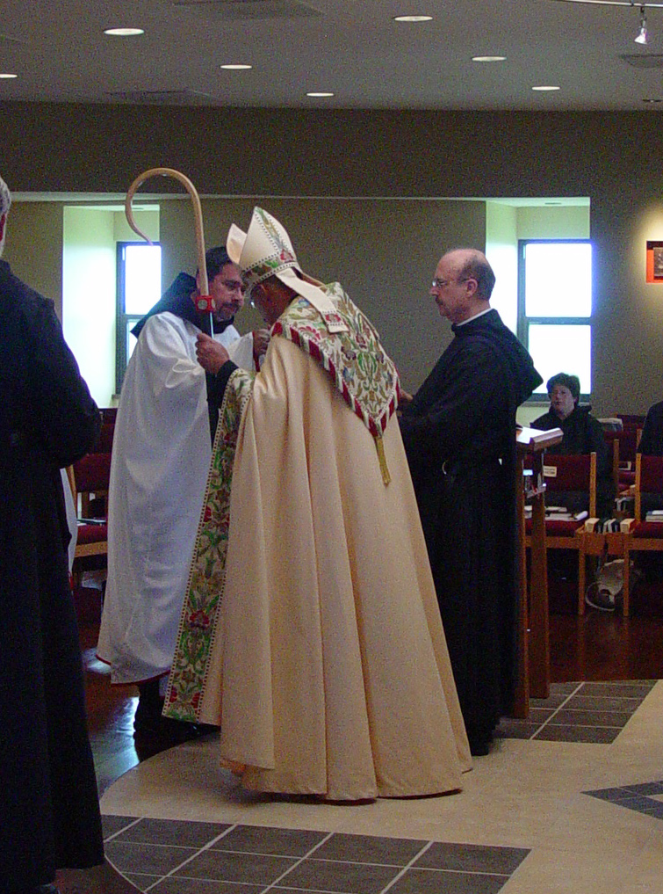
COSL Day 3 (S3) 001 Br. Chad Anselm Gerns; Br. Augustine Colvert; Abbot Michael John Austin; Br. Raymond Owens; Sr. Cecelia Lamoy
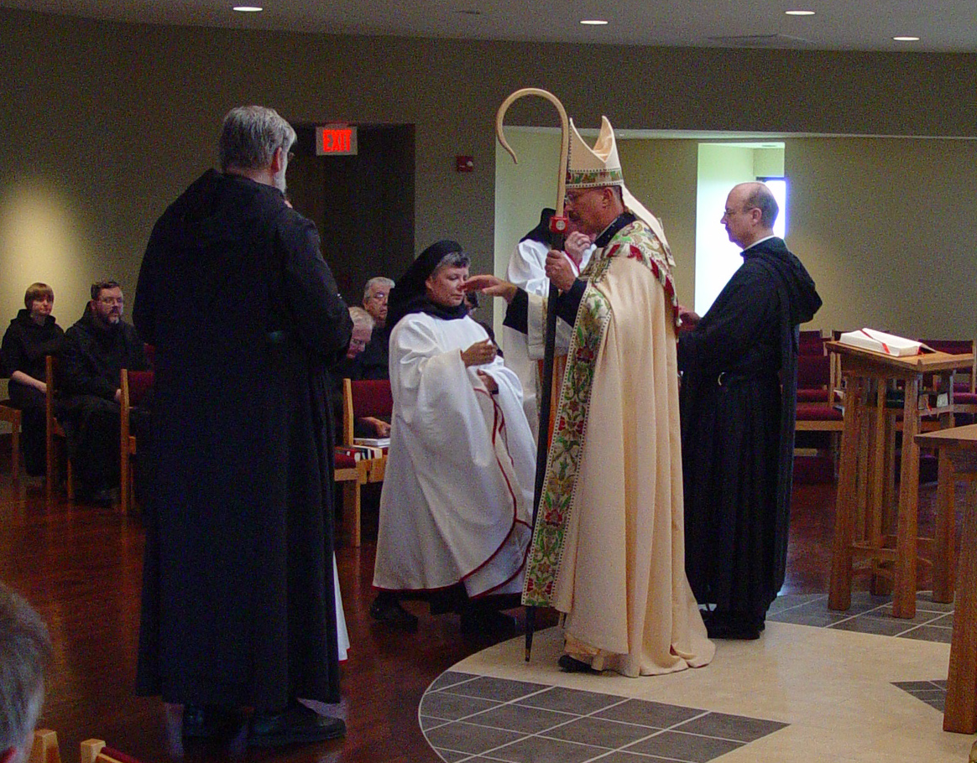
COSL Day 3 (S3) 002 Sr. Catherine Unterseher; Br. Paul Howard; Br. Chad Anselm Gerns; Br. Luke Doucette; Br. Timothy Titus Lunt; Sr. Anna Grace Madden; Br. Augustine Colvert; Abbot Michael John Austin; Br. Raymond Owens
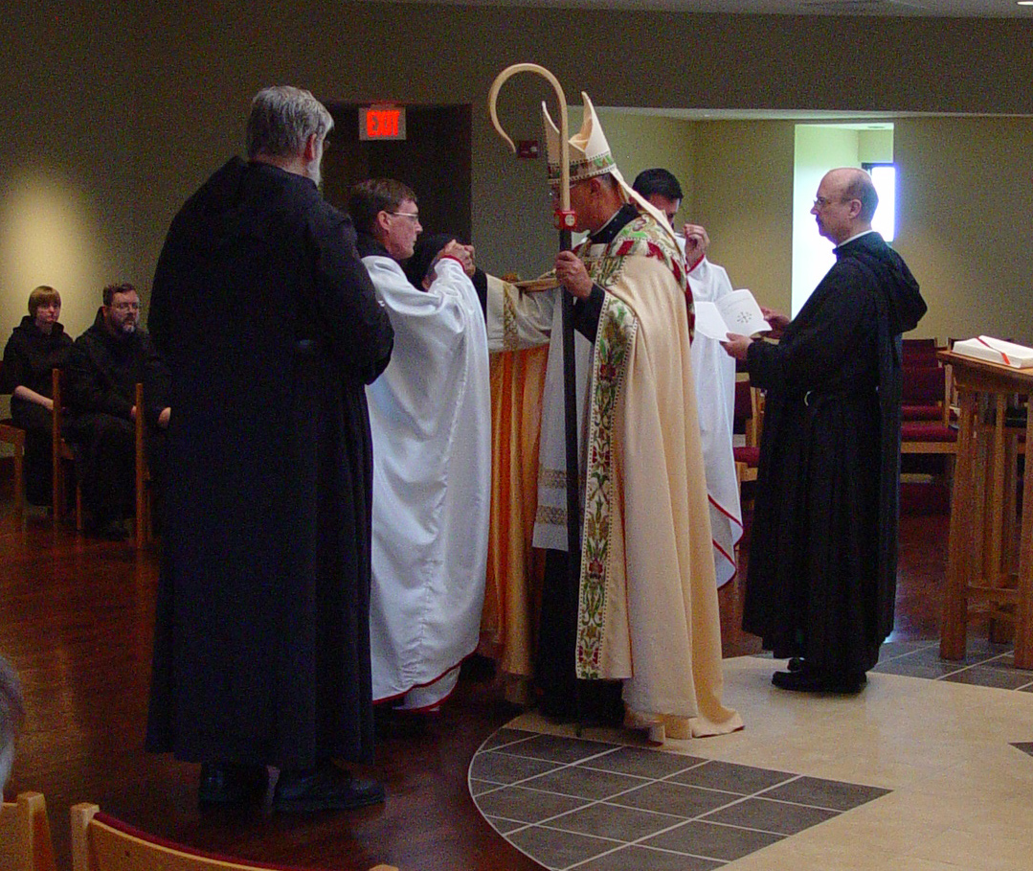
COSL Day 3 (S3) 003 Sr. Catherine Unterseher; Br. Paul Howard; Br. Chad Anselm Gerns; Br. Camillus Converse; Abbot Michael John Austin; Br. Augustine Colvert; Br. Raymond Owens

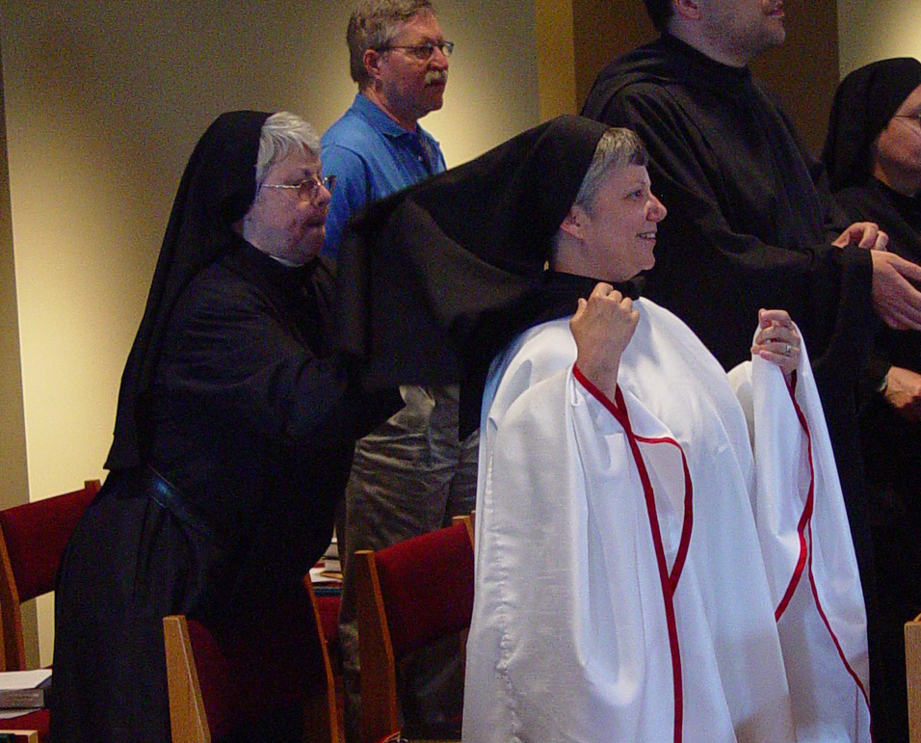
COSL Day 3 (S3) 004 Sr. Clare Benedicta Myers; Fr. Mel Schlacter; Sr. Anna Grace Madden; Br. Anthony Bernard Campos; St. Theodora of Jesus Perecca
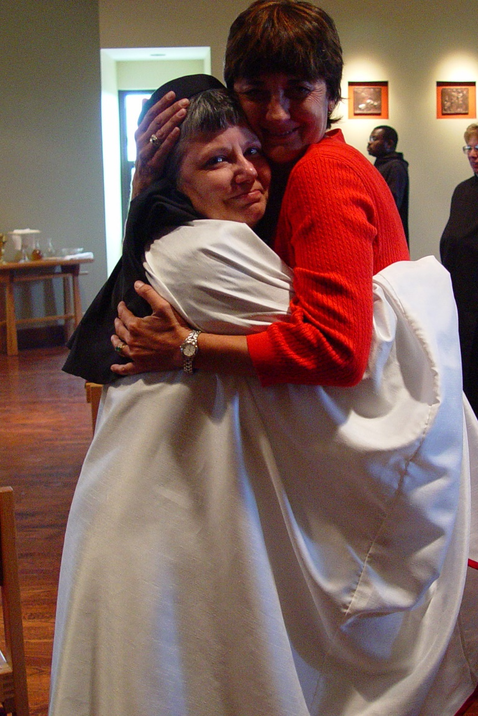
COSL Day 3 (S3) 005 Sr. Anna Grace Madden; Deana Flak

