Companions of St. Luke
Spring 2006 Convocation at Conception Abbey
Day 3, Part 2 of 4

~Edited by Br. Steven Olderr, 6 June 2022 with the assistance of Br. Thomas Ferrell. If you find any errors or omissions or have anything to add, please notify Br. Steven at olderr@ameritech.net

People are identified from left to right.

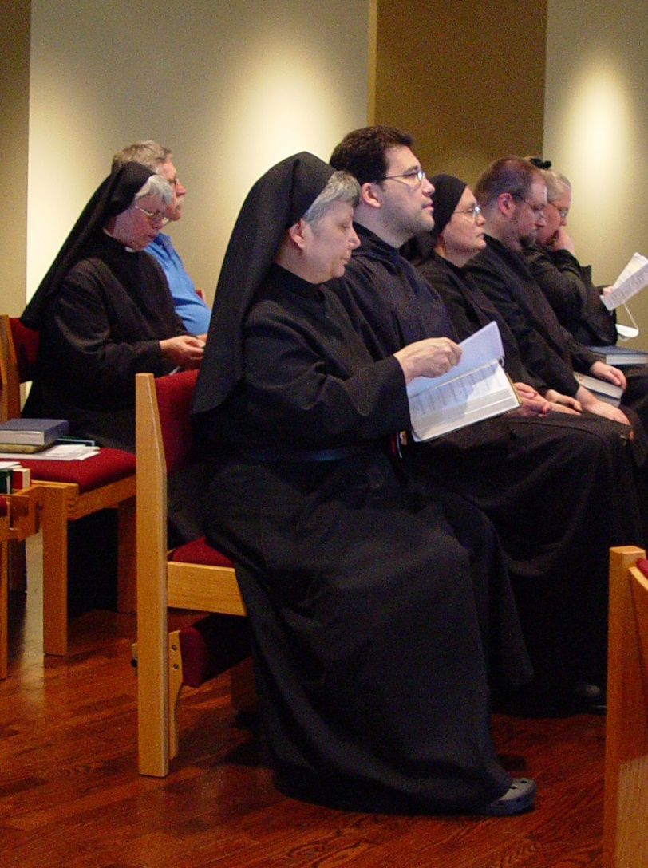
COSL Day 3 (S2) 001 Sr. Clare Benedicta Myers; Br. Anthony Bernard Campos; Sr. Theodora of Jesus Perecca; Br. Willard Moore; Sr. Margaret Moore; Fr. Mel Schlacter; Sr. Anna Grace Madden

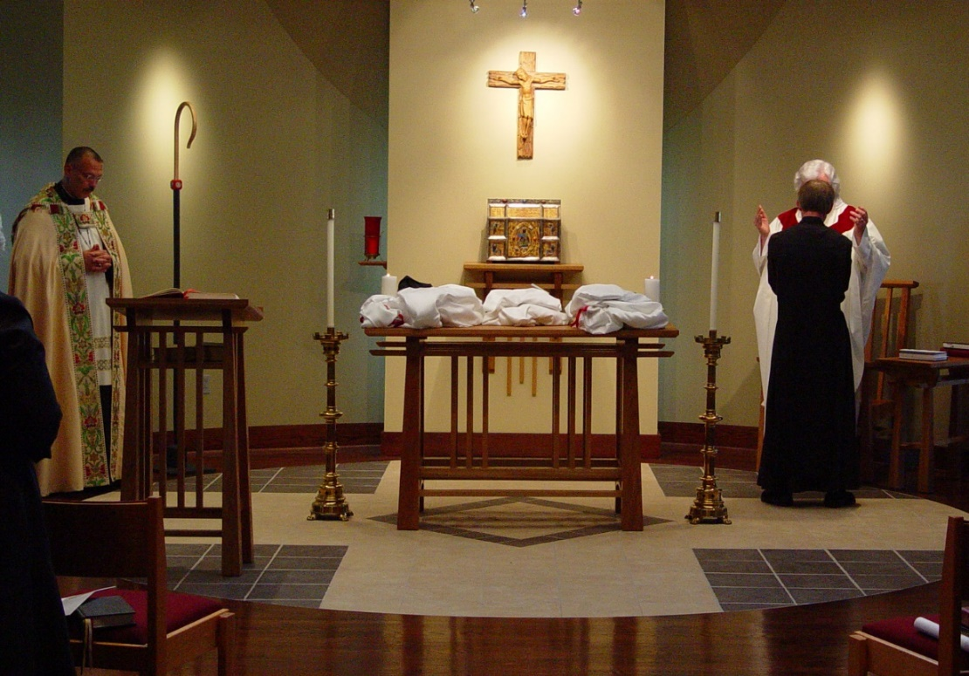
COSL Day 3 (S2) 004 Abbot Michael John Austin; Br. Lawrence Mullen; Fr. Wayne Kamm

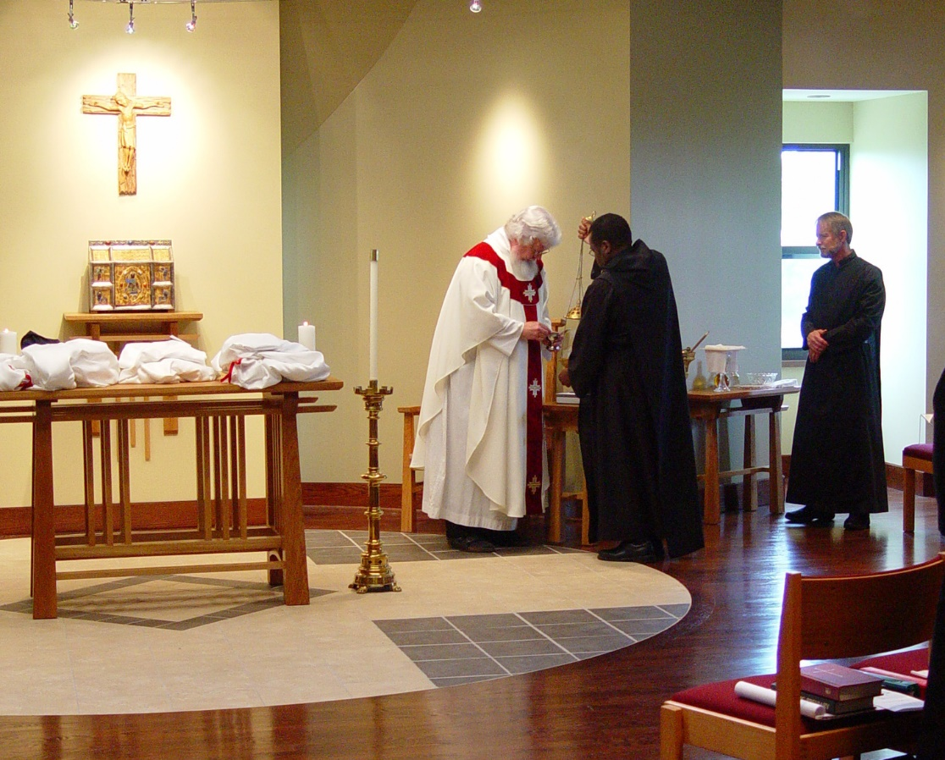
COSL Day 3 (S2) 005 Fr. Wayne Kamm; Br. Thomas Ferrell; Br. Lawrence Mullen
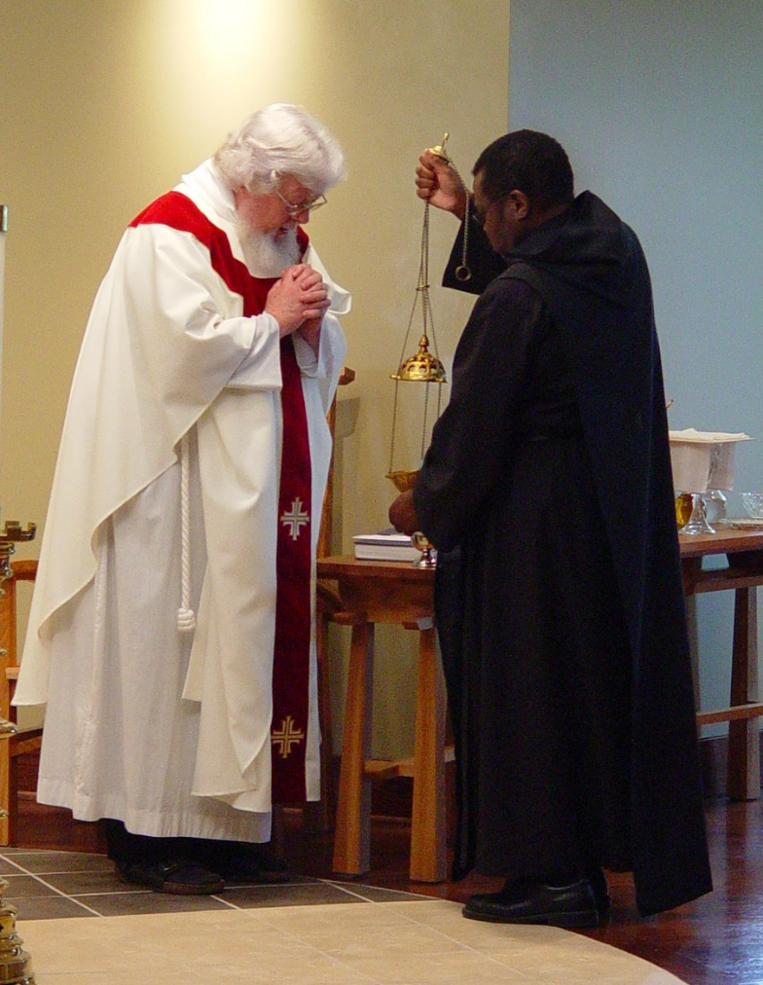
COSL Day 3 (S2) 006 Fr. Wayne Kamm; Br. Thomas Ferrell

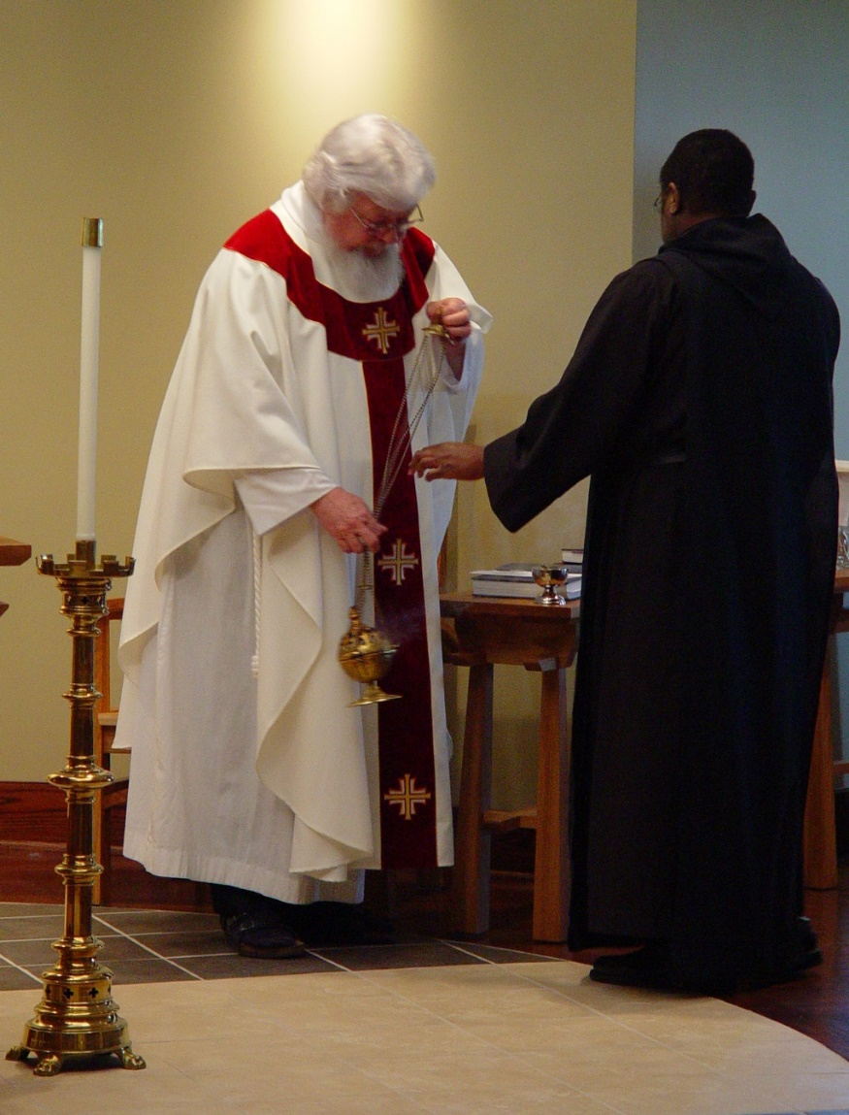
COSL Day 3 (S2) 007 Fr. Wayne Kamm; Br. Thomas Ferrell

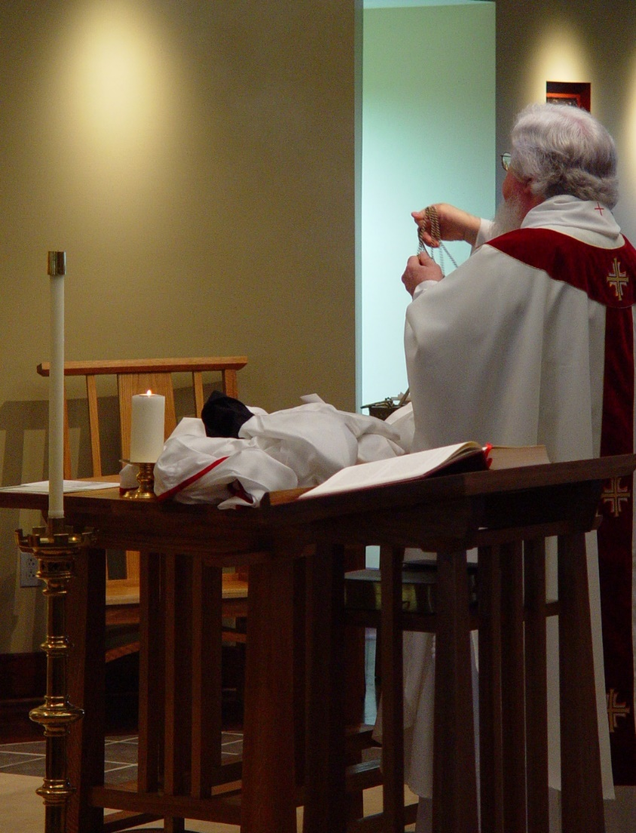
COSL Day 3 (S2) 008 Fr. Wayne Kamm
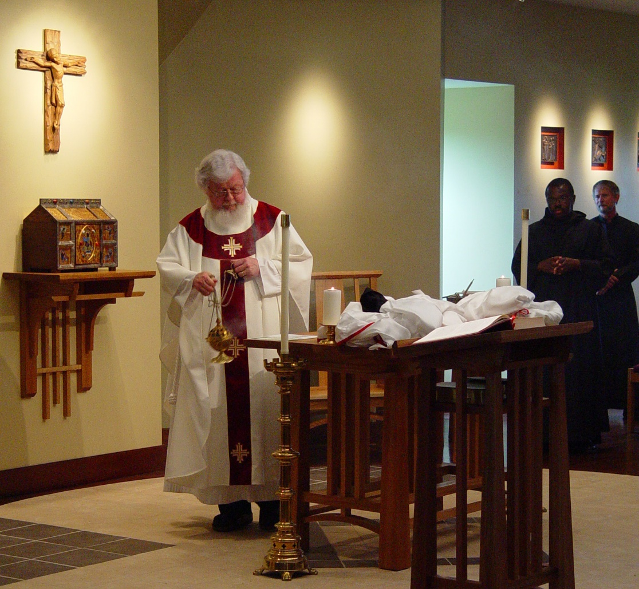
COSL Day 3 (S2) 009 Fr. Wayne Kamm; Br. Thomas Ferrell; Br. Lawrence Mullen
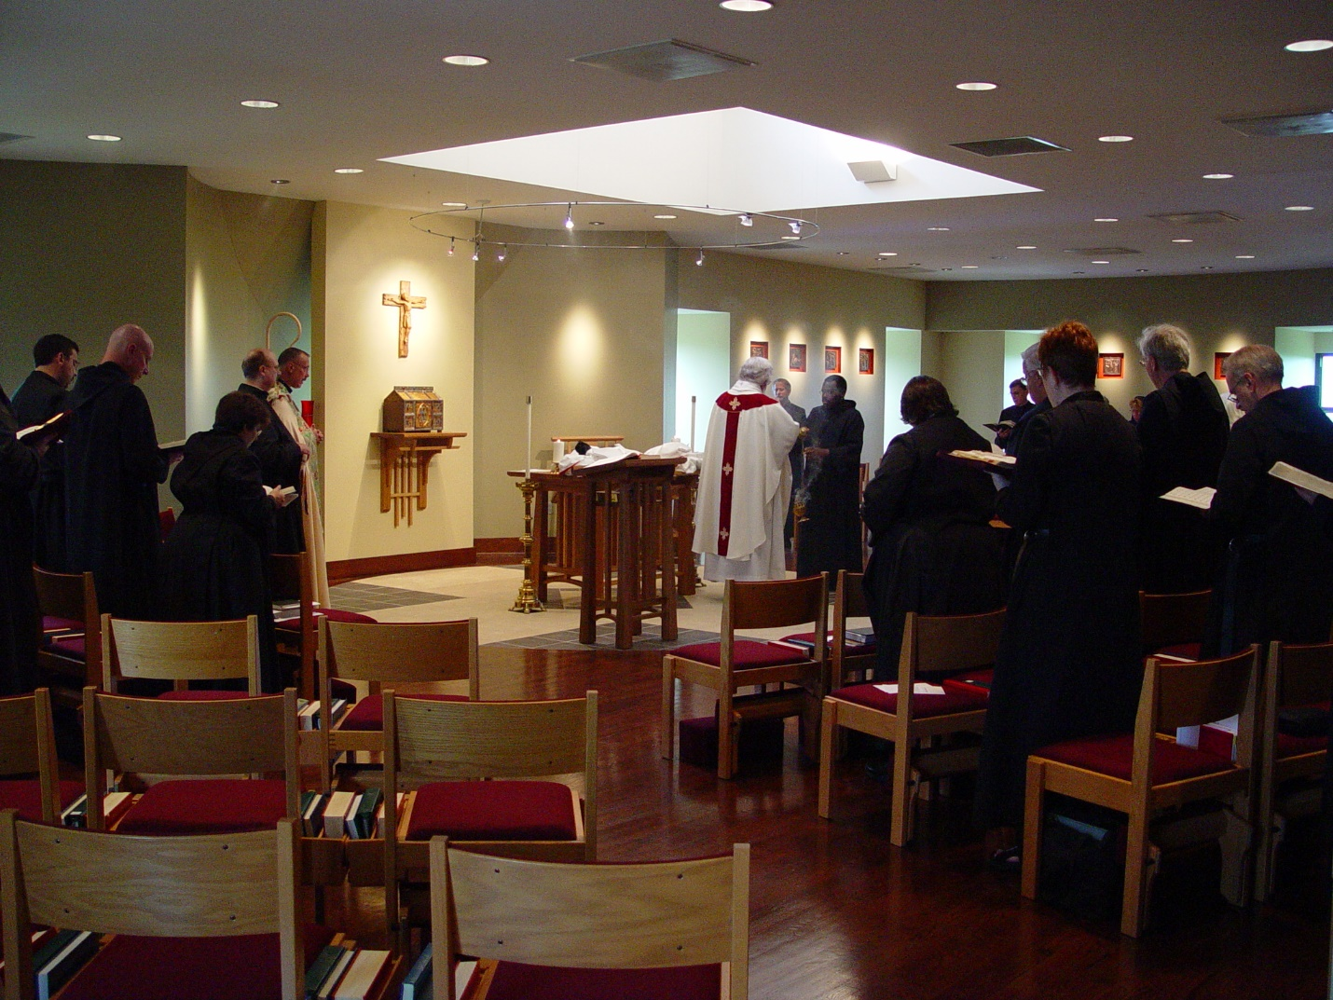
COSL Day 3 (S2) 010 Br. Augustine Colvert; Br. David Vincent Cotton; Sr. Martha Lamoy; Br. Raymond Owens; Abbot Michael John Austin; Fr. Wayne Kamm; Br. Lawrence Mullen; Br. Thomas Ferrell; Sr. Pauline Tysol; Br. Camillus Converse; Br. Timothy Titus Lunt; Sr. Brigid Gerns; Sr. Monica Ruth Mullen; Br. Luke Doucette; Br. Daniel Joseph Schroeder

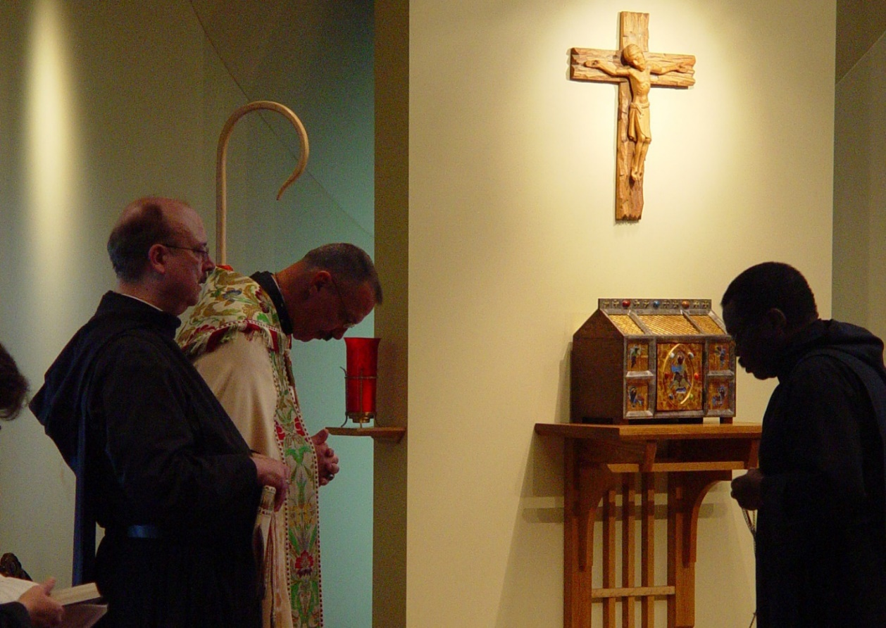
COSL Day 3 (S2) 011 Br. Raymond Owens; Abbot Michael John Austin; Br. Thomas Ferrell

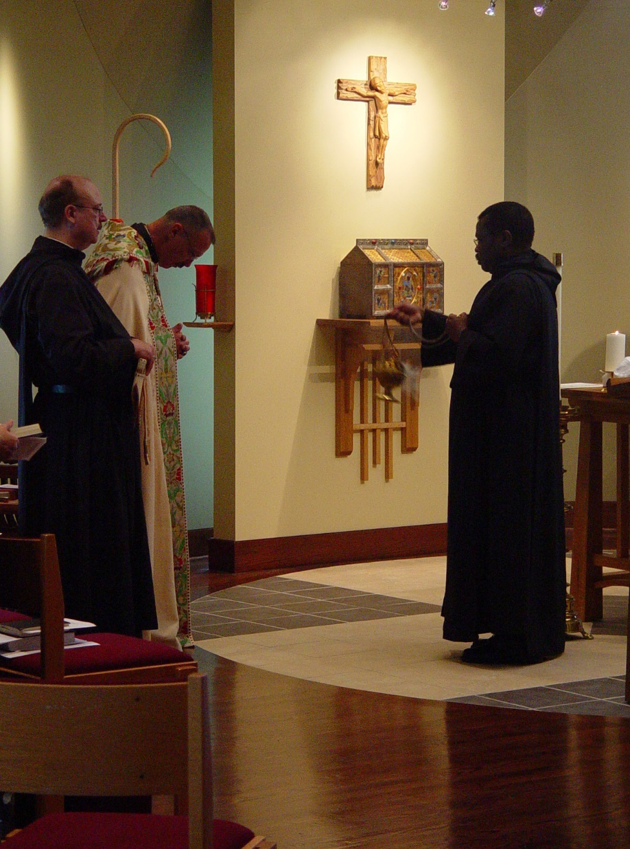
COSL Day 3 (S2) 012 Br. Raymond Owens; Abbot Michael John Austin; Br. Thomas Ferrell

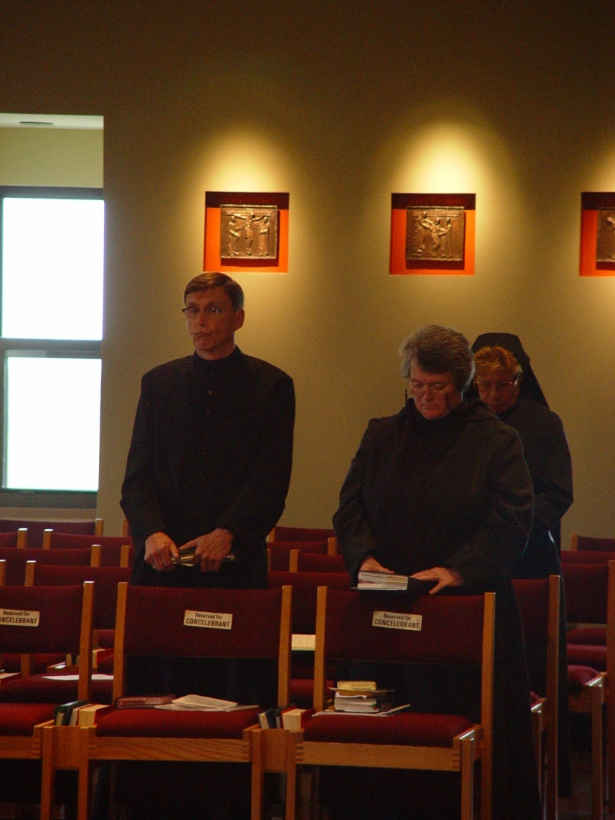
COSL Day 3 (S2) 013 Br, Camillus Converse; Sr. Vincent Marie Rittenhouse; Sr. Monica Ruth Mullen
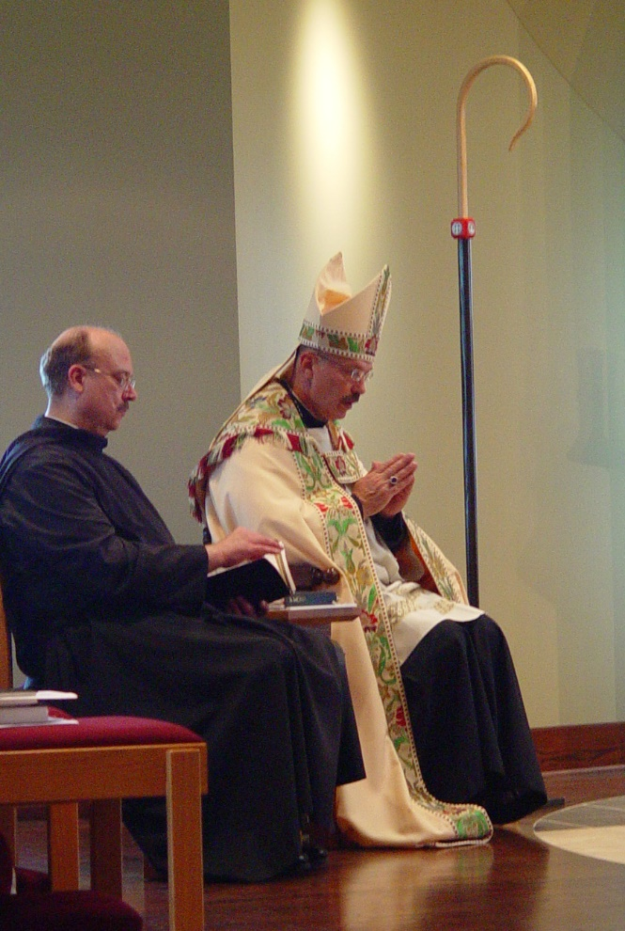
COSL Day 3 (S2) 014 Br. Raymond Owens; Abbot Michael John Austin

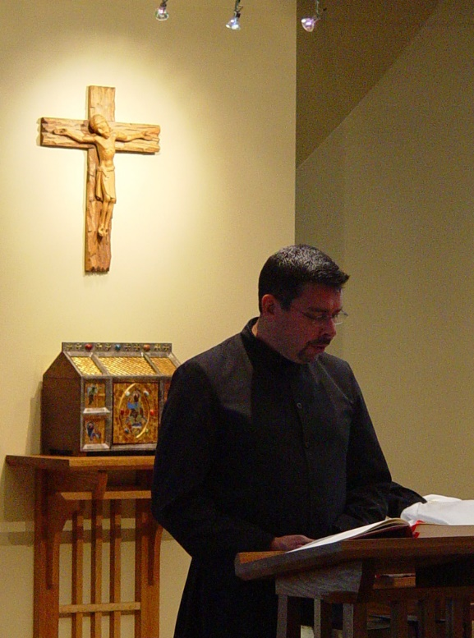
COSL Day 3 (S2) 015 Br. Augustine Colvert
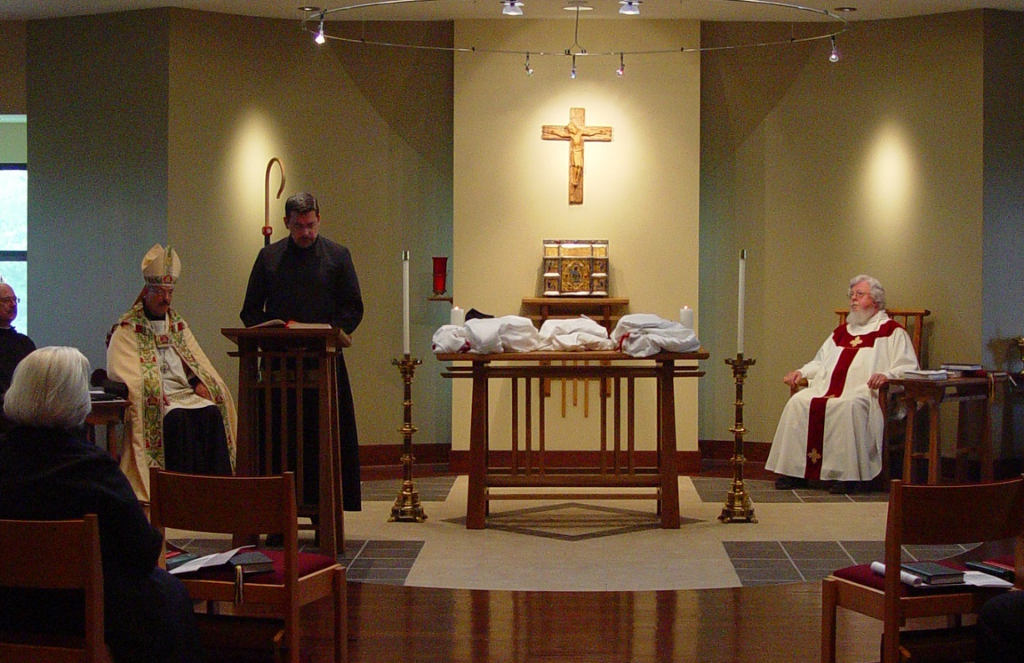
COSL Day 3 (S2) 016 Br. Raymond Owens; Sr. Elizabeth Ann Stribley; Abbot Michael John Austin; Br. Augustine Colvert; Fr. Wayne Kamm

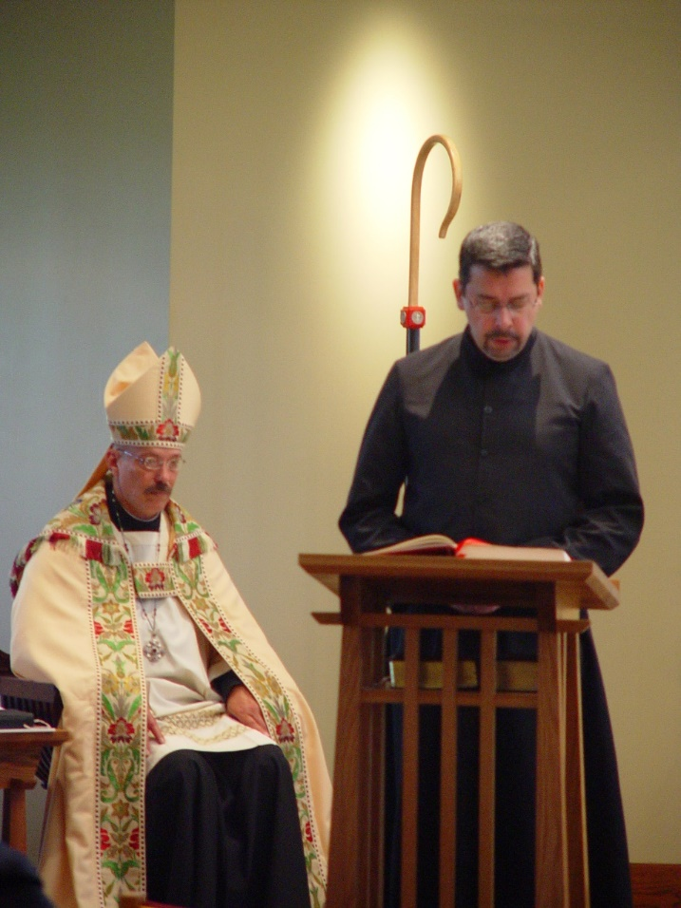
COSL Day 3 (S2) 017 Abbot Michael John Austin: Br. Augustine Colvert
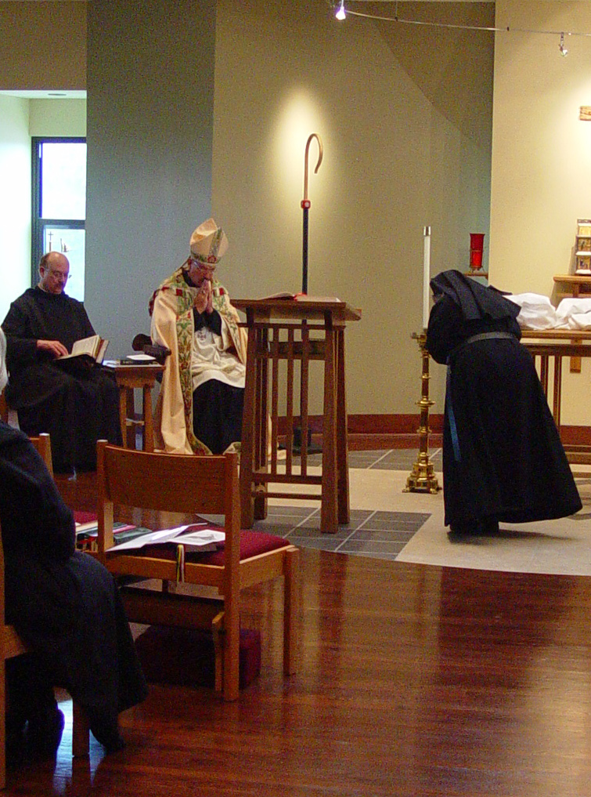
COSL Day 3 (S2) 023 Br. Raymond Owens; Abbot Michael John Austin; Sr. Anna Grace Madden
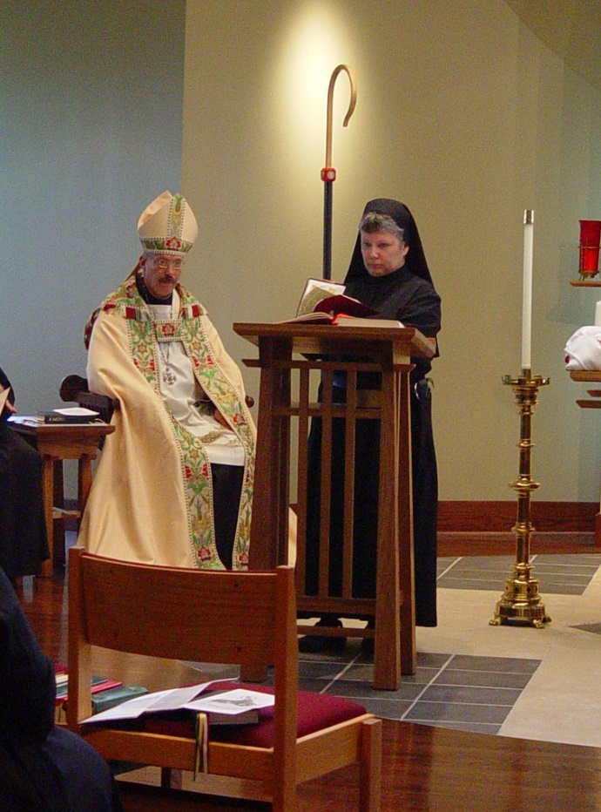
COSL Day 3 (S2) 024 Abbot Michael John Austin; Sr. Anna Grace Madden
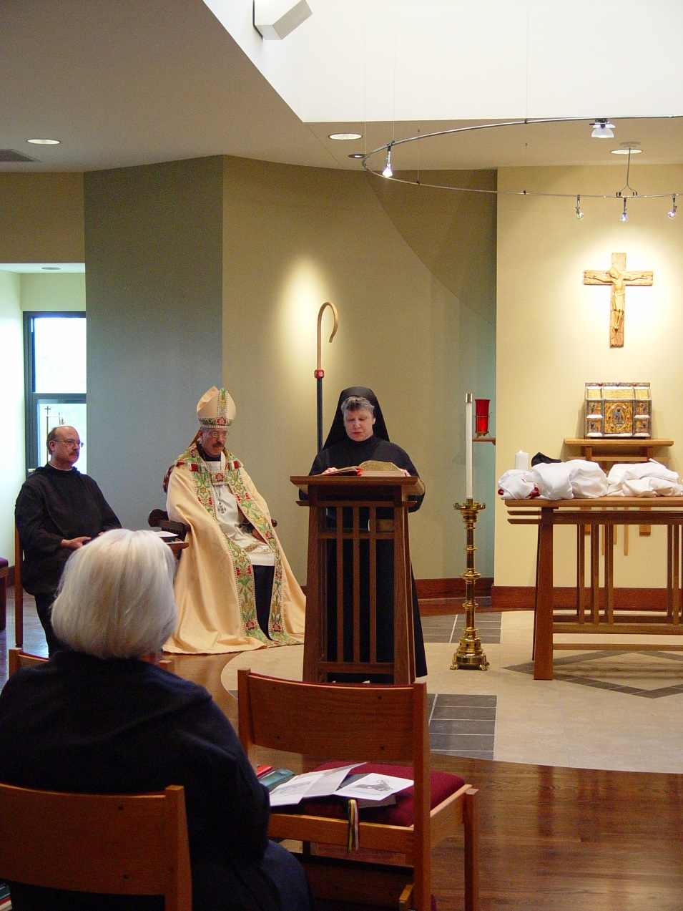
COSL Day 3 (S2) 025 Br. Raymond Owens; Sr. Elizabeth Ann Stribley; Abbot Michael John Austin; Sr. Anna Grace Madden
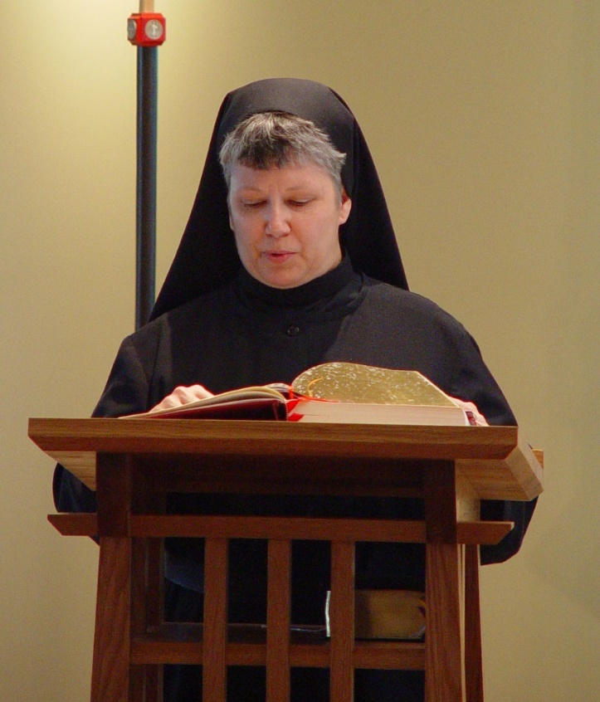
COSL Day 3 (S2) 026 Sr. Anna Grace Madden

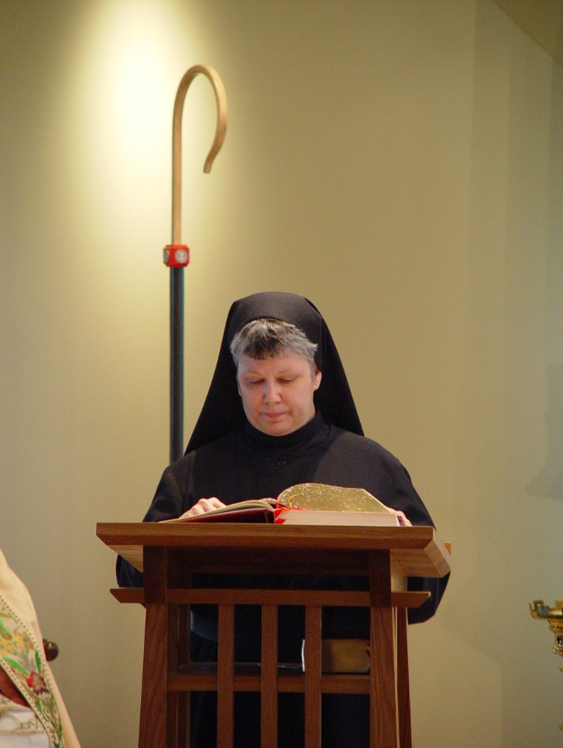
COSL Day 3 (S2) 027 Sr. Anna Grace Madden
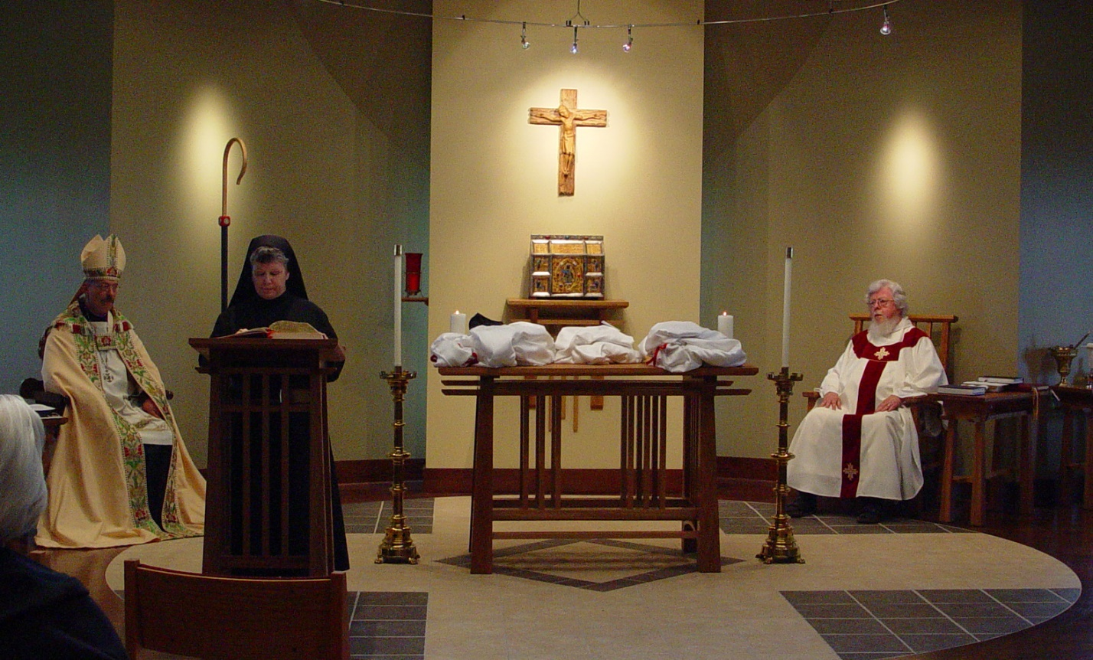
COSL Day 3 (S2) 028 Sr. Elizabeth Ann Stribley; Abbot Michael John Austin; Sr. Anna Grace Madden; Fr. Wayne Kamm

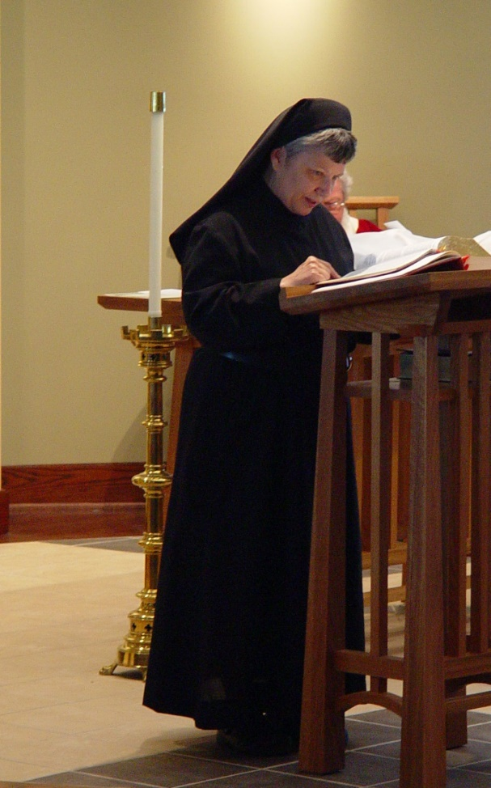
COSL Day 3 (S2) 029 Sr. Anna Grace Madden

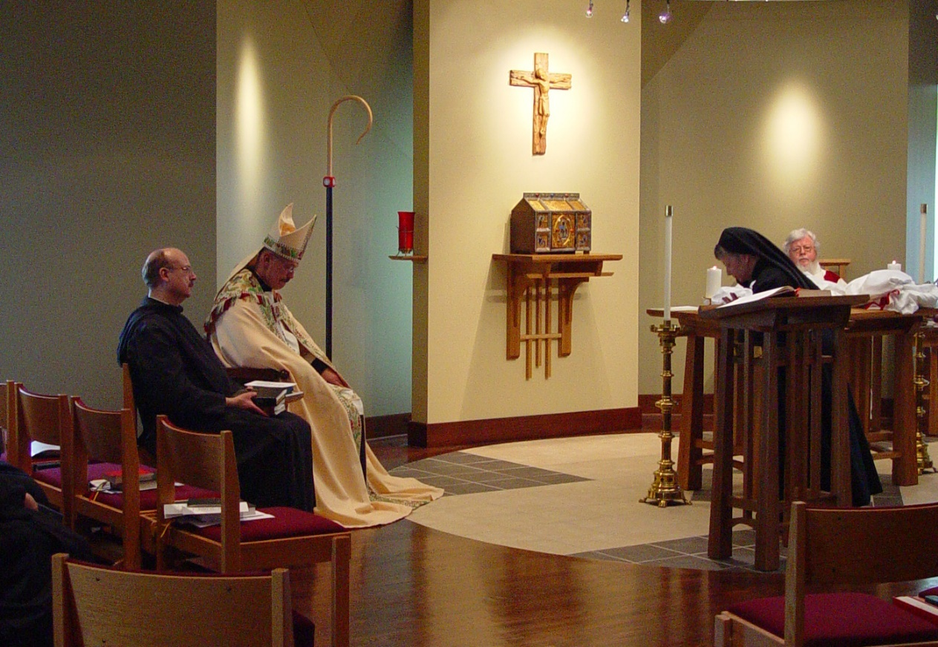
COSL Day 3 (S2) 030 Br. Raymond Owens; Abbot Michael John Austin; Sr. Anna Grace Madden; Fr. Wayne Kamm

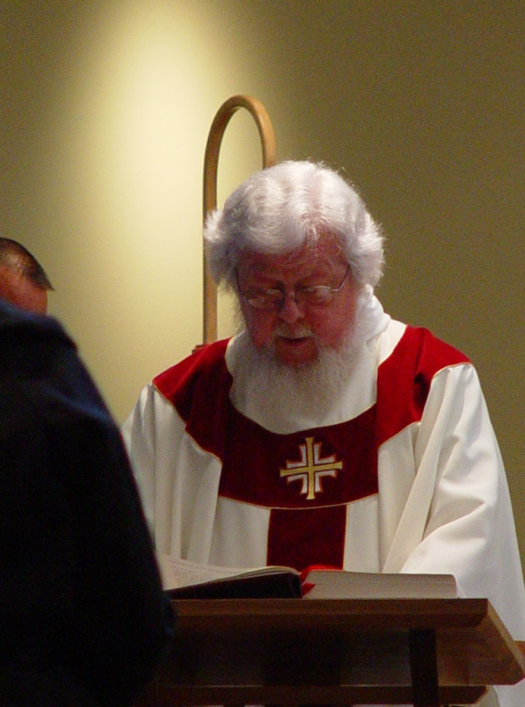
COSL Day 3 (S2) 031 Fr. Wayne Kamm
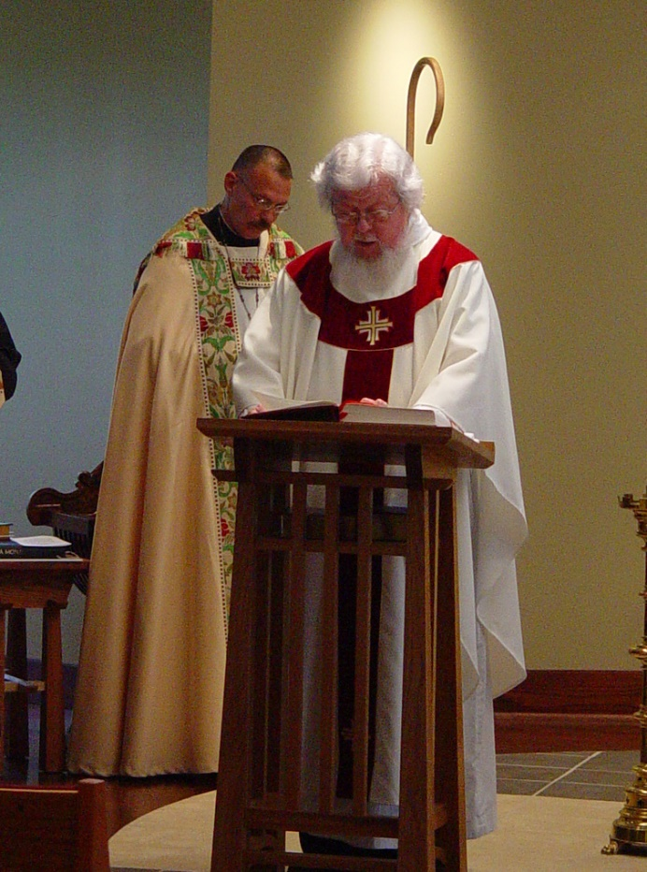
COSL Day 3 (S2) 032 Abbot Michael John Austin; Fr. Wayne Kamm

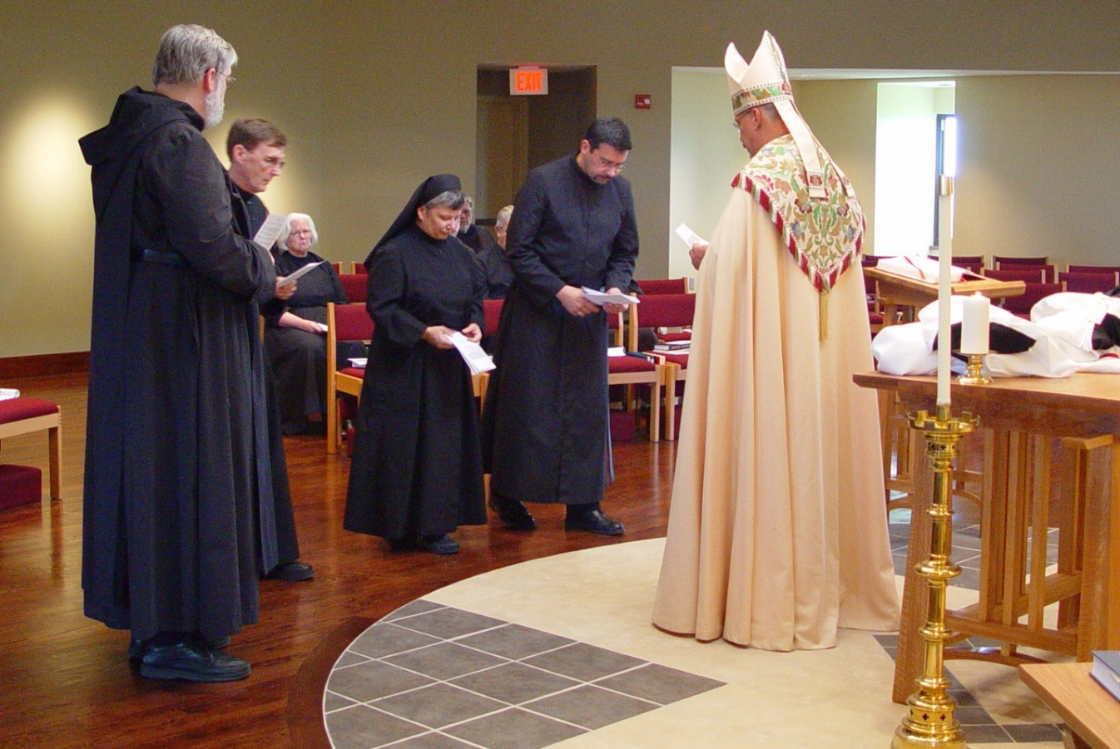
COSL Day 3 (S2) 033 Br. Chad Anselm Gerns; Br. Camillus Converse; Sr. Elizabeth Ann Stribley; Sr. Anna Grace Madden; Br. Nathan Gregory Miller; Br. Timothy Titus Lunt; Br. Augustine Colvert; Abbot Michael John Austin

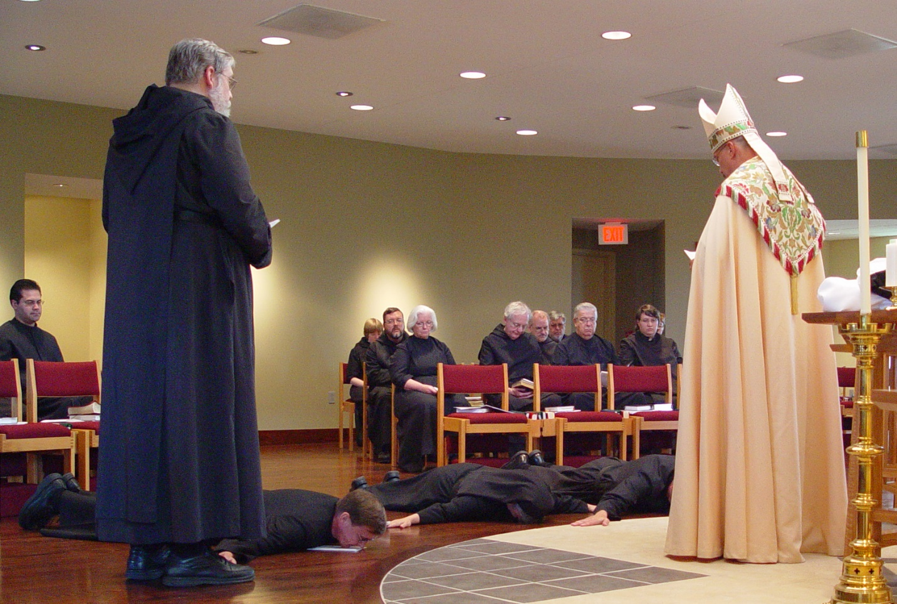
COSL Day 3 (S2) 034 Br. Daniel Medina; Br. Chad Anselm Gerns; Br. Camillus Converse; Sr. Catherine Unterseher; Br. Paul Howard; Sr. Elizabeth Ann Stribley; Sr. Anna Grace Madden; Br. Luke Doucette; Br. Daniel Joseph Schroeder; Br. Nathan Gregory Miller; Br. Timothy Titus Lunt; Sr. Pauline Tysol; Sr. Brigid Gerns; Abbot Michael John Austin

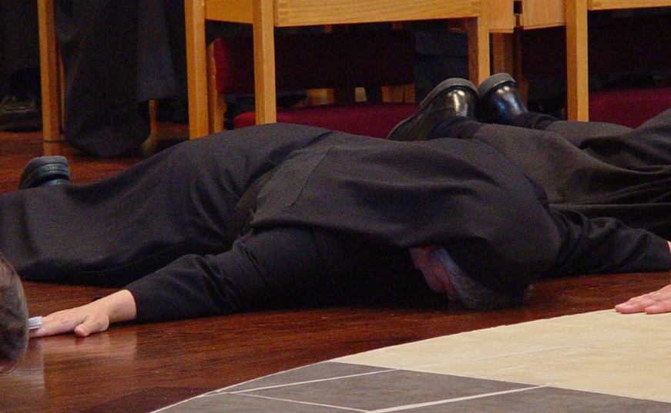
COSL Day 3 (S2) 035 Sr. Anna Grace Madden

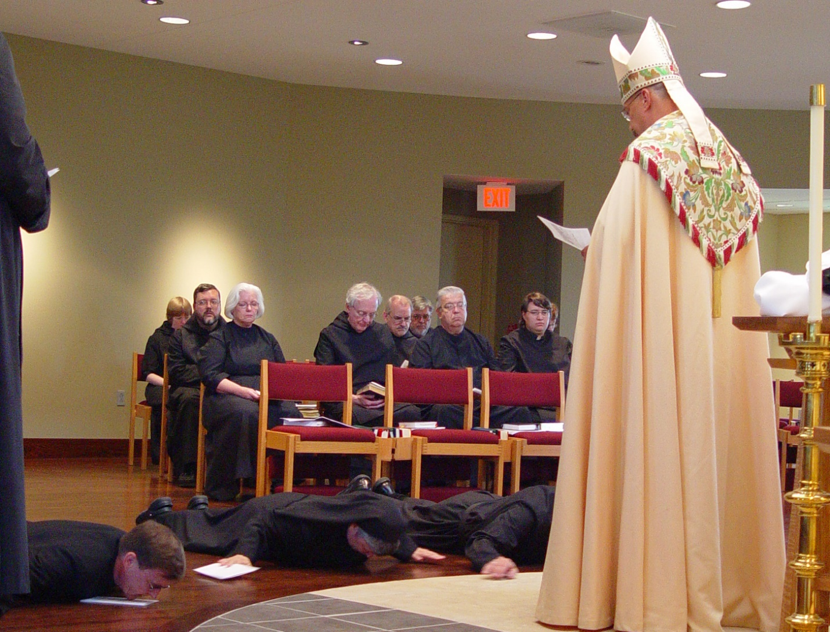
COSL Day 3 (S2) 036 Br. Chad Anselm Gerns; Br. Camillus Converse; Sr. Catherine Unterseher; Br. Paul Howard; Sr. Elizabeth Ann Stribley; Sr. Anna Grace Madden; Br. Luke Doucette; Br. Daniel Joseph Schroeder; Br. Nathan Gregory Miller; Br. Timothy Titus Lunt; Sr. Pauline Tysol; Abbot Michael John Austin; Sr. Brigid Gerns
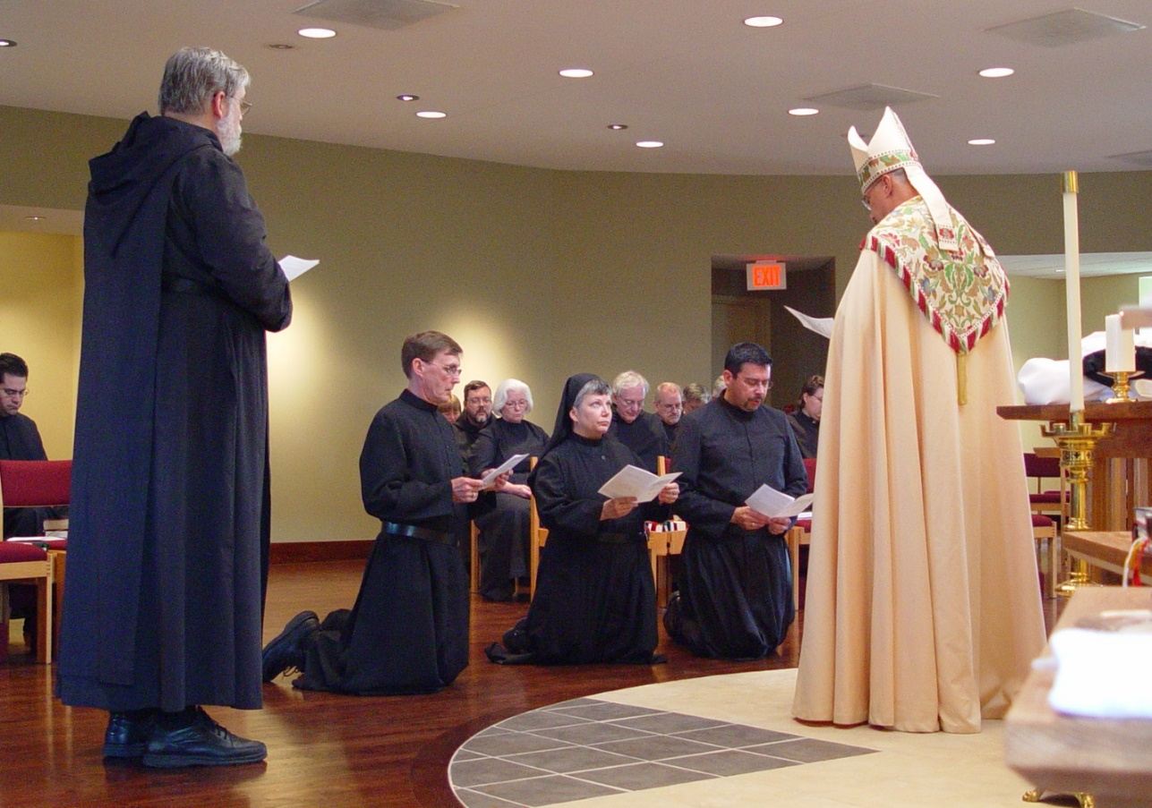
COSL Day 3 (S2) 037 Br. Daniel Medina; Br. Chad Anselm Gerns; Br. Camillus Converse; Sr. Catherine Unterseher; Br. Paul Howard; Sr. Elizabeth Ann Stribley; Sr. Anna Grace Madden; Br. Luke Doucette; Br. Daniel Joseph Schroeder; Br. Nathan Gregory Miller; Br. Timothy Titus Lunt; Sr. Pauline Tysol; Abbot Michael John Austin

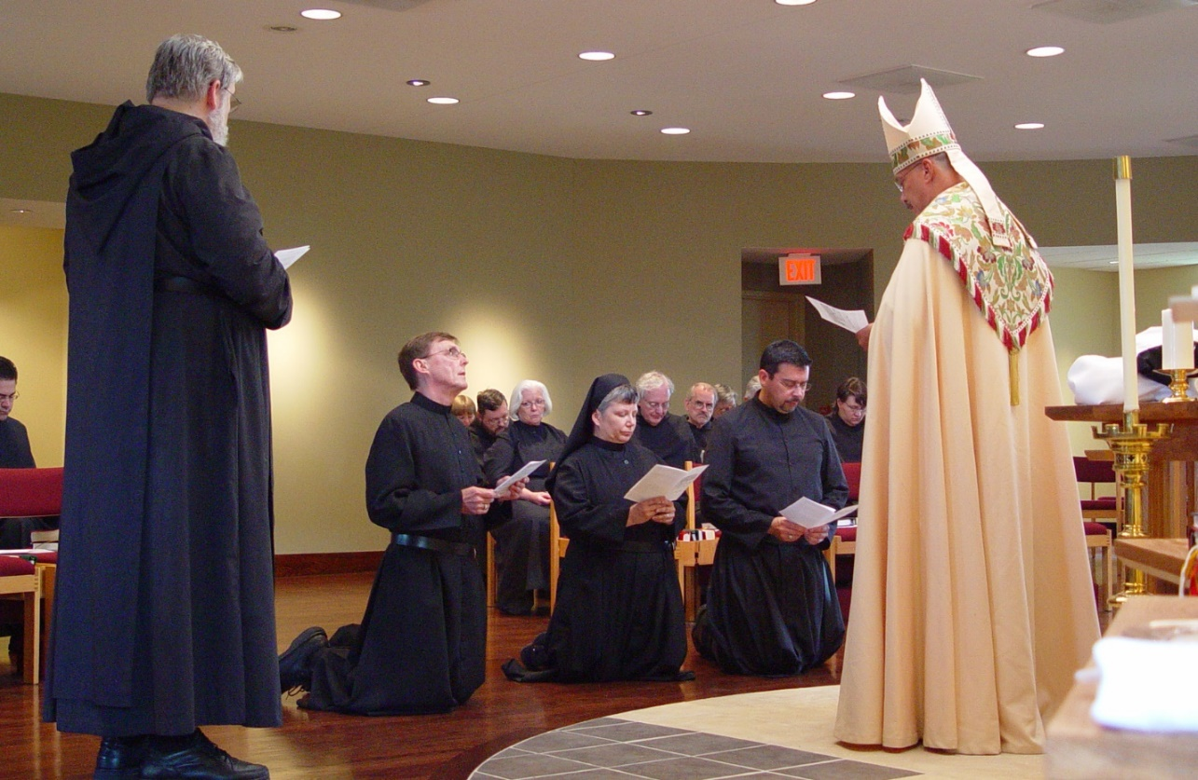
COSL Day 3 (S2) 038 Br. Daniel Medina; Br. Chad Anselm Gerns; Br. Camillus Converse; Sr. Catherine Unterseher; Br. Paul Howard; Sr. Elizabeth Ann Stribley; Sr. Anna Grace Madden; Br. Luke Doucette; Br. Daniel Joseph Schroeder; Br. Nathan Gregory Miller; Br. Timothy Titus Lunt; Sr. Pauline Tysol; Abbot Michael John Austin

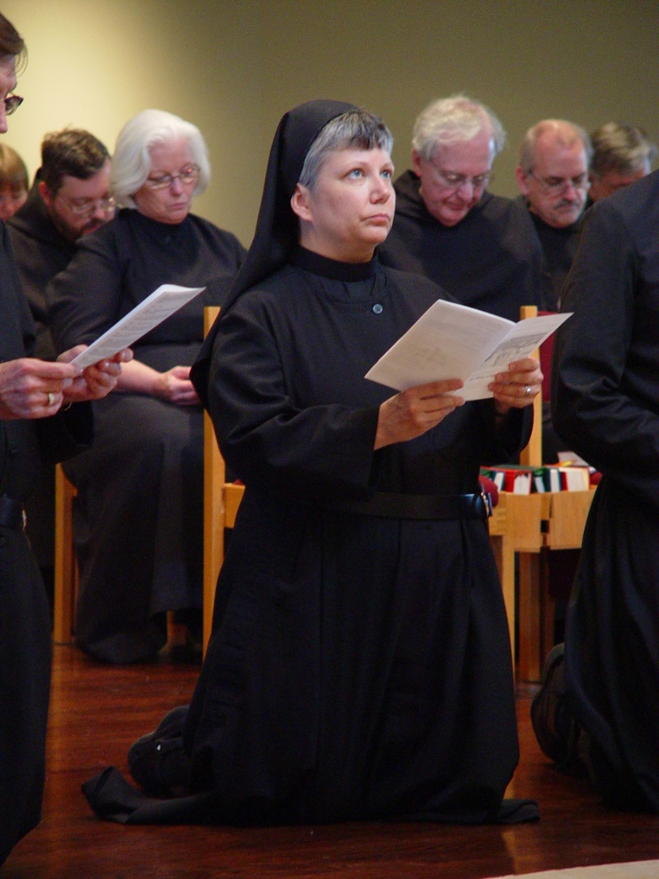
COSL Day 3 (S2) 039 Br. Camillus Converse; Sr. Catherine Unterseher; Br. Paul Howard; Sr. Elizabeth Ann Stribley; Sr. Anna Grace Madden; Br. Luke Doucette; Br. Paul Schroeder; Br. Nathan Gregory Miller
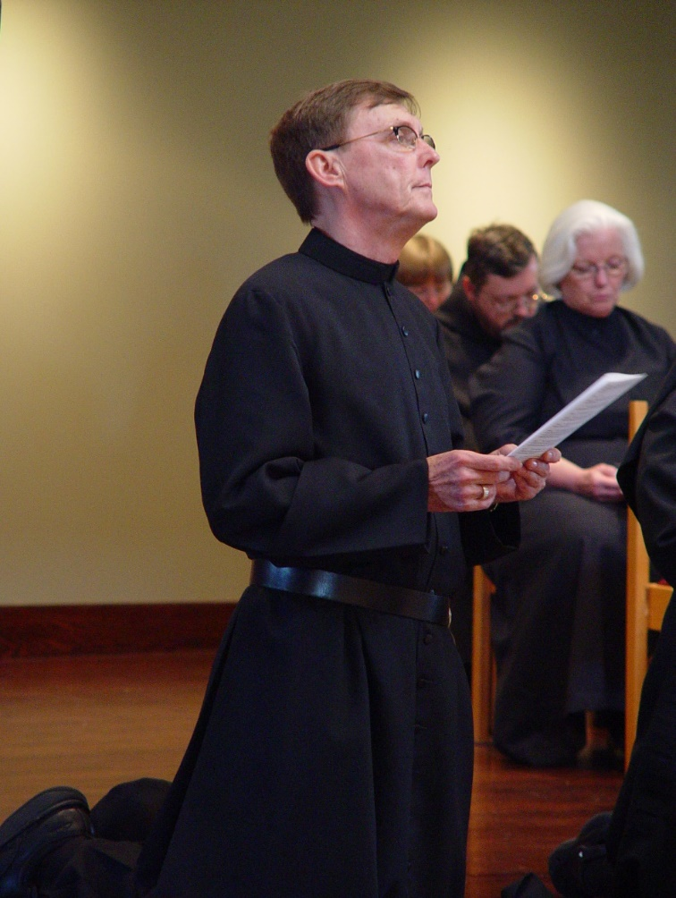
COSL Day 3 (S2) 040 Br. Camillus Converse; Sr. Catherine Unterseher; Br. Paul Howard; Sr. Elizabeth Ann Stribley
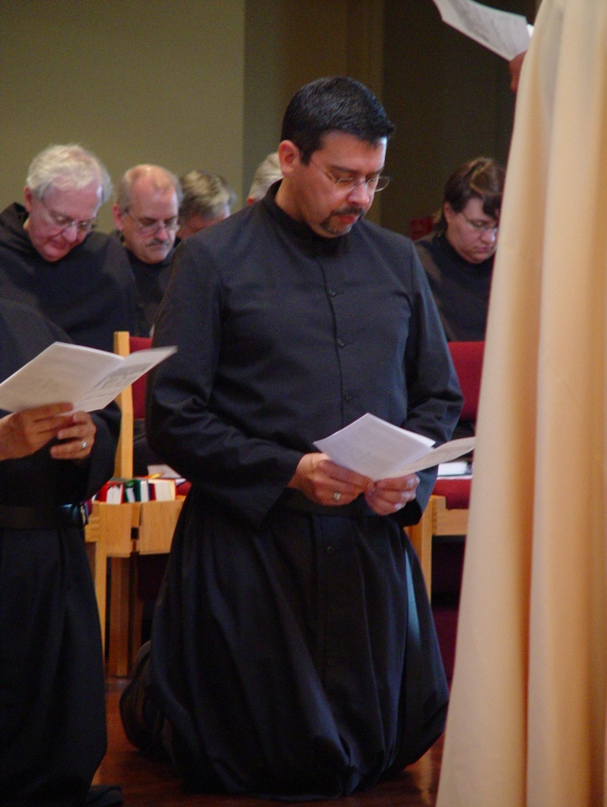
COSL Day 3 (S2) 041 Br. Luke Doucette; Br. Daniel Joseph Schroeder; Br. Nathan Gregory Miller; Br. Augustine Colvert; Sr. Pauline Tysol
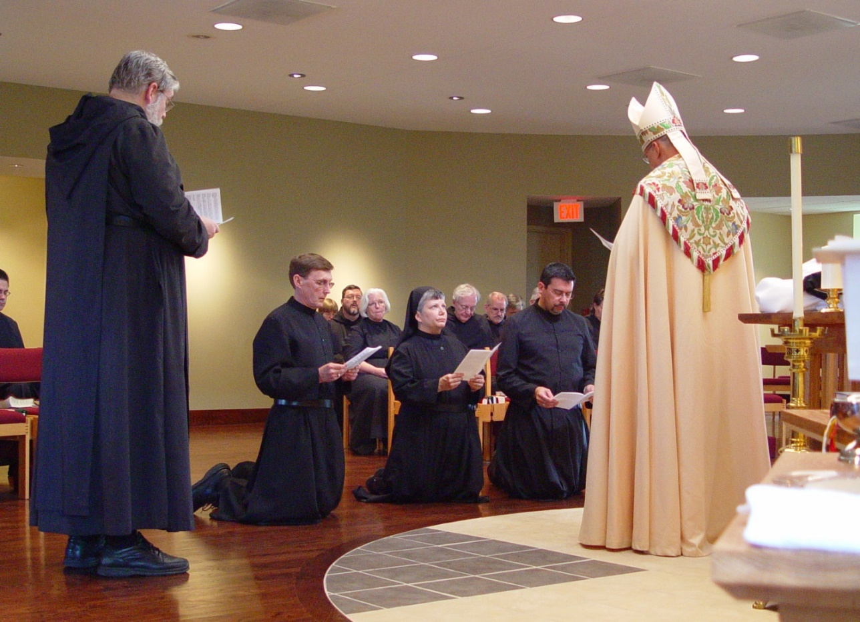
COSL Day 3 (S2) 042 Br. Daniel Medina; Br. Chad Anselm Gerns; Br. Camillus Converse; Sr. Catherine Unterseher; Br. Paul Howard; St. Elizabeth Ann Stribley; Anna Grace Madden; Br. Luke Doucette; Br. Daniel Joseph Schroeder; Br. Augustine Colvert; Sr. Pauline Tysol; Abbot Michael John Austin

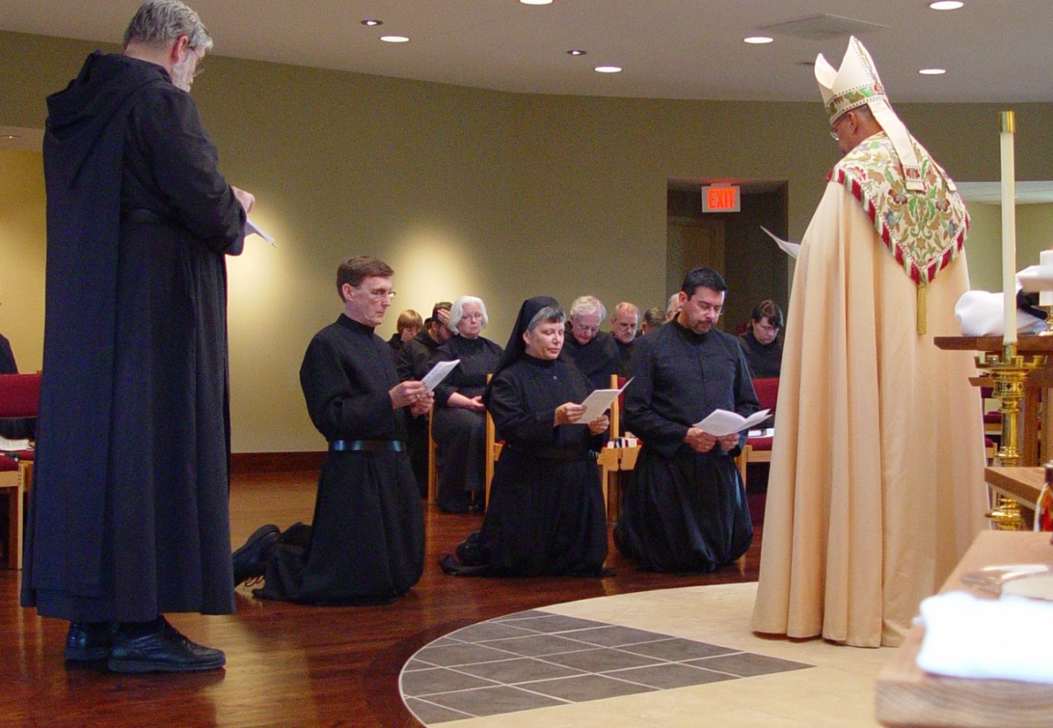
COSL Day 3 (S2) 043 Br. Chad Anselm Gerns; Br. Camillus Converse; Sr. Catherine Unterseher; Br. Paul Howard; Sr. Elizabeth Ann Stribley; Anna Grace Madden; Br. Luke Doucette; Br. Daniel Joseph Schroeder; Br. Augustine Colvert; Sr. Pauline Tysol; Abbot Michael John Austin

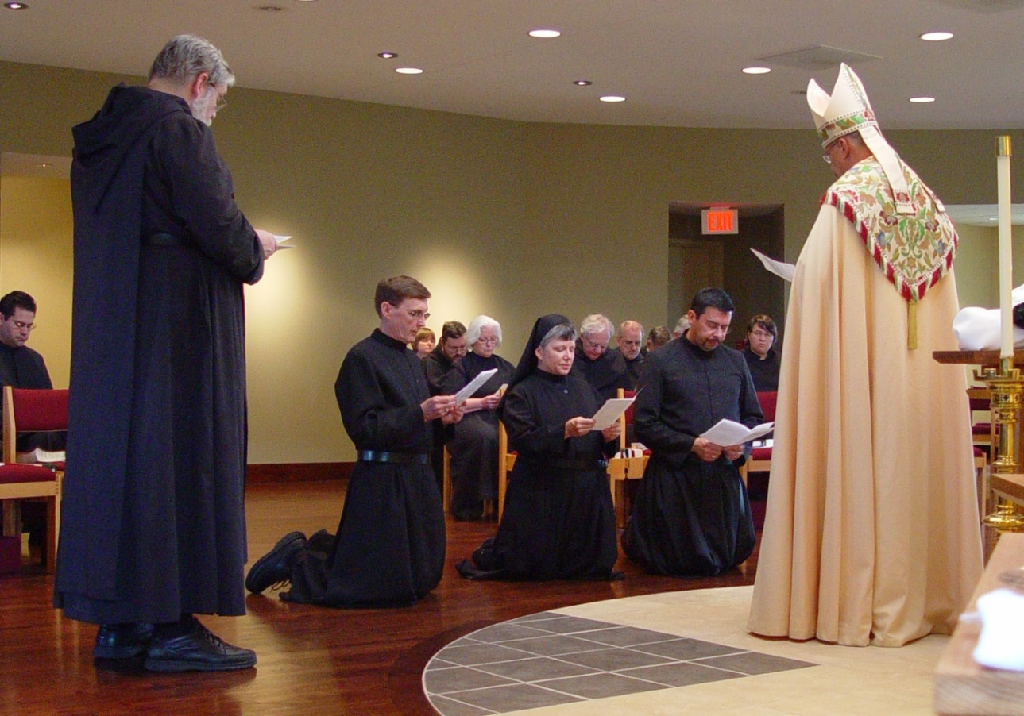
COSL Day 3 (S2) 044 Br. Daniel Medina; Br. Chad Anselm Gerns; Br. Camillus Converse; Sr. Catherine Unterseher; Br. Paul Howard; St. Elizabeth Ann Stribley; Anna Grace Madden; Br. Luke Doucette; Br. Daniel Joseph Schroeder; Br. Augustine Colvert; Sr. Pauline Tysol; Abbot Michael John Austin

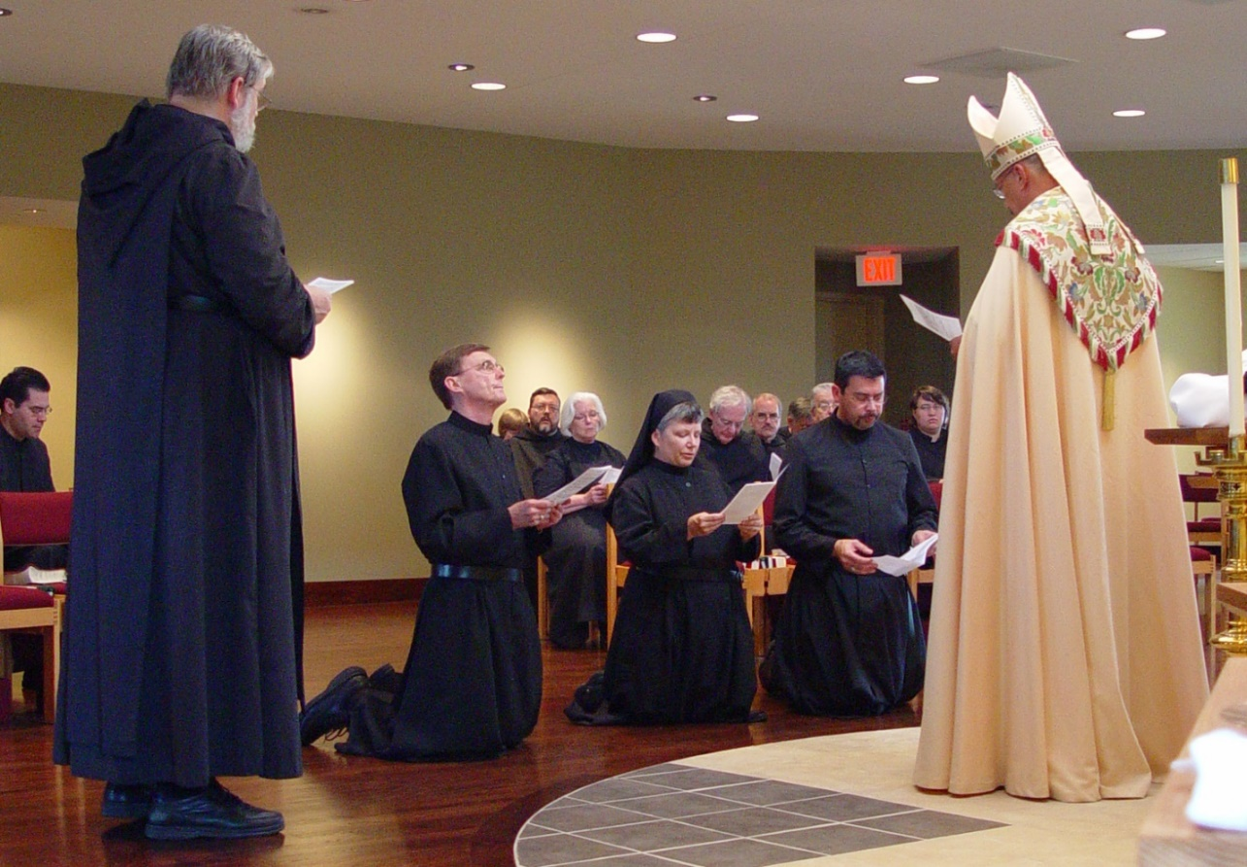
COSL Day 3 (S2) 045 Br. Daniel Medina; Br. Chad Anselm Gerns; Br. Camillus Converse; Sr. Catherine Unterseher; Br. Paul Howard; Sr. Elizabeth Ann Stribley; Anna Grace Madden; Br. Luke Doucette; Br. Daniel Joseph Schroeder; Br. Timothy Titus Lunt; Br. Augustine Colvert; Sr. Pauline Tysol; Abbot Michael John Austin
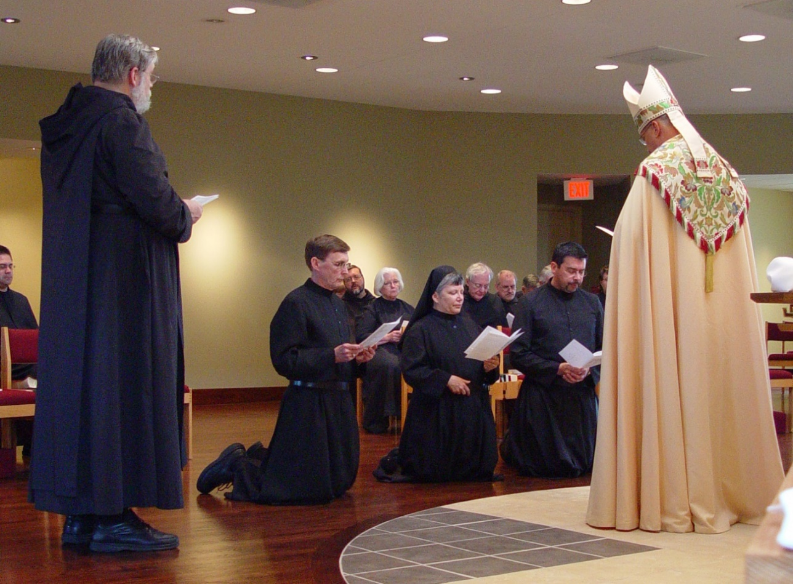
COSL Day 3 (S2) 046 Br. Daniel Medina; Br. Chad Anselm Gerns; Br. Camillus Converse; Br. Paul Howard; Sr. Elizabeth Ann Stribley; Anna Grace Madden; Br. Luke Doucette; Br. Daniel Joseph Schroeder; Br. Augustine Colvert; Sr. Pauline Tysol; Abbot Michael John Austin

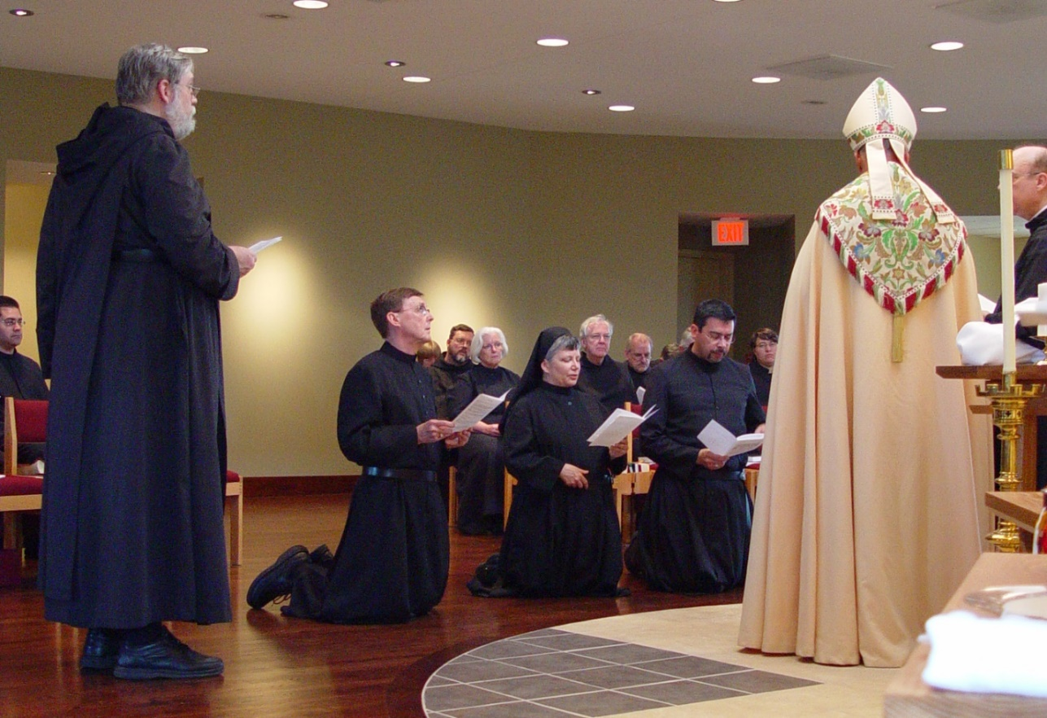
COSL Day 3 (S2) 047 Br. Daniel Medina; Br. Chad Anselm Gerns; Br. Camillus Converse; Sr. Catherine Unterseher; Br. Paul Howard; Sr. Elizabeth Ann Stribley; Anna Grace Madden; Br. Luke Doucette; Br. Daniel Joseph Schroeder; Br. Augustine Colvert; Sr. Pauline Tysol; Abbot Michael John Austin

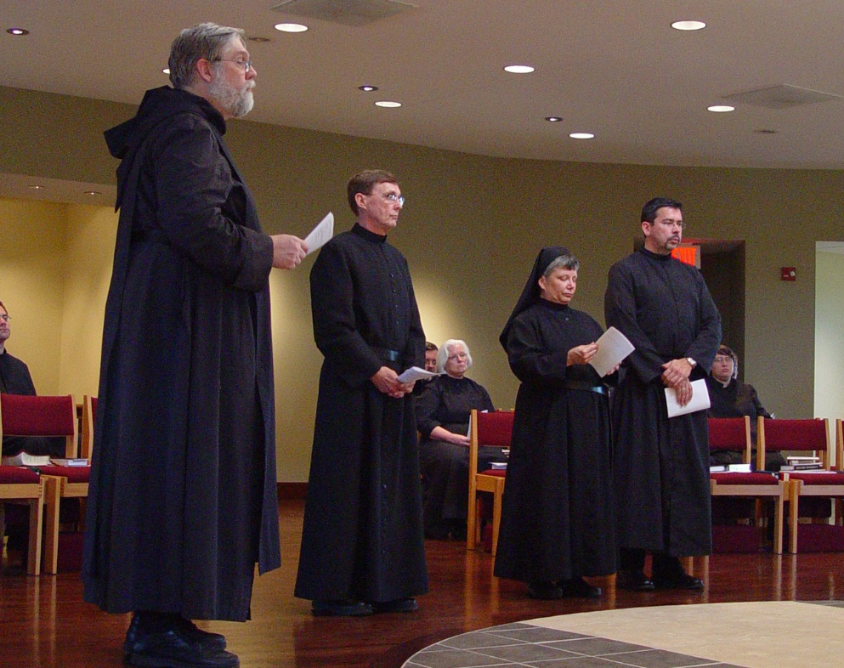
COSL Day 3 (S2) 048 Br. Daniel Medina; Br. Chad Anselm Gerns; Br. Camillus Converse; Br. Paul Howard; Sr. Elizabeth Ann Stribley; Sr. Anna Grace Madden; Br. Augustine Colvert; Sr. Pauline Tysol

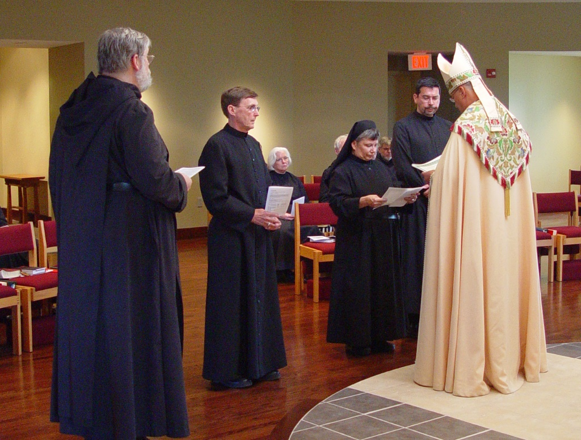
COSL Day 3 (S2) 049 Br. Chad Anselm Gerns; Br. Camillus Converse; Sr. Elizabeth Ann Stribley; Sr. Anna Grace Madden; Br. Nathan Gregory Miller; Br. Augustine Colvert; Abbot Michael John Austin
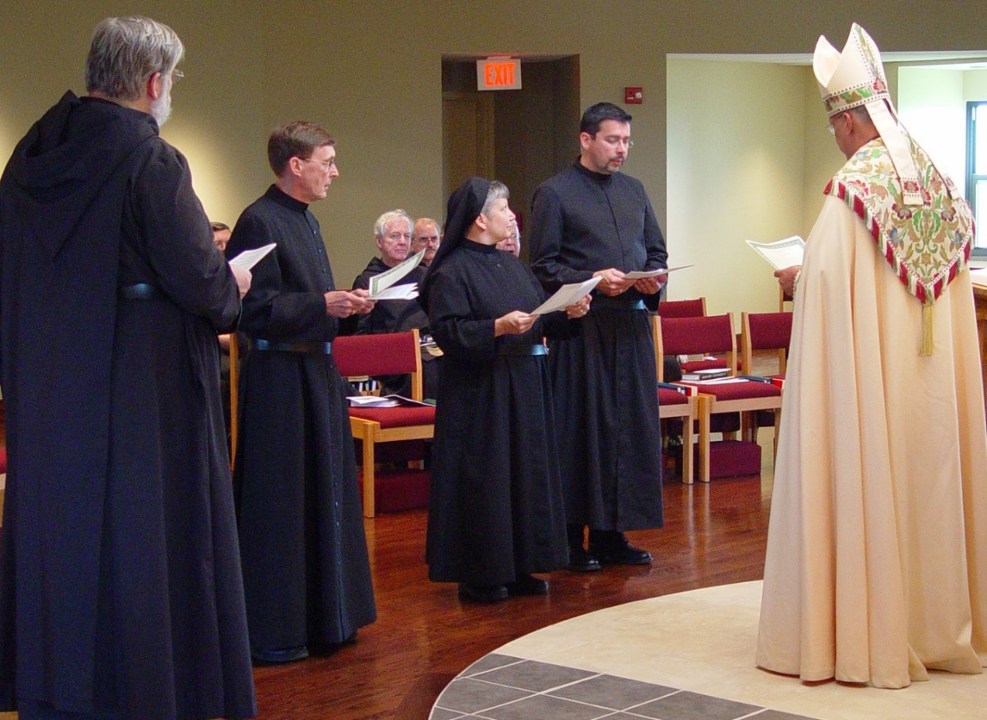
COSL Day 3 (S2) 050 Br. Chad Anselm Gerns; Br. Paul Howard; Br. Camillus Converse; Br. Luke Doucette; Br. Daniel Joseph Schroeder; Sr. Anna Grace Madden; Br. Timothy Titus; Br. Augustine Colvert; Abbot Michael John Austin

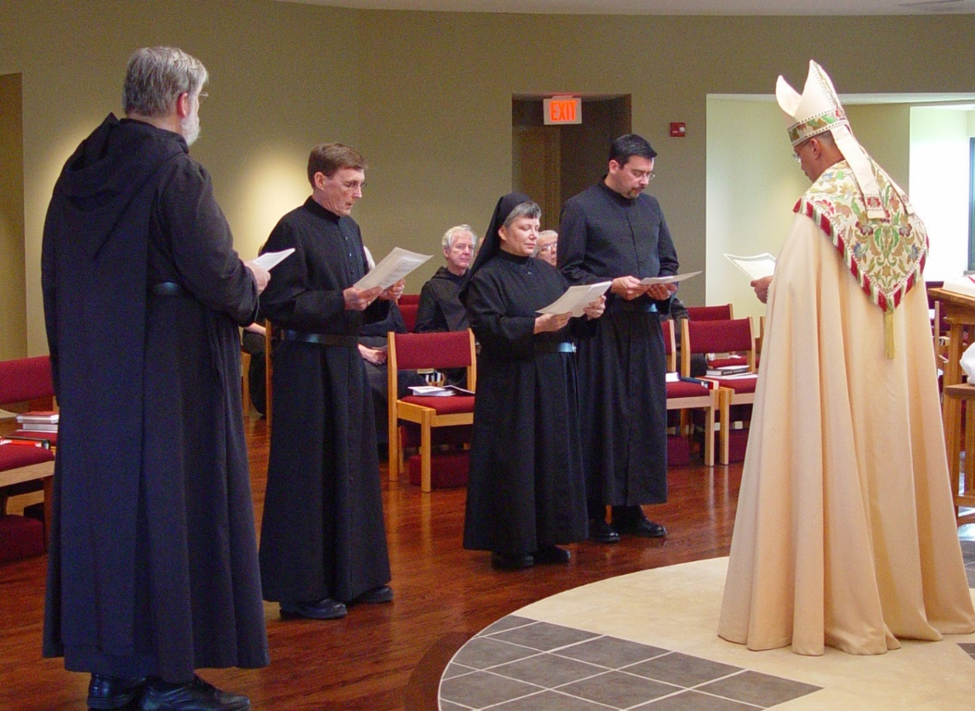
COSL Day 3 (S2) 051 Br. Chad Anselm Gerns; Br. Camillus Converse; Br. Luke Doucette; Sr. Anna Grace Madden; Br. Timothy Titus Lunt; Br. Augustine Colvert; Abbot Michael John Austin

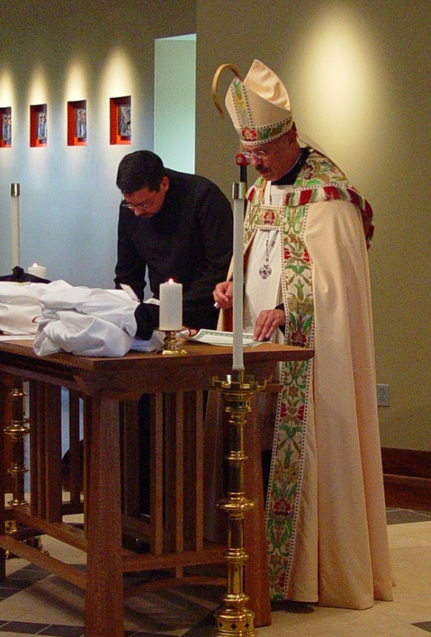
COSL Day 3 (S2) 052 Br. Augustine Colvert; Abbot Michael John Austin

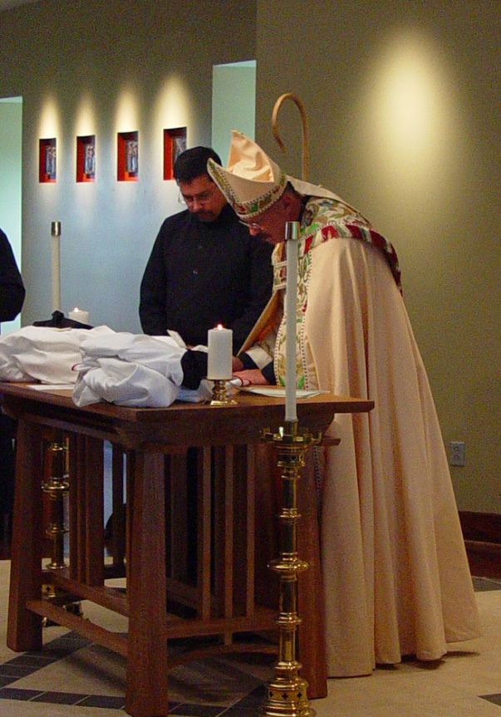
COSL Day 3 (S2) 053 Br. Augustine Colvert; Abbot Michael John Austin
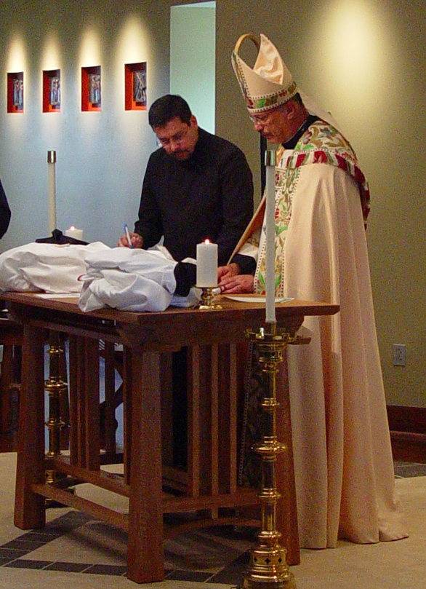
COSL Day 3 (S2) 054 Br. Augustine Colvert; Abbot Michael John Austin

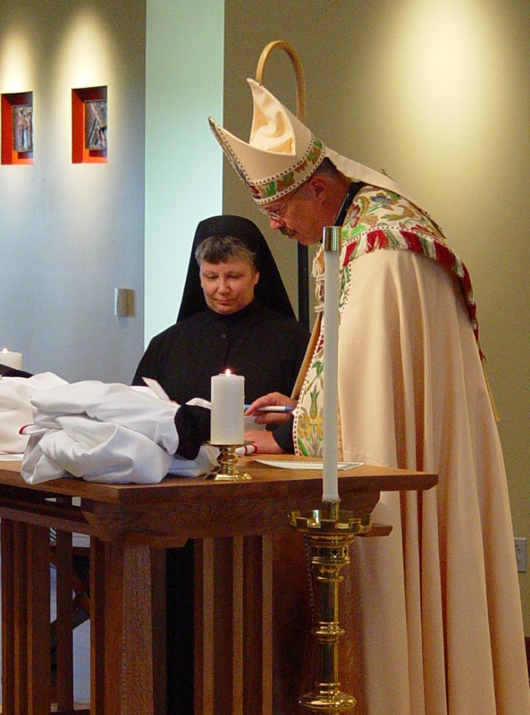
COSL Day 3 (S2) 055 Sr. Anna Grace Madden; Abbot Michael John Austin
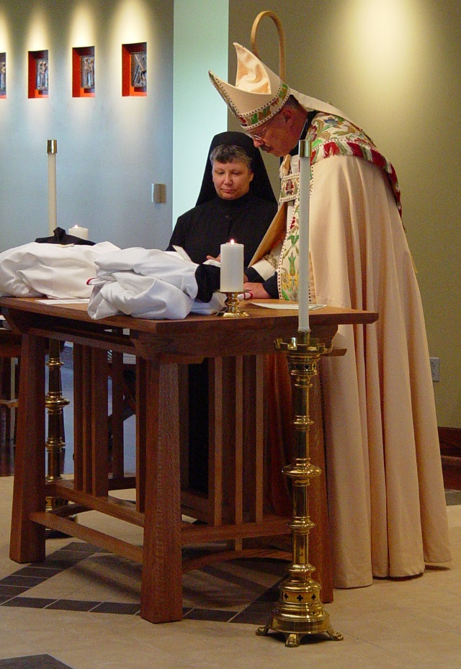
COSL Day 3 (S2) 056 Sr. Anna Grace Madden; Abbot Michael John Austin

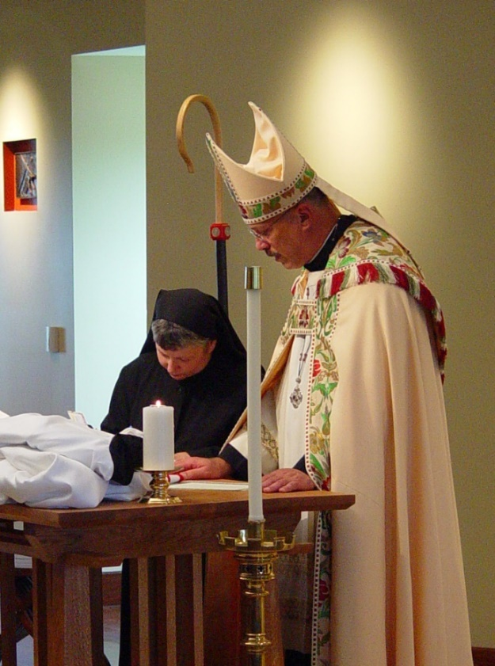
COSL Day 3 (S2) 057 Sr. Anna Grace Madden; Abbot Michael John Austin
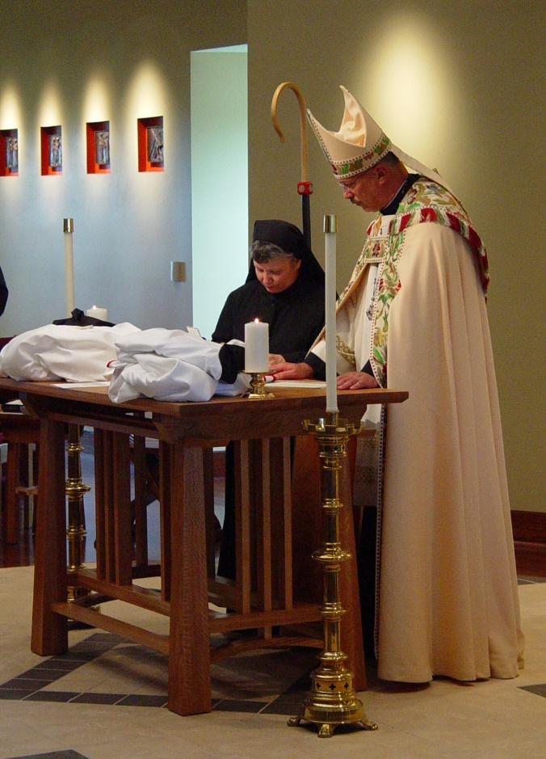
COSL Day 3 (S2) 058 Sr. Anna Grace Madden; Abbot Michael John Austin

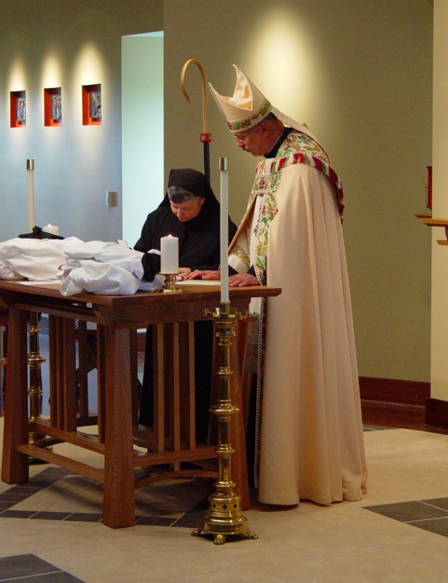
COSL Day 3 (S2) 059 Sr. Anna Grace Madden; Abbot Michael John Austin

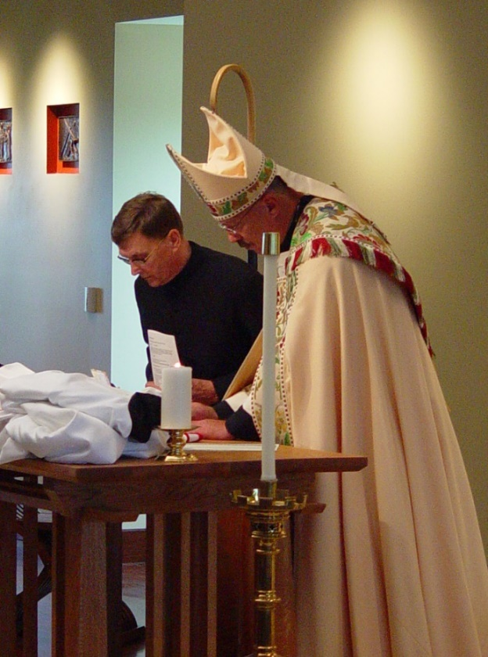
COSL Day 3 (S2) 060 Br. Camillus Converse; Abbot Michael John Austin

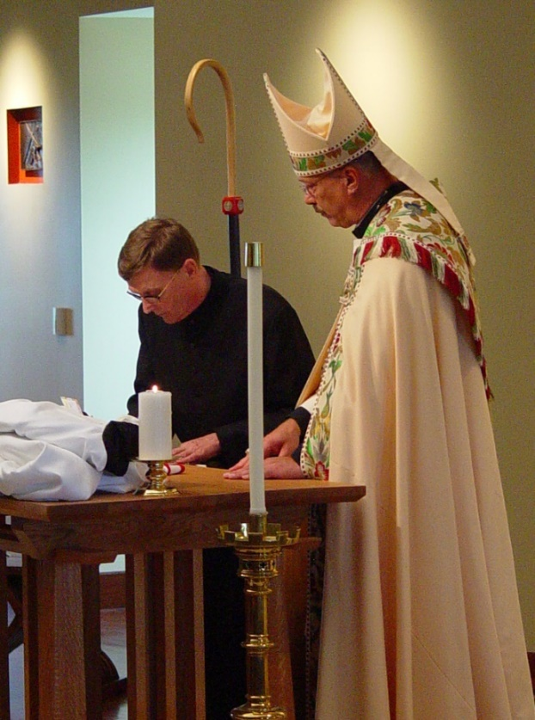
COSL Day 3 (S2) 061 Br. Camillus Converse; Abbot Michael John Austin

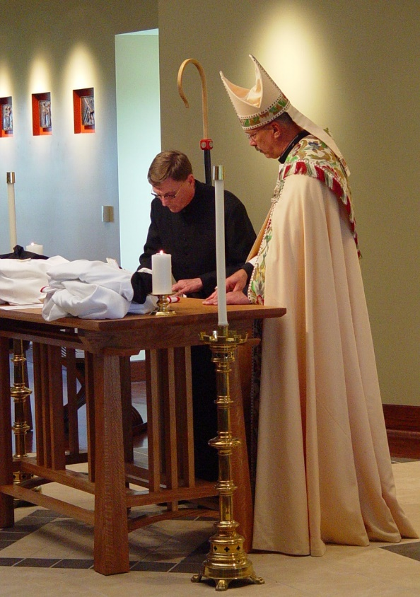
COSL Day 3 (S2) 062 Br. Camillus Colvert; Abbot Michael John Austin

