Companions of St. Luke
Spring 2006 Convocation at Conception Abbey
Day 3, Part 1 of 4

~Edited by Br. Steven Olderr, 2 June 2022 with the assistance of Br. Thomas Ferrell. If you find any errors or omissions or have anything to add, please notify Br. Steven at olderr@ameritech.net

People are identified from left to right.

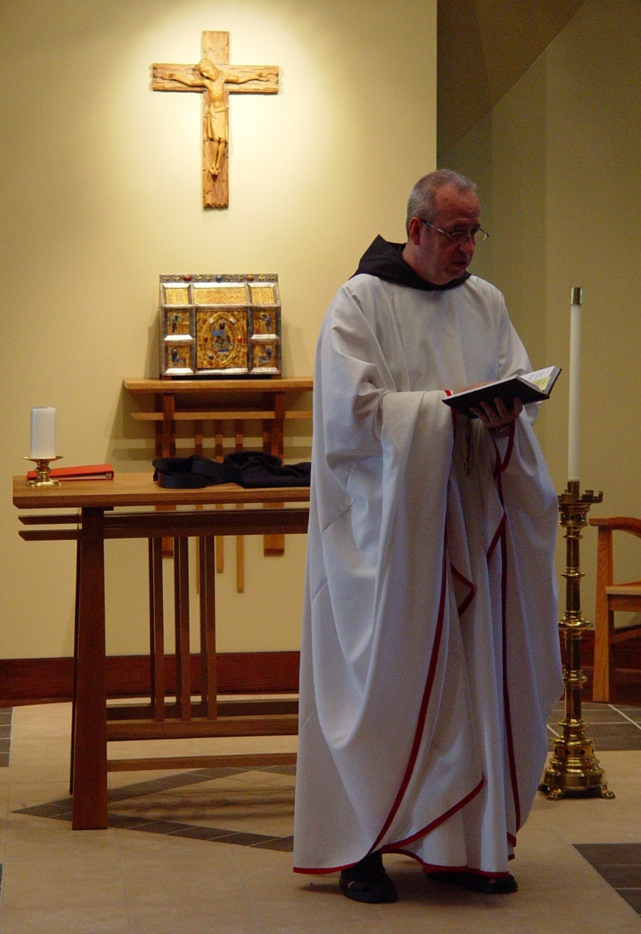
COSL Day 3 (S1)005 Br. Gabriel Hale

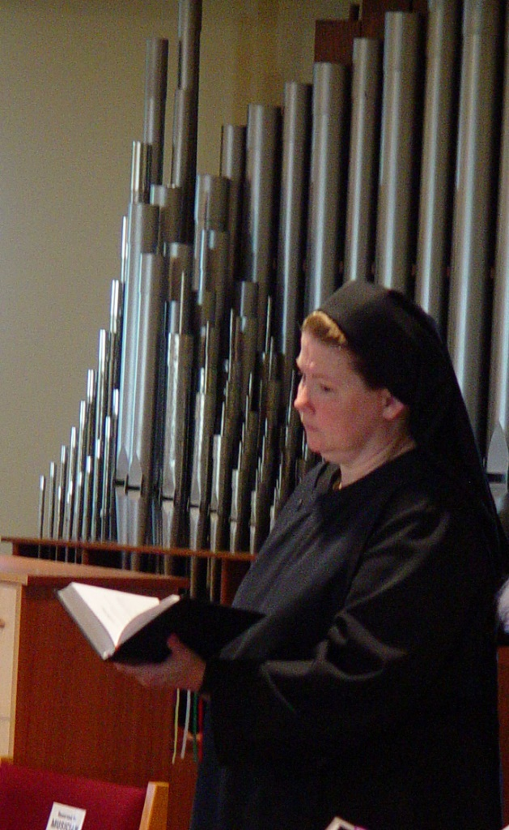
COSL Day 3 (S1)006 Sr. Hillary Grace Lundgren
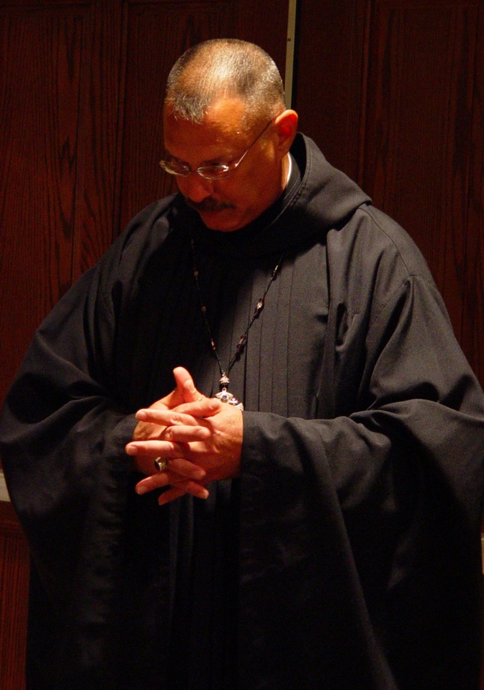
COSL Day 3 (S1)007 Abbot Michael John Austin

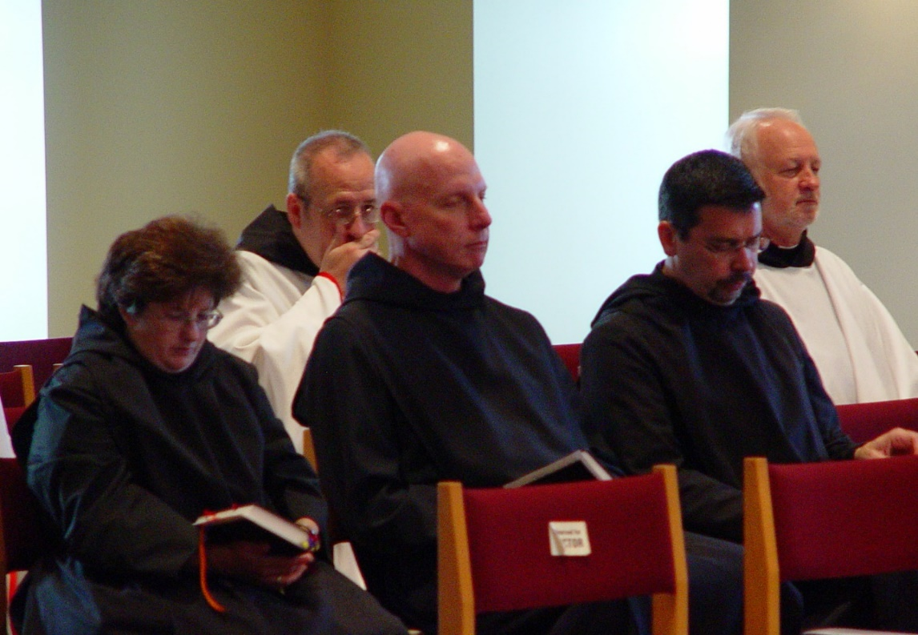
COSL Day 3 (S1)008 Sr. Cecelia Lamoy; Br. Gabriel Hale; Br. David Vincent Cotton; Br. Augustine Colvert; Br. Christopher John Baumann
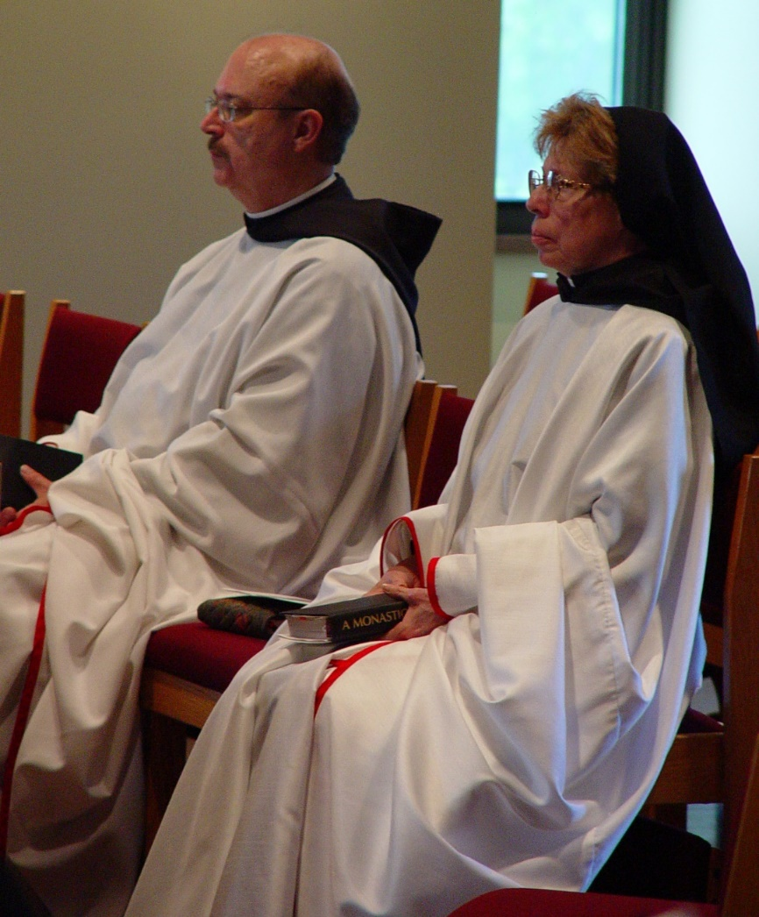
COSL Day 3 (S1)009 Br. Raymond Owens; Sr. Monica Ruth Mullen

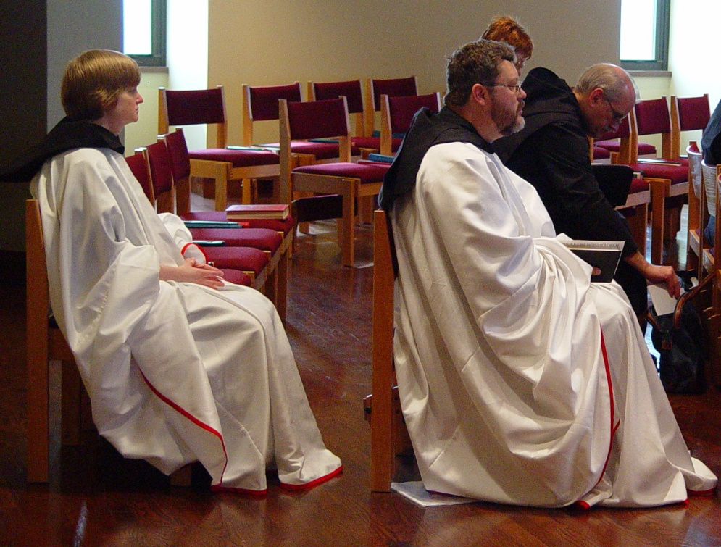
COSL Day 3 (S1)010 Sr. Catherine Unterseher; Br. Paul Howard; Sr. Brigid Gerns; Br. Daniel Joseph Schroeder
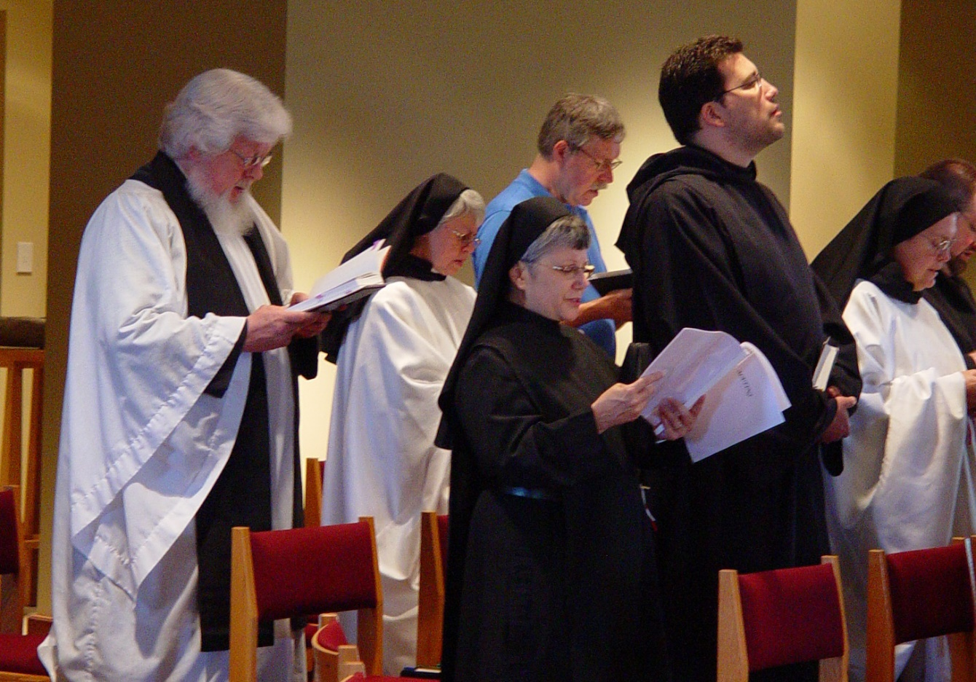
COSL Day 3 (S1)011 Fr. Wayne Kamm; Sr. Clare Benedicta Myers; Sr. Anna Grace Madden; Fr. Mel Schlacter; Br Anthony Bernard Campos; Sr. Theodora of Jesus Perecca; Br. Willard Moore

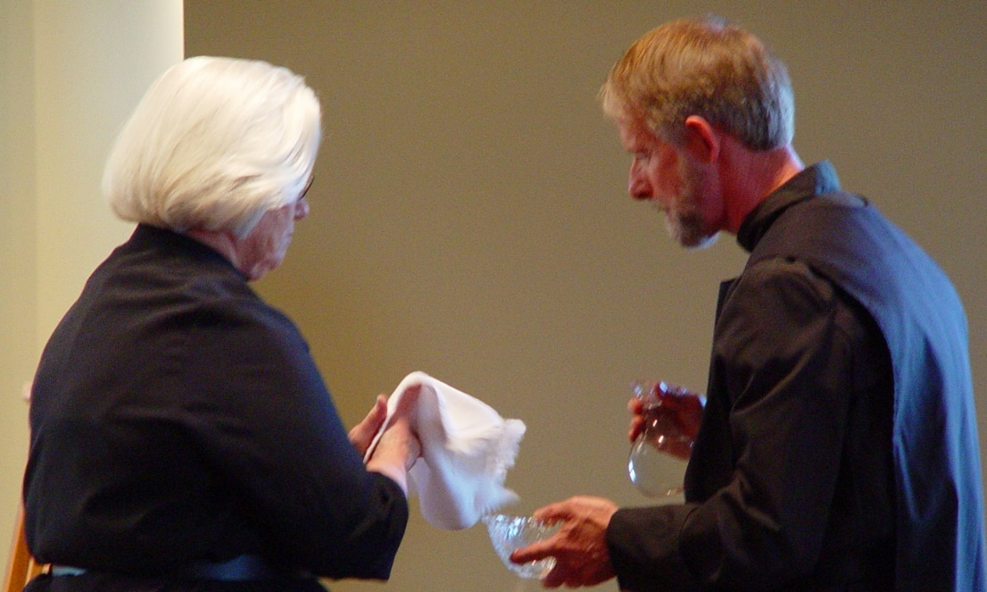
COSL Day 3 (S1)012 Sr. Elizabeth Ann Stribley; Br. Lawrence Mullen

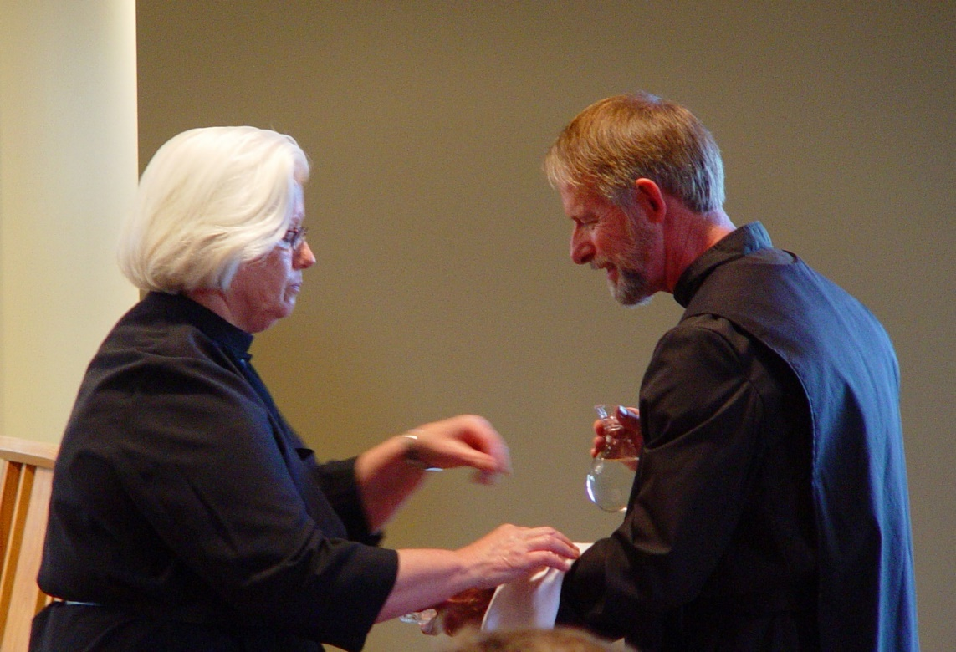
COSL Day 3 (S1)013 Sr. Elizabeth Ann Stribley; Br. Lawrence Mullen

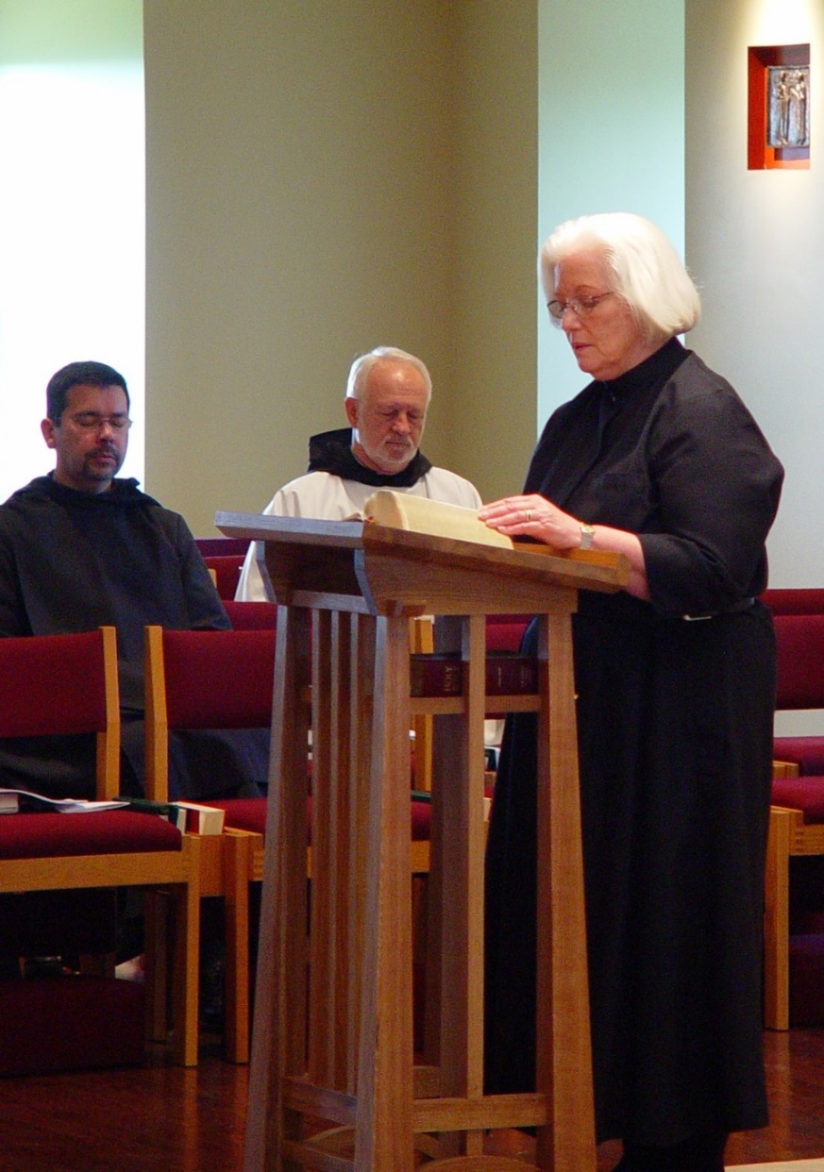
COSL Day 3 (S1)014 Br. Augustine Colvert; Br. Christopher John Baumann; Sr. Elizabeth Ann Stribley

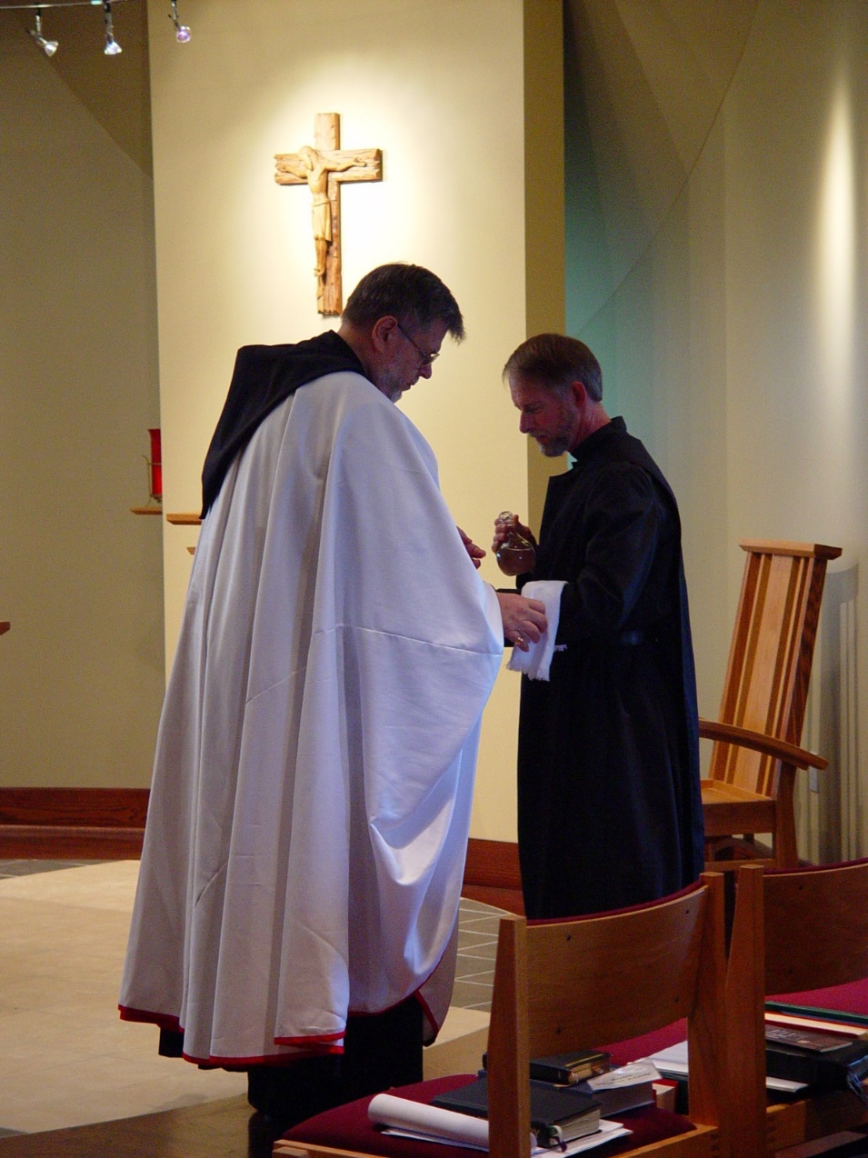
COSL Day 3 (S1)015 Br. Nathan Gregory Miller; Br. Lawrence Mullen
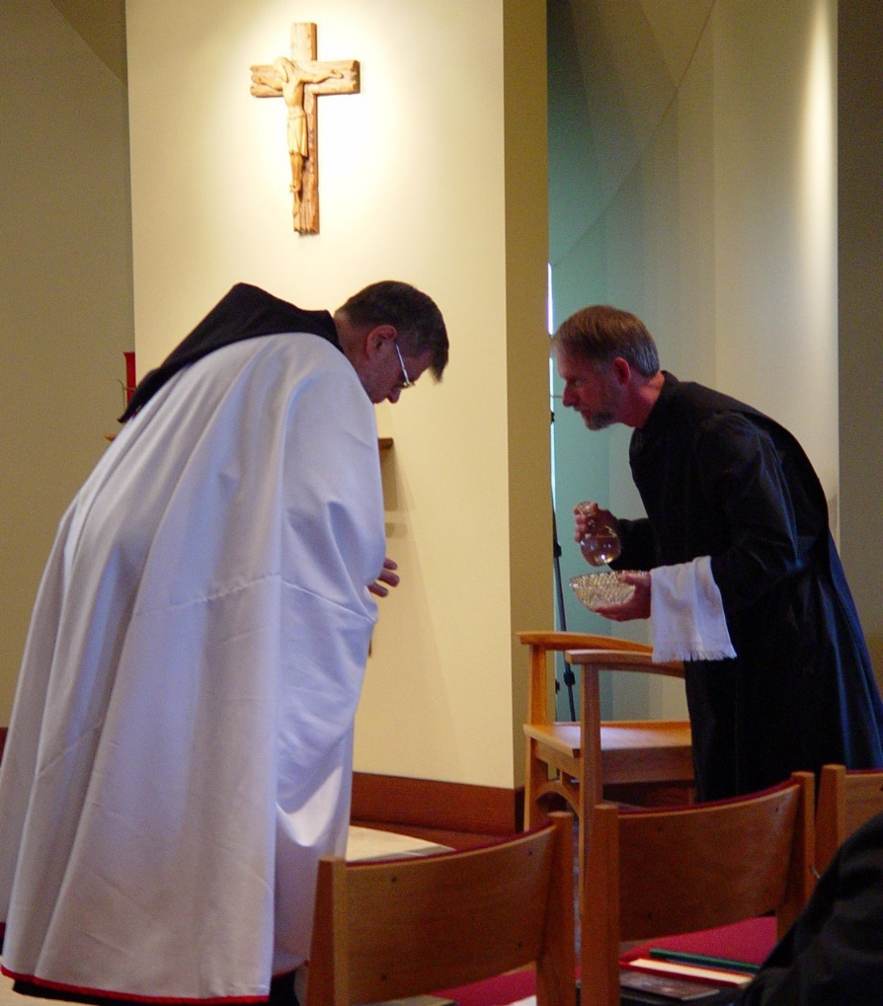
COSL Day 3 (S1)016 Br. Nathan Gregory Miller; Br. Lawrence Mullen

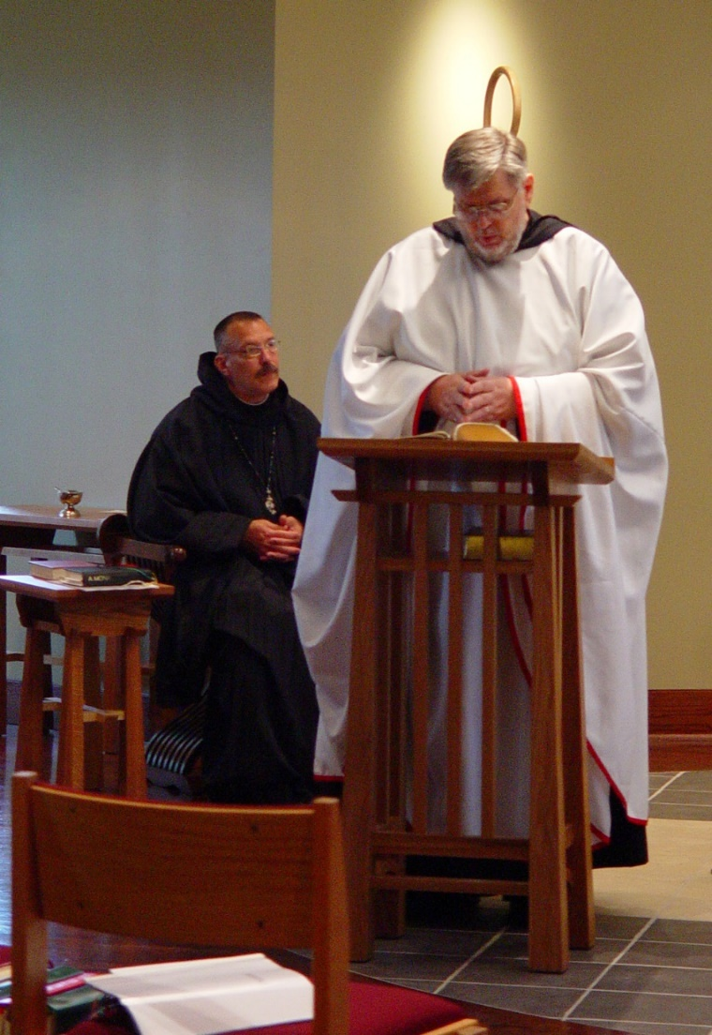
COSL Day 3 (S1)017 Abbot Michael John Austin; Br. Nathan Gregory Miller

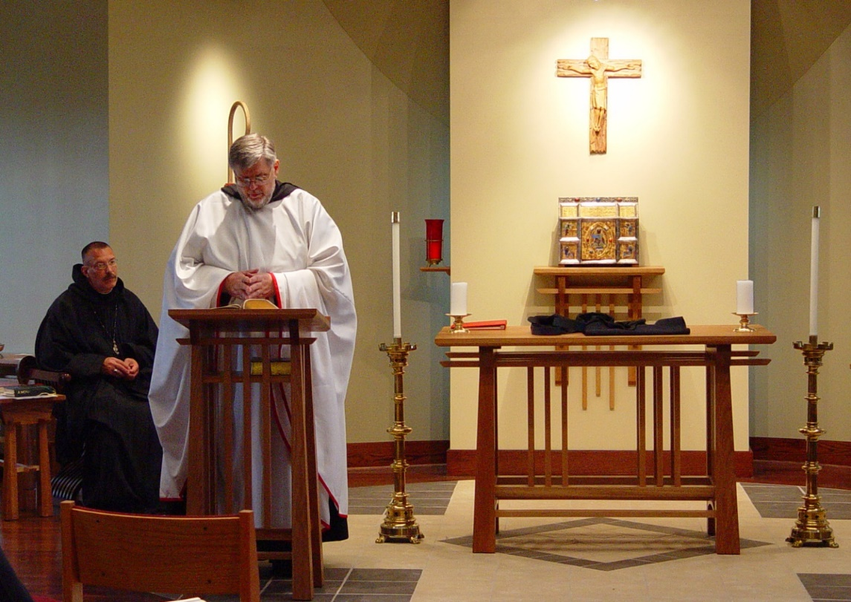
COSL Day 3 (S1)018 Abbot Michael John Austin; Br. Nathan Gregory Miller

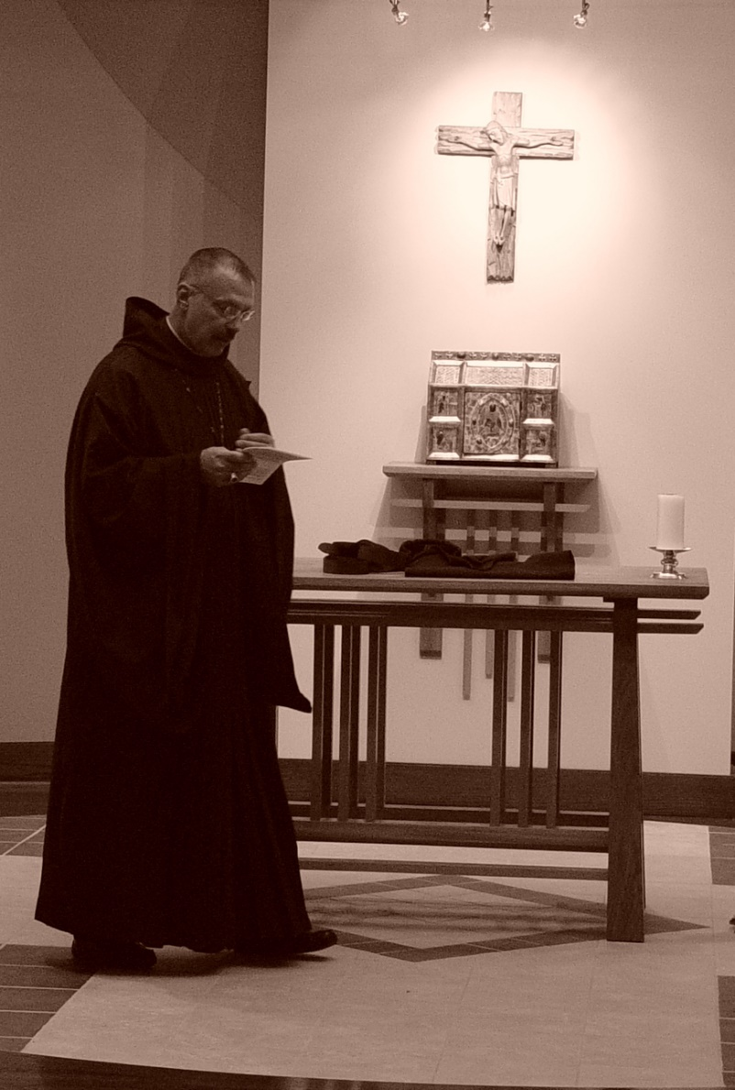
COSL Day 3 (S1)021 Abbot Michael John Austin
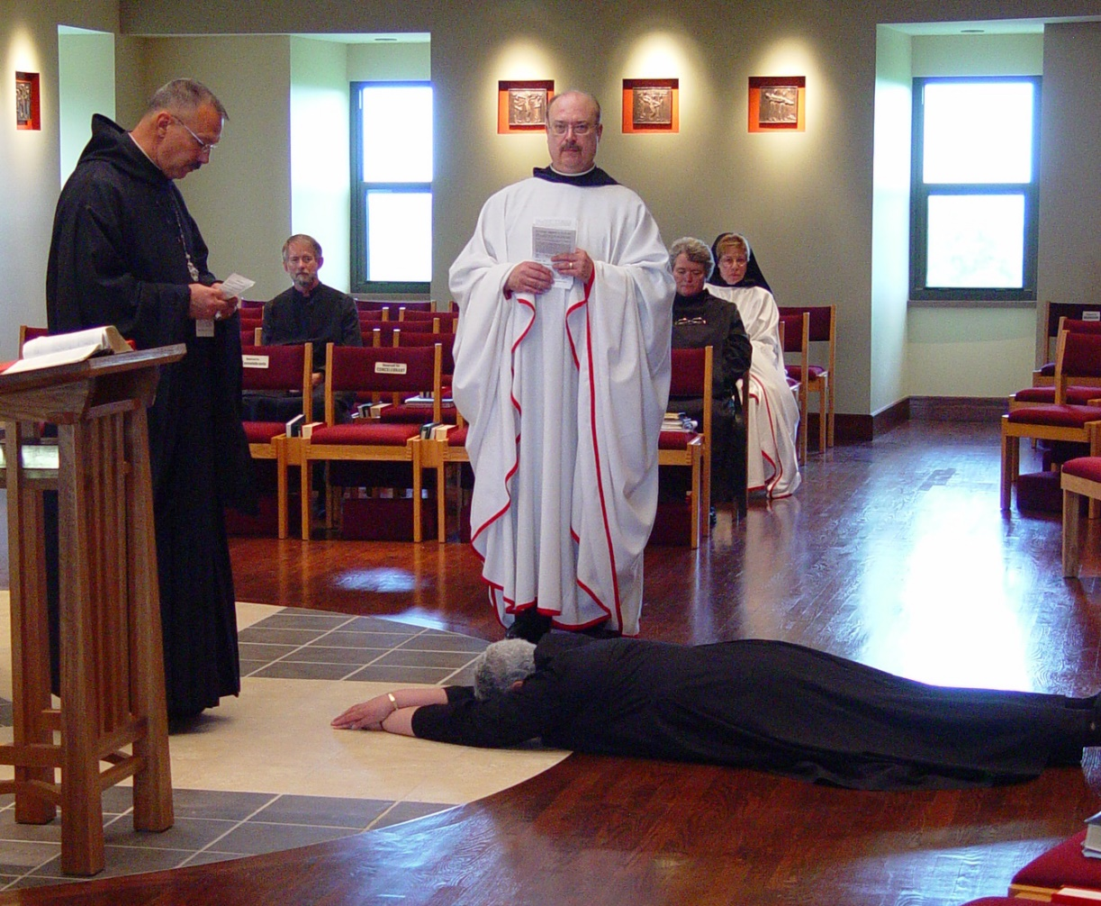
COSL Day 3 (S1)022 Abbot Michael John Austin; Br. Lawrence Mullen; Sr. Mary Catherine Christopher; Br. Raymond Owens; Sr. Vincent Marie Rittenhouse; Sr. Monica Ruth Mullen

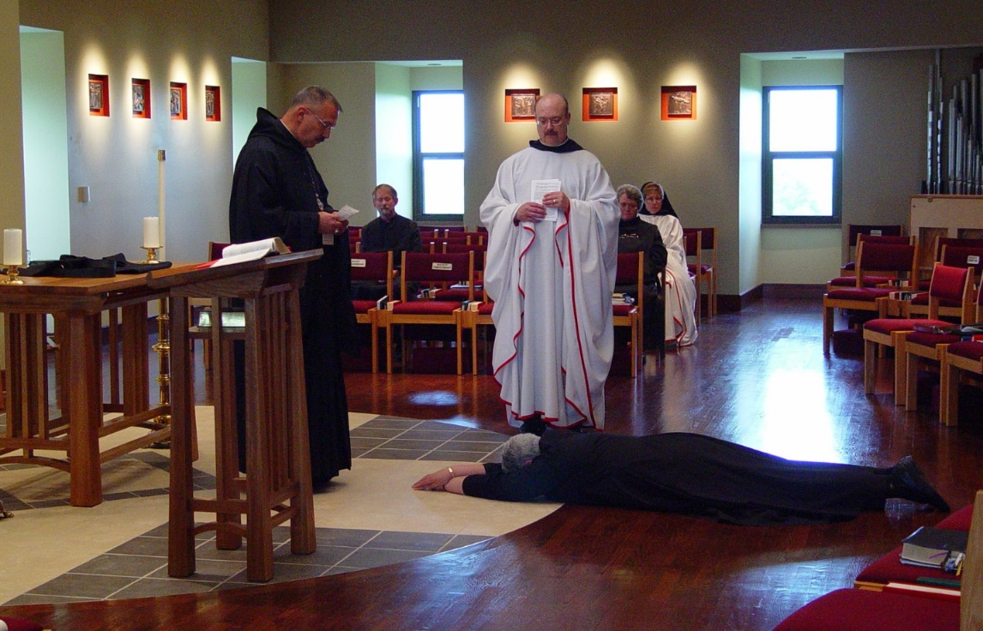
COSL Day 3 (S1)023 Abbot Michael John Austin; Br. Lawrence Mullen; Sr. Mary Catherine Christopher; Br. Raymond Owens; Sr. Vincent Marie Rittenhouse; Sr. Monica Ruth Mullen

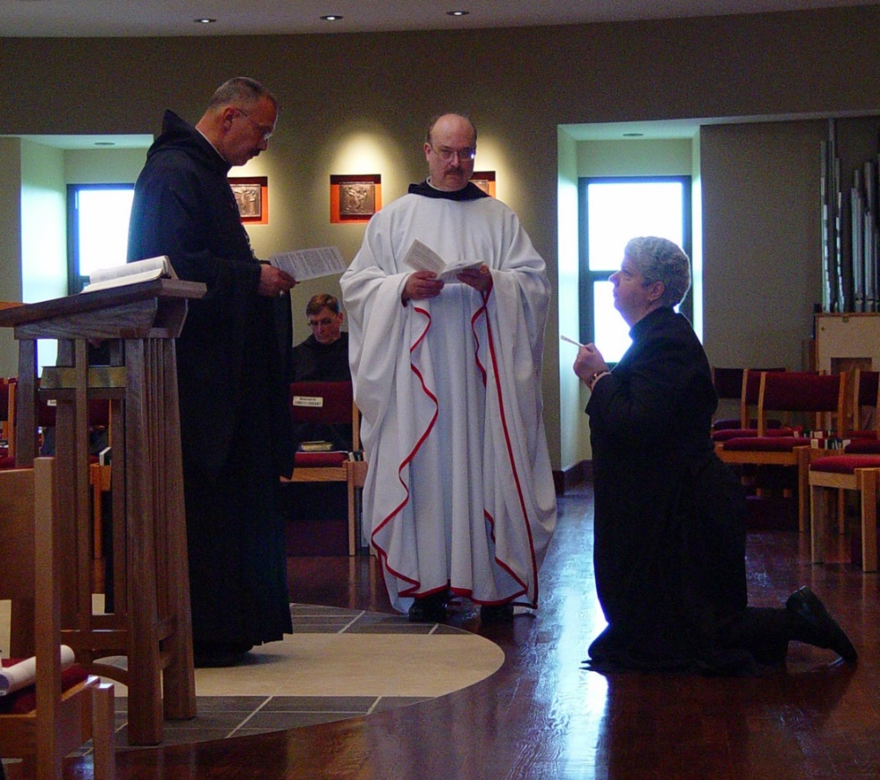
COSL Day 3 (S1)024 Abbot Michael John Austin; Br. Camillus Converse; Br. Raymond Owens; Sr. Mary Catherine Christopher

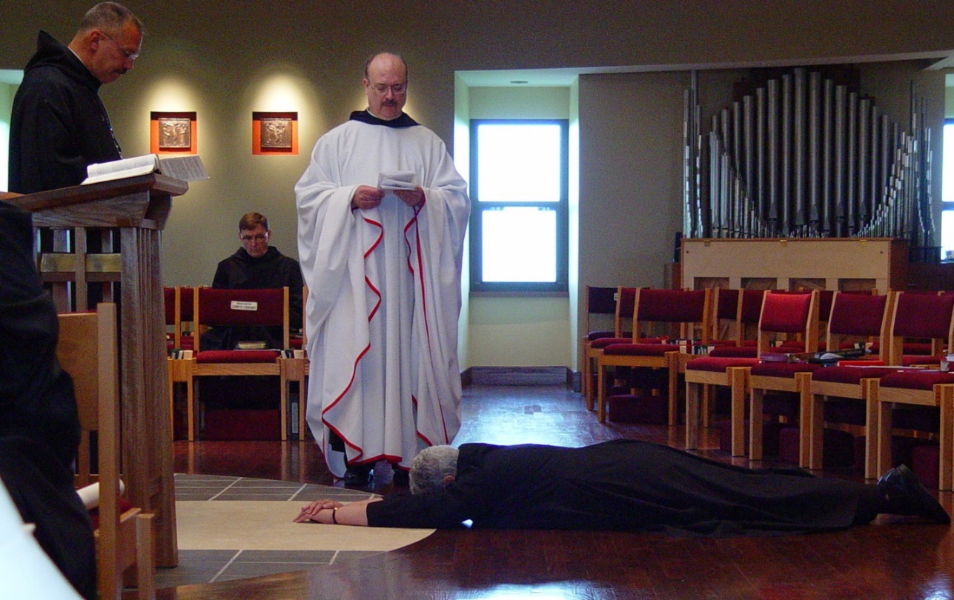
COSL Day 3 (S1)025 Abbot Michael John Austin; Br. Camillus Converse; Br. Raymond Owens; Sr. Mary Catherine Christopher
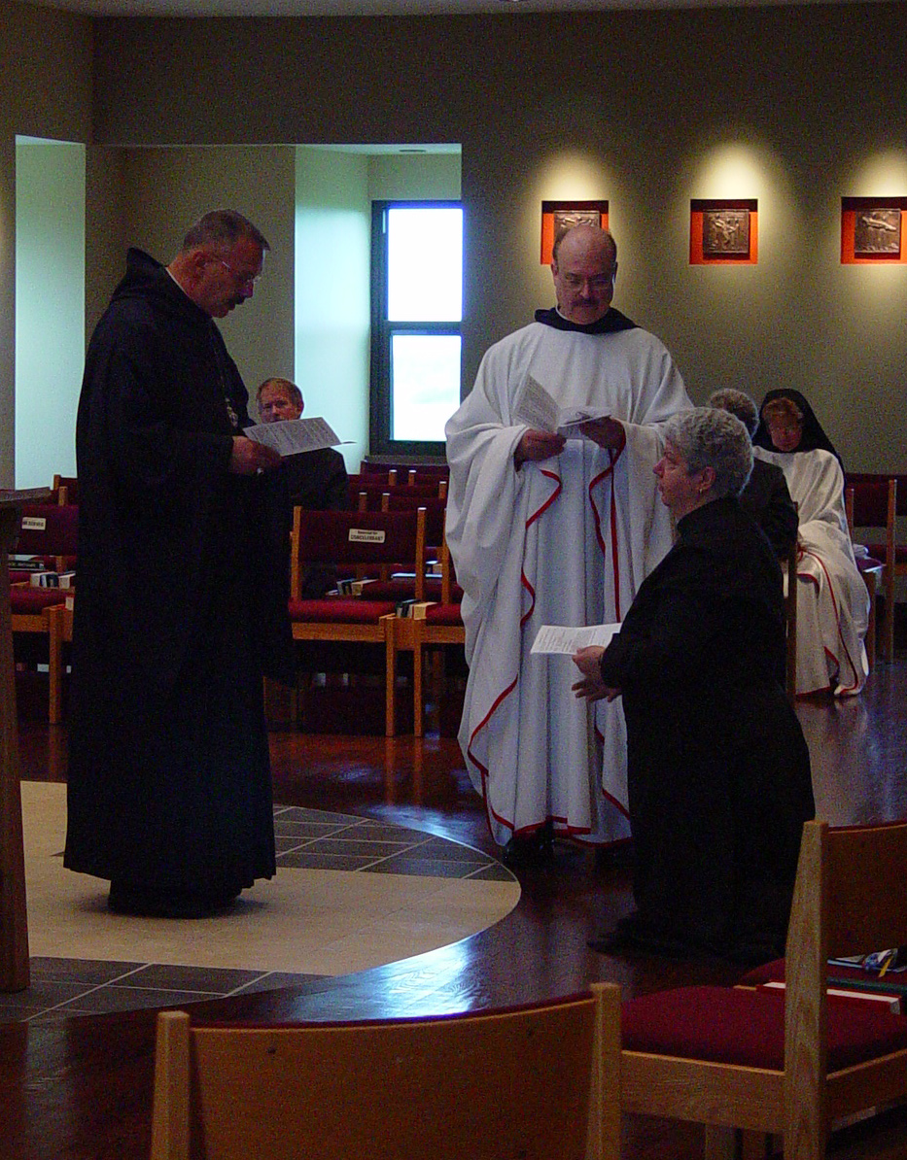
COSL Day 3 (S1)026 Abbot Michael John Austin; Br. Lawrence Mullen; Br. Raymond Owens; Sr. Mary Catherine Christopher; Sr. Monica Ruth Mullen
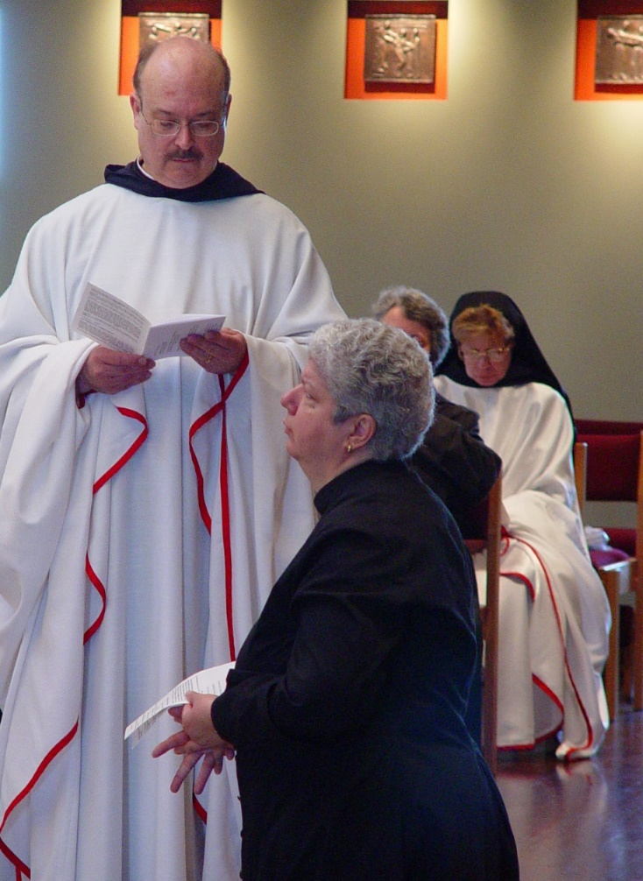
COSL Day 3 (S1)027 Br. Raymond Owens; Sr. Mary Catherine Christopher; Sr. Vincent Marie Rittenhouse; Sr. Monica Ruth Mullen

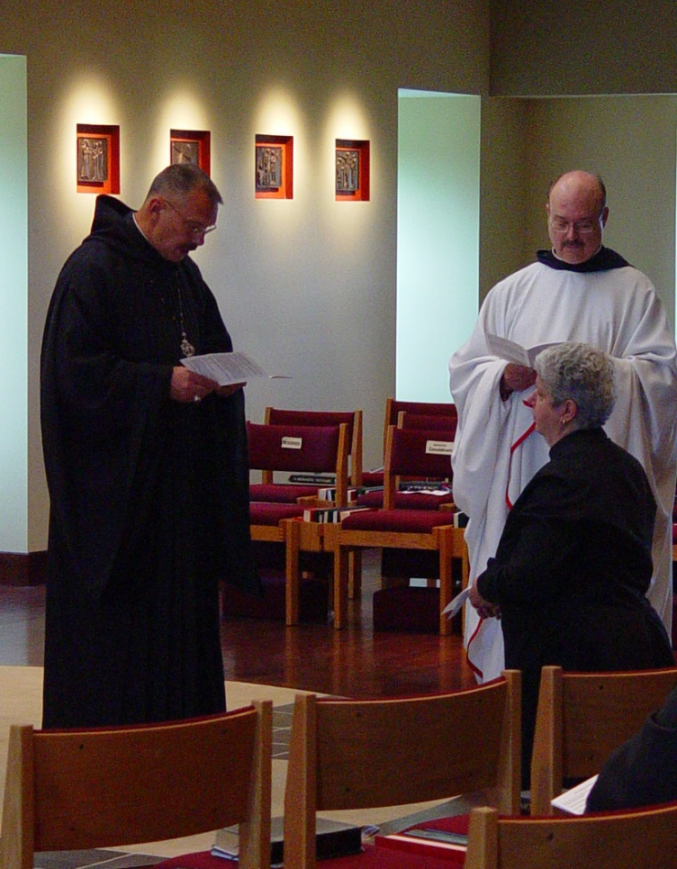
COSL Day 3 (S1)028 Abbot Michael John Austin; Sr. Mary Catherine Christopher; Br. Raymond Owens
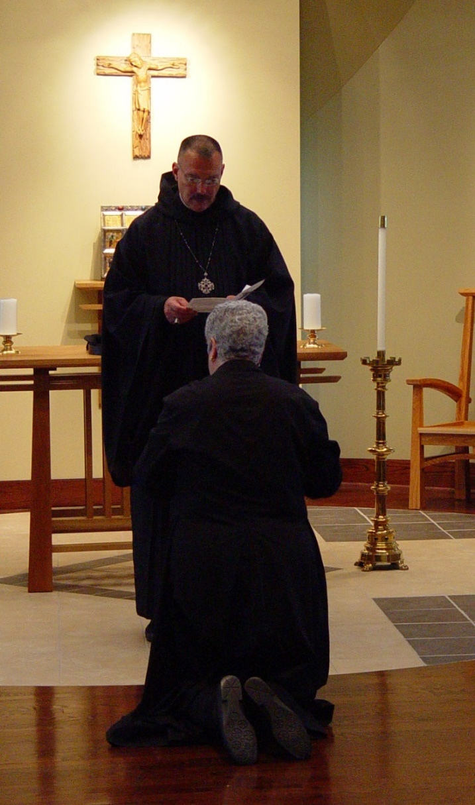
COSL Day 3 (S1)029 Abbot Michael John Austin; Sr. Mary Catherine Christopher
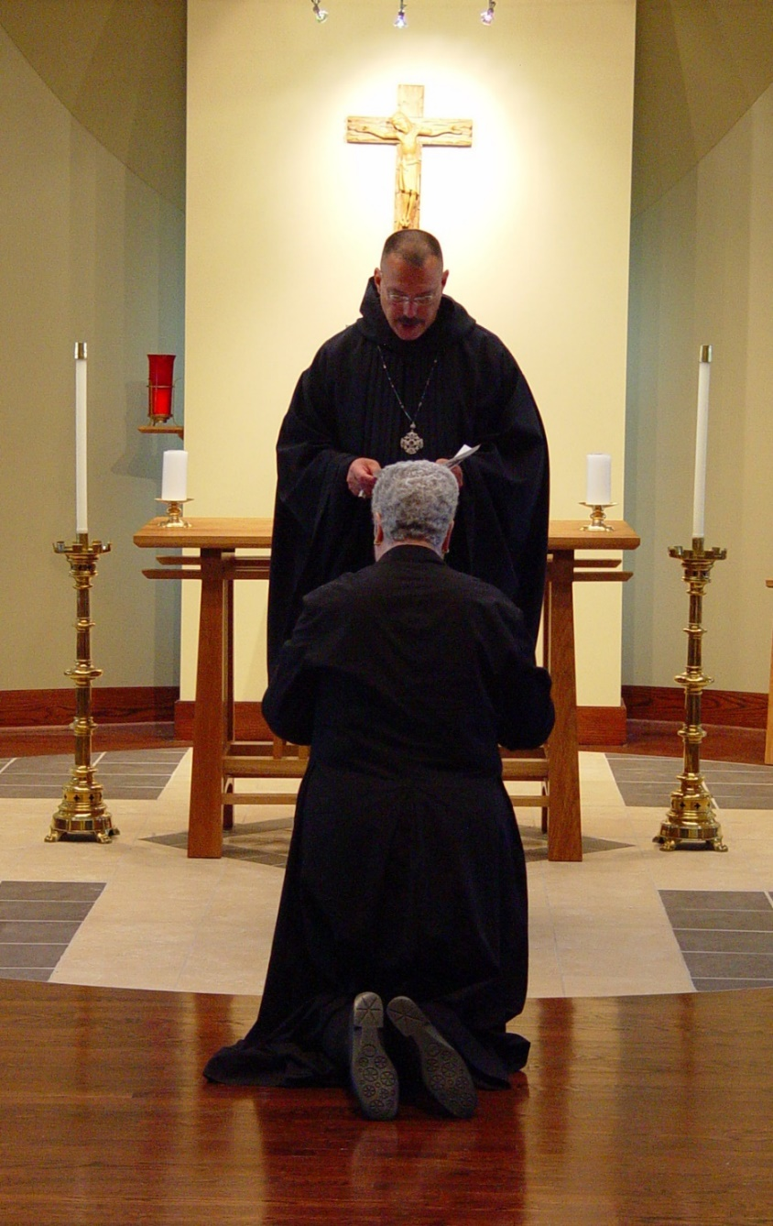
COSL Day 3 (S1)030 Abbot Michael John Austin; Sr. Mary Catherine Christopher
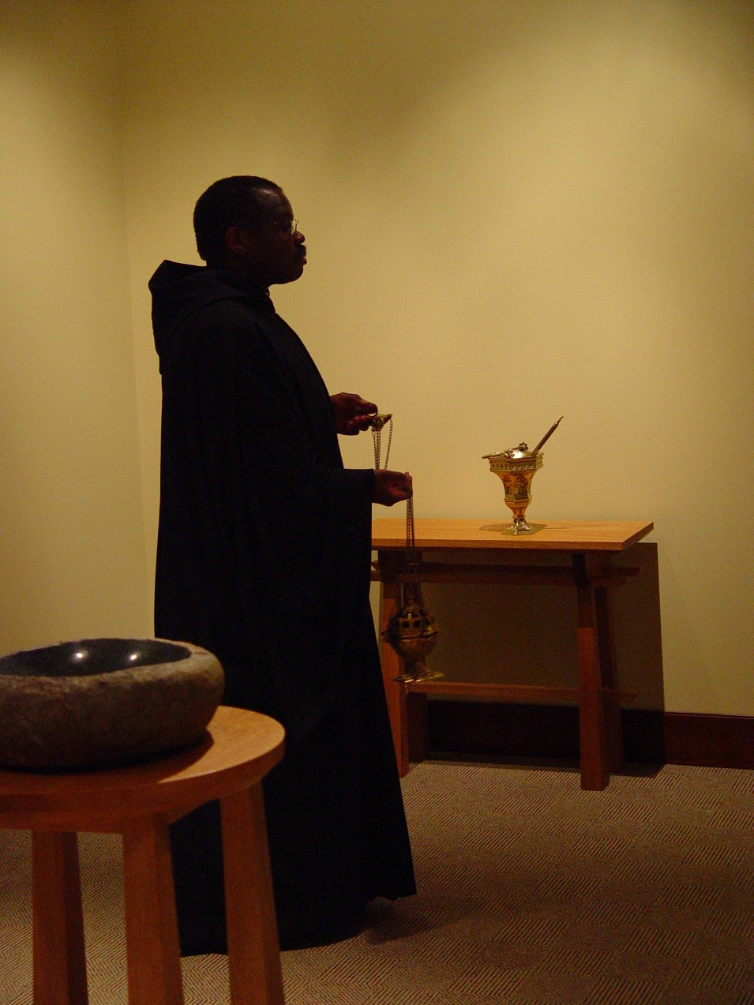
COSL Day 3 (S1)031 Br. Thomas Ferrell
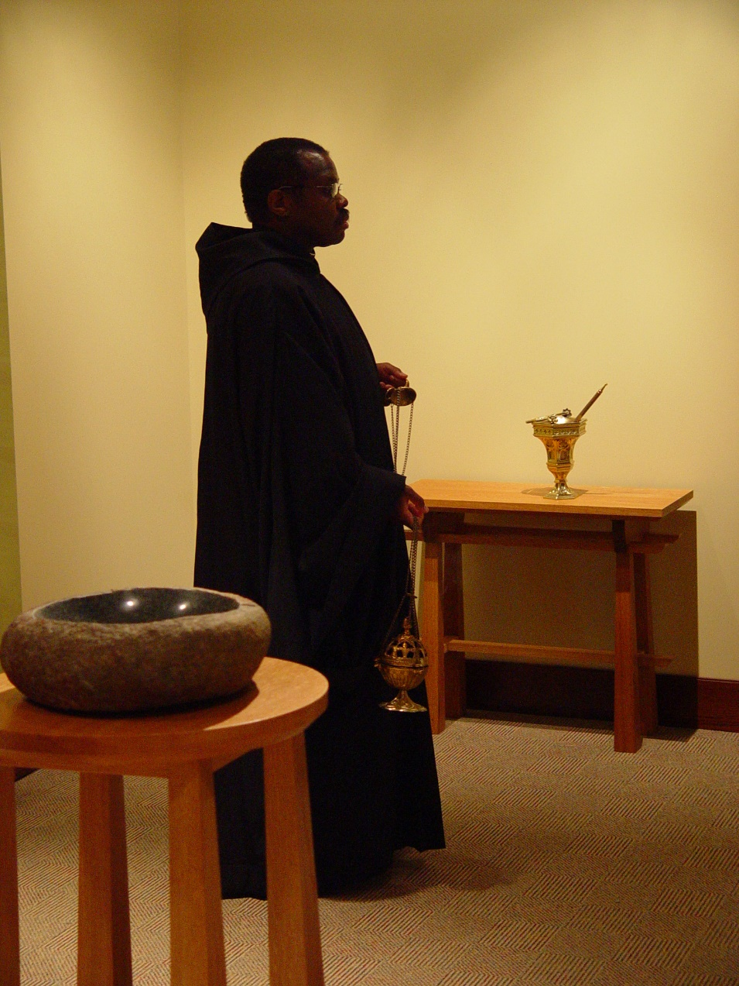
COSL Day 3 (S1)032 Br. Thomas Ferrell
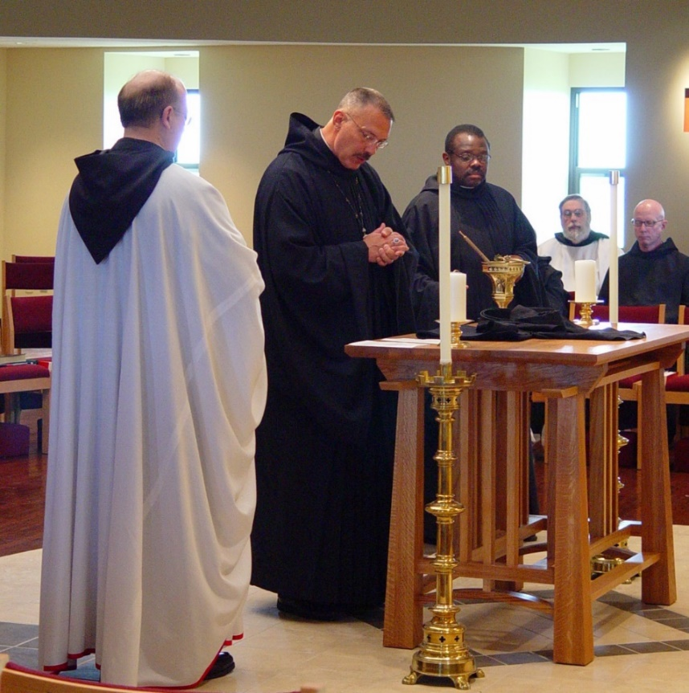
COSL Day 3 (S1)033 Br. Raymond Owens; Abbot Michael John Austin; Br. Thomas Ferrell; Br. Chad Anselm Gerns; Br. David Vincent Cotton

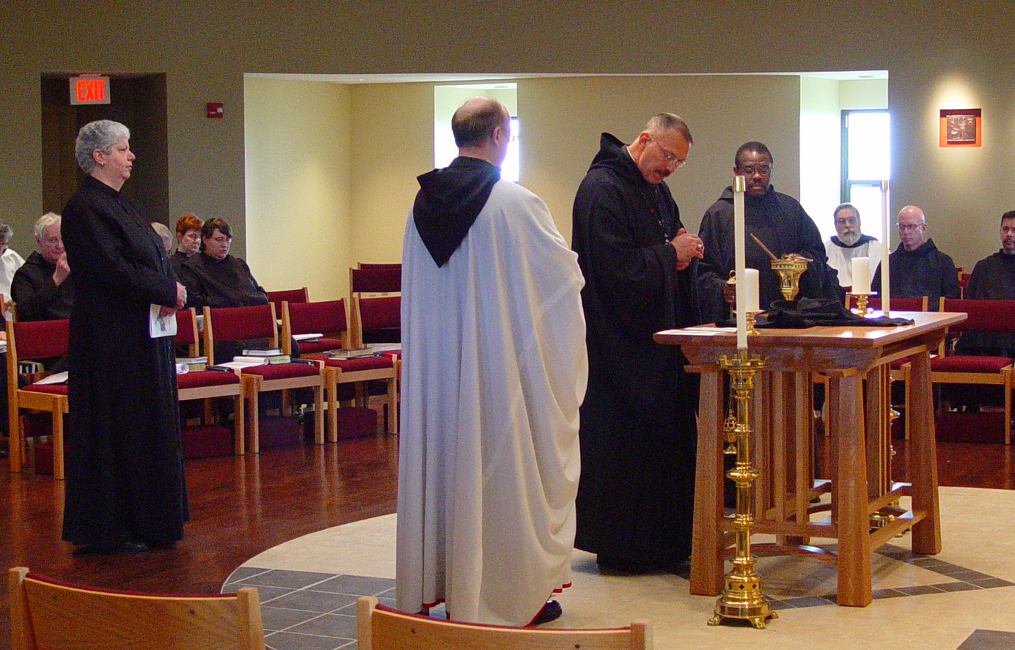
COSL Day 3 (S1)034 Br. Luke Doucette; Sr. Mary Catherine Christopher; Br. Timothy Titus Lunt; Sr. Brigid Gerns; Sr. Pauline Tysol; Br. Raymond Owens; Abbot Michael John Austin; Br. Thomas Ferrell; Br. Chad Anselm Gerns; Br. David Vincent Cotton; Br. Augustine Colvert
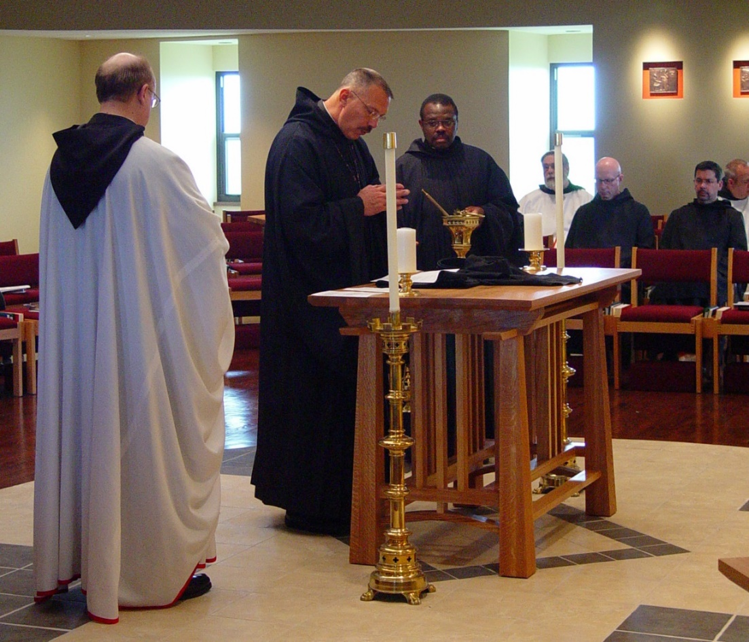
COSL Day 3 (S1)035 Br. Raymond Owens; Abbot Michael John Austin; Br. Thomas Ferrell; Br. Chad Anselm Gerns; Br. David Vincent Cotton; Br. Augustine Colvert; Br. Gabriel Hale
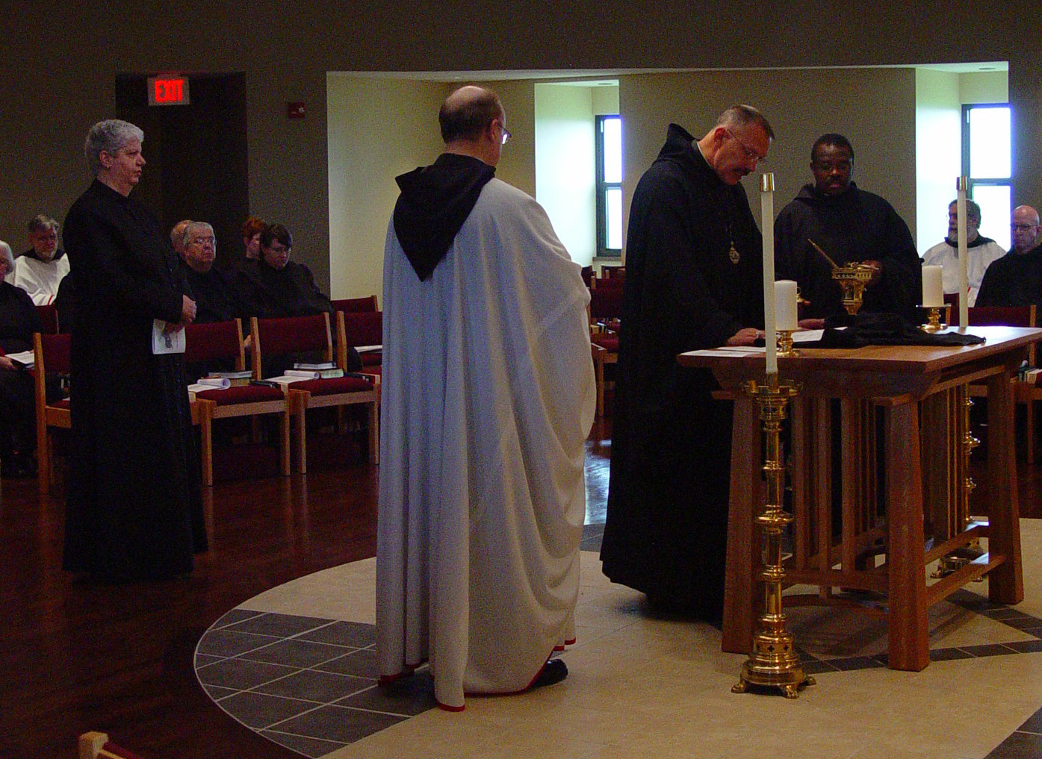
COSL Day 3 (S1)036 Br. Nathan Gregory Miller; Sr. Mary Catherine Christopher; Br. Timothy Titus Lunt; Sr. Brigid Gerns; Sr. Pauline Tysol; Br. Raymond Owens; Abbot Michael John Austin; Br. Thomas Ferrell; Br. Chad Anselm Gerns; Br. David Vincent Cotton
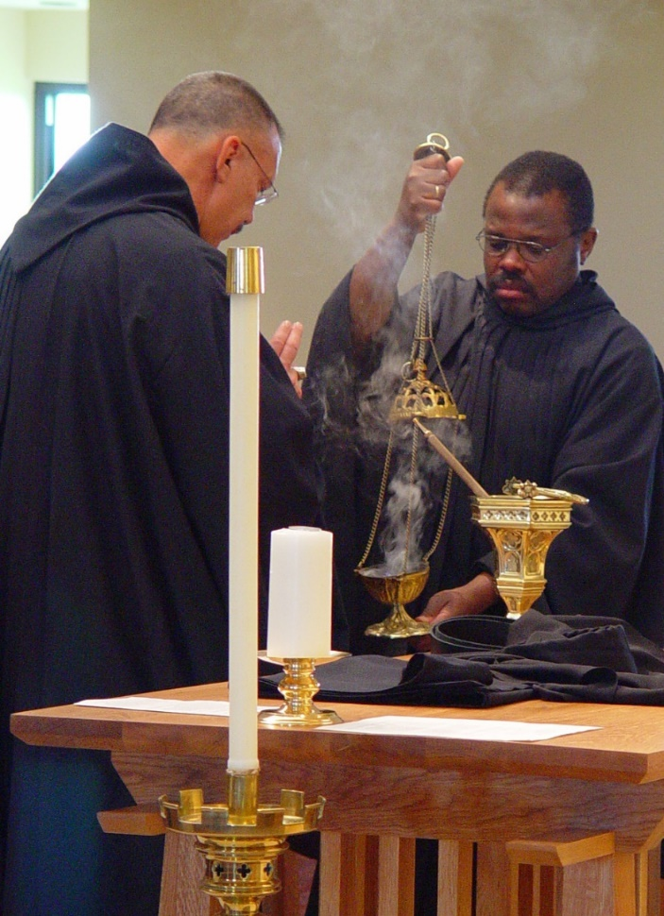
COSL Day 3 (S1)037 Abbot Michael John Austin; Br. Thomas Ferrell
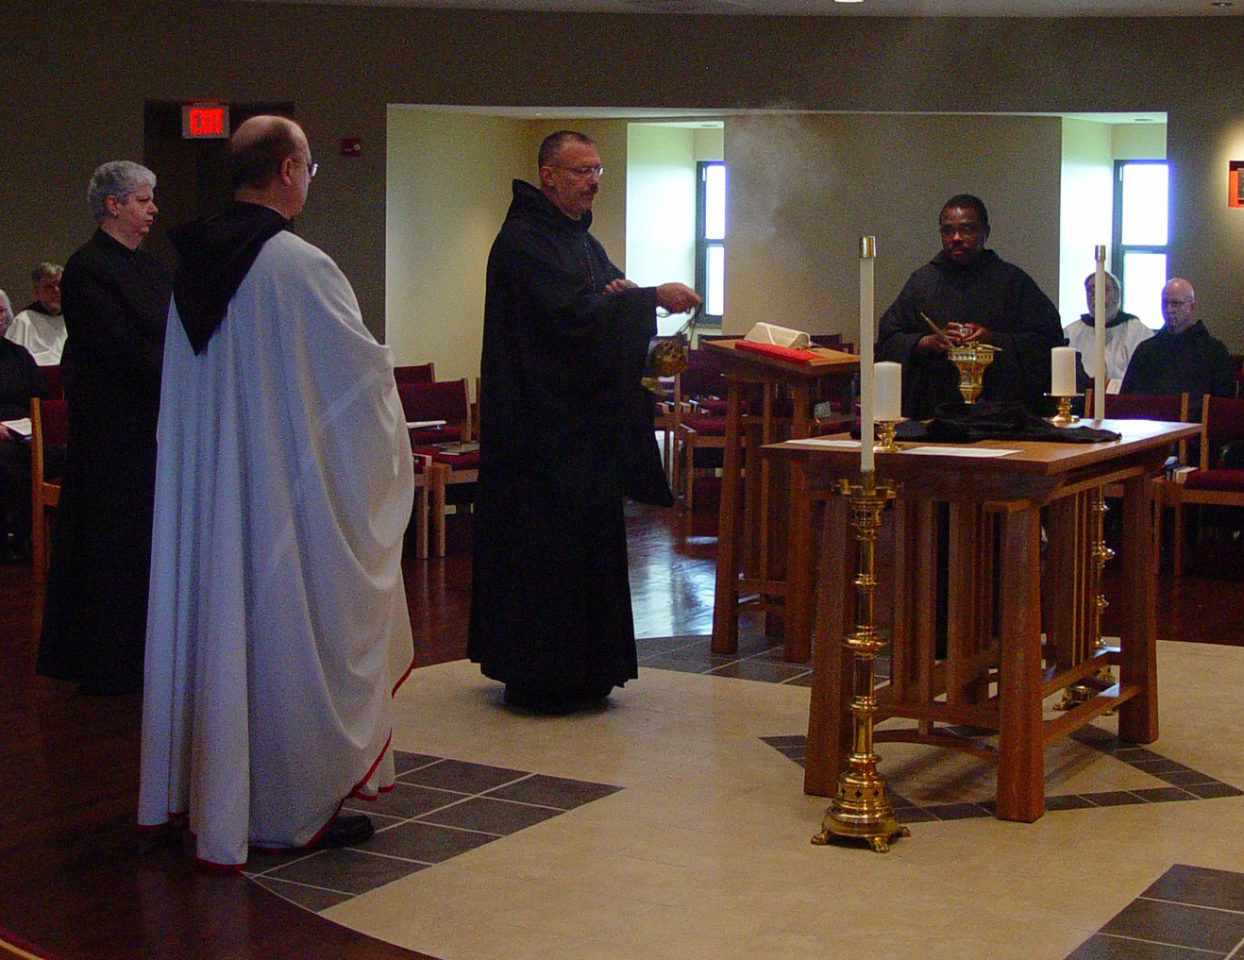
COSL Day 3 (S1)038 Br. Nathan Gregory Miller; Sr. Mary Catherine Christopher; Br. Raymond Owens; Abbot Michael John Austin; Br. Thomas Ferrell; Br. Chad Anselm Gerns; Br. David Vincent Cotton
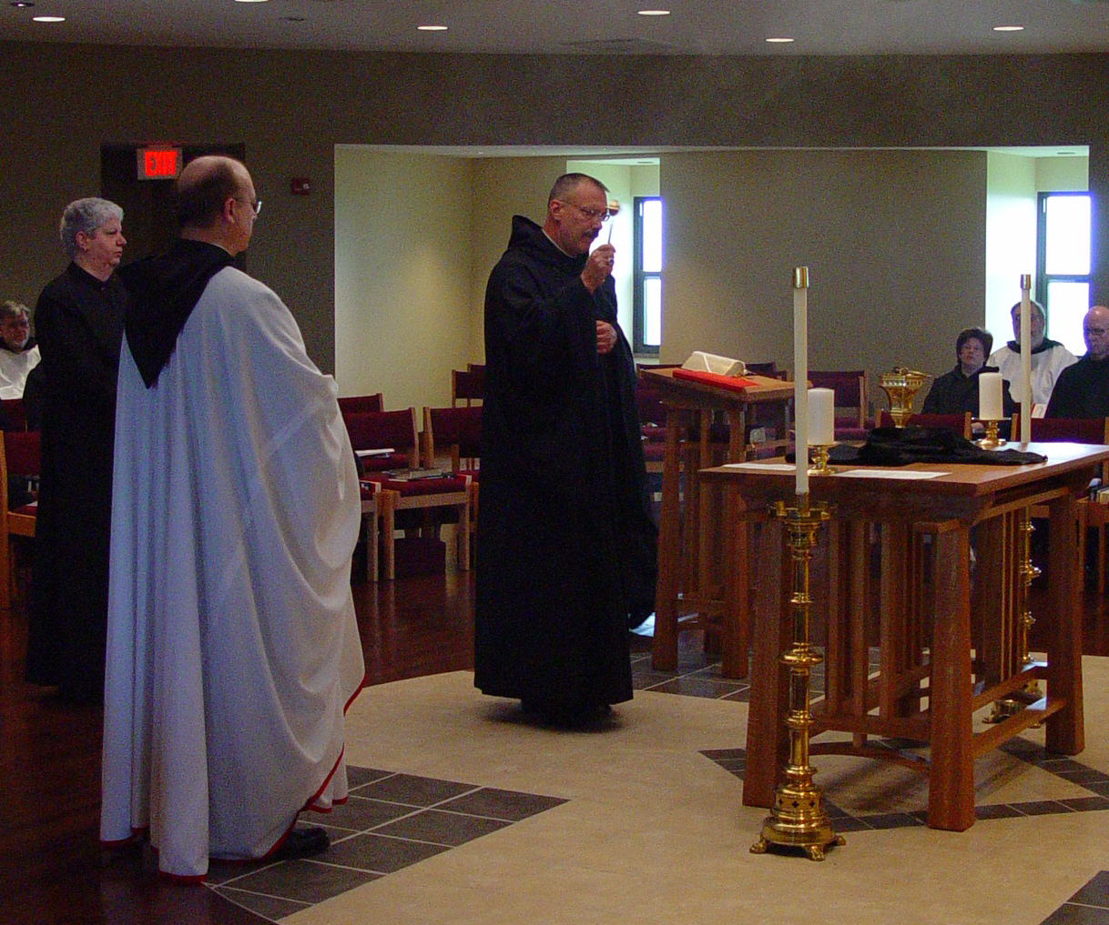
COSL Day 3 (S1)039 Br. Nathan Gregory Miller; Sr. Mary Catherine Christopher; Br. Raymond Owens; Abbot Michael John Austin; Sr. Cecelia Lamoy; Br. Chad Anselm Gerns; Br. David Vincent Cotton
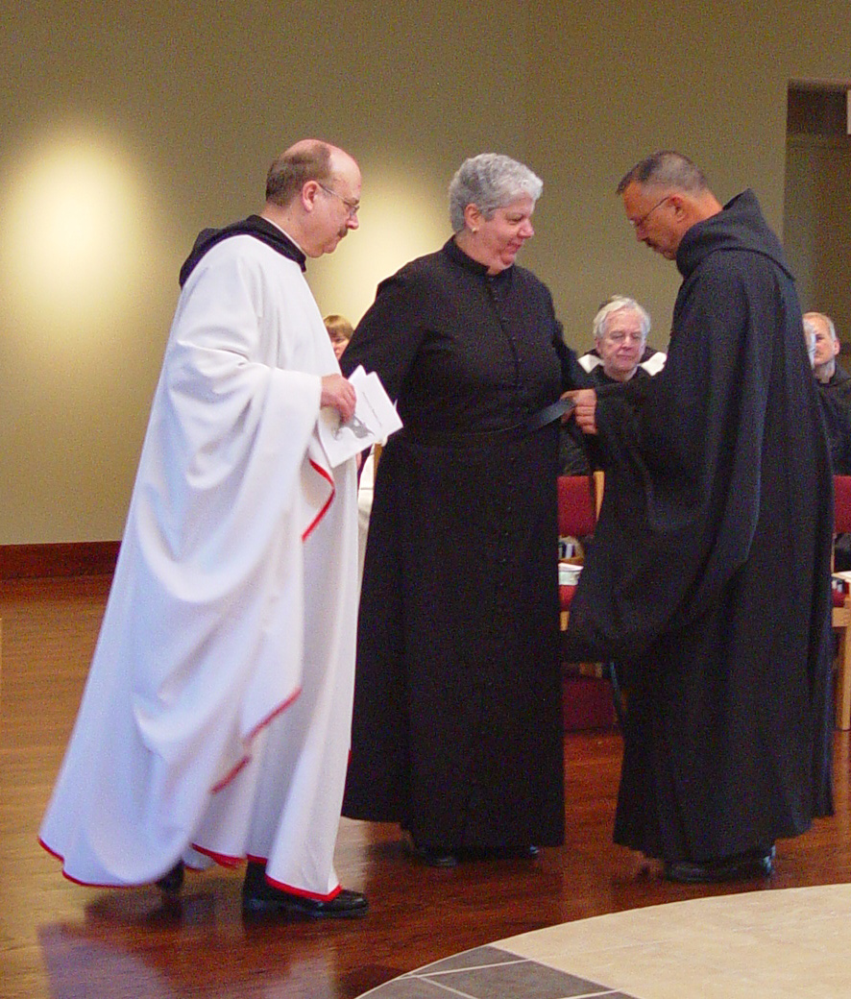
COSL Day 3 (S1)040 Br. Raymond Owens; Sr. Catherine Unterseher; Sr. Mary Catherine Christopher; Br. Luke Doucette; Abbot Michael John Austin; Br. Daniel Joseph Schroeder
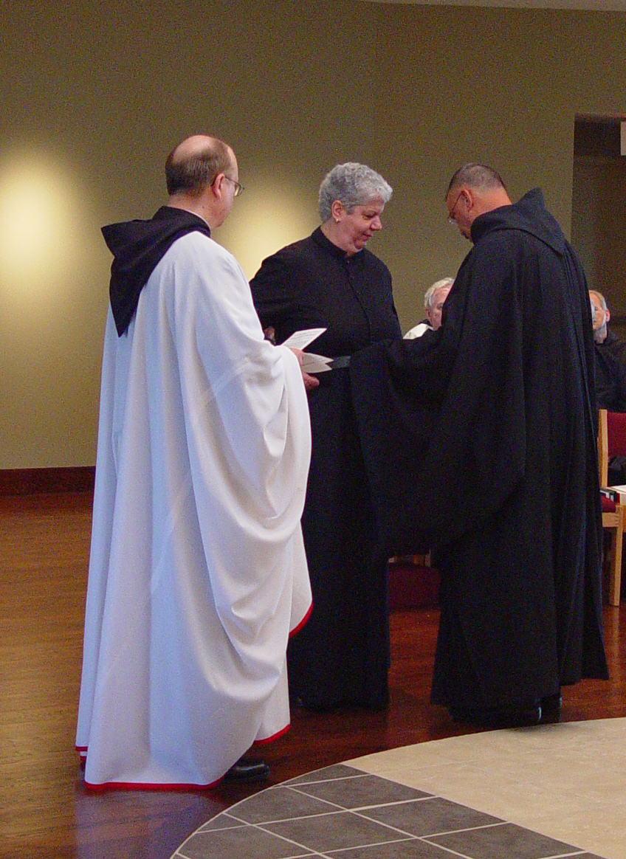
COSL Day 3 (S1)041 Br. Raymond Owens; Sr. Mary Catherine Christopher; Br. Luke Doucette; Abbot Michael John Austin; Br. Daniel Joseph Schroeder
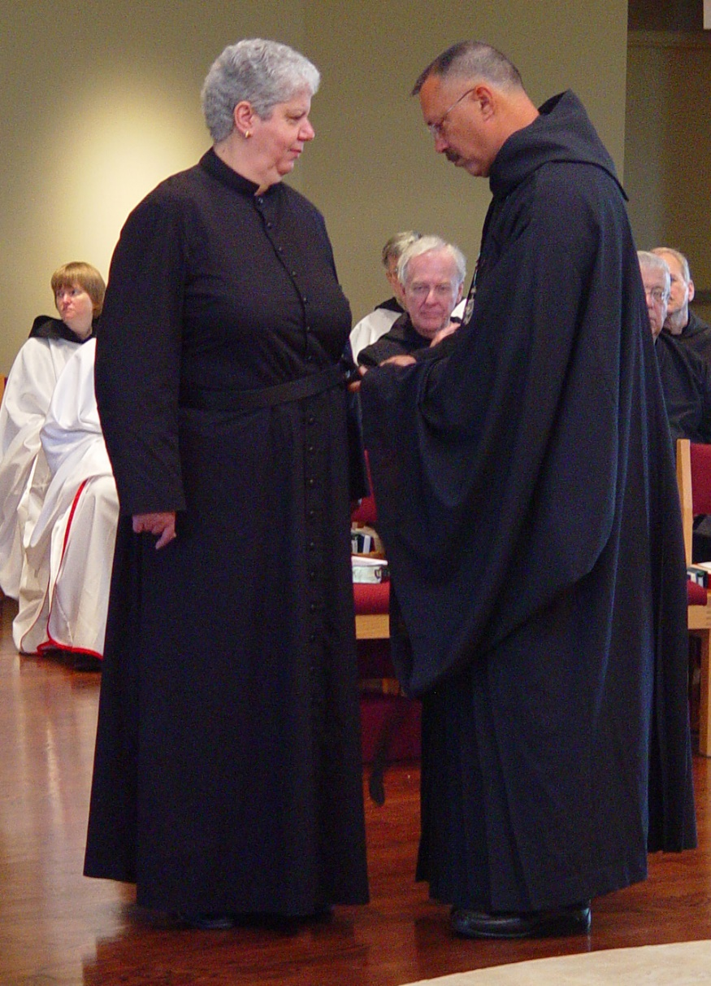
COSL Day 3 (S1)042 Sr. Catherine Unterseher; Sr. Mary Catherine Christopher; Br. Luke Doucette; Abbot Michael John Austin; Br. Timothy Titus Lunt; Br. Daniel Joseph Schroeder
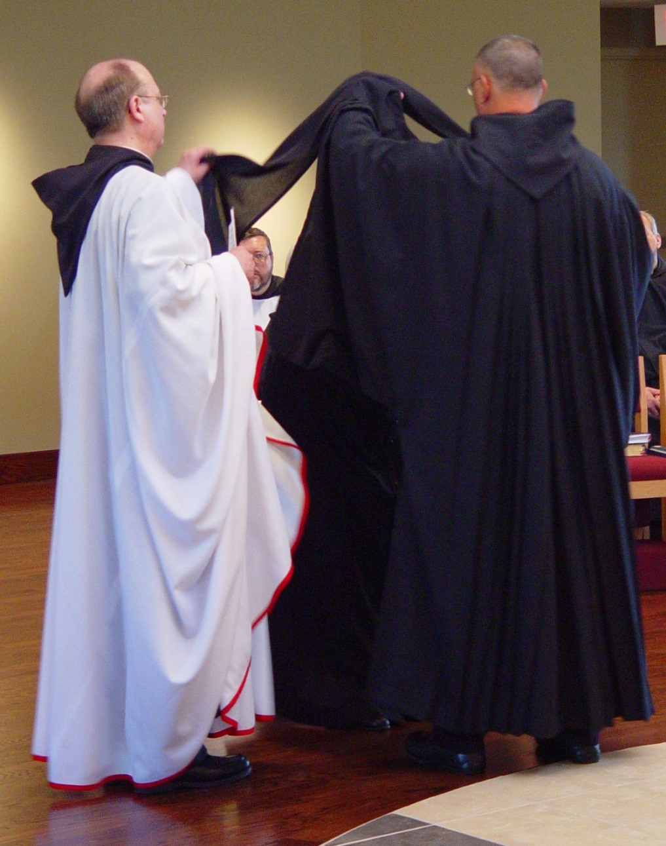
COSL Day 3 (S1)043 Br. Raymond Owens; Br. Paul Howard; Sr. Mary Catherine Christopher; Abbot Michael John Austin
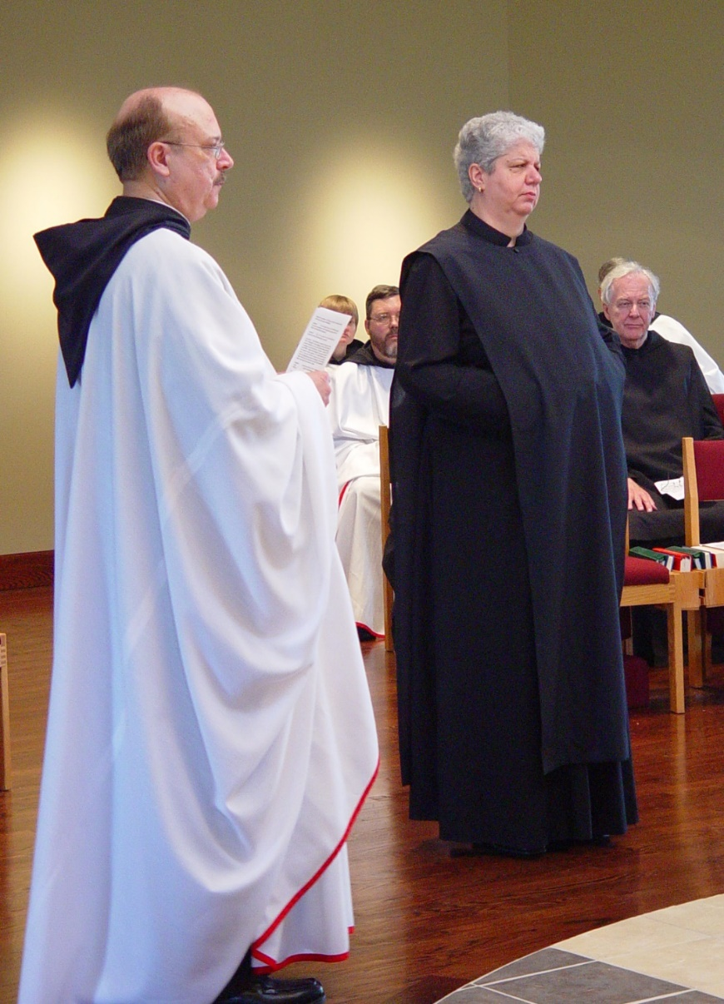
COSL Day 3 (S1)044 Sr. Catherine Unterseher; Br. Raymond Owens; Sr. Catherine Unterseher; Br. Paul Howard; Sr. Mary Catherine Christopher; Br. Luke Doucette
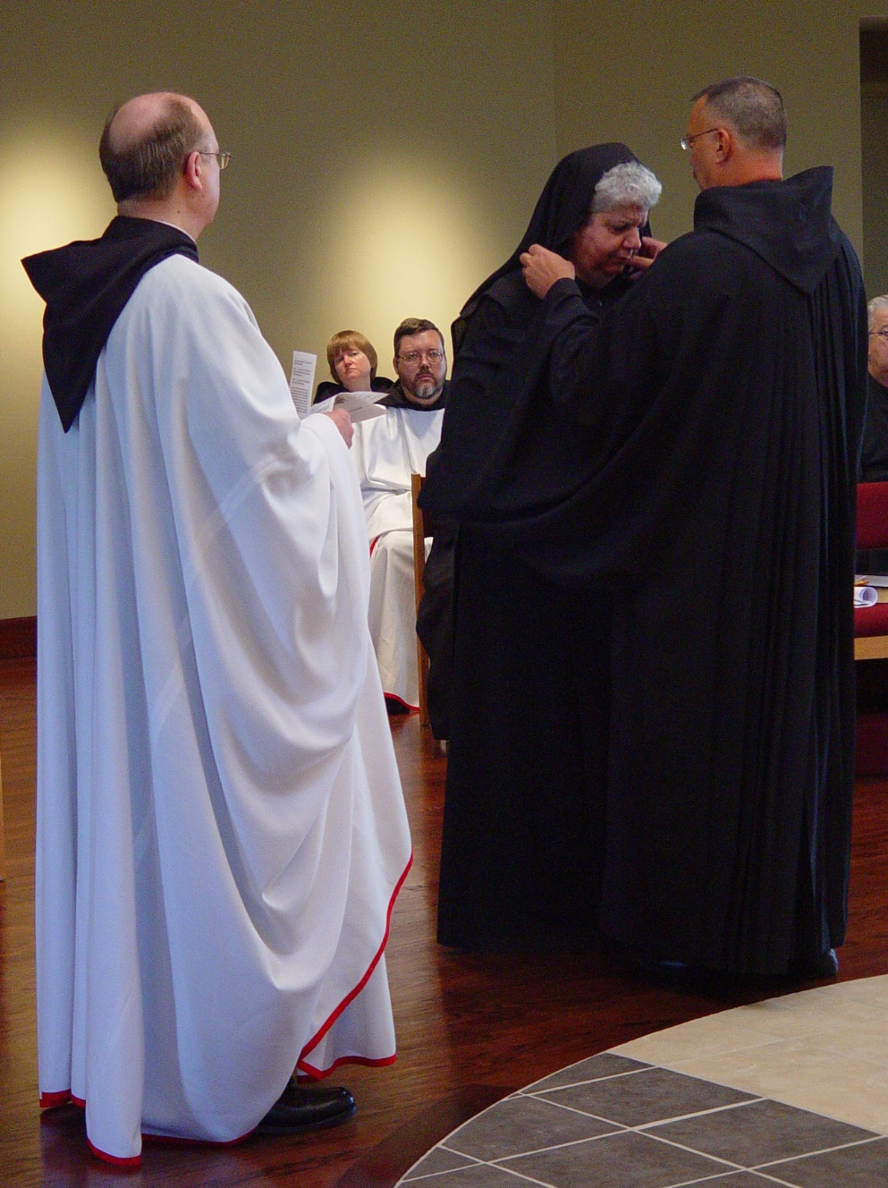
COSL Day 3 (S1)045 Br. Raymond Owens; Sr. Catherine Unterseher; Br. Paul Howard; Sr. Mary Catherine Christopher; Abbot Michael John Austin; Br. Timothy Titus Lunt
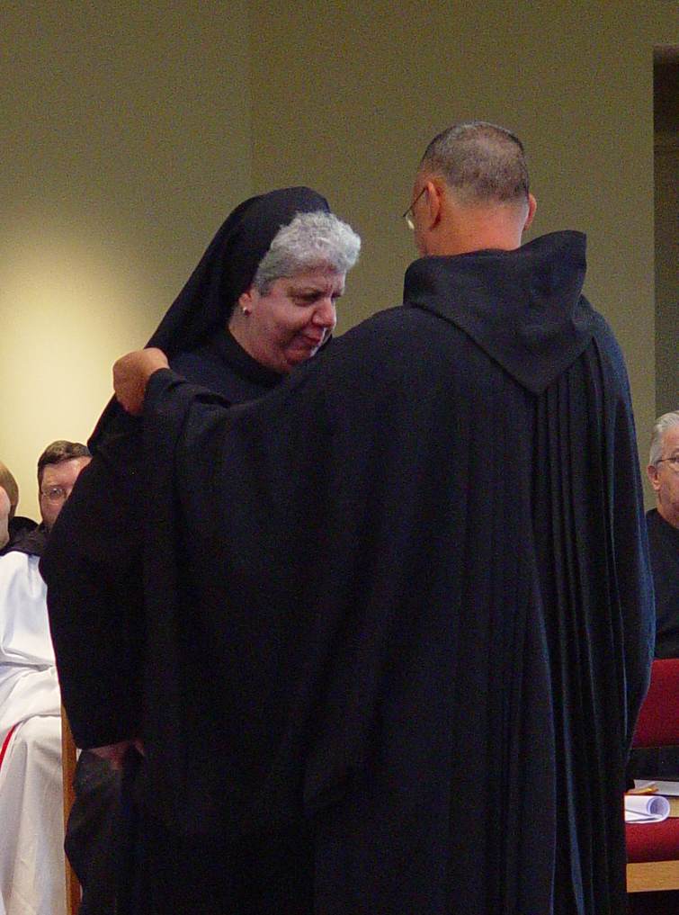
COSL Day 3 (S1)046 Br. Paul Howard; Sr. Mary Catherine Christopher; Abbot Michael John Austin; Br. Timothy Titus Lunt
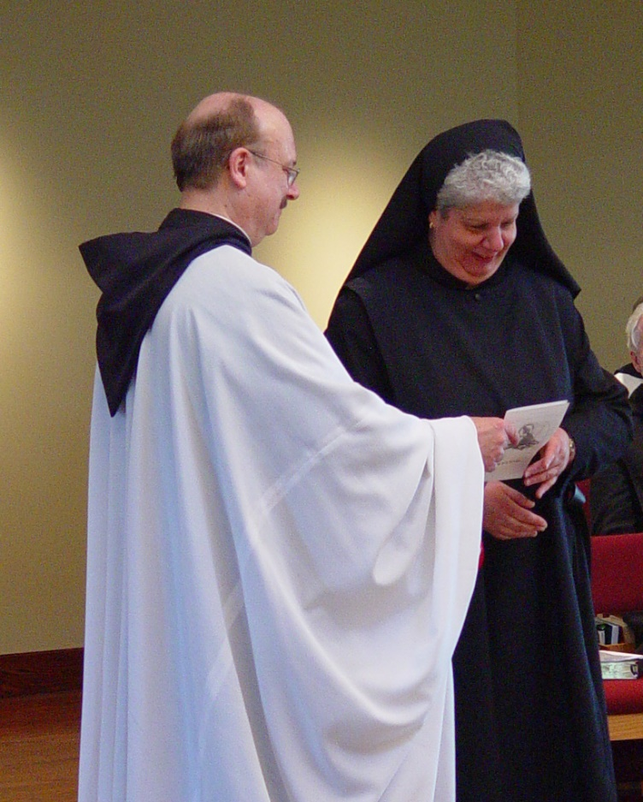
COSL Day 3 (S1)047 Br. Raymond Owens; Sr. Mary Catherine Christopher
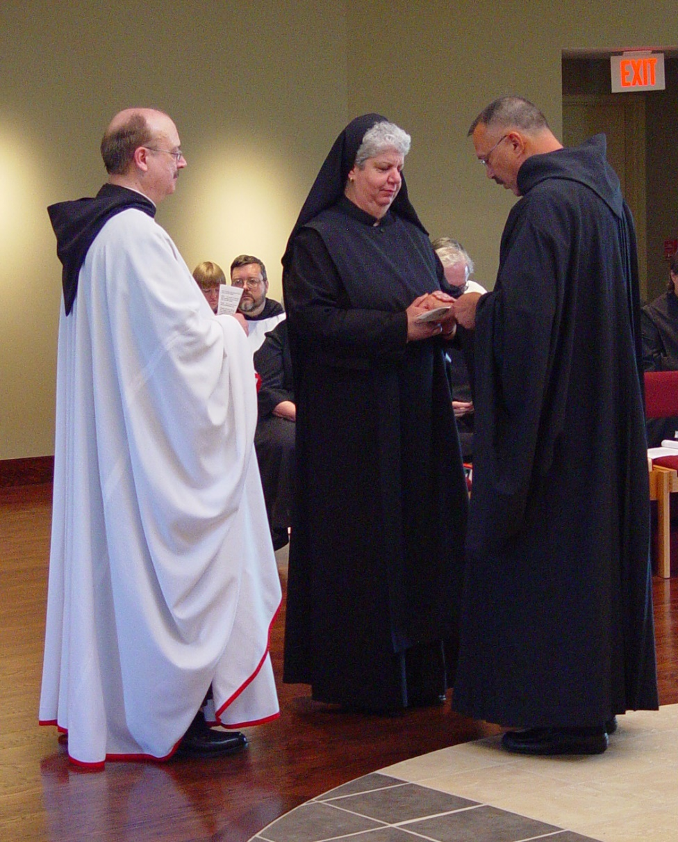
COSL Day 3 (S1)048 Br. Raymond Owens; Sr. Catherine Unterseher; Br. Paul Howard; Sr. Mary Catherine Christopher; Abbot Michael John Austin
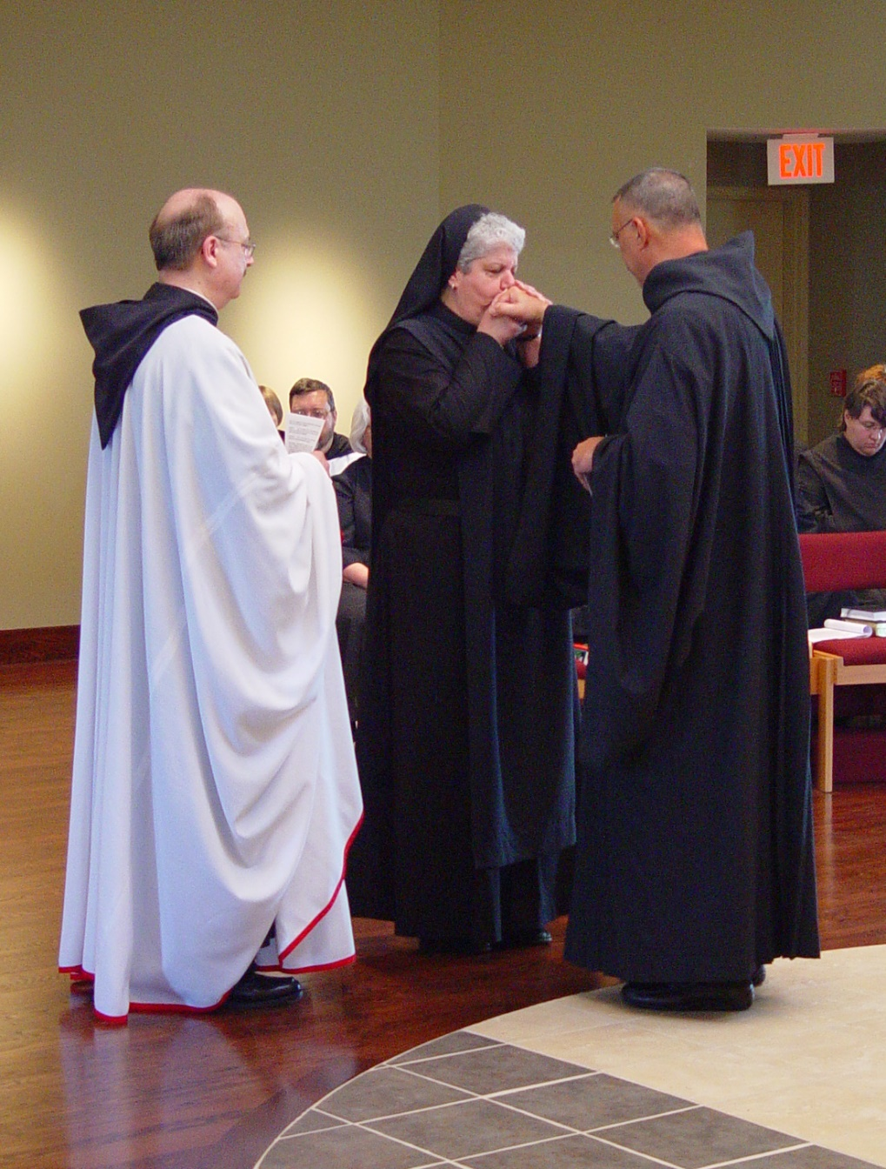
COSL Day 3 (S1)049 Br. Paul Howard; Br. Raymond Owens; Sr. Mary Catherine Christopher; Abbot Michael John Austin; Sr. Pauline Tysol

