Companions of St. Luke
Spring 2006 Convocation at Conception Abbey
Day 2, Part 1 of 3

~Edited by Br. Steven Olderr, 3 June 2022 with the assistance of Br. Thomas Ferrell. If you find any errors or omissions or have anything to add, please notify Br. Steven at olderr@ameritech.net

People are identified from left to right.

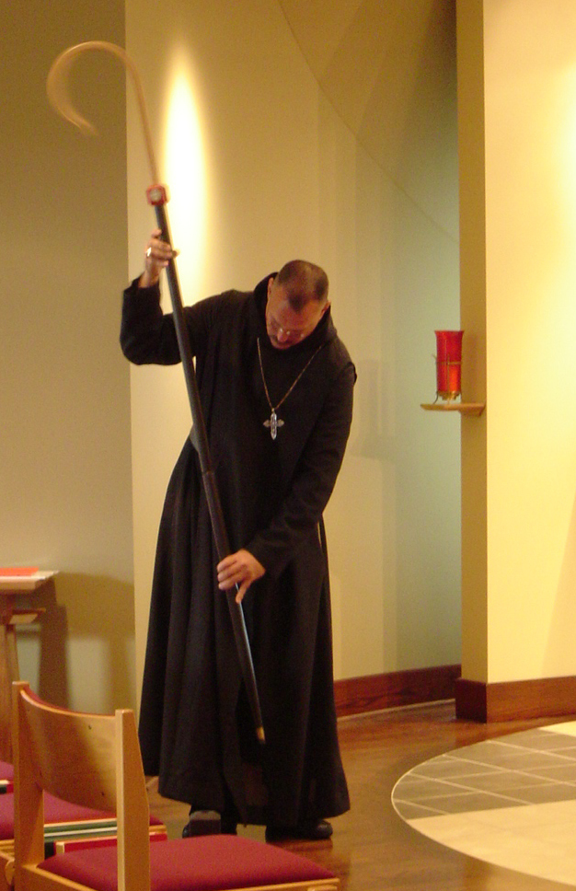
COSL Day 2 (S1) 001 Abbot Michael John Austin

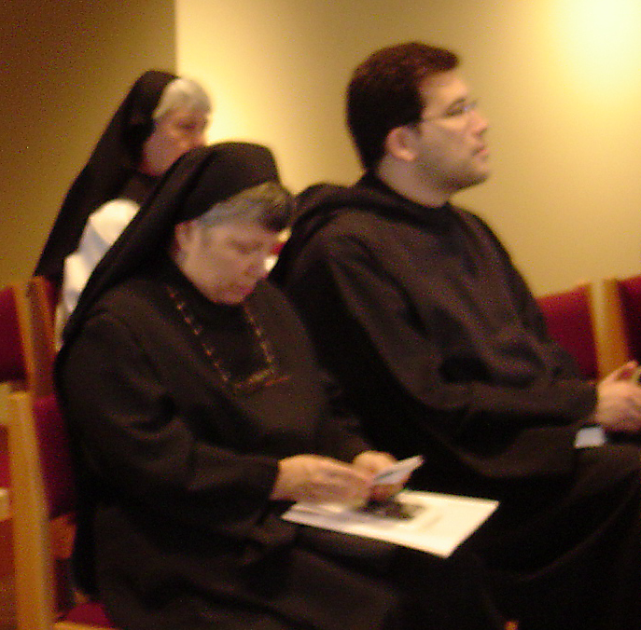
COSL Day 2 (S1) 002 Sr. Clare Benedicta; Sr, Anna Grace Madden; Br. Anthony Bernard Campos
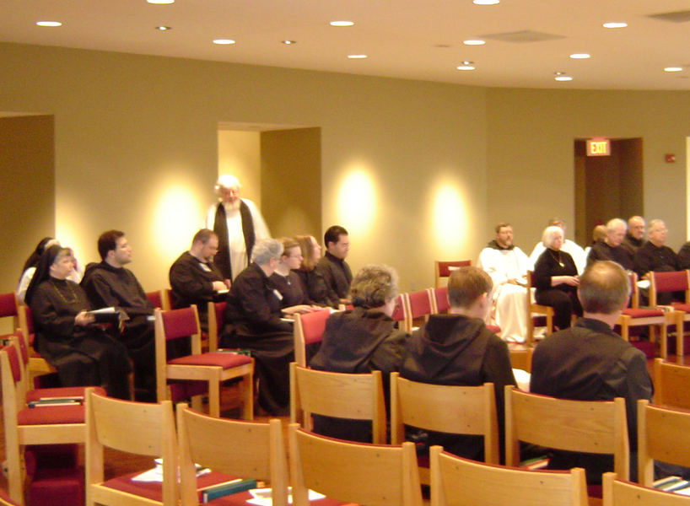COSL Day 2 (S1) 003 Sr. Anna Grace Madden; Br. Bernard Campos; Br. Willard Moore; Fr. Wayne Kamm; Sr. Mary Catherine Christopher; Jan Wolsleben; Jane Bebee; Daniel Medina; Vincent Marie Rittenhouse; Br. Camillus Converse; Br. Paul Howard; Judith Stribley; Br. Chad Anselm Gerns; Br. Luke Doucette; Br. Lawrence Mullen; Br. Daniel Joseph Schroeder; Tom Lunt
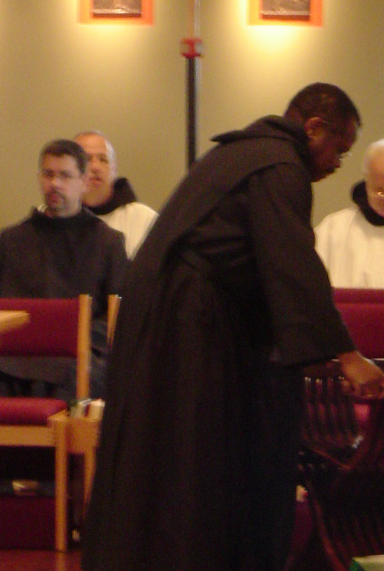
COSL Day 2 (S1) 004 Br. Augustine Colvert; Br. Gabriel Hale; Br. Thomas Ferrell; Br. Christopher John Baumann

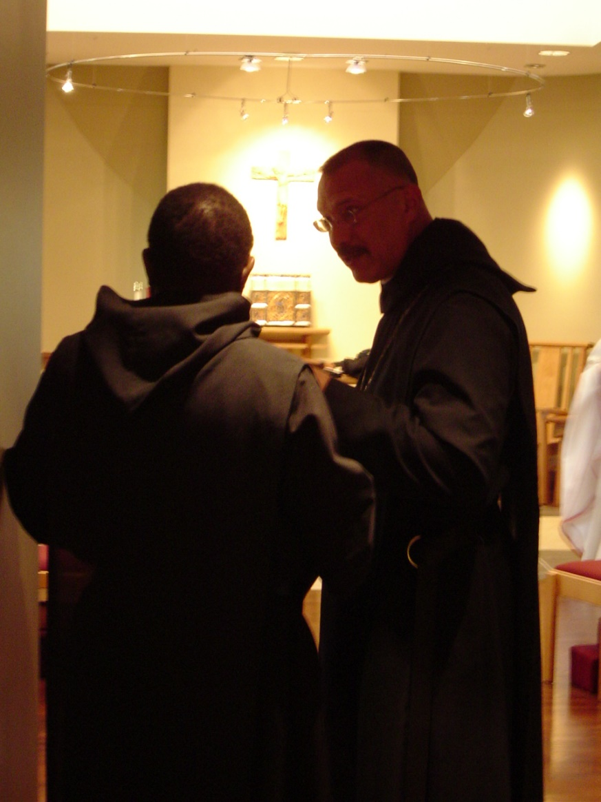
COSL Day 2 (S1) 005 Br. Thomas Ferrell; Abbot Michael John Austin
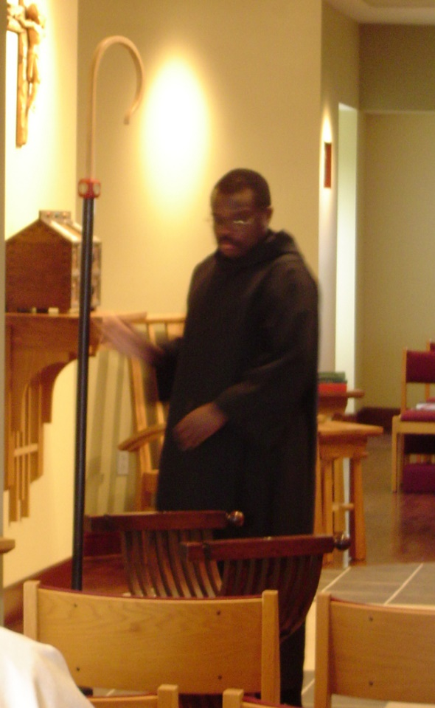
COSL Day 2 (S1) 006 Br. Thomas Ferrell

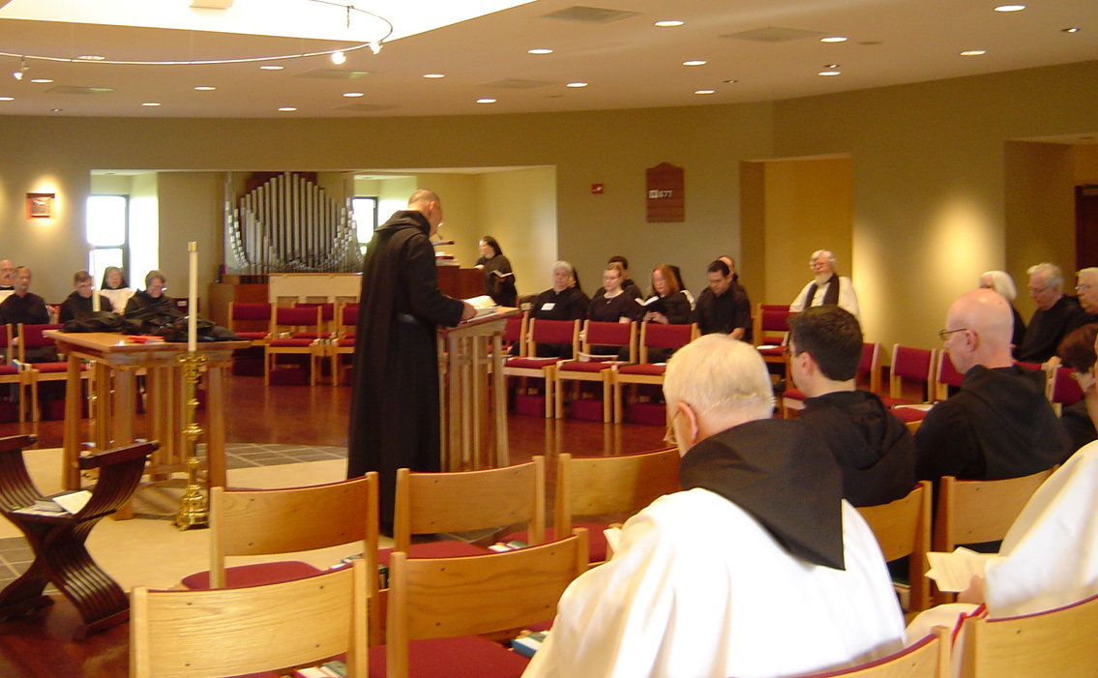COSL Day 2 (S1) 007 Br. Raymond Owens; Br. Lawrence Mullen; Br. Camillus Converse; Sr. Monica Ruth Mullen; Sr. Vincent Marie Rittenhouse; Abbot Michael John Austin; Sr. Hillary Grace Lundgren; Sr. Mary Catherine Christopher; Jan Wolsleben; Jane Bebee; Br. Christopher John Baumann; Br. Augustine Colvert; Daniel Medina; Fr. Wayne Kamm; Br. David Vincent Cotton; Judith Stribley; Br. Luke Doucette; Tom Lunt

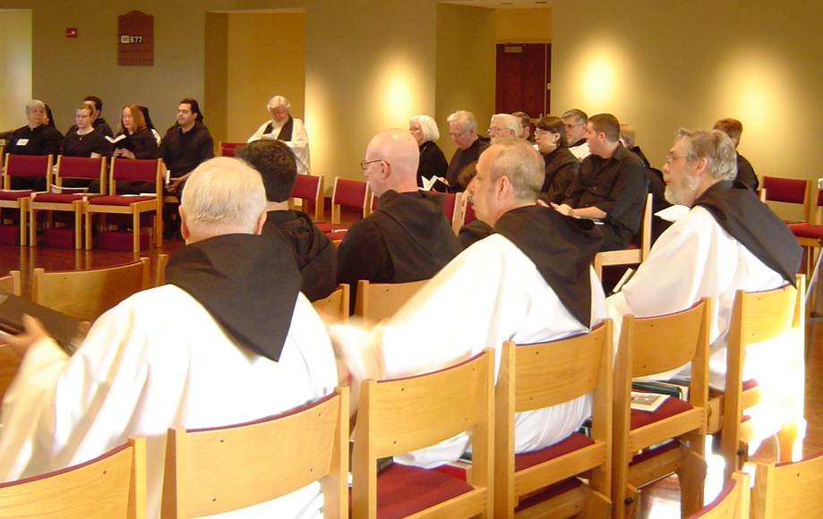COSL Day 2 (S1) 008 Sr. Mary Catherine Christopher; Jan Wolsleben; Jane Bebee; Daniel Medina; Br. Christopher John Baumann; Br. Augustine Colvert; Fr. Wayne Kamm; Br. David Vincent Cotton; Judith Stribley; Br. Luke Doucette; Br. Nathan Hale; Tom Lunt; Sr. Pauline Tysol; Br. Nathan Gregory Miller; Joshua Shawnee; Br. Chad Anselm Gerns; Sr. Brigid Gerns

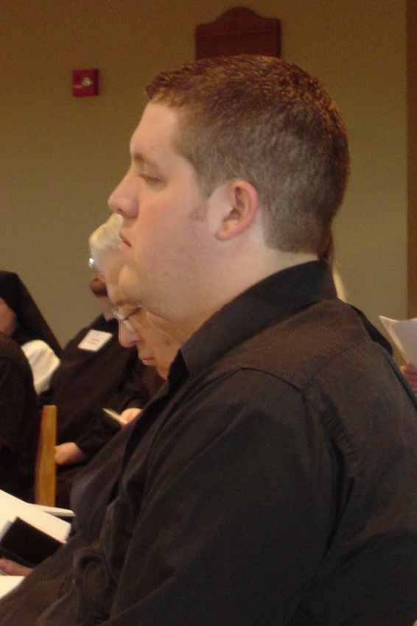
COSL Day 2 (S1) 009 Tom Lunt; Joshua Shawnee

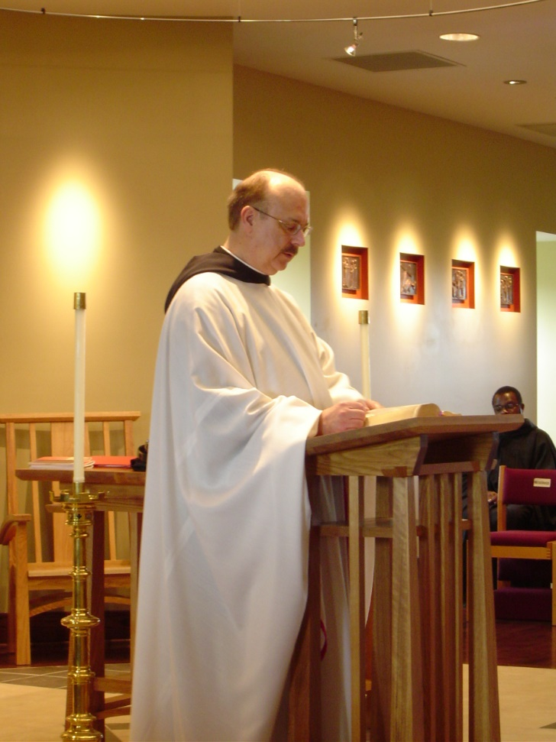
COSL Day 2 (S1) 010 Br. Raymond Owens; Br. Thomas Ferrell
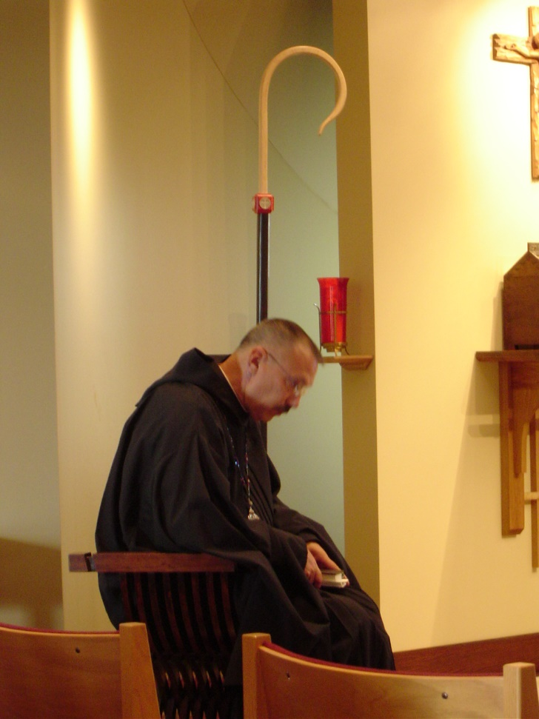
COSL Day 2 (S1) 011 Abbot Michael John Austin

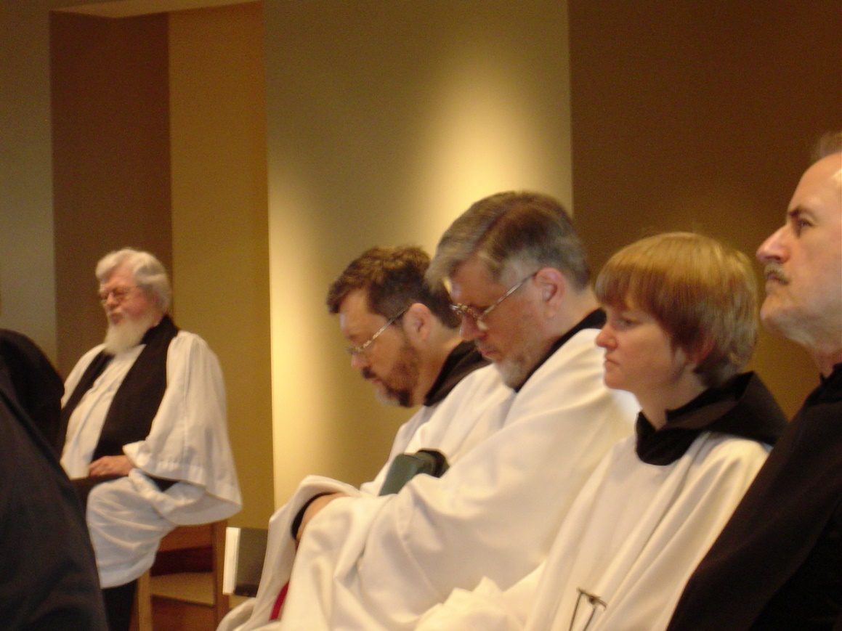
COSL Day 2 (S1) 012 Fr. Wayne Kamm; Br. Paul Howard; Br. Nathan Gregory Miller; Sr. Catherine Unterseher; Br. Daniel Joseph Schroeder

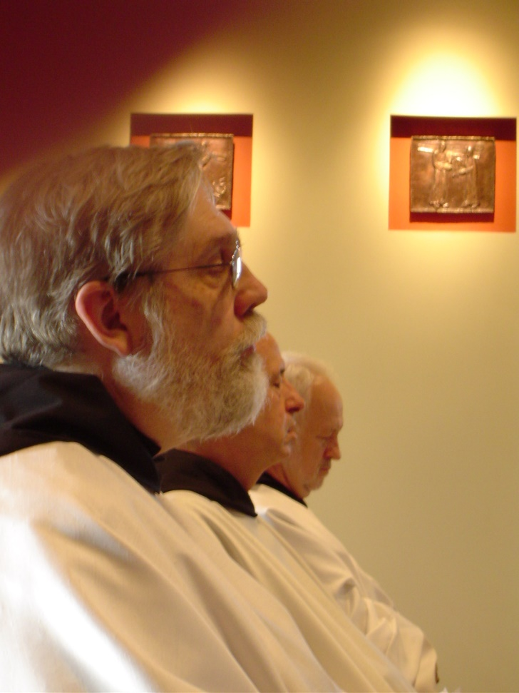
COSL Day 2 (S1) 013 Br. Chad Anselm Gerns; Br. Gabriel Hale; Br. Christopher John Baumann
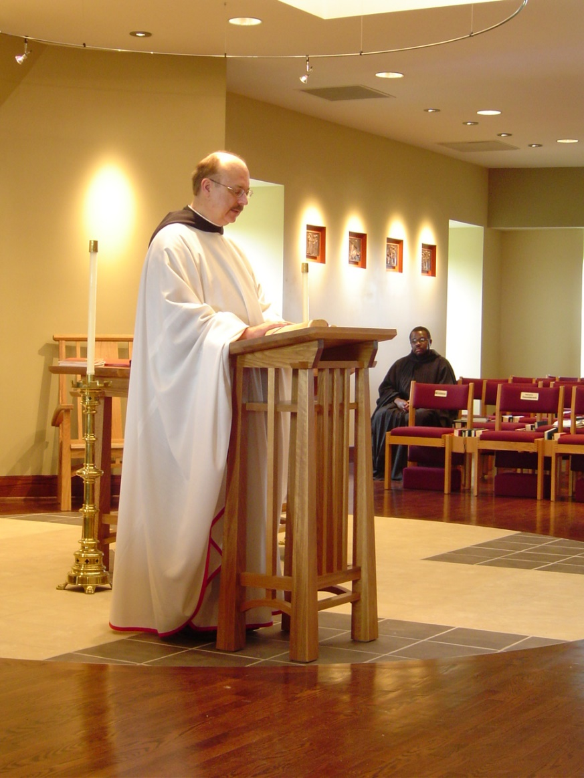
COSL Day 2 (S1) 014 Br. Raymond Owens; Br. Thomas Ferrell
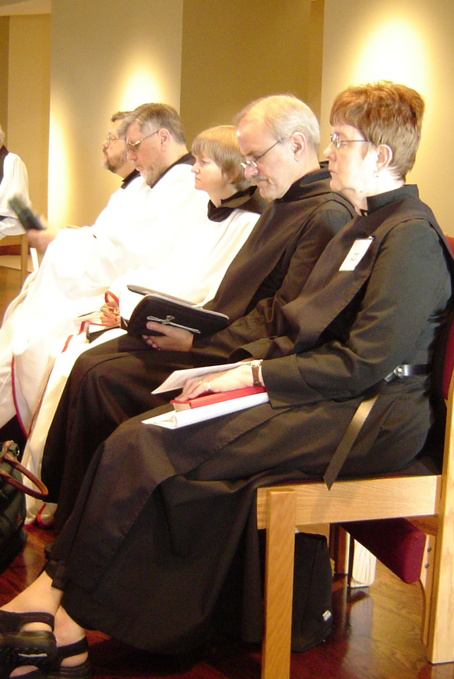
COSL Day 2 (S1) 015 Br. Paul Howard; Br. Nathan Gregory Miller; Sr. Catherine Unterseher; Br. Daniel Joseph Schroeder; Sr. Brigid Gerns
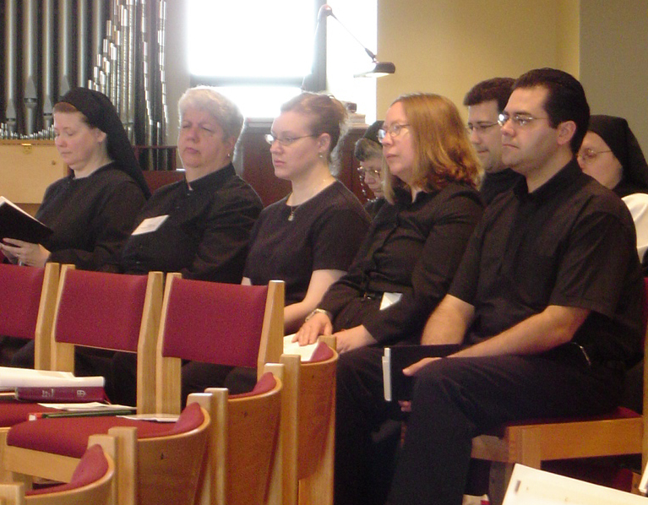
COSL Day 2 (S1) 016 Sr. Hillary Grace Lundgren; Sr. Mary Catherine Christopher; Jan Wolsleben; Sr. Anna Grace Madden; Jane Bebee; Br. Anthony Bernard Campos; Daniel Medina; Sr. Theodora of Jesus Perecca
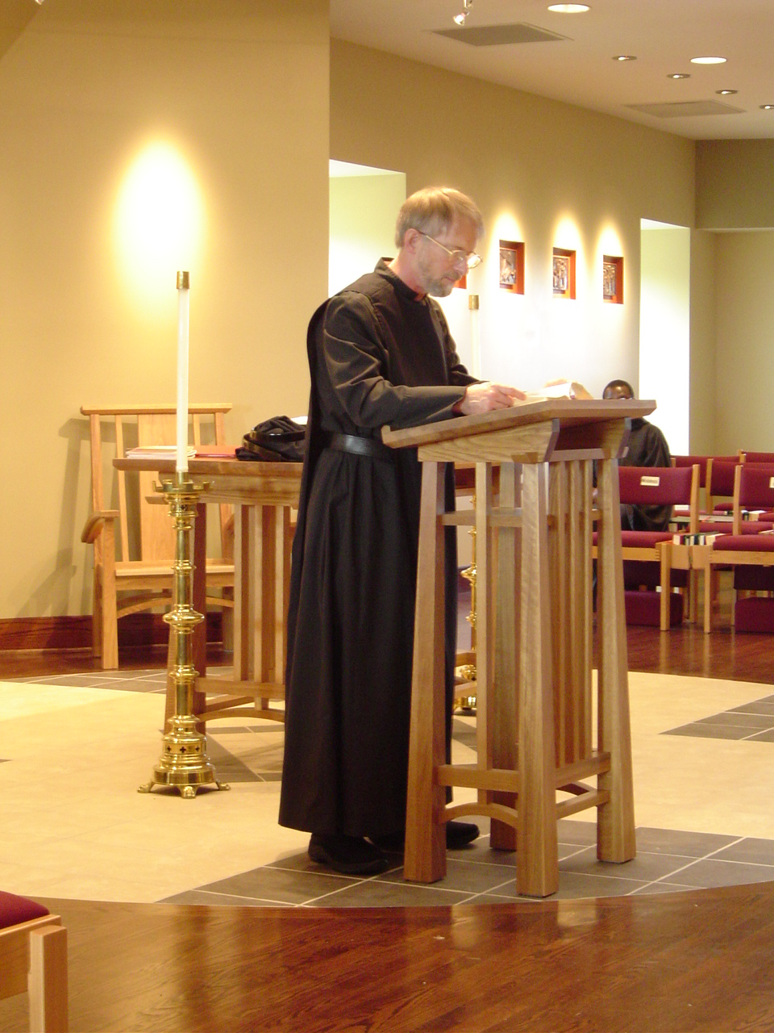
COSL Day 2 (S1) 017 Br. Lawrence Mullen; Br. Thomas Ferrell
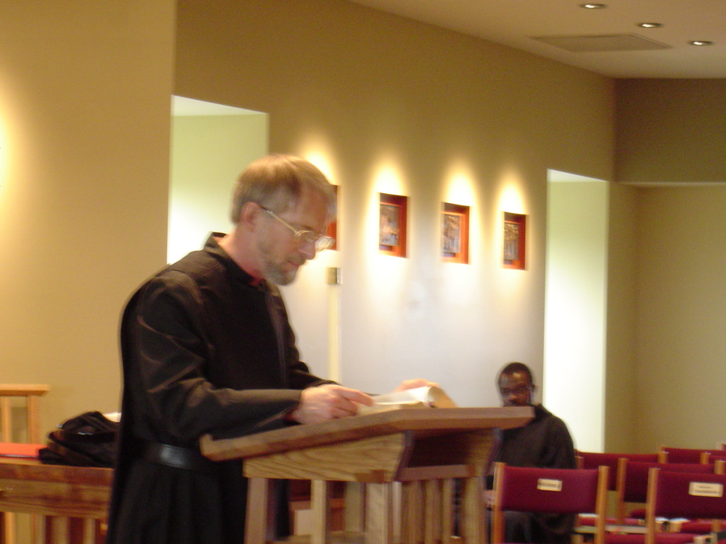COSL Day 2 (S1) 018 Br. Lawrence Mullen; Br. Thomas Ferrell

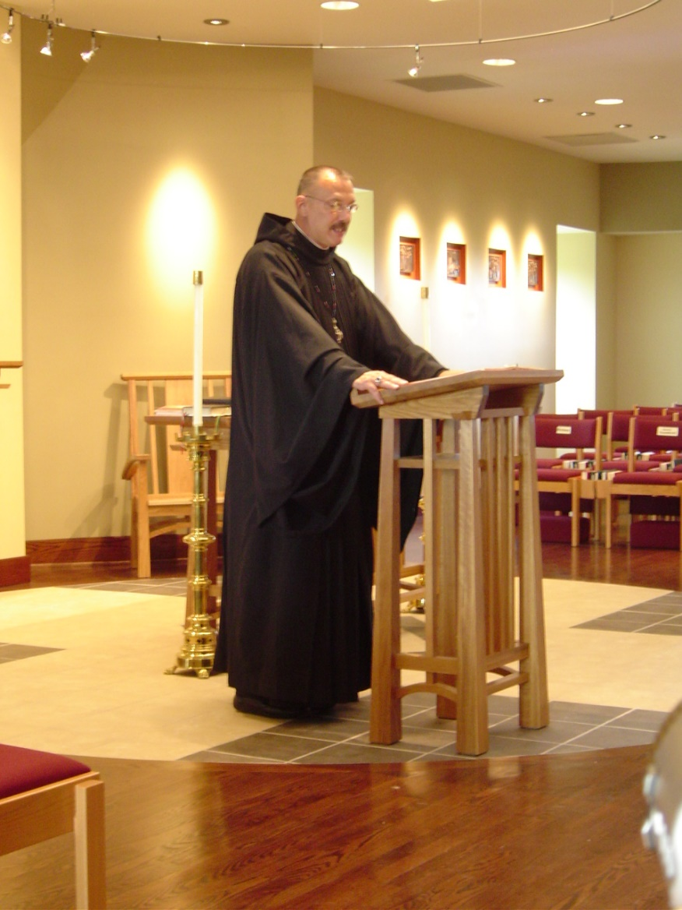
COSL Day 2 (S1) 019 Abbot Michael John Austin
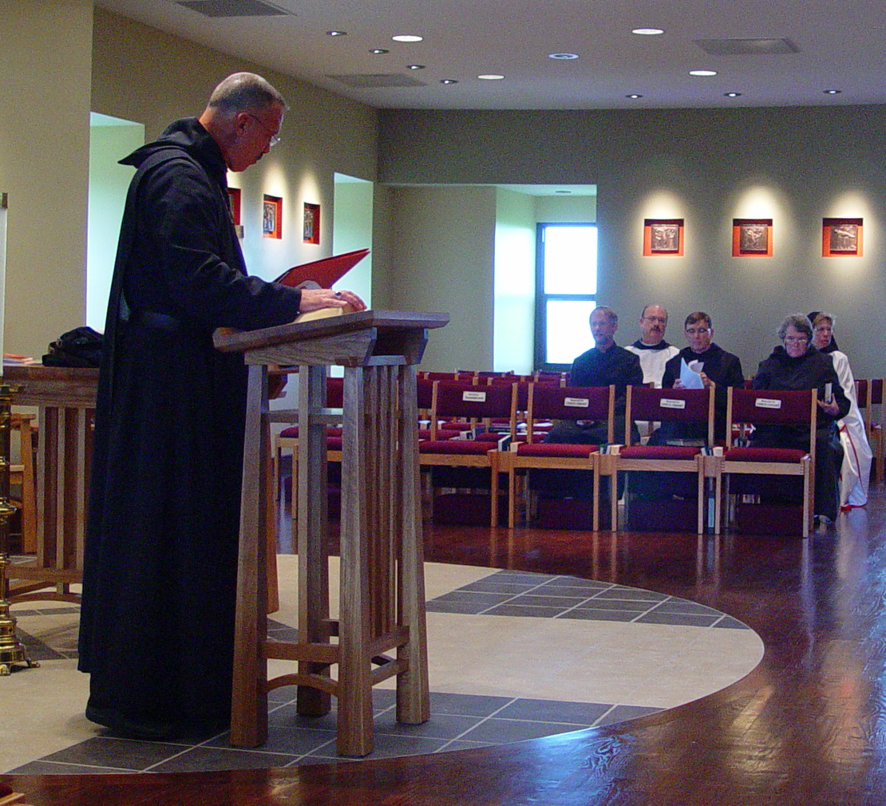
COSL Day 2 (S2) 001 Abbot Michael John Austin; Br. Lawrence Mullen; Br. Raymond Owens; Br. Camillus Converse; Sr. Vincent Marie Rittenhouse; Sr. Monica Ruth Mullen

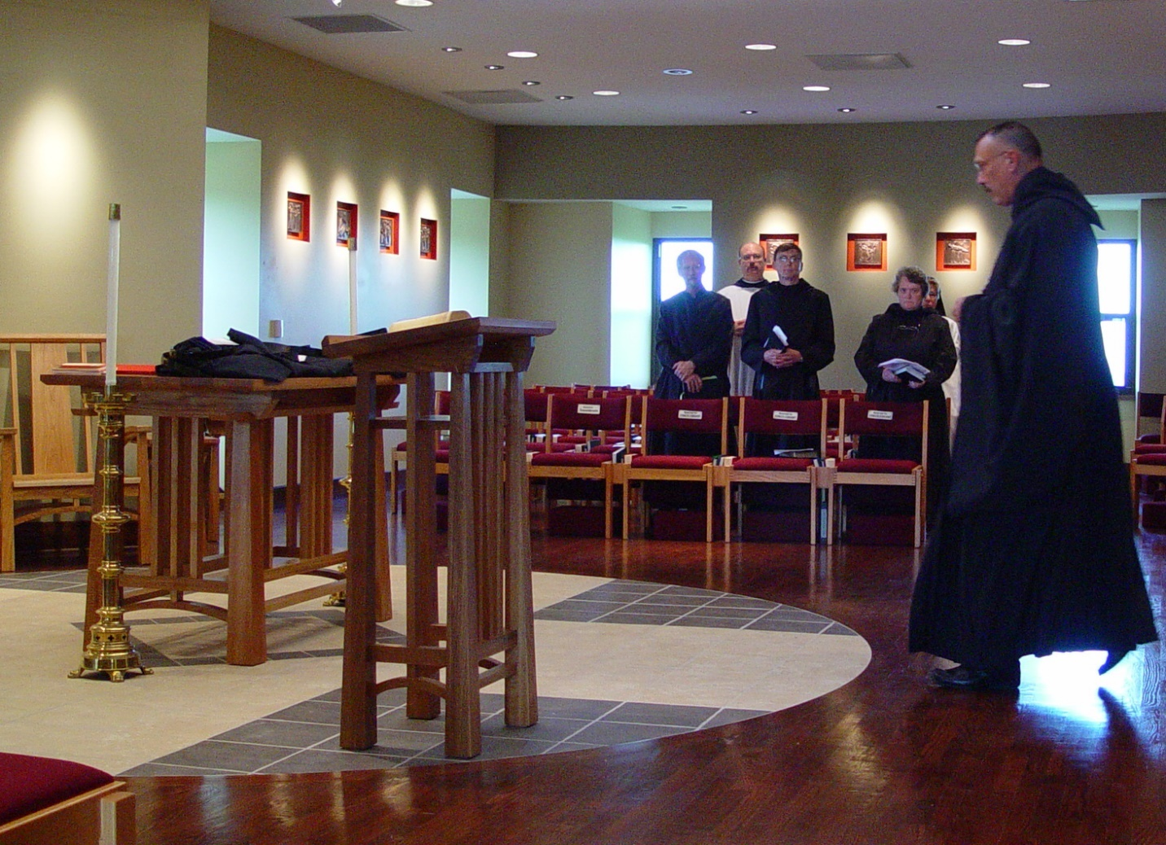COSL Day 2 (S2) 002 Br. Lawrence Mullen; Br. Raymond Owens; Br. Camillus Converse; Sr. Vincent Marie Rittenhouse; Sr. Monica Ruth Mullen; Abbot Michael John Austin

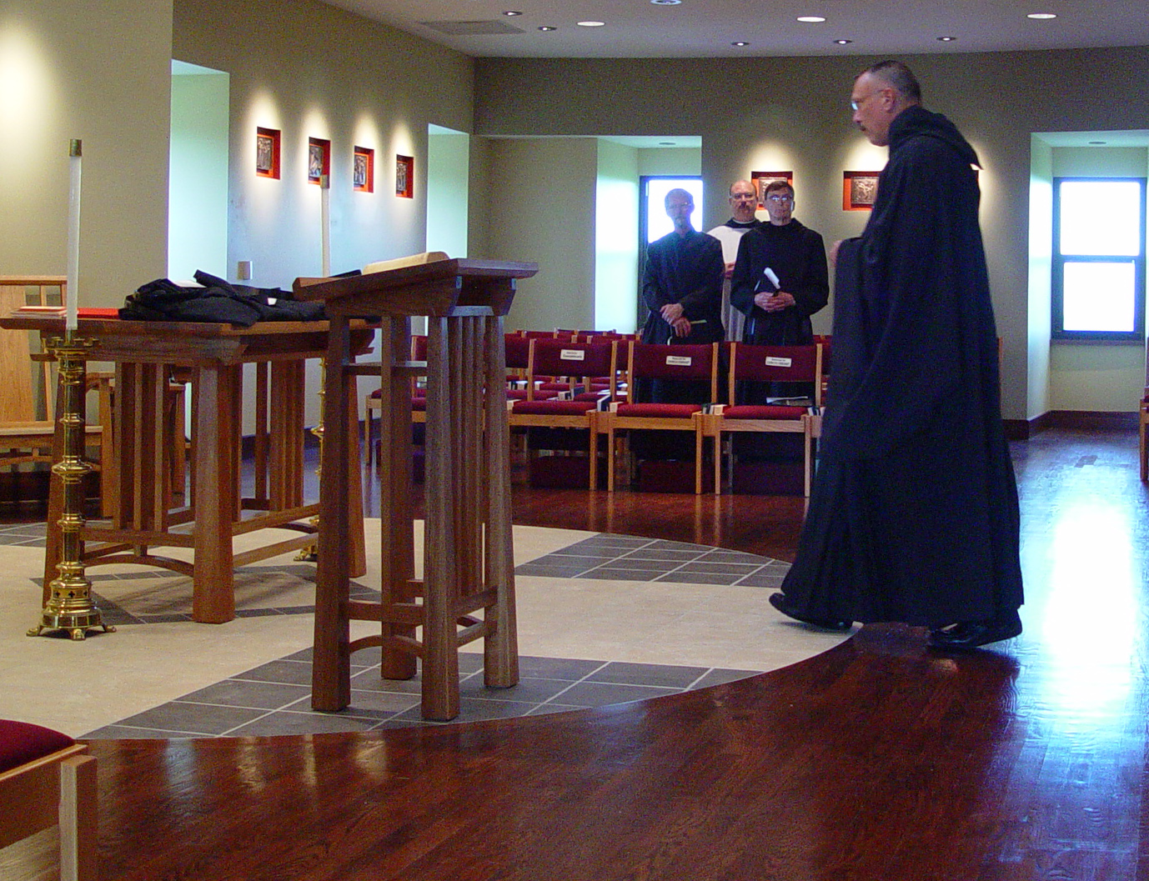
COSL Day 2 (S2) 003 Br. Lawrence Mullen; Br. Raymond Owens; Br. Camillus Converse; Abbot Michael John Austin;
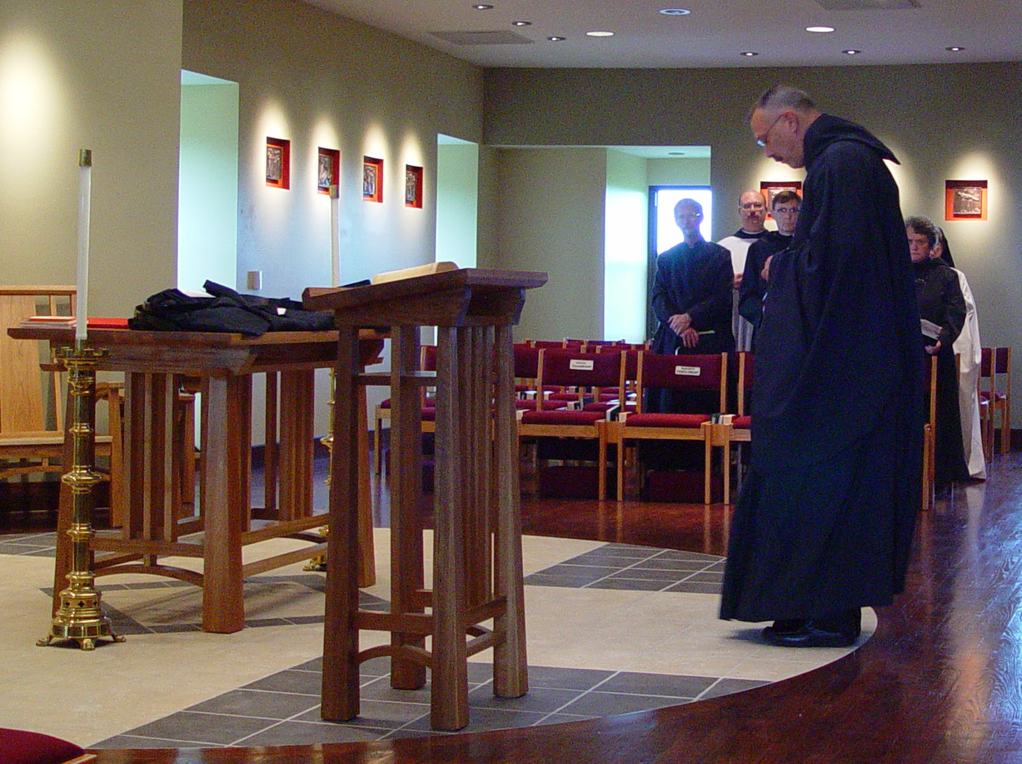COSL Day 2 (S2) 004 Br. Lawrence Mullen; Br. Raymond Owens; Br. Camillus Converse; Abbot Michael John Austin; Sr. Vincent Marie Rittenhouse; Sr. Monica Ruth Mullen
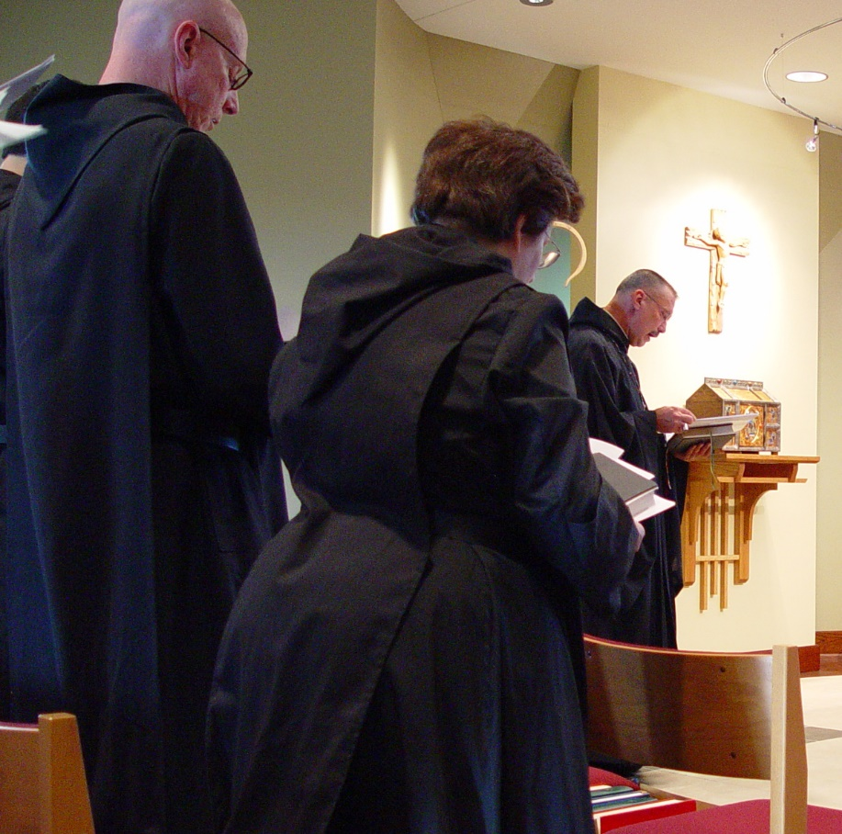
COSL Day 2 (S2) 005 Br. David Vincent Cotton; Sr. Cecelia Lamoy; Abbot Michael John Austin
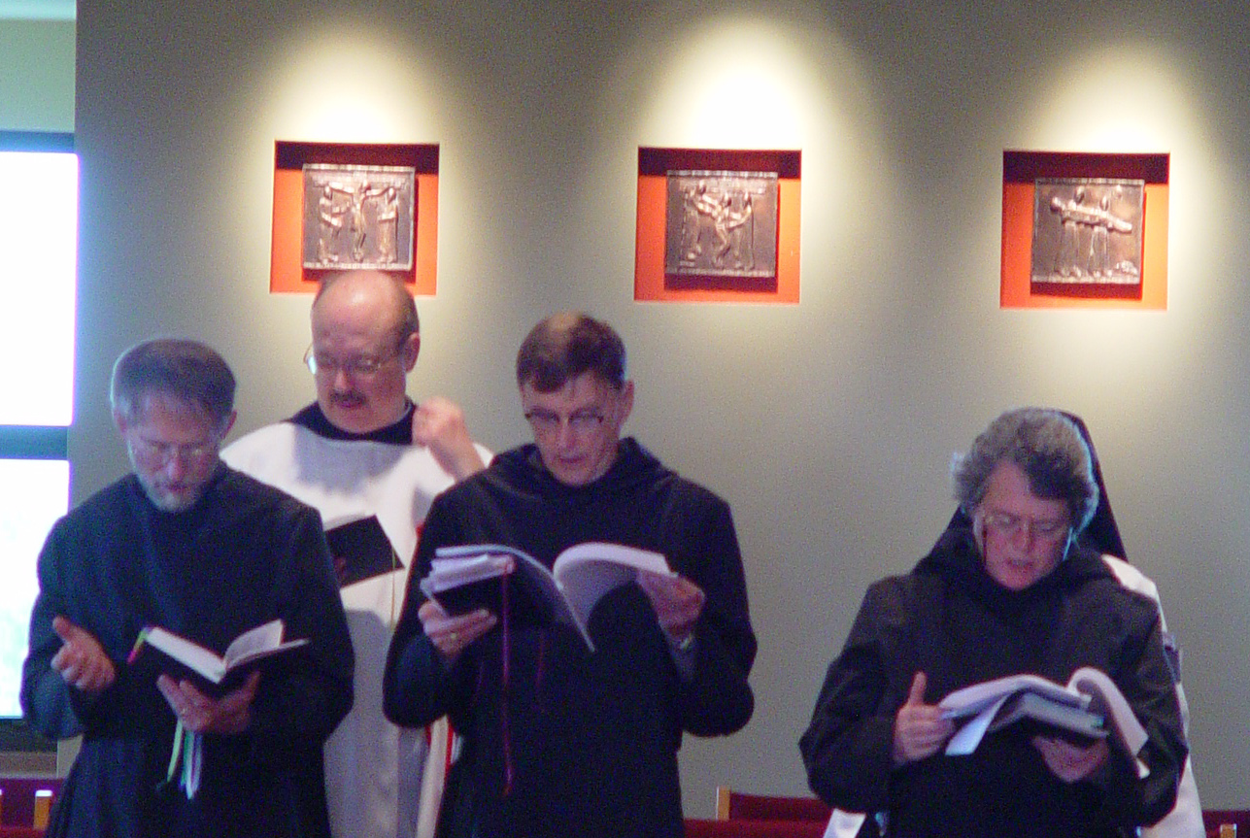COSL Day 2 (S2) 006 Br. Lawrence Mullen; Br. Raymond Owens; Br. Camillus Converse; Sr. Vincent Marie Rittenhouse

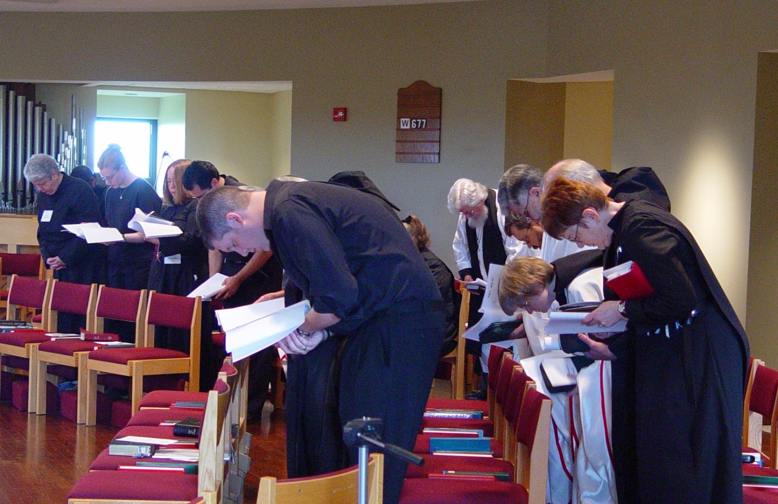COSL Day 2 (S2) 007 Sr. Mary Catherine Christopher; Jan Wolsleben; Jane Bebee; Daniel Medina; Joshua Shawnee; Sr. Margaret Moore; Fr. Wayne Kamm; Br. Paul Howard; Br. Nathan Gregory Miller; Sr. Catherine Unterseher; Br. Daniel Joseph Schroeder; Sr. Brigid Gerns

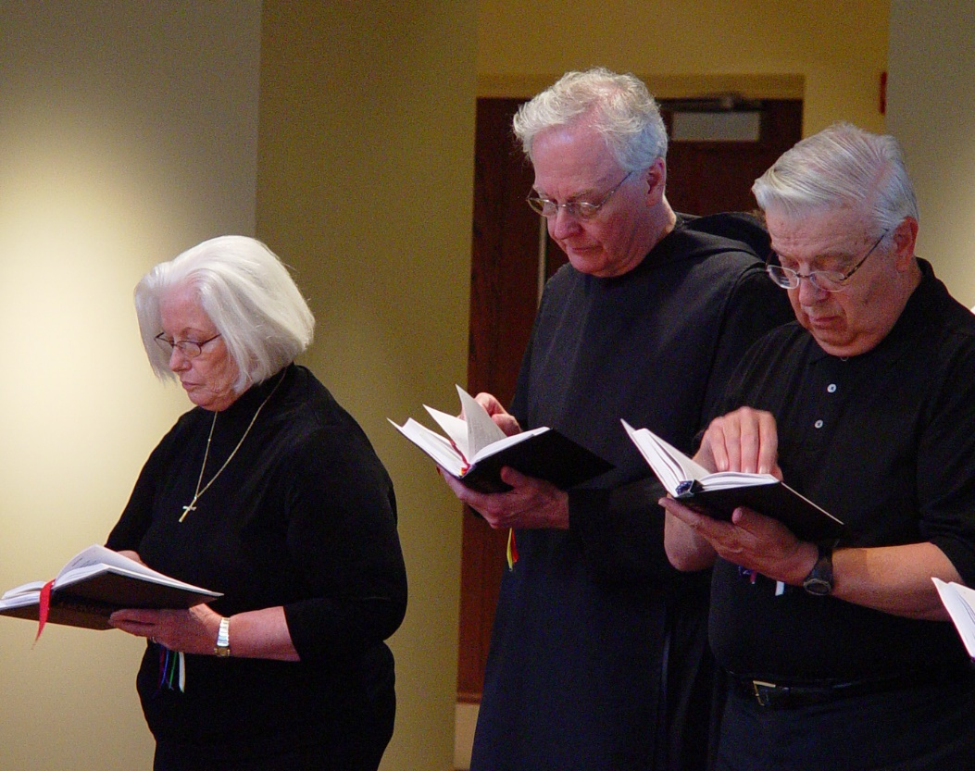
COSL Day 2 (S2) 008 Judith Stribley; Br. Luke Doucette; Tom Lunt
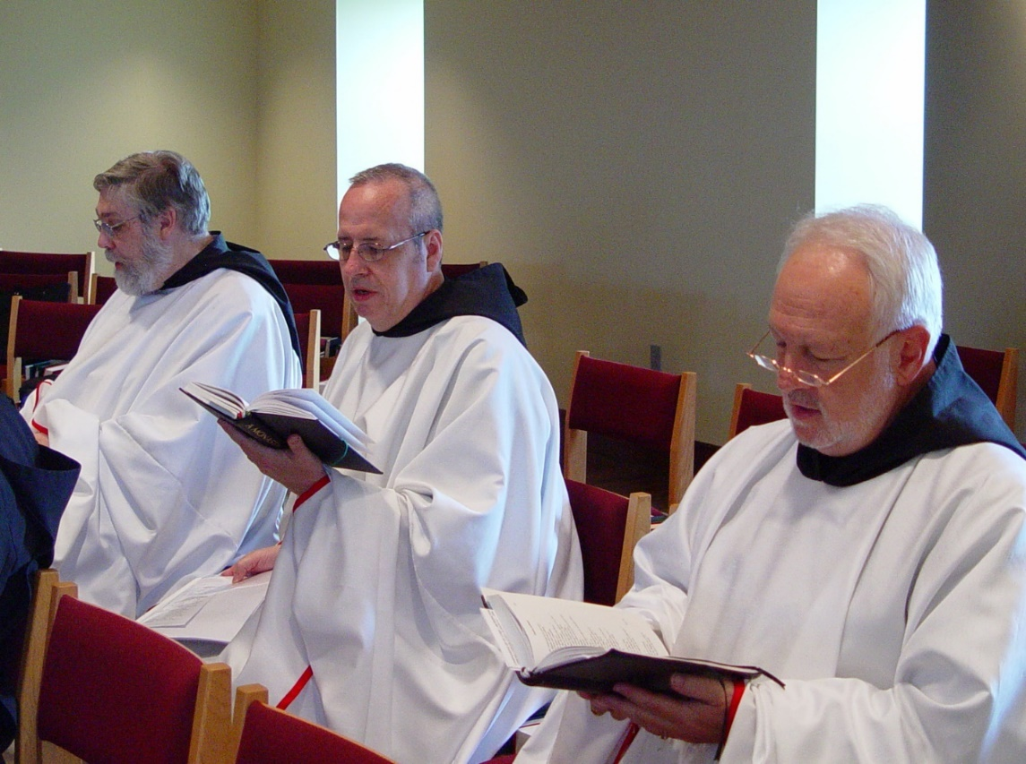
COSL Day 2 (S2) 009 Br. Chad Anselm Gerns; Br. Gabriel Hale; Br. Christopher John Baumann

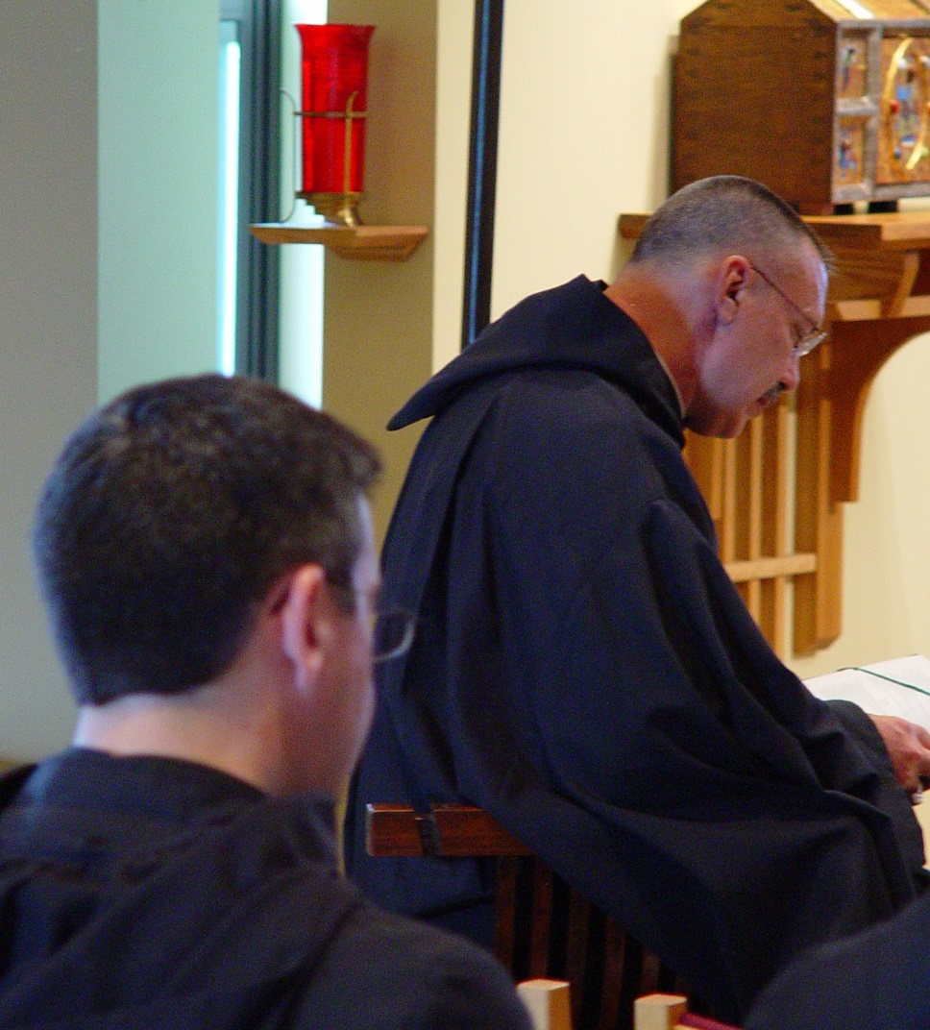
COSL Day 2 (S2) 010 Br. Augustine Colvert; Abbot Michael John Austin
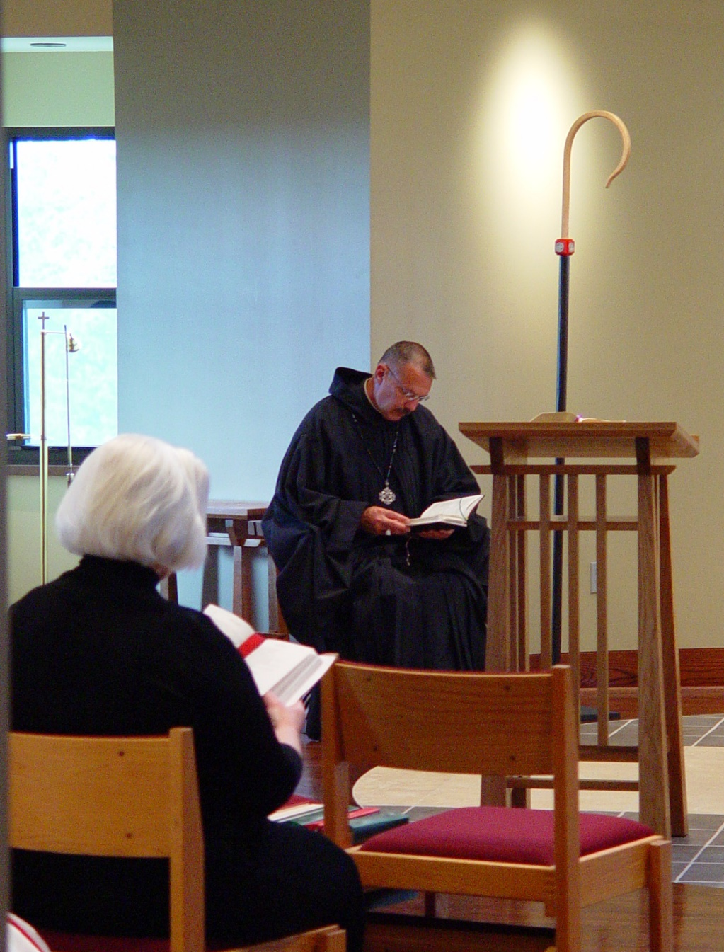
COSL Day 2 (S2) 011 Judith Stribley; Abbot Michael John Austin
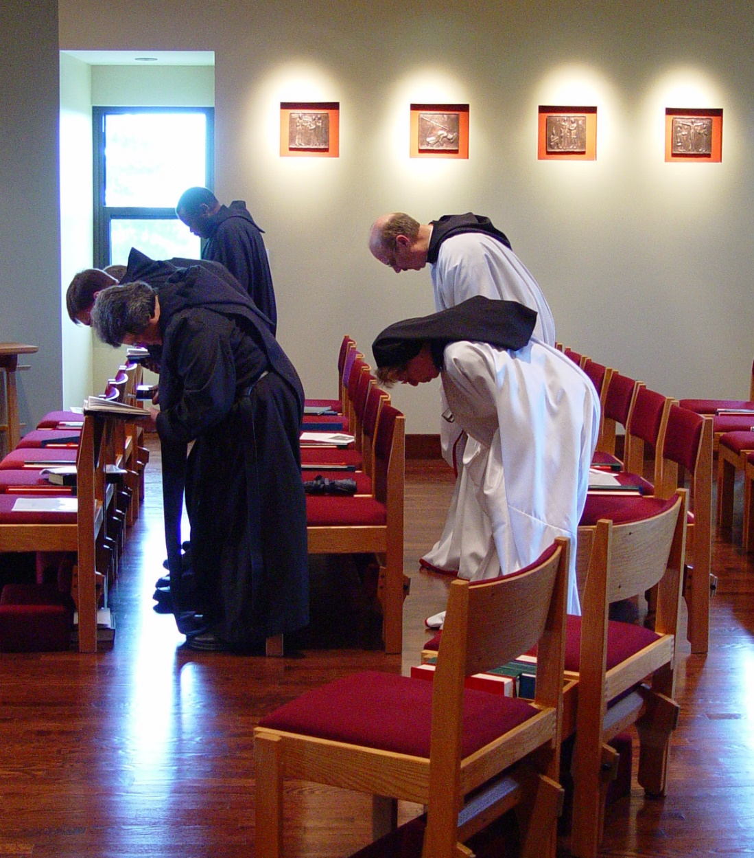
COSL Day 2 (S2) 012 Sr. Vincent Marie Rittenhouse; Br. Camillus Converse; Br. Thomas Ferrell; Sr. Monica Ruth Mullen; Br. Raymond Owens
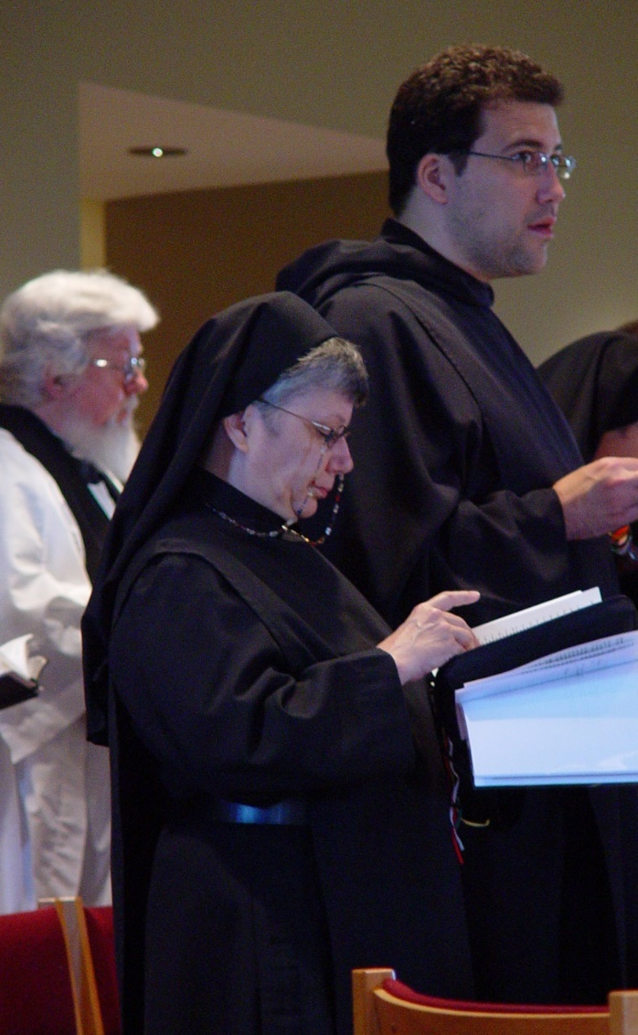
COSL Day 2 (S2) 013 Fr. Wayne Kamm; Sr. Anna Grace Madden; Br. Anthony Bernard Campos
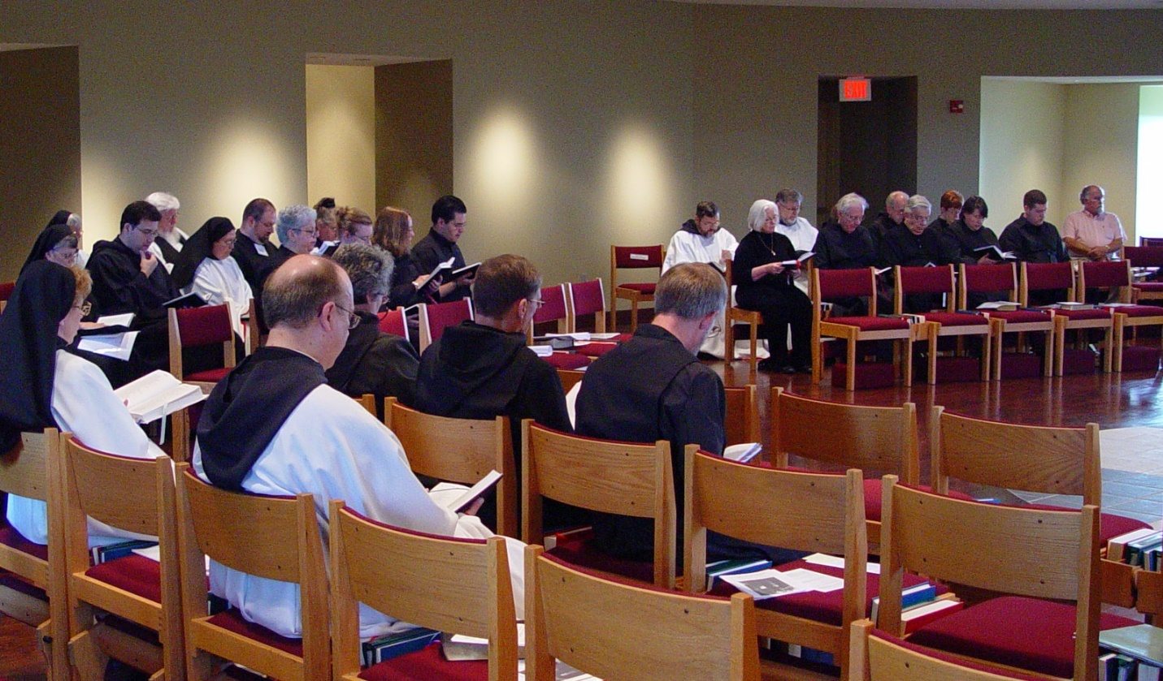COSL Day 2 (S2) 014 Sr. Monica Ruth Mullen; Sr. Anna Grace Madden; Sr. Clare Benedicta Myers; Br. Anthony Bernard Campos; Fr. Wayne Kamm; Sr. Theodora of Jesus Perecca; Br. Willard Moore; Br. Raymond Owens; Sr. Mary Catherine Christopher; Sr. Margaret Moore; Sr. Vincent Marie Rittenhouse; Jan Wolsleben; Jane Bebee; Br. Augustine Colvert; Br. Camillus Converse; Br. Lawrence Mullen; Judith Stribley; Br. Nathan Gregory Miller; Br. Luke Doucette; Br. Daniel Joseph Schroeder; Tom Lunt; Sr. Brigid Gerns; Daniel Medina; Fr. Mel Schlacter

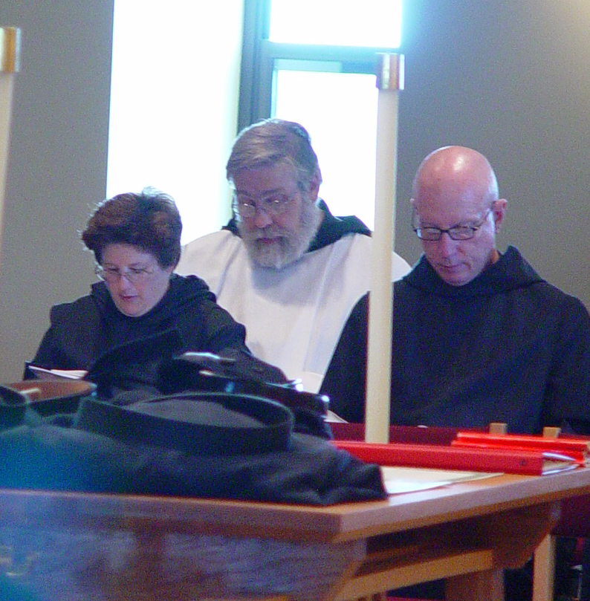
COSL Day 2 (S2) 015 Sr. Cecelia; Br. Chad Anselm Gerns; Br. David Vincent Cotton
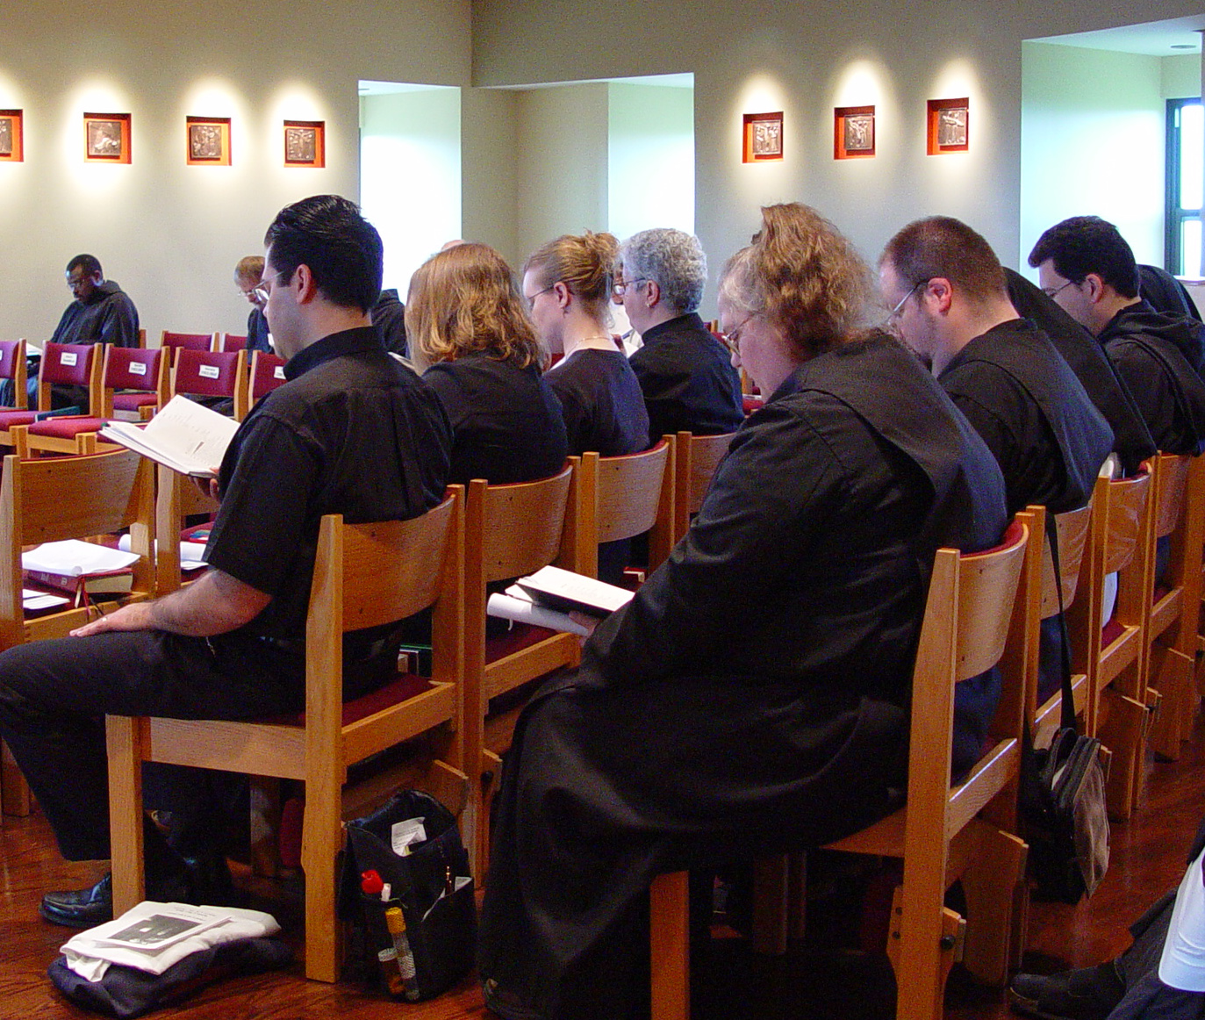COSL Day 2 (S2) 016 Br. Thomas Ferrell; Br. Lawrence Mullen; Daniel Medina; Jane Bebee; Jan Wolsleben; Sr. Mary Catherine Christopher; Sr. Margaret Moore; Br. Willard Moore; Br. Anthony Bernard Campos
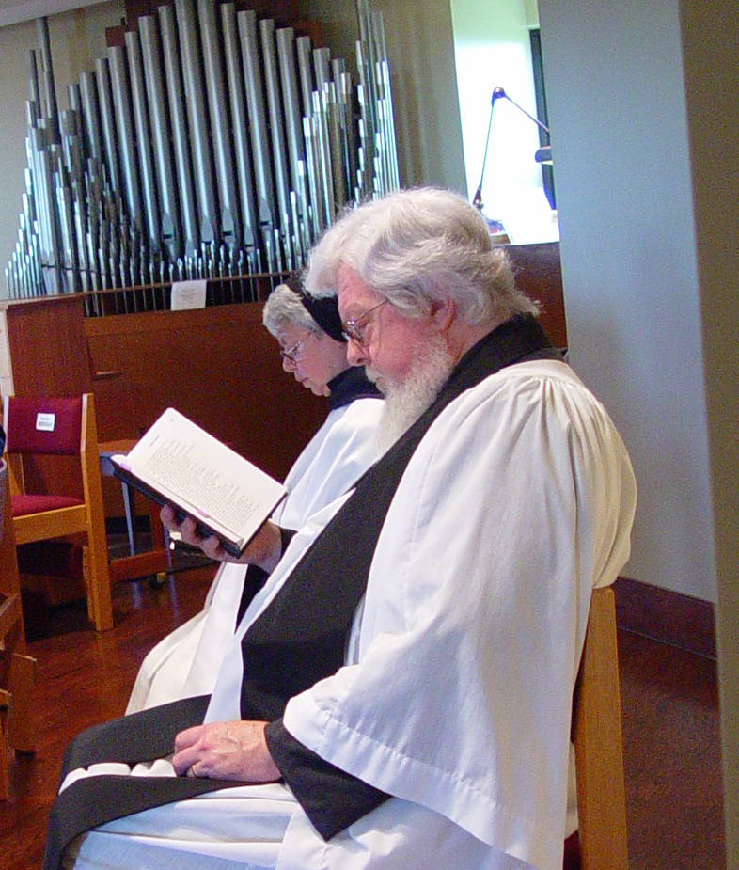
COSL Day 2 (S2) 017 Sr. Clare Benedicta Myers; Fr. Wayne Kamm
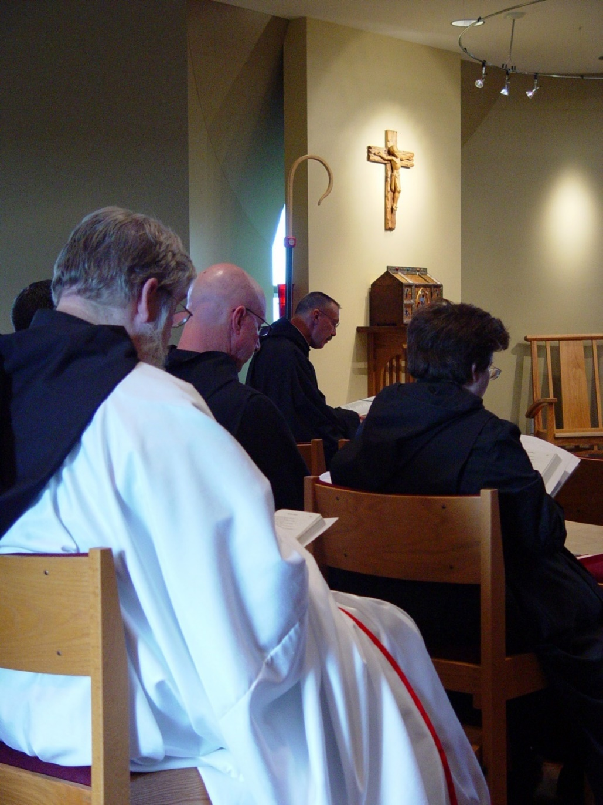
COSL Day 2 (S2) 018 Br. Chad Anselm Gerns; Br. David Vincent Cotton; Abbot Michael John Austin; Sr. Cecelia Lamoy

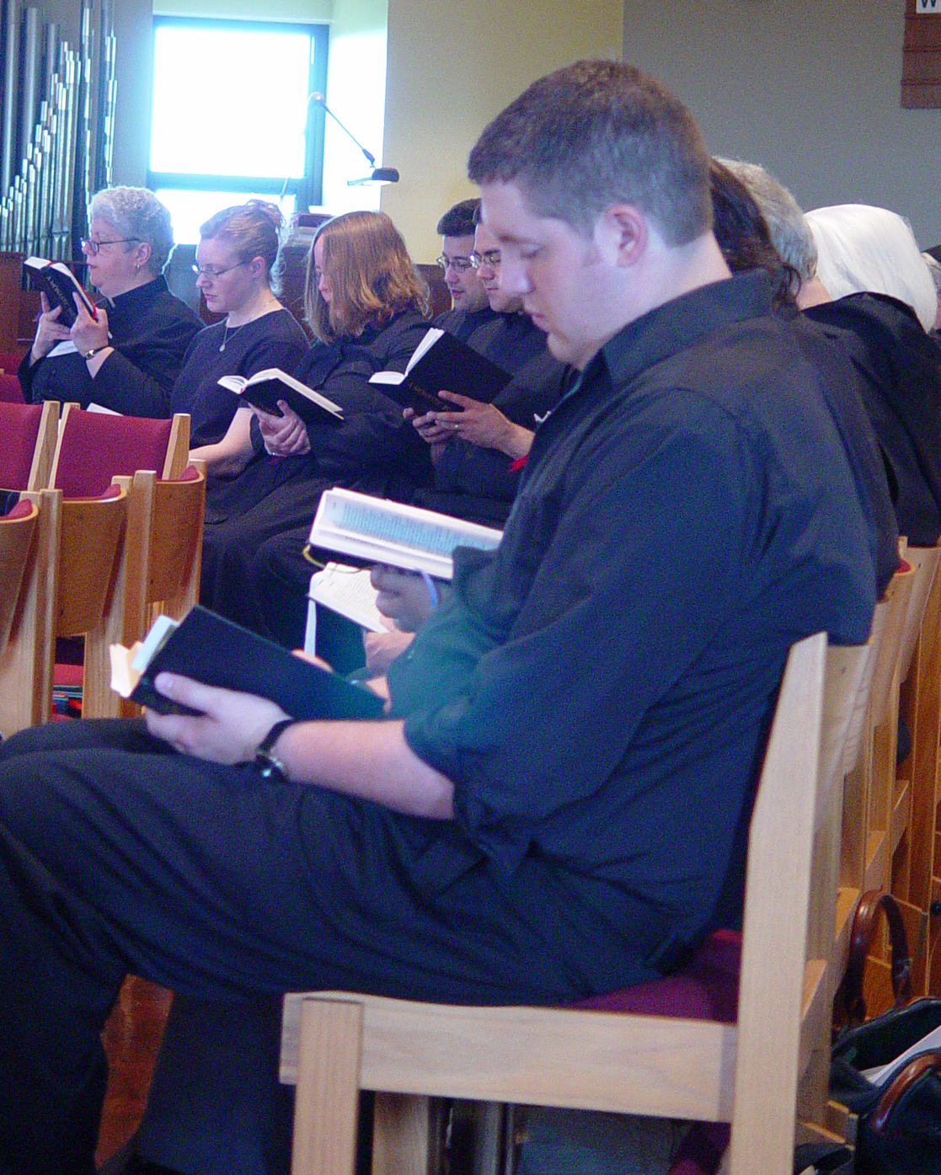
COSL Day 2 (S2) 019 Sr. Mary Catherine Christopher; Jan Wolsleben; Jane Bebee; Br. Anthony Bernard Campos; ?; ?; Judith Stribley; Joshua Shawnee

