Companions of St. Luke
Spring 2006 Convocation at Conception Abbey
Day 2, Part 1 of 3

~Edited by Br. Steven Olderr, 29 May 2022 with the assistance of Br. Thomas Ferrell. If you find any errors or omissions or have anything to add, please notify Br. Steven at olderr@ameritech.net

People are identified from left to right.

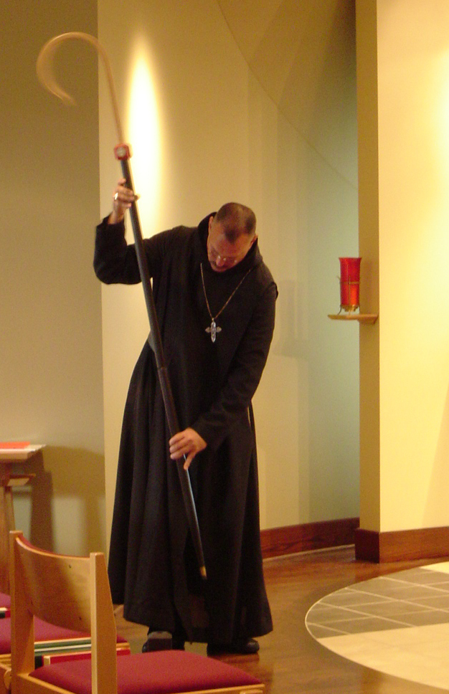
COSL Day 2 (S1) 001 Abbot Michael John Austin

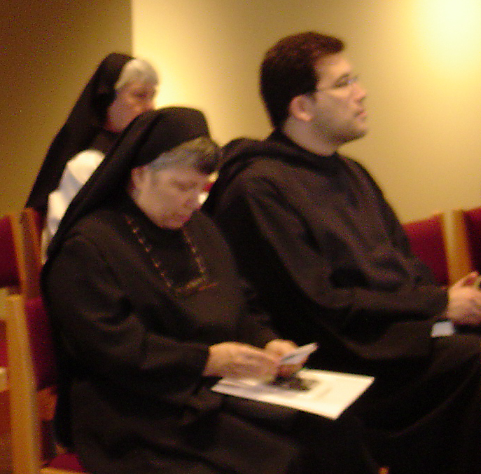
COSL Day 2 (S1) 002 ?; Sr, Anna Grace Madden; Br. Anthony Bernard Campos
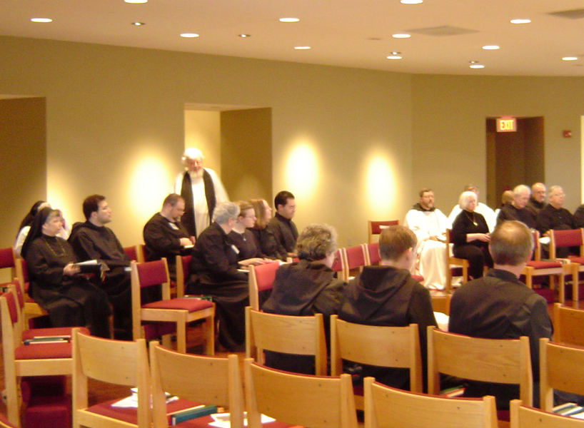COSL Day 2 (S1) 003 Sr. Anna Grace Madden; Br. Bernard Campos; Br. Willard Moore; Fr. Wayne Kamm; Sr. Mary Catherine Christopher; Jan Wolsleben; Jane Bebee; Daniel Medina; Vincent Marie Rittenhouse; Br. Camillus Converse; Br. Paul Howard; Judith Stribley; Br. Chad Anselm Gerns; Br. Luke Doucette; Br. Lawrence Mullen; Br. Daniel Joseph Schroeder; Tom Lunt
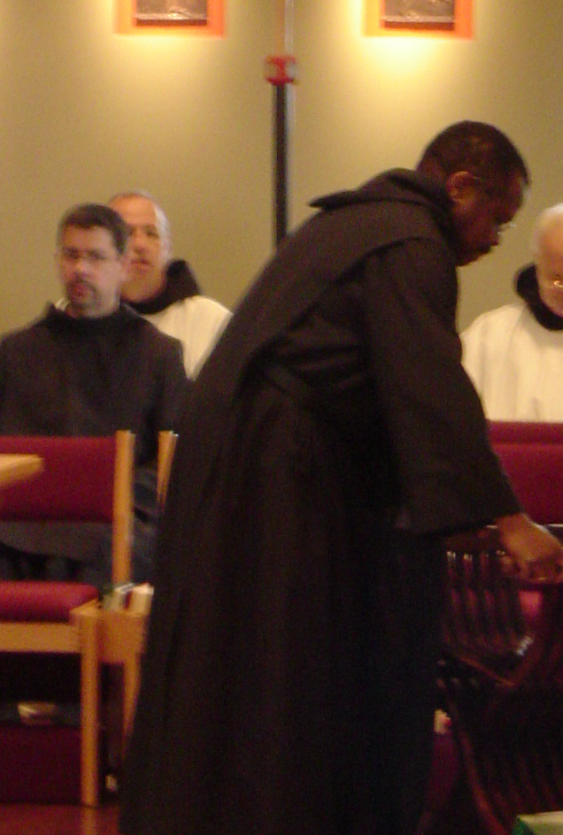
COSL Day 2 (S1) 004 Br. Augustine Colvert; Br. Gabriel Hale; Br. Thomas Ferrell; Br. Christopher John Baumann

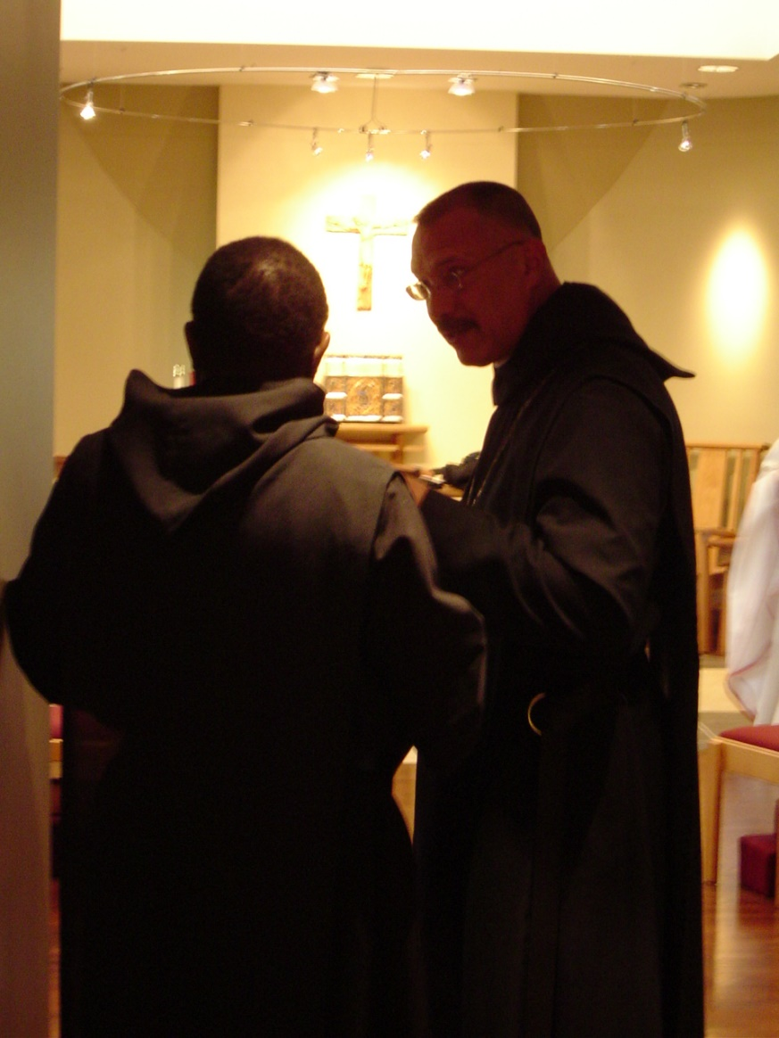
COSL Day 2 (S1) 005 Br. Thomas Ferrell; Abbot Michael John Austin
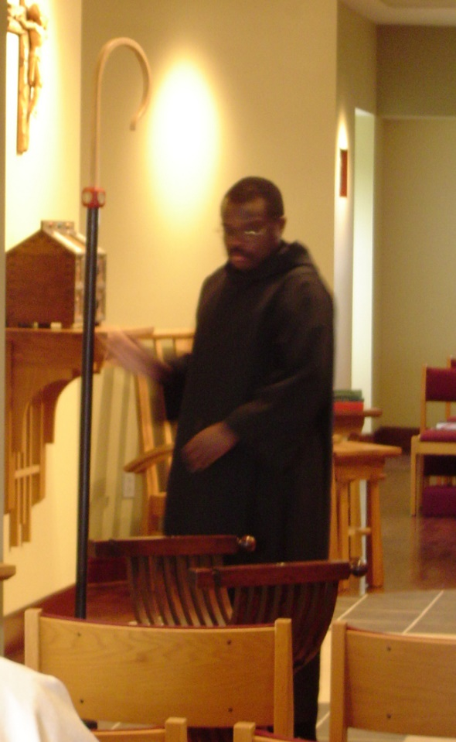
COSL Day 2 (S1) 006 Br. Thomas Ferrell

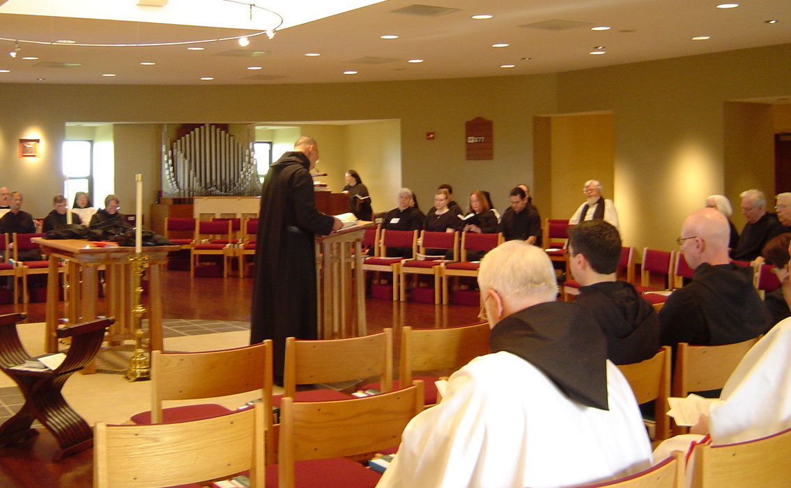COSL Day 2 (S1) 007 Br. Raymond Owens; Br. Lawrence Mullen; Br. Camillus Converse; Sr. Monica Ruth Mullen; Sr. Vincent Marie Rittenhouse; Abbot Michael John Austin; Sr. Hillary Grace Lundgren; Sr. Mary Catherine Christopher; Jan Wolsleben; Jane Bebee; Br. Christopher John Baumann; Br. Augustine Colvert; Daniel Medina; Fr. Wayne Kamm; Br. David Vincent Cotton; Judith Stribley; Br. Luke Doucette; Tom Lunt

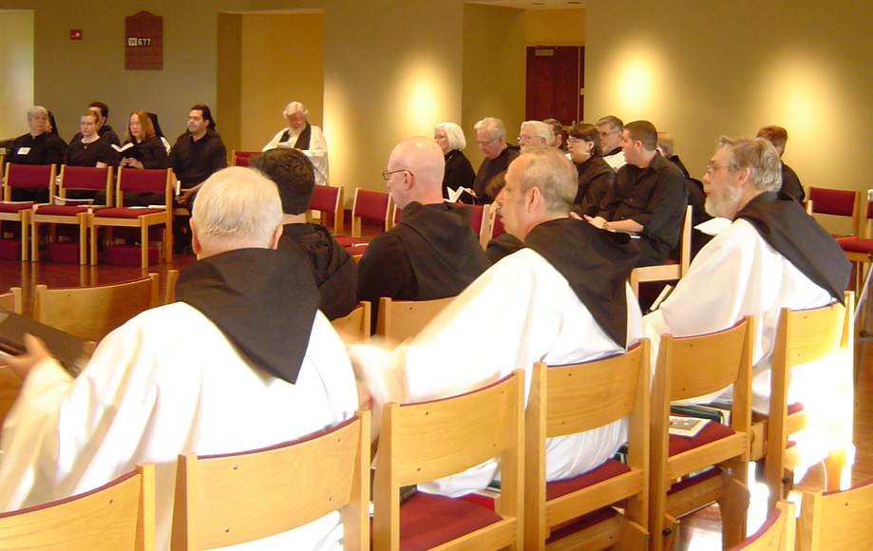COSL Day 2 (S1) 008 Sr. Mary Catherine Christopher; Jan Wolsleben; Jane Bebee; Daniel Medina; Br. Christopher John Baumann; Br. Augustine Colvert; Fr. Wayne Kamm; Br. David Vincent Cotton; Judith Stribley; Br. Luke Doucette; Br. Nathan Hale; Tom Lunt; Sr. Pauline Tysol; Br. Nathan Gregory Miller; Joshua Shawnee; Br. Chad Anselm Gerns; Sr. Brigid Gerns

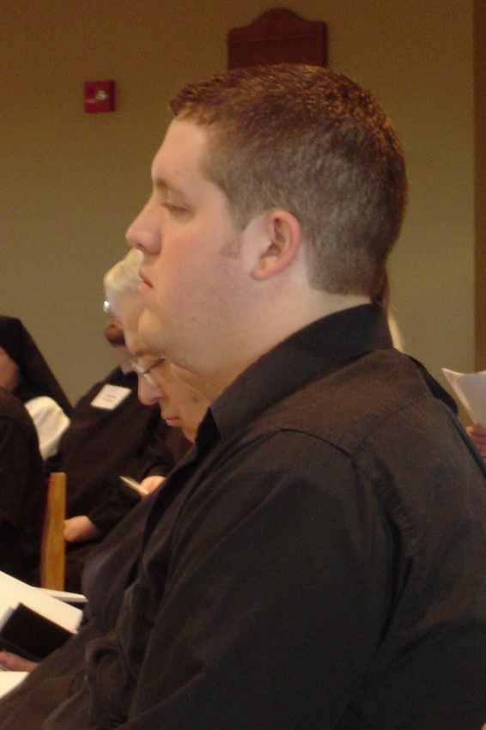
COSL Day 2 (S1) 009 Tom Lunt; Joshua Shawnee

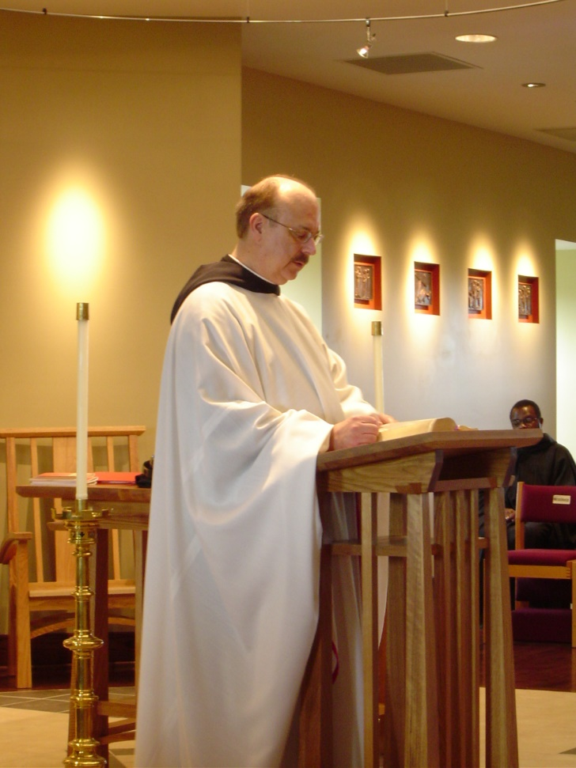
COSL Day 2 (S1) 010 Br. Raymond Owens; Br. Thomas Ferrell
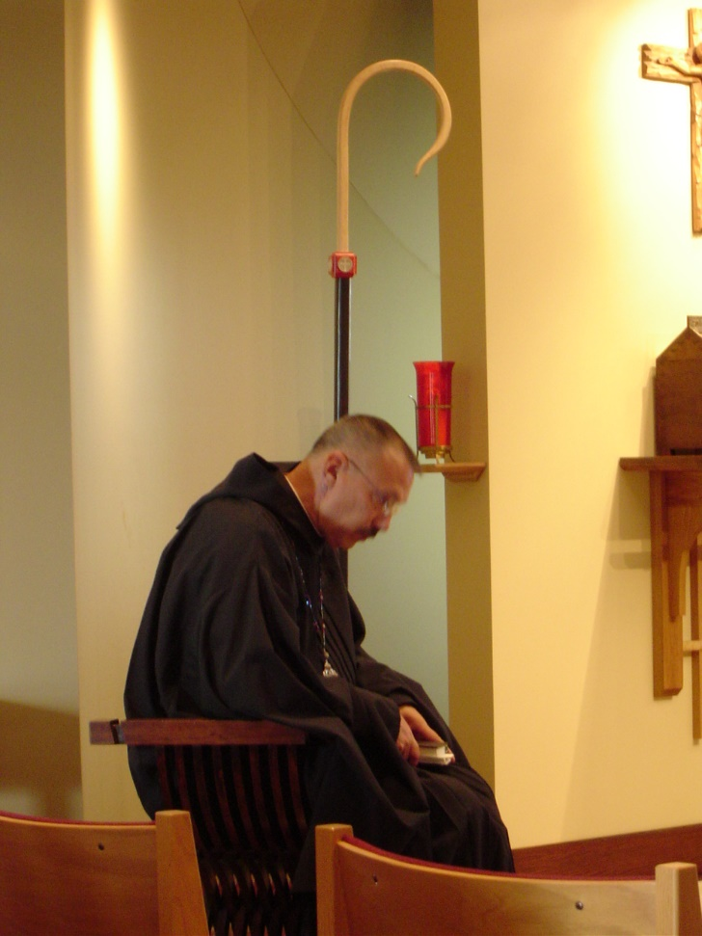
COSL Day 2 (S1) 011 Abbot Michael John Austin

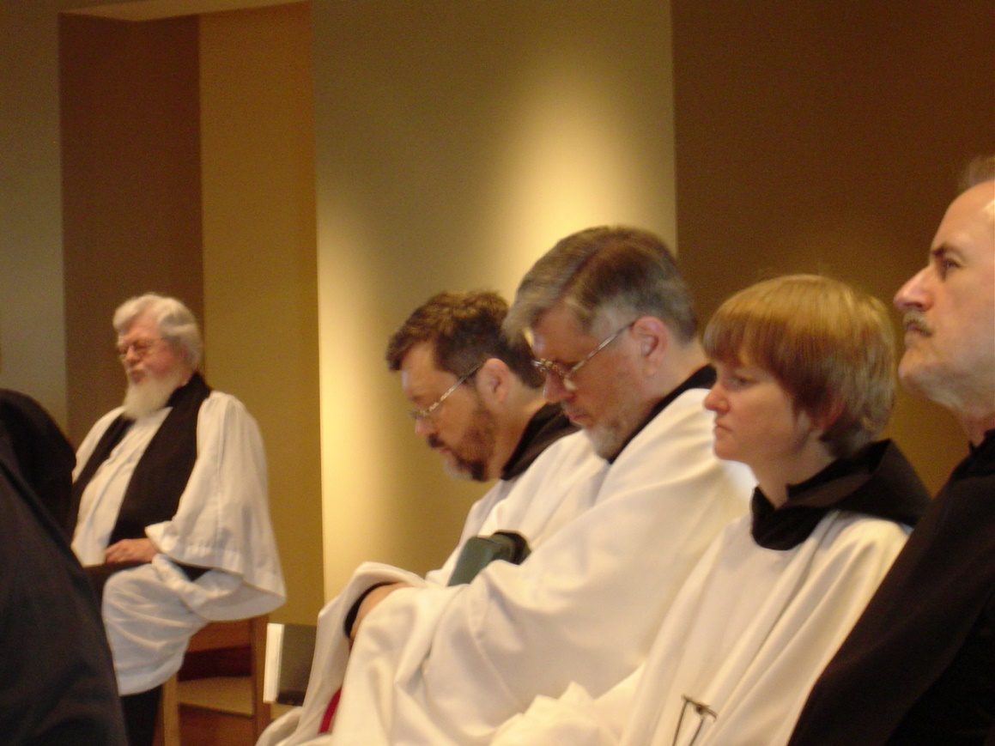
COSL Day 2 (S1) 012 Fr. Wayne Kamm; Br. Paul Howard; Br. Nathan Gregory Miller; Sr. Catherine Unterseher; Br. Daniel Joseph Schroeder

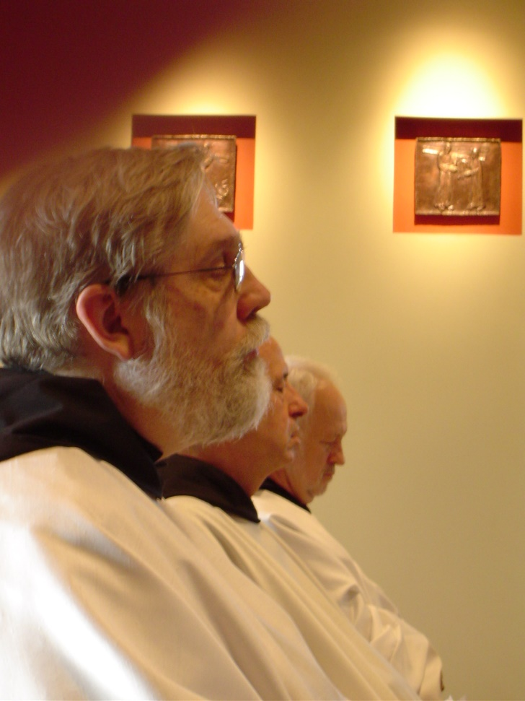
COSL Day 2 (S1) 013 Br. Chad Anselm Gerns; Br. Gabriel Hale; Br. Christopher John Baumann
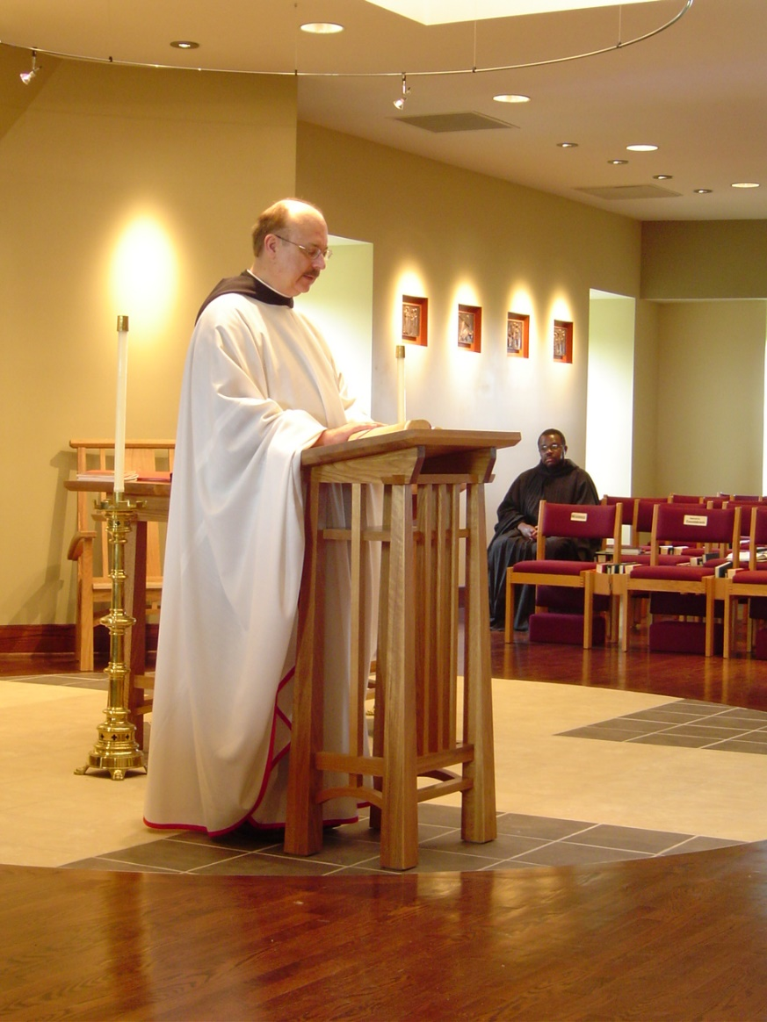
COSL Day 2 (S1) 014 Br. Raymond Owens; Br. Thomas Ferrell
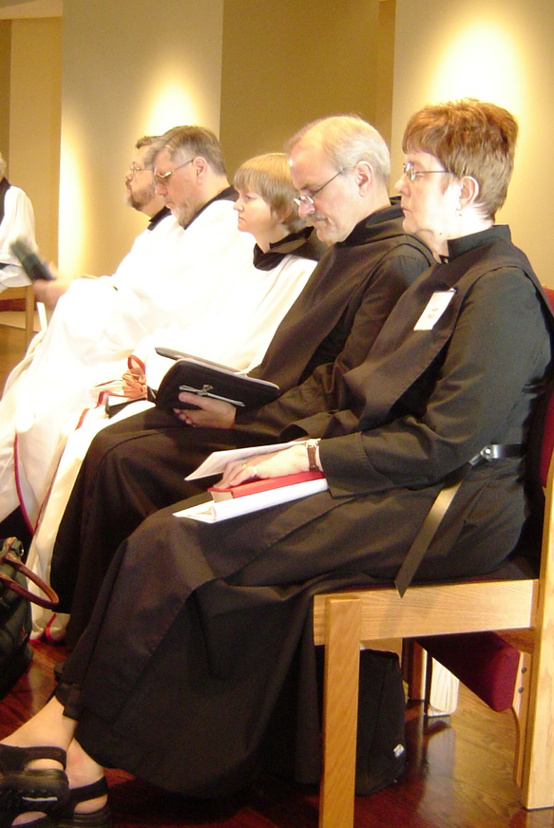
COSL Day 2 (S1) 015 Br. Paul Hale; Br. Nathan Gregory Miller; Sr. Catherine Unterseher; Br. Daniel Joseph Schroeder; Sr. Brigid Gerns
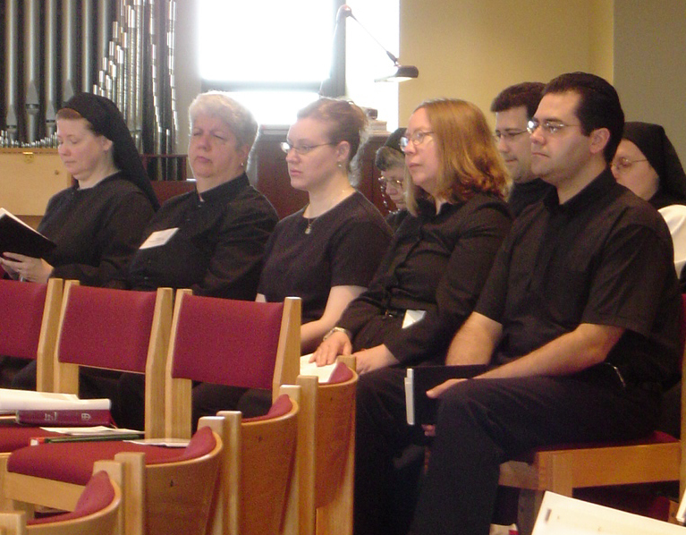
COSL Day 2 (S1) 016 Sr. Hillary Grace Lundgren; Sr. Mary Catherine Christopher; Jan Wolsleben; Sr. Anna Grace Madden; Jane Bebee; Br. Anthony Bernard Campos; Daniel Medina; Sr. Theodora of Jesus Perecca
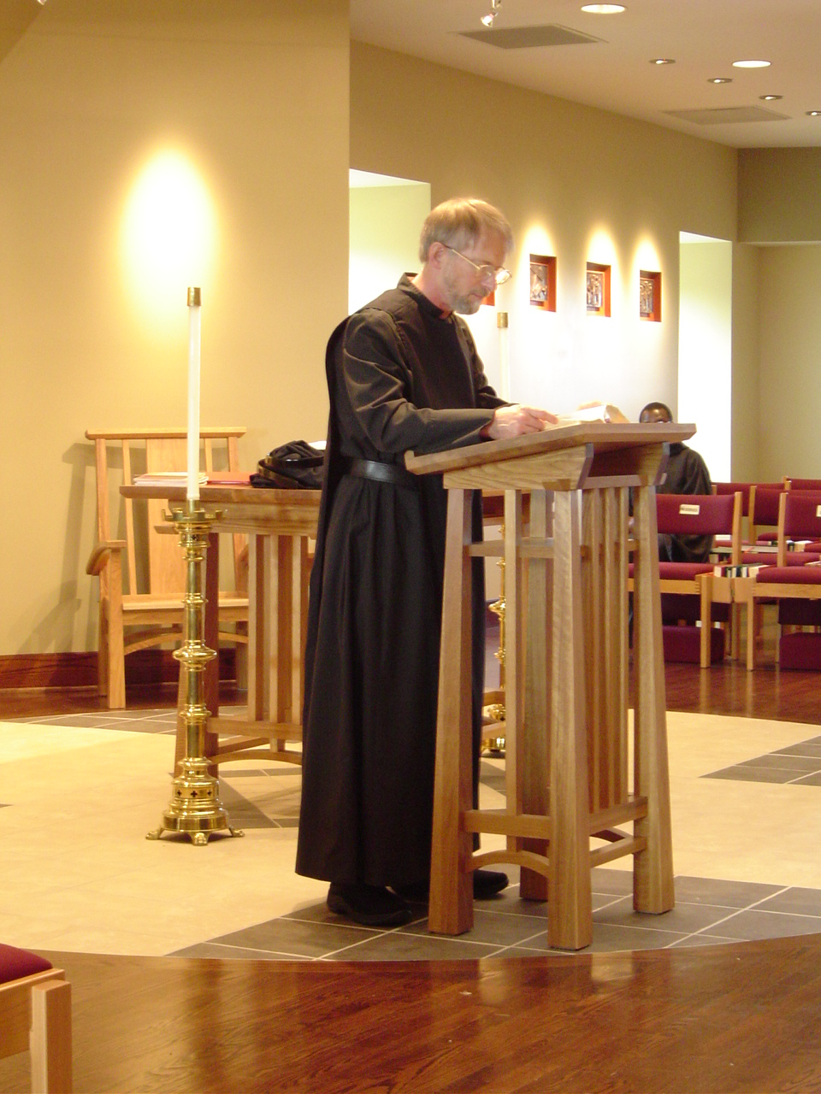
COSL Day 2 (S1) 017 Br. Daniel Joseph Schroeder; Br. Thomas Ferrell
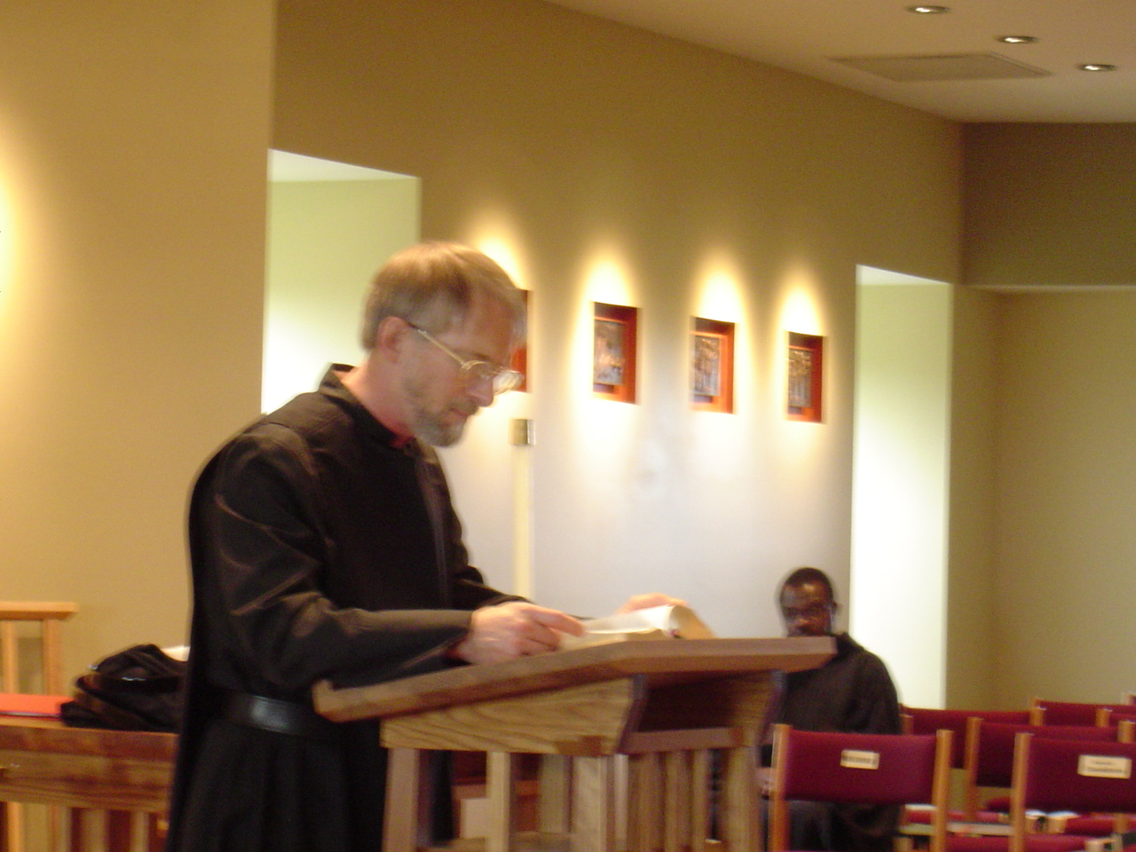COSL Day 2 (S1) 018 Br. Daniel Joseph Schroeder; Br. Thomas Ferrell

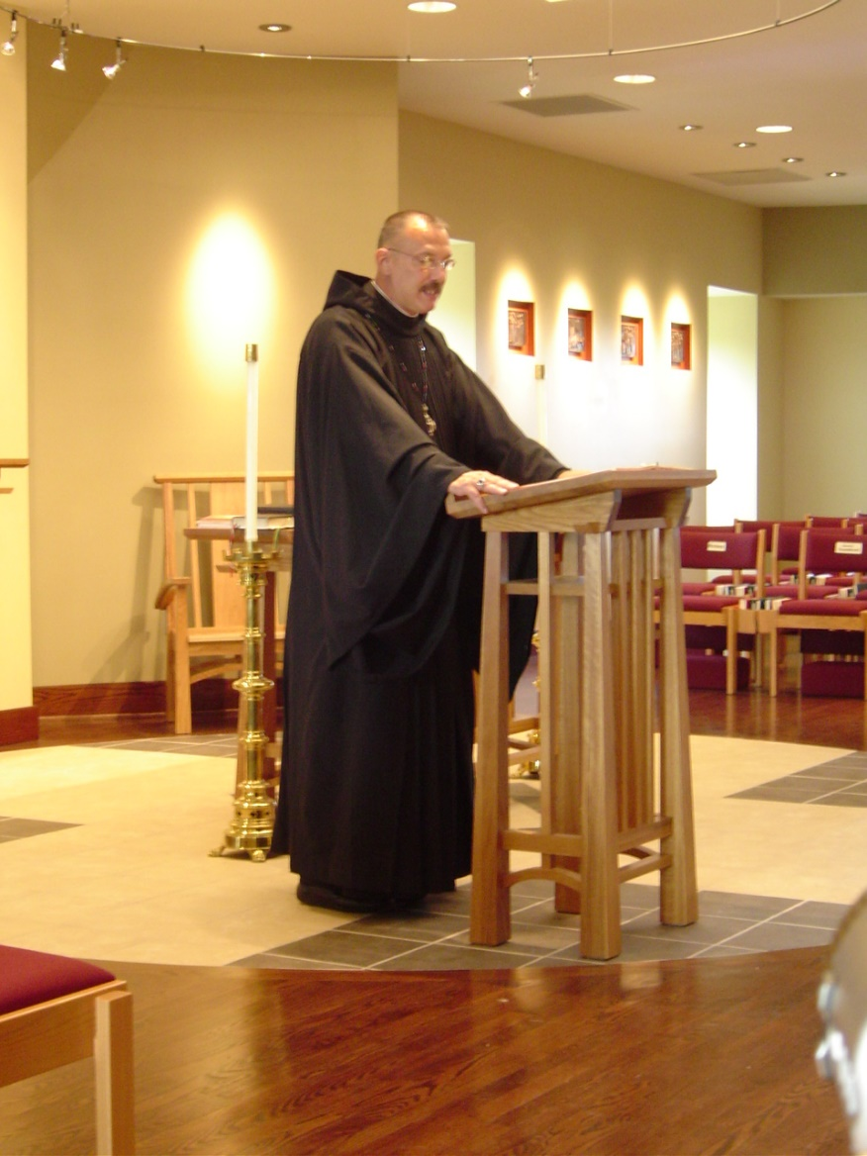
COSL Day 2 (S1) 019 Abbot Michael John Austin
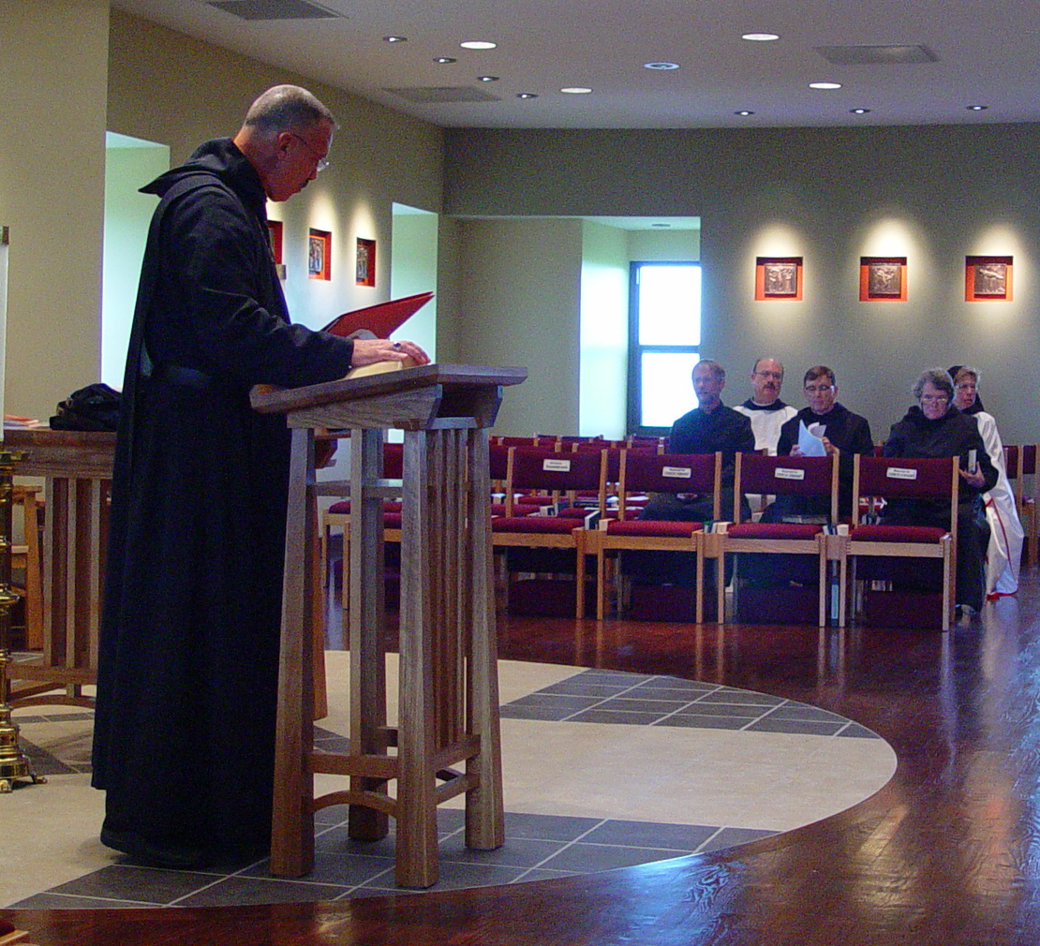
COSL Day 2 (S2) 001 Abbot Michael John Austin; Br. Daniel Joseph Schroeder; Br. Raymond Owens; Br. Camillus Converse; Sr. Vincent Marie Rittenhouse; Sr. Monica Ruth Mullen

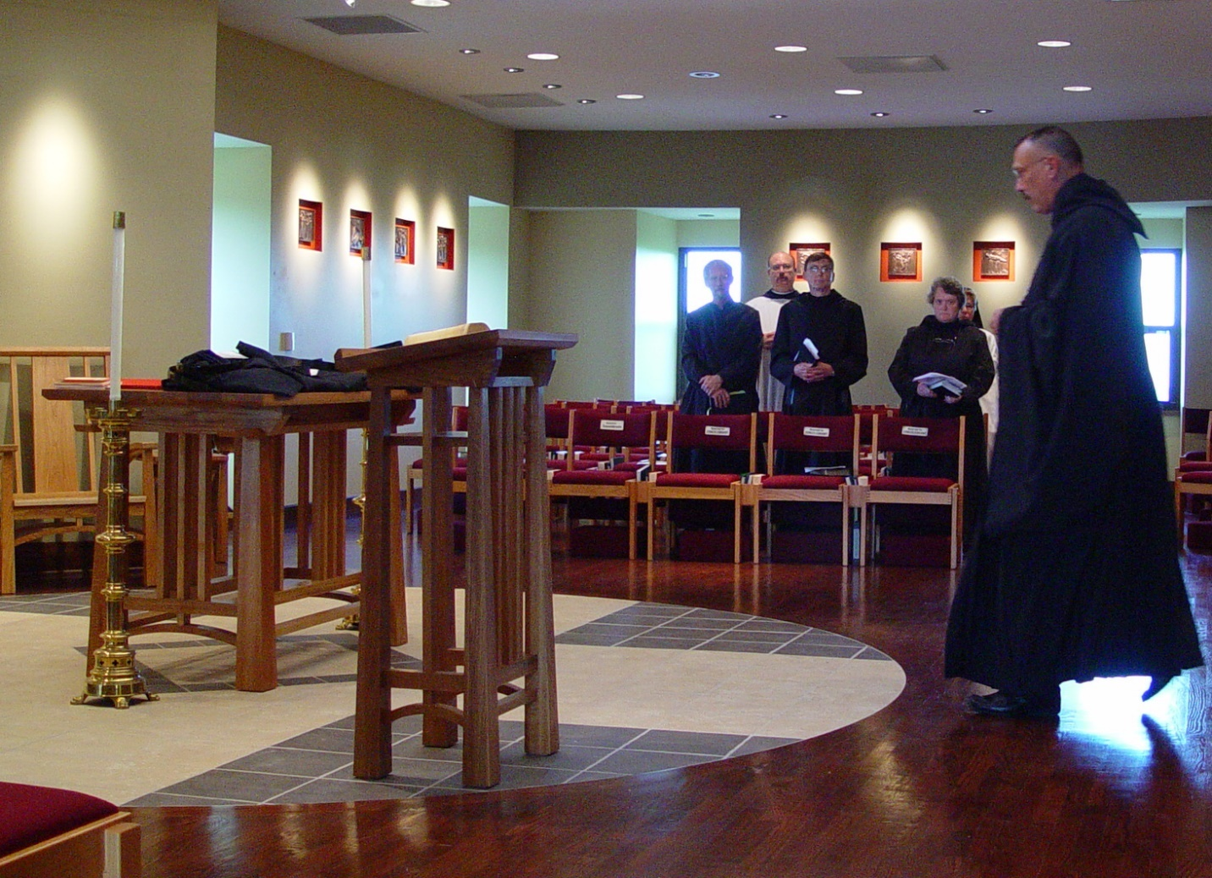COSL Day 2 (S2) 002 Br. Daniel Joseph Schroeder; Br. Raymond Owens; Br. Camillus Converse; Sr. Vincent Marie Rittenhouse; Sr. Monica Ruth Mullen; Abbot Michael John Austin

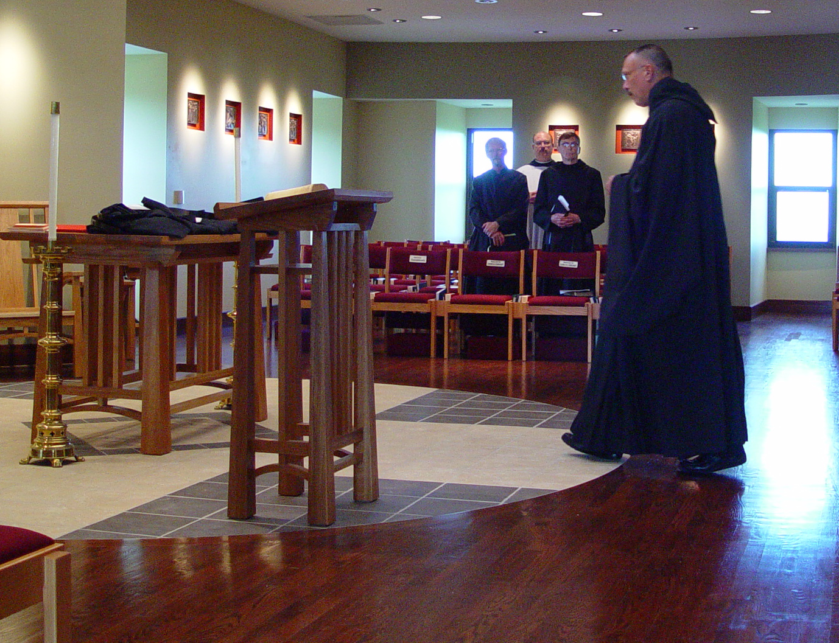
COSL Day 2 (S2) 003 Br. Daniel Joseph Schroeder; Br. Raymond Owens; Br. Camillus Converse; Abbot Michael John Austin;
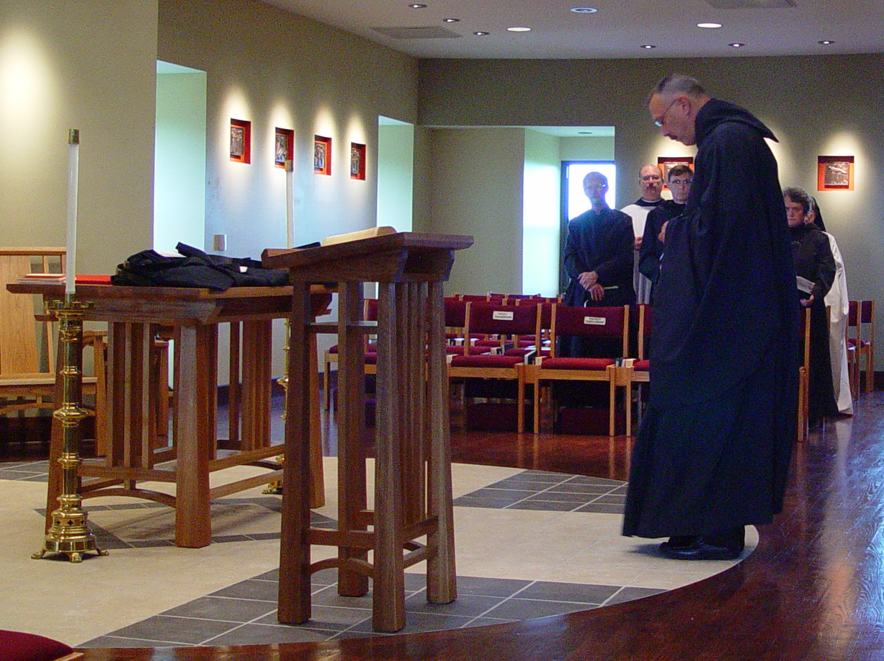COSL Day 2 (S2) 004 Br. Daniel Joseph Schroeder; Br. Raymond Owens; Br. Camillus Converse; Abbot Michael John Austin; Sr. Vincent Marie Rittenhouse; Sr. Monica Ruth Mullen
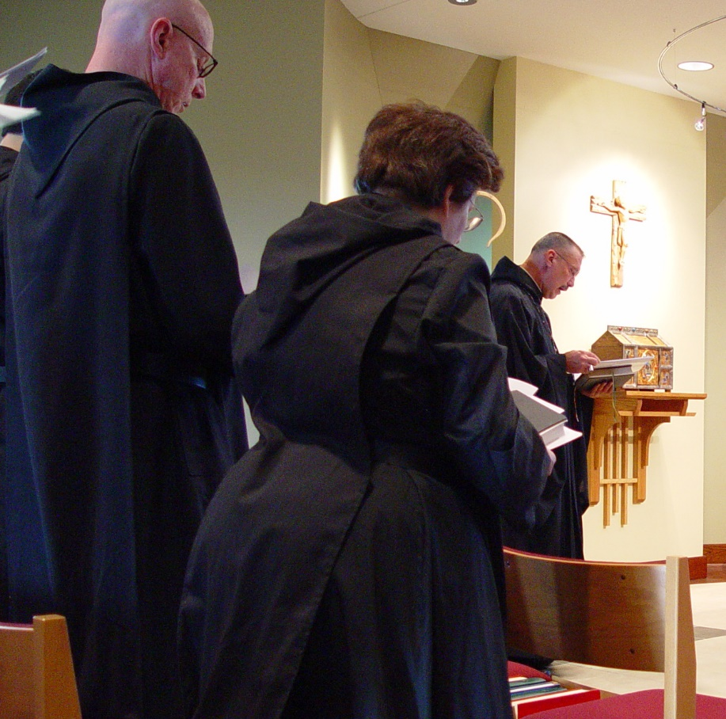
COSL Day 2 (S2) 005 Br. David Vincent Cotton; Sr. Cecelia Lamoy; Abbot Michael John Austin
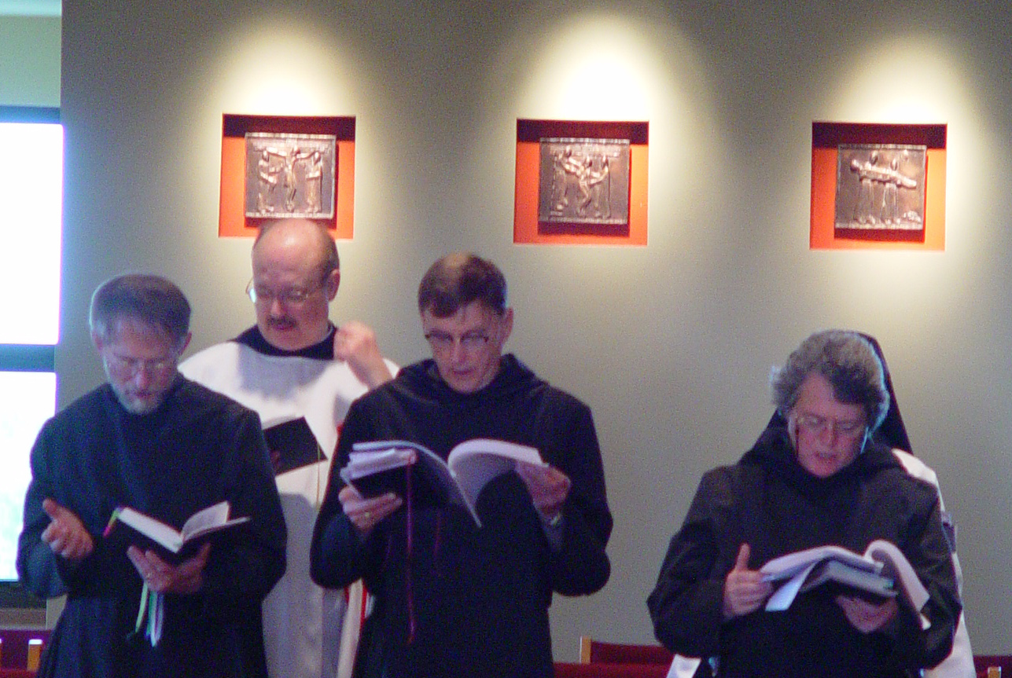COSL Day 2 (S2) 006 Br. Daniel Joseph Schroeder; Br. Raymond Owens; Br. Camillus Converse; Sr. Vincent Marie Rittenhouse

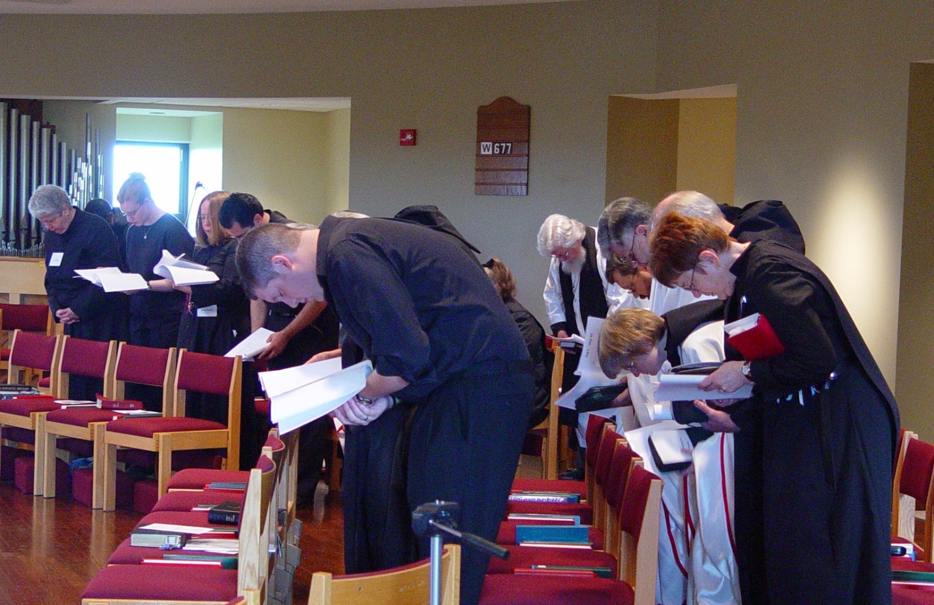COSL Day 2 (S2) 007 Sr. Mary Catherine Christopher; Jan Wolsleben; Jane Bebee; Daniel Medina; Joshua Shawnee; Sr. Margaret Moore; Fr. Wayne Kamm; Br. Paul Howard; Br. Nathan Gregory Miller; Sr. Catherine Unterseher; Br. Daniel Joseph Schroeder; Sr. Brigid Gerns

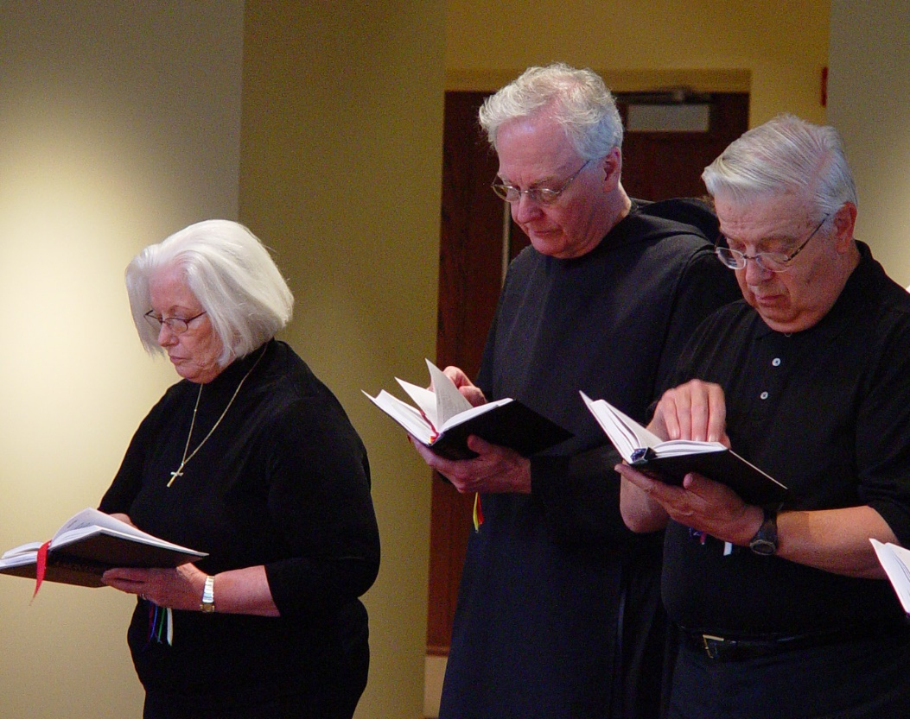
COSL Day 2 (S2) 008 Judith Stribley; Br. Luke Doucette; Tom Lunt
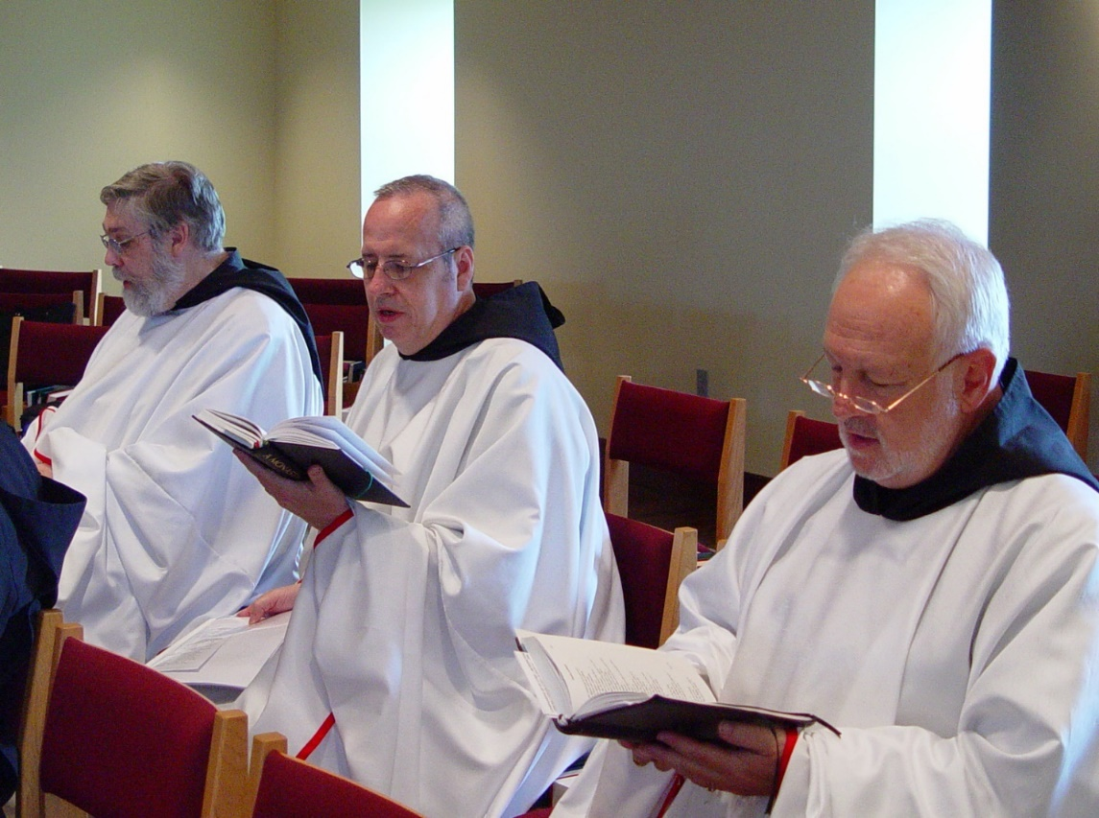
COSL Day 2 (S2) 009 Br. Chad Anselm Gerns; Br. Gabriel Hale; Br. Christopher John Baumann

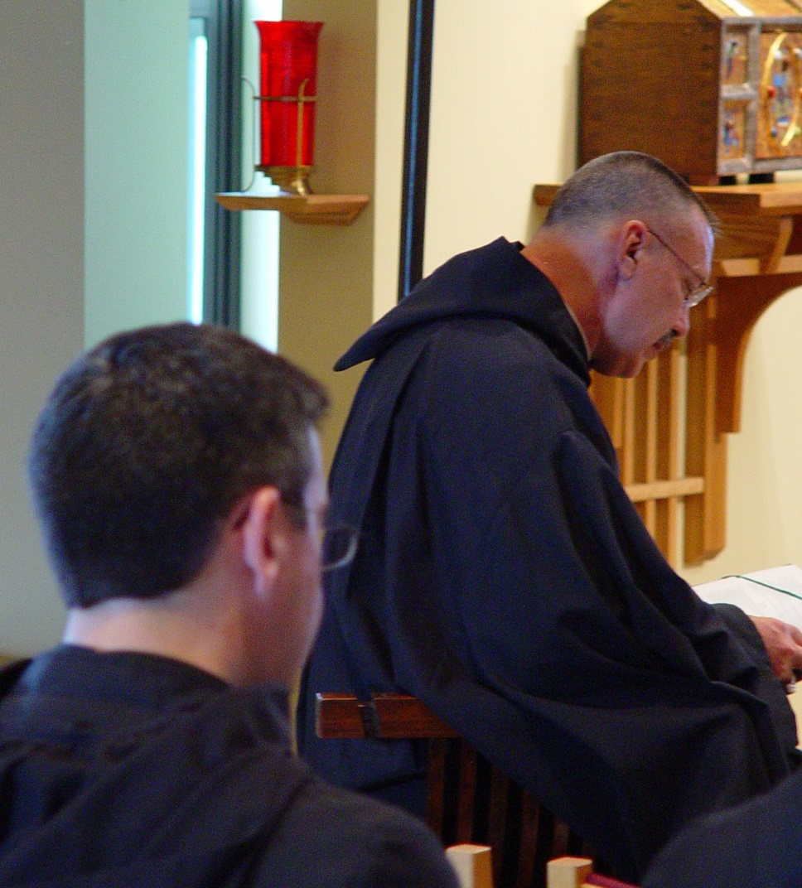
COSL Day 2 (S2) 010 Br. Augustine Colvert; Abbot Michael John Austin
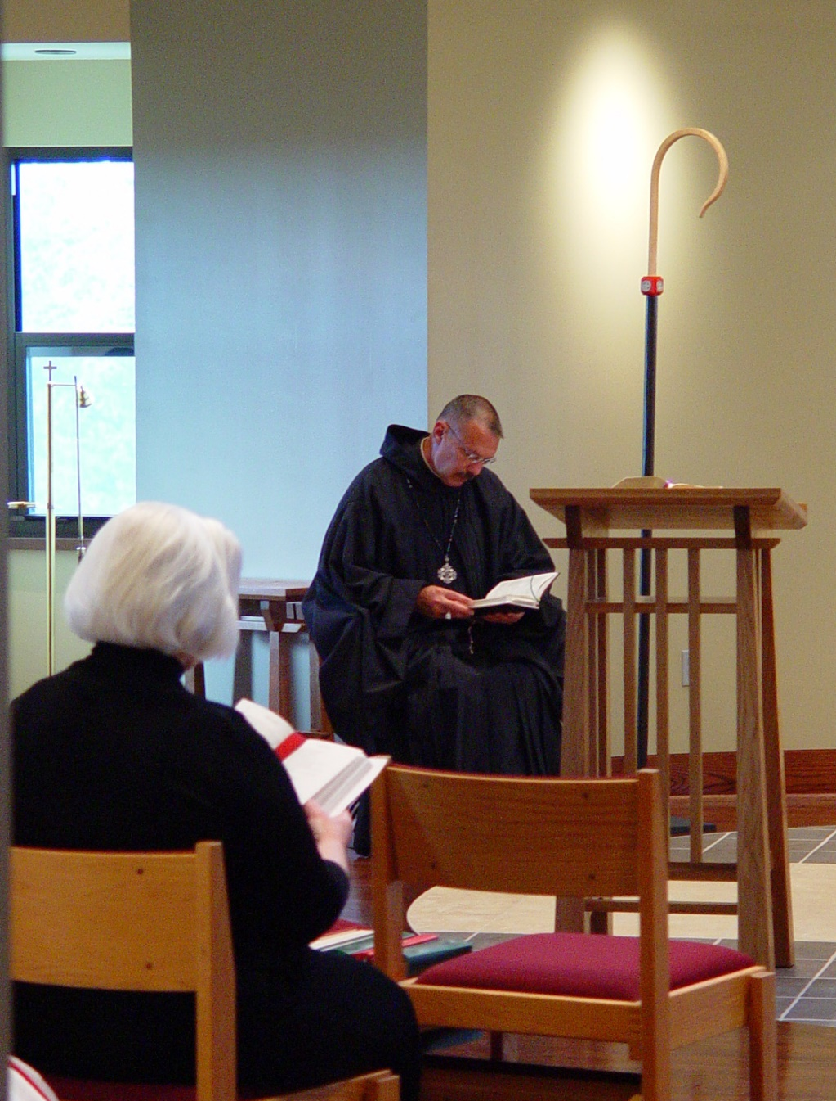
COSL Day 2 (S2) 011 Judith Stribley; Abbot Michael John Austin
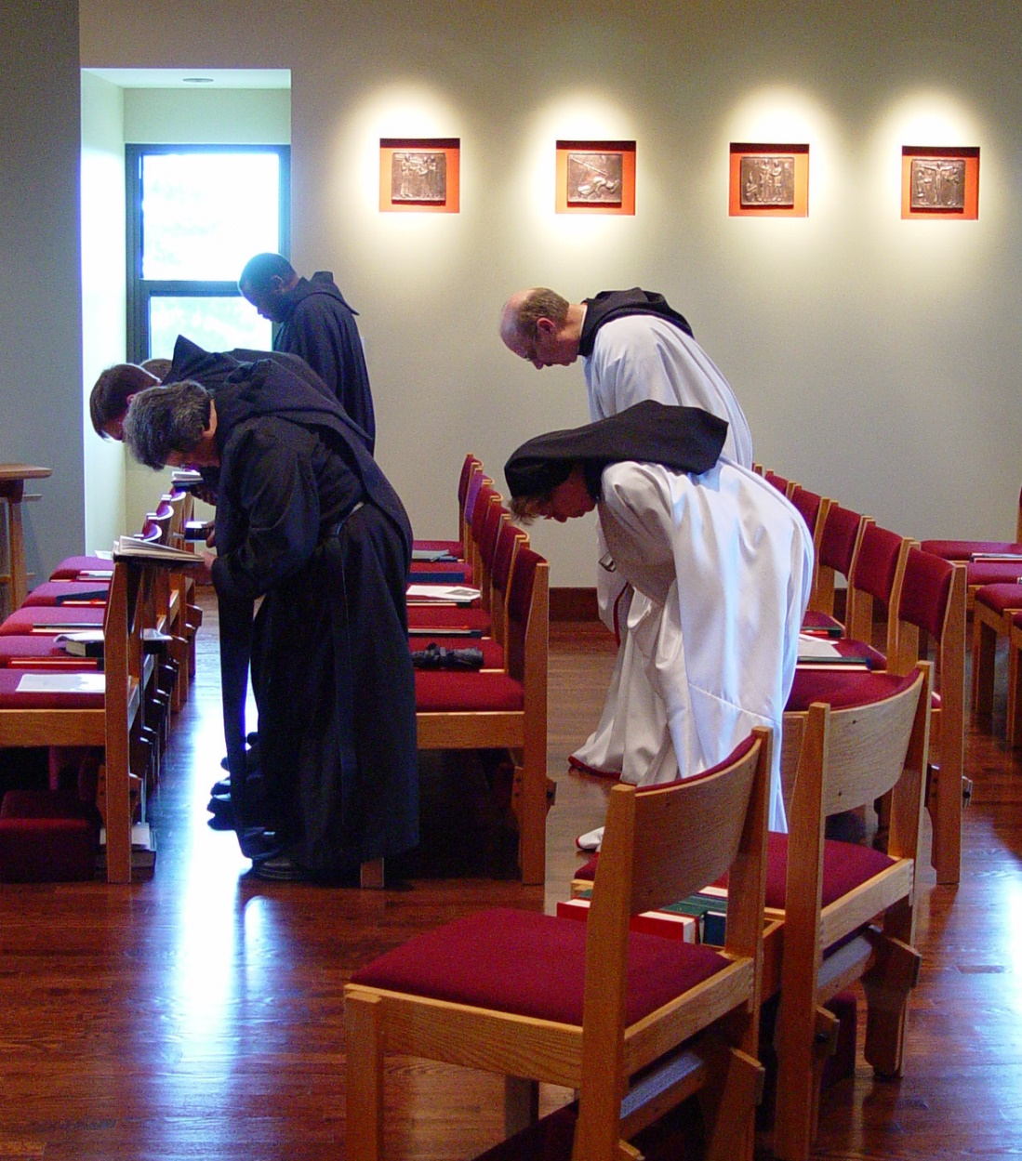
COSL Day 2 (S2) 012 Sr. Vincent Marie Rittenhouse; Br. Camillus Converse; Br. Thomas Ferrell; Sr. Monica Ruth Mullen; Br. Raymond Owens
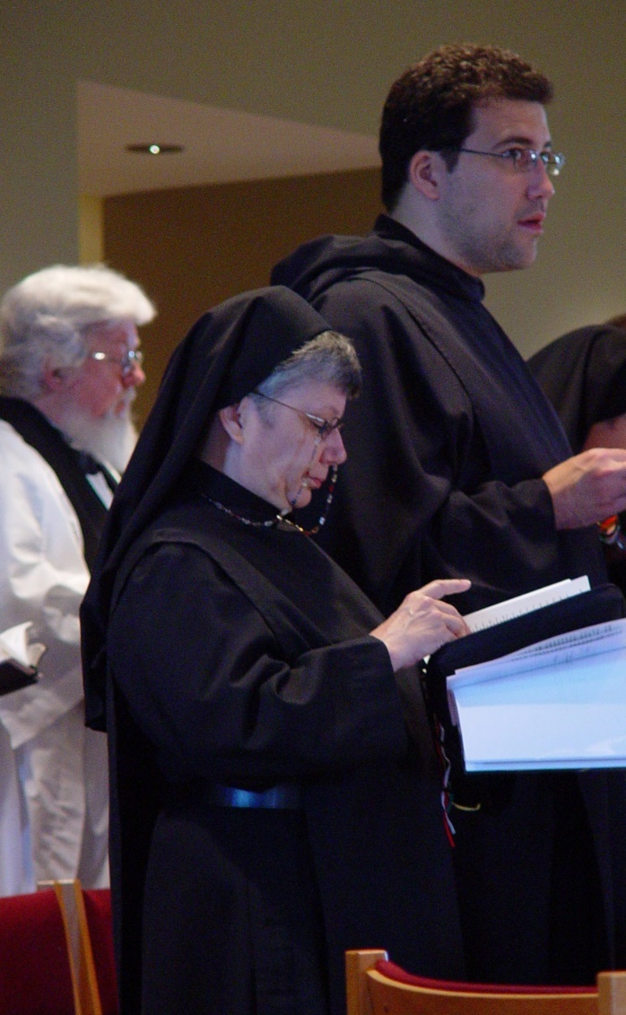
COSL Day 2 (S2) 013 Fr. Wayne Kamm; Sr. Anna Grace Madden; Br. Anthony Bernard Campos
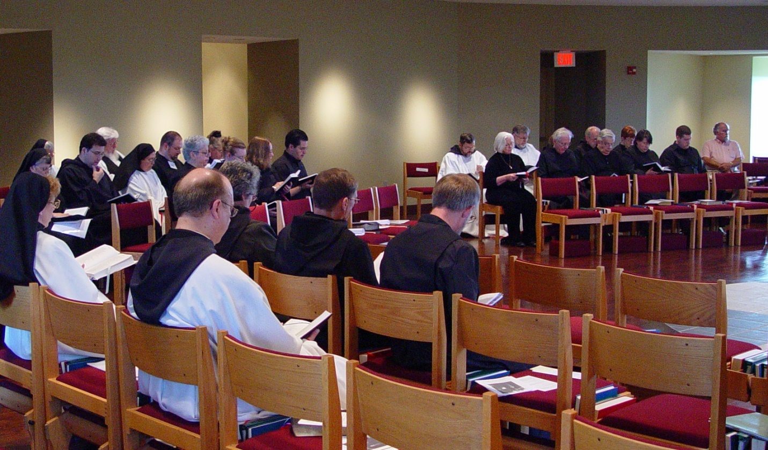COSL Day 2 (S2) 014 Sr. Monica Ruth Mullen; Sr. Anna Grace Madden; Sr. Clare Benedicta Myers; Br. Anthony Bernard Campos; Fr. Wayne Kamm; Sr. Theodora of Jesus Perecca; Br. Willard Moore; Br. Raymond Owens; Sr. Mary Catherine Christopher; Sr. Margaret Moore; Sr. Vincent Marie Rittenhouse; Jan Wolsleben; Jane Bebee; Br. Augustine Colvert; Br. Camillus Converse; Br. Lawrence Mullen; Judith Stribley; Br. Nathan Gregory Miller; Br. Luke Doucette; Br. Daniel Joseph Schroeder; Tom Lunt; Sr. Brigid Gerns; Daniel Medina; Fr. Mel Schlacter

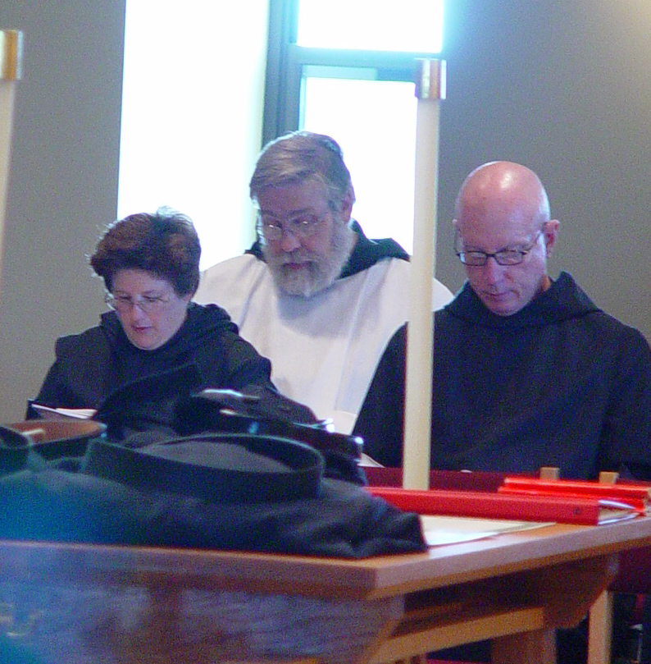
COSL Day 2 (S2) 015 Sr. Cecelia; Br. Chad Anselm Gerns; Br. David Vincent Cotton
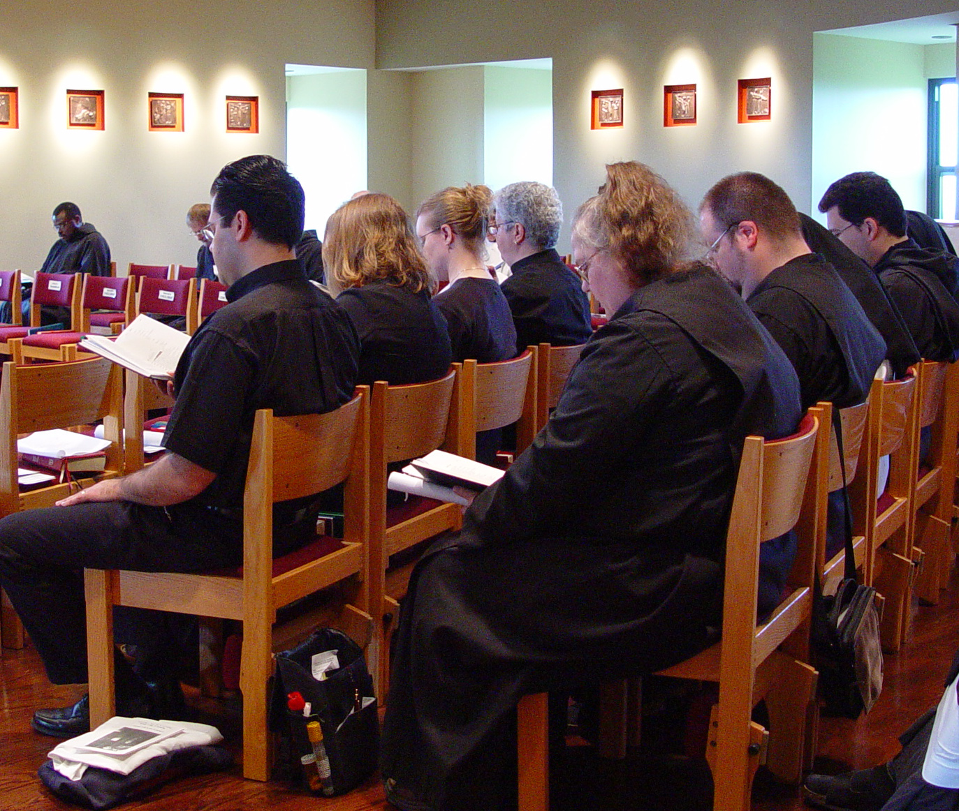COSL Day 2 (S2) 016 Br. Thomas Ferrell; Br. Lawrence Mullen; Daniel Medina; Jane Bebee; Jan Wolsleben; Sr. Mary Catherine Christopher; Sr. Margaret Moore; Br. Willard Moore; Br. Anthony Bernard Campos
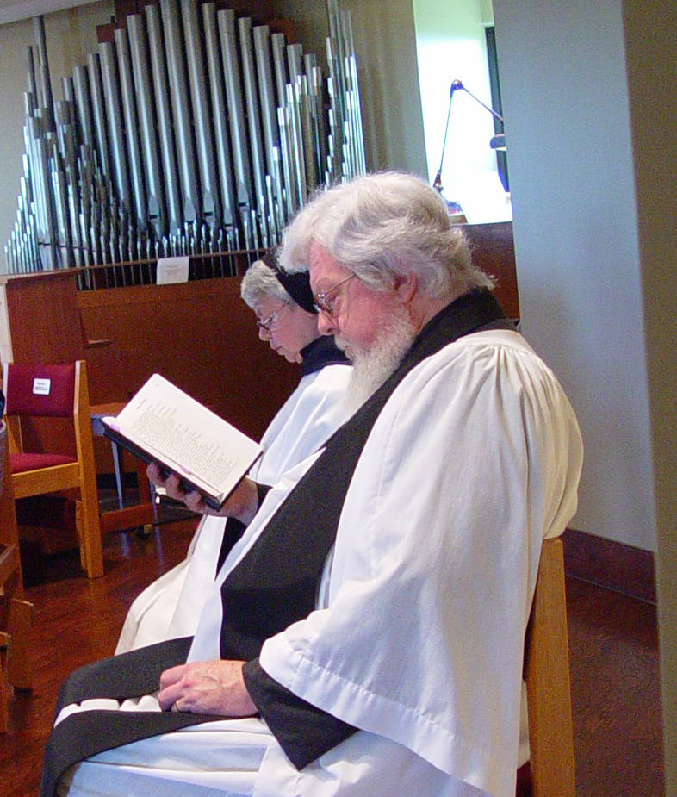
COSL Day 2 (S2) 017 Sr. Clare Benedicta Myers; Fr. Wayne Kamm
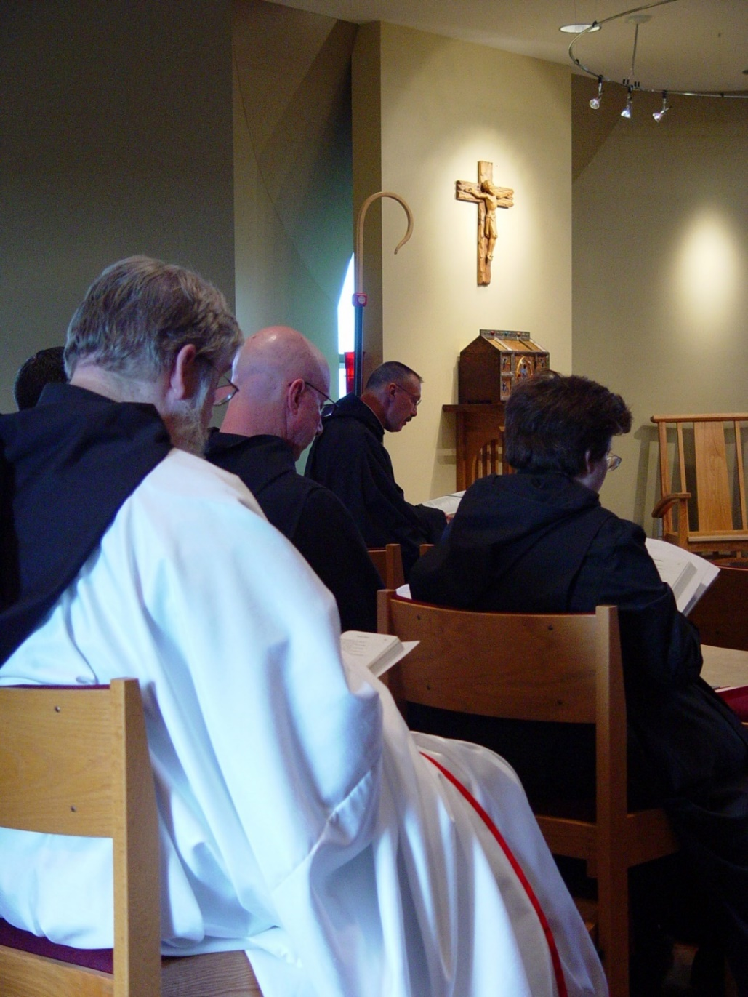
COSL Day 2 (S2) 018 Br. Chad Anselm Gerns; Br. David Vincent Cotton; Abbot Michael John Austin; Sr. Cecelia Lamoy

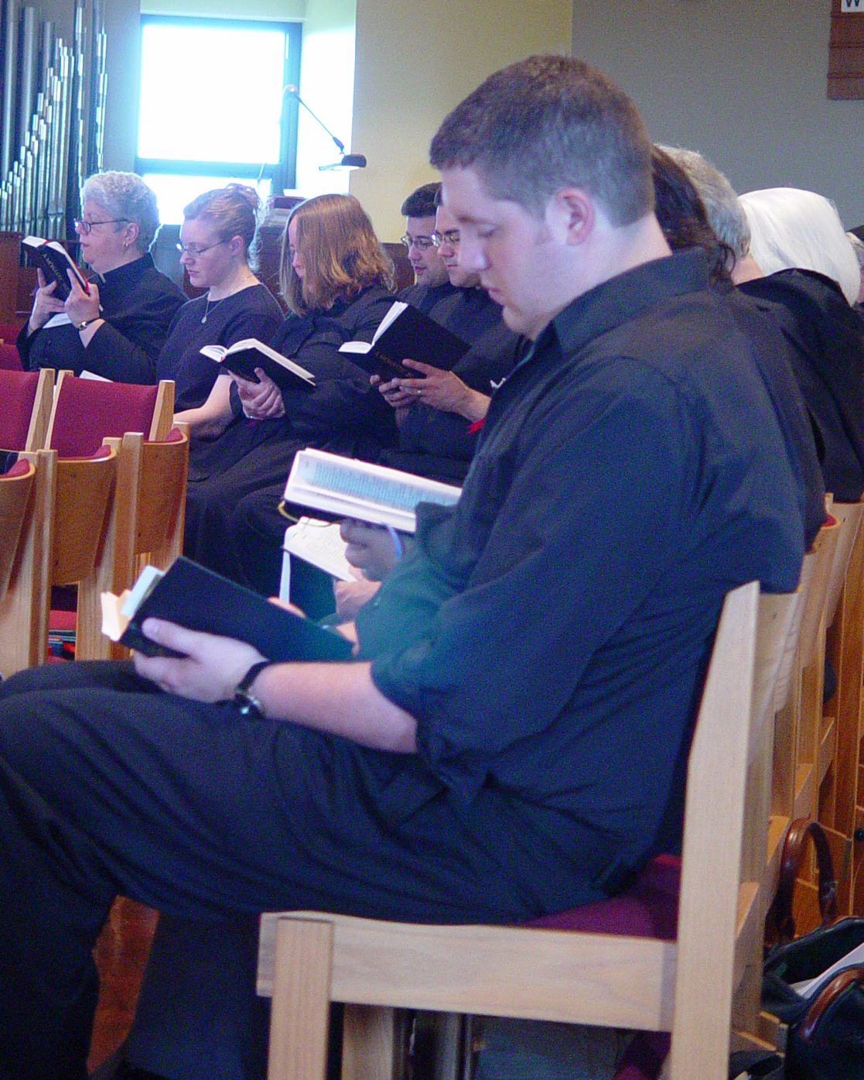
COSL Day 2 (S2) 019 Sr. Mary Catherine Christopher; Han Wolsleben; Jane Bebee; Br. Anthony Bernard Campos; ?; Judith Stribley; Joshua Shawnee

