Hilary Grace Lundgren; Companions of St. Luke
Spring 2006 Convocation at Conception Abbey
Day 1

~Edited by Br. Steven Olderr, 31 May 2022 with the assistance of Br. Thomas Ferrell. If you find any errors or omissions or have anything to add, please notify Br. Steven at olderr@ameritech.net

People are identified from left to right.

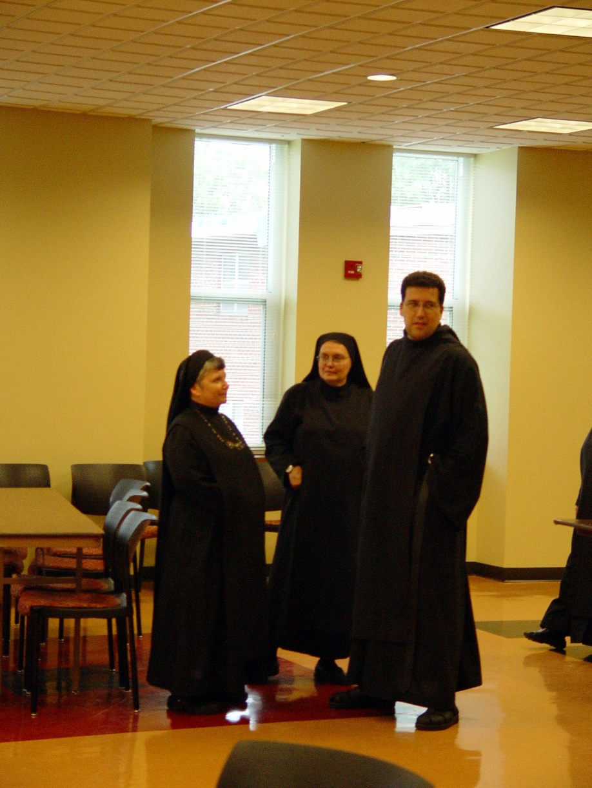
COSL Day 1 001 Sr. Anna Grace Madden; Sr. Theodora of Jesus Perecca; Br. Anthony Bernard Campos
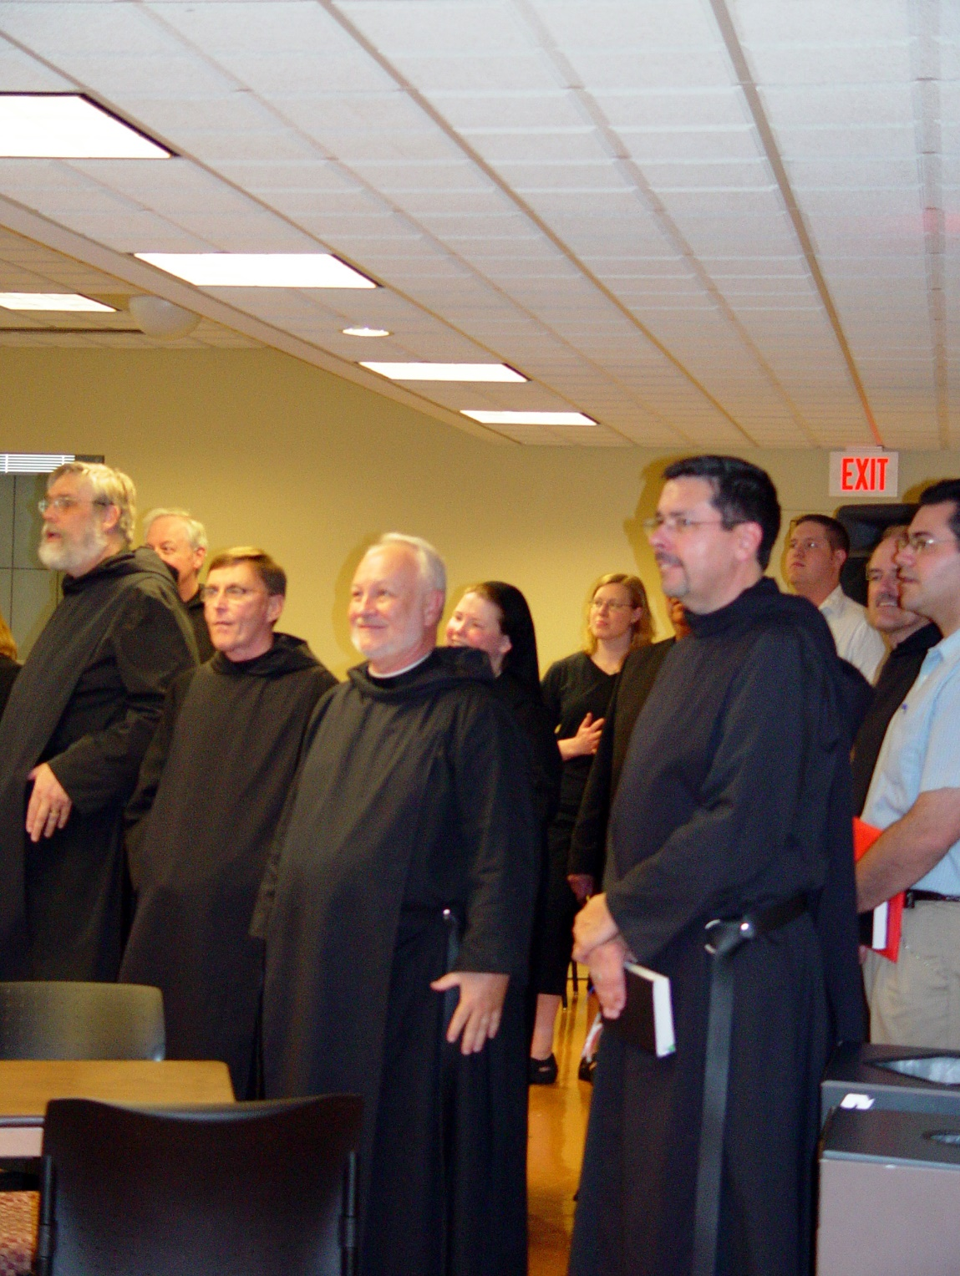
COSL Day 1 002 Br. Chad Anselm Gerns; Br. Luke Doucette; Br. Camillus Converse; Br. Christopher John Baumann; Sr. Hillary Grace Lundgren; Jan Wolsleben (later Sr. Hannah Sophia); Tom Lunt; Br. Augustine Colvert; Joshua Shawnee (later Br. Caedmon); Br. Daniel Joseph Schroeder; Daniel Medina
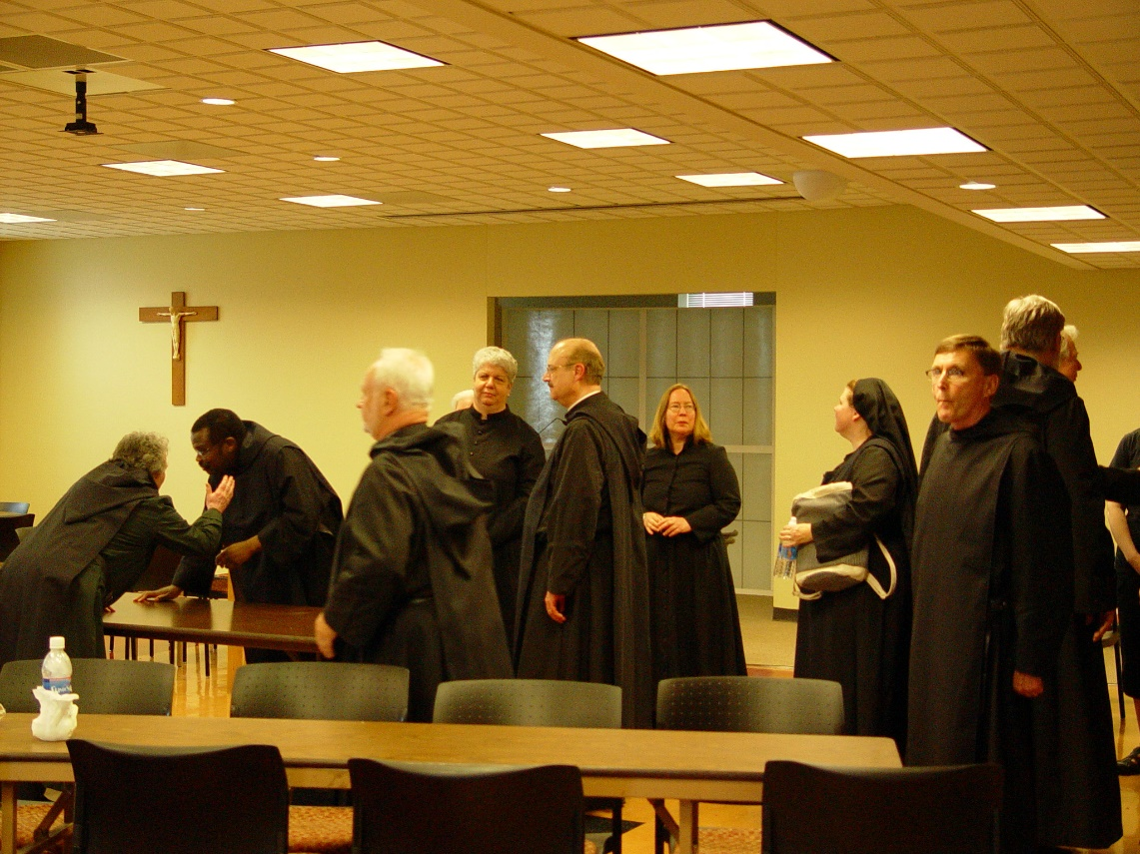
COSL Day 1 003 Sr. Vincent Marie Rittenhouse; Br. Thomas Ferrell; Br. Christopher John Baumann; Sr. Mary Christopher; Br. Raymond Owens; Jane Beebe (later Sr. Teresa); Sr. Hillary Grace Lundgren; Br. Camillus Converse; Br. Chad Anselm Gerns; Br. Luke Doucette
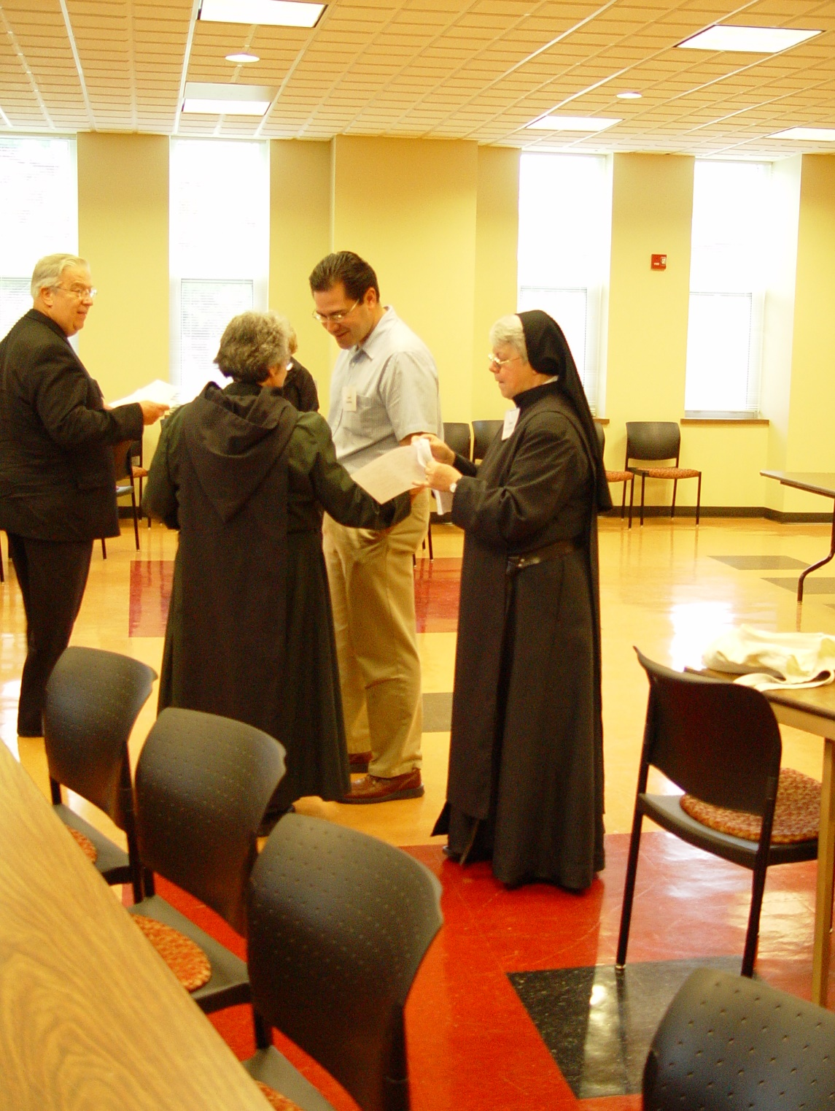
COSL Day 1 004 Tom Lunt; Sr. Vincent Marie Rittenhouse; Daniel Medina; Sr. Clare Benedicta Myers
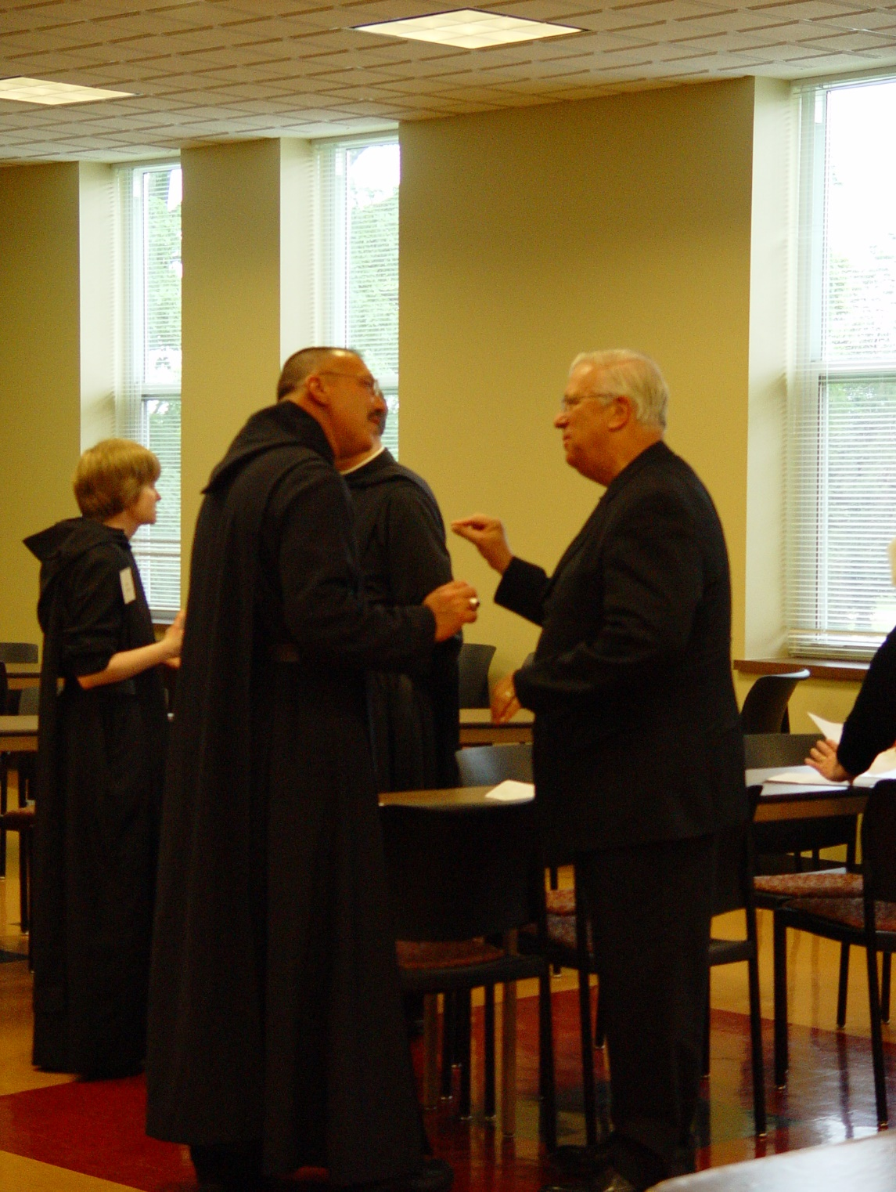
COSL Day 1 005 Sr. Catherine Unterseher; Abbot Michael John Austin; Tom Lunt
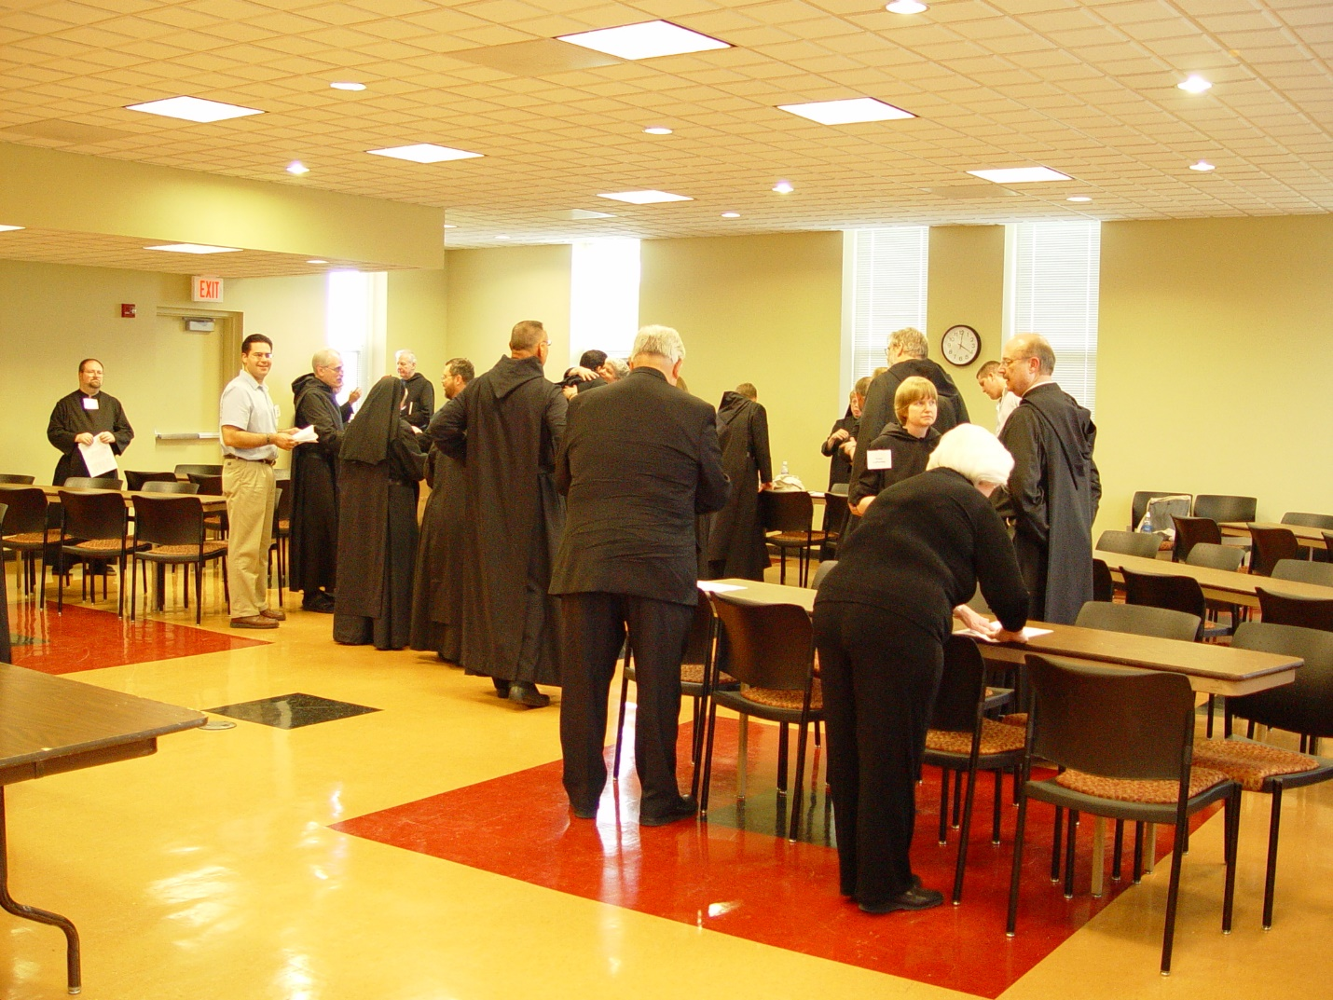
COSL Day 1 006 Br. Willard Moore; Daniel Medina; Br. Daniel Joseph Schroeder; Sr. Clare Benedicta Myers; Br. Luke Doucette; Br. Paul Howard; Abbot Michael John Austin; Br. Augustine Colvert; Mary Christopher; Tom Lunt; Br. Camillus Converse; Sr. Monica Ruth Mullen; Br. Lawrence Mullen; Br. Chad Anselm Gerns; Sr. Catherine Unterseher; Judith Stribley; Joshua Shawnee; Br. Raymond Owens
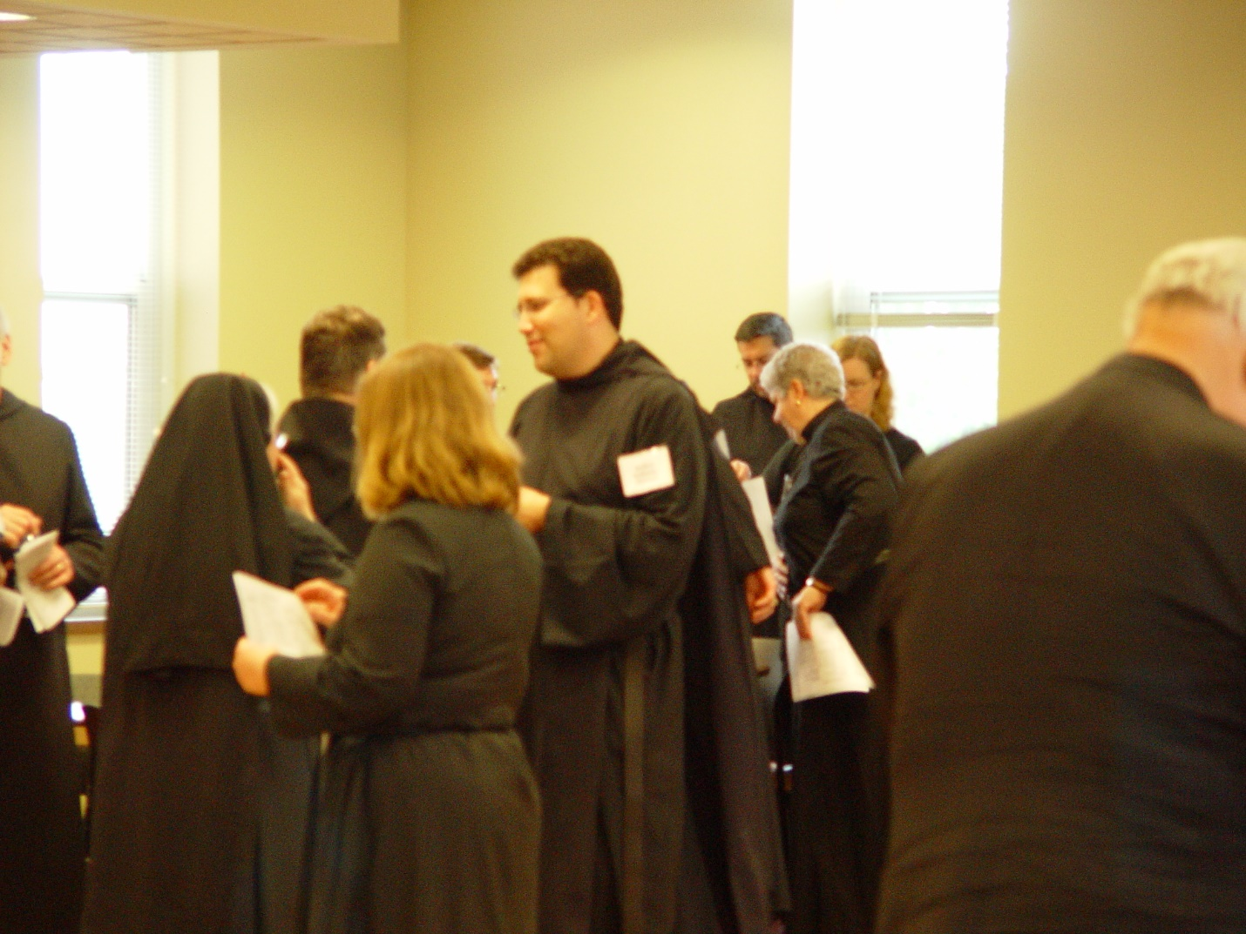
COSL Day 1 007 Sr. Clare Benedicta Myers; Br. Paul Howard; Jane Bebee; Br. Camillus Converse; Br. Anthony Bernard Campos; Br. Augustine Colvert; Sr. Mary Catherine Christopher; Jan Wolsleben; Tom Lunt
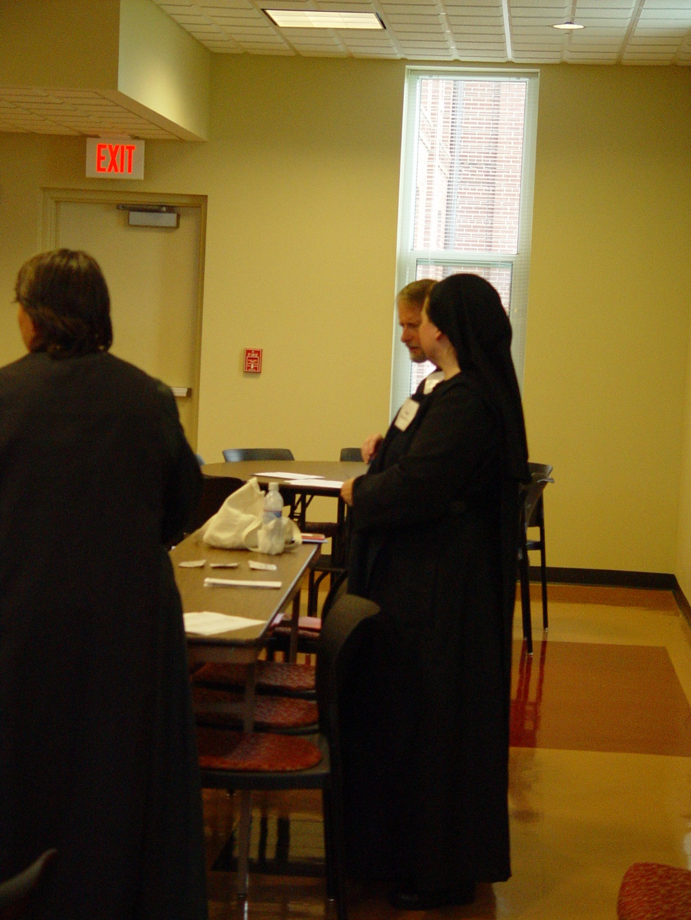
COSL Day 1 008 Sr. Pauline Tysol; Br. Lawrence Mullen; Sr. Hillary Grace Lundgren
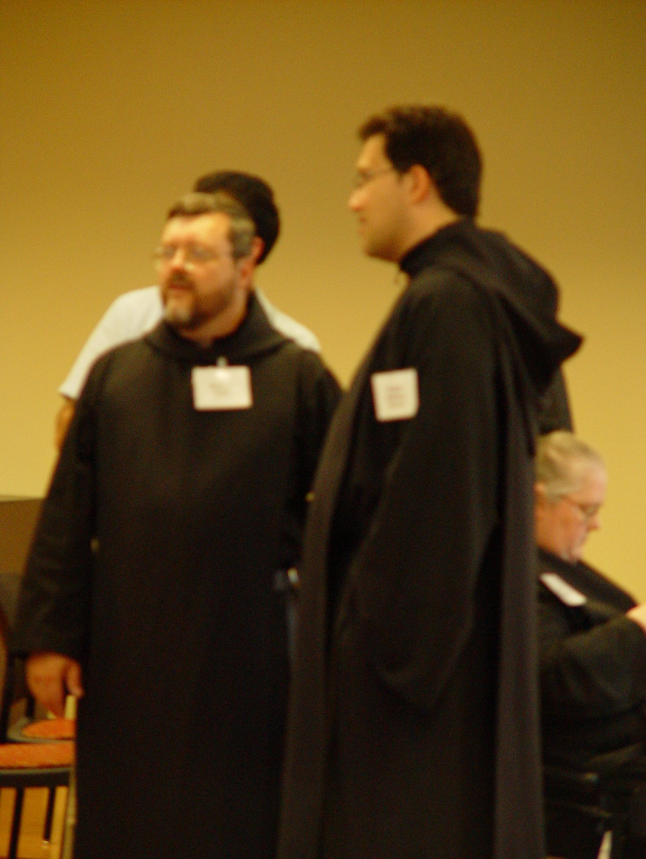
COSL Day 1 009 Daniel Medina; Br. Paul Howard; Br. Anthony Bernard Campos; Sr. Margaret Moore
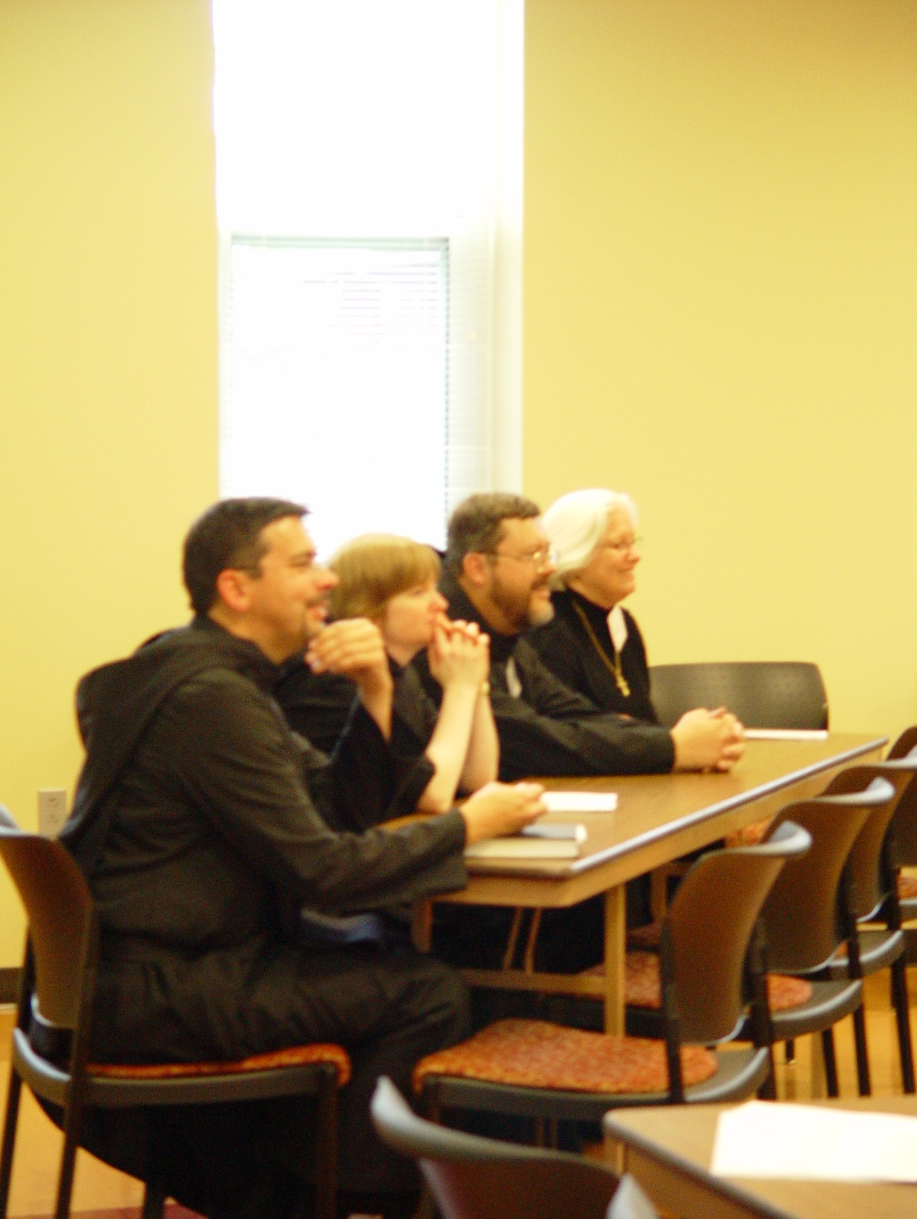
COSL Day 1 010 Br. Augustine Colvert; Sr. Catherine Unterseher; Br. Paul Howard; Judith Stribley
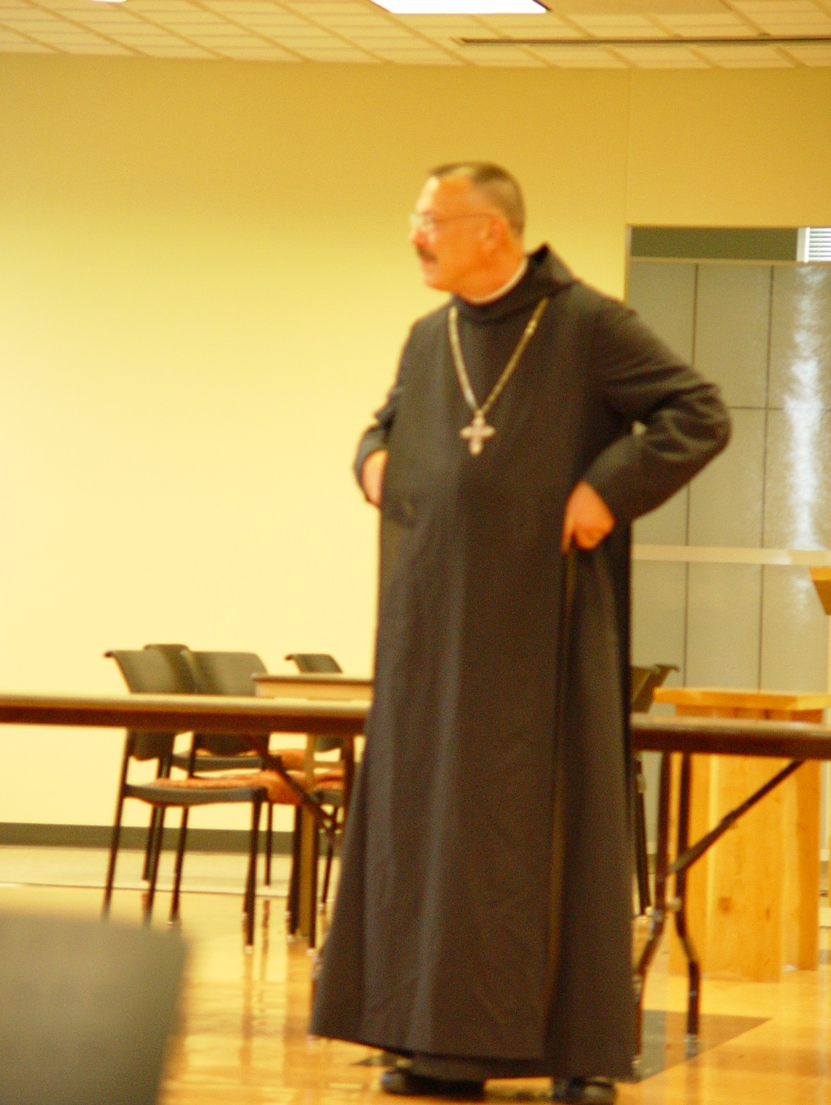
COSL Day 1 011 Abbot Michael John Austin
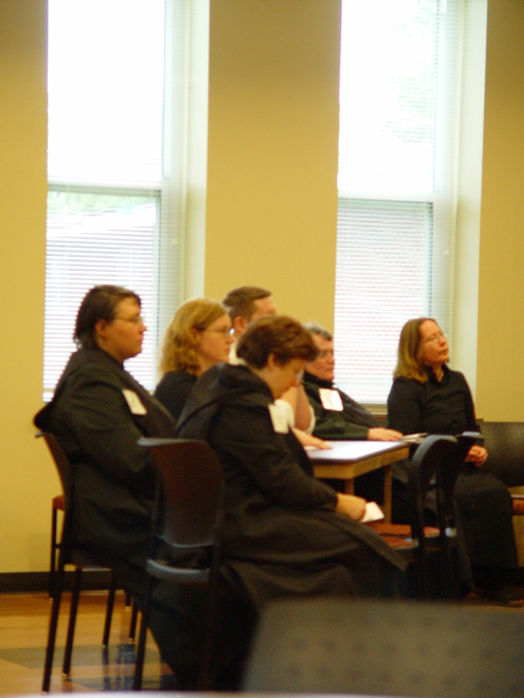
COSL Day 1 012 Sr. Pauline Tysol; Jan Wolsleben; Joshua Shawnee; Sr. Cecelia Lamoy; Sr. Vincent Marie Rittenhouse; Jane Bebee
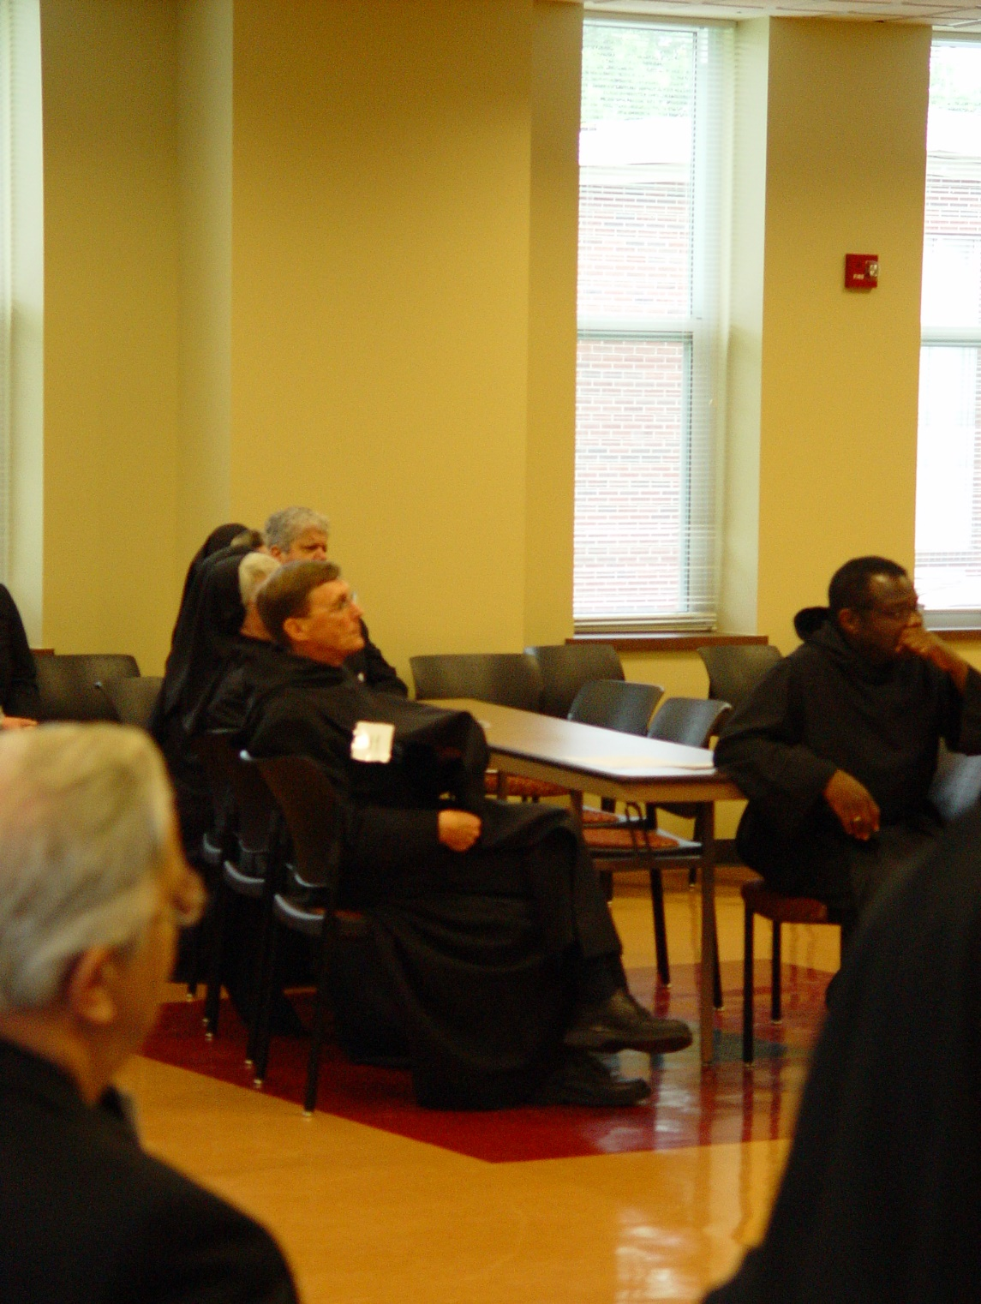
COSL Day 1 013 Tom Lunt; Br. Camillus Converse; Sr. Clare Benedicta Myers; Sr. Anna Grace Madden; Mary Christopher; Br. Thomas Ferrell
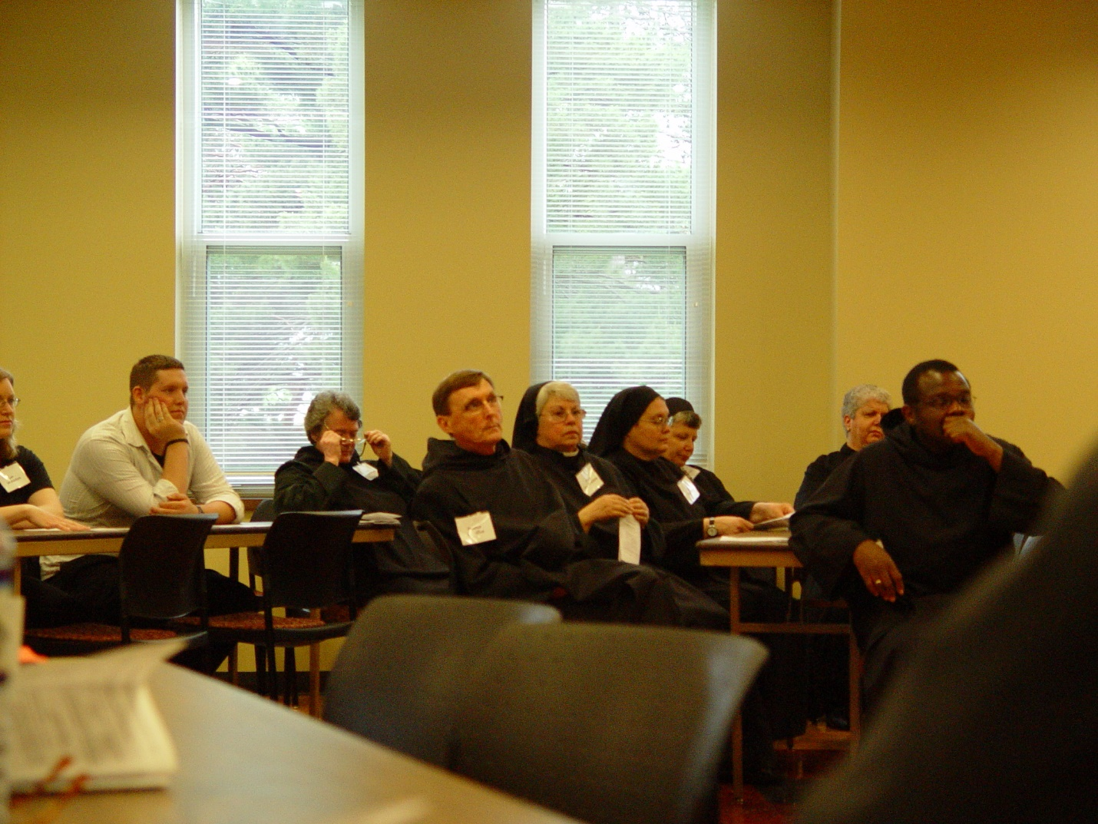
COSL Day 1 014 Jan Wolsleben; Joshua Shawnee; Sr. Vincent Marie Rittenhouse; Br. Camillus Converse; Sr. Clare Benedicta Myers; Sr. Theodora of Jesus Perecca; Sr. Anna Grace Madden; May Christopher; Br. Thomas Ferrell
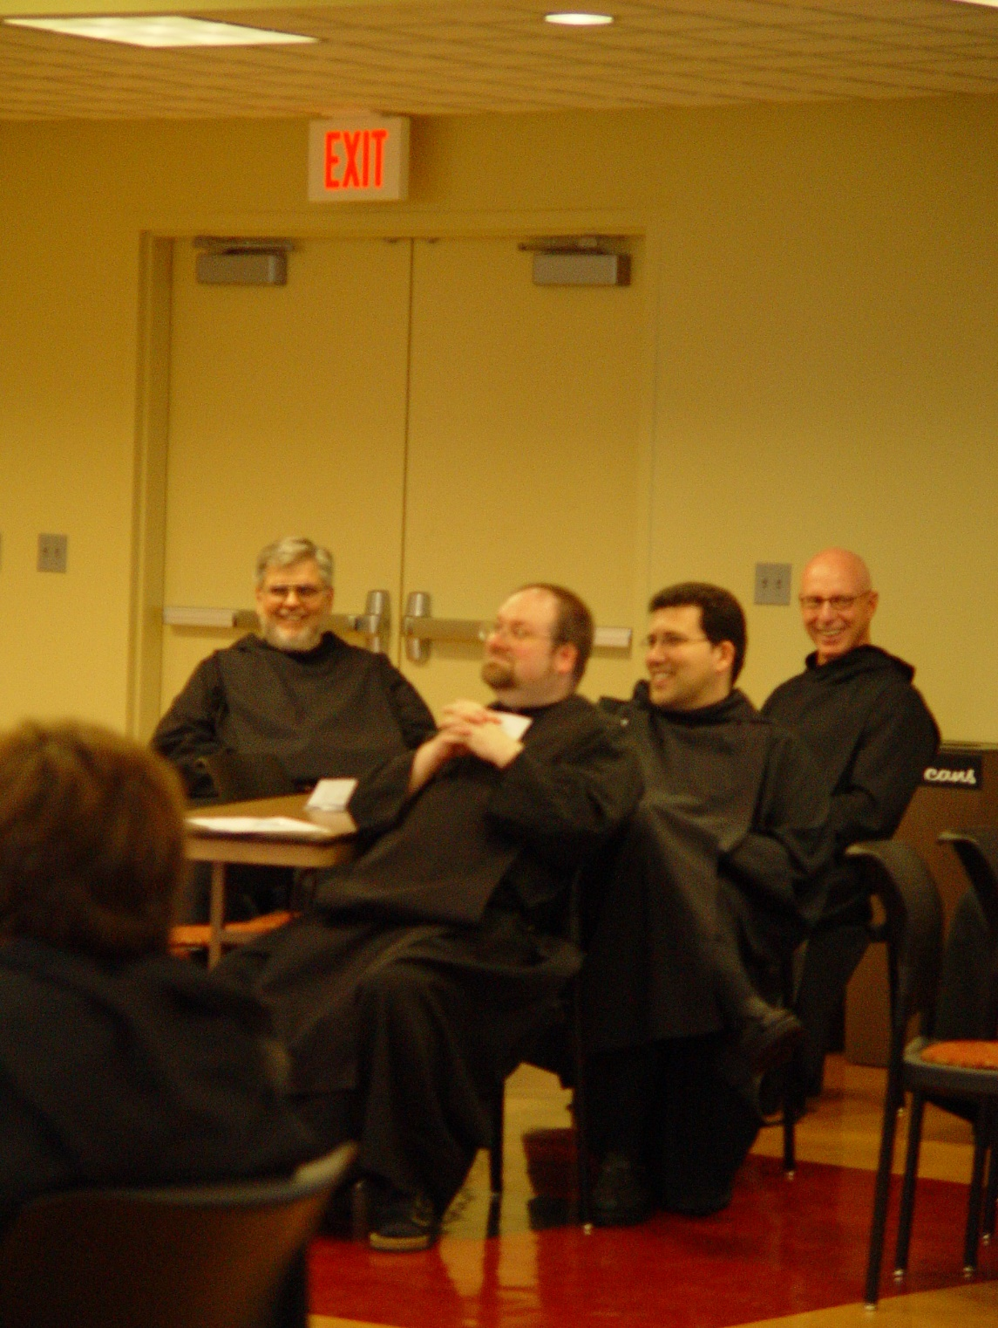
COSL Day 1 015 Sr. Cecelia Lamoy; Br. Nathan Gregory Miller; Br. Willard Moore; Br. Anthony Bernard Campos; Br. David Vincent Cotton
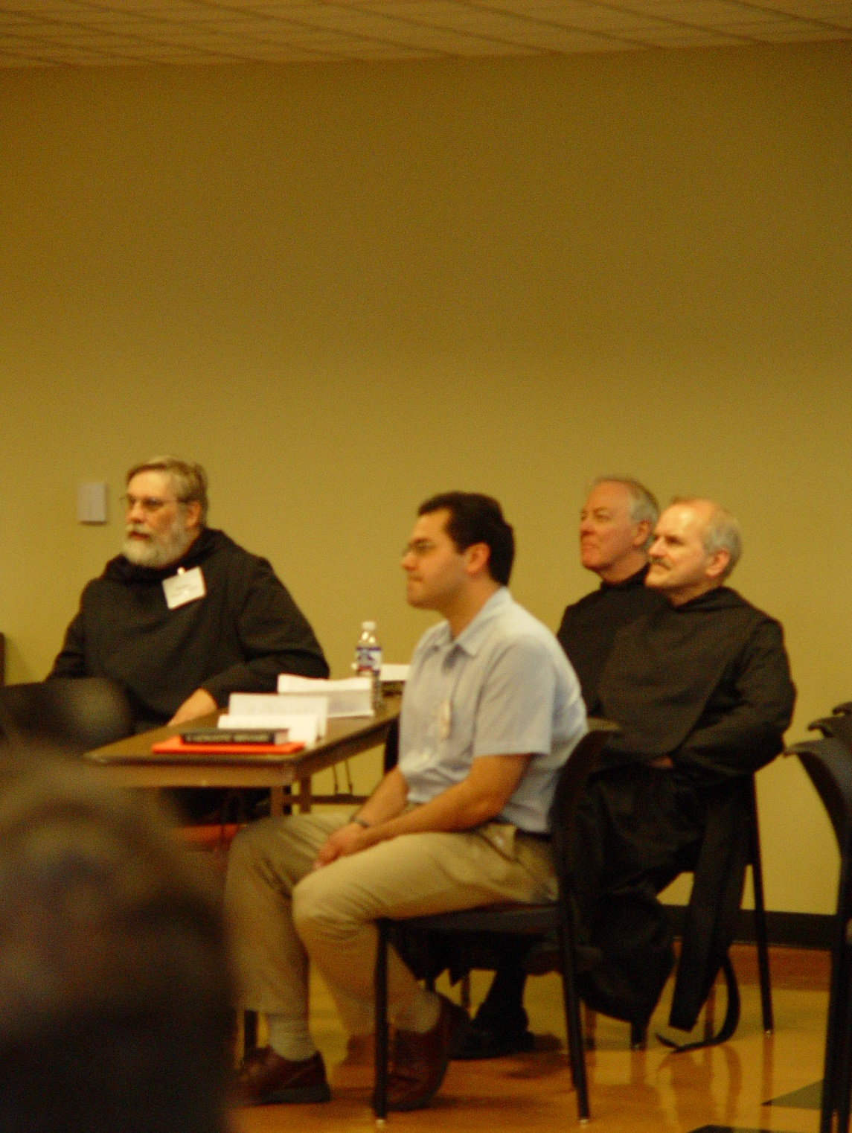
COSL Day 1 016 Br. Chad Anselm Gerns; Daniel Medina; Br. Luke Doucette; Br. Daniel Joseph Schroeder
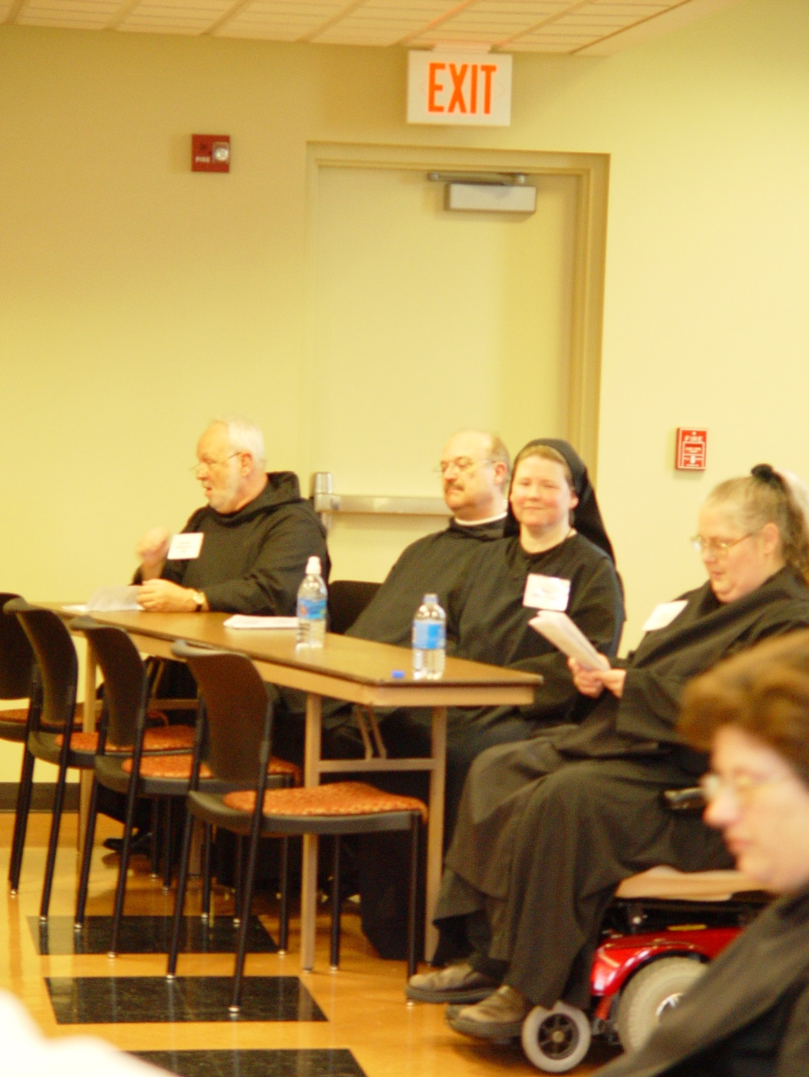
COSL Day 1 017 Br. Christopher John Baumann; Br. Raymond Owens; Sr. Hillary Grace Lundgren; Sr. Margaret Moore; Sr. Cecelia Lamoy
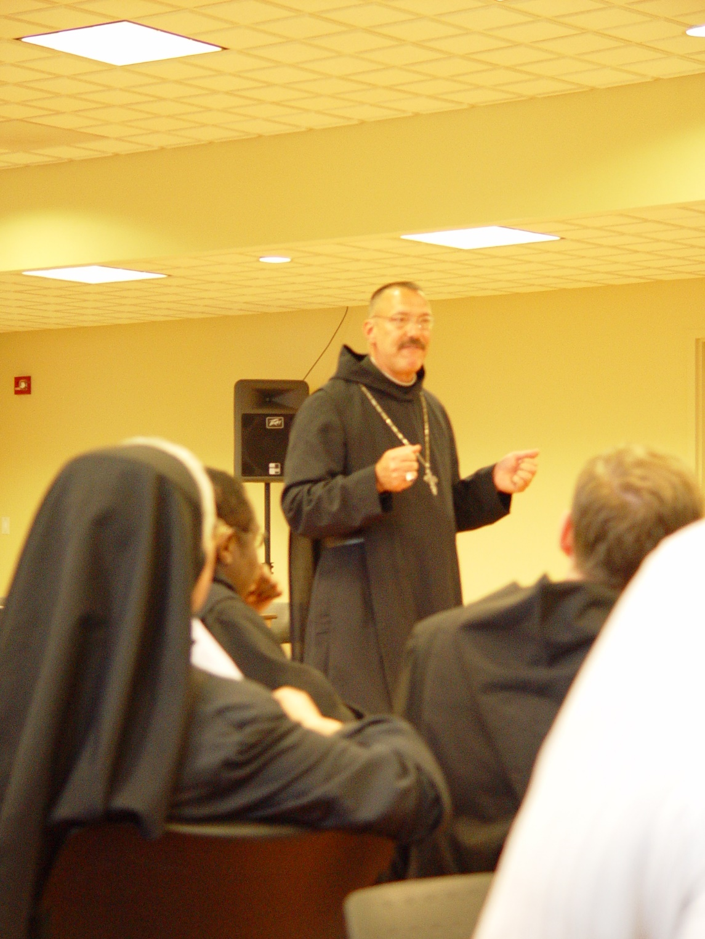
COSL Day 1 018 Sr. Clare Benedicta Myers; Br. Thomas Ferrell; Abbot Michael John Austin; Br. Camillus Converse
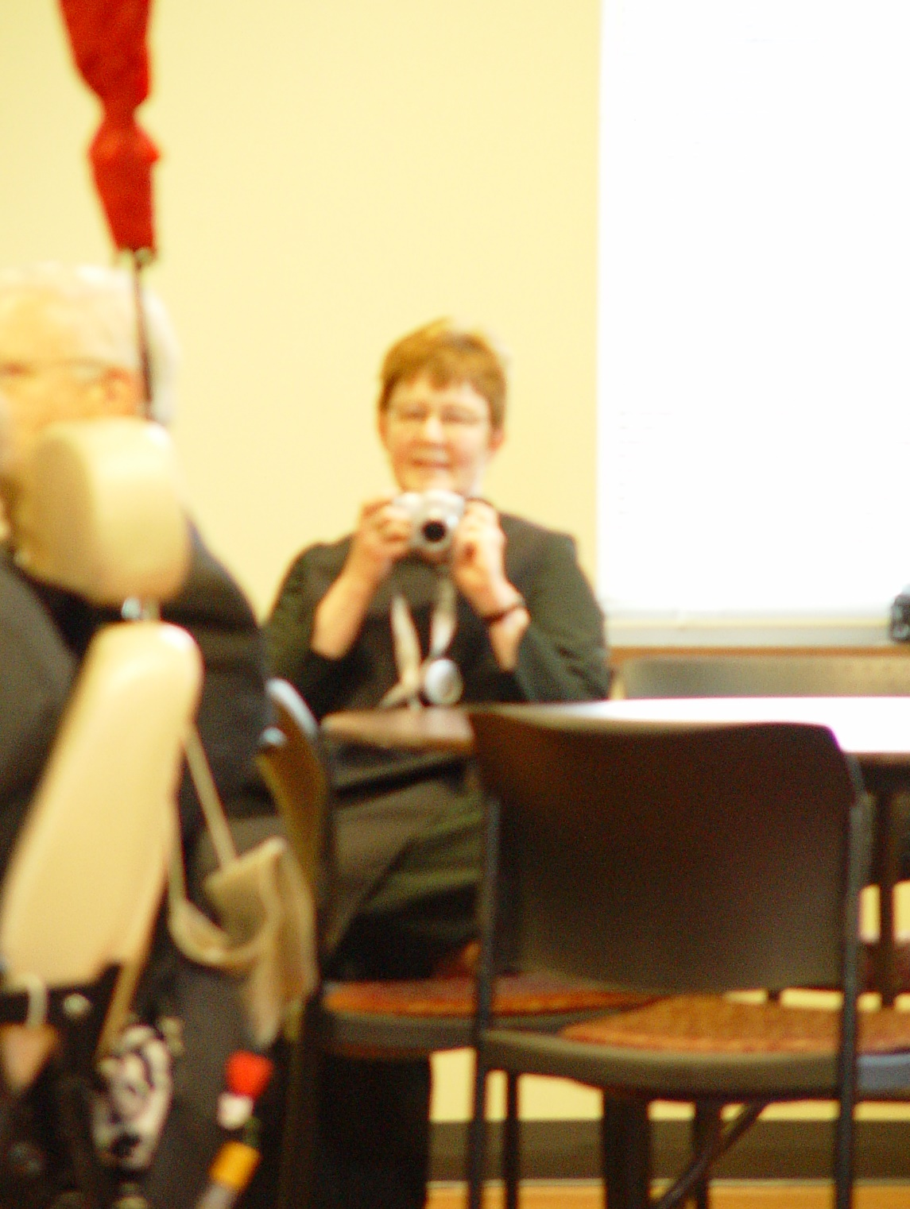
COSL Day 1 019 Sr. Brigid Gerns
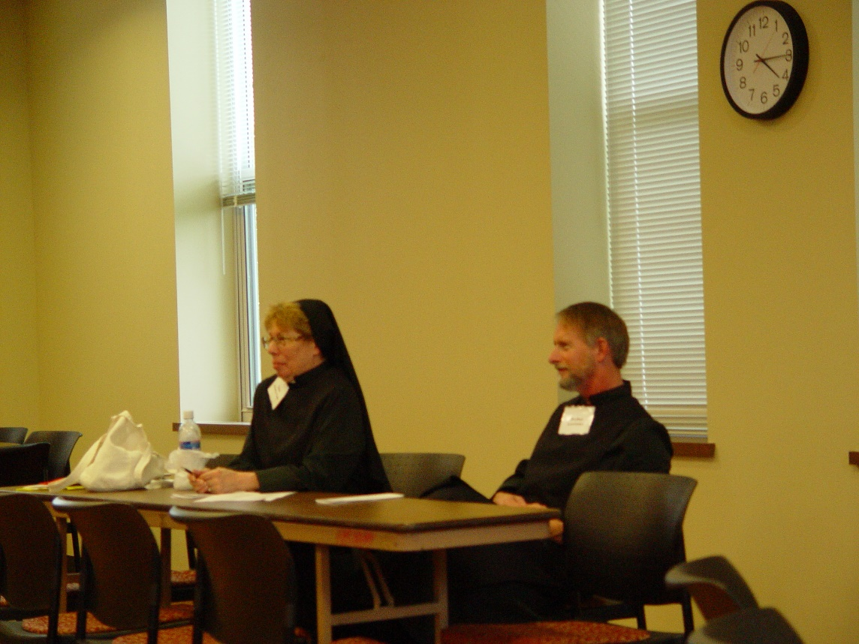
COSL Day 1 020 Sr. Monica Ruth Mullen; Br. Lawrence Mullen
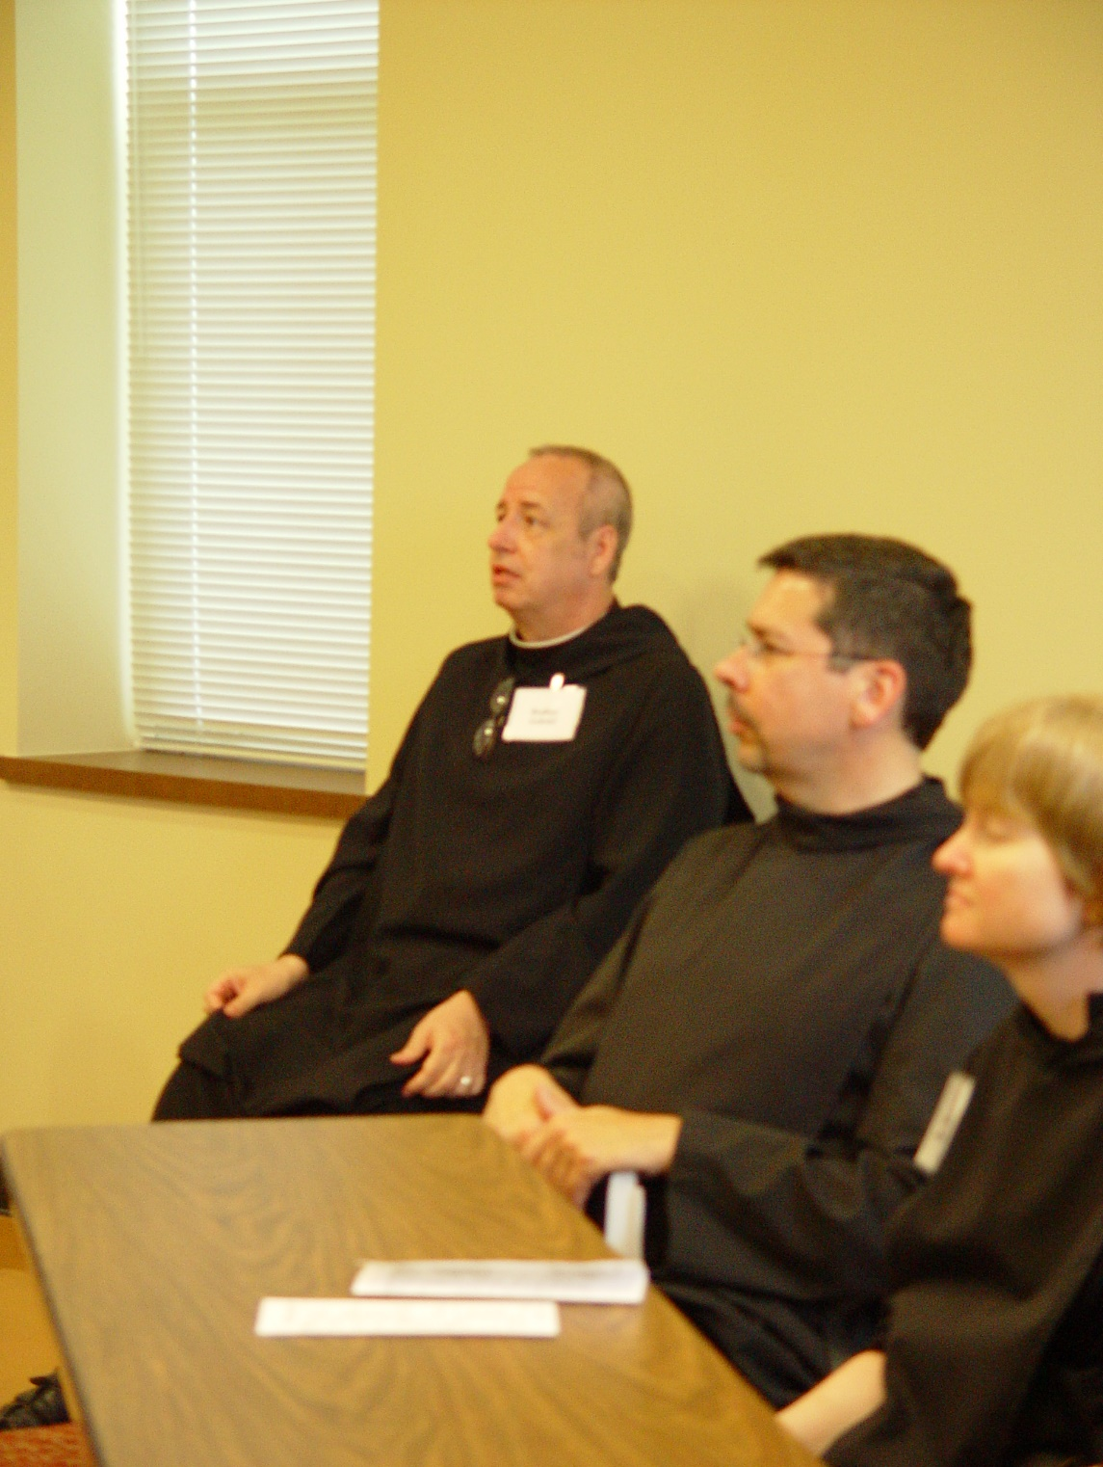
COSL Day 1 021 Br. Gabriel Hale; Br. Augustine Colvert; Sr. Catherine Unterseher
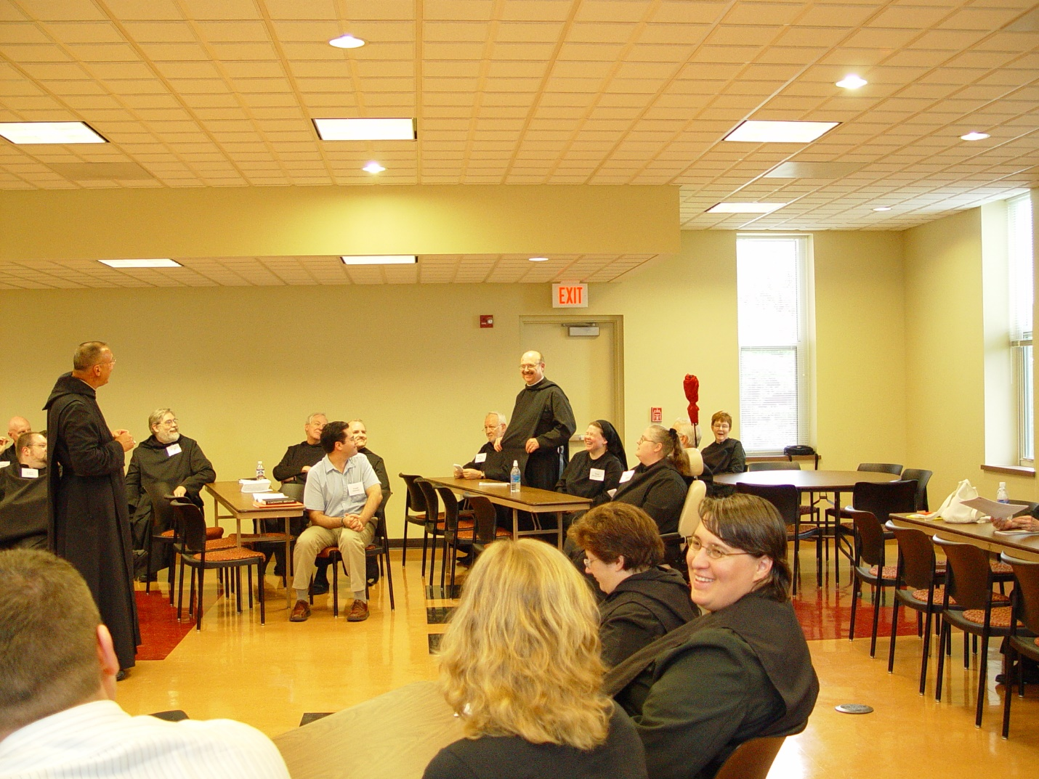
COSL Day 1 022 Joshua Shawnee; Br. David Vincent Cotton; Br. Willard Moore; Abbot Michael John Austin; Br. Chad Anselm Gerns; Br. Luke Doucette; Daniel Medina; Br. Daniel Joseph Schroeder; Br. Christopher John Baumann; Br. Raymond Owens; Sr.. Hillary Grace Lundgren; Sr. Cecelia Lamoy; Sr. Margaret Moore; Tom Lunt; Sr. Pauline Tysol; Sr. Brigid Gerns
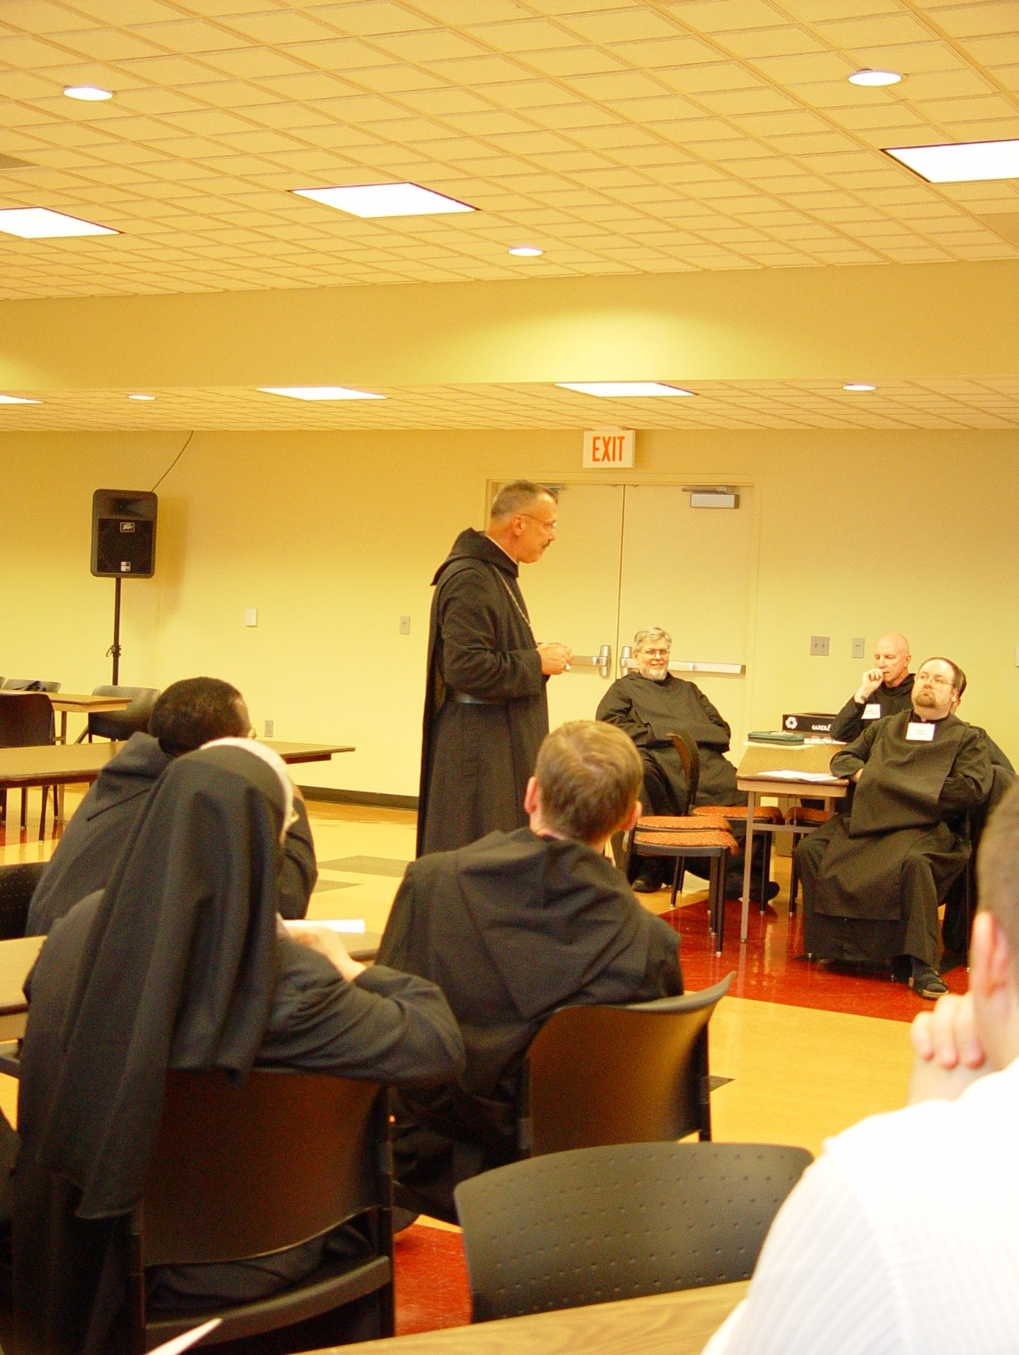
COSL Day 1 023 Br. Thomas Ferrell; Sr. Clare Benedicta Myers; Br. Camillus Converse; Abbot Michael John Austin’ Br. Nathan Gregory Miller; Br. David Vincent Cotton; Br. Willard Moore
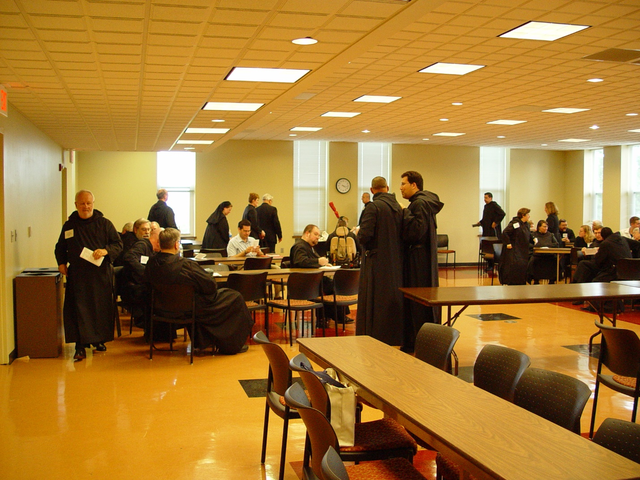
COSL Day 1 024 Br. Christopher John Baumann; Br. Chad Anselm Gerns; Br. David Vincent Cotton; Br. Nathan Gregory Miller; Sr. Hillary Grace Lundgren; Daniel Medina; Sr. Brigid Gerns; Tom Lunt; Br. Willard Moore; Sr. Margaret Moore; Br. Gabriel Hale; Abbot Michael John Austin; Br. Anthony Bernard Campos; Br. Augustine Colvert; Sr. Cecelia Lamoy; Sr. Pauline Tysol; Jane Beebe; Br. Paul Howard; Jan Wolsleben; Br. Camillus Converse; Br. Thomas Ferrell; Joshua Shawnee; Sr. Clare Benedicta; Daniel Medina; Mary Christopher
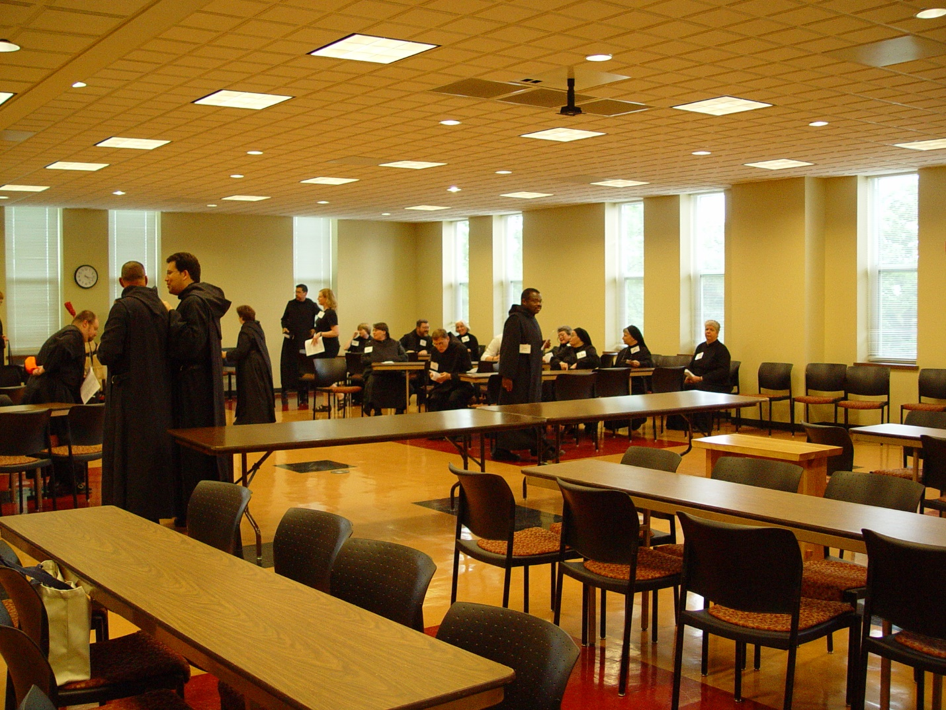
COSL Day 1 025 Br. Willard Moore; Abbot Michael John Austin; Br. Anthony Bernard Campos; Sr, Cecelia Lamoy; Br. Augustine Colvert; Jane Beebe; Sr. Catherine Unterseher; Sr. Pauline Tysol; Br. Paul Howard; Br. Camillus Converse; Judith Stribley; Br. Thomas Ferrell; Sr. Vincent Marie Rittenhouse; Sr. Hillary Grace Lundgren; Sr. Clare Benedicta Myers; Mary Christopher
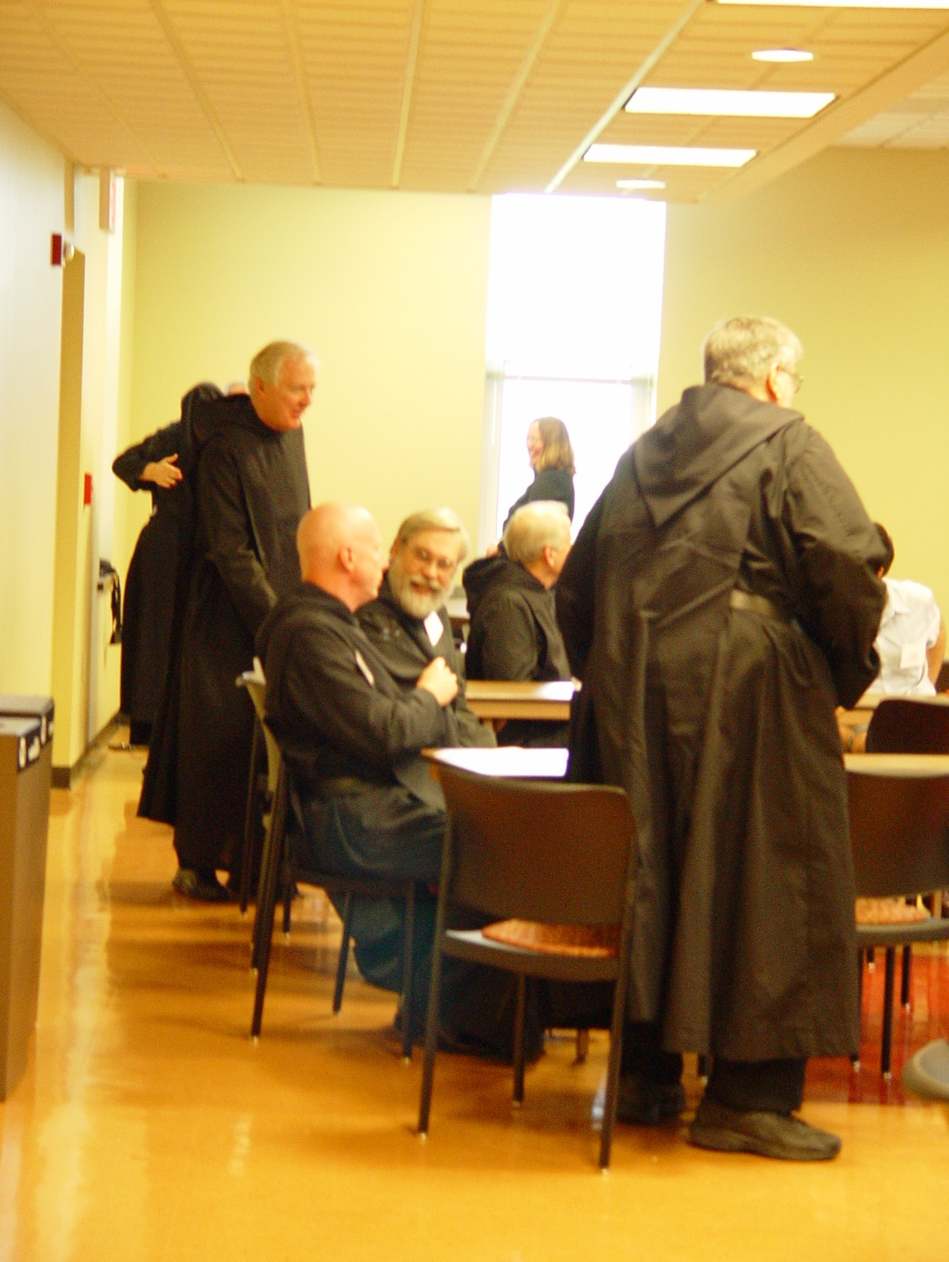
COSL Day 1 026 Br. Luke Doucette; Br. David Vincent Cotton; Br. Chad Anselm Gerns; Jane Beebe; Br. Nathan Gregory Miller; Daniel Medina
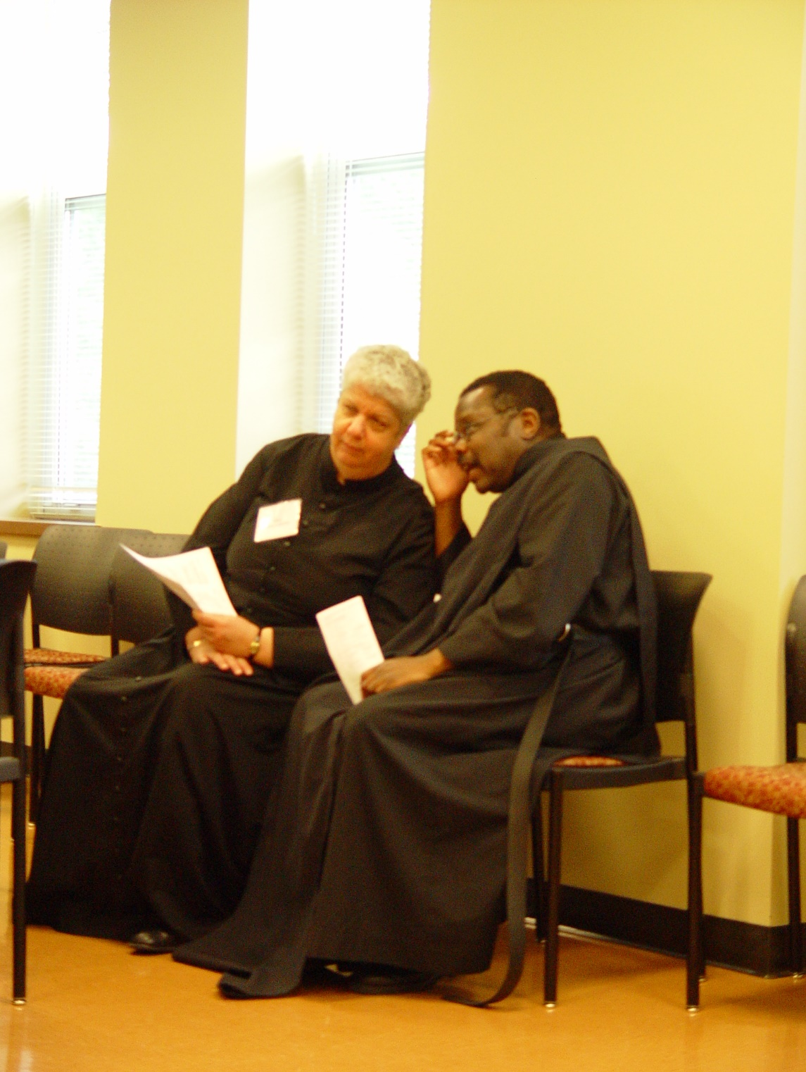
COSL Day 1 027 Mary Christopher; Br. Thomas Ferrell
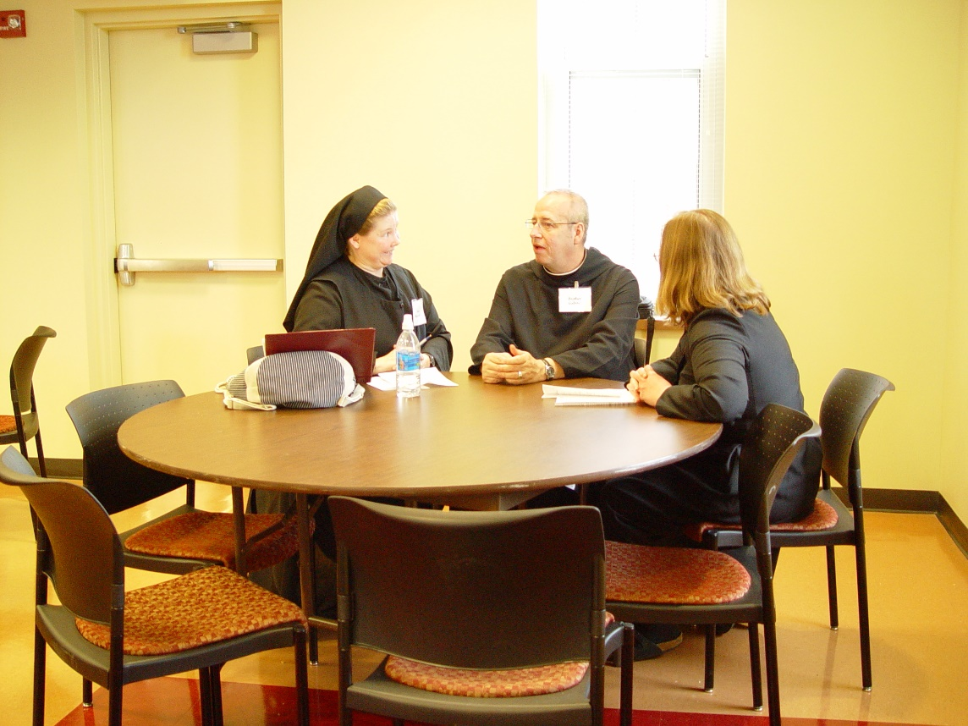
COSL Day 1 028 Sr. Hillary Grace Lundgren; Br. Gabriel Hale; Jane Beebe

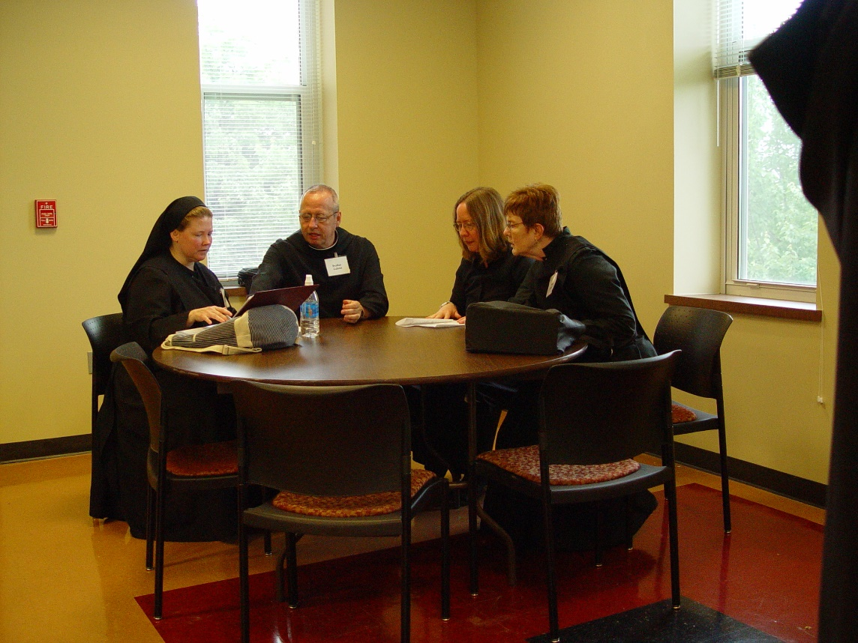
COSL Day 1 039 [sic] Sr. Hillary Grace Lundgren; Br. Gabriel Hale; Jane Beebe; Sr. Brigid Gerns
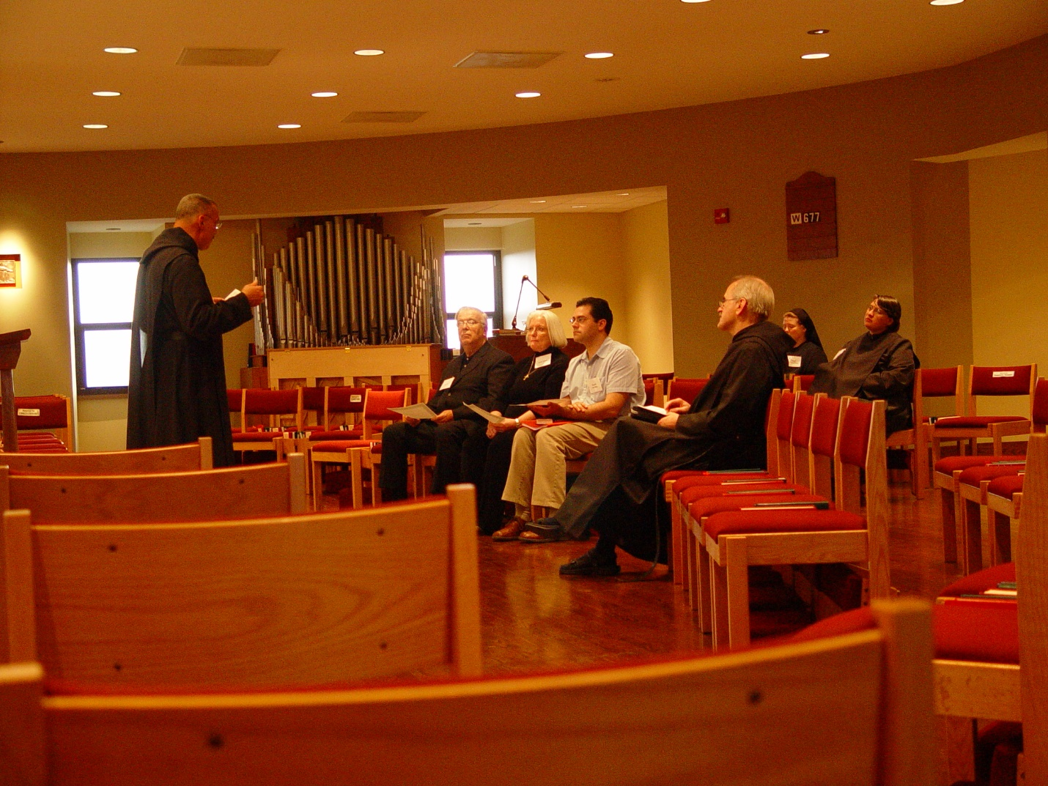
COSL Day 1 040 Abbot Michael John Austin; Tom Lunt; Judith Stribley; Dan Medina; Br. Daniel Joseph Schroeder; Sr. Hilary Grace Lundgren; Sr. Pauline Tysol

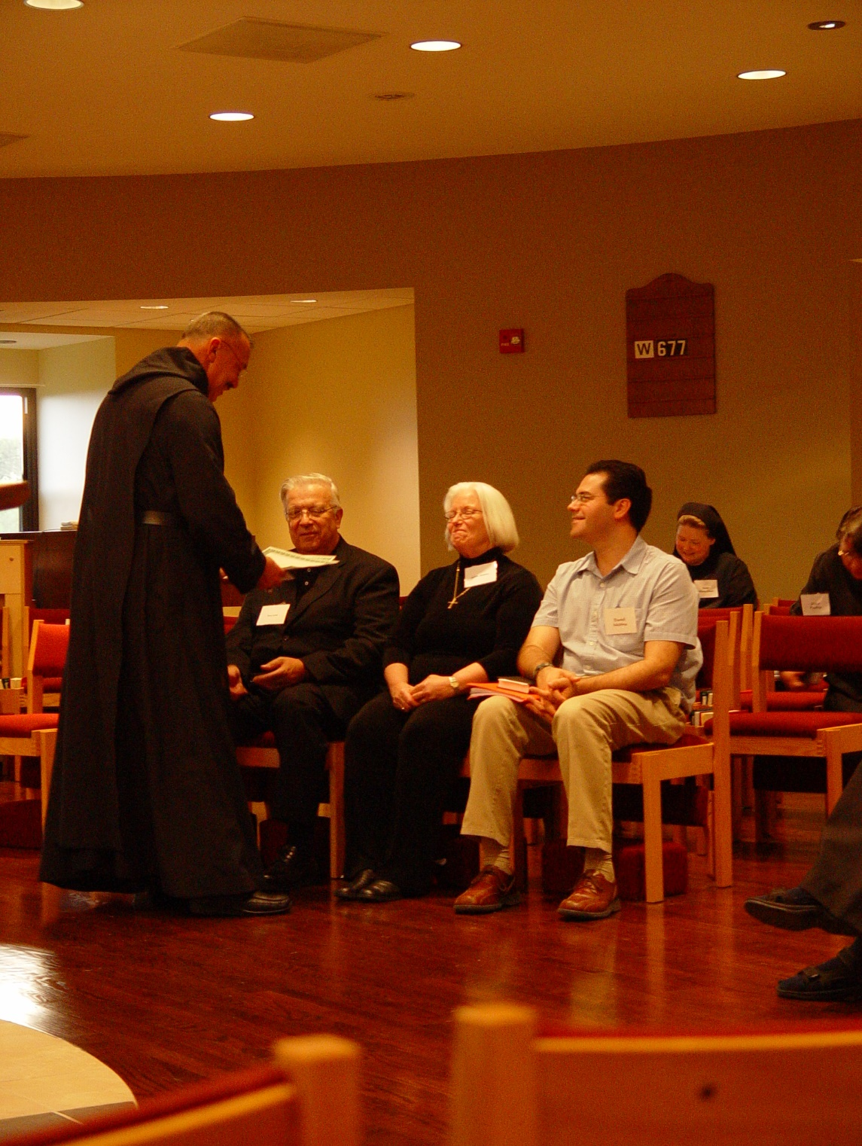
COSL Day 1 041 Abbot Michael John Austin; Tom Lunt; Judith Stribley; Sr. Hillary Grace Lundgren; Sr. Pauline Tysol

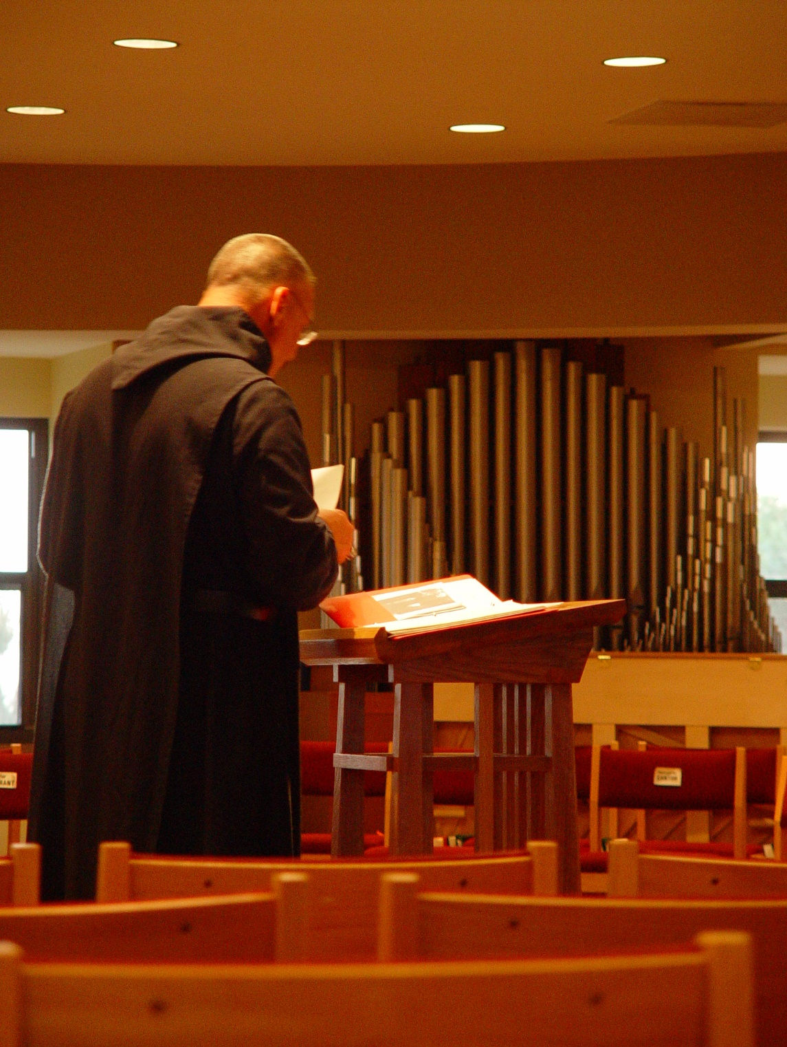
COSL Day 1 042 Abbot Michael John Austin

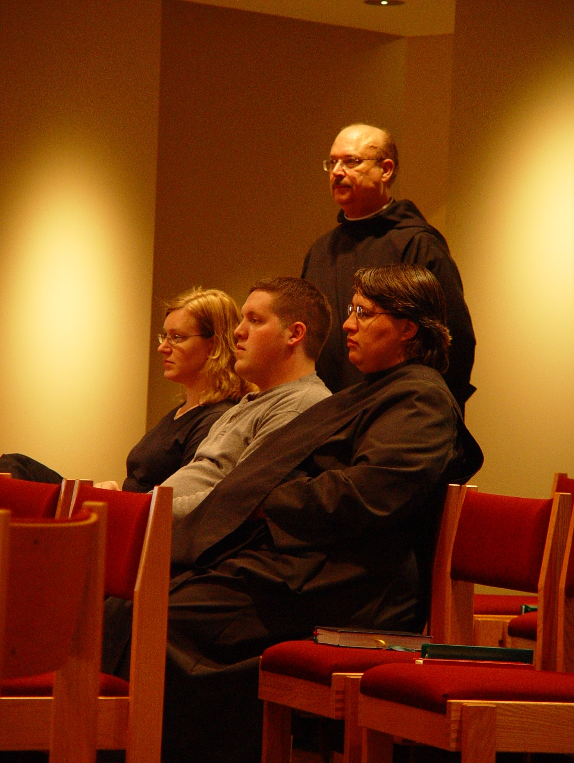
COSL Day 1 043 Jan Wolsleben; Joshua Shawnee; Br. Raymond Owens’ Sr. Pauline Tysol
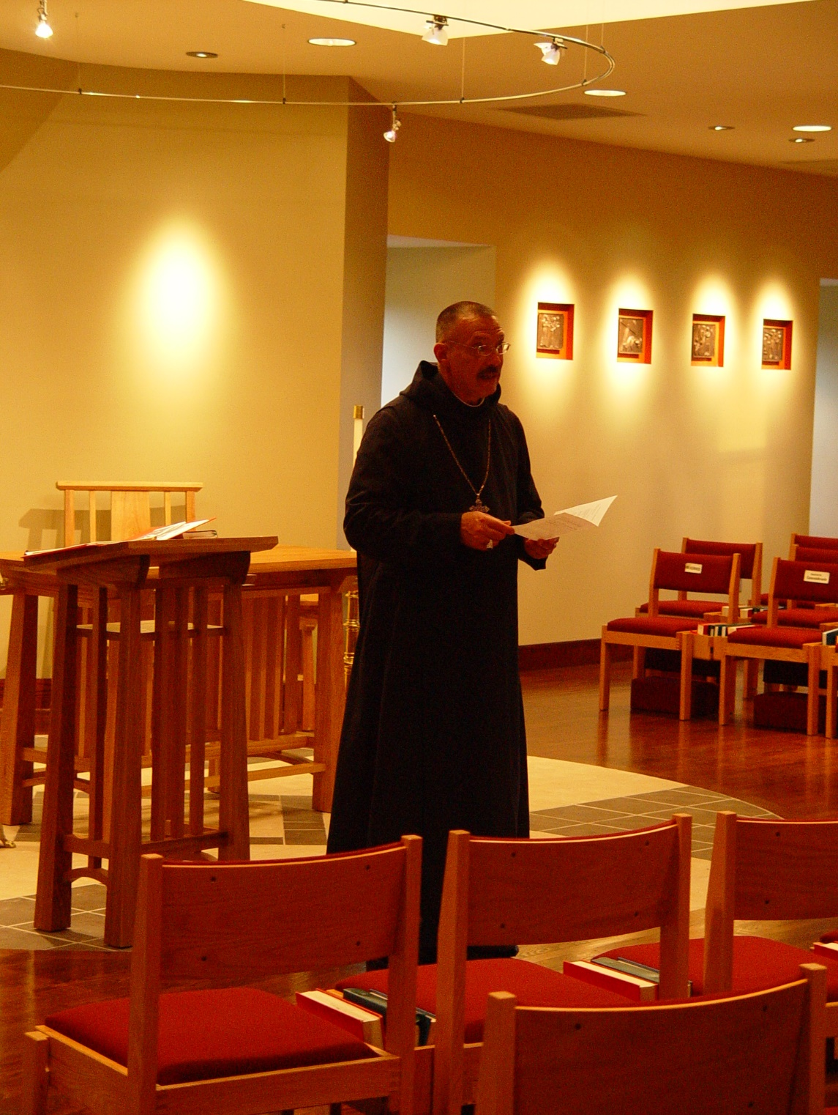
COSL Day 1 044 Abbot Michael John Austin

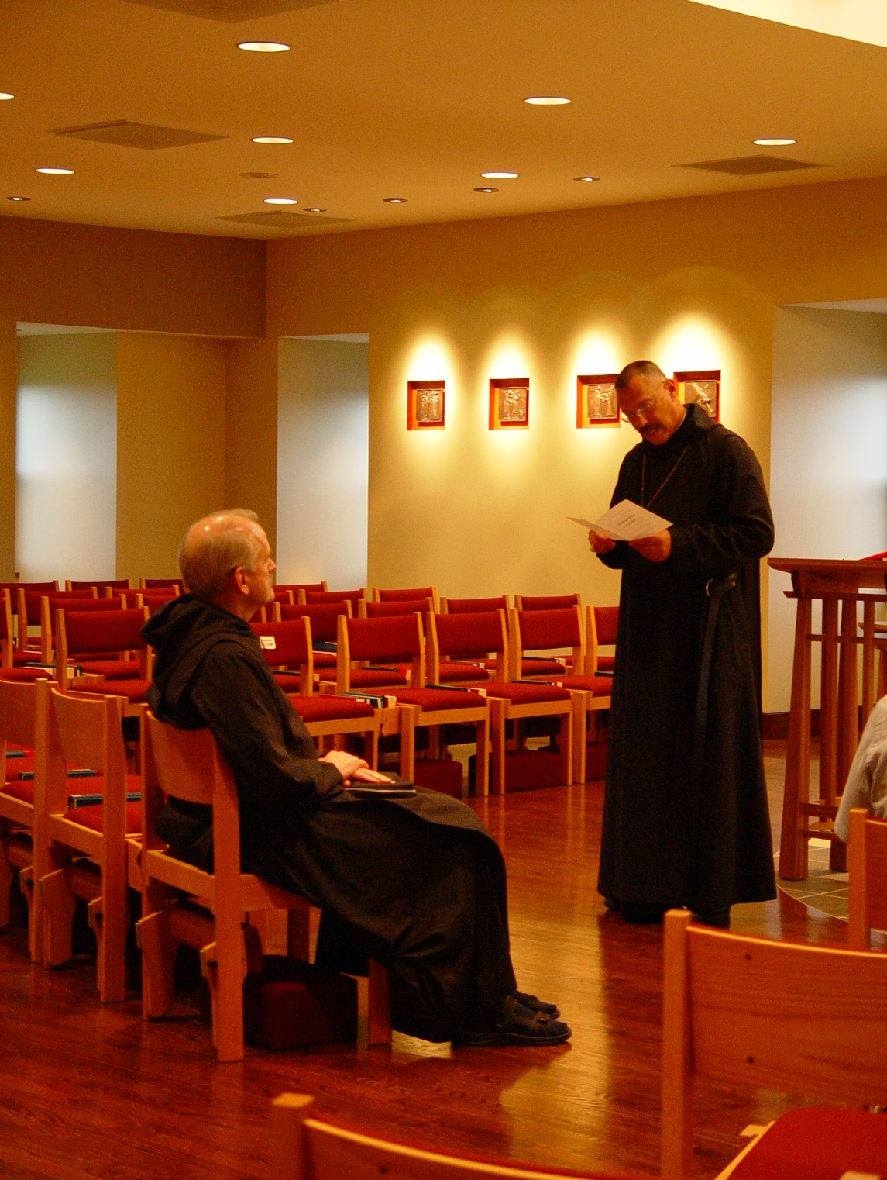
COSL Day 1 045 Dr. Daniel Joseph Schroeder; Abbot Michael John Austin

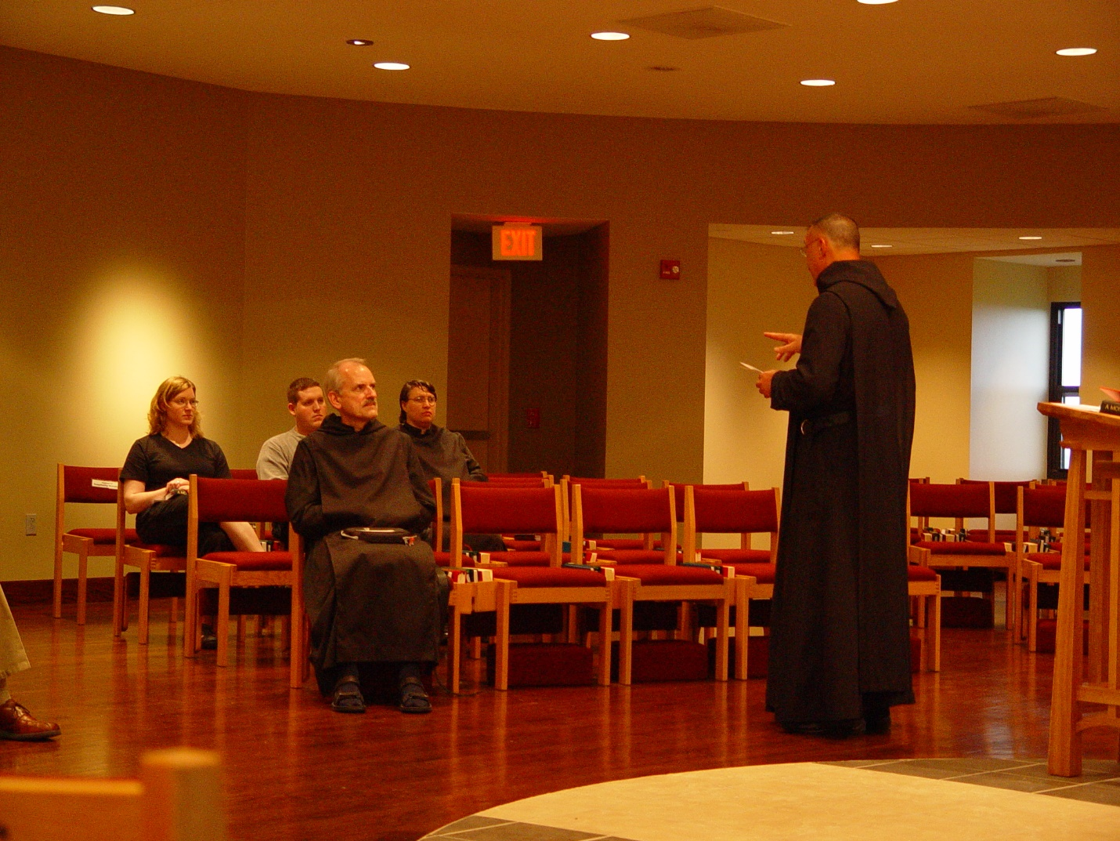
COSL Day 1 046 Jan Wolsleben; Joshua Shawnee; Br. Daniel Joseph Schroeder; Sr. Pauline Tysol; Abbot Michael John Austin
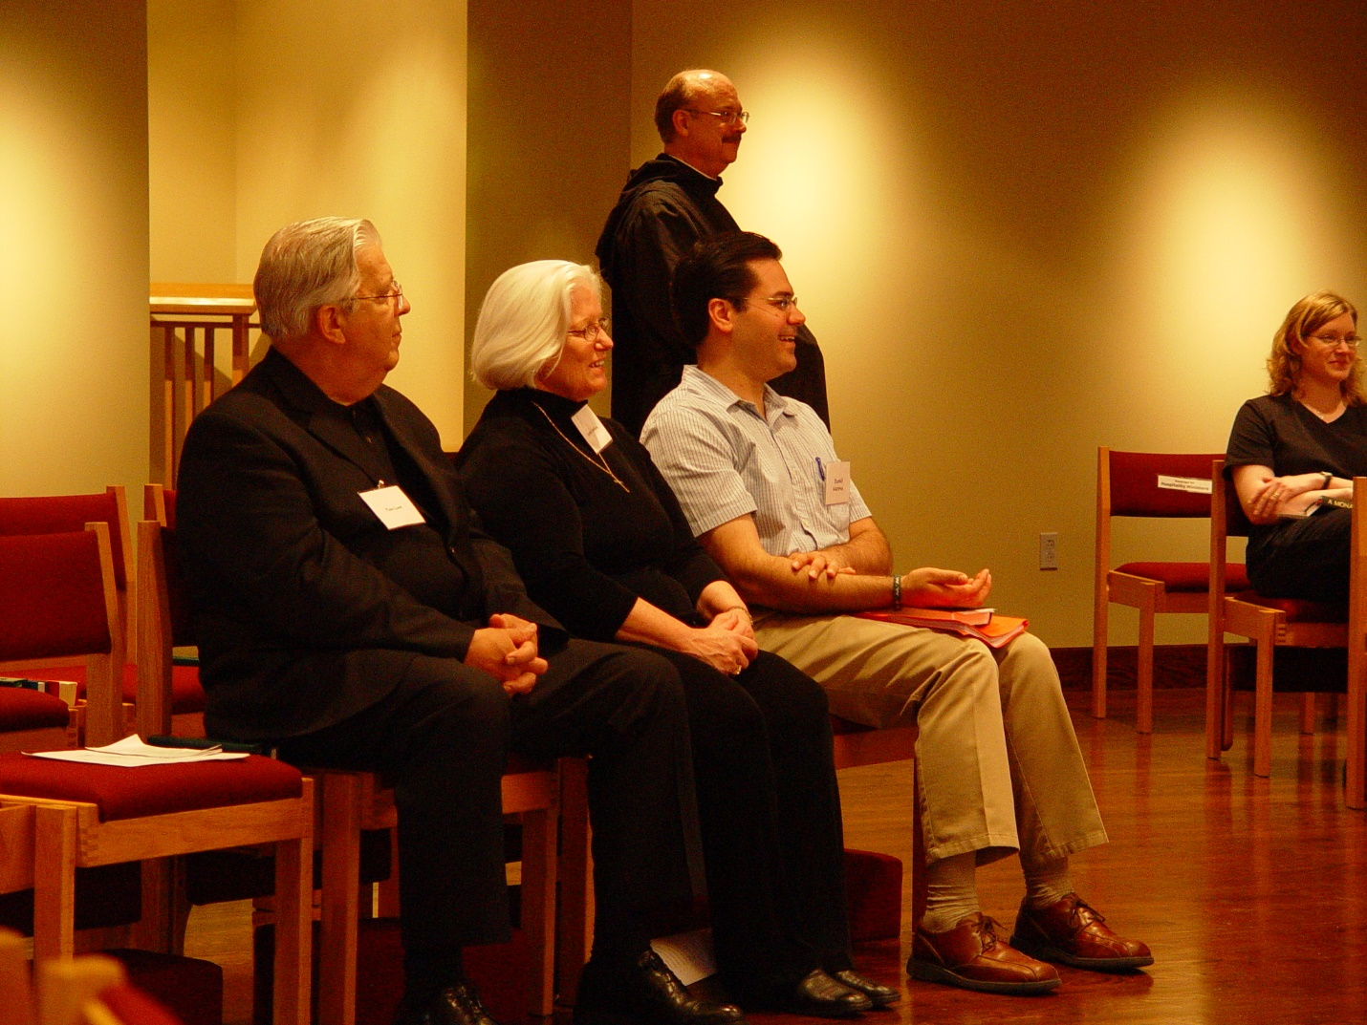
COSL Day 1 047 Tom Lunt; Judith Stribley; Daniel Medina; Br. Raymond Owens; Jan Wolsleben
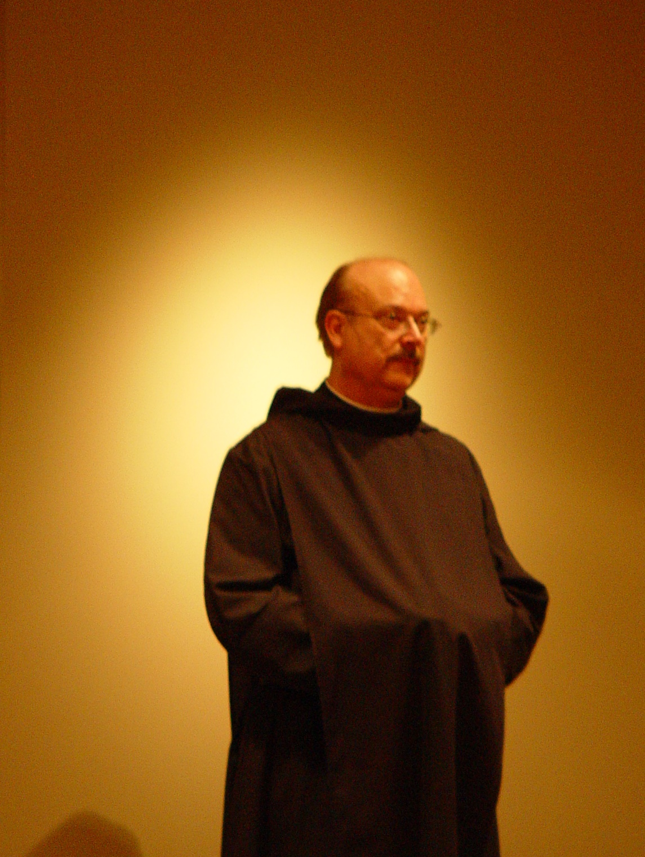
COSL Day 1 048 Br. Raymond Owens
COSL Day 1 049 Br. Raymond Owens

