Companions of St. Luke
Fall 2004 Convocation at Conception Abbey
Vol. IV. Part 2 of 2

~Edited by Br. Steven Olderr, 29 May 2022 with the assistance of Br. Thomas Ferrell; if you find any errors or omissions, please notify Br. Steven at olderr@ameritech.net

People are identified from left to right.

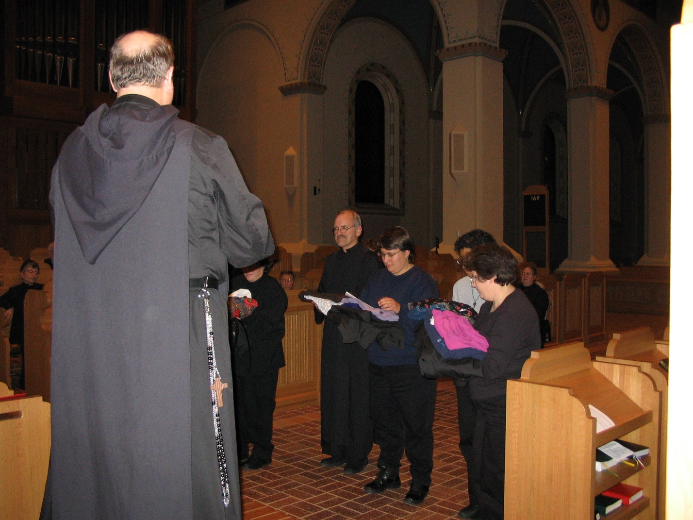
IMG 0157 Sr. Anna Grace Madden; Br. Raymond Owens; Sr. Vincent Marie Rittenhouse; Br. Camillus Converse; Br. Daniel Joseph Schroeder; Sr. Pauline Tysol; Sr. Julian Baker; Sr. Cecelia Lamoy; Sr. Margaret Moore
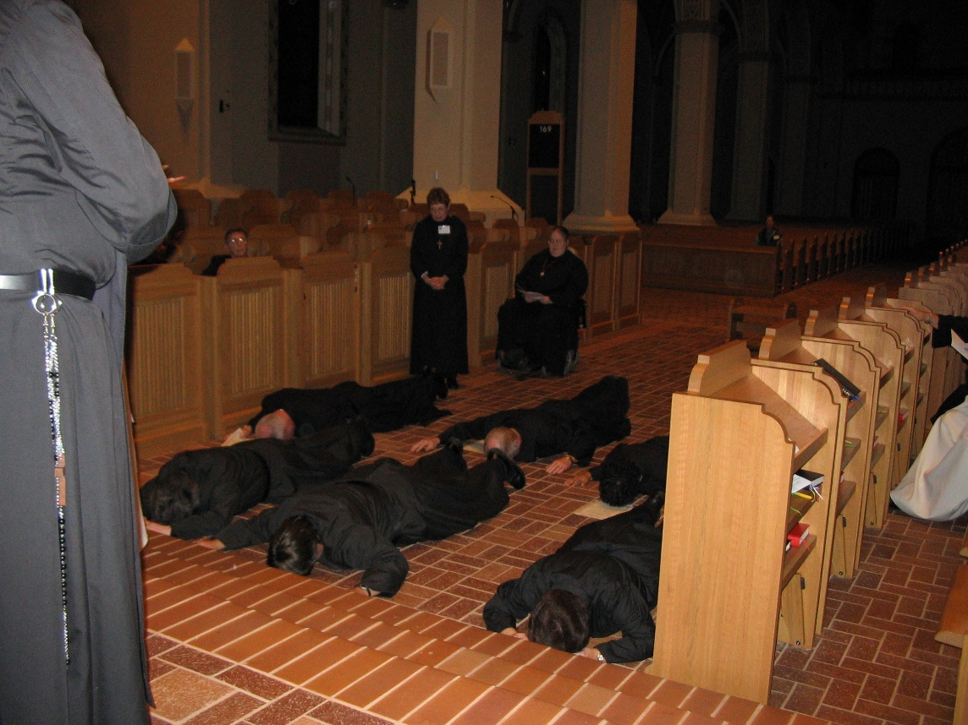
IMG 0158 Sr. Vincent Marie Rittenhouse; Br. Camillus Converse; Br. David Vincent Cotton; Sr. Monica Ruth Mullen; ; Sr. Pauline Tysol; Br. Daniel Joseph Schroeder; Sr. Julian Baker; Sr. Cecelia Lamoy; Sr. Margaret Moore

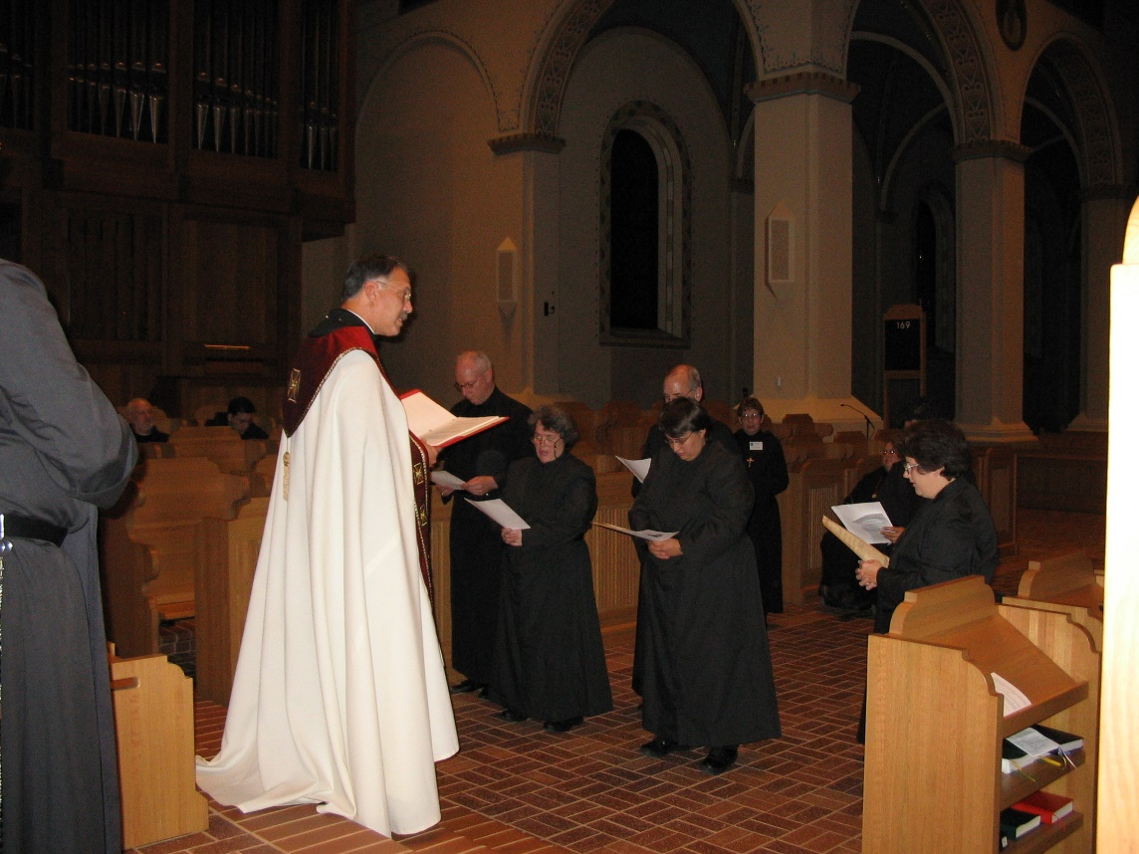
IMG 0159 Br. Anthony Bernard Campos; Abbot Michael John Austin; Br. David Vincent Cotton; Sr. Vincent Marie Rittenhouse; Br. Daniel Joseph Schroeder; Sr. Pauline Tysol; Sr. Monica Ruth Mullen; Sr. Margaret Moore; Sr. Cecelia Lamoy
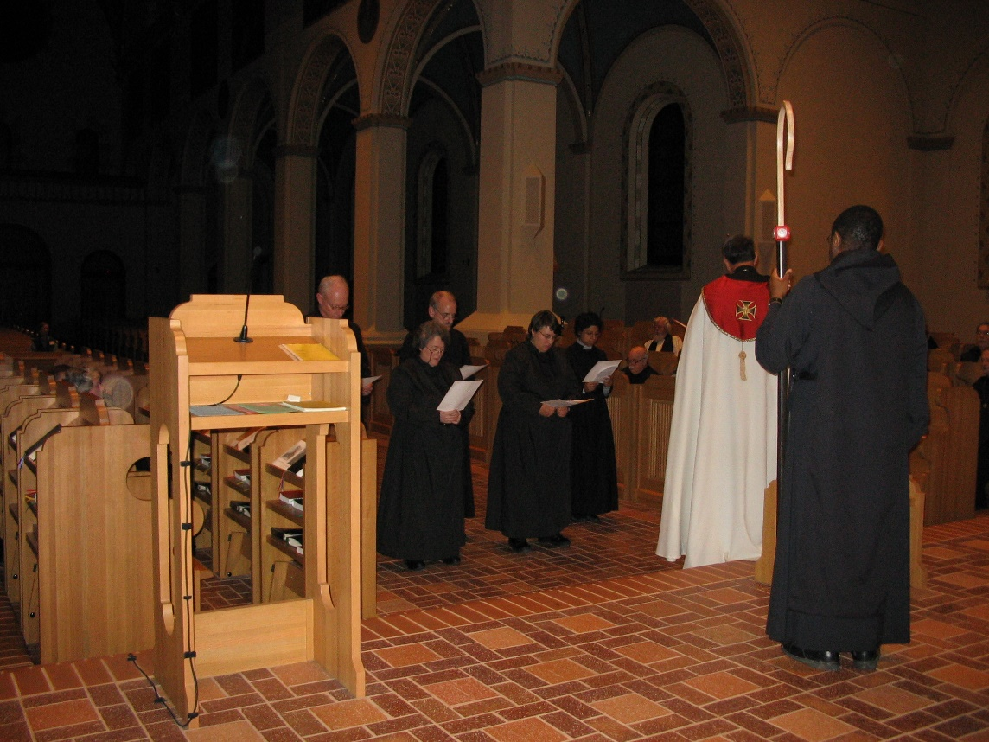
IMG 0160 Br. David Vincent Cotton; Sr. Vincent Marie Rittenhouse; Br. Daniel Schroeder; Sr. Pauline Tysol; Sr. Julian Baker; Br. Benedict Truitt; Fr. Wayne Kamm; Abbot Michael John Austin; Br. Thomas Ferrell

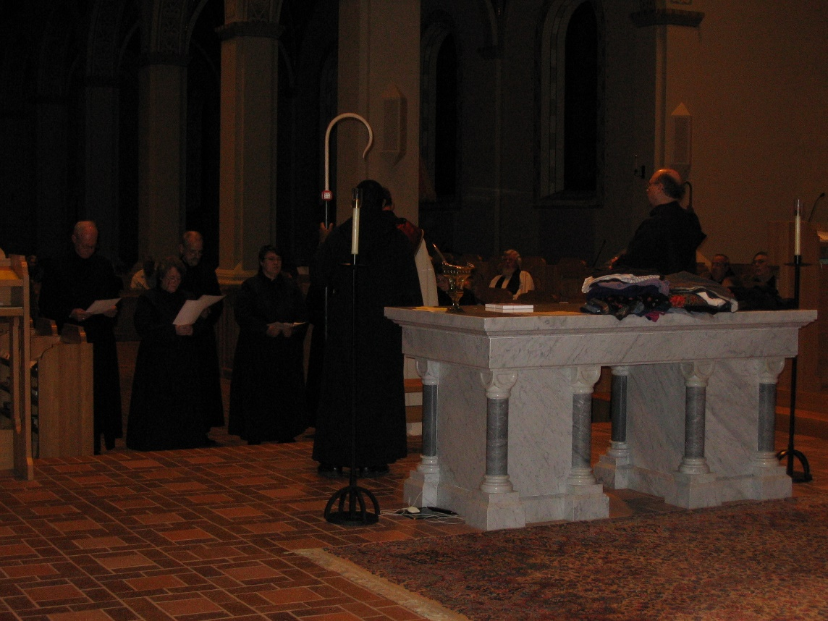
IMG 0161 Br. David Vincent Cotton; Sr. Vincent Marie Rittenhouse; Br. Daniel Joseph Schroeder; Sr. Pauline Tysol; Br. Thomas Ferrell; Abbot Michael John Austin; Fr. Wayne Kamm; Br. Raymond Owens
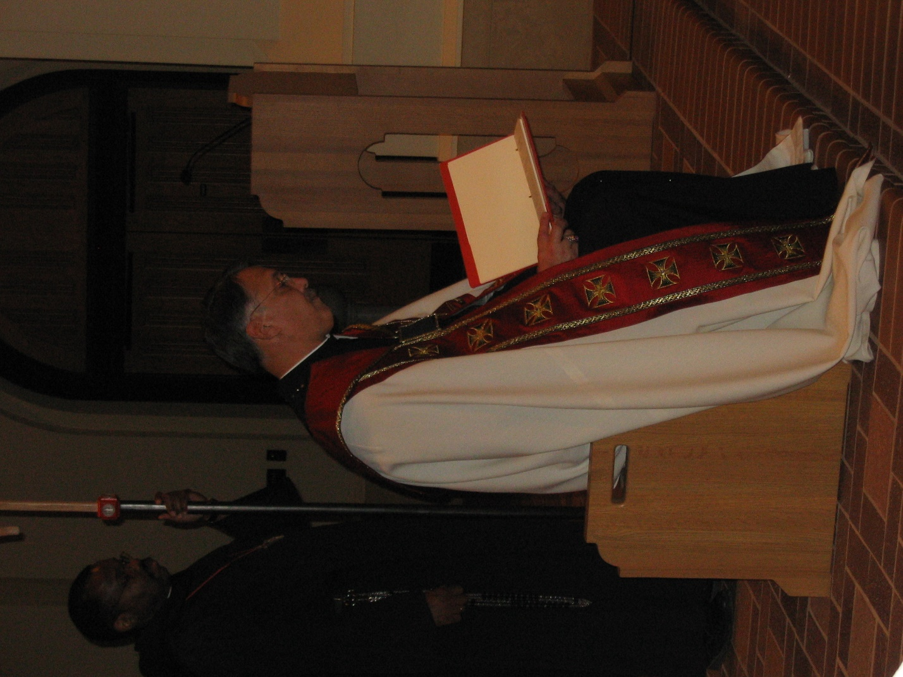
IMG 0162 Abbot Michael John Austin

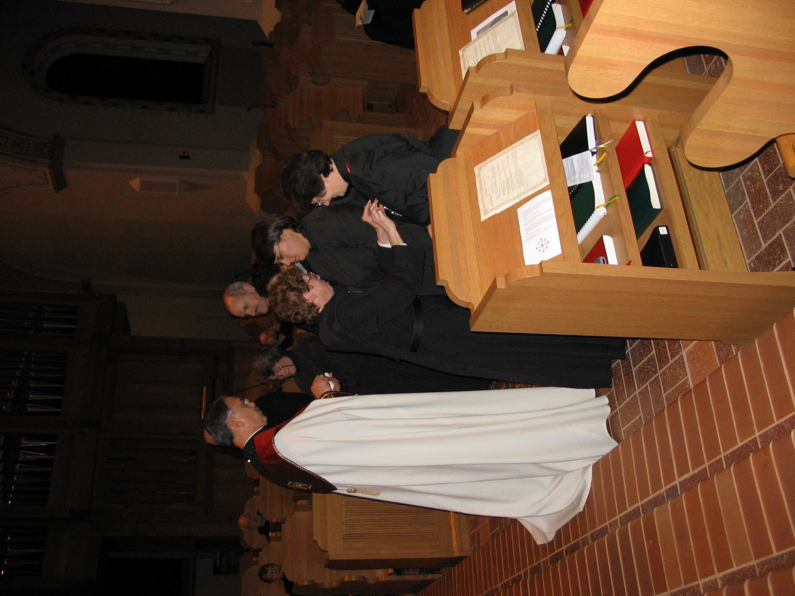
IMG 0163 Sr. Anna Grace Madden; Br. Christopher John Baumann; Abbot Michael John Austin; Br. David Vincent Cotton; Sr. Vincent Marie Rittenhouse; Br. Willard Moore; Sr. Monica Ruth Mullen; Sr. Julian Baker; Sr. Pauline Tysol; Sr. Cecelia Lamoy
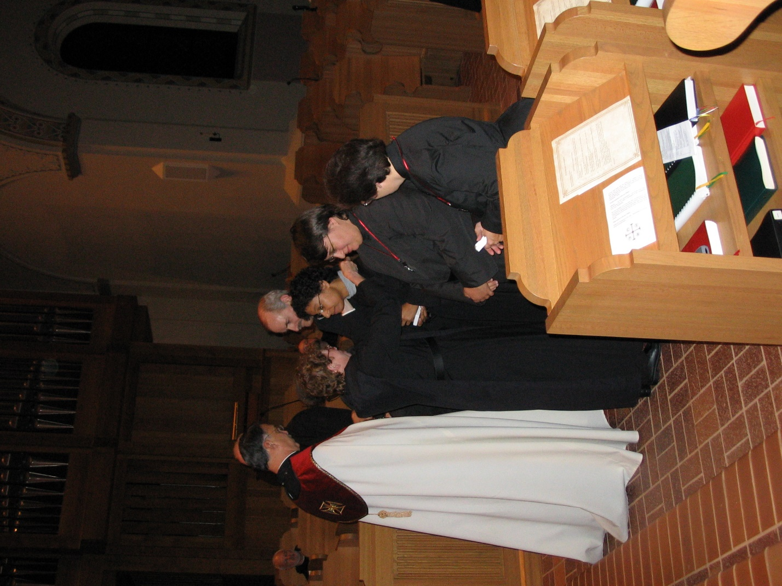
IMG 0164 Br. Christopher John Baumann; Abbot Michael John Austin; Br. David Vincent Cotton; Sr. Monica Ruth Mullen; Br. Willard Moore; Br. Daniel Joseph Schroeder; Sr. Julian Baker; Sr. Pauline Tysol; Sr. Cecelia Lamoy
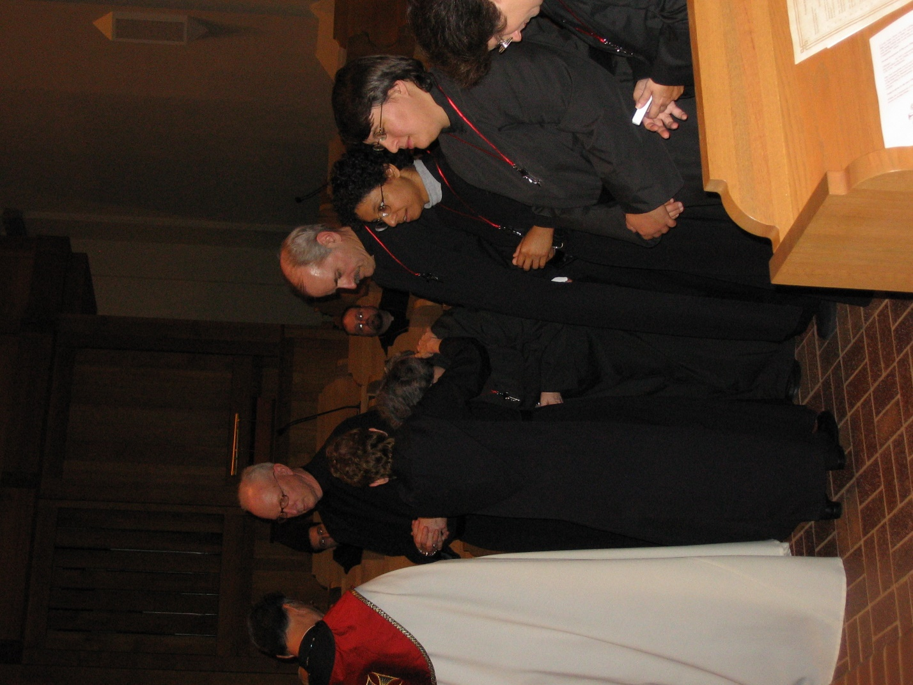
IMG 0165 Abbot Michael John Austin; Br. Anthony Bernard Campos; Br. David Vincent Cotton; Sr. Monica Ruth Mullen; Sr. Vincent Marie Rittenhouse; Br. Willard Moore; Br. Daniel Joseph Schroeder; Sr. Julian Baker; Sr. Pauline Tysol; Sr. Cecelia Lamoy
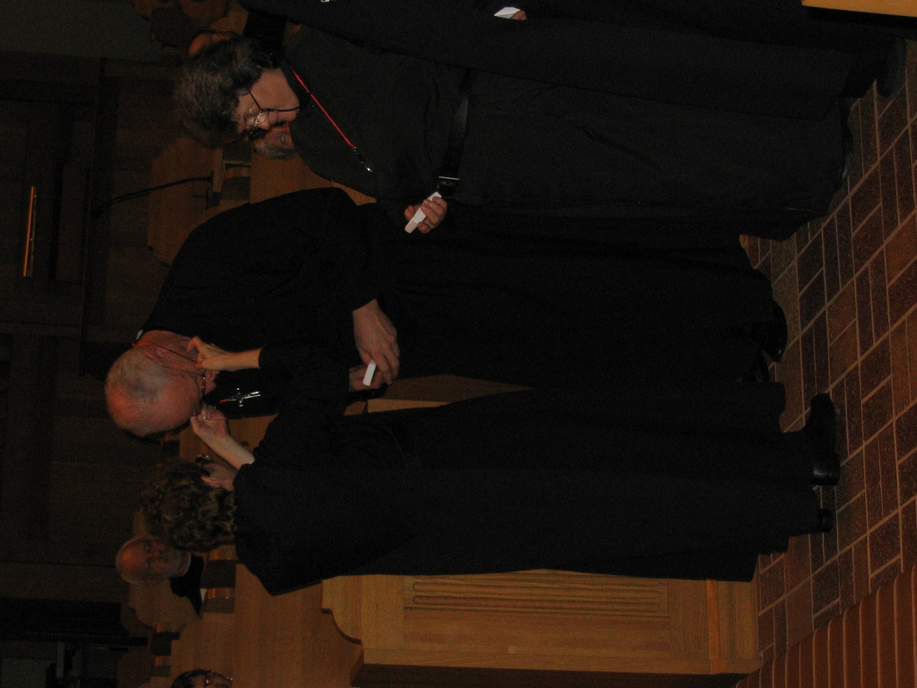
IMG 0166 Br. Christopher John Baumann; Sr. Monica Ruth Mullen; Br. David Vincent Cotton; Sr. Johanna Kirkpatrick; Sr. Vincent Marie Rittenhouse
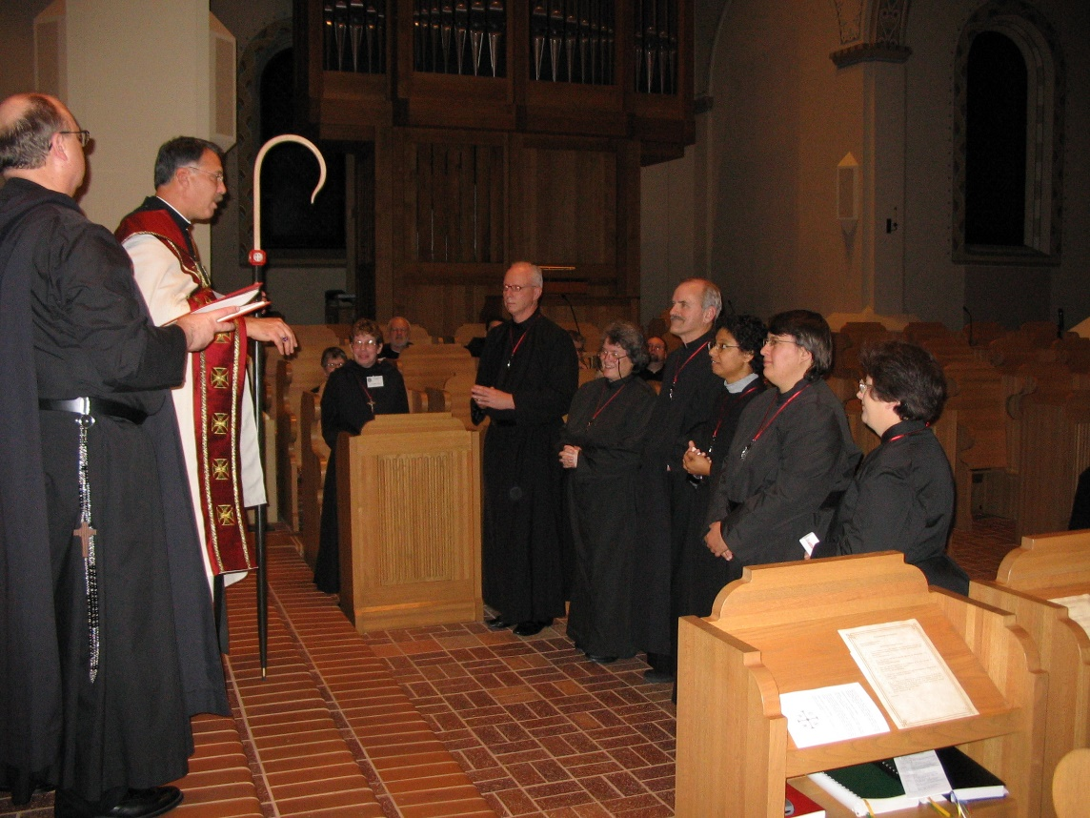
IMG 0167 Br. Raymond Owens; Abbot Michael John Austin; Sr. Monica Ruth Mullen; Br. Christopher John Baumann; Br. David Vincent Cotton; Sr. Vincent Marie Rittenhouse; Br. Daniel Joseph Schroeder; Sr. Julian Baker; Sr. Pauline Tysol; Sr. Cecelia Lamoy

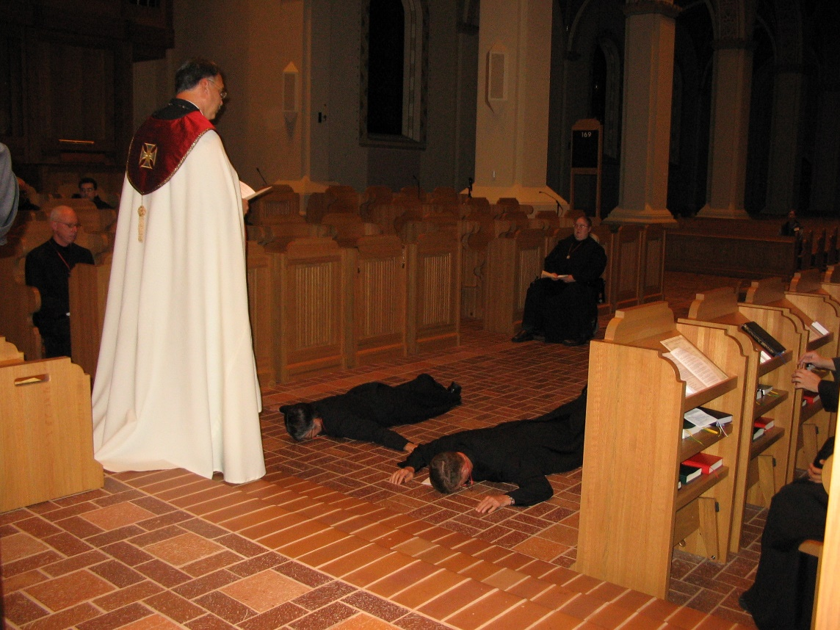
IMG 0168 Br. David Vincent Cotton; Abbot Michael John Austin; Sr. Anna Grace Madden; Sr. Margaret Moore; Br. Camillus Converse
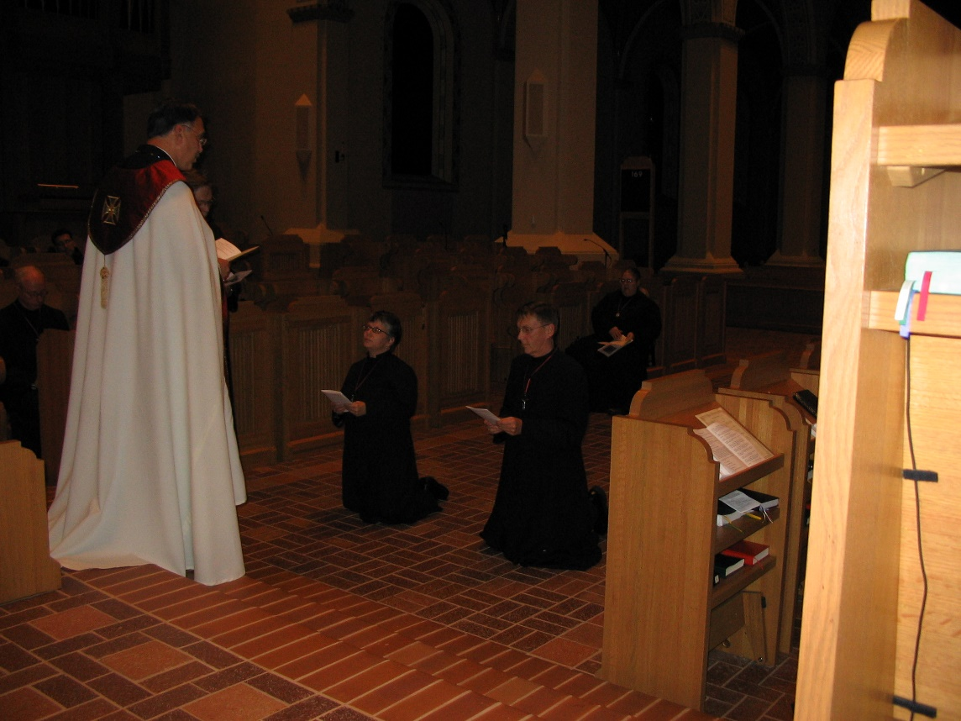
IMG 0169 Abbot Michael John Austin; Sr. Anna Grace Madden; Br. Camillus Converse; Sr. Margaret Moore

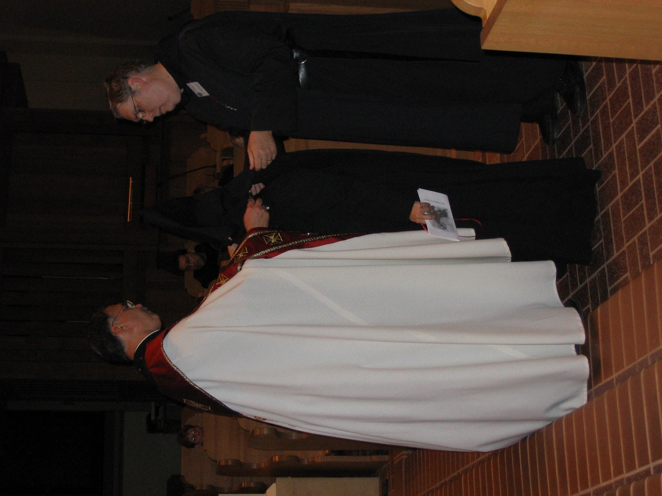
IMG 0170 Sr. Monica Ruth Mullen; Abbot Michael John Austin; Br. Anthony Bernard Campos; Br. Camillus Converse; Br. Chad Anselm Gerns
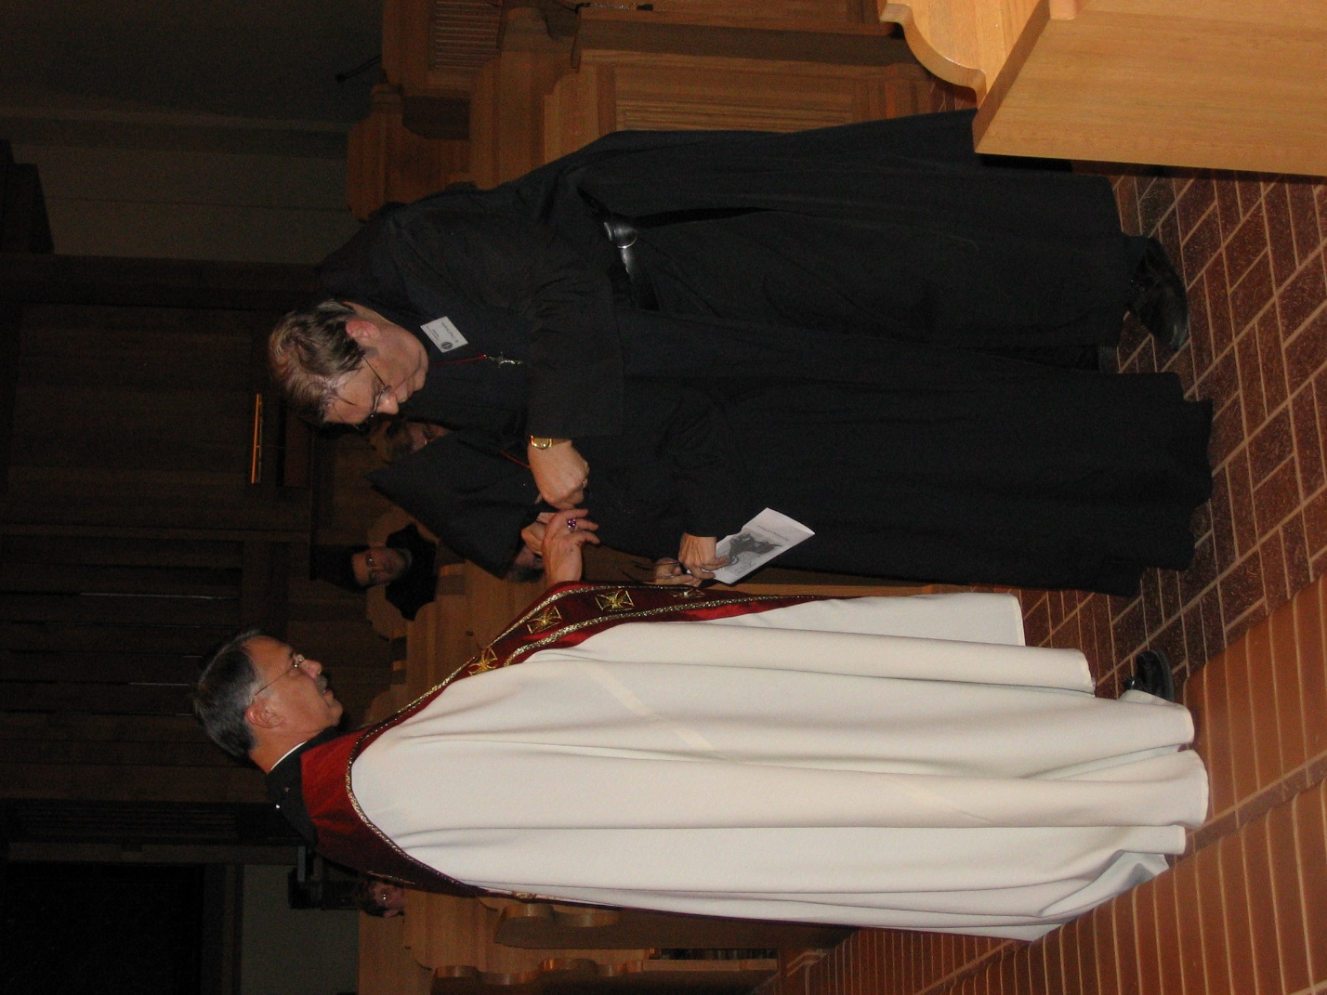
IMG 0171 Sr. Monica Ruth Mullen; Abbot Michael John Austin; Br. Anthony Bernard Campos; Br. Camillus Converse; Br. Chad Anselm Gerns
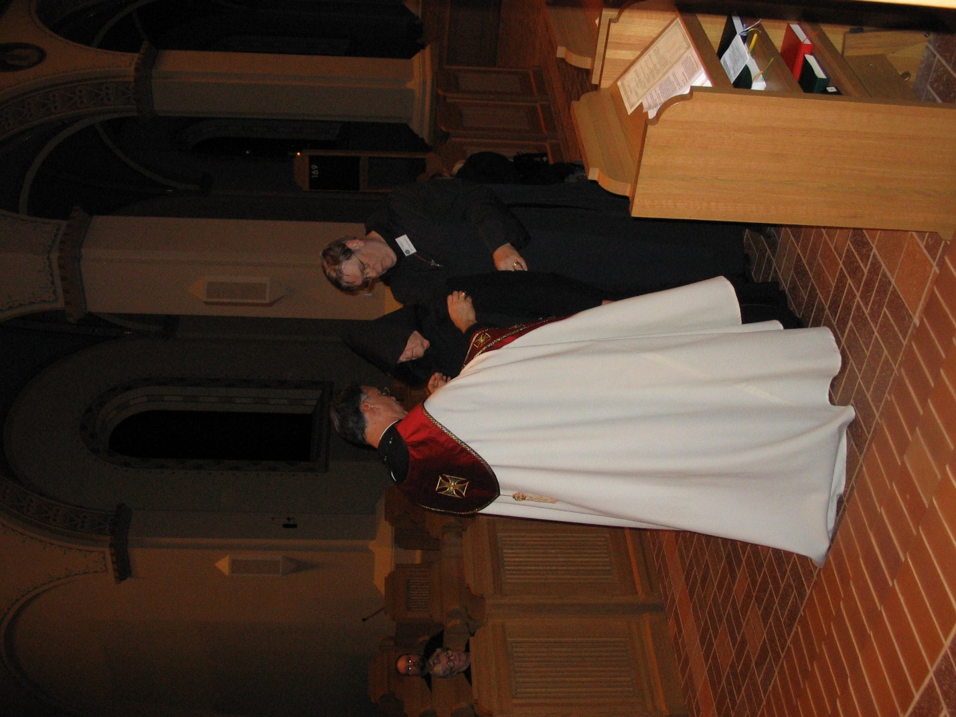
IMG 0172 Sr. Johanna Kirkpatrick; Br. Willard Moore; Abbot Michael John Austin; Br. Camillus Converse; Br. Chad Anselm Gerns
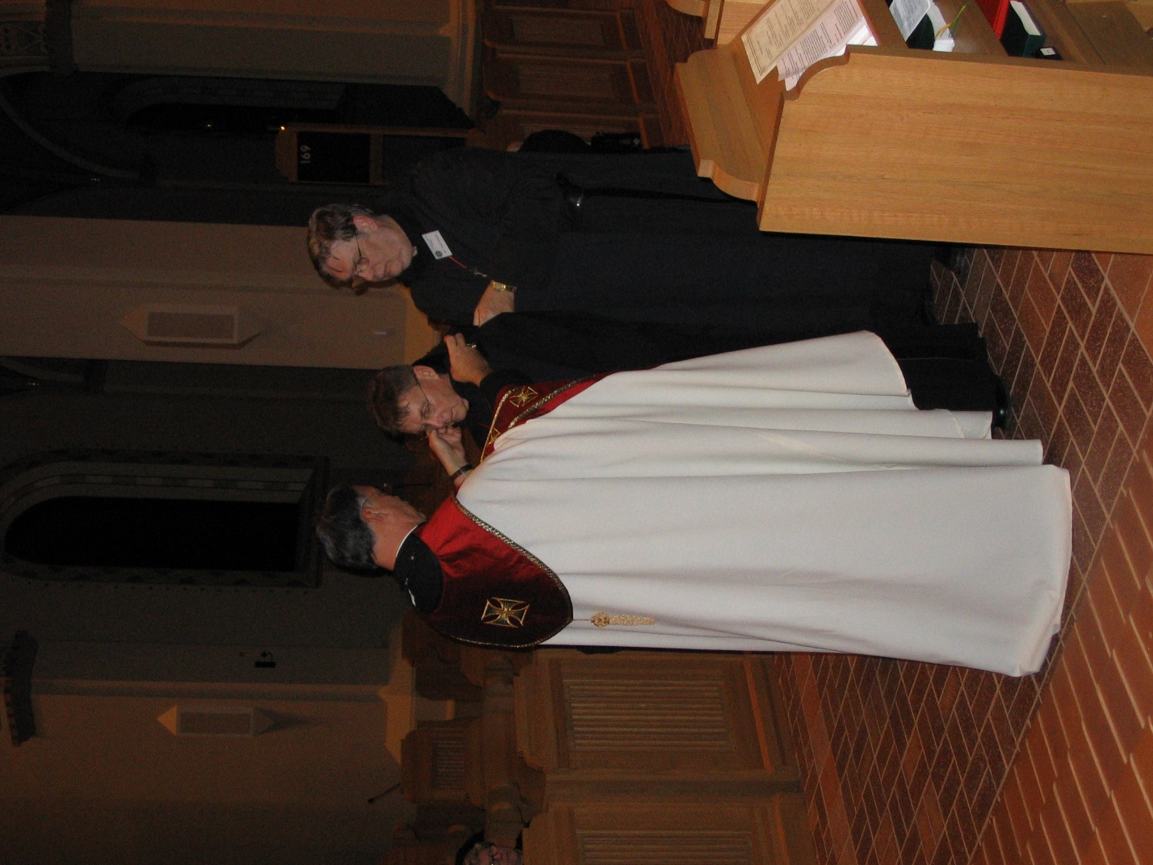
IMG 0173 Sr. Johanna Kirkpatrick; Abbot Michael John Austin; Br. Camillus Converse; Br. Chad Anselm Gerns
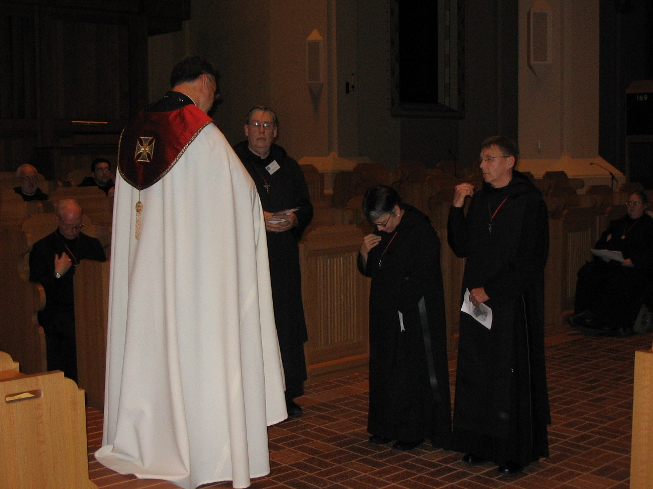
IMG 0174 Br. Christopher John Baumann; Br. Anthony Bernard Campos; Br. David Vincent Cotton; Abbot Michael John Austin; Br. Chad Anselm Gerns; Sr. Anna Grace Madden; Br. Camillus Converse; Sr. Margaret Moore
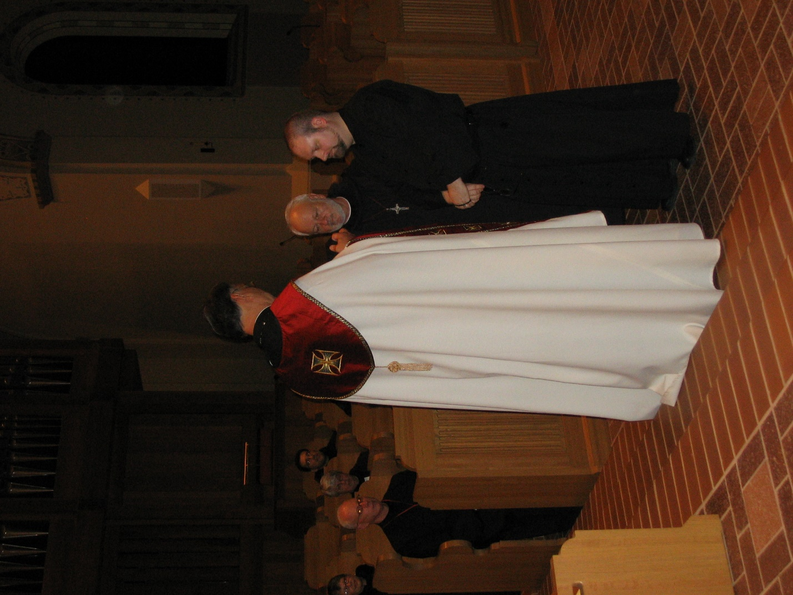
IMG 0175 Sr. Anna Grace Madden; Br. David Vincent Cotton; Sr Clare Benedicta Meyers; Br. Anthony Bernard Campos; Abbot Michael John Austin; Br. Christopher John Baumann; Br. Willard Moore
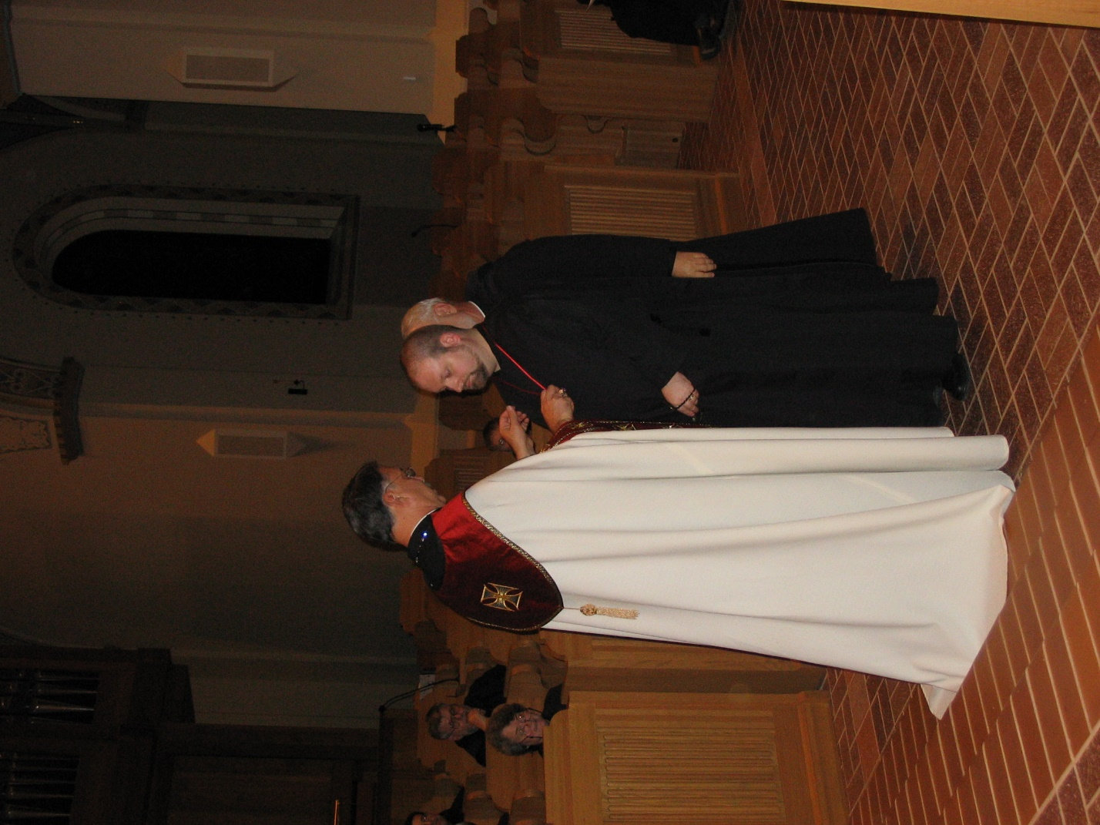
IMG 0176 Sr. Vincent Marie Rittenhouse; Br. Nathan Gregory Miller; Abbot Michael John Austin; Br. Willard Moore; Br. Christopher John Baumann
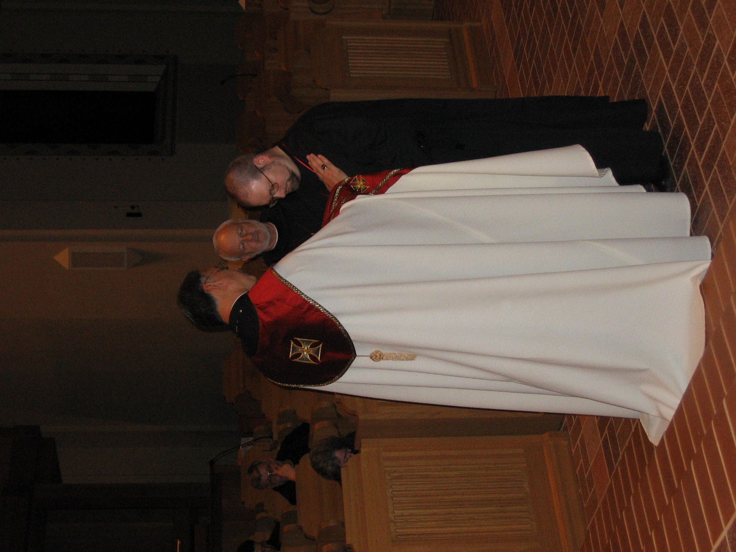
IMG 0177 Br Nathan Gregory Miller; Sr. Vincent Marie Rittenhouse; Abbot Michael John Austin; Br. Christopher John Baumann; Br. Willard Moore
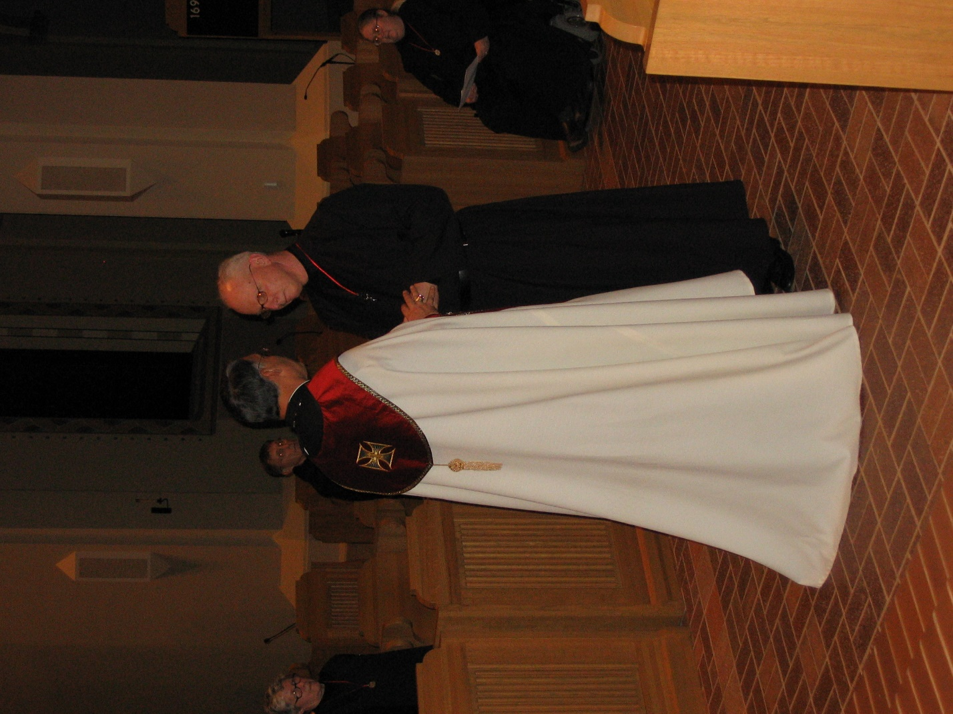
IMG 0178 Sr. Johanna Kirkpatrick; Br. Camillus Converse; Abbot Michael John Austin; Br. David Vincent Cotton; Sr. Margaret Moore
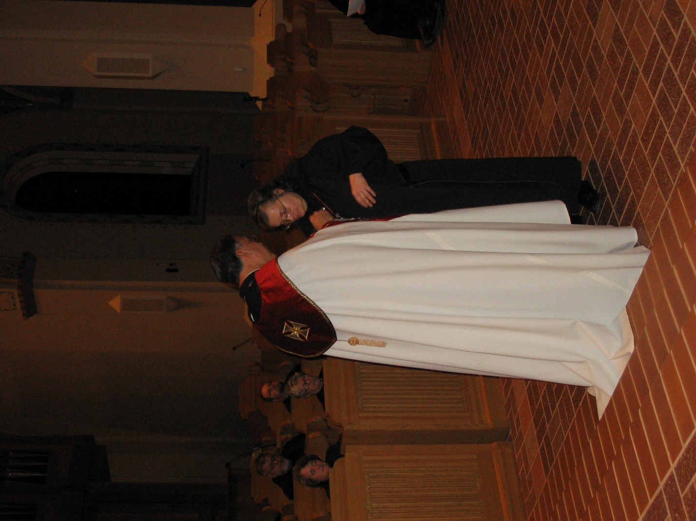
IMG 0179 Sr. Vincent Marie Rittenhouse; Br. Nathan Gregory Miller; Sr. Johanna Kirkpatrick; Br. Willard Moore; Abbot Michael John Austin; Sr. Theodora of Jesus Perecca
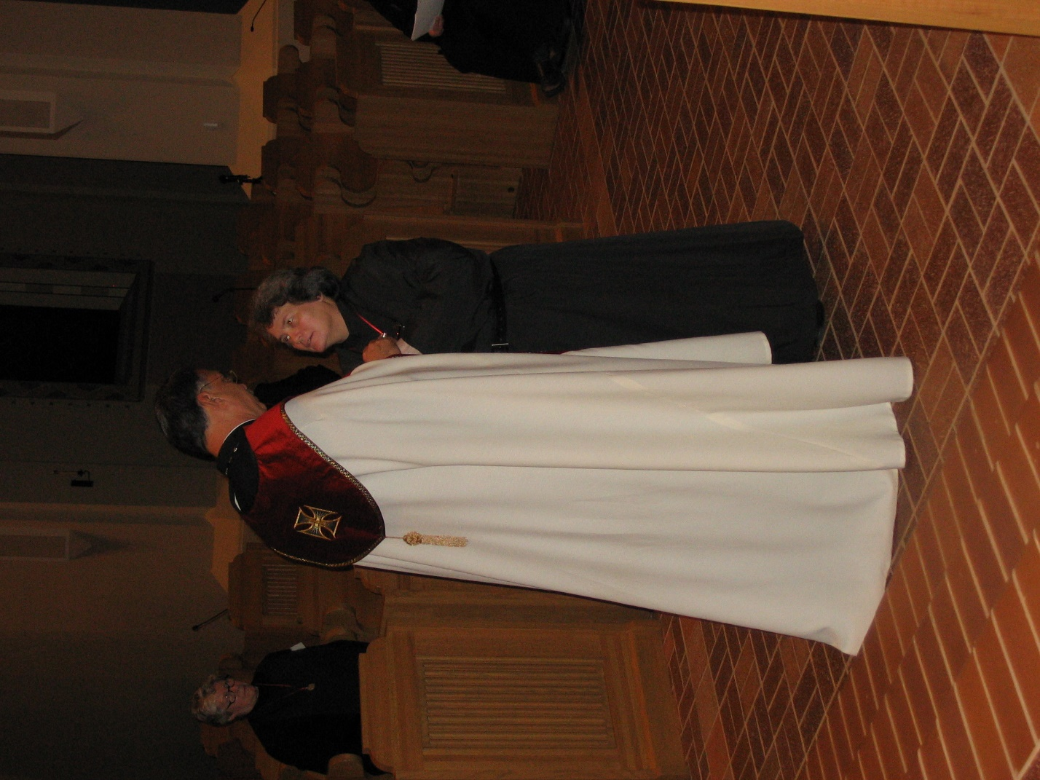
IMG 0180 Sr. Johanna Kirkpatrick; Abbot Michael John Austin; Sr. Vincent Marie Rittenhouse
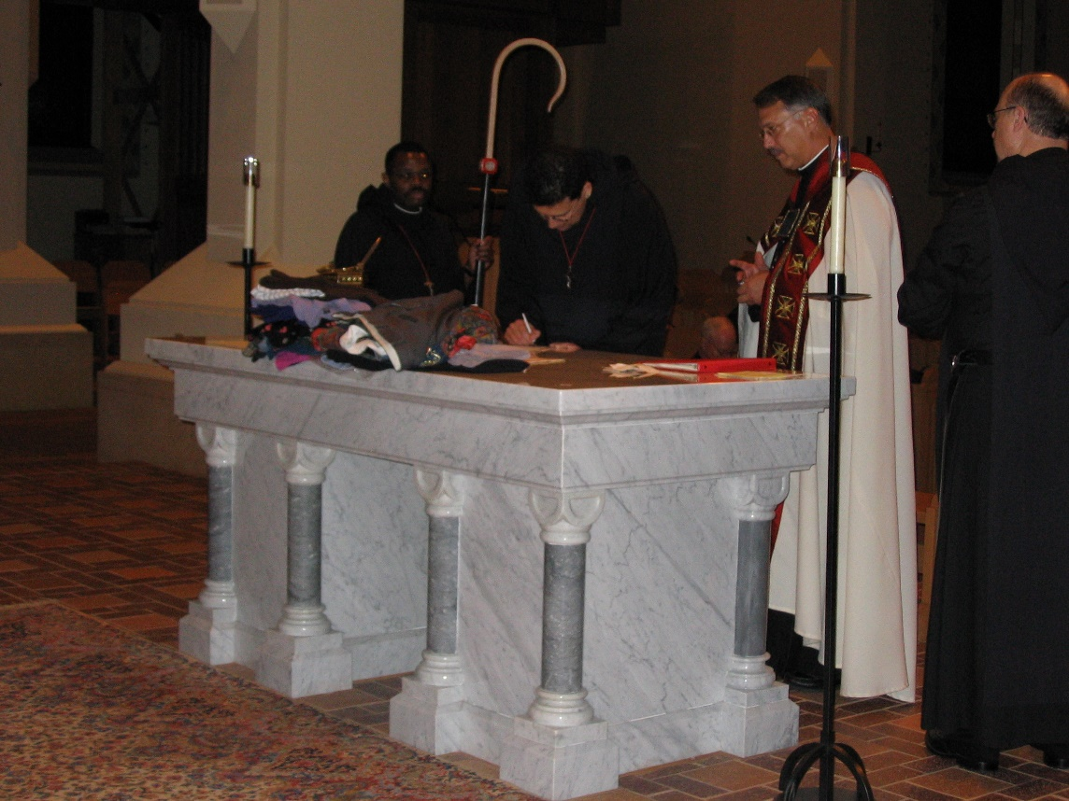
IMG 0181 Br. Thomas Ferrell; Br. Anthony Bernard Campos; Abbot Michael John Austin; Br. Raymond Owens

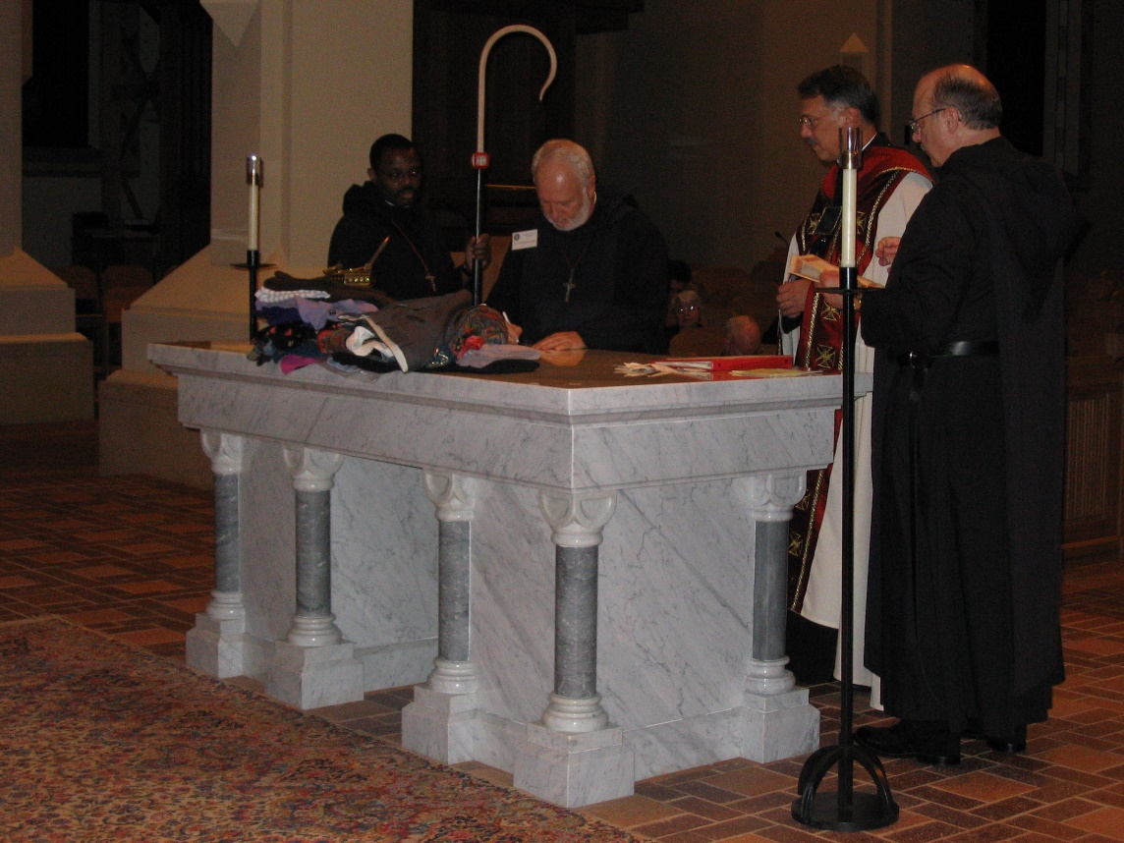
IMG 0182 Br. Thomas Ferrell; Br. Christopher John Baumann; Abbot Michael John Austin; Br. Raymond Owens
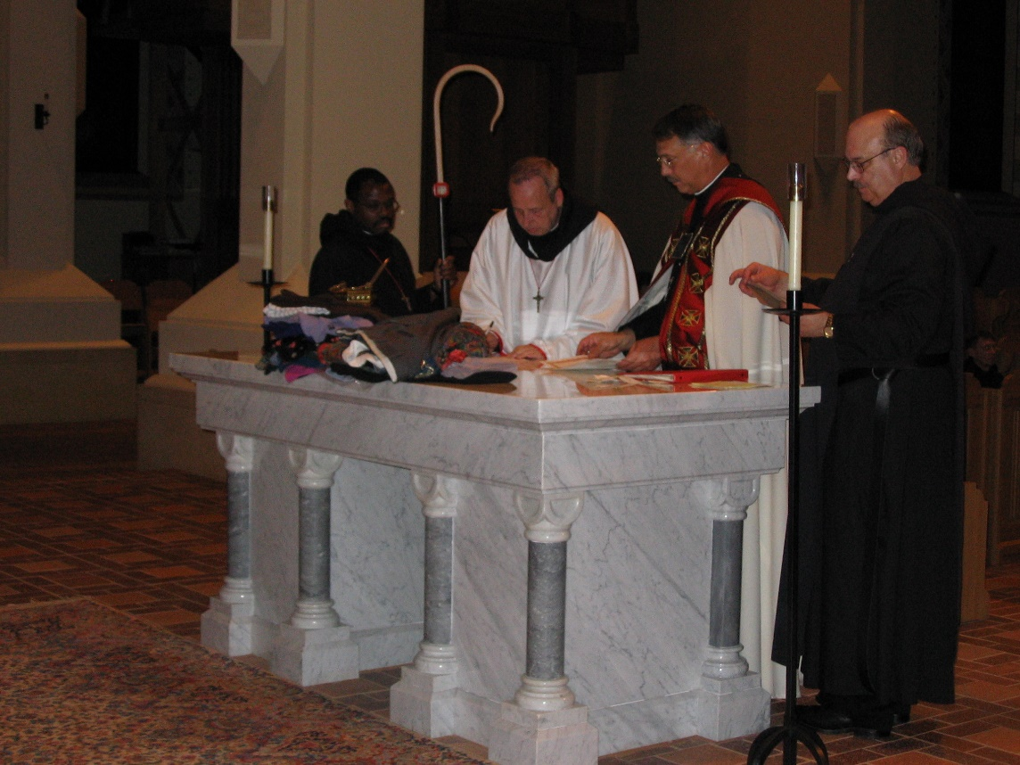
IMG 0183 Br. Thomas Ferrell; Br. Gabriel Hale; Abbot Michael John Austin; Br. Raymond Owens

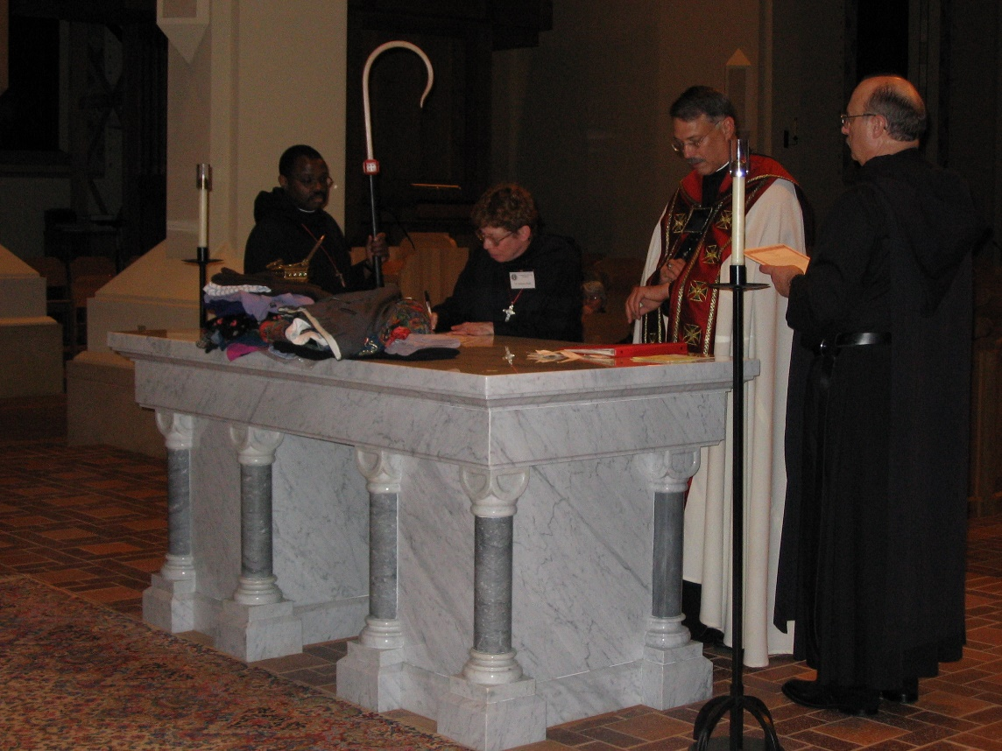
IMG 0184 Br. Thomas Ferrell; Sr. Monica Ruth Mullen; Abbot Michael John Austin; Br. Raymond Owens
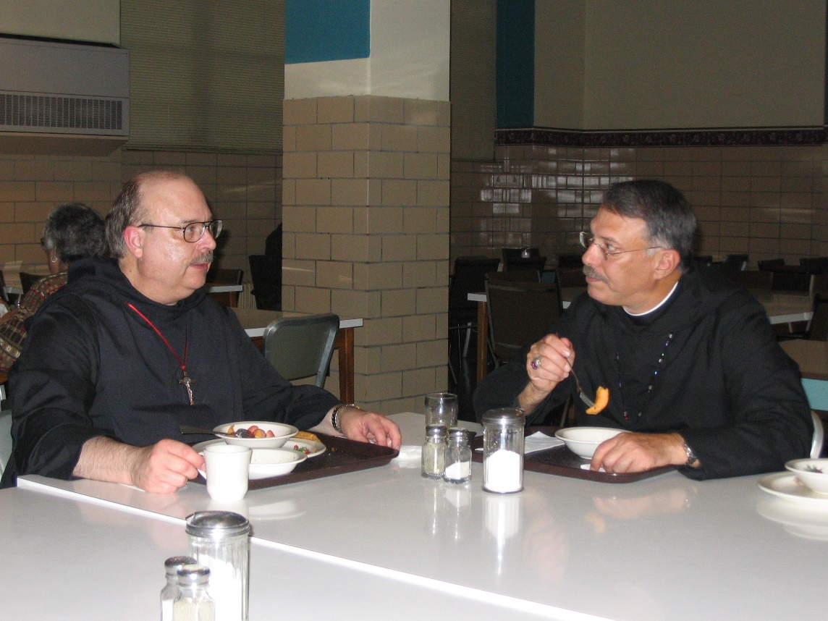
IMG 0185 Sr. Clare Benedicta Meyers; Br. Raymond Owens; Abbot Michael John Austin

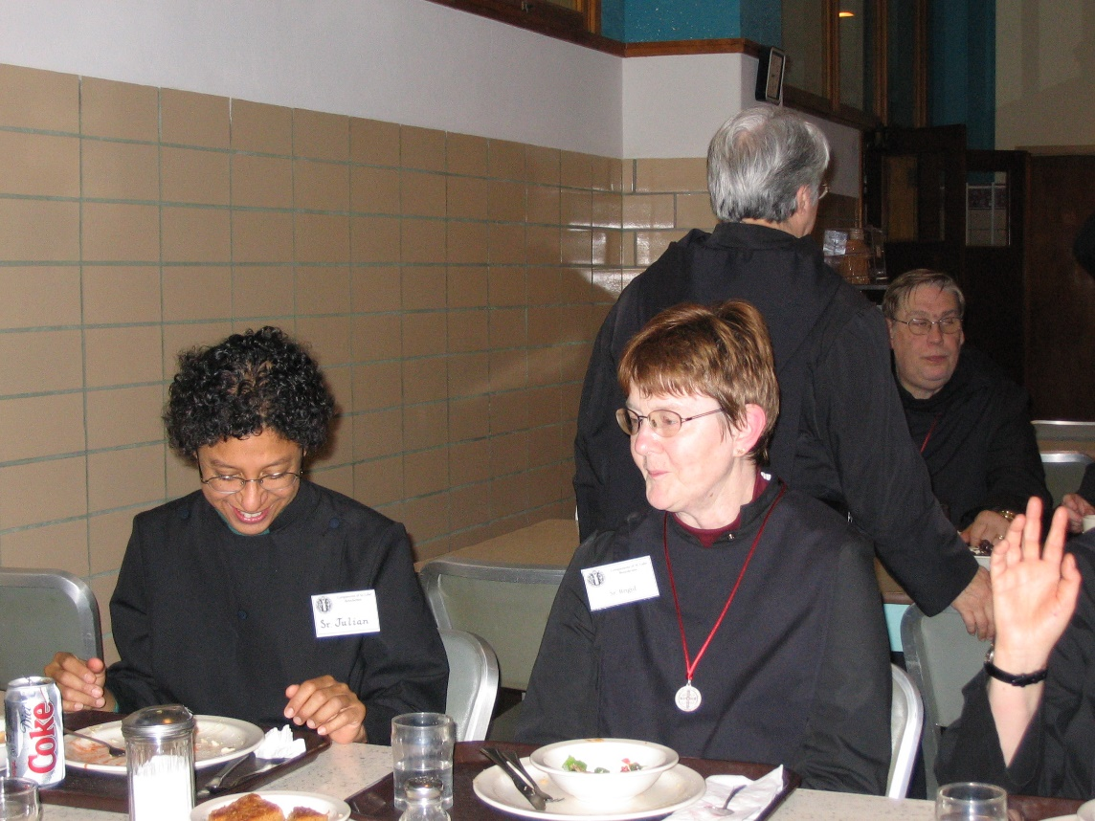
IMG 0186 Sr. Julian Baker; Sr. Brigid Gerns; Str. Clare Benedicta Meyers; Br. Chad Anselm Gerns
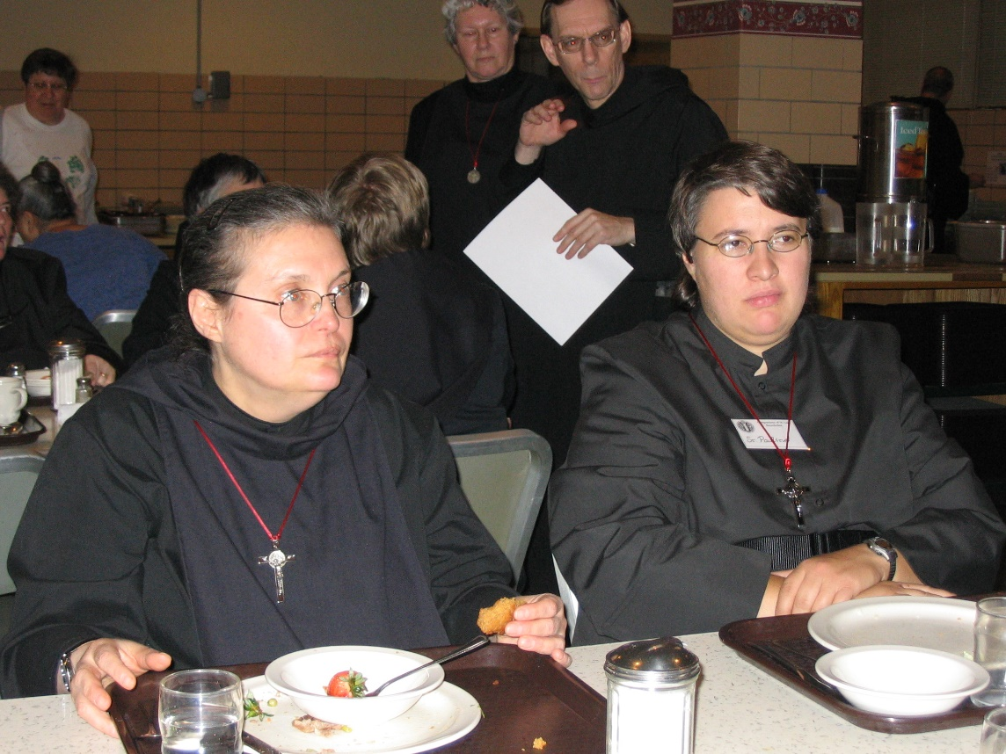
IMG 0187 Sr. Theodora of Jesus Perecca; Sr. Johanna Kirkpatrick; Br. Cyprian (guestmaster of Conception Abbey); Sr. Pauline Tysol
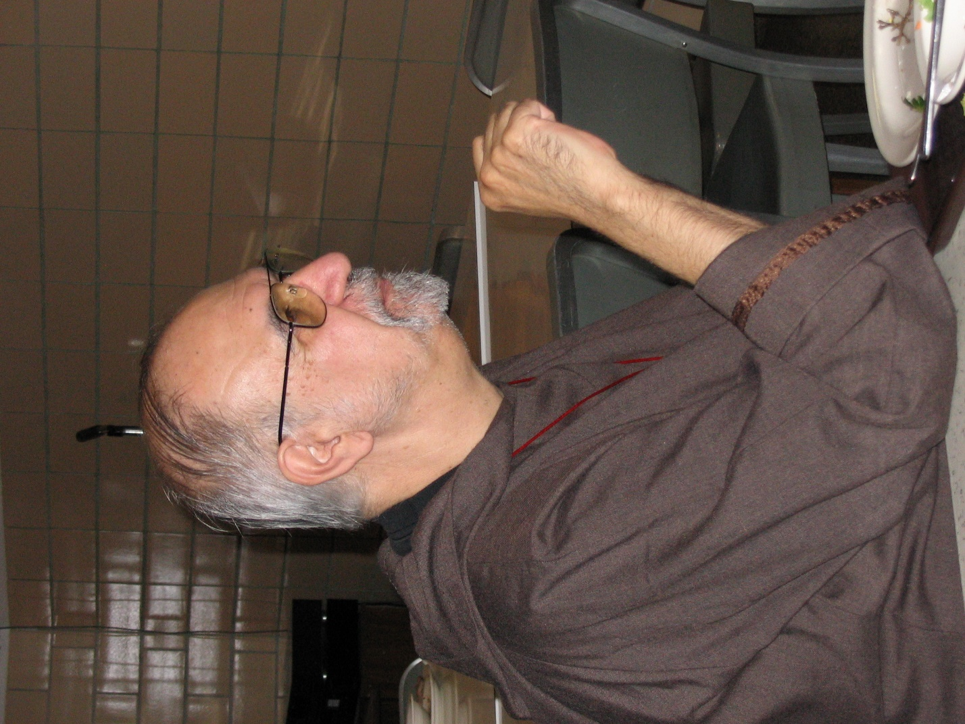
IMG 0188 Br. Joseph Benedict DiMauro, SA
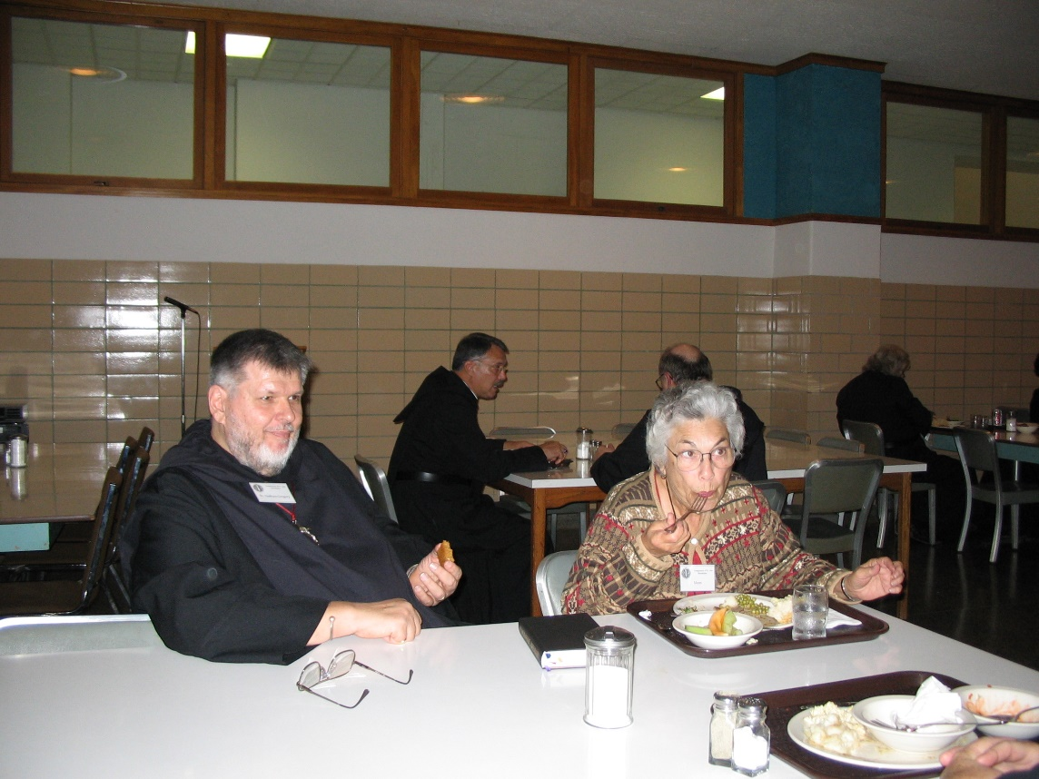
IMG 0189 Br. Nathan Gregory Miller; Abbot Michael John Austin; Jeanetta Doan (mother of MJ); Br. Raymond Owens

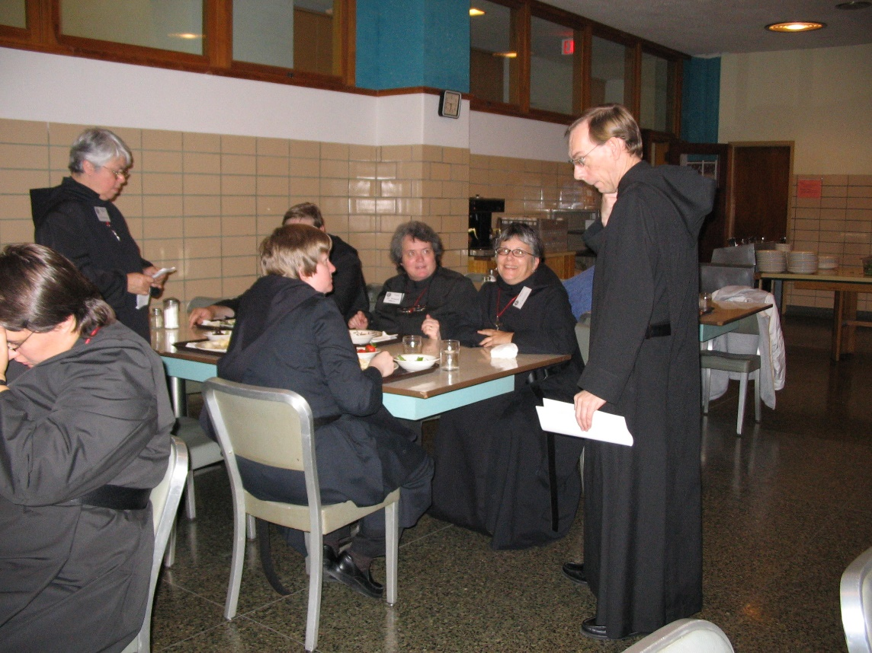
IMG 0190 Sr. Pauline Tysol; Sr. Clare Benedicta Meyers; Sr. Catherine Unterseher; Sr. Vincent Marie Rittenhouse; Sr. Anna Grace Madden; Br. Cyprian (guestmaster of Conception Abbey)
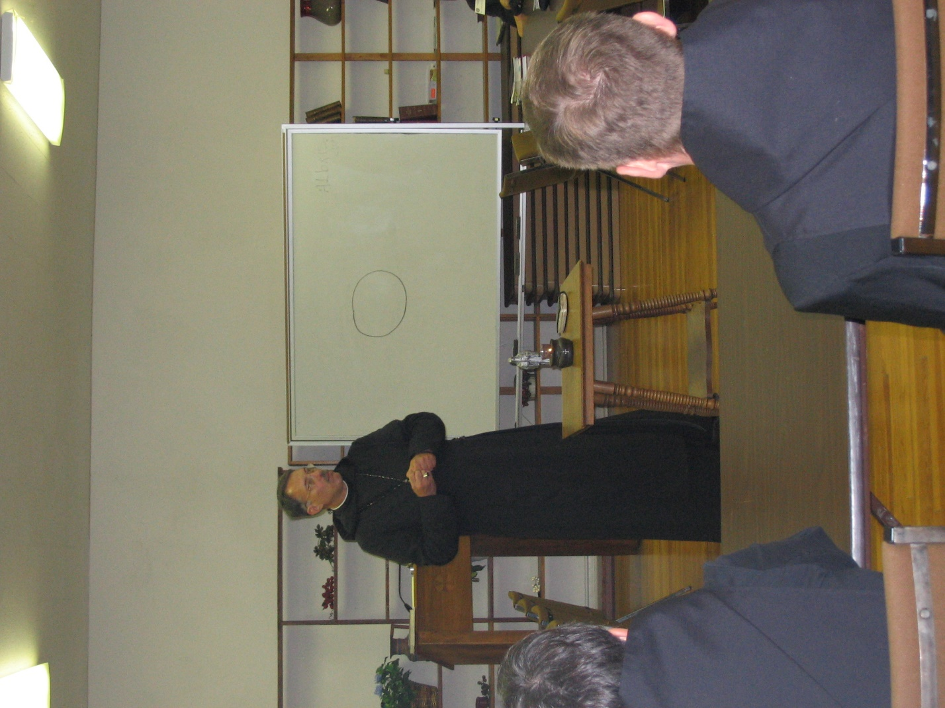
IMG 0191 Abbot Michael John Austin; Br. Camillus Converse
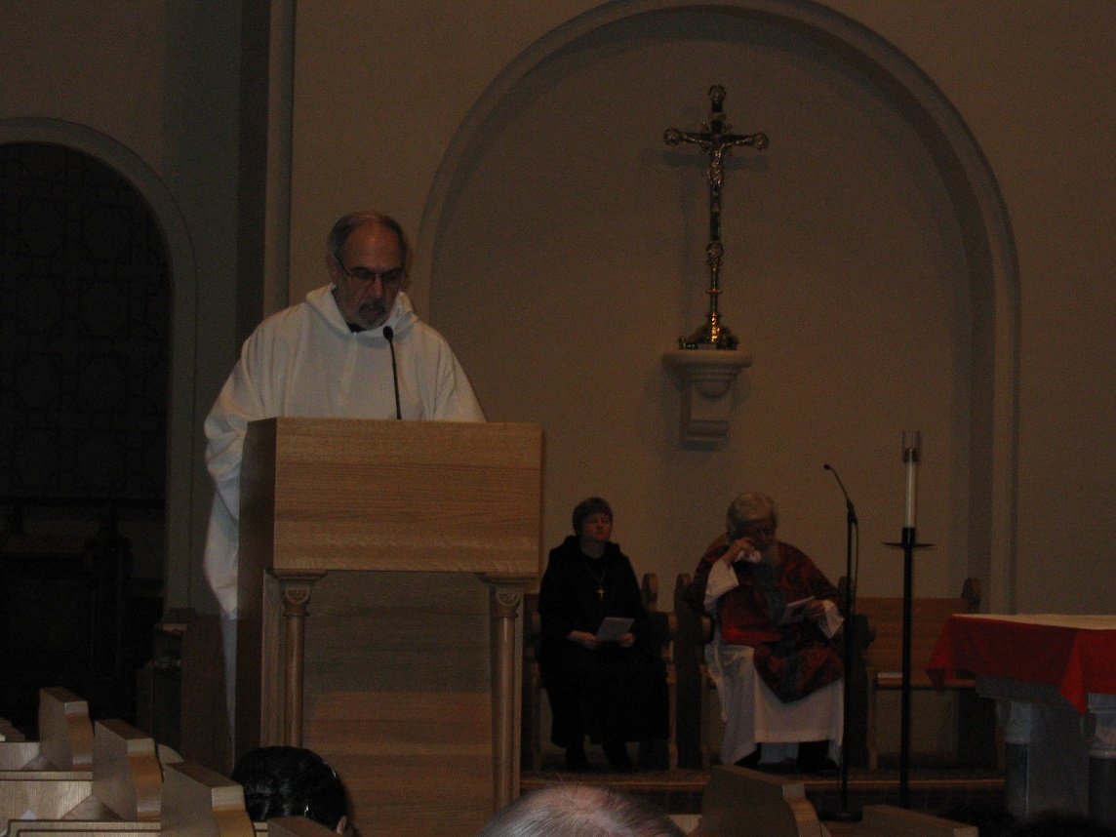
IMG 0192 Br. Joseph Benedict DiMauro, SA; Sr. Catherine Unterseher; Fr. Wayne Kamm

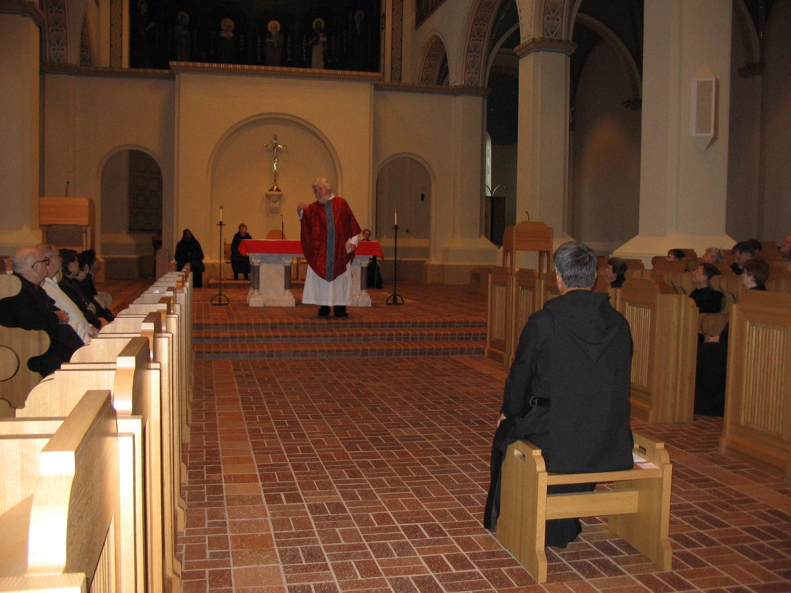
IMG 0193 Br. Benedict Truitt; Br. Joseph Benedict DiMauro, SA; Sr. Pauline Tysol; Sr. Cecelia Lamoy; Sr. Julian Baker; Br. Thomas Ferrell; Sr. Catherine Unterseher; Fr. Wayne Kamm; Br. Lawrence Mullen; Abbot Michael John Austin; Sr. Vincent Marie Rittenhouse; Sr. Anna Grace Madden; Br. Camillus Converse; Sr. Clare Benedicta Meyers; Br. Nathan Gregory Miller; Sr. Brigid Gerns
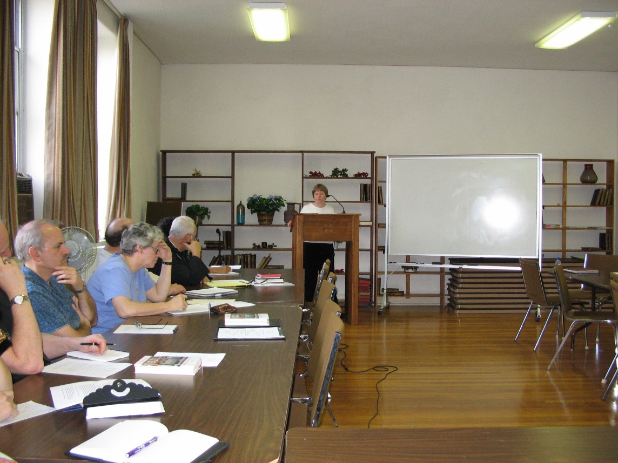
IMG 0194 Br. Daniel Joseph Schroeder; Sr. Johanna Kirkpatrick; Br. Raymond Owens; Br. Christopher John Baumann; Sr. Catherine Unterseher

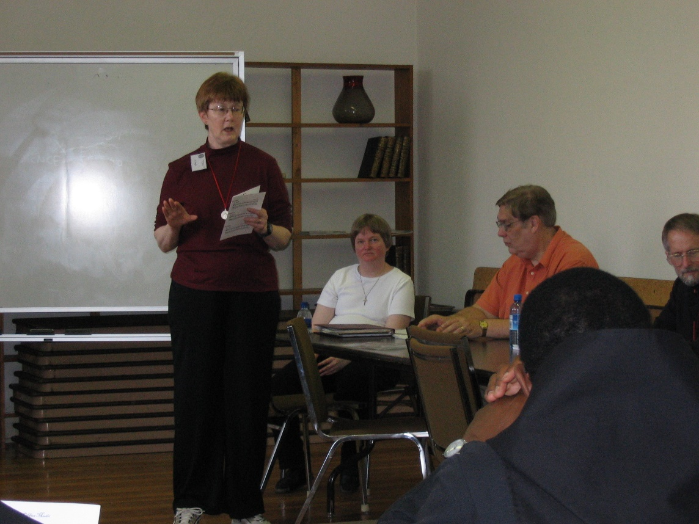
IMG 0195 Sr. Brigid Gerns; Sr. Catherine Unterseher; Br. Chad Anselm Gerns; Br. Thomas Ferrell; Br. Lawrence Mullen
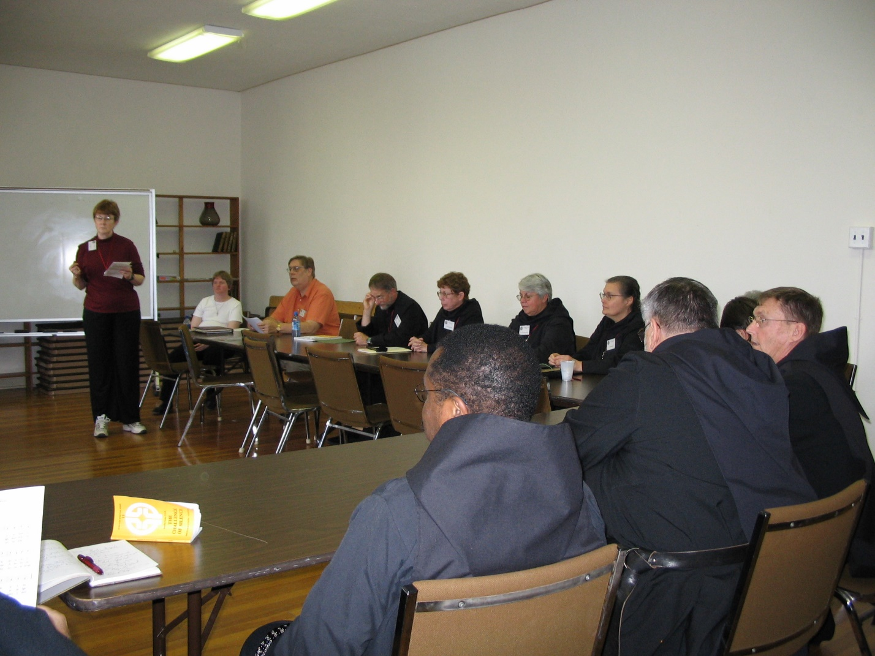
IMG 0196 Sr. Brigid Gerns; Sr. Catherine Unterseher; Br. Chad Anselm Gerns; Br. Lawrence Mullen; Sr. Monica Ruth Mullen; Br. Thomas Ferrell; Sr. Clare Benedicta Meyers; Sr. Theodora of Jesus Perecca; Br. Nathan Gregory Miller; Br. Camillus Converse
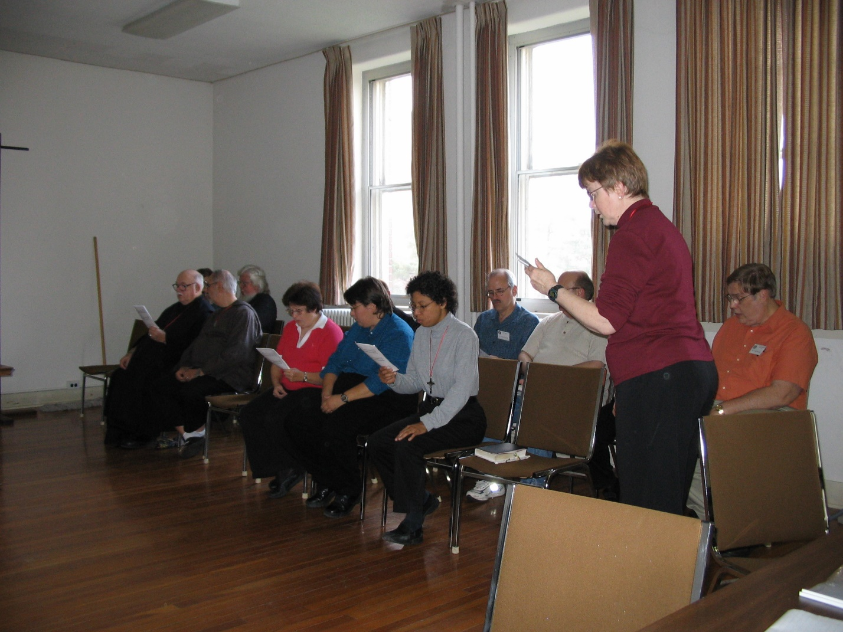
IMG 0197 Br. Benedict Truitt; Br. Joseph Benedict DiMauro, SA; Fr. Wayne Kamm; Sr. Cecelia Lamoy; Sr. Pauline Tysol; Sr. Julian Baker; Br. Daniel Joseph Schroeder; Br. Raymond Owens; Sr. Brigid Gerns; Br. Chad Anselm Gerns
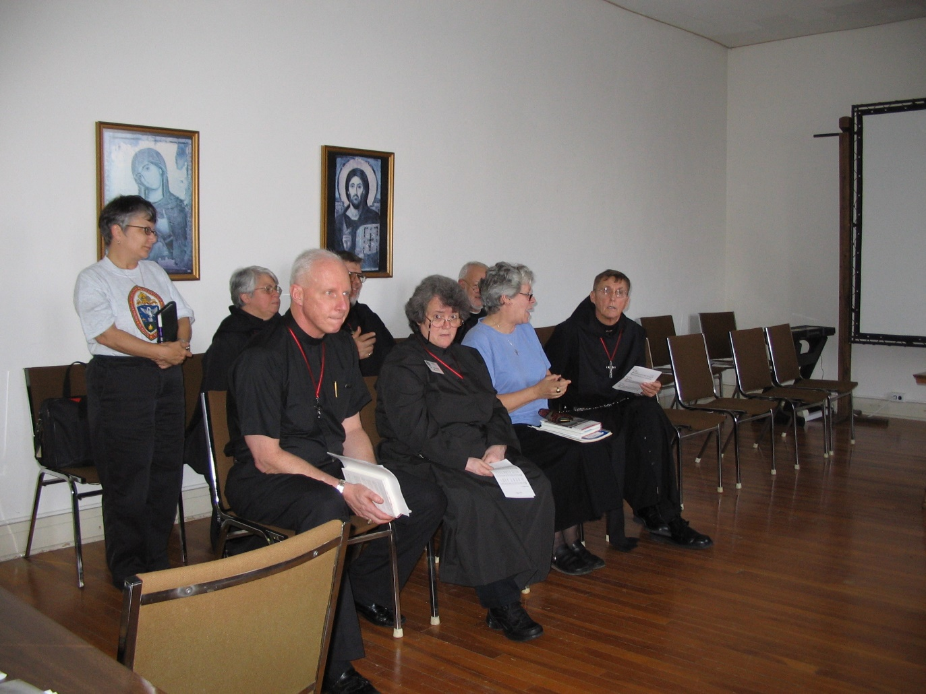
IMG 0198 Sr. Anna Grace Madden; Sr. Clare Benedicta Meyers; Br. David Vincent Cotton; Br. Nathan Gregory Miller; Sr. Vincent Marie Rittenhouse; Br. Christopher John Baumann; Sr. Johanna Kirkpatrick; Br. Camillus Converse
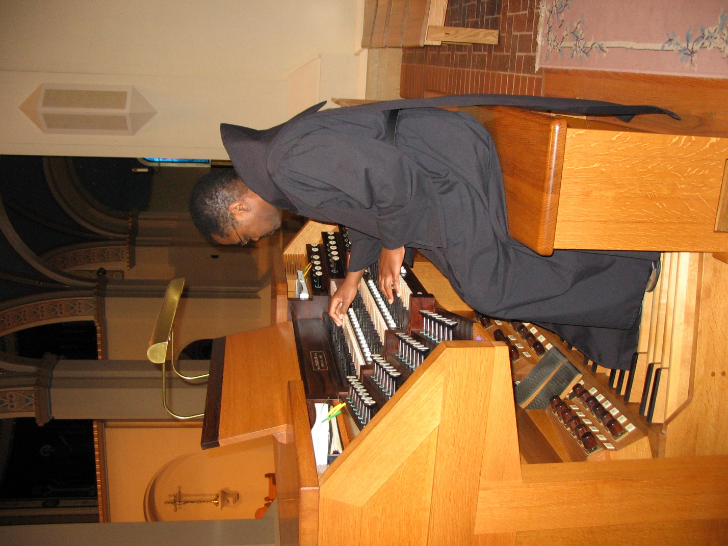
IMG 0199 Br. Thomas Ferrell
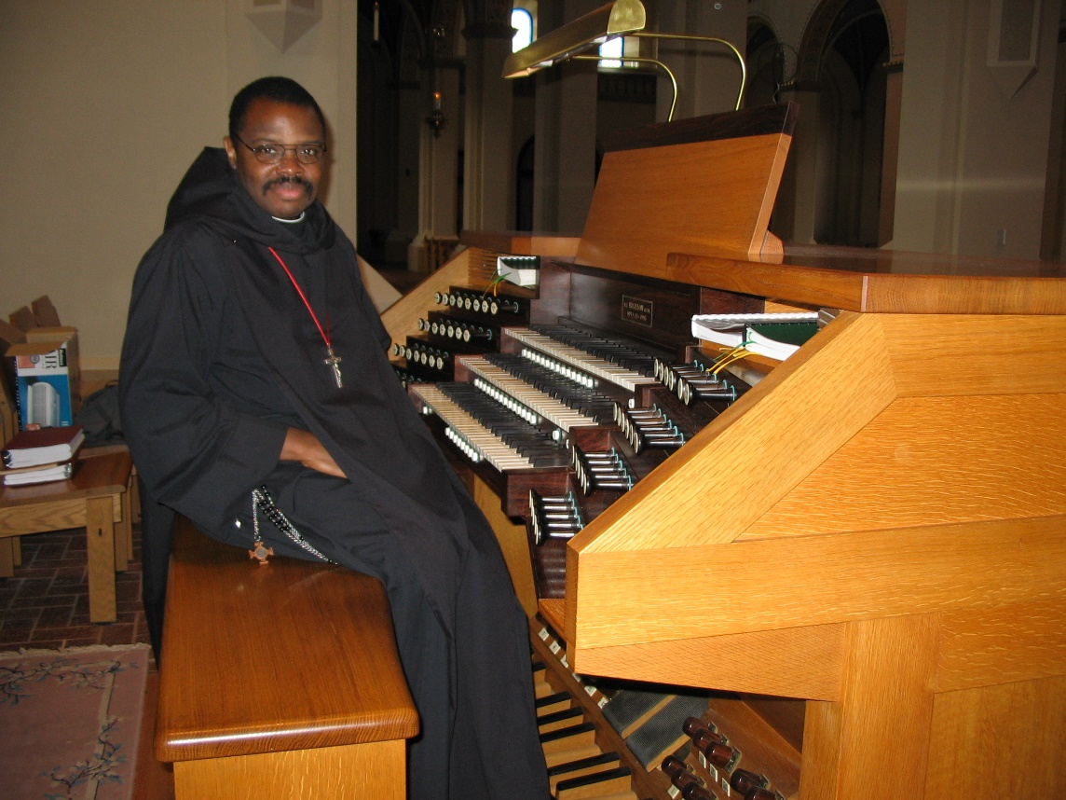
IMG 0200 Br. Thomas Ferrell

