Companions of St. Luke
Fall 2004 Convocation at Conception Abbey
Vol. IV. Part 1 of 2

~Edited by Br. Steven Olderr, 30 May 2022 with the assistance of Br. Thomas Ferrell; if you find any errors or omissions, please notify Br. Steven at olderr@ameritech.net

People are identified from left to right.

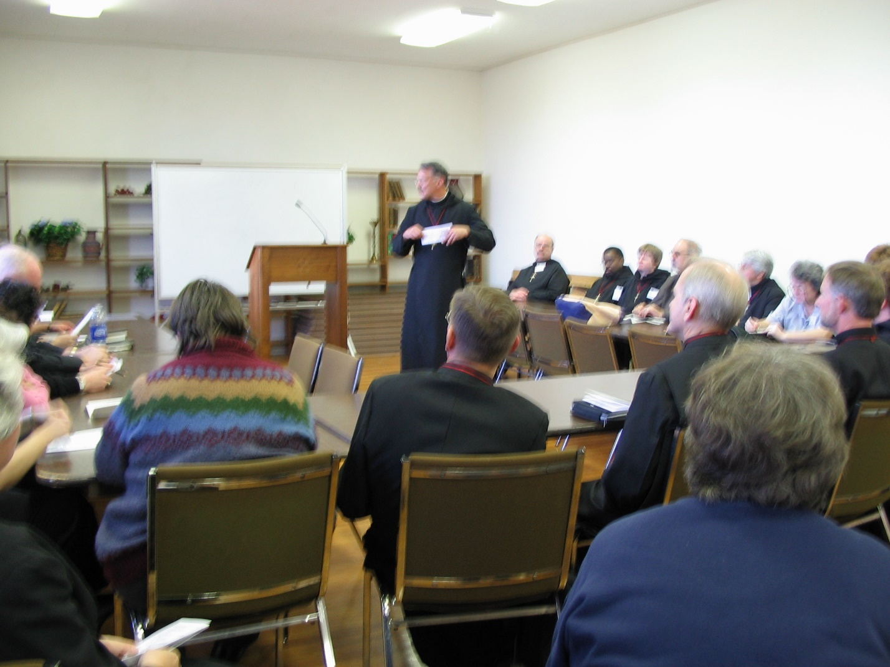
IMG 0101 Sr. Pauline Tysol; Abbot Michael John Austin; Br. Camillus Converse; Br. Daniel Joseph Converse; Br. Lawrence Mullen; Sr. Vincent Marie Rittenhouse; Sr. Clare Benedicta Meyers; Br. Joseph Benedict DiMauro, SA; St. Catherine Unterseher; Br/ Thomas Ferrell; Br. Raymond Owens

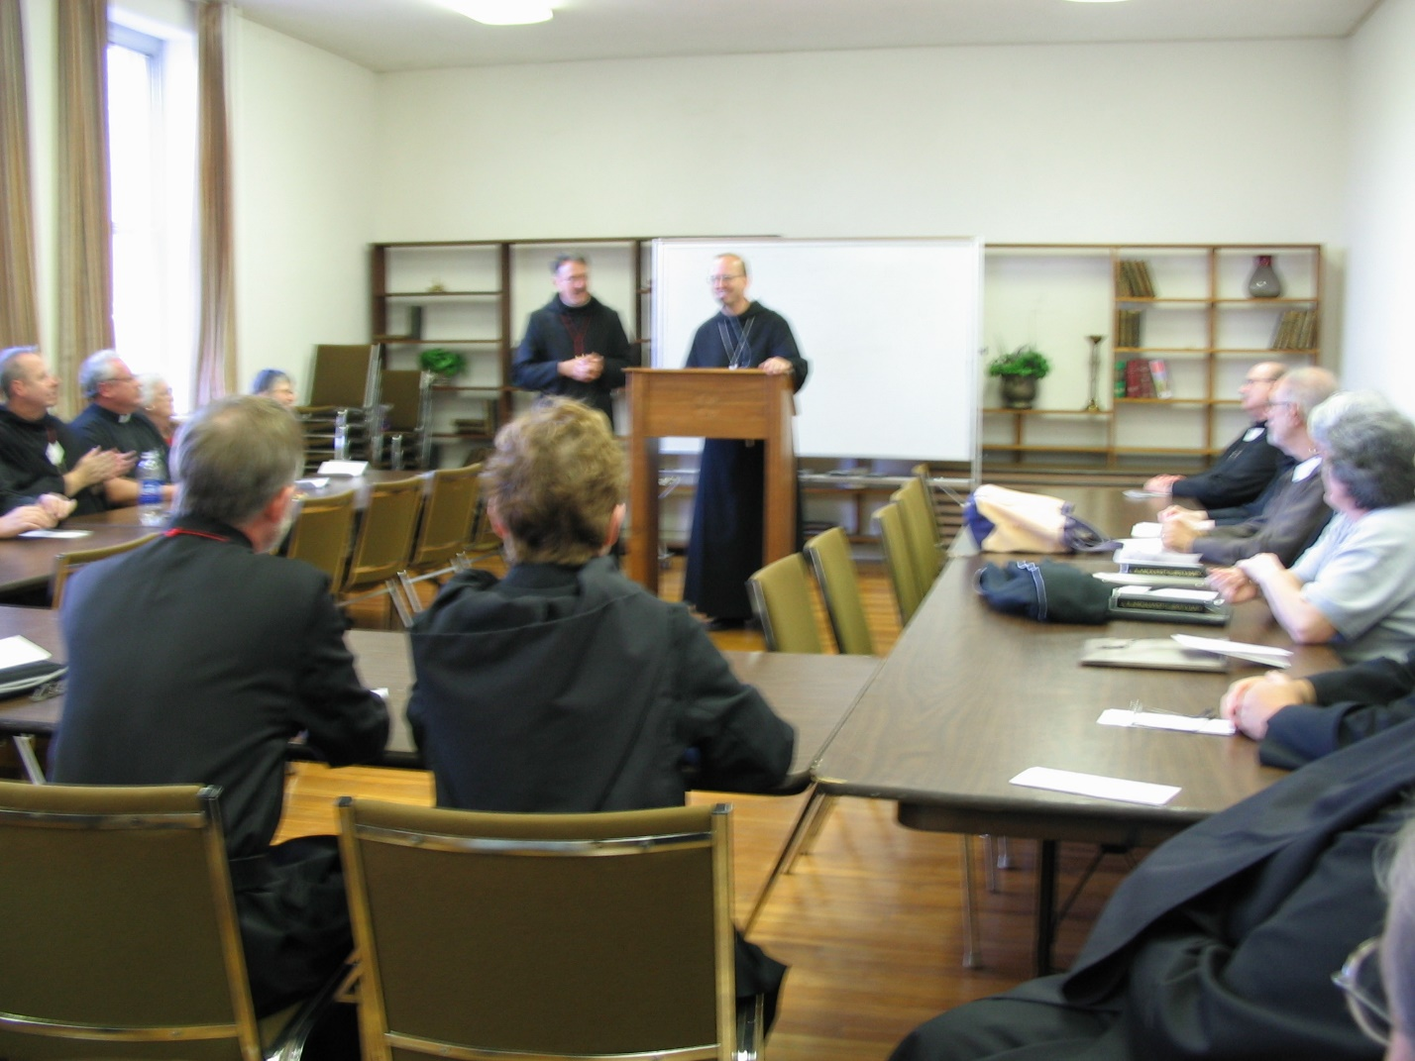IMG 0102 Sr. Anna Grace; Jackie Hale; Rev. Stephen Hale; Br. Gabriel Hale; Br. Lawrence Hale; Sr. Monica Ruth Mullen; Prior Michael John; Austin; Abbot Gregory Polan of Conception Abbey; Sr. Vincent Marie Rittenhouse; Br. Joseph Benedict DiMauro, SA; Br. Raymond Owens
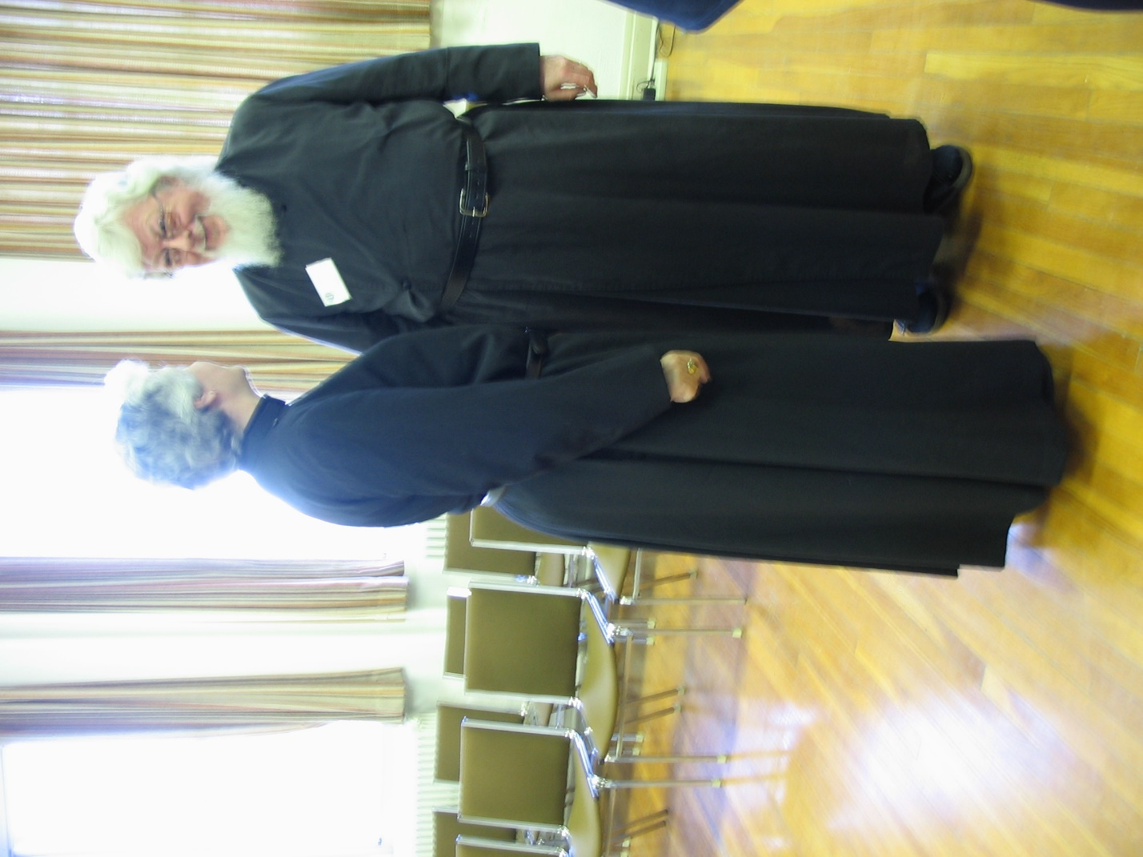
IMG 0103 Sr. Johanna Kirkpatrick; Fr. Wayne Kamm
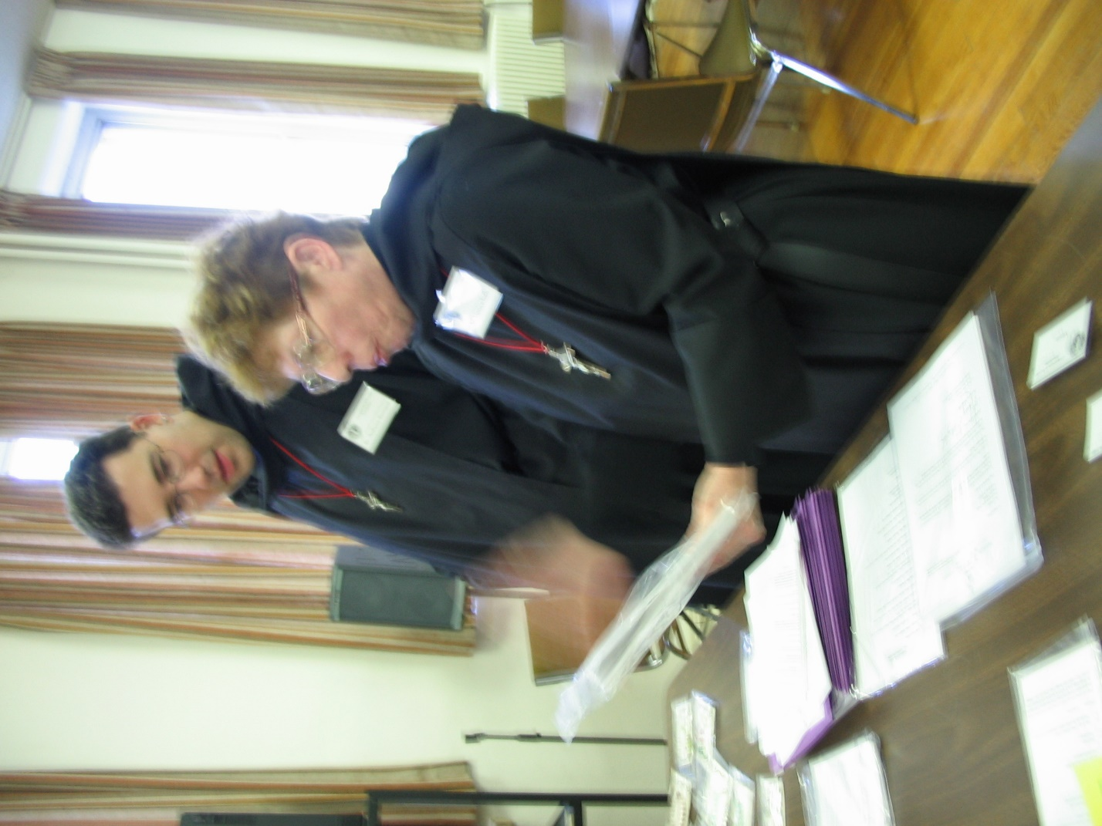
IMG 0104 Br. Anthony Bernard Campos; Sr. Monica Ruth Mullen

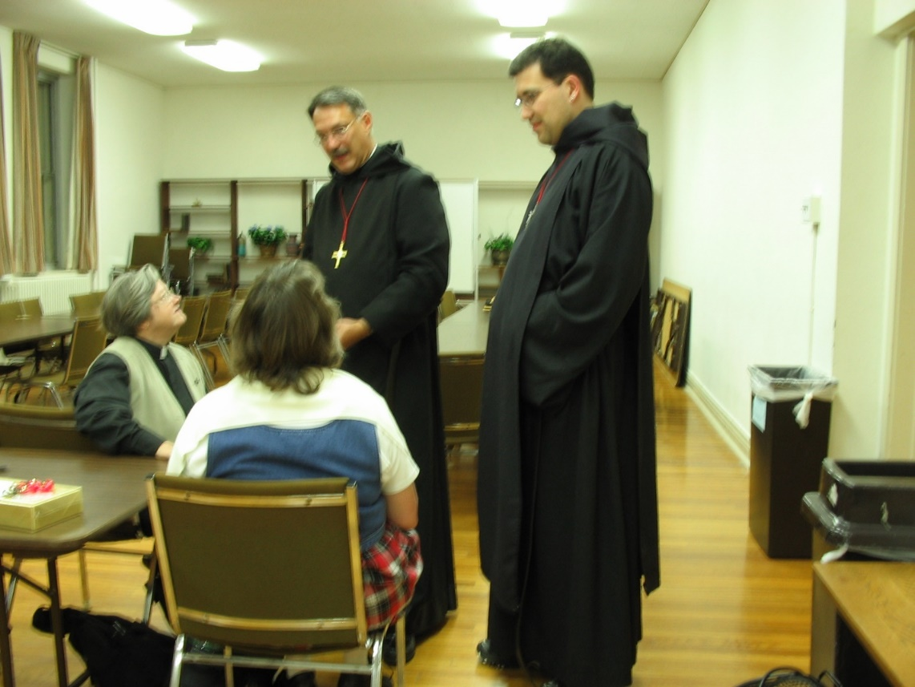
IMG 0105 Deacon Dian Ong; Mary Kamm; Prior Michael John Austin; Br. Anthony Bernard Campos

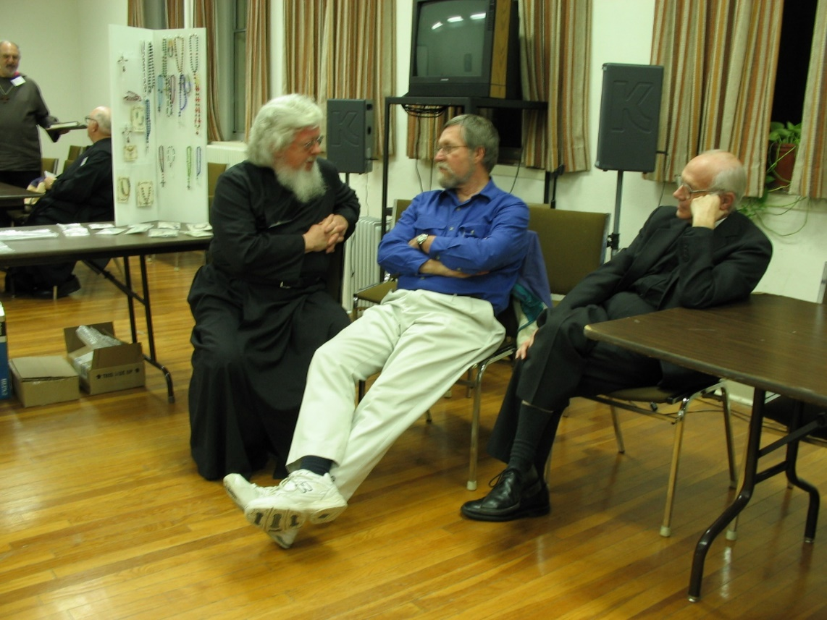
IMG 0106 Fr. Wayne Kamm
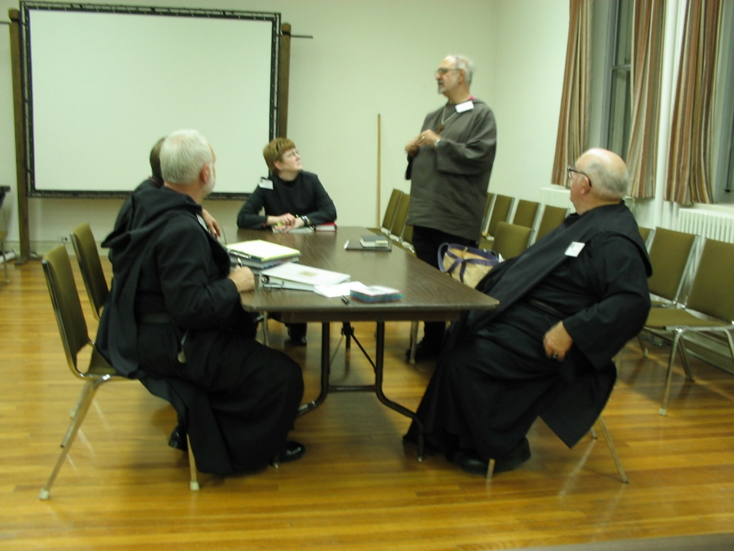
IMG 0107 Br. Christopher John Baumann; Sr. Brigid Gerns; Br. Joseph Benedict Di Mauro, SA* ; Br. Benedict Truitt

*Br. Joseph Benedict, SA was a priest in the Franciscan Society of the Atonement, but in an act of ecumenism joined CSL as an oblate. He remained in the CSL until 2009 when Abbot Michael John Austin resigned. He then joined the House of Initia Nova, MJ’s successor community. Br. Joseph Benedict died on 29 Nov 2018.

The Society of the Atonement was originally founded as an Episcopal community but went over to the Roman Catholic Church in 1909.

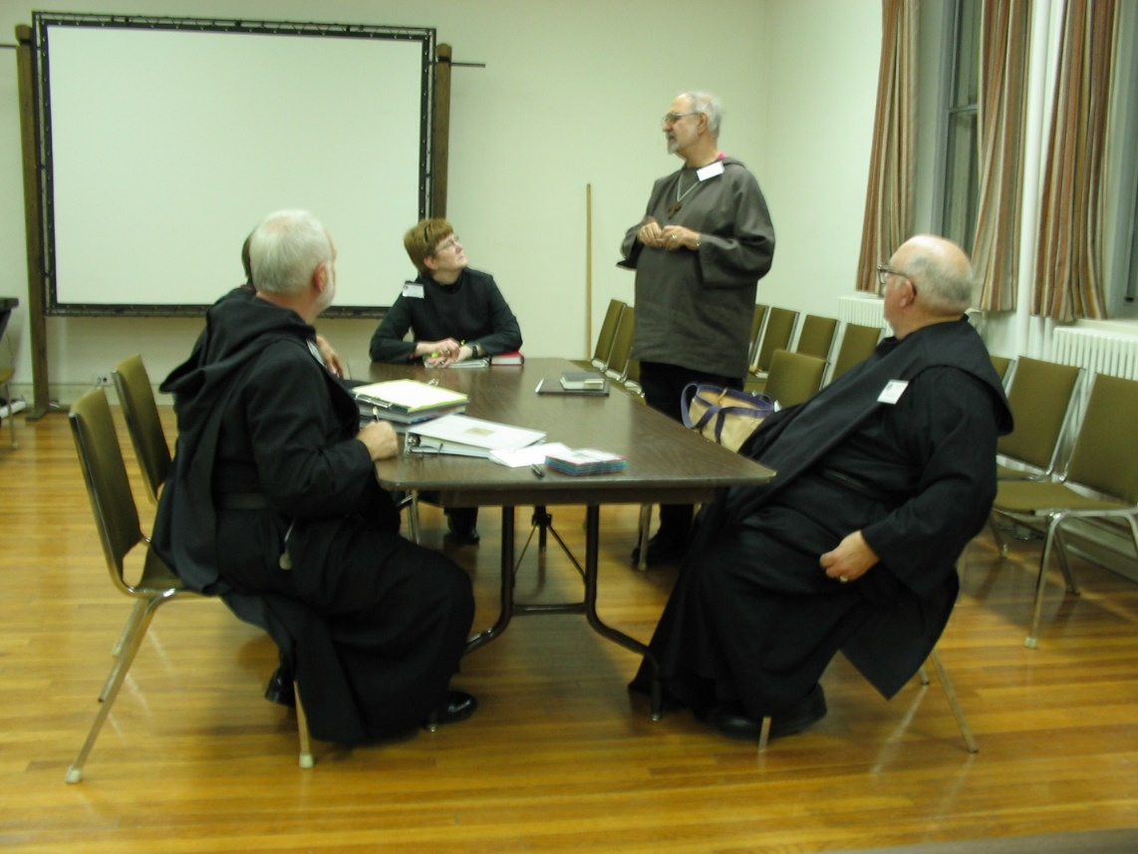
IMG 0108 Br. Christopher John Baumann; Sr. Brigid Gerns; Br. Joseph Benedict Di Mauro, SA; Br. Benedict Truitt

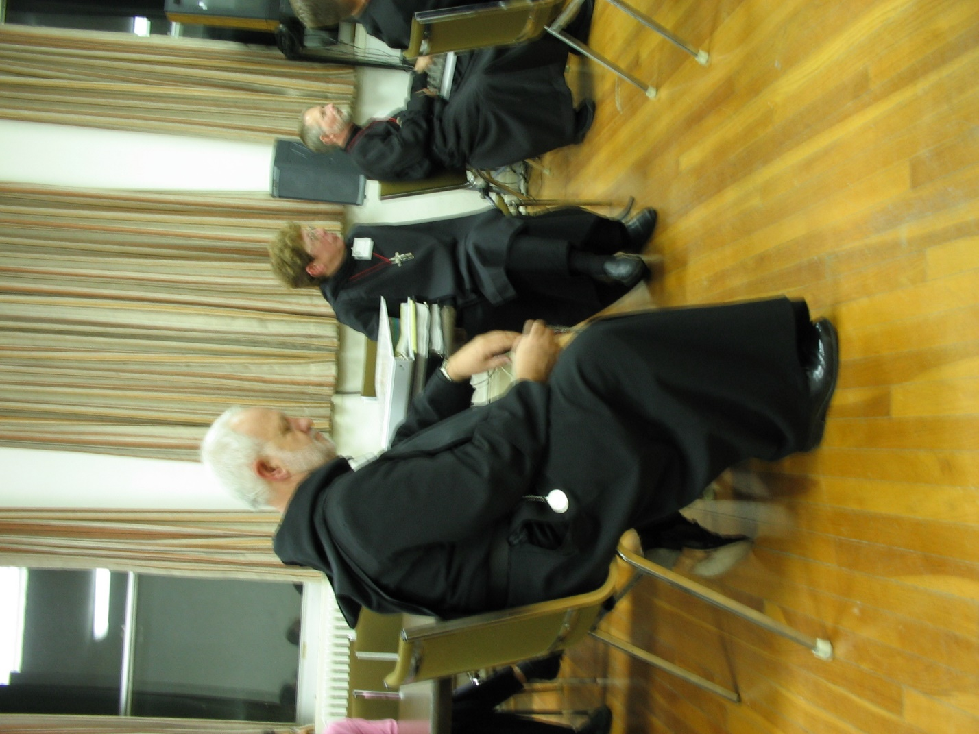
IMG 0109 Br. Christopher John Baumann; Sr. Monica Ruth Mullen; Br. Lawrence Mullen

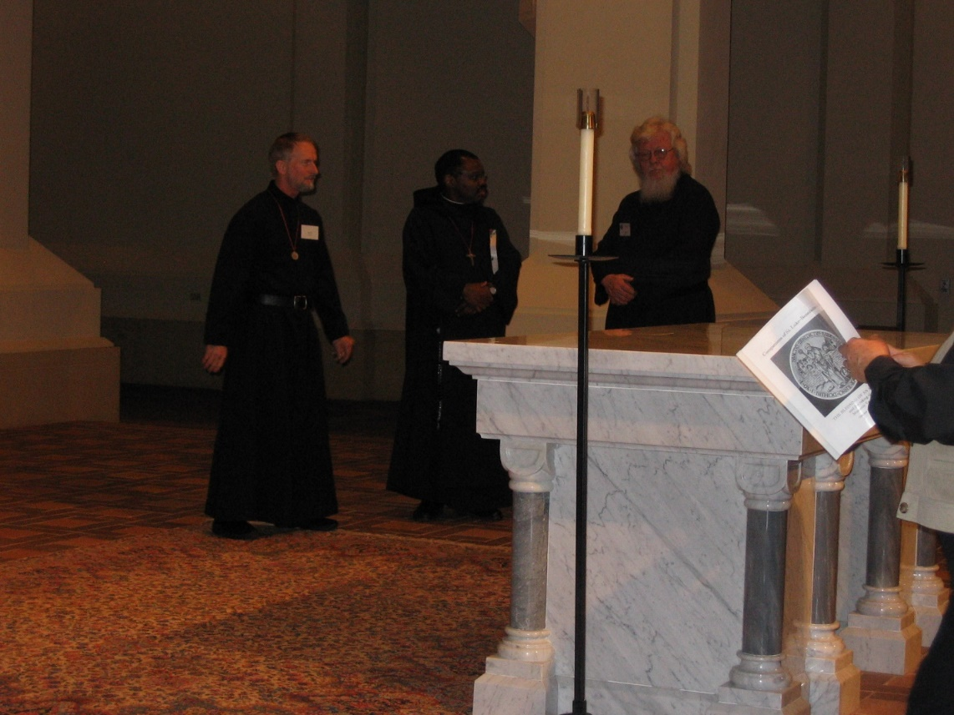
IMG 0110 Br. Lawrence Mullen; Br. Thomas Ferrell; Fr. Wayne Kamm

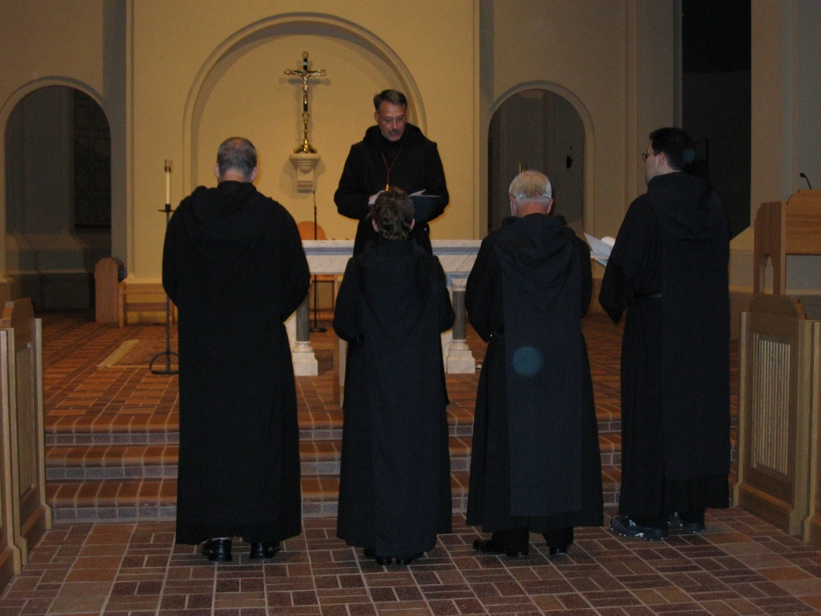
IMG 0111 Br. Gabriel Hale; Sr. Monica Ruth Mullen; Prior Michael John Austin; Br. Christopher John Baumann; Br. Anthony Bernard Campos

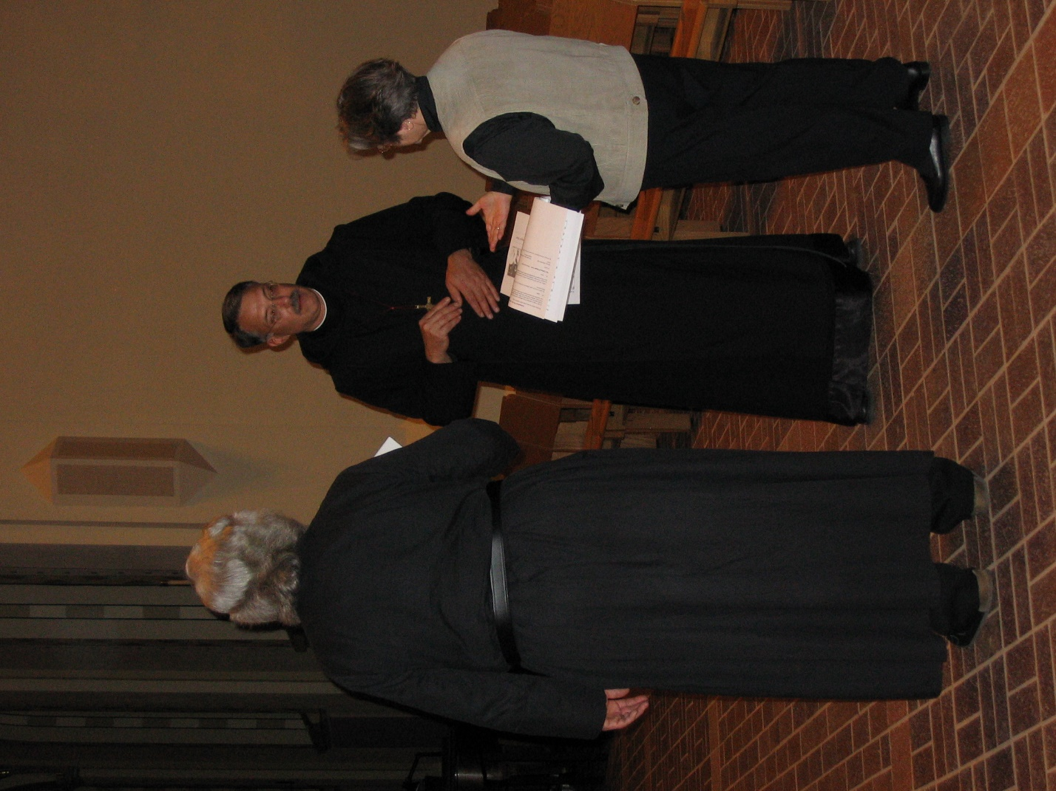
IMG 0112 Fr. Wayne Kamm; Prior Michael John Austin; Deacon Dian Ong
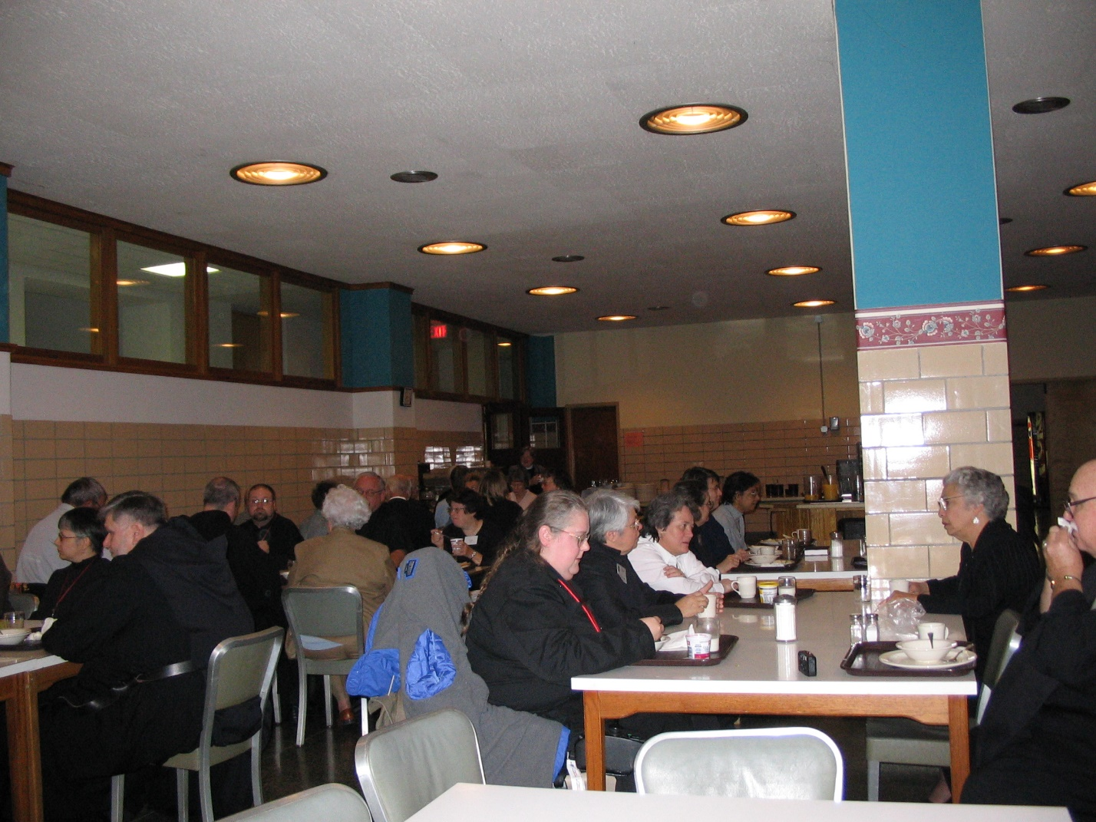
IMG 0113 Sr. Anna Grace Madden; Br. Nathan Gregory Miller; Br. Gabriel Hale; Br. Willard Moore; Jackie Hale; Rev. Stephen Hale; Sr. Cecelia Lamoy; Sr. Margaret Moore; Sr. Clare Benedicta Meyers; Sr. Vincent Marie Rittenhouse; Sr. Theodora of Jesus Perecca; Sr. Pauline Tysol; Sr. Julian Baker; Jeanetta Doan; Br. Benedict Truitt
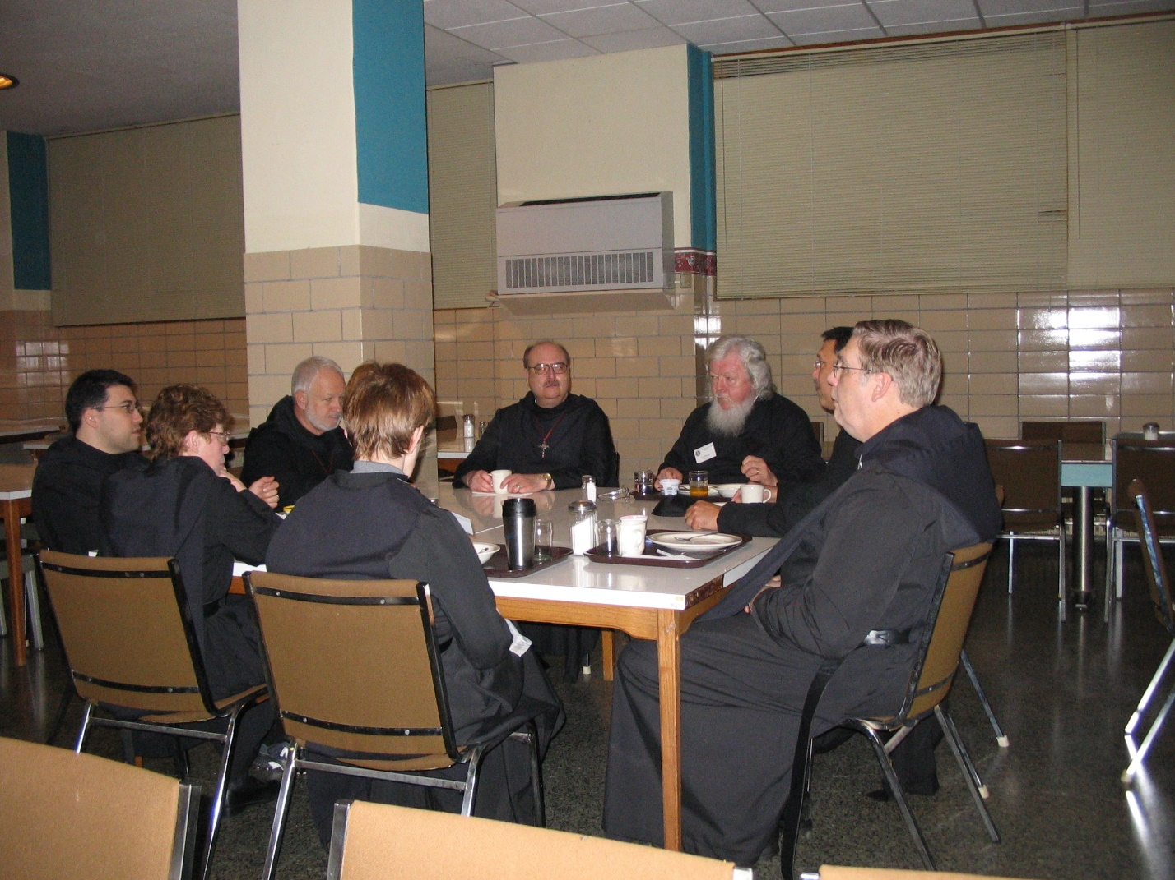
IMG 0114 Br. Anthony Bernard Campos; Sr. Monica Ruth Mullen; Br. Christopher John Baumann; Sr. Brigid Gerns; Br. Raymond Owens; Fr. Wayne Kamm; Prior Michael John Austin; Br. Chad Anselm Gerns

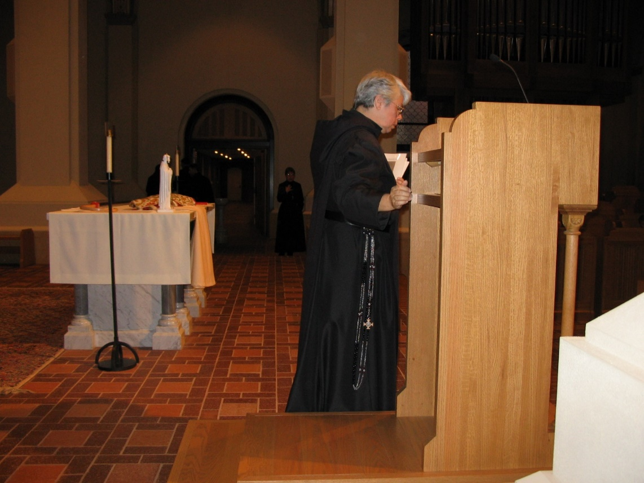
IMG 0116 Sr. Clare Benedicta Meyers

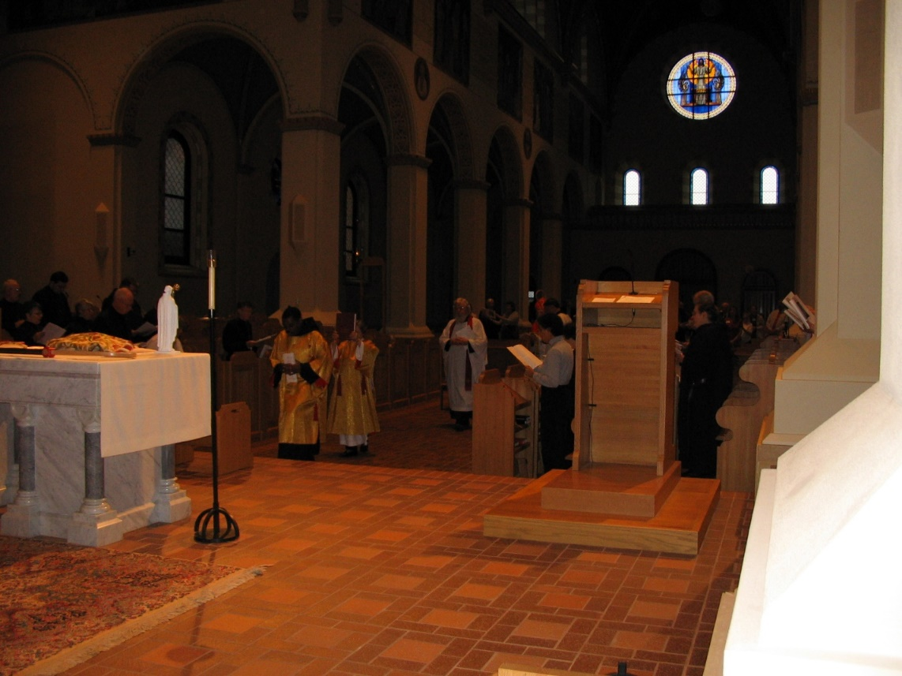
IMG 0117 Br. David Vincent Cotton; Br. Thomas Ferrell; Deacon Dian Ong; Fr. Wayne Kamm; St. Julian Baker
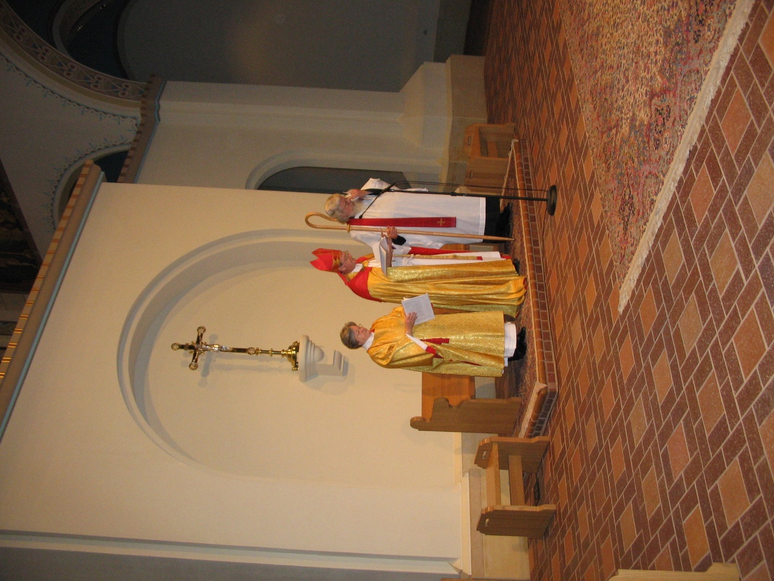
IMG 0118 Deacon Dian Ong; Bp. Alan Scarfe; Fr. Wayne Kamm
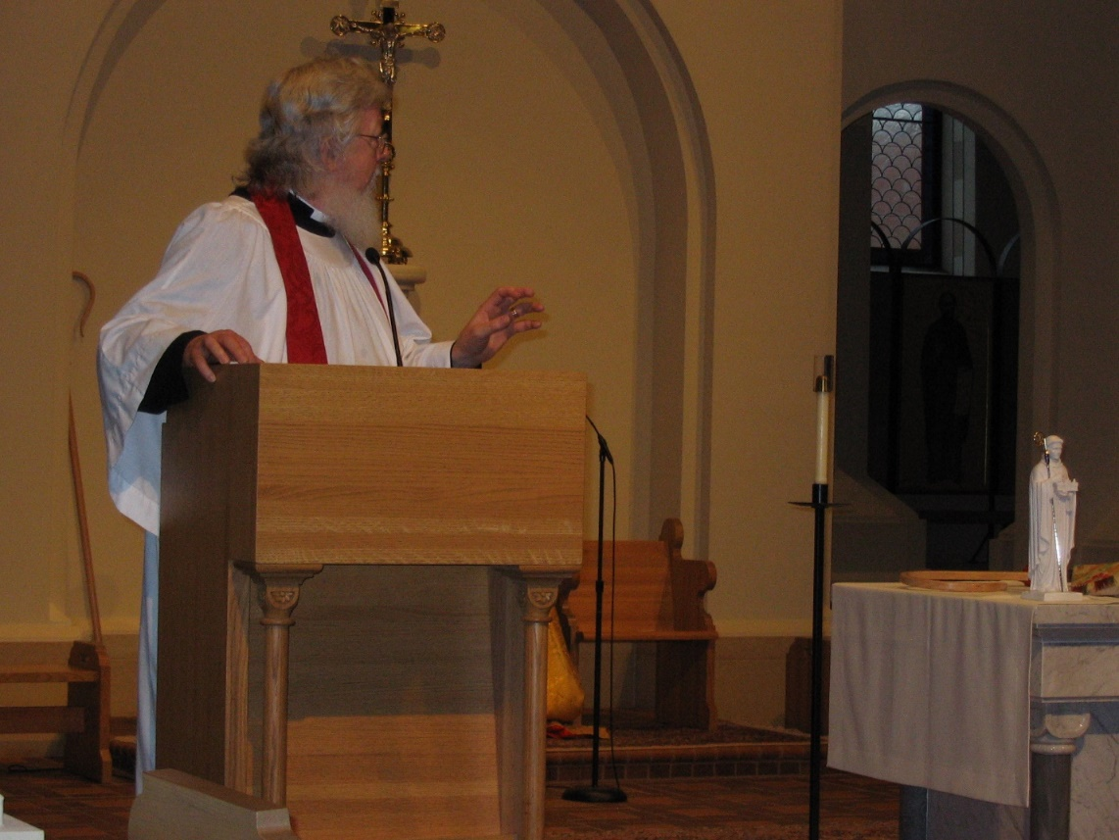
IMG 0119 Fr. Wayne Kamm

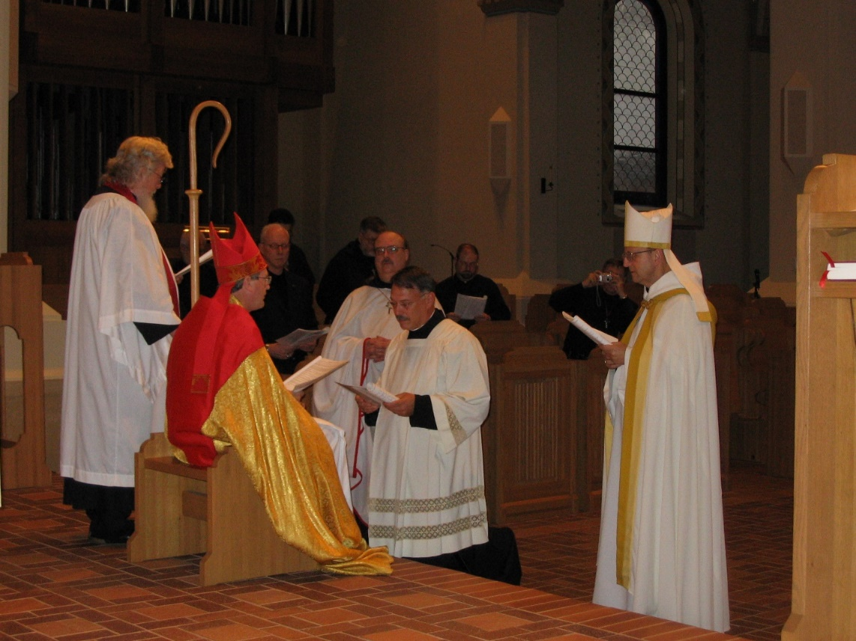
IMG 0120 Fr. Wayne Kamm; Bp. Alan Scarfe; Br. David Vincent Cotton; Br. Raymond Owens; Prior Michael John Austin; Br. Willard Moore; Abbot Gregory of Conception Abbey
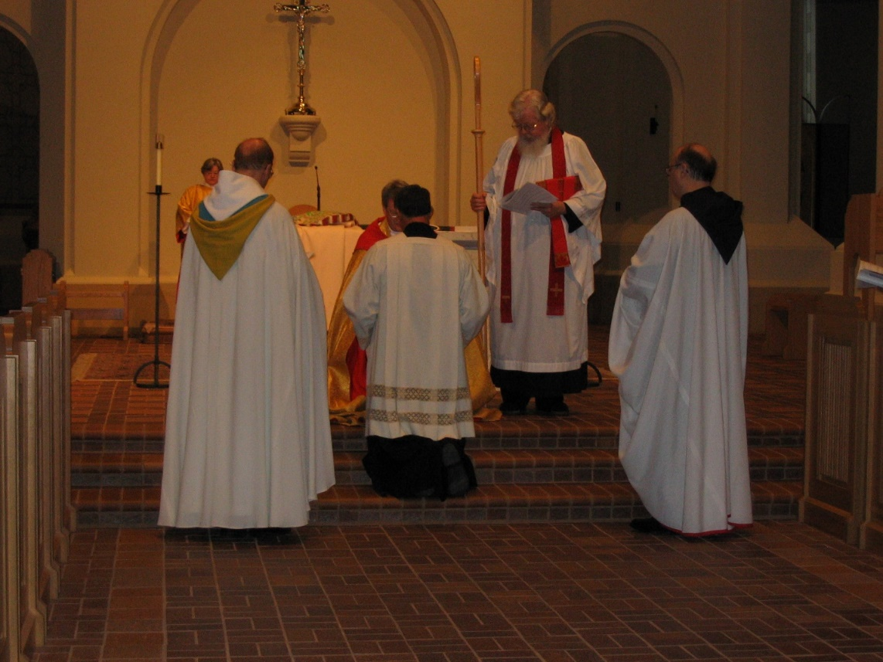
IMG 0121 Deacon Dian Ong; Abbot Gregory of Conception Abbey; Bp. Alan Scarfe; Prior Michael John Austin; Fr. Wayne Kamm; Br. Raymond Owens

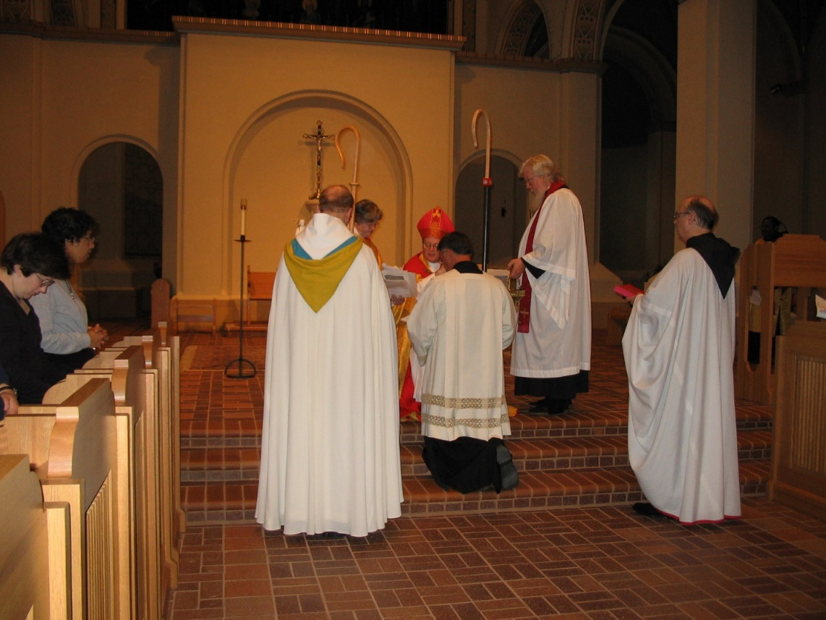
IMG 0122 Sr. Cecelia Lamoy; Sr. Julian Baker; Abbot Gregory of Conception Abbey; Prior Michael John Austin; Deacon Dian Ong; Bp. Alan Scarfe; Prior Michael John Austin; Fr. Wayne Kamm; Br. Raymond Owens

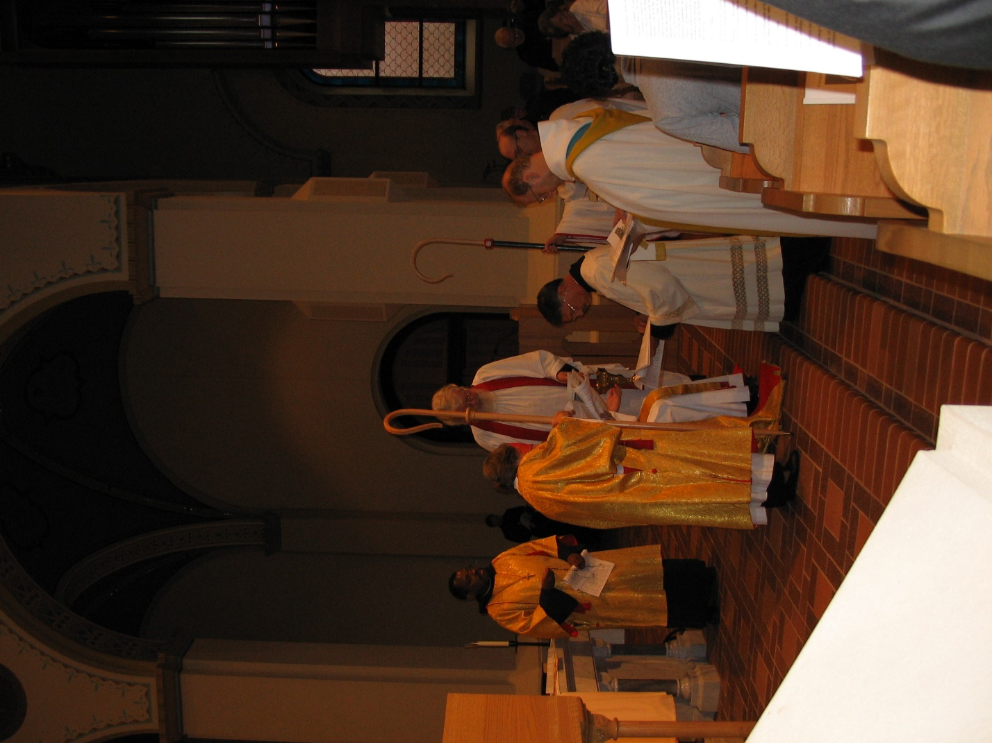
IMG 0123 Br. Thomas Ferrell; Deacon Dian Ong; Fr. Wayne Kamm; Prior Michael John Austin; Abbot Gregory of Conception Abbey; Br. Raymond Owens; Sr. Julian Baker
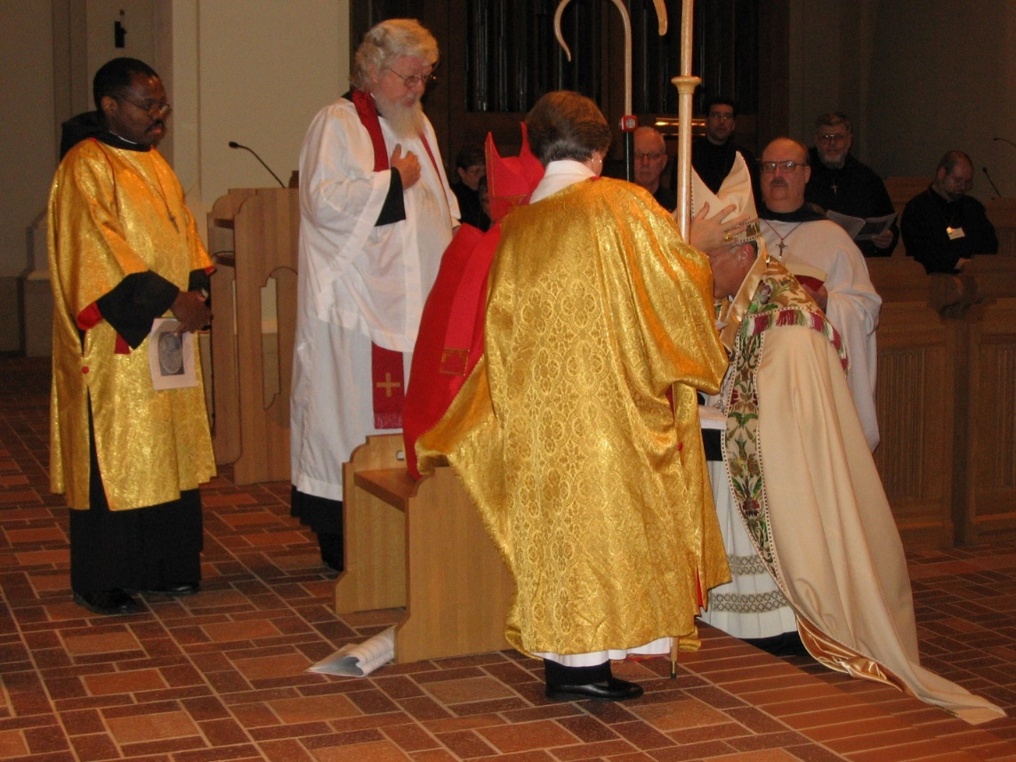
IMG 0124 Br. Thomas Ferrell; Fr. Wayne Kamm; Br. Alan Scarfe; Deacon Dian Ong; Br. David Vincent Cotton; Abbot Michael John Austin; Br. Anthony Bernard Campos; Br. Raymond Owens; Br. Nathan Gregory Miller; Br. Willard Moore

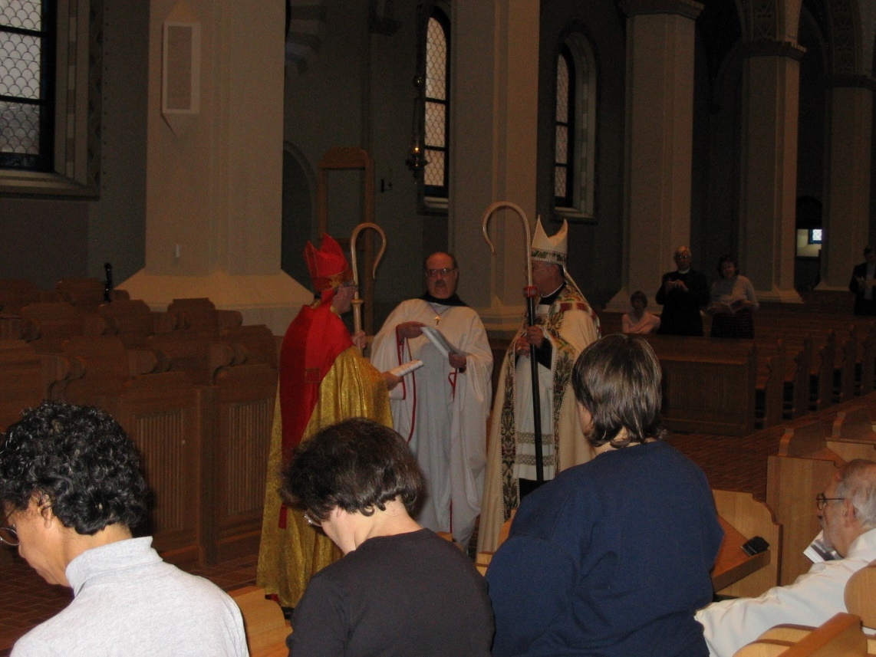
IMG 0125 Sr. Julian Baker; Br. Alan Scarfe; Sr. Cecelia Lamoy; Br. Raymond Owens; Abbot Michael John Austin; Sr. Pauline Tysol
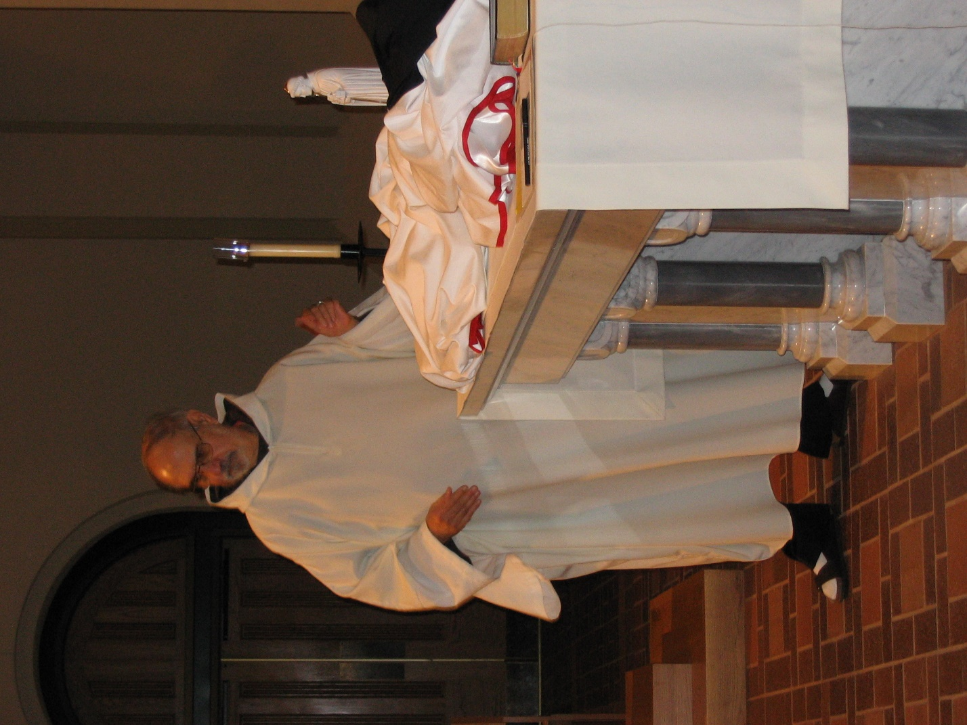
IMG 0126 Br. Joseph Benedict DiMauro, SA
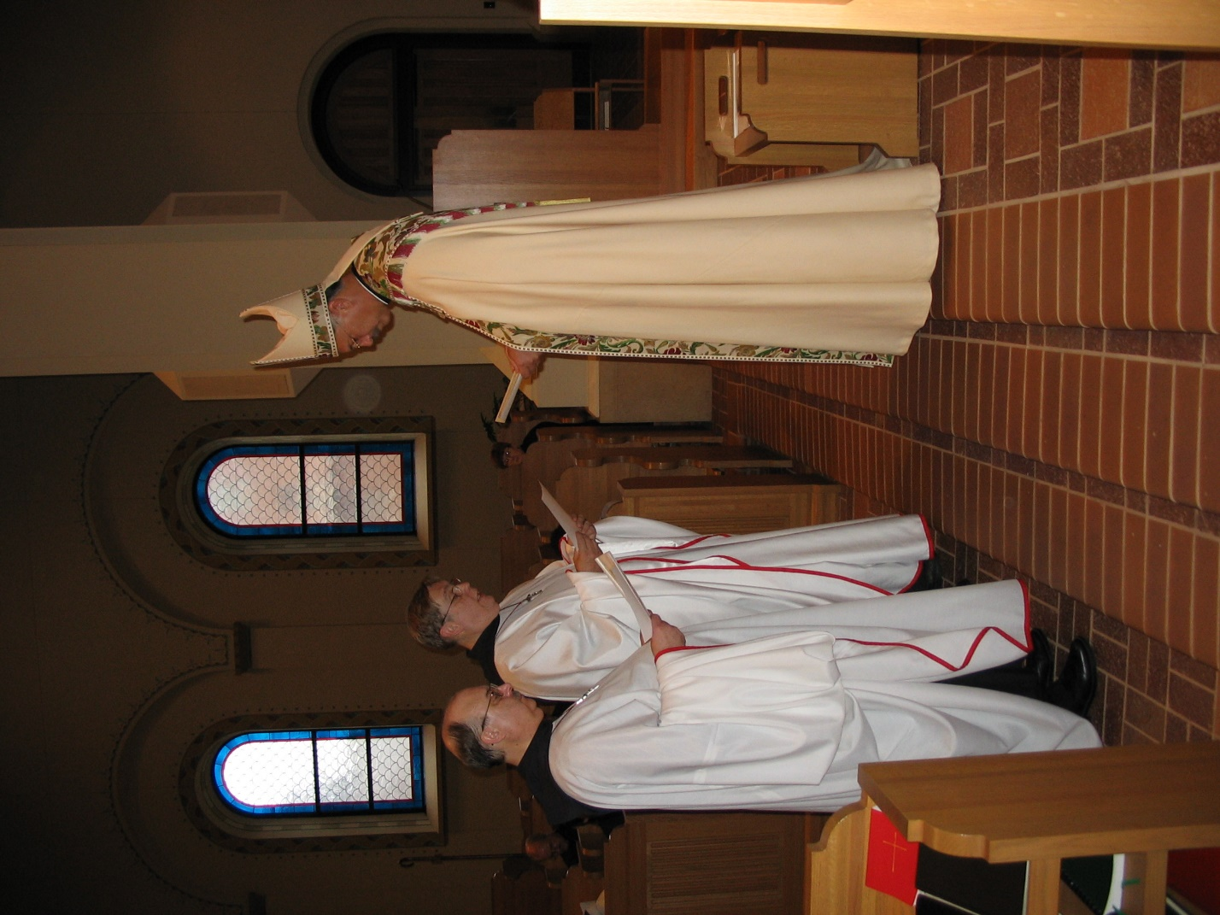
IMG 0127 Br. Raymond Owens; Br. Chad Anselm Gerns; Abbot Michael John Austin
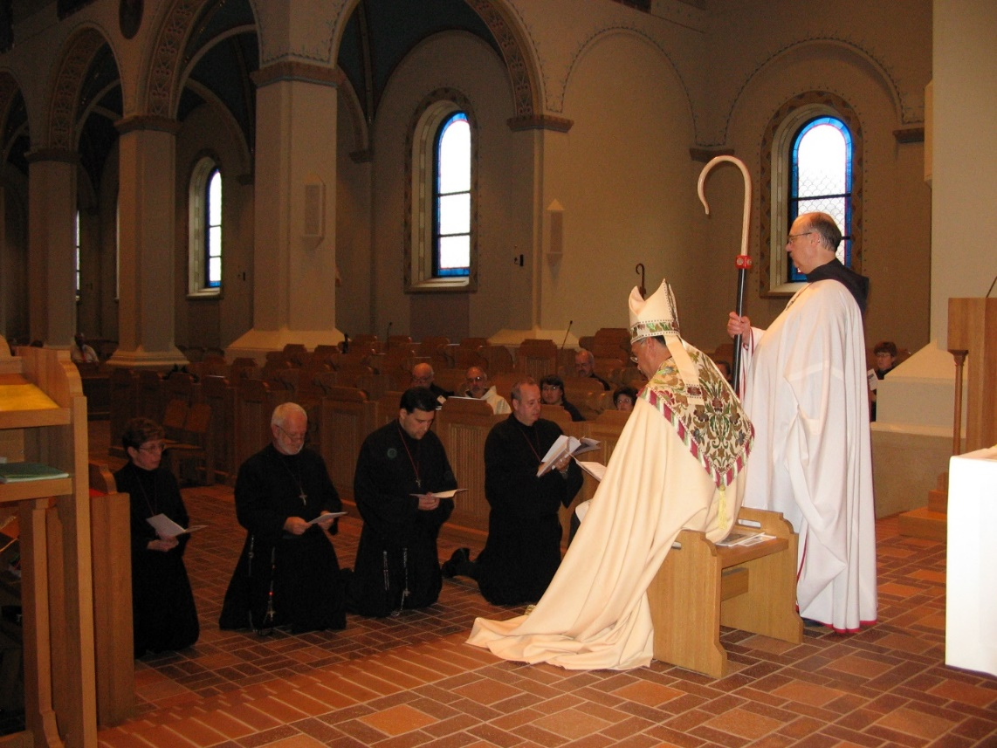
IMG 0128 Sr. Monica Ruth Mullen; Br. Christopher John Baumann; Br. Anthony Bernard Campos; Br. Gabriel Hale; Br. Joseph Benedict DiMauro, SA; Sr. Pauline Tysol; Sr. Cecelia Lamoy; Abbot Michael John Austin; Br. Raymond Owens; Sr. Brigid Gerns

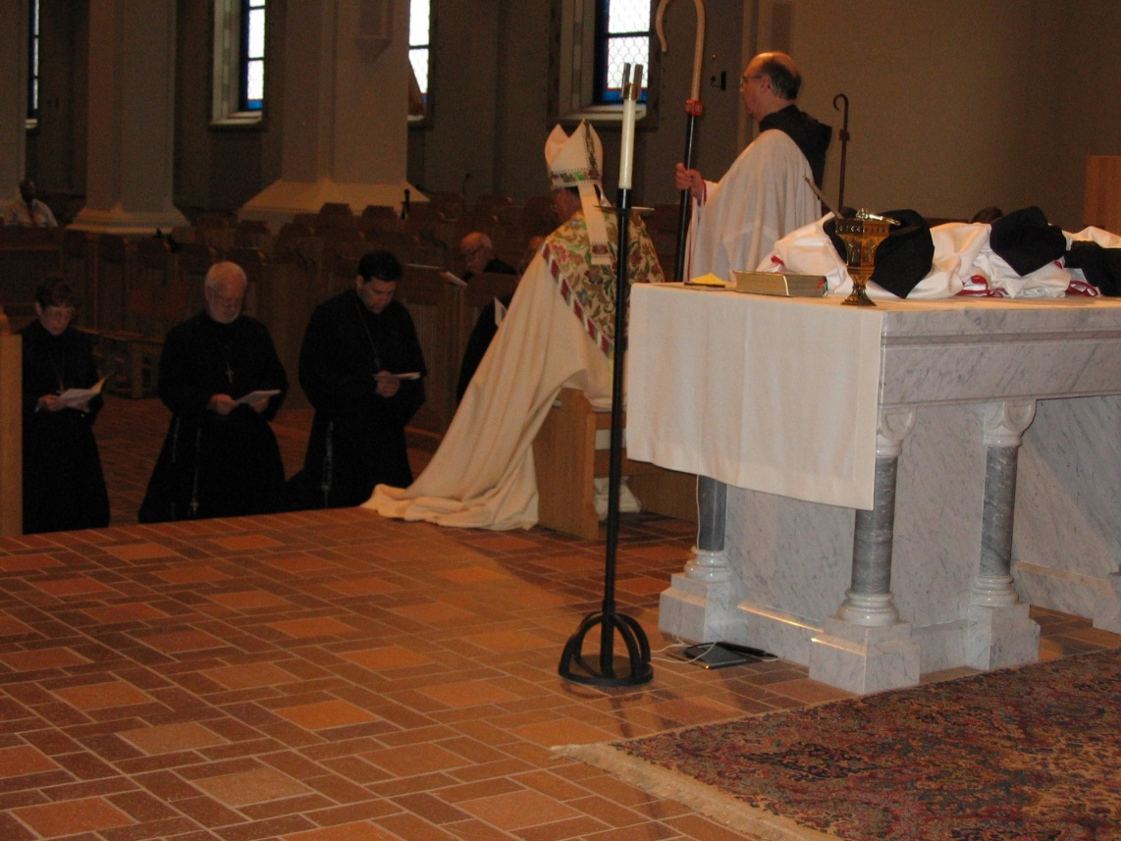
IMG 0129 Sr. Monica Ruth Mullen; Br. Christopher John Baumann; Br. Anthony Bernard Campos; Br. Benedict Truitt; Abbot Michael John Austin; Br. Raymond Owens
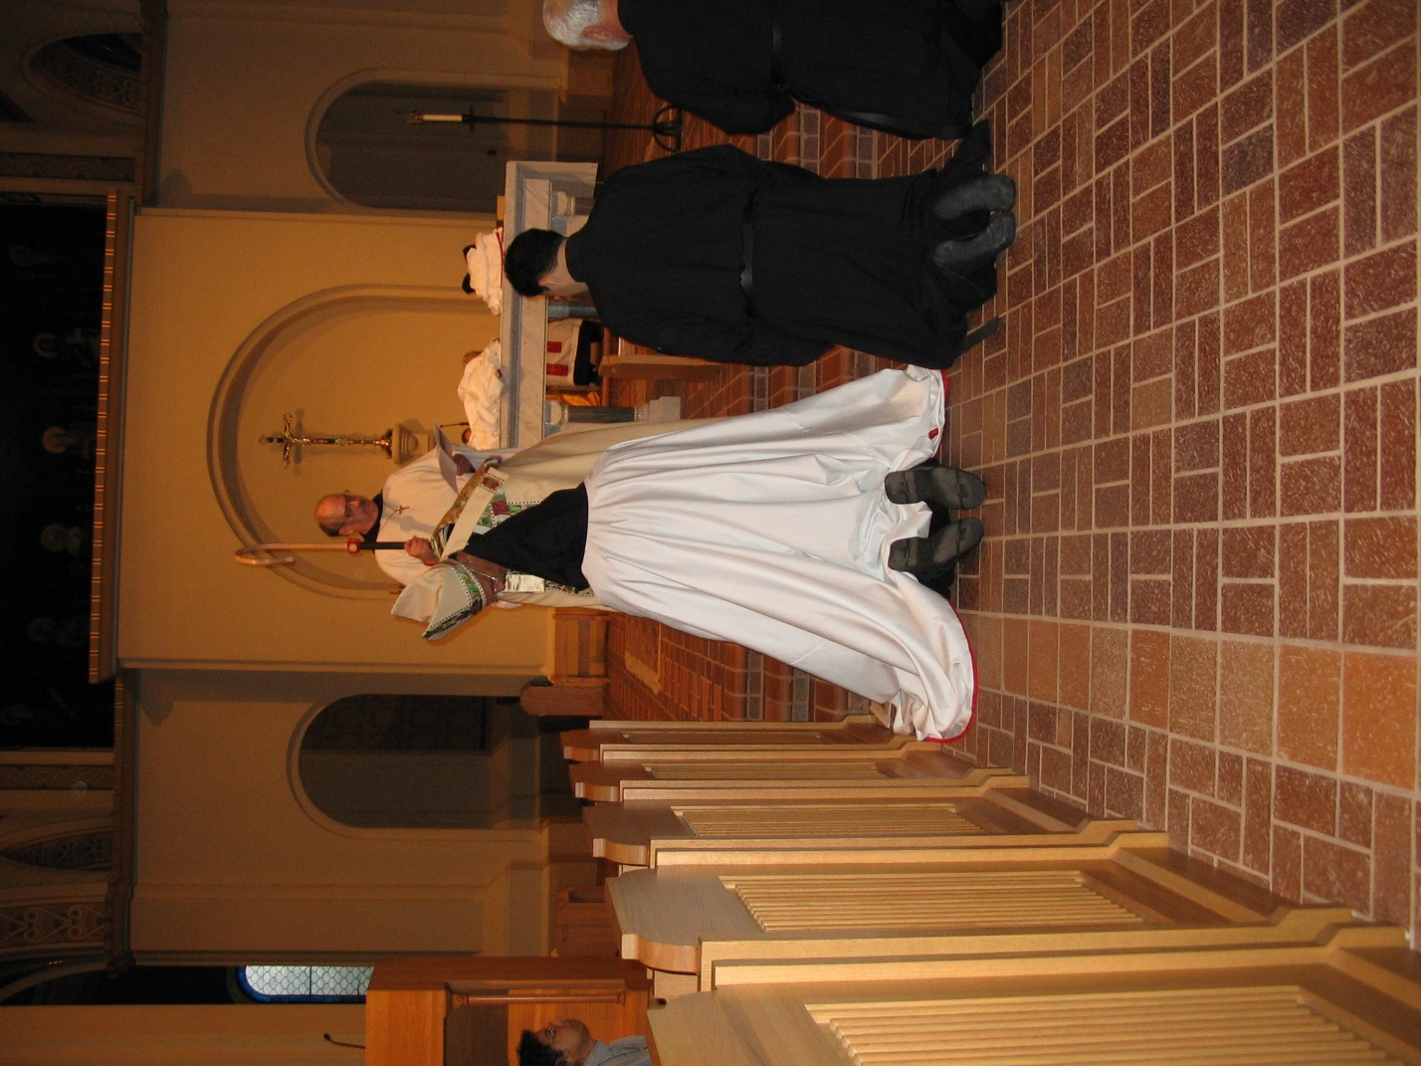
IMG 0130 Sr. Julian Baker; Abbot Michael John Austin; Br. Gabriel Hale; Br. Raymond Owens; Br. Anthony Bernard Campos; Br. Christopher Baumann
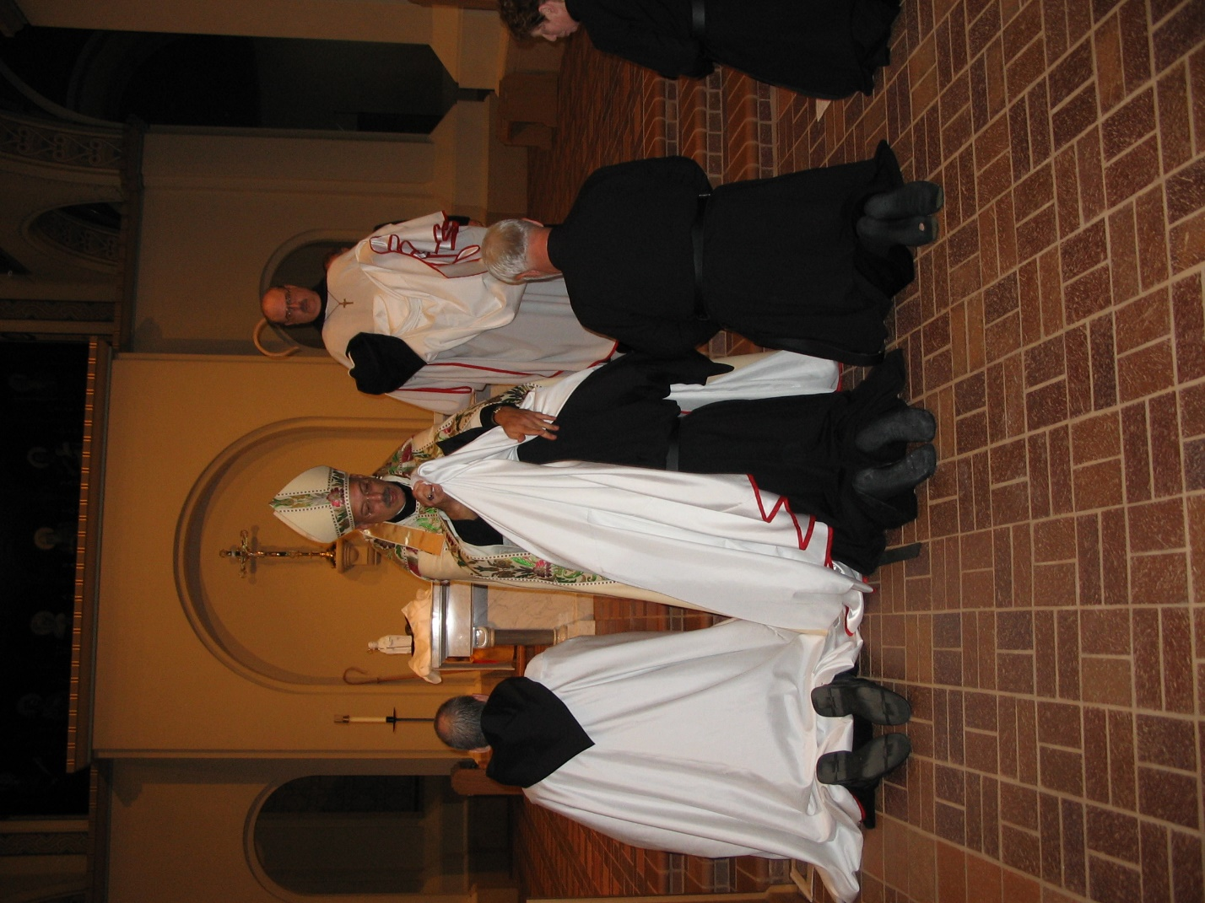
IMG 0131 Br. Gabriel Hale; Abbot Michael John Austin; Br. Anthony Bernard Campos; Br. Raymond Owens; Br. Christopher John Baumann; Sr. Monica Ruth Mullen
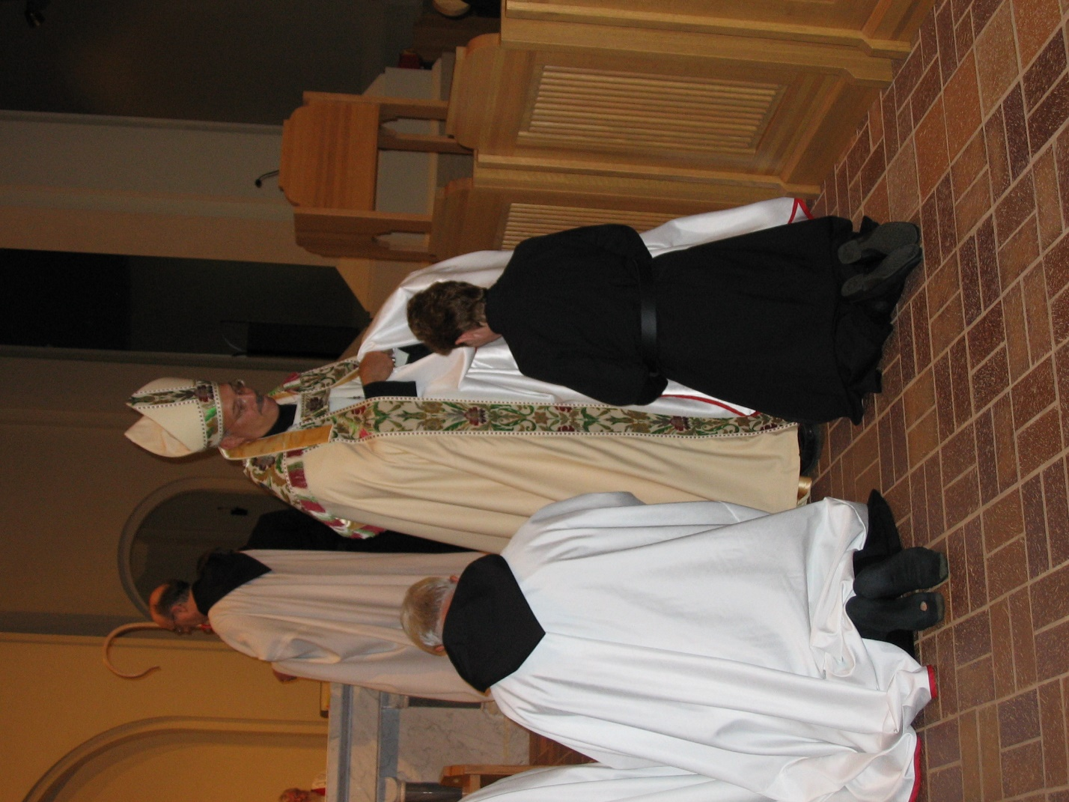
IMG 0132 Br. Christopher John Baumann; Br. Raymond Owens; Abbot Michael John Austin; Sr. Monica Ruth Mullen

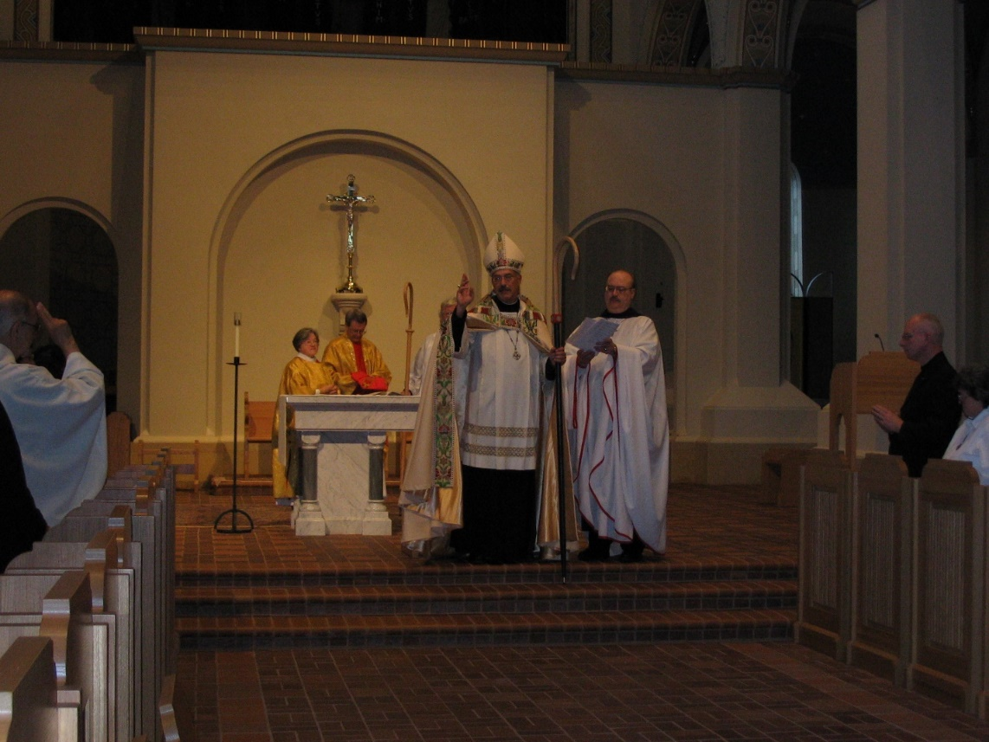
IMG 0133 Br. Joseph Benedict DiMauro, SA; Deacon Dian Ong; Br. Alan Scarfe; Fr. Wayne Kamm; Abbot Michael John Austin; Br. Raymond Owens; Br. David Vincent Cotton; Sr. Vincent Marie Rittenhouse

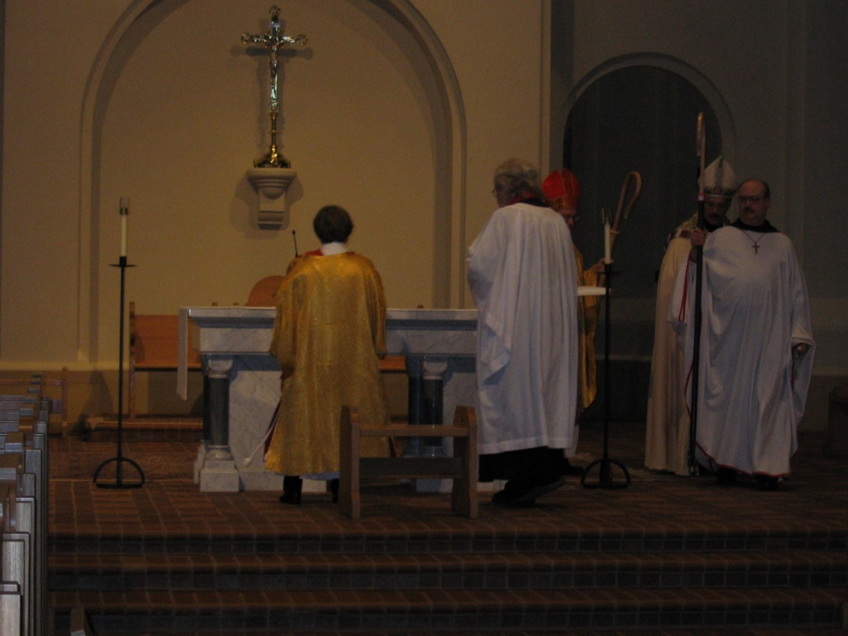
IMG 0134 Deacon Dian Ong; Fr. Wayne Kamm; Bp. Alan Scarfe; Abbot Michael John Austin; Br. Raymond Owens
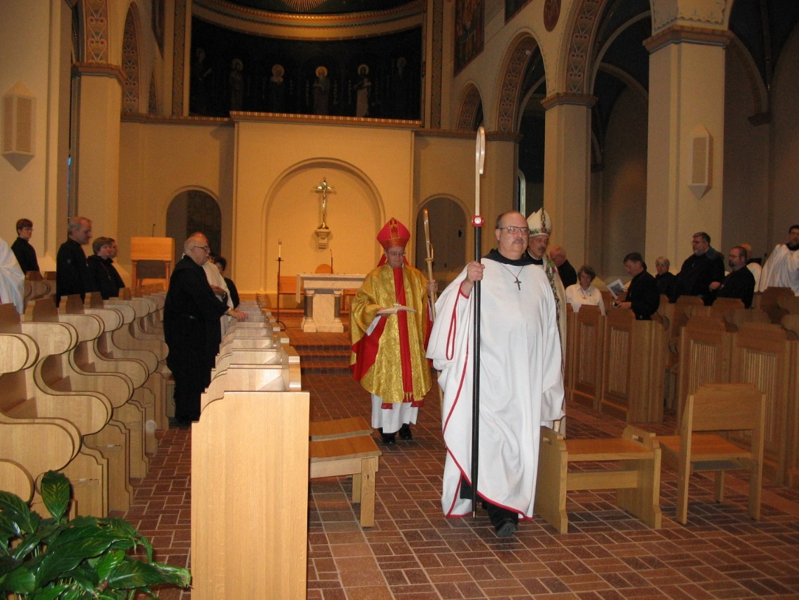
IMG 0135 Sr. Brigid Gerns; Br. Daniel Joseph Schroeder; St. Catherine Unterseher; Br. Benedict Truitt; Bp. Alan Scarfe; Br. Raymond Owens; Abbot Michael John Austin; Br. David Vincent Cotton; Sr. Vincent Marie Rittenhouse; Br. Camillus Converse; Sr. Clare Benedicta Rittenhouse; Br. Nathan Gregory Miller; Br. Willard Moore; Br. Anthony Bernard Campos

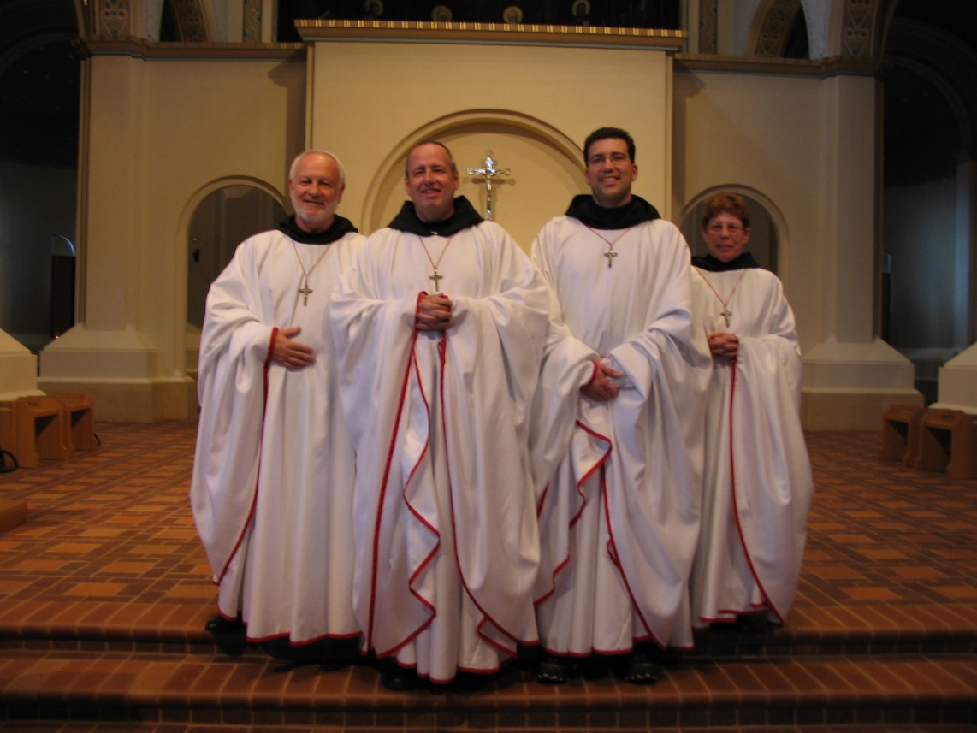
IMG 0136 Br. Christopher John Baumann; Br. Gabriel Hale; Br. Anthony Bernard Campos; Sr. Monica Ruth Mullen
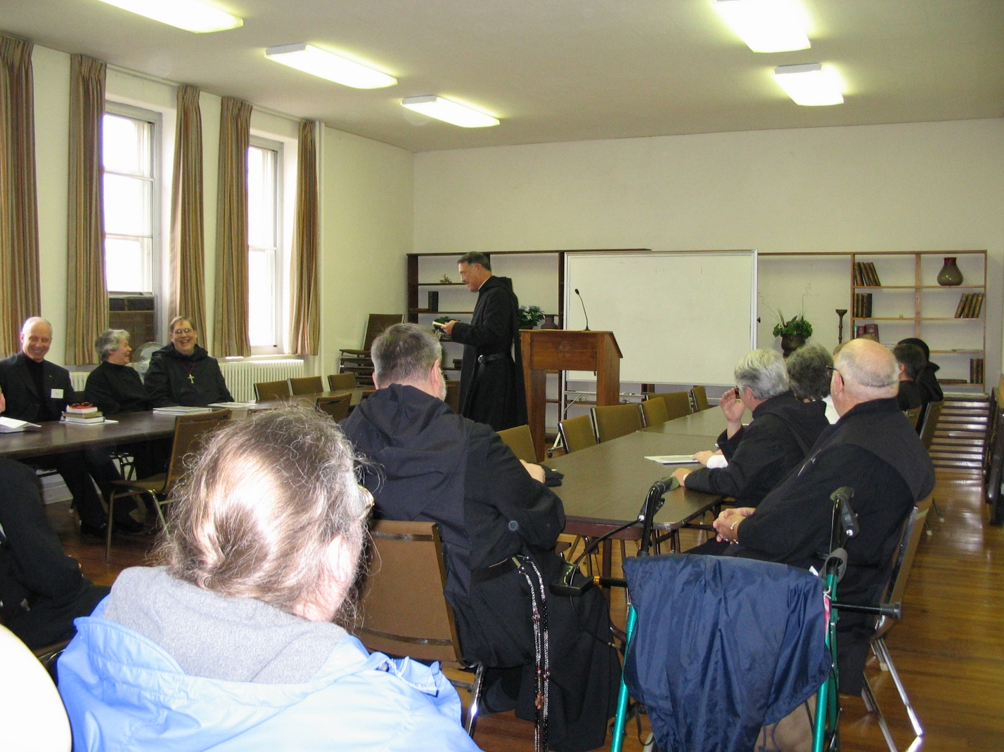
IMG 0137 Br. David Vincent Cotton; Sr. Johanna Kirkpatrick; Br. Chad Anselm Gerns; Sr. Margaret Moore; Br. Nathan Gregory Miller; Abbot Michael John Austin; Sr. Clare Benedicta Rittenhouse; Sr. Vincent Marie Rittenhouse; Br. Benedict Truitt
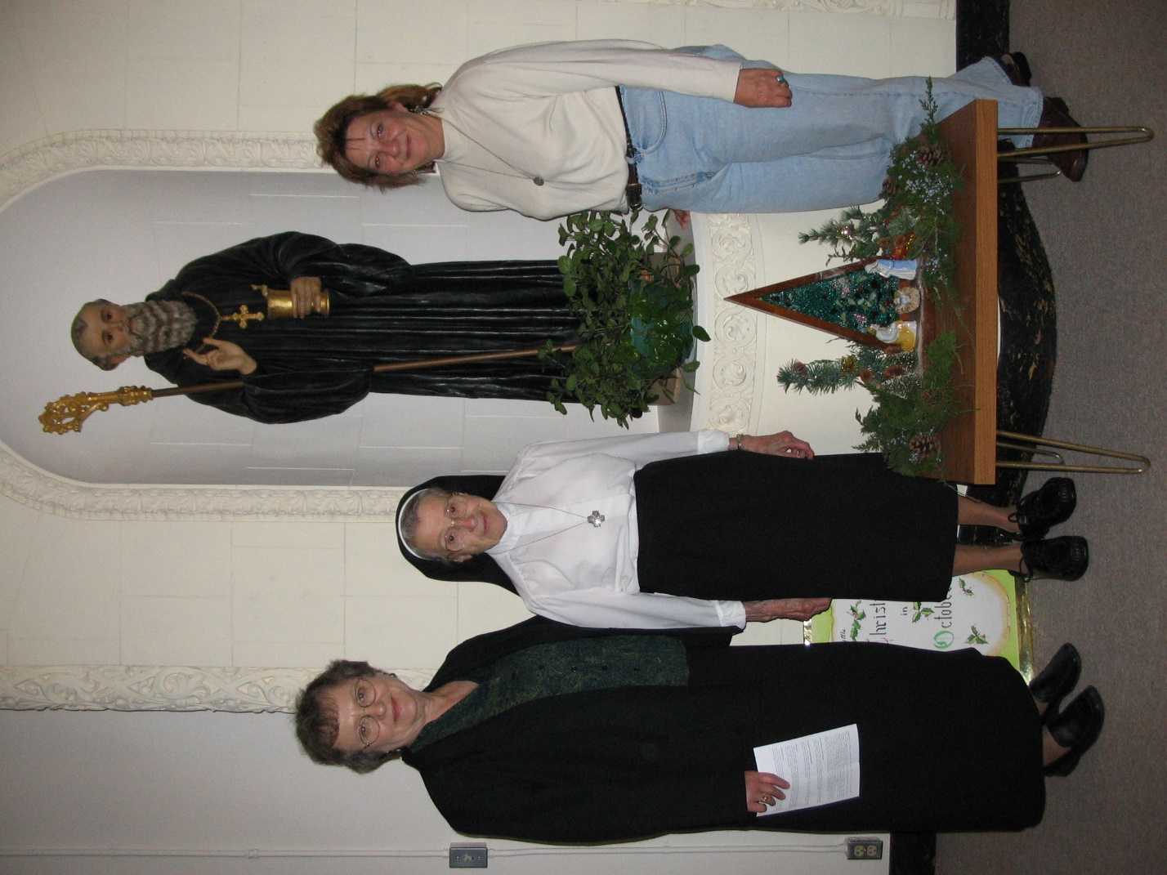
IMG 0138 Mary Kamm; Sister from the Clyde, MO Convent; Shelley McKeehan
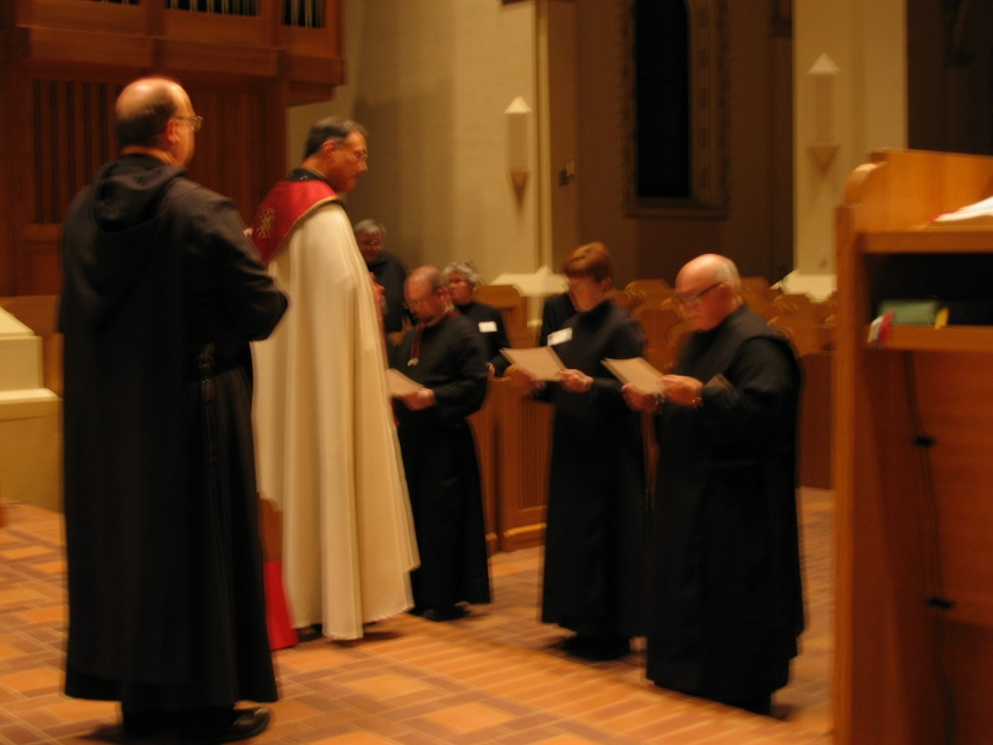
IMG 0139 Br. Raymond Owens; Abbot Michael John Austin; Br. Nathan Gregory Miller; Br. Willard Moore; Sr. Johanna Kirkpatrick; Sr. Brigid Gerns; Br. Benedict Truitt

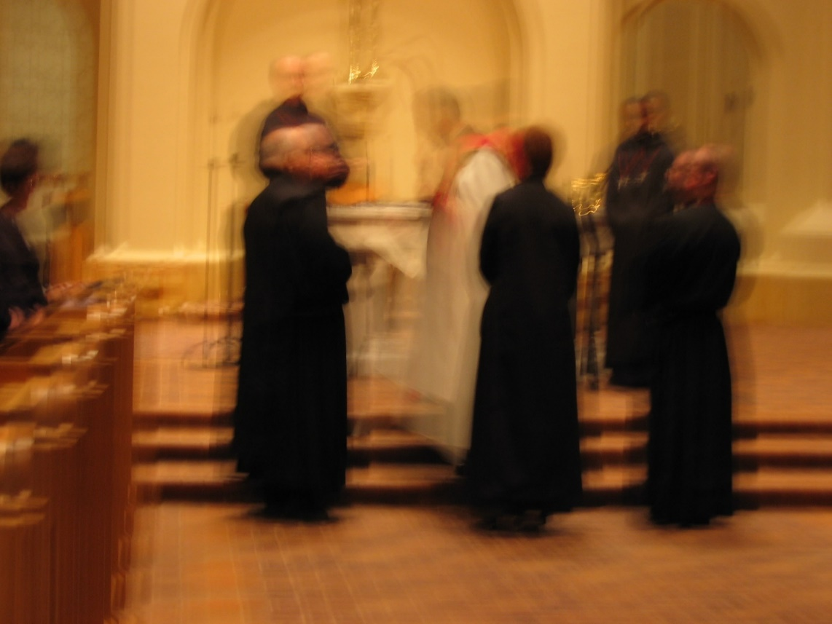
IMG 0140 Br. Raymond Owens; Br. Benedict Truitt; Abbot Michael John Austin; Sr. Brigid Gerns; Br. Thomas Ferrell; Br. Willard Moore
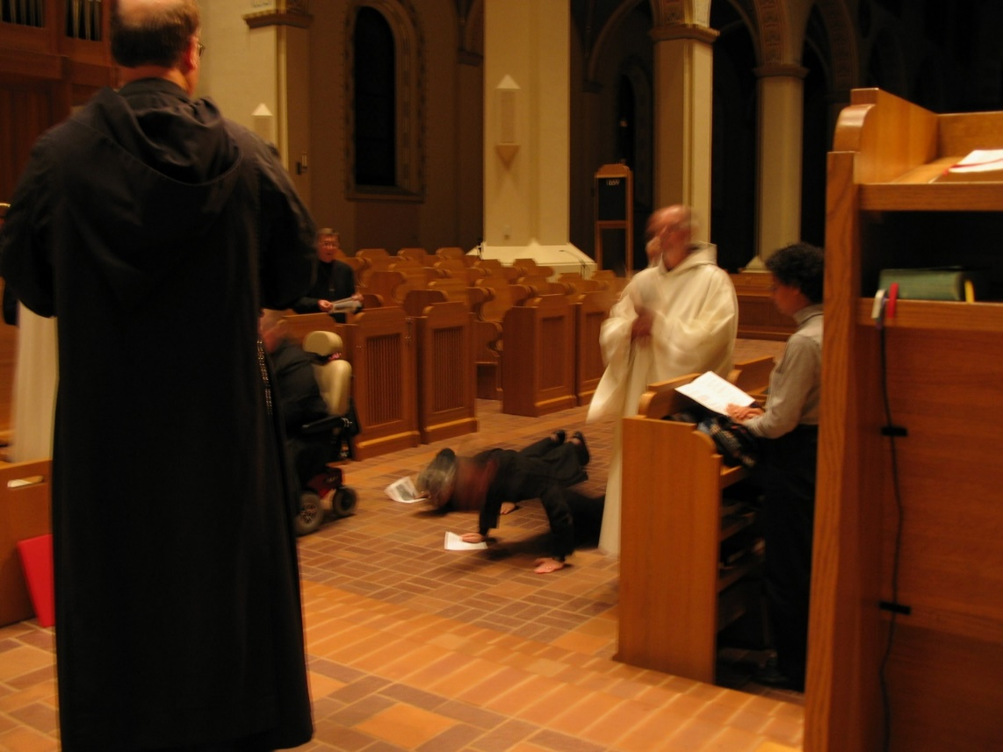
IMG 0141 Br Raymond Owens; Br. Camillus Converse; Sr. Margaret Moore; Sr. Johanna Kirkpatrick; Br. Lawrence Mullen; Br. Joseph Benedict DiMauro, SA; Sr. Julian Baker

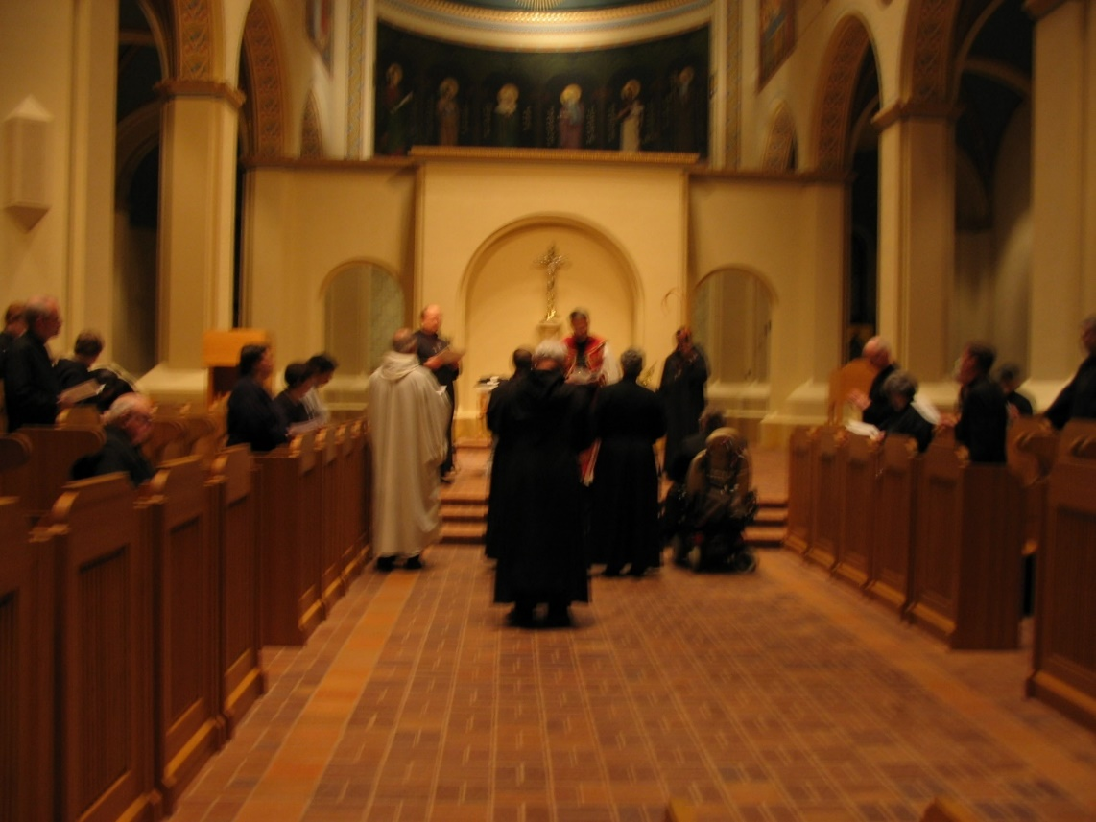
IMG 0142 Br. Joseph Benedict DiMauro, SA; Br. Raymond Owens; Br. Lawrence Mullen; ; Br. Christopher John Baumann; Abbot Michael John Austin; Sr. Johanna Kirkpatrick; Br. Thomas Ferrell; Sr. Margaret Moore
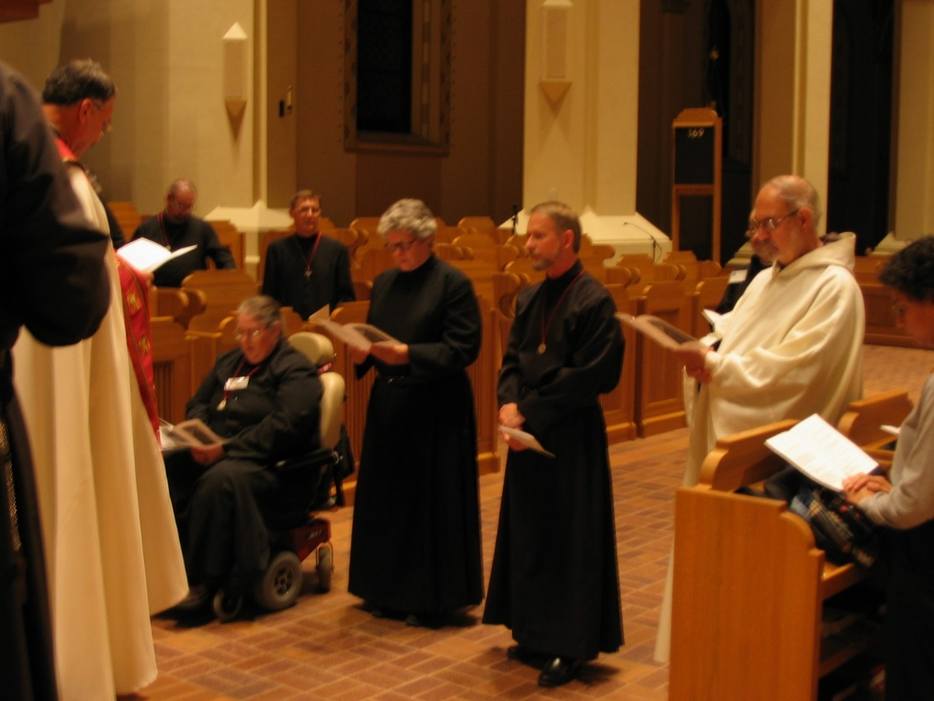
IMG 0143 Abbot Michael John Austin; Br. Willard Moore; Sr. Margaret Moore; Br. Camillus Converse; Sr. Johanna Kirkpatrick; Br. Lawrence Mullen; Br. Joseph Benedict DiMauro, SA; Sr. Julian Baker

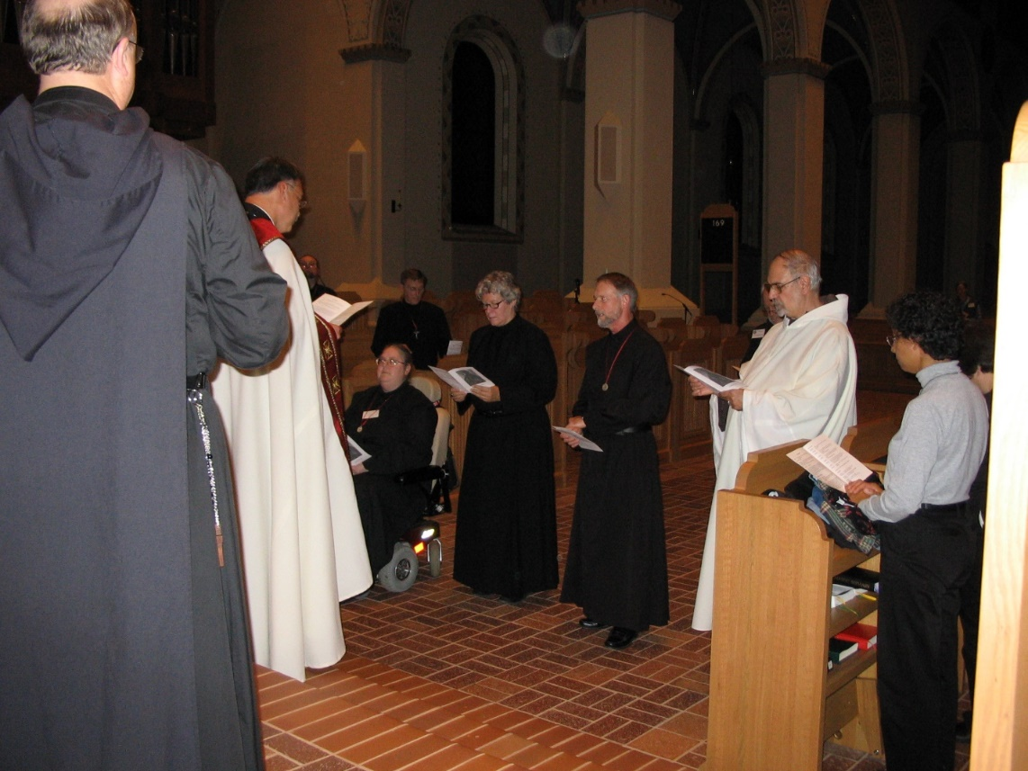
IMG 0144 Br. Raymond Owens; Abbot Michael John Austin; Sr. Margaret Moore; Br. Camillus Converse; Sr. Johanna Kirkpatrick; Br. Lawrence Mullen; Br. Joseph Benedict DiMauro, SA; Sr. Julian Baker
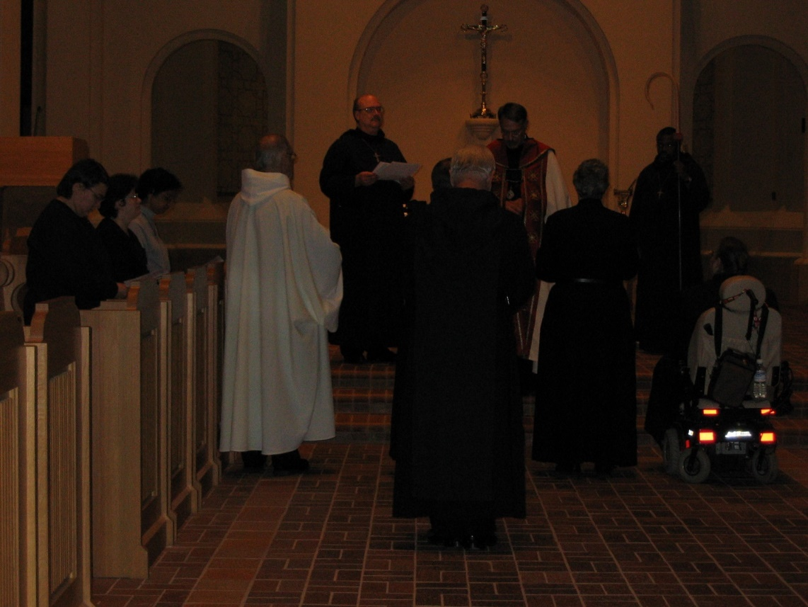
IMG 0145 Sr. Pauline Tysol; Sr. Cecelia Lamoy; Sr. Julian Baker; Br. Joseph Benedict DiMauro, SA; Br. Raymond Owens; Br. Lawrence Mullen; Br. Christopher John Baumann; Abbot Michael John Austin; Sr. Johanna Kirkpatrick; Br. Thomas Ferrell; Sr. Margaret Moore

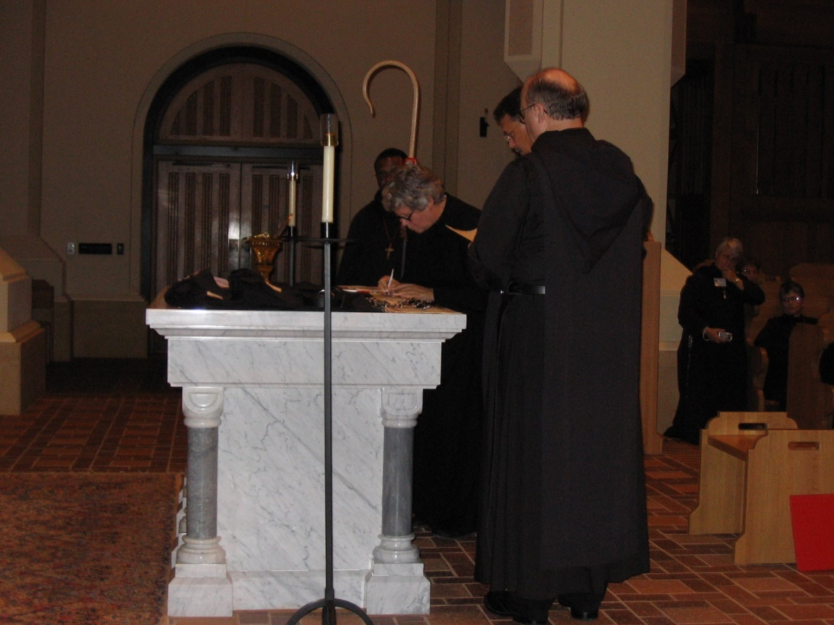
IMG 0146 Br. Thomas Ferrell; Sr. Johanna Kirkpatrick; Abbot Michael John Austin; Br. Raymond Owens; Sr. Clare Benedicta Meyers; Sr. Anna Grace Madden
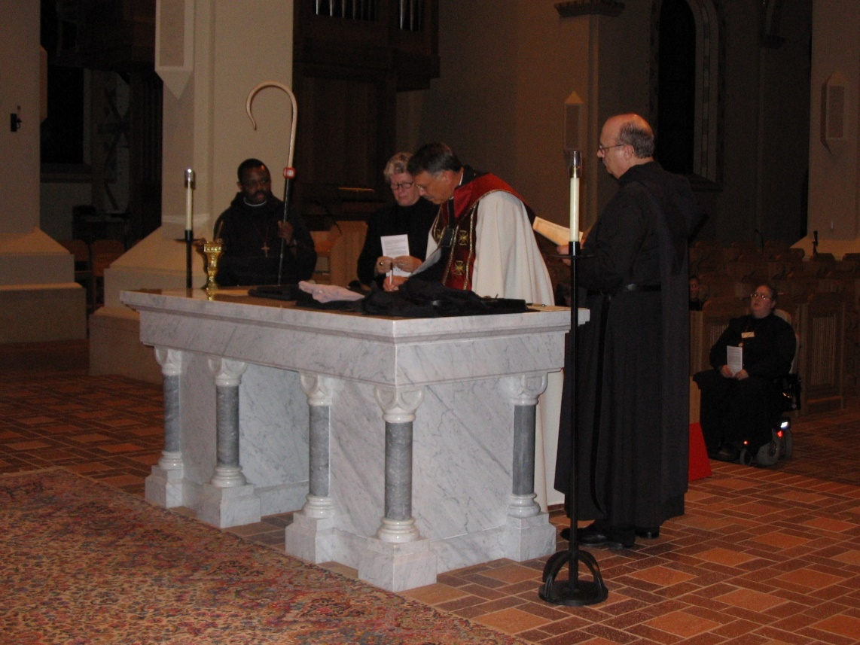
IMG 0147 Br. Thomas Ferrell; Sr. Johanna Kirkpatrick; Abbot Michael John Austin; Br. Raymond Owens; Sr. Margaret Moore

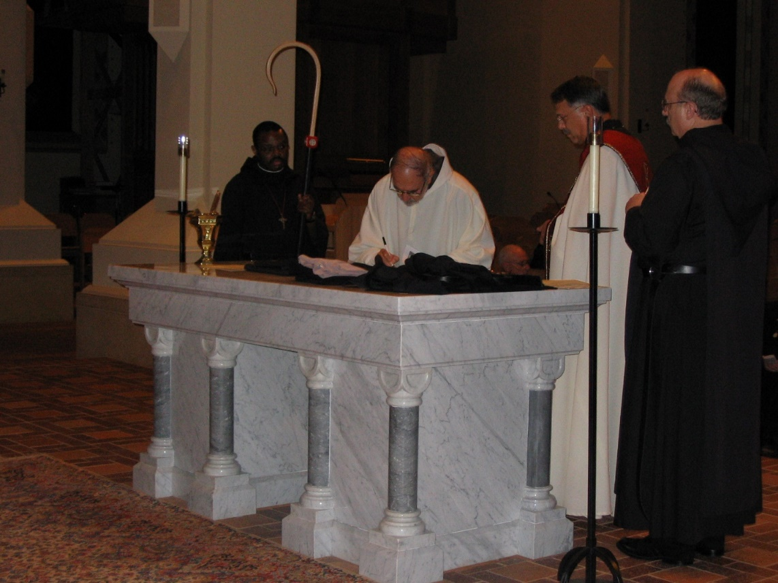
IMG 0148 Br. Thomas Ferrell; Br. Joseph Benedict DiMauro, SA; Abbot Michael John Austin; Br. Raymond Owens
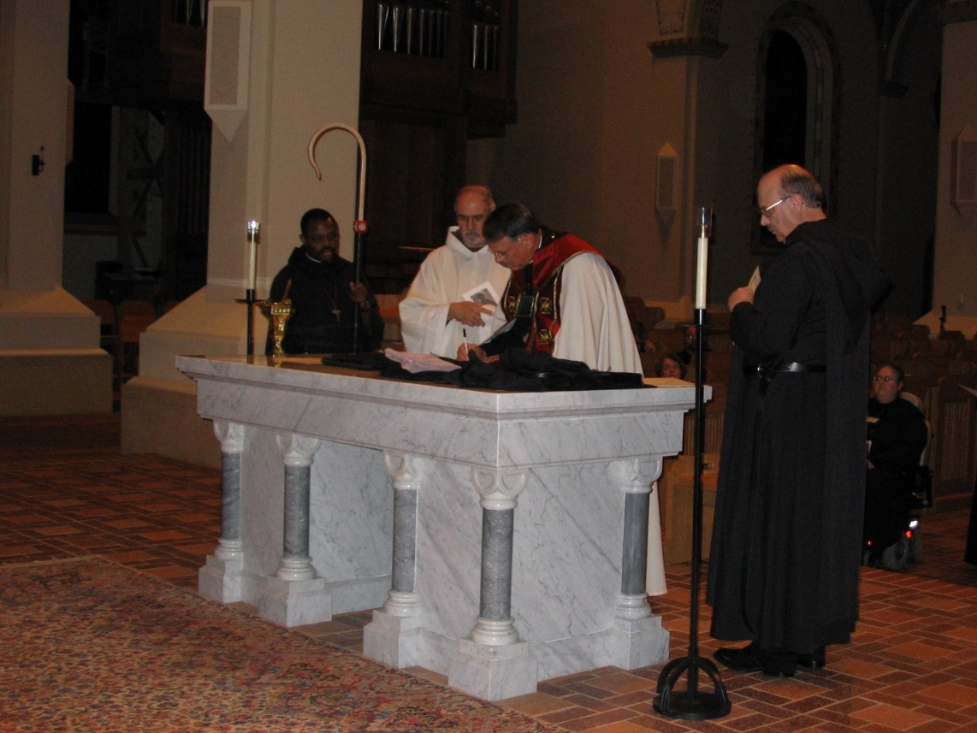
IMG 0149 Br. Thomas Ferrell; Br. Joseph Benedict DiMauro, SA; Abbot Michael John Austin; Sr. Vincent Marie Rittenhouse; Br. Raymond Owens; Sr. Margaret Moore

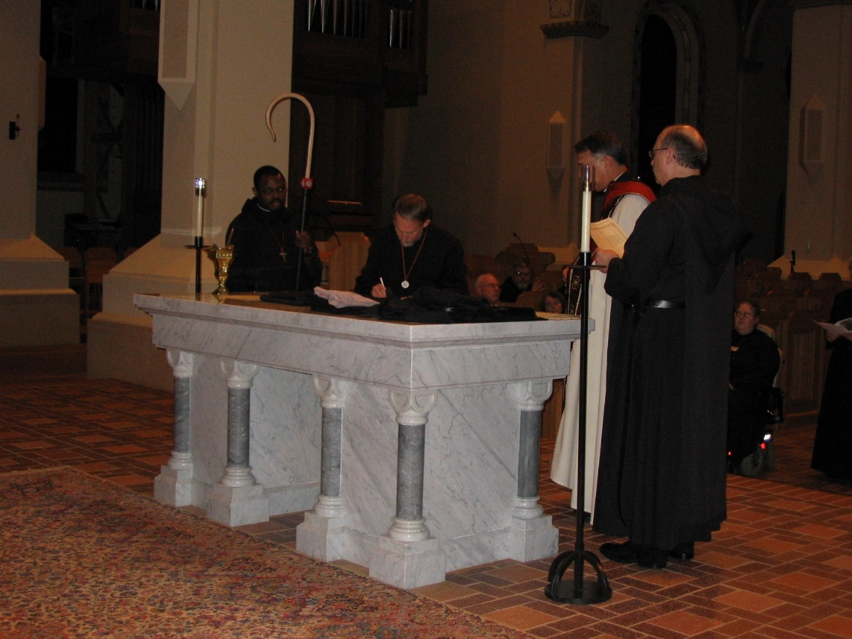
IMG 0150 Br. Thomas Ferrell; Br. Lawrence Mullen; Br. David Vincent Cotton; Abbot Michael John Austin; Br. Raymond Owens; Sr. Margaret Moore
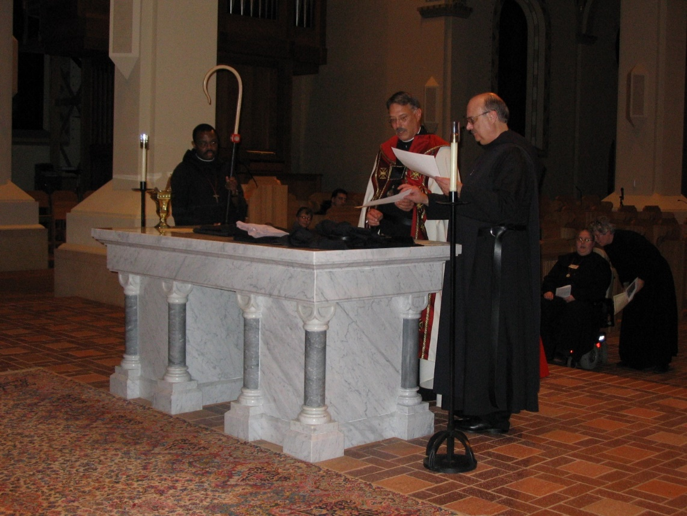
IMG 0151 Br. Thomas Ferrell; Abbot Michael John Austin; Br. Raymond Owens; Sr. Margaret Moore; Sr. Johanna Kirkpatrick
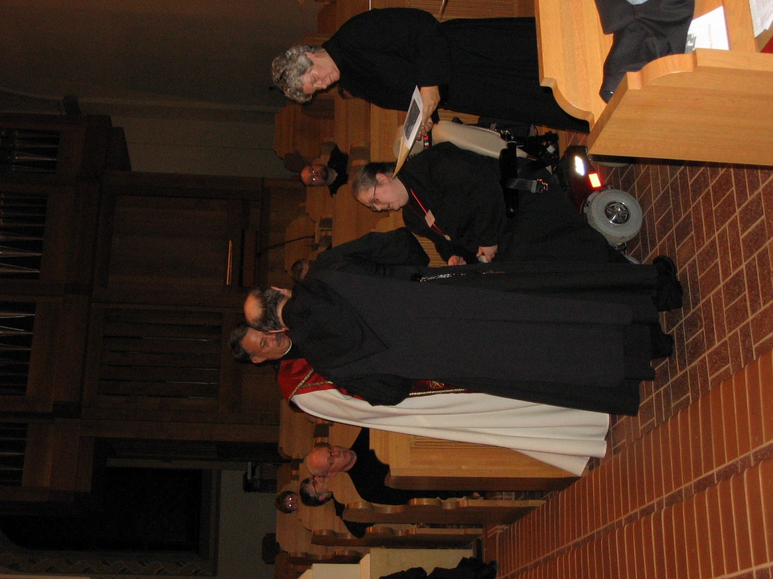
IMG 0152 Sr. Monica Ruth Mullen; Sr. Anna Grace Madden; Br. David Vincent Cotton; Abbot Michael John Austin; Br. Raymond Owens; Sr. Margaret Moore; Br. Willard Moore; Sr. Johanna Kirkpatrick
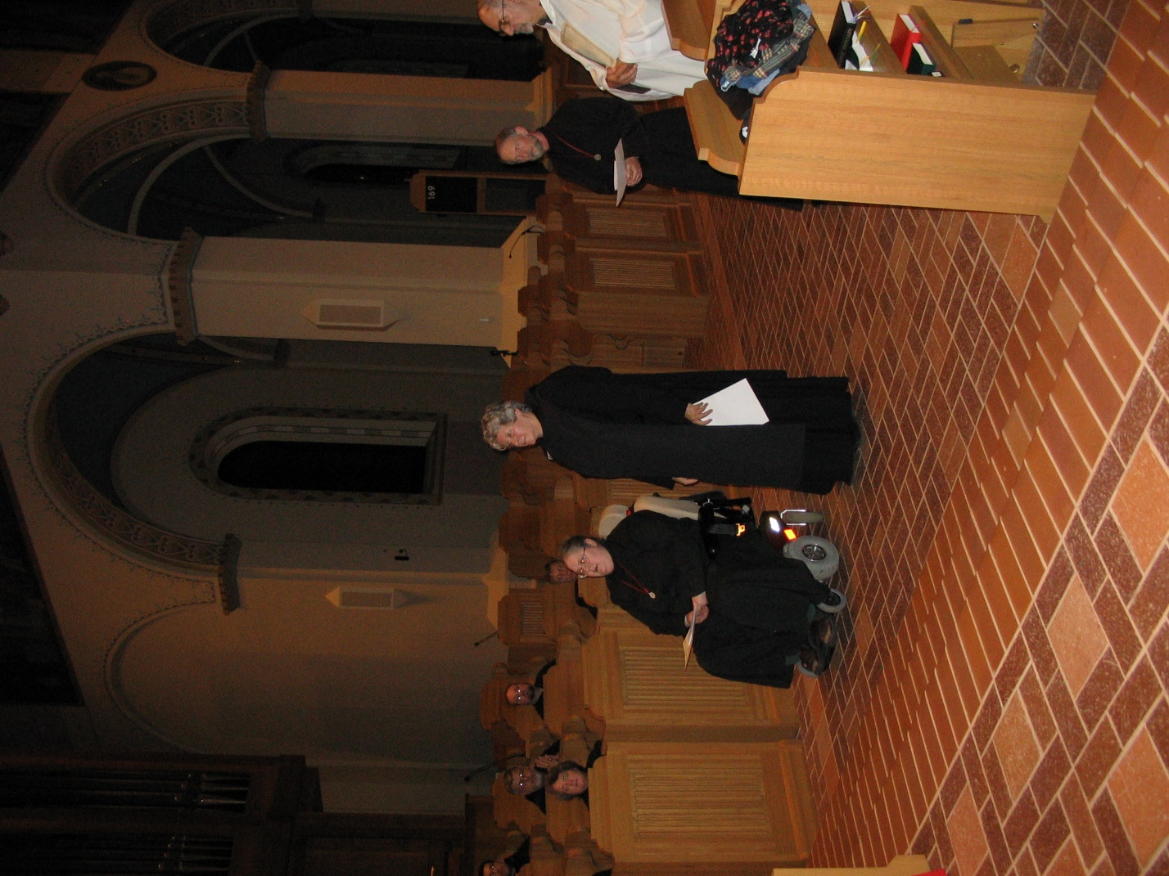
IMG 0153 Sr, Vincent Marie Rittenhouse; Br. Nathan Gregory Miller; Br. Willard Moore; Sr. Margaret Moore; Sr. Johann Kirkpatrick; Br. Lawrence Mullen; Br. Joseph Benedict DiMauro, SA
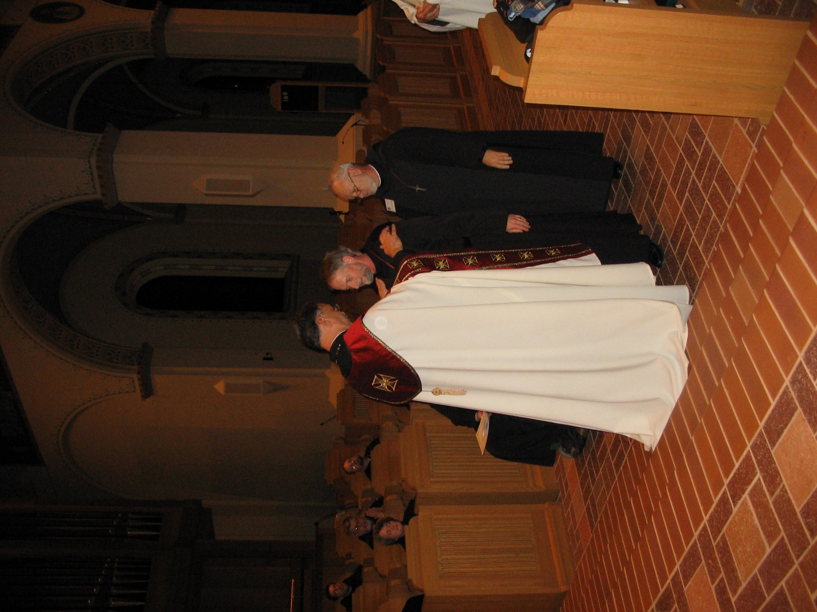
IMG 0154 Br. Anthony Bernard Campos; Br. Nathan Gregory Miller; Sr. Vincent Marie Rittenhouse; Br. Willard Moore; Sr. Margaret Moore; Abbot Michael John Austin; Br. Lawrence Mullen; Br. Christopher John Baumann
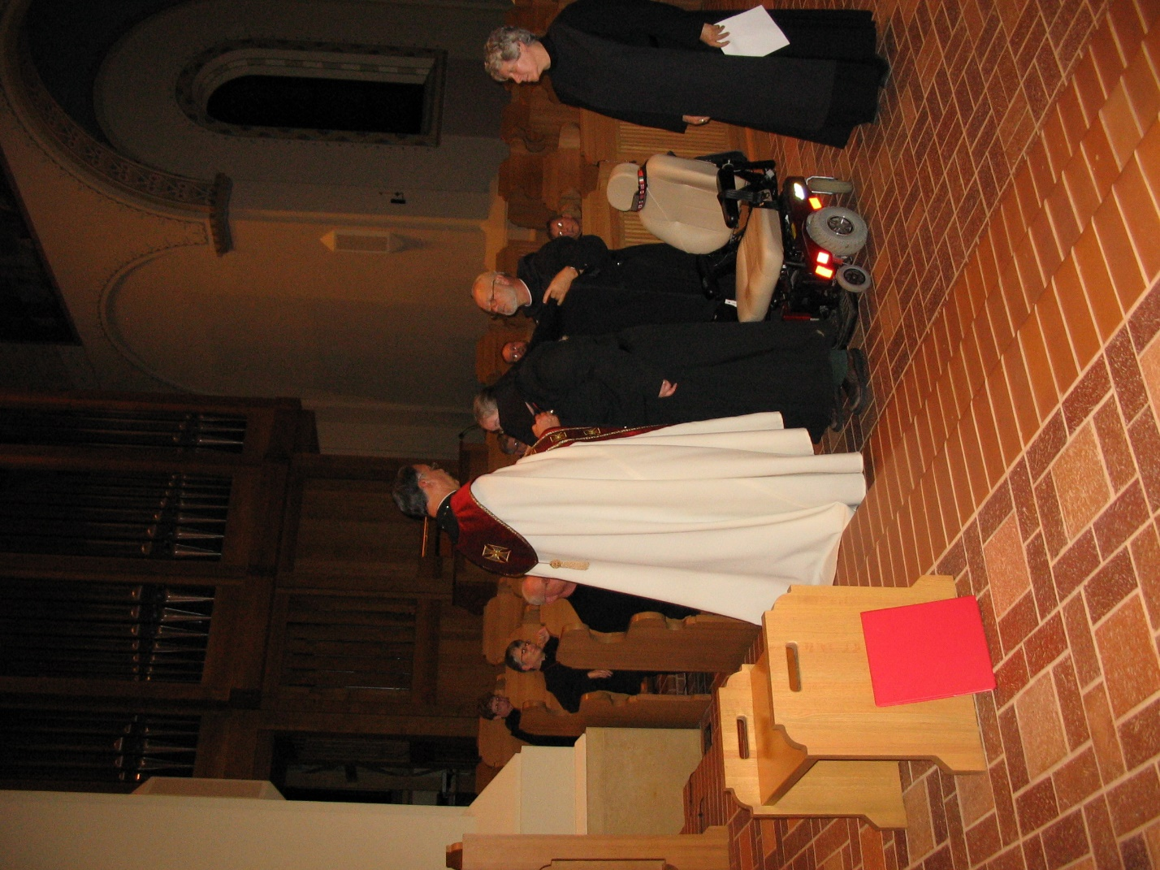
IMG 0155 Sr. Monica Ruth Mullen; Sr. Anna Grace Madden; Br. David Vincent Cotton; Abbot Michael John Austin; Br. Nathan Gregory Miller; Sr. Margaret Moore; Br. Willard Moore; Br. Christopher John Baumann; Br. Camillus Converse; Sr. Johanna Kirkpatrick
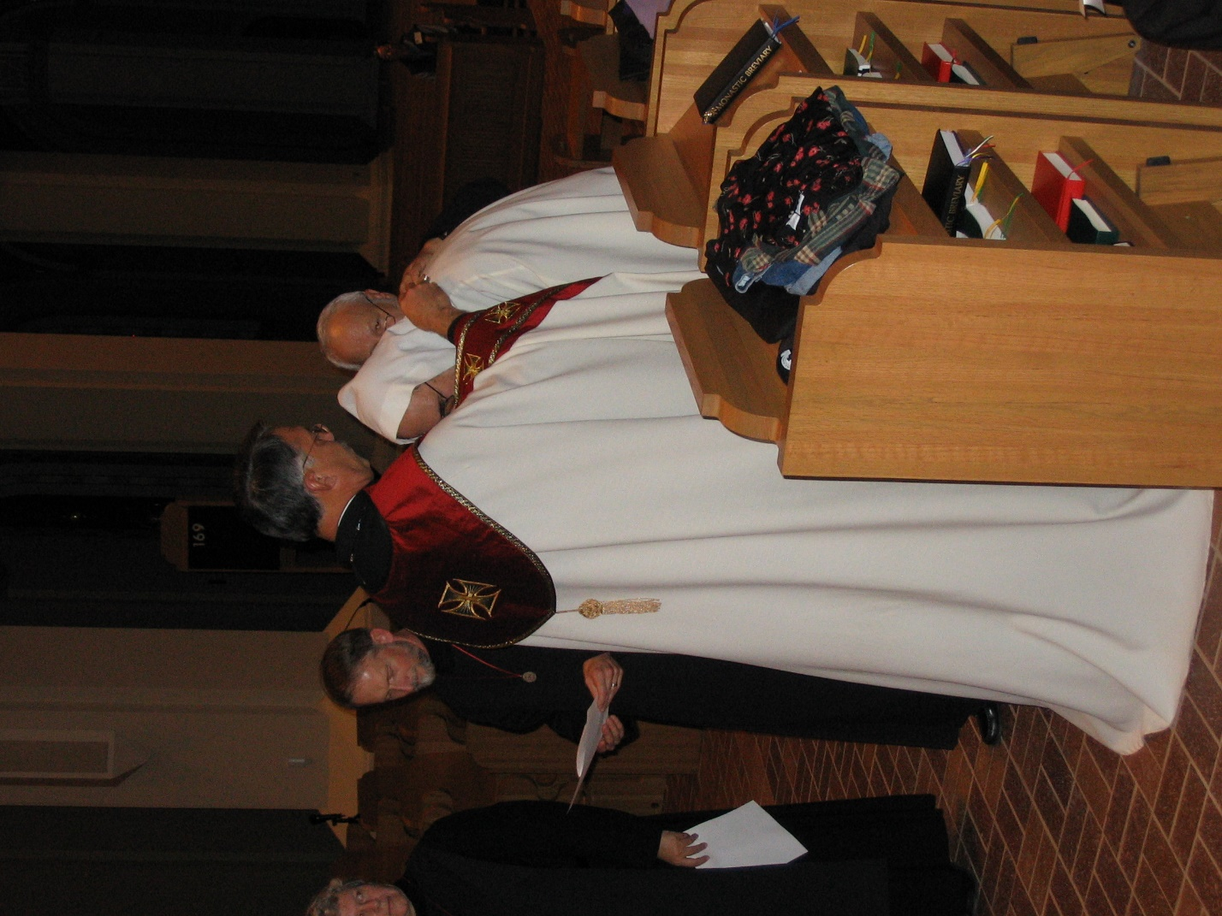
IMG 0156 Sr. Johanna Kirkpatrick; Br. Lawrence Mullen; Abbot Michael John Austin; Br. Joseph Benedict DiMauro, SA; Br. Christopher John Baumann

