Companions of St. Luke
Fall 2004 Convocation at Conception Abbey
Vol. III

~Edited by Br. Steven Olderr, 27 May 2022 with the assistance of Br. Thomas Ferrell; if you find any errors or omissions, please notify Br. Steven at olderr@ameritech.net

People are identified from left to right.

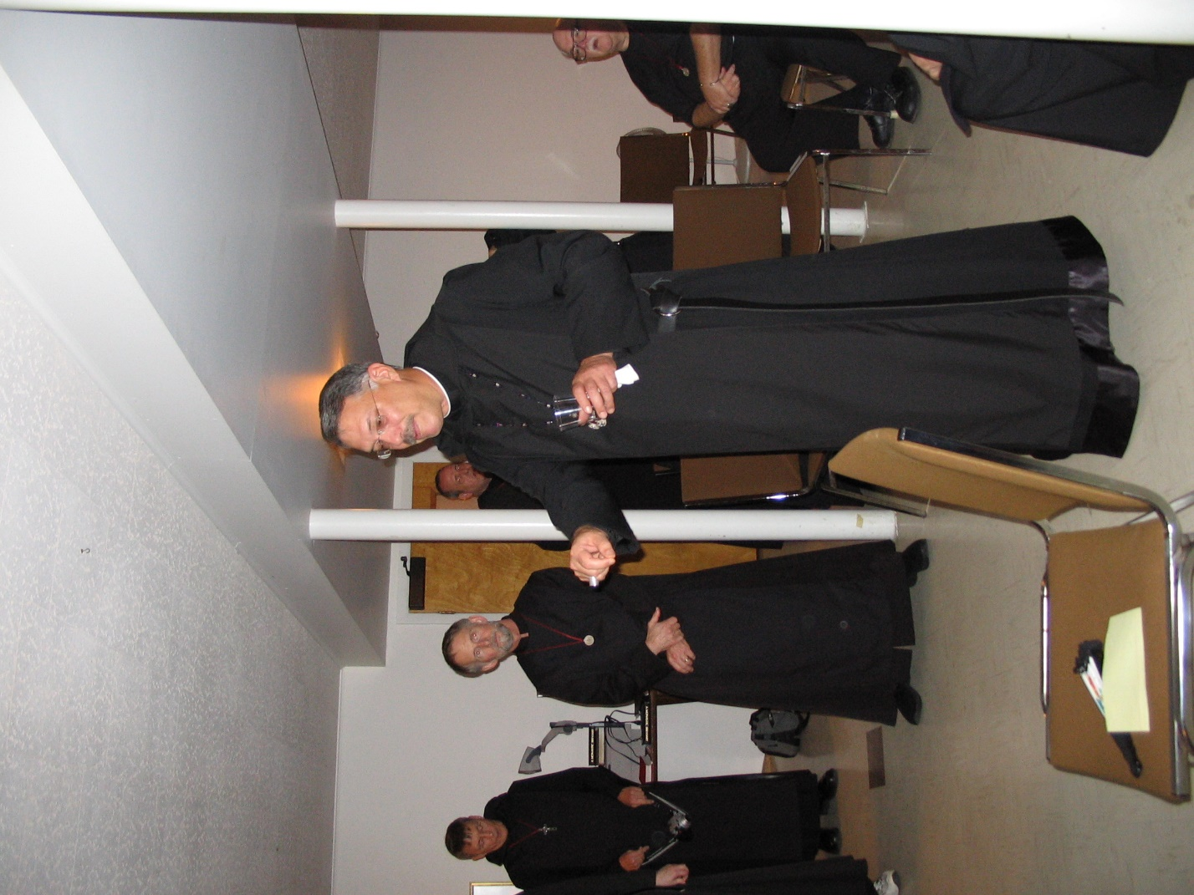
IMG 0223 Br. Camillus Converse; Br. Lawrence Mullen; Br. Gabriel Hale; Abbot Michael John Austin; Br. Benedict Truitt

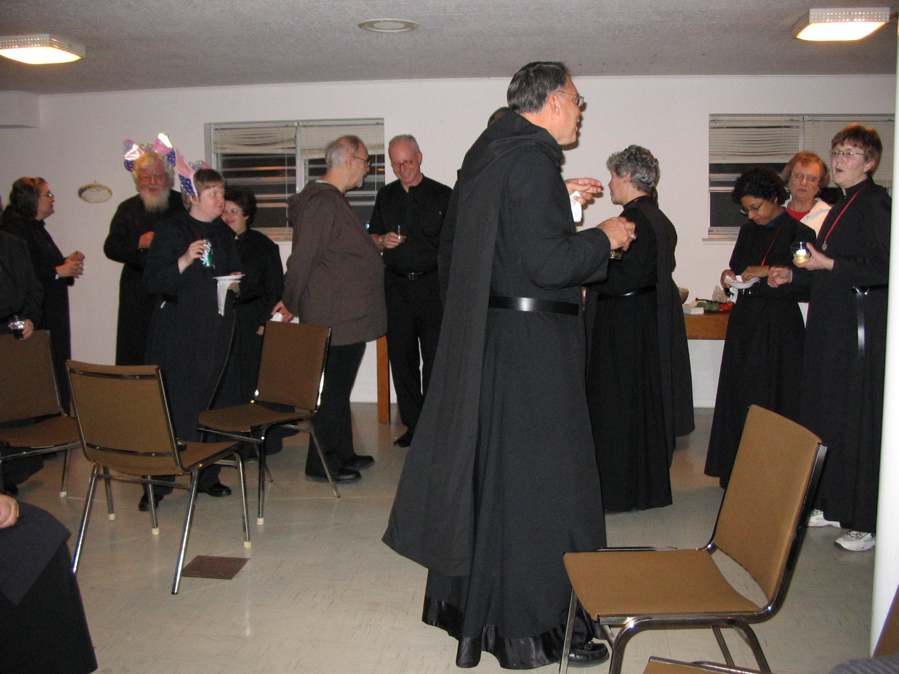
IMG 0224 Sr. Theodora of Jesus Perecca; Br. Wayne Kamm; Sr. Catherine Unterseher; Sr. Cecelia Lamoy; Br. Joseph Benedict DiMauro, SA*; Br. David Vincent Cotton; Abbot Michael John Austin; Sr. Johanna Kirkpatrick; Sr. Julian Baker; Mary Kamm; Sr. Brigid Gerns

*Br. Joseph Benedict, SA was a priest in the Franciscan Society of the Atonement, but in an act of ecumenism joined CSL as an oblate. He remained in the CSL until 2009 when Abbot Michael John Austin resigned. He then joined the House of Initia Nova, MJ’s successor community. Br. Joseph Benedict died on 29 Nov 2018.

The Society of the Atonement was originally founded as an Episcopal community but went over to the Roman Catholic Church in 1909.

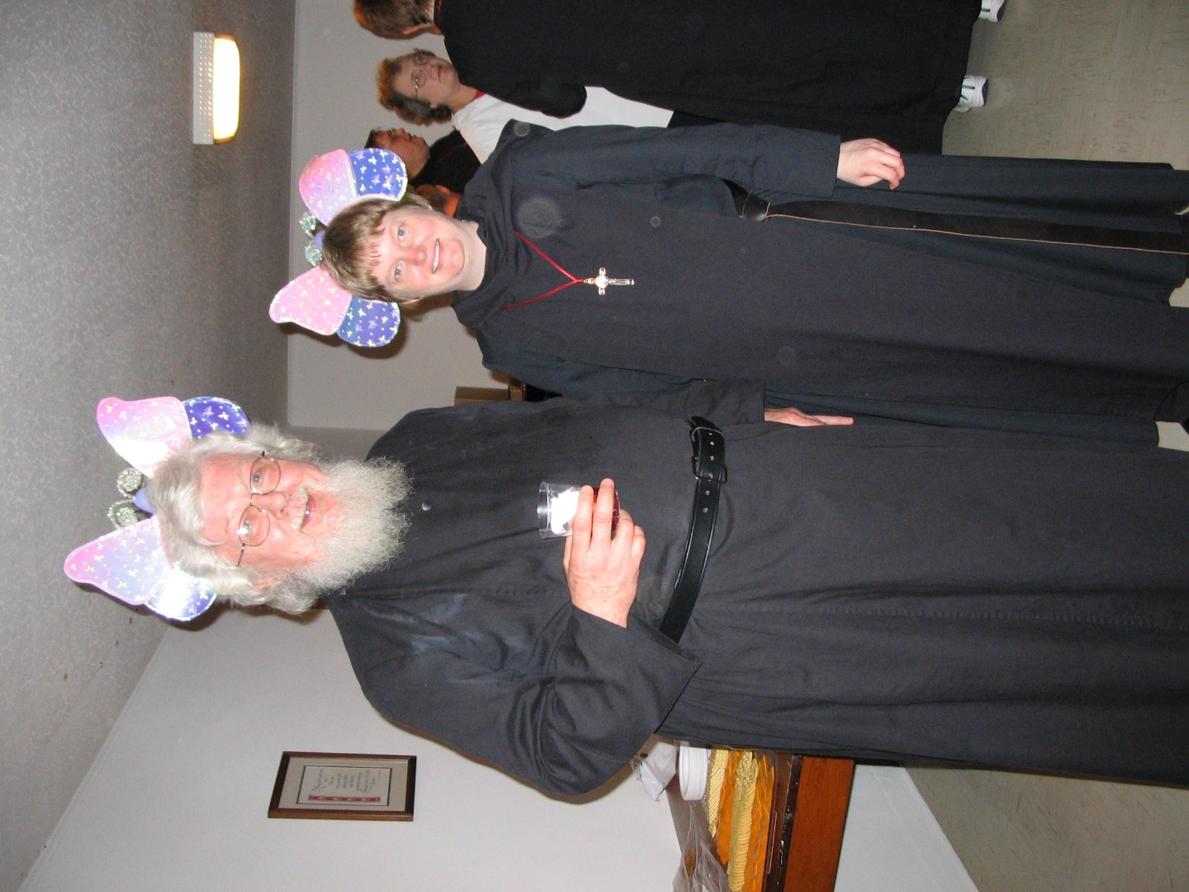
IMG 0225 Fr. Wayne Kamm; Sr. Catherine Unterseher; Br. Chad Anselm Gerns; Mary Kamm; Sr. Brigid Gerns
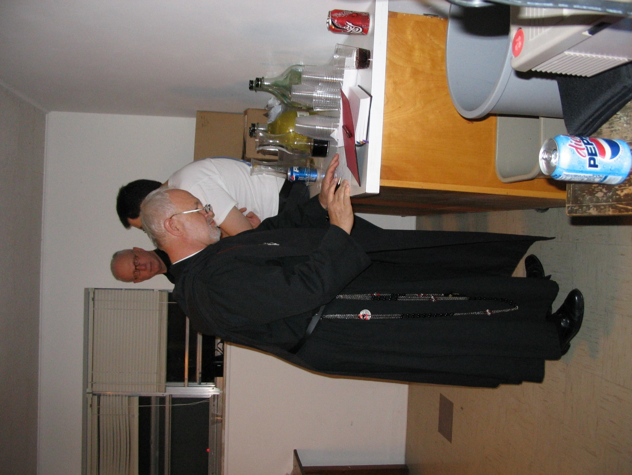
IMG 0226 Br. David Vincent Cotton; Br. Christopher John Baumann; Br. Anthony Bernard Campos
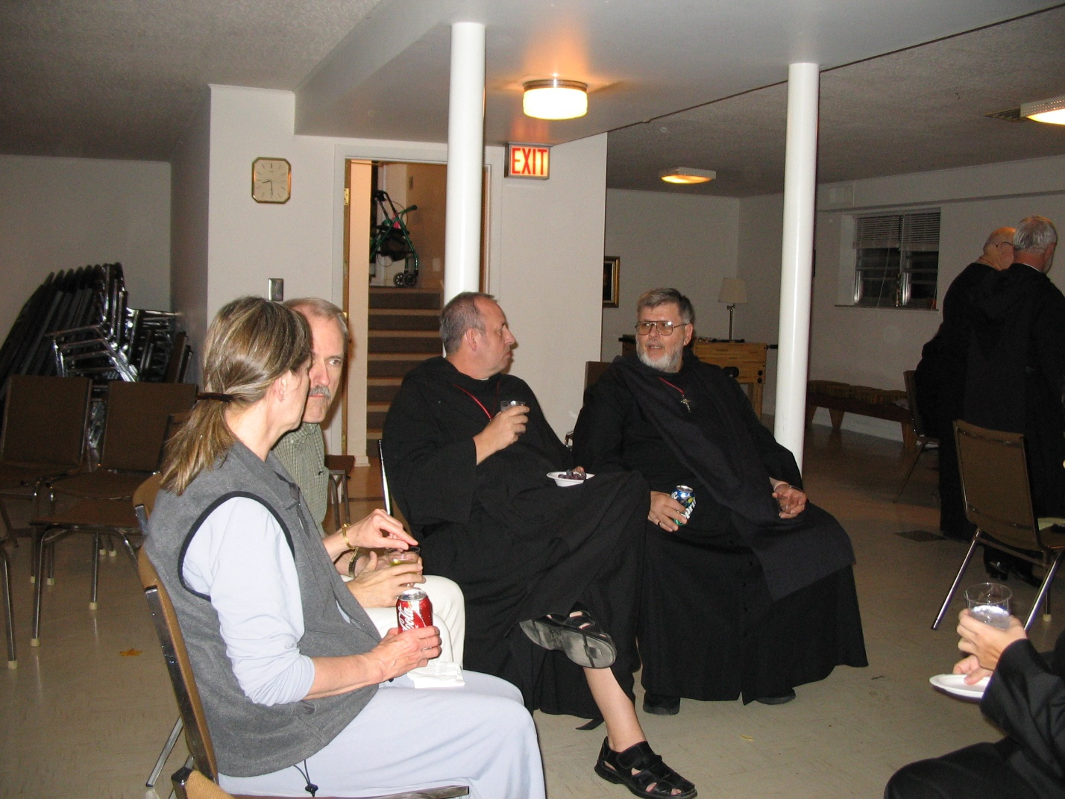
IMG 0227 Mary Schroeder; Br. Daniel Joseph Schroeder; Br. Gabriel Hale; Br. Nathan Gregory Miller; Br. Benedict Truitt; Br. Christopher John Baumann
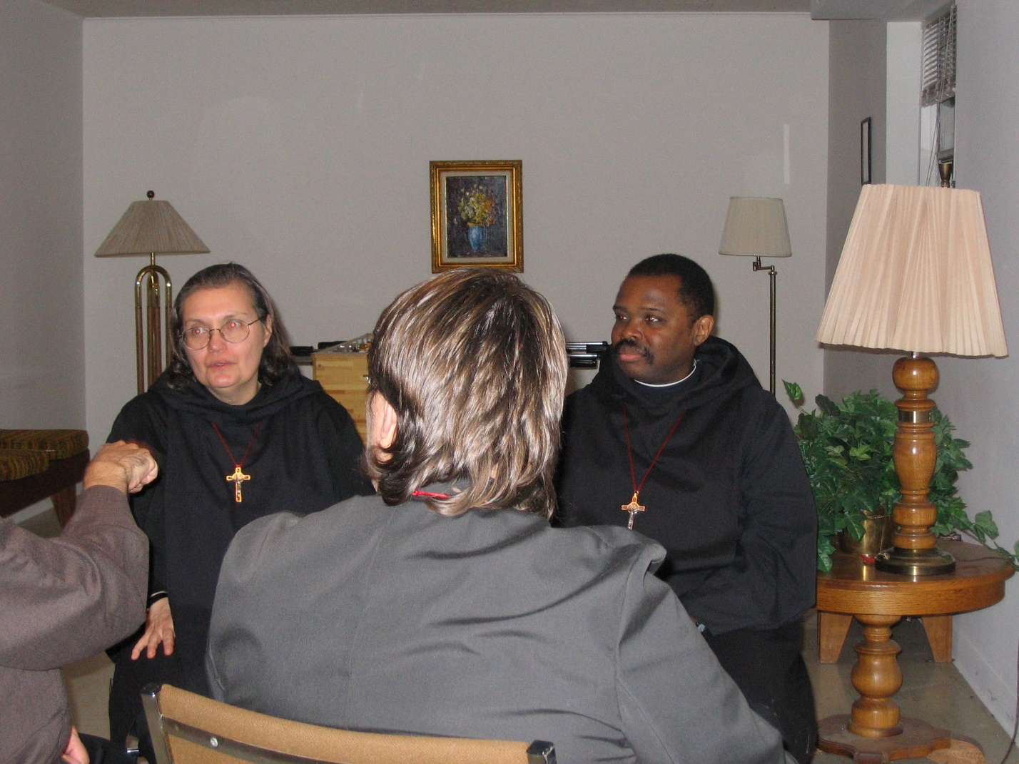
IMG 0228 Sr. Theodora of Jesus Perecca; Sr. Pauline Tysol; Br. Thomas Ferrell
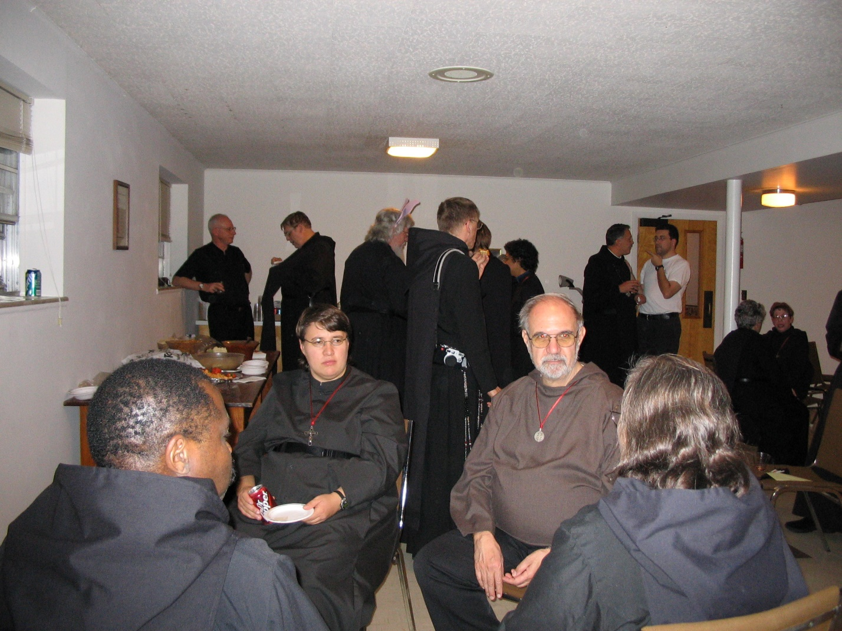
IMG 0229 Foreground: Br. Thomas Ferrell; Sr. Pauline Tysol; Br. Joseph Benedict DiMauro, SA; Sr. Theodora of Jesus Perecca
Background: St. David Vincent Cotton; Br. Chad Anselm Gerns; Fr. Wayne Kamm; Br. Camillus Converse; Sr. Julian Baker; Abbot Michael John Austin; Br. Anthony Bernard Campos; Sr. Johanna Kirkpatrick; Sr. Monica Ruth Mullen
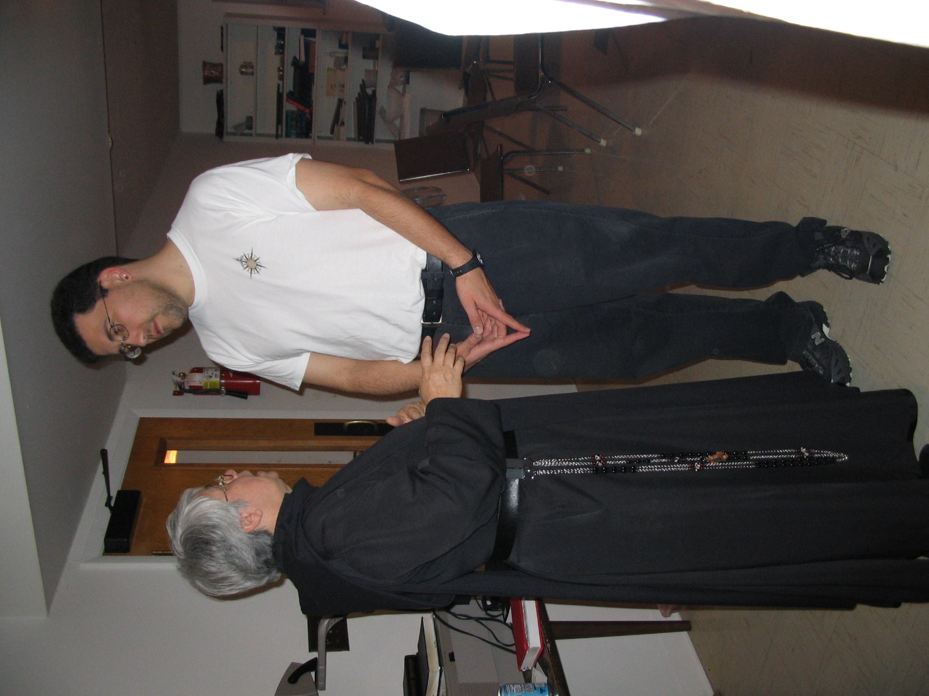
IMG 0230 Sr. Clare Benedicta Meyers; Br. Anthony Bernard Campos
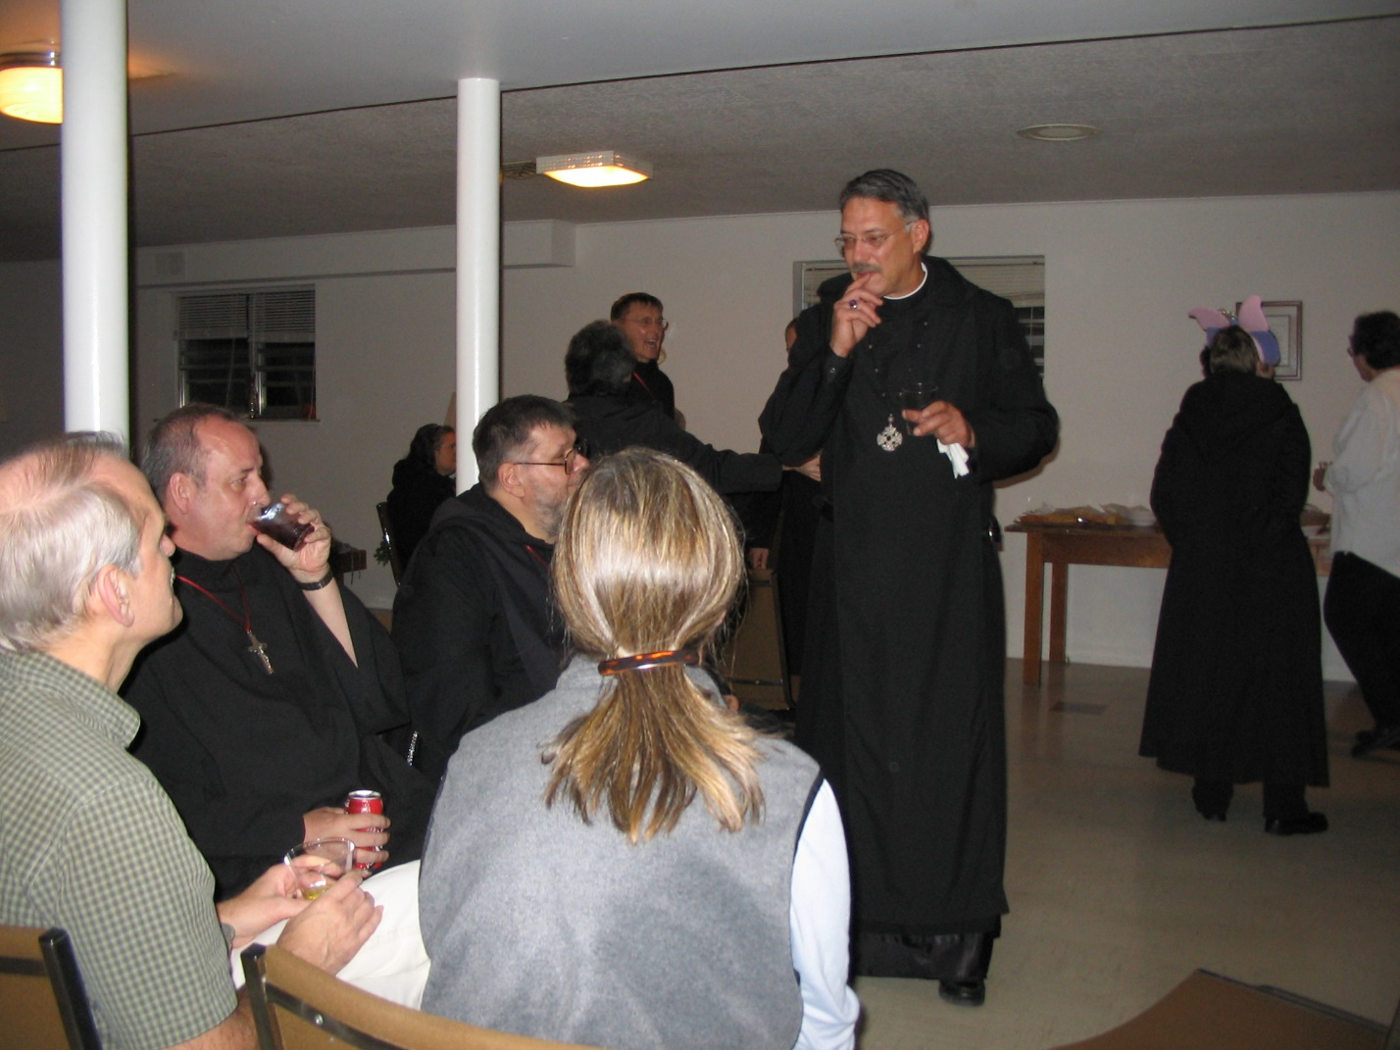
IMG 0231 Br. Daniel Joseph Schroeder; Br. Gabriel Hale; Br. Nathan Gregory Miller; Mary Schroeder; Sr. Vincent Marie Rittenhouse; Br. Camillus Converse; Abbot Michael John Austin; Sr. Catherine Unterseher; Mary Kamm
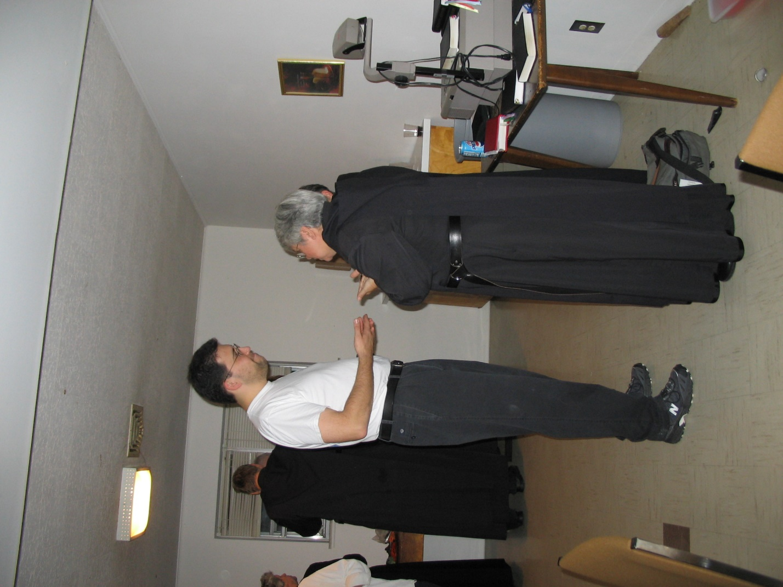
IMG 0232 Sr. Johanna Kirkpatrick; Br. Chad Anselm Gerns; Br. Anthony Bernard Campos; Sr. Clare Benedicta
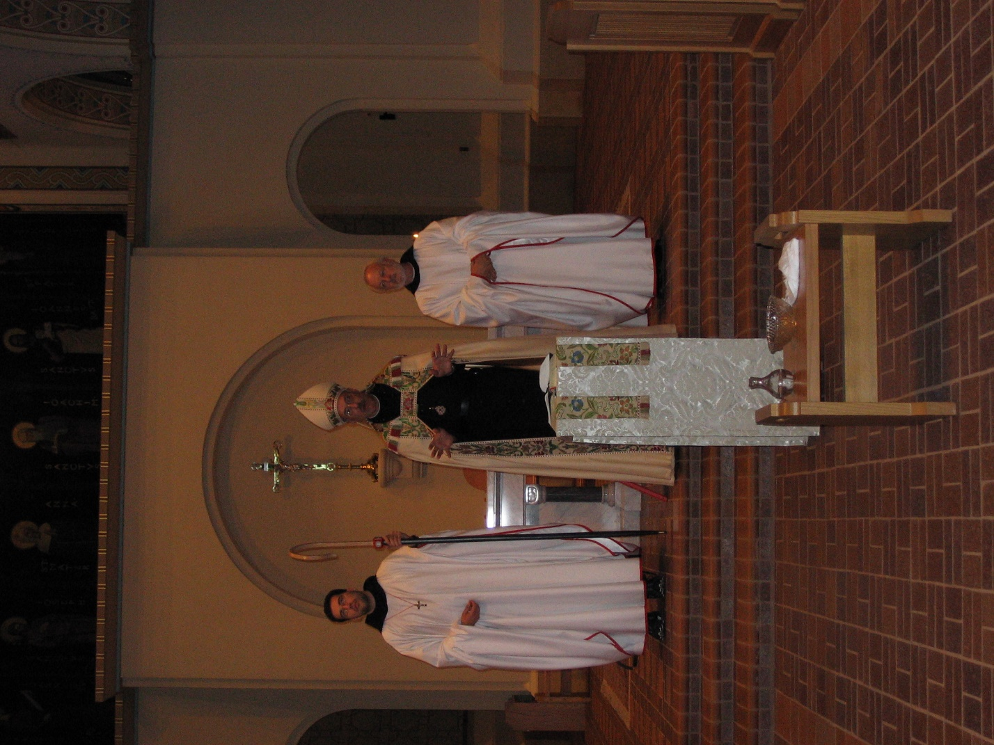
IMG 0233 Br. Anthony Bernard Campos; Abbot Michael John Austin; Br. Christopher John Baumann
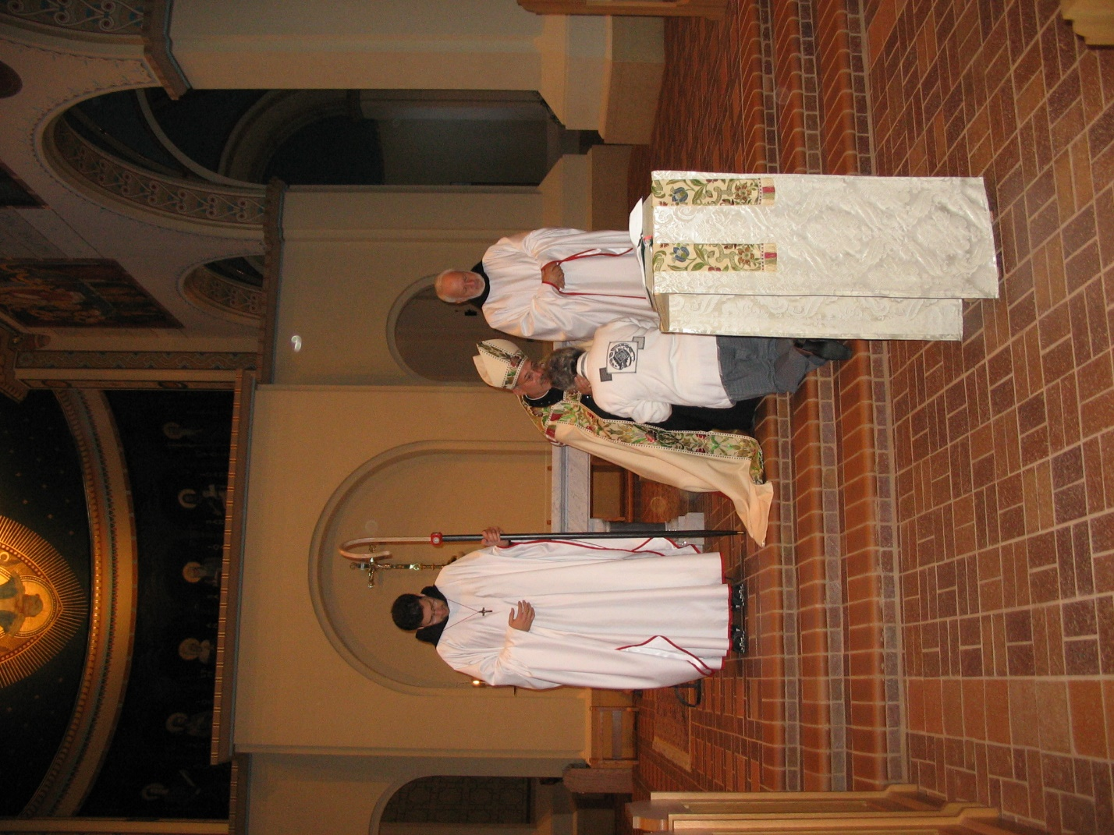
IMG 0234 Br. Anthony Bernard Campos; Abbot Michael John Austin; Jeanetta Doan; Br. Christopher John Baumann

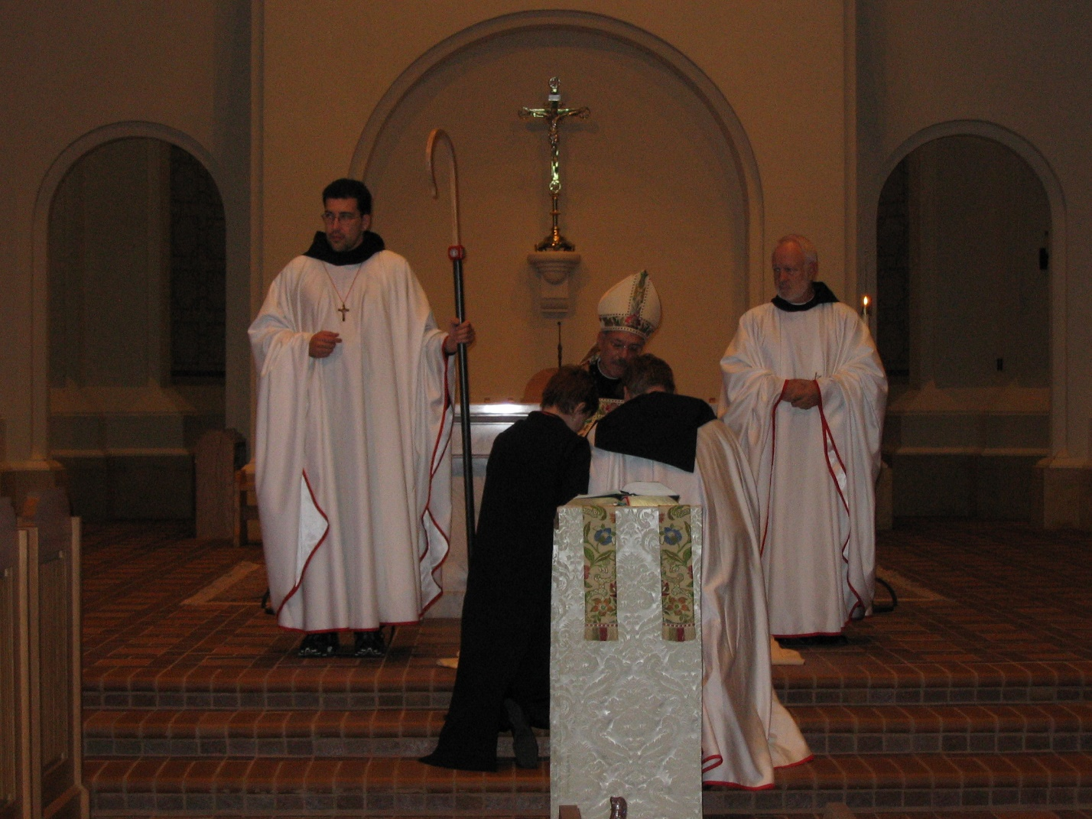
IMG 0235 Br. Anthony Bernard Campos; Sr. Brigid Gerns; Abbot Michael John Austin; Br. Chad Anselm Gerns; Br. Christopher John Baumann

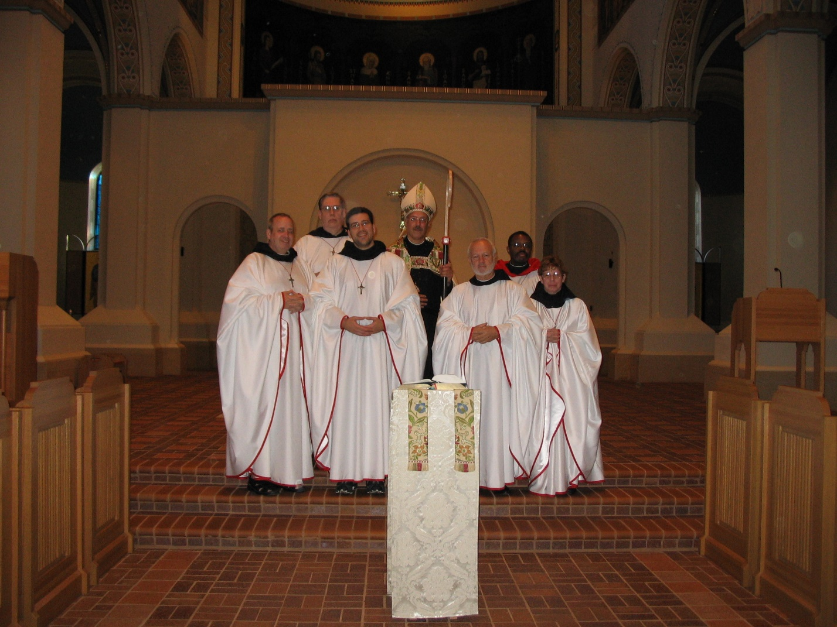
IMG 0236 Br. Gabriel Hale; Br. Chad Anselm Gerns; Br. Anthony Bernard Campos; Abbot Michael John Austin; Br. Christopher John Baumann; Br. Thomas Ferrell; Sr. Monica Ruth Mullen
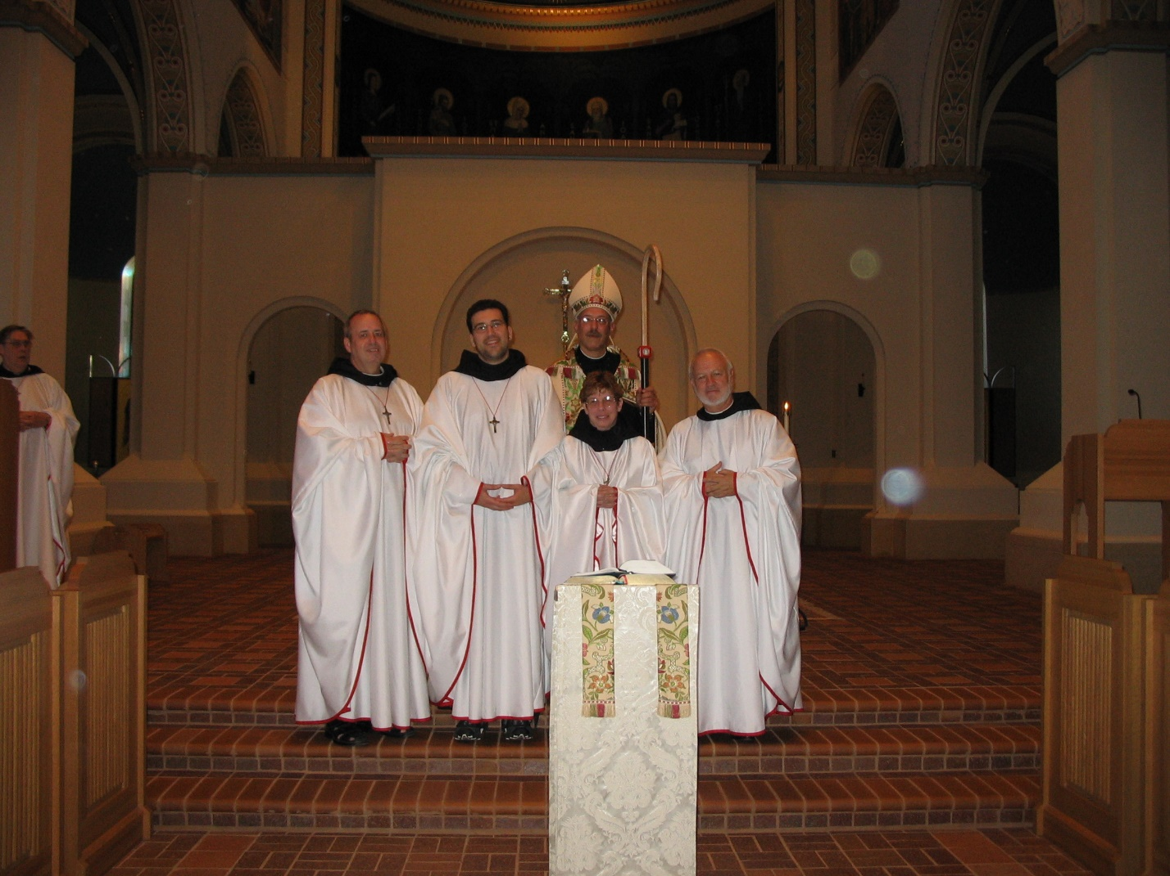
IMG 0237 Br. Chad Anselm Gerns; Br. Gabriel Hale; Br. Anthony Bernard Campos; Abbot Michael John Austin; Sr. Monica Ruth Mullen; Br. Christopher John Baumann

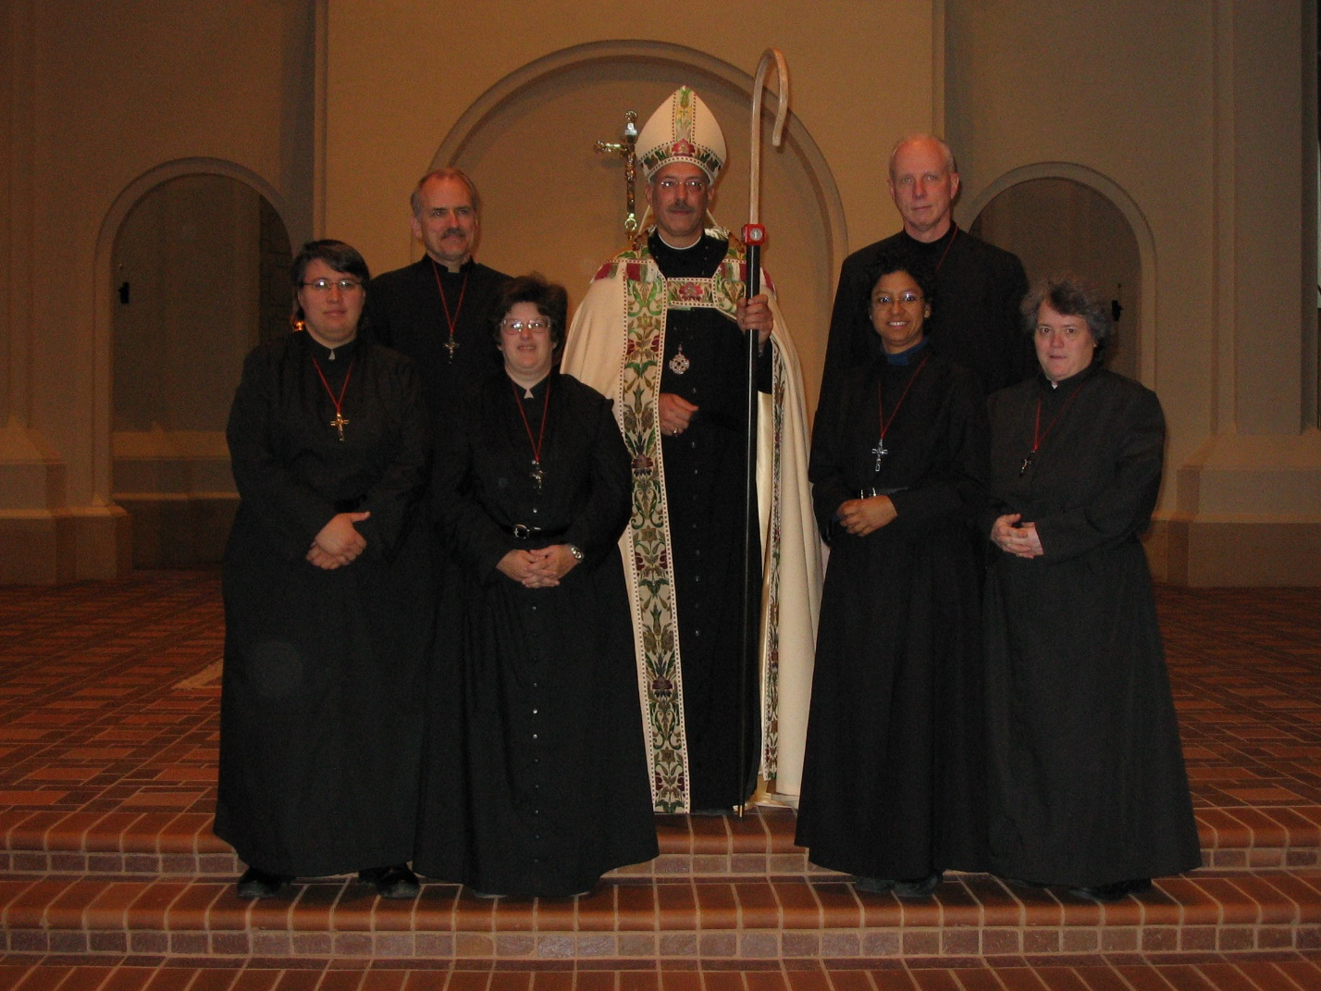
IMG 0238 Sr. Pauline Tysol; Br. Lawrence Mullen; Sr. Cecelia Lamoy; Abbot Michael John Austin; Sr. Julian Baker; Br. David Vincent Cotton; Sr. Vincent Marie Rittenhouse
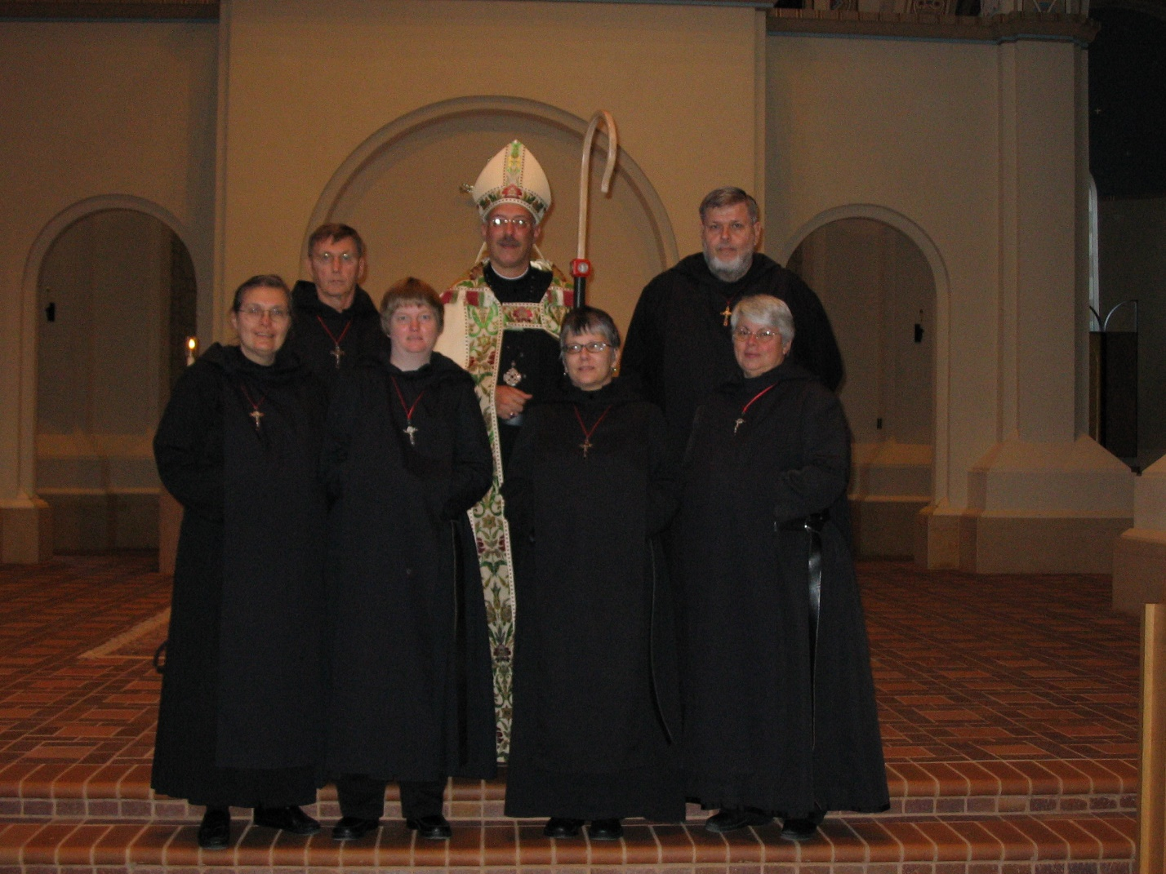
IMG 0239 Sr. Theodora of Jesus Perecca; Br. Camillus Converse; Sr. Catherine Unterseher; Abbot Michael John Austin; Sr. Anna Grace Madden; Br. Nathan Gregory Miller; Sr. Clre Benedicta Meyers
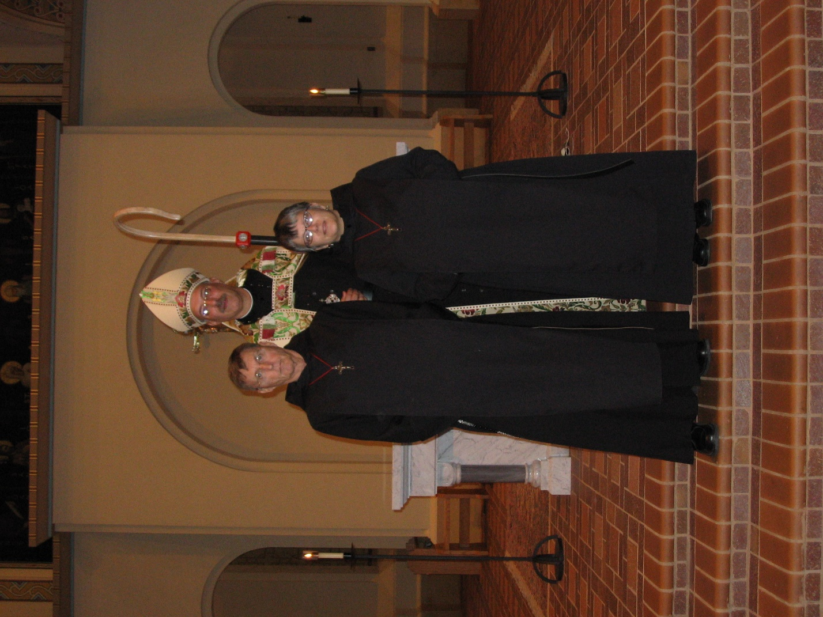
IMG 0240 Br. Camillus Converse; Abbot Michael John Austin; Sr. Anna Grace Madden
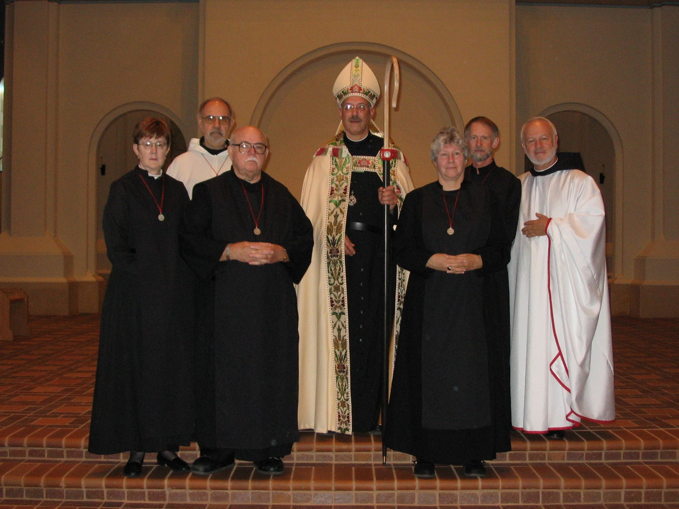
IMG 0241 Sr. Brigid Gerns; Br. Joseph Benedict DiMauro, SA; Br. Benedict Truitt; Abbot Michael John Austin; Sr. Johanna Kirkpatrick; Br. Lawrence Mullen; Br. Christopher John Baumann
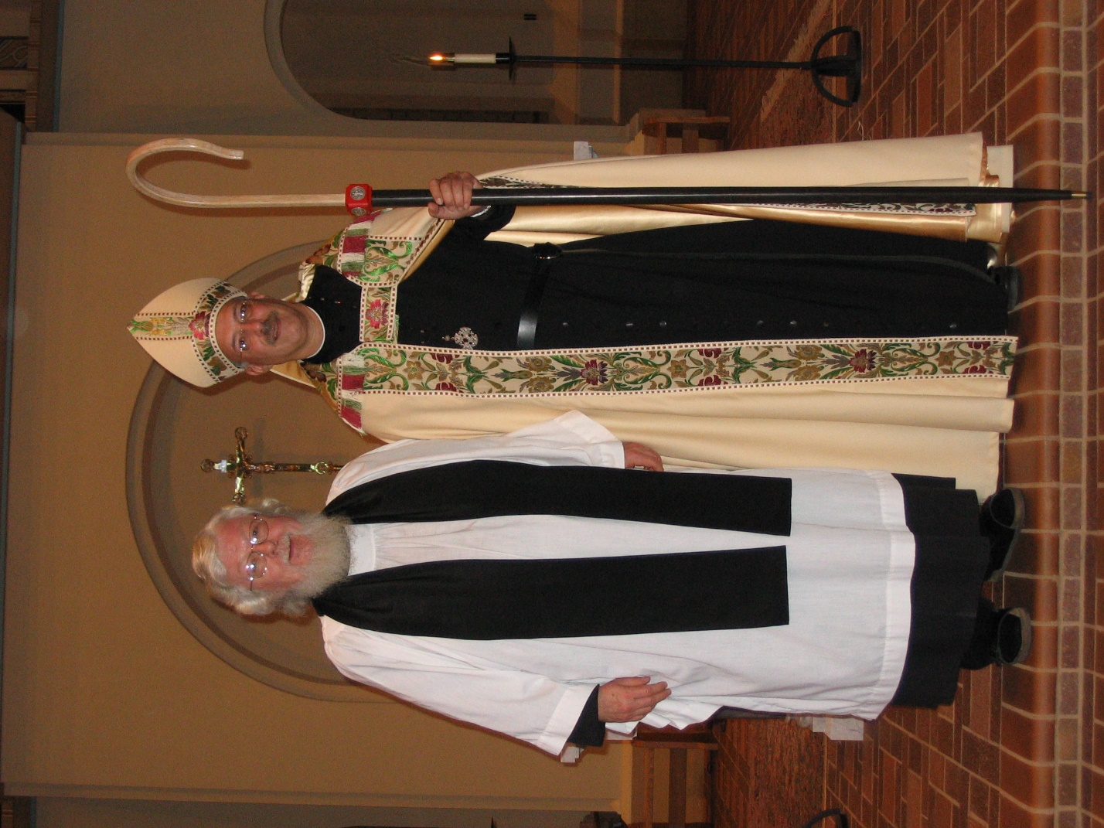
IMG 0242 Fr. Wayne Kamm; Abbot Michael John Austin
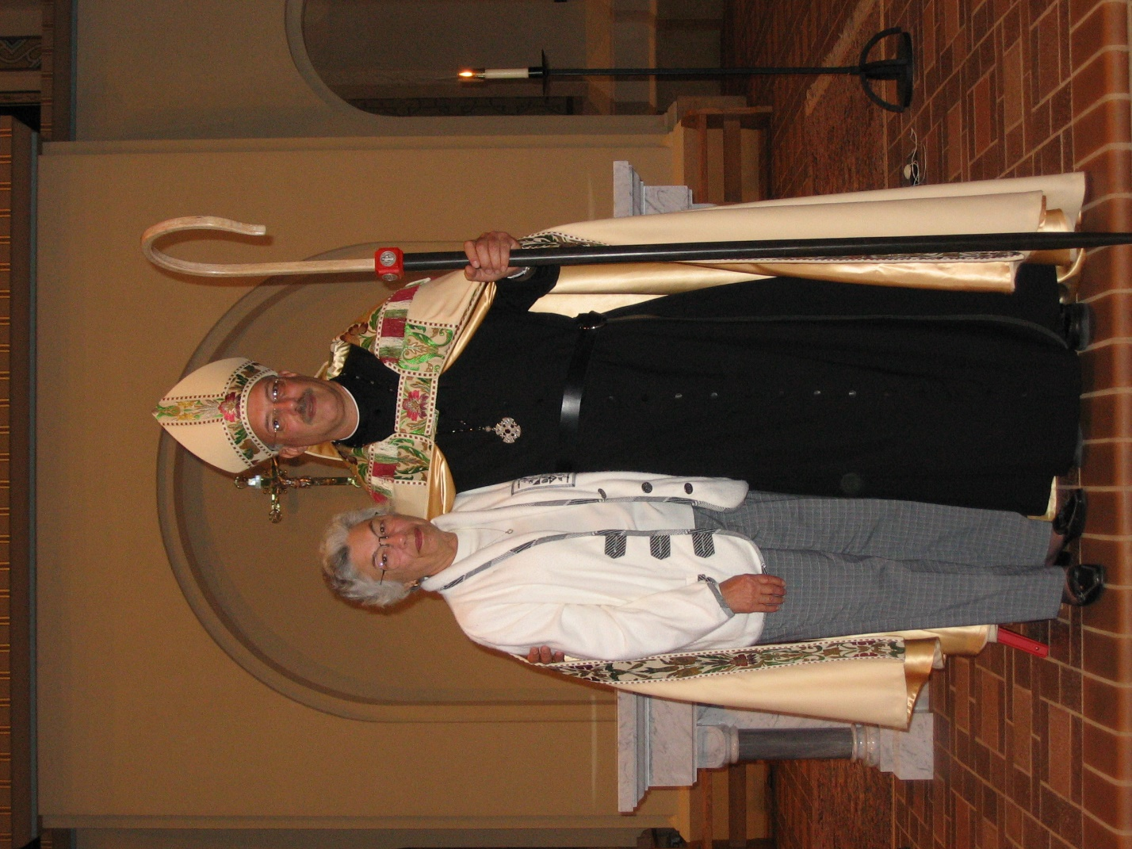
IMG 0243 Jean Doan (MJ’s mother); Abbot Michael John Austin

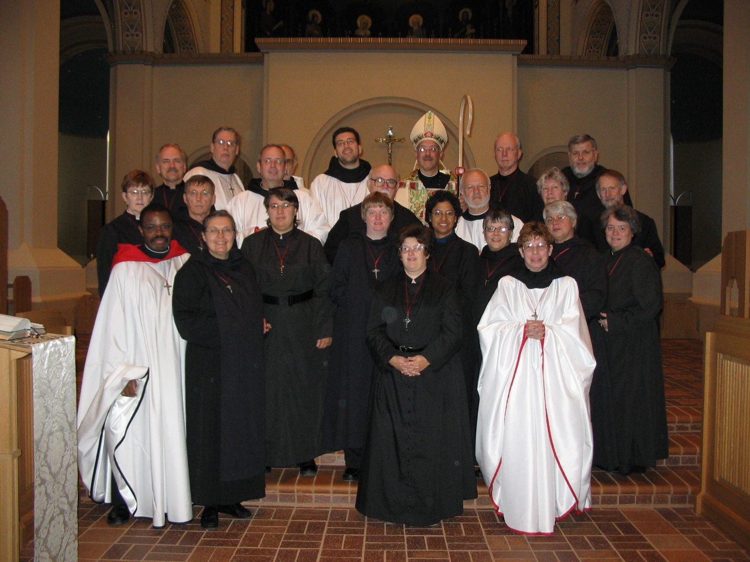
IMG 0244
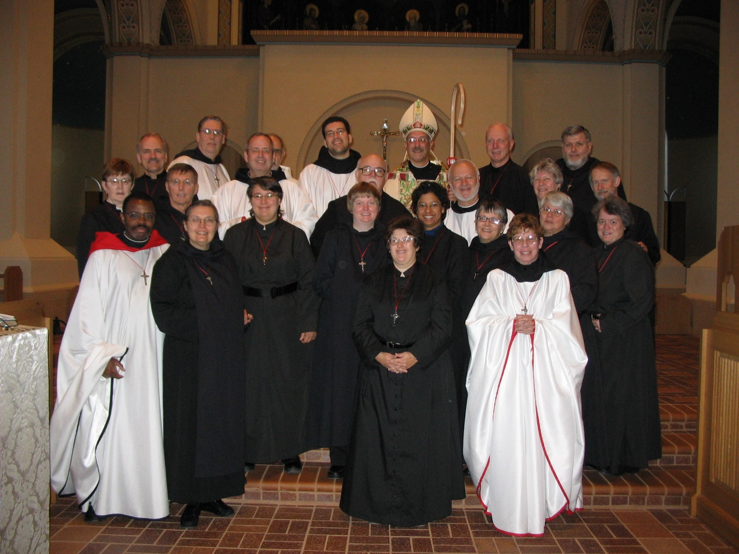
IMG 0245 Front row: Br. Thomas Ferrell; Sr. Theodora of Jesus Perecca; Sr. Pauline Tysol; St. Catherine Unterseher; Sr. Cecelia Lamoy; Sr. Julian Baker; Sr. Anna Grace Madden; Sr. Monica Ruth Mullen; Sr. Clare Benedicta Meyers; Sr. Vincent Marie Rittenhouse
Middle row: Sr. Brigid Gerns; Br. Camillus Converse; Br. Gabriel Hale; Br. Benedict Truitt; Br. Christopher John Baumann; Sr. Johanna Kirkpatrick; Br. Lawrence Mullen
Back row: Br. Daniel Joseph Schroeder; Br. Chad Anselm Gerns; Br. Joseph Benedict DiMauro, SA; Br. Anthony Bernard Campos; Abbot Michael John Campos; Br. David Vincent Cotton; Br. Nathan Gregory Miller
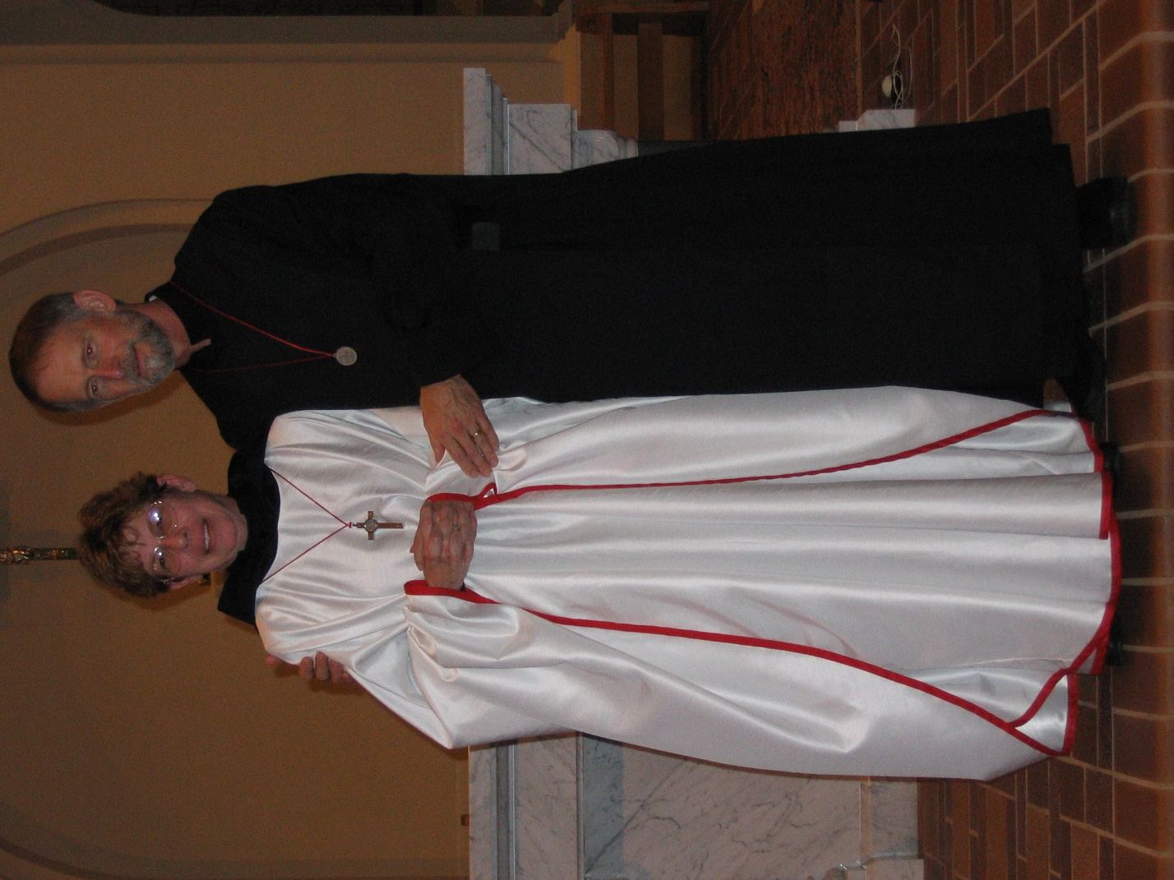
IMG 0246 Sr. Monica Ruth Mullen; Br. Lawrence Mullen

