Companions of St. Luke
Spring 2005 Convocation at Conception Abbey
Part 5 of 5

NOTE: Disc is dated 28 May 2003 but the people present and other documents show this is Spring 2005.

~Edited by Br. Steven Olderr, 19 May 2022 with the assistance of Br. Thomas Ferrell; if you find any errors or omissions, please notify Br. Steven at olderr@ameritech.net

People are identified from left to right.
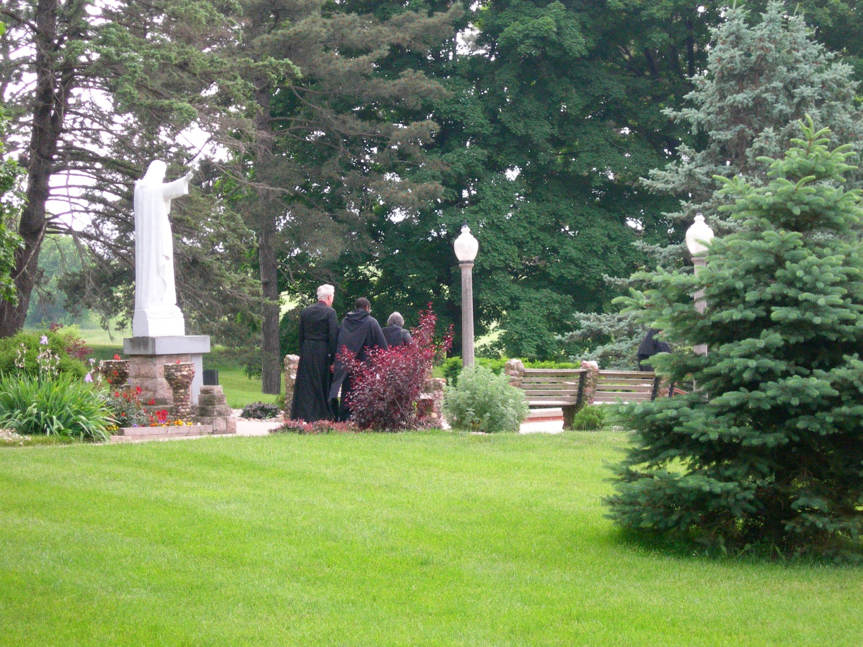
DSCN0395 Br. Luke Doucette; Br. Thomas Ferrell; Sr. Hillary Grace Lundgren
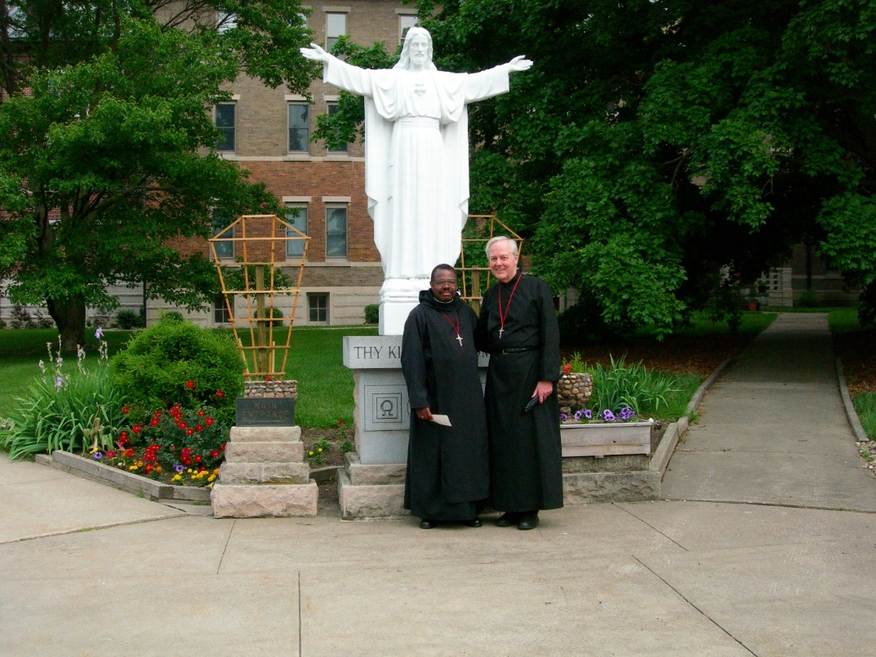
DSCN0396 Br. Thomas Ferrell; Br. Luke Doucette

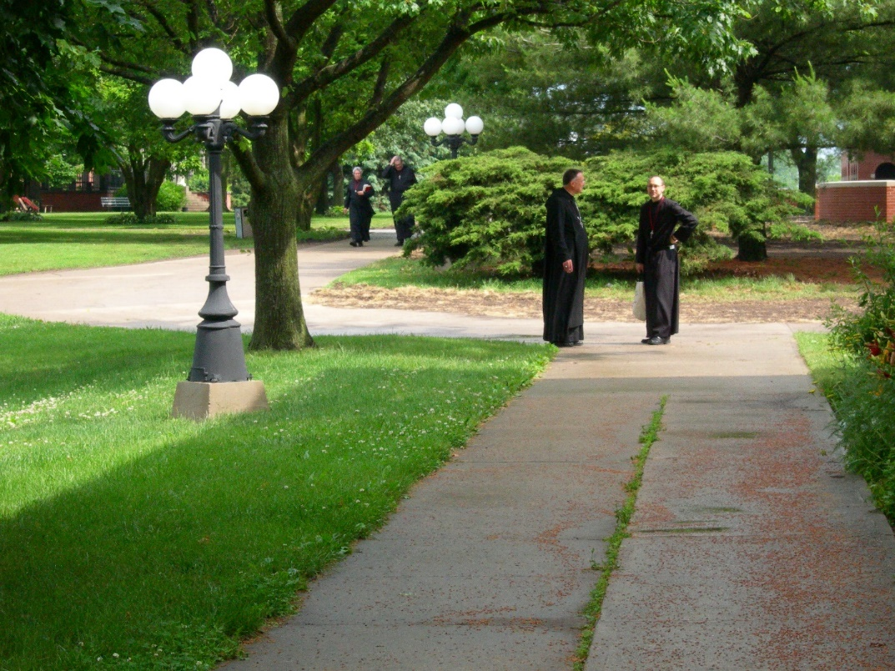
DSCN0356 Abbot Michael John Austin; Br. Eckhart Sowers
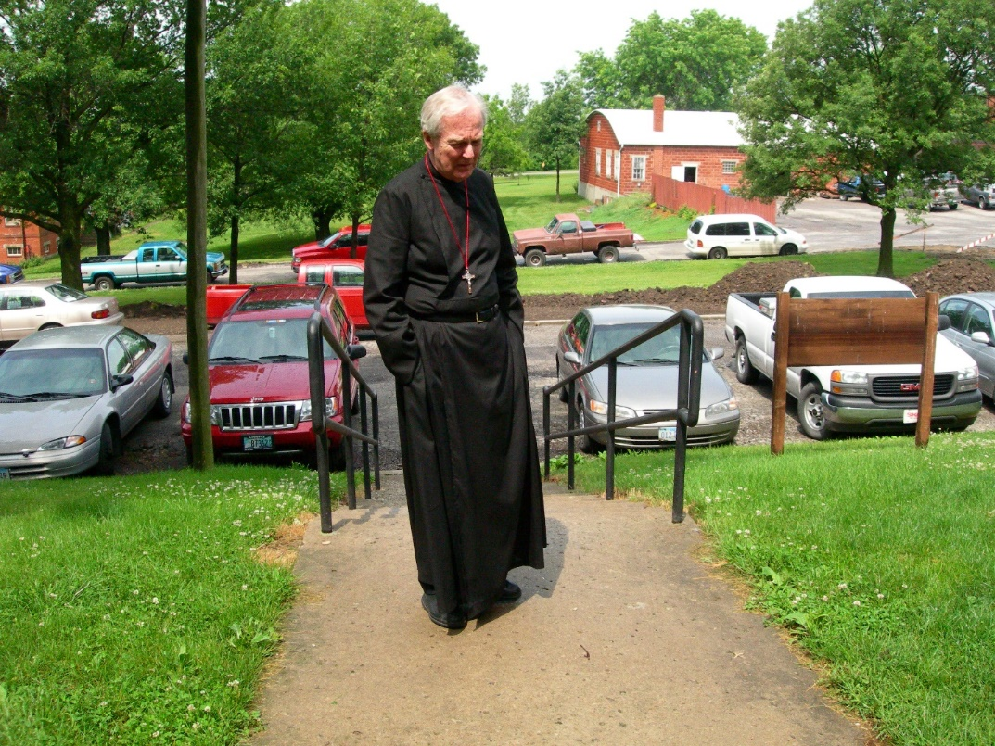
DSCN0399 Br. Luke Doucette

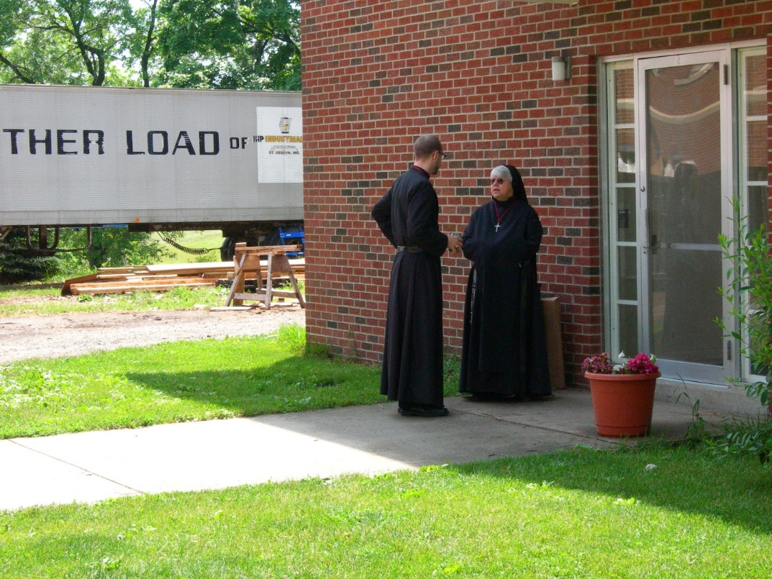
DSCN0400 Br. Eckhart Sowers; Sr. Clare Benedicta Meyers
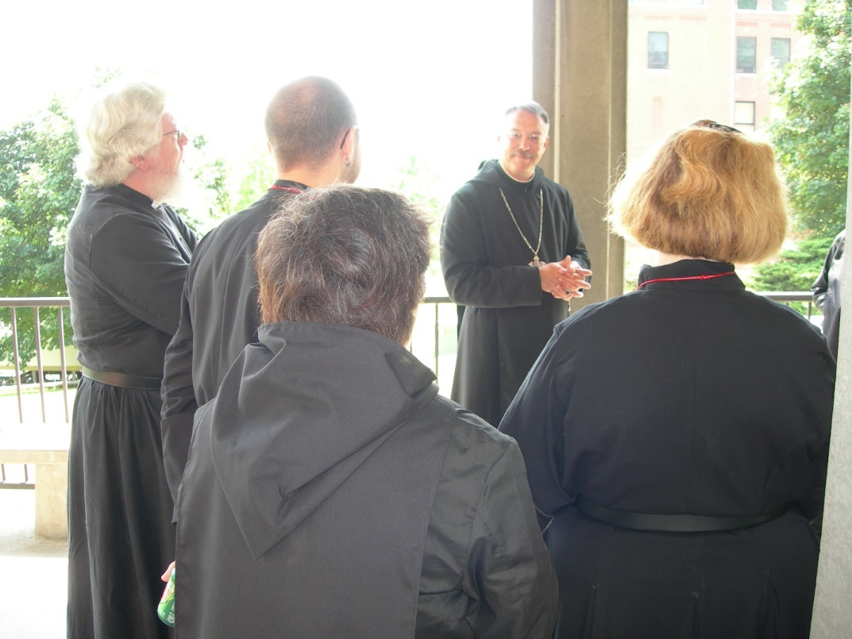
DSCN0401 Fr. Wayne Kamm; Br. Eckhart Sowers; Sr. Cecelia Lamoy; Abbot Michael John Austin; Sr. Hillary Grace Lundgren

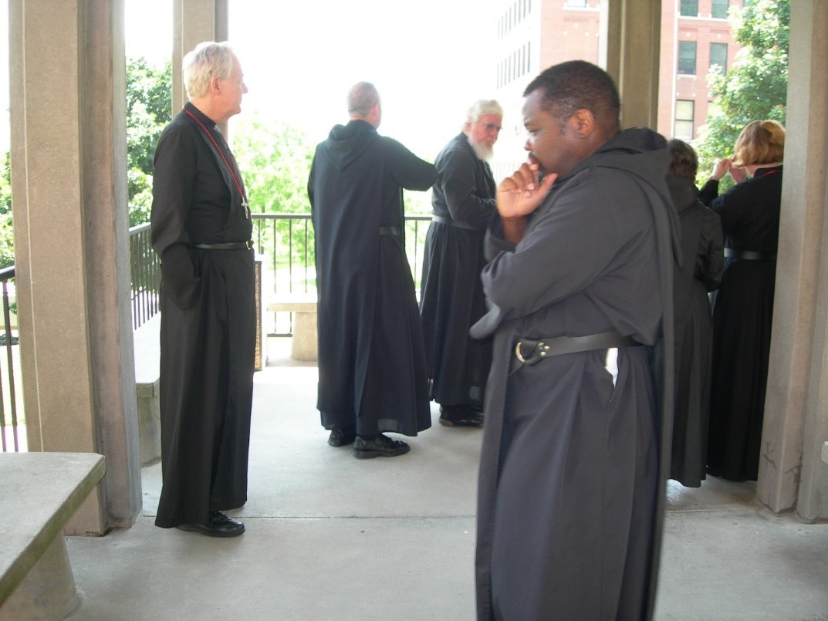
DSCN0402 Br. Luke Doucette; Br. Gabriel Hale; Fr. Wayne Kamm; Br. Thomas Ferrell; Sr. Hillary Gace Lundgren
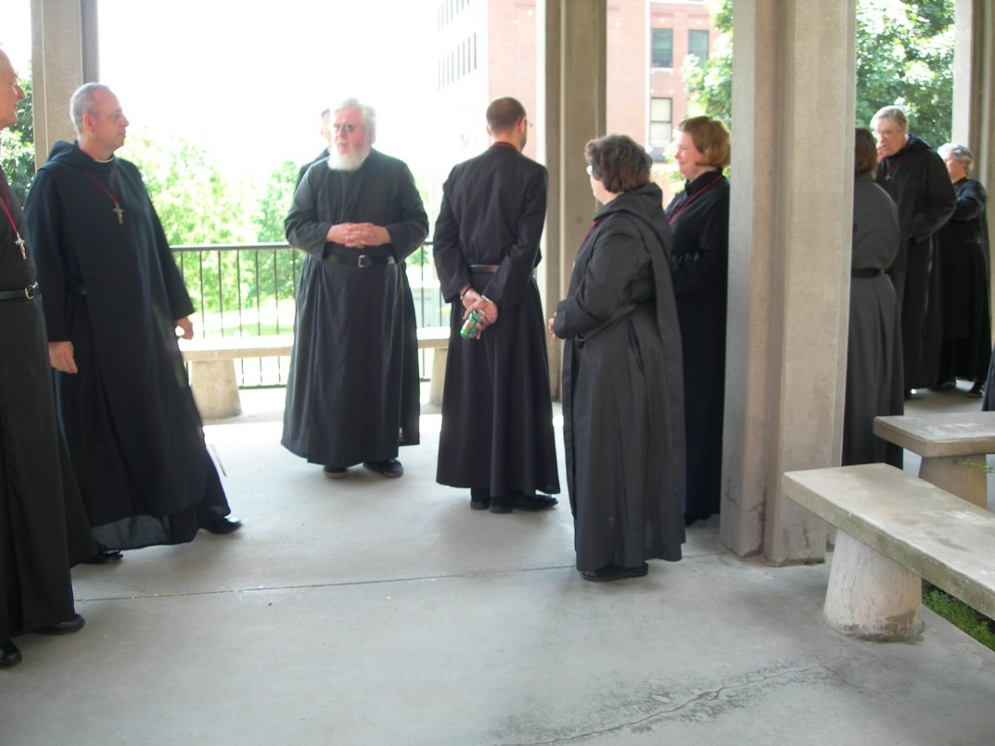
DSCN0403 Br. Luke Doucette; Br. Gabriel Hale; Fr. Wayne Kamm; Br. Eckhart Sowers; Sr. Cecelia Lamoy; Sr. Hillary Grace Lundgren; Br. Chad Anselm Gerns

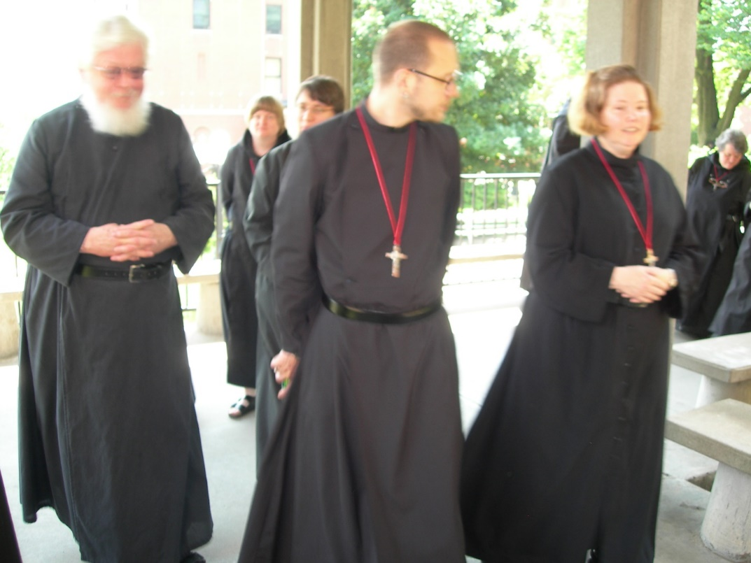
DSCN0404 Fr. Wayne Kamm; Sr. Catherine Unterseher; Sr. Pauline Tysol; Br. Eckhart Sowers; Sr. Hillary Grace Lundgren; Sr. Vincent Marie Rittenhouse
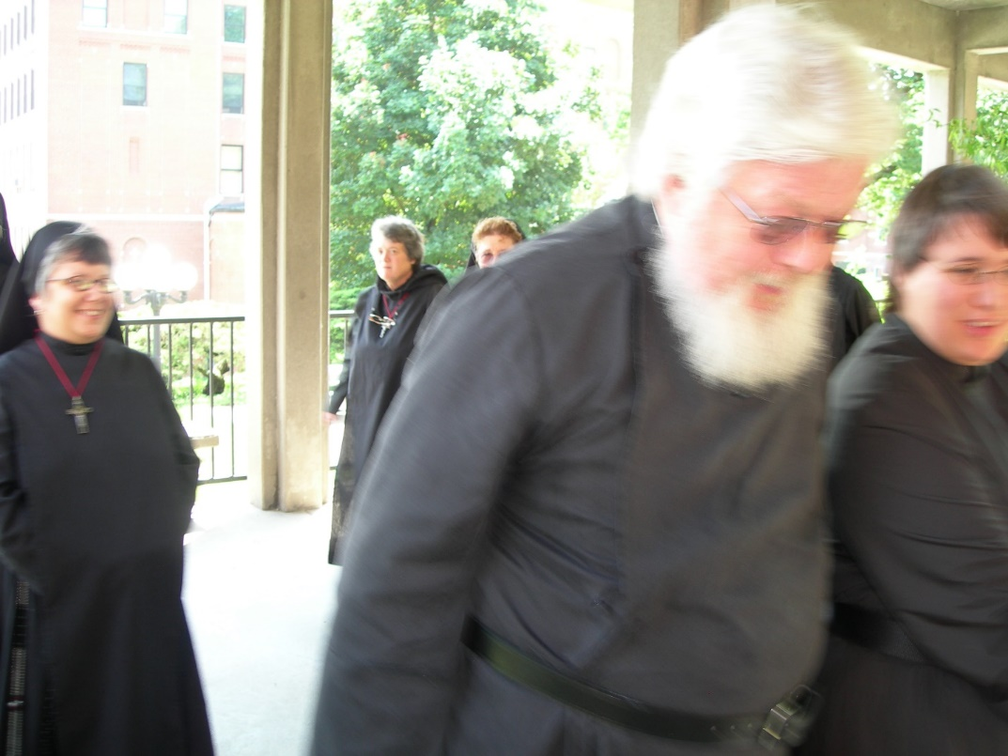
DSCN0405 Sr. Anna Grace Madden; Sr. Vincent Marie Rittenhouse; Sr. Monica Ruth Mullen; Fr. Wayne Kamm; Sr. Sr. Pauline Tysol

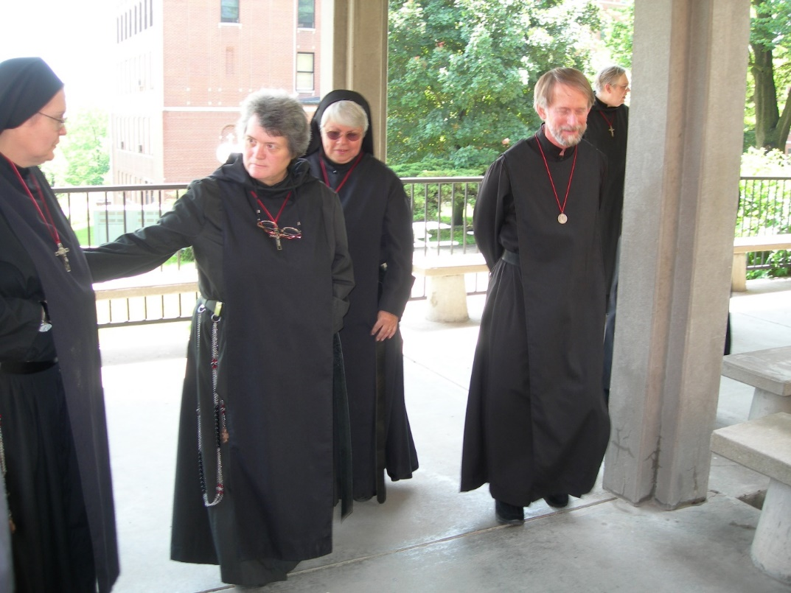
DSCN0406 Sr. Theodora of Jesus Oerecca; Sr. Vincent Marie Rittenhouse; Sr. Clare Benedicta Meyers; Br. Lawrence Mullen; Br. Chad Anselm Gerns
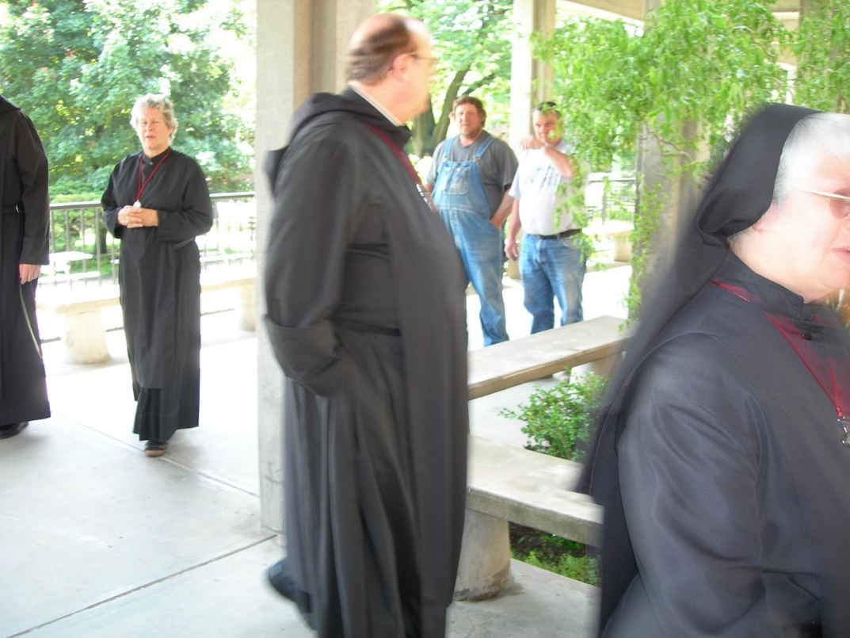
DSCN0407 Sr. Johanna Kirkpatrick; Br. Raymond Hale; Sr. Clare Benedicta Meyers

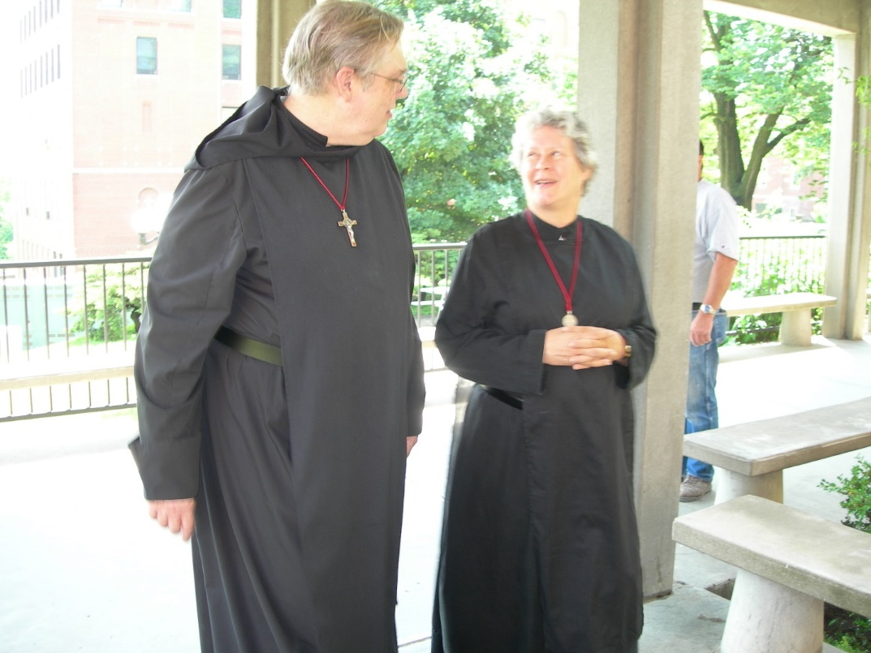
DSCN0408 Br. Chad Anselm Gerns; Sr. Johanna Kirkpatrick
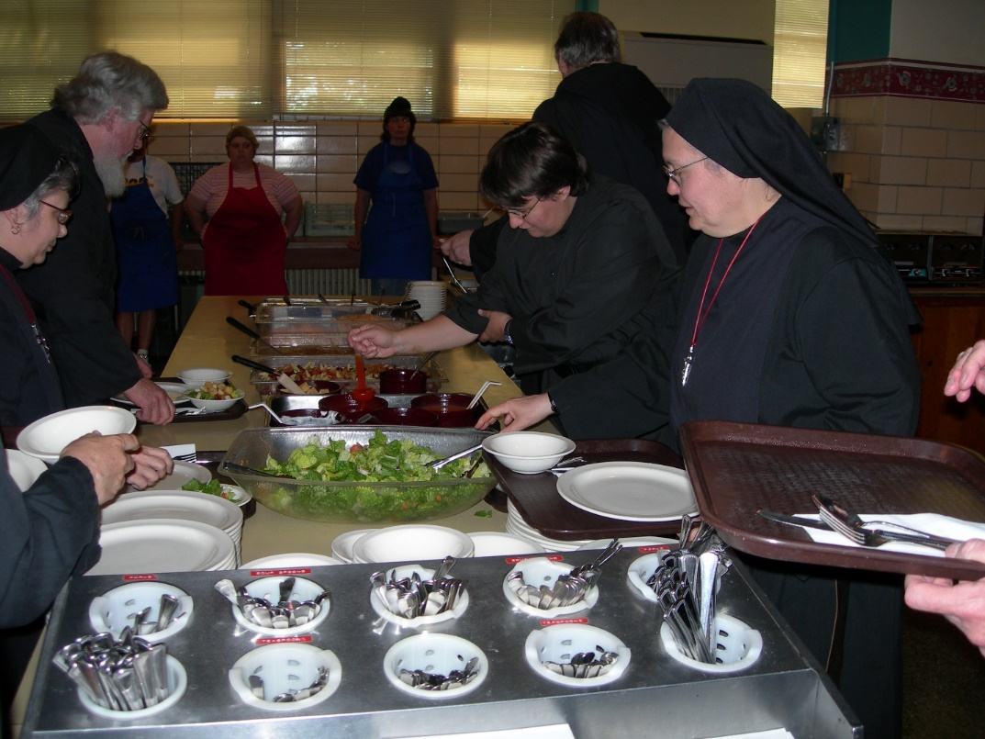
DSCN0410 Sr. Anna Grace Madden; Fr. Wayne Kamm; Sr. Pauline Tysol; Sr. Theodora of Jesus Perecca

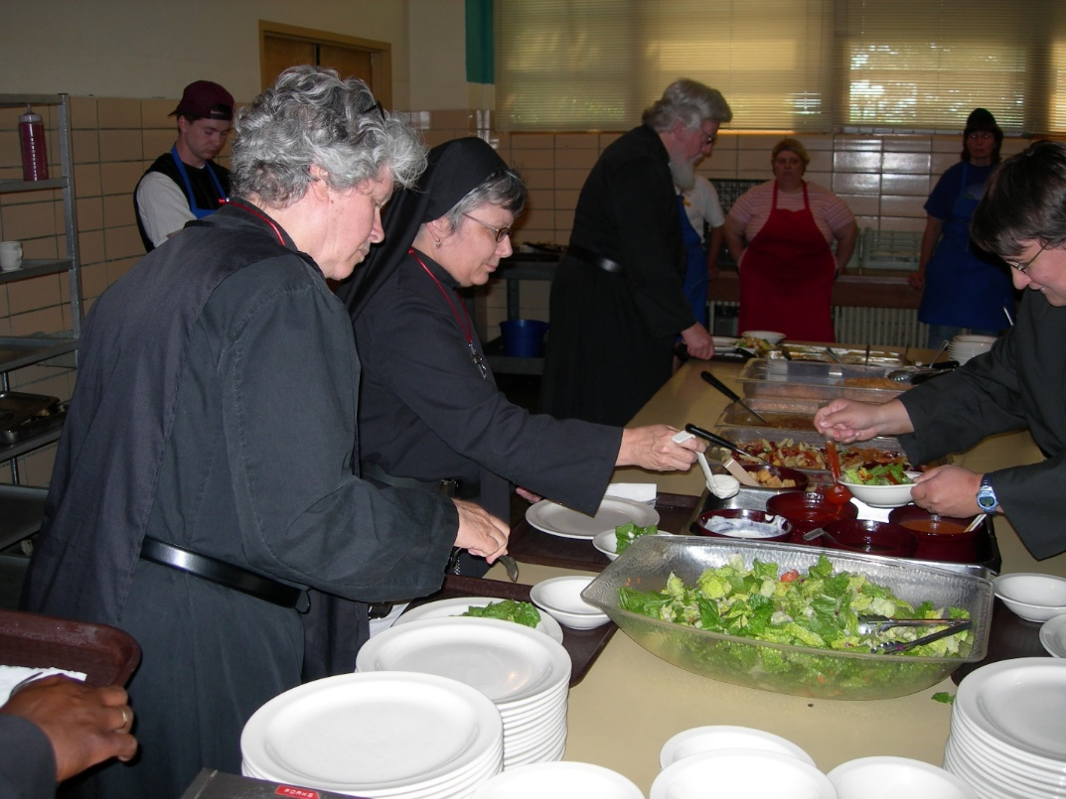
DSCN0411 Sr. Johanna Kirkpatrick; Sr. Anna Grace Madden; Fr. Wayne Kamm; Sr. Pauline Tysol
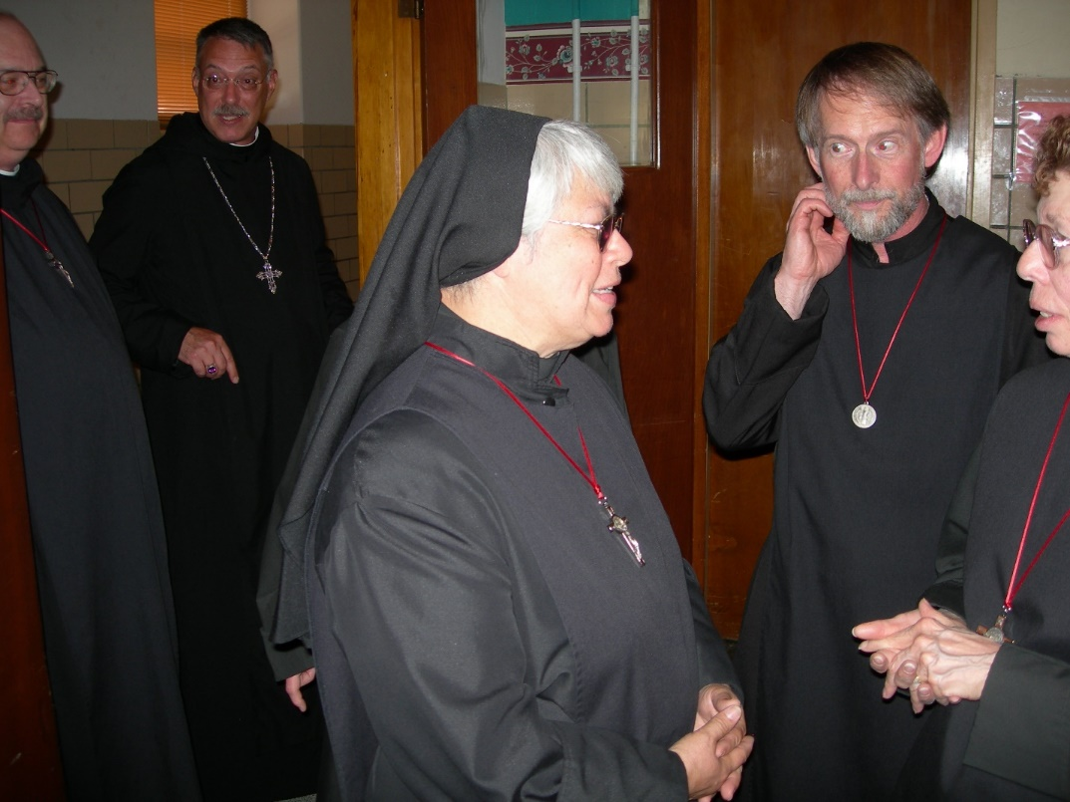
DSCN0412 Br. Raymond Owens; Abbot Michael John Austin; Sr. Clare Benedicta Meyers; Br. Lawrence Mullen; Sr Monica Ruth Mullen

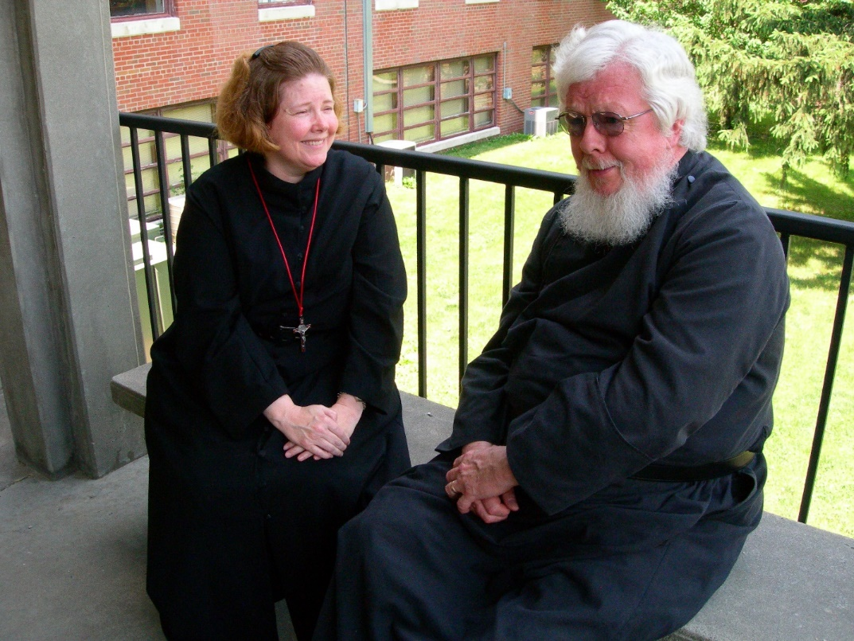
DSCN0414 Sr. Hillary Grace Lundgren; Fr. Wayne Kamm
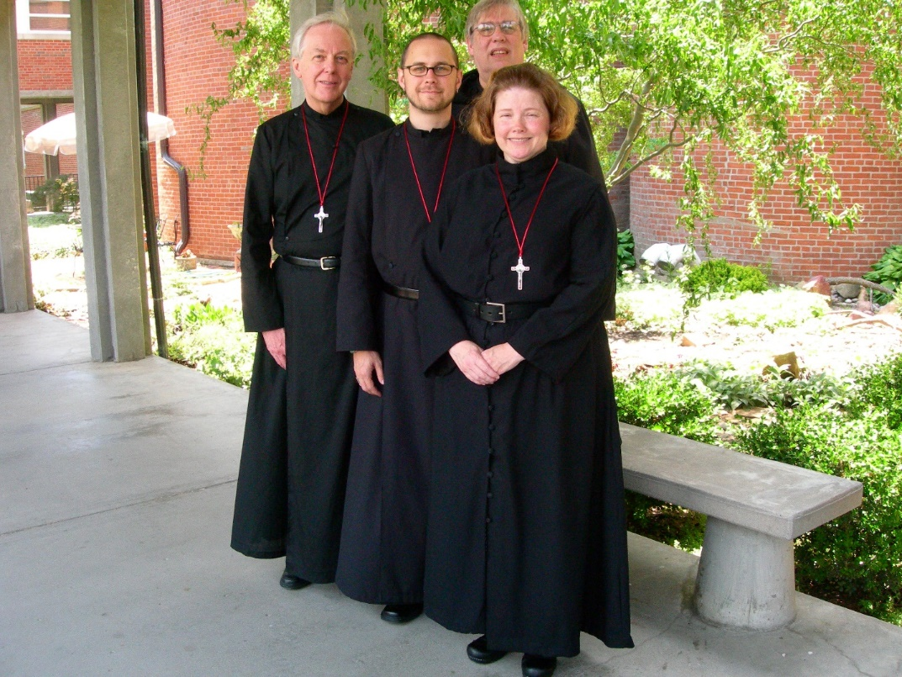
DSCN0415 Br. Luke Doucette; Br. Eckhart Sowers; Br. Chad Anselm Gerns; Sr. Hillary Grace Lundgren

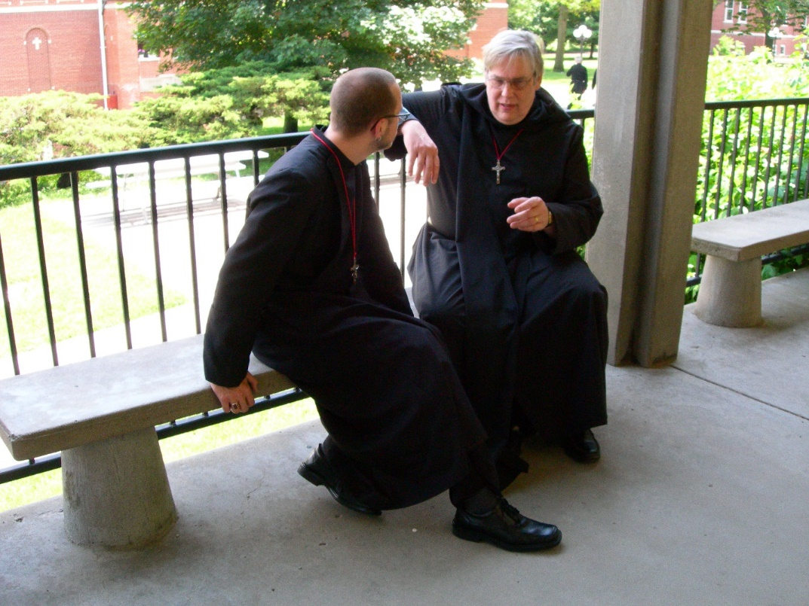
DSCN0416 Br. Eckhart Sowers; Br. Chad Anselm Gerns
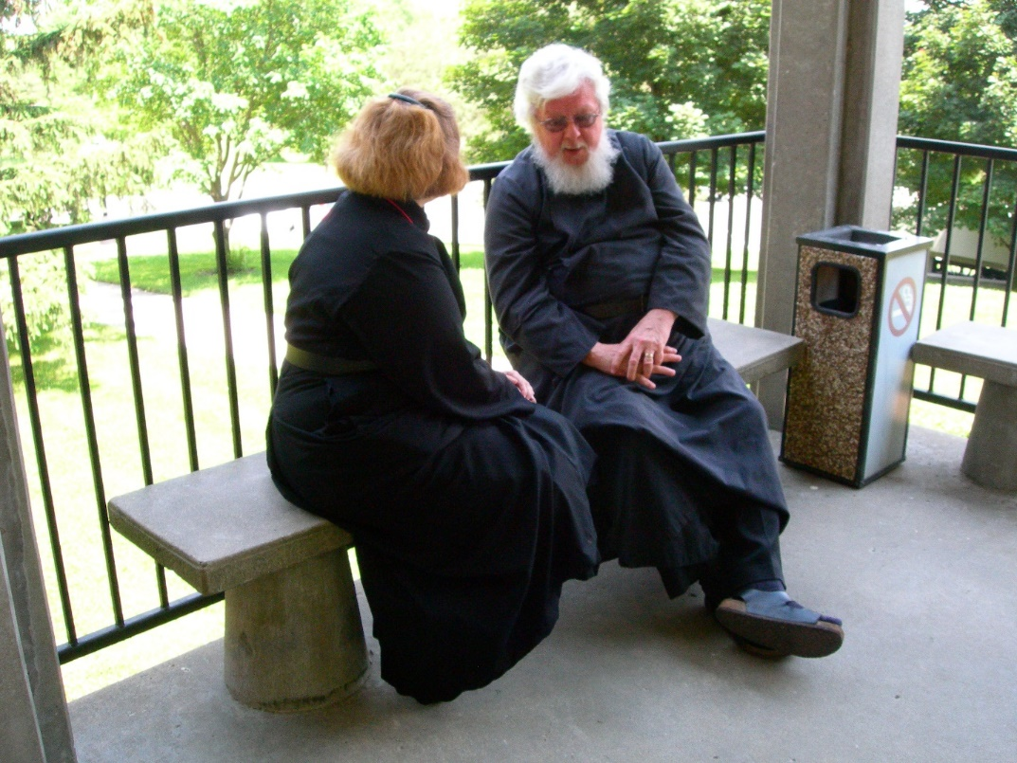
DSCN0417 Sr. Hillary Grace Lundgren; Fr. Wayne Kamm

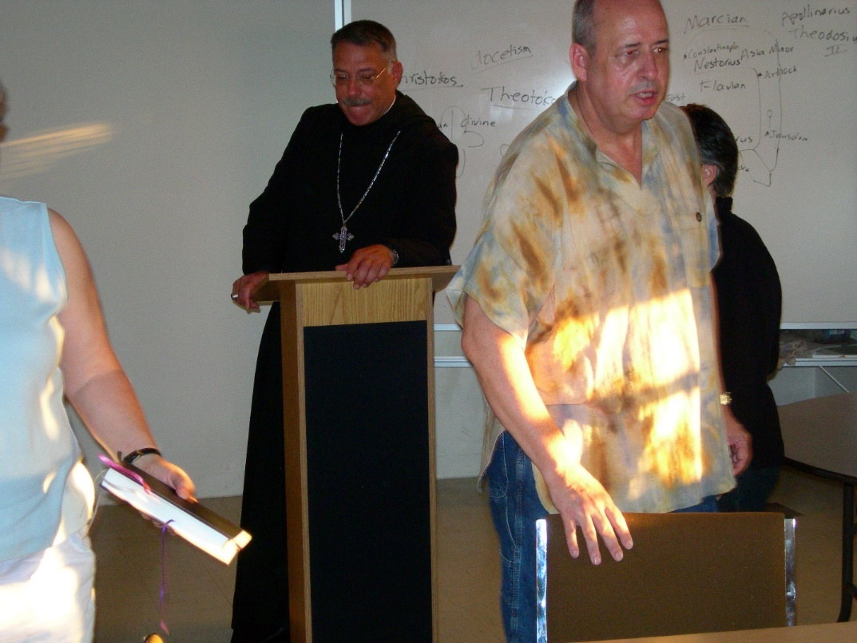
DSCN0418 Abbot Michael John Austin; Br. Gabriel Hale

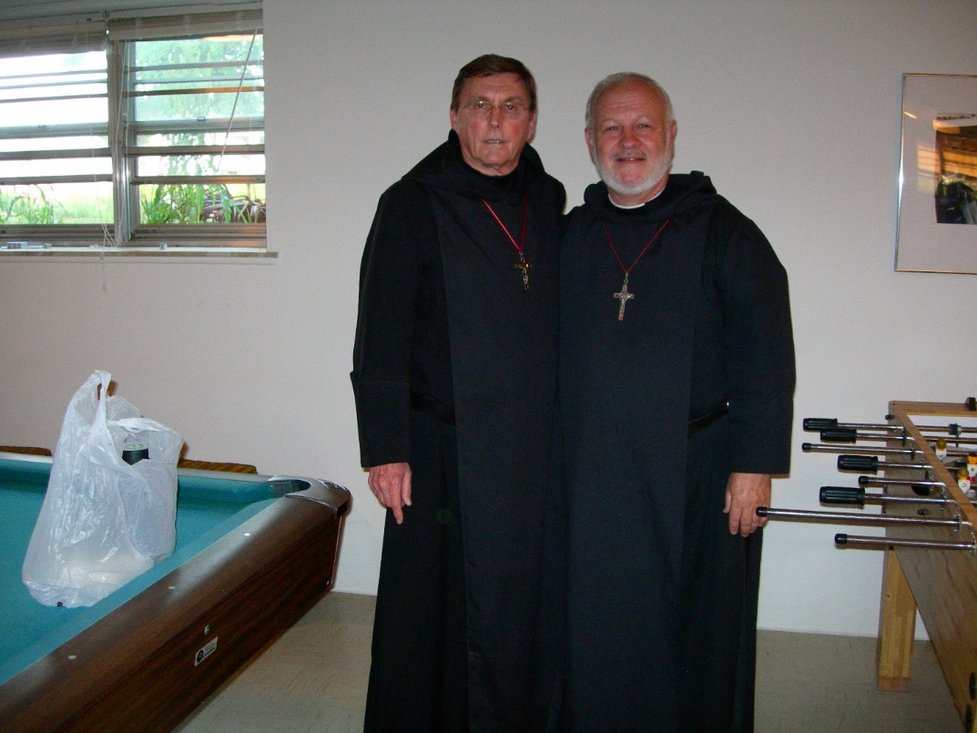
DSCN0419 Br. Camillus Converse; Br. Christopher John Baumann

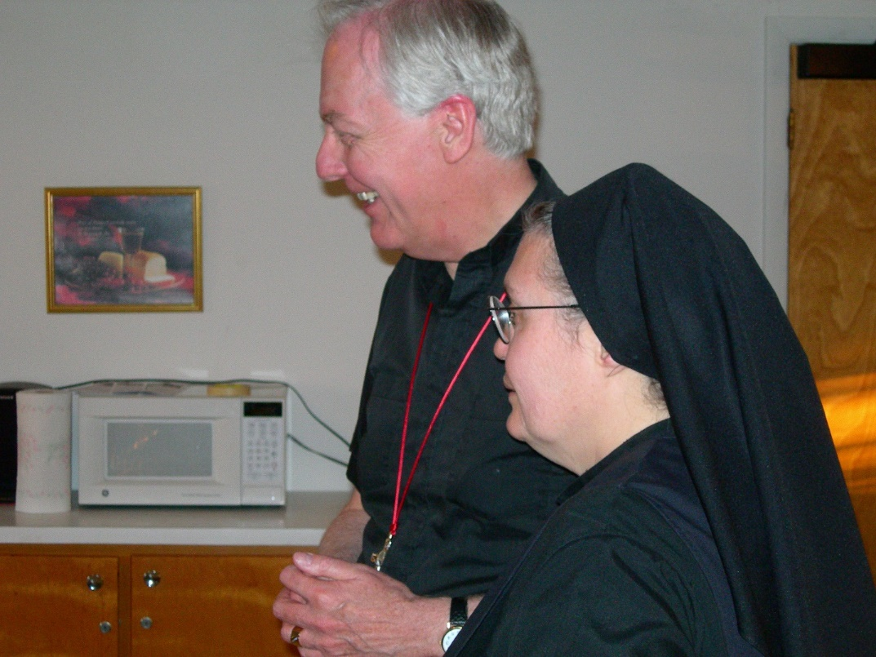
DSCN0420 Br. Luke Doucette; Sr. Theodora of Jesus Perecca
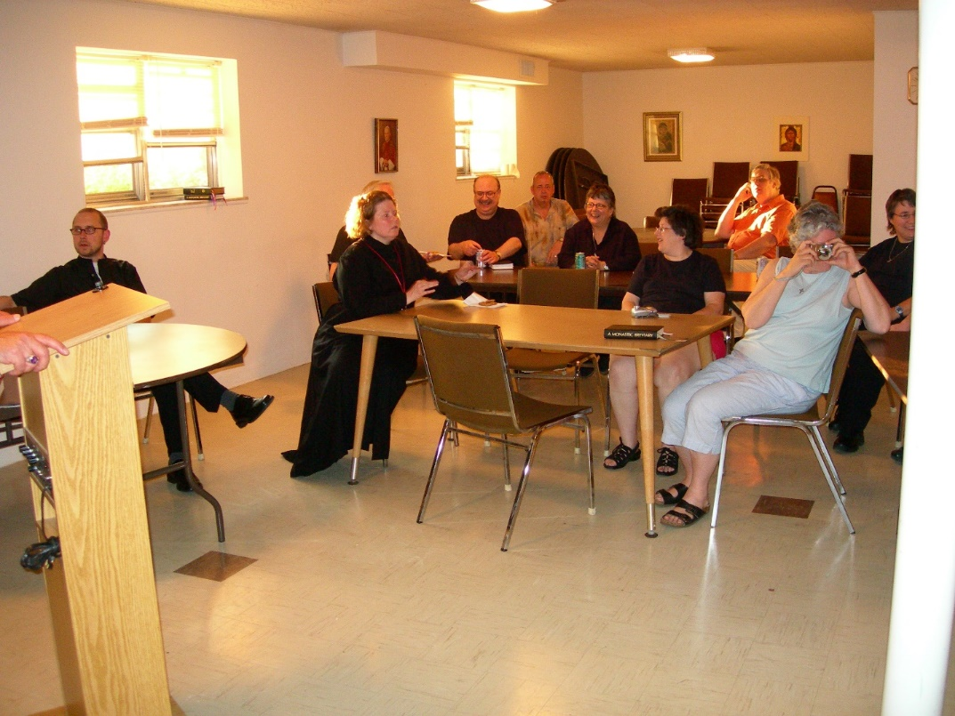
DSCN0421 Br. Eckhart Sowers; Sr. Hillary Grace Lundgren; Br. Raymond Owens; Br. Gabriel Hale; Sr. Anna Grace Madden; Sr.Cecelia Lamoy; Br. Chad Anselm Gerns; Sr. Johanna Kirkpatrick; Sr. Pauline Tysol

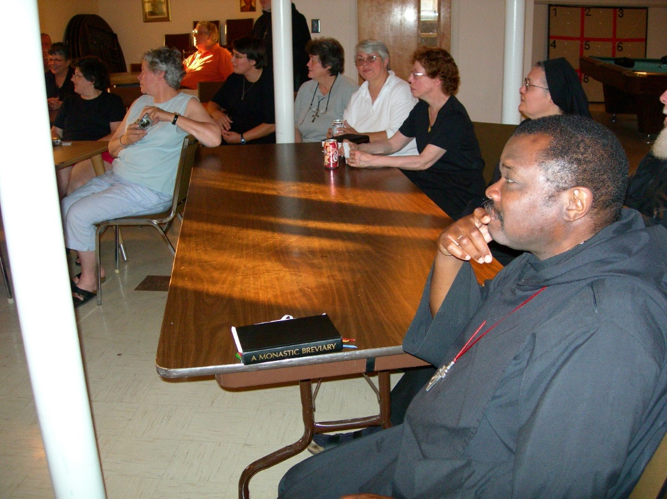
DSCN0422 Sr. Anna Grace Madden; Sr. Cecelia Lamoy; Sr. Johanna Kirkpatrick; Br. Chad Anselm Gerns; Sr. Pauline Tysol; Sr. Vincent Marie Rittenhouse; Sr. Clare Benedicta Meyers; Sr. Monica Ruth Mullen; Br. Thomas Ferrell; Sr.Theodora of Jesus Perecca
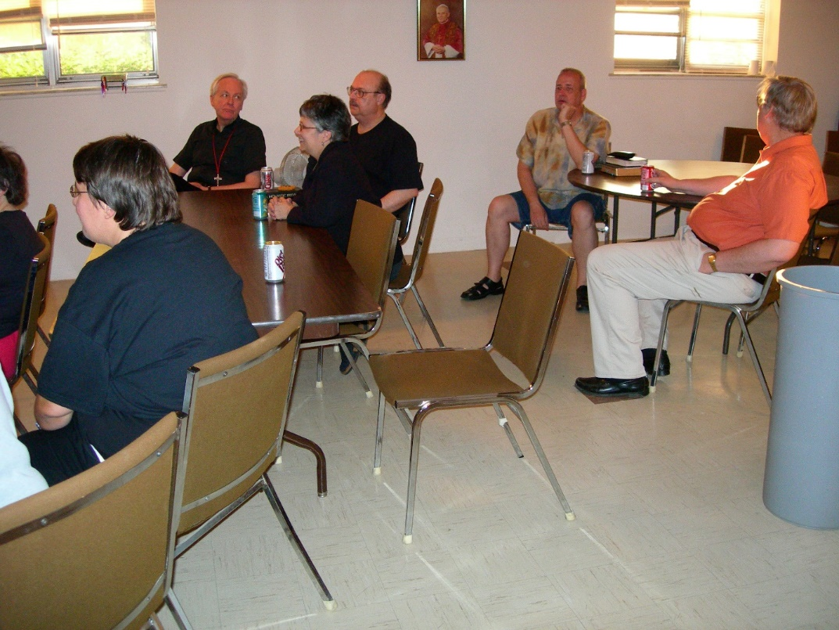
DSCN0423 Sr. Pauline Tysol; Br. Luke Doucette; Sr. Anna Grace Madden; Br. Raymond Owens; Br. Gabriel Hale; Br. Chad Anselm Gerns

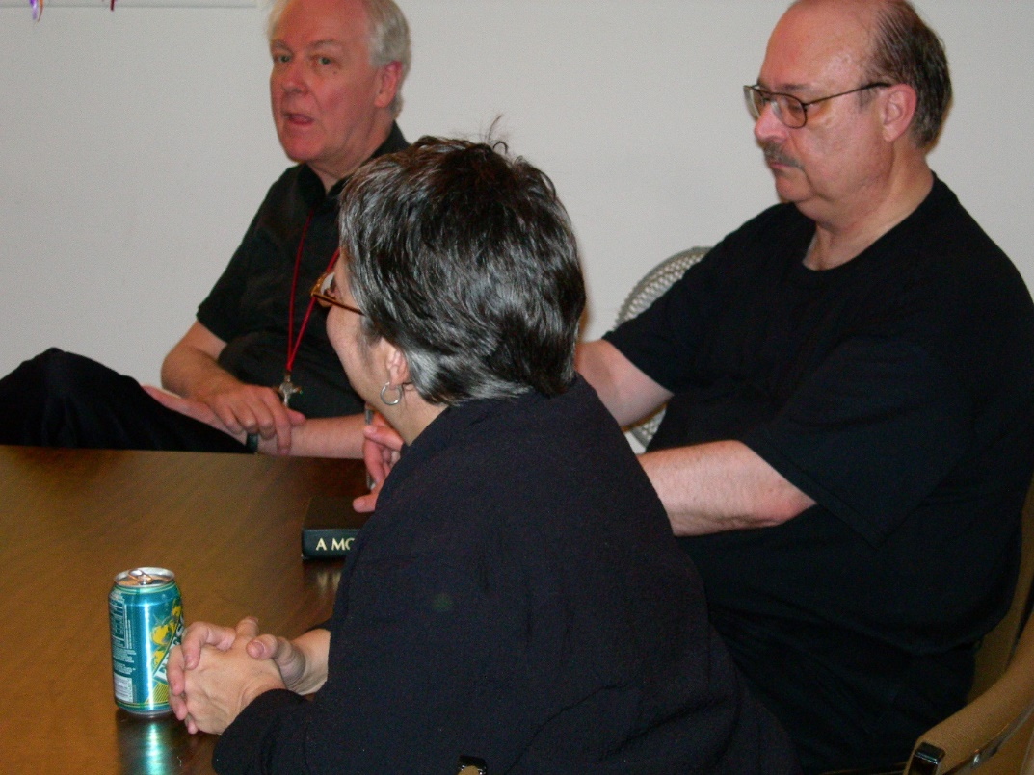
DSCN0424 Br. Luke Doucette; Sr. Anna Grace Madden; Br. Raymond Owens
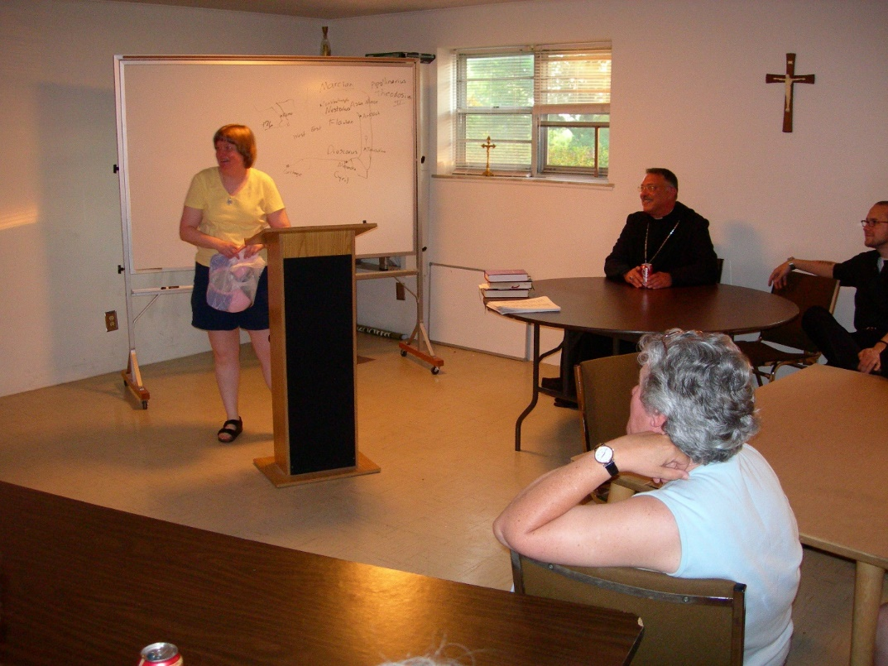
DSCN0426 Sr. Catherine Unterseher; Abbot Michael John Austin; Sr. Johanna Kirkpatrick; Br. Eckhart Sowers

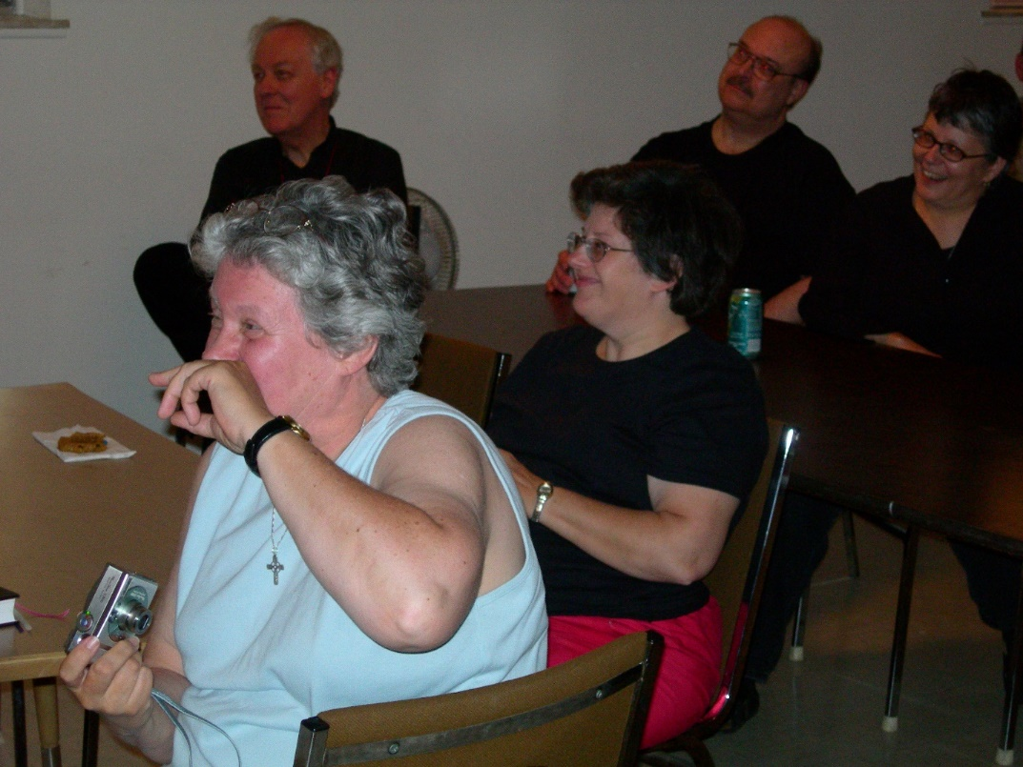
DSCN0427 Sr. Johanna Kirkpatrick; Br. Luke Doucette; Sr. Cecelia Lamoy; Br. Raymond Owens; Sr. Anna Grace Madden
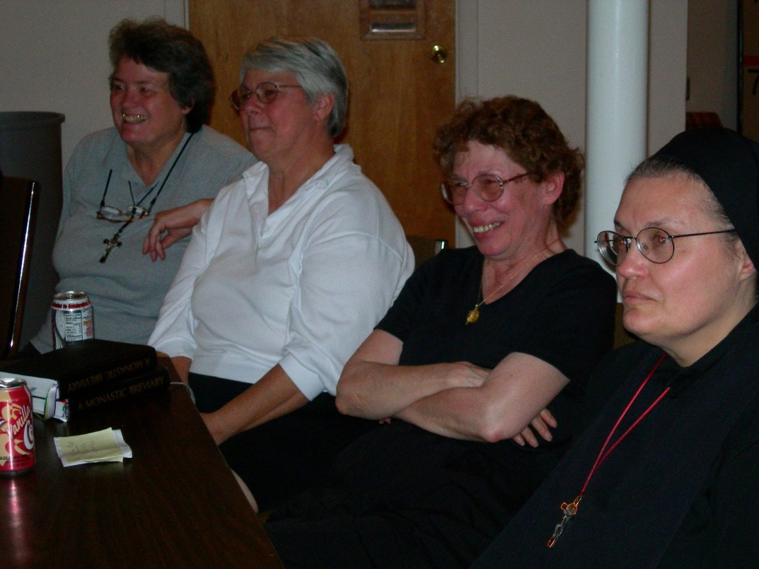
DSCN0428 Sr. Vincent Marie Rittenhouse; Sr. Clare Benedicta Meyers; Sr. Monica Ruth Mullen; Sr. Theodora of Jesus Perecca


DSCN0429 Sr. Monica Ruth Mullen; Fr. Wayne Kamm; Sr. Catherine Unterseher
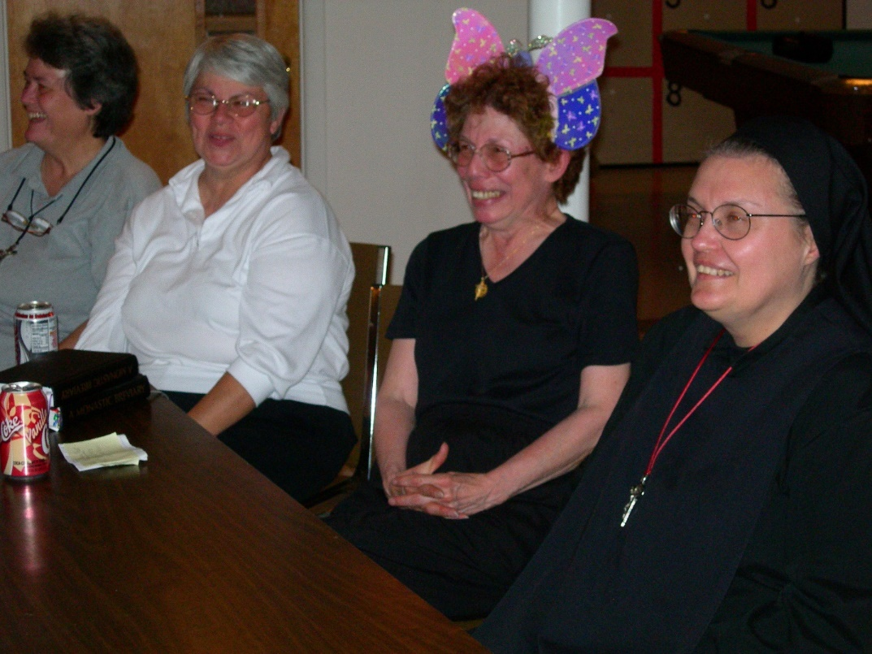
DSCN0430 Sr. Vincent Marie Rittenhouse; Sr. Clare Benedicta Meyers; Sr. Monic Ruth Mullen; Sr. Theodora of Jesus Perecca

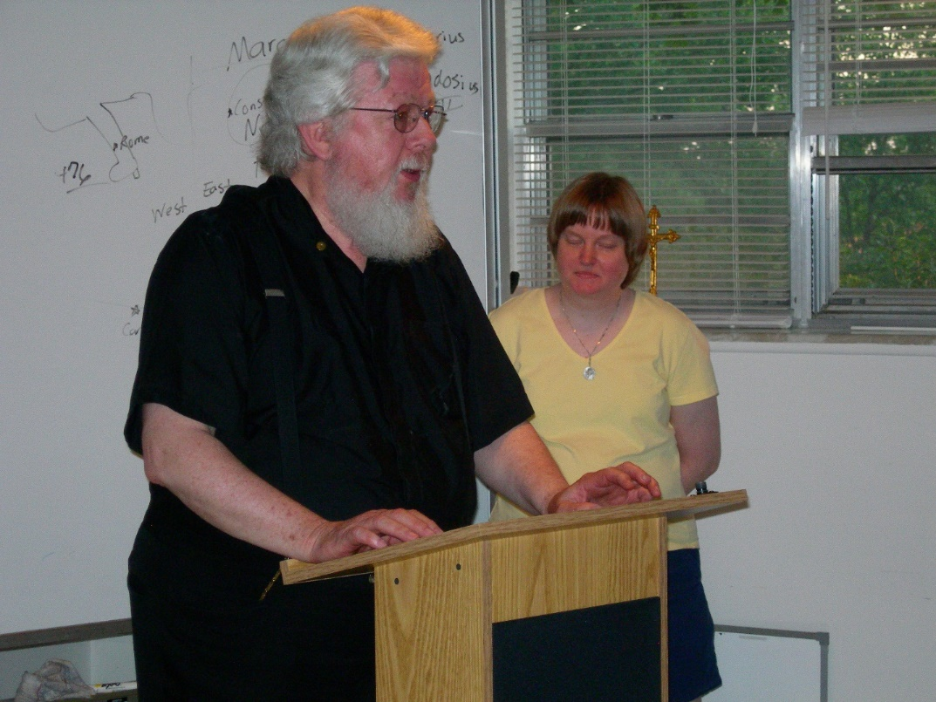
DSCN0432 Fr. Wayne Kamm; Sr. Catherine Unterseher
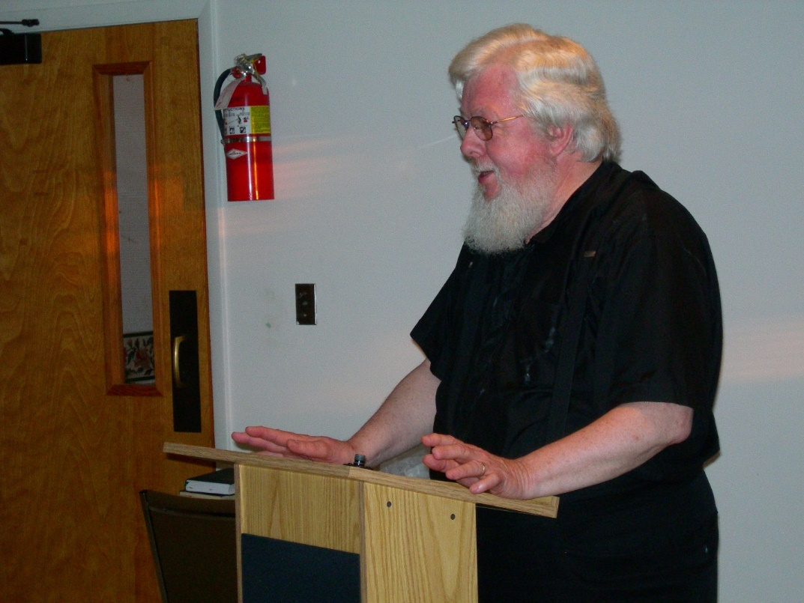
DSCN0433 Fr.Wayne Kamm

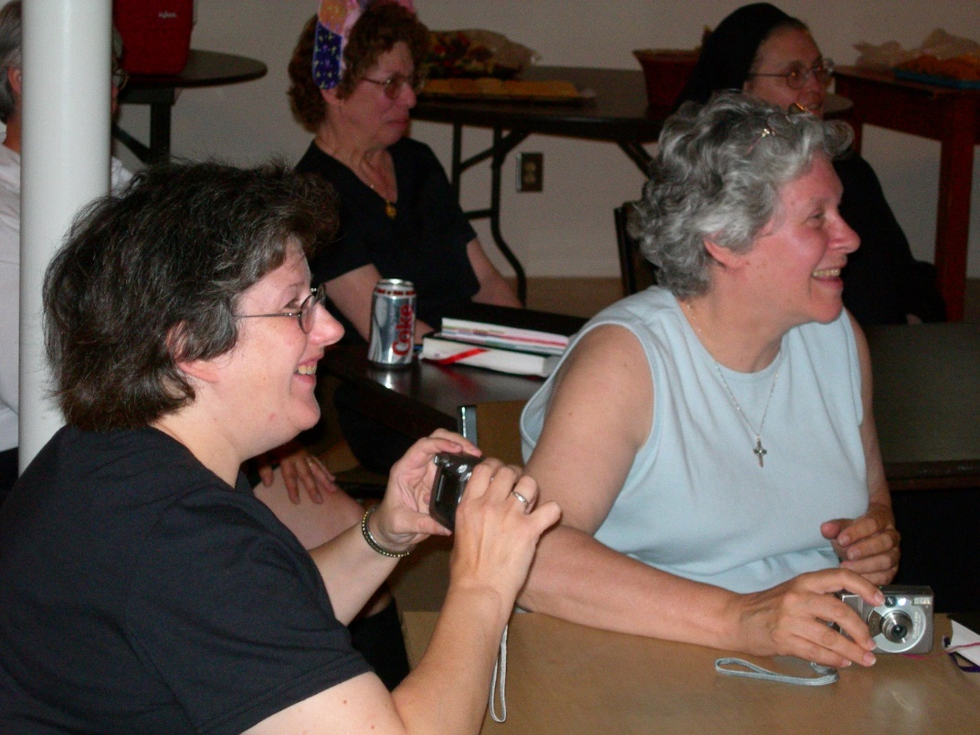
DSCN0434 Sr. Cecelia Lamoy; Sr. Monica Ruth Mullen; Sr. Johanna Kirkpatrick; Sr. Theodora of Jesus Perecca
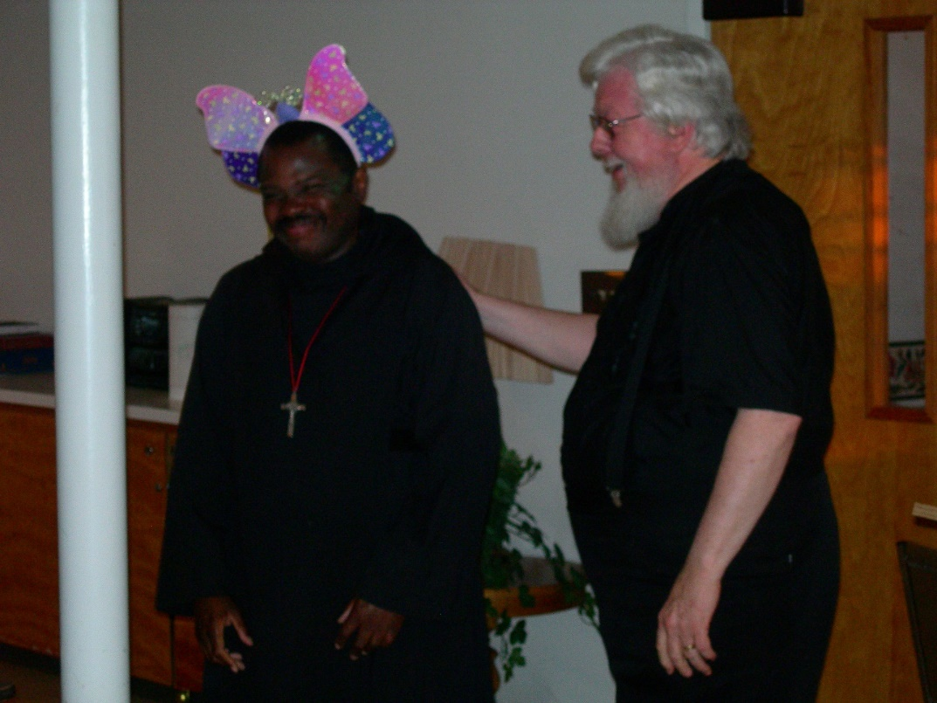
DSCN0435 Br. Thomas Ferrell; Fr. Wayne Kamm

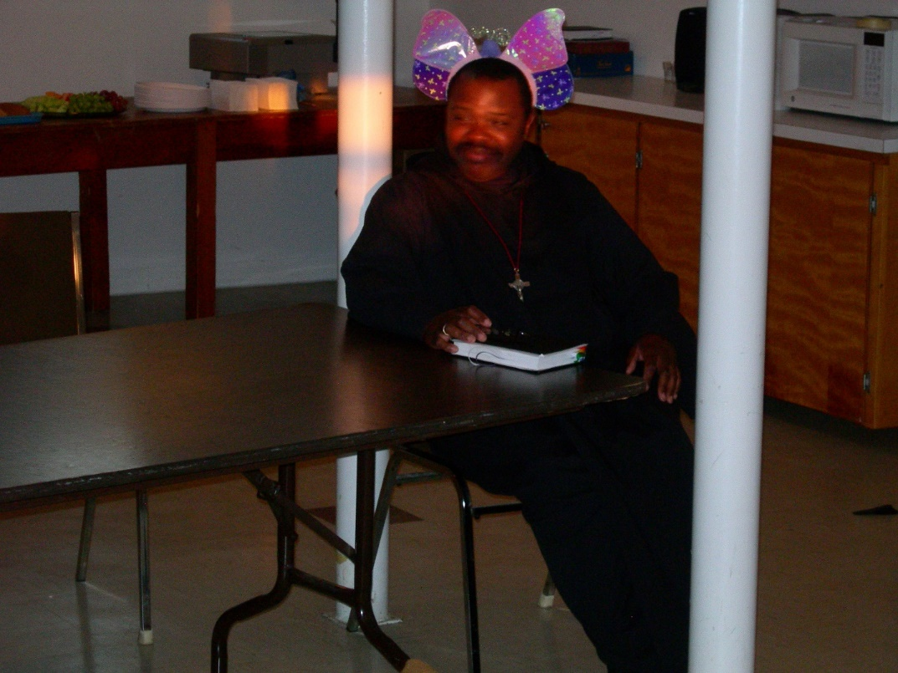
DSCN0436 Br. Thomas Ferrell
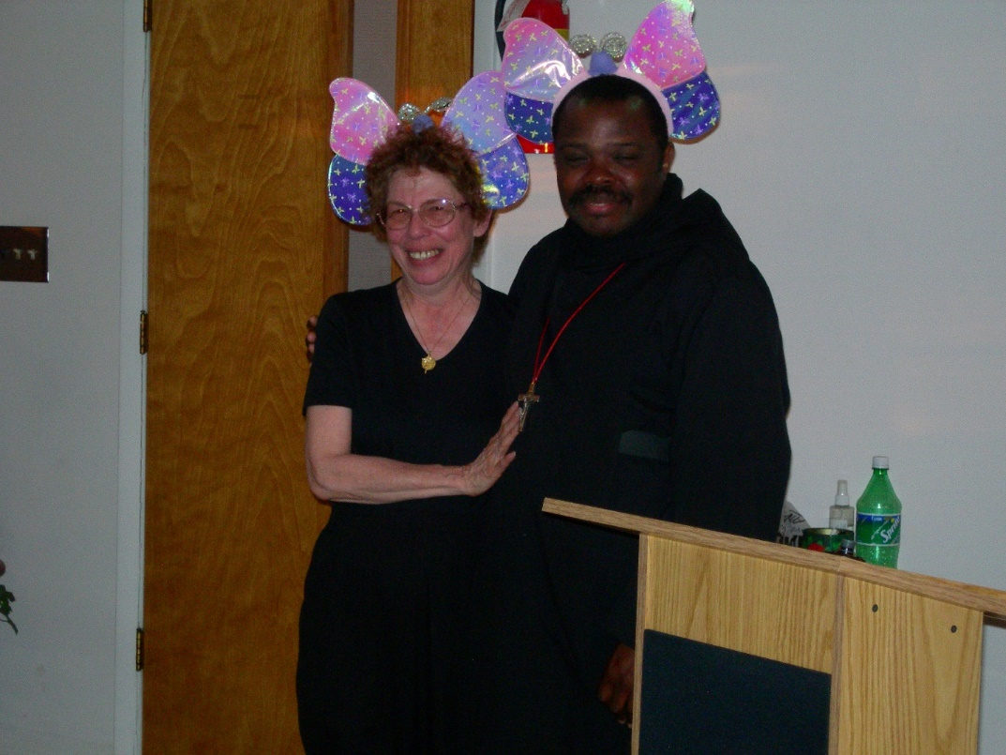
DSCN0437 Sr. Monica Ruth Mullen; Br. Thomas Ferrell

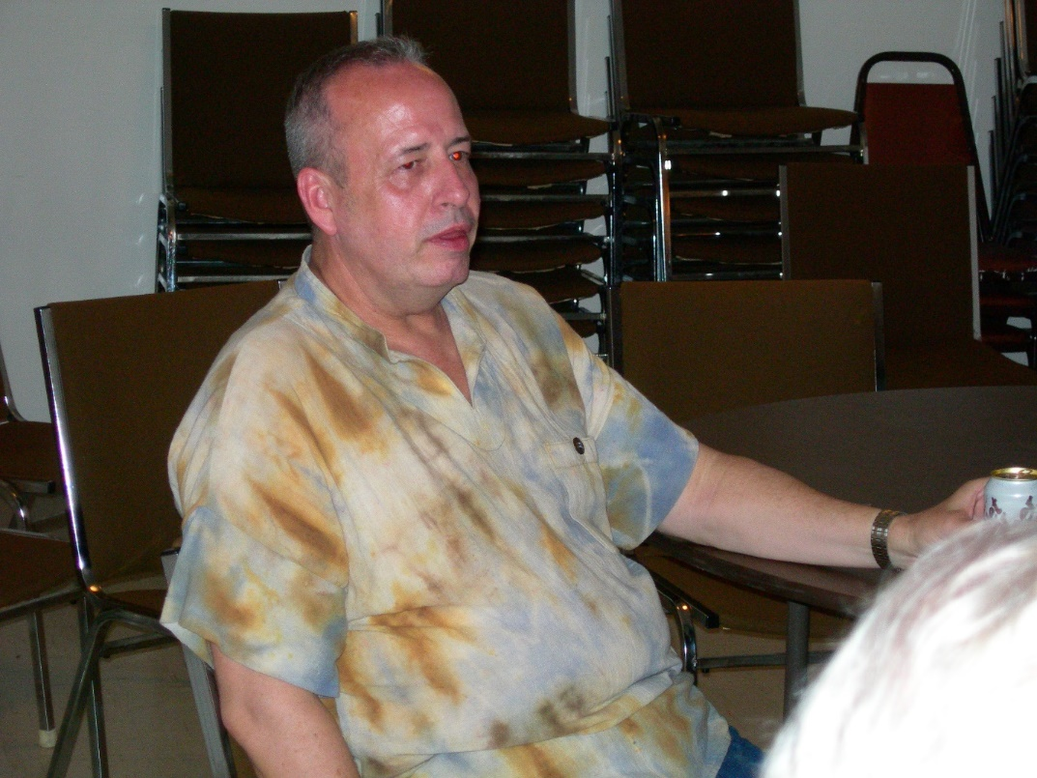
DSCN0438 Br. Gabriel Hale
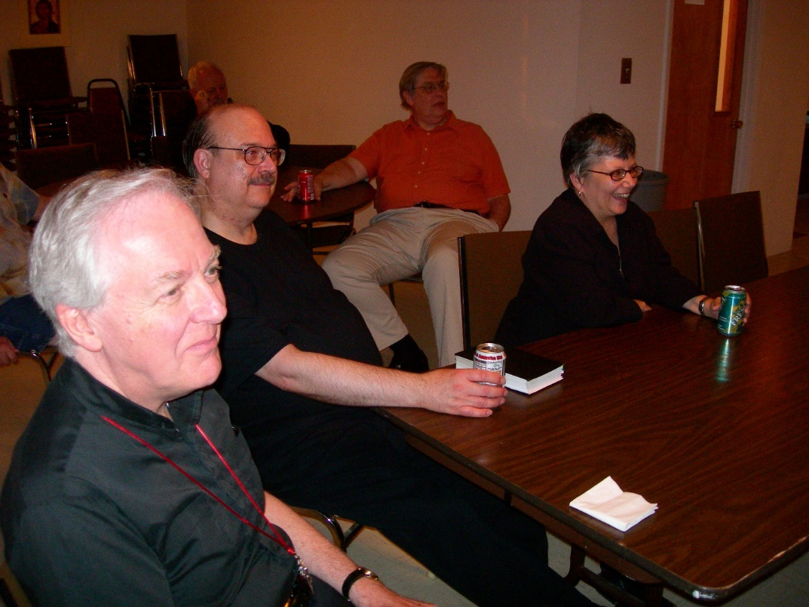
DSCN0439 Br. Luke Doucette; Br. Raymond Owens; Br. Chad Anselm Gerns; Sr. Anna Grace Madden

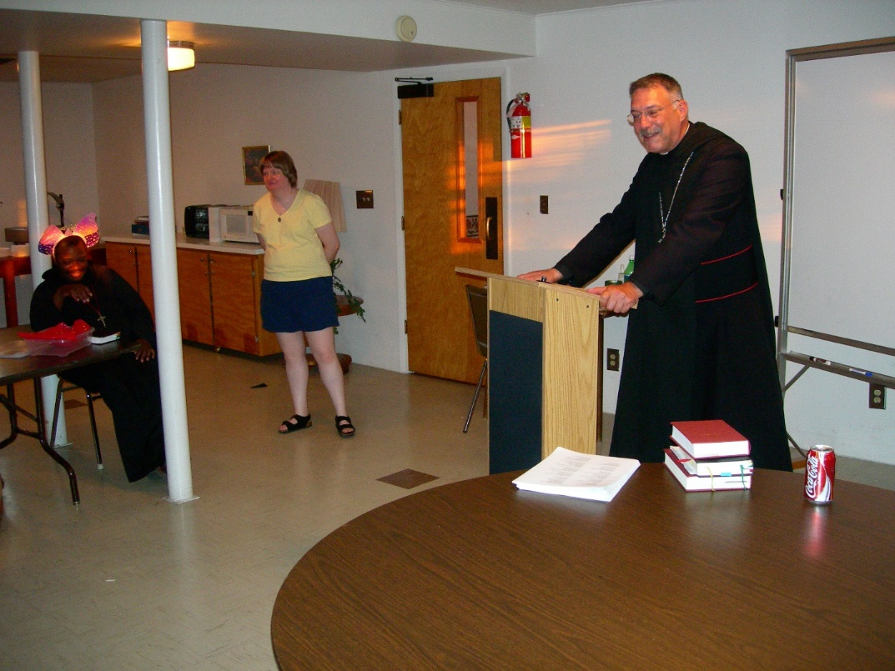
DSCN0441 Br. Thomas Ferrell; Sr. Catherine Unterseher; Fr. Wayne Kamm
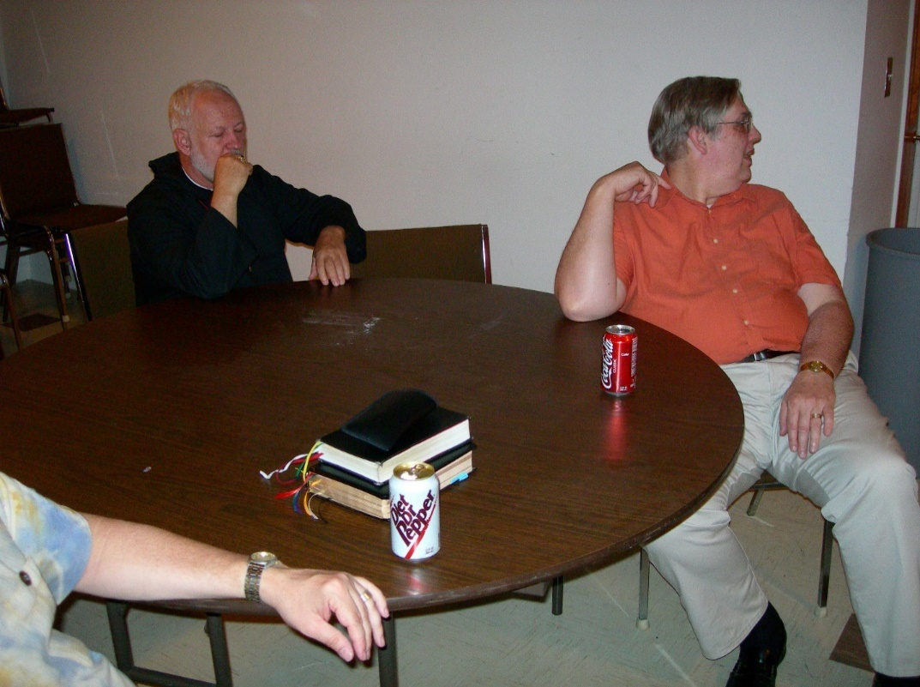
DSCN0442 Br. Christopher John Baumann; Br. Chad Anselm Gerns

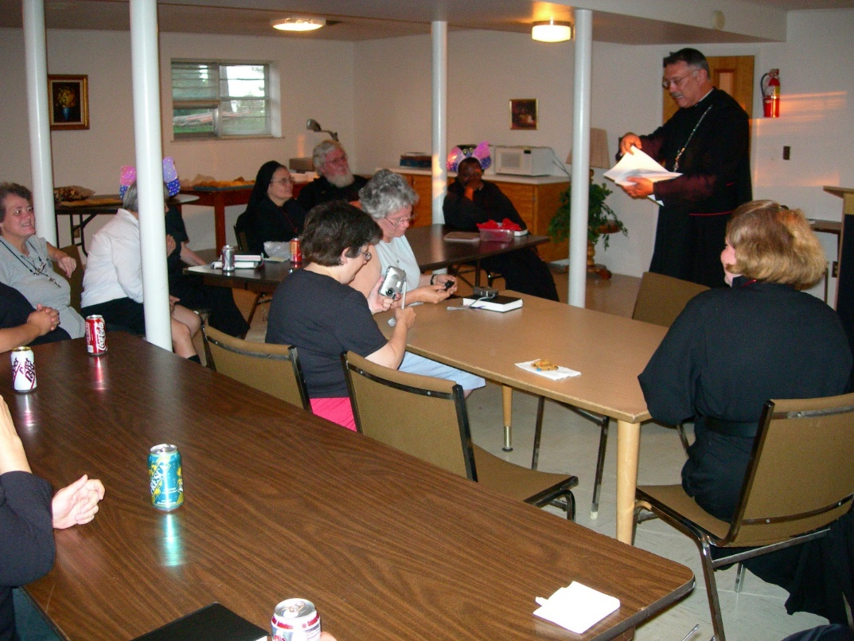
DSCN0443 Sr. Vincent Marie Rittenhouse; Sr. Clare Benedicta Meyers; Sr. Theodora of Jesus Perecca; Sr. Cecelia Lamoy; Fr. Wayne Kamm; Sr. Johanna Kirkpatrick; Br. Thomas Ferrell; Abbot Michael John Austin; Sr. Hillary Grace Lundgren

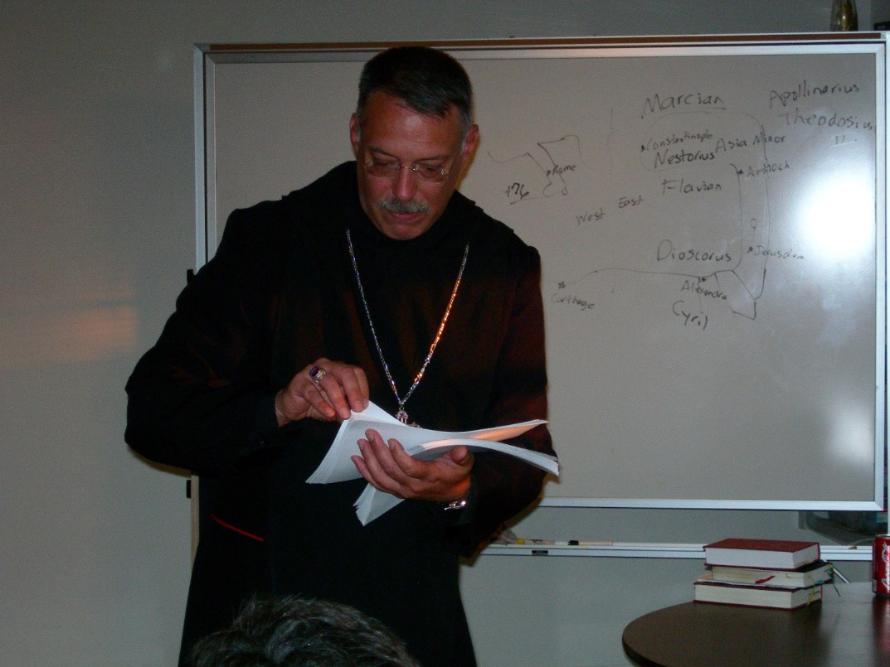
DSCN0444 Abbot Michael John Austin

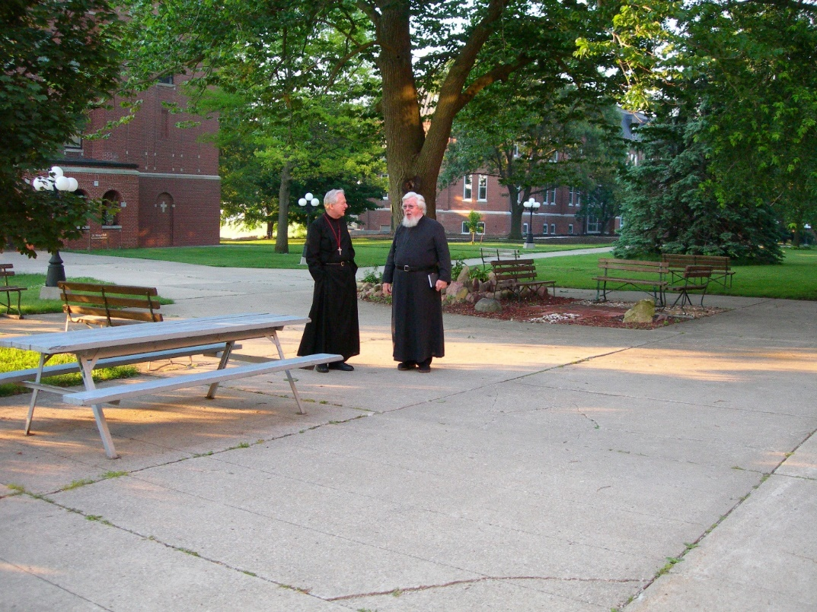
DSCN0446 Br. Luke Doucette; Fr. Wayne Kamm

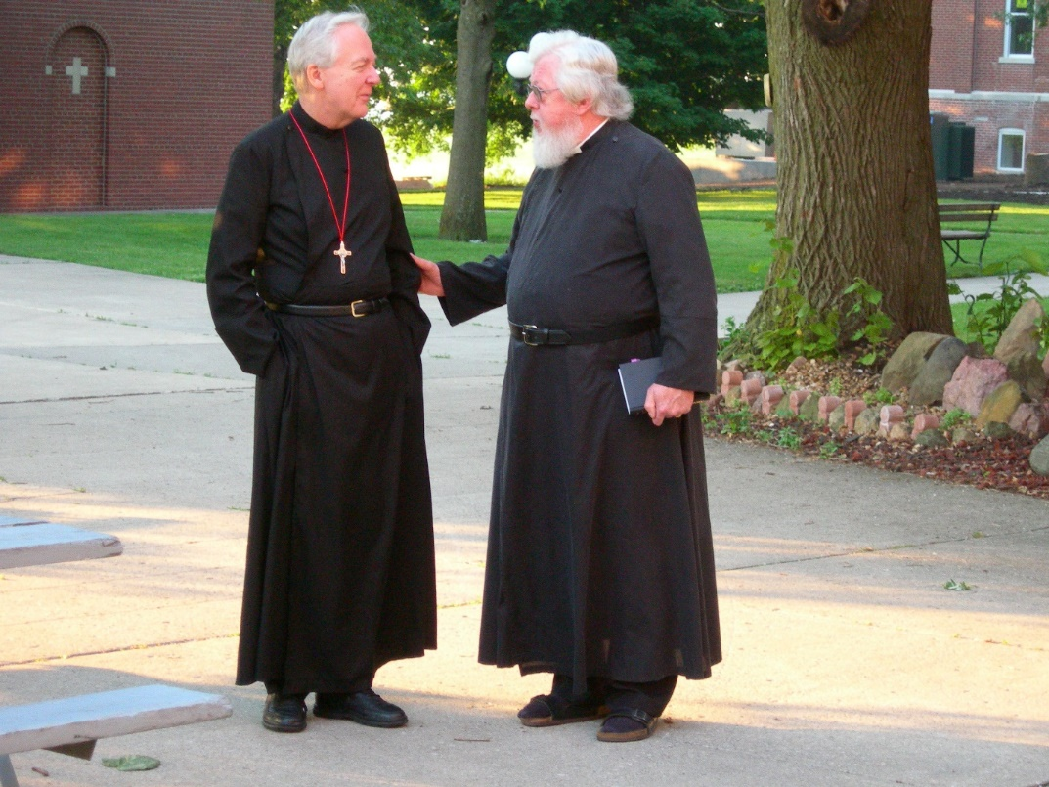
DSCN0447 Br. Luke Doucette; Fr. Wayne Kamm

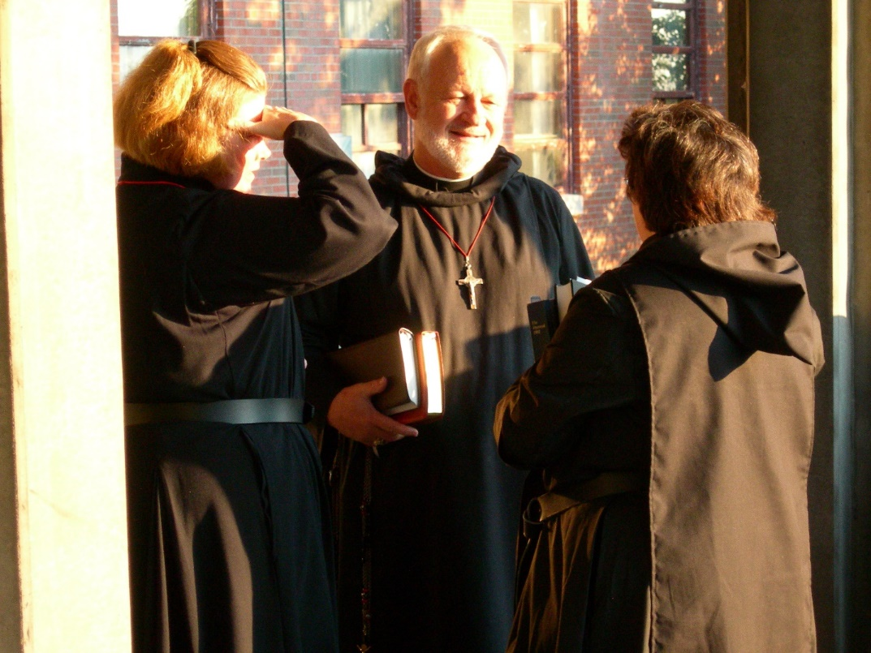
DSCN0448 Sr. Hillary Grace Lundgren; Br. Christopher John Baumann; Sr. Cecelia Lamoy

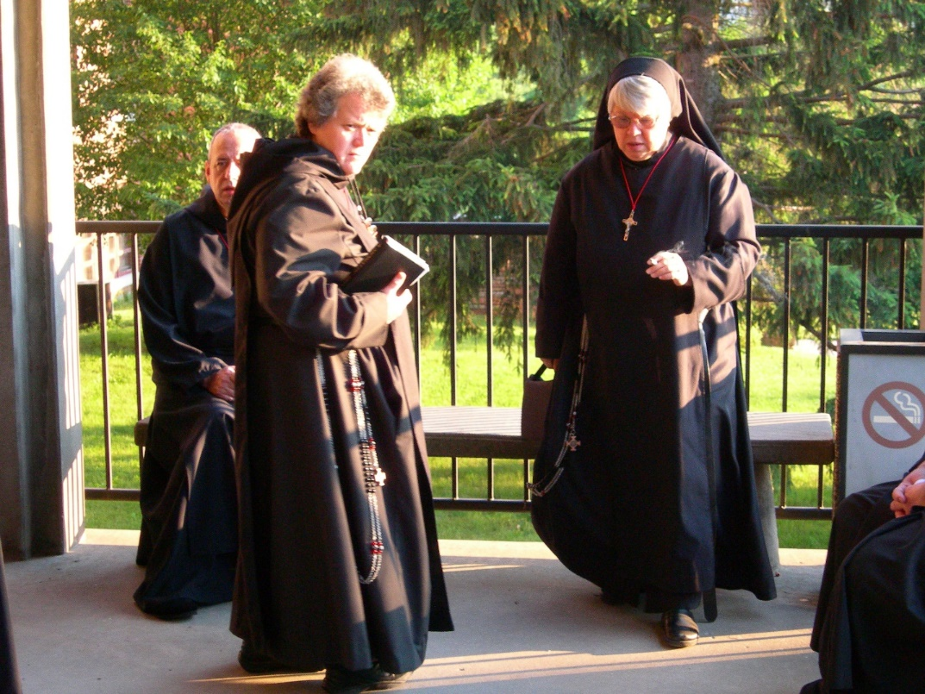
DSCN0449 Br. Gabriel Hale; Sr. Vincent Marie Rittenhouse; Sr. Clare Benedicta Meyers

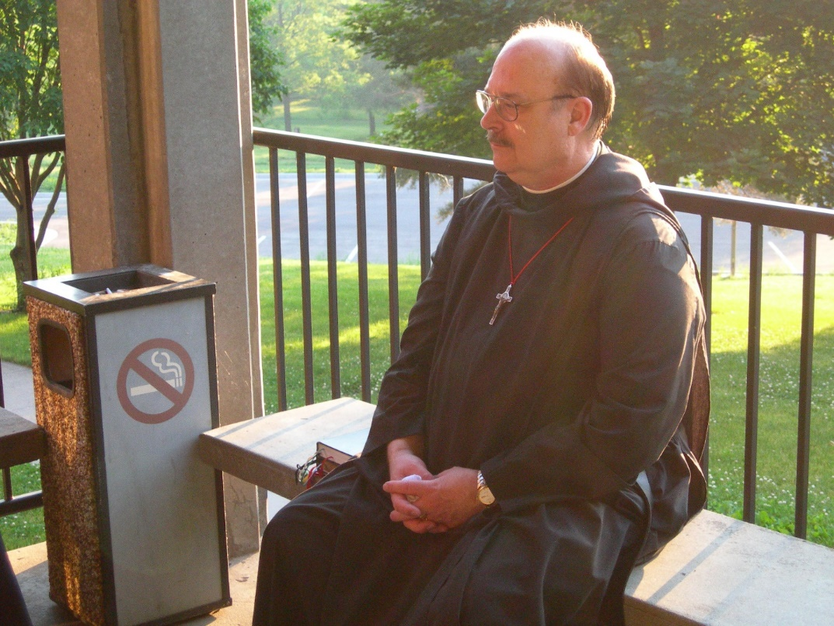
DSCN0451 Br. Raymond Owens

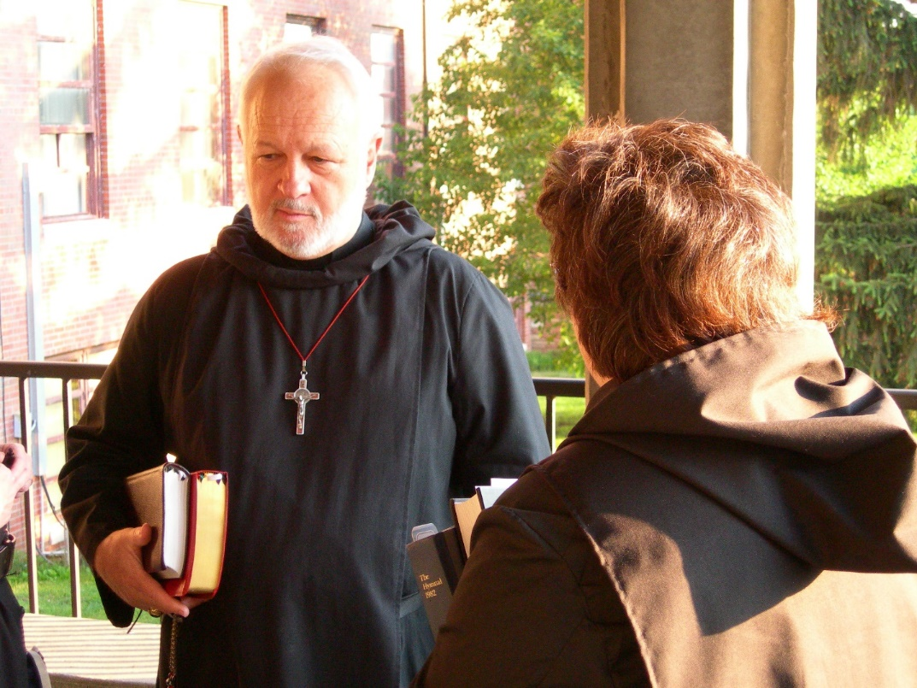
DSCN0452 Br. Christopher John Baumann; Sr. Cecelia Lamoy

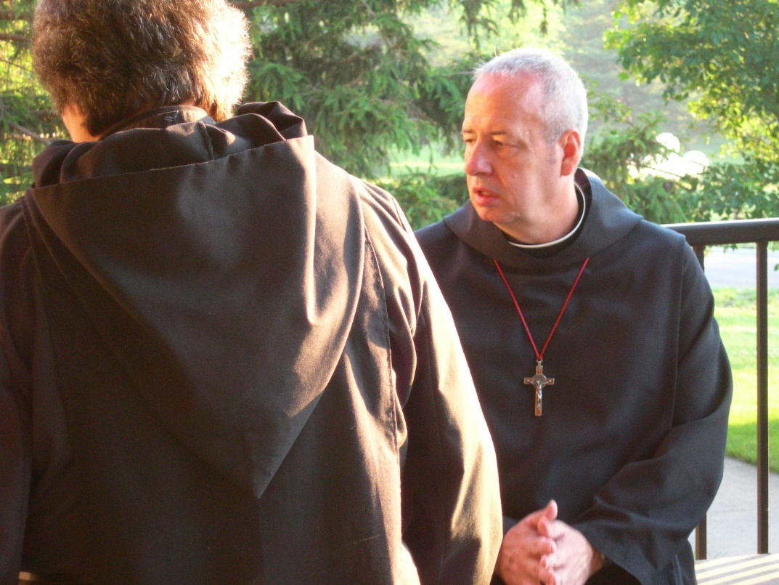
DSCN0454 Sr. Cecelia Lamoy; Br. Gabriel Hale

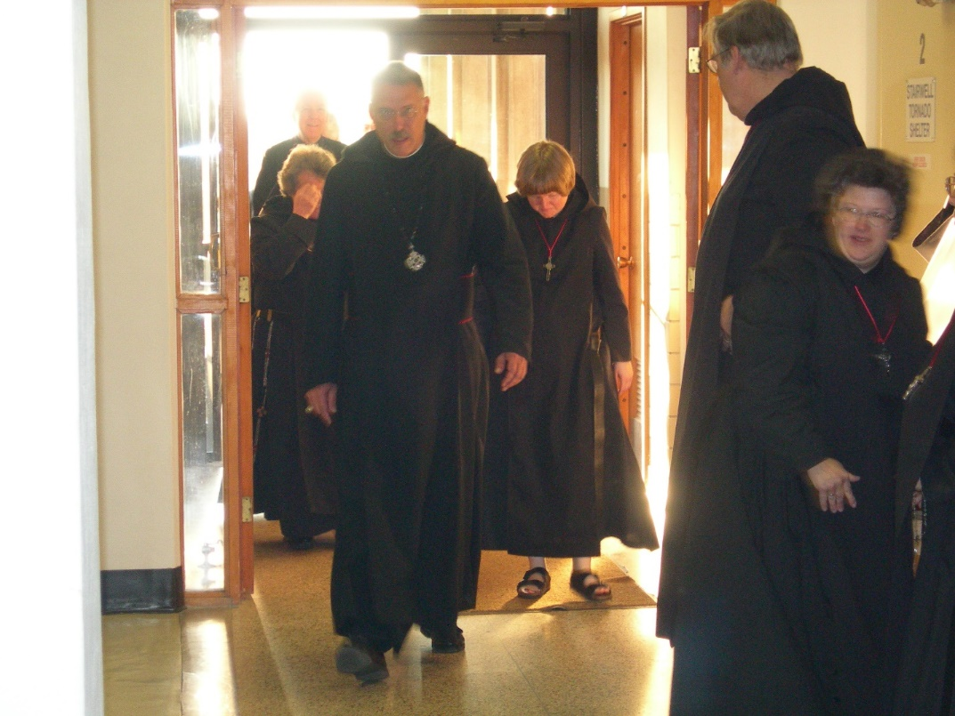
DSCN0455 Sr. Vincent Marie Rittenhouse; Br. Luke Doucette; Abbot Michael John Austin; Sr. Catherine Unterseher; Br. Chad Anselm Gerns; Sr. Cecelia Lamoy

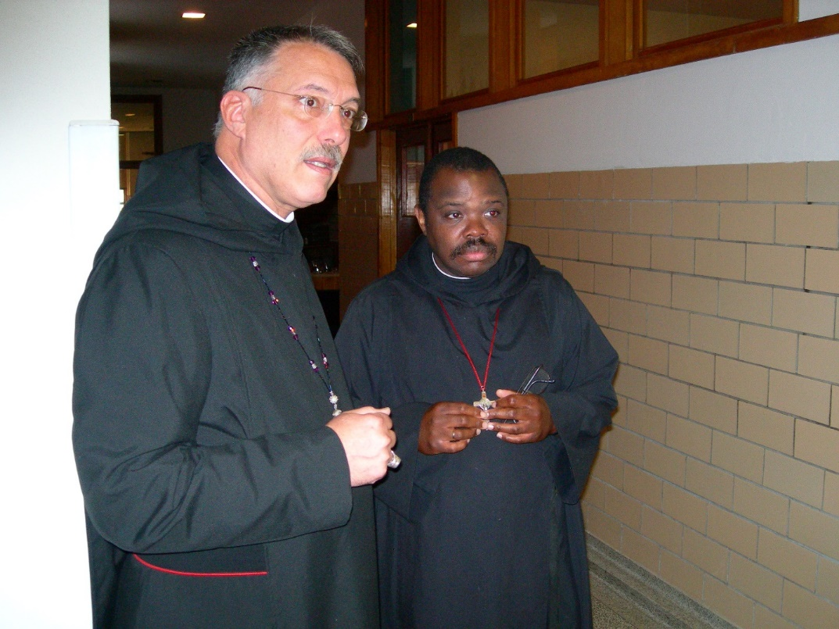
DSCN0456 Abbot Michael John Austin; Br. Thomas Ferrell

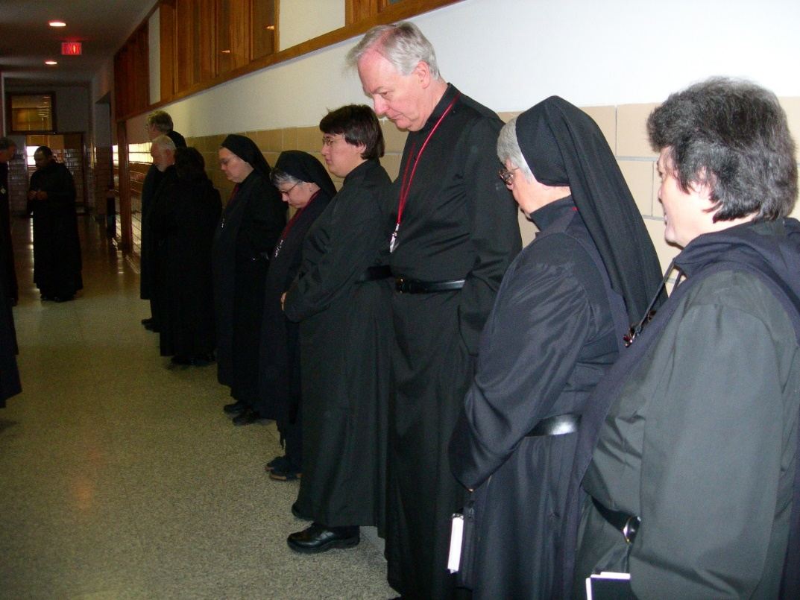
DSCN0457 Br. Chad Anselm Gerns; Br. Christopher John Baumann; Sr. Theodora of Jesus Perecca; Sr. Anna Grace Madden; Sr. Pauline Tysol; Br. Luke Doucette; Sr. Clare Benedicta Meyers; Sr. Vincent Marie Rittenhouse

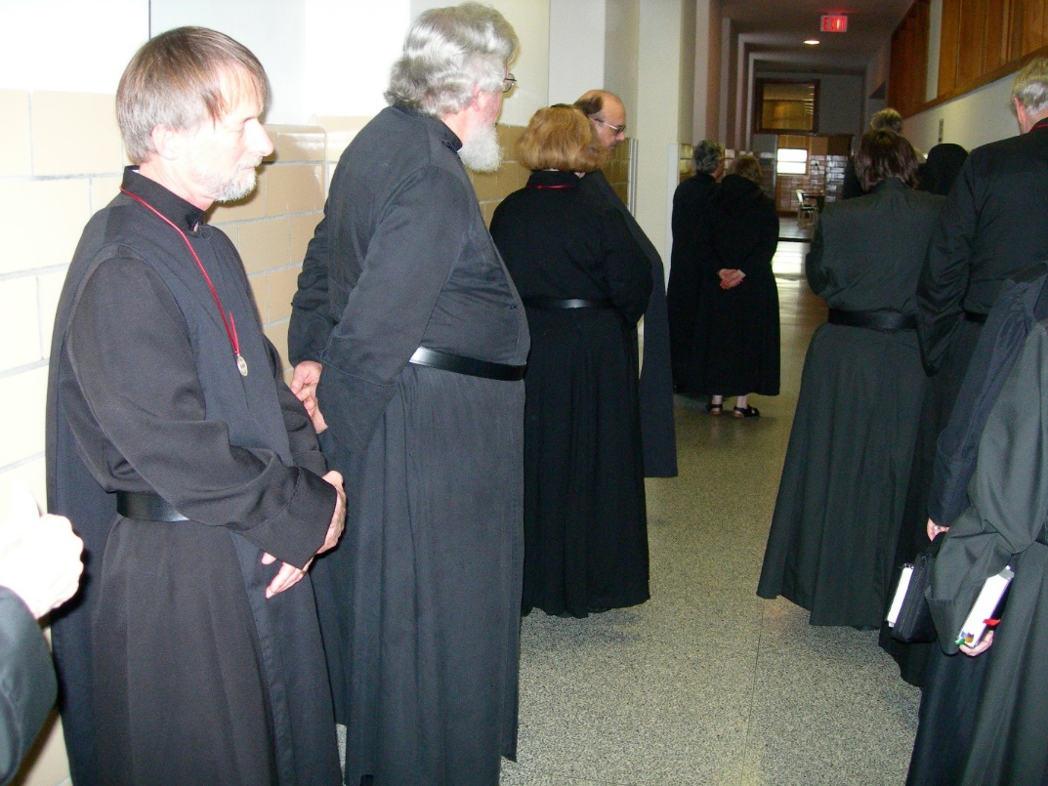
DSCN0458 Br. Lawrence Mullen; Fr. Wayne Kamm; Sr. Hillary Grace Lundgren; Br. Raymond Owens

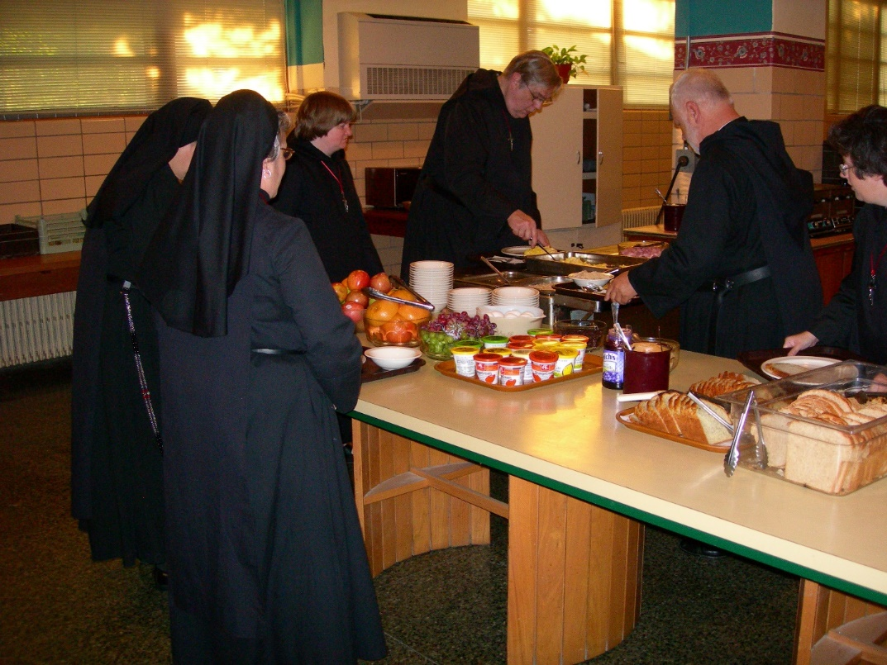
DSCN0459 Sr. Catherine Unterseyer; Br. Chad Anselm Gerns; Br. Christopher John Baumann; Sr. Cecelia Lamoy

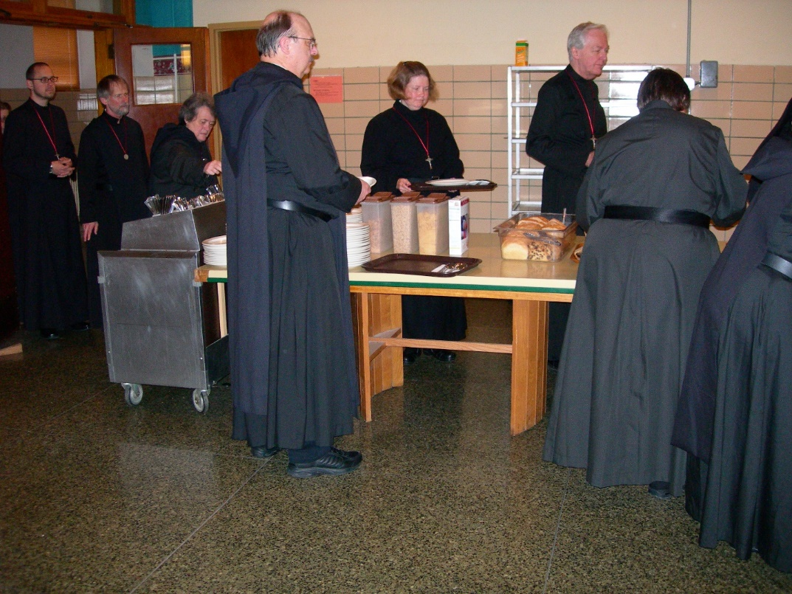
DSCN0460 Br. Eckhart Sowers; Br. Lawrence Mullen; Sr. Vincent Marie Rittenhouse; Br. Raymond Owens; Sr. Hillary Grace Lundgren; Br. Luke Doucette; Sr. Pauline Tysol

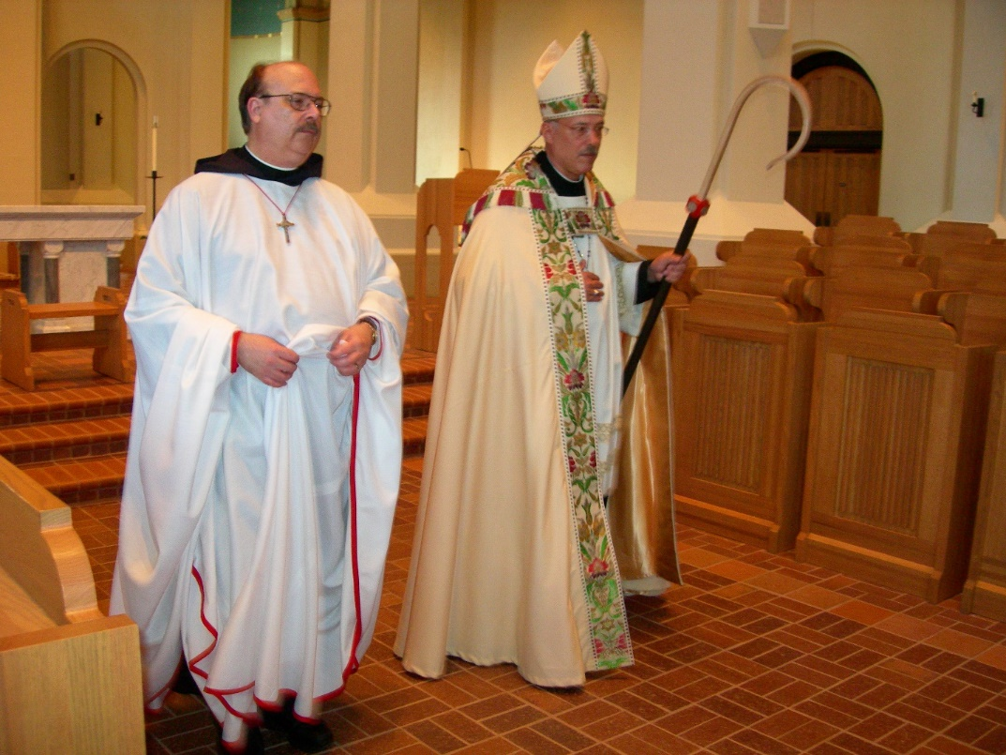
DSCN0462 Br. Raymond Owens; Abbot Michael John Austin

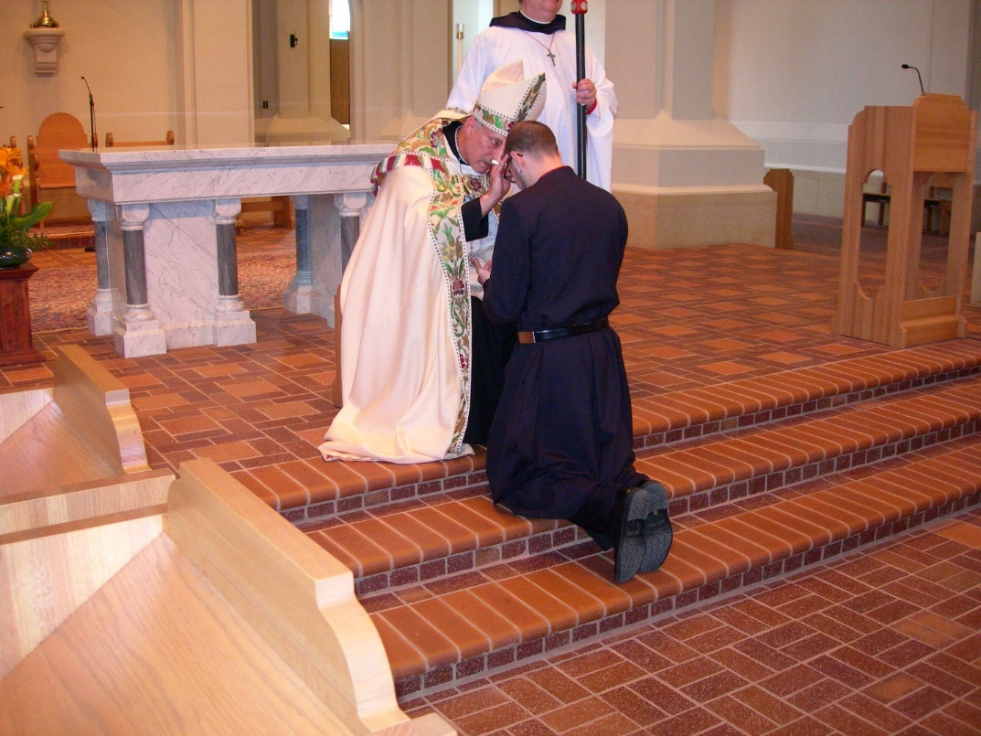
DSCN0463 Abbot Michael John Austin; Br. Eckhart Sowers; Br. Raymond Owens

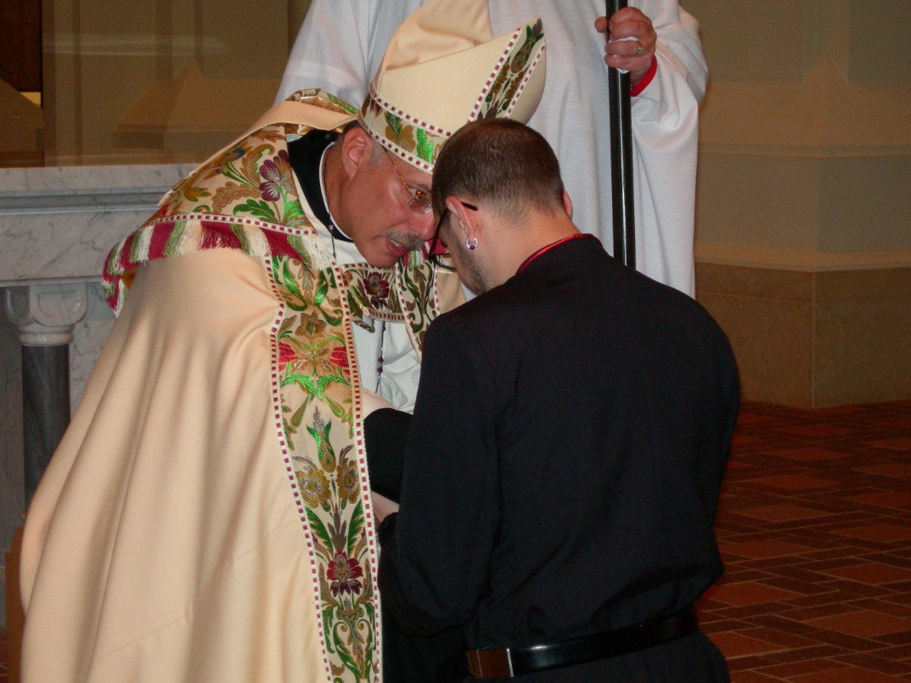
DSCN0464 Abbot Michael John Austin; Br. Eckhart Sowers; Br. Raymond Owens

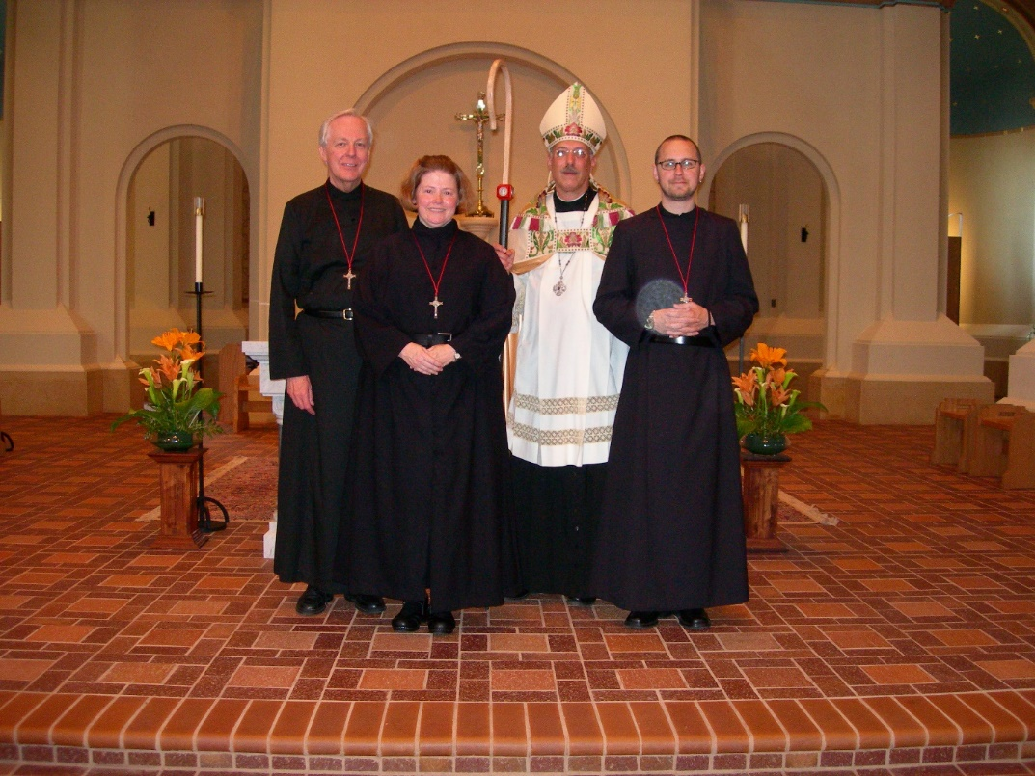
DSCN0466 Br. Luke Doucette; Sr. Hillary Grace Lundgren; Abbot Michael John Austin; Br. Eckhart Sowers

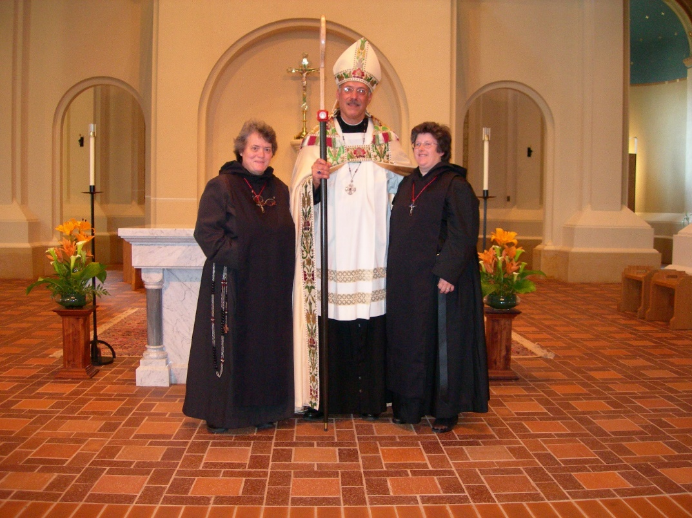
DSCN0467 Sr.Vincent Marie Rittenhouse; Abbot Michael John Austin; Sr, Cecelia Lamoy

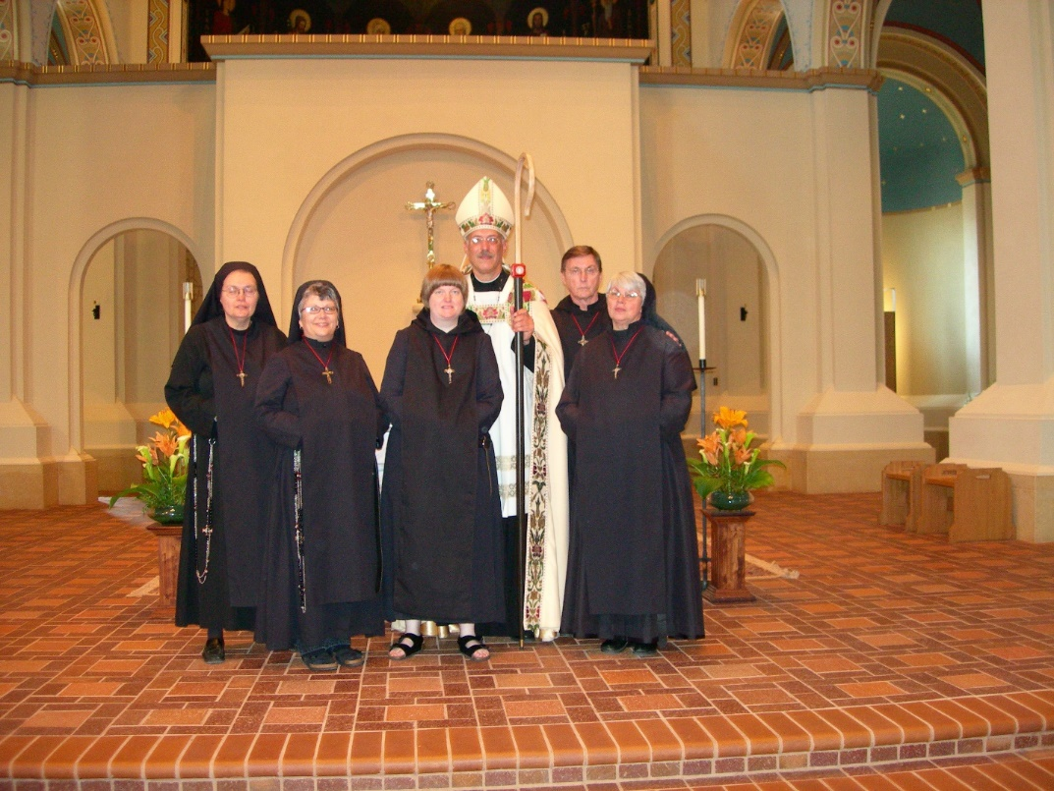
DSCN0468 Sr. Theodora of Jesus Perecca; Sr. Anna Grace Madden; Sr. Catherine Unterseher; Abbot Michael John Austin; Br. Camillus Converse; Sr. Clare Benedicta Meyers

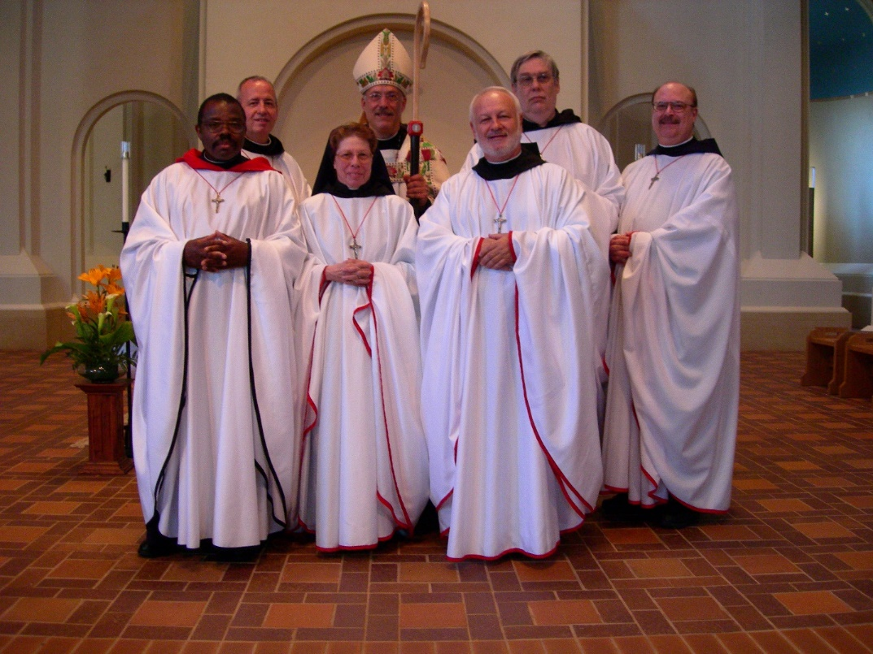
DSCN0469 Br. Thomas Ferrell; Br. Gabriel Hale; Sr. Monica Ruth Mullen; Abbot Michael John Austin; Br. Christopher John Baumann; Br. Chad Anselm Gerns; Br. Raymond Hale

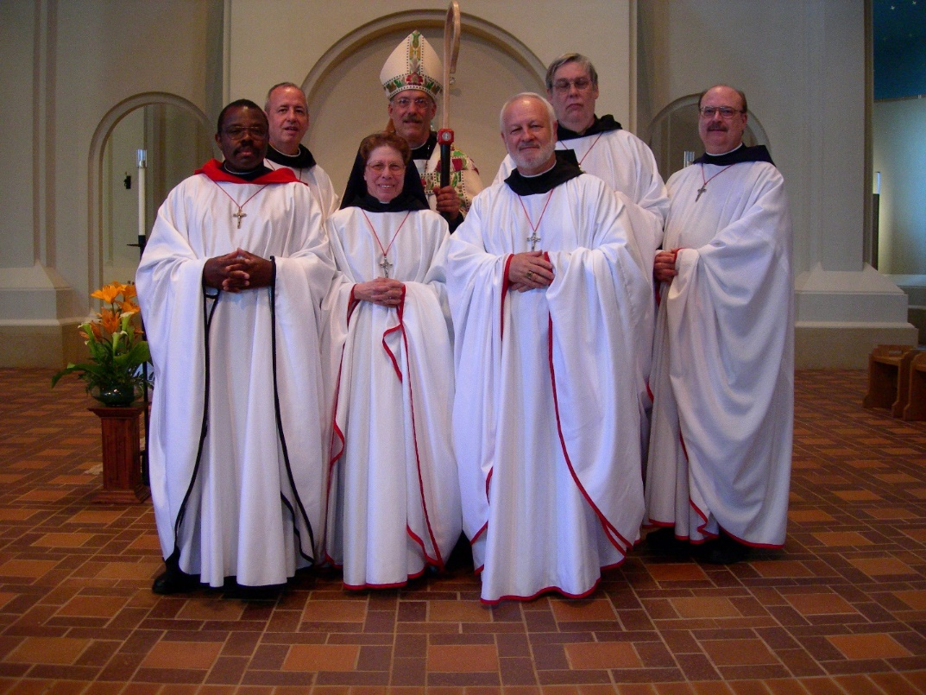
DSCN0470 Br. Thomas Ferrell; Br. Gabriel Hale; Sr. Monica Ruth Mullen; Abbot Michael John Austin; Br. Christopher John Baumann; Br. Chad Anselm Gerns; Br. Raymond Hale

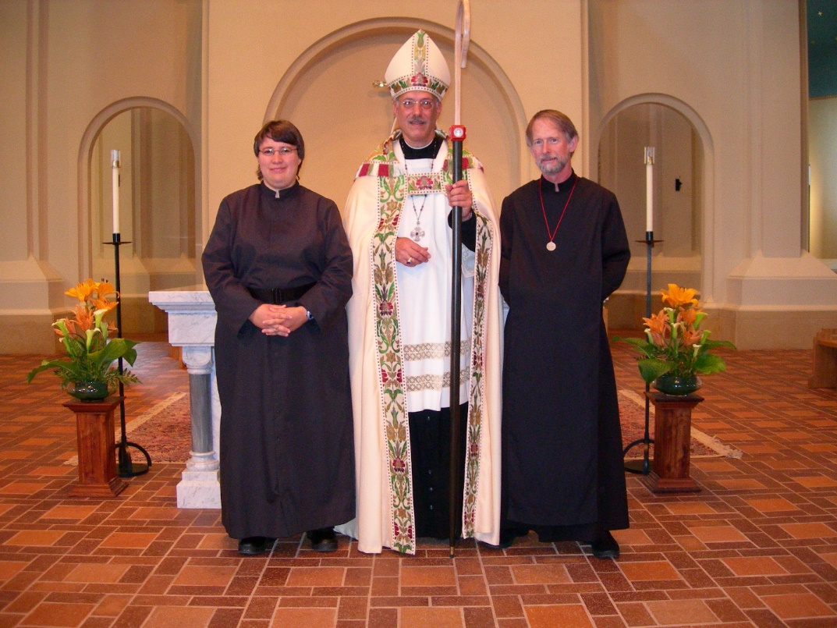
DSCN0471 Sr. Pauline Tysol; Abbot Michael John Austin; Br. Lawrence Mullen

