Companions of St. Luke
Spring 2005 Convocation at Conception Abbey
Part 4 of 5

NOTE: Disc is dated 28 May 2003 but the people present and other documents show this is Spring 2005.

~Edited by Br. Steven Olderr, 19 May 2022 with the assistance of Br. Thomas Ferrell; if you find any errors or omissions, please notify Br. Steven at olderr@ameritech.net

People are identified from left to right.

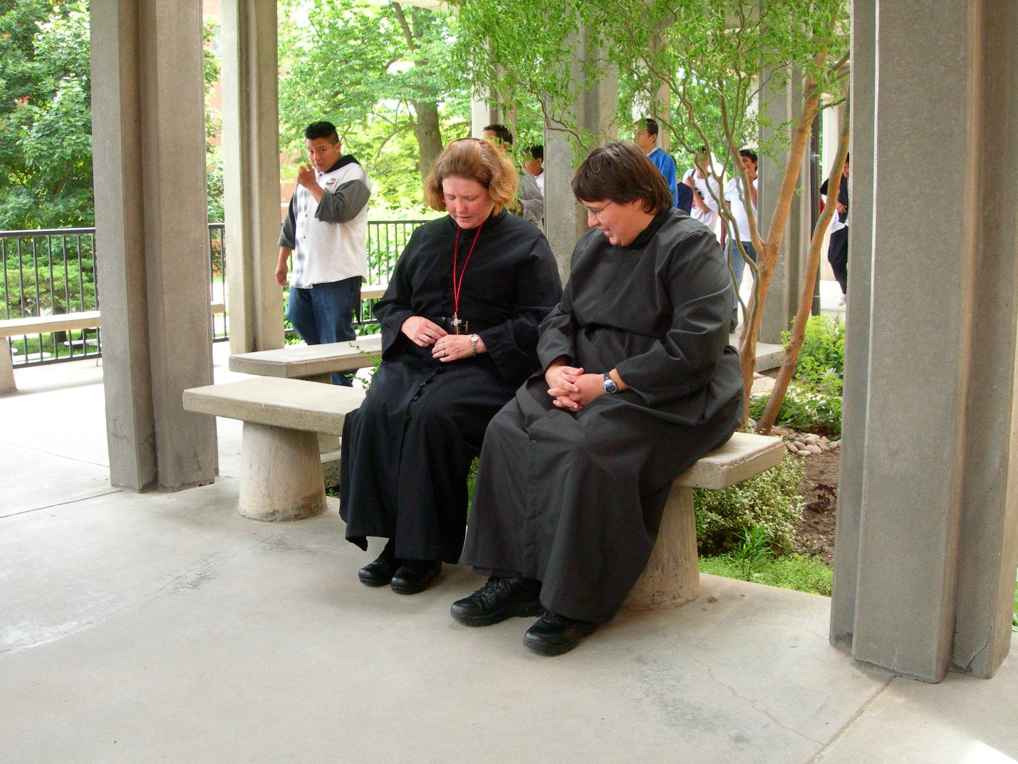
DSCN0323 Sr. Hillary Grace Lundgren; Sr. Pauline Tysol
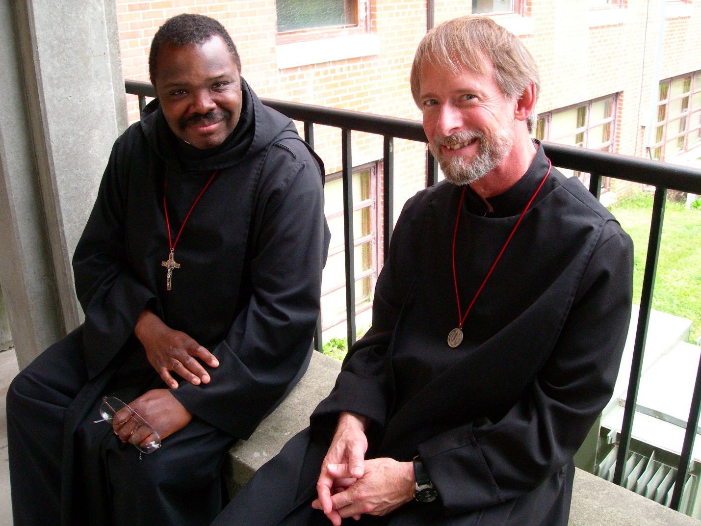
DSCN0324 Br. Thomas Ferrell; Br. Lawrence Mullen
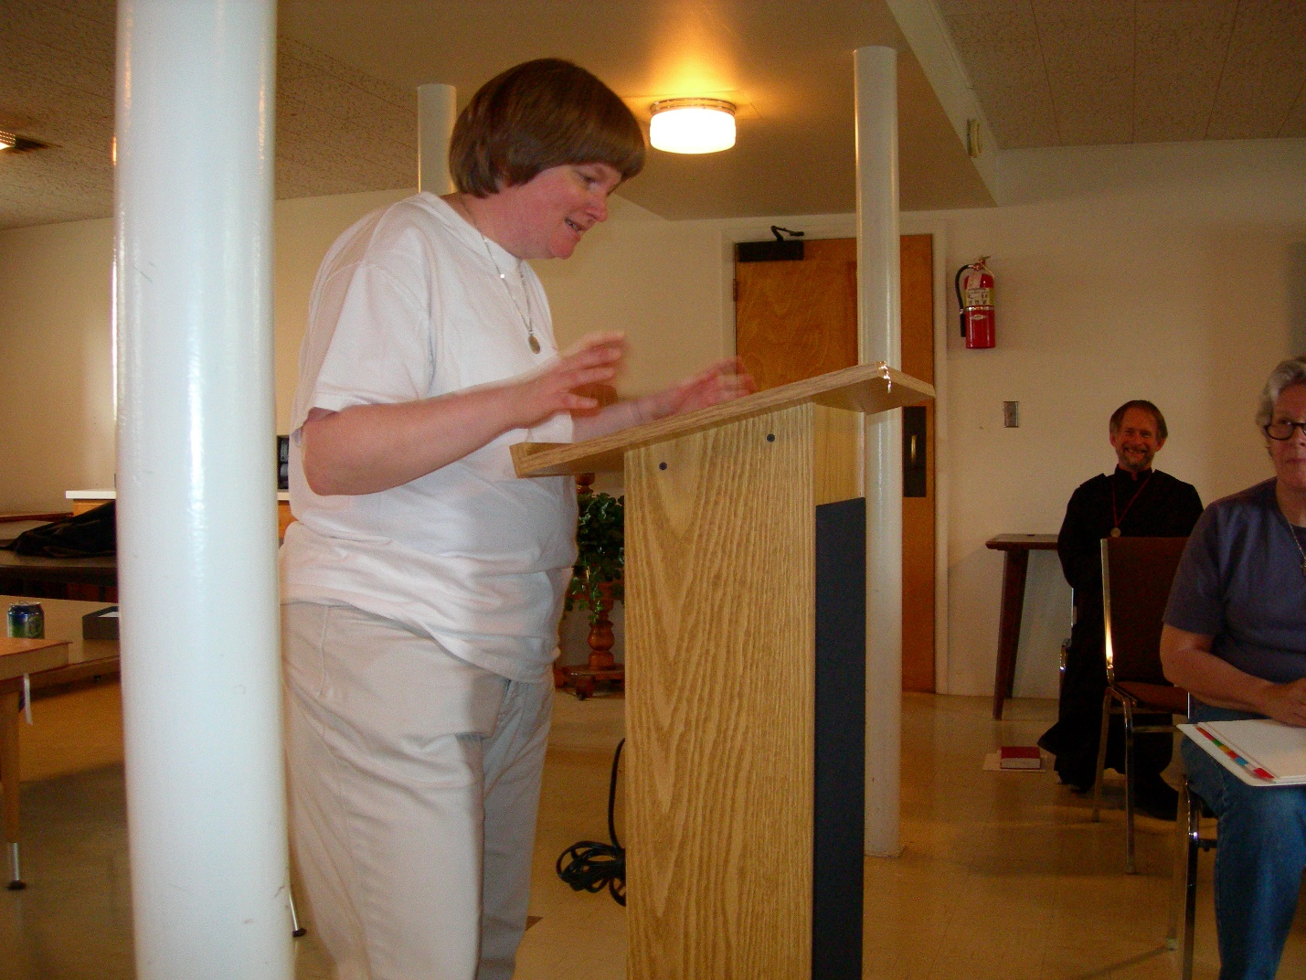
DSCN0325 Sr. Catherine Unterseher; Br. Lawrence Mullen; Sr. Johanna Kirkpatrick
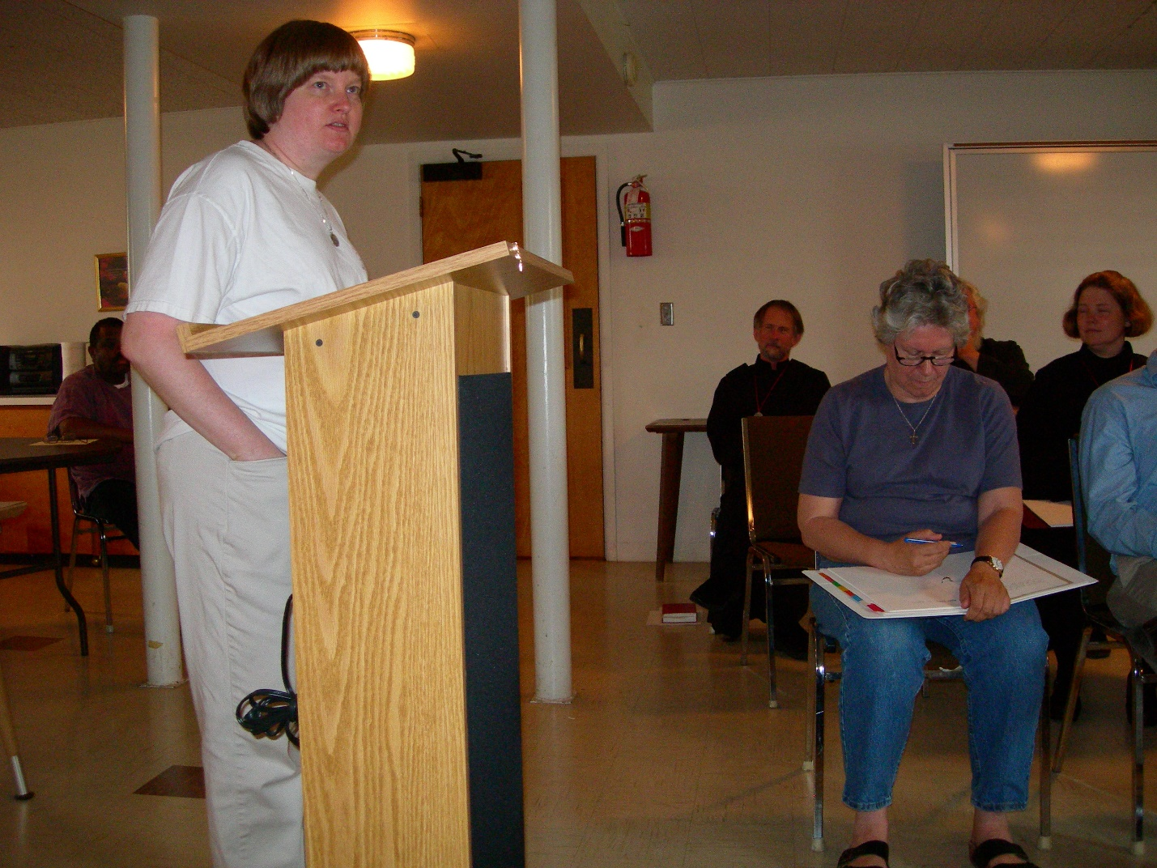
DSCN0326 Sr. Catherine Unterseher; Br. Lawrence Mullen; Sr. Johanna Kirkpatrick; Sr. Hillary Grace Lundgren
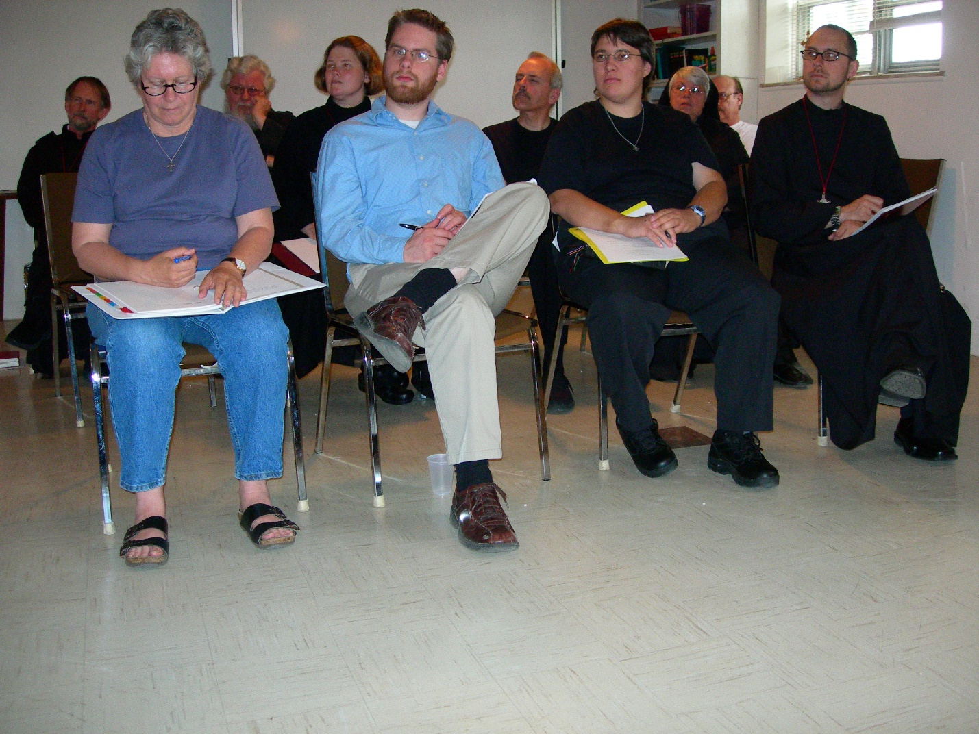
DSCN0327 Br. Lawrence Mullen; Sr. Johanna Lirkpatrick; Fr. Wayne Kamm; Sr. Hillary Grace Lundgren; Friend of Br. Eckhart Sowers; Br. Daniel Joseph Schroeder; Sr. Pauline Tysol; Sr. Clare Benedicta Meyers; Br. Raymond Owens; Br. Eckart Sowers
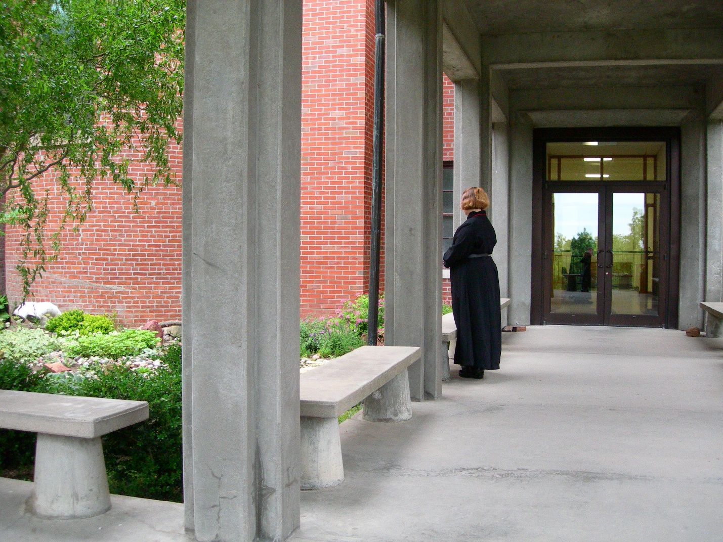
DSCN0328 Sr. Hillary Grace Lundgren
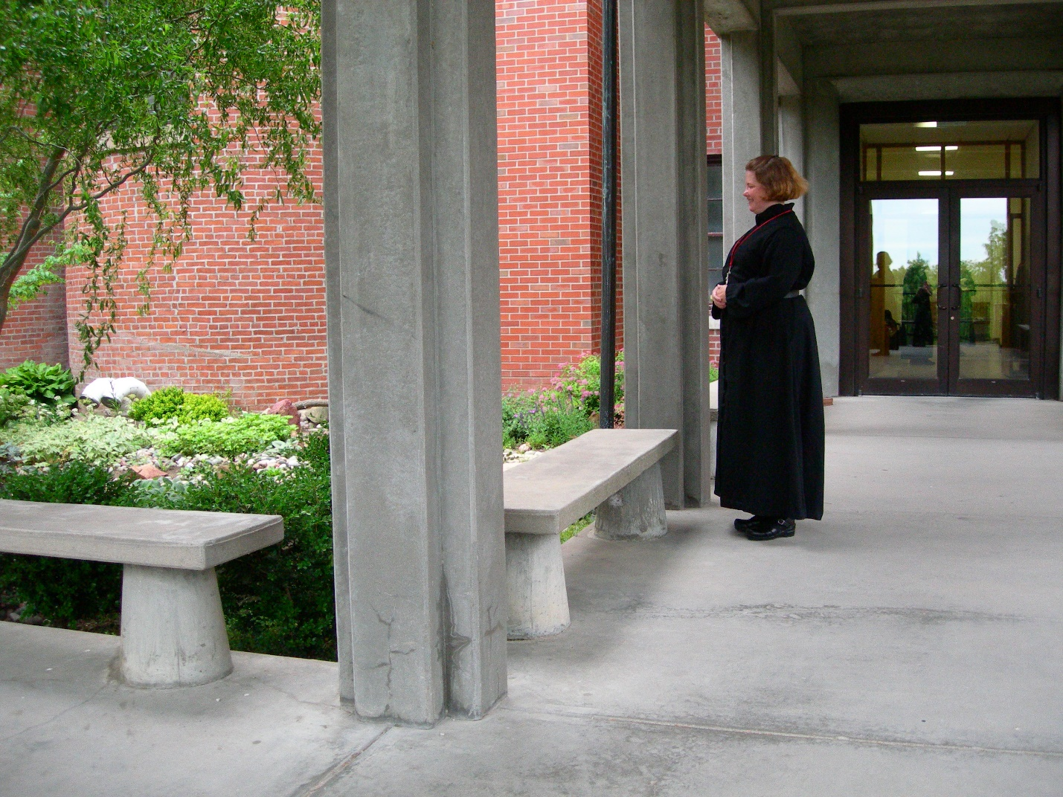DSCN0329 Sr. Hillary Grace Lundgren 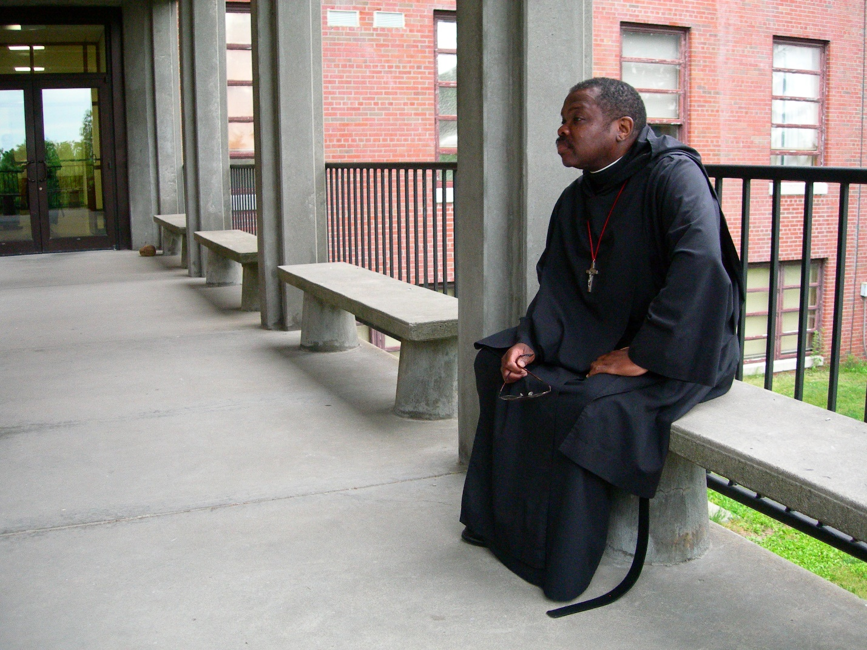
DSCN0330 Br. Thoams Ferrell
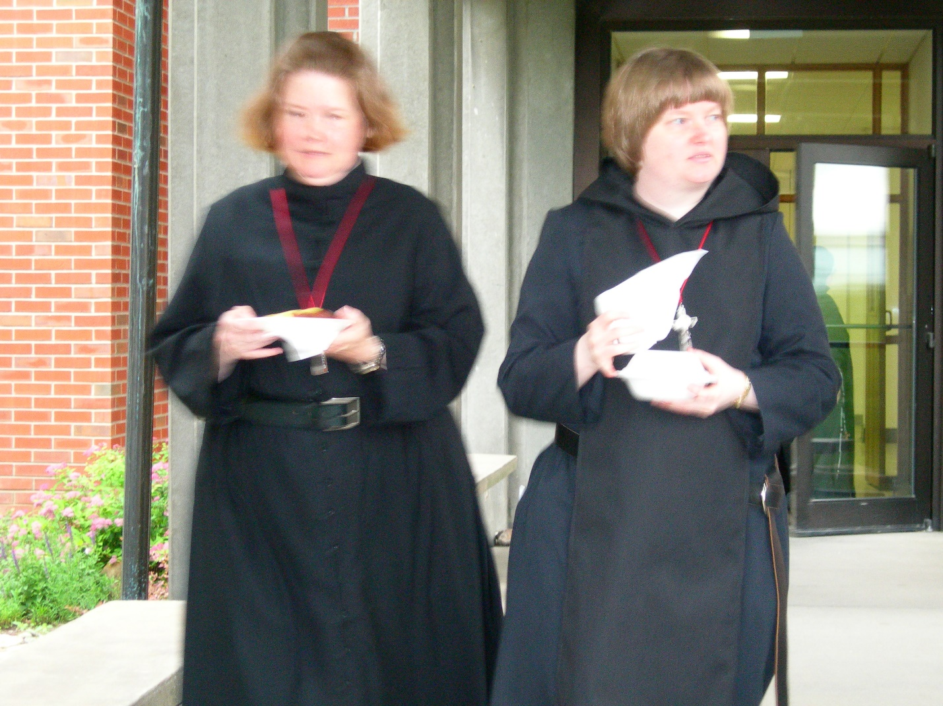
DSCN0331 Sr. Hillary Grace Lundgren; Sr. Catherine Unterseher
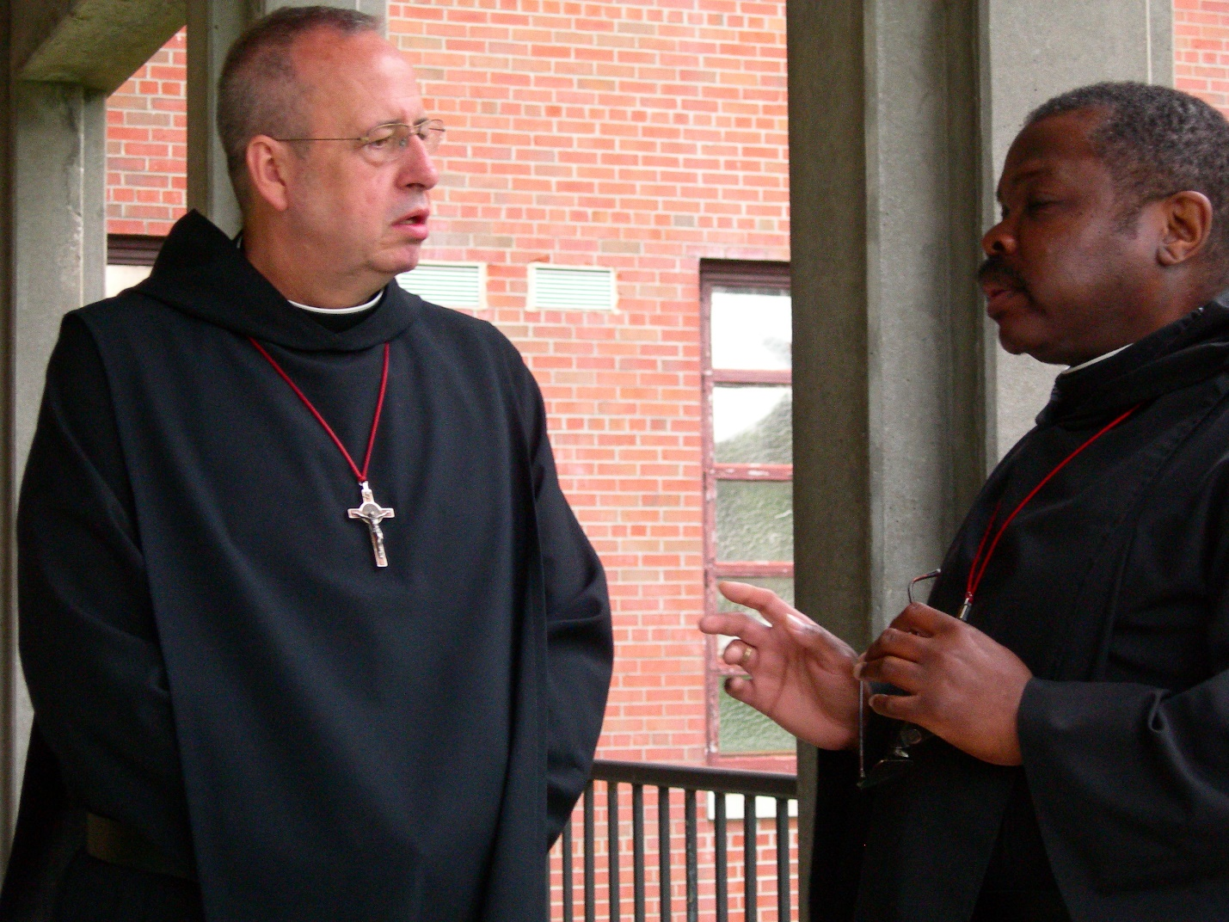
DSCN0332 Br. Gabriel Hale; Br. Thomas Ferrell
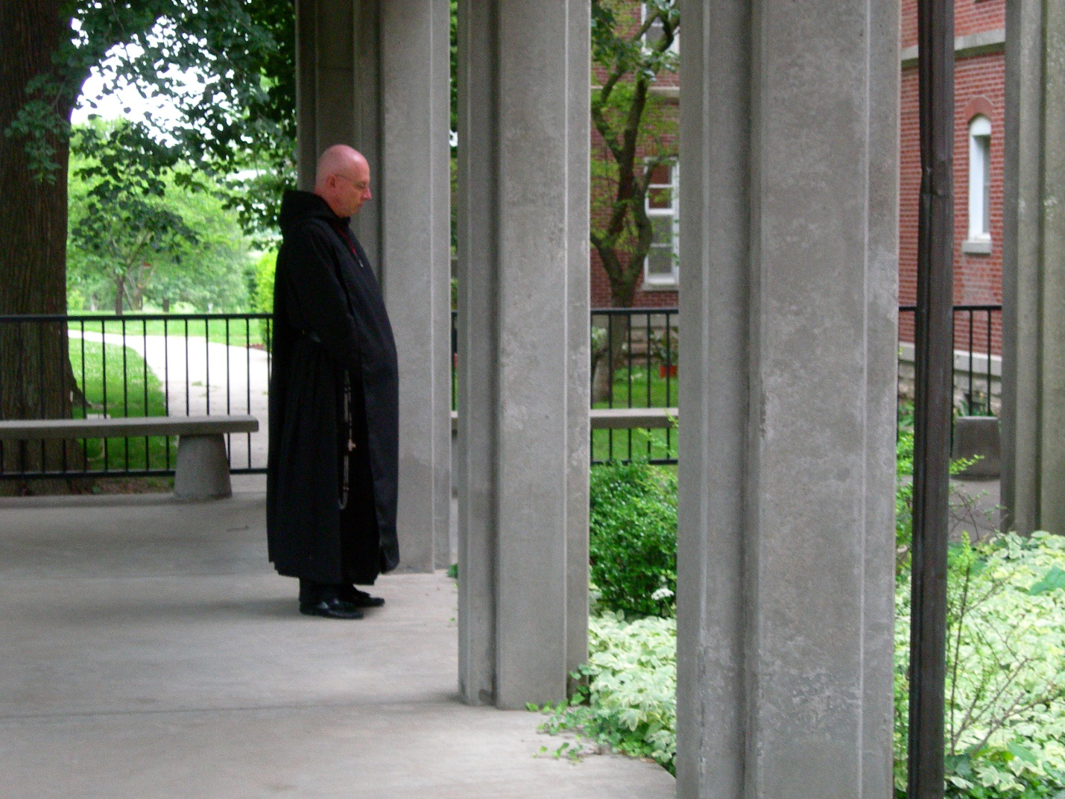
DSCN0333 Br. David Vincent Cotton
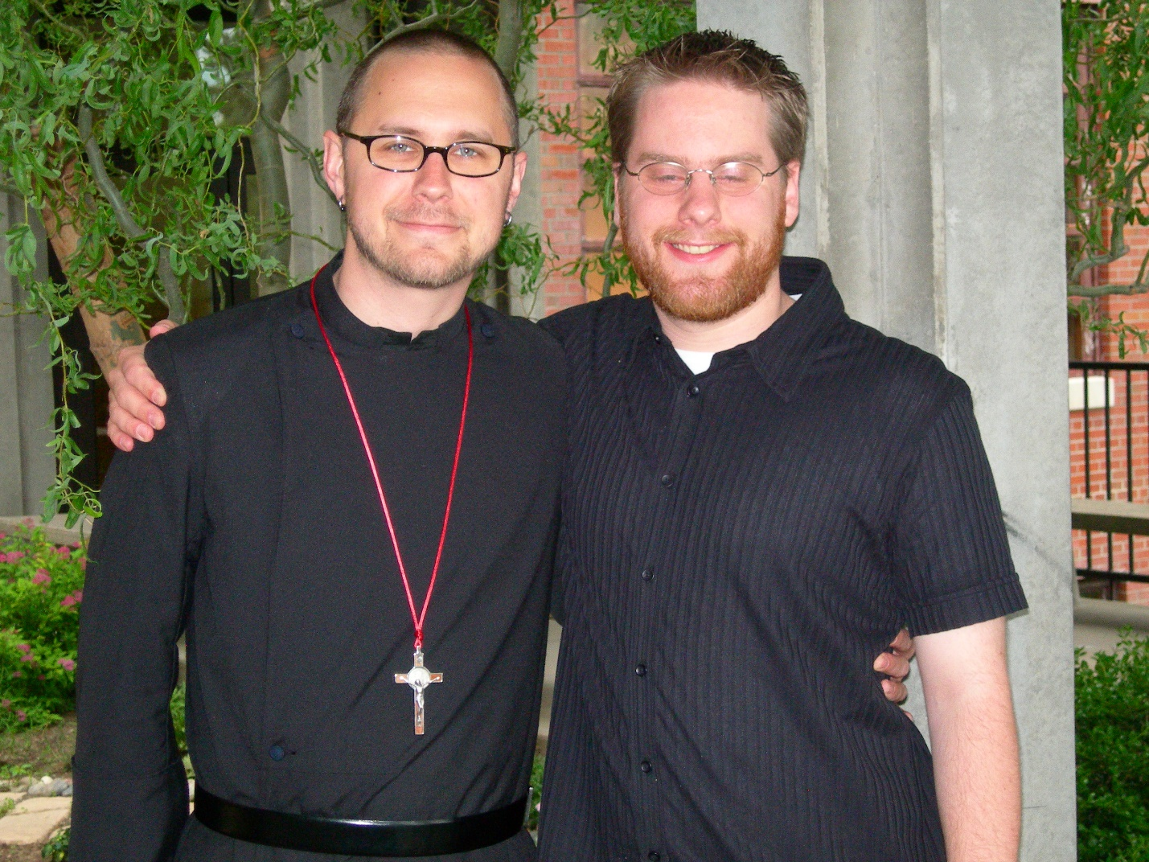
DSCN0334 Br. Eckhart Sowers; Friend of Br. Eckhart Sowers
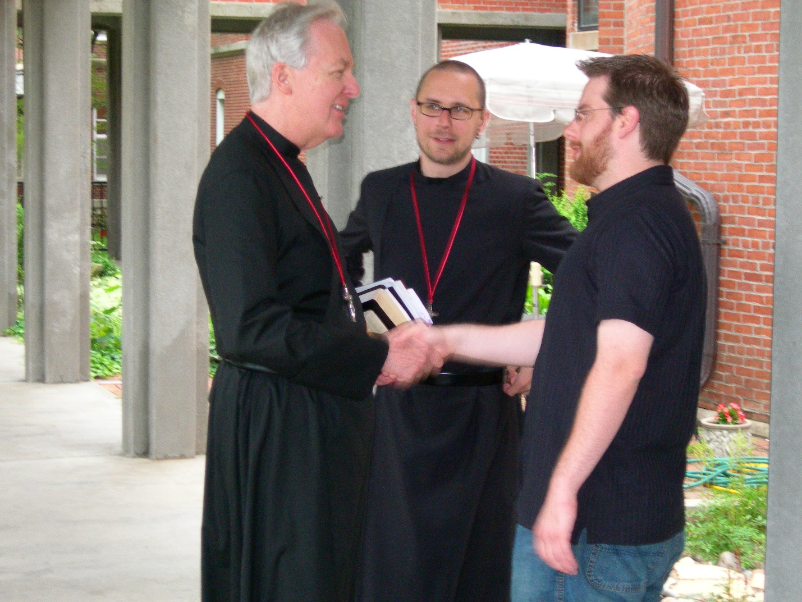
DSCN0335 Br. Luke Doucette; Br. Eckhart Sowers; Friend of Br. Eckhart Sowers
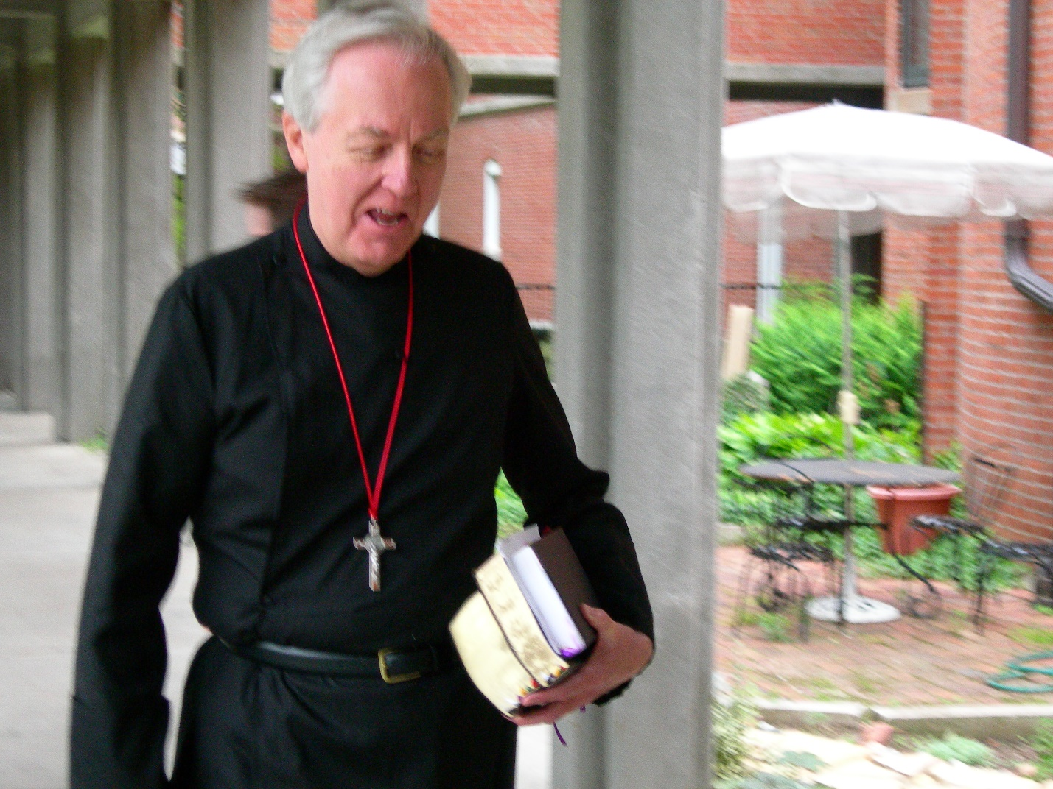
DSCN0336 Br. Luke Doucette
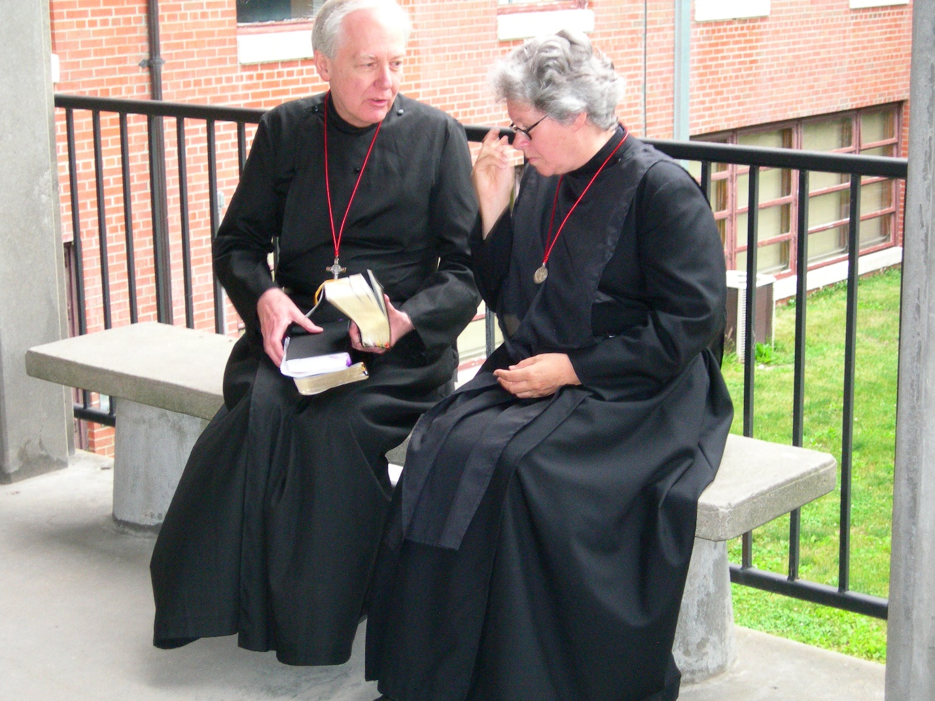
DSCN0337 Br. Luke Doucette; Sr. Johanna Kirkpatrick
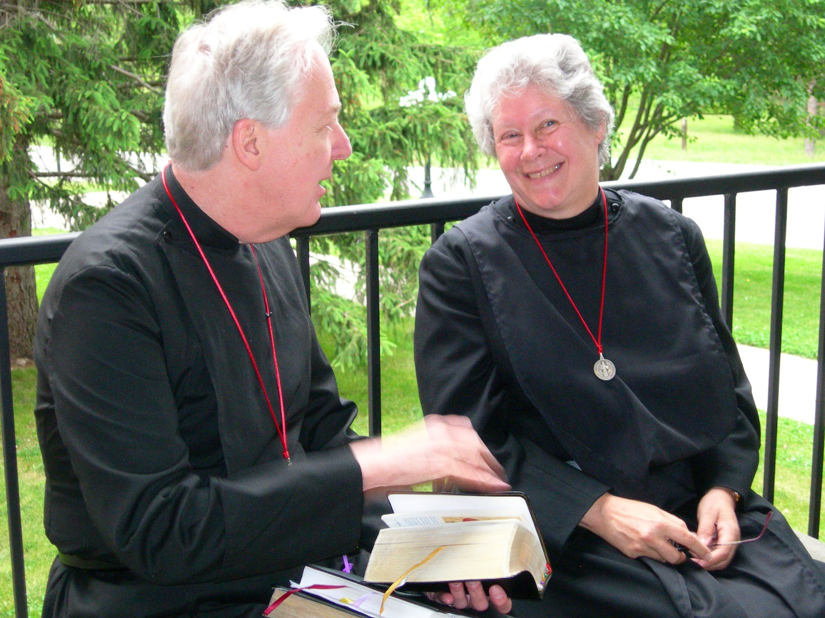
DSCN0338 Br. Luke Doucette; Sr. Johanna Kirkpatrick
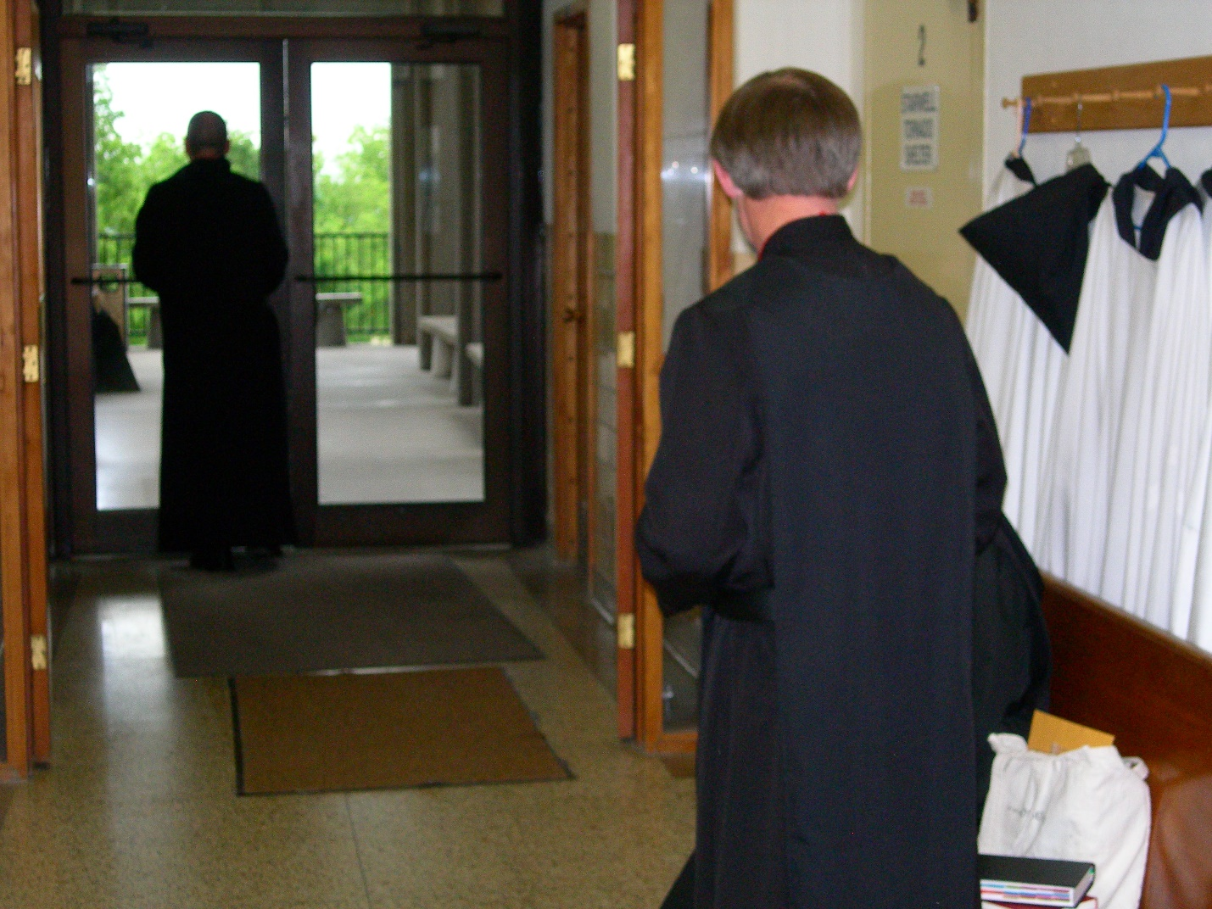
DSCN0339 Br. Gabriel Hale; Br. Lawrence Mullen
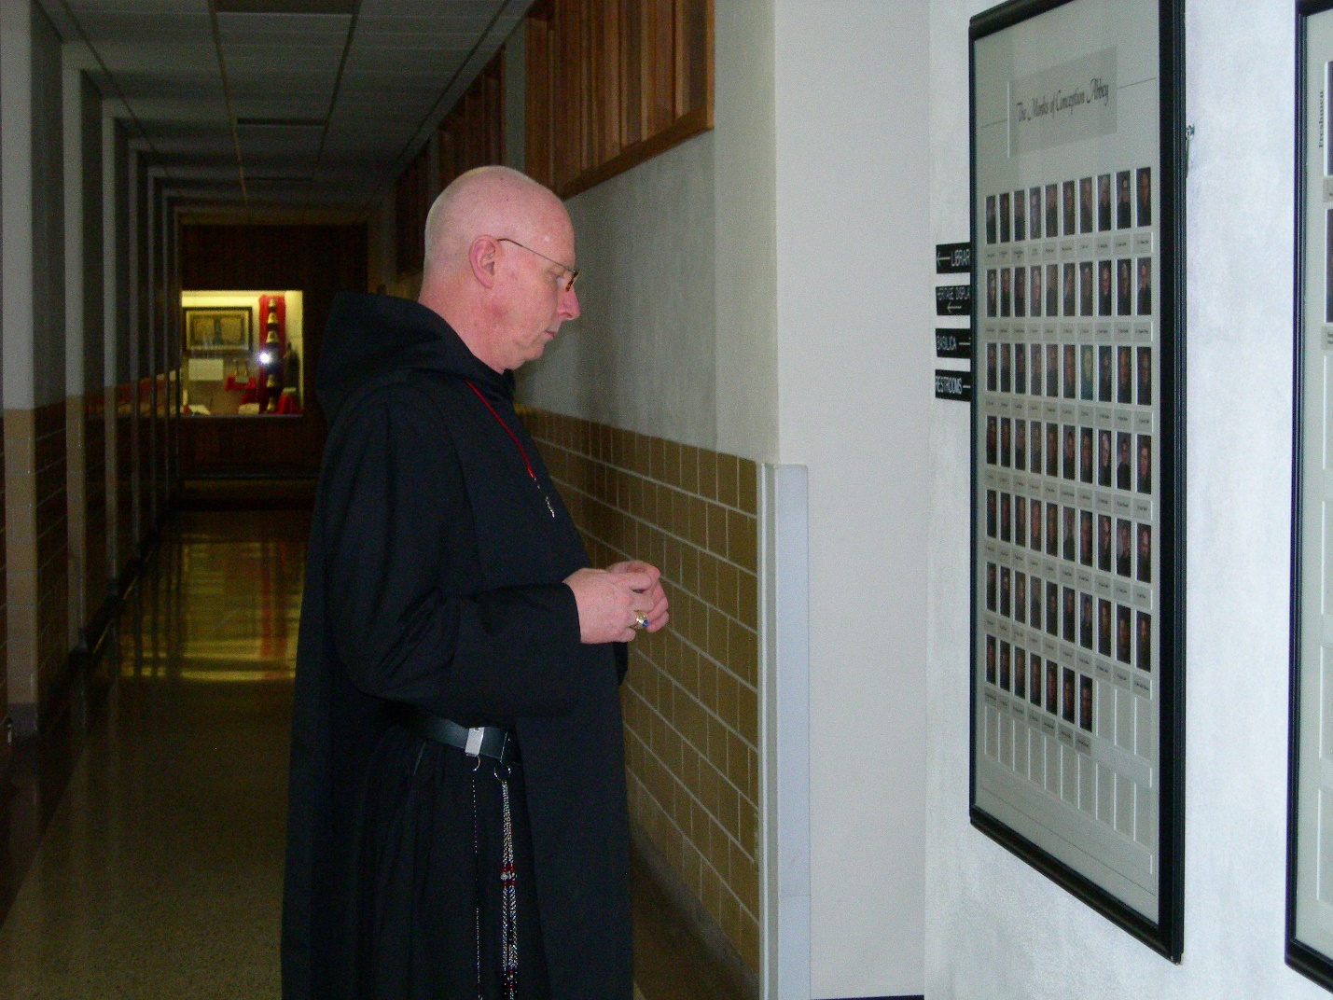
DSCN0340 Br. David Vincent Cotton
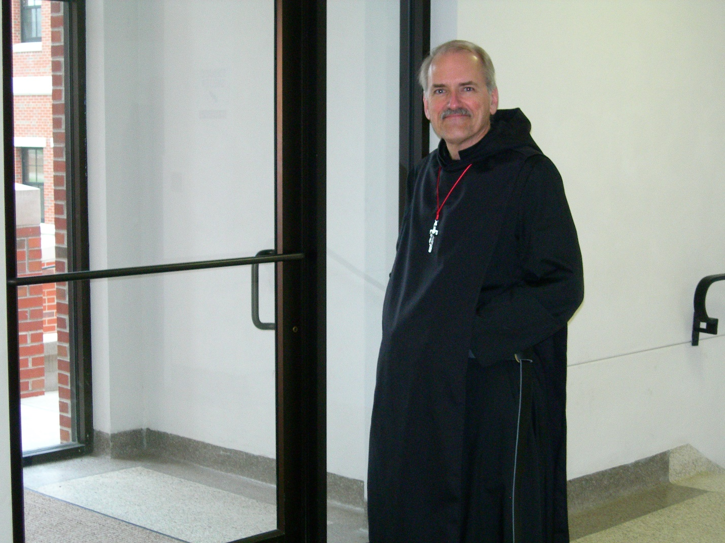
DSCN0341 Br. Daniel Joseph Schroeder
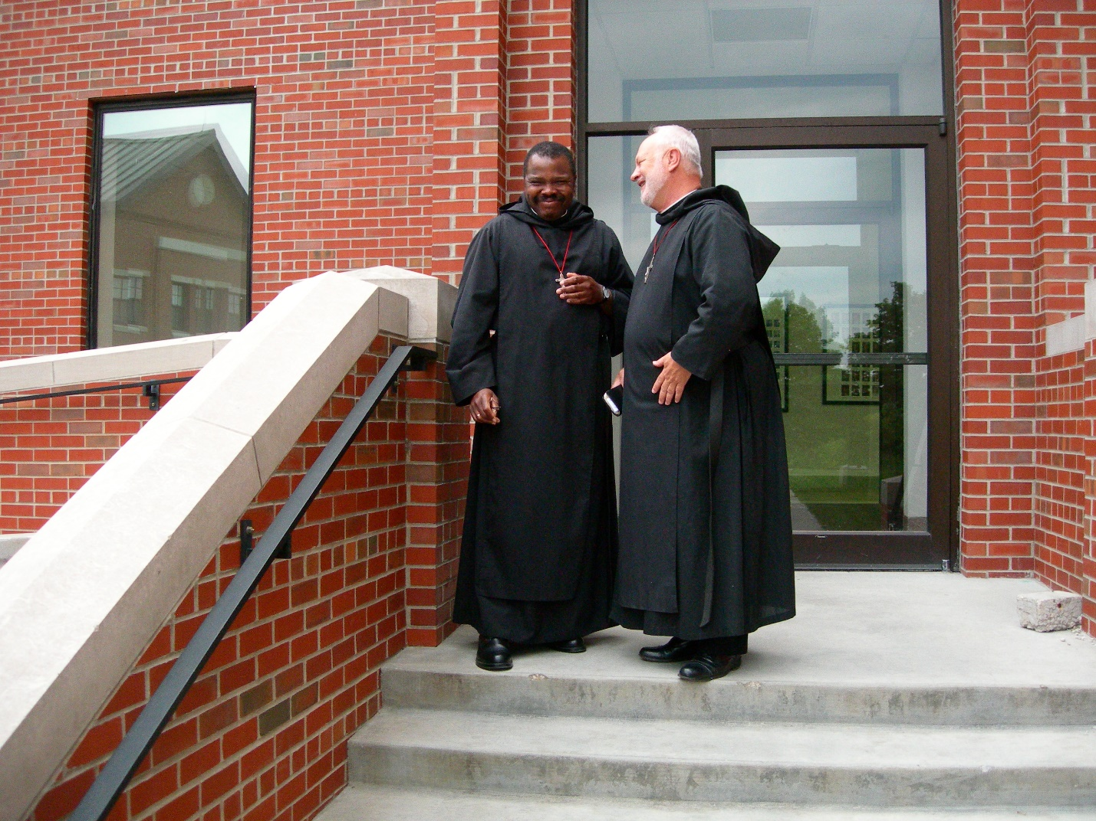
DSCN0342 Br. Thomas Ferrell; Br. Christopher John Baumann
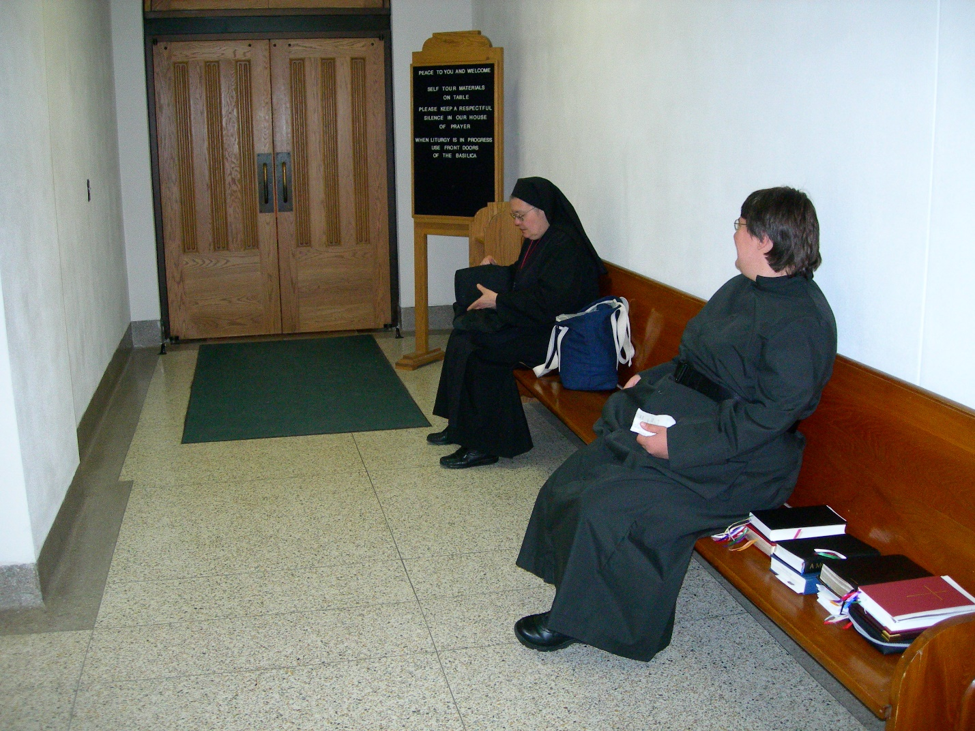
DSCN0343 Sr. Theodora of Jesus Perecca; Sr. Pauline Tysol
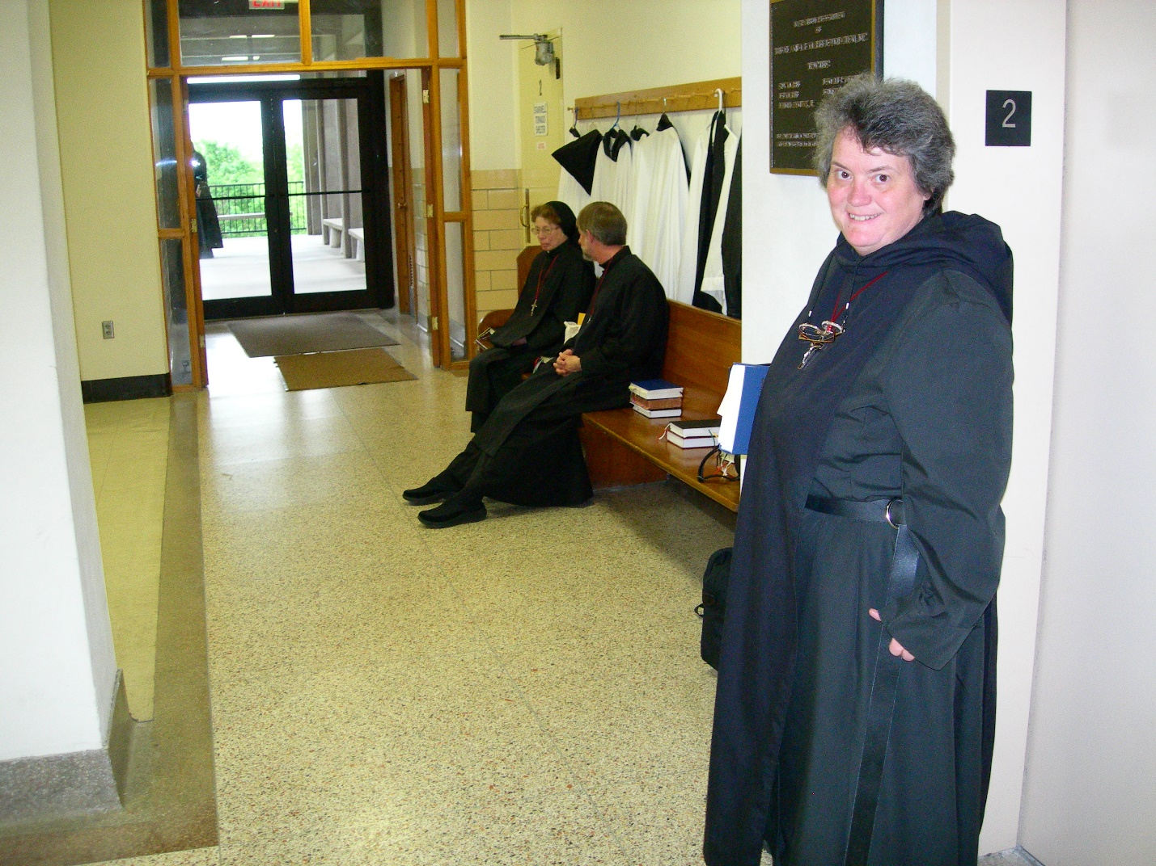
DSCN0344 Sr. Monica Ruth Mullen; Br. Lawrence Mullen; Sr. Vincent Marie Rittenhouse
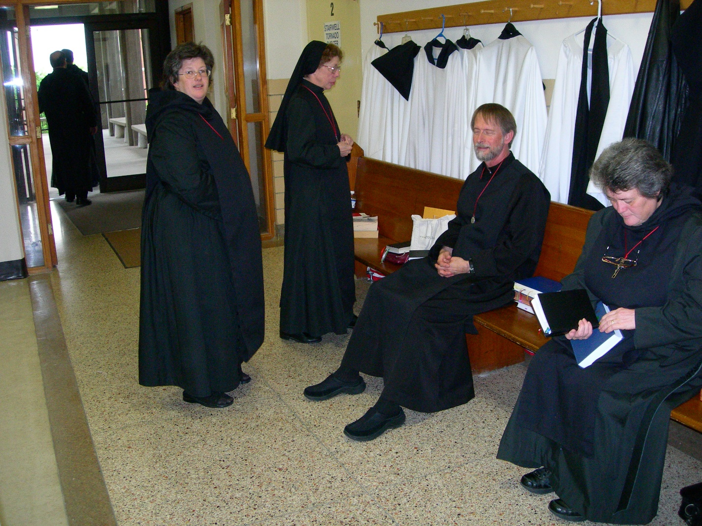
DSCN0345 Br. Raymond Owens; Abbot Michael John Austin; Sr. Cecelia Lamoy; Sr. Monica Ruth Mullen; Br. Lawrence Mullen; Sr. Vincent Marie Rittehouse
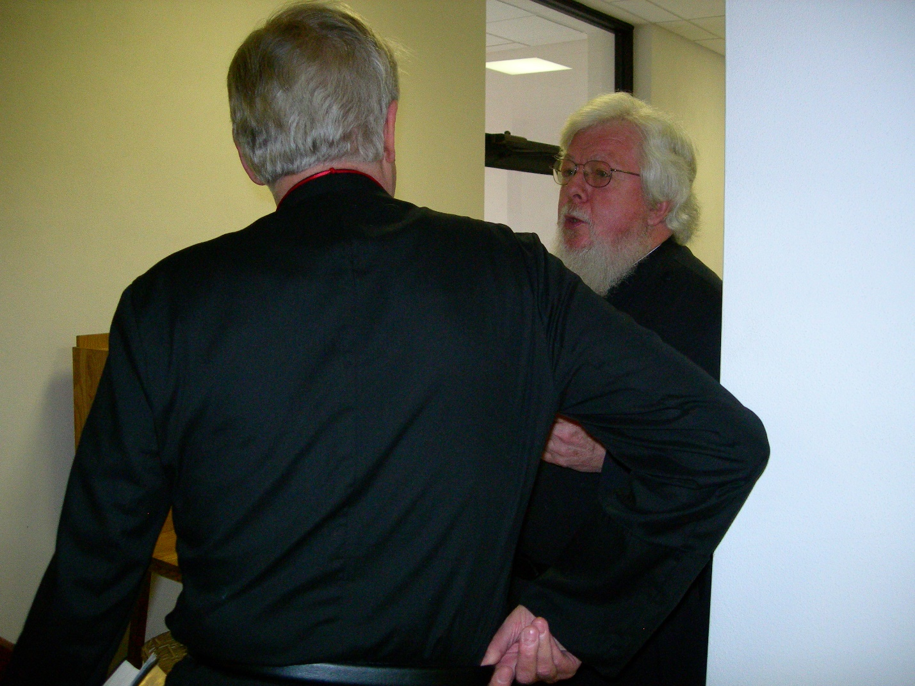
DSCN0346 Br. Luke Doucette; Fr. Wayne Kamm
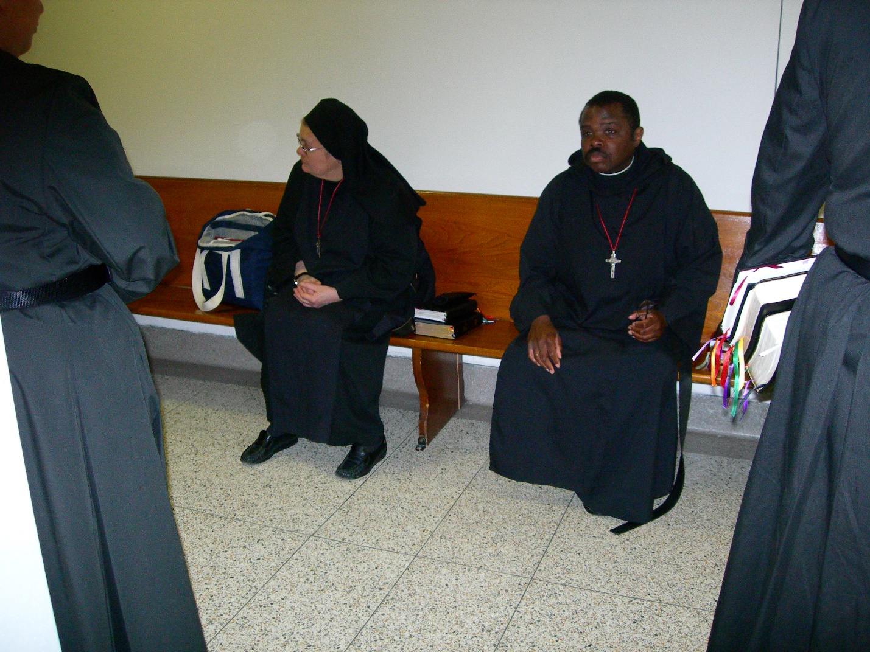
DSCN0347 Sr. Theodora of Jesus Perecca; Br. Thomas Ferrell
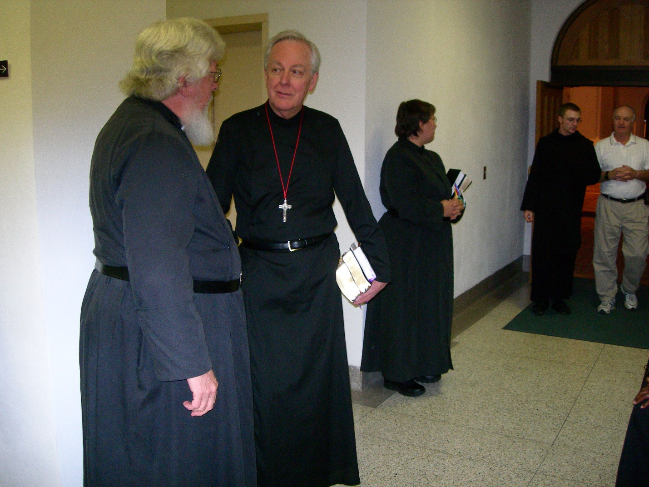
DSCN0348 Fr. Wayne Kamm; Br. Luke Doucette; Sr. Pauline Tysol; Monk of Conception Abbey
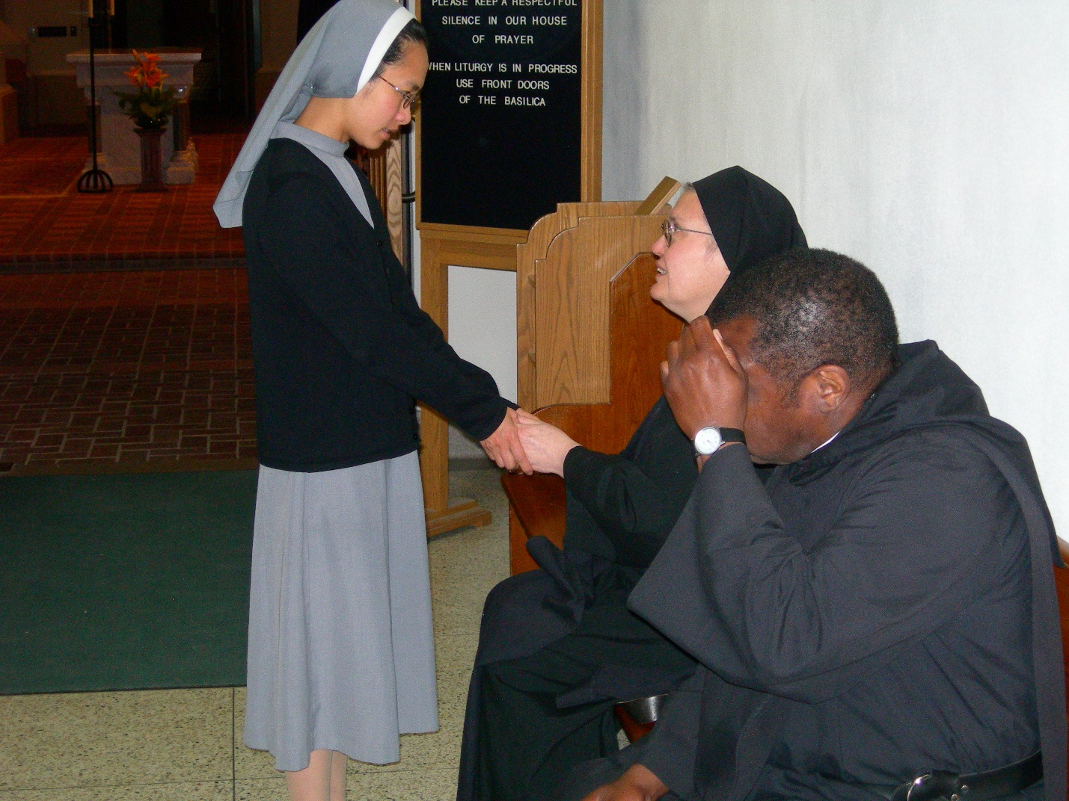
DSCN0349 Visiting nun; Sr. Theodora of Jesus Perecca; Br. Thomas Ferrell
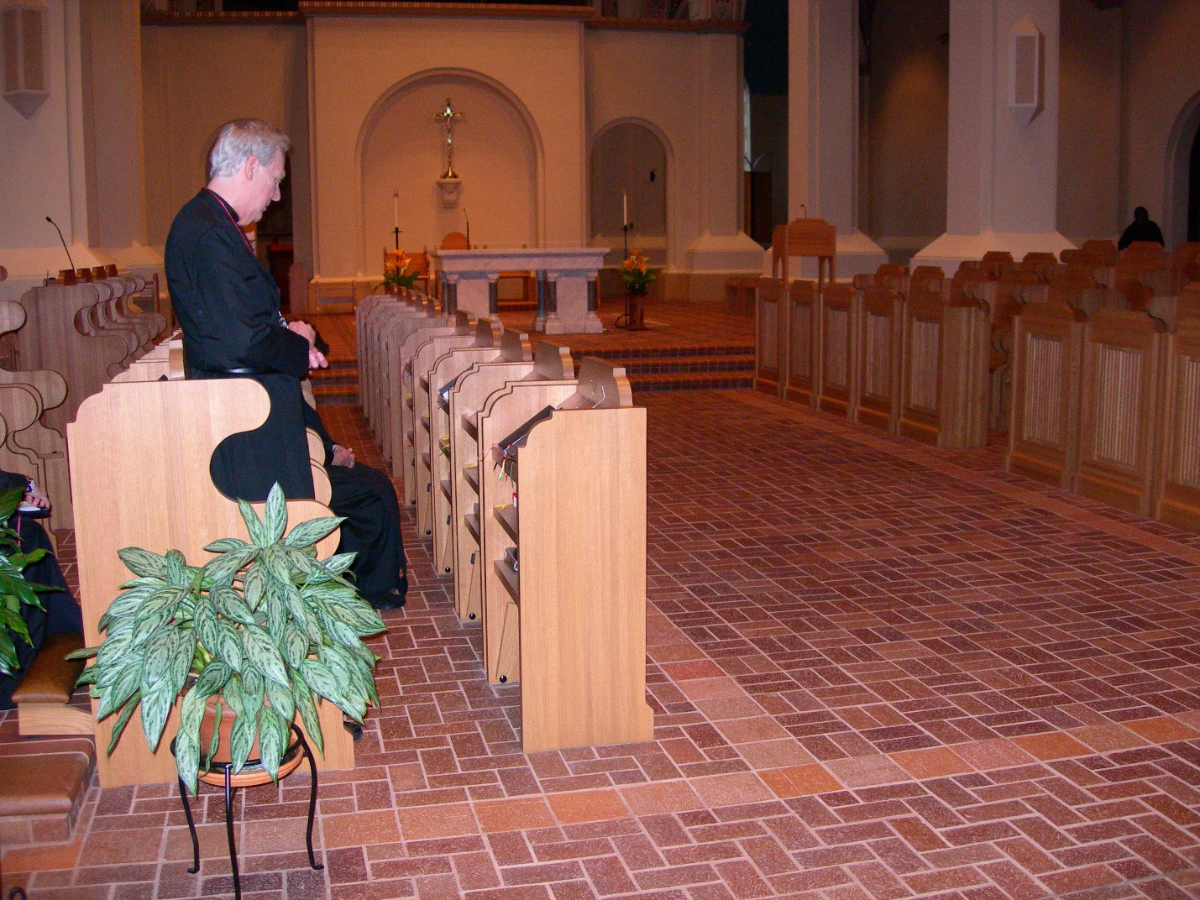
DSCN0351 Br. Luke Doucette
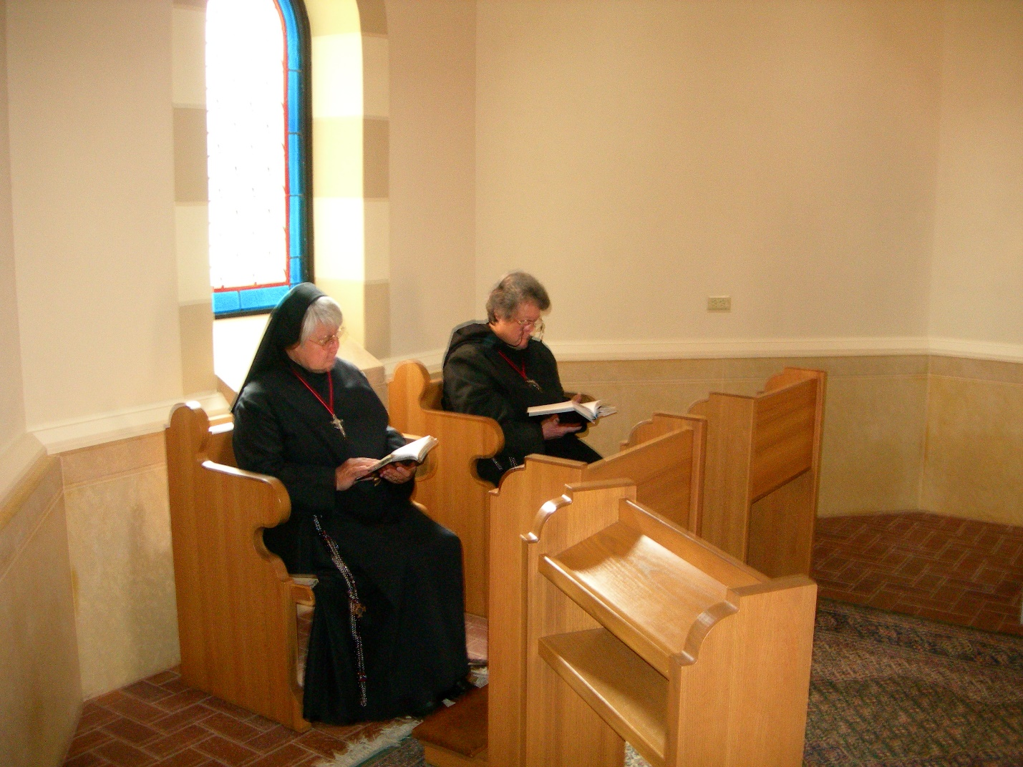
DSCN0352 Sr. Clare Benedicta Meyers; Sr. Vincent Marie Rittenhouse
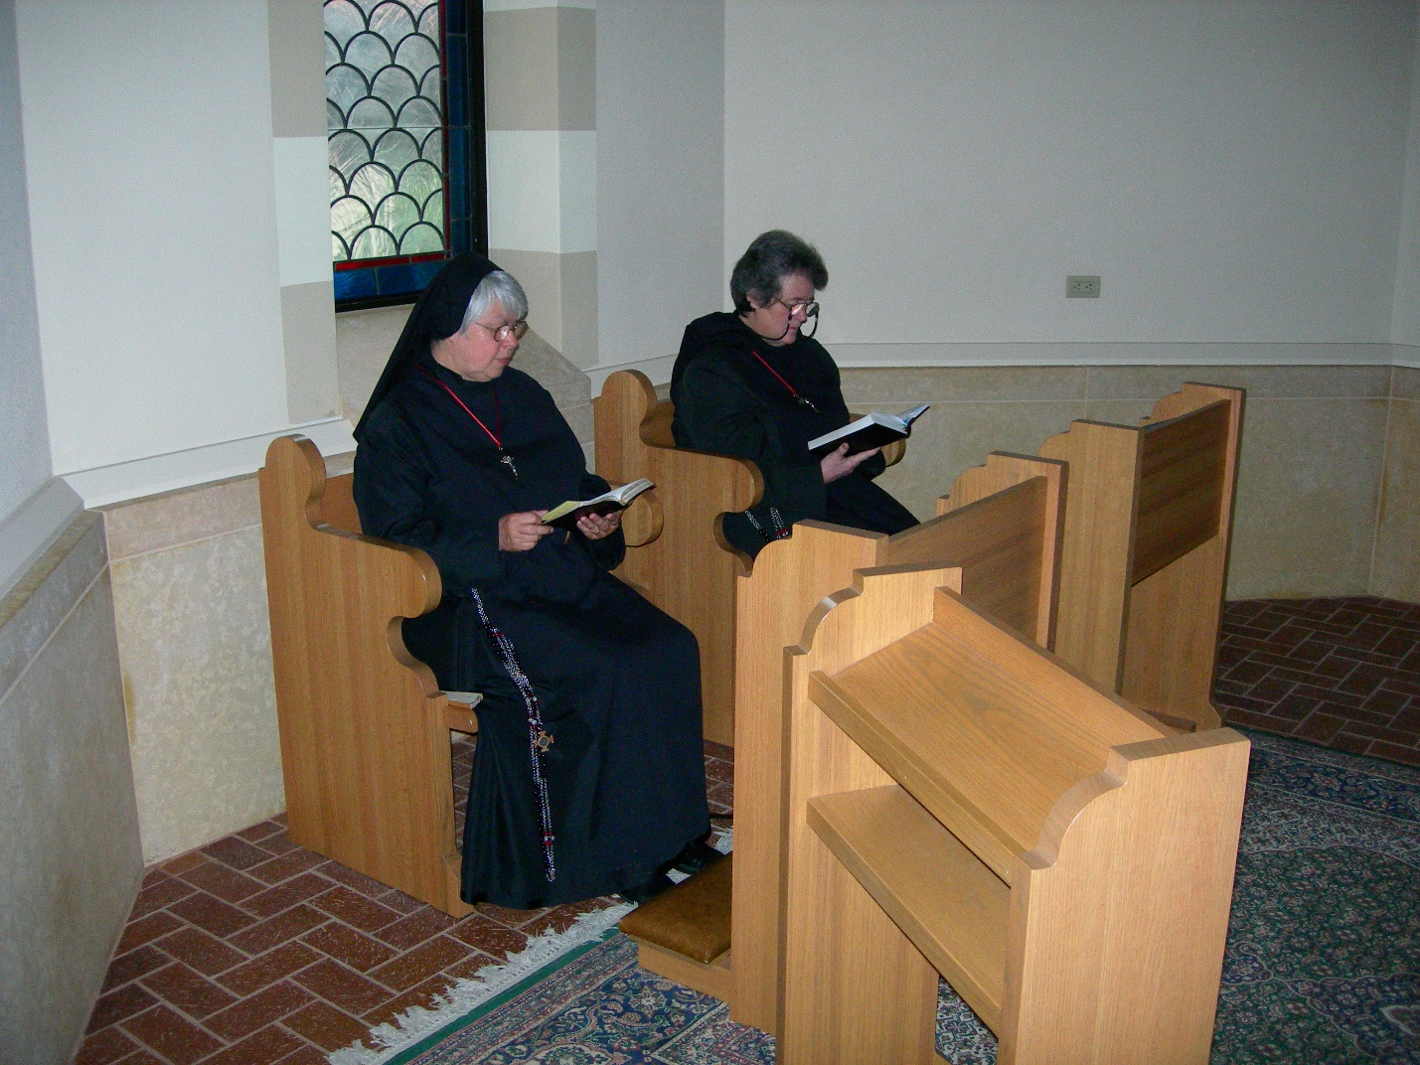
DSCN0353 Sr. Clare Benedicta Meyers; Sr. Vincent Marie Rittenhouse

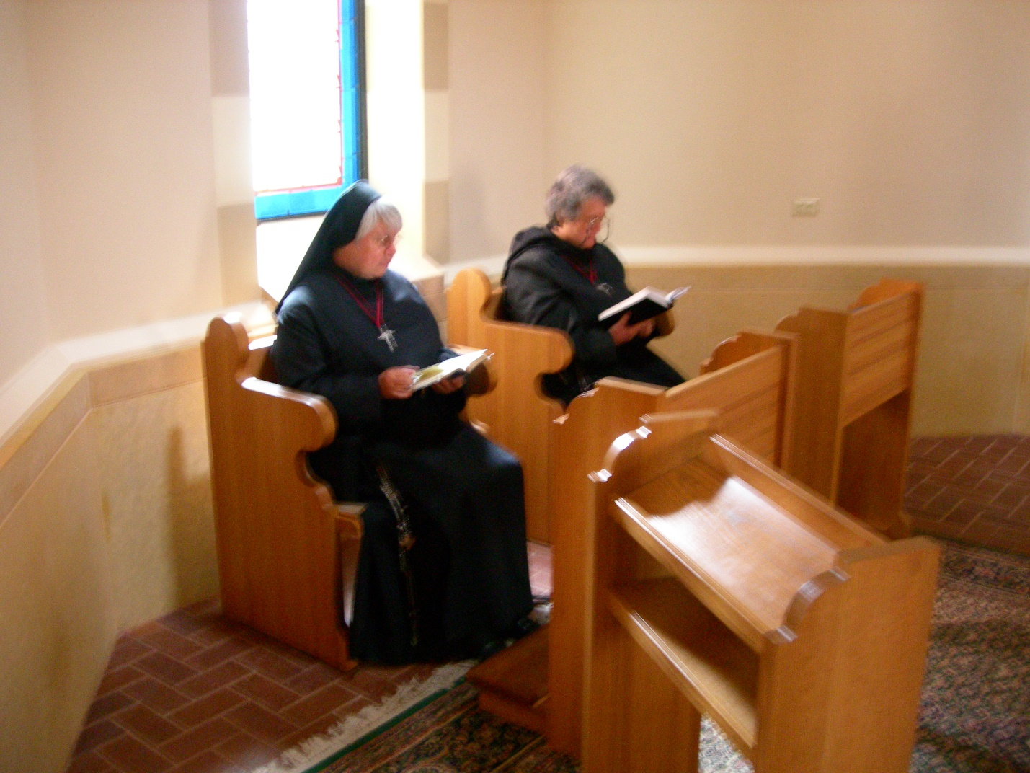
DSCN0354 Sr. Clare Benedicta Meyers; Sr. Vincent Marie Rittenhouse

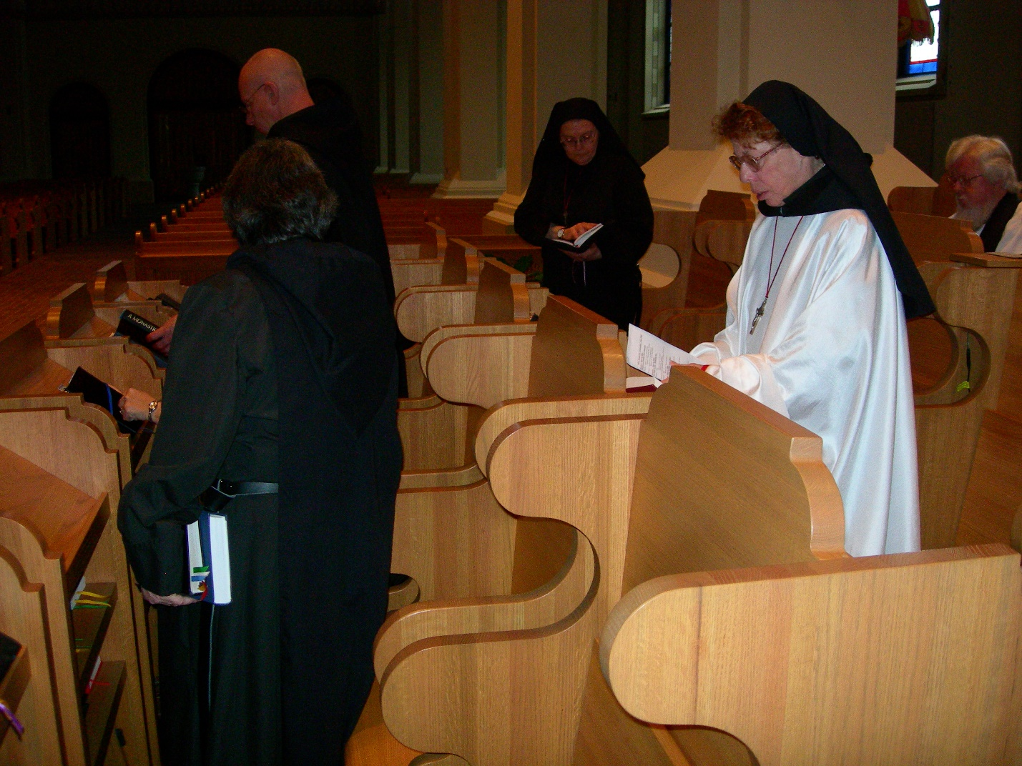
DSCN0355 Sr. Vincent Marie Rittenhouse; Br. David Vincent Cotton; Sr. Theodora of Jesus Perecca; Sr. Monica Ruth Mullen; Fr. Wayne Kamm
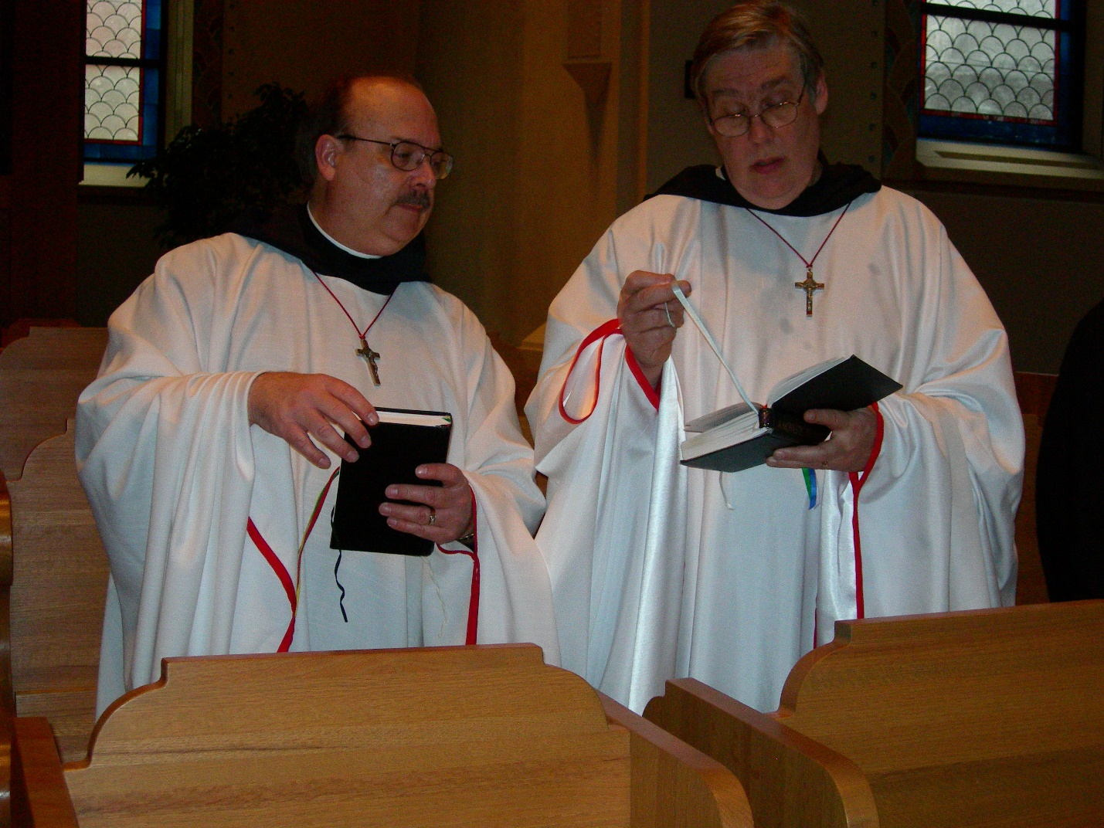
DSCN0356 Br. Raymond Owens; Br. Chad Anselm Gerns

